**Supporting Information for:**

**Identification of unsaturated and 2H polyfluorocarboxylate homologous series, and their detection in environmental samples and as polymer degradation products**

*John W. Washington,*,1 Thomas M. Jenkins2 and Eric J. Weber*,1*

*1USEPA National Exposure Research Laboratory, Athens, GA*

*2Senior Environmental Employment Program, Athens, GA*

Discussion S1: Chemicals used

Table S1. Chemical names and abbreviations of fluorinated chemicals referred to in this paper.

Discussion S2: Method development

Table S2: LC/MS/MS parameters used in this investigation.

Figure S1: Mass chromatograms extracted from uPFOA daughter scan

Figure S2: Mass chromatograms extracted from uPFOA daughter scan

Figure S3: Daughter scan and spectra of HPFOA in Wellington authentic sample

Figure S4: Mass chromatograms of the primary transitions of HPFCAs in an agricultural soil

Table S3: Optimized LC/MS/MS analytical parameters for uPFCAs

Table S4: Optimized LC/MS/MS analytical parameters for HPFCAs

Discussion S3: Detection of PFCAs and uPFCAs by decarboxylation via relatively high-voltage negative electro spray ionization

Figure S5: Detection of PFCAs in a soil sample by decarboxylation at the ESI

Figure S6: Secondary peaks for the series shown in Figure S3

Table S5: Optimized LC/MS/MS detection parameters for analysis of PFCAs by decarboxylation in the ESI

Figure S7: Mass chromatograms of uPFCAs in a sludge-applied soil, detected by decarboxylation in the ESI

Figure S8: Secondary peaks for m/z 281 through 531 in a sludge-applied soil

Table S6: Optimized LC/MS/MS detection parameters for analysis of uPFCAs by decarboxylation in the ESI

Discussion S4: Mass chromatograms for data shown in Table 1

Figure S9: Mass chromatograms of uPFCAs in fodder grass grown in sludge-applied soils

Figure S10: Mass chromatogram of uPFCAs in a commercial fluorotelomer-based polymer

Figure S11: Mass chromatograms of HPFCAs in fodder grass grown in sludge-applied soils showing detections of HPFHxA (C6) through HPFTrDA (C13)

Figure S12: Mass chromatogram of HPFCAs in a commercial fluorotelomer-based polymer showing detections of HPFHxA (C6) through uPFHxDA (C16)

Figure S13: Mass chromatograms of uPFOA in two control grass samples

Discussion S5: Analysis of spiked microcosms

Figure S14: Detection of PFOA in microcosms spiked with 8:2 FTOH, 8:2 FTUCA and 7:2sFTOH

Figure S15: Chromatograms showing production of uPFOA from 8:2 FTUCA

Figure S16: Incubated microcosms spiked with 7:2 sFTOH (28 day), 8:2 FTOH (101 day), PFOA & m8PFOA (roughly 4 years)

Figure S17: Production of C6 from 8:2 FTOH and 8:2 FTUCA, but not 7:2 sFTOH

Figure S18: HPFOA increasing in 8:2 FTOH microcosm from 2 days to 101 days

Figure S19: HPFOA increasing in 8:2 FTUCA microcosm from 2 days to 28 days

Discussion S6: Possible detection of uPFOS in environmental samples

Figure S20: Primary and secondary transitions for hypothetical uPFOS in a sludge applied soil

Figure S21: Primary MS/MS transitions for hypothetical uPFOS in three sludge-applied soils

Table S7: Optimized MS/MS detection parameters for hypothetical uPFHxS and uPFOS

Discussion S7: Possible detection of conceptual compounds listed in Table 2

Figure S22: Three mass transitions for the possible detection of 2-OH 7:3 FTCA

Figure S23: Two mass transitions for the possible detection of 2-keto 7:3 FTCA

Figure S24: Two mass transitions for the possible detection of 8:2 FTUUCA

Table S8: Optimized MS/MS detection parameters for hypothetical pathway compounds listed in Table 2

Supporting Information References

**Discussion S1: Chemicals Used**

Chemicals used in this study were of the highest purity offered by the suppliers, uniformly ≥97% purity. Unless specifically noted otherwise, all labeled and unlabeled perfluorocarboxylic acids, telomer acids, and all other perfluoro and polyfluoro alkylate substances were purchased as certified standards from Wellington Laboratories through TerraChem (Shawnee Mission, KS, USA). Table S1 provides the names and abbreviations of the fluorinated chemicals referred to in this paper.

Tetrabutylammonium hydrogen sulfate (TBAHS) and sodium carbonate, were purchased from Aldrich Chemical (Milwaukee, WI, USA). Acetonitrile (ACN), glacial acetic acid, methanol (MeOH) and methyl tert-butyl ether (MTBE) were purchased from Fisher Chemical (Fairlawn, NJ, USA).

Oasis HLB solid-phase extraction (SPE) cartridges, 35-cm3 capacity, were purchased from Waters (Milford, MA, USA).

Commercial fluorotelomer polymers were provided in their commercially distributed form as suspended colloids by DuPont.

Use of these chemicals, in generation of the in-stock samples reported upon in this paper, is provided in detail in the original papers.1-3

Table S1. Chemical names and abbreviations of fluorinated chemicals referred to in this paper.



**Discussion S2: Method Development**

Instrumental parameters used in this investigation are based on previous analytical methods efforts,4 and summarized in Table S2.

Table S2: LC/MS/MS parameters used in this investigation.



We obtained an authentic sample of unsaturated PFOA, with the double bond at the α-β position, from Wellington Laboratories from which we prepared a standard at [uPFOA] = 44 ng/g in ACN. With the LC/MS/MS in negative ESI mode, daughter scans were run with the first quadrupole focused on 375 D/esu and collision energies (CEs) set at 10 and 24 volts (V) (Figure 1 of paper). The mass spectrum at CE = 24 V (Figure 1 again), suggested a fragmentation homologous series having increments of 50 (= CF2) starting at m/z = 119 D/esu. Extracting this hypothetical fragmentation series, we obtained the mass chromatograms in Figure S1. The mass spectrum at CE = 24 V (Figure 1) also suggested a second fragmentation homologous series having increments of 50 starting at 131 D/esu, which we plotted in Figure S2.

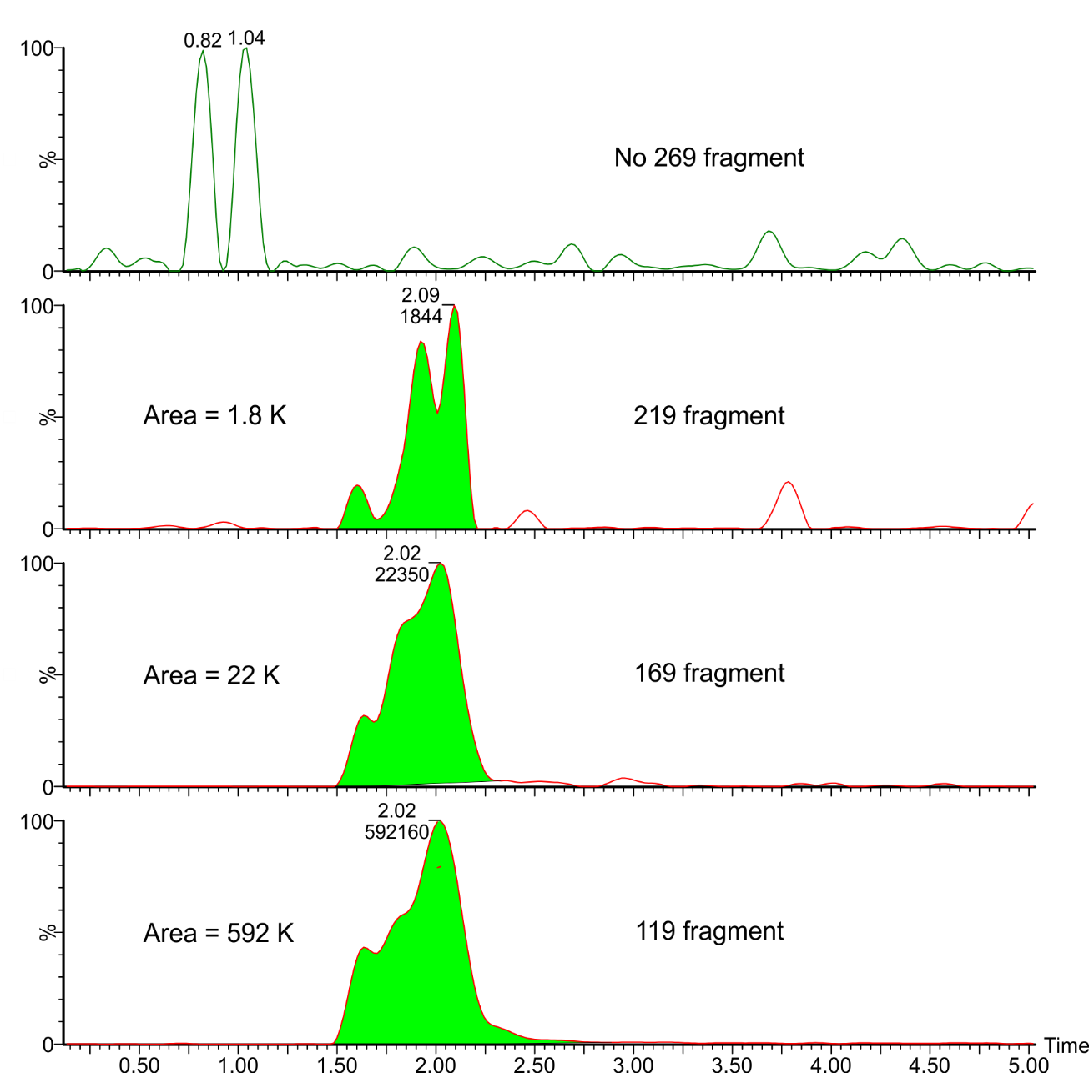

Figure S1: Mass chromatograms of fragments extracted from a daughter scan of an authentic uPFOA sample. Three out of four possible fragments from the classic PFCA MS/MS fragmentation series of F3C(CF2)n- were detected.

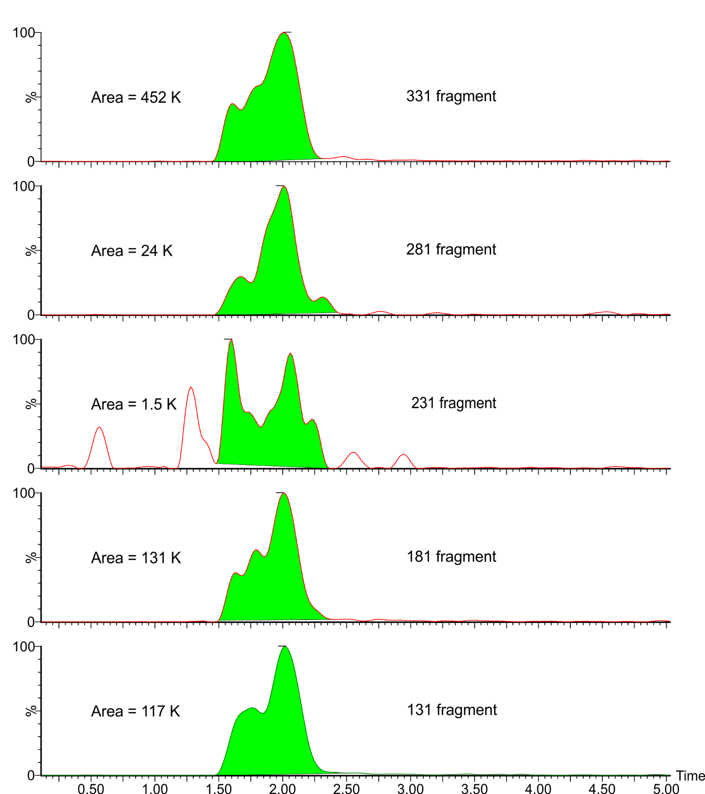

Figure S2: Mass chromatograms of a second hypothetical fragmentation series extracted from a daughter scan of an authentic uPFOA sample. We interpret this series as representing:

331 = C7F13 = F3C(CF2)4(CF)=CF-

281 = C6F11 = F3C(CF2)3(CF)=CF-

231 = C5F9 = F3C(CF2)2(CF)=CF-

181 = C4F7 = F3C(CF2)(CF)=CF-

131 = C3F5 = F3C(CF)=CF-

The strongest transitions in Figures 1 (of the paper), S1 and S2 are familiar in PFCA LC/MS/MS work; 375 🡪 331 represents loss of CO2 and 375 🡪 119 is the commonly encountered F3C(CF2)- fragment.

Analogous to Figure 2 of the paper, Figure S3 depicts the fragmentation patterns for 2HPOA. Like 2uPFOA, 2HPFOA indicates two fragmentation series with 50 D/esu, corresponding to CF2, the 119, 169 . . . series, and the 131, 181 . . . series.

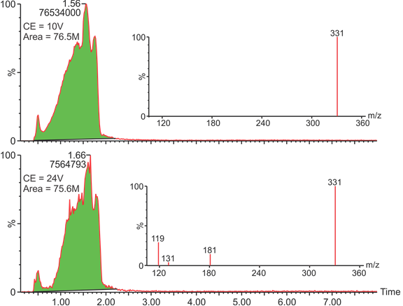

Figure S3: Daughter scan and spectra of HPFOA in Wellington authentic sample.

Using the transitions on the authentic 2uPFOA and 2HPFOA sample as a guide, we explored for homologues in environmental samples. Optimized LC/MS/MS detection parameters for this series yielded the mass chromatograms depicted in Figure 2 of the paper showing uPFCAs in the Decatur agricultural soil and Figure S4 showing HPFCAs in the Decatur agricultural soil.

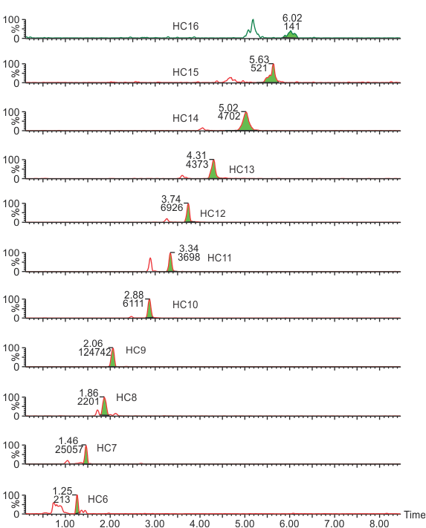

Figure S4: Mass chromatograms of the primary transitions of HPFCAs in an agricultural soil

The exploratory efforts depicted in Figure 2 of the paper and S4 were used to identify optimized detection parameters for uPFCAs and HPFCAs. These optimized parameters are summarized in Table S3 for uPFCAs and Table S4 for HPFCAs.

Table S3: Optimized LC/MS/MS analytical parameters for unsaturated perfluorocarboxylates



Table S4: Optimized LC/MS/MS analytical parameters for H perfluorocarboxylates



**Discussion S3: Detection of PFCAs and uPFCAs by decarboxylation via relatively high-voltage negative electro spray ionization**

We have discovered that a modest increase in the negative electrospray ionization energy (-ESI; “cone potential”) in the analysis of perfluorocarboxylates (PFCAs) leads to decarboxylation in front of the first quad. So for PFOA, the first quad can be focused on m/z = 369 D/esu, representing:



Using this approach, we are able to detect the homologous series consisting of m/z = (269, 319, 369, 419, 469, 519, 569, 619, 669) in several sludge-applied soil samples from Decatur, AL (Figure S3).3 We also have identified confirmation fragments in these samples (Figure S4). Optimized MS/MS parameters for detection of PFCAs by this method are summarized in Table S5.

By analogy for the PFCA analytical method we describe above, we tried increasing –ESI potential for the analysis of uPFCAs by decarboxylating in the ESI, so the uPFOA fragment in the first quad would be m/z = 331 D/esu representing:



Using this approach, we further confirmed the identity of the homologous series of uPFCAs as shown in mass chromatograms depicted in Figures S5 and S6. Optimized MS/MS parameters for detection of uPFCAs by this method are summarized in Table S6.

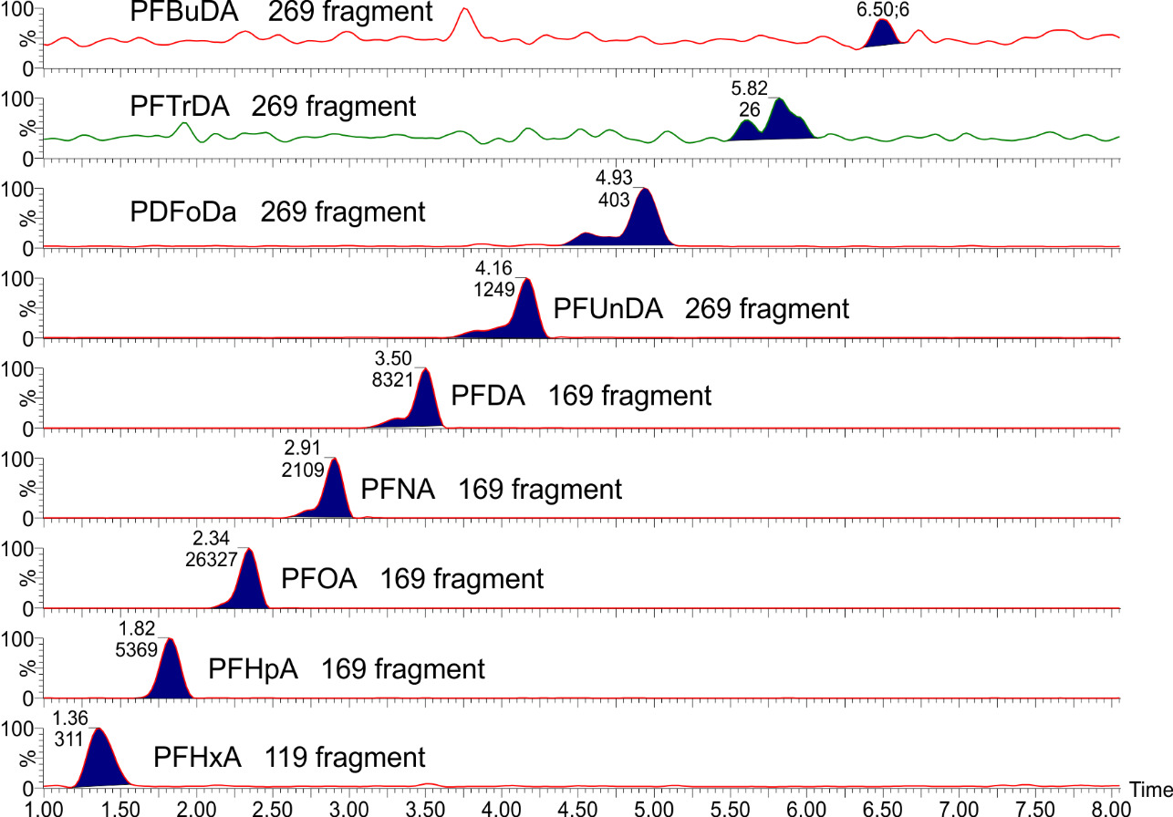

Figure S5: Detection of PFCAs in a soil sample by decarboxylation at the ESI. Primary peaks for m/z 269 through 669 are shown, representing PFHxA (C6) through PFTeDA (C14).

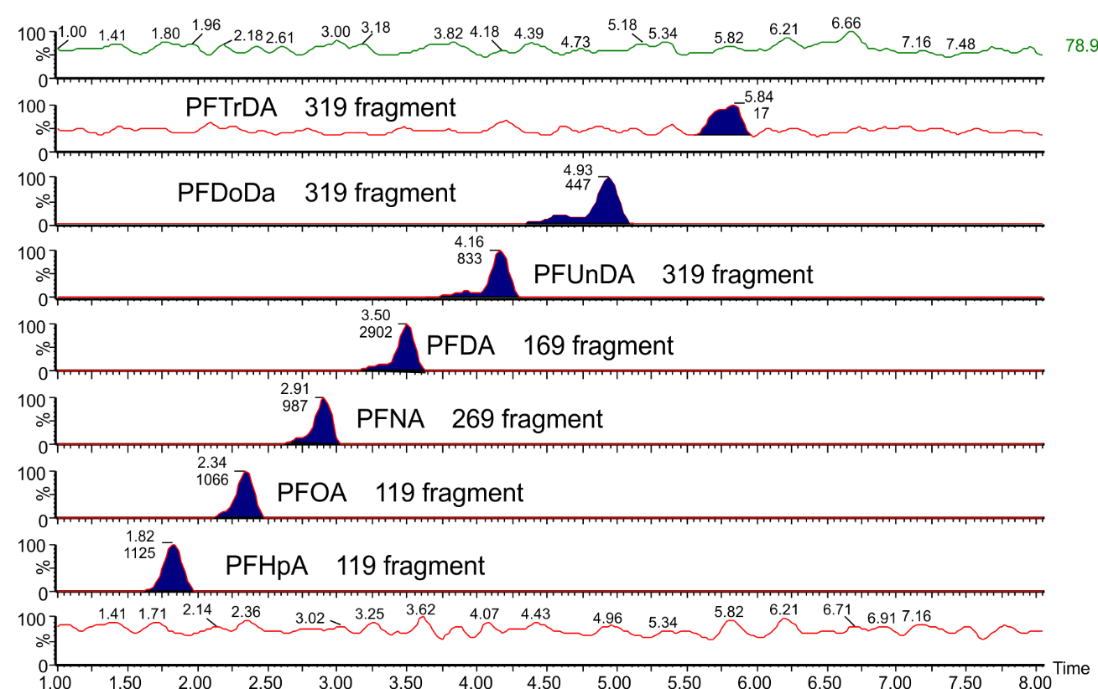

Figure S6: Secondary peaks for the series shown in Figure S3 for m/z 319 through 619, representing PFHpA (C7) through PFTDA (C13).

Table S5: Optimized LC/MS/MS detection parameters for analysis of PFCAs by decarboxylation in the ESI

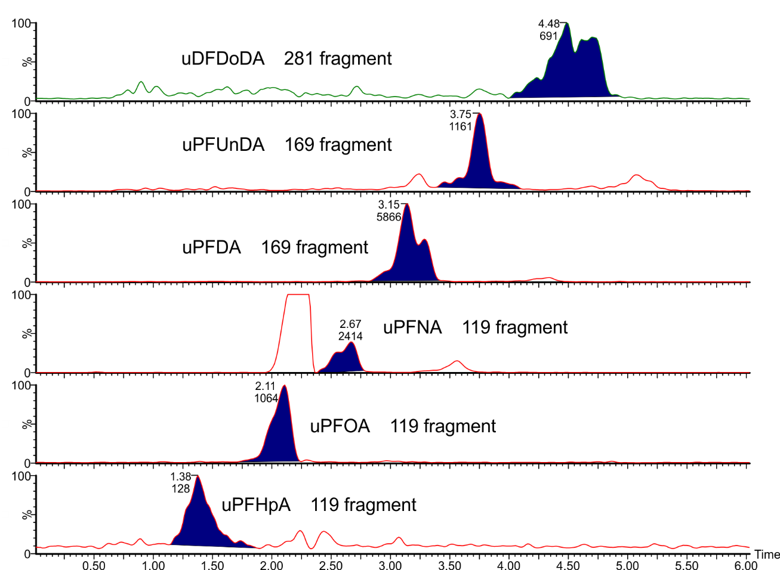

Figure S7: Mass chromatograms of uPFCAs in a sludge-applied soil, detected by decarboxylation in the ESI.

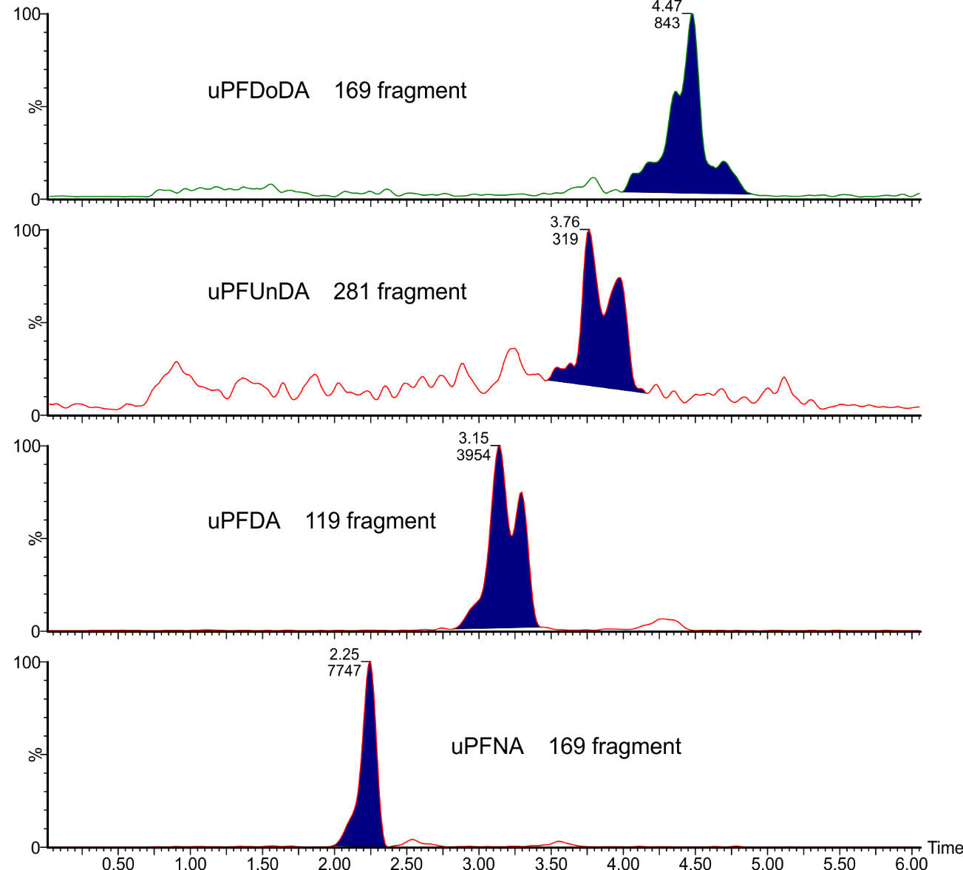

Figure S8: Secondary peaks for m/z 281 through 531 in a sludge-applied soil.

Table S6: Optimized LC/MS/MS detection parameters for analysis of uPFCAs by decarboxylation in the ESI

**Discussion S4: Mass chromatograms for data shown in Table 1**

A chromatogram for the soils summarized in Table 1 is shown as Figure 3 in the paper and Figure S4. The following Figure S9 shows uPFCAs in fodder grass grown in sludge-applied soils.5 Figure S10 depicts uPFCA mass chromatograms for a sample of a commercial fluorotelomer-based polymer that had been aged in soil microcosms.1 Figure S11 shows HPFCAs in fodder grass grown in sludge-applied soils.5 And Figure S12 shows HPFCAs in commercial fluorotelomer-based polymer that had been aged in soil microcosms.1

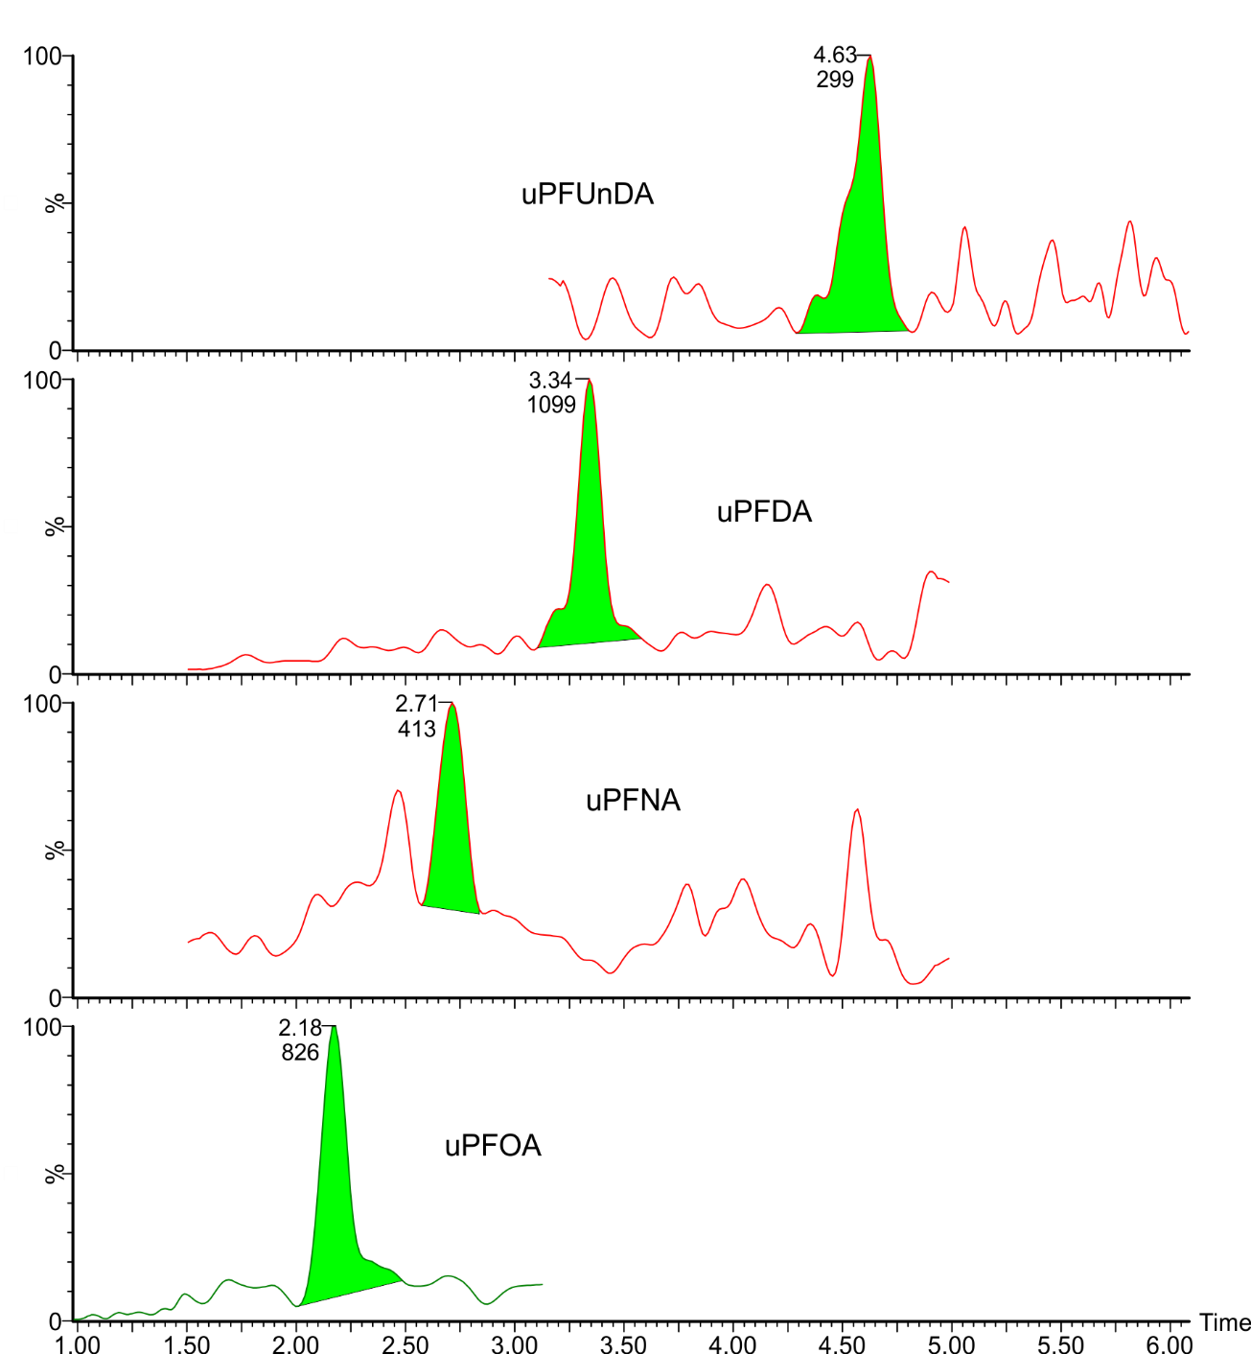

Figure S9: Mass chromatograms of uPFCAs in fodder grass grown in sludge-applied soils showing detections of uPFOA (C8) through uPFDA (C10) and uPFDoDA (C12).

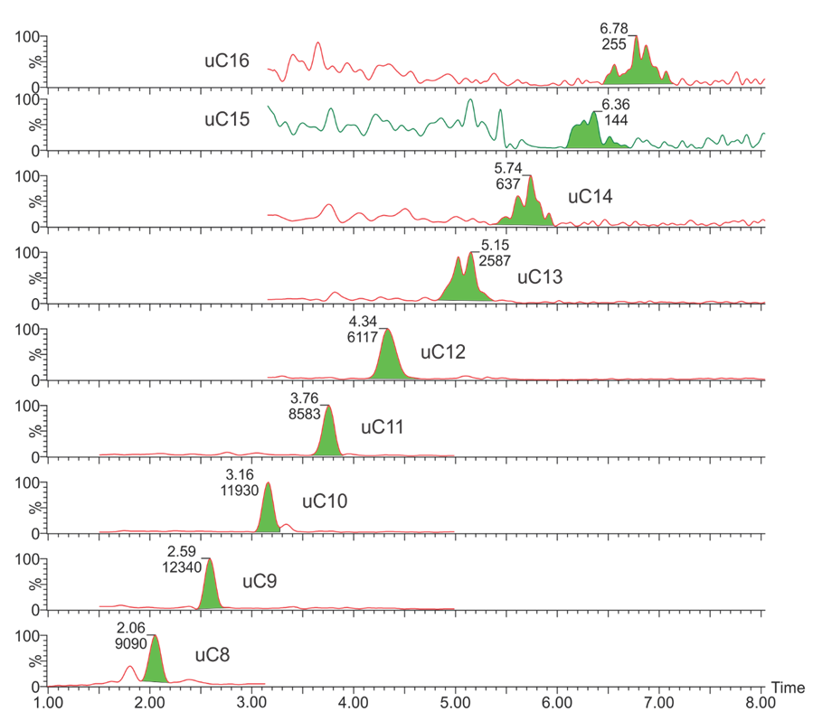

Figure S10: Mass chromatogram of uPFCAs in a commercial fluorotelomer-based polymer1 showing detections of uPFOA (C8) through uPFHxDA (C16).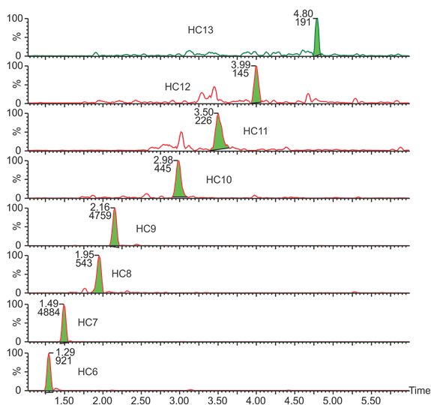

Figure S11: Mass chromatograms of HPFCAs in fodder grass grown in sludge-applied soils showing detections of HPFHxA (C6) through HPFTrDA (C13).

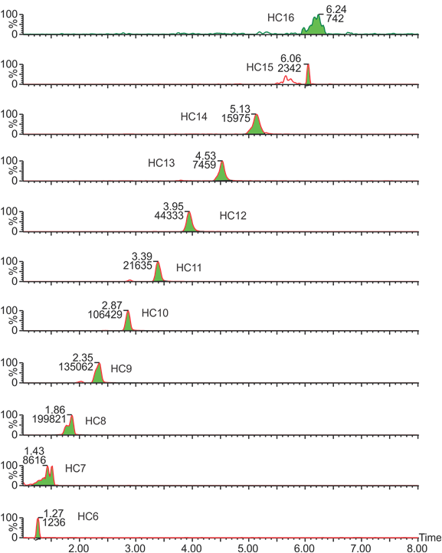

Figure S12: Mass chromatogram of HPFCAs in a commercial fluorotelomer-based polymer1 showing detections of HPFHxA (C6) through uPFHxDA (C16).

1. Control grass sample A

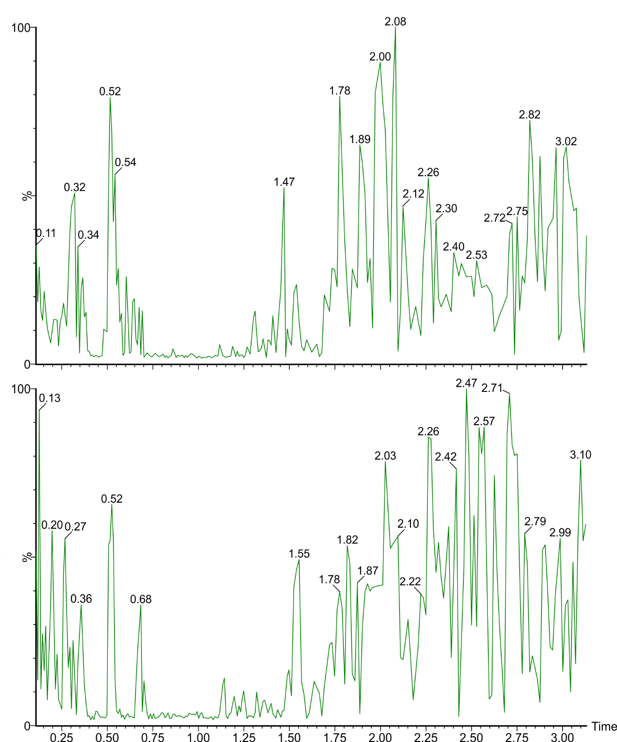

Figure S13: Mass chromatograms of uPFOA in two control grass samples (A and B) collected from our EPA campus in Athens, GA showing an absence of uPFOA peaks in uncontaminated samples.

**Discussion S5: Analysis of spiked microcosms**

Inspecting the microcosms we spiked with 8:2 FTOH, 8:2 FTUCA and 7:2 sFTOH, we found PFOA as a product of all three spiked compounds as expected (Figure S14). When we analyzed for uPFOA, we found this product only in microcosms spiked with 8:2 FTUCA (Figure S15). We also noted the production of PFHxA in microcosms containing 8:2 FTOH and 8:2 FTUCA, but no such detection in microcosms spiked with 7:2 sFTOH (Figure S16), nor PFOA plus 13C8-PFOA.

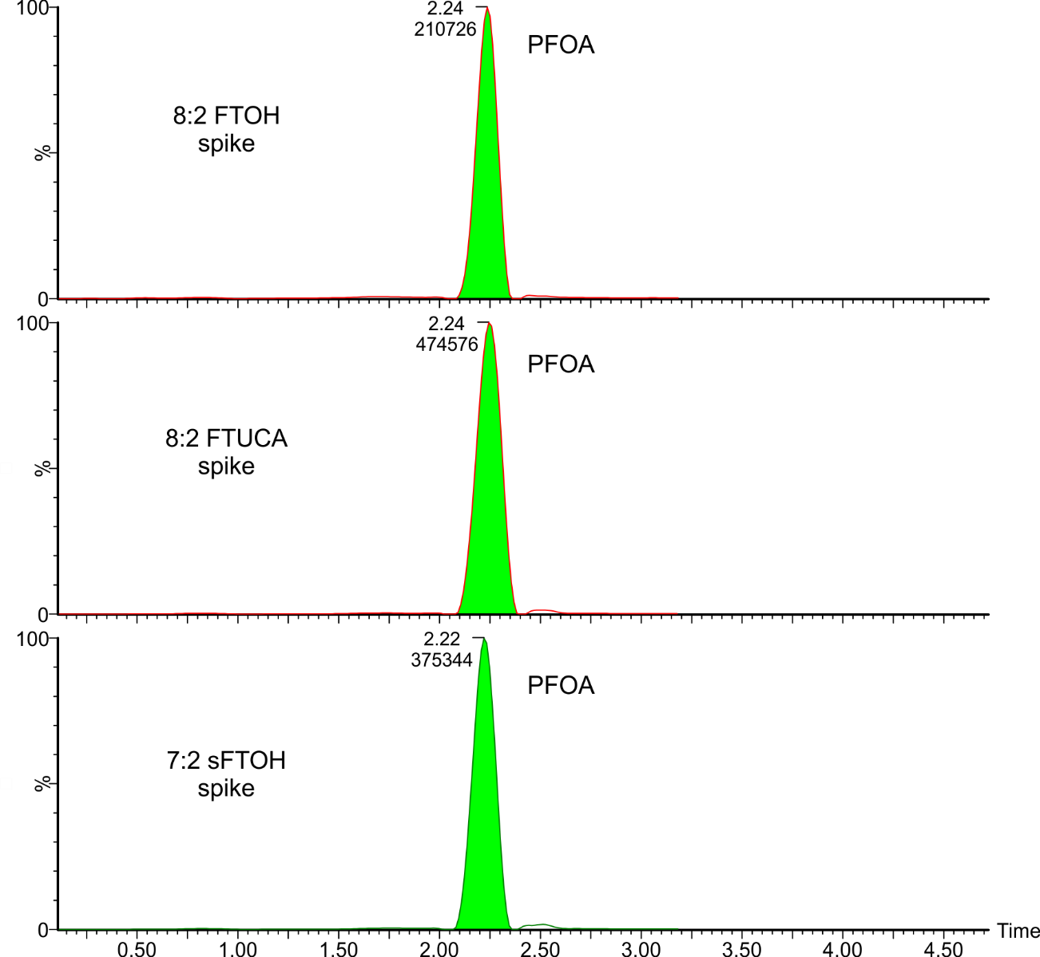

Figure S14: Detection of PFOA in microcosms spiked with 8:2 FTOH, 8:2 FTUCA and 7:2 sFTOH

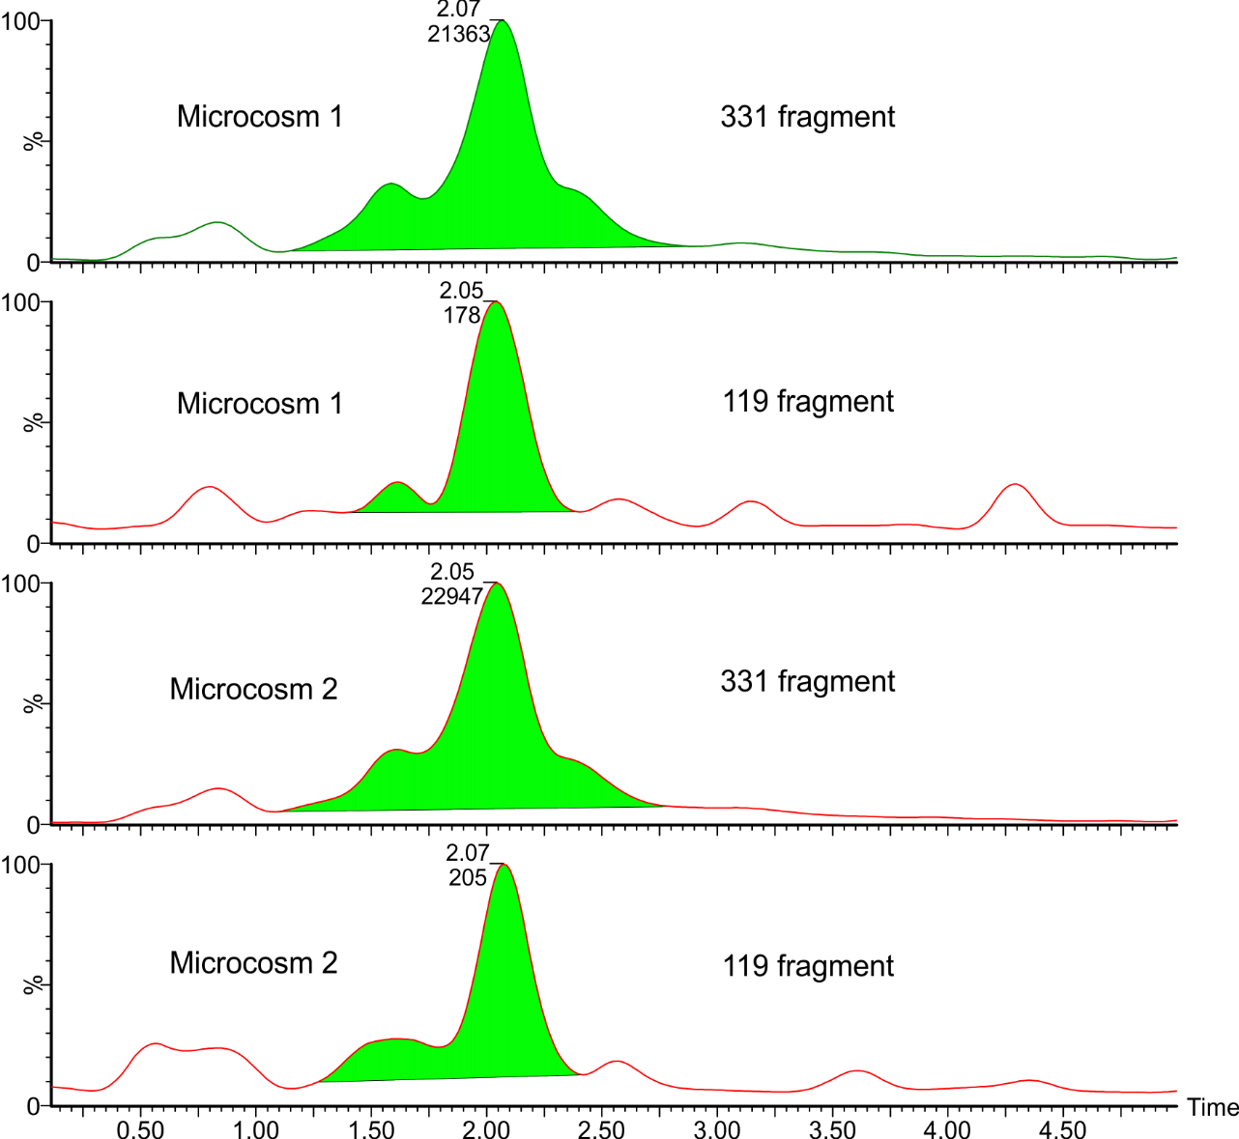

Figure S15: Chromatograms showing production of uPFOA from 8:2 FTUCA. Showing primary and secondary transitions for two incubated microcosms spiked with 8:2 FTUCA (28 day).

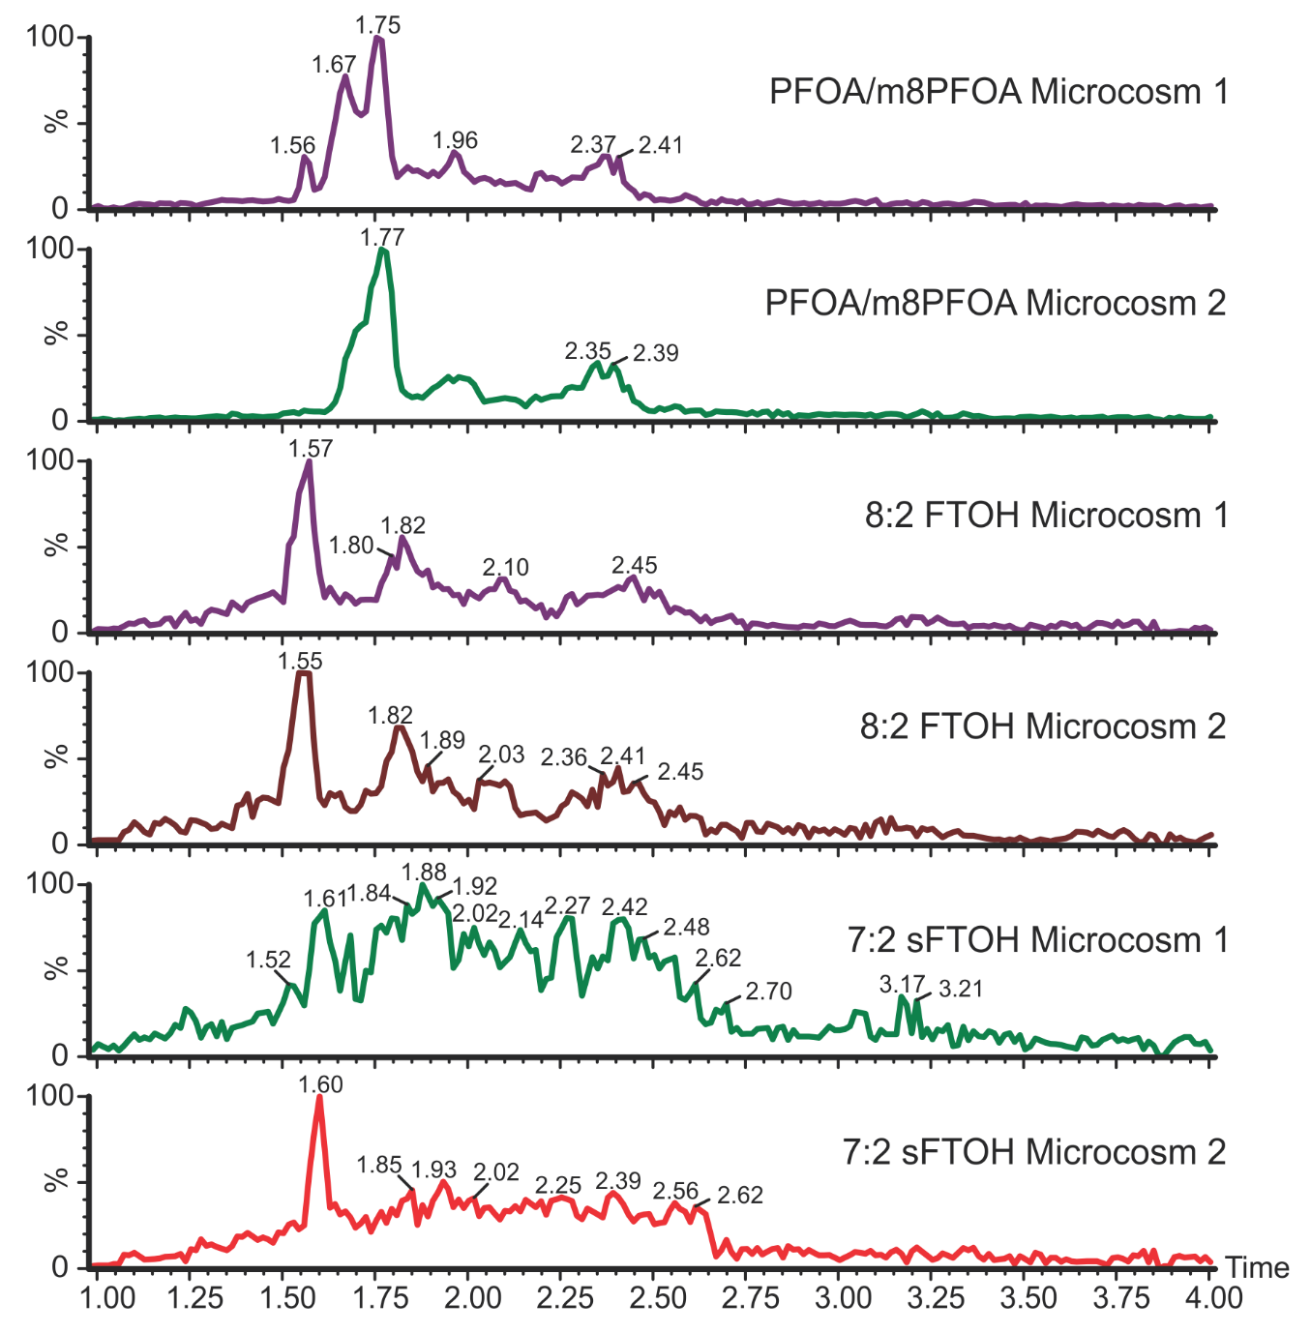

Figure S16: Incubated microcosms spiked with 7:2 sFTOH (28 day), 8:2 FTOH (101 day), PFOA & m8PFOA (roughly 4 years) chromatograms showing no evidence of uPFOA (eluting at 2.1 to 2.2 minutes)

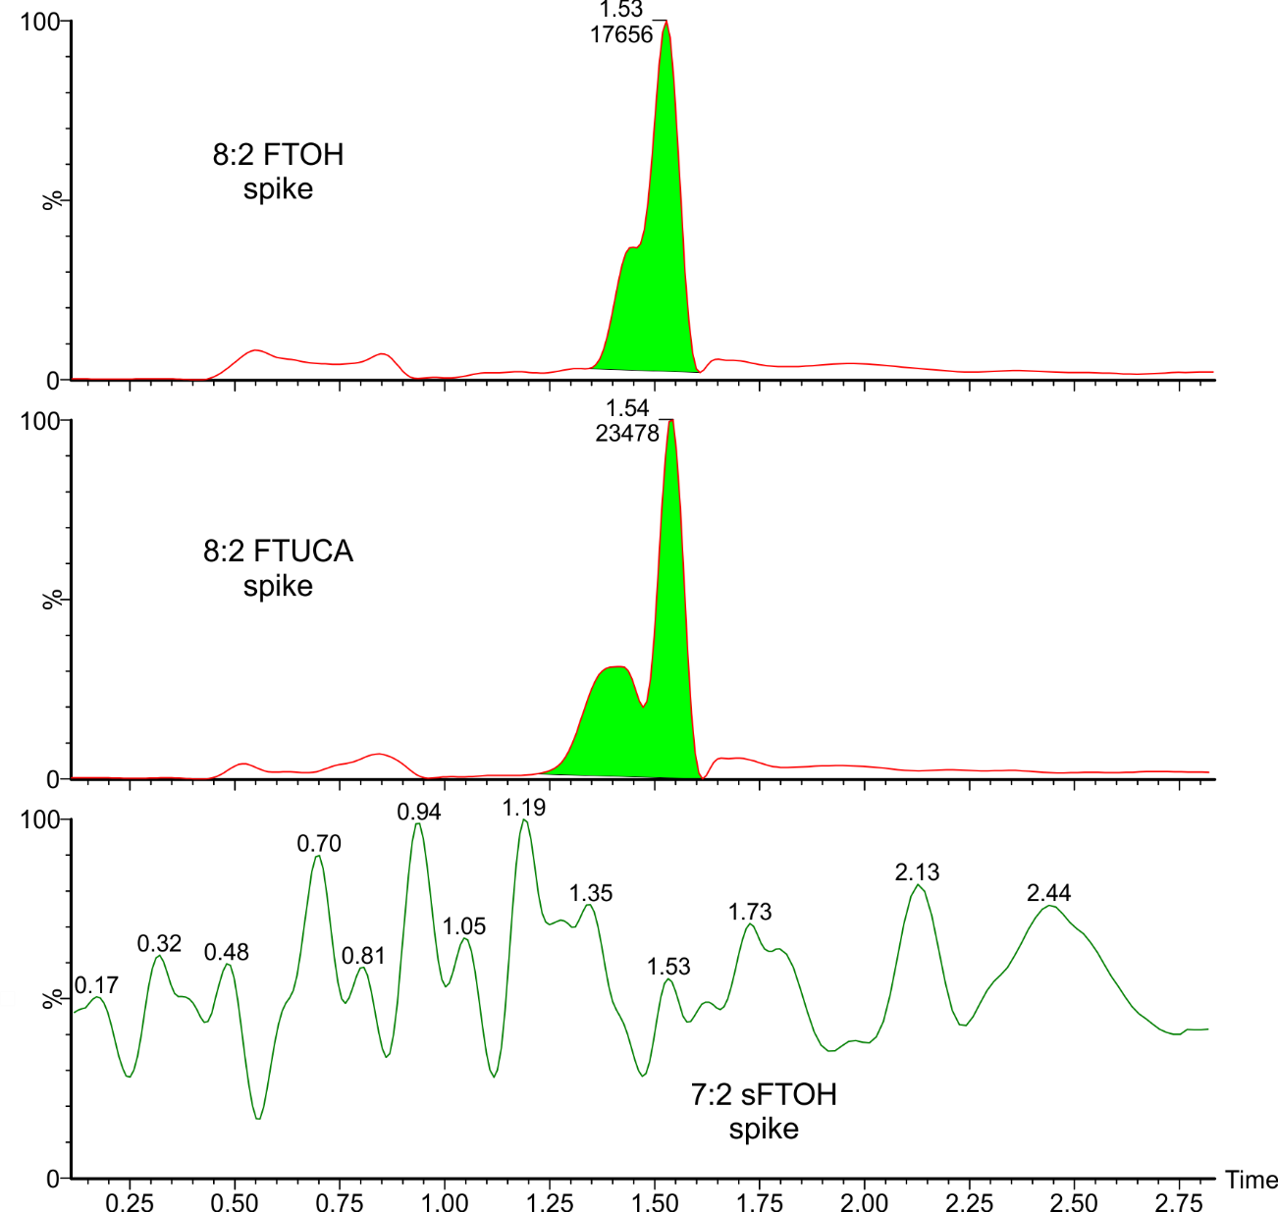

Figure S17: Production of C6 from 8:2 FTOH and 8:2 FTUCA, but not 7:2 sFTOH

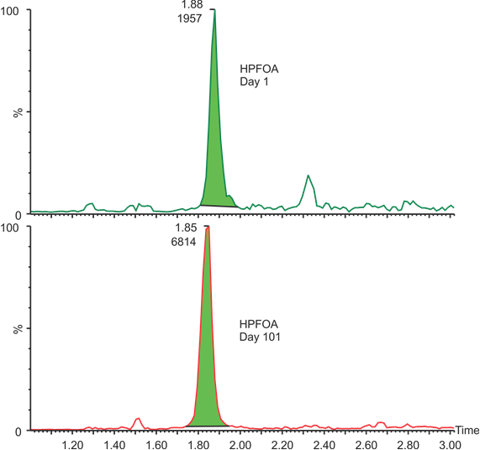

Figure S18: HPFOA increasing in 8:2 FTOH microcosm from 2 days (top) to 101 days (bottom).

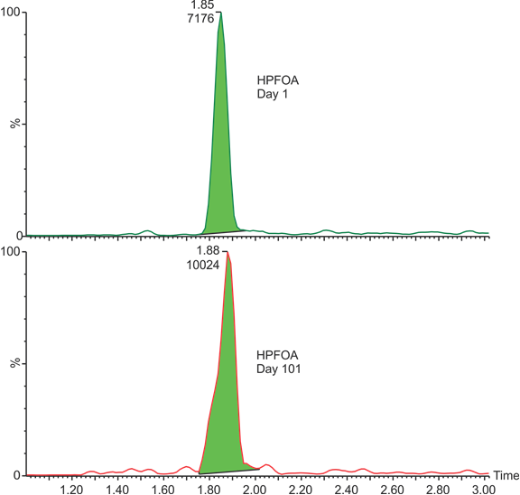

Figure S19: HPFOA increasing in 8:2 FTUCA microcosm from 2 days (top) to 28 days (bottom).

**Discussion S6: Possible detection of uPFOS in environmental samples**

We ran sludge-applied soil samples from our Decatur, AL study,3 inspecting for the possible detection of uPFOS. We focused the first quad on m/z = 461 D/esu (PFOS – 2F = 499 – 38 = 461). The second quad was focused on conventional PFOS fragments of 80 and 99 D/esu. The mass chromatograms shown in Figures S20 and S21 suggest the possibility of the presence of unsaturated PFOS in these environmental samples. MS/MS MRM transitions are summarized in Table S7.

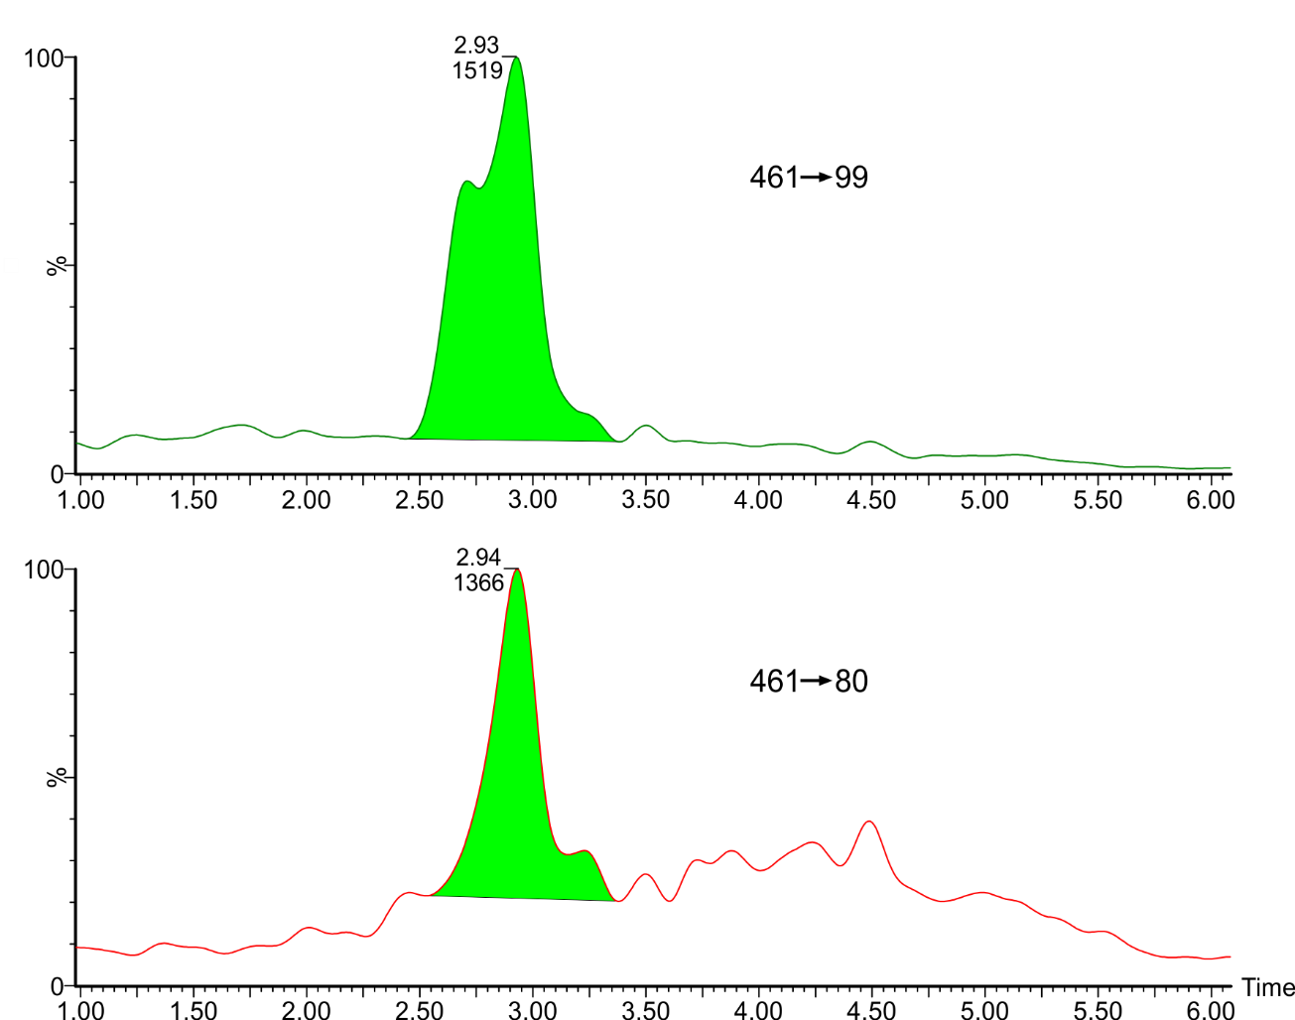

Figure S20: Primary and secondary transitions for tentatively identified uPFOS in a sludge applied soil.

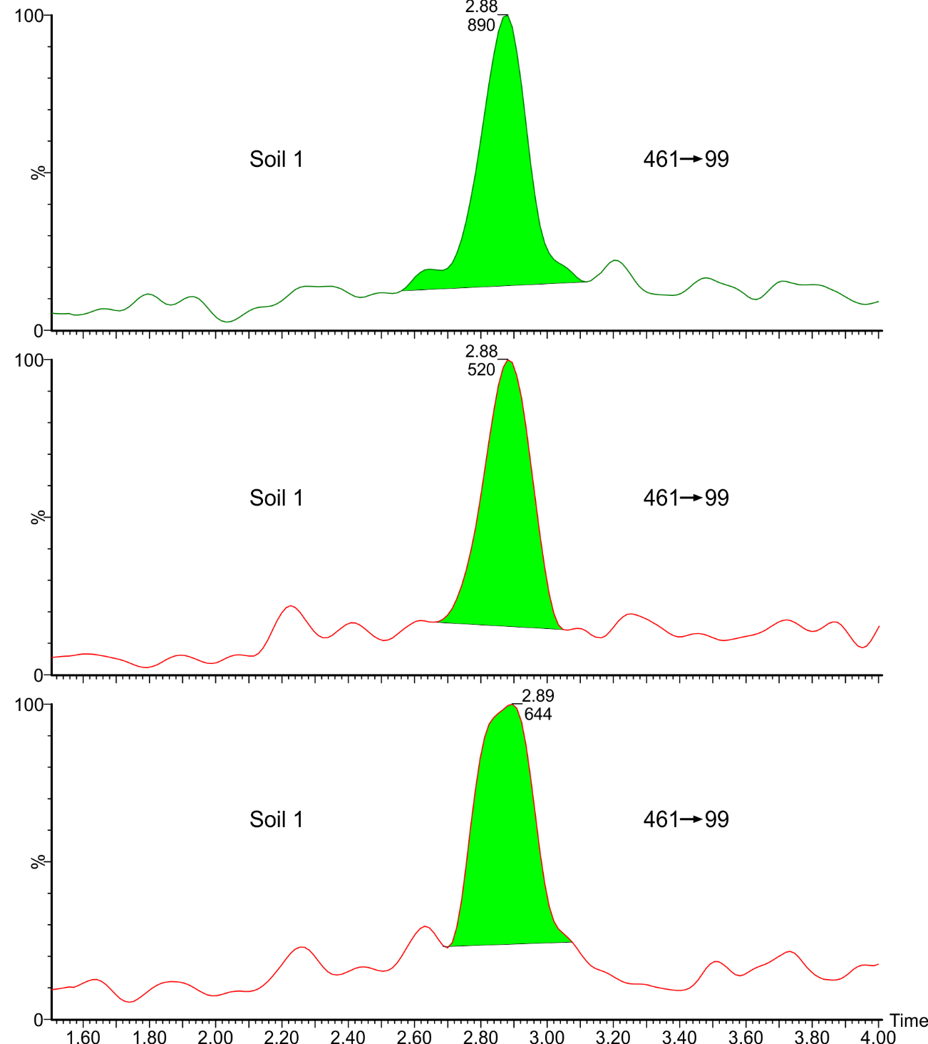

Figure S21: Primary MS/MS transitions for tentatively identified uPFOS in three sludge applied soils showing that the detection in Figure S11 was not unique.

Table S7: Optimized MS/MS detection parameters for hypothetical uPFHxS and uPFOS

**Discussion S7: Possible detection of conceptual compounds listed in Table 2**

Table 2 lists the number of transitions observed for each possibly detected compound in microcosm or environmental samples. These generally are compounds thought possible by analogy with known transformation pathways for fatty acids that we looked for in our sample extracts using both scan and MRM modes. When complex matrices of the sample extracts rendered scan mode less than ideally sensitive, we used analytical experience with known fluorotelomer and perfluorocompound analytical methods to estimate ionization energies, parent m/z values, collision energy, and fragment m/z values. These efforts resulted in the following possible detections (Figures S22-S24). Analytical details are summarized in Table S8.

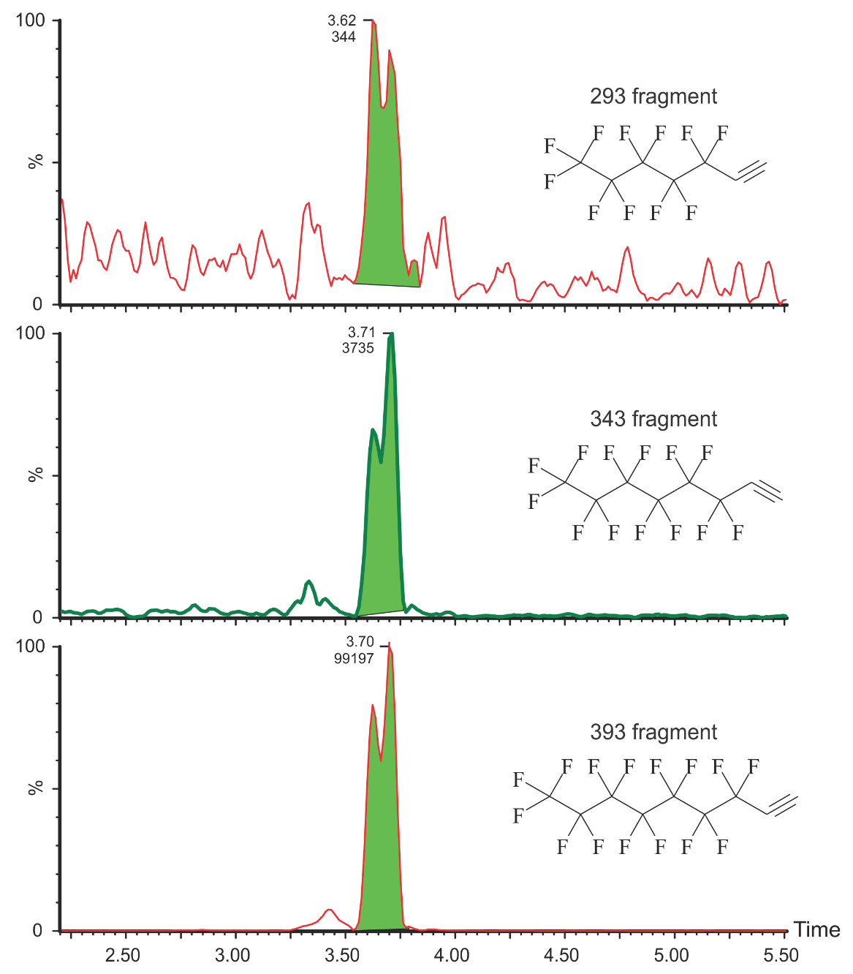

Figure S22: Three mass transitions for the possible detection of 2-OH 7:3 FTCA (Figure 5 of paper) in extracts from our experiment showing that commercial FTPs degrade with half lives on the order of decades. Possible fragmentation structures are depicted.

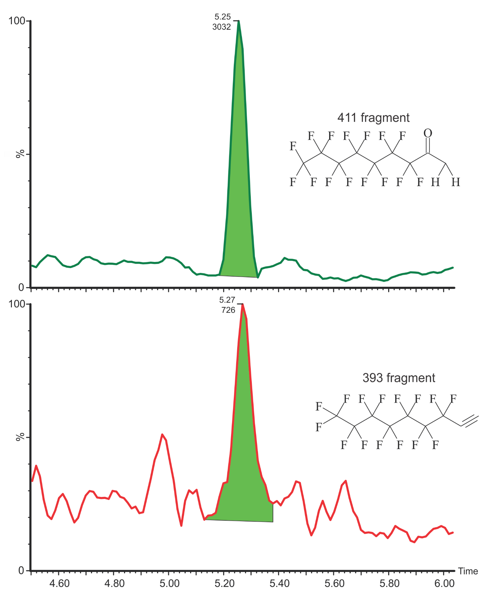

Figure S23: Two mass transitions for the possible detection of 2-keto 7:3 FTCA (Figure 5 of paper) in extracts of our commercial FTP degradation study. Possible fragmentation structures are depicted.

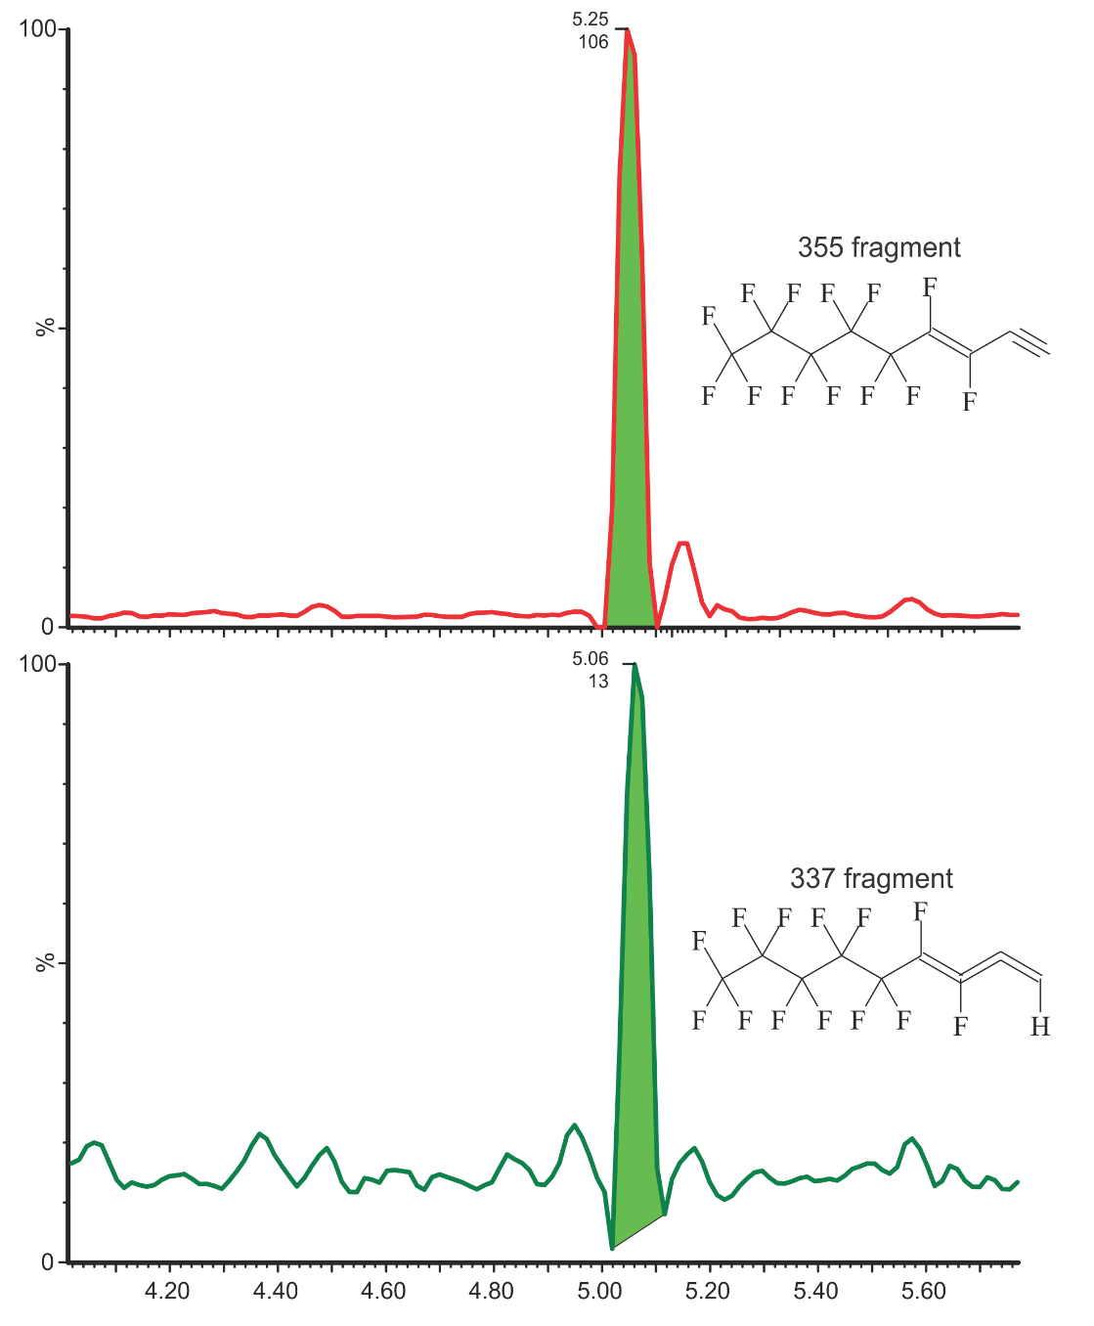



Figure S24: Two mass transitions for the possible detection of 8:2 FTUUCA (Figure 5 of paper) in extracts of sludge-applied soils. Possible fragment structures are depicted.

Table S8: Optimized MS/MS detection parameters for hypothetical pathway compounds listed in Table 2



**Supporting Information Reference**

1. Washington, J. W.; Jenkins, T. M.; Rankin, K.; Naile, J. E., Decades-scale degradation of commercial, side-chain, fluorotelomer-based polymers in soils & water. *Environ. Sci. Technol.* **2015,** *49*, (2), 915-923.

2. Washington, J. W.; Naile, J. E.; Jenkins, T. M.; Lynch, D. G., Characterizing Fluorotelomer and Polyfluoroalkyl Substances in New and Aged Fluorotelomer-Based Polymers for Degradation Studies with GC/MS and LC/MS/MS. *Environ. Sci. Technol.* **2014,** *48*, (10), 5762-5769.

3. Washington, J. W.; Yoo, H.; Ellington, J. J.; Jenkins, T. M.; Libelo, E. L., Concentrations, Distribution, and Persistence of Perfluoroalkylates in Sludge-Applied Soils near Decatur, Alabama, USA. *Environ. Sci. Technol.* **2010,** *44*, (22), 8390-8396.

4. Washington, J. W.; Henderson, W. M.; Ellington, J. J.; Jenkins, T. M.; Evans, J. J., Analysis of perfluorinated carboxylic acids in soils II: Optimization of chromatography and extraction. *J. Chromatogr. A* **2008,** *1181*, (1-2), 21-32.

5. Yoo, H.; Washington, J. W.; Jenkins, T. M.; Ellington, J. J., Quantitative Determination of Perfluorochemicals and Fluorotelomer Alcohols in Plants from Biosolid-Amended Fields using LC/MS/MS and GC/MS. *Environ. Sci. Technol.* **2011,** *45*, (19), 7985-7990.