Supplementary Material
Water Quality Modeling in the Dead End Sections of
Drinking Water Distribution Networks
Ahmed A. Abokifaª, Y. Jeffrey Yang^{b}, Cynthia S. Loª, Pratim Biswas^{a,}*
ª Department of Energy, Environmental and Chemical Engineering
Washington University in St. Louis, MO 63130, USA
^{b} U.S. EPA, Office of Research and Development, National Risk Management Research Laboratory, Cincinnati, OH 45268, USA
Contents Page

Nomenclature 2
S-1 Eularian-Lagrangian Numerical Solution 3
S-2 Correction Factors – Analytical Derivation 6
2.1 Residence Time
2.2 Dispersion Rate
2.3 Wall Demand
S-3 Additional Results 9
3.1 Aerial Photos of CHBPs dead ends
3.2 Time Averaged Transport Parameters
3.3 Stagnation Probability
Figures 11
References 16

Nomenclature
$A_{p}$ pipe cross-sectional area
a pipe radius (in)
β_{j} Advection projections
C instantaneous disinfectant concentration in the dead end (mg/L)
CF correction factor
E longitudinal dispersion coefficient (m²/sec)
E_{T} Taylor’s dispersion coefficient (m²/sec)
D molecular diffusivity (m²/sec)
$d$ pipe diameter (in)
Gf front solution of numerical green’s function
Gr rear solution of numerical green’s function
H homogenous solution of numerical green’s function
K overall first order decay rate constant (sec⁻¹)
k_{w} wall decay constant (m/sec)
k_{f} mass transfer coefficient (m/sec)
L pipe length (ft).
N_{seg} No. of withdrawal points along the axis of the dead end pipe
N_{i} No. of grid points in segment i
$Q_{i}$ flow rate of segment i
$q_{j}$ flow demand of withdrawal point j
R_{w} overall wall demand (sec⁻¹)
r_{h} pipe hydraulic mean radius (m).
$τ_{0}$ characteristic residence time (sec)
t time (sec)
u average flow velocity in the pipe (m/sec)
x axial space coordinate (m)
S-1. Eularian-Lagrangian Numerical Solution
The governing transport equation (Eq. 2) is split into two separate steps:
I- Lagrangian Step:
$\frac{C^{a}-C^{k}}{Δt}=-u\frac{∂C^{k}}{∂x}-K C^{k}$ (S.1)
II-Eularian Step:
$\frac{C^{k+1}-C^{a}}{Δt}=E\frac{∂^{2}C^{k}}{∂x^{2}}$ (S.2)
The space-time domain for each pipe segment is discretized into a rectangular grid as shown in (Fig. S-1). The total number of axial grid points in any segment is $N_{i}+1$ and is calculated as:
$N_{i}+1=INTEGER(\frac{L_{i}}{u_{i}Δt})$ (S.3)
Where: $L_{i}$ is the length of segment i; $u_{i}$ is the flow velocity in segment i; and $∆t$ is water quality time step.
The grid size for the pipe segment is then calculated by:
$Δx_{i}=\left(\frac{L_{i}}{N_{i}+1}\right)$ (S.4)
In the Lagrangian stage, the current time step (t^{k}) grid points are projected forwards in time based on the MOCs scheme where their projection locations on the following time step (t^{k+1}) are given the symbol (β_{j}) (Fig. S-1). These projections are conducted based on the characteristic advection line described by${dx}_{i}/dt=u_{i}$. Hence, the forward projection locations can be calculated based on the following equation:
$β_{j}=x_{j}+u_{i}∆t$ (S.5)
Using the known concentration profile for the current time step at all the axial grid points C^{k}(X_{j}) , the values of the concentration profile can be evaluated at different β_{j} positions. By applying the reaction term to the advected concentration profile, we can get the advected-reacted concentration profile defined for numerical grid locations Cª(β_{j}) in the next time step for each segment.
$C^{a}\left(β_{j}\right)=C^{k}\left(X_{j}\right)*exp⁡(-K_{i}Δt)$ (S.6)
The following time step concentration profile defined at grid locations $C^{a}\left(X_{j}\right)=C_{j}^{a}$ can then be evaluated from $C^{a}\left(β_{j}\right)$ through linear interpolation. The Eulerian step is then introduced using the fully implicit forward time central space FTCS finite difference discretization of the dispersion equation (Eq. S.2) which gives:
$\frac{C_{j}^{k+1}-C_{j}^{a}}{∆t}=E_{i}\frac{C_{j-1}^{k+1}-C_{j}^{k+1}+C_{j+1}^{k+1}}{{(∆x)}^{2}}$ (S.7)
The previous equation can be re-arranged to give the following system of linear equations:
$-r_{i}C_{j-1}^{k+1}+\left(1-2r_{i}\right)C_{j}^{k+1}-r_{i}C_{j-1}^{k+1}=C_{j}^{a}$ (S.8)
Where: $r_{i}=E_{i}Δt/{Δx}_{i}^{2}$. The numerical Green’s function technique proposed by Aldama et al., (1998) and implemented in the model developed by Tzatchkov et al., (2002) is used in this study to efficiently solve the generated system of linear equations numerically. The concentration at each grid point is computed as the superposition of three numerical components:
$C_{j}^{k+1}=H_{j}^{k+1}+{Gr}_{j}^{k+1}*C_{j=1}^{k+1}+{Gf}_{j}^{k+1}*C_{j=N_{i}+1}^{k+1}$ (S.9)
The first term on the LHS of (Eq. S.9) represents the homogeneous solution obtained by assigning zero boundary conditions at both front and rear points of each pipe segment (at j=1,and j= N_{i}+1). The second and third terms represent two particular solutions obtained for both the front and rear end of each segment. To numerically evaluate the values of Greens’ functions at different grid locations, the discretized form of the dispersion equation (Eq. S.8) is used. For the homogenous part, the values of H_{j=1} and H_{j=Ni-1} are set as zeros. For the rear Green’s function, the values of Gr_{j=1} and Gr_{j=Ni-1} are set as one and zero respectively, while for the front Green’s function Gf_{j=1} and Gf_{j=Ni-1} are taken as zero and one respectively. The values on the RHS of (Eq. S.8) are set to Cª_{j} that were evaluated in the previous Lagrangian step when calculating the homogenous part, while taken equal to zeros for the other two particular functions. By applying these conditions in (Eq. S.8), three systems of linear equations are generated for each pipe segment, which are solved to get the values of the three Greens’ functions at all grid locations. To generate the concentration profile in each segment, (Eq. S.9) is applied for each grid point to calculate the concentration values. However, the values of $C_{j=1}^{k+1}$ and $C_{j=N_{i}+1}^{k+1}$ (which are the concentration values at the connecting withdrawal nodes) are still unknown at this point. To evaluate the concentration values at the withdrawal nodes, a special numerical discretization for the dispersion equation (Eq. S.2) is required to account for the spatial variation in characteristics between the two connected pipe segments. This can be described as:
$\frac{\left({∆x}_{i}+{∆x}_{i+1}\right)}{2}\frac{{Cn}_{i}^{k+1}-{Cn}_{i}^{a}}{∆t}=\left[E_{i}\frac{{{(C}_{j=N_{i}}^{k+1})}_{i}-{Cn}_{i}^{k+1}}{{∆x}_{i}}+E_{i+1}\frac{{{(C}_{j=2}^{k+1})}_{i+1}-{Cn}_{i}^{k+1}}{{∆x}_{i+1}}\right]$ (S.10)
Where:$Cn_{i}$ is the concentration at withdrawal node i that connects the pipe segments i and i+1 (Fig. S-1). Using mass balance, the concentration at any node i is always equal to the concentration of the terminal grid point in segment i:
${Cn}_{i}={(C_{j=N_{i}+1})}_{i}$ (S.11)
By substituting the values of ${{(C}_{j=N_{i}}^{k+1})}_{i} ,{{(C}_{j=2}^{k+1})}_{i+1}$ from (Eq. S.9) into (Eq. S.10), we get a closed set of linear equations that is solved simultaneously to generate the concentrations at the withdrawal nodes. The latter are plugged in (Eq. S.7) to calculate the concentrations at different grid points and the procedure is repeated for all segments.
As the model considers extended period simulations (EPS) of hydraulic and transport parameters, pipe flow changes from one hydraulic step to the other while kept steady within the hydraulic step. The duration of the simulation hydraulic step is dictated by the aggregation period of the generated stochastic demands. A new discretization grid is generated for all segments at the beginning of each new hydraulic step and the transport and reaction parameters are recalculated.

S-2. Correction Factors – Analytical Derivation
2.1. Residence Time
The corrected residence time $τ_{corr}$for a multi-segment dead end with $N_{seg}$withdrawal points is evaluated as the sum of residence times over all segments, which can be written as:
$τ_{corr}=\sum_{i=1}^{N_{seg}}{τ_{i}}=A _{p}\sum_{i=1}^{N_{seg}}{\frac{L_{i}}{Q_{i}}}$ (S.12)
Where, $τ_{i}$is the residence time in segment i; $L_{i}$is the length of segment i; $Q_{i}$is the flow rate of segment i; and $A_{p}$is the pipe cross-sectional area. From mass conservation, $Q_{i}$ can be written as:
$Q_{i}=Q_{1}-\sum_{j=1}^{i-1}{q_{j}}$ (S.13)
Where, $Q_{1}$ is the total dead end pipe demand; $q_{j}$ is the flow demand of withdrawal point j (Fig. 1-A). Assuming equally spaced withdrawal nodes with equal demand shares, $L_{i}$ and $Q_{i}$ can be written as:
$L_{i}=\frac{L}{N_{seg}}$ (S.14)
$Q_{i}=Q_{1}-(i-1) \frac{Q_{1}}{N_{seg}}=\frac{Q_{1}}{N_{seg}}[N_{seg}-i+1]$ (S.15)
Where, L is the total pipe length. Applying in (Eq. S.12) yields:
$τ_{corr}=\frac{Ap L}{Q_{1}} \sum_{i=1}^{N_{seg}}{\frac{1}{N_{seg}-i+1}}=τ_{0}\sum_{i=1}^{N_{seg}}{\frac{1}{N_{seg}-i+1}}$ (S.16)
Where, $τ_{0}$ is the residence time calculated using the single segment model based on the total demand of the dead end pipe. The correction factor for the residence time in the pipe can then be written as:
$CF_{τ}=\frac{τ_{corr}}{τ_{0}}=\sum_{i=1}^{N_{seg}}{\frac{1}{N_{seg}-i+1}}$ (S.17)
2.2. Dispersion Rate
Taylor’s dispersion coefficient for each segment i can be written as:
$E_{T,i}=\frac{u_{i}^{2}a^{2}}{48D}$ (S.18)
Where, $u_{i}$ is the flow velocity in segment i, which based on (Eq. S.15) and after applying mass continuity for a steady incompressible flow can be written as:
$u_{i}=\frac{u_{1}}{N_{seg}}[N_{seg}-i+1]$ (S.19)
The corrected dispersion coefficient can be approximated as the average over different segments of the dead end:
$E_{T,corr}=\frac{1}{N_{seg}}\sum_{i}^{N_{seg}}{E_{T,i}}$ (S.20)
Which after applying (Eq. S.18) and (Eq. S.19) will be:
$E_{T,corr}=\frac{u_{1}^{2}a^{2}}{48D}\frac{\sum_{i=1}^{N_{seg}}{(N_{seg}-i+1})^{2}}{N_{seg}^{3}}=E_{T,0}\frac{\sum_{i=1}^{N_{seg}}{(N_{seg}-i+1})^{2}}{N_{seg}^{3}}$ (S.21)
Where, $E_{T,0}$ is the dispersion coefficient of the single segment model based on the total demand of the dead end pipe. The correction factor for the dispersion rate in the pipe can then be written as:
$CF_{E}=\frac{E_{T,corr}}{E_{T,0}}=\frac{\sum_{i=1}^{N_{seg}}{{(N_{seg}-i+1)}^{2}}}{N_{seg}^{3}}$ (S.22)
2.3. Wall demand
The overall wall demand for each segment i can be written as:
$R_{w,i}=\frac{k_{w}k_{f,i}}{r_{h}(k_{w}+k_{f,i})}$ (S.23)
Where $k_{f,i}$ is the lumped mass transfer coefficient of segment i which is a function of the flow velocity (Rossman et al. 1994). For laminar flow:
$k_{f,i}=α+β\frac{u_{i}}{1+χ u_{i}^{2/3}}$ (S.24)
Where, $α=3.65\frac{D}{d}$; $β=0.0668\frac{d}{L_{i}}$; and $χ=0.04{(\frac{d^{2}}{D L_{i}})}^{2/3}$. Dead end pipes are typically characterized by low flow velocities, which indirectly results in high wall decay coefficient $k_{w}$ as a result of significant biofilm growth (Yeh et al. 2008; Biswas et al. 1993). In addition, it leads to low magnitudes for the mass transfer coefficient, leading the overall wall demand to be consistently mass transfer limited. Under these conditions, (Eq. S.23) can then be reduced to:
$R_{w,i}≅\frac{k_{f,i}}{r_{h}}…∀\frac{k_{w}}{k_{f,i}}>>1$ (S.25)
The dependence of the overall mass transfer coefficient on the flow velocity is highly nonlinear as shown in (Eq. S.24), and therefore some simplifying assumptions were to be made in order to reduce the wall demand formula. In particular, the magnitude of the term ($χ u_{i}^{2/3}$) compared to unity is of interest in this case. This term can be written in its original form as:
$0.04χ u_{i}^{2/3}=0.04{(\frac{Re Sc}{{L_{i}}/d})}^{2/3}$ (S.26)
Where, $Re$ is the Reynolds number; and $Sc$is the Schmidt number. The magnitude of this term for a dead end operating under an average Reynolds number of 500, with Schmidt number in the order of 1000 and with segment length of around 100 diameters will be in the order of 10. Thus, (Eq. S.24) can be reduced to:
$k_{f,i}≅α+\frac{β}{χ}u_{i}^{1/3}…∀ 0.04{(\frac{Re Sc}{{L_{i}}/d})}^{2/3}>>1$ (S.27)
The same analysis can be applied to compare the magnitudes of the two terms in (Eq. S.27) as follows:
$\frac{β}{α χ}u_{i}^{1/3}=0.458{(\frac{Re Sc}{{L_{i}}/d})}^{1/3}$
Which will be in the order of 10 considering the same magnitudes for $Re$, $Sc$ and ${L_{i}}/d$. Therefore, the overall wall demand for segment i in the reduced form can be written as:
$R_{w,i}≅\frac{β}{χ r_{h}}u_{i}^{1/3}=6.68{(\frac{D^{2}}{L_{i}d^{4}})}^{1/3} u_{i}^{1/3}$ (S.28)
The corrected wall demand rate can be approximated as the weighted average over all segments, where weights are evaluated based on the relative residence time in order to conserve the overall dimensionless Damkohler number:
$R_{w,corr}=\sum_{i}^{N_{seg}}{\frac{τ_{i}}{τ_{corr}}R_{w,i}}$ (S.29)
By combining (Eq. S.14) and (Eq. S.15):
$τ_{i}=\frac{τ_{0}}{N_{seg}-i+1}$ (S.30)
And from (Eq. S.17) we can get:
$\frac{τ_{i}}{τ_{corr}}=\frac{1}{CF_{τ}}⋅\frac{1}{N_{seg}-i+1}$ (S.31)
Plugging in (Eq. S.29) yields:
$R_{w,corr}=\frac{1}{CF_{τ}}\sum_{i}^{N_{seg}}{ }\frac{6.68{(\frac{D^{2}}{L_{i}d^{4}})}^{1/3}}{N_{seg}-i+1}{[\frac{ u_{1}}{N_{seg}}(N_{seg}-i+1)]}^{1/3}$ (S.32)
And from (Eq. S.28), the wall demand rate based on the total pipe flow demand can be written as:
$R_{w,0}=6.68{(\frac{D^{2}}{(L_{i}N_{seg})d^{4}})}^{1/3}u_{1}^{1/3}$ (S.33)
Therefore, the correction factor for the wall demand rate will be:
$CF_{R}=\frac{R_{w,corr}}{R_{w,0}}=\frac{1}{CF_{τ}}\sum_{i=1}^{N_{seg}}{{(N_{seg}-i+1)}^{-2/3}}$ (S.34)
S-3. Additional Results
3.1. Aerial Photos of the Cherry Hill Brushy Plains dead ends
Using the site maps given in the original paper by Rossman et al., (1994), and by comparing the skeleton grid with the all-pipe layout given by Nilsson et al., (2005), the exact dead end pipes that were included in the sampling study could be identified. Google Earth® software was then used to locate the two dead ends and identify the number of consumption points on each dead end through aerial photos captured on March 15, 1992. (Fig. S-2).
3.2. Stagnation Probability
As the stochastic demand generator is able to simulate flow rates in a second-by-second bases, it was used herein to predict the percentage of no flow time in different sections of the two dead ends 10 and 34. A set of 200 realizations were performed where the axial hydraulic profile was kept constant for each pipe. The results reflected the realistic behavior of a typical residential dead-end where the probability of stagnation is the highest at the downstream sections of the pipe. The stagnation time increased from 16% in the first segment to 73% for the last one in pipe 10, and from 55% to 88% in pipe 34 (See Fig. S-3). The absolute value of the stagnation time is dependent on the base nodal demand and the chosen statistical parameters for the probability distributions of demand pulse intensity.
3.3 Time Averaged Transport Parameters
To understand the effect of spatial variation of the flow rate on the transport parameters, the time averaged dispersion coefficient and first order decay rate was calculated for the different sections of the two dead ends and the results are shown in (Fig. S-4). The dispersion coefficient drops severely as the flow moves towards the terminal point in the dead end. The value of the average dispersion coefficient dropped to about 12% of its initial value at the terminal point of both dead ends. This is because the dispersion coefficient in laminar regime is proportional to the square of the flow velocity as given by Taylor’s equation (Eq. 4) which constantly decreases in the axial direction. The average first order decay rate showed a small drop in both cases due to the generally small flow velocities in both dead-ends. As indicated by Rossman et al., (1994), the chlorine reactions in the bulk phase dominate the total decay coefficient as the velocity decreases. The drop in the flow velocity will only cause the mass transfer coefficient k_{f} to drop, but the overall wall decay term is still small compared to the bulk decay.

Figures

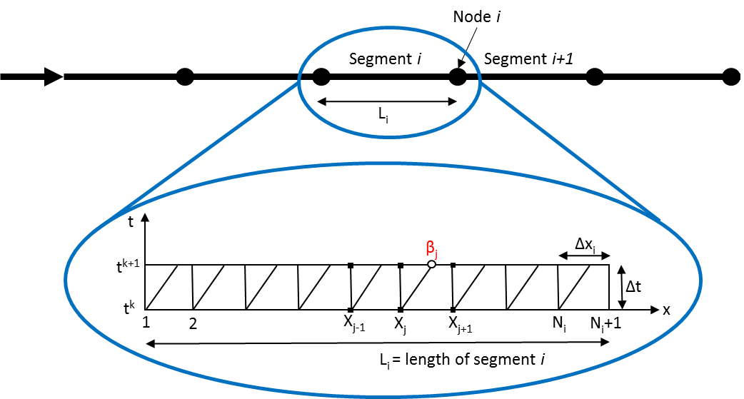

Figure S-1. Time space discretization grid for pipe segment i

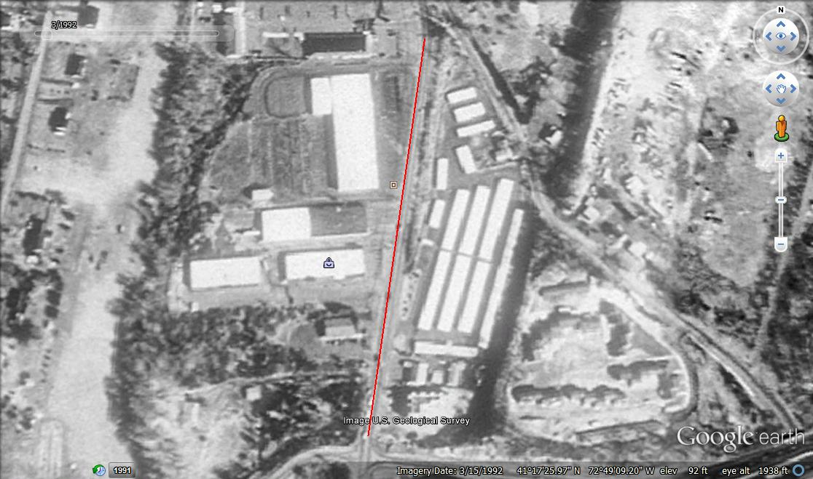
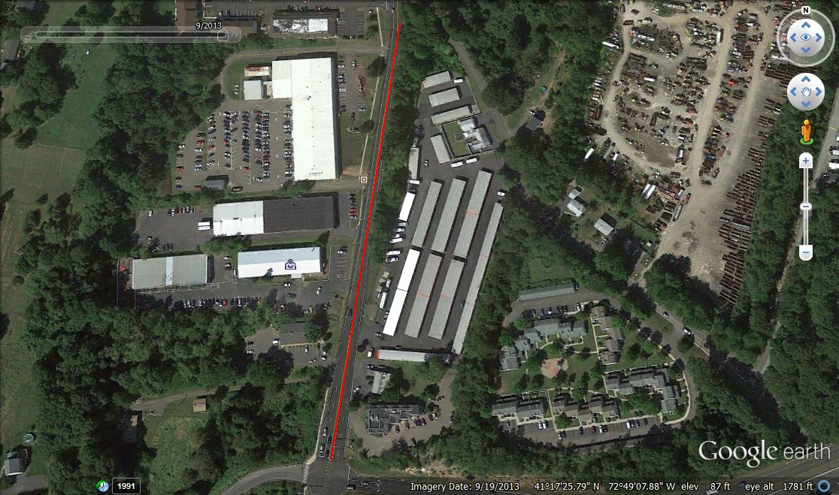
A
B
Figure S-2. Aerial Photos of Dead End pipe 10 retrieved by Google® earth®. (A) 9/19/2013; (B) 3/15/1992
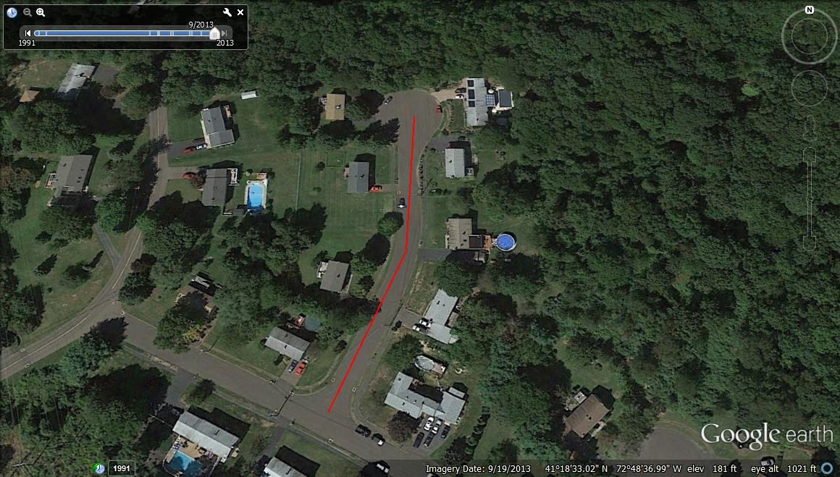
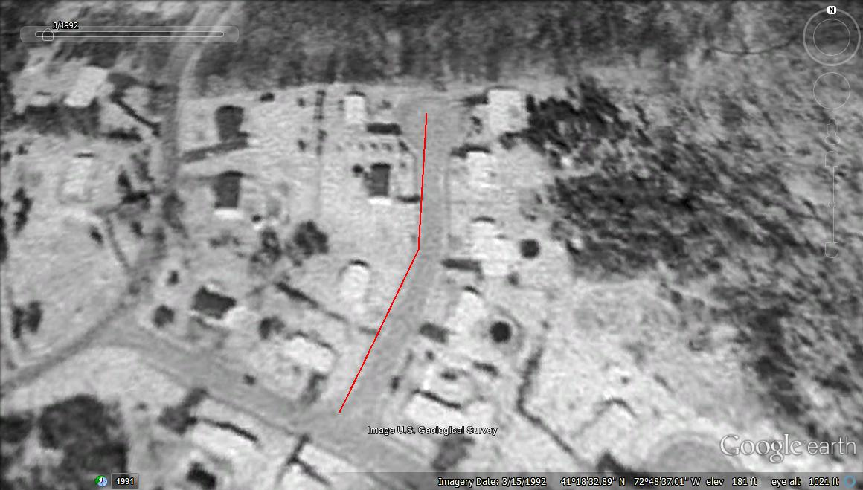
C
D
Figure S-2. Aerial Photos of Dead End pipe 34 retrieved by Google® earth®. (C) 9/19/2013; (D) 3/15/1992

Figure S-3. Simulated stagnation time using stochastic demand generator for: (A) Dead End 10; (B) Dead End 34

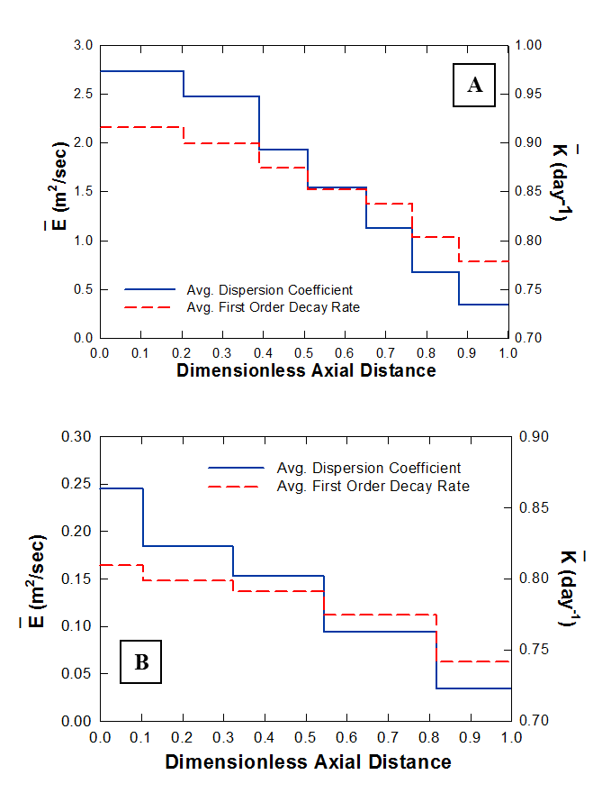

Figure S-4. Time averaged longitudinal dispersion coefficient and first order decay rate for (A) Pipe 10; and (B) Pipe 34

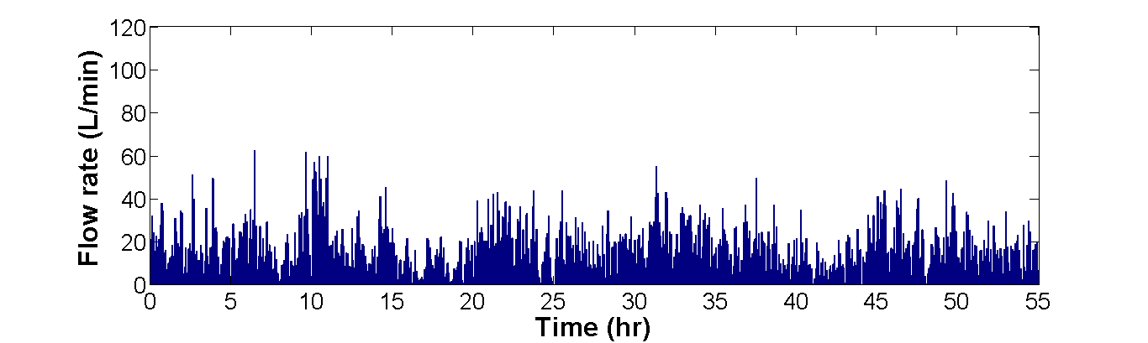
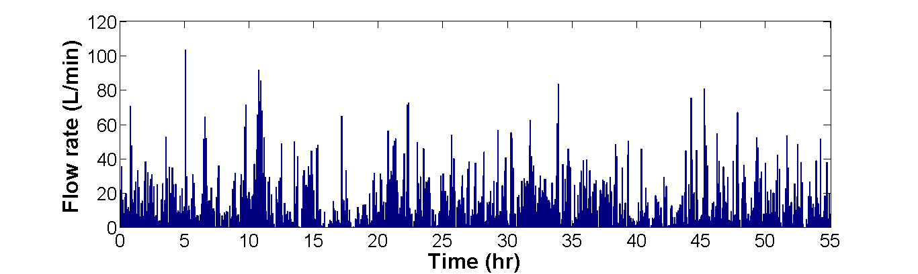
A

B

Figure S-5. Generated stochastic flow demands for different ratios of indoor demands with aggregation interval of 5 minutes. (A) 100% indoor demand pulses; (B) 50% indoor-50% outdoor demand pulses

References
Aldama, A.A., Tzatchkov, V.G. & Arreguin, F.I., 1998. The numerical Green’s function technique for boundary value problems in networks. Water studies series, pp.121–130. Available at: http://cat.inist.fr/?aModele=afficheN&cpsidt=1578894.
Biswas, P., Lu, C. & Clark, R.M., 1993. A model for chlorine concentration decay in pipes. Water research, 27 (12), pp.1715–1724.
Nilsson, K.A., Buchberger, S.G. & Clark, R.M., 2005. Simulating exposures to deliberate intrusions into water distribution systems. JOURNAL OF Water RESOURCES PLANNING AND MANAGEMENT, 131 (3)(June), pp.228–237.
Rossman, L.A., Clark, R.M. & Grayman, W.M., 1994. Modeling chlorine residuals in drinking-water distribution systems. Journal of Environmental Engineering, 120 (4), pp.803–820.
Tzatchkov, V.G., Aldama, A.A. & Arreguin, F.I., 2002. Advection-dispersion-reaction modeling in water distribution networks. JOURNAL OF Water RESOURCES PLANNING AND MANAGEMENT, 128 (5)(October), pp.334–342.
Yeh, H.-D. et al., 2008. A new approximate solution for chlorine concentration decay in pipes. Water research, 42(10-11), pp.2787–95. Available at: http://www.ncbi.nlm.nih.gov/pubmed/18336858 [Accessed October 12, 2014].

