Supplemental Figure 2
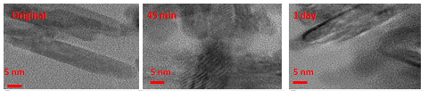
These are images.

