Supplemental Figure 1
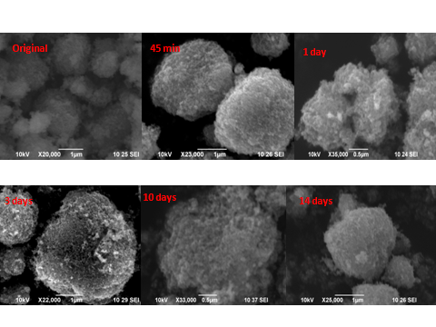
These are images.

