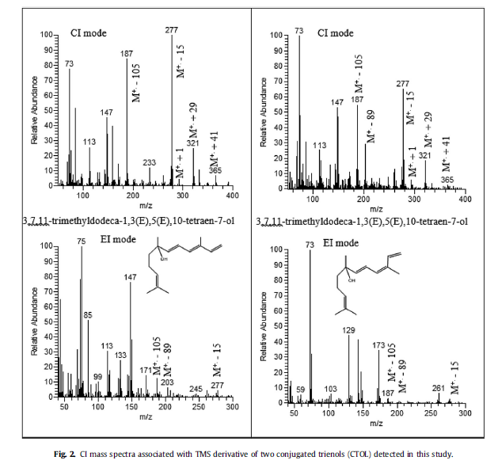
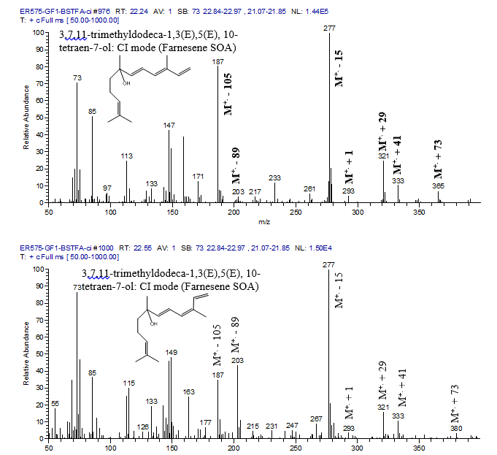

Experiment number: ER-575
GC-MS file name: ER575-GF1-BSTFA-ci injected on 9/11/2012 at 5:53:33 pm (note these are mass spectra originated from Figure 1). The EI mass spectra were originated from IR483-den1-BSTFA

Filter number: GF1
Injection volume: 2 ul (see details of the GC.MS and BSTFA derivatization in the paper)
The same GC and MS parameters as reported for Figure 1 (see FarneseneNOx0AE2016-ScienceHub_Figure 1.docx).

