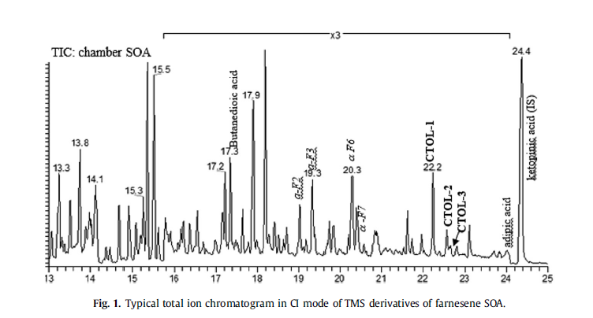

Experiment number: ER 575
GC-MS file name: ER575-GF1-BSTFA-ci injected on 9/11/2012 at 5:53:33 pm
Filter number: GF1
Injection volume: 2 ul (see details of the GC.MS and BSTFA derivatization in the paper)
GC-MS parameters:
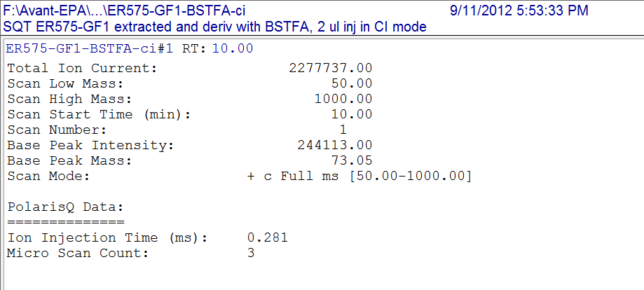

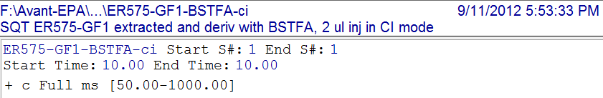
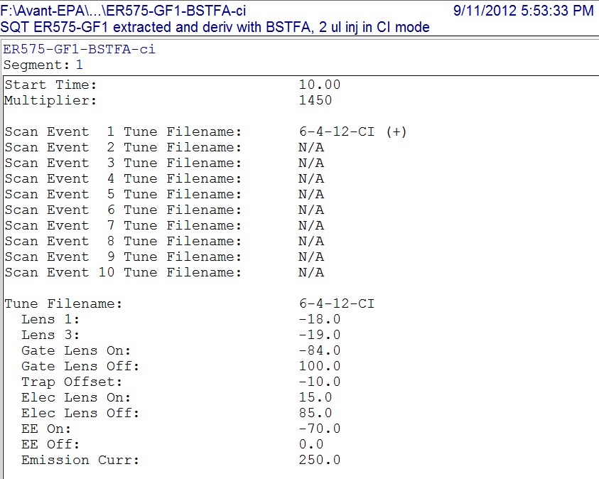
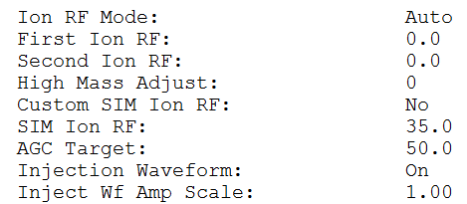

GC parameters:

