Spore Recovery for Mechanical Shaking versus Manual Hand Shaking

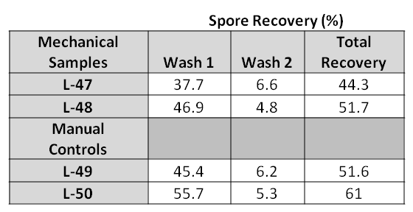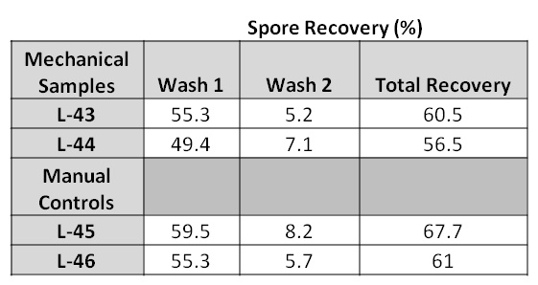
425 rpm for 6 minutes
350 rpm for 6 minutes
MetaData:
Mechanical Samples: Samples shaken using the New Brunswick Innova 2100 Platform Shaker. Speeds used for the shaker were wither 350 or 425 rpm.
Manual Controls: Samples were manually shaken (by hand)
Wash 1 and 2: Percent recovery was measured after each of two washes
Total Recovery: Summation of wash 1 and 2 recoveries
L-43, L-44, L-45, L-46, L-47, L-48, L-49, L-50: Assigned sample ID numbers

