Supplemental Information

EcoToxChip Provides Insights into Pathway Perturbation Upon Chlorantraniliprole Exposure to Larval Fathead Minnow

Marissa Jensen-Brickley², Jacob Collins³, Jenna Cavallin¹, Dan Villeneuve¹, Carlie LaLone¹

¹US Environmental Protection Agency, Office of Research and Development, Center for Computational Toxicology and Exposure, Great Lakes Toxicology and Ecology Division, Duluth, MN
²University of Minnesota-Duluth, Duluth, MN
³Oak Ridge Institute for Science and Education, US EPA, Office of Research and Development, Great Lakes Toxicology and Ecology Division, Duluth, MN

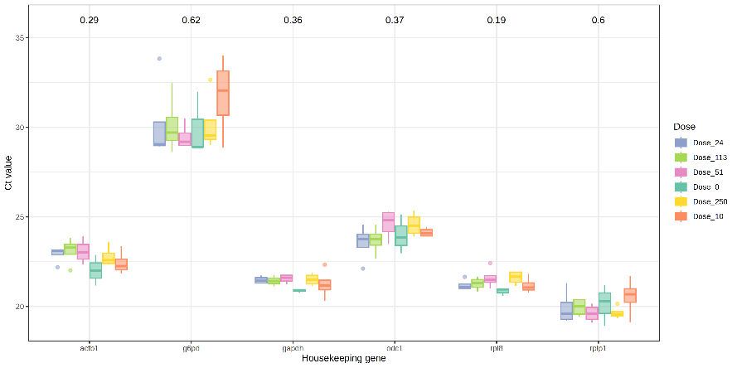

Supplemental Figure S1. EcoToxXplorer housekeeping gene quality control plot. While none of the housekeeping genes were statistically significant from the control group (p-values presented at the top of each gene), the gene g6pd was removed from all analyses due to its high C_{T} value and possible treatment effect.

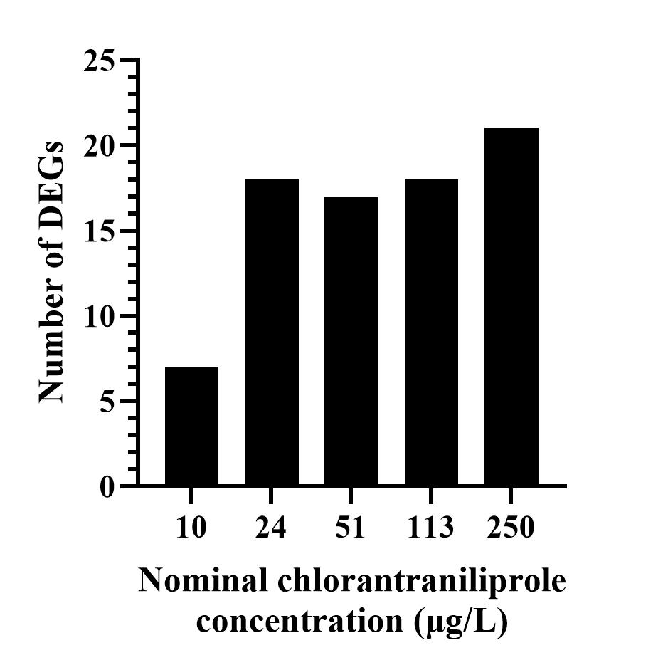

Supplemental Figure S2. Number of Differentially Expressed Genes (DEGs) as a function of chlorantraniliprole (CHL) concentration. The number of DEGs increased as CHL concentration increased. While only seven DEGs were detected at 10 µg/L, 17 – 21 DEGs were identified at the 24, 51, 113, and 250 µg/L concentrations.

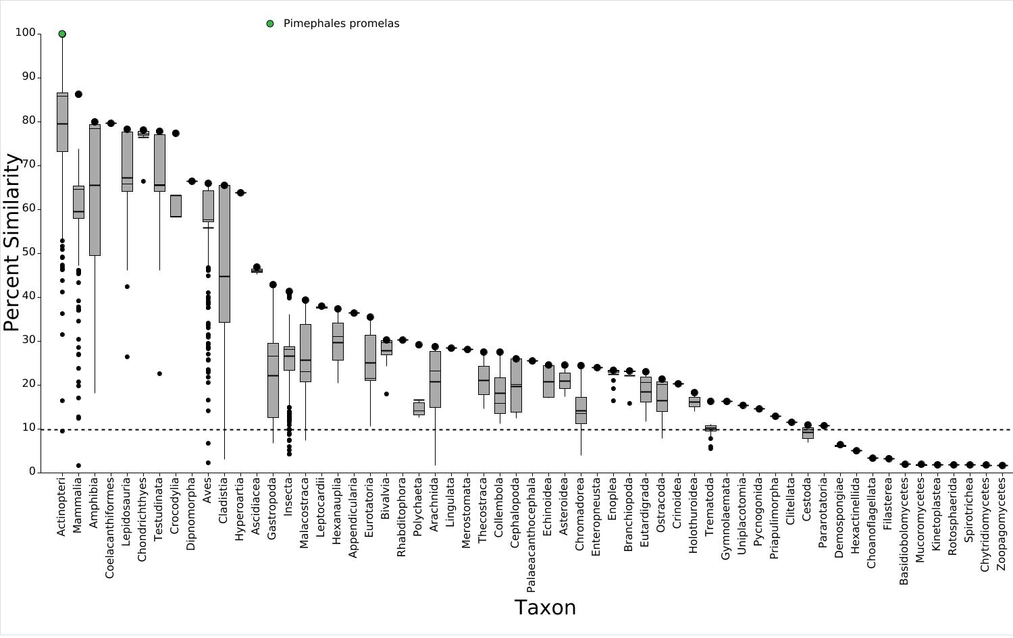
Supplemental Figure S3. Sequence Alignment to Predict Across Species Susceptibility (SeqAPASS) Level 1 boxplot of the ryanodine receptor 1 (RyR1) analysis. The query species was Pimephales promelas (fathead minnow). Taxonomic groups are listed on the x-axis, starting with Actinopteri. Percent similarity is presented on the y-axis, compared to the query species. The susceptibility cut-off is represented as a dashed line. P. promelas is shown as a green circle on the plot.

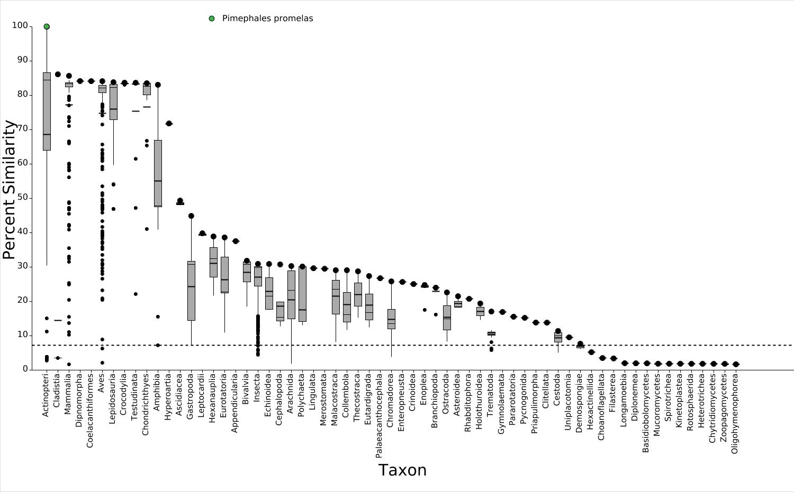
Supplemental Figure S4. Sequence Alignment to Predict Across Species Susceptibility (SeqAPASS) Level 1 boxplot of the ryanodine receptor 2 (RyR2) analysis. The query species was Pimephales promelas (fathead minnow). Taxonomic groups are listed on the x-axis, starting with Actinopteri. Percent similarity is presented on the y-axis, compared to the query species. The susceptibility cut-off is represented as a dashed line. P. promelas is shown as a green circle on the plot.

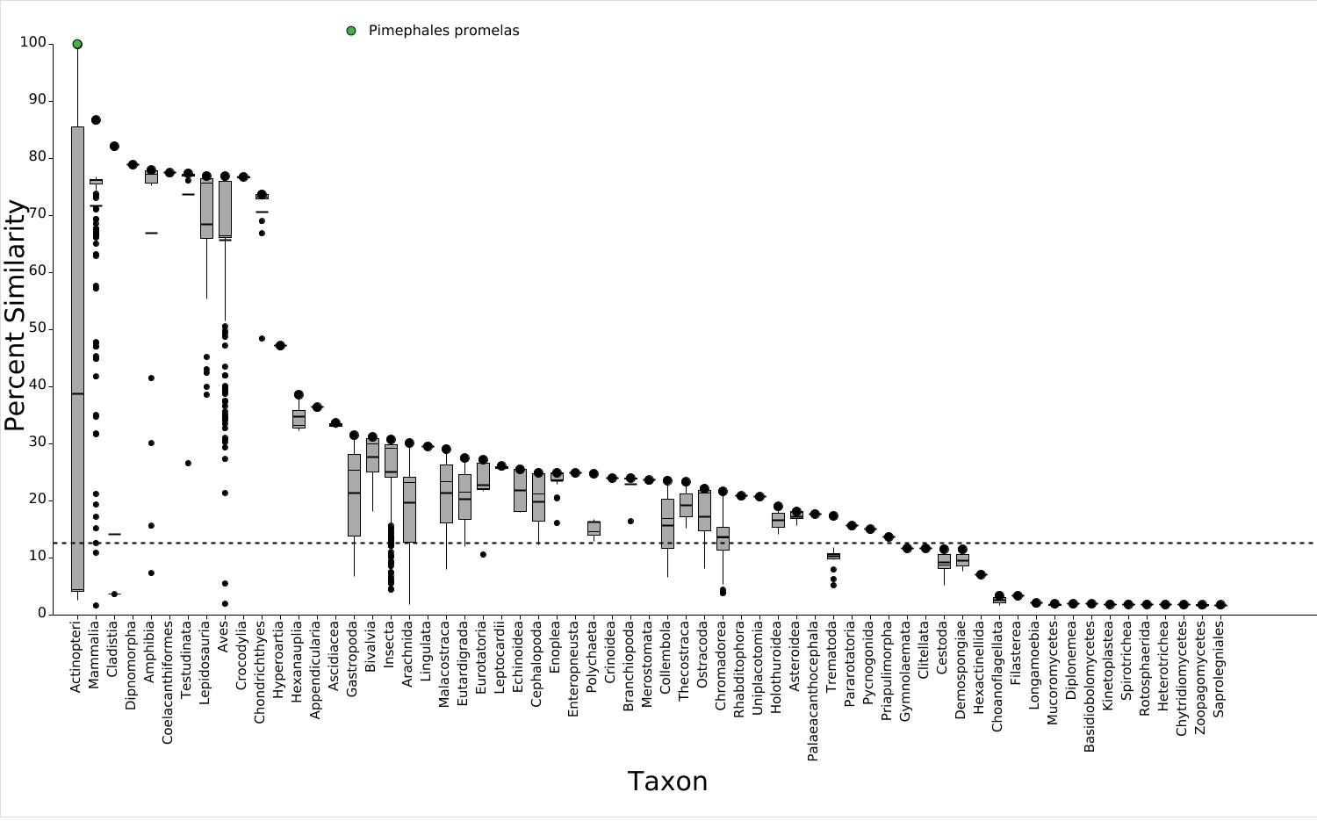
Supplemental Figure S5. Sequence Alignment to Predict Across Species Susceptibility (SeqAPASS) Level 1 boxplot of the ryanodine receptor 3 (RyR3) analysis. The query species was Pimephales promelas (fathead minnow). Taxonomic groups are listed on the x-axis, starting with Actinopteri. Percent similarity is presented on the y-axis, compared to the query species. The susceptibility cut-off is represented as a dashed line. P. promelas is shown as a green circle on the plot.

SeqAPASS Decision Summary Reports for Ryanodine Receptor 1, 2, and 3 Analyses
Sequence Alignment to Predict Across Species Susceptibility (SeqAPASS)
Decision Summary Report

Level 1
Level 1 Query Protein Information Report Settings

SeqAPASS ID: 4130 Report Type: Primary
Query Species: Pimephales promelas E-value: 0.01
Query Protein: LOW QUALITY PROTEIN: ryanodine receptor 1 Sorted By Taxonomic Group: CLASS Query Accession: XP_039533197.1 Common Domains: 1
Ortholog Count: 276 Species Read-Across: Y
Protein and Taxonomy Data: 01/11/2023 Cut-off %: 9.75
BLAST Version: 2.15.0 Show Only Eukaryotes: Y Software Version: 7.1
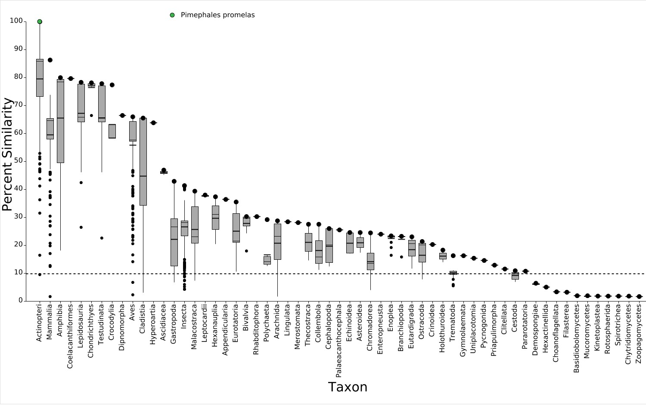
Level 1 Visualization - Primary Report

Level 3

Selected Amino Acids
4534Y,4537R,4538F,4541L,4632T,4768Y,4769L,4772Y,4792D,4796G
Level 3 Template Protein Information
SeqAPASS ID: 4130
Template Species: Pimephales promelas
Template Protein: [XP_039533197.1] LOW QUALITY PROTEIN: ryanodine receptor 1
Protein and Taxonomy Data: 01/11/2023 BLAST Version: 2.15.0
Software Version: 7.1

Final Decision Summary Report

Species | Protein | Level 1 Susceptible (Y/N) | Level 3 Template | Level 3 Amino Acids (Y/N)
Pimephales promelas | LOW QUALITY  PROTEIN: ryanodine receptor 1 | Y | Pimephales promelas | Y
Rhinichthys klamathensis goyatoka | ryanodine receptor 1 isoform X4 | Y | Pimephales promelas | Y
Megalobrama amblycephala | LOW QUALITY  PROTEIN: ryanodine receptor 1 | Y | Pimephales promelas | Y
Ctenopharyngodon idella | ryanodine receptor 1 | Y | Pimephales promelas | Y
Danio aesculapii | LOW QUALITY  PROTEIN: ryanodine receptor 1-like | Y | Pimephales promelas | Y
Carassius carassius | ryanodine receptor 1-like | Y | Pimephales promelas | Y
Danio rerio | ryanodine receptor 1 isoform X1 | Y | Pimephales promelas | Y
Puntigrus tetrazona | LOW QUALITY  PROTEIN: ryanodine receptor 1 | Y | Pimephales promelas | Y
Carassius gibelio | ryanodine receptor 1 isoform X4 | Y | Pimephales promelas | Y
Carassius auratus | ryanodine receptor 1-like isoform X4 | Y | Pimephales promelas | Y
Labeo rohita | ryanodine receptor 1 isoform X4 | Y | Pimephales promelas | Y
Sinocyclocheilus anshuiensis | PREDICTED: ryanodine receptor 1-like isoform X2 | Y | Pimephales promelas | Y
Onychostoma macrolepis | ryanodine receptor 1 isoform X2 | Y | Pimephales promelas | Y
Sinocyclocheilus rhinocerous | PREDICTED: ryanodine receptor 1-like | Y | Pimephales promelas | Y
Myxocyprinus asiaticus | ryanodine receptor 1 | Y | Pimephales promelas | N
Triplophysa rosa | ryanodine receptor 1 isoform X8 | Y | Pimephales promelas | Y
Xyrauchen texanus | LOW QUALITY  PROTEIN: ryanodine receptor 1 | Y | Pimephales promelas | N
Triplophysa dalaica | ryanodine receptor 1 | Y | Pimephales promelas | Y
Misgurnus anguillicaudatus | ryanodine receptor 1 isoform X1 | Y | Pimephales promelas | Y
Sinocyclocheilus grahami | PREDICTED: ryanodine receptor 1-like | Y | Pimephales promelas | Y
Astyanax mexicanus | ryanodine receptor 1 isoform X2 | Y | Pimephales promelas | Y
Colossoma macropomum | LOW QUALITY  PROTEIN: ryanodine receptor 1 | Y | Pimephales promelas | Y

 | Pygocentrus nattereri | ryanodine receptor 1 | Y | Pimephales promelas | Y
 | Ictalurus punctatus | ryanodine receptor 1 isoform X2 | Y | Pimephales promelas | Y
 | Neoarius graeffei | ryanodine receptor 1 isoform X5 | Y | Pimephales promelas | Y
 | Ictalurus furcatus | ryanodine receptor 1 | Y | Pimephales promelas | Y
 | Clarias gariepinus | ryanodine receptor 1 | Y | Pimephales promelas | Y
 | Hemibagrus wyckioides | ryanodine receptor 1 | Y | Pimephales promelas | Y
 | Alosa sapidissima | ryanodine receptor 1 isoform X2 | Y | Pimephales promelas | Y
 | Tachysurus fulvidraco | ryanodine receptor 1 isoform X2 | Y | Pimephales promelas | Y
 | Denticeps clupeoides | ryanodine receptor 1-like isoform X6 | Y | Pimephales promelas | Y
 | Esox lucius | ryanodine receptor 1 isoform X2 | Y | Pimephales promelas | Y
 | Tachysurus vachellii | ryanodine receptor 1 | Y | Pimephales promelas | Y
 | Parambassis ranga | ryanodine receptor 1-like isoform X9 | Y | Pimephales promelas | Y
 | Electrophorus electricus | LOW QUALITY  PROTEIN: ryanodine receptor 1 | Y | Pimephales promelas | Y
 | Morone saxatilis | ryanodine receptor 1-like isoform X1 | Y | Pimephales promelas | Y
 | Myripristis murdjan | ryanodine receptor 1-like | Y | Pimephales promelas | Y
 | Seriola aureovittata | ryanodine receptor 1-like | Y | Pimephales promelas | Y
 | Larimichthys crocea | ryanodine receptor 1 isoform X1 | Y | Pimephales promelas | Y
 | Amphiprion ocellaris | ryanodine receptor 1-like isoform X4 | Y | Pimephales promelas | Y
 | Seriola dumerili | ryanodine receptor 1-like | Y | Pimephales promelas | Y
 | Scophthalmus maximus | putative ryanodine receptor 1-like | Y | Pimephales promelas | Y
 | Solea senegalensis | ryanodine receptor 1-like isoform X2 | Y | Pimephales promelas | Y
 | Siniperca chuatsi | ryanodine receptor 1-like isoform X12 | Y | Pimephales promelas | Y
 | Seriola lalandi dorsalis | ryanodine receptor 1-like isoform X1 | Y | Pimephales promelas | Y
 | Anoplopoma fimbria | ryanodine receptor 1-like | Y | Pimephales promelas | Y
 | Chelmon rostratus | ryanodine receptor 1-like | Y | Pimephales promelas | Y
 | Nothobranchius furzeri | ryanodine receptor 1 isoform X3 | Y | Pimephales promelas | Y
 | Echeneis naucrates | ryanodine receptor 1-like isoform X3 | Y | Pimephales promelas | Y
 | Perca flavescens | ryanodine receptor 1-like | Y | Pimephales promelas | Y
 | Mugil cephalus | ryanodine receptor 1-like isoform X8 | Y | Pimephales promelas | Y
 | Oryzias melastigma | ryanodine receptor 1 | Y | Pimephales promelas | Y

 |  | isoform X2
 | Hypomesus transpacificus | ryanodine receptor 1 isoform X15 | Y | Pimephales promelas | N
 | Micropterus salmoides | ryanodine receptor 1-like isoform X9 | Y | Pimephales promelas | Y
 | Neolamprologus brichardi | ryanodine receptor 1-like isoform X4 | Y | Pimephales promelas | Y
 | Pundamilia nyererei | PREDICTED: ryanodine receptor 1-like isoform X2 | Y | Pimephales promelas | Y
 | Astatotilapia calliptera | ryanodine receptor 1-like isoform X4 | Y | Pimephales promelas | Y
 | Haplochromis burtoni | ryanodine receptor 1 isoform X4 | Y | Pimephales promelas | Y
 | Simochromis diagramma | ryanodine receptor 1-like isoform X4 | Y | Pimephales promelas | Y
 | Etheostoma cragini | ryanodine receptor 1-like isoform X7 | Y | Pimephales promelas | Y
 | Dicentrarchus labrax | ryanodine receptor 1 isoform X4 | Y | Pimephales promelas | Y
 | Toxotes jaculatrix | ryanodine receptor 1-like | Y | Pimephales promelas | Y
 | Brienomyrus brachyistius | ryanodine receptor 1 isoform X1 | Y | Pimephales promelas | Y
 | Maylandia zebra | ryanodine receptor 1 isoform X1 | Y | Pimephales promelas | Y
 | Doryrhamphus excisus | ryanodine receptor 1-like isoform X5 | Y | Pimephales promelas | Y
 | Micropterus dolomieu | ryanodine receptor 1-like | Y | Pimephales promelas | Y
 | Paralichthys olivaceus | PREDICTED: ryanodine receptor 1-like isoform X2 | Y | Pimephales promelas | Y
 | Sparus aurata | ryanodine receptor 1-like isoform X10 | Y | Pimephales promelas | Y
 | Stegastes partitus | PREDICTED: ryanodine receptor 1-like isoform X4 | Y | Pimephales promelas | Y
 | Oreochromis niloticus | ryanodine receptor 1 | Y | Pimephales promelas | Y
 | Scomber japonicus | ryanodine receptor 1-like | Y | Pimephales promelas | Y
 | Acanthochromis polyacanthus | ryanodine receptor 1-like | Y | Pimephales promelas | Y
 | Etheostoma spectabile | ryanodine receptor 1-like isoform X7 | Y | Pimephales promelas | Y
 | Solea solea | ryanodine receptor 1 isoform X4 | Y | Pimephales promelas | Y
 | Hippocampus zosterae | ryanodine receptor 1-like isoform X3 | Y | Pimephales promelas | Y
 | Labrus mixtus | ryanodine receptor 1-like | Y | Pimephales promelas | Y
 | Oreochromis aureus | ryanodine receptor 1-like | Y | Pimephales promelas | Y
 | Periophthalmus magnuspinnatus | ryanodine receptor 1-like isoform X11 | Y | Pimephales promelas | Y

 | Anarrhichthys ocellatus | ryanodine receptor 1-like | Y | Pimephales promelas | Y
 | Sander lucioperca | ryanodine receptor 1 isoform X7 | Y | Pimephales promelas | Y
 | Acanthopagrus latus | ryanodine receptor 1-like | Y | Pimephales promelas | Y
 | Betta splendens | ryanodine receptor 1-like isoform X5 | Y | Pimephales promelas | Y
 | Labrus bergylta | LOW QUALITY  PROTEIN: ryanodine receptor 1-like | Y | Pimephales promelas | Y
 | Hippoglossus stenolepis | ryanodine receptor 1 isoform X5 | Y | Pimephales promelas | Y
 | Scleropages formosus | ryanodine receptor 1-like | Y | Pimephales promelas | Y
 | Oryzias latipes | ryanodine receptor 1 isoform X3 | Y | Pimephales promelas | Y
 | Dunckerocampus dactyliophorus | ryanodine receptor 1-like isoform X6 | Y | Pimephales promelas | Y
 | Hippoglossus hippoglossus | ryanodine receptor 1 isoform X8 | Y | Pimephales promelas | Y
 | Takifugu rubripes | ryanodine receptor 1-like isoform X11 | Y | Pimephales promelas | Y
 | Corythoichthys intestinalis | ryanodine receptor 1-like | Y | Pimephales promelas | Y
 | Xiphias gladius | ryanodine receptor 1-like | Y | Pimephales promelas | Y
 | Fundulus heteroclitus | ryanodine receptor 1 isoform X2 | Y | Pimephales promelas | Y
 | Cyclopterus lumpus | ryanodine receptor 1 | Y | Pimephales promelas | Y
 | Gouania willdenowi | LOW QUALITY  PROTEIN: ryanodine receptor 1-like | Y | Pimephales promelas | Y
 | Poecilia latipinna | PREDICTED: ryanodine receptor 1-like isoform X1 | Y | Pimephales promelas | Y
 | Poecilia formosa | PREDICTED: ryanodine receptor 1-like isoform X1 | Y | Pimephales promelas | Y
 | Poecilia mexicana | PREDICTED: ryanodine receptor 1-like isoform X1 | Y | Pimephales promelas | Y
 | Pleuronectes platessa | ryanodine receptor 1 | Y | Pimephales promelas | Y
 | Girardinichthys multiradiatus | ryanodine receptor 1-like | Y | Pimephales promelas | Y
 | Cyprinodon variegatus | PREDICTED: ryanodine receptor 1-like isoform X3 | Y | Pimephales promelas | Y
 | Cyprinodon tularosa | ryanodine receptor 1-like isoform X3 | Y | Pimephales promelas | Y
 | Xiphophorus maculatus | ryanodine receptor 1-like isoform X3 | Y | Pimephales promelas | Y
 | Boleophthalmus pectinirostris | ryanodine receptor 1-like | Y | Pimephales promelas | Y
 | Pungitius pungitius | ryanodine receptor 1-like | Y | Pimephales promelas | Y

 | Pungitius pungitius | ryanodine receptor 1-like isoform X2 | Y | Pimephales promelas | Y
 | Xiphophorus hellerii | ryanodine receptor 1-like isoform X3 | Y | Pimephales promelas | Y
 | Coregonus clupeaformis | ryanodine receptor 1-like | Y | Pimephales promelas | Y
 | Limanda limanda | ryanodine receptor 1-like | Y | Pimephales promelas | Y
 | Xiphophorus couchianus | ryanodine receptor 1-like isoform X3 | Y | Pimephales promelas | Y
 | Salvelinus namaycush | ryanodine receptor 1-like | Y | Pimephales promelas | Y
 | Synchiropus splendidus | ryanodine receptor 1-like isoform X6 | Y | Pimephales promelas | Y
 | Syngnathus scovelli | ryanodine receptor 1 isoform X9 | Y | Pimephales promelas | Y
 | Nematolebias whitei | ryanodine receptor 1 | Y | Pimephales promelas | Y
 | Gasterosteus aculeatus aculeatus | ryanodine receptor 1-like isoform X4 | Y | Pimephales promelas | Y
 | Syngnathus acus | ryanodine receptor 1-like isoform X9 | Y | Pimephales promelas | Y
 | Anabas testudineus | ryanodine receptor 1-like isoform X2 | Y | Pimephales promelas | Y
 | Kryptolebias marmoratus | ryanodine receptor 1 isoform X4 | Y | Pimephales promelas | Y
 | Hippocampus comes | PREDICTED: ryanodine receptor 1-like isoform X6 | Y | Pimephales promelas | Y
 | Syngnathus typhle | ryanodine receptor 1-like isoform X4 | Y | Pimephales promelas | Y
 | Archocentrus centrarchus | ryanodine receptor 1-like | Y | Pimephales promelas | Y
 | Poeciliopsis prolifica | ryanodine receptor 1-like isoform X3 | Y | Pimephales promelas | Y
 | Oncorhynchus keta | ryanodine receptor 1-like isoform X1 | Y | Pimephales promelas | Y
 | Thalassophryne amazonica | ryanodine receptor 1-like | Y | Pimephales promelas | Y
 | Gambusia affinis | ryanodine receptor 1-like isoform X4 | Y | Pimephales promelas | Y
 | Salvelinus fontinalis | ryanodine receptor 1-like | Y | Pimephales promelas | Y
 | Salmo trutta | ryanodine receptor 1-like | Y | Pimephales promelas | Y
 | Melanotaenia boesemani | ryanodine receptor 1-like | Y | Pimephales promelas | Y
 | Pseudoliparis swirei | ryanodine receptor 1-like isoform X4 | Y | Pimephales promelas | Y
 | Sphaeramia orbicularis | ryanodine receptor 1-like | Y | Pimephales promelas | Y
 | Makaira nigricans | ryanodine receptor RyR1 isoform | Y | Pimephales promelas | Y
 | Salmo salar | ryanodine receptor 1 isoform X4 | Y | Pimephales promelas | Y
 | Merluccius polli | Ryanodine receptor 2 | Y | Pimephales promelas | Y
 | Monopterus albus | LOW QUALITY  PROTEIN: ryanodine receptor 1-like | Y | Pimephales promelas | Y

 | Oncorhynchus mykiss | ryanodine receptor 1-like | Y | Pimephales promelas | Y
 | Oncorhynchus gorbuscha | ryanodine receptor 1-like | Y | Pimephales promelas | Y
 | Pseudochaenichthys georgianus | ryanodine receptor 1-like isoform X7 | Y | Pimephales promelas | Y
 | Gymnodraco acuticeps | LOW QUALITY  PROTEIN: ryanodine receptor 1-like | Y | Pimephales promelas | Y
 | Cottoperca gobio | ryanodine receptor 1-like | Y | Pimephales promelas | Y
 | Oncorhynchus nerka | ryanodine receptor 1-like | Y | Pimephales promelas | Y
 | Oncorhynchus kisutch | ryanodine receptor 1-like | Y | Pimephales promelas | Y
 | Gadus morhua | ryanodine receptor 1-like | Y | Pimephales promelas | Y
 | Austrofundulus limnaeus | PREDICTED: LOW QUALITY PROTEIN:  ryanodine receptor 1-like | Y | Pimephales promelas | Y
 | Trematomus bernacchii | LOW QUALITY  PROTEIN: ryanodine receptor 1-like | Y | Pimephales promelas | Y
 | Gadus macrocephalus | ryanodine receptor 1-like isoform X8 | Y | Pimephales promelas | Y
 | Silurus meridionalis | ryanodine receptor 1 | Y | Pimephales promelas | Y
 | Oncorhynchus tshawytscha | ryanodine receptor 1-like | Y | Pimephales promelas | Y
 | Alosa alosa | LOW QUALITY  PROTEIN: ryanodine receptor 1-like | Y | Pimephales promelas | Y
 | Chanos chanos | ryanodine receptor 1 | Y | Pimephales promelas | Y
 | Paramormyrops kingsleyae | ryanodine receptor 1-like | Y | Pimephales promelas | Y
 | Salvelinus alpinus | LOW QUALITY  PROTEIN: ryanodine receptor 1-like | Y | Pimephales promelas | Y

Sequence Alignment to Predict Across Species Susceptibility (SeqAPASS)
Decision Summary Report

Level 1
Level 1 Query Protein Information Report Settings

SeqAPASS ID: 4130 Report Type: Primary
Query Species: Pimephales promelas E-value: 0.01
Query Protein: LOW QUALITY PROTEIN: ryanodine receptor 2 Sorted By Taxonomic Group: CLASS Query Accession: XP_039539628.1 Common Domains: 1
Ortholog Count: 1210 Species Read-Across: Y
Protein and Taxonomy Data: 01/11/2023 Cut-off %: 7.13
BLAST Version: 2.15.0 Show Only Eukaryotes: Y Software Version: 7.1
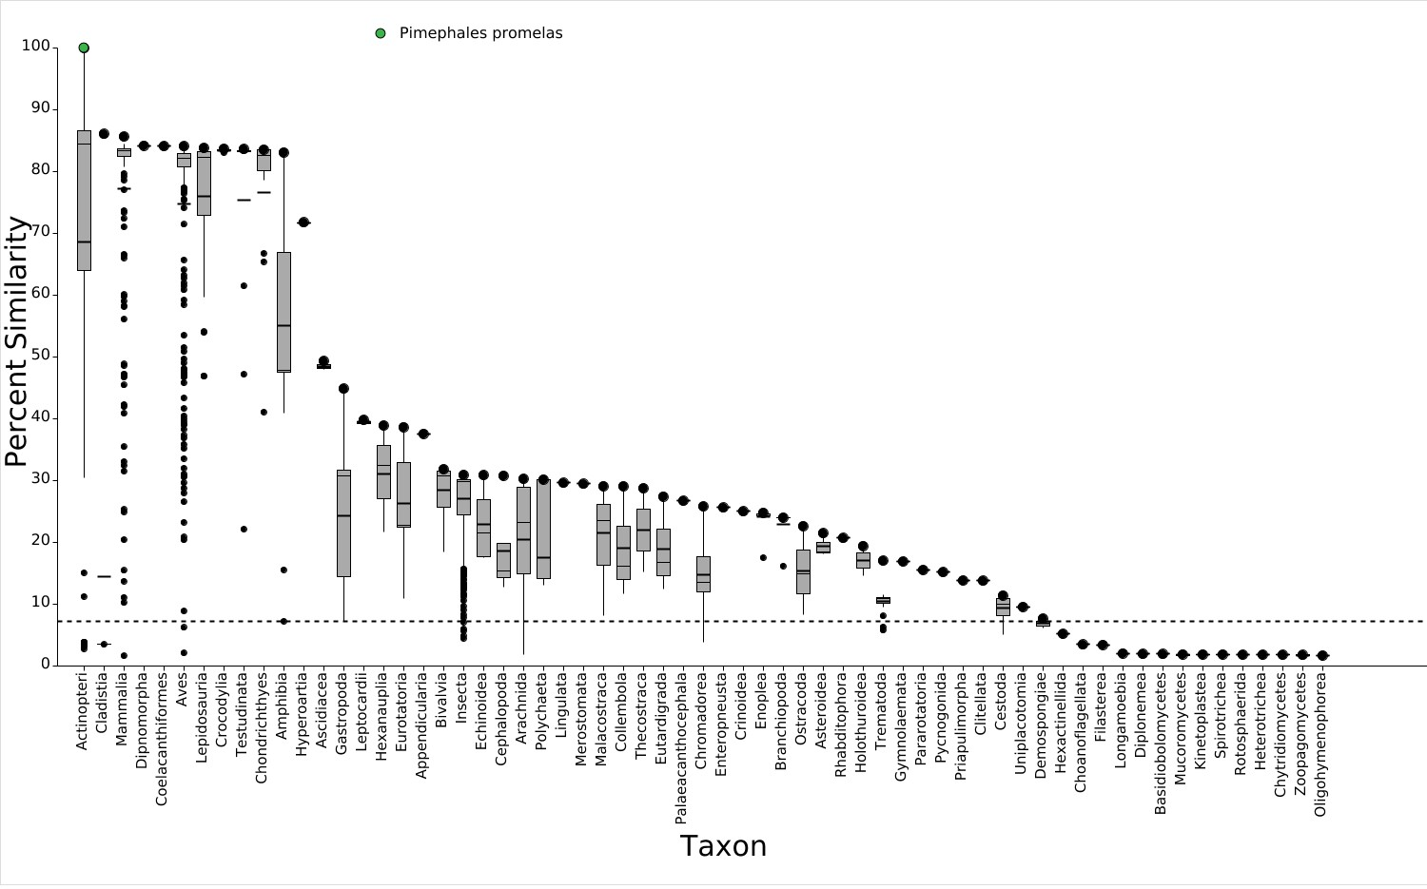
Level 1 Visualization - Primary Report

Level 3

Selected Amino Acids
4452Y,4455R,4456M,4459L,4540C,4675Y,4676L,4679Y,4699D,4703G
Level 3 Template Protein Information
SeqAPASS ID: 4130
Template Species: Pimephales promelas
Template Protein: [XP_039539628.1] LOW QUALITY PROTEIN: ryanodine receptor 2
Protein and Taxonomy Data: 01/11/2023 BLAST Version: 2.15.0
Software Version: 7.1

Final Decision Summary Report

Species | Protein | Level 1 Susceptible (Y/N) | Level 3 Template | Level 3 Amino Acids (Y/N)
Pimephales promelas | LOW QUALITY  PROTEIN: ryanodine receptor 2 | Y | Pimephales promelas | Y
Megalobrama amblycephala | LOW QUALITY  PROTEIN: ryanodine receptor 2 | Y | Pimephales promelas | Y
Ctenopharyngodon idella | ryanodine receptor 2 isoform X1 | Y | Pimephales promelas | Y
Labeo rohita | ryanodine receptor 2 isoform X3 | Y | Pimephales promelas | Y
Onychostoma macrolepis | LOW QUALITY  PROTEIN: ryanodine receptor 2 | Y | Pimephales promelas | Y
Puntigrus tetrazona | LOW QUALITY  PROTEIN: ryanodine receptor 2 | Y | Pimephales promelas | Y
Carassius auratus | ryanodine receptor 2 isoform X1 | Y | Pimephales promelas | Y
Carassius gibelio | ryanodine receptor 2 isoform X4 | Y | Pimephales promelas | Y
Carassius carassius | ryanodine receptor 2 isoform X1 | Y | Pimephales promelas | Y
Myxocyprinus asiaticus | ryanodine receptor 2 | Y | Pimephales promelas | Y
Misgurnus anguillicaudatus | ryanodine receptor 2 isoform X1 | Y | Pimephales promelas | Y
Triplophysa dalaica | ryanodine receptor 2 isoform X4 | Y | Pimephales promelas | Y
Xyrauchen texanus | ryanodine receptor 2 | Y | Pimephales promelas | Y
Cyprinus carpio | LOW QUALITY  PROTEIN: ryanodine receptor 2 | Y | Pimephales promelas | Y
Triplophysa rosa | ryanodine receptor 2 | Y | Pimephales promelas | Y
Colossoma macropomum | LOW QUALITY  PROTEIN: ryanodine receptor 2 | Y | Pimephales promelas | Y
Pygocentrus nattereri | ryanodine receptor 2 isoform X23 | Y | Pimephales promelas | Y
Astyanax mexicanus | ryanodine receptor 2 isoform X3 | Y | Pimephales promelas | Y
Hemibagrus wyckioides | ryanodine receptor 2 isoform X11 | Y | Pimephales promelas | Y
Sinocyclocheilus rhinocerous | PREDICTED: ryanodine receptor 2 | Y | Pimephales promelas | Y
Anguilla anguilla | ryanodine receptor 2 isoform X4 | Y | Pimephales promelas | Y
Silurus meridionalis | ryanodine receptor 2 isoform X3 | Y | Pimephales promelas | Y

 | Denticeps clupeoides | ryanodine receptor 2 isoform X9 | Y | Pimephales promelas | Y
 | Chanos chanos | ryanodine receptor 2 | Y | Pimephales promelas | Y
 | Danio aesculapii | LOW QUALITY  PROTEIN: ryanodine receptor 2-like | Y | Pimephales promelas | Y
 | Conger conger | ryanodine receptor 2-like | Y | Pimephales promelas | Y
 | Ictalurus punctatus | ryanodine receptor 2 isoform X7 | Y | Pimephales promelas | Y
 | Ictalurus furcatus | ryanodine receptor 2 | Y | Pimephales promelas | Y
 | Tachysurus fulvidraco | ryanodine receptor 2 isoform X2 | Y | Pimephales promelas | Y
 | Tachysurus vachellii | ryanodine receptor 2 | Y | Pimephales promelas | Y
 | Hypomesus transpacificus | ryanodine receptor 2 | Y | Pimephales promelas | Y
 | Brienomyrus brachyistius | ryanodine receptor 2 isoform X3 | Y | Pimephales promelas | Y
 | Scleropages formosus | ryanodine receptor 2 isoform X1 | Y | Pimephales promelas | Y
 | Alosa sapidissima | ryanodine receptor 2 isoform X1 | Y | Pimephales promelas | Y
 | Alosa alosa | ryanodine receptor 2 isoform X1 | Y | Pimephales promelas | Y
 | Lepisosteus oculatus | PREDICTED: ryanodine receptor 2 isoform X7 | Y | Pimephales promelas | Y
 | Electrophorus electricus | ryanodine receptor 2 isoform X1 | Y | Pimephales promelas | Y
 | Epinephelus lanceolatus | ryanodine receptor 2-like isoform X2 | Y | Pimephales promelas | Y
 | Clupea harengus | ryanodine receptor 2 isoform X2 | Y | Pimephales promelas | Y
 | Larimichthys crocea | ryanodine receptor 2 isoform X1 | Y | Pimephales promelas | Y
 | Epinephelus fuscoguttatus | ryanodine receptor 2 | Y | Pimephales promelas | Y
 | Plectropomus leopardus | ryanodine receptor 2 | Y | Pimephales promelas | Y
 | Sparus aurata | ryanodine receptor 2 isoform X1 | Y | Pimephales promelas | Y
 | Seriola aureovittata | ryanodine receptor 2 isoform X1 | Y | Pimephales promelas | Y
 | Paramormyrops kingsleyae | ryanodine receptor 2 isoform X4 | Y | Pimephales promelas | Y
 | Centropristis striata | ryanodine receptor 2-like | Y | Pimephales promelas | Y
 | Dicentrarchus labrax | ryanodine receptor 2 isoform X1 | Y | Pimephales promelas | Y
 | Acanthopagrus latus | ryanodine receptor 2 isoform X2 | Y | Pimephales promelas | Y
 | Seriola dumerili | ryanodine receptor 2 | Y | Pimephales promelas | Y
 | Epinephelus moara | ryanodine receptor 2 | Y | Pimephales promelas | Y
 | Thunnus maccoyii | ryanodine receptor 2 | Y | Pimephales promelas | Y
 | Thunnus albacares | ryanodine receptor 2 | Y | Pimephales promelas | Y

 | Chelmon rostratus | ryanodine receptor 2 | Y | Pimephales promelas | Y
 | Salmo trutta | ryanodine receptor 2 | Y | Pimephales promelas | Y
 | Myripristis murdjan | ryanodine receptor 2 | Y | Pimephales promelas | Y
 | Lates calcarifer | ryanodine receptor 2 isoform X1 | Y | Pimephales promelas | Y
 | Sander lucioperca | ryanodine receptor 2 isoform X1 | Y | Pimephales promelas | Y
 | Scatophagus argus | ryanodine receptor 2 isoform X1 | Y | Pimephales promelas | Y
 | Scophthalmus maximus | ryanodine receptor 2 isoform X1 | Y | Pimephales promelas | Y
 | Toxotes jaculatrix | ryanodine receptor 2 | Y | Pimephales promelas | Y
 | Scomber japonicus | ryanodine receptor 2 | Y | Pimephales promelas | Y
 | Esox lucius | ryanodine receptor 2 isoform X6 | Y | Pimephales promelas | Y
 | Acanthochromis polyacanthus | ryanodine receptor 2 | Y | Pimephales promelas | Y
 | Micropterus salmoides | ryanodine receptor 2 | Y | Pimephales promelas | Y
 | Hippoglossus hippoglossus | ryanodine receptor 2 isoform X7 | Y | Pimephales promelas | Y
 | Oncorhynchus mykiss | ryanodine receptor 2 | Y | Pimephales promelas | Y
 | Betta splendens | ryanodine receptor 2 isoform X6 | Y | Pimephales promelas | Y
 | Perca fluviatilis | LOW QUALITY  PROTEIN: ryanodine receptor 2 | Y | Pimephales promelas | Y
 | Anabas testudineus | LOW QUALITY  PROTEIN: ryanodine receptor 2 | Y | Pimephales promelas | Y
 | Salmo salar | ryanodine receptor 2-like | Y | Pimephales promelas | Y
 | Cottoperca gobio | ryanodine receptor 2 | Y | Pimephales promelas | Y
 | Amphiprion ocellaris | ryanodine receptor 2 isoform X5 | Y | Pimephales promelas | Y
 | Solea senegalensis | ryanodine receptor 2 isoform X1 | Y | Pimephales promelas | Y
 | Paralichthys olivaceus | PREDICTED: ryanodine receptor 2 | Y | Pimephales promelas | Y
 | Solea solea | ryanodine receptor 2 isoform X15 | Y | Pimephales promelas | Y
 | Pleuronectes platessa | ryanodine receptor 2 | Y | Pimephales promelas | Y
 | Micropterus dolomieu | ryanodine receptor 2 | Y | Pimephales promelas | Y
 | Sebastes umbrosus | ryanodine receptor 2 isoform X1 | Y | Pimephales promelas | Y
 | Limanda limanda | ryanodine receptor 2 | Y | Pimephales promelas | Y
 | Salvelinus fontinalis | ryanodine receptor 2-like | Y | Pimephales promelas | Y
 | Perca flavescens | ryanodine receptor 2 isoform X4 | Y | Pimephales promelas | Y
 | Amia calva | RYR2 protein | Y | Pimephales promelas | Y
 | Lampris incognitus | LOW QUALITY | Y | Pimephales promelas | Y

 |  | PROTEIN: ryanodine receptor 2
 | Gymnodraco acuticeps | ryanodine receptor 2 isoform X3 | Y | Pimephales promelas | Y
 | Hippoglossus stenolepis | ryanodine receptor 2 | Y | Pimephales promelas | Y
 | Cyclopterus lumpus | ryanodine receptor 2 | Y | Pimephales promelas | Y
 | Simochromis diagramma | ryanodine receptor 2 isoform X1 | Y | Pimephales promelas | Y
 | Maylandia zebra | ryanodine receptor 2 isoform X1 | Y | Pimephales promelas | Y
 | Haplochromis burtoni | ryanodine receptor 2 | Y | Pimephales promelas | Y
 | Astatotilapia calliptera | ryanodine receptor 2 isoform X1 | Y | Pimephales promelas | Y
 | Oreochromis niloticus | ryanodine receptor 2 | Y | Pimephales promelas | Y
 | Coregonus clupeaformis | LOW QUALITY  PROTEIN: ryanodine receptor 2-like | Y | Pimephales promelas | Y
 | Monopterus albus | ryanodine receptor 2 isoform X1 | Y | Pimephales promelas | Y
 | Archocentrus centrarchus | LOW QUALITY  PROTEIN: ryanodine receptor 2 | Y | Pimephales promelas | Y
 | Pseudoliparis swirei | ryanodine receptor 2 | Y | Pimephales promelas | Y
 | Melanotaenia boesemani | ryanodine receptor 2 | Y | Pimephales promelas | Y
 | Girardinichthys multiradiatus | ryanodine receptor 2 | Y | Pimephales promelas | Y
 | Cynoglossus semilaevis | ryanodine receptor 2 | Y | Pimephales promelas | Y
 | Polyodon spathula | ryanodine receptor 2 isoform X6 | Y | Pimephales promelas | Y
 | Xiphophorus maculatus | ryanodine receptor 2 isoform X4 | Y | Pimephales promelas | Y
 | Echeneis naucrates | LOW QUALITY  PROTEIN: ryanodine receptor 2 | Y | Pimephales promelas | Y
 | Poeciliopsis prolifica | ryanodine receptor 2 | Y | Pimephales promelas | Y
 | Xyrichtys novacula | ryanodine receptor 2 | Y | Pimephales promelas | Y
 | Xiphophorus hellerii | ryanodine receptor 2 isoform X3 | Y | Pimephales promelas | Y
 | Gasterosteus aculeatus aculeatus | ryanodine receptor 2 isoform X1 | Y | Pimephales promelas | Y
 | Cyprinodon tularosa | ryanodine receptor 2 | Y | Pimephales promelas | Y
 | Xiphophorus couchianus | ryanodine receptor 2 isoform X4 | Y | Pimephales promelas | Y
 | Labrus mixtus | ryanodine receptor 2 | Y | Pimephales promelas | Y
 | Gambusia affinis | ryanodine receptor 2 isoform X1 | Y | Pimephales promelas | Y
 | Pseudochaenichthys georgianus | ryanodine receptor 2 | Y | Pimephales promelas | Y
 | Pungitius pungitius | ryanodine receptor 2 isoform X1 | Y | Pimephales promelas | Y

 | Fundulus heteroclitus | ryanodine receptor 2 | Y | Pimephales promelas | Y
 | Acipenser oxyrinchus oxyrinchus | ryanodine receptor 2 | Y | Pimephales promelas | Y
 | Synchiropus splendidus | ryanodine receptor 2 isoform X3 | Y | Pimephales promelas | Y
 | Seriola lalandi dorsalis | ryanodine receptor 2 | Y | Pimephales promelas | Y
 | Atractosteus spatula | RYR2 protein | Y | Pimephales promelas | Y
 | Etheostoma spectabile | ryanodine receptor 2 | Y | Pimephales promelas | Y
 | Etheostoma cragini | ryanodine receptor 2 isoform X1 | Y | Pimephales promelas | Y
 | Cheilinus undulatus | ryanodine receptor 2 | Y | Pimephales promelas | Y
 | Gadus morhua | ryanodine receptor 2 isoform X1 | Y | Pimephales promelas | Y
 | Oryzias melastigma | ryanodine receptor 2 isoform X1 | Y | Pimephales promelas | Y
 | Mugil cephalus | ryanodine receptor 2 isoform X5 | Y | Pimephales promelas | Y
 | Gadus macrocephalus | ryanodine receptor 2-like | Y | Pimephales promelas | Y
 | Gadus chalcogrammus | ryanodine receptor 2 | Y | Pimephales promelas | Y
 | Oreochromis aureus | LOW QUALITY  PROTEIN: ryanodine receptor 2 | Y | Pimephales promelas | Y
 | Trematomus bernacchii | ryanodine receptor 2 | Y | Pimephales promelas | Y
 | Gouania willdenowi | ryanodine receptor 2 isoform X1 | Y | Pimephales promelas | Y
 | Periophthalmus magnuspinnatus | ryanodine receptor 2 | Y | Pimephales promelas | Y
 | Boleophthalmus pectinirostris | ryanodine receptor 2 | Y | Pimephales promelas | Y
 | Oryzias latipes | ryanodine receptor 2 isoform X1 | Y | Pimephales promelas | Y
 | Stegastes partitus | PREDICTED: LOW QUALITY PROTEIN:  ryanodine receptor 2-like | Y | Pimephales promelas | Y
 | Dunckerocampus dactyliophorus | ryanodine receptor 2 isoform X8 | Y | Pimephales promelas | Y
 | Doryrhamphus excisus | ryanodine receptor 2 isoform X2 | Y | Pimephales promelas | Y
 | Poecilia reticulata | PREDICTED: ryanodine receptor 2 isoform X1 | Y | Pimephales promelas | Y
 | Thalassophryne amazonica | ryanodine receptor 2 isoform X3 | Y | Pimephales promelas | Y
 | Bagarius yarrelli | Ryanodine receptor 2 | Y | Pimephales promelas | Y
 | Syngnathus scovelli | ryanodine receptor 2 isoform X2 | Y | Pimephales promelas | Y
 | Hippocampus zosterae | ryanodine receptor 2 isoform X4 | Y | Pimephales promelas | Y
 | Syngnathus acus | LOW QUALITY  PROTEIN: ryanodine receptor 2 | Y | Pimephales promelas | Y

 | Corythoichthys intestinalis | ryanodine receptor 2 isoform X1 | Y | Pimephales promelas | Y
 | Mastacembelus armatus | LOW QUALITY  PROTEIN: ryanodine receptor 2 | Y | Pimephales promelas | Y
 | Syngnathus typhle | LOW QUALITY  PROTEIN: ryanodine receptor 2 | Y | Pimephales promelas | Y
 | Hippocampus comes | PREDICTED: ryanodine receptor 2 | Y | Pimephales promelas | Y
 | Oncorhynchus kisutch | LOW QUALITY  PROTEIN: ryanodine receptor 2-like | Y | Pimephales promelas | Y
 | Takifugu rubripes | ryanodine receptor 2 isoform X1 | Y | Pimephales promelas | Y
 | Takifugu flavidus | ryanodine receptor 2 isoform X1 | Y | Pimephales promelas | Y
 | Siniperca chuatsi | LOW QUALITY  PROTEIN: ryanodine receptor 2 | Y | Pimephales promelas | Y
 | Acipenser ruthenus | Ryanodine receptor 2 | Y | Pimephales promelas | Y
 | Cyprinodon variegatus | PREDICTED: ryanodine receptor 2 | Y | Pimephales promelas | Y
 | Notolabrus celidotus | ryanodine receptor 2 | Y | Pimephales promelas | Y
 | Morone saxatilis | ryanodine receptor 2-like | Y | Pimephales promelas | Y
 | Collichthys lucidus | Ryanodine receptor 2 | Y | Pimephales promelas | Y
 | Oncorhynchus gorbuscha | ryanodine receptor 2-like isoform X1 | Y | Pimephales promelas | Y
 | Oncorhynchus nerka | LOW QUALITY  PROTEIN: ryanodine receptor 2-like | Y | Pimephales promelas | Y
 | Oncorhynchus tshawytscha | ryanodine receptor 2 | Y | Pimephales promelas | Y
 | Salvelinus namaycush | ryanodine receptor 2-like | Y | Pimephales promelas | Y
 | Oncorhynchus keta | ryanodine receptor 2-like isoform X2 | Y | Pimephales promelas | Y
 | Salvelinus alpinus | ryanodine receptor 2-like | Y | Pimephales promelas | Y
 | Megalops cyprinoides | ryanodine receptor 2 | Y | Pimephales promelas | Y
 | Poecilia latipinna | PREDICTED: ryanodine receptor 2-like | Y | Pimephales promelas | Y
 | Danio rerio | LOW QUALITY  PROTEIN: ryanodine receptor 2 isoform X1 | Y | Pimephales promelas | Y
 | Poecilia formosa | PREDICTED: ryanodine receptor 2 | Y | Pimephales promelas | Y
 | Poecilia mexicana | PREDICTED: ryanodine receptor 2-like | Y | Pimephales promelas | Y
 | Nothobranchius furzeri | ryanodine receptor 2 | Y | Pimephales promelas | Y
 | Nibea albiflora | Ryanodine receptor 2 | Y | Pimephales promelas | Y

Sequence Alignment to Predict Across Species Susceptibility (SeqAPASS)
Decision Summary Report

Level 1
Level 1 Query Protein Information Report Settings

SeqAPASS ID: 4130 Report Type: Primary
Query Species: Pimephales promelas E-value: 0.01
Query Protein: ryanodine receptor 3 isoform X15 Sorted By Taxonomic Group: CLASS Query Accession: XP_039525313.1 Common Domains: 1
Ortholog Count: 76 Species Read-Across: Y
Protein and Taxonomy Data: 01/11/2023 Cut-off %: 12.58
BLAST Version: 2.15.0 Show Only Eukaryotes: Y Software Version: 7.1
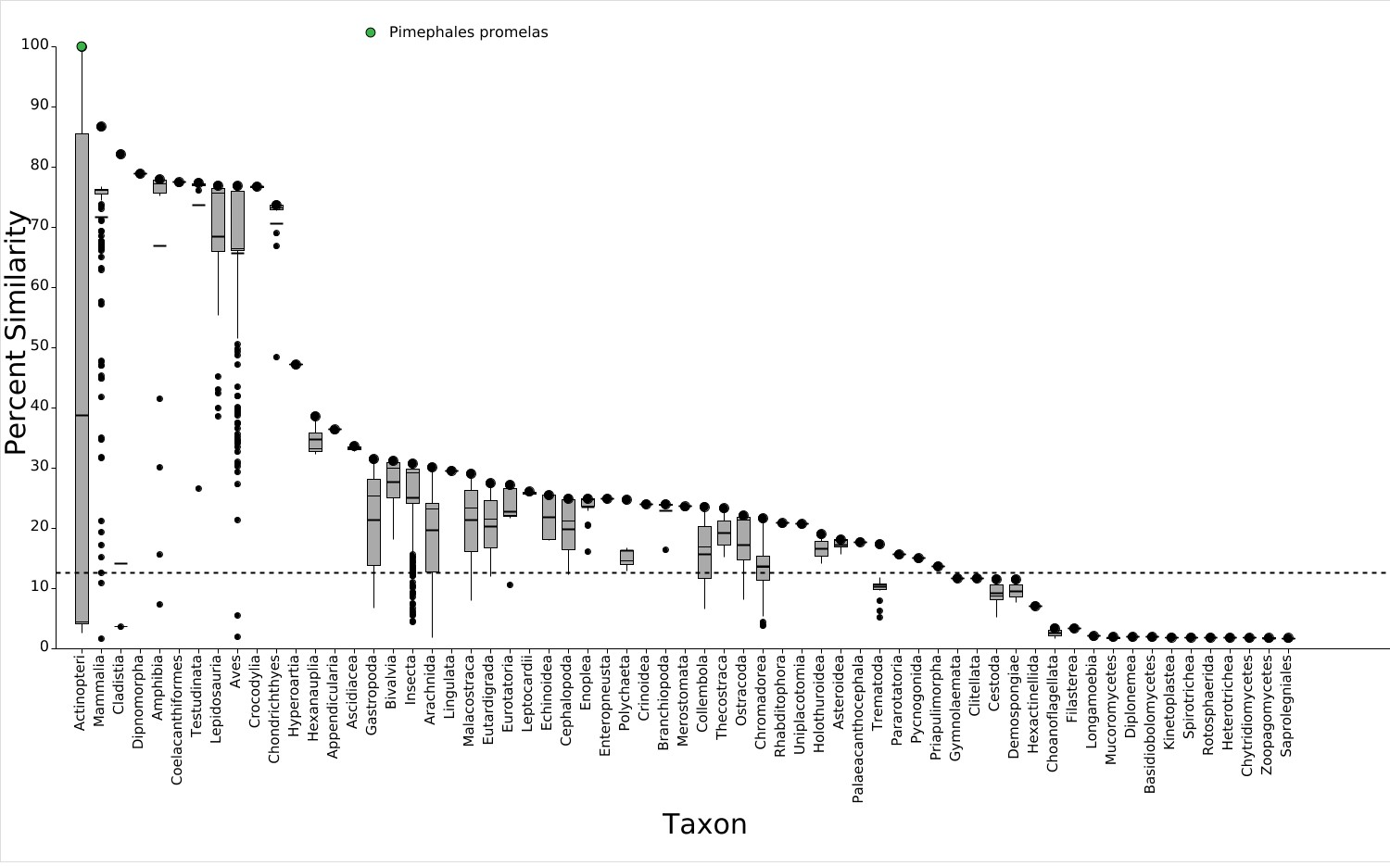
Level 1 Visualization - Primary Report

Level 3

Selected Amino Acids
4412Y,4415R,4416F,4419L,4488C,4621Y,4622L,4625Y,4645D,4649G
Level 3 Template Protein Information
SeqAPASS ID: 4130
Template Species: Pimephales promelas
Template Protein: [XP_039525313.1] ryanodine receptor 3 isoform X15
Protein and Taxonomy Data: 01/11/2023 BLAST Version: 2.15.0
Software Version: 7.1

Final Decision Summary Report

Species | Protein | Level 1 Susceptible (Y/N) | Level 3 Template | Level 3 Amino Acids (Y/N)
Pimephales promelas | ryanodine receptor 3 isoform X15 | Y | Pimephales promelas | Y
Rhinichthys klamathensis goyatoka | ryanodine receptor 3 | Y | Pimephales promelas | Y
Megalobrama amblycephala | ryanodine receptor 3 isoform X2 | Y | Pimephales promelas | Y
Ctenopharyngodon idella | ryanodine receptor 3 isoform X12 | Y | Pimephales promelas | Y
Labeo rohita | ryanodine receptor 3 isoform X1 | Y | Pimephales promelas | Y
Myxocyprinus asiaticus | ryanodine receptor 3-like | Y | Pimephales promelas | Y
Onychostoma macrolepis | LOW QUALITY  PROTEIN: ryanodine receptor 3 | Y | Pimephales promelas | Y
Puntigrus tetrazona | ryanodine receptor 3 isoform X10 | Y | Pimephales promelas | Y
Carassius gibelio | ryanodine receptor 3 isoform X1 | Y | Pimephales promelas | Y
Carassius carassius | ryanodine receptor 3 isoform X6 | Y | Pimephales promelas | Y
Sinocyclocheilus anshuiensis | PREDICTED: ryanodine receptor 3-like | Y | Pimephales promelas | Y
Xyrauchen texanus | LOW QUALITY  PROTEIN: ryanodine receptor 3 | Y | Pimephales promelas | Y
Carassius auratus | ryanodine receptor 3-like | Y | Pimephales promelas | Y
Misgurnus anguillicaudatus | ryanodine receptor 3 isoform X15 | Y | Pimephales promelas | Y
Astyanax mexicanus | ryanodine receptor 3-like isoform X4 | Y | Pimephales promelas | Y
Colossoma macropomum | ryanodine receptor 3 | Y | Pimephales promelas | Y
Triplophysa dalaica | ryanodine receptor 3 isoform X2 | Y | Pimephales promelas | Y
Pygocentrus nattereri | ryanodine receptor 3-like isoform X1 | Y | Pimephales promelas | Y
Pangasianodon hypophthalmus | ryanodine receptor 3 isoform X9 | Y | Pimephales promelas | Y
Neoarius graeffei | ryanodine receptor 3 | Y | Pimephales promelas | Y
Hemibagrus wyckioides | ryanodine receptor 3 isoform X4 | Y | Pimephales promelas | Y
Chanos chanos | ryanodine receptor 3-like | Y | Pimephales promelas | Y
Ictalurus furcatus | ryanodine receptor 3 | Y | Pimephales promelas | Y
Ictalurus punctatus | ryanodine receptor 3 | Y | Pimephales promelas | Y
Clarias gariepinus | LOW QUALITY  PROTEIN: ryanodine receptor 3 | Y | Pimephales promelas | Y

 | Denticeps clupeoides | ryanodine receptor 3-like isoform X18 | Y | Pimephales promelas | Y
 | Tachysurus fulvidraco | ryanodine receptor 3 isoform X1 | Y | Pimephales promelas | Y
 | Tachysurus vachellii | ryanodine receptor 3 | Y | Pimephales promelas | Y
 | Triplophysa rosa | ryanodine receptor 3 | Y | Pimephales promelas | Y
 | Myripristis murdjan | ryanodine receptor 3-like | Y | Pimephales promelas | Y
 | Lampris incognitus | ryanodine receptor 3-like | Y | Pimephales promelas | Y
 | Alosa alosa | ryanodine receptor 3-like isoform X7 | Y | Pimephales promelas | Y
 | Micropterus salmoides | LOW QUALITY  PROTEIN: ryanodine receptor 3-like | Y | Pimephales promelas | Y
 | Lates calcarifer | ryanodine receptor 3 isoform X2 | Y | Pimephales promelas | Y
 | Epinephelus fuscoguttatus | ryanodine receptor 3-like isoform X7 | Y | Pimephales promelas | Y
 | Alosa sapidissima | ryanodine receptor 3-like isoform X7 | Y | Pimephales promelas | Y
 | Seriola lalandi dorsalis | ryanodine receptor 3-like | Y | Pimephales promelas | Y
 | Electrophorus electricus | LOW QUALITY  PROTEIN: ryanodine receptor 3 | Y | Pimephales promelas | Y
 | Amphiprion ocellaris | ryanodine receptor 3-like isoform X5 | Y | Pimephales promelas | Y
 | Astatotilapia calliptera | ryanodine receptor 3-like isoform X14 | Y | Pimephales promelas | Y
 | Seriola aureovittata | ryanodine receptor 3-like isoform X2 | Y | Pimephales promelas | Y
 | Dicentrarchus labrax | ryanodine receptor 3-like isoform X10 | Y | Pimephales promelas | Y
 | Salarias fasciatus | ryanodine receptor 3-like | Y | Pimephales promelas | Y
 | Micropterus dolomieu | ryanodine receptor 3-like | Y | Pimephales promelas | Y
 | Epinephelus moara | ryanodine receptor 3-like | Y | Pimephales promelas | Y
 | Simochromis diagramma | ryanodine receptor 3-like isoform X7 | Y | Pimephales promelas | Y
 | Maylandia zebra | ryanodine receptor 3 isoform X2 | Y | Pimephales promelas | Y
 | Siniperca chuatsi | ryanodine receptor 3-like isoform X12 | Y | Pimephales promelas | Y
 | Clupea harengus | LOW QUALITY  PROTEIN: ryanodine receptor 3-like | Y | Pimephales promelas | Y
 | Neolamprologus brichardi | ryanodine receptor 3-like isoform X3 | Y | Pimephales promelas | Y
 | Epinephelus lanceolatus | LOW QUALITY  PROTEIN: ryanodine receptor 3-like | Y | Pimephales promelas | Y
 | Oreochromis niloticus | ryanodine receptor 3 isoform X4 | Y | Pimephales promelas | Y

 | Sphaeramia orbicularis | ryanodine receptor 3-like | Y | Pimephales promelas | Y
 | Haplochromis burtoni | ryanodine receptor 3 isoform X6 | Y | Pimephales promelas | Y
 | Acanthopagrus latus | ryanodine receptor 3-like isoform X3 | Y | Pimephales promelas | Y
 | Anabas testudineus | ryanodine receptor 3-like | Y | Pimephales promelas | Y
 | Betta splendens | ryanodine receptor 3-like isoform X3 | Y | Pimephales promelas | Y
 | Mugil cephalus | ryanodine receptor 3-like isoform X7 | Y | Pimephales promelas | Y
 | Sparus aurata | ryanodine receptor 3-like isoform X8 | Y | Pimephales promelas | Y
 | Xiphias gladius | ryanodine receptor 3-like | Y | Pimephales promelas | Y
 | Perca fluviatilis | ryanodine receptor 3-like isoform X12 | Y | Pimephales promelas | Y
 | Thunnus maccoyii | ryanodine receptor 3-like | Y | Pimephales promelas | Y
 | Sander lucioperca | ryanodine receptor 3-like isoform X4 | Y | Pimephales promelas | Y
 | Etheostoma spectabile | ryanodine receptor 3-like isoform X5 | Y | Pimephales promelas | Y
 | Larimichthys crocea | ryanodine receptor 3 | Y | Pimephales promelas | Y
 | Thunnus albacares | ryanodine receptor 3-like isoform X4 | Y | Pimephales promelas | Y
 | Sebastes umbrosus | ryanodine receptor 3-like isoform X8 | Y | Pimephales promelas | Y
 | Oncorhynchus kisutch | ryanodine receptor 3-like isoform X4 | Y | Pimephales promelas | Y
 | Oryzias melastigma | ryanodine receptor 3 isoform X7 | Y | Pimephales promelas | Y
 | Etheostoma cragini | ryanodine receptor 3-like isoform X5 | Y | Pimephales promelas | Y
 | Perca flavescens | ryanodine receptor 3-like | Y | Pimephales promelas | Y
 | Chelmon rostratus | ryanodine receptor 3-like | Y | Pimephales promelas | Y
 | Parambassis ranga | ryanodine receptor 3-like | Y | Pimephales promelas | Y
 | Oncorhynchus tshawytscha | ryanodine receptor 3 | Y | Pimephales promelas | Y
 | Echeneis naucrates | ryanodine receptor 3-like | Y | Pimephales promelas | Y
 | Pundamilia nyererei | PREDICTED: LOW QUALITY PROTEIN:  ryanodine receptor 3-like | Y | Pimephales promelas | Y
 | Labrus mixtus | ryanodine receptor 3-like | Y | Pimephales promelas | Y
 | Anarrhichthys ocellatus | ryanodine receptor 3-like isoform X14 | Y | Pimephales promelas | Y
 | Synchiropus splendidus | ryanodine receptor 3-like isoform X2 | Y | Pimephales promelas | Y
 | Monopterus albus | ryanodine receptor 3-like | Y | Pimephales promelas | Y
 | Scatophagus argus | ryanodine receptor 3-like | Y | Pimephales promelas | Y
 | Seriola dumerili | ryanodine receptor 3-like | Y | Pimephales promelas | Y
 | Scomber japonicus | ryanodine receptor 3-like | Y | Pimephales promelas | Y

 | Gouania willdenowi | ryanodine receptor 3-like isoform X4 | Y | Pimephales promelas | Y
 | Esox lucius | ryanodine receptor 3 | Y | Pimephales promelas | Y
 | Oncorhynchus keta | ryanodine receptor 3-like isoform X11 | Y | Pimephales promelas | Y
 | Paralichthys olivaceus | PREDICTED: ryanodine receptor 3-like | Y | Pimephales promelas | Y
 | Xyrichtys novacula | ryanodine receptor 3-like isoform X17 | Y | Pimephales promelas | Y
 | Scophthalmus maximus | ryanodine receptor 3 isoform X3 | Y | Pimephales promelas | Y
 | Salmo trutta | ryanodine receptor 3-like | Y | Pimephales promelas | Y
 | Kryptolebias marmoratus | ryanodine receptor 3 isoform X4 | Y | Pimephales promelas | Y
 | Salvelinus fontinalis | ryanodine receptor 3-like isoform X9 | Y | Pimephales promelas | Y
 | Takifugu flavidus | ryanodine receptor 3-like isoform X9 | Y | Pimephales promelas | Y
 | Oryzias latipes | ryanodine receptor 3-like isoform X15 | Y | Pimephales promelas | Y
 | Takifugu rubripes | ryanodine receptor 3-like isoform X10 | Y | Pimephales promelas | Y
 | Centropristis striata | ryanodine receptor 3-like | Y | Pimephales promelas | Y
 | Hippoglossus stenolepis | ryanodine receptor 3 isoform X2 | Y | Pimephales promelas | Y
 | Xiphophorus hellerii | ryanodine receptor 3-like isoform X6 | Y | Pimephales promelas | Y
 | Coregonus clupeaformis | ryanodine receptor 3 | Y | Pimephales promelas | Y
 | Gymnodraco acuticeps | ryanodine receptor 3-like isoform X5 | Y | Pimephales promelas | Y
 | Poeciliopsis prolifica | ryanodine receptor 3-like | Y | Pimephales promelas | Y
 | Poecilia reticulata | PREDICTED: ryanodine receptor 3-like isoform X4 | Y | Pimephales promelas | Y
 | Xiphophorus maculatus | ryanodine receptor 3-like isoform X4 | Y | Pimephales promelas | Y
 | Oncorhynchus mykiss | ryanodine receptor 3 | Y | Pimephales promelas | Y
 | Salmo salar | ryanodine receptor 3 isoform X4 | Y | Pimephales promelas | Y
 | Solea senegalensis | ryanodine receptor 3-like | Y | Pimephales promelas | Y
 | Xiphophorus couchianus | ryanodine receptor 3-like isoform X6 | Y | Pimephales promelas | Y
 | Dunckerocampus dactyliophorus | ryanodine receptor 3-like isoform X3 | Y | Pimephales promelas | Y
 | Trematomus bernacchii | ryanodine receptor 3-like | Y | Pimephales promelas | Y
 | Thalassophryne amazonica | LOW QUALITY  PROTEIN: ryanodine receptor 3-like | Y | Pimephales promelas | Y
 | Fundulus heteroclitus | ryanodine receptor 3 isoform X9 | Y | Pimephales promelas | Y

 | Doryrhamphus excisus | ryanodine receptor 3-like isoform X1 | Y | Pimephales promelas | Y
 | Gambusia affinis | ryanodine receptor 3-like | Y | Pimephales promelas | Y
 | Oncorhynchus gorbuscha | ryanodine receptor 3-like isoform X3 | Y | Pimephales promelas | Y
 | Cyprinodon variegatus | PREDICTED: ryanodine receptor 3 isoform X13 | Y | Pimephales promelas | Y
 | Limanda limanda | ryanodine receptor 3-like | Y | Pimephales promelas | Y
 | Solea solea | ryanodine receptor 3-like isoform X16 | Y | Pimephales promelas | Y
 | Gasterosteus aculeatus aculeatus | ryanodine receptor 3-like isoform X19 | Y | Pimephales promelas | Y
 | Cyclopterus lumpus | LOW QUALITY  PROTEIN: ryanodine receptor 3-like | Y | Pimephales promelas | Y
 | Hippocampus zosterae | ryanodine receptor 3 isoform X3 | Y | Pimephales promelas | Y
 | Cottoperca gobio | ryanodine receptor 3-like | Y | Pimephales promelas | Y
 | Pungitius pungitius | ryanodine receptor 3-like | Y | Pimephales promelas | Y
 | Notolabrus celidotus | ryanodine receptor 3-like | Y | Pimephales promelas | Y
 | Oncorhynchus nerka | LOW QUALITY  PROTEIN: ryanodine receptor 3-like | Y | Pimephales promelas | Y
 | Hippoglossus hippoglossus | LOW QUALITY  PROTEIN: ryanodine receptor 3-like | Y | Pimephales promelas | Y
 | Salvelinus namaycush | ryanodine receptor 3-like | Y | Pimephales promelas | Y
 | Pleuronectes platessa | ryanodine receptor 3 | Y | Pimephales promelas | Y
 | Acanthochromis polyacanthus | ryanodine receptor 3 isoform X3 | Y | Pimephales promelas | Y
 | Silurus meridionalis | ryanodine receptor 3-like | Y | Pimephales promelas | Y
 | Girardinichthys multiradiatus | ryanodine receptor 3-like | Y | Pimephales promelas | Y
 | Anoplopoma fimbria | LOW QUALITY  PROTEIN: ryanodine receptor 3-like | Y | Pimephales promelas | Y
 | Periophthalmus magnuspinnatus | ryanodine receptor 3-like | Y | Pimephales promelas | Y
 | Austrofundulus limnaeus | PREDICTED: ryanodine receptor 3-like | Y | Pimephales promelas | Y
 | Syngnathus scovelli | ryanodine receptor 3 isoform X2 | Y | Pimephales promelas | Y
 | Syngnathus acus | ryanodine receptor 3-like isoform X5 | Y | Pimephales promelas | Y
 | Morone saxatilis | ryanodine receptor 3-like | Y | Pimephales promelas | Y
 | Gadus chalcogrammus | ryanodine receptor 3-like | Y | Pimephales promelas | Y
 | Boleophthalmus pectinirostris | ryanodine receptor 3-like | Y | Pimephales promelas | Y
 | Plectropomus leopardus | ryanodine receptor 3-like | Y | Pimephales promelas | Y
 | Pseudoliparis swirei | LOW QUALITY | Y | Pimephales promelas | Y

 |  | PROTEIN: ryanodine receptor 3-like
 | Labrus bergylta | LOW QUALITY  PROTEIN: ryanodine receptor 3-like | Y | Pimephales promelas | Y
 | Archocentrus centrarchus | ryanodine receptor 3-like | Y | Pimephales promelas | Y
 | Gadus morhua | LOW QUALITY  PROTEIN: ryanodine receptor 3-like | Y | Pimephales promelas | Y
 | Toxotes jaculatrix | LOW QUALITY  PROTEIN: ryanodine receptor 3-like | Y | Pimephales promelas | Y
 | Cyprinodon tularosa | ryanodine receptor 3-like | Y | Pimephales promelas | Y
 | Cheilinus undulatus | LOW QUALITY  PROTEIN: ryanodine receptor 3-like | Y | Pimephales promelas | Y
 | Corythoichthys intestinalis | ryanodine receptor 3-like isoform X4 | Y | Pimephales promelas | Y
 | Melanotaenia boesemani | LOW QUALITY  PROTEIN: ryanodine receptor 3-like | Y | Pimephales promelas | Y
 | Syngnathus typhle | LOW QUALITY  PROTEIN: ryanodine receptor 3-like | Y | Pimephales promelas | Y
 | Hypomesus transpacificus | ryanodine receptor 3 | Y | Pimephales promelas | Y
 | Acipenser ruthenus | ryanodine receptor 3 isoform X21 | Y | Pimephales promelas | Y
 | Polyodon spathula | ryanodine receptor 3 isoform X16 | Y | Pimephales promelas | Y
 | Oreochromis aureus | ryanodine receptor 3 | Y | Pimephales promelas | Y
 | Stegastes partitus | PREDICTED: ryanodine receptor 3 isoform X4 | Y | Pimephales promelas | Y
 | Mastacembelus armatus | ryanodine receptor 3 isoform X4 | Y | Pimephales promelas | Y
 | Sinocyclocheilus rhinocerous | PREDICTED: ryanodine receptor 3-like | Y | Pimephales promelas | Y
 | Danio aesculapii | ryanodine receptor 3 isoform X2 | Y | Pimephales promelas | Y
 | Poecilia latipinna | PREDICTED: ryanodine receptor 3 isoform X10 | Y | Pimephales promelas | Y
 | Poecilia mexicana | PREDICTED: ryanodine receptor 3 isoform X10 | Y | Pimephales promelas | Y
 | Danio rerio | ryanodine receptor 3 isoform X2 | Y | Pimephales promelas | Y
 | Pseudochaenichthys georgianus | LOW QUALITY  PROTEIN: ryanodine receptor 3-like | Y | Pimephales promelas | Y
 | Nothobranchius furzeri | LOW QUALITY  PROTEIN: ryanodine receptor 3 | Y | Pimephales promelas | Y
 | Poecilia formosa | PREDICTED: ryanodine | Y | Pimephales promelas | Y

 |  | receptor 3 isoform X2
 | Sinocyclocheilus grahami | PREDICTED: ryanodine receptor 3-like | Y | Pimephales promelas | Y
 | Nematolebias whitei | ryanodine receptor 3 | Y | Pimephales promelas | Y
 | Cynoglossus semilaevis | LOW QUALITY  PROTEIN: ryanodine receptor 3 | Y | Pimephales promelas | Y
 | Gadus macrocephalus | ryanodine receptor 3 isoform X5 | Y | Pimephales promelas | Y
 | Liparis tanakae | Ryanodine receptor 3 | Y | Pimephales promelas | Y

