Electronic Supplementary Materials: Appendix 1

Table 1: The first row in this table describes the seven metrics used to determine if a sample was classified as in-bloom (IB) or out-of-bloom (OB) the following rows represent an individual sample. Supporting information for classification existed for 11=IB and 11=OB samples. Bolded values signify those that were considered to fall under IB conditions. Many of these samples used a proxy that was taken at the same station but at a different time given that not every sample had all seven metrics collected. Those fields in the table that contain an “x” did not have an available proxy to fill in the missing data.

Extracted Chlorophyll a µg/L: values >20  = IB | Biomass cyanobacteria g/m³: values > 2  = IB | Proportion biomass cyanobacteria g/m³: values ≥50%  = IB | Biomass Microcystis g/m³: values > 2 = IB |  | Average fluoroprobe cyanobacteria µg/L: values >2  = IB | Proportion fluoroprobe: cyanobacteria µg/L: values ≥50%  = IB |  | Concentration: Max MC µg/L: values > 2  = IB | Designation | Basin of collection
8.64 | 4.34 | 97.77 |  | 4.22 | 7.28 | 78.05 | 3.86 |  | IB | Western
42.78 | 9.89 | 91.81 |  | 9.60 | 14.76 | 83.39 | 18.15 |  | IB | Western
24.68 | 0.94 | 34.07 |  | 0.81 | 11.00 | 76.84 | 11.63 |  | IB | Western
52.32 | 8.18 | 90.94 |  | 7.72 | 10.97 | 83.90 | x |  | IB | Western
19.41 | 9.70 | 90.56 |  | 9.38 | 2.37 | 79.99 | 4.44 |  | IB | Western
45.60 | 0.84 | 34.71 |  | 0.70 | 18.05 | 81.15 | 7.55 |  | IB | Western
19.36 | 5.79 | 95.21 |  | 5.52 | 8.09 | 79.93 | 5.04 |  | IB | Western
49.11 | 8.18 | 90.94 |  | 7.72 | 10.97 | 83.90 | x |  | IB | Western
15.25 | 5.79 | 95.21 |  | 5.52 | 8.09 | 79.93 | 5.04 |  | IB | Western
23.70 | 9.70 | 90.56 |  | 9.38 | 2.37 | 80.00 | 4.44 |  | IB | Western
36.28 | 10.18 | 80.86 |  | 10.07 | 18.05 | 81.15 | 7.55 |  | IB | Western
5.05 | 0.03 | 6.89 |  | 0.00 | 0.58 | 8.90 | 0.87 |  | OB | Western
5.63 | 0.10 | 23.02 |  | 0.05 | 0.58 | 8.94 | 0.87 |  | OB | Western
3.18 | 0.04 | 13.36 |  | 0.00 | 0.00 | 0.05 | 1.73 |  | OB | Central
3.87 | 0.04 | 4.87 |  | 0.00 | 0.02 | 0.32 | 0.92 |  | OB | Central
8.20 | 0.13 | 2.98 |  | 0.08 | 1.74 | 19.40 | 0.68 |  | OB | Western
5.15 | 0.52 | 47.17 |  | 0.42 | 0.94 | 13.04 | 0.99 |  | OB | Western
4.39 | 0.02 | 1.03 |  | 0.00 | 0.36 | 5.02 | 0.91 |  | OB | Western
3.15 | 0.04 | 13.36 |  | 0.00 | 0.00 | 0.11 | 0.92 |  | OB | Central
3.92 | 0.04 | 4.87 |  | 0.00 | 0.00 | 0.07 | 0.99 |  | OB | Central
6.11 | 0.52 | 47.17 |  | 0.42 | 1.06 | 13.99 | 0.99 |  | OB | Western
4.16 | 0.02 | 1.03 |  | 0.00 | 0.40 | 5.37 | 0.91 |  | OB | Western

Biomass of prominent phytoplankton groups based on counts g/m³
Cyanobacteria | Microcystis | Chlorophyceae | Chrysophyceae Haptophyceae | Diatomeae | Cryptophyceae | Dinophyceae | Total biomass |  | Total taxa | Designation
9.89 | 9.60 | 0.00 | 0.01 | 0.85 | 0.02 | 0.00 | 10.77 |  | 20 | IB
0.94 | 0.81 | 0.05 | 0.01 | 1.39 | 0.09 | 0.27 | 2.75 |  | 25 | IB
0.84 | 0.70 | 0.03 | 0.02 | 1.41 | 0.12 | 0.00 | 2.42 |  | 41 | IB
5.79 | 5.52 | 0.02 | 0.02 | 0.16 | 0.06 | 0.03 | 6.08 |  | 28 | IB
10.18 | 10.07 | 0.16 | 0.00 | 2.15 | 0.10 | 0.00 | 12.59 |  | 20 | IB
4.34 | 4.22 | 0.00 | 0.05 | 0.02 | 0.01 | 0.02 | 4.43 |  | 21 | IB
0.03 | 0.00 | 0.12 | 0.03 | 0.18 | 0.08 | 0.04 | 0.49 |  | 36 | OB
0.10 | 0.05 | 0.09 | 0.04 | 0.11 | 0.06 | 0.03 | 0.43 |  | 33 | OB
0.04 | 0.00 | 0.00 | 0.06 | 0.17 | 0.04 | 0.00 | 0.31 |  | 27 | OB
0.04 | 0.00 | 0.02 | 0.15 | 0.57 | 0.02 | 0.05 | 0.85 |  | 31 | OB
0.13 | 0.08 | 0.05 | 0.04 | 3.92 | 0.03 | 0.16 | 4.33 |  | 29 | OB
0.52 | 0.42 | 0.10 | 0.04 | 0.22 | 0.04 | 0.19 | 1.10 |  | 39 | OB
0.02 | 0.00 | 0.17 | 0.01 | 1.53 | 0.01 | 0.00 | 1.75 |  | 19 | OB
Average biomass based on counts g/m³
5.33 | 5.15 | 0.04 | 0.02 | 1.00 | 0.07 | 0.05 | 6.51 |  | 25.83 | IB
0.13 | 0.08 | 0.08 | 0.05 | 0.96 | 0.04 | 0.07 | 1.32 |  | 30.57 | OB
Table 2: Of the samples that have an in-bloom (IB) or out-of-bloom (OB) designation, a subset of 6=IB and 7=OB samples had associated phytoplankton biomass counts. For a rough approximation of bloom composition these biomass counts were averaged for each designation in this table.

¹³C_{POM} | ¹⁵N_{POM} | Designation | Basin of collection
-21.65 | 8.74 | IB | Western
-23.56 | 6.94 | IB | Western
-23.3 | 6.36 | IB | Western
-22.67 | 7.89 | IB | Western
-21.44 | 9.74 | IB | Western
-22.91 | 5.44 | IB | Western
-23.07 | 8.45 | IB | Western
-23.6 | 6.20 | IB | Western
-22.21 | 9.08 | IB | Western
-21.32 | 9.17 | IB | Western
-24.08 | 6.32 | IB | Western
-23.88 | 6.78 | OB | Western
-24.29 | 7.43 | OB | Western
-27.13 | 19.18 | OB | Central
-26.95 | 5.29 | OB | Central
-27.46 | 7.46 | OB | Western
-26.53 | 8.00 | OB | Western
-25.79 | 0.49 | OB | Western
-27.55 | 4.73 | OB | Central
-27.4 | 5.27 | OB | Central
-27.28 | 7.16 | OB | Western
-25.81 | 4.22 | OB | Western
Table 3: Particulate organic matter (POM) isotopic ratios for carbon (C) and nitrogen (N) values (δ¹³C_{POM} and δ¹⁵N_{POM}) of IB and OB samples. Most of the IB and OB samples were collected during HAB events in the western basin when supporting classification metrics were collected for verification of the designation (11=IB and 11=OB samples).

Table 4: Particulate organic matter (POM) isotopic ratios for carbon (C) and nitrogen (N) values (δ¹³C_{POM} and δ¹⁵N_{POM}) summarized by month and basin of collection. May samples were excluded from the isoscape due to seasonal differences but included here for comparison.

Month | May |  |  | July |  |  | August | September
Basin | Western | Central | Eastern | Western | Central | Eastern | Western | Western | Central | Eastern
Sample number | 1 | 16 | 4 | 14 | 18 | 4 | 22 | 15 | 37 | 4
δ¹³C_{POM}
Mean | -22.24 | -24.61 | -27.99 | -25.32 | -26.82 | -25.92 | -23.67 | -22.75 | -25.60 | -26.13
Standard deviation | NA | 4.59 | 1.16 | 2.10 | 0.97 | 1.83 | 1.38 | 1.24 | 2.00 | 0.92
δ¹⁵N_{POM}
Mean | 5.05 | 4.99 | 4.36 | 6.38 | 5.04 | 4.28 | 7.37 | 6.47 | 7.31 | 6.61
Standard deviation | NA | 0.66 | 0.92 | 2.29 | 3.80 | 1.14 | 1.87 | 1.61 | 1.22 | 0.81

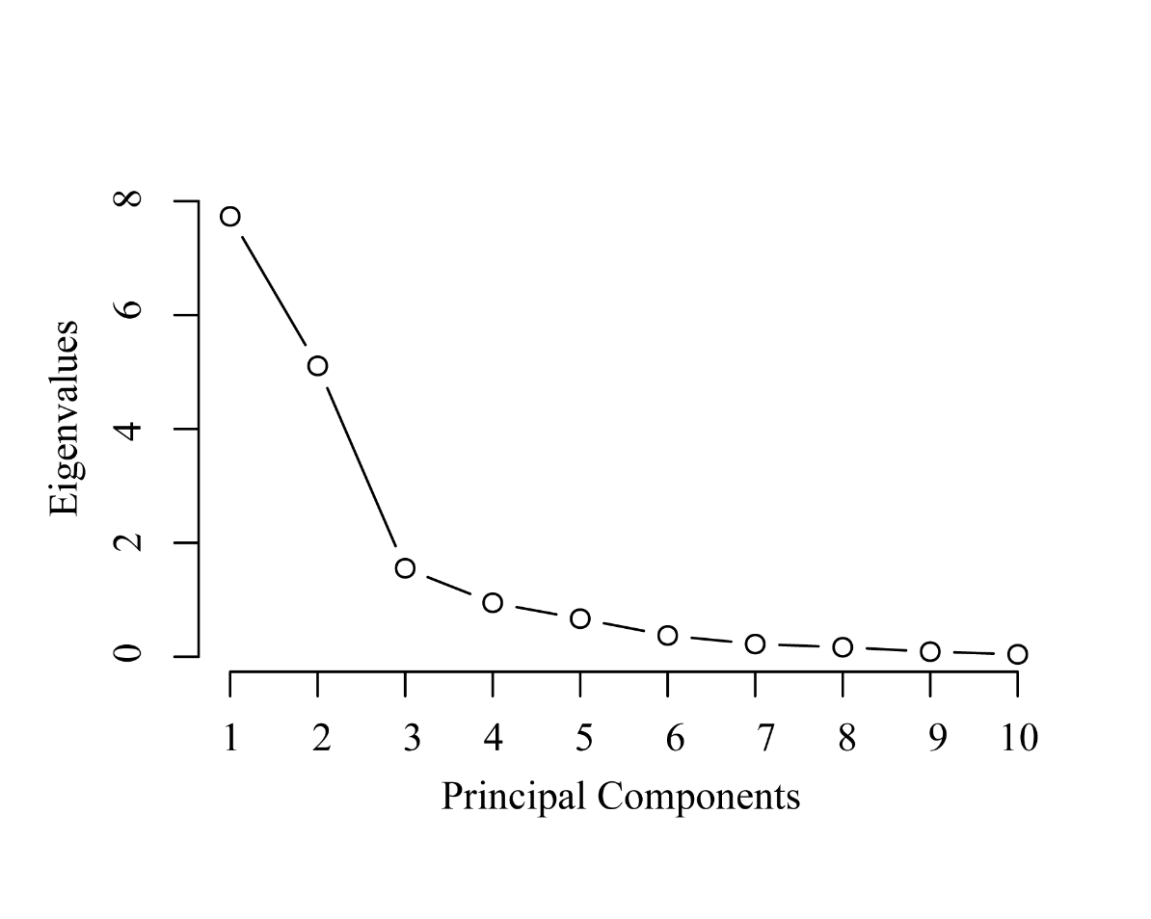
 | PC1 | PC2 | PC3
Standard deviation | 2.78 | 2.26 | 1.25
Proportion of Variance | 0.45 | 0.30 | 0.09
Cumulative Proportion | 0.45 | 0.76 | 0.85

Fig. 1: The scree plot displays the eigenvalues on the y-axis and the number of principal components (PCs) on the x-axis. The table shows the amount of variance explained by the top three PCs. The principal component analysis was conducted using biogeochemical variables sampled inside and outside of harmful algal blooms in Lake Erie during July and August 2019.

