Supplemental Information

Retrospective Stepwise Prioritization of Chemicals Detected in Great Lakes Tributaries (2008 – 2018).
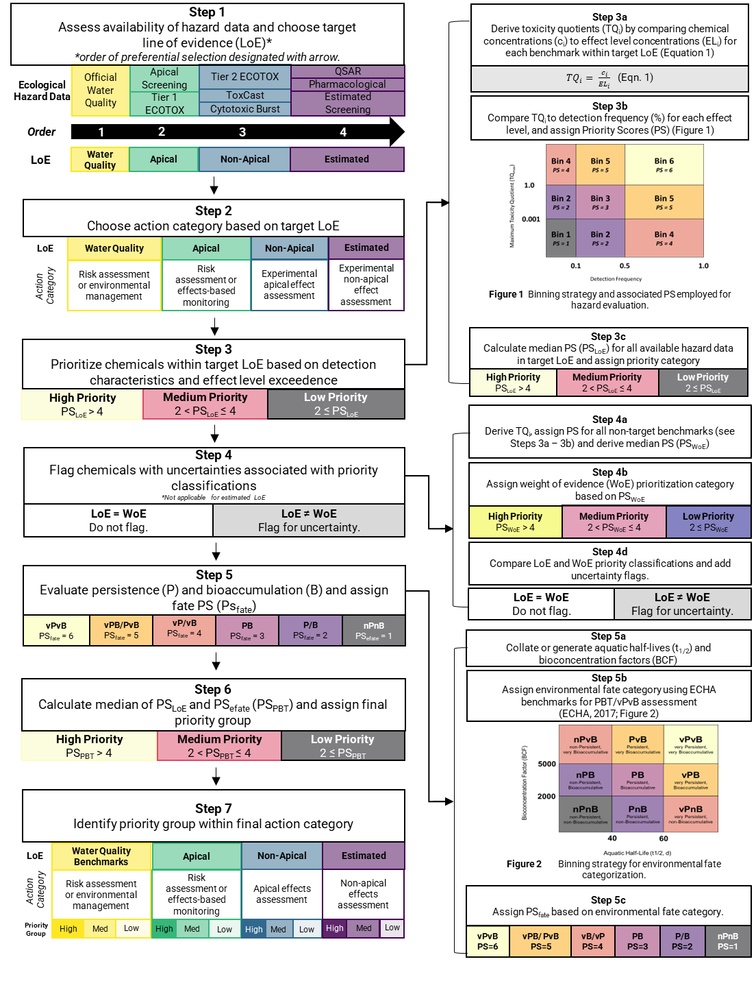
SI Figure 1 Detailed outline of stepwise, risk-based prioritization strategy used to identify high, medium (med), and low priority compounds detected in aquatic contaminants collected from the Great Lakes tributaries (2009 – 2018).

SI 1.1 Prioritization of Chemicals with Water Quality Criteria as their Target Line of Evidence (Action Category = Risk Assessment or Environmental Management)
Of the 334 compounds detected in grab/composite samples collected from across the Great Lakes tributaries, 61 were associated with water quality criteria and were assigned ‘Water Quality Criteria’ as their target line of evidence (LoE) (SI Table 9). Most of these compounds were pesticides or pesticide transformation products (TP; 30/61 or 49%). Industrial/multi-use compounds were the second most prominent chemical class in this target LoE group (11/61 or 18%), followed by fuels and polycyclic aromatic hydrocarbons (PAHs; 10/61 or 16%), pharmaceuticals and personal care products (PPCPs); 7/61 or 12%), wastewater indicators (WWIs; 4/61 or 7%), and finally flame retardants (1/74 or 2%) (SI Figure 2A).
Stepwise prioritization of these chemicals allowed for the identification of 36 high priority compounds, 18 medium priority compounds, and 7 low priority compounds (SI Figure 2B; SI Table 2). Amongst these compounds, 4 compounds identified as high priority, 4 identified as medium priority, and 2 identified as low priority were flagged as being associated with uncertainties due to differences between line of evidence (LoE) and weight of evidence (WoE) classifications (Step 4). Finally, consideration of environmental fate (persistence and bioaccumulation) (Step 5) resulted in the identification of 4 high priority compounds, 32 medium priority compounds, and 15 low priority compounds for which environmental management and/or risk assessment would be appropriate further action(s) to define risk potential (SI Figure 2C; SI Table 10). Furthermore, 10 additional compounds were identified that require further investigation to better discern ecotoxicological potential (SI Table 10).
High priority compounds included benzo[a]pyrene, fluoranthene, pyrene, and 4-nonylphenol. Medium priority compounds included three fuels/PAHs, 7 industrial/multi-use compounds, one PPCP, one WWI, and 20 pesticides/pesticide TPs (SI Table 10). Low priority compounds included one fuel/PAH, two industrial/multi-use compounds, 7 pesticides/pesticide TP, and 5 PPCPs (SI Table 10). Substances flagged as having uncertainties included one flame retardant, 3 fuels/PAHs, 2 industrial/multi-use compounds, 3 pesticides, and one PPCP (SI Table 10).
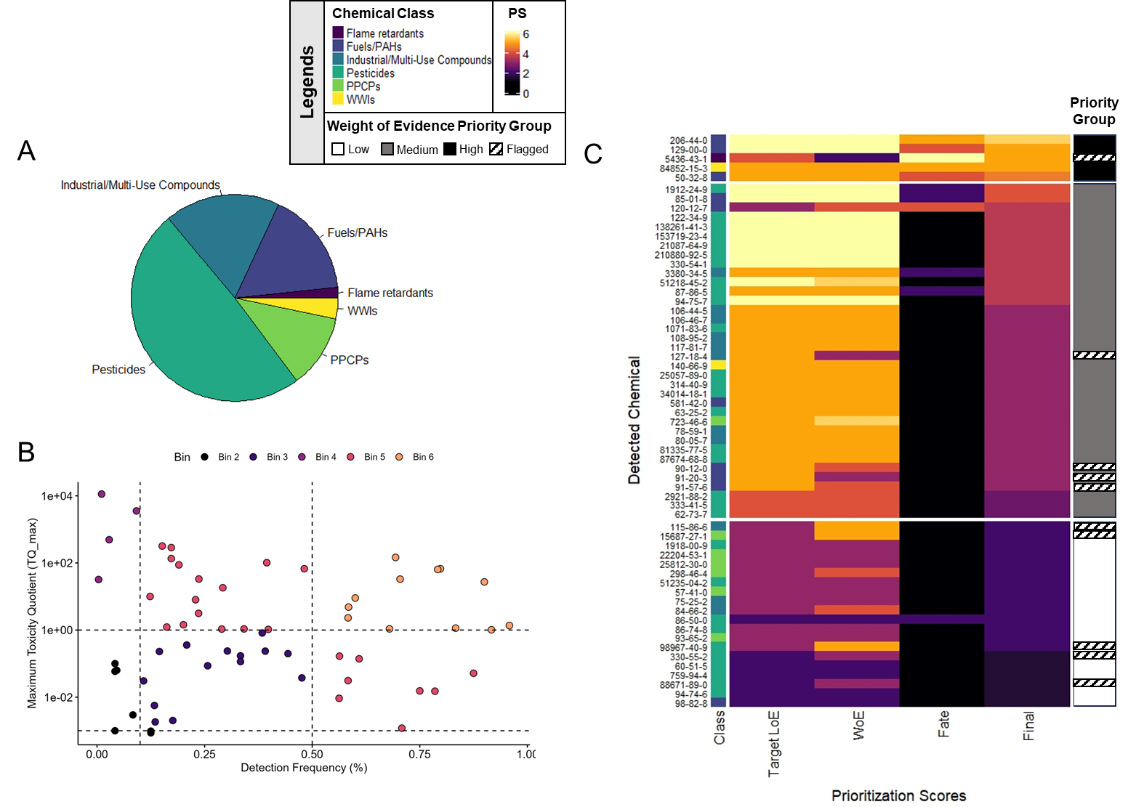
SI Figure 2 Prioritization of chemicals associated with ‘water quality criteria’ and ‘environmental management or risk assessment’ as an action category, including: (A) chemical class distribution of the 61 compounds identified as data sufficient within the water quality criteria target line of evidence (LoE); (B) assignment of prioritization scores (PS) based on the intersection of detection frequency (%) and maximum toxicity quotients (TQ_max) derived by comparing maximum detect concentrations to water quality criteria; and C) assignment of final priority groups based on the comparison of target LoE, weight-of-evidence (WoE), and environmental fate (fate) PS for each individual chemical.*
* Chemical class and prioritization scores are indicated by colour throughout the figure (as indicated by the upper legend). Detected chemicals are identified by chemical abstract services (CAS) numbers.

SI 1.2 Prioritization of Chemicals with Apical Hazard Concentrations as their Target Line of Evidence (Action Category = Effects-Based Monitoring or Risk Assessment)
Overall, 126 compounds detected in grab/composite samples collected from Great Lakes tributaries were associated with apical hazard concentrations (e.g., apical screening values or Tier 1 ECOTOX hazard concentrations) but were not associated with water quality criteria and were assigned ‘Apical’ hazard concentrations as their target LoE. Most of these compounds were PPCPs (52/126 or 41%). Pesticides or pesticide TPs were the second most dominant chemical class (38/126 or 38%), followed by industrial/multi-use compounds (13/126 or 10%), WWIs (10/126 or 8%) and fire retardants (3/126 or 2 %) (SI Figure 3A).
Stepwise prioritization of these compounds yielded 39 high priority, 43 medium priority, and 44 low priority compounds within this target LoE (SI Figure 3B; SI Table 11). Of these compounds, 4 high priority, 17 medium priority compounds and 9 low priority compounds were flagged due to uncertainties associated with target LoE classifications. Finally, consideration of environmental fate parameters yielded 3 high priority, 43 medium priority, 50 low priority compounds for which environmental risk assessment and/or effects-based monitoring would be appropriate further action(s) to define risk potential (SI Figure 3; SI Table 10). Furthermore, 30 compounds were identified which require further investigation to better discern their ecotoxicological potential (SI Table 11).
High priority compounds included two WWIs (cholesterol, β-sitosterol) and one PPCP (tolytriazole). Medium priority compounds included 2 flame retardants, 2 industrial/multi-use compounds, 19 pesticides or pesticide TPs, 15 PPCPs, and 5 WWIs (SI Table 11). Low priority compounds included one flame retardant, 5 industrial/multi-use compounds, 16 pesticides or pesticide TPs, and 28 PPCPs (SI Table 11). Compounds requiring further investigation to discern ecotoxicological potential included 6 industrial/multi-use compounds, 13 pesticides or pesticide TPs, 8 PPCPs, and 3 WWIs (SI Table 11; SI Figure 3).

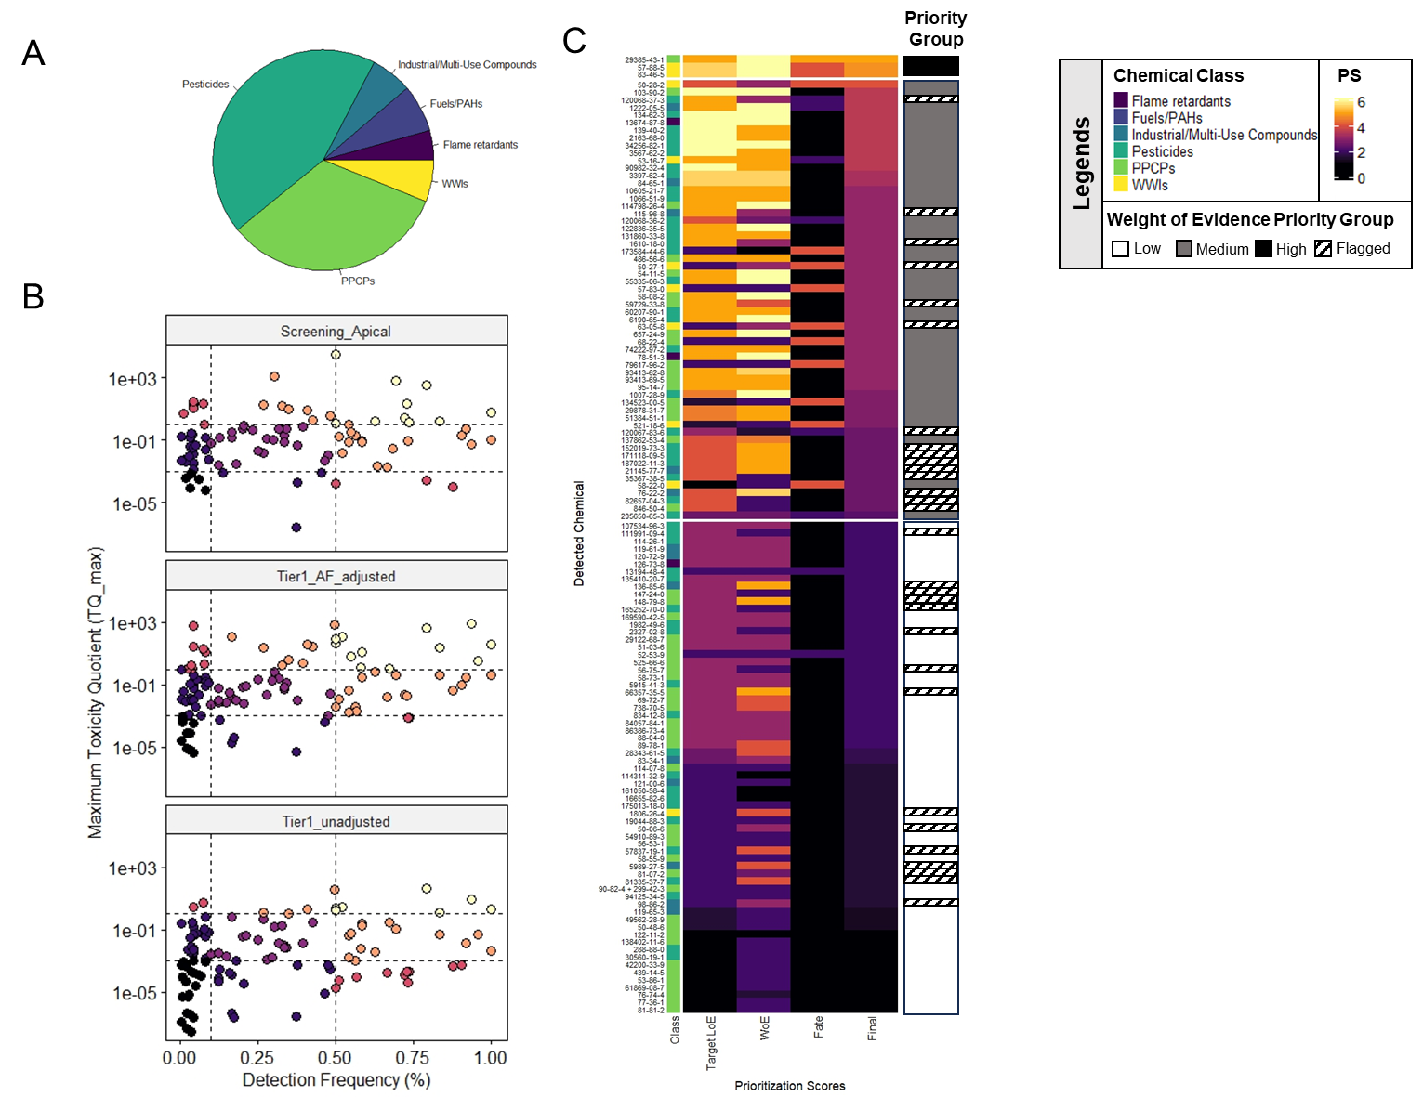
SI Figure 3 Prioritization of chemicals associated with ‘apical’ hazard values and ‘effects-based monitoring or risk assessment’ as an action category including: (A) chemical class distribution of the 124 compounds identified as data sufficient within the apical line of evidence (LoE); (B) assignment of prioritization scores (PS) based on the intersection of detection frequency (%) and toxicity quotients (TQ_max) derived by comparing maximum detect concentrations to apical screening values and application factor (AF)-adjusted and unadjusted tier 1 ECOTOX hazard concentrations; and C) assignment of final priority groups based on the comparison of apical (target) LoE, weight-of-evidence (WoE), and environmental fate (fate) PS for each individual chemical.*
* Chemical class and prioritization scores are indicated by colour throughout the figure (as indicated by the upper legend). Detected chemicals are identified by chemical abstract services (CAS) numbers.

SI 1.3 Prioritization of Chemicals with Non-Apical Hazard Concentrations as their Target Line of Evidence (Action Category = Apical Effects Assessment)
Of the 334 detected compounds in grab/composite samples collected from the Great Lakes Tributaries, 56 were associated with non-apical hazard concentrations (Tier 2 ECOTOX, ToxCast, or Cytotoxic Burst) but not apical or water quality criteria and were assigned ‘Non-Apical’ hazard concentrations as their target LoE. Most of these compounds were PPCPs (46/56 or 82%), with lower amounts of industrial/multi-use (2/56 or 4%), pesticides or pesticide TP (4/56 or 7%) and WWIs (4/56 or 7%) also being present in this group (SI Figure 4).
Stepwise prioritization of these compounds identified 1 high priority, 29 medium priority, and 26 low priority compounds (SI Figure 4; SI Table 11). Altogether, the one high priority classification, 1 medium priority classifications, and 4 low priority classifications were flagged due to uncertainties associated with target LoE classification. Altogether this analysis yielded 14 medium priority, and 22 low priority compounds for which apical effects assessment represents appropriate action to define risk potential (SI Figure 4; SI Table 11). Furthermore, 20 compounds were identified that require further investigation to better understand their ecotoxicological potential.
Medium priority compounds included 12 PPCPs, one pesticide TP, and one WWI (SI Table 11; SI Figure 4). Low priority compounds included 21 PPCPs, and one WWI (SI Table 11; SI Figure 4). Finally, compounds flagged as being associated with uncertainties (and likely requiring further investigation to confirm ecotoxicological potential) included 13 PPCPs, two industrial/multi-use compounds, three pesticides/pesticide TPs, and two wastewater indicators (SI Table 11; SI Figure 4).

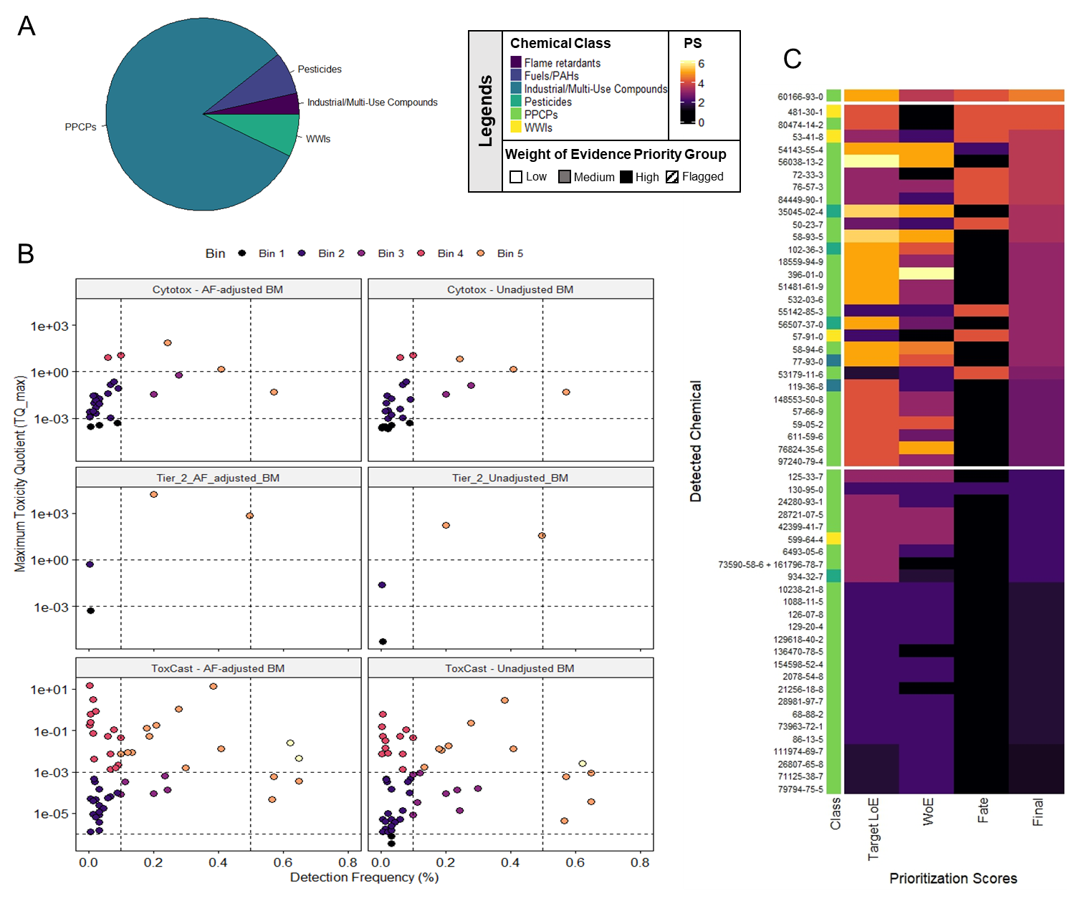
SI Figure 4 Prioritization of chemicals associated with ‘non-apical hazard concentrations’ and ‘apical effects assessment’ as their action category, including: (A) chemical class distribution of the 56 compounds identified as data sufficient within the non-apical LoE; (B) assignment of prioritization scores (PS) based on the intersection of detection frequency (%) and toxicity quotients (TQ_max) derived by comparing maximum detect concentrations to application factor (AF) adjusted and unadjusted Cytotoxic Burst, tier 2 ECOTOX, and ToxCast hazard concentrations; and C) assignment of final priority groups based on the comparison of non-apical (target) LoE, weight-of-evidence (WoE), and environmental fate (fate) PS for each individual chemical.*
* Chemical class and prioritization scores are indicated by colour throughout the figure (as indicated by the upper legend). Detected chemicals are identified by chemical abstract services (CAS) numbers.

SI 1.4 Prioritization of Chemicals with Estimated Hazard Concentrations as their Target Line of Evidence (Action Category = “Non-Apical Effects Assessment”)
Overall, 91 compounds detected in grab/composite water samples were associated with estimated hazard concentrations (e.g., QSAR, Estimated Screening, or Pharmacological) but were data limited in all other benchmark categories, and were assigned ‘estimated’ hazard concentrations as their target LoE. Compounds within this target LoE were primarily PPCPs (56/91 or 62%), however there were also lower amounts of pesticides/pesticide TPs (26/91 or 29%), WWIs (8/91 or 9%), and industrial/multi-use compounds (1/91 or 1%) (SI Figure 5).
Stepwise prioritization identified three high priority, 35 medium priority, and 53 low priority compounds for which non-apical effects assessment would represent an appropriate action for better discerning risk potential (SI Figure 5; SI Table 13). These data were not flagged for uncertainty (i.e., Step 4 in the prioritization framework did not apply) because all these chemicals were data limited in all other benchmark categories. High priority compounds included one PPCP (fexofenadine) and two WWIs (3β-stigmastanol, coprosterol) (SI Figure 5; SI Table 13). Medium priority compounds included 9 pesticides/pesticide TPs, 21 PPCPs, and five WWIs (SI Figure 5; SI Table 12). Finally, low priority compounds included one industrial/multi-use compound, 17 pesticides/pesticide TP, one WWI, and 34 PPCPs.

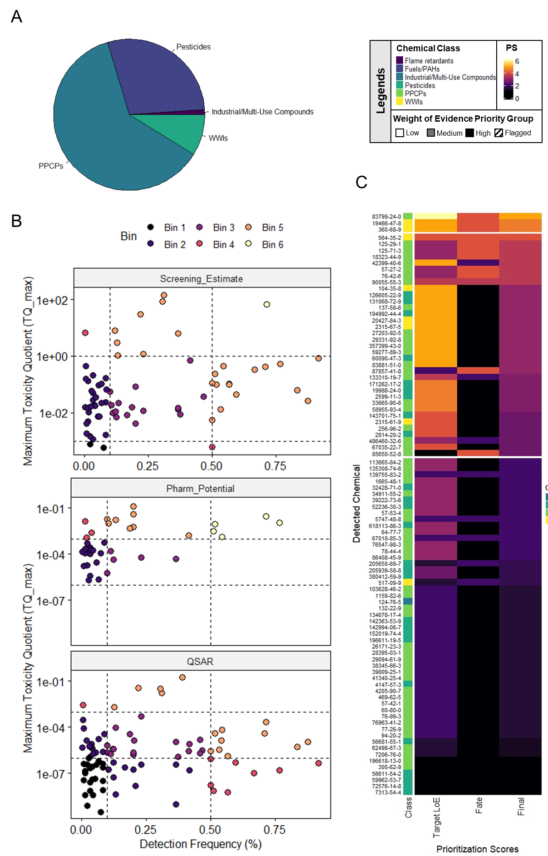
SI Figure 5 Prioritization of chemicals associated with ‘estimated hazard concentrations’ and ‘non-apical effects assessment’ as their action category, including: (A) chemical class distribution of the 91 compounds identified as data sufficient within the apical LoE; (B) assignment of prioritization scores (PS) based on the intersection of detection frequency (%) and toxicity quotients (TQ_max) derived by comparing maximum detect concentrations to estimated screening (Screening_Estimate), pharmacological (Pharms) and quantitative structure-activity relationship (QSAR) hazard concentrations; and C) assignment of final priority groups based on the comparison of apical (target) LoE, and environmental fate (fate) PS for each chemical.*
* Chemical class and prioritization scores are indicated by colour throughout the figure (as indicated by the upper legend). Detected chemicals are identified by chemical abstract services (CAS) numbers.

