Supporting Information

Examining the Effects of Analytical Replication on Data Quality in a Non-Targeted Analysis Experiment

Troy M. Ferland^{1,2}*, Heather D. Whitehead¹, Timothy J. Buckley¹, Alex Chao¹, Jeffrey M. Minucci³, E. Tyler Carr^{1,4}, Greg Janesch^{1,4}, Safia Rizwan^{1,4}, Nathaniel Charest¹, Antony J. Williams¹, James P. McCord^{5*}, Jon R. Sobus*¹

¹United States Environmental Protection Agency, Office of Research and Development, Center for Computational Toxicology and Exposure, 109 TW Alexander Dr., Research Triangle Park, NC 27711, United States

²Oak Ridge Institute for Science and Education (ORISE) Participant, Oak Ridge, TN 37831, USA

³United States Environmental Protection Agency, Office of Research and Development, Center for Public Health and Environmental Assessment, 109 TW Alexander Dr., Research Triangle Park, NC 27711, United States

⁴Oak Ridge Affiliated Universities (ORAU) Student Services Contractor, 109 T.W Alexander Drive, Research Triangle Park, NC 27711, United States

⁵United States Environmental Protection Agency, Office of Research and Development, Center for Environmental Measurement and Modelling, 109 TW Alexander Dr., Research Triangle Park, NC 27711, United States

*Authors to whom correspondence should be addressed:
Troy Ferland (ferland.troy@epa.gov)
James McCord (mccord.james@epa.gov)
Jon Sobus (sobus.jon@epa.gov)

Statistical Modeling of Stratified Feature/Occurrence Categories

Statistical comparison of FDR and FNR across scenarios, PFAS/non-PFAS groups, and abundance quantiles was performed using linear mixed-effects models (SAS 9.4, Proc MIXED). Only data from scenarios four (75% replication) through fourteen (12.5% replication) were used because we observed increased variance and non-linearity at extreme high and low replication levels. The full dataset contained 54,997 FDR and FNR estimates at the feature and occurrence levels, whereas the PFAS-stratified dataset contained 109,994 FDR and FNR estimates (i.e., 54,997 for h=2 PFAS groups), and the abundance-stratified dataset contained 219,988 FDR and FNR estimates (i.e., 54,997 for h=4 quartile groups) (Figure S3).

Eight models in total were generated with significance determined using α=0.05 (we advise caution when interpreting reported p-values due to the re-sampled nature of the dataset):

Model 1: ${Occurrence FDR}_{hij}=β_{0}+β_{1_{h}}\left({PFAS}_{h}\right)+β_{2}\left({Percentage}_{i}\right)+b_{hi}{+ε}_{hij}$
Model 2: $Occurrence {FNR}_{hij}^{'}=β_{0}+β_{1_{h}}\left({PFAS}_{h}\right)+β_{2}\left({Percentage}_{i}\right)+b_{hi}+ε_{hij}$

Model 3: ${Occurrence FDR}_{hij}=β_{0}+β_{1_{h}}\left({Quartile}_{h}\right)+β_{2}\left({Percentage}_{i}\right)+{b_{hi}+ε}_{hij}$
Model 4: $Occurrence {FNR}_{hij}^{'}=β_{0}+β_{1_{h}}\left({Quartile}_{h}\right)+β_{2}\left({Percentage}_{i}\right)+b_{hi}+ε_{hij}$

Model 5: ${Feature FDR}_{hij}=β_{0}+β_{1_{h}}\left({PFAS}_{h}\right)+β_{2}\left({Percentage}_{i}\right)+b_{hi}+ε_{hij}$
Model 6: $Feature {FNR}_{hij}^{'}=β_{0}+β_{1_{h}}\left({PFAS}_{h}\right)+β_{2}\left({Percentage}_{i}\right)+b_{hi}+ε_{hij}$

Model 7: ${Feature FDR}_{hij}=β_{0}+β_{1_{h}}\left({Quartile}_{h}\right)+β_{2}\left({Percentage}_{i}\right)+b_{hi}+ε_{hij}$
Model 8: $Feature {FNR}_{hij}^{'}=β_{0}+β_{1_{h}}\left({Quartile}_{h}\right)+β_{2}\left({Percentage}_{i}\right)+b_{hi}+ε_{hij}$

where:

- ${FDR}_{hij}$ is the FDR from the j^{th} simulation of the i^{th} scenario for the h^{th} feature/occurrence group;
- ${FNR}_{hij}^{'}$ is the Box-Cox transformed FNR from the j^{th} simulation of the i^{th} scenario for the h^{th} group;
- ${PFAS}_{h}$is the PFAS designation for the h^{th} group (PFAS vs. not PFAS);
- ${Quartile}_{h}$is the abundance quartile designation for the h^{th} group (Q1 vs. Q2 vs. Q3 vs. Q4);
- ${Percentage}_{i}$ is the replication percentage for the i^{th} scenario;
- $β_{0}$ is the model intercept;
- $β_{1_{h}}$is the categorical coefficient for the fixed effect of the h^{th} group;
- $β_{2}$ is the linear coefficient for the fixed effect of ${Percentage}_{i}$;
- $b_{hi}$ is the random effect for the i^{th} scenario for the h^{th} group;
- $ε_{hij}$ is the random error for j^{th} simulation of the i^{th} scenario for the h^{th} group.

Box-Cox transformation of FNR values was necessary in models 2, 4, 6, and 8 to meet linearity, normality, and homoscedasticity assumptions. The optimal lambda value for each Box-Cox transformation was determined using the SAS ‘TRANSREG’ procedure (λ=0.5 was chosen for each FNR model). Prior to transformation and modelling, feature-level FNR zero values were imputed using the lowest observed value divided by $\sqrt{2}$. Imputations comprised 2.7% of FNR values used in models 6 and 8. Model suitability was examined using quantile-quantile plots, histograms, and predicted mean vs. residual plots displaying Pearson residuals. Additional models were examined that: (1) included an interaction term for $'PFAS×Percentage^{'}$ (for models 1, 2, 5, and 6) or $'Quartile×Percentage^{'}$ (for models 3, 4, 7 and 8); or (2) allowed unequal group variance (using Satterthwaite approximation). Model fit statistics, including the Bayesian information criterion, indicated that models with only main effects and equal group variance were generally preferable.

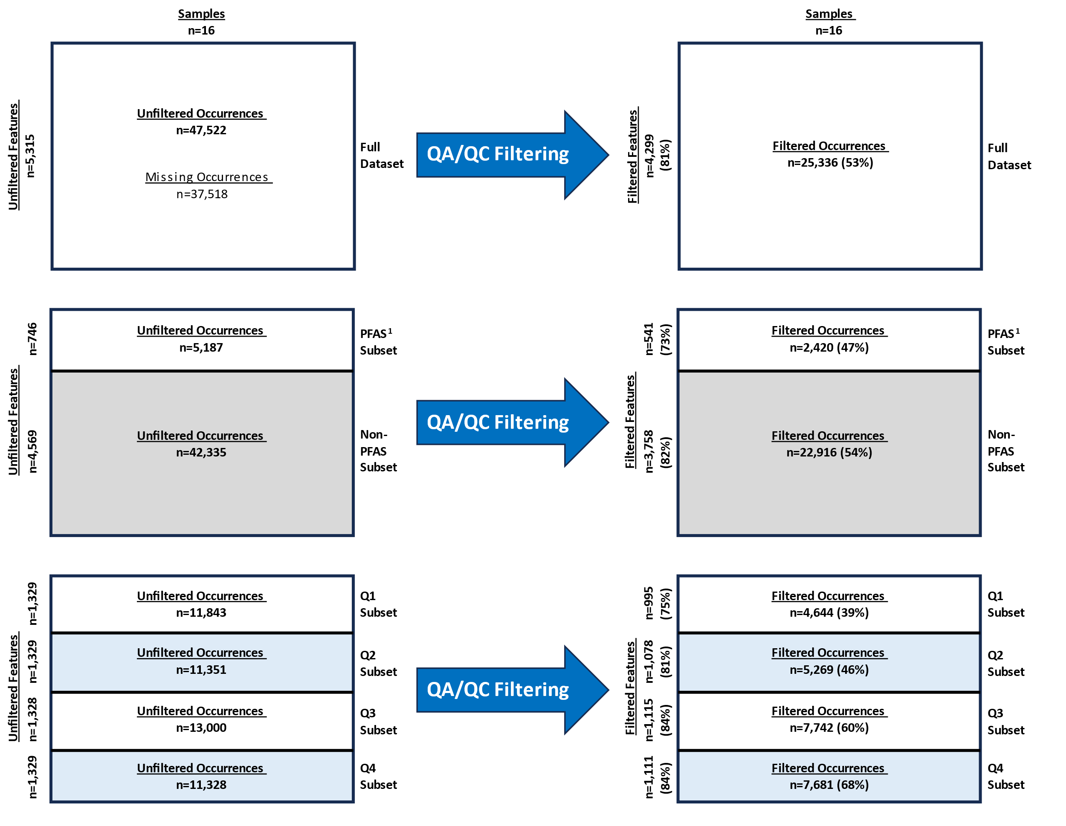

Figure S1. Counts associated with unfiltered features and occurrences, and filtered features and occurrences, based on all data and data stratified according to feature designations. Percentage values given in parentheses represent the percentage of unfiltered values in the input data preserved as filtered values in the output data. ¹The ‘PFAS Subset’ includes features matching in monoisotopic mass to chemicals listed on PFASSTRUCTV5 on the CompTox Chemicals Dashboard (https://comptox.epa.gov/dashboard/chemical-lists/PFASSTRUCTV5).

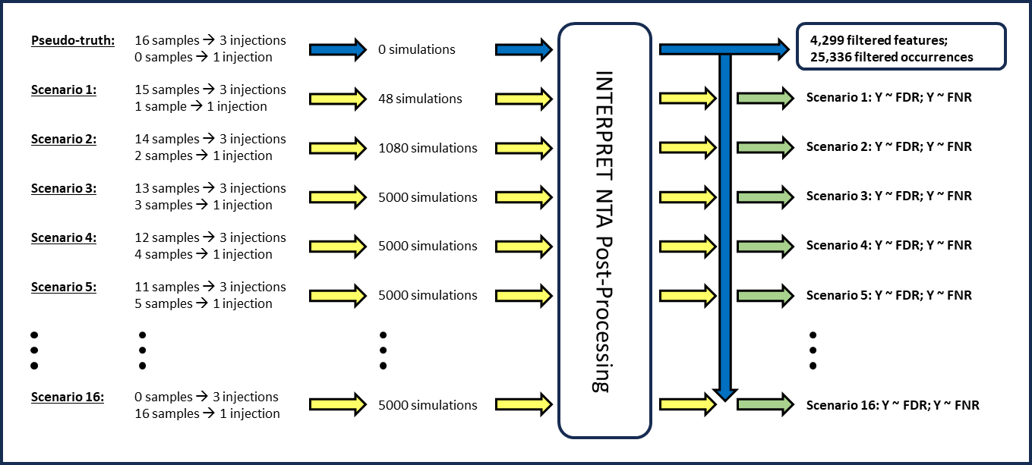

Figure S2. The experimental design for reduced replication analyses. The ‘pseudo-truth’ reflects the results of automated processing of fully replicated analytical data. Scenarios 1-16 represent reduced replication scenarios in which one or more samples were simulated to have been examined without analytical replication. All simulated data were processed through INTERPRET NTA using identical filtering thresholds. Results of all simulations for each scenario were compared to the pseudo-truth to yield distributions (denoted using “Y ~”) of false discovery rates (FDR) and false negative rates (FNRs). These distributions were the basis for downstream modeling efforts with FDR and FNR treated as dependent variables.

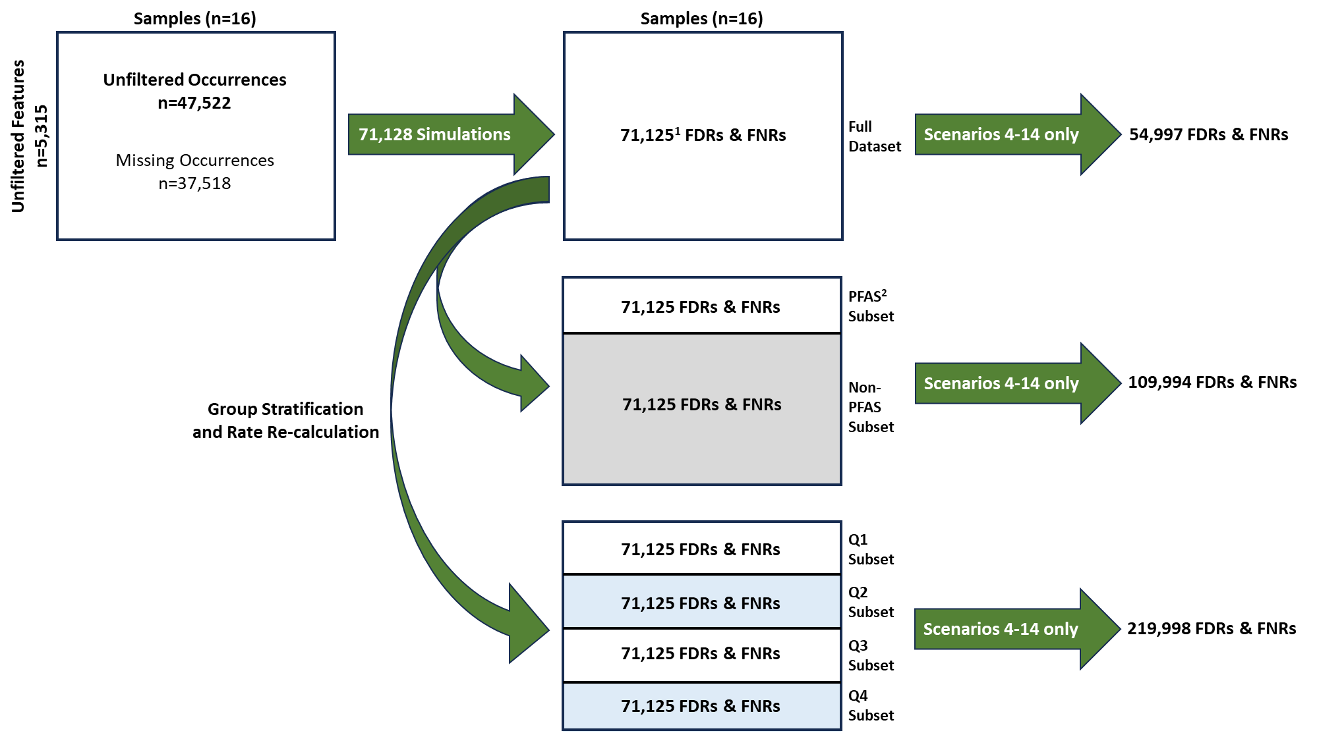

Figure S3. Schematic displaying the sequencing of simulation, feature stratification, and rate calculation (for false discovery rates [FDRs] and false negative rates [FNRs]). Given the experimental design, larger numbers of stratified groups yielded larger numbers of FDR and FNR estimates. ¹For scenarios 6 and 8 (see Figure S2), only 4,998 and 4,999 simulations produced unique results due to duplication from random selection. This ultimately yielded 71,125 discrete FDR and FNR estimates from 71,128 simulations across all sixteen scenarios. ²The ‘PFAS Subset’ includes experimental features matching in monoisotopic mass to chemicals listed on PFASSTRUCTV5.
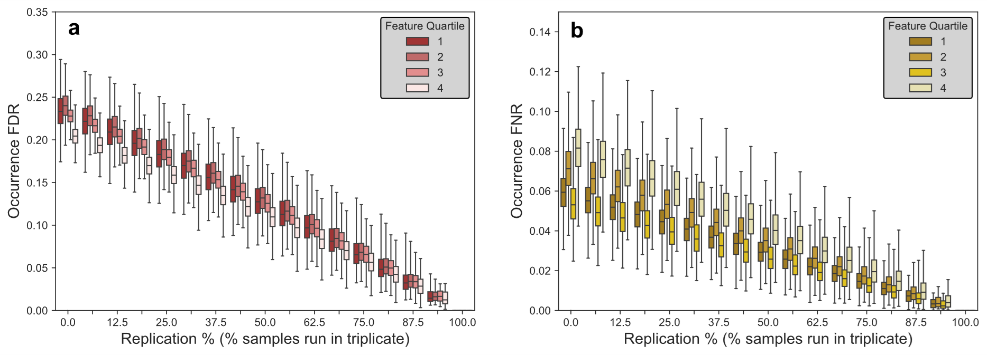

Figure S4. Estimated false discovery rates (a) and false negative rates (b) for occurrences from 71,125 discrete simulations of sixteen reduced replication scenarios. An ‘occurrence’ is the presence of a feature in a study sample. The ‘replication percentage’ (X axis) is the percentage of study samples (n=16) run in triplicate, with a minimum value of 0% and a maximum of 93.75%. Only X-axis values between 12.5% and 75% were used in regression models. Boxes represent the 25th, 50th, and 75th percentile estimates across all simulations. Error bars represent the 0.05th and 99.95th percentile estimates. Groups are defined by feature quartile, where the 1st and 4th quartiles are the 25% highest and lowest abundant features, respectively.

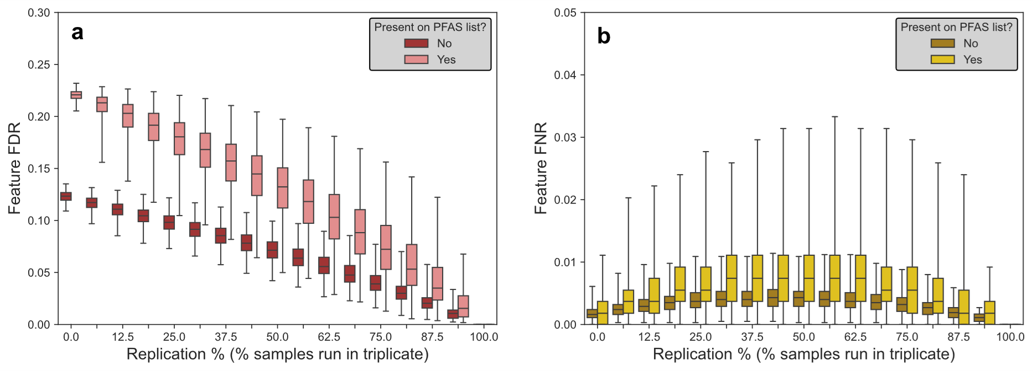

Figure S5. Estimated false discovery rates (a) and false negative rates (b) for features from 71,125 discrete simulations of sixteen reduced replication scenarios. A ‘feature’ is a detected (but not necessarily annotated) analyte in study samples. The ‘replication percentage’ (X axis) is the percentage of study samples (n=16) run in triplicate, with a minimum value of 0% and a maximum of 93.75%. Only X-axis values between 12.5% and 75% were used in regression models. Boxes represent the 25th, 50th, and 75th percentile estimates across all simulations. Error bars represent the 0.05th and 99.95th percentile estimates. Groups are defined by PFAS designation.

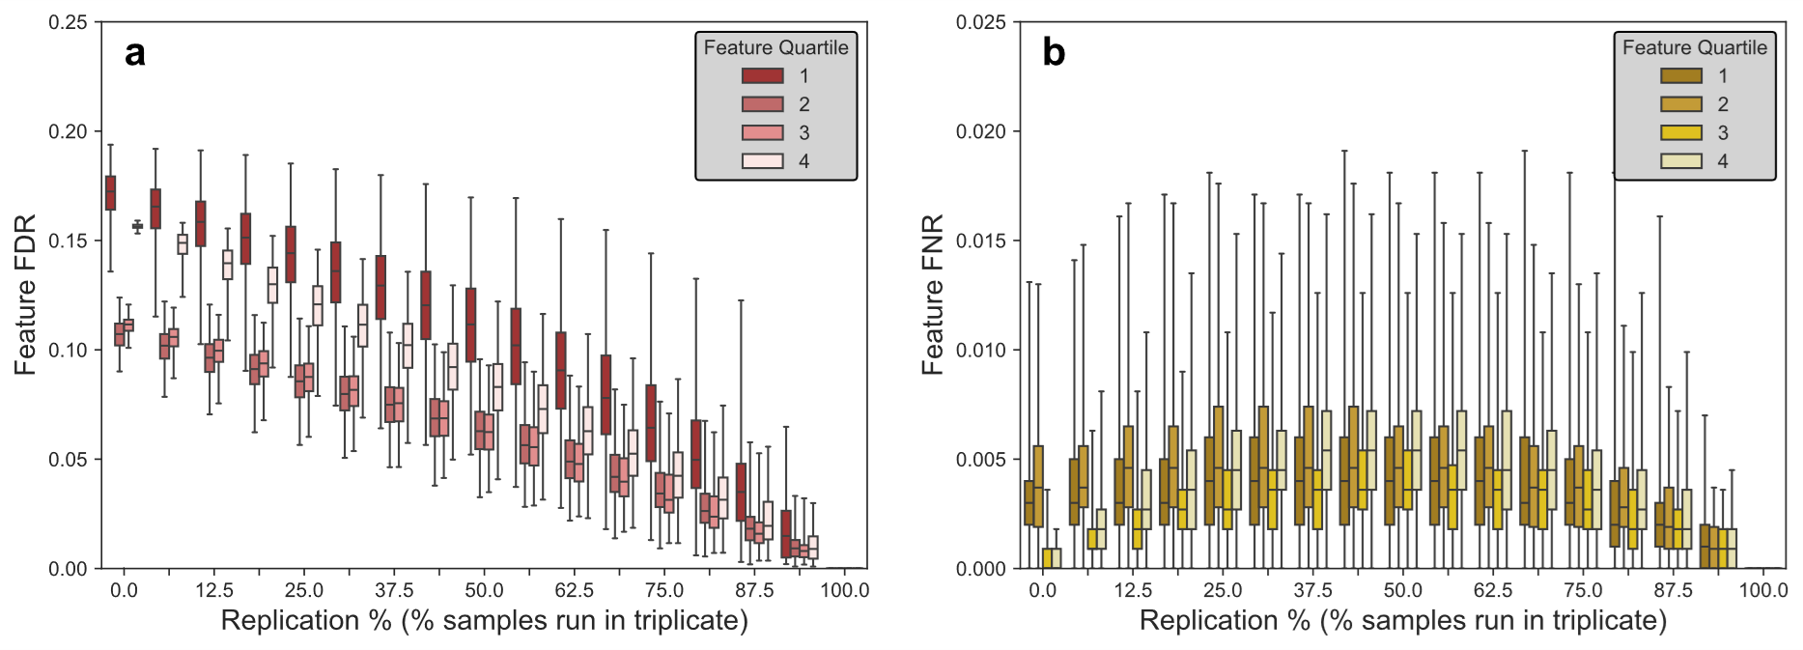

Figure S6. Estimated false discovery rates (a) and false negative rates (b) for features from 71,125 discrete simulations of sixteen reduced replication scenarios. A ‘feature’ is a detected (but not necessarily annotated) analyte in study samples. The ‘replication percentage’ (X axis) is the percentage of study samples (n=16) run in triplicate, with a minimum value of 0% and a maximum of 93.75%. Only X-axis values between 12.5% and 75% were used in regression models. Boxes represent the 25th, 50th, and 75th percentile estimates across all simulations. Error bars represent the 0.05th and 99.95th percentile estimates. Groups are defined by feature quartile, where the 1st and 4th quartiles are the 25% highest and lowest abundant features, respectively.

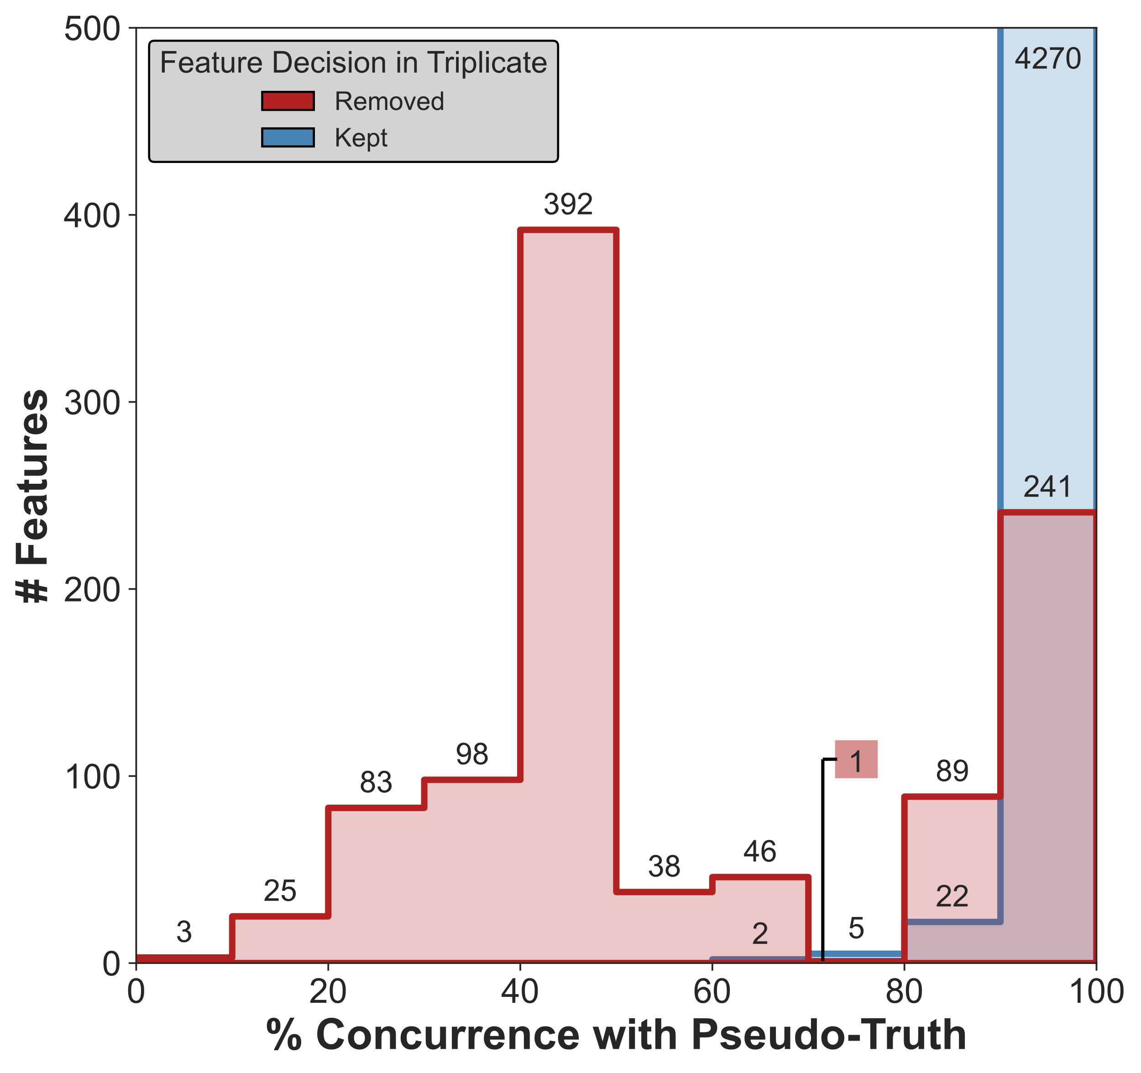

Figure S7. Distributions of features removed (red) and kept (blue) in the full replication analysis based on the level of concurrence in reduced replication scenarios. As an example, there were 4,299 features kept in the full replication analysis, with 4,270 kept in at least 90% of reduced replication simulations (thus yielding ≥ 90% concurrence with the pseudo-truth).

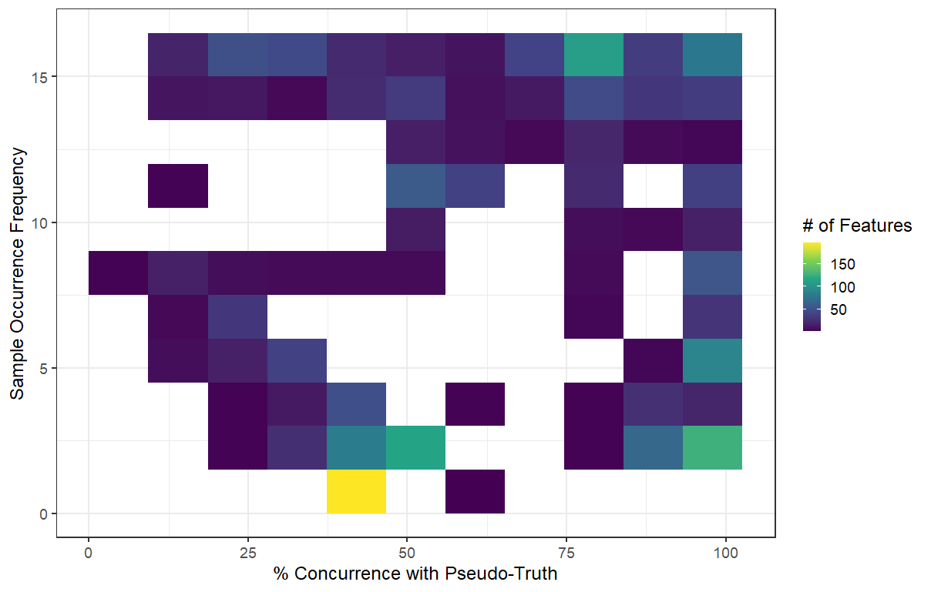
Figure S8. Heatmap of removed features by sample occurrence frequency (n = 1-16) and concurrence with pseudo-truth. The majority of removed features occur in only 1-2 samples (bottom) with a sizeable minority occurring ubiquitously (top right). All features with 100% concurrence with pseudo-truth are removed by MRL filtering alone, independent of replication.

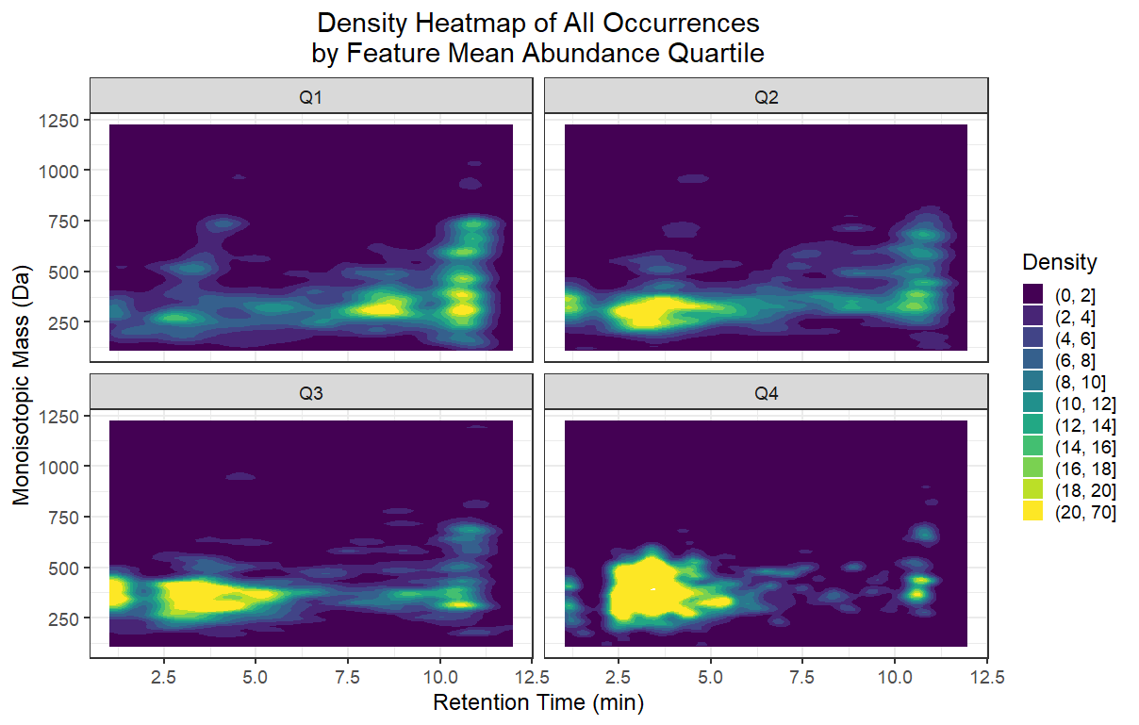

Figure S9. Mass vs. Retention Time plot for all occurrences, stratified by mean feature abundance quartile.

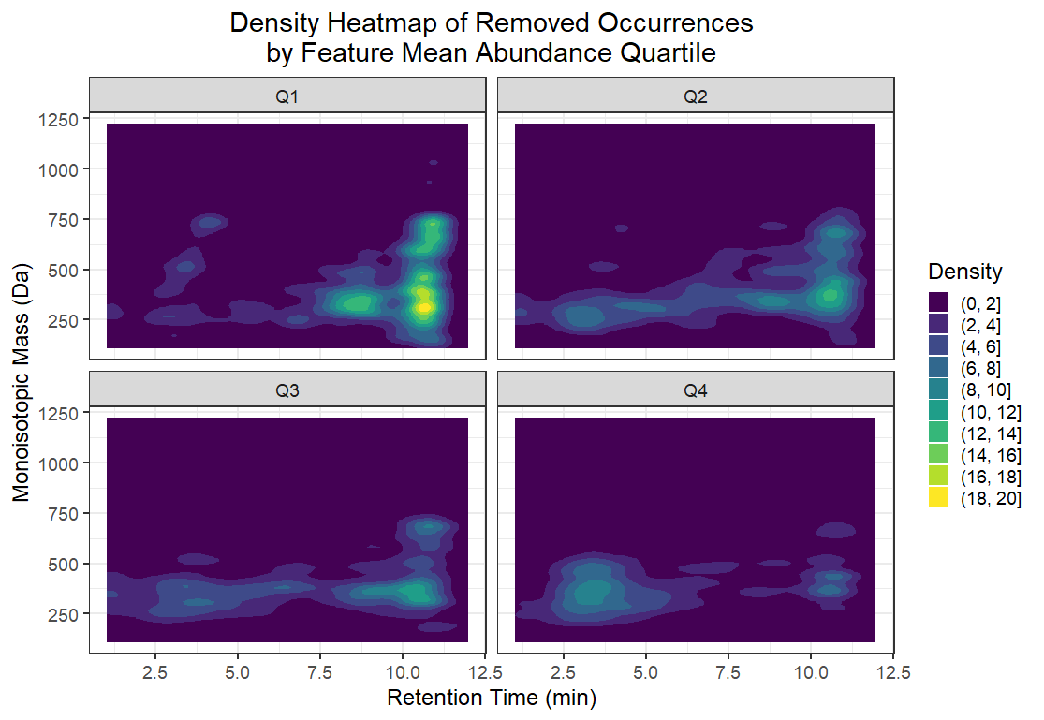
Figure S10. Density heatmap of removed occurrences by feature mean abundance quartile. Removed occurrences from higher abundance features (Q1) are mostly associated with the late gradient wash (RT >10min). Removed occurrences from lower abundance features (Q4) are mostly associated with poorly retained, polar species (RT < 3min).

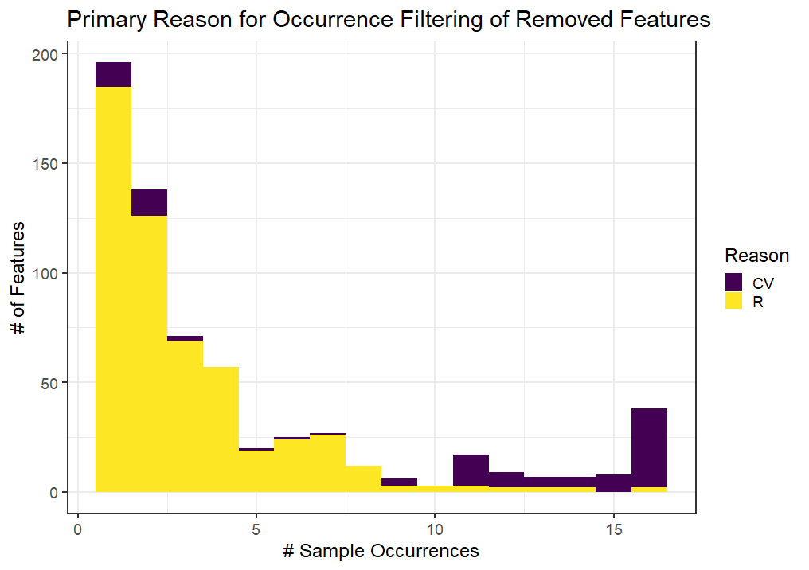

Figure S11. Primary reason for removal of FP features, excluding MRL filtering.

