Supplemental Information
Title: Derivation and Characterization of Environmental Hazard Concentrations for Chemical Prioritization: A Case Study in the Great Lakes Tributaries

Supplemental Methods

Generation of Concentration Detection Map
To highlight site-specific concentration trends, a detection map was constructed using ArcGIS Pro (v. 2.7.3) in WGS 1984 Mercator (auxiliary sphere), with post-formatting performed in Adobe Illustrator (v. 24.0.2). Briefly, chemical concentrations were normalized by dividing site-specific concentrations by the maximum detected concentration for the associated chemical class. For each site, the dominant class was defined as that with the highest normalized cumulative concentration. For example, imagine a hypothetical scenario where ten chemicals were detected at ‘Site A’ and these chemicals consisted of three pharmaceuticals, three pesticides, two sterols, and two PAHs. First, the concentrations of each of these chemicals detected at ‘Site A’ would be ‘normalized’ by dividing them by the maximum concentration detected for each associated chemical class (e.g., maximum individual concentration detected for a ‘pharmaceutical’, a ‘pesticide’, a ‘sterol’, and a ‘PAH/fuel’ across the Great Lakes dataset). This would yield the following concentrations (denoted as = [ ]): [pharmaceutical 1] _{normalized}, [pharmaceutical 2]_{normalized}, [pharmaceutical 3]_{normalized}; [pesticide 1]_{normalized}, [pesticide 2]_{normalized}, [pesticide 3]_{normalized}; [sterol 1]_{normalized}, [sterol 2]_{normalized}; [PAH 1]_{normalized}, [PAH 2]_{normalized}. Subsequently, the normalized concentrations of each chemical would be summed by class to generate a site specific, normalized concentration for each chemical class at Site A. The chemical class with the highest cumulative concentration would subsequently be defined as the ‘dominant chemical class’ at Site A. If multiple chemical classes were identified as dominant at a particular site (e.g., there was an equivalent highest cumulative concentration for multiple chemical classes), detection frequency was incorporated into the comparative analysis. A base map of the Great Lakes Tributaries was developed using published political boundaries (Instituto Nacional de Estadística Geografía e Informática, 2006), a Great Lakes basin boundary derived from the 1:250,000-scale Hydrologic Unit Code dataset, and the 1:2,000,000-scale Canadian Inventory Level I Watersheds database (Department of Agriculture and Agri-Food Canada, 2020; Steeves and Nebert, 1994). Each sampled site was plotted on the baseline map using geographic coordinates (SI Table 1). For each site, the dominant chemical class was depicted by colour. Cumulative concentration of that chemical class at each site was subsequently compared to the maximum cumulative concentration for that class across the dataset, and relative concentration was visualized by point size.

1.2 Ecotoxicological Hazard Concentration Derivation
Using CAS as chemical identifiers, full records of associated ecotoxicology studies were pulled from the ECOTOXicology Knowledgebase. Data were filtered to include only studies deemed relevant for freshwater (aquatic) risk assessment. Effect concentrations flagged as approximate; formulated chemicals; and dietary, in vitro, topical, or multiple source exposure types were excluded. Endpoints related to bioaccumulation (e.g., bioconcentration factors (BCF), bioaccumulation factors (BAF), etc.), time-to-effects (e.g., median lethal/effect time (LT/ET_{xx})), asymptomatic threshold concentrations (ATCN), and unreported (NR) endpoints were excluded from the final dataset. Collated data were subdivided into ‘Tier 1’ and ‘Tier 2’ effect groups based on their relationships to apical adverse outcomes. Tier 1 data included endpoints related to mortality, reproduction, behaviour, intoxication, development, and morphology. Tier 2 data included all other measured endpoints (e.g., genetics, enzymes, histology, biochemistry, hormones, physiology, immunology, cellular responses, injury, ecosystem processes, etc.).
Within each effect group, data were further subdivided into ‘measured’ and ‘nominal’ effect concentrations based on whether analytical determination was carried out in the associated reference study. Preferentially, Tier 1 and Tier 2 effect levels were derived using measured effect concentrations. However, to enhance chemical coverage, nominal effect concentrations were employed for when measured effect concentrations were unavailable. Prior to use in hazard concentration development, data within each group were evaluated for the presence of lower outliers. First, effect concentration distributions were examined for each chemical, and effect values below inner-quartile range were flagged as potential outliers. Subsequently, chemicals with less than five effect concentrations and a 10-fold difference between the first and second minimum values were flagged as potential outliers. All potential outliers were subject to a cursory screening, whereby associated studies were examined to ensure accessibility, quality, statistical/ecotoxicological acceptability, and effect-concentration accuracy. Data derived from inaccessible studies, secondary literature, or studies lacking sufficient methodological description, quality control, or consideration of statistical significance were excluded from the dataset. To ensure final hazard concentrations represented reasonable approximations of ecotoxicological potential, minimum effect concentrations for each chemical were further examined. Effect values associated with formulated products, multi-stressor exposures (e.g., phototoxicity), and/or potential statistical issues (e.g., confidence intervals overlapping 0, effect concentrations extrapolated far outside of the tested range, no observable effect concentrations (NOEC) at the highest tested value, etc.) were removed from the dataset.
Final unadjusted Tier 1 and Tier 2 effect levels represented the minimum effect concentrations within the final ECOTOX datasets (SI Tables 6 and 7). To account for differences across ecotoxicological data, application factor (AF) adjusted benchmarks were also generated using methodology described in Maloney et al. (2023) and Pronschinske et al. (2022). Briefly, data were annotated based on endpoint type, study length, and data richness. Endpoint type was defined based on the endpoint associated with the final unadjusted effect level (no effect = NOECs, no observable effect levels (NOEL), not reported-zero effect concentrations (NR ZERO), and effect/inhibition/lethal concentrations (EC/IC/LC) < 10; low effect = lowest effect concentrations/levels (LOECs/LOELs), maximum acceptable toxicant concentrations (MATCs), and EC/IC/LC values 10 ≤ x < 50; high effect = EC/IC/LC values ≥ 50, and not reported – lethal concentrations (NR-LETH)) and assigned AF ranged from 0 - 5 (Table 1). Study length was defined based on the exposure period (acute ≤ 7 days; chronic > 7 days) and assigned AF ranged from 1 – 5 (Table 1). Data richness was defined based on the number of unique ecotoxicology studies available for key taxonomic groups (fish + amphibians, invertebrates, aquatic plants), and assigned AF ranged from 0 – 5 (Table 1). Final Tier 1 and Tier 2 AF-adjusted effect levels (SI Tables 6 and 7) were derived by dividing the unadjusted effect level by the product of all AF for each individual chemical (c_{i}) (SI Equation 1):
$AF-adjusted ECOTOX effect level Ci= \frac{unadjusted ECOTOX effect level Ci}{{AF}_{endpoint } x {AF}_{length} x {AF}_{richness}}$ (SI 1)

Supplemental Results

2.1 Ecotoxicological Hazard Concentration Exceedance

2.1.1 Water Quality Guidelines
Comparison of concentrations of chemicals detected in grab/composite samples to water quality guidelines yielded 32 compounds with TQ_{max} ≥ 1, 27 compounds with TQ_{max} 10⁻³ ≥ x > 1, and 2 compounds with TQ_{max} < 10⁻³ (SI Figure 1, SI Table 16). Of the 32 compounds that displayed TQ_{max} ≥ 1 there were: 15 pesticides (2,4-D, atrazine, bromacil, carbaryl, chlorpyrifos, clothianidin, diazinon, dichlorvos, diuron, imidacloprid, metolachlor, metribuzin, pentachlorophenol, simazine, thiamethoxam); 8 fuels/polycyclic aromatic hydrocarbons (PAHs) (1-methylnaphthalene, 2,6-dimethylnaphthalene, 2-methylnaphthalene, benzo[a]pyrene, fluoranthene, naphthalene, phenanthrene. pyrene); 1 fire retardant (2,2’,4,4’-tetrabromodiphenyl ether); and 8 industrial/mixed-used chemicals (1,4-dichlorobenzene, 4-(1,1,3,3-tetramethylbutyl)phenol, 4-nonylphenol, bisphenol A, di(2-ethylhexyl)phthalate, phenol, tetrachloroethylene, triclosan). Compounds displaying TQ_{max} 10⁻³ ≥ x > 1 included 13 pesticides, 5 industrial/mixed-use compounds, 2 fuel/PAH, and 7 PPCPs (SI Table 16). The two compounds displaying TQ_{max} < 10⁻³ were pesticides (linuron and myclobutanil).

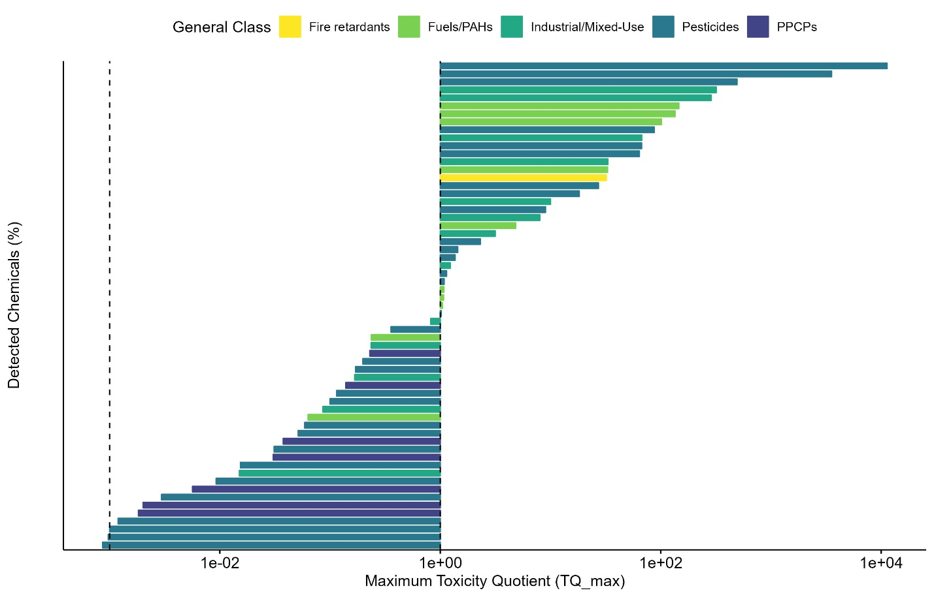
SI Figure 1 Characterization of water quality guideline exceedance for chemicals detected in grab/composite samples collected from across the Great Lakes Tributaries (2009 – 2018). Exceedance is based on maximum toxicity quotients (TQ_max), generated by comparing maximum detect concentrations to water quality guidelines. Chemical class is denoted by colour.

Apical Screening Values
Of the 149 chemicals with available apical screening values, 59 displayed TQ_{max} ≥ 1, 79 displayed 10⁻³ ≤ TQ_{max} < 1, and 13 displayed TQ_{max} < 10⁻³ (SI Figure 2, SI Table 16). Compounds displaying TQ_{max} ≥ 1 included: 4 fire retardants (2,2’,4,4’-tetrabromodiphenyl ether, tributyl phosphate, tris(1,3-dichloro-2-propyl)phosphate, tris(2-butoxyethyl)phosphate, tris(2-chloroethyl)phosphate); 8 fuels/PAHs (1-methylnaphthalene, 2-methylnaphthalene, 2,6-dimethylnaphthalene, anthracene, benzo[a]pyrene, fluoranthene, phenanthrene, pyrene); 11 industrial/mixed-use compounds (1,4-dichlorobenzene, 4-(1,1,3,3-tetramethylbutyl)phenol, 4-nonylphenol, 4-octylphenol, bisphenol A, di(2-ethylhexyl)phthalate, diethyl phthalate, p-cresol, triclosan, triphenyl phosphate, tris(2-chloroethyl) phosphate); 1 pesticide transformation product (TP) (deethylatrazine) , 26 pesticides (2,4-D, acetochlor, atrazine, bifenthrin, bromacil, carbaryl, chlorimuron-ethyl, chlorpyrifos, clothianidin, diazinon, dicamba, dichlorvos, diflubenzuron, dimethenamid, diuron, fipronil, flumetsulam, imazamox, imidacloprid, metolachlor, metribuzin, pentachlorophenol, prometon, propazine, simazine, thiamethoxam); and 9 PPCPs (17β-estradiol, caffeine, carbamazepine, estrone, nicotine, sulfamethoxazole, temazepam, tolytriazole, venlafaxine). Substances displaying 10⁻³ ≤ TQ_{max} < 1 included 2 fuels/PAHs, 11 industrial/mixed-use compounds, 3 pesticide TPs, 34 pesticides, and 29 PPCPs (SI Table 16). Substances displaying TQmax < 10⁻³ included 3 pesticide TPs, 3 pesticides, and 7 PPCPs (SI Table 16).
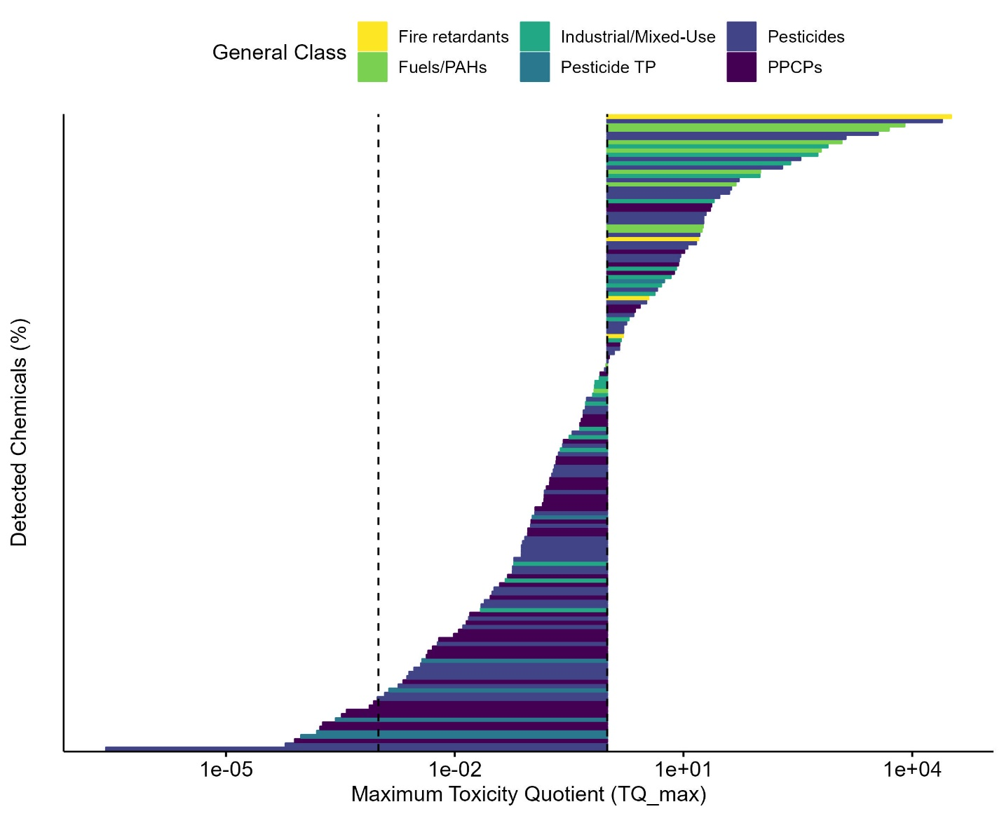
SI Figure 2 Characterization of apical screening value exceedance for chemicals detected in grab/composite samples collected from across the Great Lakes Tributaries (2009 – 2018). Exceedance is based on maximum toxicity quotients (TQ_max), generated by comparing maximum detect concentrations to apical screening values. Chemical class is denoted by colour.

Tier 1 (apical) ECOTOX Effect Levels
Comparison of chemical concentrations to unadjusted tier 1 ECOTOX effect levels yielded 35 compounds with TQ_{max} ≥ 1, 78 compounds with 10⁻³ ≤ TQ_{max} < 1, and 57 compounds with TQ_{max} < 10⁻³ (SI Figure 3A, SI Table 16). Substances with TQ_{max} ≥ 1 included: 1 fire retardant (tris(1,3-dichloro-2-propyl)phosphate); fuels/PAHs (fluoranthene, pyrene); 6 industrial/mixed-use compounds (1,4-dichlorobenzene, bisphenol A, di(2-ethylhexyl)phthalate, phenol, triclosan, triphenyl phosphate); 2 pesticide TPs (2-hydroxyatrazine, N-(3,4-dichlorophenyl)-N’-methylurea); 19 pesticides (2,4-D, acetochlor, atrazine, bifenthrin, carbaryl, chlorimuron-ethyl, chlorpyrifos, clothianidin, DEET, diazinon, dichlorvos, diuron, flumetsulam, glyphosate, imidacloprid, metribuzin, pentachlorophenol, prometon, simazine); and 5 PPCPs (17β-estradiol, citalopram, estrone, methocarbamol, venlafaxine). Compounds displaying 10⁻³ ≤ TQ_{max} < 1 included 2 fire retardants, 8 fuels/PAHs, 12 industrial/mixed-use compounds, 5 pesticide TPs, 31 pesticides, 18 PPCPs, and 2 sterols (SI Table 16). Compounds with TQ_{max} < 10⁻³ included 1 fire retardant, 7 industrial/mixed-use compounds, 4 pesticide TPs, 14 pesticides, and 31 PPCPs (SI Table 16).
Evaluation of chemical concentrations using application factor (AF)-adjusted effect levels yielded slightly different results. Overall, 79 compounds exceeded a TQ_{max} of 1, 79 compounds displayed TQ_{max} of 10⁻³ ≤ x < 1, and 12 compounds displayed TQ_{max} < 10⁻³ (SI Figure 3B, SI Table 16). Chemicals with TQ_{max} ≥ 1 included: 1 fire retardant (tris(1,3-dichloro-2-propyl)phosphate); 7 fuel/PAHs (2,6-dimethylnaphthalene, anthracene, benzo[a]pyrene, fluoranthene, naphthalene, phenanthrene, pyrene); 14 industrial/mixed-use compounds (1,4-dichlorobenzene, 4-(1,1,3,3-tetramethylbutyl)phenol, 4-nonylphenol, acetyl hexamethyl tetrahydronaphthalene, anthraquinone, benzophenone, bisphenol A, cyclopenta[g]-2-benzopyran, 1,3,4,6,7,8-hexahydro-4,6,6,7,8,8-hexamethyl, d-limonene, di(2-ethylhexyl)phthalate, phenol, triclosan); 5 pesticide TPs (2-hydroxyatrazine, 6-chloro-1,3,5-triazine-2,4-diamine, fipronil sulfide, fipronil sulfone, N-(3,4-dichlorophenyl)-N’-methylurea, triphenyl phosphate, tris(2-chloroethyl)phosphate); 6 pesticide TP (2-hydroxyatrazine, 3,4-dichlorophenylurea, 6-chloro-1,3,5-triazine-2,4-diamine, fipronil sulfide, fipronil sulfone, n-(3,4-Dichlorophenyl)-N'-methylurea); 35 pesticides (2,4-D, acetochlor, ametryn, atrazine, azinophos-methyl, azoxystrobin, bifenthrin, bromacil, carbaryl, chlorimuron-ethyl, chlorpyrifos, clothianidin, DEET, diazinon, dichlorvos, diflubenzuron, dimethoate, diuron, fipronil, flumetsulam, glyphosate, imidacloprid, linuron, MCPA, metolachlor, metribuzin, pentachlorophenol, prometon, propazine, simazine, sulfentrazone, sulfometuron-methyl, tebuthiuron, thiamethoxam); 14 PPCPs (17β-estradiol, acetaminophen, carbamazepine, chloramphenicol, citalopram, diphenhydramine hydrochloride, estriol, estrone, gemfibrozil, norethindrone, sulfamethoxazole, temazepam, thiabendazole, venlafaxine); and two sterols (β-sitosterol, cholesterol). Chemicals with TQ_{max} of 10⁻³ ≤ x < 1 included 3 fire retardants, 3 fuels/PAHs, 10 industrial/mixed-use compounds, 4 pesticide TPs, 27 pesticides, and 32 PPCPs (Table 16). Finally, one industrial/mixed-use compound, one pesticide TP, two pesticides, and eight PPCPs displayed TQ_{max} < 10⁻³ (SI Table 16).
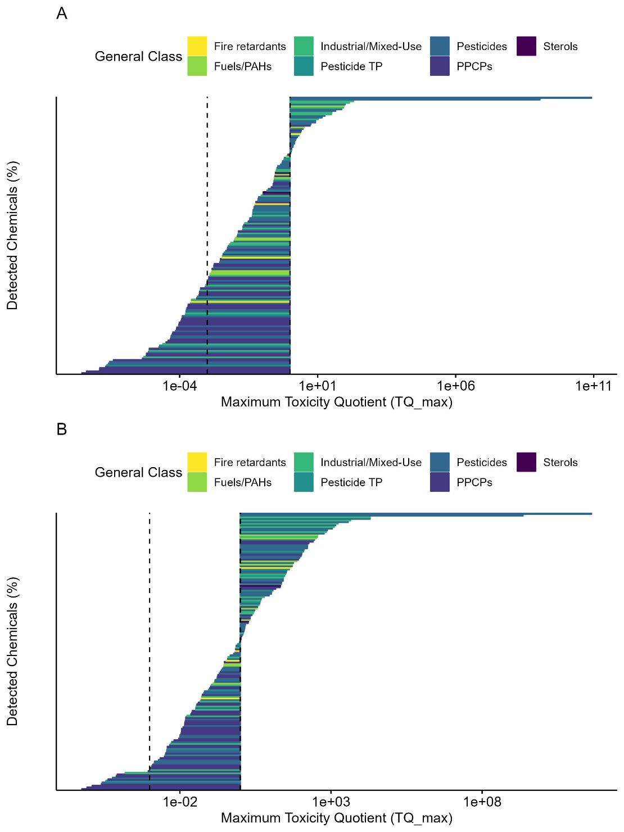
SI Figure 3 Characterization of exceedance of (A) unadjusted and (B) application factor (AF) adjusted tier 1 (apical) ECOTOX effect levels for chemicals detected in grab/composite samples collected from across the Great Lakes Tributaries (2009 – 2018). Exceedance is based on maximum toxicity quotients (TQ_max), generated by comparing maximum detect concentrations to unadjusted or AF-adjusted effect levels. Chemical class is denoted by colour.

Tier 2 (non apical) ECOTOX Effect Levels
Comparison of chemical concentrations to unadjusted tier 2 (non apical) ECOTOX benchmarks yielded 37 compounds with TQ_{max} ≥ 1, 56 compounds with 10⁻³ ≤ TQ_{max} < 1, and 26 compounds with TQ_{max} < 10⁻³ (Figure 4A, SI Table 16). Compounds with TQ_{max} ≥ 1 included 2 fuels/PAHS (benzo(a)pyrene, pyrene), 9 industrial/mixed-use compounds (4-octylphenol, acetyl hexamethyl tetrahydronaphthalene, bisphenol A, cyclopenta[g]-2-benzopyran 1,34,6,7,8-hexahydro-4,6,6,7,8,8-hexamethyl-, di(2-ethylhexyl)phthalate, diethyl phthalate, phenol, triclosan, triphenyl phosphate), two pesticide TPs (3,4-dichlorophenylurea, N-(3,4-dichlorophenyl)-N’-methylurea), 11 pesticides (3,4-dichlorophenylurea, acetochlor, atrazine, carbaryl, chlorpyrifos, DEET, diazinon, diuron, imidacloprid, metribuzin, pentachlorophenol), and 13 PPCPs (acetaminophen, atorvastatin, caffeine, carbamazepine, diltiazem, estrone, ibuprofen, metformin, methocarbamol, ranitidine, sulfamethoxazole, thiabendazole, venlafaxine). Compounds with 10⁻³ ≤ TQ_{max} < 1 included 4 fire retardants, 3 fuels/PAHs, 6 industrial/mixed-use compounds, 3 pesticide TPs, 23 pesticides, and 14 PPCPs (SI Table 16). Compounds with TQ_{max} < 10⁻³ included 1 fuel/PAH, 2 industrial/mixed-use compounds, 16 pesticides, and 7 PPCPs (SI Table 16).
Use of application factors to adjust tier 2 effect levels significantly influenced comparative analyses, yielding 70 compounds with TQ_{max} ≥ 1, 42 compounds with 10⁻³ ≤ TQ_{max} < 1, and 7 compounds with TQ_{max} < 10⁻³ (Figure 4B, SI Table 16). Compounds with TQ_{max} ≥ 1 included: 3 fire retardants (tributyl phosphate, tris(1,3-dichloro-2-propyl)phosphate, tris(2-butoxyethyl)phosphate; four fuels/PAHs (anthracene, benzo(a)pyrene, fluoranthene, pyrene), 14 industrial/mixed-use compounds (1,4-dichlorobenzene, 4-(1,1,3,3-tetramethylbutyl)phenol, 4-nonylphenol, 4-octylphenol, acetyl hexamethyl tetrahydronaphthalene, bisphenol A, cyclopenta[g]-2-benzopyran 1,34,6,7,8-hexahydro-4,6,6,7,8,8-hexamethyl-, di(2-ethylhexyl)phthalate, diethyl phthalate, phenol, tetrachloroethylene, triclosan, triphenyl phosphate, tris(2-chloroethyl)phosphate), 5 pesticide TPs (6-chloro-1,3,5-triazine-2,4-diamine, deethylatrazine, deisopropylatrazine, N-(3,4-dichlorophenylurea), N-(3,4-dichlorophenyl)-N’-methylurea); 21 pesticides (3,4-dichlorophenylurea, acetochlor, ametryn, atrazine, bifenthrin, carbaryl, chlorpyrifos, clothianidin, DEET, diazinon, diuron, hexazinone, imidacloprid, metribuzin, myclobutanil, pentachlorophenol, propiconazole, pyraclostrobin, simazine, thiamethoxam, triclopyr); and 23 PPCPs (verapamil, 17β-estradiol, acetaminophen, atenolol, atorvastatin, caffeine, carbamazepine, celecoxib, chloramphenicol, diltiazem, diphenhydramine hydrochloride, estriol, estrone, fluoxetine, gemfibrozil, ibuprofen, metformin, methocarbamol, metoprolol, ranitidine, sulfamethoxazole, thiabendazole, venlafaxine). Compounds with 10⁻³ ≤ TQ_{max} < 1 included one fire retardant, 2 fuels/PAHs, 3 industrial/mixed-use compounds, 24 pesticides, and 12 PPCPs (SI Table 16). Finally, compounds with TQ_{max} < 10⁻³ included 5 pesticides, and 2 PPCPs (SI Table 16).
SI Figure 4 Characterization of exceedance of (A) unadjusted and (B) application factor (AF) adjusted tier 2 (non apical) ECOTOX effect levels for chemicals detected in grab/composite samples collected from across the Great Lakes Tributaries (2009 – 2018). Exceedance is based on maximum toxicity quotients (TQ_max), generated by comparing maximum detect concentrations to unadjusted or AF-adjusted effect levels. Chemical class is denoted by colour.

ToxCast Bioactivity Concentrations
Comparison of chemical concentrations to unadjusted ToxCast bioactivity concentrations yielded 9 compounds with TQ_{max} ≥ 1, 96 compounds with 10⁻³ ≤ TQ_{max} < 1, and 99 compounds with TQ_{max} < 10⁻³ (SI Figure 5A, SI Table 16). Compounds with TQ_{max} ≥ 1 included one fuel/PAH (phenanthrene), 2 industrial/mixed-use compounds (bisphenol A, triethyl citrate), 2 pesticides (dicamba, prometon), and 4 PPCPs (5α-dihydrotestosterone, caffeine, diethylstilbestrol, norethindrone). Compounds with 10⁻³ ≤ TQ_{max} < 1 included 3 fire retardants, 3 fuels/PAHs, 22 industrial/mixed-use compounds, 3 pesticide TPs, 25 pesticides, and 40 PPCPs (SI Table 16). Compounds with TQ_{max} < 10⁻³ included one fire retardant, 4 fuels/PAHs, 4 industrial/mixed-use compounds, 7 pesticide TPs, 30 pesticides, and 53 PPCPs.
Adjustment of ToxCast bioactivity concentrations with AF yielded slightly different exceedance trends. Overall, 20 compounds had TQ_{max} ≥ 1, 114 had 10⁻³ ≤ TQ_{max} < 1, and 70 had TQ_{max} < 10⁻³ (SI Figure 5B, SI Table 16). Compounds with TQ_{max} ≥ 1 included: one fuel/PAH (phenanthrene), 2 industrial/mixed-use compounds (bisphenol A, triethyl citrate), 3 pesticides (2,4-D, dicamba, prometon), and 14 PPCPs (17α-estradiol, 17beta-estradiol, 4-androstene-3,17-dione, 5alpha-dihydrotestosterone, caffeine, diethylstilbestrol, estriol, estrone, famotidine, menthol, norethindrone, raloxifene, testosterone, trimethoprim). Compounds with 10⁻³ ≤ TQ_{max} < 1 included 3 fire retardants, 7 fuels/PAHs, 25 industrial/mixed-use compounds, 7 pesticide TPs, 31 pesticides, and 41 PPCPs (SI Table 16). Compounds with TQ_{max} < 10⁻³ included one fire retardant, one industrial/mixed-use compound, 3 pesticide TPs, 23 pesticides, and 42 PPCPs (SI Table 16).
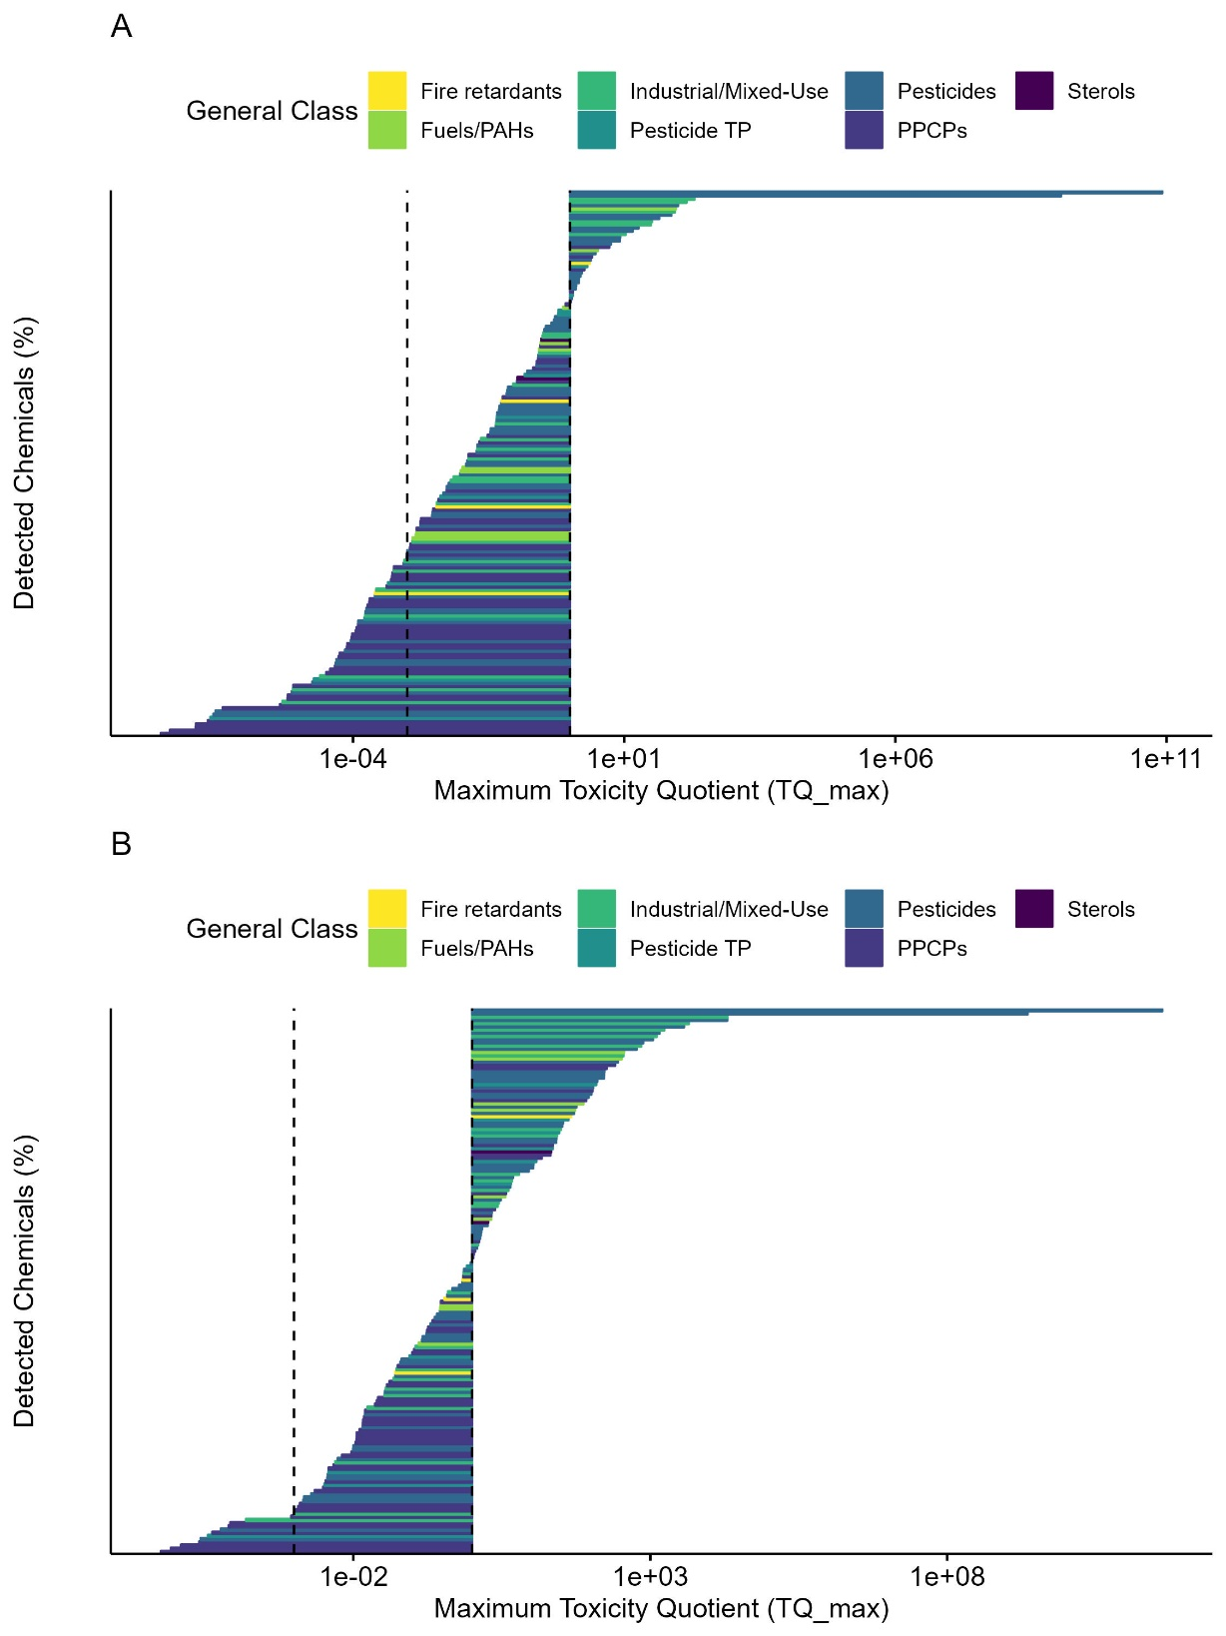
SI Figure 5 Characterization of exceedance of (A) unadjusted and (B) application factor (AF) adjusted ToxCast bioactivity concentrations for chemicals detected in grab/composite samples collected from across the Great Lakes Tributaries (2009 – 2018). Exceedance is based on maximum toxicity quotients (TQ_max), generated by comparing maximum detect concentrations to unadjusted or AF-adjusted ToxCast bioactivity concentrations. Chemical class is denoted by colour.

Cytotoxic Burst Concentrations
Of the 100 chemicals with Cytotoxic Burst concentrations, 18 displayed TQ_{max} ≥ 1, 61 displayed 10⁻³ ≤ TQ_{max} < 1, and 22 displayed TQ_{max} < 10⁻³ (SI Figure 6A; SI Table 16). Compounds with TQ_{max} ≥ 1 included: 2 fire retardants (tris(dichloroisopropyl)phosphate, tris(2-butoxyethyl)phosphate); 6 industrial/mixed-use compounds (3,4-dichlorophenyl isocyanate, 5-methyl-1H-benzotriazole, bis(2-ethylhexyl) phthalate, bisphenol A, methyl salicylate, triclosan); 3 pesticides (atrazine, chlorpyrifos, pentachlorophenol); and 7 PPCPs (caffeine, losartan, methotrexate, ranitidine, salicylic acid, tolytriazole, topiramate). Compounds with 10⁻³ ≤ TQ_{max} < 1 included 2 fire retardants, 5 fuels/PAHs, 9 industrial/mixed-use compounds, 17 pesticides, and 28 PPCPs (SI Table 16). Compounds with TQ_{max} < 10⁻³ included 5 pesticides, and 17 PPCPs (SI Table 16).
When AF-adjusted Cytotoxic Burst concentrations were employed, 20 compounds displayed TQ_{max} ≥ 1, 69 displayed 10⁻³ ≤ TQ_{max} < 1, and 12 displayed TQ_{max} < 10⁻³ (SI Figure 6B; SI Table 16). Compounds with TQ_{max} ≥ 1 included: 2 fire retardants (tris(dichloroisopropyl)phosphate tris(2-butoxyethyl)phosphate); one fuel/PAH (cumene); 7 industrial/mixed-use compounds (3,4-dichlorophenyl isocyanate, 5-methyl-1H-benzotriazole, bis(2-ethylhexyl) phthalate, bisphenol A, isophorone, methyl salicylate, triclosan); 3 pesticides (atrazine, chlorpyrifos, pentachlorophenol); and 7 PPCPs (caffeine, losartan, methotrexate, ranitidine, salicylic acid, tolytriazole, topiramate). Compounds with 10⁻³ ≤ TQ_{max} < 1 included 2 fire retardants, 4 fuels/PAHs, 8 industrial/mixed-use compounds, 17 pesticides, and 38 PPCPs (SI Table 16). Compounds with TQ_{max} < 10⁻³ included 5 pesticides, and 7 PPCPs (SI Table 16).
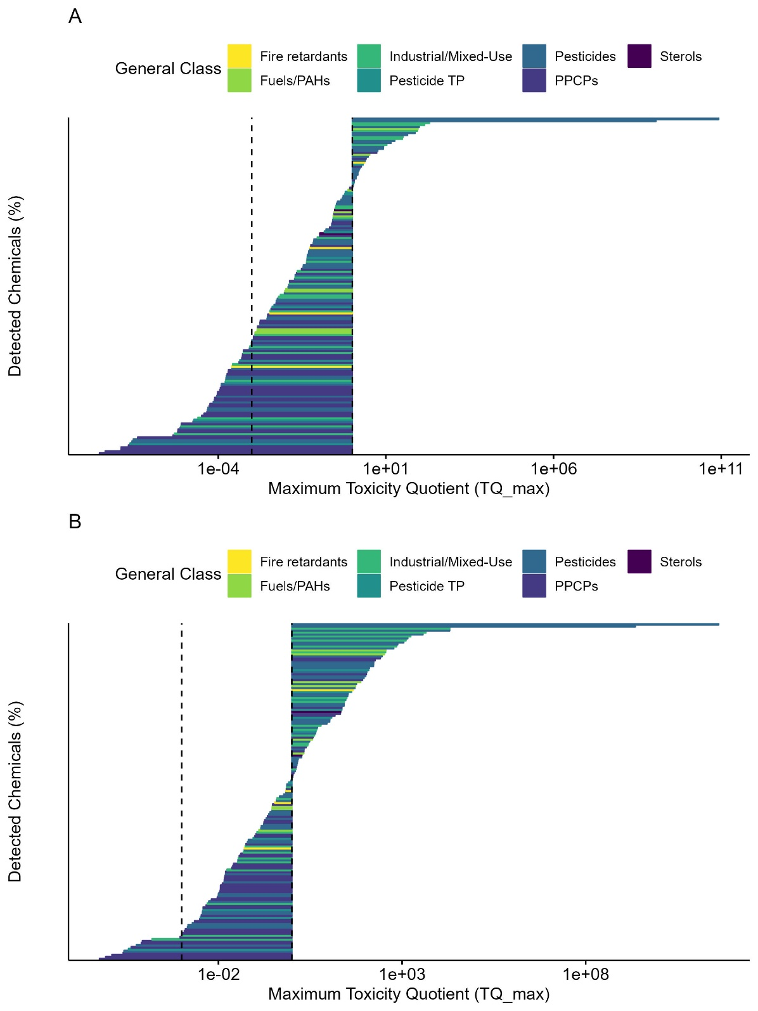
SI Figure 6 Characterization of exceedance of (A) unadjusted and (B) application factor (AF) adjusted Cytotoxic Burst concentrations for chemicals detected in grab/composite samples collected from across the Great Lakes Tributaries (2009 – 2018). Exceedance is based on maximum toxicity quotients (TQ_max), generated by comparing maximum detect concentrations to unadjusted or AF-adjusted Cytotoxic Burst concentrations. Chemical class is denoted by colour.

Estimated Screening Values
Comparison of chemical concentrations to estimated screening values yielded 41 compounds with TQ_{max} ≥ 1, 165 compounds with 10⁻³ ≤ TQ_{max} < 1, and 9 compounds with TQ_{max} < 10⁻³ (SI Figure 7, SI Table 16). Compounds with TQ_{max} ≥ 1included: 1 fire retardant (tris(2-butoxyethyl)phosphate); 4 fuels/PAHs (2,6-dimethylnaphthalene, benzo[a]pyrene, fluoranthene, phenanthrene); 12 industrial/mixed-use compounds (2-(4-nonylphenoxy)ethanol, 2-[2-(4-nonylphenoxy)ethoxy]ethanol, 2-[4-(2,4,4-trimethyl-2-pentanyl)phenoxy]ethanol, 3,4-dichlorophenyl isocyanate, 4-(1,1,3,3-tetramethylbutyl)phenol, 4-cumylphenol, 4-nonylphenol, bisphenol A, camphor, d-limonene, triethyl citrate, triton X-100.2); 3 pesticide TPs (4-hydroxy-2,5,6-tichloroisophthalonitrile, 6-chloro-1,3,5-triazine-2,4-diamine, deisopropylatrazine); 4 pesticides (3,4-dichlorophenyl isocyanate, chlorpyrifos, diazinon, sulfentrazone); 14 PPCPs (11-ketotestosterone, atorvastatin, celecoxib, dimethyl 2,6-dimethyl-4-(2-nitrophenyl)-3,5-pyridinedicarboxylate, famotidine, fexofenadine, griseofulvin, ibuprofen, iminostilbene, iopamidol, lamotrigine 2-N-glucuronide, methotrexate, sucralose, triamterene), and 3 sterols (3-β-stigmastanol, β-sitosterol, cholesterol). Chemicals with 10⁻³ ≤ TQ_{max} < 1 included 6 fuels/PAHs, 15 industrial/mixed-use compounds, 23 pesticide TPs, 14 pesticides, and 107 PPCPs (SI Table 16). Compounds with TQ_{max} < 10⁻³ consisted of one pesticide TP, and 8 PPCPs (SI Table 16).
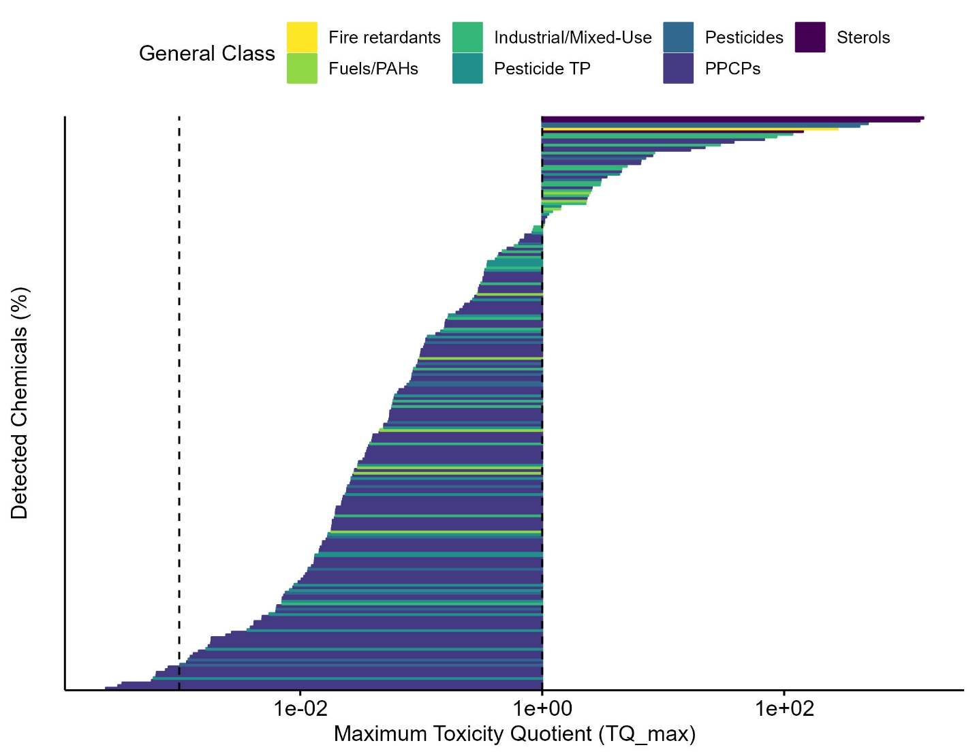
SI Figure 7 Characterization of exceedance of estimated screening values for chemicals detected in grab/composite samples collected from across the Great Lakes Tributaries (2009 – 2018). Exceedance is based on maximum toxicity quotients (TQ_max), generated by comparing maximum detect concentrations to estimated screening values. Chemical class is denoted by colour.

Pharmacological Effect levels
Of the 128 PPCPs with available pharmacological effect levels, one (an antidepressant; desvenlafaxine) displayed TQ_{max} ≥ 1, 51 displayed 10⁻³ ≤ TQ_{max} < 1, and 77 displayed TQ_{max} < 10⁻³ (SI Figure 8, SI Table 16). The PPCPs with TQ_{max} < 1 included a range of different pharmaceuticals including (but not limited to) antivirals/antimicrobials, blood pressure medications, opioids, antihistamines, anticonvulsants, antidepressants, and non-steroidal anti-inflammatory drugs (SI Table 16).
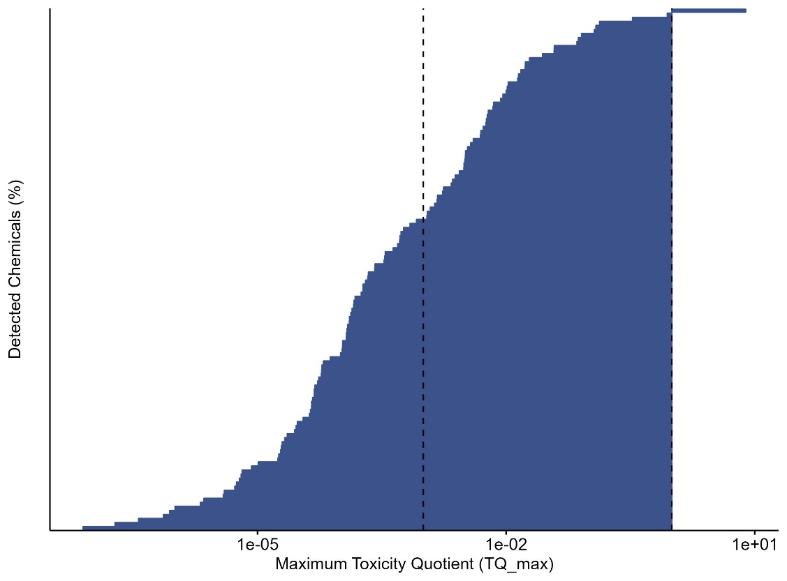
SI Figure 8 Characterization of exceedance of pharmacological effect levels for pharmaceuticals detected in grab/composite samples collected from across the Great Lakes Tributaries (2009 – 2018). Exceedance is based on maximum toxicity quotients (TQ_max), generated by comparing maximum detect concentrations to pharmacological effect levels.

Quantitative Structure-Activity Relationships
Overall, comparison of chemical concentrations to quantitative structure-activity relationship (QSAR) derived estimates yielded 33 compounds with 10⁻³ ≤ TQ_{max} < 1 (SI Figure 9, SI Table 16). Compounds with 10⁻³ ≤ TQ_{max} < 1 included 3 fire retardants, 8 fuels/PAHs, 13 industrial/mixed-use compounds, 3 pesticides, 2 PPCPs, and 4 sterols (SI Table 16). The remaining 301 chemicals detected in grab/composite samples did not exceed TQ_{max} = 10⁻³ (SI Table 16).

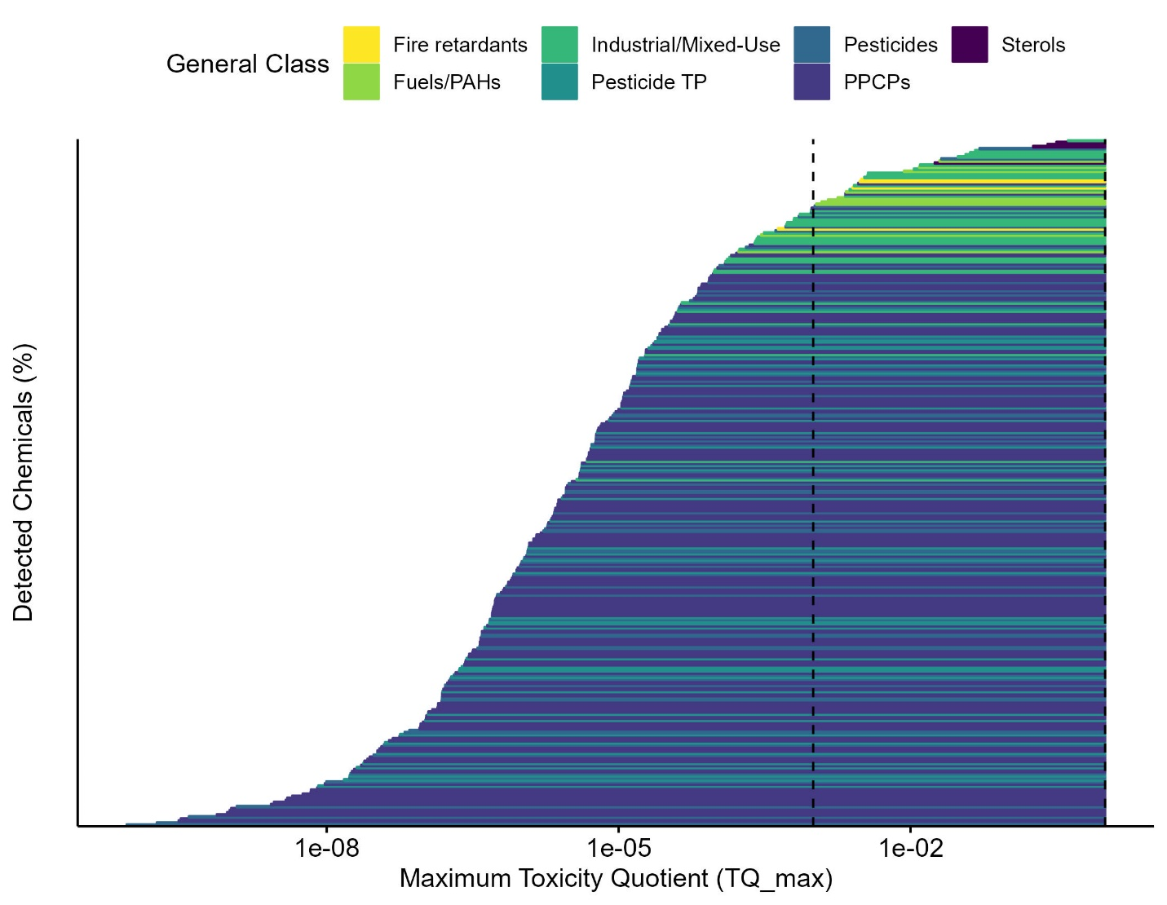
SI Figure 9 Characterization of exceedance of quantitative structure-activity relationship (QSAR) estimates for chemicals detected in grab/composite samples collected from across the Great Lakes Tributaries (2009 – 2018). Exceedance is based on maximum toxicity quotients (TQ_max), generated by comparing maximum detect concentrations to QSAR benchmarks. Chemical class is denoted by colour.

Hazard Concentration Exceedance using Differing (Unfixed) Exceedence Criteria
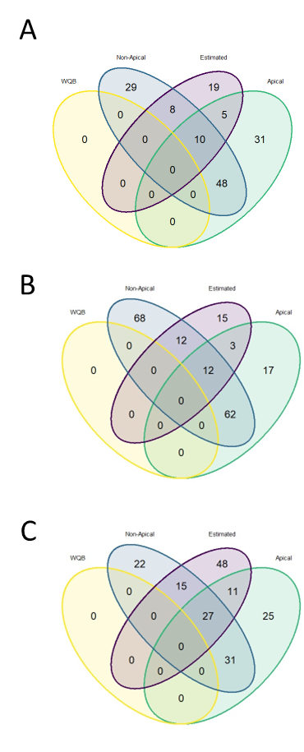

SI Figure 10 Comparison of hazard concentration exceedances amongst water quality guidelines (WQB), apical, estimated, and non-apical effect level groups using (A) a fixed exceedance criteria of a toxicity quotient (TQ) of 1, (B) an exceedence criteria of TQ = 10⁻³ for ToxCast bioactivity concentrations and TQ = 1 for all other ecotoxicological hazard concentrations, and (C) an exceedence criteria of TQ = 10⁻³ for ToxCast, QSAR, and Pharmacological effect levels and TQ = 1 for all other ecotoxicological hazard concentrations. This demonstrates the diverse intersections amongst hazard concentration exceedance for chemicals detected in grab/composite samples collected from the Great Lakes Tributaries.

References for Supplemental Information
Department of Agriculture and Agri-Food Canada, 2020. Canada Land Inventory Level I Watersheds, 1:2,000,000 scale. [WWW Document]. URL http://geogratis.cgdi.gc.ca/
Instituto Nacional de Estadística Geografía e Informática, 2006. The Atlas of Canada, U.S. Geological Survey [WWW Document]. North Am. Atlas - Polit. Boundaries. URL https://nationalmap.gov/small_scale/mld/bound0m.html. %0A
Maloney, E.M., Villeneuve, D.L., Blackwell, B.R., Vitense, K., Corsi, S.R., Pronschinske, M.A., Jensen, K.M., Ankley, G.T., 2023. A framework for prioritizing contaminants in retrospective ecological assessments: Application in the Milwaukee Estuary (Milwaukee, WI). Integr. Environ. Assess. Manag. n/a. https://doi.org/https://doi.org/10.1002/ieam.4725
Pronschinske, M.A., Corsi, S.R., DeCicco, L.A., Furlong, E.T., Ankley, G.T., Blackwell, B.R., Villeneuve, D.L., Lenaker, P.L., Nott, M.A., 2022. Prioritizing Pharmaceutical Contaminants in Great Lakes Tributaries Using Risk-Based Screening Techniques. Environ. Toxicol. Chem. 41, 2221–2239. https://doi.org/https://doi.org/10.1002/etc.5403
Steeves, P., Nebert, D., 1994. 1:250,000-scale Hydrologic Units of the United States. Reston, VA.

