Supplemental Material
Table of Contents
Supplemental Material 1
Supplemental Figures 6
Supplemental References 14

Data Source Descriptions
Consumer Products
The Chemicals and Products Database (CPDat) offers information about how chemicals appear and are used in both consumer and industrial products (Dionisio et al. 2018; Handa et al. 2024). Curated from public documents, these data provide a glimpse, albeit an in-depth one, into the chemical makeup of commercial sources. The data include a wealth of industrial and commercial use information on nearly 35,000 unique chemicals across over 375,000 products derived from over 433,000 documents, providing substantial detail about the possible origin of chemicals in environmental and ecological systems and are made publicly available via the Environmental Protection Agency’s (EPA) interactive ChemExpo web application (https://comptox.epa.gov/chemexpo/).
Industrial and Manufacturing Applications
The EPA’s 2020 Chemical Data Reporting (CDR) database (U.S. Environmental Protection Agency 2020) houses information on chemical use within, and abundance across, various industrial sectors shaped by the volume of production or importation of a chemical rather than hazard or exposure potential. While the reporting threshold for chemicals in this dataset is designated to include chemical production equal to or exceeding 25,000 lbs annually, or 2,500 lbs for chemicals subject to certain Toxic Substances Control Act (TSCA) actions (e.g., a Significant New Use Rule, or SNUR), the information gleaned from this dataset provides a deeper insight into likely chemical origins and/or sources.
Pharmaceuticals
Lists of chemicals used throughout the pharmaceutical industry were derived from the combination of the Food and Drug Administration’s (FDA) Approved Drug Products with Therapeutic Equivalence Evaluations (Orange Book) database (U.S. Food and Drug Administration 2024) and an EPA-curated list of chemicals contained in the Drugbank database (maintained by the University of Alberta), obtained via EPA’s CompTox Chemicals Dashboard (U.S. Environmental Protection Agency 2022) (hereafter referred to as “the Dashboard”, see https://comptox.epa.gov/dashboard/) (Williams et al. 2017). As refined categories were not available in these source data, the relevant, aggregated chemicals were labelled as originating from a broad “Pharmaceutical” source to represent general use within the pharmaceutical sector.
Food Additives and Contact Items
Curated lists of chemicals in food and food contact materials from the U.S. Food and Drug Administration’s Substances Added to Food (U.S. Food and Drug Administration 2022b) and Inventory of Food Contact Substances (U.S. Food and Drug Administration 2022a) databases were obtained from the Dashboard. Chemical associations with relevant Parts of CFR Title 21 (U.S. Code of Federal Regulations 2024) (e.g., “Part 175, Indirect Food Additives and Components of Coatings”) were compiled for inclusion into this analysis to accommodate food handling and distribution processes that contribute to chemical dispersal.
Environmental/Ecological Media and Receptors
The EPA’s Multimedia Monitoring Database (MMDB) was also incorporated to include chemicals present within harmonized physiological, ecological, and environmental media categories, such as blood, drinking water, and landfill leachate, among others (Isaacs et al. 2022). MMDB contains 30 unique media categories: colloquially referred to here as “sinks” as they represent probable collection points of chemicals in circulation and encompass most chemical monitoring efforts, the full list of which can be found in Supplemental Table S1.
Breakdown Processes
The final dataset used to assemble the co-occurrence information contained relationships between parent compounds and their breakdown products. This dataset, the Chemical Transformations Database (CheT) (Edelman-Muñoz et al. 2023), is in development by the EPA and available upon request. Presently, CheT contains nearly 2,100 chemicals and around 2,300 transformations which are associated with data from the EPA’s Chemical Transformation Simulator (CTS) (https://qed.epa.gov/cts/) and the European Food Safety Authority (EFSA). By assuming a directed means of traversal from parent to breakdown product, these relationships were used to infer linkages between source categories where a parent chemical was present and various sinks which contained said parent chemical’s associated breakdown products.
Physicochemical Properties and Use Predictions
All of the media categories discussed above were aggregated to provide the basis for ultimately evaluating the characteristics of interconnected chemical groups (referred to as “communities”) identified by the subsequent network analysis methodologies. Furthermore, the ‘ctxR’ R package (Kruse 2024) was used to connect with EPA’s Computational Toxicology Application Programming Interfaces (API) (U.S. Environmental Protection Agency 2024) to obtain Open (Quantitative) Structure-activity/property Relationship App (OPERA) (Mansouri et al. 2018) predictions of physicochemical properties such as the log10 of octanol-water and octanol-air partition coefficients (logK_{ow} and logK_{oa}), water solubility, vapor pressure, boiling point, and Henry’s law constant. In addition, Quantitative Structure Use Relationship (QSUR) predictions of chemical function (Phillips et al. 2017) (e.g., “solvent,” “flame retardant”) were obtained from the CompTox Exposure APIs (https://www.epa.gov/comptox-tools/computational-toxicology-and-exposure-apis) for use in providing further context to identified communities of chemicals.
Additional Details of the Application of the Quadratic Assignment Procedure
The Quadratic Assignment Procedure (QAP) is a hypothesis testing tool for dyad-wise network variables between a pair of (in)dependent variable matrices (Krackhardt 1987; Krackhardt 1988; Dekker et al. 2003; Dekker et al. 2007). It is an extension of the Mantel test (Mantel 1967) in a regression framework, which leverages Monte Carlo simulations to shuffle one of the matrices a specified number of times to build a distribution with which to compare the initially observed relationship. This approach tests an observed relationship between two matrices against randomized alternatives to determine whether the initial observation might be due to simple random labeling of the matrices (i.e., random chance). Here, QAP is used to assess the significance of all chemical pairs (edges representing co-occurrence) based on their relative presence-in-media profiles (i.e., their shared presence in source and sink categories). Any such profile can be thought of as a single chemical’s “ego-network” of media relationships represented by a binary adjacency matrix of media categories, where a one indicates that the chemical is reported in both categories and a zero designates either the presence in only one category or absence from both (Supplemental Figure S2). Since these adjacency matrices contained dichotomous values indicating shared presence between media categories relative to a single chemical, this analysis necessitated implementation of the generalized form of the QAP models contained in the “netlogit” function of the “sna” R package (Butts 2008). Classical asymptotics for the null hypothesis (Krackhardt 1987) were designated and the number of randomization trials per model was set to 1,000 for robustness (two-fold more than the default settings). The outputs from these models are t-statistics pertaining to every chemical pair which denote the significance and strength of the relationships. t-statistics between 2 and -2 are deemed insignificant and can extend positively or negatively with no upper or lower limits. Furthermore, t-statistics within this range of insignificance typically correspond with p-values greater than 0.05 when examining legacy statistical metrics.
Performing a QAP for every chemical-chemical pair in these data captures the strength of association between all chemicals and, additionally, provides justification for the removal of insignificant or relatively weak edges based on the reported t-statistic value, producing a network of significant/strong instances of chemical co-occurrence across source and sink media categories. However, co-occurrence relationships represented by these t-statistics were numerous and exhibited a similar overall network density as the original unipartite, chemical-to-chemical projection despite filtering out edges with either insignificant or negative t-statistics. Since the largest t-statistics illustrate the strongest relationships between chemical pairs, thresholding the network by this metric relative to each chemical presents a means of examining salient patterns of association by removing much of the noise contained in the original network. To address this study’s goal of identifying exposure pathways via community detection algorithms, the number of significant edges to include for each chemical was examined sequentially and concluded when a fully connected component (a network where no isolated nodes or additional disconnected subnetworks are present) could be identified. For the chemical co-occurrence network, including only the two strongest edges (while still filtering out insignificant t-statistics) produced the desired fully connected network.
Furthermore, three additional concerns become apparent when applying QAPs in the above manner: 1) these models are computationally expensive and take a long time to run, depending on model parameters, 2) constructing and storing lists of networks/adjacency matrices in RStudio’s global environment requires a large amount of storage space, and 3) for-loops, which lend themselves to programmatically repeating procedures, are sequential and not optimized for the sheer number of operations necessitated by this analysis. The solution for these concerns was to nest a for-loop solution for our analyses within a “future_mapply” statement from the “future.apply” R package (https://cran.r-project.org/web/packages/future.apply/index.html), where data management, network construction, and QAP modeling could occur within a local environment by referencing the constructed network data from the global via indices denoting which chemical-specific variables to select. Additionally, this function allowed for the parallelization of these QAP runs to leverage more computing power as needed.
Community Detection Algorithm Details
The implementation of the Walktrap algorithm is conducted with the igraph R package’s “cluster_walktrap” function, where the number of steps to take throughout each random walk was determined quantitatively by maximizing modularity (a measure of connections within communities compared to connections between communities) of the membership assignments over a range of steps between the default value of 4 and 200. Thus, the number of steps resulting in the highest modularity is specified so as to yield the ideal community membership partition.
Similar to Walktrap, BIGCLAM does not require a user-specified number of communities for which to solve, although this may be specified by the user. Our analyses made use of the C++ implementation of the Stanford Network Analysis Platform (SNAP) suite and were carried out on a workstation with an Intel® Xeon® processor running at 2.10GHz using 32GB of RAM, running Red Hat Enterprise Linux 7, and leveraging 25 cores, significantly speeding up the processing time for the algorithm. With the ability to estimate the ideal number of communities, this scalable approach generated a list of memberships based on the underlying connectivity of the network. The community membership output of BC was imported into R for further processing and analysis.
Necessary Files for BIGCLAM Implementation
Once the final filtered network was constructed, two output files were needed for subsequent modeling tasks related to SNAP’s C++ BIGCLAM algorithm. The first is a simplified edgelist, with each node entry having an integer ID, in tab delimited format and the second is a list of node IDs, matching Database chemical substance identifiers (DTXSIDs) to the integer indices of the edgelist. Since the chemical co-occurrence network is undirected, the entries contained in the aforementioned edgelist need to be duplicated and flipped so that directions between all node pairs are contained in any direction.

Supplemental Figures
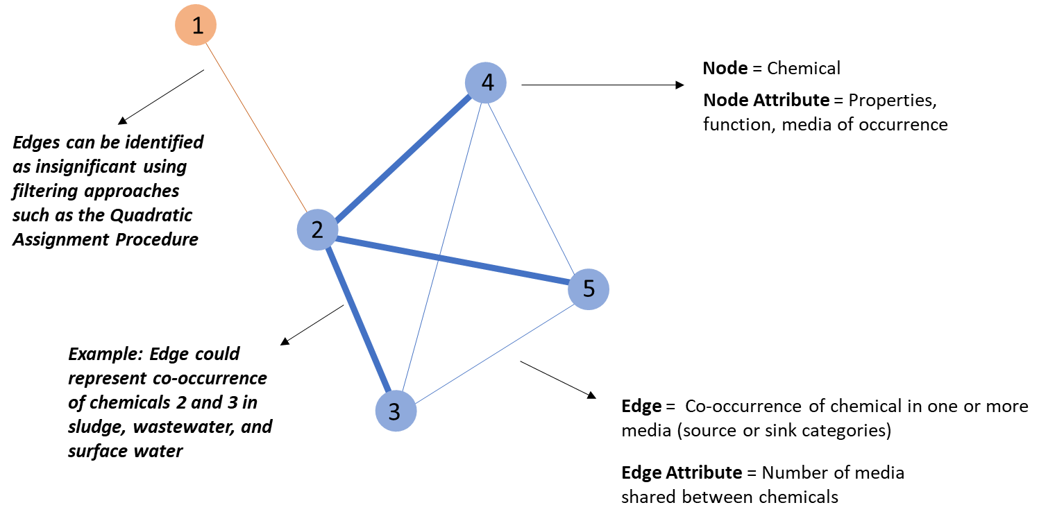
Supplemental Figure S1. Terminology, construction, and interpretation of the co-occurrence network from chemical-media source data.

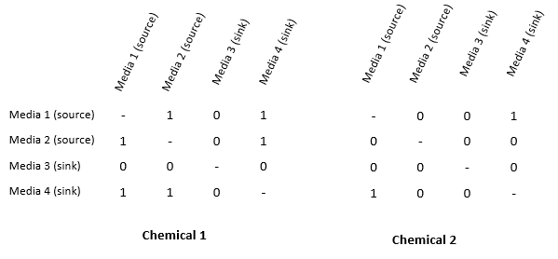
Supplemental Figure S2. Example of adjacency matrices for two hypothetical chemicals and four hypothetical media, based on their media occurrence profiles. These matrices form the basis of the Quadratic Assignment Procedure-based statistical test for a significant relationship between chemicals.

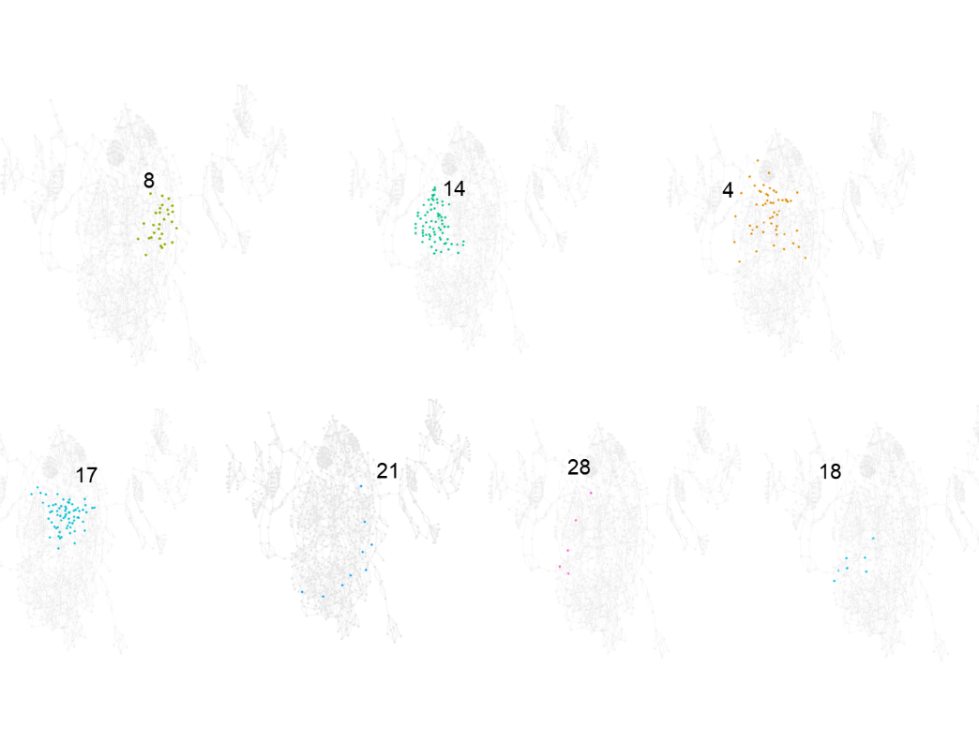
Supplemental Figure S3. Locations of entangled communities identified via the Walktrap algorithm contained in Figure 2.

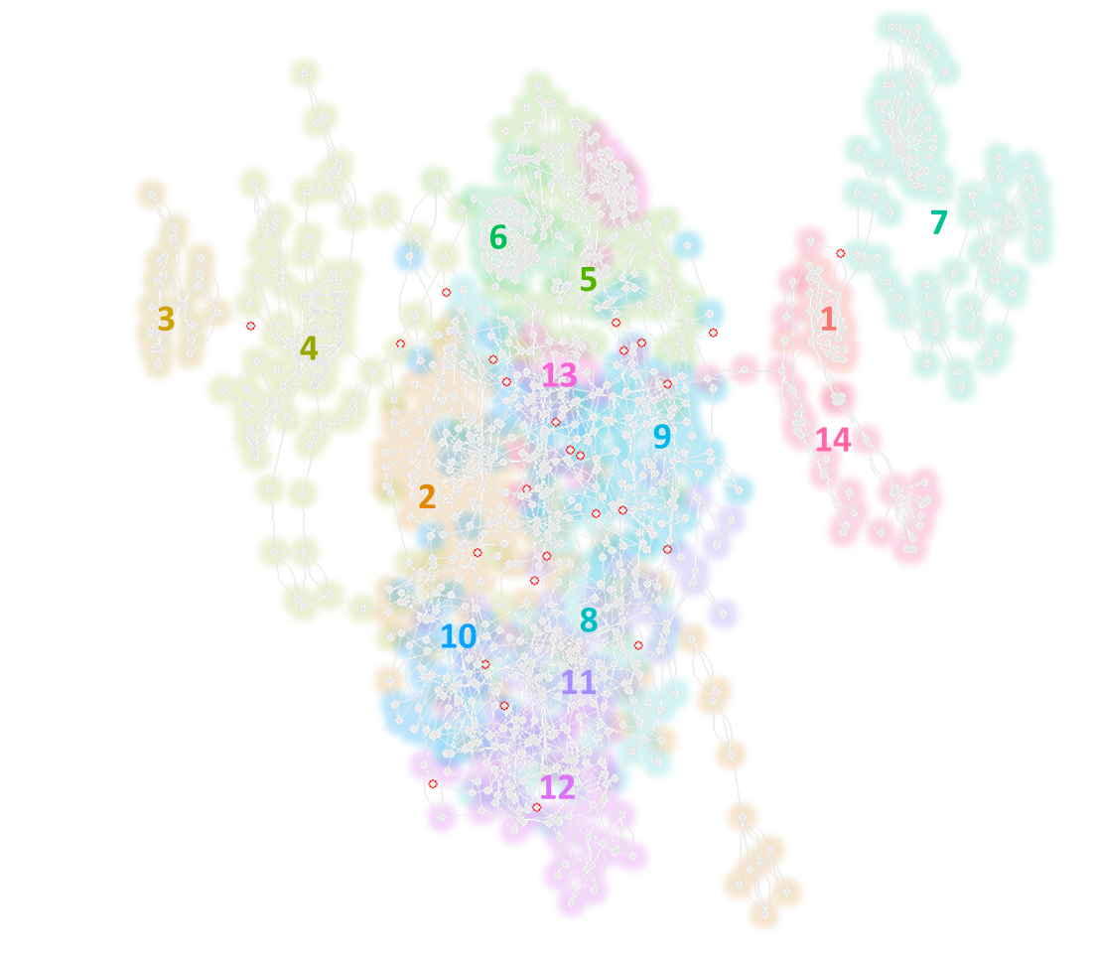
Supplemental Figure S4. Overlapping BIGCLAM communities, overlaid on the same orientation of the network as in Figure 2.

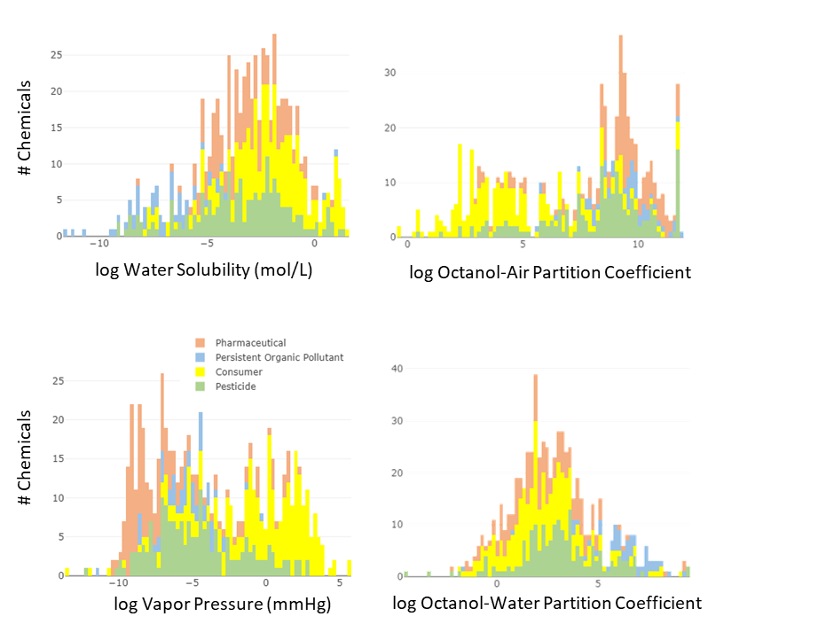
Supplemental Figure S5. Physicochemical properties (OPERA predictions) for chemicals associated with pesticide, consumer, persistent organic pollutant, and pharmaceutical related exposure pathway communities. Histograms are stacked, so the height of each bin reflects the cumulative number of chemicals across groups.

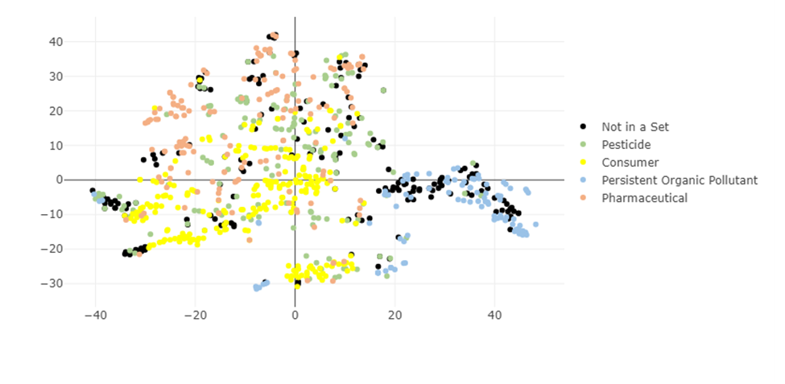
Supplemental Figure S6. Two-dimensional representation of chemicals in communities annotated as pesticide, consumer, persistent organic pollutant, or pharmaceutical related exposure pathways. This figure was generated with ChemSTER using t-distributed stochastic neighbor embedding (t-SNE) of 27 structural descriptors generated by the Mordred cheminformatic application.

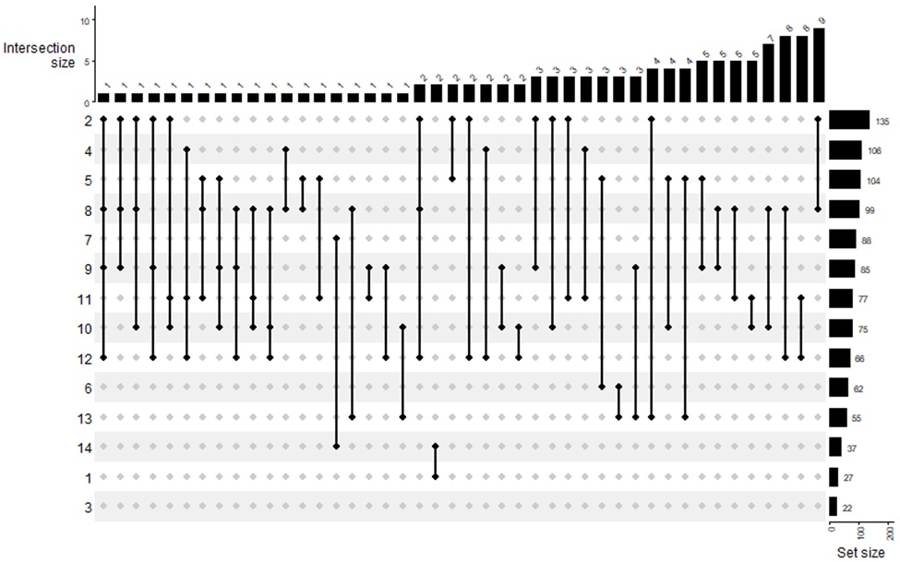
Supplemental Figure S7. Upset plot of the chemical membership of communities identified via the BIGCLAM algorithm. Upset plot showing the degree of overlap between communities. X-axis shows the number of chemicals shared between the pairs of communities depicted by the dots and connecting lines. Y-axis shows the total number of chemicals assigned to each community. The intersection sizes indicate that while overlap does exist, it is usually for a limited number of chemicals. Chemical community membership is described in detail in Supplemental Tables S6-S9).

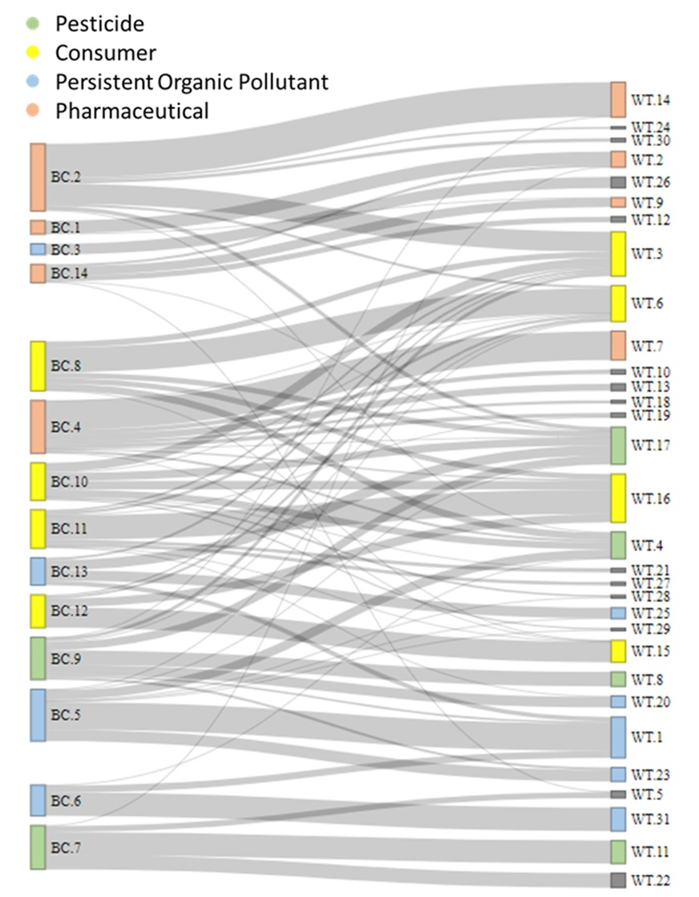
Supplemental Figure S8. Sankey Diagram visualizing shared chemicals between Walktrap and BIGCLAM communities. “BC" represents the 14 communities of BIGCLAM while "WT" refers to the 31 from Walktrap. The size of the community square is proportional to the number of chemicals assigned to each community and the width of the bands between these squares reflects the percentage of chemicals within the related communities (i.e., 100% of chemicals in WT 8 are also found in BC 9). Communities are colored according to the broad pathway categories described in Section 3.2.1-3.2.5.

Supplemental References
Butts, C. T. (2008). “network: A Package for Managing Relational Data in R.” Journal of Statistical Software, 24(2), 1-36. https://doi.org/10.18637/jss.v024.i02.
Dekker, D., Krackhardt, D., & Snijders, T. A. B. (2003). “Mulicollinearity Robust QAP for Multiple Regression.” CASOS Working Paper, Carnegie Mellon University.
Dekker, D., Krackhardt, D., & Snijders, T. A. B. (2003). “Sensitivity of MRQAP Tests to Collinearity and Autocorrelation Conditions.” Psychometrika, 72(4), 563-581.
Dionisio, K. L., Phillips, K., Price, P. S., Grulke, C. M., Williams, A., Biryol, D., Hong, T., & Isaacs, K. K. (2018). “Data Descriptor: The Chemical and Products Database, a resource for exposure-relevant data on chemicals in consumer products.” Scientific Data, 5.
Edelman-Muñoz, A, Stevens, C., Shields, L., Thillainadarajah, I., Meyer, B., Weber, E., Kolanczyk, R., & Williams, A. (2023). “The US-EPA Chemical Transformations Database (CHET): A novel web application for storage, presentation, and comparative analysis of chemical transformations.” SERMACS. Durham, NC.
Handa, S., Isaacs, K., Wall, J., Larger, A., Burns, S., Koval, L., Baron-Furuyama, K., Elonen, C., Lyons, D., Dionisio, K., Horton, B., & Phillips, K. (2024). “CPDat4.0 , an updated database for chemical and product information supporting chemical evaluations.” In review, Nature Scientific Data.
Isaacs, K. K., Wall, J. T., Williams, A. R., Hobbie, K. A., Sobus, J. R., Ulrich, E., Lyons, D., Dionisio, K. L., Williams, A. J., Grulke, C., Foster, C. A., McCoy, J., & Bevington, C. (2022). “A harmonized chemical monitoring database for support of exposure assessments.” Scientific Data, 9, 314.
Krackhardt, D. (1987). “QAP Partialling as a Test of Spuriousness.” Social Networks, 9, 171-186.
Krackhardt, D. (1988). “Predicting With Networks: Nonparametric Multiple Regression Analyses of Dyadic Data.” Social Networks, 10, 359-382.
Kruse, P. (2024). “ctxR: Access the CCTE APIs.” R package version 0.1.0.
Mansouri, K., Grulke, C. M., Judson, R. S., & Williams, A. J. (2018). “OPERA models for predicting physicochemical properties and environmental fate endpoints.” Journal of cheminformatics, 10, 10.
Mantel, N. (1967). "The detection of disease clustering and a generalized regression approach". Cancer Research, 27(2), 209-220. PMID 6018555.
Phillips, K. A., Wambaugh, J. F., Grulke, C. M., Dionisio, K. L., & Isaacs, K. K. (2017). “High-throughput screening of chemicals as functional substitutes using structure-based classification models.” Green Chemistry, 19, 1063-1074.
U.S. Code of Federal Regulations (2024). Tiltle 21. Food and Drugs.
U.S. Environmental Protection Agency (2020). 2020 CDR Data.
U.S. Environmental Protection Agency (2022). CATEGORY|PHARMACEUTICALS: DrugBank database from the University of Alberta.
U.S. Environmental Protection Agency (2024). Computational Toxicology and Exposure APIs.
U.S. Food and Drug Administration (2024). Approved Drug Products with Therapeutic Equivalence Evaluations Orange Book Database.
U.S. Food and Drug Administration (2022a). Inventory of Effective Food Contact Substance (FCS) Notifications.
U.S. Food and Drug Administration (2022b). Substances Added to Food (formerly EAFUS).
Williams, A. J., Grulke, C. M., Edwards, J., McEachran, A. D., Mansouri, K., Baker, N. C., Patlewicz, G., Shah, I., Wambaugh, J. F., Judson, R. S., & Richard, A. M. (2017). “The CompTox Chemistry Dashboard: a community data resource for environmental chemistry.” Journal of Cheminformatics, 9-61.

