Supplementary File 1

Examining Environmental Matrix Effects on Quantitative Non-Targeted Analysis Estimates of Per- and Polyfluoroalkyl Substances (PFAS)

Shirley Pu^{1,2*}, James P. McCord^{3*}, Rebecca A. Dickman⁴, Nickolas A. Sayresmith^{1,2}, Helen Sepman⁵, Anneli Kruve⁵, Diana S. Aga⁴, Jon R. Sobus^{2*}

¹Oak Ridge Institute for Science and Education (ORISE) Participant, 109 T.W Alexander Drive, Research Triangle Park, NC 27711, USA

²U.S Environmental Protection Agency, Office of Research and Development, Center for Computational Toxicology and Exposure, 109 TW Alexander Dr., Research Triangle Park, NC 27711, USA

³U.S Environmental Protection Agency, Office of Research and Development, Center for Environmental Measurement and Modeling, 109 TW Alexander Dr., Research Triangle Park, NC 27711, USA

⁴Department of Chemistry, The University at Buffalo, State University of New York, 359 Natural Sciences Complex, Buffalo, New York 14260, USA

⁵Department of Environmental Science and Analytical Chemistry, Stockholm University, Svante Arrhenius väg 16, 106 91, Stockholm, Sweden

*Authors to whom correspondence should be addressed:

Shirley Pu (pu.shirley@epa.gov); ORCID: 0000-0002-0122-3797
James McCord (mccord.james@epa.gov); ORCID: 0000-0002-1780-4916
Jon Sobus (sobus.jon@epa.gov); ORCID: 0000-0003-0740-6604

- Effect of Reconstitution Method on Recovery

A reconstitution method with high aqueous content (method “1” in Figure S1; 95:5 (v/v) of 5 mM ammonium acetate (aq) and acetonitrile) was initially explored. Poor recovery was observed for PFUdA, NMeFOSAA, PFDoA, NEtFOSAA, FOSA, and PFTeDA at low concentrations using this method (Figure S1). A more nonpolar reconstitution method (method “2” in Figure S1; 25:75 (v/v) of 5 mM ammonium acetate (aq) and methanol) improved calibration curves with better detection at low concentrations, slopes closer to 1, and higher R² values (Figure S2). Reconstitution method 2 was therefore used for all subsequent data analyses and final qNTA evaluations. Interestingly, lower RFs were observed for many compounds in DW when using the more nonpolar reconstitution method, with PFUdA, NMeFOSAA, PFDoA, NEtFOSAA, FOSA, and PFTeDA being the exceptions (Figure S1). At the time of our laboratory experiments, there existed limited literature on the effect of resuspension composition on PFAS recovery. Weed et al. [(1)] have since published results indicating loss of longer-chain PFAS dependent on polarity of the resuspension method. Lower recovery may also be attributed to the lack of internal standard (IS) correction. As discussed by Teymoorian et al. 2023 [(2)], whole-method recovery is improved compared to absolute recovery when IS correction is used.

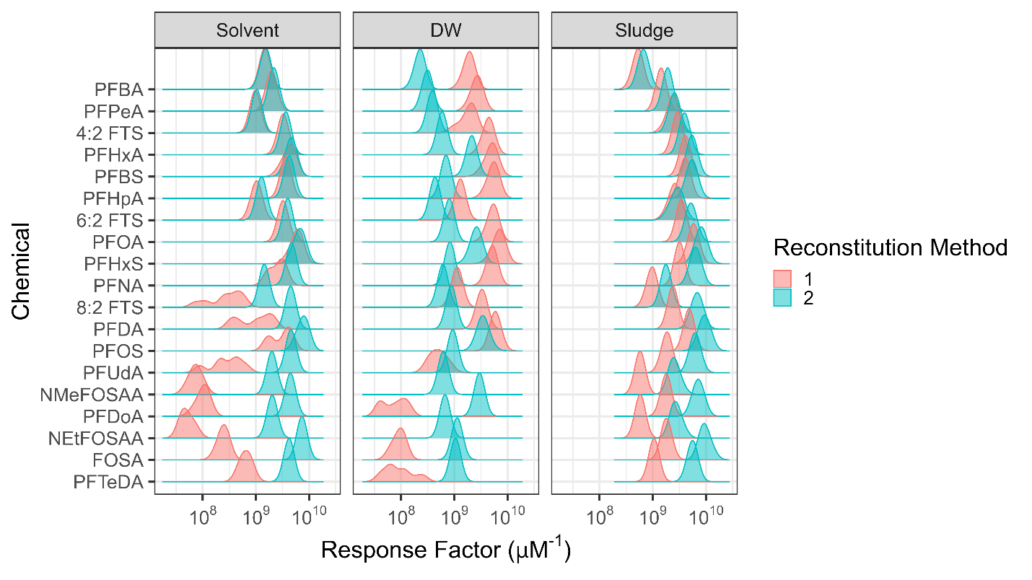

Fig.S1 Response factor distribution comparison between reconstitution method 1 (red) and 2 (blue) for solvent, DW, and sludge samples. Distributions are visualized using a bandwidth of 0.1 for kernel density estimation. NMeFOSAA and NEtFOSAA data were unavailable for method 1 due to not having a minimum of three calibration points for curve fitting.

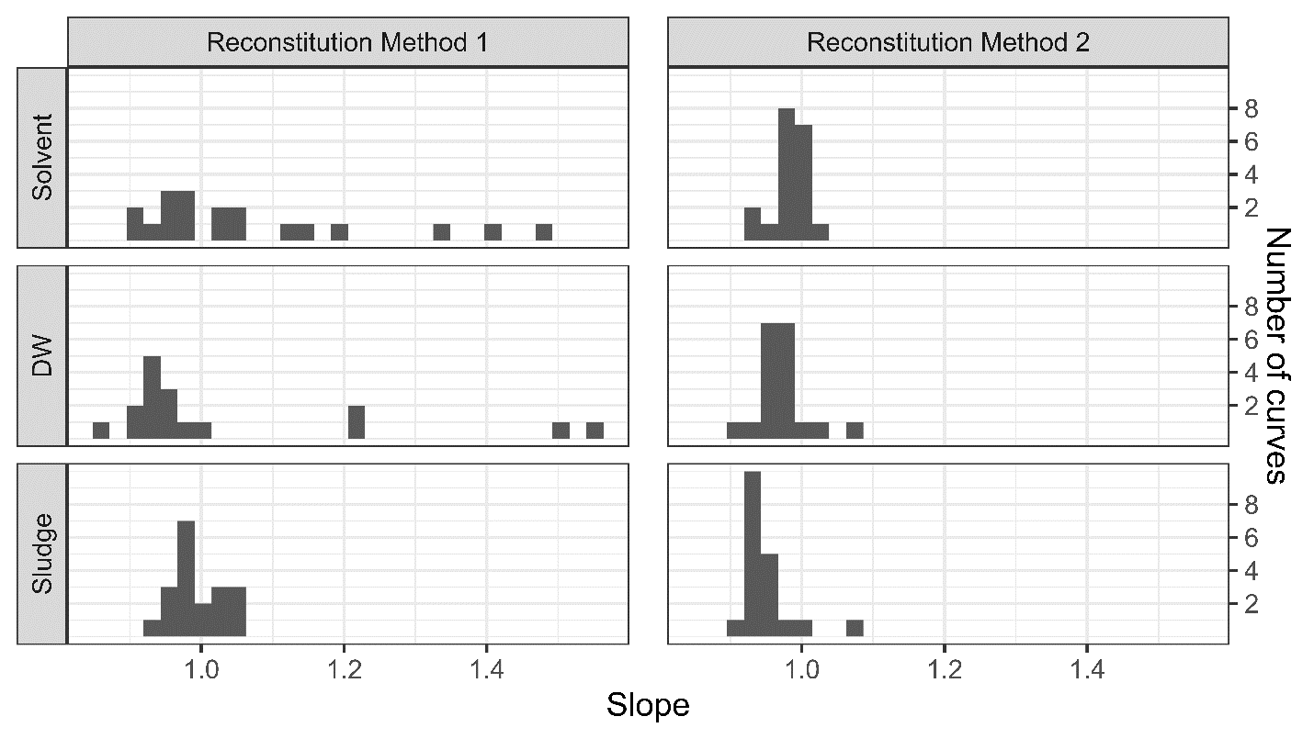
A.
B.

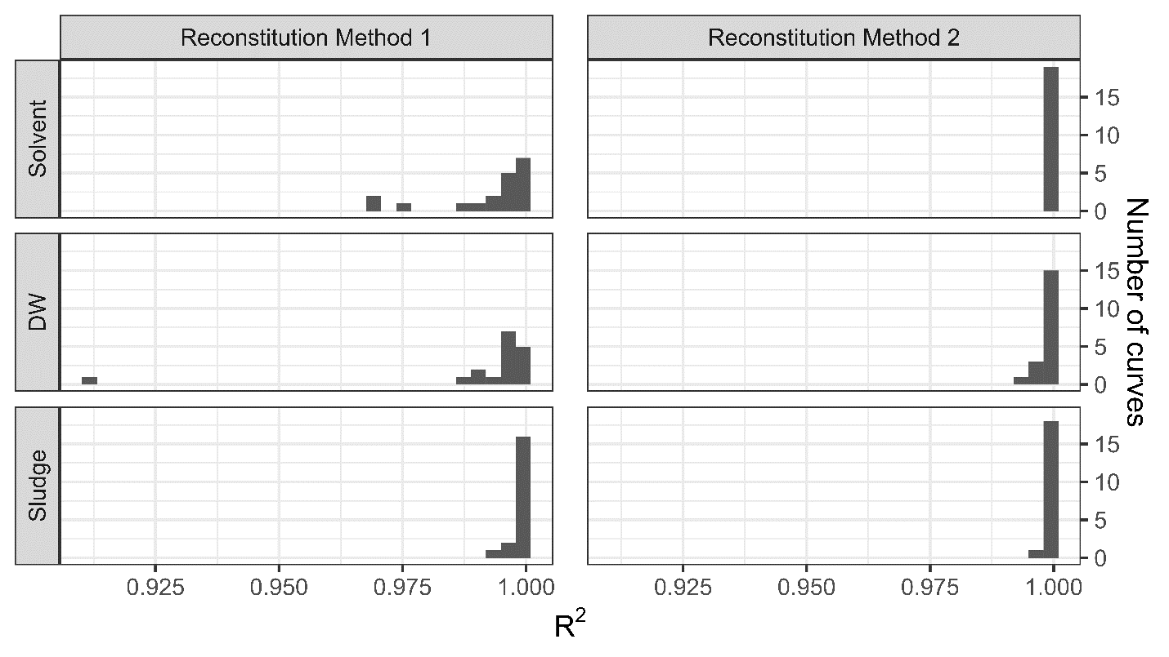
Fig.S2 Histograms of (A) slope and (B) R² values for solvent, DW, and sludge samples. Reconstitution method 2 shows narrower slope and R² distributions than reconstitution method 1.

- Chromatographic Conditions

Chromatographic separation was performed using a column at ambient temperature at a flow rate of 200 μL/min on a Waters-X-BridgeTM BEH C18 column (3.5 µM particle size, 2.1 mm internal diameter, 150 mm length), with mobile phase A composition of 5 mM ammonium acetate in water (pH 3.8) and mobile phase B composition of acetonitrile. The gradient program started with 5% of organic phase for 1 min, followed by a linear increase to 95% over 29 min. The mobile phase composition was kept constant for 5 min before reducing organic phase content back to 5% in 1 min, with column re-equilibration for 6 min. During method development, instrument blanks and matrix blanks were evaluated to determine the background levels of the targeted PFAS (Table S1). All analyses showed no background for the target analytes, so a PFAS delay column was not utilized in this study. Instrument blanks from each matrix curve evaluation were further monitored to ensure no PFAS targeted were impacted by instrument background.

- MS Instrument Conditions

PFAS detection was carried out on an Orbitrap Q Exactive Focus operating in negative electrospray ionization mode (spray voltage -2.5 kV), with HESI (heated electrospray ionization) ion source over 42-minutes of analysis. Sample injection volume was 20 μL. The instrument parameters for this method were as follows: scan range of 80 - 1200 m/z, full scan MS resolution of 70,000, AGC target (Full MS) of 1E6, capillary temp 250 °C, probe heater temp 400 °C, S-lens RF 60.00, sheath gas 45 Arb (arbitrary units), aux gas 10 Arb, sweep gas 45, ddMS² resolution of 17,000, AGC target (ddms²) of 1E5, dynamic exclusion of 10 sec, stepped collision energies of 10, 20, 30, apex trigger from 4-6 sec, and a 2 m/z isolation window. Needle washes using 50:50 water: methanol solution were performed after each injection to minimize carryover.

Calibration was performed immediately prior to the batch analysis using the vendor supplied negative calibration solutions (Pierce ESI Negative Ion Calibration Solution, PN: 88324). Calibration was performed with a Full scan MS range of 250.0-1980.0, resolution of 70,000, ACG target of 1E6, sheath gas of 10 Arb, Aux gas 0 Arb, spray voltage 3.40, capillary temperature 320 °C, and S-lens RF 60.

- Data Processing

Peak integration was based on extracted ion chromatograms of the [M-H]⁻ ion for each compound, with inclusion of the [M-CO₂-H]⁻ fragment for the C4-C14 perfluorinated carboxylic acid homologous series. Exact masses are reported in the table below. Chromatograms were extracted with a mass window of +/- 5 ppm. Initial integrated areas were obtained using the automated Genesis algorithm with 15 smoothing points and a signal-to-noise threshold of 0.5. Peak detection was performed using the highest peak, with a minimum peak height signal-to-noise ratio of 1.0. Manual review of peaks was subsequently performed.

The following masses and retention times were used for compound identification:

Compound | DTXSID | Mass (m/z) | Retention time (min)
MPFBA | DTXSID201028085 | 171.9991, 216.9923 | 9.16
M5PFPeA | DTXSID401337529 | 222.9993, 267.9925 | 12.00
M2-4:2 FTS | DTXSID801337614 | 328.9807 | 13.37
M5PFHxA | DTXSID801028083 | 272.9961, 317.9893 | 14.10
M3PFBS | DTXSID201337561 | 301.9527 | 14.57
M4PFHpA | DTXSID801337533 | 321.9895, 366.9827 | 15.80
M2-6:2 FTS | DTXSID501337615 | 428.9743 | 16.62
M8PFOA | DTXSID501337534 | 375.9997, 420.9929 | 17.33
M3PFHxS | DTXSID901337562 | 401.9463 | 18.14
M9PFNA | DTXSID201337535 | 426.9999, 471.9931 | 18.77
M2-8:2 FTS | DTXSID201337616 | 528.9679 | 19.44
M6PFDA | DTXSID50925719 | 473.9866, 518.9798 | 20.15
M8PFOS | DTXSID601337563 | 506.9567 | 21.01
M7PFUdA | DTXSID101028082 | 524.9868, 569.9800 | 21.54
d3-N-MeFOSAA | DTXSID701337609 | 572.9858 | 22.42
MPFDoA | DTXSID001028089 | 569.9668, 614.9600 | 23.00
d5-N-EtFOSAA | DTXSID001337610 | 589.0140 | 23.65
M8FOSA | DTXSID001337591 | 505.9727 | 25.28
M2PFTeDA | DTXSID301028088 | 669.9604, 714.9536 | 25.85

- Excluded Data Points

Integrated peaks were manually inspected in Thermo Xcalibur Quan. If peak integration issues were present, ion abundances were replaced with reintegrated peak areas. Following model fitting in R, calibration curves were manually inspected for potential outliers. Points observed to visually deviate from linearity or to have high coefficient-of-variation (CV) were excluded from further data analysis. Calibration levels with only one replicate passing visual inspection were removed (MPFBA DW 5ppb, M8PFOA DW 1ppb).

The following data points were excluded from further analysis:

Matrix | Compound | Concentration (ppb) | Replicate | Reason for Exclusion | Excluded in
DW | All carboxylic acids (MPFBA, M5PFPeA, M5PFHxA, M4PFHpA, M9PFNA, M6PFDA, M7PFUdA, MPFDoA, M2PFTeDA) | 0.5 | All replicates | Non-detects at low concentration | Xcalibur
DW | M3PFBS | 0.5 | All replicates | Non-detects at low concentration | Xcalibur
DW | M2-8:2 FTS | 0.5, 1 | All replicates | Non-detect at low concentration | Xcalibur
DW | M2-6:2 FTS | 0.5, 1 | All replicates | Non-detect at low concentration (0.5 ppb), poor peak quality (1 ppb) | Xcalibur
DW | M2-4:2 FTS | 0.5, 1 | All replicates | Non-detect at low concentration | Xcalibur
DW | D3-N-MeFOSAA | 0.5, 1 | All replicates | Non-detect at low concentration | Xcalibur
DW | D5-N-EtFOSAA | 0.5, 1 | All replicates | Non-detect at low concentration | Xcalibur
DW | All carboxylic acids (MPFBA, M5PFPeA, M5PFHxA, M4PFHpA, M9PFNA, M6PFDA, M7PFUdA, M2PFTeDA) with the exception of MPFDoA | 1 | All replicates, with the exception of replicate 2 for PFOA | Non-detects at low concentration | Xcalibur
DW | MPFBA | 5 | 1, 3 | Non-detects at low concentration | Xcalibur
Sludge | M2-8:2 FTS | All ≤ 1 | All replicates for 0.5 ppb; replicate 3 for 1ppb | Non-detects at low concentration | Xcalibur
Sludge | MPFBA | 0.5 | All replicates | Non-detects at low concentration | Xcalibur
Sludge | MPFBA | All ≤ 1 | All replicates | Deviation from linearity and/or high CV at low concentrations | R

- Free Acid Adjustment for Salts

The compounds M3PFBS, M3PFHxS, M8PFOS, M2-4:2FTS, M2-6:2FTS, and M2-8:2FTS are mass labeled, commercially available sodium salts which required adjustment to account for differences between the free acid concentration and the nominal concentration. The nominal concentrations were multiplied by the adjustment factor before calibration curve fitting and subsequent data analysis.

Compound | DTXSID | Nominal Concentration (ng/g) | Free Acid Concentration (ng/g) | Concentration Adjustment Factor
M3PFBS | DTXSID201337561 | 1000 | 932 | 0.932
M3PFHxS | DTXSID901337562 | 1000 | 948 | 0.948
M8PFOS | DTXSID601337563 | 1000 | 959 | 0.959
M2-4:2FTS | DTXSID801337614 | 1000 | 938 | 0.938
M2-6:2FTS | DTXSID501337615 | 1000 | 951 | 0.951
M2-8:2FTS | DTXSID201337616 | 1000 | 960 | 0.960

- Parametric Bootstrap Resampling for Confidence Interval Estimation

Parametric bootstrap resampling is required to estimate ${RF}_{0.975}$, ${RF}_{0.50}$, and ${RF}_{0.025}$ using the IE_{reg} approach. Groff et al. 2022 [(3)] provides a detailed description of the parametric bootstrap resampling procedure. In brief, a linear mixed-effect model is first fit using the existing log₁₀RF and log₁₀IE data. This model is then used to simulate new log₁₀RF values given existing log₁₀IE values, best-fit model parameter estimates, and randomly sampled random effects and residual errors. The simulation process is repeated over many iterations (10,000 for the current work). Accordingly, each data point has 10,000 simulated RF values; the 2.5th, 50th, and 97.5th percentile estimates of the simulated values for each data point are used to estimate linear relationships between log₁₀RF and log₁₀IE that serve as the lower confidence limit, line of best fit, and upper confidence limit, respectively. For any given chemical structure, the log₁₀IE associated with that structure, along with best-fit regression line and 95% prediction band, can be used to estimate ${RF}_{0.975}$, ${RF}_{0.50}$, and ${RF}_{0.025}$. Given an empirical abundance for the same structure, the three RF estimates are the basis for ${\hat{Conc}}_{LCL},$ $\hat{Conc}$, and ${\hat{Conc}}_{UCL},$respectively.

- Sources of Bias in IE_{reg} Predictions

A bias towards overprediction was observed for IE_{reg}, with median AQs above 1.3 for all matrices. This means that the majority of $\hat{Conc}$ exceeded ${Conc}_{True}$. This occurred because, more often than not, the regression-based RF estimate for a given chemical was less than the empirical RF values associated with that chemical. An investigation into the LOO mixed model regressions shed light on the causes of this outcome (see Supplementary File 5 for all regressions and Figure S3 for example regressions). The major factors contributing to the overestimation bias were: (1) unequal influence of training chemicals on the fitted regressions (due to unequal number of data points per chemical and/or the location of predicted IEs and empirical RFs relative to the overall distributions), and (2) the LOO IE models’ tendency to more often underestimate IEs compared to what was expected based on the overall log(RF) vs. log(IE) linear relationship. Regarding point 1, the RF distribution in each matrix was asymmetrical about the overall median and several chemicals appeared to exert unequal influence on the regression parameter estimates. For example, the three chemicals with the lowest RFs in solvent and the four chemicals with the highest RFs in DW appeared to most strongly influence the regression parameter estimates. These biases, depending on the LOO scenario, produced a disproportionate number of concentration over- vs. underestimations. Regarding point 2, the overall bias towards concentration overestimation in all matrices indicates that the LOO models more often predicted log(IE) values that were lower than expected based on the log(RF) vs. log(IE) linear relationship. This underprediction of log(IE) led to RF estimates that were too low and concentration estimates that were too high. Although the same predicted IEs were used across all matrices, the differences in the matrix-specific regressions led to matrix-specific AQs for a given chemical, with AQ magnitude reflecting the alignment of the IE prediction model with the empirical data. As an example, the different regressions per matrix for PFOS (Figure S3) showed the lowest IE_{reg} AQs (smallest overpredictions) for PFOS in sludge, followed by solvent and then DW, indicating that the regression was most suitable for PFOS in sludge.

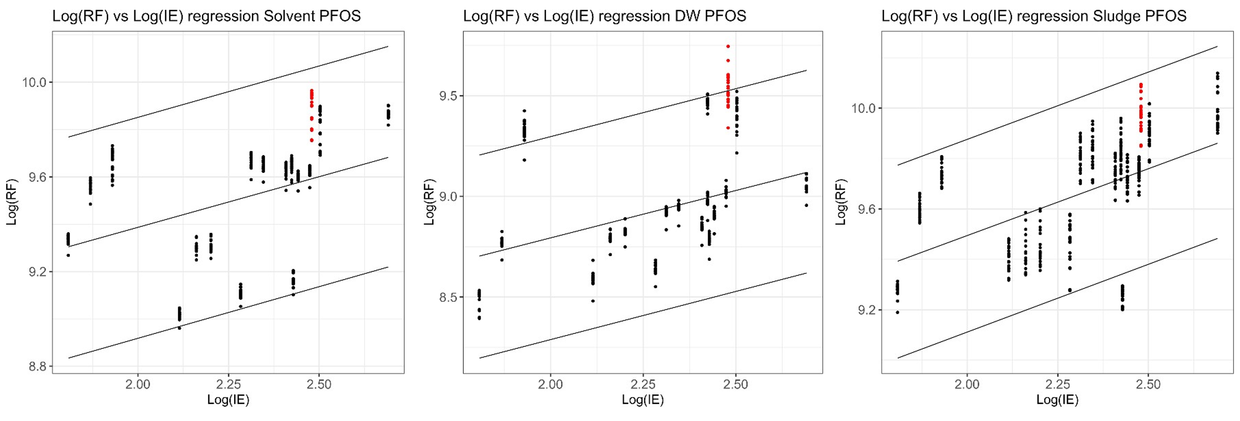

Fig.S3 Plots of log₁₀-transformed RF against log₁₀-transformed IE, as predicted using leave-one-out models (measurements of PFOS, the “left out” chemical, which was evaluated using the regressions, are shown in red). The lines of best fit and predictions bands are based on regressions of RF percentiles estimated using the parametric bootstrap procedure (described in Supporting Information 7.0) against log₁₀-transformed IE. Note that the plots here represent examples of regressions for a single chemical, PFOS; the regression plots for each chemical (shown in Supplementary File 5) differ slightly.

- Additional Supplemental Figures

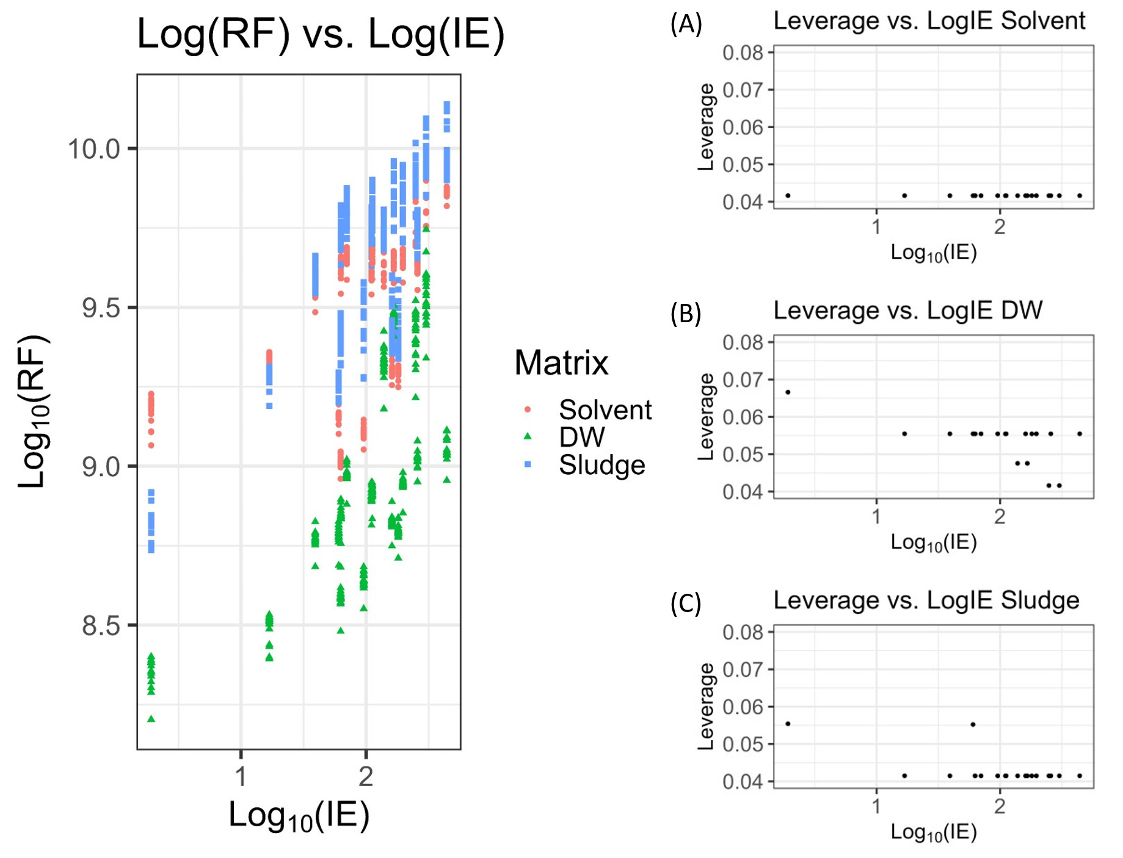

Fig.S4 Left panel: A scatterplot of log₁₀(RF) vs. log₁₀(IE) shows a large separation between PFBA (leftmost points) and the other chemicals. Right panel: Plots of per-chemical leverage on the linear regression of log₁₀(RF) vs. log₁₀(IE) in (A) solvent, (B) DW, and (C) sludge indicate that PFBA has higher leverage than all other chemicals in DW and sludge. Note: leave-one-out IE values from each chemical’s leave-one-out model are used here to provide a single representation per matrix, in contrast to individual regressions provided in Supplementary File 5.

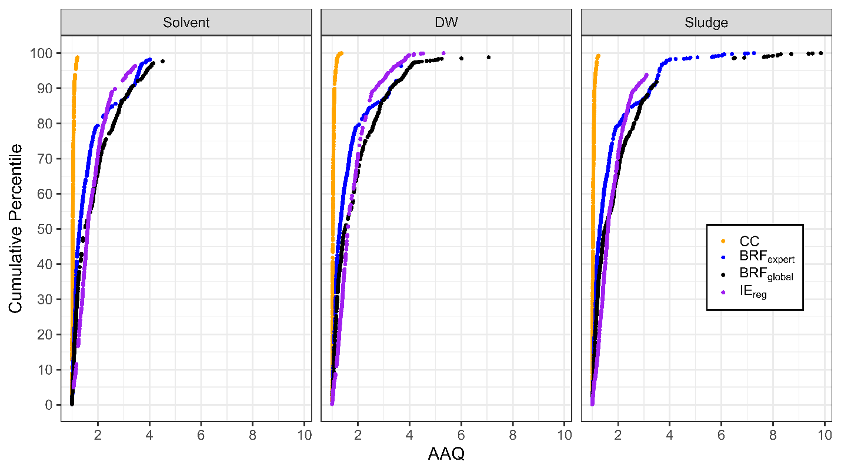
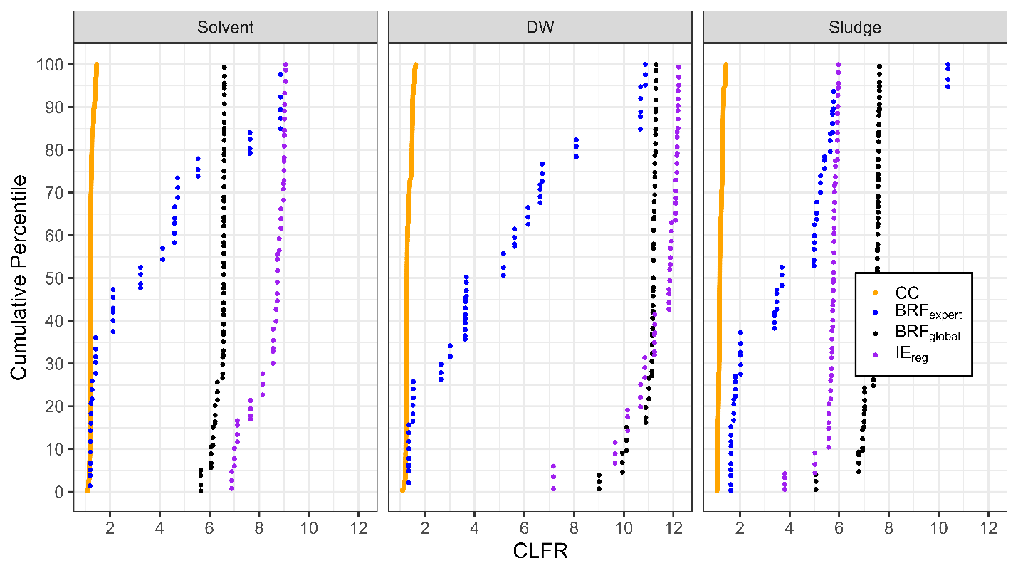

Fig.S5 Cumulative distributions of performance metrics (AAQ [top] and CLFR [bottom]) for each matrix (solvent, DW, and sludge).

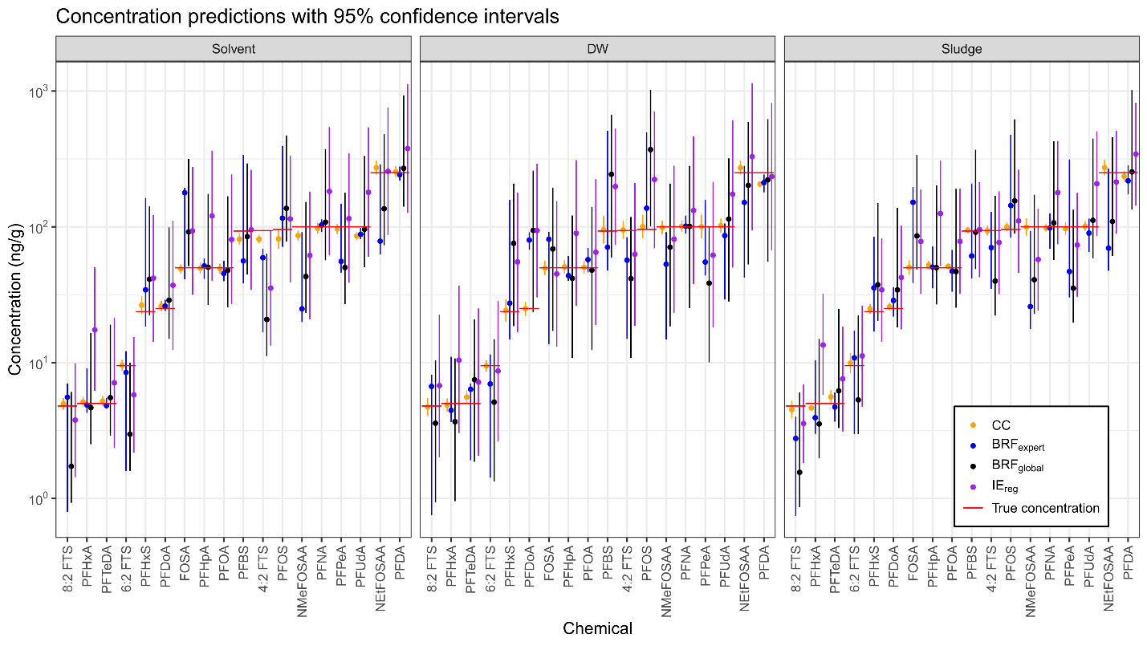

Fig.S6 Concentration estimates and confidence intervals from the four quantitation approaches, plotted for one randomly selected value per chemical. PFAS on the X-axis are sorted from left to right by increasing true concentration.

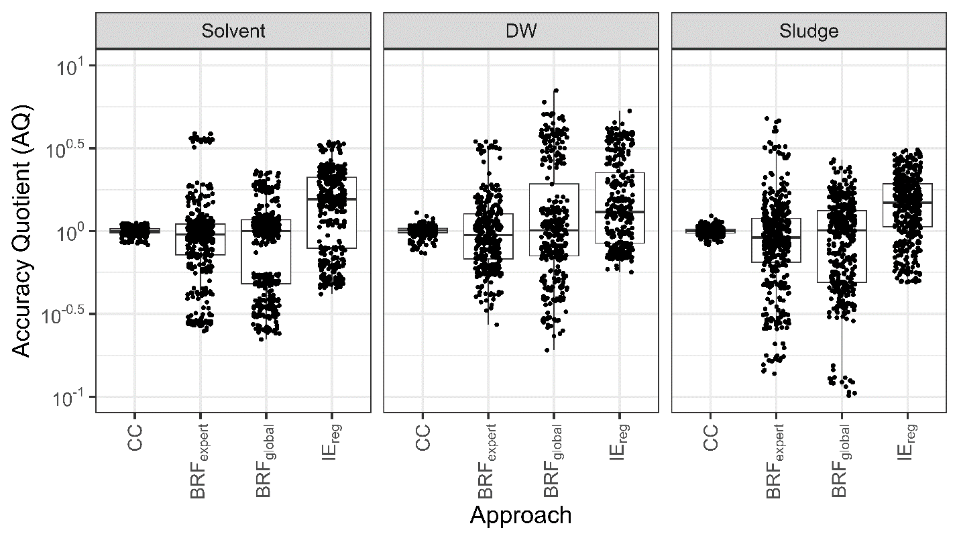

Fig.S7 Boxplots of accuracy quotients (AQs) for each quantitation approach, separated by matrix.
References

1. Weed RA, Boatman AK, Enders JR. Recovery of per- and polyfluoroalkyl substances after solvent evaporation. Environ Sci Process Impacts. 2022;24(12):2263-71.
2. Teymoorian T, Munoz G, Vo Duy S, Liu J, Sauvé S. Tracking PFAS in Drinking Water: A Review of Analytical Methods and Worldwide Occurrence Trends in Tap Water and Bottled Water. ACS ES&T Water. 2023;3(2):246-61.
3. Groff LC, 2nd, Grossman JN, Kruve A, Minucci JM, Lowe CN, McCord JP, et al. Uncertainty estimation strategies for quantitative non-targeted analysis. Anal Bioanal Chem. 2022;414(17):4919-33.

