Supplemental Information

Transcriptomic response of an algal species (Raphidocelis subcapitata) exposed to 22 per- and polyfluoroalkyl substances

Preparation of exposure solutions
A dilution series for each exposure was prepared using a Biomek i5 liquid handler (Beckman Coulter, Brea, CA, USA). Stock solutions of two PFAS at 30 mM and 9.5 mM (nominal) were pipetted into designated wells of a 96 well plate (300 µl; catalog #650101; Greiner Bio-One, NC, USA). Ten-fold serial dilutions in DMSO (or methanol) were then prepared from each stock solution to yield a total of 8 concentrations with ½ log spacing for each chemical and five replicates per concentration. In addition, two concentrations of CuSO4 (final exposure concentrations of 50 and 100 mg/L; 0.75 and 1.5 mM, respectively) three replicates each, were delivered to predetermined wells. Then each well was transferred to a new 2 ml deep-well plate (dosing plate; catalog # 503162; NEST Scientific, NJ, USA) with a predetermined random layout such that each concentration had two wells on the perimeter and three in the interior. Stocks from this dilution plate were then diluted to 0.66% in Woods Hole MBL media (Nichols 1973) yielding a 2X dosing plate with nominal concentrations ranging from 200-0.06 µM (1/2 log spacing) for each PFAS. A concentration response series for two PFAS, with a shared set of controls, was present on each 96-well plate and four replicate plates were prepared for each pair of two PFAS tested (Supplemental Figure 1). Control wells contained the same concentration (0.33%) of either DMSO or methanol as PFAS wells.
Bioassays
Raphidocelis subcapitata was purchased from Carolina Biological Supply (Burlington, NC, USA; catalog # 152520) and reared in Woods Hole MBL media (Nichols 1973) at 24°C with constant light (~250 µmol/m²/s). Prior to exposure, the cells per ml of R. subcapitata cultures in log-phase of growth was determined and adjusted to approximately 5 x 10⁶ cells/ml. Each well was loaded with 800 µl of algal suspension, centrifuged for 5 minutes at 2000 rpm to pellet algae, and 400 µl media removed. The algal pellets were resuspended in 400 µl exposure media at twice the final concentrations of exposure chemical, yielding the final exposure concentrations, nominally 100-0.03 µM. Bioassays for all 22 PFAS were conducted using the same experimental design (Supplemental Figure 1). All assays were conducted in 96-well plate format using deep-well plates (Catalog # 267007, Beckman Coulter, CA, USA). Prior to sealing each exposure plate with optically clear adhesive covers (catalog # 4311971, Thermo Fisher, MA, USA), 100 µl aliquots were taken from the phenotyping plate to measure well-specific cell density and to rule out exposure chemicals interference with future absorbance or fluorescent measurements. In addition, 100 µl was removed from each well of the three transcriptomic plates to be consistent. Algae were kept in suspension during incubation by shaking using a temperature controlled orbital shaker (Titramax 1000, Heidolph Instruments GmbH, Schwabach, Germany) at 24° C, under constant light (~250 µmol/m²/s).
At the start of an exposure and after 24 hours, biomass was assessed in the phenotyping plate via optical density measurements at 550 nm (OD550), 680 nm (OD680), and 750 nm (OD750) using a plate reader (BioTek Synergy Neo2, Agilent, Santa Clara, CA, USA). These wavelengths were based upon previous methods at 550 nm (Haire et al. 2018) or at an absorbance maximum (Horvatic et al. 2007) or minimum (Lomba et al. 2021).
In addition, an estimation of photosynthetic efficiency by measuring fluorescence at 680 nm after excitation at 470 nm (Alfred et al. 2012) was made. After each 24-hour exposure, 100 µl from each well of the phenotypic plate was transferred to a black 96 well assay plate (catalog # 3915, Corning, NY, USA), held in the dark for a minimum of 10 minutes, then the fluorescent measurement was made. With this method, an increase in fluorescence indicates inhibition of electron transport in photosystem II (Alfred et al. 2012; Bennoun and Levine 1967).
Cell viability was assessed with CellTox Green Cytotoxicity Assays (catalog # G8741, Promega, WI, USA) from a 100 µl aliquot following manufacturer’s instructions with black assay plates. Prior to conducting exposures, response linearity was verified from 100% to 0% viability. Therefore, controls, assumed to be 100% viable, and CuSO₄ positive controls, assumed to be 0% viable, were used to define the slope of the viability curve instead of a full set of standards.
Finally, photosynthetic pigment concentrations (chlorophyll A and B, total chlorophyll, and total carotenoids) per cell were measured using equations previously derived (Lichtenthaler 1987). The remaining cell suspensions on the apical plate were pelleted via centrifugation, all media aspirated, an equal volume of methanol added, and the plate was shaken. After a minimum of 45 minutes of extraction, the plate was centrifuged to pellet cell debris, and absorbance measurements (665, 652, and 470 nm) were made with a plate reader with path length correction to calculate pigment concentrations that were then normalized to cell count. The following were used to calculate pigment concentrations:
Chlorophyll A (ug/ml) = (16.72 * Ab665nm) - (9.16 * Ab652nm)
chlorophyll B (ug/ml) = (34.09 * Ab652nm) - (15.28 * Ab665nm)
total chlorophyll (ug/ml) = (1.44 * Ab665nm) + (24.93 * Ab652nm)
total carotenoids (ug/ml) = ((1000 * Ab470nm) - (1.63 * ChlA) - (104.96 * ChlB))/221
Prior to starting any chemical exposures, several media-only 96-well plates were loaded with algae and monitored to collect baseline viability data and water quality parameters following the same procedures that were used during exposure assays. Dissolved oxygen and pH were measured in 96-well plates that have a sensor integrated on the bottom of each well (OxoPlate OP96U and HydroPlate HP96U, Precision Sensing GmbH, Regensburg, Germany) following the manufacturer’s instructions using a fluorescence plate reader (BioTek Synergy Neo2, Agilent, Santa Clara, CA, USA). Because the OxoPlate and HydroPlate are standard volume 96-well plates, the total volume tested was 200 µl, while the exposure plate well volume was 700 µl. Ammonia concentrations in the wells immediately prior to the addition of algae and following 24 hours of culture were determined with a fluorometric test kit (MAK310, Sigma-Aldrich, St. Louis, MO, USA).

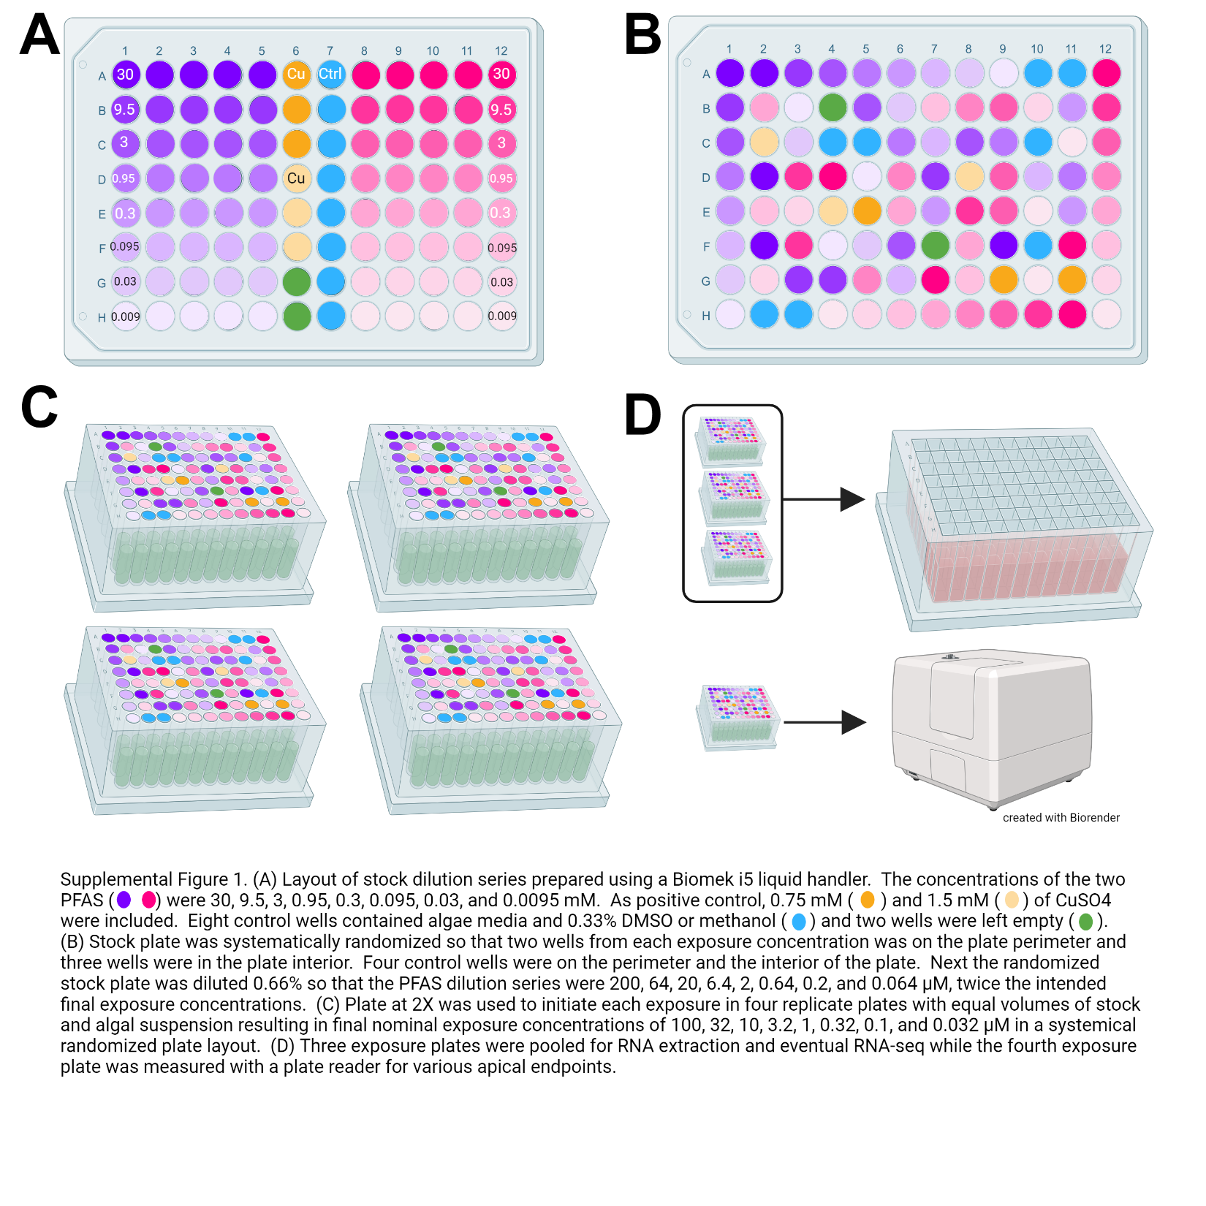

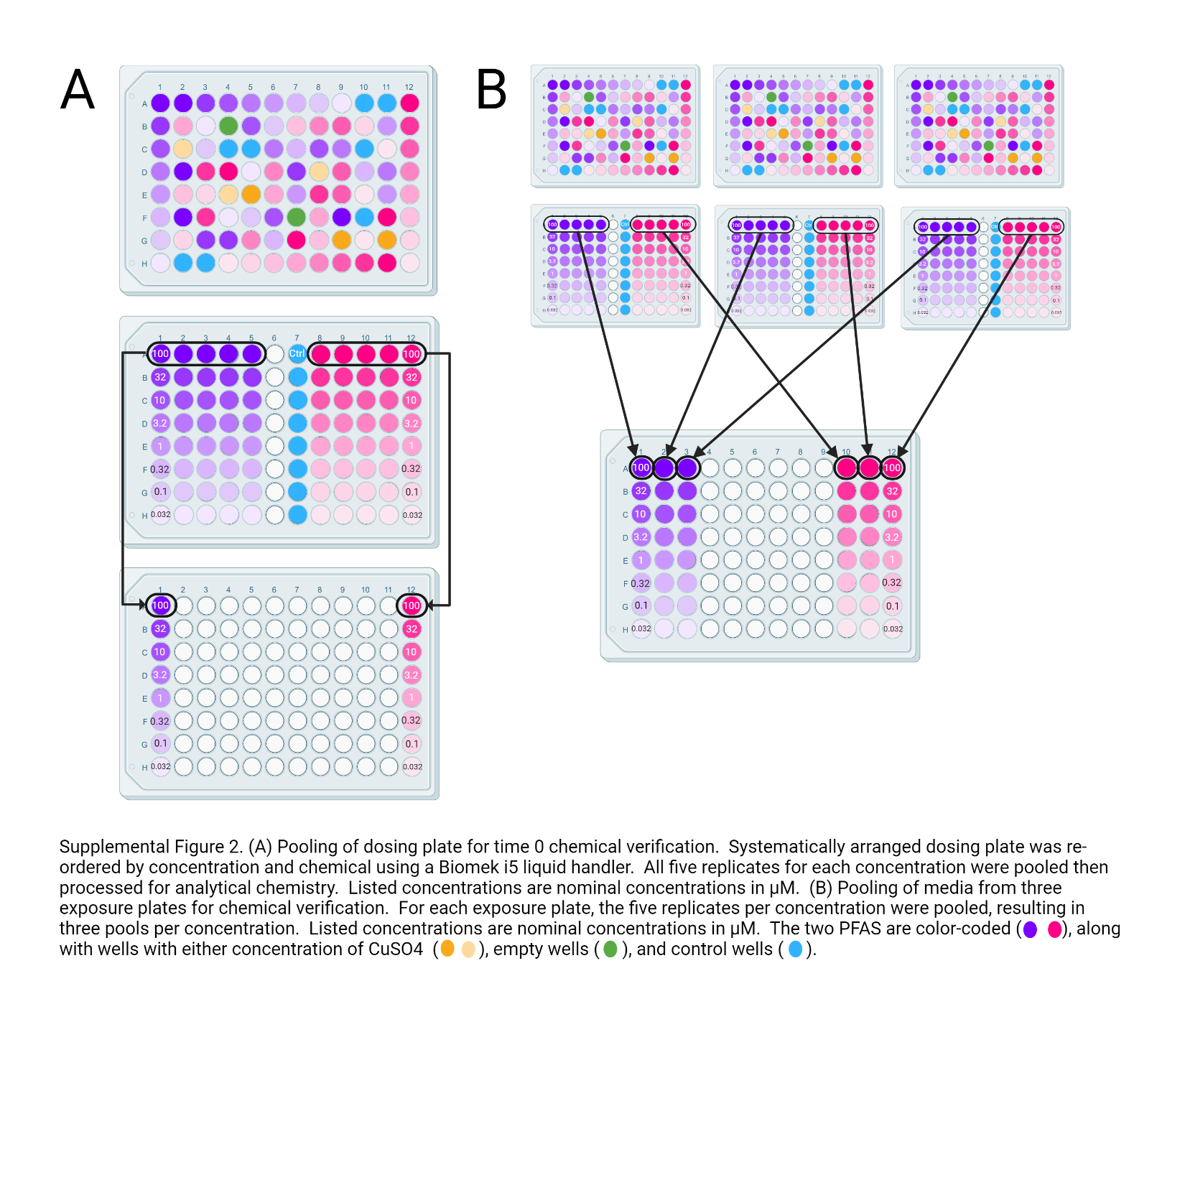Analytical verification of PFAS exposure concentrations.
Measurement of N-EtFOSA, PFTeDA, PFTrDA, PFHpA, PFPB, PFPeA, FC8diol, FC8DoD, FC10diol, PFUdA, PFTDoDA, PF4OPeA, PFOS, PFOA, PFHxS, PFNA, 8:2 FTS, 6:2 FTS, 4:2 FTS, 6:1 FTOH and PFTP were carried out using a Thermo Scientific LC-MS system consisting of a Vanquish LC system coupled to an Orbitrap-IDX tandem MS. All compounds excluding PFTP, 6:1 FTOH, and PFPB used the same method.
Method for 19 out of 21 PFAS - To obtain separation of all compounds (excluding PFPB, and 6:1 FTOH), a 5 µL injection was separated under gradient flow on an Agilent ZORBAX Eclipse Plus C18 column (50 mm x 2.1 mm, 1.8 um) using water with 5 mM ammonium acetate (solvent A) and methanol (solvent B). With a constant flow rate of 0.4 mL/min, gradient conditions began at 10% B and held constant until 0.5 minutes, increased to 55% B from 0.5 to 2.5 minutes, increased to 90% B from 2.5 to 9 minutes, increased to 100% B from 9 to 9.5 minutes, held at 100% B from 9.5 to 11.5 minutes, followed by a 2.5 minute equilibration at 10% B. Analytes were detected using electrospray ionization (ESI) in negative polarity, and ion source parameters including spray voltage (2500 V), sheath gas (50 Arb), aux gas (10 Arb), sweep gas (1 Arb), ion transfer tube temperature (325°C), and vaporizer temperature (300°C) were optimized by directly injecting all compounds and choosing values most optimal for all compounds (Supplemental Table 1). The limit of quantification for this method was 0.9 µg/L.

Supplemental Table 1. Retention time and high-resolution mass at 120,000 resolution power for each target analyte and internal standard under the optimized conditions for the analytical method.
Compound  (reference internal standard) | Retention Time  (min) | Mass/charge (m/z)
PF4OPeA (M5PFPeA) | 3.2 | 228.97318
PFPeA (M5PFPeA) | 3.86 | 262.97545
M5PFPeA | 3.86 | 267.99213
FC8diol (M5PFHxA) | 4.32 | 361.01007
4:2FTS (M2-4:2FTS) | 4.41 | 326.97374
M2-4:2FTS | 4.41 | 328.9801
M5PFHxA | 4.47 | 317.98859
FC8DoD (M4PFHpA) | 4.69 | 293.00586
PFHxS (M3PFHxS) | 5.17 | 398.9361
PFHpA (M4PFHpA) | 5.17 | 362.96907
M4PFHpA | 5.17 | 366.98276
M3PFHxS | 5.23 | 401.94571
6:2FTS (M2-6:2FTS) | 5.87 | 426.96735
M2-6:2FTS | 5.87 | 428.97421
PFOA (M8PFOA) | 5.91 | 412.9664
M8PFOA | 5.91 | 420.99222
FC10diol (M8PFOS) | 6.15 | 461.00372
PFOS (M8PFOS) | 6.55 | 498.92966
PFNA (M9PFNA) | 6.65 | 462.96268
M9PFNA | 6.65 | 471.99347
M8PFOS | 6.65 | 506.95728
8:2FTS (M2-8:2FTS) | 7.31 | 526.96096
M2-8:2FTS | 7.31 | 528.96851
M8FOSA | 7.81 | 505.97296
PFUdA (M7PFUdA) | 7.95 | 562.95629
M7PFUdA | 7.95 | 569.98083
PFTDoDA (M8FOSA) | 8.47 | 350.96976
PFTrDA (M2PFTeDA) | 8.96 | 662.94885
N-EtFOSA (M2PFTeDA) | 9.17 | 525.97717
PFTeDA (M2PFTeDA) | 9.35 | 712.94671
M2PFTeDA (M2PFTeDA) | 9.36 | 714.95477
PFTP | 1 | 128.9964

Method for PFPB - To obtain separation of PFPB, a 5 µL injection was separated under gradient flow on an Agilent ZORBAX Eclipse Plus C18 column (50 mm x 2.1 mm, 1.8 um) using water with 5 mM ammonium acetate (solvent A) and methanol (solvent B). With a constant flow rate of 0.4 mL/min, gradient conditions began at 50% B, increased to 95% B from 0 to 3 minutes, held at 95% B from 3 to 4 minutes, followed by a 2 minute equilibration at 50% B. PFPB was detected using electrospray ionization (ESI) in negative polarity, and ion source parameters including spray voltage (2500 V), sheath gas (50 Arb), aux gas (10 Arb), sweep gas (1 Arb), ion transfer tube temperature (325°C), and vaporizer temperature (300°C) were optimized. Under these conditions, retention time and mass (quant ion) were 2.39 minutes and 378.96378, respectively. The LOQ was 0.9 µg/L.
Method for 6:1 FTOH - 6:1 FTOH was analyzed under the same flow gradient and ion source parameters as PFPB, but solvents were water with 5 mM ammonium acetate (solvent A) and methanol (solvent B), and the column was an Agilent Poroshell 120 EC-C18 (50 mm x 2.1 mm, 2.7 um). Under these conditions, retention time and mass (quant ion) were 4.37 minutes and 409.0109, respectively. The LOQ was 0.9 µg/L.
RNA extraction, cDNA library preparation, and sequencing
RNA was extracted from pooled homogenates (Plant/Fungi Total RNA Purification kits, #31900, Norgen Biotek, Ontario, Canada) with a protocol slightly modified from the manufacturer’s instructions. First, the algae were centrifuged, and the supernatant was aspirated. Glass beads (0.5 mm) were added to each well and the plate went through five cycles of freezing with liquid nitrogen and bead milling for 2 minutes. Next, 400 µl of kit Buffer C was added to each well and then the manufacturer’s procedure was followed, yielding on average 40 µl at 50 ng/µl of total RNA.
RNA was shipped to the Michigan State University Research Technology Support Facility Genomics Core for library preparation and sequencing. 493 sample libraries were prepared using the Lexogen QuantSeq 3’ mRNA-Seq V2 Library Prep Kit with UDI (Unique Dual Index) and QuantSeq UMI (Unique Molecular Identifier) module with PhiX spike-in making up ~5% of the total reads in each lane. The UMI module (https://faqs.lexogen.com/faq/quantseq-umi-module) added a random, 6nt sequence to the start of each read 1 (R1), followed by a constant, 4nt (TATA) spacer. Preparation followed manufacturer’s recommendations. Completed libraries were quality checked and quantified using Qubit dsDNA HS and Agilent 4200 TapeStation HS DNA1000 assays. Libraries were pooled in equimolar amounts into 11 separate groups such that each pool consisted of two treatment groups and the pools were quantified using the Invitrogen Collibri Quantification qPCR kit. Sample pools were loaded onto separate lanes of a NovaSeq SP flow cell using the Xp loading method. Sequencing was performed in a 1x100bp single read format using an Illumina NovaSeq 6000 v1.5 100 cycle reagent kit. Base calling was done by Illumina Real Time Analysis (RTA) v3.4.4 and the output of the RTA was demultiplexed and converted to FASTQ format with Illumina Bcl2fastq v2.20.0.
Read alignment, counting, and filtering
The Raphidocelis subcapitata reference genome (GCA_003203535.1) was indexed with STAR v2.7.10a (Dobin et al. 2012) using the following parameters: genomeSAindexNbases = 11, sjdbOverhang = 99, and sjdbGTFfeatureExon = gene. The raw, 1x100bp single end FASTQ sequence files were trimmed, quality filtered (Phred score <15), and had UMIs and adapter sequences removed after deduplication using fastp v0.23.2 (Chen et al. 2018; Chen 2023). Both trimmed and untrimmed reads were quality checked using FastQC v0.11.9 and summarized by MultiQC v1.14 (Ewels et al. 2016). No samples were removed based on quality scores. Quality reads were aligned and mapped to the indexed reference genome using STAR. The resulting alignment files were sorted by coordinates and indexed by sample using Samtools v1.15.1 (Danecek et al. 2021). Aligned reads were then quantified with respect to gene features using the “intersection-nonempty” mode of HTseq v2.0.1 (Putri et al. 2022) and organized into separate (tab-delimited) count matrix files for each chemical treatment group where columns represented samples and rows represented genes. Additional quality control and filter steps were applied to each count matrix using custom R v4.1.3 functions implemented within RStudio (2022.02.0+443). Genes were filtered from the count matrices using the edgeR package v3.36.0 (Robinson, McCarthy, and Smyth 2010; McCarthy, Chen, and Smyth 2012; Chen, Lun, and Smyth 2016) where genes were kept if they had more than 10 counts in at least 70% of samples in the smallest group that expressed that gene. Additionally, genes were removed if its total count was less than 15 across all samples. Sample library size normalization factors were calculated using the filtered gene data with edgeR’s trimmed mean of M-values (TMM) method. These library normalization factors were used to remove compositional biases when calculating counts-per-million (CPM) normalized values for each gene. The filtered, CPM-normalized count matrices were then log2 transformed with a prior count of 1 added for use in downstream concentration response modeling.

Supplemental Table 2. Measured concentrations at time 0 (exposure initiation) and time 24 h (exposure termination) for the 22 per- and polyfluorinated alkyl substances tested in the present study.
Abbreviation | Nominal Concentration (µg/L) |  |  |  |  |  |  |  | Time 24 h (µg/L) * |  |  |  |  |  |  |  |  | Time 0 (µg/L)
PFPeA | 26405 | 8362 | 2641 | 836 | 264 | 84 | 26 | 8 | 23127  ±962 | 6926  ±402 | 2422  ±130 | 743  ±20 | 212  ±7 | 66  ±1 | 12  ±1 | ND  2 |  | 22020 | 6799 | 2321 | 715 | 207 | 65 |  | 11 |  | ND
PFHpA | 36406 | 11530 | 3640 | 1153 | 364 | 115 | 36 | 12 | 28499  ±473 | 8893  ±233 | 2736  ±49 | 905  ±23 | 274  ±5 | 71  ±1 | 20  ±0.3 | ND  6 |  | 26828 | 8952 | 2858 | 869 | 274 | 70 |  | 22 |  | ND
PFOA | 41407 | 13113 | 4141 | 1311 | 414 | 131 | 41 | 13 | 39547 ± 1155 | 11500  ± 422 | 3357  ± 207 | 1286 ± 57 | 128  ± 4 | 20  ± 2 | 6  ± 0.3 | ND  1 |  | 45026 | 13136 | 3847 | 1435 | 144 | 28 |  | 7 |  | ND
PFNA | 46408 | 14697 | 4641 | 1470 | 464 | 147 | 46 | 15 | 44264  ±1291 | 13402  ±468 | 4463  ±170 | 1194  ±38 | 283  ±8 | 87  ±3 | 18  ±0.4 | ND  7 |  | 24835 | 7735 | 2711 | 712 | 194 | 65 |  | 12 |  | ND
PFUdA | 56409 | 17865 | 5641 | 1787 | 564 | 179 | 56 | 18 | 9333  ±12991 | 3556  ±562 | 1305  ±66 | 211  ±19 | 12  ±2 | 1  ±1 | ND  0.4 | ND  0.1 |  | 14154 | 7034 | 2597 | 295 | 39 | 19 |  | 2 |  | ND
PFTrDA | 66411 | 21032 | 6641 | 2103 | 664 | 210 | 66 | 21 | ND | ND | ND | ND | ND | ND | ND | ND |  | 423 | 201 | ND  66 | ND  21 | ND  7 | ND  2 |  | ND  1 |  | ND  0.2
PFTeDA | 71412 | 22616 | 7141 | 2262 | 714 | 226 | 71 | 23 | ND | ND | ND | ND | ND | ND | ND | ND |  | 23353 | 3313 | 947 | 160 | ND  59 | ND  18 |  | ND  6 |  | ND  2
PF4OPeA | 23003 | 7285 | 2300 | 729 | 230 | 73 | 23 | 7 | 19186  ±623 | 6477  ±140 | 2406  ±80 | 637  ±14 | 213  ±5 | 70  ±2 | 15  ±0.1 | ND  6 |  | 19740 | 6752 | 2475 | 638 | 202 | 76 |  | 15 |  | ND
PFPB | 38006 | 12037 | 3800 | 1204 | 380 | 120 | 38 | 12 | 37007  ±2619 | 10763  ±255 | 2933  ±251 | 1160  ±40 | 331  ±9 | 86  ±1 | 20  ±0.4 | ND  6 |  | 37502 | 10672 | 3073 | 1182 | 320 | 81 |  | 19 |  | ND
PFTDoDA | 66210 | 20969 | 6621 | 2097 | 662 | 210 | 66 | 21 | 15008  ±265 | 1623  ±194 | ND | 133  ±3 | ND | ND | ND | ND |  | 41081 | 12419 | 2382 | 673 | 95 |  | 43 |  | ND  13 | ND  4
FC8diol | 36212 | 11468 | 3621 | 1147 | 362 | 115 | 36 | 11 | 29457  ±1304 | 9311  ±200 | 3295  ±95 | 982  ±56 | 204  ±1 | 69  ±2 | 8  ±0.2 | ND  4 |  | 32878 | 9905 | 3970 | 1163 | 234 | 73 |  | 8 |  | ND
FC10diol | 46213 | 14636 | 4621 | 1464 | 462 | 146 | 46 | 15 | 23419  ±139 | 6890  ±293 | 3005  ±86 | 618  ±24 | 183  ±4 | 71  ±2 | 12  ±1 | ND  5 |  | 37990 | 12361 | 4971 | 1352 | 403 | 132 |  | 26 |  | ND
FC8DoD | 29410 | 9314 | 2940 | 931 | 294 | 93 | 29 | 9 | 29448  ±881 | 8819  ±373 | 2689  ±193 | 909  ±64 | 262  ±18 | 70  ±5 | 14  ±0.1 | ND  4 |  | 31855 | 9644 | 3339 | 1045 | 304 | 84 |  | 15 |  | ND
N-EtFOSA-M/PFOS^ | 52720 | 16696 | 5272 | 1670 | 527 | 167 | 53 | 17 | 6718  ±165 | 4302  ±505 | 915  ±178 | 295  ±50 | 69  ±13 | 19  ±2 | 2  ±0.1 | ND  1 |  | 36468 | 18076 | 6351 | 1538 | 388 |  | 66 |  | ND | ND
PFHxS | 43820 | 13878 | 4382 | 1388 | 438 | 139 | 44 | 14 | 31743  ±483 | 9333  ±352 | 2414  ±76 | 992  ±64 | 175  ±6 | 75  ±2 | 10  ±1 | ND  2 |  | 36535 | 11285 | 3141 | 1150 |  |  | 86 |  | 11 | ND
PFOS | 53822 | 17045 | 5382 | 1705 | 538 | 170 | 54 | 17 | 40351  ± 970 | 13458  ± 347 | 1521 ± 0.8 | 554  ± 3 | 144 ± 2 | 47 ± 1 | 9  ± 1 | ND  4 |  | 51890 | 17203 | 2065 | 742 | 219 | 79 |  | 18 |  | ND
4:2FTS | 32815 | 10393 | 3282 | 1039 | 328 | 104 | 33 | 10 | 28359  ±231 | 8412  ±131 | 2680  ±65 | 958  ±15 | 204  ±7 | 65  ±1 | 6  ±0.3 | ND  1 | 30289 |  | 9159 | 2856 | 1016 | 232 |  | 72 |  | 6 | ND
6:2FTS | 42816 | 13560 | 4282 | 1356 | 428 | 136 | 43 | 14 | 20770  ±422 | 6119  ±93 | 2245  ±21 | 696  ±33 | 94  ±2 | 26  ±1 | 5  ±0.1 | ND  2 |  | 21711 | 6759 | 2366 | 732 | 106 |  | 30 |  | 5 | ND
8:2FTS | 52818 | 16727 | 5282 | 1672 | 528 | 167 | 53 | 17 | 3133  ±102 | 2427  ±46 | 981  ±49 | 340  ±17 | 100  ±9 | 18  ±1 | 4  ±0.2 | ND  1 |  | 38068 | 16665 | 5486 | 889 | 237 |  | 57 |  | 10 | ND
PFTP | 26208 | 8300 | 2620 | 830 | 262 | 83 | 26 | 8 | 19551  ±547 | 4905  ±137 | 773  ±17 | 574  ±18 | 125  ±5 | 28  ±2 | 5  ±0.2 | ND  2 |  | 25815 | 6193 | 1138 | 685 | 161 | 43 |  | 6 |  | ND
6:1 FTOH | 35008 | 11087 | 3501 | 1109 | 350 | 111 | 35 | 11 | ND | ND | ND | ND | ND | ND | ND | ND |  | ND | ND | ND | ND | ND |  | ND |  | ND | ND

* Concentration ± standard deviation of replicate samples; ^ Nominal concentration is target N-EtFOSA-M concentration while Time 24 and 0 concentrations are total of both N-EtFOSA-M and PFOS which were approximately a 1:1 mixture
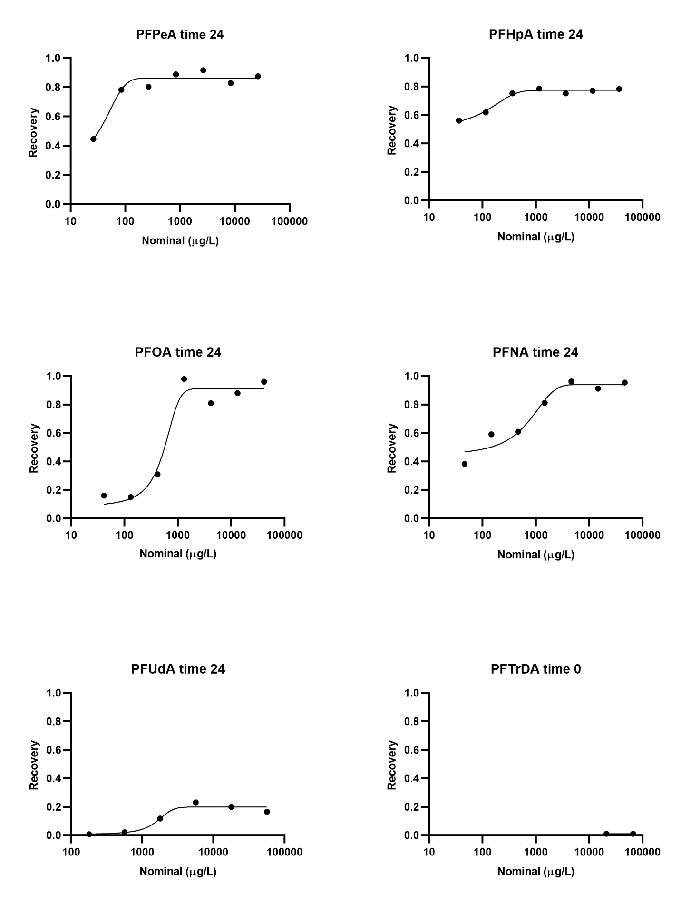

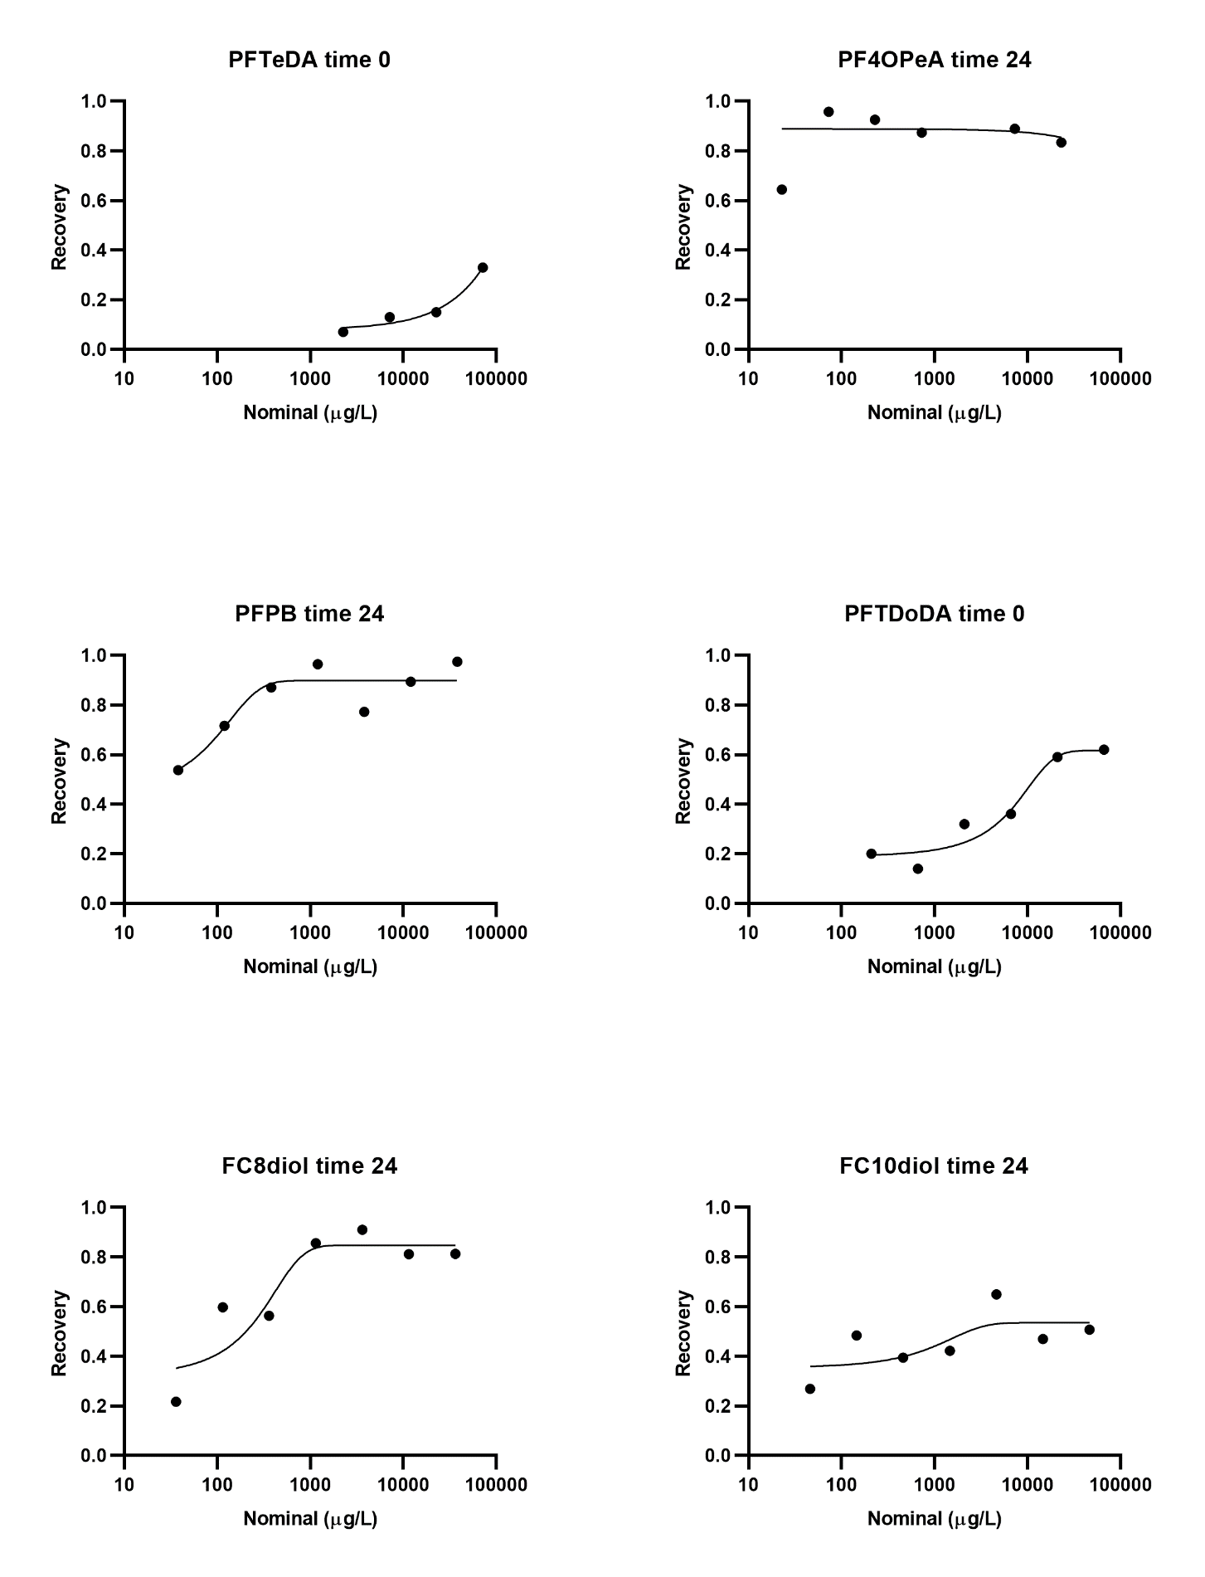

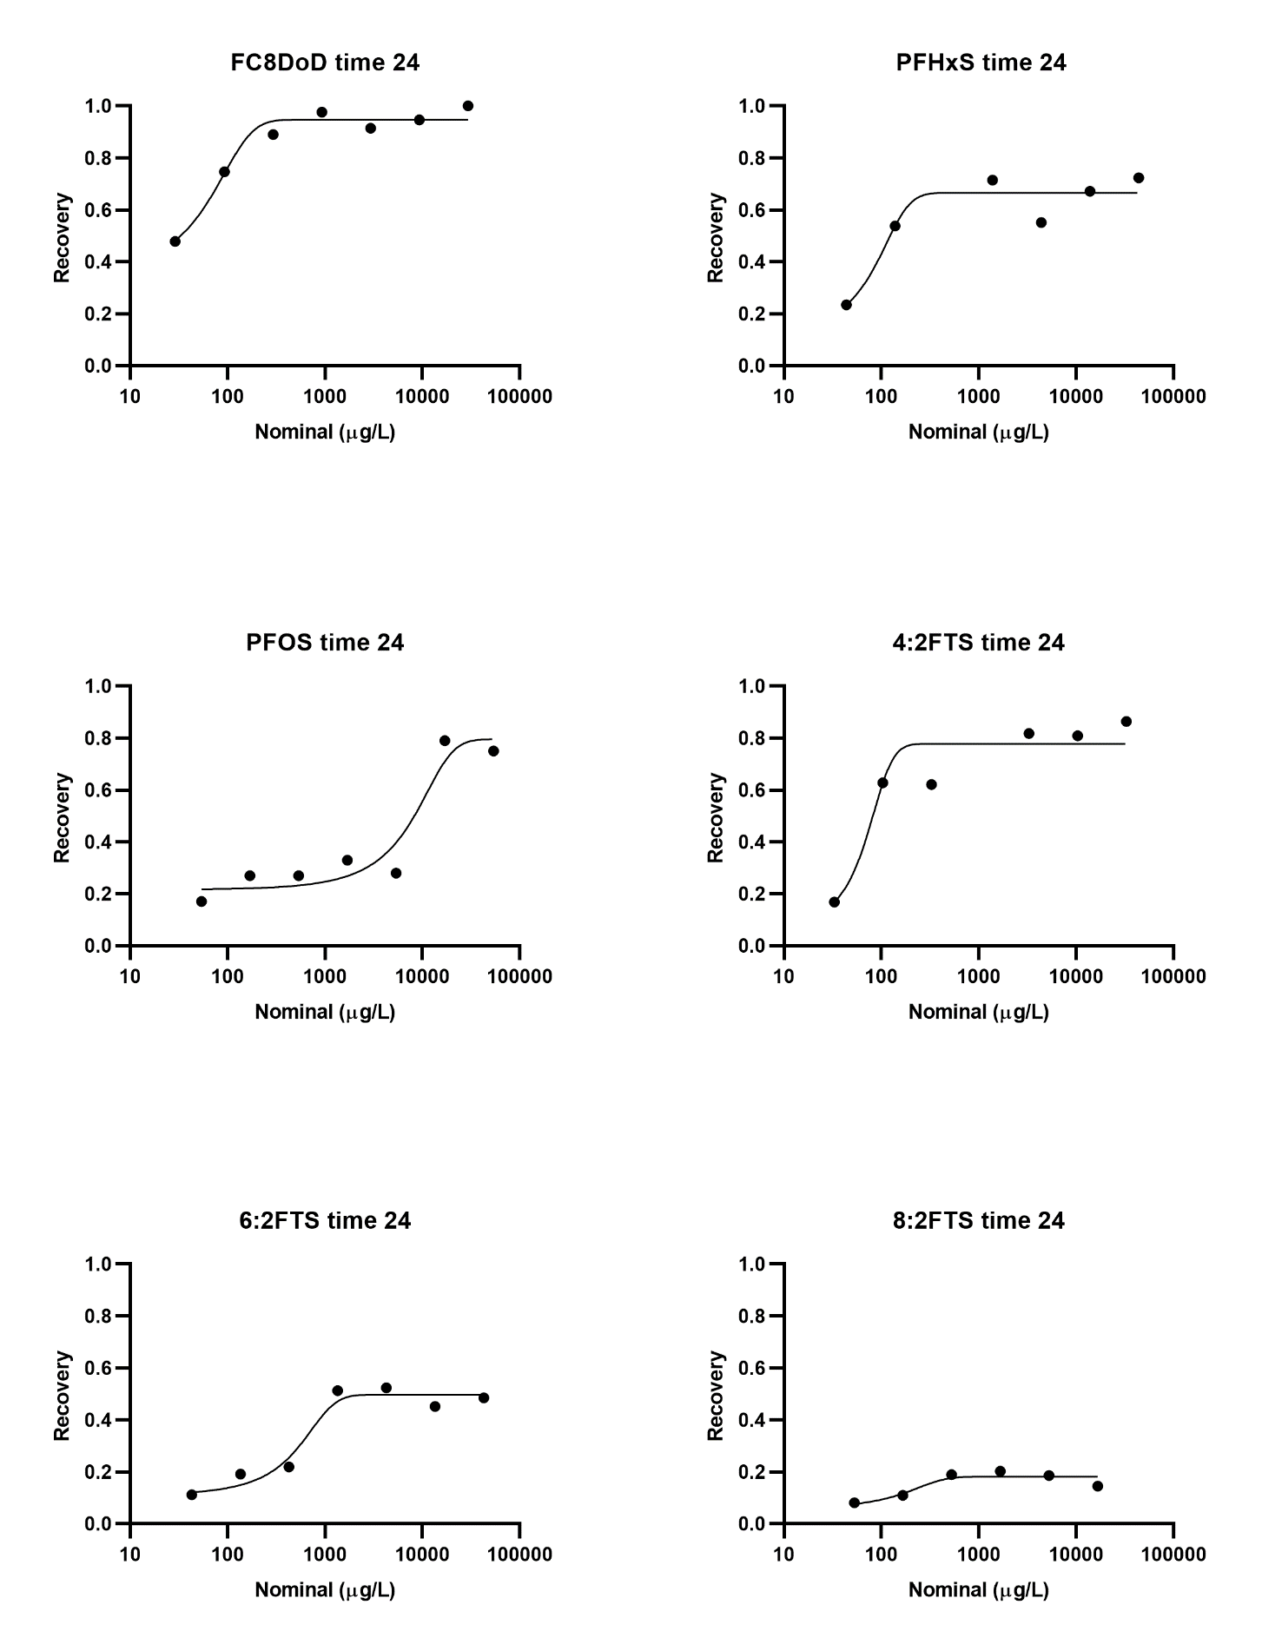

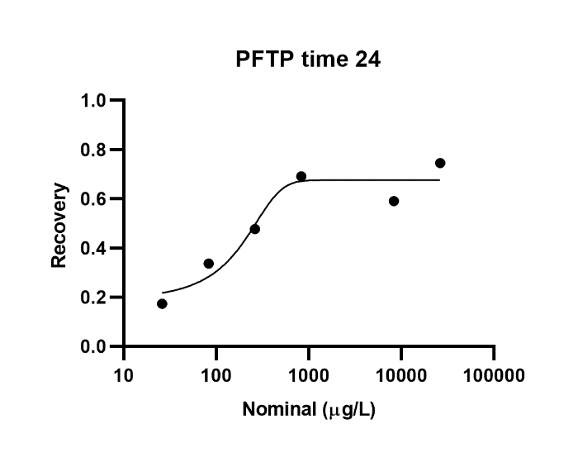
Supplemental Figure 3. Recovery ratio for the PFAS at either time 0 h or time 24 h, depending on which was used for concentration response modeling, compared to nominal concentration values. Concentrations of 6:1 FTOH were simply nominals and are not graphed. N-EtFOSA-M was actually a 1:1 mixture with PFOS and is not graphed.

Supplemental Table 3. Lowest observable effect concentration (LOEC), no observable effect concentration (NOEC), and point of departure (POD) with 95% confidence intervals (95% CI) for each PFAS across all biomass and photosynthesis endpoints. An ‘X’ indicates the effect metric could not be calculated from the data.
Chemical | Biomass (550 nm) |  |  | Biomass (680 nm) |  |  | Biomass (750 nm) |  |  | Photosynthesis
Chemical | LOEC | NOEC | POD (95% CI) | LOEC | NOEC | POD (95% CI) | LOEC | NOEC | POD (95% CI) | LOEC | NOEC | POD (95% CI)
PFPeA | 2422 | 743 | X | X | 23127 | X | X | 23127 | X | X | 23127 | X
PFHpA | 71 | 20 | 68  (18-512) | 28499 | 8893 | 2834  (952-28499) | 2736 | 905 | 2861  (961-28499) | 2736 | 905 | 2800  (1800-8000)
PFOA | X | 39547 | X | X | 39547 | X | X | 39547 | X | 39547 | X | 39547
PFNA | X | 44264 | X | X | 44264 | X | X | 44264 | X | X | 44264 | X
PFUdA | X | 9333 | X | X | 9333 | X | X | 9333 | X | X | 9333 | X
PFTrDA | X | 423 | X | X | 423 | X | 201 | 66 | 63  (119-43) | X | 423 | X
PFTeDA | X | 23553 | X | X | 23553 | X | X | 23553 | X | X | 23553 | X
PF4OPeA | X | 19186 | X | X | 19186 | X | X | 19186 | X | X | 19186 | X
PFPB | X | 37007 | X | X | 37007 | X | X | 37007 | X | X | 37007 | X
PFTDoDA | X | 41081 | X | X | 41081 | X | X | 41081 | X | X | 41081 | X
FC8diol | X | 29457 | X | X | 29457 | X | 3295 | 982 | X | 29547 | 9311 | X
FC10diol | X | 23419 | X | 23419 | 6890 | X | 23419 | 6890 | 14563  (9607-14563) | X | 23419 | X
FC8DoD | X | 29448 | X | X | 29448 | X | X | 29448 | X | X | 29448 | X
N-EtFOSA-M/PFOS | 4302 | 916 | 865  (497-965) | 4302 | 916 | 778  (576-1185) | 69 | 19 | 17  (8-41) | X | 6718 | X
PFHxS | X | 31743 | X | 31743 | 9333 | 137  (78-248) | X | 31743 | X | X | 31743 | X
PFOS | X | 40351 | X | X | 40351 | X | X | 40351 | X | X | 40351 | X
4:2FTS | X | 28559 | X | X | 28559 | X | X | 28559 | X | X | 28559 | X
6:2FTS | X | 20770 | X | X | 20770 | X | X | 20770 | X | X | 20770 | X
8:2FTS | X | 3133 | X | 3133 | 2427 | X | 3133 | 2427 | X | X | 3133 | X
PFTP | X | 19551 | X | X | 19551 | X | X | 19551 | X | X | 19551 | X
6:1 FTOH | 35008 | 11087 | 6511  (3675-26287) | 11087 | 3501 | 4000  (2718-8408) | 35008 | 11087 | 4058  (2748-8666) | X | 35008 | X

Supplemental Table 4. Lowest observable effect concentration (LOEC), no observable effect concentration (NOEC), and point of departure (POD) with 95% confidence intervals (95% CI) for each PFAS across photopigment and viability measurements. An ‘X’ indicates the effect metric could not be calculated.
Chemical | Chlorophyll A |  |  | Chlorophyll B |  |  | Carotenoids |  |  | Viability
Chemical | LOEC | NOEC | POD  (95% CI) | LOEC | NOEC | POD  (95% CI) | LOEC | NOEC | POD  (95% CI) | LOEC | NOEC | POD  (95% CI)
PFPeA | X | 23127 | X | X | 23127 | X | X | 23127 | X | X | 23127 | X
PFHpA | X | 28499 | X | X | 28499 | X | X | 28499 | X | X | 28499 | X
PFOA | X | 39547 | X | X | 39547 | X | X | 39547 | X | X | 39547 | X
PFNA | X | 44264 | X | X | 44264 | X | 283 | 87 | 1076  (289-13170) | X | 44264 | X
PFUdA | 1 | 9333 | X | 1305 | 211 | 7699  (4649-22338) | X | 9333 | X | 211 | 12 | 26  (12-27)
PFTrDA | X | 423 | X | X | 423 | X | X | 423 | X | 201 | 66 | 42  (31-63)
PFTeDA | 2 | 23553 | X | 23353 | 3313 | 11037  (7834-18620) | X | 23553 | X | 160 | 59 | 76  (38-173)
PF4OPeA | X | 19186 | X | X | 19186 | X | X | 19186 | X | 19186 | 6477 | 9079  (6459-15234)
PFPB | X | 37007 | X | X | 37007 | X | X | 37007 | X | X | 37007 | X
PFTDoDA | X | 41081 | X | X | 41081 | X | 41081 | 12419 | X | X | 41081 | X
FC8diol | X | 29457 | X | X | 29457 | X | 69 | 8 | X | X | 29457 | X
FC10diol | X | 23419 | X | 183 | 71 | X | 5 | X | X | 23419 | 6890 | 20621  (9361-22397)
FC8DoD | X | 29448 | X | X | 29448 | X | 14 | 4 | 9468  (4114-28793) | X | 29448 | X
N-EtFOSA-M/PFOS | X | 6718 | X | X | 6718 | X | X | 6718 | X | 6718 | 4302 | 4399  (2510-6503)
PFHxS | X | 31743 | X | X | 31743 | X | 31743 | X | X | X | 31743 | X
PFOS | X | 40351 | X | X | 40351 | X | X | 40351 | X | X | 40351 | X
4:2FTS | X | 28559 | X | X | 28559 | X | X | 28559 | X | X | 28559 | X
6:2FTS | X | 20770 | X | X | 20770 | X | X | 20770 | X | X | 20770 | X
8:2FTS | X | 3133 | X | X | 3133 | X | X | 3133 | X | X | 3133 | X
PFTP | X | 19551 | X | X | 19551 | X | X | 19551 | X | X | 19551 | X
6:1 FTOH | X | 35008 | X | X | 35008 | X | X | 35008 | X | X | 35008 | X

Supplemental Table 5.
Chemical | Genes in the count matrix | Genes passing Williams trend test | Genes passing filters (CRGs) | Median BMC (µg/L) | Median BMCL (µg/L) | Median BMCU  (µg/L) | tPOD from 10th percentile  (µg/L) | 10th percentile BMDL (µg/L) | 10th percentile BMDU (µg/L)
PFPeA | 9446 | 550 | 153 | 424 | 275 | 674 | 11 | 8.9 | 12
PFHpA | 9607 | 260 | 103 | 5801 | 3352 | 13107 | 18 | 14 | 52
PFOA | 9322 | 299 | 78 | 14396 | 10194 | 27076 | 4.9 | 4.0 | 5.5
PFNA | 7752 | 299 | 103 | 14566 | 10273 | 28469 | 1041 | 299 | 1653
PFUdA | 8848 | 482 | 153 | 766 | 535 | 1339 | 1.1 | 0.8 | 3.4
PFTrDA | 8231 | 157 | 52 | 207 | 115 | 406 | 0.9 | 0.3 | 1.1
PFTeDA | 8380 | 326 | 109 | 293 | 161 | 910 | 5.8 | 3.6 | 7.7
PF4OPeA | 9531 | 282 | 128 | 197 | 77 | 237 | 22 | 7 | 67
PFPB | 9613 | 533 | 140 | 607 | 407 | 974 | 20 | 18 | 21
PFTDoDA | 9494 | 958 | 361 | 3939 | 2526 | 7210 | 20 | 12 | 40
FC8diol | 9011 | 620 | 263 | 3674 | 2276 | 8146 | 92 | 64 | 248
FC10diol | 9122 | 4396 | 2463 | 5121 | 2701 | 9699 | 677 | 430 | 1354
FC8DoD | 9243 | 167 | 81 | 7604 | 4376 | 11758 | 224 | 66 | 503
N-EtFOSA-M/PFOS | 9478 | 316 | 134 | 816 | 441 | 1498 | 74 | 21 | 170
PFHxS | 9422 | 467 | 146 | 9.6 | 9.3 | 29.9 | 2.9 | 1.3 | 6.5
PFOS | 9299 | 285 | 82 | 10207 | 7536 | 15606 | 7.8 | 7.4 | 8.1
4:2FTS | 9224 | 157 | 72 | 3045 | 1908 | 8501 | 36 | 11 | 63
6:2FTS | 9158 | 217 | 67 | 3125 | 1850 | 7829 | 7.9 | 5.3 | 8.1
8:2FTS | 9241 | 192 | 60 | 200 | 120 | 503 | 3.1 | 0.6 | 3.8
PFTP | 9387 | 1143 | 555 | 354 | 142 | 578 | 2.6 | 1.3 | 4.3
6:1 FTOH | 9646 | 597 | 158 | 971 | 579 | 1714 | 36 | 30 | 70

Alfred S E, Surendra A, Le C, Lin K, Mok A, Wallace I M, Proctor M, Urbanus M L, Giaever G, & Nislow C. (2012) A phenotypic screening platform to identify small molecular modulators of Chlamydomonas reinhardtii growth, motility and photosynthesis. Genome Biology, 13: R105.

Bennoun P & Levine R P. (1967) Detecting mutants that have impaired photosynthesis by their increased level of fluorescence. Plant Physiology, 42: 1284-1287.

Haire T, Bell C, Cutshaw K, Swiger B, Winkelmann K, & Palmer A. (2018) Robust microplate-based methods for culturing and in vivo phenotypic screening of Chlamydomonas reinhardtii. Frontiers in Plant Science, 9: 235.

Horvatic J, Persic V, Pavlic Z, Stjepanovic B, & Has-Schon E. (2007) Toxicity of metals on the growth of Raphidocelis subcapitata and Chlorella kessleri using microplate bioassays. Fresenius Envrionmental Bulletin, 16: 826-831.

Lichtenthaler H K. (1987) Chlorophylls and carotenoids: pigments of photosynthetic biomembranes. In Methods in Enzymology: Plant Cell Membranes. Packer & Douce (eds.), Academic Press: San Diego, CA, USA.

Lomba L, Lapeña D, Ros N, Aso E, Cannavò M, Errazquin D, & Giner B. (2021) Ecotoxicological study of six drugs in Aliivibrio fischeri, Daphnia magna and Raphidocelis subcapitata. Environmental Science & Pollution Research, 27: 9891-9900.

Nichols H W. (1973) ). Growth media in fresh water. In Handbook of Phycological Methods, 7-24. Stein J. R. (ed.), Cambridge University Press, London, UK.

