Information about the dataset for Big Spring Run
This project involved long-term monitoring of water quality parameters at Big Spring Run in Pennsylvania. Big Spring Run was the site of a sediment restoration project.
The water samples collected at Big Spring Run were analyzed by a contractor, and an example Excel file submitted by the contractor and named EPAGP464,SS#6922,2.1A,A. Keeley,BigSpringRunStreamRestStudy,Galeone,May2013,5-28-13,oP,Br,I,GPLC.xlsx is provided to show the format of the data as reported by the contractor. There are typically three sheets in each file, named Cover Letter, Data, and QC Data.
Initial processing of each sample data file was done as follows:
- The sheets Cover Letter and Data were duplicated, so as to maintain the integrity of the original sheets.
- The duplicate sheets were then examined, and the ranges of cells on the sheets were examined for the desired data. Excel range names were assigned to each block of cells, and the identified cell ranges were color coded to indicate they had been identified.
- Visual Basic software was written to open each Excel file and to read the information in each identified range of cells.
- The software then transferred the information from the Excel files to tables in a Microsoft Access database.
The Access database:
The data are contained in an Access relational database, and it is recommended that the user view the relationships in the database to understand its structure. After opening the database, the relationships can be view by selecting the menu sequence Database Tools and clicking on the Relationships icon in the application ribbon.
Below is a screen shot of the major relationships in the Big Spring Run database. Note that Autonumber keys are used to relate the tables to one another. Also note the small “key” icon appearing next to variable names. The collection of variables identified in each table are restricted to be unique combinations of those variables. This ensured that no duplicate data could be entered into tables.
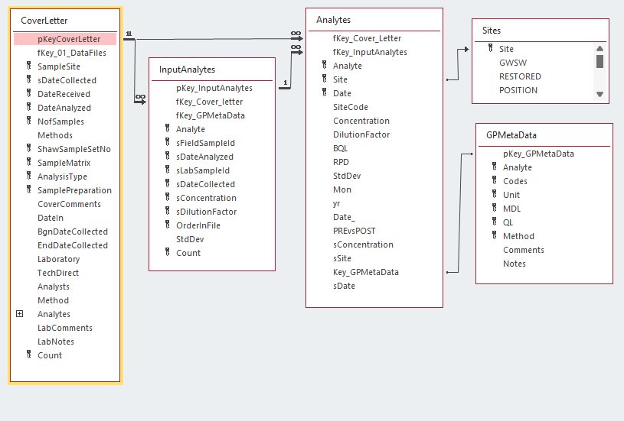

The tables in the database are as follows:
- CoverLetter: Contains information extracted from the Excel cover letter sheet. Most fields are self-explanatory but note that the date fields are stored as character strings, and not date values. This is because the contractor sometimes included alphabetic characters in sheet cells that were nominally to hold date values.
- Sites: This table provides information about each sample site, including the site’s geographic coordinates, whether the site was inside or outside of the restoration area, and whether the site survived the sediment restoration process.
- GPMetaData: This table holds information about the analytes reported in this Excel file: the name of the analyte, the code for the analyte, the method used to determine the analyte concentration, the units of the reported concentration, the minimum detection limit (MDL) and the quantitation limit (QL). The “GP” stands for General Parameters.
- InputAnalytes: This table contains the information for each sample as read from the Excel sheet. Common to all analytes are the columns Field Sample ID, Lab Sample ID, Date Collected, and Date Analyzed. Following these columns are the concentration values (labeled as Data in the sheet), the dilution factor (labeled as DF in the sheet). In some cases, a standard deviation of the concentration value was provided by the contractor.
  - These fields are typically stored as text, because the contractor frequently included alphabetic information in the sheet cells. Examples of alphabetic information include:
    - ND: Analyte was not detected.
    - BQL: Analyte was below quantitation limit.
    - RPD: Relative Percent Difference
- Analytes: This table holds the analyte information derived from the InputAnalytes table described above. It separates the numeric and text information into separate fields, so that the data can be analyzed.
- MasterIsotopes: Some samples were also analyzed for stable isotope content by the EPA’s ISIRF laboratory, and the data from these analyses are contained in this table.

The following pages were created using the Access Database Documenter utility, which provides detailed information about the contents of the database, including the characteristics of tables, their fields, and the relationships among tables.

