SPONSOR
U.S. Environmental Protection Agency
1200 Pennsylvania Ave., NW
Washington DC 20460C

USEPA Task Order/Battelle Contract No.
TO 14/ EP-W-11-063

TEST SUBSTANCE
Triclosan (Irgasan)

STUDY TITLE
Larval Amphibian Growth and Development Assay (LAGDA) of Triclosan (Irgasan) with African Clawed Frog, Xenopus laevis

TEST GUIDELINE
U.S. EPA, OCSPP 890.2300 (July 2015)

STUDY DIRECTOR
Douglas J. Fort, Ph.D.

STUDY INITIATION DATE
January 8, 2016

STUDY COMPLETION DATE
May 21, 2018

TEST FACILITY
Fort Environmental Laboratories, Inc. (In-Life Testing)
515 South Duncan Street
Stillwater, OK 74074 USA
PI SUPPORT SITES
EAG Laboratories (formerly ABC), Analytical Chemistry
7200 East ABC Lane
Columbia, MO 65202
ABC Laboratories

Experimental Pathology Laboratories (EPL) (Histopathology)
45600 Terminal Drive
Sterling, VA 20166 USA

REPORT NUMBER
BATT01-00391

Total Pages: 523

COMPLIANCE STATEMENT
This study was conducted in compliance with the following GLP principles:
- United States Environmental Protection Agency, (FIFRA), Good Laboratory Practice Standards, Title 40 Code of Federal Regulations Part 160 (effective October 16, 1989) with the following exceptions:
- Analysis of the laboratory dilution water for organics, pesticides and metals at Red River Laboratory (Oklahoma City, Oklahoma) using standard EPA methods was not GLP-compliant;
- Per Sponsor-mandated exception, the test substance was not chemically-characterized in a GLP-compliant manner;
- Per Sponsor-mandated exception, range-finding studies conducted as a component of FEL study (BATT01-00385) used to determine test concentrations for the present study, BATT01-00391, were not performed in a GLP-compliant manner;
- Per Sponsor-mandated exception, following study finalization, specimens remaining at FEL, and embedded tissues or specimens maintained by EPL will be disposed of in accordance with QMP, QAPP, and respective facility SOPs.
Since the analyses of the dilution water was conducted following standard validated methods, this exception will not be expected to impact on the study results. Lack of GLP-compliant chemical characterization or GLP-compliant range-finding studies will not be expected to impact study results, nor change the conclusions drawn from the study.

GLP Study Title: Larval Amphibian Growth and Development Assay (LAGDA) of Triclosan (Irgasan) with African Clawed Frog, Xenopus laevis

FEL Study No.: BATT01-00391

Test Substance: Triclosan (Irgasan) (CAS No. 3380-34-5)
Douglas J. Fort, Ph.D. |  | Date
Fort Environmental Laboratories, Inc.
(Study Director)
Vincent J. Brown, Ph.D. |  | Date
Battelle
(Sponsor Representative)

STATEMENT OF QUALITY ASSURANCE UNIT
This study was conducted in accordance with Standard Operating Procedures (SOPs) and the protocol as approved by the Sponsor. The Fort Environmental Laboratories, Inc. (FEL) Quality Assurance Unit conducted the inspections detailed below:

Type of Inspection | Dates
 | Inspection | Reported to  Study Director | Reported to Management
Protocol Review | 1/8/2016 | 1/8/2016 | 1/8/2016
Technical Systems Audit | 2/12/2016 | 2/12/2016 | 2/12/2016
Technical Systems Audit | 4/5/2016 | 4/5/2016 | 4/5/2016
Technical Systems Audit | 5/6/2016 | 5/6/2016 | 5/6/2016
Audit of Data Quality | 1/5/2017 | 1/5/2017 | 1/5/2017
Draft Report Audit | 8/4/2017 | 8/4/2017 | 8/4/2014
Final Report Audit | 5/21/2018 | 5/21/2018 | 5/21/2018

This report accurately reflects the raw data obtained during the performance of this study. The protocol and all protocol amendments and deviations are presented as an attachment (Appendix A). Three protocol deviations occurred during the course of this study. Procedures pertinent to this study are described in this report. The primary goal of the Quality Assurance Unit (QAU) is to ensure the accuracy and precision of routine laboratory operations, data generated reports, and presentation of studies conducted by FEL. The final report is considered to constitute an accurate and complete reflection of the data generated from this study.

Michael Mathis, QAU Manager, FEL |  | Date

CERTIFICATION
We, the undersigned, declare that this report provides an accurate evaluation of the data obtained from this study.

Study Director:

Douglas J. Fort, Ph.D., Study Director, FEL |  | Date

Performing Laboratory Management:
Deanne Fort, Facility Manager, FEL |  | Date

TABLE OF CONTENTS
1. COMPLIANCE STATEMENT 2
2. STATEMENT OF QUALITY ASSURANCE UNIT 3
3. CERTIFICATION 4
4. TABLE OF CONTENTS 5
5. EXECUTIVE SUMMARY 9
5.1. Measured Test Concentrations 9
5.2. Survival 9
5.3. Growth 9
5.4. Development 10
5.5. Histopathology (abnormal morphological features) 10
5.6. Overt toxicity and behavior 11
5.7. Conclusions 11
6. INTRODUCTION 12
7. Study Personnel 13
8. ANIMAL WELFARE COMPLIANCE 13
9. materials and methods 14
9.1. Test Substance 14
9.2. Laboratory Water 15
9.3. Test System 15
9.3.1. Feeding 16
9.4. Exposure System 16
9.4.1. Chemical analysis 17
9.5. Study Design and Additional Experimental Conditions 18
9.5.1. Biological Sample Collection 19
9.5.2. Exposure System Performance 19
9.6. Observations 19
9.6.1. Survival 19
9.6.2. Additional Daily Observations 19
9.6.3. NF Stage 62 Specimens (Endpoints/Tissue Sample Preparation) 20
9.6.4. Time to Metamorphosis (TTM) 20
9.6.5. Growth (Weight and Length) 20
9.6.6. External Evaluation 20
9.6.7. Tissue Collection and Fixation for General Histology 20
9.6.8. End of Larval Exposure Phase 21
9.6.9. In-Life Test Termination (Endpoints / Tissue Sample Preparation) 21
9.6.10. Growth (Weight and Length) 21
9.6.11. External Evaluation 22
9.6.12. Tissue Collection and Fixation for General Histology 22
9.6.13. Phenotypic and Genotypic Sexing 22
10. Data Analysis 22
11. Results 23
11.1. Range Finding 23
11.2. Water Quality Measurements and Test System Performance 24
11.3. Confirmation of Test Concentrations 24
11.4. Clinical Signs of Toxicity 24
11.5. In-Life Studies—NF 8 to NF Stage 62 24
11.5.1. Survival 24
11.5.2. Time to Metamorphosis 24
11.5.3. GRowth 25
11.6. In-Life Studies—Metamorphosed Young and Juveniles 25
11.6.1. Survival 25
11.6.2. Growth 25
11.6.3. Snout-to-Vent Length (SVL) 25
11.6.4. Liver-Somatic Index (LSI) 26
11.6.5. Gender Ratios 26
11.7. Histopathology 26
11.7.1. NF Stage 62 (ThyROID) 26
11.7.2. Juveniles (10 wpm) 27
12. Concentration Measurement Endpoints 29
13. DISCUSSION 29
13.1. Performance Criteria and Validity 29
13.2. Assessment of the LAGDA results 29
13.2.1. Measured Test Concentrations 29
13.2.2. Survival 29
13.2.3. Growth 30
13.2.4. Development 30
13.2.5. Histopathology (abnormal morphological features) 30
13.2.6. Overt toxicity and behavior 31
13.2.7. Comparison of Present Study Results to Previous Study – Fort et al. (12) 32
14. Conclusions 32
15. Sample handling and custody 34
16. Record Maintenance and Archival 34
17. Specimens Archival 34
18. test Substance waste Disposal 35
19. Study Protocol Adherence 35
20. References 36

LIST OF TABLES

Table 1. Feeding Regime for X. laevis Larvae in Flow-Through Conditions 39
Table 2. Frog food (2 mm) Feeding Rate for Metamorphosed Frogs 39
Table 3. Experimental Specifications for LAGDA Study 40
Table 4. Summary of Study Endpoints 41
Table 5. Summary of Water Quality Parameters 42
Table 6. Summary of Treatment Concentrations in LAGDA with Triclosan 43
Table 6. (continued) Summary of Treatment Concentrations in LAGDA with Triclosan 44
Table 7. Summary of Treatment Concentrations in the Larval Amphibian Growth and Development Assay (LAGDA) with Triclosan 47
Table 8. Effect of Triclosan on Survival in X. laevis (LAGDA) 48
Table 9. Effect of Triclosan on Median Metamorphosis Time (MMT) in X. laevis (LAGDA) 49
Table 10. Effect of Triclosan Exposure on Body Weight in NF Stage 62 X. laevis Larvae (LAGDA) 50
Table 11. Effect of Triclosan Exposure on Snout-to-Vent Length (SVL) in NF Stage 62 X. laevis Larvae (LAGDA) 51
Table 12. Effect of Triclosan Exposure on Body Weight in NF Stage 66 X. laevis (LAGDA) 52
Table 13. Effect of Triclosan Exposure on Body Weight in Juvenile Female X. laevis at Study Termination (LAGDA) 53
Table 14. Effect of Triclosan Exposure on Body Weight in Juvenile Male X. laevis at Study Termination (LAGDA) 54
Table 15. Effect of Triclosan Exposure on Snout-to-Vent Length (SVL) in NF Stage 66 X. laevis (LAGDA) 55
Table 16. Effect of Triclosan Exposure on Snout-to-Vent Length (SVL) in Juvenile Female X. laevis at Study Termination (LAGDA) 56
Table 17. Effect of Triclosan Exposure on Snout-to-Vent Length (SVL) in Juvenile Male X. laevis at Study Termination (LAGDA) 57
Table 18. Effect of Triclosan Exposure on Liver-Somatic Indices (LSI) in Juvenile Female X. laevis at Study Termination (LAGDA) 58
Table 19. Effect of Triclosan Exposure on Liver-Somatic Indices (LSI) in Juvenile Male X. laevis at Study Termination (LAGDA) 59
Table 20. Effect of Triclosan Exposure on Phenotypic and Genotypic Sex Ratios in Juvenile X. laevis at Study Termination (LAGDA) 60
Table 21. Summary of the Effect of Triclosan Exposure on Thyroid Histopathology Findings in NF Stage 62 Larvae 61
Table 22. Summary of the Effect of Triclosan Exposure on Prevalence and Severity of Selected Findings in the Kidneys in Female X. laevis 62
Table 23. Summary of the Effect of Triclosan Exposure on Gonadal Duct Stage Scores in Female X. laevis 63
Table 24. Summary of the Effect of Triclosan Exposure on Prevalence and Severity of Selected Findings in the Kidneys in Male X. laevis 64
Table 25. Summary of the Effect of Triclosan Exposure on Gonadal Duct Stage Scores in Male X. laevis 65
Table 26. Summary of the Effect of Triclosan Exposure on Testis Stage Scores in Male X. laevis 66
Table 27. Summary of Study BATT01-00391 Endpoint Results 67
Table 28. General Test Performance Criteria 68

LIST OF APPENDICES

Appendix A. Protocol, Protocol Amendments, and Protocol Deviations 69
Appendix B. Certificate of Analysis 118
Appendix C. Analytical Laboratory Data Reports 120
Appendix D. Histopathology Data Reports 184
Appendix E. DEST 298
Appendix F. Statistical Analyses 473
Appendix G. Range-Finding Data (range-finding studies were not performed in a GLP-compliant manner per exception noted in Section 1) 521

EXECUTIVE SUMMARY
The Larval Amphibian Growth and Development Assay (LAGDA) (OCSPP 890.2300) uses the African clawed frog (Xenopus laevis) as a surrogate to identify and characterize the adverse consequences of exposure to substances which might interfere with the normal development and growth of amphibians from embryo-larval development through metamorphosis and early juvenile development. Adverse effects identified by the LAGDA may be caused by endocrine interaction of a chemical in amphibians, especially those active within the hypothalamic-pituitary-thyroid (HPT) and hypothalamic-pituitary-gonadal (HPG) systems. In the conduct of the present study, FEL relied on internal SOPs, per the GLP regulations and documented QAU practices subject to sponsor and other government audit. These SOPs are not available to the public. Amphibian larvae at Nieuwkoop–Faber (NF) Stage 8-10 (80/treatment group and 160/control group(s); 20/replicate) were exposed to triclosan (Irgasan or TCS) (99.8% pure) at test chemical nominal concentrations of 0.0 (control), 3.60, 10.9, 33.0, and 100 µg/L, until 10 weeks post median metamorphosis time (MMT) (median time at which 50% of the controls reach NF stage 62) There was one interim sub-sample at MMT. Endpoints evaluated during the exposure included those indicative of generalized toxicity: mortality (survival), growth (length and weight), development (time to metamorphosis at NF stage 62 (TTM)), morphological features (histopathology), overt toxicity, and behavior. Thyroid histopathology of NF stage 62 specimens and gonad, gonadal ducts, liver, and kidney histopathology of study termination specimens were performed. The assay was conducted under flow-through conditions. The test system was maintained at 21.3 to 21.9º C and a pH of 6.9 to 8.0.

A summary of the results is provided below.

Measured Test Concentrations
- The mean measured concentrations for the 0.0 (control), 3.6, 10.9, 33.0, and 100 µg/L TCS treatments (nominal) were (<0.199 µg/L [minimum quantitation level, MQL]), 4.23, 13.8, 39.7, and 111 μg/L TCS (see Table 6).

Survival
- No significant effects on larval or juvenile survival were observed during the study.

Growth
- No effect of TCS exposure on body weight or snout-vent length (SVL) in NF stage 62 larvae relative to the control was observed (Jonckheere-Terpstra test, p>0.05).
- A significant reduction in weight (Jonckheere-Terpstra test, p=0.0258), but not SVL, was noted in NF stage 66 larvae exposed to 100 μg/L TCS compared to the control.
- No effects of TCS exposure on body weight or SVL in female or male juvenile X. laevis at 10 wpm relative to the control were observed (Jonckheere-Terpstra test, p>0.05).
- No effects of TCS exposure on liver-somatic index (LSI) were observed in either female or male termination specimens at 10 wpm compared to control (Jonckheere-Terpstra test, p>0.05).

Development
- The median metamorphosis time (MMT) in larvae exposed to 100 µg/L was significantly greater than the control (Cox Proportional Hazard Model, Chi Square, p<0.0001) suggestive of developmental delay during metamorphosis.
- Asynchronous development was not noted in the control or treatments during the conduct of the study.
- No marked changes in phenotype or genotype ratios were observed in TCS-treated frogs relative to controls, and correspondence between phenotypic and genotypic genders were noted regardless of treatment.

Histopathology (abnormal morphological features)

- THYROID: An increase in the prevalence of follicular cell hypertrophy at the minimal severity level in the thyroid glands of frogs exposed to 33.0 and 100 µg/LTCS as compared to controls (RSCABS, p=0.0375 and 0.0132, respectively). Minimal to mild follicular cell hypertrophy was a common finding, with a high prevalence in all groups. Because anuran metamorphosis is considered to be a thyroid-dependent process, basal levels of follicular cell hypertrophy and hyperplasia are anticipated findings in control frogs at NF Stage 62.

- LIVER: There were no treatment-related findings in the livers of male or female terminal sacrifice frogs or gonadal ducts of female terminal sacrifice frogs.
- KIDNEY: Treatment-related findings in the kidneys of male 10 wpm frogs included: increased severity of mineralization (mild to moderate) at all three sections in 33.0 and 100.0 μg/L treatment groups males; increased prevalence and severity of dilated tubules (minimal to mild) in all three sections in 33.0 and 100.0 μg/L treatment group, and at the anterior and middle levels of 10.9 μg/L treatment group; and an increased prevalence of interstitial fibrosis (minimal) in the posterior section in 100.0 μg/L treatment group (RSCABS, p<0.05). Mineralization and tubular dilation were scattered throughout the renal parenchyma in contrast to interstitial fibrosis, which affected primarily the lateral regions of the kidneys surrounding the Wolffian ducts.
Treatment-related findings in the kidneys of 10 wpm female frogs included: increased mineralization of minimal to moderate severity in all three sections of the 100.0 μg/L treatment group, and in the middle section of 33.0 μg/L treatment group; increased prevalence and severity of dilated tubules (minimal to mild) in all three sections of the 33.0 and 100.0 μg/L treatment group, and in the posterior section of 10.9 μg/L treatment group (RSCABS, p<0.05). An increased prevalence of interstitial fibrosis (minimal to mild) in the anterior and middle sections of the 100.0 μg/L treatment group, and the anterior level of 33.0 μg/L treatment group females was also observed (RSCABS, p<0.05). An increased prevalence of mononuclear cell infiltrates in the middle section of 100.0 μg/L treatment group was noted (RSCABS, p<0.05).
- MALE GONADAL DUCTS: Treatment-related findings in the gonadal ducts of 10 wpm male frogs included: an increased prevalence and/or severity of cytoplasmic inclusions (minimal to mild) in the Wolffian duct epithelial cells in all three sections of the 100.0 μg/L treatment group; and decreased Wolffian duct stage scores in the anterior segment of 10.9, 33.0, and 100.0 μg/L treatment groups (RSCABS, p<0.05).
- TESTES: Treatment-related findings in the testes of 10 wpm male frogs included: an increased prevalence and/or severity of germ cell degeneration (minimal to mild) in the anterior, middle, and posterior sections of the 33.0 and 100.0 µg/L treatment group males, and in the anterior and middle levels of 10.9 µg/L treatment group (RSCABS, p<0.05). Differences in testis stage scores in the anterior segments of 33.0 and 100.0 µg/L treatment group males, and in the middle segment of 100.0 µg/L treatment were also observed (RSCABS, p<0.05).
- FEMALE GONADAL DUCTS: An increase in the prevalence and/or severity of cytoplasmic inclusions (minimal to mild) in the Wolffian duct epithelial cells in the anterior segment in 33.0 and 100.0 μg/L dose treatment females, and in the posterior segment in 100.0 μg/L treatment group females were observed (RSCABS, p<0.05). Further, Wolffian duct stage scores in 10 wpm female frogs were significantly less than controls in the middle segment of 10.9, 33.0, and 100.0 μg/L treatment groups.
- OVARIES: There were no treatment-related findings in the ovaries of 10 wpm females. A single frog of the 100.0 µg/L treatment group was diagnosed as being hermaphroditic.

Overt toxicity and behavior
- No significant effects on behavior or signs of overt toxicity were noted.

Conclusions
Survival from NF Stage 8 to NF Stage 62 was 100% for the control and all TCS treatments. No effects on behavior or signs of overt toxicity were noted. The MMT of larvae exposed to 100 µg/L TCS was significantly greater than the control (Cox Proportional Hazard Model, Chi Square, p<0.0001). No marked effects on growth at NF stage 62 (larval stage) were observed during the study as the result of exposure to TCS. An increase in the prevalence of follicular cell hypertrophy at the minimal severity level was observed in the thyroid glands of frogs exposed to 33.0 and 100 µg/LTCS as compared to controls (RSCABS, p=0.0375 and 0.0132, respectively). Minimal to mild follicular cell hypertrophy was a common finding, with a high prevalence in all groups.

Survival from NF Stage 62 to NF Stage 66 and from NF Stage 66 to test termination (10 wpm) was 100% for the control and all TCS treatments. No marked effects on growth at 10 wpm, LSI, or skewed phenotype and genotype ratios were observed during the study as the result of exposure to TCS. There were no treatment-related findings in the livers of male or female terminal sacrifice frogs or gonadal ducts of female terminal sacrifice frogs. Treatment-related findings in the kidneys of male 10 wpm frogs included: increased severity of mineralization (mild to moderate) in all three sections in 33.0 and 100.0 μg/L treatment groups males; increased prevalence and severity of dilated tubules (minimal to mild) in all three sections in 33.0 and 100.0 μg/L treatment group, and at the anterior and middle levels of 10.9 μg/L treatment group; and an increased prevalence of interstitial fibrosis (minimal) in the posterior section in 100.0 μg/L treatment group (RSCABS, p<0.05). Treatment-related findings in the kidneys of 10 wpm female frogs included: increased mineralization of minimal to moderate severity in all three sections of the 100.0 μg/L treatment group, and in the middle section of 33.0 μg/L treatment group; increased prevalence and severity of dilated tubules (minimal to mild) in all three sections of the 33.0 and 100.0 μg/L treatment groups, and in the posterior section of 10.9 μg/L treatment group (RSCABS, p<0.05). An increased prevalence of interstitial fibrosis (minimal to mild) in the anterior and middle sections of the 100.0 μg/L treatment group, and the anterior level of 33.0 μg/L treatment group females was also observed (RSCABS, p<0.05). An increased prevalence of mononuclear cell infiltrates in the middle section of 100.0 μg/L treatment group was noted (RSCABS, p<0.05). Treatment-related findings in the gonadal ducts of 10 wpm male frogs included: an increased prevalence and/or severity of cytoplasmic inclusions (minimal to mild) in the Wolffian duct epithelial cells in all three sections of the 100.0 μg/L treatment group; and decreased Wolffian duct stage scores in the anterior segment of 10.9, 33.0, and 100.0 μg/L treatment groups (RSCABS, p<0.05). An increase in the prevalence and/or severity of cytoplasmic inclusions (minimal to mild) in the Wolffian duct epithelial cells in the anterior segment in 33.0 and 100.0 μg/L dose treatment females, and in the posterior segment in 100.0 μg/L treatment group females were observed (RSCABS, p<0.05). Further, Wolffian duct stage scores in 10 wpm female frogs were significantly less than controls in the middle segment of 10.9, 33.0, and 100.0 μg/L treatment groups. There were no treatment-related findings in the ovaries of 10 wpm females.

Using the decision criteria in the LAGDA test guideline (OCSPP 890.2300), TCS appeared to delay metamorphosis at the highest test concentration (100 µg/L TCS), but did not appear to alter growth, LSI, or genotype:phenotype ratios. While there are significant histopathological findings caused by exposure to triclosan (males and females), it is unclear whether these effects were caused by an endocrine-mediated mechanism.

INTRODUCTION
FEL was contracted by Battelle Memorial Institute to perform the Larval Amphibian Growth and Development Assay using Triclosan (Irgasan or TCS) (test substance) as directed by USEPA Task Order (TO) 14 under USEPA/Battelle Memorial Institute contract EP-W-11-063 and sponsor-approved Quality Assurance Project Plan (QAPP) (1). This study was conducted in accordance with the USEPA FIFRA, Good Laboratory Practice (GLP) Standards, Final Rule, 40 CFR Part 160 (2), the Larval Amphibian Growth and Development Assay (LAGDA, OCSPP 890.2300) guidance document (3), under the FEL Quality Assurance Management Plan (QAMP) (4), relevant facility standard operating procedures (SOPs), and the following Study Protocol No. BATT01-6 prepared for Study No. BATT01-00391. In the conduct of the present study, FEL relied on internal SOPs, per the GLP regulations and documented QAU practices subject to sponsor and other government audit. These SOPs are not available to the public. The in-life study was initiated on February 10, 2016 and concluded May 29, 2016.

LAGDA was intended to identify and characterize the adverse consequences of exposure to substances which interfere with the normal development and growth of amphibians through larval development and metamorphosis. LAGDA evaluated potential, inciting contributors to amphibian population declines by evaluating the effects, both through endocrine and non-endocrine mechanisms, from exposure to contaminants during the larval stage of development that may adversely affect populations. Thus, the primary objective of the study was to evaluate the potential developmental toxicity of TCS to X. laevis in general accordance with the USEPA guidelines established for the LAGDA (3).

The general experimental design entailed exposing Nieuwkoop and Faber (NF) stage 8 X. laevis embryos (5) to four different concentrations of a test chemical and a control until 10 weeks post median metamorphosis time (MMT); which for this study was defined as the median time at which 50% of controls reach NF stage 62. There was one interim sub-sample at MMT. There were four replicates in each test concentration with eight replicates for the control. Endpoints evaluated during the exposure included those indicative of generalized toxicity: mortality, abnormal behavior, abnormal morphological features, time to metamorphosis at NF stage 62 (TTM), and growth determinations (length and weight). Thyroid histopathology of NF stage 62 specimens and gonad, gonadal ducts, liver, and kidney histopathology of study termination specimens were performed.

Study Personnel
- Dr. Vincent Brown, Battelle -Study Monitor
- Dr. Douglas Fort, FEL – Study Director
- Ms. Deanne Fort, FEL – Manager, In-life study facility
- Mr. Michael Mathis, FEL – QAU Manager
- Dr. Tom Leak, EAG Laboratories, Inc. – PI, analytical chemistry
- Dr. Jeffrey Wolf, EPL – PI, histopathology
- Mr. Kevin Todhunter, FEL – Technician
- Ms. Alex Oppenborn, FEL – Technician
- Ms. Jennifer Staines, FEL – Technician
- Ms. Franchesca Rollerson, FEL – Technician
- Mr. Troy Fort, FEL – Technician

ANIMAL WELFARE COMPLIANCE
This study complied with all applicable sections of the Final Rules of the Animal Welfare Act regulations (9 CFR). The Sponsor made note of the following:

- The Sponsor signature on the protocol documents for the Study Director the Sponsor’s assurance that the study described in the protocol did not unnecessarily duplicate previous experiments.

- Whenever possible, procedures used in this study were designed to avoid or minimize discomfort, distress or pain to animals. All methods were described in the study protocol or in written laboratory standard operating procedures.

- By design, this study killed and/or resulted in the pain and distress of test organisms. Euthanasia of test organisms before completion of the test interfered with study objectives. Upon completion of the test all distressed amphibians were painlessly euthanized in a timely manner.

- Methods of euthanasia used during this study conformed with the above referenced regulation and are consistent with OCSPP 890.2300 Larval Amphibian Growth and Development Assay (LAGDA) (3).

materials and methods

Test Substance
TCS (Sigma-Aldrich, St. Louis, MO, lot number BCBM7780V, expiration date and re-test date not provided, 99.8% (w/w) pure [w/w] per Certificate of Analysis (Appendix B) produced by Sigma Aldrich) was received from Sigma Aldrich. Physicochemical information is provided below:

Name:  IUPAC Name: | Triclosan (Irgasan or TCS)  5-chloro-2-(2,4-dichlorophenoxy) phenol
Structure: | 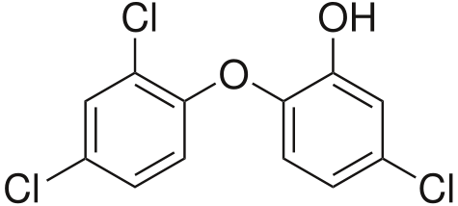
Phase/Color: | powder, white
Specific Gravity: | NA
Solubility (water): | 12 g/L at 20°C
Melting Point: | 56.0-58.0°C
Synonyms: | Triclosan, 2,4,4'-trichloro-2'-hydroxydiphenyl ether, 5-chloro-(2,4-dichlorophenoxy) phenol, trichloro-2'-hydroxydiphenyl ether, CH-3565, Lexol 300, Irgasan DP 300, Ster-Zac
CAS number: | 3380-34-5
Molecular formula: | C₁₂H₇Cl₃O₂

The test substance was stored in the chemical repository at room temperature (RT) while not in use as recommended by the Certificate of Analysis supplied by Sigma-Aldrich. The definitive test concentrations used were determined by a range-finding study designed to identify the concentration of test chemical that causes lethality and morbidity.

Laboratory Water
It is well-established that Xenopus can develop successfully over a wide range of water quality parameters. Laboratory water was used as the culture media for the study control and as the diluent for preparing all aqueous chemical solutions used in this study. Overall, the animals were exposed using a flow-through water renewal system that maintained adequate water quality (temperature, dissolved oxygen, low ammonia, etc.), and ensured a consistent exposure of the test organisms to the parent chemical.

FEL used dechlorinated (charcoal-filtered) tap water as the dilution water for this study. The dechlorinated laboratory water was prepared by passing tap water through a 4-filter system; a multimedia filter to remove suspended solids in the feed water; a 10” pre-treatment filter (5 µm) to remove any additional solids; a 3.6 ft³ activated virgin carbon treatment filter to remove chlorine, ammonia, and higher molecular weight organics; and a 5 µm polishing filter to remove any carbon particles from the carbon treatment phase. The dechlorinated tap water also served as the laboratory control water. Water quality characteristics of the laboratory water were monitored bimonthly for pH, dissolved oxygen (DO), conductivity, hardness, alkalinity, ammonia, residual oxidants; and at least annually for iodide (I-), polyaromatic hydrocarbons (PAHs), pesticides, and metals. Results of dilution and laboratory control water analysis for pesticides, PAHs, and metals are attached in Appendix A. In addition, I- analyses were performed on dilution/laboratory control water on Study Day (SD) 0, SD 45, and at 10 wpm (in-life conclusion). LAGDA test guidelines (3), recommend dilution water I⁻ concentrations between 0.5 and 10 µg/L be used.

Test System
The test species was the African Clawed Frog (X. laevis). Xenopus laevis is a well-studied laboratory animal that exhibits ease of use in the laboratory, rapid development, and simplicity of observation due to transparency during embryo-larval development (6). In addition, Xenopus laevis is routinely cultured in laboratories worldwide and is easily obtainable through commercial suppliers. Reproduction was easily induced in this species throughout the year using human chorionic gonadotropin (hCG) injections and the resultant larvae were routinely reared to selected developmental stages in large numbers to permit the use of stage-specific test protocols. It was also the test organism required in the OCSPP 890.2300 test guideline (3). The X. laevis larvae used for this study were obtained from an in-house culture. The adult breeding stock frogs (originally purchased from Xenopus I, Dexter, MI) were selected based on general productivity and health. After spawning of adults, embryos were collected, cysteine treated, and screened for viability per ASTM E1439-98 standards (6). Test organisms from a single spawn were used in the in-life study. Spawns resulting in greater than 70% viability be used for the test. Embryos were randomly distributed into exposure treatment tanks containing 4 L of dilution water until each tank contained 20 embryos. Embryos were carefully handled during this transfer to minimize handling stress and to avoid any injury. Details for adult frog care and breeding, specific to FEL, but consistent with OCSPP 890.2300 Larval Amphibian Growth and Development Assay (LAGDA) (3), are found in facility SOPs. Fertilized egg collection was performed as described in ASTM E1439-98 (6) and OCSPP 890.2300 Larval Amphibian Growth and Development Assay (LAGDA) test guideline (3).

Feeding
The diet selected for use (Tables 1 and 2) was required to meet the performance recommended by OCSPP 890.2300 Larval Amphibian Growth and Development Assay (LAGDA) (3). X. laevis embryos were not fed until free-swimming larval stage (NF stage 46) was reached. At NF stage 47, the tadpoles were fed a diet that consists of trout starter (Purina AquaMax Starter, Aquatic Ecosystems, Apopka, FL), Spirulina algae discs (Wardley, Secaucus, NJ), and TetraFin® flakes (Tetra Holding (US), Blacksburg, VA) homogenized in culture (or dilution) water (3) (Table 2). This mixture was administered three times daily on weekdays and once daily on weekends. Tadpoles were also fed brine shrimp nauplii (Artemia spp.) (Aquatic Ecosystems, Apopka, FL) twice daily on weekdays and once daily on the weekends starting on day 8 post-fertilization (dpf). The larval feeding was consistent in each test vessel and allowed appropriate growth and development of test animals ensuring reproducibility and transferability of the assay results. More specifically, the median time to NF stage 62 in controls should be ≤45 days with a mean weight of 1.0±0.2 g at NF stage 62 in controls.

Once tadpoles reached NF stage 62, the feeding regime consisted of 2 mm (3/32 inch) sinking frog food (Ziegler Brothers, Gardners, PA). Metamorphosed test animals were fed once per day. For post-NF stage 62 larvae and newly metamorphosed frogs, the pellets were briefly crushed with a mortar and pestle to reduce their size. Once juveniles were large enough to consume full pellets, grinding or crushing was no longer necessary. The animals were fed once per day. The juvenile feeding allowed appropriate growth and development of the organisms to reach a mean weight of 11.5±3 g in control juveniles at the termination of the assay. The feeding rate for metamorphosed X. laevis is provided in Table 2.

Exposure System
The route of exposure was aqueous, which was the most appropriate method for aquatic organisms and a relatively water-soluble test substance. A flow-through diluter system was used in the performance of the LAGDA exposure. The system had water-contact components of glass (aquaria), stainless steel (diluter housing and water bath), and Teflon® (tubing responsible for test material delivery). Exposure tanks were glass aquaria (with approximate measurements of 22.5 x 14.0 x 16.5 cm deep) equipped with standpipes that resulted in an actual tank volume of 4.0 L and minimum water depth of 10 to 15 cm. Each dilution cell within the headbox of the diluter was labelled with the color-coded laboratory tape with the test concentration. The replicate splitter cell and aquaria delivery tubing were labeled with the same color tape as the appropriate dilution cell and the replicate for each test concentration. Each aquarium was labelled with identical tape color and specifically denoted test concentration and replicate. Test system calibration was checked prior to study start, weekly during the study, and at test termination. The system supported 4 exposure concentrations and a control, with 4 replicates per treatment. The flow rate to each tank was 25 mL/min which provided a complete volume replacement every 2.7 h. Fluorescent lighting was used to provide a photoperiod of 12 h light and 12 h dark at an intensity that ranged from 600 to 2,000 lux (lumens/m2) at the water surface. Water temperature was maintained at 21º ± 1°C, pH maintained between 6.5 to 8.5, and the dissolved oxygen (DO) concentration > 3.5 mg/L (> 40% of the air saturation) in each test tank. The test organism loading per water renewal rate was within recommended guidelines (3) and maintained acceptable water quality while not utilizing an excessive amount of test material. Tanks were randomly assigned for the LAGDA assay. This design was intended to randomize out the effects associated with the local environment (i.e., light and water) and possible trends associated with the diluter during testing. All test animals were impartially assigned to tanks before exposure. Tanks were equipped with baffles to separate metamorphosed test animals from test larvae.

Temperature was measured daily; and pH, DO, and light intensity (lux) were measured three times per week. Total hardness and alkalinity were measured in the control and one replicate of the highest concentration once per week. The solubility, purity, and stability (volatility and degradation rate) of test article was provided to FEL prior to in-life test initiation by the supplier of the test article (TCI America). After initial diluter calibration, a sample of test solution from each diluter concentration was sampled for chemical analysis during the diluter equilibration phase. A water sample from each replicate for each treatment concentration was sampled for analysis at in-life test initiation (day 0) and termination. During the remainder of the exposure phase (excluding termination), a sample was collected from one replicate tank of the control and each test concentration. The replicate selected for weekly sampling will rotate (week 1 – A, week 2 – B, week 3 – C, and week 4 –D) and repeat every 5th week of the in-life phase. Samples will be collected at test initiation, weekly thereafter, and at test termination. A laboratory blank was also collected with the batch of samples.

Exposure tanks were siphoned daily to remove uneaten food and waste products. Care was taken to minimize stress and trauma to the animals, especially during movement, cleaning of aquaria, and manipulation. Stressful conditions/activities were avoided such as loud and/or incessant noise, tapping on aquaria, vibrations in the aquaria, excessive activity in the laboratory, and rapid changes in environmental conditions (light availability, temperature, pH, DO, water flow rates, etc.).

Chemical analysis
The analytical measurement method (7) for TCS determined by EAG Laboratories in conjunction with the Study Director and Study Monitor was performed in accordance with procedures and SOPs in place at EAG. Test substance stock solutions were prepared prior to the consumption of the previous stock solution. Each stock solution of TCS used in the present study was sampled following preparation for analysis with each set of diluter samples collected during the study. Each replicate test concentration was sampled on day 0 and at test termination for TCS analysis. Samples were collected in one replicate of each treatment and the control during each sampling event in rotation so that each replicate was sampled in succession. All samples with the exception of the blank were collected in duplicate. Duplicate samples were collected as a split of the original sample to be analyzed in the event samples were lost or broken during shipment, lab error occurred during the processing or extraction, or spurious results were obtained as determined by the Study Director. Immediately following collection, the TCS stock and diluter samples were preserved 1:1 (20 mL sample:20 mL methanol) and prepared for shipment to EAG Laboratories. Duplicate samples and samples not shipped on the day of collection were stored at FEL at 4°C. Samples were shipped to EAG once per week. Due to the biodegradability of TCS in aqueous conditions, analyses were performed as soon as possible following collection (Appendix C). Test samples were analyzed for TCS using liquid chromatography with a mass spectrometer detector (LC-MS/MS) in a multiple reaction monitoring mode (MRM). Analysis was accomplished based on methods developed and validated at EAG Laboratories. At EAG Laboratories, samples were first diluted with 5 mL of methanol at a 1:1 ratio. Samples were further diluted, if necessary, with 50:50 MeOH: HPLC-grade water to produce sample concentrations that fell within the calibration curve. At least two quality control (QC) fortification spikes were prepared in a similar manner at concentrations that bracket the expected high and low test substance treatment concentrations. The samples were capped and shaken/vortexed to mix prior to being vialed for analysis by LC-MS/MS. The peak responses of TCS were integrated and quantitated using Analyst 1.6.2 software by AB SCIEX.

Instrument: UPLC system: Waters Acquity
MS Spectrometer: AB Sciex API-5000
Column: Phenomenex Kinetex XB-C18 50mm x 2.1mm, 1.7µm
Ionization: TurboIon Spray
Mobile Phase A: 0.1% Formic Acid in Water (aq)
Mobile Phase B: 0.1% Formic Acid in Methanol
Gradient:
Time (min) A% B%
0.00 30 70
2.50 30 70
Flow Rate: 0.500 mL/min
Injection Volume: 20 µL
Mass Spec. Scan Mode: MRM
Polarity: Negative
Compound | MRM transitions
Triclosan  Triclosan a | Q1 (Da) | Q3 (Da) | Dwell Time (msec)
 | 287.0  289.0 | 35.0  37.0 | 200  200

Study Design and Additional Experimental Conditions
An overview of the test and relevant test specifications are provided in Table 3. This assay was intended for use in determining the developmental toxicity of chemicals on amphibian larval growth and development. The assay was initiated with newly spawned embryos and continued through metamorphosis into juvenile development. A summary of study endpoints is presented in Table 4. Animals were examined daily for mortality and any signs of abnormal behavior. At MMT, a sub-sample of five animals/replicate were collected and various endpoints examined. Remaining animals were continuously exposed until each reached NF stage 66 at which time the exposure tanks were culled to 10 organisms/replicate tank. The remaining 10 organisms/tank were then exposed for the remainder of the exposure period (10 weeks from the MMT). Endpoints were taken throughout the exposure period and at test termination (see Table 4).

Biological Sample Collection
Three samplings of test specimens were performed. The first event was unexposed day 0 embryos (20-30) for initial stage verification. The second event was performed as individual organisms reached MMT (NF stage 62). The final specimen sampling was performed at test conclusion (10 weeks after 50% of the control organisms reached MMT).

Exposure System Performance
Temperatures were measured in all tanks daily. DO and pH were measured two times per week. Total hardness, alkalinity, and conductivity were measured in the control and one replicate of each treatment once per week such that complete analysis for a given treatment or control was provided monthly. Relative humidity inside the diluter system was measured once per month post-metamorphosis and maintained with facility records. Light intensity (lux) was measured once on SD 0.

Observations
Endpoints were assessed over the course of and at conclusion of the assay. For those endpoints measured at test termination, growth (length and weight) measurements were taken immediately after anesthetization of an individual specimen.

Survival
All test tanks were checked daily for dead animals and the number of survivors recorded for each tank, along with the date, concentration, and replicate ID.

Additional Daily Observations
Observation of abnormal behavior, grossly visible malformations, or lesions were recorded daily by date, treatment, replicate ID. Normal behavior for larval animals was characterized by suspension in the water column with tail elevated above the head, regular rhythmic tail fin beating, periodic surfacing, operculating (respiring through the gills), and being responsive to stimuli. Abnormal behavior included, for example, floating on the surface, lying on the bottom of the tank, inverted or irregular swimming, lack of surfacing activity, and being non-responsive to stimuli. For post-metamorphic animals, in addition to the above abnormal behaviors, gross differences in food consumption between treatments were recorded. Gross malformations and lesions included morphological abnormalities, such as; limb deformities, hemorrhagic lesions, abdominal edema, and bacterial or fungal infections. These determinations were qualitative and considered clinical signs of disease/stress and made in comparison to control animals.

NF Stage 62 Specimens (Endpoints/Tissue Sample Preparation)
Larvae that reached NF stage 62 were physically separated from the remaining tadpoles in the tank with a baffle in accordance with the OCSPP 890.2300 test guideline (3). Tadpoles were checked daily, and the TTM recorded for each individual. One NF stage 62 larvae of every four removed from a given replicate tank was randomly selected for morphological, biological, and histopathological measurements. Those NF stage 62 larvae not sampled were physically separated from the remaining tadpoles for continued exposure. Selection of the sub-sampled test organisms was randomized, using a net. The following endpoints were obtained from the newly metamorphosed larvae sub-sampling:

- Time to NF Stage 62 (TTM)
- Morphometrics (growth – weight and length)
- External abnormality
- Thyroid histopathology.

Time to Metamorphosis (TTM)
In this study, the TTM was the number of days required for a test specimen to reach NF stage 62 (from embryonic NF stage 8 to NF stage 62 larvae). TTM determined for each larva and the median time to metamorphosis (MMT) was determined for each replicate of the control. The control or treatment MMT was based on the median of the replicate MMTs (n=8 for control and 4 for the treatments).

Growth (Weight and Length)
The wet weight of each newly metamorphosed specimen was measured immediately after they became non-responsive. Specimens were blotted dry before weighing to remove excess adherent water. Weight was measured on an analytical balance to the nearest mg. Digital photographs of each specimen were taken for SVL measurement. Photos were taken with a ruler to provide scale and electronically digitized for linear length using Sigma Scan Pro (Aspire Software International (Ashburn, VA). Length was measured to the nearest mm. These measurements assessed possible effects of test substances on the growth rate of organisms and were useful in detecting generalized toxicity.

External Evaluation
After measurements of body size were made, any gross morphological abnormalities, signs of disease, and / or clinical signs of toxicity were noted and digitally recorded. These included scoliosis, petechiae, hemorrhage, limb, and eye defects. Observations of scoliosis were counted (incidence) and graded with respect to severity.

Tissue Collection and Fixation for General Histology
For the sub-sampling, thyroid glands were fixed and preserved for histology. Fixation and preservation required removal of the lower torso below the forelimbs. The lower torso was then discarded. The trimmed carcass was placed into individually labeled vials and fixed in Davidson’s solution. The volume of fixative in the container was at least 10 times the approximated volume of the tissue. Appropriate agitation of the fixative was required to adequately fix the tissue samples. All tissue remained in Davidson’s fixative for 72 h, at which time they were rinsed in dechlorinated tap water and stored in 10% (v/v) neutral buffered formalin (NBF) until further processed (3,8).

EPL, under the direction of the Sponsor, performed the tissue preparation, histology, and histopathological interpretation in accordance with appropriate facility guidance documents (SOPs) and the relevant guidance documents on histopathology for the LAGDA (3). Following collection, FEL sent 5 NBF preserved larvae per replicate (20 per treatment or control) to EPL via overnight courier for histopathological processing and analyses.

End of Larval Exposure Phase
The end of larval exposure phase was determined by the MMT, which was the time required for half of the population of test control animals to reach NF stage 62. The larval portion of the exposure did not exceed 70 days. When all the organisms reached NF stage 66, test organisms were culled such that 10 metamorphosed young per treatment were exposed for the remainder of the in-life study (10 weeks post-MMT). Any organisms remaining at the end of this period were euthanized by immersion in 200 mg/L buffered MS-222 (pH 7.0). The tadpoles were weighed, staged (3), and digitally photographed. Snout-vent length (SVL) was measured and any developmental abnormalities noted. Phenotypic sex was noted as female, male, or indeterminate.

In-Life Test Termination (Endpoints / Tissue Sample Preparation)
After 10 weeks of exposure post-MMT, the remaining animals were anesthetized, and then euthanized and the following endpoints evaluated and recorded:

- Morphometrics (growth – weight and length)
- External evaluation of test organism
- Nuptial pad development (morphological)
- Liver weight (Liver-somatic index)
- Gonad, reproductive ducts, kidney, and liver histopathology
- Phenotypic and genotypic sex ratios.

Growth (Weight and Length)
The wet weight and snout to vent length of each juvenile specimen were measured using the same procedure as used for the newly metamorphosed specimens. Specimens were blotted dry before weighing to remove excess adherent water. After measurements of body size were made, any gross morphological abnormalities and/or clinical signs of toxicity were noted and digitally recorded.

External Evaluation
As with the newly metamorphosed specimens, any gross morphological abnormalities, diseases, and/or clinical signs of toxicity observed were recorded with digital photographs.

Tissue Collection and Fixation for General Histology
Livers were removed, weighed, and prepared for histological analysis during the final sampling. A hind limb was retained for genetic sex determination. The remaining carcass, without the hind limbs, but including the gonads, and gonadal ducts, and kidneys was fixed for future histological analyses. Thus, the gonads were physically removed from the carcass. The collected tissues were placed into labeled histological vials and fixed in Davidson’s fixative as described for the sub-sampled NF stage 62 specimens. All tissue remained in Davidson’s fixative for at least 48-72 h, but no longer than 96 h, at which time they were rinsed in dechlorinated tap water and stored in 10% (v/v) NBF (3).

EPL, under the direction of the Sponsor, performed the gonad, gonadal duct, kidney, and liver tissue preparation, histology, and histopathological interpretation in accordance with appropriate facility guidance documents (SOPs) and the relevant guidance documents on histopathology for the LAGDA (3,8). Following collection, FEL sent preserved juveniles to EPL via overnight courier for histopathological processing and analyses.

Phenotypic and Genotypic Sexing
DNA samples from the juvenile frogs were obtained from a hind foot removed during dissection. The hind foot from each juvenile specimen were stored at -20°C ± 5° until DNA isolation. Testing for the presence or absence of a marker were performed by PCR as described in the facility SOP. Information regarding the development of the marker used for genetic sexing of X. laevis is described in Yoshimoto et al. (9).

Data Analysis
All data were tabulated in data entry spreadsheet templates (DEST) by FEL. The DESTs were then used by FEL to prepare the final report. The histopathology report (EPL, Sterling, VA), raw data (DEST), and statistical report (Battelle) are provided in Appendices D through F, respectively. In an effort to present the most realistic estimation of exposure concentrations, analytical chemistry analysis results of the duplicate analytical samples were averaged with the original sample result and both the individual results and average were reported in the DESTs unless the original or the duplicate were found to be an outlier and thus, not used in the average determination. In the event a result from an original sample or its duplicate was found to be an outlier as defined as being outside the interquartile range (IQR), both results were included in the DEST, but the outlier (either original or duplicate) was not used in the analysis of the mean measured concentration used to estimate exposure concentration in the report. Outliers were determined by (Q1 – 1.5*IQR) and (Q3 + 1.5*IQR), where IQR was the interquartile difference defined as Q3 minus Q1. Statistical analyses of the data were performed by Battelle and will be consistent with the TO 14 QAPP (1), OCSPP 890.2300 Larval Amphibian Growth and Development Assay (LAGDA) test guideline (3), and generally followed procedures described in the document Current Approaches in the Statistical Analysis of Ecotoxicity Data: A Guidance to Application (10). For toxicological endpoint data, descriptive statistics included the mean, median, standard deviation, minimum value, maximum value, first and third quartiles (Q1 and Q3), and the coefficient of variation (CV). Statistical outliers were determined as described above. Analysis of the data from this study report revealed 41 potential outliers occurring in the following biological endpoints: TTM at NF Stage 62 (n=24), Body Weight at NF Stage 62 (n=2), Snout-to-Vent Length at NF Stage 62, Body Weight at NF Stage 66 (n=2), Snout-to-Vent Length at NF Stage 66, Male Body Weight at Termination (n=2), Female Snout-to-Vent Length at Termination, Male Snout-to-Vent Length at Termination (n=4), Female LSI at Termination (n=2), and Male LSI at Termination (n=2) (Appendix F). However, in accordance with LAGDA guidance (3), none of the endpoint outliers were excluded from statistical analyses presented in the present report for study BATT01-00391.

Three different types of data sets were collected: 1) quantitative continuous data (mortality, growth, and LSI), 2) time-to-event data (developmental rates such as TTM), and 3) ordinal data (severity scores and developmental stages from histopathological evaluations). For continuous data sets, data expressed as proportions were transformed to the arc sine square root. Monotonicity of the data sets were evaluated using Analysis of Variance (ANOVA) comparing linear and quadratic contrasts or the equivalent. Continuous data sets that were monotonic were evaluated using a step-down Jonckheere-Terpstra trend test or the equivalent using replicate medians. If the data were non-monotonic, parametric assumptions were tested using deviations from normality with the Shapiro-Wilks’ test (α=0.05) and homogeneity of variance tested with Levene’s test (α = 0.05). Parametric data sets were evaluated using ANOVA followed by Dunnett’s or Bonferroni t-test as post-hoc tests or the equivalent. Kruskal-Wallis (KW) ANOVA test followed by a pairwise Dunn’s test as a post hoc test or the equivalent were used when assumptions of normality and homogeneity of variances are not met. These tests were used to determine NOEC and LOEC numerical endpoints for each of the appropriate measurement endpoints.

The TTM data were treated as time to event data, with mortalities or larvae not reaching stage 62 in 70 d treated as censured data. The replicate MMT represented the median of the individual TTM values. The treatment MMT was the median of the replicate medians. Thus, the MMT was the 50% point in the cumulative metamorphosis curve using a mixed-effects Cox proportional hazard model. Histopathology data were in the form of severity scores or developmental stages. RSCABS (Rao-Scott Cochran-Armitage by Slices) or the equivalent using step-down trend analysis on each level of severity in a histopathology response was performed. Developmental staging data (gonad and reproductive ducts) was analyzed as reported to detect acceleration in development and then manually inverted prior to a second analysis to detect a delay in development. For all statistical evaluations, the replicate was considered the experimental unit and α=0.05.

Results

Range Finding
The range-finding study was conducted separately (FEL Study No. BATT01-00385) and was not required to be GLP-compliant. Based on range-finding, the maximum tolerable concentration (MTC) was determined to be 100 µg/L (Appendix G). The test concentration series was 1x, 0.33x, 0.11x, and 0.04x, where x was the MTC value. Therefore, the test concentrations were 100.0, 33.0, 10.9, and 3.60 µg/L.

Water Quality Measurements and Test System Performance
Results of water quality measurements and test system performance are presented in Table 5. All physicochemical water quality parameters in study were within acceptable ranges (Table 5).

Confirmation of Test Concentrations
Nominal TCS concentrations selected for the Amphibian Metamorphosis Assay study were 0.0 (control), 3,60, 10.9, 33.0, and 100 µg/L. Various dilution water control solutions showed trace levels of TCS yielding a mean measured concentration of 0.370 µg/L (MQL=0.199 µg/L) (Table 6). The mean measured concentration represents the average of weekly data points. On SD 0 and in-life phase termination all replicate control replicates (n=8) and treatment replicates (n=4) were sampled and analyzed. On the weeks between these two points, a sample was collected from one replicate tank of the control and each test concentration. The replicate selected for weekly sampling rotated. Coefficient of variation [(CV) Standard deviation / mean)100] was calculated by dividing the standard deviation of the replicate means (n=8 for control and 4 for treatments) for the control and each treatment by the mean measured concentration of each replicate per facility SOPs. IQRs determined for the 0.0 (control), 3.60, 10.9, 33.0, and 100 µg/L TCS treatments were 0.100-0.100, 1.40-6.89, 5.69-21.8, 20.5-60.5, 68.5-153 µg/L TCS, respectively. Based on IQR analysis of 0.0 µg/L replicates A-H original samples from Study Week (SW) 0, and 3.6, 10.9. 33.0, and 100 µg/L replicate C original samples from Study SW 7 were considered outliers (Appendix C). The corresponding mean measured concentrations in the definitive study were 4.23, 13.8, 39.7, and 111 μg/L TCS (Table 7). The CVs of the intra-replicate means of the measured test concentrations for the 3.60, 10.9, 33.0, and 100 µg/L treatments were 6%, 2%, 6%, and 3%, respectively which were consistent with protocol BATT01-6 for study BATT01-00391 (Appendix A).

Clinical Signs of Toxicity
No signs of abnormal behavior, grossly visible malformations, or lesions including scoliosis, petechiae, and hemorrhage, limb, and eye defects were observed in any of the specimens in the present study.

In-Life Studies—NF 8 to NF Stage 62

Survival
Survival from NF Stage 8 to NF Stage 62 was 100% for the control and all TCS treatments (Table 8).

Time to Metamorphosis
The median MMT (NF Stage 62) for control X. laevis was 38.8 d (Table 9). The median MMT for larvae exposed to TCS ranged from 39.3 d in the 10.9 µg/L treatment to 44.8 d in the 33.0 µg/L treatment. The MMT of larvae exposed to 100 µg/L TCS was significantly greater than the control (Cox Proportional Hazard Model, Chi Square, p<0.0001).

GRowth

Body Weight
Mean body weight of NF Stage 62 frogs was 0.954 g in the control treatment. The mean body weight ranged from 0.911 to 0.967 g in the 10.9 and 100 µg/L treatments, respectively (Table 10). Mean body weight in the TCS treatments were not significantly different from the control (Jonckheere-Terpstra test, p>0.05).

Snout-to-Vent Length (SVL)
Mean SVL of NF Stage 62 frogs was 18.1 mm in the control treatment and ranged from 18.1 to 17.3 mm in the 33.0 and 100 µg/L treatments, respectively (Table 11). SVL in the treatments were not significantly different from the control (Jonckheere-Terpstra test, p>0.05, respectively).

In-Life Studies—Metamorphosed Young and Juveniles

Survival
Survival from NF Stage 62 to NF Stage 66 and from NF Stage 66 to test termination (10 wpm) was 100% for the control and all TCS treatments (Table 8).

Growth

Body Weight
Mean body weight of NF Stage 66 frogs was 0.745 g in the control treatment and ranged from 0.642 to 0.798 g in the 100 and 10.9 µg/L TCS treatments, respectively (Table 12). Mean body weight of frogs exposed to 100 µg/L TCS was significantly less than the control (Jonckheere-Terpstra test, p=0.0258). This was the only statistically significant growth effect found in the present study.

Mean body weight of female X. laevis at 10 wpm was 10.1 g in the control and ranged from 10.1 to 10.4 g in the 10.9 and 100 µg/L TCS treatments, respectively (Table 13). Mean body weight in female X. laevis at termination in the TCS treatments were not significantly different from the control (Jonckheere-Terpstra test, p>0.05).

Mean body weight of male X. laevis at 10 wpm was 10.0 g in the control treatment and ranged from 10.1 to 10.3 g in the 10.9 and 100, and 3.60 µg/L TCS treatments, respectively (Table 14). Mean body weights in female X. laevis at termination in the TCS treatments were not significantly different from the control (Jonckheere-Terpstra test, p>0.05).

Snout-to-Vent Length (SVL)
Mean SVL of NF Stage 66 frogs was 19.6 mm in the control and ranged from 18.5 to 20.35 mm in the 100 and 10.9 µg/L TCS treatments, respectively (Table 15). Mean SVLs at NF stage 66 in the TCS treatments were not significantly different from the control (Dunnett’s test, p>0.05).

Mean SVL of 10 wpm female X. laevis was 35.1 mm in the control and ranged from 35.2 to 35.5 mm in the 10.9 µg/L and 3.60, 33.0, and 100 µg/L TCS treatments, respectively (Table 16). Mean SVLs of female X. laevis at termination in the TCS treatments were not significantly different from the control (Jonckheere-Terpstra test, p>0.05).

Mean SVL of male X. laevis at 10 wpm was 35.1 mm in the control and ranged from 34.5 to 35.3 mm in the 100 and 3.60 µg/L TCS treatments, respectively (Table 17). Mean SVLs of male X. laevis at termination in the TCS treatments were not significantly different from the control (Jonckheere-Terpstra test, p>0.05).

Liver-Somatic Index (LSI)
Mean LSI of frogs measured in the control at the termination of in-life (10 wpm) were 0.078 for females (Table 18) and males (Table 19). LSI for female X. laevis ranged from 0.068 to 0.080 in the 10.9 and 100 µg/L TCS treatments, respectively (Table 18). Mean LSI in female X. laevis for the TCS treatments were not significantly different from the control (Jonckheere-Terpstra test, p>0.05). LSI for male X. laevis ranged from 0.0078 to 0.081 in the 3.60, 10.9 and 33.0 µg/L TCS treatments, and the 100 µg/L TCS treatment (Table 19). Mean LSI in male frogs for the TCS treatments were not significantly different from the control (Jonckheere-Terpstra test, p>0.05).

Gender Ratios
The phenotypic and genotypic sex ratios at the termination are presented in Table 20. Control X. laevis were slightly phenotypically skewed toward males as was the 3.60, 10.9, and 33 µg/L TCS treatments. The 100 µg/L TCS treatment was essentially balanced between phenotype males and females. One genetic female and one male in the control, and genetic female in the 100 µg/L TCS treatment had an indeterminant phenotype. Genotype was consistent with phenotypic identification. Thus, no marked changes phenotype or genotype ratios were observed in TCS-treated frogs relative to controls, and correspondence between phenotypic and genotypic genders were noted regardless of treatment.

Histopathology

NF Stage 62 (ThyROID)
An increase in the prevalence of follicular cell hypertrophy at the minimal severity level in the thyroid glands of frogs exposed to 33.0 and 100 µg/LTCS as compared to controls (RSCABS, p=0.0375 and 0.0132, respectively). Minimal to mild follicular cell hypertrophy was a common finding, with a high prevalence in all groups (Table 21). Because anuran metamorphosis is considered to be a thyroid-dependent process, basal levels of follicular cell hypertrophy and hyperplasia are anticipated findings in control frogs at NF Stage 62.

Juveniles (10 wpm)
Results of histopathological examination of female and male liver, kidney, gonadal ducts, and gonads from 10 wpm X. laevis (termination specimens) are enumerated in Tables 22-25. There were no treatment-related findings in the livers of female or male terminal sacrifice frogs exposed to TCS.

Females

Kidney
Treatment-related findings in the kidneys of female X. laevis included increased severity of mineralization of moderate severity in all three sections in 100 µg/L treatment group (RSCABS, p=0.0243 [anterior], 0.0001 [middle], p<0.0001 [posterior], respectively), and in the middle section of the 33.0 µg/L treatment group (RSACBS, p=0.0228) relative to controls (Table 22). In addition, increased prevalence and severity of dilated tubules of minimal severity at all three sections in 33.0 µg/L (RSCABS, p=0.0398 [anterior], 0.0103 [middle], and 0.0034 [posterior]) and 100.0 µg/L treatment groups (RSCABS, p<0.0001 for each) compared to controls were observed. Increased prevalence and severity of dilated tubules of minimal severity in the posterior section of 10.9 µg/L treatment group compared to controls was found (RSCABS, p=0.0137). Increased prevalence and severity of dilated tubules of mild severity at all three sections in 100.0 µg/L treatment group (RSCABS, p=0.0001 [anterior], p<0.0001 [middle and posterior], and in the middle and posterior sections of the 33.0 µg/L treatment group (RSCABS, p=0.0072 and 0.0470, respectively) relative to controls were noted. An increased prevalence of interstitial fibrosis of minimal severity in the anterior and middle sections in 100.0 µg/L treatment group (RSCABS, p<0.0001 and p=0.0327), and the anterior section of 33.0 µg/L treatment group (RSCABS, p=0.0470) compared to controls was observed. An increased prevalence of interstitial fibrosis of mild severity in anterior (RSCABS, p=0.0196) section in 100.0 µg/L treatment group compared to controls was also found. Finally, an increased prevalence of mononuclear cell infiltrates of minimal (RSCABS, 0.0163) and mild (RSCABS, p=0.0196) severity in the middle section of 100.0 µg/L treatment group relative to controls was observed.

Gonadal Ducts
Regarding the gonadal ducts, an increase in the prevalence of cytoplasmic inclusions of minimal severity in the Wolffian duct epithelial cells in the anterior section in 33.0 (RSCABS, p=0.0335) and 100.0 μg/L (RSACBS, p=0.0123) treatment groups, and in the posterior section in 100.0 μg/L treatment group (RSCABS, p=0.0126) compared to controls were observed (Table 23). Additionally, Wolffian duct stage scores were significantly lower in the middle segment of 10.9, 33.0, and 100.0 μg/L treatment groups than controls (RSCABS, p=0.0091, 0.0008. and 0.0450, respectively).

Ovary
No treatment-related findings in the ovaries of 10 wpm female X. laevis. A single frog from the 100.0 µg/L treatment group was found to possess both testicular and ovarian tissue, and was diagnosed as being hermaphroditic.

Males

Kidney
Treatment-related findings in the kidneys of male X. laevis included increased severity of mineralization of mild and moderate severity in all three sections in 33.0 µg/L treatment group (RSCABS, p=0.0245 and 0.0046 [anterior], 0.0067 and 0.0457 [middle], 0.0457 and 0.0087 [posterior], respectively); and in all three sections of the 33.0 µg/L treatment group (RSCABS, p=0.0046 and 0.0001 [anterior], 0.0014 and 0.0012 [middle], 0.0177 and p<0.0001 [posterior], respectively) relative to controls was observed (Table 24). In addition, increased prevalence of dilated tubules of minimal severity in the anterior section of each of the treatment groups (RSCABS, p=0.0043, 0.0002, p<0.0001, and p<0.0001) and mild severity in 10.9, 33.0 and 100 µg/L treatment groups (RSCABS, p=0.0007, 0.0012, and 0.0003, respectively) compared to controls was noted. Increased occurrence of dilated tubules of minimal severity in the middle section of each of the treatment groups (RSCABS, p=0.0154, 0.0010, p<0.0001, and p<0.0001) and mild severity in 10.9, 33.0 and 100 µg/L treatment groups (RSCABS, p=0.0067, 0.0002, and p<0.0001, respectively) compared to controls was noted. Increased occurrence of dilated tubules of minimal and mild severity in the posterior section of the 33.0 (RSCABS, p<0.0001 [minimal] and p=0.0004 [mild] and 100 µg/L treatment groups (RSCABS, p<0.0001 for both grades]. Finally, an increased occurrence of interstitial fibrosis of minimal severity in the 100 µg/L treatment group relative to controls was found (RSCABS, p=0.0483).

Gonadal Ducts
Treatment-related findings in the gonadal ducts of male terminal sacrifice frogs included an increased prevalence of cytoplasmic inclusions in the Wolffian duct epithelial cells of minimal severity in middle (RSCABS, p=0.0009) and posterior (RSCABS, p=0.0292) sections, and of mild severity in the anterior (RSCABS, p=0.0131) and middle (RSCABS, p=0.0043) sections of males exposed to 100 µg/L TCS (Table 25). In a given individual, the inclusions were present in single or multiple cells, and at single or multiple sectioning levels. They tended to be slightly more numerous and larger in TCS-exposed frogs relative to controls (Appendix D)). Decreased Wolffian duct stage scores in the anterior section of male X. laevis exposed to 10.9, 33.0, and 100.0 µg/L TCS RSCABS, p=0.292 for each) was indicative of significant development delay.

Testes
Treatment-related findings in the testes of male terminal sacrifice frogs included an increased prevalence of minimal germ cell degeneration in the anterior and middle sections of 10.9, 33.0 and 100.0 µg/L treatment groups (RSCABS, p<0.0001 (anterior) and p=0.0007, 0.0004, and 0006, respectively), and the 33.0 and 100.0 µg/L treatment groups of the posterior section (RSCABS, p=0.0107 and 0.0006, respectively) (Table 26). An increased prevalence of mild germ cell degeneration in the anterior section of the 33.0 and 100.0 µg/L treatment groups (RSCABS, p=0.0010 and 0.0001, respectively), in the middle section of the 10.9, 33.0, and 100 µg/L treatment groups (RSCABS, p=0.0103, 0.0004, and 0.0421, respectively), and in the posterior section of the 100 µg/L treatment group (RSCABS, p=0.0459). Germ cell degeneration was characterized by individual cell necrosis, intraluminal exfoliated germ cells, and/or germ cell syncytia (Appendix D). In addition, differences in testis stage scores were observed in the anterior segments of 33.0 and 100.0 µg/L treatment groups (RSCABS, p=0.0186 and 0.0357, respectively), and in the middle segment of 100.0 µg/L treatment group (RSCABS, p=0.0368) (Table 27). Testicular oocytes (minimal) were observed in the testis of a single male of the 3.6 µg/L treatment group; this was considered most likely to be a spontaneous finding unrelated to treatment (Appendix D). Based on concurrent findings in the present study, there is no evidence to suggest that the testicular degeneration was necessarily caused by an endocrine-mediated mechanism. Because the Wolffian duct also serves as the ureter in X. laevis, the cytoplasmic inclusions may be related to TCS-induced renal toxicity as opposed to effects on the reproductive tract or endocrine systems.

Concentration Measurement Endpoints
The No Observable Effect Concentration (NOEC) and Lowest Observable-Effect Concentration (LOEC) for the various endpoints measured are summarized in Table 27.

DISCUSSION

Performance Criteria and Validity
Performance of the present study and the relationship to the performance criteria and test validity established in protocol BATT01-6 (Appendix A) and study guidance document (3) are provided in Table 28. The coefficients of variation (CV, expressed as %) for the mean measured test concentrations between each replicate of each treatment concentration were <20%. Control mortality was <10% in each replicate of the control. The median time to NF stage 62 in the controls ≤ 45 d. The mean weights of control organisms at NF stage 62 and at the conclusion of the in-life phase (10 wpm) were 1.0±0.2 g and 11.5±3 g, respectively. The range of pH measured in the control and treatments was between 6.5 and 8.5, the temperature in the study was maintained at 21±1ºC, and the inter-replicate range in temperature was maintained at ≤0.5 ºC. None of the test concentrations demonstrated overt toxicity and none of the test concentrations, including the control, had compromised replicates. Finally, the genotype:phenotype gender concordance in the control was >95%. In summary, the present study met performance criteria established for the OPPTS 890.2300 Larval Amphibian Growth and Development Assay (3).

Assessment of the LAGDA results
The following results were considered, using the framework outlined in Ankley and Jensen (11), as a basis for concluding if TCS has the potential to interact with the endocrine system.

Measured Test Concentrations
- The mean measured concentrations for the 0.0 (control), 3.6, 10.9, 33.0, and 100 µg/L TCS treatments (nominal) were (<0.199 µg/L [minimum quantitation level, MQL]), 4.23, 13.8, 39.7, and 111 μg/L TCS (see Table 6).

Survival
- No significant effects on larval or juvenile survival were observed during the study.

Growth
- No effect of TCS exposure on body weight or snout-vent length (SVL) in NF stage 62 larvae relative to the control was observed (Jonckheere-Terpstra test, p>0.05).
- A significant reduction in weight (Jonckheere-Terpstra test, p=0.0258), but not SVL, was noted in NF stage 66 larvae exposed to 100 μg/L TCS compared to the control.
- No effects of TCS exposure on body weight or SVL in female or male juvenile X. laevis at 10 wpm relative to the control were observed (Jonckheere-Terpstra test, p>0.05).
- No effects of TCS exposure on liver-somatic index (LSI) were observed in either female or male termination specimens at 10 wpm compared to control (Jonckheere-Terpstra test, p>0.05).

Development
- The median metamorphosis time (MMT) in larvae exposed to 100 µg/L was significantly greater than the control (Cox Proportional Hazard Model, Chi Square, p<0.0001) suggestive of developmental delay during metamorphosis.
- Asynchronous development was not noted in the control or treatments during the conduct of the study.
- No marked changes in phenotype or genotype ratios were observed in TCS-treated frogs relative to controls, and correspondence between phenotypic and genotypic genders were noted regardless of treatment.

Histopathology (abnormal morphological features)

- THYROID: An increase in the prevalence of follicular cell hypertrophy at the minimal severity level was observed in the thyroid glands of frogs exposed to 33.0 and 100 µg/LTCS as compared to controls (RSCABS, p=0.0375 and 0.0132, respectively). Minimal to mild follicular cell hypertrophy was a common finding, with a high prevalence in all groups. Because anuran metamorphosis is considered to be a thyroid-dependent process, basal levels of follicular cell hypertrophy and hyperplasia are anticipated findings in control frogs at NF Stage 62.

- LIVER: There were no treatment-related findings in the livers of male or female terminal sacrifice frogs or gonadal ducts of female terminal sacrifice frogs.
- KIDNEY: Treatment-related findings in the kidneys of male 10 wpm frogs included: increased severity of mineralization (mild to moderate) at all three sections in 33.0 and 100.0 μg/L treatment groups males; increased prevalence and severity of dilated tubules (minimal to mild) in all three sections in 33.0 and 100.0 μg/L treatment groups, and at the anterior and middle levels of 10.9 μg/L treatment group; and an increased prevalence of interstitial fibrosis (minimal) in the posterior section in 100.0 μg/L treatment group (RSCABS, p<0.05). Mineralization and tubular dilation were scattered throughout the renal parenchyma in contrast to interstitial fibrosis, which affected primarily the lateral regions of the kidneys surrounding the Wolffian ducts.
Treatment-related findings in the kidneys of 10 wpm female frogs included: increased mineralization of minimal to moderate severity in all three sections of the 100.0 μg/L treatment group, and in the middle section of 33.0 μg/L treatment group; increased prevalence and severity of dilated tubules (minimal to mild) in all three sections of the 33.0 and 100.0 μg/L treatment groups, and in the posterior section of 10.9 μg/L treatment group (RSCABS, p<0.05). An increased prevalence of interstitial fibrosis (minimal to mild) in the anterior and middle sections of the 100.0 μg/L treatment group, and the anterior level of 33.0 μg/L treatment group females was also observed (RSCABS, p<0.05). An increased prevalence of mononuclear cell infiltrates in the middle section of 100.0 μg/L treatment group was noted (RSCABS, p<0.05).
- MALE GONADAL DUCTS: Treatment-related findings in the gonadal ducts of 10 wpm male frogs included: an increased prevalence and/or severity of cytoplasmic inclusions (minimal to mild) in the Wolffian duct epithelial cells in all three sections of the 100.0 μg/L treatment group; and decreased Wolffian duct stage scores in the anterior segment of 10.9, 33.0, and 100.0 μg/L treatment groups (RSCABS, p<0.05).
- TESTES: Treatment-related findings in the testes of 10 wpm male frogs included: an increased prevalence and/or severity of germ cell degeneration (minimal to mild) in the anterior, middle, and posterior sections of the 33.0 and 100.0 µg/L treatment group males, and in the anterior and middle levels of 10.9 µg/L treatment group (RSCABS, p<0.05). Differences in testis stage scores in the anterior segments of 33.0 and 100.0 µg/L treatment group males, and in the middle segment of 100.0 µg/L treatment were also observed (RSCABS, p<0.05).
- FEMALE GONADAL DUCTS: An increase in the prevalence and/or severity of cytoplasmic inclusions (minimal to mild) in the Wolffian duct epithelial cells in the anterior segment in 33.0 and 100.0 μg/L dose treatment females, and in the posterior segment in 100.0 μg/L treatment group females were observed (RSCABS, p<0.05). Further, Wolffian duct stage scores in 10 wpm female frogs were significantly less than controls in the middle segment of 10.9, 33.0, and 100.0 μg/L treatment groups.
- OVARIES: There were no treatment-related findings in the ovaries of 10 wpm females. A single frog of the 100.0 µg/L treatment group was diagnosed as being hermaphroditic.

Overt toxicity and behavior
- No significant effects on behavior or signs of overt toxicity were noted.

Comparison of Present Study Results to Previous Study – Fort et al. (12)
- Fort et al. (12) study was conducted using an early draft guidance available at the time of study performance. Further Fort et al. (12) only tested TCS concentration ≤25 µg/L which represents the bottom-most end of the concentration range of the current study, the Fort et al. (12) focused on environmental relevant concentrations, not those toxicologically-based as in the present study. As indicated in Fort et al. (12), a primary focus of the paper was to evaluate the difference in the draft LAGDA guidance and the presently adopted guideline (used in the present study). The differences in the methodology and the impact on the method were discussed in Fort et al. (12). Overall, difference in growth and development rates, and the number of histological findings, most notably of the thyroid follicles found in the present study constitute the differences in results between the present study and Fort et al. (12).

- Two primary factors, test concentration and feeding regime used likely resulted in the difference in effects on growth, rate of development (metamorphosis), and histopathological findings between the present study and Fort et al. (12). In the present study, 100 µg/L test concentration, which is 4x greater than used in Fort et al. (12), slowed the rate of metamorphosis. With regards to growth, the effect of food and feeding regime on growth/development can be pronounced and appeared a contributing factor that separates the Fort et al. (12) which used Sera Micron® as the larval diet and the present study which used a prescribed blended EPA diet. The draft LAGDA guidelines allowed freedom to use an established diet (Sera Micron® or the blended EPA diet with brine shrimp) as long as the acceptability criteria were met. The final guidance (3) more specifically stipulated the use of a blended diet with brine shrimp rather than Sera Micron®. Based on the present study in which the blended diet with brine shrimp was used exclusively in lieu of Sera Micron®, the blended diet afforded better growth. In addition, the volume (g/frog) of post-metamorphic food provided was increased dramatically in the final guidance document (3).

- In Fort et al. (12), there were no histopathologic findings in the thyroid gland that were significantly more prevalent or severe in TCS-treated frogs as compared to controls. However, in the present study, an increase in the prevalence of follicular cell hypertrophy at the minimal severity level in the thyroid glands of frogs exposed to 33.0 and 100 µg/LTCS as compared to controls (RSCABS, p=0.0375 and 0.0132, respectively). Overall, the only statistically significant histopathology findings with toxicological relevance found in larvae exposed to TCS was decrease in the prevalence of stage 3 Müllerian ducts in the anterior trunk sections of 25.0 µg TCS/L treatment group females as compared to controls. In summary, the increased number of findings in the present study most likely relates to higher test concentrations used compared to Fort et al. (12).

Conclusions
Survival from NF Stage 8 to NF Stage 62 was 100% for the control and all TCS treatments. No effects on behavior or signs of overt toxicity were noted. The MMT of larvae exposed to 100 µg/L TCS was significantly greater than the control (Cox Proportional Hazard Model, Chi Square, p<0.0001). No marked effects on growth at NF stage 62 (larval stage) were observed during the study as the result of exposure to TCS. An increase in the prevalence of follicular cell hypertrophy at the minimal severity level in the thyroid glands of frogs exposed to 33.0 and 100 µg/LTCS as compared to controls (RSCABS, p=0.0375 and 0.0132, respectively). Minimal to mild follicular cell hypertrophy was a common finding, with a high prevalence in all groups.

Survival from NF Stage 62 to NF Stage 66 and from NF Stage 66 to test termination (10 wpm) was 100% for the control and all TCS treatments. A significant reduction in weight (Jonckheere-Terpstra test, p=0.0258), but not SVL, were noted in NF stage 66 larvae exposed to 100 μg/L TCS compared to the control. No marked effects on growth at 10 wpm, LSI, or skewed phenotype and genotype ratios were observed during the study as the result of exposure to TCS. There were no treatment-related findings in the livers of male or female terminal sacrifice frogs or gonadal ducts of female terminal sacrifice frogs. Treatment-related findings in the kidneys of male 10 wpm frogs included: increased severity of mineralization (mild to moderate) at all three sections in 33.0 and 100.0 μg/L treatment groups males; increased prevalence and severity of dilated tubules (minimal to mild) in all three sections in 33.0 and 100.0 μg/L treatment group, and in the anterior and middle levels of 10.9 μg/L treatment group; and an increased prevalence of interstitial fibrosis (minimal) in the posterior section in 100.0 μg/L treatment group (RSCABS, p<0.05). Treatment-related findings in the kidneys of 10 wpm female frogs included: increased mineralization of minimal to moderate severity in all three sections of the 100.0 μg/L treatment group, and in the middle section of 33.0 μg/L treatment group; increased prevalence and severity of dilated tubules (minimal to mild) in all three sections of the 33.0 and 100.0 μg/L treatment groups, and in the posterior section of 10.9 μg/L treatment group (RSCABS, p<0.05). An increased prevalence of interstitial fibrosis (minimal to mild) in the anterior and middle sections of the 100.0 μg/L treatment group, and the anterior level of 33.0 μg/L treatment group females was also observed (RSCABS, p<0.05). An increased prevalence of mononuclear cell infiltrates in the middle section of 100.0 μg/L treatment group was noted (RSCABS, p<0.05). Treatment-related findings in the gonadal ducts of 10 wpm male frogs included: an increased prevalence and/or severity of cytoplasmic inclusions (minimal to mild) in the Wolffian duct epithelial cells in all three sections of the 100.0 μg/L treatment group; and decreased Wolffian duct stage scores in the anterior segment of 10.9, 33.0, and 100.0 μg/L treatment group (RSCABS, p<0.05). An increase in the prevalence and/or severity of cytoplasmic inclusions (minimal to mild) in the Wolffian duct epithelial cells in the anterior segment in 33.0 and 100.0 μg/L dose treatment females, and in the posterior segment in 100.0 μg/L treatment group females were observed (RSCABS, p<0.05). Further, Wolffian duct stage scores in 10 wpm female frogs were significantly less controls in the middle segment of 10.9, 33.0, and 100.0 μg/L treatment group. No treatment-related findings in the ovaries of 10 wpm females.

Using the decision criteria in the LAGDA test guideline (OCSPP 890.2300) (3), TCS appeared to delay metamorphosis at the highest test concentration (100 µg/L TCS), but did not appear to alter growth, LSI, or genotype:phenotype ratios. While there are significant histopathological findings caused by exposure to triclosan (males and females), it is unclear whether these effects were caused by an endocrine-mediated mechanism.

Sample handling and custody
All samples received, generated during the course of testing, and submitted to EAG Laboratories (Columbia, MO) and EPL (Sterling, VA) in this study were accompanied by an appropriately signed chain of custody and handled in accordance with facility SOPs. Samples were entered into a sample check-in logbook and assigned a unique sample tracking number. Each sample was also properly labeled with its assigned sample tracking number. Sets of test solution samples collected by FEL and preserved as described by EAG Laboratories were shipped to EAG Laboratories by commercial carrier. Whole body tissue samples collected at the conclusion of the in-life phase were shipped to EPL via commercial carrier. Samples, when not in use, were properly preserved as described previously and stored per facility SOP, based on sample matrix.

Record Maintenance and Archival
Test facility-related records (personnel training, equipment calibration and maintenance, storage temperature records, etc.) were retained at the Test Facility. No records were disposed of without the authorization of the Sponsor. The records were organized and included an index.

Certified exact copies of the original raw data, derived data (DEST), QA reports, study guidance documents, correspondence, and draft and final reports were electronically maintained at the In-life test facility in accordance with facility SOPs until study finalization. All original raw data and the original Final Study Report were kept in designated file cabinets located in a secured file room at the Test Facility. After final approval of all reports and conclusion of the study, all electronic files will be transferred to compact discs (CDs) and verified as exact copies of the original. Copies of the electronic disc and the Final Study Report were sent to the Sponsor. Immediately following finalization of the final report, all original handwritten raw data, original raw data files, the original Final Study Report, protocol and protocol amendments associated with the study were maintained in the archive at FEL until shipped to the archive location below. In addition, all EPL-generated histology data records were shipped to the Sponsor for archiving. Original raw analytical data and original analytical reports from EAG Laboratories were sent to the Sponsor for archiving. The archive location is:

Battelle Memorial Institute
505 King Avenue
Columbus, OH 43201-2696
Attn: Vincent J. Brown, Ph.D.
614-424-5928
brownv@battelle.org

Specimens Archival
The preserved test specimens were labeled and stored at FEL until study finalization in accordance with facility SOPs. Per Sponsor mandated exception, following study finalization, specimens remaining at FEL, and embedded tissues or specimens maintained by EPL will be disposed of in accordance with QMP, QAPP, and respective facility SOPs. All slides produced during the histopathological analyses were stored at EPL until study finalization. After study finalization, all slides were shipped to the sponsor at the address below.

Sharlene R. Matten, Ph.D.
Senior Biologist, US EPA
Exposure Assessment Coordination and Policy Division
Office of Science Coordination and Policy
1200 Pennsylvania Ave., N.W., Mail Code 7203M
Washington, D.C. 20460
Tel: 202-564-0130
e-mail: matten.sharlene@epa.gov

test Substance waste Disposal
Disposal of waste material generated by the study was performed in accordance with those requirements provided in the Material Safety Data Sheets (MSDS) and facility SOPs. A retention sample of the test substance was collected per facility SOP. Unused test substance will be disposed of in accordance with those requirements provided in the facility SOPs.

Study Protocol Adherence
The study was performed in accordance with Study Protocol No. BATT01-6 (Appendix A). There were seven amendments to and three deviations from the Study Protocol (Appendix A). The following protocol deviations were noted:

- Section 9.9.2.5. Thyroid Histopathology – EPL Test Site - Following collection, FEL will send 5 NBF preserved larvae per replicate (20 per treatment or control) to EPL via overnight courier for histopathological processing and analyses. Following collection, FEL sent 5 NBF preserved larvae per replicate (40 per control and 20 per treatment) to EPL via overnight courier for histopathological processing and analyses. Typographical error, the correct number of control specimens were collected and shipped based on correct citation of the proper number of control NF stage 62 sub-sampled specimens to be collected within other sections of protocol 1-6 and LAGDA guidance document OCSPP 890.2300, Larval Amphibian Growth and Development Assay (LAGDA), EPA publication number 740-C-15-001, July 2015. Therefore, no negative impact is anticipated from this deviation.
- Section 9.9.3. End of Larval Exposure Phase - When all of the organisms reach NF stage 66 (or exposure d 70, whichever occurs first), test organisms will be culled such that 10 metamorphosed young per treatment are exposed for the remainder of the in-life study (10 weeks post-MMT). As was originally intended, 10 metamorphosed young per replicate for each treatment and control were used for the remainder of the in-life study. The word “treatment” was mistakenly used instead of “replicate”. The number of young used in the study was correct, therefore, no negative impact is anticipated from this deviation.
- Section 9.10. Data Analysis - Kruskal-Wallis (KW) ANOVA test followed by a step-down pairwise Dunn’s test as a post hoc test or the equivalent will be used when assumptions of normality and homogeneity of variances are not met. A step-down process was not performed with Dunn’s test. For LAGDA (OCSPP. 890.2300), Dunn’s test is specified but the ‘step-down’ procedure is not appropriate with that test. No impact as the correct statistical practice was applied.

References

- QAPP, Endocrine Disruptor Screening Program (EDSP) Tier 1 and Tier 2 In Vivo Testing of Selected Chemicals for Potential Endocrine Effects in Non-Mammals. EPA Contract No. EP-W-11-063 Task Order 14, version 1.2, August 28, 2015.
- USEPA, Federal Insecticide, Fungicide, Rodenticide Act (FIFRA). Good Laboratory Practice Standards, Title 40 Code of Federal Regulations Part 160 (effective October 16, 1989).
- OCSPP 890:2300 Larval Amphibian Growth and Development Assay (LAGDA). U.S. Environmental Protection Agency (USEPA), EPA Pub No. 740-C-15-001, July 2015.
- Fort Environmental Laboratories (FEL). Quality Assurance Management Plan, Version 4. July 23, 2010.
- Nieuwkoop, P.D. and Faber, J. Normal Tables of Xenopus laevis (Daudin). Garland Publishing, London, 1994.
- American Society for Testing and Materials (ASTM). ASTM E1439-98: Standard Guide for Conducting the Frog Embryo Teratogenesis Assay – Xenopus (FETAX). ASTM International, West Conshohocken, PA, Reapproved 2004.
- ABC Laboratories. Validated Analytical Chemistry Test Method for Triclosan (Irgasan) in Aquatic Assays for EPA EDSP. Under subcontract with Battelle for U.S. EPA Prime Contract No. EP-W-11-063, Task Order 14, 2015.
- Wolf, J. (12 Aug 2015). Draft Procedures for EDSP Studies. EPL (Experimental Pathology Laboratories, Inc.) internal document.
- Yoshimoto, S., Okada, E., Umemoto, H., Tamura, K., Uno, Y., Nishida-Umehara, C., Matsuda, Y., Takamatsu, N., Shiba, T., and Ito, M. A W-linked DM-domain gene, DM-W, participates in primary ovary development in Xenopus laevis. Proc. Natl. Acad. Sci., US. 105(7): 2469-2474, 2008.
- Organisation of Economic Co-operation and Development (OECD). Current Approaches in the Statistical Analysis of Ecotoxicity Data: A Guidance to Application. Environ Health Safety Pub, Paris, 2006.
- Ankley, G.T., Jensen, K.M. 2014. A novel framework for interpretation of data from the fish short-term reproduction assay (FSTRA) for the detection of endocrine-disrupting chemicals. Env, Tox. and Chem. 33.1: 2529–2540.
- Fort, D.J., Mathis, M.B., Pawlowski, S., Wolf, J.C., Peter, R., and Champ, S. 2017. Effect of triclosan on anuran development and growth in a larval amphibian and development assay. Appl. Toxicol. 37:1182-1194.

TABLES

- Feeding Regime for X. laevis Larvae in Flow-Through Conditions
Time (weeks) | SD | Trout Starter/Algae/TetraFin® |  | Brine Shrimp
 |  | Weekday (mL) | Weekend (mL) | Weekday (mL) | Weekend (mL)
0-1 | 0-14 | 0.33 | 1.2 | 0.5 | 0.5
2 | 15-21 | 0.67 | 2.4 | 1.0 | 1.0
3 | 22-28 | 1.3 | 4.0 | 1.0 | 1.0
4 | 29-35 | 1.5 | 4.0 | 1.0 | 1.0
5 | 36-42 | 1.6 | 4.4 | 1.0 | 1.0
6 | 43-49 | 1.6 | 4.6 | 1.0 | 1.0
7 | 50-56 | 1.7 | 4.6 | 1.0 | 1.0
8 | 57-63 | 1.7 | 4.6 | 1.0 | 1.0
9 | 64-70 | 1.7 | 4.6 | 1.0 | 1.0
10 | 71-77 | 1.7 | 4.6 | 1.0 | 1.0

- Frog food (2 mm) Feeding Rate for Metamorphosed Frogs
Post-Metamorphosis Age  (weeks post-median NF 62) | Crushed Pellet Weight  (mg/organism) | Amount of Food per Frog  (mg/organism)
NF Stage 62 | 25 | 0
0-1 weeks | 25 | 28
2-3 weeks | 0 | 110
4-5 weeks | 0 | 165
6-9 weeks | 0 | 220

- Experimental Specifications for LAGDA Study
Parameter | Conditions and Frequency Tested
Test Article | Triclosan (Irgasan)
Test species | African clawed frog (Xenopus laevis) embryos (blastulae stage)
Exposure phase duration | Median time to NF stage 62 (MMT) plus 10 weeks post-MMT
Diluent; Negative control | Dechlorinated (DeCl₂) tap water (carbon filtered)
Test chamber size | 10 L glass aquarium (tank)
Test media volume | 4 L at 10 cm minimum water depth
Media flow rate | 27 mL / min (minimum 3x/week)
Rate of media exchange | 10 tank volumes / d
Test concentrations (µg/L) | 0 (control), 3.6, 10.9, 33.0, and 100.0
Replicates / treatment  Replicates / control | 4 replicates / treatment  8 replicates / control
Animals / replicate chamber  Animals / control  Animals / treatment  Animals / test  Culling | 20  160  80  480  At NF stage 66 – 10 organisms / replicate
Feeding regime | Tadpoles – See Table 2, and Juveniles – See Table 3
Photo period | 12 h light : 12 h dark
Media temperature | Daily, 21°C ± 1°C; inter-replicate and inter-treatment differentials (within one day) should not exceed 1.0°C
Light intensity | Once at SD 0, 600 – 2000 lux
DO | 2x/week, ≥ 3.5 mg/L (≥ 40% air saturation)
pH | 2x/week, 6.5 – 8.5; inter-replicate and inter-treatment differentials should not exceed 0.5
Hardness, alkalinity, conductivity | 1x monthly there after using replicate rotation
Relative humidity | >30%, 1x/month post-metamorphosis phase in diluter system
Iodide | Measured at SD 0, 45, and 10 wpm (in-life termination) and reported with study results
Aeration | Only if needed
Apical endpoints | Survival, disease/abnormality, TTM, thyroid histology, growth, phenotypic sex ratio, nuptial pad development, and gonad, gonadal ducts, kidney, and liver histology
Sample frequency for water and specimens | Water – One water sample from each of the 4 replicates per treatment (and control) will be collected on in-life day 0 (initiation) and termination. Subsequently, a water sample from one replicate for each treatment will be collect weekly. A laboratory blank will also be collected.  Sub-sampled specimens – 5 newly metamorphosed / replicate tank (NF stage 62)  Juvenile specimens – All surviving frogs at test termination

- Summary of Study Endpoints
Endpoints | Daily | NF Stage 62  Sub-Sampling | Test  Termination
Mortality | x
Abnormal appearances: Clinical signs of disease and/or general toxicities | x
TTM |  | x
Thyroid histopathology |  | x
Morphometrics (growth in weight and  length) |  | x | x
Liver-somatic index (LSI) |  |  | x
Genetic/phenotypic sex ratios |  |  | x
Gonad, reproductive ducts, liver, and kidney histopathology |  |  | x

- Summary of Water Quality Parameters
Parameter | Minimum | Maximum | Measurement Interval
Temperature (ºC) | 21.3 | 21.9 | 3x Weekly
pH | 6.9 | 8.0 | 3x Weekly
Dissolved oxygen (mg/L) | 4.0 | 8.9 | 3x Weekly
Light Intensity (Lux) | 608 | 1833 | 3x Weekly
Conductivity (µS/cm) | 602 | 759 | Monthly
Hardness (mg/L as CaCO3) | 112 | 152 | Monthly
Alkalinity (mg/L as CaCO3) | 24 | 72 | Monthly
Ammonia (mg/L) | <0.06 | <0.06 | Monthly
Residual oxidants (mg/L) | <0.05 | <0.05 | Monthly
Iodide (μg/L) | 7.0 | 8.6 | SD 0, 45, and 10 wpm
- Summary of Treatment Concentrations in LAGDA with Triclosan
Test Day | Nominal Concentration (μg/L) | Replicate | Measured Concentration (μg/L) | CV (%)
0 | 0.0 | A | <MQL | -
 |  | B3 | <MQL
 |  | C3 | <MQL
 |  | D3 | <MQL
 |  | E3 | <MQL
 |  | F3 | <MQL
 |  | G3 | <MQL
 |  | H3 | <MQL
 | 3.6 | A | 4.10 | 8.44
 |  | B | 4.49
 |  | C | 4.77
 |  | D | 5.00
 | 10.9 | A | 13.6 | 4.93
 |  | B | 12.7
 |  | C | 12.1
 |  | D | 13.1
 | 33.0 | A | 37.9 | 7.30
 |  | B | 43.7
 |  | C | 40.3
 |  | D | 37.3
 | 100 | A | 124 | 3.15
 |  | B | 119
 |  | C | 115
 |  | D | 121
7 | 0.0 | A | <MQL | -
 | 3.6 | A | 2.17 | -
 | 10.9 | A | 8.05 | -
 | 33.0 | A | 26.3 | -
 | 100 | A | 77.8 | -
14 | 0.0 | B | <MQL | -
 | 3.6 | B | 2.82 | -
 | 10.9 | B | 10.5 | -
 | 33.0 | B | 37.1 | -
 | 100 | B | 116 | -

Table 6. (continued) Summary of Treatment Concentrations in LAGDA with Triclosan

Test Day | Nominal Concentration (μg/L) | Replicate | Measured Concentration (μg/L) | CV (%)
21 | 0.0 | C | <MQL | -
 | 3.6 | C | 1.32 | -
 | 10.9 | C | 11.4 | -
 | 33.0 | C | 40.8 | -
 | 100 | C3 | 120 | -
28 | 0.0 | D | <MQL | -
 | 3.6 | D | 3.53 | -
 | 10.9 | D | 13.5 | -
 | 33.0 | D | 35.5 | -
 | 100 | D | 99.0 | -
35 | 0.0 | E | <MQL | -
 | 3.6 | A | 4.23 | -
 | 10.9 | A | 14.0 | -
 | 33.0 | A | 33.4 | -
 | 100 | A | 100 | -
42 | 0.0 | F | <MQL | -
 | 3.6 | B | 3.56 | -
 | 10.9 | B | 16.2 | -
 | 33.0 | B | 46.0 | -
 | 100 | B | 103 | -
49 | 0.0 | G | <MQL | -
 | 3.6 | C3 | 3.94 | -
 | 10.9 | C3 | 11.8 | -
 | 33.0 | C3 | 34.5 | -
 | 100 | C3 | 108 | -
56 | 0.0 | H | <MQL | -
 | 3.6 | D | 4.55 | -
 | 10.9 | D | 12.0 | -
 | 33.0 | D | 36.1 | -
 | 100 | D | 114 | -
Table 6. (continued) Summary of Treatment Concentrations in LAGDA with Triclosan

Test Day | Nominal Concentration (μg/L) | Replicate | Measured Concentration (μg/L) | CV (%)
63 | 0.0 | A | <MQL | -
 | 3.6 | A | 3.87 | -
 | 10.9 | A | 13.4 | -
 | 33.0 | A | 33.8 | -
 | 100 | A | 107 | -
70 | 0.0 | B | <MQL | -
 | 3.6 | B | 3.38 | -
 | 10.9 | B | 11.3 | -
 | 33.0 | B | 36.0 | -
 | 100 | B | 103 | -
77 | 0.0 | C | <MQL | -
 | 3.6 | C | 3.28 | -
 | 10.9 | C | 11.5 | -
 | 33.0 | C | 36.5 | -
 | 100 | C | 98.0 | -
84 | 0.0 | D | <MQL | -
 | 3.6 | D | 3.48 | -
 | 10.9 | D | 12.6 | -
 | 33.0 | D | 38.1 | -
 | 100 | D | 88.8 | -
91 | 0.0 | E | <MQL | -
 | 3.6 | A | 4.05 | -
 | 10.9 | A | 15.9 | -
 | 33.0 | A | 41.4 | -
 | 100 | A | 106 | -
98 | 0.0 | F | <MQL | -
 | 3.6 | B | 4.31 | -
 | 10.9 | B | 15.7 | -
 | 33.0 | B | 33.5 | -
 | 100 | B | 100 | -
Table 6. (continued) Summary of Treatment Concentrations in LAGDA with Triclosan

Test Day | Nominal Concentration (μg/L) | Replicate | Measured Concentration (μg/L) | CV (%)
105 | 0.0 | G | <MQL | -
 | 3.6 | C | 7.29 | -
 | 10.9 | C | 19.1 | -
 | 33.0 | C | 51.5 | -
 | 100 | C | 126 | -
109 | 0.0 | A | <MQL | -
 |  | B | <MQL
 |  | C | <MQL
 |  | D | <MQL
 |  | E | <MQL
 |  | F | <MQL
 |  | G | <MQL
 |  | H | <MQL
 | 3.6 | A | 5.32 | 4.97
 |  | B | 5.70
 |  | C | 5.84
 |  | D | 5.98
 | 10.9 | A | 15.5 | 8.74
 |  | B | 16.4
 |  | C | 18.7
 |  | D | 18.2
 | 33.0 | A | 46.9 | 3.79
 |  | B | 46.7
 |  | C | 49.7
 |  | D | 50.2
 | 100 | A | 129 | 4.92
 |  | B | 117
 |  | C | 126
 |  | D | 131
- Summary of Treatment Concentrations in the Larval Amphibian Growth and Development Assay (LAGDA) with Triclosan

Nominal Concentration  (μg/L) | Measured Treatment Concentration
 | Mean (μg/L) | CV (%) | % of Nominal
0.00 | <MQL | --- | ---
3.60 | 4.23 | 6 | 117
10.9 | 13.8 | 2 | 127
33.0 | 39.7 | 6 | 120
100 | 111 | 3 | 111

- Effect of Triclosan on Survival in X. laevis (LAGDA)

 |  | NF Stage 62 (%) |  |  |  |  | Termination (%)
Treatment  [Mean Measured Conc.]  (µg/L) | Replicate | N | Replicate  Percent | Mean | Std  Dev | CV (%) | N | Replicate  Percent | Mean | Std  Dev | CV (%)
0.0  [<0.199] | A | 20 | 100 | 100 | 0 | 0 | 10 | 100 | 100 | 0 | 0
 | B | 20 | 100 |  |  |  | 10 | 100
 | C | 20 | 100 |  |  |  | 10 | 100
 | D | 20 | 100 |  |  |  | 10 | 100
 | E | 20 | 100 |  |  |  | 10 | 100
 | F | 20 | 100 |  |  |  | 10 | 100
 | G | 20 | 100 |  |  |  | 10 | 100
 | H | 20 | 100 |  |  |  | 10 | 100
3.60  [4.23] | A | 20 | 100 | 100 | 0 | 0 | 10 | 100 | 100 | 0 | 0
 | B | 20 | 100 |  |  |  | 10 | 100
 | C | 20 | 100 |  |  |  | 10 | 100
 | D | 20 | 100 |  |  |  | 10 | 100
10.9  [13.8] | A | 20 | 100 | 100 | 0 | 0 | 10 | 100 | 100 | 0 | 0
 | B | 20 | 100 |  |  |  | 10 | 100
 | C | 20 | 100 |  |  |  | 10 | 100
 | D | 20 | 100 |  |  |  | 10 | 100
33  [39.7] | A | 20 | 100 | 100 | 0 | 0 | 10 | 100 | 100 | 0 | 0
 | B | 20 | 100 |  |  |  | 10 | 100
 | C | 20 | 100 |  |  |  | 10 | 100
 | D | 20 | 100 |  |  |  | 10 | 100
100  [110] | A | 20 | 100 | 100 | 0 | 0 | 10 | 100 | 100 | 0 | 0
 | B | 20 | 100 |  |  |  | 10 | 100
 | C | 20 | 100 |  |  |  | 10 | 100
 | D | 20 | 100 |  |  |  | 10 | 100

- Effect of Triclosan on Median Metamorphosis Time (MMT) in X. laevis (LAGDA)

Treatment  [Mean Measured Conc.]  (µg/L) | Replicate |  |  | Median  (d) | Standard Deviation | CV (%)
 | ID | N | Median  (d)
0.0  [<0.199] | A | 20 | 40.0 | 38.75 | 1.85 | 4.72
 | B | 20 | 40.0
 | C | 20 | 43.0
 | D | 20 | 39.0
 | E | 20 | 38.5
 | F | 20 | 38.0
 | G | 20 | 38.0
 | H | 20 | 37.0
3.60  [4.23] | A | 20 | 40.0 | 40.25 | 3.19 | 8.07
 | B | 20 | 40.5
 | C | 20 | 42.5
 | D | 20 | 35.0
10.9  [13.8] | A | 20 | 40.0 | 39.25 | 1.31 | 3.38
 | B | 20 | 39.0
 | C | 20 | 37.0
 | D | 20 | 39.5
33  (39.7] | A | 20 | 40.0 | 39.50 | 3.35 | 8.25
 | B | 20 | 38.0
 | C | 20 | 39.0
 | D | 20 | 45.5
100  [110] | A | 20 | 48.5 | 44.75 | 2.04 | 4.49
 | B | 20 | 44.5
 | C | 20 | 44.0
 | D | 20 | 45.0

- Effect of Triclosan Exposure on Body Weight in NF Stage 62 X. laevis Larvae (LAGDA)
Treatment  [Mean Measured Conc.]  (µg/L) | Replicate |  |  |  | Mean  (g) | Std  Dev | SEM | CV  (%)
 | ID | N | Mean  (g) | Std  Dev
0.0  [<0.199] | A | 5 | 0.953 | 0.164 | 0.954 | 0.052 | 0.018 | 5.408
 | B | 5 | 0.978 | 0.114
 | C | 5 | 1.001 | 0.123
 | D | 5 | 1.018 | 0.133
 | E | 5 | 0.893 | 0.092
 | F | 5 | 0.889 | 0.078
 | G | 5 | 0.905 | 0.125
 | H | 5 | 0.991 | 0.128
3.60  [4.23] | A | 5 | 0.910 | 0.096 | 0.951 | 0.033 | 0.017 | 3.501
 | B | 5 | 0.949 | 0.092
 | C | 5 | 0.954 | 0.121
 | D | 5 | 0.991 | 0.122
10.9  [13.8] | A | 5 | 0.872 | 0.041 | 0.911 | 0.035 | 0.018 | 3.866
 | B | 5 | 0.956 | 0.118
 | C | 5 | 0.918 | 0.099
 | D | 5 | 0.899 | 0.091
33  (39.7] | A | 5 | 0.896 | 0.091 | 0.922 | 0.052 | 0.026 | 5.620
 | B | 5 | 0.866 | 0.042
 | C | 5 | 0.946 | 0.060
 | D | 5 | 0.983 | 0.114
100  [110] | A | 5 | 0.900 | 0.076 | 0.967 | 0.079 | 0.039 | 8.146
 | B | 5 | 1.072 | 0.117
 | C | 5 | 0.981 | 0.130
 | D | 5 | 0.913 | 0.120

- Effect of Triclosan Exposure on Snout-to-Vent Length (SVL) in NF Stage 62 X. laevis Larvae (LAGDA)
Treatment  [Mean Measured Conc.]  (µg/L) | Replicate |  |  |  | Mean (mm) | Std  Dev | SEM | CV  (%)
 | ID | N | Mean  (mm) | Std  Dev
0.0  [<0.199] | A | 5 | 18.380 | 0.646 | 18.050 | 0.460 | 0.163 | 2.551
 | B | 5 | 17.960 | 1.316
 | C | 5 | 18.320 | 1.540
 | D | 5 | 18.660 | 1.146
 | E | 5 | 18.120 | 0.926
 | F | 5 | 18.100 | 1.776
 | G | 5 | 17.160 | 1.498
 | H | 5 | 17.700 | 0.510
3.60  [4.23] | A | 5 | 17.720 | 0.983 | 18.030 | 0.674 | 0.337 | 3.740
 | B | 5 | 17.240 | 0.760
 | C | 5 | 18.720 | 1.424
 | D | 5 | 18.440 | 1.861
10.9  [13.8] | A | 5 | 17.920 | 2.108 | 17.660 | 0.262 | 0.131 | 1.485
 | B | 5 | 17.600 | 0.616
 | C | 5 | 17.320 | 0.356
 | D | 5 | 17.800 | 1.271
33  (39.7] | A | 5 | 18.940 | 0.885 | 18.075 | 0.657 | 0.328 | 3.632
 | B | 5 | 17.720 | 1.064
 | C | 5 | 17.440 | 0.786
 | D | 5 | 18.200 | 1.771
100  [110] | A | 5 | 18.580 | 0.876 | 17.295 | 1.204 | 0.602 | 6.960
 | B | 5 | 18.060 | 1.689
 | C | 5 | 16.200 | 2.559
 | D | 5 | 16.340 | 1.736

- Effect of Triclosan Exposure on Body Weight in NF Stage 66 X. laevis (LAGDA)

Treatment  [Mean Measured Conc.]  (µg/L) | Replicate |  |  |  | Mean  (g) | Std  Dev | SEM | CV  (%)
 | ID | N | Mean  (g) | Std  Dev
0.0  [<0.199] | A | 5 | 0.796 | 0.078 | 0.745 | 0.065 | 0.023 | 8.667
 | B | 5 | 0.724 | 0.111
 | C | 5 | 0.717 | 0.178
 | D | 5 | 0.678 | 0.141
 | E | 5 | 0.835 | 0.104
 | F | 5 | 0.654 | 0.107
 | G | 5 | 0.744 | 0.047
 | H | 5 | 0.813 | 0.125
3.60  [4.23] | A | 5 | 0.563 | 0.135 | 0.720 | 0.169 | 0.084 | 23.435
 | B | 5 | 0.649 | 0.083
 | C | 5 | 0.712 | 0.124
 | D | 5 | 0.956 | 0.157
10.9  [13.8] | A | 5 | 0.777 | 0.221 | 0.798 | 0.041 | 0.021 | 5.195
 | B | 5 | 0.795 | 0.177
 | C | 5 | 0.857 | 0.156
 | D | 5 | 0.763 | 0.048
33  (39.7] | A | 5 | 0.863 | 0.035 | 0.691 | 0.121 | 0.060 | 17.465
 | B | 5 | 0.581 | 0.102
 | C | 5 | 0.665 | 0.122
 | D | 5 | 0.657 | 0.080
100  [110] | A | 5 | 0.629 | 0.138 | 0.642 | 0.067 | 0.033 | 10.375
 | B | 5 | 0.623 | 0.213
 | C | 5 | 0.736 | 0.188
 | D | 5 | 0.579 | 0.089

- Effect of Triclosan Exposure on Body Weight in Juvenile Female X. laevis at Study Termination (LAGDA)
Treatment  [Mean Measured Conc.]  (µg/L) | Replicate |  |  |  | Mean  (g) | Std  Dev | SEM | CV  (%)
 | ID | N | Mean  (g) | Std  Dev
0.0  [<0.199] | A | 6 | 9.271 | 0.437 | 10.065 | 0.724 | 0.256 | 7.189
 | B | 7 | 10.731 | 0.865
 | C | 5 | 10.444 | 1.102
 | D | 3 | 8.866 | 0.310
 | E | 4 | 10.071 | 0.636
 | F | 6 | 9.757 | 0.718
 | G | 3 | 10.432 | 0.911
 | H | 1 | 10.948 | .
3.60  [4.23] | A | 4 | 10.223 | 0.608 | 10.304 | 0.364 | 0.182 | 3.531
 | B | 1 | 10.770 | .
 | C | 3 | 9.889 | 0.262
 | D | 3 | 10.334 | 1.087
10.9  [13.8] | A | 2 | 10.461 | 1.475 | 10.139 | 0.418 | 0.209 | 4.124
 | B | 4 | 9.526 | 0.747
 | C | 4 | 10.322 | 1.063
 | D | 2 | 10.249 | 0.713
33  (39.7] | A | 4 | 10.216 | 1.197 | 10.147 | 0.705 | 0.352 | 6.947
 | B | 4 | 9.634 | 1.133
 | C | 1 | 11.119 | .
 | D | 3 | 9.620 | 0.348
100  [110] | A | 7 | 9.868 | 1.028 | 10.382 | 0.625 | 0.312 | 6.015
 | B | 4 | 10.905 | 0.983
 | C | 5 | 10.939 | 1.453
 | D | 4 | 9.815 | 0.235

- Effect of Triclosan Exposure on Body Weight in Juvenile Male X. laevis at Study Termination (LAGDA)
Treatment  [Mean Measured Conc.]  (µg/L) | Replicate |  |  |  | Mean  (g) | Std  Dev | SEM | CV  (%)
 | ID | N | Mean  (g) | Std  Dev
0.0  [<0.199] | A | 4 | 8.810 | 0.367 | 9.986 | 0.681 | 0.241 | 6.820
 | B | 3 | 10.921 | 0.933
 | C | 5 | 10.440 | 1.531
 | D | 7 | 9.217 | 0.639
 | E | 6 | 10.339 | 1.187
 | F | 4 | 10.154 | 0.963
 | G | 7 | 9.866 | 0.949
 | H | 9 | 10.144 | 0.682
3.60  [4.23] | A | 6 | 10.382 | 0.898 | 10.270 | 0.243 | 0.122 | 2.368
 | B | 9 | 9.964 | 0.701
 | C | 7 | 10.529 | 0.567
 | D | 7 | 10.205 | 0.683
10.9  [13.8] | A | 8 | 10.391 | 0.982 | 10.130 | 0.374 | 0.187 | 3.693
 | B | 6 | 10.017 | 0.461
 | C | 6 | 10.461 | 0.762
 | D | 8 | 9.651 | 0.538
33  (39.7] | A | 6 | 10.151 | 1.101 | 10.152 | 0.266 | 0.133 | 2.615
 | B | 6 | 9.777 | 0.860
 | C | 9 | 10.322 | 0.834
 | D | 7 | 10.357 | 0.634
100  [110] | A | 3 | 9.558 | 0.716 | 10.072 | 0.348 | 0.174 | 3.454
 | B | 6 | 10.159 | 0.657
 | C | 5 | 10.273 | 0.483
 | D | 6 | 10.297 | 1.091

- Effect of Triclosan Exposure on Snout-to-Vent Length (SVL) in NF Stage 66 X. laevis (LAGDA)
Treatment  [Mean Measured Conc.]  (µg/L) | Replicate |  |  |  | Mean  (mm) | Std  Dev | SEM | CV  (%)
 | ID | N | Mean  (mm) | Std  Dev
0.0  [<0.199] | A | 5 | 18.860 | 0.723 | 19.625 | 0.892 | 0.315 | 4.545
 | B | 5 | 18.500 | 0.894
 | C | 5 | 20.160 | 1.509
 | D | 5 | 19.580 | 1.305
 | E | 5 | 20.280 | 0.870
 | F | 5 | 18.620 | 0.811
 | G | 5 | 20.020 | 0.593
 | H | 5 | 20.980 | 1.242
3.60  [4.23] | A | 5 | 18.140 | 1.218 | 19.395 | 1.299 | 0.650 | 6.699
 | B | 5 | 18.920 | 0.669
 | C | 5 | 19.320 | 1.128
 | D | 5 | 21.200 | 1.699
10.9  [13.8] | A | 5 | 19.900 | 2.144 | 20.265 | 0.329 | 0.165 | 1.624
 | B | 5 | 20.700 | 1.535
 | C | 5 | 20.240 | 1.024
 | D | 5 | 20.220 | 0.864
33  (39.7] | A | 5 | 20.500 | 1.411 | 19.535 | 0.750 | 0.375 | 3.838
 | B | 5 | 18.720 | 1.176
 | C | 5 | 19.260 | 1.280
 | D | 5 | 19.660 | 0.635
100  [110] | A | 5 | 19.060 | 1.262 | 18.450 | 0.784 | 0.392 | 4.250
 | B | 5 | 18.940 | 2.122
 | C | 5 | 18.460 | 1.607
 | D | 5 | 17.340 | 1.232

- Effect of Triclosan Exposure on Snout-to-Vent Length (SVL) in Juvenile Female X. laevis at Study Termination (LAGDA)

Treatment  [Mean Measured Conc.]  (µg/L) | Replicate |  |  |  | Mean  (mm) | Std  Dev | SEM | CV  (%)
 | ID | N | Mean  (mm) | Std  Dev
0.0  [<0.199] | A | 6 | 35.667 | 1.159 | 35.141 | 0.802 | 0.283 | 2.281
 | B | 7 | 35.571 | 2.036
 | C | 5 | 34.820 | 2.411
 | D | 3 | 35.967 | 1.305
 | E | 4 | 35.400 | 1.030
 | F | 6 | 33.367 | 1.445
 | G | 3 | 35.033 | 3.502
 | H | 1 | 35.300 | .
3.60  [4.23] | A | 4 | 35.650 | 2.367 | 35.471 | 0.720 | 0.360 | 2.031
 | B | 1 | 35.500 | .
 | C | 3 | 34.500 | 1.308
 | D | 3 | 36.233 | 3.553
10.9  [13.8] | A | 2 | 35.600 | 2.687 | 35.194 | 1.163 | 0.582 | 3.306
 | B | 4 | 33.475 | 2.256
 | C | 4 | 35.650 | 2.312
 | D | 2 | 36.050 | 0.495
33  (39.7] | A | 4 | 35.100 | 2.258 | 35.504 | 1.972 | 0.986 | 5.555
 | B | 4 | 34.350 | 2.615
 | C | 1 | 38.400 | .
 | D | 3 | 34.167 | 1.290
100  [110] | A | 7 | 33.757 | 2.822 | 35.506 | 1.781 | 0.890 | 5.015
 | B | 4 | 36.825 | 2.910
 | C | 5 | 37.240 | 2.803
 | D | 4 | 34.200 | 1.189

- Effect of Triclosan Exposure on Snout-to-Vent Length (SVL) in Juvenile Male X. laevis at Study Termination (LAGDA)

Treatment  [Mean Measured Conc.]  (µg/L) | Replicate |  |  |  | Mean  (mm) | Std  Dev | SEM | CV  (%)
 | ID | N | Mean  (mm) | Std  Dev
0.0  [<0.199] | A | 4 | 34.825 | 1.731 | 35.117 | 0.615 | 0.217 | 1.751
 | B | 3 | 35.400 | 1.905
 | C | 5 | 35.120 | 4.783
 | D | 7 | 35.671 | 3.575
 | E | 6 | 35.517 | 3.029
 | F | 4 | 35.800 | 3.123
 | G | 7 | 33.971 | 2.418
 | H | 9 | 34.633 | 1.620
3.60  [4.23] | A | 6 | 35.467 | 2.412 | 35.248 | 0.853 | 0.427 | 2.420
 | B | 9 | 34.156 | 2.522
 | C | 7 | 36.214 | 1.749
 | D | 7 | 35.157 | 2.322
10.9  [13.8] | A | 8 | 35.563 | 1.854 | 34.976 | 0.839 | 0.419 | 2.397
 | B | 6 | 34.883 | 1.153
 | C | 6 | 35.633 | 1.885
 | D | 8 | 33.825 | 1.646
33  (39.7] | A | 6 | 34.617 | 2.813 | 34.572 | 0.395 | 0.198 | 1.144
 | B | 6 | 34.000 | 2.733
 | C | 9 | 34.844 | 1.610
 | D | 7 | 34.829 | 2.341
100  [110] | A | 3 | 32.267 | 1.332 | 34.499 | 1.657 | 0.829 | 4.803
 | B | 6 | 34.333 | 2.477
 | C | 5 | 35.280 | 0.554
 | D | 6 | 36.117 | 3.052

- Effect of Triclosan Exposure on Liver-Somatic Indices (LSI) in Juvenile Female X. laevis at Study Termination (LAGDA)

Treatment  [Mean Measured Conc.]  (µg/L) | Replicate |  |  |  | Mean | Std  Dev | SEM | CV  (%)
 | ID | N | Mean | Std  Dev
0.0  [<0.199] | A | 6 | 0.070 | 0.005 | 0.078 | 0.006 | 0.002 | 7.179
 | B | 7 | 0.078 | 0.005
 | C | 5 | 0.080 | 0.004
 | D | 3 | 0.085 | 0.004
 | E | 4 | 0.081 | 0.006
 | F | 6 | 0.082 | 0.008
 | G | 3 | 0.079 | 0.008
 | H | 1 | 0.069 | .
3.60  [4.23] | A | 4 | 0.078 | 0.008 | 0.076 | 0.003 | 0.001 | 3.356
 | B | 1 | 0.074 | .
 | C | 3 | 0.077 | 0.004
 | D | 3 | 0.073 | 0.007
10.9  [13.8] | A | 2 | 0.067 | 0.009 | 0.068 | 0.006 | 0.003 | 9.426
 | B | 4 | 0.072 | 0.012
 | C | 4 | 0.075 | 0.010
 | D | 2 | 0.060 | 0.001
33  [39.7] | A | 4 | 0.076 | 0.011 | 0.083 | 0.006 | 0.003 | 7.610
 | B | 4 | 0.081 | 0.013
 | C | 1 | 0.089 | .
 | D | 3 | 0.088 | 0.008
100  [110] | A | 7 | 0.080 | 0.013 | 0.080 | 0.006 | 0.003 | 7.192
 | B | 4 | 0.086 | 0.009
 | C | 5 | 0.083 | 0.004
 | D | 4 | 0.072 | 0.013

- Effect of Triclosan Exposure on Liver-Somatic Indices (LSI) in Juvenile Male X. laevis at Study Termination (LAGDA)

Treatment  [Mean Measured Conc.]  (µg/L) | Replicate |  |  |  | Mean | Std  Dev | SEM | CV  (%)
 | ID | N | Mean | Std  Dev
0.0  [<0.199] | A | 4 | 0.069 | 0.006 | 0.078 | 0.005 | 0.002 | 6.549
 | B | 3 | 0.074 | 0.002
 | C | 5 | 0.085 | 0.004
 | D | 7 | 0.083 | 0.004
 | E | 6 | 0.078 | 0.010
 | F | 4 | 0.078 | 0.006
 | G | 7 | 0.079 | 0.005
 | H | 9 | 0.079 | 0.004
3.60  [4.23] | A | 6 | 0.080 | 0.006 | 0.078 | 0.002 | 0.001 | 2.372
 | B | 9 | 0.079 | 0.006
 | C | 7 | 0.077 | 0.007
 | D | 7 | 0.076 | 0.006
10.9  [13.8] | A | 8 | 0.077 | 0.012 | 0.078 | 0.005 | 0.003 | 6.736
 | B | 6 | 0.080 | 0.009
 | C | 6 | 0.071 | 0.011
 | D | 8 | 0.083 | 0.010
33  [39.7] | A | 6 | 0.074 | 0.014 | 0.078 | 0.004 | 0.002 | 5.129
 | B | 6 | 0.076 | 0.013
 | C | 9 | 0.082 | 0.008
 | D | 7 | 0.080 | 0.011
100  [110] | A | 3 | 0.085 | 0.009 | 0.081 | 0.006 | 0.003 | 7.024
 | B | 6 | 0.076 | 0.013
 | C | 5 | 0.076 | 0.015
 | D | 6 | 0.086 | 0.007

- Effect of Triclosan Exposure on Phenotypic and Genotypic Sex Ratios in Juvenile X. laevis at Study Termination (LAGDA)

Treatment  [Mean Measured Conc.]  (µg/L) | Phenotypic Sex |  |  |  | Genotypic Sex
 | Female (n,%) | Male  (n,%) | Indeterminate  (%) | Ratio | Female (n,%) | Male  (n,%) | Ratio | Phenotype:Genotype Ratio (%)
0.0  [<0.199] | 34 (79,43.0) | 44 (79,55.7) | 2 (2.5) | 0.77 | 35 (80,43.8) | 45 (80,56.2) | 0.78 | 99
3.6  [4.23] | 11 (40,27.5) | 29 (40,72.5) | 0 (0.0) | 0.38 | 11 (40,27.5) | 29 (40,72.5) | 0.38 | 100
10.9  [13.8] | 12 (40,30.0) | 28 (40,70.0) | 0 (0.0) | 0.43 | 12 (40,30.0) | 28 (40,70.0) | 0.43 | 100
33  [39.7] | 12 (40,30.0) | 28 (40,70.0) | 0 (0.0) | 0.43 | 12 (40,30.0) | 28 (40,70.0) | 0.43 | 100
100  [110] | 18 (38,47.4) | 19 (39,48.7) | 1 (2.5) | 0.97 | 20 (40,50.0) | 20 (40,50.0) | 1.0 | 97

- Summary of the Effect of Triclosan Exposure on Thyroid Histopathology Findings in NF Stage 62 Larvae

Pathological Finding | Treatment [Mean Measured Conc.] (µg/L)
 | 0.0 [<0.199] | 3.60 [4.23] | 10.9 [13.8] | 33.0 [39.7] | 100 [110]
n | 40 | 20 | 20 | 19 | 19
Follicular Cell Hypertrophy | 35 | 19 | 19 | 19 | 19
minimal | 31 | 17 | 16 | 19 | 17
mild | 4 | 2 | 3 | - | 2
n | 40 | 20 | 20 | 19 | 19
Follicular Cell Hyperplasia | 5 | 4 | 0 | 0 | 4
minimal | 5 | 4 | - | - | 4

- Summary of the Effect of Triclosan Exposure on Prevalence and Severity of Selected Findings in the Kidneys in Female X. laevis
Pathological Finding | Treatment  [Mean Measured Conc.] (µg/L)
 | 0.0 [<0.199] | 3.60 [4.23] | 10.9 [13.8] | 33.0 [39.7] | 100 [110]
n | 34 | 11 | 12 | 12 | 19
Anterior Kidney: Mineralization total | 34 | 11 | 12 | 12 | 19
minimal | 4 | 3 | 2 | 1 | -
mild | 27 | 8 | 10 | 8 | 12
moderate | 3 | - | - | 3 | 7
n | 34 | 11 | 12 | 12 | 19
Middle Kidney: Mineralization total | 34 | 11 | 12 | 12 | 19
minimal | 4 | 1 | 4 | 1 | -
mild | 29 | 10 | 8 | 7 | 9
moderate | 1 | - | - | 4 | 10
n | 34 | 11 | 12 | 12 | 19
Posterior Kidney: Mineralization total | 34 | 11 | 12 | 12 | 19
minimal | 3 | - | 1 | 1 | -
mild | 29 | 10 | 11 | 8 | 5
moderate | 2 | 1 | - | 3 | 14
n | 34 | 11 | 12 | 12 | 19
Anterior Kidney: Dilated Tubules total | 1 | 0 | 1 | 2 | 15
minimal | - | - | 1 | 1 | 6
mild | 1 | - | - | 1 | 9
n | 34 | 11 | 12 | 12 | 19
Middle Kidney: Dilated Tubules total | 1 | 2 | 1 | 4 | 16
minimal | 1 | 2 | 1 | 2 | 8
mild | - | - | - | 2 | 8
n | 34 | 11 | 12 | 12 | 19
Posterior Kidney: Dilated Tubules total | 1 | 1 | 3 | 4 | 16
minimal | 1 | 1 | 3 | 3 | 5
mild | - | - | - | 1 | 11
n | 34 | 11 | 12 | 12 | 19
Anterior Kidney: Interstitial Fibrosis total | 0 | 0 | 0 | 1 | 5
minimal | - | - | - | 1 | 3
mild | - | - | - | - | 2
n | 34 | 11 | 12 | 12 | 19
Middle Kidney: Interstitial Fibrosis total | 0 | 0 | 1 | 0 | 2
minimal | - | - | 1 | - | 1
mild | - | - | - | - | 1
n | 34 | 11 | 12 | 12 | 19
Middle Kidney: Mononuclear Cell Infiltrates total | 4 | 1 | 2 | 3 | 7
minimal | 4 | 1 | 2 | 3 | 5
mild | - | - | - | - | 2

- Summary of the Effect of Triclosan Exposure on Gonadal Duct Stage Scores in Female X. laevis

Pathological Finding | Treatment  [Mean Measured Conc.]  (µg/L)
 | 0.0 [<0.199] | 3.60 [4.23] | 10.9 [13.8] | 33.0 [39.7] | 100 [110]
n | 34 | 11 | 12 | 12 | 18
Anterior Wolffian Ducts: Epithelial Cells, Cytoplasmic Inclusions total | 0 | 0 | 0 | 1 | 2
minimal | - | - | - | 1 | 1
mild | - | - | - | - | 1
n | 33 | 11 | 12 | 11 | 18
Middle Wolffian Ducts: Epithelial Cells, Cytoplasmic Inclusions total | 0 | 0 | 0 | 0 | 1
minimal | - | - | - | - | 1
n | 33 | 10 | 12 | 12 | 19
Posterior Wolffian Ducts: Epithelial Cells, Cytoplasmic Inclusions total | 1 | 0 | 0 | 1 | 4
minimal | 1 | - | - | 1 | 3
mild | - | - | - | - | 1
n | 33 | 11 | 12 | 11 | 18
Middle Wolffian Ducts: Stage Scores
Stage 1 | 5 | 1 | 8 | 5 | 6
Stage 2 | 22 | 9 | 4 | 6 | 7
Stage 3 | 6 | 1 | - | - | 5

- Summary of the Effect of Triclosan Exposure on Prevalence and Severity of Selected Findings in the Kidneys in Male X. laevis
Pathological Finding | Treatment  [Mean Measured Conc.]  (µg/L)
 | 0.0 [<0.199] | 3.60 [4.23] | 10.9 [13.8] | 33.0 [39.7] | 100 [110]
n | 42 | 29 | 28 | 28 | 20
Anterior Kidney: Mineralization total | 41 | 29 | 28 | 28 | 20
minimal | 7 | 4 | 2 | 1 | -
mild | 30 | 24 | 23 | 17 | 9
moderate | 4 | 1 | 3 | 10 | 11
n | 44 | 29 | 28 | 28 | 20
Middle Kidney: Mineralization total | 44 | 29 | 28 | 28 | 20
minimal | 8 | 4 | 2 | - | -
mild | 30 | 24 | 20 | 20 | 8
moderate | 6 | 1 | 6 | 8 | 12
n | 44 | 29 | 28 | 28 | 20
Posterior Kidney: Mineralization total | 44 | 29 | 28 | 28 | 20
minimal | 4 | 2 | 1 | - | -
mild | 36 | 27 | 23 | 20 | 6
moderate | 4 | - | 4 | 8 | 14
n | 42 | 29 | 28 | 28 | 20
Anterior Kidney: Dilated Tubules total | 1 | 7 | 11 | 14 | 13
minimal | 1 | 7 | 6 | 10 | 81⁵
mild | - | - | 5 | 4 | 5
n | 44 | 29 | 28 | 28 | 20
Middle Kidney: Dilated Tubules total | 2 | 6 | 9 | 16 | 13
minimal | 2 | 6 | 6 | 101⁵ | 61⁵
mild | - | - | 3 | 6 | 71⁵
n | 44 | 29 | 28 | 28 | 20
Posterior Kidney: Dilated Tubules total | 2 | 2 | 2 | 14 | 13
minimal | 2 | 2 | 2 | 91⁵ | 71⁵
mild | - | - | - | 5 | 61⁵
n | 44 | 29 | 28 | 28 | 20
Posterior Kidney: Interstitial Fibrosis total | 0 | 0 | 0 | 0 | 1
minimal | - | - | - | - | 1
- Summary of the Effect of Triclosan Exposure on Gonadal Duct Stage Scores in Male X. laevis
Pathological Finding | Treatment  [Mean Measured Conc.]  (µg/L)
 | 0.0 [<0.199] | 3.60 [4.23] | 10.9 [13.8] | 33.0 [39.7] | 100 [110]
n | 42 | 28 | 28 | 26 | 20
Anterior Wolffian Ducts: Epithelial Cells, Cytoplasmic Inclusions total | 0 | 1 | 0 | 0 | 4
mild | - | 1 | - | - | 4
n | 44 | 29 | 28 | 28 | 20
Middle Wolffian Ducts: Epithelial Cells, Cytoplasmic Inclusions total | 0 |  | 0 | 1 | 4
minimal | - | - | - | 1 | 1
mild | - | - | - | - | 3
n | 43 | 28 | 26 | 28 | 20
Posterior Wolffian Ducts: Epithelial Cells, Cytoplasmic Inclusions total | 1 | 0 | 0 | 0 | 4
minimal | 1 | - | - | - | 3
mild | - | - | - | - | 1
n | 42 | 28 | 28 | 26 | 20
Anterior Wolffian Ducts: Stage Scores
Stage 1 | 4 | 5 | 13 | 6 | 5
Stage 2 | 29 | 18 | 12 | 14 | 9
Stage 3 | 9 | 5 | 3 | 6 | 6

- Summary of the Effect of Triclosan Exposure on Testis Stage Scores in Male X. laevis
Pathological Finding | Treatment  [Mean Measured Conc.]  (µg/L)
 | 0.0 [<0.199] | 3.60 [4.23] | 10.9 [13.8] | 33.0 [39.7] | 100 [110]
n | 35 | 26 | 28 | 21 | 18
Anterior Testis: Germ Cell Degeneration total | 2 | 6 | 15 | 14 | 7
minimal | 2 | 6 | 14 | 101 | 31
mild | - | - | 1 | 4 | 4
n | 38 | 27 | 28 | 24 | 19
Middle Testis: Germ Cell Degeneration total | 6 | 9 | 16 | 13 | 10
minimal | 6 | 9 | 13 | 7 | 10
mild | - | - | 3 | 6 | -
n | 36 | 21 | 19 | 21 | 16
Posterior Testis: Germ Cell Degeneration total | 6 | 6 | 5 | 9 | 7
minimal | 5 | 6 | 5 | 5 | 5
mild | 1 | - | - | 4 | 2
n | 35 | 26 | 28 | 21 | 18
Anterior Testis: Stage Scores
Stage 3 | 8 | 9 | 6 | - | 3
Stage 4 | 23 | 13 | 21 | 20 | 14
Stage 5 | 3 | 2 | 1 | 1 | -
Mean Score | 3.9 | 3.7 | 3.8 | 4.0 | 3.8
n | 38 | 27 | 27 | 23 | 19
Middle Testis: Stage Scores
Stage 2 | - | 1 | - | - | -
Stage 3 | 7 | 6 | 4 | 2 | 1
Stage 4 | 28 | 18 | 22 | 20 | 16
Stage 5 | 3 | 2 | 1 | 1 | 2
Mean Score | 3.9 | 3.8 | 3.9 | 4.0 | 4.1

- Summary of Study BATT01-00391 Endpoint Results
Endpoint | NOEC  (µg TCS/L) | LOEC  (µg TCS/L)
Survival | 100 | >100
Clinical signs of disease  and/or general toxicities | 100 | >100
MMT | 33.0 | 100
NF Stage 62 Body Weight | 100 | >100
NF Stage 62 SVL | 100 | >100
Thyroid follicle hypertrophy | 100 | >100
Thyroid follicle hyperplasia | 10.9 | 33.0
Thyroid histopathology | 100 | >100
NF Stage 66 Body Weight | 33 | 100
NF Stage 66 SVL | 100 | >100
Juvenile female body weight (Termination) | 100 | >100
Juvenile male body weight (Termination) | 100 | >100
Juvenile female SVL (Termination) | 100 | >100
Juvenile male SVL (Termination) | 100 | >100
Genetic/phenotypic sex ratios | 100 | >100
Juvenile female liver histopathology | 100 | >100
Juvenile female kidney histopathology | 3.6 | 10.9
Juvenile female gonadal ducts3 | 3.6 | 10.9
Juvenile female gonad3 | 33.0 | 100
Juvenile male liver histopathology | 100 | >100
Juvenile male kidney histopathology3 | 3.6 | 10.9
Juvenile male gonadal ducts3 | 3.6 | 10.9
Juvenile male gonad3 | 3.6 | 10.9

- General Test Performance Criteria
Parameter | Conditions | Criteria Achieved (√)
Test Concentrations | Maintain concentrations within the mean measured (or time-weighted average) value over course of in-life period | √
Viability of spawn | ≥70% viability in clutch used to initiate study | √
Median time to NF stage 62 in controls | ≤45 d | √
Mean weight of the test organisms in controls | 1.0±0.2 g at NF stage 62 and 11.5 ±3 g at in-life phase conclusions | √
Dissolved oxygen | ≥40% of saturation | √
pH | 6.5-8.5, inter-replicate and inter-treatment differential ≤0.5 | √
Water temperature | 21 ± 1°C with inter-replicate and inter-treatment differential ≤1°C | √
Test concentrations without overt toxicity | ≥3. Excessive mortality is defined as >20% in 2 or more replicates that cannot be explained by technical error | √
Replicate performance | ≤1 compromised replicate/treatment | √
Idiopathic scoliosis in larvae | <10% moderate and severe | √
Genotype/Phenotype gender concordance | >95% | √

Protocol, Protocol Amendments, and Protocol Deviations

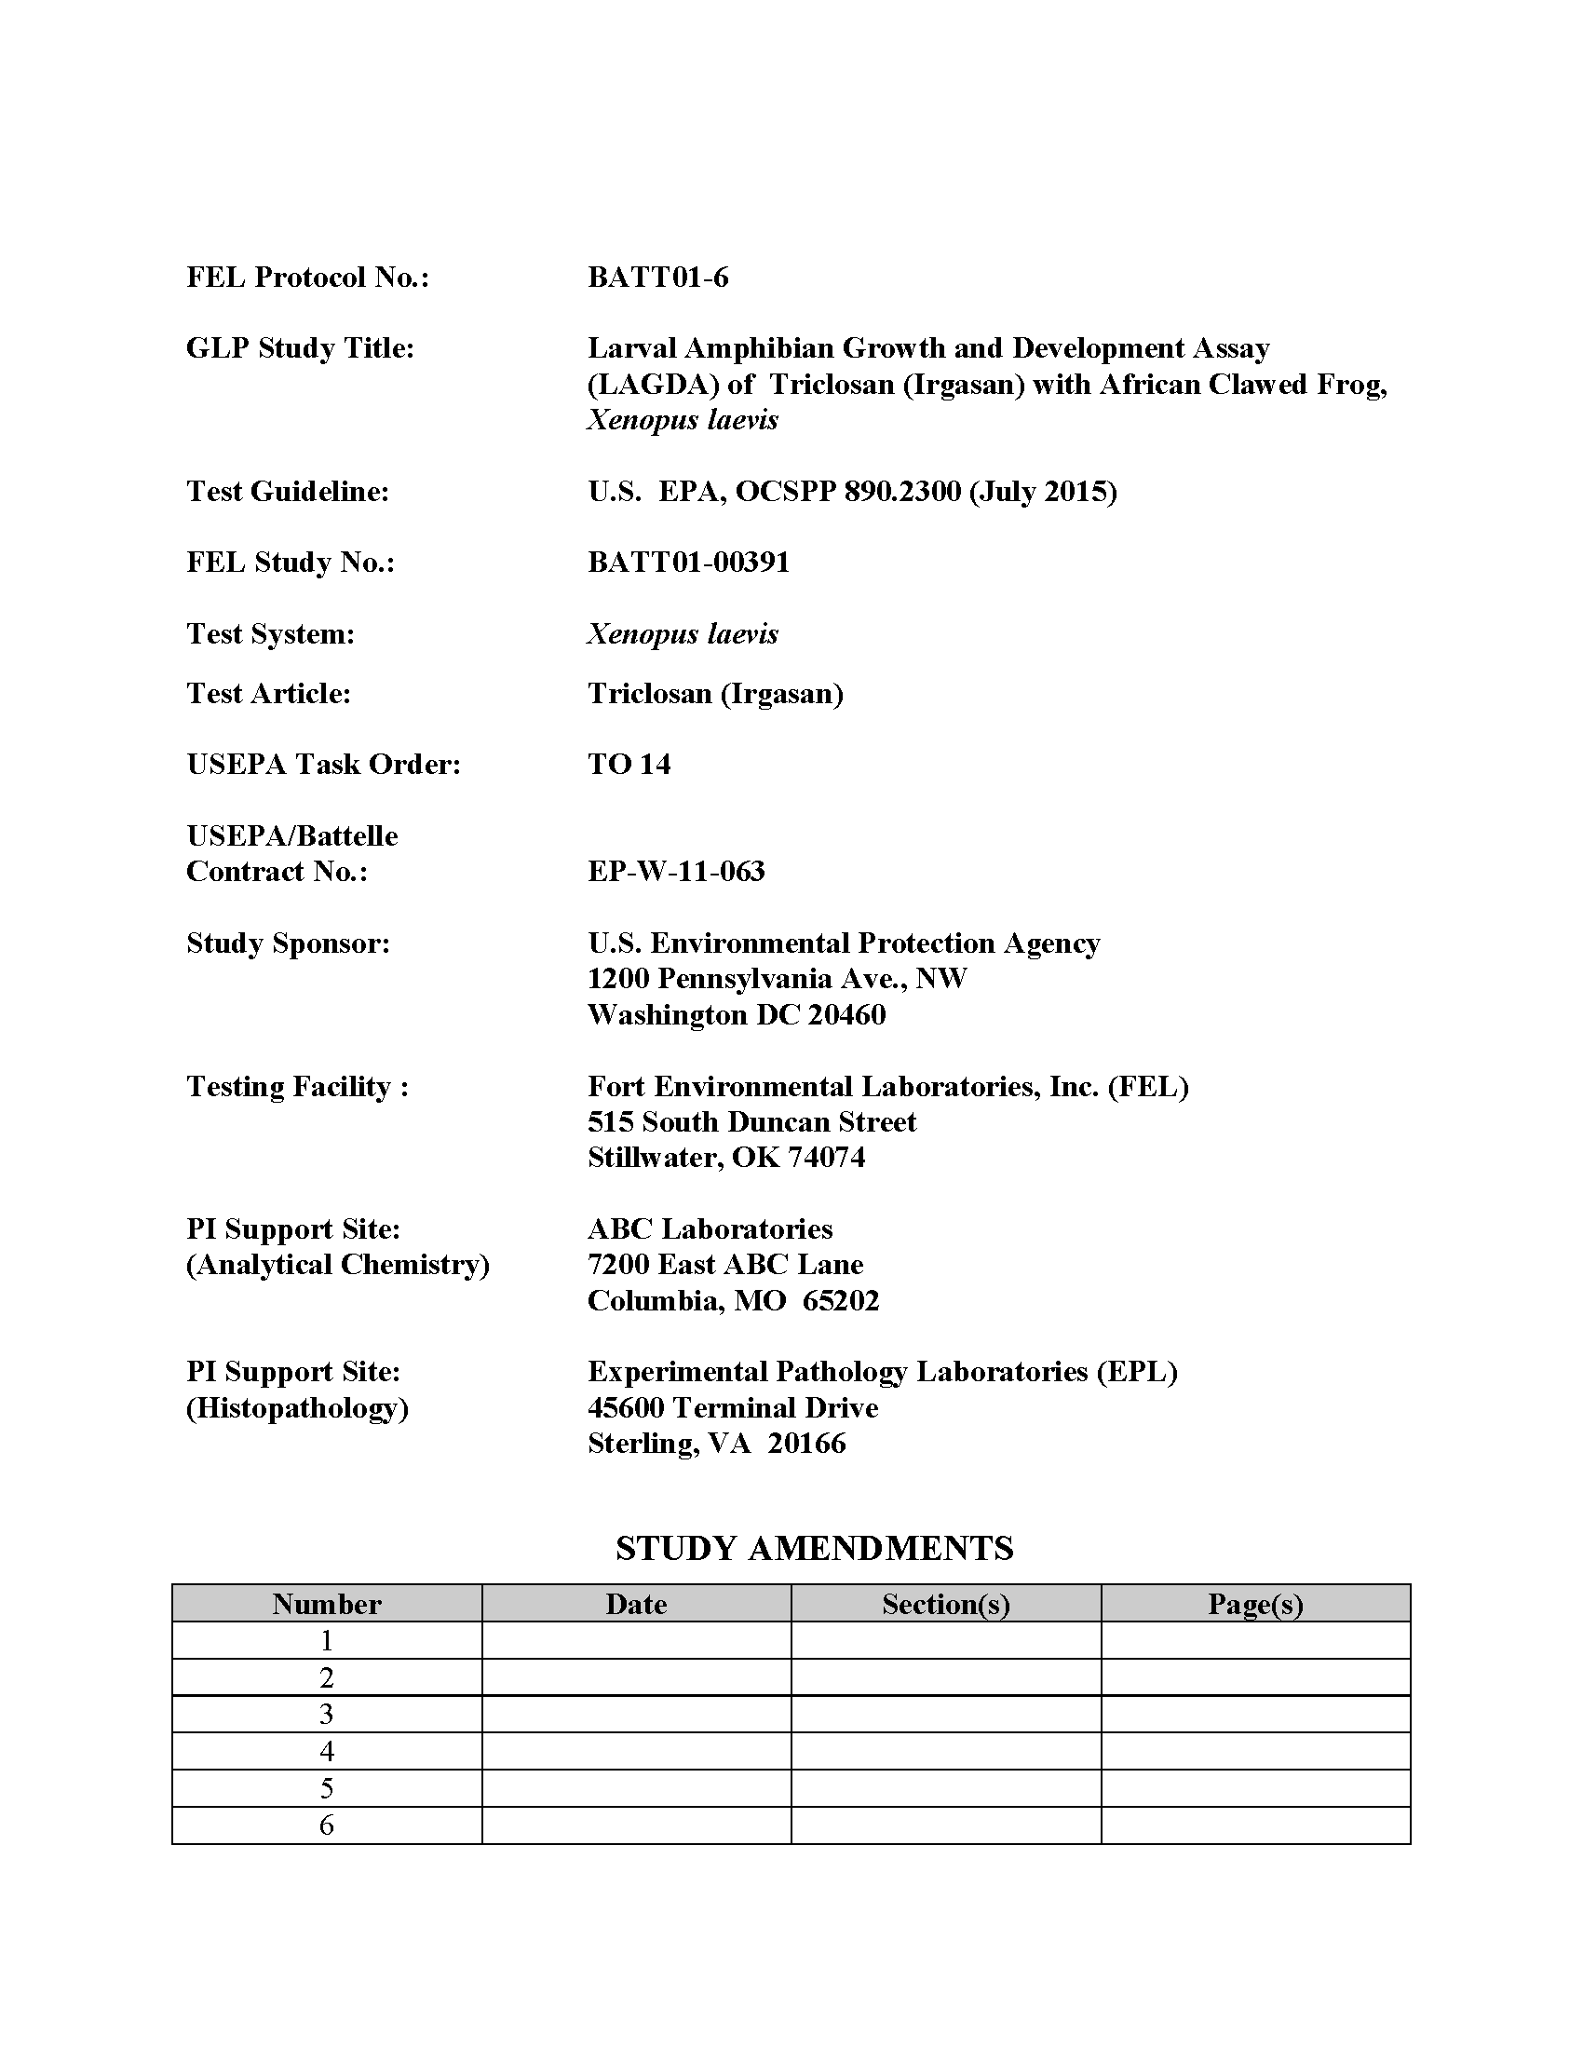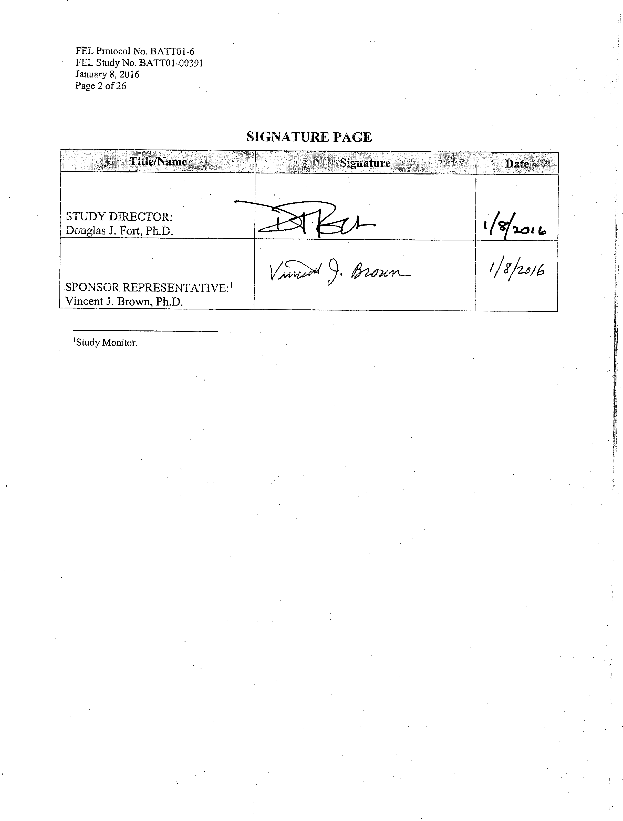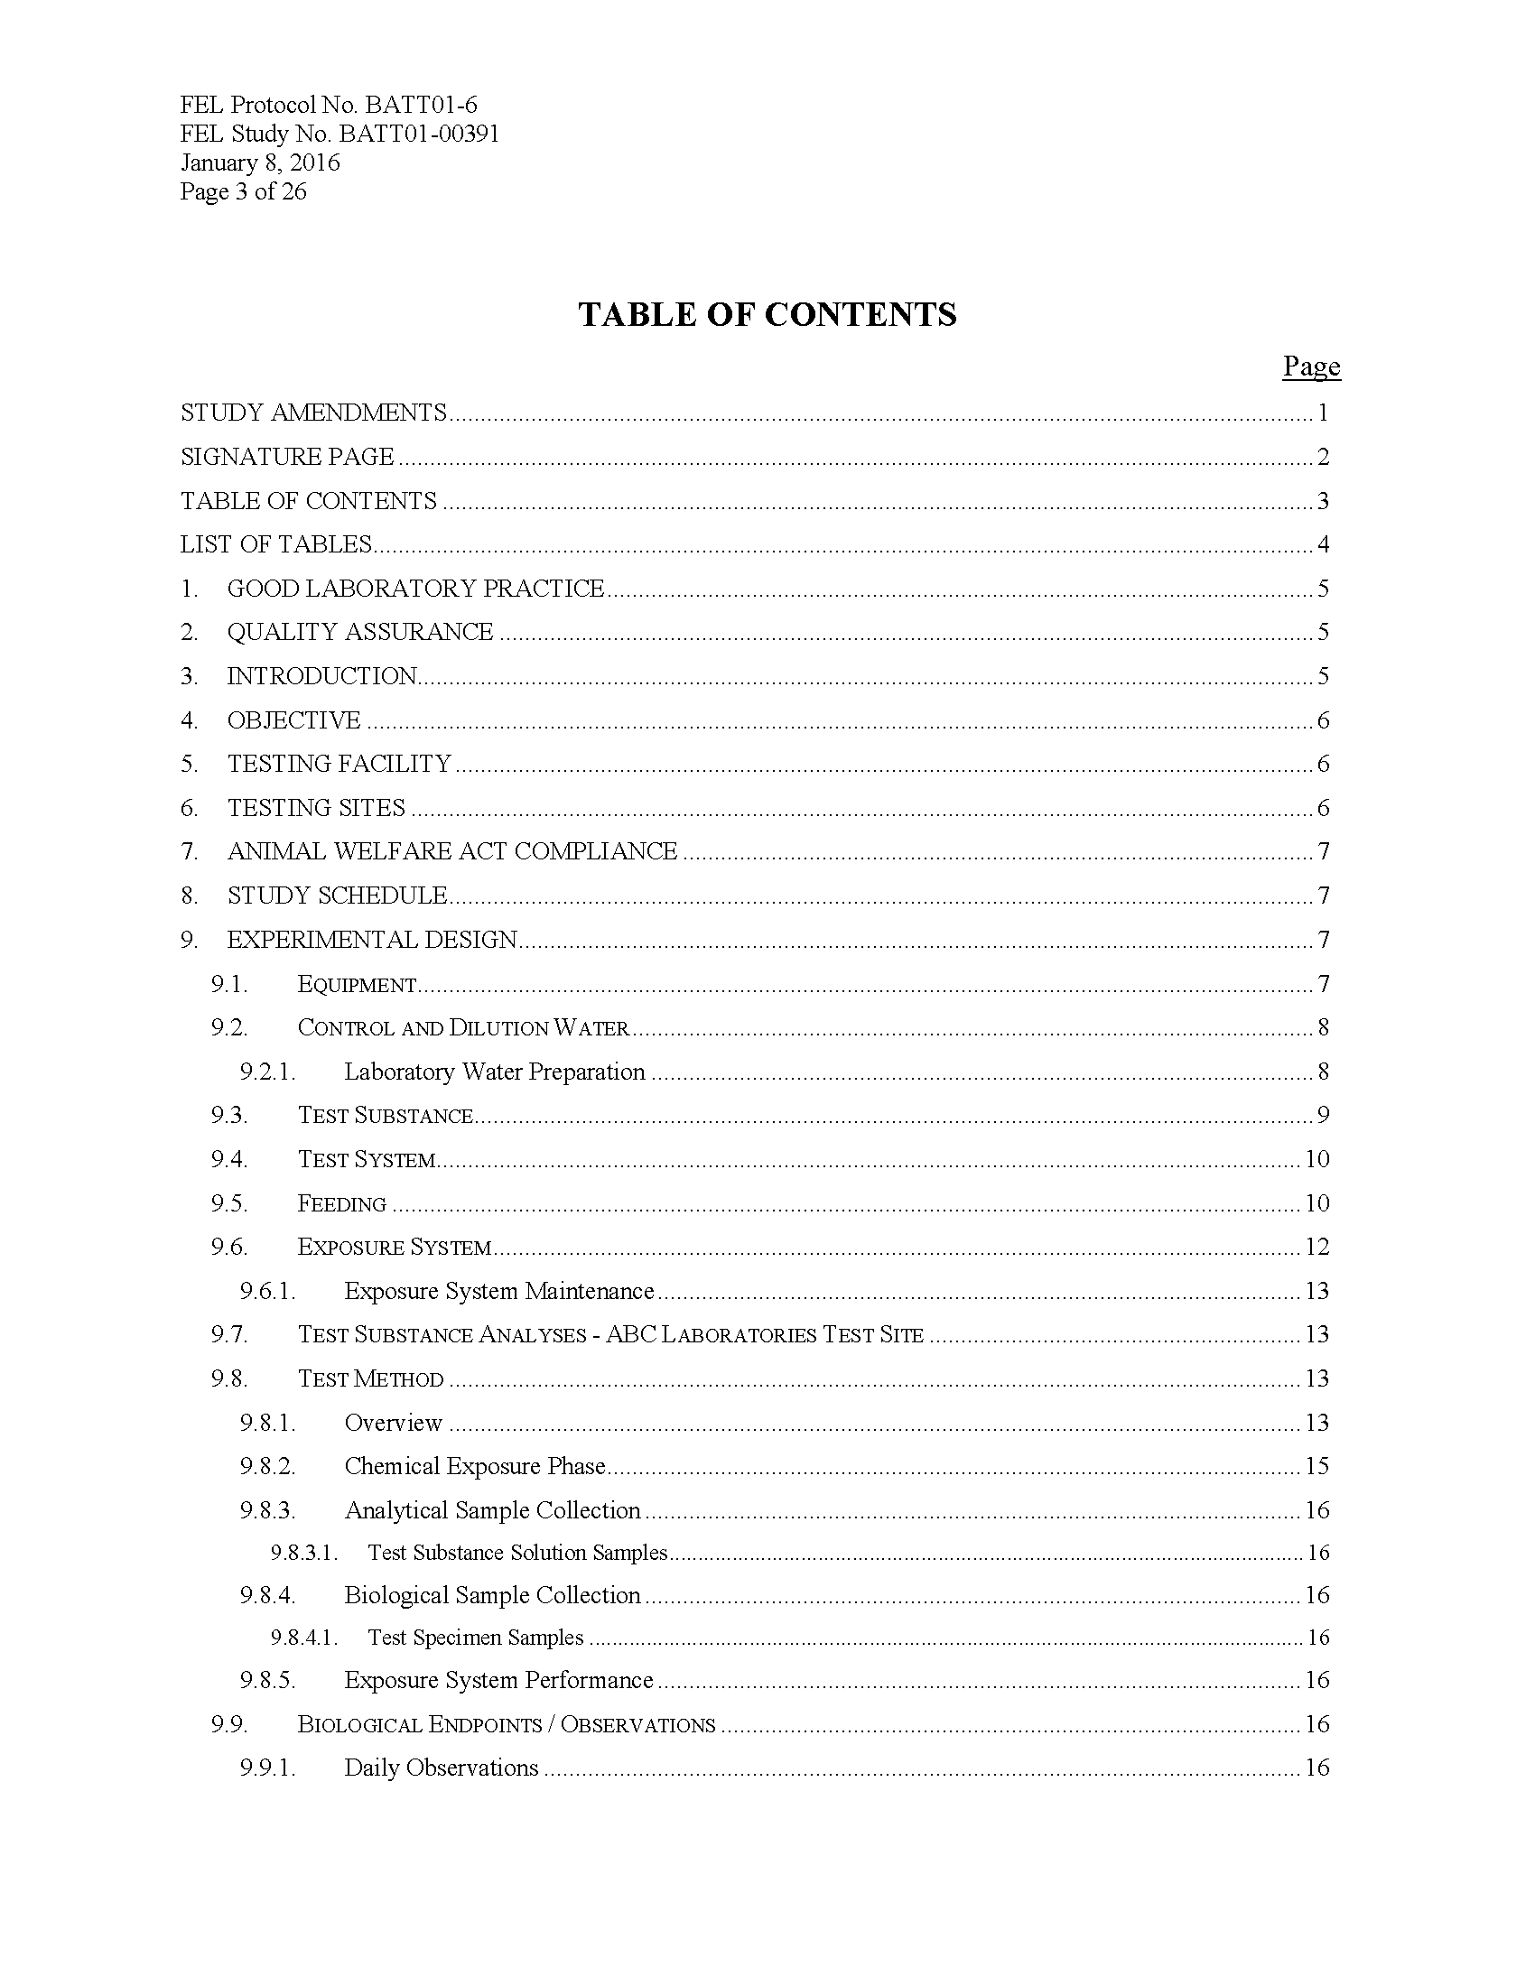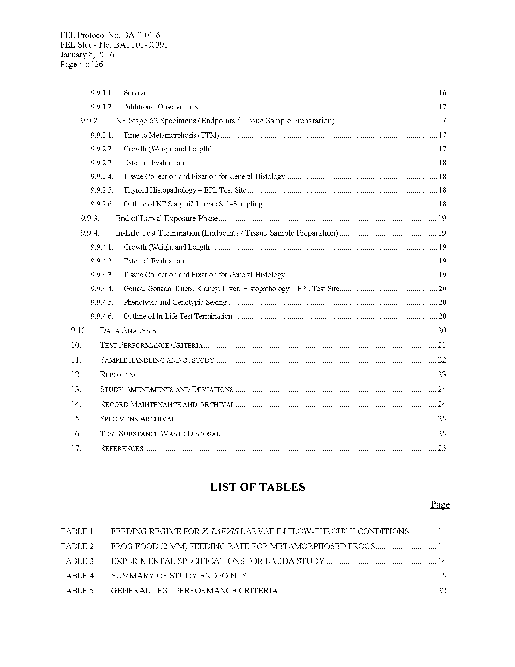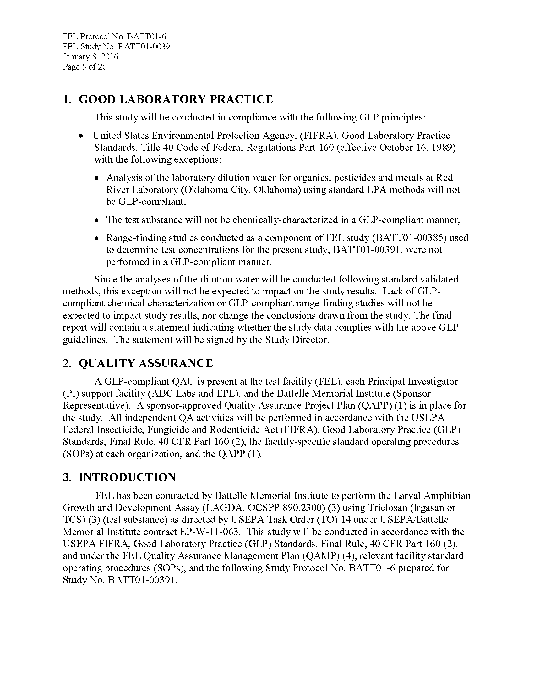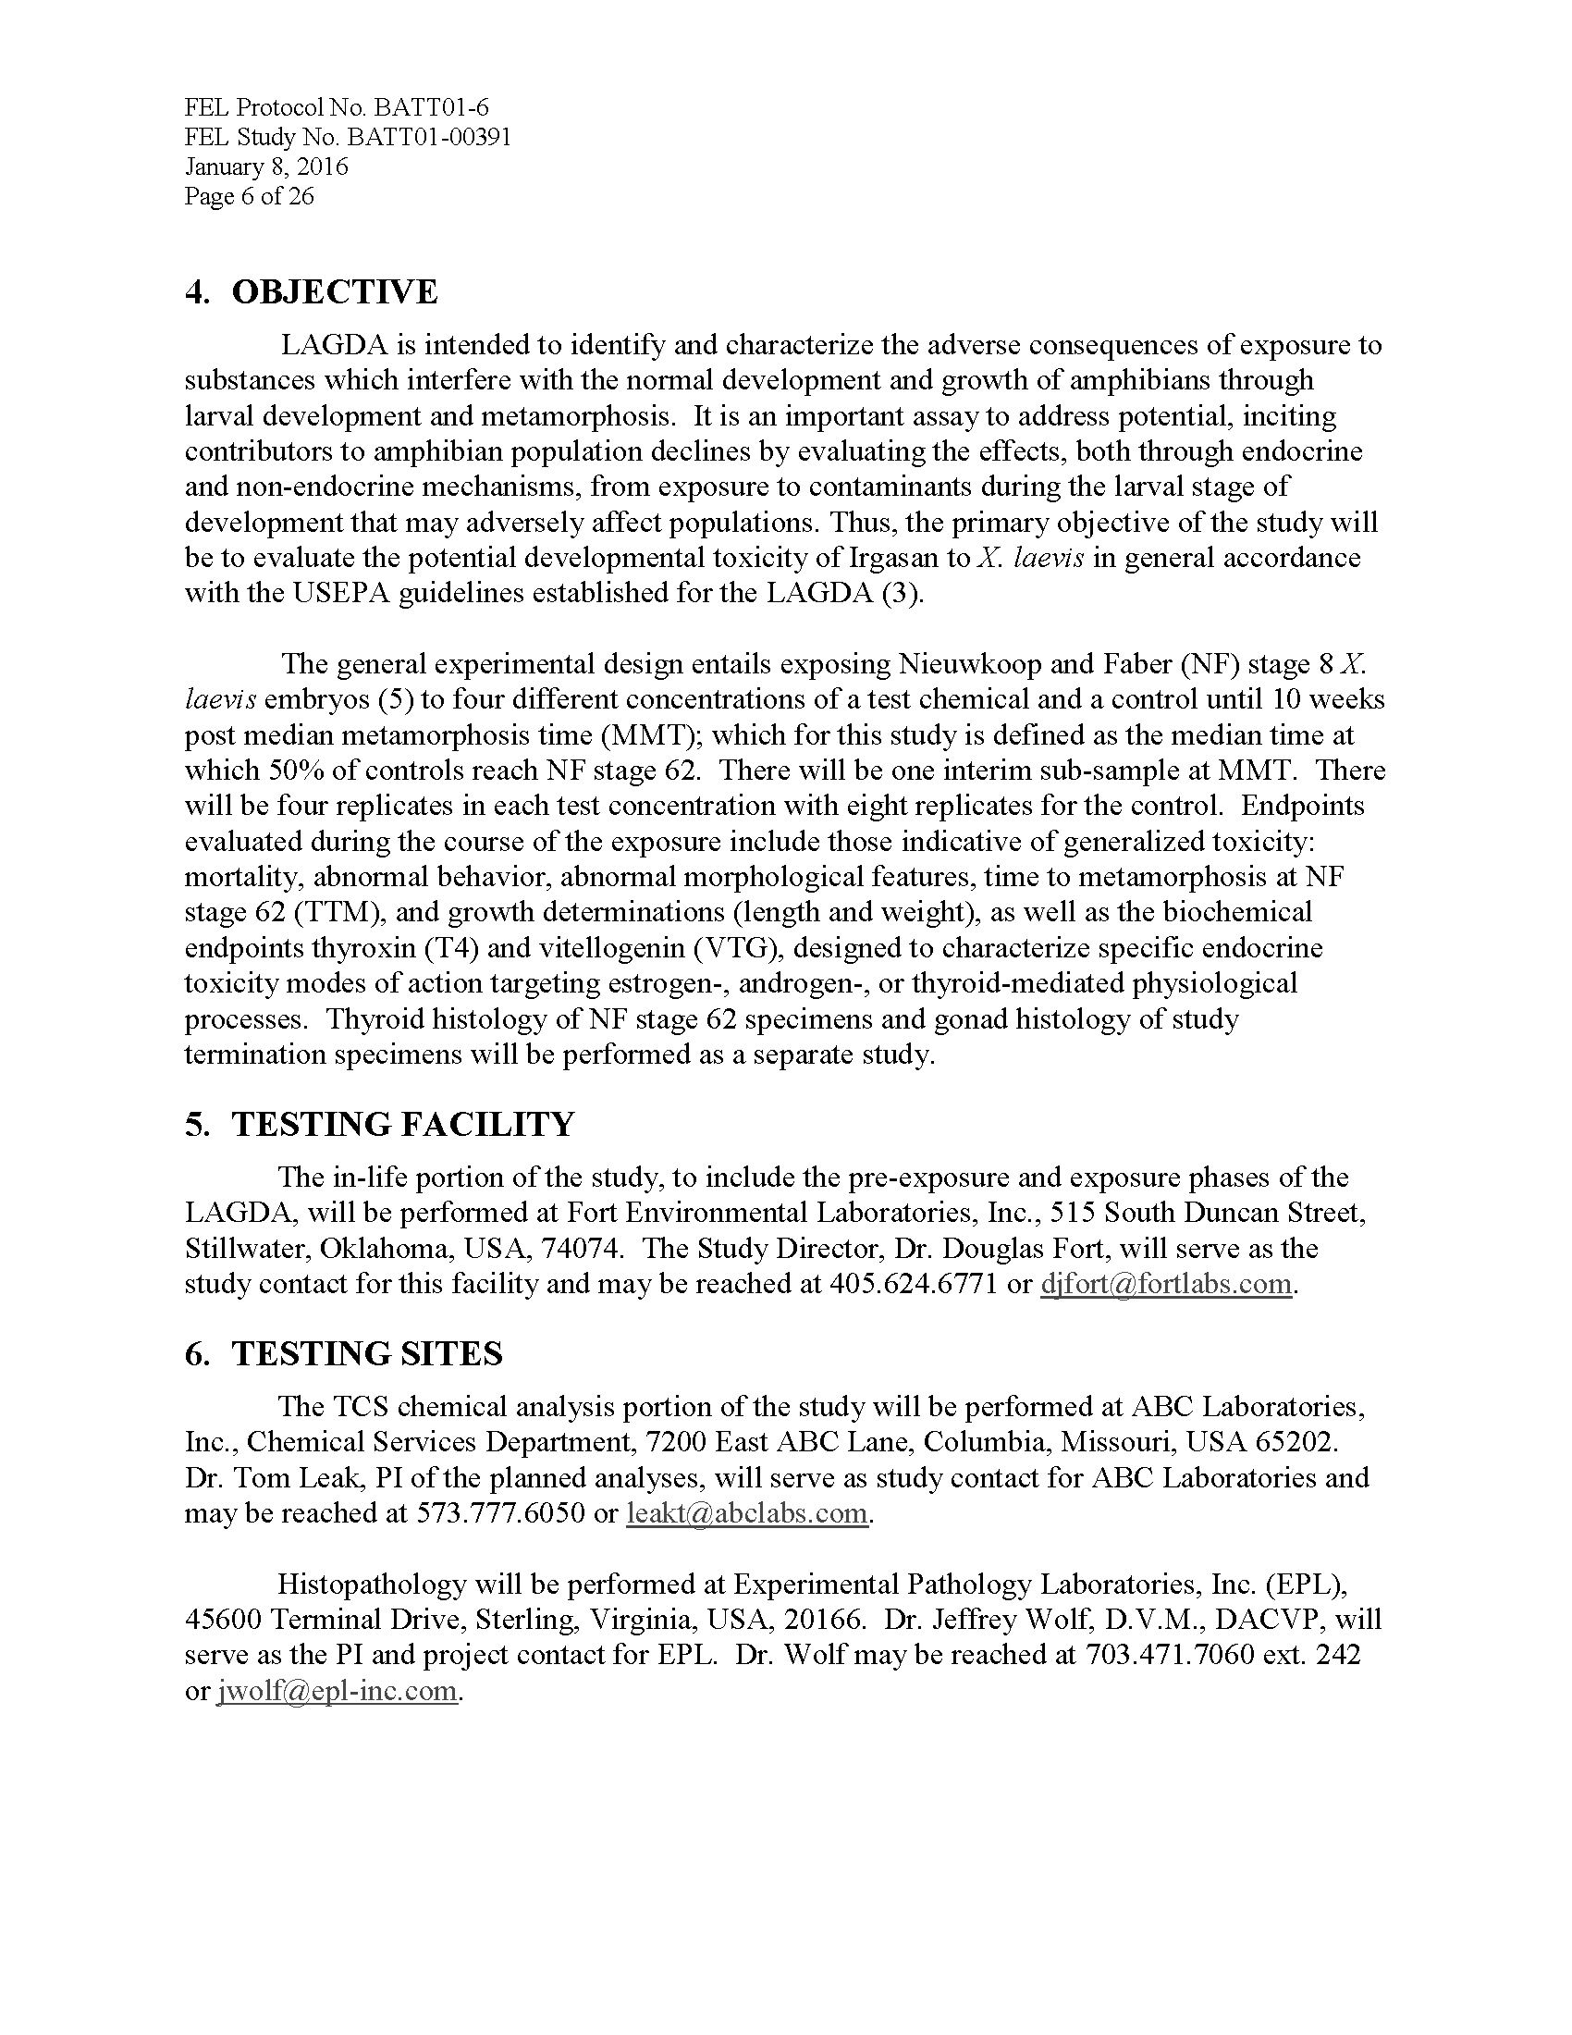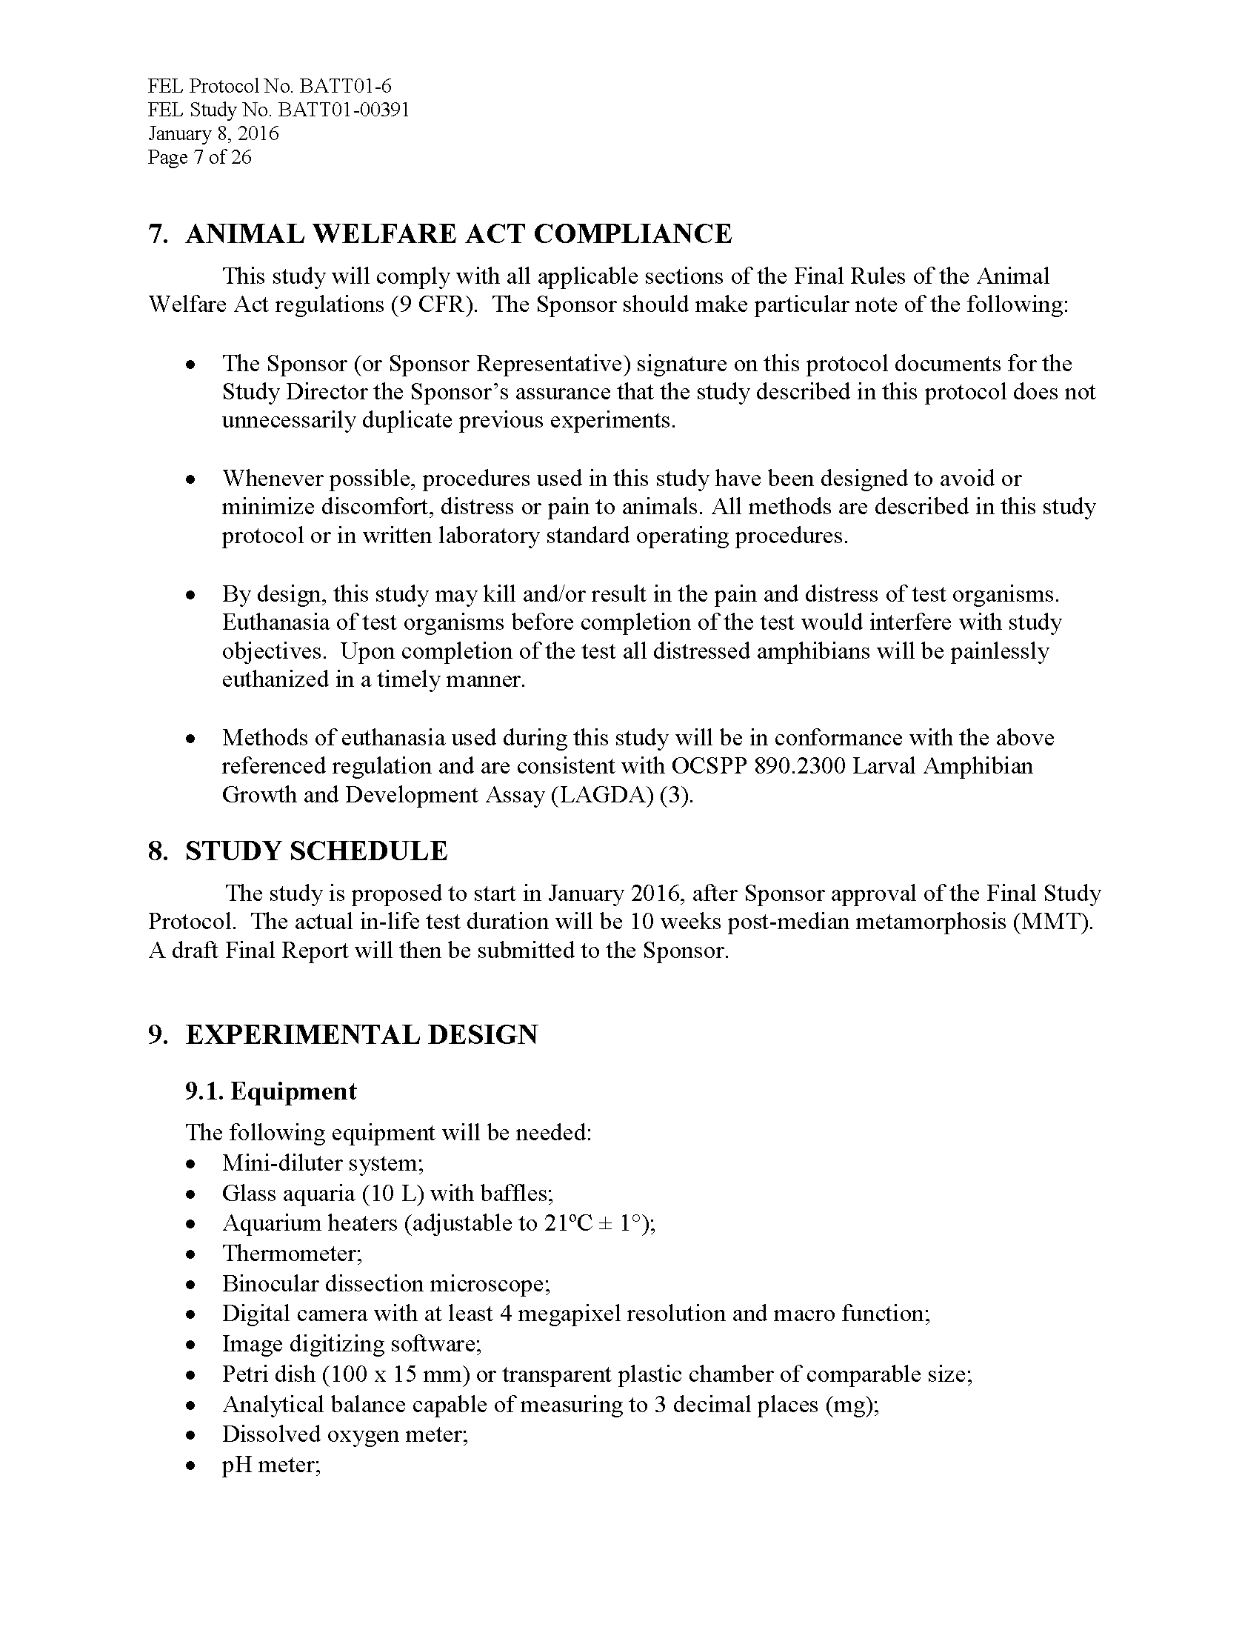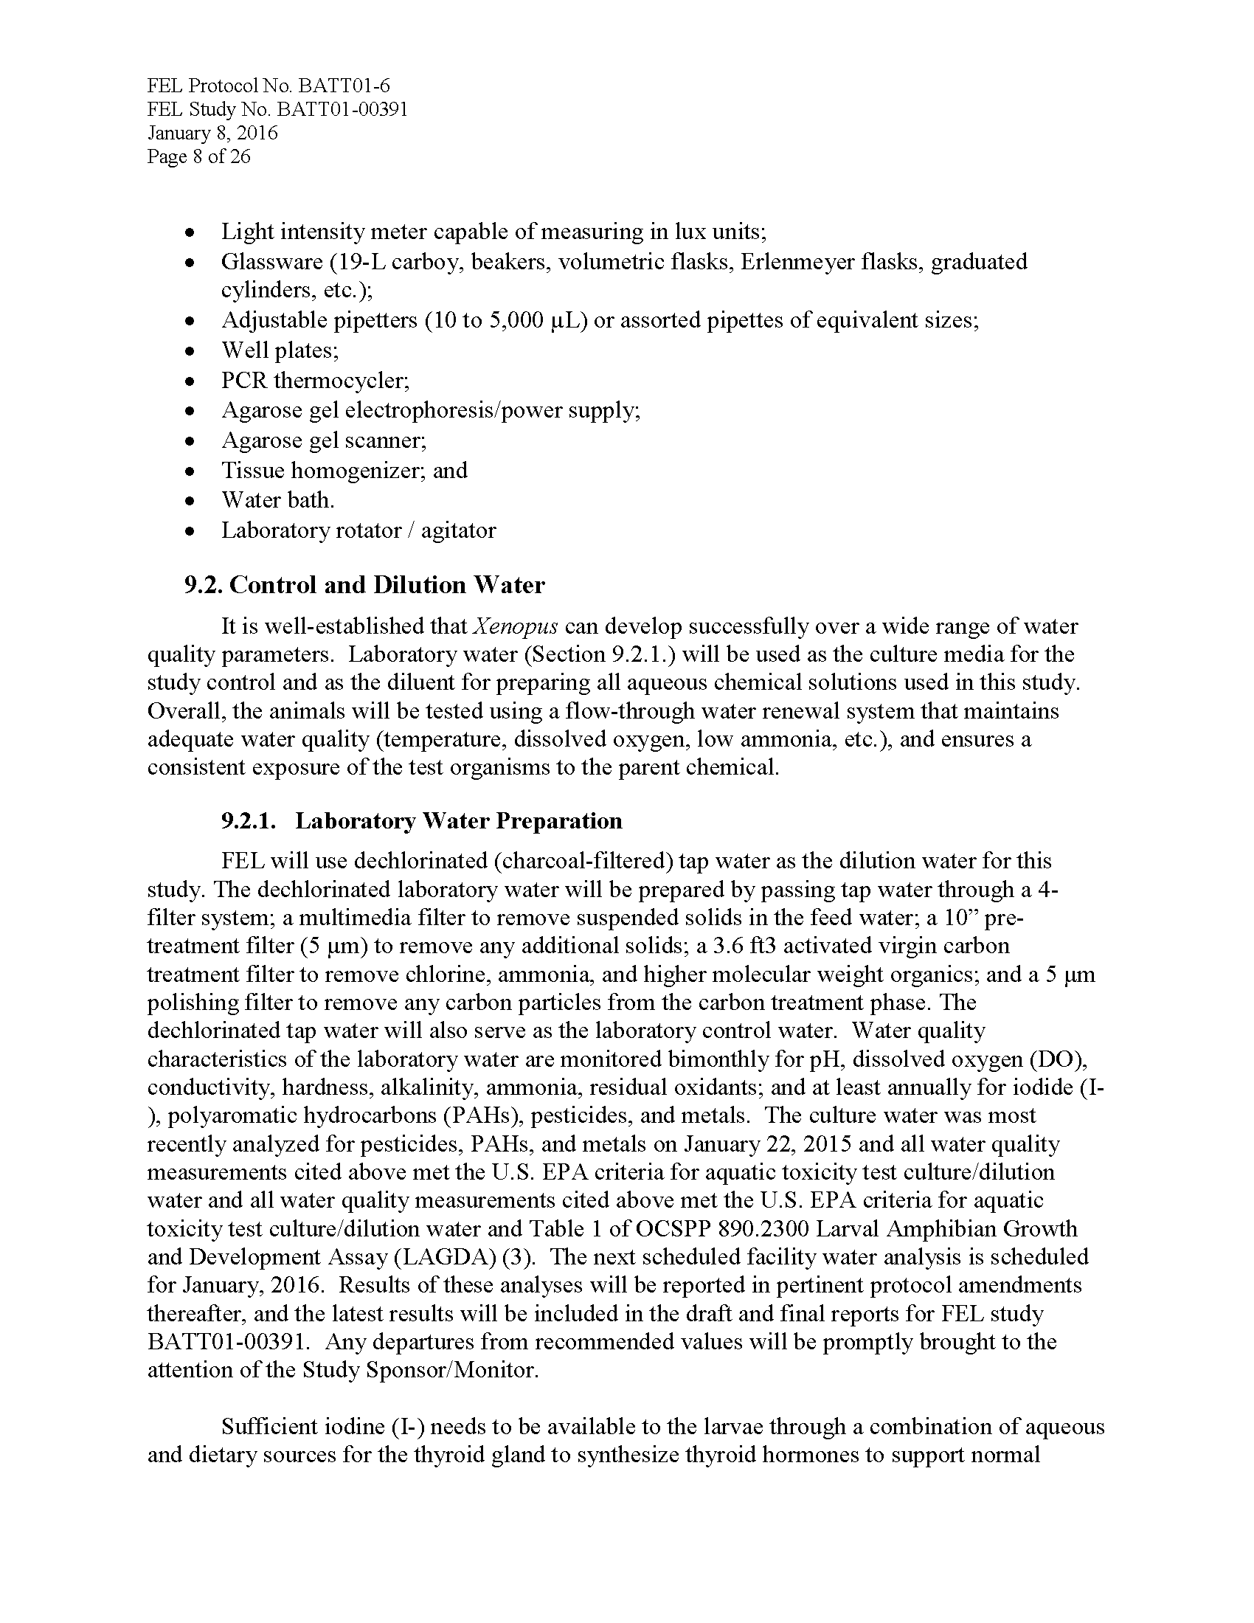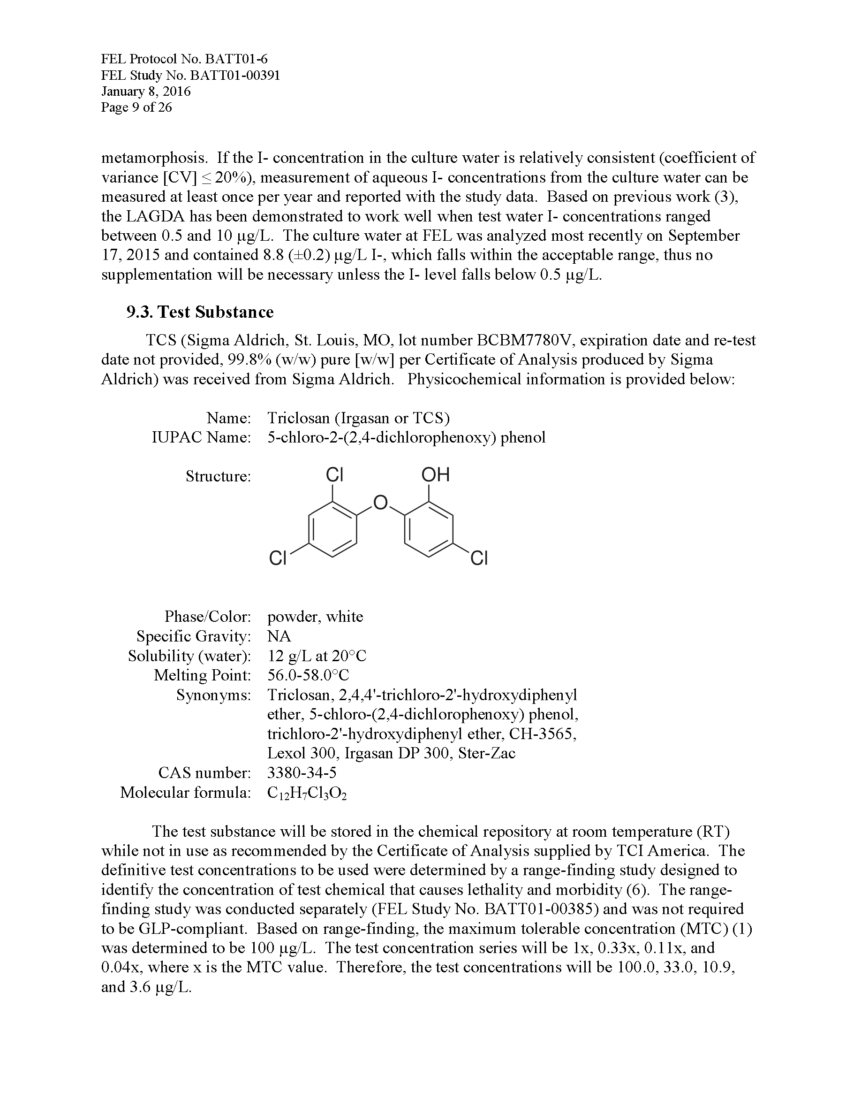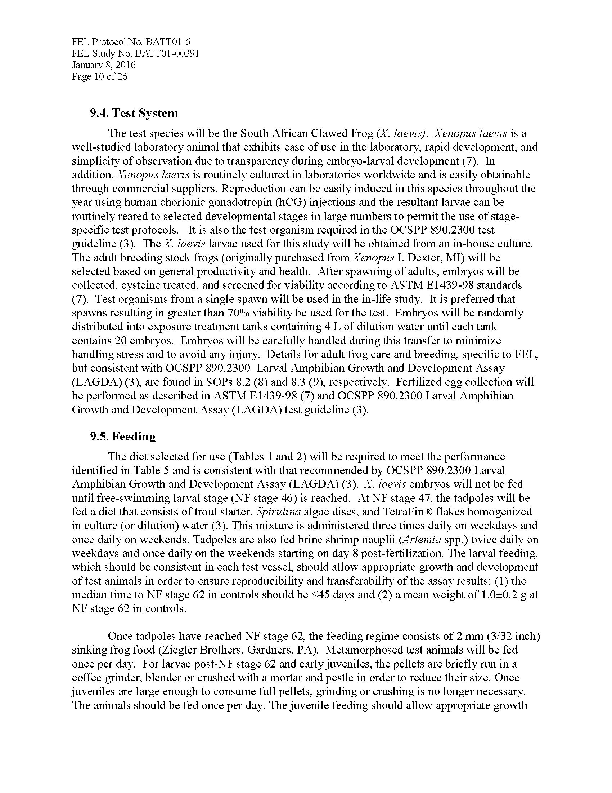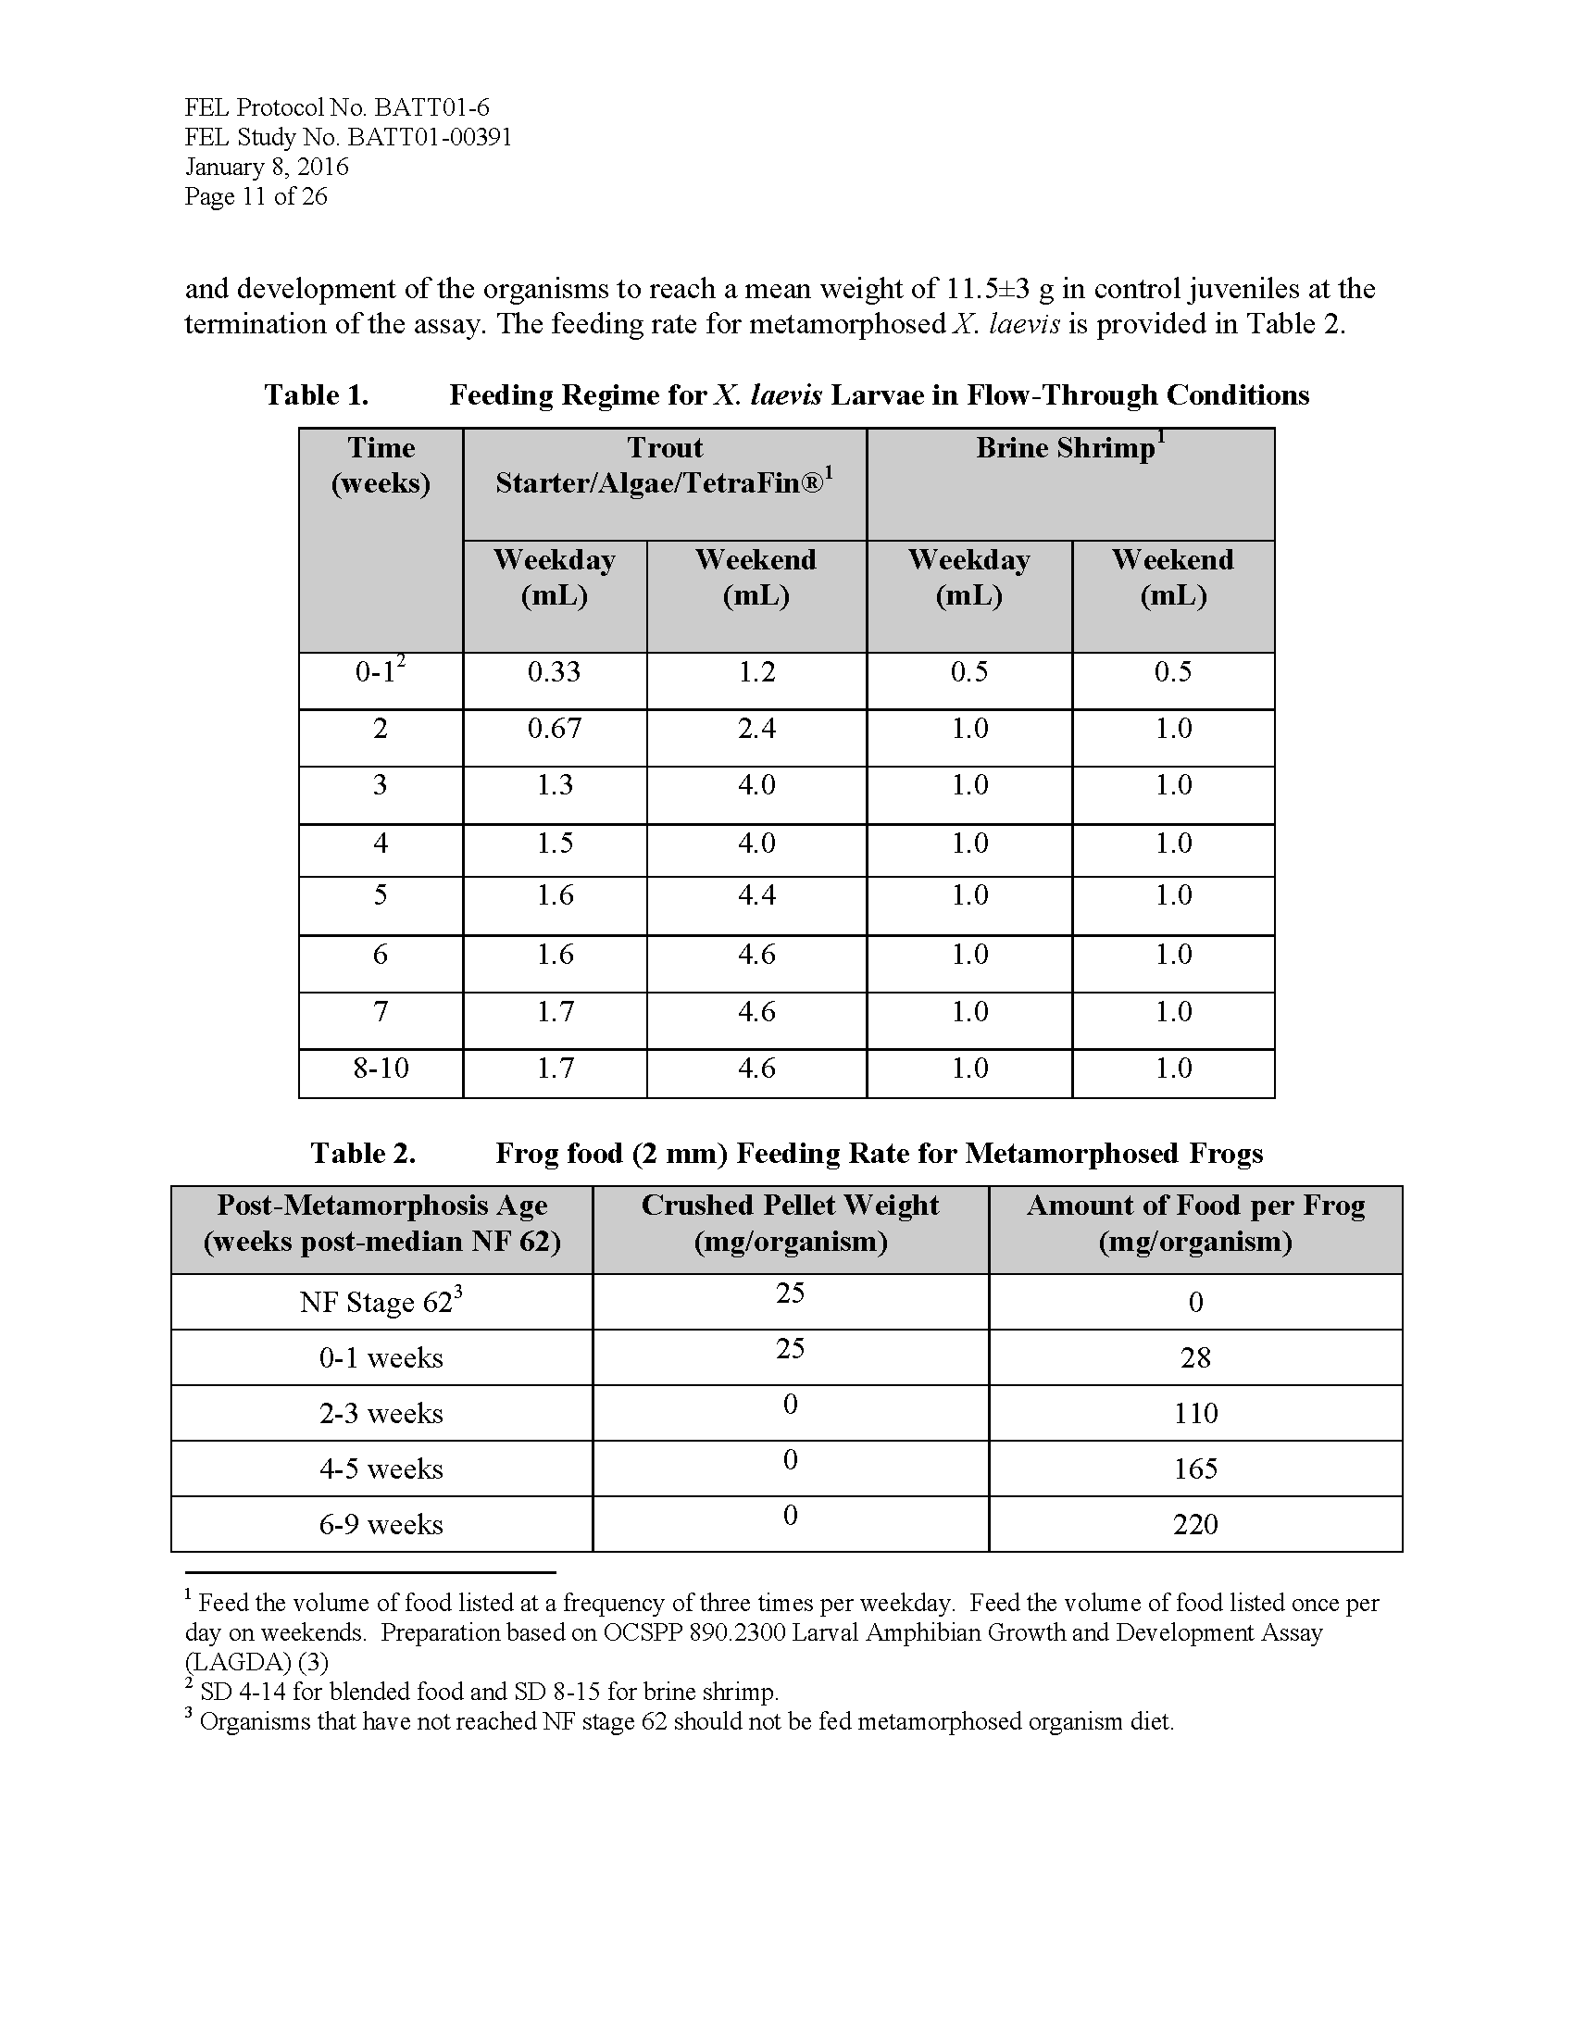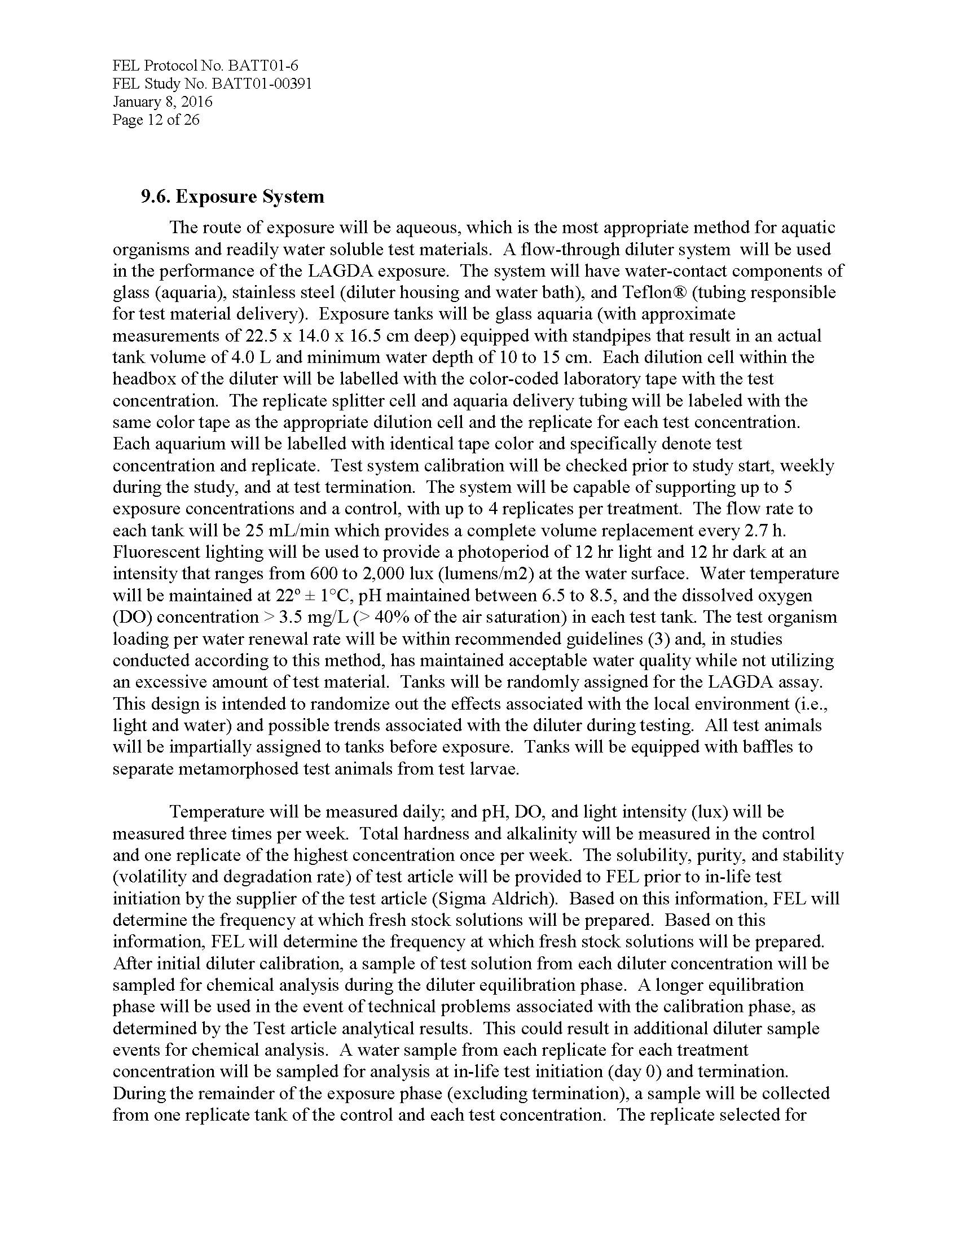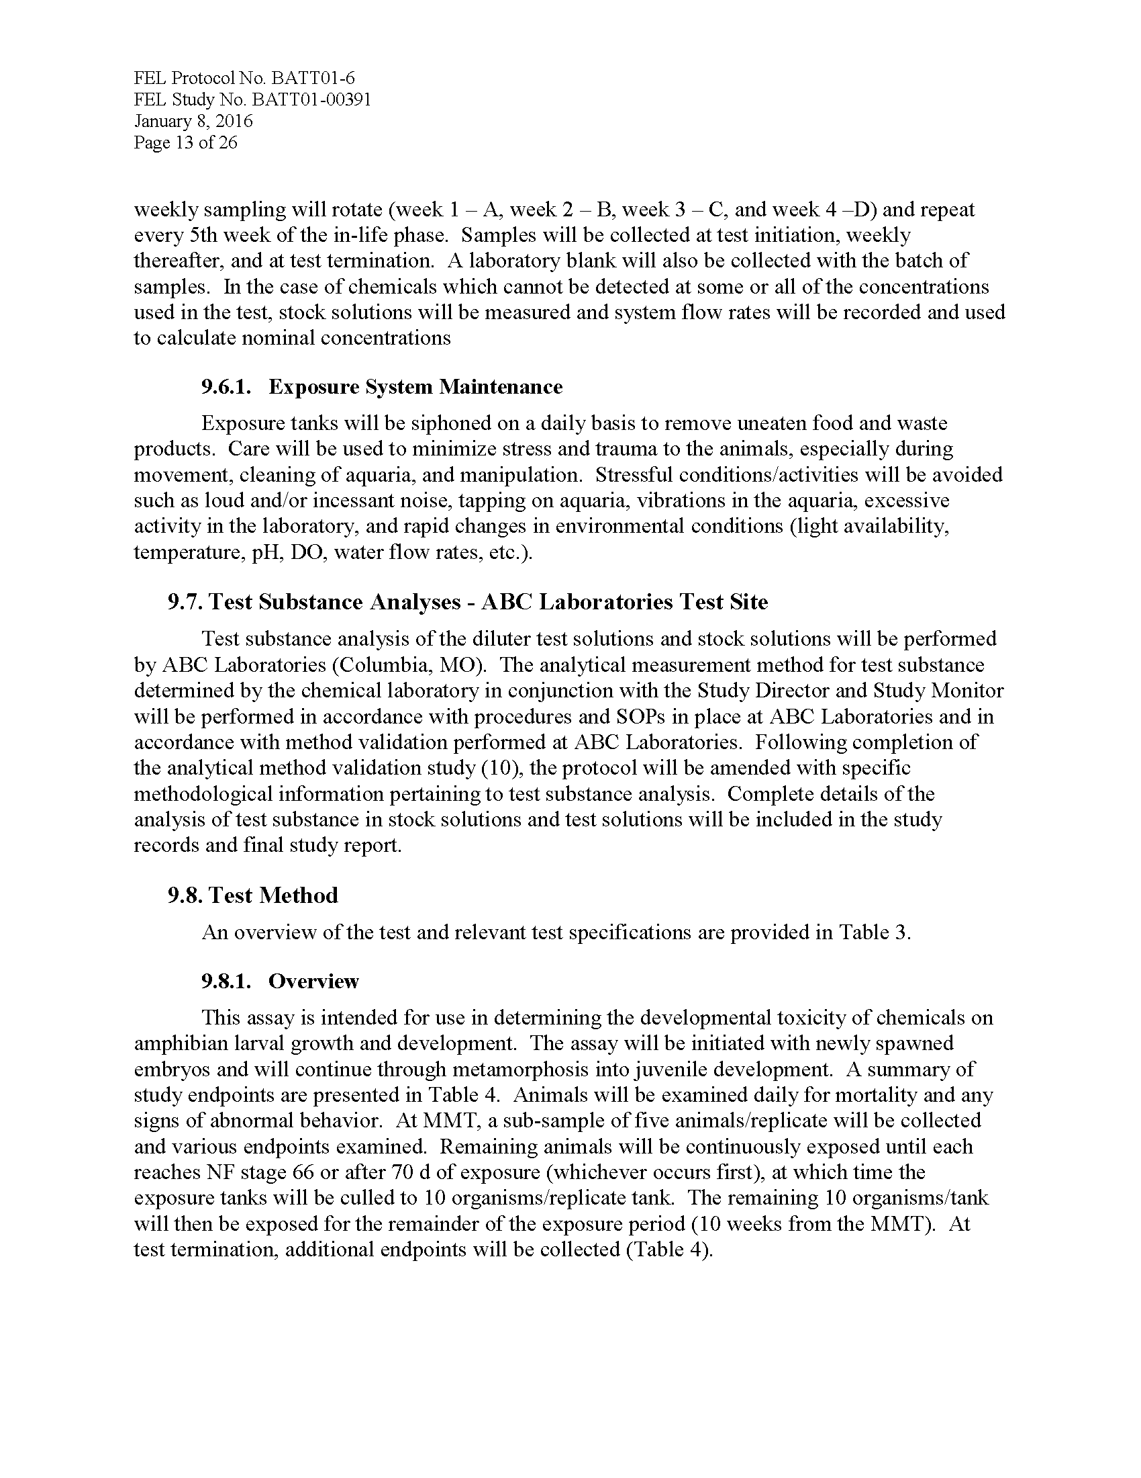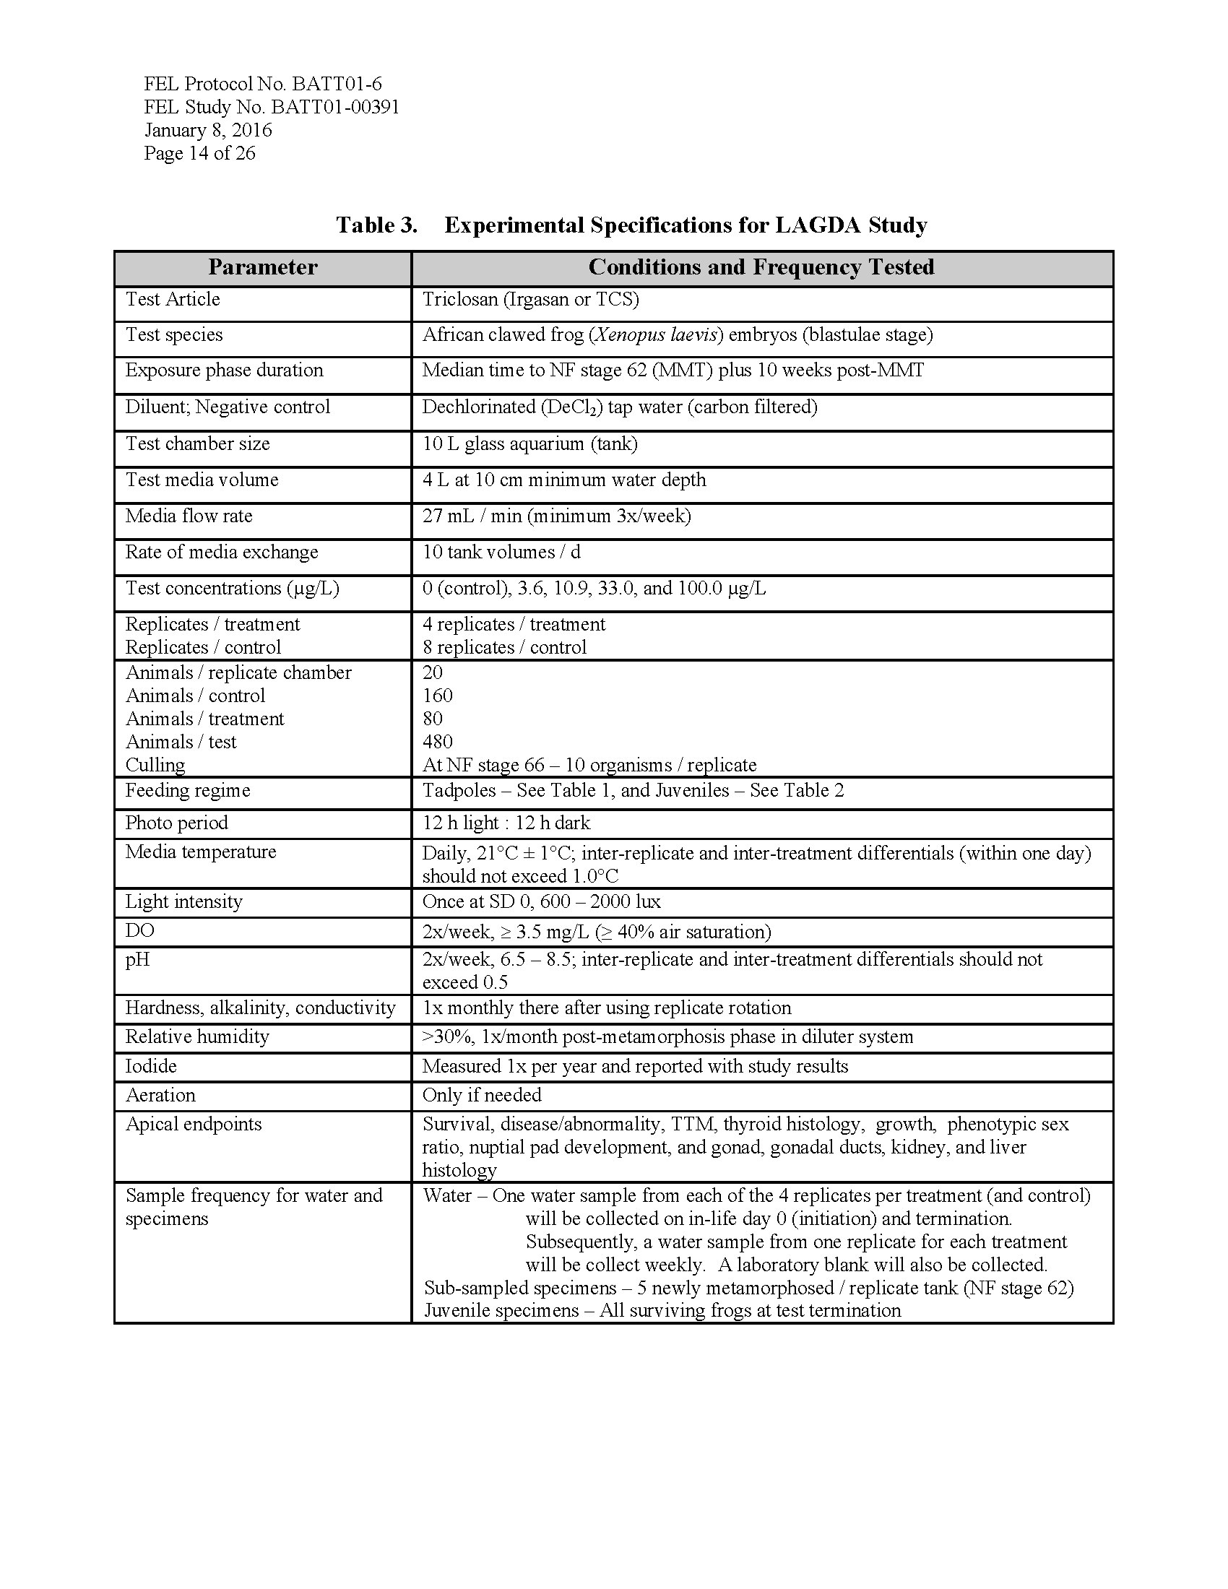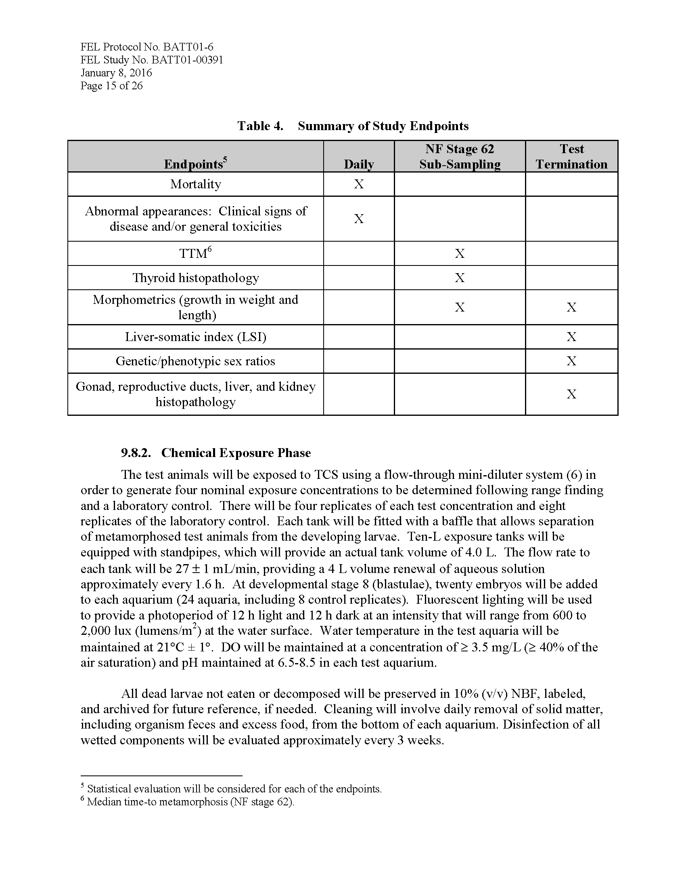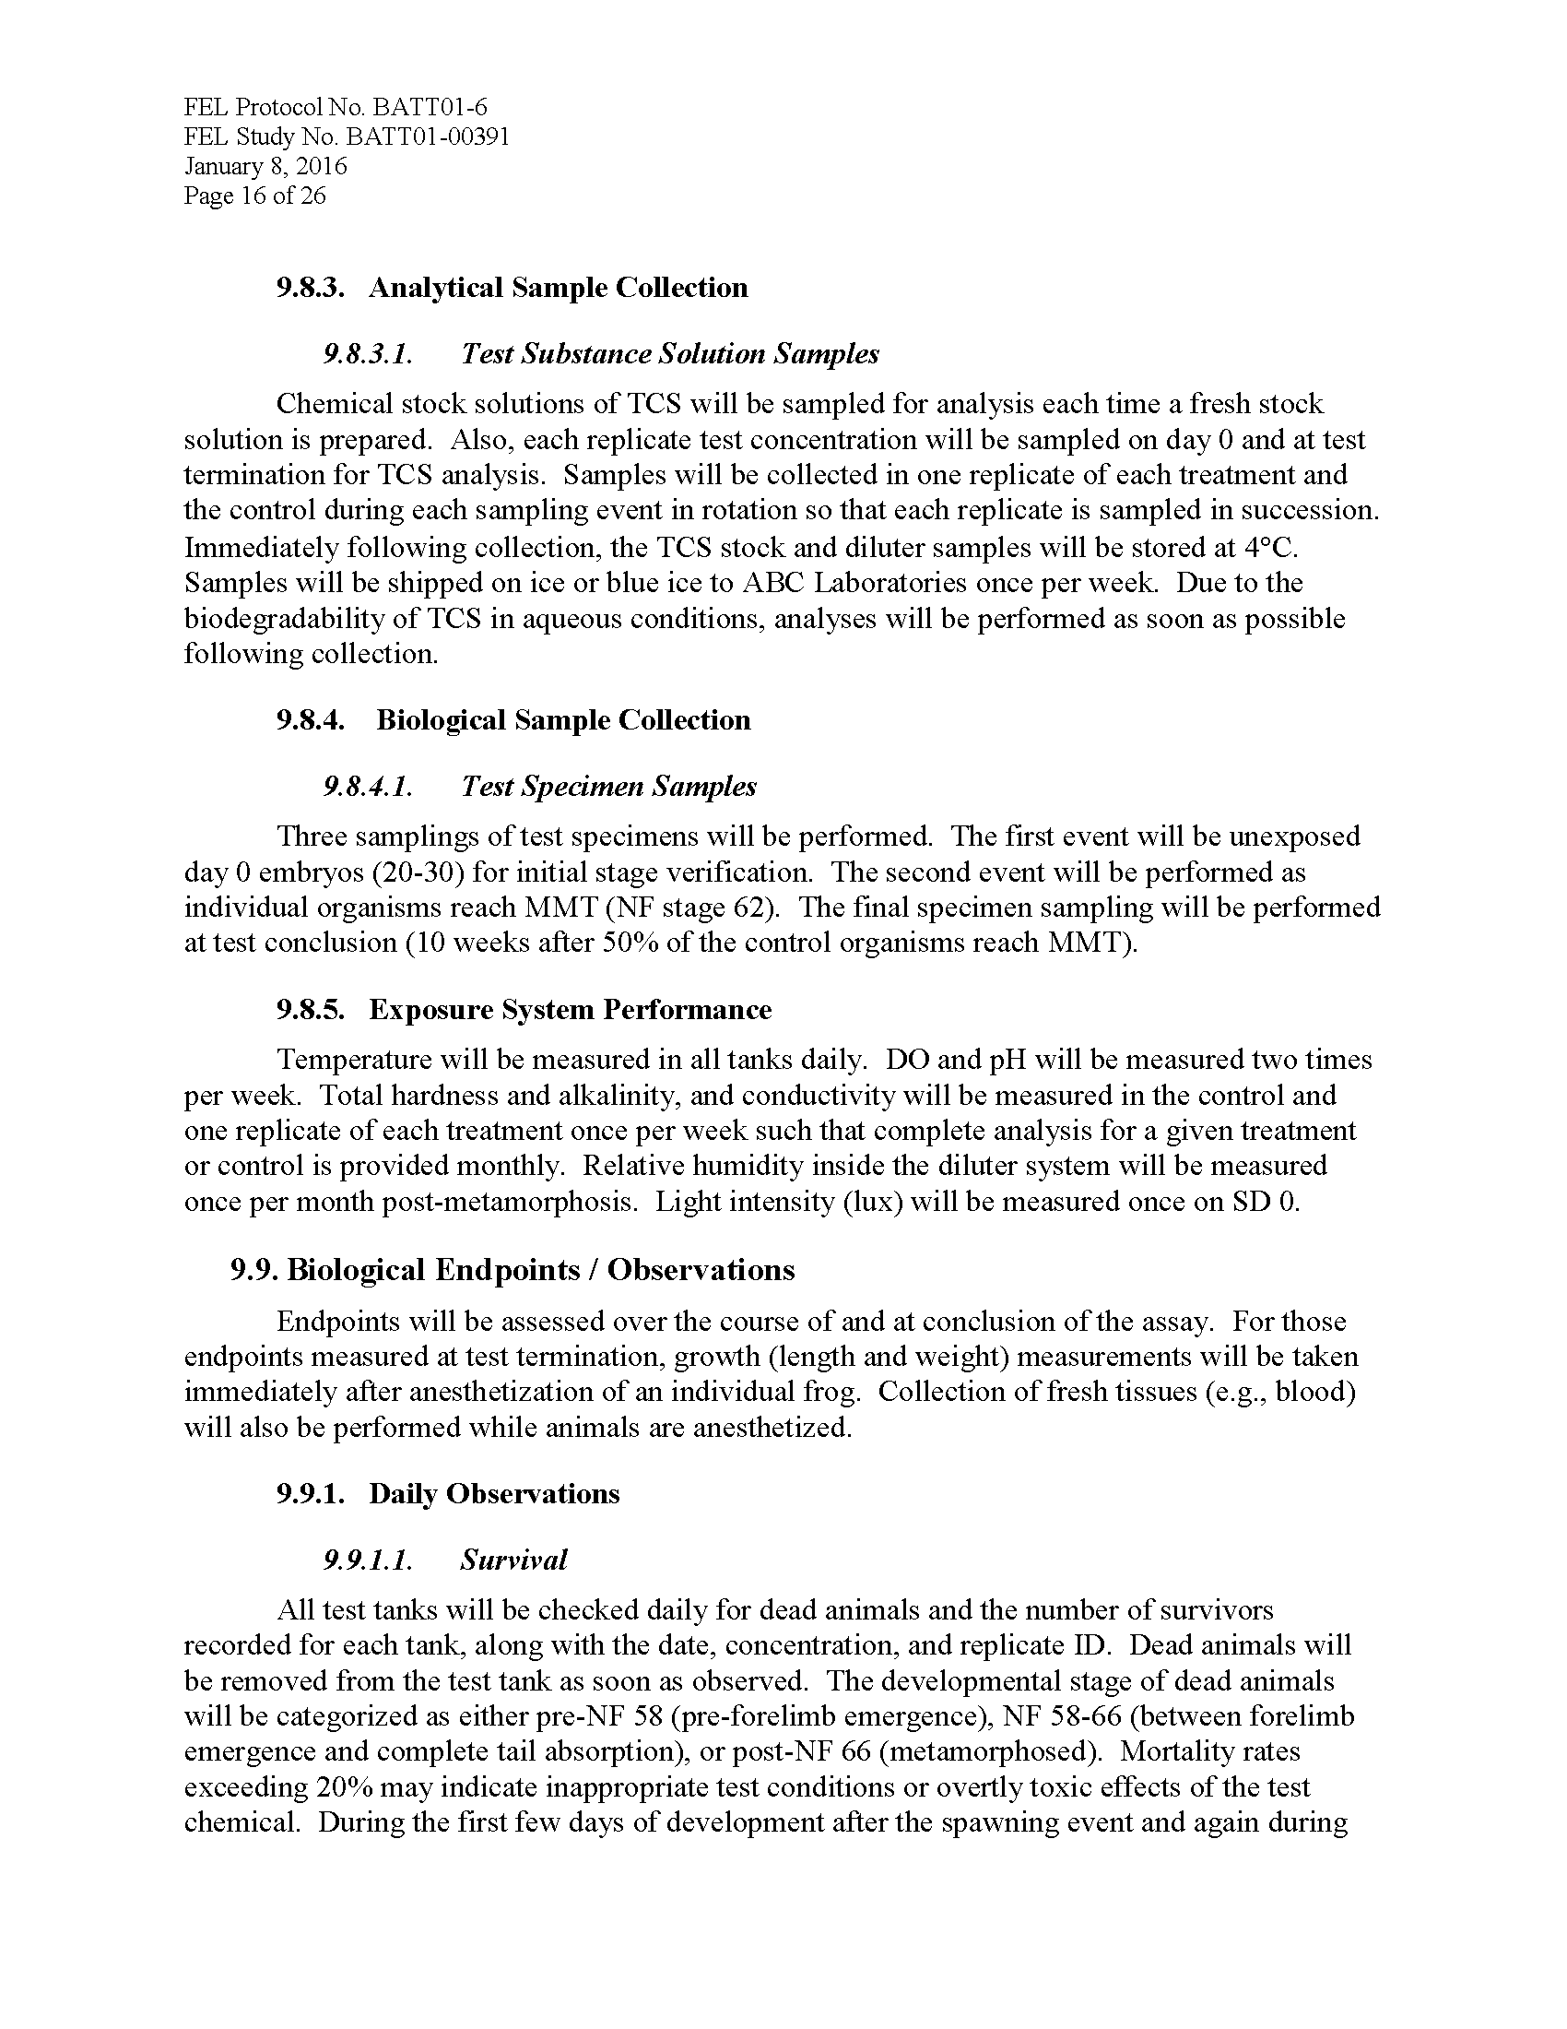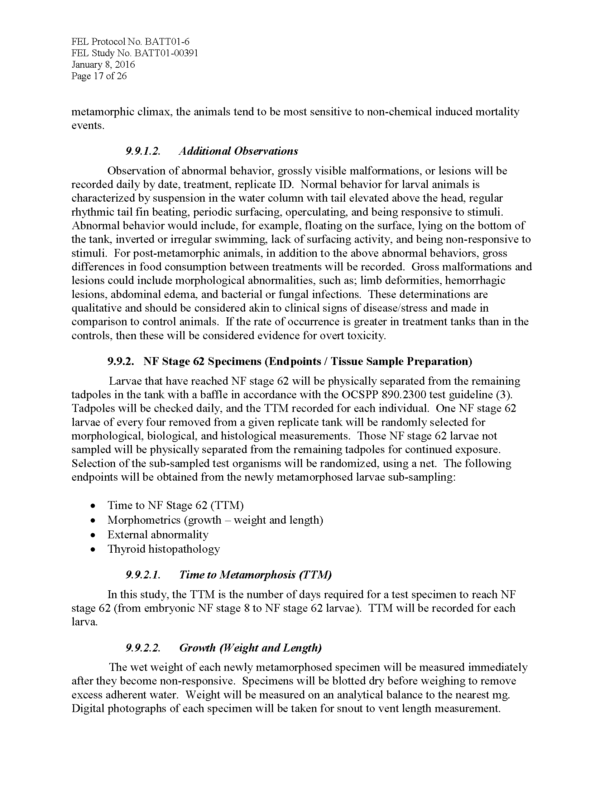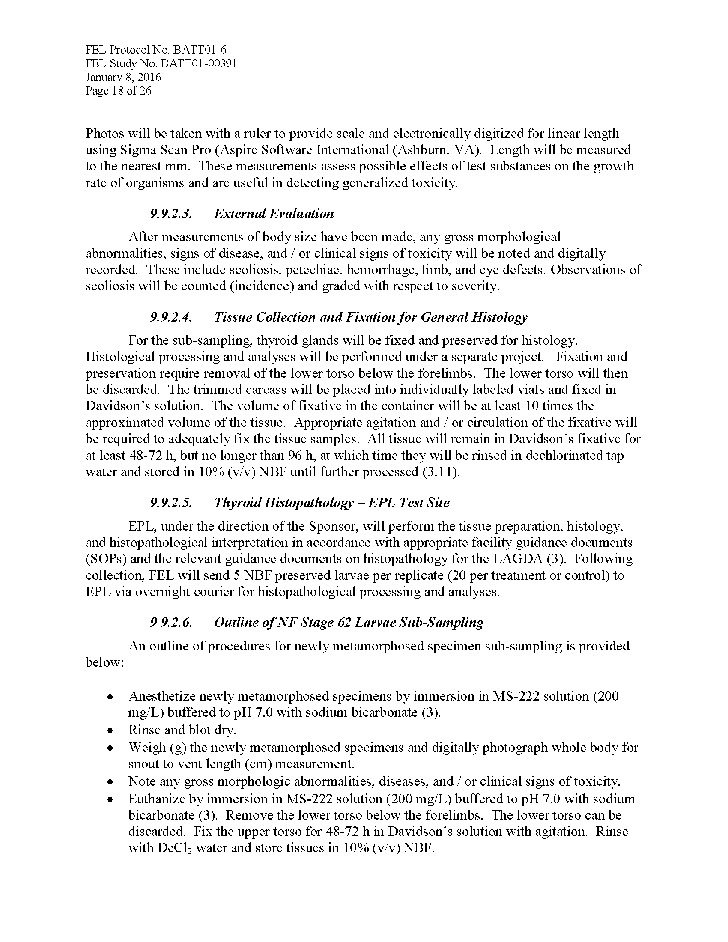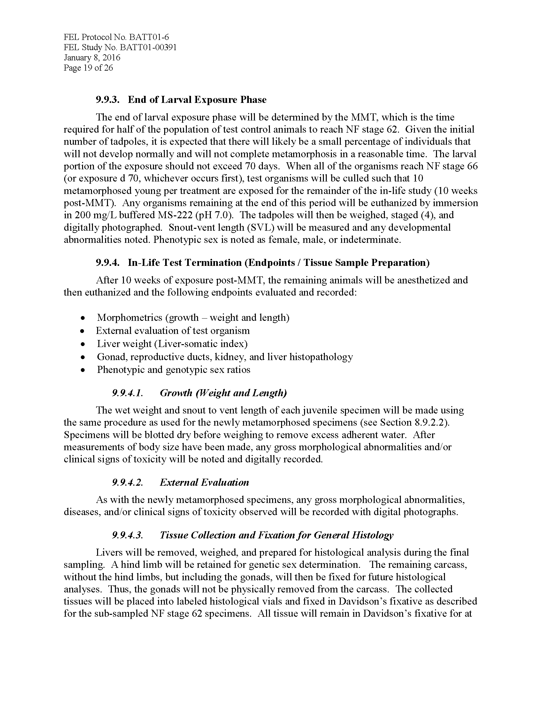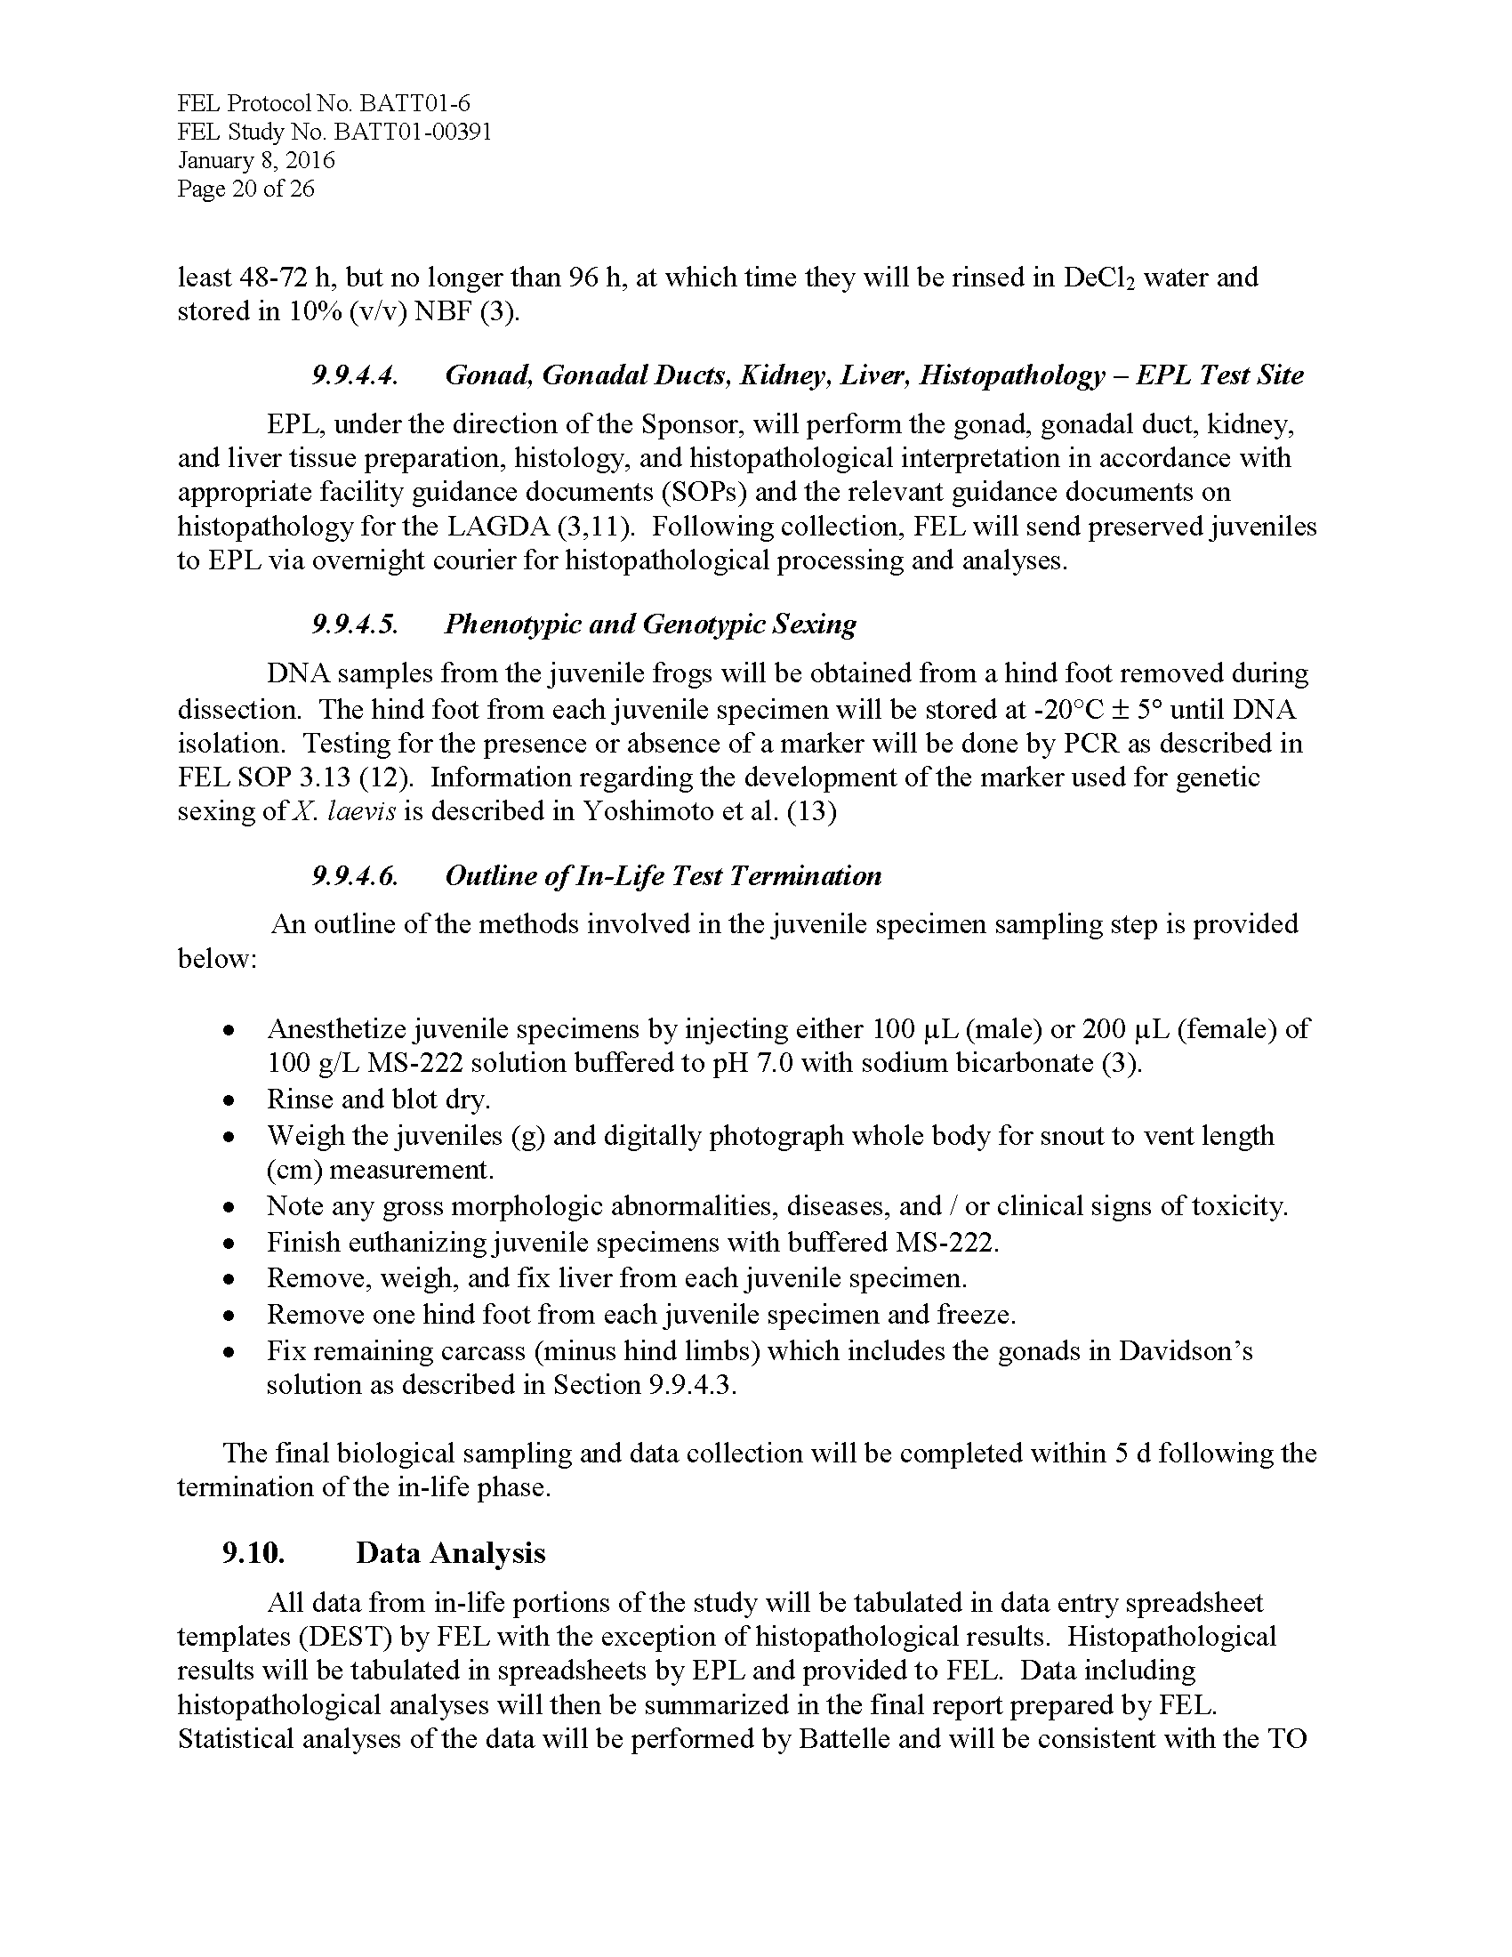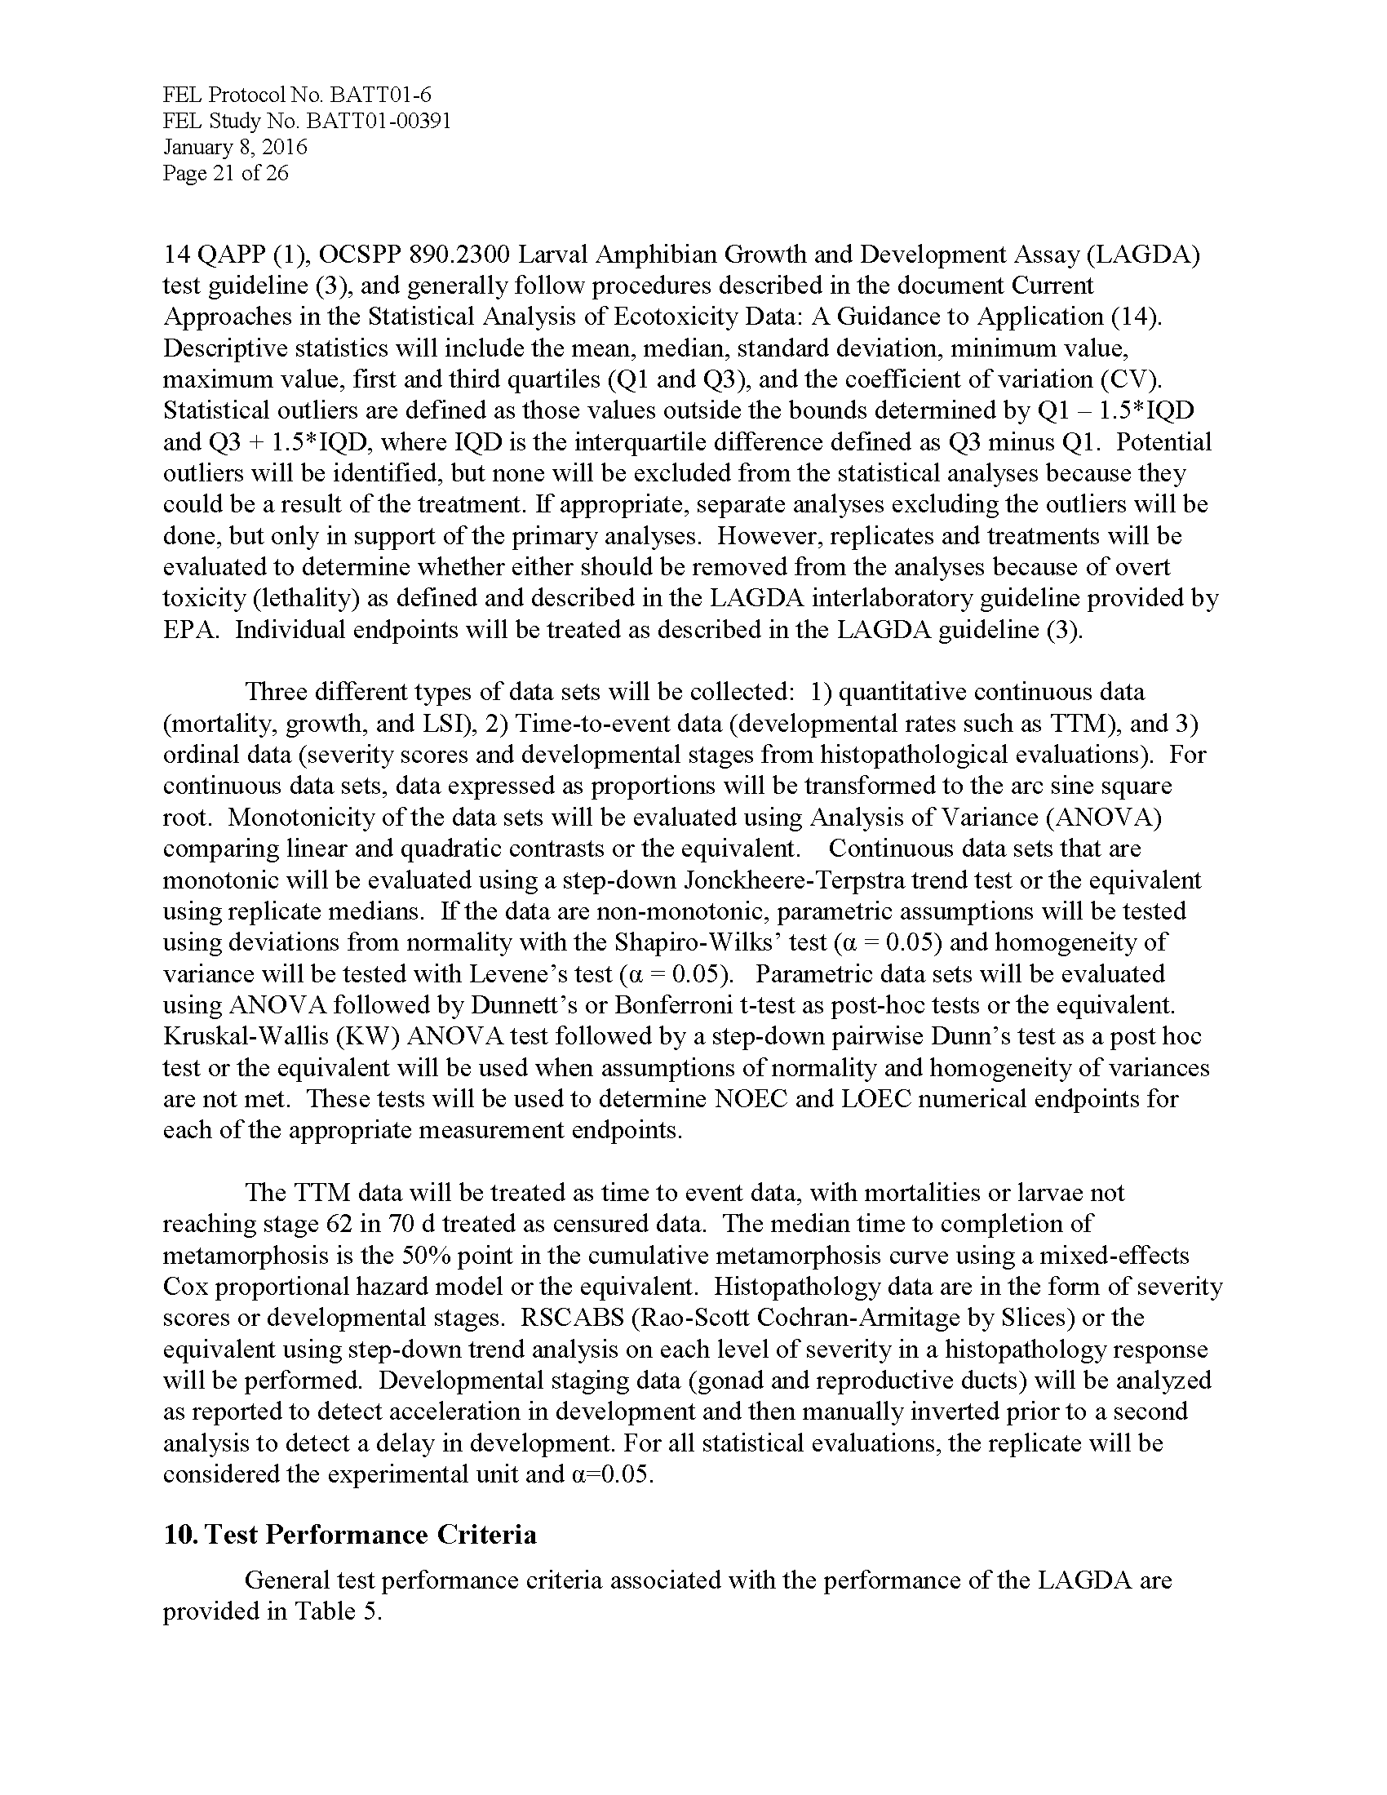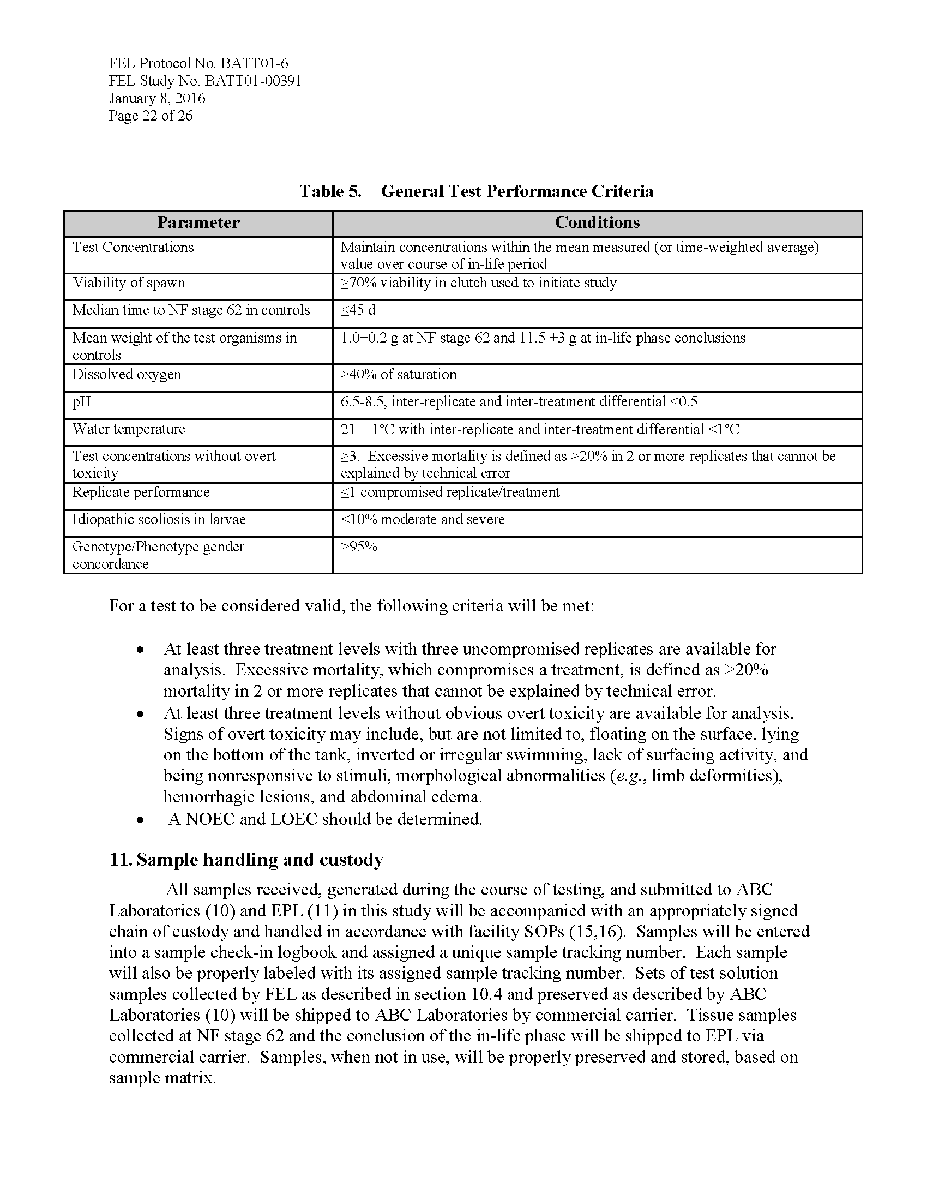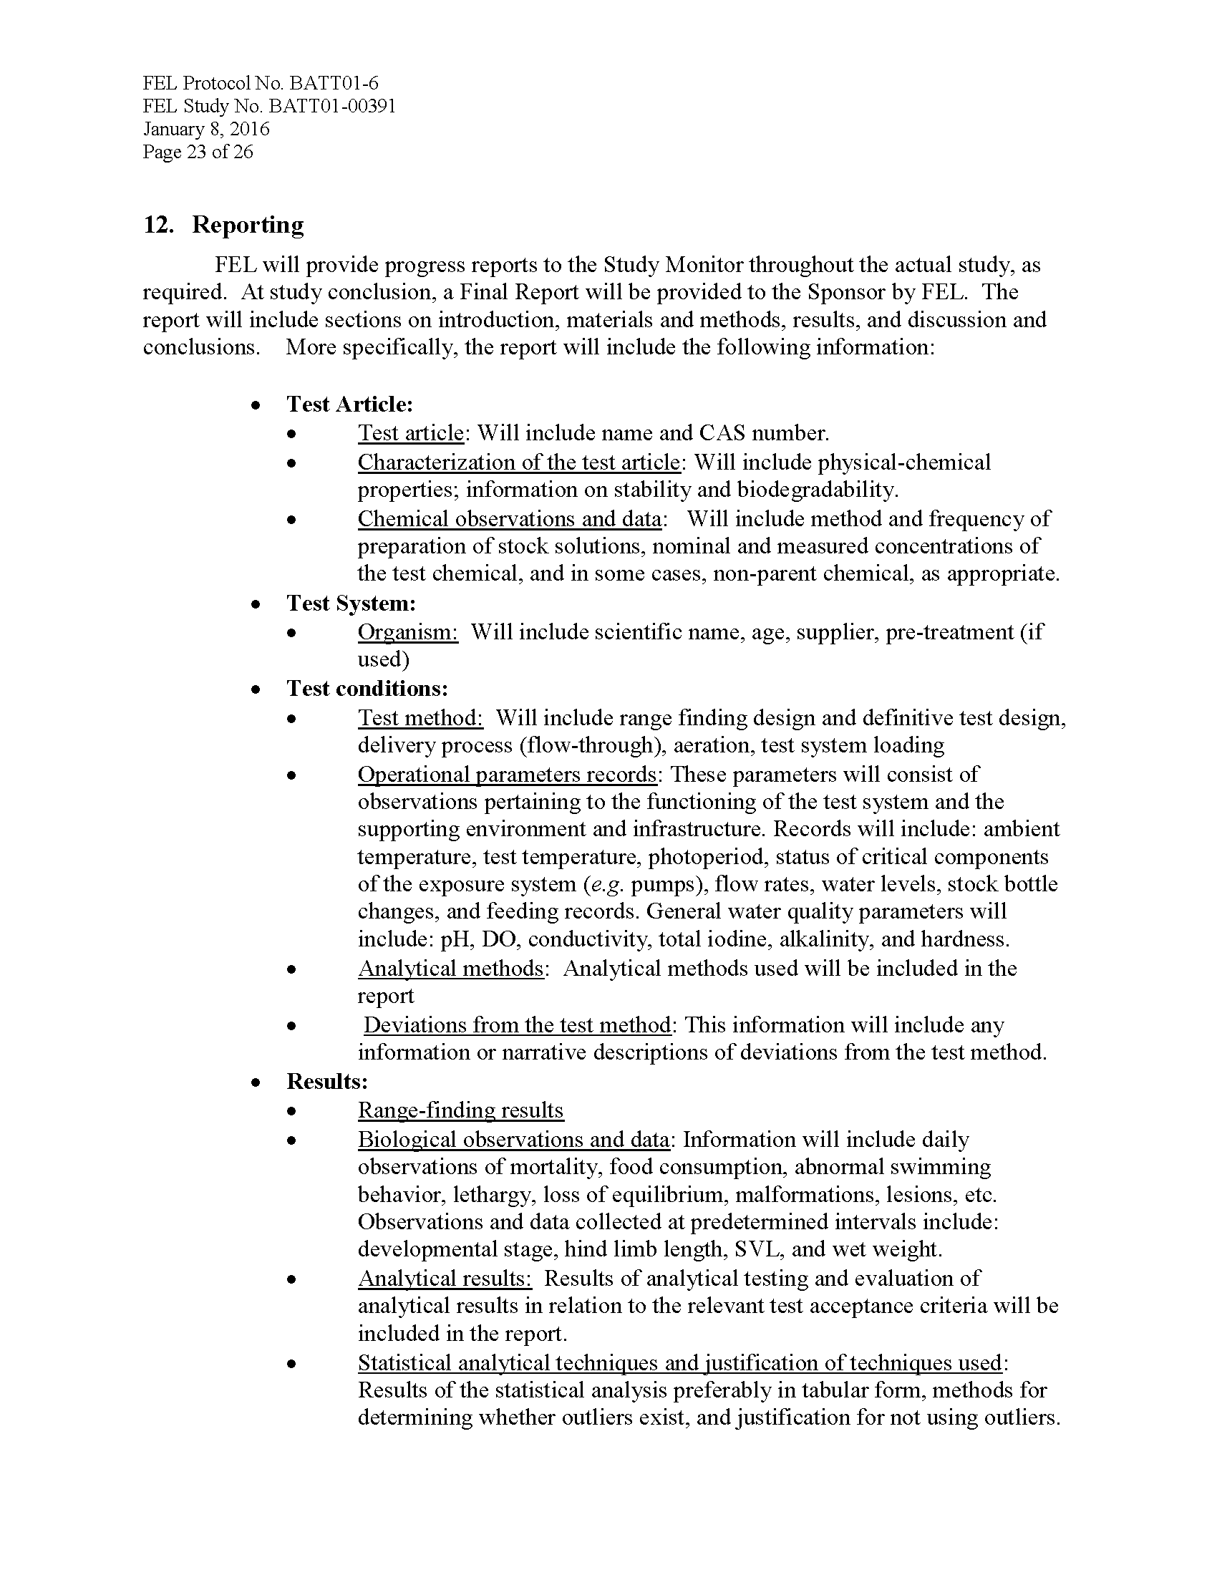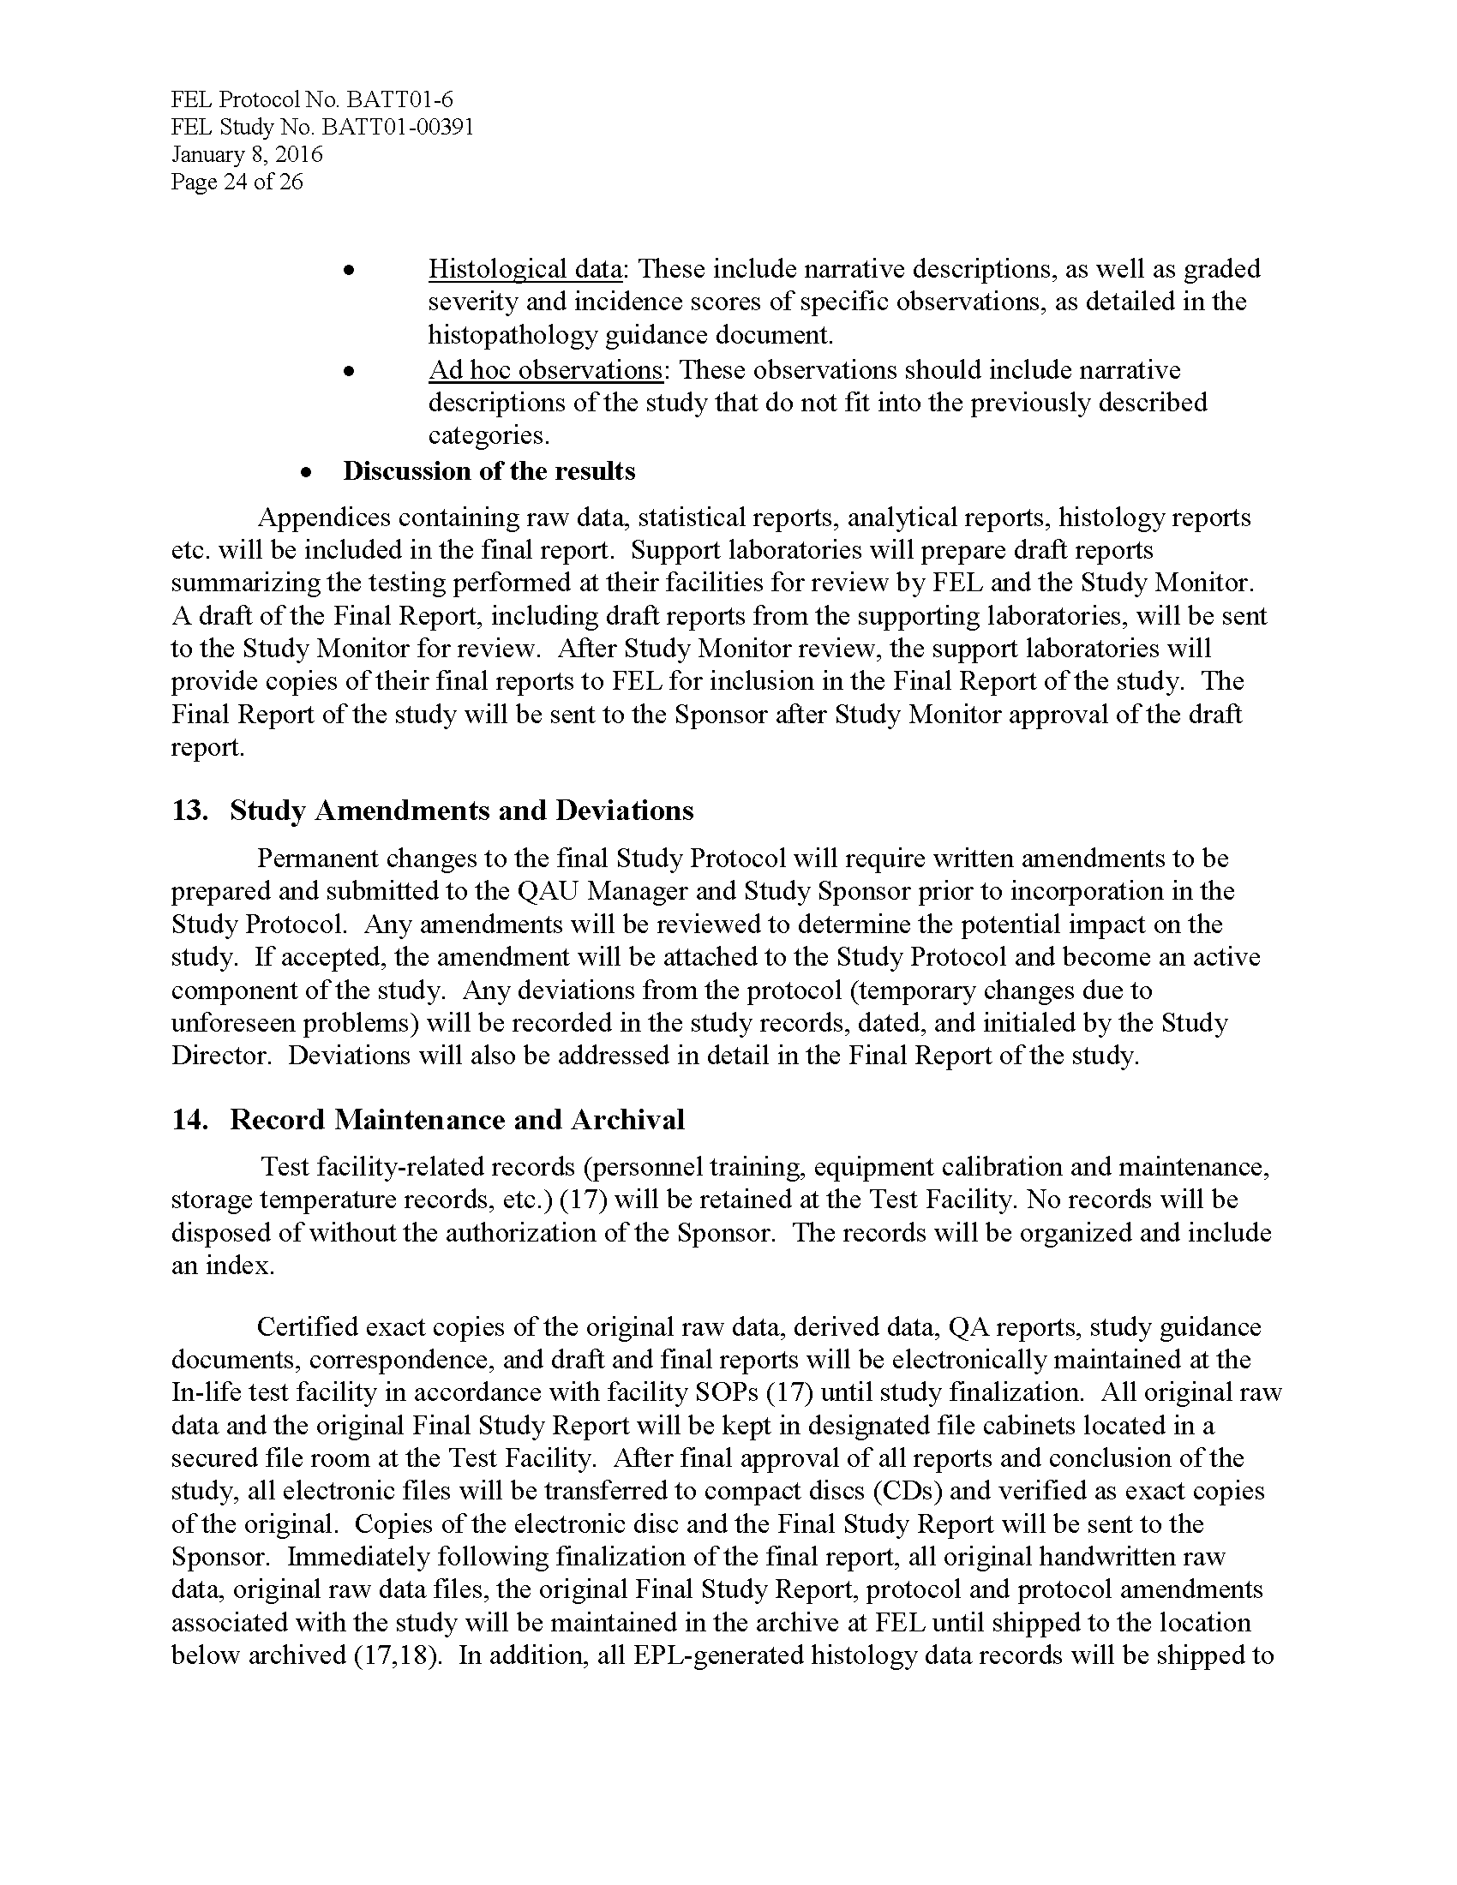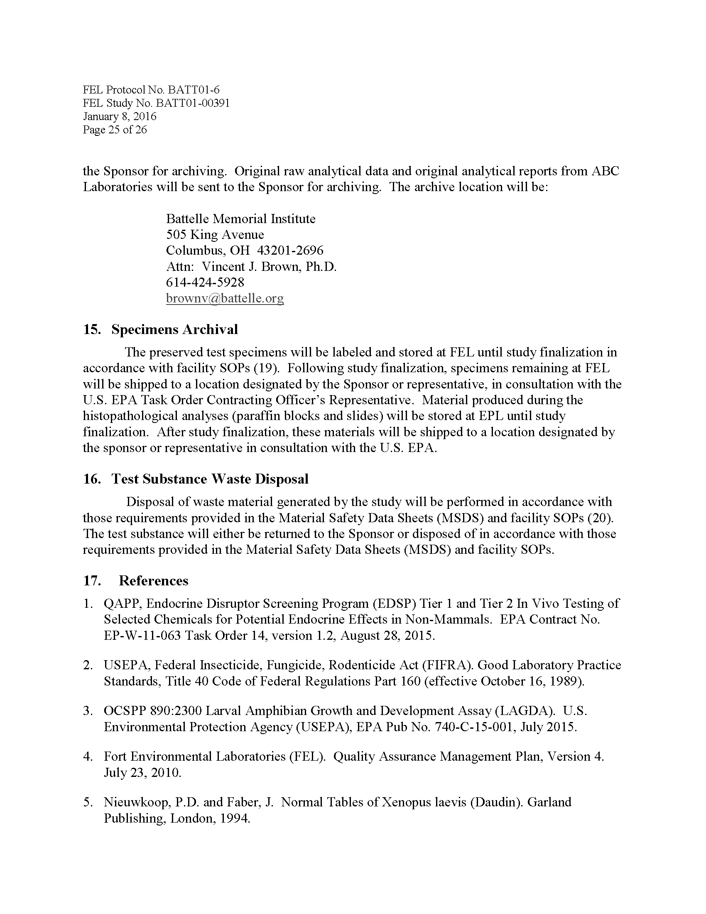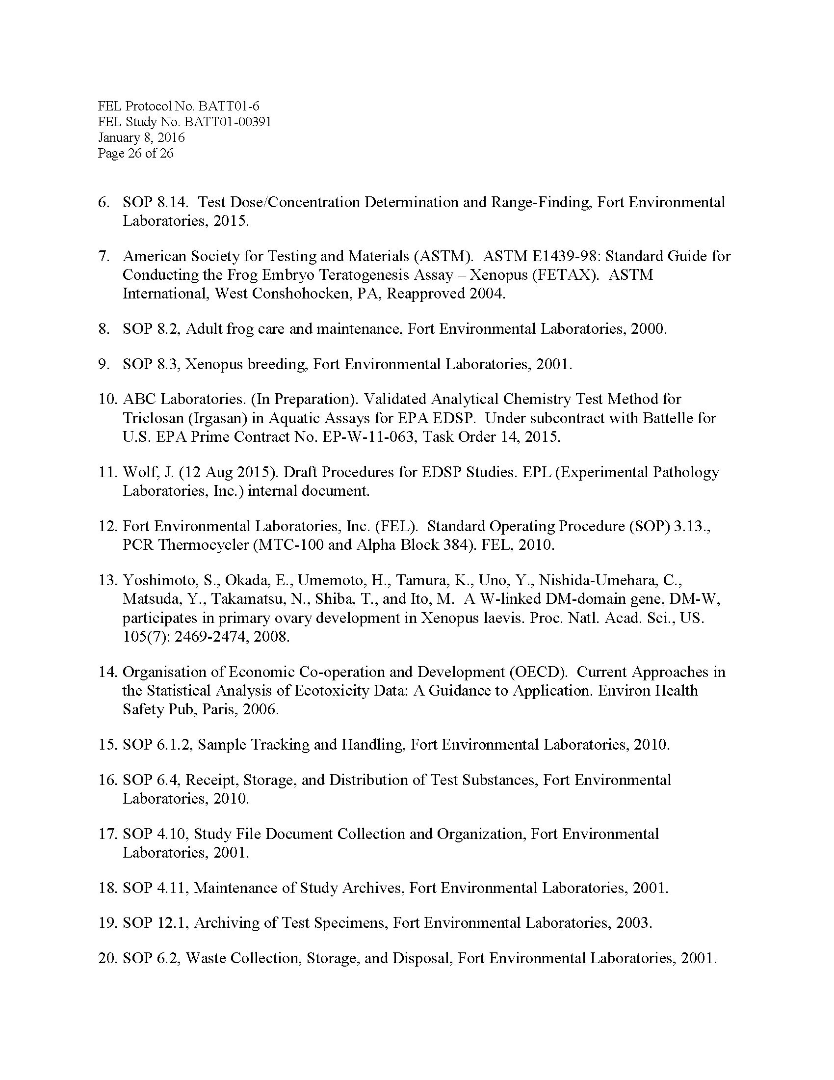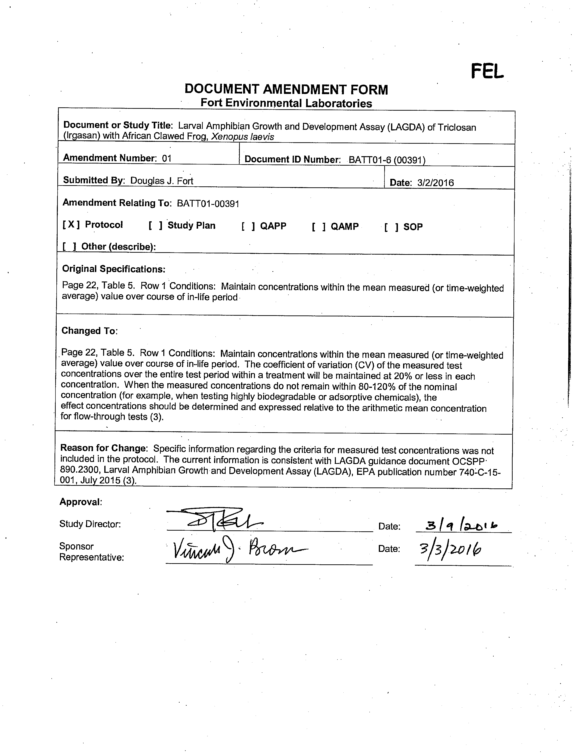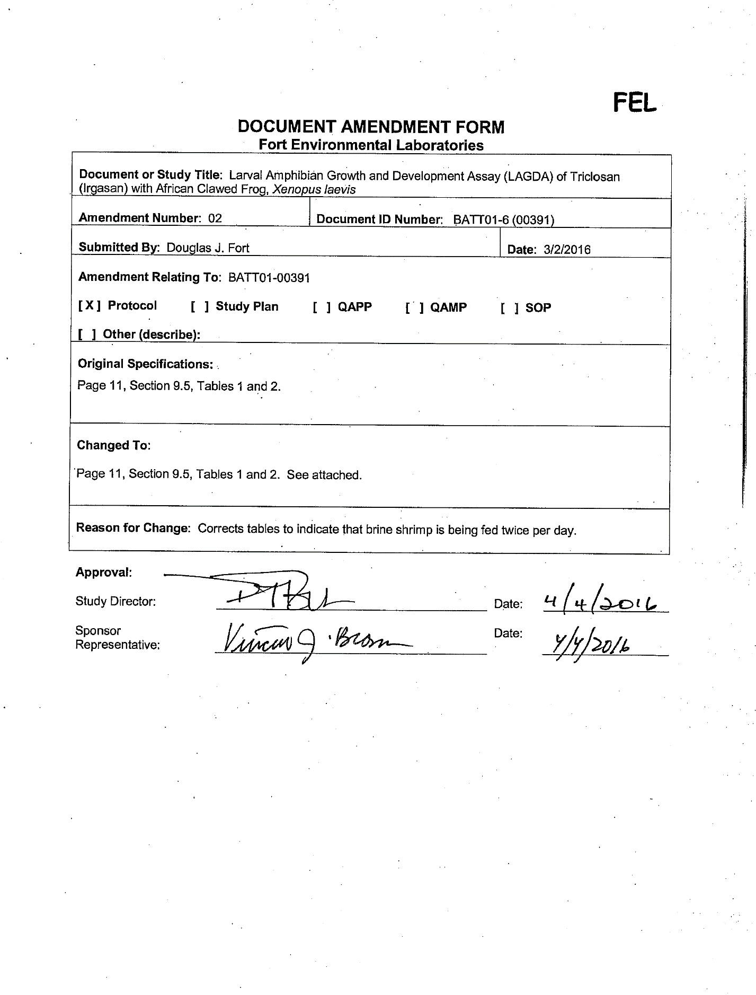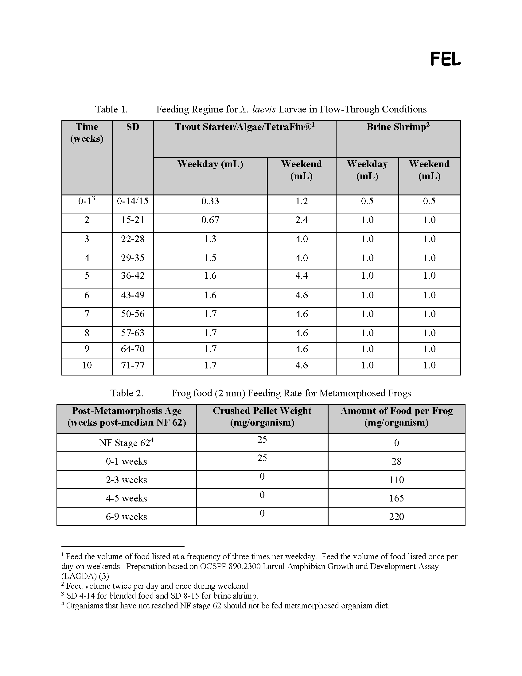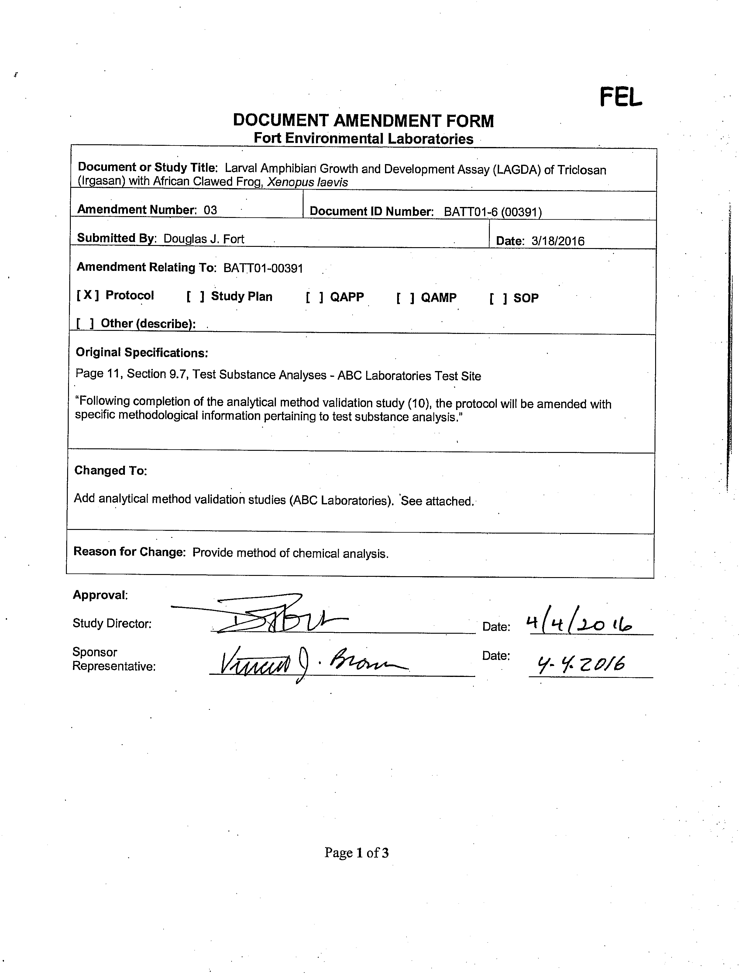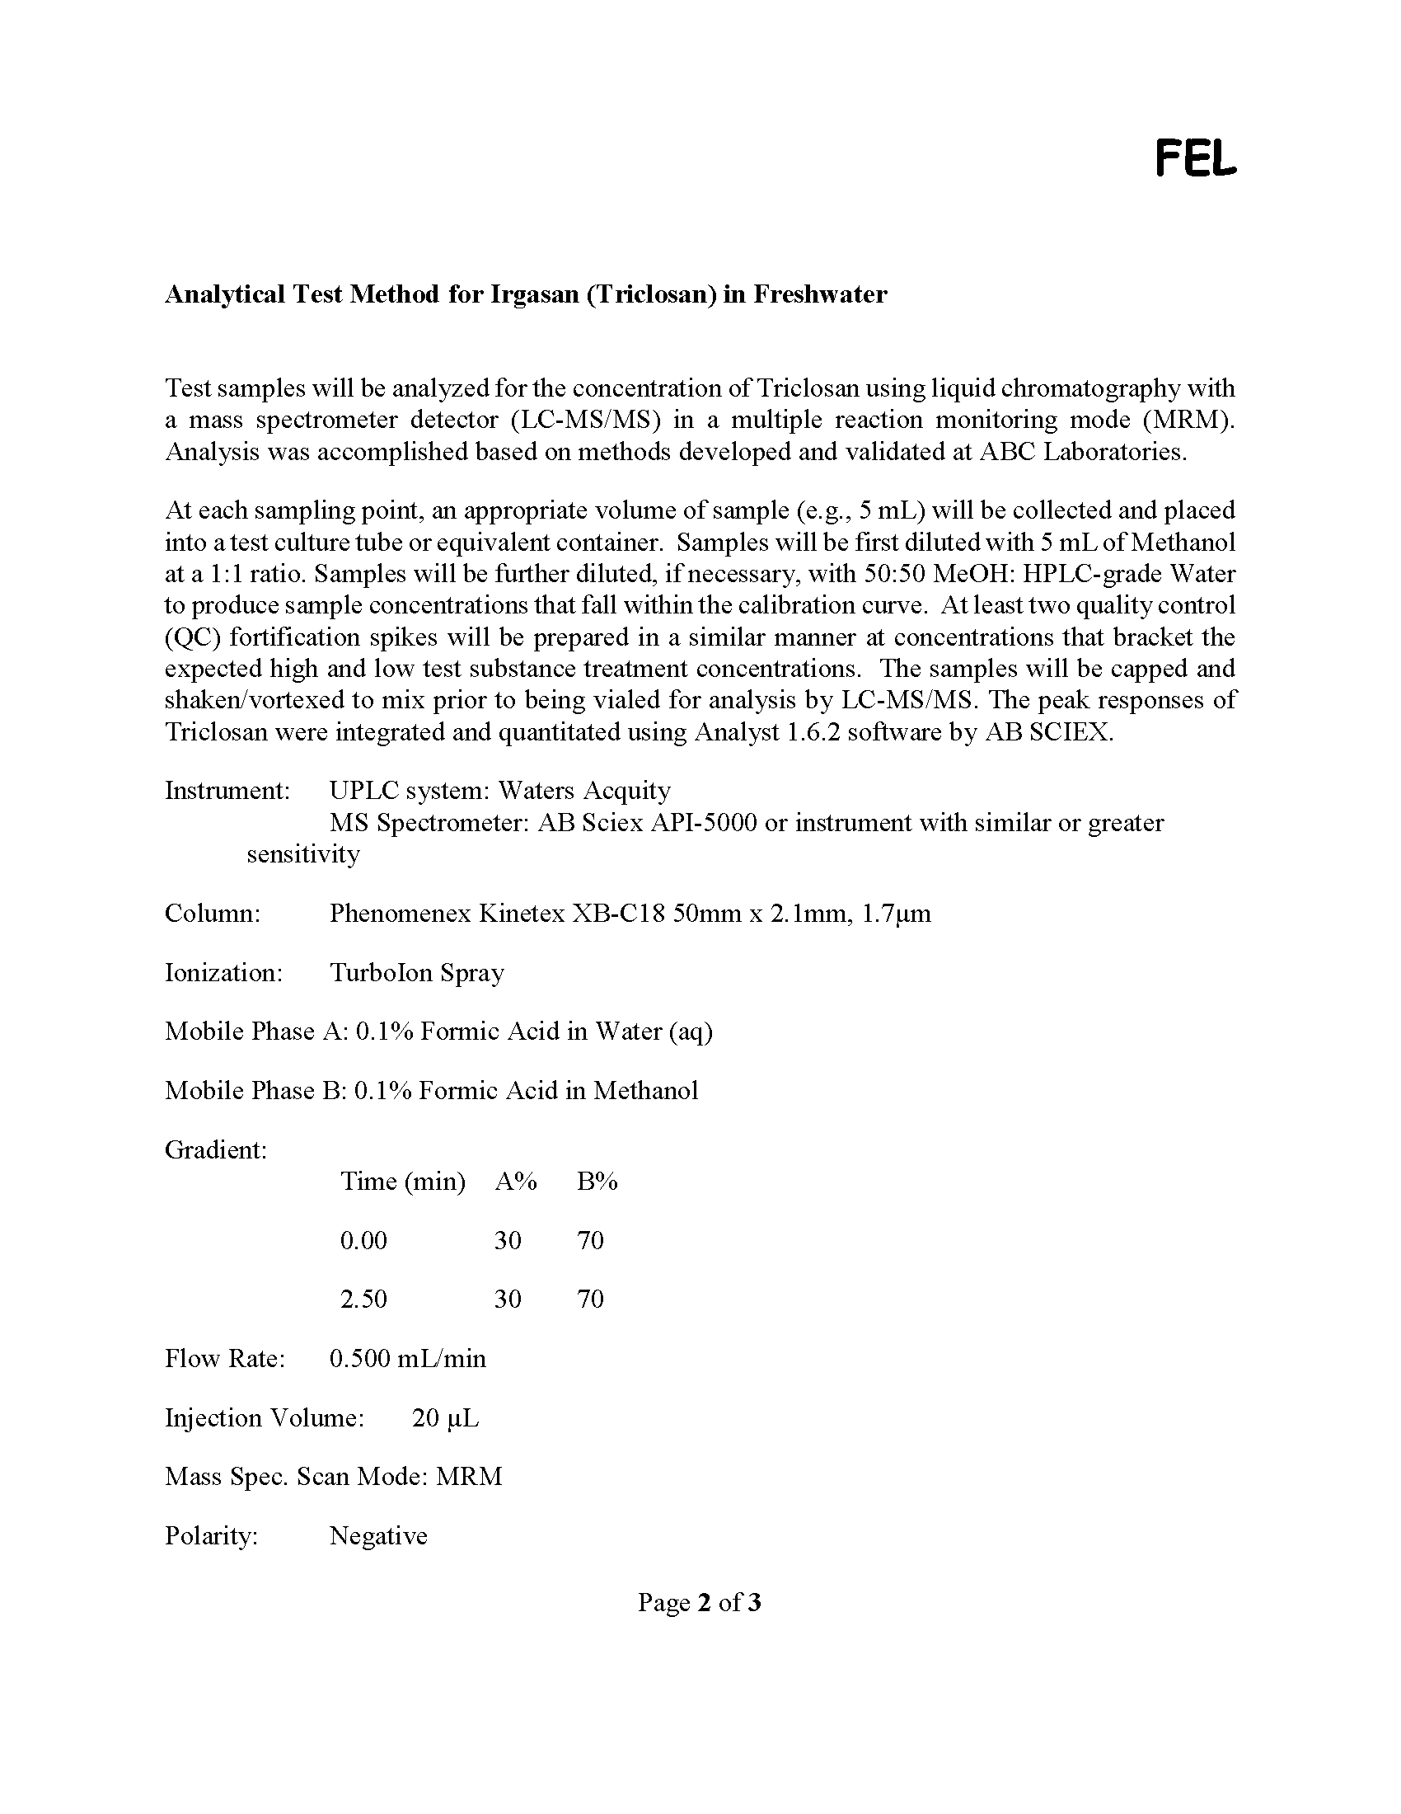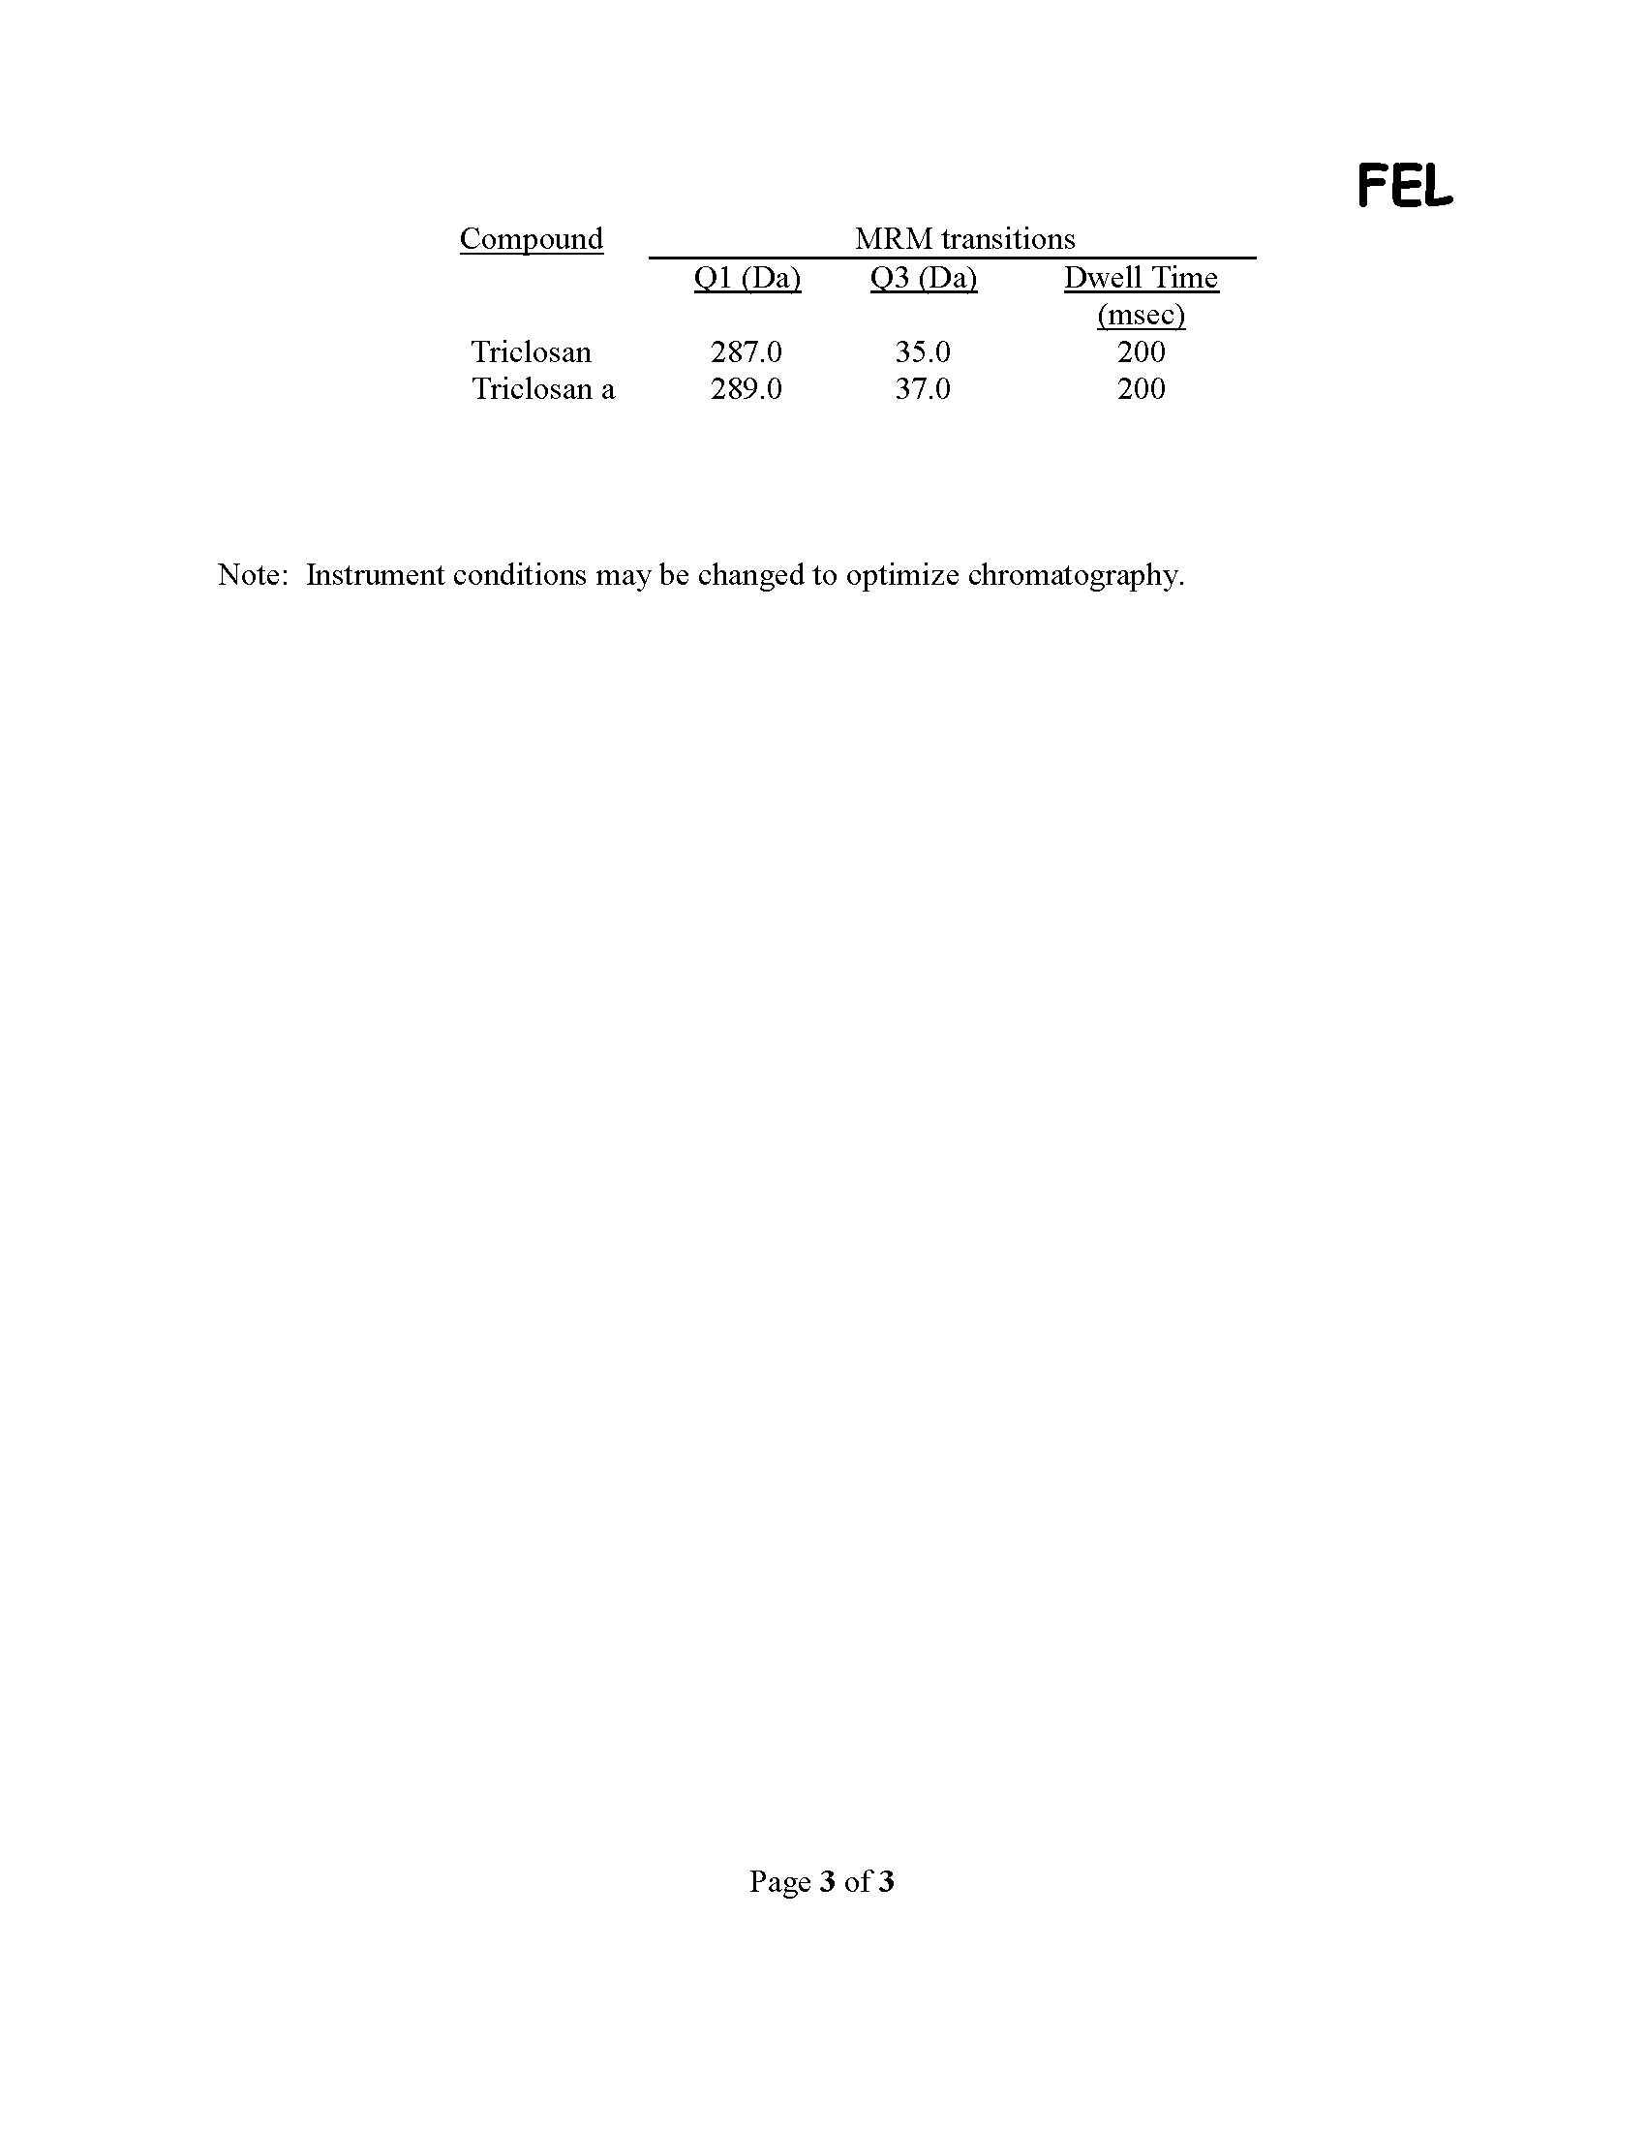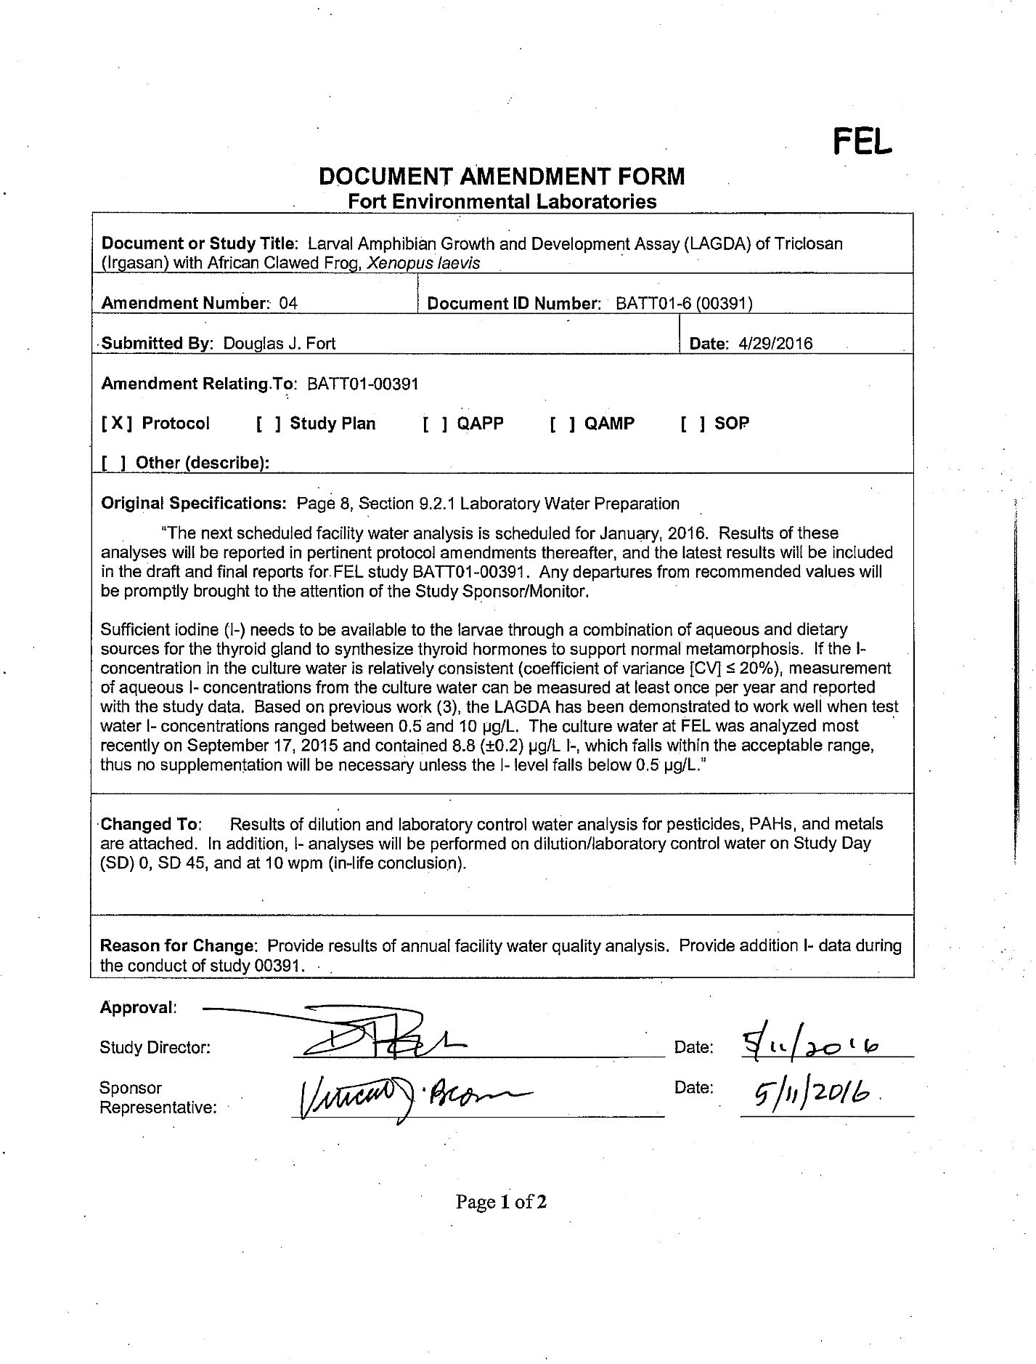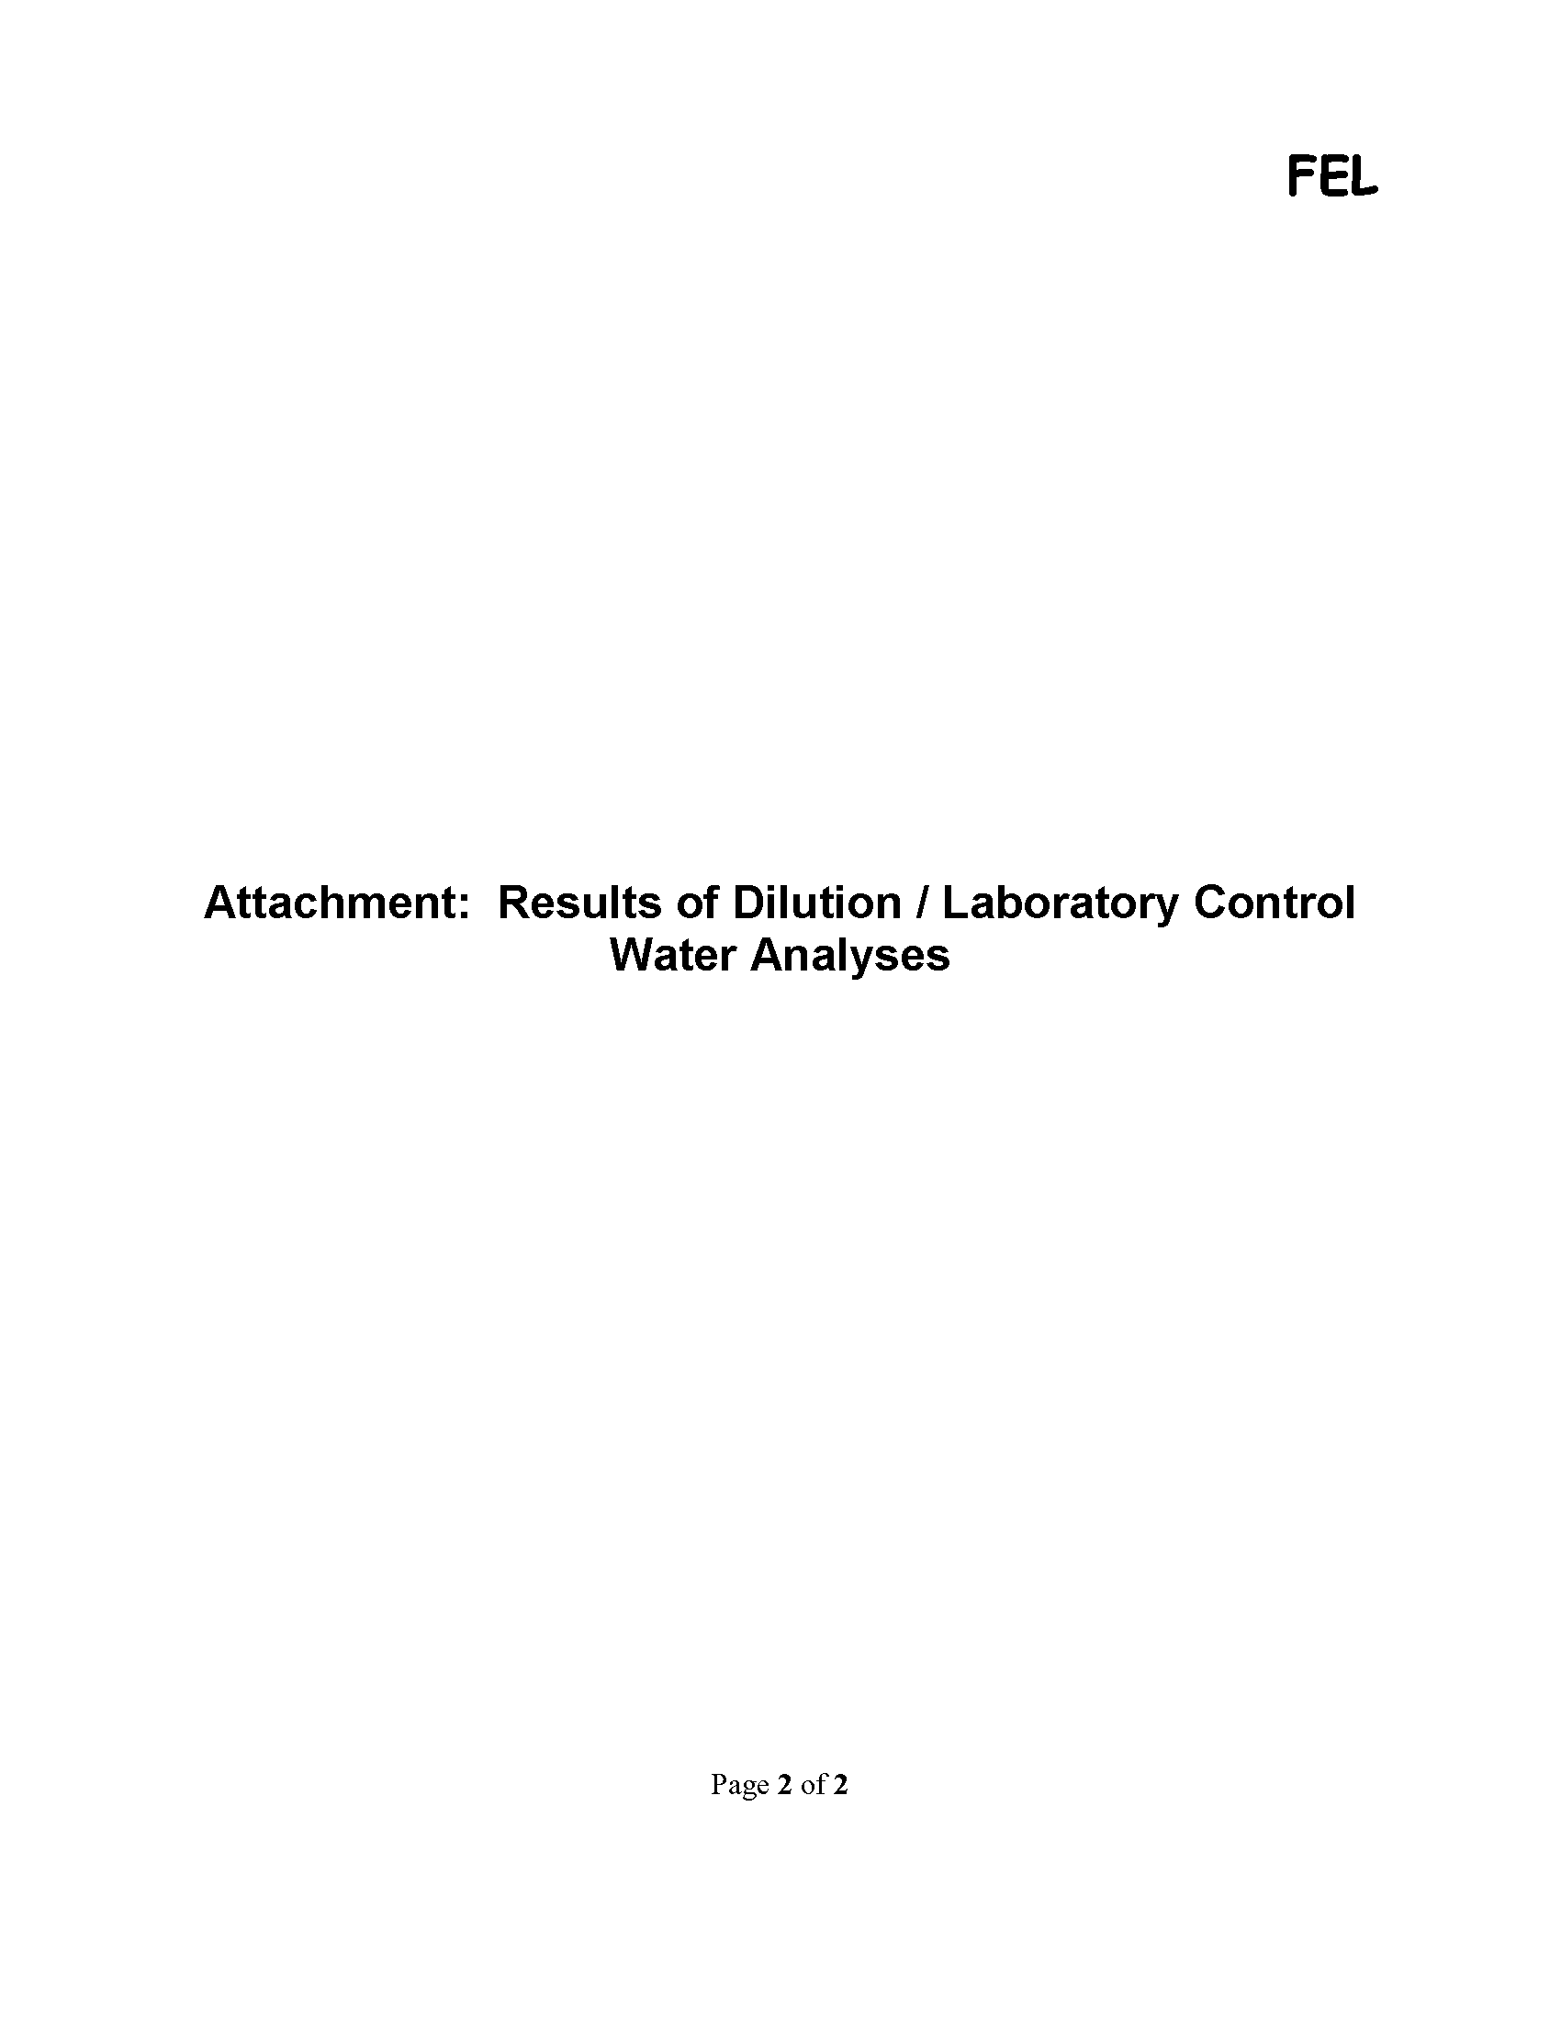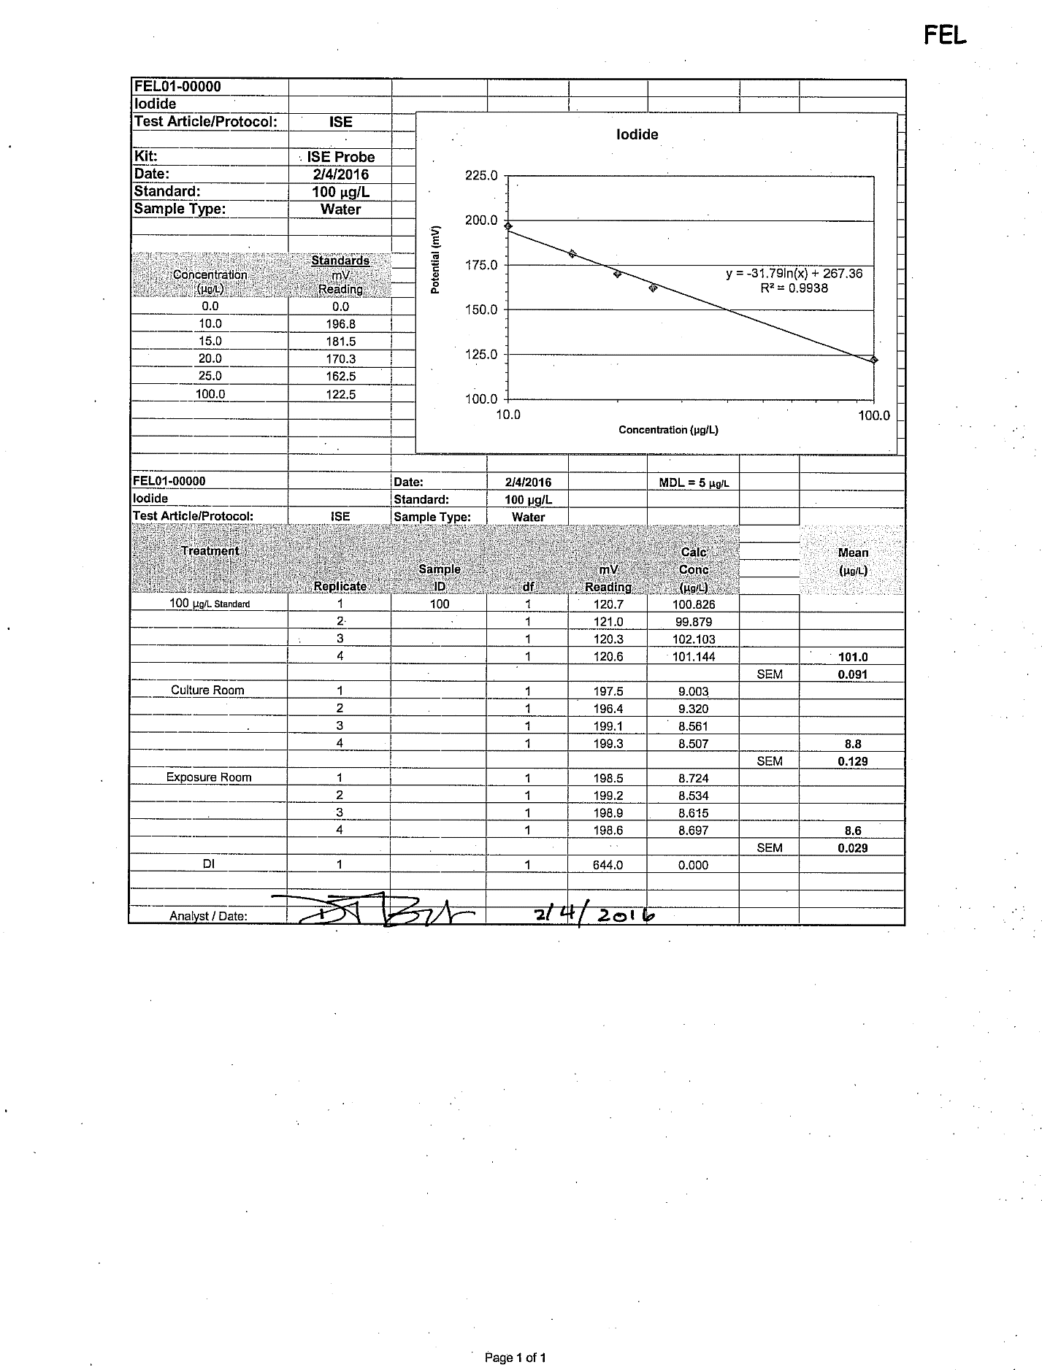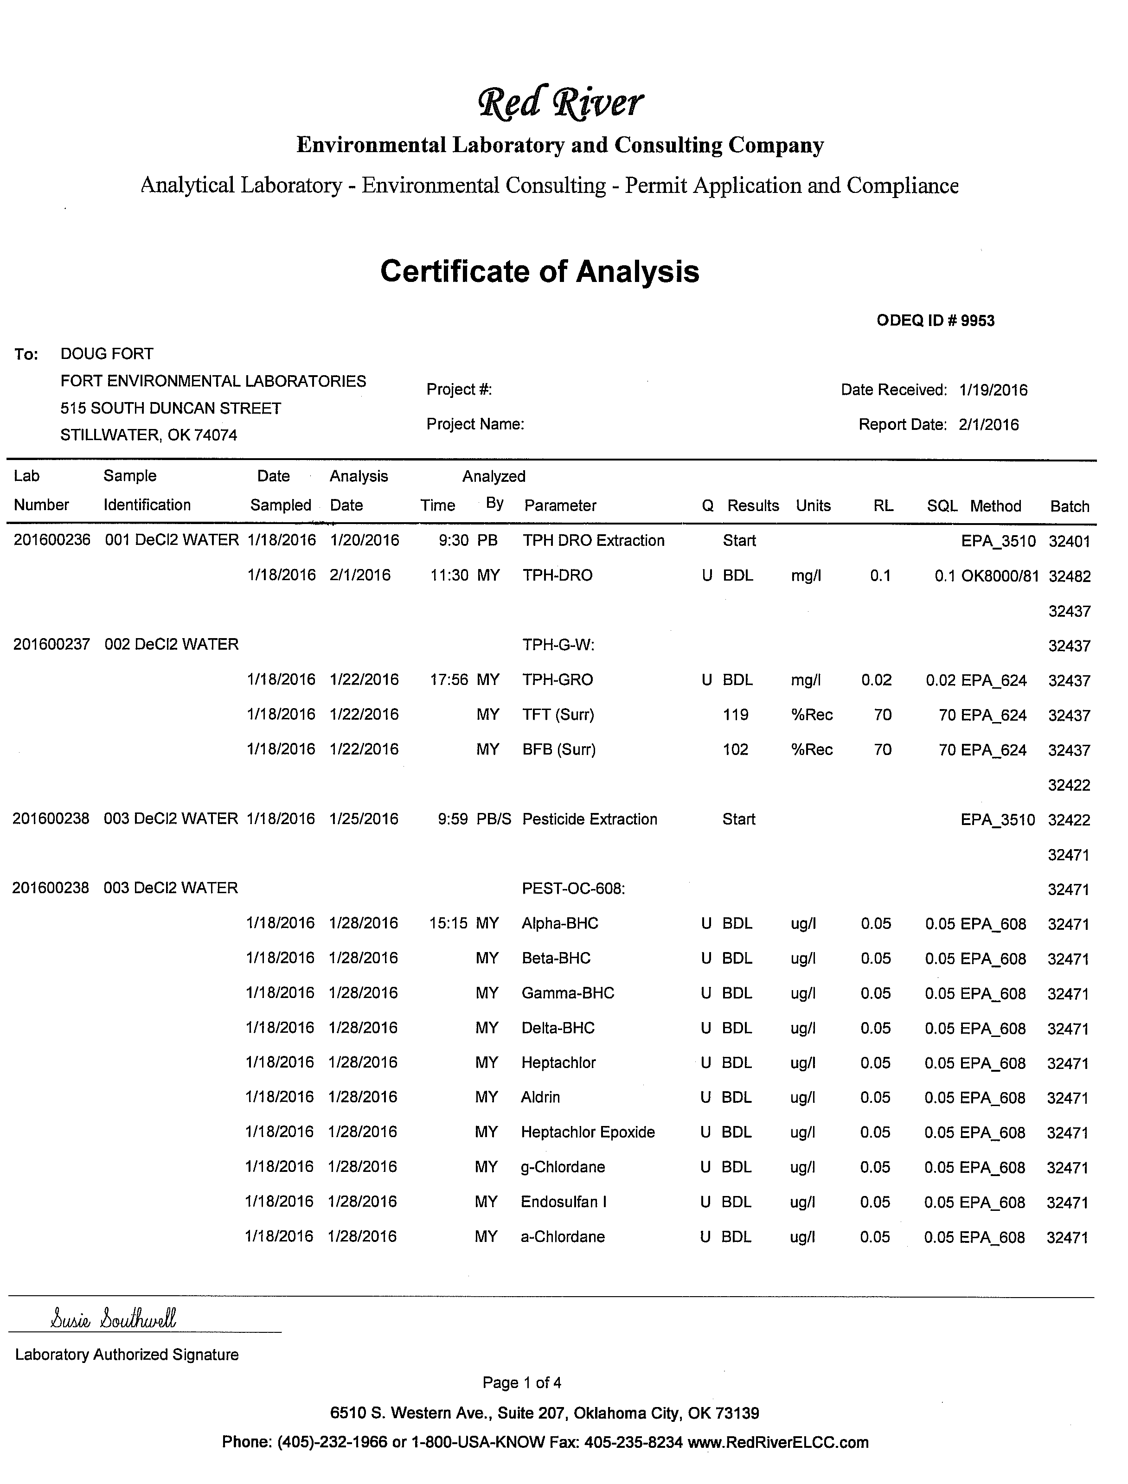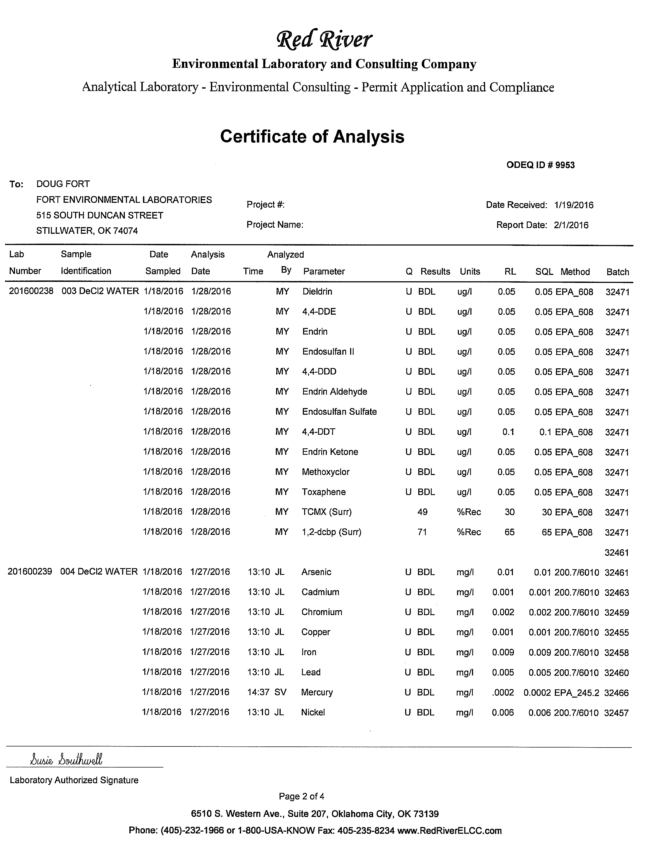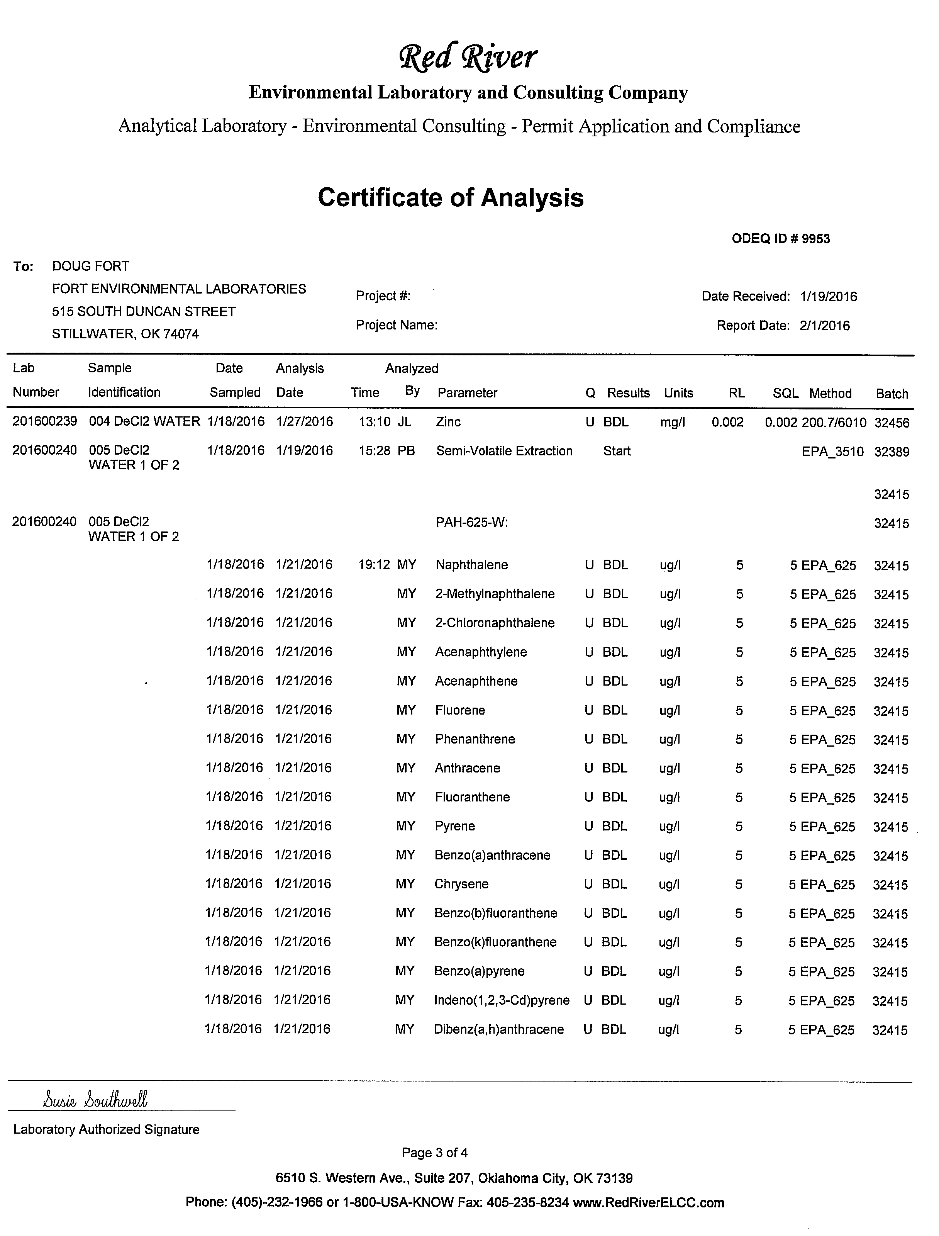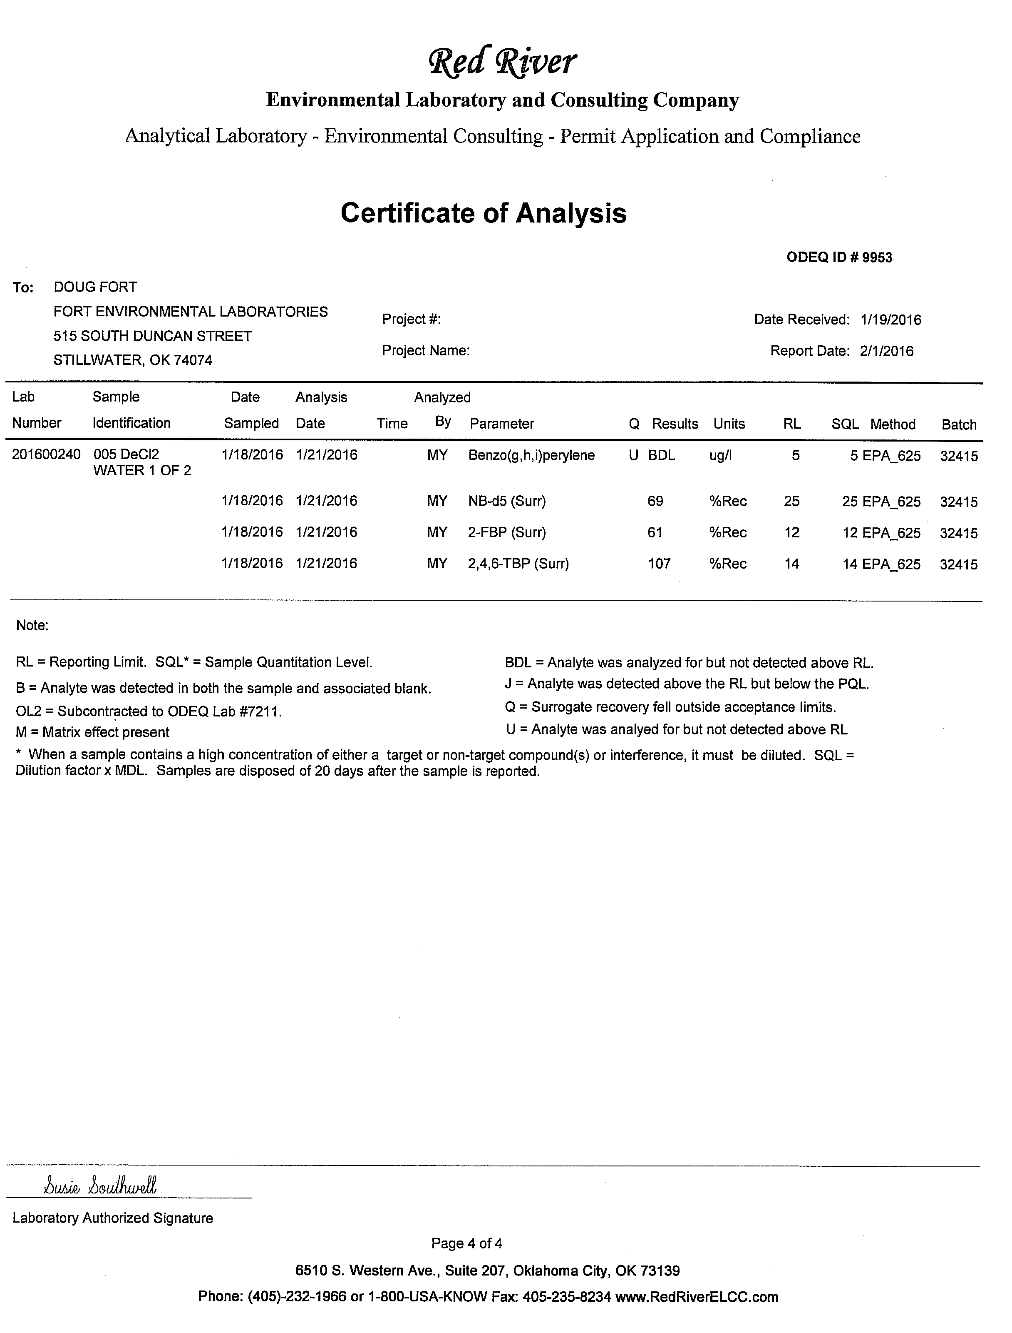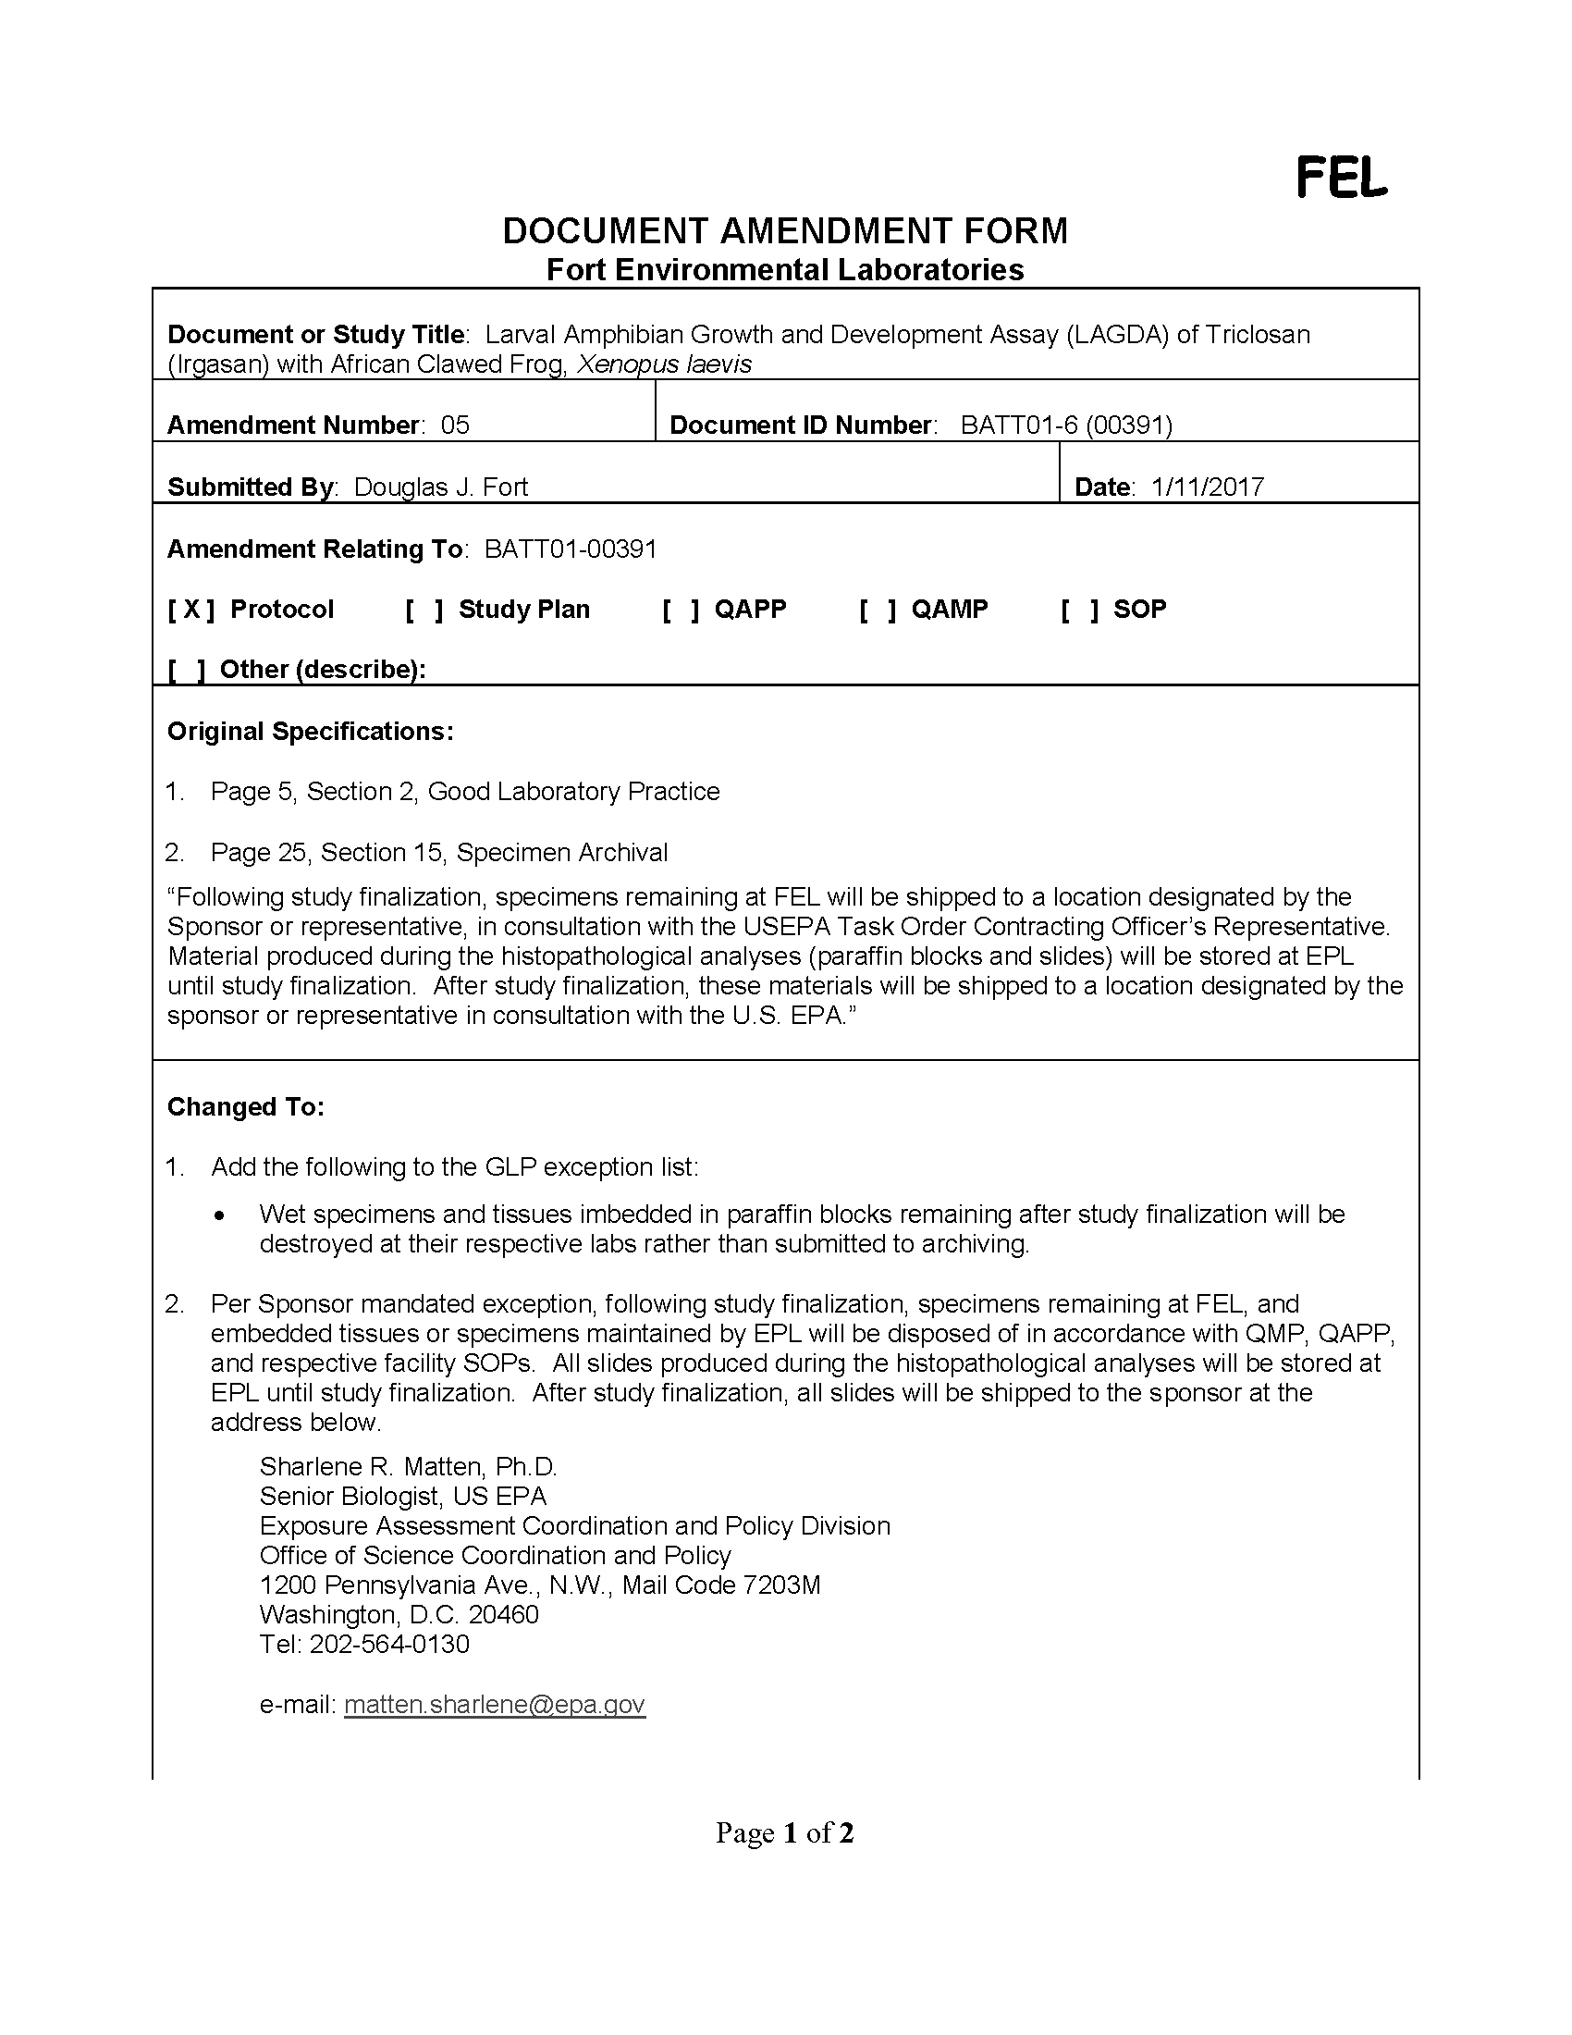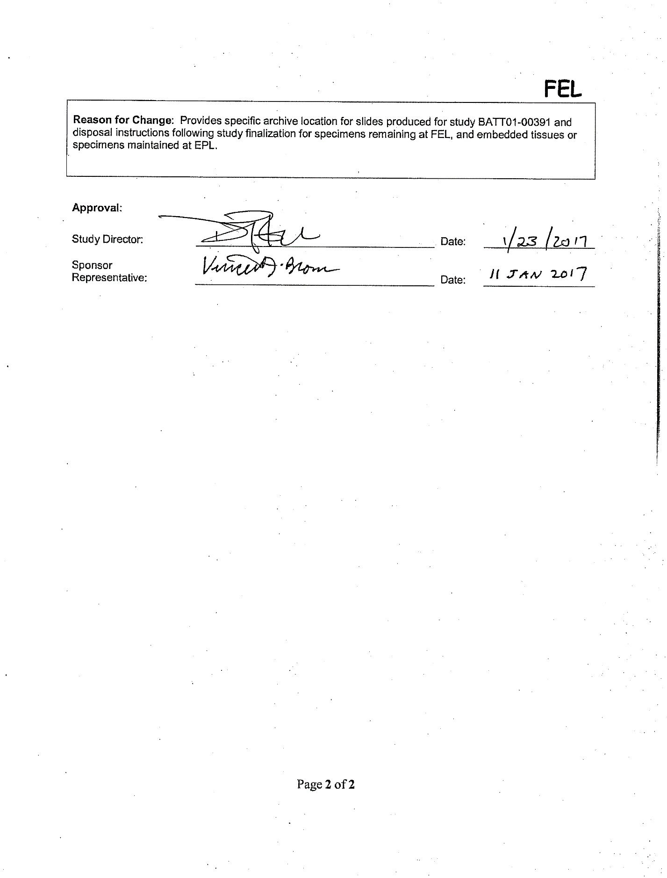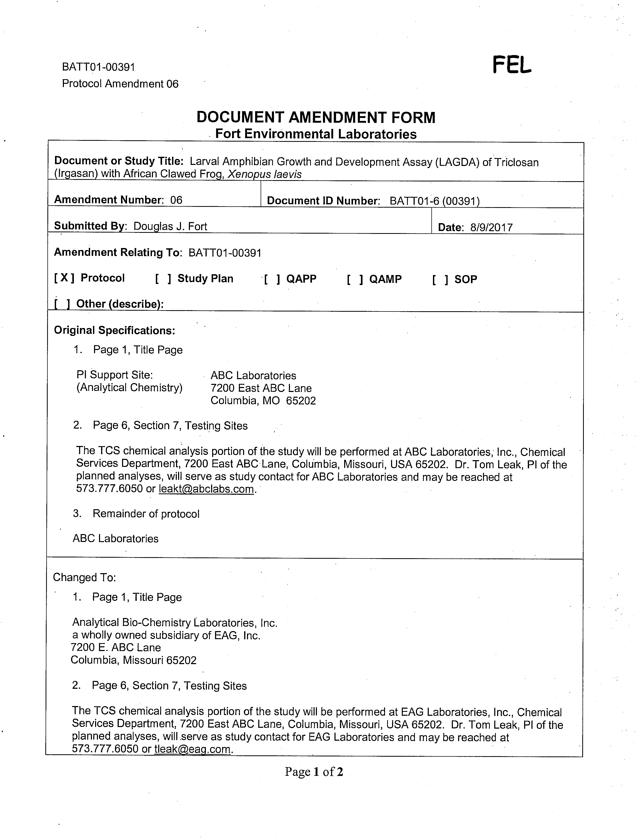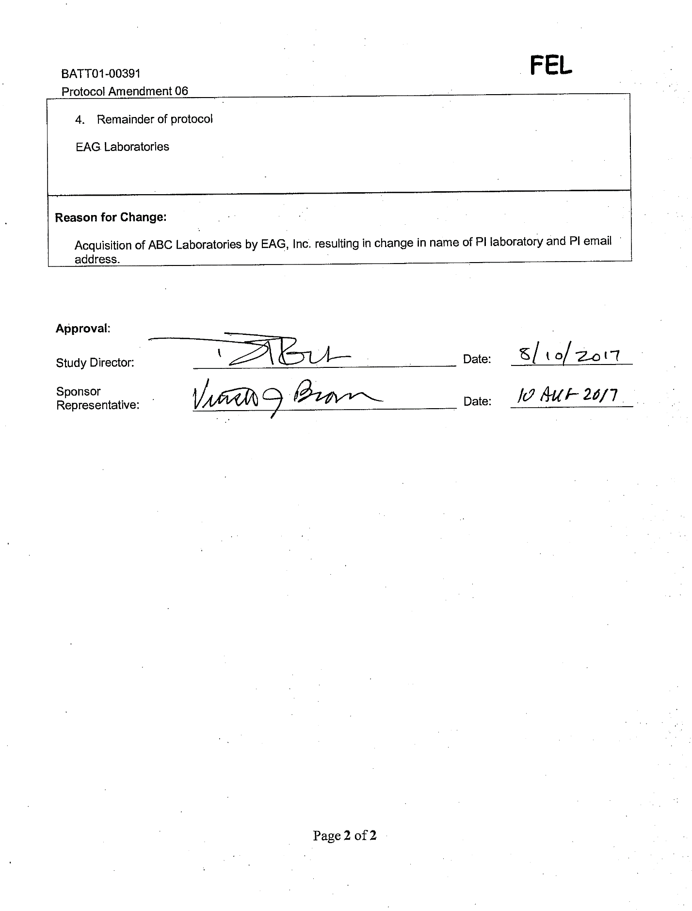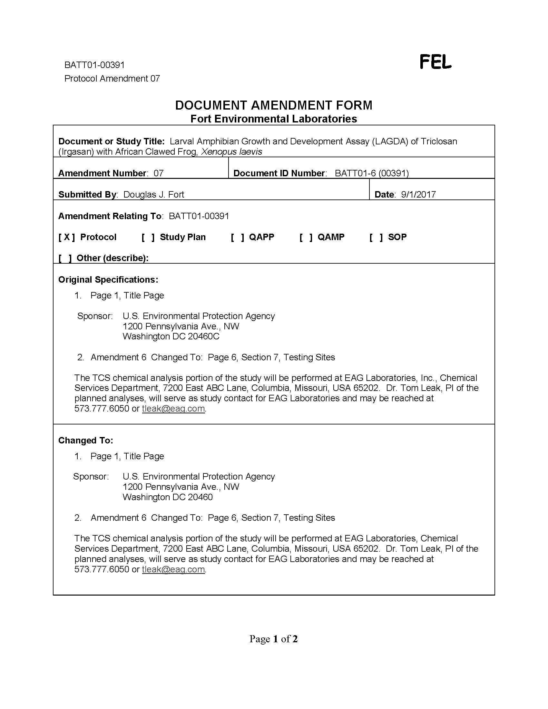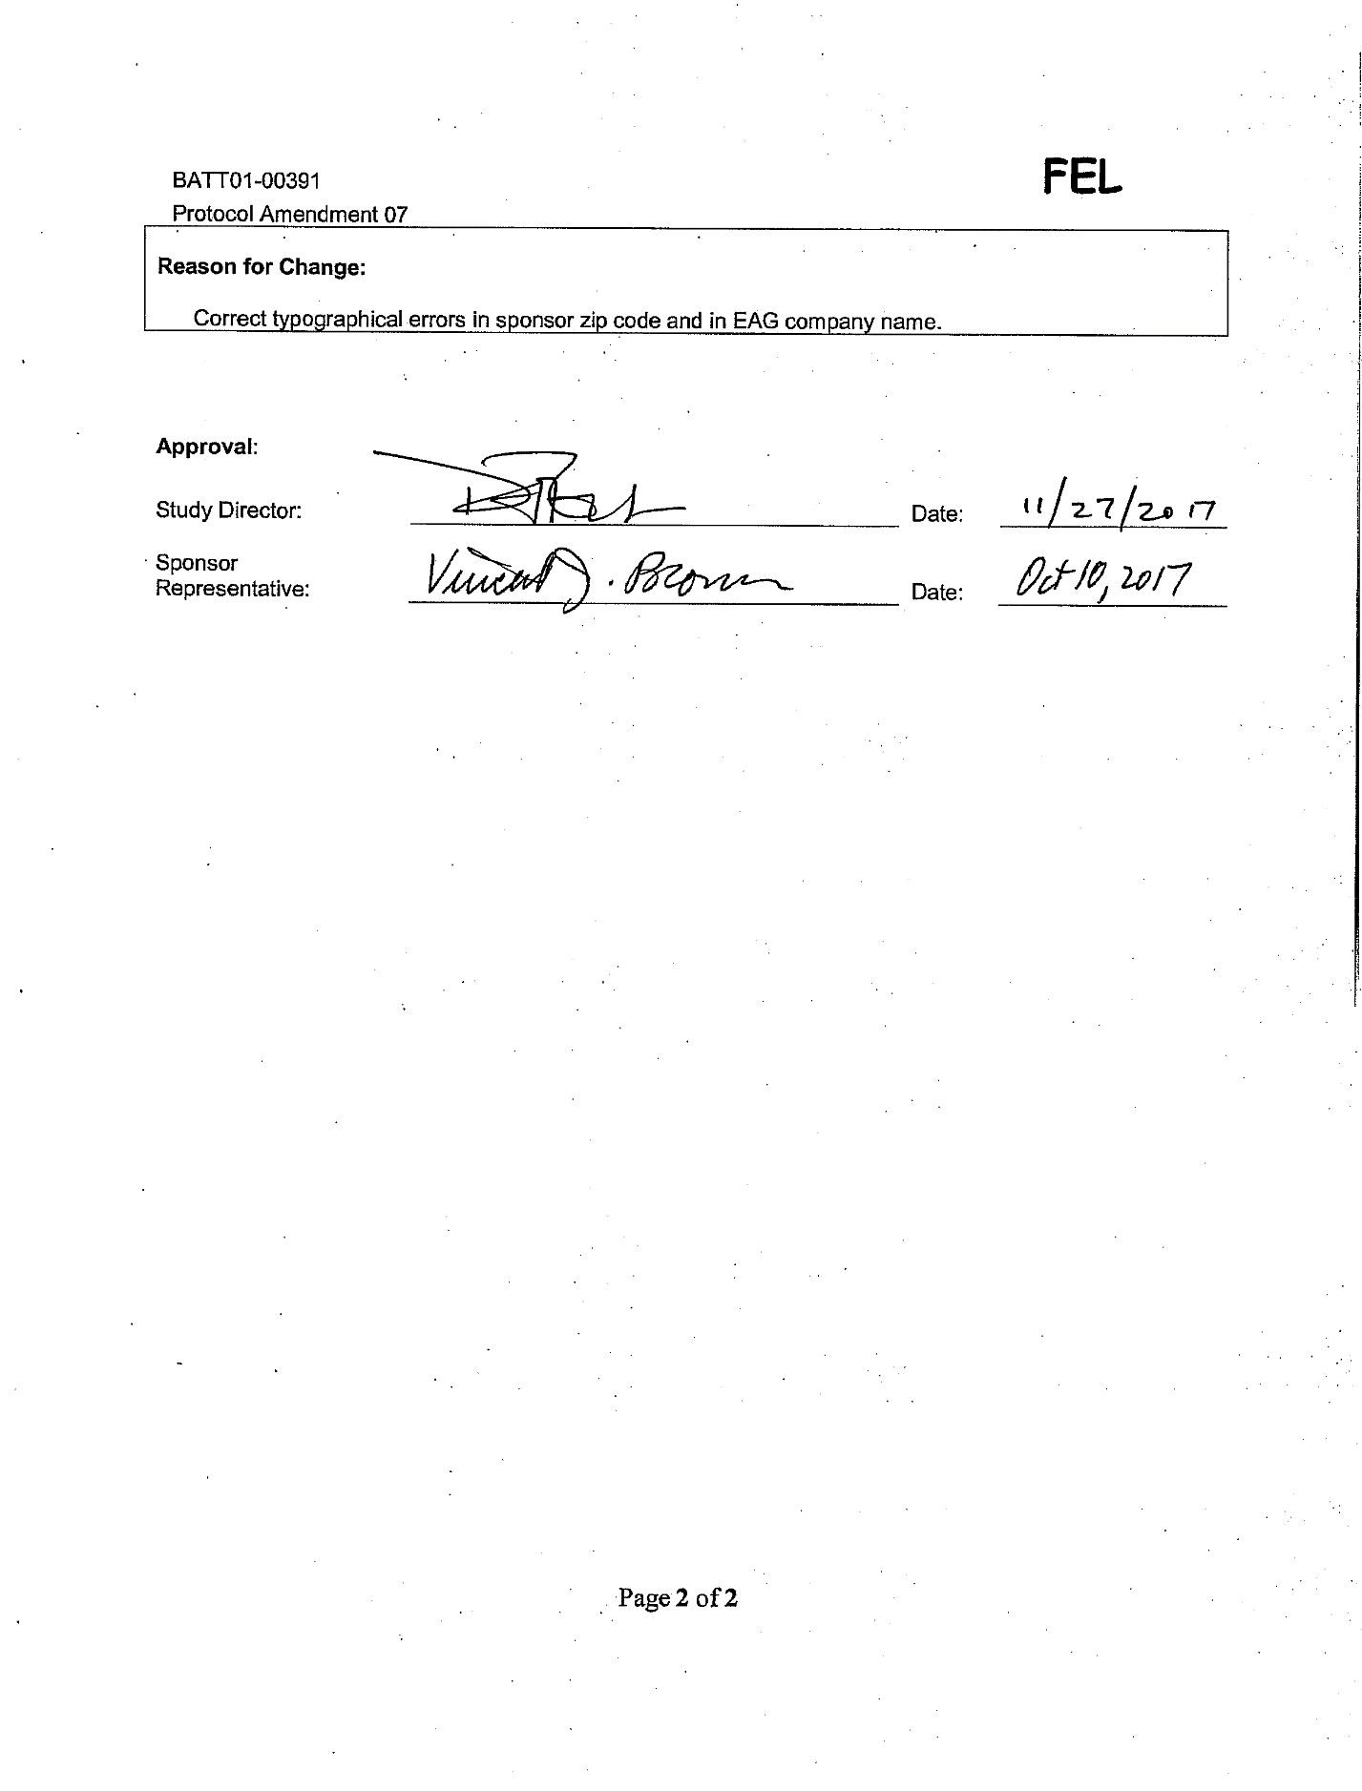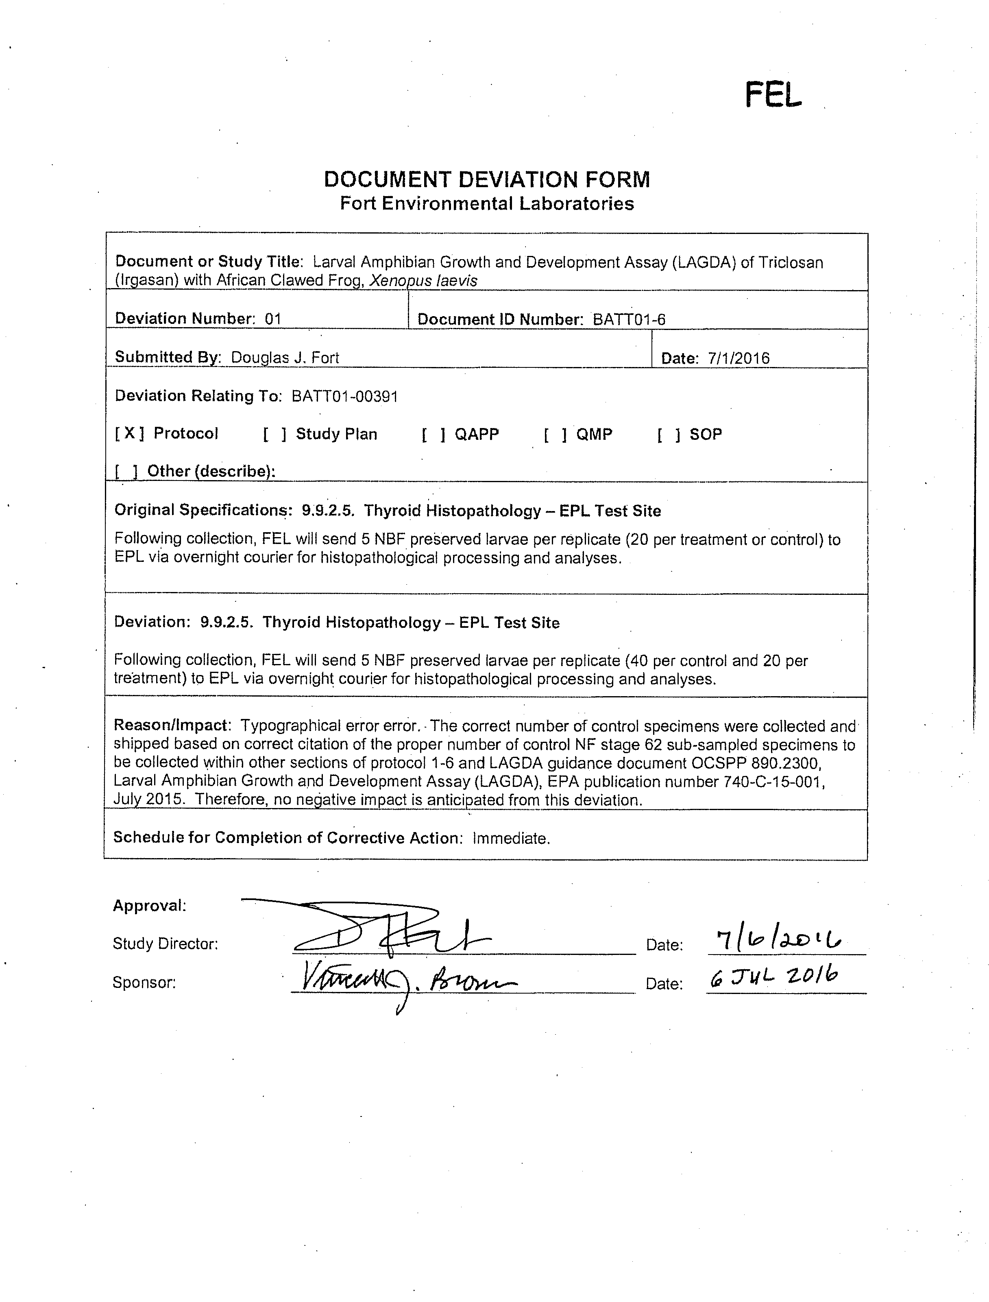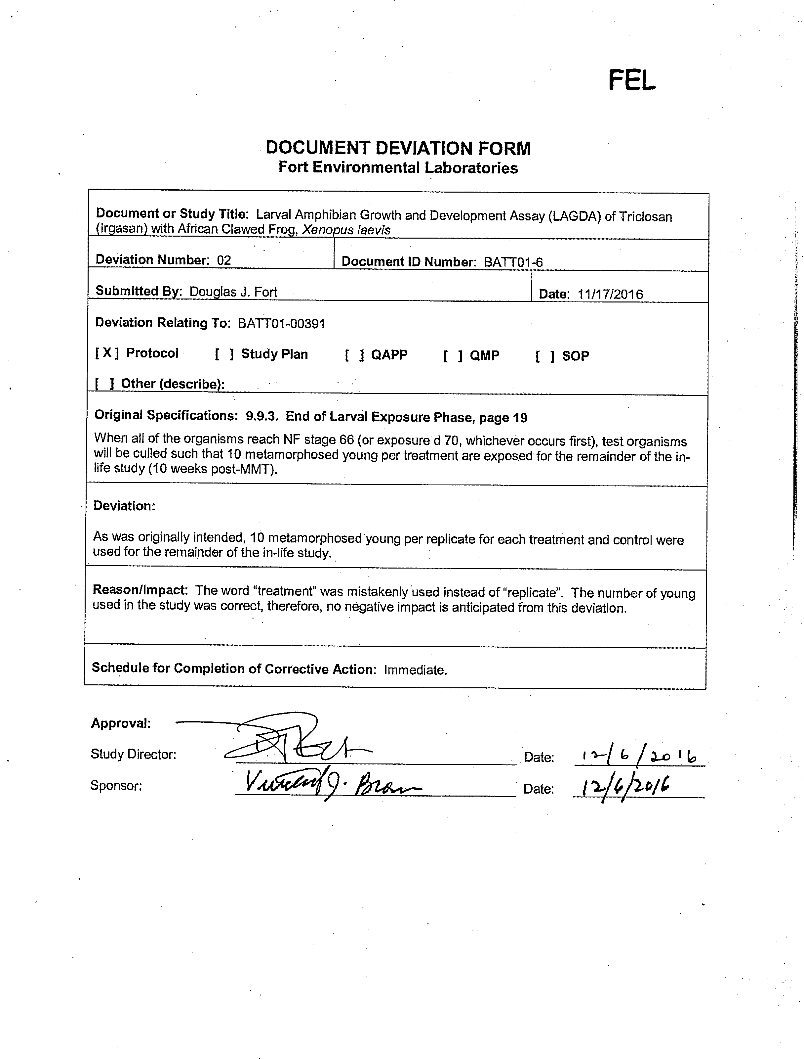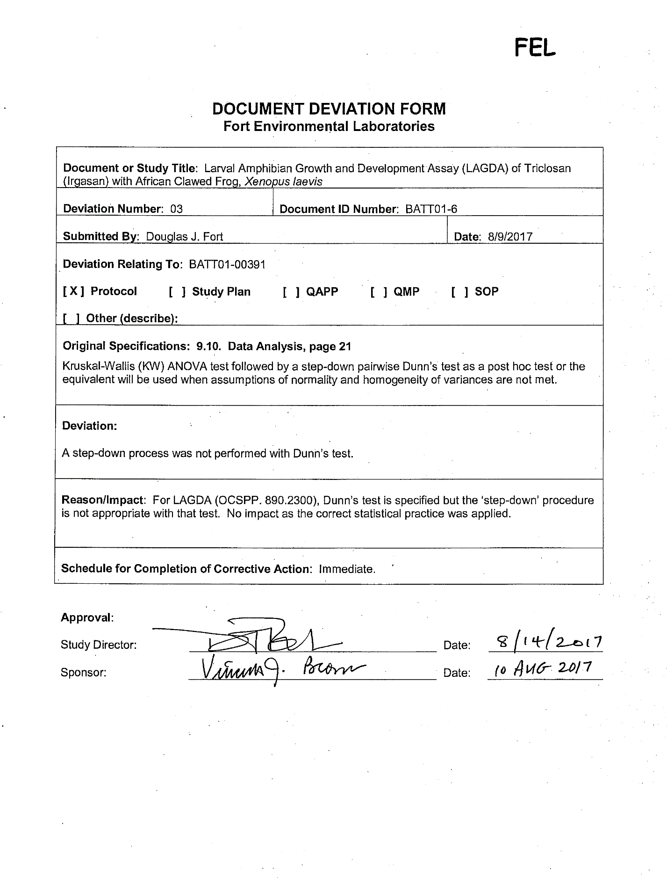

Certificate of Analysis

Analytical Laboratory Data Reports

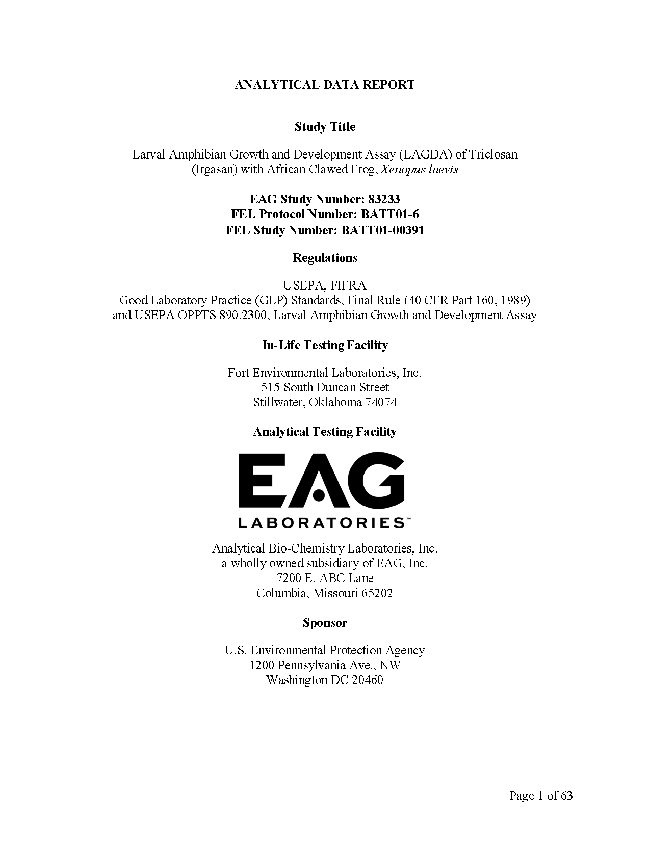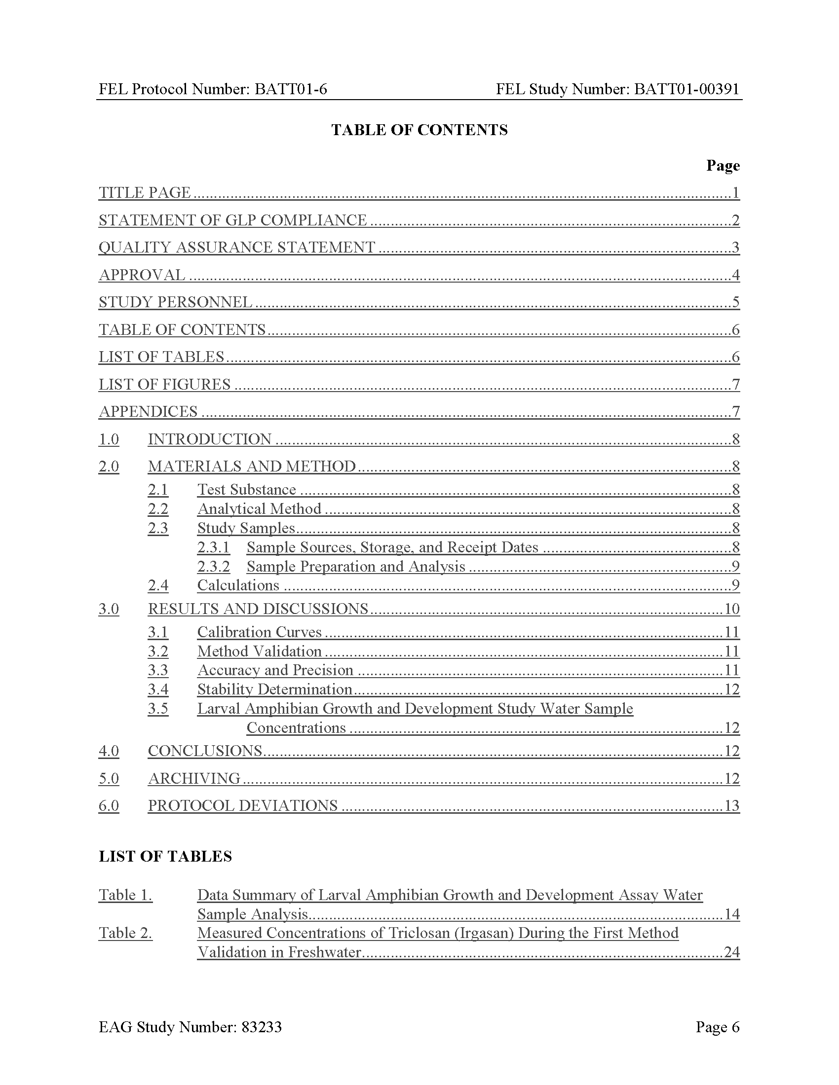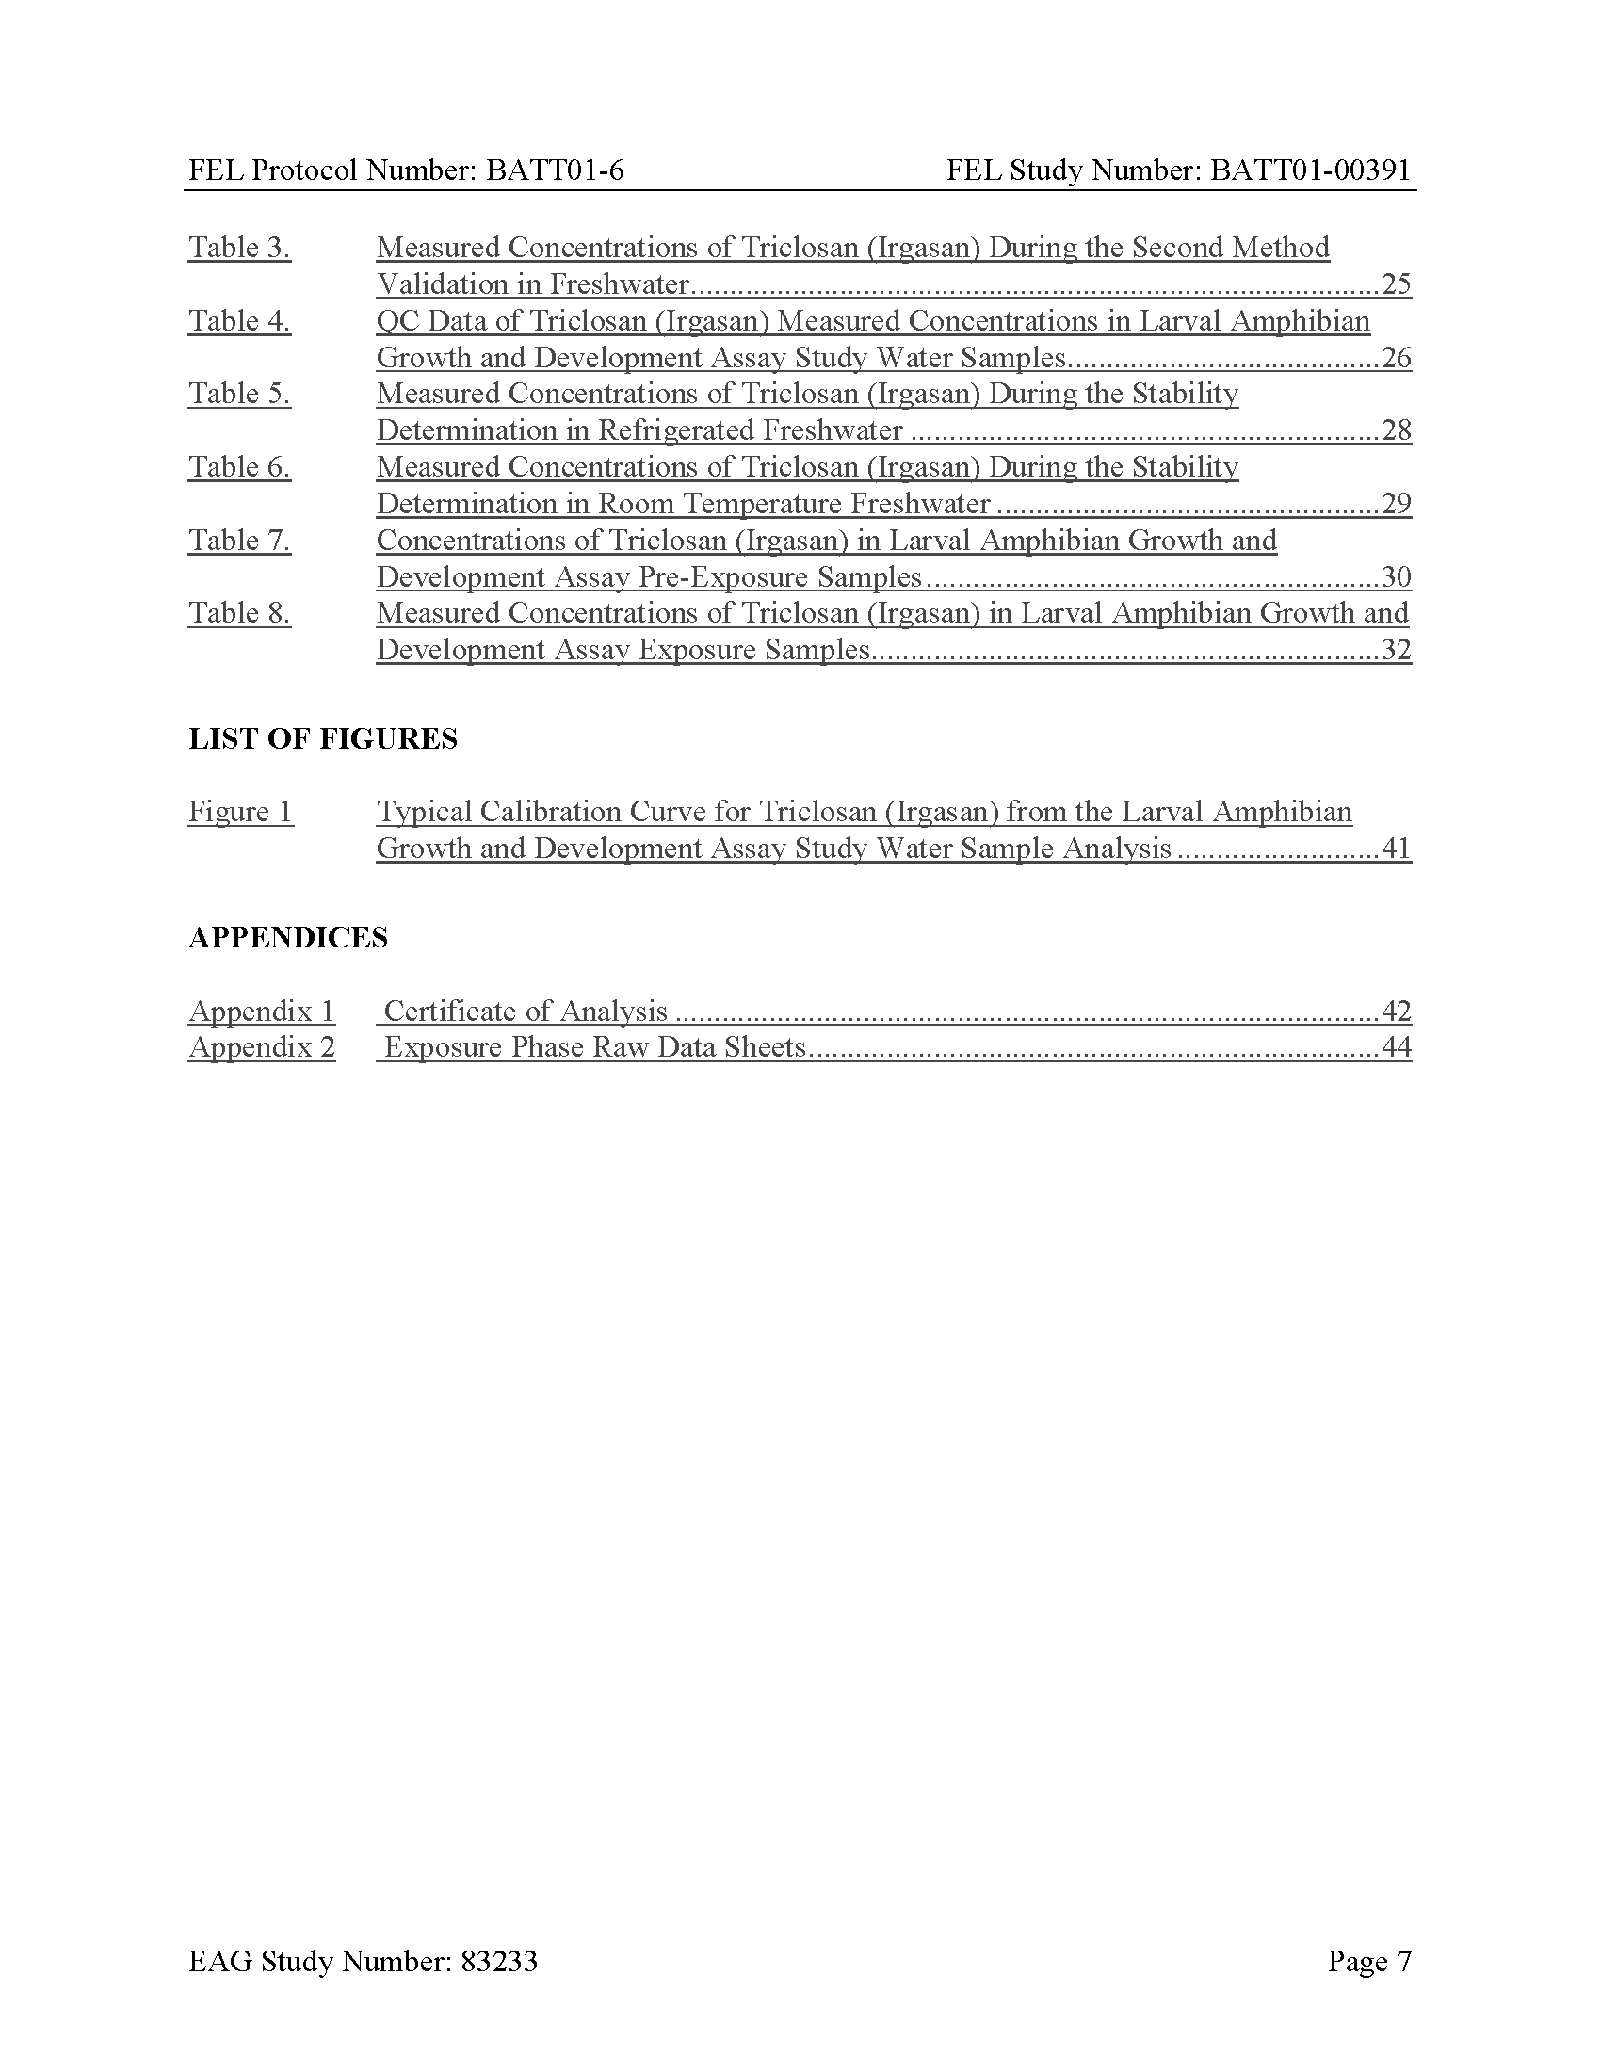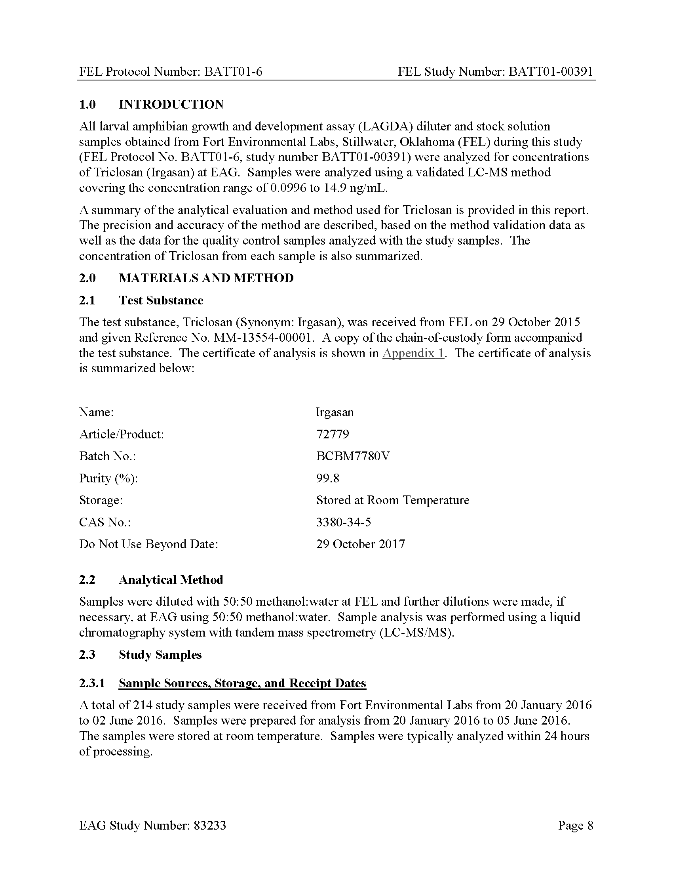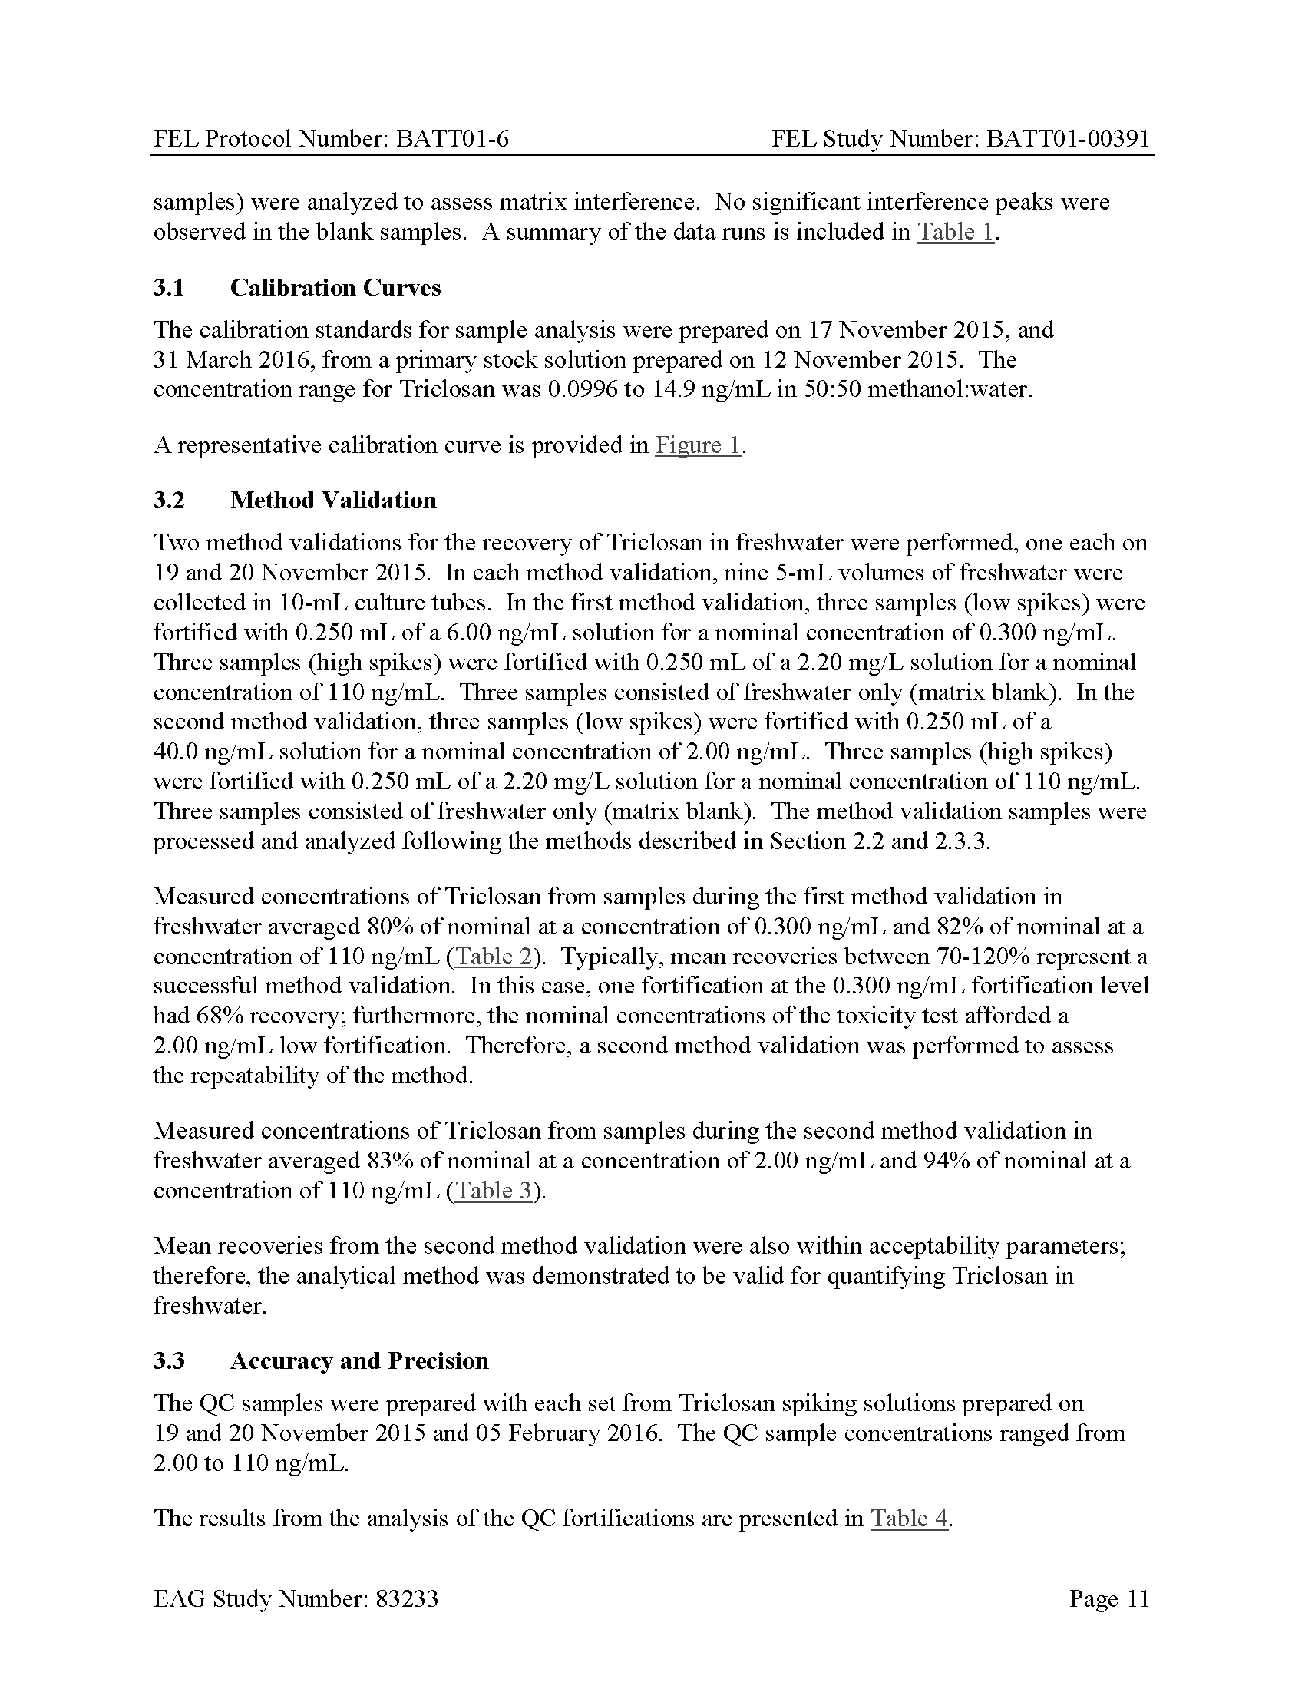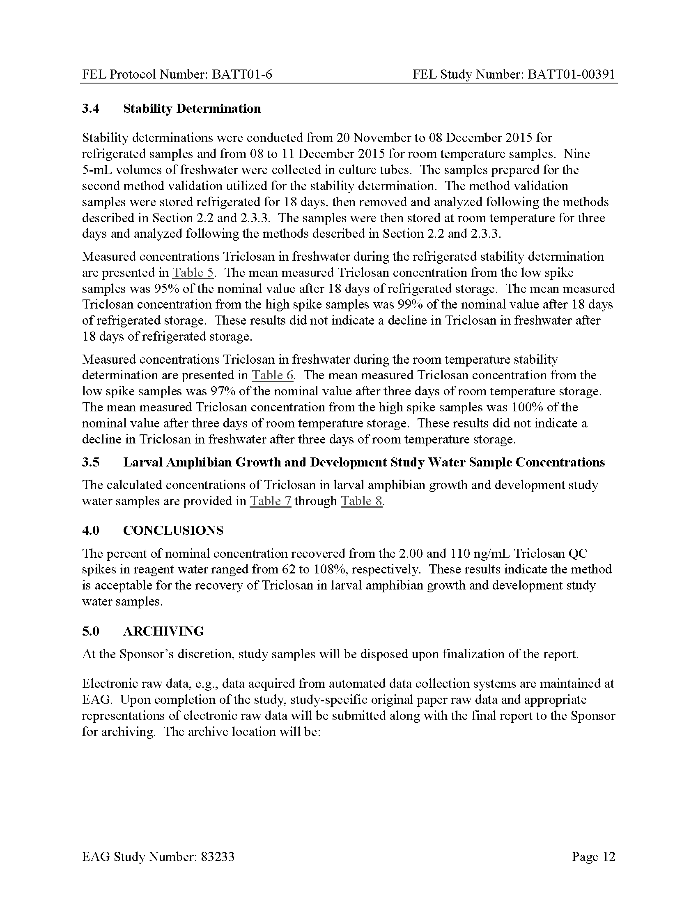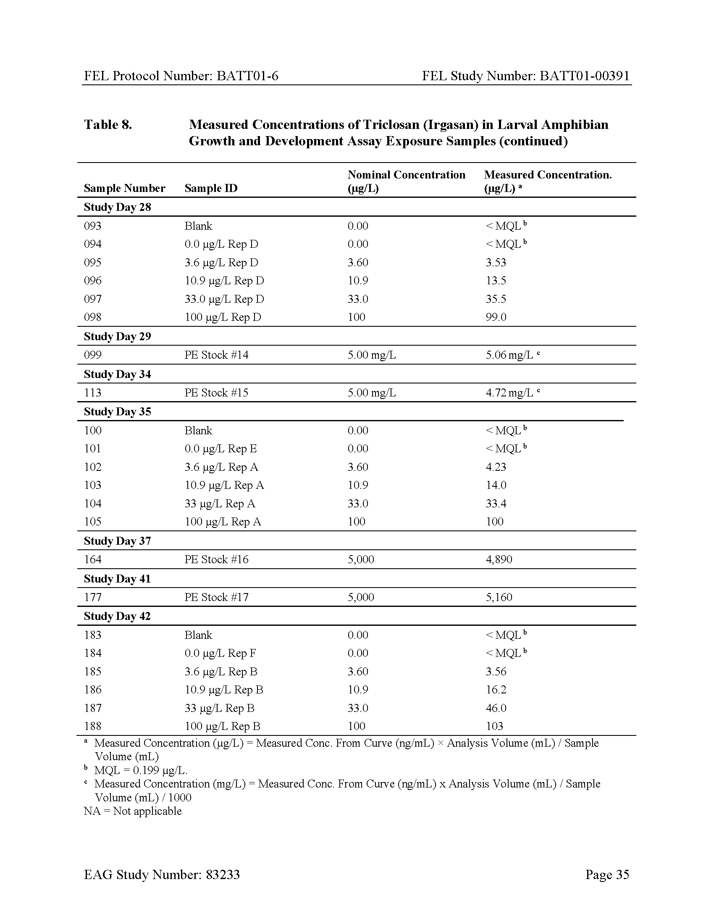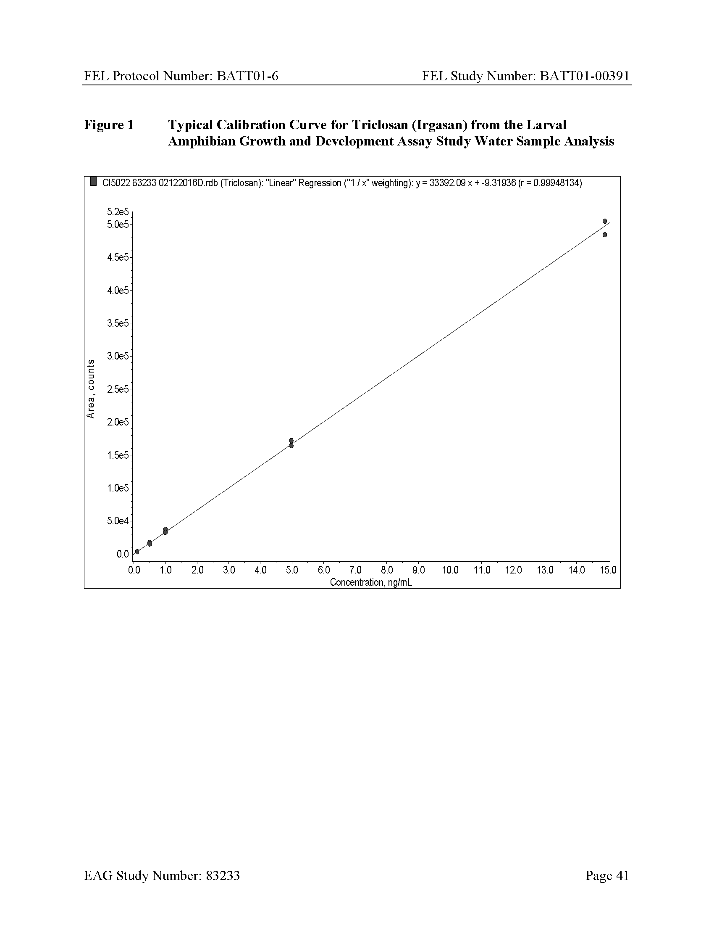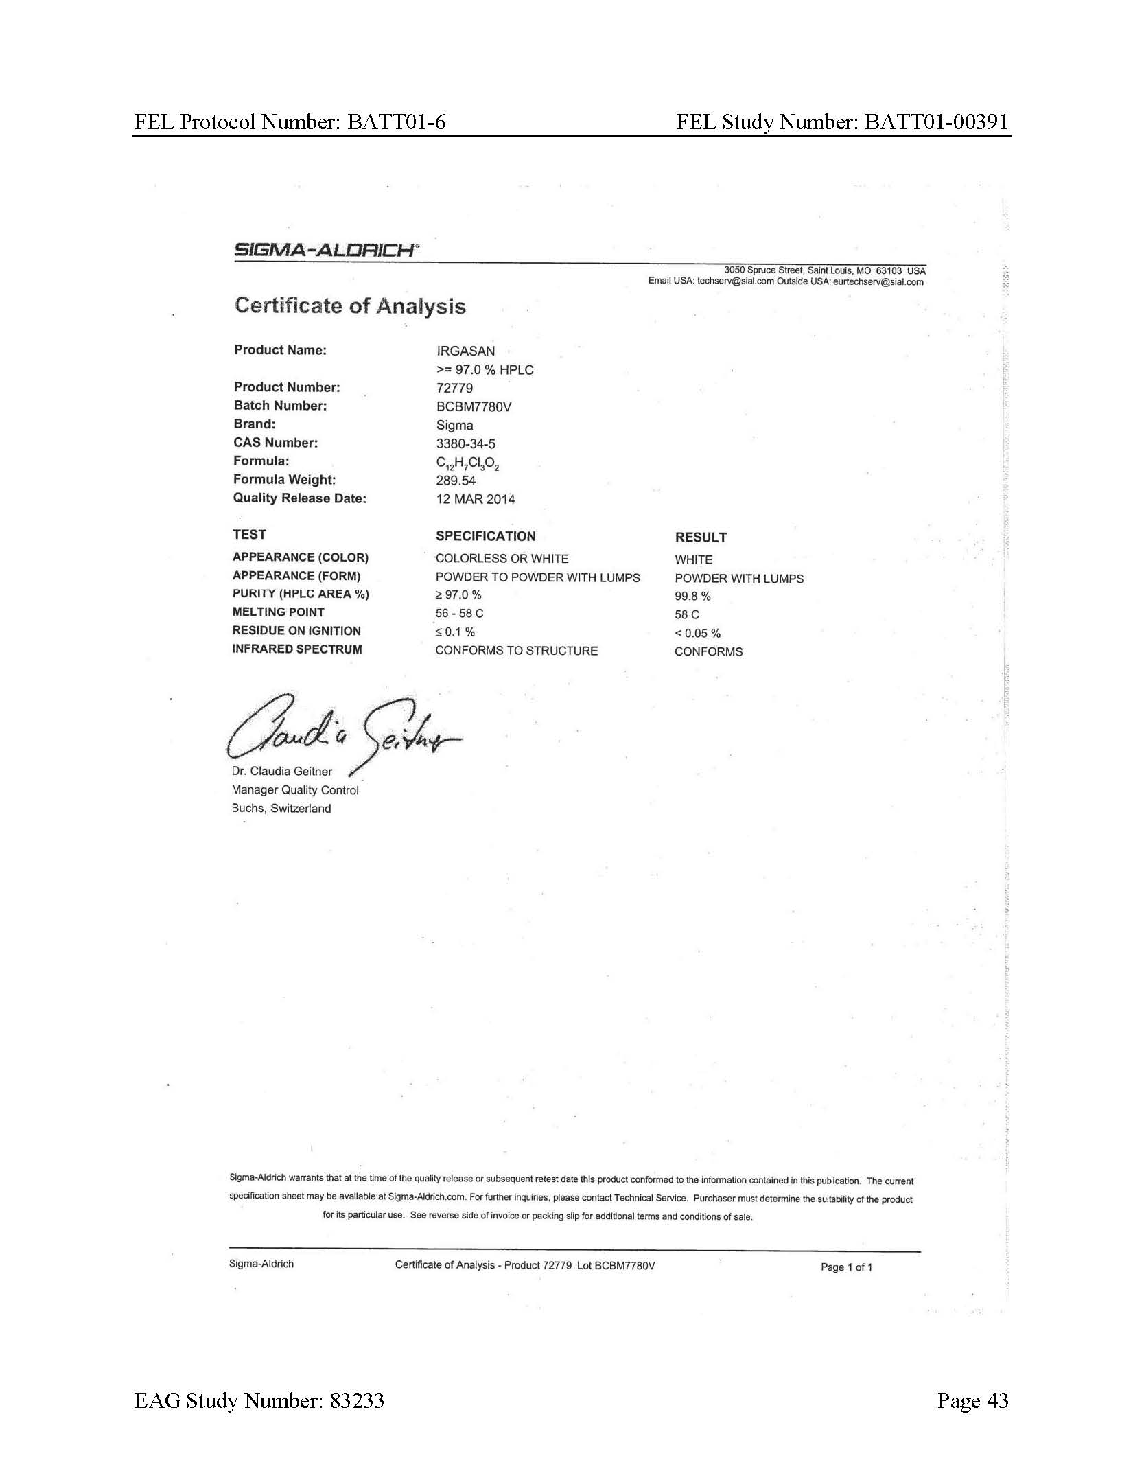

Histopathology Data Reports

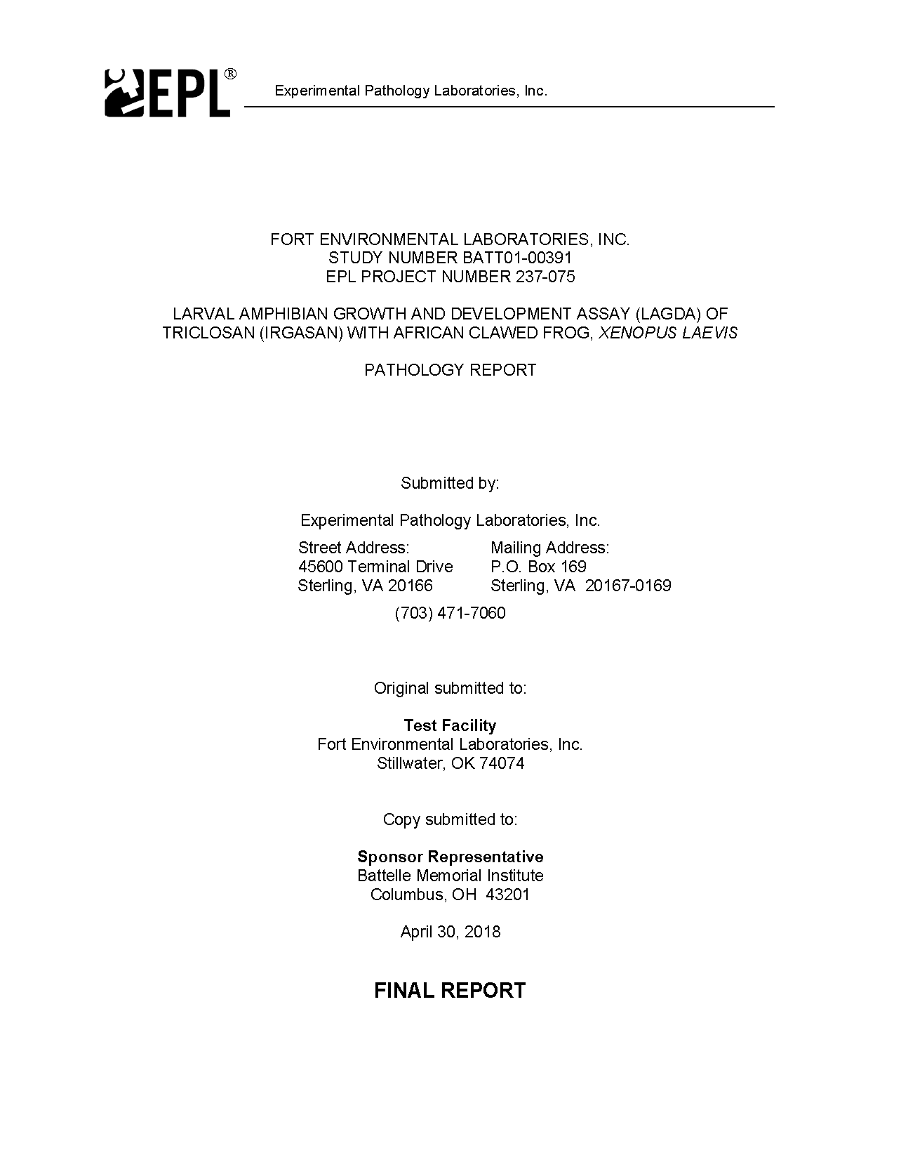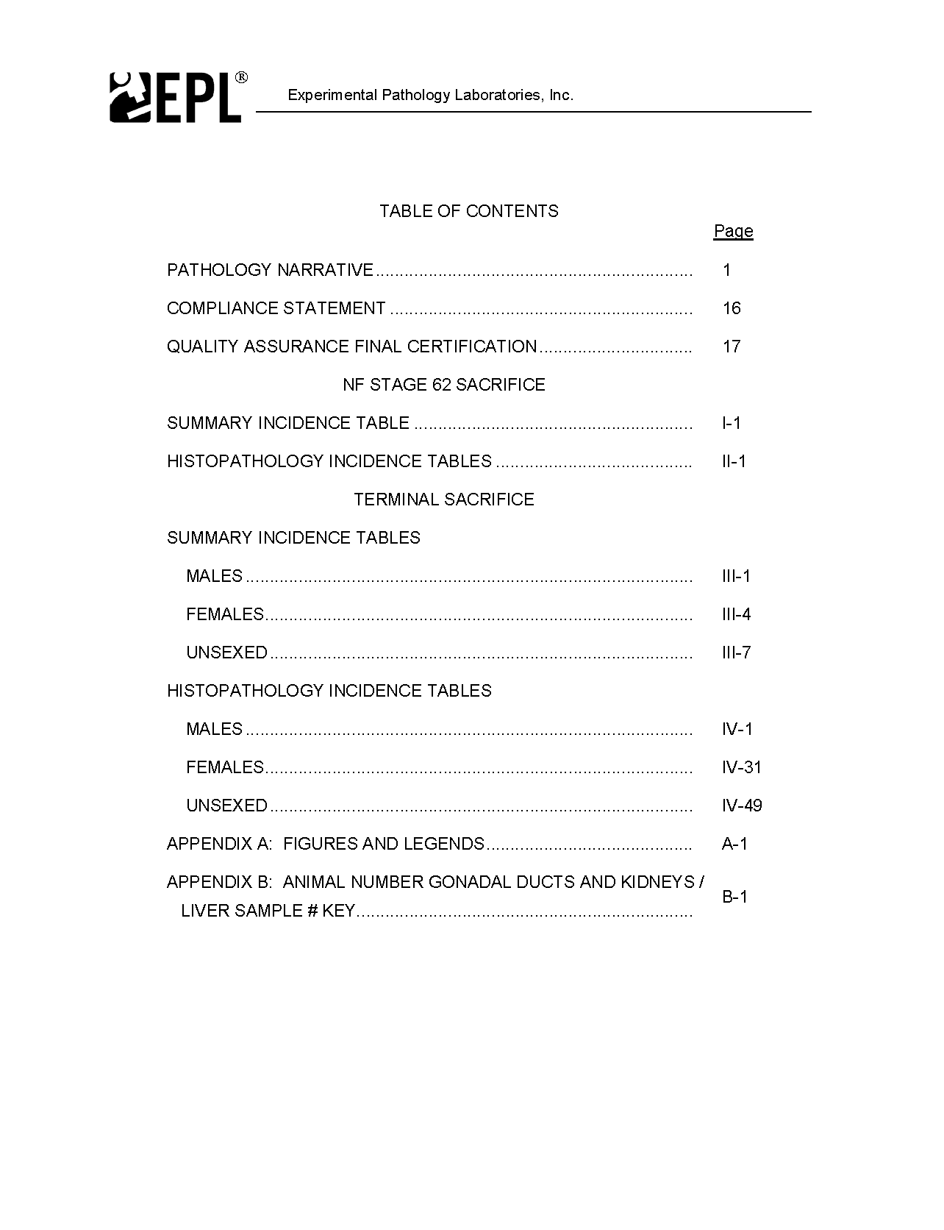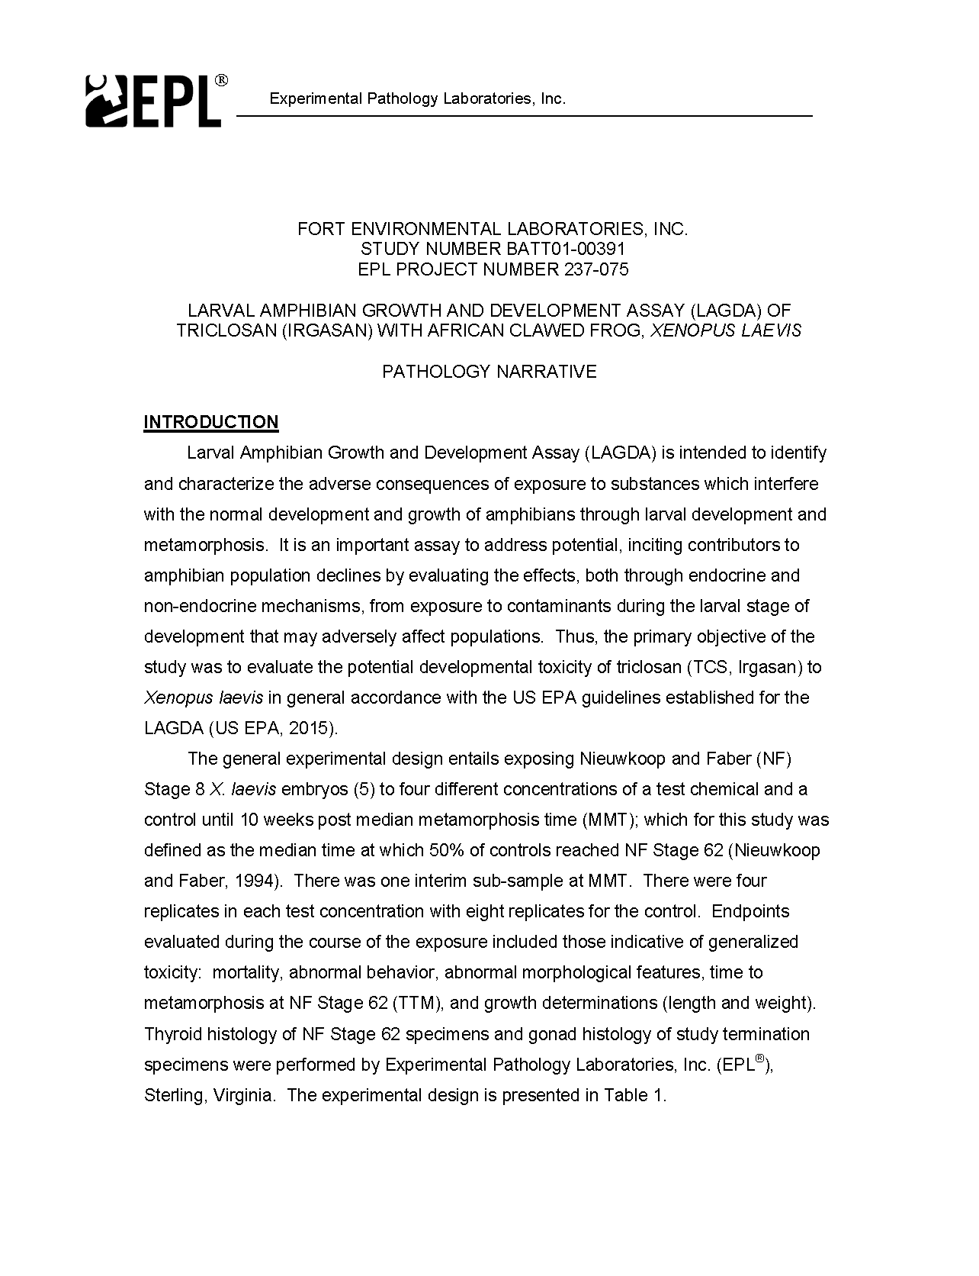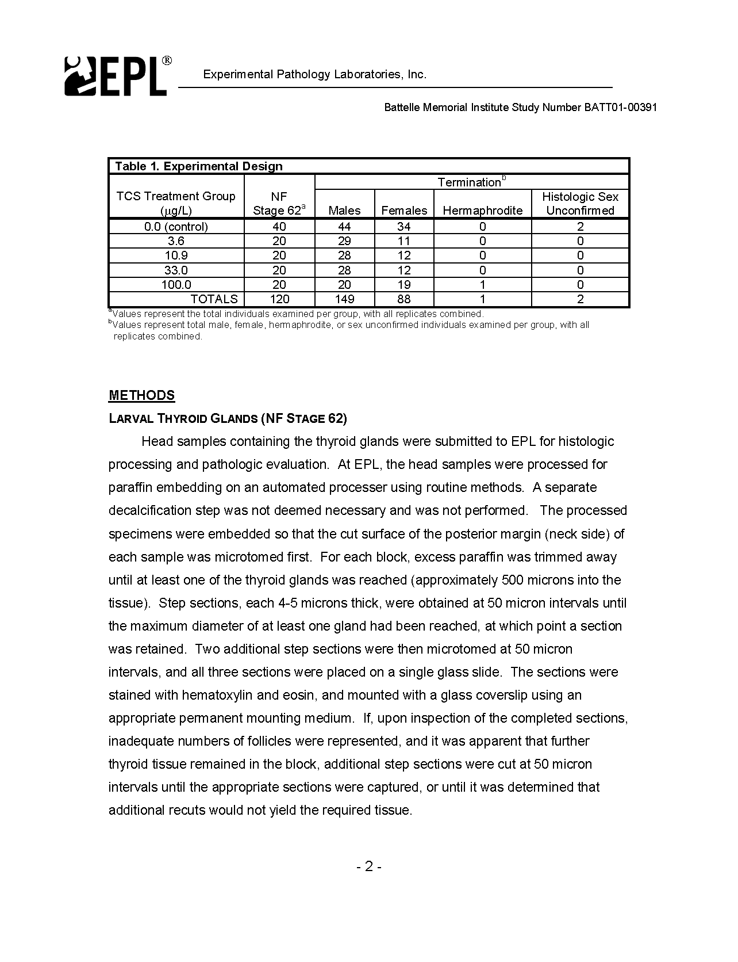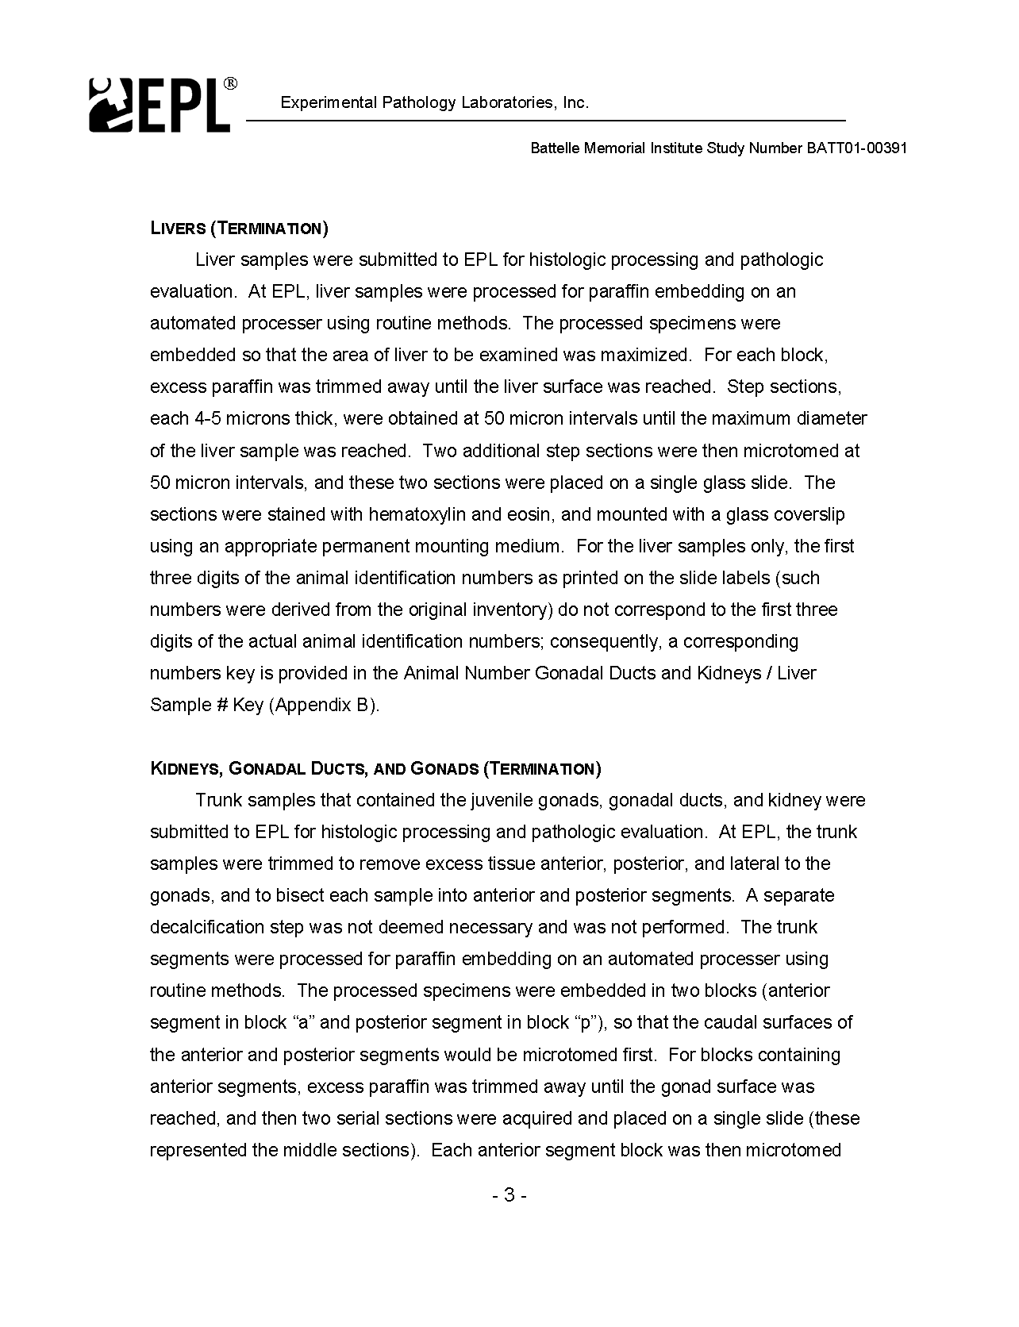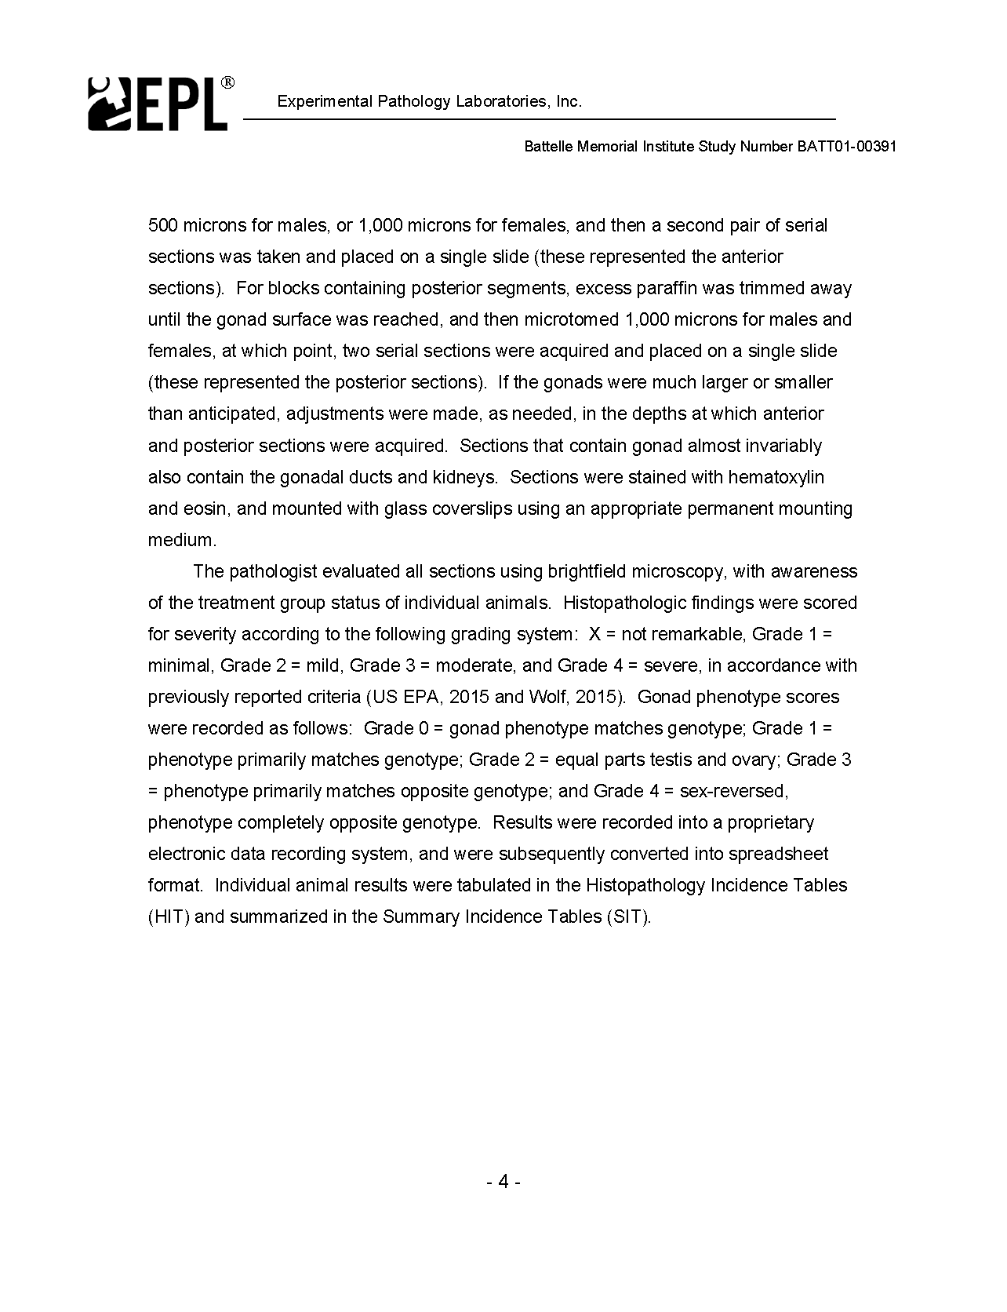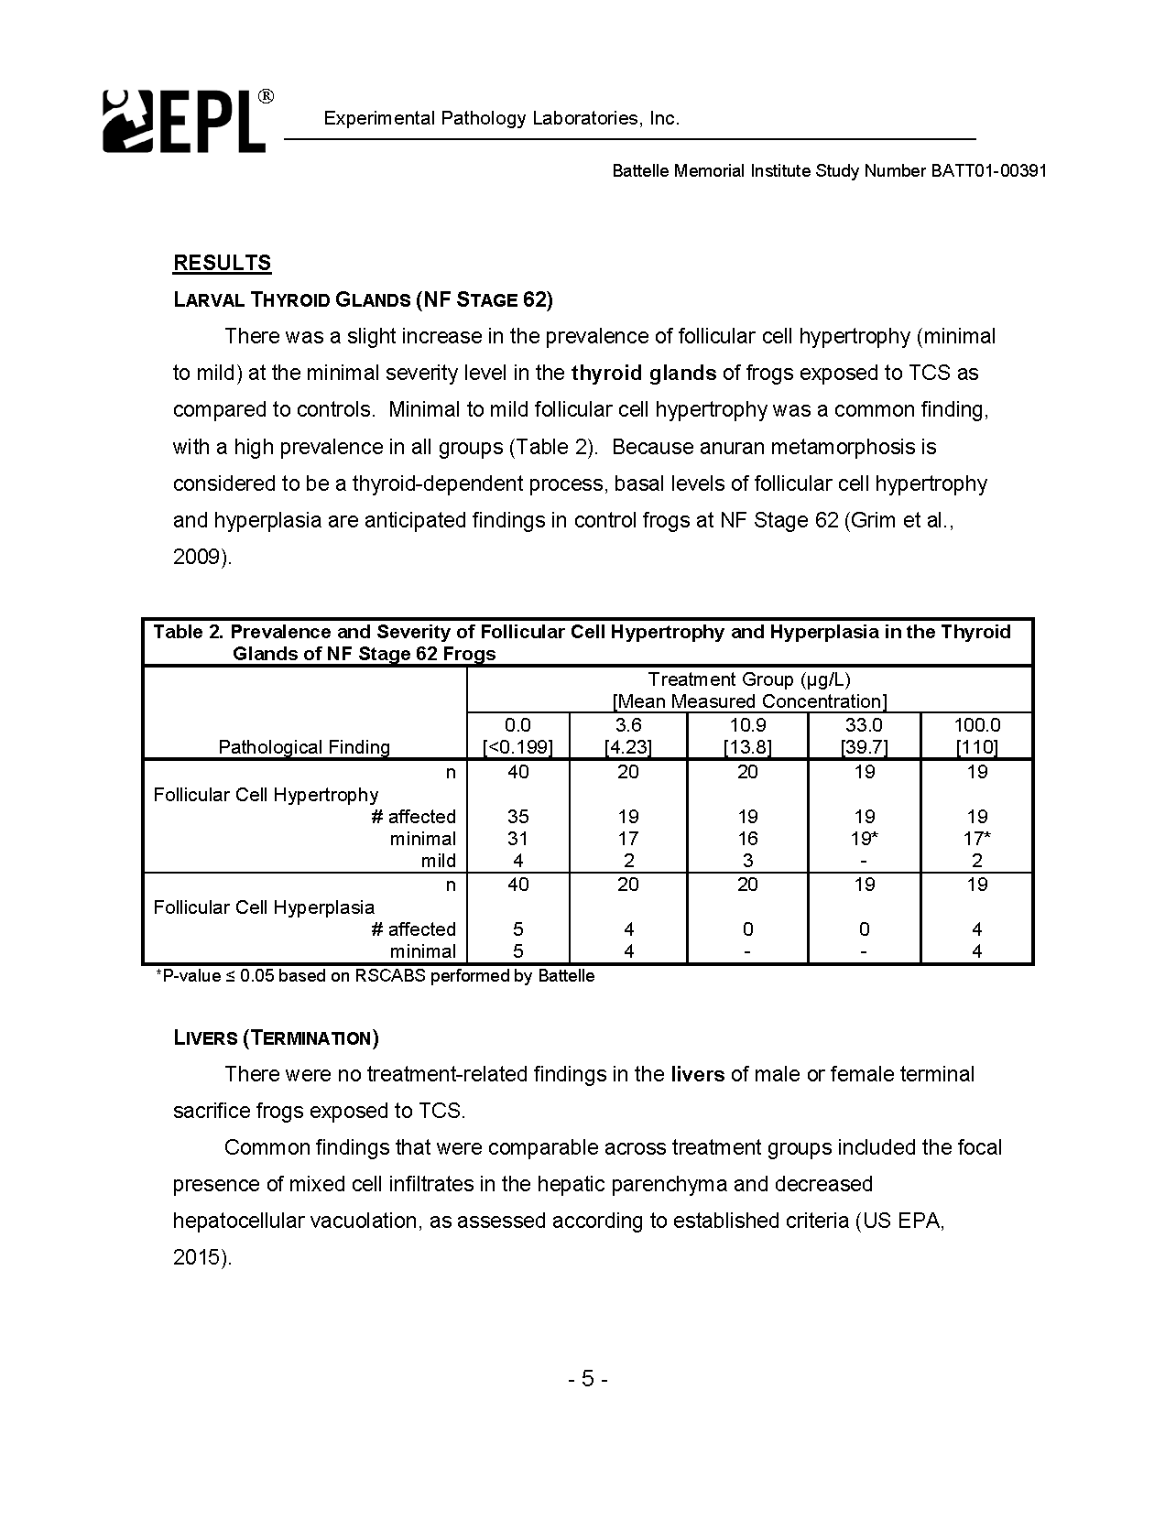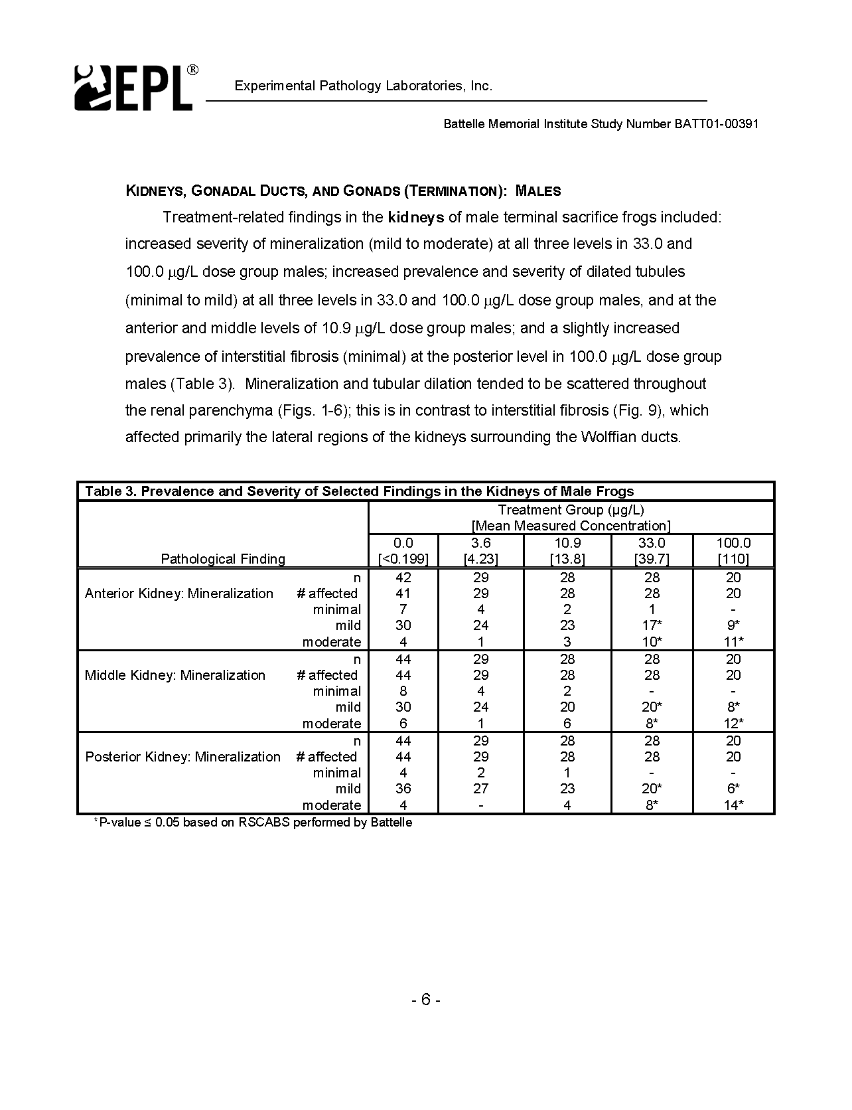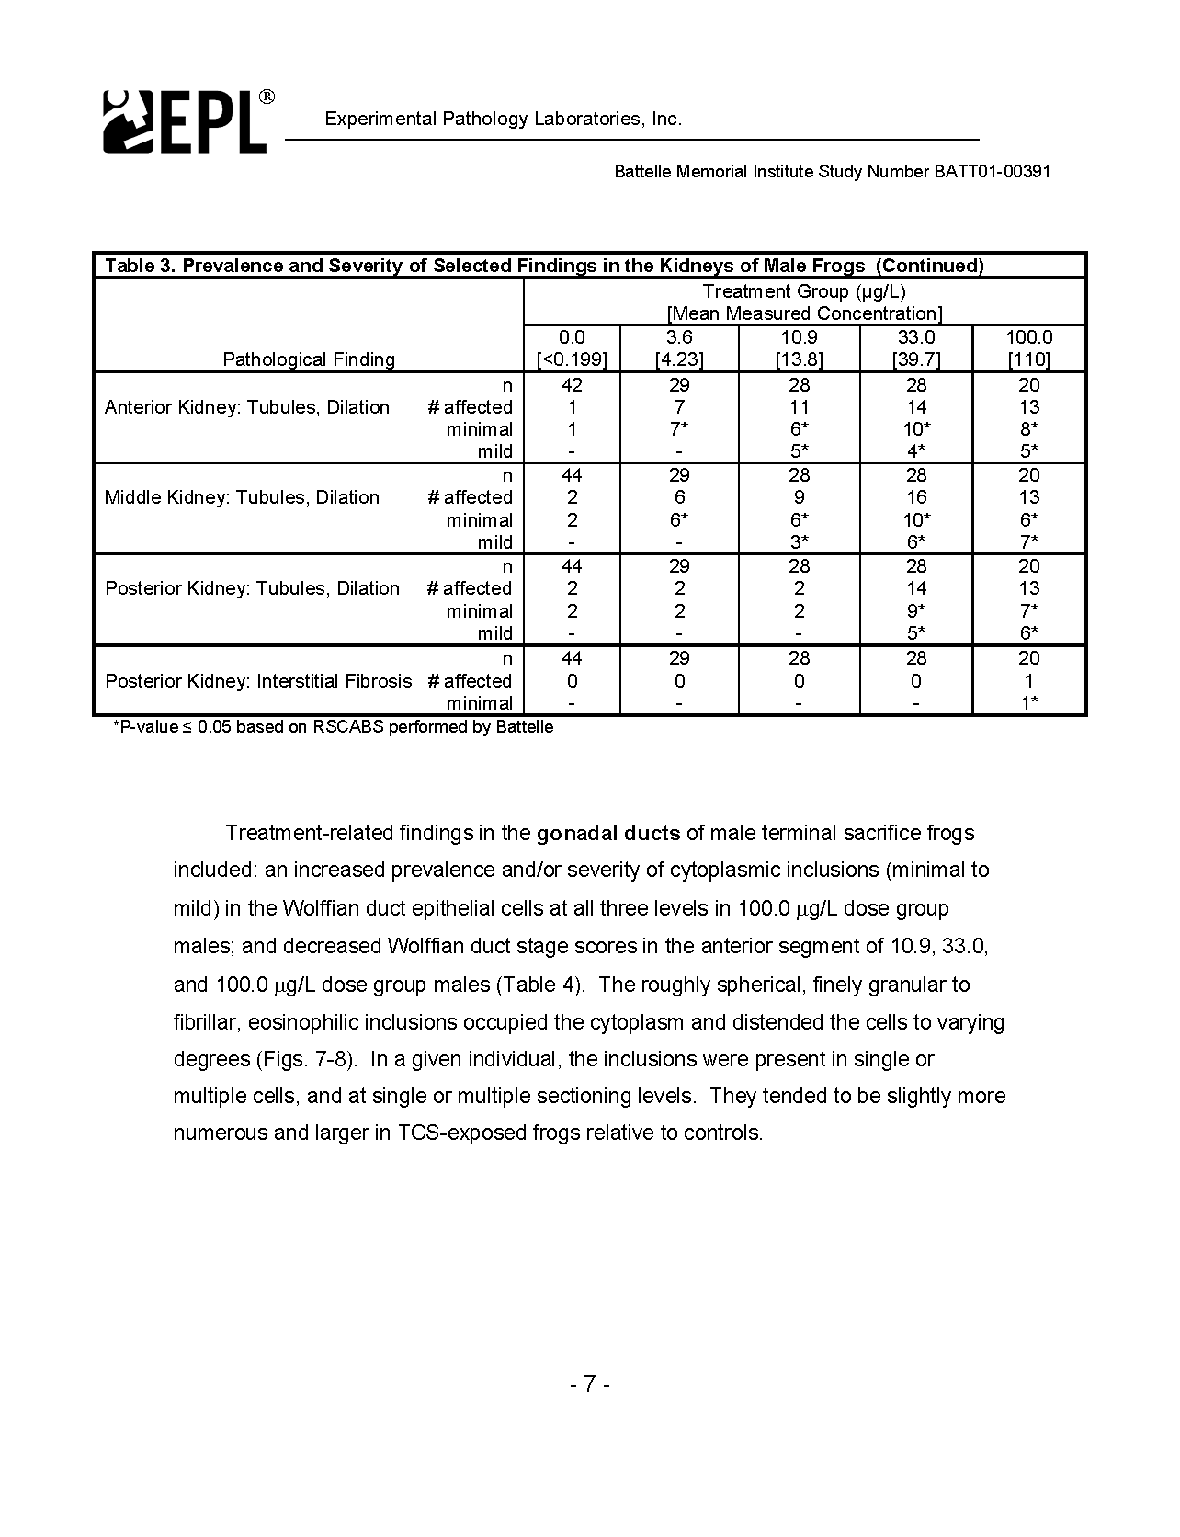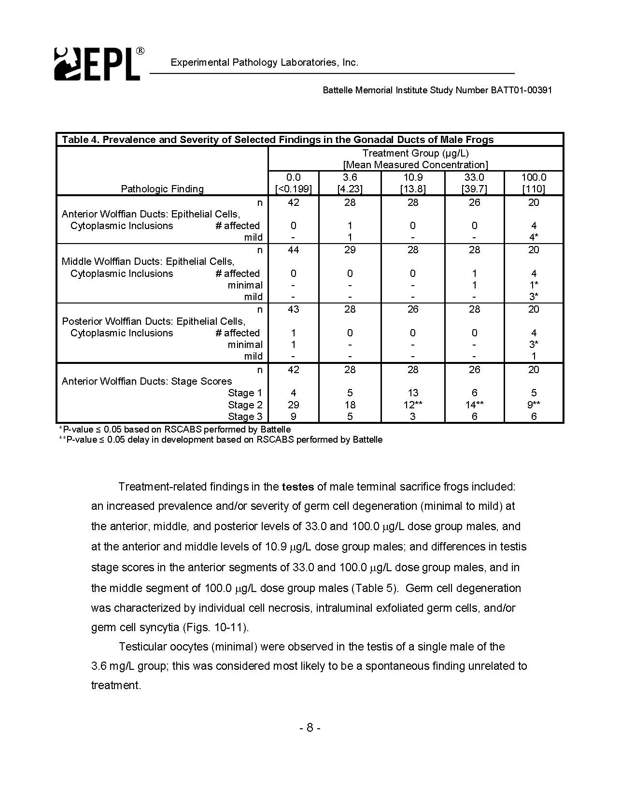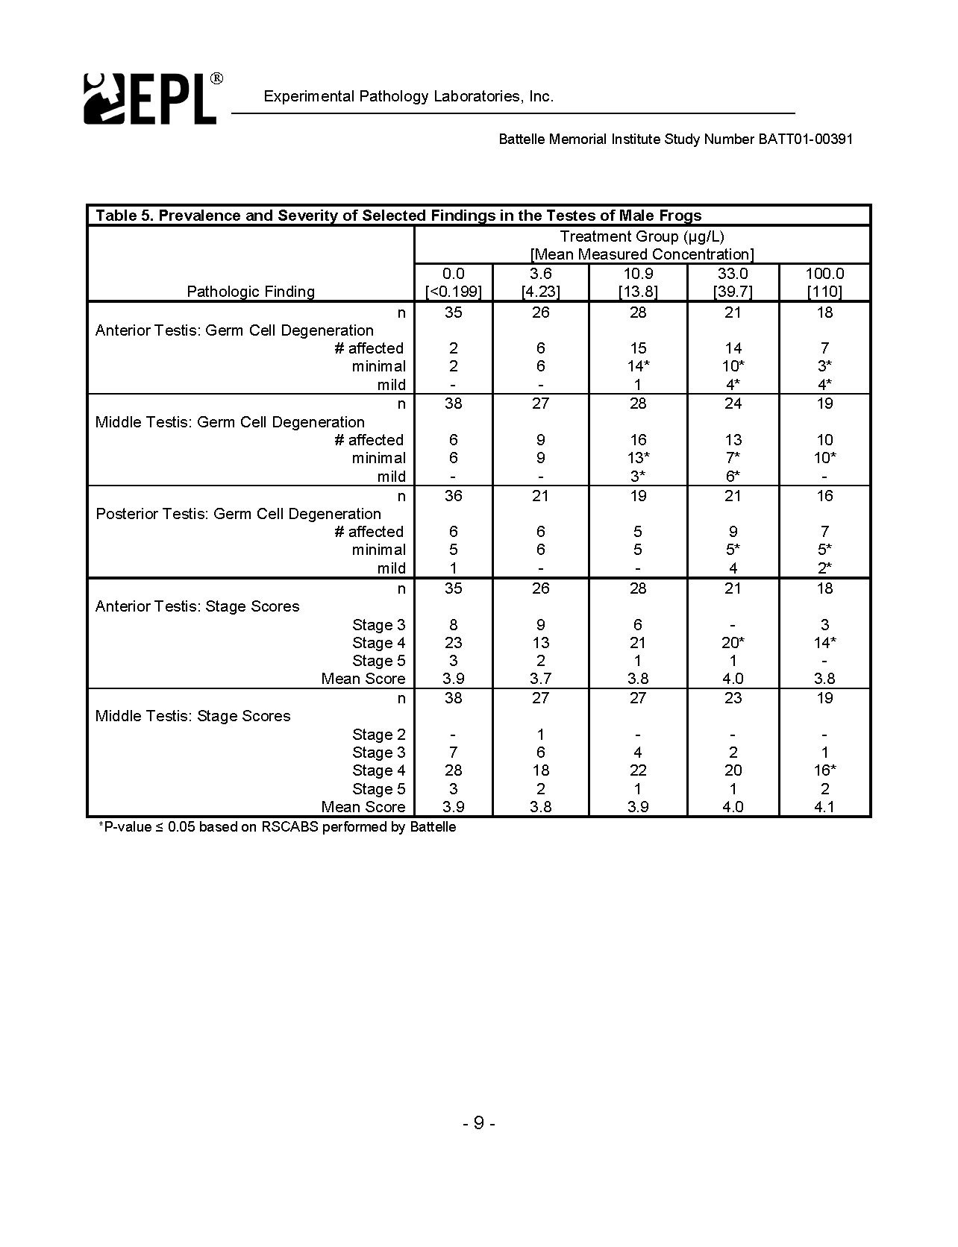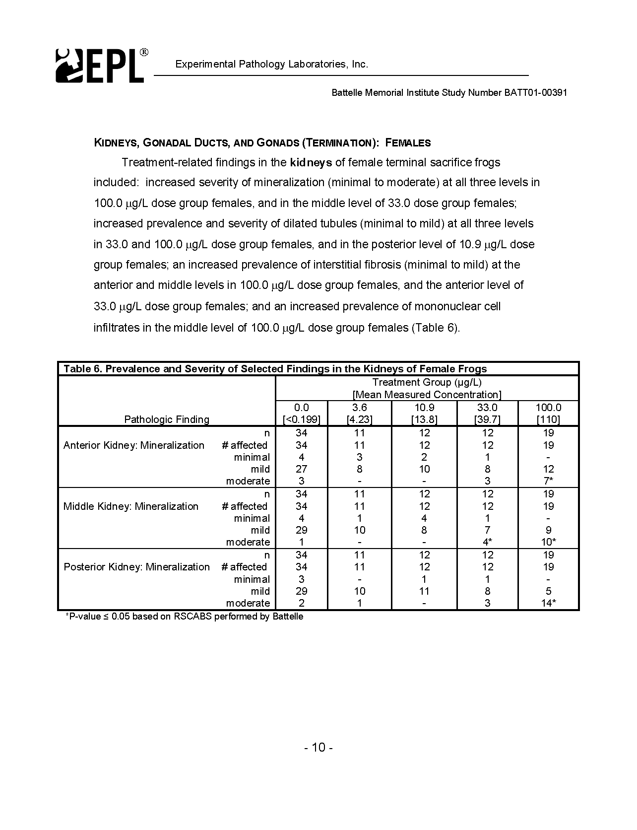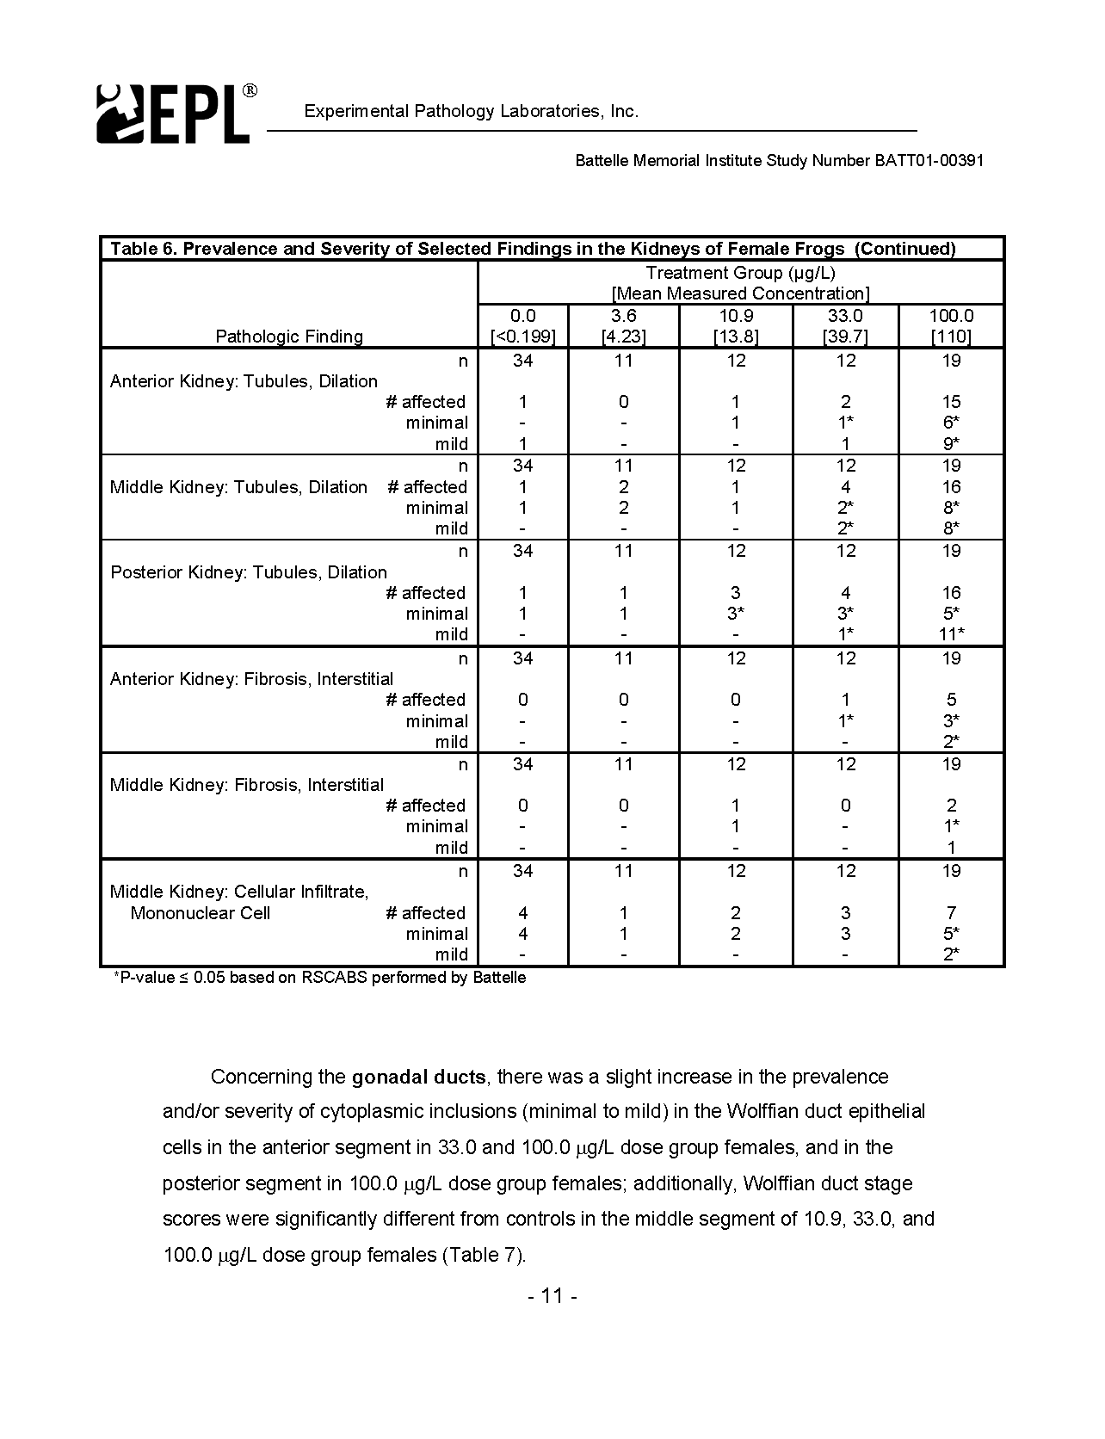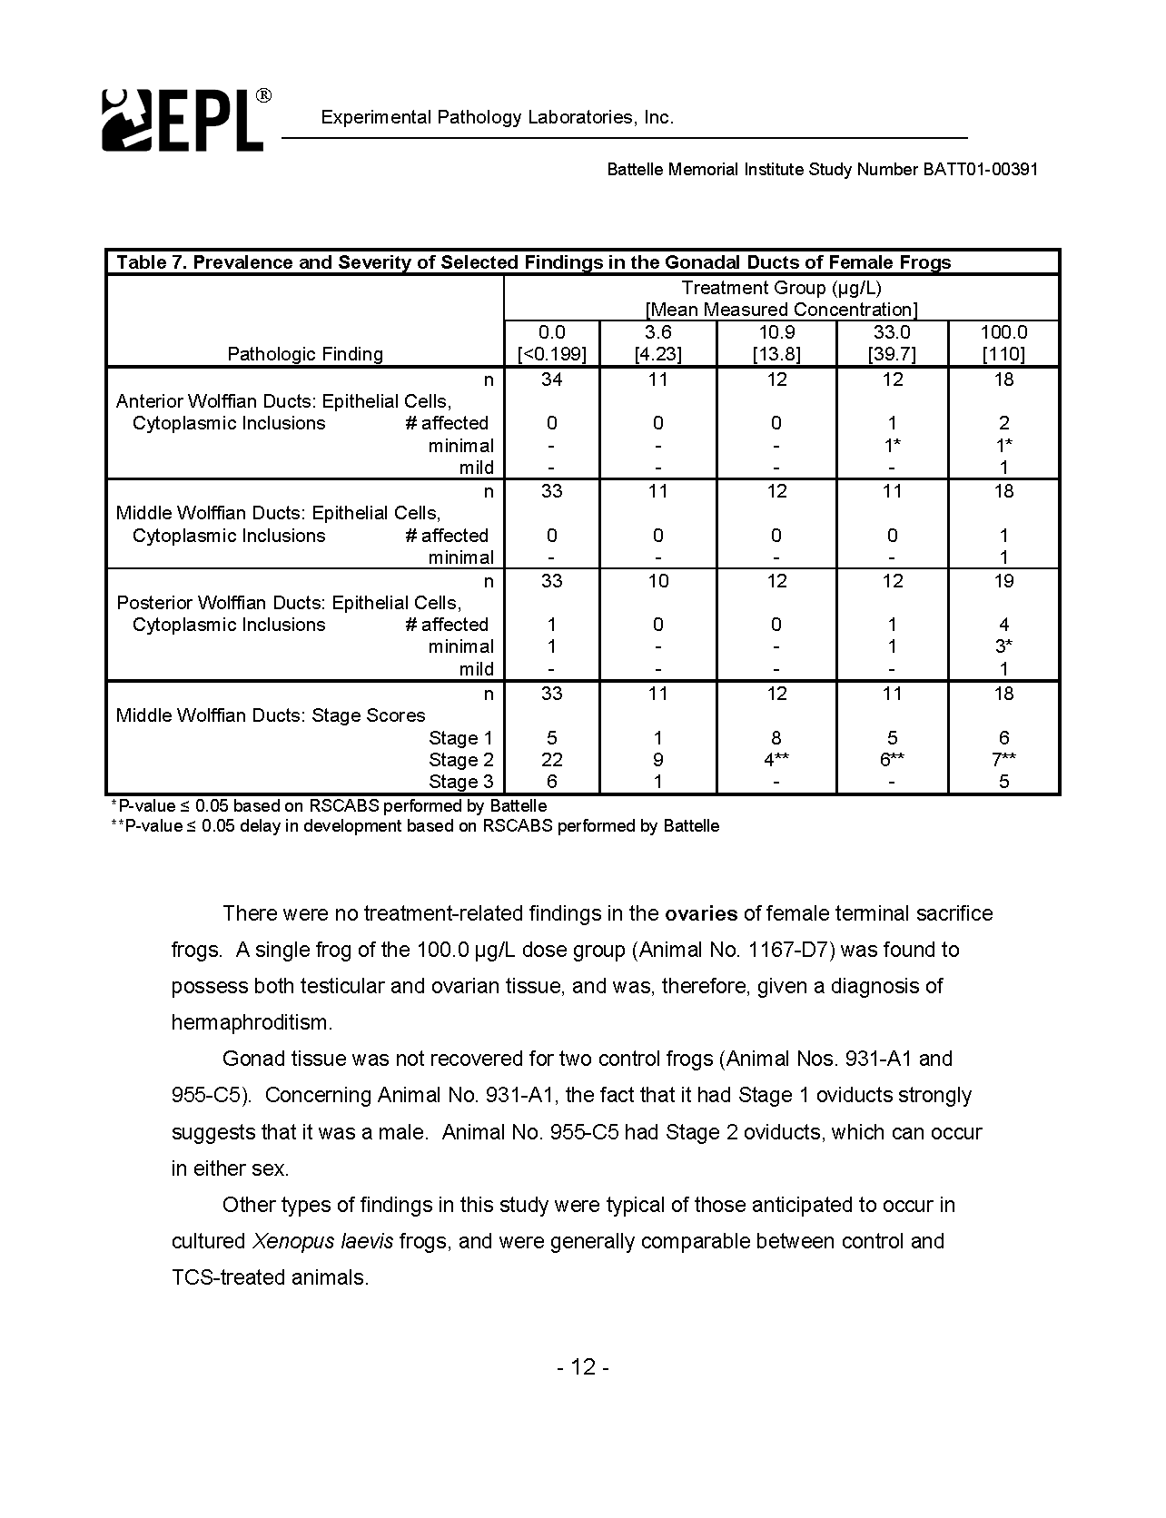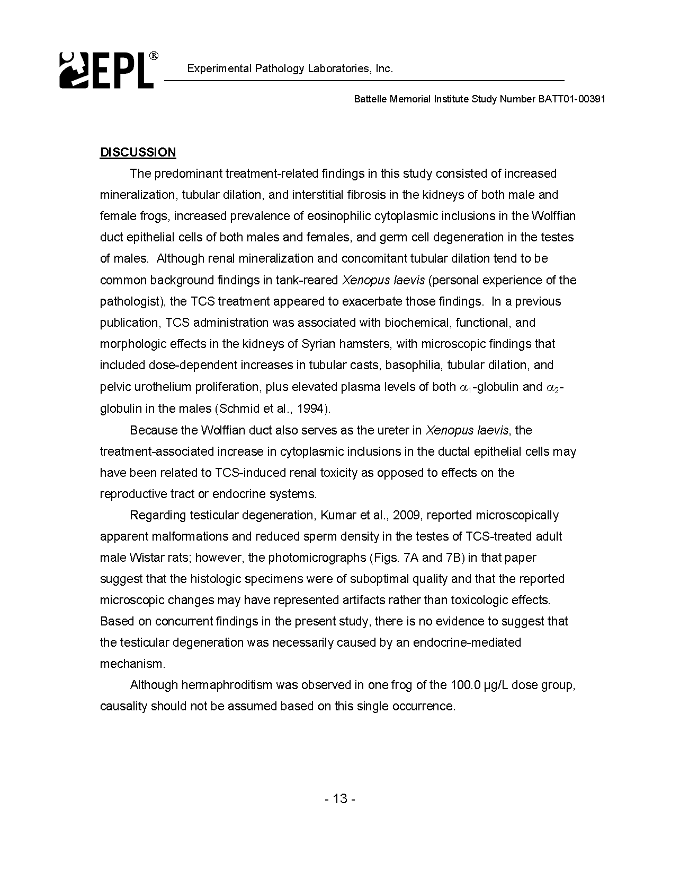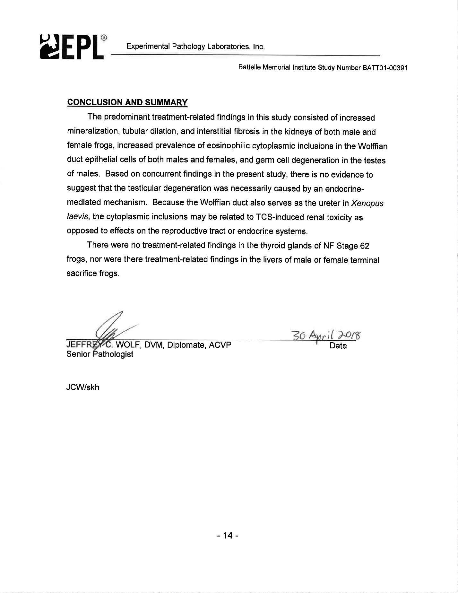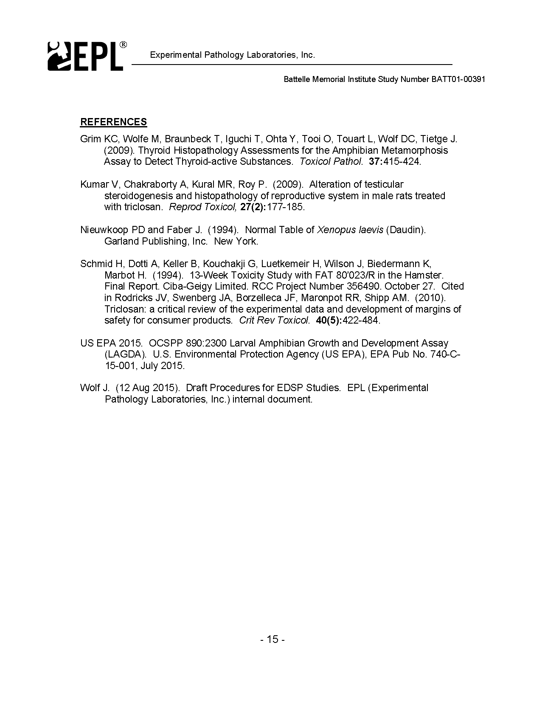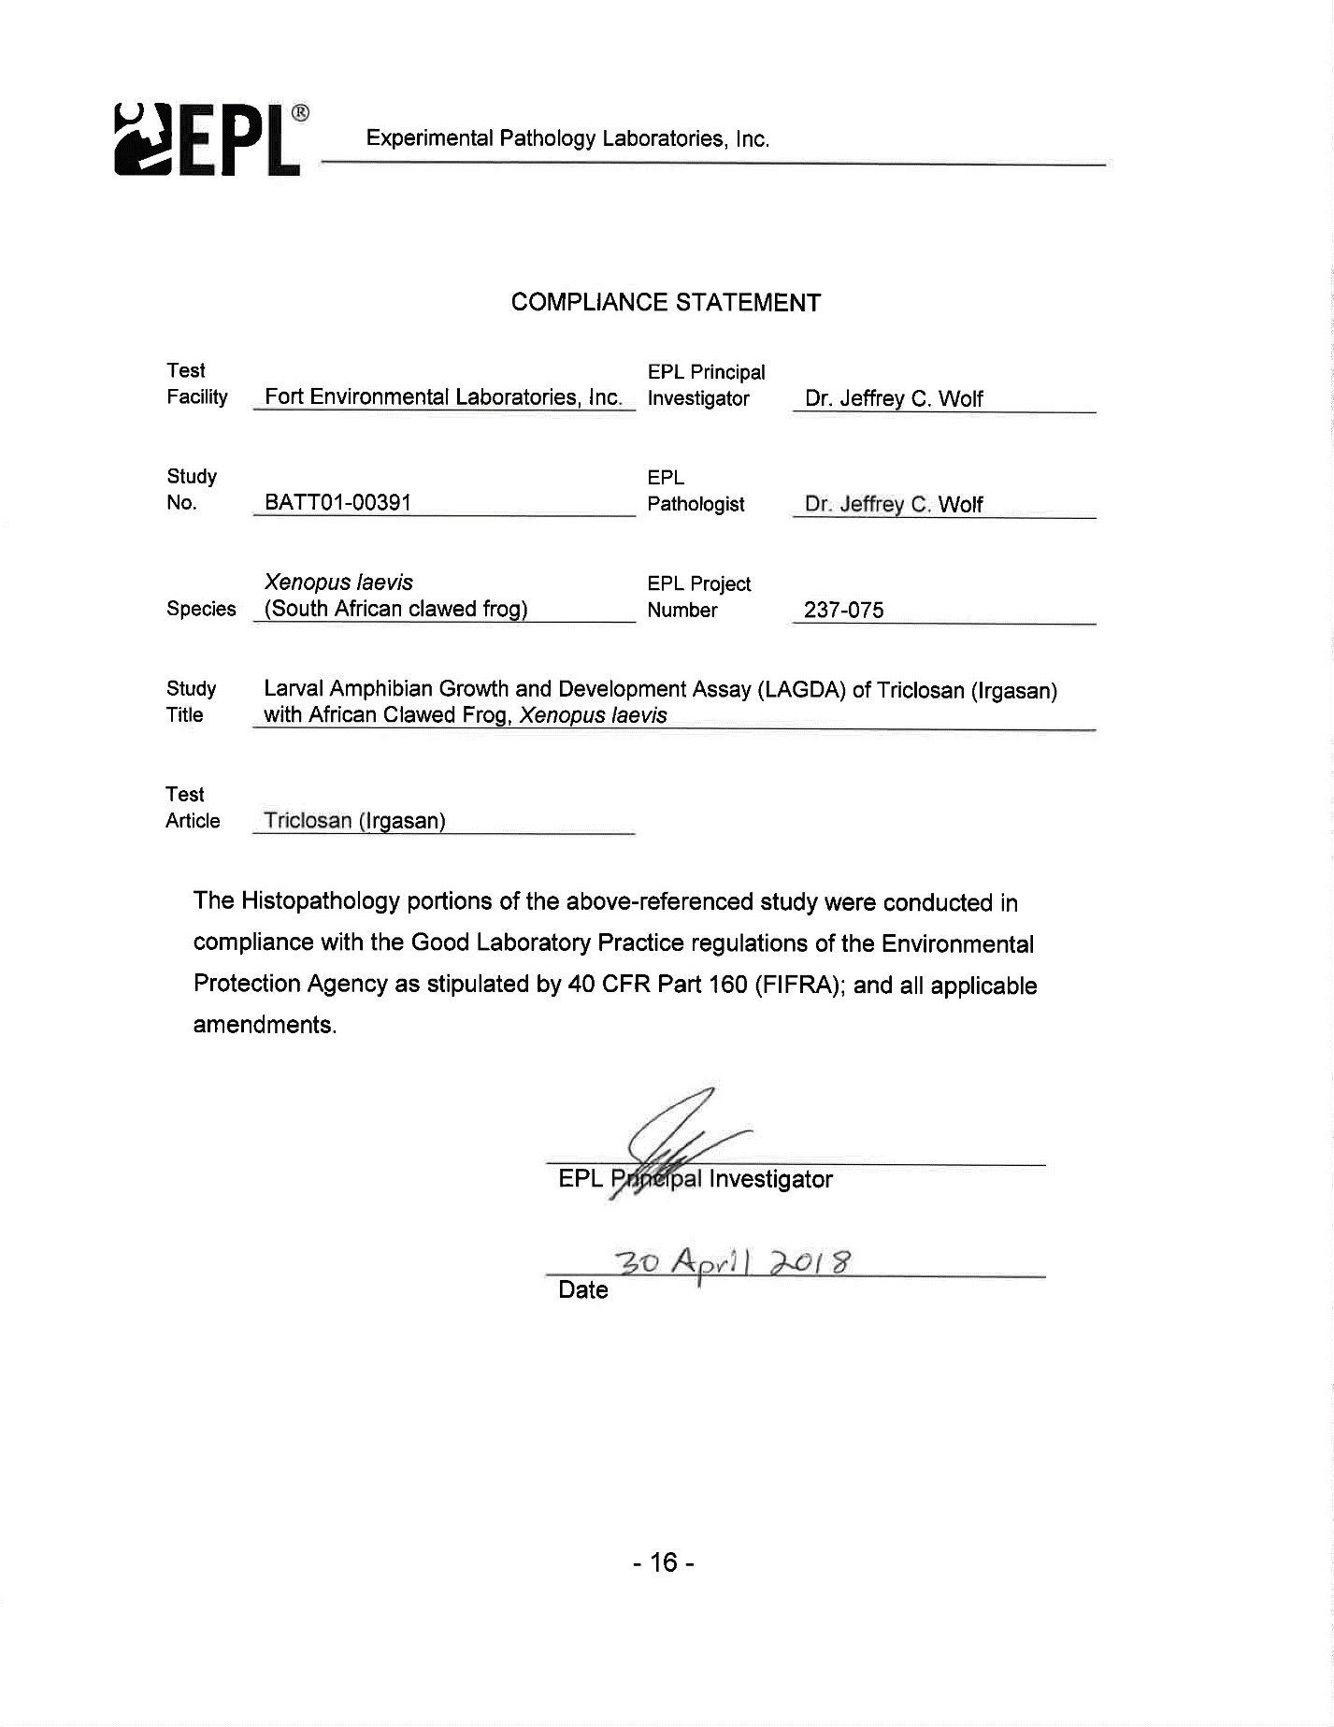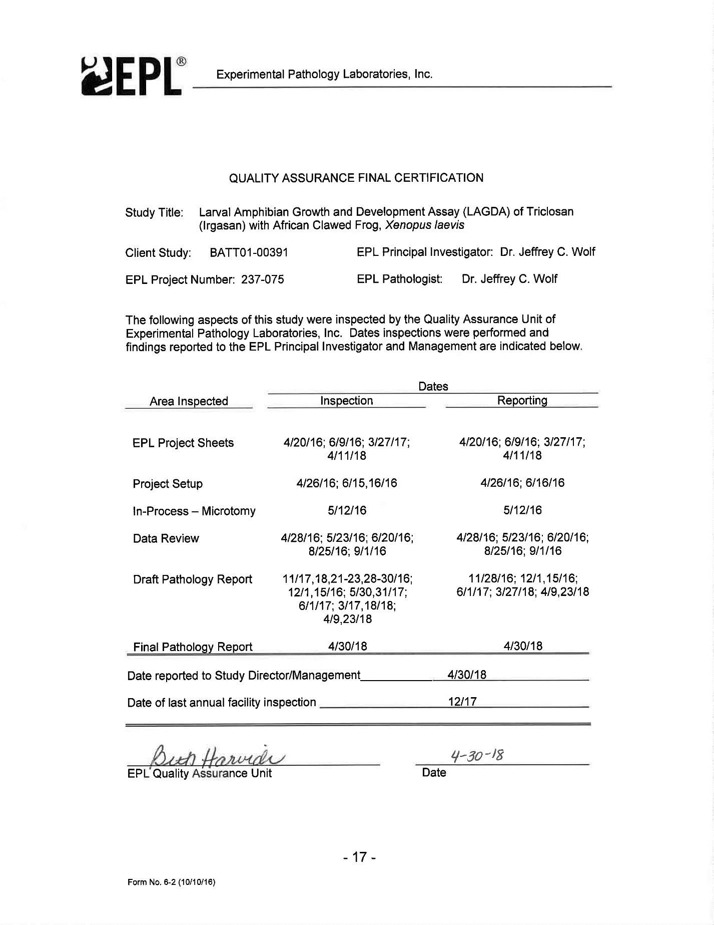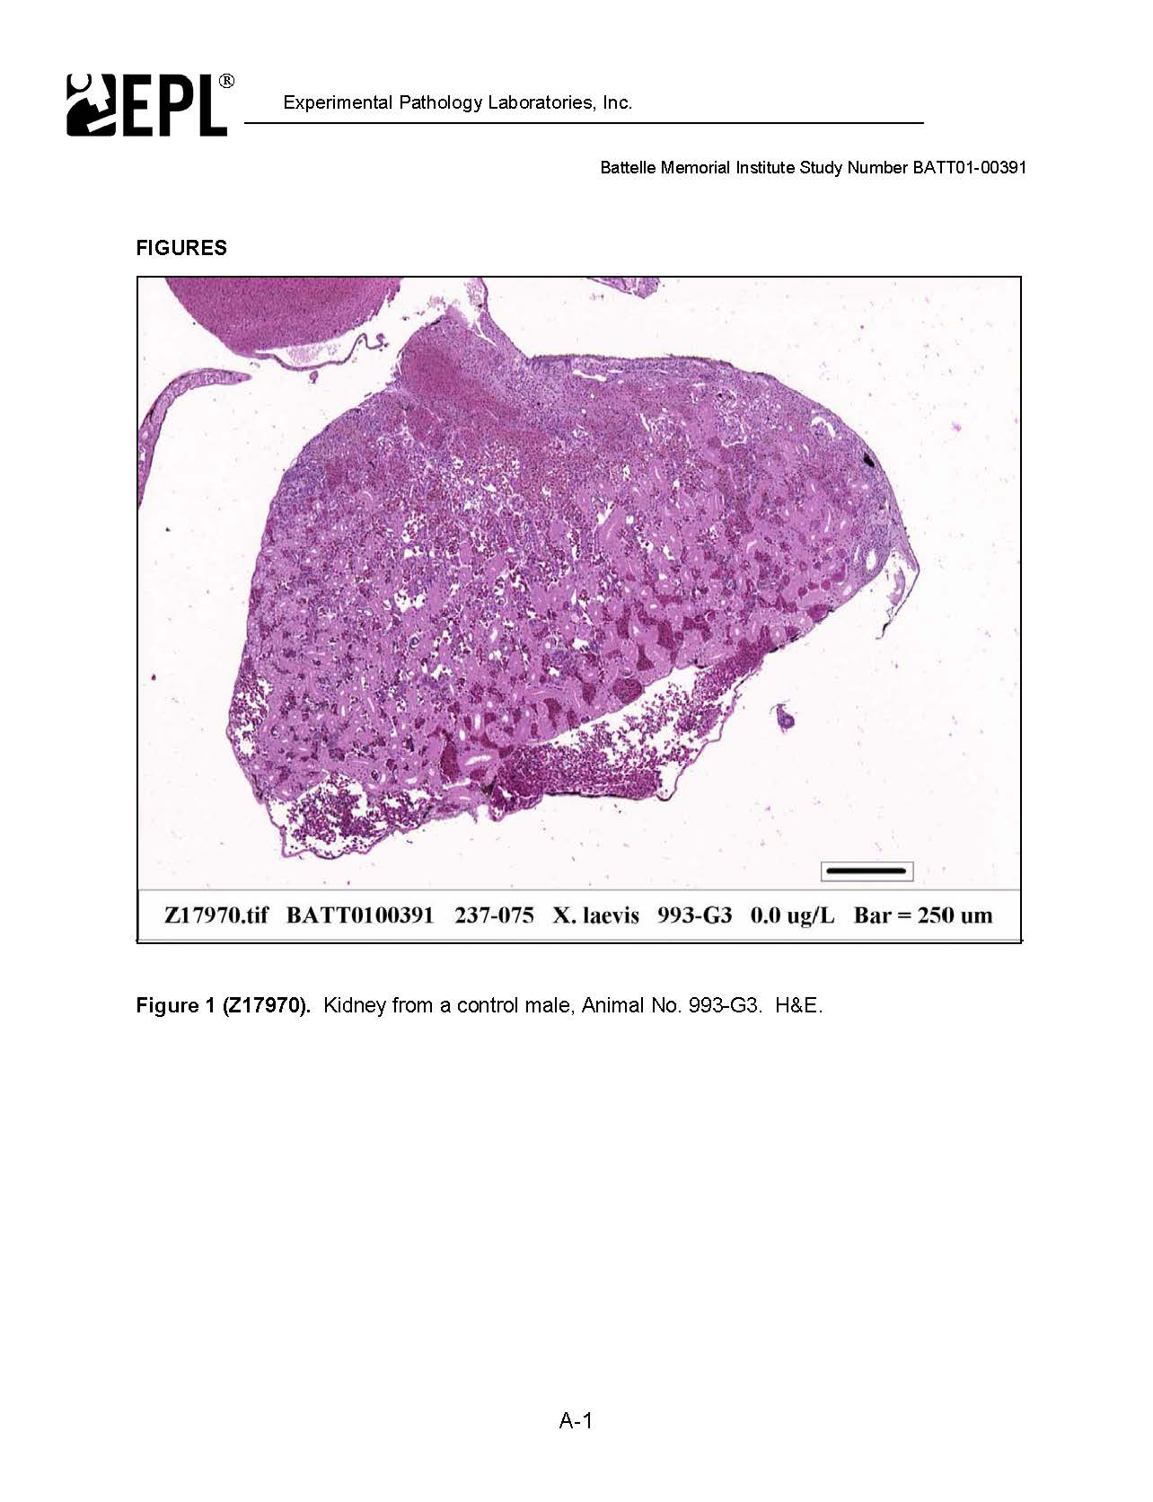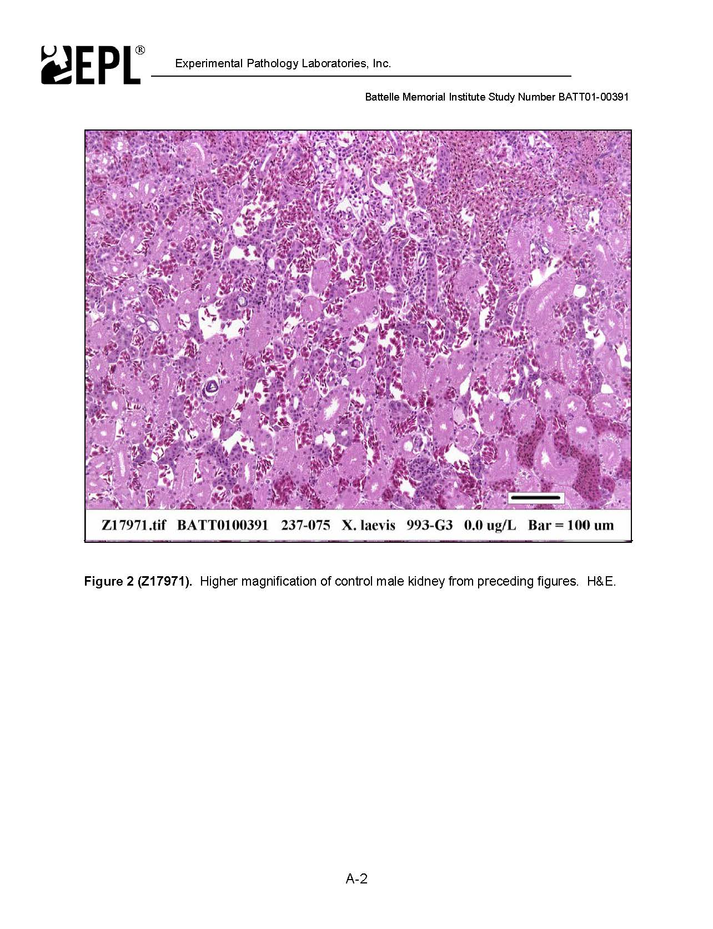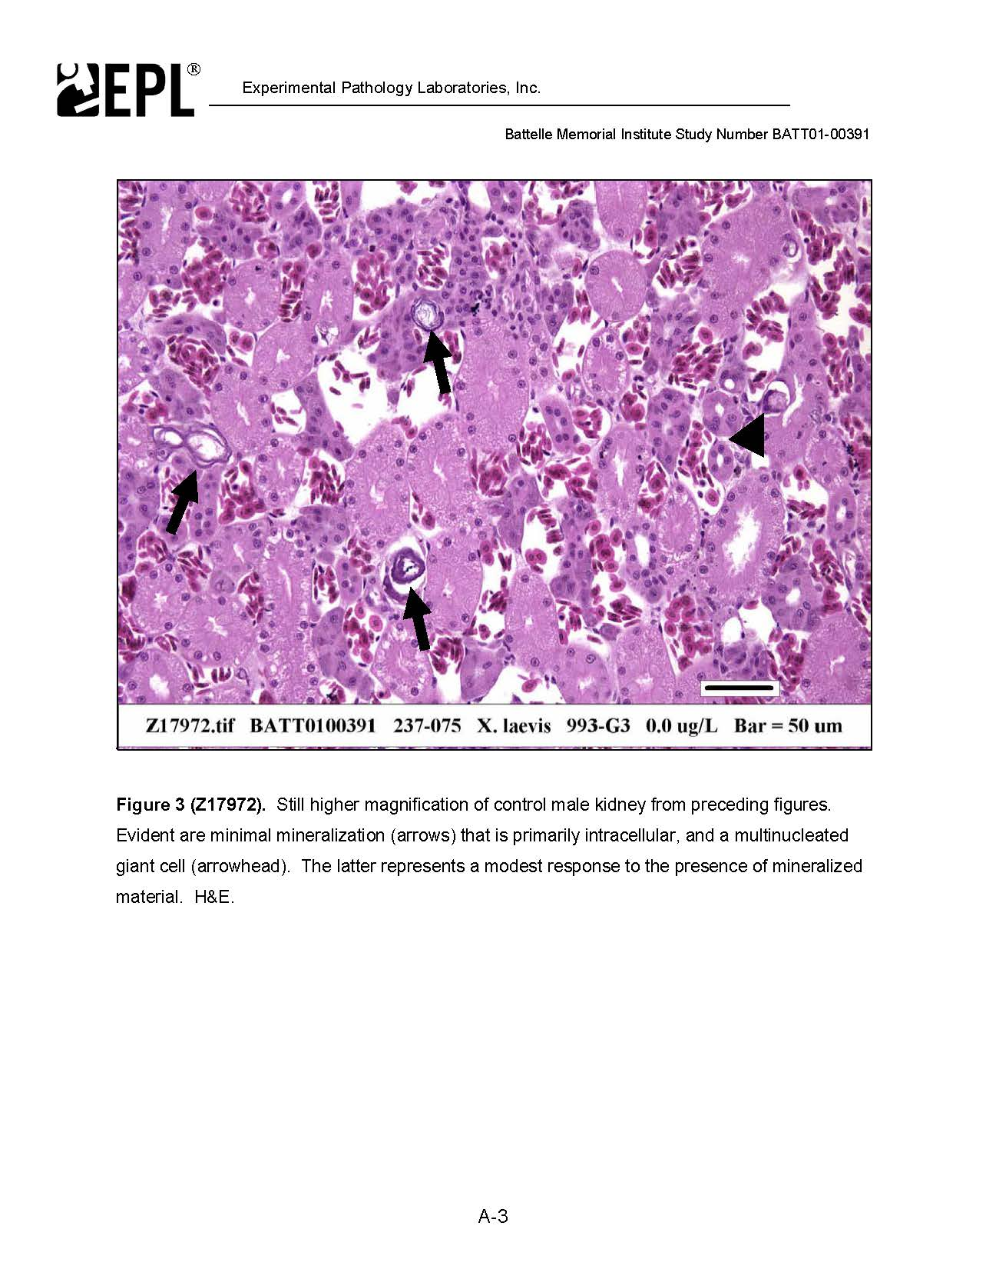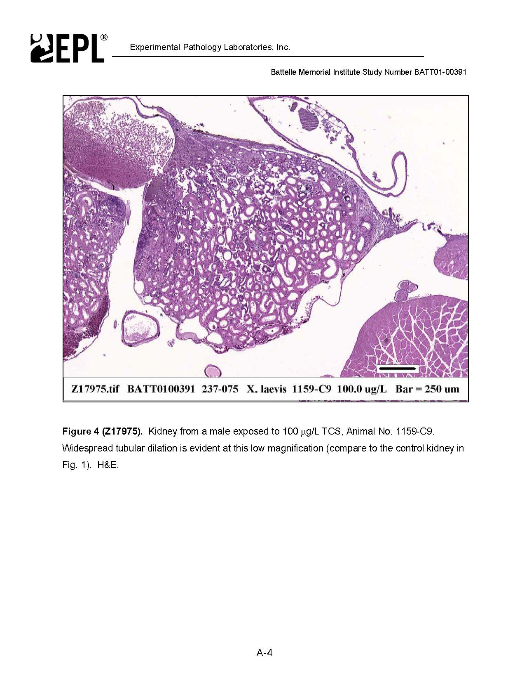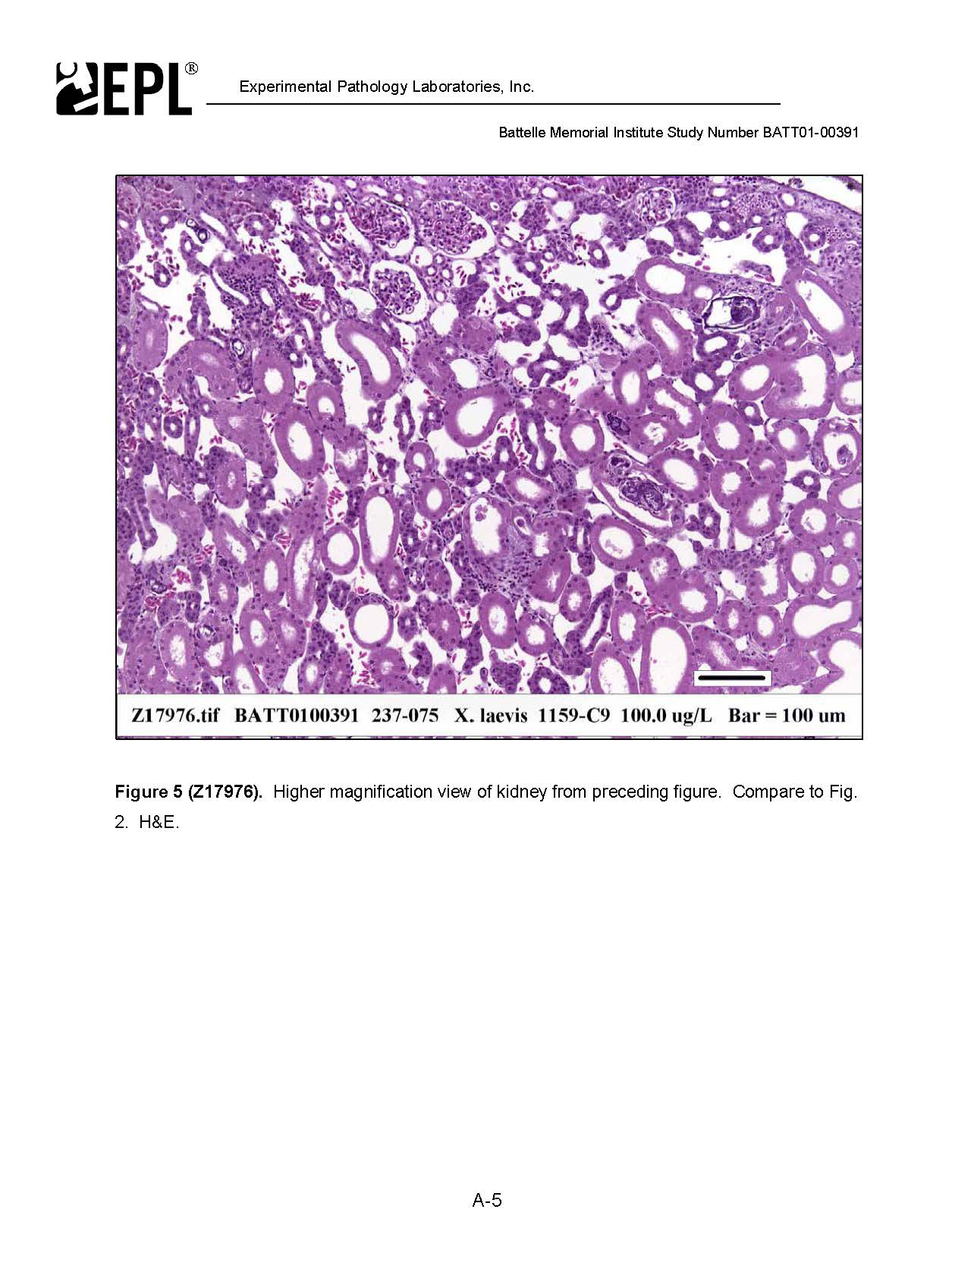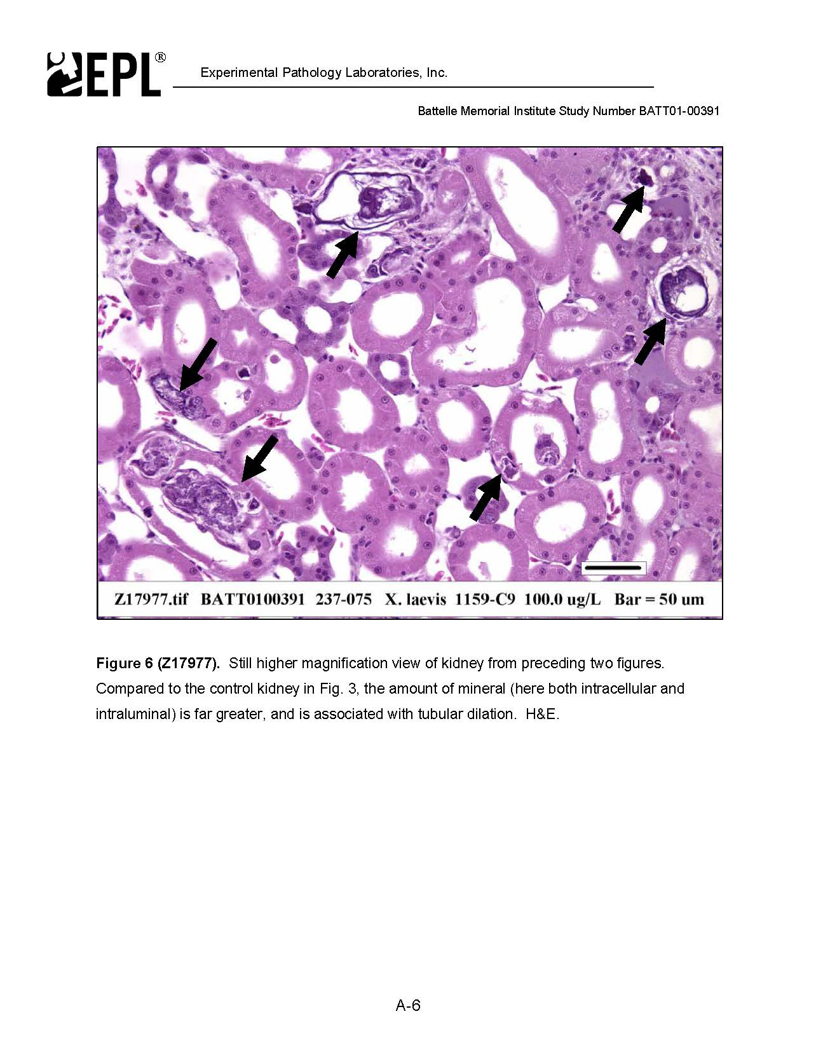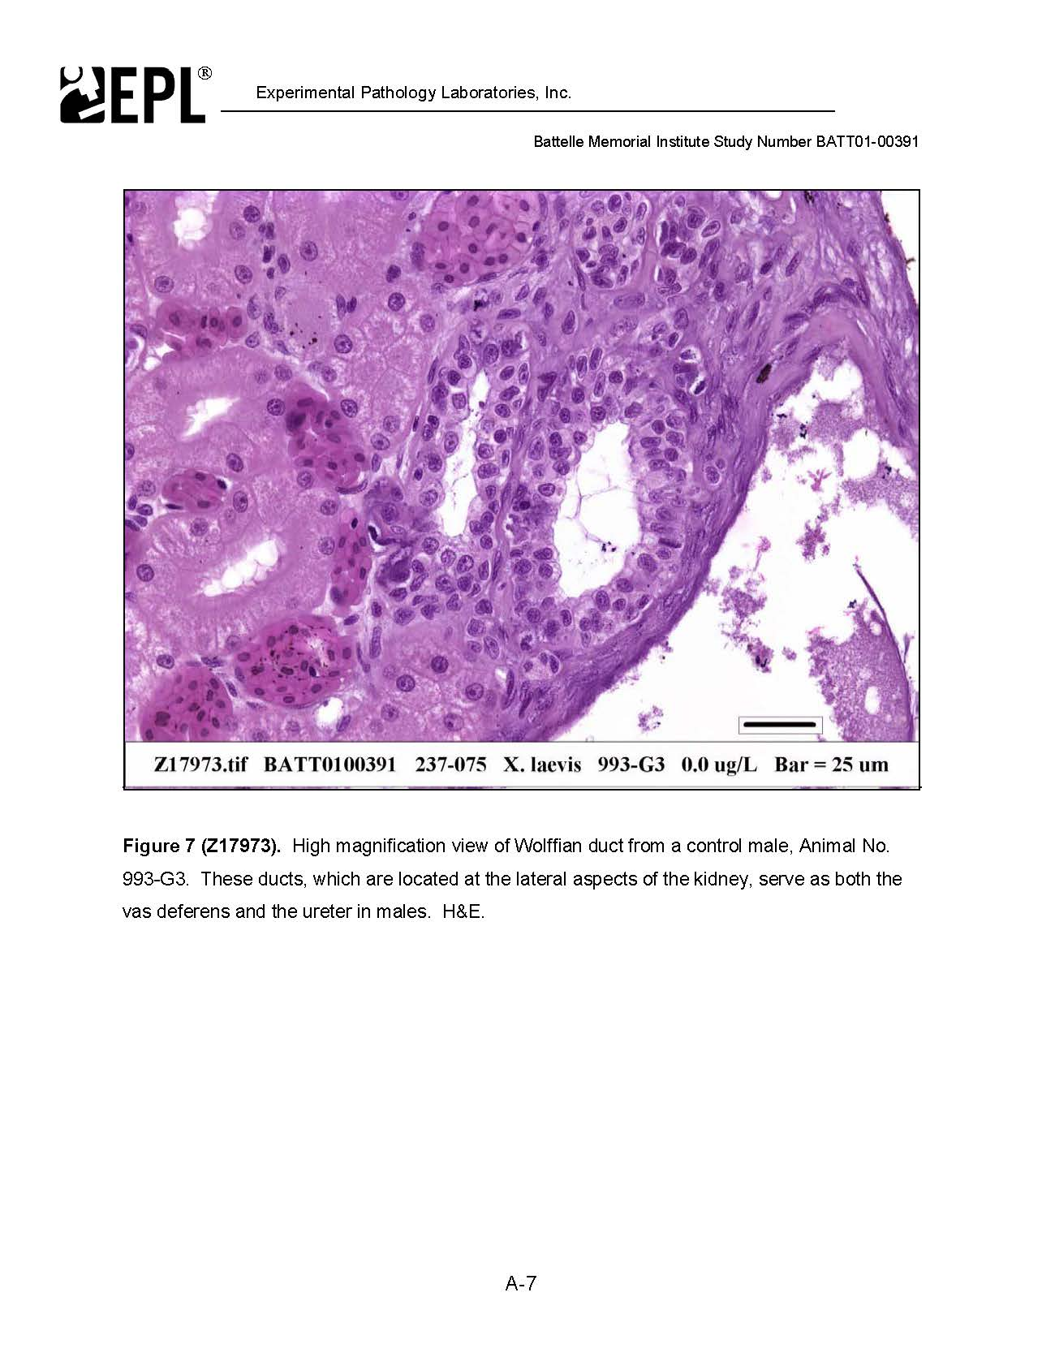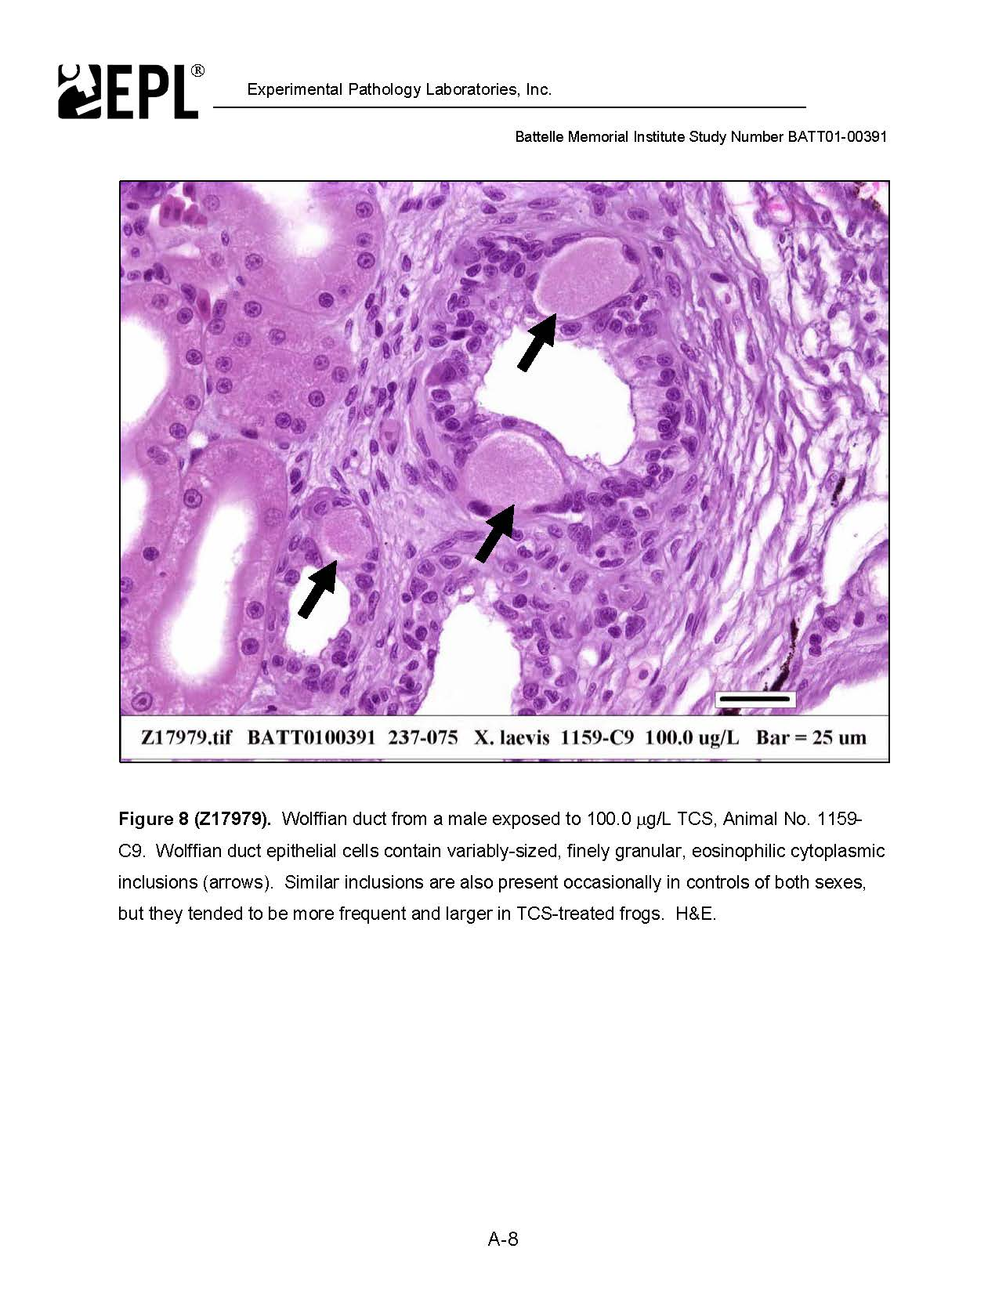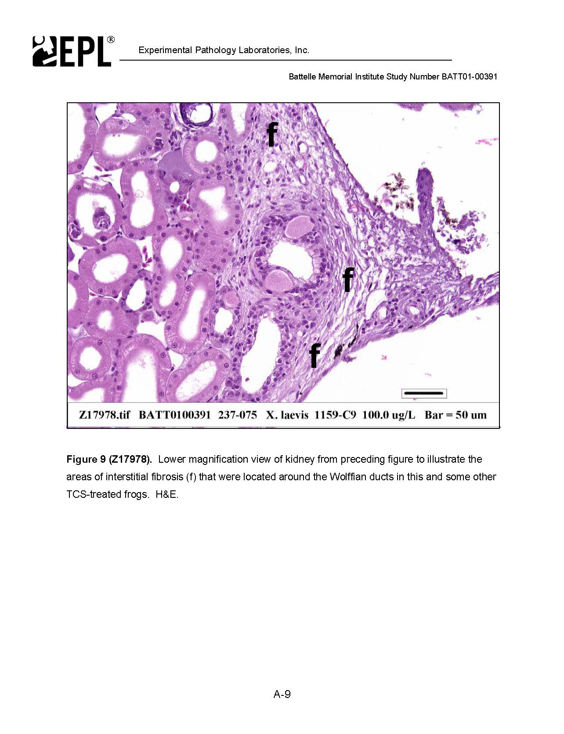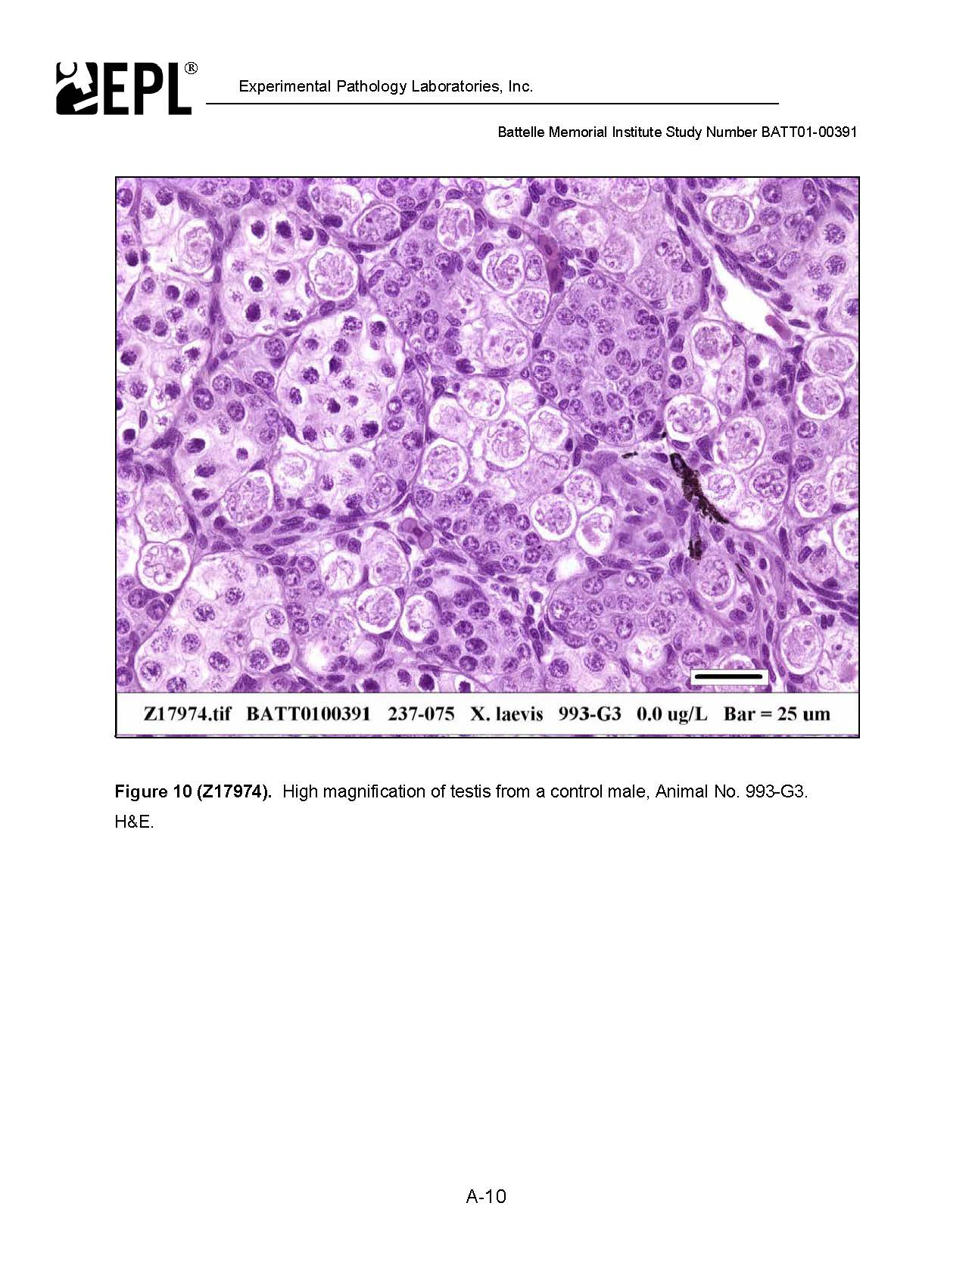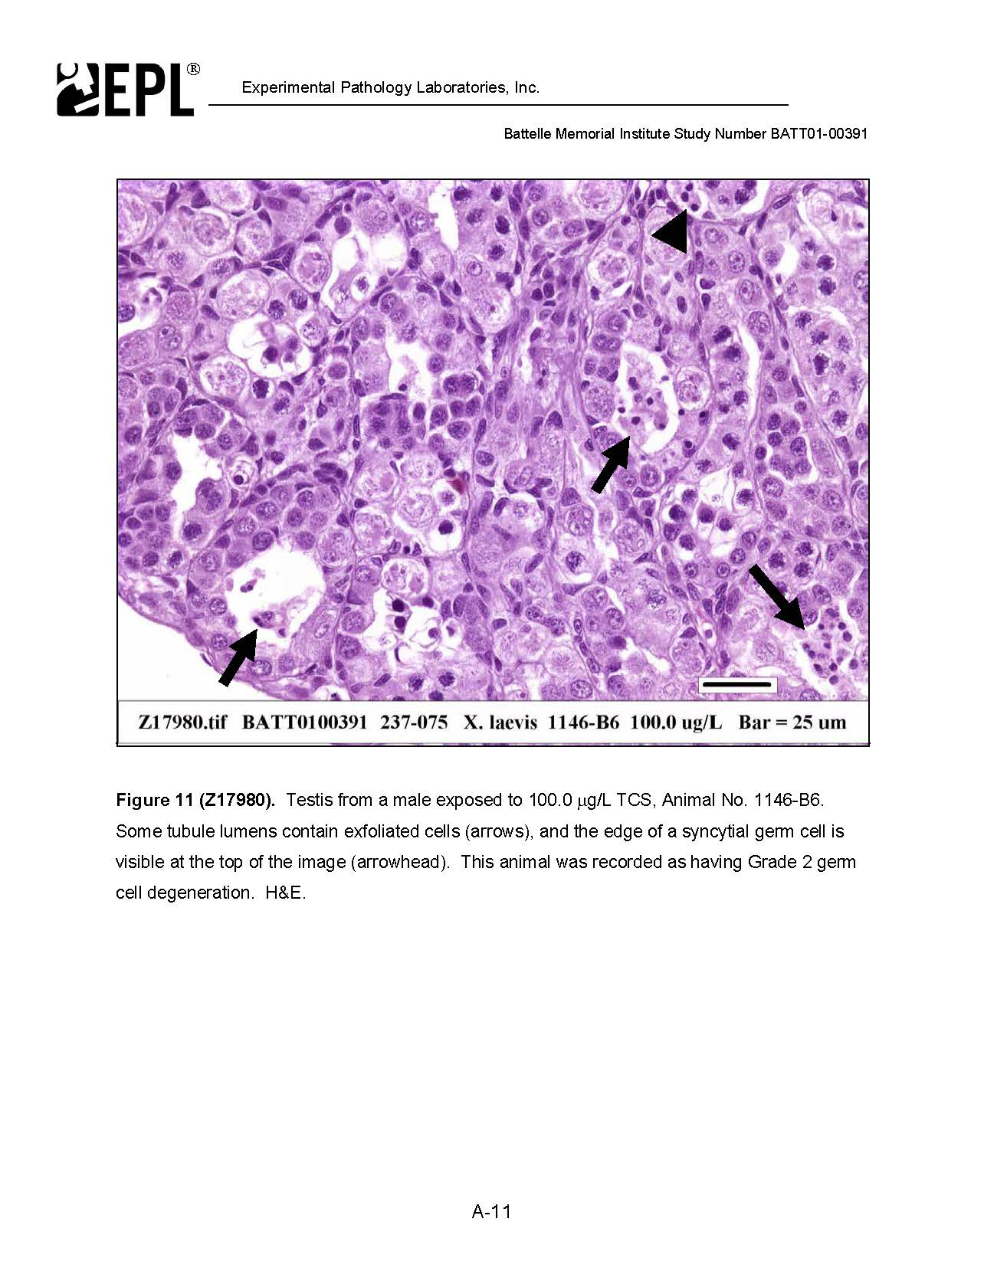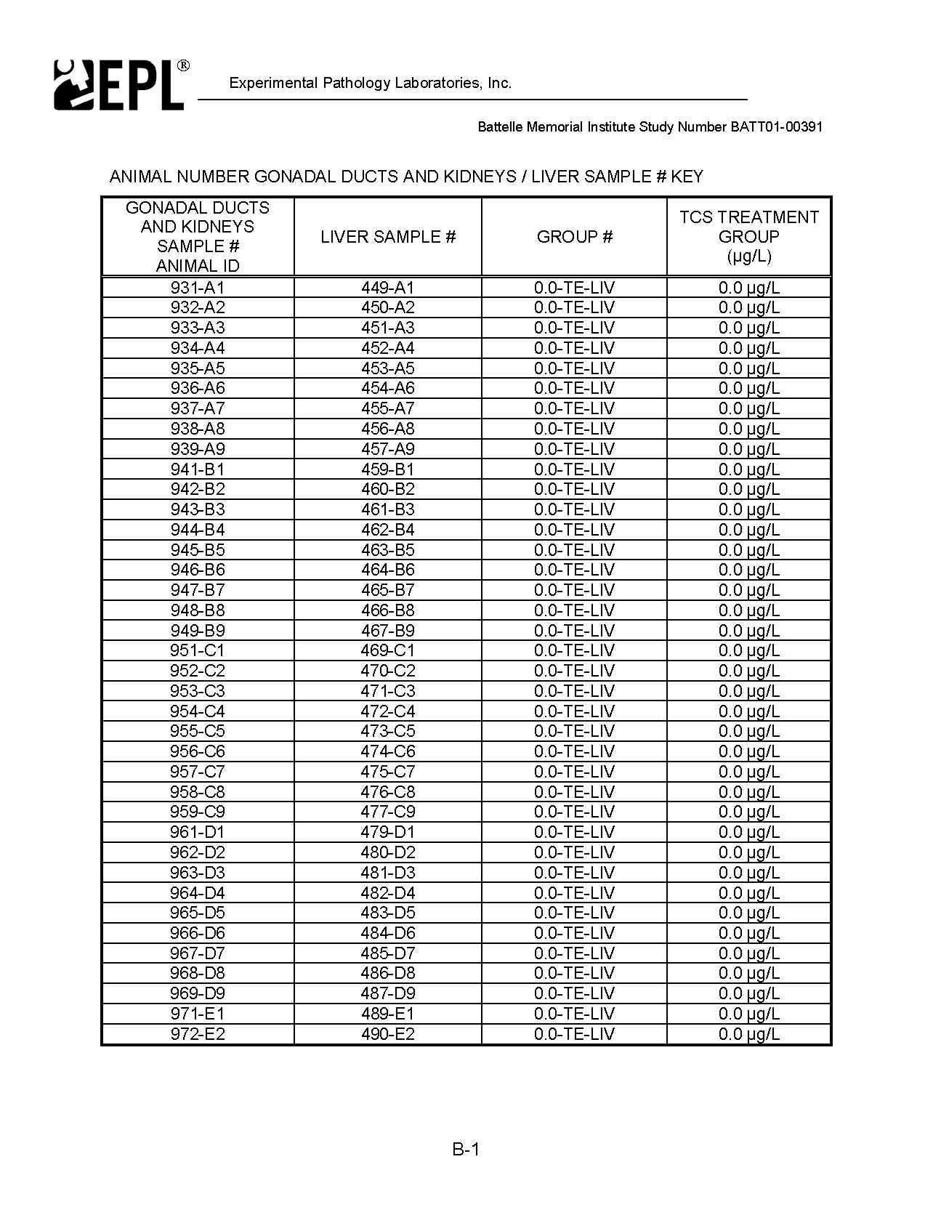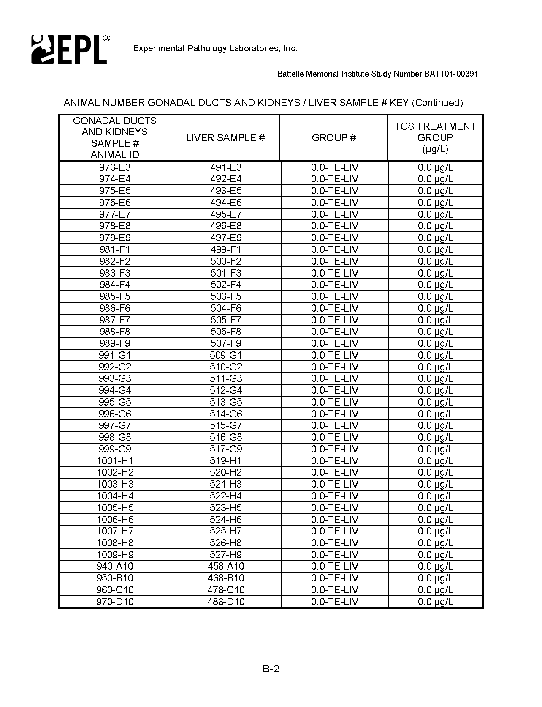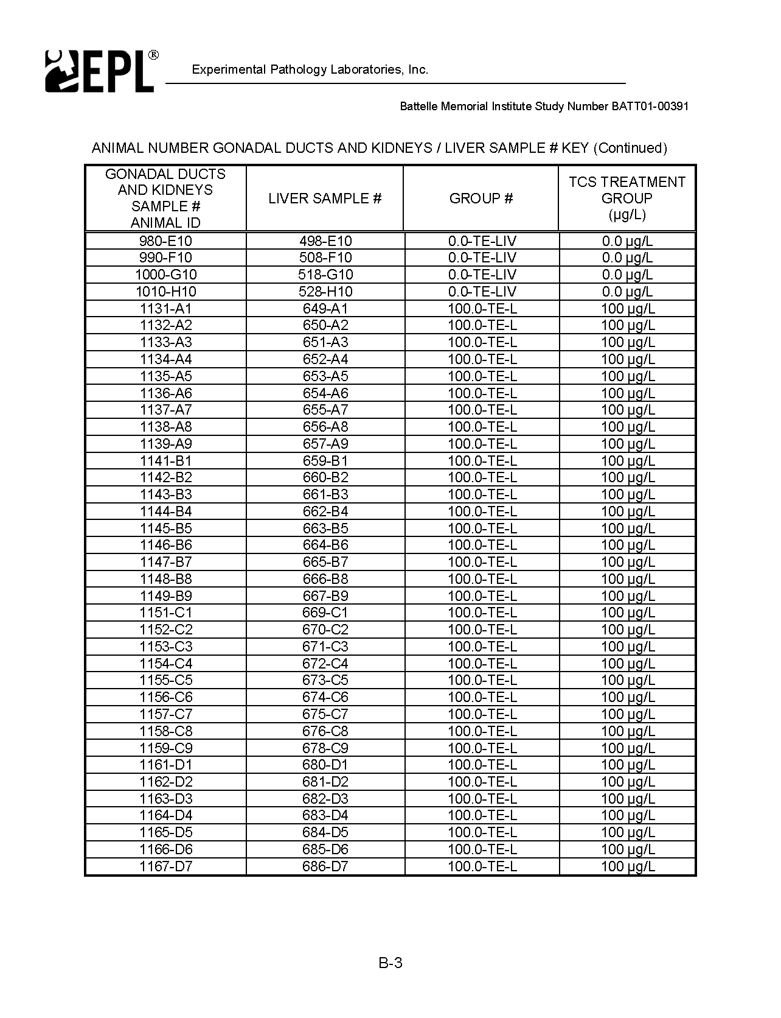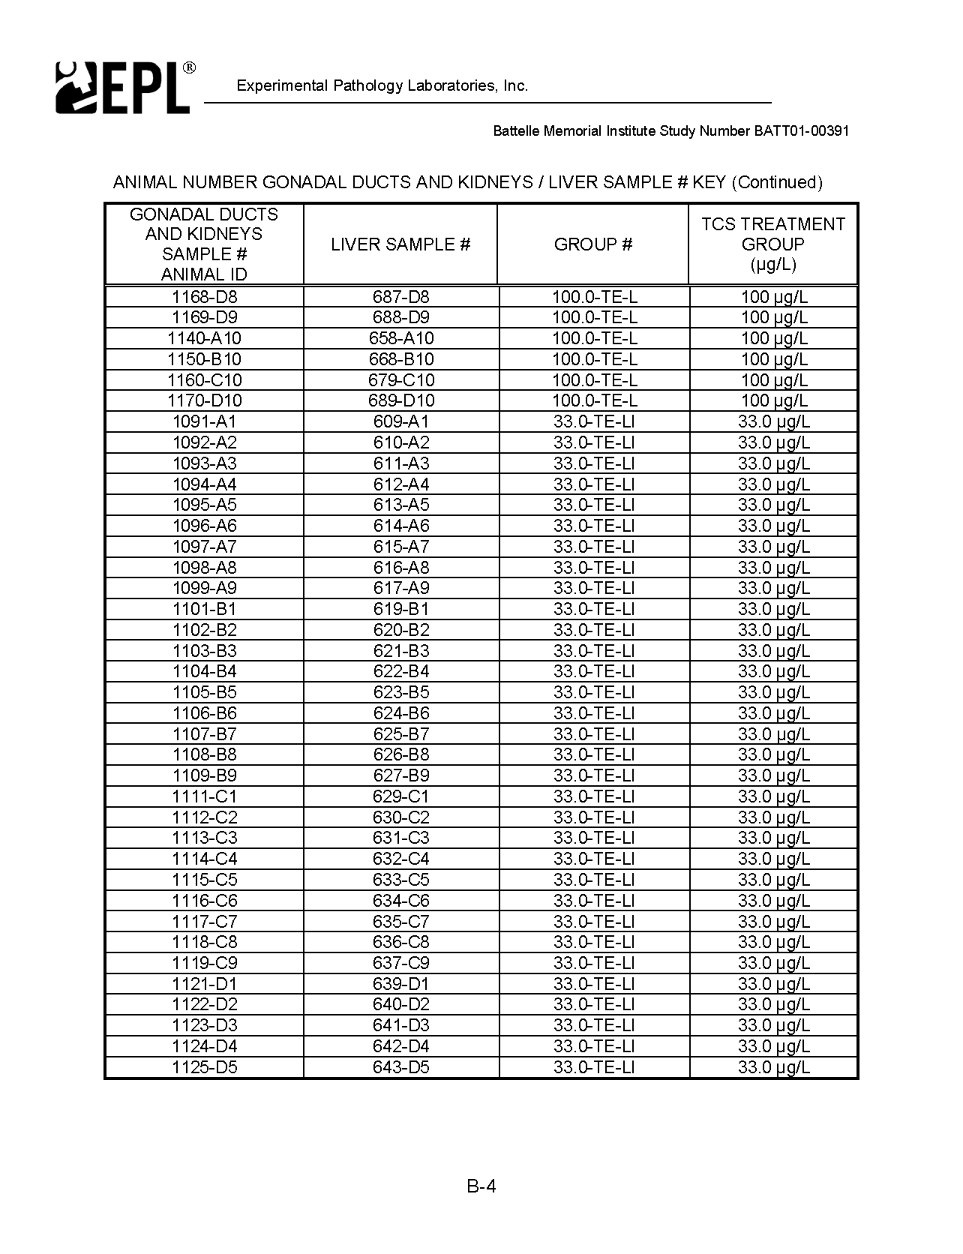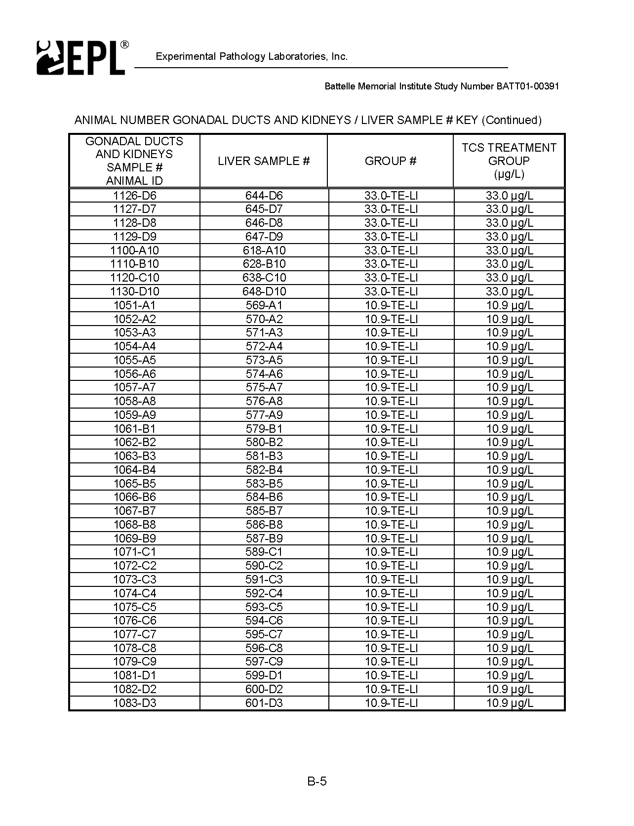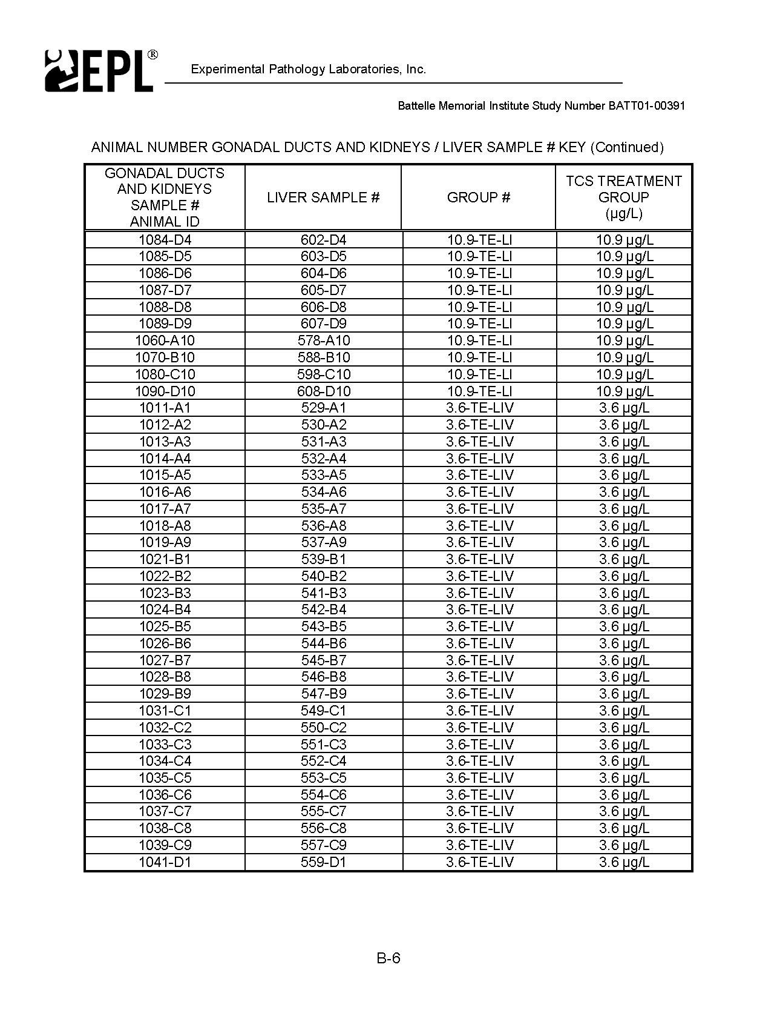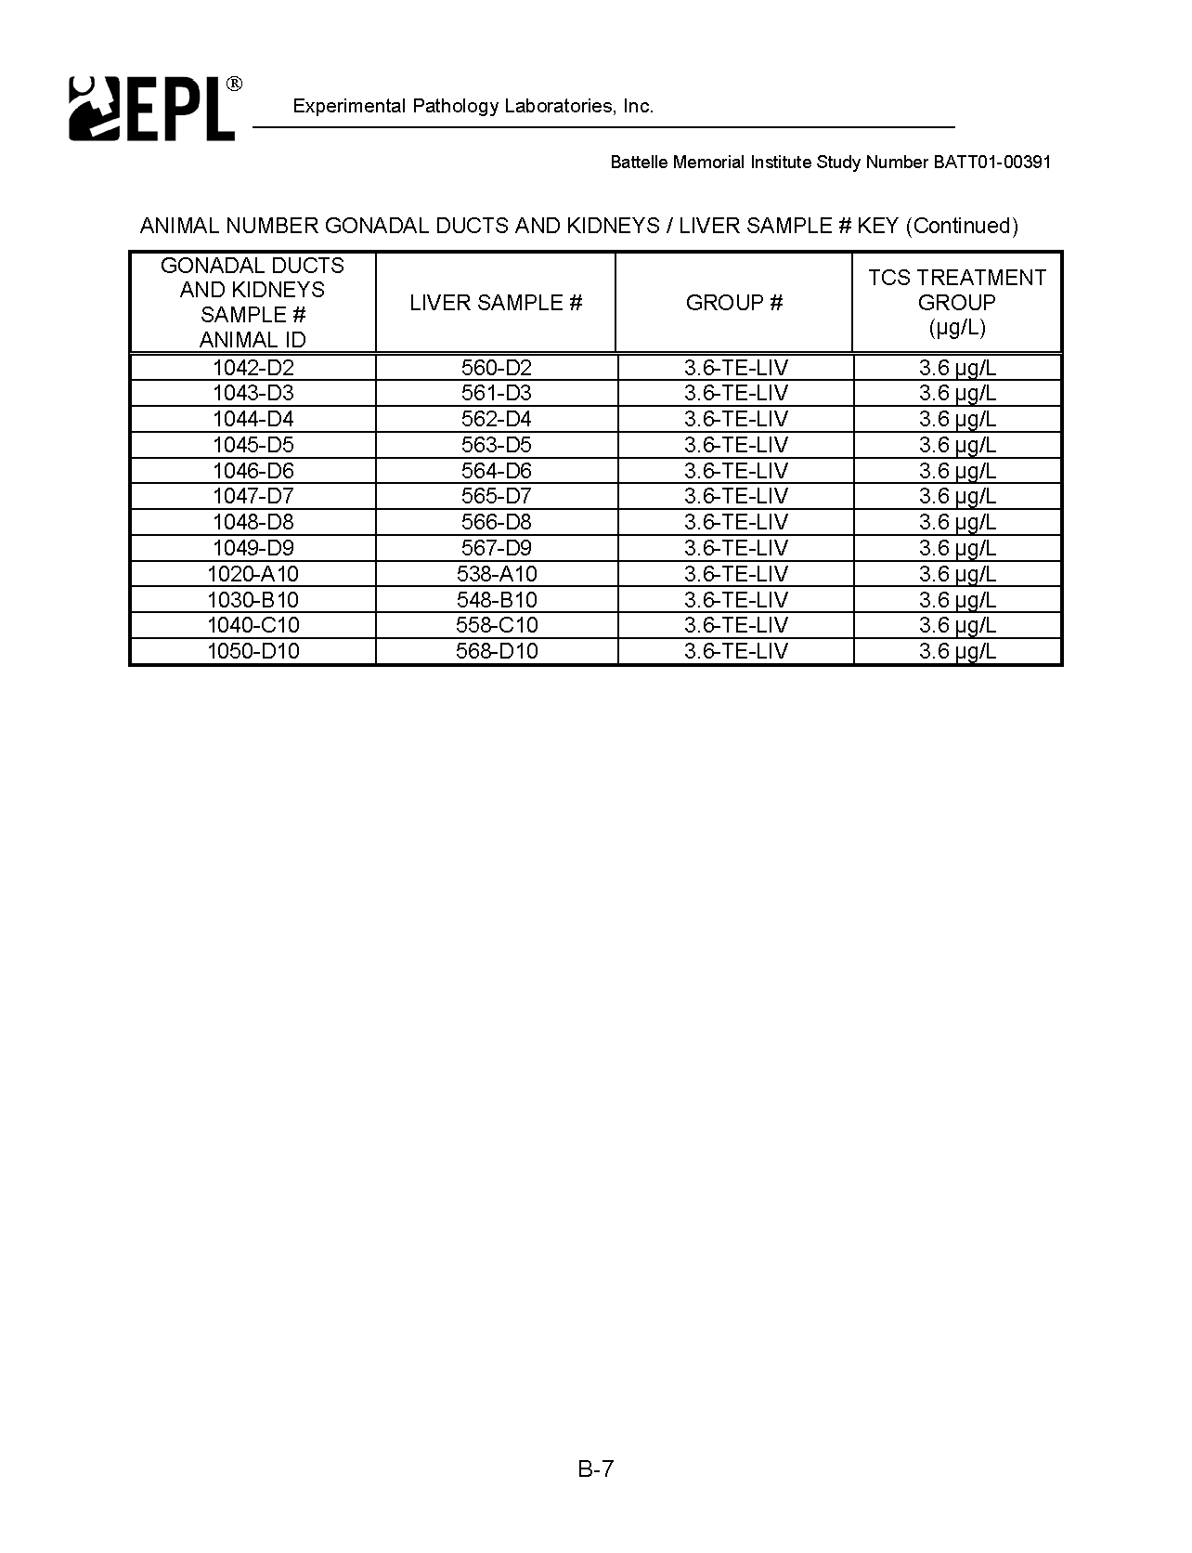

DEST

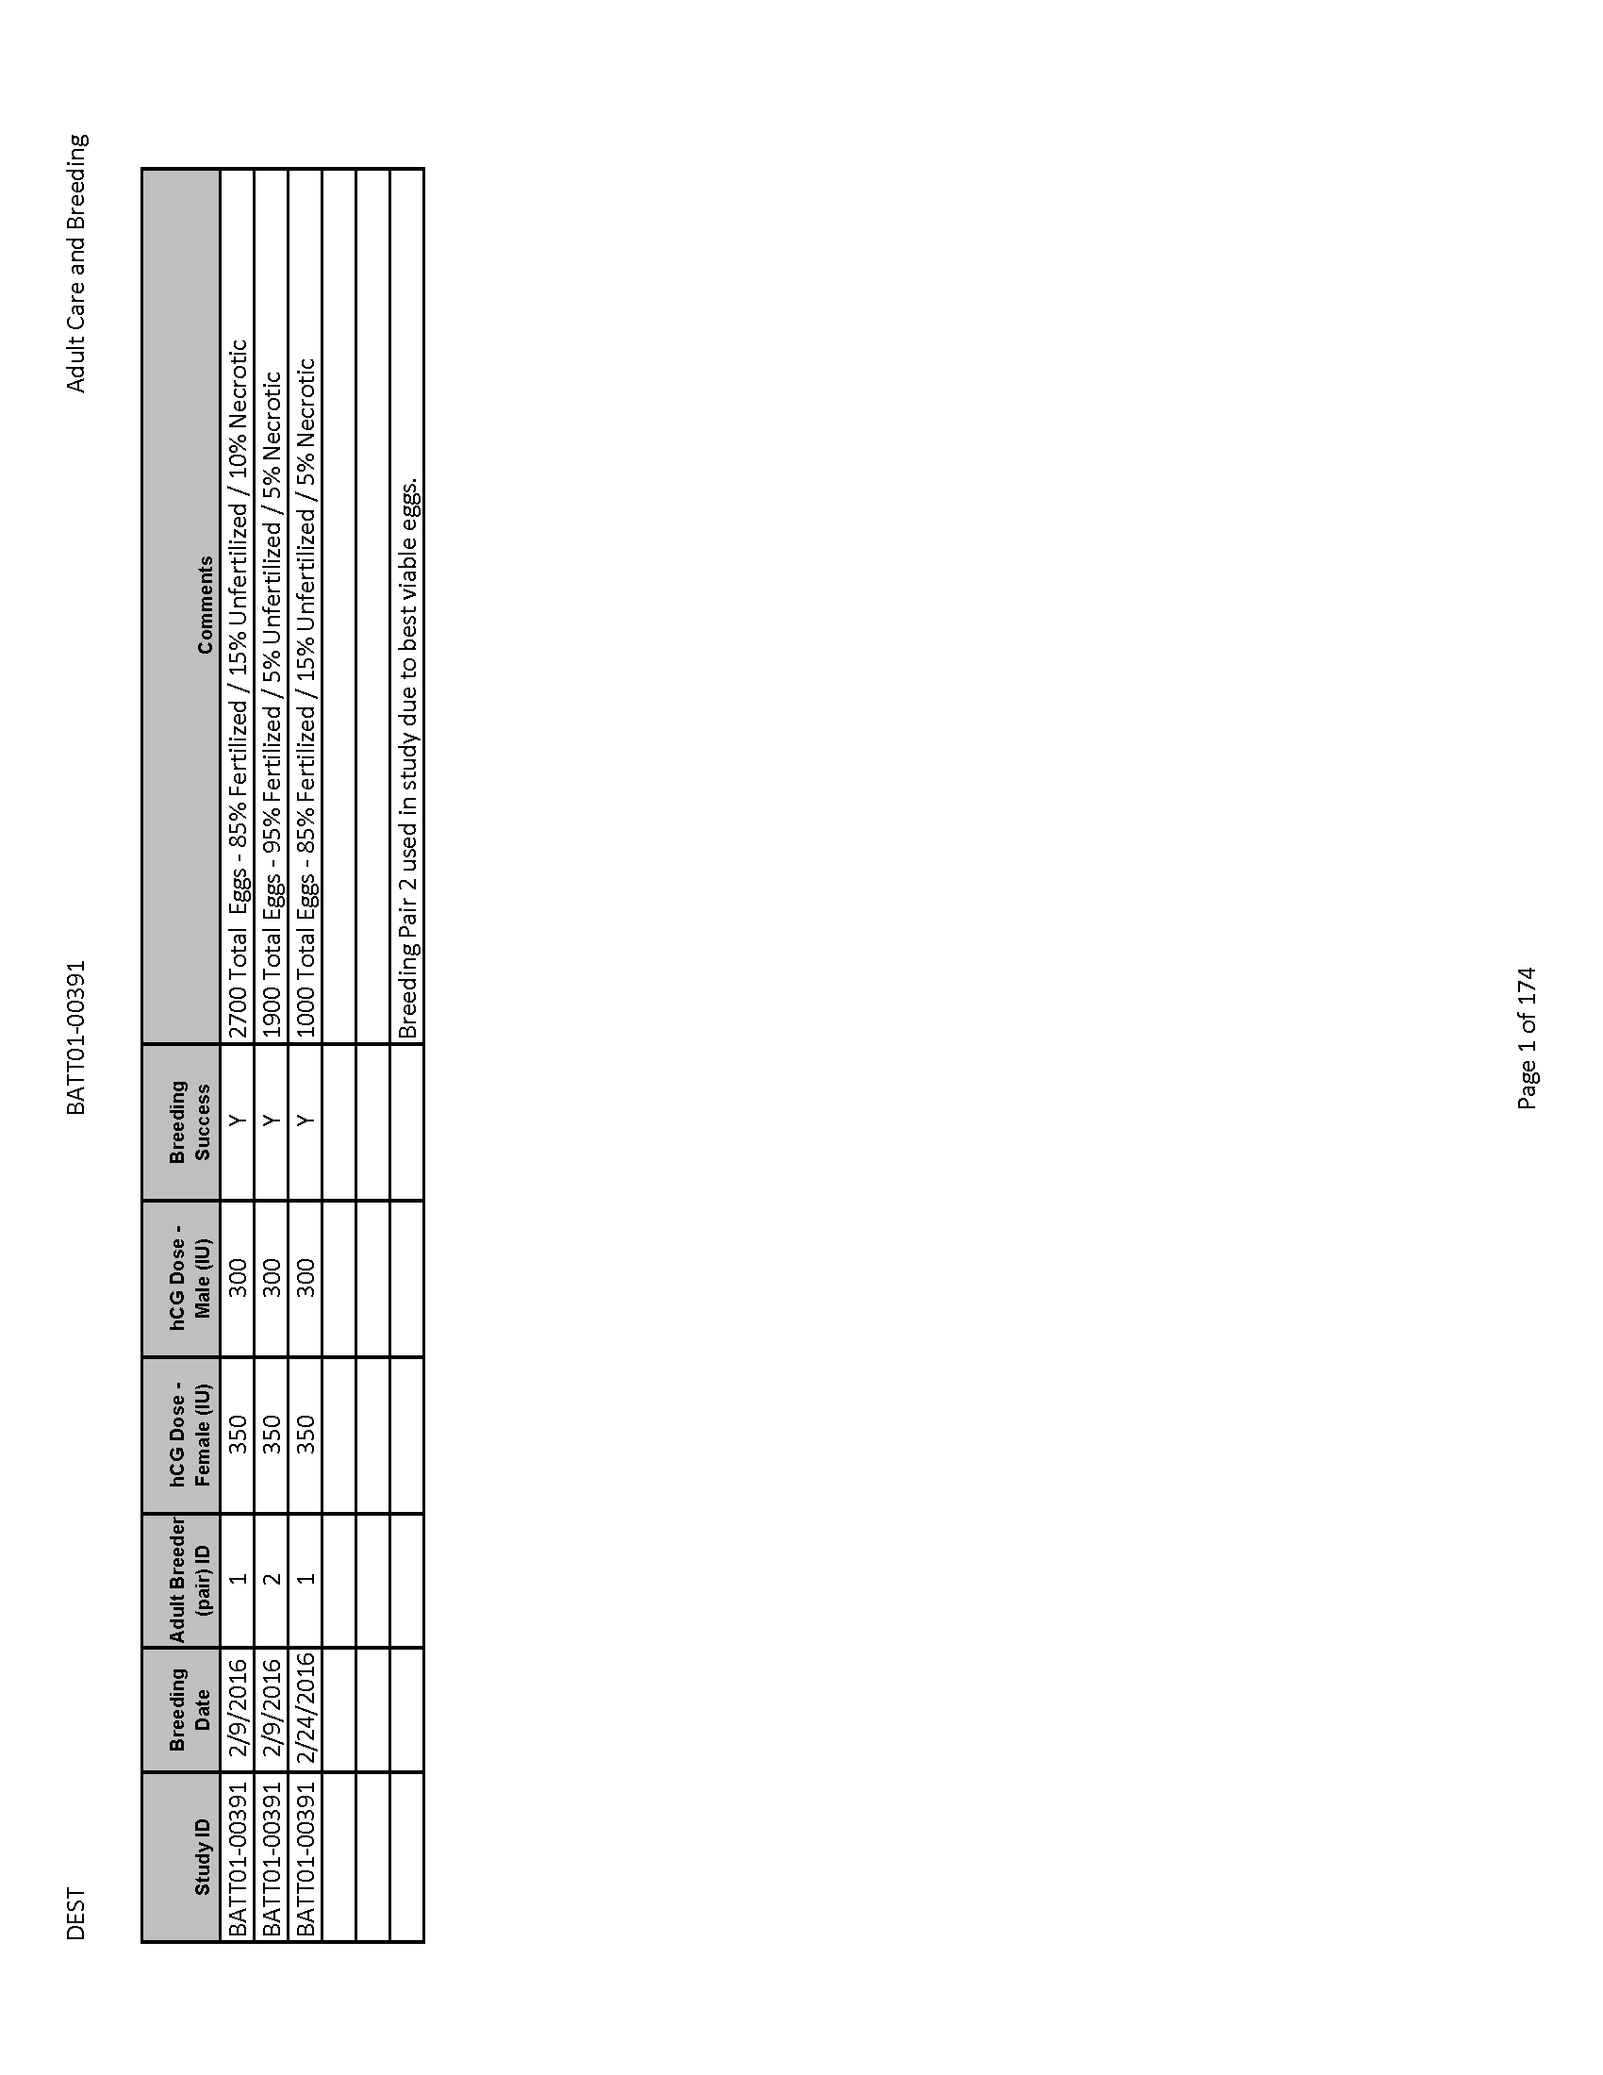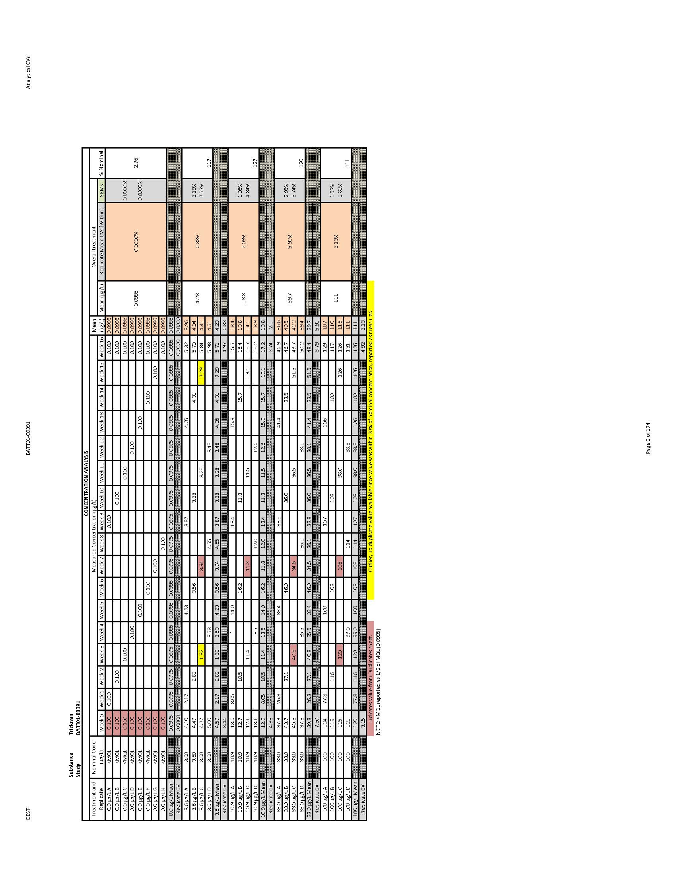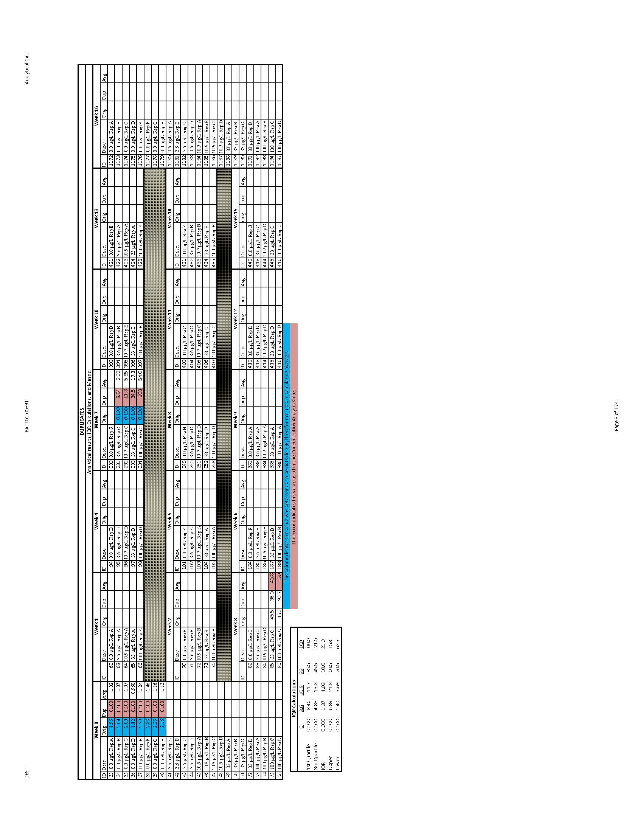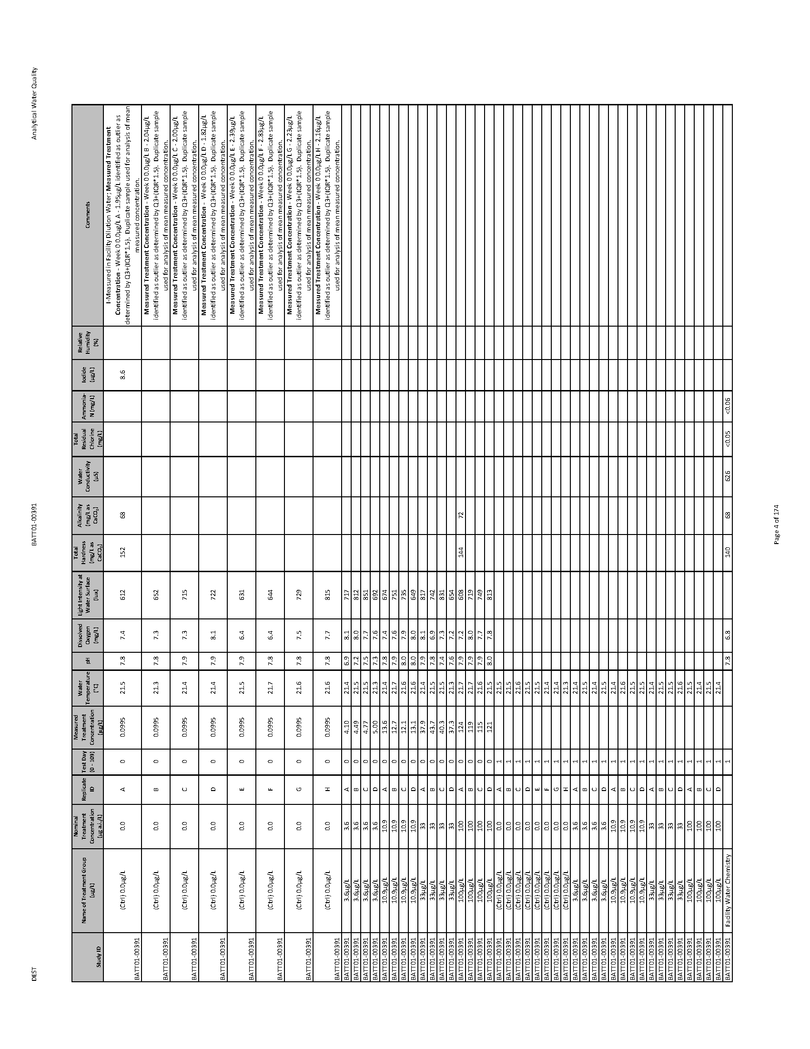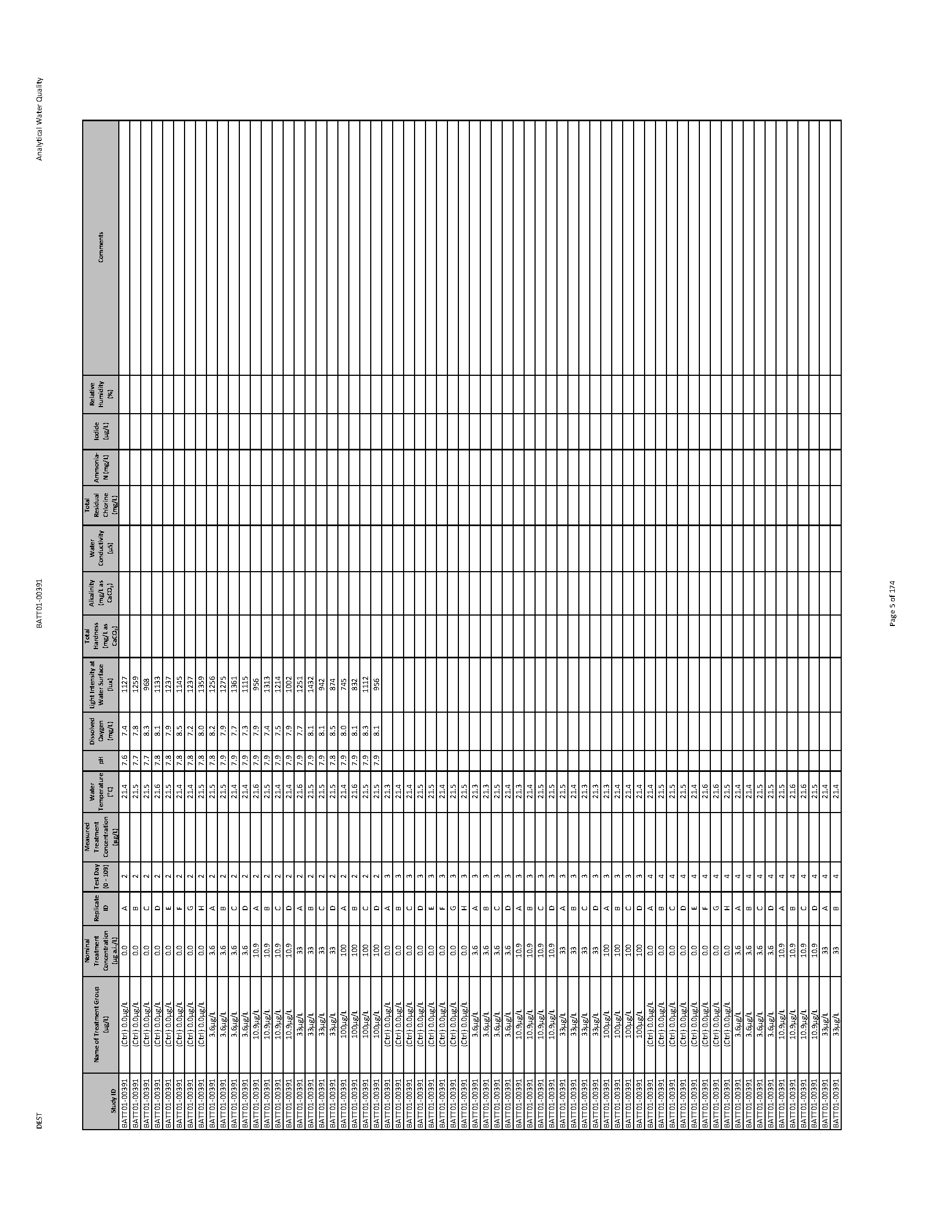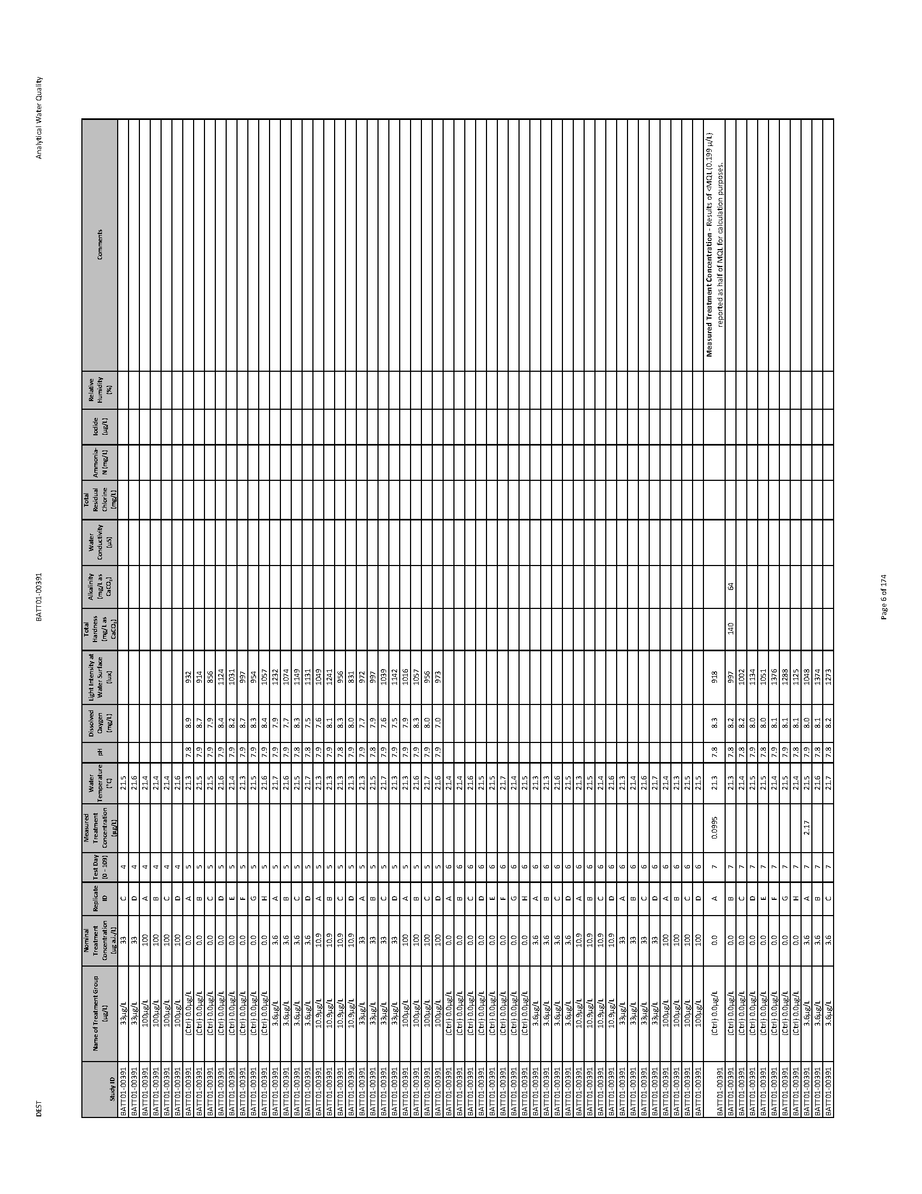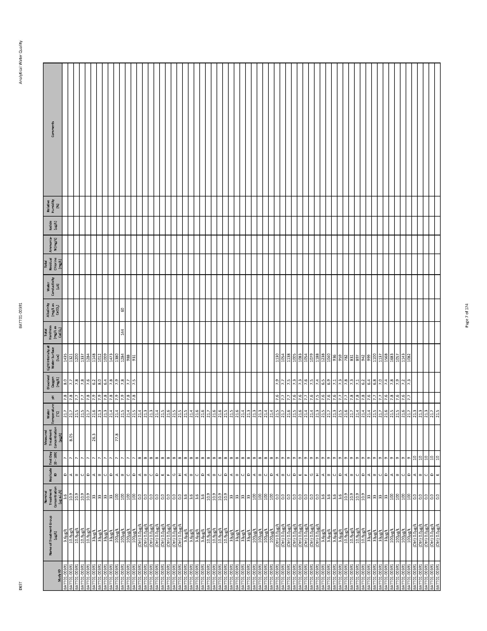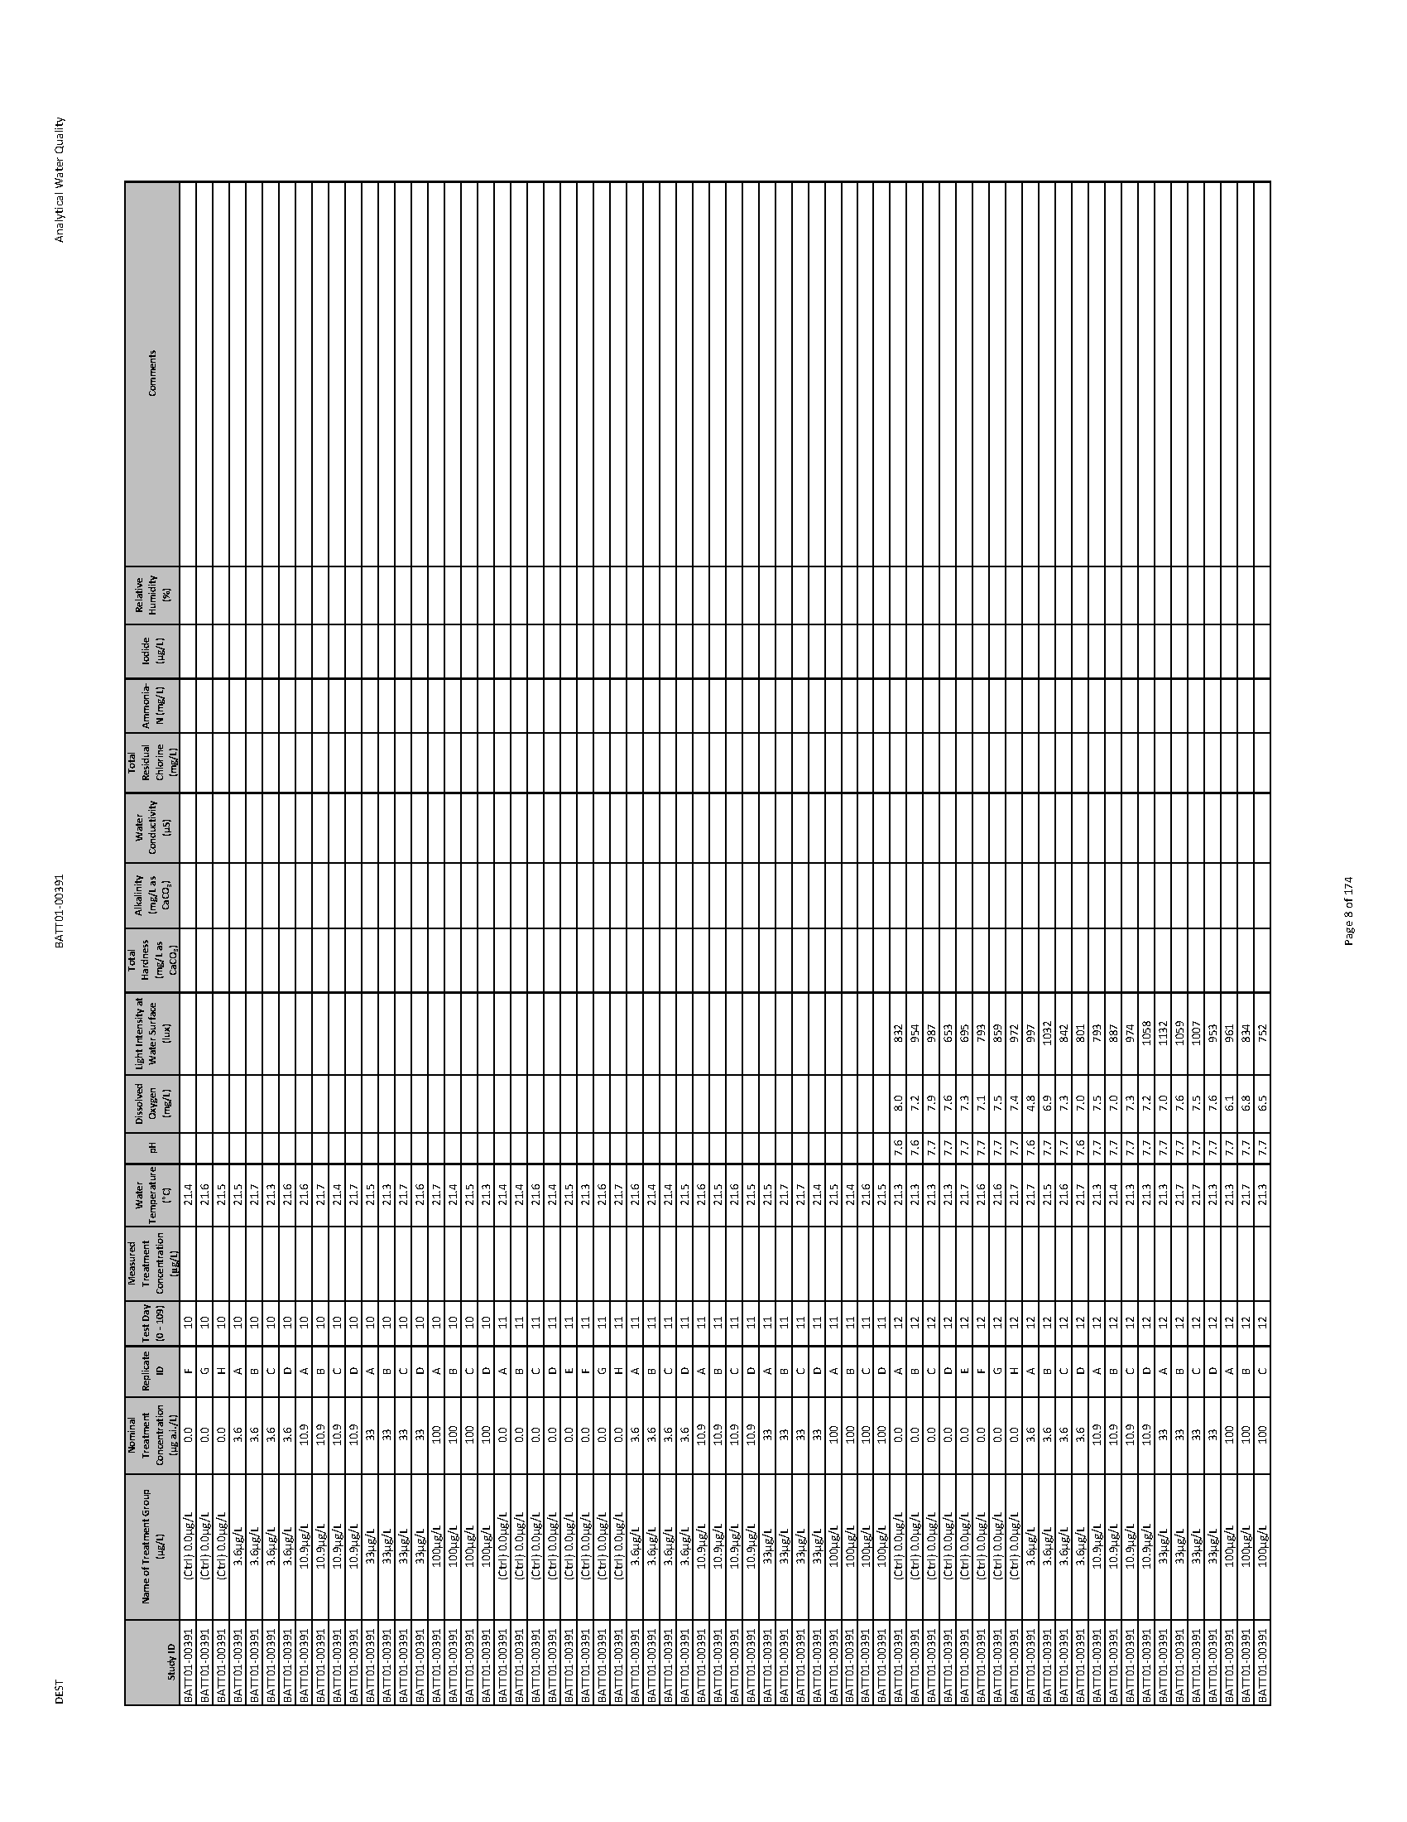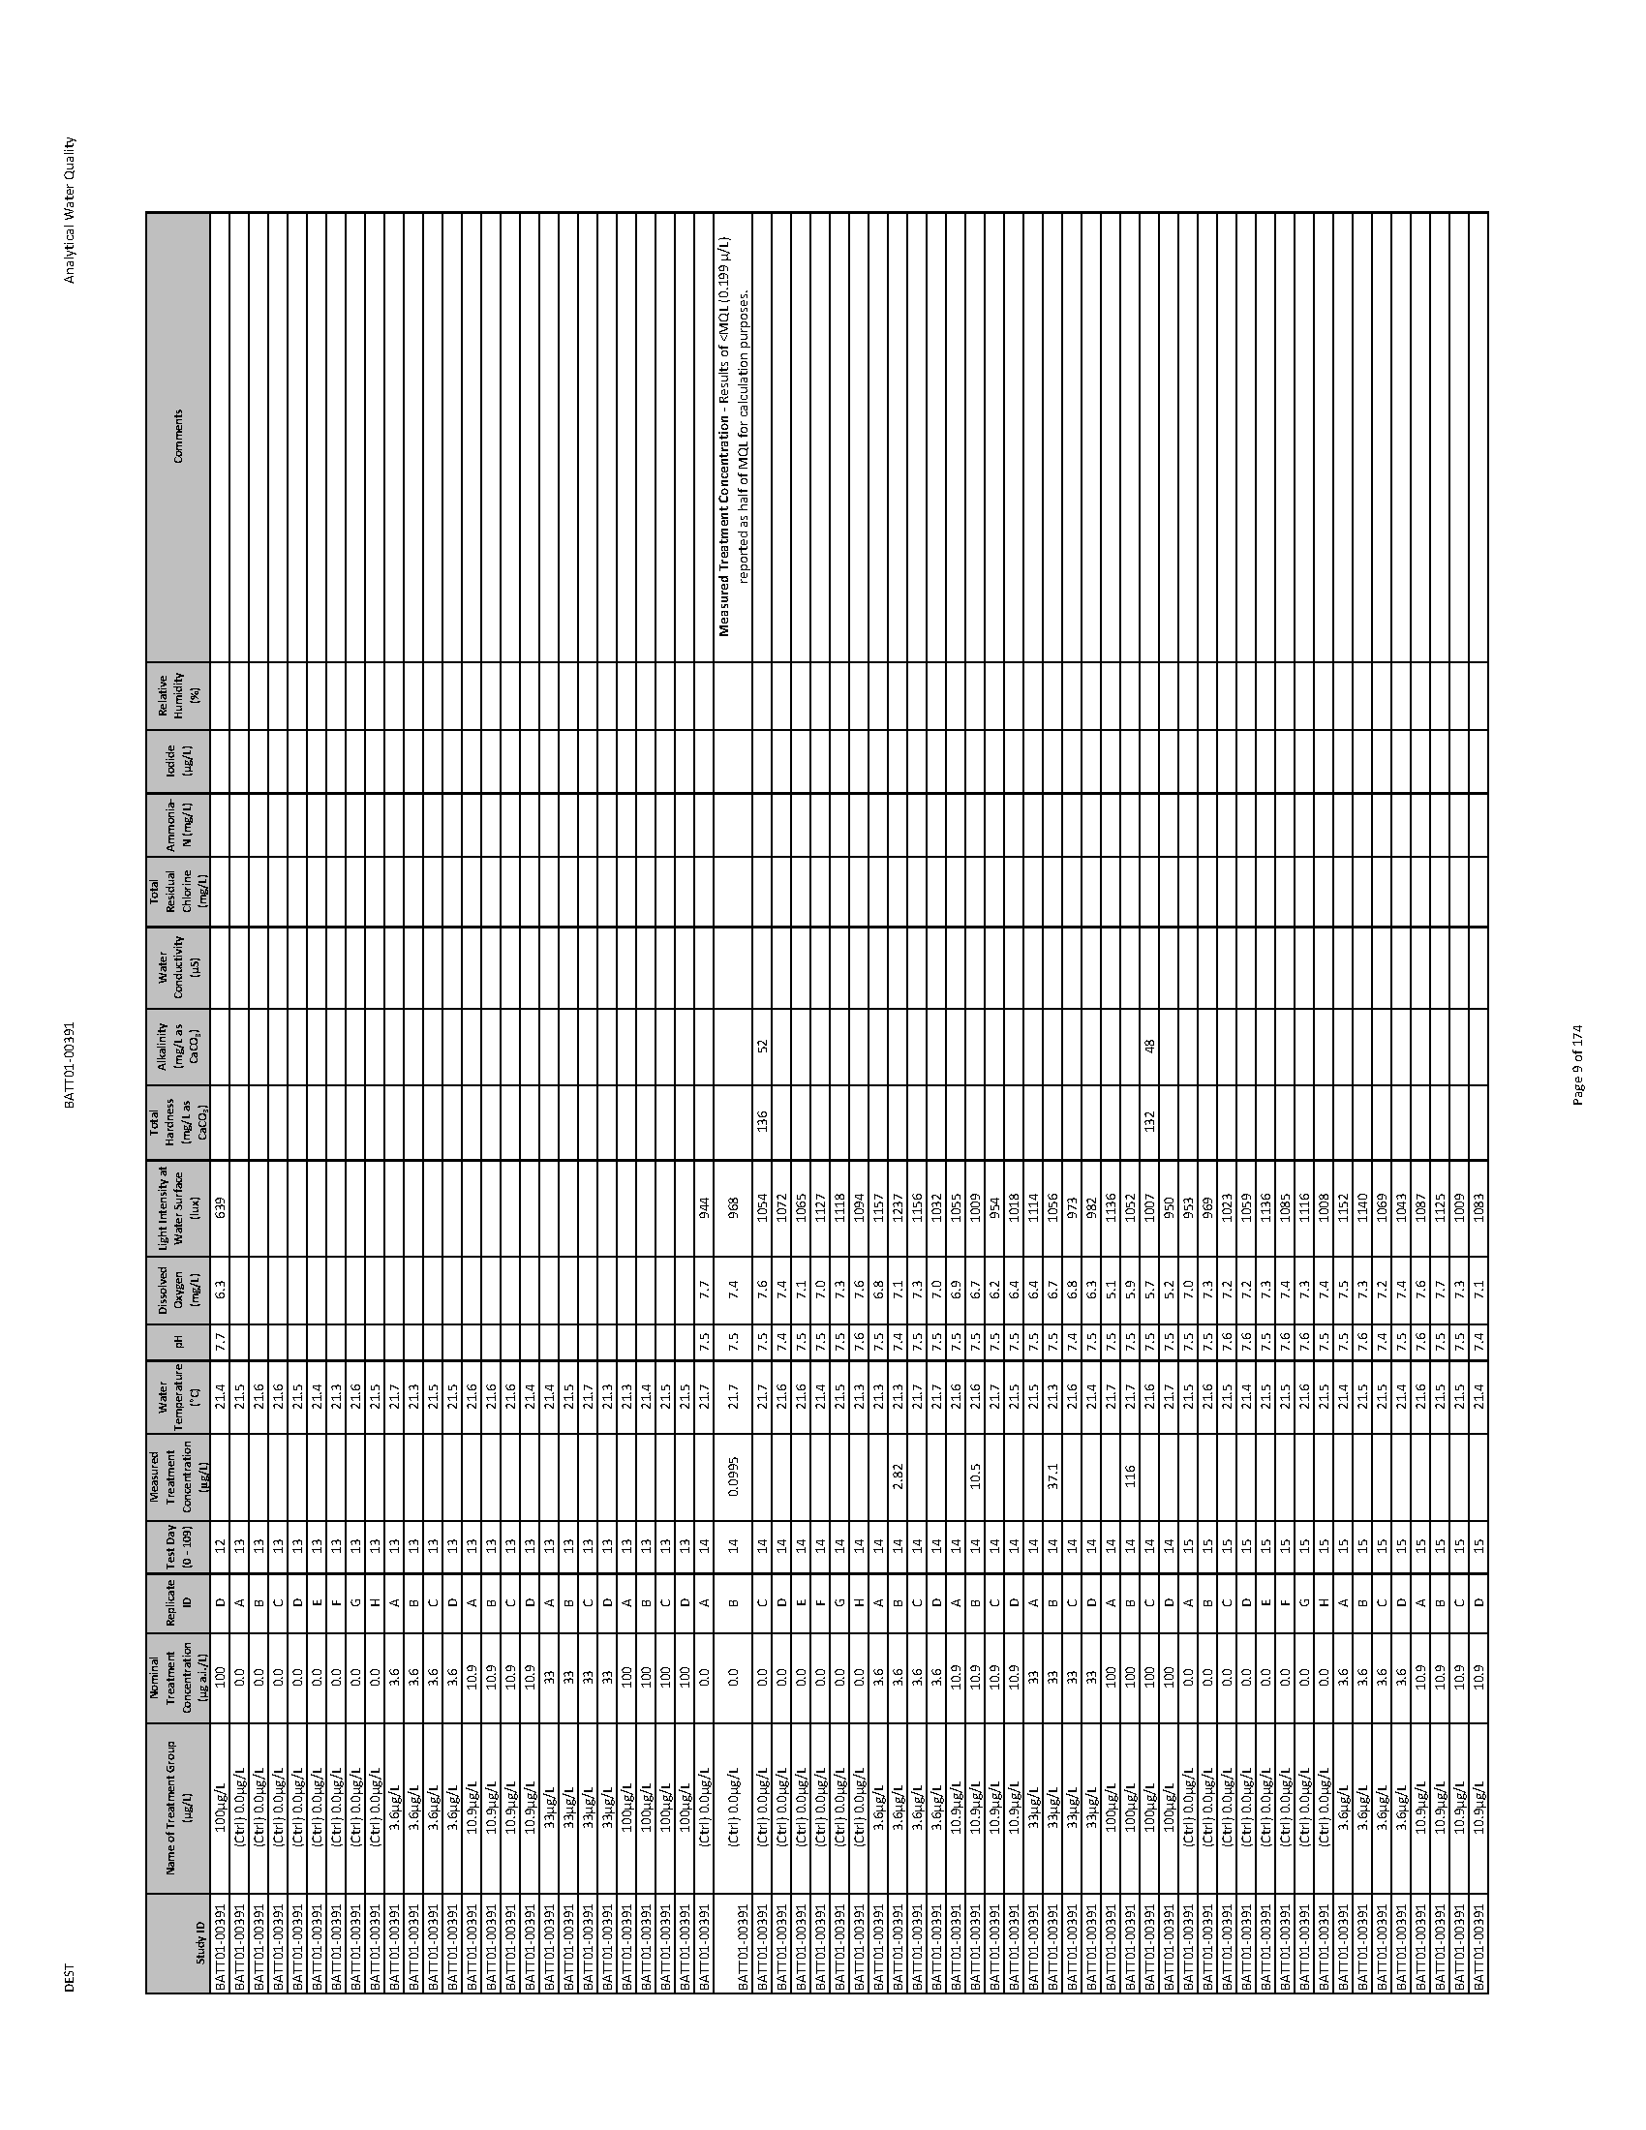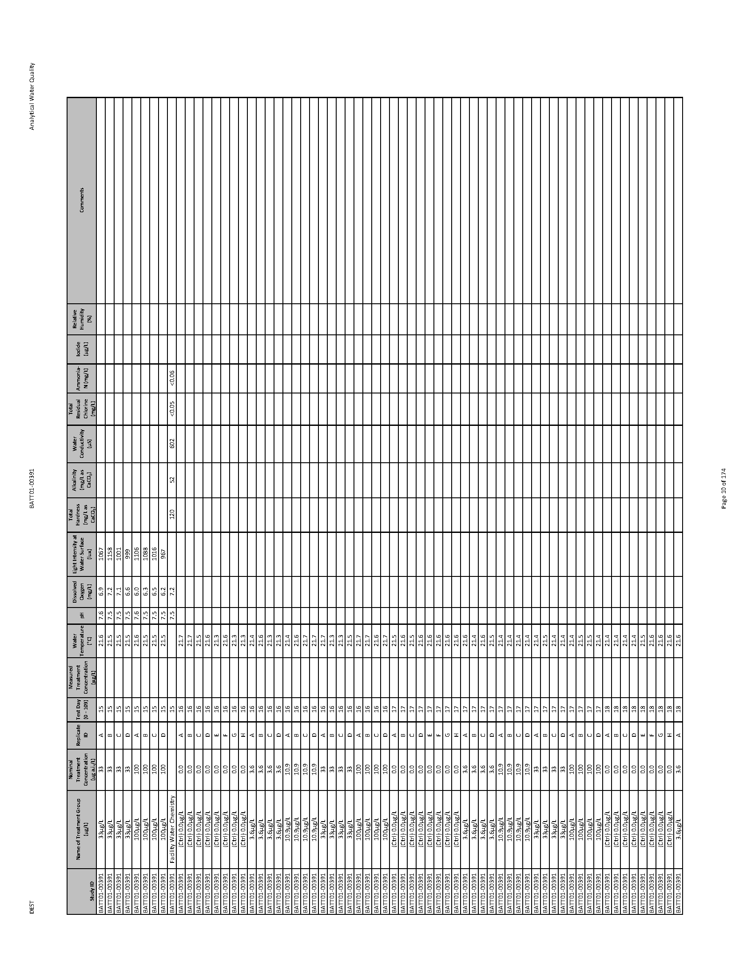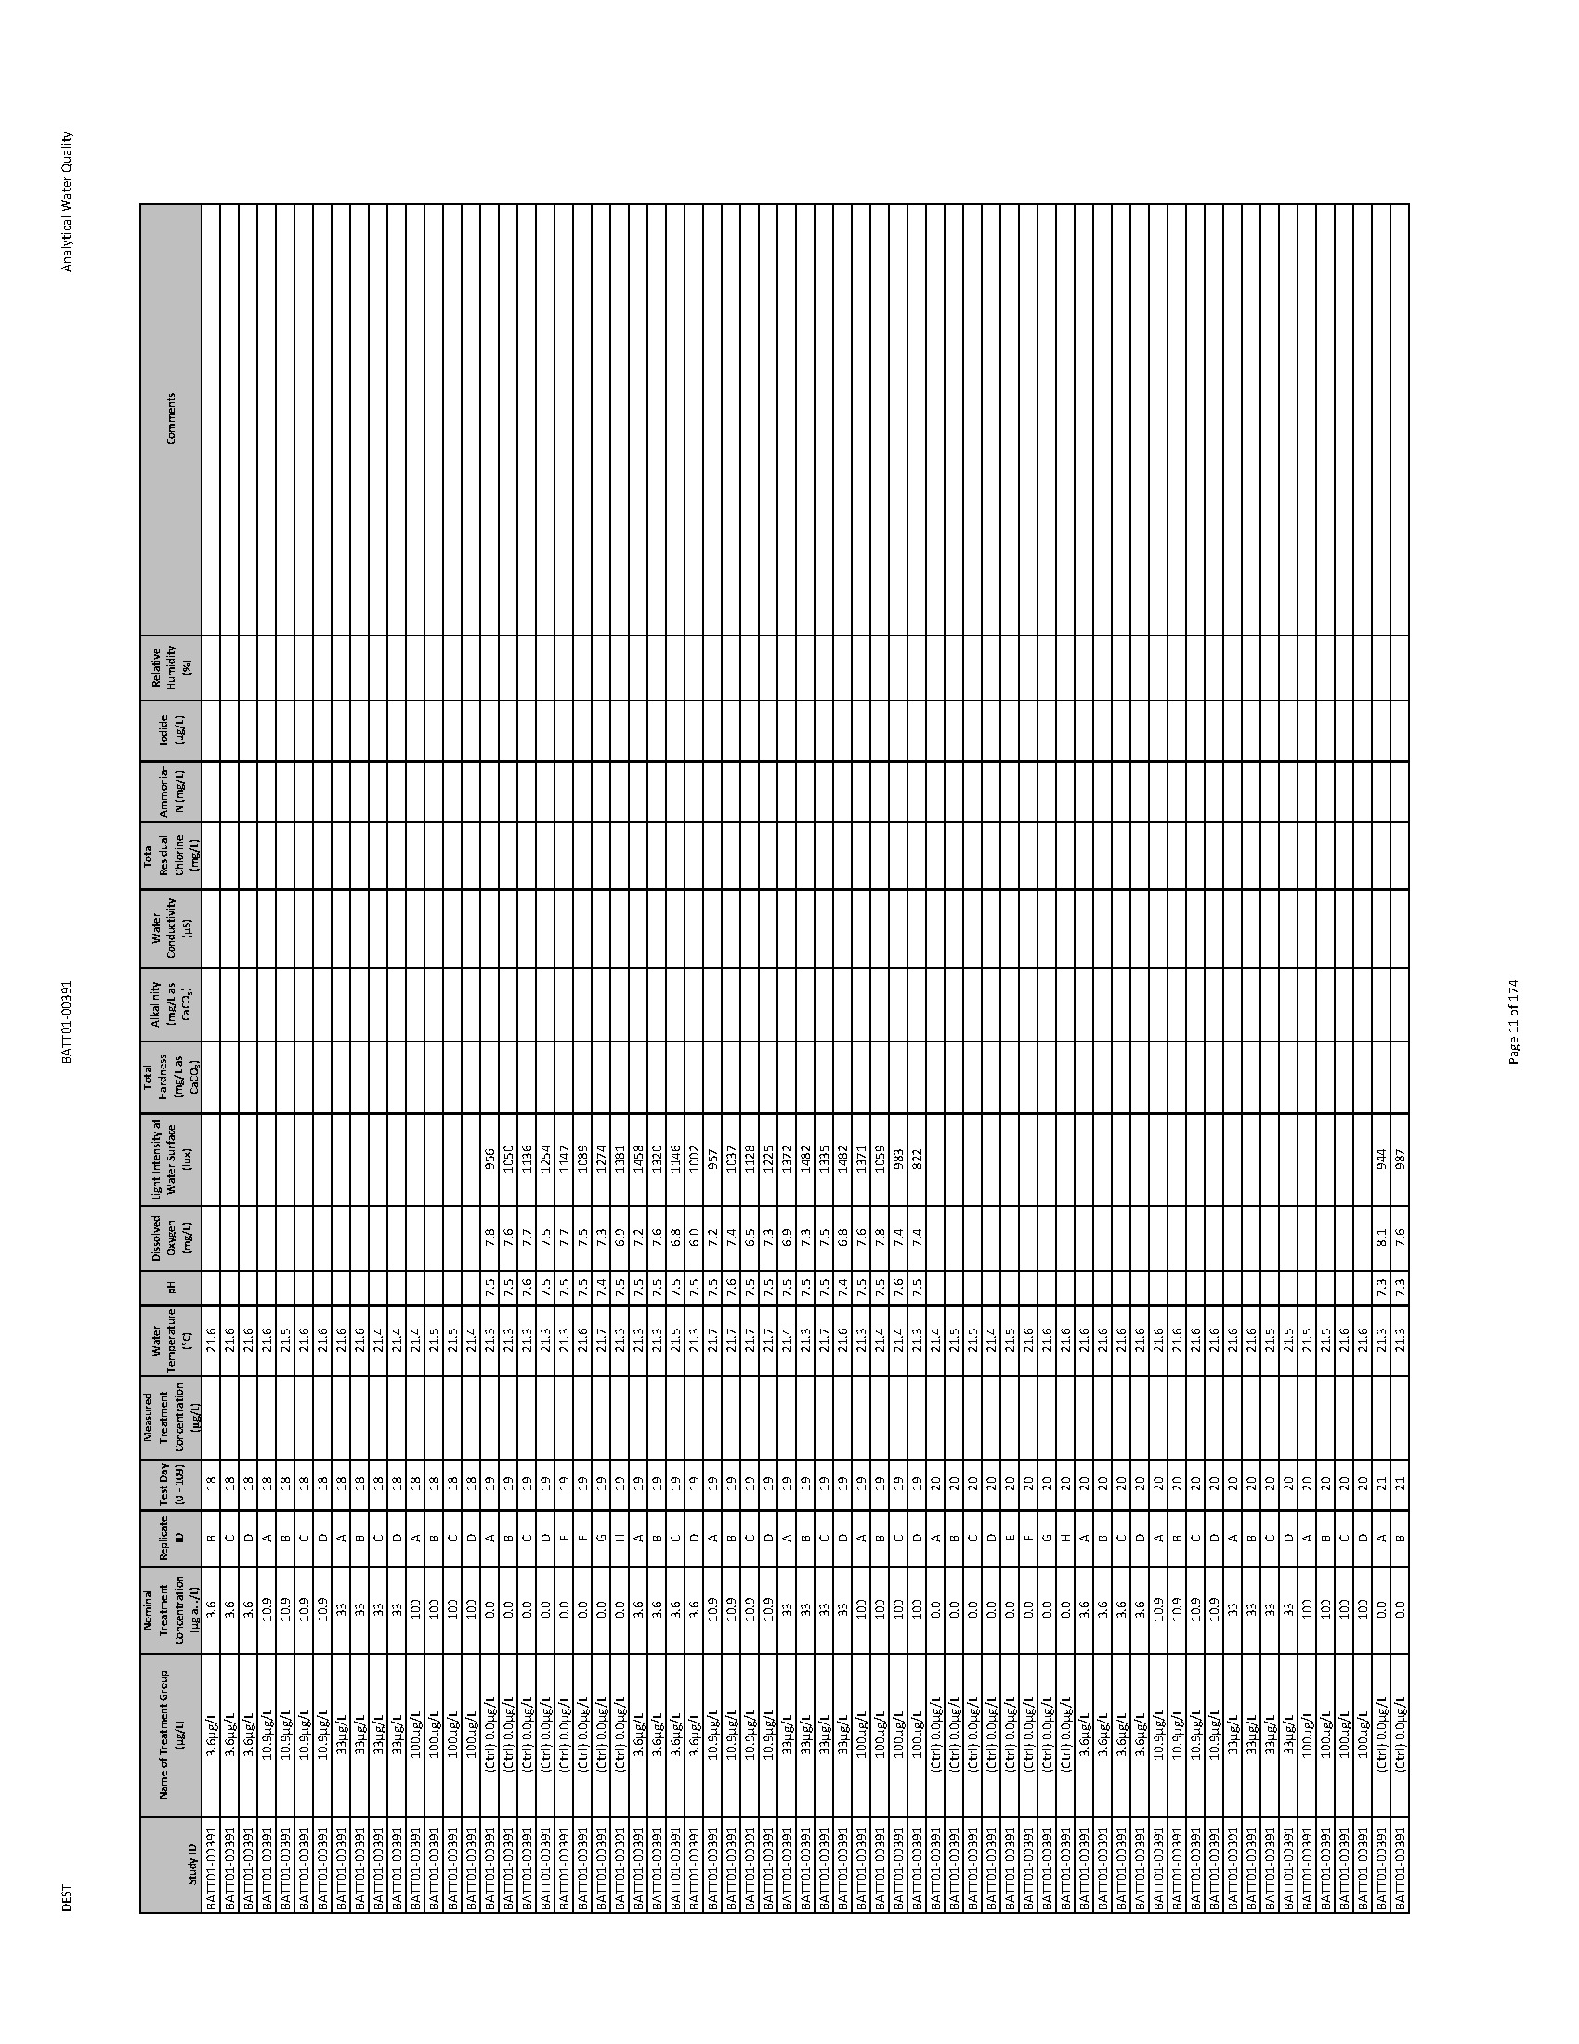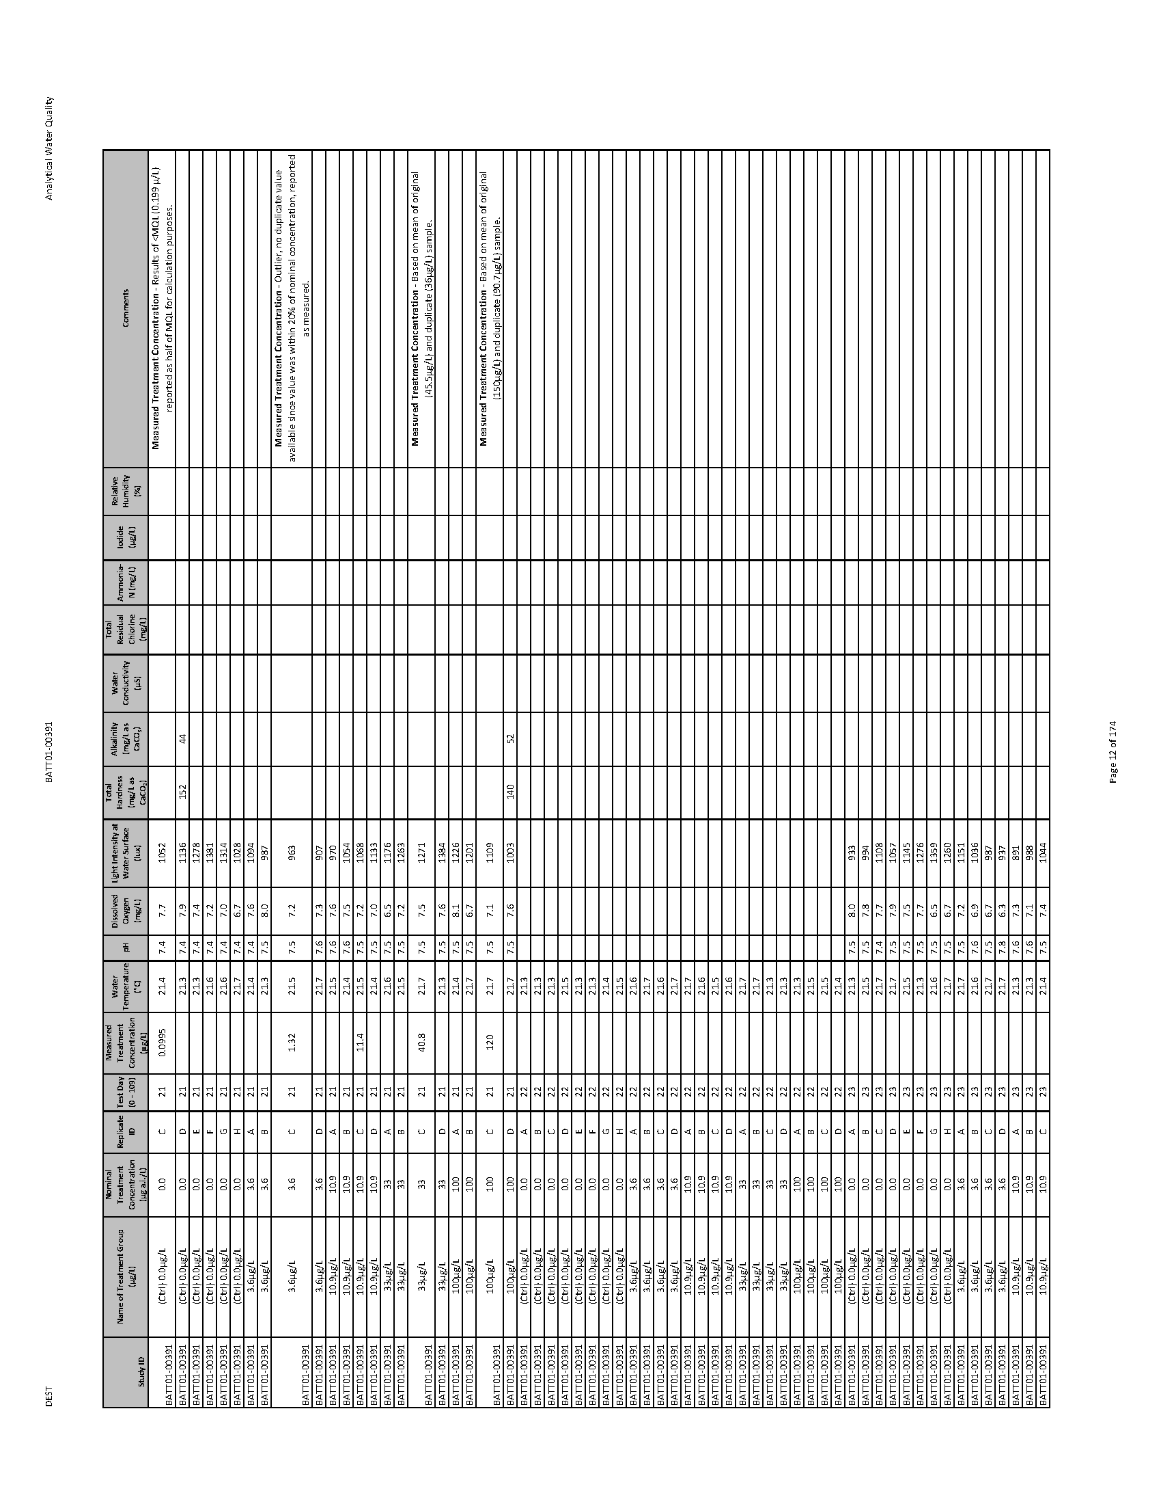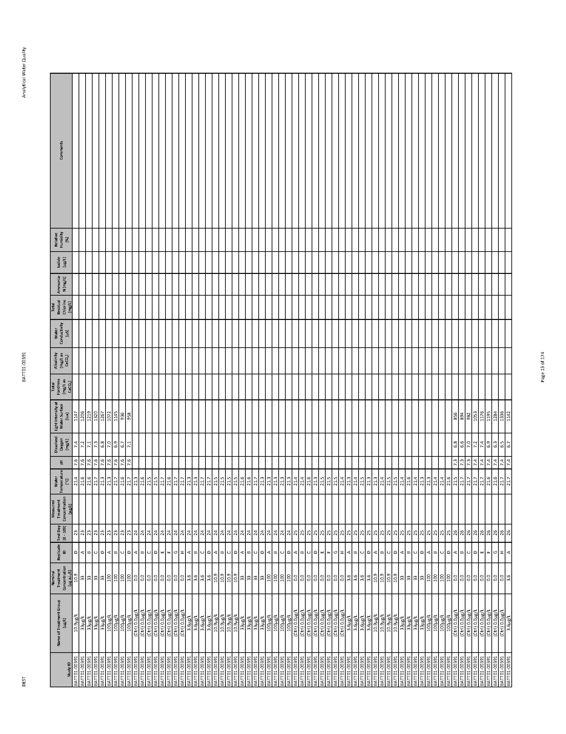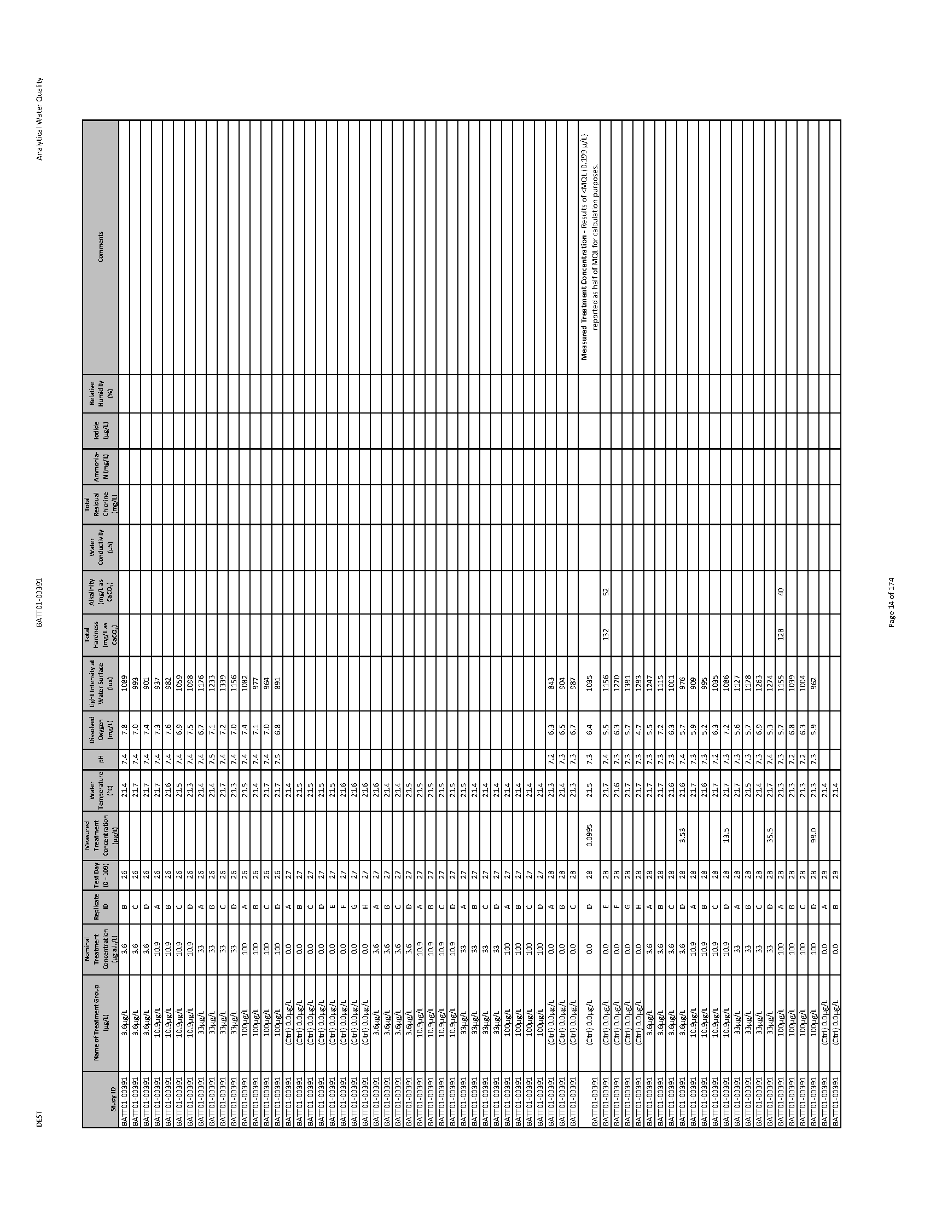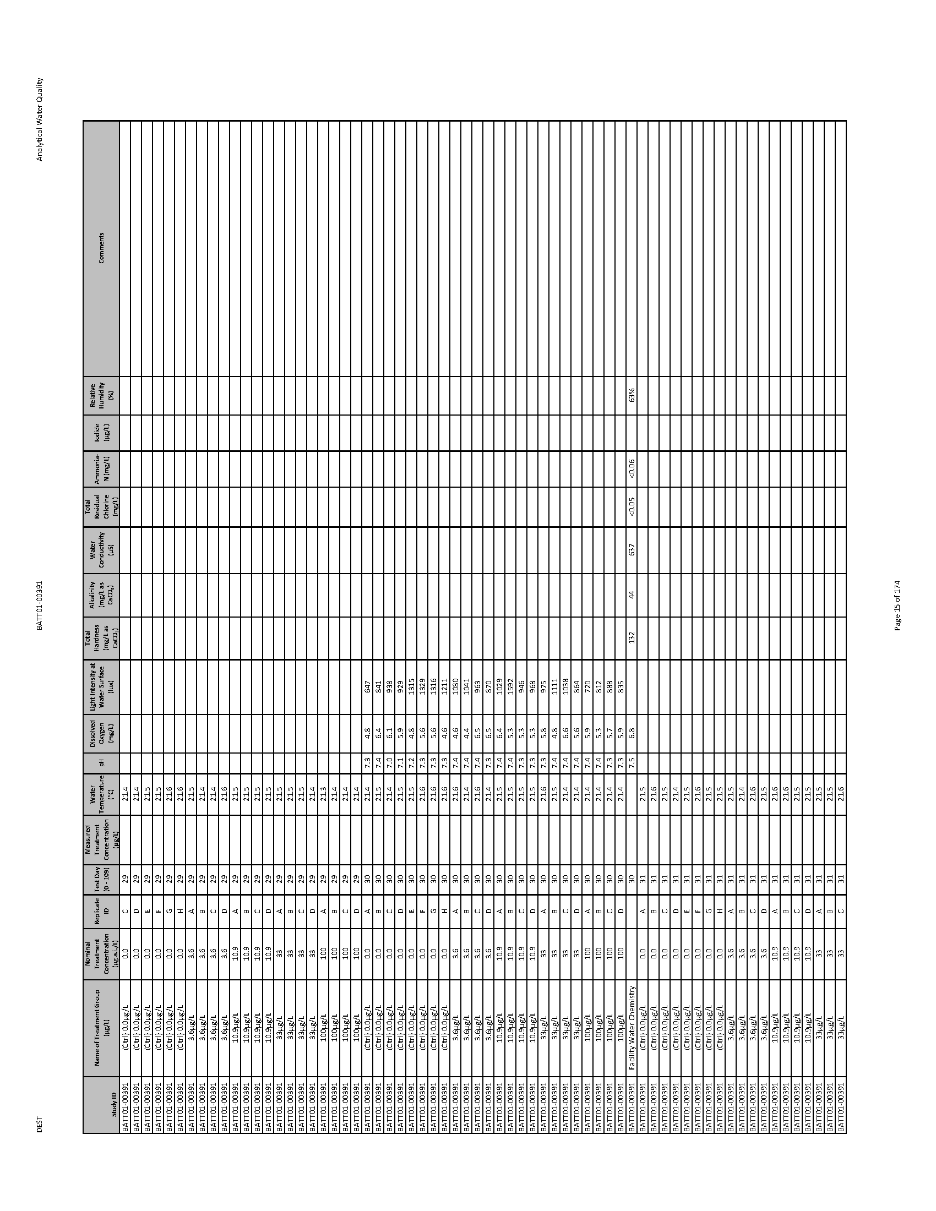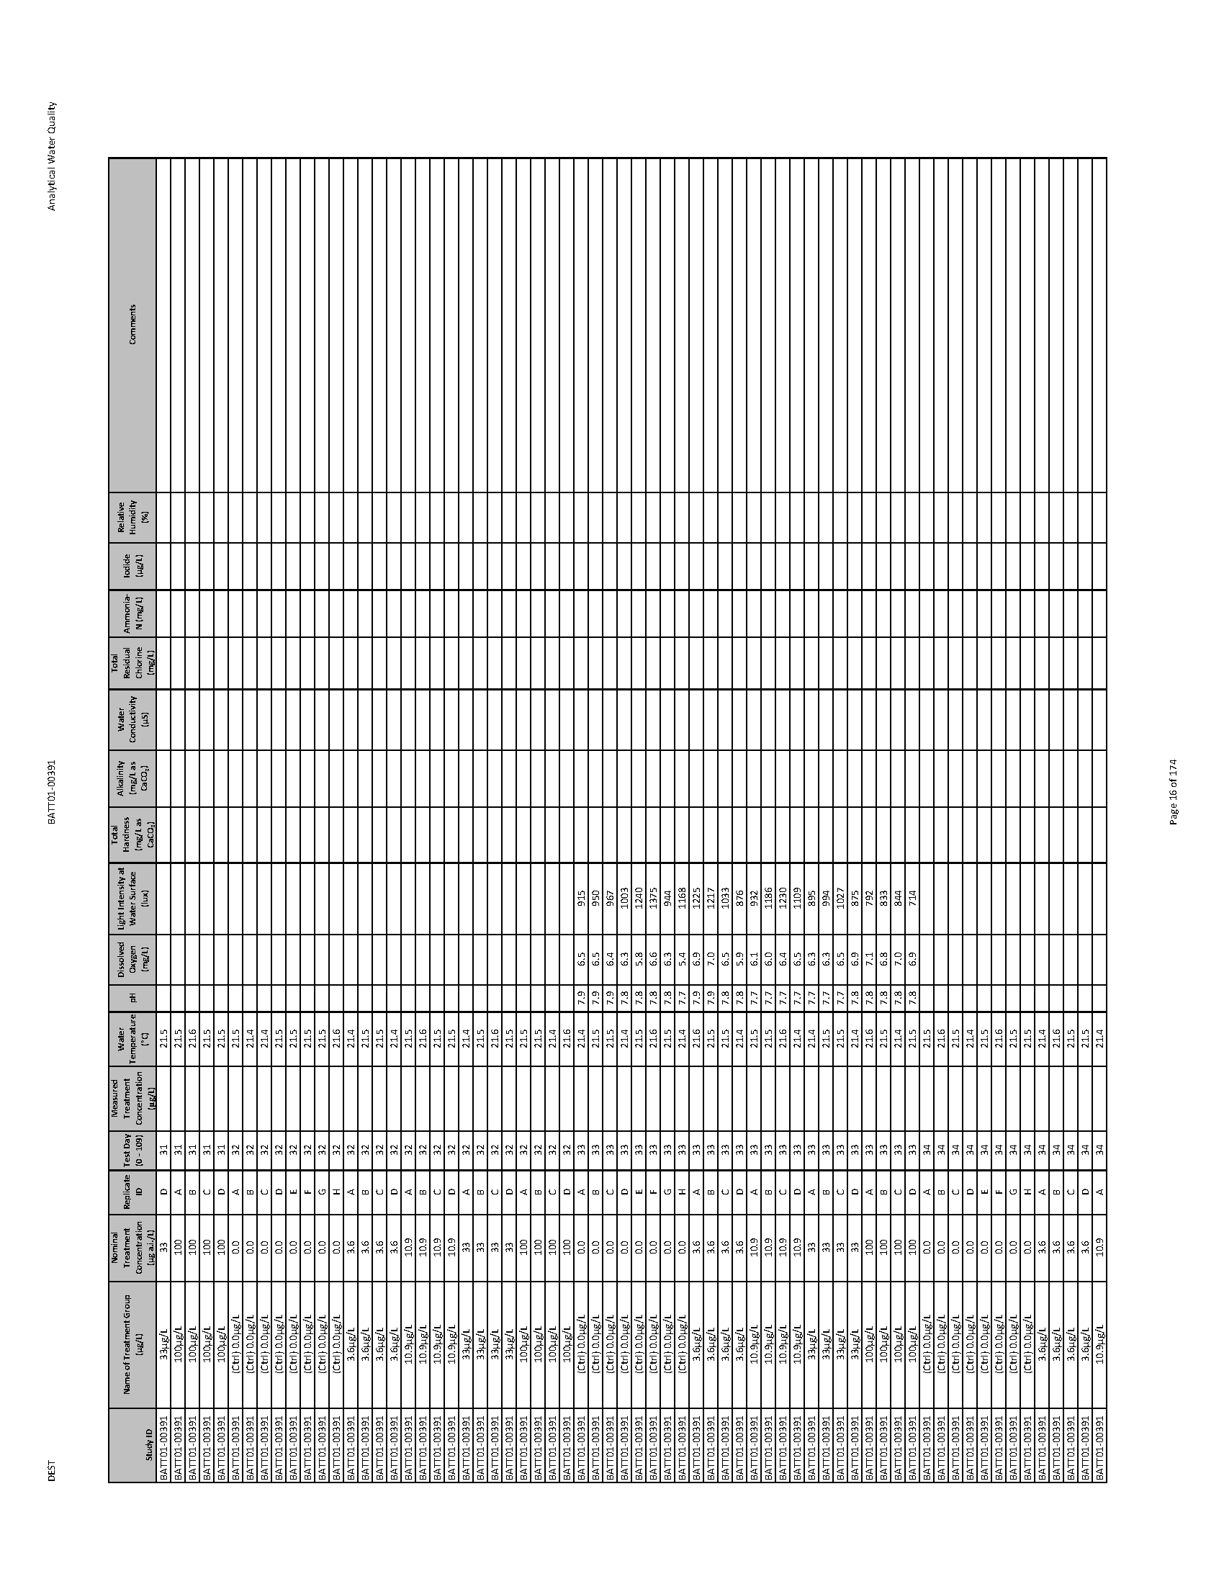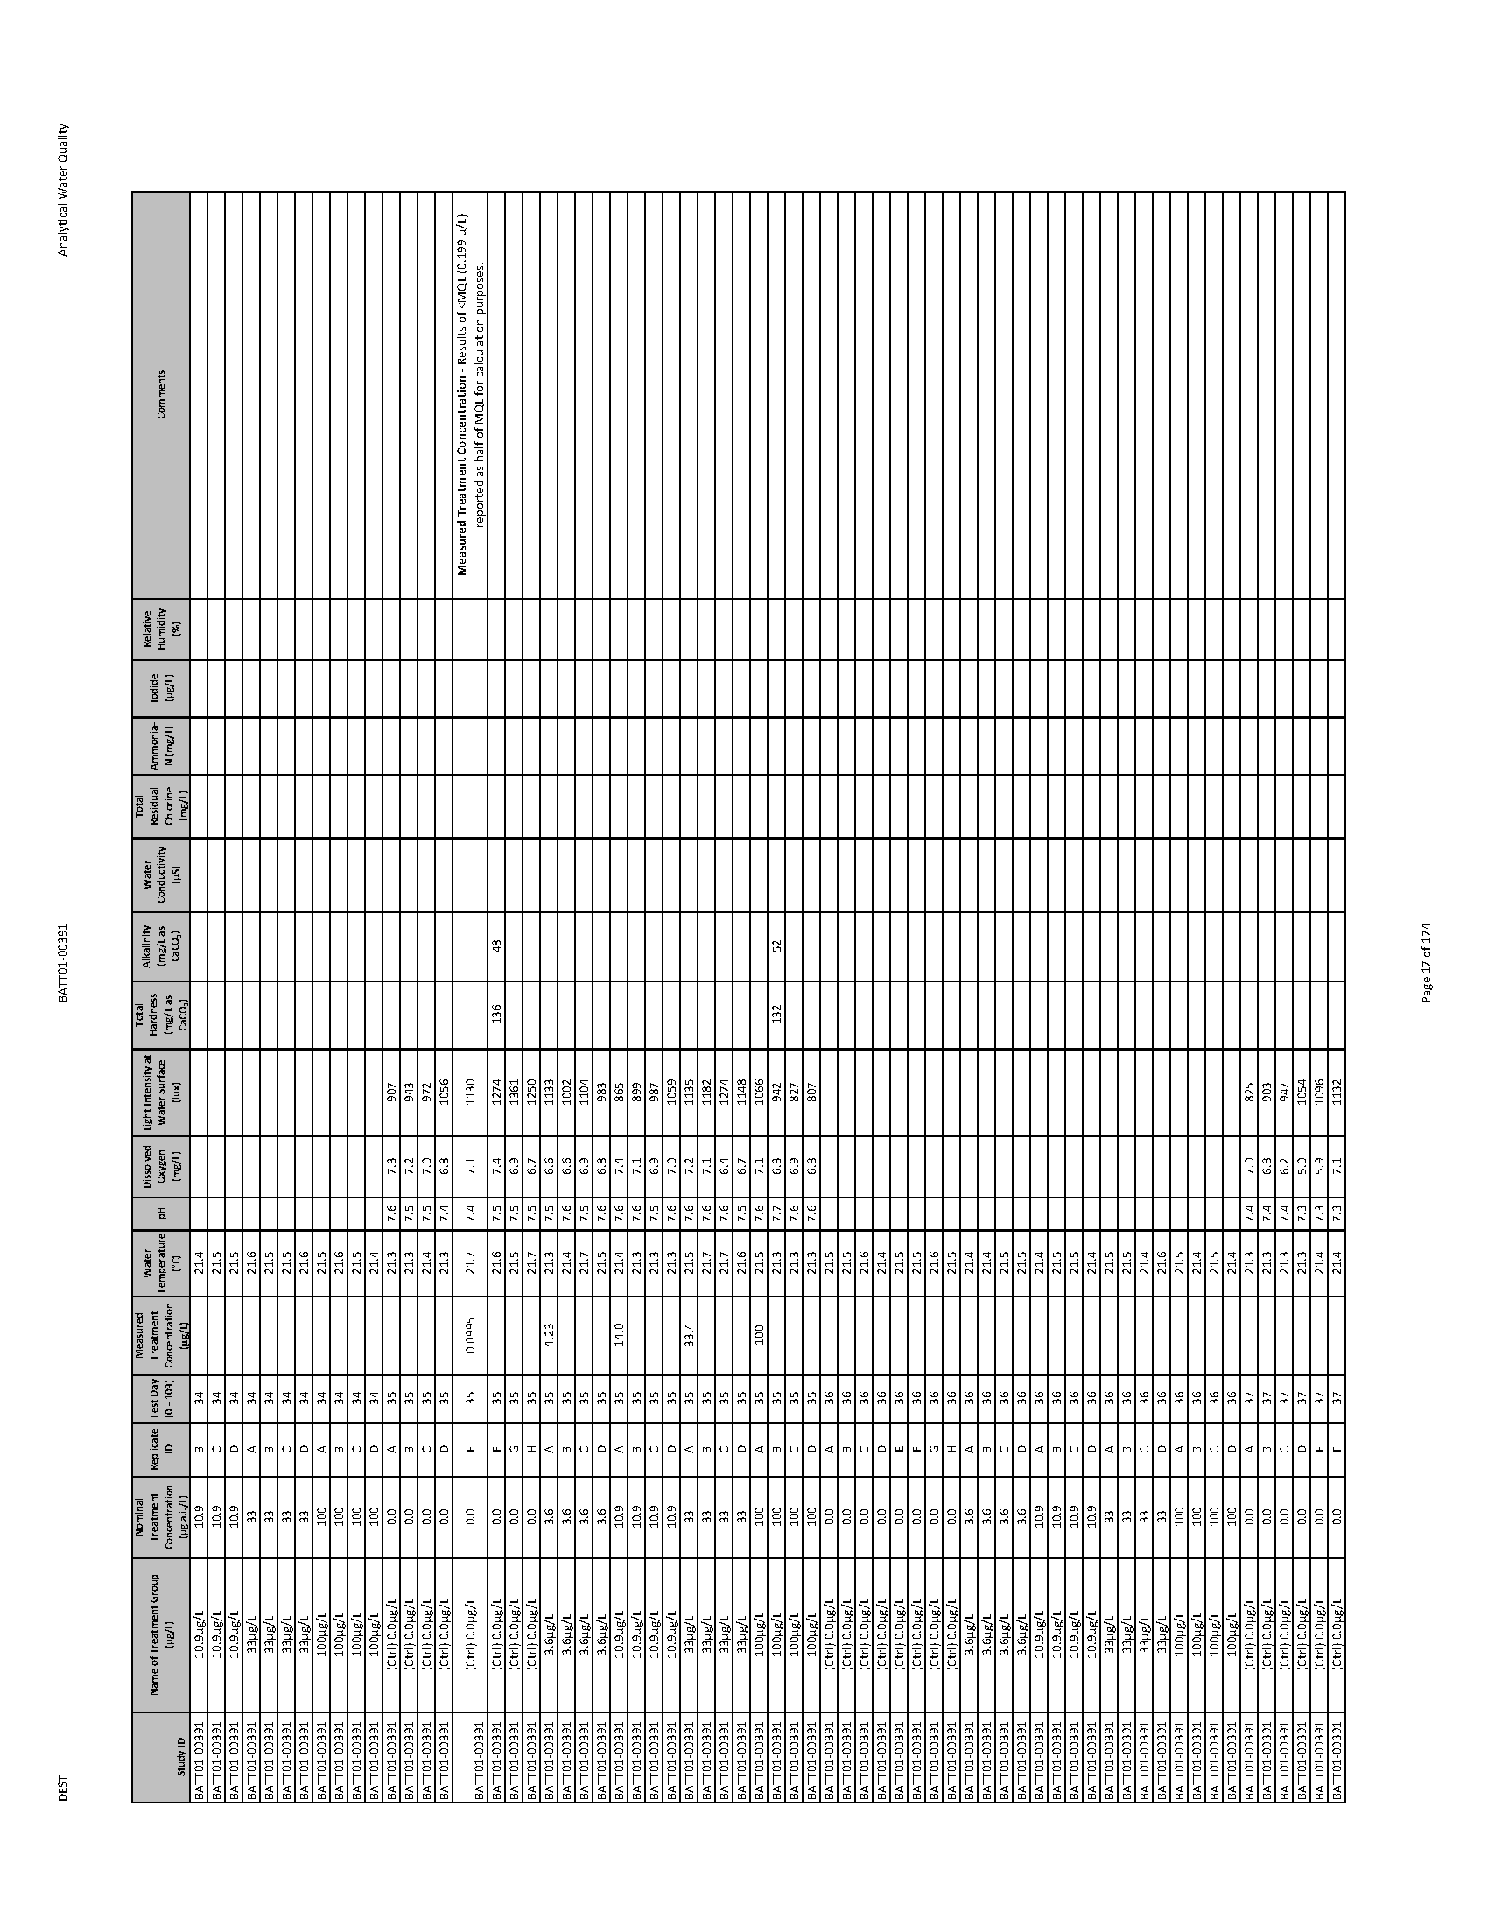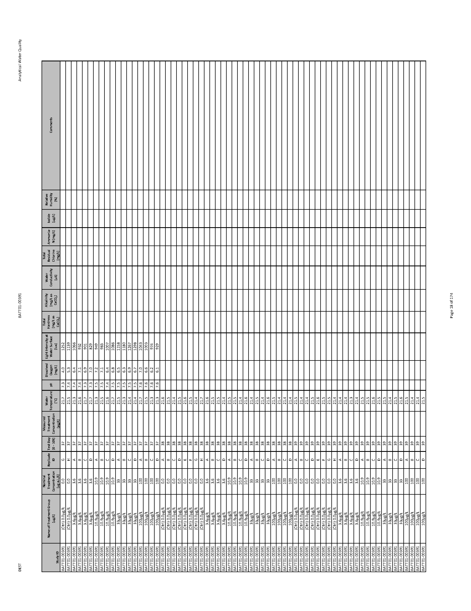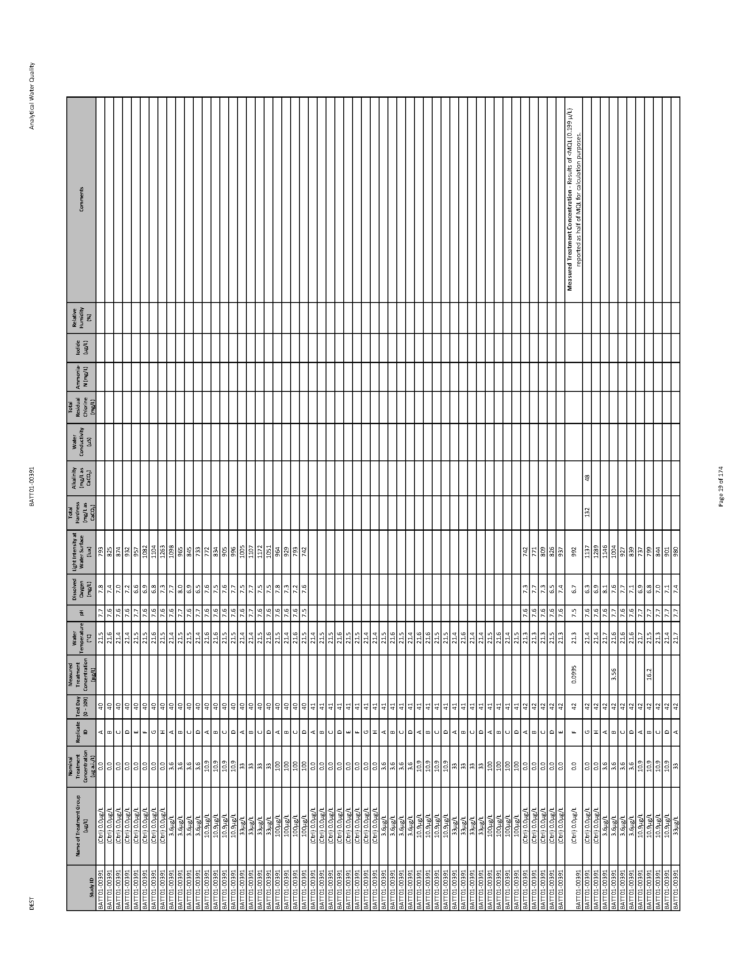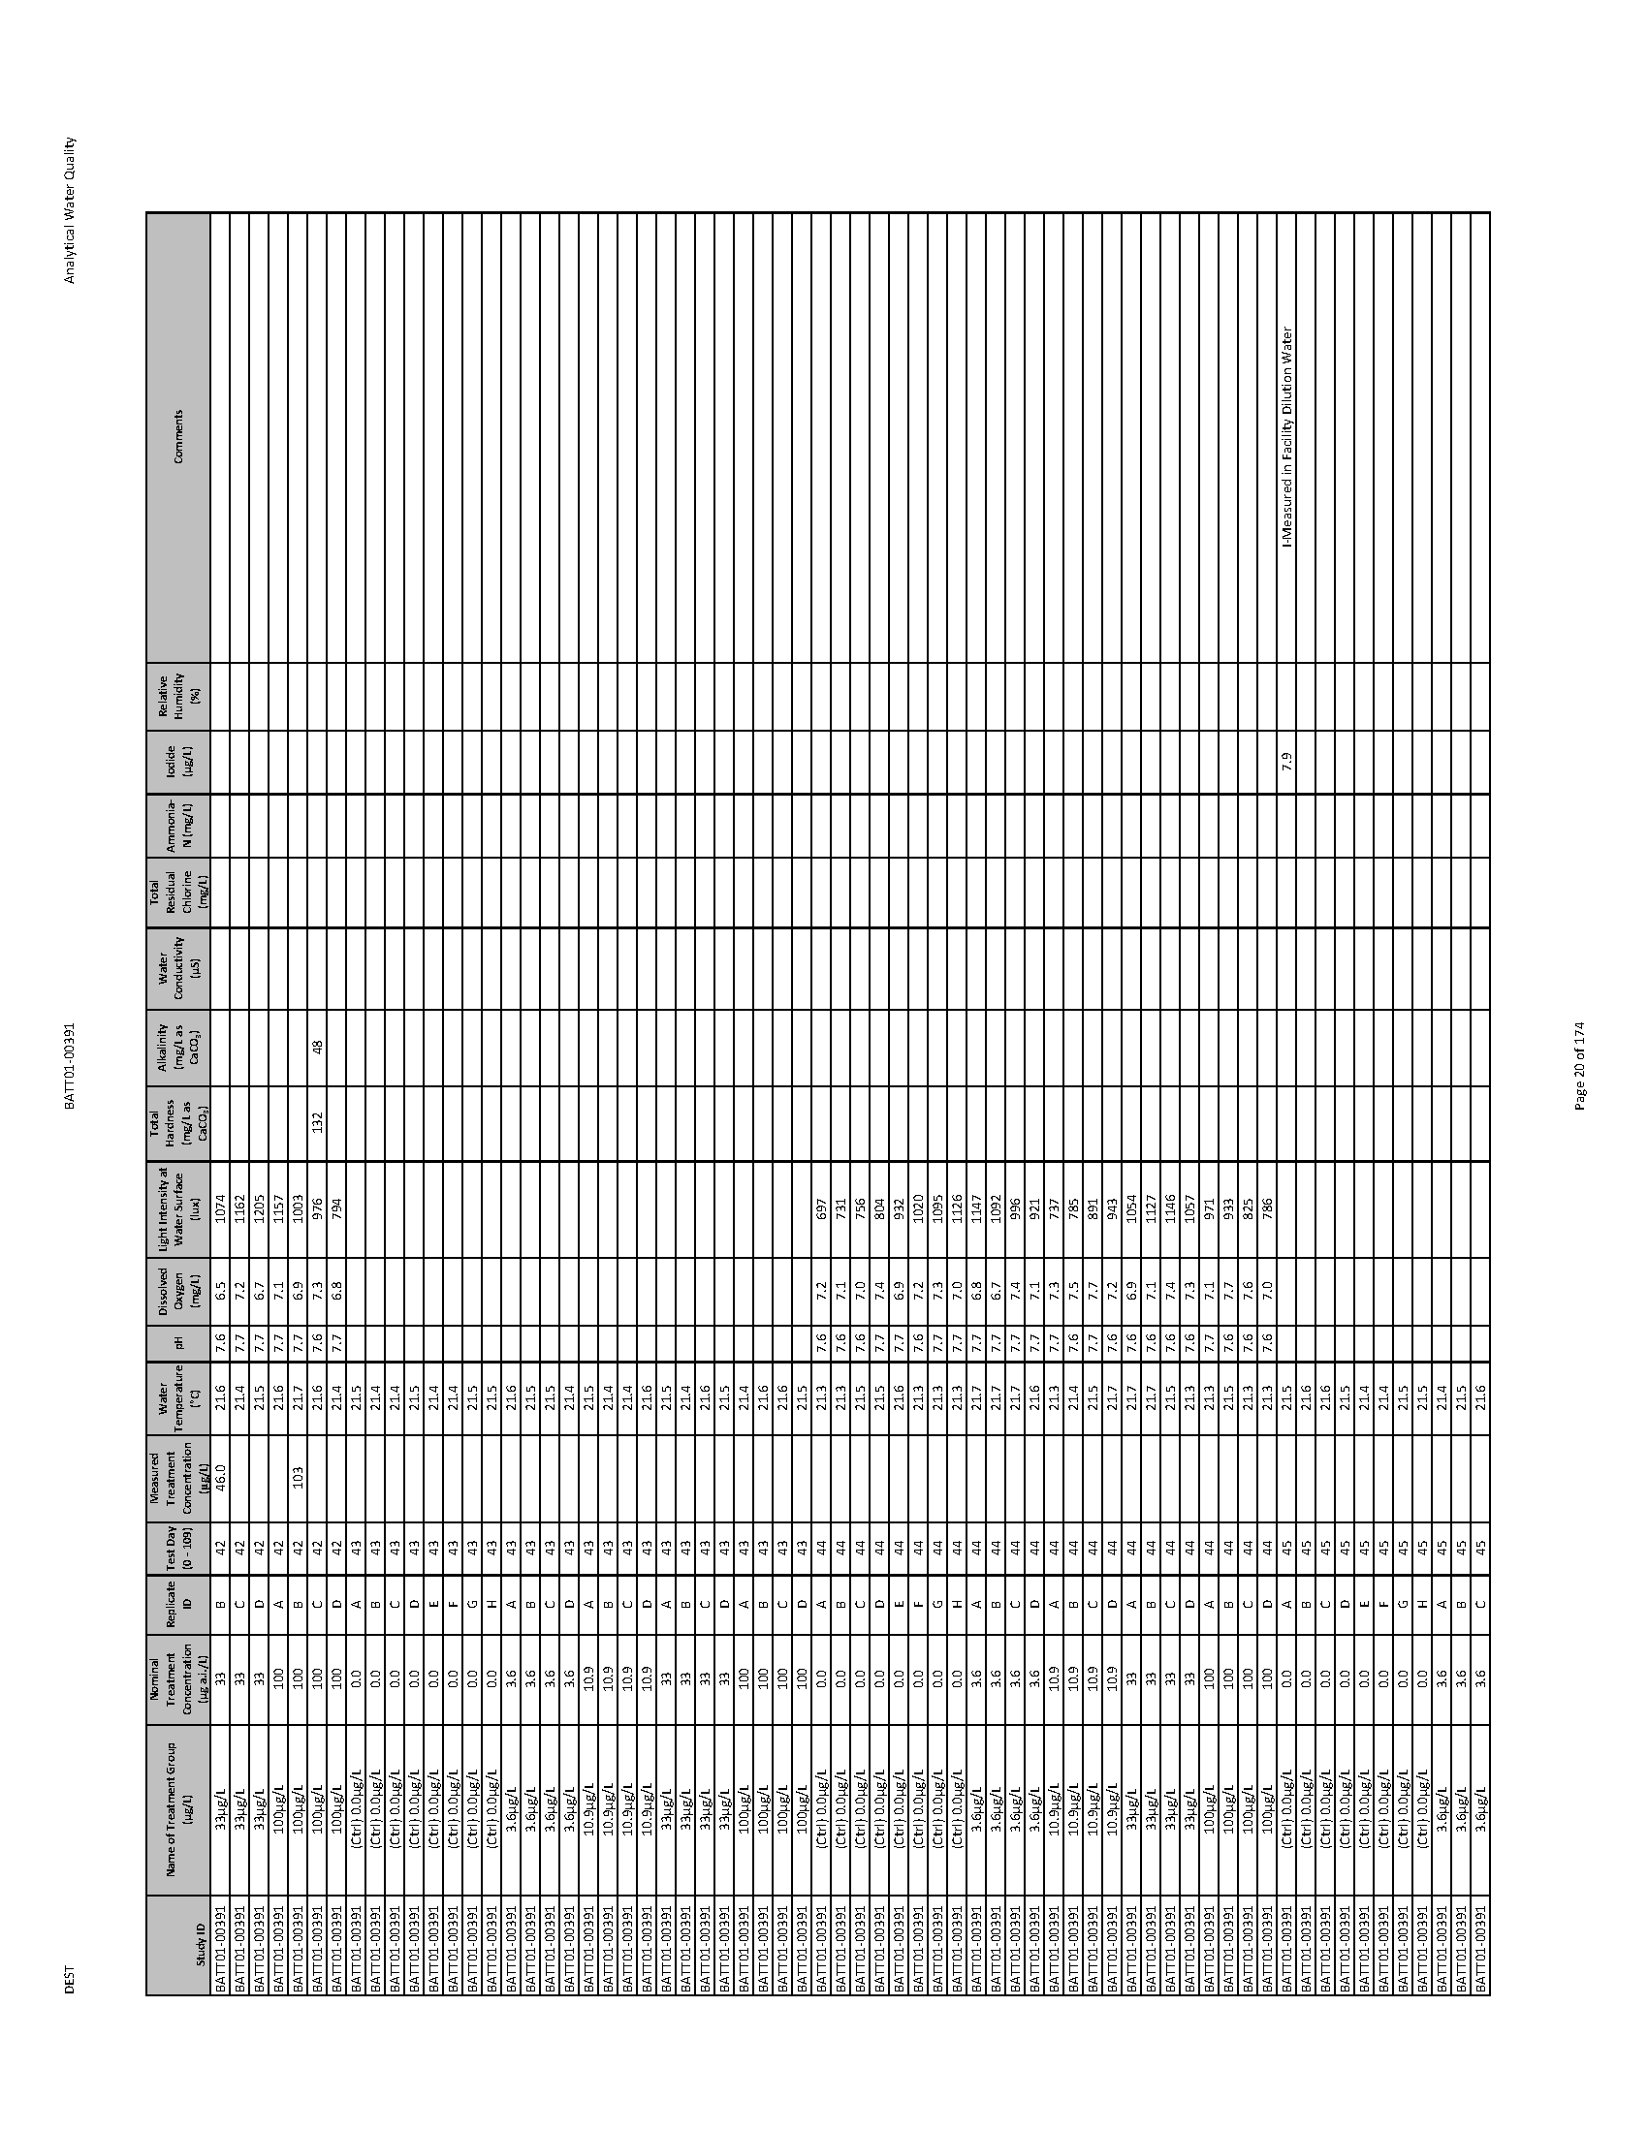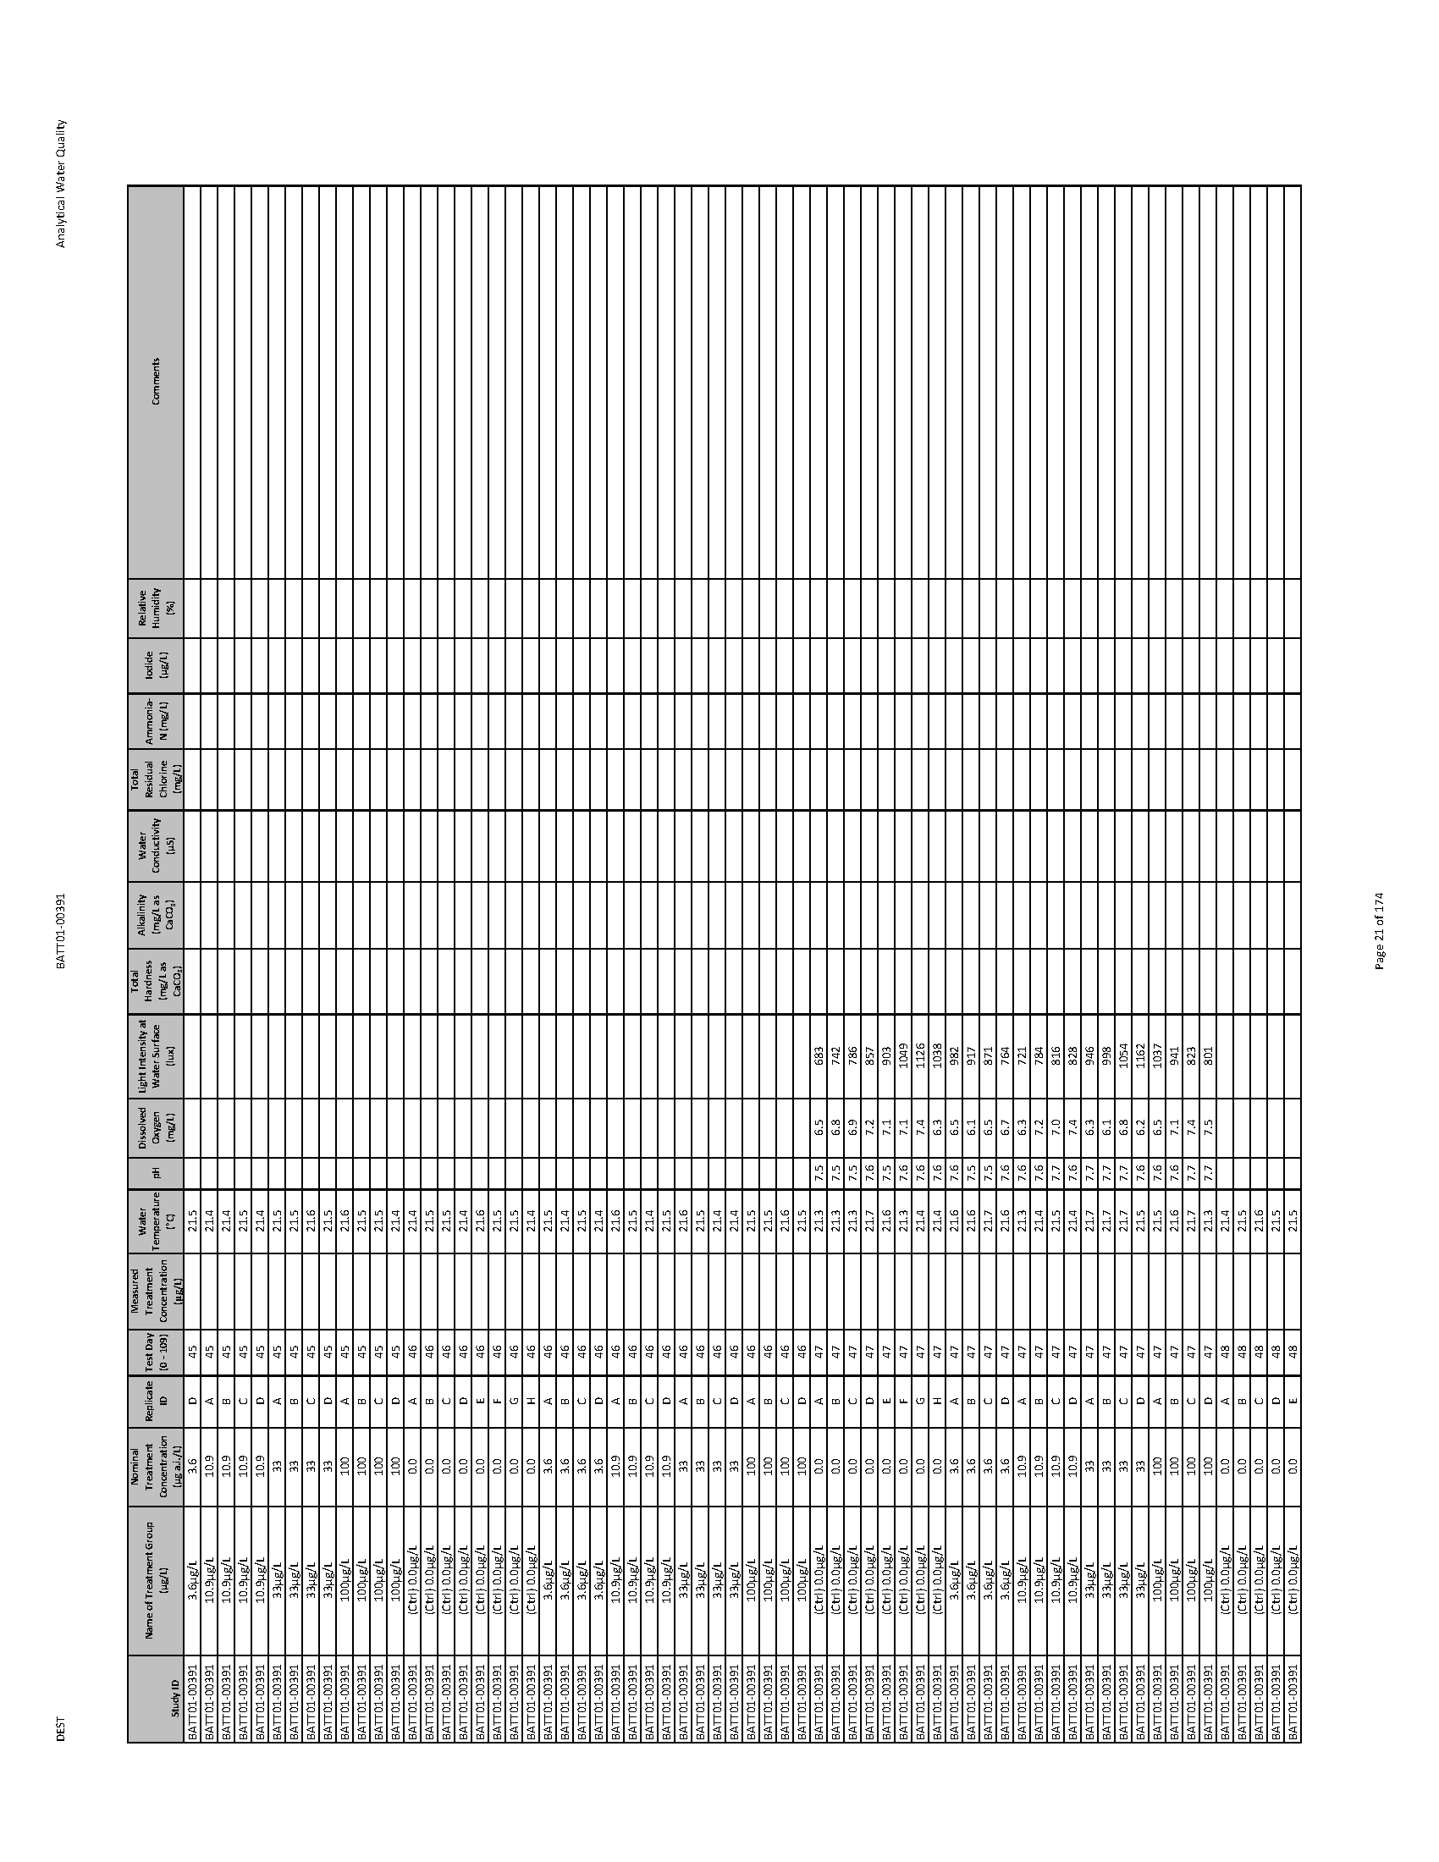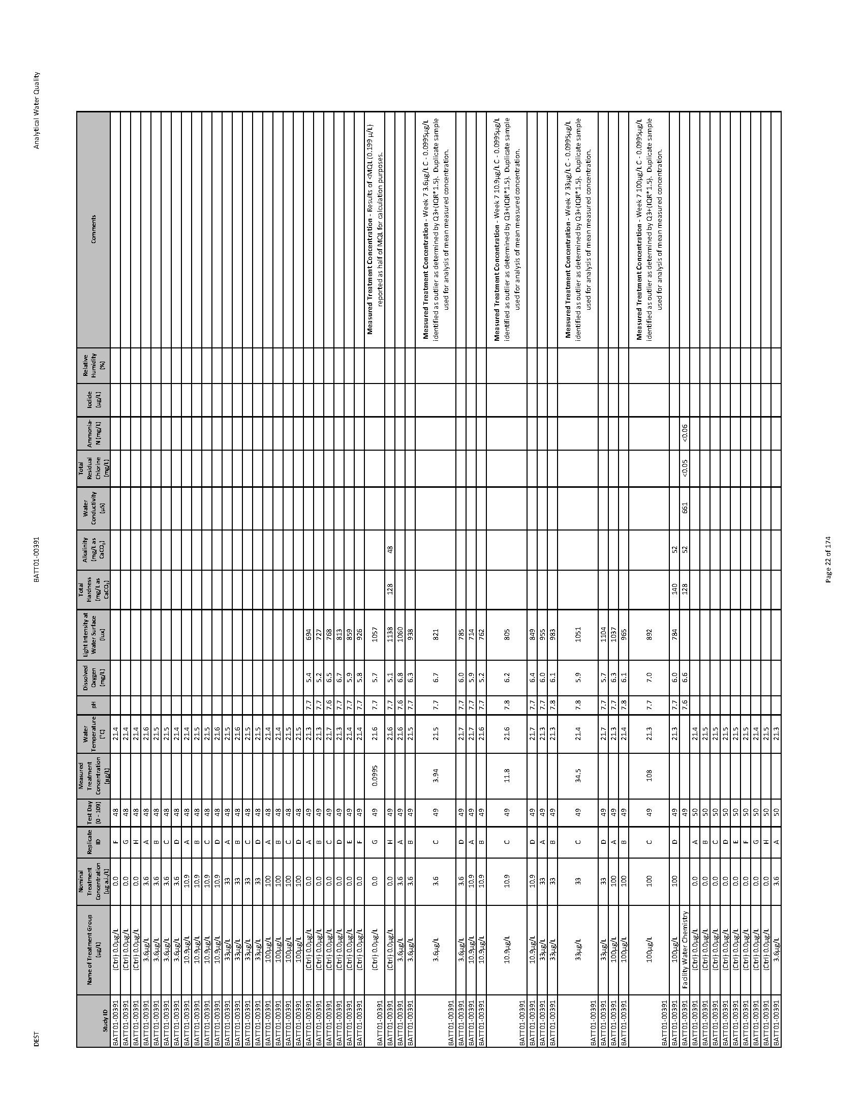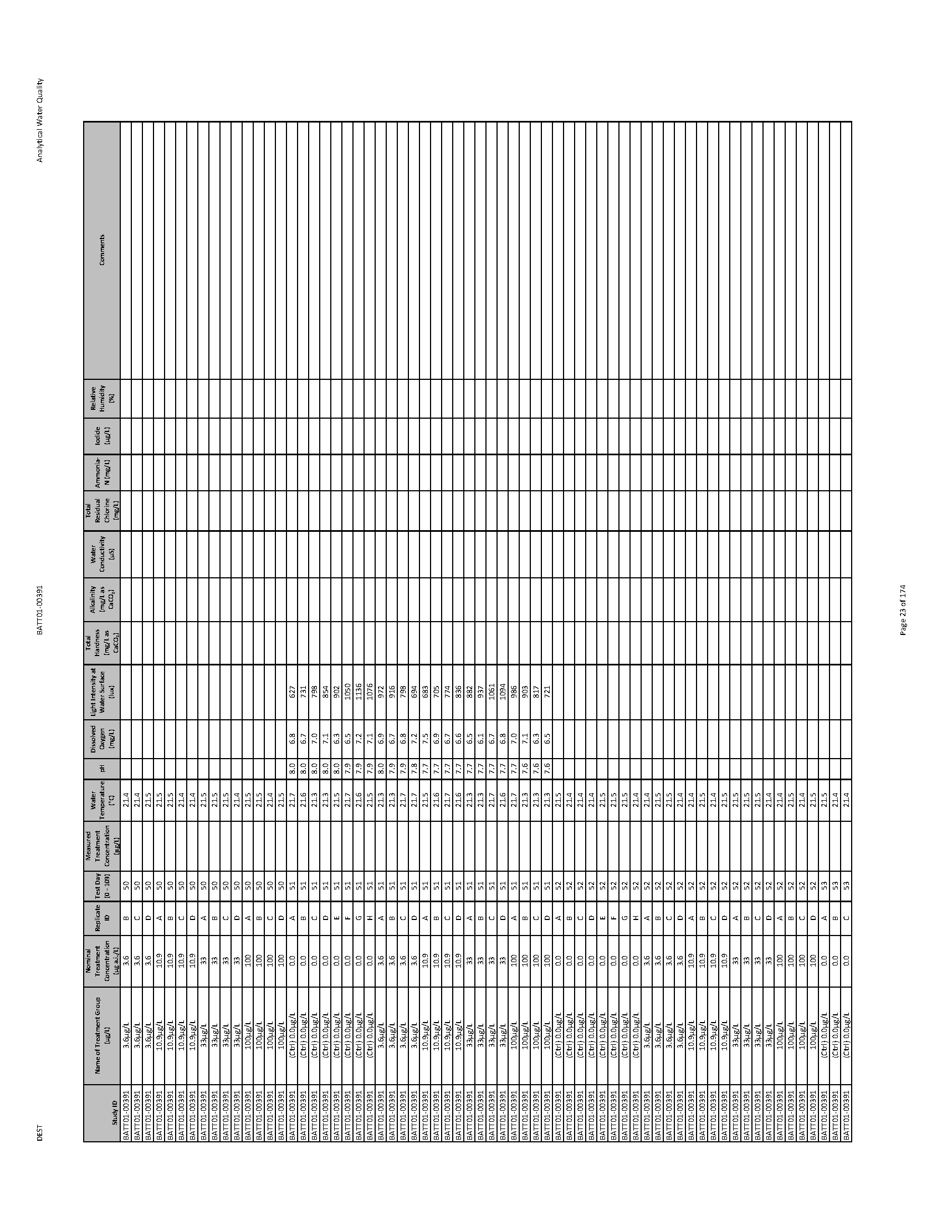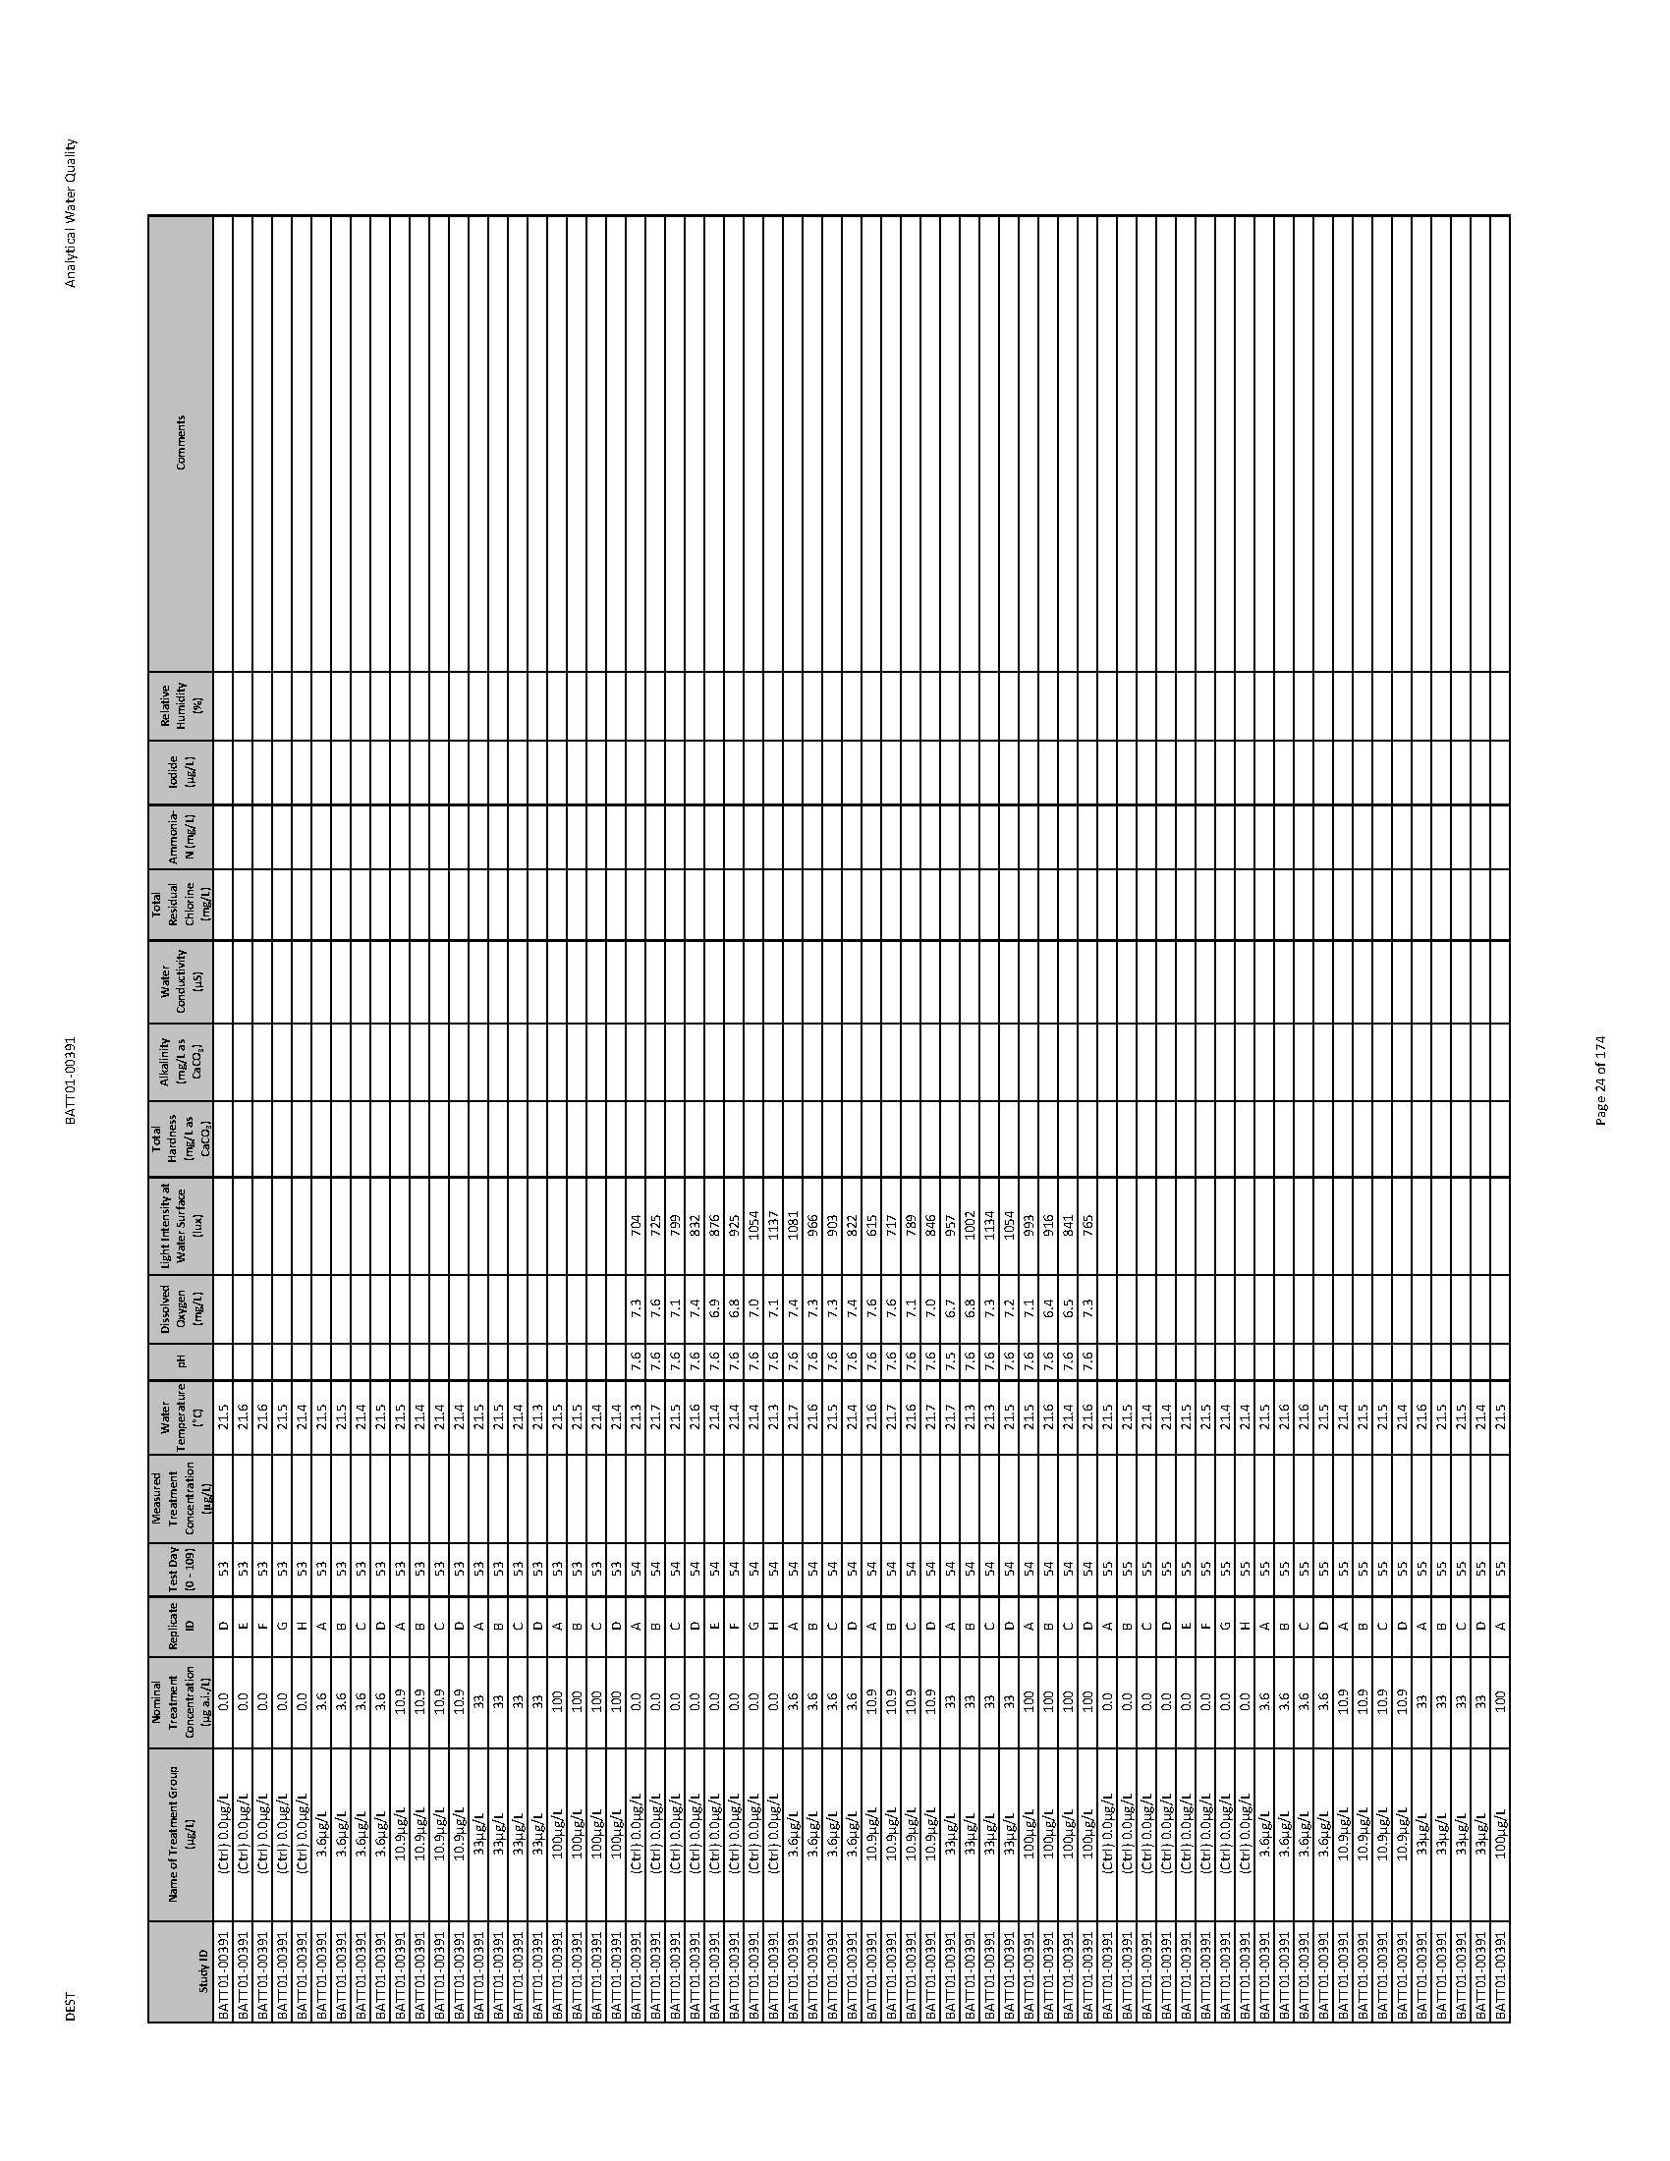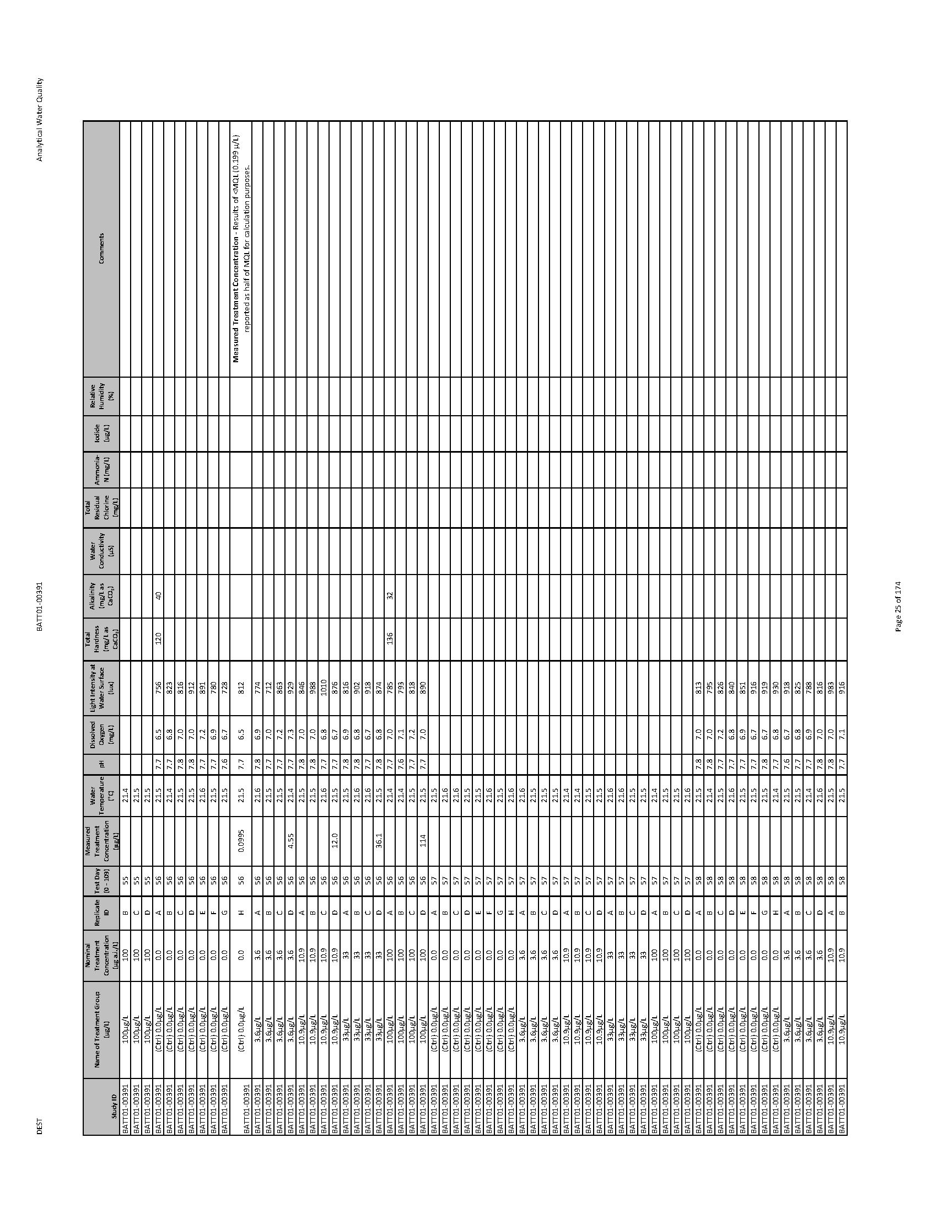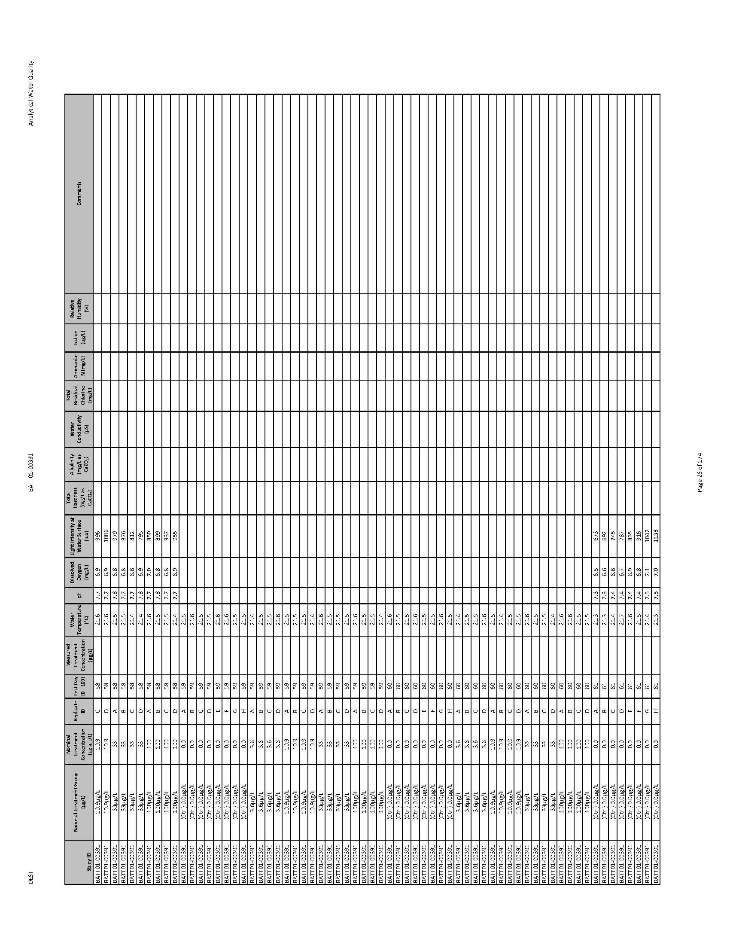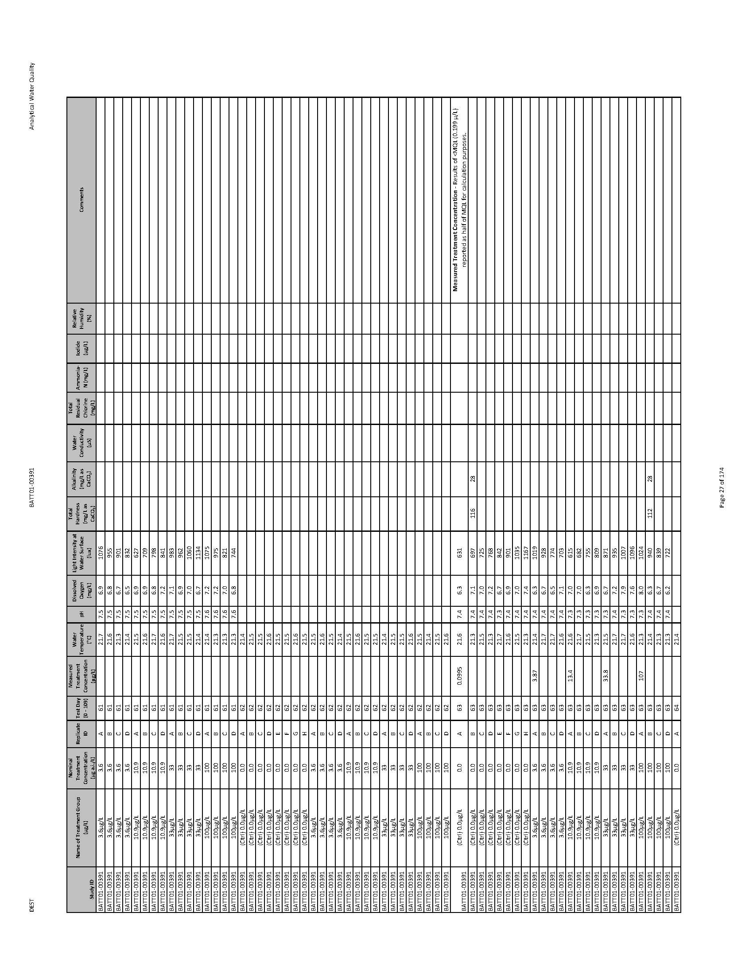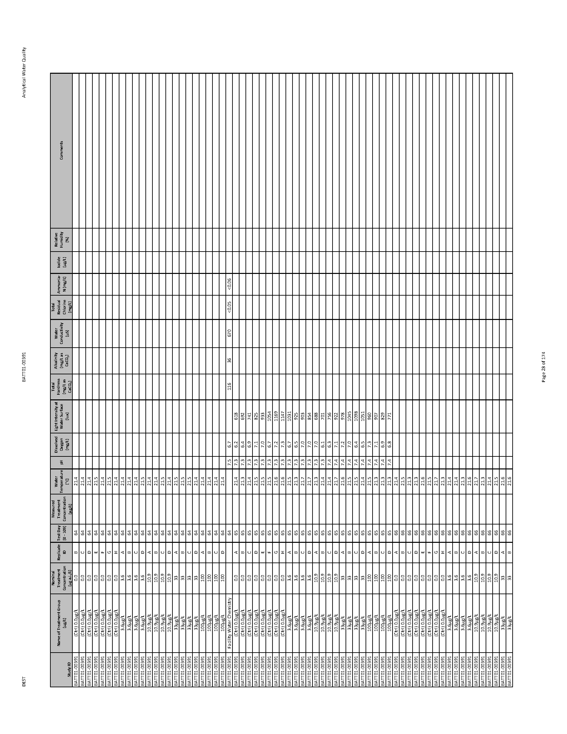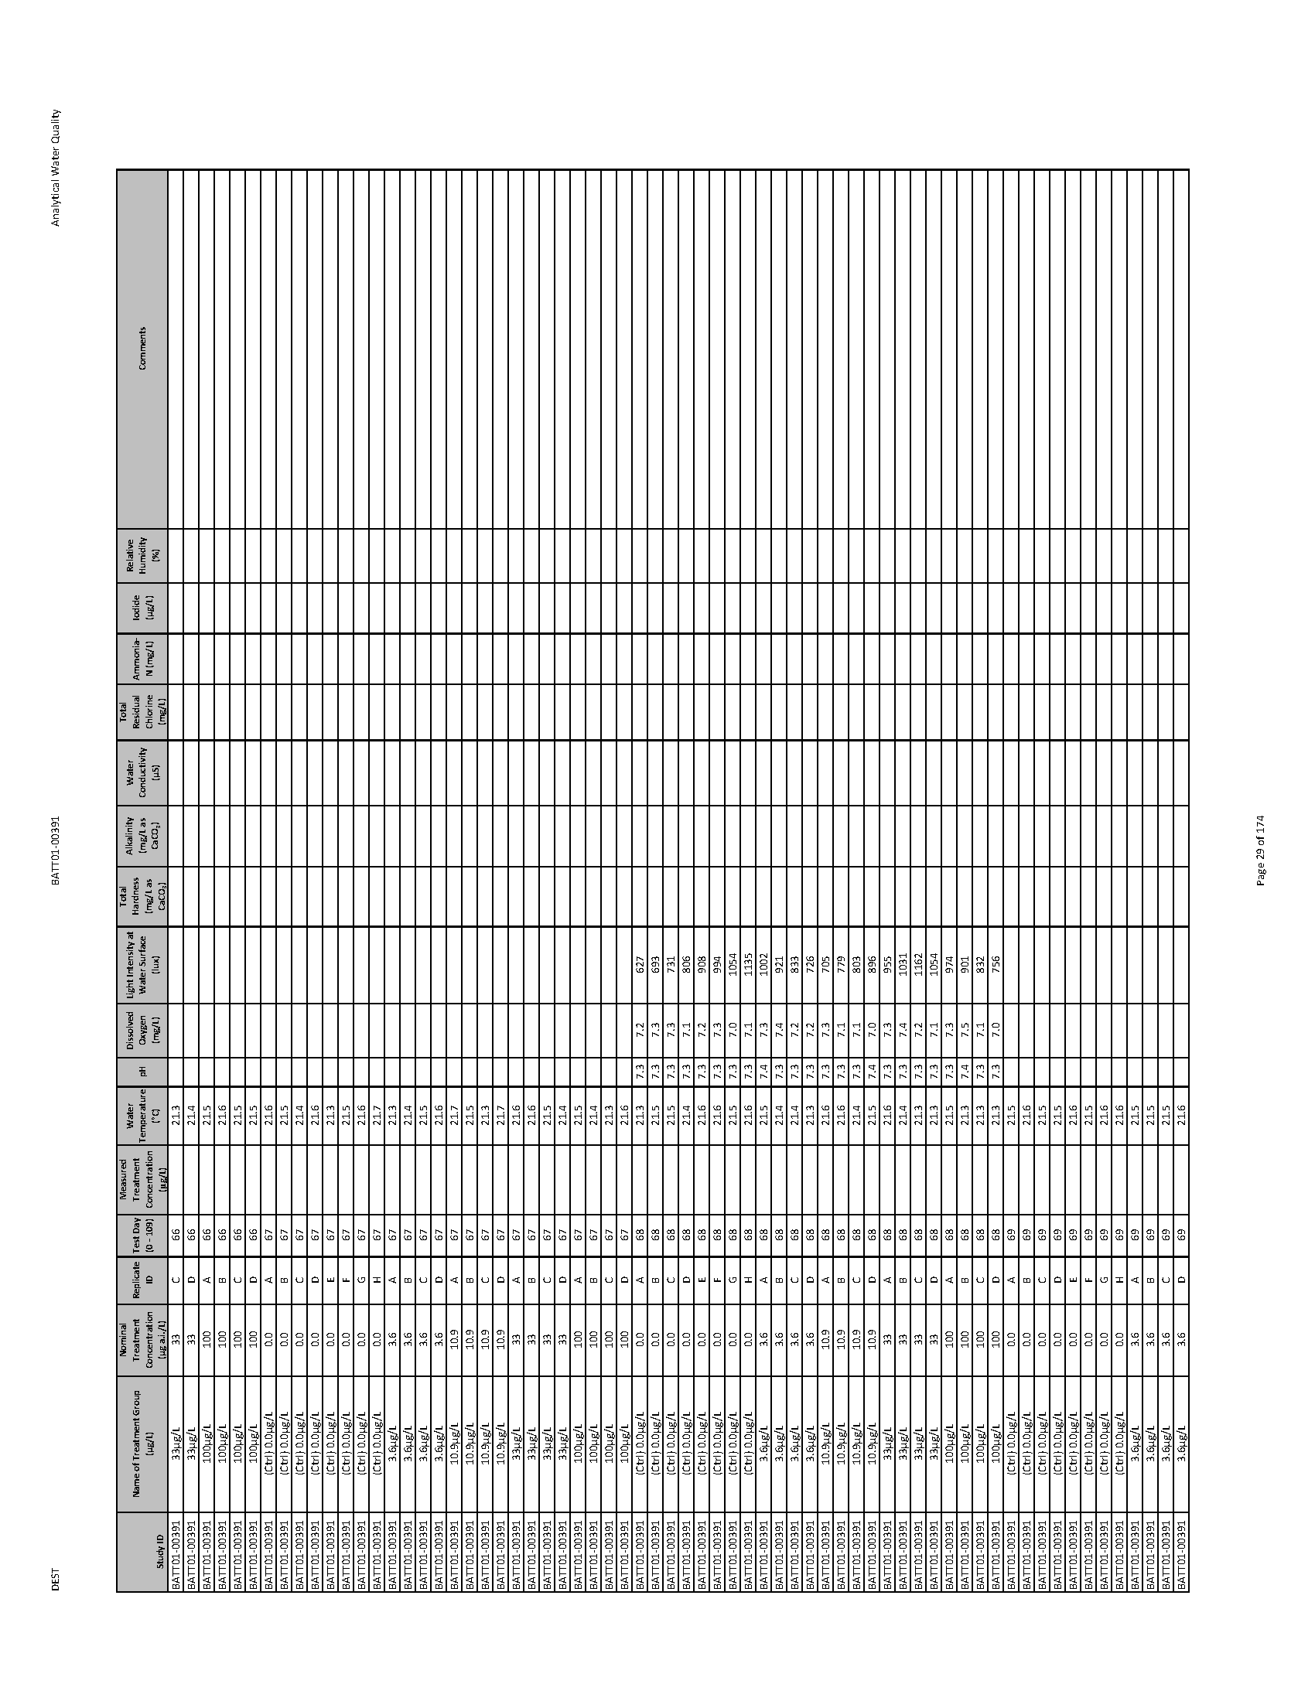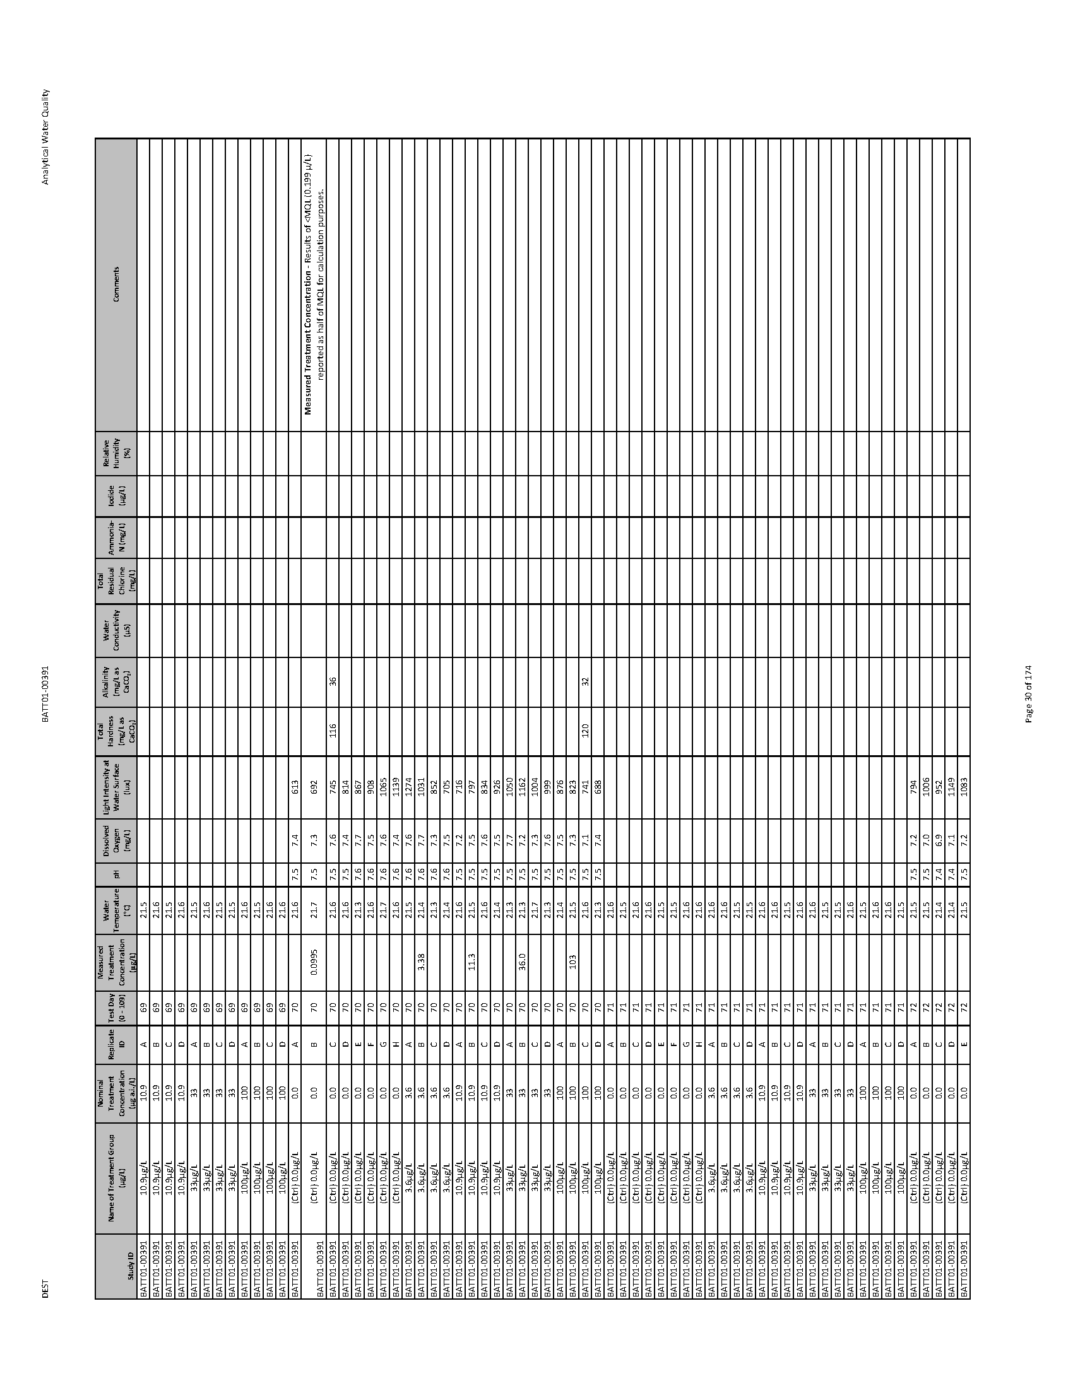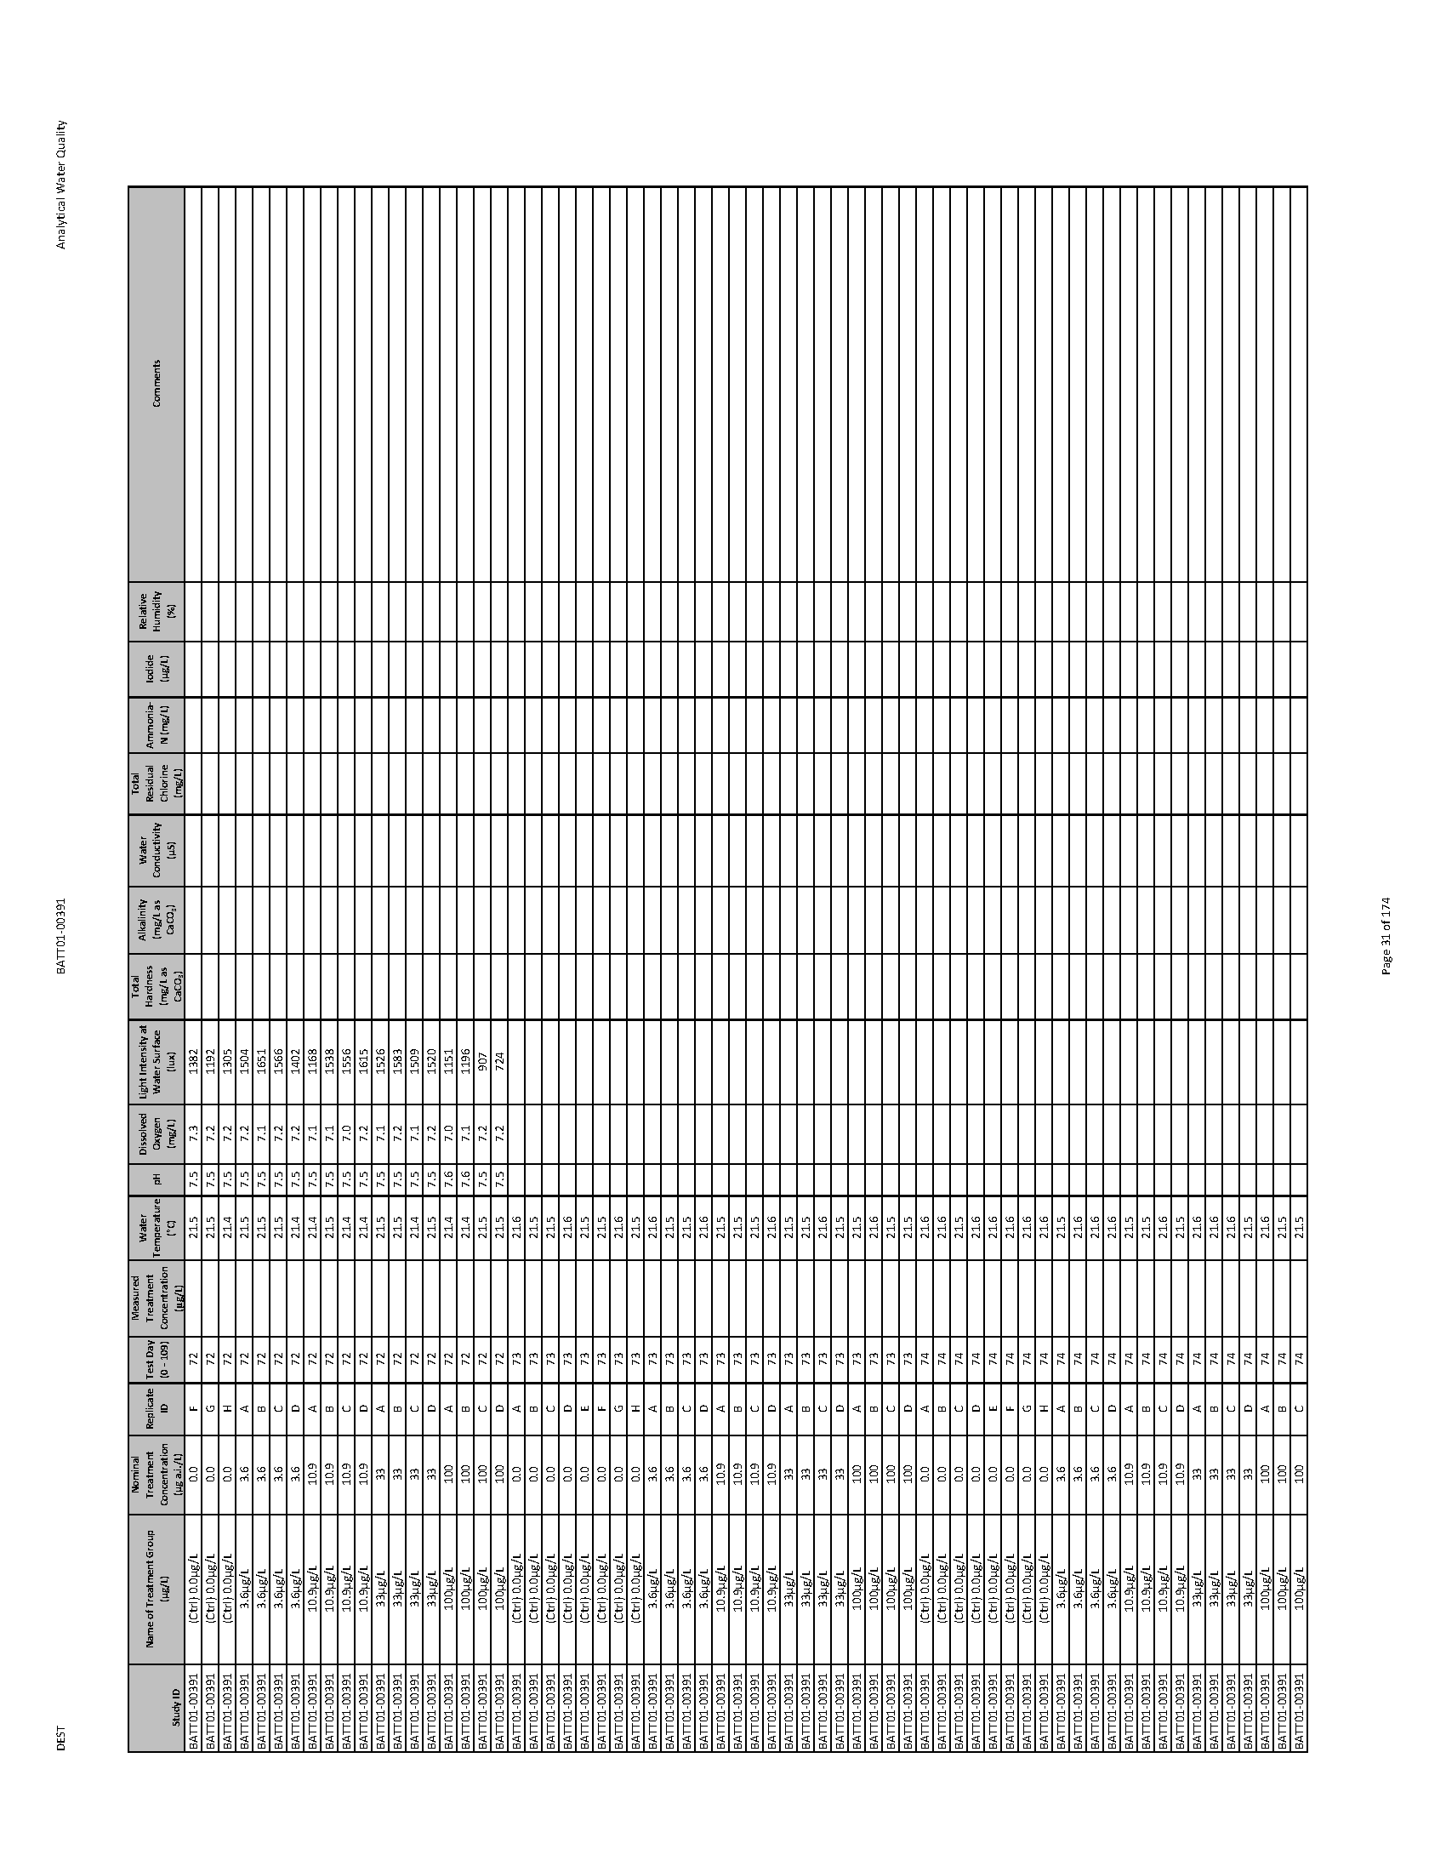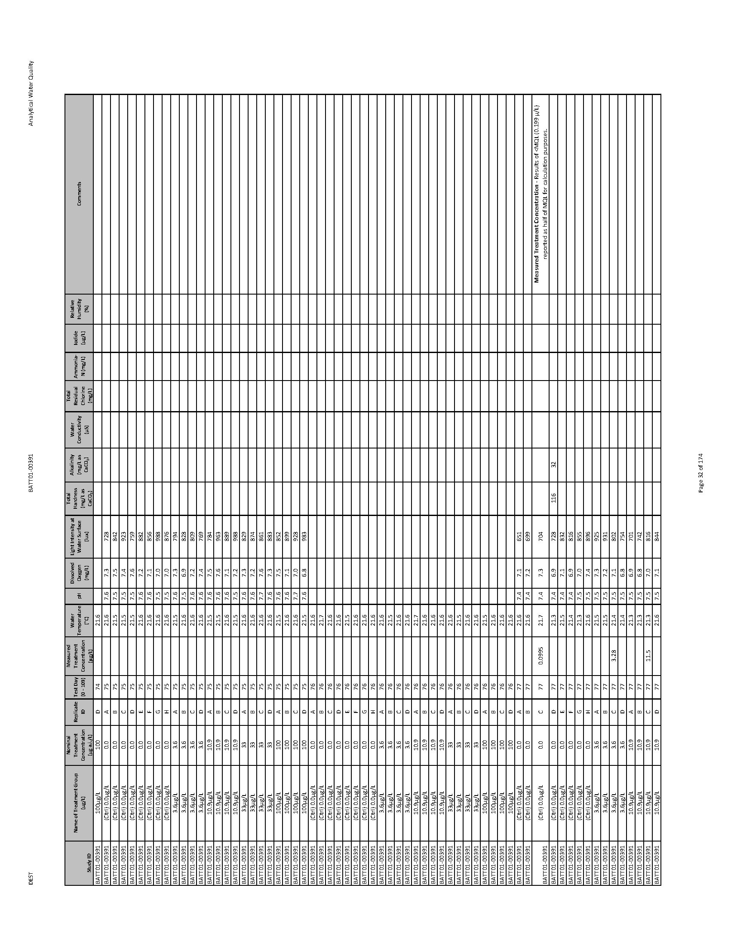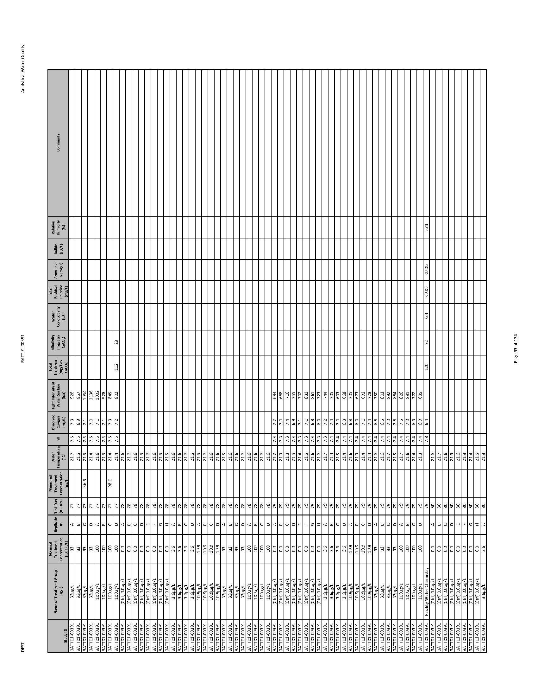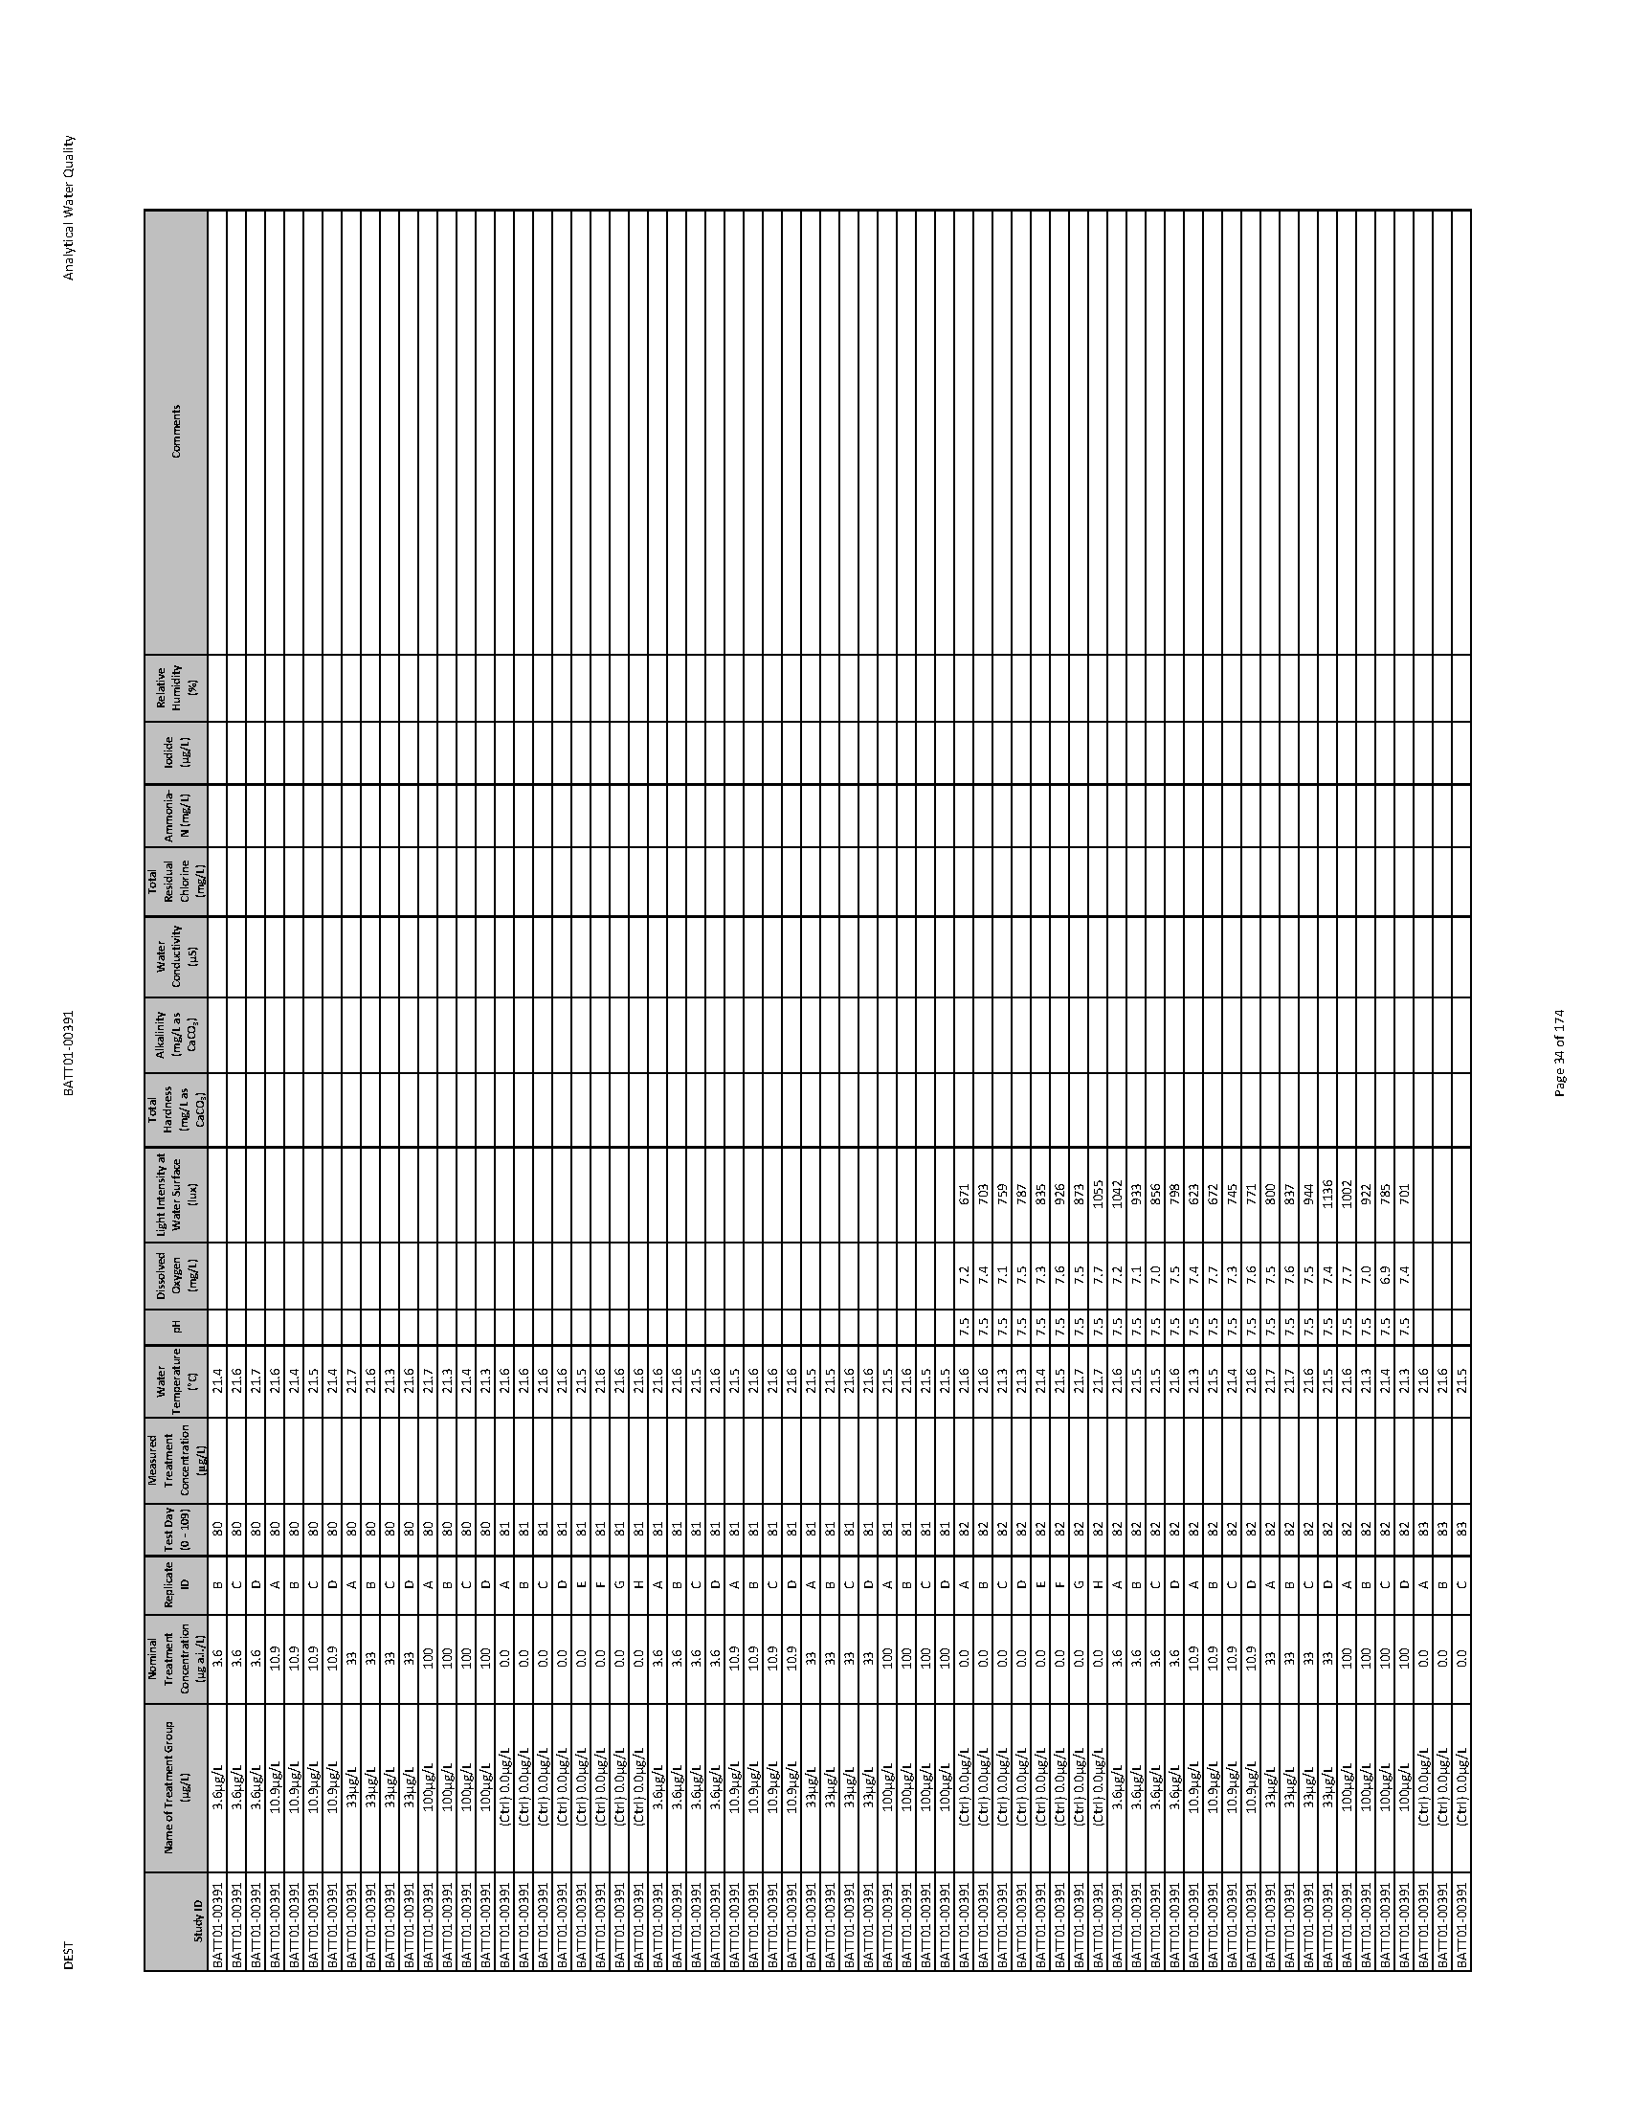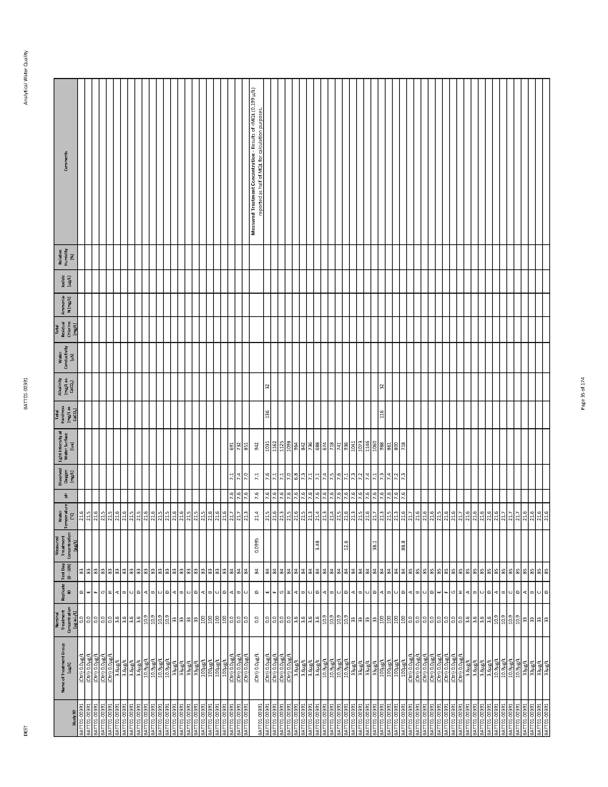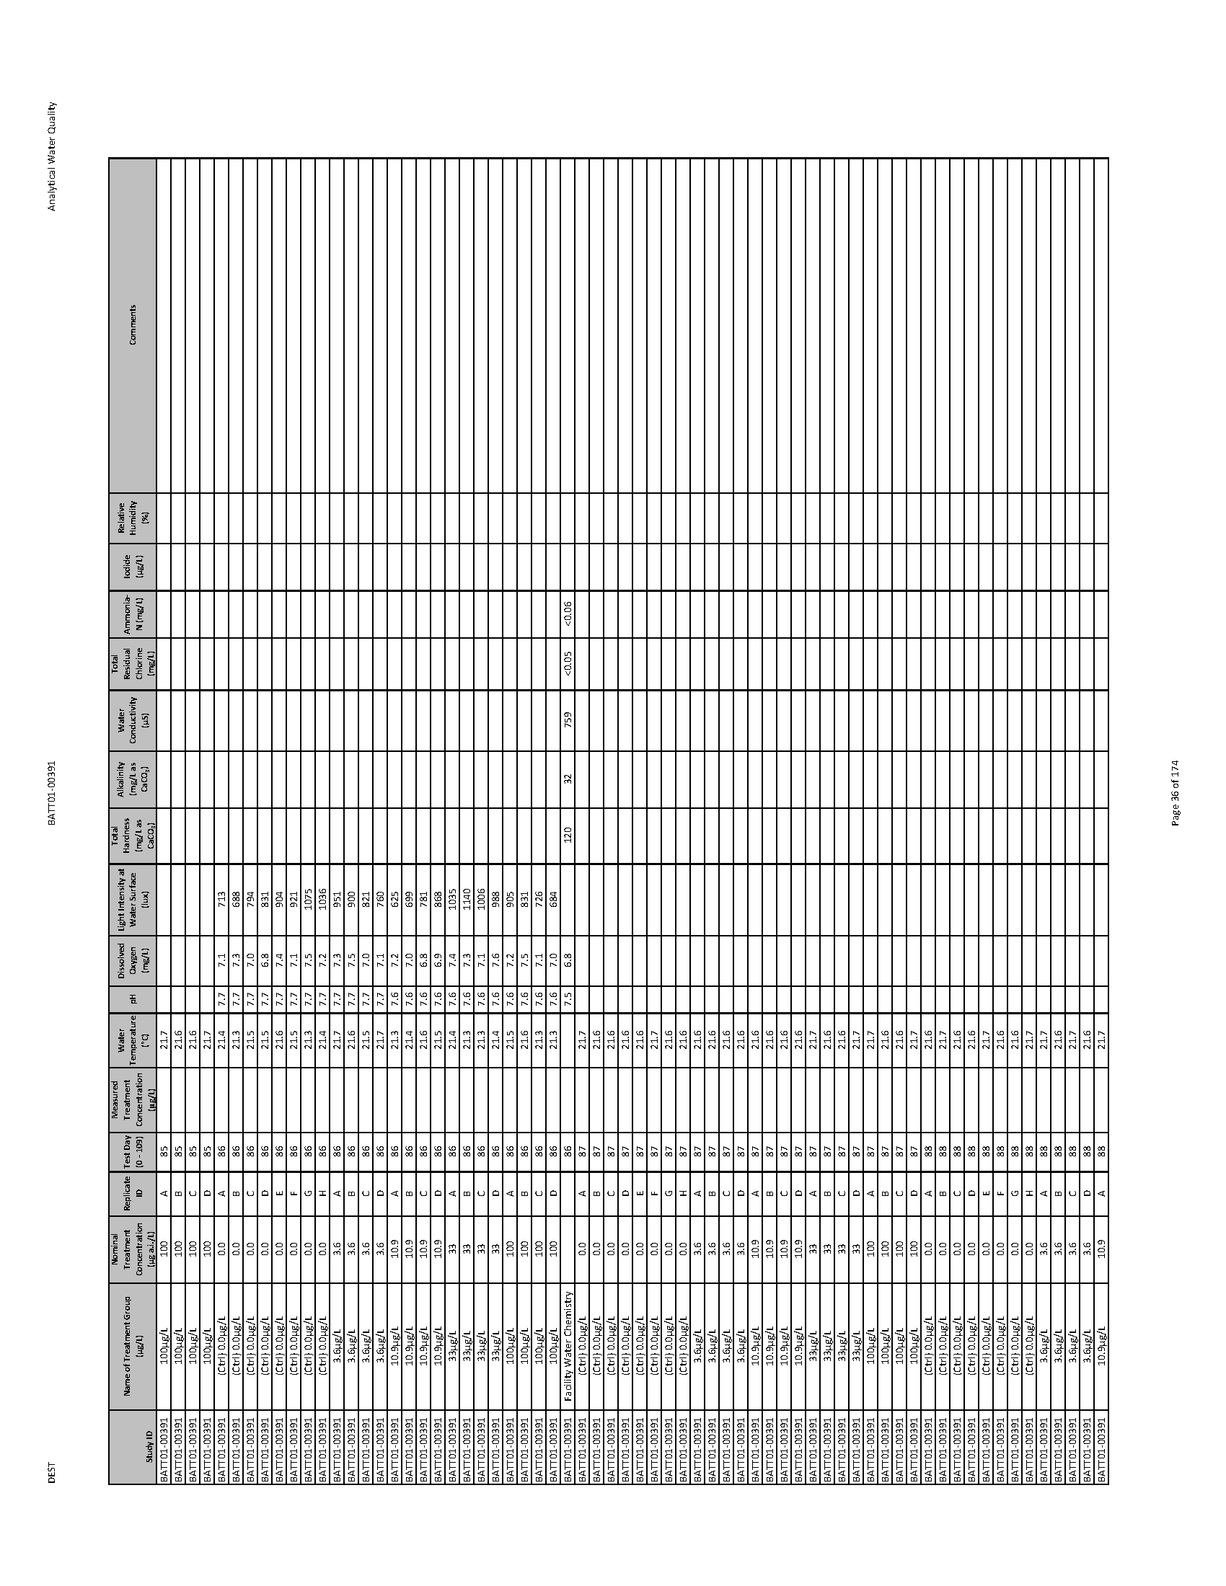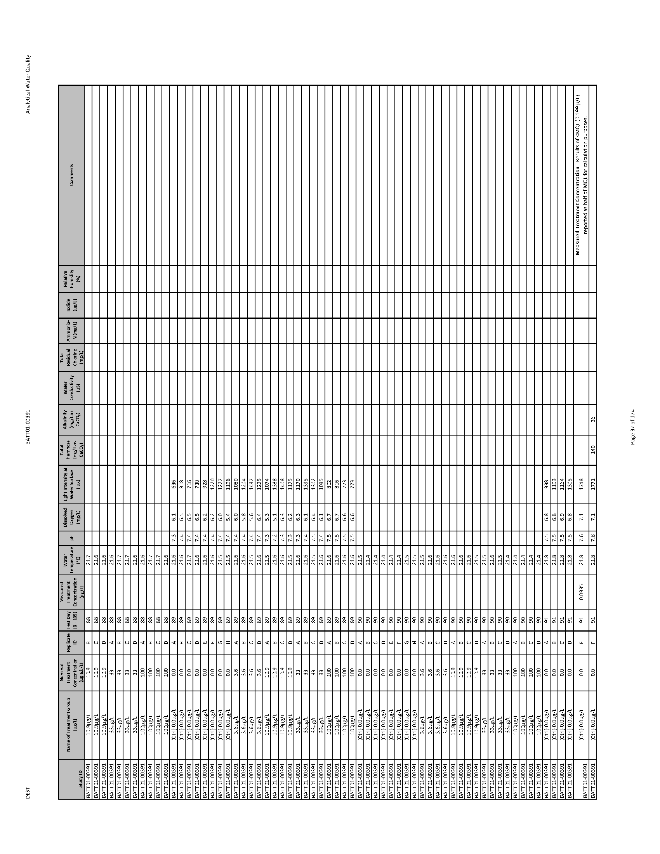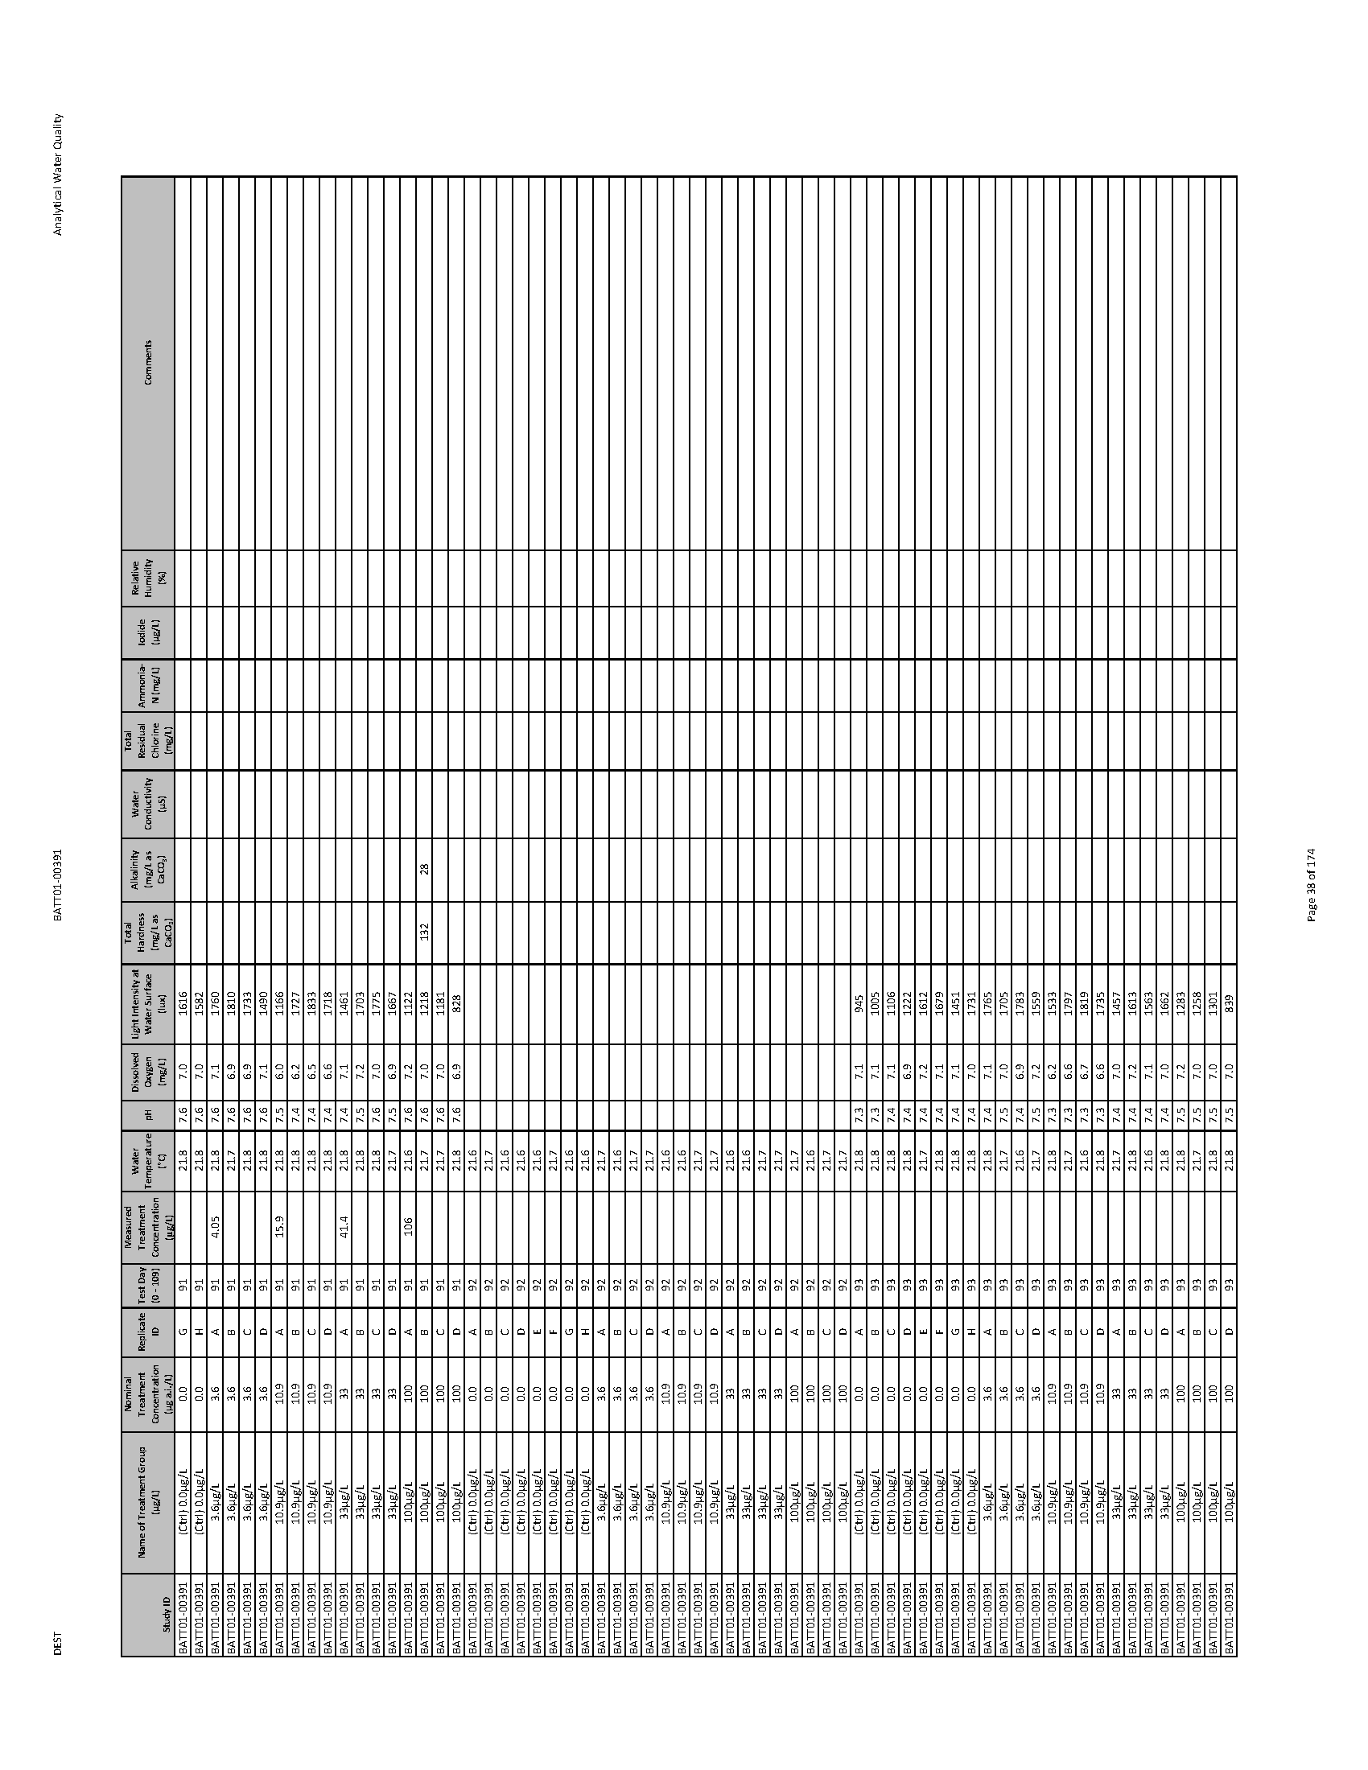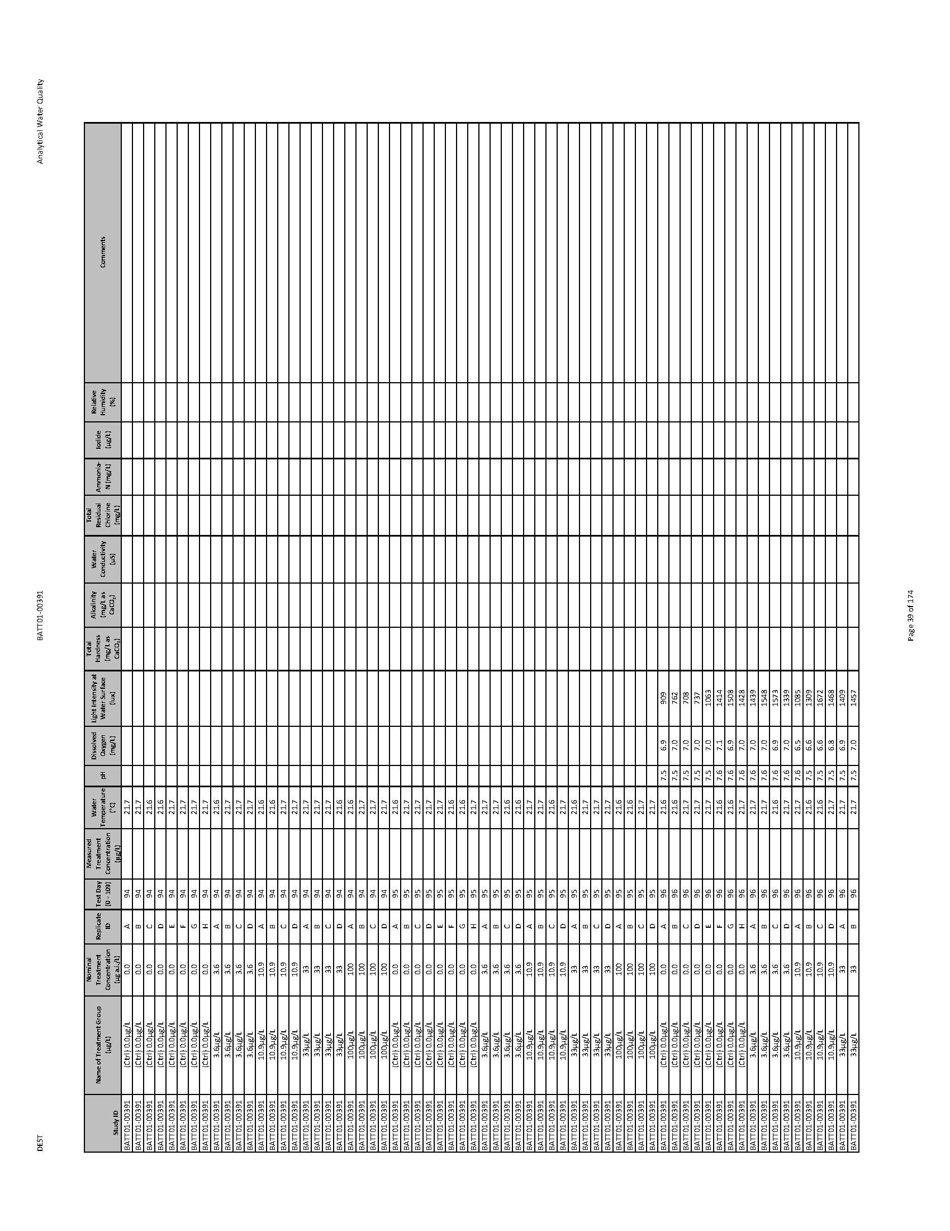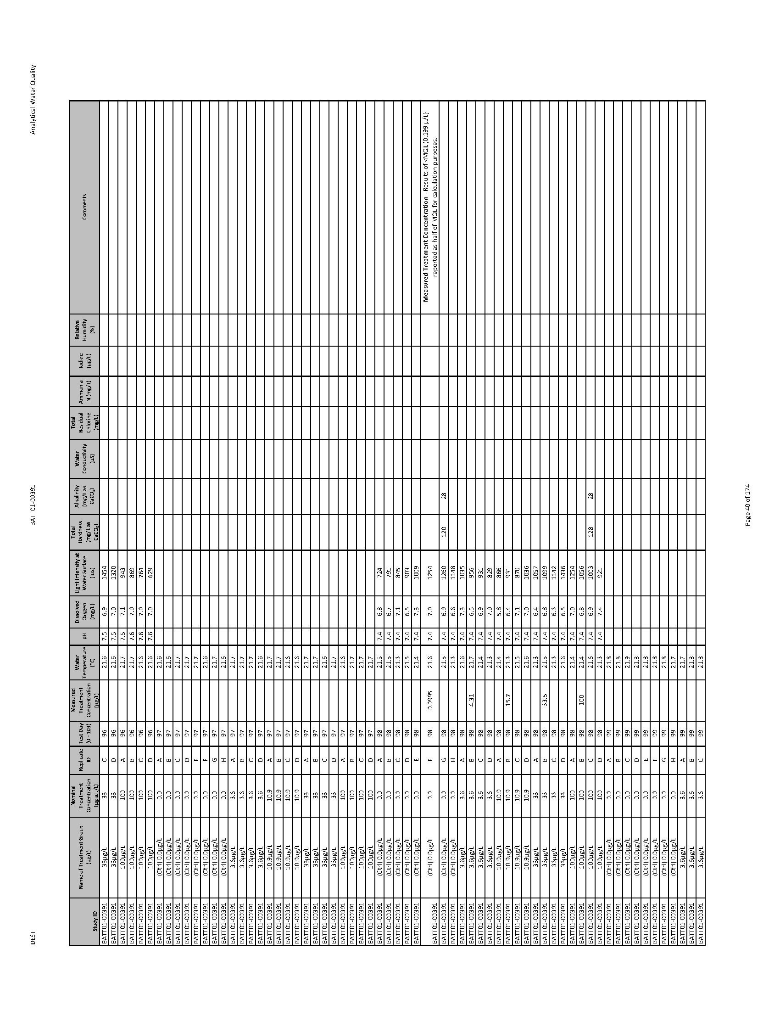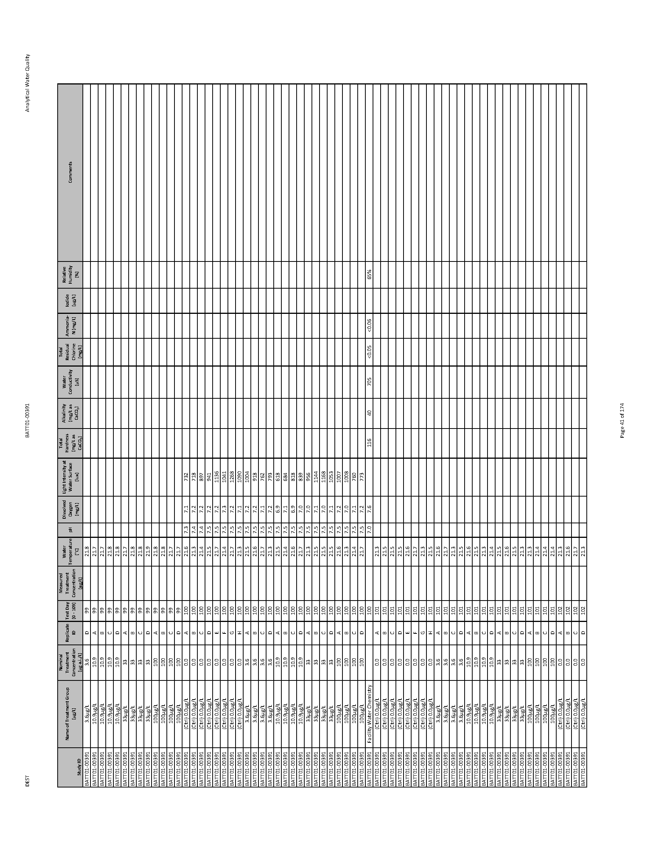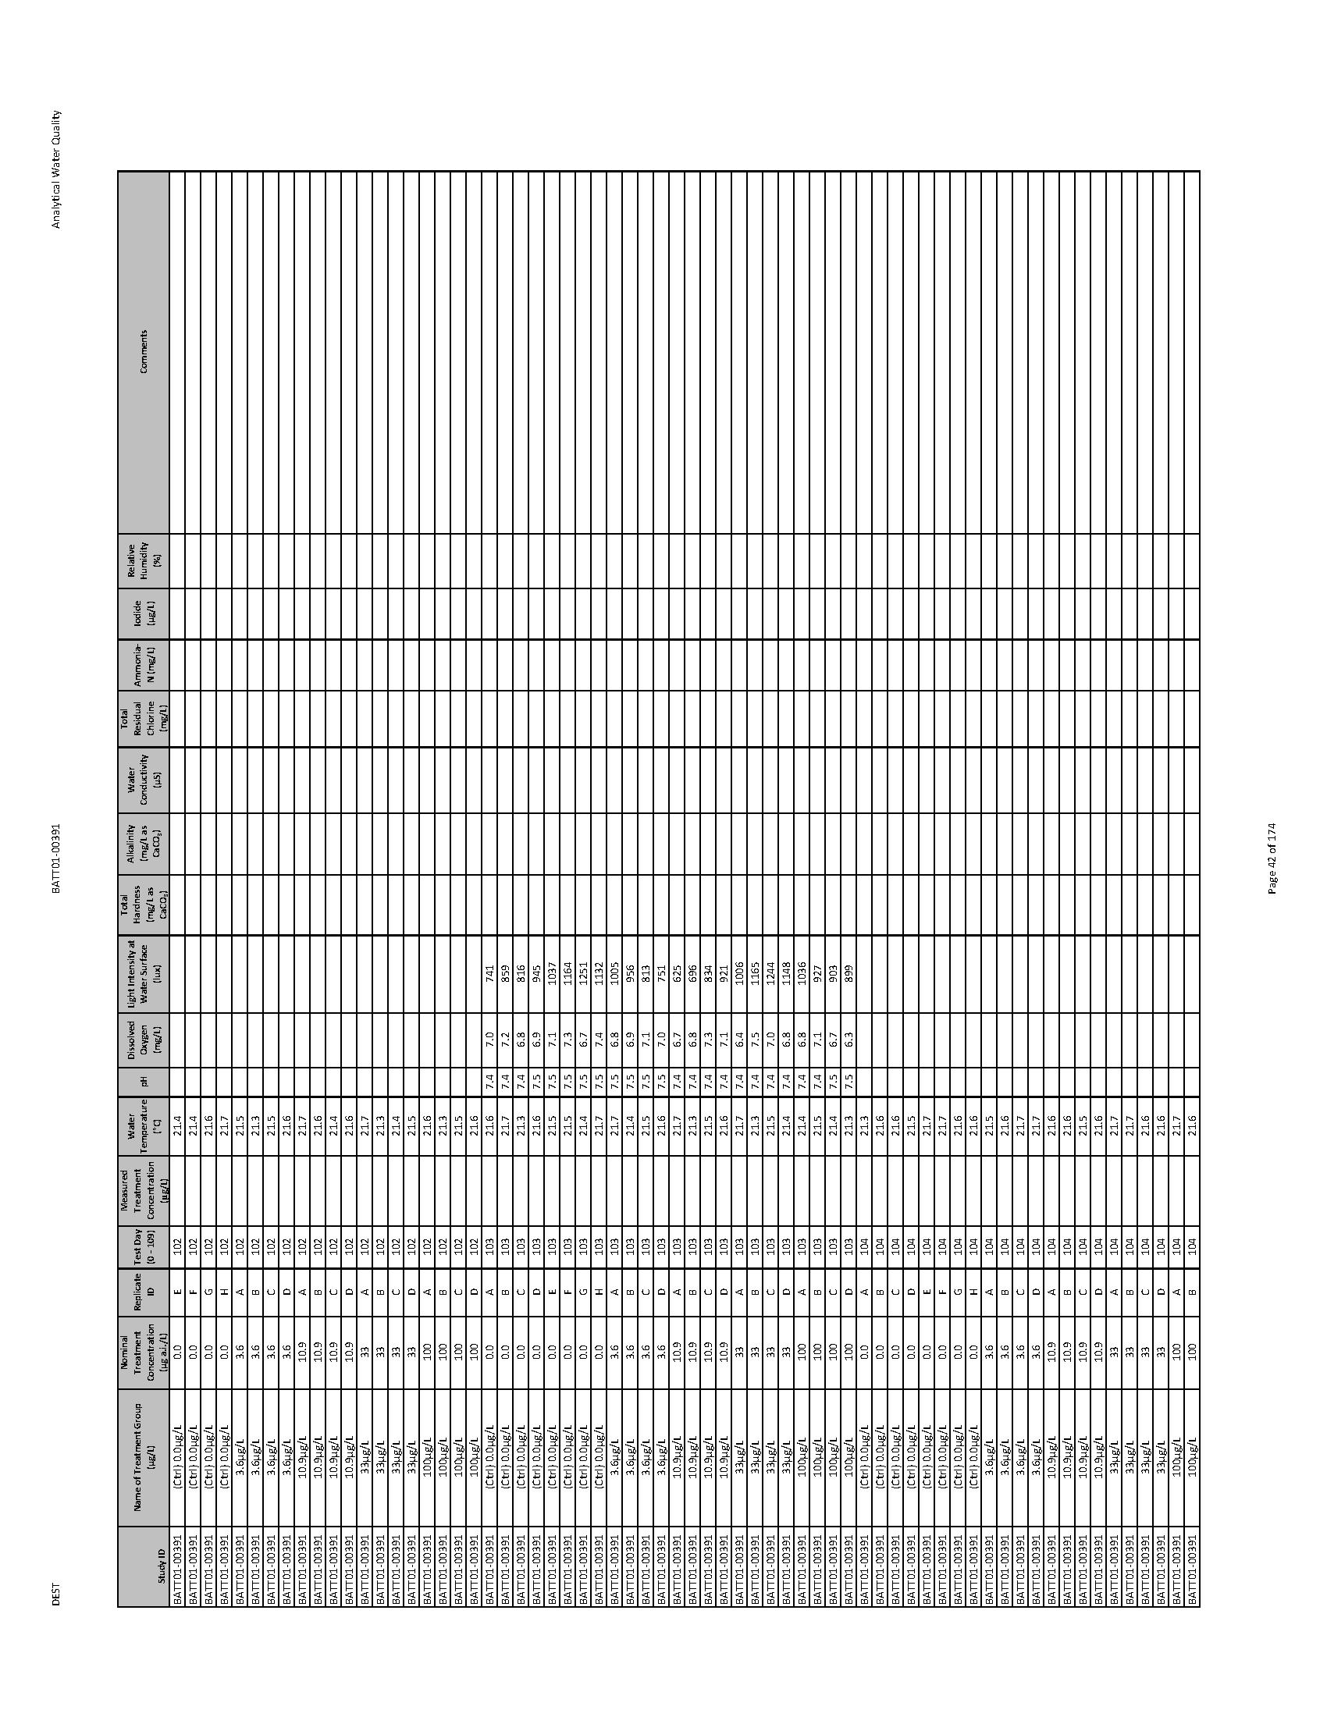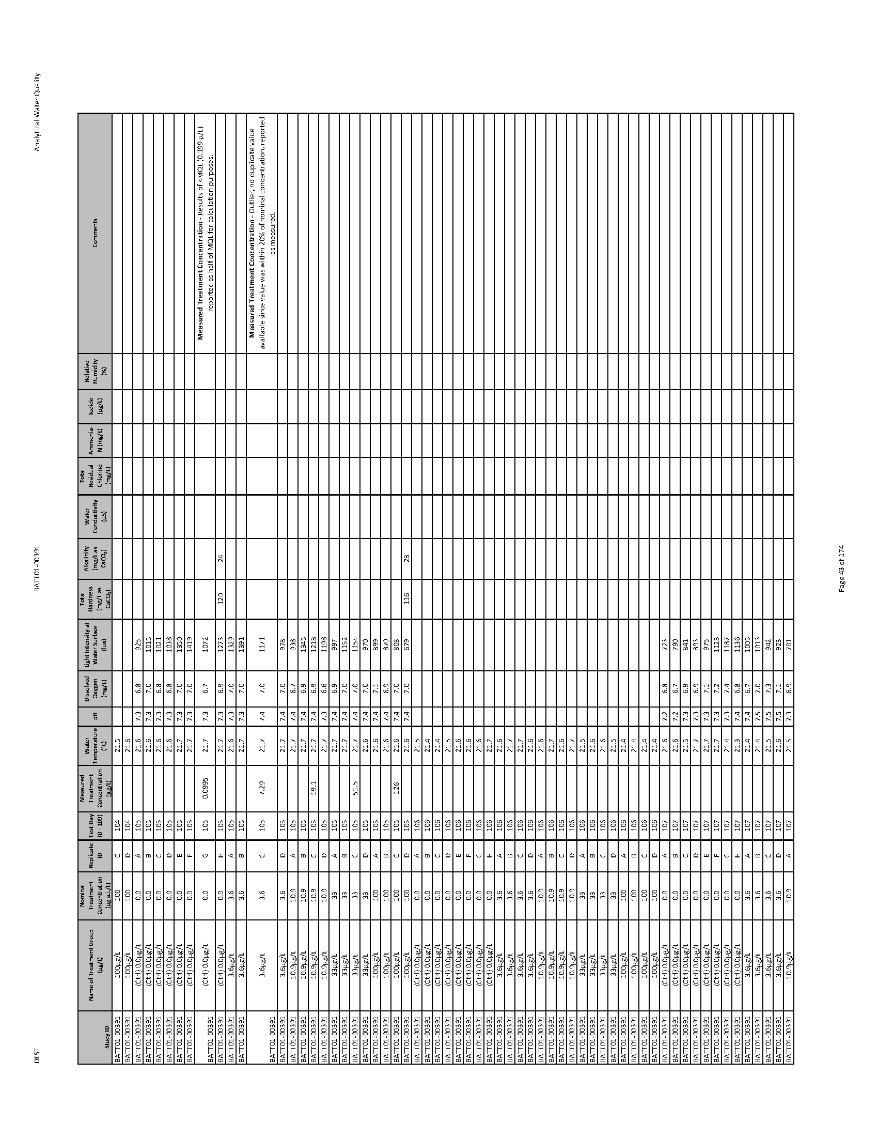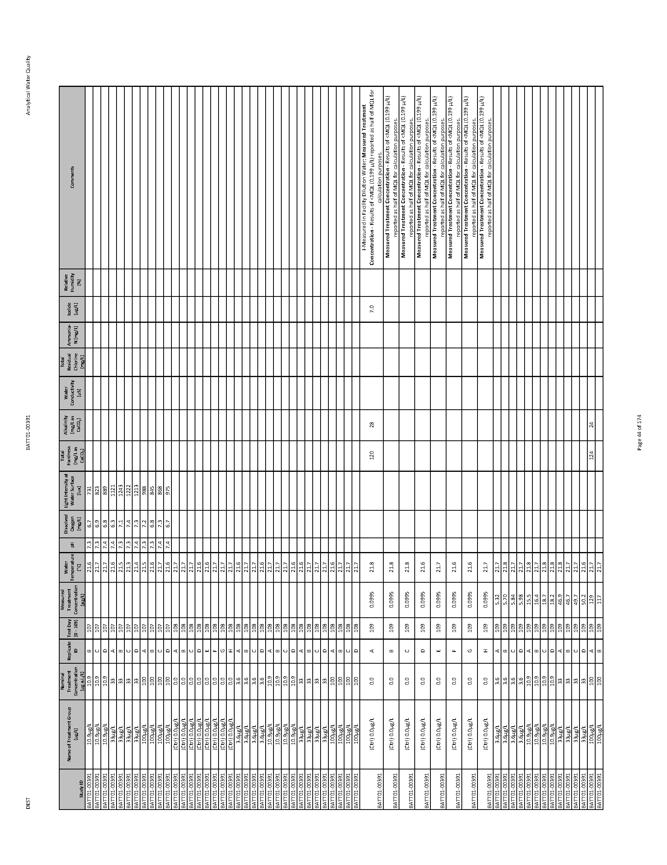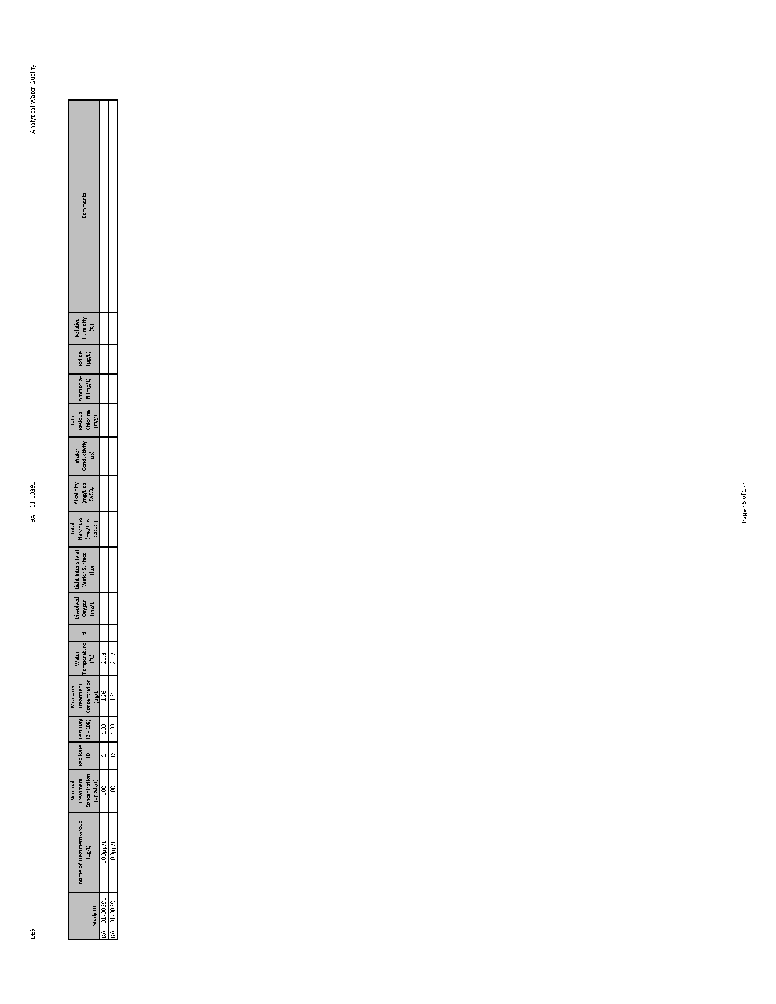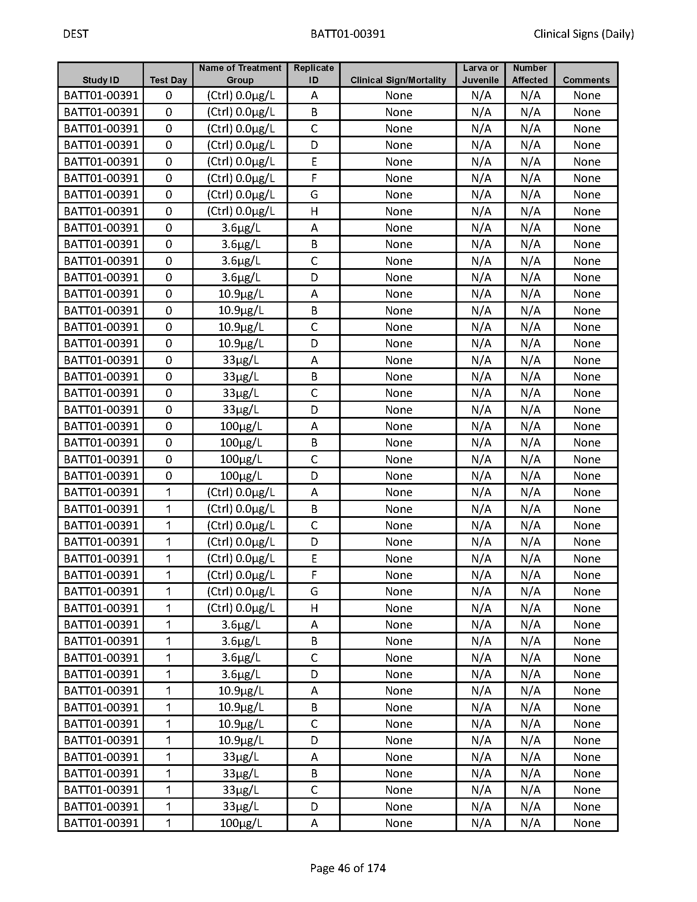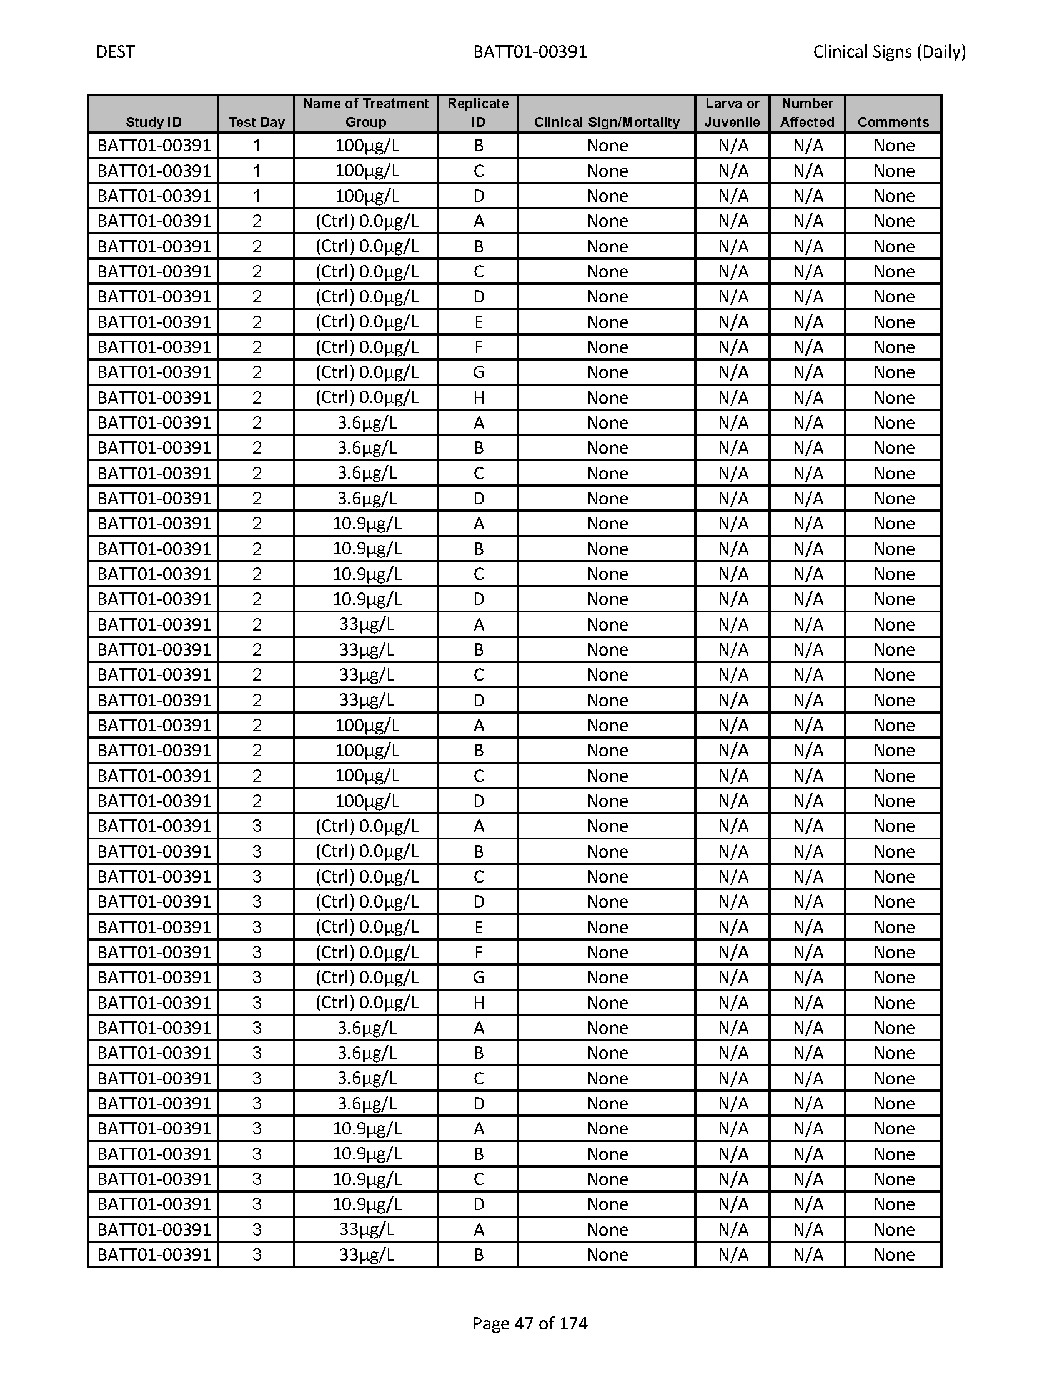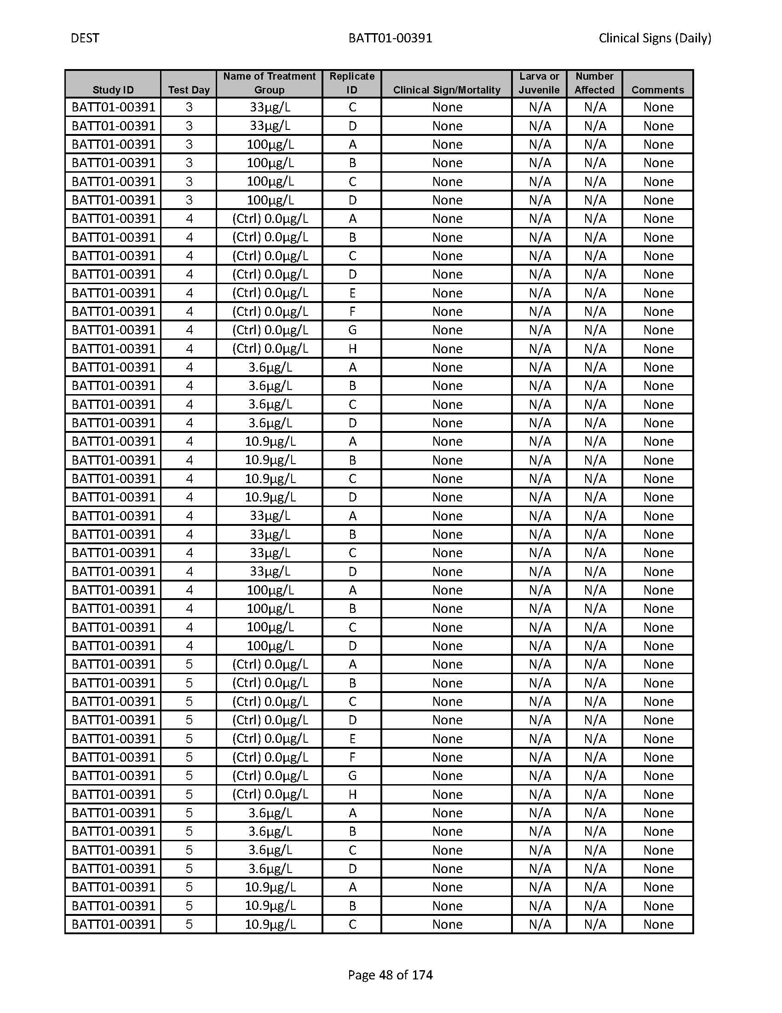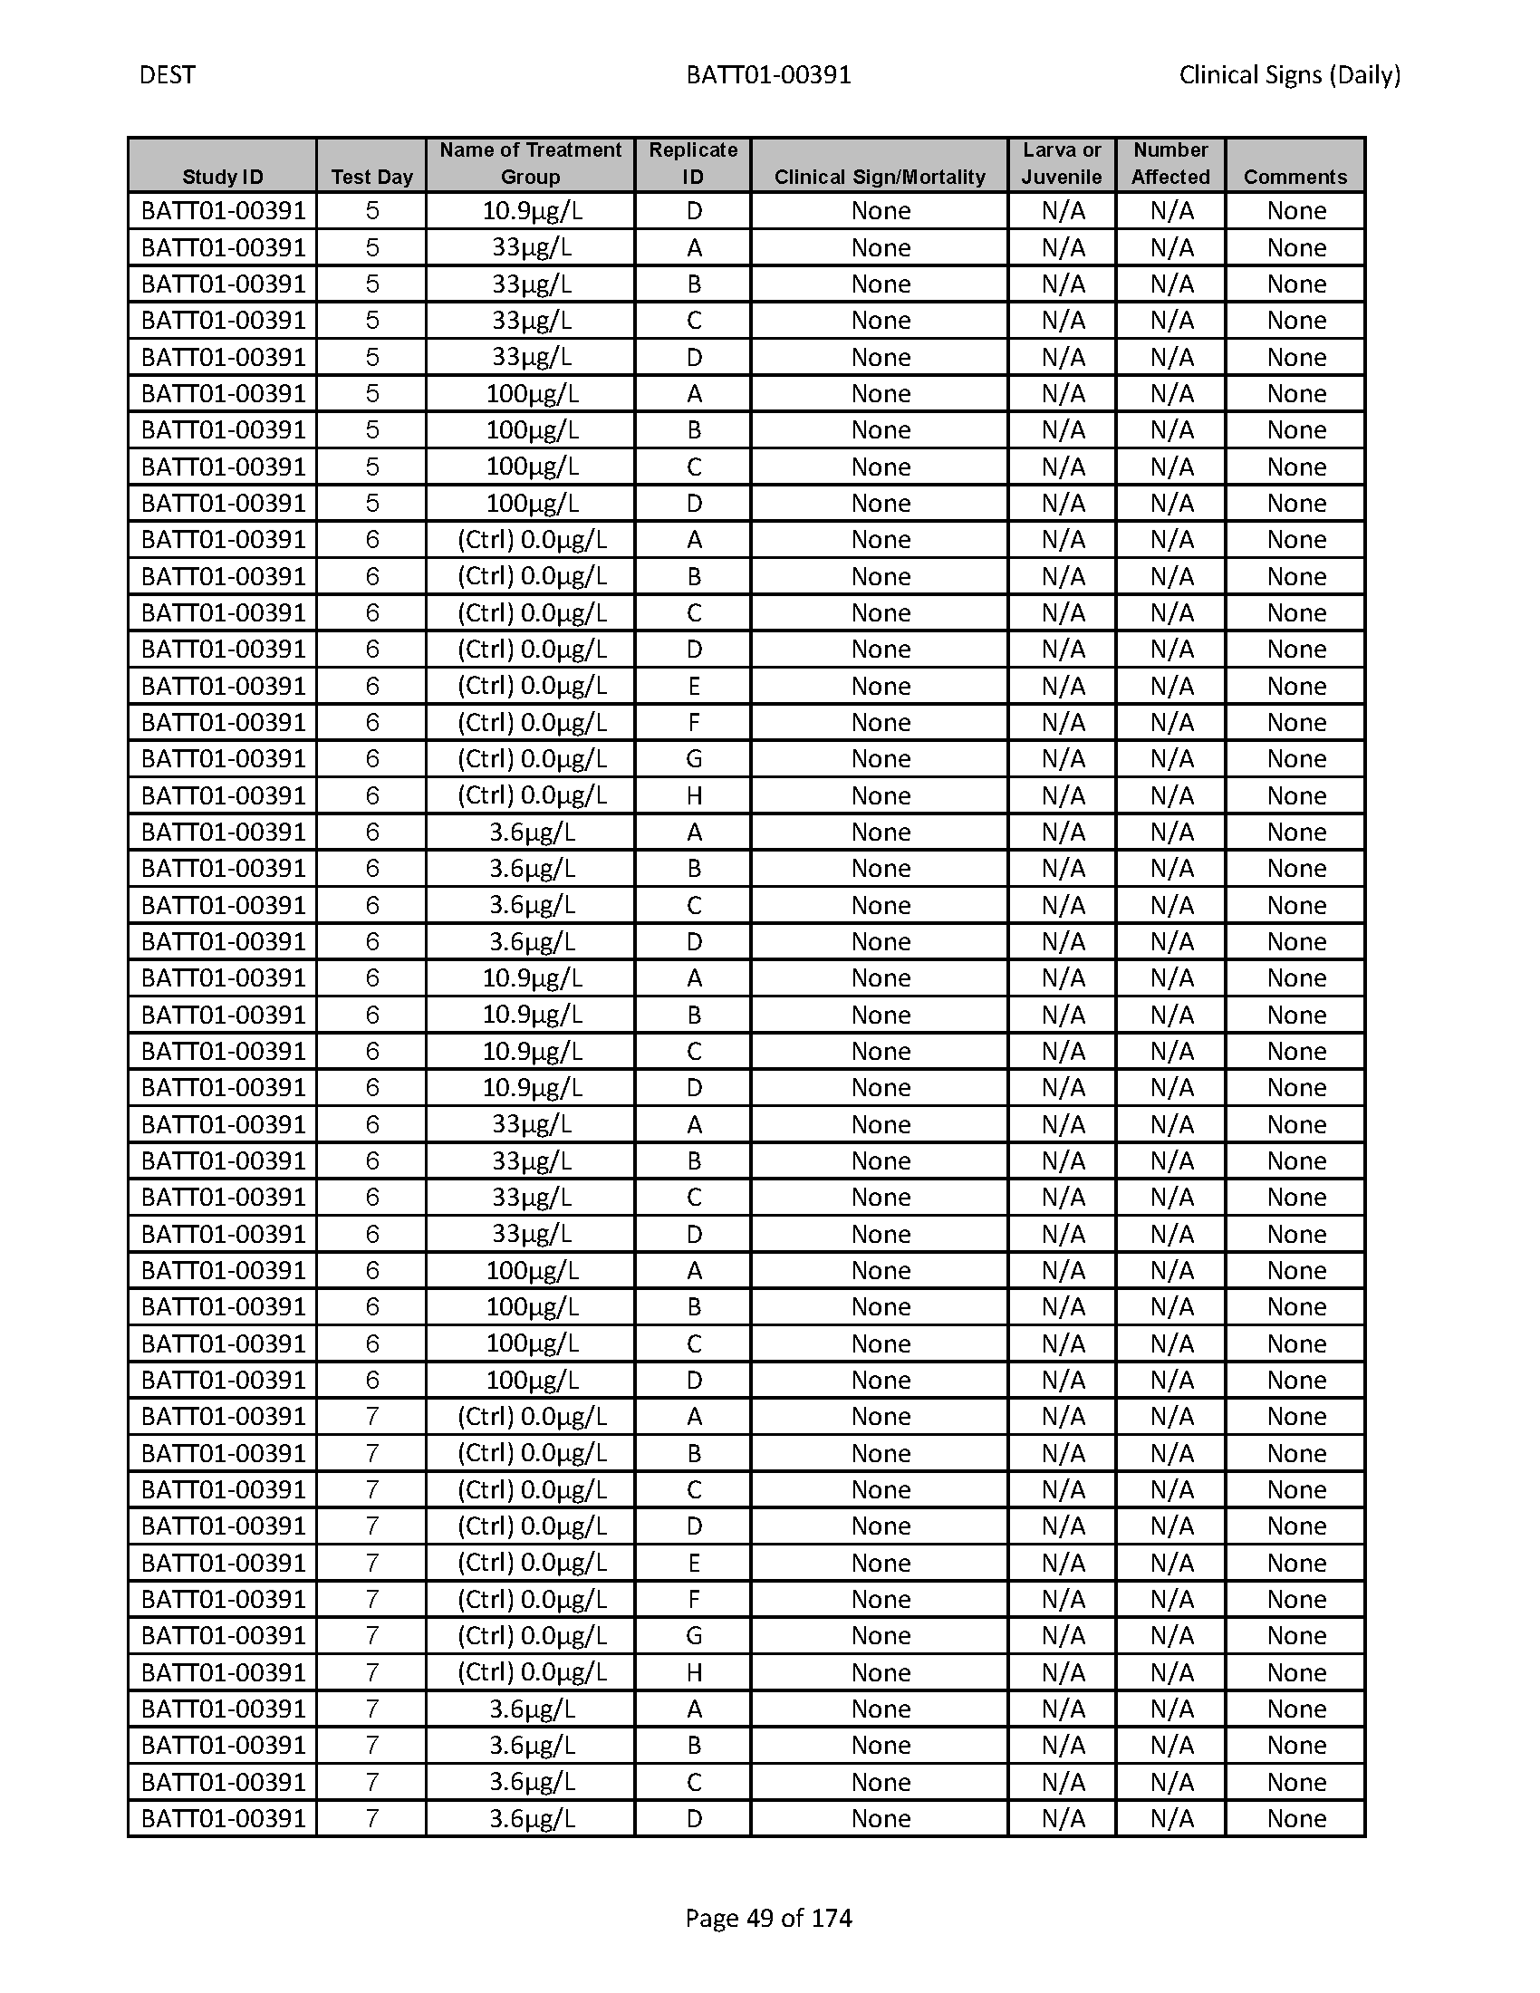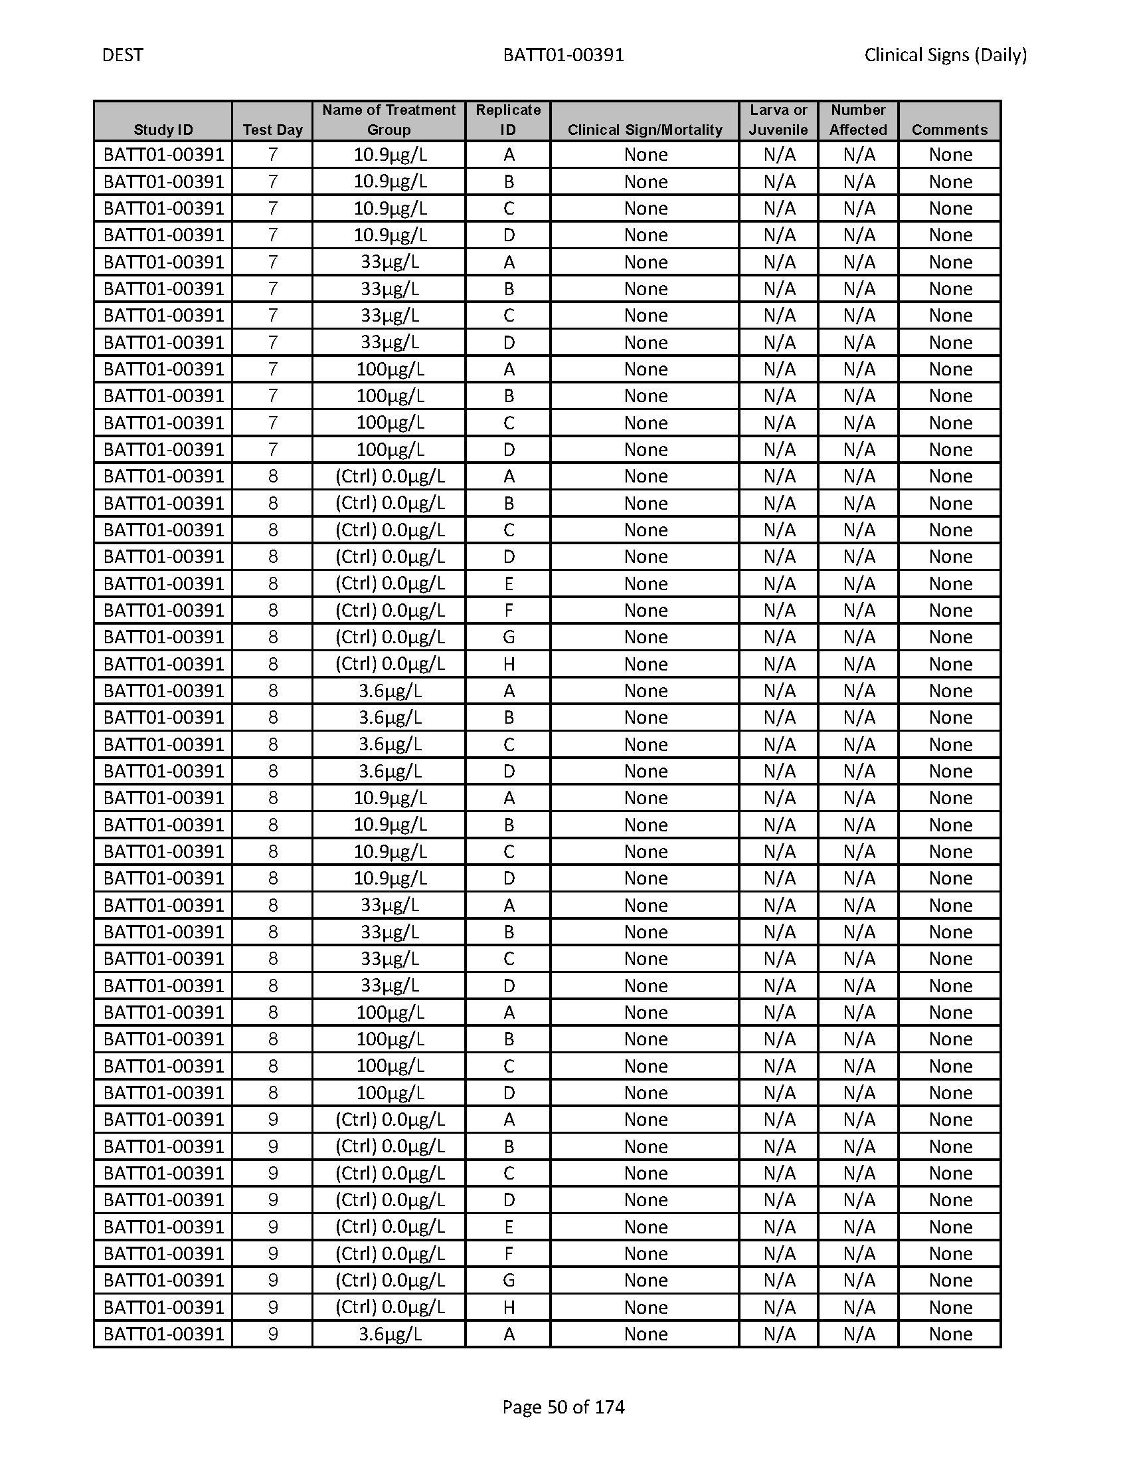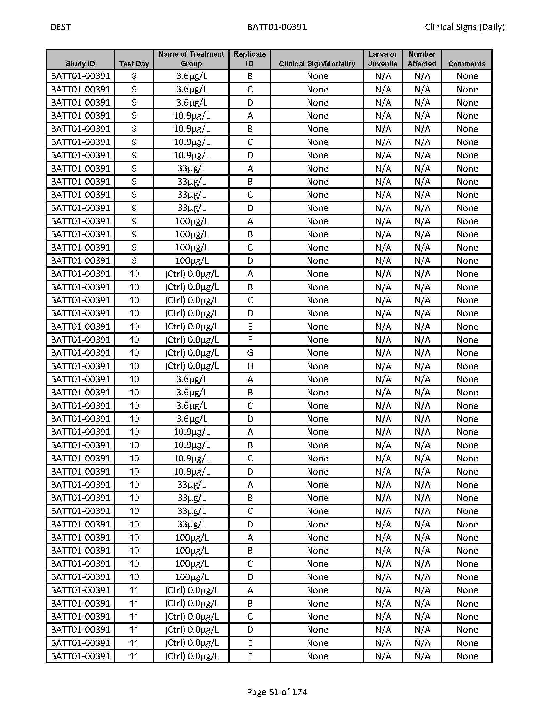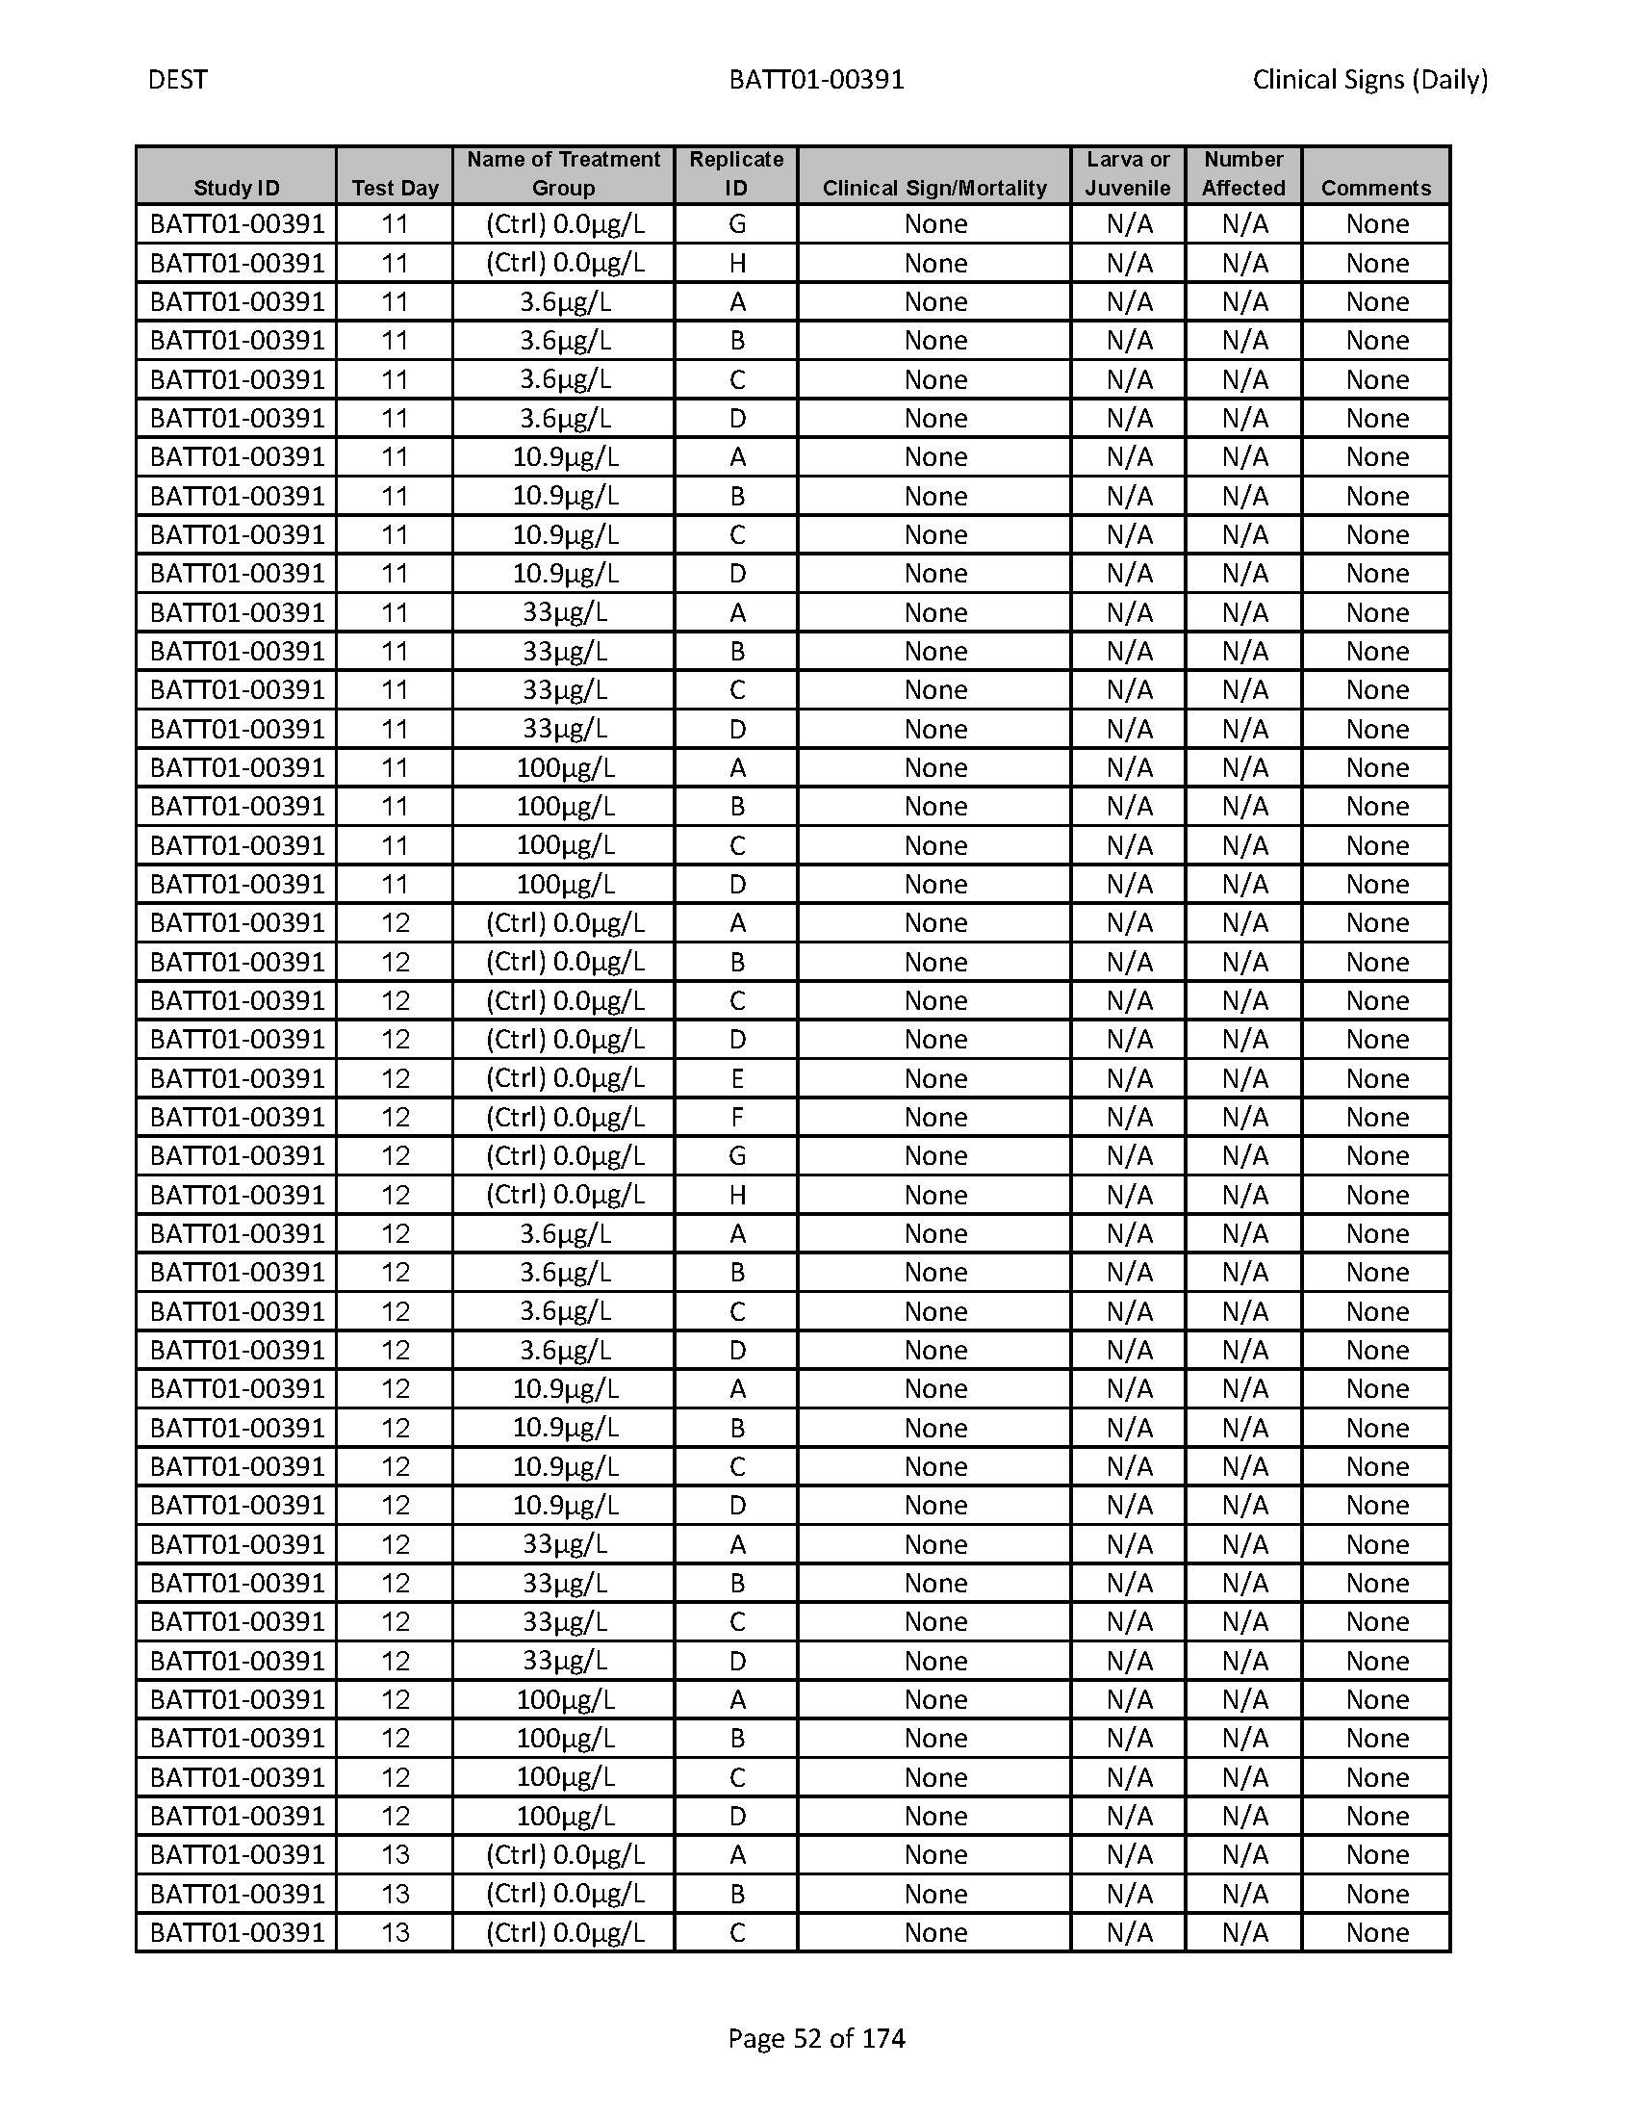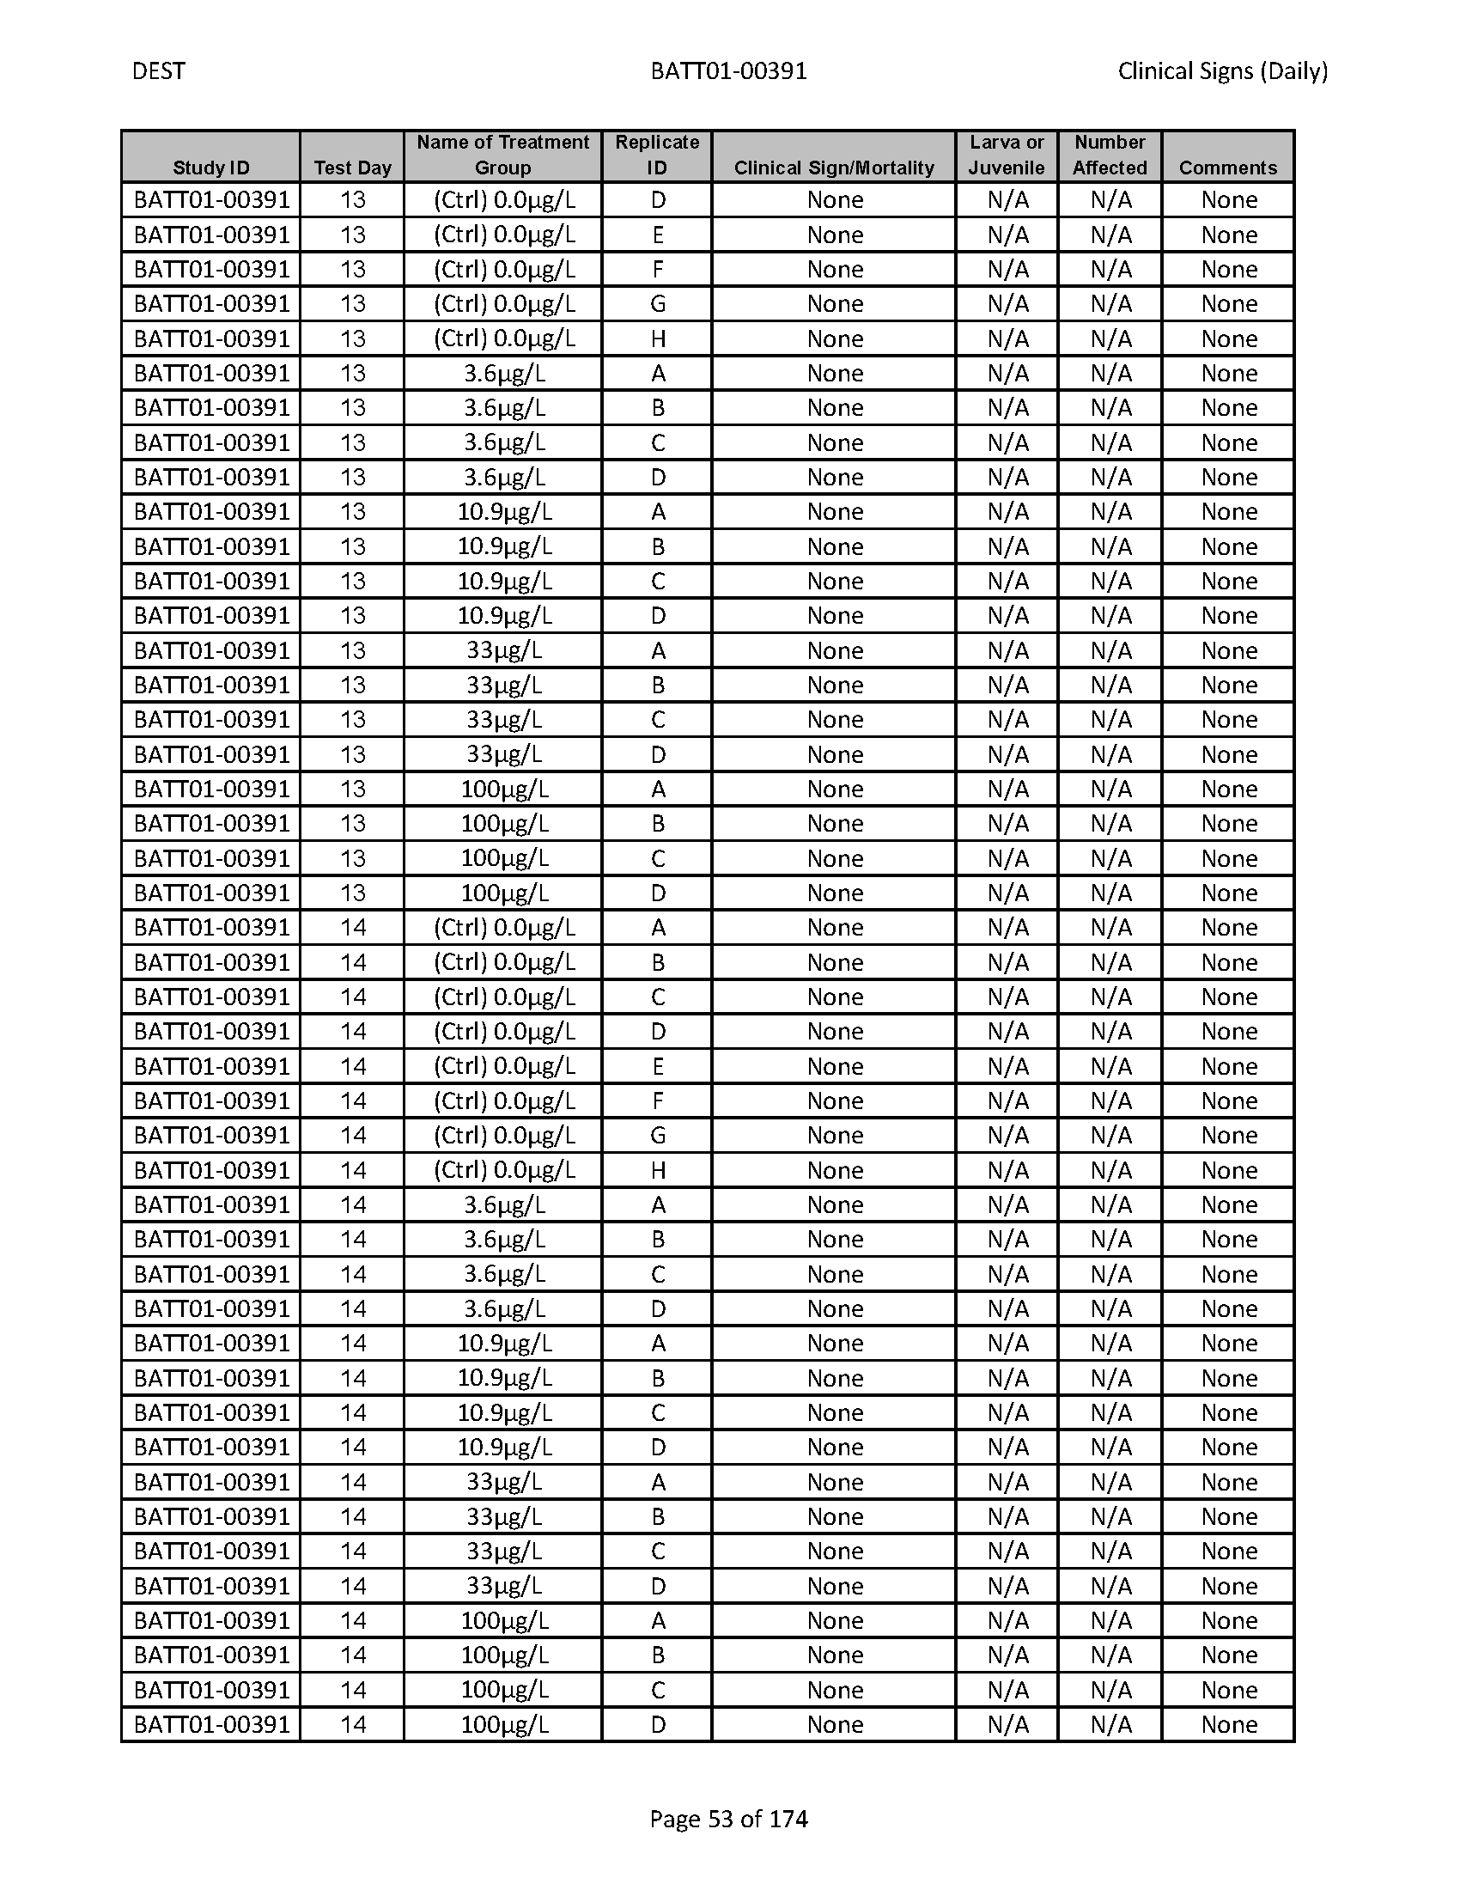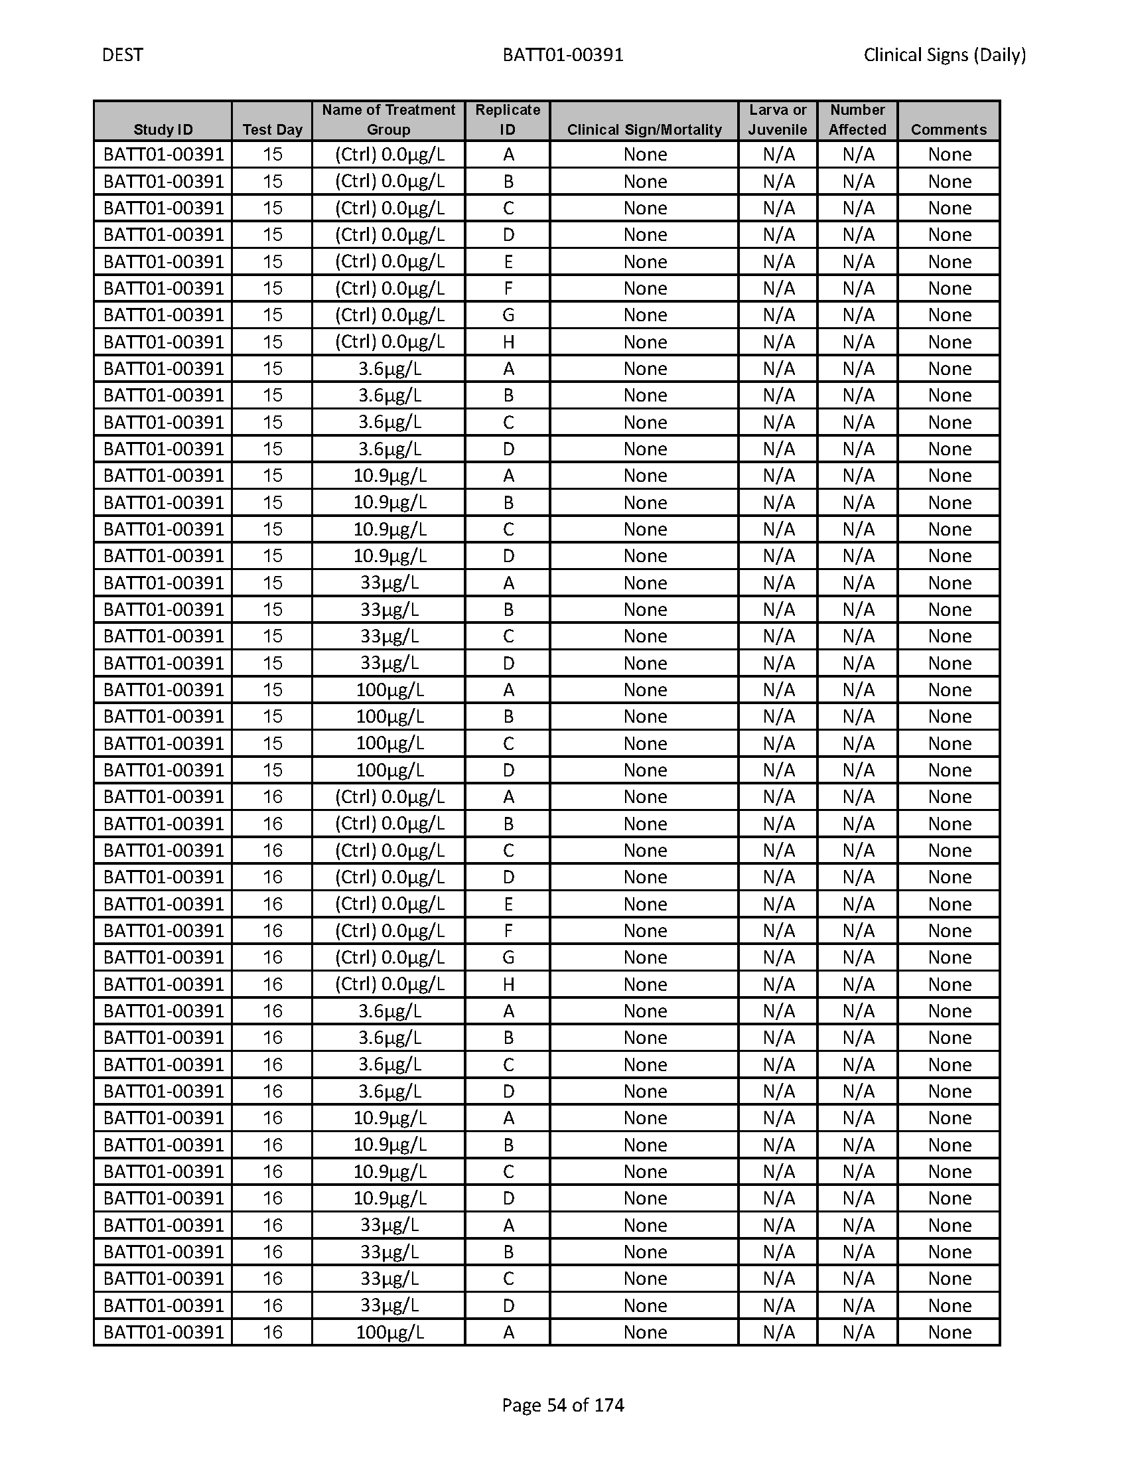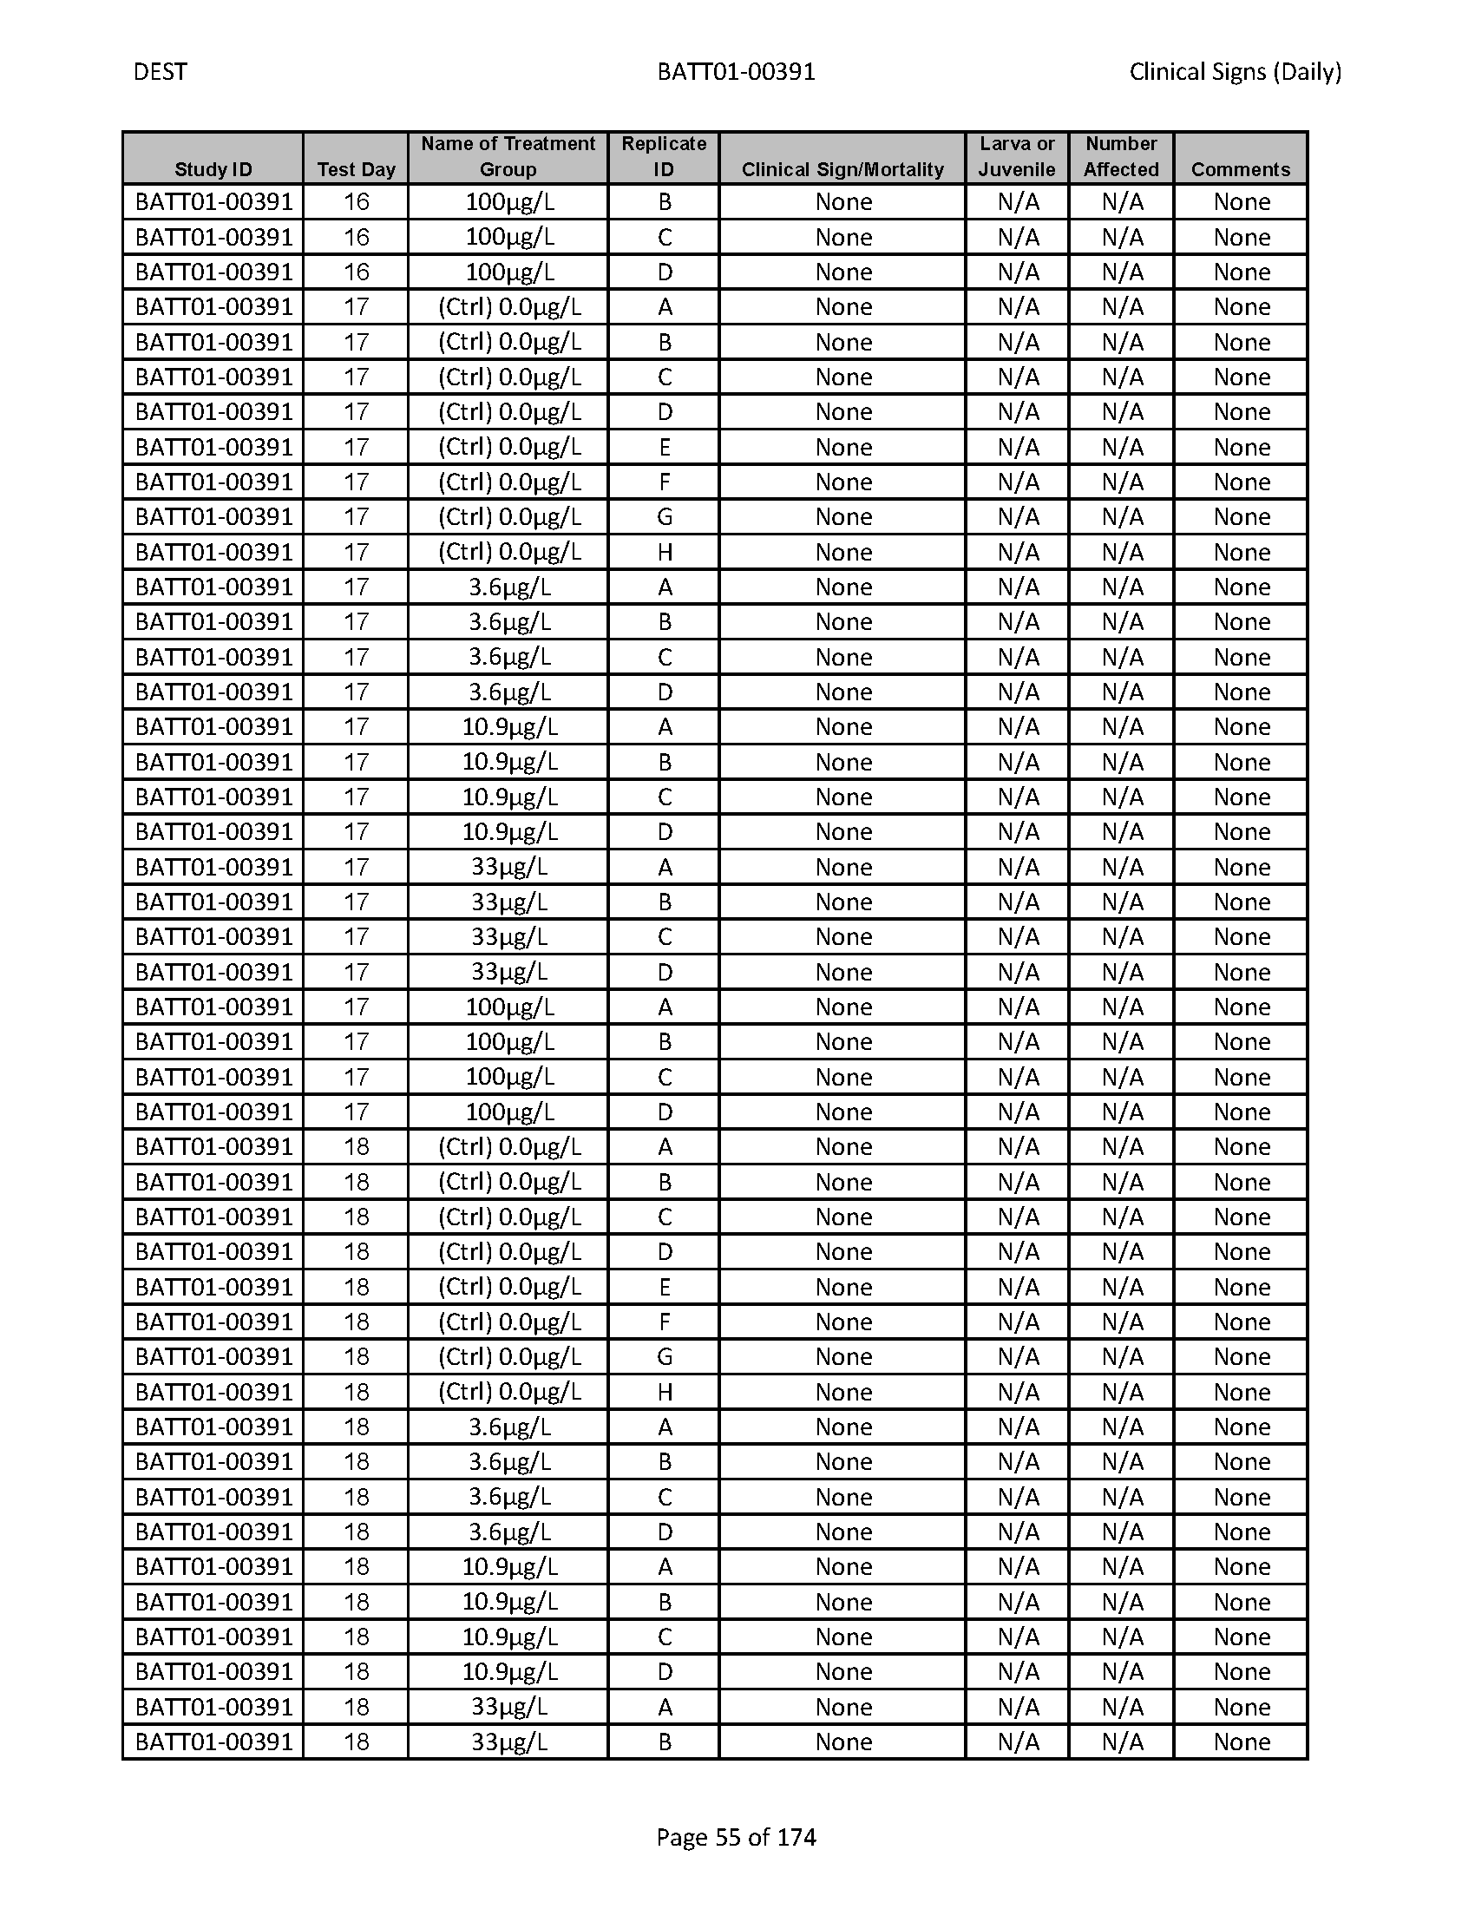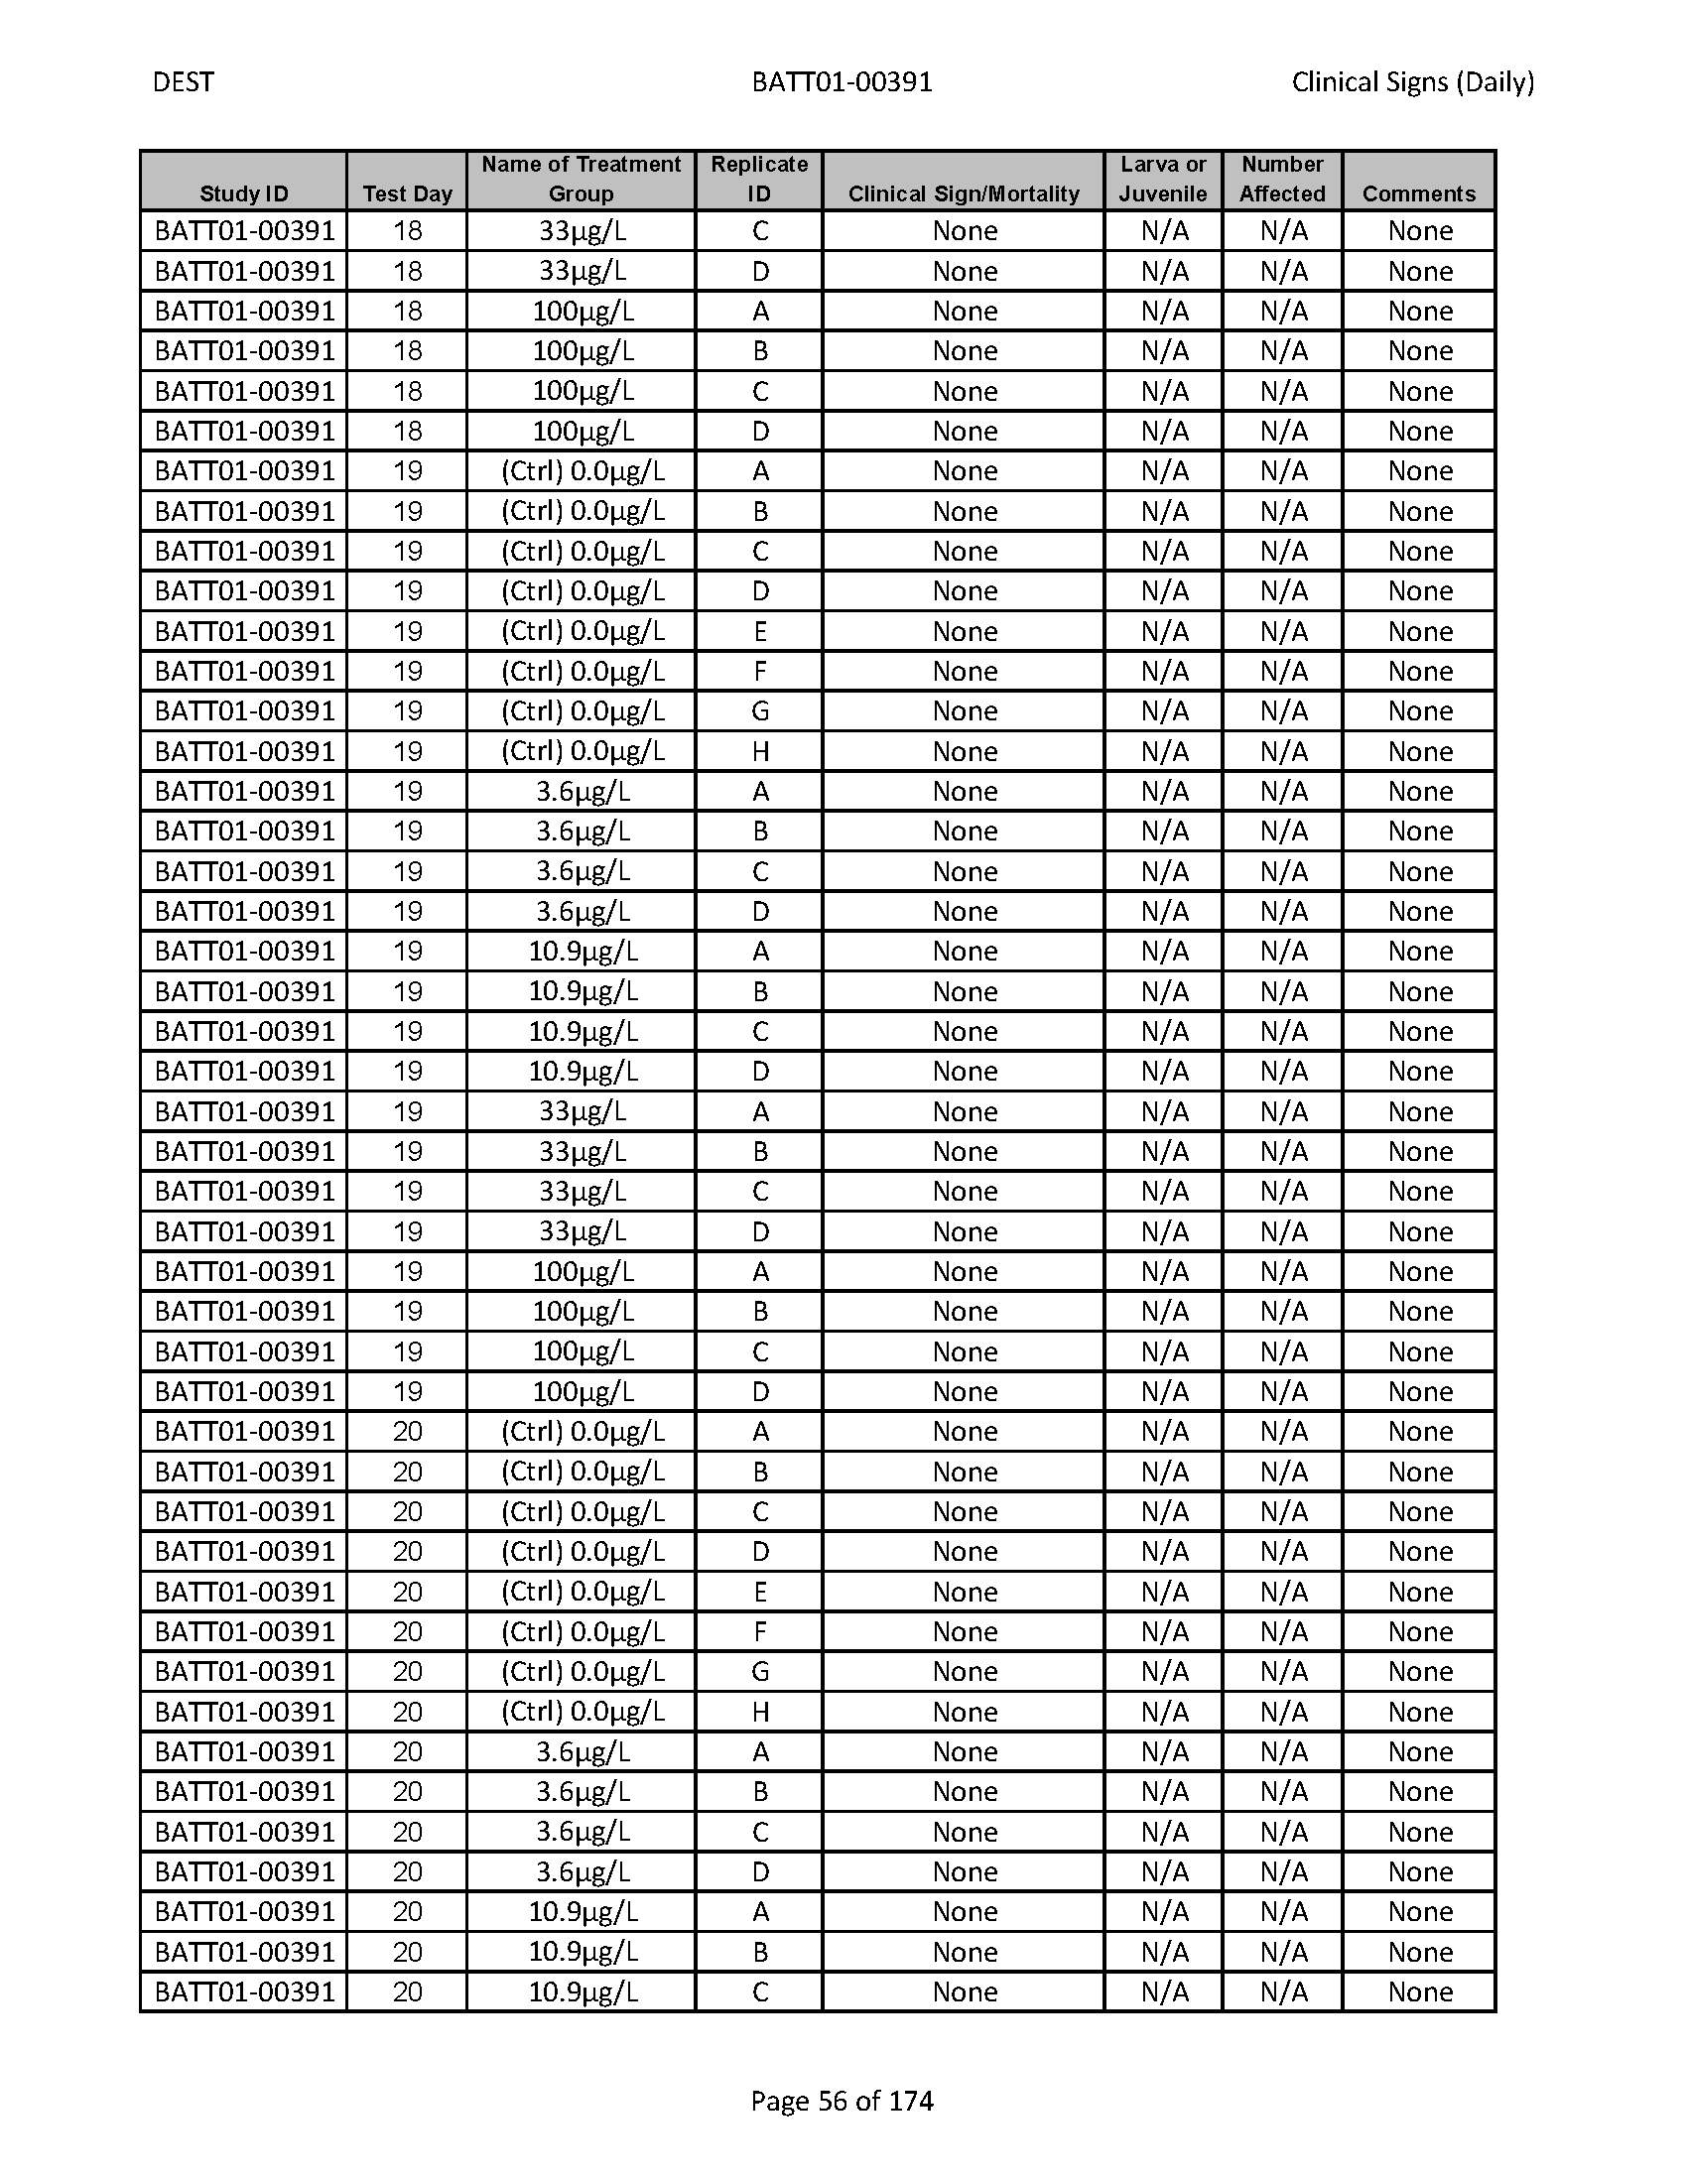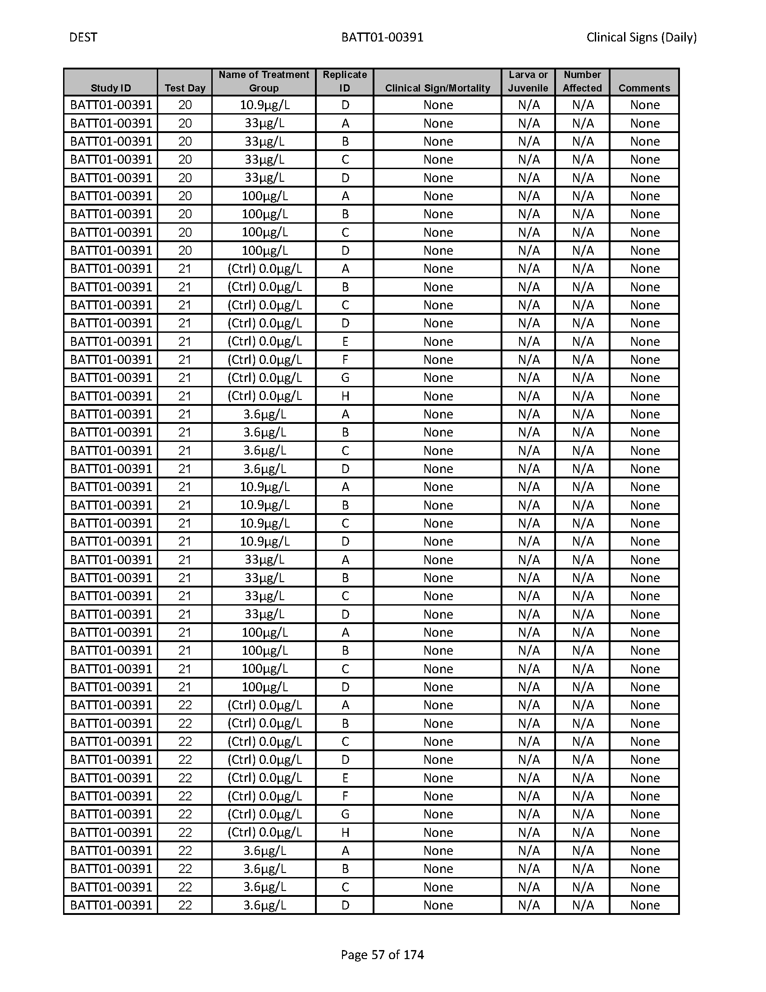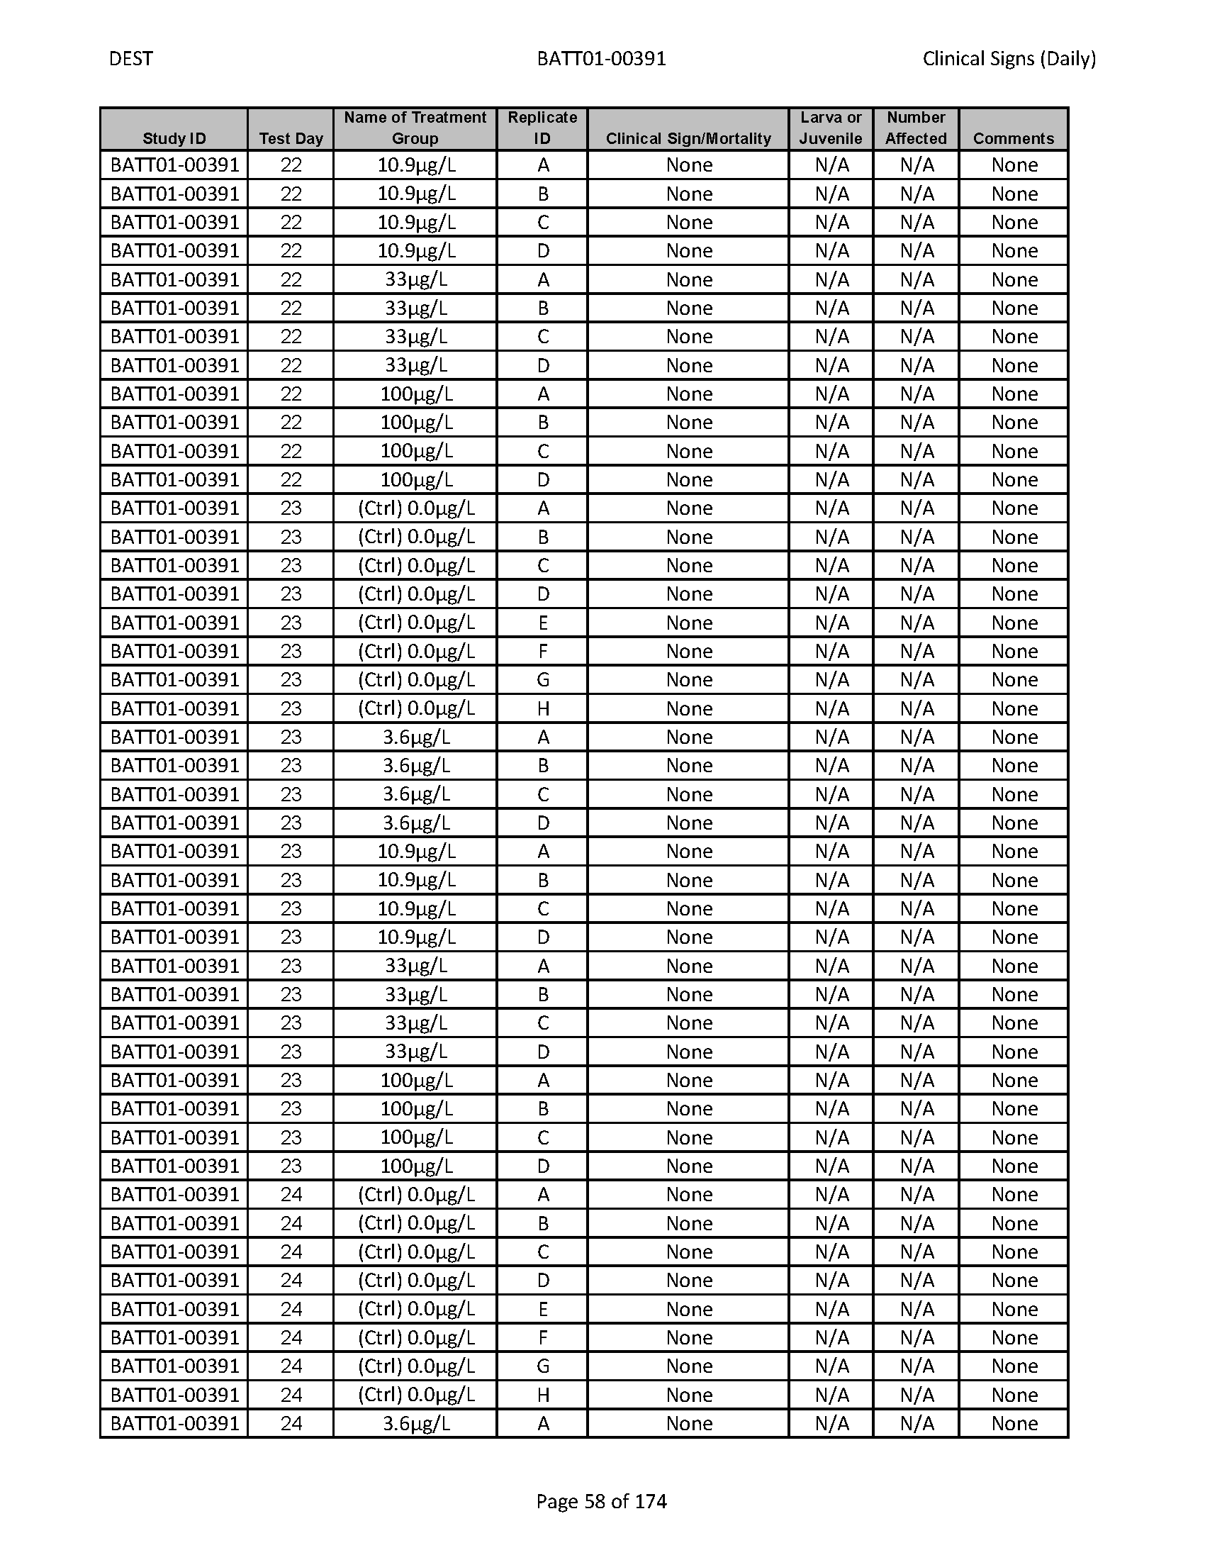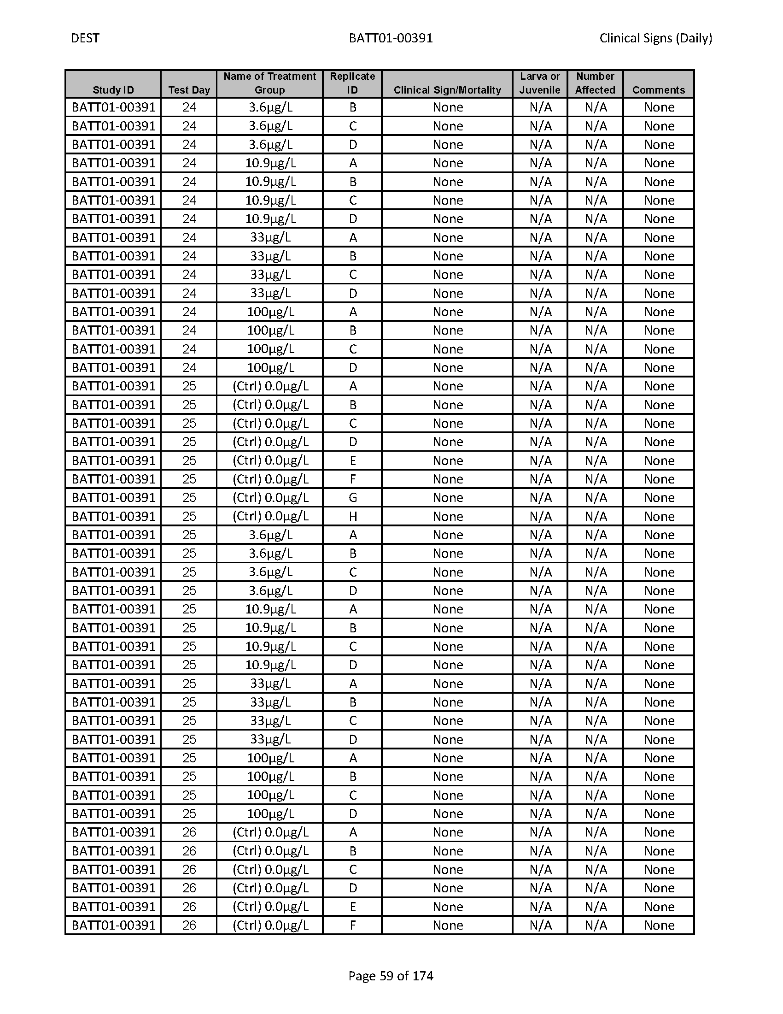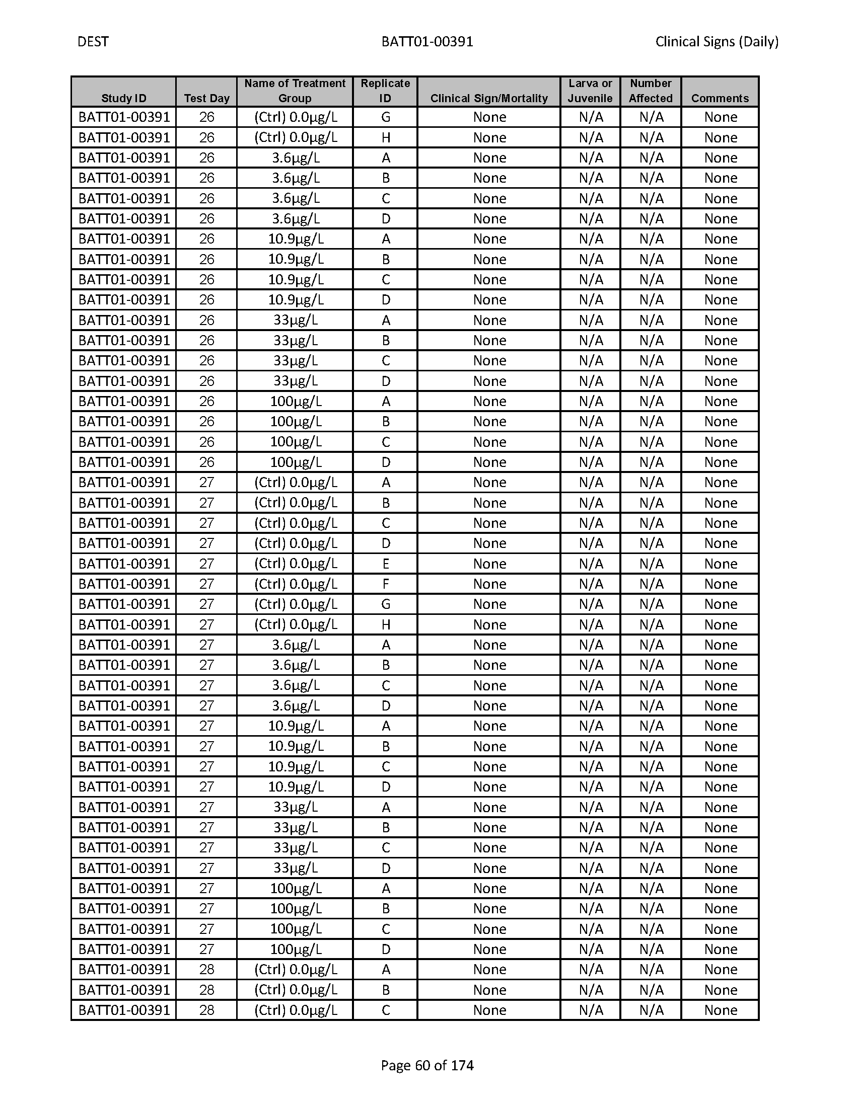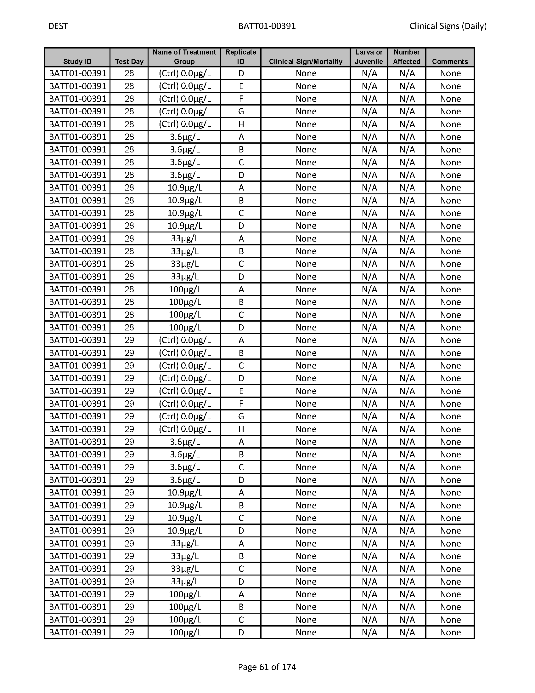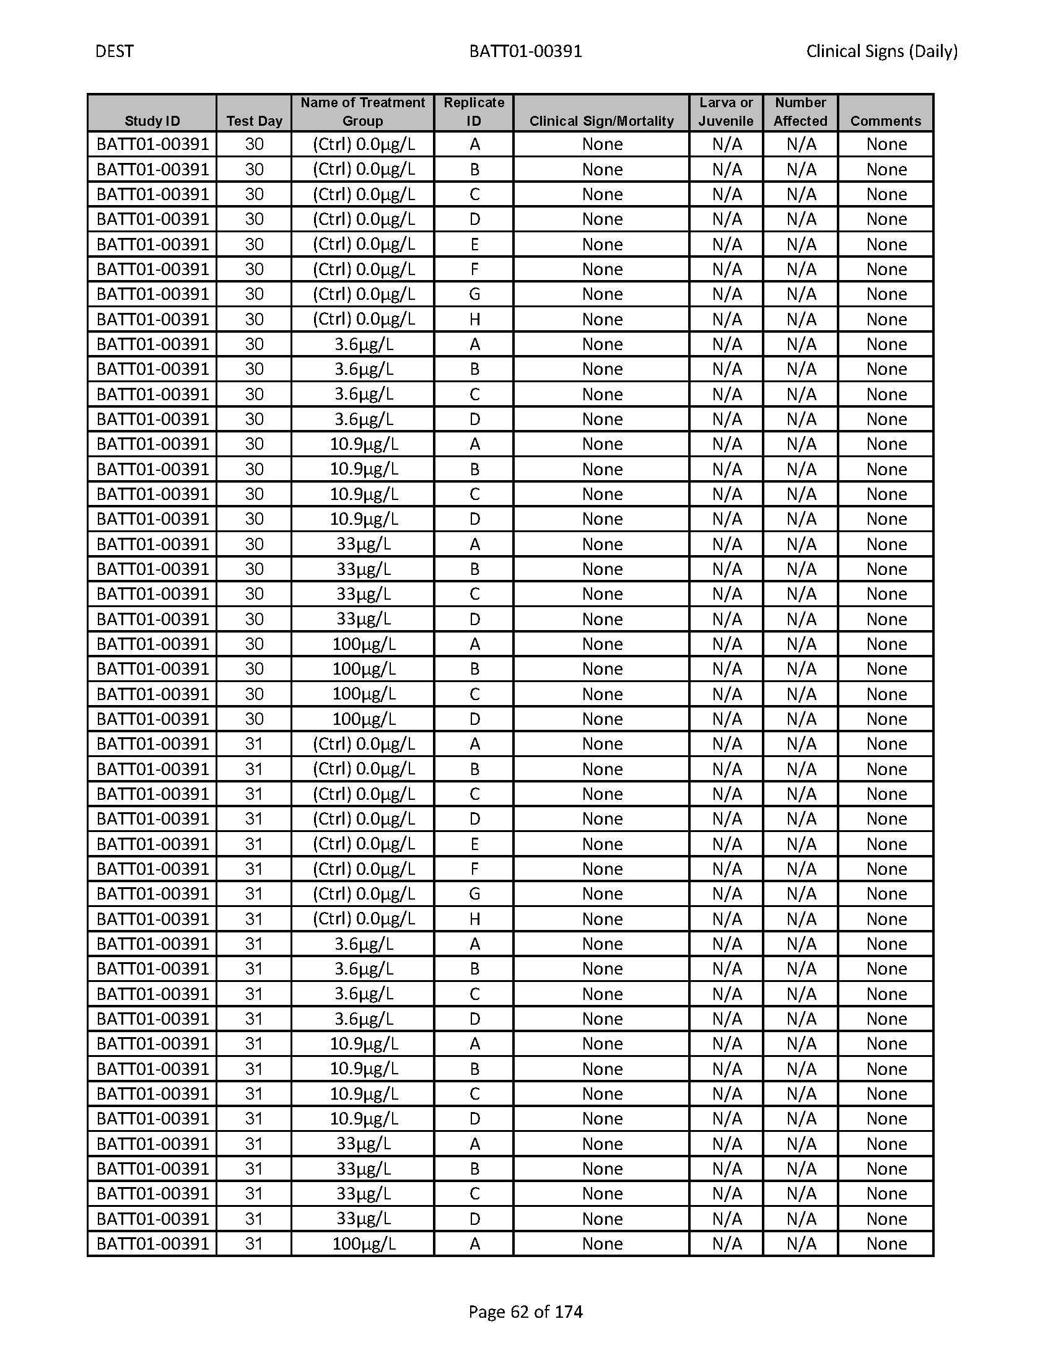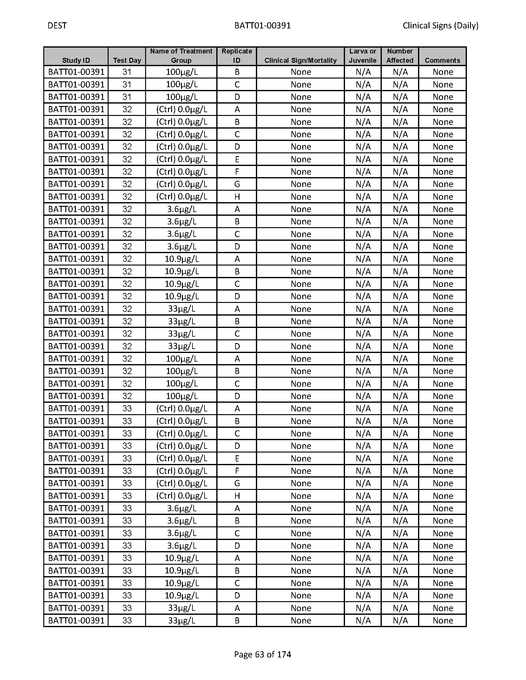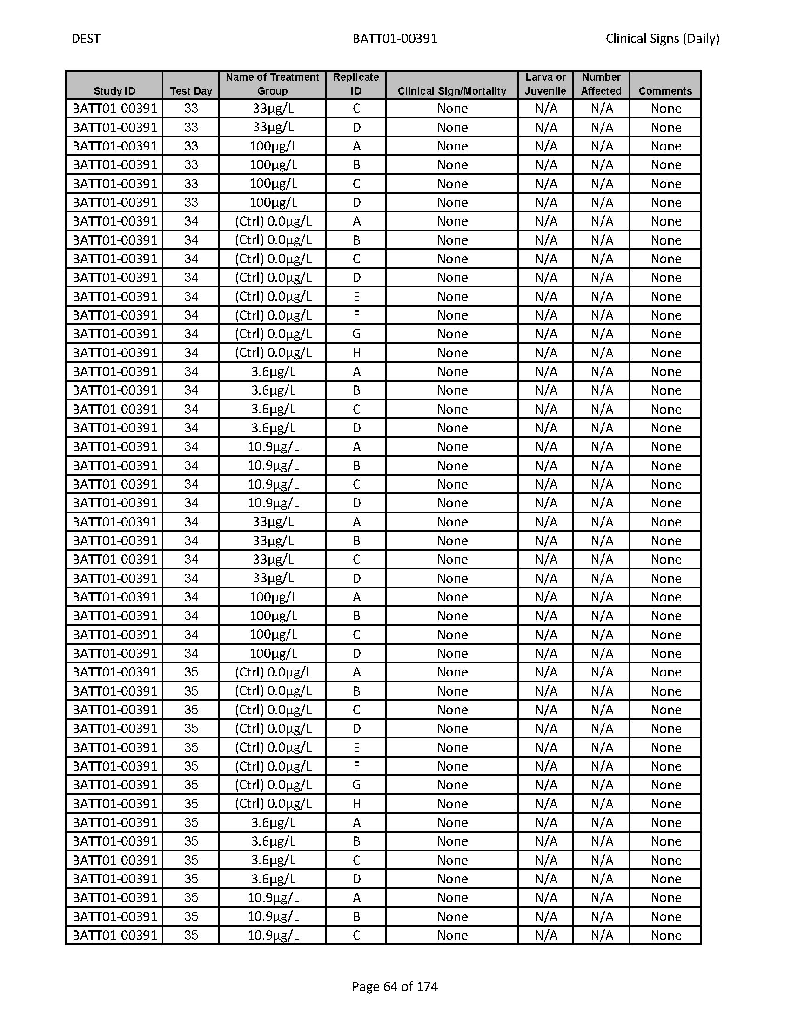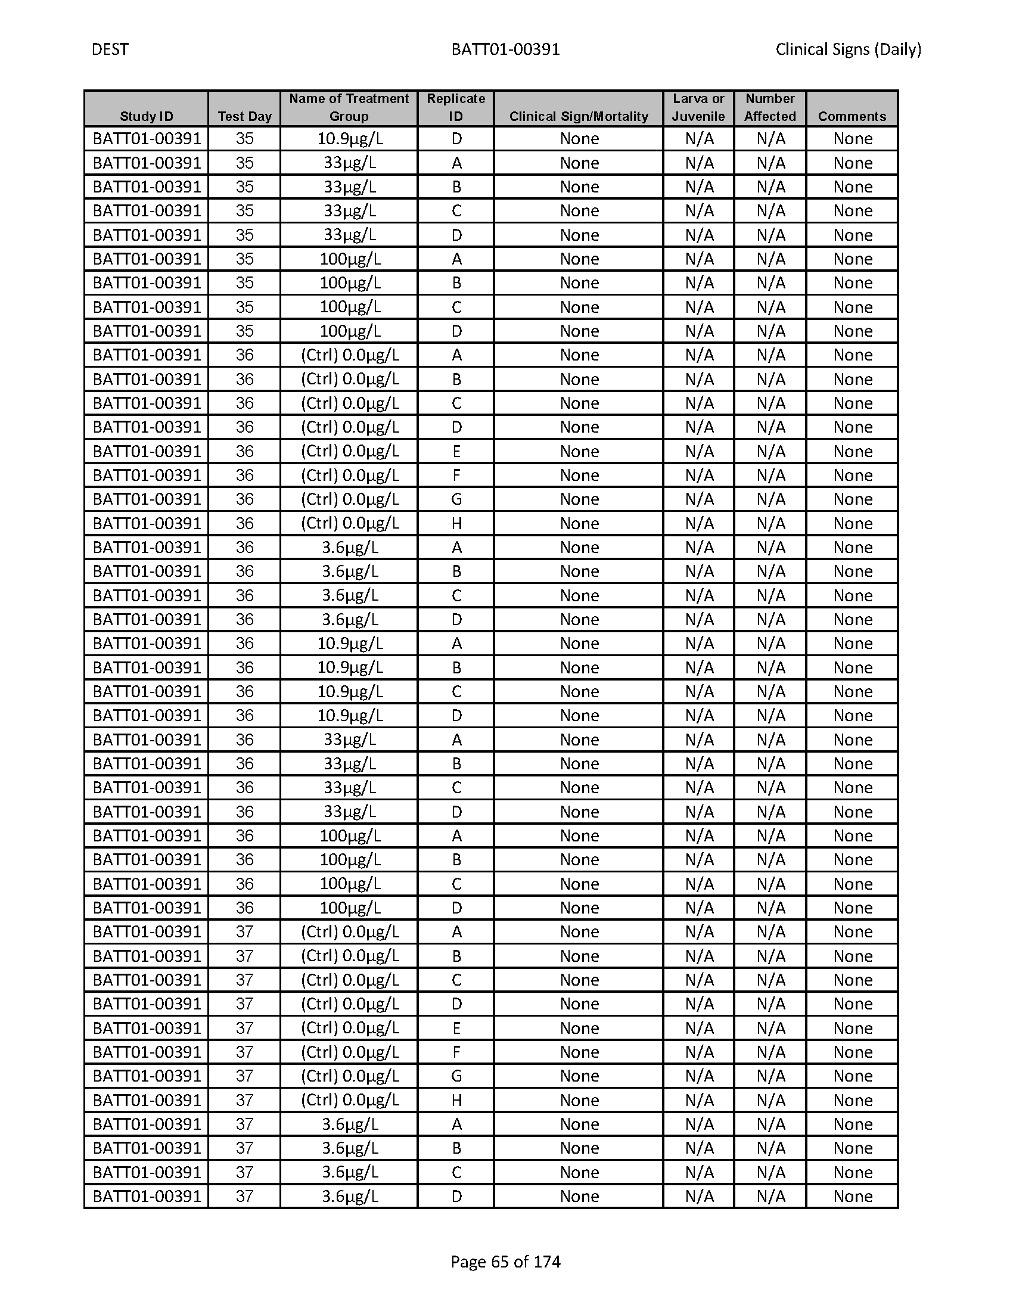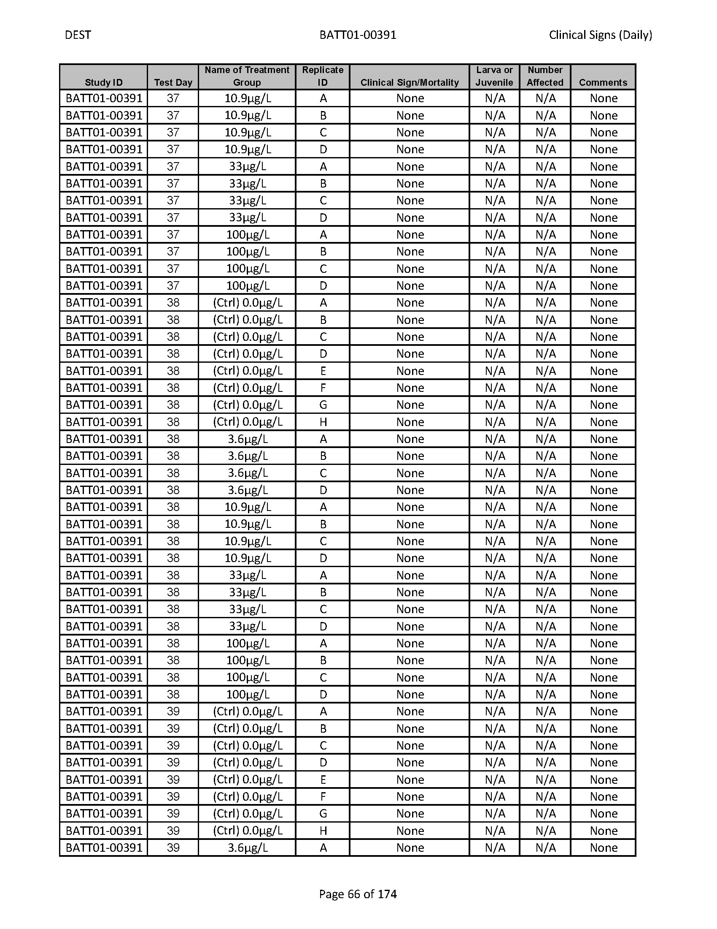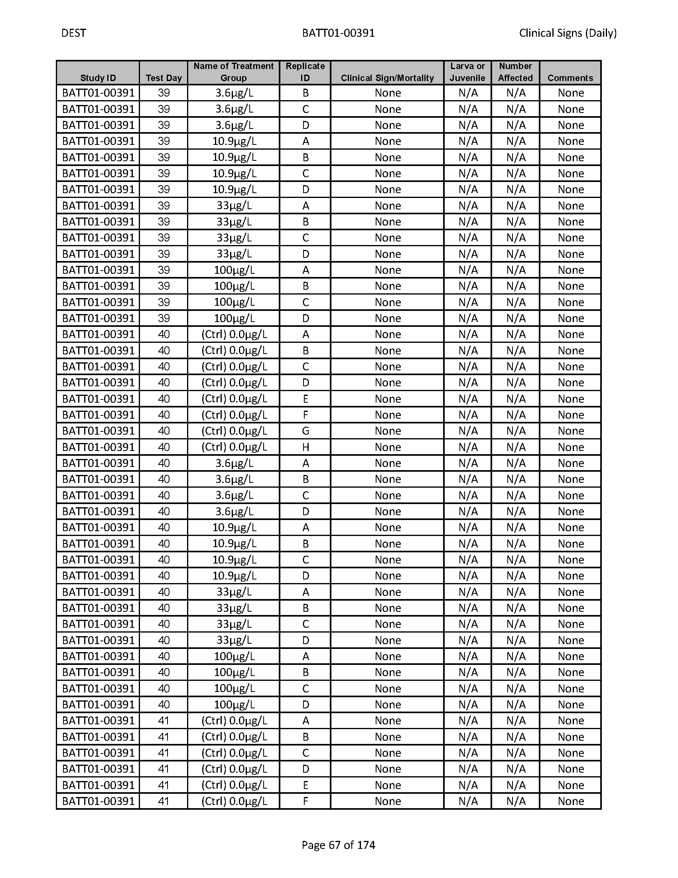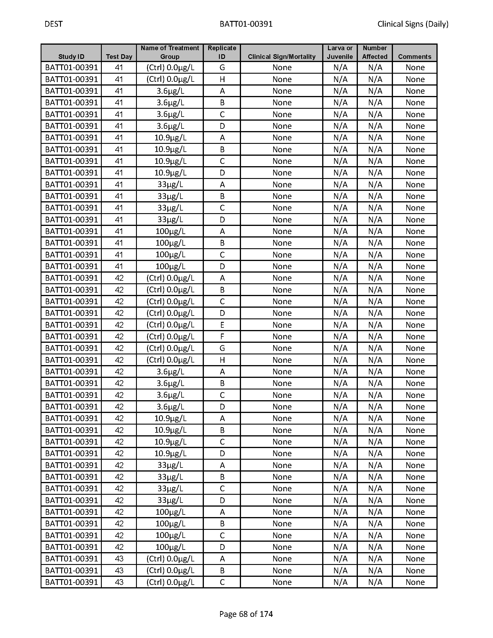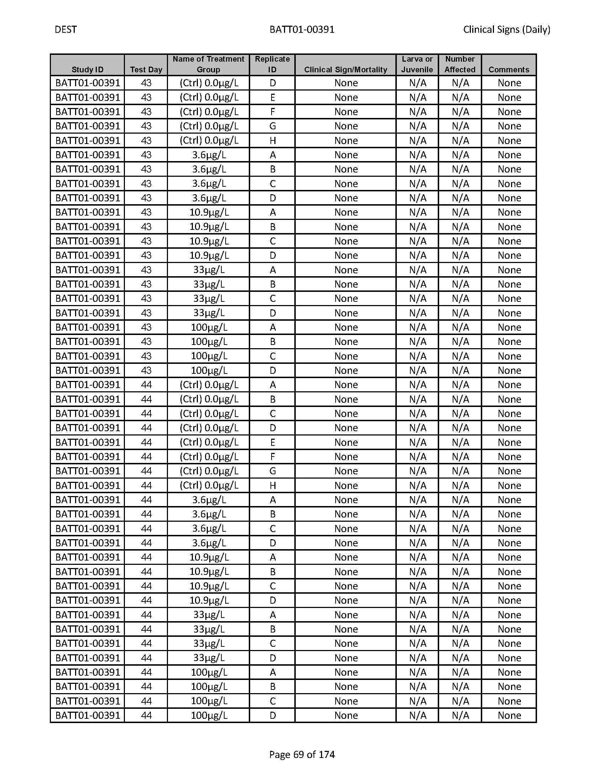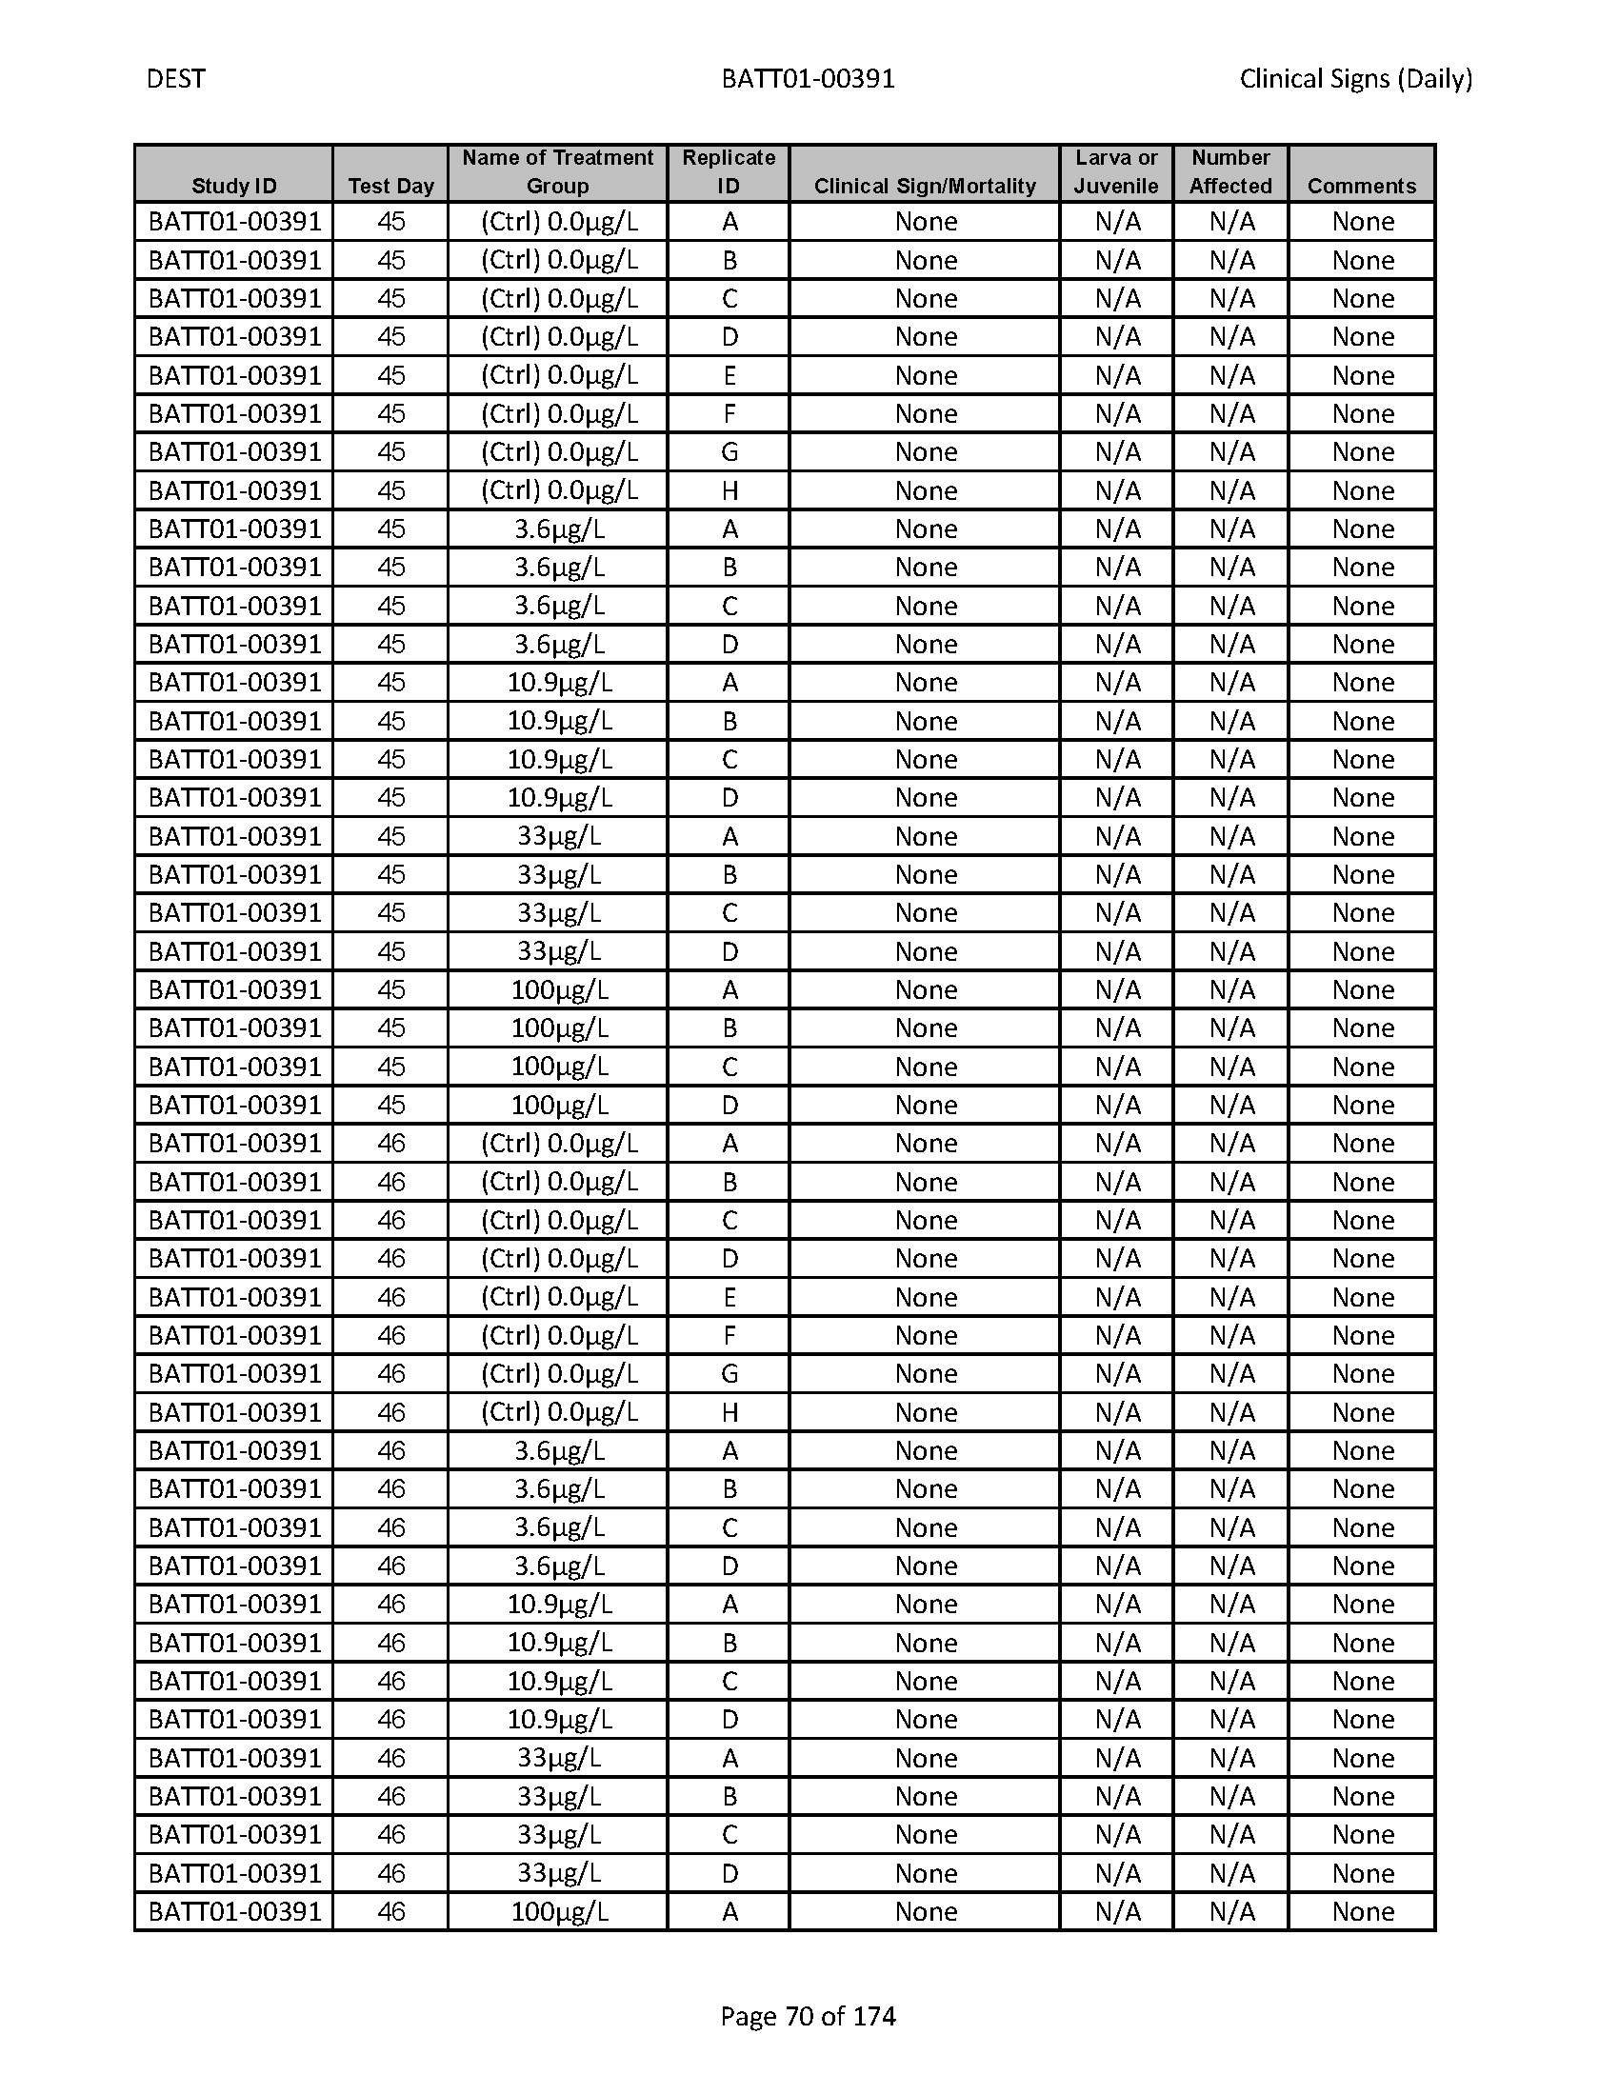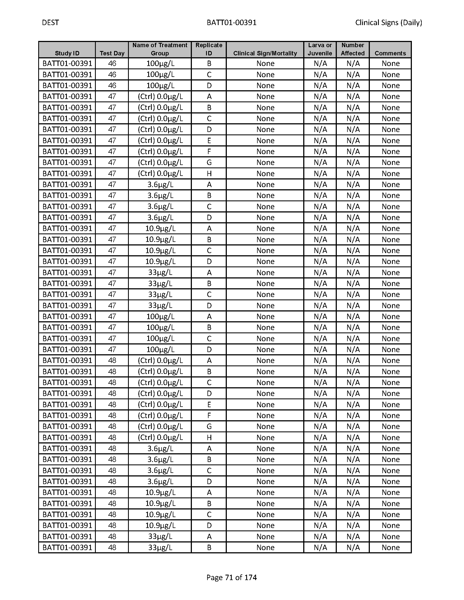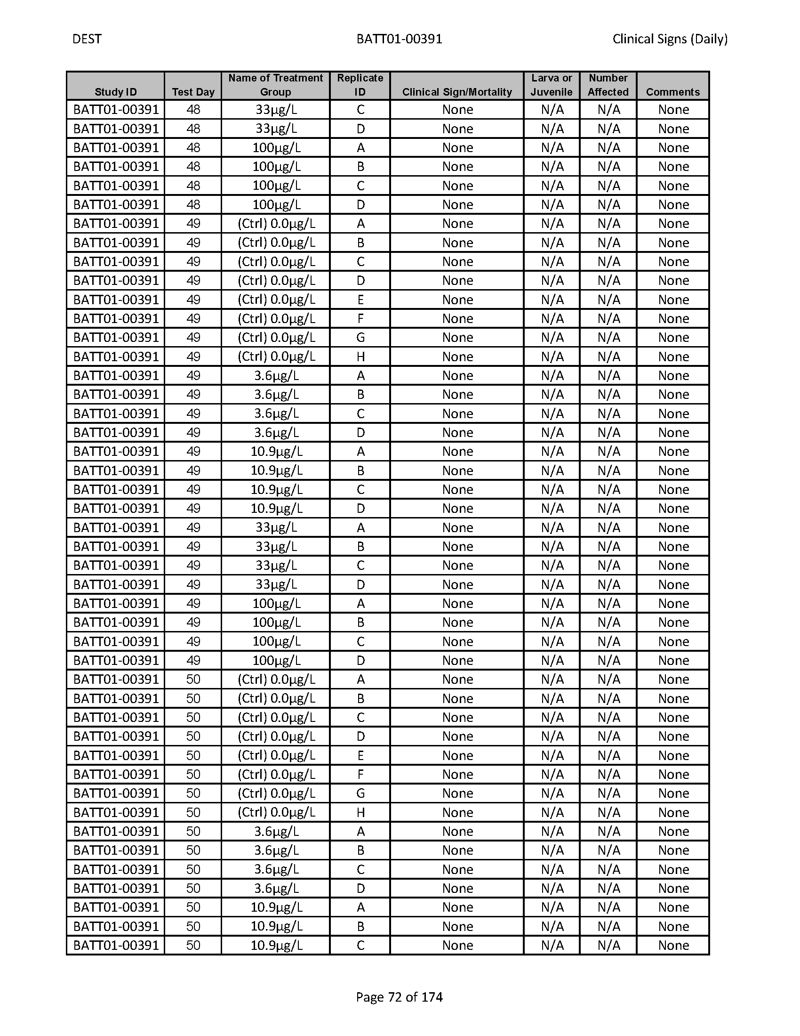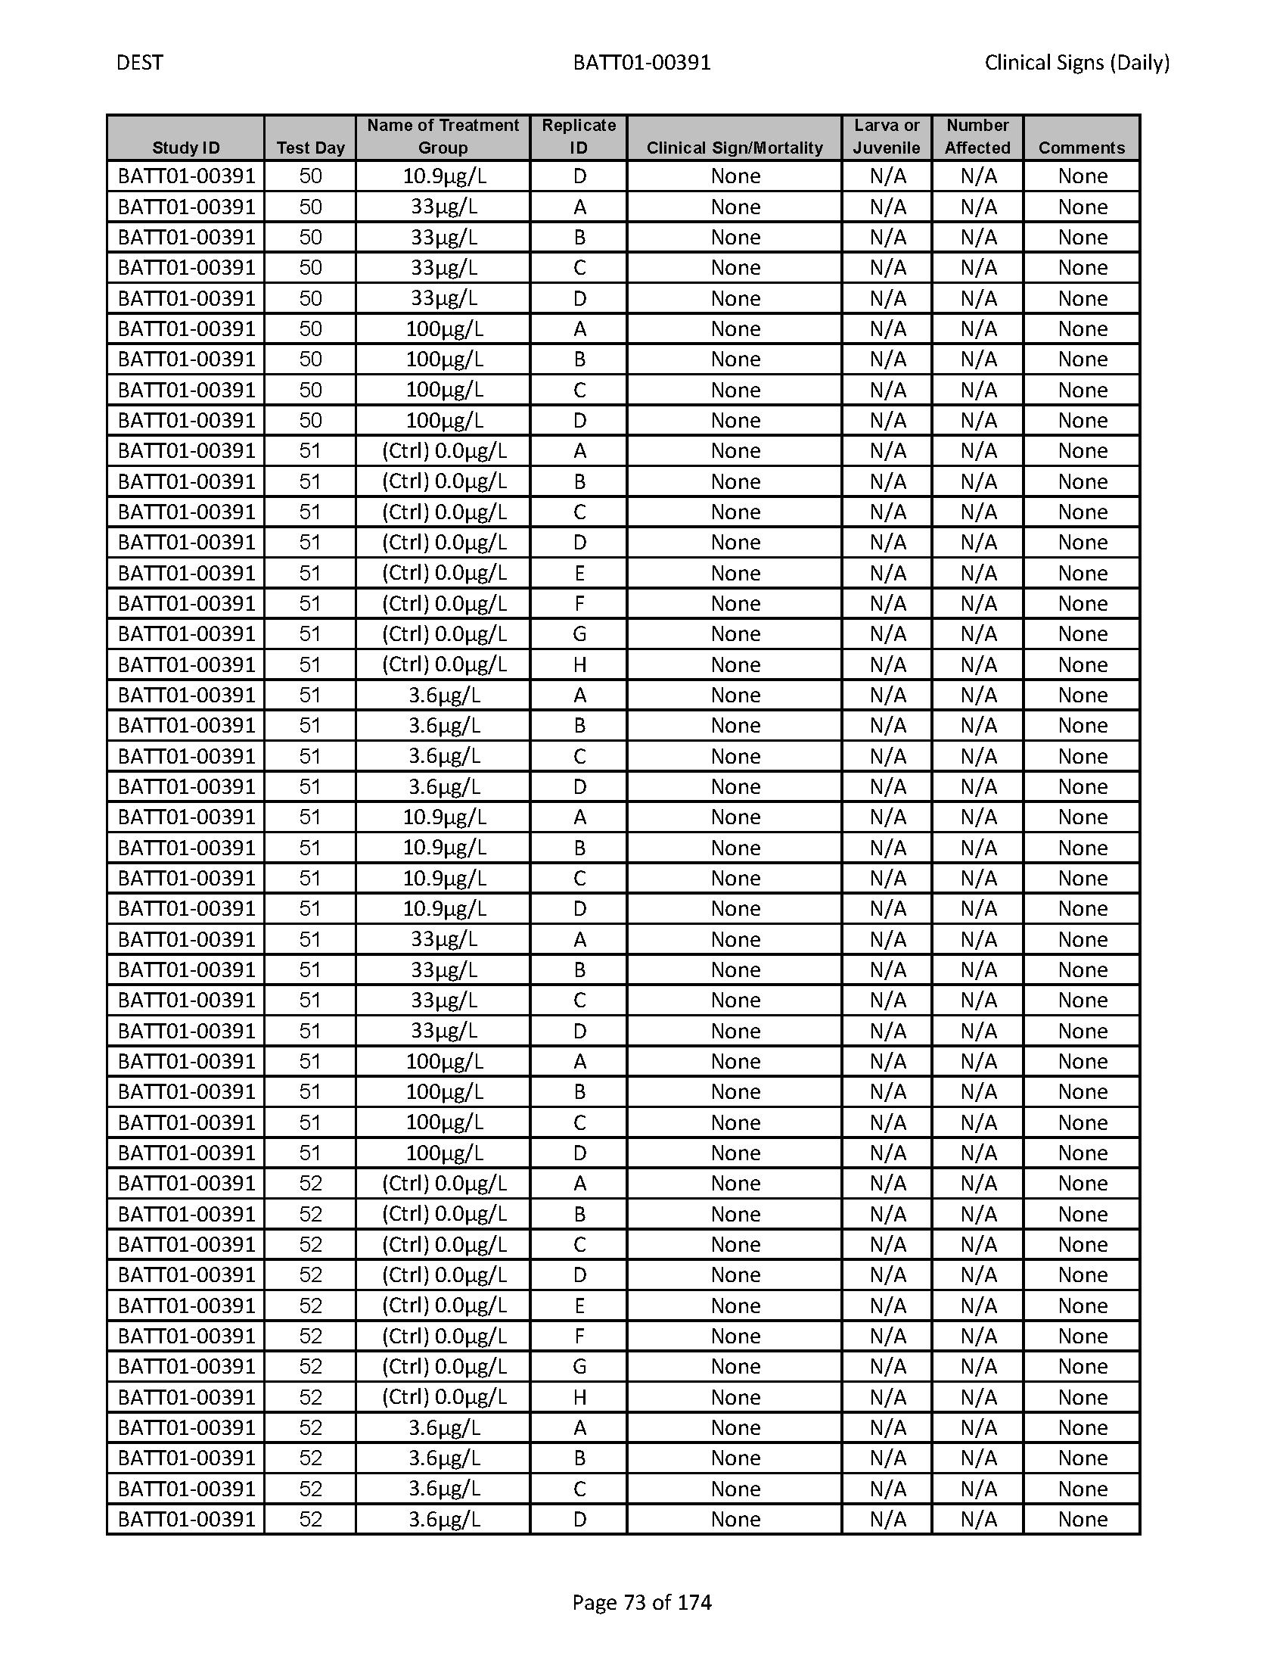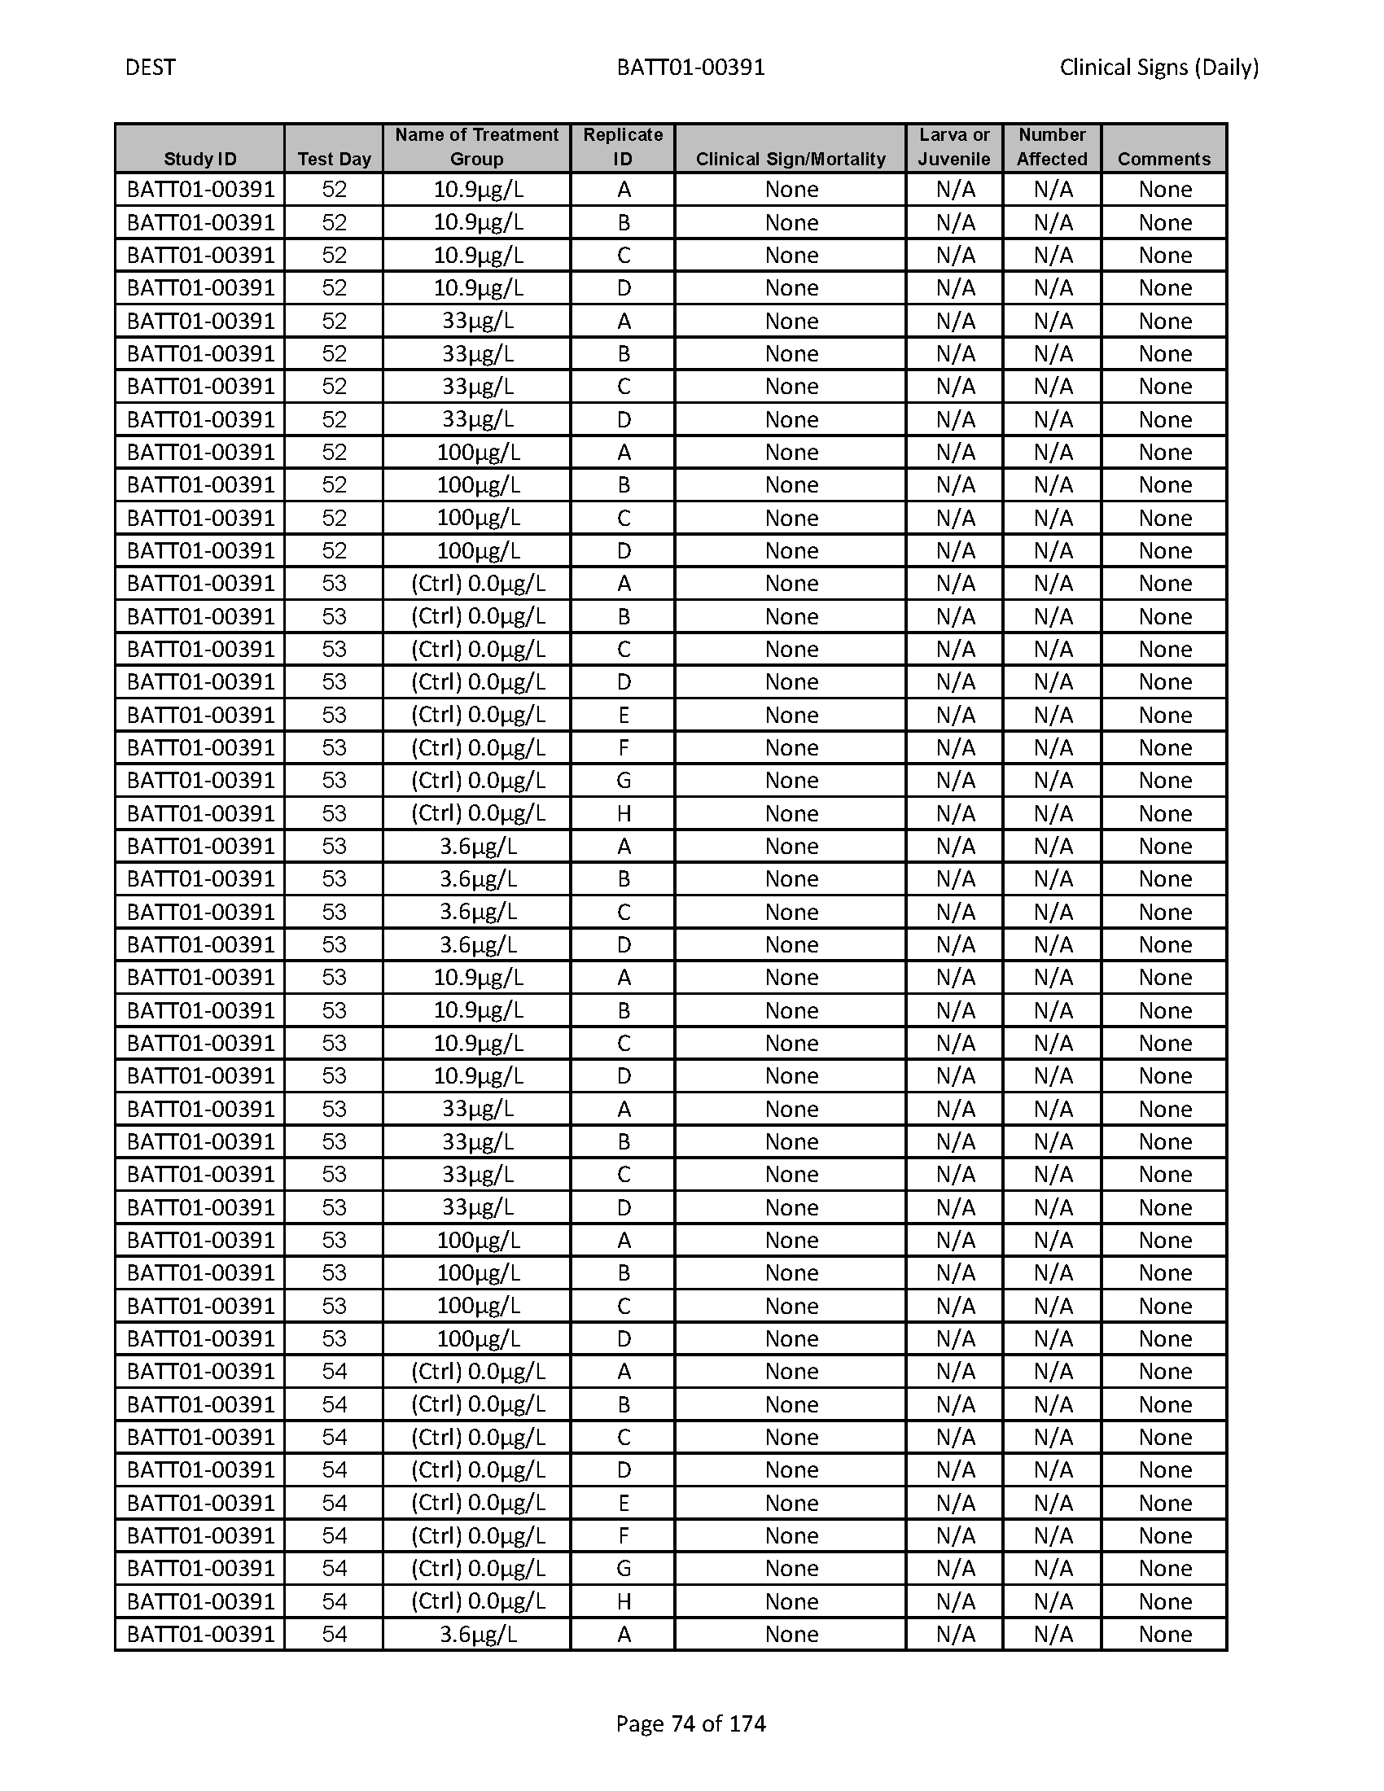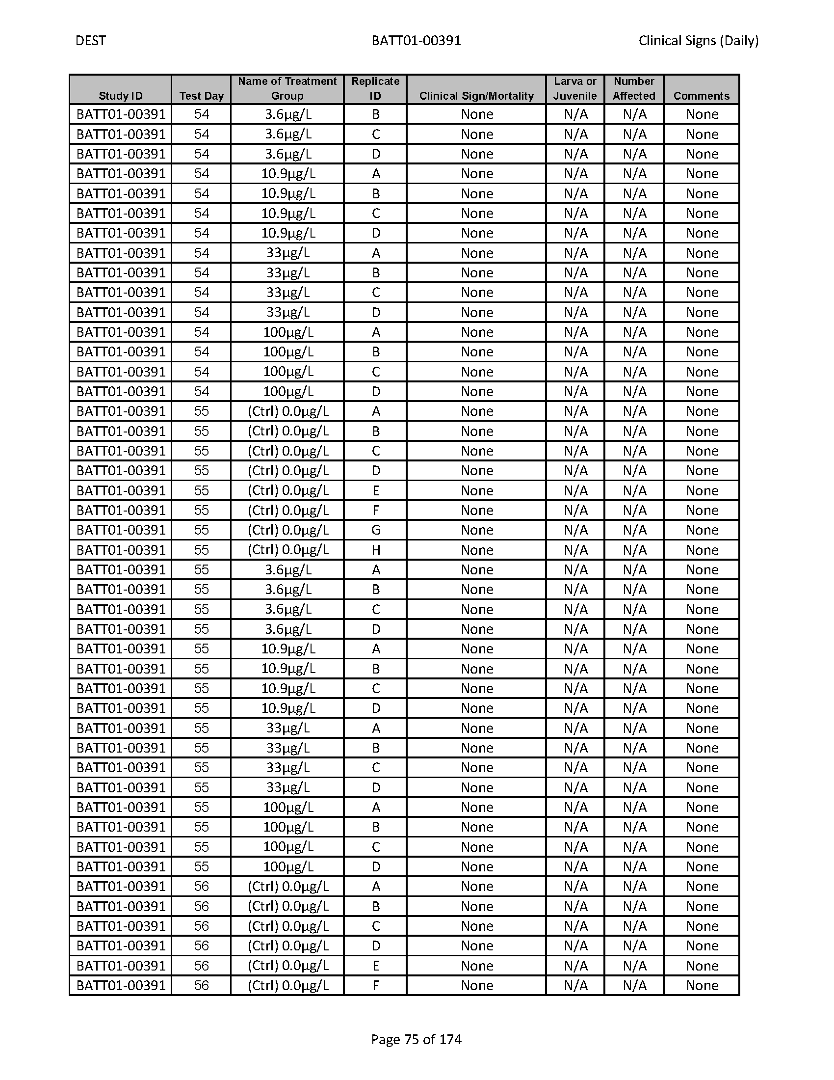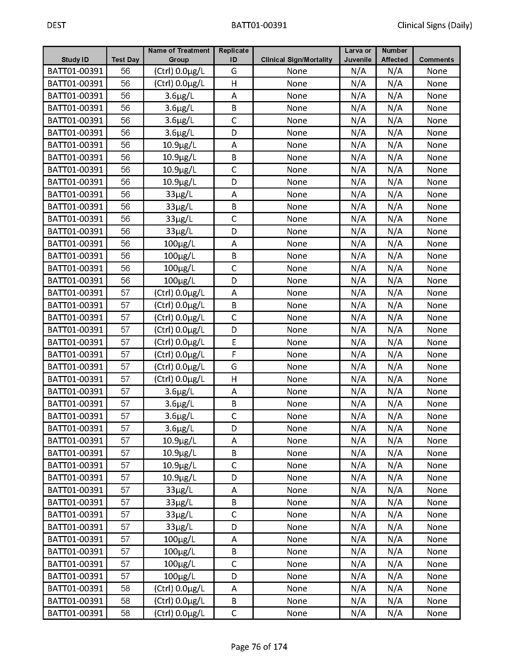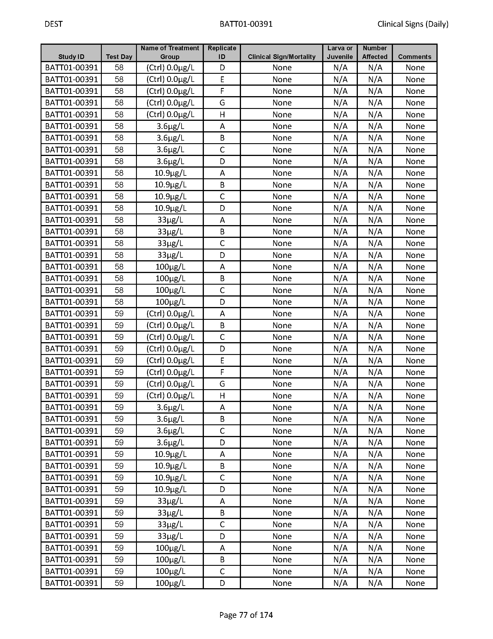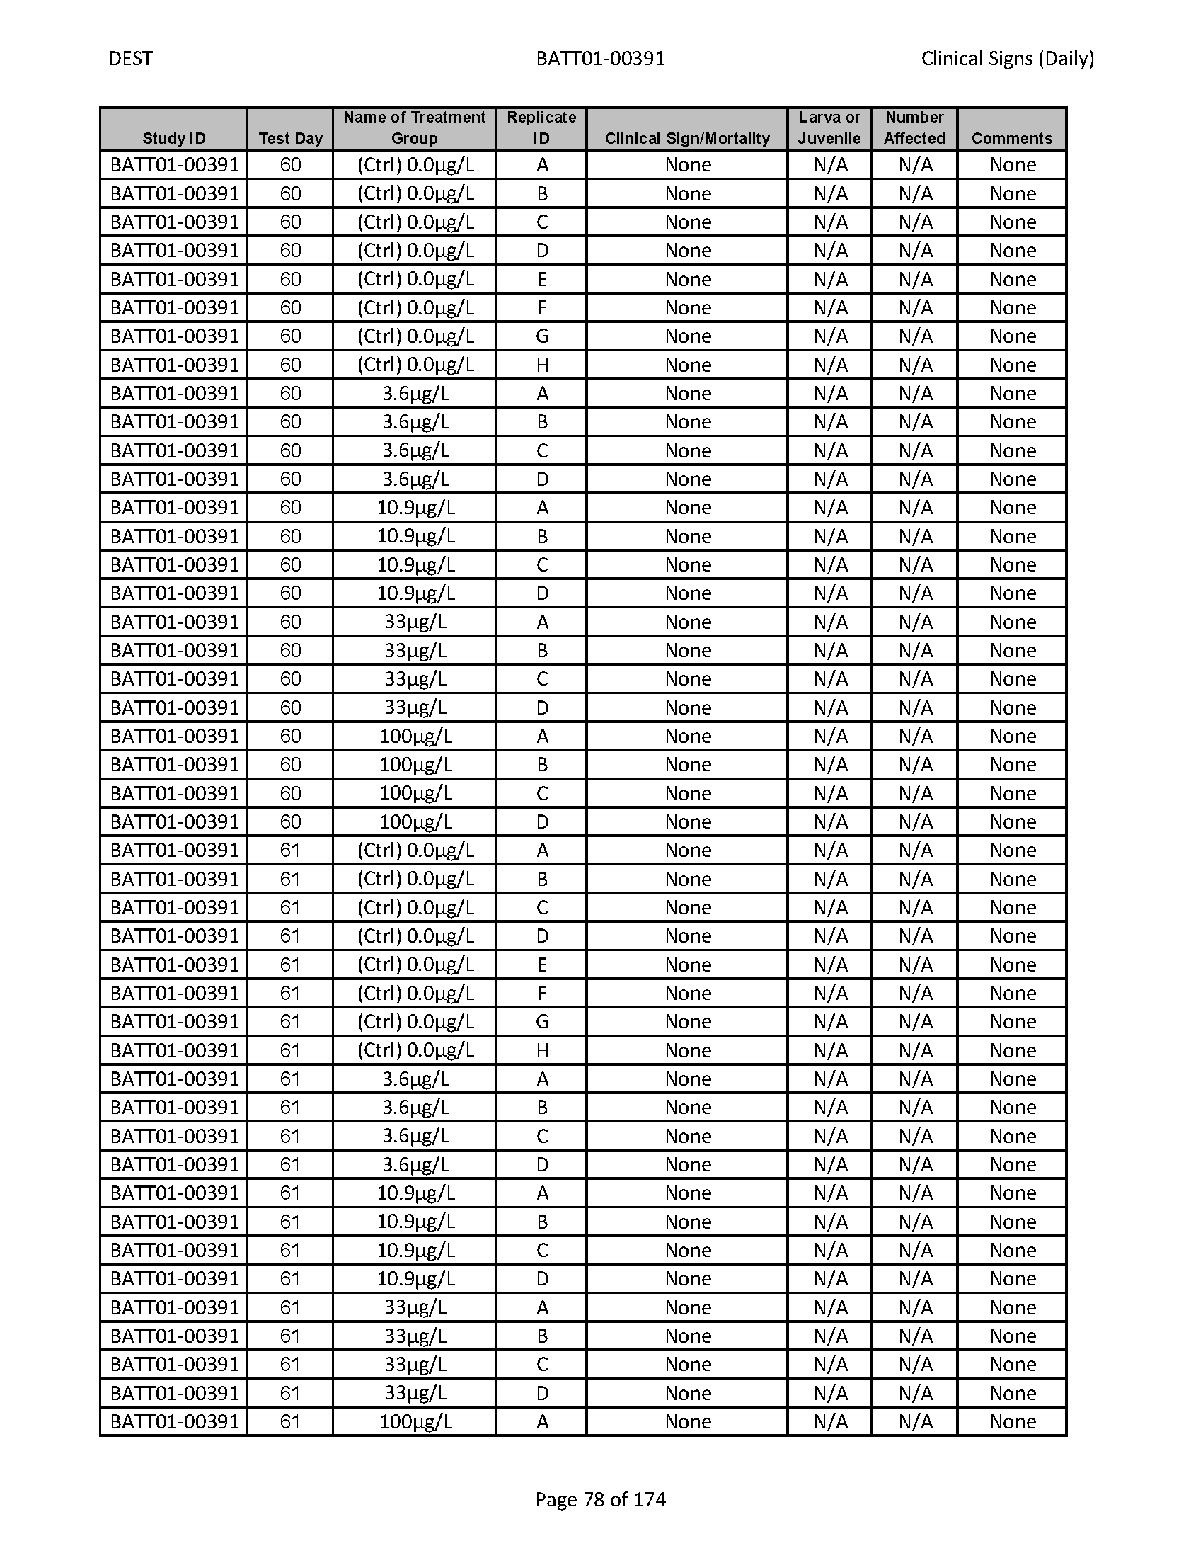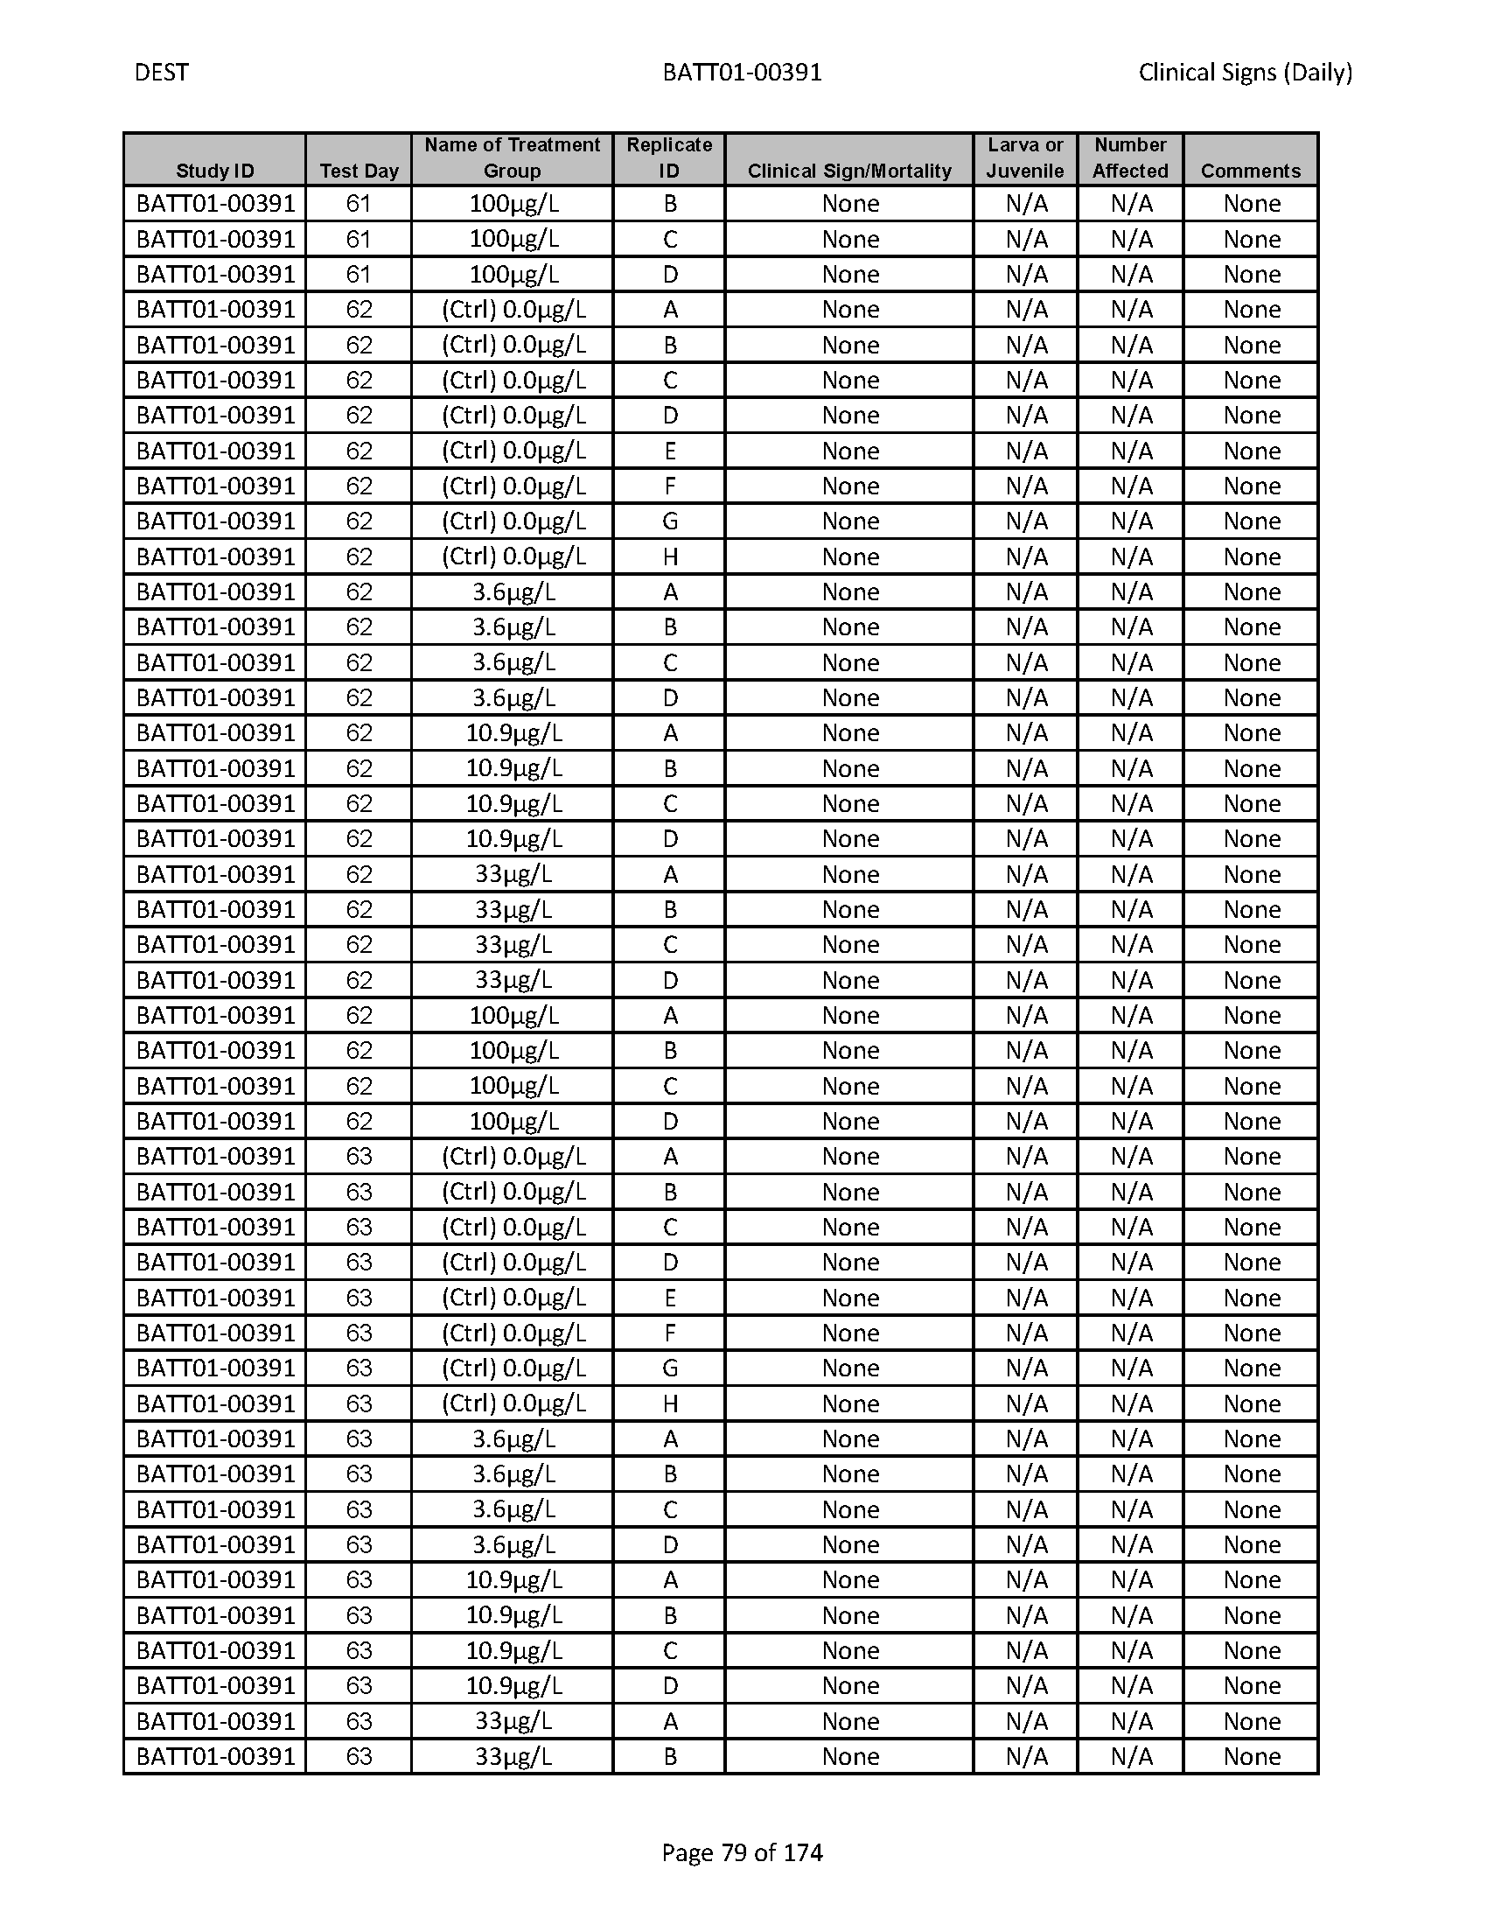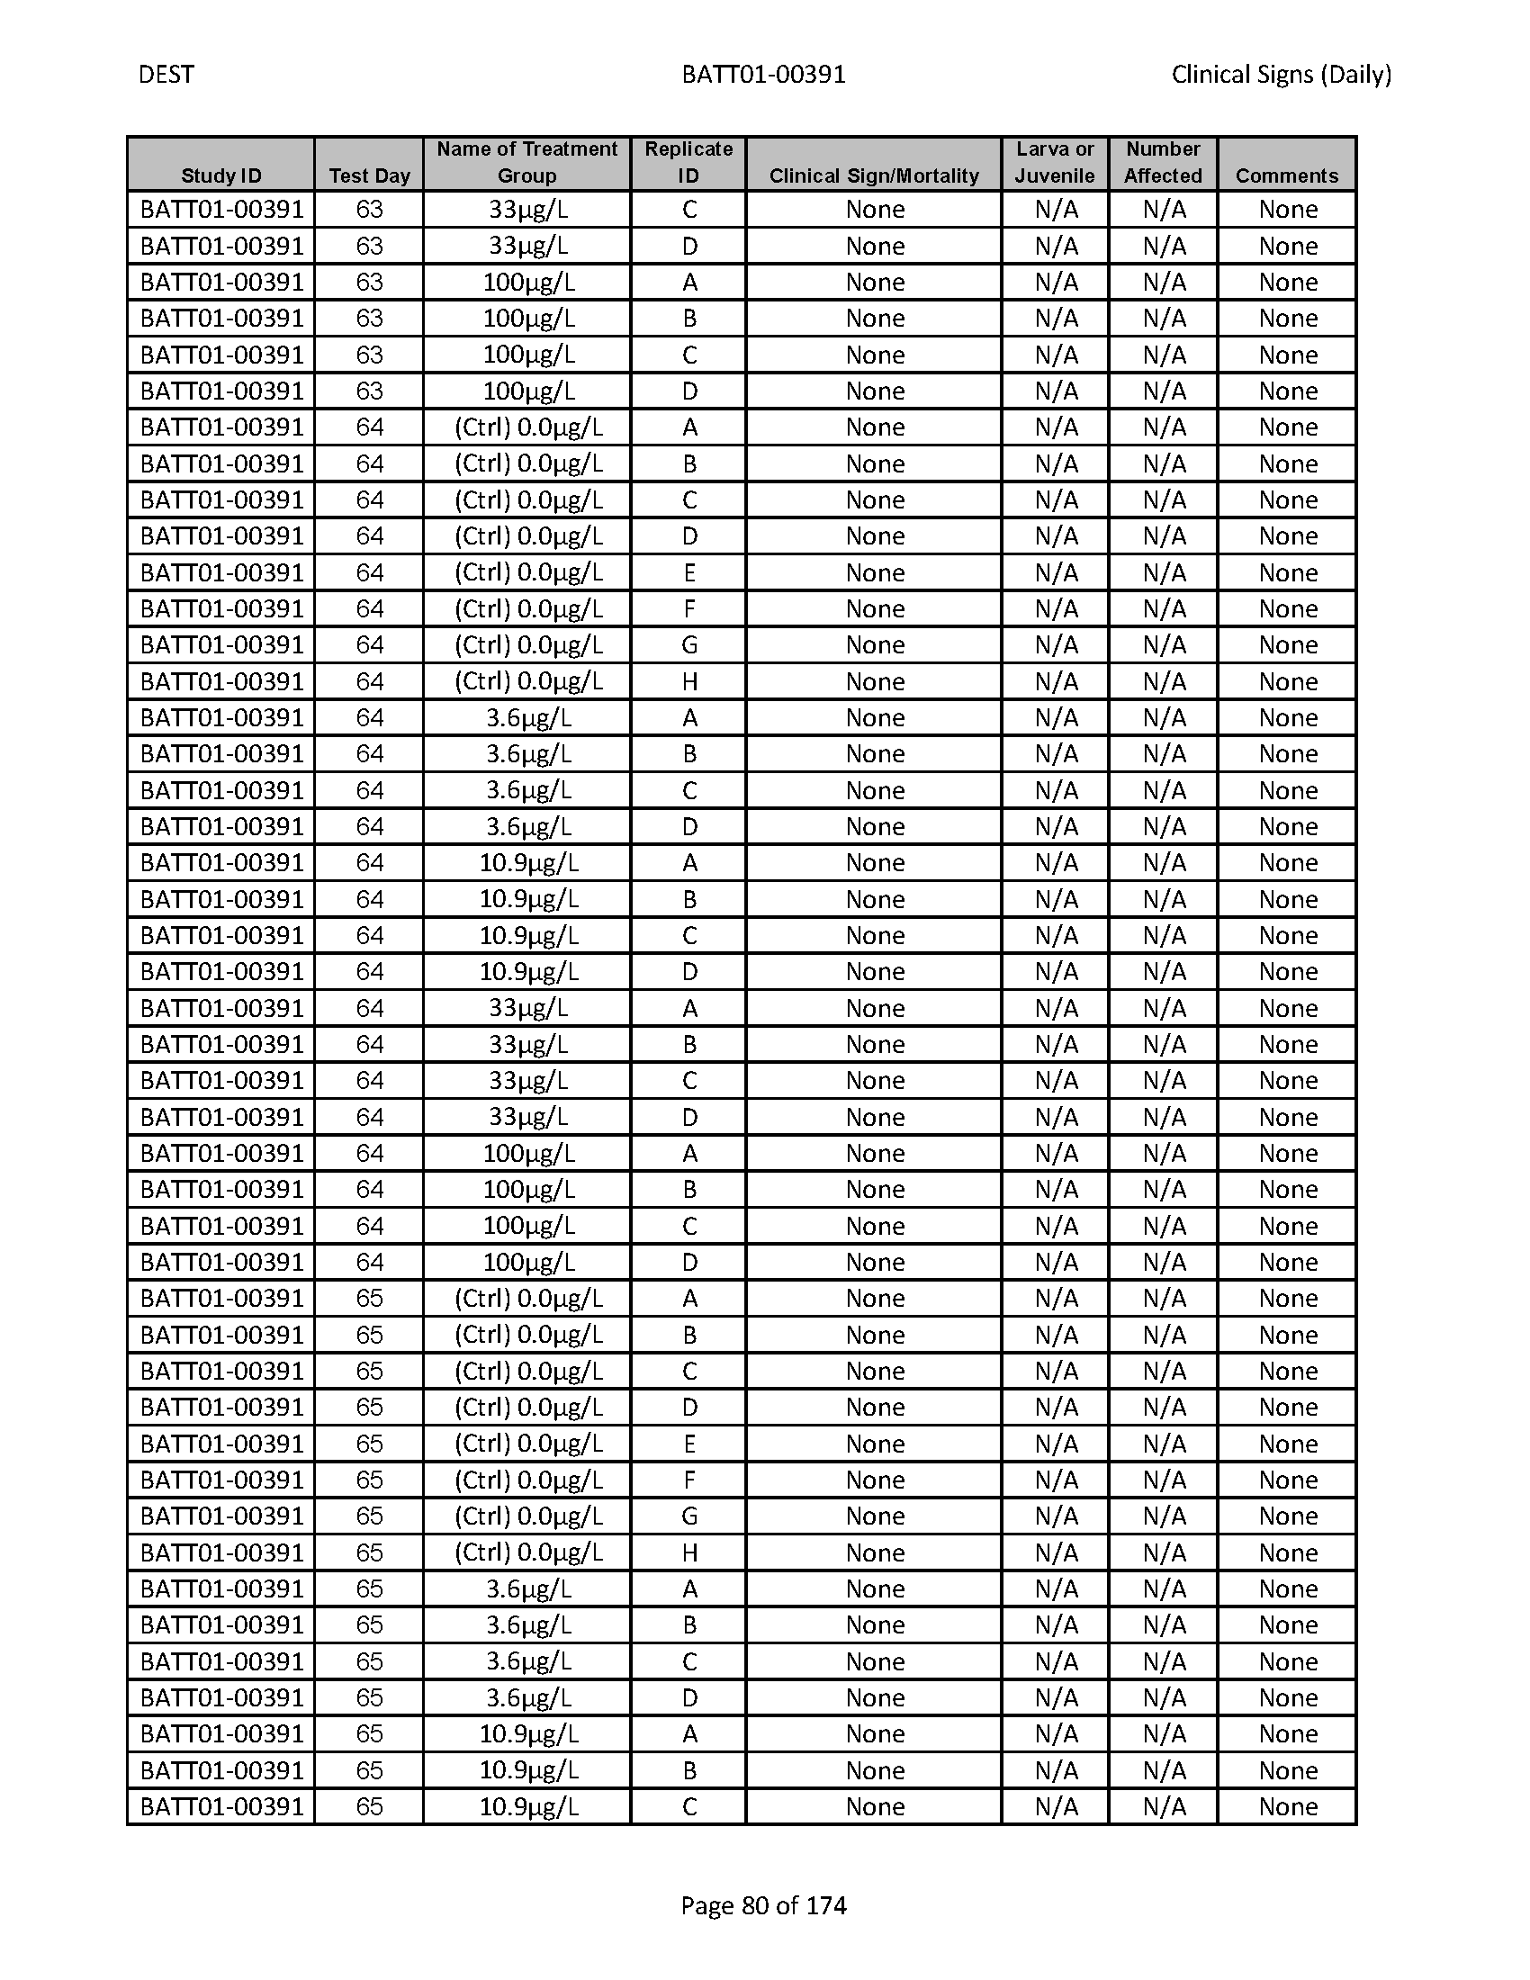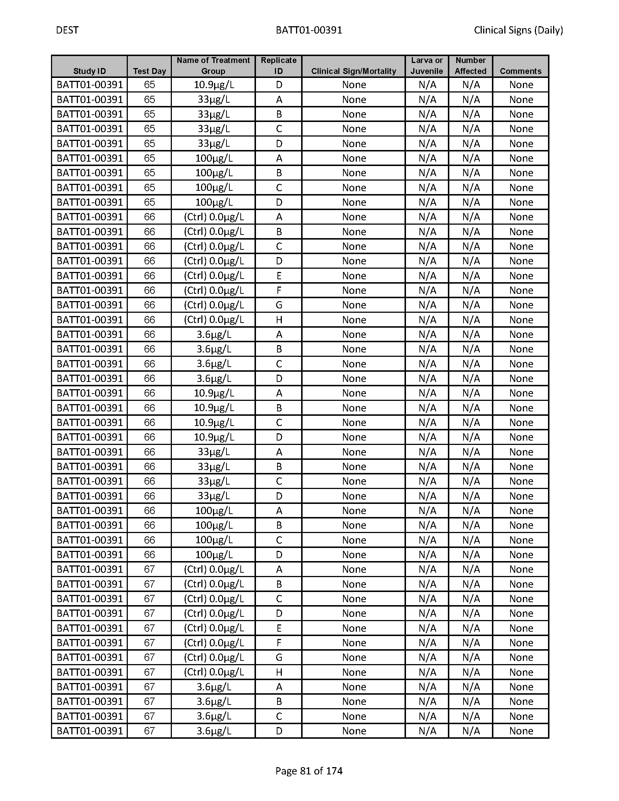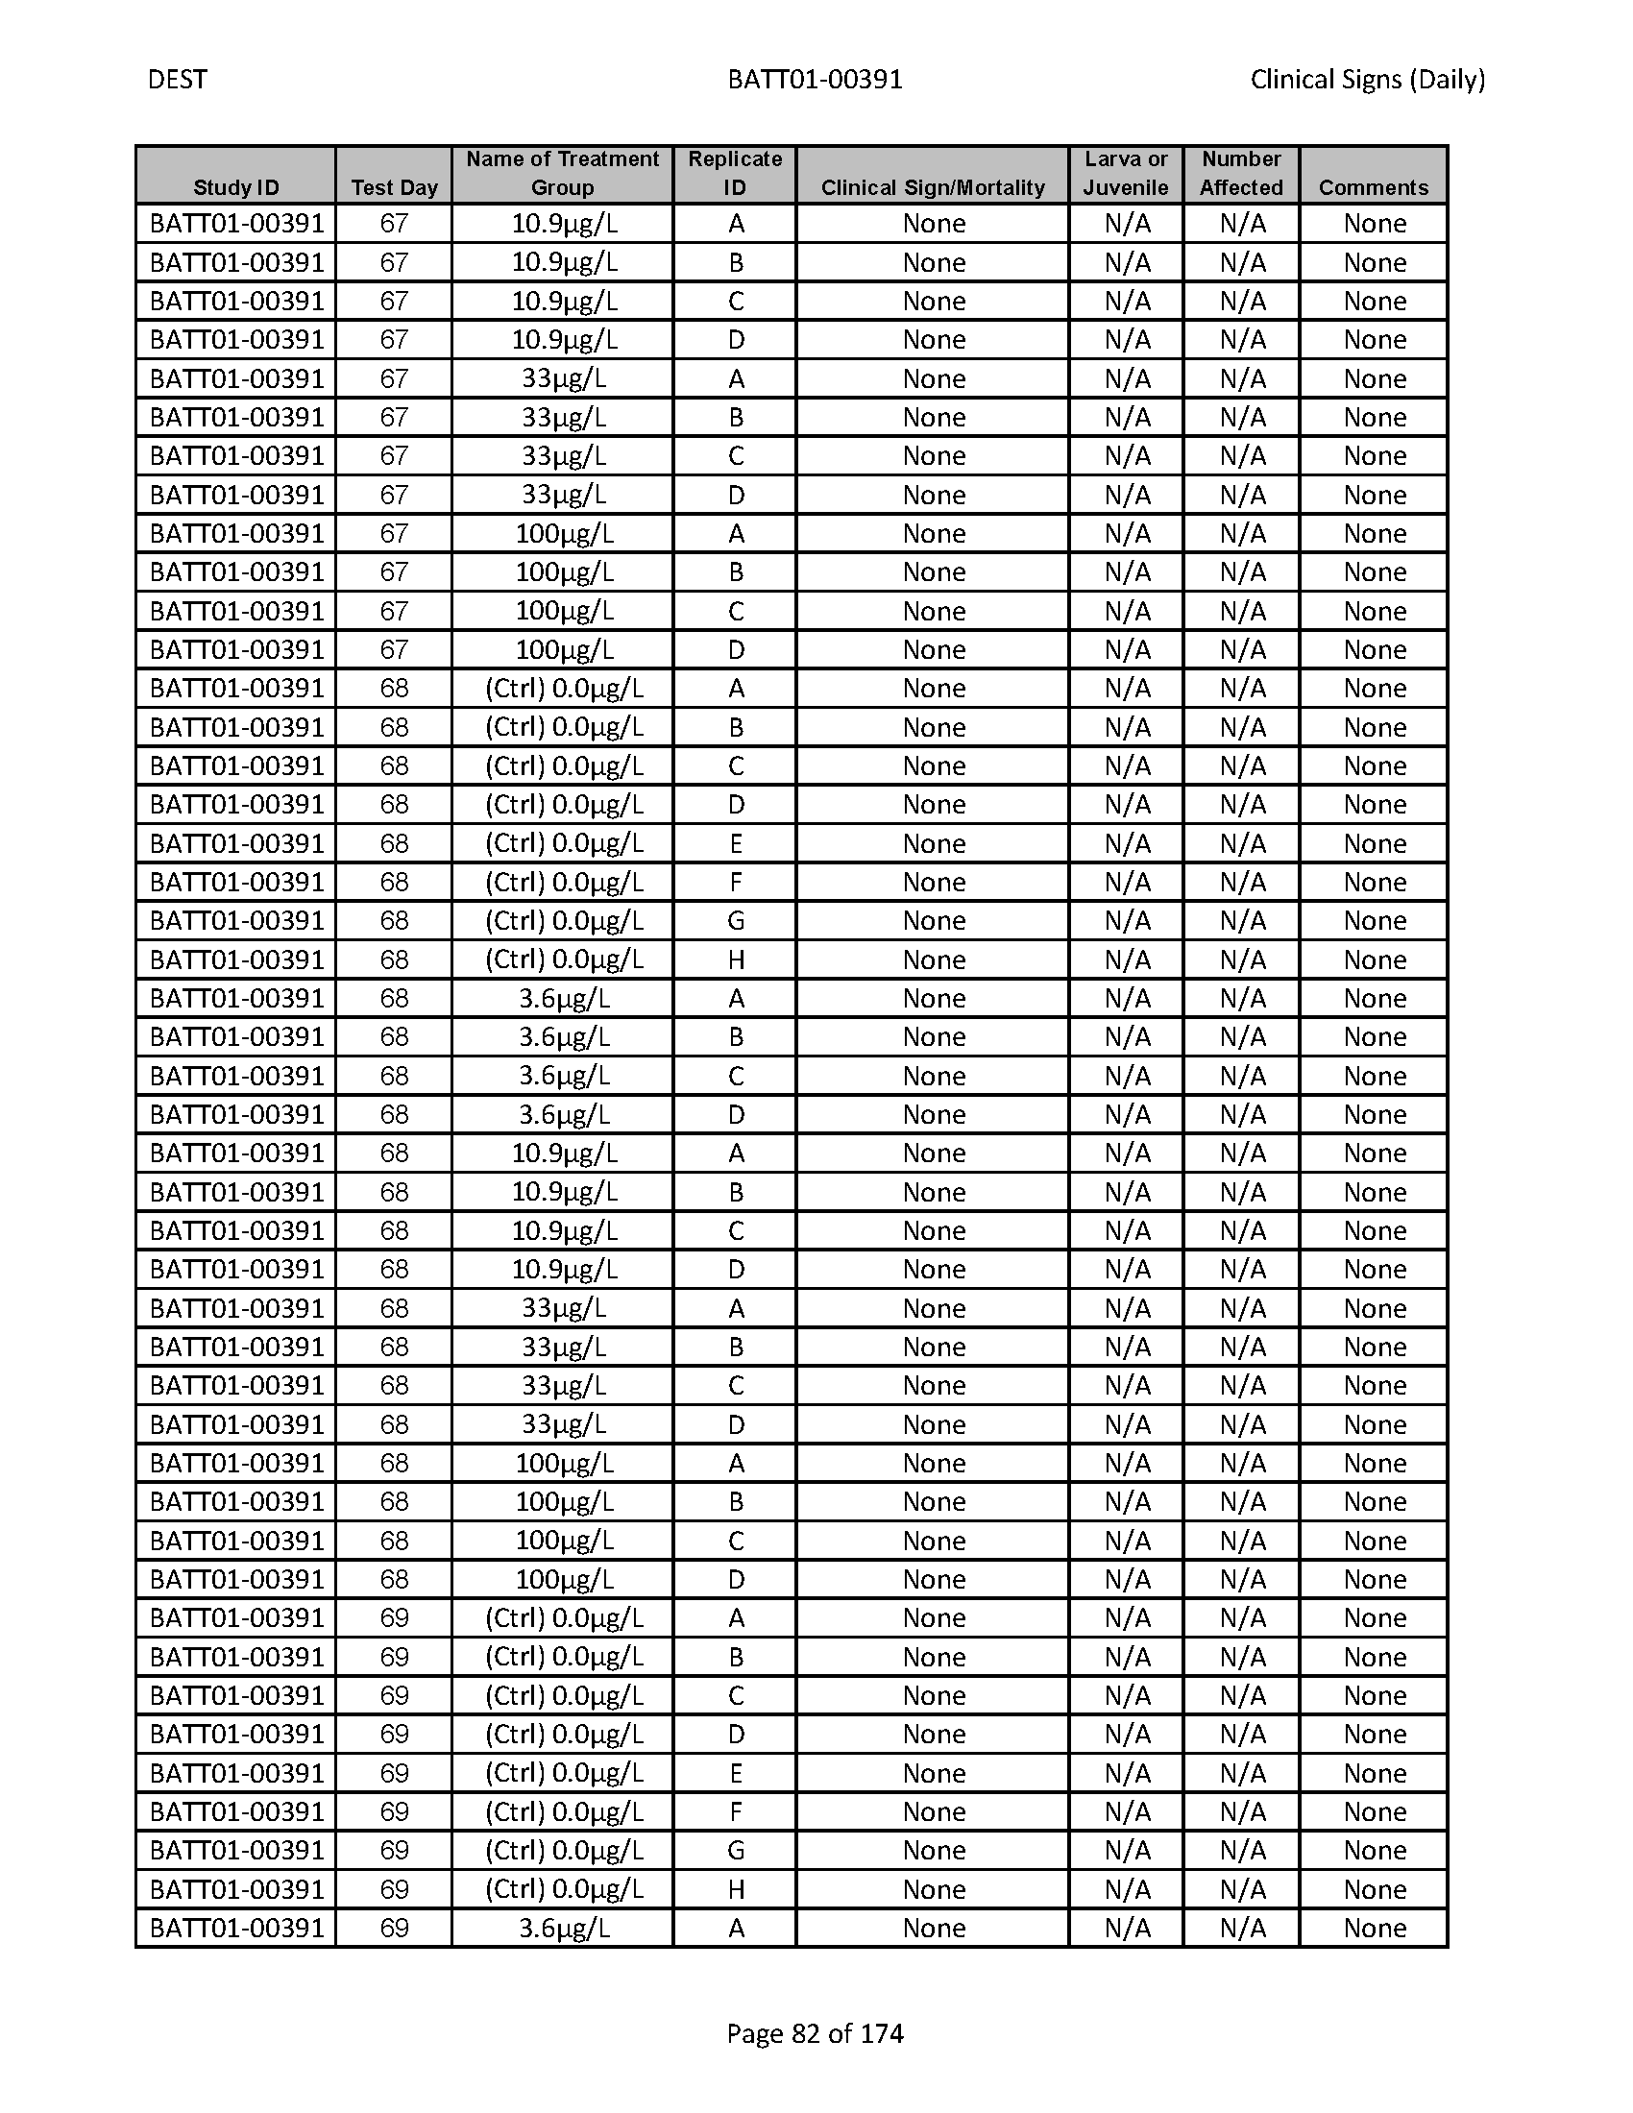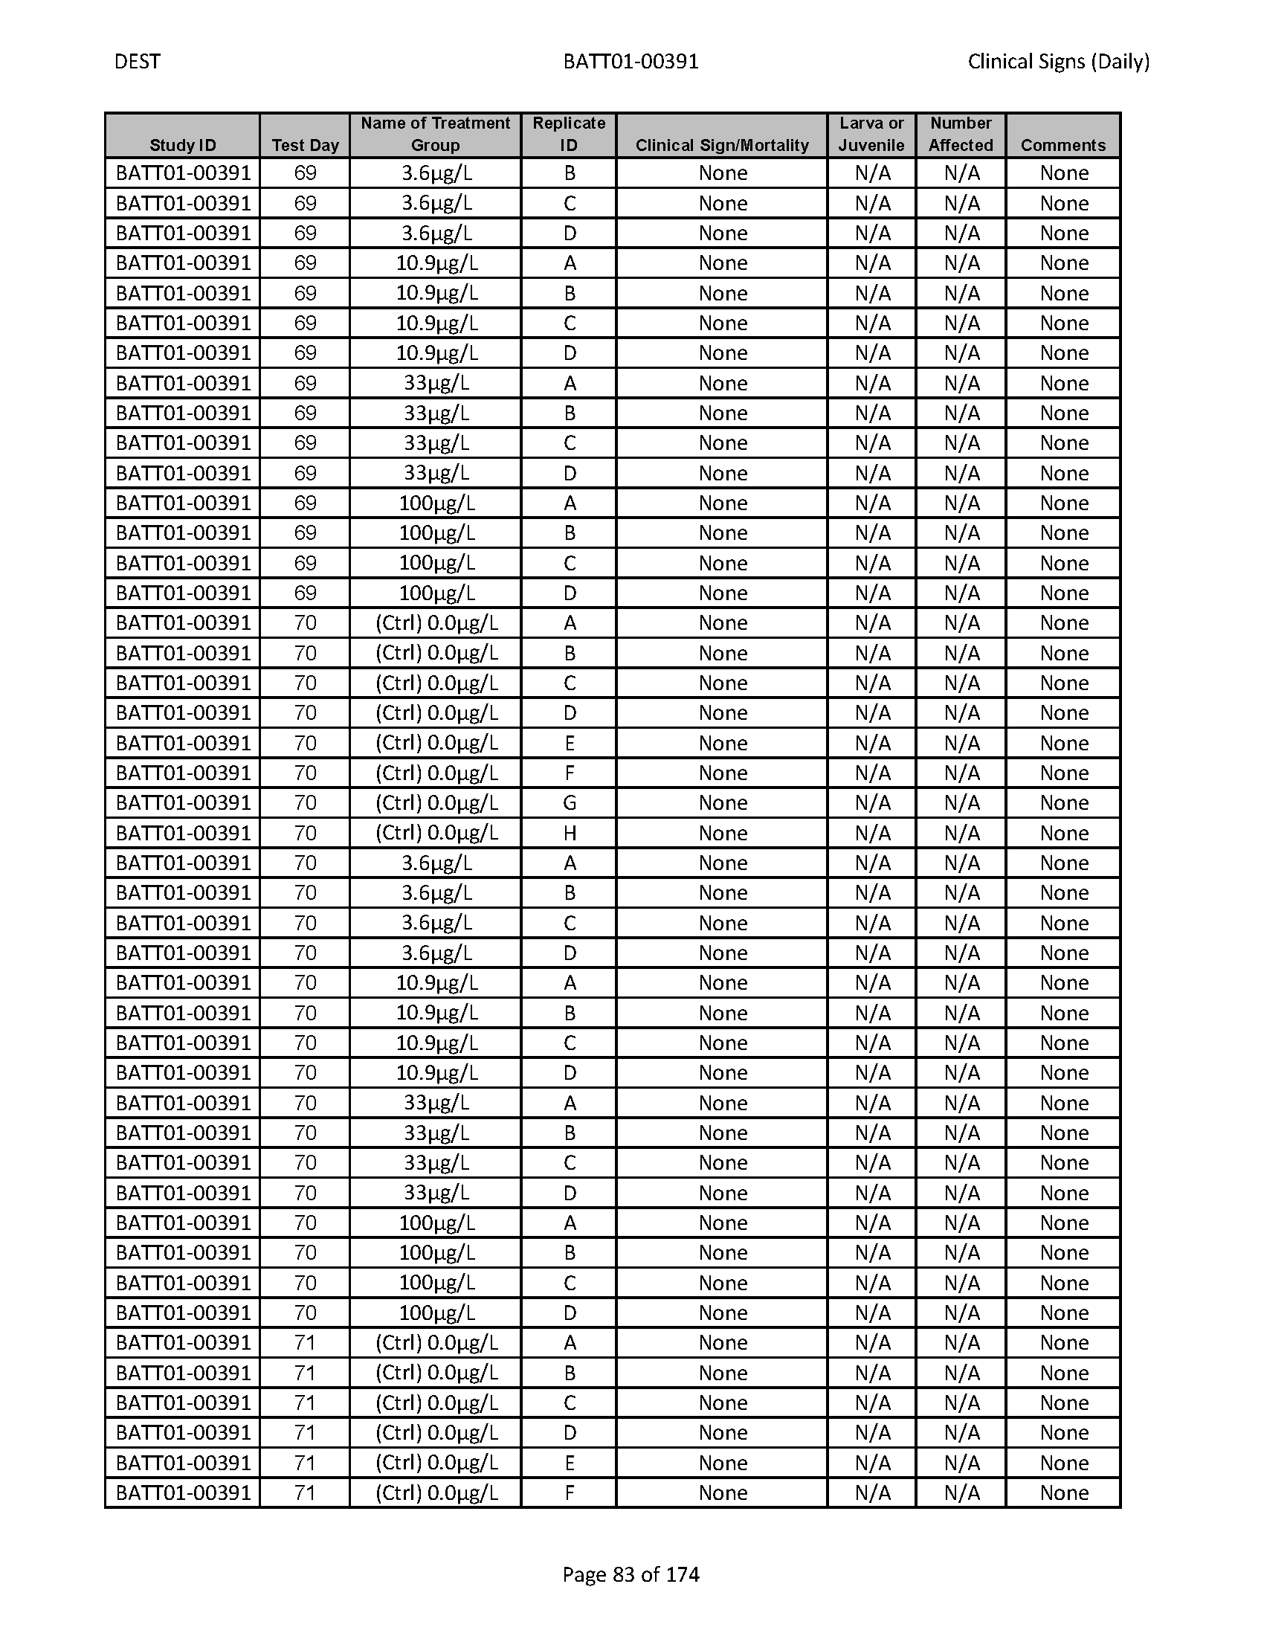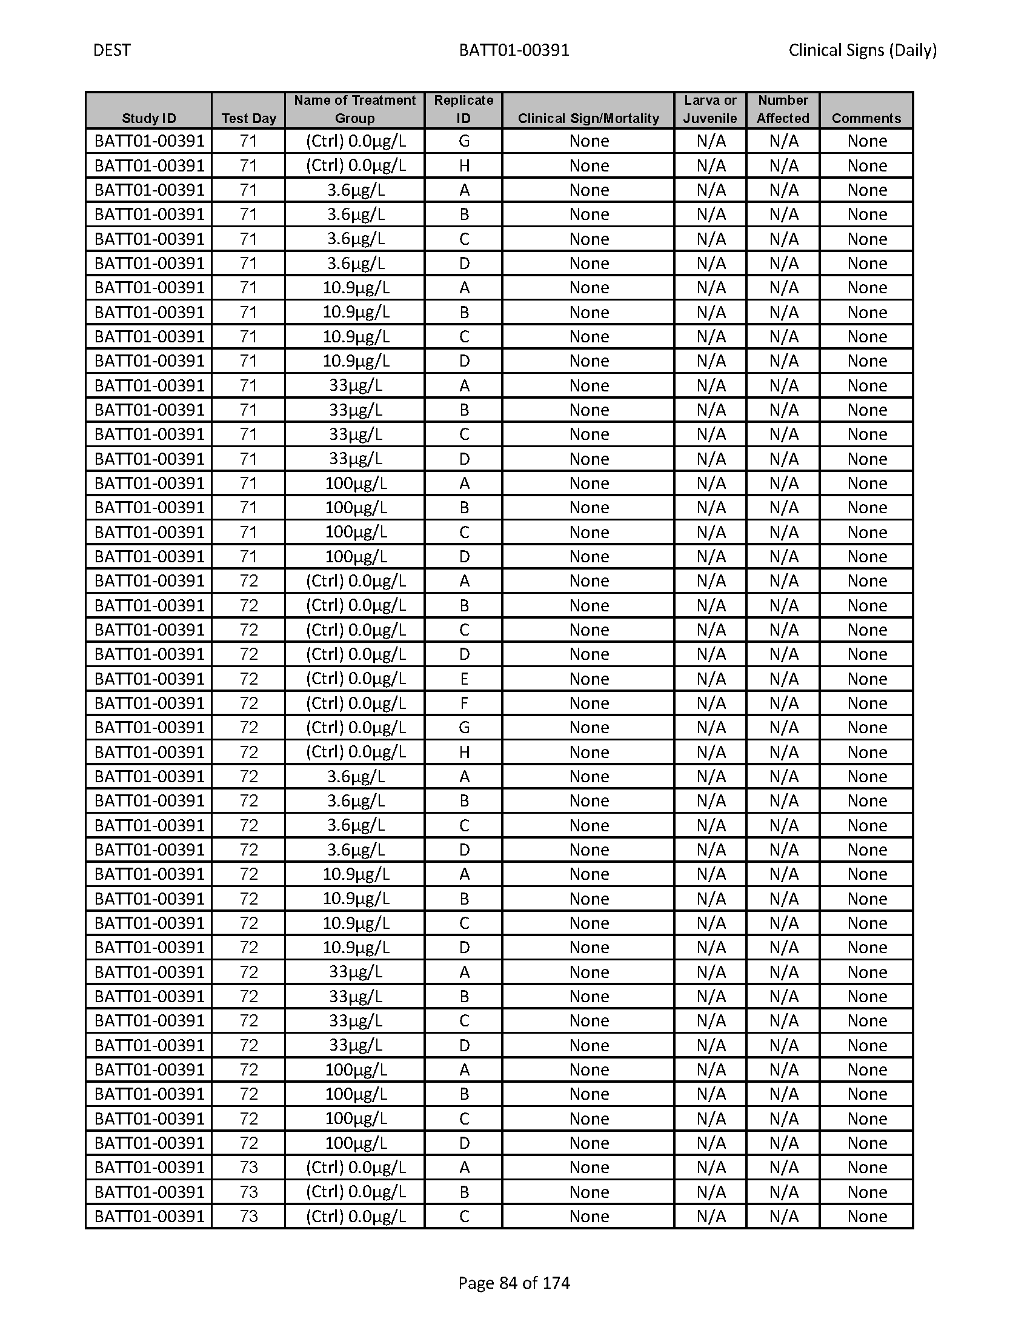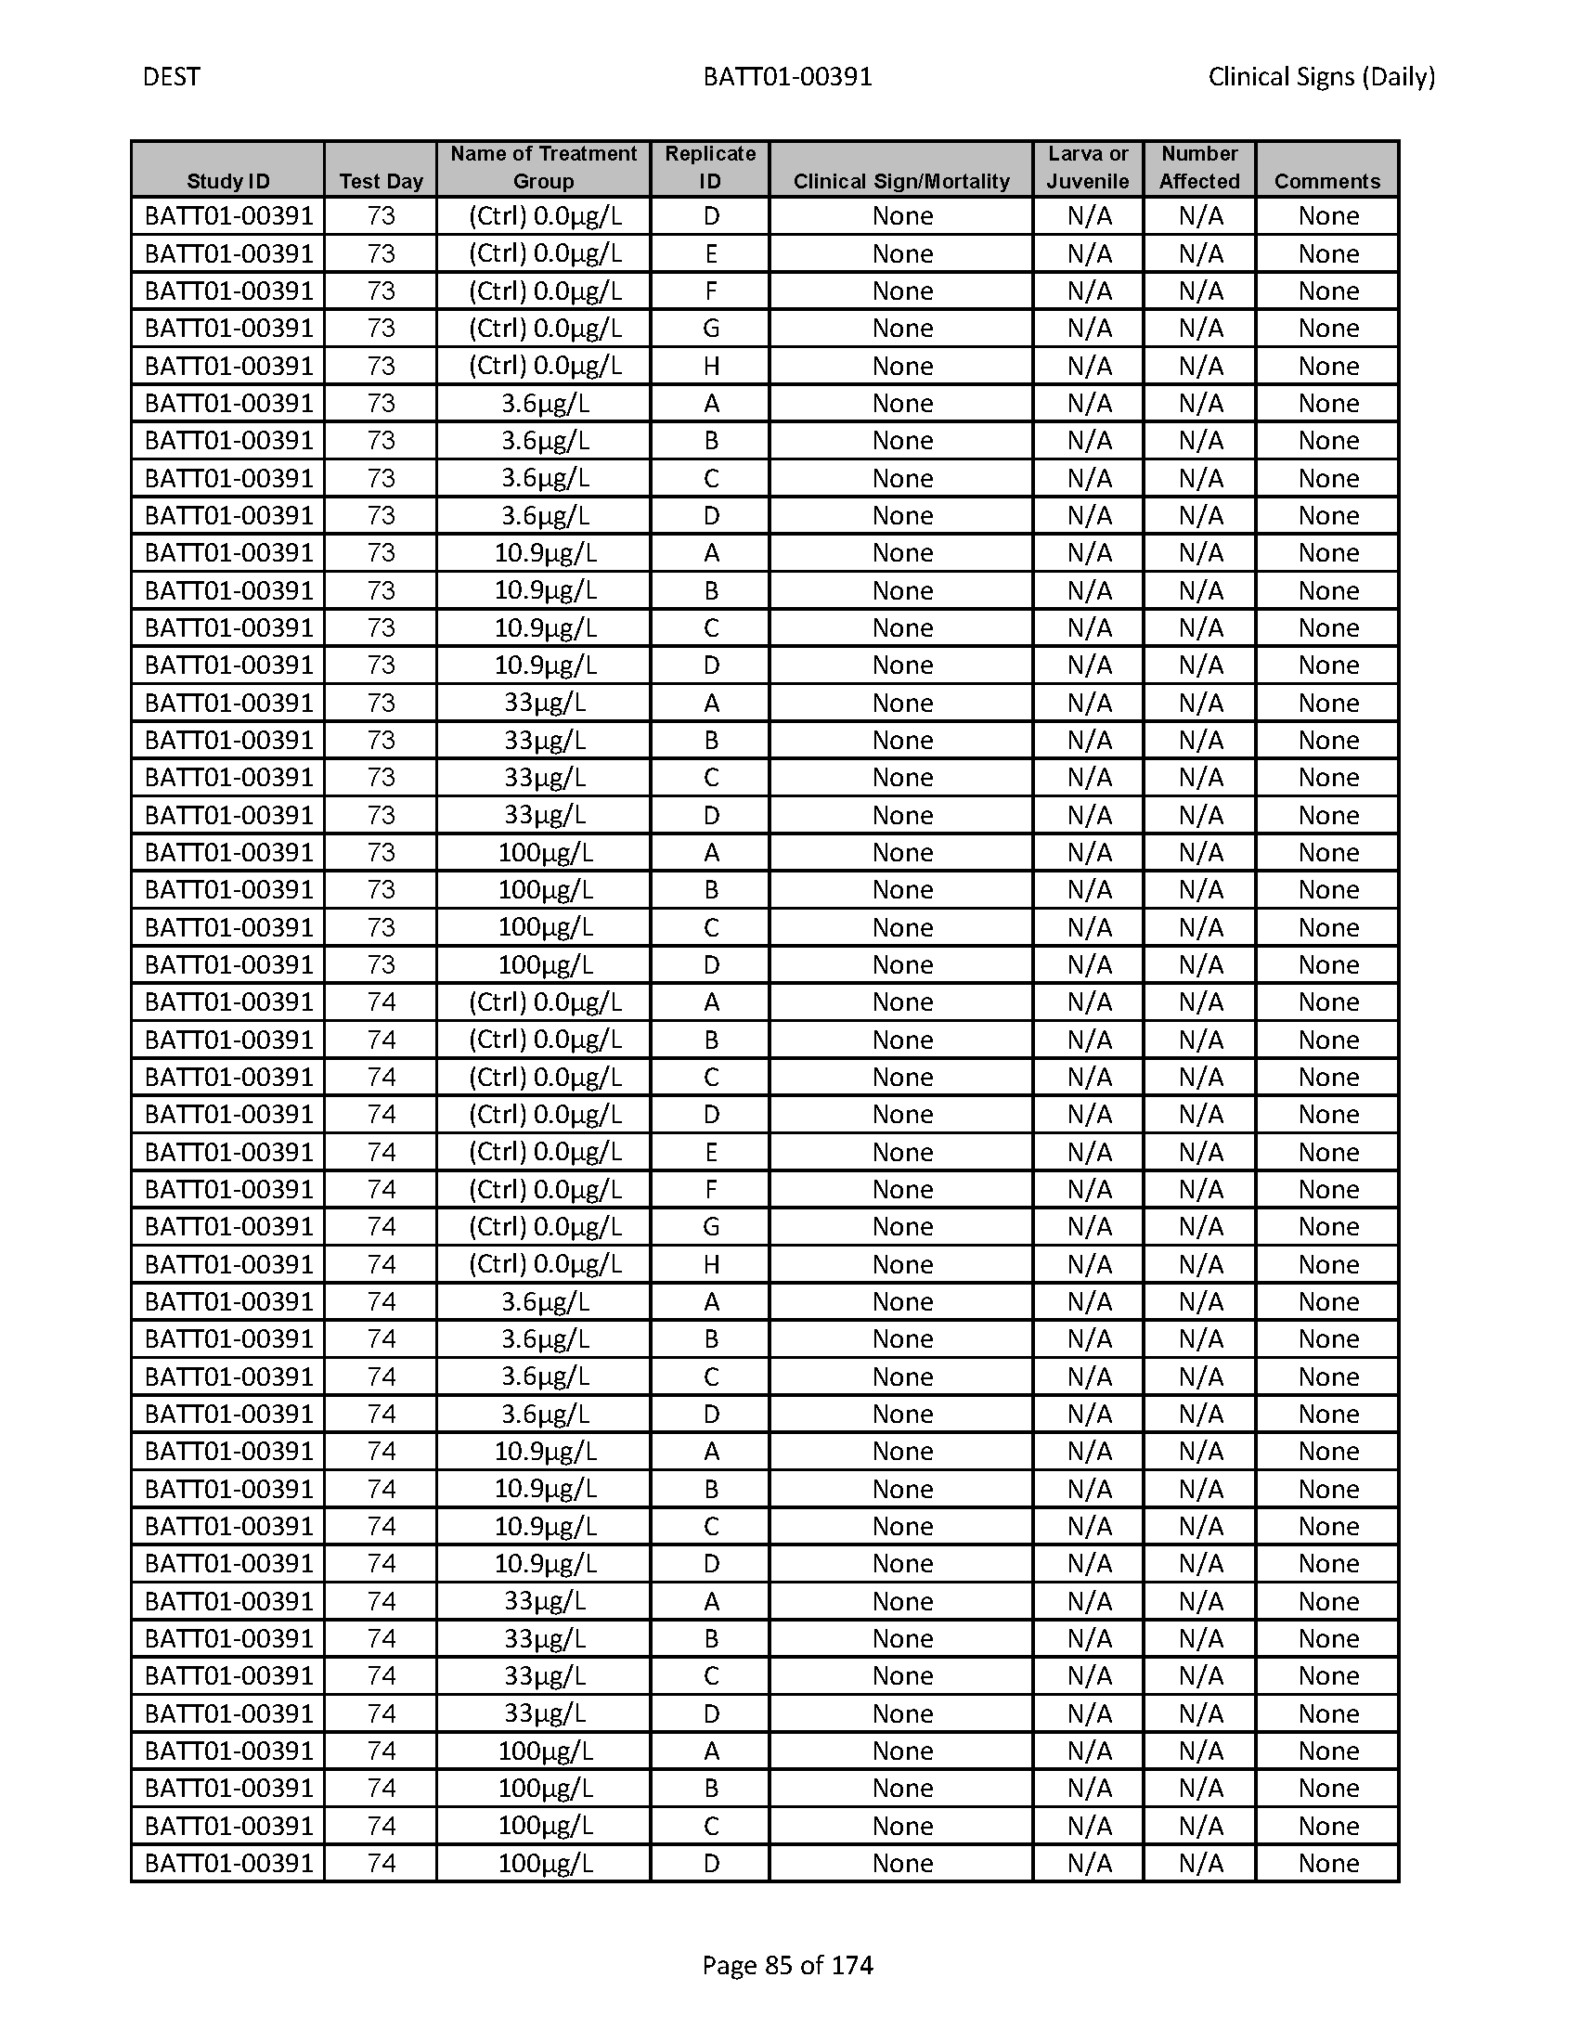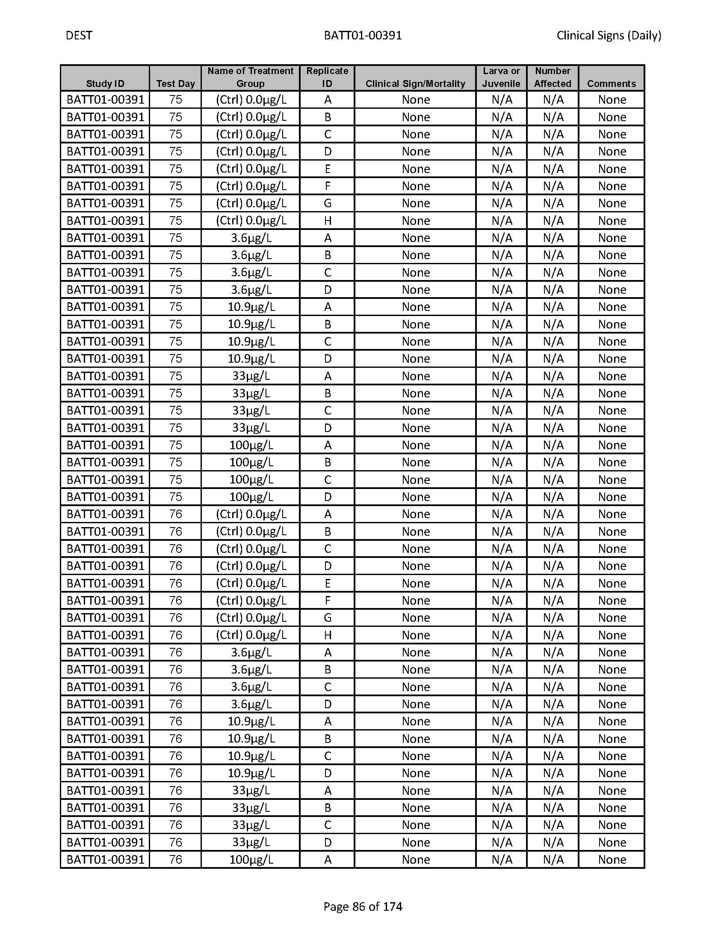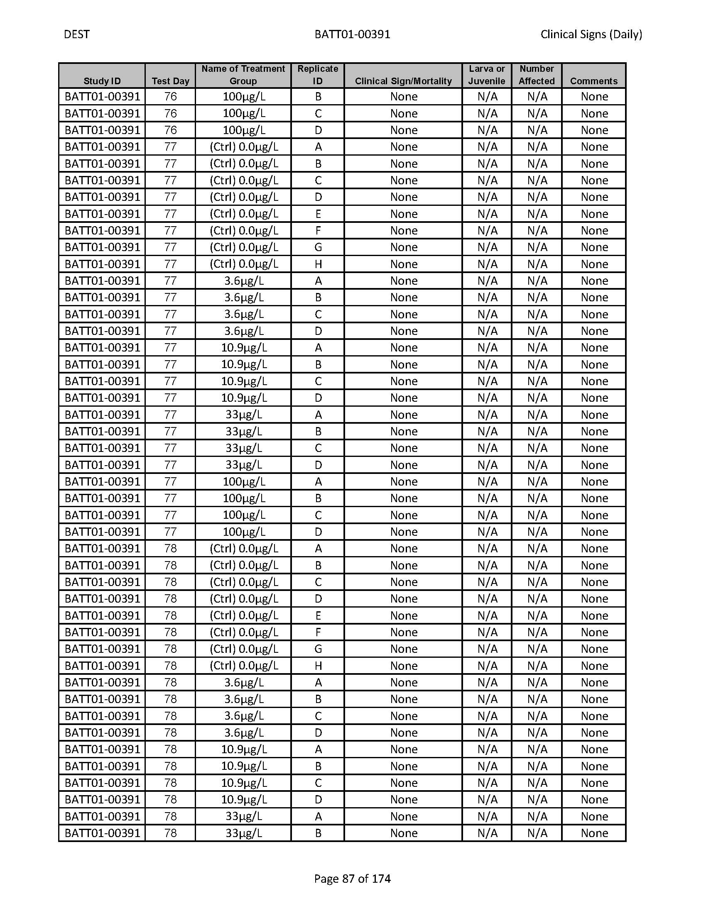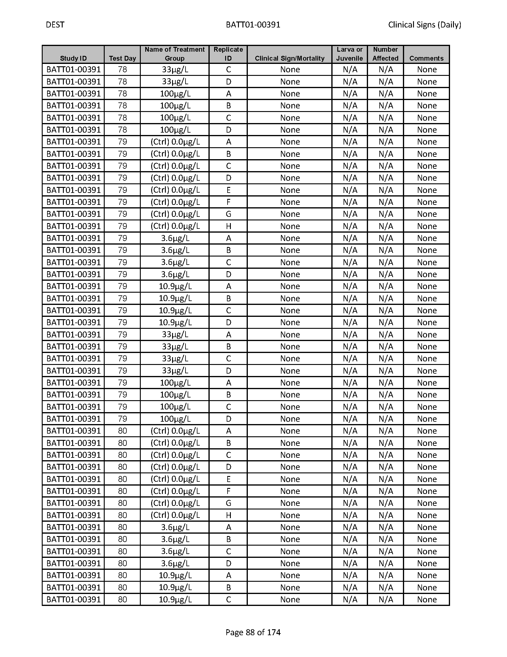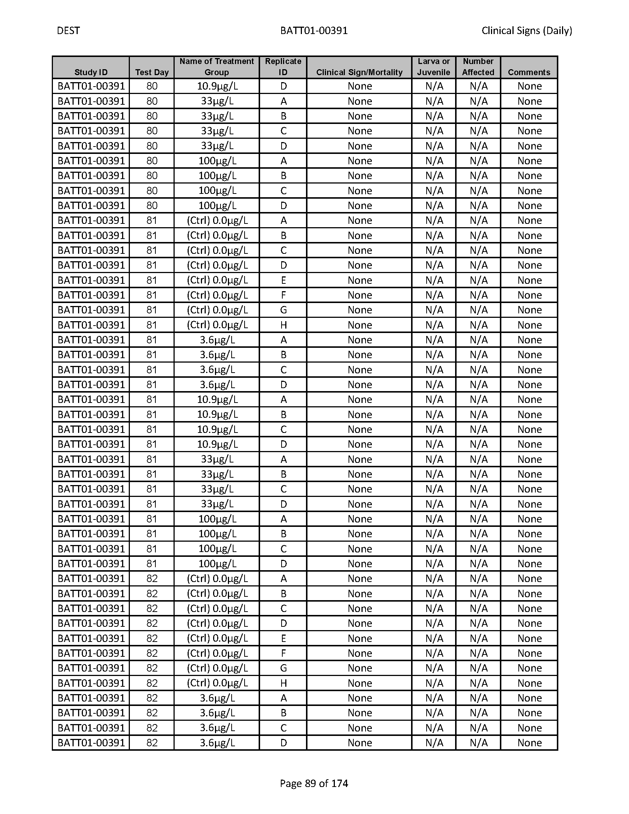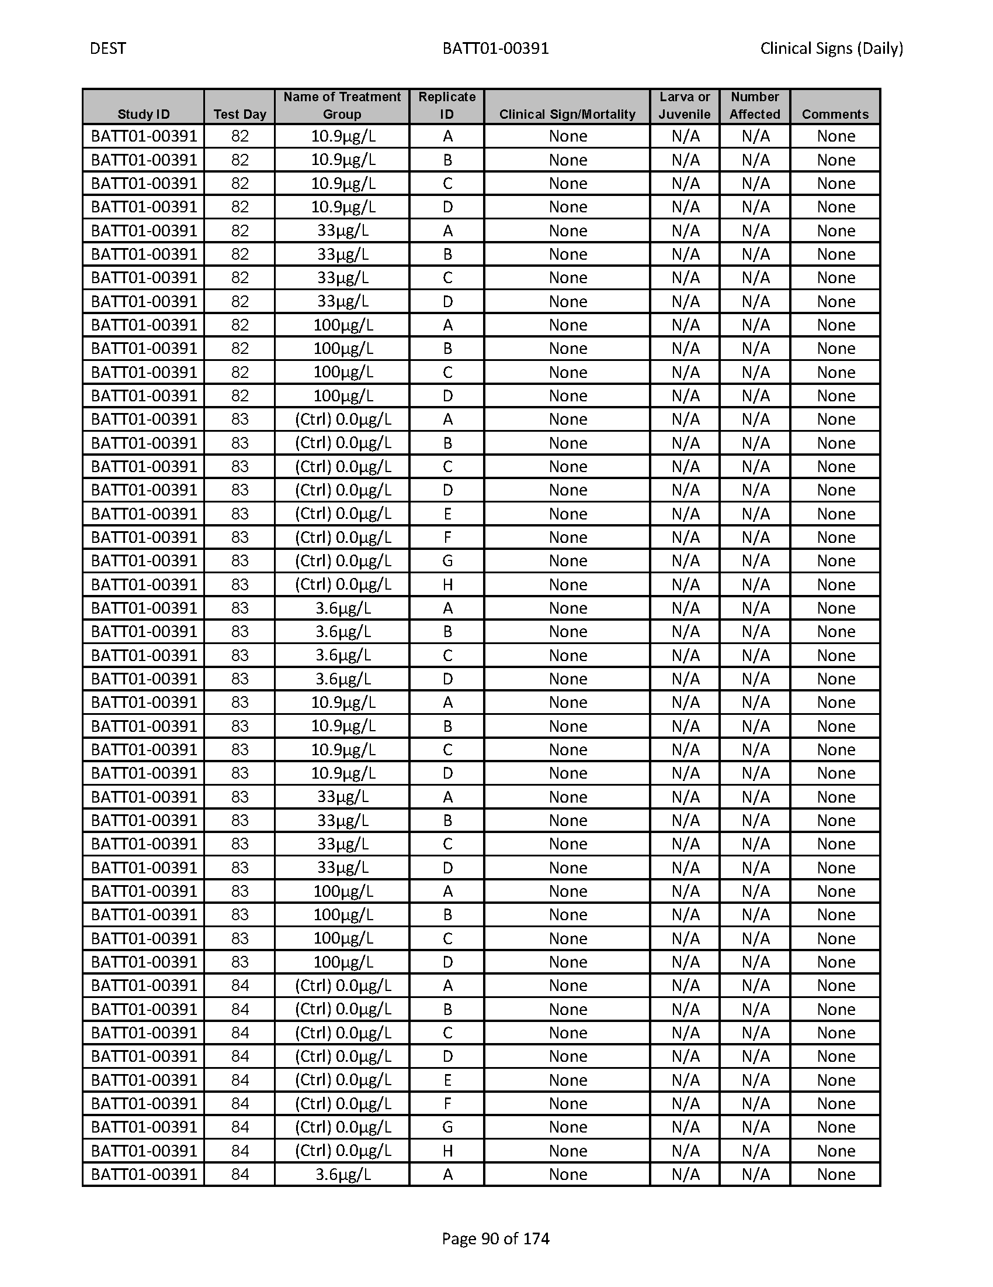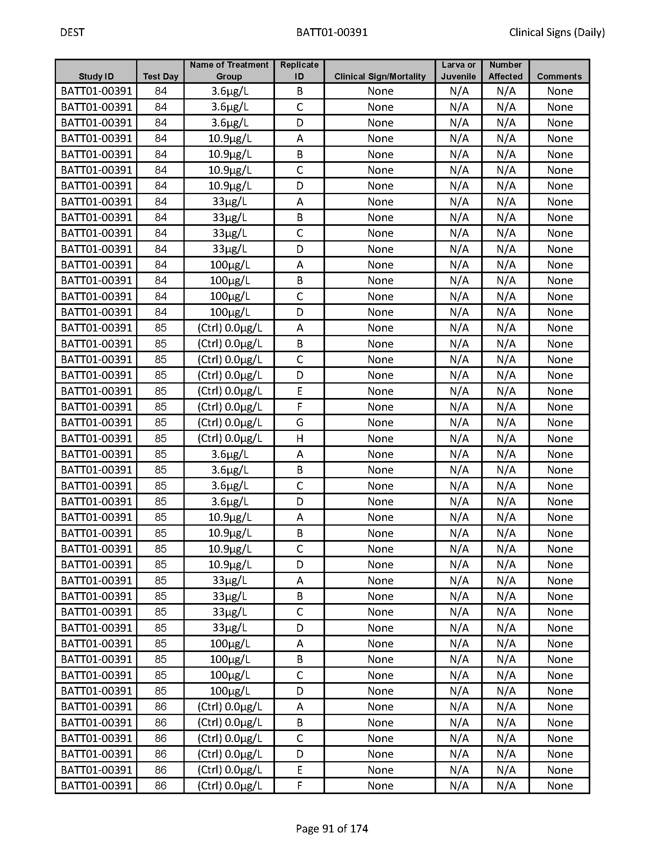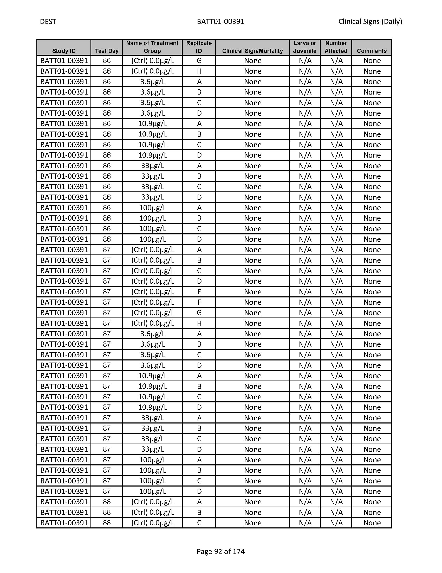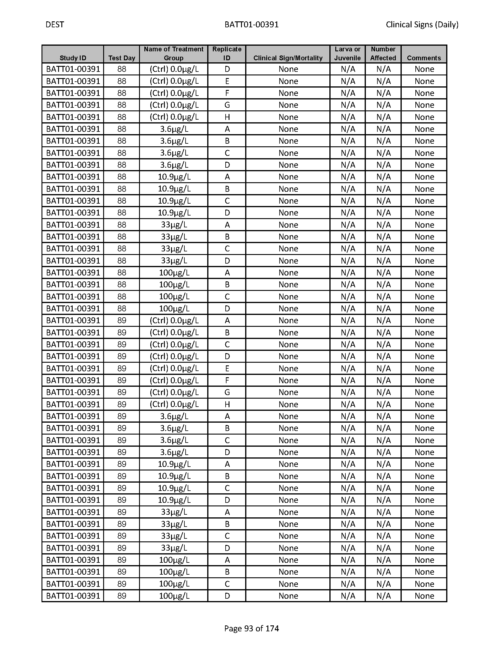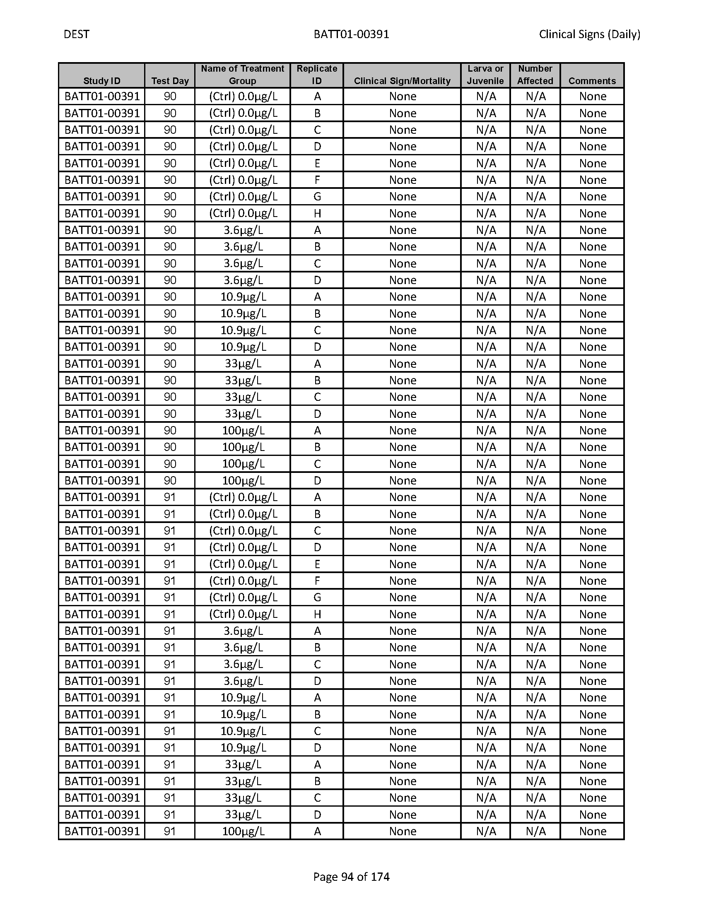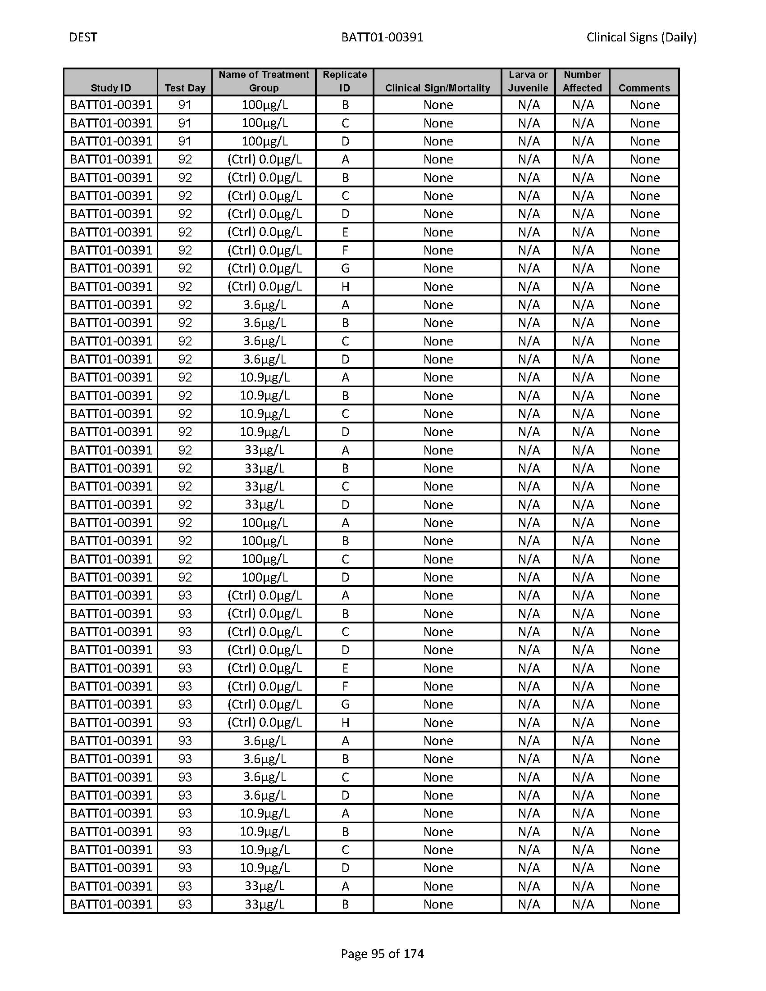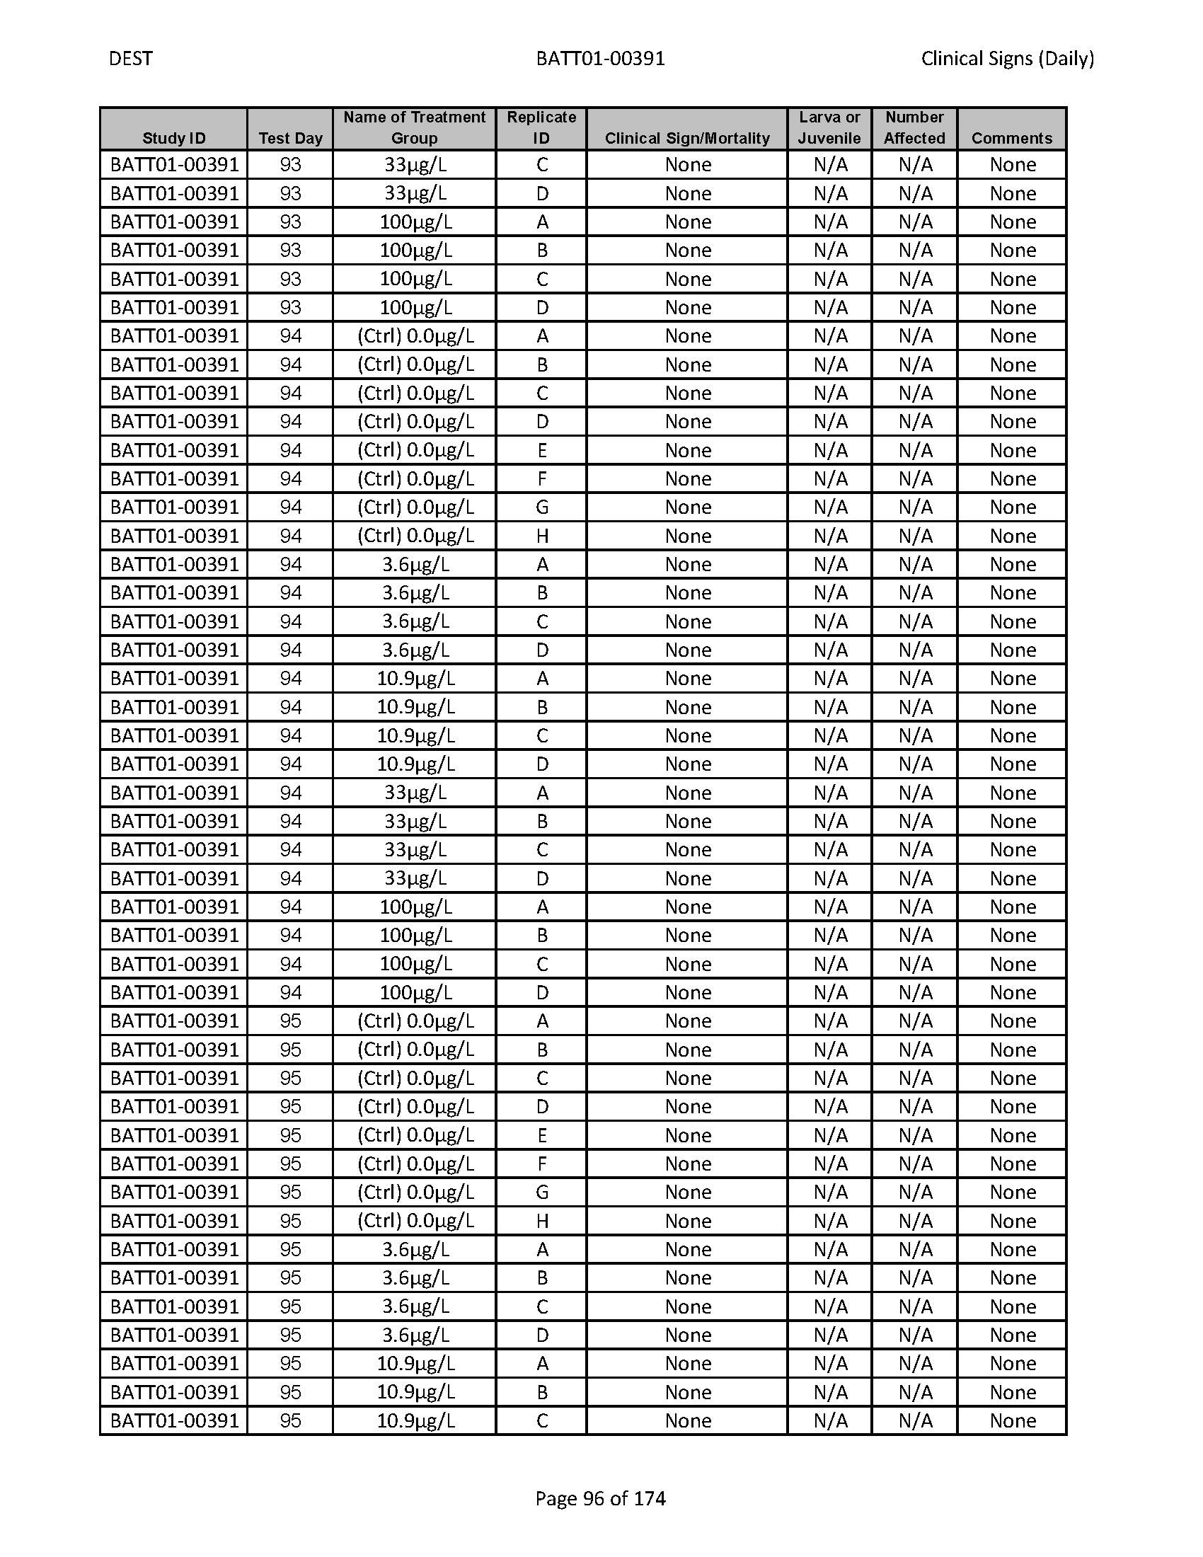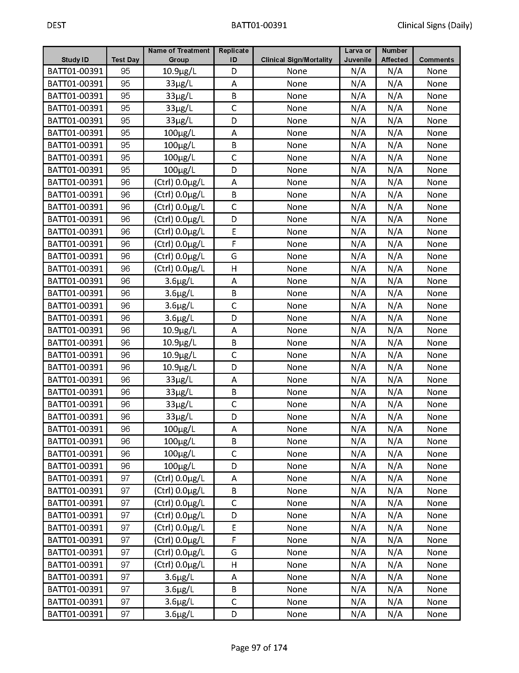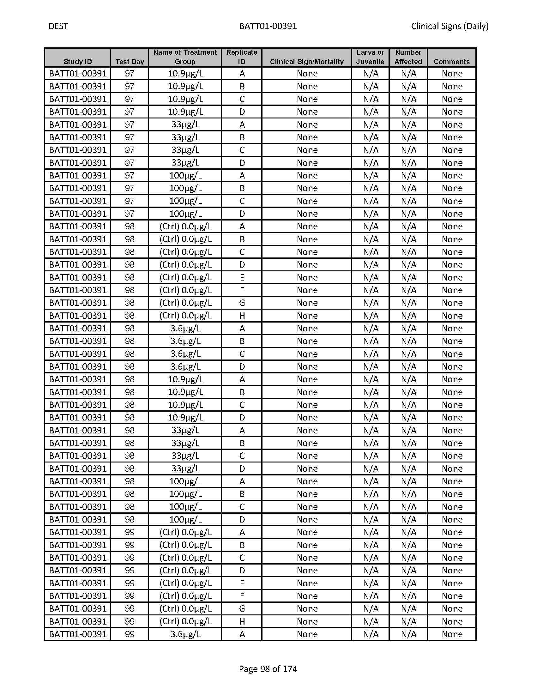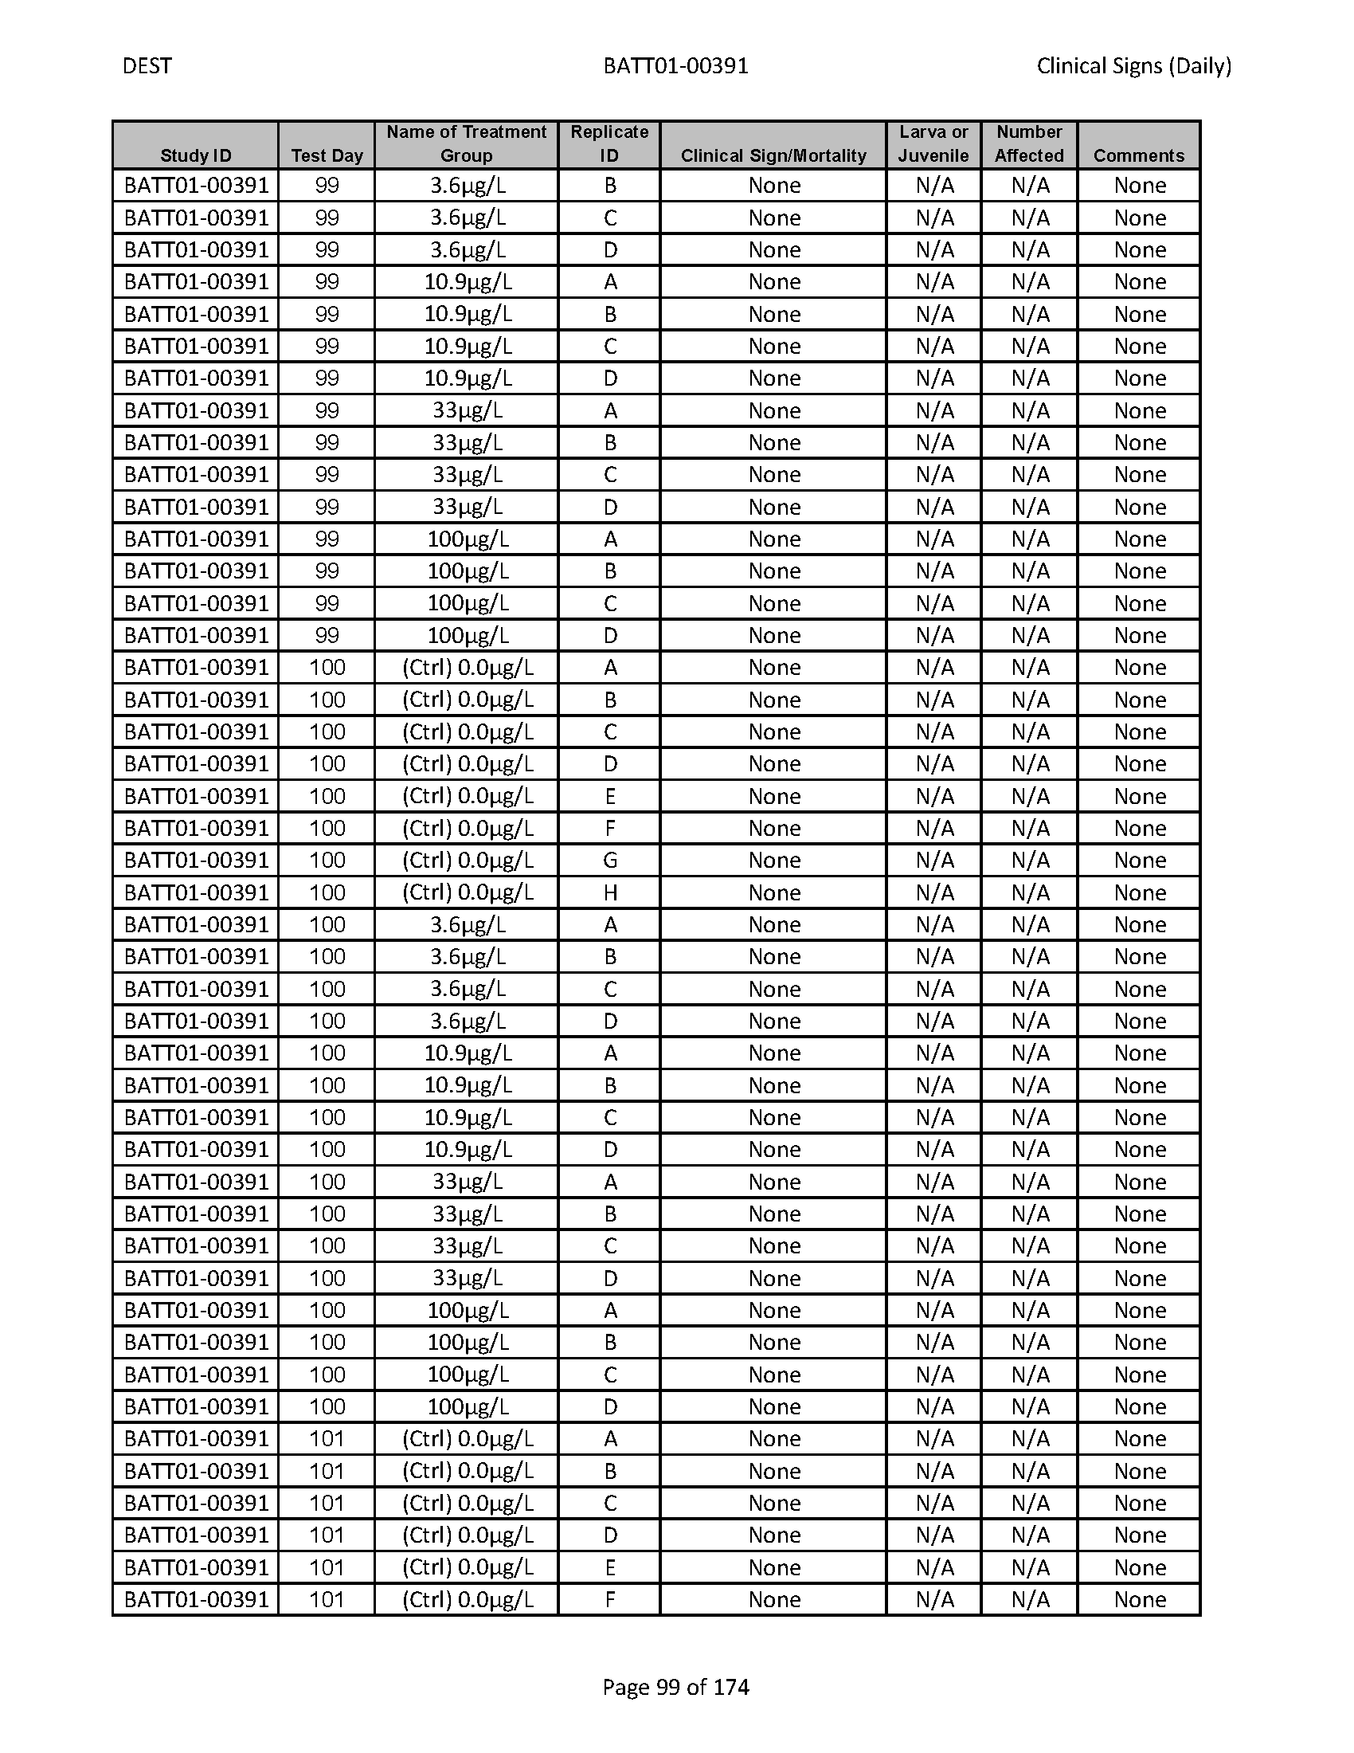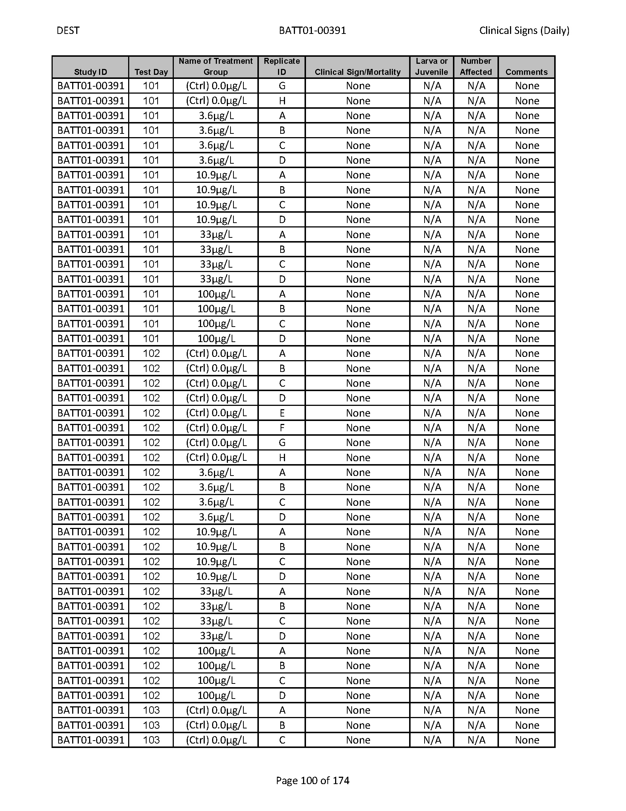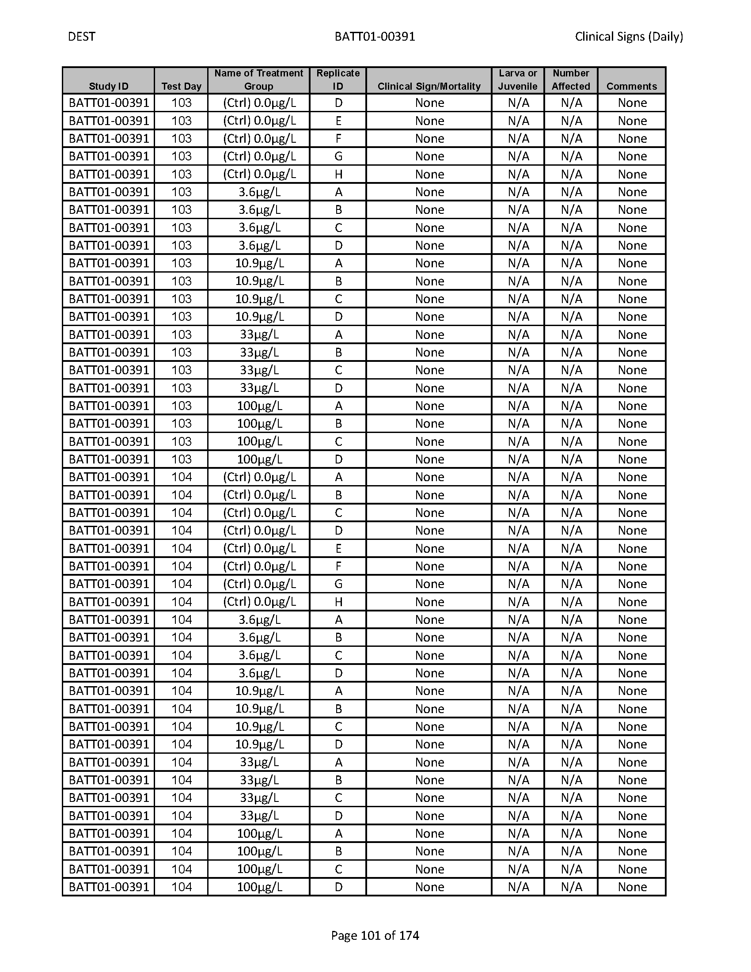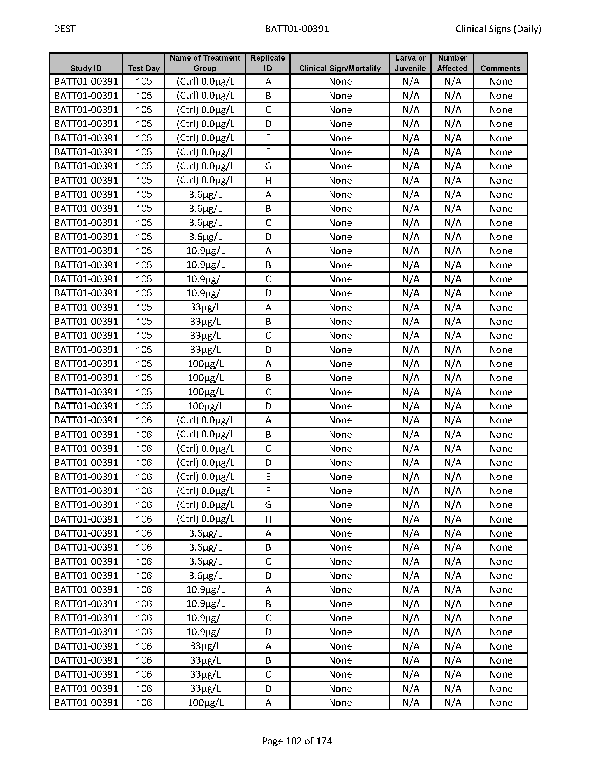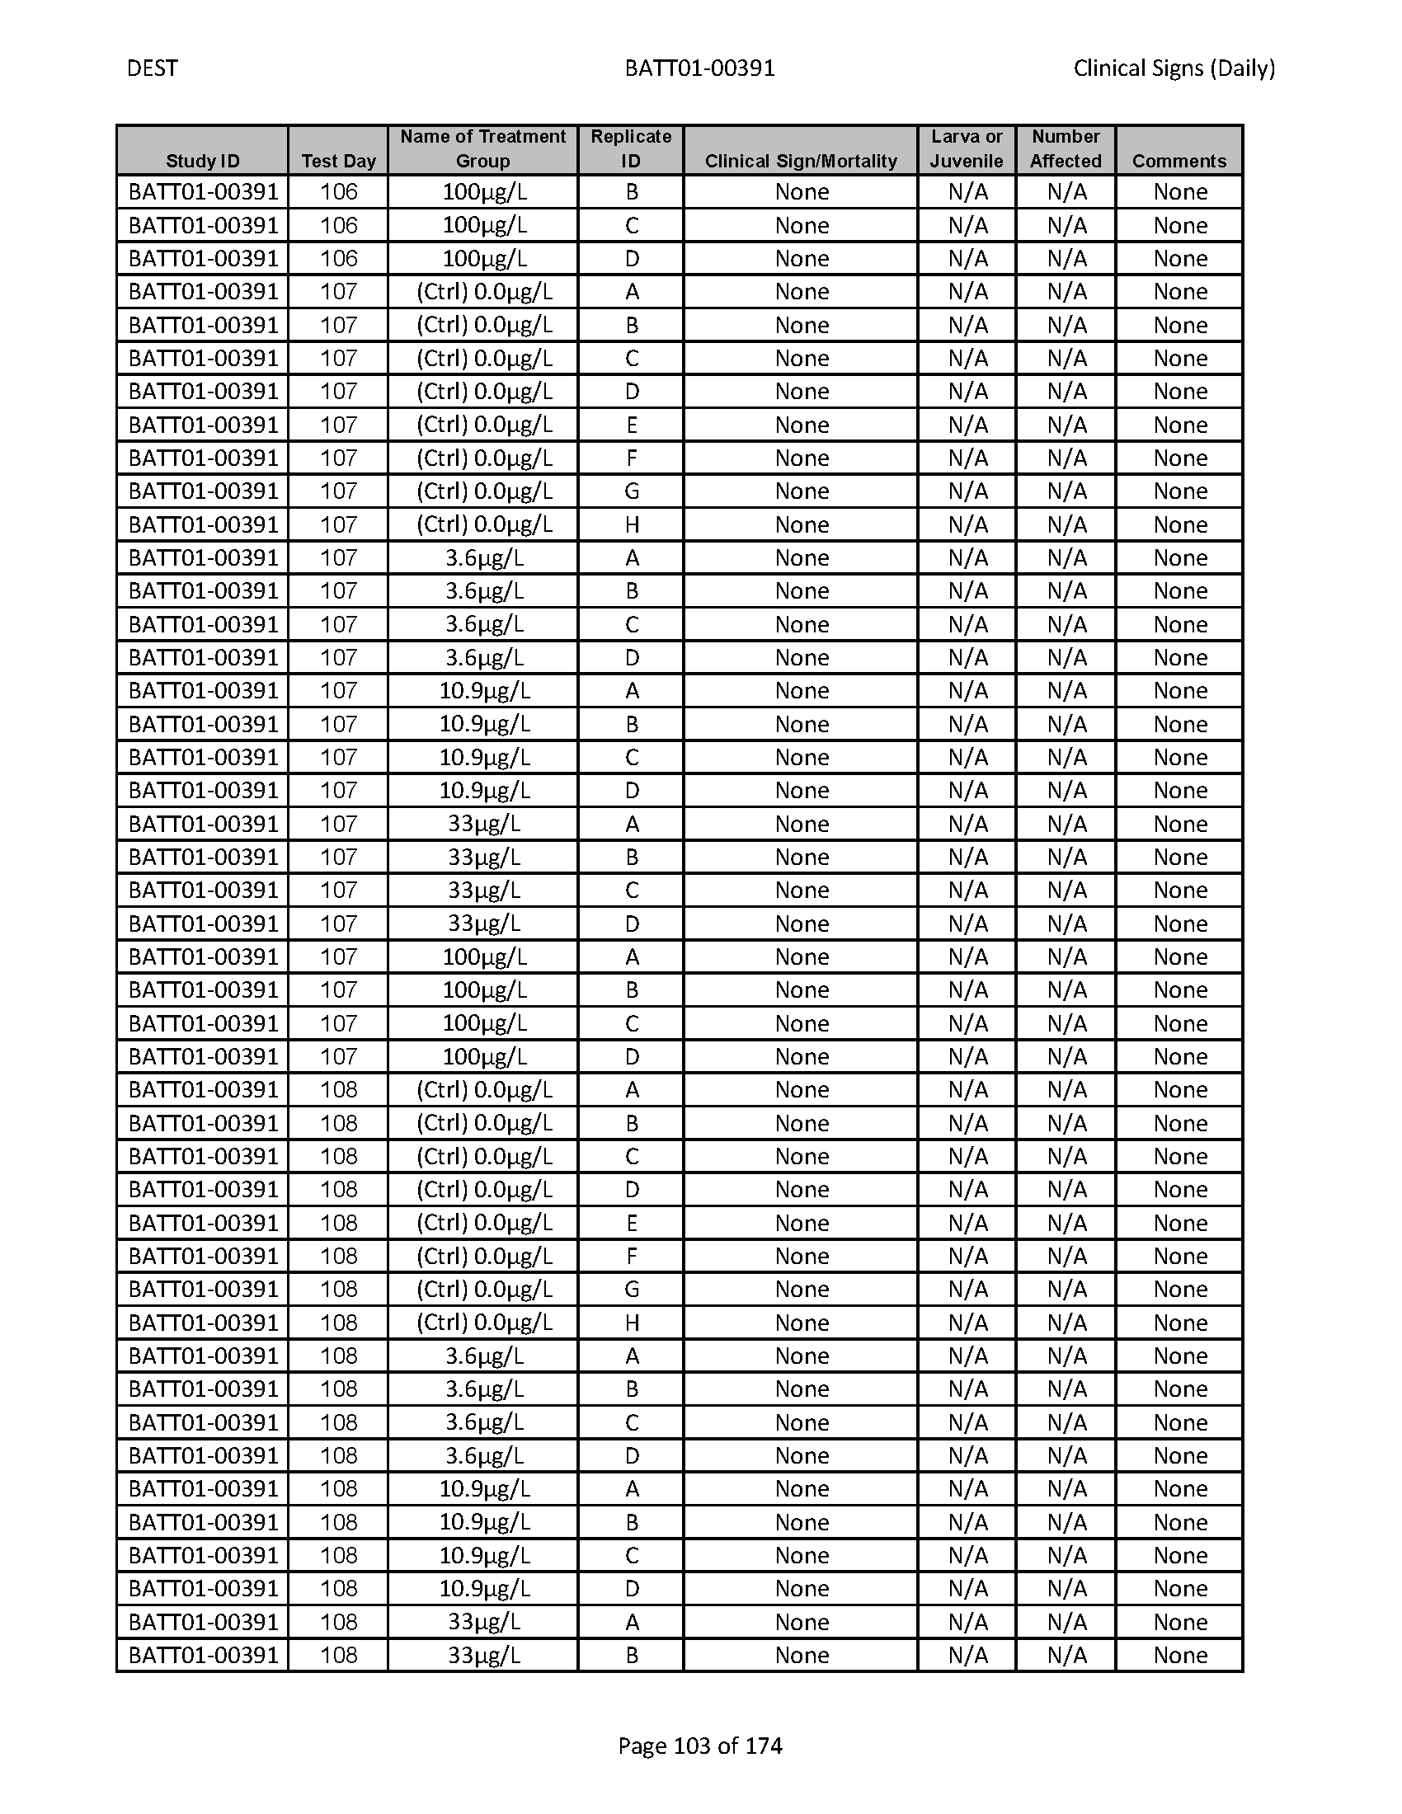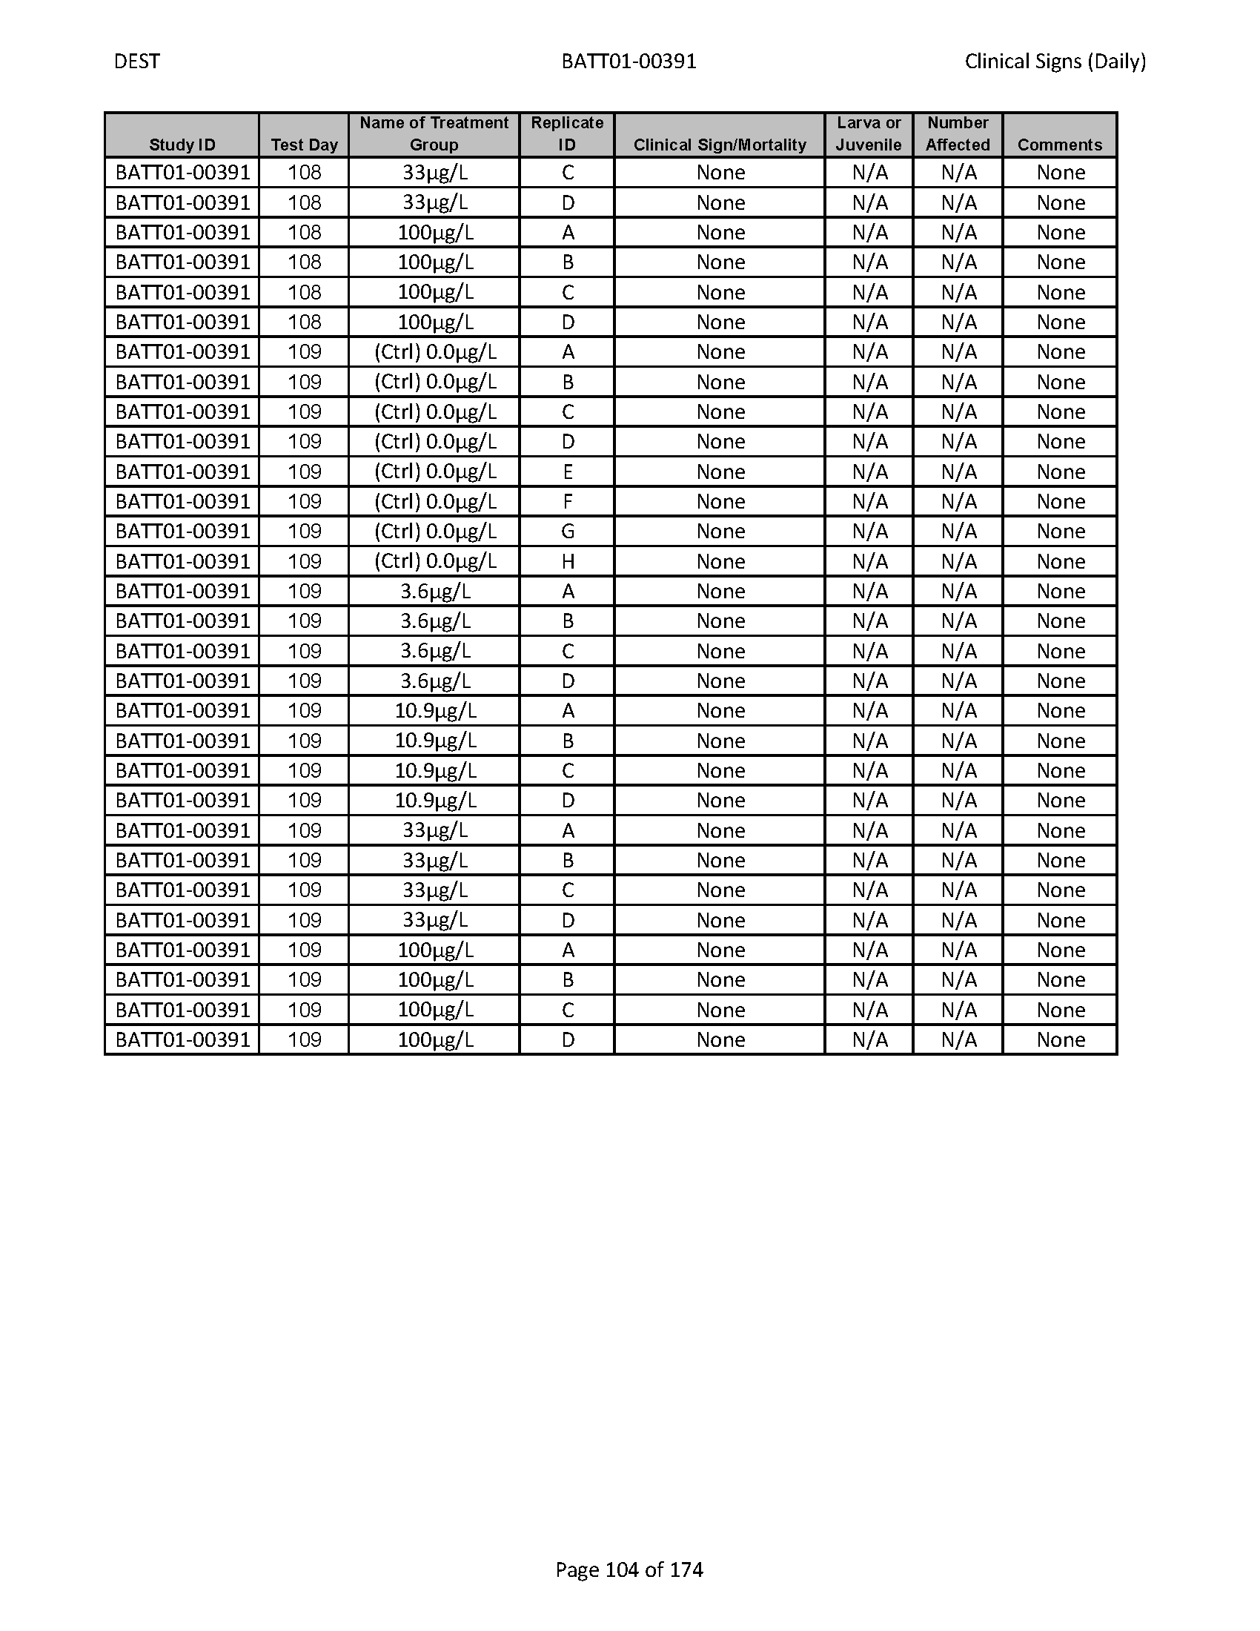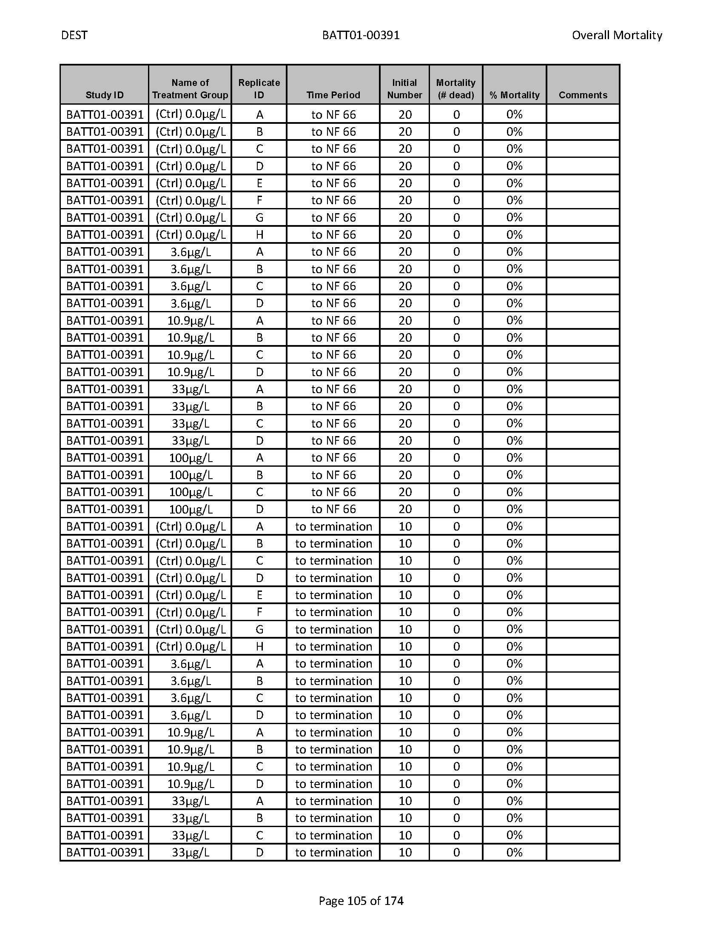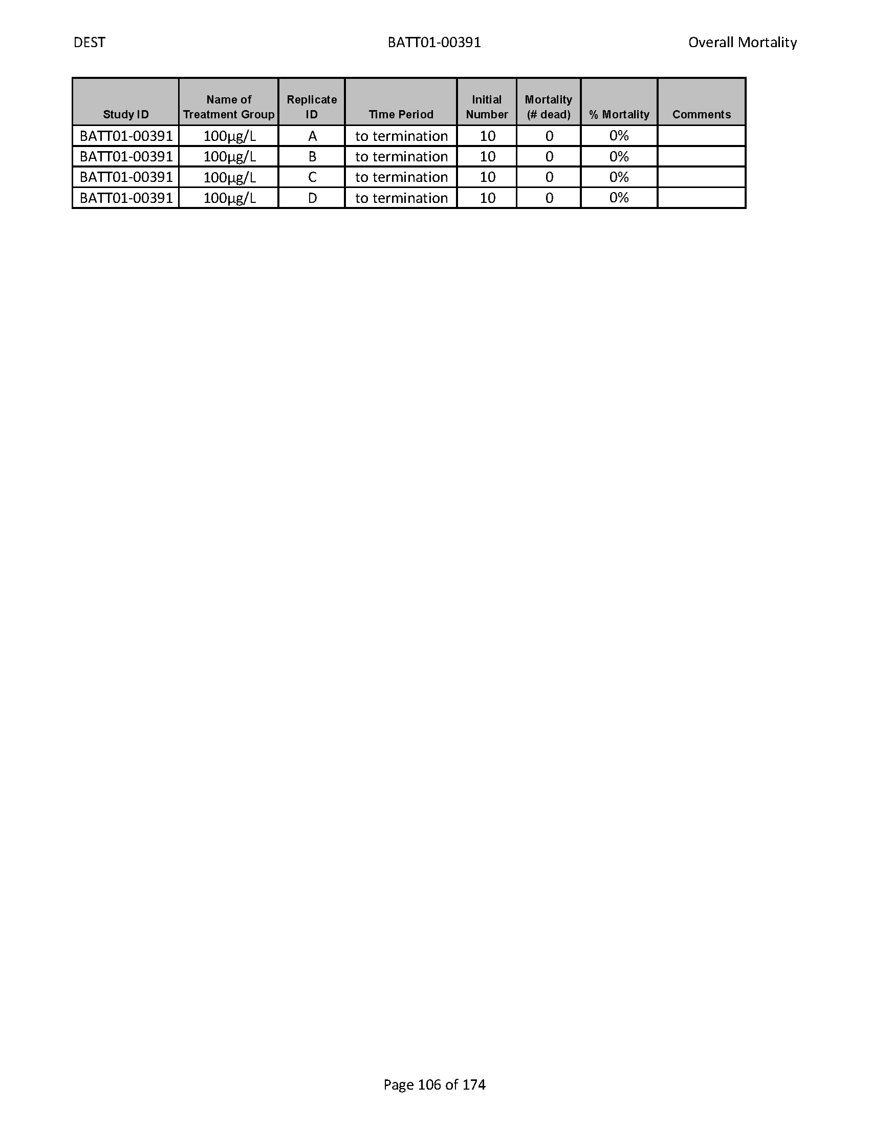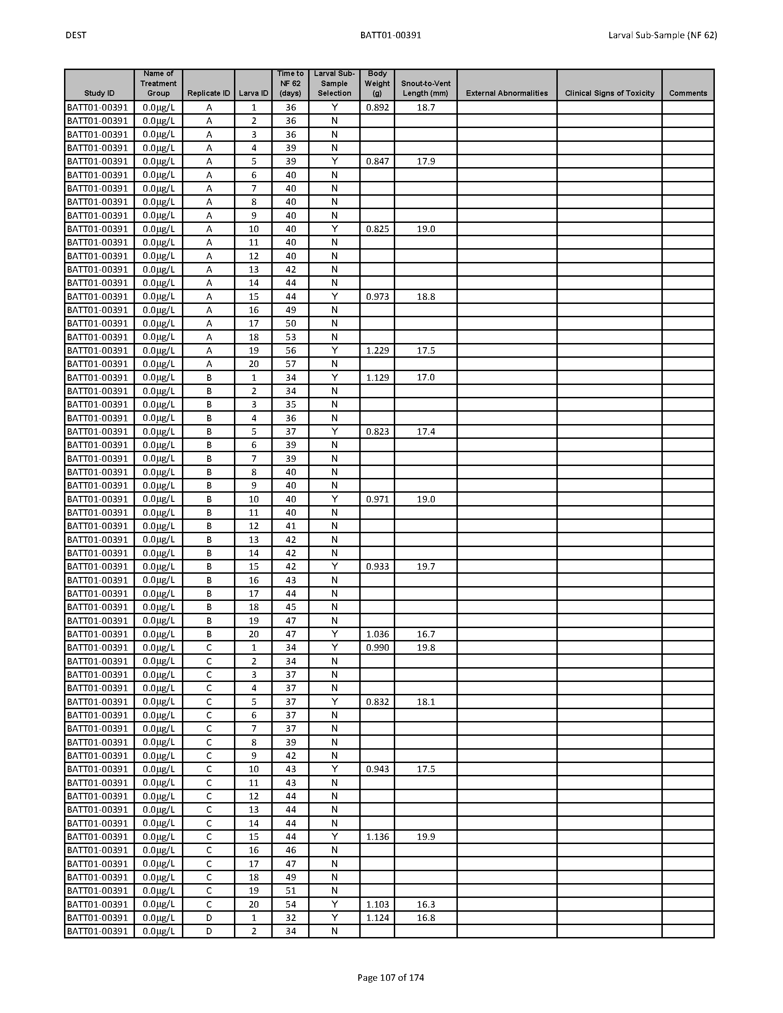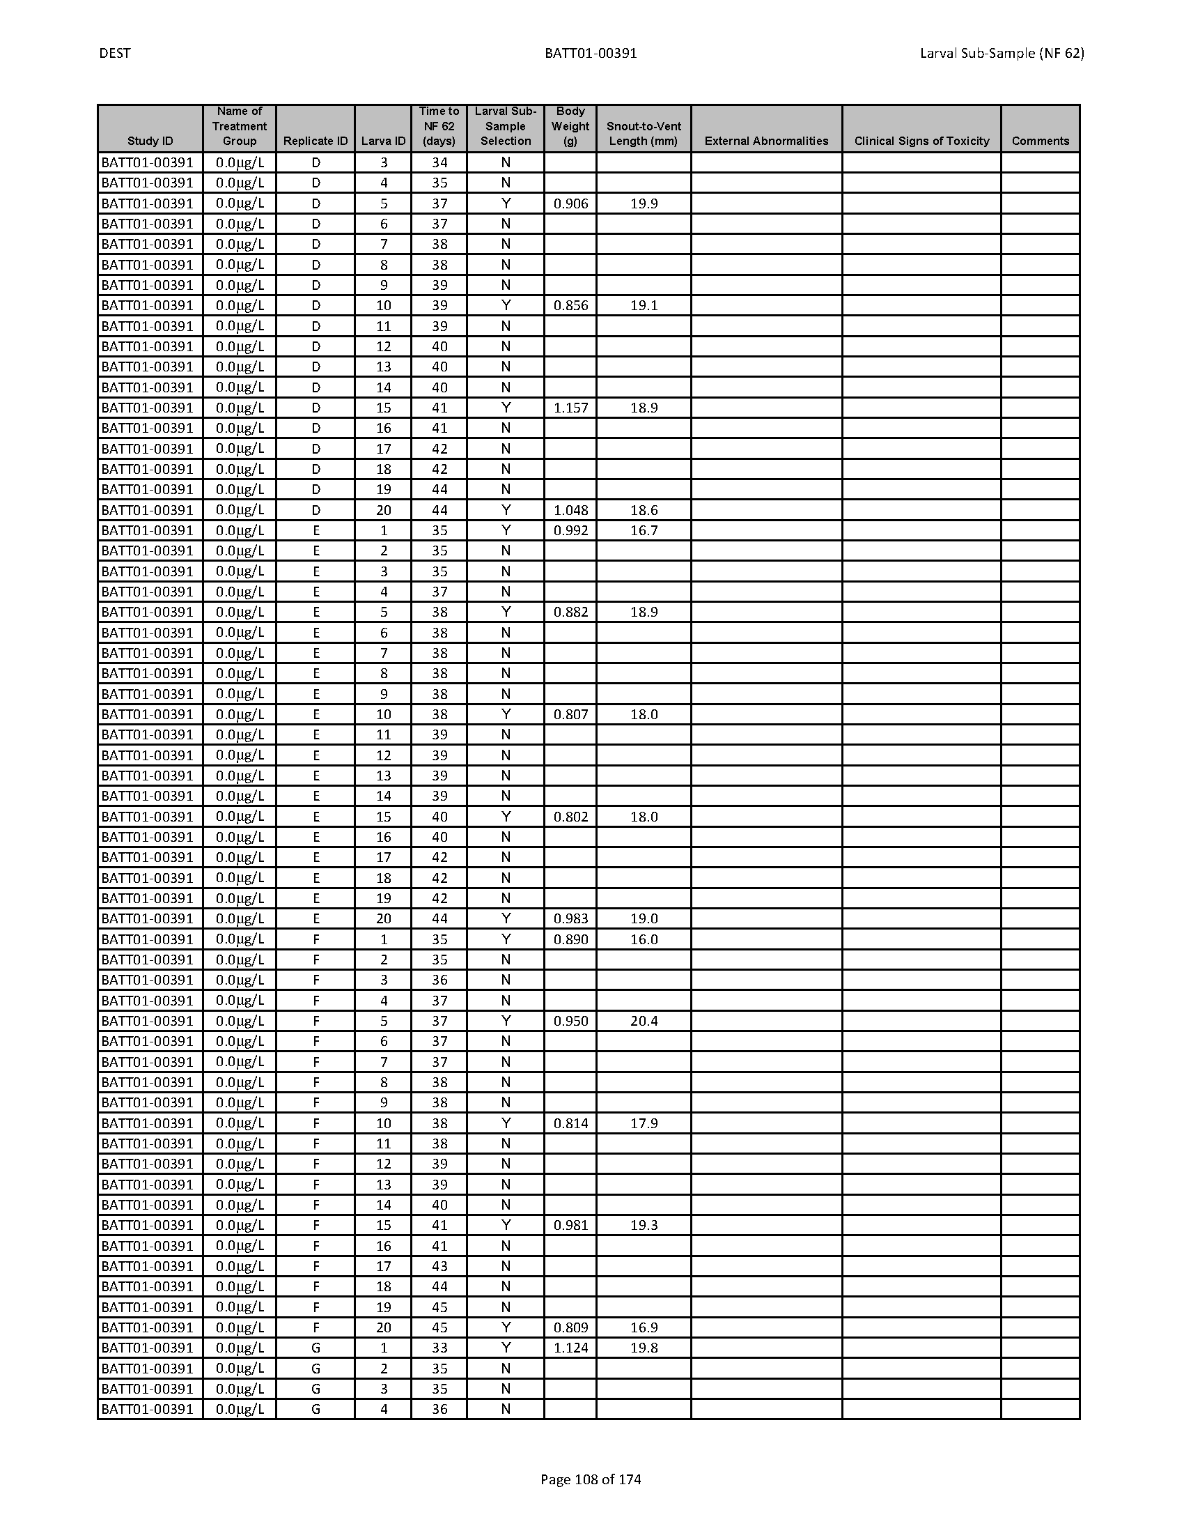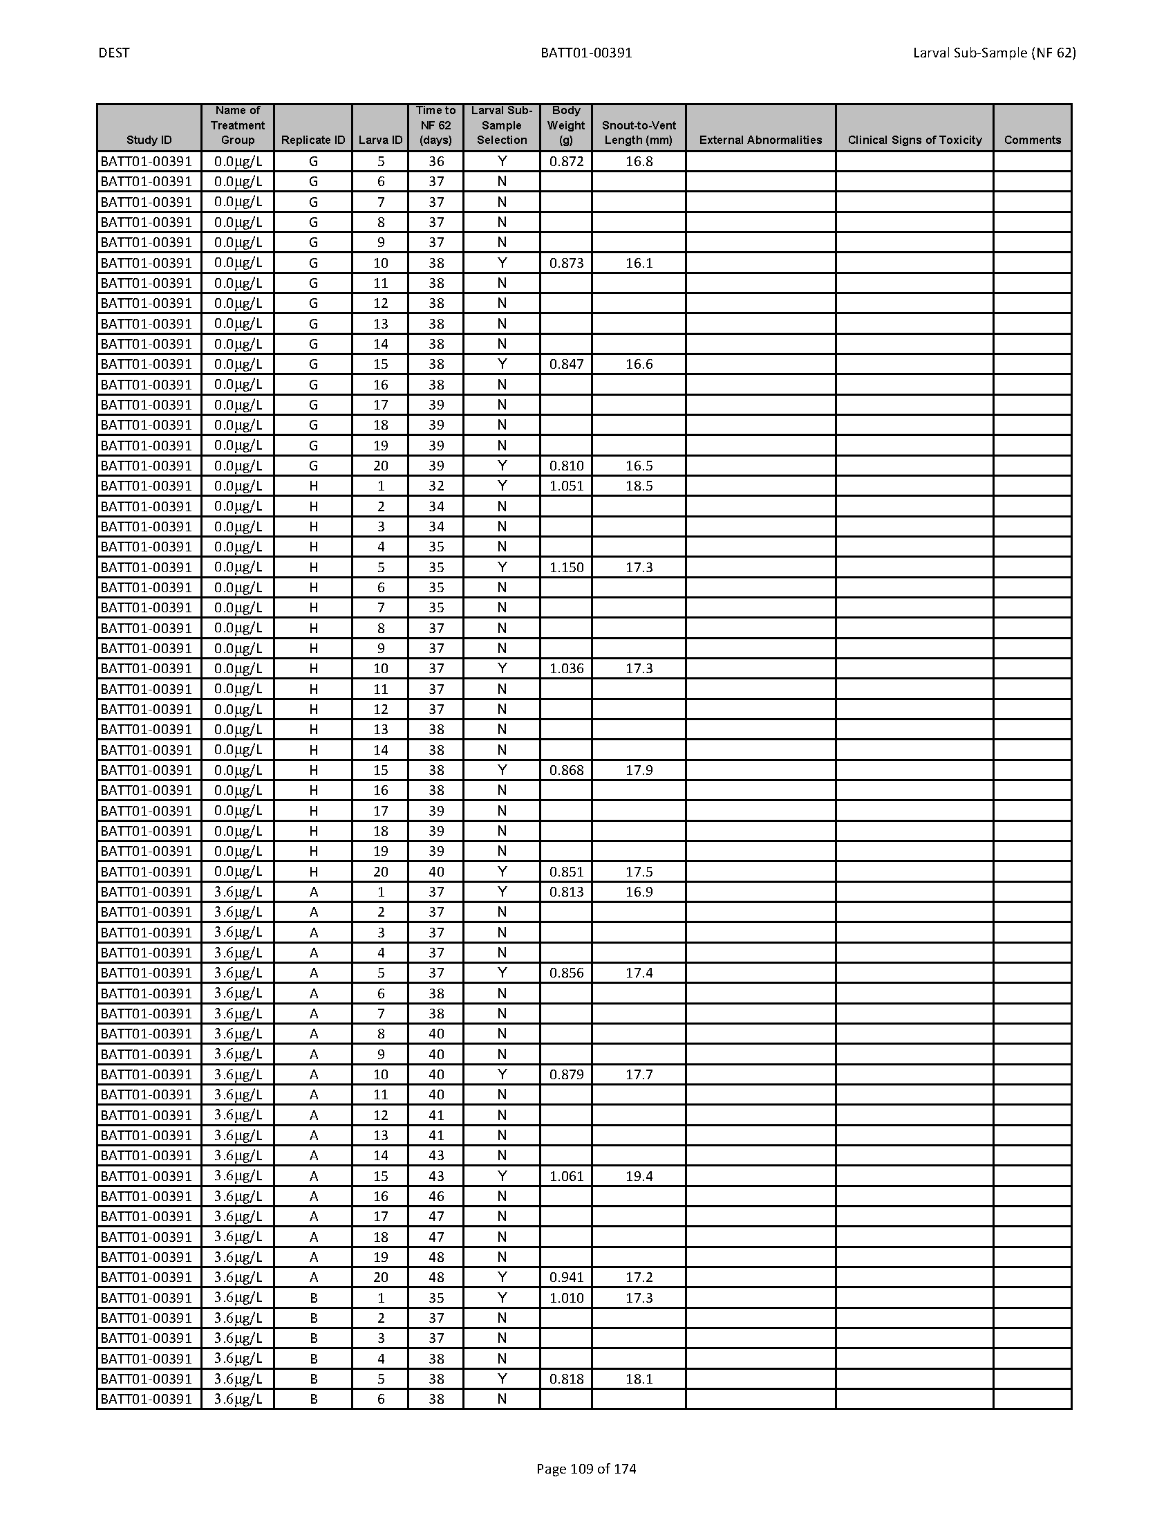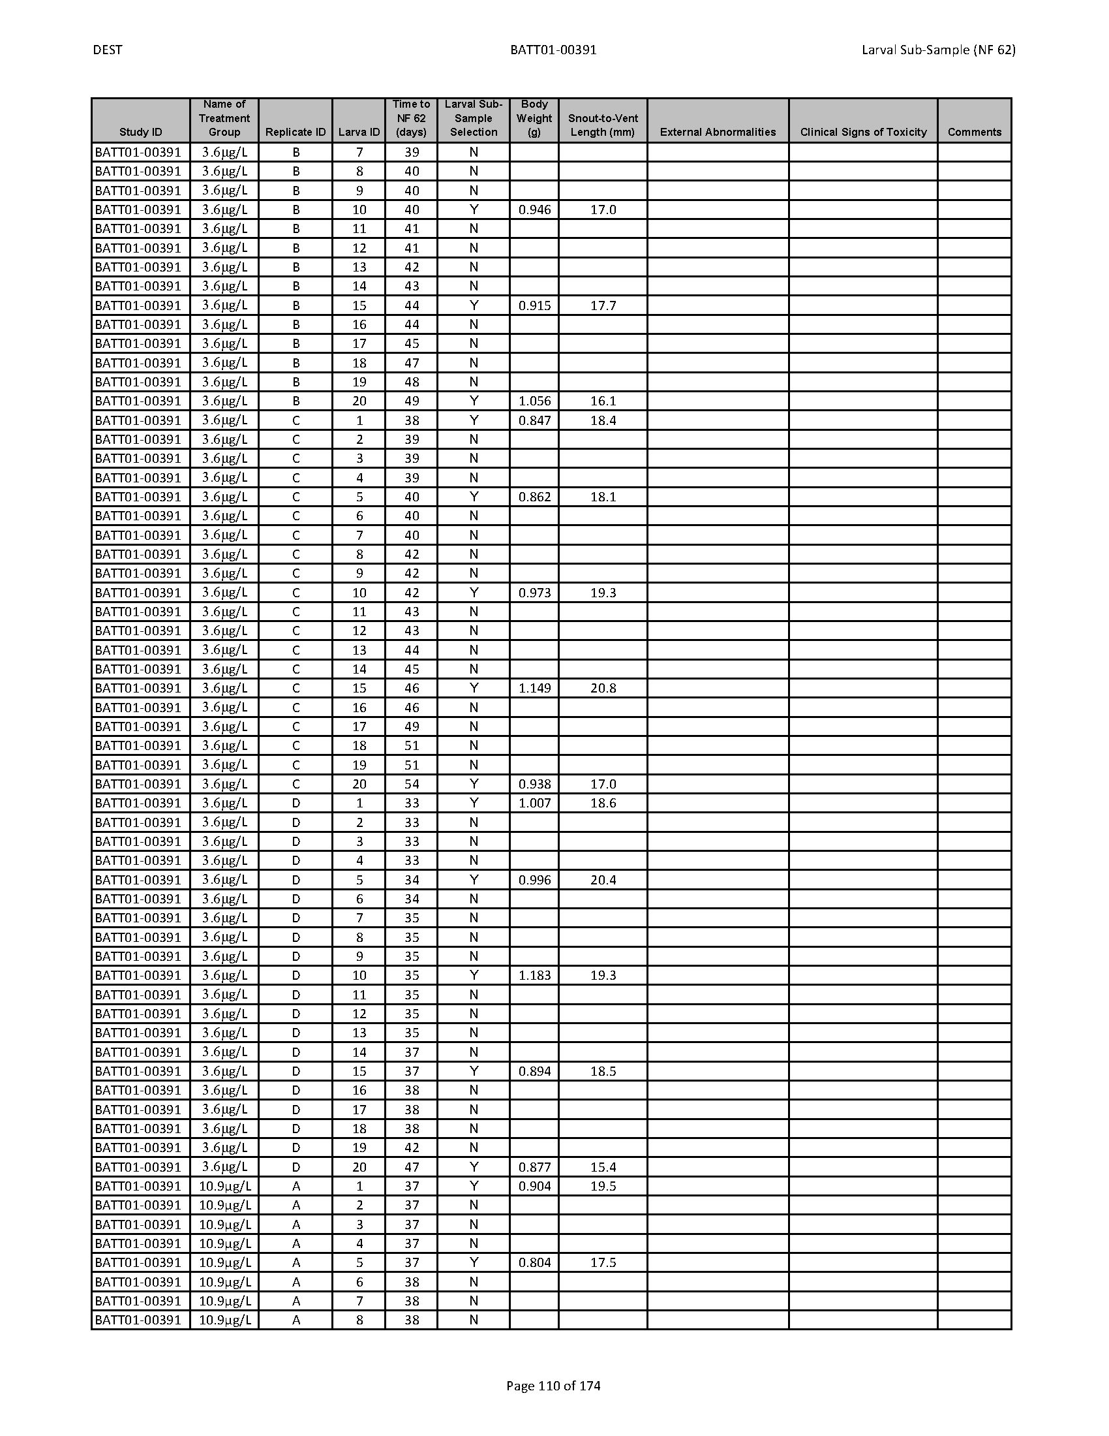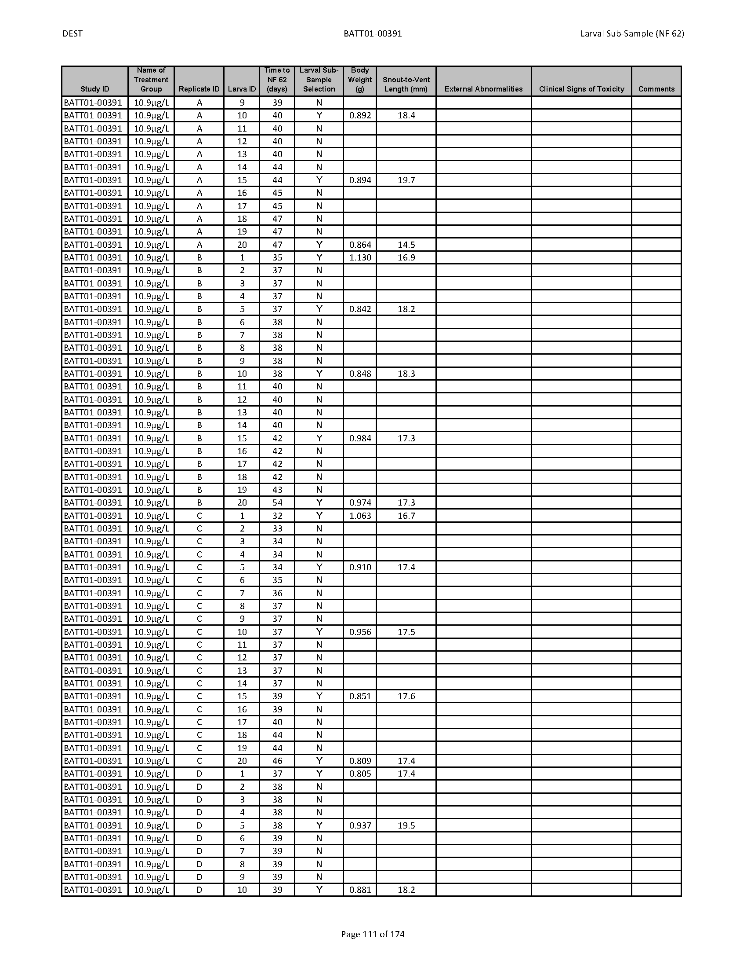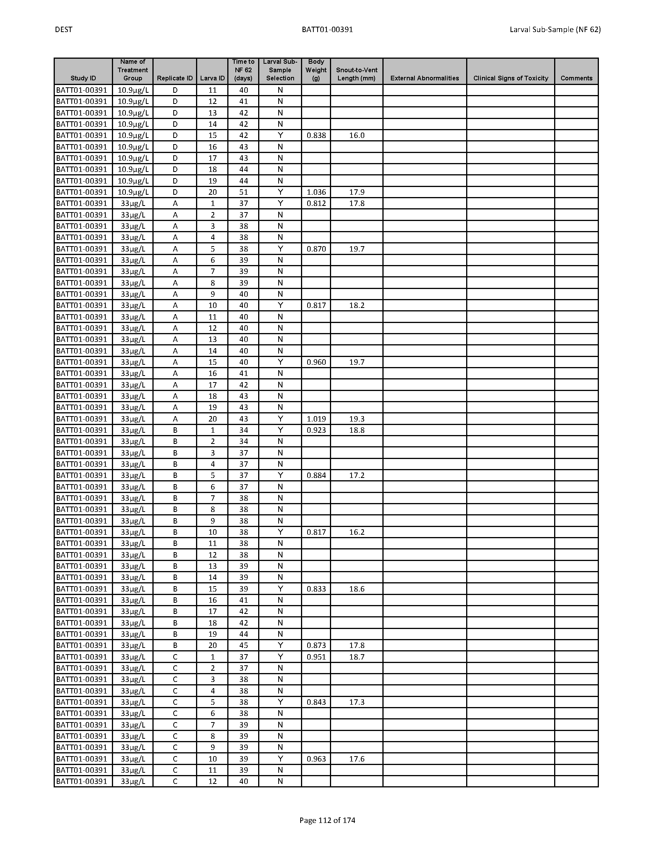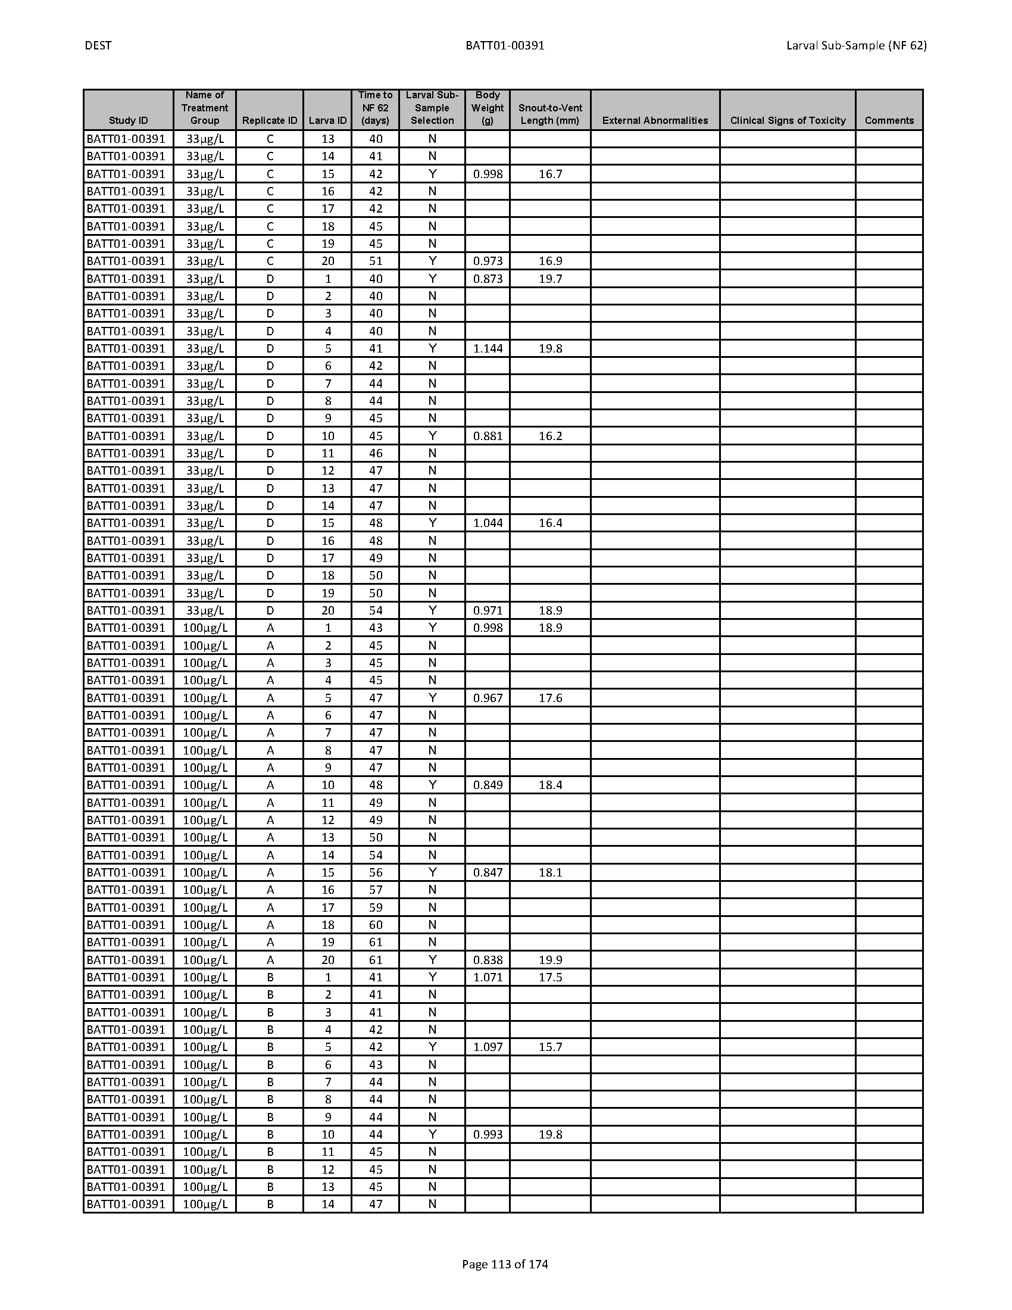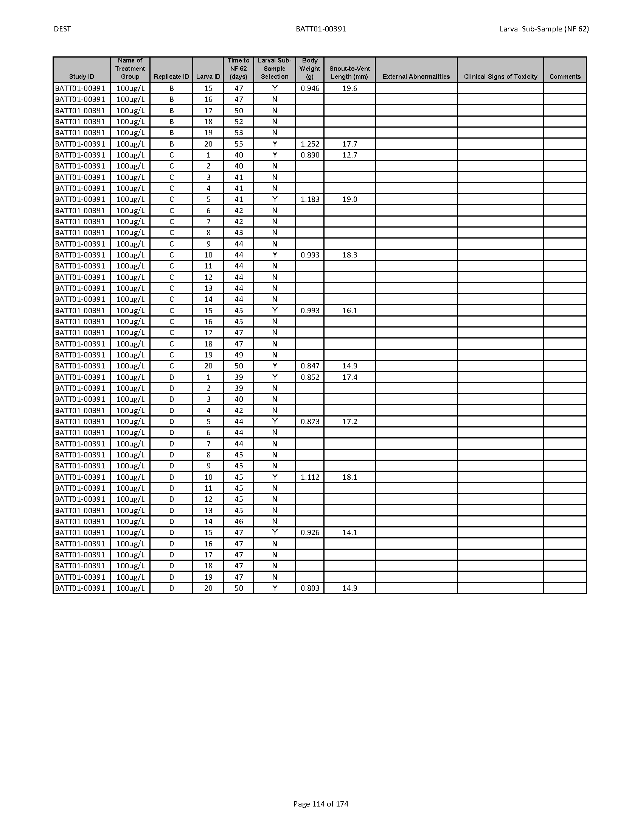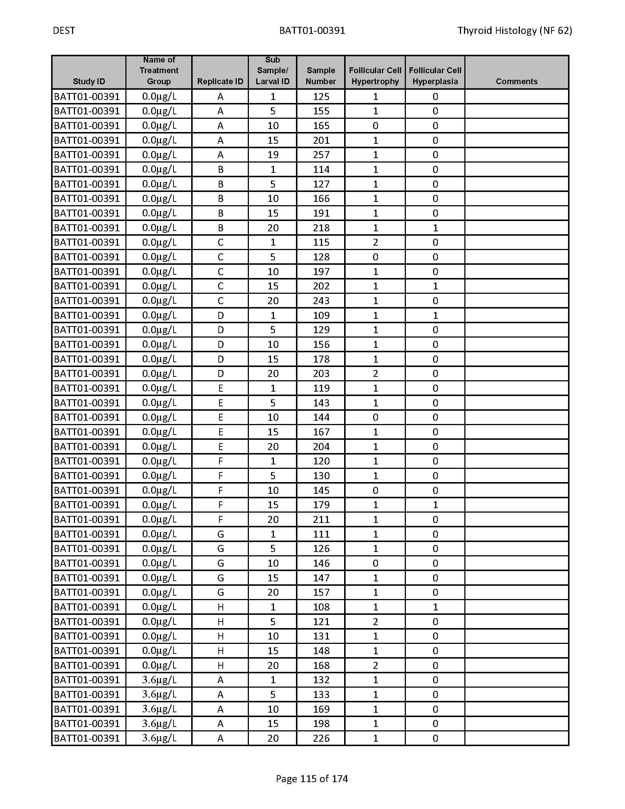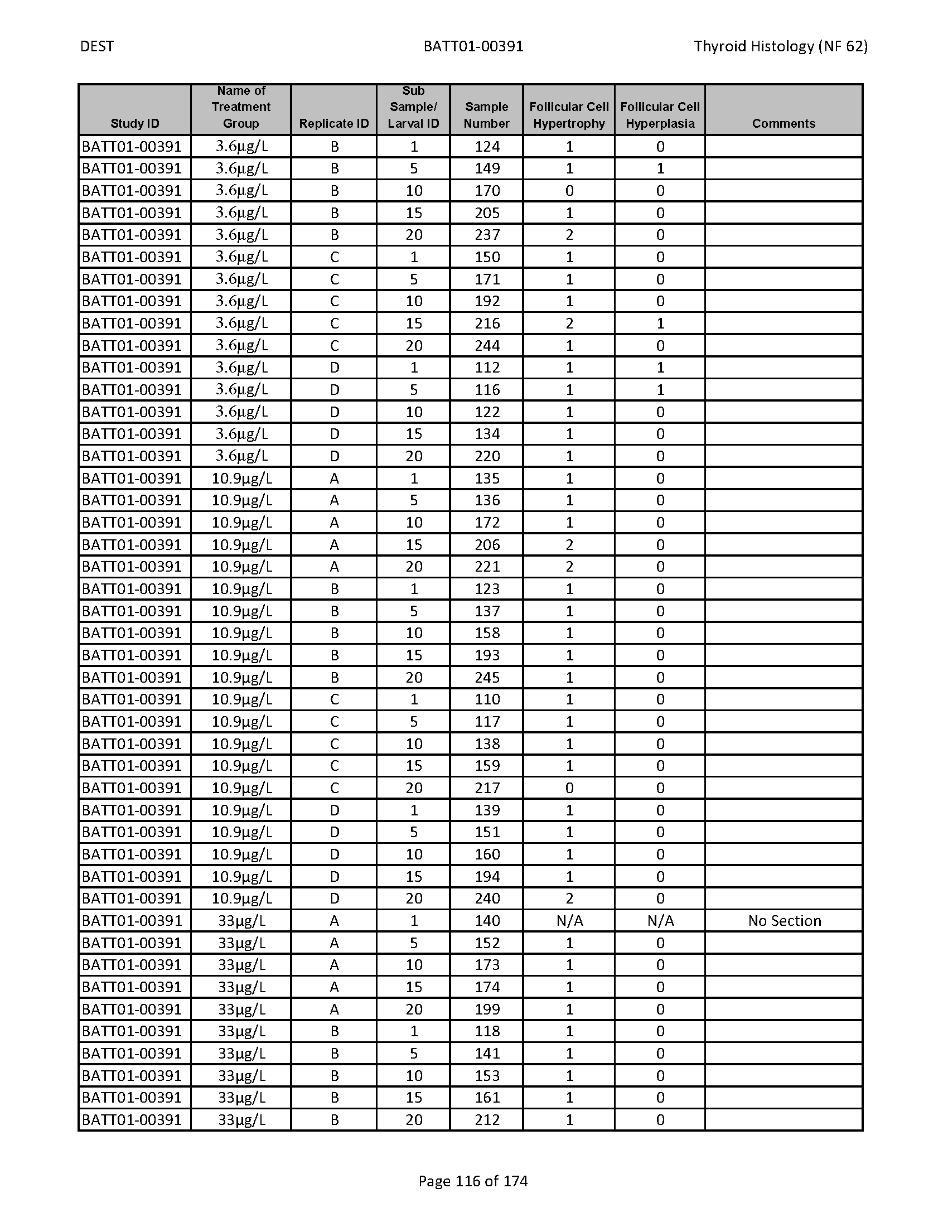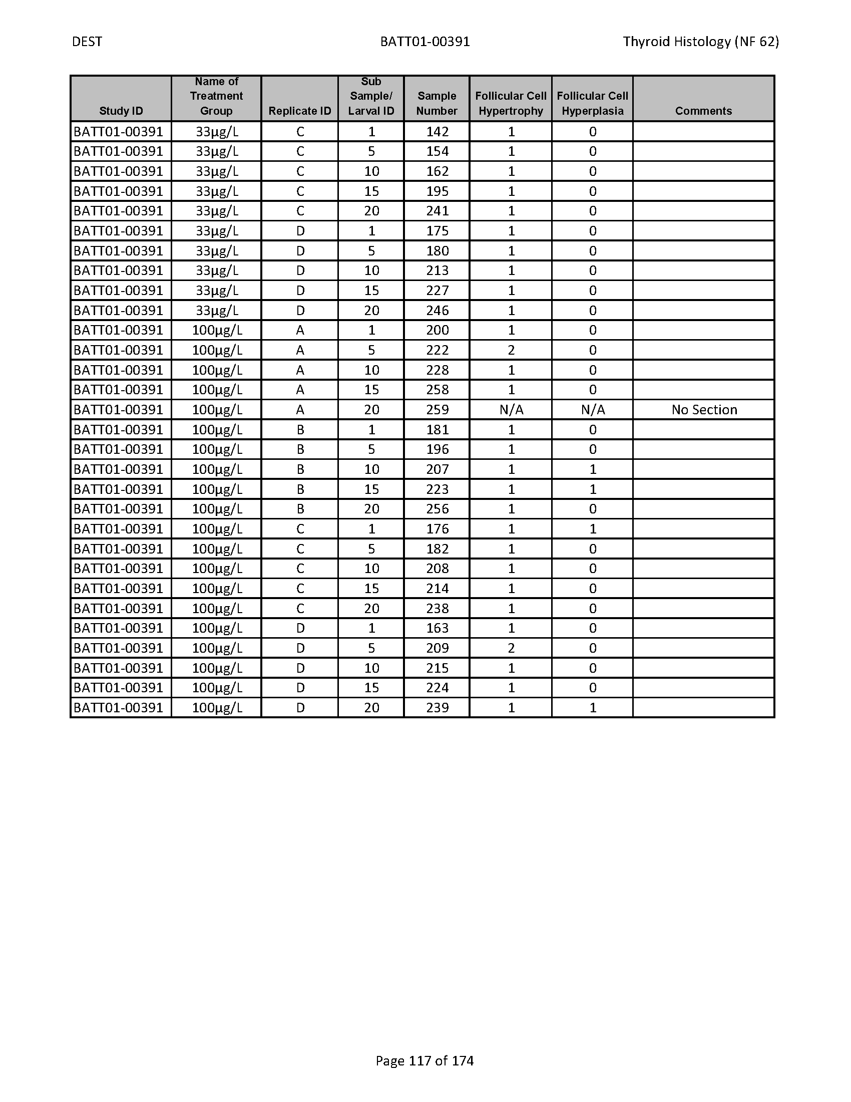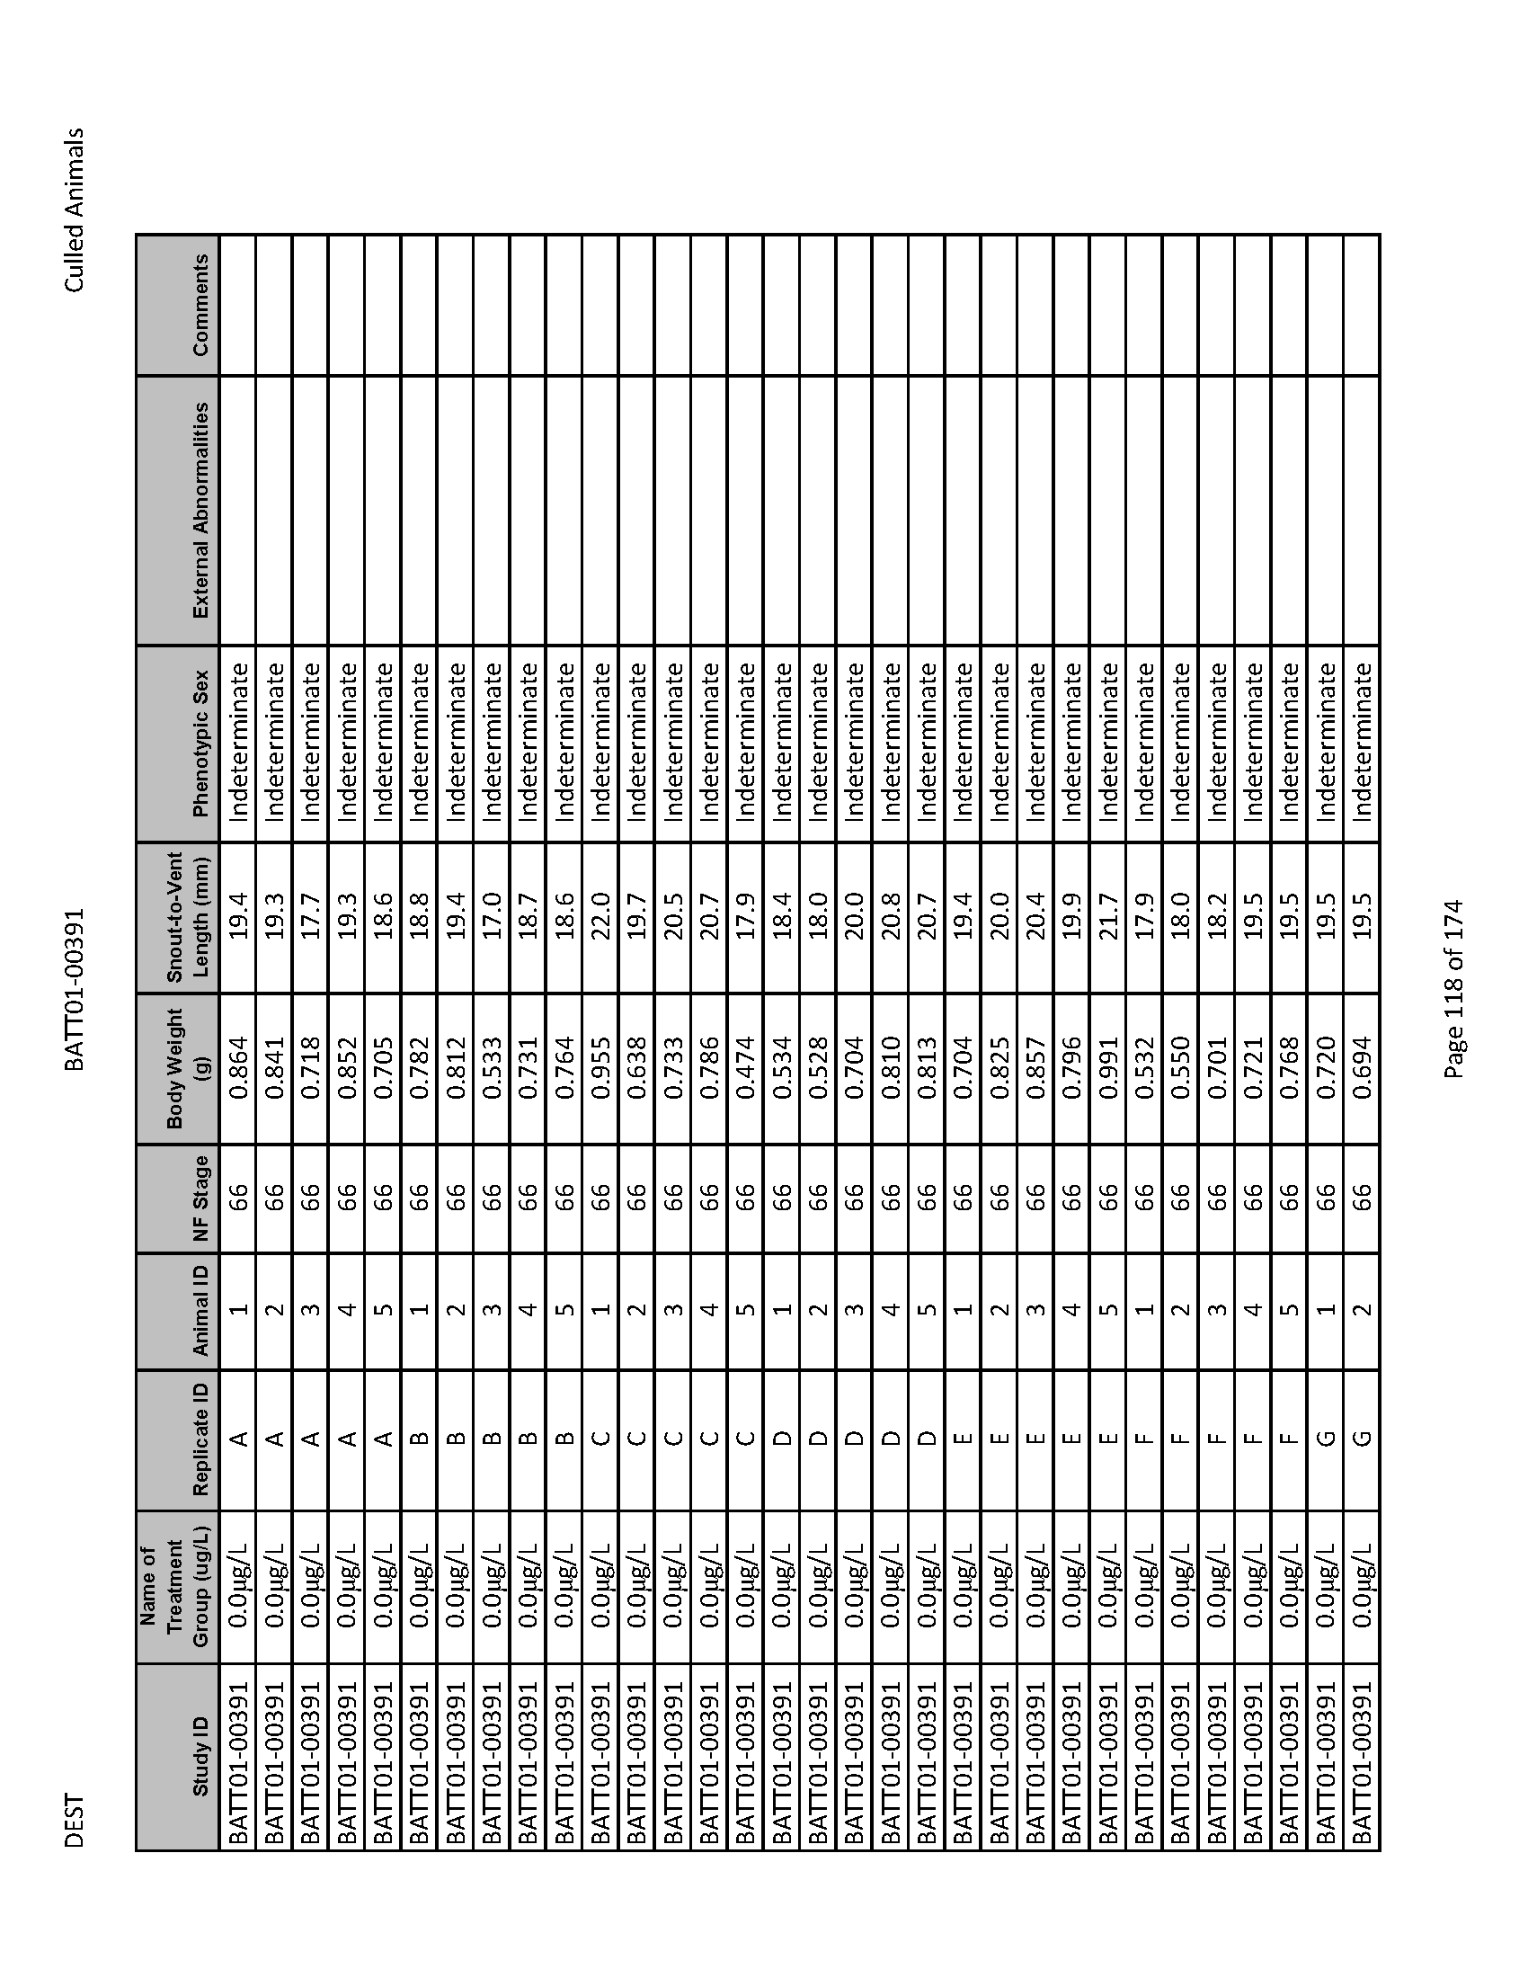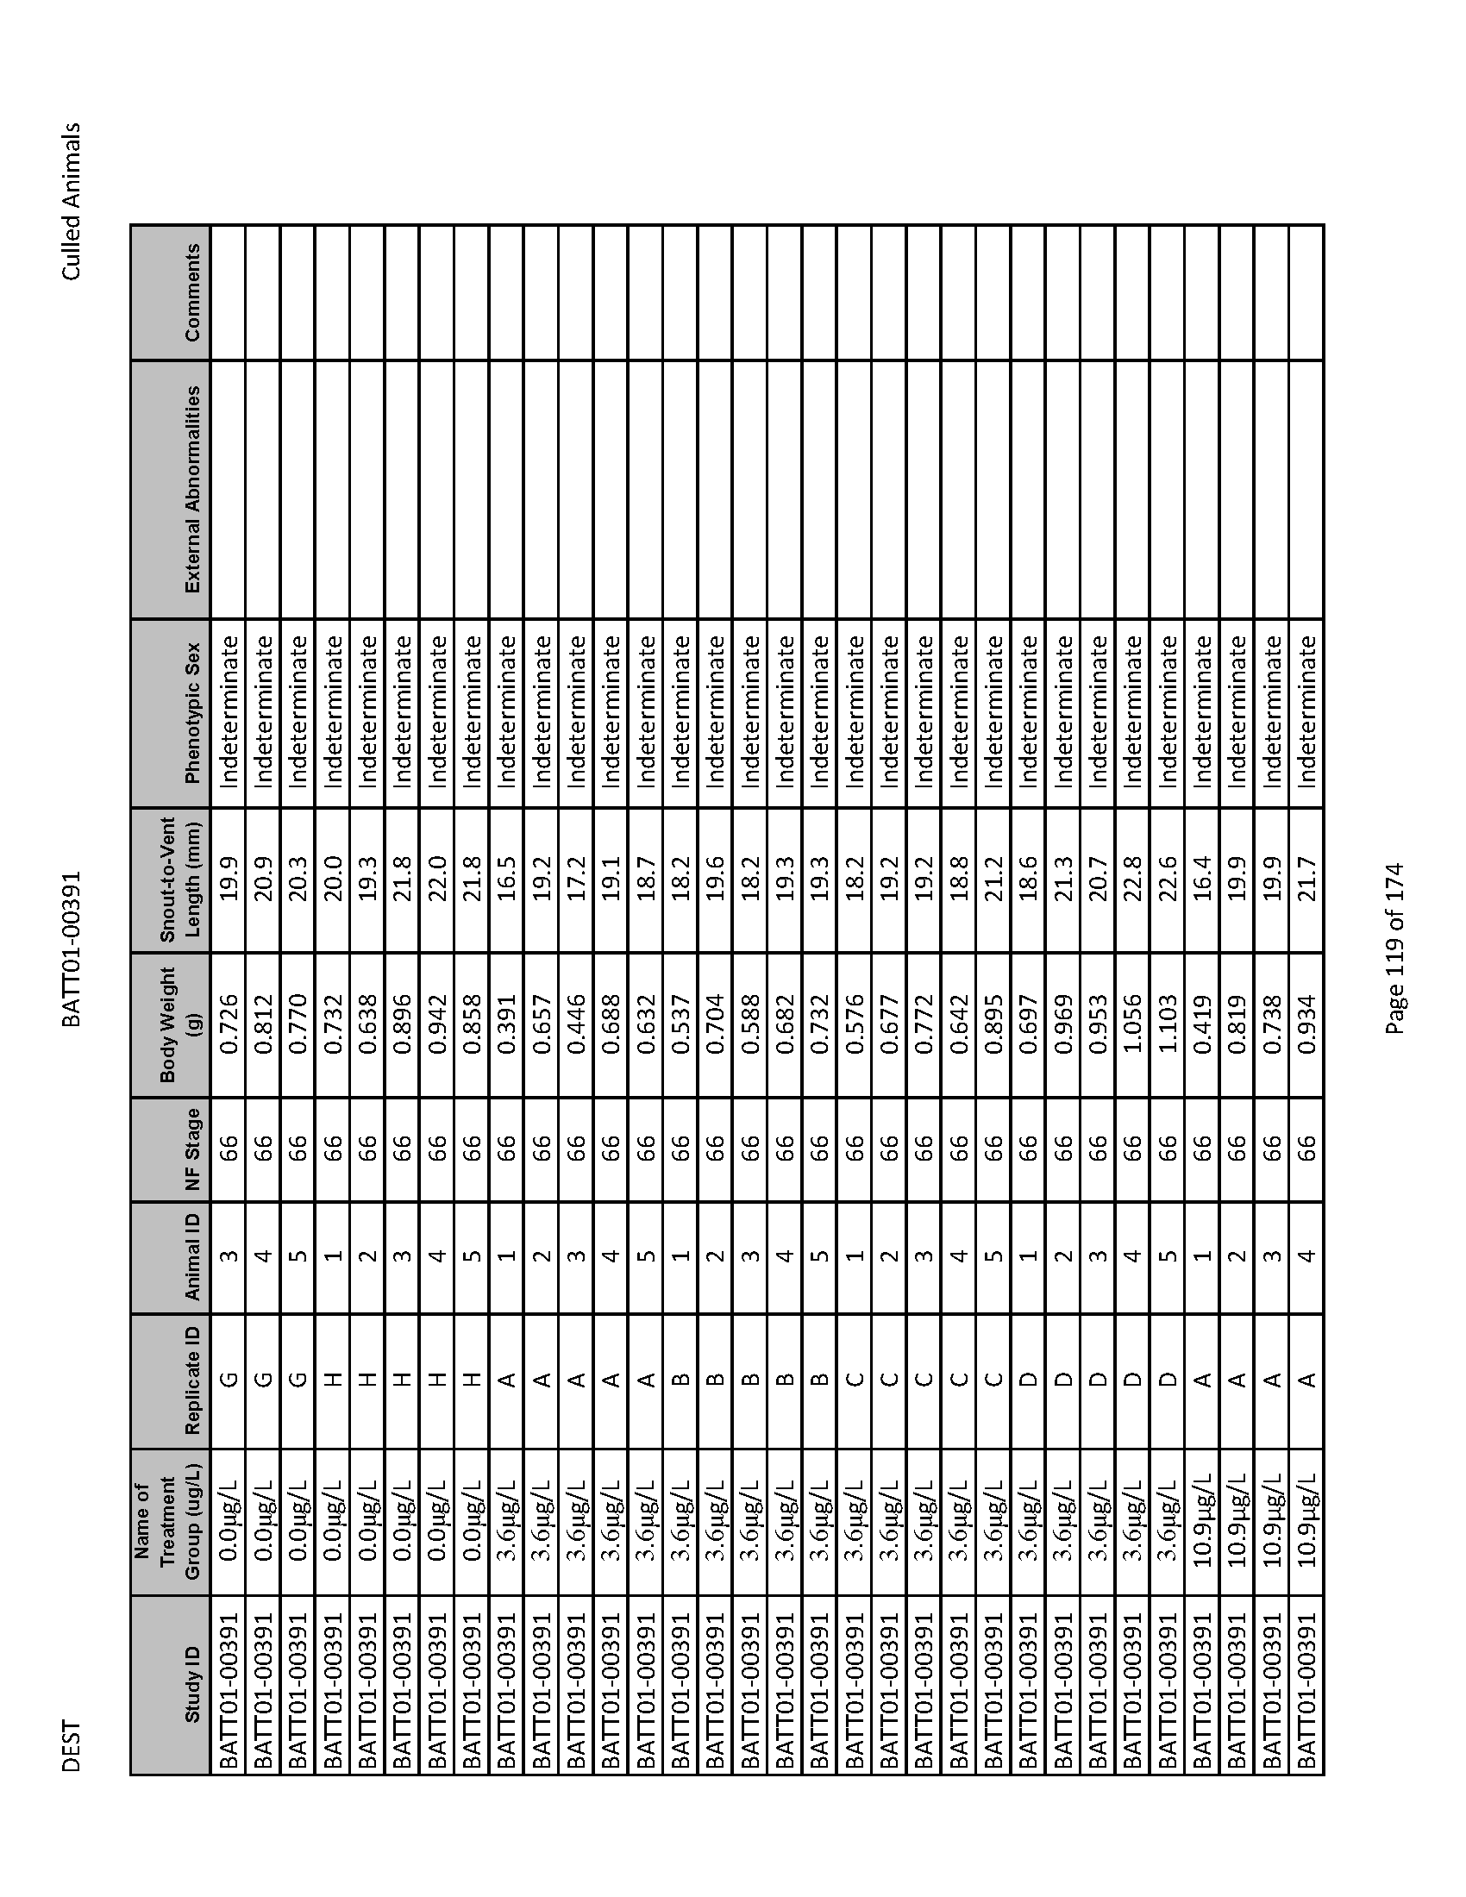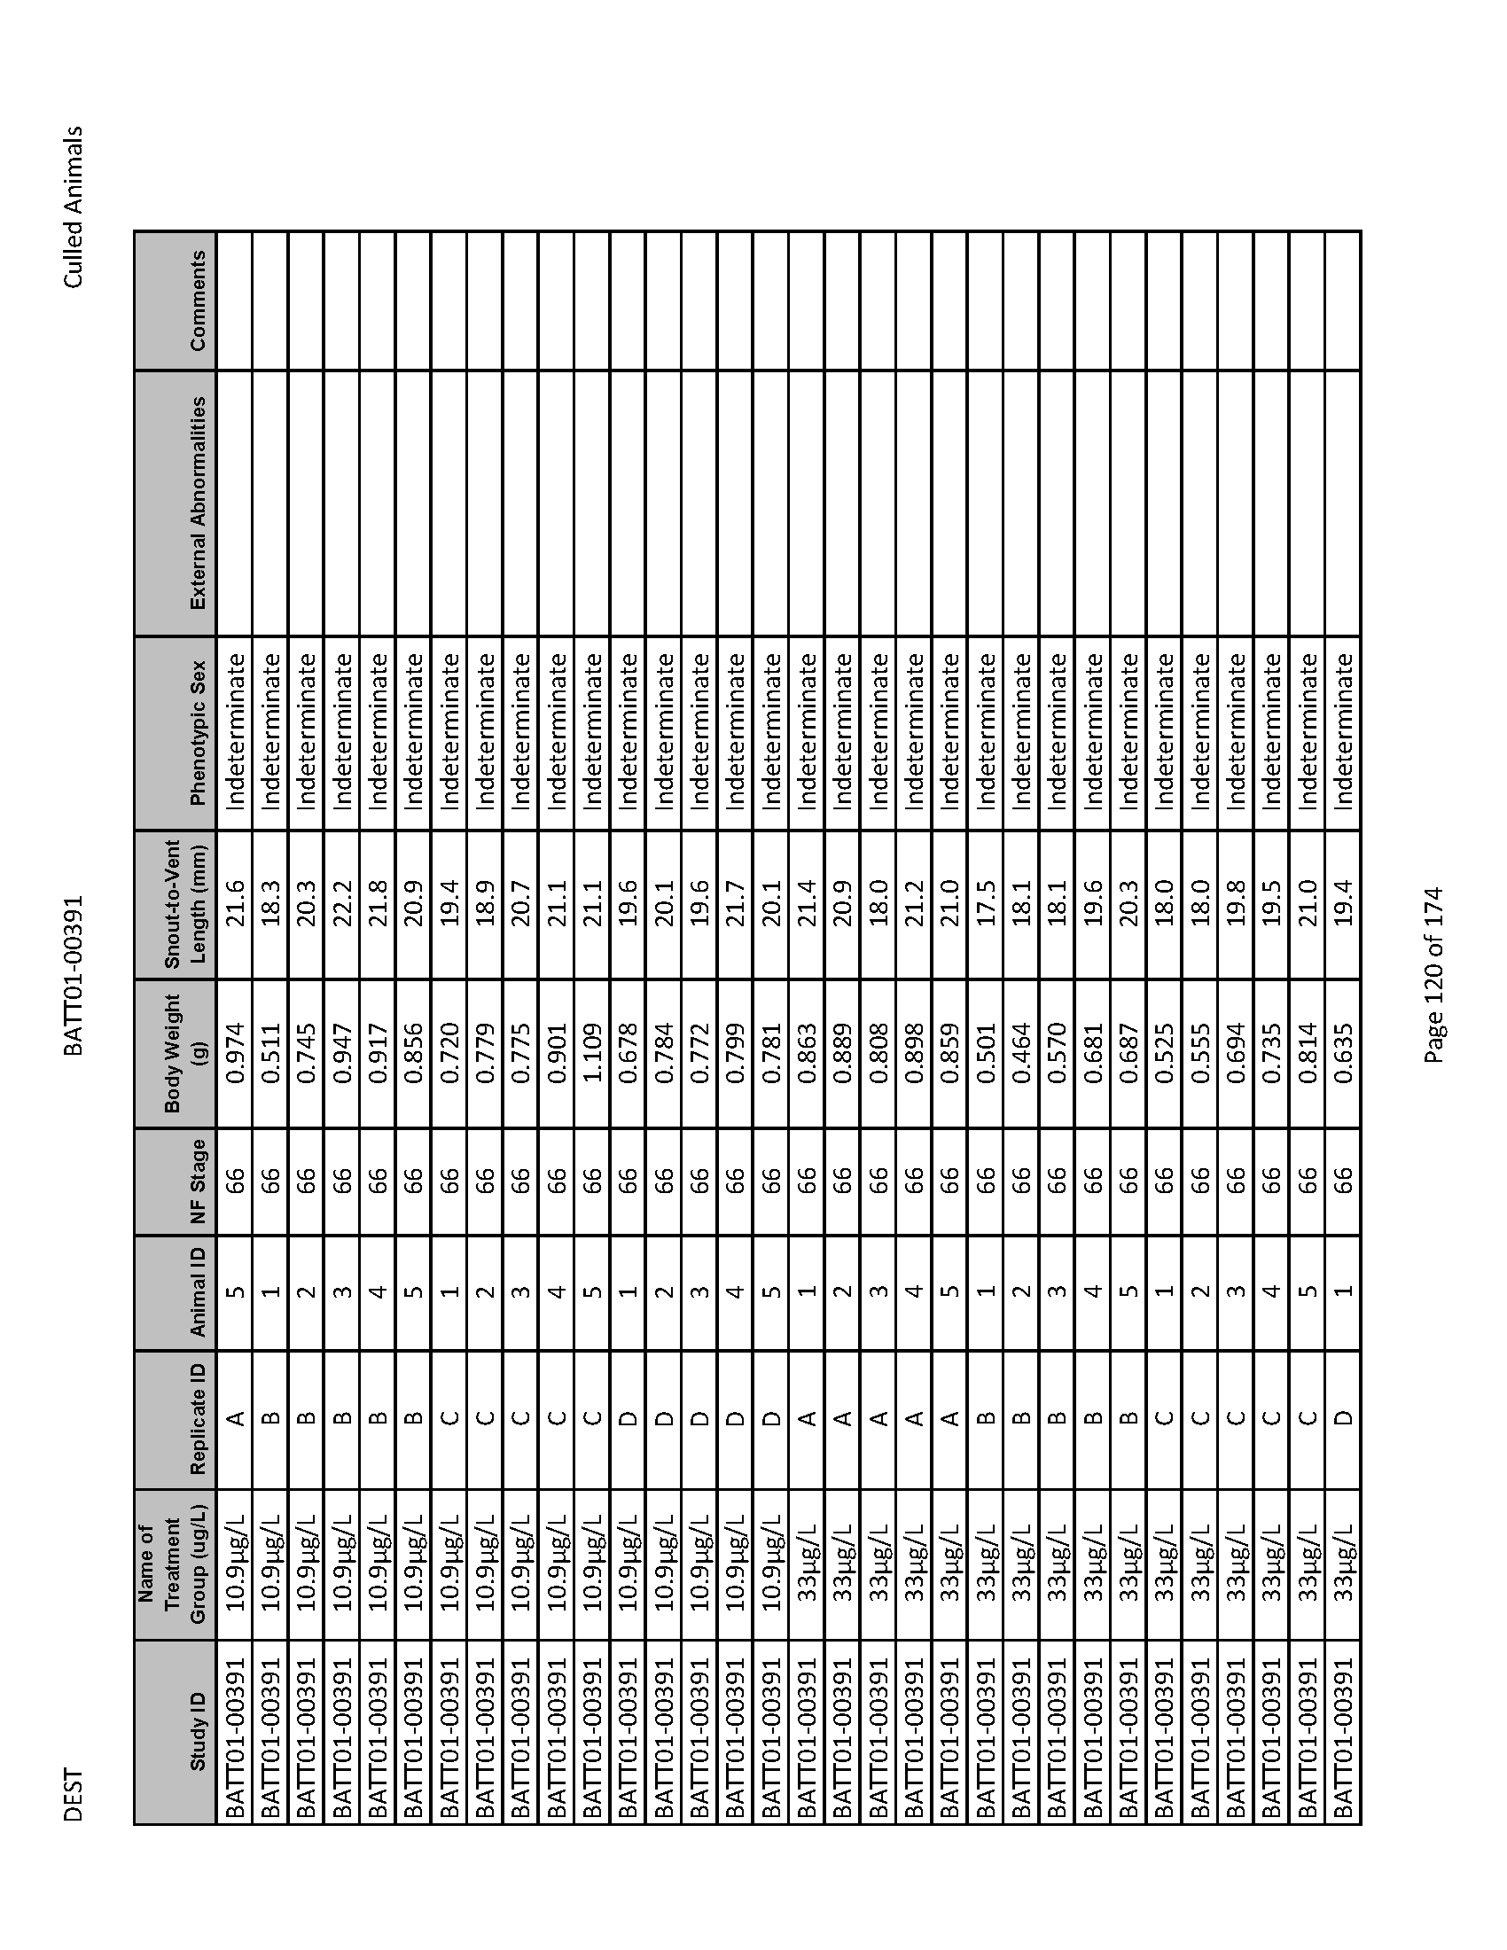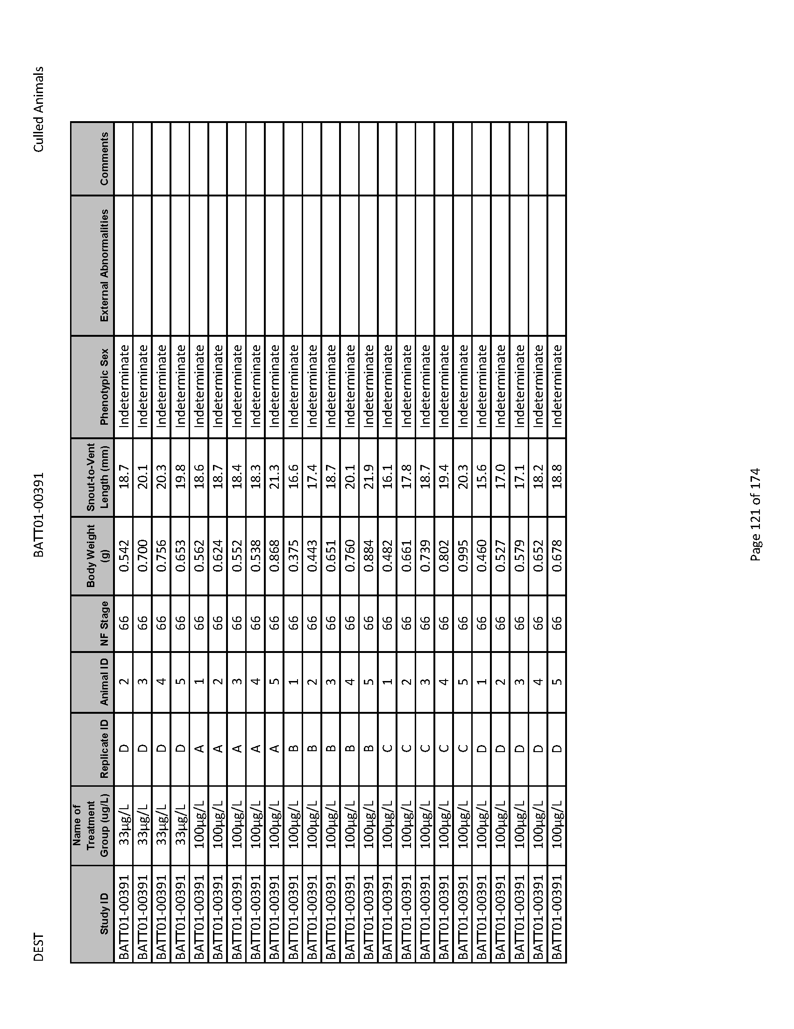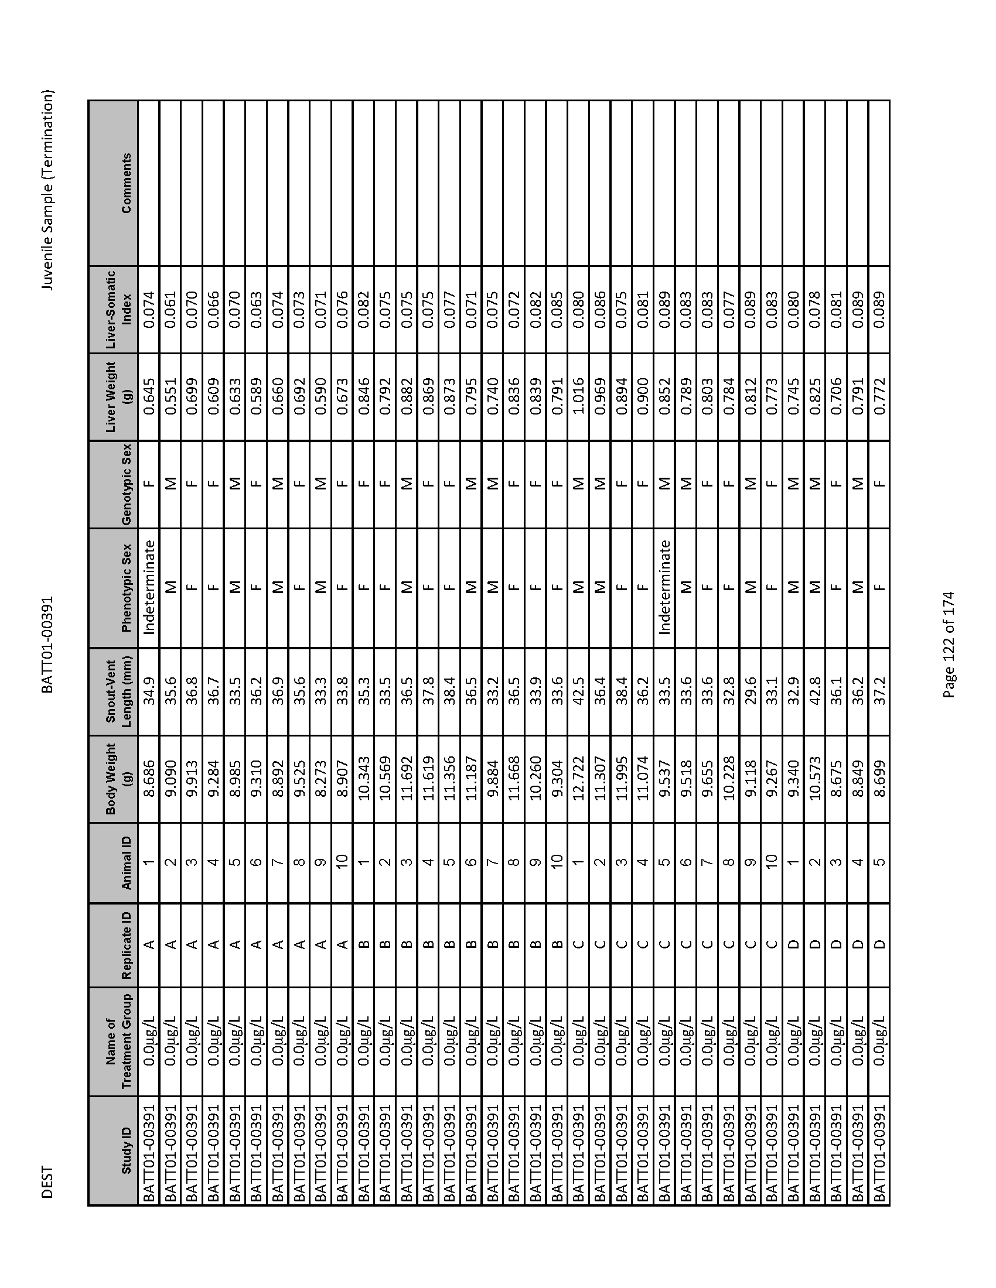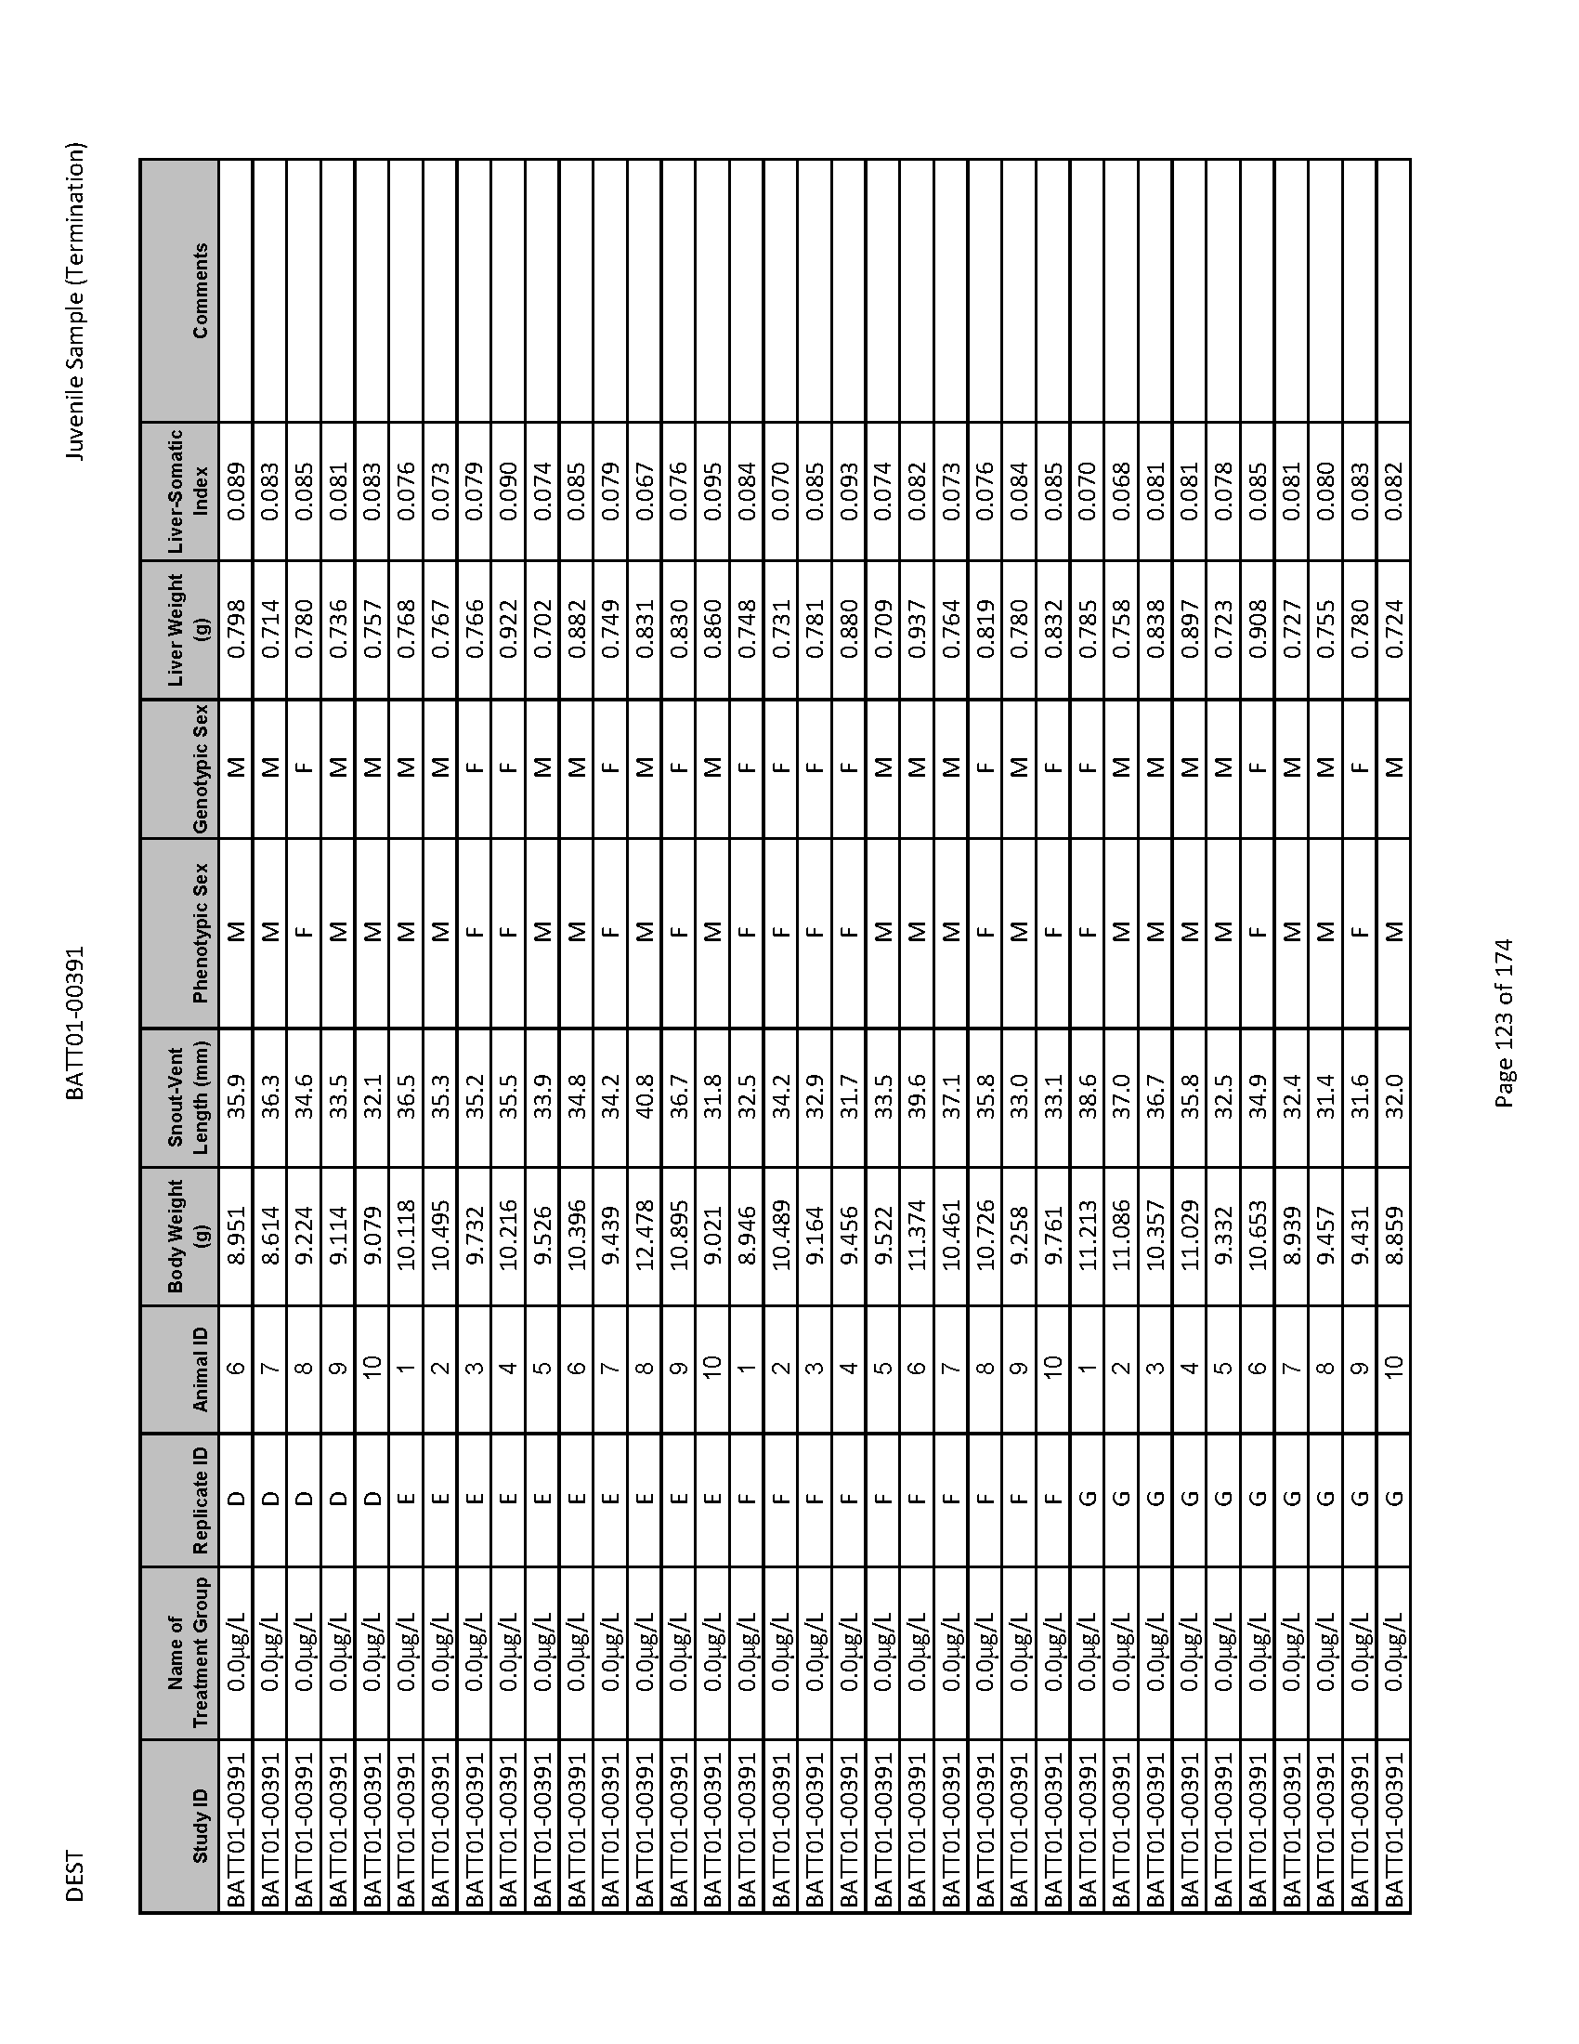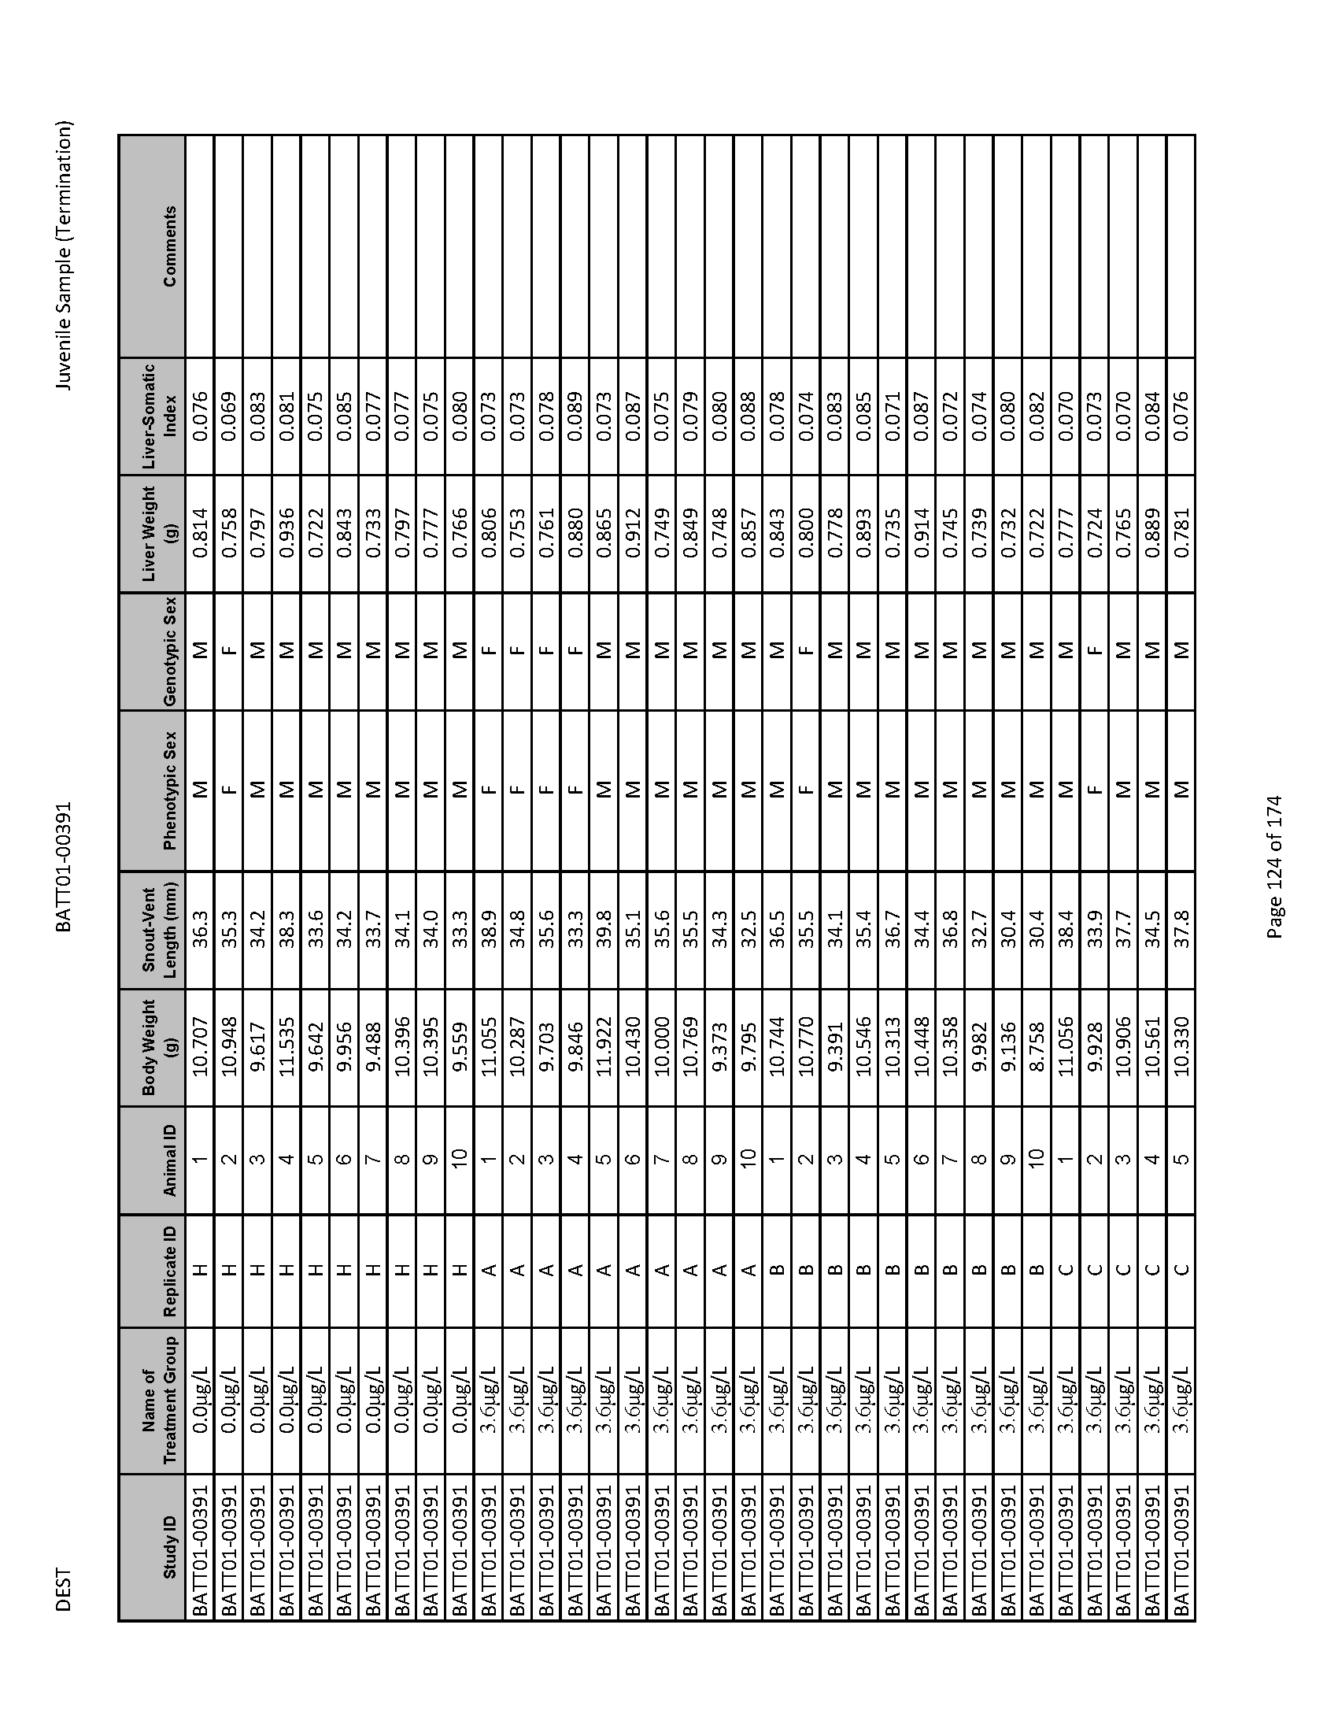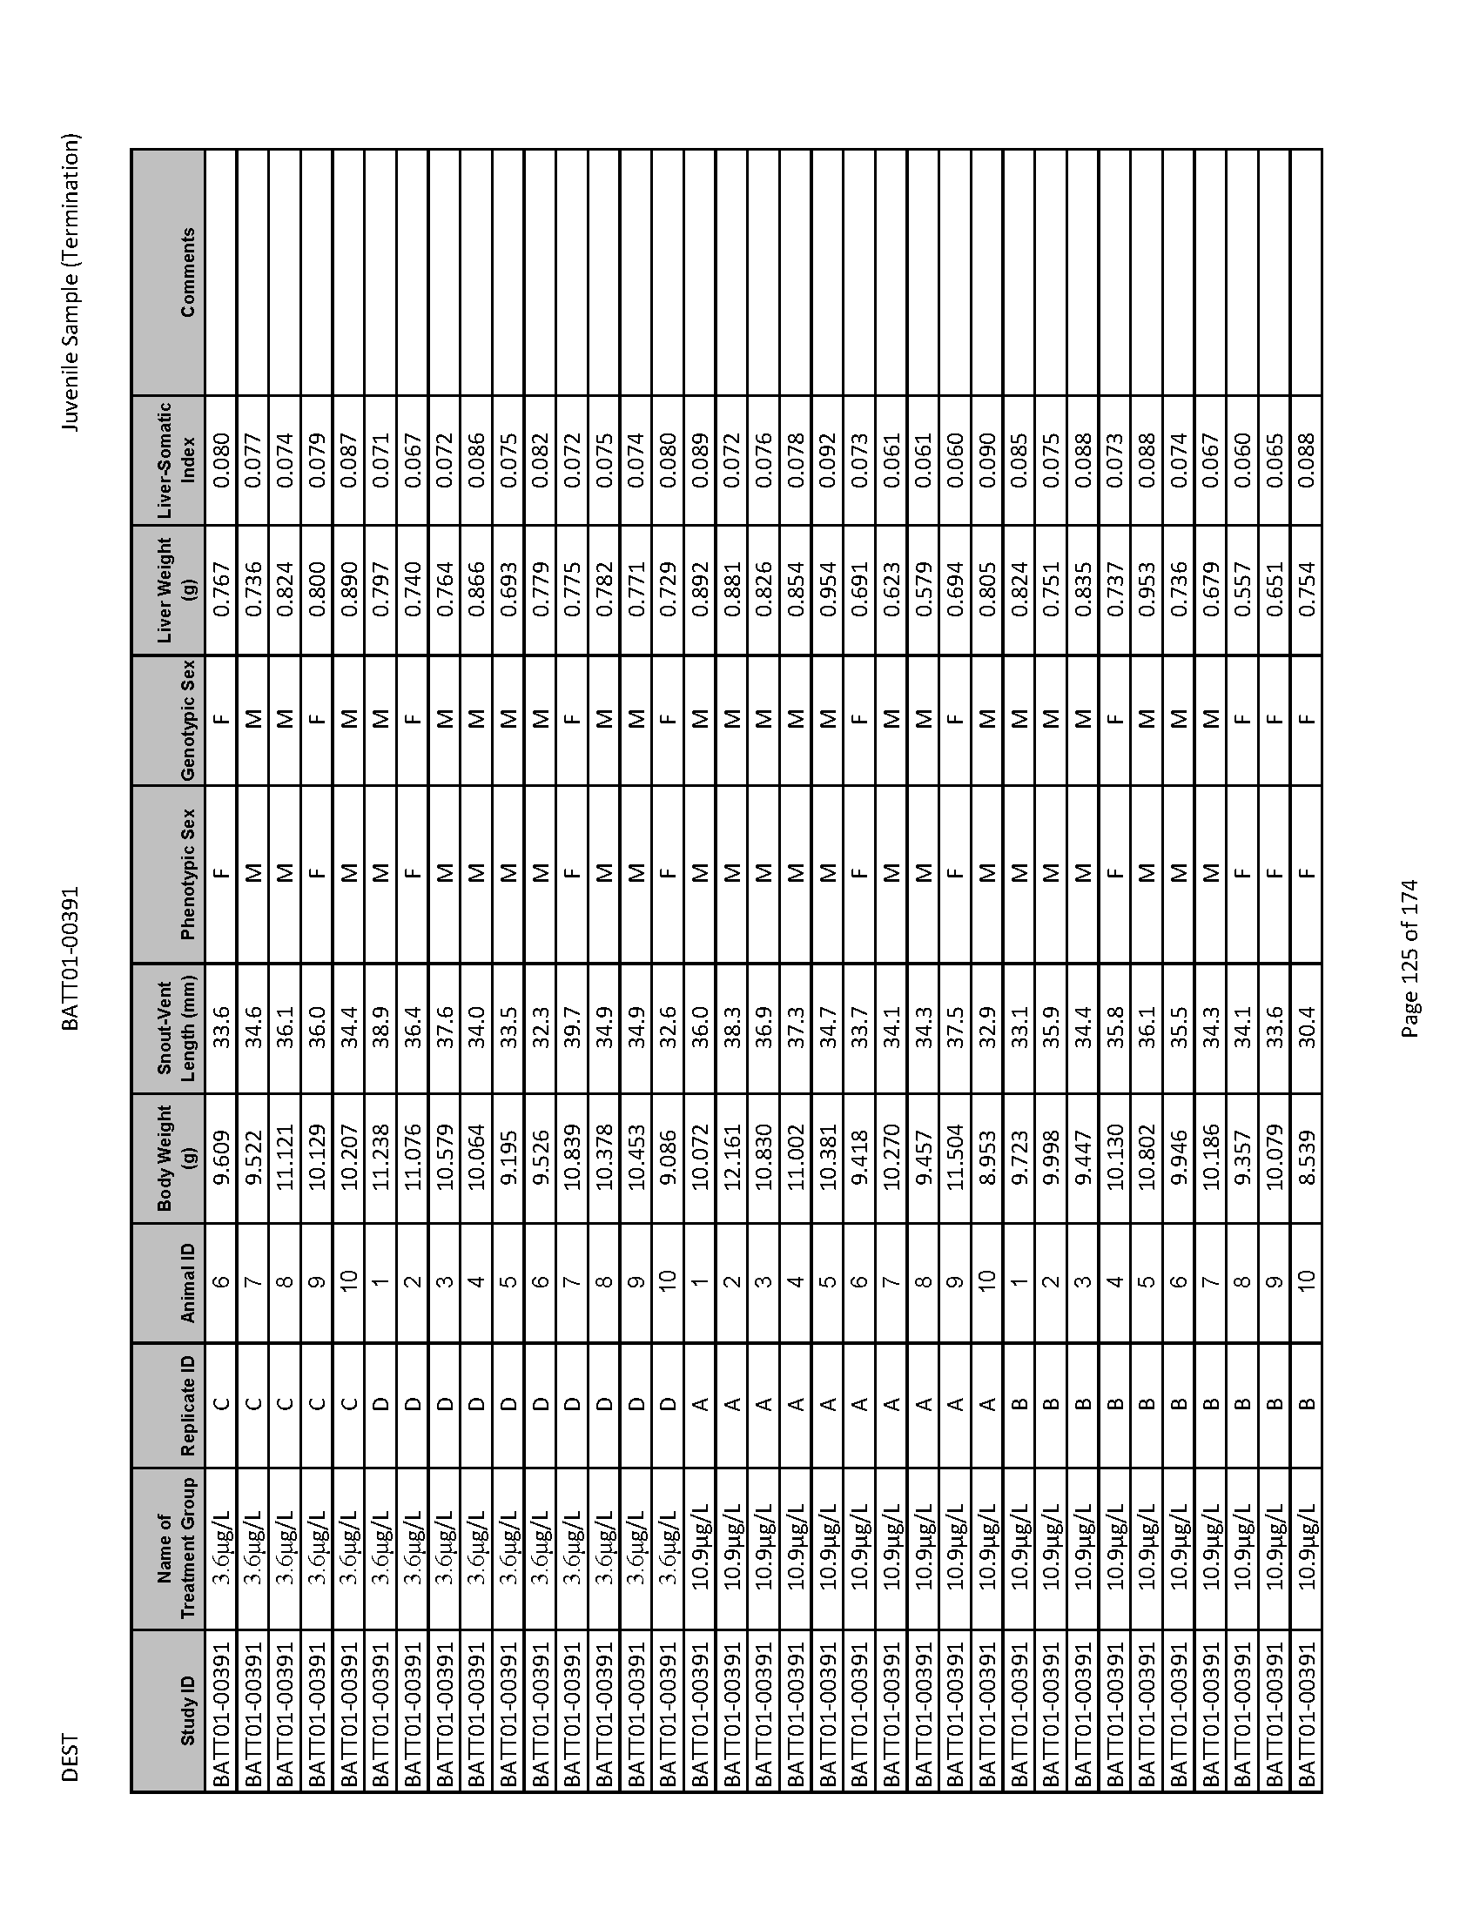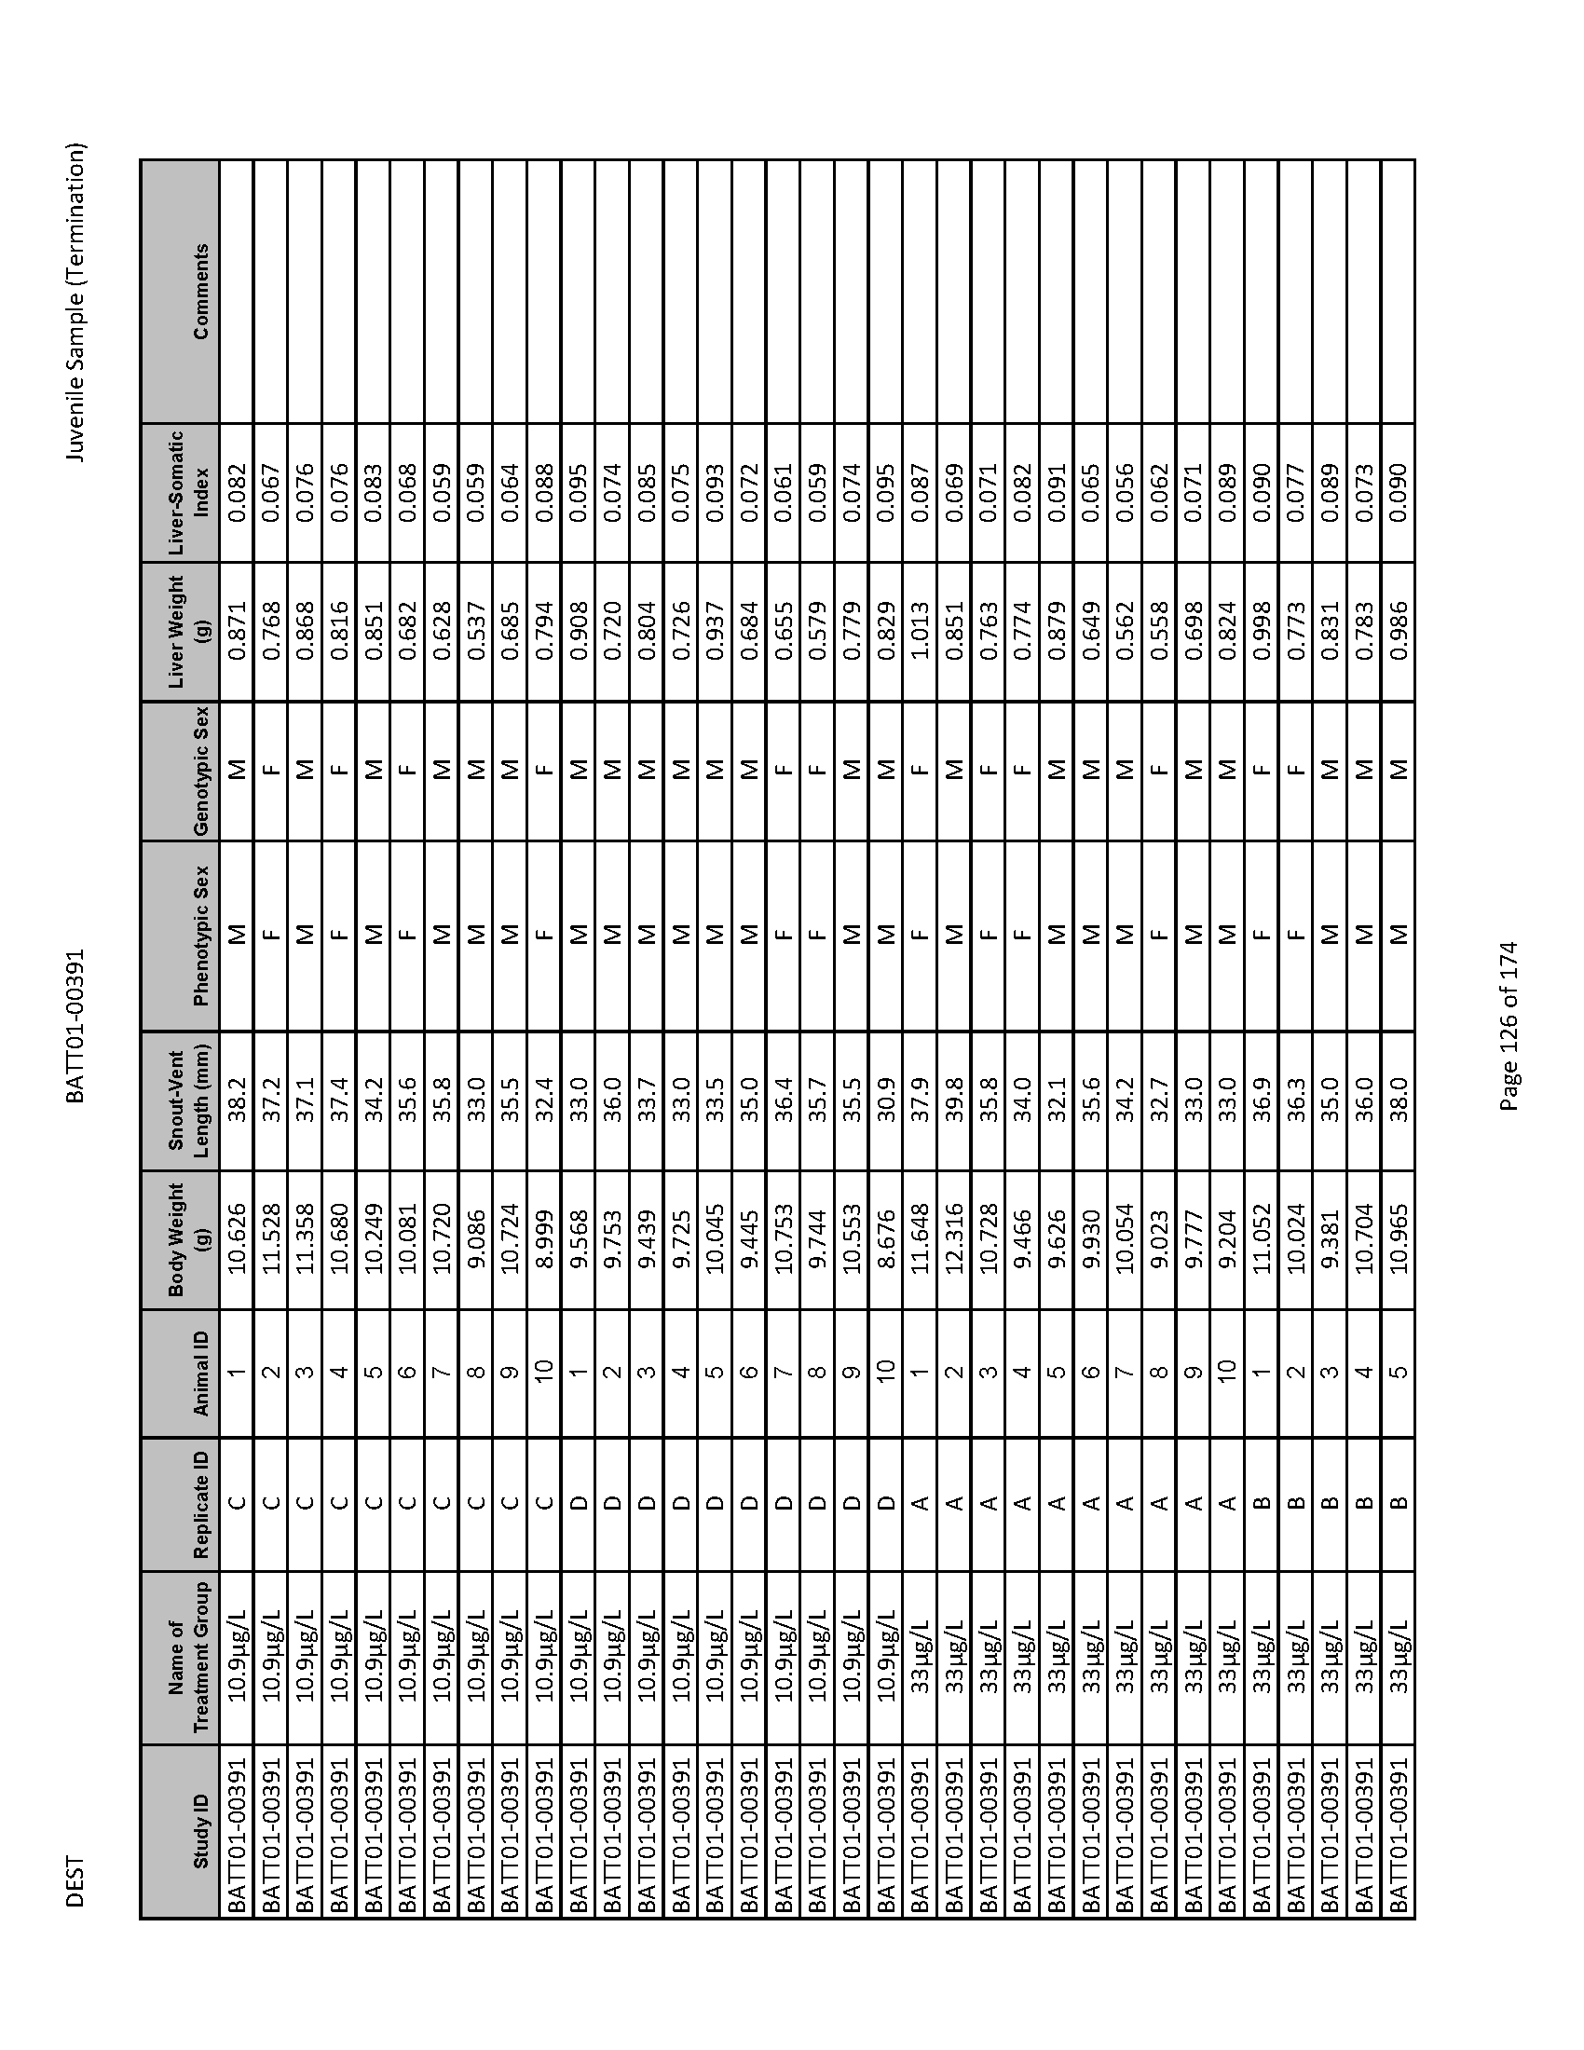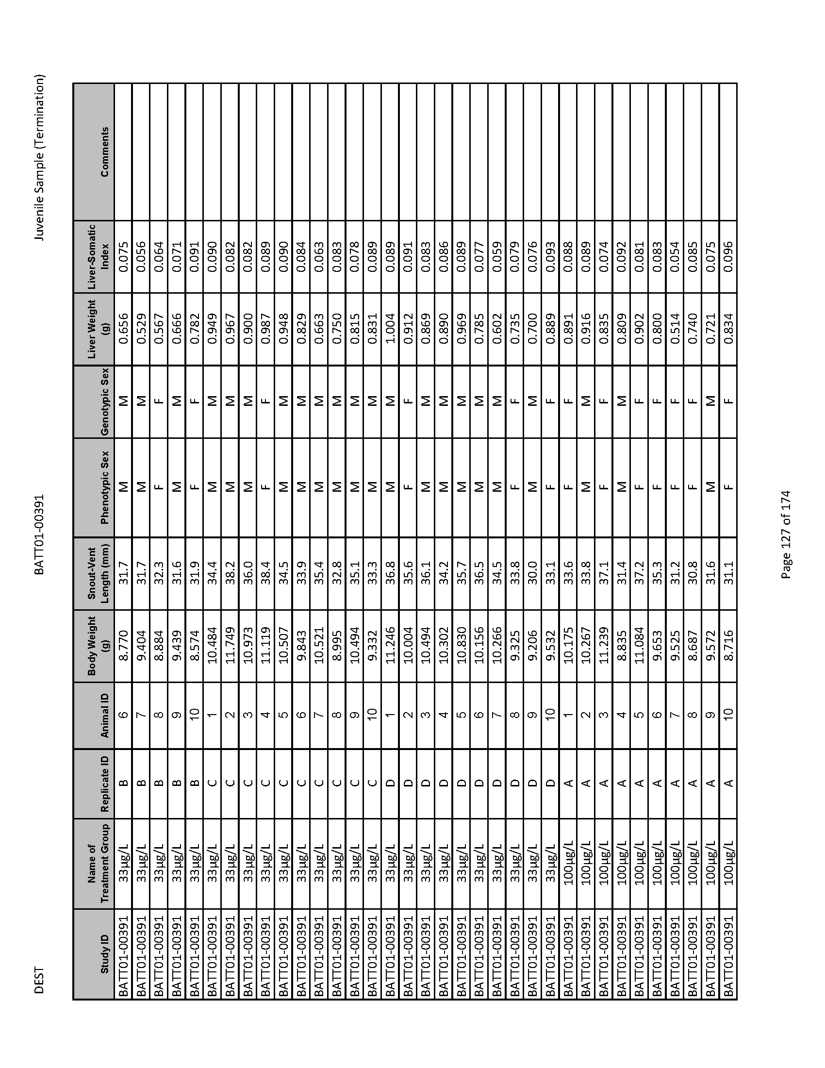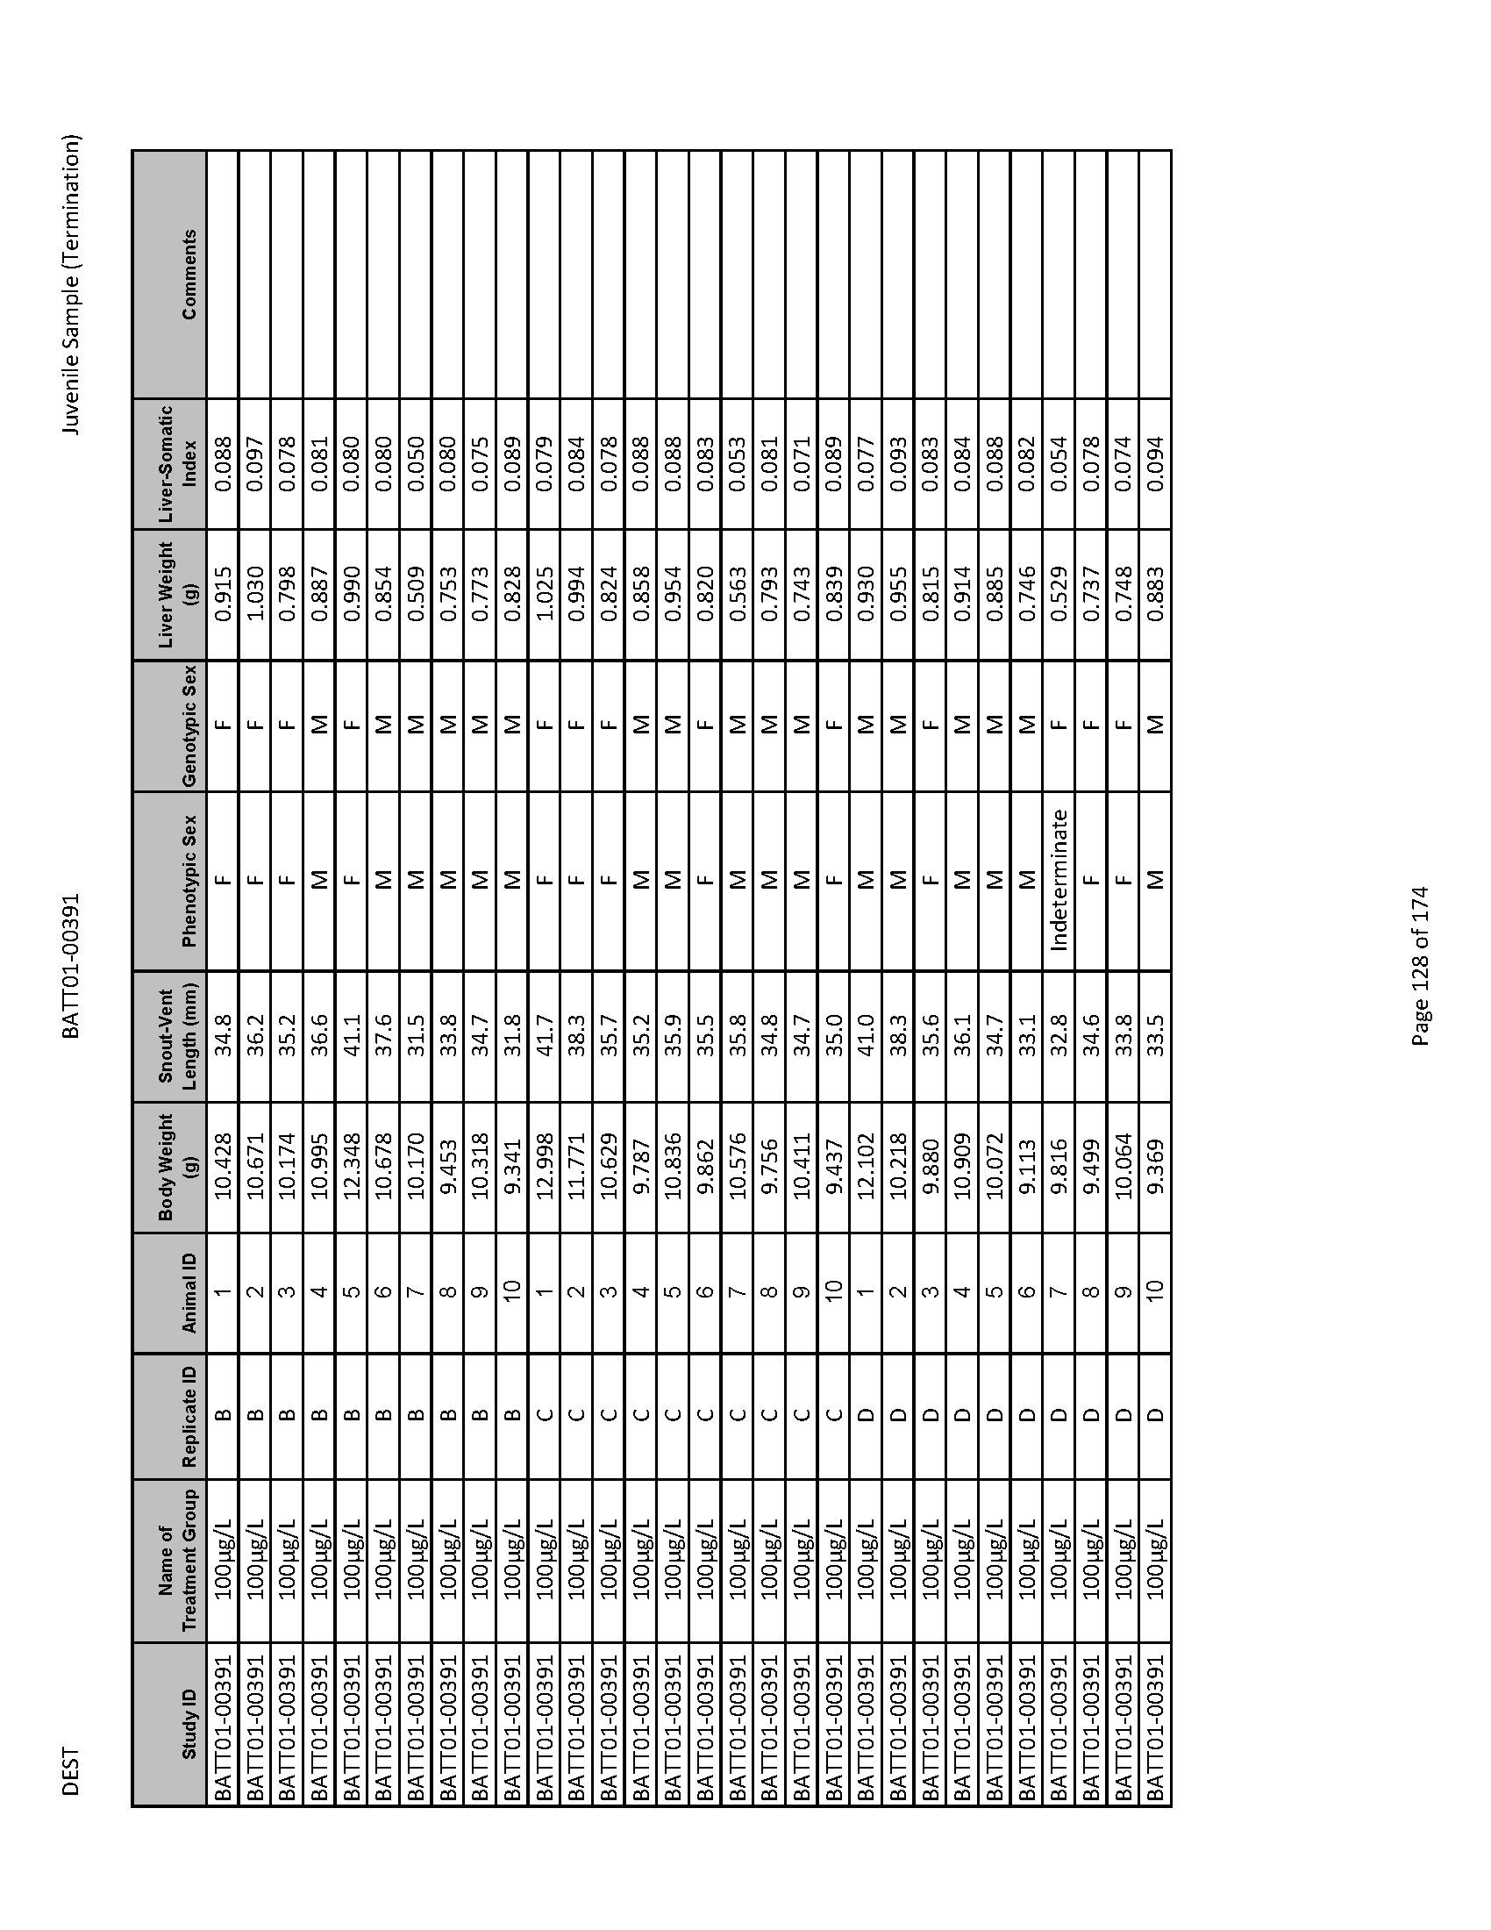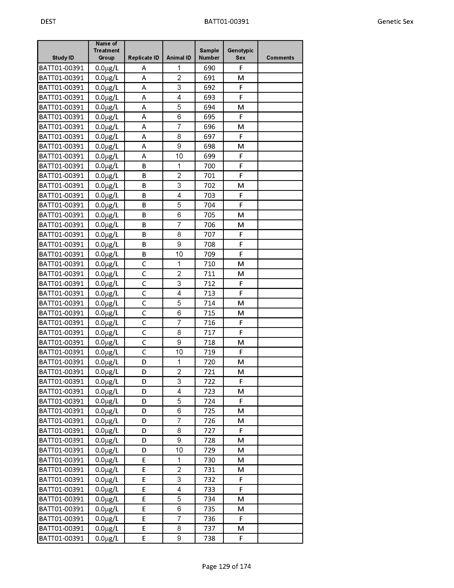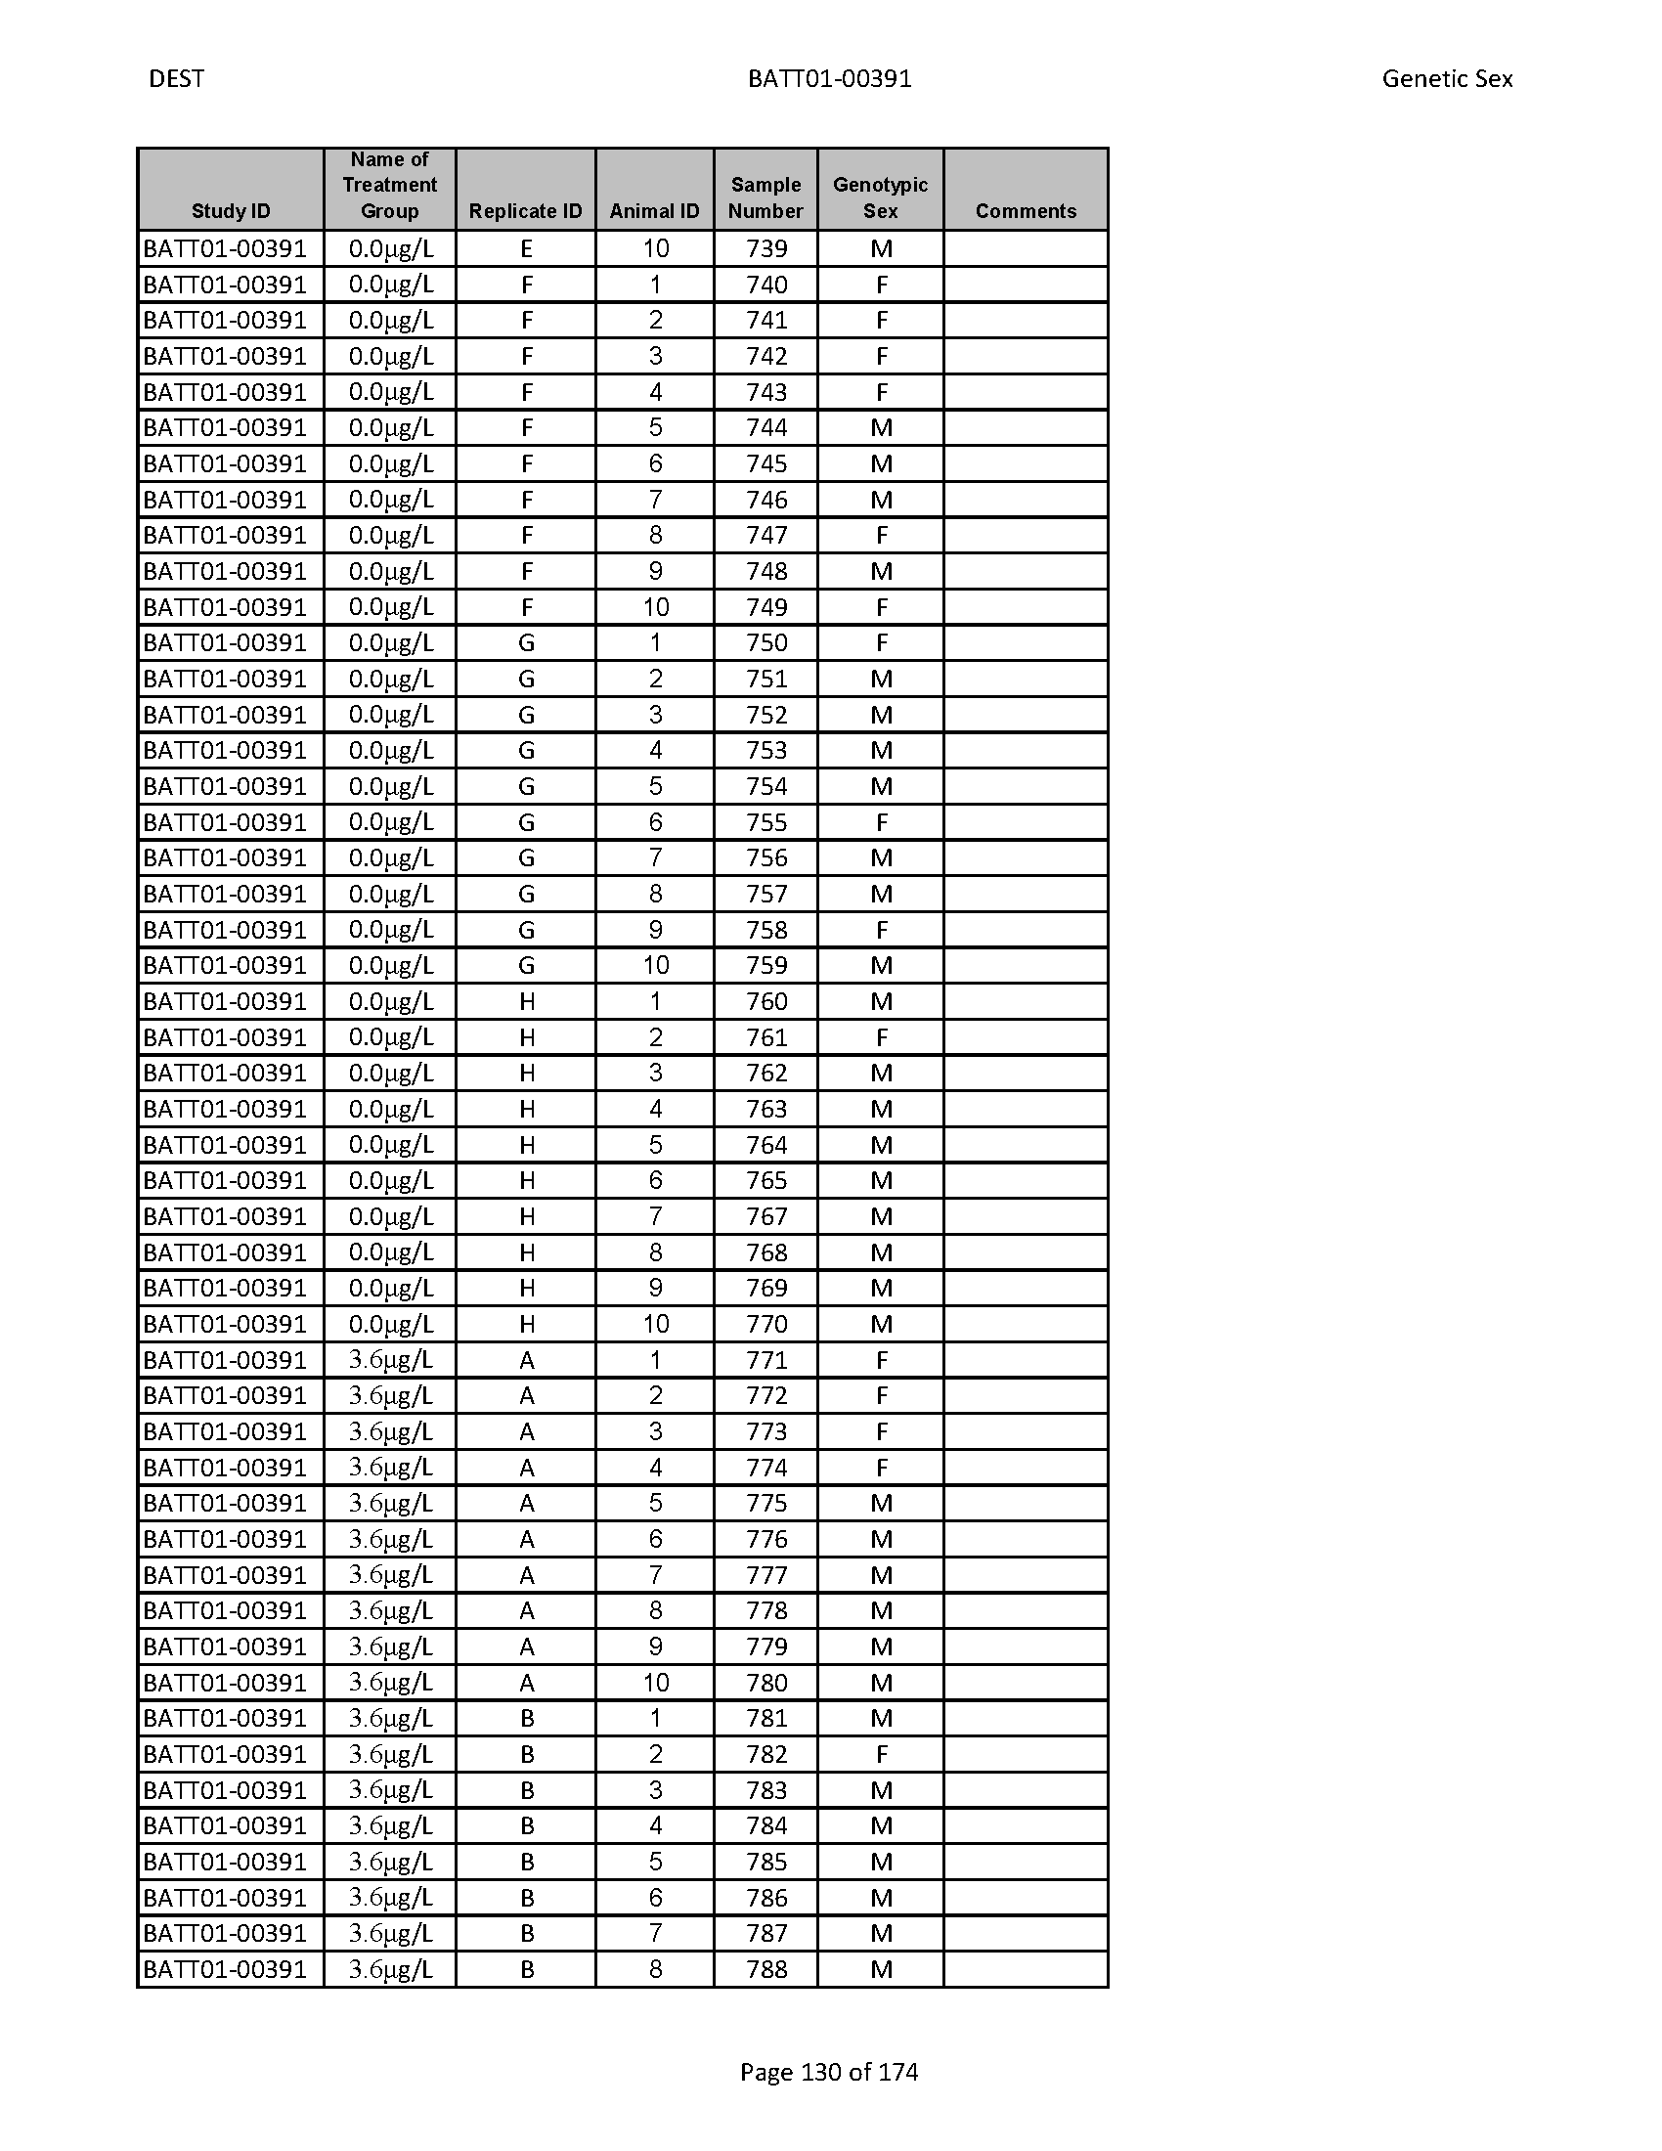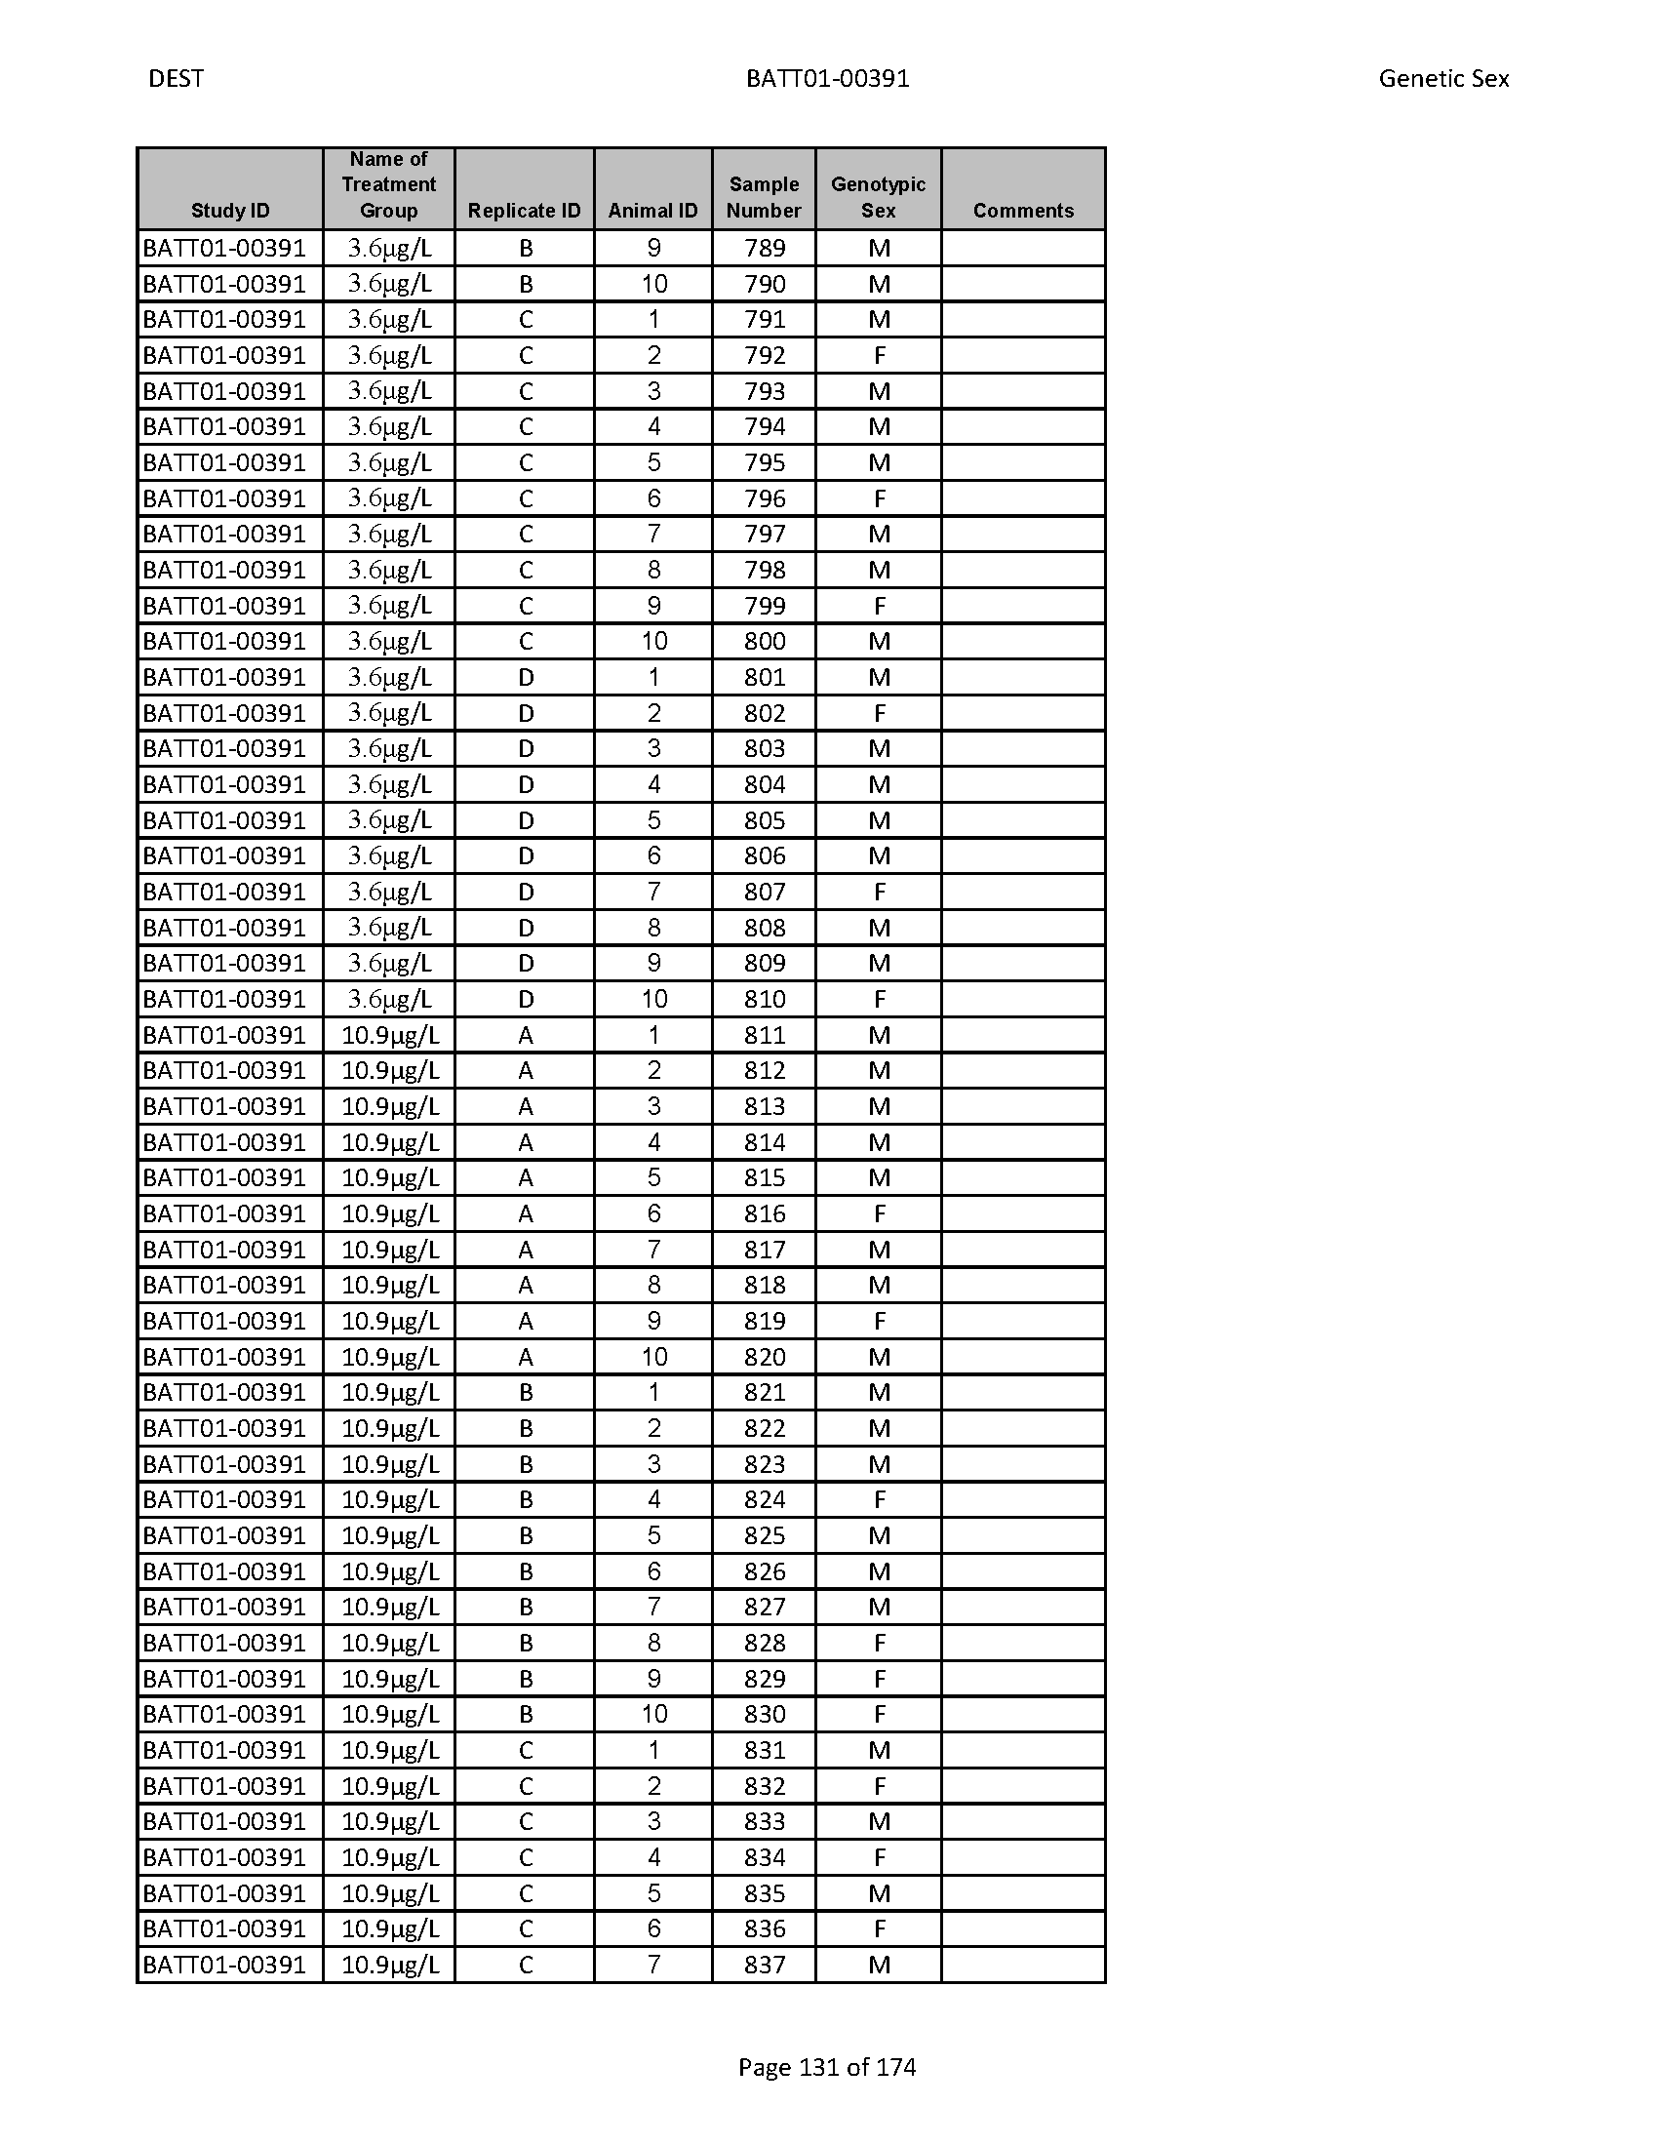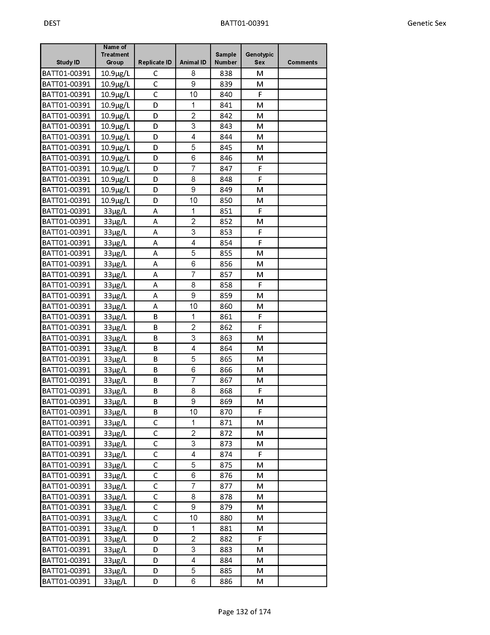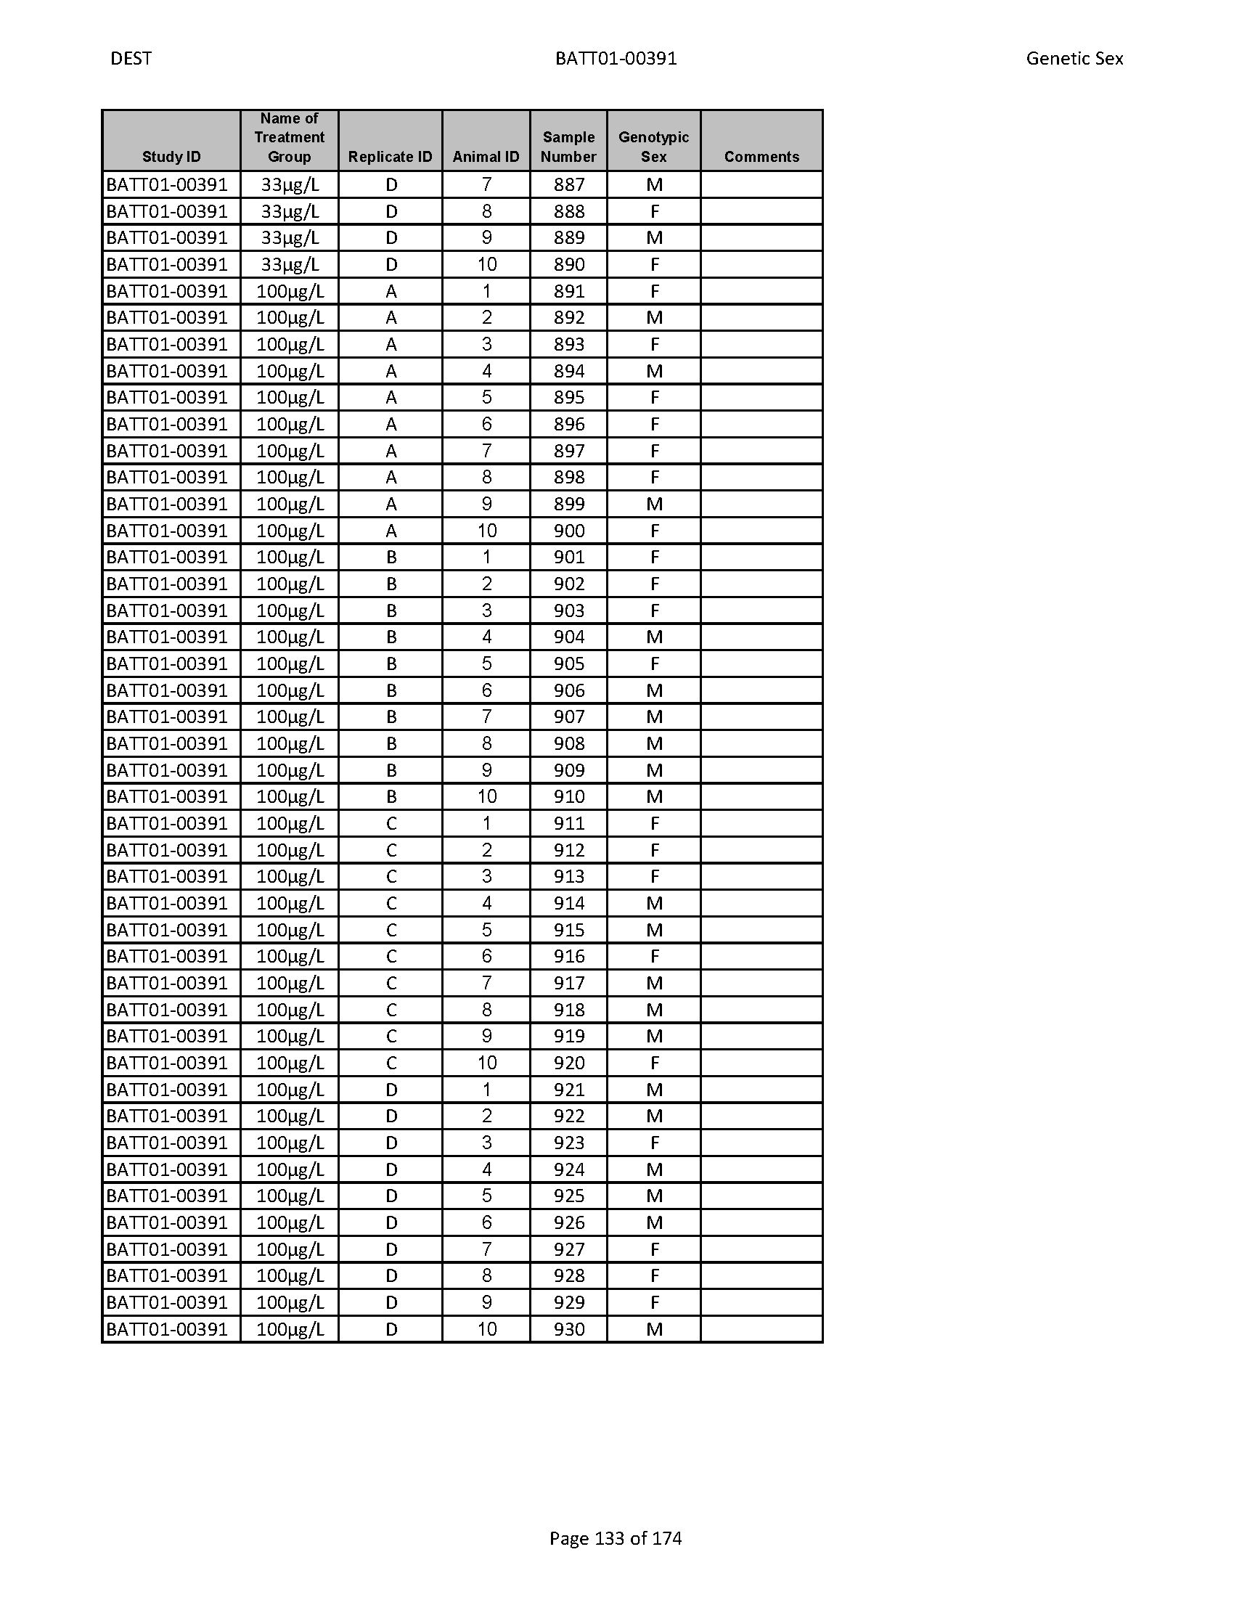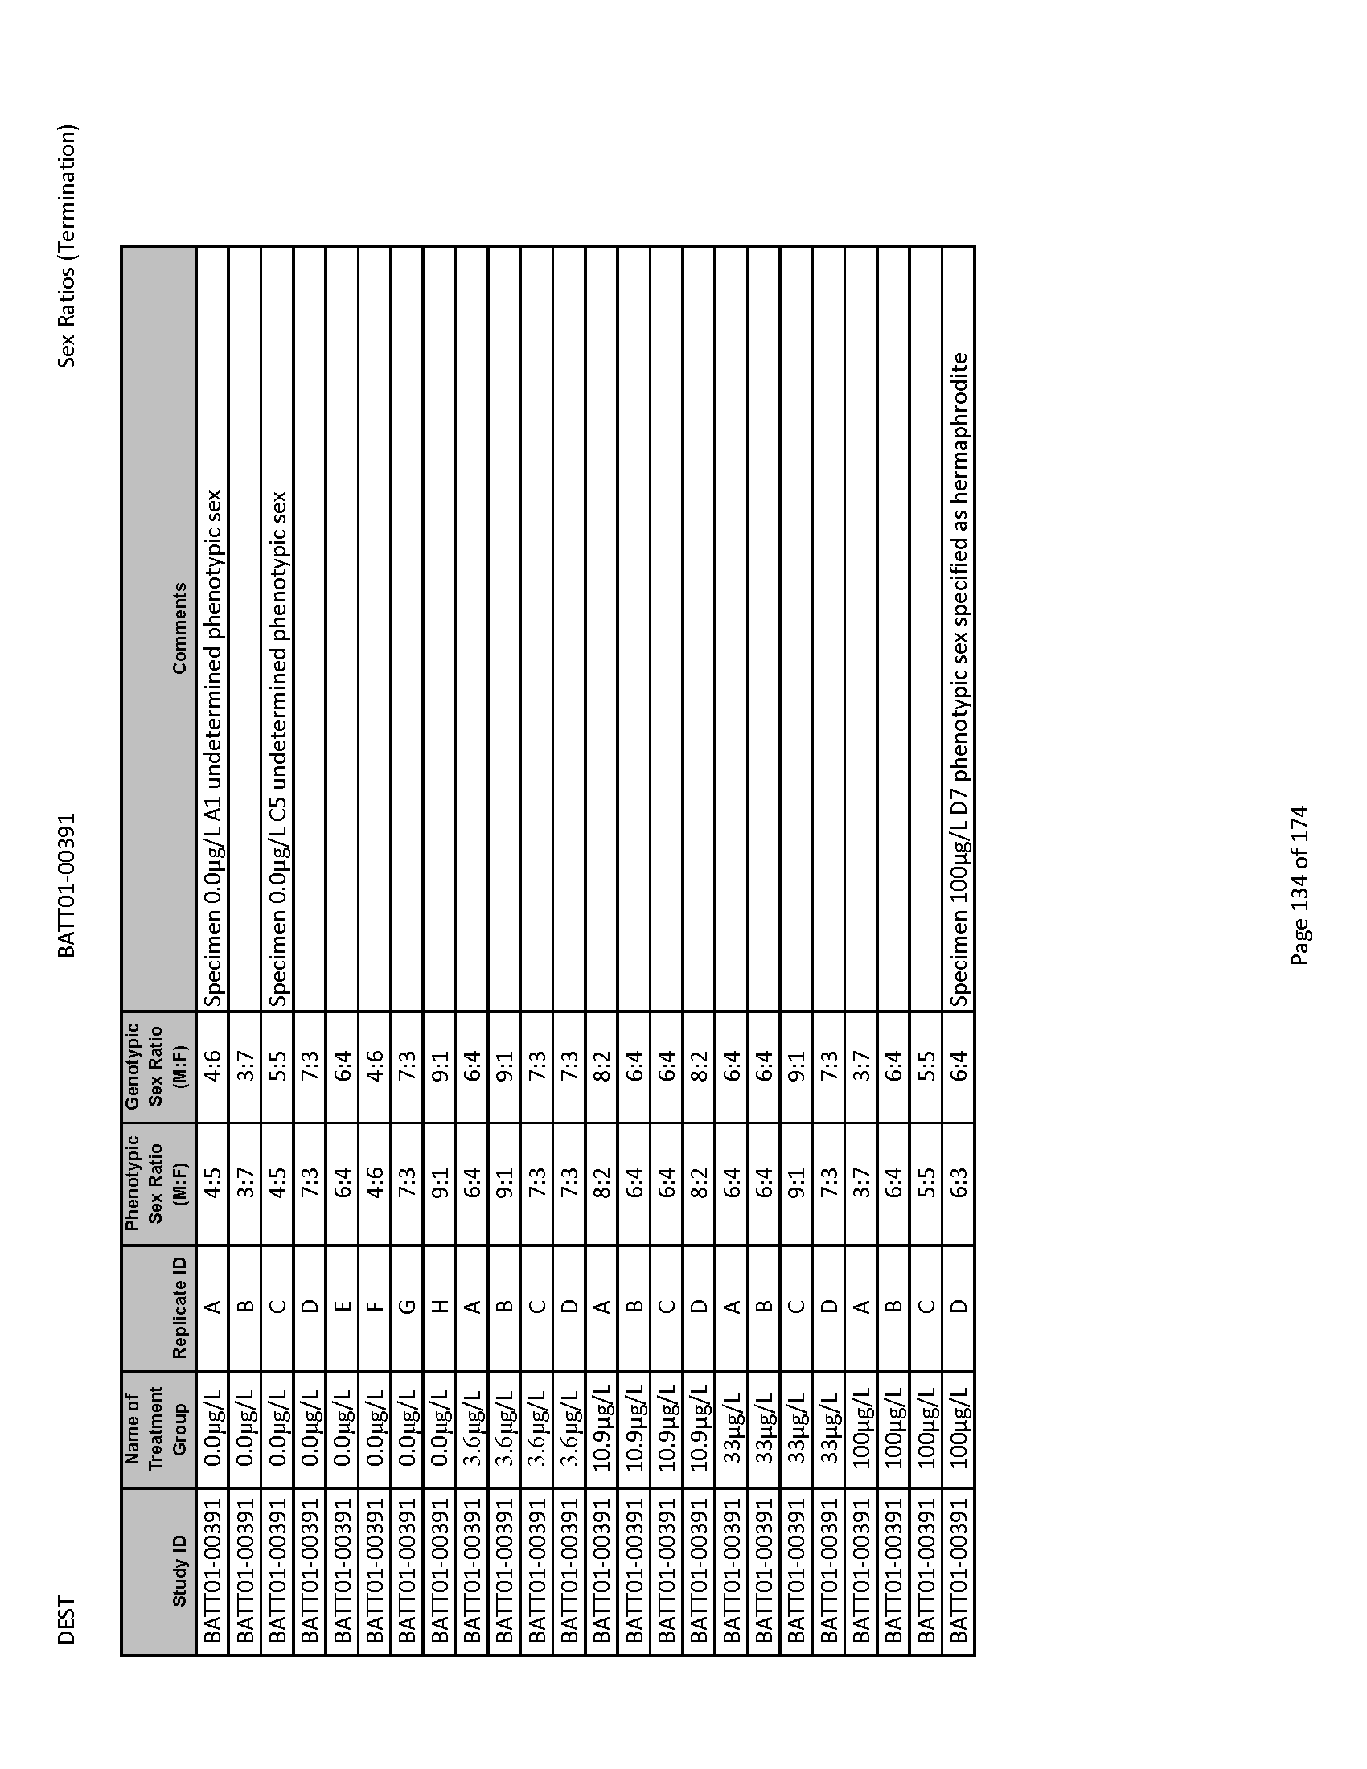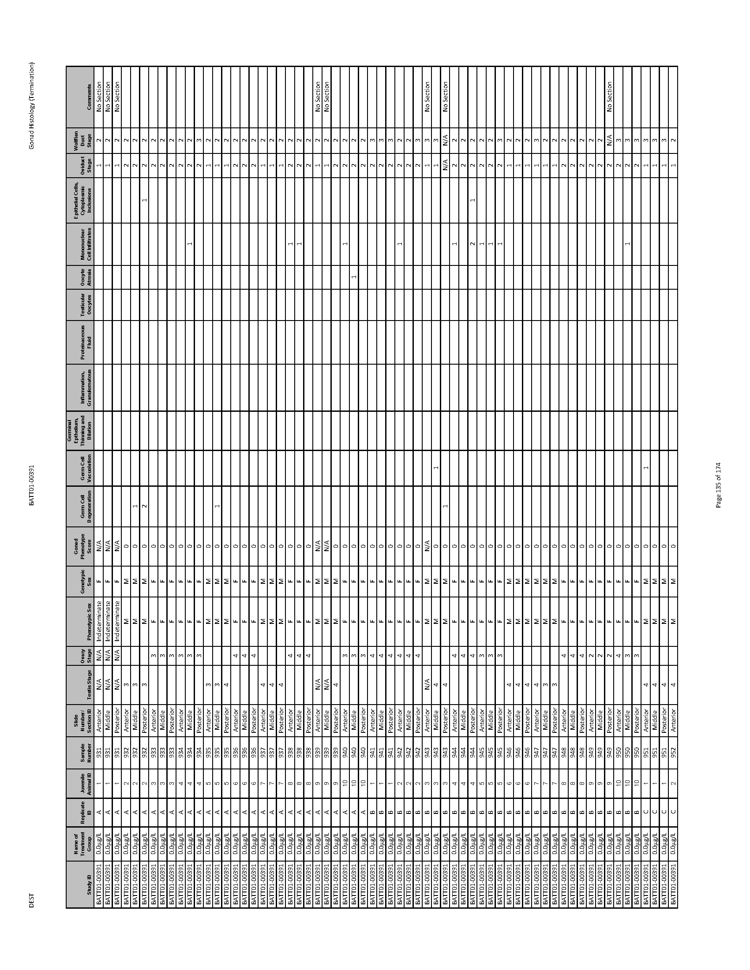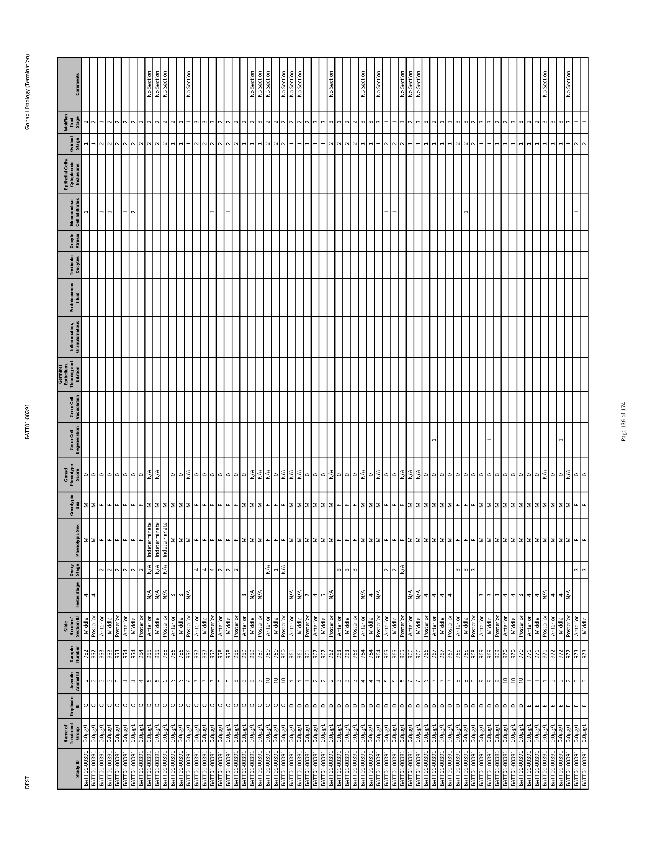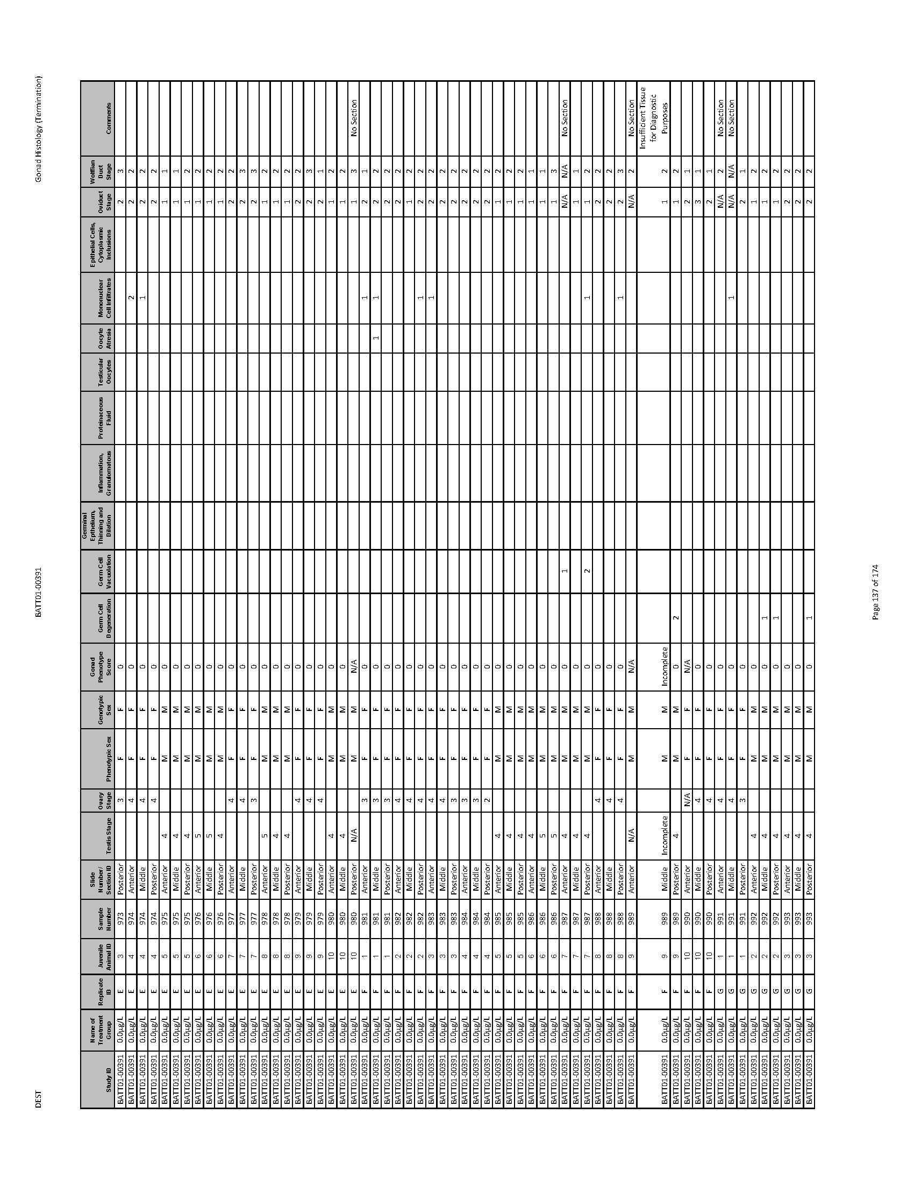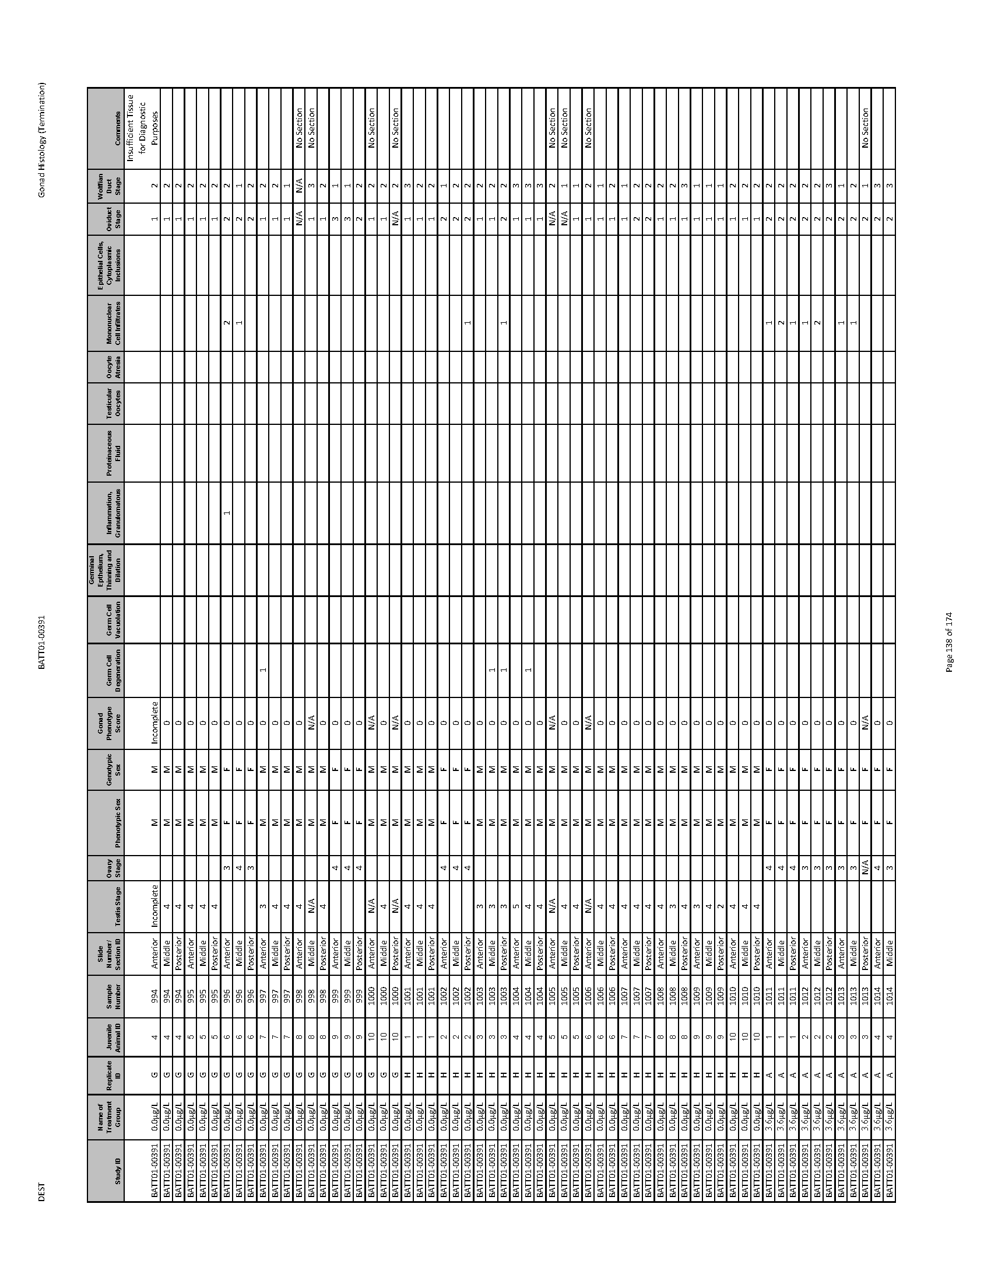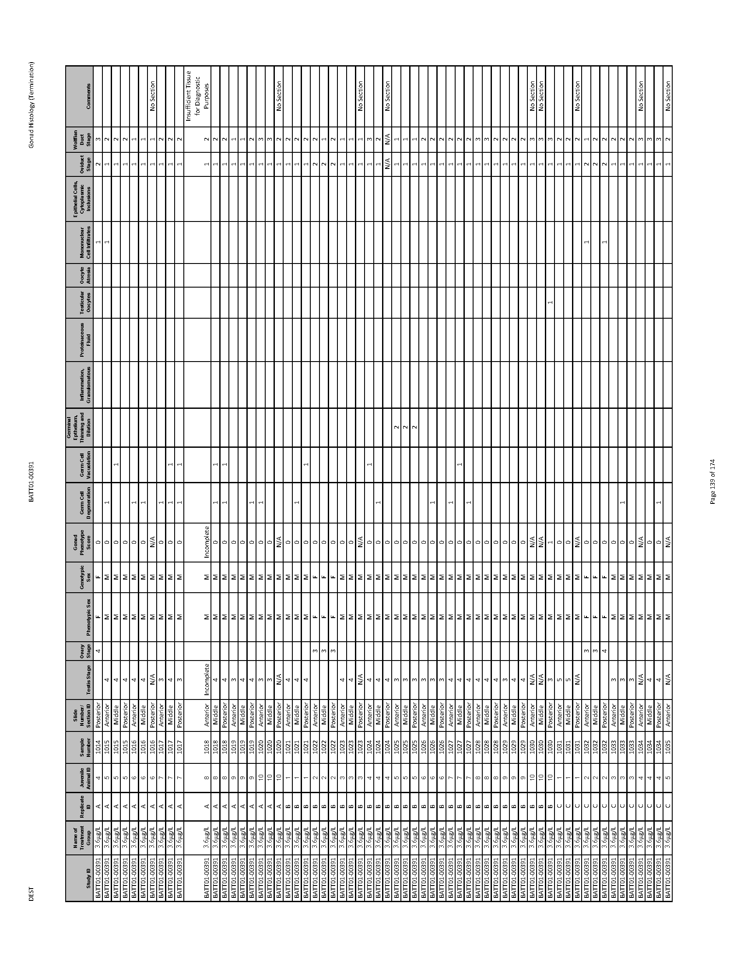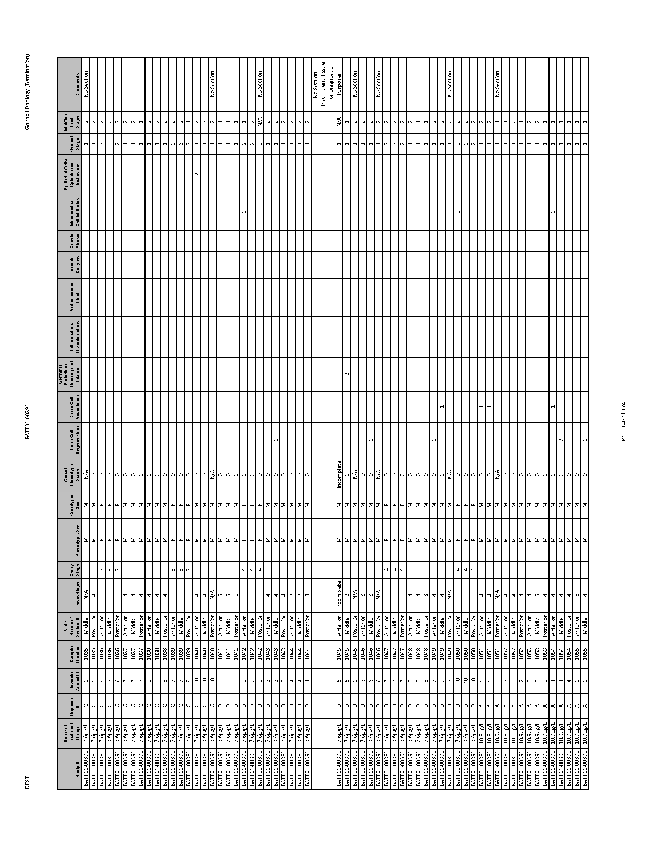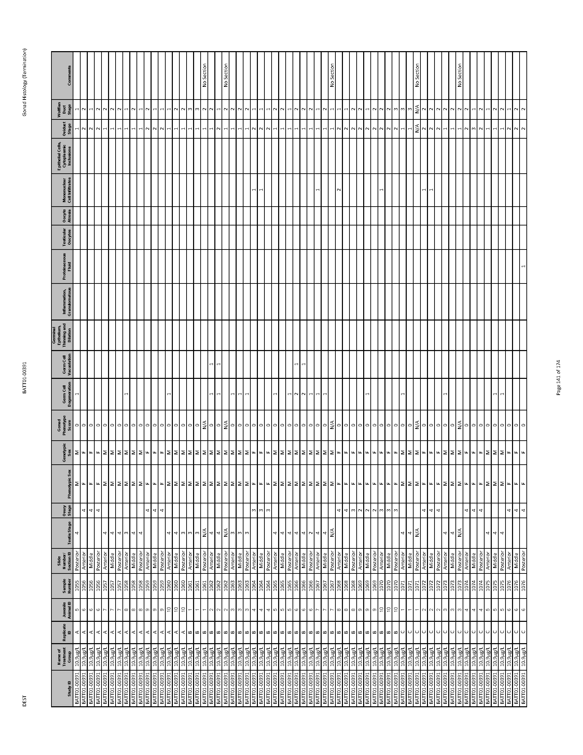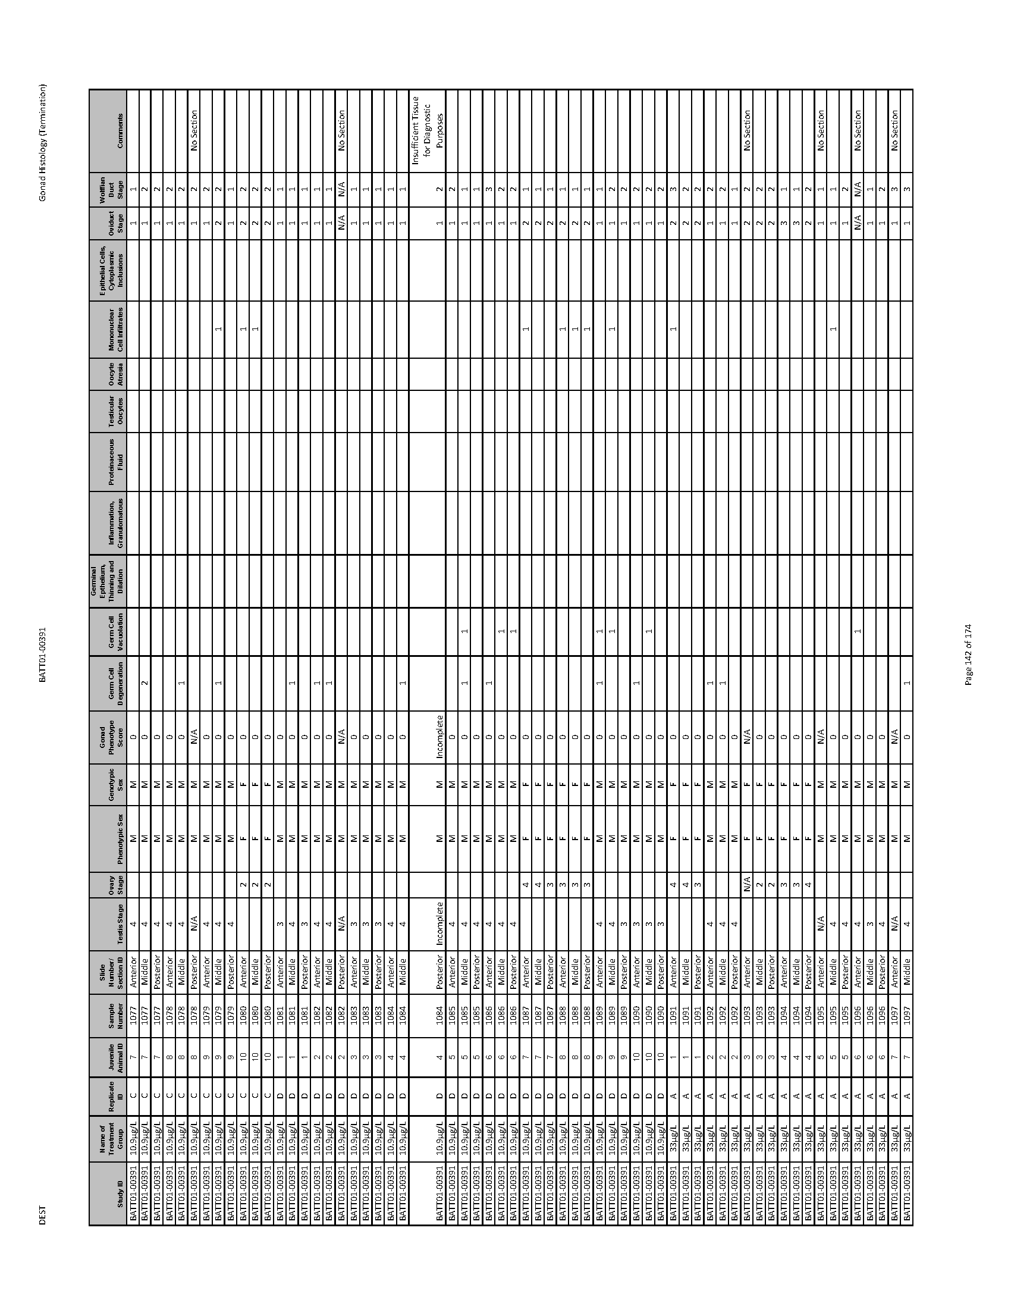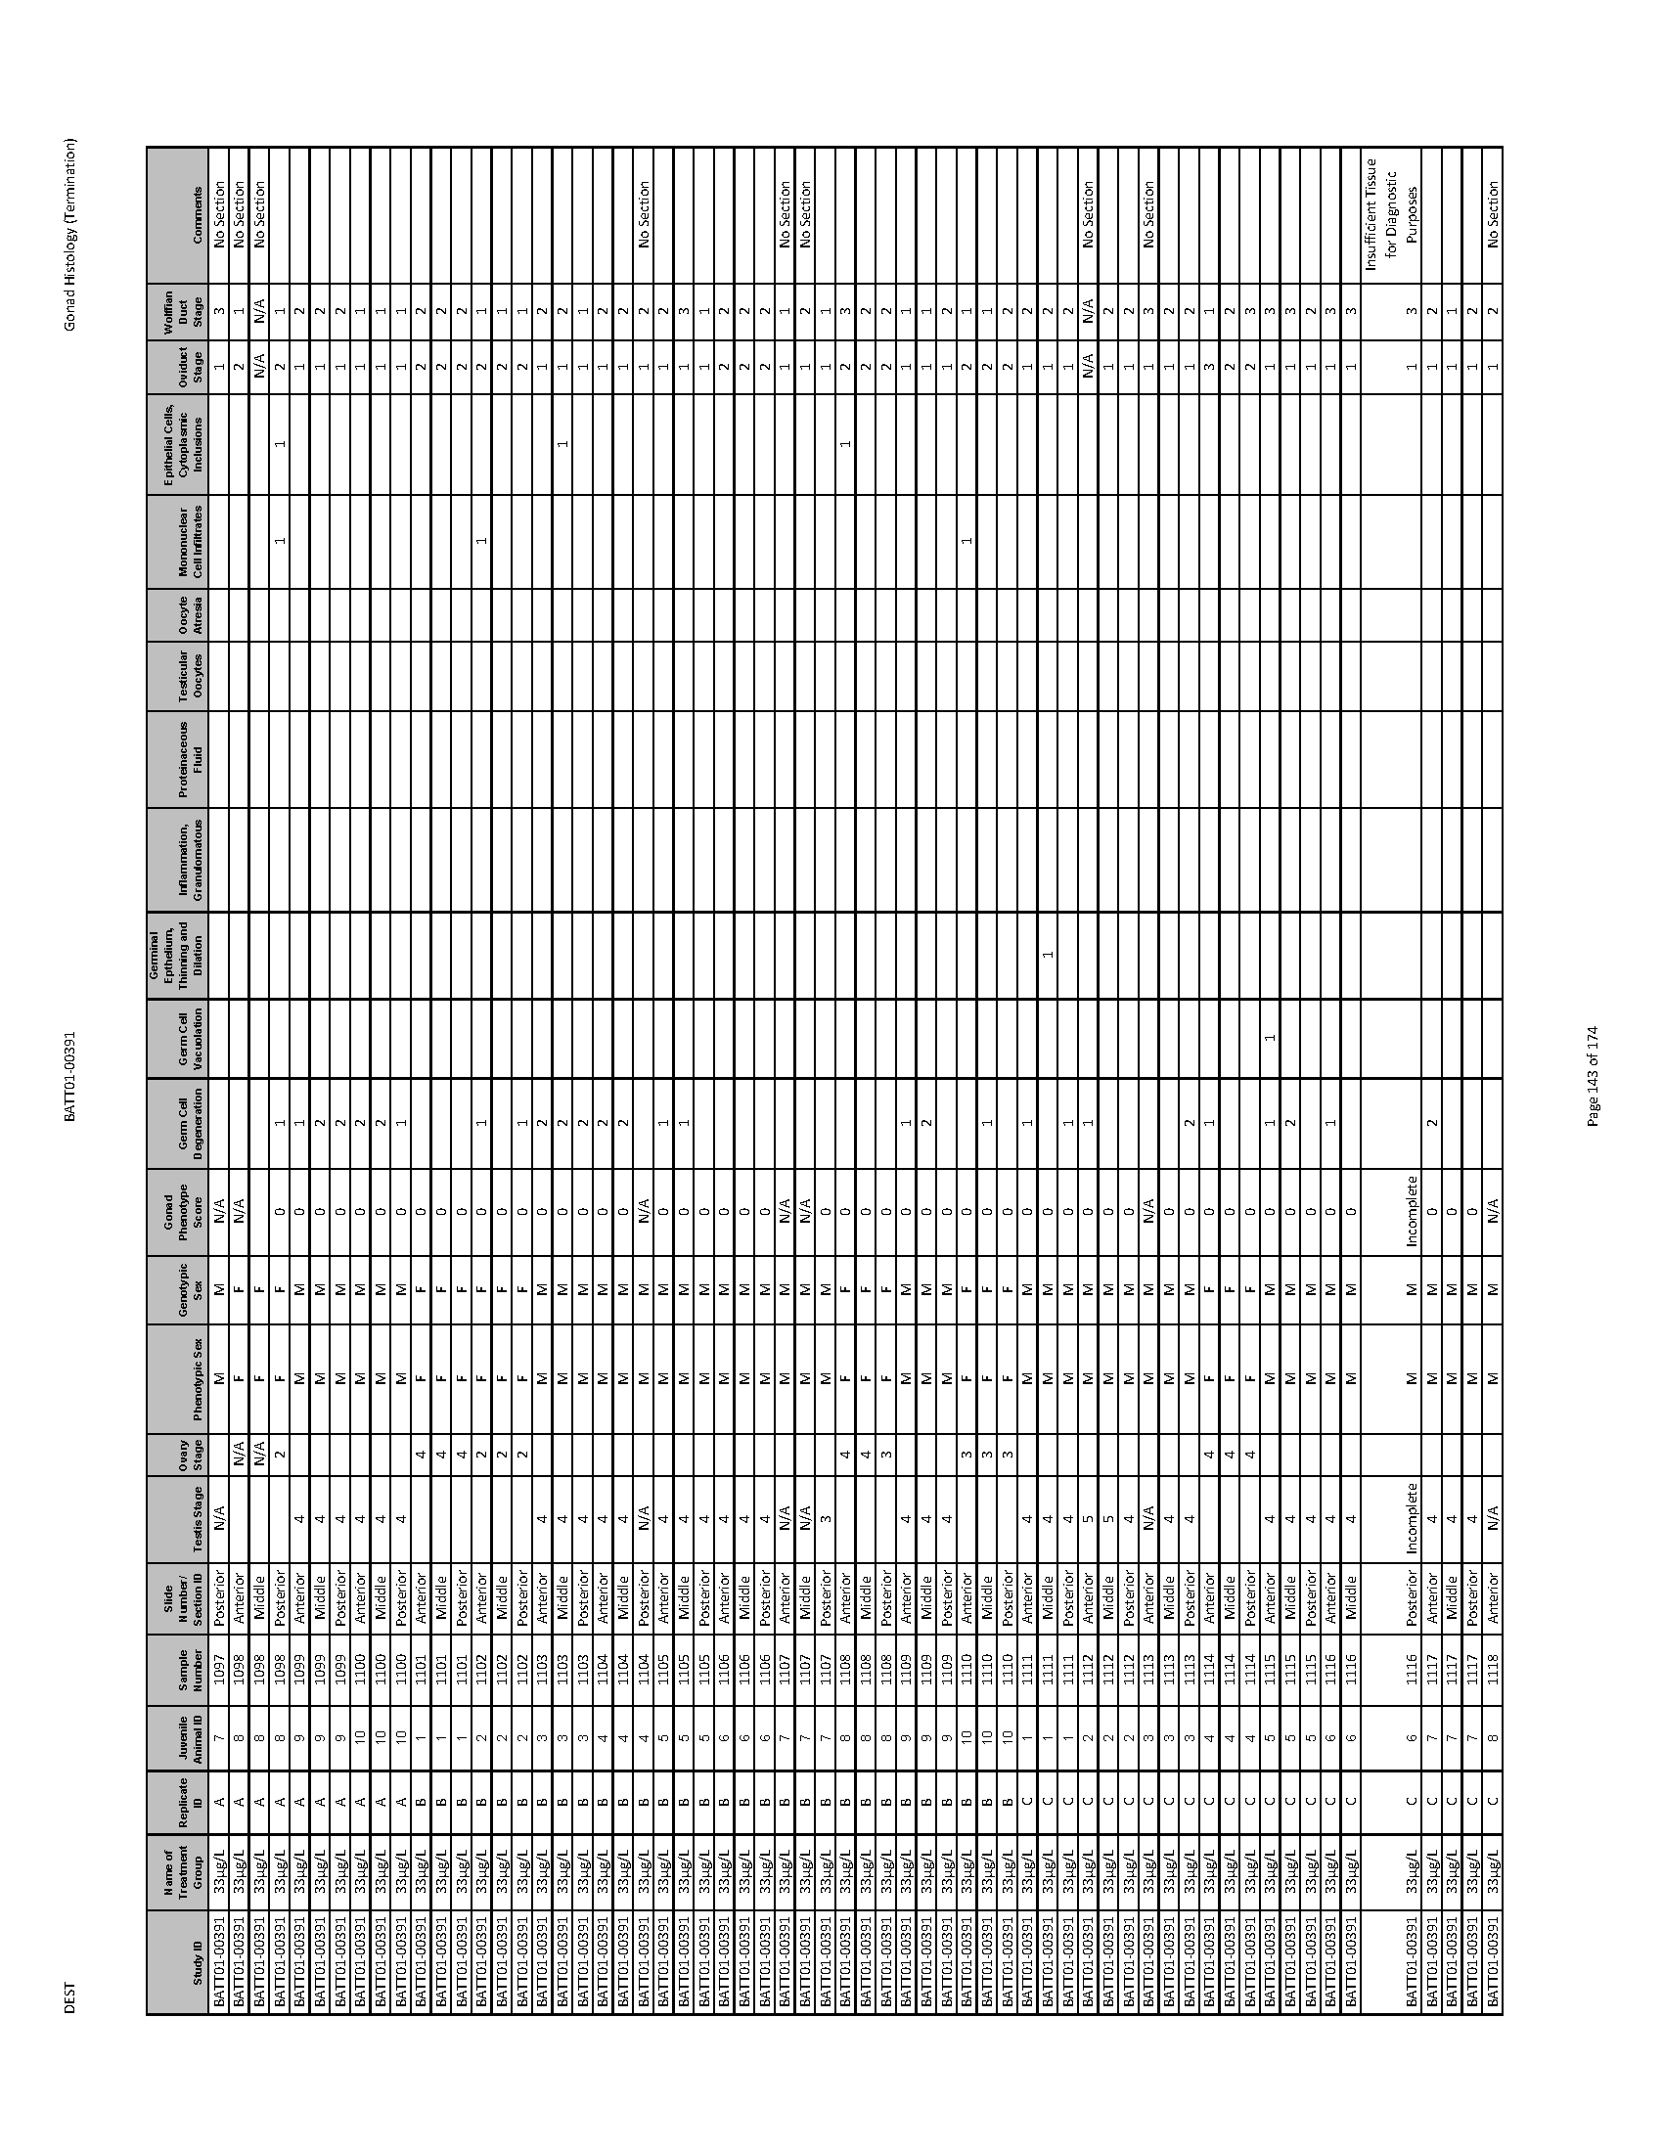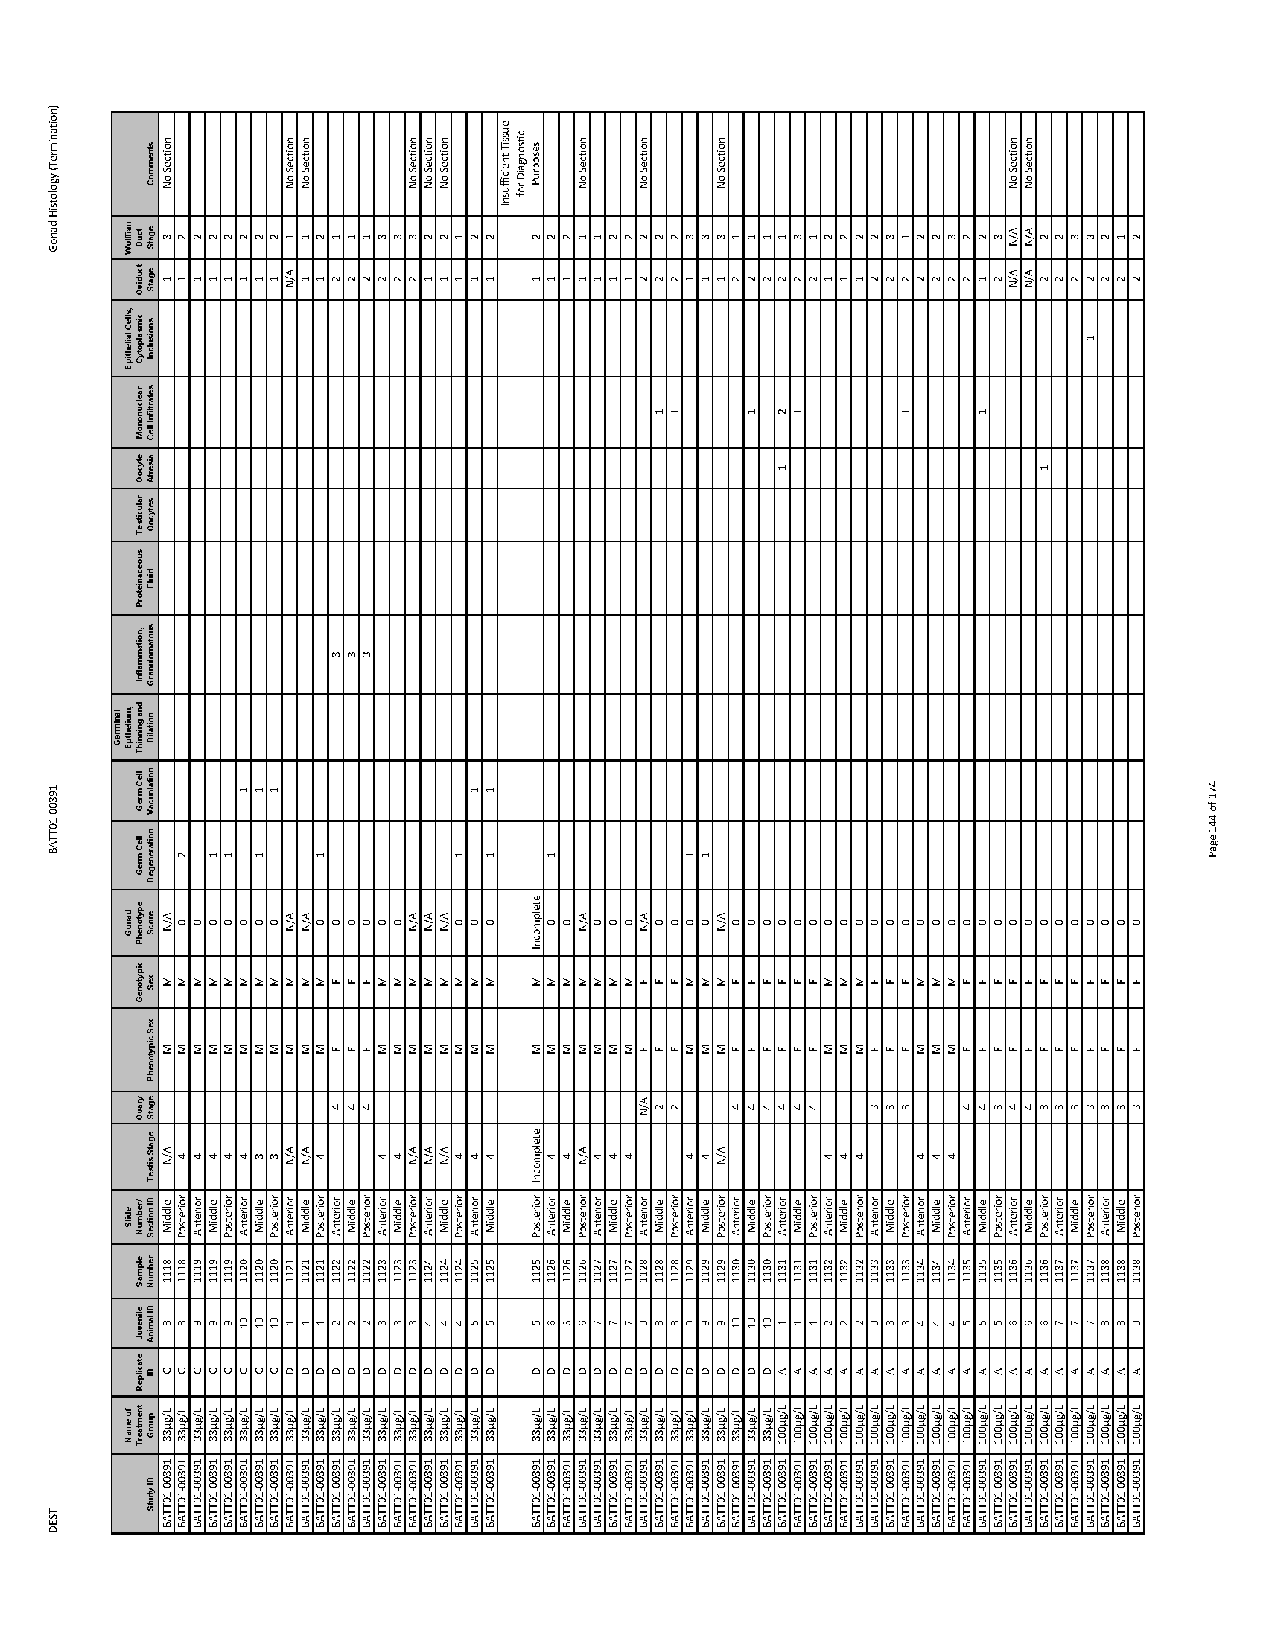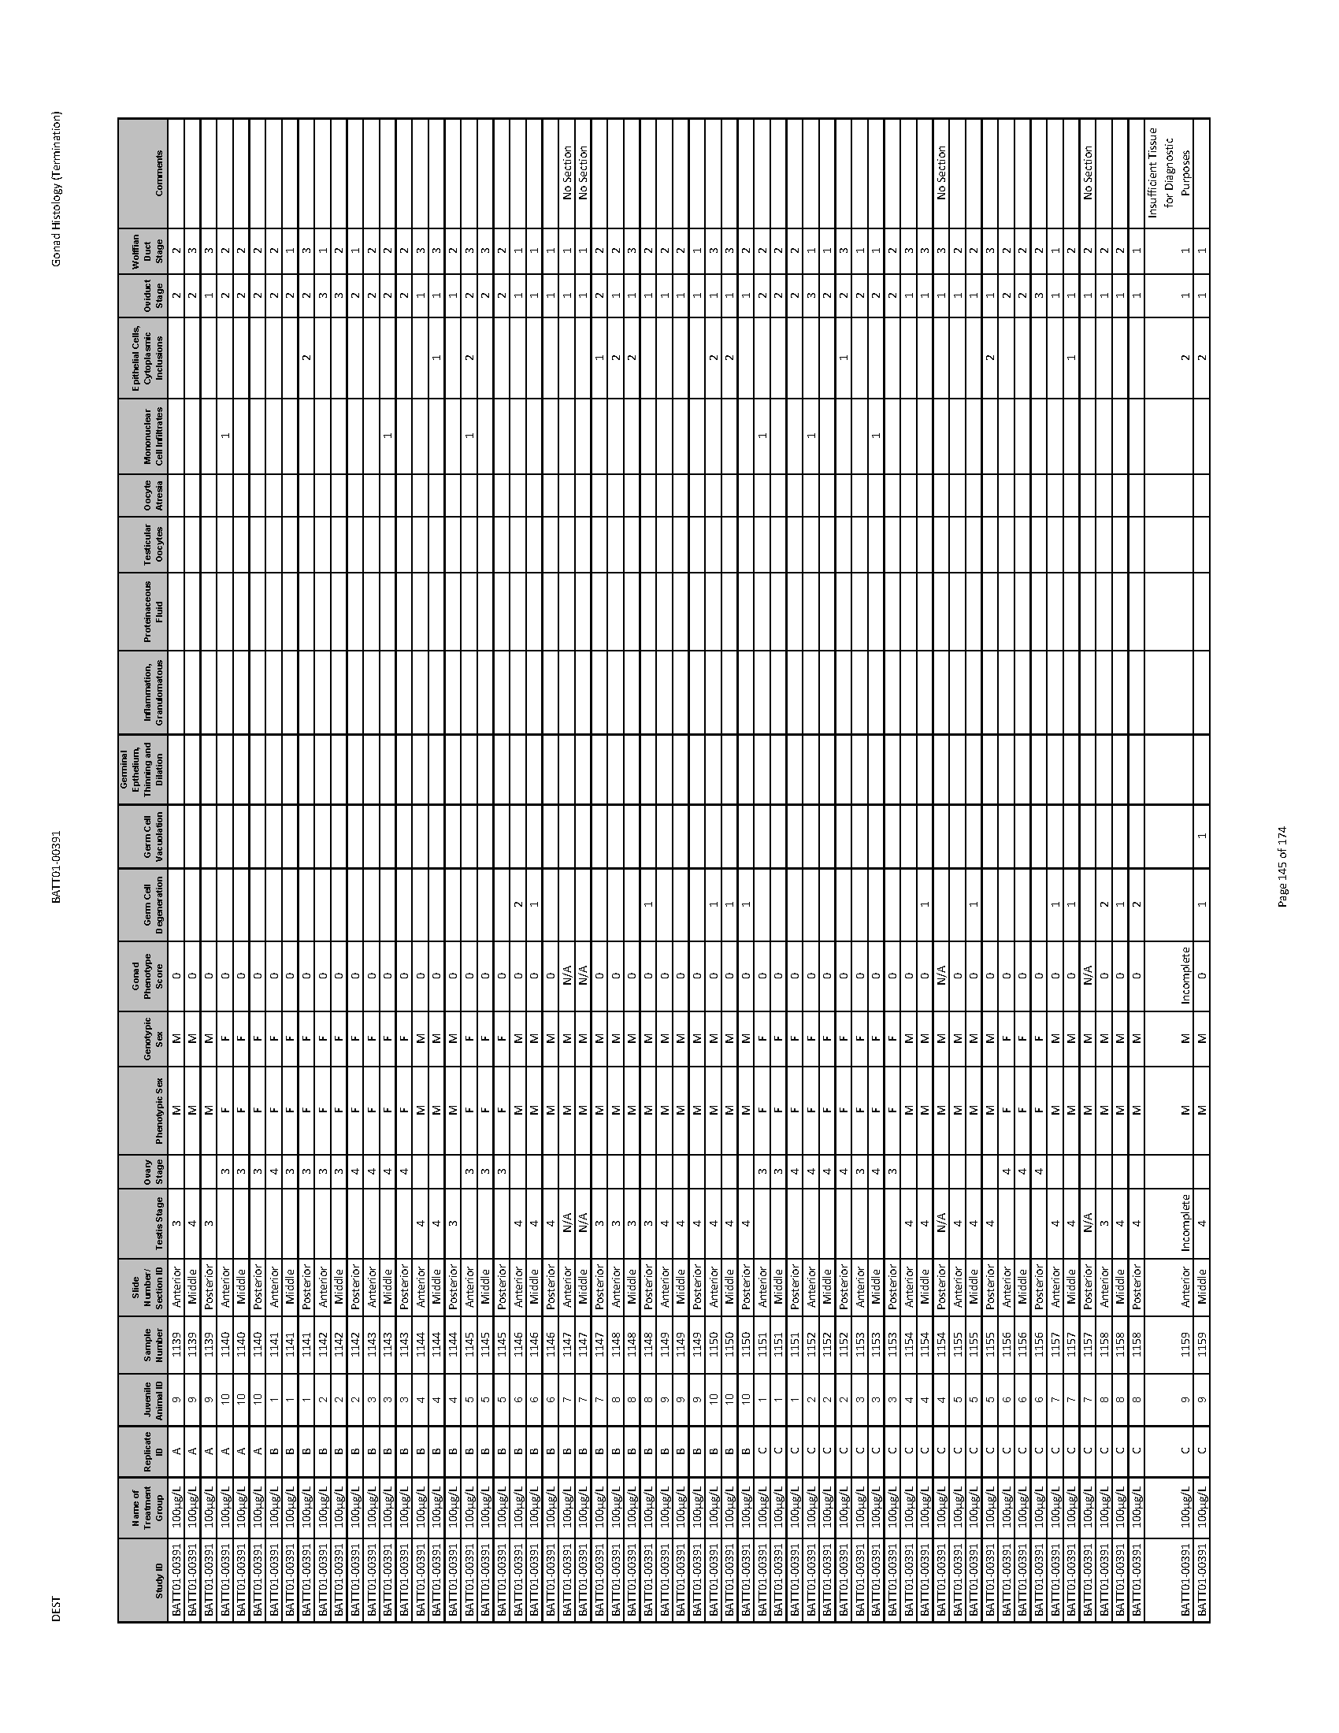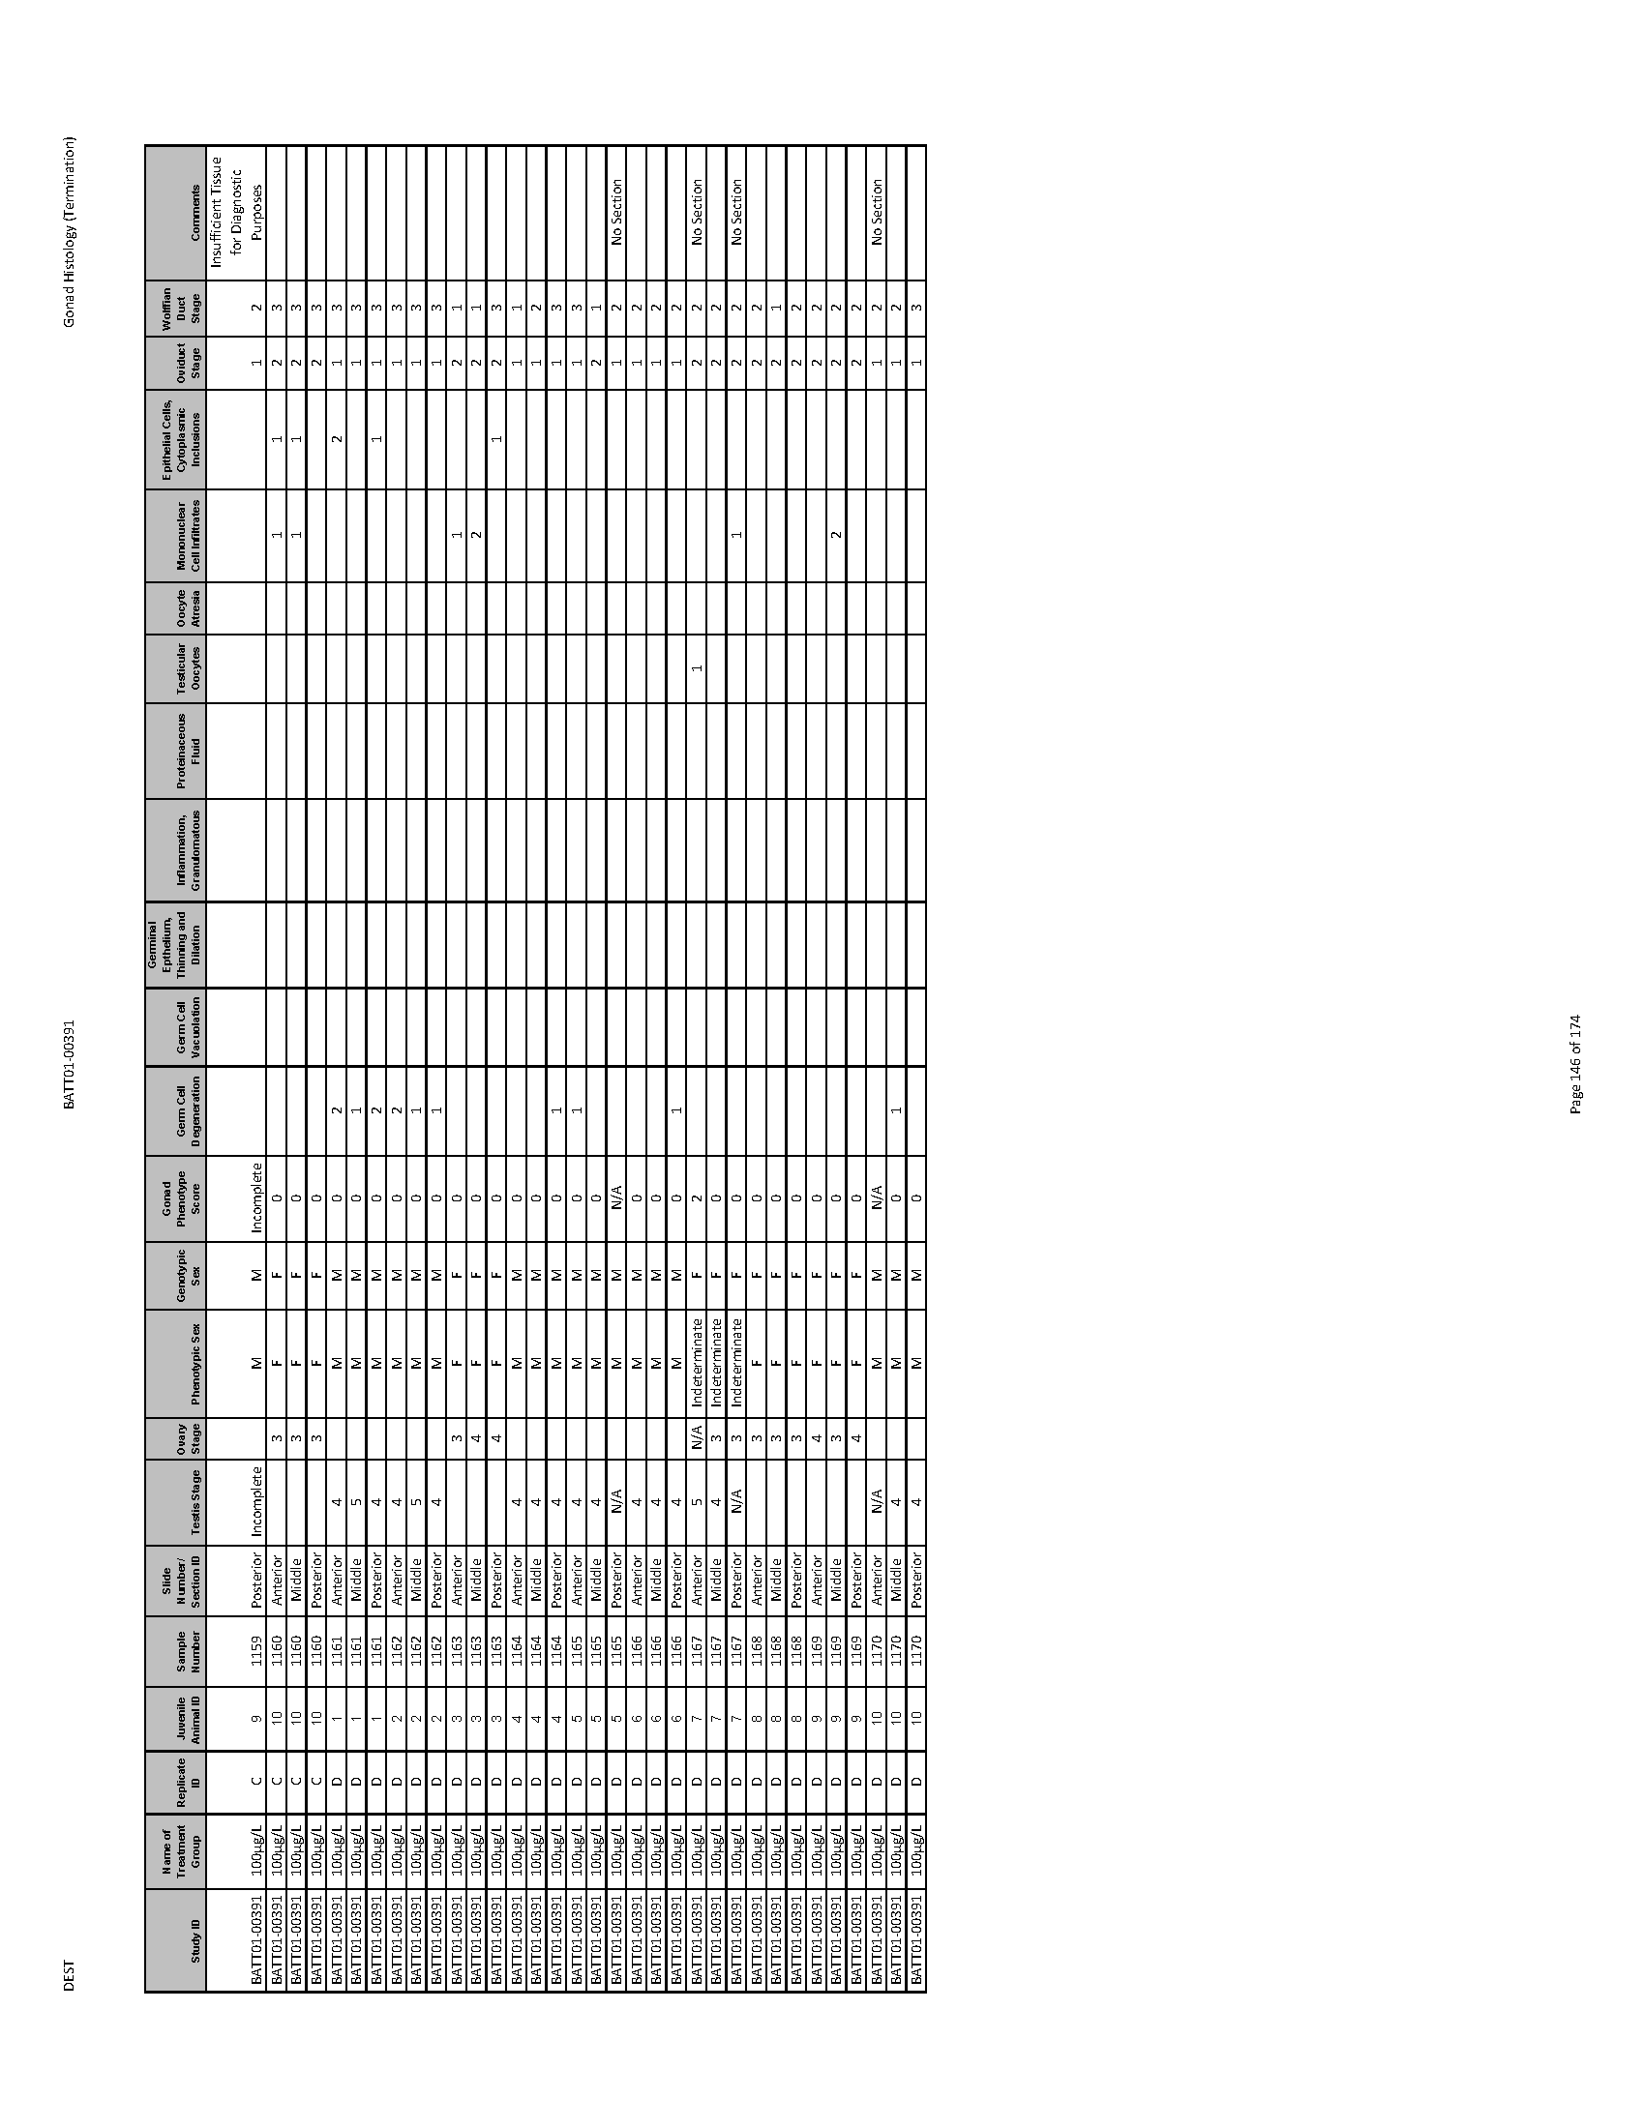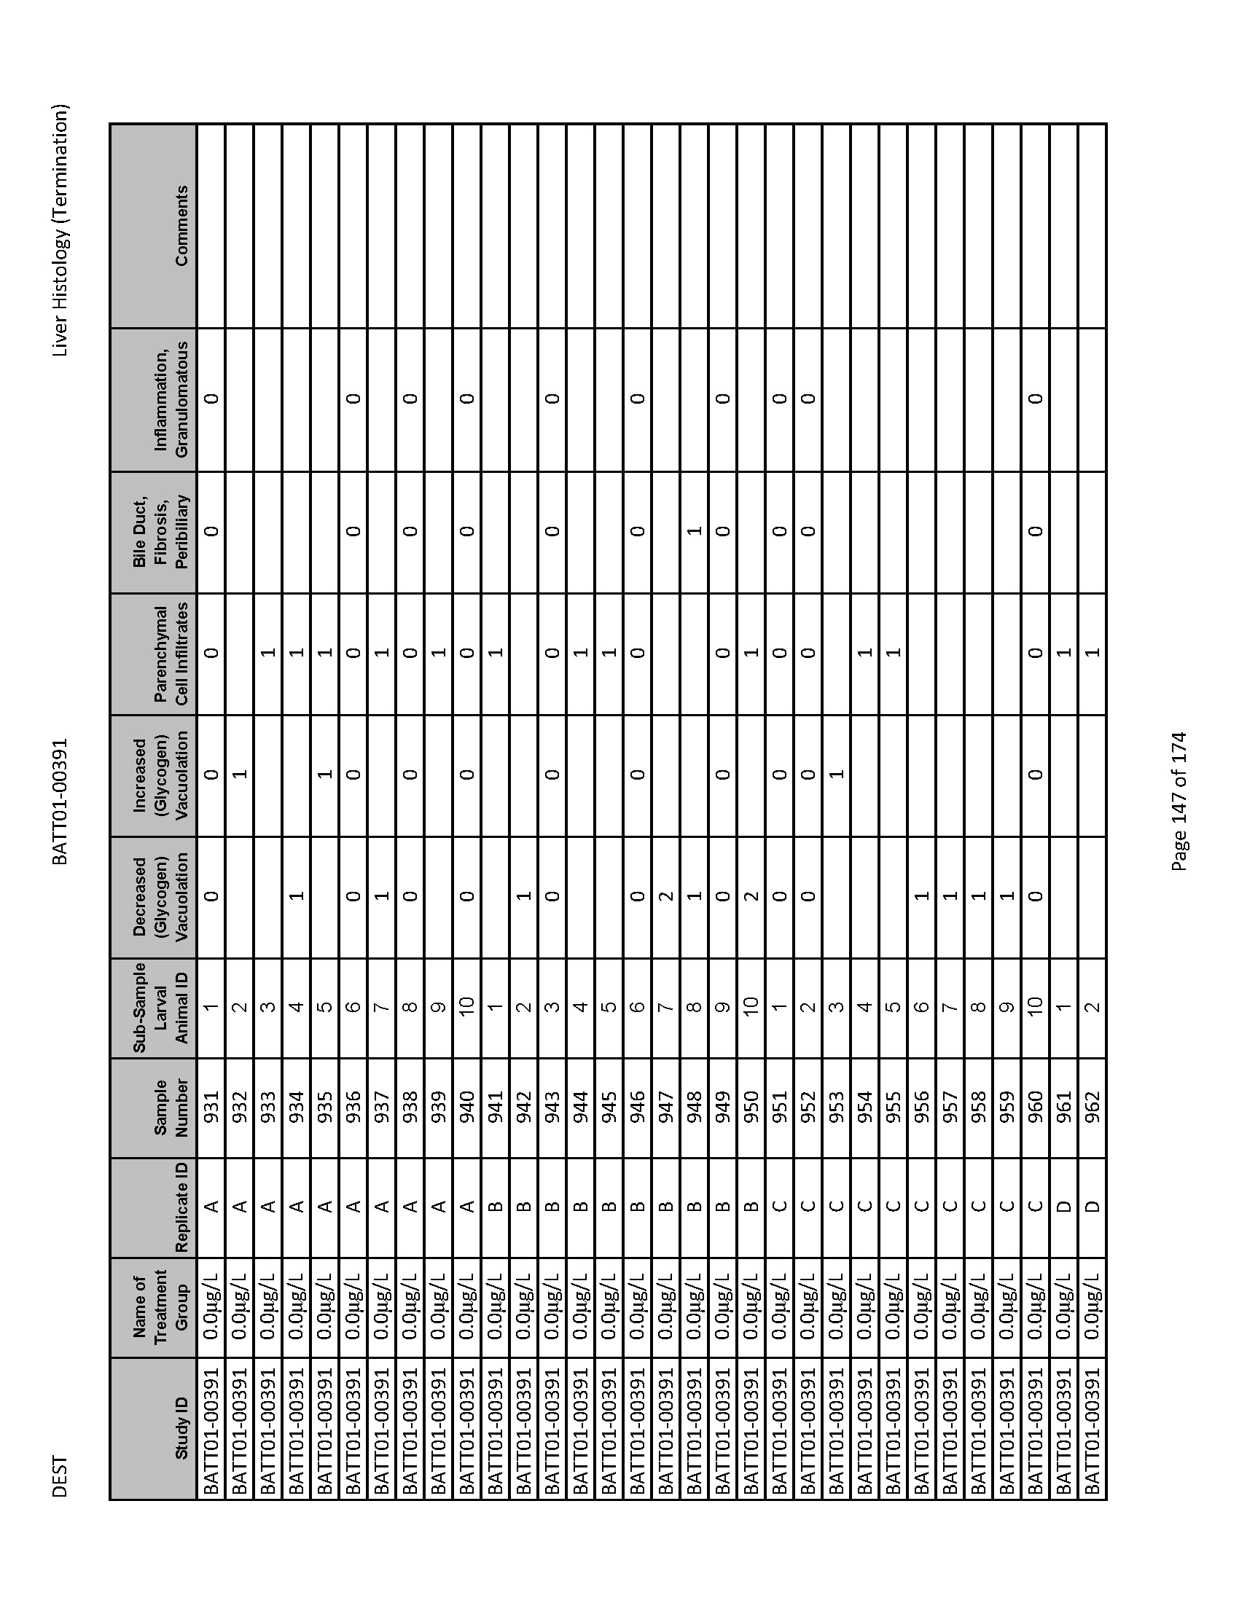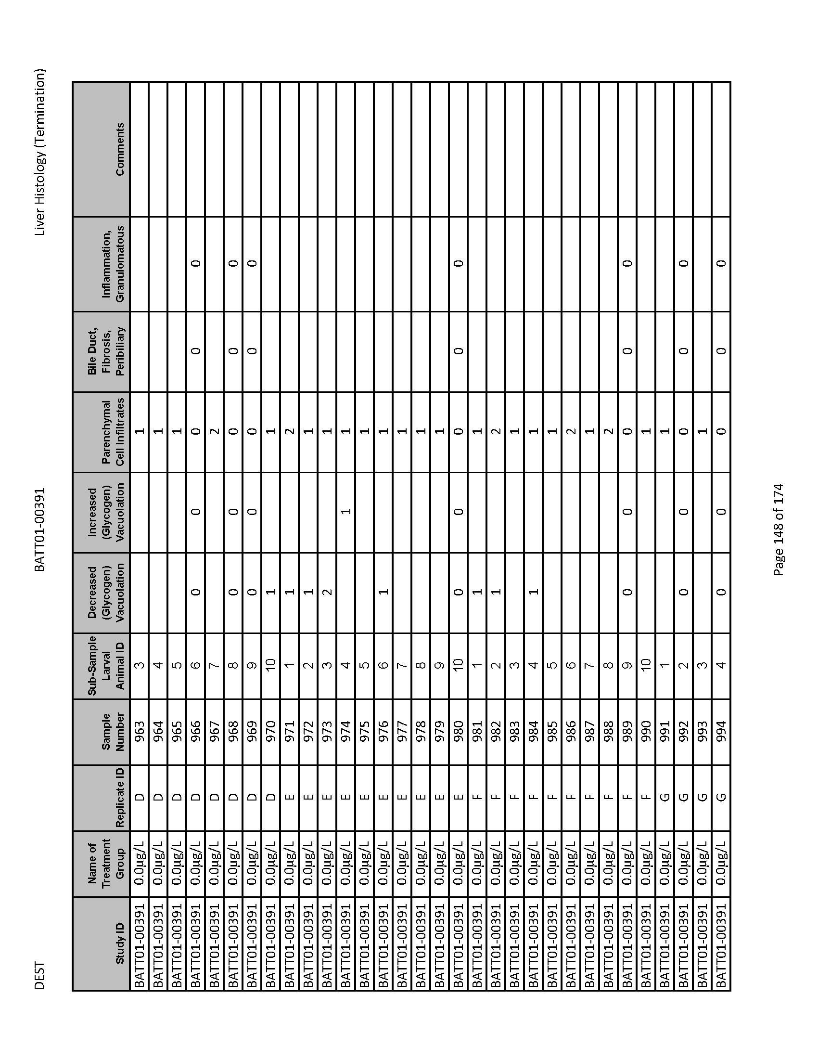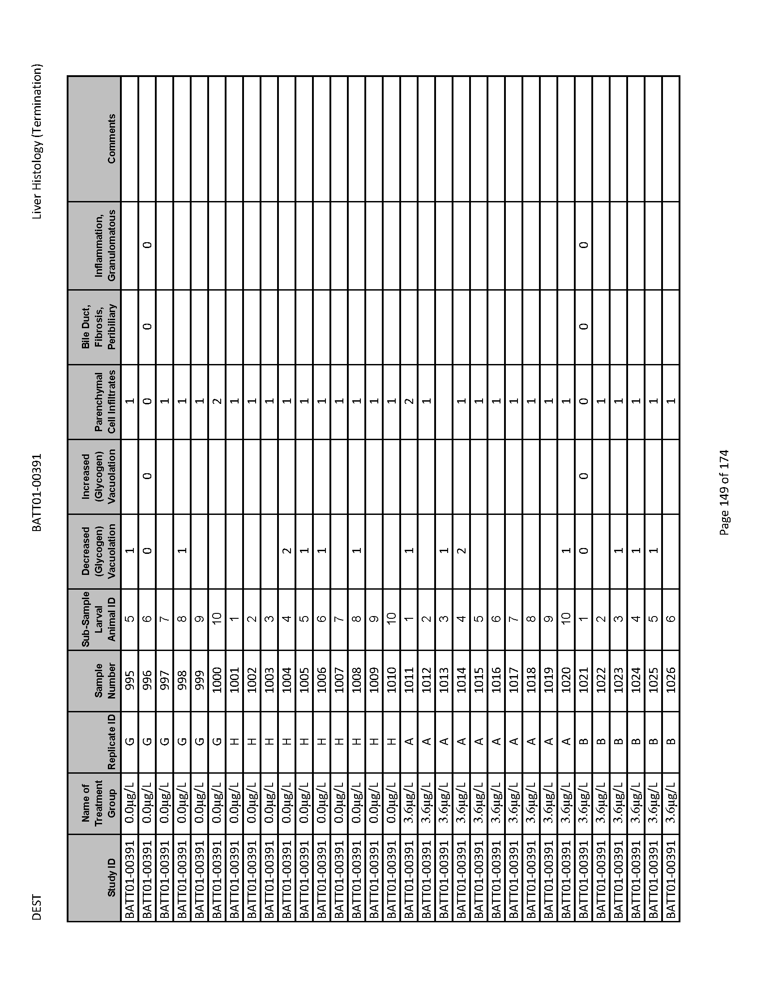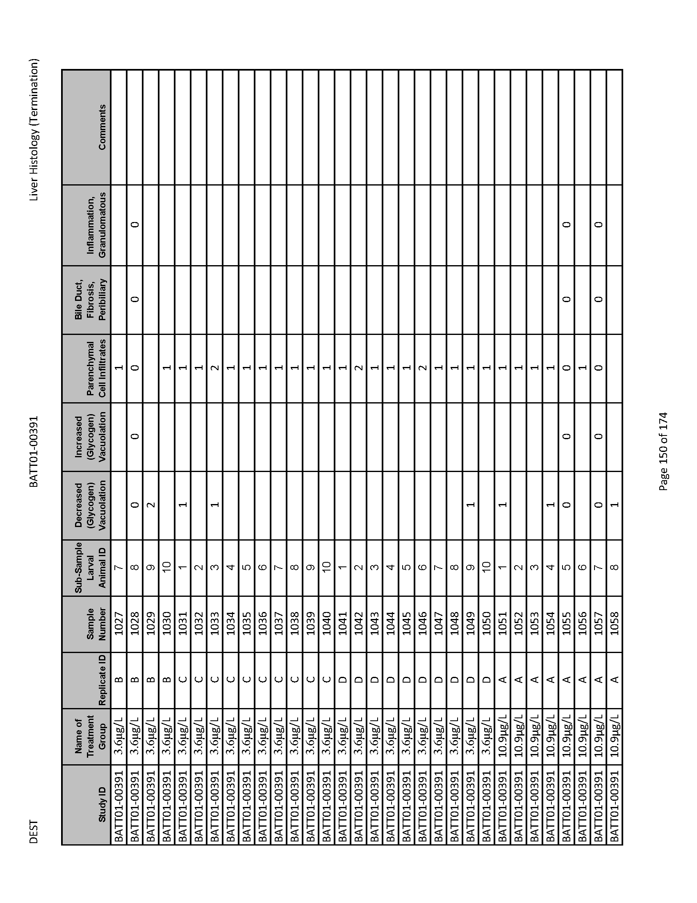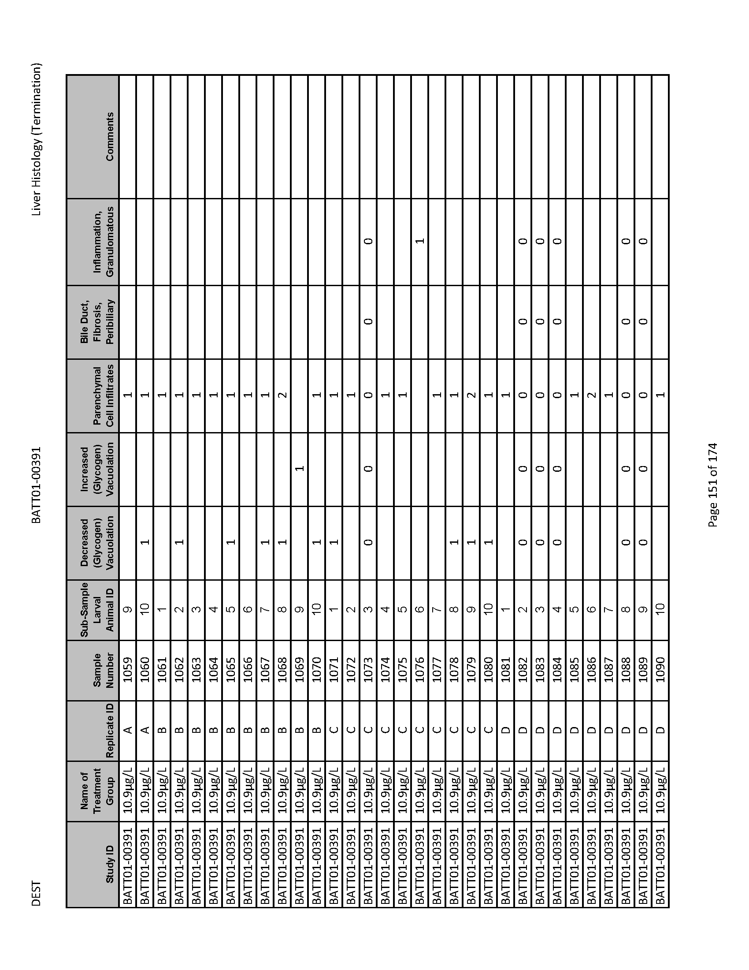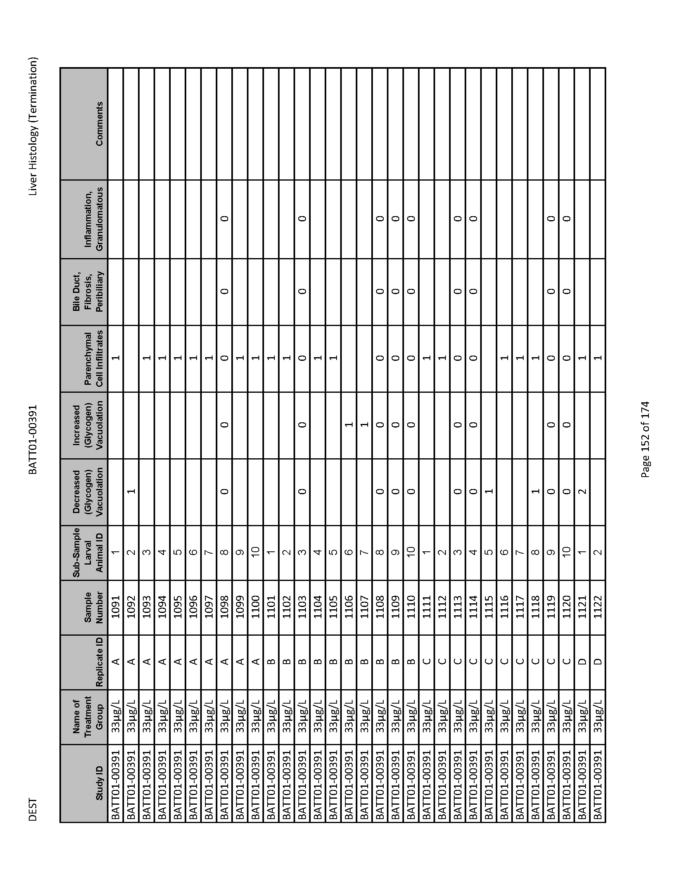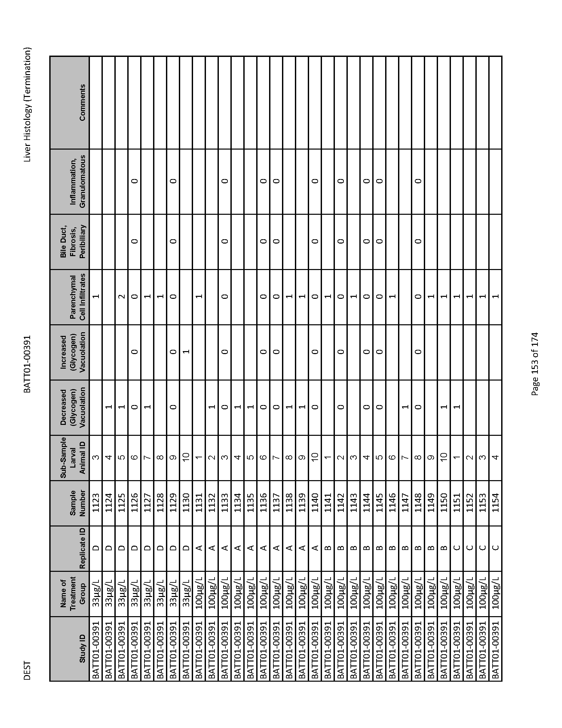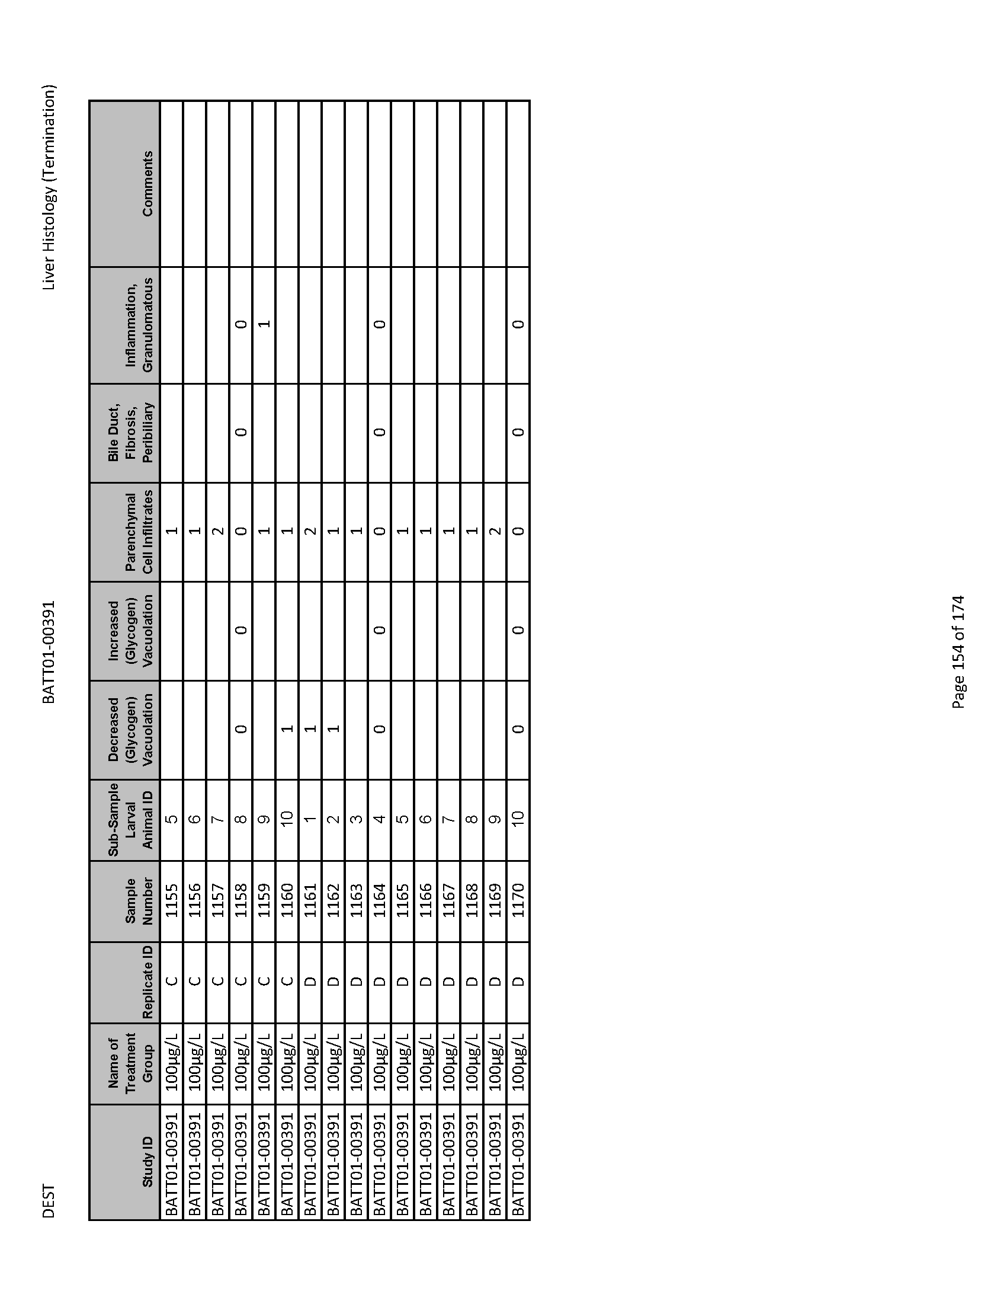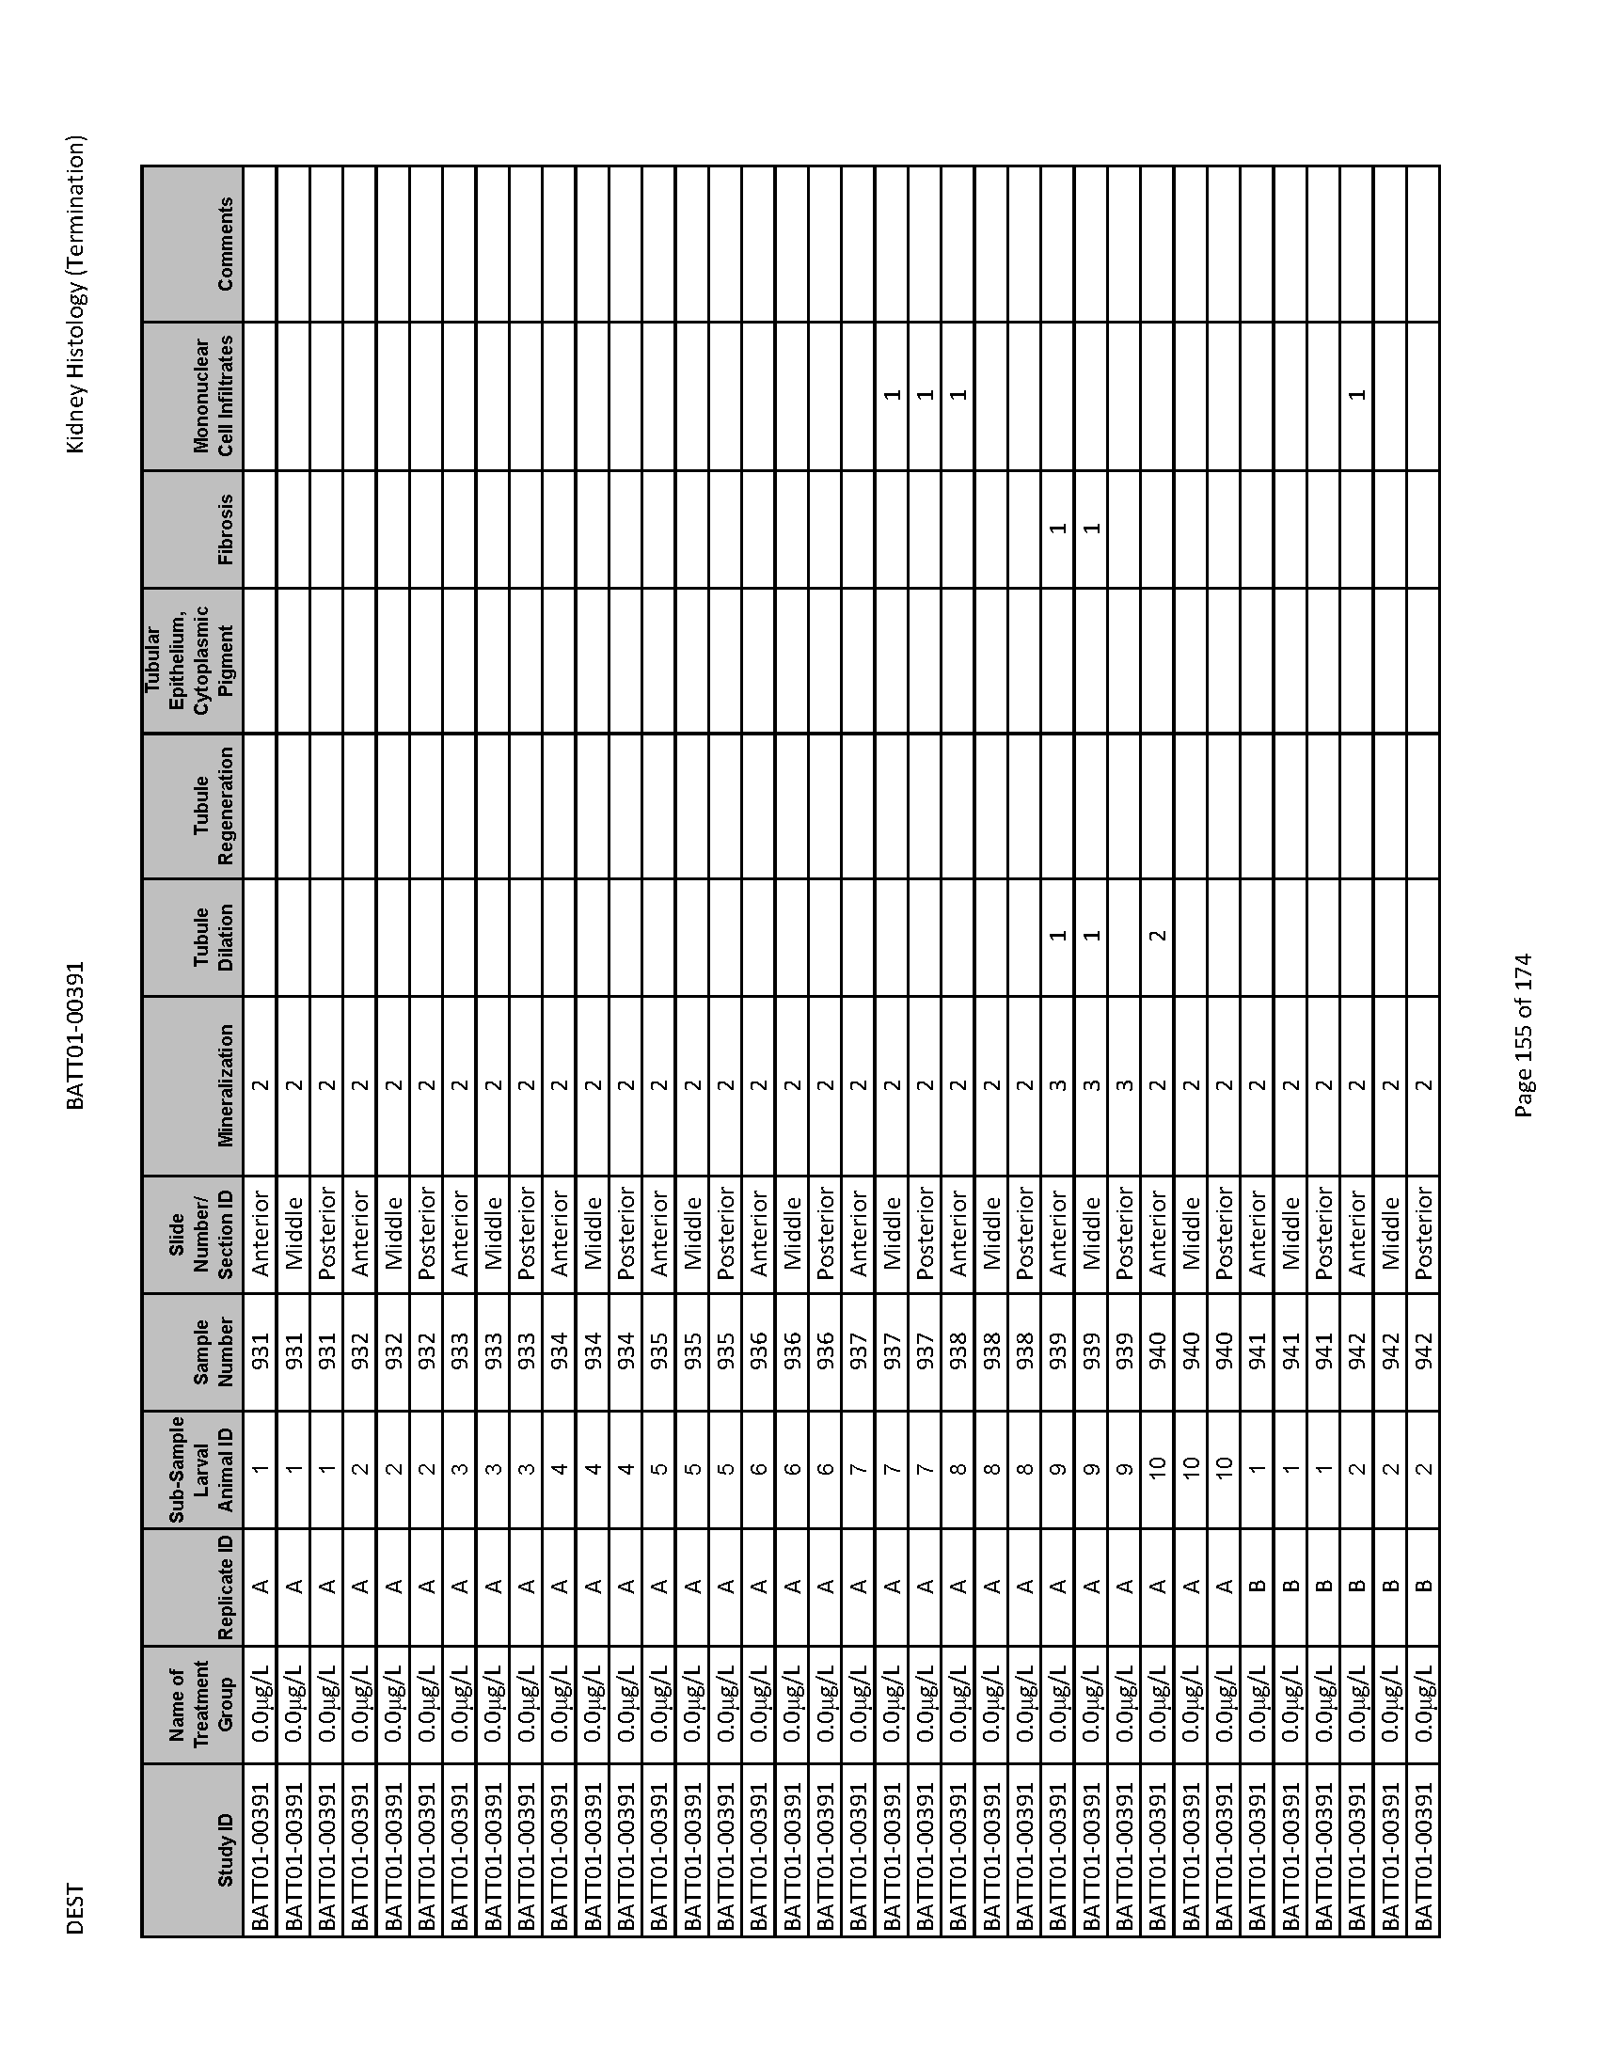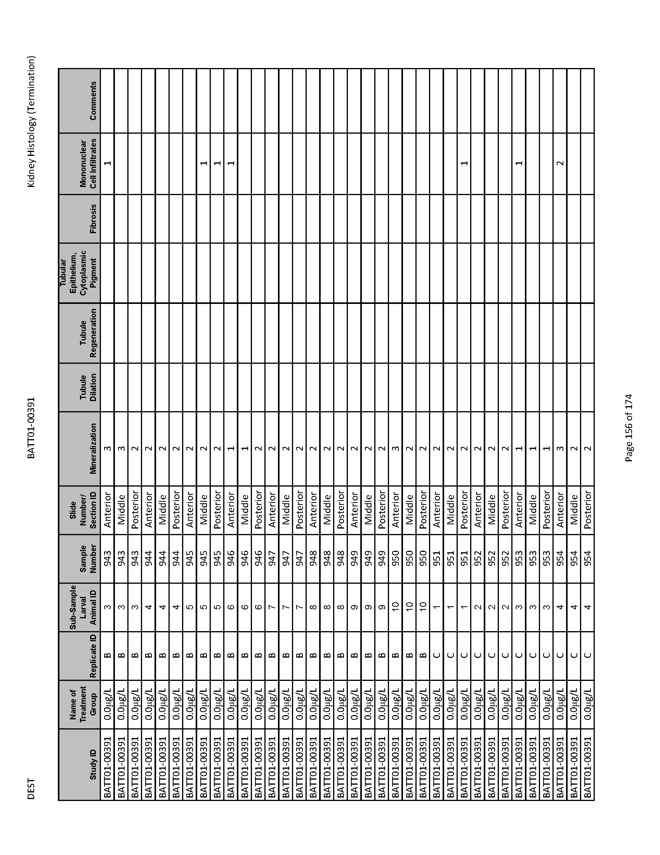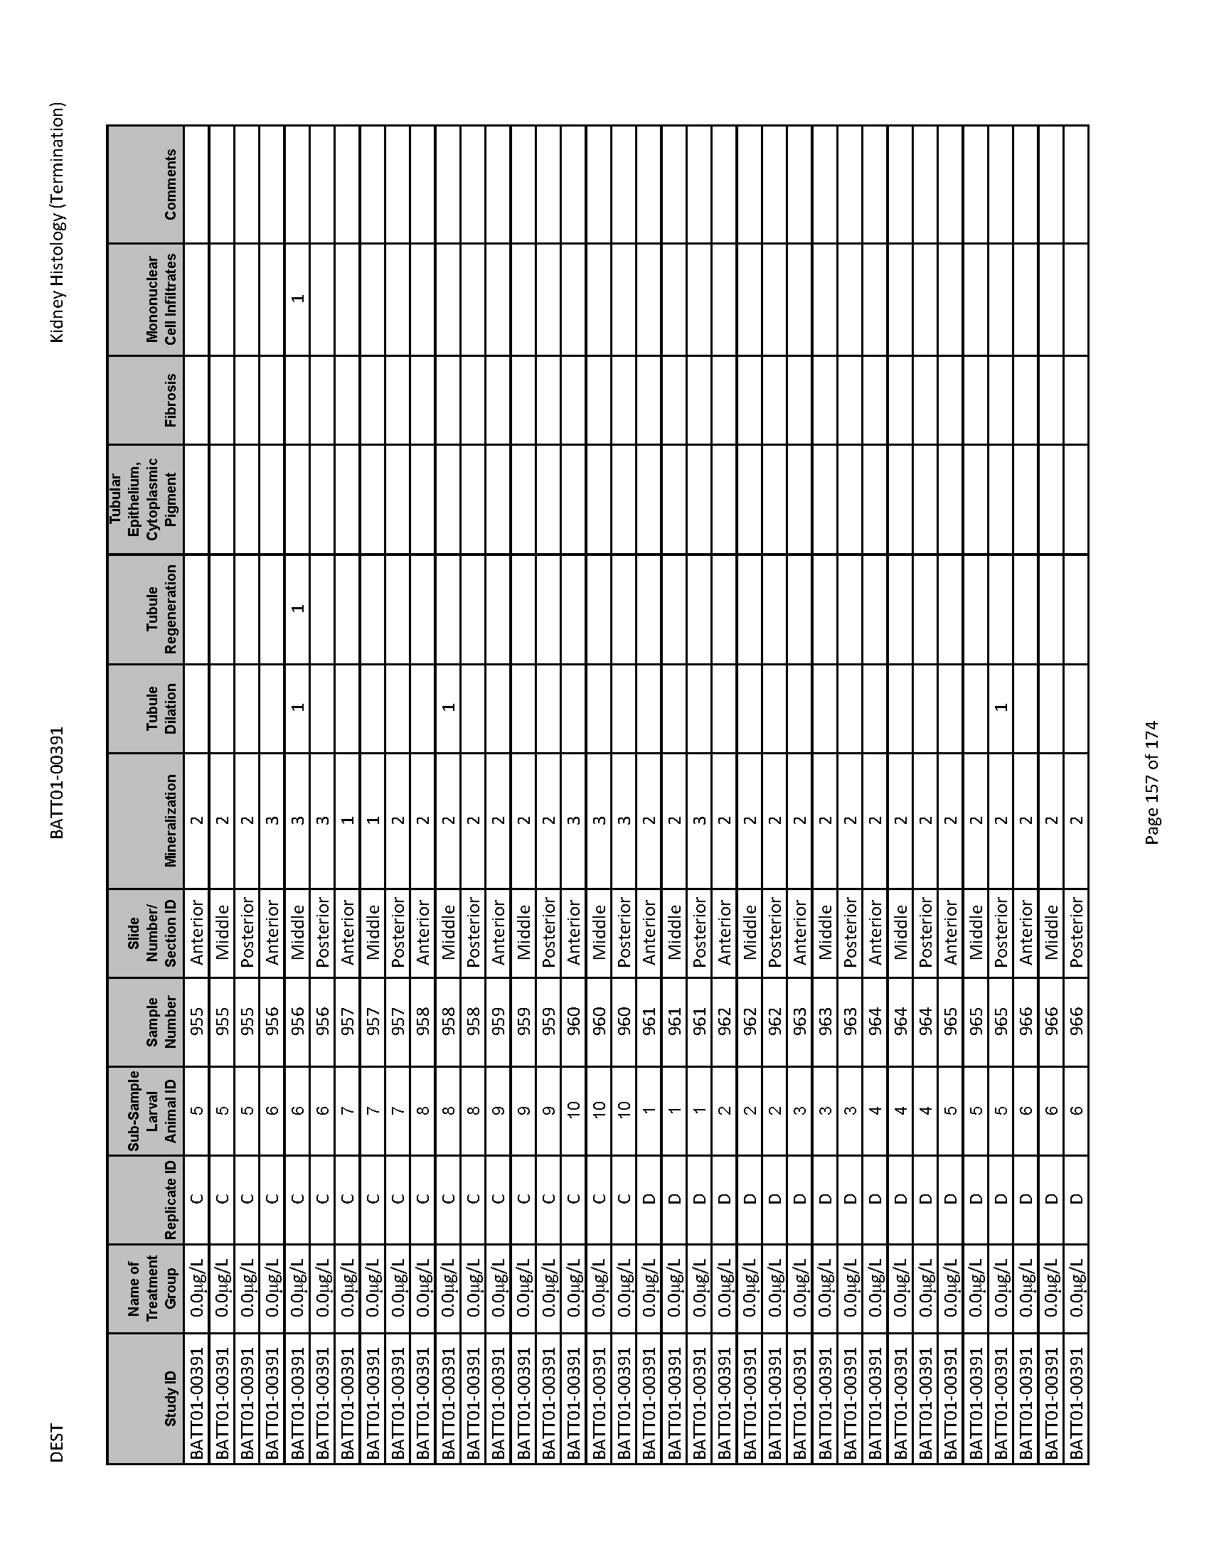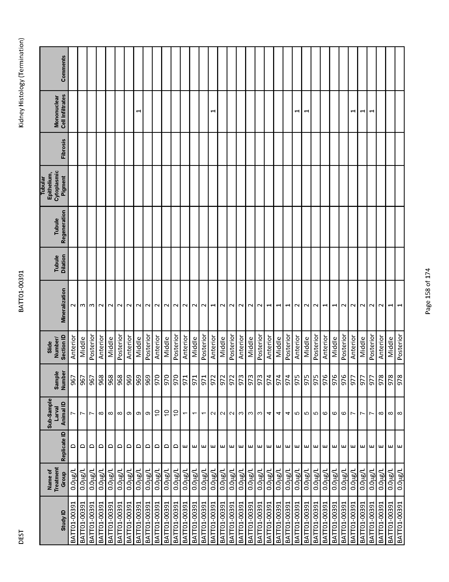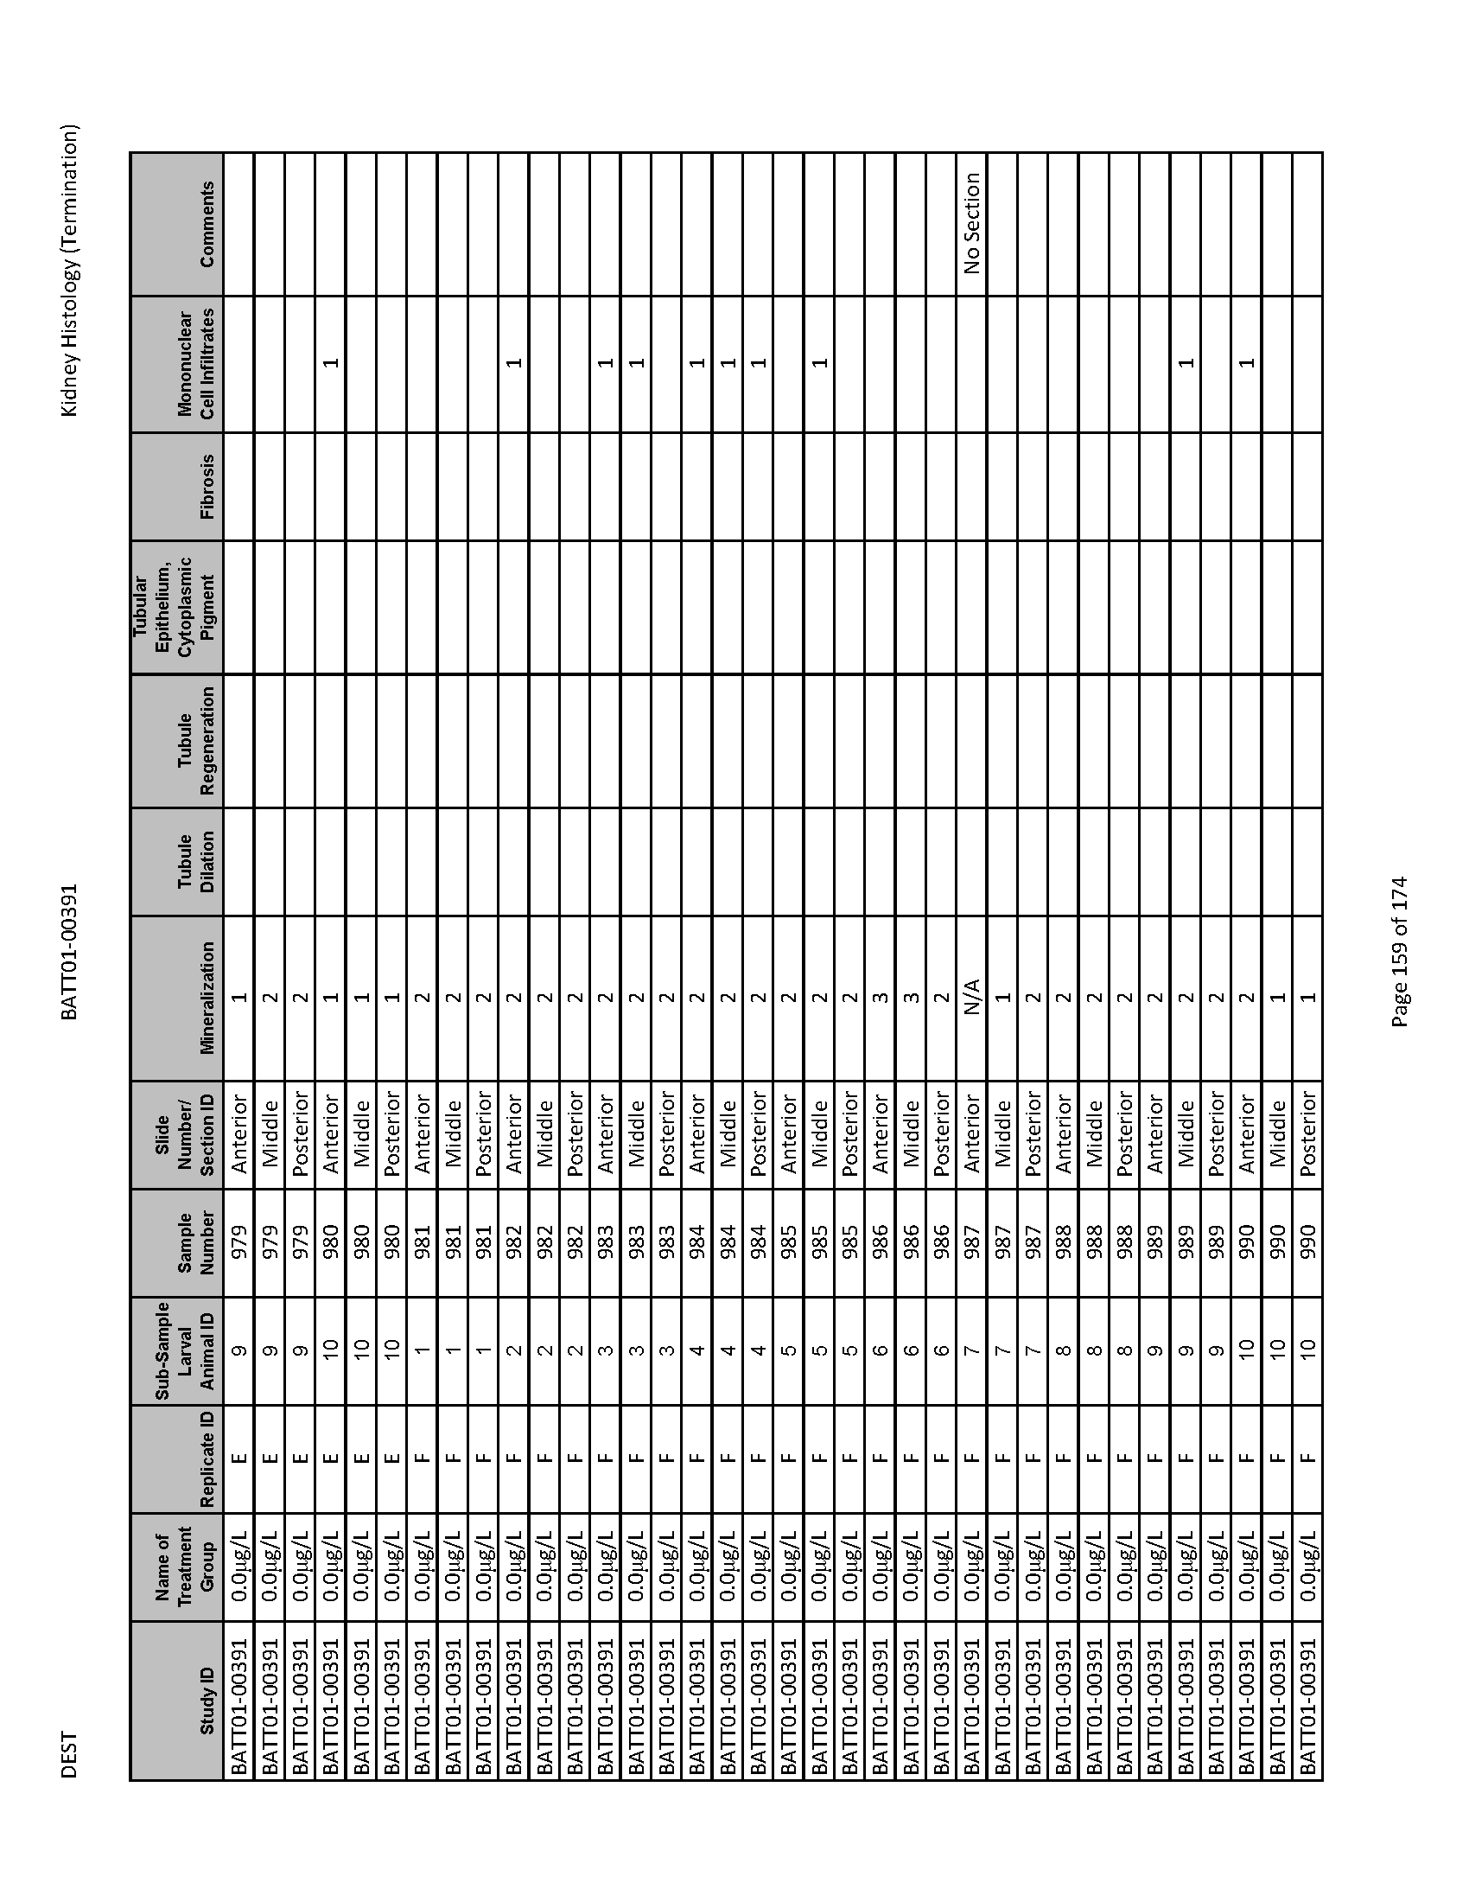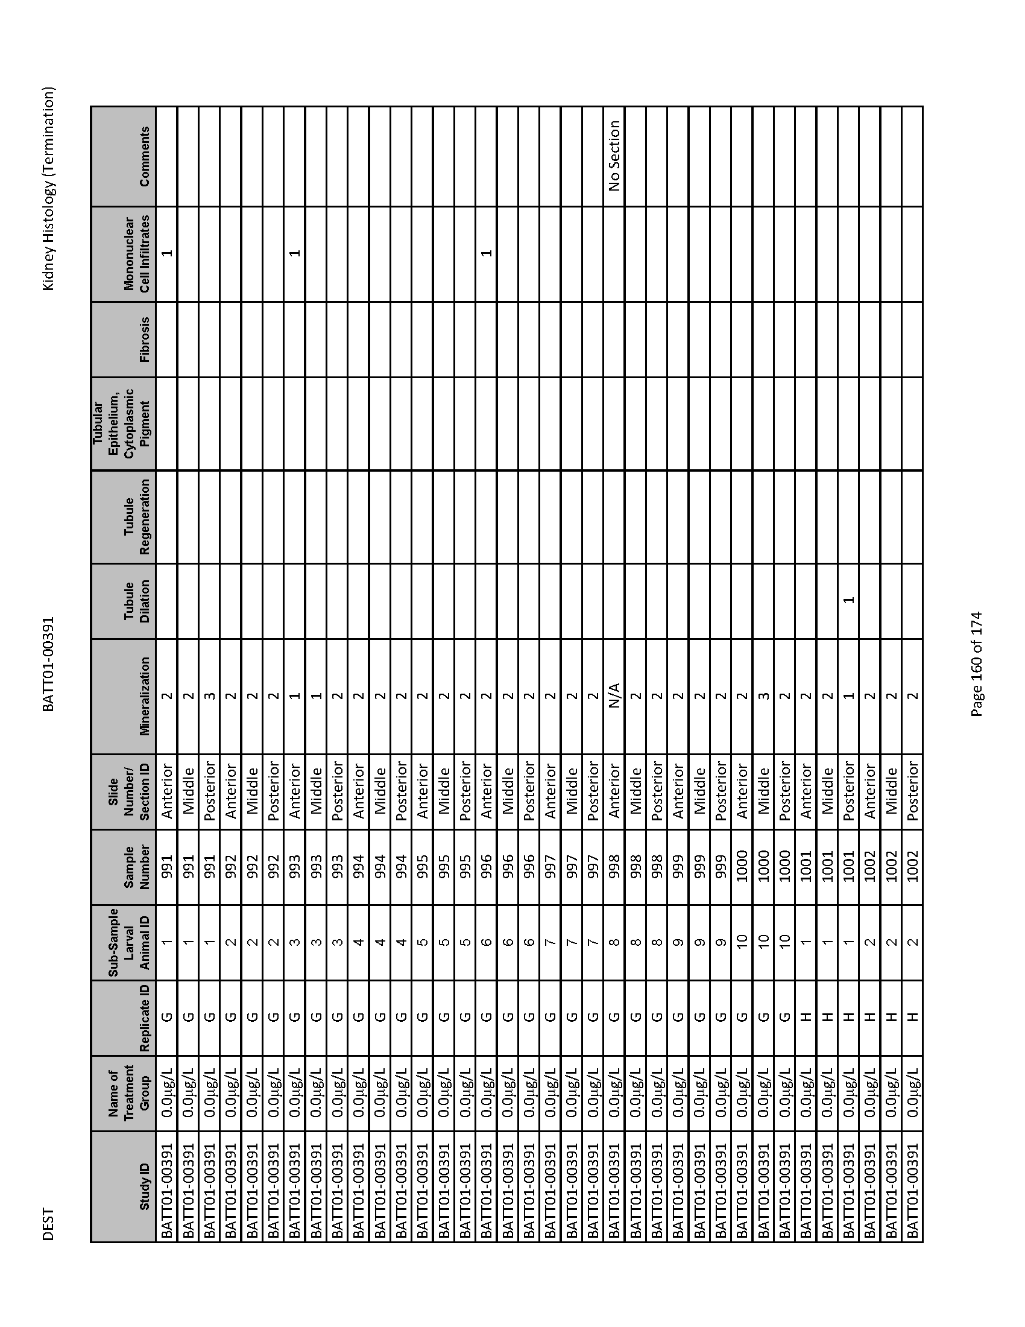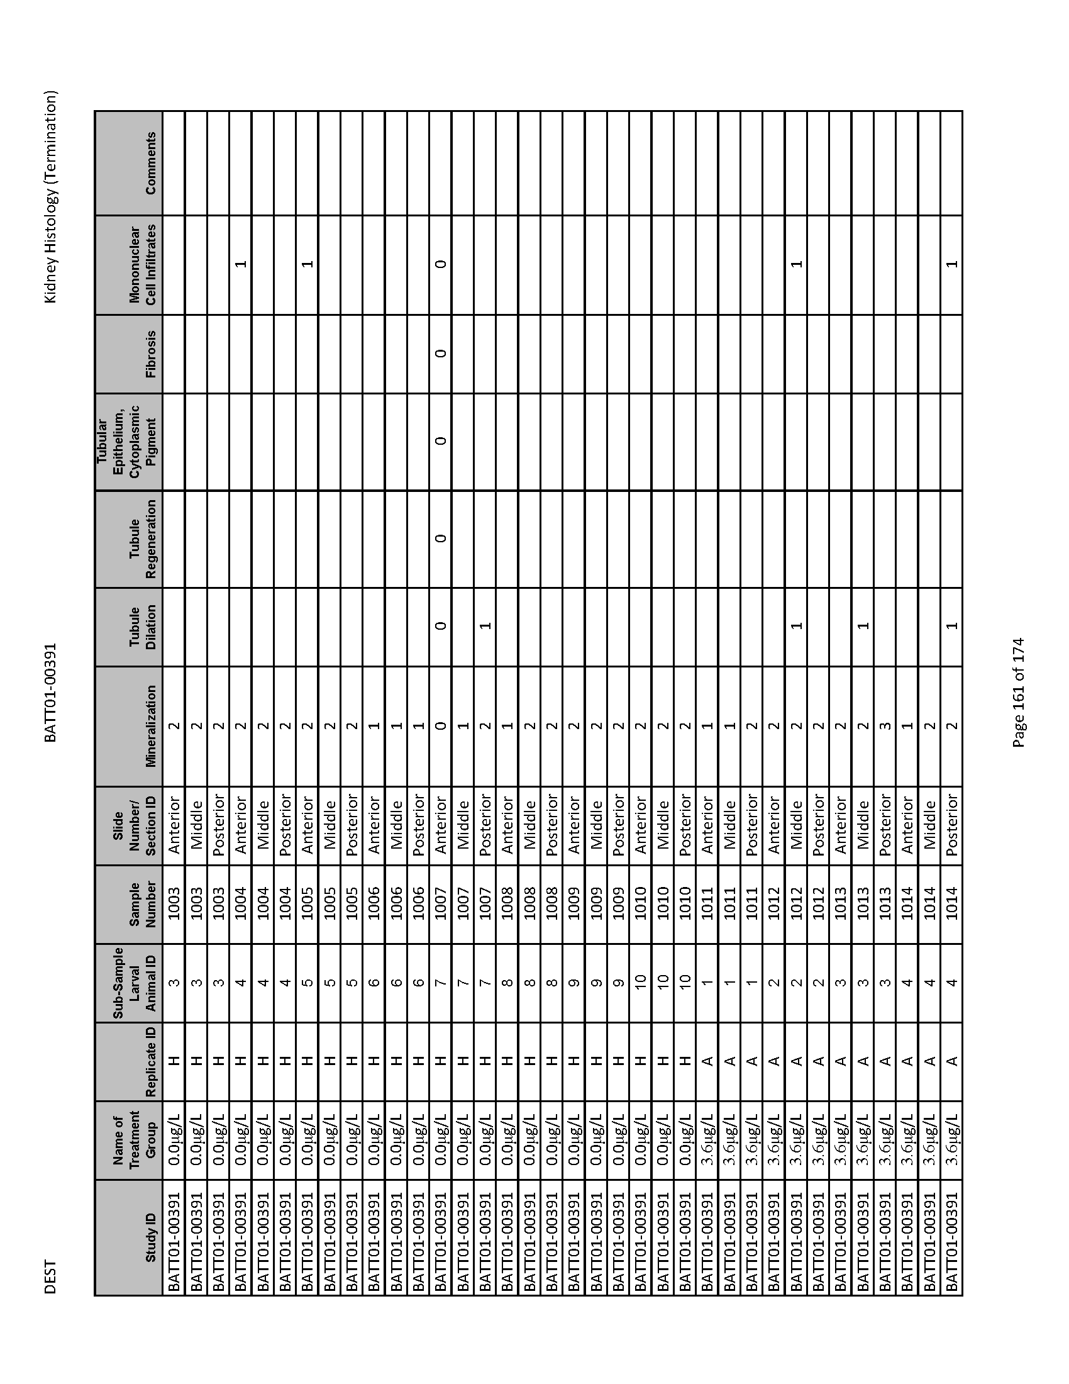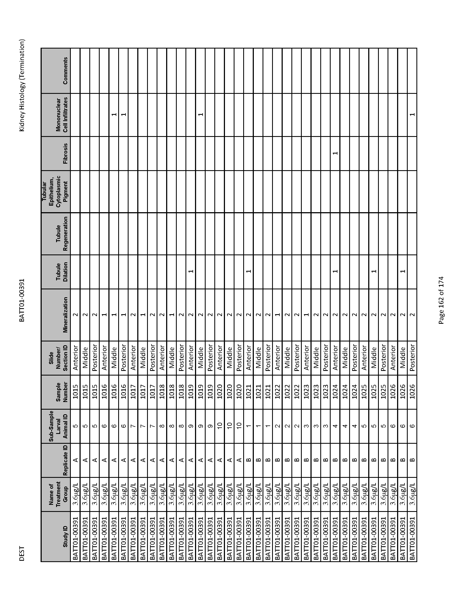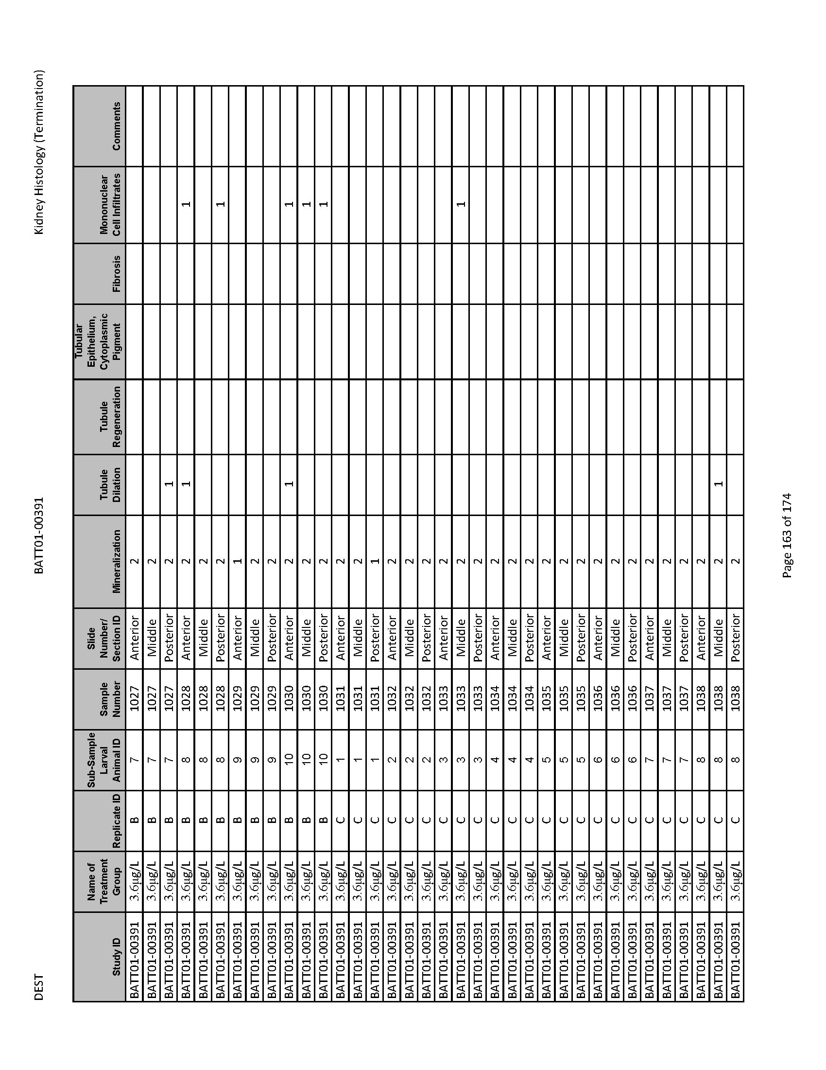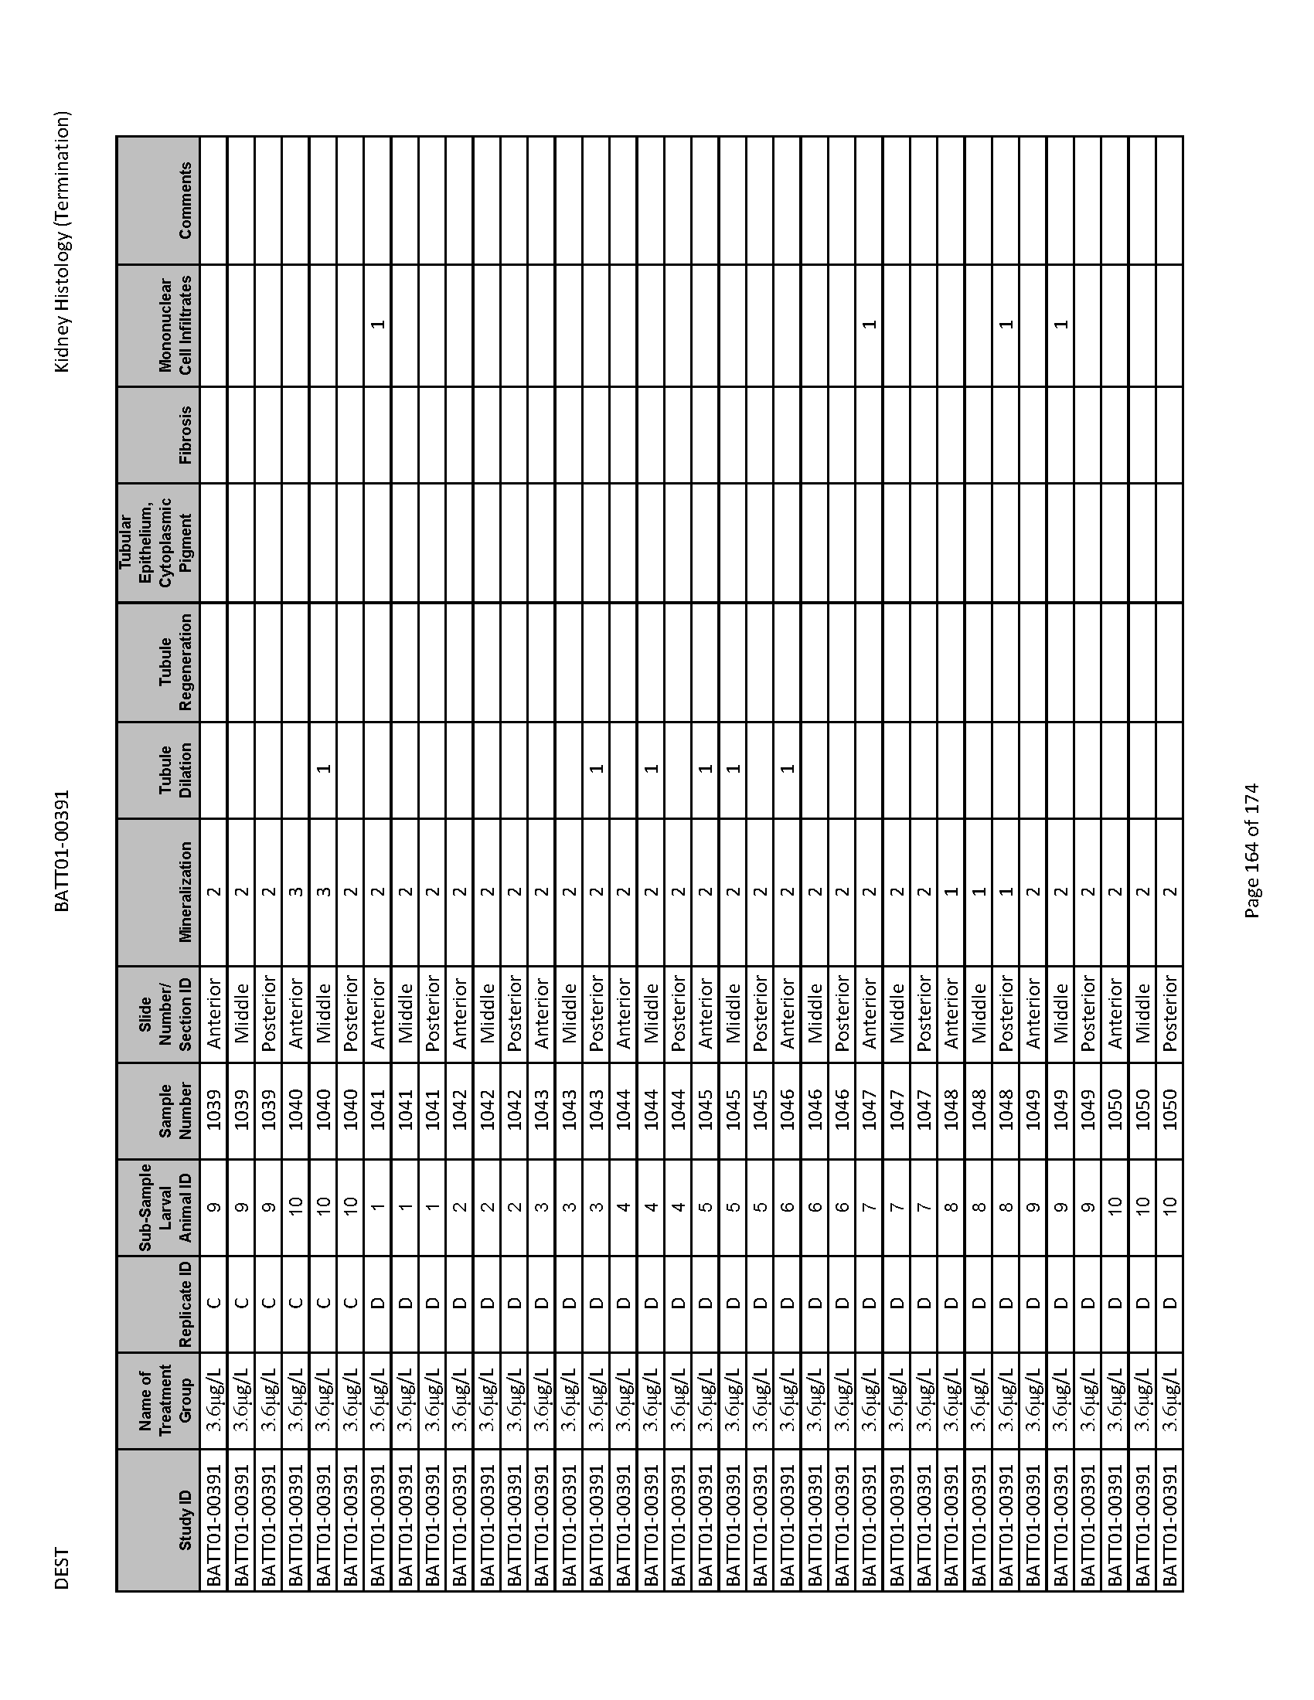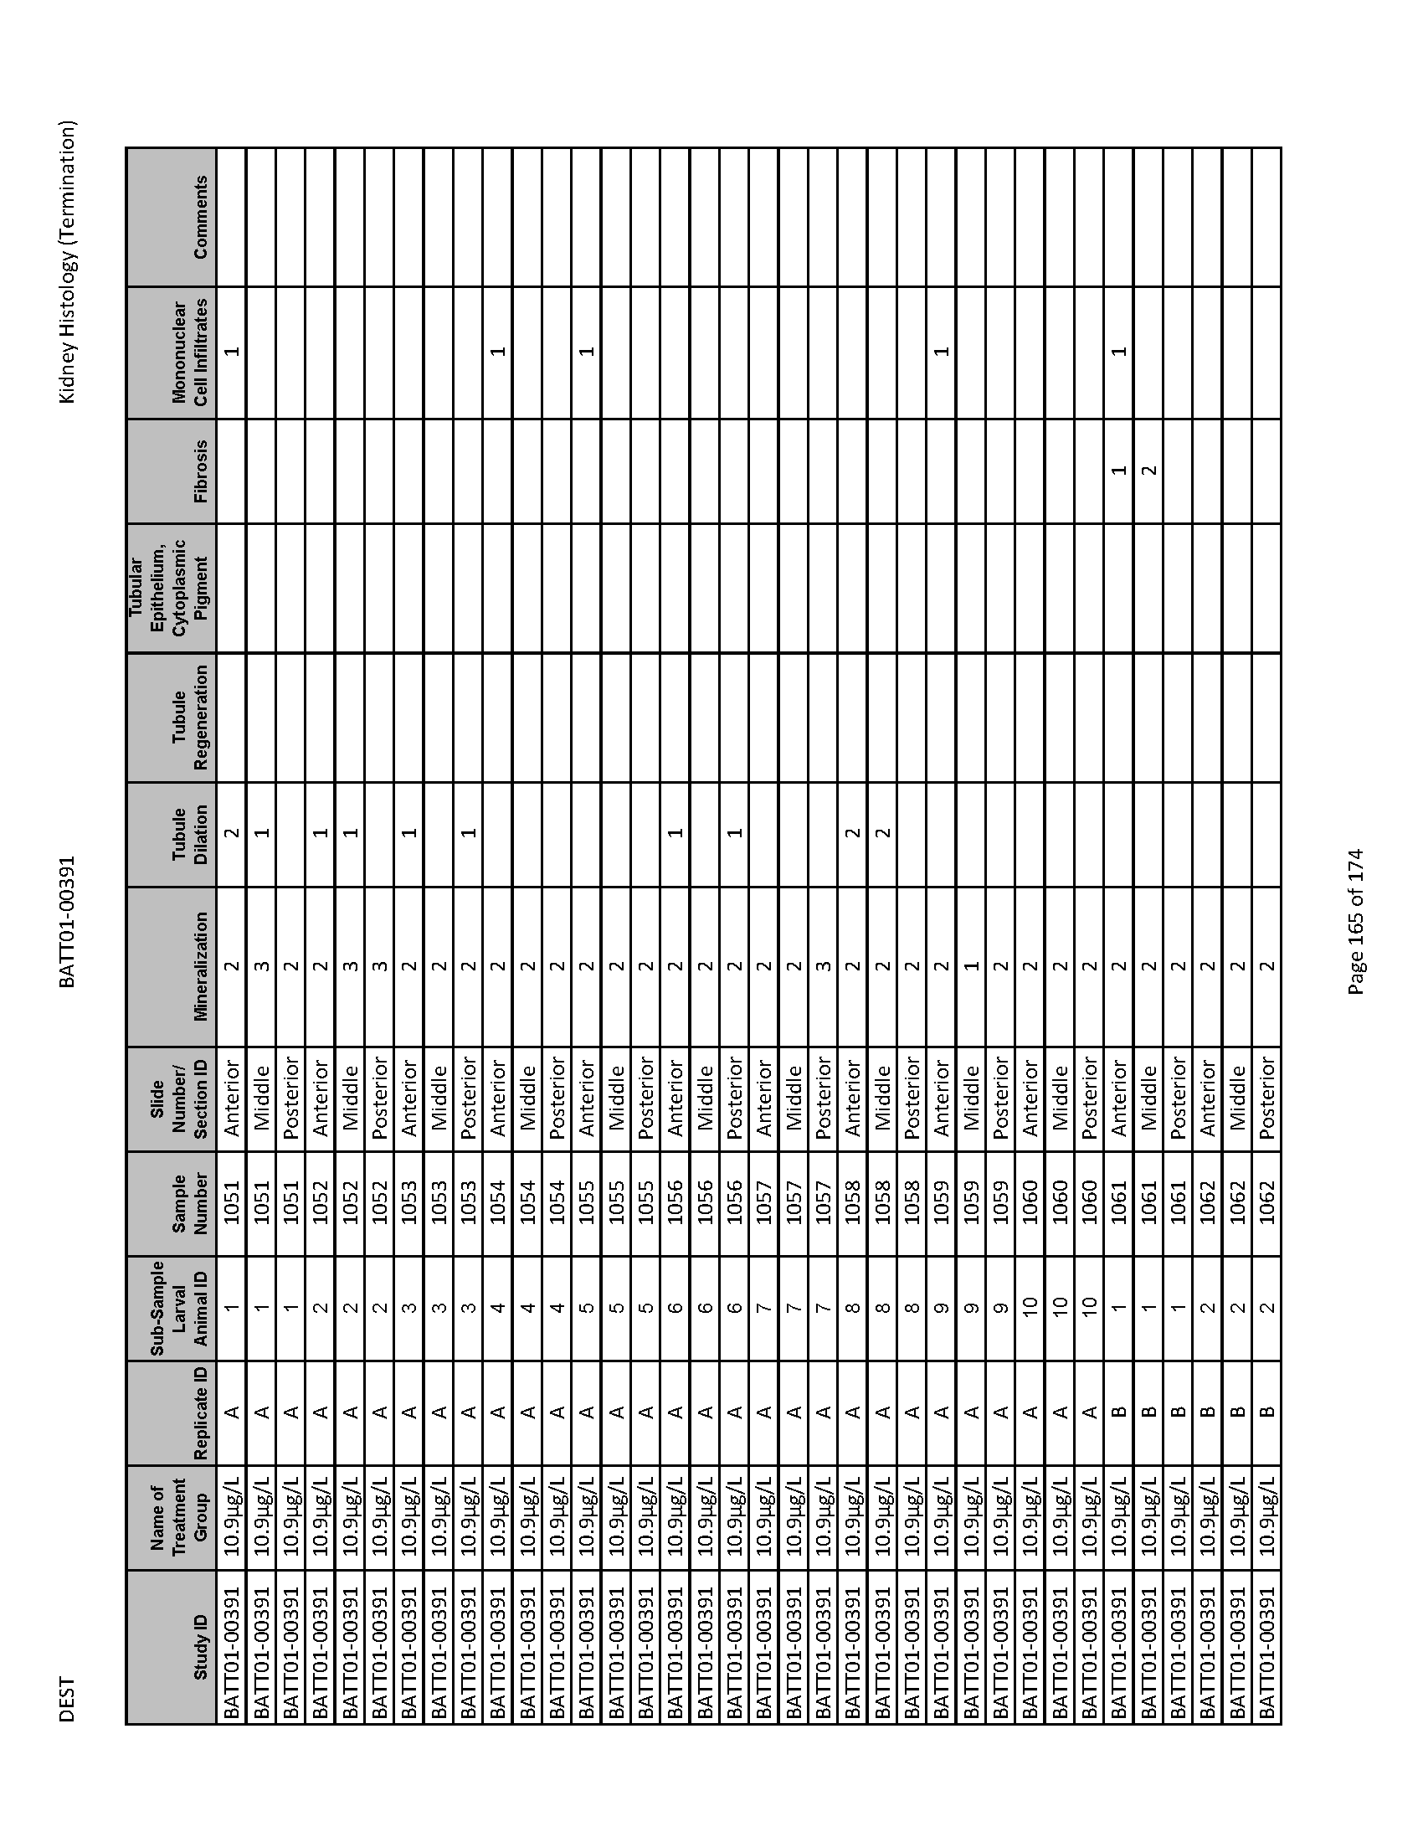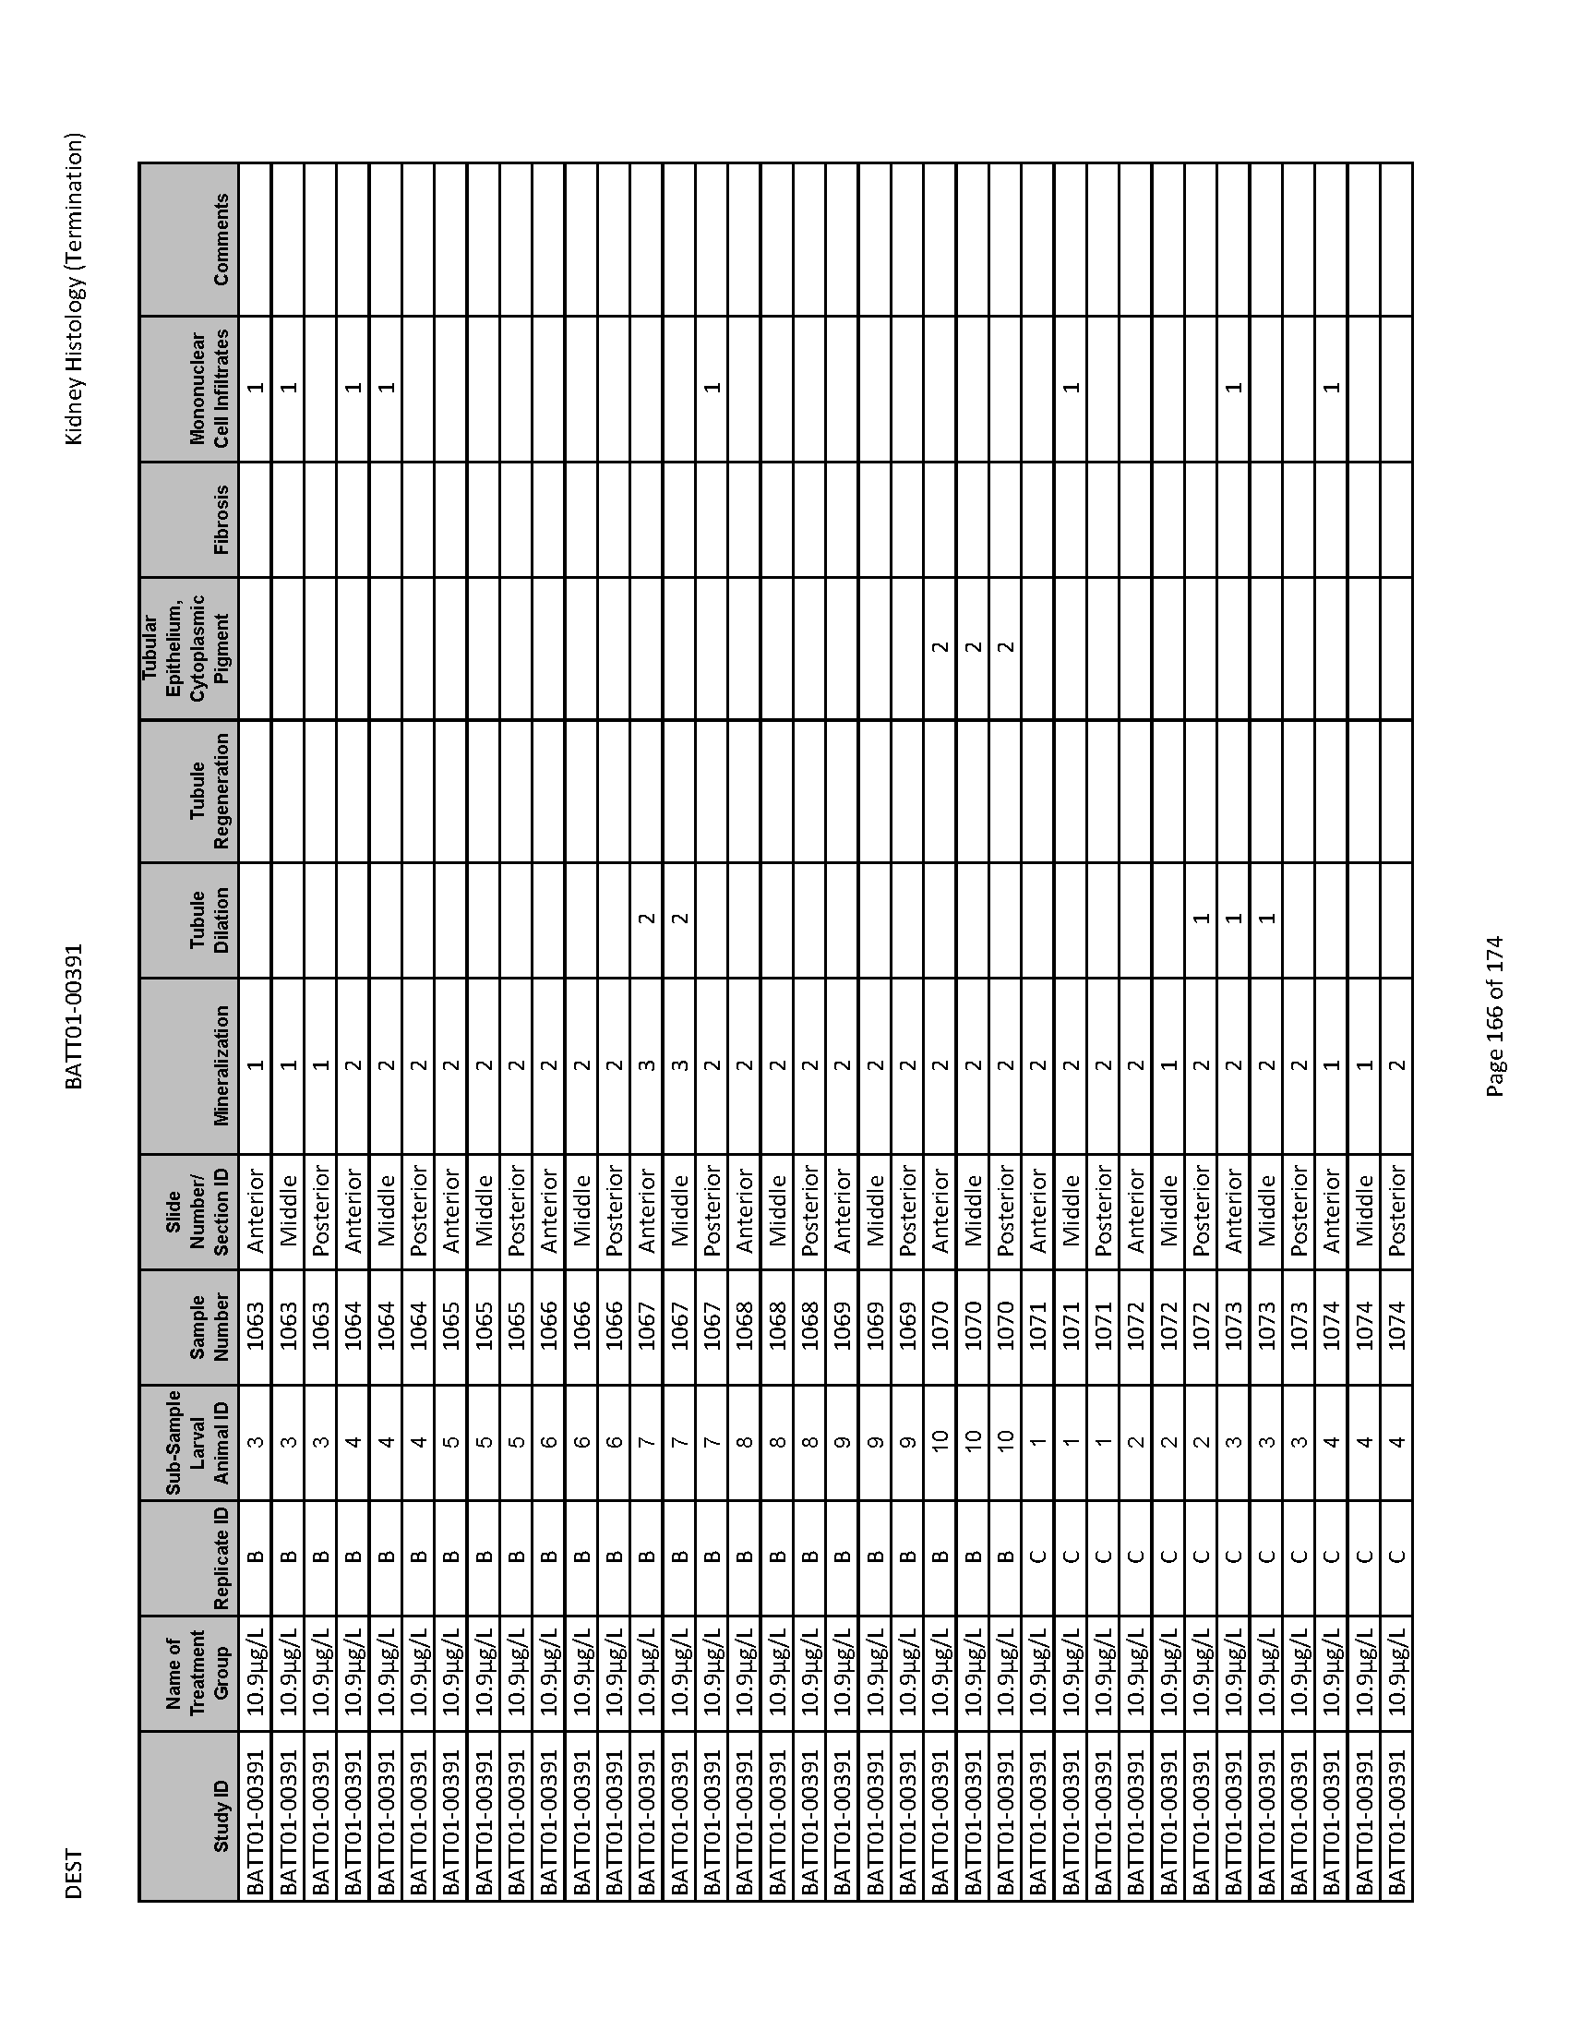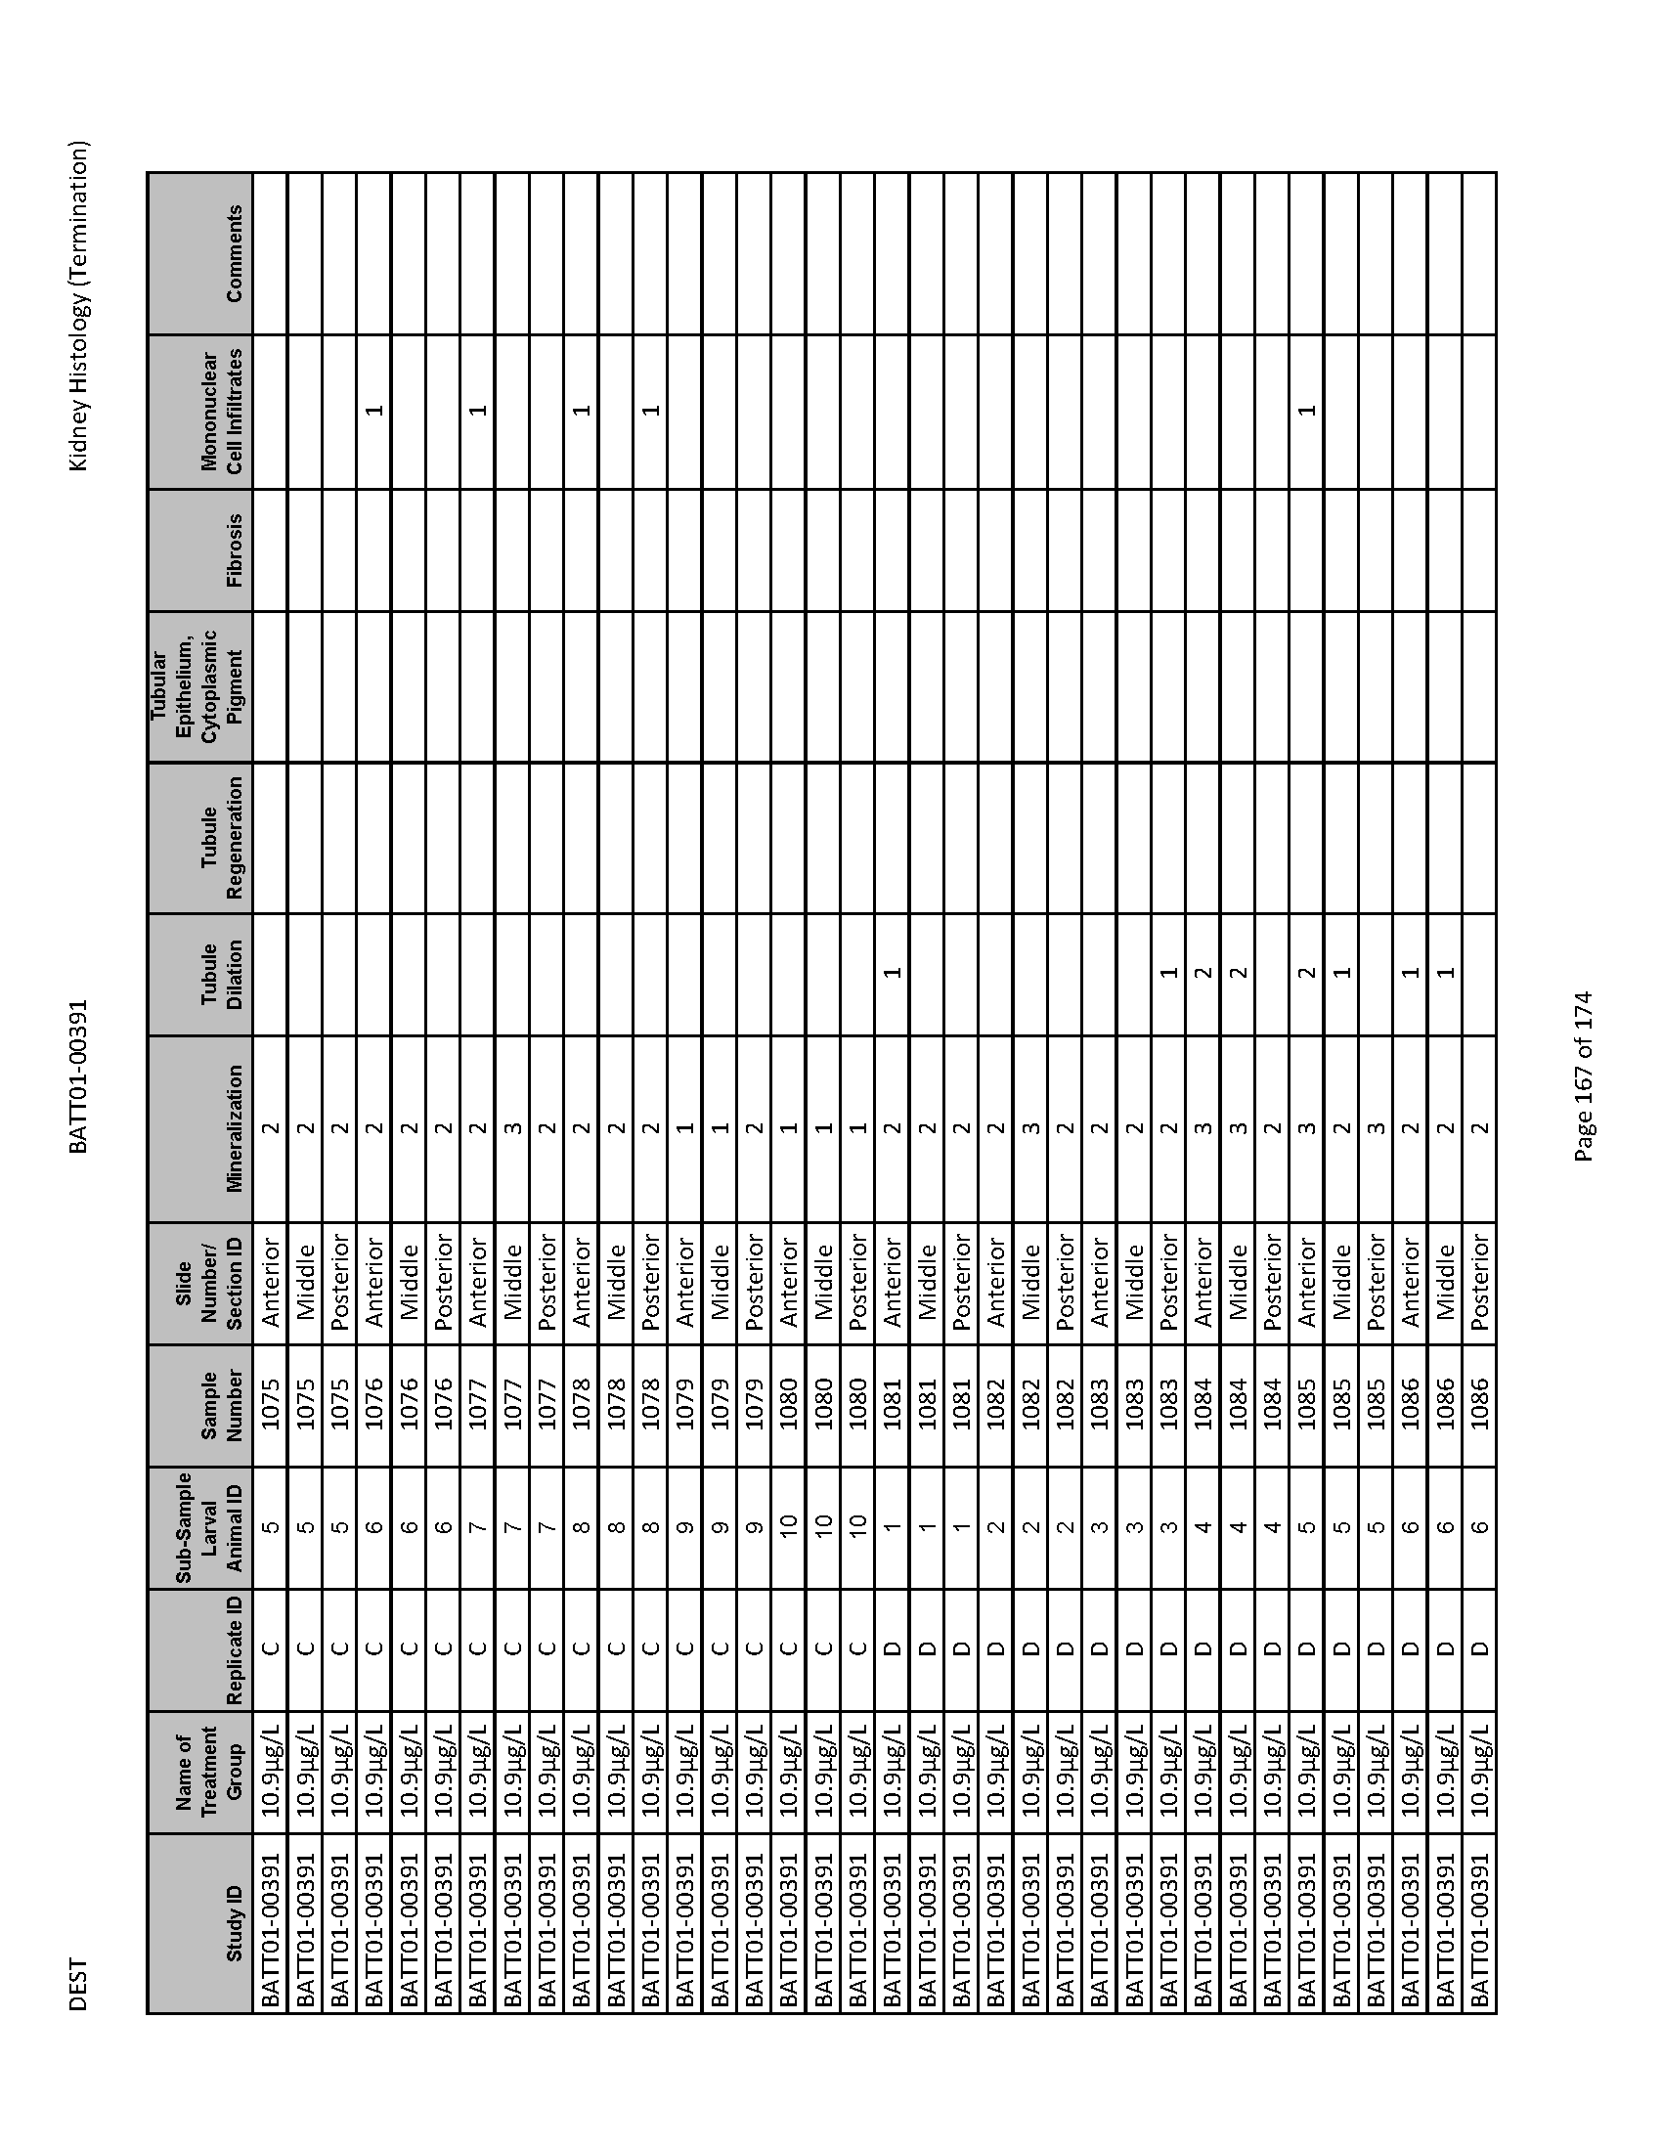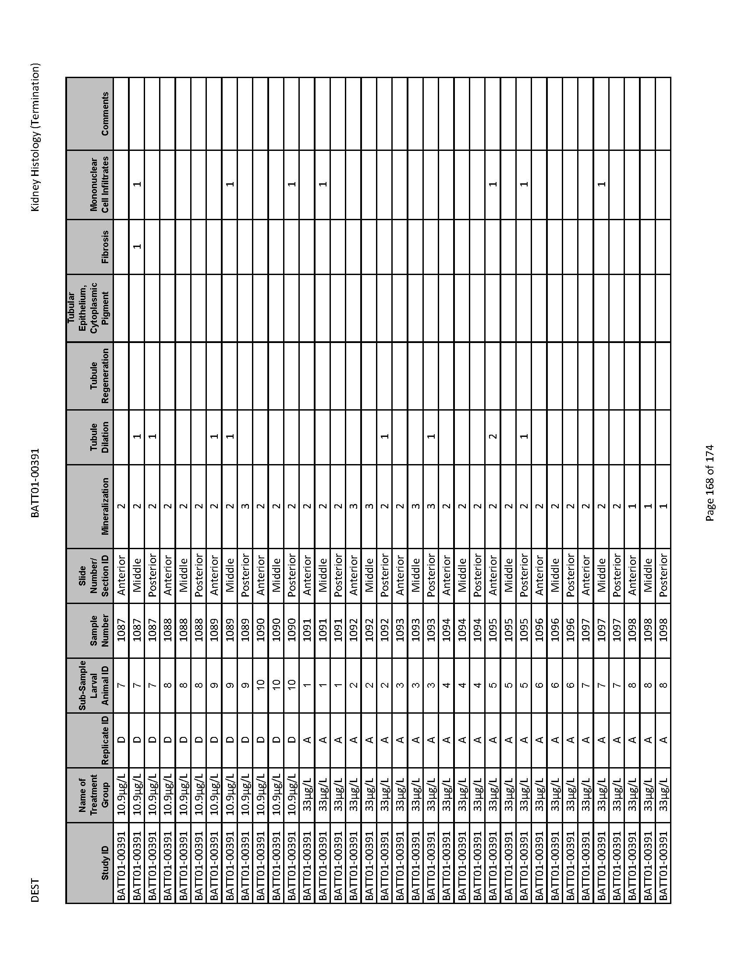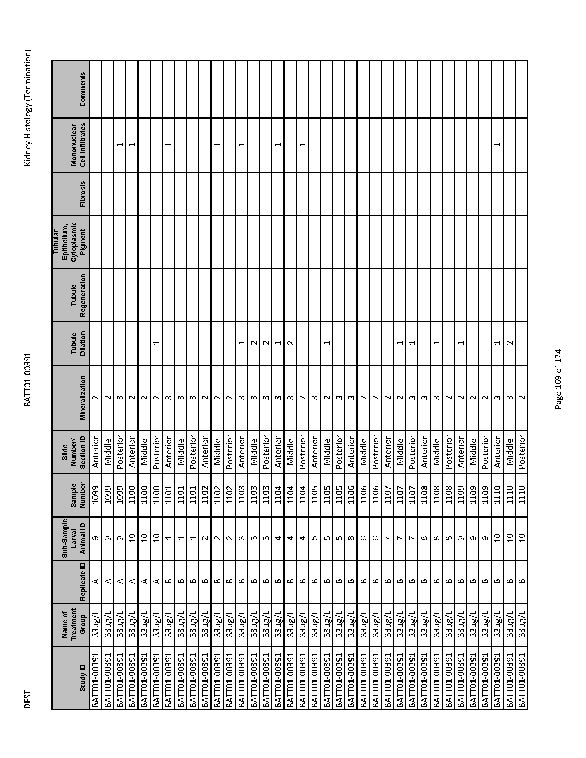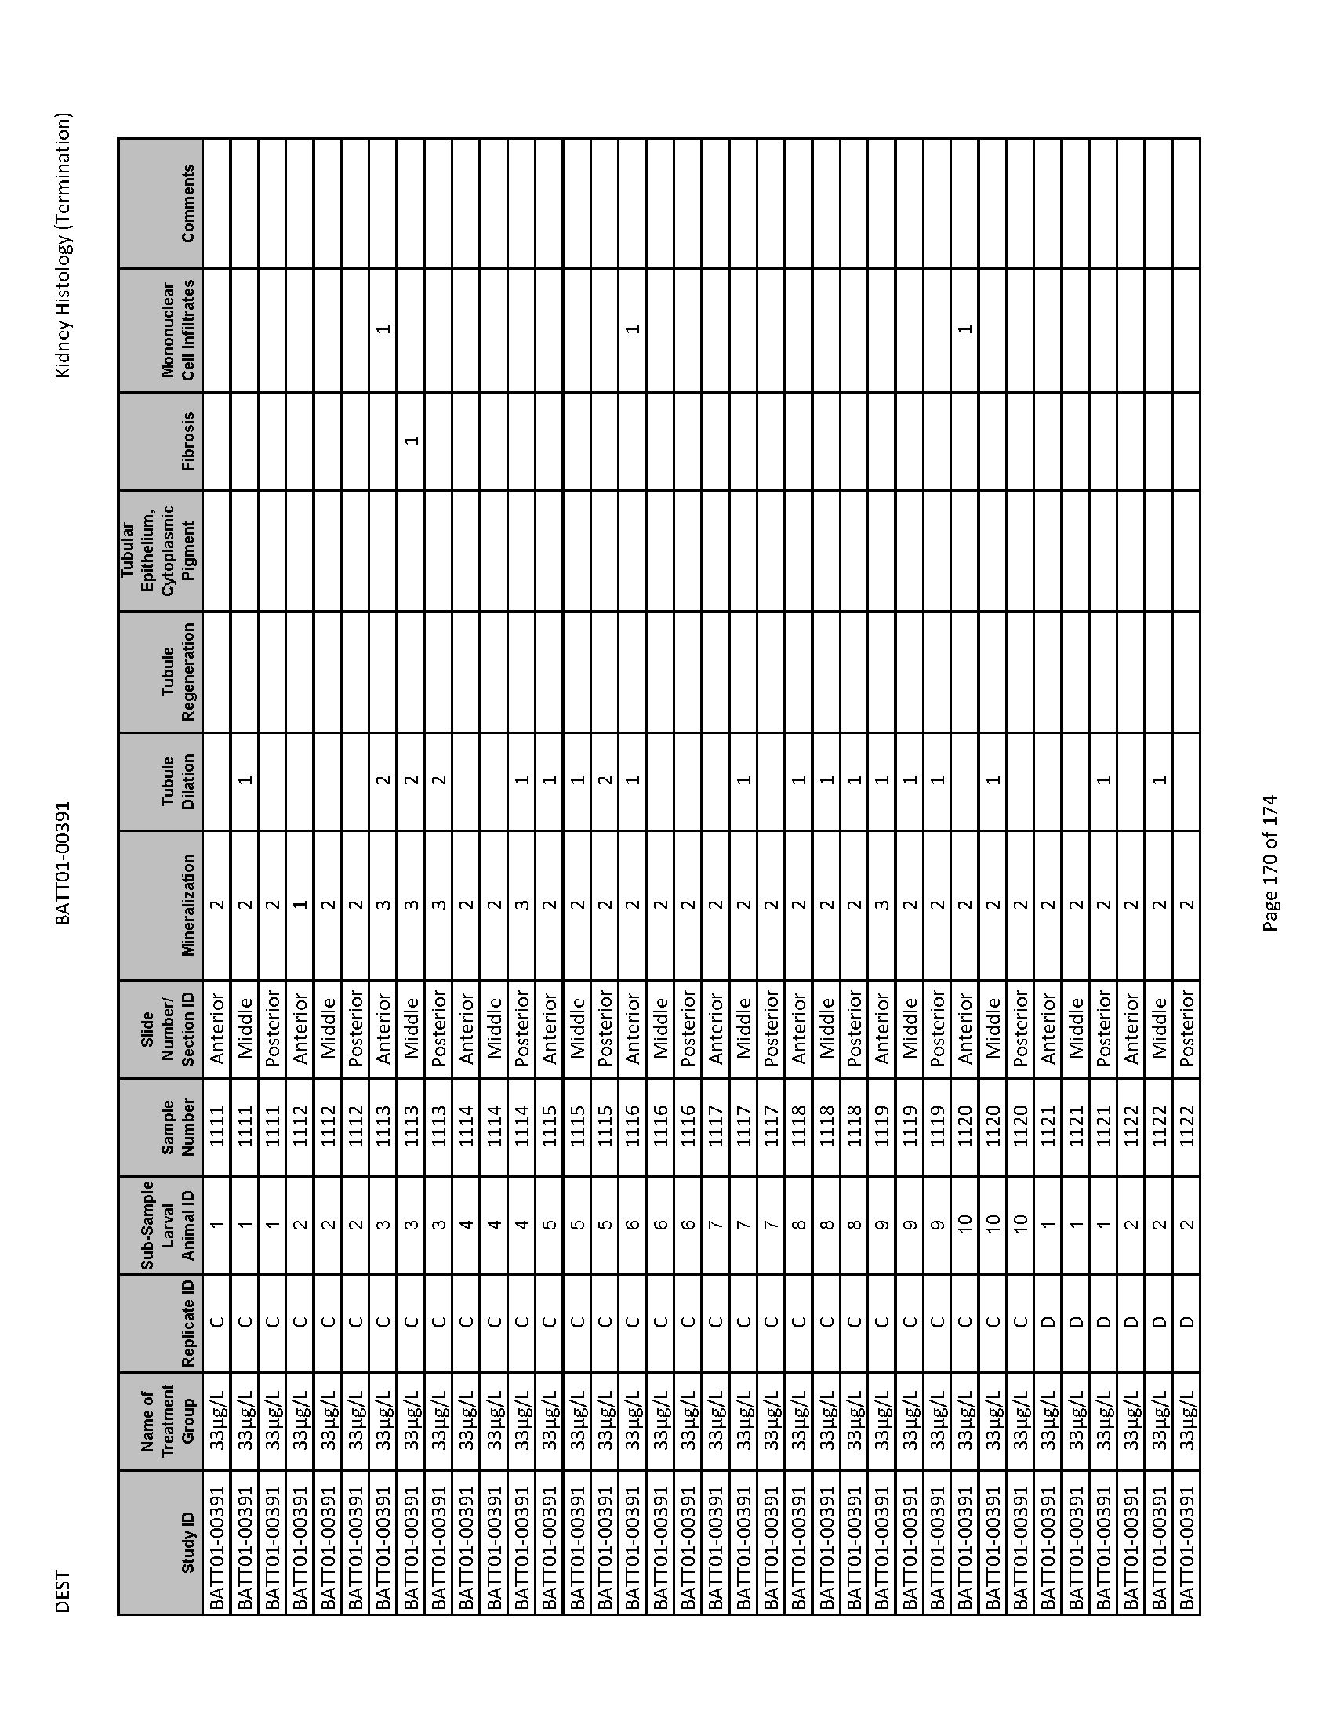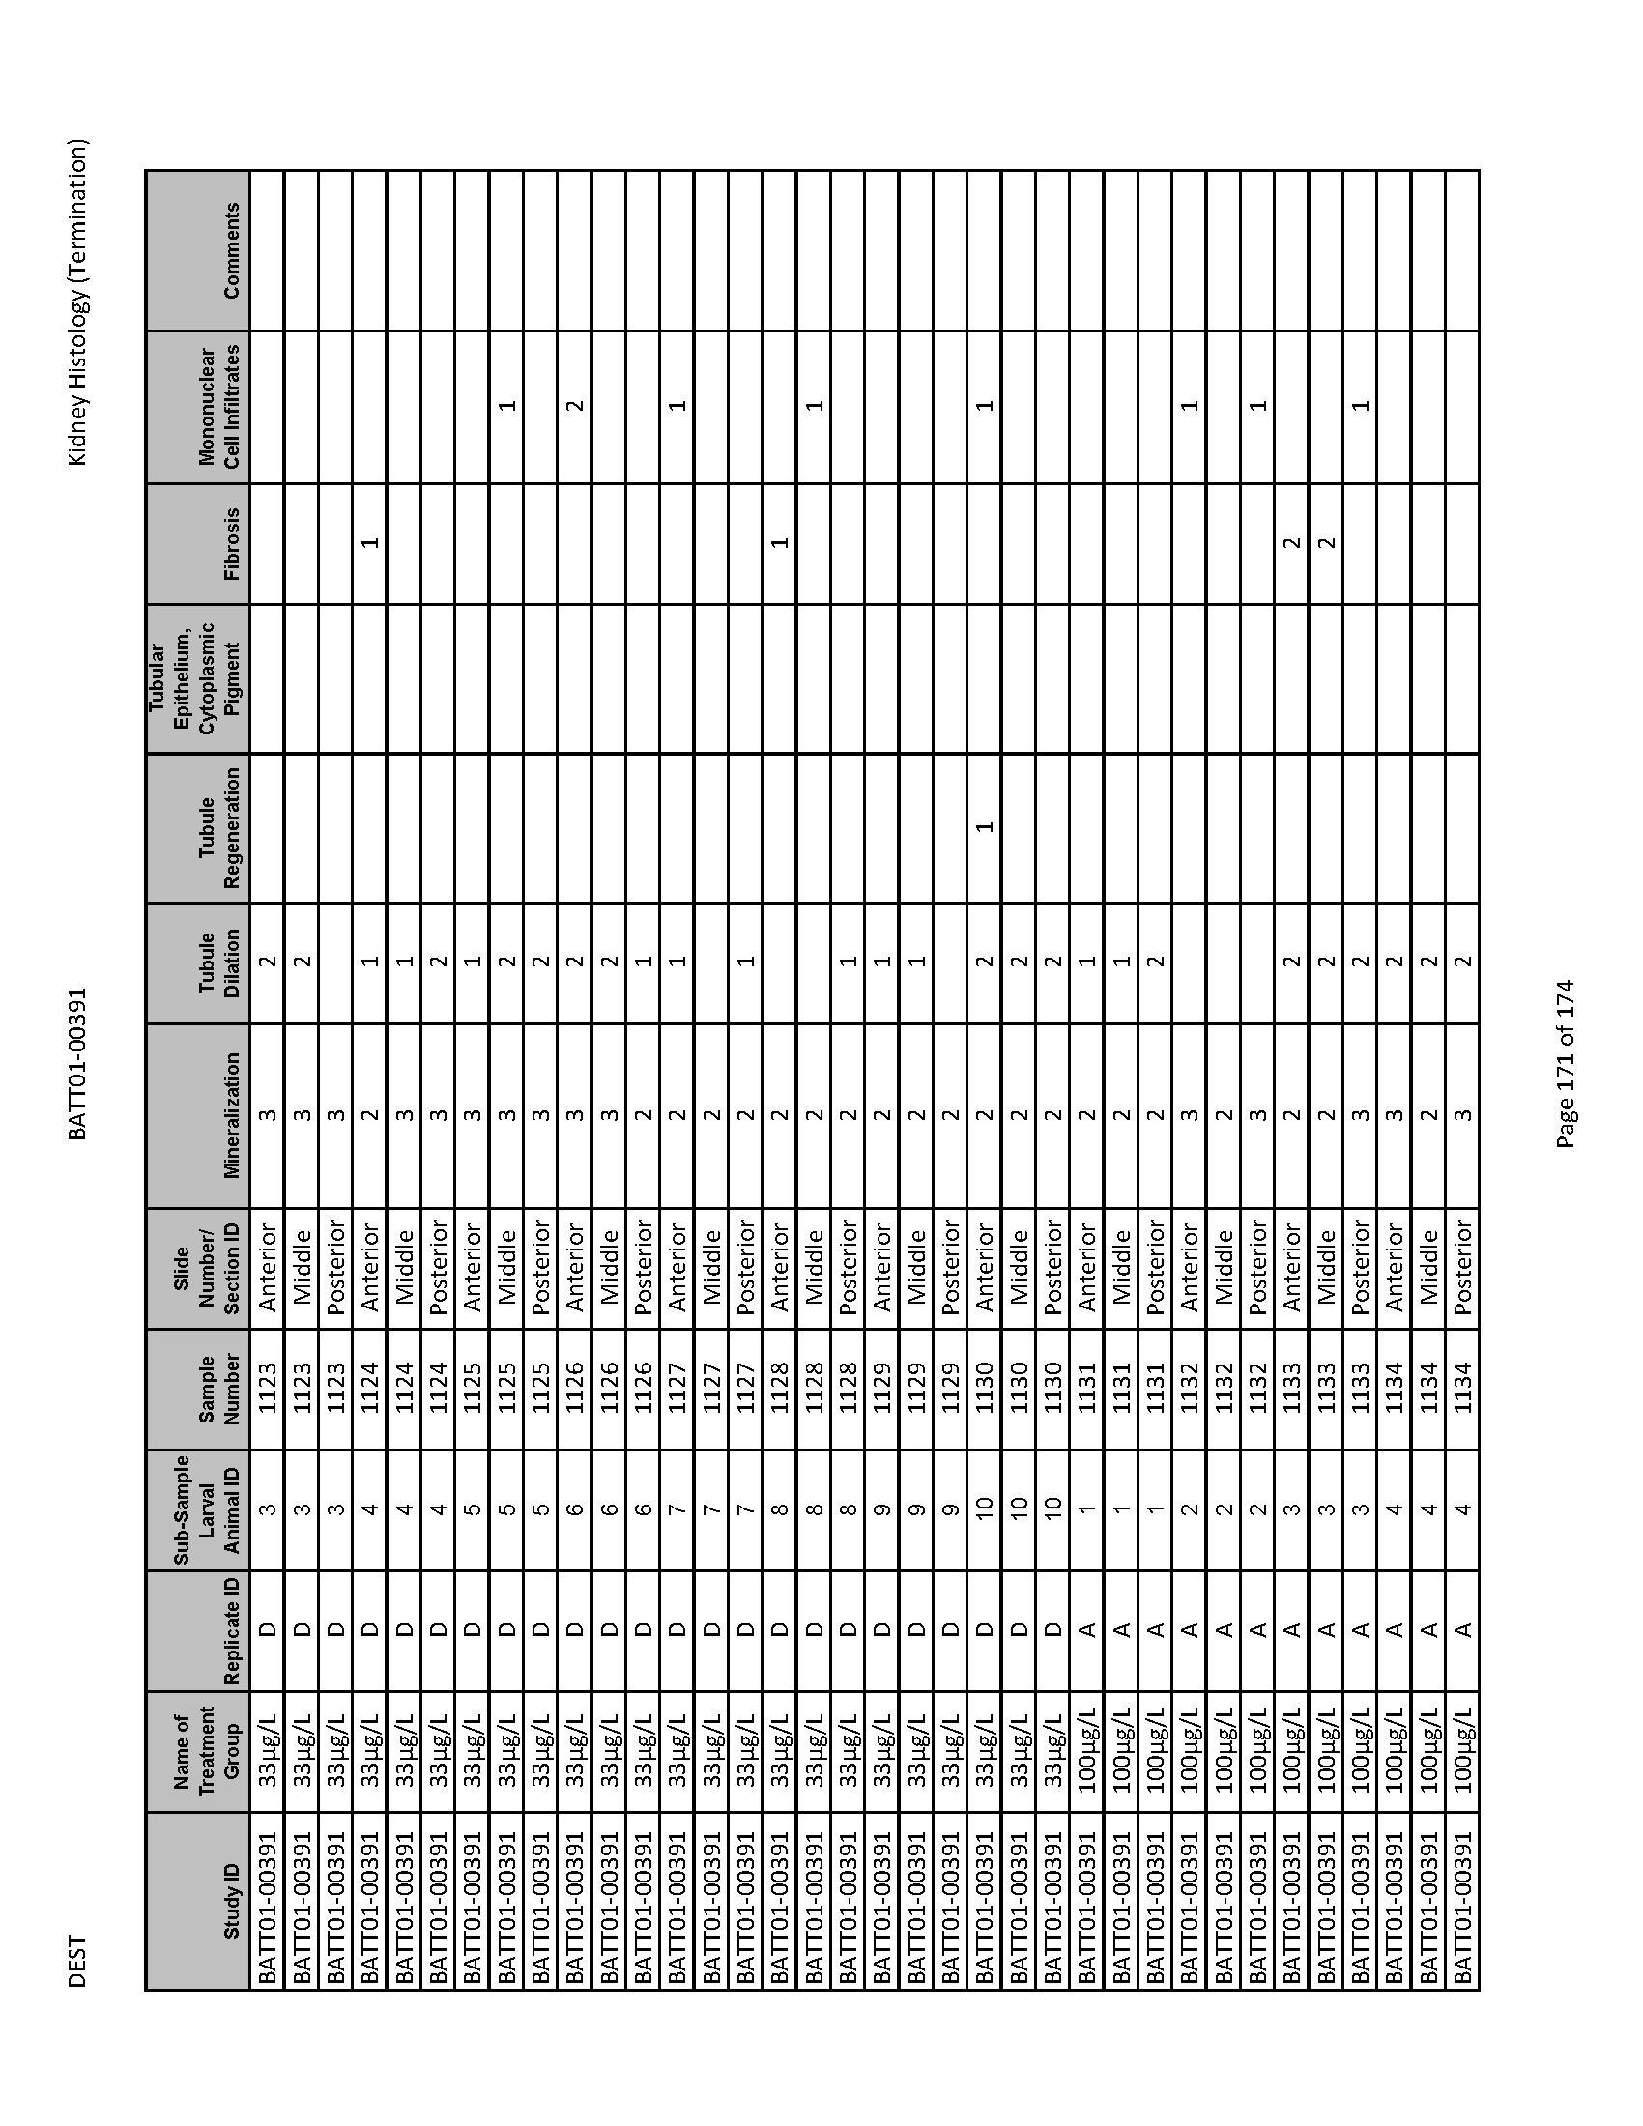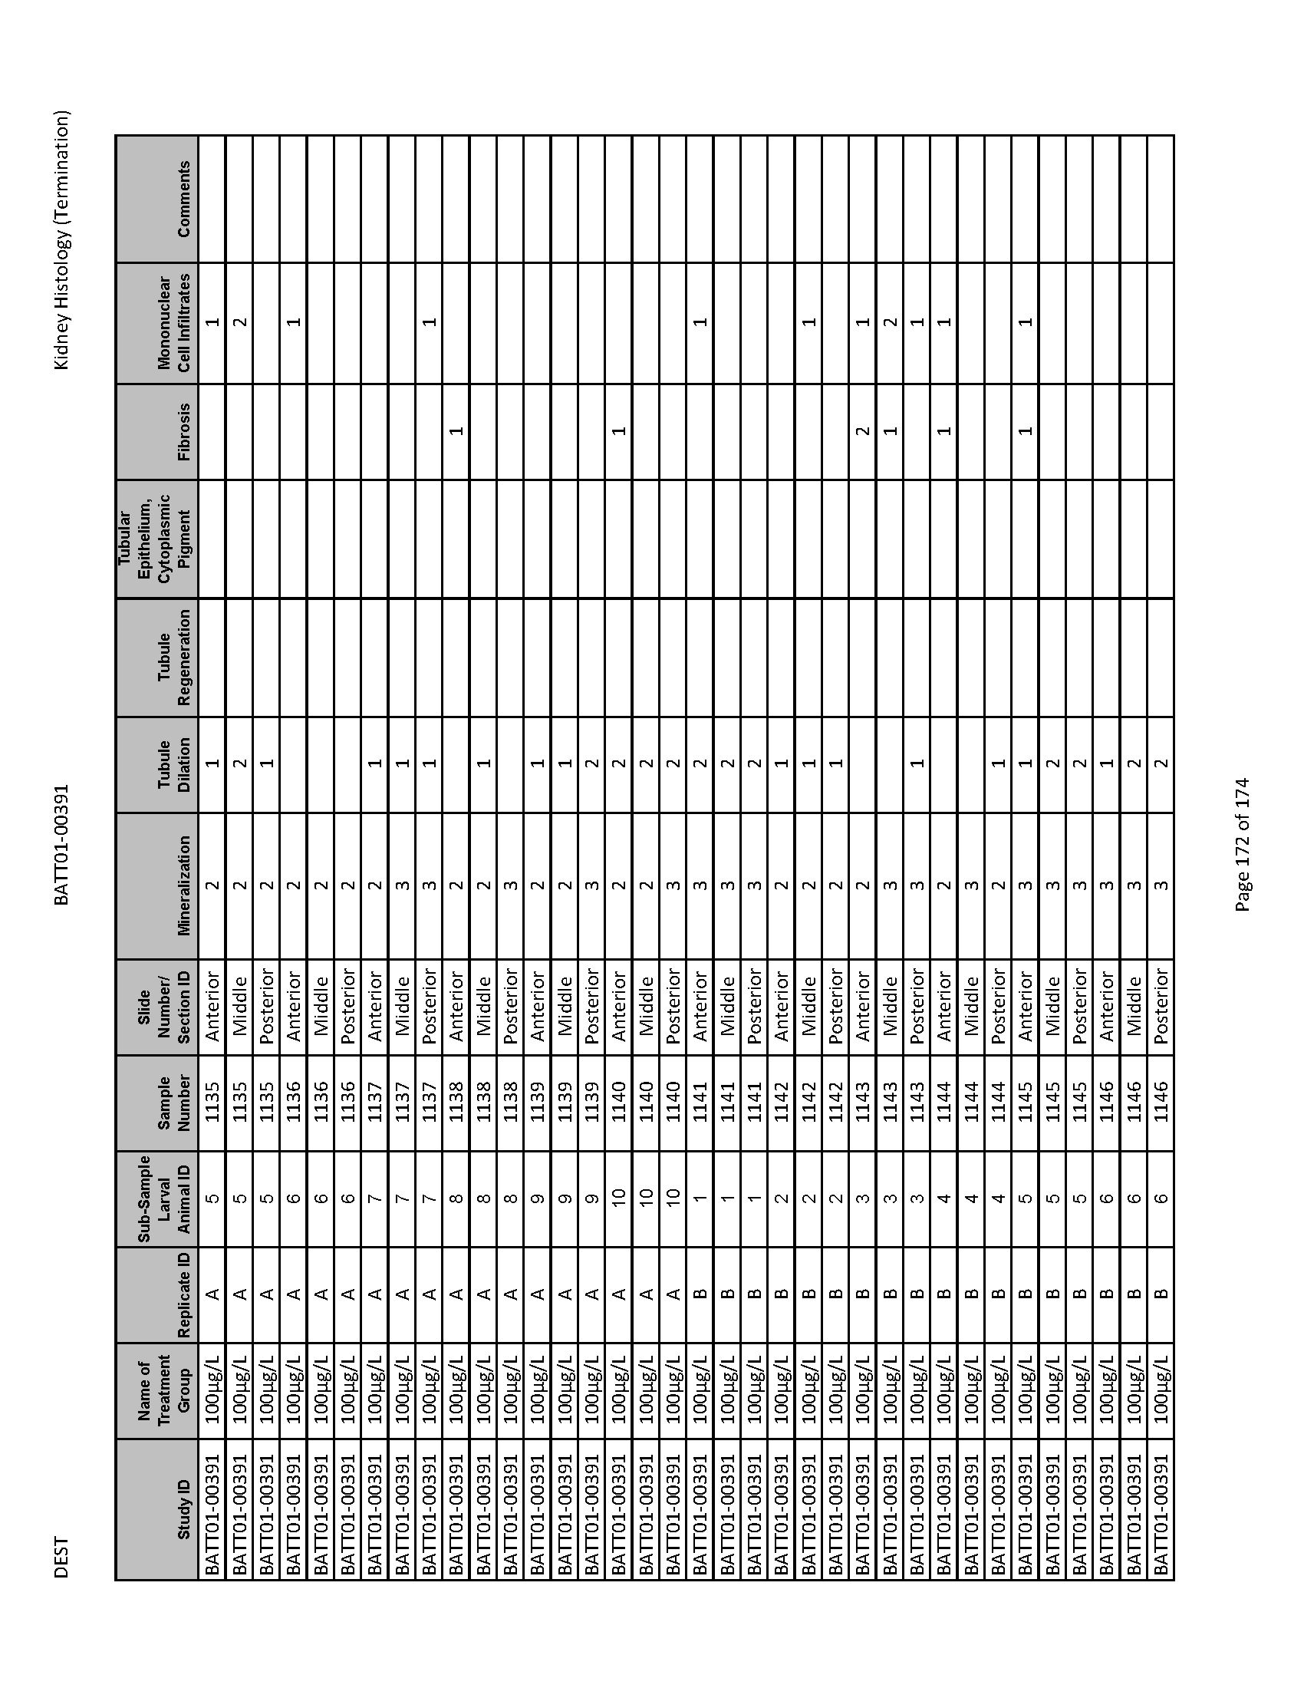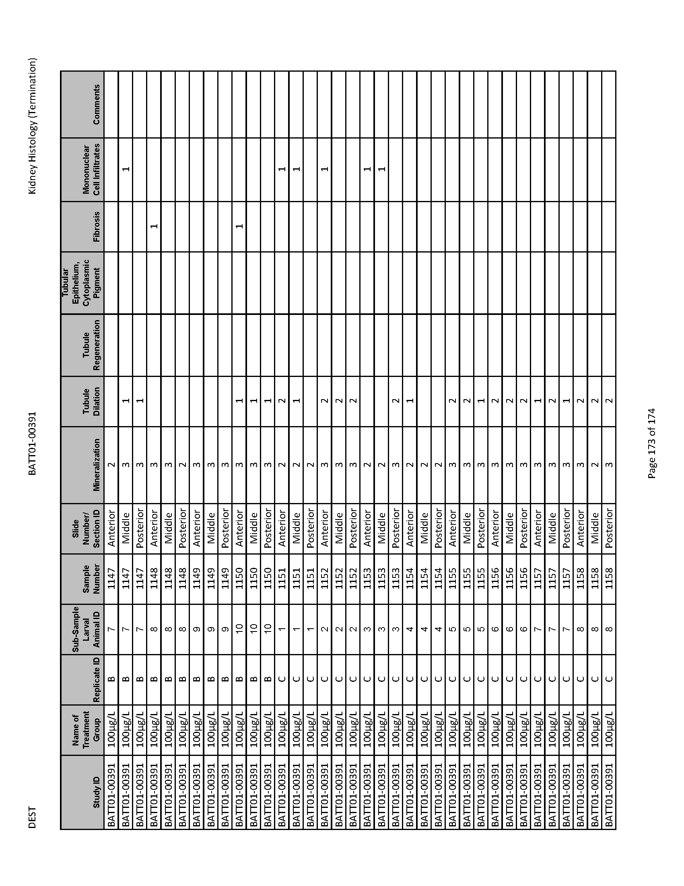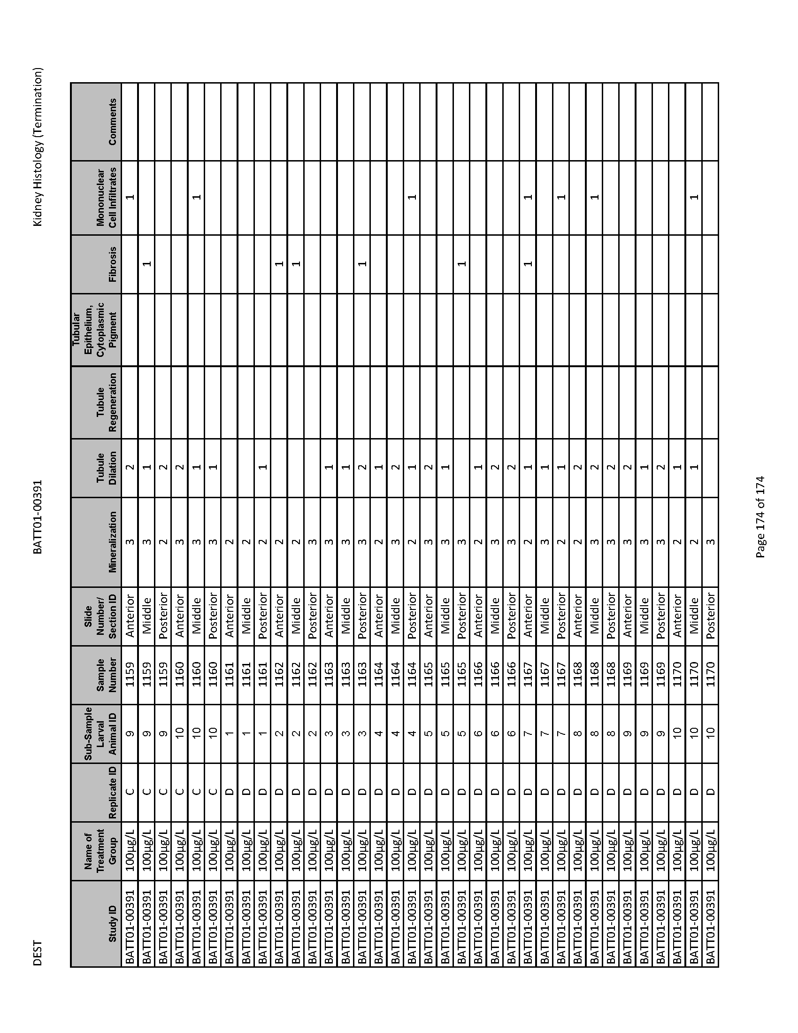

Statistical Analyses

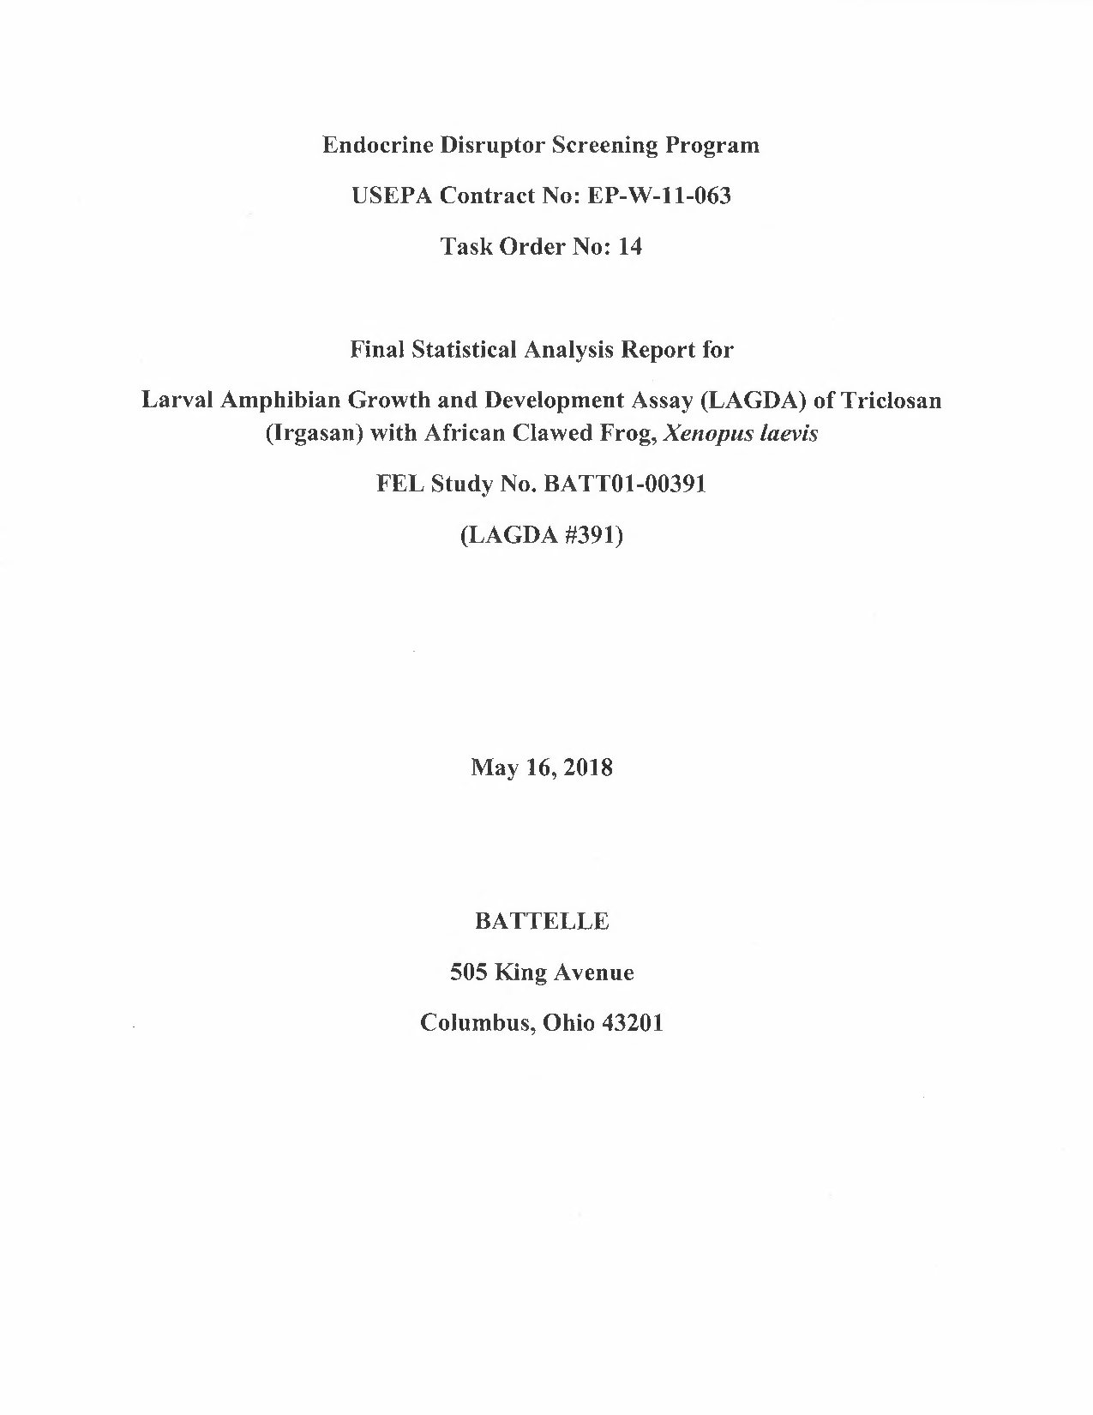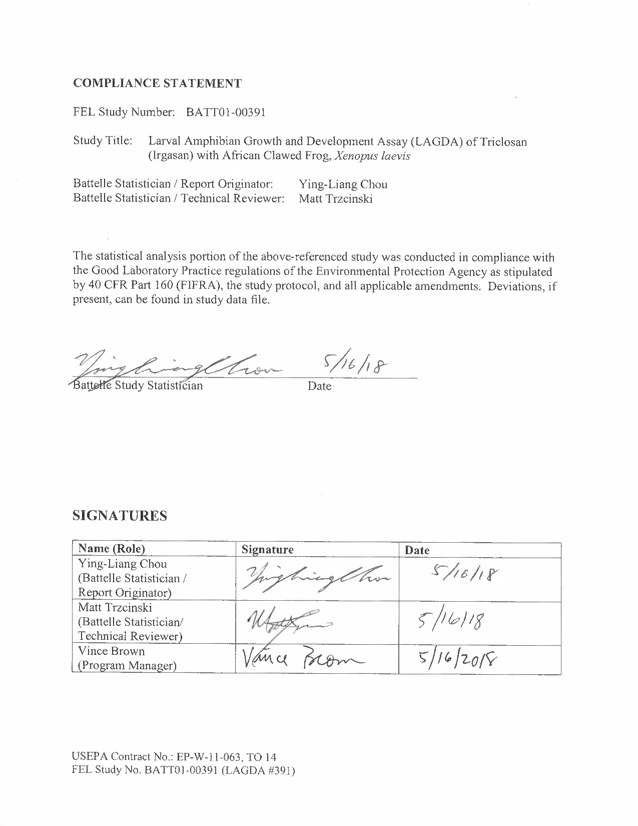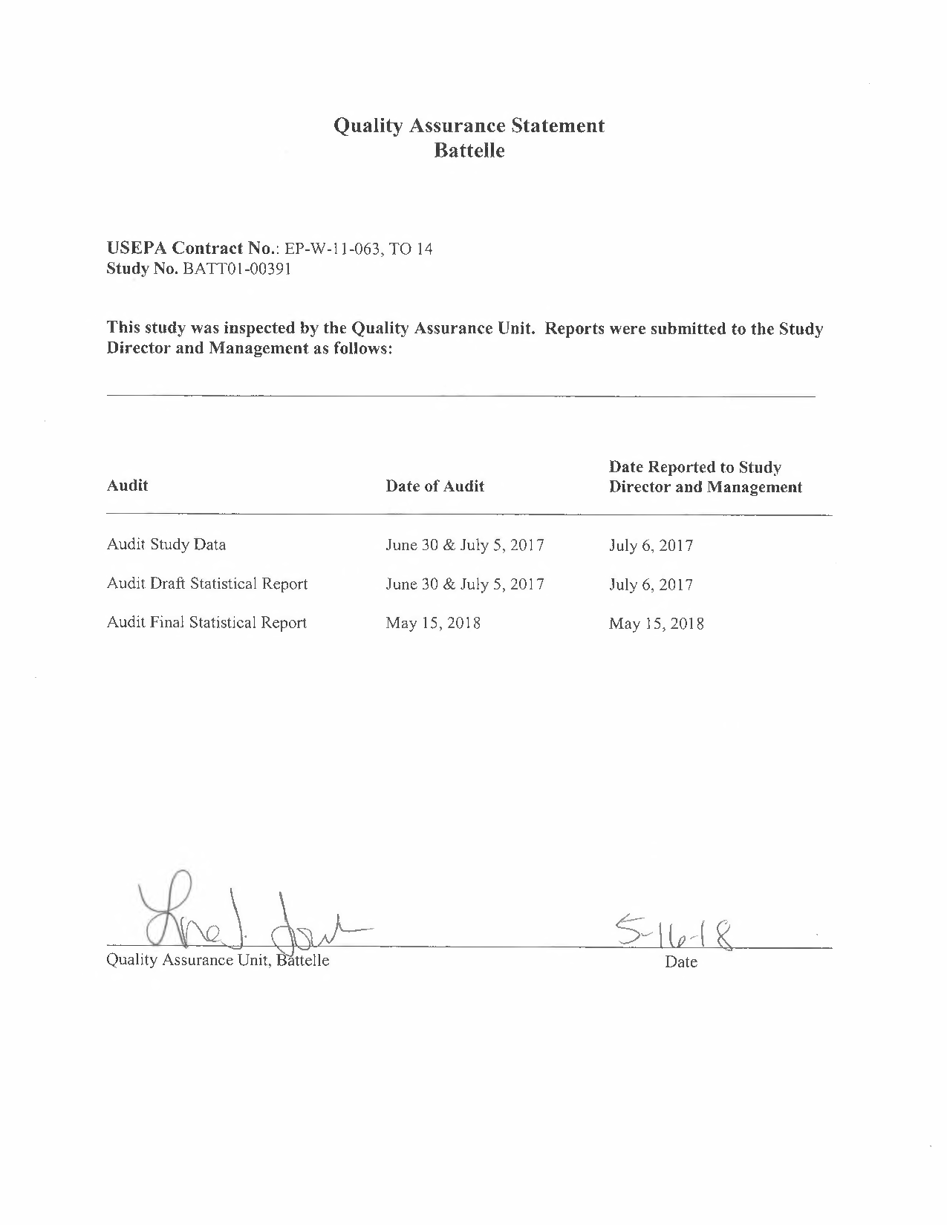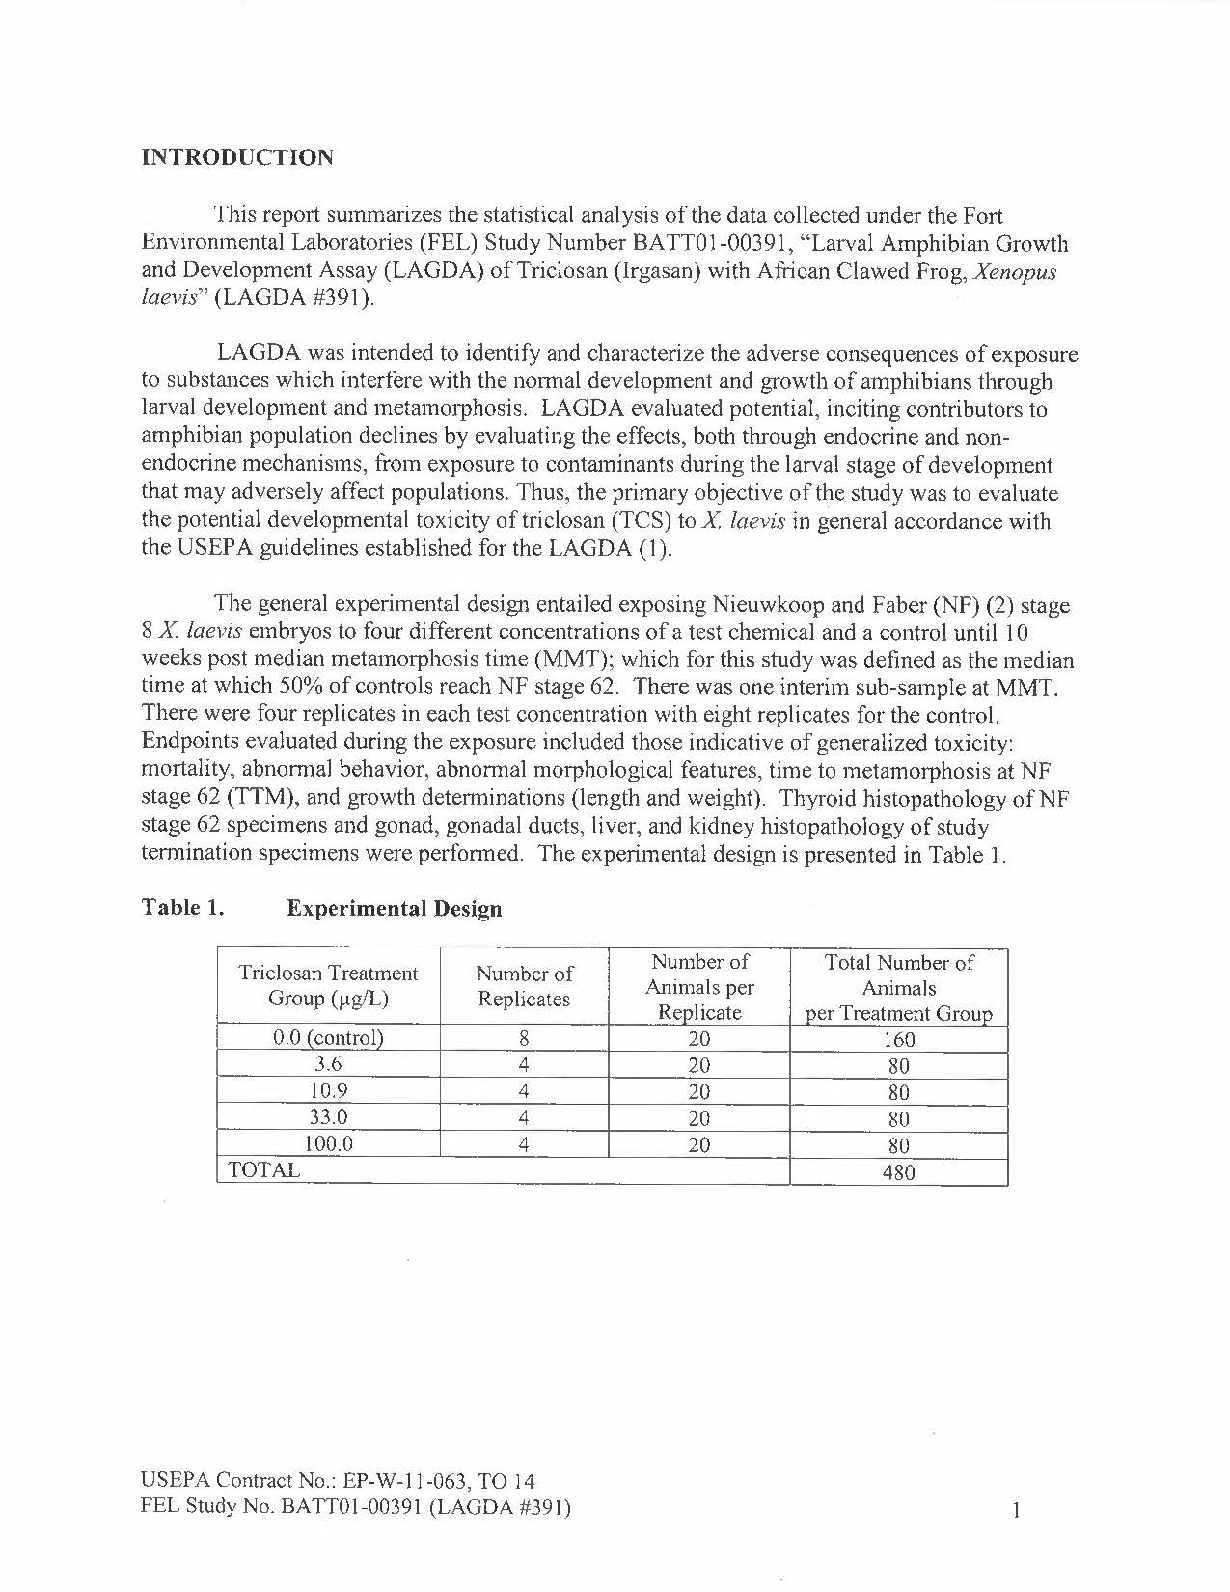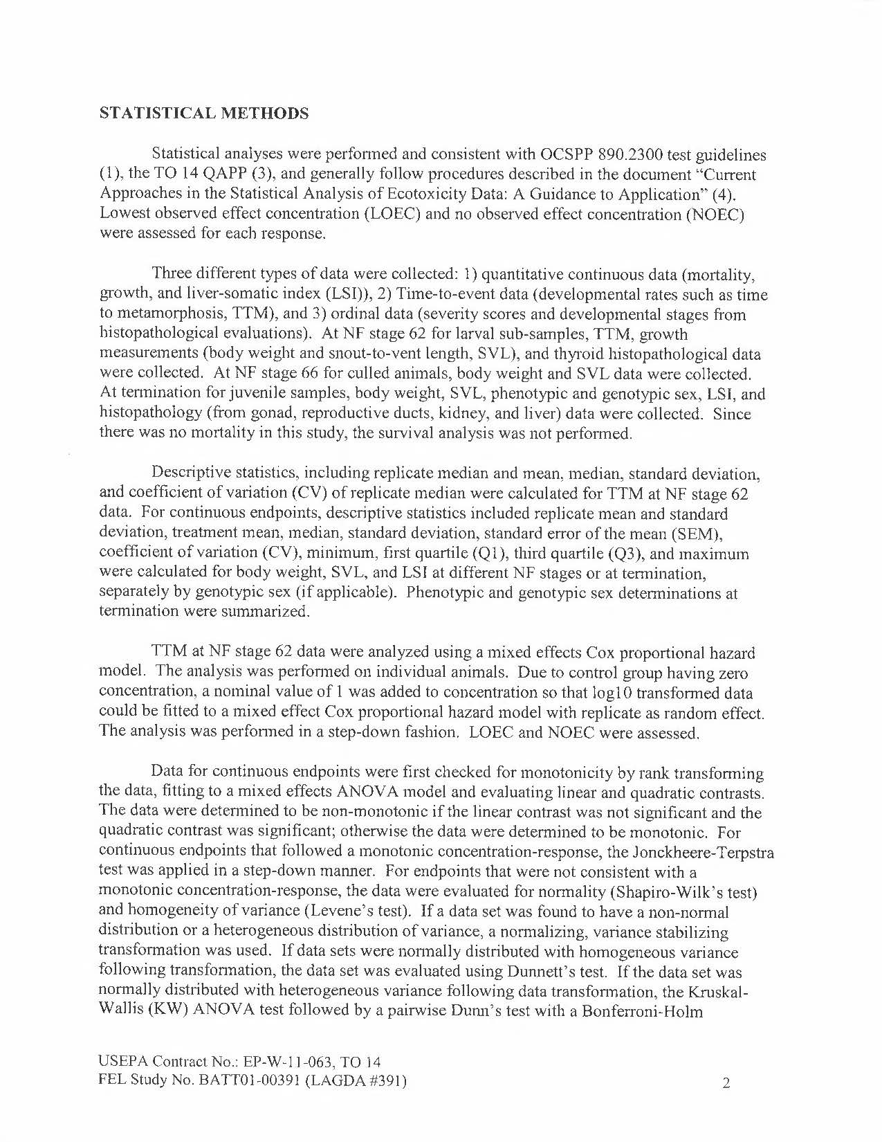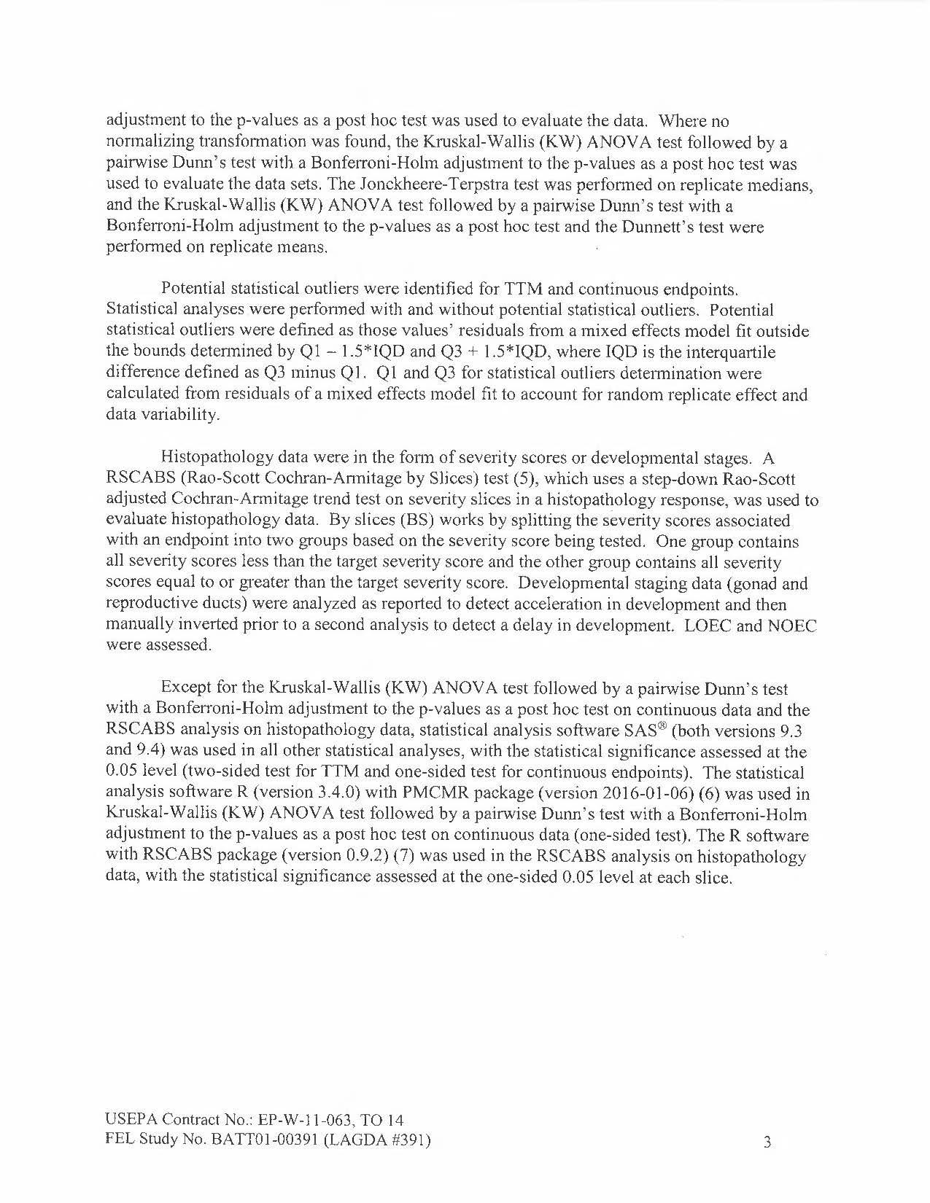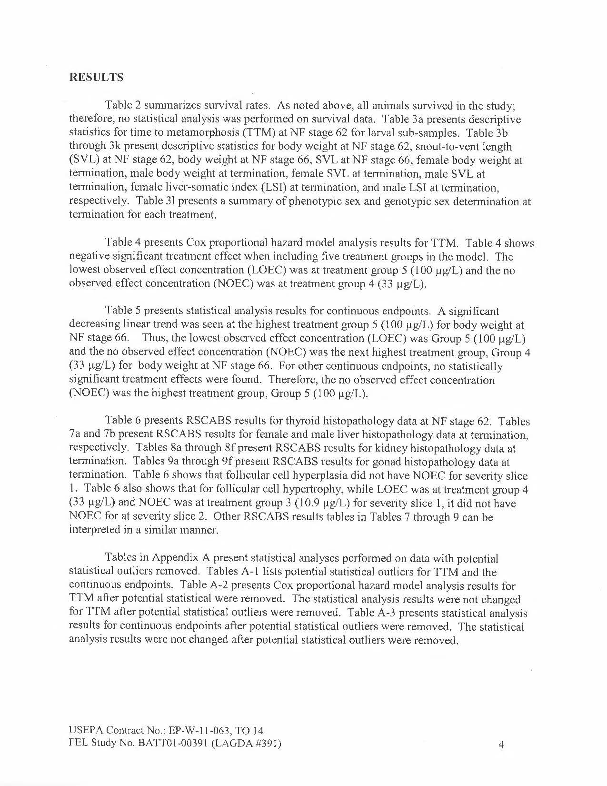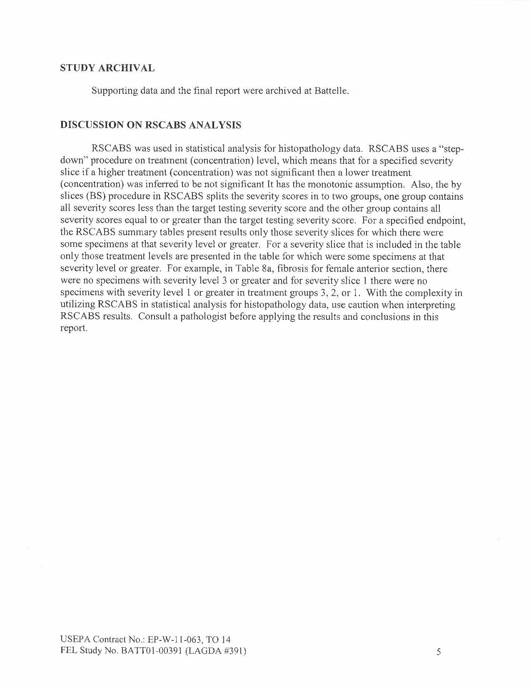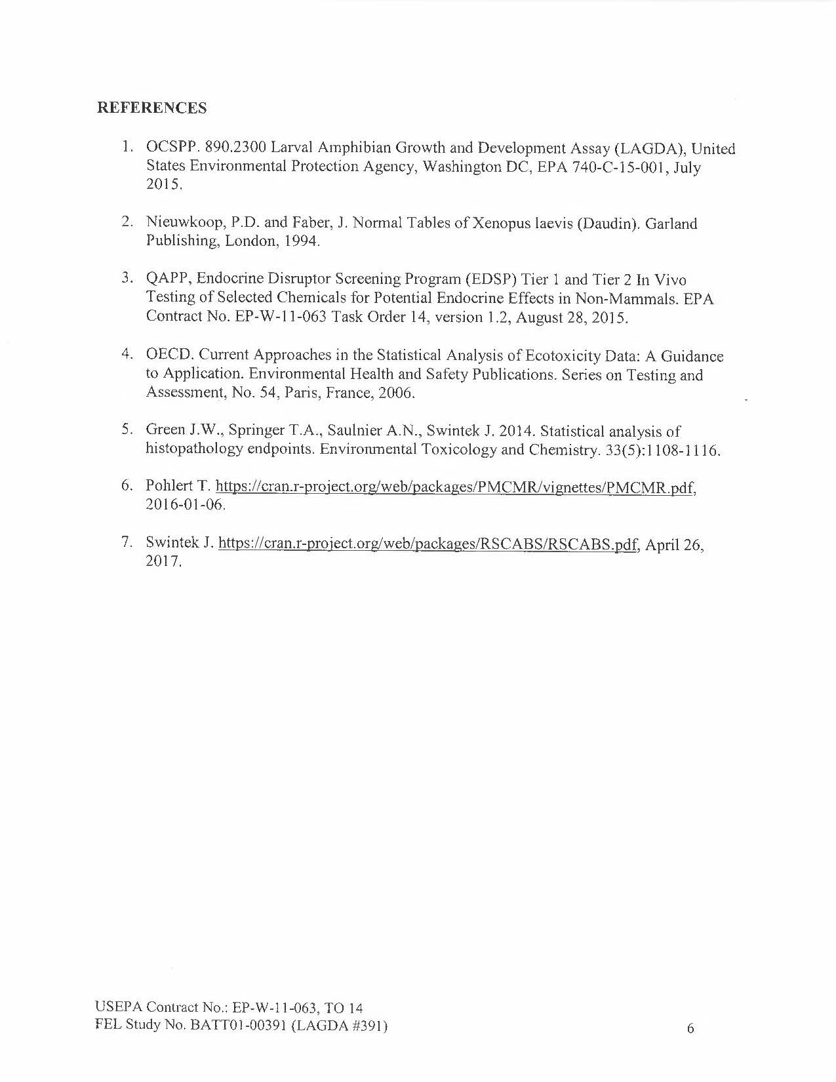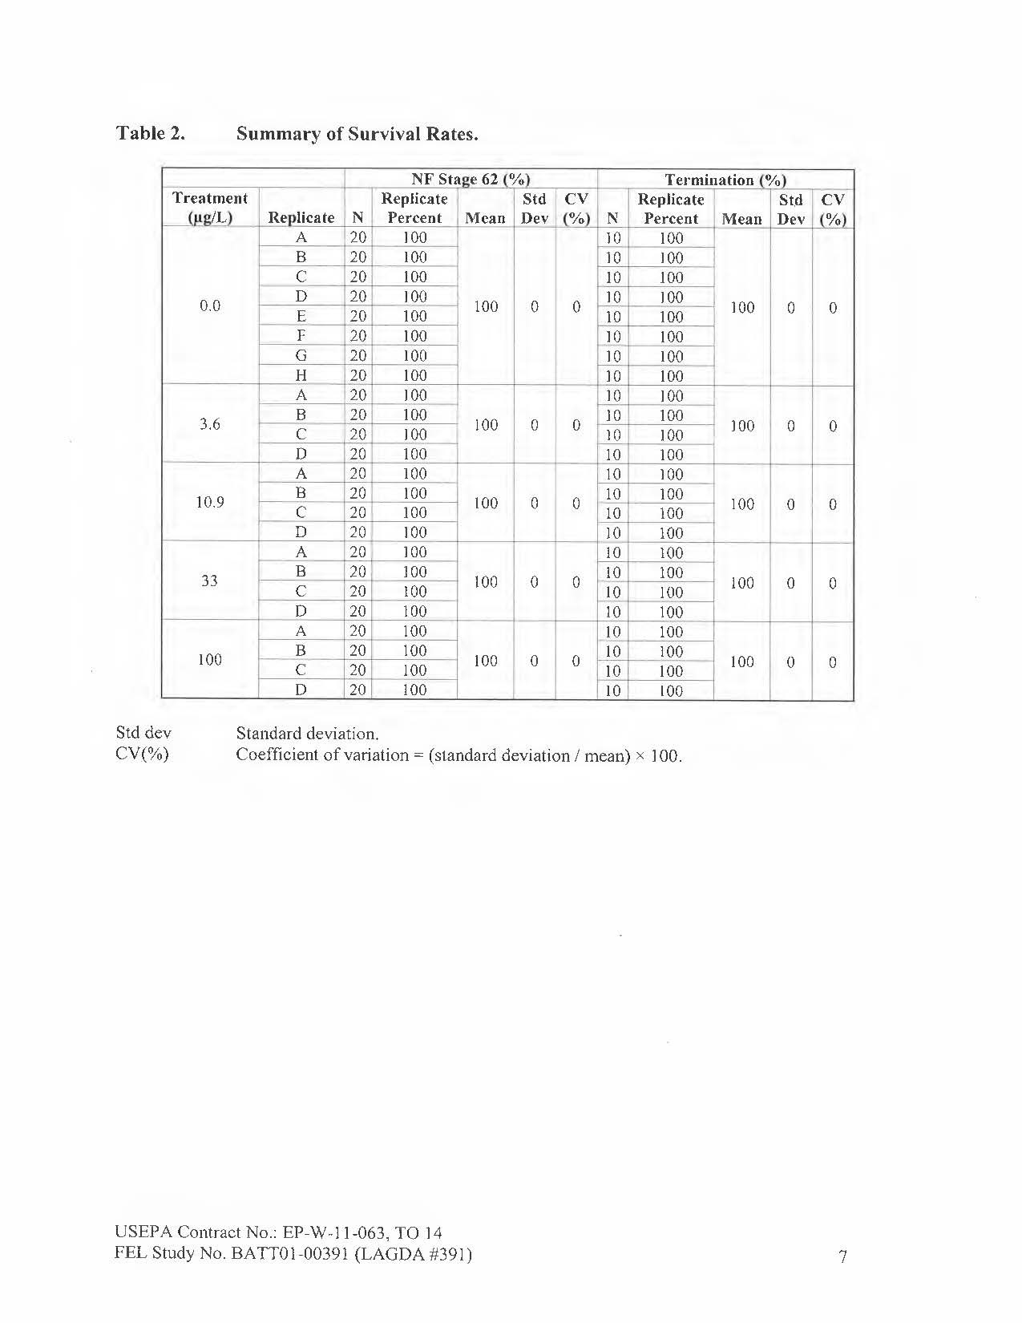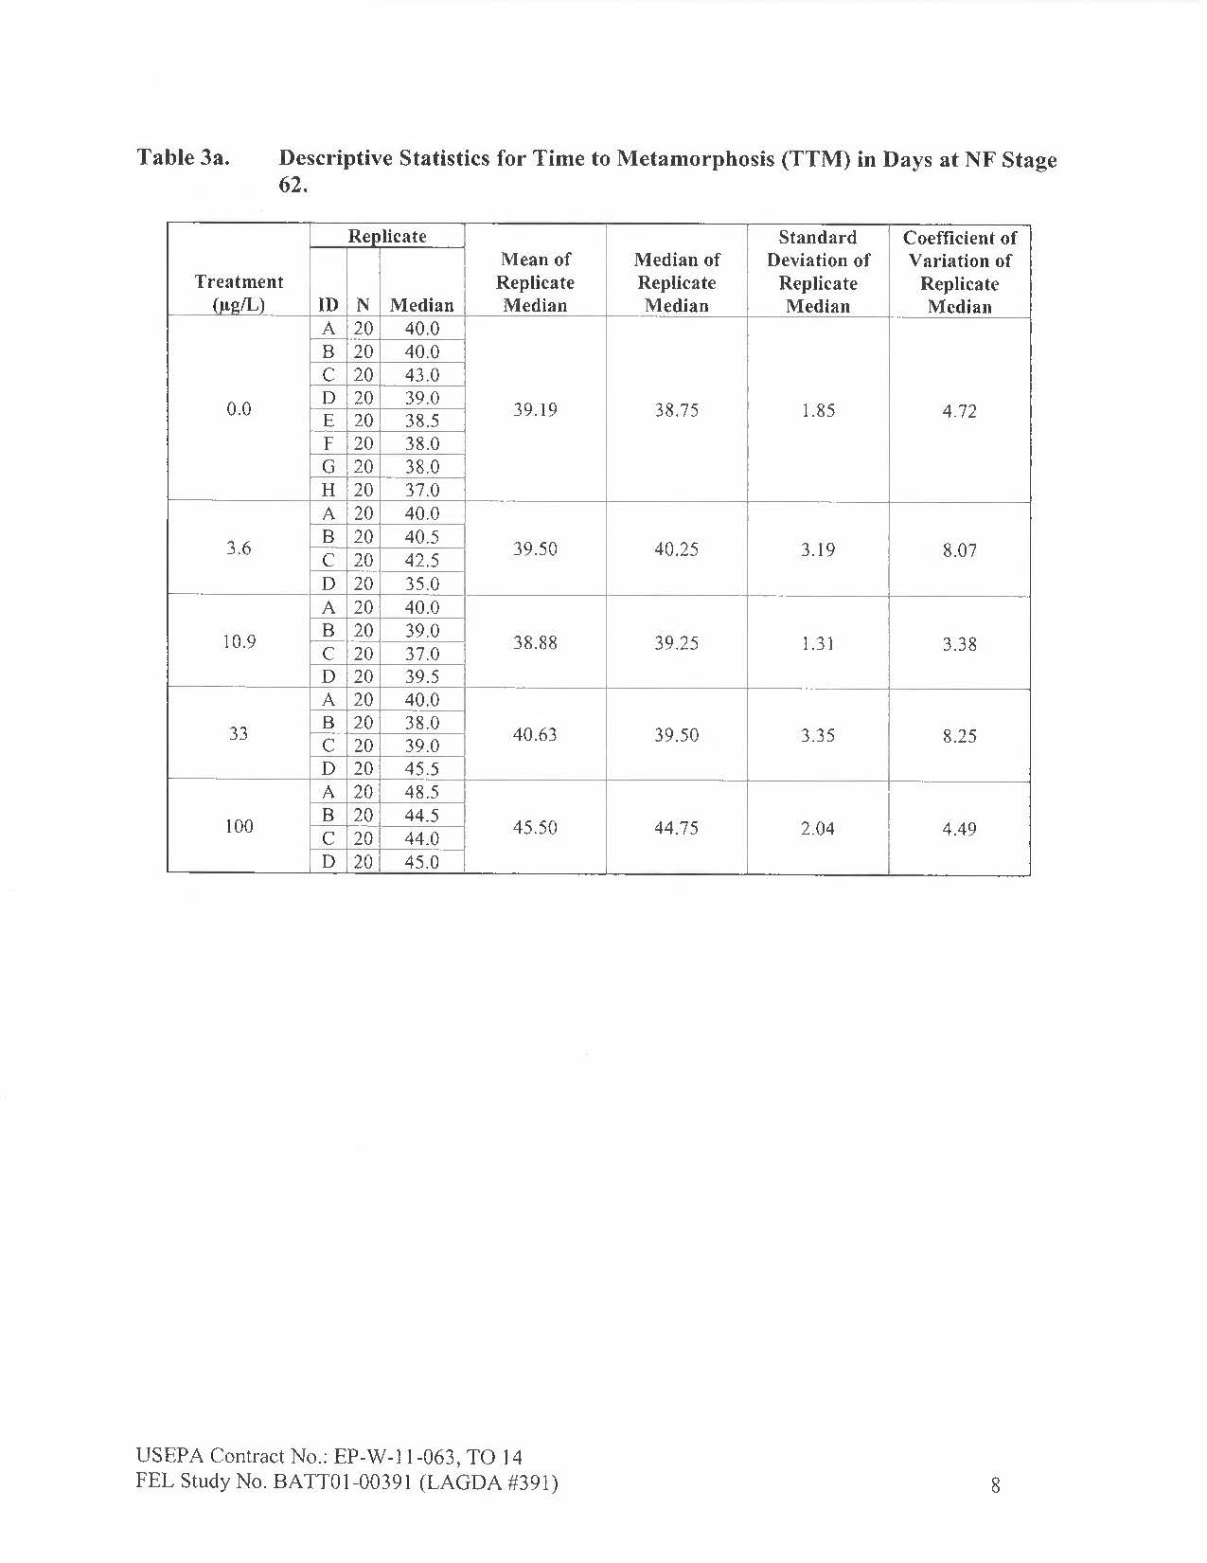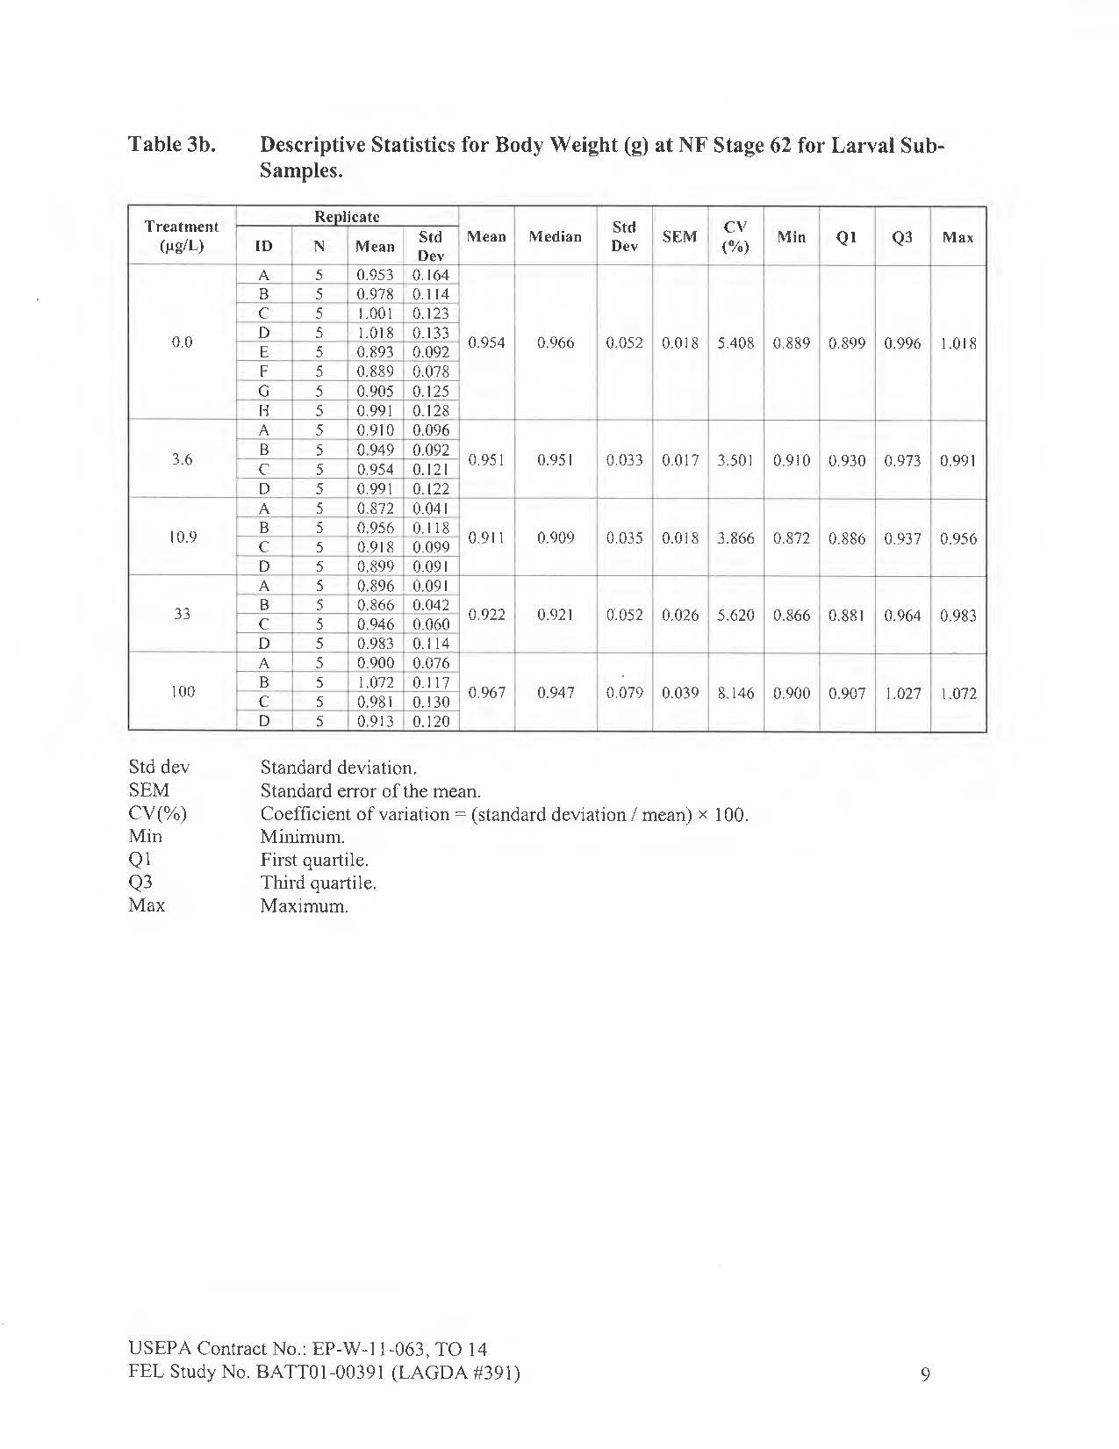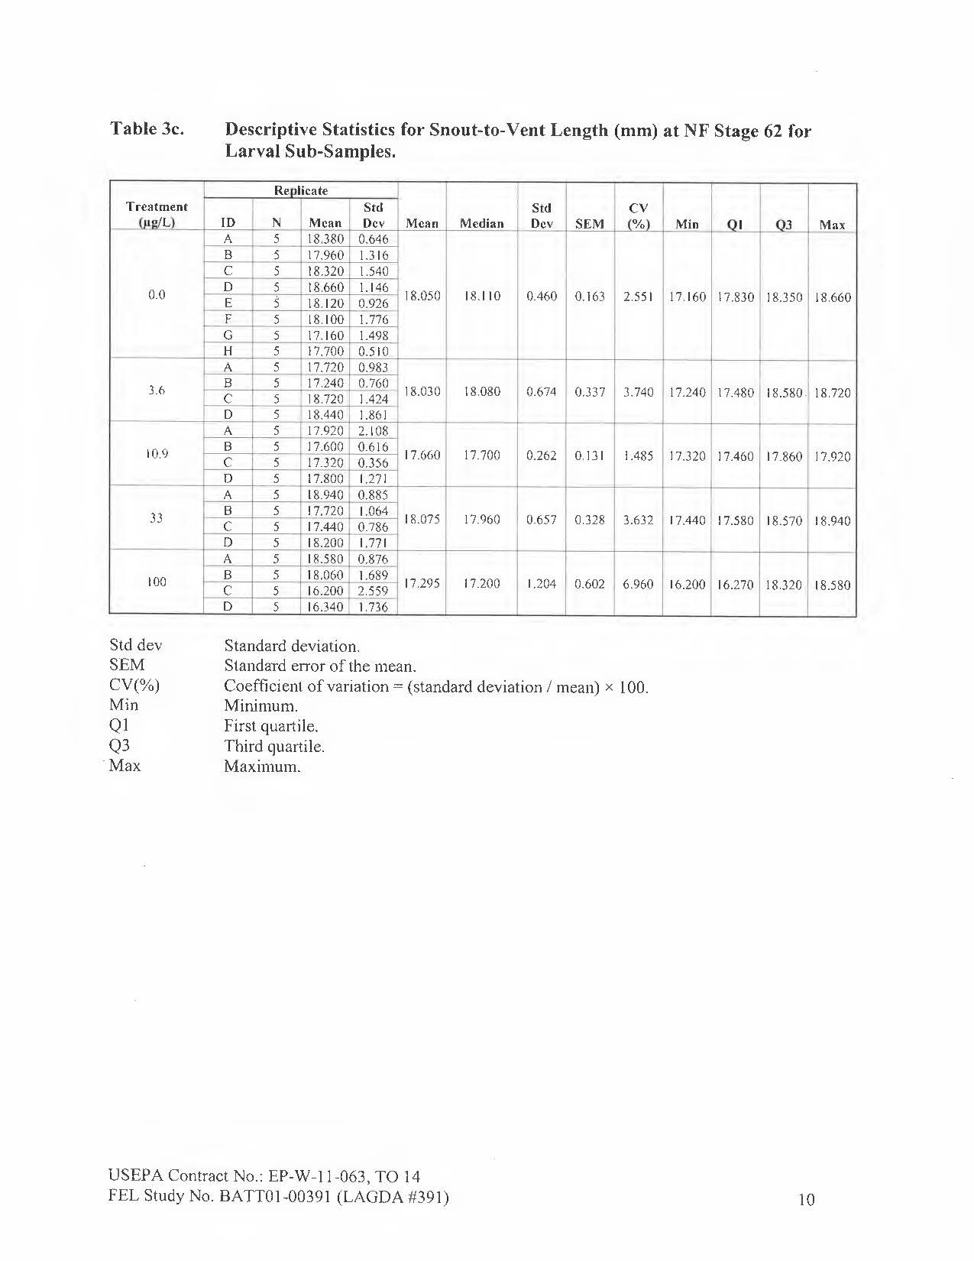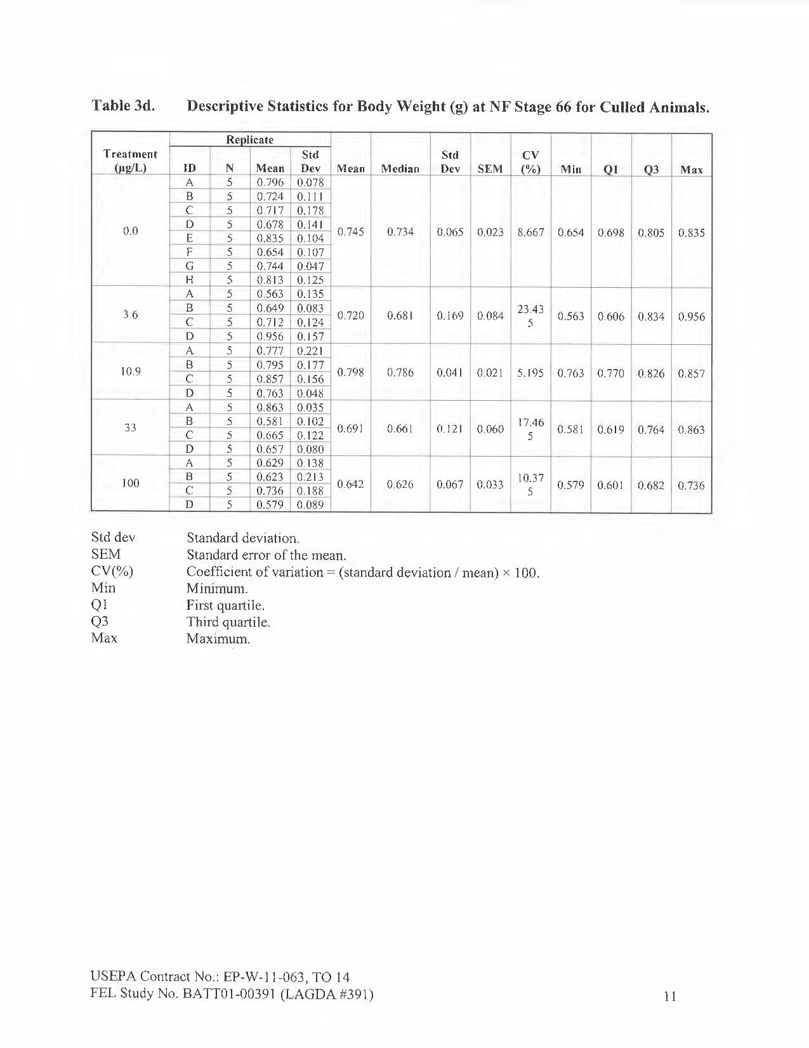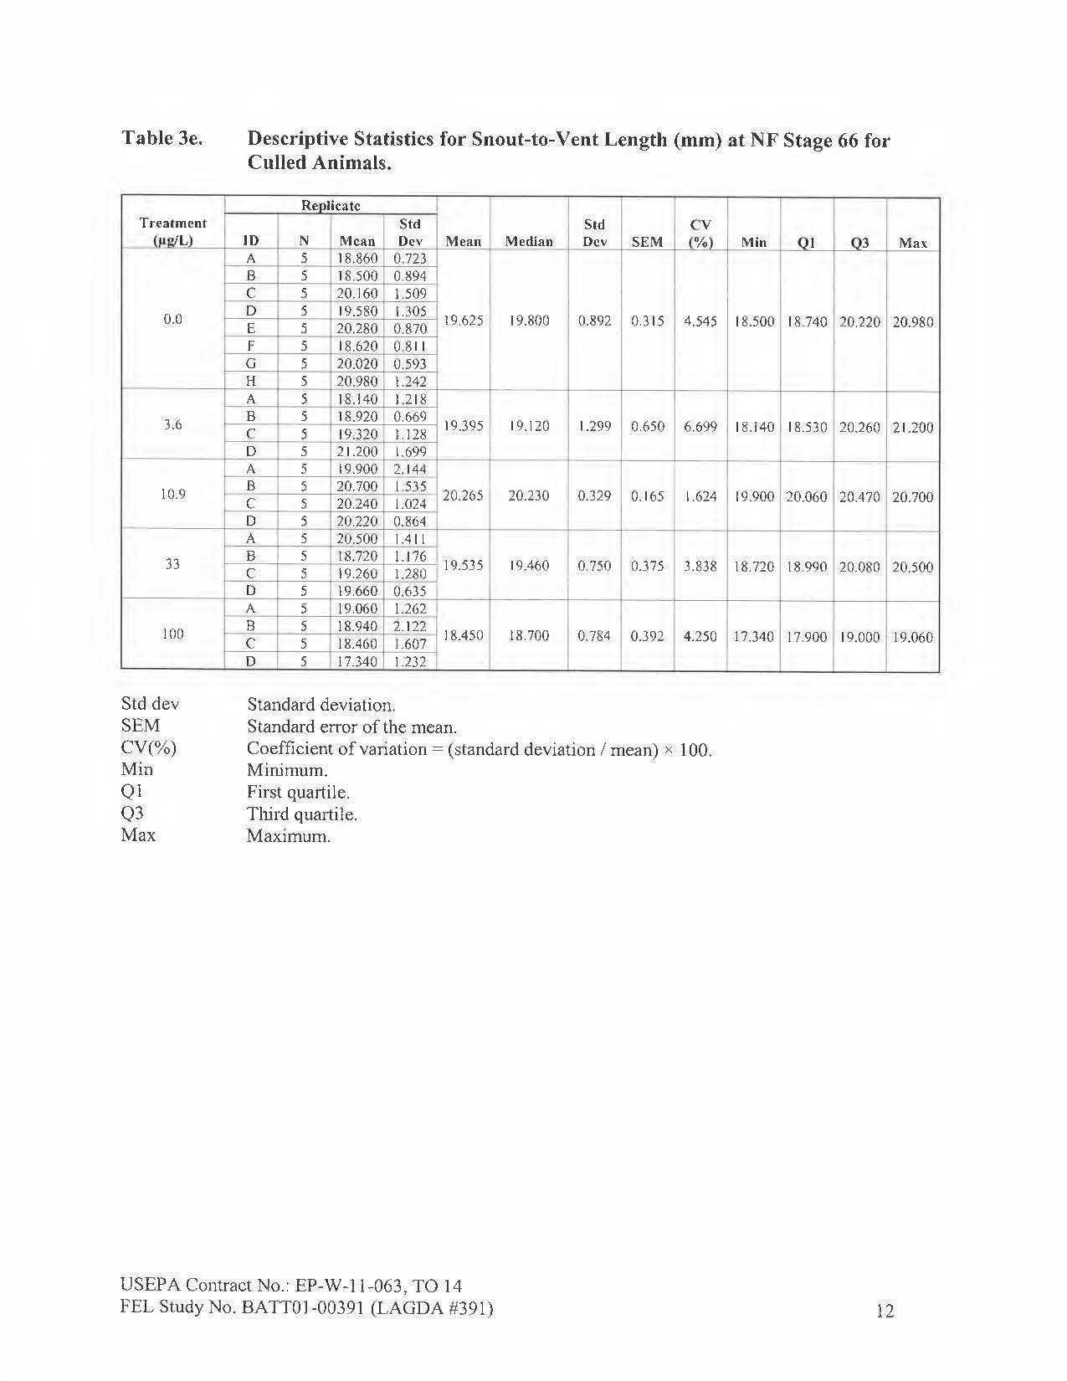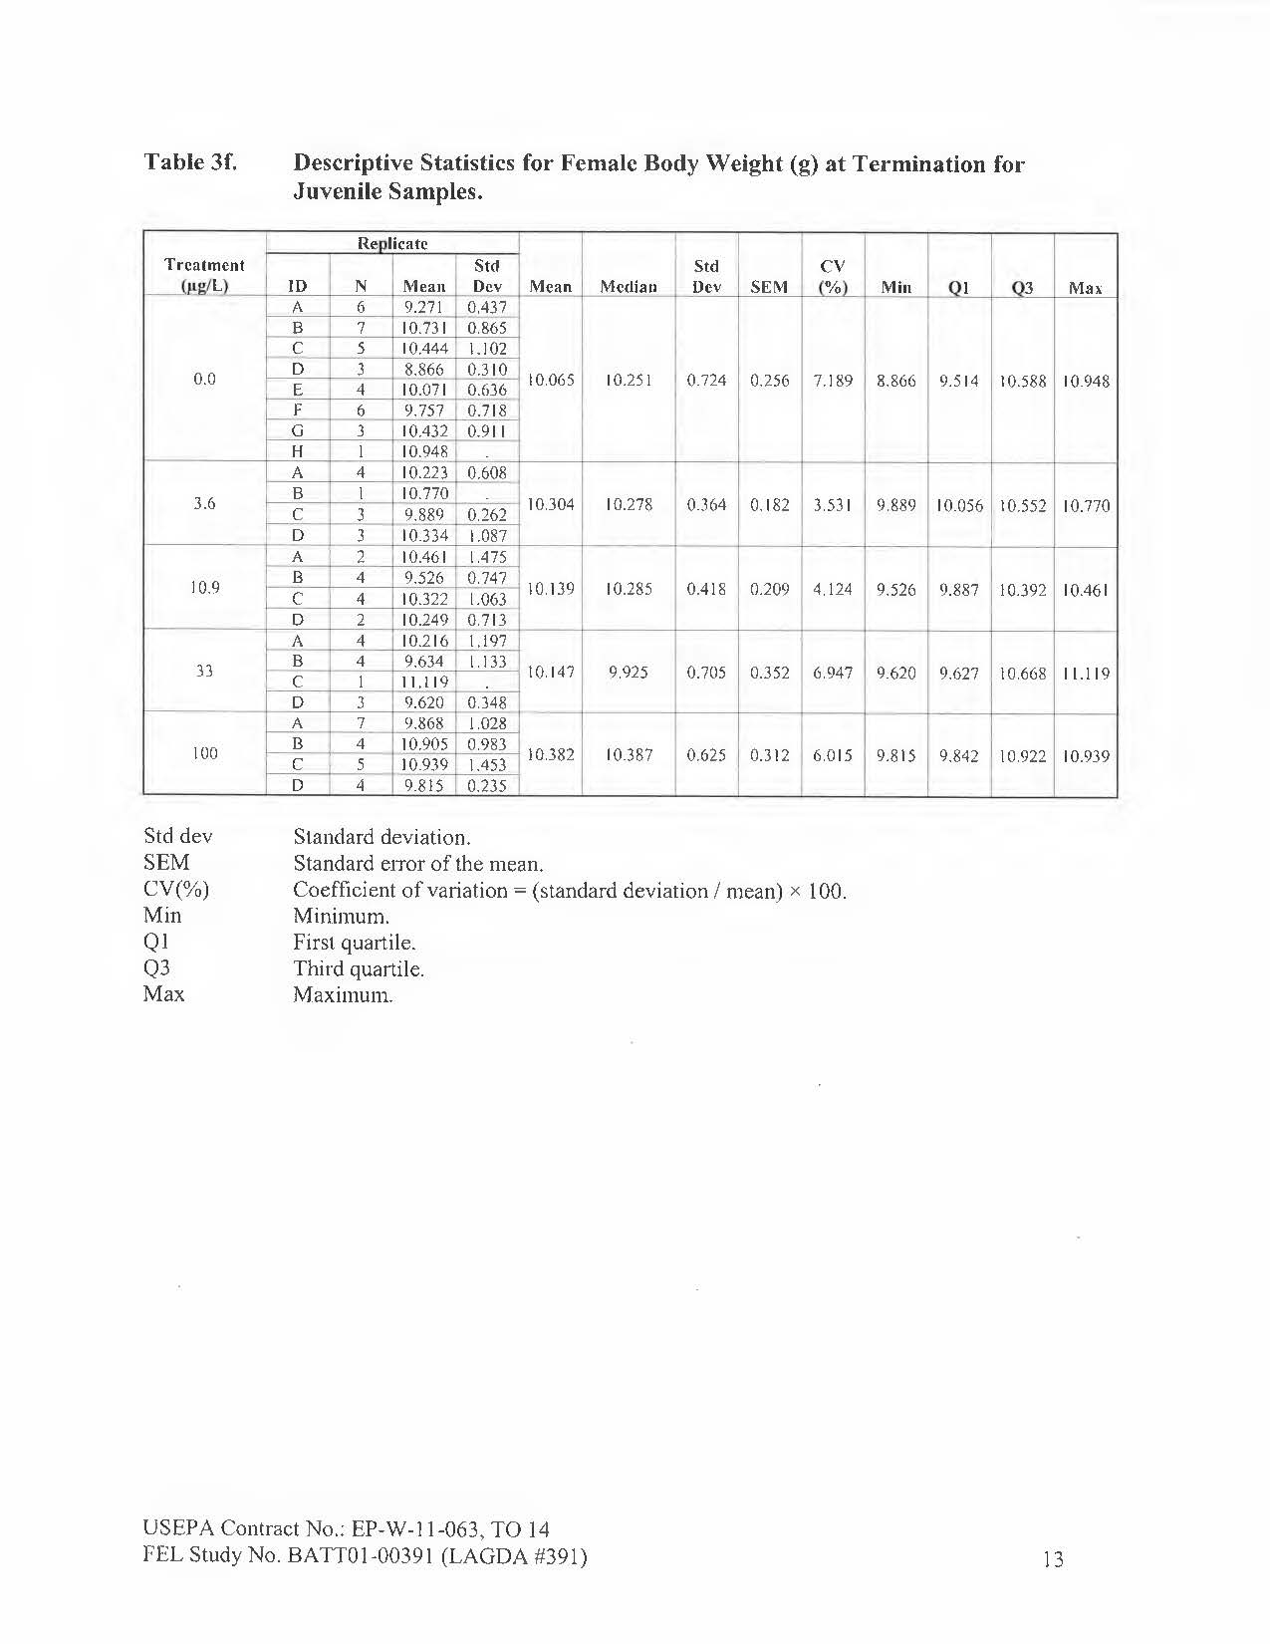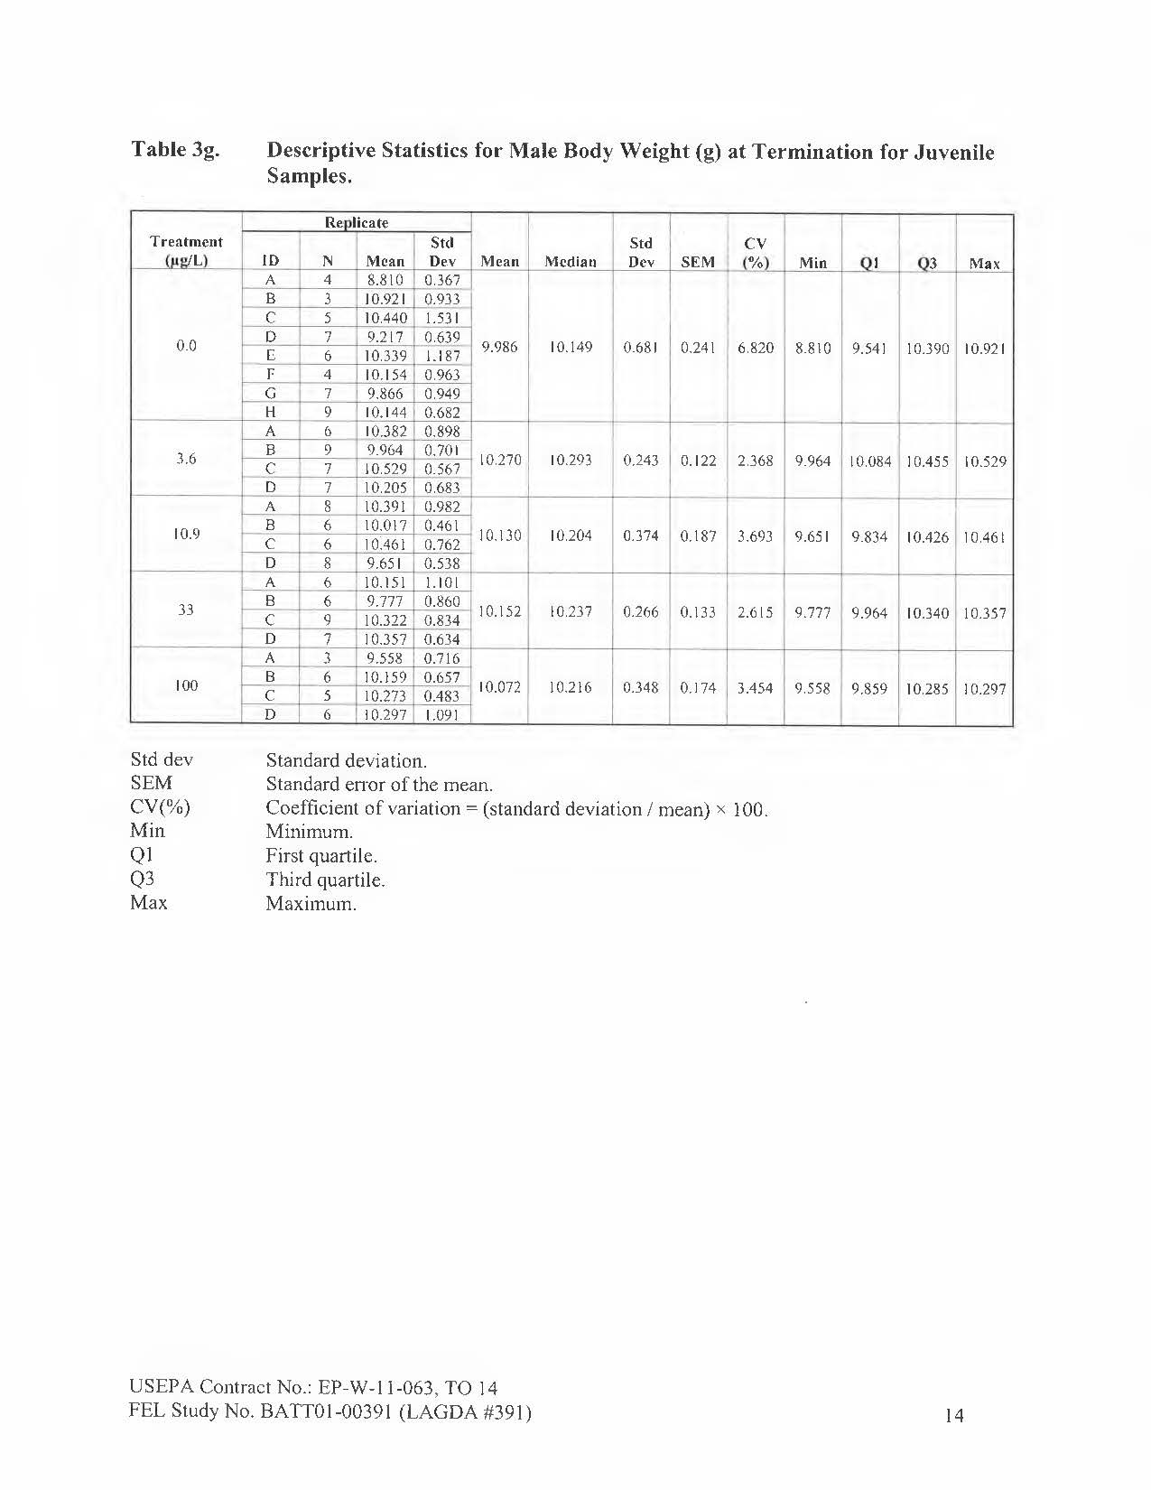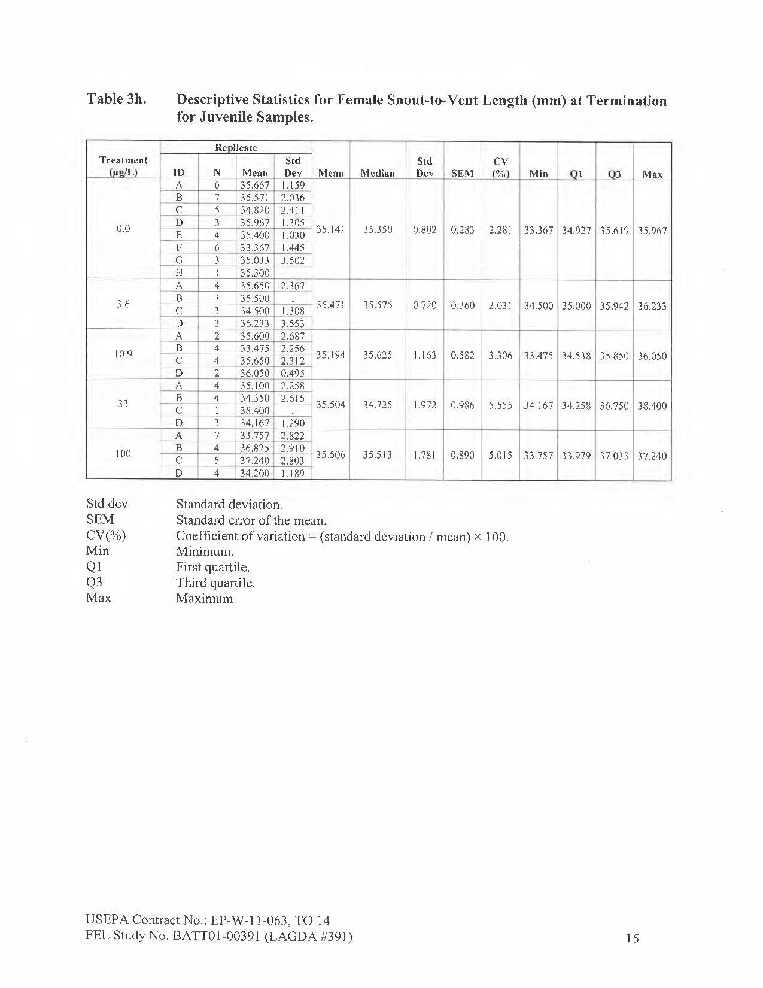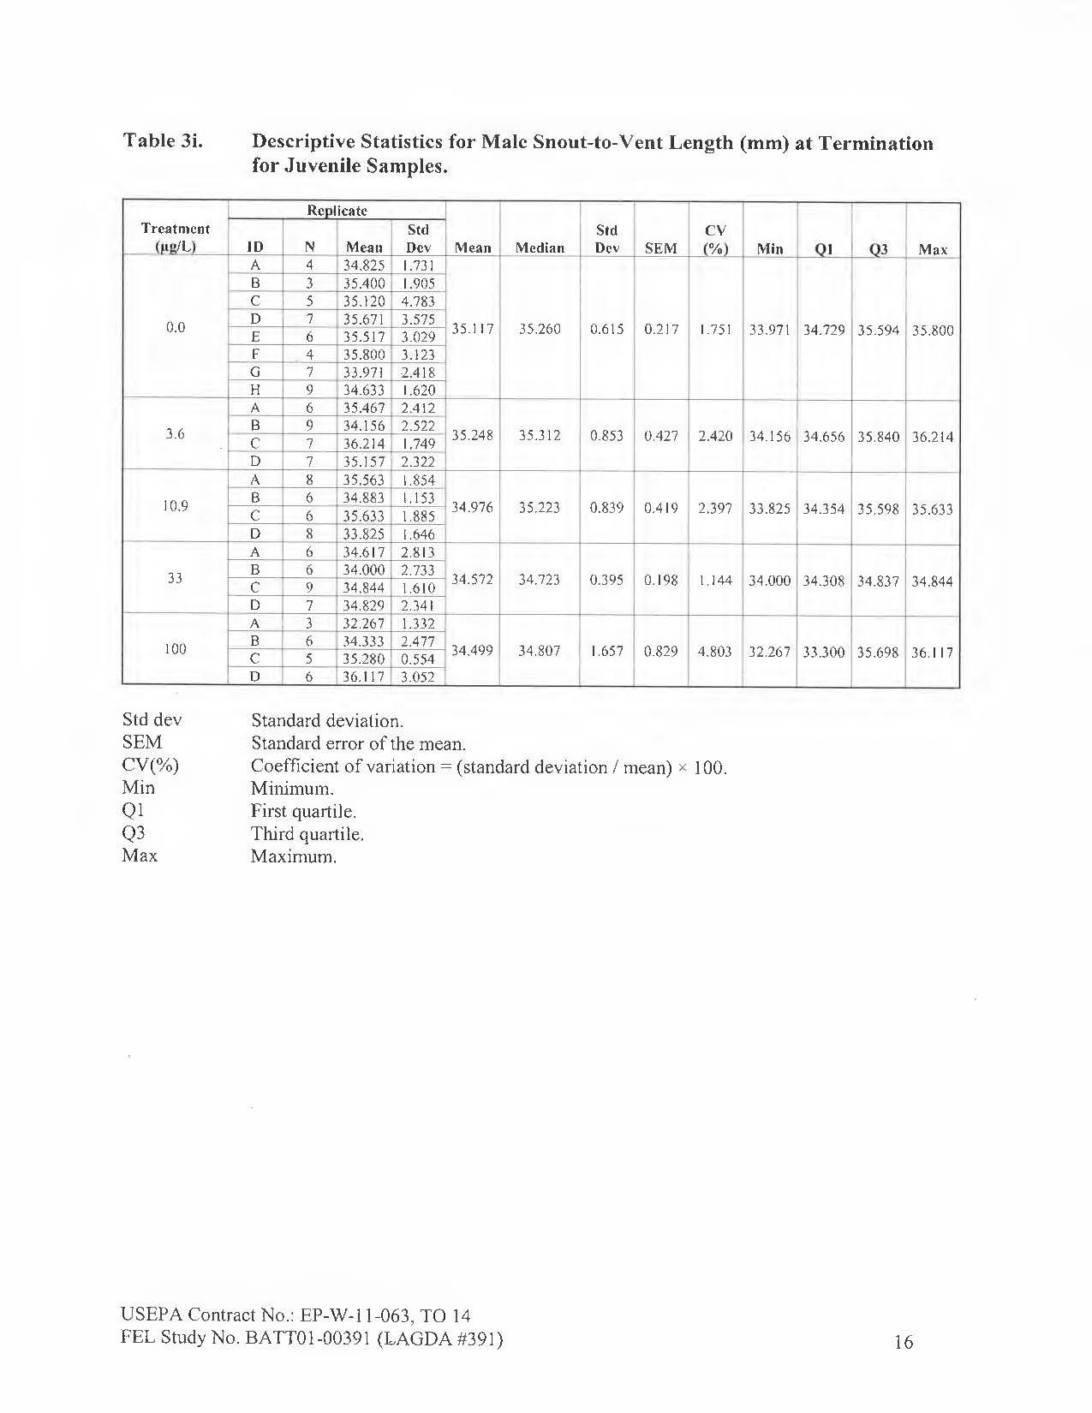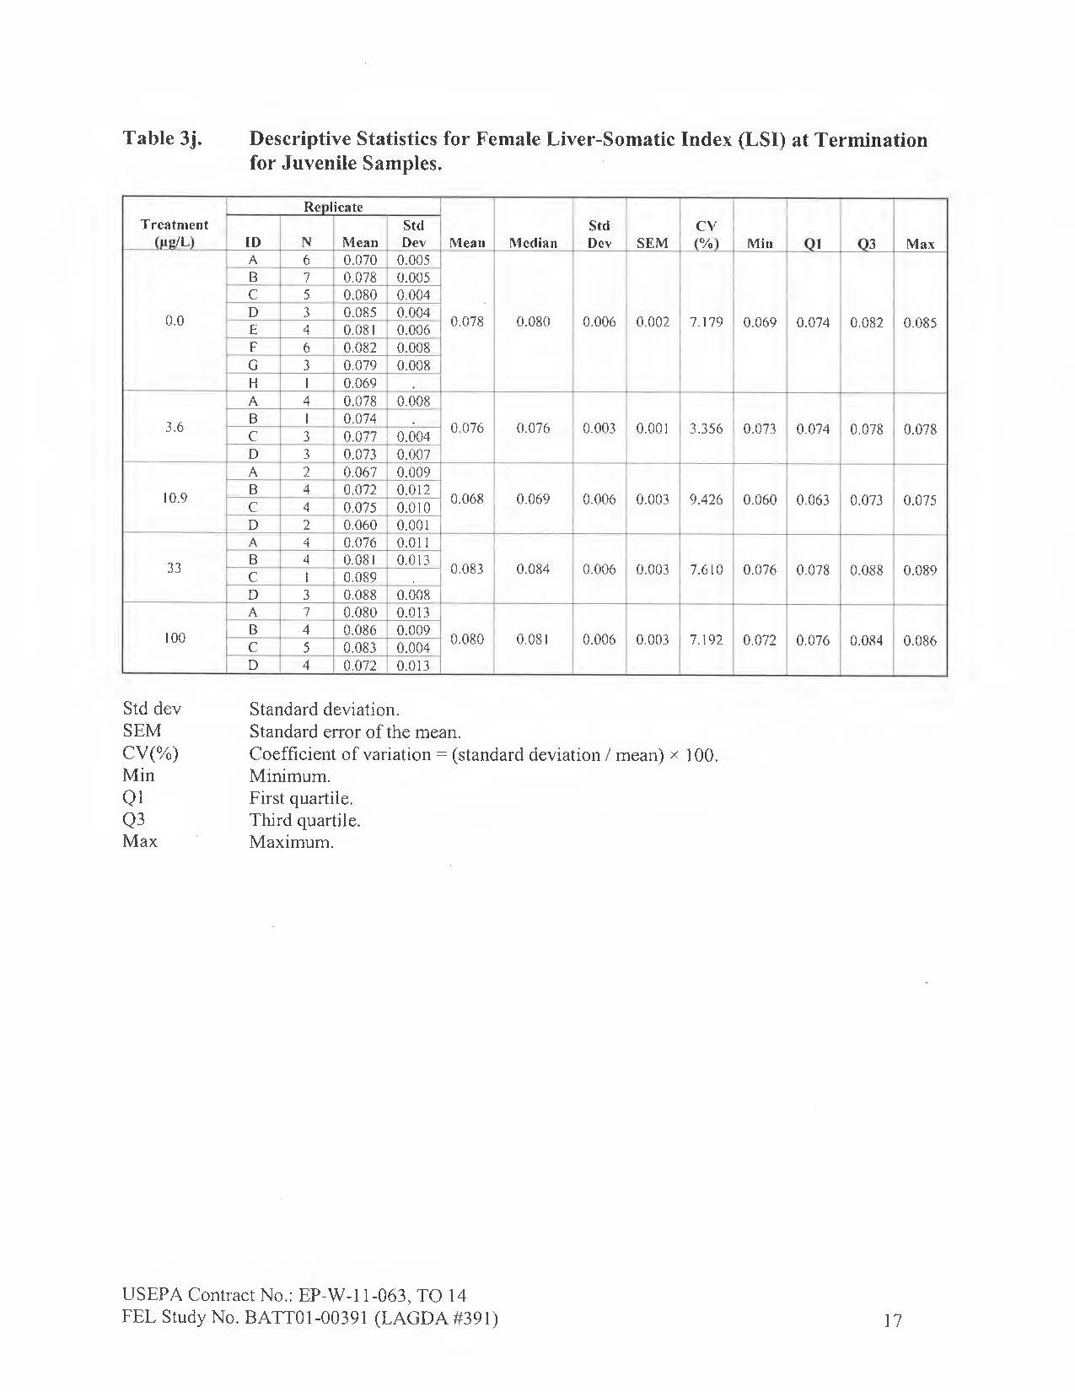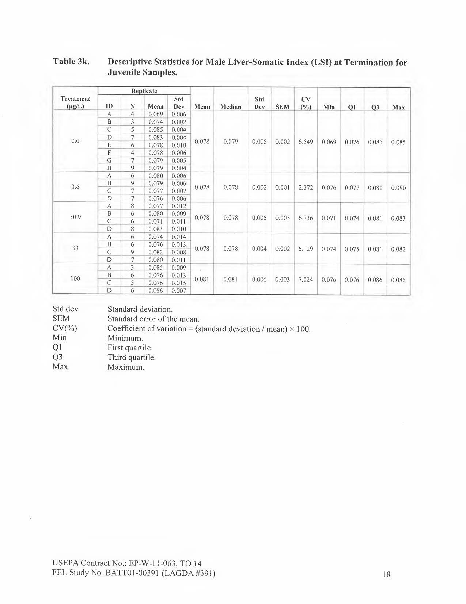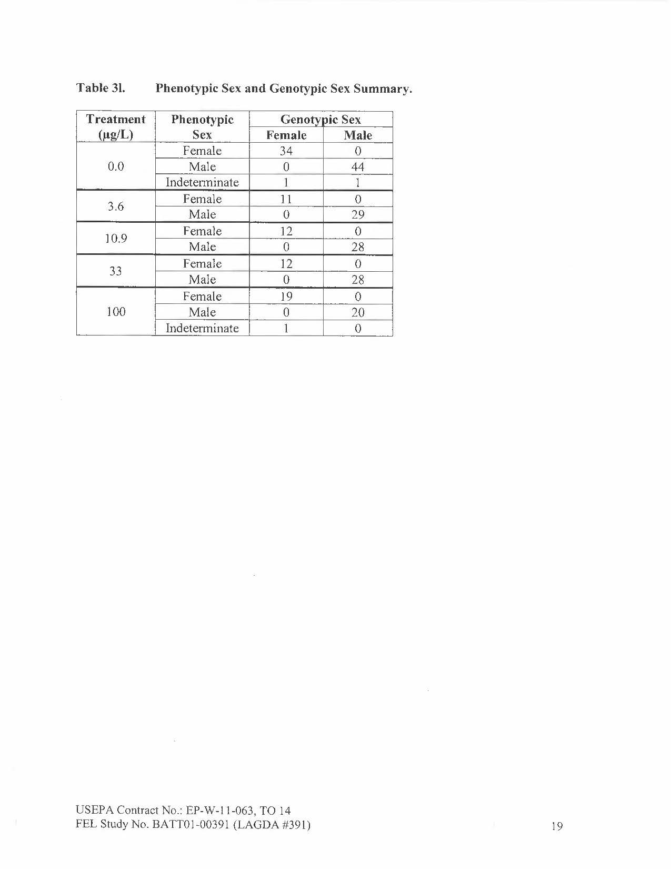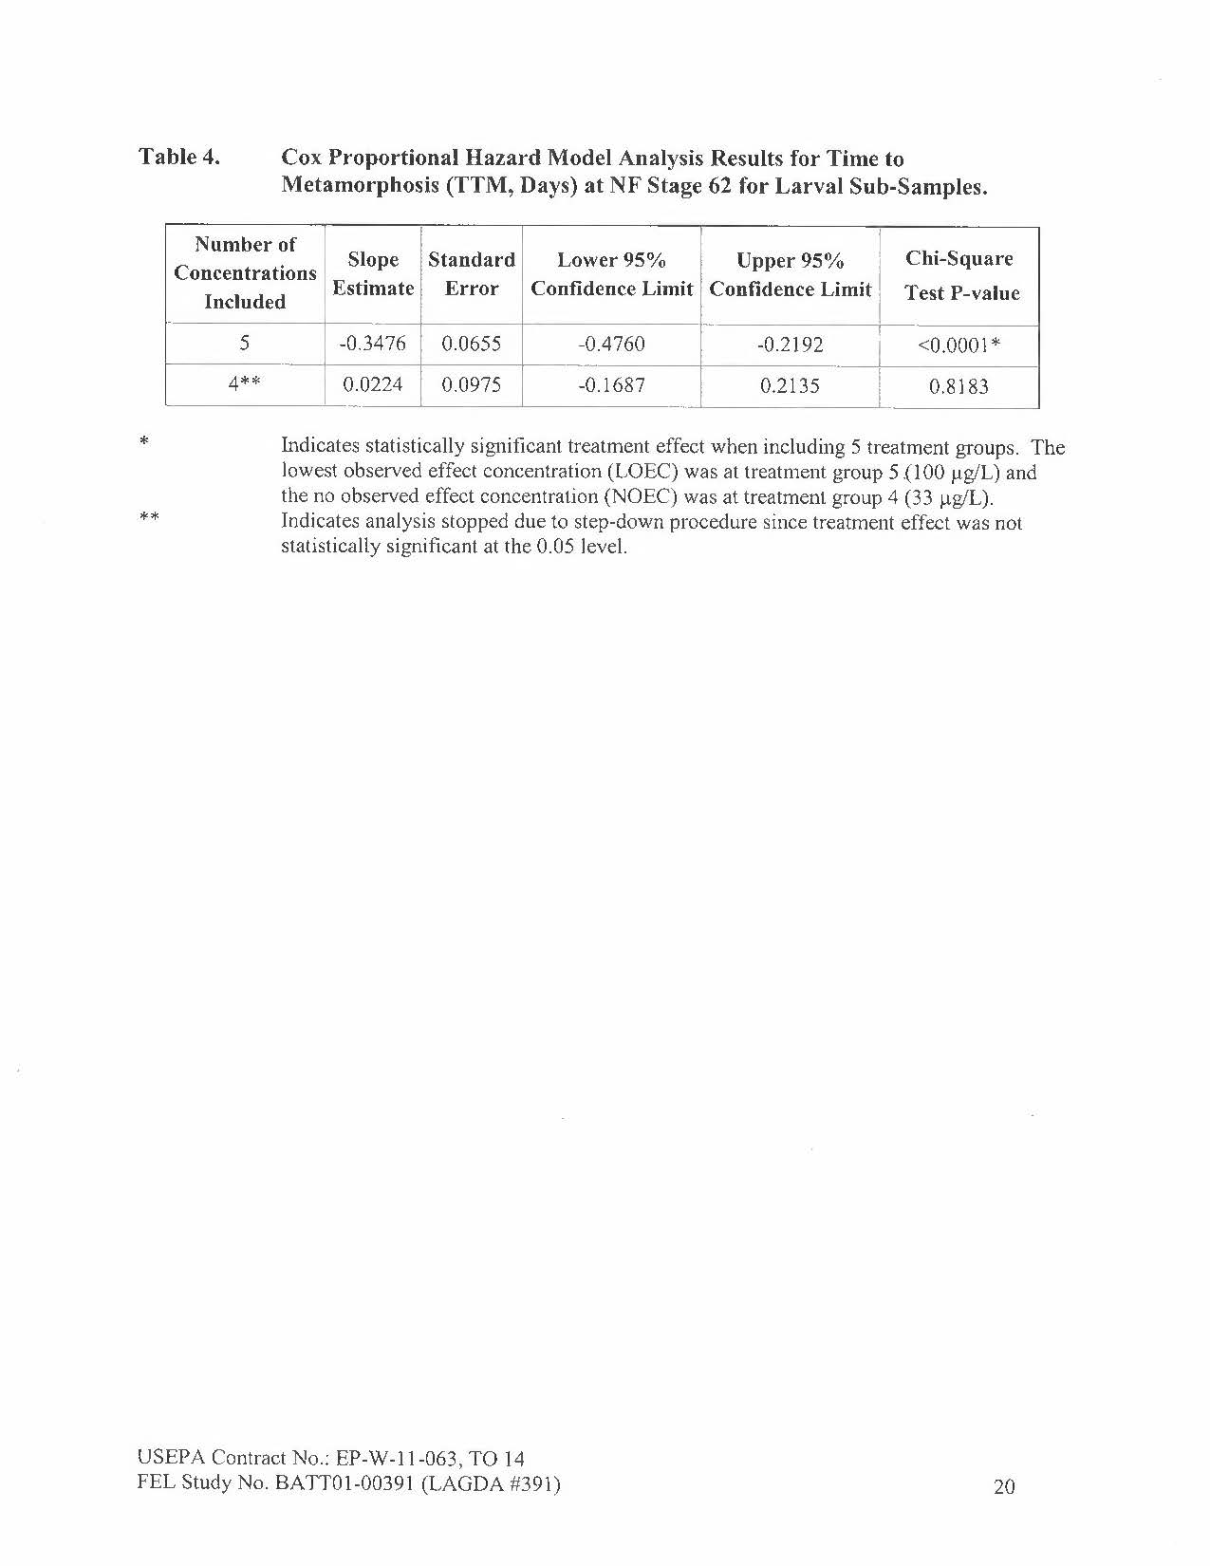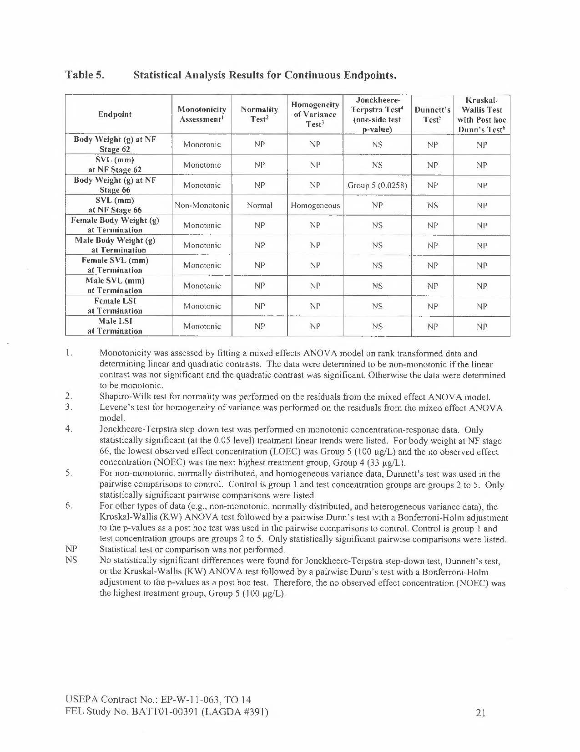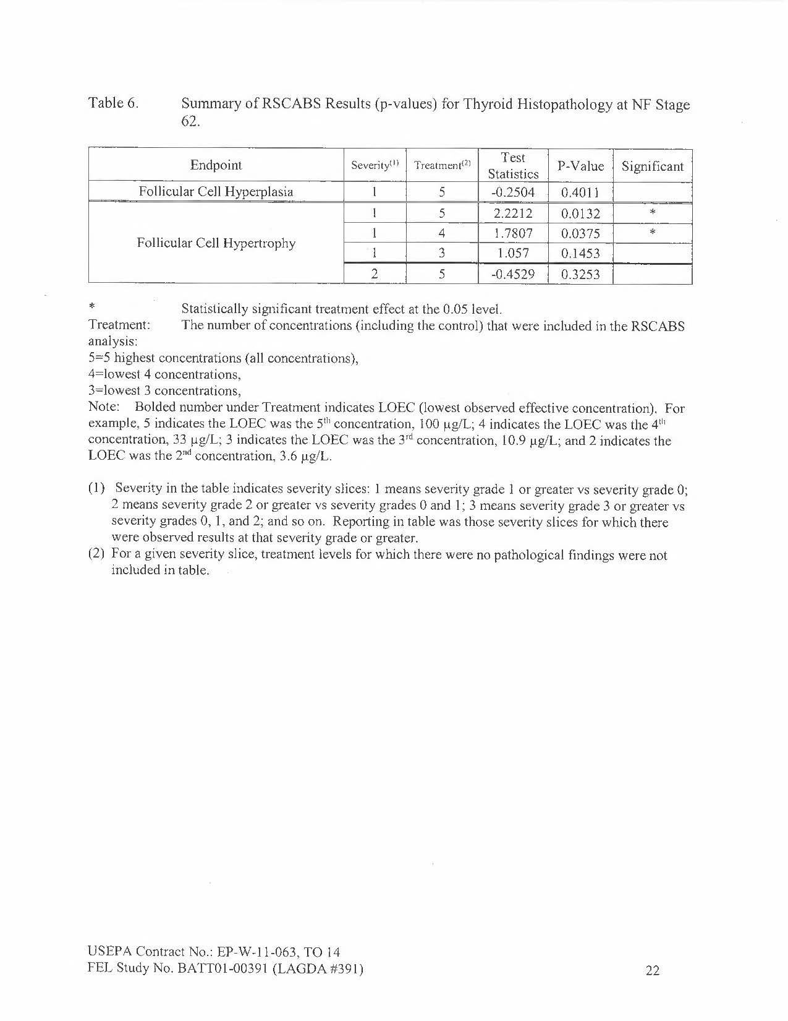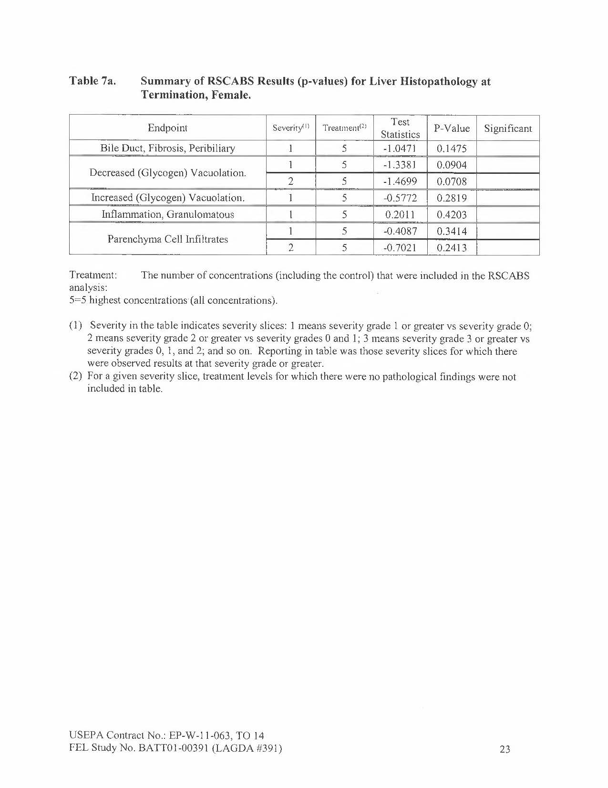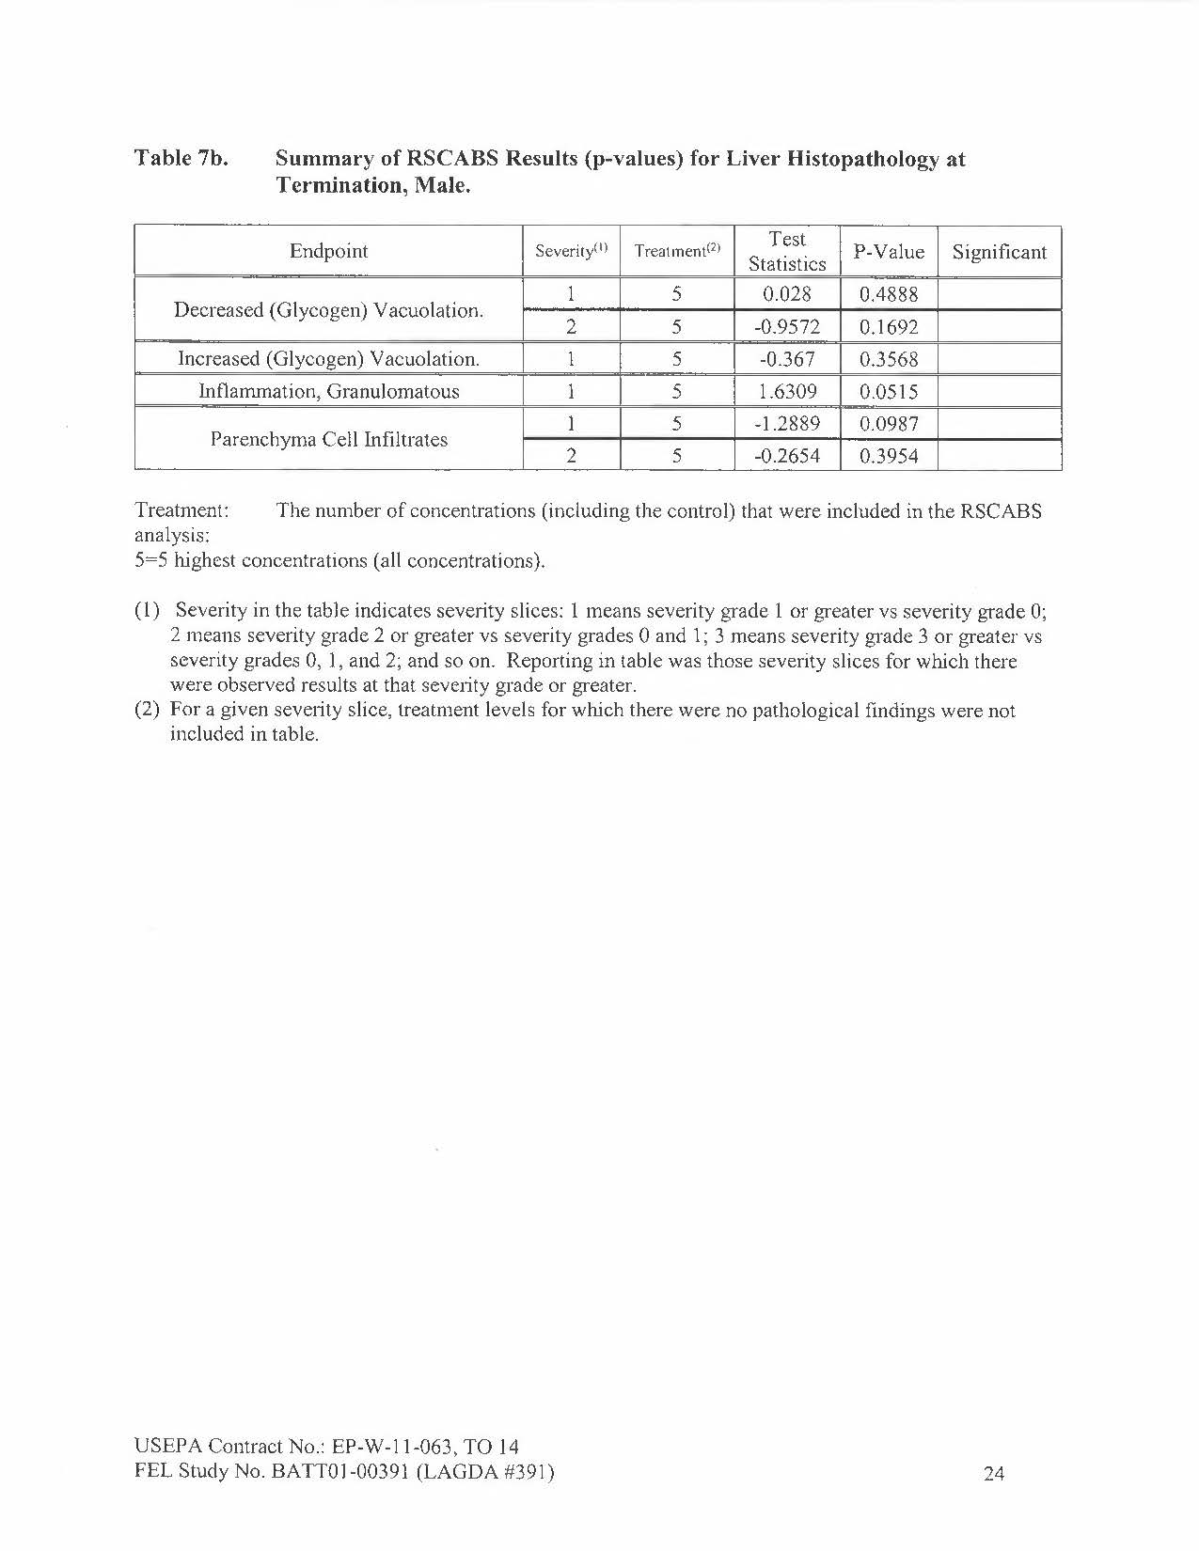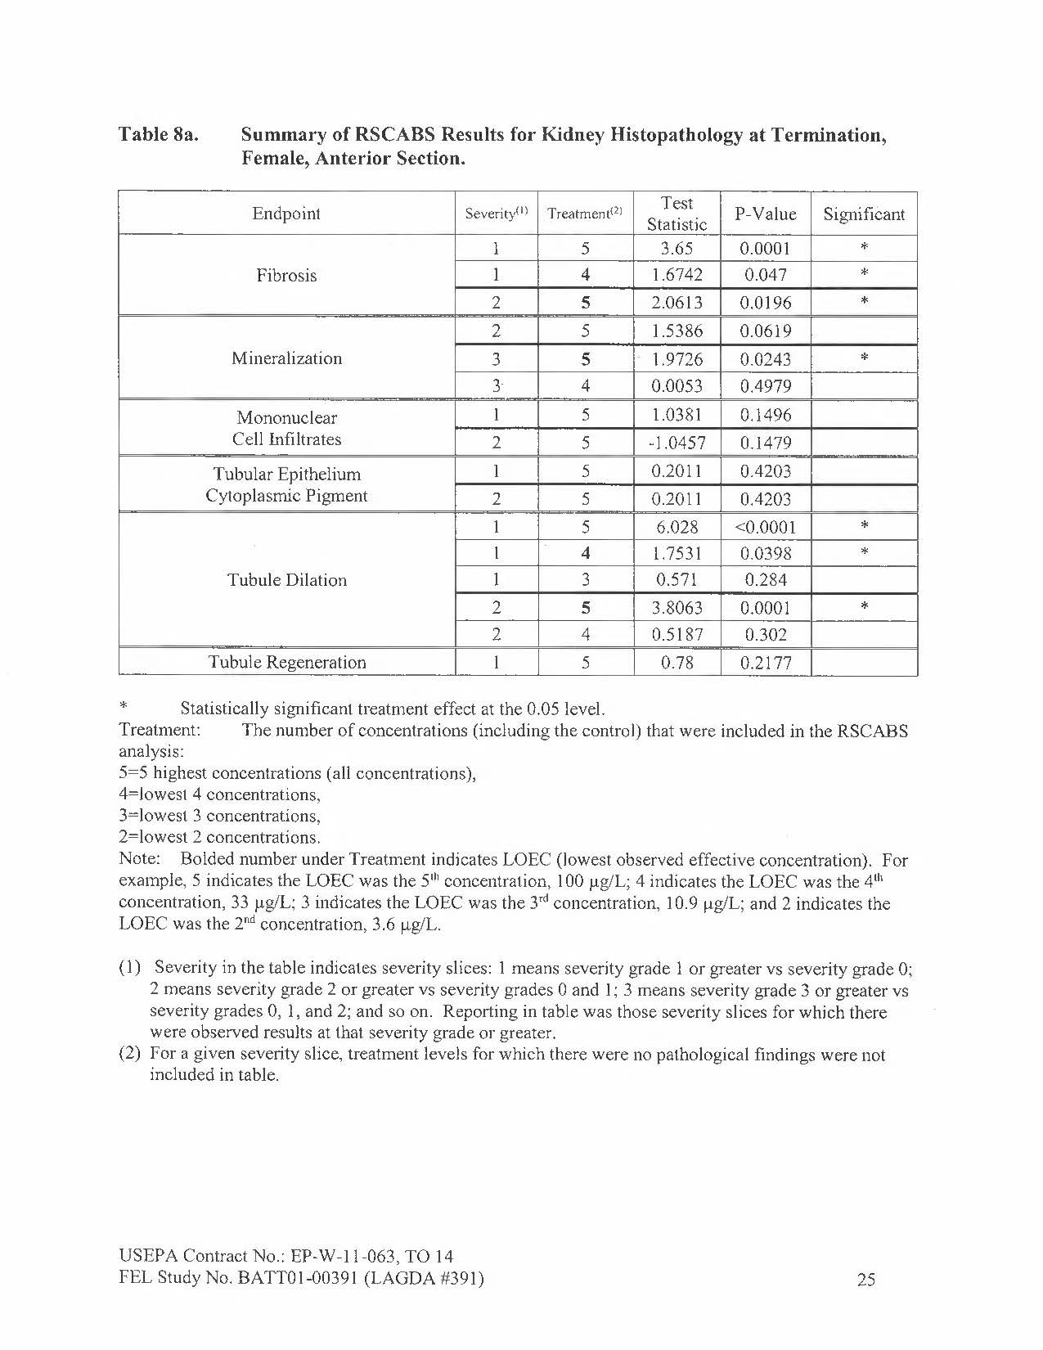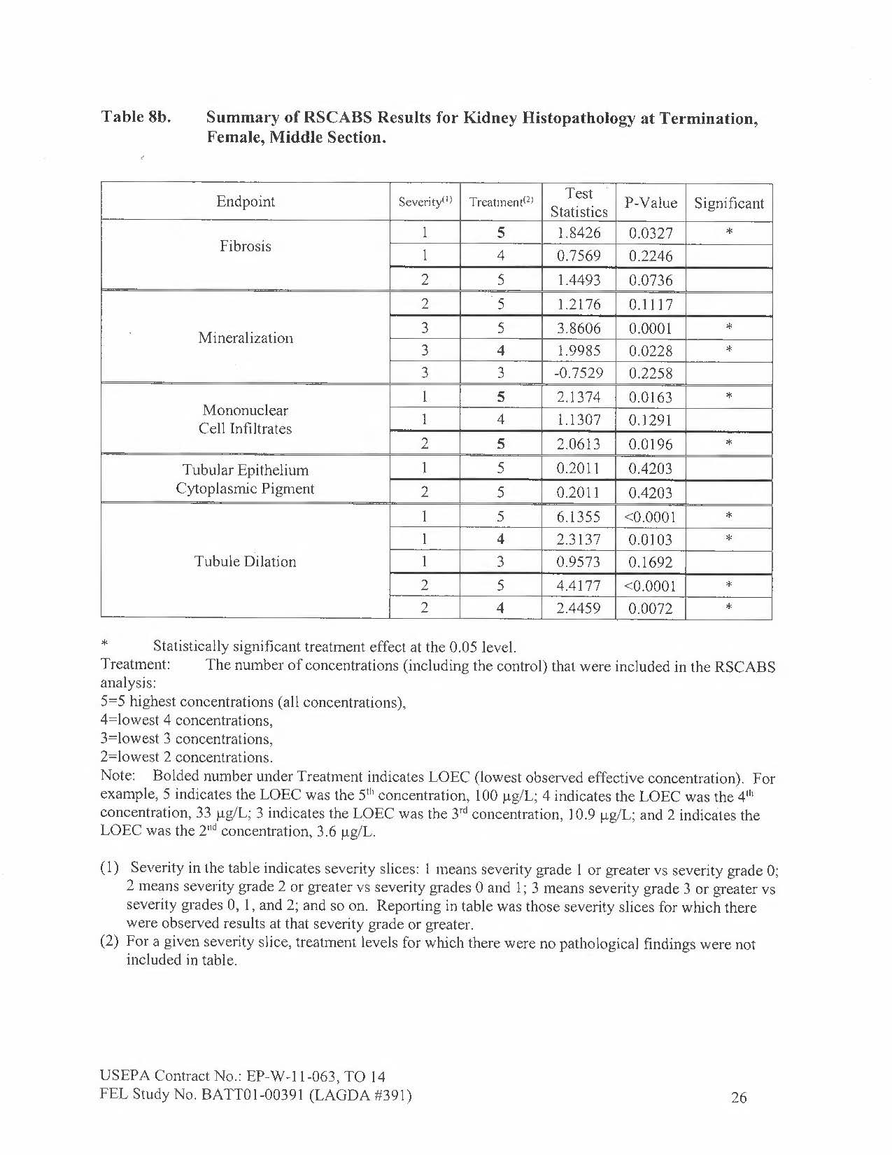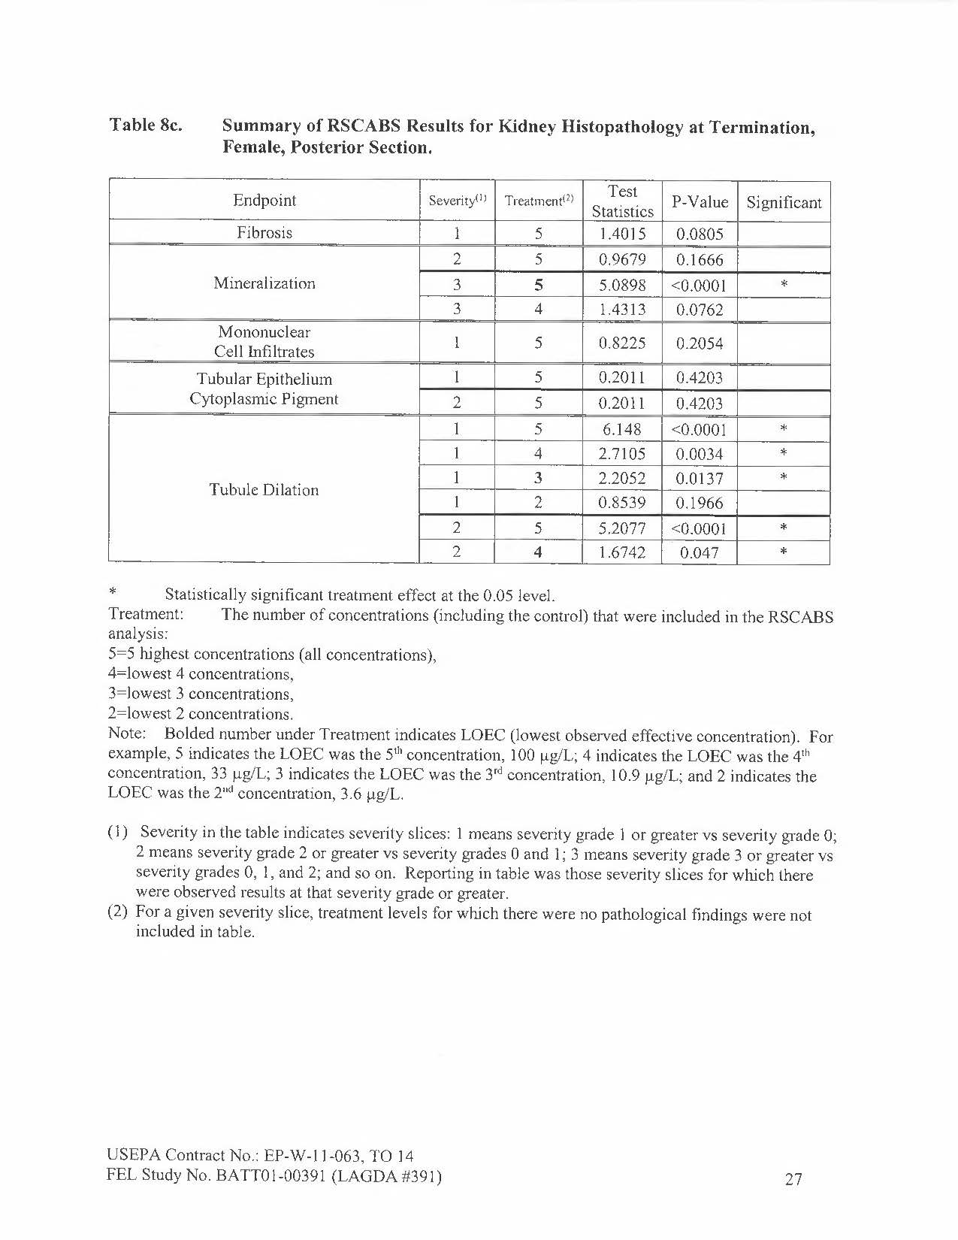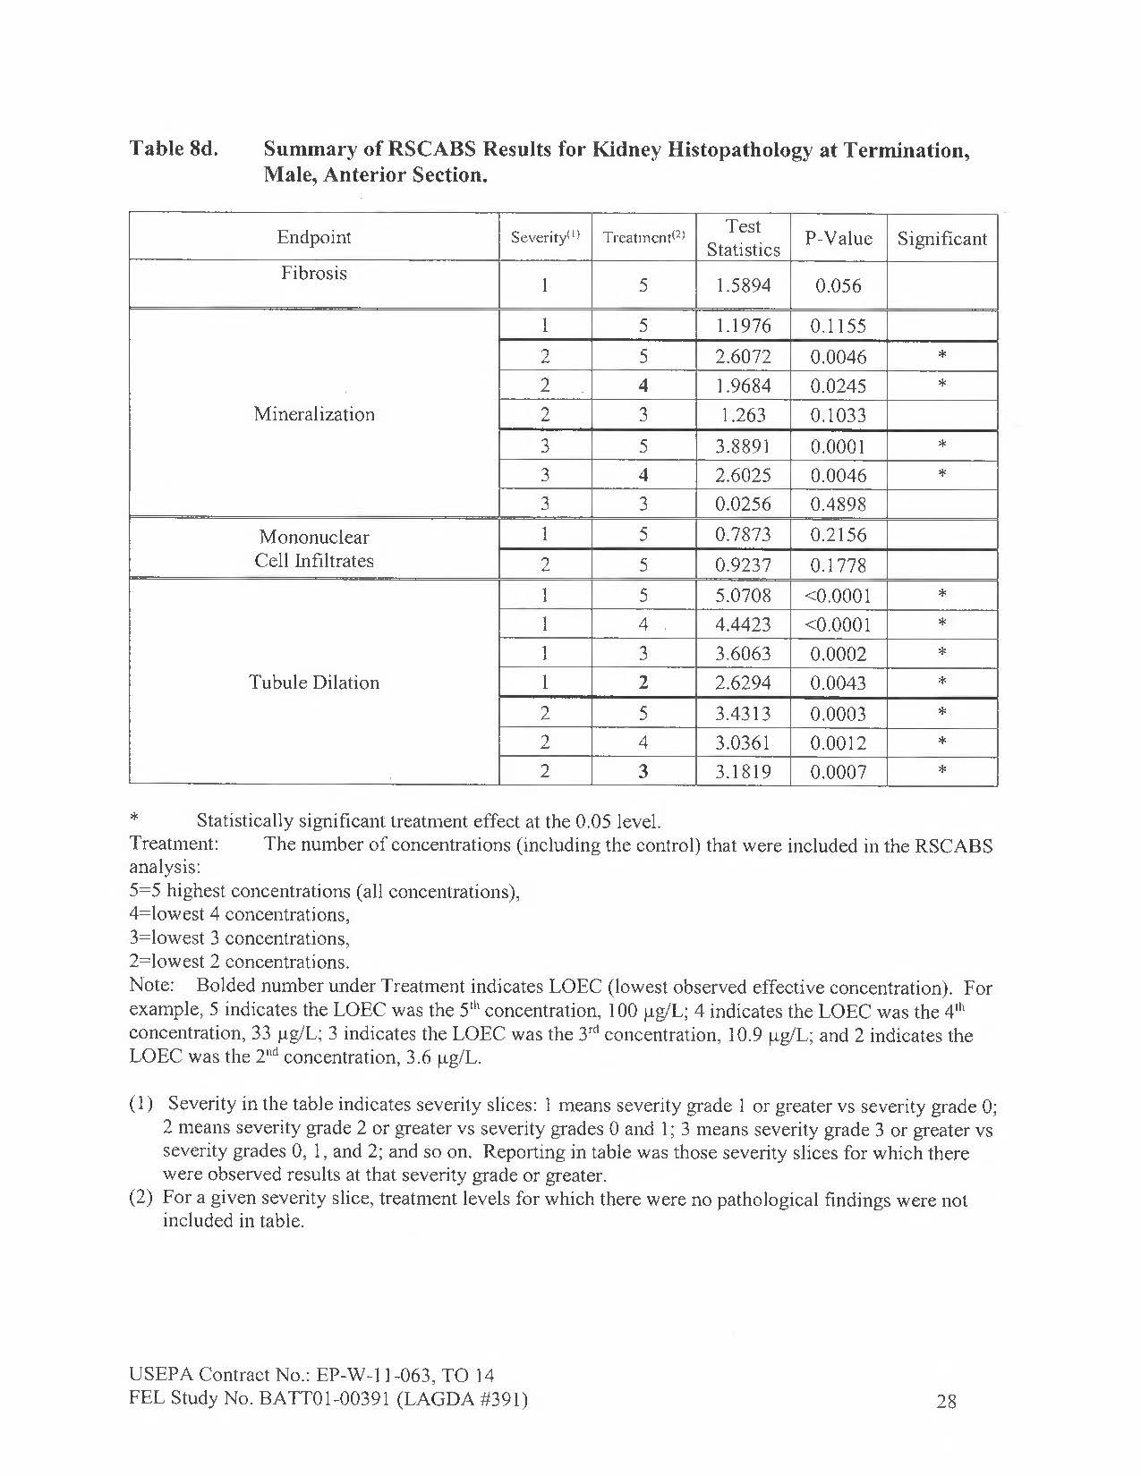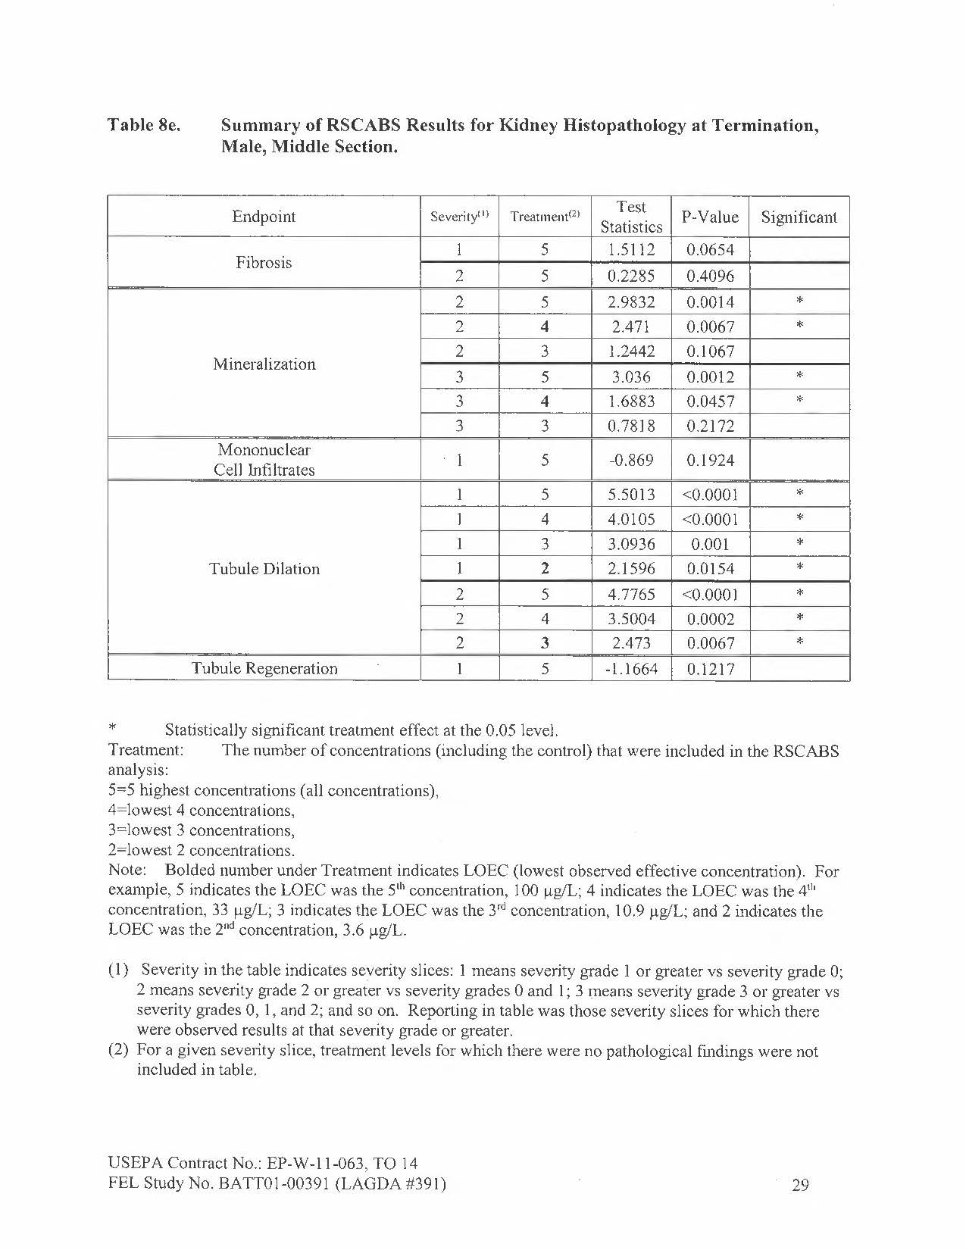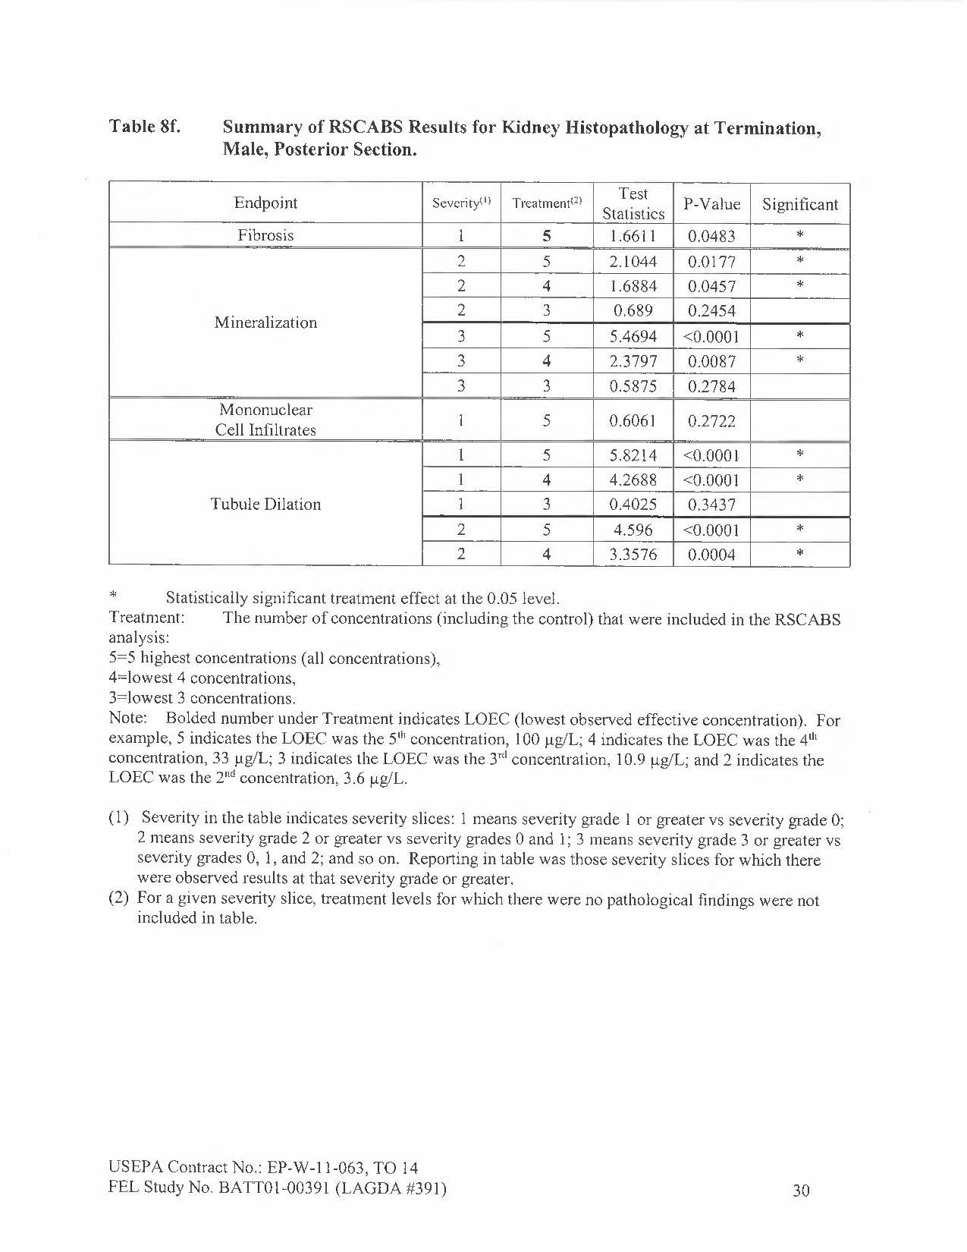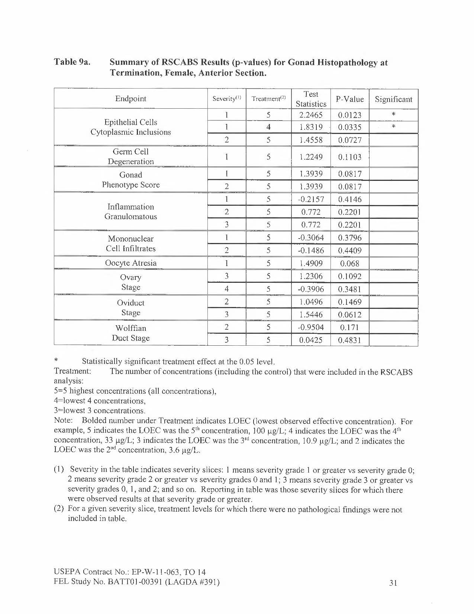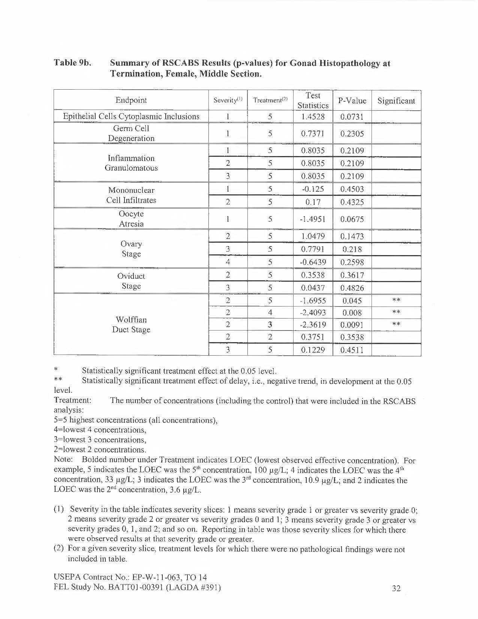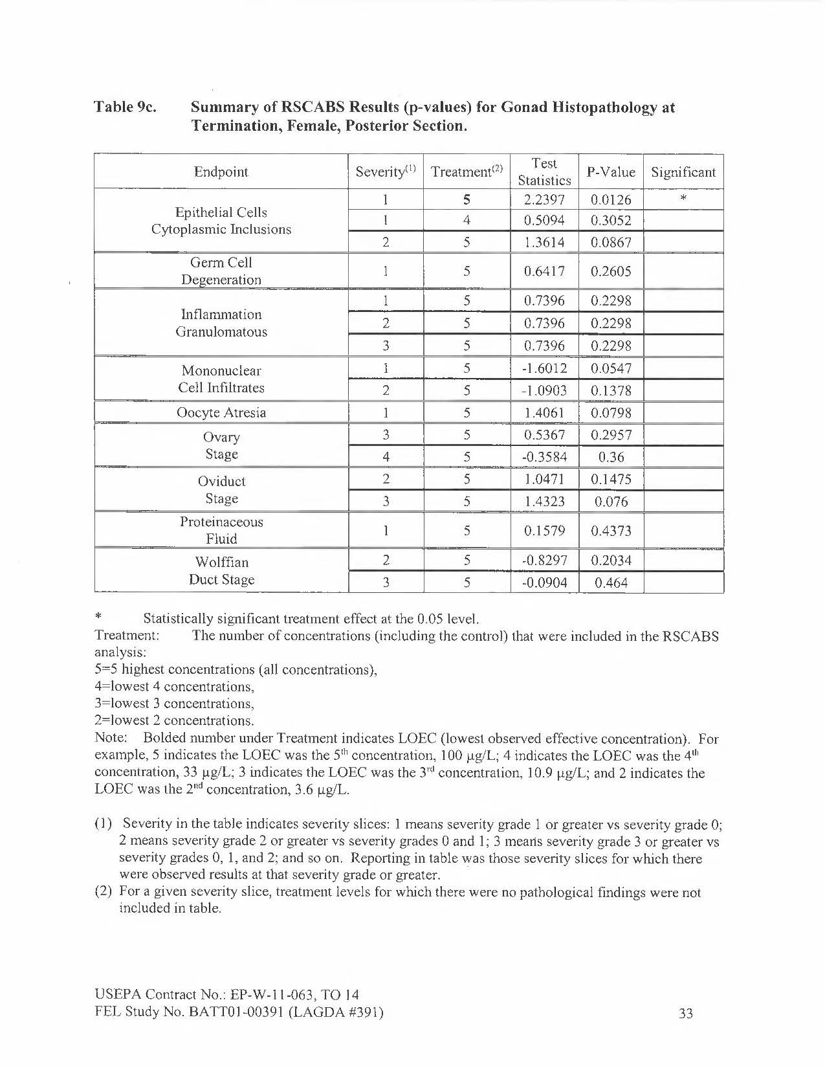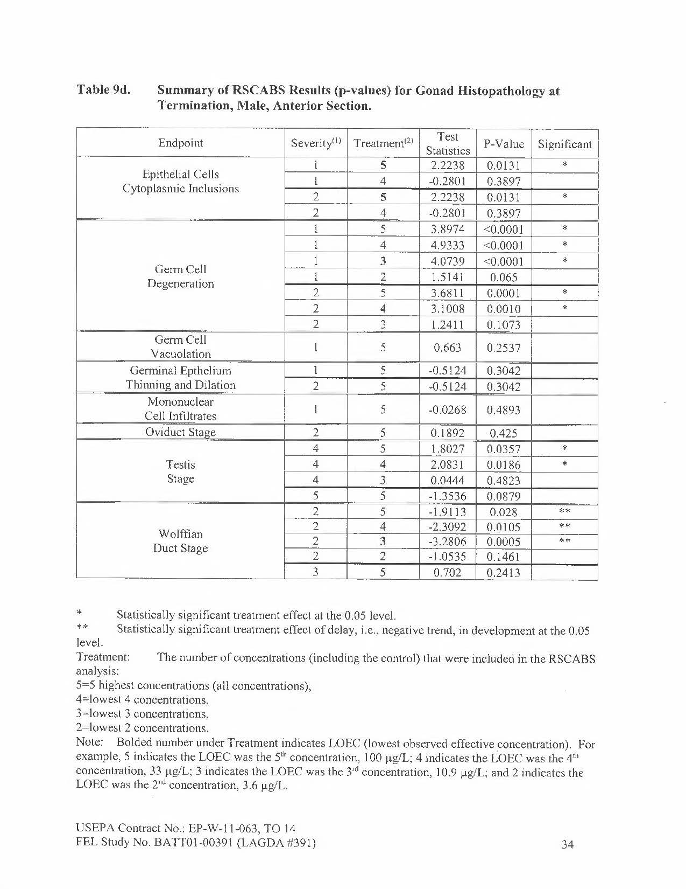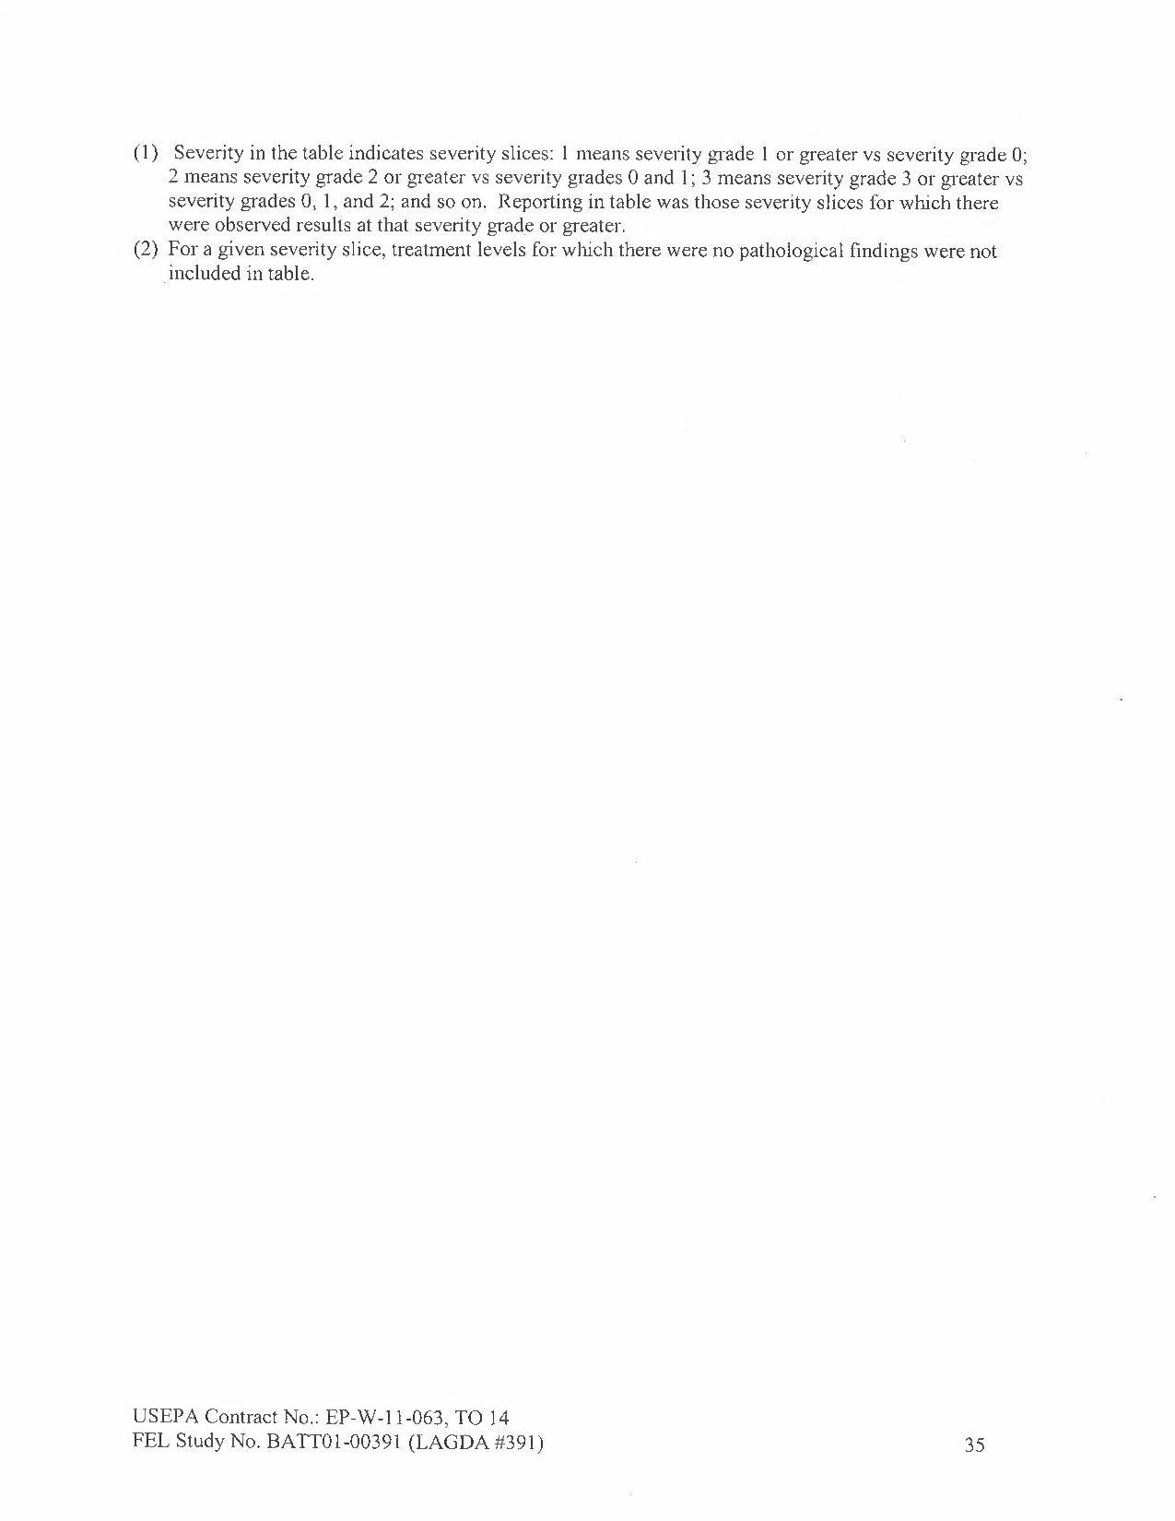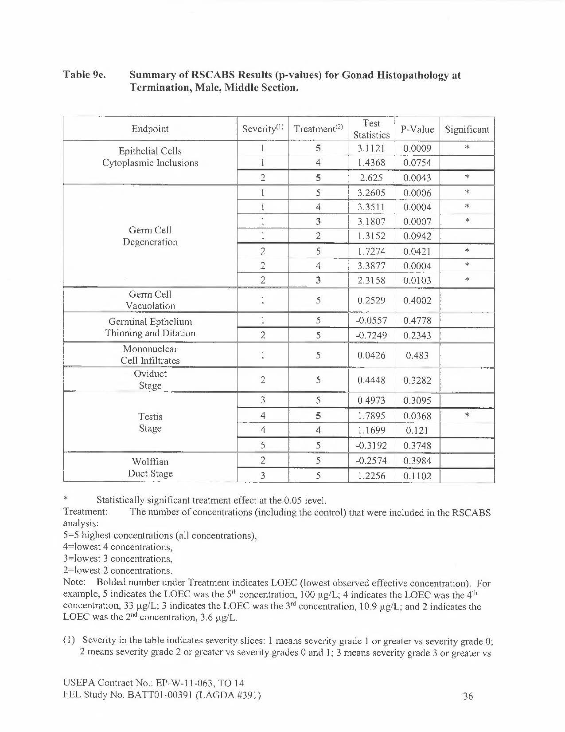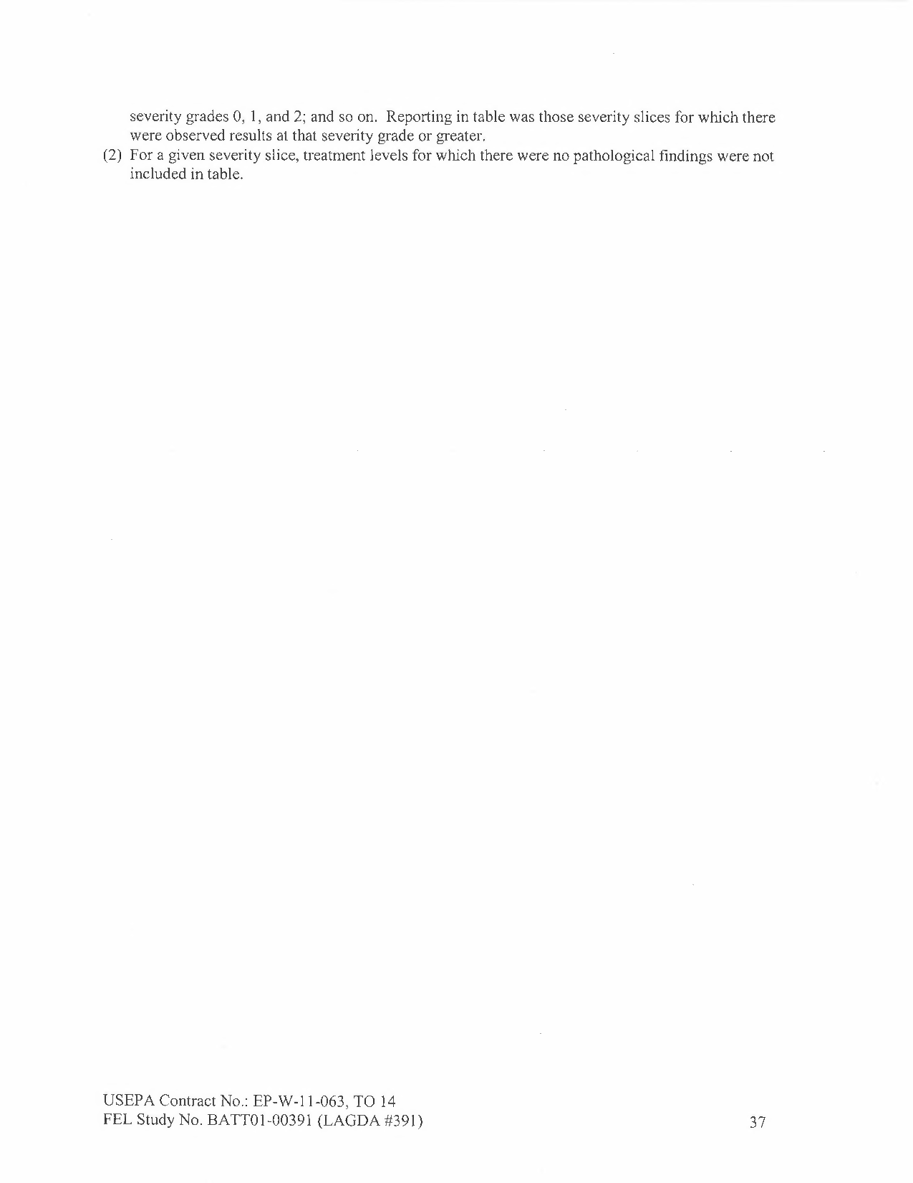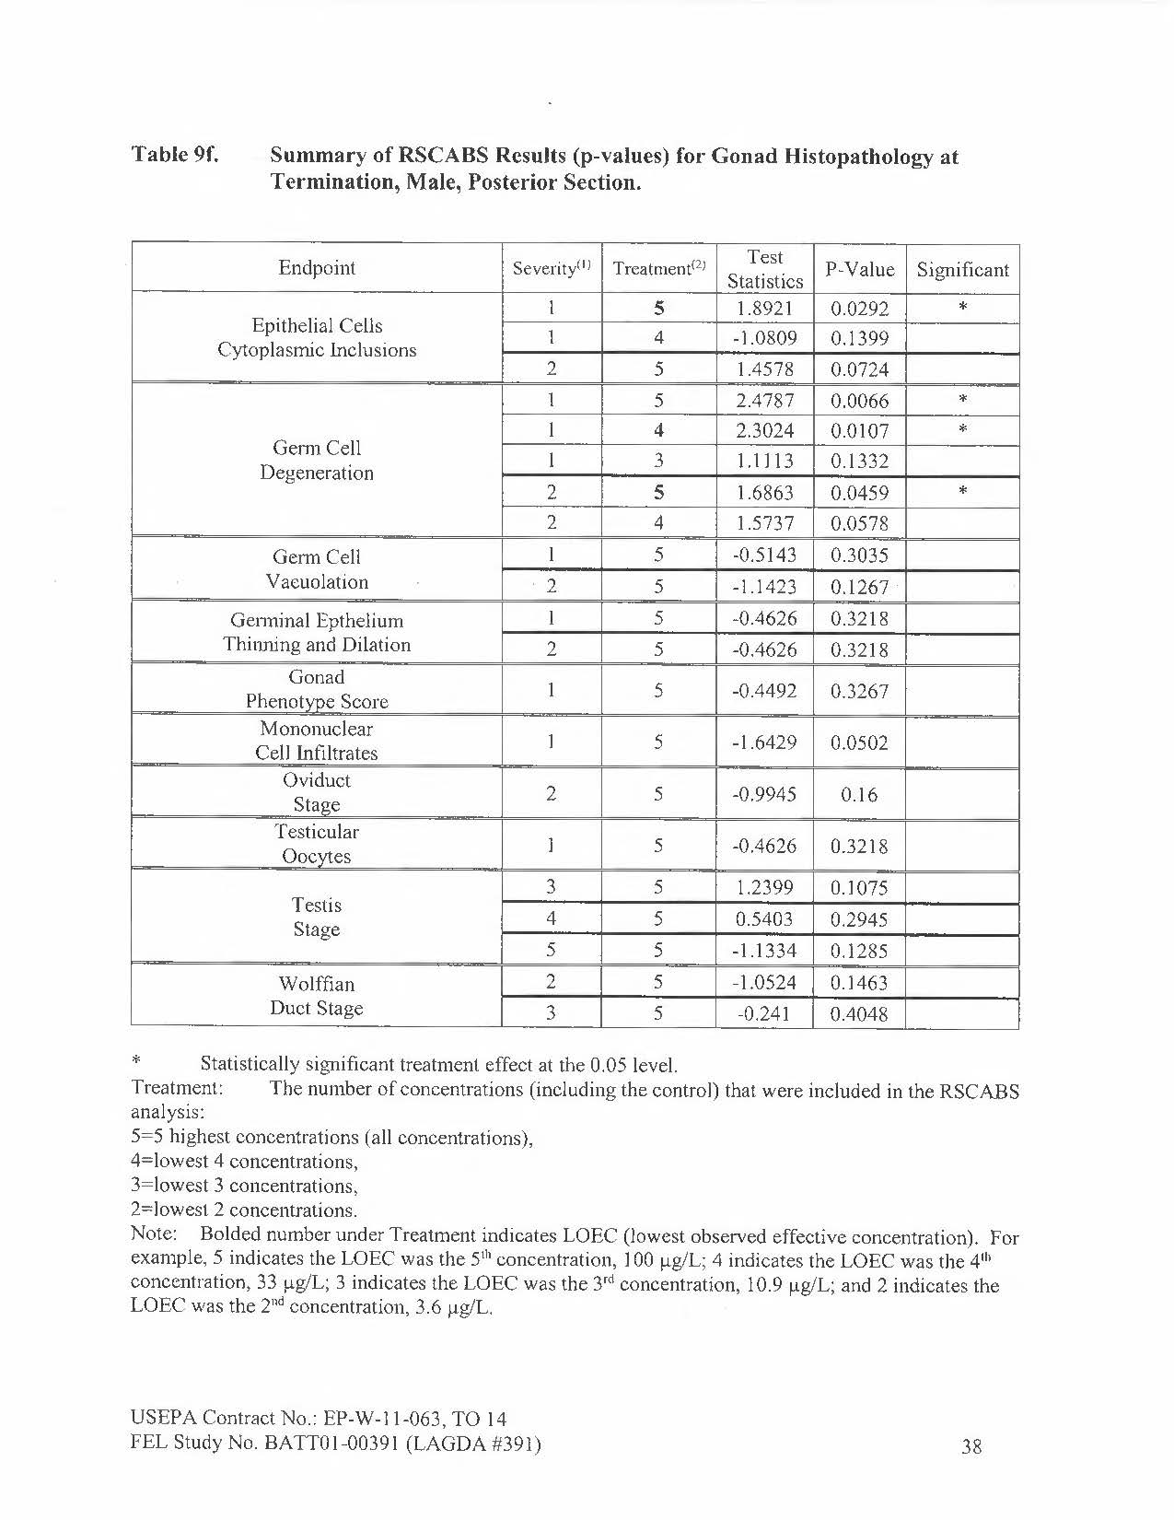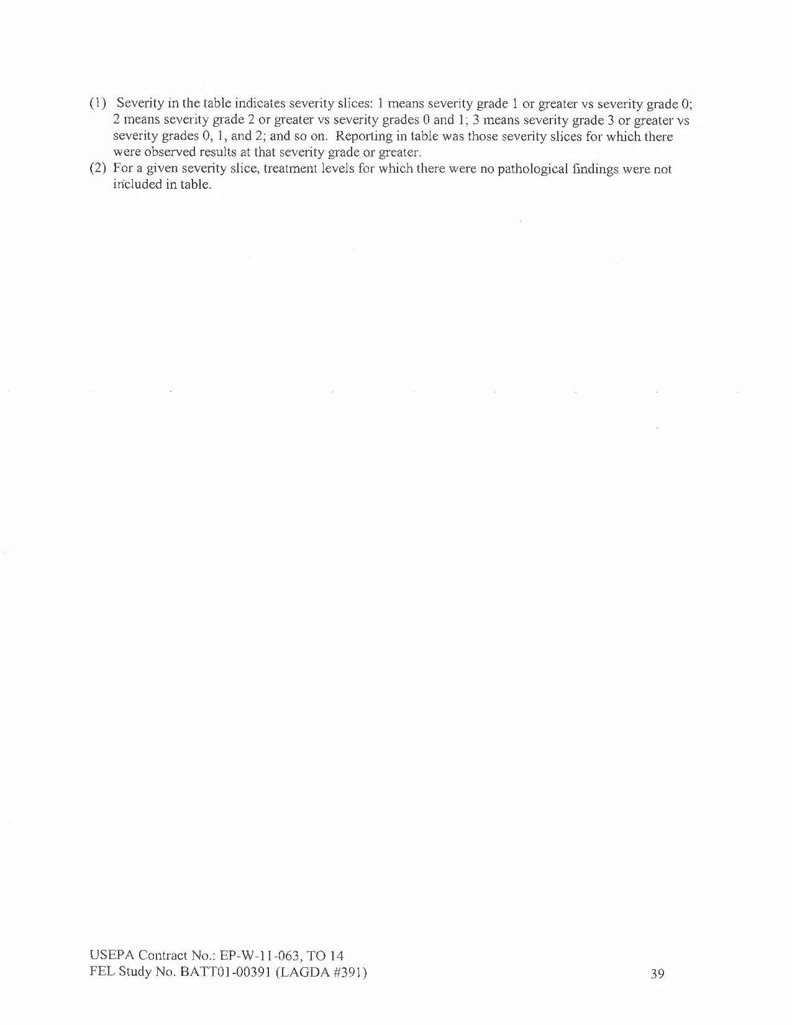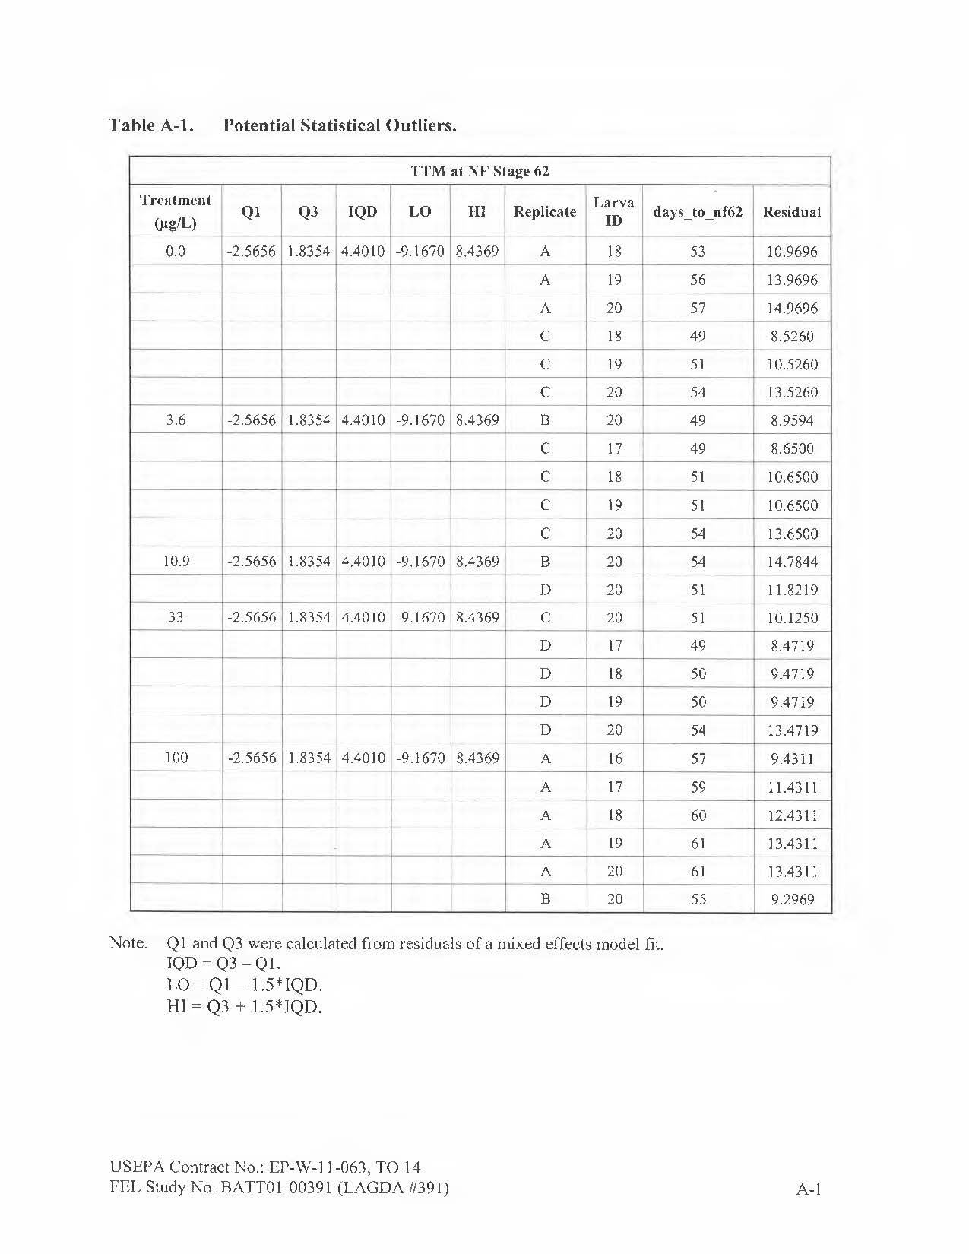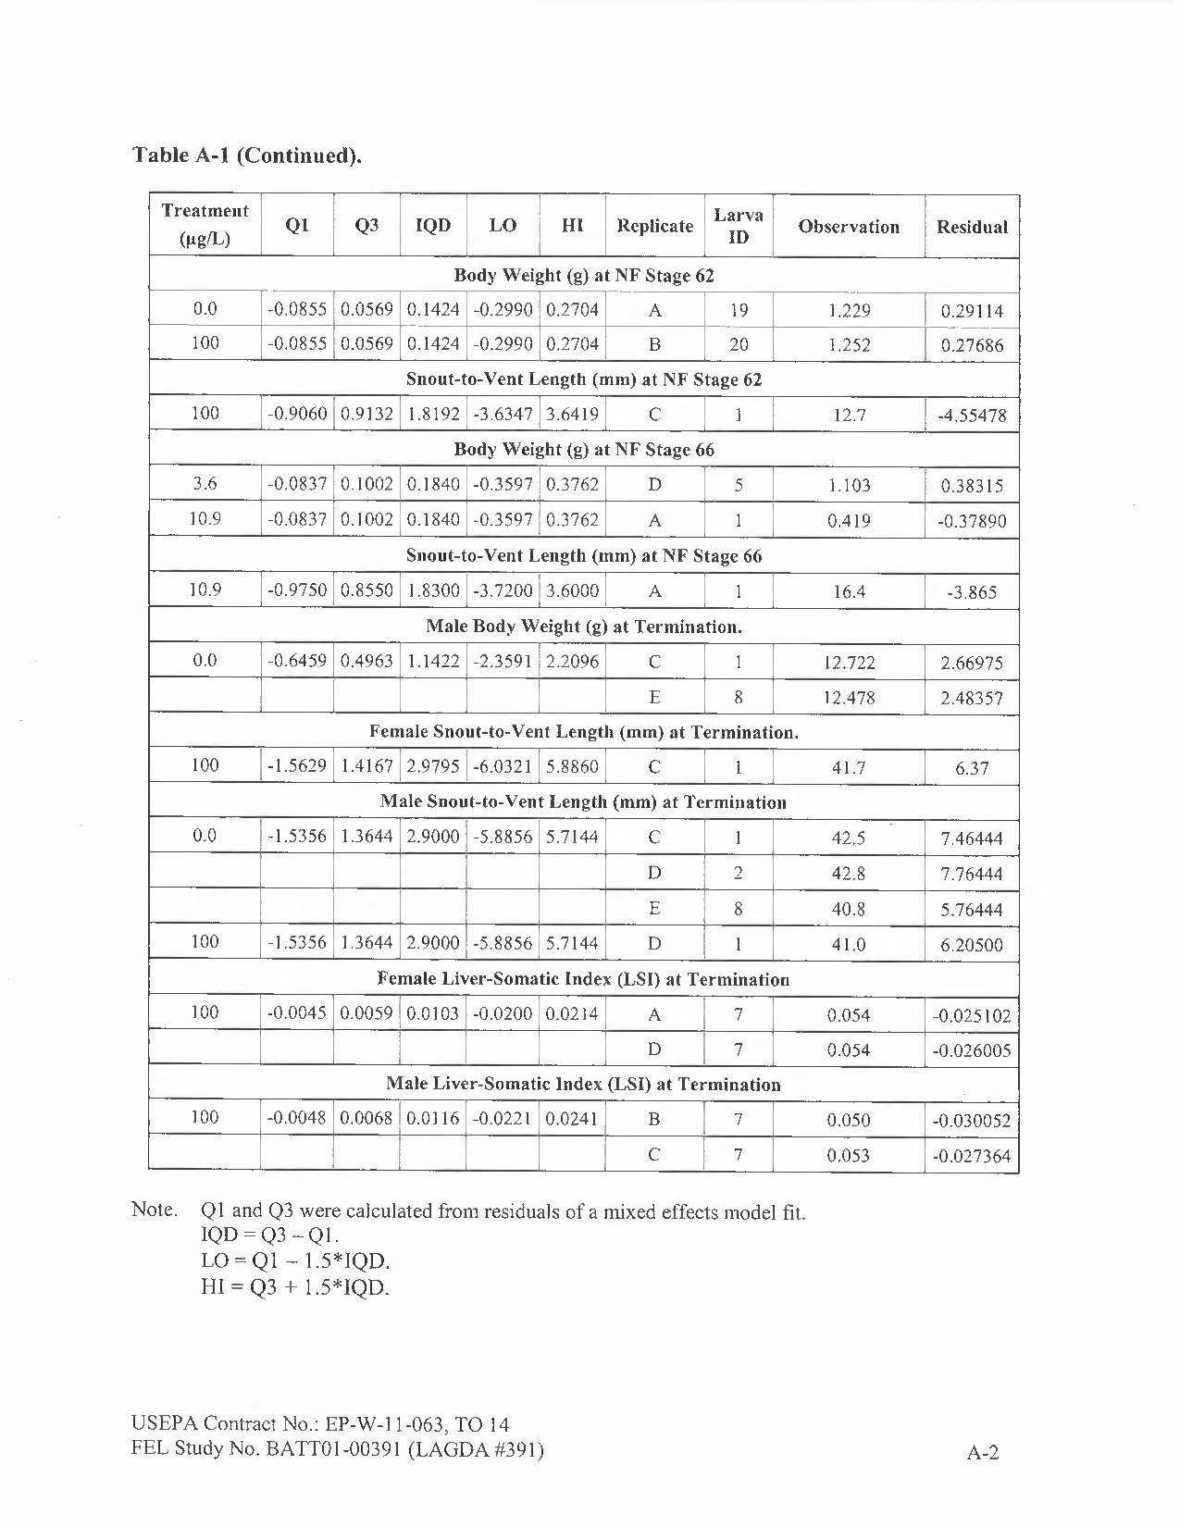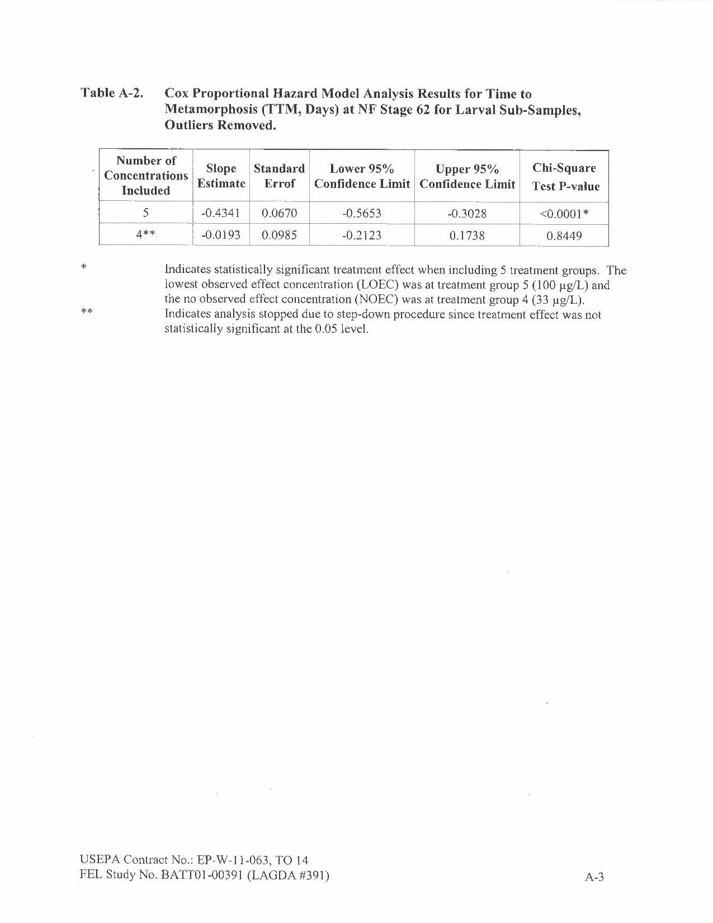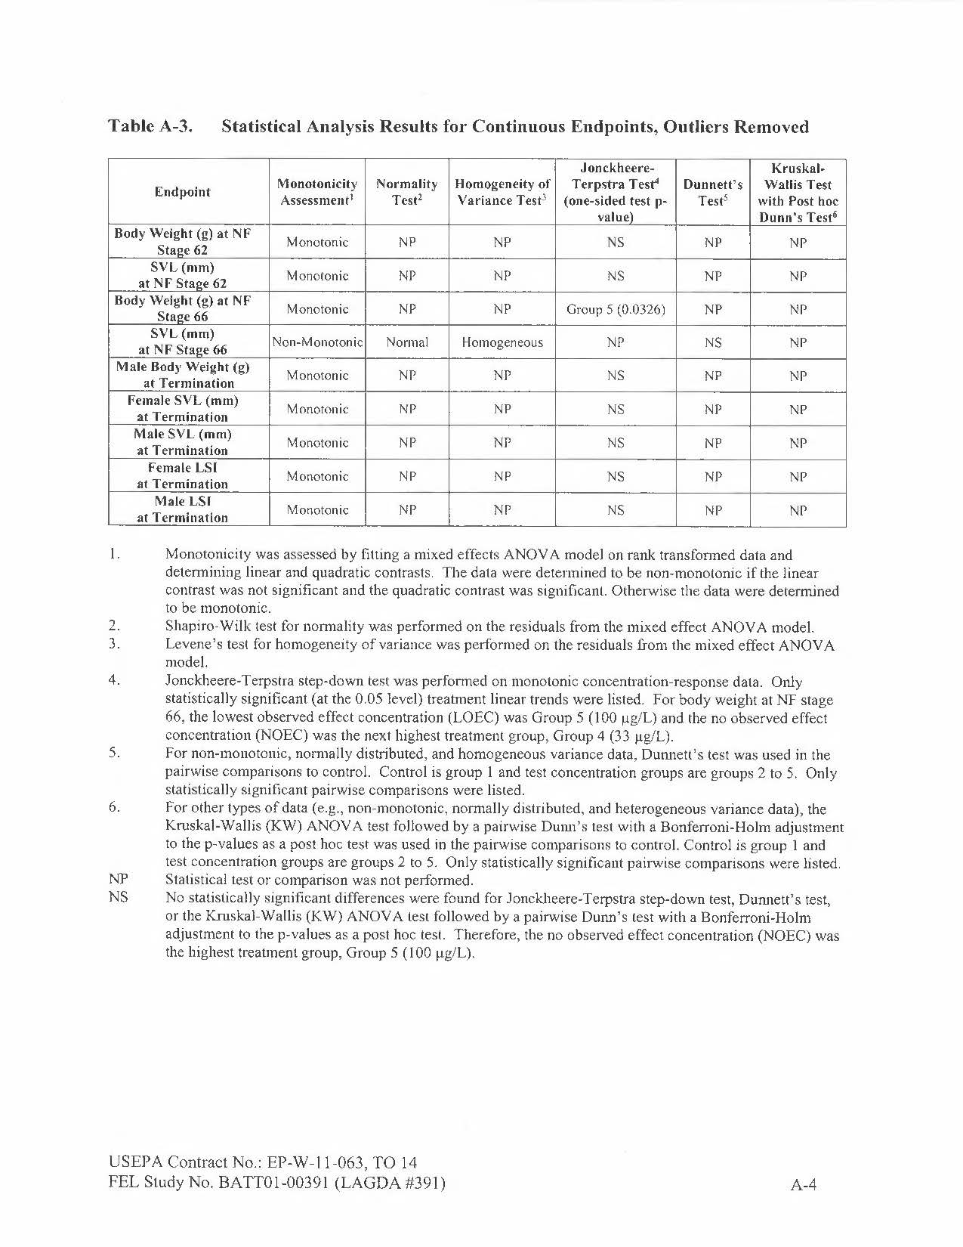

Range-Finding Data (range-finding studies were not performed in a GLP-compliant manner per exception noted in Section 1)

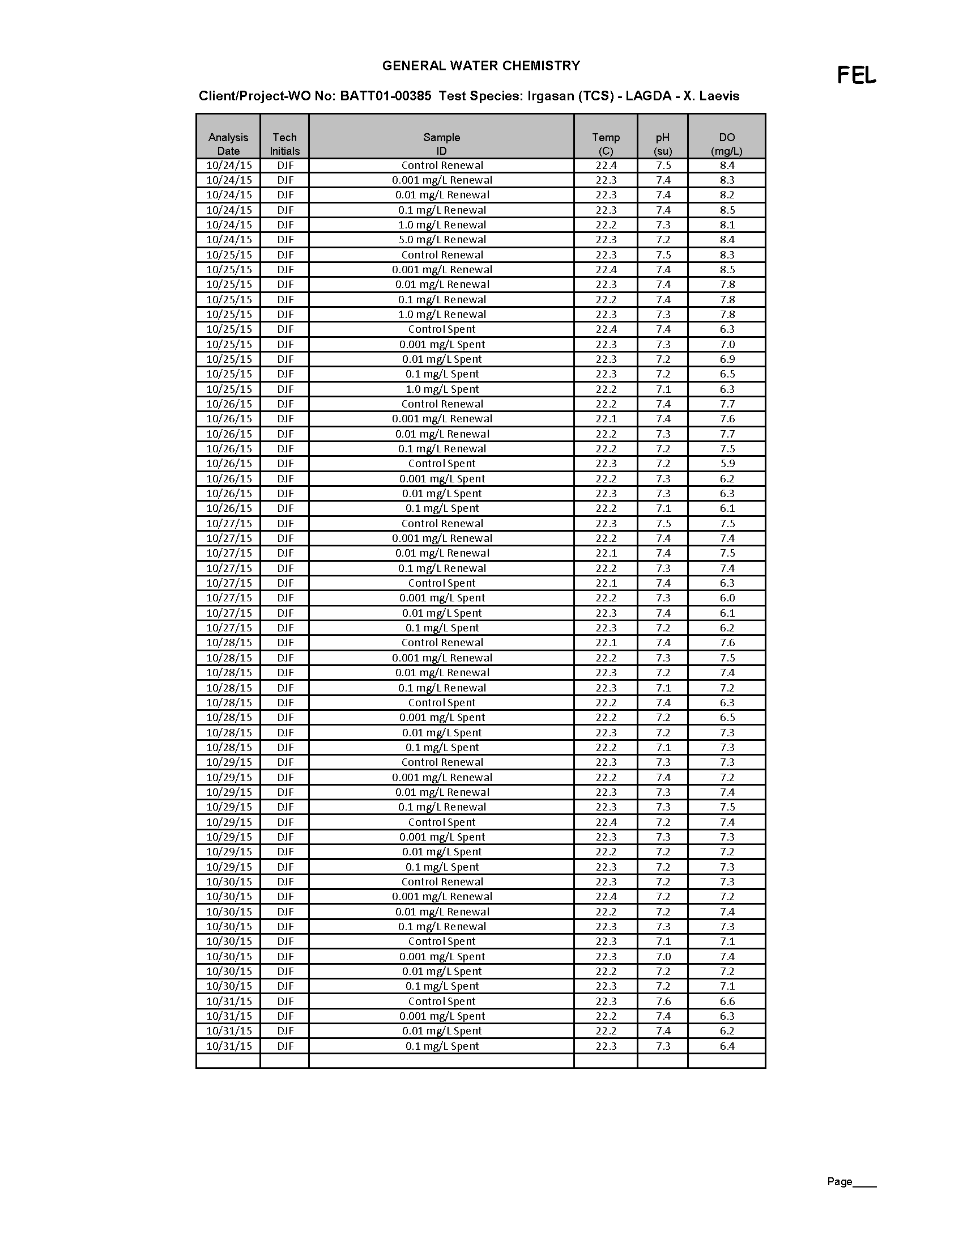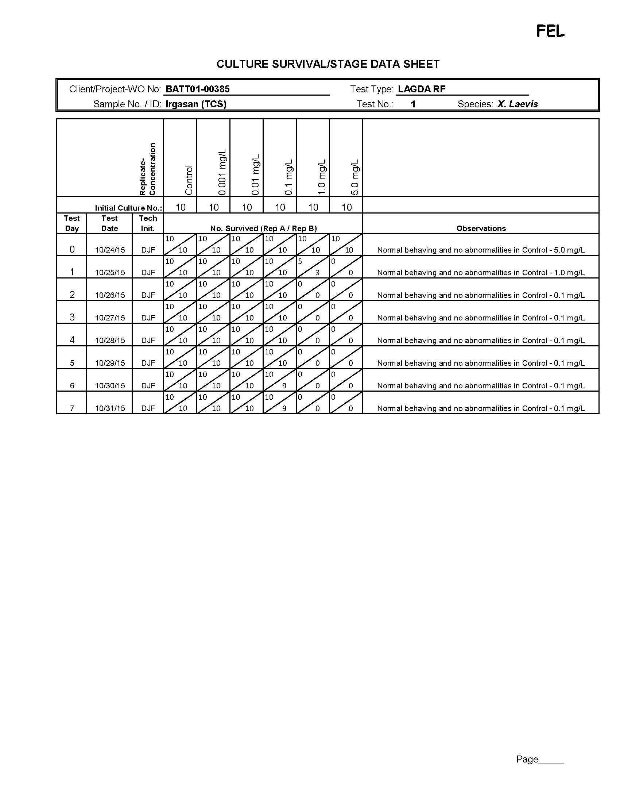

Feed the volume of food listed at a frequency of three times per weekday. Feed the volume of food listed once per day on weekends. Preparation based on OCSPP 890.2300 Larval Amphibian Growth and Development Assay (LAGDA) (3)
Feed volume twice per day and once during weekend.
SD 4-14 (feeding initiated on SD 4) for blended food and SD 8-15 for brine shrimp.
Organisms that have not reached NF stage 62 should not be fed metamorphosed organism diet.
Statistical evaluation will be considered for each of the endpoints.
Used to determine median time-to metamorphosis (NF stage 62) or MMT.
Minimum detection limit (MDL) is 0.06 mg/L; 0.5x detection limit used for calculation purposes.
Minimum detection limit (MDL) is 0.05 mg/L; 0.5x detection limit used for calculation purposes.
Measured on SD 0, 45, and 10 wpm (in-life termination).
Minimum Quantitation Level (MQL) = 0.199 μg/L.
Coefficient of variation = (Standard deviation / mean)100. Represents inter-replicate CV at each sampling point based on mean and standard deviation of each replicate (A-D) for each test concentration at each time points measured. Only determined on SD 0 and SD 109 (exposure termination) since only single replicates in rotation were analyzed on designated SD in between.
Average of original and duplicate sample.
Minimum Quantitation Level (MQL) = 0.199 μg/L.
Coefficient of variation = (Standard deviation / mean)100. Represents inter-replicate CV at each sampling point based on mean and standard deviation of each replicate (A-D) for each test concentration at each time points measured. Only determined on SD 0 and SD 109 (exposure termination) since only single replicates in rotation were analyzed on designated SD in between.
Average of original and duplicate sample.
Minimum Quantitation Level (MQL) = 0.199 μg/L.
Coefficient of variation = (Standard deviation / mean)100. Represents inter-replicate CV at each sampling point based on mean and standard deviation of each replicate (A-D) for each test concentration at each time points measured. Only determined on SD 0 and SD 109 (exposure termination) since only single replicates in rotation were analyzed on designated SD in between.
Minimum Quantitation Level (MQL) = 0.199 μg/L.
Coefficient of variation = (Standard deviation / mean)100. Represents inter-replicate CV at each sampling point based on mean and standard deviation of each replicate (A-D) for each test concentration at each time points measured. Only determined on SD 0 and SD 109 (exposure termination) since only single replicates in rotation were analyzed on designated SD in between.
Since time interval between sample collection events was consistent throughout study, the mean measured concentration represents an accurate estimation of exposure concentration. The mean measured concentration represents the average of weekly data points. On SD 0 and in-life phase termination all replicate control replicates (n=8) and treatment replicates (n=4) were sampled and analyzed. On the weeks between these two points, a sample was collected from one replicate tank of the control and each test concentration. The replicate selected for weekly sampling rotated. Coefficient of variation = (Standard deviation / mean*100). CV is based on the standard deviation of mean measured concentration of each replicate and mean measured treatment concentration per facility SOP.
Minimum Quantitation Level (MQL) = 0.199 μg/L.
Std Dev = Standard deviation. CV (%) = Coefficient of variation = (standard deviation / mean) × 100.
Survival at NF stage 66 prior to cull from N=15 to N=10 was 100% in each replicate of the control and each treatment. Since the survival at NF stage 66 was not analyzed statistically, it was not enumerated in table.
TTM defined as the time required to reach NF stage 62. The median TTM (or MMT) for each replicate of the control and each treatment was determined. The treatment MMT represents the median of the replicate median TTM. Coefficient of variation = (standard deviation / mean) × 100%. Median, Standard deviation, and coefficient of variation calculated from the replicate medians for each treatment (i.e., N=8 for control and N=4 for other treatment groups). d = days.
Significantly greater than control (Cox Proportional Hazard Model, Chi Square, p<0.0001).
Std Dev = standard deviation, SEM = standard error of the mean, and CV(%) = coefficient of variation (standard deviation / mean) × 100. Mean, Std Dev, SEM, CV (%) were calculated from the replicate means for each treatment (i.e., N=8 for control and N=4 for other treatment groups). Not significantly different from control (Jonckheere-Terpstra test, p>0.05).
Std Dev = standard deviation, SEM = standard error of the mean, and CV(%) = coefficient of variation (standard deviation / mean) × 100. Mean, Std Dev, SEM, CV (%) were calculated from the replicate means for each treatment (i.e., N=8 for control and N=4 for other treatment groups). Not significantly different from control (Jonckheere-Terpstra test, p>0.05).
Std Dev = standard deviation, SEM = standard error of the mean, and CV (%) = coefficient of variation (standard deviation / mean) × 100. Mean, Std Dev, SEM, CV (%) were calculated from the replicate means for each treatment (i.e., N=8 for control and N=4 for other treatment groups).
Significantly less than control (Jonckheere-Terpstra test, p=0.0258).
Std Dev = standard deviation, SEM = standard error of the mean, and CV(%) = coefficient of variation (standard deviation / mean) × 100. Mean, Std Dev, SEM, CV (%) were calculated from the replicate means for each treatment (i.e., N=8 for control and N=4 for other treatment groups). Not significantly different from control (Jonckheere-Terpstra test, p>0.05).
Std Dev = standard deviation, SEM = standard error of the mean, and CV(%) = coefficient of variation (standard deviation / mean) × 100. Mean, Std Dev, SEM, CV (%) were calculated from the replicate means for each treatment (i.e., N=8 for control and N=4 for other treatment groups). Not significantly different from control (Jonckheere-Terpstra test, p>0.05).
Std Dev = standard deviation, SEM = standard error of the mean, and CV(%) = coefficient of variation (standard deviation / mean) × 100. Mean, Std Dev, SEM, CV (%) were calculated from the replicate means for each treatment (i.e., N=8 for control and N=4 for other treatment groups). Not significantly different from control (Dunnett’s test, p>0.05).
Std Dev = standard deviation, SEM = standard error of the mean, and CV(%) = coefficient of variation (standard deviation / mean) × 100. Mean, Std Dev, SEM, CV (%) were calculated from the replicate means for each treatment (i.e., N=8 for control and N=4 for other treatment groups). Not significantly different from control (Jonckheere-Terpstra test, p>0.05).
Std Dev = standard deviation, SEM = standard error of the mean, and CV(%) = coefficient of variation (standard deviation / mean) × 100. Mean, Std Dev, SEM, CV (%) were calculated from the replicate means for each treatment (i.e., N=8 for control and N=4 for other treatment groups). Not significantly different from control (Jonckheere-Terpstra test, p>0.05).
Std Dev = standard deviation, SEM = standard error of the mean, and CV(%) = coefficient of variation (standard deviation / mean) × 100. Mean, Std Dev, SEM, CV (%) were calculated from the replicate means for each treatment (i.e., N=8 for control and N=4 for other treatment groups. Not significantly different from control (Jonckheere-Terpstra test, p>0.05).
Std Dev = standard deviation, SEM = standard error of the mean, and CV(%) = coefficient of variation (standard deviation / mean) × 100. Mean, Std Dev, SEM, CV (%) were calculated from the replicate means for each treatment (i.e., N=8 for control and N=4 for other treatment groups). Not significantly different from control (Jonckheere-Terpstra test, p>0.05).
N= 80 for control and 40 for each treatment.
Female to male ratio. Does not include indeterminants in phenotype ratio.
A single frog of the 100.0 µg/L dose group (Animal No. 1167-D7) was found to possess both testicular and ovarian tissue, and was, therefore, given a diagnosis of hermaphroditism. It was excluded from the determination of the phenotypic ratio only. The genotype of this individual was considered.
Histopathologic findings were scored for severity according to the following grading system: X = not remarkable, Grade 1 = minimal, Grade 2 = mild, Grade 3 = moderate, and Grade 4 = severe, in accordance with previously reported criteria (3,8).
Significantly greater than the control (RSCABS, p=0.0375).
Significantly greater than the control (RSCABS, p=0.0132).
Histopathologic findings were scored for severity according to the following grading system: X = not remarkable, Grade 1 = minimal, Grade 2 = mild, Grade 3 = moderate, and Grade 4 = severe, in accordance with previously reported criteria (3,8).
Significantly greater than control (RSCABS, p=0.0243).
Significantly greater than control (RSCABS, p=0.0228).
Significantly greater than control (RSCABS, p=0.0001).
Significantly greater than control (RSCABS, p<0.0001).
Significantly greater than control (RSCABS, p=0.0398).
Significantly greater than control (RSCABS, p<0.0001).
Significantly greater than control (RSCABS, p=0.0001).
Significantly greater than control (RSCABS, p=0.0103).
Significantly greater than control (RSCABS, p<0.0001).
Significantly greater than control (RSCABS, p=0.0072).
Significantly greater than control (RSCABS, p<0.0001).
Significantly greater than control (RSCABS, p=0.0137).
Significantly greater than control (RSCABS, p=0.0034).
Significantly greater than control (RSCABS, p<0.0001).
Significantly greater than control (RSCABS, p=0.0470).
Significantly greater than control (RSCABS, p<0.0001).
Significantly greater than control (RSCABS, p=0.0470).
Significantly greater than control (RSCABS, p<0.0001).
Significantly greater than control (RSCABS, p=0.0196).
Significantly greater than control (RSCABS, p=0.0327).
Significantly greater than control (RSCABS, p=0.0163).
Significantly greater than control (RSCABS, p=0.0196).
Histopathologic findings were scored for severity according to the following grading system: X = not remarkable, Grade 1 = minimal, Grade 2 = mild, Grade 3 = moderate, and Grade 4 = severe, in accordance with previously reported criteria (3,8). Gonad phenotype scores were recorded as follows: Grade 0 = gonad phenotype matches genotype; Grade 1 = phenotype primarily matches genotype; Grade 2 = equal parts testis and ovary; Grade 3 = phenotype primarily matches opposite genotype; and Grade 4 = sex-reversed, phenotype completely opposite genotype.
Significantly greater than control (RSCABS, p=0.0335).
Significantly greater than control (RSCABS, p=0.0123).
Significantly greater than control (RSCABS, p=0.0126).
Significantly less than control (RSCABS, p<0.0091). Results suggest significant developmental delay.
Significantly less than control (RSCABS, p<0.0008). Results suggest significant developmental delay.
Significantly less than control (RSCABS, p<0.0450). Results suggest significant developmental delay.
Histopathologic findings were scored for severity according to the following grading system: X = not remarkable, Grade 1 = minimal, Grade 2 = mild, Grade 3 = moderate, and Grade 4 = severe, in accordance with previously reported criteria (3,8).
Significantly greater than control (RSCABS, p=0.0245).
Significantly greater than control (RSCABS, p=0.0046).
Significantly greater than control (RSCABS, p=0.0046).
Significantly greater than control (RSCABS, p=0.0001).
Significantly greater than control (RSCABS, p=0.0067).
Significantly greater than control (RSCABS, p=0.0014).
Significantly greater than control (RSCABS, p=0.0457).
Significantly greater than control (RSCABS, p=0.0012).
Significantly greater than control (RSCABS, p=0.0457).
Significantly greater than control (RSCABS, p=0.0177).
Significantly greater than control (RSCABS, p=0.0087).
Significantly greater than control (RSCABS, p<0.0001).
Significantly greater than control (RSCABS, p=0.0043).
Significantly greater than control (RSCABS, p=0.0002).
Significantly greater than control (RSCABS, p<0.0001).
Significantly greater than control (RSCABS, p=0.0007).
Significantly greater than control (RSCABS, p=0.0012).
Significantly greater than control (RSCABS, p=0.0003).
Significantly greater than control (RSCABS, p=0.0154).
Significantly greater than control (RSCABS, p=0.0010).
Significantly greater than control (RSCABS, p=0.0067).
Significantly greater than control (RSCABS, p=0.0002).
Significantly greater than control (RSCABS, p=0.0004).
Significantly greater than control (RSCABS, p=0.0483).
Histopathologic findings were scored for severity according to the following grading system: X = not remarkable, Grade 1 = minimal, Grade 2 = mild, Grade 3 = moderate, and Grade 4 = severe, in accordance with previously reported criteria (3,8). Gonad phenotype scores were recorded as follows: Grade 0 = gonad phenotype matches genotype; Grade 1 = phenotype primarily matches genotype; Grade 2 = equal parts testis and ovary; Grade 3 = phenotype primarily matches opposite genotype; and Grade 4 = sex-reversed, phenotype completely opposite genotype.
Significantly greater than control (RSCABS, p=0.0131).
Significantly greater than control (RSCABS, p=0.0009).
Significantly greater than control (RSCABS, p=0.0043).
Significantly greater than control (RSCABS, p=0.0292).
Significantly less than control (RSCABS, p=0.0292). Results suggest significant developmental delay.
Significantly less than control (RSCABS, p=0.0292). Results suggest significant developmental delay.
Significantly less than control (RSCABS, p=0.0292). Results suggest significant developmental delay.
Histopathologic findings were scored for severity according to the following grading system: X = not remarkable, Grade 1 = minimal, Grade 2 = mild, Grade 3 = moderate, and Grade 4 = severe, in accordance with previously reported criteria (3,8). Gonad phenotype scores were recorded as follows: Grade 0 = gonad phenotype matches genotype; Grade 1 = phenotype primarily matches genotype; Grade 2 = equal parts testis and ovary; Grade 3 = phenotype primarily matches opposite genotype; and Grade 4 = sex-reversed, phenotype completely opposite genotype.
Significantly greater than control (RSCABS, p<0.0001).
Significantly greater than control (RSCABS, p=0.0010).
Significantly greater than control (RSCABS, p=0.0001).
Significantly greater than control (RSCABS, p=0.0007).
Significantly greater than control (RSCABS, p=0.0004).
Significantly greater than control (RSCABS, p=0.0006).
Significantly greater than control (RSCABS, p=0.0103).
Significantly greater than control (RSCABS, p=0.0004).
Significantly greater than control (RSCABS, p=0.0421).
Significantly greater than control (RSCABS, p=0.0107).
Significantly greater than control (RSCABS, p=0.0066).
Significantly greater than control (RSCABS, p=0.0459).
Significantly greater than control (RSCABS, p=0.0186).
Significantly greater than control (RSCABS, p=0.0357).
Significantly greater than control (RSCABS, p=0.0368).
Nominal concentrations.
Median metamorphosis time determined from the time to metamorphosis from each individual in a given replicate (replicate MMT). The treatment and control MMTs were based on the median of the replicate MMT values.
Based on most-sensitive finding for the tissue represented.
Coefficient of variation = (Standard deviation / mean). CV based on the standard deviation of mean measured concentration of each replicate and mean measured treatment concentration per FEL SOP 6.1.

