SPONSOR
U.S. Environmental Protection Agency
1200 Pennsylvania Ave., NW
Washington DC 20460C

USEPA Task Order/Battelle Contract No.
TO 14/ EP-W-11-063

TEST SUBSTANCE
4-nonylphenol, branched

STUDY TITLE
Larval Amphibian Growth and Development Assay (LAGDA) of 4-nonylphenol, branched, with African Clawed Frog, Xenopus laevis

TEST GUIDELINE
U.S. EPA, OCSPP 890.2300 (July 2015)

STUDY DIRECTOR
Douglas J. Fort, Ph.D.

STUDY INITIATION DATE
January 8, 2016

STUDY COMPLETION DATE
May 31, 2018

TEST FACILITY
Fort Environmental Laboratories, Inc. (In-Life Testing)
515 South Duncan Street
Stillwater, OK 74074 USA
PI SUPPORT SITES
EAG Laboratories (formerly ABC), Analytical Chemistry
7200 East ABC Lane
Columbia, MO 65202

Experimental Pathology Laboratories (EPL), Histopathology
45600 Terminal Drive
Sterling, VA 20166 USA

REPORT NUMBER
BATT01-00392

Total Pages: 511

COMPLIANCE STATEMENT
This study was conducted in compliance with the following GLP principles:
- United States Environmental Protection Agency, (FIFRA), Good Laboratory Practice Standards, Title 40 Code of Federal Regulations Part 160 (effective October 16, 1989) with the following exceptions:
- Analysis of the laboratory dilution water for organics, pesticides and metals at Red River Laboratory (Oklahoma City, Oklahoma) using standard EPA methods was not GLP-compliant;
- Per Sponsor-mandated exception, the test substance was not chemically-characterized in a GLP-compliant manner;
- Per Sponsor-mandated exception, range-finding studies conducted as a component of FEL study (BATT01-00385) used to determine test concentrations for the present study, BATT01-00392, were not performed in a GLP-compliant manner;
- Per Sponsor-mandated exception, following study finalization, specimens remaining at FEL, and embedded tissues or specimens maintained by EPL will be disposed of in accordance with QMP, QAPP, and respective facility SOPs.
Since the analyses of the dilution water was conducted following standard validated methods, this exception will not be expected to impact on the study results. Lack of GLP-compliant chemical characterization or GLP-compliant range-finding studies will not be expected to impact study results, nor change the conclusions drawn from the study.

GLP Study Title: Larval Amphibian Growth and Development Assay (LAGDA) of 4-nonylphenol, branched, with African Clawed Frog, Xenopus laevis

FEL Study No.: BATT01-00392

Test Substance: 4-nonylphenol, branched (CAS No. 84852-15-3)
Douglas J. Fort, Ph.D. |  | Date
Fort Environmental Laboratories, Inc.
(Study Director)
Vincent J. Brown, Ph.D. |  | Date
Battelle
(Sponsor Representative)

STATEMENT OF QUALITY ASSURANCE UNIT
This study was conducted in accordance with Standard Operating Procedures (SOPs) and the protocol as approved by the Sponsor. The Fort Environmental Laboratories, Inc. (FEL) Quality Assurance Unit conducted the inspections detailed below:

Type of Inspection | Dates
 | Inspection | Reported to  Study Director | Reported to Management
Protocol Review | 1/8/2016 | 1/8/2016 | 1/8/2016
Technical Systems Audit | 4/25/2016 | 4/25/2016 | 4/25/2016
Audit of Data Quality | 4/27/2017 | 4/27/2017 | 4/27/2017
Draft Report Audit | 8/8/2017 | 8/8/2017 | 8/8/2017
Final Report Audit | 5/31/2018 | 5/31/2018 | 5/31/2018

This report accurately reflects the raw data obtained during the performance of this study. The protocol and all protocol amendments and deviations are presented as an attachment (Appendix A). Three protocol deviations occurred during the course of this study. Procedures pertinent to this study are described in this report. The primary goal of the Quality Assurance Unit (QAU) is to ensure the accuracy and precision of routine laboratory operations, data generated reports, and presentation of studies conducted by FEL. The final report is considered to constitute an accurate and complete reflection of the data generated from this study.
Michael Mathis, QAU Manager |  | Date

CERTIFICATION
We, the undersigned, declare that this report provides an accurate evaluation of the data obtained from this study.

Study Director:
Douglas J. Fort, Ph.D., Study Director, FEL |  | Date

Performing Laboratory Management:
Deanne Fort, Facility Manager, FEL |  | Date

TABLE OF CONTENTS
1. COMPLIANCE STATEMENT 2
2. STATEMENT OF QUALITY ASSURANCE UNIT 3
3. CERTIFICATION 4
4. TABLE OF CONTENTS 5
5. EXECUTIVE SUMMARY 8
5.1. Measured Test Concentrations 8
5.2. Survival 8
5.3. Growth 8
5.4. Development 9
5.5. Histopathology (abnormal morphological features) 9
5.6. Overt Toxicity and Behavior 11
5.7. Conclusions 11
6. INTRODUCTION 13
7. Study Personnel 14
8. ANIMAL WELFARE COMPLIANCE 15
9. materials and methods 15
9.1. Test Substance 15
9.2. Laboratory Water 16
9.3. Test System 17
9.3.1. Feeding 17
9.4. Exposure System 18
9.4.1. Chemical analysis 19
9.5. Study Design and Additional Experimental Conditions 21
9.5.1. Biological Sample Collection 21
9.5.2. Exposure System Performance 21
9.6. Observations 21
9.6.1. Survival 21
9.6.2. Additional Daily Observations 21
9.6.3. NF Stage 62 Specimens (Endpoints/Tissue Sample Preparation) 22
9.6.4. Time to Metamorphosis (TTM) 22
9.6.5. Growth (Weight and Length) 22
9.6.6. External Evaluation 22
9.6.7. Tissue Collection and Fixation for General Histology 23
9.6.8. End of Larval Exposure Phase 23
9.6.9. In-Life Test Termination (Endpoints / Tissue Sample Preparation) 23
9.6.10. Growth (Weight and Length) 23
9.6.11. External Evaluation 24
9.6.12. Tissue Collection and Fixation for General Histology 24
9.6.13. Phenotypic and Genotypic Sexing 24
10. Data Analysis 24
11. Results 26
11.1. Range Finding 26
11.2. Water Quality Measurements and Test System Performance 26
11.3. Confirmation of Test Concentrations 26
11.4. Clinical Signs of Toxicity 26
11.5. In-Life Studies—NF 8 to NF Stage 62 26
11.5.1. Survival 26
11.5.2. Time to Metamorphosis (Median Metamorphosis Time, MMT) 27
11.5.3. Growth 27
11.6. In-Life Studies—Metamorphosed Young (NF Stage 66) and Juveniles 27
11.6.1. Survival 27
11.6.2. Growth 27
11.7. Liver-Somatic Index (LSI) 28
11.8. Gender Ratios 28
11.9. Histopathology 28
11.9.1. NF Stage 62 28
11.9.2. Juveniles 29
12. Concentration Measurement Endpoints 31
13. DISCUSSION 31
13.1. Performance Criteria and Validity 31
13.2. Assessment of the LAGDA results 32
13.3. Measured Test Concentrations 32
13.3.1. Survival 32
13.3.2. Growth 32
13.3.3. Development 32
13.3.4. Histopathology (abnormal morphological features) 33
13.3.5. Comparison to Literature 35
13.3.6. Overt Toxicity and Behavior 35
14. Conclusions 35
15. Sample handling and custody 38
16. Record Maintenance and Archival 38
17. Specimens Archival 38
18. test Substance waste Disposal 39
19. Study Protocol Adherence 39
20. References 41

LIST OF TABLES
Table 1. Feeding Regime for X. laevis Larvae in Flow-Through Conditions 44
Table 2. Frog food (2 mm) Feeding Rate for Metamorphosed Frogs 44
Table 3. Experimental Specifications for LAGDA Study 45
Table 4. Summary of Study Endpoints 46
Table 5. Summary of Water Quality Parameters 47
Table 6. Summary of Treatment Concentrations in LAGDA with 4-NP 48
Table 7. Summary of Treatment Concentrations in the Larval Amphibian Growth and Development Assay (LAGDA) with 4-NP 52
Table 8. Effect of 4-NP on Survival in X. laevis (LAGDA) 53
Table 9. Effect of 4-NP on Median Metamorphosis Time (MMT) in X. laevis (LAGDA) 54
Table 10. Effect of 4-NP Exposure on Body Weight in NF Stage 62 X. laevis Larvae (LAGDA) 55
Table 11. Effect of 4-NP Exposure on Snout-to-Vent Length (SVL) in NF Stage 62 X. laevis Larvae (LAGDA) 56
Table 12. Effect of 4-NP Exposure on Body Weight in NF Stage 66 X. laevis (LAGDA) 57
Table 13. Effect of 4-NP Exposure on Body Weight in Juvenile Female X. laevis at Study Termination (LAGDA) 58
Table 14. Effect of 4-NP Exposure on Body Weight in Juvenile Male X. laevis at Study Termination (LAGDA) 59
Table 15. Effect of 4-NP Exposure on Snout-to-Vent Length (SVL) in NF Stage 66 X. laevis (LAGDA) 60
Table 16. Effect of 4-NP Exposure on Snout-to-Vent Length (SVL) in Juvenile Female X. laevis at Study Termination (LAGDA) 61
Table 17. Effect of 4-NP Exposure on Snout-to-Vent Length (SVL) in Juvenile Male X. laevis at Study Termination (LAGDA) 62
Table 18. Effect of 4-NP Exposure on Liver-Somatic Indices (LSI) in Juvenile Female X. laevis at Study Termination (LAGDA) 63
Table 19. Effect of 4-NP Exposure on Liver-Somatic Indices (LSI) in Juvenile Male X. laevis at Study Termination (LAGDA) 64
Table 20. Effect of 4-NP Exposure on Phenotypic and Genotypic Sex Ratios in Juvenile X. laevis at Study Termination (LAGDA) 65
Table 21. Summary of the Effect of 4-NP Exposure on Thyroid Histopathology Findings in NF Stage 62 Larvae 66
Table 22. Summary of the Effect of 4-NP Exposure on Gonadal Duct Stage Scores in Female X. laevis 67
Table 23. Summary of the Effect of 4-NP Exposure on Gonadal Duct Stage Scores in Male X. laevis 68
Table 24. Summary of the Effect of 4-NP Exposure on Testis Stage Scores in Male X. laevis 69
Table 25. Summary of Study BATT01-00392 Endpoint Results 70
Table 26. General Test Performance Criteria 71

LIST OF APPENDICES
Appendix A. Protocol, Protocol Amendments, and Protocol Deviation 72
Appendix B. Certificate of Analysis 122
Appendix C. Analytical Laboratory Data Reports 126
Appendix D. Histopathology Data Reports 192
Appendix E. DEST 297
Appendix F. Statistical Analyses 461
Appendix G. Range-Finding Data (range-finding studies were not performed in a GLP-compliant manner per exception noted in Section 1) 509

EXECUTIVE SUMMARY
The Larval Amphibian Growth and Development Assay (LAGDA) (OCSPP 890.2300) uses the African clawed frog (Xenopus laevis) as a surrogate to identify and characterize the adverse consequences of exposure to substances which might interfere with the normal development and growth of amphibians from embryo-larval development through metamorphosis and early juvenile development. Adverse effects identified by the LAGDA may be caused by endocrine interaction of a chemical in amphibians, especially those active within the hypothalamic-pituitary-thyroid (HPT) and hypothalamic-pituitary-gonadal (HPG) systems. In the conduct of the present study, FEL relied on internal SOPs, per the GLP regulations and documented QAU practices subject to sponsor and other government audit. These SOPs are not available to the public. Amphibian larvae at Nieuwkoop–Faber (NF) Stage 8-10 (80/treatment group and 160/control group(s); 20/replicate) were exposed to 4-nonylphenol, branched (4-NP) (92.9% pure) at test chemical nominal concentrations of 0.0 (control), 1.80, 5.50, 16.5, and 50.0 µg/L, until 10 weeks post median metamorphosis time (MMT) (median time at which 50% of the controls reach NF stage 62) There was one interim sub-sample at MMT. Endpoints evaluated during the exposure included those indicative of generalized toxicity: mortality (survival), growth (length and weight), development (time to metamorphosis at NF stage 62 (TTM)), morphological features (histopathology), overt toxicity, and behavior. Thyroid histopathology of NF stage 62 specimens and gonad, gonadal ducts, liver, and kidney histopathology of study termination specimens were performed. The assay was conducted under flow-through conditions. The test system was maintained at 21.3 to 21.9ºC and a pH of 6.5 to 8.1.

A summary of the results is provided below.

Measured Test Concentrations
- The mean measured concentrations for the 0.0 (control), 1.80, 5.50, 16.5, and 50.0 µg/L 4-NP treatments (nominal) were (<0.333 µg/L [minimum quantitation level, MQL]), 1.66, 5.42, 14.7, and 40.1 μg/L 4-NP.

Survival
- No significant effects on larval or juvenile survival were observed during the study.

Growth
- No significant effects on NF stage 62 body weight or snout-vent length (SVL) compared to the control were noted (Jonckheere-Terpstra test, p<0.05).
- Decreased body weight, but not SVL, was noted in culled NF stage 66 larvae exposed to 4-NP compared to the control (Jonckheere-Terpstra test, p<0.05).
- Increased body weight, but not SVL, in 10 weeks post-metamorphosis (wpm) female and male specimens exposed to 16.5 and 50.0 μg/L 4-NP relative to the control was noted (Jonckheere-Terpstra test, p<0.05).
- No effect of 4-NP exposure on liver-somatic index (LSI) was observed in either female or male 10 wpm compared to control (Jonckheere-Terpstra test, p>0.05).

Development
- The MMTs in the 16.5 and 50 µg/L 4-NP treatments were significantly greater than the control (Cox Proportional Hazard Model, Chi Square, p<0.0001) suggestive of developmental delay during metamorphosis.
- Asynchronous development was not noted in the control or treatments during the conduct of the study.
- No marked changes in phenotype or genotype ratios were observed in 4-NP-treated frogs relative to controls, and correspondence between phenotypic and genotypic genders was noted regardless of treatment.

Histopathology (abnormal morphological features)
- THYROID: There were no treatment-related findings in the thyroid glands of NF Stage 62 frogs. Because anuran metamorphosis is considered to be a thyroid-dependent process, basal levels of follicular cell hypertrophy and hyperplasia are anticipated findings in control frogs at NF Stage 62.
- LIVER: There were no treatment-related findings in the livers of 10 wpm female X. laevis exposed to 4-NP. However, a decrease in focal parenchyma cellular infiltrate in male 10 wpm X. laevis liver was observed relative to controls (RSCABS, p<0.05).
- KIDNEY: In the anterior kidney section, a reduction in the occurrence of mild mononuclear cell cellular infiltrate and mild tubule dilation in female 10 wpm frogs exposed to 50.0 µg/L 4-NP relative to the control was noted (RSCABS, p=0.0419 and 0.0393, respectively). In the middle kidney section, a reduction in the occurrence of moderate mineralization in X. laevis exposed to 50.0 µg/L 4-NP (RSCABS, p=0.0444), minimal tubule dilation in 10 wpm frogs exposed to 5.50, 16.5, and 50 µg/L 4-NP (RSCABS, p=0.0033, 0.0440, and 0.0440, respectively), and mild tubule dilation in 10 wpm frogs exposed to 50 µg/L 4-NP (RSCABS, p=0.0274) were observed. In the posterior kidney section, reduction in the occurrence of minimal interstitial fibrosis (RSCABS, p=0.0455), and minimal and moderate tubule dilation (RSCABS, p=0.0357 and 0.0391, respectively) were observed in 10 wpm frogs exposed to 50 µg/L 4-NP. Since reduction in occurrence and severity was generally observed in the 4-NP treatments relative to control, the findings cited above were not considered to be toxicologically-relevant.
In the anterior kidney section, an increase in minimal tubule dilation in 10 wpm male X. laevis exposed to 50.0 µg/L 4-NP compared to controls was found (RSCABS, p=0.0428). In the middle kidney section, increased mild mineralization (RSCABS, p=0.0428) and decreased mononuclear cell infiltrate (RSCABS, p=0.0138) were observed in 10 wpm male X. laevis exposed to 50.0 µg/L 4-NP relative to the control.
- MALE GONADAL DUCTS: Treatment related findings in gonadal ducts from the 4-NP-exposed males compared to controls included increased mean oviduct stage scores, and the presence of cellular debris in the oviduct lumen. In the anterior section, an increased prevalence of stage 3 oviducts was noted in 10 wpm frogs exposed to 16.5 and 50.0 µg/L 4-NP compared to controls (RSCABS, p=0.0123 and 0.0043, respectively). This corresponded with a decrease in the presence of stage 3 Wolffian ducts in 10 wpm frogs exposed to 16.5 and 50.0 µg/L 4-NP compared to controls (RSCABS, p=0.0433 and 0.0354, respectively). An increased occurrence of oviduct fibroplasia was noted in 10 wpm frogs exposed to 50 µg/L 4-NP compared to controls (RSCABS, p=0.0428). In the middle section, increased presence of stage 3 oviducts was observed in 10 wpm frogs exposed to 50.0 µg/L 4-NP compared to controls (RSCABS, p=0.0093). Overall, a clear treatment-related finding in the gonadal ducts of male terminal sacrifice frogs was a transition from stage 2 to stage 3 in the anterior, middle and/or posterior oviducts of two males each from the 16.5 and 50.0 µg/L treatment groups. Stage 3 oviducts rarely, if ever, occur in male X. laevis at any phase of maturation, since the oviducts (Müllerian ducts) develop initially as stage 2 and gradually regress to stage 1 in males (see Appendix D). This shift toward stage 3 resulted in slightly increased mean oviduct stage scores at the anterior and middle levels in males from the 50.0 µg/L treatment group. Mean Wolffian duct scores were consistent 4-NP-exposed male and control male frogs.

- TESTES: Mean testis stage scores were slightly decreased in male frogs exposed to 4-NP relative to controls. An increased presence of mild exfoliated germ cells in the testis was observed in 10 wpm frogs exposed to 5.5, 16.5 and 50.0 µg/L 4-NP compared to controls (RSCABS, p=0.0134, 0.0074, and 0.0191, respectively). In the posterior section, a reduction in testis stage 5 was also noted in 10 wpm frogs exposed to 5.5, 16.5, and 50.0 µg/L 4-NP compared to controls (RSCABS, p=0.0025, 0.0177, and 0.0315, respectively) which was indicative of developmental delay. An increase in minimal mononuclear cell cellular infiltrate of the testis and an increase in mild exfoliated germ cells in 10 wpm male frogs relative to controls were observed (RSCABS, p=0.0067 and 0.0428, respectively).
- FEMALE GONADAL DUCTS: There were two treatment related findings in gonadal ducts from the 4-NP-exposed females compared to controls: increased mean oviduct stage scores and the presence of cellular debris (minimal to mild) in the oviduct lumen. In the anterior oviduct section, an increase in the presence of stage 3 oviducts was observed in the 16.5 and 50.0 µg/L 4-NP treatments (RSCABS, p=0.0140 and 0.0000, respectively). An increase in minimal cellular debris in the anterior section of the oviduct lumen of frogs exposed to 50.0 µg/L 4-NP relative to controls was also observed (RSCABS, p=0.0005). In the middle oviduct section, an increase in the presence of stage 3 was observed in the 16.5 and 50.0 µg/L 4-NP treatments (RSCABS, p=0.0305 and 0.0006, respectively), but a decrease was observed in the 5.5 µg/L 4-NP treatment (RSCABS, p=0.0386). An increase in mild mononuclear cell cellular infiltrate was observed in the middle section of the ovary in frogs exposed to 50 µg/L 4-NP (RSCABS, p=0.0400). An increase in minimal cellular debris in the middle section of the oviduct lumen of frogs exposed to 50.0 µg/L 4-NP relative to controls was also observed (RSCABS, p=0.0049). In the posterior section, an increase in the presence of stage 3 was observed in the 50.0 µg/L 4-NP treatment (RSCABS, p=0.0001). An increase in minimal and mild cellular debris in the posterior section of the oviduct lumen of frogs exposed to 50.0 µg/L 4-NP relative to controls was also observed (RSCABS, p=0.0109 [minimal] and 0.0205 [mild]). Increased oviduct stage scores were the result of shifts from Stage 2 to stage 3 in the 16.5 and 50.0 µg/L treatment groups, and to a stage 4 oviduct in two females of the 50.0 µg/L treatment group. Stage 4 oviducts are not typically observed at the level of reproductive tract maturity exhibited by frogs tested according to the LAGDA guidelines, and were incongruous with the degree of gonadal development evident in the current study. Thus, these shifts represent accelerated oviduct maturation (see Appendix D). Cellular debris in the oviduct lumen is an unusual finding that was restricted to females of the 50.0 µg/L treatment group. Wolffian duct stage scores were generally comparable between control and 4-NP-exposed frogs. No incidence of intersexual organisms was found in the present study. Other recorded microscopic observations in this study were background-type findings of generally low prevalence and severity, which were present at comparable degrees in both control and 4-NP-treated specimens.
- OVARIES: There were no findings in the ovaries of female frogs that were attributable to 4-NP exposure.

Overt Toxicity and Behavior
- No significant effects on behavior or signs of overt toxicity were noted.

Conclusions
Survival from NF Stage 8 to NF Stage 62 was 100% for the control and all 4-NP treatments. No effects on behavior or signs of overt toxicity were noted. The MMTs in the 16.5 and 50 µg/L 4-NP treatments were significantly greater than the control (Cox Proportional Hazard Model, Chi Square, p<0.0001), and the response in each treatment was suggestive of concentration-related developmental delay during metamorphosis. Asynchronous development was not noted in the control or treatments during the conduct of the study. No marked effects on growth at NF stage 62 (larval stage) were observed during the study as the result of exposure to 4-NP. There were no treatment-related findings in the thyroid glands of NF Stage 62 frogs.

Survival from NF Stage 62 to NF Stage 66 and from NF Stage 66 to test termination (10 wpm) was 100% for the control and all 4-NP treatments. Decreased body weight, but not SVL, was noted in culled NF stage 66 larvae exposed to 4-NP compared to the control (Jonckheere-Terpstra test, p<0.05). Increased body weight, but not SVL, was noted in 10 wpm female and male specimens exposed to 16.5 and 50.0 μg/L 4-NP relative to the control (Jonckheere-Terpstra test, p<0.05). No marked changes in LSI or phenotype/genotype ratios were observed in 4-NP-treated frogs relative to controls. There were no treatment-related findings in the livers of 10 wpm female X. laevis exposed to 4-NP. However, a decrease in focal parenchyma cellular infiltrate in male 10 wpm X. laevis liver was observed relative to controls (RSCABS, p<0.05). In the anterior kidney section, a reduction in the occurrence of mild mononuclear cell cellular infiltrate and mild tubule dilation in 10 wpm female frogs exposed to 50.0 µg/L 4-NP relative to the control was noted (RSCABS, p=0.0419 and 0.0393, respectively). In the middle kidney section, a reduction in the occurrence of moderate mineralization in X. laevis exposed to 50.0 µg/L 4-NP (RSCABS, p=0.0444), minimal tubule dilation in 10 wpm frogs exposed to 5.50, 16.5, and 50 µg/L 4-NP (RSCABS, p=0.0033, 0.0440, and 0.0440, respectively), and mild tubule dilation in 10 wpm frogs exposed to 50 µg/L 4-NP (RSCABS, p=0.0274). In the posterior kidney section, reduction in the occurrence of minimal interstitial fibrosis (RSCABS, p=0.0455), and minimal and moderate tubule dilation (RSCABS, p=0.0357 and 0.0391, respectively) were observed in 10 wpm frogs exposed to 50 µg/L 4-NP. Since reduction in occurrence and severity was generally observed in the 4-NP treatments relative to control, the findings cited above were not considered to be toxicologically-relevant. In the anterior kidney section, an increase in minimal tubule dilation in 10 wpm male X. laevis exposed to 50.0 µg/L 4-NP compared to controls was found (RSCABS, p=0.0428). In the middle kidney section, increased mild mineralization (RSCABS, p=0.0428) and decreased mononuclear cell infiltrate (RSCABS, p=0.0138) in 10 wpm male X. laevis exposed to 50.0 µg/L 4-NP relative to the control.
Treatment related findings in gonadal ducts from the 4-NP-exposed males compared to controls included increased mean oviduct stage scores, and the presence of cellular debris in the oviduct lumen. In the anterior section, an increased prevalence of stage 3 oviducts was noted in 10 wpm frogs exposed to 16.5 and 50.0 µg/L 4-NP compared to controls (RSCABS, p=0.0123 and 0.0043, respectively). This corresponded with a decrease in the presence of stage 3 Wolffian ducts in 10 wpm frogs exposed to 16.5 and 50.0 µg/L 4-NP compared to controls (RSCABS, p=0.0433 and 0.0354, respectively). An increased occurrence of oviduct fibroplasia was noted in 10 wpm frogs exposed to 50 µg/L 4-NP compared to controls (RSCABS, p=0.0428). In the middle section, increased presence of stage 3 oviducts was observed in 10 wpm frogs exposed to 50.0 µg/L 4-NP compared to controls (RSCABS, p=0.0093). Overall, a clear treatment-related finding in the gonadal ducts of male terminal sacrifice frogs was a transition from stage 2 to stage 3 in the anterior, middle and/or posterior oviducts of two males each from the 16.5 and 50.0 µg/L treatment groups. Stage 3 oviducts rarely, if ever, occur in male X. laevis at any phase of maturation, since the oviducts (Müllerian ducts) develop initially as stage 2 and gradually regress to stage 1 in males (see Appendix D). This shift toward stage 3 resulted in slightly increased mean oviduct stage scores at the anterior and middle levels in males from the 50.0 µg/L treatment group. Mean Wolffian duct scores were consistent 4-NP-exposed male and control male frogs. There were two treatment related findings in gonadal ducts from the 4-NP-exposed females compared to controls: increased mean oviduct stage scores and the presence of cellular debris (minimal to mild) in the oviduct lumen. In the anterior oviduct section, an increase in the presence of stage 3 oviducts was observed in the 16.5 and 50.0 µg/L 4-NP treatments (RSCABS, p=0.0140 and 0.0000, respectively). An increase in minimal cellular debris in the anterior section of the oviduct lumen of frogs exposed to 50.0 µg/L 4-NP relative to controls was also observed (RSCABS, p=0.0005). In the middle oviduct section, an increase in the presence of stage 3 was observed in the 16.5 and 50.0 µg/L 4-NP treatments (RSCABS, p=0.0305 and 0.0006, respectively), but a decrease was observed in the 5.5 µg/L 4-NP treatment (RSCABS, p=0.0386). An increase in mild mononuclear cell cellular infiltrate was observed in the middle section of the ovary in frogs exposed to 50 µg/L 4-NP (RSCABS, p=0.0400). An increase in minimal cellular debris in the middle section of the oviduct lumen of frogs exposed to 50.0 µg/L 4-NP relative to controls was also observed (RSCABS, p=0.0049). In the posterior section, an increase in the presence of stage 3 was observed in the 50.0 µg/L 4-NP treatment (RSCABS, p=0.0001). An increase in minimal and mild cellular debris in the posterior section of the oviduct lumen of frogs exposed to 50.0 µg/L 4-NP relative to controls was also observed (RSCABS, p=0.0109 [minimal] and 0.0205 [mild]). Increased oviduct stage scores were the result of shifts from Stage 2 to stage 3 in the 16.5 and 50.0 µg/L treatment groups, and to a stage 4 oviduct in two females of the 50.0 µg/L treatment group. Stage 4 oviducts are not typically observed at the level of reproductive tract maturity exhibited by frogs tested according to the LAGDA guidelines, and were incongruous with the degree of gonadal development evident in the current study. Thus, these shifts represent accelerated oviduct maturation (see Appendix D). Cellular debris in the oviduct lumen is an unusual finding that was restricted to females of the 50.0 µg/L treatment group. Wolffian duct stage scores were generally comparable between control and 4-NP-exposed frogs. No incidence of intersexual organisms was found in the present study. Other recorded microscopic observations in this study were background-type findings of generally low prevalence and severity, which were present at comparable degrees in both control and 4-NP-treated specimens.
Mean testis stage scores were slightly decreased in male frogs exposed to 4-NP relative to controls. An increased presence of mild exfoliated germ cells in the testis was observed in 10 wpm frogs exposed to 5.5, 16.5 and 50.0 µg/L 4-NP compared to controls (RSCABS, p=0.0134, 0.0074, and 0.0191, respectively). In the posterior section, a reduction in testis stage 5 was also noted in 10 wpm frogs exposed to 5.5, 16.5, and 50.0 µg/L 4-NP compared to controls (RSCABS, p=0.0025, 0.0177, and 0.0315, respectively) which was indicative of developmental delay. An increase in minimal mononuclear cell cellular infiltrate of the testis and an increase in mild exfoliated germ cells in 10 wpm male frogs relative to controls were observed (RSCABS, p=0.0067 and 0.0428, respectively). There were no findings in the ovaries of female frogs that were attributable to 4-NP exposure.
Using the decision criteria in the LAGDA test guideline (OCSPP 890.2300) (3), 4-NP appeared to delay metamorphosis in a concentration-dependent manner, and notably the two highest test concentrations (16.5 and 50.0 µg/L 4-NP). Increased body weight, but not SVL, in 10 wpm female and male specimens exposed to 16.5 and 50.0 μg/L 4-NP relative to the control was noted. Further, no marked changes in LSI or phenotype/genotype ratios were observed in 4-NP-treated frogs relative to controls. Findings in this study related to 4-NP exposure included increased mean oviduct stage scores in male and female frogs, which were interpreted as hyper-development and accelerated development of the oviduct, respectively. In females of the 50.0 µg/L dose group, oviduct enlargement was additionally associated with the presence of intraluminal cellular debris.

INTRODUCTION
FEL was contracted by Battelle Memorial Institute to perform the Larval Amphibian Growth and Development Assay using 4-nonylphenol, branched (4-NP) (test substance) as directed by USEPA Task Order (TO) 14 under USEPA/Battelle Memorial Institute contract EP-W-11-063 and sponsor-approved Quality Assurance Project Plan (QAPP) (1). This study was conducted in accordance with the USEPA FIFRA, Good Laboratory Practice (GLP) Standards, Final Rule, 40 CFR Part 160 (2), the Larval Amphibian Growth and Development Assay (LAGDA, OCSPP 890.2300) guidance document (3), under the FEL Quality Assurance Management Plan (QAMP) (4), relevant facility standard operating procedures (SOPs), and the following Study Protocol No. BATT01-7 prepared for Study No. BATT01-00392. In the conduct of the present study, FEL relied on internal SOPs, per the GLP regulations and documented QAU practices subject to sponsor and other government audit. These SOPs are not available to the public. The in-life study was initiated on March 21, 2016 and concluded July 14, 2016.

LAGDA was intended to identify and characterize the adverse consequences of exposure to substances which interfere with the normal development and growth of amphibians through larval development and metamorphosis. LAGDA evaluated potential, inciting contributors to amphibian population declines by evaluating the effects, both through endocrine and non-endocrine mechanisms, from exposure to contaminants during the larval stage of development that may adversely affect populations. Thus, the primary objective of the study was to evaluate the potential developmental toxicity of 4-NP to X. laevis in general accordance with the USEPA guidelines established for the LAGDA (3).

The general experimental design entailed exposing Nieuwkoop and Faber (NF) stage 8-10 X. laevis embryos (5) to four different concentrations of a test chemical and a control until 10 weeks post median metamorphosis time (MMT); which for this study was defined as the median time at which 50% of controls reach NF stage 62. There was one interim sub-sample at MMT. There were four replicates in each test concentration with eight replicates for the control. Endpoints evaluated during the exposure included those indicative of generalized toxicity: mortality, abnormal behavior, abnormal morphological features, time to metamorphosis at NF stage 62 (TTM), and growth determinations (length and weight). Thyroid histopathology of NF stage 62 specimens and gonad, gonadal ducts, liver, and kidney histopathology of study termination specimens were performed.

Study Personnel
- Dr. Vincent Brown, Battelle Memorial Institute – Study Monitor
- Dr. Douglas Fort, FEL – Study Director
- Ms. Deanne Fort, FEL – Manager, In-life study facility
- Mr. Michael Mathis, FEL – QAU Manager
- Dr. Tom Leak, EAG (formerly ABC Laboratories, Inc.) – Principal Investigator (PI), analytical chemistry
- Dr. Jeffrey Wolf, Experimental Pathology Laboratories (EPL), Inc. – PI, histopathology
- Mr. Kevin Todhunter, FEL – Technician
- Ms. Alex Oppenborn, FEL – Technician
- Ms. Jennifer Staines, FEL – Technician
- Ms. Franchesca Rollerson, FEL – Technician
- Mr. Troy Fort, FEL – Technician

ANIMAL WELFARE COMPLIANCE
This study complied with all applicable sections of the Final Rules of the Animal Welfare Act regulations (9 CFR). The Sponsor made note of the following:

- The Sponsor signature on the protocol documents for the Study Director the Sponsor’s assurance that the study described in the protocol did not unnecessarily duplicate previous experiments.

- Whenever possible, procedures used in this study were designed to avoid or minimize discomfort, distress or pain to animals. All methods were described in the study protocol or in written laboratory standard operating procedures.

- By design, this study killed and/or resulted in the pain and distress of test organisms. Euthanasia of test organisms before completion of the test interfered with study objectives. Upon completion of the test all distressed amphibians were painlessly euthanized in a timely manner.

- Methods of euthanasia used during this study conformed with the above referenced regulation and are consistent with OCSPP 890.2300 Larval Amphibian Growth and Development Assay (LAGDA) (3).

materials and methods

Test Substance
4-NP (Sigma-Aldrich Chemical Company, St. Louis, MO, lot number SZBD326XV, expiration date 11/22/2018, 92.9% (w/w) pure [w/w] per Certificate of Analysis produced by Sigma Aldrich Chemical Company) was received from Sigma Aldrich Chemical Company (Appendix B). Physicochemical information is provided below:

Name:  IUPAC Name: | 4-nonylphenol, branched (4-NP)  4-(2,4-dimethylheptan-3-yl) phenol
Structure: | 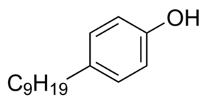
Phase/Color: | liquid
Specific Gravity: | 0.936 g/mL at 25°C
Solubility (water): | 5.7 mg/L at 25°C
Boiling Point: | 302°C
Synonyms: | 4-nonylphenol, branched, nonylphenol, branched 4-nonylphenol, branched 4-nonylphenol (mixed isomers), branched p-nonylphenol
CAS number: | 84852-15-3
Molecular formula: | C₁₅H₂₄O
Molecular weight: | 220.4 g/mole

Due to limited water solubility, a solid phase saturator column was used to maximize 4-NP concentrations in water and was used to prepare a master stock solution ultimately used to prepare each test concentration. The solid phase saturator columns were prepared by FEL. The test substance was stored in the chemical repository at room temperature (RT) while not in use as recommended by the Certificate of Analysis supplied by Sigma-Aldrich Chemical Company. The definitive test concentrations were determined by a range-finding study designed to identify the concentration of test chemical that causes lethality and morbidity.

Laboratory Water
It is well-established that Xenopus can develop successfully over a wide range of water quality parameters. Laboratory water was used as the culture media for the study control and as the diluent for preparing all aqueous chemical solutions used in this study. Overall, the animals were exposed using a flow-through water renewal system that maintained adequate water quality (temperature, dissolved oxygen, low ammonia, etc.), and ensured a consistent exposure of the test organisms to the parent chemical.

FEL used dechlorinated (charcoal-filtered) tap water as the dilution water for this study. The dechlorinated laboratory water was prepared by passing tap water through a 4-filter system; a multimedia filter to remove suspended solids in the feed water; a 10” pre-treatment filter (5 µm) to remove any additional solids; a 3.6 ft³ activated virgin carbon treatment filter to remove chlorine, ammonia, and higher molecular weight organics; and a 5 µm polishing filter to remove any carbon particles from the carbon treatment phase. The dechlorinated tap water also served as the laboratory control water. Water quality characteristics of the laboratory water were monitored bimonthly for pH, dissolved oxygen (DO), conductivity, hardness, alkalinity, ammonia, residual oxidants; and at least annually for iodide (I-), polyaromatic hydrocarbons (PAHs), pesticides, and metals. Results of dilution and laboratory control water analysis for pesticides, PAHs, and metals are attached in Appendix A. In addition, I- analyses were performed on dilution/laboratory control water on Study Day (SD) 0, SD 45, and at 10 wpm (in-life conclusion). LAGDA test guidelines (3), recommend dilution water I⁻ concentrations between 0.5 and 10 µg/L be used.

Test System
The test species was the African Clawed Frog (X. laevis). Xenopus laevis is a well-studied laboratory animal that exhibits ease of use in the laboratory, rapid development, and simplicity of observation due to transparency during embryo-larval development (6). In addition, Xenopus laevis is routinely cultured in laboratories worldwide and is easily obtainable through commercial suppliers. Reproduction was easily induced in this species throughout the year using human chorionic gonadotropin (hCG) injections and the resultant larvae were routinely reared to selected developmental stages in large numbers to permit the use of stage-specific test protocols. It was also the test organism required in the OCSPP 890.2300 test guideline (3). The X. laevis larvae used for this study were obtained from an in-house culture. The adult breeding stock frogs (originally purchased from Xenopus I, Dexter, MI) were selected based on general productivity and health. After spawning of adults, embryos were collected, cysteine treated, and screened for viability per ASTM E1439-98 standards (6). Test organisms from a single spawn were used in the in-life study. Spawns resulting in greater than 70% viability be used for the test. Embryos were randomly distributed into exposure treatment tanks containing 4 L of dilution water until each tank contained 20 embryos. Embryos were carefully handled during this transfer to minimize handling stress and to avoid any injury. Details for adult frog care and breeding, specific to FEL, but consistent with OCSPP 890.2300 Larval Amphibian Growth and Development Assay (LAGDA) (3), are found in facility SOPs. Fertilized egg collection was performed as described in ASTM E1439-98 (6) and OCSPP 890.2300 Larval Amphibian Growth and Development Assay (LAGDA) test guideline (3).

Feeding
The diet selected for use (Tables 1 and 2) was required to meet the performance recommended by OCSPP 890.2300 Larval Amphibian Growth and Development Assay (LAGDA) (3). X. laevis embryos were not fed until free-swimming larval stage (NF stage 46) was reached. At NF stage 47, the tadpoles were fed a diet that consists of trout starter (Purina AquaMax Starter, Aquatic Ecosystems, Apopka, FL), Spirulina algae discs (Wardley, Secaucus, NJ), and TetraFin® flakes (Tetra Holding (US), Blacksburg, VA) homogenized in culture (or dilution) water (3) (Table 2). This mixture was administered three times daily on weekdays and once daily on weekends. Tadpoles were also fed brine shrimp nauplii (Artemia spp.) (Aquatic Ecosystems, Apopka, FL) twice daily on weekdays and once daily on the weekends starting on day 8 post-fertilization (dpf). The larval feeding was consistent in each test vessel and allowed appropriate growth and development of test animals ensuring reproducibility and transferability of the assay results. More specifically, the median time to NF stage 62 in controls should be ≤45 days with a mean weight of 1.0±0.2 g at NF stage 62 in controls.

Once tadpoles reached NF stage 62, the feeding regime consisted of 2 mm (3/32 inch) sinking frog food (Ziegler Brothers, Gardners, PA). Metamorphosed test animals were fed once per day. For post-NF stage 62 larvae and newly metamorphosed frogs, the pellets were briefly crushed with a mortar and pestle to reduce their size. Once juveniles were large enough to consume full pellets, grinding or crushing is no longer necessary. The animals were fed once per day. The juvenile feeding allowed appropriate growth and development of the organisms to reach a mean weight of 11.5±3 g in control juveniles at the termination of the assay. The feeding rate for metamorphosed X. laevis is provided in Table 3.

Exposure System
The route of exposure was aqueous, which was the most appropriate method for aquatic organisms. A flow-through diluter system was used in the performance of the LAGDA exposure. The system had water-contact components of glass (aquaria), stainless steel (diluter housing and water bath), and Teflon® (tubing responsible for test material delivery). Exposure tanks were glass aquaria (with approximate measurements of 22.5 x 14.0 x 16.5 cm deep) equipped with standpipes that resulted in an actual tank volume of 4.0 L and minimum water depth of 10 to 15 cm. Each dilution cell within the headbox of the diluter was labelled with the color-coded laboratory tape with the test concentration. The replicate splitter cell and aquaria delivery tubing were labeled with the same color tape as the appropriate dilution cell and the replicate for each test concentration. Each aquarium was labelled with identical tape color and specifically denoted test concentration and replicate. Test system calibration was checked prior to study start, weekly during the study, and at test termination. The system supported up to 5 exposure concentrations and a control, with up to 4 replicates per treatment. The flow rate to each tank was 25 mL/min which provided a complete volume replacement every 2.7 h. Fluorescent lighting was used to provide a photoperiod of 12 h light and 12 h dark at an intensity that ranged from 600 to 2,000 lux (lumens/m²) at the water surface. Water temperature was maintained at 22º ± 1°C, pH maintained between 6.5 to 8.5, and the dissolved oxygen (DO) concentration > 3.5 mg/L (> 40% of the air saturation) in each test tank. The test organism loading per water renewal rate was within recommended guidelines (3) and maintained acceptable water quality while not utilizing an excessive amount of test material. Tanks were randomly assigned for the LAGDA assay. This design was intended to randomize out the effects associated with the local environment (i.e., light and water) and possible trends associated with the diluter during testing. All test animals were impartially assigned to tanks before exposure. Tanks were equipped with baffles to separate metamorphosed test animals from test larvae.

4-NP feed stock was prepared and pumped to the master mixing cell of the diluter using continuous flow dual solid-liquid saturator columns in which ca. 5 g of 4-NP was loaded on each column in acetone. Saturator columns were prepared on December 7 (column 1) and 8 (column 2), 2015. The acetone was evacuated prior to use using a vacuum pump and 2 to 3-week continuous column flushing during the equilibration phase. The columns were plumbed in series and dechlorinated tap water was pumped through the columns at a rate of ca. 4 mL/min. to produce one stock solution pumped into the master mixing cell of the diluter. The same columns were used for the BATT01-00389 study; and the entire pre-exposure and exposure periods of the present study (BATT01-00392). Following completion of the BATT01-00389 study and prior to the initiation of the present study, the columns were maintained in-line filled with dechlorinated tap water at room temperature, but dechlorinated tap water flow to the columns was terminated. Prior to exposure phase of the present study (BATT01-00392), dechlorinated tap water flow to the columns was resumed and the columns were equilibrated for at least two weeks prior to use. Equilibration was noted by the production of a consistent stock concentration. Since the stock was produced by the saturator columns, the nominal concentration was estimated based on solubility and diluter operation (flows) were based strictly on measured stock concentrations. Diluter operation was based on stock concentration based on PD=HCxDD/SC, where PD is pump delivery rate, HC is high test concentration, DD is the diluter delivery rate (volume), and SC is the stock concentration.

Temperature was measured daily; and pH, DO, and light intensity (lux) were measured three times per week. Total hardness and alkalinity were measured in the control and one replicate of the highest concentration once per week. The solubility, purity, and stability (volatility and degradation rate) of test article was provided to FEL prior to in-life test initiation by the supplier of the test article (TCI America). After initial diluter calibration, a sample of test solution from each diluter concentration was sampled for chemical analysis during the diluter equilibration phase. A water sample from each replicate for each treatment concentration was sampled for analysis at in-life test initiation (day 0) and termination. During the remainder of the exposure phase (excluding termination), a sample was collected from one replicate tank of the control and each test concentration. The replicate selected for weekly sampling rotated (week 1 – A, week 2 – B, week 3 – C, and week 4 –D) and repeated when the replicate set was complete. Samples will be collected at test initiation, weekly thereafter, and at test termination. A laboratory blank was also collected with the batch of samples.

Exposure tanks were siphoned daily to remove uneaten food and waste products. Care was taken to minimize stress and trauma to the animals, especially during movement, cleaning of aquaria, and manipulation. Stressful conditions/activities were avoided such as loud and/or incessant noise, tapping on aquaria, vibrations in the aquaria, excessive activity in the laboratory, and rapid changes in environmental conditions (light availability, temperature, pH, DO, water flow rates, etc.).

Chemical analysis
The analytical measurement method (7) for 4-NP determined by EAG Laboratories in conjunction with the Study Director and Study Monitor were performed in accordance with procedures and SOPs in place at ABC Laboratories (Appendix C). Chemical stock solutions of 4-NP were sampled for analysis with each set of diluter samples collected during the study. Each replicate test concentration was sampled on day 0 and at test termination for 4-NP analysis. Samples were collected in one replicate of each treatment and the control during each sampling event in rotation so that each replicate was sampled in succession. All samples with the exception of the blank were collected in duplicate. Immediately following collection, the 4-NP stock and diluter samples were preserved 10:1 (30 mL sample:3 mL hexanes) and prepared for shipment to EAG Laboratories. The vials were sealed with appropriate caps and carefully shaken by hand for at least one minute. During the one min. shaking time, the extraction containers were vented at least twice by carefully opening the cap to release any pressure that built up inside the container. Following this initial one min. shaking, sample containers were carefully and tightly sealed for shipment to EAG Laboratories.

The water/hexane samples received from FEL were transferred to appropriately-sized separatory funnels. Each sample was carefully shaken by hand for at least one minute. After the water and hexanes phases were allowed to separate, the water (bottom layer) was transferred into its original shipping container, and the hexanes layer was transferred to a separate container (e.g., 10 mL culture tube) pre-calibrated to the appropriate (e.g., 1 mL or 5 mL) volume mark. The water was then transferred back to the separatory funnel. The hexanes extract was concentrated under a gentle nitrogen blow-down using 40 ºC temperature until almost dry. The hexanes extraction process described above was repeated twice more, with the exception of the final blow-down where the extracts were blown-down to the appropriate pre-calibrated volume mark. If necessary, the samples were further diluted by removing an aliquot from the sample and diluting to an appropriate volume in a separate culture tube using hexanes, capped and shaken/vortexed to mix well. An aliquot of the extract was vialed and analyzed by GC/MS-EI. The peak responses of 4-nonylphenol of samples was integrated and quantitated in ChemStation software (Version E.02.00.493) by Agilent Technologies.

Sample analysis was performed using a GC-MS system equipped with the following analytical parameters:

Instrument: Agilent 6890 GC system (or equivalent) equipped with 7683B injector, and Agilent 5973 Mass Spectrometer
Column: HP-5MS, 30 m x 0.250 mm x 0.25 µm
Detector: EI-MSD
Temperatures:
Injector (°C): 250
MS Detector (°C): EI Source 230; Quad 150; Thermal Aux 280
Oven temperature program:
Initial (°C): 90 Hold (min): 0.50
Rate (°C/min): 10
Final (°C): 250 Hold (min): 2.50
Stop time (min): 19
Injection volume: 2 µL
Injection mode: Pulsed Splitless
Pulse Pressure: 20.0 psi
Pulse Time: 1.00 min
Purge time (Min): 3.0
Purge flow (mL/min): 15.0
Inlet liner: 4 mm i.d. single gooseneck splitless liner packed with CarboFrit
Gas Flows:
Column: 1.2 mL Helium /min (carrier gas, constant flow)
Mass Spectrometer:
Acquisition mode: Selective Ion Monitoring (SIM)
SIM ions (m/z): Quant. Ion: 135 with dwell time of 100 milliseconds
Confirmation Ions: 121 with dwell time of 100 milliseconds
220 with dwell time of 100 milliseconds

Study Design and Additional Experimental Conditions
An overview of the test and relevant test specifications are provided in Table 3. This assay was intended for use in determining the developmental toxicity of chemicals on amphibian larval growth and development. The assay was initiated with newly spawned embryos and continued through metamorphosis into juvenile development. A summary of study endpoints is presented in Table 4. Animals were examined daily for mortality and any signs of abnormal behavior. At the median metamorphosis time (NF stage 62, or MMT), a sub-sample of five animals/replicate were collected and various endpoints examined. Remaining animals were continuously exposed until each reached NF stage 66 (conclusion of metamorphosis) at which time the exposure tanks were culled to 10 organisms/replicate tank. The remaining 10 organisms/tank were then exposed for the remainder of the exposure period (10 weeks from the MMT). At test termination, additional endpoints were collected (Table 4).

Biological Sample Collection
Three samplings of test specimens were performed. The first event was unexposed day 0 embryos (20-30) for initial stage verification. The second event was performed as individual organisms reached MMT (NF stage 62). The final specimen sampling was performed at test conclusion (10 weeks after 50% of the control organisms post-MMT).

Exposure System Performance
Temperature were measured in all tanks daily. DO and pH were measured two times per week. Total hardness and alkalinity, and conductivity were measured in the control and one replicate of each treatment once per week such that complete analysis for a given treatment or control was provided monthly. Relative humidity inside the diluter system was measured once per month post-metamorphosis and maintained with facility records. Light intensity (lux) was measured once on SD 0.

Observations
Endpoints were assessed over the course of and at conclusion of the assay. For those endpoints measured at test termination, growth (length and weight) measurements were taken immediately after anesthetization of an individual specimen.

Survival
All test tanks were checked daily for dead animals and the number of survivors recorded for each tank, along with the date, concentration, and replicate ID.

Additional Daily Observations
Observation of abnormal behavior, grossly visible malformations, or lesions were recorded daily by date, treatment, replicate ID. For the purpose of the present study, the terms “treatment” and “exposure” are considered synonymous. Normal behavior for larval animals was characterized by suspension in the water column with tail elevated above the head, regular rhythmic tail fin beating, periodic surfacing, operculating (respiration through gills), and being responsive to stimuli. Abnormal behavior included, for example, floating on the surface, lying on the bottom of the tank, inverted or irregular swimming, lack of surfacing activity, and being non-responsive to stimuli. For post-metamorphic animals, in addition to the above abnormal behaviors, gross differences in food consumption between treatments were recorded. Gross malformations and lesions included morphological abnormalities, such as; limb deformities, hemorrhagic lesions, abdominal edema, and bacterial or fungal infections. These determinations were qualitative and considered clinical signs of disease/stress and made in comparison to control animals.

NF Stage 62 Specimens (Endpoints/Tissue Sample Preparation)
Larvae that reached NF stage 62 were physically separated from the remaining tadpoles in the tank with a baffle in accordance with the OCSPP 890.2300 test guideline (3). Tadpoles were checked daily, and the TTM recorded for each individual. One NF stage 62 larvae of every four removed from a given replicate tank was randomly selected for morphological, biological, and histopathological measurements. Those NF stage 62 larvae not sampled were physically separated from the remaining tadpoles for continued exposure. Selection of the sub-sampled test organisms was randomized, using a net. The following endpoints were obtained from the newly metamorphosed larvae sub-sampling:

- Time to NF Stage 62 (TTM)
- Morphometrics (growth – weight and length)
- External abnormality
- Thyroid histopathology.

Time to Metamorphosis (TTM)
In this study, the TTM was the number of days required for a test specimen to reach NF stage 62 (from embryonic NF stage 8 to NF stage 62 larvae). TTM was recorded for each larva.

Growth (Weight and Length)
The wet weight of each newly metamorphosed specimen was measured immediately after they became non-responsive. Specimens were blotted dry before weighing to remove excess adherent water. Weight was measured on an analytical balance to the nearest mg. Digital photographs of each specimen were taken for SVL measurement. Photos were taken with a ruler to provide scale and electronically digitized for linear length using Sigma Scan Pro (Aspire Software International (Ashburn, VA). Length was measured to the nearest mm. These measurements assessed possible effects of test substances on the growth rate of organisms and were useful in detecting generalized toxicity.

External Evaluation
After measurements of body size were made, any gross morphological abnormalities, signs of disease, and / or clinical signs of toxicity will be noted and digitally recorded. These include scoliosis, petechiae, hemorrhage, limb, and eye defects. Observations of scoliosis will be counted (incidence) and graded with respect to severity.

Tissue Collection and Fixation for General Histology
For the sub-sampling, thyroid glands were fixed and preserved for histology. Fixation and preservation required removal of the lower torso below the forelimbs. The lower torso was then discarded. The trimmed carcass was placed into individually labeled vials and fixed in Davidson’s solution. The volume of fixative in the container was at least 10 times the approximated volume of the tissue. Appropriate agitation of the fixative was required to adequately fix the tissue samples. All tissue remained in Davidson’s fixative for 72 h, at which time they were rinsed in DeCl₂ water and stored in 10% (v/v) neutral buffered formalin until further processed (3,8).

EPL, under the direction of the Sponsor, performed the tissue preparation, histology, and histopathological interpretation in accordance with appropriate facility guidance documents (SOPs) and the relevant guidance documents on histopathology for the LAGDA (3). Following collection, FEL sent 5 NBF preserved larvae per replicate (20 per treatment or control) to EPL via overnight courier for histopathological processing and analyses.

End of Larval Exposure Phase
The end of larval exposure phase was determined by the MMT, which was the time required for half of the population of test control animals to reach NF stage 62. The larval portion of the exposure did not exceed 70 days. When all the organisms reached NF stage 66, test organisms were culled such that 10 metamorphosed young per treatment were exposed for the remainder of the in-life study (10 weeks post-MMT). Any organisms remaining at the end of this period were euthanized by immersion in 200 mg/L buffered MS-222 (pH 7.0). The tadpoles were weighed, staged (4), and digitally photographed. Snout-vent length (SVL) was measured and any developmental abnormalities noted. Phenotypic sex was noted as female, male, or indeterminate.

In-Life Test Termination (Endpoints / Tissue Sample Preparation)
After 10 weeks of exposure post-MMT, the remaining animals were anesthetized, and then euthanized and the following endpoints evaluated and recorded:

- Morphometrics (growth – weight and length)
- External evaluation of test organism
- Nuptial pad development (morphological)
- Liver weight (Liver-somatic index)
- Gonad, reproductive ducts, kidney, and liver histopathology
- Phenotypic and genotypic sex ratios.

Growth (Weight and Length)
The wet weight and snout to vent length of each juvenile specimen were measured using the same procedure as used for the newly metamorphosed specimens (see Section 8.9.2.2). Specimens were blotted dry before weighing to remove excess adherent water. After measurements of body size were made, any gross morphological abnormalities and/or clinical signs of toxicity were noted and digitally recorded.

External Evaluation
As with the newly metamorphosed specimens, any gross morphological abnormalities, diseases, and/or clinical signs of toxicity observed was recorded with digital photographs.

Tissue Collection and Fixation for General Histology
Livers were removed, weighed, and prepared for histological analysis during the final sampling. A hind limb was retained for genetic sex determination. The remaining carcass, without the hind limbs, but including the gonads, and gonadal ducts, and kidneys was fixed for future histological analyses. Thus, the gonads were physically removed from the carcass. The collected tissues were placed into labeled histological vials and fixed in Davidson’s fixative as described for the sub-sampled NF stage 62 specimens. All tissue remained in Davidson’s fixative for at least 48-72 h, but no longer than 96 h, at which time they were rinsed in dechlorinated tap water and stored in 10% (v/v) NBF (3).

EPL, under the direction of the Sponsor, performed the gonad, gonadal duct, kidney, and liver tissue preparation, histology, and histopathological interpretation in accordance with appropriate facility guidance documents (SOPs) and the relevant guidance documents on histopathology for the LAGDA (3,11). Following collection, FEL sent preserved juveniles to EPL via overnight courier for histopathological processing and analyses.

Phenotypic and Genotypic Sexing
DNA samples from the juvenile frogs were obtained from a hind foot removed during dissection. The hind foot from each juvenile specimen were stored at -20°C ± 5° until DNA isolation. Testing for the presence or absence of a marker were performed by PCR as described in the facility SOP. Information regarding the development of the marker used for genetic sexing of X. laevis is described in Yoshimoto et al. (9).

Data Analysis
All data were tabulated in data entry spreadsheet templates (DEST) by FEL. The DESTs were then used by FEL to prepare the final report. The histopathology report (EPL, Sterling, VA), raw data (DEST), and statistical report (Battelle) are provided in Appendices D through F, respectively. In an effort to present the most realistic estimation of exposure concentrations, analytical chemistry analysis results of the duplicate analytical samples were averaged with the original sample result and both the individual results and average were reported in the DESTs unless the original or the duplicate were found to be an outlier and thus, not used in the average determination. In the event a result from an original sample or its duplicate was found to be an outlier as defined as being outside the interquartile range (IQR), both results were included in the DEST, but the outlier (either original or duplicate) was not used in the analysis of the mean measured concentration used to estimate exposure concentration in the report. Outliers were determined by (Q1 – 1.5*IQR) and (Q3 + 1.5*IQR), where IQR was the interquartile difference defined as Q3 minus Q1. Statistical analyses of the data were performed by Battelle and will be consistent with the TO 14 QAPP (1), OCSPP 890.2300 Larval Amphibian Growth and Development Assay (LAGDA) test guideline (3), and generally followed procedures described in the document Current Approaches in the Statistical Analysis of Ecotoxicity Data: A Guidance to Application (10). For toxicological endpoint data, descriptive statistics included the mean, median, standard deviation, minimum value, maximum value, first and third quartiles (Q1 and Q3), and the coefficient of variation (CV). Statistical outliers were determined as described above. Analysis of the data from this study report revealed 24 potential outliers occurring in the following biological endpoints: Body Weight at NF Stage 62 (n=2), Snout-to-Vent Length at NF Stage 62, Body Weight at NF Stage 66 (n=2), Snout-to-Vent Length at NF Stage 66 (n=2), Female Body Weight at Termination (n=2), Male Body Weight at Termination (n=3), Female Snout-to-Vent Length at Termination (n=4), Male Snout-to-Vent Length at Termination, Female LSI at Termination (n=6), and Male LSI at Termination (Appendix F). However, in accordance with LAGDA guidance (3), none of the endpoint outliers were excluded from statistical analyses presented in the present report for study BATT01-00392.

Three different types of data sets were collected: 1) quantitative continuous data (mortality, growth, and LSI), 2) time-to-event data (developmental rates such as TTM), and 3) ordinal data (severity scores and developmental stages from histopathological evaluations). For continuous data sets, data expressed as proportions were transformed to the arc sine square root. Monotonicity of the data sets were evaluated using Analysis of Variance (ANOVA) comparing linear and quadratic contrasts or the equivalent. Continuous data sets that were monotonic were evaluated using a step-down Jonckheere-Terpstra trend test or the equivalent using replicate medians. If the data were non-monotonic, parametric assumptions were tested using deviations from normality with the Shapiro-Wilks’ test (α=0.05) and homogeneity of variance tested with Levene’s test (α = 0.05). Parametric data sets were evaluated using ANOVA followed by Dunnett’s or Bonferroni t-test as post-hoc tests or the equivalent. Kruskal-Wallis (KW) ANOVA test followed by a pairwise Dunn’s test as a post hoc test or the equivalent were used when assumptions of normality and homogeneity of variances were not met. These tests were used to determine NOEC and LOEC numerical endpoints for each of the appropriate measurement endpoints.

The TTM data were treated as time to event data, with mortalities or larvae not reaching stage 62 in 70 d treated as censured data. The median time to completion of metamorphosis (MMT) was the 50% point in the cumulative metamorphosis curve using a mixed-effects Cox proportional hazard model. Histopathology data were in the form of severity scores or developmental stages. RSCABS (Rao-Scott Cochran-Armitage by Slices) or the equivalent using step-down trend analysis on each level of severity in a histopathology response was performed. Developmental staging data (gonad and reproductive ducts) was analyzed as reported to detect acceleration in development and then manually inverted prior to a second analysis to detect a delay in development. For all statistical evaluations, the replicate was considered the experimental unit and α=0.05.

Results

Range Finding
The range-finding study was conducted separately (FEL Study No. BATT01-00385) and was not required to be GLP-compliant. In order to properly define the range of test concentrations, results from Amphibian Metamorphosis Assay study with 4-NP (FEL Study No. BATT01-00389) were considered along with the range-finding test in the establishment of the proper test concentration range (Appendix G). Based on this collective information, the maximum tolerable concentration (MTC) was determined to be 50 µg/L. The test concentration series was 1x, 0.33x, 0.11x, and 0.04x, where x was the MTC value. Therefore, the test concentrations were 50.0, 16.5, 5.50, and 1.80 µg/L.

Water Quality Measurements and Test System Performance
Results of water quality measurements and test system performance are presented in Table 5. All physicochemical water quality parameters in study were within acceptable ranges.

Confirmation of Test Concentrations
Nominal 4-NP concentrations selected for the LAGDA study were 0.0 (control), 1.80, 5.50, 16.5, and 50.0 µg/L. Concentrations of 4-NP measured in in samples collected from the control and treatments during the study are provided in Table 6. The corresponding mean measured concentrations in the definitive study were <0.333 (control), 1.67, 5.42, 14.7, and 40.1 μg/L 4-NP (Table 7). The mean measured concentration represents the average of weekly data points. On SD 0 and in-life phase termination all replicate control replicates (n=8) and treatment replicates (n=4) were sampled and analyzed. On the weeks between these two points, a sample was collected from one replicate tank of the control and each test concentration. The replicate selected for weekly sampling rotated. Coefficient of variation [(CV) Standard deviation / mean)100]. Standard deviation of the replicate means (n=8 for control and 4 for treatments) for the control and each treatment was determined and divided by the mean measured concentration of each replicate per facility SOP. Treatment coefficients of variation (CVs) for the 1.80, 5.50, 16.5, and 50.0 µg/L treatments were 23%, 10%, 12%, and 7%, respectively. The mean measured concentrations were generally consistent with protocol BATT01-7 for study BATT01-00392 (Appendix A). Thus, the mean measured concentrations were a reasonable estimation of exposure concentration.

Clinical Signs of Toxicity
No signs of abnormal behavior, grossly visible malformations, or lesions including scoliosis, petechiae, and hemorrhage, limb, and eye defects were observed in any of the specimens in the present study.

In-Life Studies—NF 8 to NF Stage 62

Survival
Survival through NF Stage 62 was 100 percent for the control and all 4-NP treatments (Table 8).

Time to Metamorphosis (Median Metamorphosis Time, MMT)
The median MMT (NF Stage 62) for control X. laevis was 42.3 d (Table 9). The median MMT for larvae exposed to 4-NP ranged from 43.8 d in the 1.80 µg/L treatment to 46.6 d in the 50.0 µg/L treatment. The MMT in the 16.5 and 50.0 µg/L 4-NP treatments was significantly greater than the control (Cox Proportional Hazard Model, Chi Square, p<0.0001).

Growth

Body Weight
Mean body weight of NF Stage 62 frogs was 0.885 g in the control. The mean body weight ranged from 0.892 to 0.923 g in the 5.50 and 1.80 µg/L 4-NP treatments, respectively (Table 10). Mean body weight in the 4-NP treatments were not significantly different from the control (Jonckheere-Terpstra test, p>0.05).

Snout-to-Vent Length (SVL)
Mean SVL of NF Stage 62 frogs was 17.9 mm in the control and ranged from 17.6 to 18.6 mm in the 16.5 and 1.80 µg/L 4-NP treatments, respectively (Table 11). SVL in 4-NP treatments were not significantly different from the control (Jonckheere-Terpstra test, p>0.05).

In-Life Studies—Metamorphosed Young (NF Stage 66) and Juveniles

Survival
Survival from NF Stage 62 to NF Stage 66 (see footnote 2, Table 8) and from NF Stage 66 to test termination (10 wpm) was 100% for the control and all 4-NP treatments (Table 8).

Growth

Body Weight
Mean body weight of NF Stage 66 frogs was 0.874 g in the control and ranged from 0.618 to 0.955 g in the 16.5 and 1.80 µg/L 4-NP treatments, respectively (Table 12). Mean body weight in the 4-NP treatments were significantly less than the control (Jonckheere-Terpstra test, p=0.0102 and 0.0229, respectively).

Mean body weight of female X. laevis at 10 wpm was 12.7 g in the control and ranged from 12.9 to 13.6 g in the 1.80 and 16.5 µg/L 4-NP treatments, respectively (Table 13). Mean body weight in female X. laevis at termination in the 4-NP treatments were significantly greater than the control (Jonckheere-Terpstra test, p=0.0111 and 0.0168, respectively).

Mean body weight of male X. laevis at 10 wpm was 12.6 g in the control and ranged from 12.6 to 13.5 g in the 1.80 and 16.5 µg/L 4-NP treatments, respectively (Table 14). Mean body weights in male X. laevis at termination in the 4-NP treatments were greater different from the control (Jonckheere-Terpstra test, p=0.0145 and 0.0157, respectively).

Snout-to-Vent Length
Mean SVL of NF Stage 66 frogs was 21.4 mm in the control and ranged from 19.5 to 22.0 mm in the 16.5 and 1.80 µg/L 4-NP treatments, respectively (Table 15). Mean SVLs at NF stage 66 in the 4-NP treatments were not significantly different from the control (Jonckheere-Terpstra test, p>0.05).

Mean SVL of female X. laevis 10 wpm was 36.1 mm in the control and ranged from 35.0 to 36.8 mm in the 5.50 and 50.00 µg/L 4-NP treatments, respectively (Table 16). Mean SVLs of female X. laevis at termination in the 10.9, 33, and 100 µg/L 4-NP treatments were not significantly different from the control (KW ANOVA, p>0.05).

Mean SVL of male X. laevis at 10 wpm was 35.5 mm in the control and ranged from 34.8 to 36.2 mm in the 1.80 and 16.5 µg/L 4-NP treatments, respectively (Table 17). Mean SVLs of male X. laevis at termination in the 10.9, 33, and 100 µg/L 4-NP treatments were not significantly different from the control (Jonckheere-Terpstra test, p>0.05).

Liver-Somatic Index (LSI)
Mean LSI of frogs measured in the control at the termination of in-life (10 wpm) were 0.061 for females (Table 18) and 35.5 for males (Table 19). LSI for female X. laevis ranged from 0.0601 to 0.064 in the 5.50 and 50.0 µg/L 4-NP treatments, respectively (Table 19). Mean LSI in female X. laevis for the 4-NP treatments were not significantly different from the control (Jonckheere-Terpstra test, p >0.05). LSI for male X. laevis ranged from 0.061 to 0.064 in the 5.50 and 50.00 µg/L 4-NP treatments (Table 20). Mean LSI in male frogs for the 4-NP treatments were not significantly different from the control (Jonckheere-Terpstra test, p>0.05).

Gender Ratios
The phenotypic and genotypic sex ratios at the termination are presented in Table 20. Control X. laevis were slightly skewed toward the male phenotype. Equal phenotype distribution was observed in the 1.80 and 5.50 µg/L 4-NP treatments. The 16.5 and 50.0 µg/L 4-NP treatments were slightly skewed toward the female phenotype. One genetic female in the 16.5 µg/L 4-NP treatment had an indeterminant phenotype. Genotype was consistent with phenotypic identification. Thus, no marked changes phenotype or genotype ratios were observed in 4-NP-treated frogs relative to controls, and correspondence between phenotypic and genotypic genders was noted regardless of treatment.

Histopathology
Detailed histopathology findings for NF Stage 62 and juveniles (10 wpm) male and female frogs exposed to 4-NP are described in the histopathology report (Appendix D).

NF Stage 62
No treatment-related findings were observed in the thyroid glands of female and male frogs exposed to 4-NP (Table 21) (Appendix D).

Juveniles
Results of histopathological examination of female and male liver, kidney, gonadal ducts, and gonads from 10 wpm X. laevis (termination specimens) are enumerated in Tables 22-24 (Appendix D). There were no incidences of intersex in this study. Gonads were not recovered histologically from two frogs of the 16.5 µg/L dose group, EPL Animal Nos. A5-16-5, and A7-16-5, which were genetic male and female frogs, respectively. Lack of recovery was either due to the lack of gonad tissue, loss of gonadal tissue during either the gross dissection or microtomy phases of specimen processing, or a combination or both issues.

Females

Liver
There were no treatment-related findings in the livers of male of female terminal sacrifice frogs exposed to 4-NP (Appendix D).

Kidneys
In the anterior kidney section, a reduction in the occurrence of mild mononuclear cell cellular infiltrate and mild tubule dilation in 10 wpm frogs exposed to 50.0 µg/L 4-NP relative to the control was noted (RSCABS, p=0.0419 and 0.0393, respectively) (Appendix D). In the middle kidney section, a reduction in the occurrence of moderate mineralization in X. laevis exposed to 50.0 µg/L 4-NP (RSCABS, p=0.0444), minimal tubule dilation in 10 wpm frogs exposed to 5.50, 16.5, and 50.0 µg/L 4-NP (RSCABS, p=0.0033, 0.0440, and 0.0440, respectively), and mild tubule dilation in 10 wpm frogs exposed to 50.0 µg/L 4-NP (RSCABS, p=0.0274). In the posterior kidney section, reduction in the occurrence of minimal interstitial fibrosis (RSCABS, p=0.0455), and minimal and moderate tubule dilation (RSCABS, p=0.0357 and 0.0391, respectively) were observed in 10 wpm frogs exposed to 50.0 µg/L 4-NP. Since reduction in occurrence and severity was generally observed in the 4-NP treatments relative to control, the findings cited above were not considered to be toxicologically-relevant.

Gonadal Ducts
There were two treatment related findings in gonadal ducts from the 4-NP-exposed females compared to controls: increased mean oviduct stage scores and the presence of cellular debris (minimal to mild) in the oviduct lumen (Table 22) (Appendix D). In the anterior oviduct section, an increase in the presence of stage 3 oviducts was observed in the 16.5 and 50.0 µg/L 4-NP treatments (RSCABS, p=0.0140 and 0.0000, respectively). An increase in minimal cellular debris in the anterior section of the oviduct lumen of frogs exposed to 50.0 µg/L 4-NP relative to controls was also observed (RSCABS, p=0.0005). In the middle oviduct section, an increase in the presence of stage 3 was observed in the 16.5 and 50.0 µg/L 4-NP treatments (RSCABS, p=0.0305 and 0.0006, respectively), but a decrease was observed in the 5.5 µg/L 4-NP treatment (RSCABS, p=0.0386). An increase in mild mononuclear cell cellular infiltrate was observed in the middle section of the ovary in frogs exposed to 50 µg/L 4-NP (RSCABS, p=0.0400). An increase in minimal cellular debris in the middle section of the oviduct lumen of frogs exposed to 50.0 µg/L 4-NP relative to controls was also observed (RSCABS, p=0.0049). In the posterior section, an increase in the presence of stage 3 was observed in the 50.0 µg/L 4-NP treatment (RSCABS, p=0.0001). An increase in minimal and mild cellular debris in the posterior section of the oviduct lumen of frogs exposed to 50.0 µg/L 4-NP relative to controls was also observed (RSCABS, p=0.0109 [minimal] and 0.0205 [mild]).

Increased oviduct stage scores were the result of shifts from Stage 2 to stage 3 in the 16.5 and 50.0 µg/L treatment groups, and to a stage 4 oviduct in two females of the 50.0 µg/L treatment group. Stage 4 oviducts are not typically observed at the level of reproductive tract maturity exhibited by frogs tested according to the LAGDA guidelines, and were incongruous with the degree of gonadal development evident in the current study. Thus, these shifts represent accelerated oviduct maturation (see Appendix D). Cellular debris in the oviduct lumen is an unusual finding that was restricted to females of the 50.0 µg/L treatment group. Wolffian duct stage scores were generally comparable between control and 4-NP-exposed frogs. No incidence of intersexual organisms were found in the present study. Other recorded microscopic observations in this study were background-type findings of generally low prevalence and severity, which were present at comparable degrees in both control and 4-NP-treated specimens.

Ovaries
There were no findings in the ovaries of female frogs that were attributable to 4-NP exposure (Appendix D).

Males

Liver
A decrease in focal parenchyma cellular infiltrate in male 10 wpm X. laevis liver was observed relative to controls (RSCABS, p=0.0191 and 0.0138, respectively) (Appendix D).

Kidneys
In the anterior kidney section, an increase in minimal tubule dilation in 10 wpm male X. laevis exposed to 50.0 µg/L 4-NP compared to controls was found (RSCABS, p=0.0428) (Appendix D). In the middle kidney section, increased mild mineralization (RSCABS, p=0.0428) and decreased mononuclear cell infiltrate (RSCABS, p=0.0138) in 10 wpm male X. laevis exposed to 50.0 µg/L 4-NP relative to the control.

Gonadal Ducts
Treatment related findings in gonadal ducts from the 4-NP-exposed males compared to controls included increased mean oviduct stage scores, and the presence of cellular debris in the oviduct lumen (Table 23) (Appendix D). In the anterior section, an increased prevalence of stage 3 oviducts was noted in 10 wpm frogs exposed to 16.5 and 50.0 µg/L 4-NP compared to controls (RSCABS, p=0.0123 and 0.0043, respectively). This corresponded with a decrease in the presence of stage 3 Wolffian ducts in 10 wpm frogs exposed to 16.5 and 50.0 µg/L 4-NP compared to controls (RSCABS, p=0.0433 and 0.0354, respectively). An increased occurrence of oviduct fibroplasia was noted in 10 wpm frogs exposed to 50 µg/L 4-NP compared to controls (RSCABS, p=0.0428). In the middle section, increased presence of stage 3 oviducts was observed in 10 wpm frogs exposed to 50.0 µg/L 4-NP compared to controls (RSCABS, p=0.0093).

Overall, a clear treatment-related finding in the gonadal ducts of male terminal sacrifice frogs was a transition from stage 2 to stage 3 in the anterior, middle and/or posterior oviducts of two males each from the 16.5 and 50.0 µg/L treatment groups. Stage 3 oviducts rarely, if ever, occur in male X. laevis at any phase of maturation, since the oviducts (Müllerian ducts) develop initially as stage 2 and gradually regress to stage 1 in males (see Appendix D). This shift toward stage 3 resulted in slightly increased mean oviduct stage scores at the anterior and middle levels in males from the 50.0 µg/L treatment group. Mean Wolffian duct scores were consistent 4-NP-exposed male and control male frogs.

Testis
Mean testis stage scores were slightly decreased in male frogs exposed to 4-NP relative to controls (Table 24) (Appendix D). An increased presence of mild exfoliated germ cells in the testis was observed in 10 wpm frogs exposed to 5.5, 16.5 and 50.0 µg/L 4-NP compared to controls (RSCABS, p=0.0134, 0.0074, and 0.0191, respectively). In the posterior section, a reduction in testis stage 5 was also noted in 10 wpm frogs exposed to 5.5, 16.5, and 50.0 µg/L 4-NP compared to controls (RSCABS, p=0.0025, 0.0177, and 0.0315, respectively) which was indicative of developmental delay. An increase in minimal mononuclear cell cellular infiltrate of the testis and an increase in mild exfoliated germ cells in 10 wpm male frogs relative to controls were observed (RSCABS, p=0.0067 and 0.0428, respectively).

Concentration Measurement Endpoints
The No Observable Effect Concentration (NOEC) and Lowest Observable-Effect Concentration (LOEC) for the various endpoints measured are summarized in Table 25.

DISCUSSION

Performance Criteria and Validity
Performance of the present study and the relationship to the performance criteria and test validity established in protocol BATT01-7 (Appendix A) and study guidance document (3) are provided in Table 26. The coefficients of variation (CV, expressed as %) for the mean measured test concentrations between each replicate of each treatment concentration were <20% with the exception of the 1.8 µg/L 4-NP treatment. Although the CV for the 1.8 μg/L 4-NP exceeded the established criteria of 20% provided by the test guidance (3) and protocol BATT01-7 (Appendix A) for study BATT01-00392, the mean measured concentrations were a reasonable estimation of exposure concentration and the excursion did not impact the interpretation of the results or conclusions drawn. Control mortality was <10% in each replicate of the control. The median time to NF stage 62 in the controls ≤ 45 d. The mean weights of control organisms at NF stage 62 and at the conclusion of the in-life phase (10 wpm) were 1.0±0.2 g and 11.5±3 g, respectively. The range of pH measured in the control and treatments was between 6.5 and 8.5, the temperature in the study was maintained at 21±1ºC, and the inter-replicate range in temperature was maintained at ≤0.5 ºC. None of the test concentrations demonstrated overt toxicity and none of the test concentrations, including the control, had compromised replicates. Finally, the genotype:phenotype gender concordance in the control was >95%. In summary, the present study met performance criteria established for the OPPTS 890.2300 Larval Amphibian Growth and Development Assay (3) with the exception noted above.

Assessment of the LAGDA results
The following results were considered, using the framework outlined in Ankley and Jensen (11), as a basis for concluding if 4-NP has the potential to interact with the endocrine system.

Measured Test Concentrations
- The mean measured concentrations for the 0.0 (control), 1.80, 5.50, 16.5, and 50.0 µg/L 4-NP treatments (nominal) were (<0.333 µg/L [minimum quantitation level, MQL]), 1.66, 5.42, 14.7, and 40.1 μg/L 4-NP.

Survival
- No significant effects on larval or juvenile survival were observed during the study.

Growth
- No significant effects on NF stage 62 body weight or SVL compared to the control were noted (Jonckheere-Terpstra test, p<0.05).
- Decreased body weight, but not SVL, was noted in culled NF stage 66 larvae exposed to 4-NP compared to the control (Jonckheere-Terpstra test, p<0.05).
- Increased body weight, but not SVL, in 10 weeks post-metamorphosis (wpm) female and male specimens exposed to 16.5 and 50.0 μg/L 4-NP relative to the control was noted (Jonckheere-Terpstra test, p<0.05).
- No effect of 4-NP exposure on LSI was observed in either female or male 10 wpm compared to control (Jonckheere-Terpstra test, p>0.05).

Development
- The MMTs in the 16.5 and 50 µg/L 4-NP treatments were significantly greater than the control (Cox Proportional Hazard Model, Chi Square, p<0.0001) suggestive of developmental delay during metamorphosis.
- Asynchronous development was not noted in the control or treatments during the conduct of the study.
- No marked changes in phenotype or genotype ratios were observed in 4-NP-treated frogs relative to controls, and correspondence between phenotypic and genotypic genders was noted regardless of treatment.

Histopathology (abnormal morphological features)
- THYROID: There were no treatment-related findings in the thyroid glands of NF Stage 62 frogs. Because anuran metamorphosis is considered to be a thyroid-dependent process, basal levels of follicular cell hypertrophy and hyperplasia are anticipated findings in control frogs at NF Stage 62.
- LIVER: There were no treatment-related findings in the livers of 10 wpm female X. laevis exposed to 4-NP. However, a decrease in focal parenchyma cellular infiltrate in male 10 wpm X. laevis liver was observed relative to controls (RSCABS, p<0.05).
- KIDNEY: In the anterior kidney section, a reduction in the occurrence of mild mononuclear cell cellular infiltrate and mild tubule dilation in 10 wpm female frogs exposed to 50.0 µg/L 4-NP relative to the control was noted (RSCABS, p=0.0419 and 0.0393, respectively). In the middle kidney section, a reduction in the occurrence of moderate mineralization in X. laevis exposed to 50.0 µg/L 4-NP (RSCABS, p=0.0444), minimal tubule dilation in 10 wpm frogs exposed to 5.50, 16.5, and 50 µg/L 4-NP (RSCABS, p=0.0033, 0.0440, and 0.0440, respectively), and mild tubule dilation in 10 wpm frogs exposed to 50 µg/L 4-NP (RSCABS, p=0.0274). In the posterior kidney section, reduction in the occurrence of minimal interstitial fibrosis (RSCABS, p=0.0455), and minimal and moderate tubule dilation (RSCABS, p=0.0357 and 0.0391, respectively) were observed in 10 wpm frogs exposed to 50 µg/L 4-NP. Since reduction in occurrence and severity was generally observed in the 4-NP treatments relative to control, the findings cited above were not considered to be toxicologically-relevant.
In the anterior kidney section, an increase in minimal tubule dilation in 10 wpm male X. laevis exposed to 50.0 µg/L 4-NP compared to controls was found (RSCABS, p=0.0428). In the middle kidney section, increased mild mineralization (RSCABS, p=0.0428) and decreased mononuclear cell infiltrate (RSCABS, p=0.0138) in 10 wpm male X. laevis exposed to 50.0 µg/L 4-NP relative to the control.
- MALE GONADAL DUCTS: Treatment related findings in gonadal ducts from the 4-NP-exposed males compared to controls included increased mean oviduct stage scores, and the presence of cellular debris in the oviduct lumen. In the anterior section, an increased prevalence of stage 3 oviducts was noted in 10 wpm frogs exposed to 16.5 and 50.0 µg/L 4-NP compared to controls (RSCABS, p=0.0123 and 0.0043, respectively). This corresponded with a decrease in the presence of stage 3 Wolffian ducts in 10 wpm frogs exposed to 16.5 and 50.0 µg/L 4-NP compared to controls (RSCABS, p=0.0433 and 0.0354, respectively). An increased occurrence of oviduct fibroplasia was noted in 10 wpm frogs exposed to 50 µg/L 4-NP compared to controls (RSCABS, p=0.0428). In the middle section, increased presence of stage 3 oviducts was observed in 10 wpm frogs exposed to 50.0 µg/L 4-NP compared to controls (RSCABS, p=0.0093). Overall, a clear treatment-related finding in the gonadal ducts of male terminal sacrifice frogs was a transition from stage 2 to stage 3 in the anterior, middle and/or posterior oviducts of two males each from the 16.5 and 50.0 µg/L treatment groups. Stage 3 oviducts rarely, if ever, occur in male X. laevis at any phase of maturation, since the oviducts (Müllerian ducts) develop initially as stage 2 and gradually regress to stage 1 in males (see Appendix D). This shift toward stage 3 resulted in slightly increased mean oviduct stage scores at the anterior and middle levels in males from the 50.0 µg/L treatment group. Mean Wolffian duct scores were consistent 4-NP-exposed male and control male frogs.

- TESTES: Mean testis stage scores were slightly decreased in male frogs exposed to 4-NP relative to controls. An increased presence of mild exfoliated germ cells in the testis was observed in 10 wpm frogs exposed to 5.5, 16.5 and 50.0 µg/L 4-NP compared to controls (RSCABS, p=0.0134, 0.0074, and 0.0191, respectively). In the posterior section, a reduction in testis stage 5 was also noted in 10 wpm frogs exposed to 5.5, 16.5, and 50.0 µg/L 4-NP compared to controls (RSCABS, p=0.0025, 0.0177, and 0.0315, respectively) which was indicative of developmental delay. An increase in minimal mononuclear cell cellular infiltrate of the testis and an increase in mild exfoliated germ cells in 10 wpm male frogs relative to controls were observed (RSCABS, p=0.0067 and 0.0428, respectively).
- FEMALE GONADAL DUCTS: There were two treatment related findings in gonadal ducts from the 4-NP-exposed females compared to controls: increased mean oviduct stage scores and the presence of cellular debris (minimal to mild) in the oviduct lumen. In the anterior oviduct section, an increase in the presence of stage 3 oviducts was observed in the 16.5 and 50.0 µg/L 4-NP treatments (RSCABS, p=0.0140 and 0.0000, respectively). An increase in minimal cellular debris in the anterior section of the oviduct lumen of frogs exposed to 50.0 µg/L 4-NP relative to controls was also observed (RSCABS, p=0.0005). In the middle oviduct section, an increase in the presence of stage 3 was observed in the 16.5 and 50.0 µg/L 4-NP treatments (RSCABS, p=0.0305 and 0.0006, respectively), but a decrease was observed in the 5.5 µg/L 4-NP treatment (RSCABS, p=0.0386). An increase in mild mononuclear cell cellular infiltrate was observed in the middle section of the ovary in frogs exposed to 50 µg/L 4-NP (RSCABS, p=0.0400). An increase in minimal cellular debris in the middle section of the oviduct lumen of frogs exposed to 50.0 µg/L 4-NP relative to controls was also observed (RSCABS, p=0.0049). In the posterior section, an increase in the presence of stage 3 was observed in the 50.0 µg/L 4-NP treatment (RSCABS, p=0.0001). An increase in minimal and mild cellular debris in the posterior section of the oviduct lumen of frogs exposed to 50.0 µg/L 4-NP relative to controls was also observed (RSCABS, p=0.0109 [minimal] and 0.0205 [mild]). Increased oviduct stage scores were the result of shifts from Stage 2 to stage 3 in the 16.5 and 50.0 µg/L treatment groups, and to a stage 4 oviduct in two females of the 50.0 µg/L treatment group. Stage 4 oviducts are not typically observed at the level of reproductive tract maturity exhibited by frogs tested according to the LAGDA guidelines, and were incongruous with the degree of gonadal development evident in the current study. Thus, these shifts represent accelerated oviduct maturation (see Appendix D). Cellular debris in the oviduct lumen is an unusual finding that was restricted to females of the 50.0 µg/L treatment group. Wolffian duct stage scores were generally comparable between control and 4-NP-exposed frogs. No incidence of intersexual organisms was found in the present study. Other recorded microscopic observations in this study were background-type findings of generally low prevalence and severity, which were present at comparable degrees in both control and 4-NP-treated specimens.
- OVARIES: There were no findings in the ovaries of female frogs that were attributable to 4-NP exposure.

Comparison to Literature
- Soares et al. (12) found that nonylphenols exert estrogenic activity acting through estrogen receptor binding consistent with a classical study in which juvenile male and female Rana nigromaculata exposed to 17-β-estradiol induced marked Müllerian duct hypertrophy relative to untreated controls. Consistent with the present study, the hypertrophic effects were pronounced in female frogs. In contract to the current study; however, the treatment-related presence of cellular debris within the oviduct lumen was not reported (12). Based on the period in which the Iwasawa and Kobayashi (13) was performed, exposure and histopathological methodology was not as standardized as used in the current guidance. No morphologic effects in the thyroid glands were observed in the present study. In a previous metamorphosis assay (14), exposure of Bombina orientalis to nonylphenol induced significant decrease in T3-induced tail resorption was observed in frogs exposed to 1 µM nonylphenol, but no changes in whole body T3 or T4 concentrations were observed. Since whole body T3 or T4 levels were not altered, TSH levels were most likely not altered as well. Considering that TSH controls thyroid activity including function of the thyroid glands, these findings are consistent with the results of the present study.

Overt Toxicity and Behavior
- No significant effects on behavior or signs of overt toxicity were noted.

Conclusions
Survival from NF Stage 8 to NF Stage 62 was 100% for the control and all 4-NP treatments. No effects on behavior or signs of overt toxicity were noted. The MMTs in the 16.5 and 50 µg/L 4-NP treatments were significantly greater than the control (Cox Proportional Hazard Model, Chi Square, p<0.0001), and the response in each treatment was suggestive of concentration-related developmental delay during metamorphosis. Asynchronous development was not noted in the control or treatments during the conduct of the study. No marked effects on growth at NF stage 62 (larval stage) were observed during the study as the result of exposure to 4-NP. There were no treatment-related findings in the thyroid glands of NF Stage 62 frogs.

Survival from NF Stage 62 to NF Stage 66 and from NF Stage 66 to test termination (10 wpm) was 100% for the control and all 4-NP treatments. Decreased body weight, but not SVL, was noted in culled NF stage 66 larvae exposed to 4-NP compared to the control (Jonckheere-Terpstra test, p<0.05). Increased body weight, but not SVL, was noted in 10 wpm female and male specimens exposed to 16.5 and 50.0 μg/L 4-NP relative to the control (Jonckheere-Terpstra test, p<0.05). No marked changes in LSI or phenotype/genotype ratios were observed in 4-NP-treated frogs relative to controls. There were no treatment-related findings in the livers of 10 wpm female X. laevis exposed to 4-NP. However, a decrease in focal parenchyma cellular infiltrate in male 10 wpm X. laevis liver was observed relative to controls (RSCABS, p<0.05). In the anterior kidney section, a reduction in the occurrence of mild mononuclear cell cellular infiltrate and mild tubule dilation in 10 wpm female frogs exposed to 50.0 µg/L 4-NP relative to the control was noted (RSCABS, p=0.0419 and 0.0393, respectively). In the middle kidney section, a reduction in the occurrence of moderate mineralization in X. laevis exposed to 50.0 µg/L 4-NP (RSCABS, p=0.0444), minimal tubule dilation in 10 wpm frogs exposed to 5.50, 16.5, and 50 µg/L 4-NP (RSCABS, p=0.0033, 0.0440, and 0.0440, respectively), and mild tubule dilation in 10 wpm frogs exposed to 50 µg/L 4-NP (RSCABS, p=0.0274). In the posterior kidney section, reduction in the occurrence of minimal interstitial fibrosis (RSCABS, p=0.0455), and minimal and moderate tubule dilation (RSCABS, p=0.0357 and 0.0391, respectively) were observed in 10 wpm frogs exposed to 50 µg/L 4-NP. Since reduction in occurrence and severity was generally observed in the 4-NP treatments relative to control, the findings cited above were not considered to be toxicologically-relevant. In the anterior kidney section, an increase in minimal tubule dilation in 10 wpm male X. laevis exposed to 50.0 µg/L 4-NP compared to controls was found (RSCABS, p=0.0428). In the middle kidney section, increased mild mineralization (RSCABS, p=0.0428) and decreased mononuclear cell infiltrate (RSCABS, p=0.0138) in 10 wpm male X. laevis exposed to 50.0 µg/L 4-NP relative to the control.
Treatment related findings in gonadal ducts from the 4-NP-exposed males compared to controls included increased mean oviduct stage scores, and the presence of cellular debris in the oviduct lumen. In the anterior section, an increased prevalence of stage 3 oviducts was noted in 10 wpm frogs exposed to 16.5 and 50.0 µg/L 4-NP compared to controls (RSCABS, p=0.0123 and 0.0043, respectively). This corresponded with a decrease in the presence of stage 3 Wolffian ducts in 10 wpm frogs exposed to 16.5 and 50.0 µg/L 4-NP compared to controls (RSCABS, p=0.0433 and 0.0354, respectively). An increased occurrence of oviduct fibroplasia was noted in 10 wpm frogs exposed to 50 µg/L 4-NP compared to controls (RSCABS, p=0.0428). In the middle section, increased presence of stage 3 oviducts was observed in 10 wpm frogs exposed to 50.0 µg/L 4-NP compared to controls (RSCABS, p=0.0093). Overall, a clear treatment-related finding in the gonadal ducts of male terminal sacrifice frogs was a transition from stage 2 to stage 3 in the anterior, middle and/or posterior oviducts of two males each from the 16.5 and 50.0 µg/L treatment groups. Stage 3 oviducts rarely, if ever, occur in male X. laevis at any phase of maturation, since the oviducts (Müllerian ducts) develop initially as stage 2 and gradually regress to stage 1 in males (see Appendix D). This shift toward stage 3 resulted in slightly increased mean oviduct stage scores at the anterior and middle levels in males from the 50.0 µg/L treatment group. Mean Wolffian duct scores were consistent 4-NP-exposed male and control male frogs. There were two treatment related findings in gonadal ducts from the 4-NP-exposed females compared to controls: increased mean oviduct stage scores and the presence of cellular debris (minimal to mild) in the oviduct lumen. In the anterior oviduct section, an increase in the presence of stage 3 oviducts was observed in the 16.5 and 50.0 µg/L 4-NP treatments (RSCABS, p=0.0140 and 0.0000, respectively). An increase in minimal cellular debris in the anterior section of the oviduct lumen of frogs exposed to 50.0 µg/L 4-NP relative to controls was also observed (RSCABS, p=0.0005). In the middle oviduct section, an increase in the presence of stage 3 was observed in the 16.5 and 50.0 µg/L 4-NP treatments (RSCABS, p=0.0305 and 0.0006, respectively), but a decrease was observed in the 5.5 µg/L 4-NP treatment (RSCABS, p=0.0386). An increase in mild mononuclear cell cellular infiltrate was observed in the middle section of the ovary in frogs exposed to 50 µg/L 4-NP (RSCABS, p=0.0400). An increase in minimal cellular debris in the middle section of the oviduct lumen of frogs exposed to 50.0 µg/L 4-NP relative to controls was also observed (RSCABS, p=0.0049). In the posterior section, an increase in the presence of stage 3 was observed in the 50.0 µg/L 4-NP treatment (RSCABS, p=0.0001). An increase in minimal and mild cellular debris in the posterior section of the oviduct lumen of frogs exposed to 50.0 µg/L 4-NP relative to controls was also observed (RSCABS, p=0.0109 [minimal] and 0.0205 [mild]). Increased oviduct stage scores were the result of shifts from Stage 2 to stage 3 in the 16.5 and 50.0 µg/L treatment groups, and to a stage 4 oviduct in two females of the 50.0 µg/L treatment group. Stage 4 oviducts are not typically observed at the level of reproductive tract maturity exhibited by frogs tested according to the LAGDA guidelines, and were incongruous with the degree of gonadal development evident in the current study. Thus, these shifts represent accelerated oviduct maturation (see Appendix D). Cellular debris in the oviduct lumen is an unusual finding that was restricted to females of the 50.0 µg/L treatment group. Wolffian duct stage scores were generally comparable between control and 4-NP-exposed frogs. No incidence of intersexual organisms was found in the present study. Other recorded microscopic observations in this study were background-type findings of generally low prevalence and severity, which were present at comparable degrees in both control and 4-NP-treated specimens.
Mean testis stage scores were slightly decreased in male frogs exposed to 4-NP relative to controls. An increased presence of mild exfoliated germ cells in the testis was observed in 10 wpm frogs exposed to 5.5, 16.5 and 50.0 µg/L 4-NP compared to controls (RSCABS, p=0.0134, 0.0074, and 0.0191, respectively). In the posterior section, a reduction in testis stage 5 was also noted in 10 wpm frogs exposed to 5.5, 16.5, and 50.0 µg/L 4-NP compared to controls (RSCABS, p=0.0025, 0.0177, and 0.0315, respectively) which was indicative of developmental delay. An increase in minimal mononuclear cell cellular infiltrate of the testis and an increase in mild exfoliated germ cells in 10 wpm male frogs relative to controls were observed (RSCABS, p=0.0067 and 0.0428, respectively). There were no findings in the ovaries of female frogs that were attributable to 4-NP exposure.
Using the decision criteria in the LAGDA test guideline (OCSPP 890.2300) (3), 4-NP appeared to delay metamorphosis in a concentration-dependent manner, and notably the two highest test concentrations (16.5 and 50.0 µg/L 4-NP). Increased body weight, but not SVL, in 10 wpm female and male specimens exposed to 16.5 and 50.0 μg/L 4-NP relative to the control was noted. Further, no marked changes in LSI or phenotype/genotype ratios were observed in 4-NP-treated frogs relative to controls. Findings in this study related to 4-NP exposure included increased mean oviduct stage scores in male and female frogs, which were interpreted as hyper-development and accelerated development of the oviduct, respectively. In females of the 50.0 µg/L dose group, oviduct enlargement was additionally associated with the presence of intraluminal cellular debris.

Sample handling and custody
All samples received, generated during the course of testing, and submitted to EAG Laboratories and EPL in this study were accompanied by an appropriately signed chain of custody and handled in accordance with facility SOPs. Samples were entered into a sample check-in logbook and assigned a unique sample tracking number. Each sample was also properly labeled with its assigned sample tracking number. Sets of test solution samples collected by FEL and preserved as described by EAG Laboratories were shipped to EAG Laboratories by commercial carrier. Whole body tissue samples collected at the conclusion of the in-life phase were shipped to EPL via commercial carrier. Samples, when not in use, were properly preserved and stored, based on sample matrix.

Record Maintenance and Archival
Test facility-related records (personnel training, equipment calibration and maintenance, storage temperature records, etc.) were retained at the Test Facility in accordance with facility SOPs. No records were disposed of without the authorization of the Sponsor. The records were organized and included an index.

Certified exact copies of the original raw data, derived data (DEST), QA reports, study guidance documents, correspondence, and draft and final reports were electronically maintained at the In-life test facility in accordance with facility SOPs until study finalization. All original raw data and the original Final Study Report were kept in designated file cabinets located in a secured file room at the Test Facility. After final approval of all reports and conclusion of the study, all electronic files will be transferred to compact discs (CDs) and verified as exact copies of the original. Copies of the electronic disc and the Final Study Report will be sent to the Sponsor. Immediately following finalization of the final report, all original handwritten raw data, original raw data files, the original Final Study Report, protocol and protocol amendments associated with the study will be maintained in the archive at FEL until shipped to the archive location below. In addition, all EPL-generated histology data records will be shipped to the Sponsor for archiving. Original raw analytical data and original analytical reports from EAG Laboratories will be sent to the Sponsor for archiving. The archive location is:

Battelle Memorial Institute
505 King Avenue
Columbus, OH 43201-2696
Attn: Vincent J. Brown, Ph.D.
614-424-5928
brownv@battelle.org

Specimens Archival
The preserved test specimens were labeled and stored at FEL until study finalization in accordance with facility SOPs. Per Sponsor mandated exception, following study finalization, specimens remaining at FEL, and embedded tissues or specimens maintained by EPL were disposed of in accordance with QMP, QAPP, and respective facility SOPs. All slides produced during the histopathological analyses were stored at EPL until study finalization. After study finalization, all slides will be shipped to the sponsor at the address below.

Sharlene R. Matten, Ph.D.
Senior Biologist, US EPA
Exposure Assessment Coordination and Policy Division
Office of Science Coordination and Policy
1200 Pennsylvania Ave., N.W., Mail Code 7203M
Washington, D.C. 20460
Tel: 202-564-0130
e-mail: matten.sharlene@epa.gov

test Substance waste Disposal
Disposal of waste material generated by the study was performed in accordance with those requirements provided in the Material Safety Data Sheets (MSDS) and facility SOPs. A retention sample of the test substance was collected per facility SOP. Unused test substance will be disposed of in accordance with those requirements provided in the facility SOPs.

Study Protocol Adherence
The study was performed in accordance with Study Protocol No. BATT01-7 (Appendix A). There were seven amendments to and three deviations from the Study Protocol (Appendix A). The following protocol deviations were noted:

- Section 9.9.2.5. Thyroid Histopathology – EPL Test Site - Following collection, FEL will send 5 NBF preserved larvae per replicate (20 per treatment or control) to EPL via overnight courier for histopathological processing and analyses. Following collection, FEL sent 5 NBF preserved larvae per replicate (40 per control and 20 per treatment) to EPL via overnight courier for histopathological processing and analyses. Typographical error, the correct number of control specimens were collected and shipped based on correct citation of the proper number of control NF stage 62 sub-sampled specimens to be collected within other sections of protocol 1-6 and LAGDA guidance document OCSPP 890.2300, Larval Amphibian Growth and Development Assay (LAGDA), EPA publication number 740-C-15-001, July 2015. Therefore, no negative impact is anticipated from this deviation.
- Section 9.9.3. End of Larval Exposure Phase - When all of the organisms reach NF stage 66 (or exposure d 70, whichever occurs first), test organisms will be culled such that 10 metamorphosed young per treatment are exposed for the remainder of the in-life study (10 weeks post-MMT). As was originally intended, 10 metamorphosed young per replicate for each treatment and control were used for the remainder of the in-life study. The word “treatment” was mistakenly used instead of “replicate”. The number of young used in the study was correct, therefore, no negative impact is anticipated from this deviation.
- Section 9.10. Data Analysis - Kruskal-Wallis (KW) ANOVA test followed by a step-down pairwise Dunn’s test as a post hoc test or the equivalent will be used when assumptions of normality and homogeneity of variances are not met. A step-down process was not performed with Dunn’s test. For LAGDA (OCSPP. 890.2300), Dunn’s test is specified but the ‘step-down’ procedure is not appropriate with that test. No impact as the correct statistical practice was applied.

References
- QAPP, Endocrine Disruptor Screening Program (EDSP) Tier 1 and Tier 2 In Vivo Testing of Selected Chemicals for Potential Endocrine Effects in Non-Mammals. EPA Contract No. EP-W-11-063 Task Order 14, version 1.2, August 28, 2015.
- USEPA, Federal Insecticide, Fungicide, Rodenticide Act (FIFRA). Good Laboratory Practice Standards, Title 40 Code of Federal Regulations Part 160 (effective October 16, 1989).
- OCSPP 890:2300 Larval Amphibian Growth and Development Assay (LAGDA). U.S. Environmental Protection Agency (USEPA), EPA Pub No. 740-C-15-001, July 2015.
- Fort Environmental Laboratories (FEL). Quality Assurance Management Plan, Version 4. July 23, 2010.
- Nieuwkoop, P.D. and Faber, J. Normal Tables of Xenopus laevis (Daudin). Garland Publishing, London, 1994.
- American Society for Testing and Materials (ASTM). ASTM E1439-98: Standard Guide for Conducting the Frog Embryo Teratogenesis Assay – Xenopus (FETAX). ASTM International, West Conshohocken, PA, Reapproved 2004.
- EAG Laboratories. Validated Analytical Chemistry Test Method for 4-nonylphenol, branched, in Aquatic Assays for EPA EDSP. Under subcontract with Battelle for U.S. EPA Prime Contract No. EP-W-11-063, Task Order 14, 2015.
- Wolf, J. (12 Aug 2015). Draft Procedures for EDSP Studies. EPL (Experimental Pathology Laboratories, Inc.) internal document.
- Yoshimoto, S., Okada, E., Umemoto, H., Tamura, K., Uno, Y., Nishida-Umehara, C., Matsuda, Y., Takamatsu, N., Shiba, T., and Ito, M. A W-linked DM-domain gene, DM-W, participates in primary ovary development in Xenopus laevis. Proc. Natl. Acad. Sci., US. 105(7): 2469-2474, 2008.
- Organisation of Economic Co-operation and Development (OECD). Current Approaches in the Statistical Analysis of Ecotoxicity Data: A Guidance to Application. Environ Health Safety Pub, Paris, 2006.
- Ankley, G.T., Jensen, K.M. 2014. A novel framework for interpretation of data from the fish short-term reproduction assay (FSTRA) for the detection of endocrine-disrupting chemicals. Env, Tox. and Chem. 33.1: 2529–2540.
- Soares A, Guieysse B, Jefferson B, Cartmell E, Lester JN. (2008). Nonylphenol in the environment: a critical review on occurrence, fate, toxicity and treatment in wastewaters. Environ Int 34(7): 1033–049.

- Iwasawa H, Kobayashi M. (1974). Effects of Testosterone and Estradiol on the Development of Sexual Characters in Young Rana nigromaculata. Biology of Reproduction 11, 398-405.

- Park CJ, Kang HS, Gye MC. (2010) Effects of nonylphenol on early embryonic development, pigmentation and 3,5,3'-triiodothyronine-induced metamorphosis in Bombina orientalis (Amphibia: Anura). Chemosphere, 81(10):1292-1300.

TABLES

- Feeding Regime for X. laevis Larvae in Flow-Through Conditions

Time (weeks) | SD | Trout Starter/Algae/TetraFin® |  | Brine Shrimp
 |  | Weekday (mL) | Weekend (mL) | Weekday (mL) | Weekend (mL)
0-1 | 0-14/15 | 0.33 | 1.2 | 0.5 | 0.5
2 | 15-21 | 0.67 | 2.4 | 1.0 | 1.0
3 | 22-28 | 1.3 | 4.0 | 1.0 | 1.0
4 | 29-35 | 1.5 | 4.0 | 1.0 | 1.0
5 | 36-42 | 1.6 | 4.4 | 1.0 | 1.0
6 | 43-49 | 1.6 | 4.6 | 1.0 | 1.0
7 | 50-56 | 1.7 | 4.6 | 1.0 | 1.0
8 | 57-63 | 1.7 | 4.6 | 1.0 | 1.0
9 | 64-70 | 1.7 | 4.6 | 1.0 | 1.0
10 | 71-77 | 1.7 | 4.6 | 1.0 | 1.0

- Frog food (2 mm) Feeding Rate for Metamorphosed Frogs

Post-Metamorphosis Age  (weeks post-median NF 62) | Crushed Pellet Weight  (mg/organism) | Amount of Food per Frog  (mg/organism)
NF Stage 62 | 25 | 0
0-1 weeks | 25 | 28
2-3 weeks | 0 | 110
4-5 weeks | 0 | 165
6-9 weeks | 0 | 220

- Experimental Specifications for LAGDA Study
Parameter | Conditions and Frequency Tested
Test Article | 4-nonylphenol, branched
Test species | African clawed frog (Xenopus laevis) embryos (blastulae stage)
Exposure phase duration | Median time to NF stage 62 (MMT) plus 10 weeks post-MMT
Diluent; Negative control | Dechlorinated (DeCl₂) tap water (carbon filtered)
Test chamber size | 10 L glass aquarium (tank)
Test media volume | 4 L at 10 cm minimum water depth
Media flow rate | 27 mL / min (minimum 3x/week)
Rate of media exchange | 10 tank volumes / d
Test concentrations (µg/L) | 0 (control), 1.80, 5.50, 16.5, and 50.0
Replicates / treatment  Replicates / control | 4 replicates / treatment  8 replicates / control
Animals / replicate chamber  Animals / control  Animals / treatment  Animals / test  Culling | 20  160  80  480  At NF stage 66 – 10 organisms / replicate
Feeding regime | Tadpoles – See Table 2, and Juveniles – See Table 3
Photo period | 12 h light : 12 h dark
Media temperature | Daily, 21°C ± 1°C; inter-replicate and inter-treatment differentials (within one day) should not exceed 1.0°C
Light intensity | Once at SD 0, 600 – 2000 lux
DO | 2x/week, ≥ 3.5 mg/L (≥ 40% air saturation)
pH | 2x/week, 6.5 – 8.5; inter-replicate and inter-treatment differentials should not exceed 0.5
Hardness, alkalinity, conductivity | 1x monthly there after using replicate rotation
Relative humidity | >30%, 1x/month post-metamorphosis phase in diluter system
Iodide | Measured at SD 0, 45, and 10 wpm (in-life termination) and reported with study results
Aeration | Only if needed
Apical endpoints | Survival, disease/abnormality, TTM, thyroid histology, growth, phenotypic sex ratio, nuptial pad development, and gonad, gonadal ducts, kidney, and liver histology
Sample frequency for water and specimens | Water – One water sample from each of the 4 replicates per treatment (and control) will be collected on in-life day 0 (initiation) and termination. Subsequently, a water sample from one replicate for each treatment will be collect weekly. A laboratory blank will also be collected.  Sub-sampled specimens – 5 newly metamorphosed / replicate tank (NF stage 62)  Juvenile specimens – All surviving frogs at test termination

- Summary of Study Endpoints

Endpoints | Daily | NF Stage 62  Sub-Sampling | Test  Termination
Mortality | x
Abnormal appearances: Clinical signs of disease and/or general toxicities | x
TTM |  | x
Thyroid histopathology |  | x
Morphometrics (growth in weight and  length) |  | x | x
Liver-somatic index (LSI) |  |  | x
Genetic/phenotypic sex ratios |  |  | x
Gonad, reproductive ducts, liver, and kidney histopathology |  |  | x

- Summary of Water Quality Parameters

Parameter | Minimum | Maximum | Measurement Interval
Temperature (ºC) | 21.3 | 21.9 | Daily
pH | 6.5 | 8.1 | 3x Weekly
Dissolved oxygen (mg/L) | 3.6 | 8.5 | 3x Weekly
Light Intensity (Lux) | 578 | 1922 | 3x Weekly
Conductivity (µS/cm) | 339 | 759 | Monthly
Hardness (mg/L as CaCO3) | 96 | 128 | Monthly
Alkalinity (mg/L as CaCO3) | 24 | 56 | Monthly
Ammonia (mg/L) | <0.06 | <0.06 | Monthly
Residual oxidants (mg/L) | <0.05 | <0.05 | Monthly
Iodide (μg/L) | 6.8 | 7.9 | SD 0, 45, and 10 wpm
- Summary of Treatment Concentrations in LAGDA with 4-NP

Test Day | Nominal Concentration (μg/L) | Replicate | Measured Concentration (μg/L) | CV (%)
0 | 0.00 | A | <MQL | -
 |  | B | <MQL3
 |  | C | <MQL3
 |  | D | <MQL3
 |  | E | <MQL3
 |  | F | <MQL3
 |  | G | <MQL3
 |  | H | <MQL3
 | 1.80 | A | 1.03 | 1.67
 |  | B | 1.04
 |  | C | 1.02
 |  | D | 1.00
 | 5.50 | A | 7.19 | 11.7
 |  | B | 5.38
 |  | C | 6.32
 |  | D | 6.43
 | 16.5 | A | 15.6 | 24.1
 |  | B | 14.0
 |  | C | 13.8
 |  | D | 8.433
 | 50.0 | A | 53.8 | 6.03
 |  | B | 49.0
 |  | C | 56.4
 |  | D | 51.4
7 | 0.00 | A | <MQL | -
 | 1.80 | A | 1.85 | -
 | 5.50 | A | 9.20 | -
 | 16.5 | A | 20.4 | -
 | 50.0 | A | 65.1 | -
14 | 0.00 | B | <MQL | -
 | 1.80 | B | 1.95 | -
 | 5.50 | B | 7.05 | -
 | 16.5 | B | 21.2 | -
 | 50.0 | B | 51.2 | -
Table 6. (continued) Summary of Treatment Concentrations in LAGDA with 4-NP

Test Day | Nominal Concentration (μg/L) | Replicate | Measured Concentration (μg/L) | CV (%)
21 | 0.00 | C | <MQL | -
 | 1.80 | C | 3.68 | -
 | 5.50 | C | 7.72 | -
 | 16.5 | C | 21.5 | -
 | 50.0 | C | 34.6 | -
28 | 0.00 | D | <MQL | -
 | 1.80 | D | 1.79 | -
 | 5.50 | D | 4.84 | -
 | 16.5 | D | 11.2 | -
 | 50.0 | D | 25.7 | -
35 | 0.00 | E | <MQL | -
 | 1.80 | A | 2.10 | -
 | 5.50 | A | 3.063 | -
 | 16.5 | A | 11.93 | -
 | 50.0 | A | 25.33 | -
42 | 0.00 | F | <MQL3 | -
 | 1.80 | B | 2.72 | -
 | 5.50 | B | 6.64 | -
 | 16.5 | B | 11.8 | -
 | 50.0 | B | 43.93 | -
49 | 0.00 | G | <MQL | -
 | 1.80 | C | 1.083 | -
 | 5.50 | C | 3.88 | -
 | 16.5 | C | 11.9 | -
 | 50.0 | C | 45.73 | -
56 | 0.00 | H | <MQL | -
 | 1.80 | D | 1.27 | -
 | 5.50 | D | 4.19 | -
 | 16.5 | D | 18.6 | -
 | 50.0 | D | 49.9 | -

Table 6. (continued) Summary of Treatment Concentrations in LAGDA with 4-NP

Test Day | Nominal Concentration (μg/L) | Replicate | Measured Concentration (μg/L) | CV (%)
63 | 0.00 | A | <MQL | -
 | 1.80 | A | 0.812 | -
 | 5.50 | A | 2.61 | -
 | 16.5 | A | 11.4 | -
 | 50.0 | A | 37.5 | -
70 | 0.00 | B | <MQL | -
 | 1.80 | B | 5.10 | -
 | 5.50 | B | 8.97 | -
 | 16.5 | B | 26.0 | -
 | 50.0 | B | 57.2 | -
77 | 0.00 | C | <MQL | -
 | 1.80 | C | 1.39 | -
 | 5.50 | C | 7.77 | -
 | 16.5 | C | 13.4 | -
 | 50.0 | C | 44.7 | -
84 | 0.00 | D | <MQL | -
 | 1.80 | D | 2.27 | -
 | 5.50 | D | 5.96 | -
 | 16.5 | D | 17.5 | -
 | 50.0 | D | 42.4 | -
91 | 0.00 | E | <MQL | -
 | 1.80 | A | 1.20 | -
 | 5.50 | A | 5.49 | -
 | 16.5 | A | 18.8 | -
 | 50.0 | A | 42.3 | -
98 | 0.00 | F | <MQL | -
 | 1.80 | B | 1.50 | -
 | 5.50 | B | 5.37 | -
 | 16.5 | B | 20.3 | -
 | 50.0 | B | 38.4 | -

Table 6. (continued) Summary of Treatment Concentrations in LAGDA with 4-NP

Test Day | Nominal Concentration (μg/L) | Replicate | Measured Concentration (μg/L) | CV (%)
105 | 0.00 | A | <MQL | -
 | 1.80 | A | 2.07 | -
 | 5.50 | A | 6.02 | -
 | 16.5 | A | 22.0 | -
 | 50.0 | A | 52.8 | -
112 | 0.00 | A | <MQL | -
 |  | B | <MQL
 |  | C | <MQL
 |  | D | <MQL
 |  | E | <MQL
 |  | F | <MQL
 |  | G | <MQL
 |  | H | <MQL
 | 1.80 | A | 1.16 | 21.3
 |  | B | 0.8623
 |  | C | 0.7293
 |  | D | 0.7953
 | 5.50 | A | 2.933 | 4.42
 |  | B | 2.773
 |  | C | 2.633
 |  | D | 2.783
 | 16.5 | A | 7.463 | 3.56
 |  | B | 7.733
 |  | C | 7.473
 |  | D | 8.043
 | 50.0 | A | 11.03 | 16.7
 |  | B | 16.63
 |  | C | 15.13
 |  | D | 14.83

- Summary of Treatment Concentrations in the Larval Amphibian Growth and Development Assay (LAGDA) with 4-NP

Nominal Concentration  (μg/L) | Mean Measured Treatment Concentration
 | Mean (μg/L) | CV (%) | % of Nominal
0.00 | <MQL | --- | ---
1.80 | 1.66 | 22.9 | 92.2
5.50 | 5.42 | 10.2 | 98.5
16.5 | 14.7 | 11.5 | 89.2
50.0 | 40.1 | 6.51 | 80.1

- Effect of 4-NP on Survival in X. laevis (LAGDA)

 |  | NF Stage 62 (%) |  |  |  |  | Termination (%)
Treatment  [Mean Measured Conc.]  (µg/L) | Replicate | N | Replicate  Percent | Mean | Std  Dev | CV (%) | N | Replicate  Percent | Mean | Std  Dev | CV (%)
0.0  [<0.333] | A | 20 | 100 | 100 | 0 | 0 | 10 | 100 | 100 | 0 | 0
 | B | 20 | 100 |  |  |  | 10 | 100
 | C | 20 | 100 |  |  |  | 10 | 100
 | D | 20 | 100 |  |  |  | 10 | 100
 | E | 20 | 100 |  |  |  | 10 | 100
 | F | 20 | 100 |  |  |  | 10 | 100
 | G | 20 | 100 |  |  |  | 10 | 100
 | H | 20 | 100 |  |  |  | 10 | 100
1.80  [1.67] | A | 20 | 100 | 100 | 0 | 0 | 10 | 100 | 100 | 0 | 0
 | B | 20 | 100 |  |  |  | 10 | 100
 | C | 20 | 100 |  |  |  | 10 | 100
 | D | 20 | 100 |  |  |  | 10 | 100
5.50  [5.42] | A | 20 | 100 | 100 | 0 | 0 | 10 | 100 | 100 | 0 | 0
 | B | 20 | 100 |  |  |  | 10 | 100
 | C | 20 | 100 |  |  |  | 10 | 100
 | D | 20 | 100 |  |  |  | 10 | 100
16.5  [14.7] | A | 20 | 100 | 100 | 0 | 0 | 10 | 100 | 100 | 0 | 0
 | B | 20 | 100 |  |  |  | 10 | 100
 | C | 20 | 100 |  |  |  | 10 | 100
 | D | 20 | 100 |  |  |  | 10 | 100
50.0  [40.1] | A | 20 | 100 | 100 | 0 | 0 | 10 | 100 | 100 | 0 | 0
 | B | 20 | 100 |  |  |  | 10 | 100
 | C | 20 | 100 |  |  |  | 10 | 100
 | D | 20 | 100 |  |  |  | 10 | 100

- Effect of 4-NP on Median Metamorphosis Time (MMT) in X. laevis (LAGDA)

Treatment  [Mean Measured Conc.]  (µg/L) | Replicate |  |  | Group MMT  (d) | Standard Deviation | CV (%)
 | ID | N | MMT  (d)
0.0  [<0.333] | A | 20 | 44.0 | 42.25 | 1.09 | 2.60
 | B | 20 | 41.0
 | C | 20 | 43.0
 | D | 20 | 42.5
 | E | 20 | 41.0
 | F | 20 | 41.0
 | G | 20 | 42.5
 | H | 20 | 42.0
1.80  [1.67] | A | 20 | 46.5 | 43.75 | 4.68 | 10.79
 | B | 20 | 41.0
 | C | 20 | 38.0
 | D | 20 | 48.0
5.50  [5.42] | A | 20 | 41.5 | 44.25 | 5.96 | 13.54
 | B | 20 | 50.5
 | C | 20 | 37.0
 | D | 20 | 47.0
16.5  [14.7] | A | 20 | 47.0 | 46.25 | 1.08 | 2.35
 | B | 20 | 44.5
 | C | 20 | 46.0
 | D | 20 | 46.5
50.0  [40.1] | A | 20 | 48.0 | 46.502 | 3.59 | 7.86
 | B | 20 | 41.0
 | C | 20 | 49.0
 | D | 20 | 45.0

- Effect of 4-NP Exposure on Body Weight in NF Stage 62 X. laevis Larvae (LAGDA)

Treatment  [Mean Measured Conc.]  (µg/L) | Replicate |  |  |  | GroupMean BW  (g) | Std  Dev | SEM | CV  (%)
 | ID | N | Mean BW  (g) | Std  Dev
0.0  [<0.333] | A | 5 | 0.946 | 0.125 | 0.885 | 0.051 | 0.018 | 5.709
 | B | 5 | 0.952 | 0.113
 | C | 5 | 0.935 | 0.109
 | D | 5 | 0.854 | 0.067
 | E | 5 | 0.862 | 0.099
 | F | 5 | 0.833 | 0.031
 | G | 5 | 0.859 | 0.055
 | H | 5 | 0.837 | 0.068
1.80  [1.67] | A | 5 | 0.887 | 0.079 | 0.923 | 0.065 | 0.033 | 7.043
 | B | 5 | 1.012 | 0.118
 | C | 5 | 0.864 | 0.070
 | D | 5 | 0.931 | 0.035
5.50  [5.42] | A | 5 | 0.855 | 0.046 | 0.892 | 0.042 | 0.021 | 4.670
 | B | 5 | 0.905 | 0.072
 | C | 5 | 0.864 | 0.054
 | D | 5 | 0.945 | 0.165
16.5  [14.7] | A | 5 | 0.957 | 0.086 | 0.901 | 0.043 | 0.022 | 4.786
 | B | 5 | 0.894 | 0.062
 | C | 5 | 0.853 | 0.035
 | D | 5 | 0.898 | 0.085
50.0  [40.1] | A | 5 | 0.911 | 0.068 | 0.896 | 0.035 | 0.017 | 3.900
 | B | 5 | 0.844 | 0.033
 | C | 5 | 0.920 | 0.092
 | D | 5 | 0.910 | 0.155

- Effect of 4-NP Exposure on Snout-to-Vent Length (SVL) in NF Stage 62 X. laevis Larvae (LAGDA)

Treatment  [Mean Measured Conc.]  (µg/L) | Replicate |  |  |  | Mean (mm) | Std  Dev | SEM | CV  (%)
 | ID | N | Mean  (mm) | Std  Dev
0.0  [<0.333] | A | 5 | 18.960 | 1.337 | 17.900 | 0.588 | 0.208 | 3.283
 | B | 5 | 18.540 | 1.815
 | C | 5 | 17.680 | 1.517
 | D | 5 | 17.780 | 1.161
 | E | 5 | 17.960 | 1.339
 | F | 5 | 17.160 | 0.802
 | G | 5 | 17.700 | 1.963
 | H | 5 | 17.420 | 1.163
1.80  [1.67] | A | 5 | 17.320 | 1.851 | 18.595 | 1.501 | 0.750 | 8.071
 | B | 5 | 20.460 | 0.740
 | C | 5 | 19.160 | 0.456
 | D | 5 | 17.440 | 1.627
5.50  [5.42] | A | 5 | 17.340 | 0.611 | 17.790 | 0.306 | 0.153 | 1.719
 | B | 5 | 17.960 | 2.715
 | C | 5 | 17.860 | 0.416
 | D | 5 | 18.000 | 2.633
16.5  [14.7] | A | 5 | 17.380 | 2.036 | 17.620 | 0.266 | 0.133 | 1.509
 | B | 5 | 17.860 | 1.172
 | C | 5 | 17.400 | 1.461
 | D | 5 | 17.840 | 2.572
50.0  [40.1] | A | 5 | 16.660 | 0.904 | 17.725 | 0.778 | 0.389 | 4.391
 | B | 5 | 18.100 | 0.731
 | C | 5 | 18.460 | 1.708
 | D | 5 | 17.680 | 1.624

- Effect of 4-NP Exposure on Body Weight in NF Stage 66 X. laevis (LAGDA)

Treatment  [Mean Measured Conc.]  (µg/L) | Replicate |  |  |  | Mean  (g) | Std  Dev | SEM | CV  (%)
 | ID | N | Mean  (g) | Std  Dev
0.0  [<0.333] | A | 5 | 0.906 | 0.553 | 0.874 | 0.158 | 0.056 | 18.113
 | B | 5 | 1.202 | 0.282
 | C | 5 | 0.968 | 0.263
 | D | 5 | 0.860 | 0.126
 | E | 5 | 0.688 | 0.149
 | F | 5 | 0.755 | 0.244
 | G | 5 | 0.825 | 0.206
 | H | 5 | 0.790 | 0.279
1.80  [1.67] | A | 5 | 0.650 | 0.210 | 0.955 | 0.255 | 0.128 | 26.711
 | B | 5 | 1.270 | 0.201
 | C | 5 | 0.984 | 0.278
 | D | 5 | 0.915 | 0.332
5.50  [5.42] | A | 5 | 0.858 | 0.222 | 0.705 | 0.159 | 0.079 | 22.521
 | B | 5 | 0.597 | 0.146
 | C | 5 | 0.824 | 0.189
 | D | 5 | 0.542 | 0.123
16.5  [14.7] | A | 5 | 0.473 | 0.094 | 0.618 | 0.120 | 0.060 | 19.366
 | B | 5 | 0.758 | 0.200
 | C | 5 | 0.587 | 0.177
 | D | 5 | 0.655 | 0.203
50.0  [40.1] | A | 5 | 0.985 | 0.335 | 0.753 | 0.205 | 0.103 | 27.227
 | B | 5 | 0.865 | 0.140
 | C | 5 | 0.559 | 0.078
 | D | 5 | 0.604 | 0.248

- Effect of 4-NP Exposure on Body Weight in Juvenile Female X. laevis at Study Termination (LAGDA)

Treatment  [Mean Measured Conc.]  (µg/L) | Replicate |  |  |  | Mean  (g) | Std  Dev | SEM | CV  (%)
 | ID | N | Mean  (g) | Std  Dev
0.0  [<0.333] | A | 4 | 12.326 | 2.031 | 12.730 | 0.491 | 0.174 | 3.861
 | B | 2 | 13.255 | 0.449
 | C | 7 | 12.704 | 0.481
 | D | 5 | 12.039 | 0.854
 | E | 5 | 12.316 | 0.633
 | F | 6 | 12.666 | 0.747
 | G | 7 | 13.169 | 1.633
 | H | 1 | 13.367 | --
1.80  [1.67] | A | 6 | 12.779 | 1.795 | 12.928 | 0.275 | 0.137 | 2.123
 | B | 5 | 13.149 | 0.544
 | C | 4 | 13.167 | 0.884
 | D | 5 | 12.615 | 0.816
5.50  [5.42] | A | 5 | 12.548 | 0.667 | 12.982 | 0.720 | 0.360 | 5.547
 | B | 5 | 12.351 | 0.572
 | C | 6 | 13.067 | 1.098
 | D | 4 | 13.963 | 1.032
16.5  [14.7] | A | 5 | 14.007 | 1.101 | 13.614 | 0.342 | 0.171 | 2.512
 | B | 6 | 13.437 | 0.739
 | C | 7 | 13.239 | 1.292
 | D | 4 | 13.771 | 0.535
50.0  [40.1] | A | 6 | 14.188 | 0.340 | 13.312 | 0.766 | 0.383 | 5.752
 | B | 5 | 13.576 | 0.581
 | C | 6 | 12.374 | 1.729
 | D | 8 | 13.110 | 0.669

- Effect of 4-NP Exposure on Body Weight in Juvenile Male X. laevis at Study Termination (LAGDA)

Treatment  [Mean Measured Conc.]  (µg/L) | Replicate |  |  |  | Mean  (g) | Std  Dev | SEM | CV  (%)
 | ID | N | Mean  (g) | Std  Dev
0.0  [<0.333] | A | 6 | 12.339 | 1.735 | 12.558 | 0.653 | 0.231 | 5.196
 | B | 8 | 12.638 | 0.801
 | C | 3 | 13.259 | 0.279
 | D | 5 | 12.241 | 1.617
 | E | 5 | 12.127 | 0.659
 | F | 4 | 13.691 | 1.682
 | G | 3 | 11.628 | 1.226
 | H | 9 | 12.543 | 1.135
1.80  [1.67] | A | 4 | 11.721 | 0.754 | 12.572 | 0.956 | 0.478 | 7.606
 | B | 5 | 13.295 | 1.236
 | C | 6 | 13.499 | 0.921
 | D | 5 | 11.773 | 1.007
5.50  [5.42] | A | 5 | 12.508 | 0.273 | 12.899 | 0.440 | 0.220 | 3.408
 | B | 5 | 12.931 | 0.819
 | C | 4 | 12.653 | 0.671
 | D | 6 | 13.503 | 1.606
16.5  [14.7] | A | 5 | 14.041 | 1.063 | 13.493 | 0.378 | 0.189 | 2.801
 | B | 4 | 13.187 | 1.038
 | C | 3 | 13.429 | 0.449
 | D | 6 | 13.317 | 0.743
50.0  [40.1] | A | 4 | 13.603 | 0.577 | 13.037 | 0.766 | 0.383 | 5.878
 | B | 5 | 13.687 | 0.669
 | C | 4 | 12.055 | 0.617
 | D | 2 | 12.803 | 0.592

- Effect of 4-NP Exposure on Snout-to-Vent Length (SVL) in NF Stage 66 X. laevis (LAGDA)

Treatment  [Mean Measured Conc.]  (µg/L) | Replicate |  |  |  | Mean  (mm) | Std  Dev | SEM | CV  (%)
 | ID | N | Mean  (mm) | Std  Dev
0.0  [<0.333] | A | 5 | 21.240 | 3.696 | 21.425 | 1.296 | 0.458 | 6.048
 | B | 5 | 23.740 | 1.592
 | C | 5 | 22.500 | 1.231
 | D | 5 | 21.320 | 1.126
 | E | 5 | 19.600 | 1.584
 | F | 5 | 20.100 | 1.861
 | G | 5 | 21.220 | 1.226
 | H | 5 | 21.680 | 1.268
1.80  [1.67] | A | 5 | 19.740 | 1.869 | 21.945 | 1.853 | 0.926 | 8.443
 | B | 5 | 24.180 | 1.601
 | C | 5 | 22.400 | 1.787
 | D | 5 | 21.460 | 2.455
5.50  [5.42] | A | 5 | 19.900 | 2.080 | 19.575 | 1.176 | 0.588 | 6.010
 | B | 5 | 19.780 | 2.601
 | C | 5 | 20.700 | 1.259
 | D | 5 | 17.920 | 1.636
16.5  [14.7] | A | 5 | 17.720 | 1.662 | 19.520 | 1.560 | 0.780 | 7.991
 | B | 5 | 21.520 | 0.766
 | C | 5 | 19.280 | 1.633
 | D | 5 | 19.560 | 1.730
50.0  [40.1] | A | 5 | 22.620 | 1.929 | 20.815 | 1.931 | 0.965 | 9.275
 | B | 5 | 22.320 | 1.003
 | C | 5 | 18.860 | 0.865
 | D | 5 | 19.460 | 2.363

- Effect of 4-NP Exposure on Snout-to-Vent Length (SVL) in Juvenile Female X. laevis at Study Termination (LAGDA)

Treatment  [Mean Measured Conc.]  (µg/L) | Replicate |  |  |  | Mean  (mm) | Std  Dev | SEM | CV  (%)
 | ID | N | Mean  (mm) | Std  Dev
0.0  [<0.333] | A | 4 | 35.225 | 3.433 | 36.098 | 1.091 | 0.386 | 3.022
 | B | 2 | 37.300 | 0.424
 | C | 7 | 36.029 | 0.588
 | D | 5 | 34.300 | 3.639
 | E | 5 | 36.240 | 2.031
 | F | 6 | 35.350 | 1.718
 | G | 7 | 37.143 | 3.425
 | H | 1 | 37.200 | --
1.80  [1.67] | A | 6 | 35.733 | 3.137 | 35.625 | 0.273 | 0.137 | 0.767
 | B | 5 | 35.960 | 0.885
 | C | 4 | 35.425 | 1.184
 | D | 5 | 35.380 | 1.782
5.50  [5.42] | A | 5 | 34.020 | 1.734 | 34.980 | 1.108 | 0.554 | 3.168
 | B | 5 | 34.040 | 1.438
 | C | 6 | 35.733 | 3.015
 | D | 4 | 36.125 | 2.169
16.5  [14.7] | A | 5 | 35.420 | 1.366 | 36.546 | 1.350 | 0.675 | 3.693
 | B | 6 | 35.383 | 2.223
 | C | 7 | 37.357 | 2.391
 | D | 4 | 38.025 | 2.053
50.0  [40.1] | A | 6 | 37.383 | 1.439 | 36.745 | 0.500 | 0.250 | 1.362
 | B | 5 | 36.620 | 1.432
 | C | 6 | 36.800 | 4.302
 | D | 8 | 36.175 | 1.228

- Effect of 4-NP Exposure on Snout-to-Vent Length (SVL) in Juvenile Male X. laevis at Study Termination (LAGDA)

Treatment  [Mean Measured Conc.]  (µg/L) | Replicate |  |  |  | Mean  (mm) | Std  Dev | SEM | CV  (%)
 | ID | N | Mean  (mm) | Std  Dev
0.0  [<0.333] | A | 6 | 35.683 | 3.211 | 35.530 | 1.280 | 0.452 | 3.601
 | B | 8 | 35.700 | 1.380
 | C | 3 | 36.567 | 0.379
 | D | 5 | 34.540 | 2.607
 | E | 5 | 34.580 | 1.656
 | F | 4 | 37.750 | 2.774
 | G | 3 | 33.667 | 2.371
 | H | 9 | 35.756 | 1.869
1.80  [1.67] | A | 4 | 33.775 | 1.493 | 34.816 | 0.906 | 0.453 | 2.603
 | B | 5 | 35.600 | 2.015
 | C | 6 | 35.550 | 1.654
 | D | 5 | 34.340 | 1.646
5.50  [5.42] | A | 5 | 34.060 | 1.496 | 34.860 | 0.685 | 0.342 | 1.964
 | B | 5 | 35.580 | 2.243
 | C | 4 | 35.250 | 2.249
 | D | 6 | 34.550 | 2.741
16.5  [14.7] | A | 5 | 35.620 | 1.385 | 36.174 | 0.699 | 0.350 | 1.933
 | B | 4 | 35.525 | 3.021
 | C | 3 | 36.867 | 1.007
 | D | 6 | 36.683 | 1.559
50.0  [40.1] | A | 4 | 35.300 | 1.010 | 35.700 | 1.111 | 0.555 | 3.111
 | B | 5 | 37.000 | 1.595
 | C | 4 | 34.400 | 1.846
 | D | 2 | 36.100 | 1.414

- Effect of 4-NP Exposure on Liver-Somatic Indices (LSI) in Juvenile Female X. laevis at Study Termination (LAGDA)

Treatment  [Mean Measured Conc.]  (µg/L) | Replicate |  |  |  | Mean | Std  Dev | SEM | CV  (%)
 | ID | N | Mean | Std  Dev
0.0  [<0.333] | A | 4 | 0.064 | 0.010 | 0.061 | 0.002 | 0.001 | 3.743
 | B | 2 | 0.061 | 0.005
 | C | 7 | 0.063 | 0.003
 | D | 5 | 0.063 | 0.006
 | E | 5 | 0.060 | 0.002
 | F | 6 | 0.060 | 0.004
 | G | 7 | 0.062 | 0.005
 | H | 1 | 0.057 | --
1.80  [1.67] | A | 6 | 0.064 | 0.005 | 0.061 | 0.003 | 0.002 | 5.453
 | B | 5 | 0.057 | 0.003
 | C | 4 | 0.061 | 0.002
 | D | 5 | 0.064 | 0.003
5.50  [5.42] | A | 5 | 0.064 | 0.008 | 0.060 | 0.004 | 0.002 | 6.256
 | B | 5 | 0.060 | 0.003
 | C | 6 | 0.061 | 0.009
 | D | 4 | 0.055 | 0.006
16.5  [14.7] | A | 5 | 0.061 | 0.009 | 0.061 | 0.002 | 0.001 | 2.600
 | B | 6 | 0.060 | 0.008
 | C | 7 | 0.063 | 0.011
 | D | 4 | 0.059 | 0.005
50.0  [40.1] | A | 6 | 0.060 | 0.008 | 0.064 | 0.003 | 0.002 | 5.108
 | B | 5 | 0.065 | 0.006
 | C | 6 | 0.068 | 0.004
 | D | 8 | 0.063 | 0.007

- Effect of 4-NP Exposure on Liver-Somatic Indices (LSI) in Juvenile Male X. laevis at Study Termination (LAGDA)

Treatment  [Mean Measured Conc.]  (µg/L) | Replicate |  |  |  | Mean | Std  Dev | SEM | CV  (%)
 | ID | N | Mean | Std  Dev
0.0  [<0.333] | A | 6 | 0.060 | 0.004 | 0.061 | 0.002 | 0.001 | 3.217
 | B | 8 | 0.064 | 0.004
 | C | 3 | 0.060 | 0.006
 | D | 5 | 0.061 | 0.003
 | E | 5 | 0.063 | 0.004
 | F | 4 | 0.059 | 0.005
 | G | 3 | 0.062 | 0.001
 | H | 9 | 0.064 | 0.003
1.80  [1.67] | A | 4 | 0.063 | 0.003 | 0.062 | 0.004 | 0.002 | 6.294
 | B | 5 | 0.061 | 0.007
 | C | 6 | 0.058 | 0.004
 | D | 5 | 0.067 | 0.005
5.50  [5.42] | A | 5 | 0.064 | 0.005 | 0.061 | 0.002 | 0.001 | 2.881
 | B | 5 | 0.061 | 0.009
 | C | 4 | 0.060 | 0.006
 | D | 6 | 0.061 | 0.008
16.5  [14.7] | A | 5 | 0.058 | 0.007 | 0.061 | 0.005 | 0.002 | 7.388
 | B | 4 | 0.062 | 0.006
 | C | 3 | 0.058 | 0.006
 | D | 6 | 0.068 | 0.008
50.0  [40.1] | A | 4 | 0.060 | 0.005 | 0.064 | 0.005 | 0.003 | 7.916
 | B | 5 | 0.061 | 0.005
 | C | 4 | 0.072 | 0.005
 | D | 2 | 0.065 | 0.002

- Effect of 4-NP Exposure on Phenotypic and Genotypic Sex Ratios in Juvenile X. laevis at Study Termination (LAGDA)

Treatment  [Mean Measured Conc.]  (µg/L) | Phenotypic Sex |  |  |  | Genotypic Sex
 | Female (n,%) | Male  (n,%) | Indeterminate  (n,%) | Ratio | Female (n,%) | Male  (n,%) | Ratio | Phenotype:Genotype Ratio (%)
0.0  [<0.333] | 37 (80,46.3) | 43 (80,53.7) | 0 (80,0.0) | 0.86 | 37 (80,46.3) | 43 (80,53.7) | 0.86 | 100
1.8  [1.67] | 20 (40,50.0) | 20 (40,50.0) | 0 (40,0.0) | 1.00 | 20 (40,50.0) | 20 (40,50.0) | 1.00 | 100
5.50  [5.42] | 20 (40,50.0) | 20 (40,50.0) | 0 (40,0.0) | 1.00 | 20 (40,50.0) | 20 (40,50.0) | 1.00 | 100
16.5  [14.7] | 21 (39,53.8) | 17 (39,43.6) | 2 (40,5.0) | 1.23 | 22 (40,30.0) | 18 (40,70.0) | 1.22 | 101
50.0  [40.1] | 25 (40,62.5) | 15 (40,37.5) | 0 (40,0.0) | 1.67 | 25 (40,62.5) | 15 (40,37.5) | 1.67 | 100

- Summary of the Effect of 4-NP Exposure on Thyroid Histopathology Findings in NF Stage 62 Larvae

Pathological Finding | Treatment  [Mean Measured Conc.]  (µg/L)
 | 0.0 [<0.333] | 1.80 [1.67] | 5.50 [5.42] | 16.5 [14.7] | 50.0 [40.1]
n | 40 | 20 | 20 | 20 | 19
Follicular Cell Hypertrophy | 28 | 16 | 17 | 15 | 14
minimal | 26 | 14 | 17 | 15 | 12
mild | 2 | 2 | - | - | 2
n | 40 | 20 | 20 | 20 | 19
Follicular Cell Hyperplasia | 5 | 0 | 2 | 2 | 2
minimal  mild | 4  1 | -  - | 2  - | 2  - | 2  -

- Summary of the Effect of 4-NP Exposure on Gonadal Duct Stage Scores in Female X. laevis
Pathological Finding | Treatment [Mean Measured Conc.] (µg/L)
 | 0.0 [<0.333] | 1.80 [1.67] | 5.50 [5.42] | 16.5 [14.7] | 50.0 [40.1]
n | 37 | 20 | 20 | 21 | 25
Anterior Oviducts: Stage Scores
Stage 2 | 30 | 18 | 19 | 10 | 2
Stage 3 | 7 | 2 | 1 | 11 | 21
Stage 4 | - | - | - | - | 2
Mean Score | 2.2 | 2.1 | 2.1 | 2.5 | 3.0
n | 37 | 20 | 20 | 21 | 25
Middle Oviducts: Stage Scores
Stage 1 | - | - | - | - | 1
Stage 2 | 29 | 18 | 19 | 10 | 3
Stage 3 | 8 | 2 | 1 | 11 | 20
Stage 4 | - | - | - | - | 1
Mean Score | 2.2 | 2.1 | 2.1 | 2.5 | 2.8
n | 37 | 20 | 20 | 21 | 25
Posterior Oviducts: Stage Scores
Stage 1 | - | - | 1 | - | -
Stage 2 | 34 | 20 | 19 | 20 | 3
Stage 3 | 3 | - | - | 1 | 21
Stage 4 | - | - | - | - | 1
Mean Score | 2.1 | 2.0 | 2.0 | 2.0 | 2.9
n | 37 | 20 | 20 | 21 | 25
Anterior Oviducts: Lumen, Cellular Debris | 0 | 0 | 0 | 0 | 6
minimal | - | - | - | - | 5
mild | - | - | - | - | 1
n | 37 | 20 | 20 | 21 | 25
Middle Oviducts: Lumen, Cellular Debris | 0 | 0 | 0 | 0 | 5
minimal | - | - | - | - | 5
n | 37 | 20 | 20 | 21 | 25
Posterior Oviducts: Lumen, Cellular Debris | 0 | 0 | 0 | 0 | 5
minimal | - | - | - | - | 3
mild | - | - | - | - | 2
n | 37 | 20 | 20 | 21 | 25
Anterior Wolffian Duct: Stage Scores
Stage 1 | 12 | 6 | 10 | 12 | 11
Stage 2 | 24 | 14 | 10 | 9 | 14
Stage 3 | 1 | - | - | - | -
Mean Score | 1.7 | 1.7 | 1.5 | 1.4 | 1.6
n | 37 | 20 | 20 | 21 | 25
Middle Wolffian Duct: Stage Scores
Stage 1 | 17 | 6 | 9 | 12 | 14
Stage 2 | 19 | 14 | 11 | 9 | 11
Stage 3 | 1 | - | - | - | -
Mean Score | 1.6 | 1.7 | 1.6 | 1.4 | 1.4
n | 37 | 20 | 20 | 21 | 25
Posterior Wolffian Duct: Stage Scores
Stage 1 | 21 | 13 | 9 | 15 | 19
Stage 2 | 16 | 7 | 10 | 6 | 6
Stage 3 | - | - | 1 | - | -
Mean Score | 1.4 | 1.4 | 1.6 | 1.3 | 1.2
- Summary of the Effect of 4-NP Exposure on Gonadal Duct Stage Scores in Male X. laevis
Pathological Finding | Treatment [Mean Measured Conc.] (µg/L)
 | 0.0 [<0.333] | 1.80 [1.67] | 5.50 [5.42] | 16.5 [14.7] | 50.0 [40.1]
n | 42 | 19 | 20 | 17 | 15
Anterior Oviduct: Stage Scores
Stage 1 | 38 | 16 | 17 | 15 | 11
Stage 2 | 4 | 3 | 3 | - | 2
Stage 3 | - | - | - | 2 | 2
Mean Score | 1.1 | 1.2 | 1.2 | 1.2 | 1.4
n | 41 | 19 | 20 | 17 | 15
Middle Oviduct: Stage Scores
Stage 1 | 38 | 16 | 18 | 15 | 12
Stage 2 | 3 | 3 | 2 | 1 | 1
Stage 3 | - | - | - | 1 | 2
Mean Score | 1.1 | 1.2 | 1.1 | 1.2 | 1.3
n | 43 | 20 | 19 | 17 | 15
Posterior Oviduct: Stage Scores
Stage 1 | 39 | 19 | 18 | 15 | 14
Stage 2 | 4 | 1 | 1 | 1 | 1
Stage 3 | - | - | - | 1 | -
Mean Score | 1.1 | 1.1 | 1.1 | 1.2 | 1.1
n | 42 | 19 | 20 | 17 | 15
Anterior Wolffian Duct: Stage Scores
Stage 1 | 8 | 2 | 3 | 3 | -
Stage 2 | 31 | 17 | 17 | 14 | 15
Stage 3 | 3 | - | - | - | -
Mean Score | 1.9 | 1.9 | 1.9 | 1.8 | 2.0
n | 41 | 19 | 20 | 17 | 15
Middle Wolffian Duct: Stage Scores
Stage 1 | 8 | 1 | 5 | 2 | -
Stage 2 | 31 | 18 | 15 | 14 | 14
Stage 3 | 2 | - | - | 1 | 1
Mean Score | 1.9 | 1.9 | 1.8 | 1.9 | 2.1
n | 43 | 20 | 20 | 17 | 15
Posterior Wolffian Duct: Stage Scores
Stage 1 | 11 | 10 | 5 | 5 | 2
Stage 2 | 31 | 10 | 15 | 12 | 13
Stage 3 | 1 | - | - | - | -
Mean Score | 1.8 | 1.5 | 1.8 | 1.7 | 1.9

- Summary of the Effect of 4-NP Exposure on Testis Stage Scores in Male X. laevis

Pathological Finding | Treatment [Mean Measured Conc.] (µg/L)
 | 0.0 [<0.333] | 1.80 [1.67] | 5.50 [5.42] | 16.5 [14.7] | 50.0 [40.1]
n | 40 | 17 | 19 | 17 | 14
Anterior Testis: Stage Scores
Stage 1 | 1 | - | - | - | 1
Stage 3 | - | 1 | - | - | -
Stage 4 | 6 | 4 | 7 | 5 | 3
Stage 5 | 33 | 12 | 12 | 12 | 10
Mean Score | 4.8 | 4.6 | 4.6 | 4.7 | 4.5
n | 38 | 17 | 19 | 17 | 15
Middle Testis: Stage Scores
Stage 1 | 1 | - | - | - | 1
Stage 3 | - | 1 | - | - | -
Stage 4 | 4 | 3 | 11 | 5 | 4
Stage 5 | 33 | 13 | 8 | 12 | 10
Mean Score | 4.8 | 4.7 | 4.4 | 4.7 | 4.5
n | 29 | 17 | 18 | 8 | 12
Posterior Testis: Stage Scores
Stage 1 | - | - | - | - | 1
Stage 4 | 6 | 7 | 11 | 4 | 2
Stage 5 | 22 | 10 | 7 | 4 | 92
Mean Score | 4.8 | 4.6 | 4.4 | 4.5 | 4.52
Unable to Stage | 1 | - | - | - | -

- Summary of Study BATT01-00392 Endpoint Results

Endpoint | NOEC  (µg 4-NP/L) | LOEC  (µg 4-NP/L)
Survival | 50.0 | >50.0
Clinical signs of disease  and/or general toxicities | 50.0 | >50.0
MMT | 5.5 | 16.5
NF Stage 62 Body Weight | 50.0 | >50.0
NF Stage 62 SVL | 50.0 | >50.0
Thyroid histopathology | 50.0 | >50.0
NF Stage 66 Body Weight | 5.5 | 16.5
NF Stage 66 SVL | 50.0 | >50.0
Juvenile female body weight (Termination) | 5.5 | 16.5
Juvenile male body weight (Termination) | 5.5 | 16.5
Juvenile female SVL (Termination) | 50.0 | >50.0
Juvenile male SVL (Termination) | 50.0 | >50.0
Genetic/phenotypic sex ratios | 50.0 | >50.0
Juvenile female liver histopathology | 50.0 | >50.0
Juvenile female kidney histopathology3 | 1.8 | 5.5
Juvenile female gonadal ducts3 | 1.8 | 5.5
Juvenile female gonad3 | 16.5 | 50.0
Juvenile male liver histopathology3 | 5.5 | 16.5
Juvenile male kidney histopathology3 | 16.5 | 50.0
Juvenile male gonadal ducts3 | 5.5 | 16.5
Juvenile male gonad3 | 1.8 | 5.5

- General Test Performance Criteria

Parameter | Conditions | Criteria Achieved (√)
Test Concentrations | Maintain concentrations within the mean measured (or time-weighted average) value over course of in-life period | √
Viability of spawn | ≥70% viability in clutch used to initiate study | √
Median time to NF stage 62 in controls | ≤45 d | √
Mean weight of the test organisms in controls | 1.0±0.2 g at NF stage 62 and 11.5 ±3 g at in-life phase conclusions | √
Dissolved oxygen | ≥40% of saturation | √
pH | 6.5-8.5, inter-replicate and inter-treatment differential ≤0.5 | √
Water temperature | 21 ± 1°C with inter-replicate and inter-treatment differential ≤1°C | √
Test concentrations without overt toxicity | ≥3. Excessive mortality is defined as >20% in 2 or more replicates that cannot be explained by technical error | √
Replicate performance | ≤1 compromised replicate/treatment | √
Idiopathic scoliosis in larvae | <10% moderate and severe | √
Genotype/Phenotype gender concordance | >95% | √

Protocol, Protocol Amendments, and Protocol Deviations

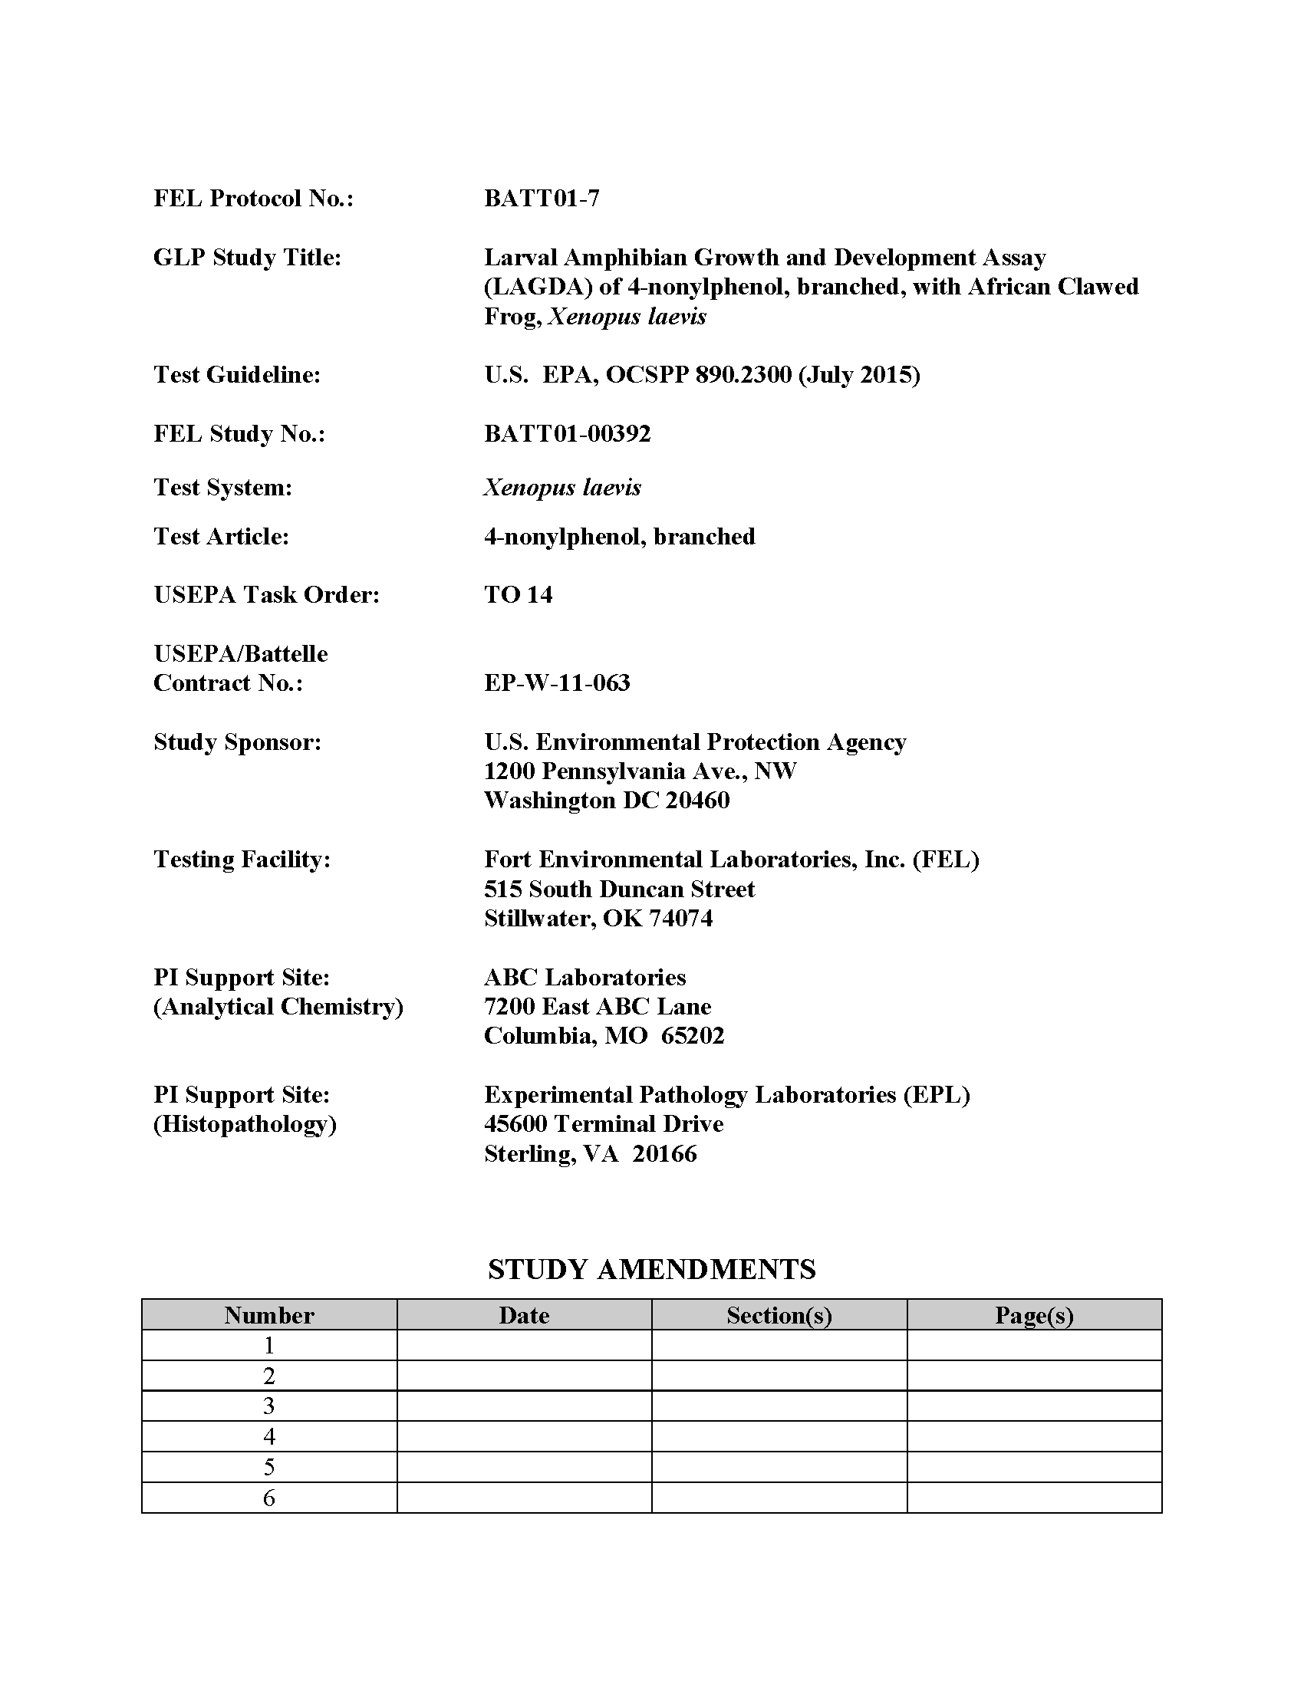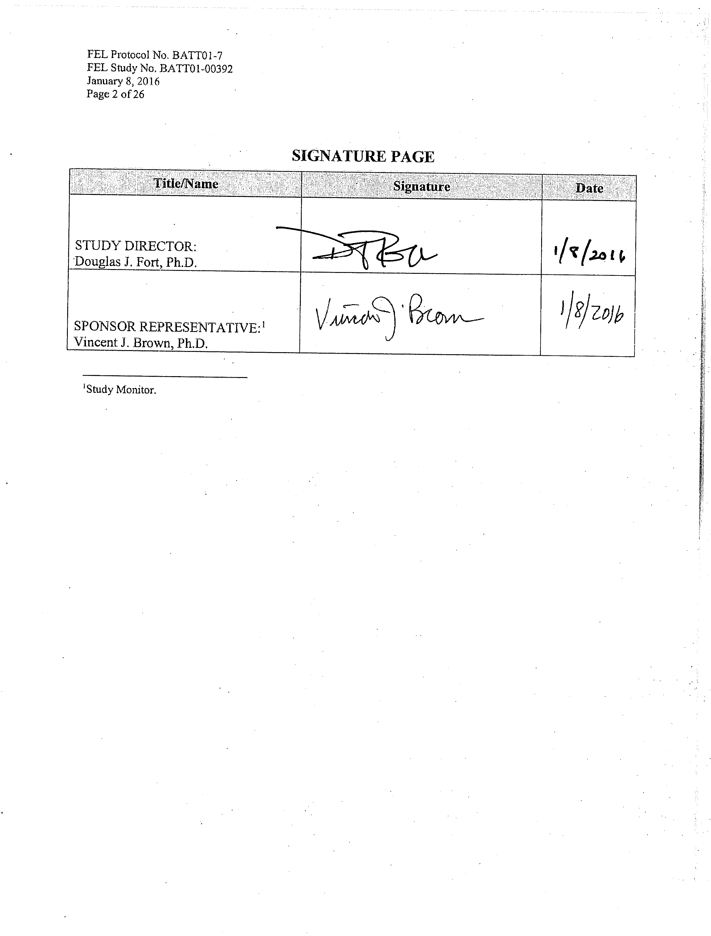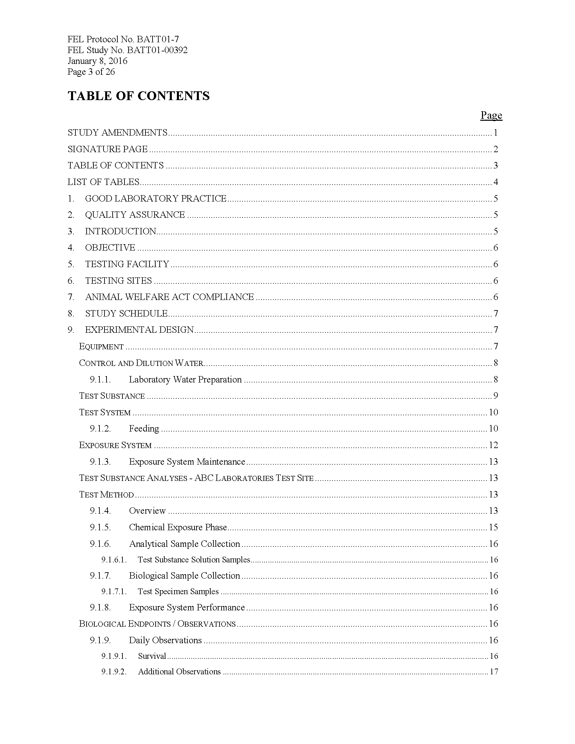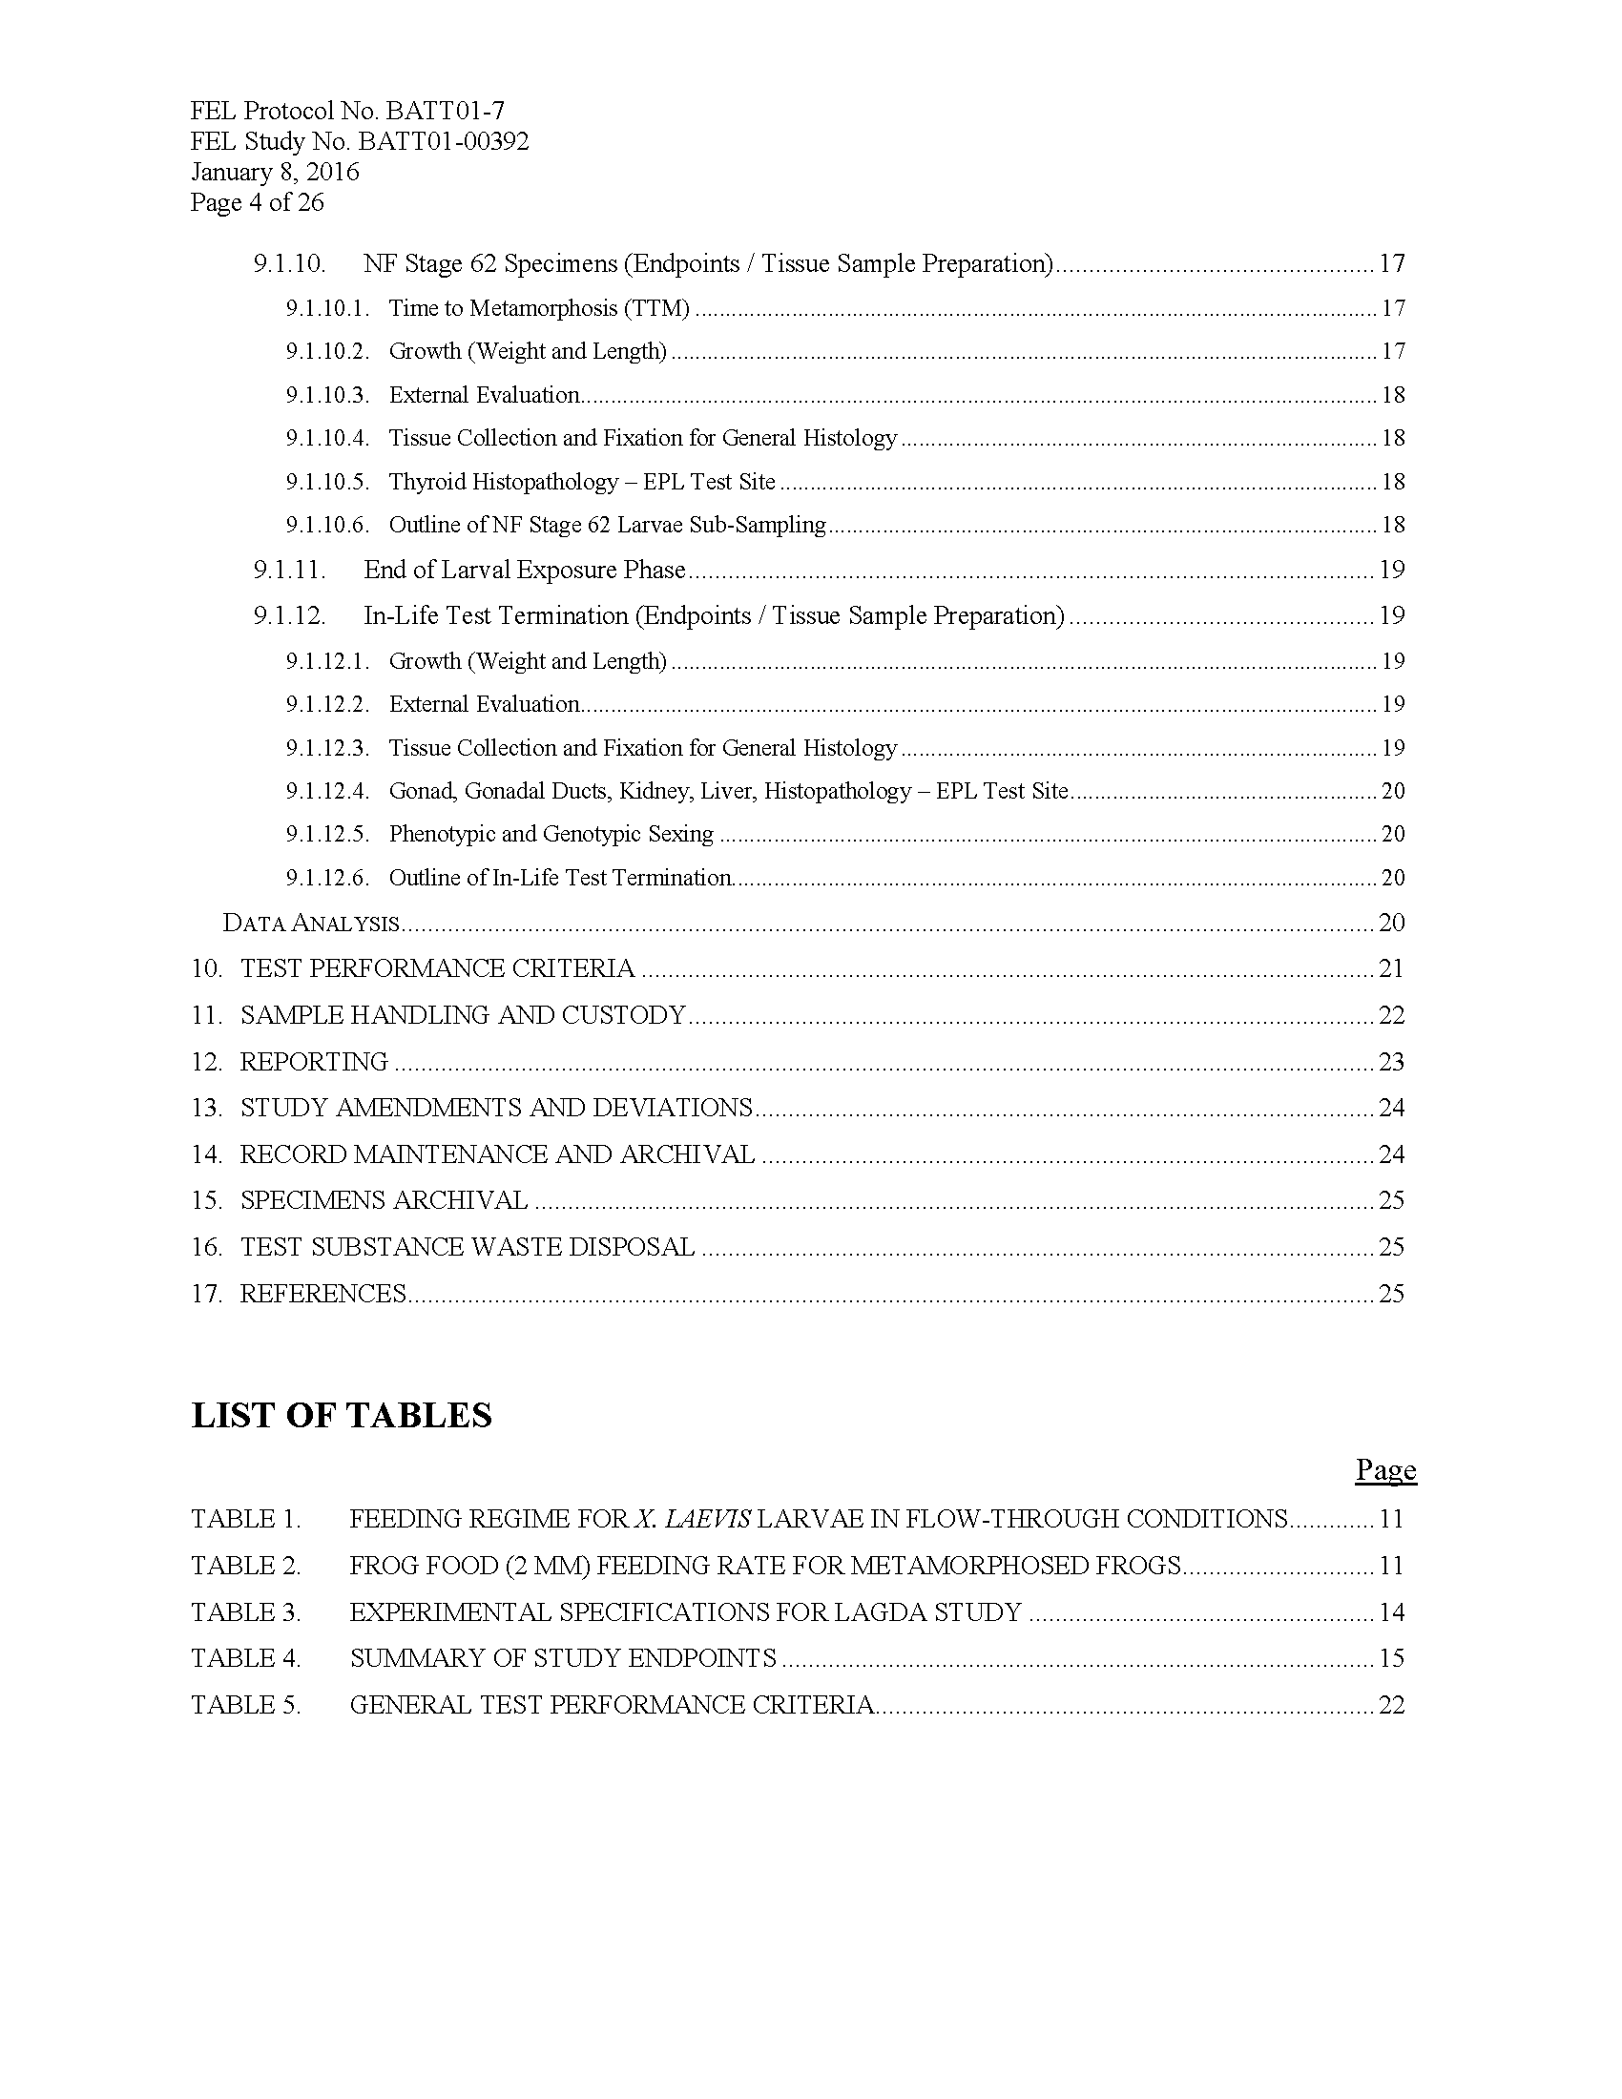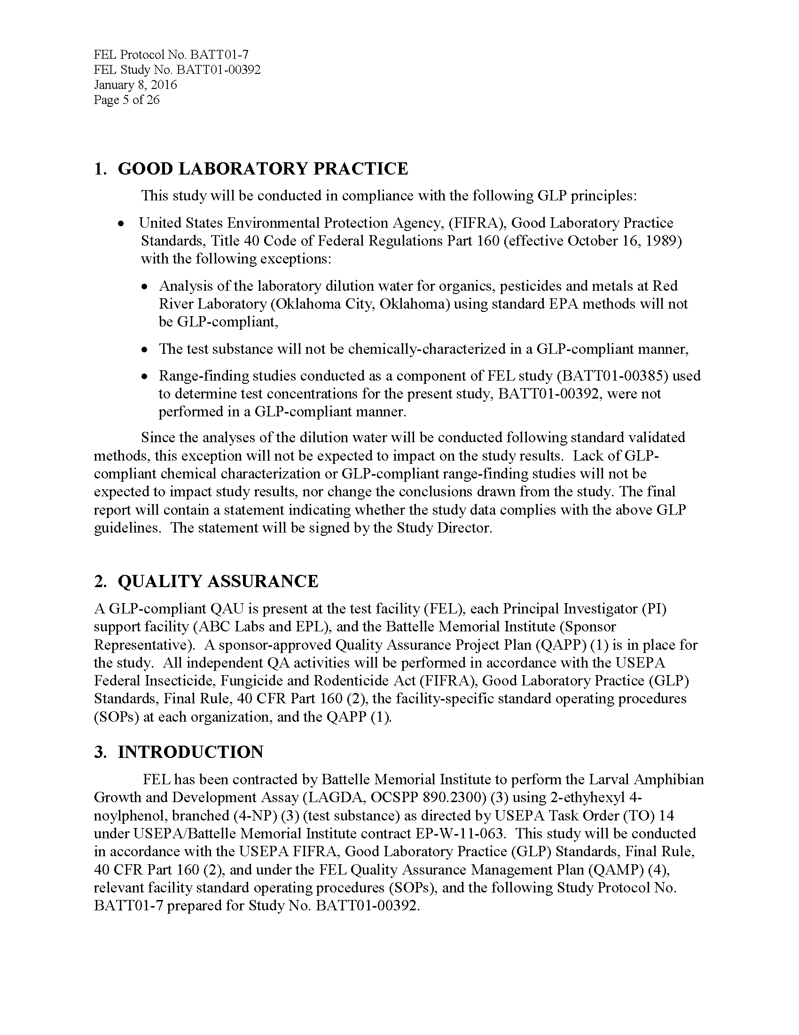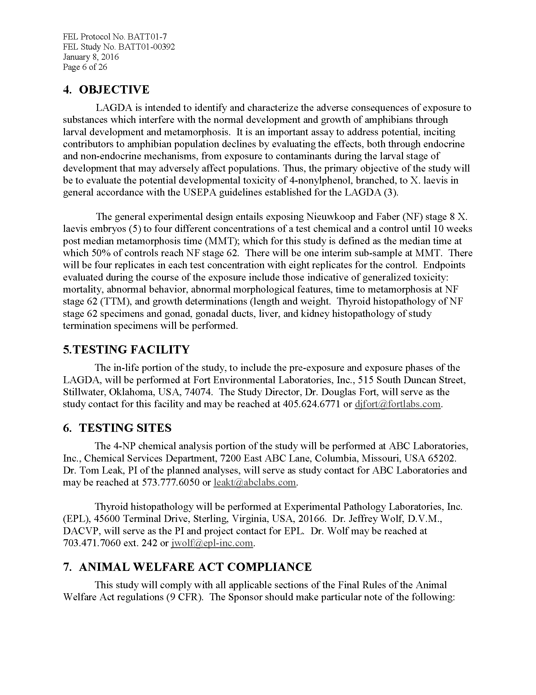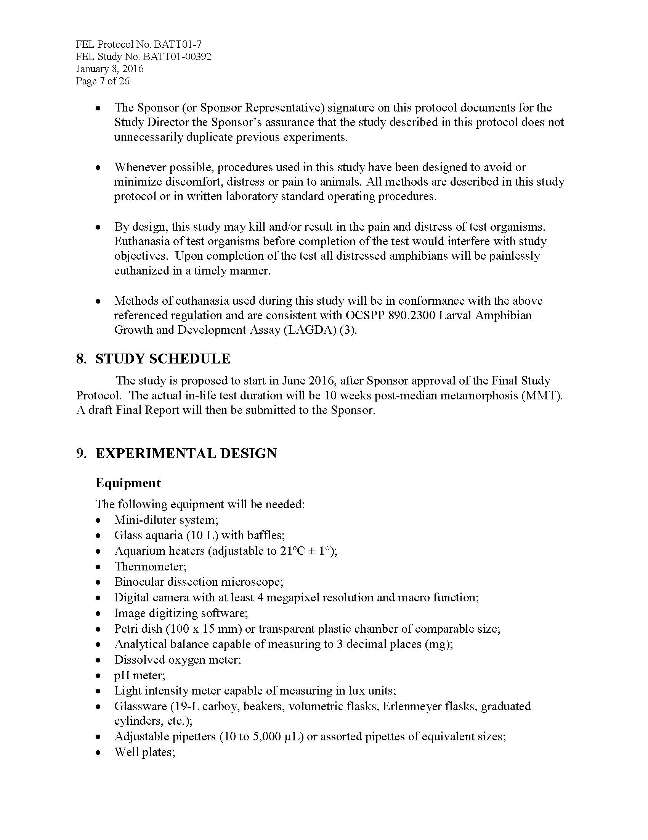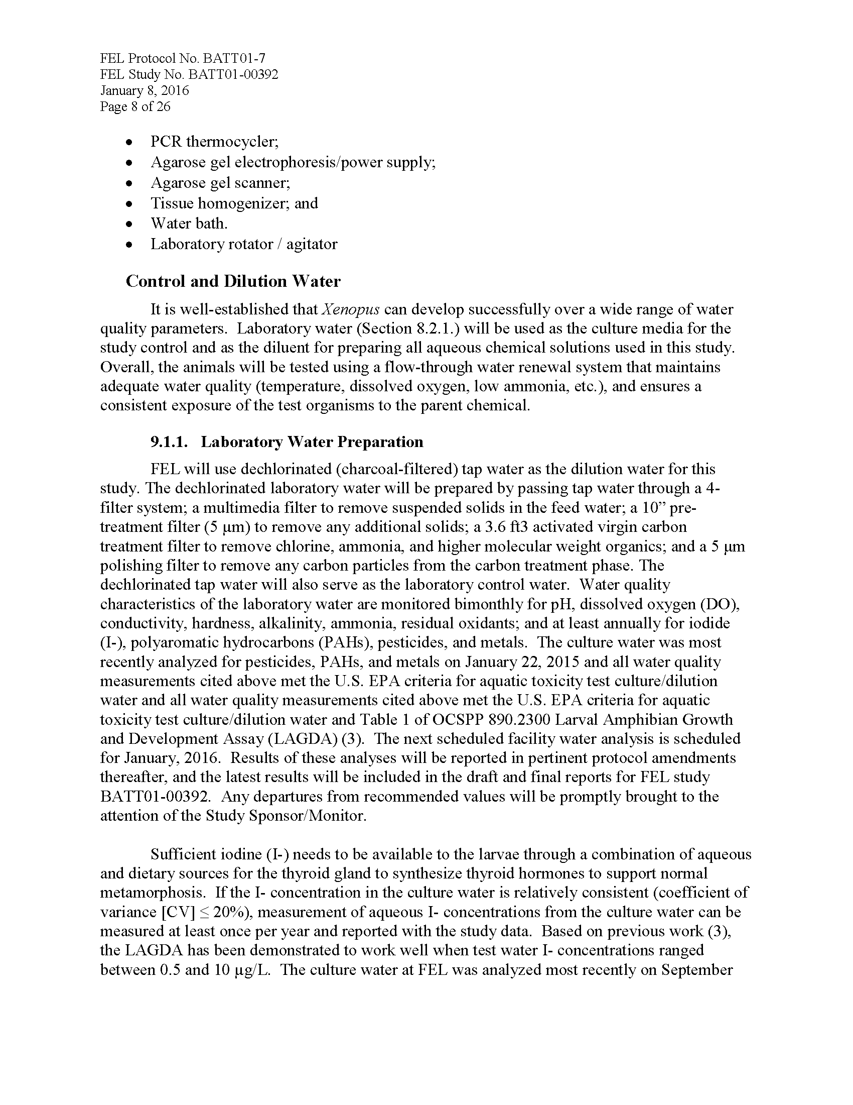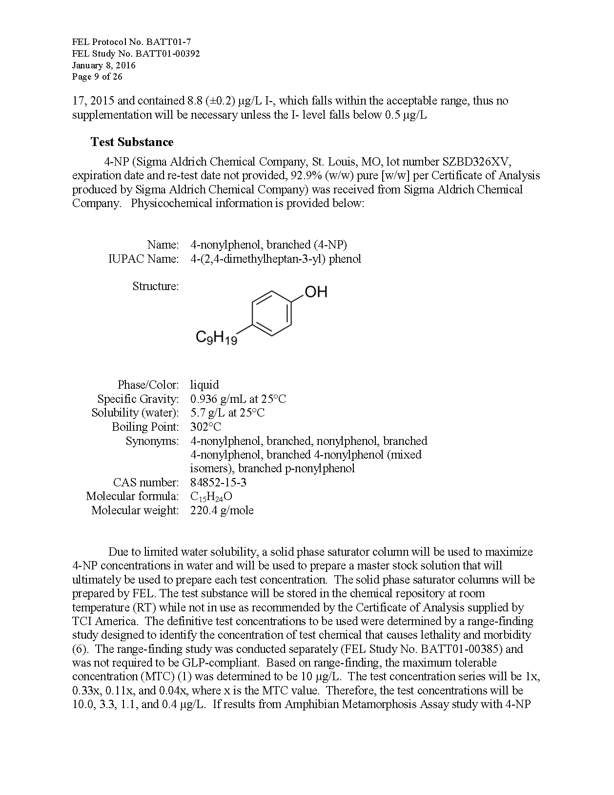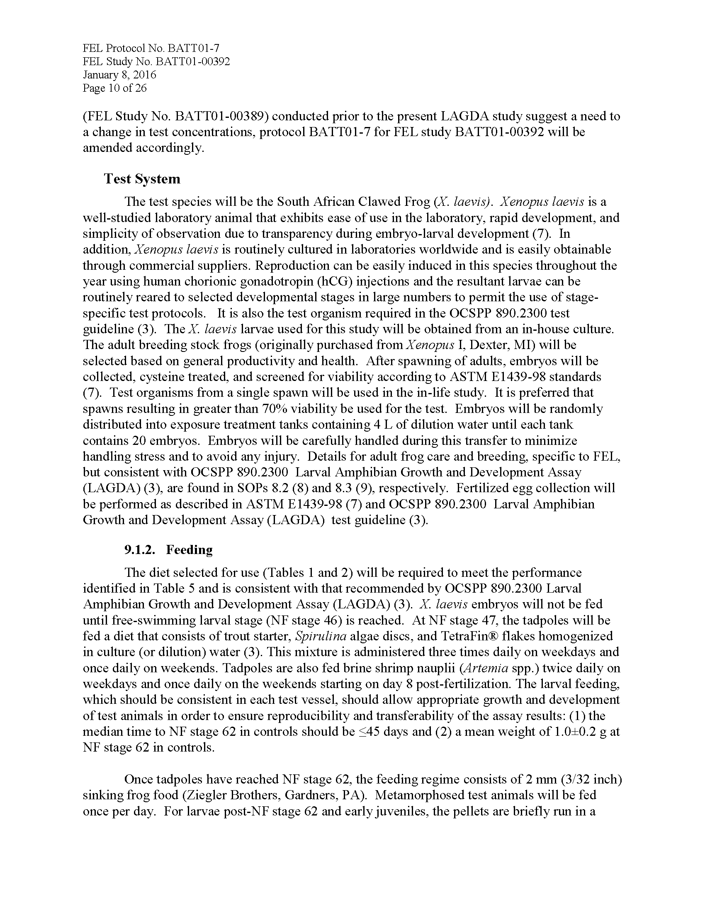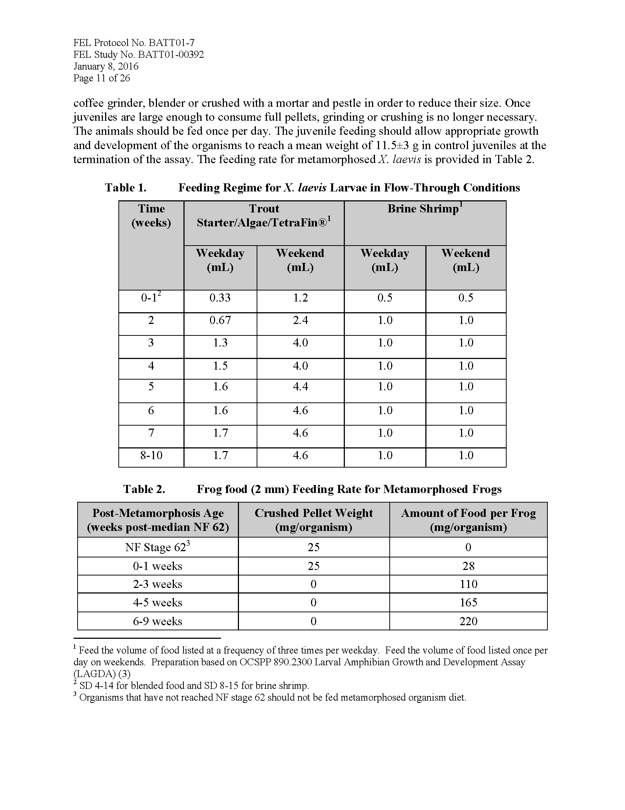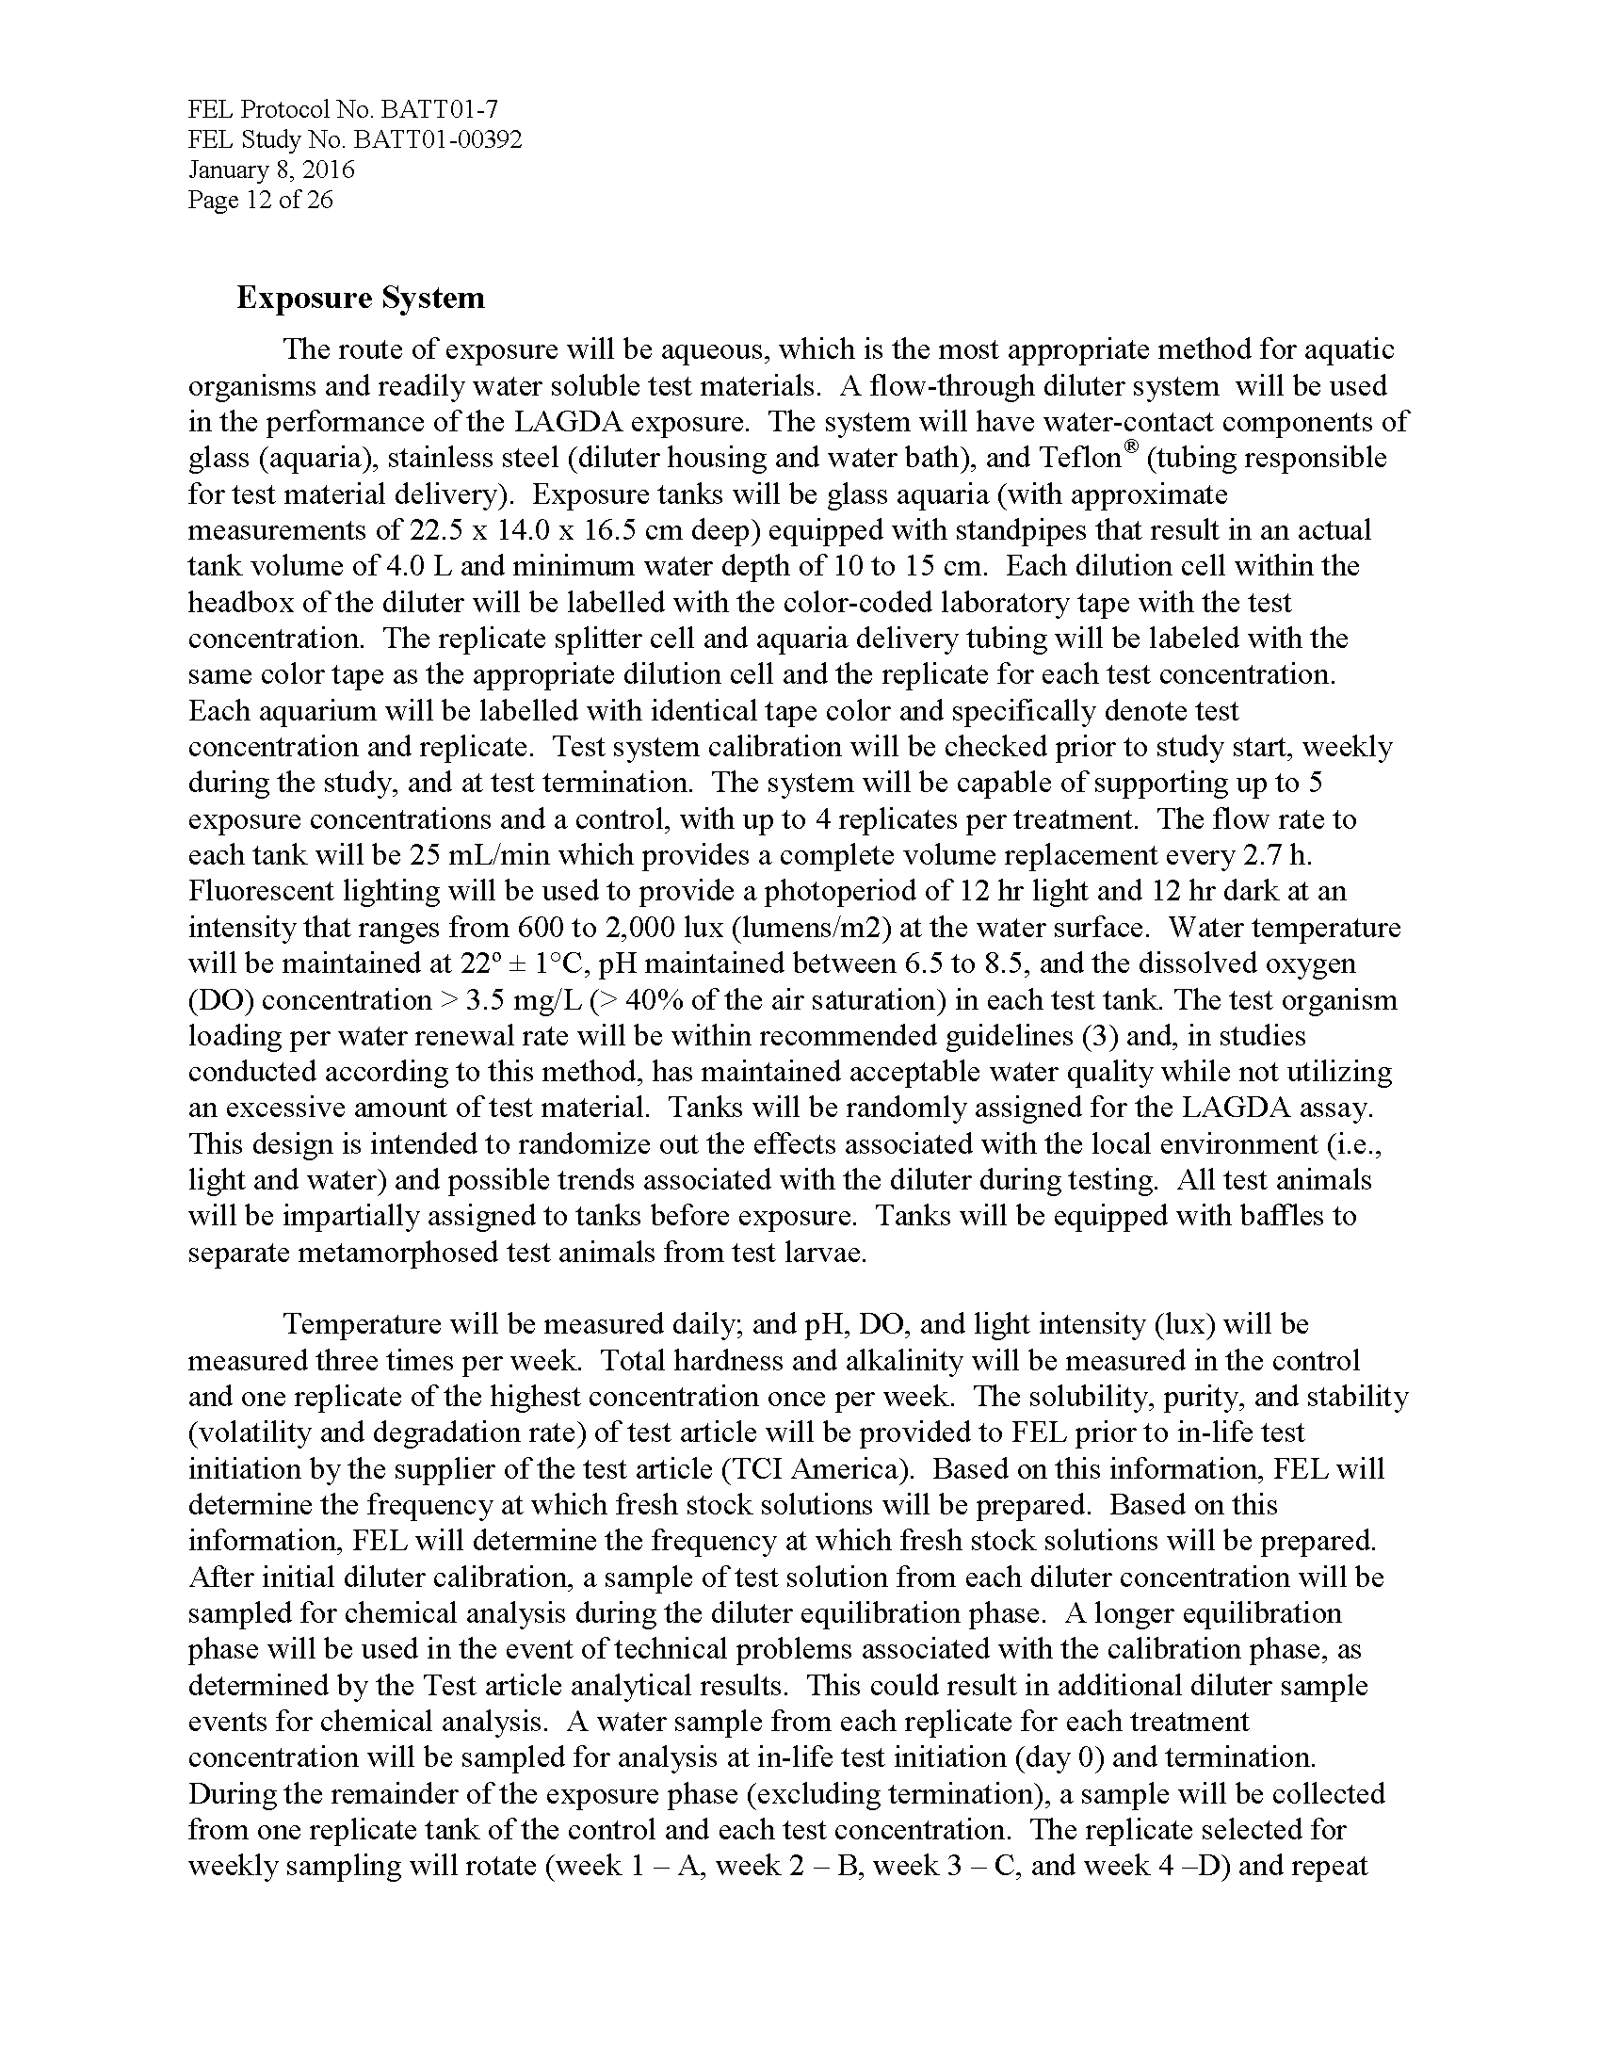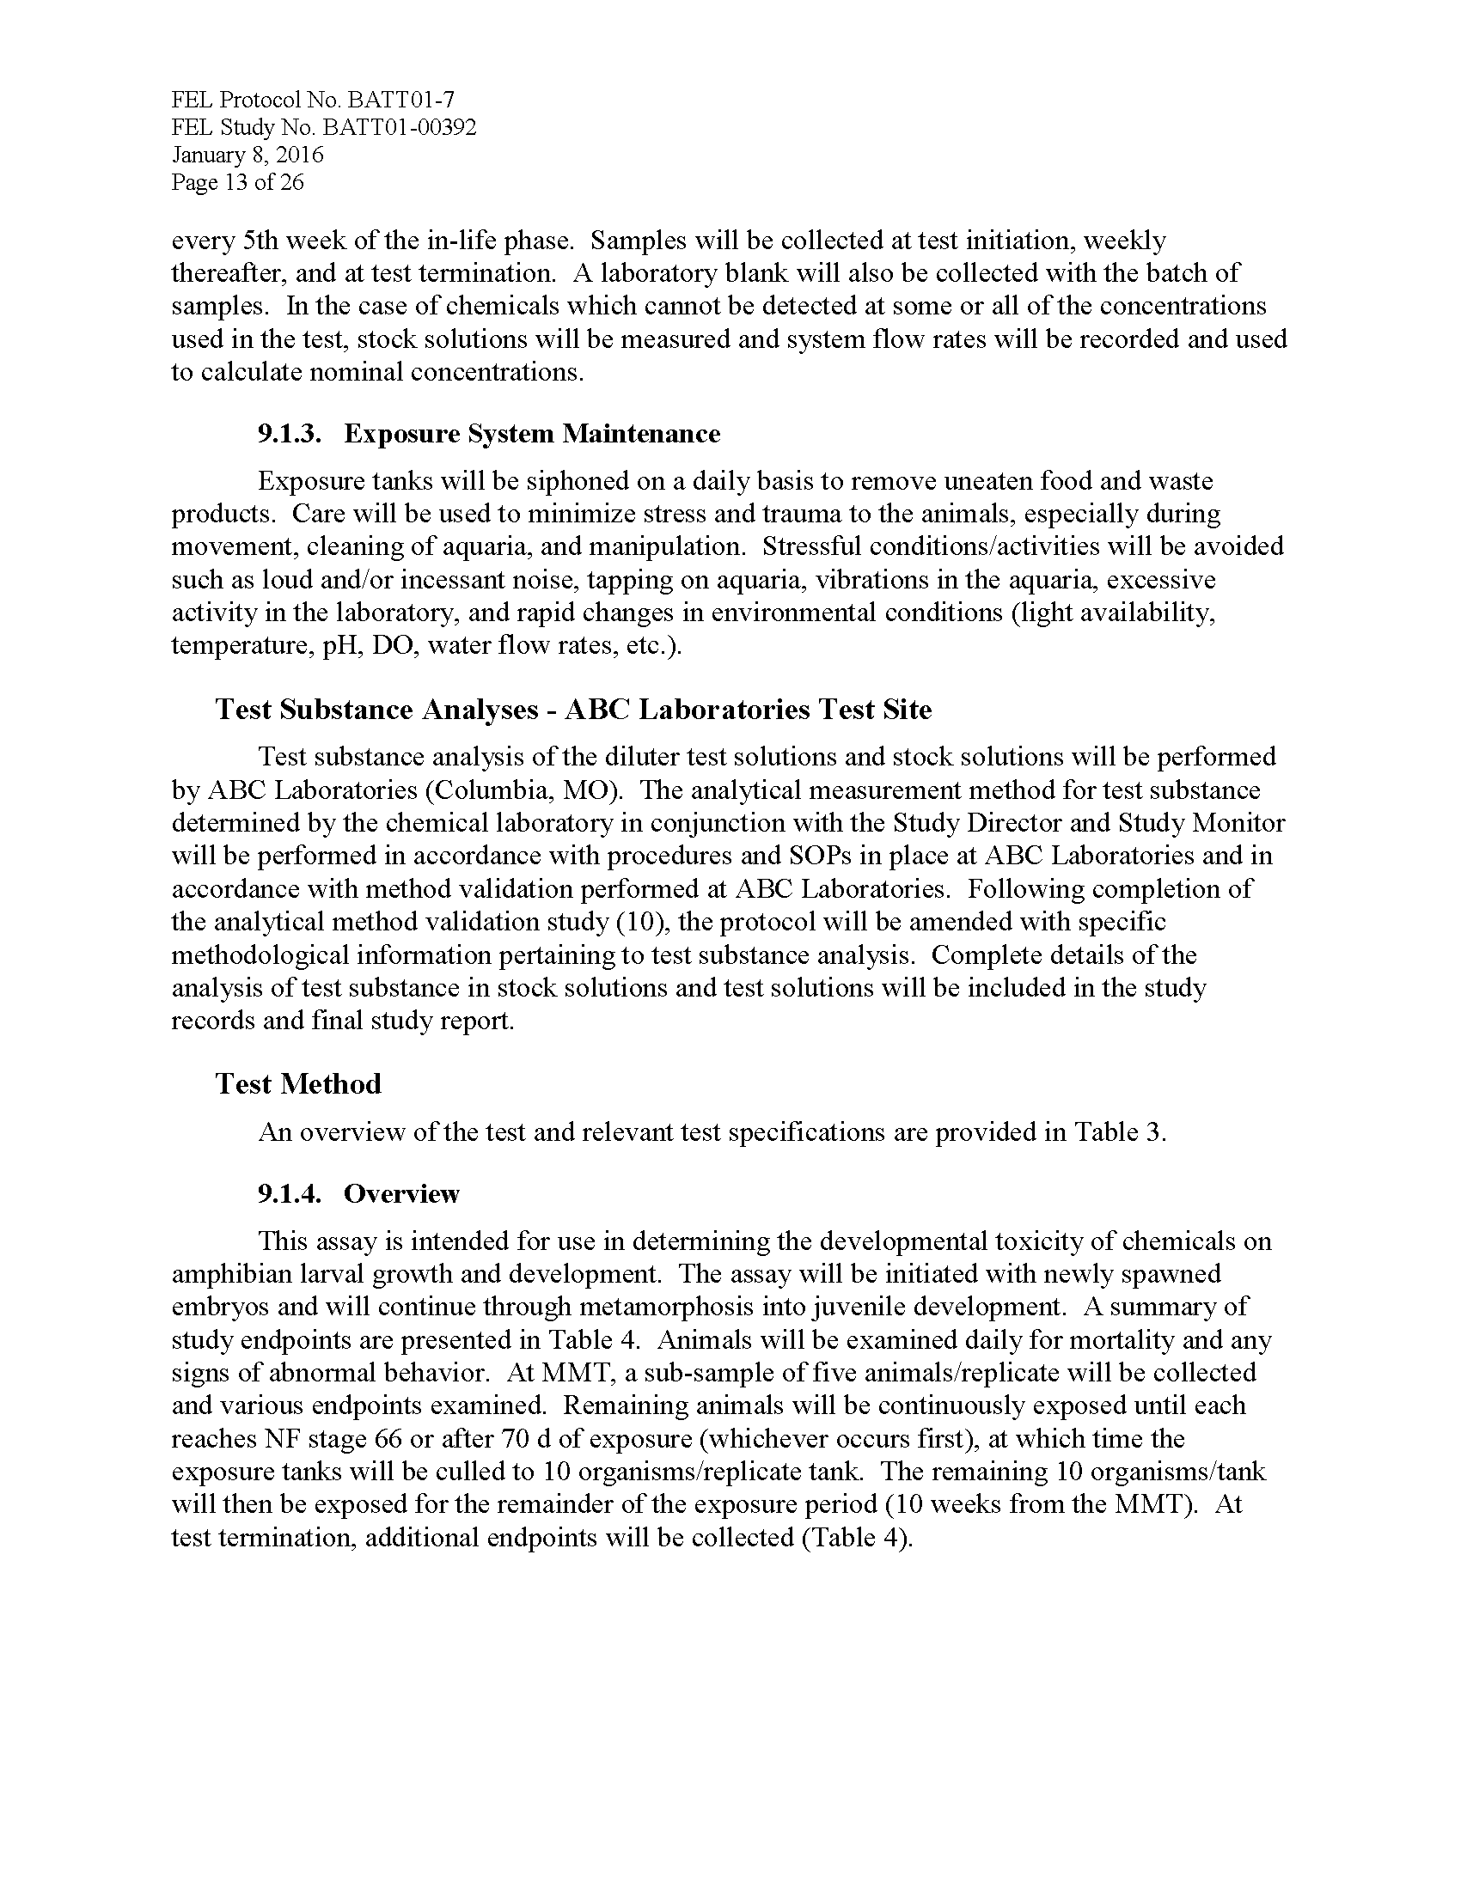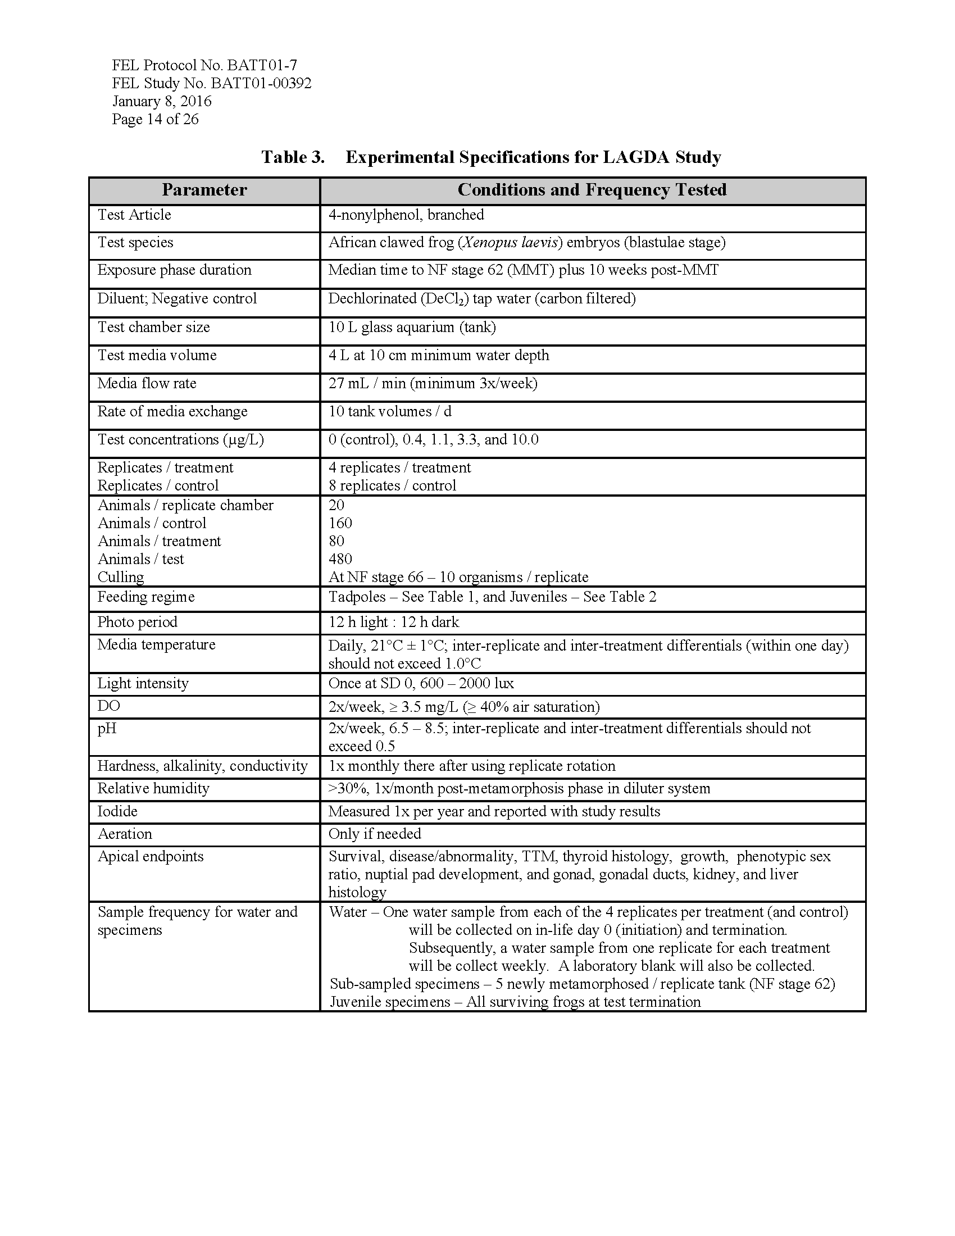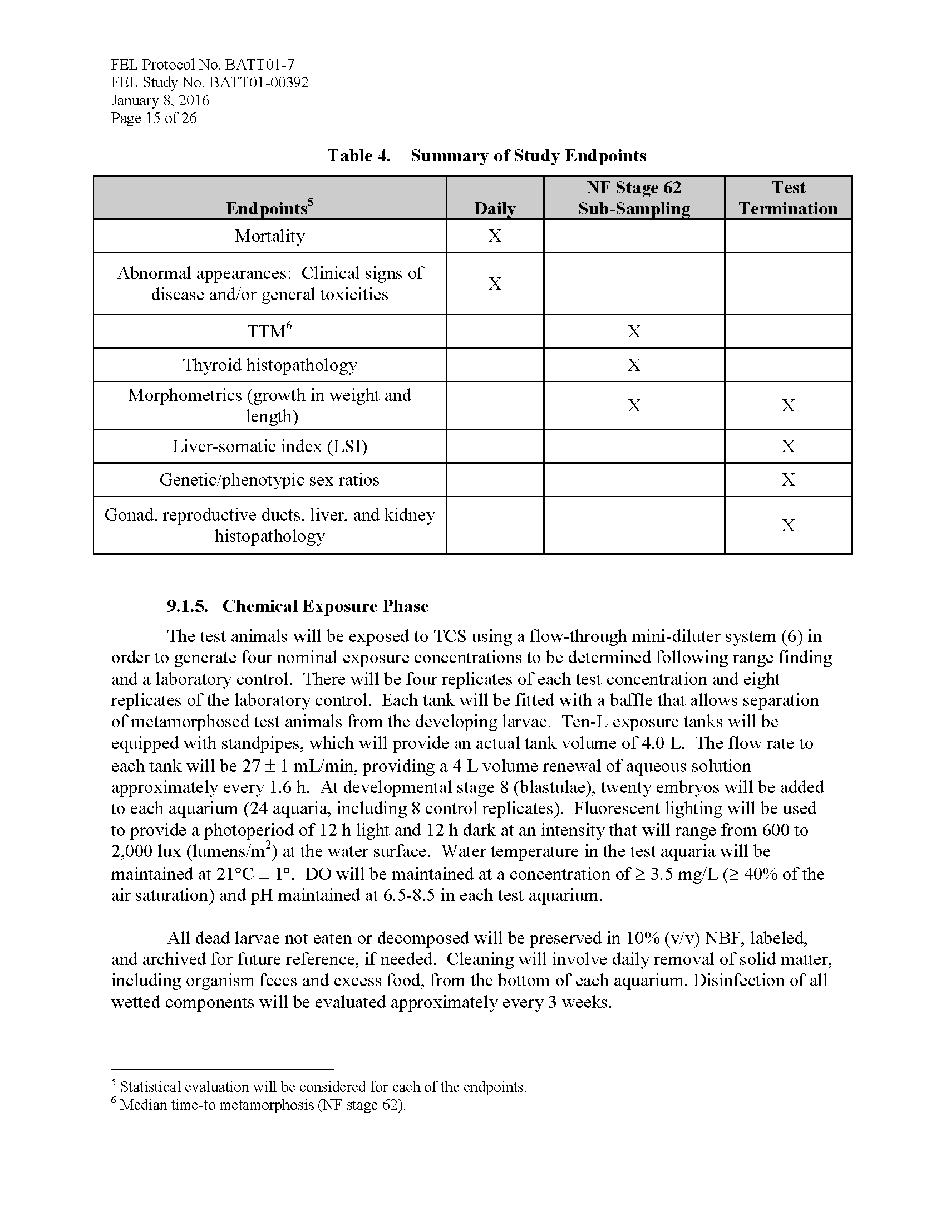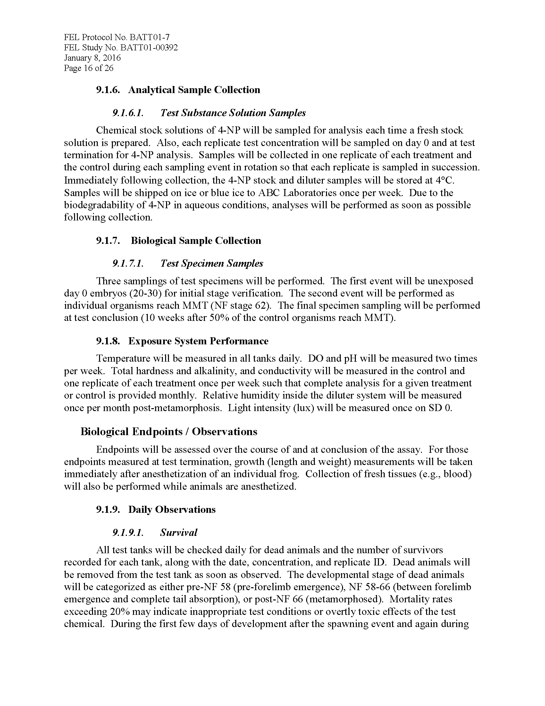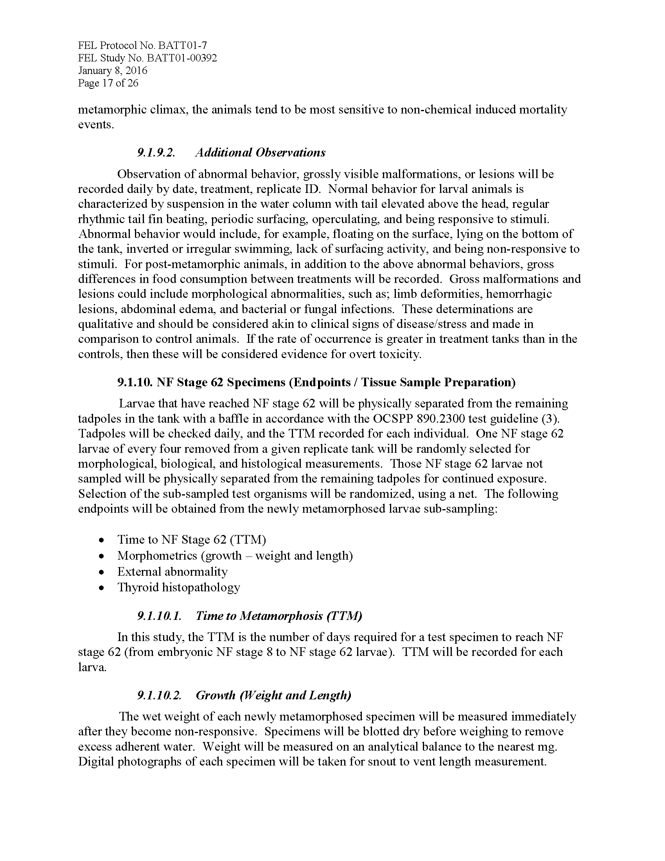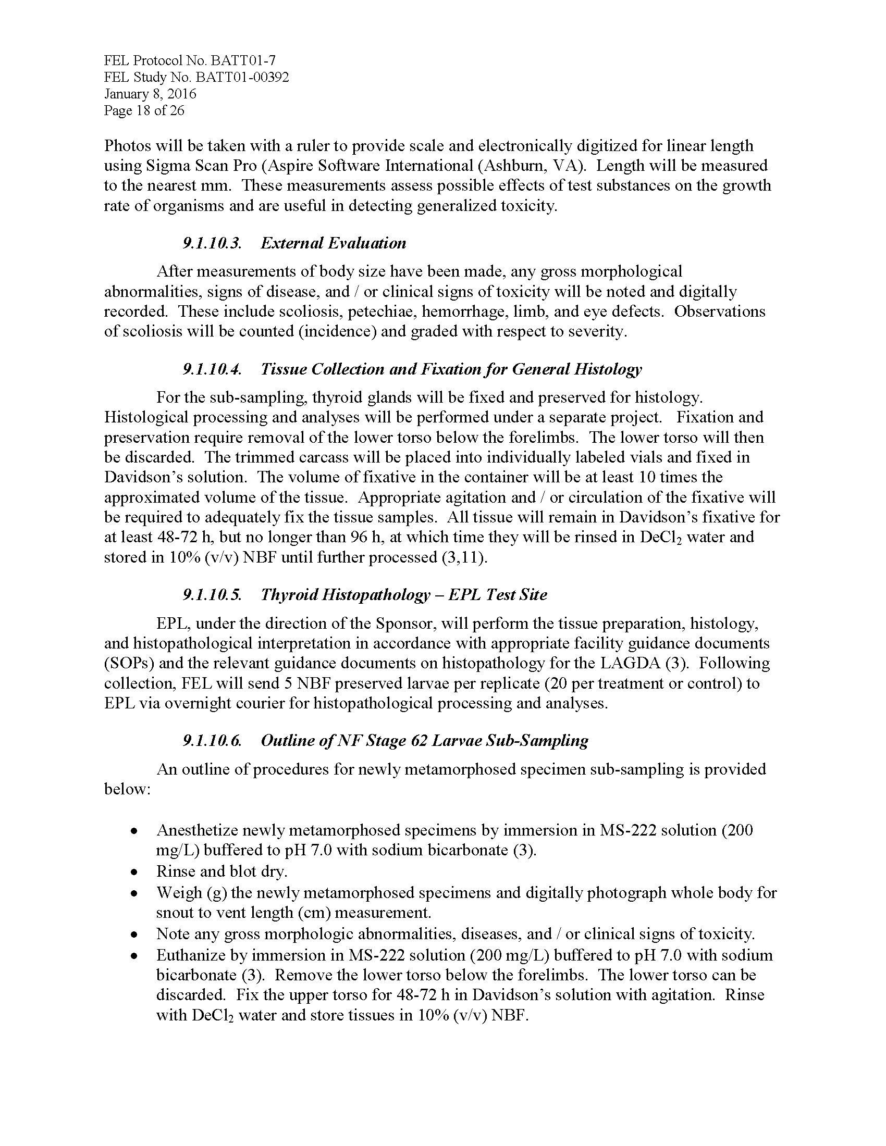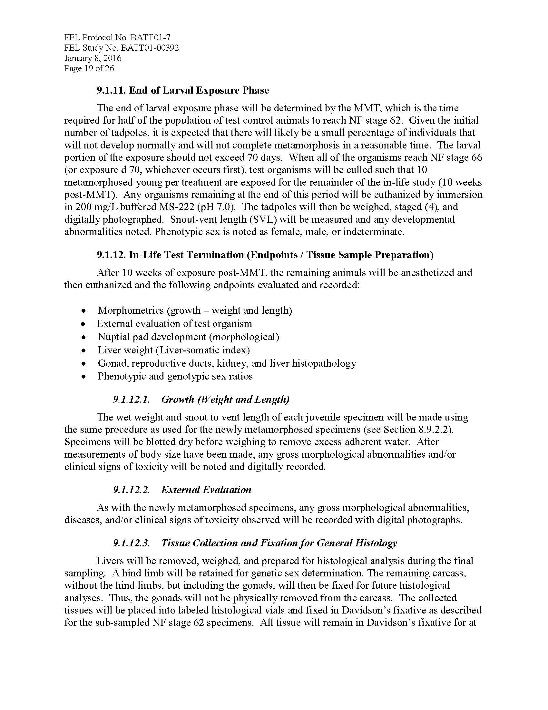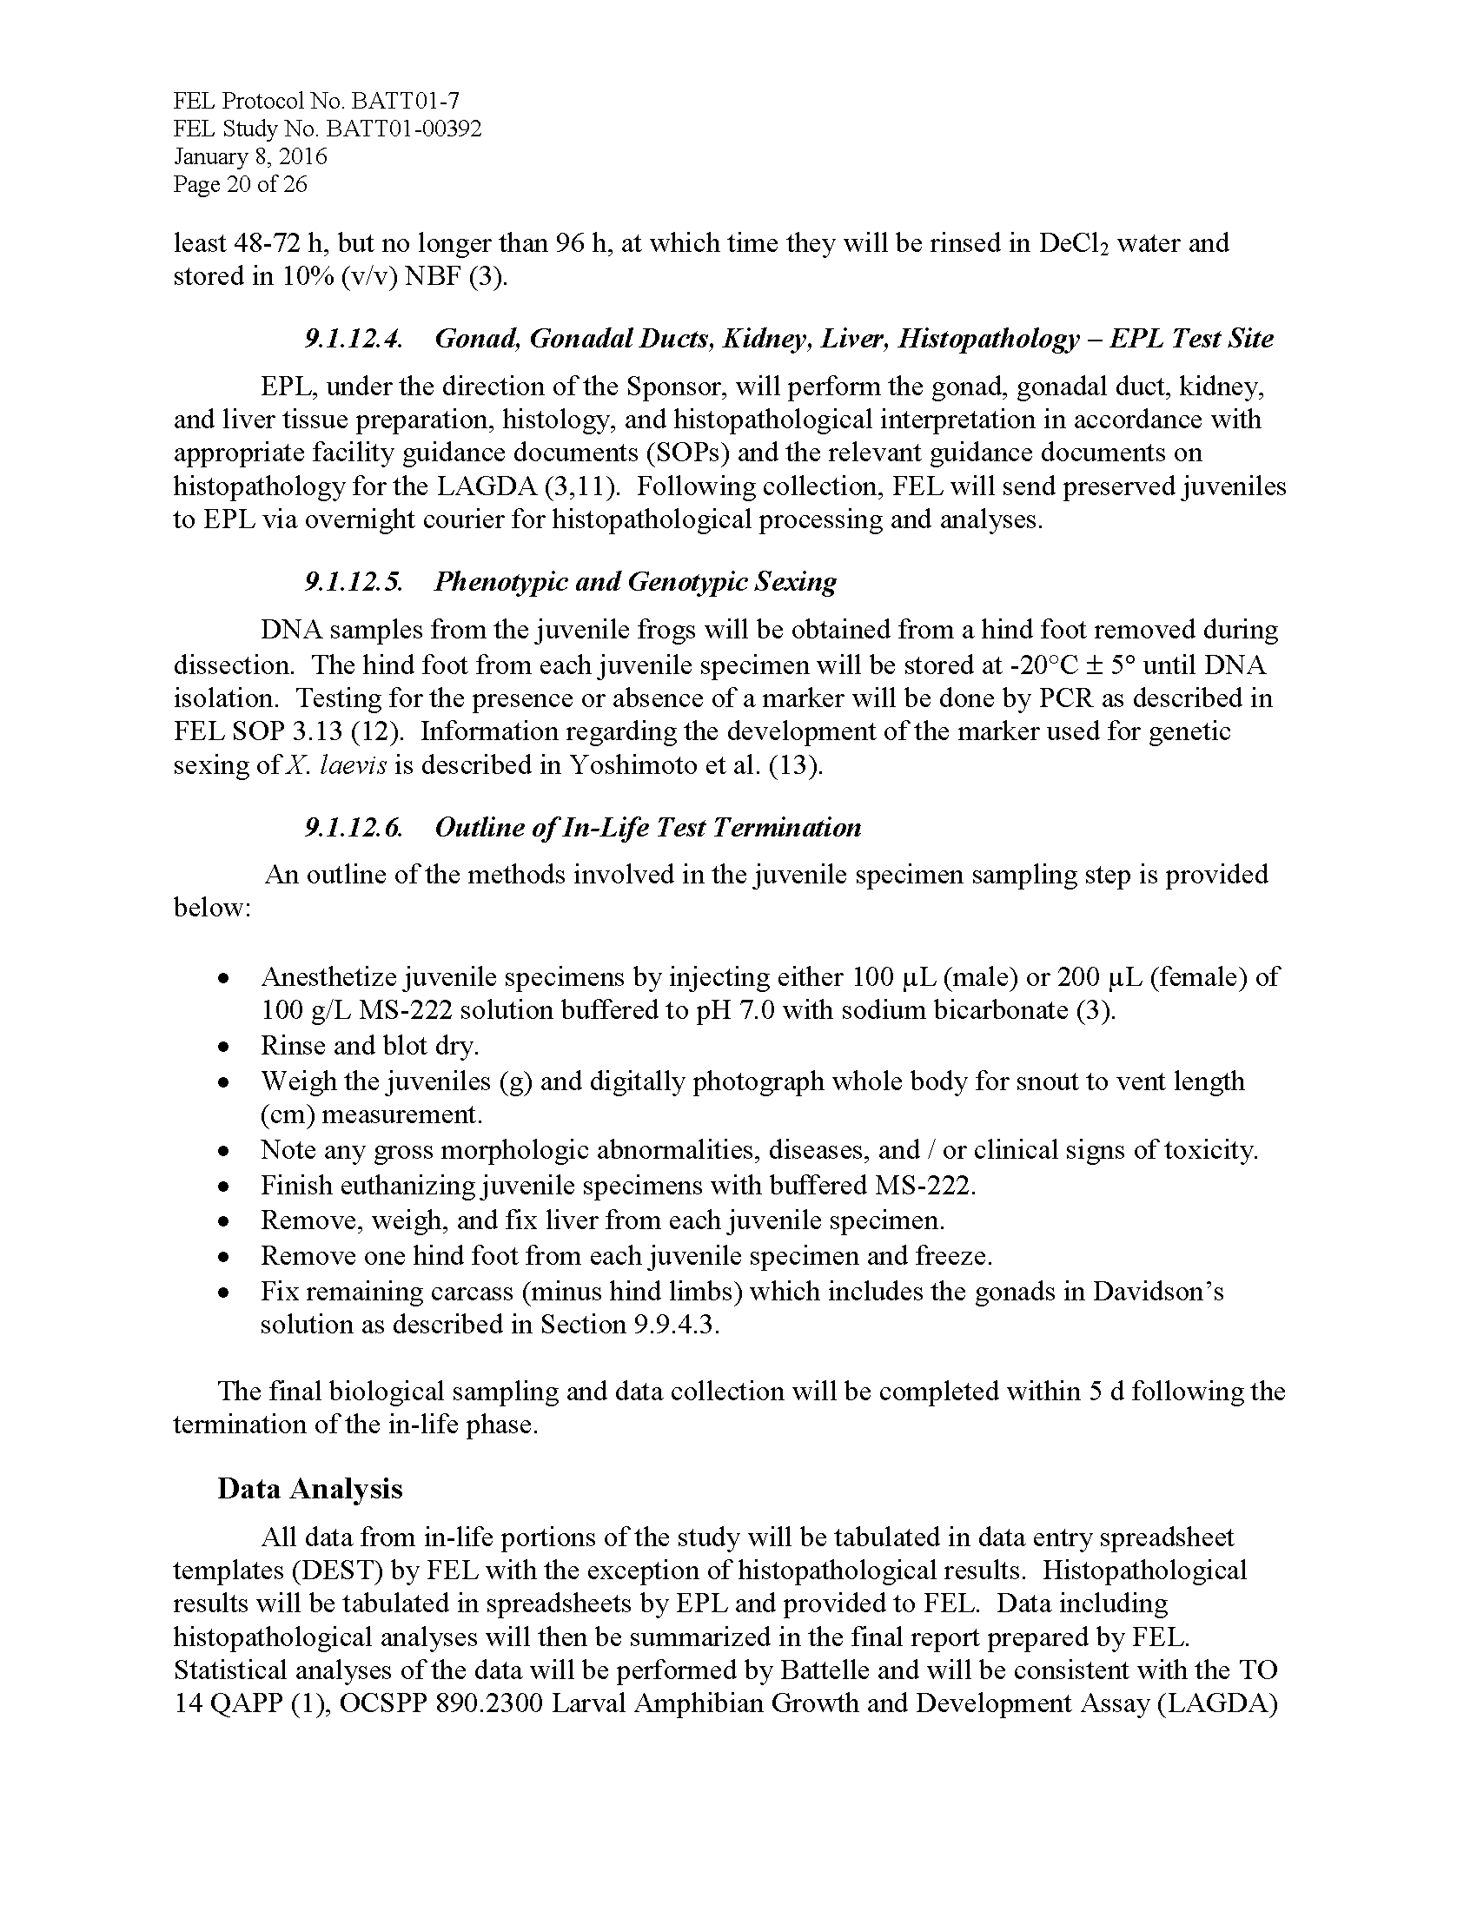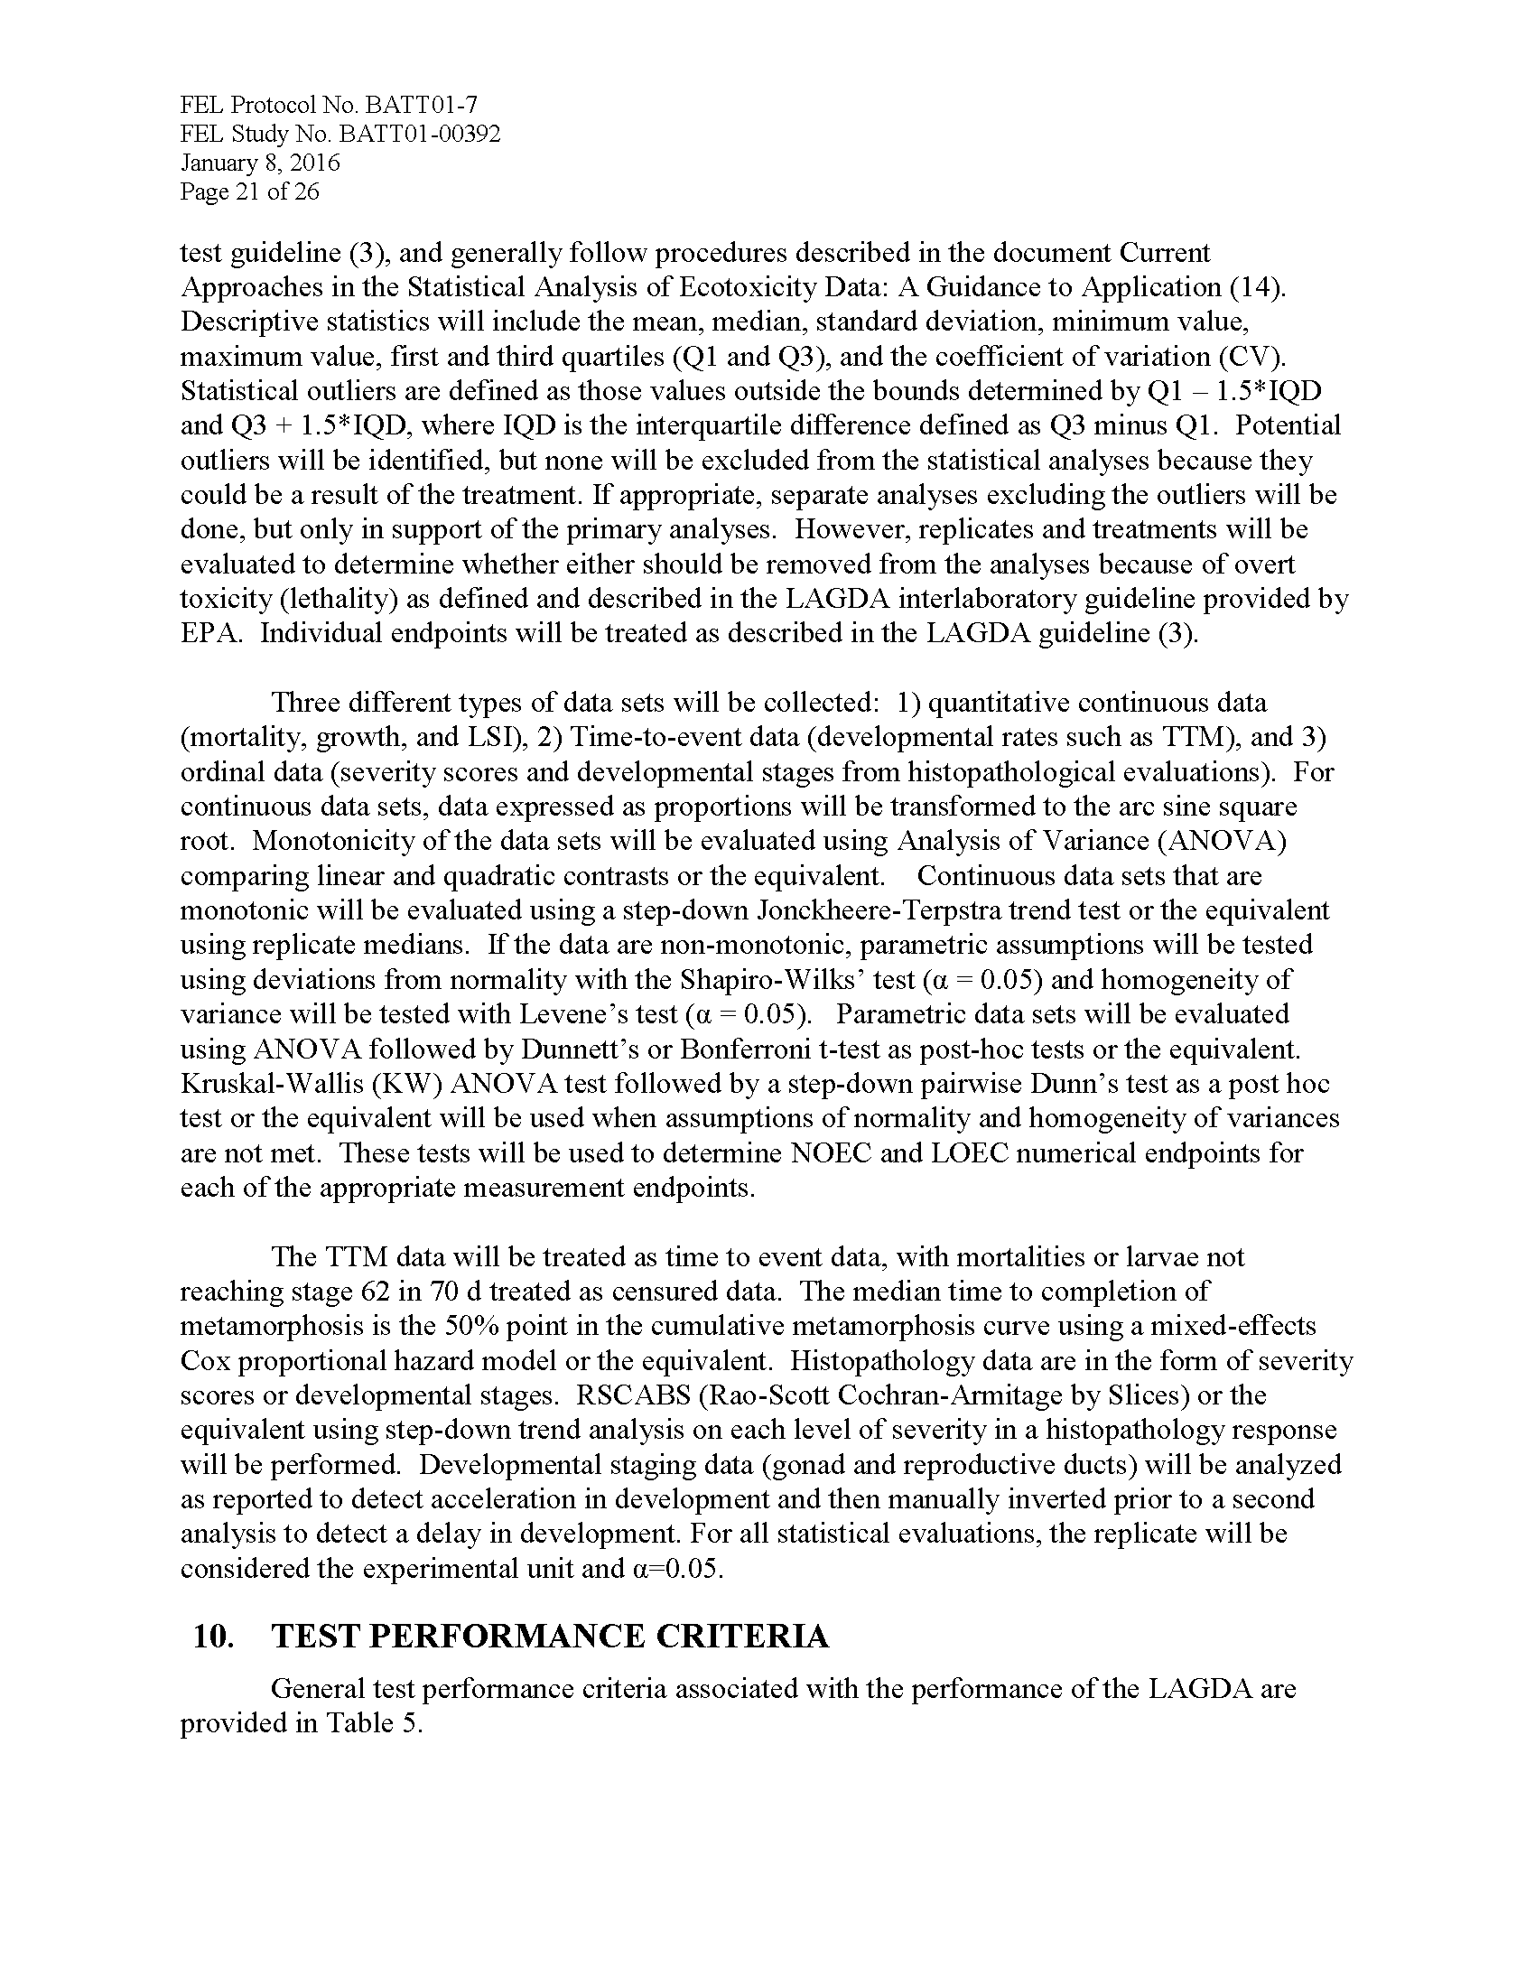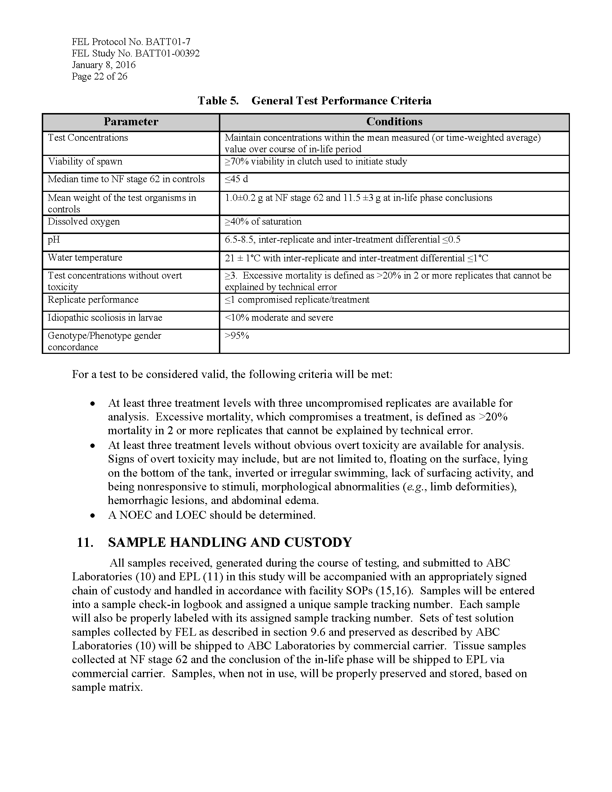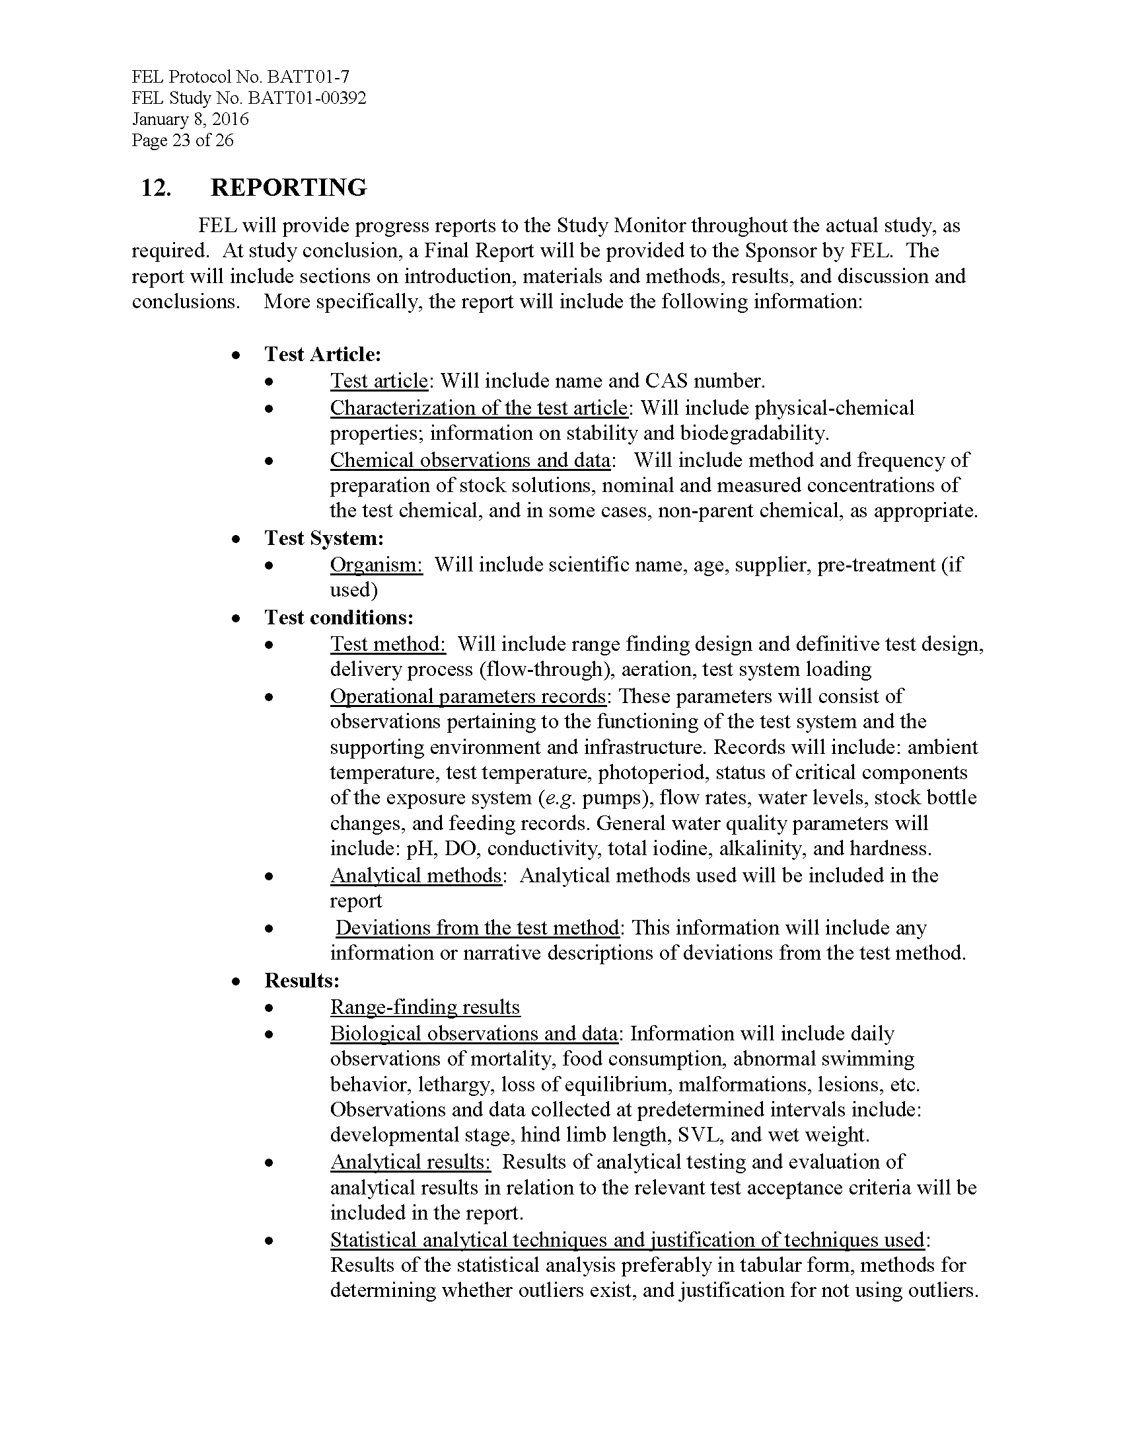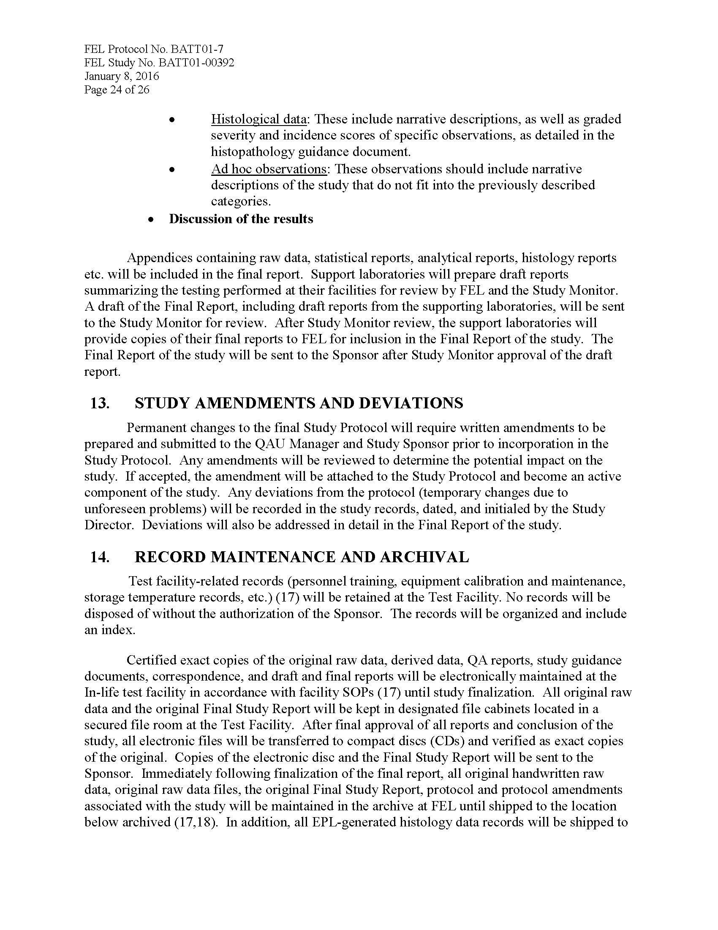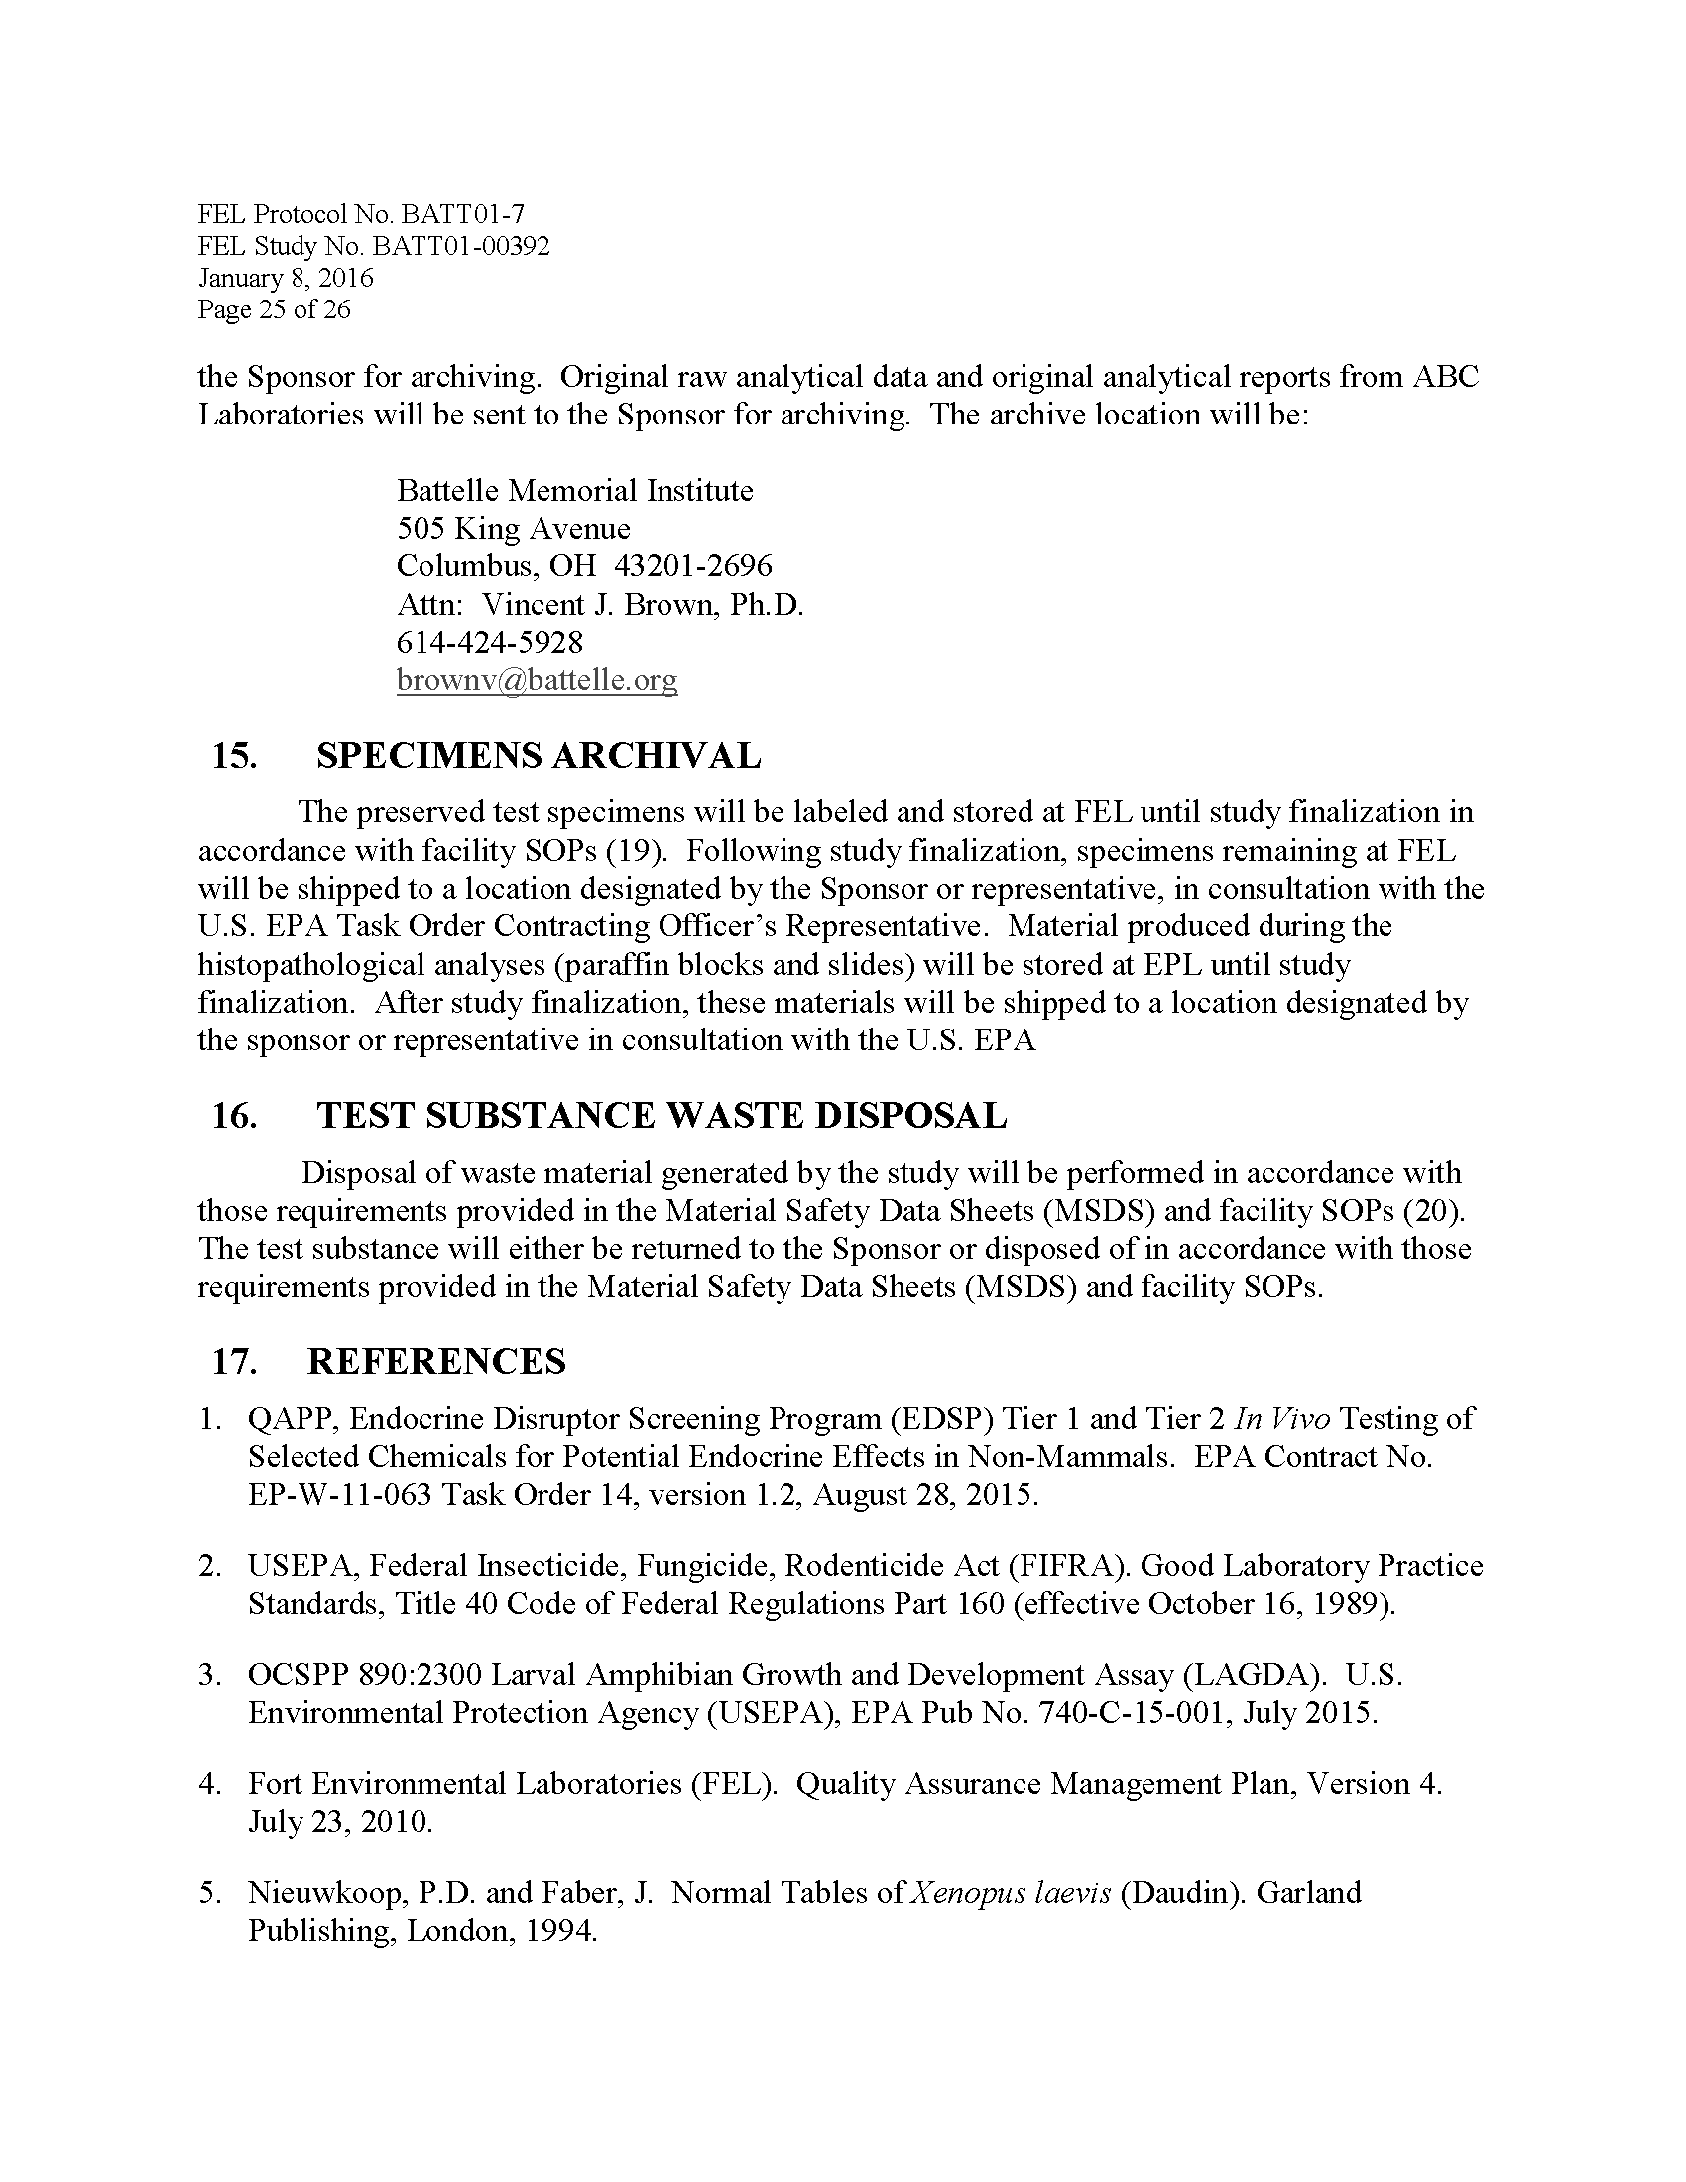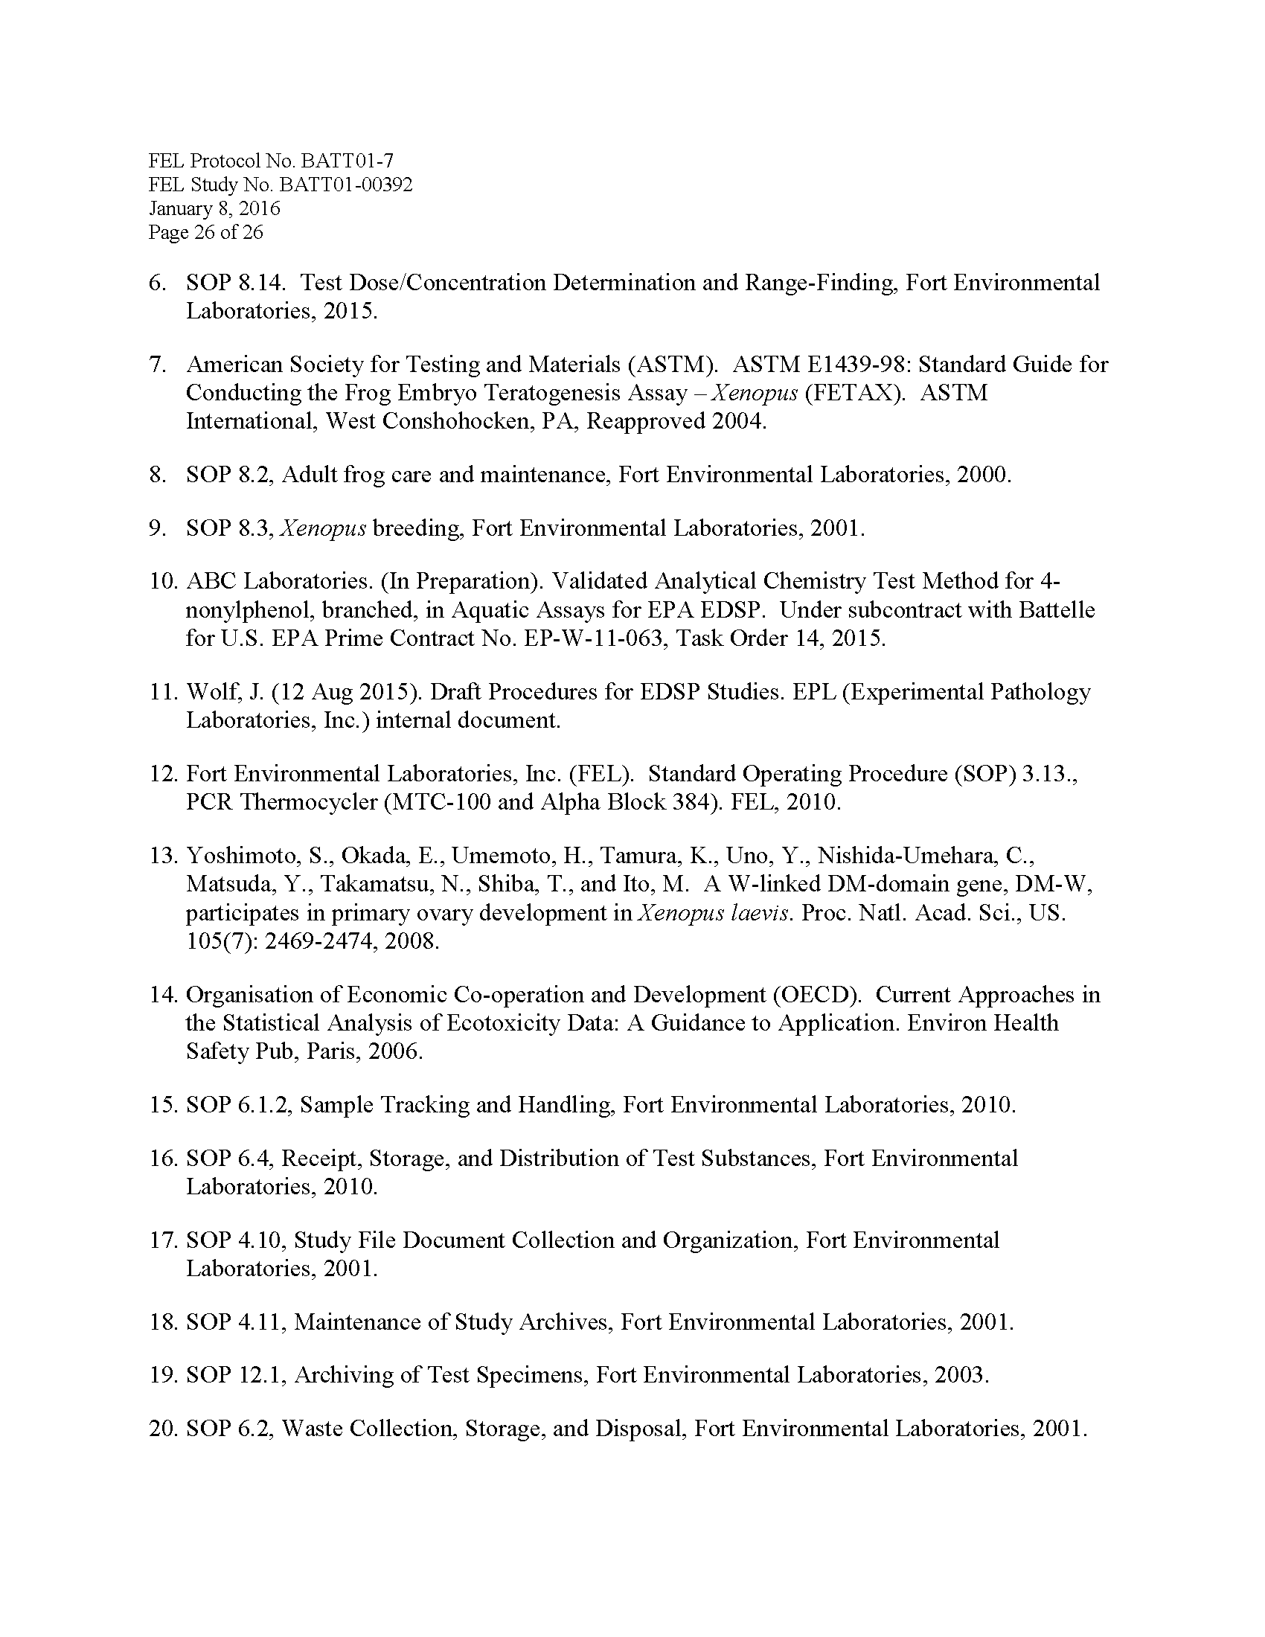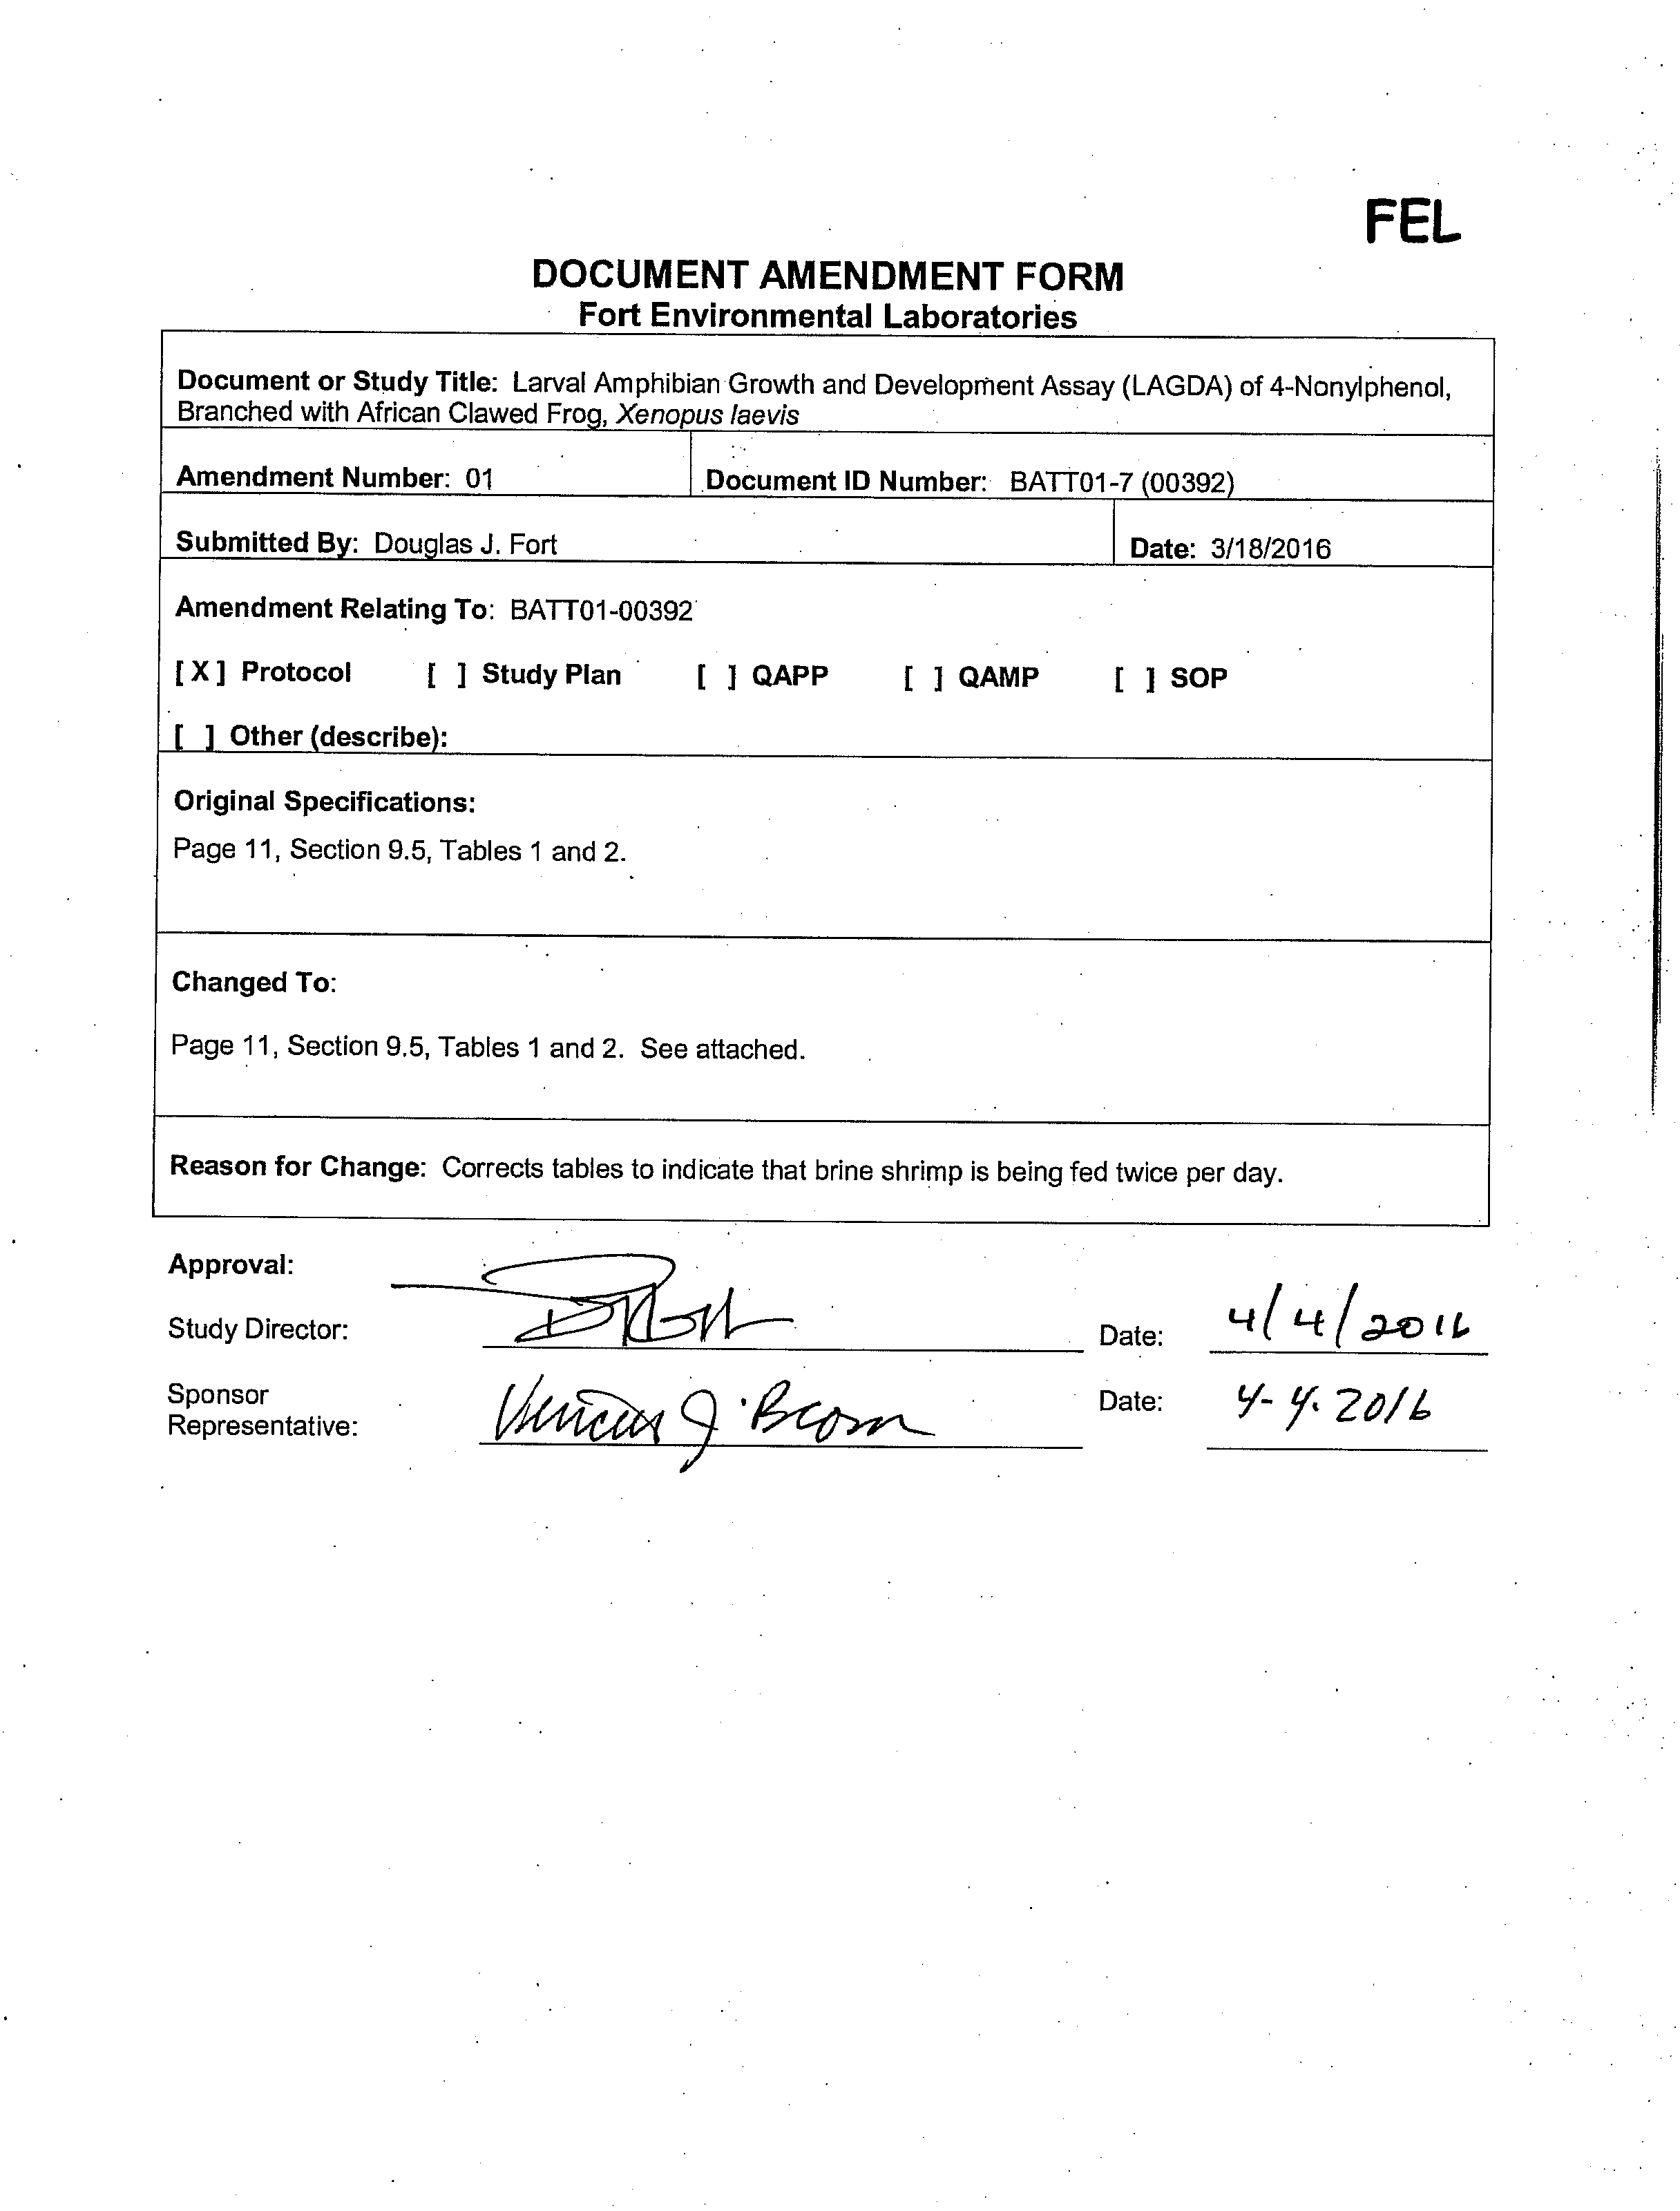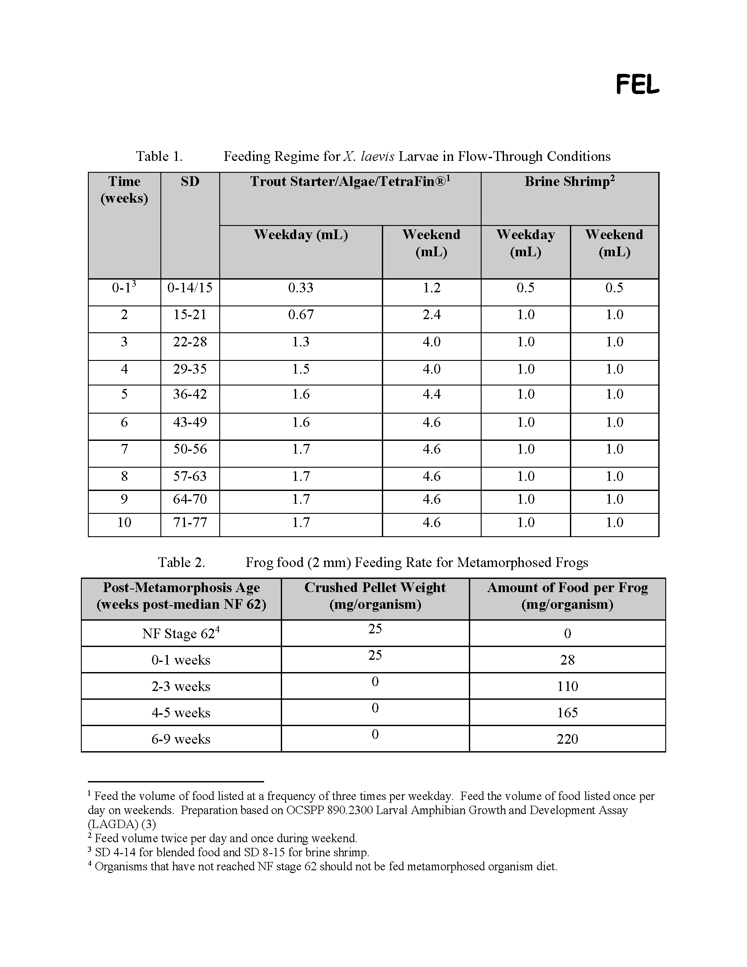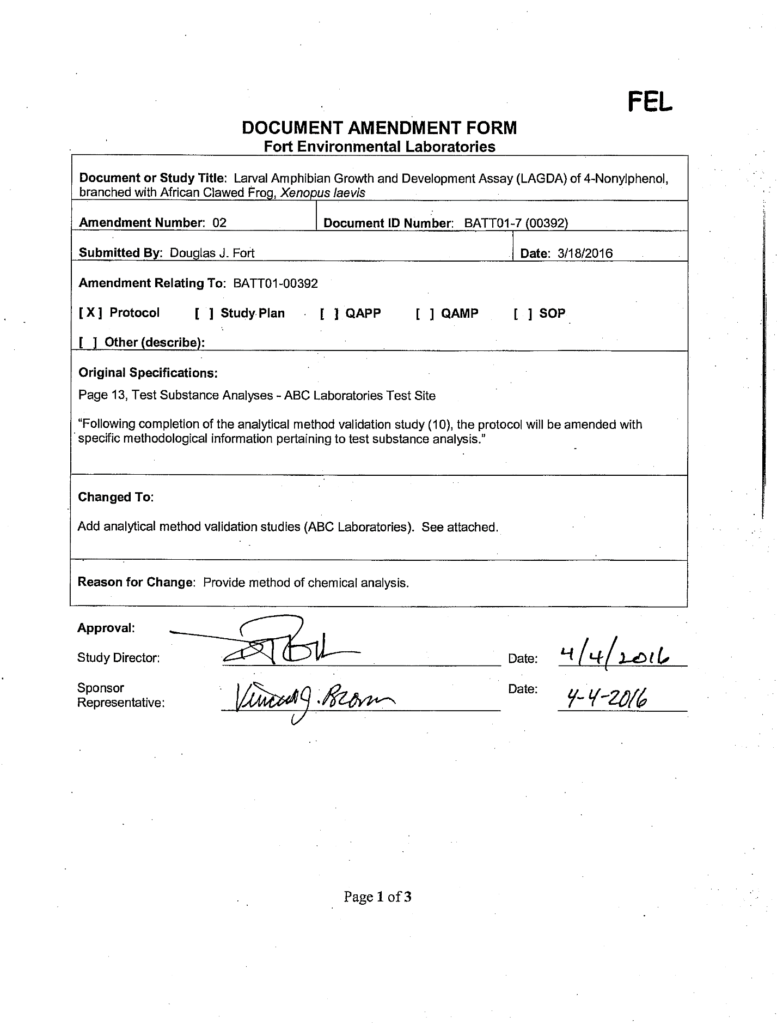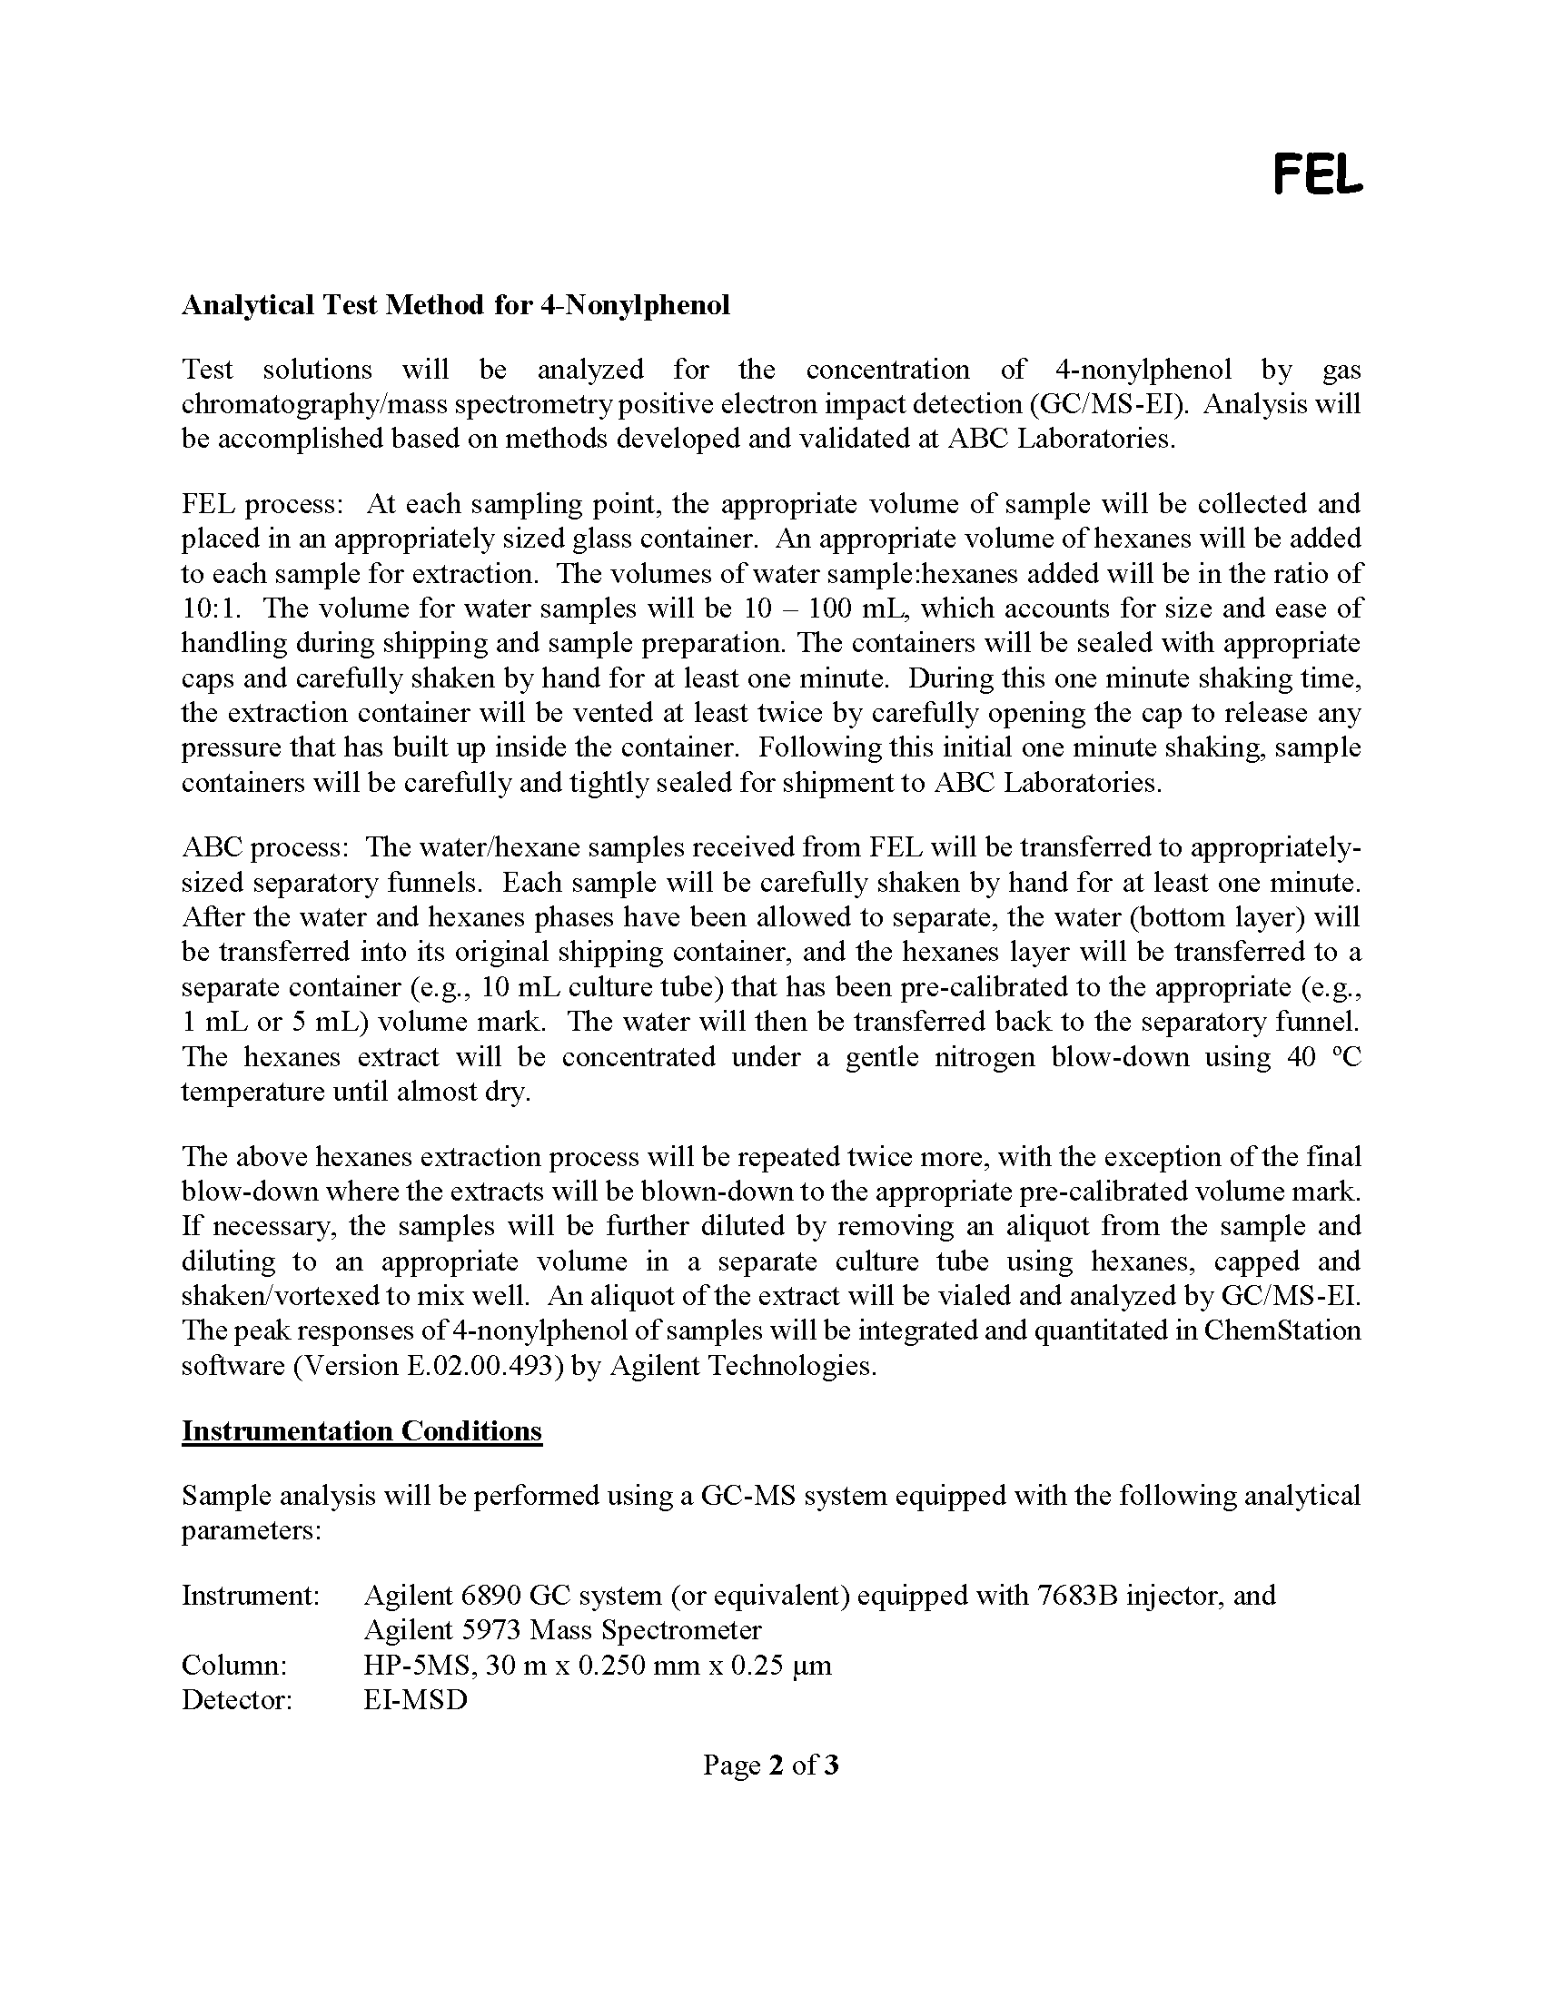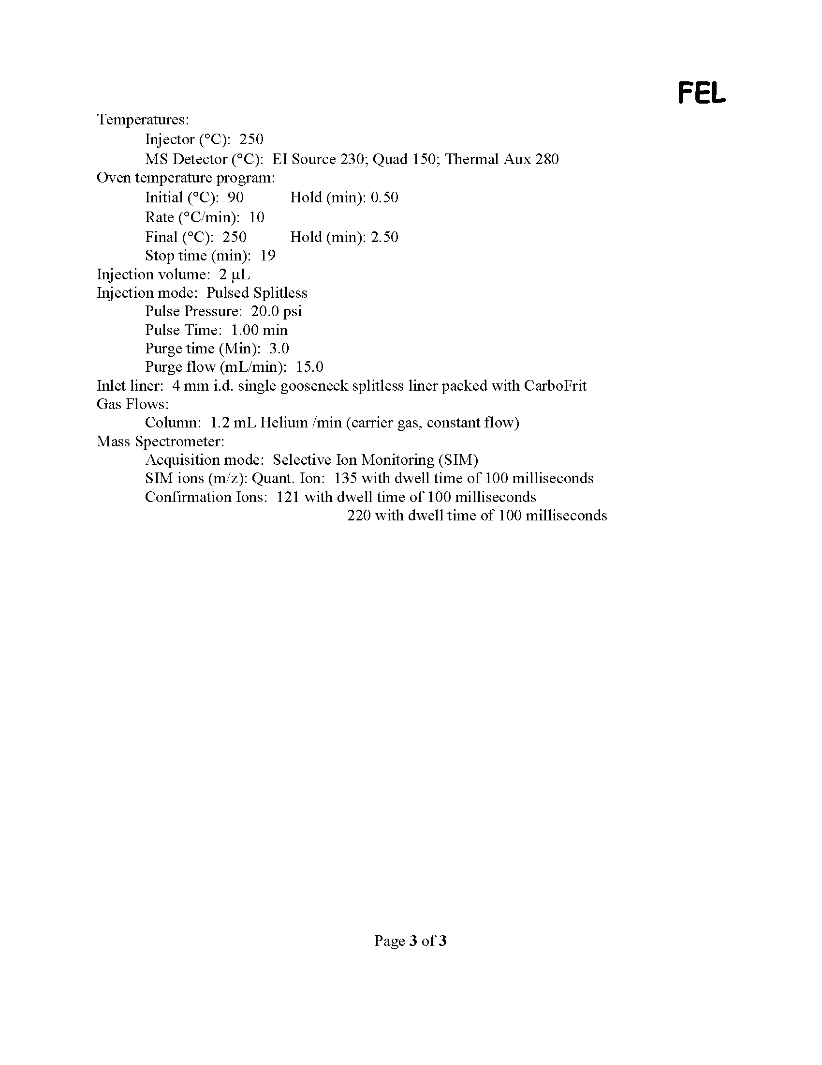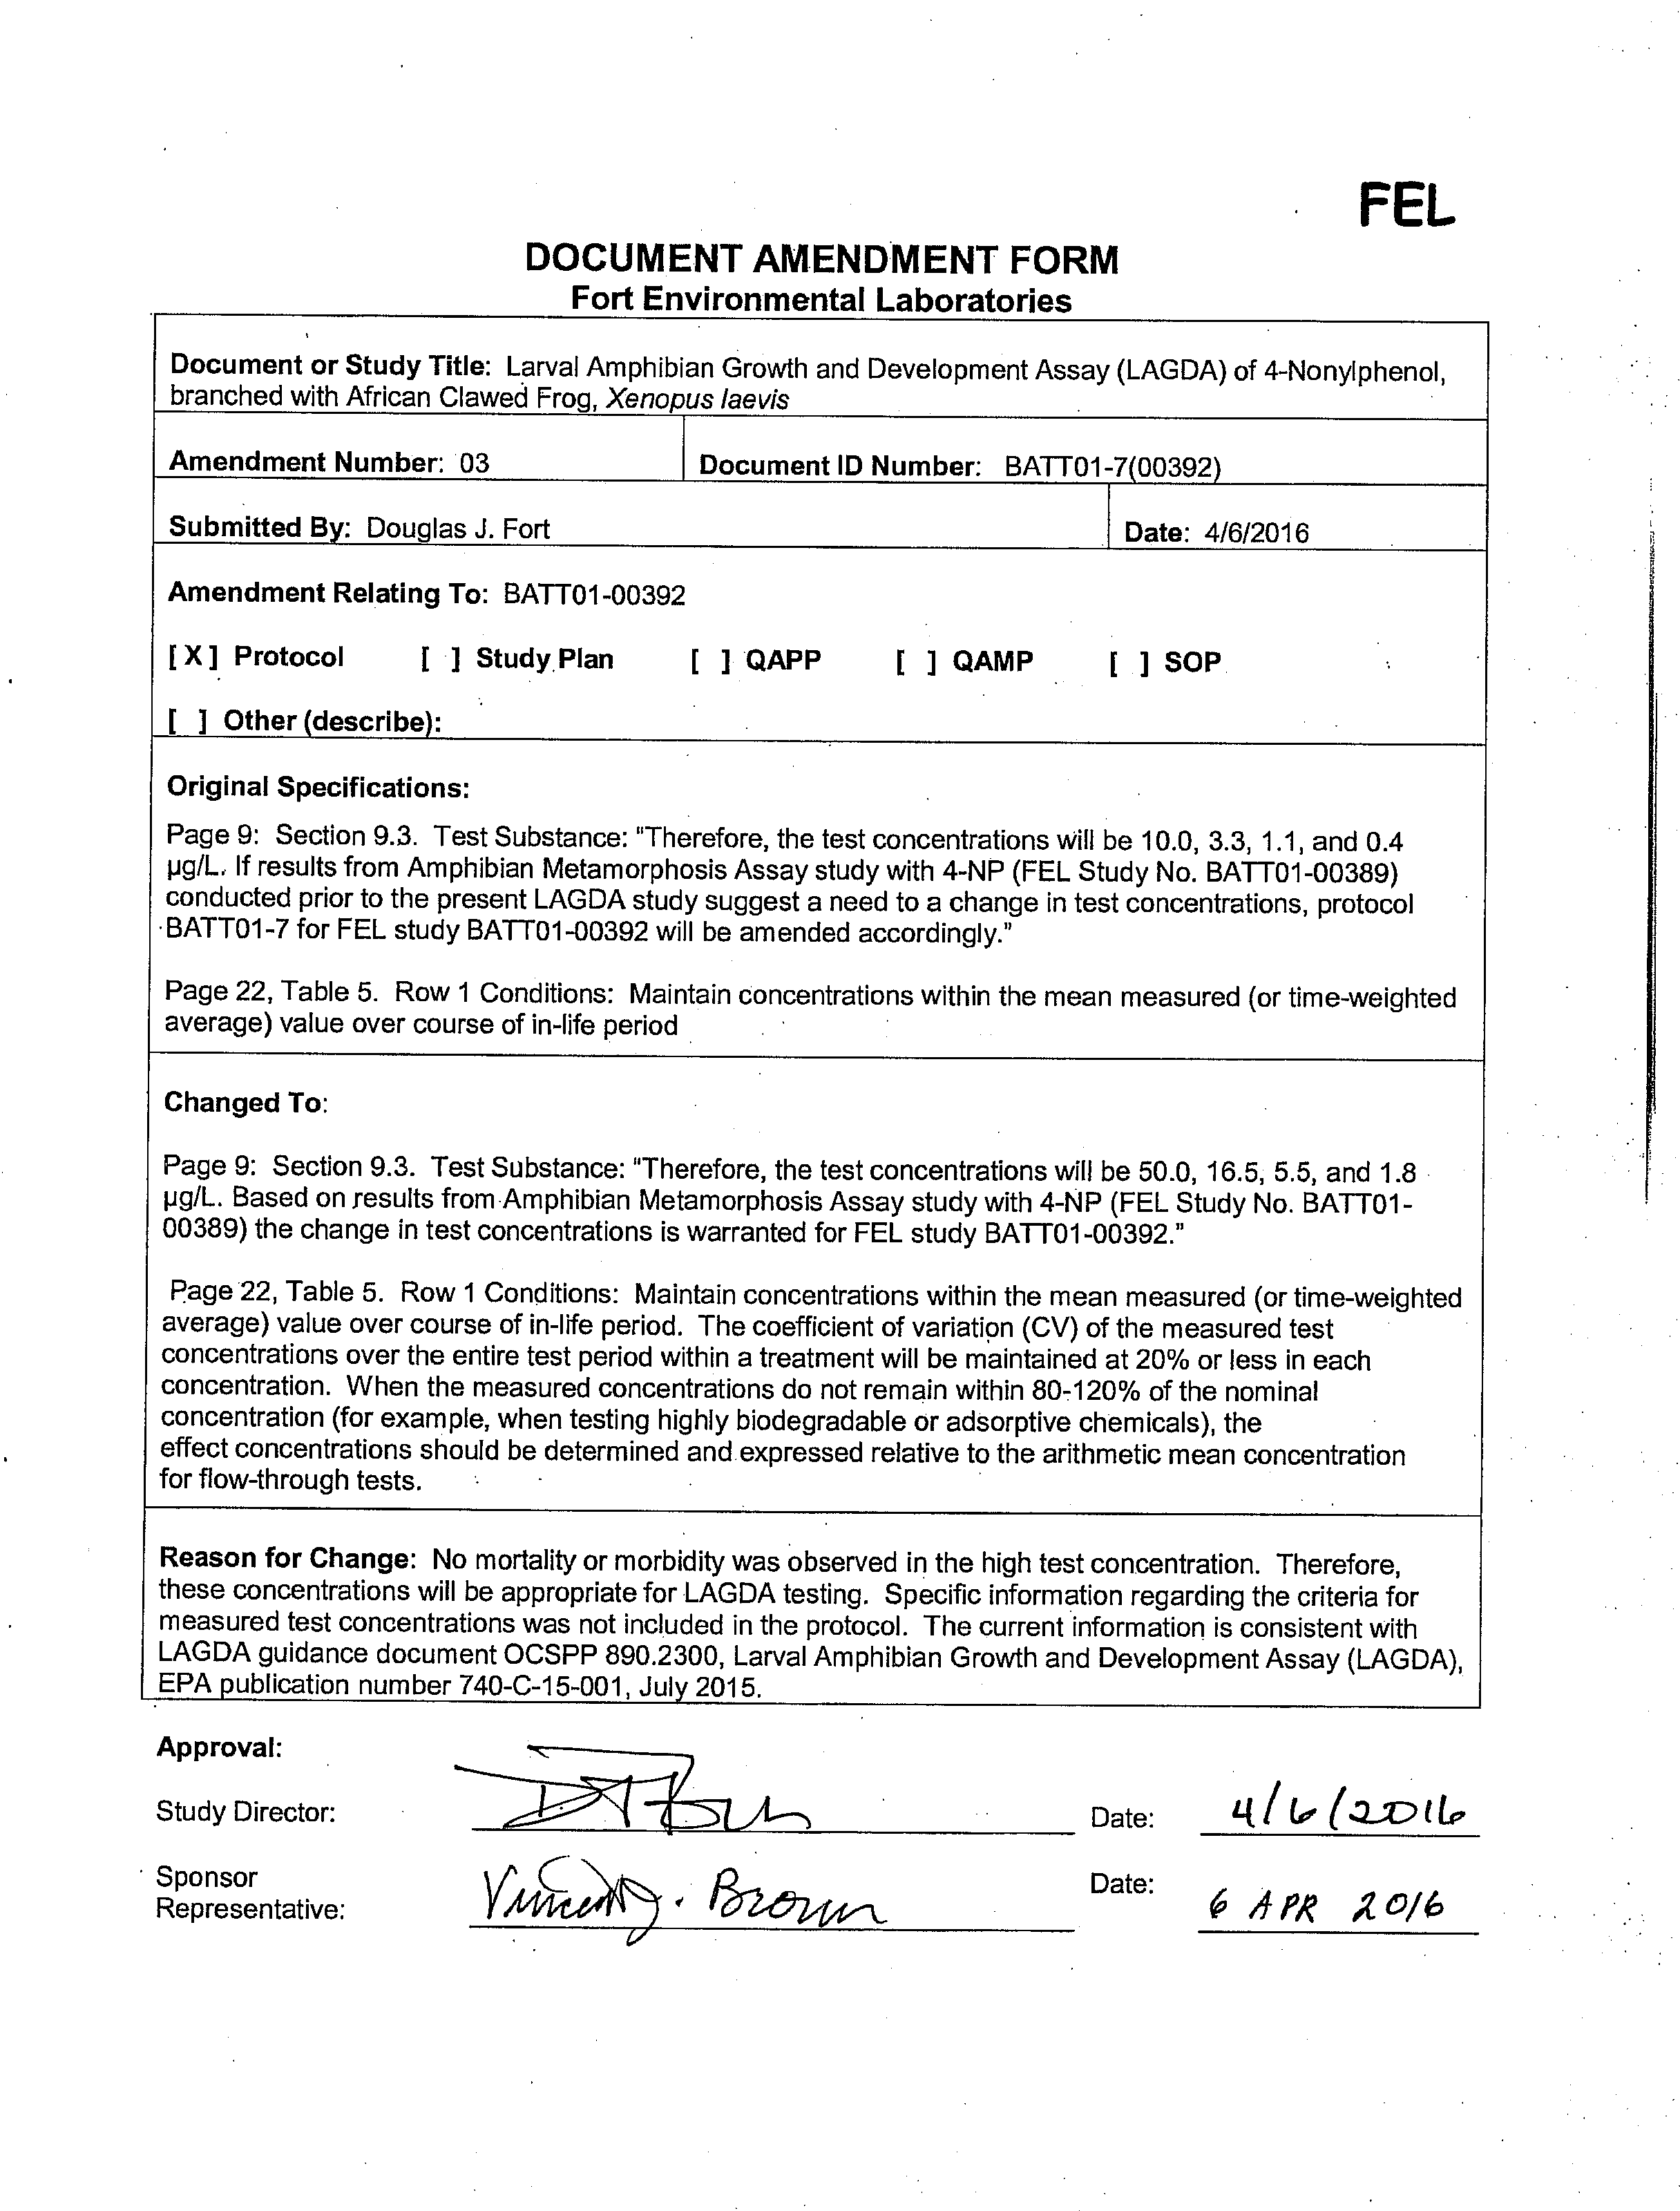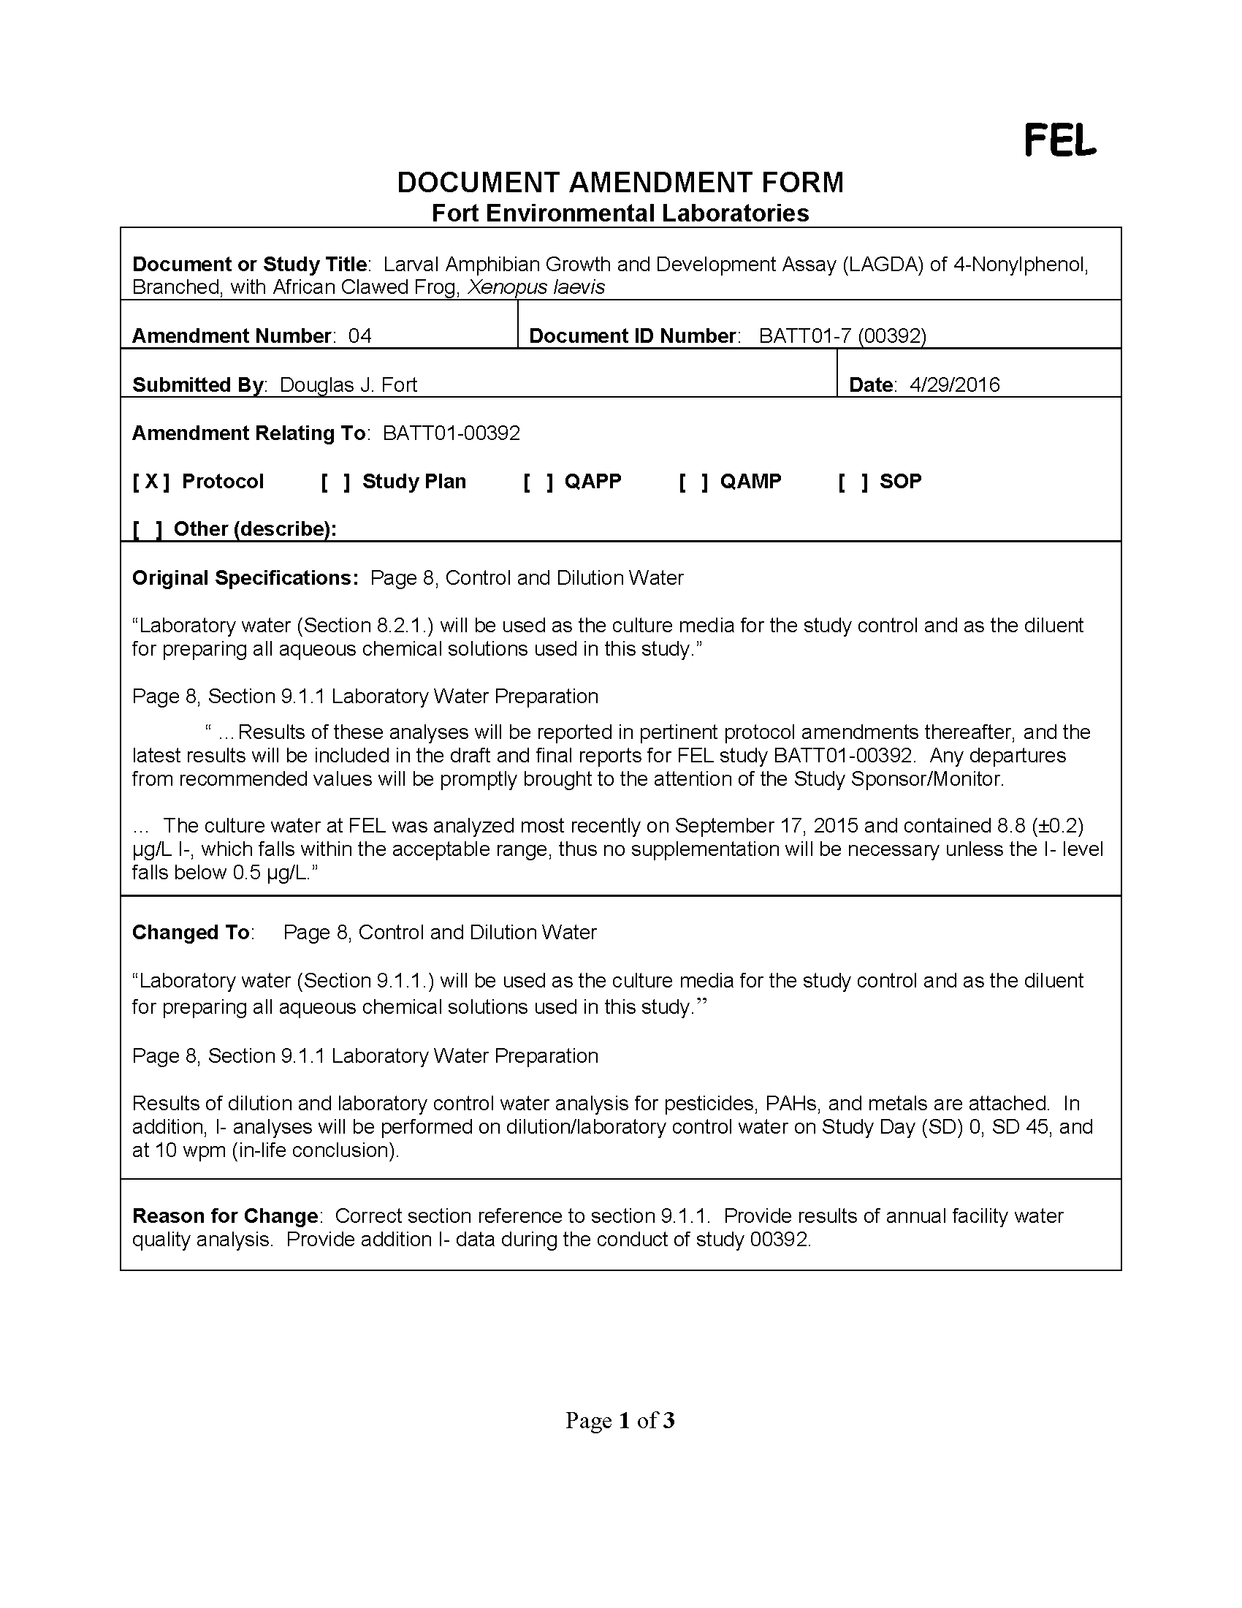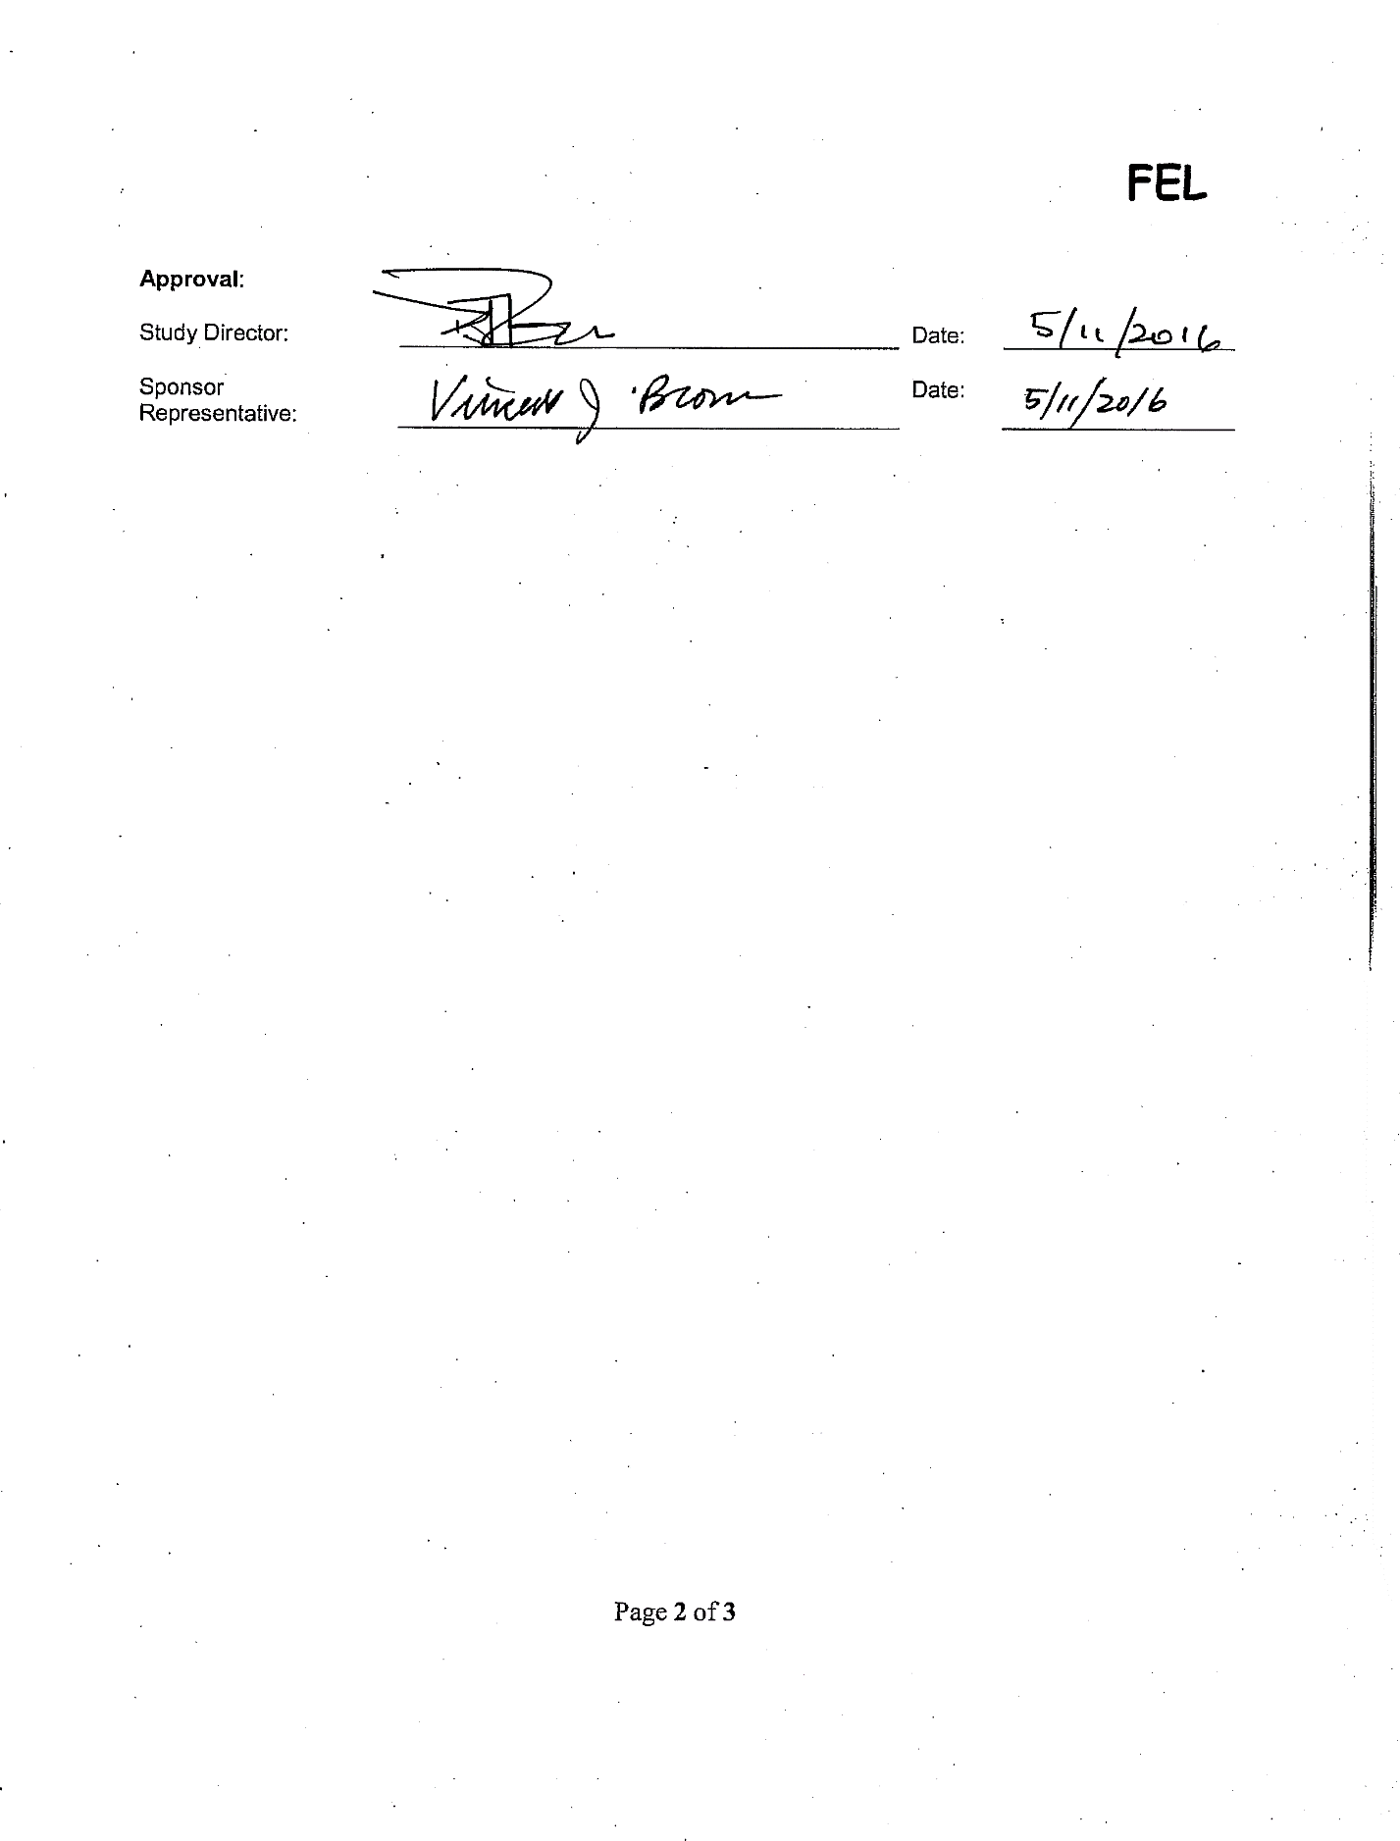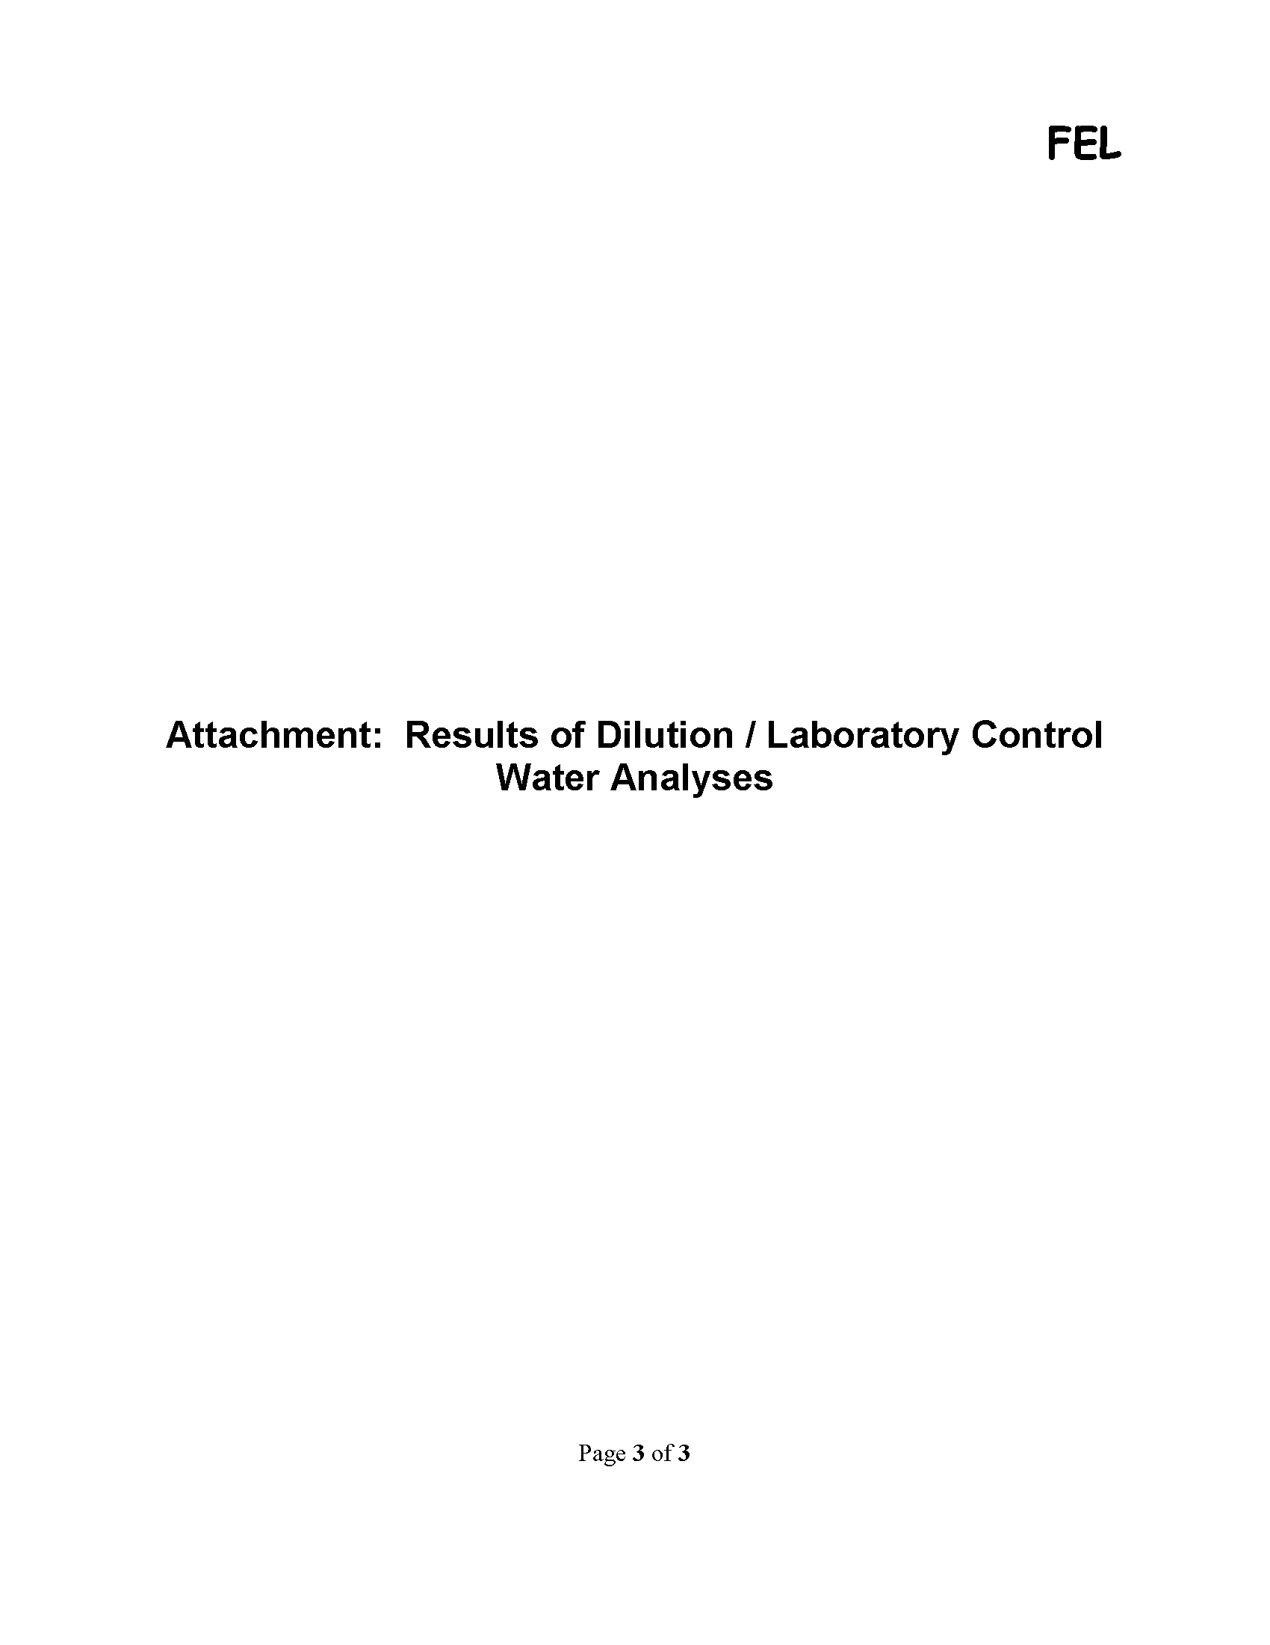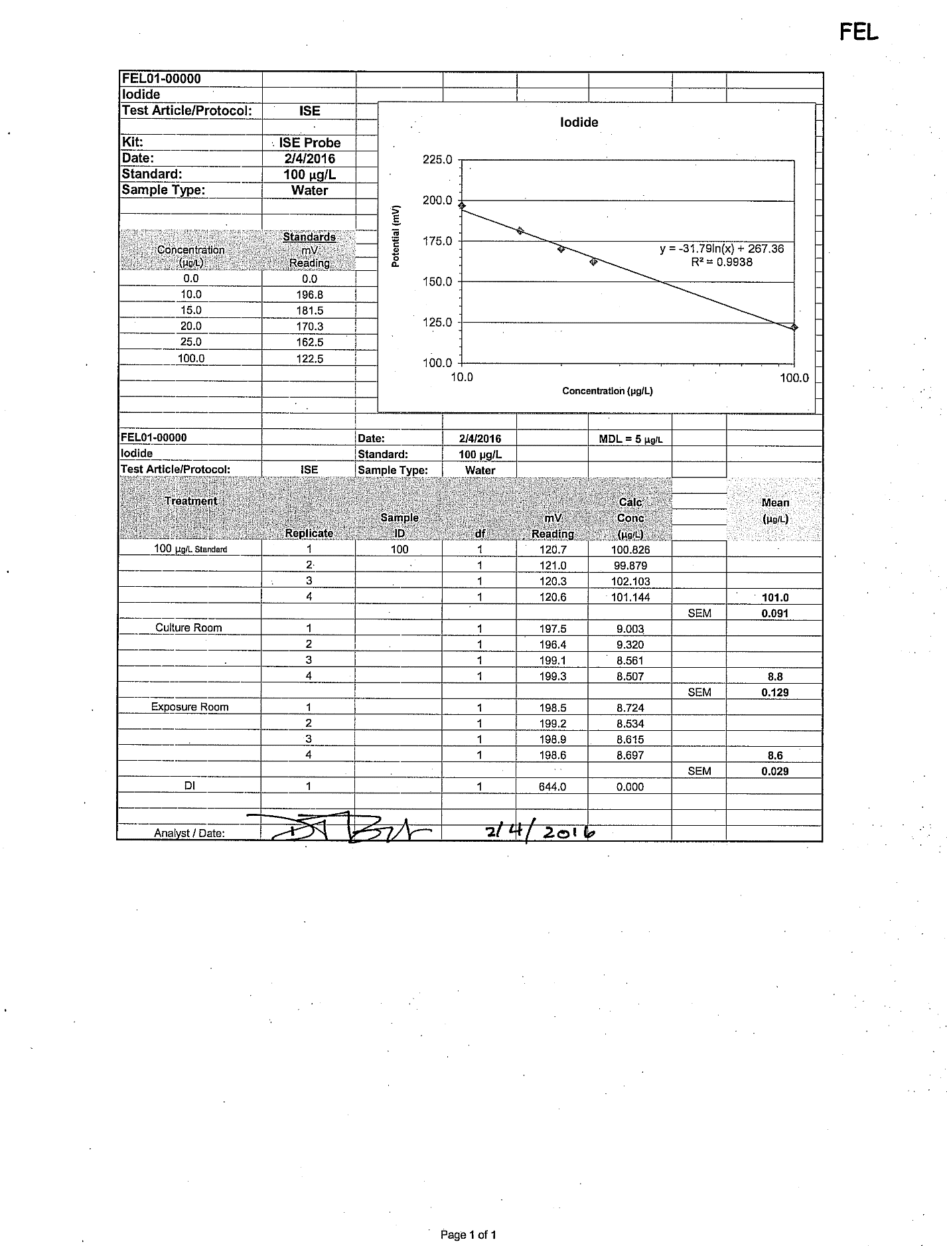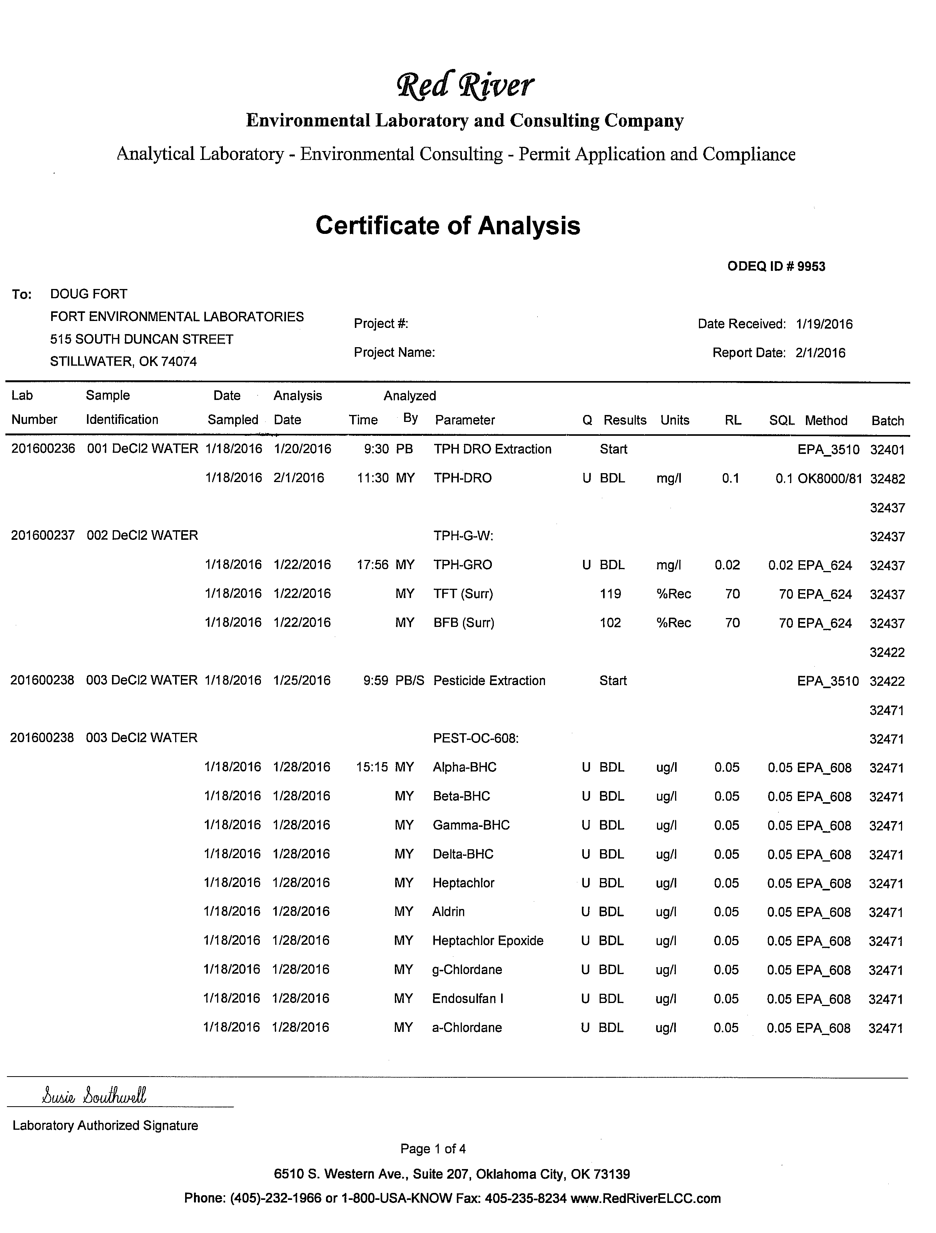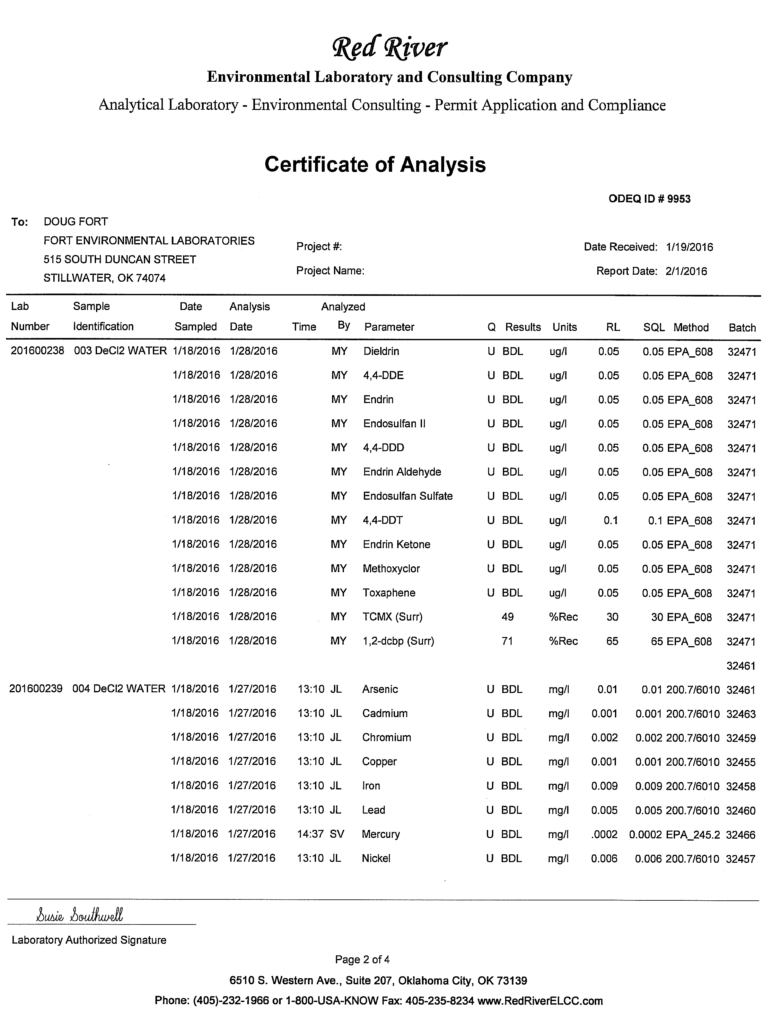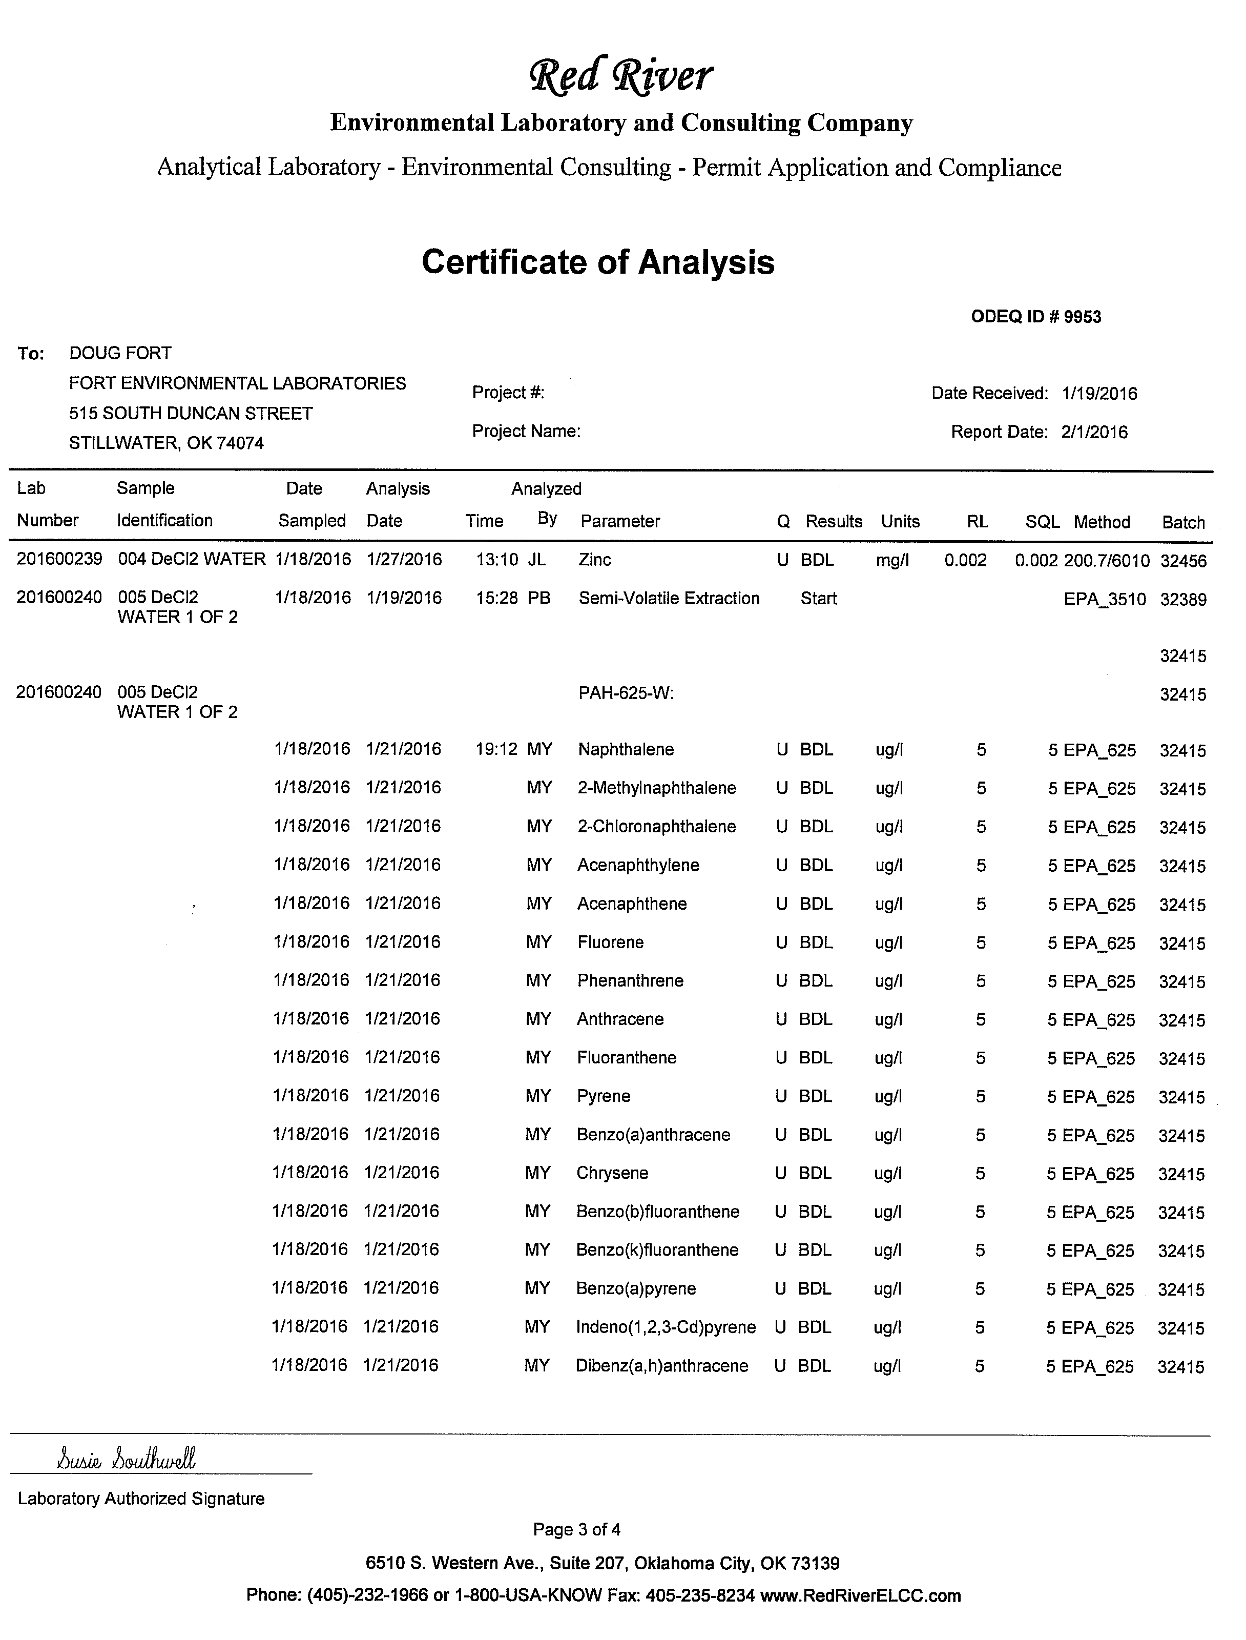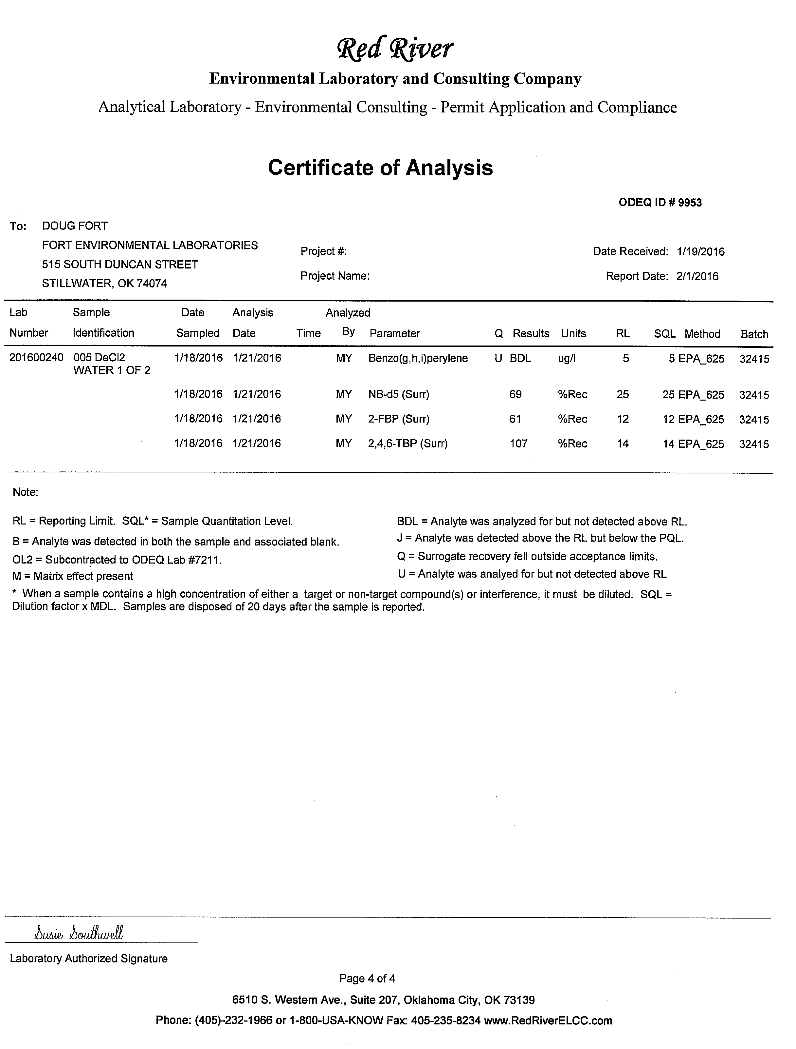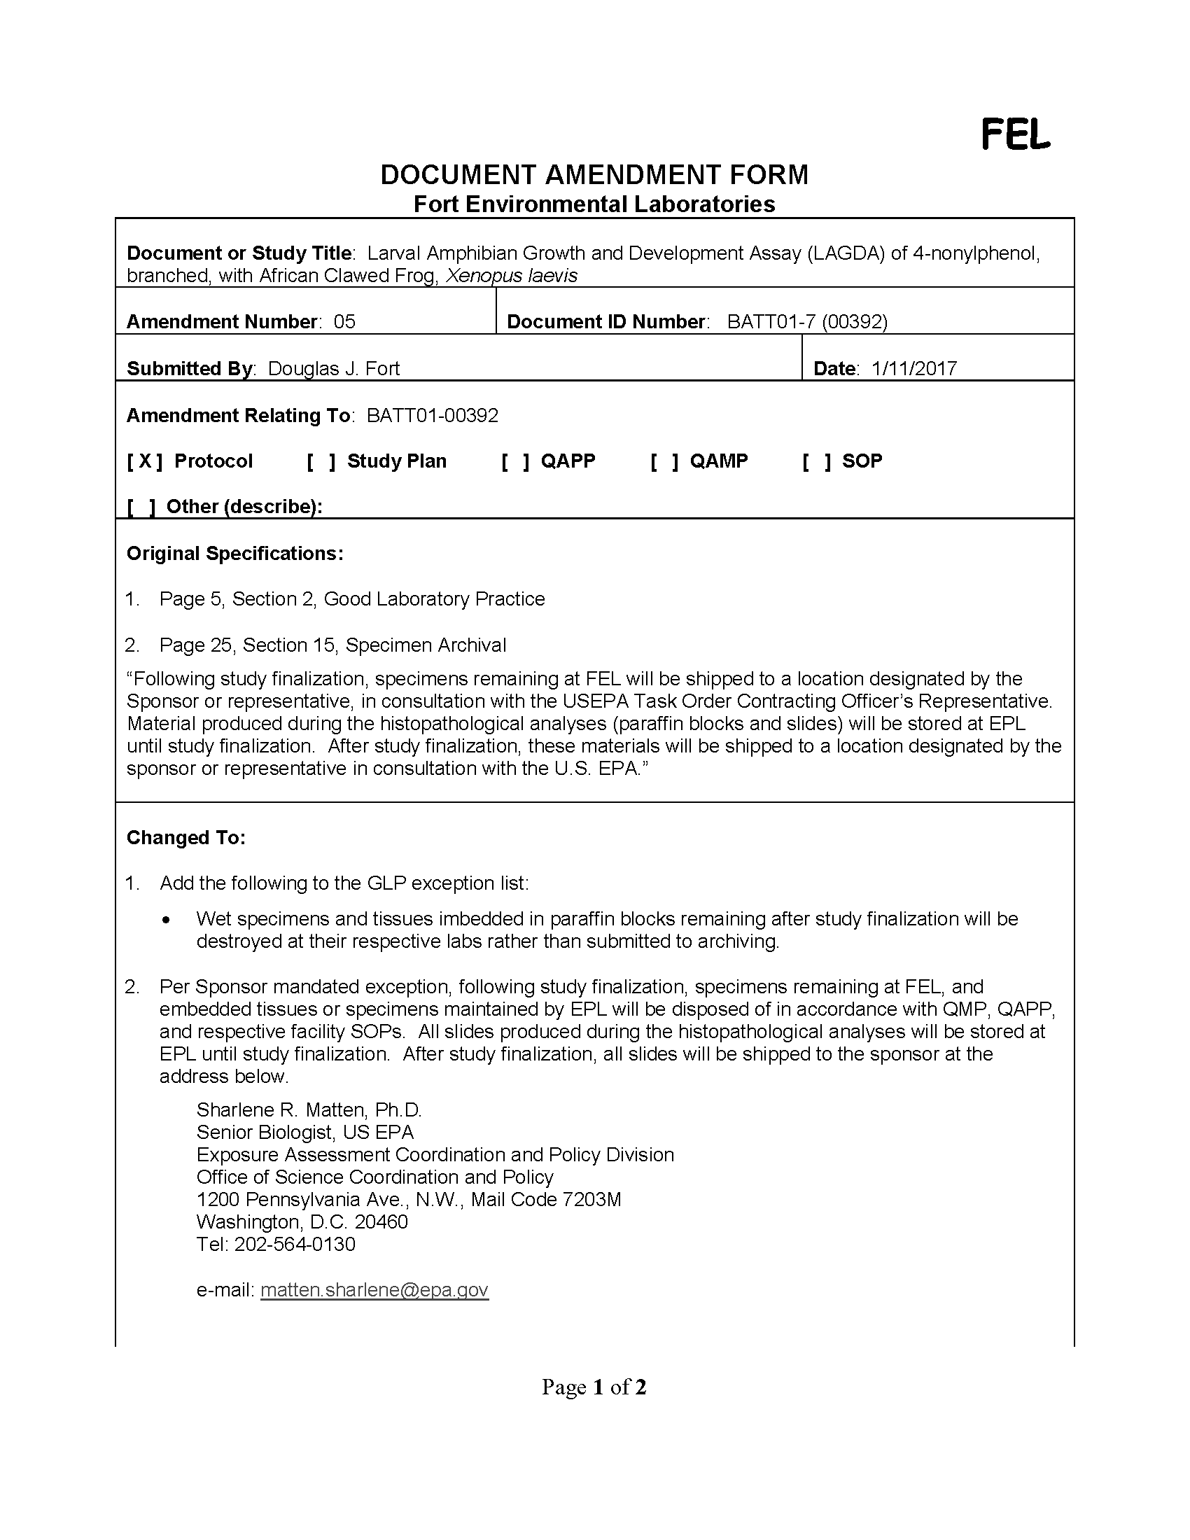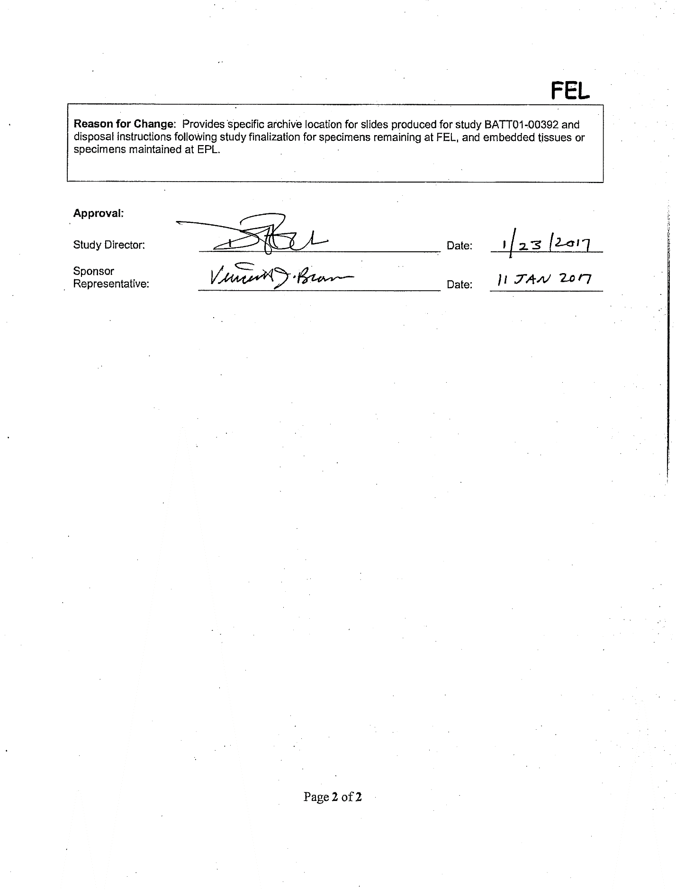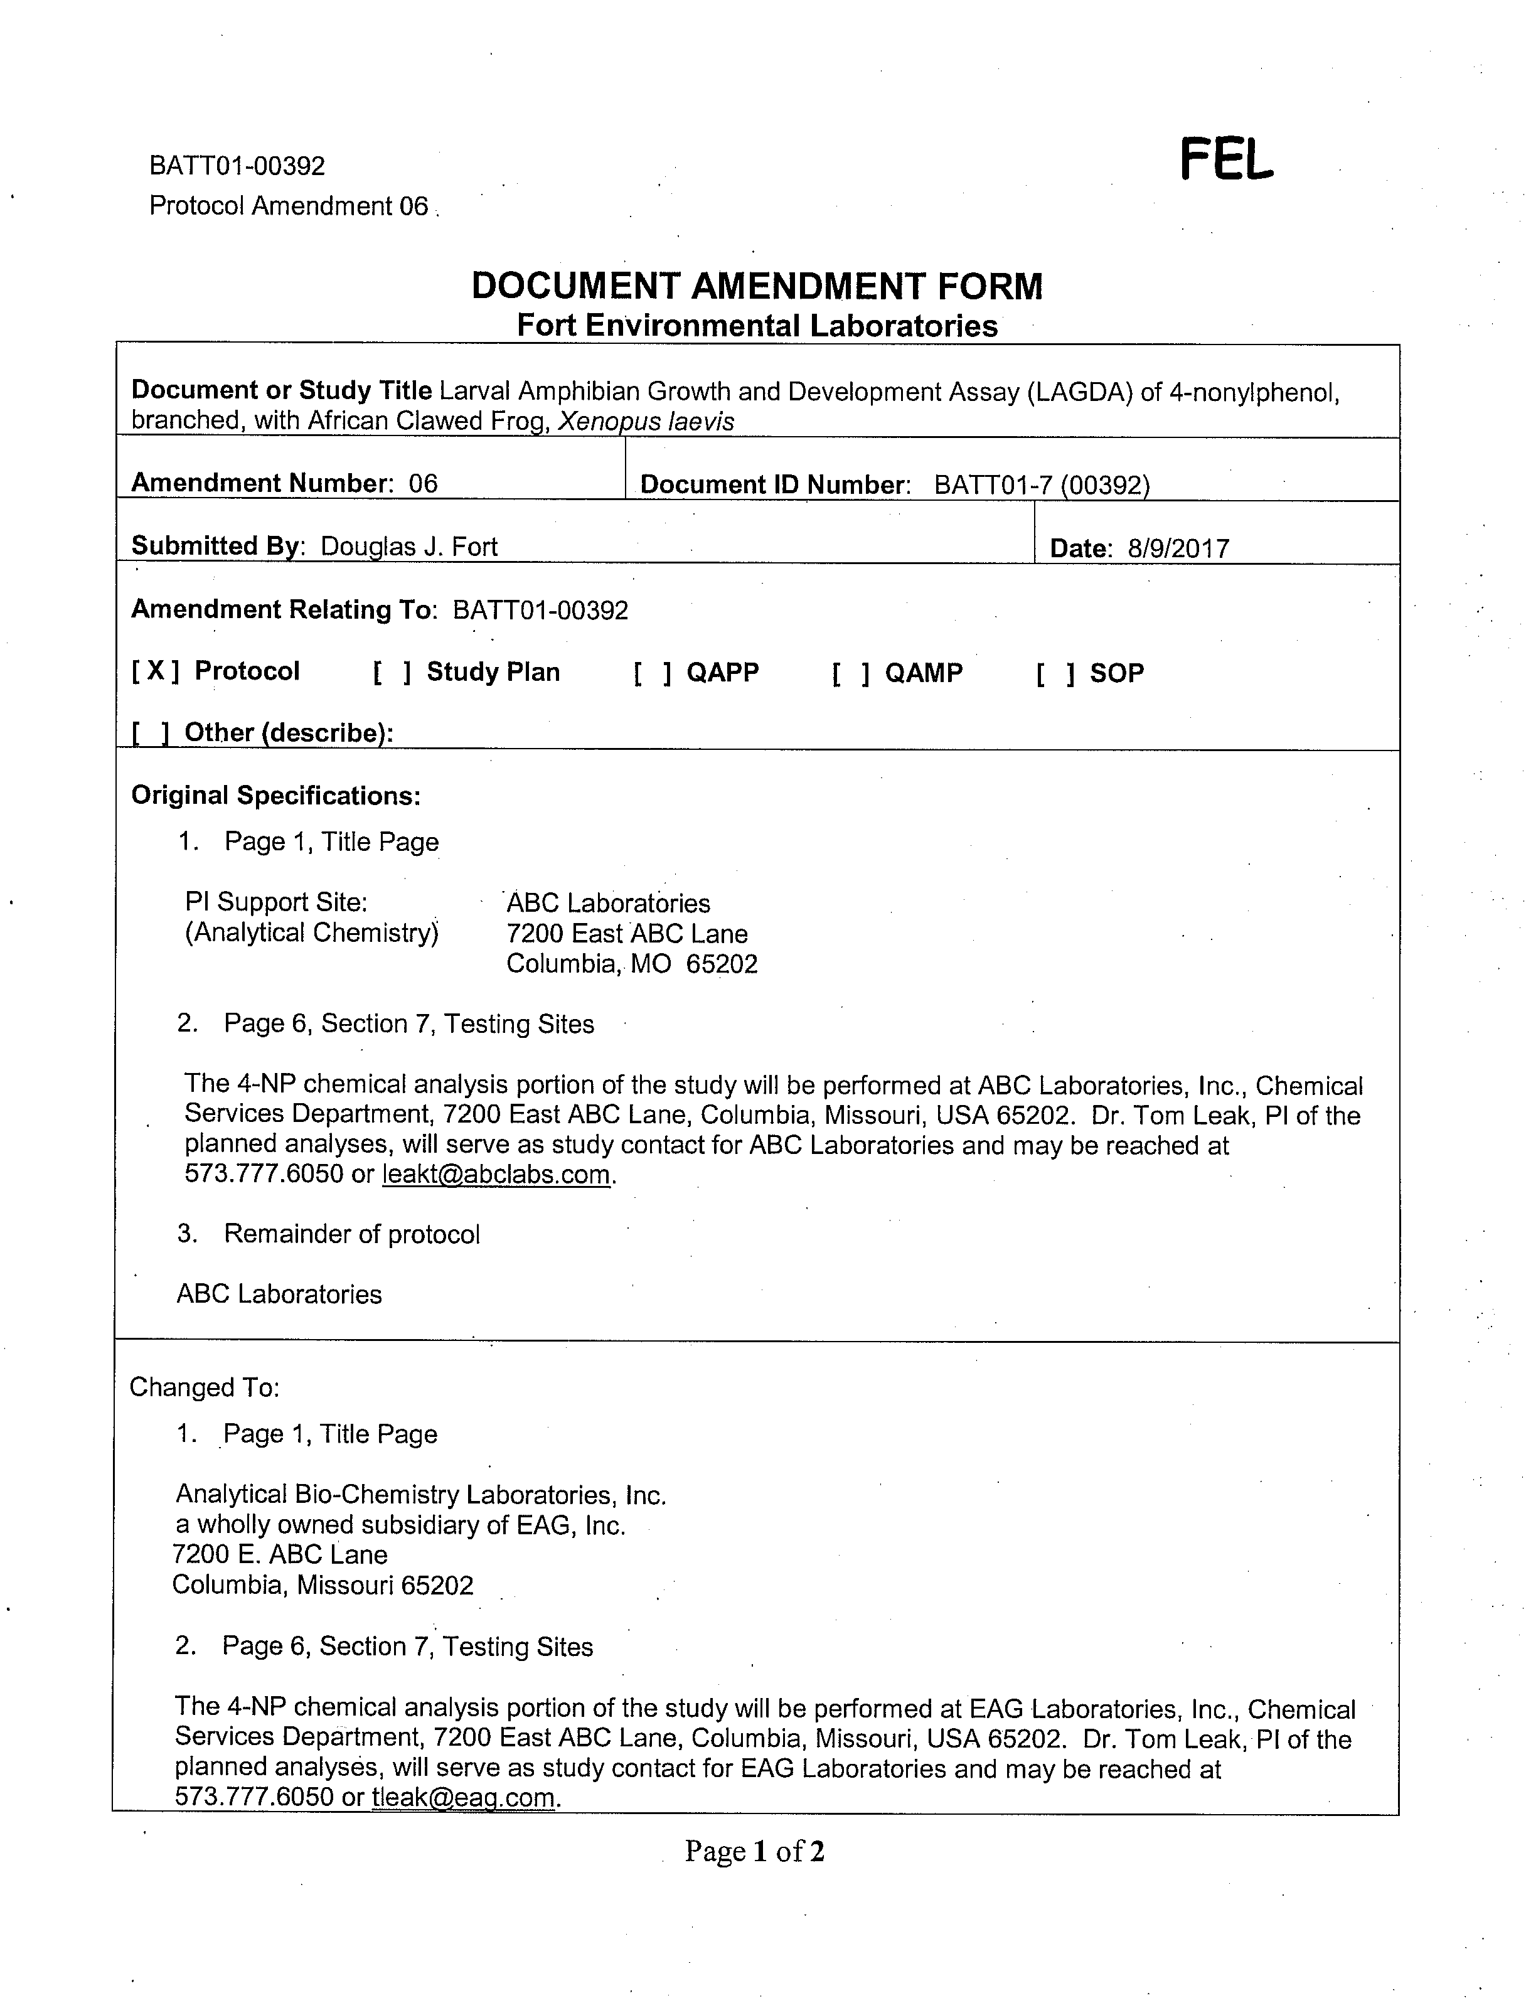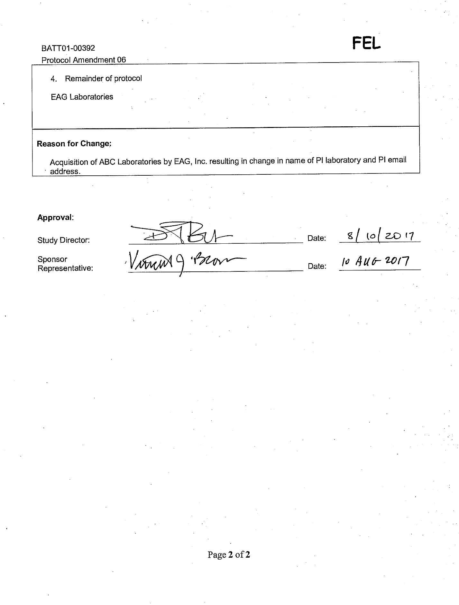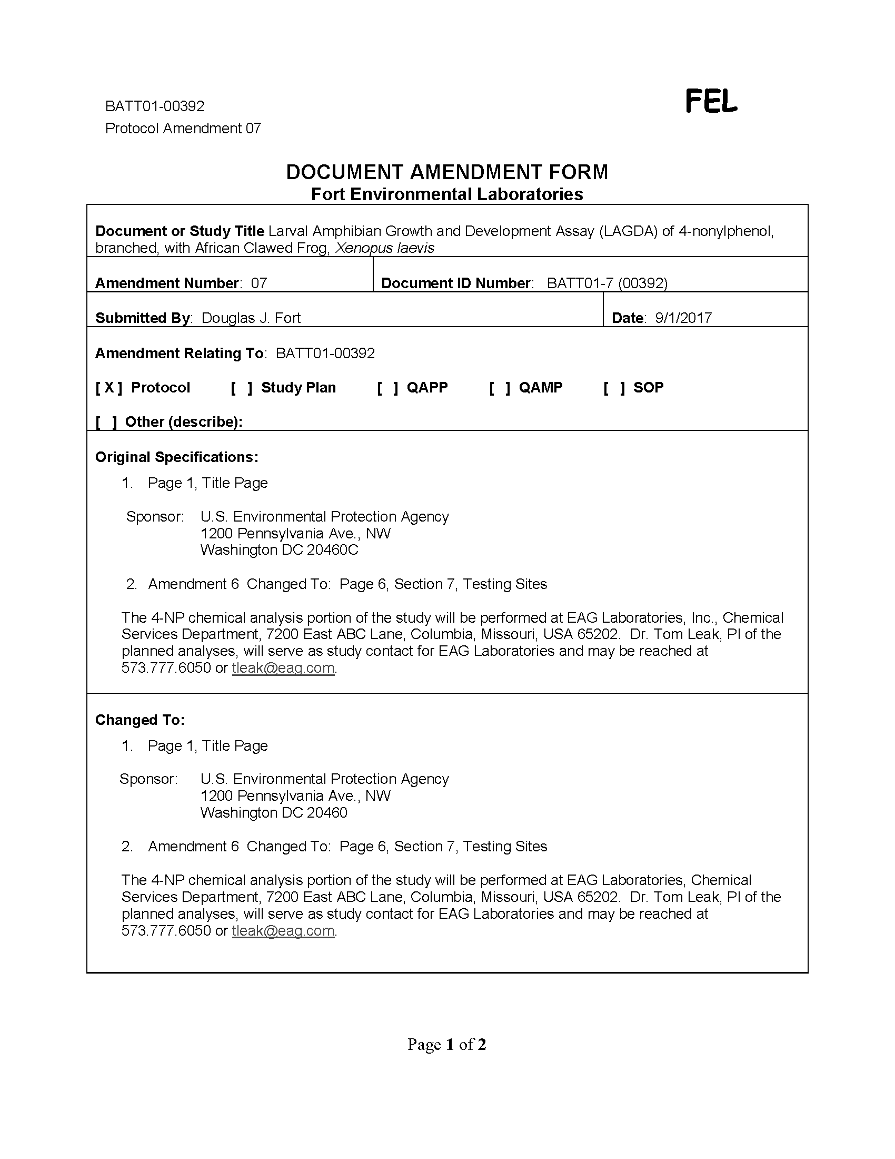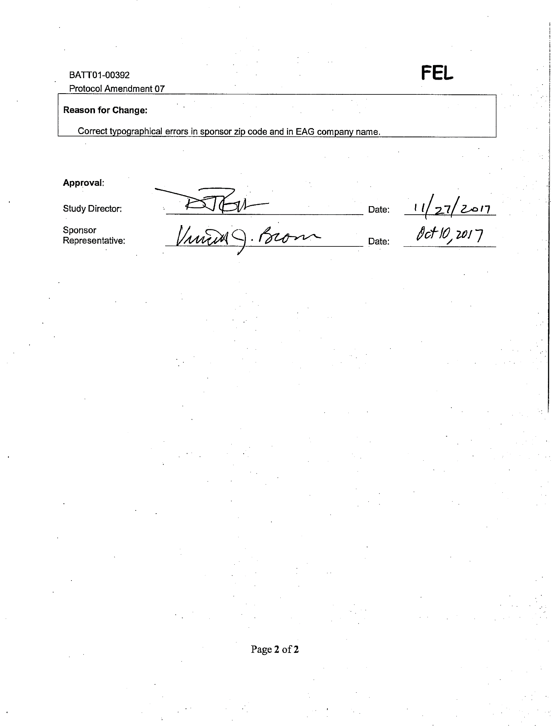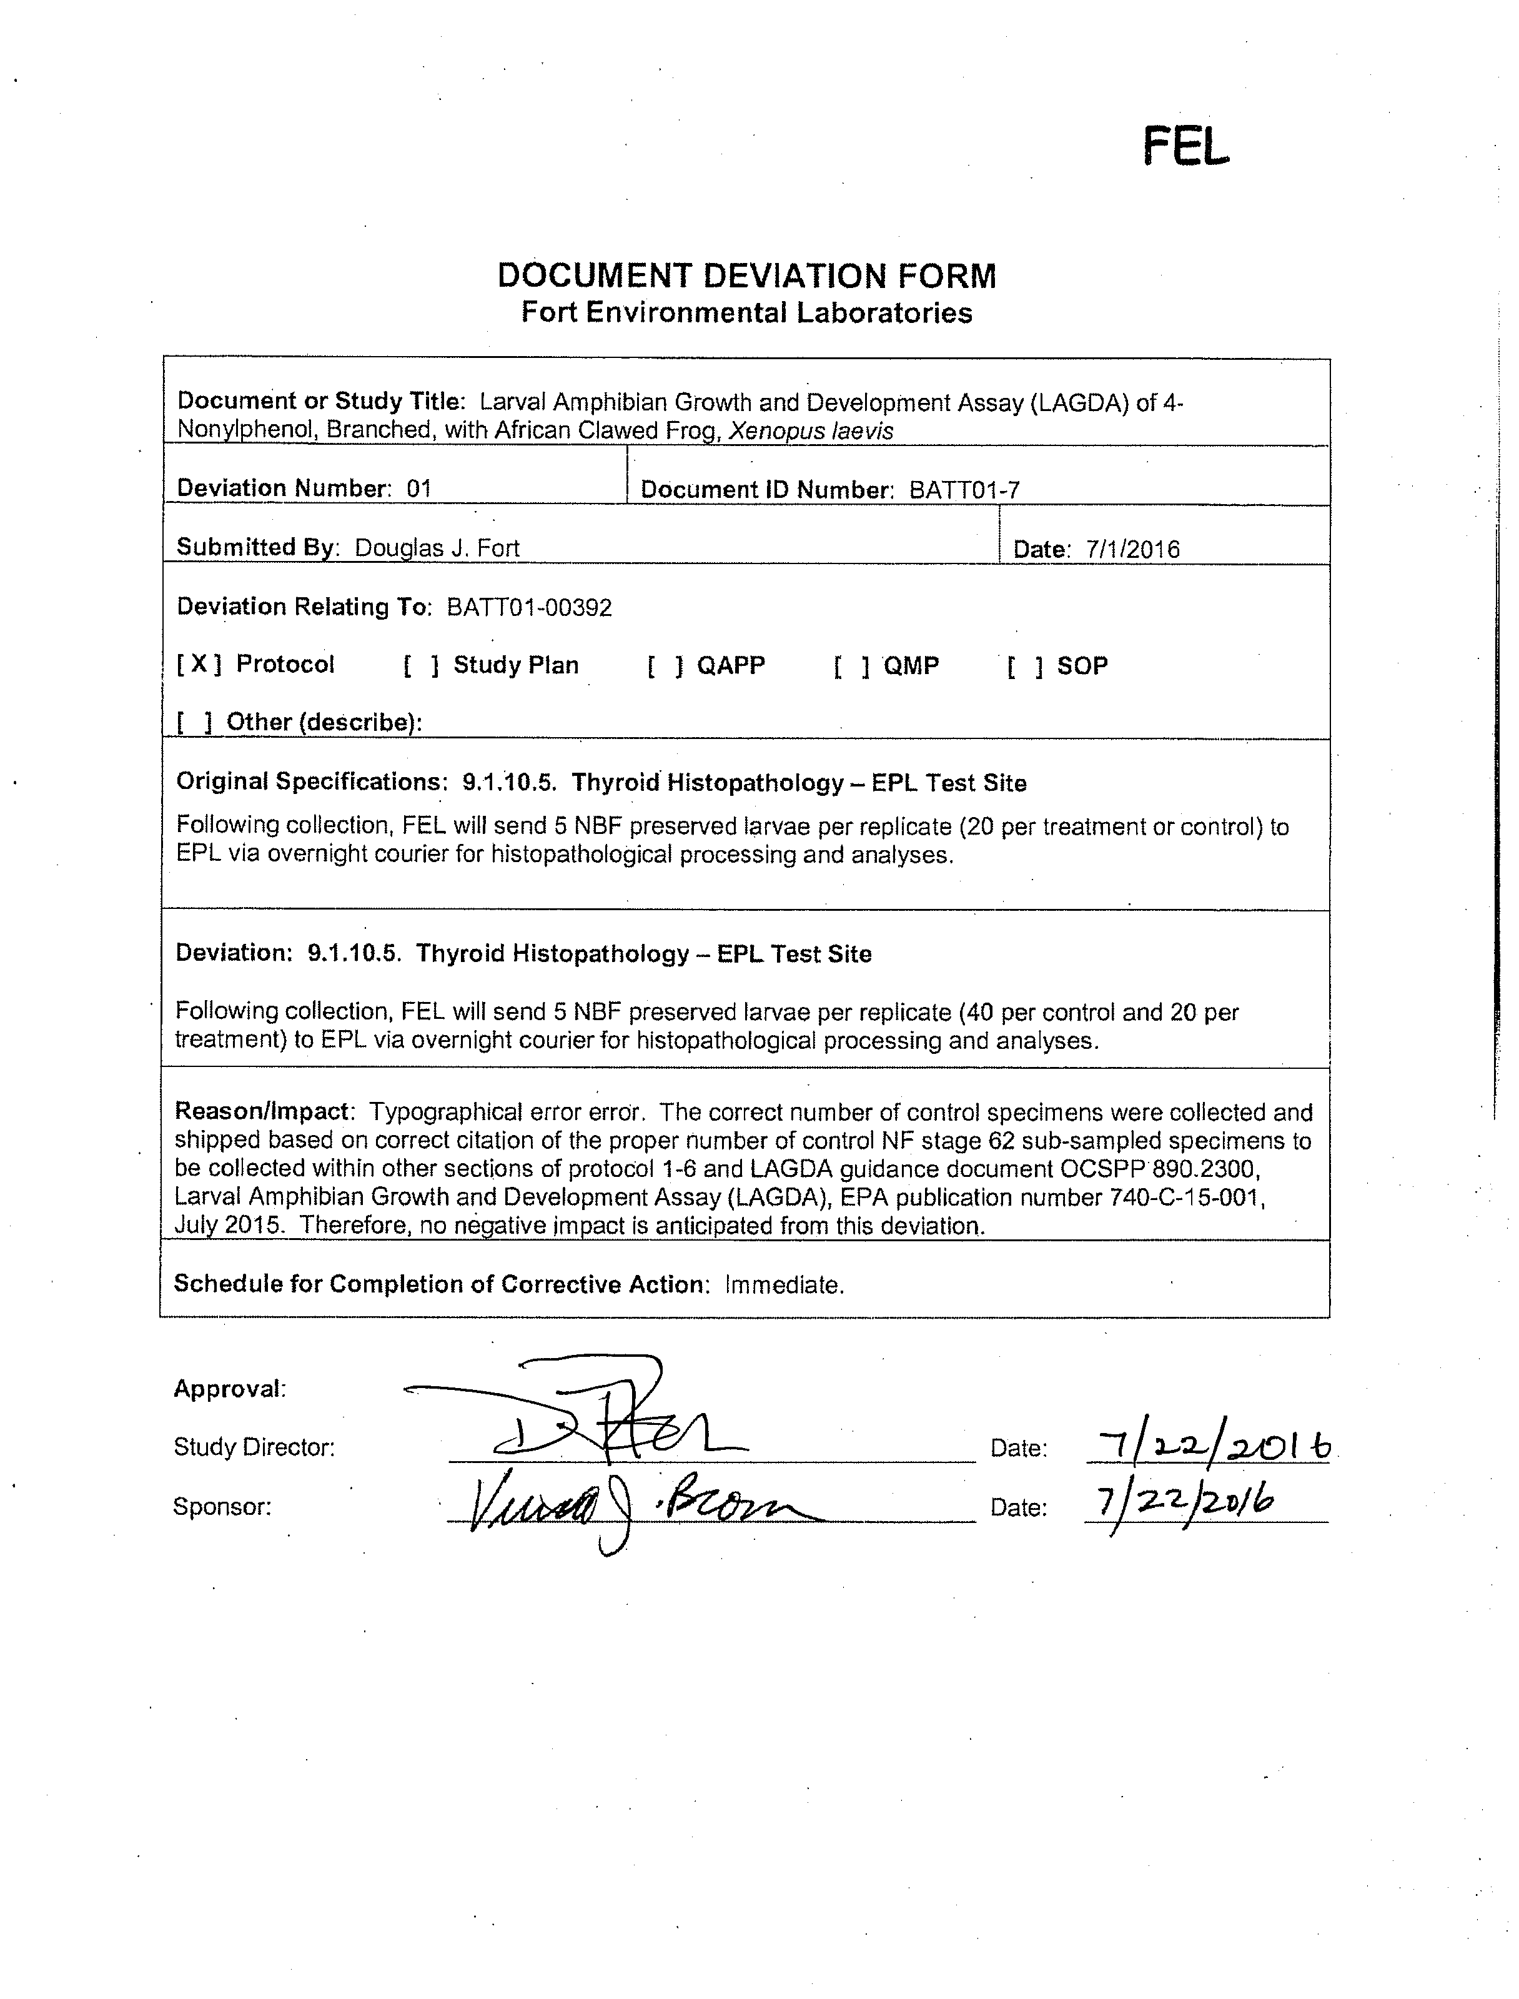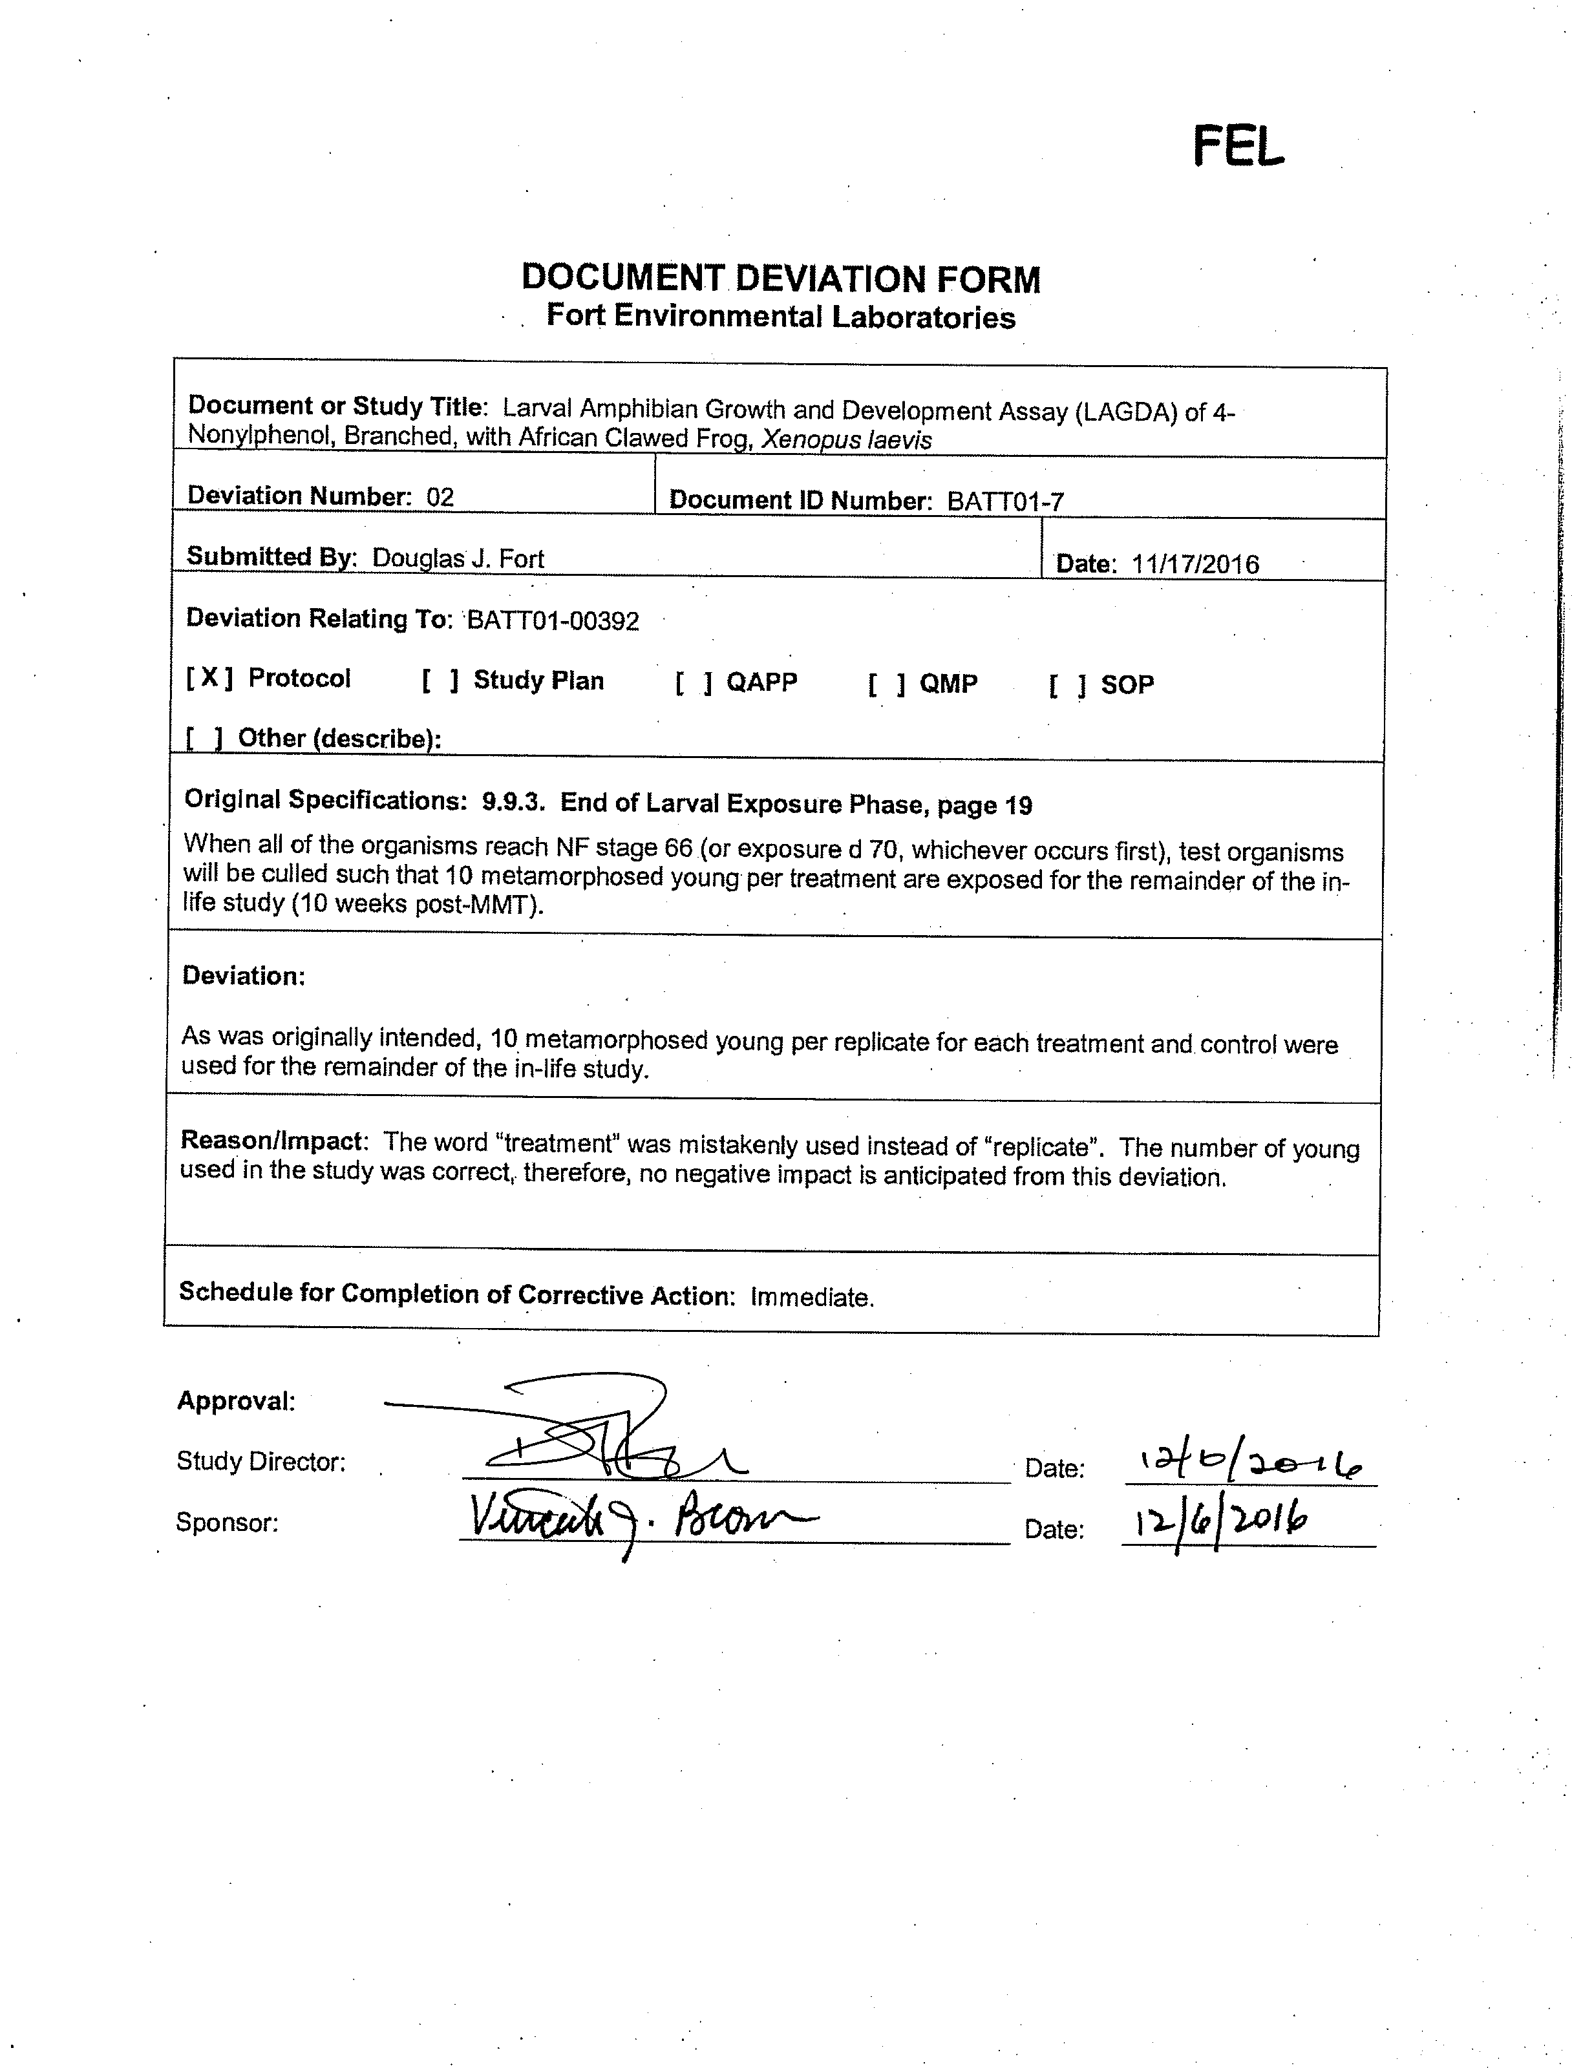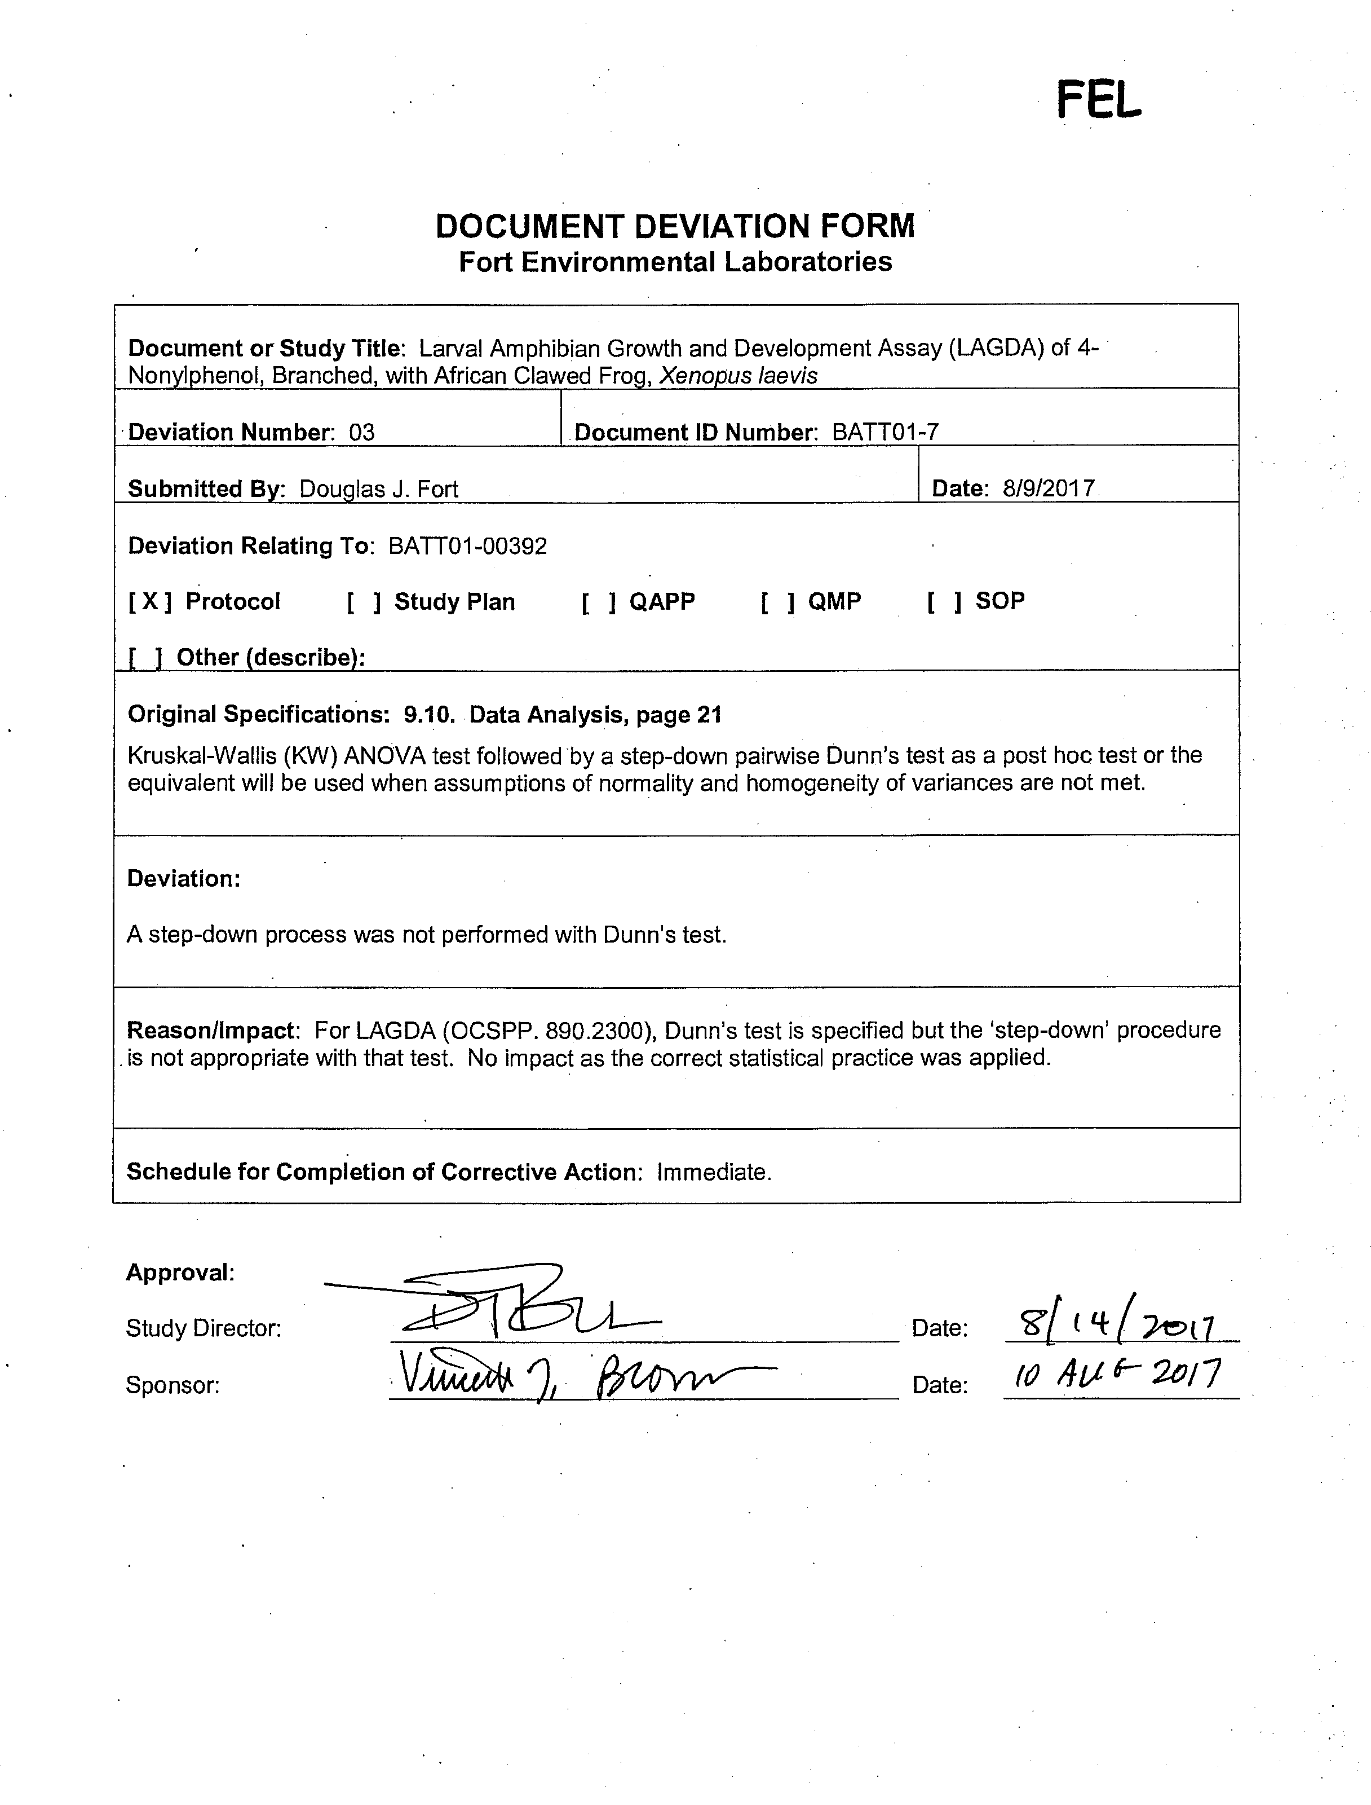

Certificate of Analysis

Analytical Laboratory Data Reports

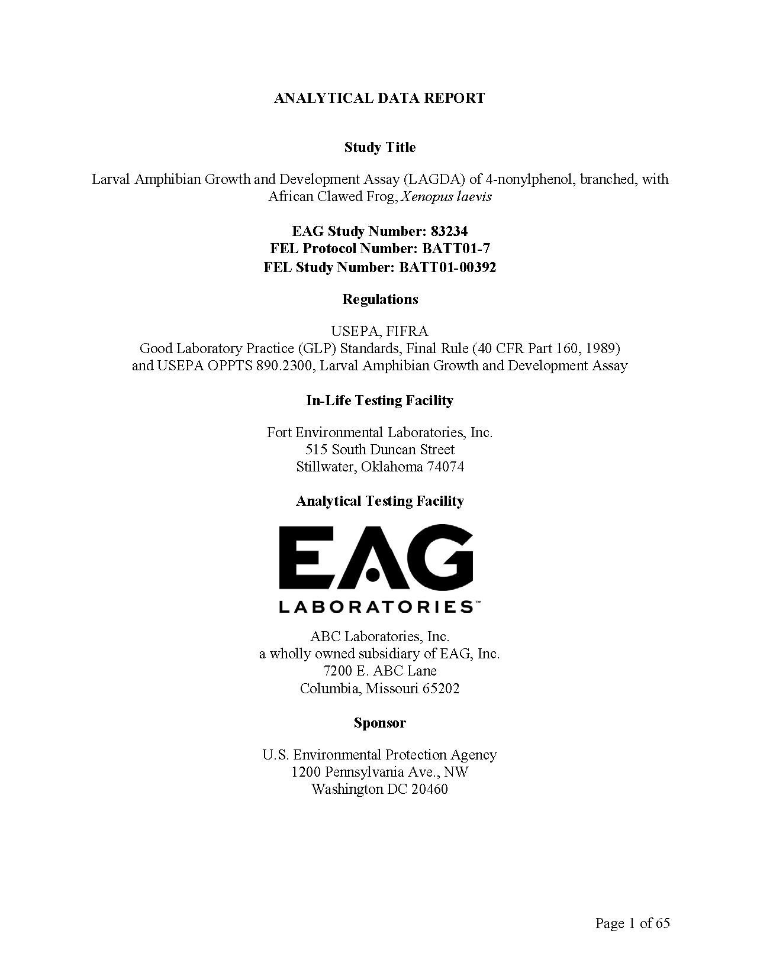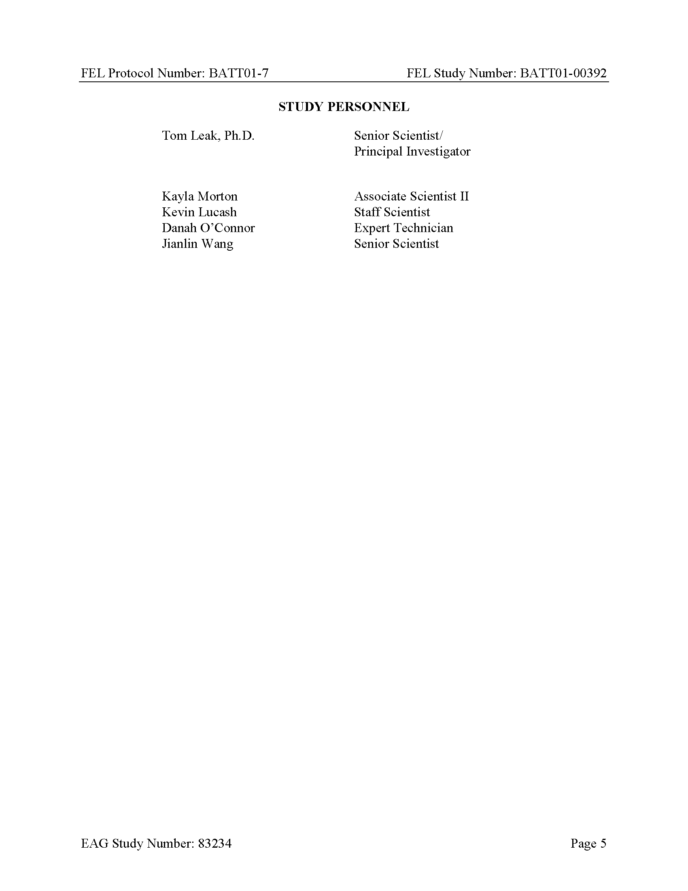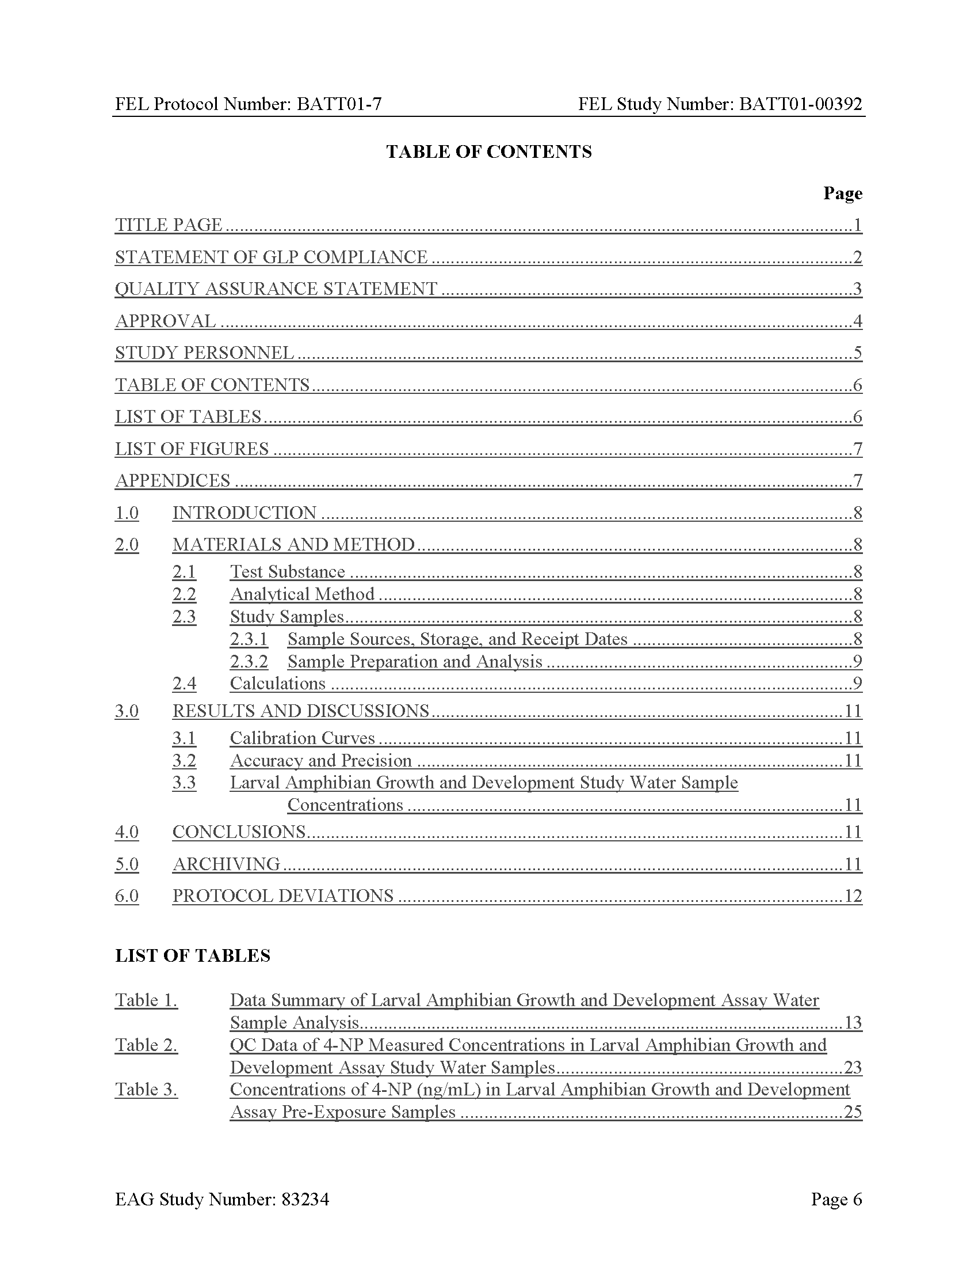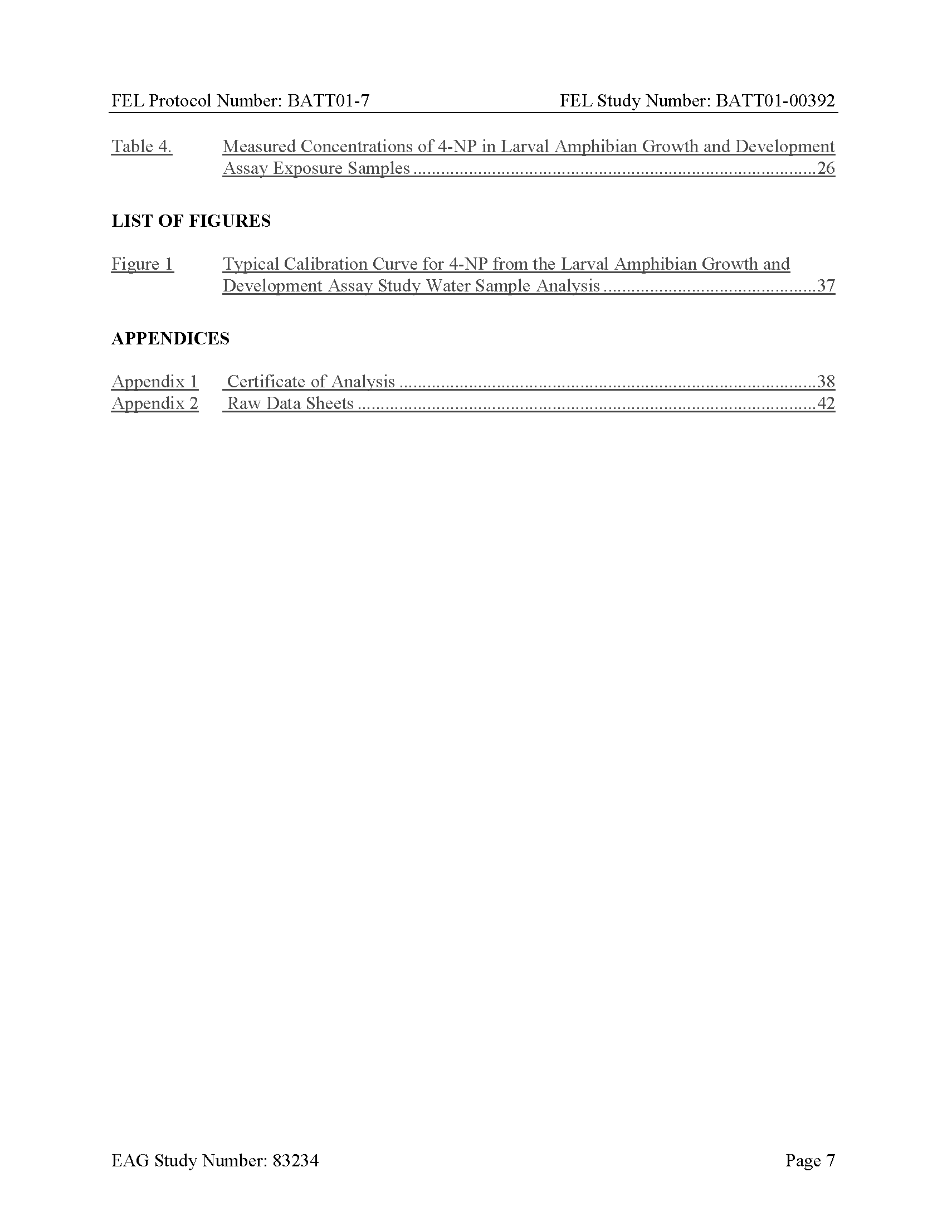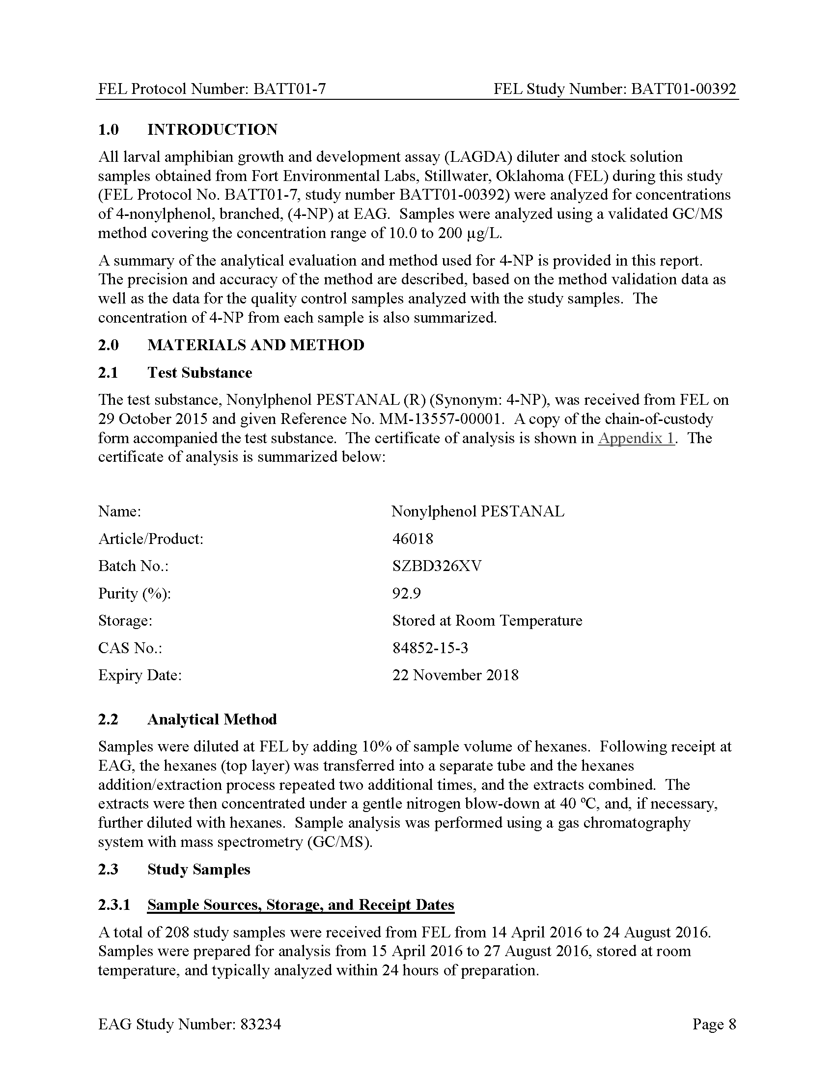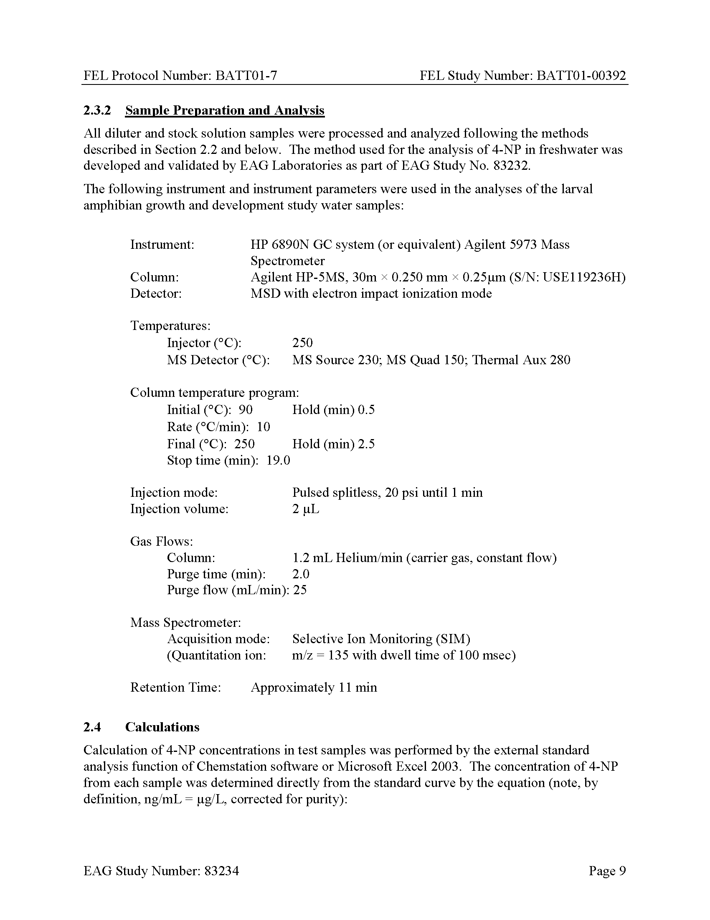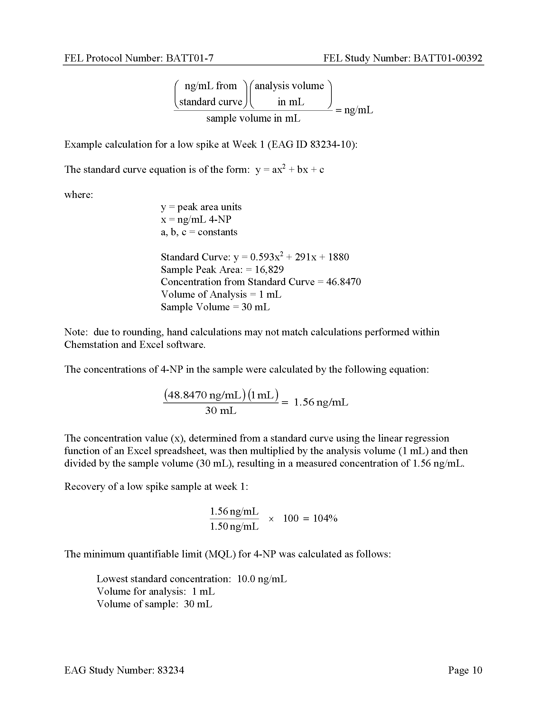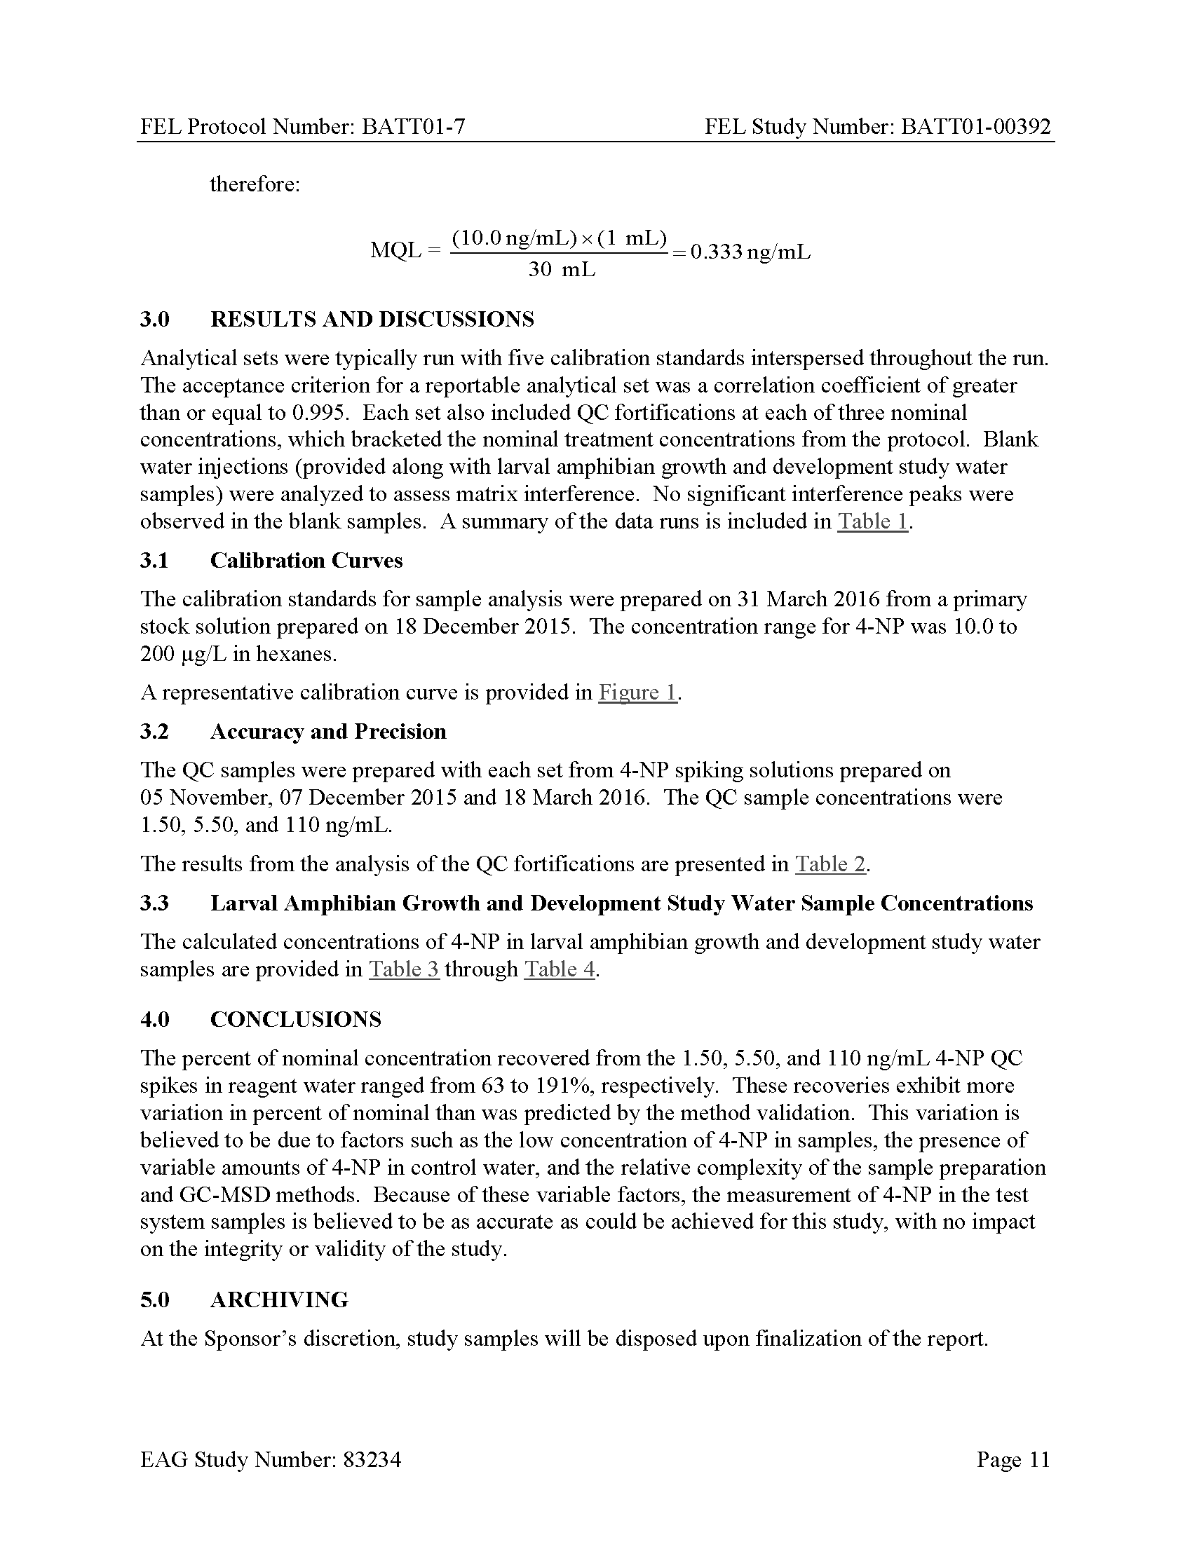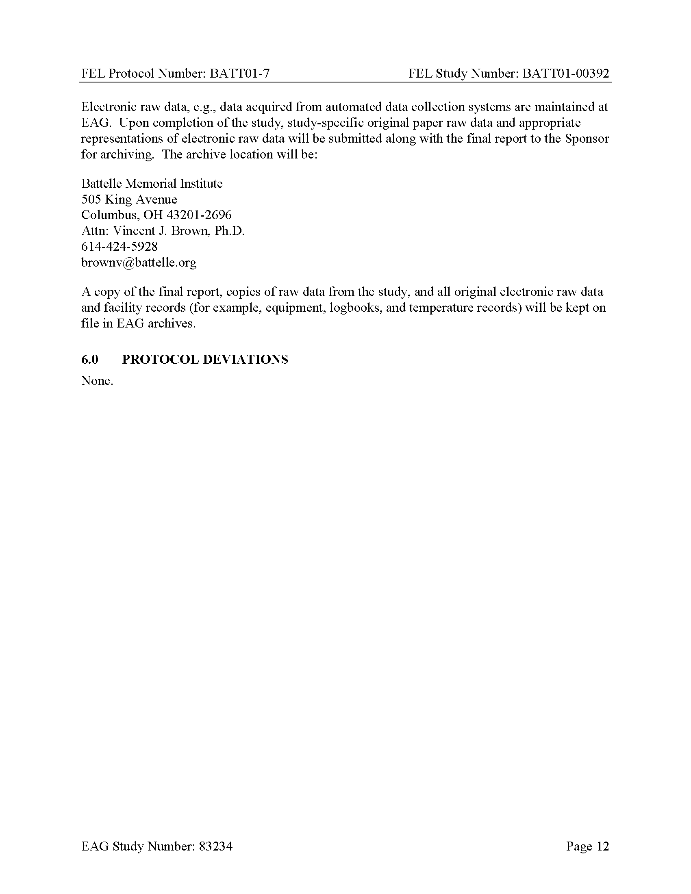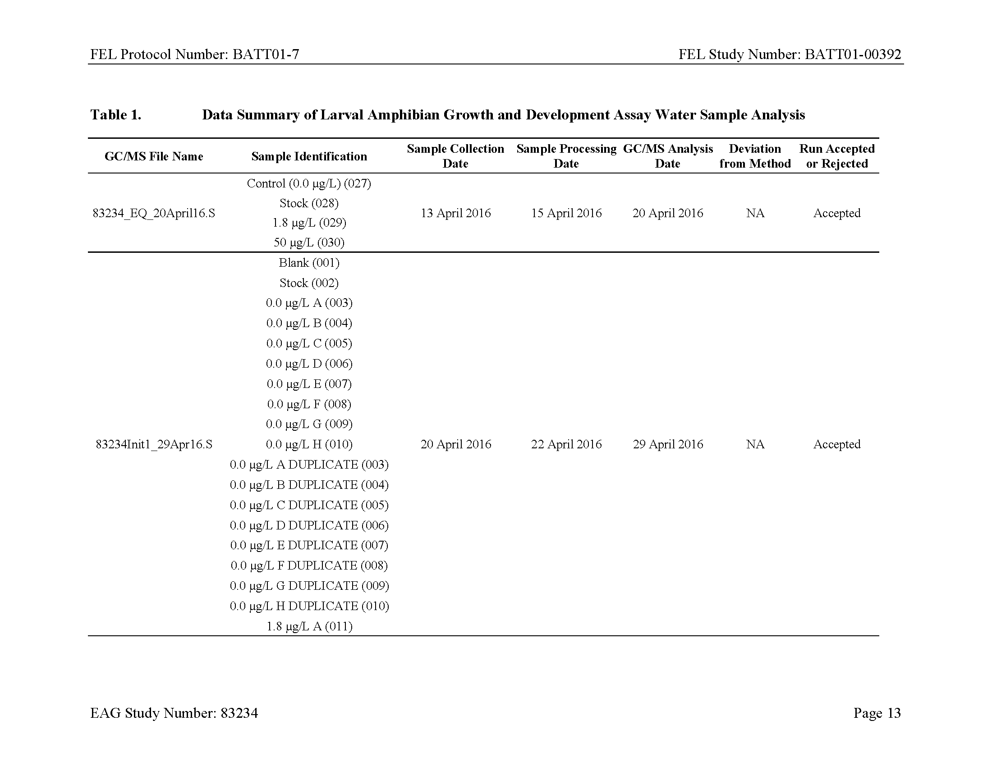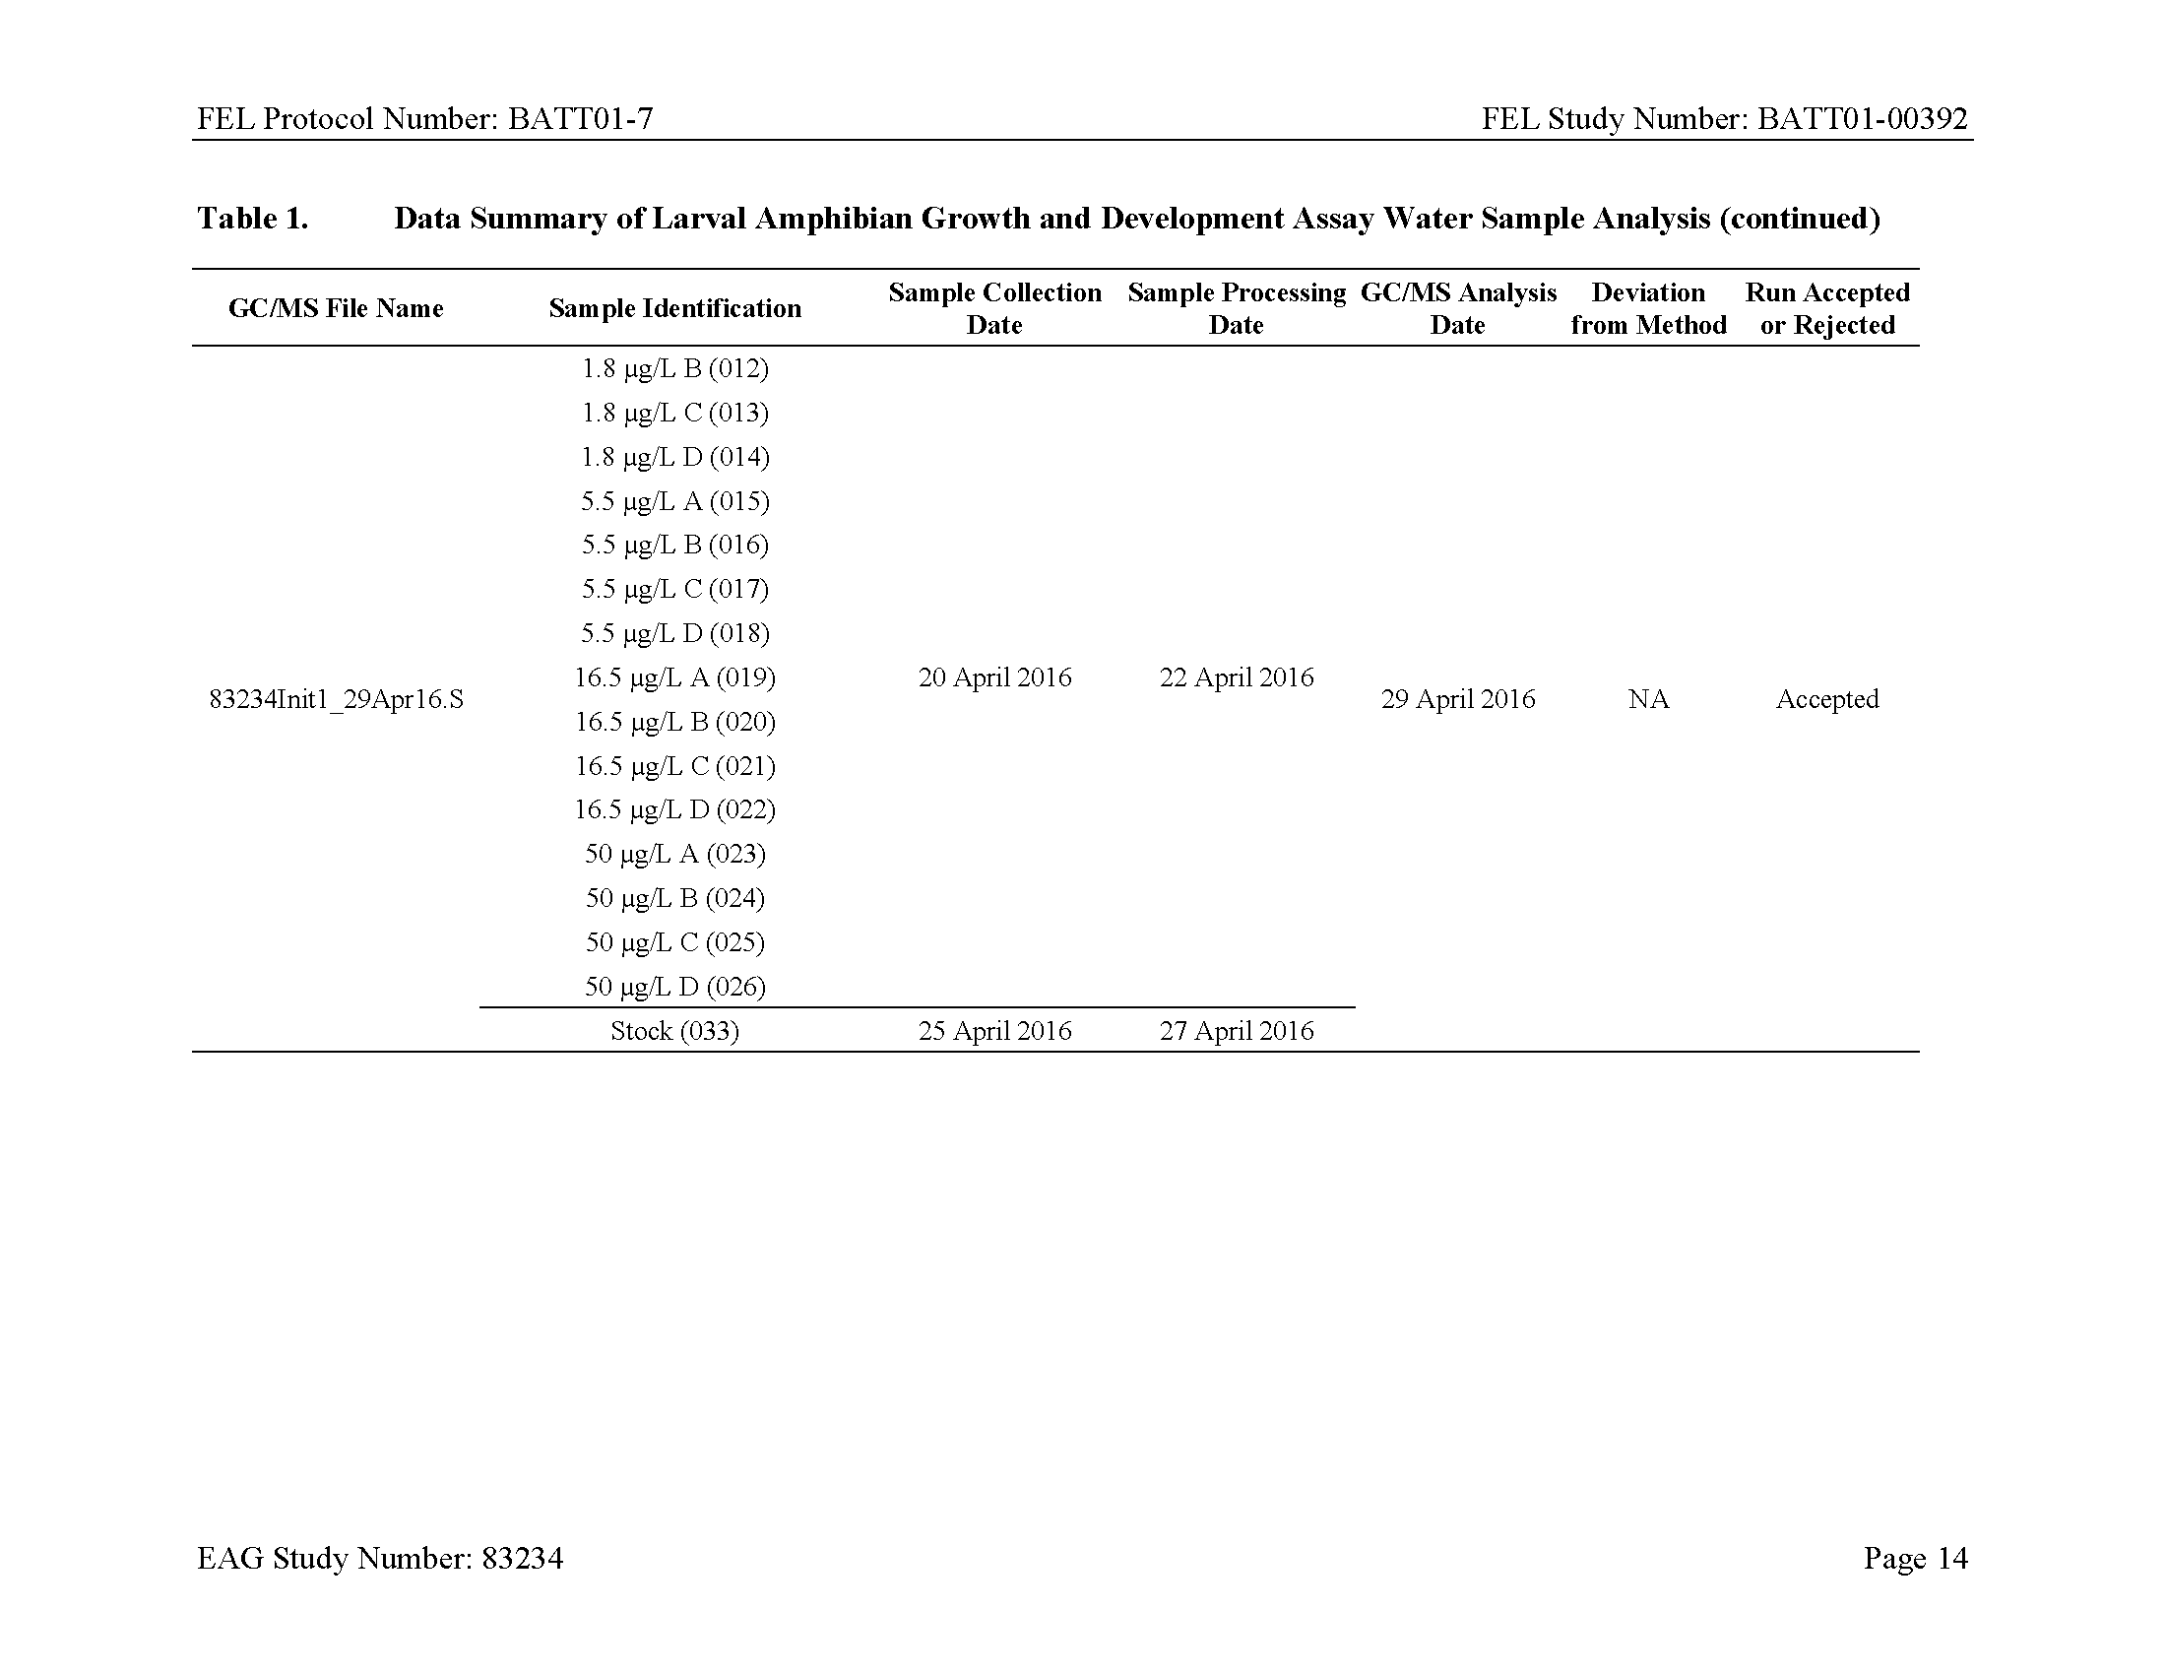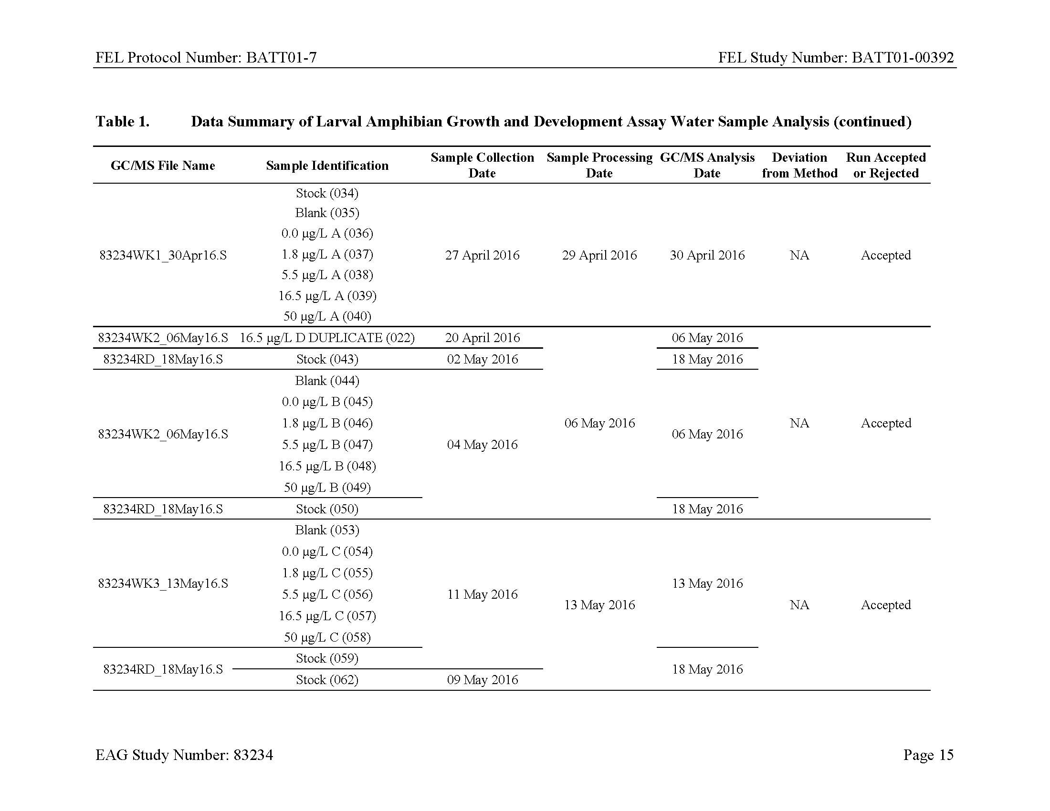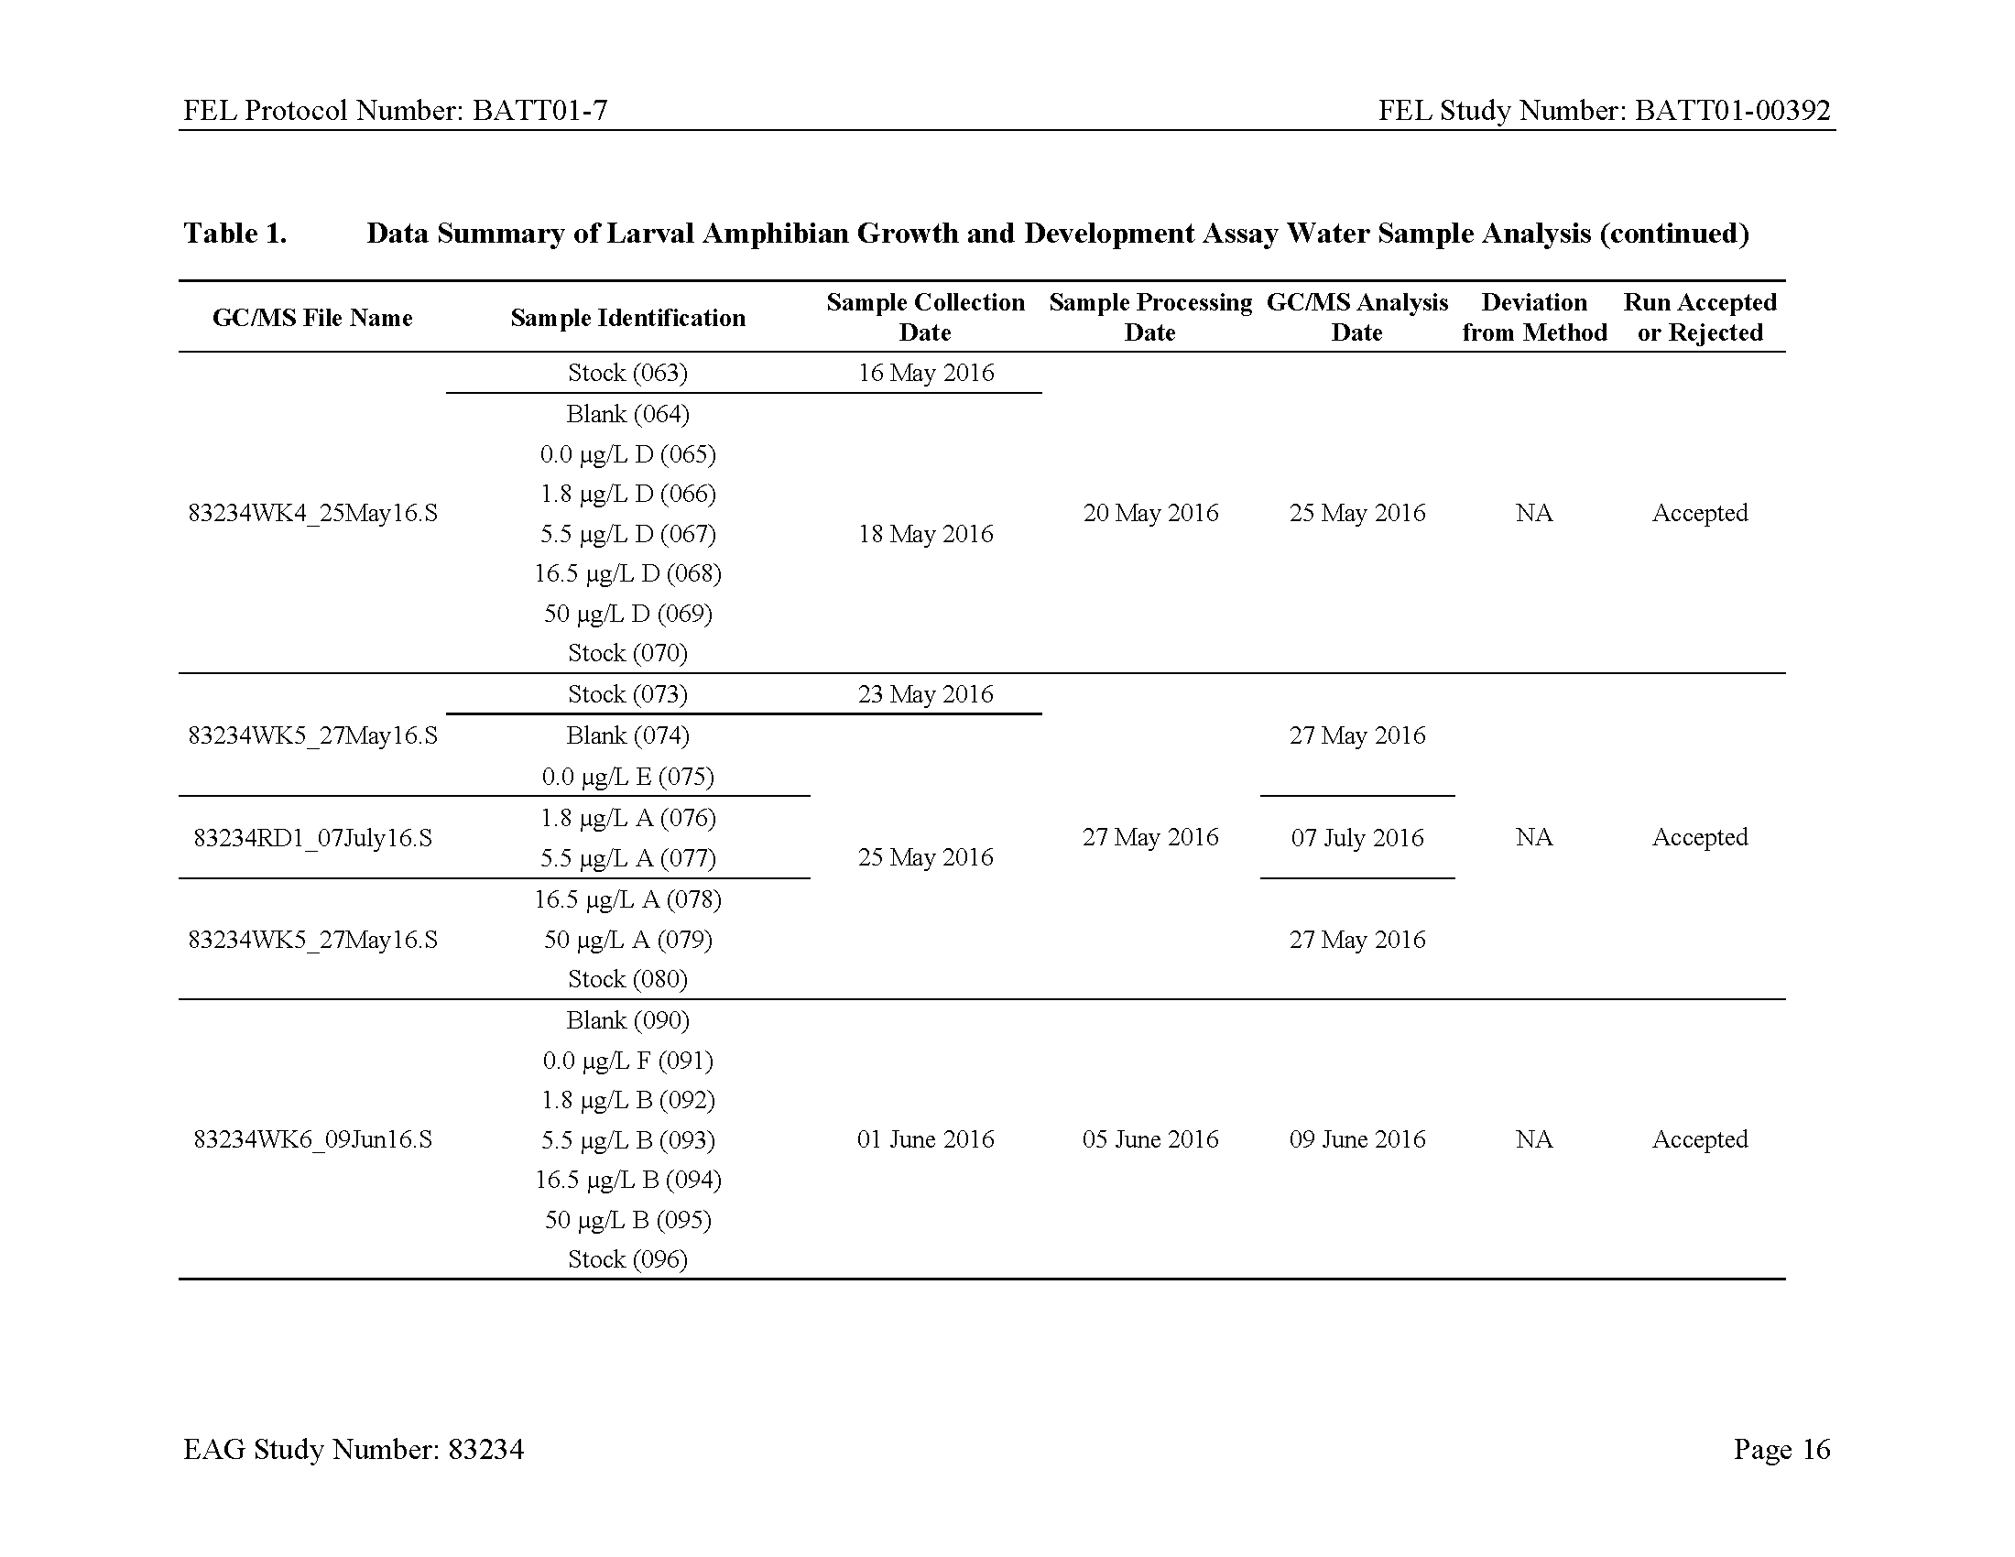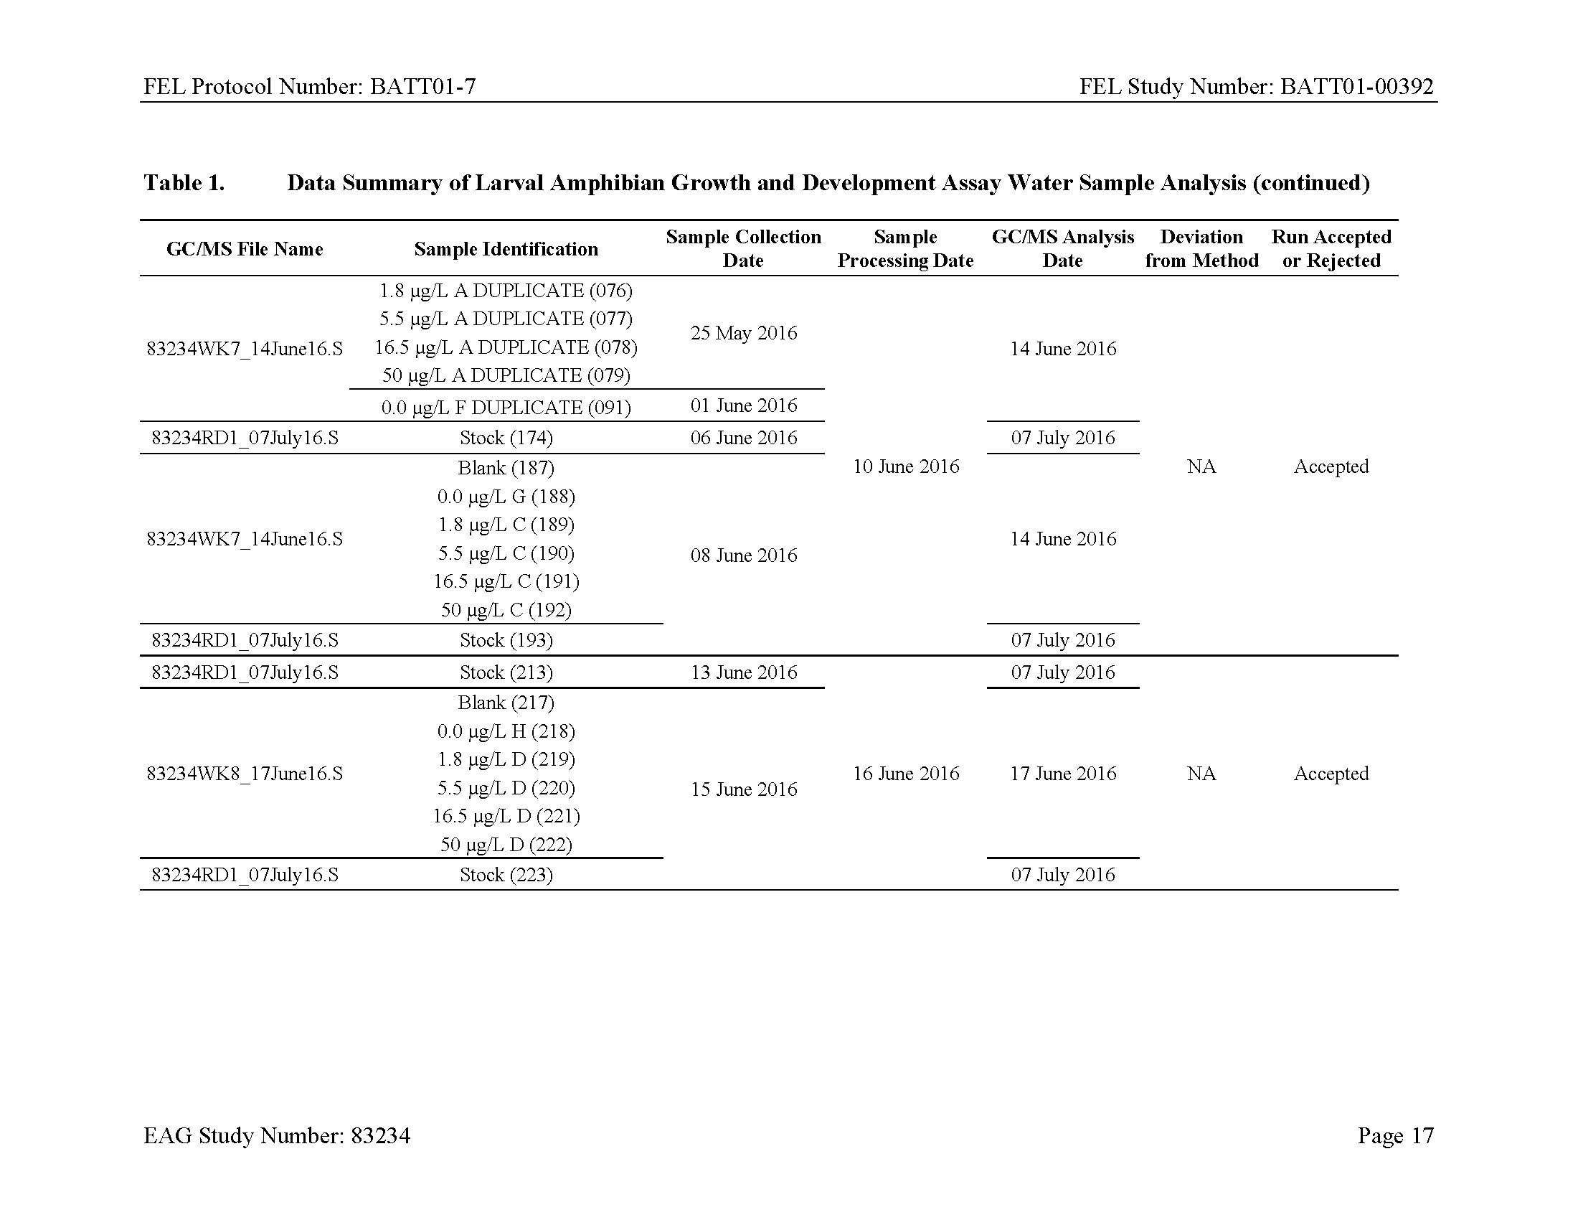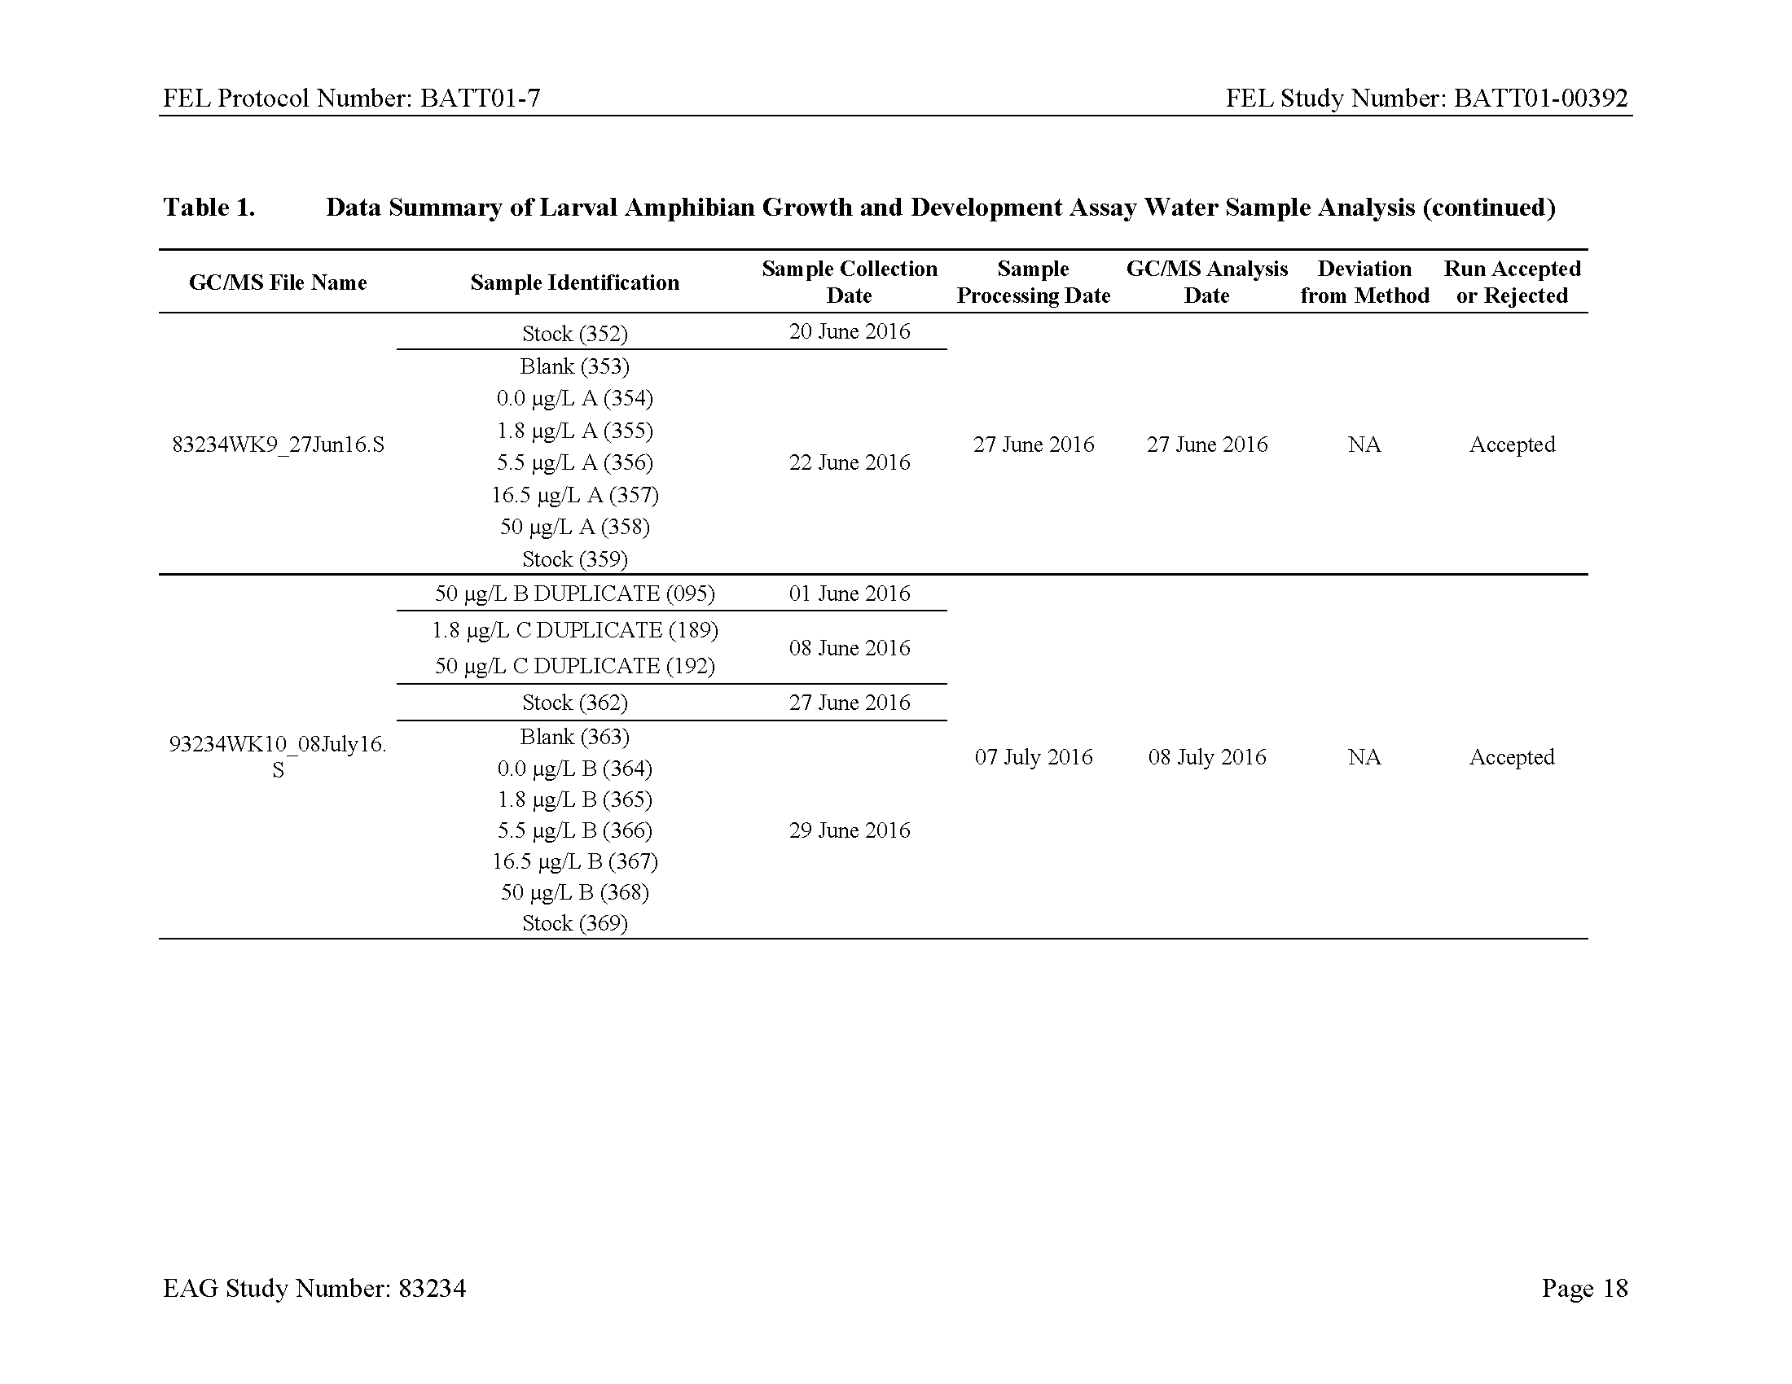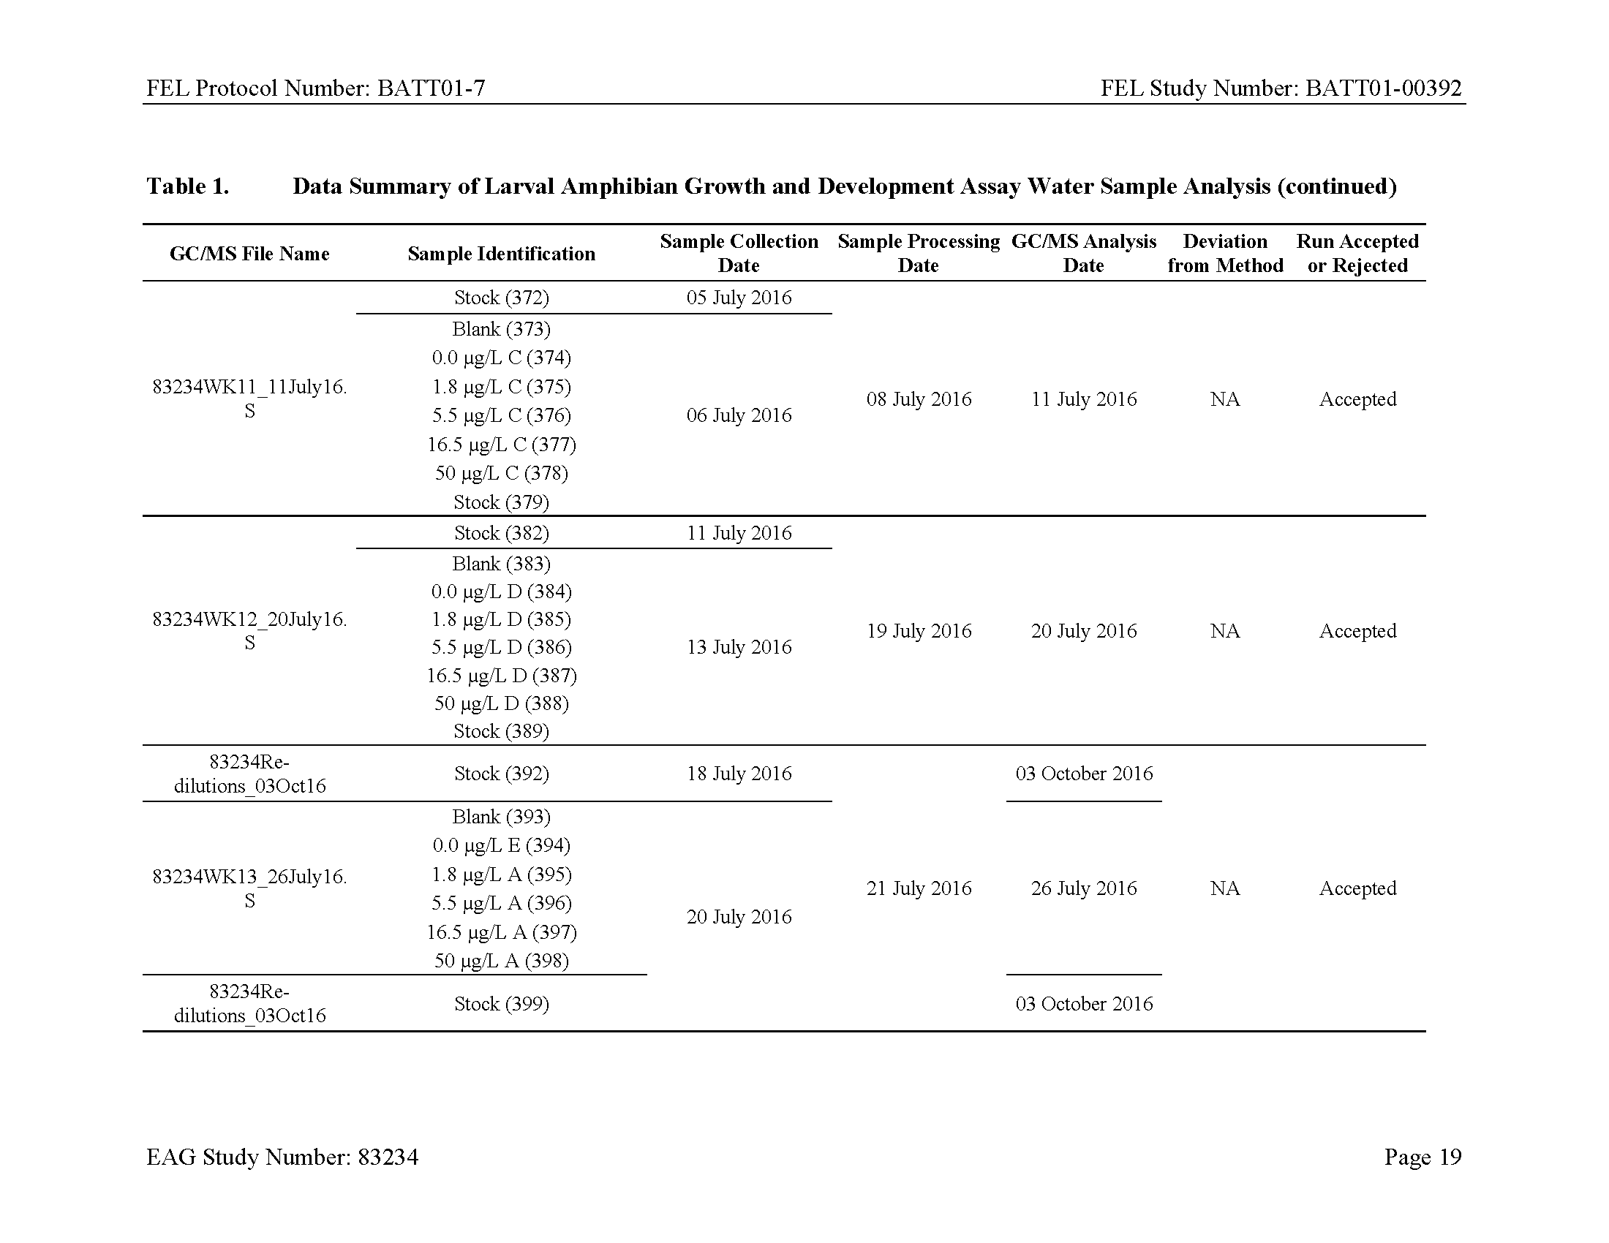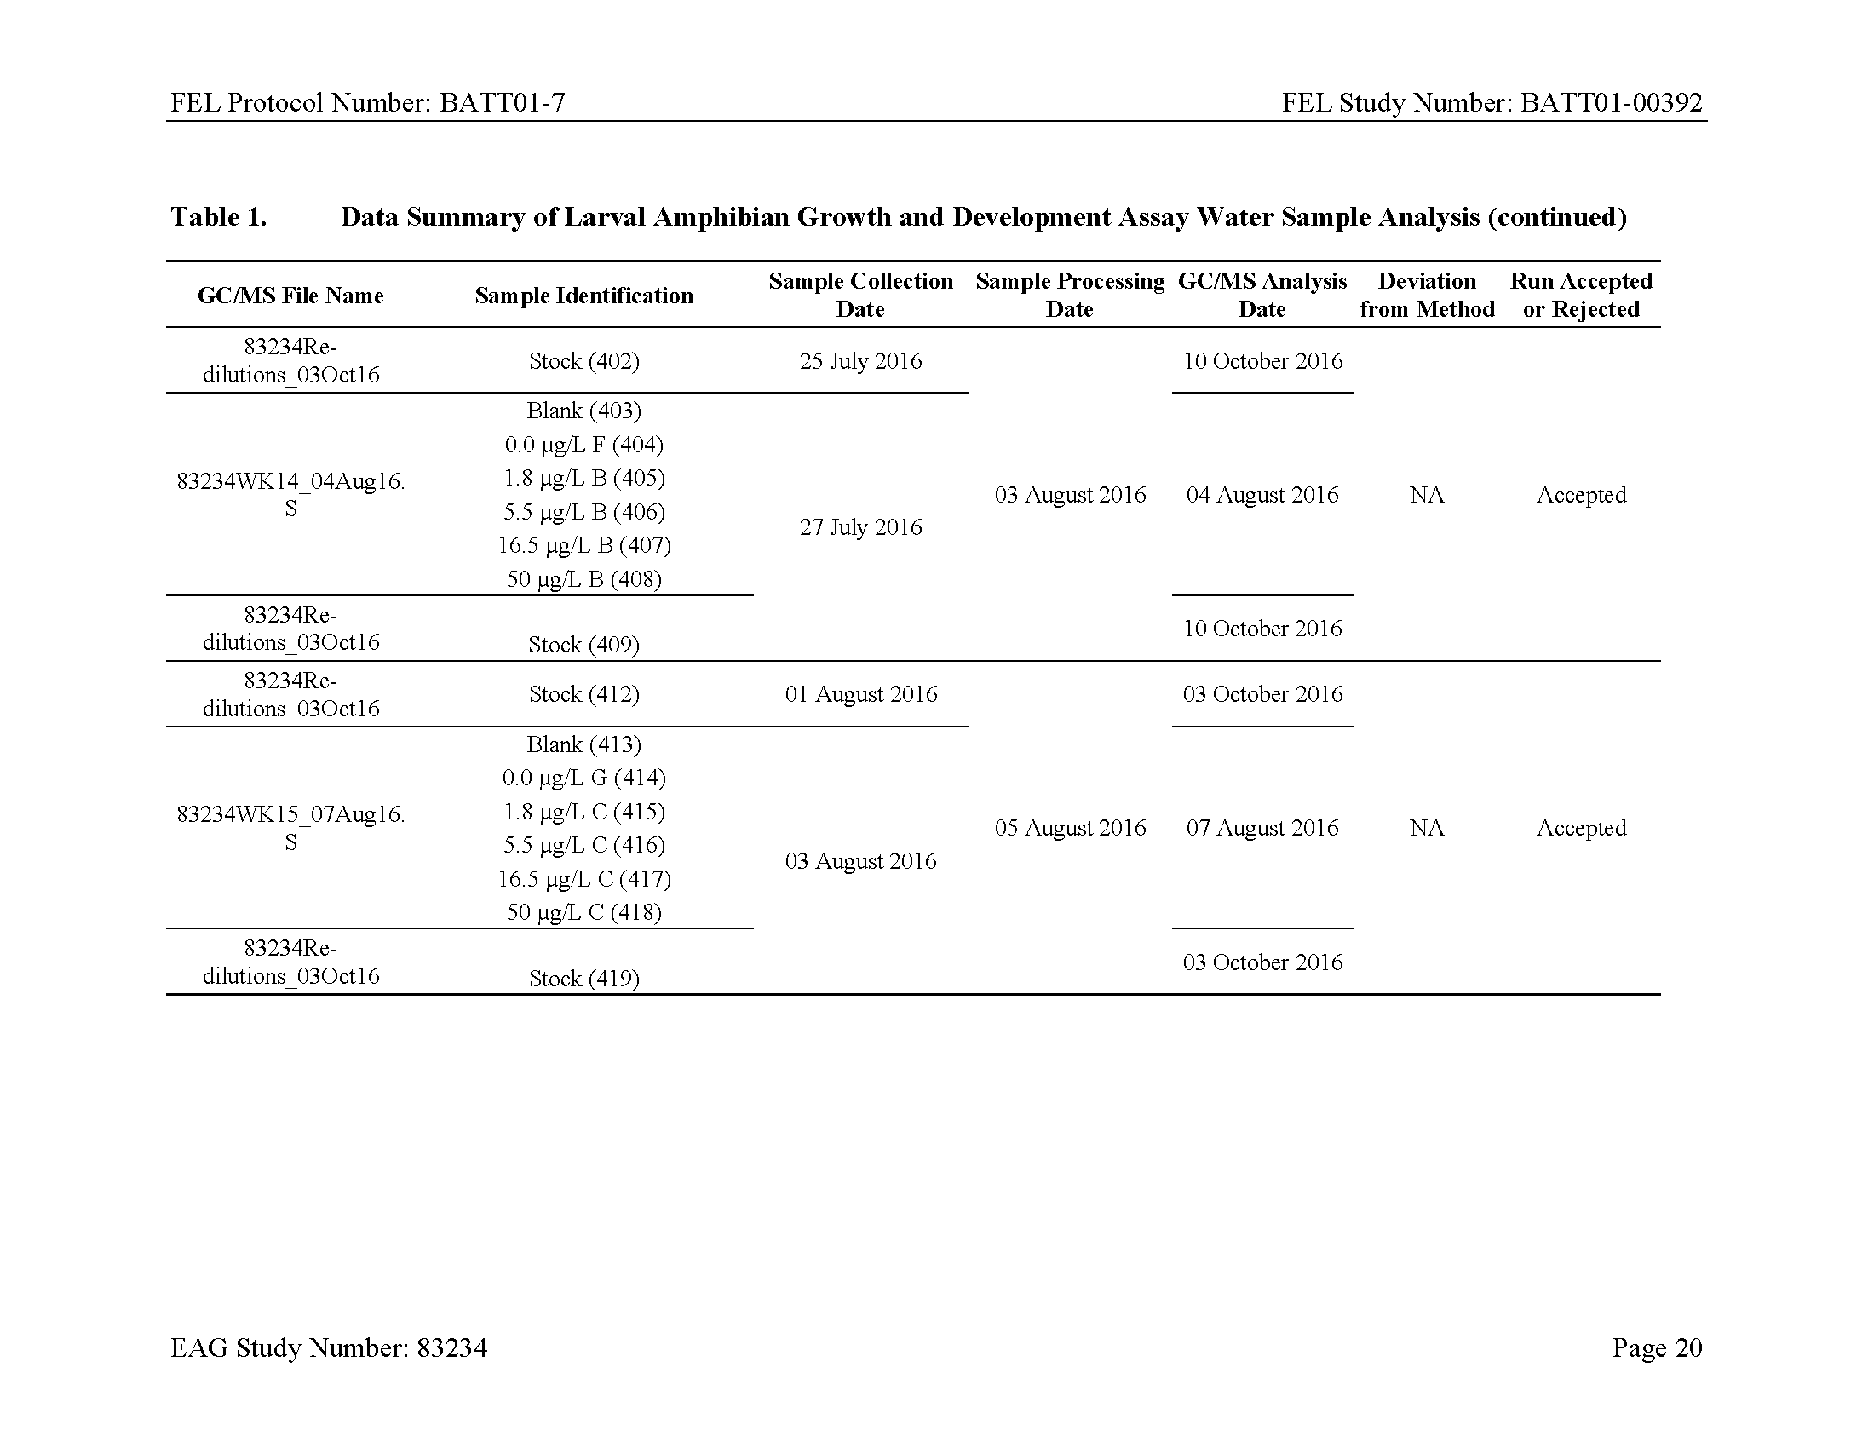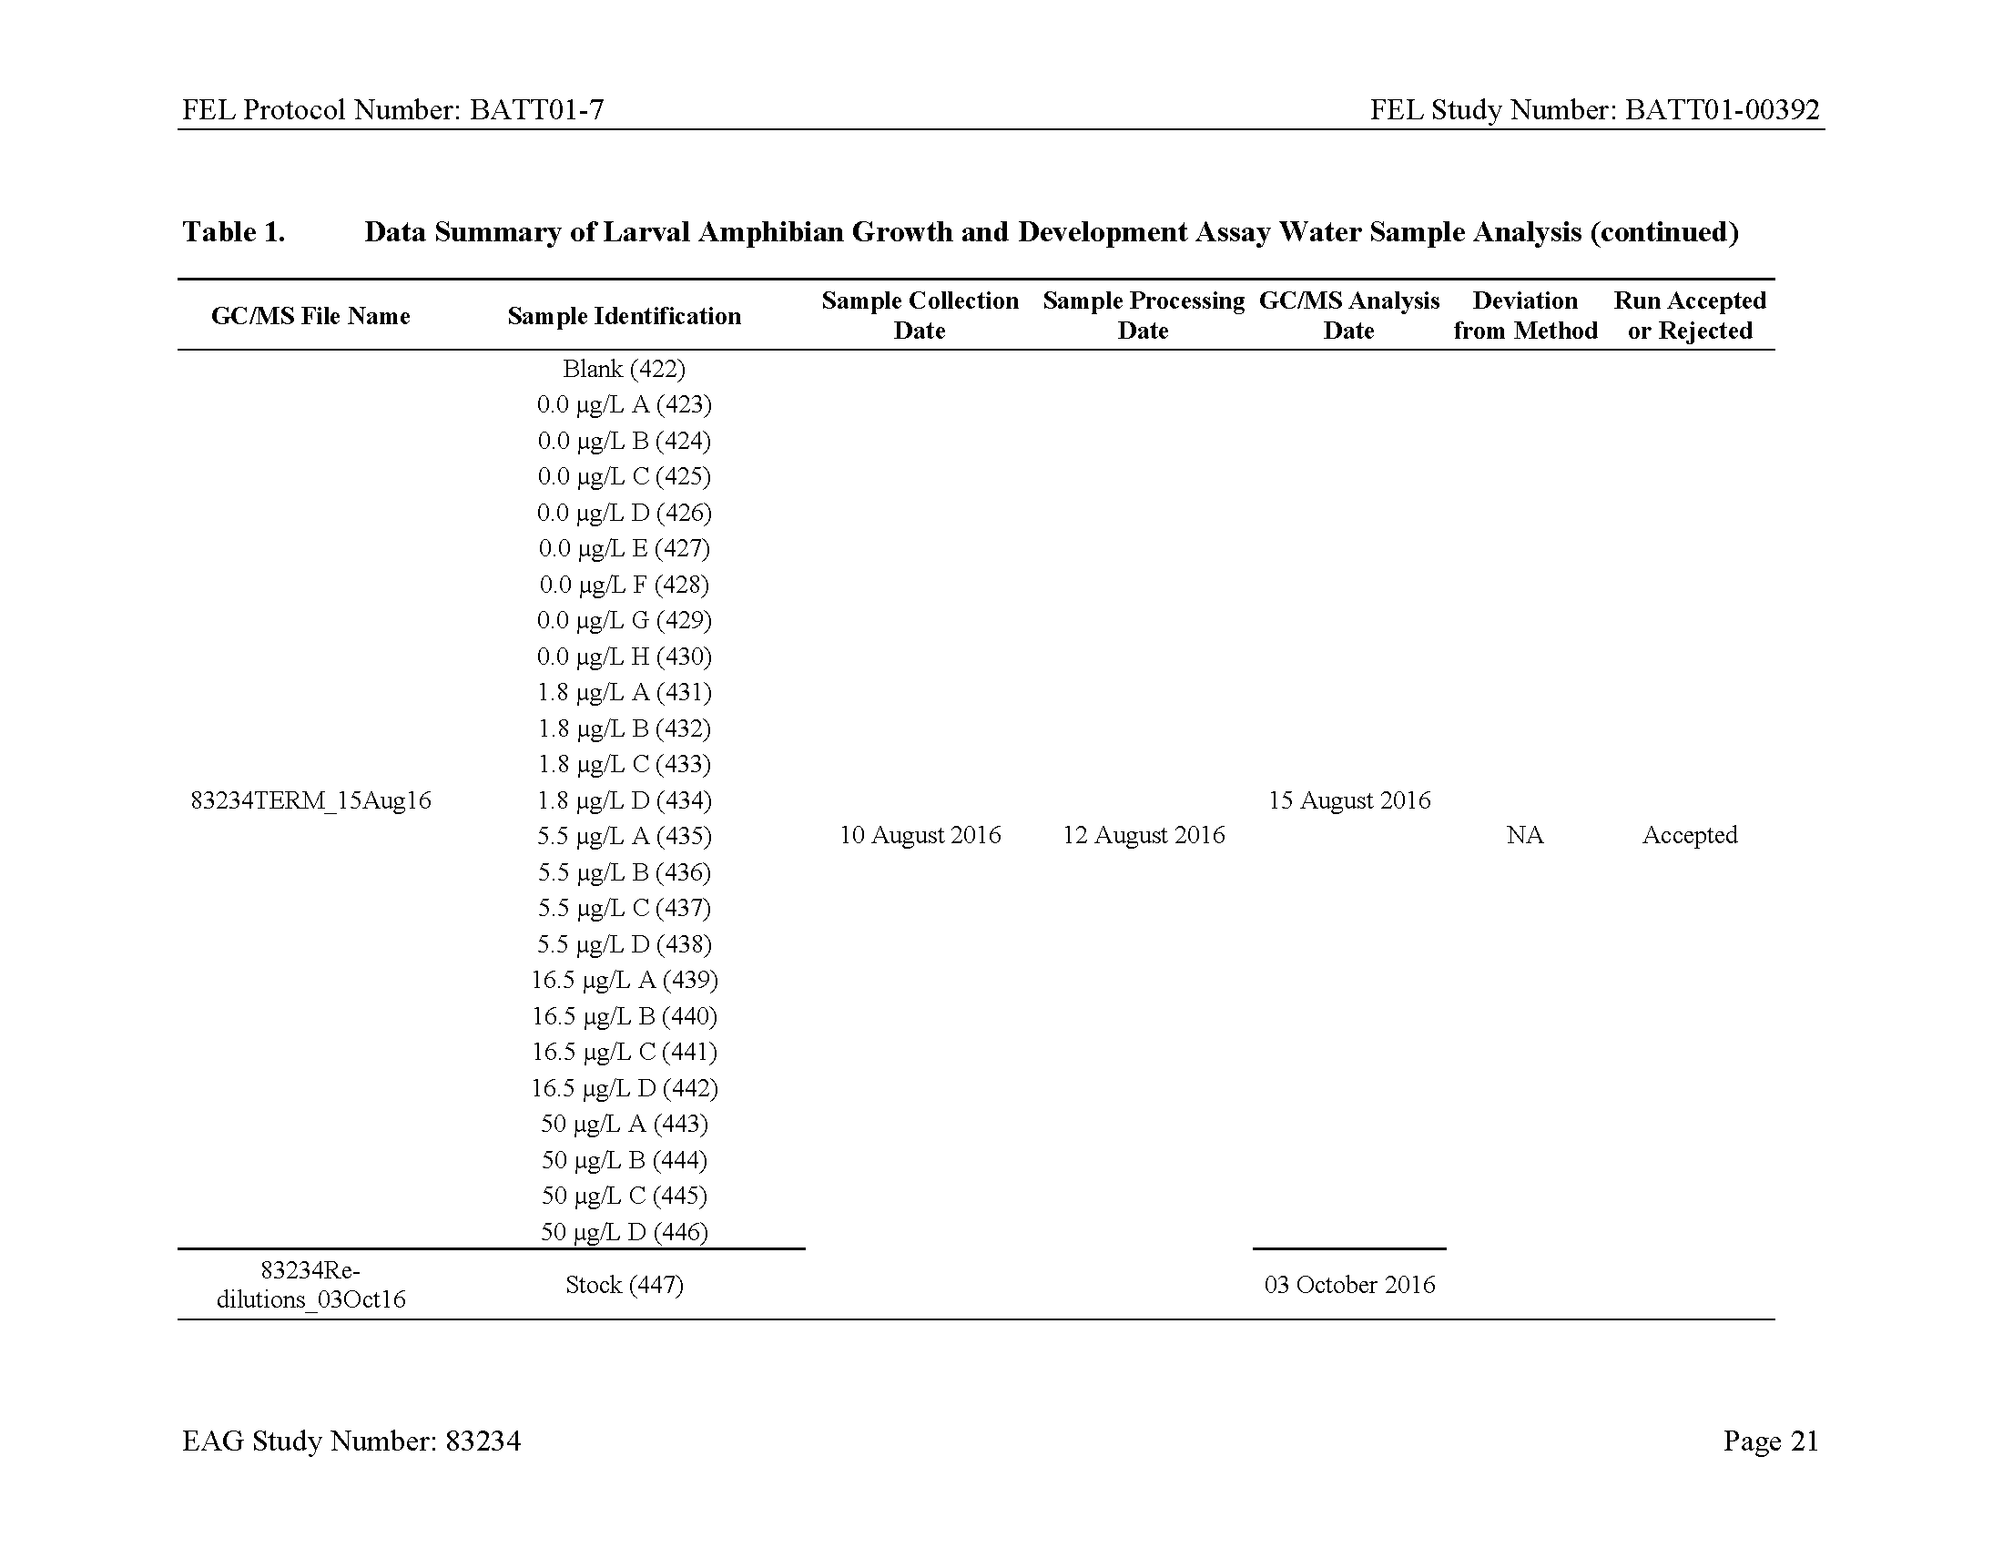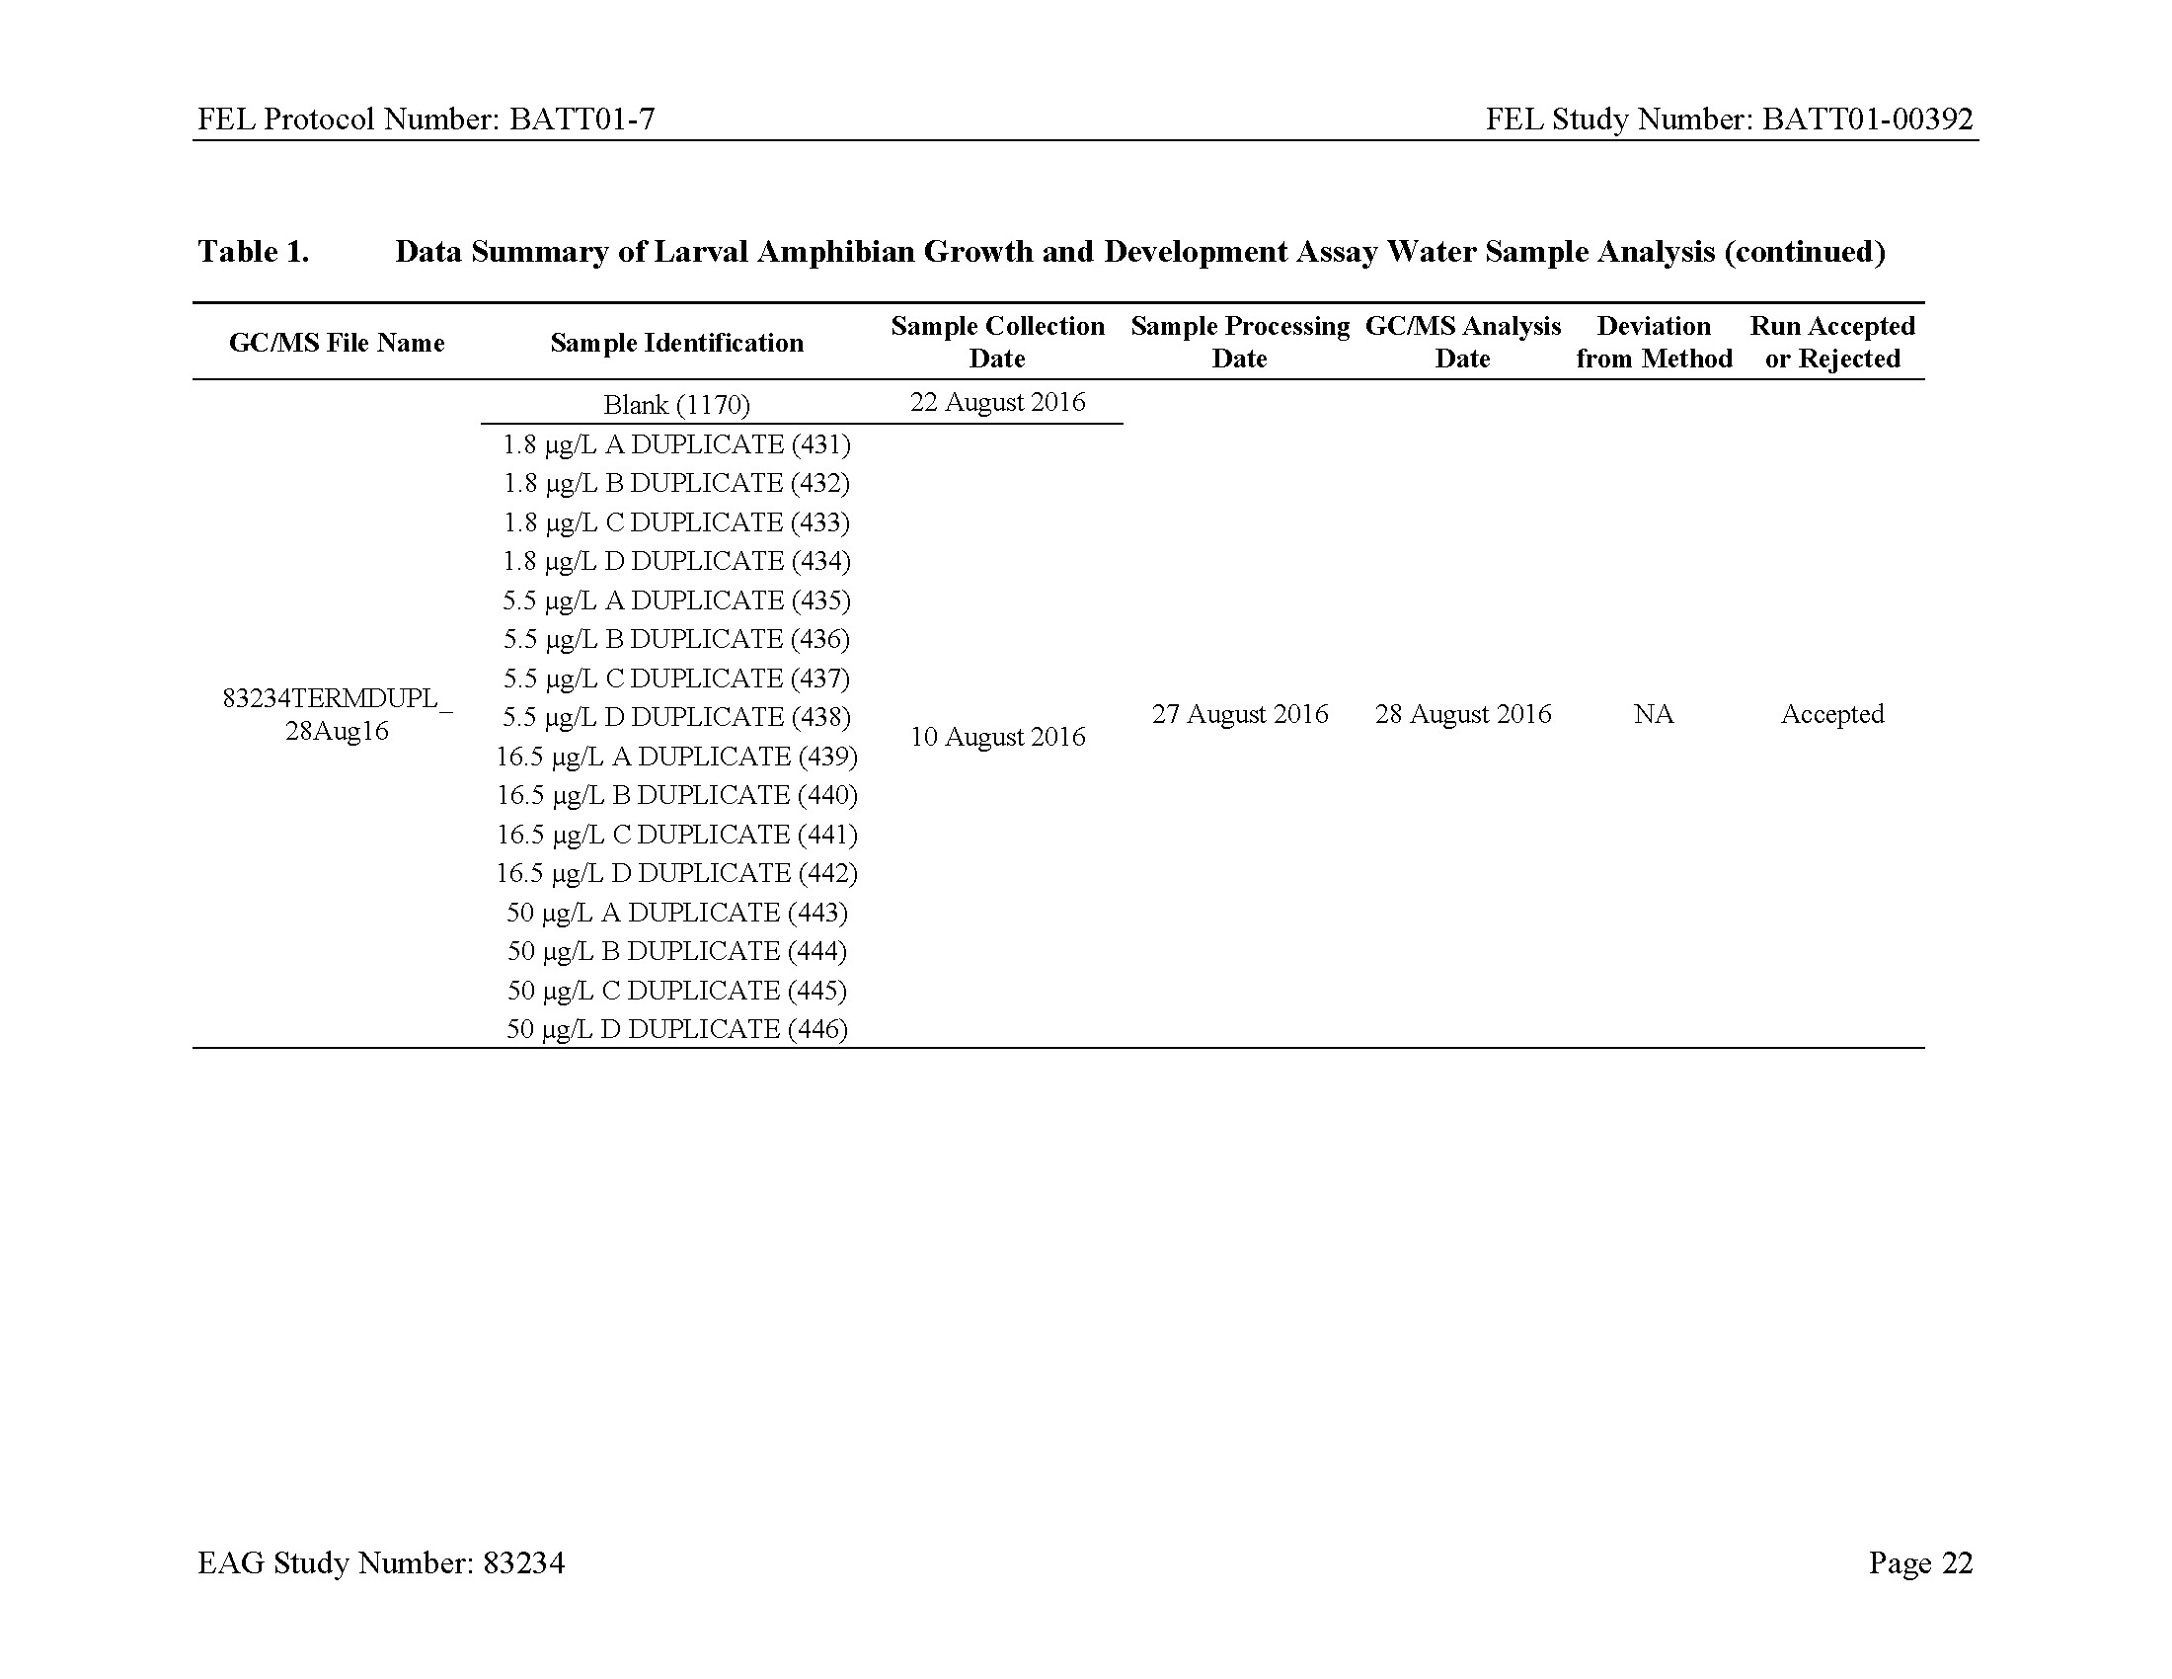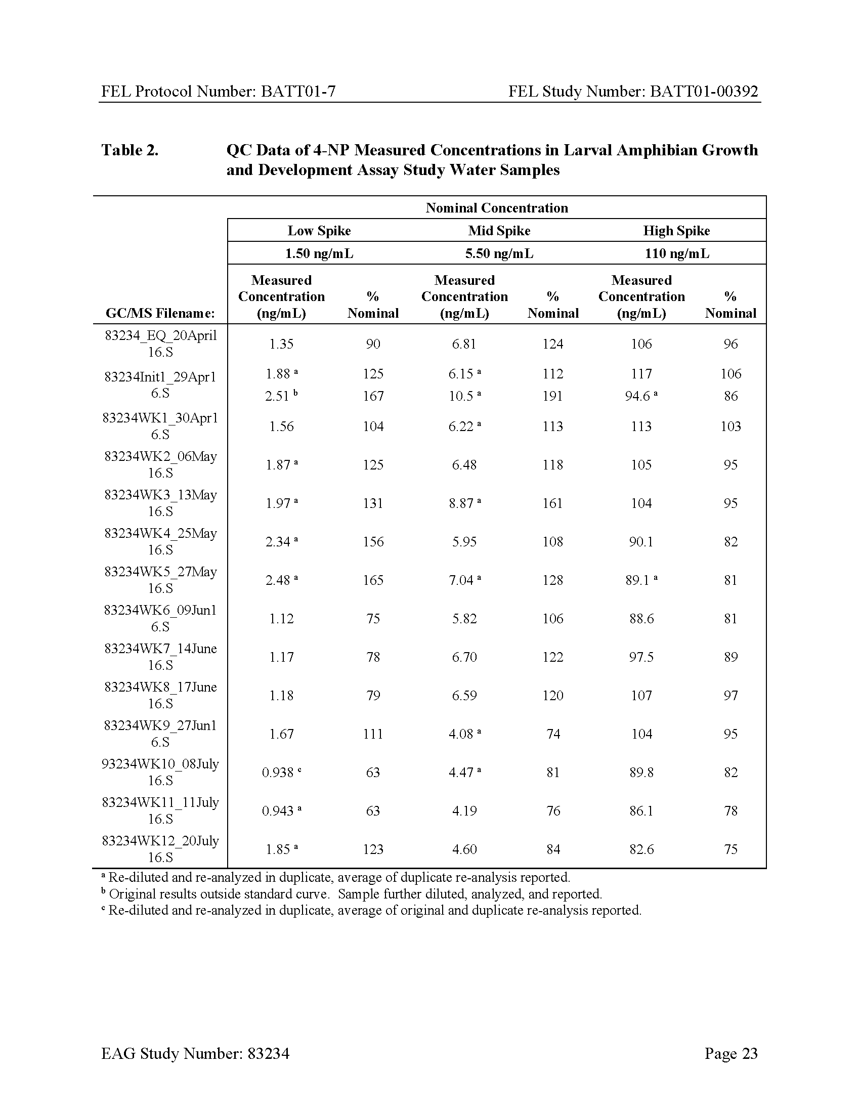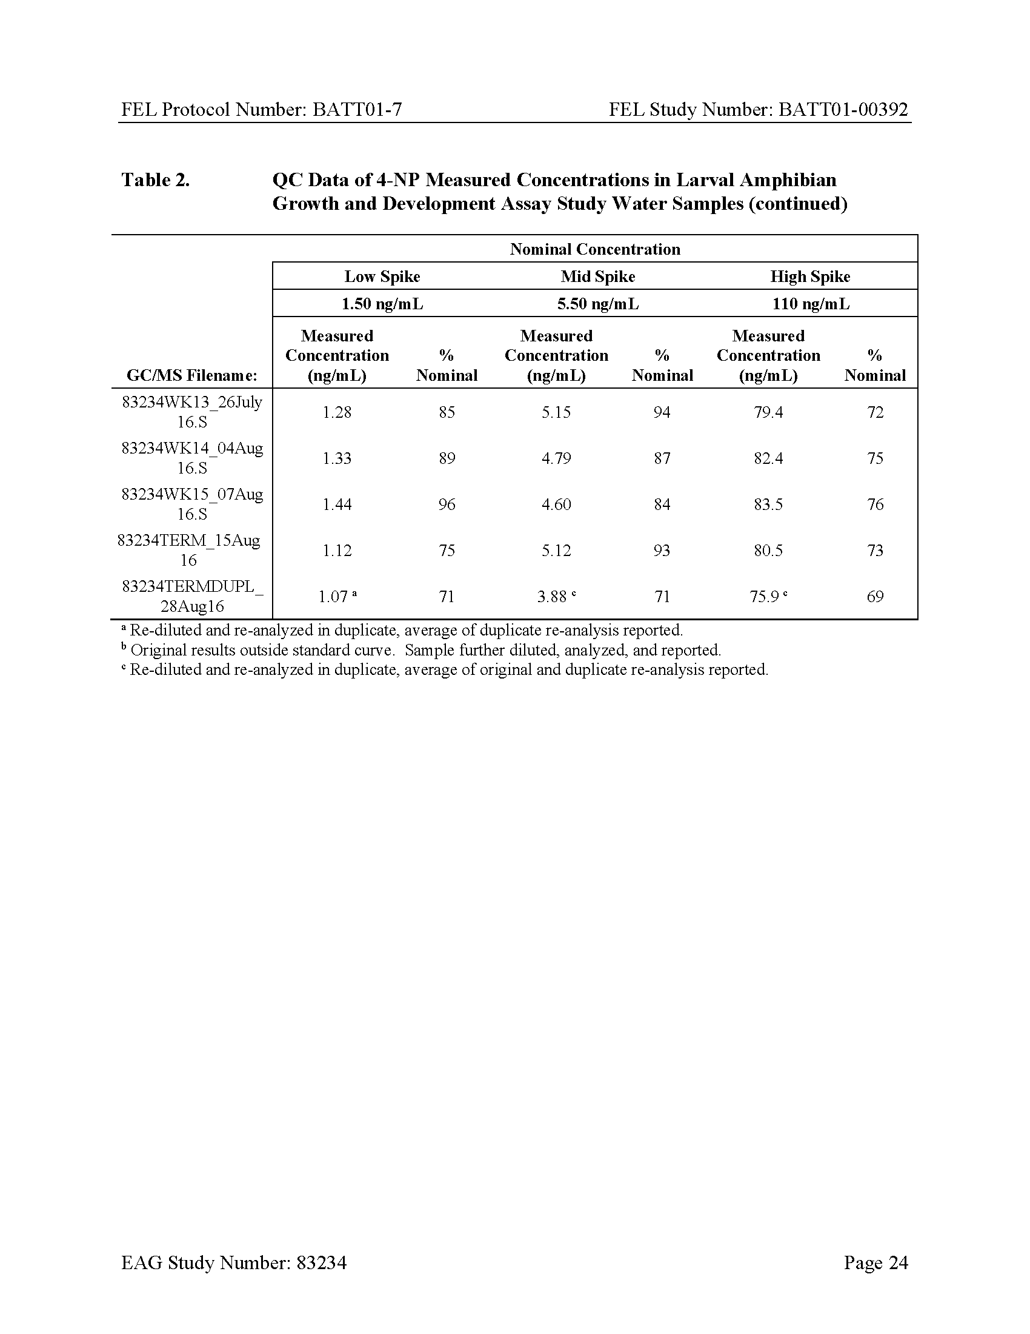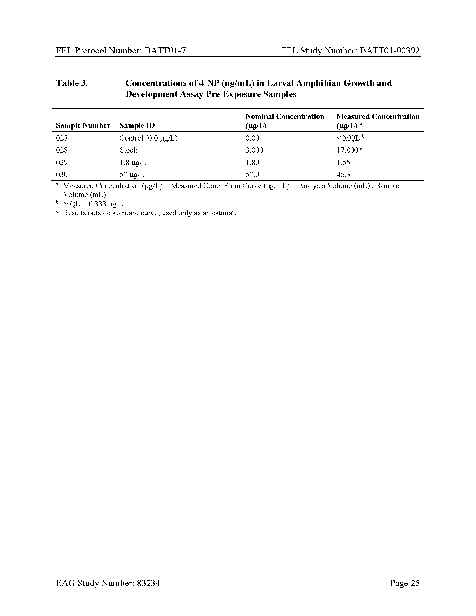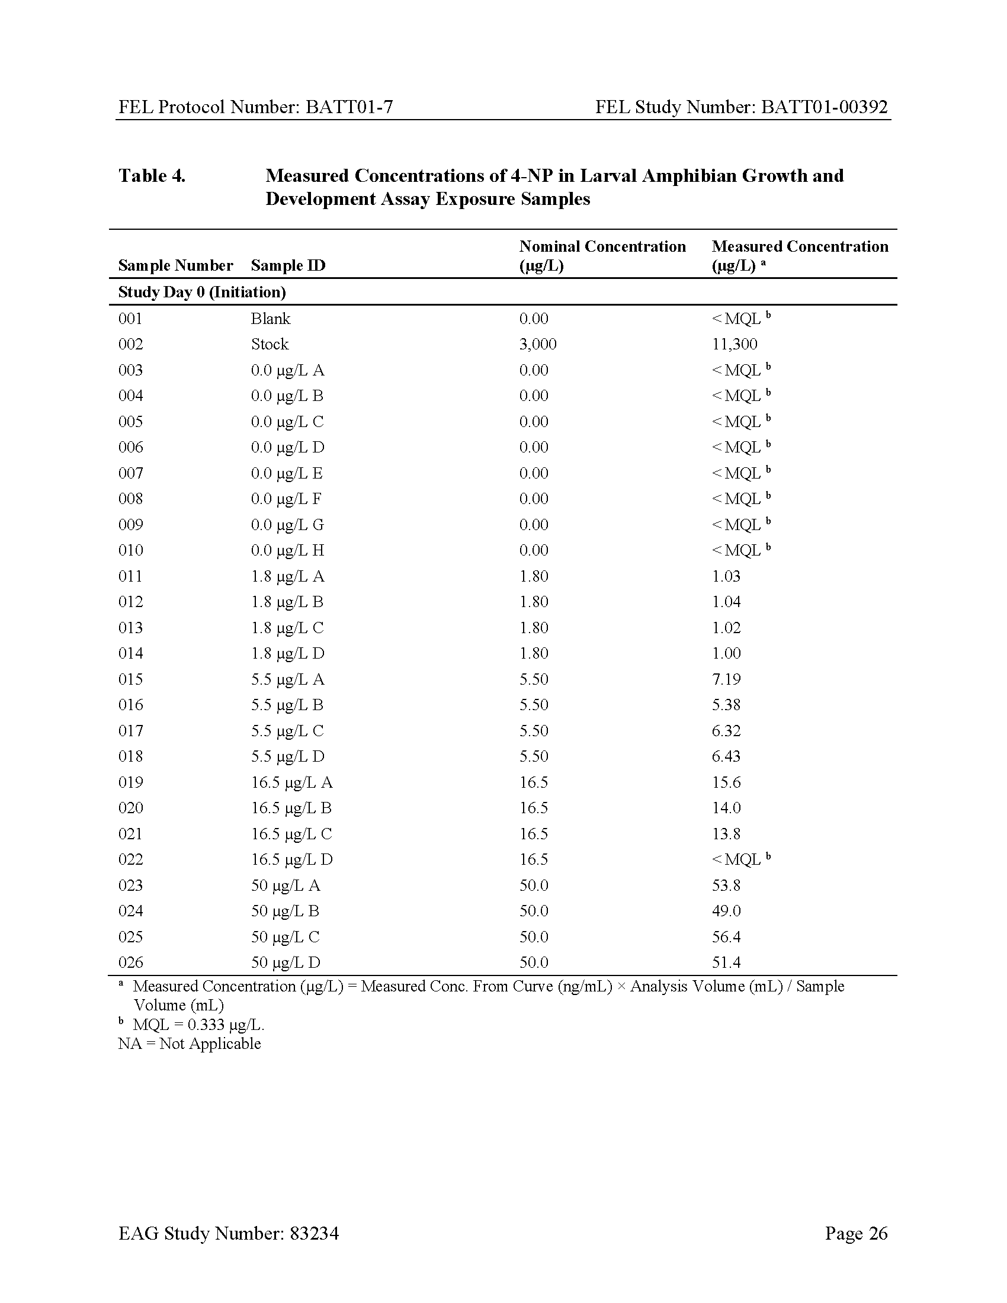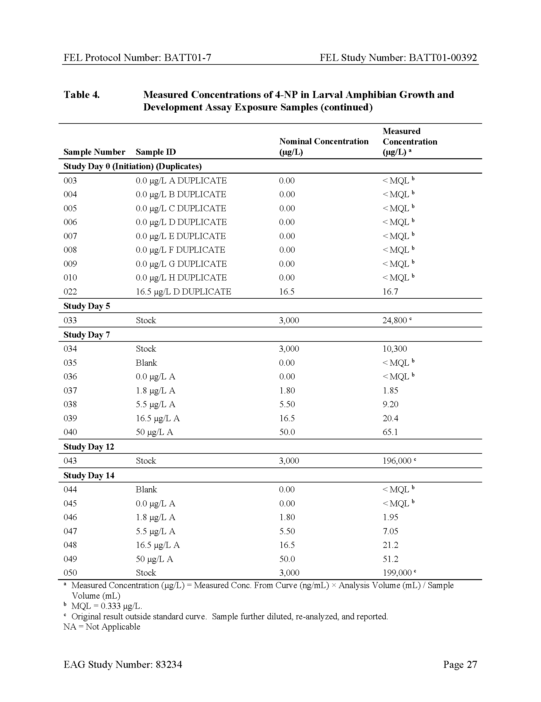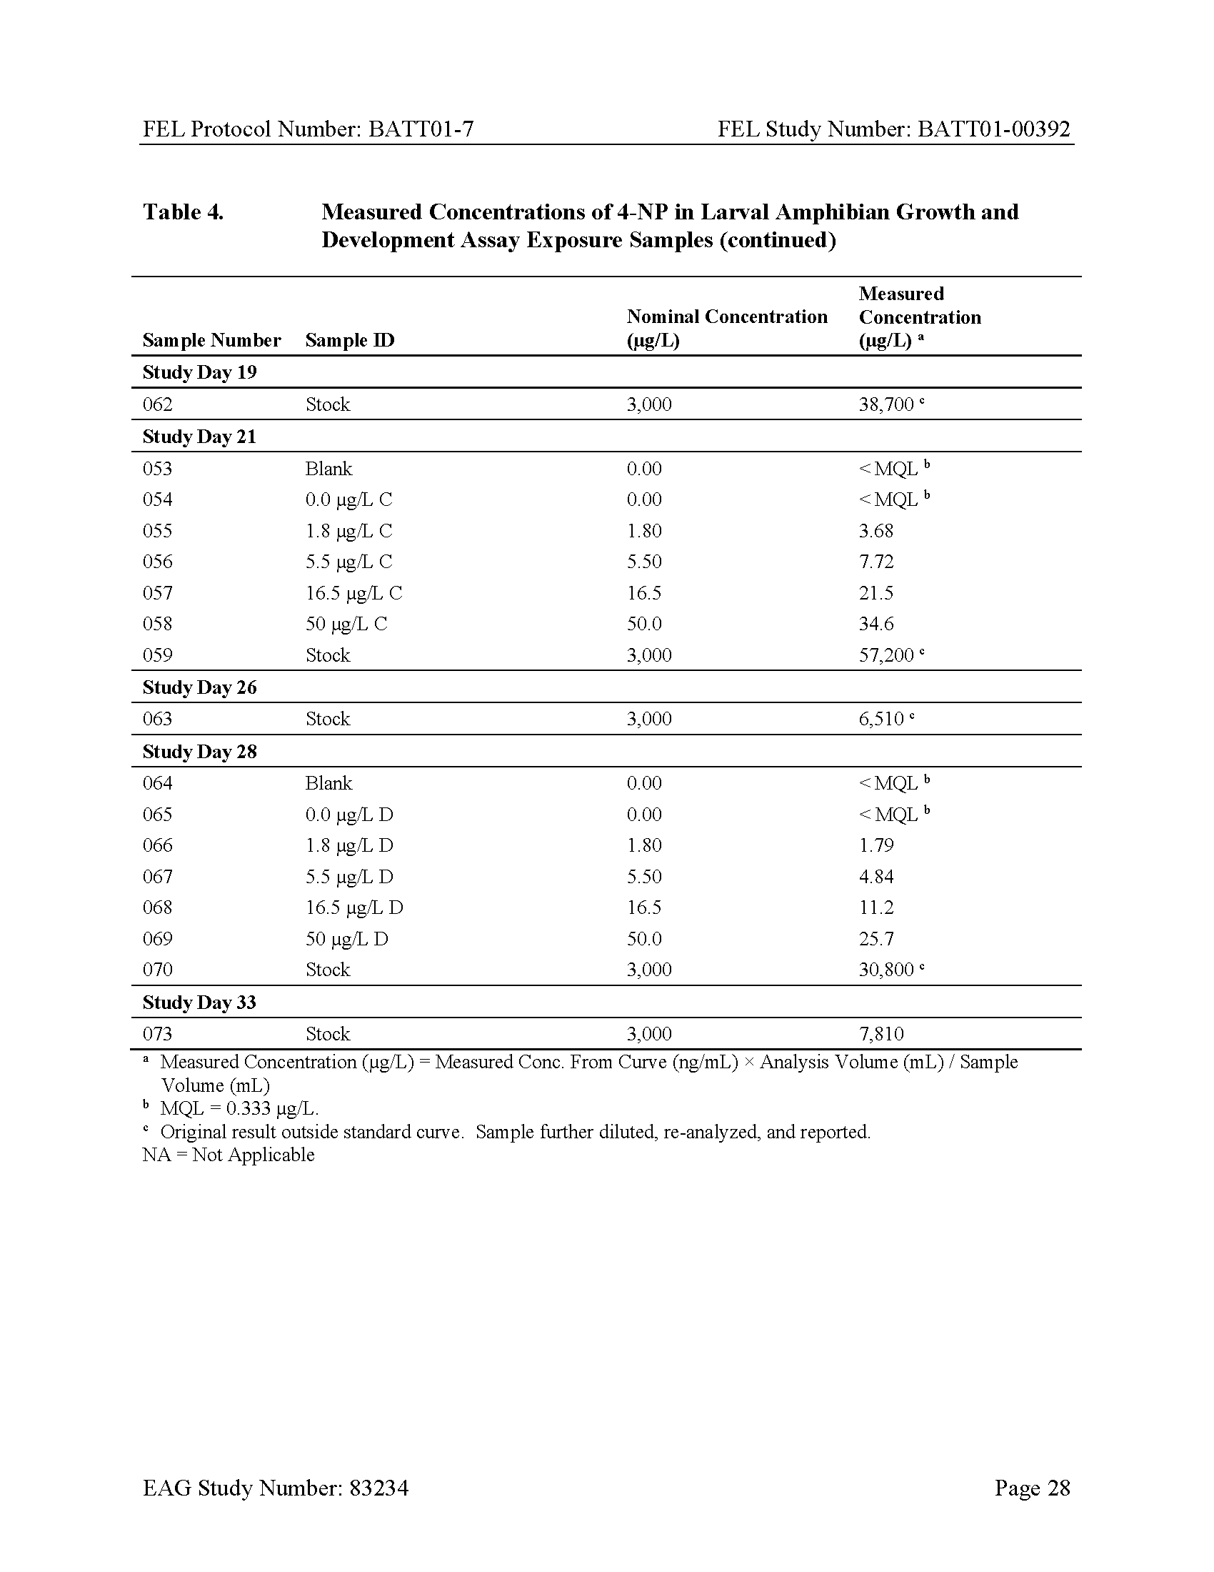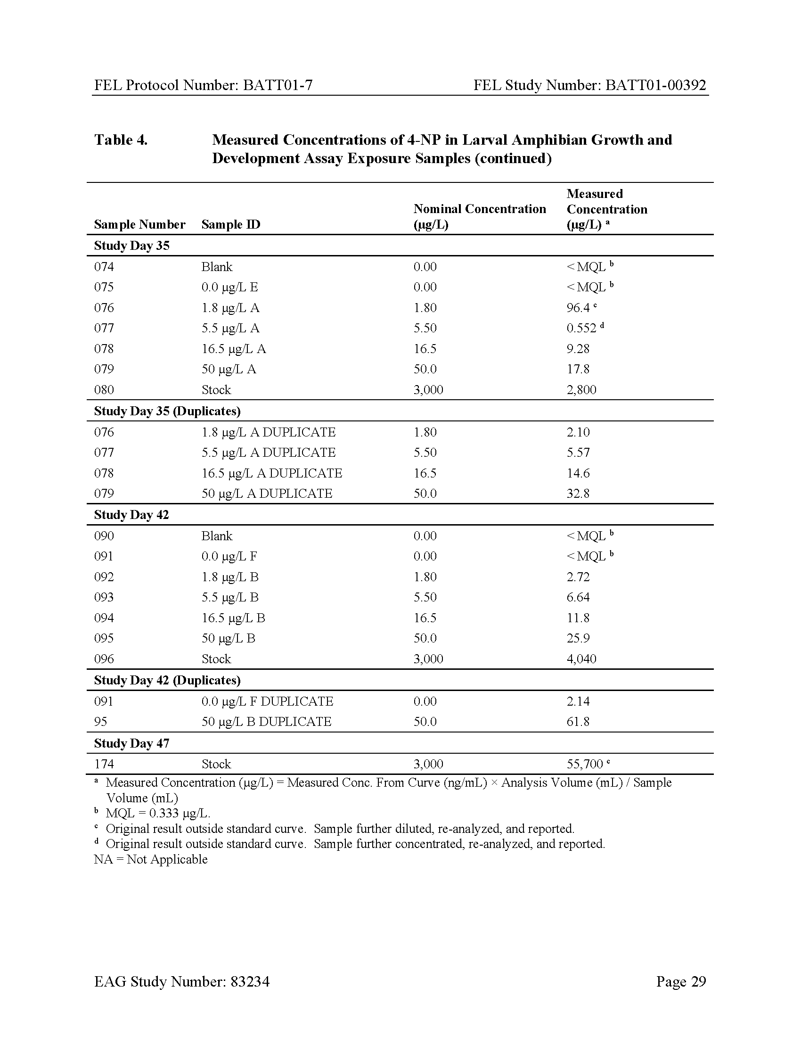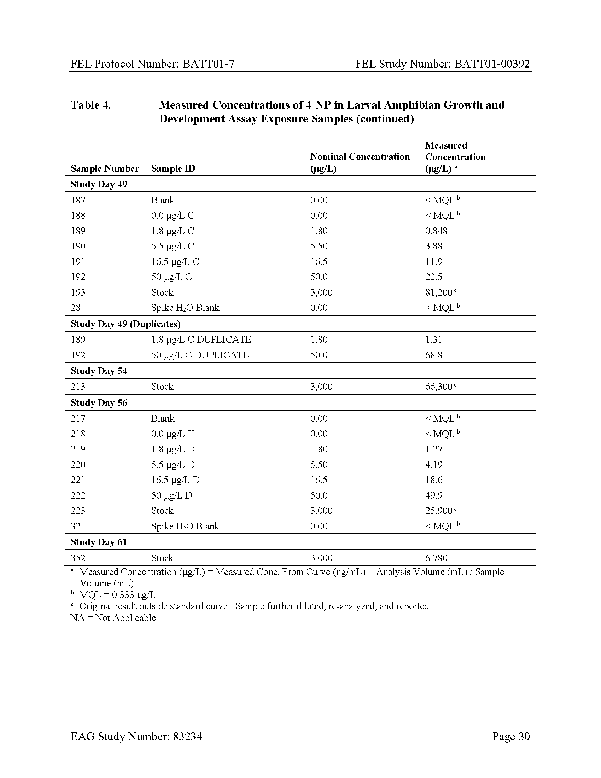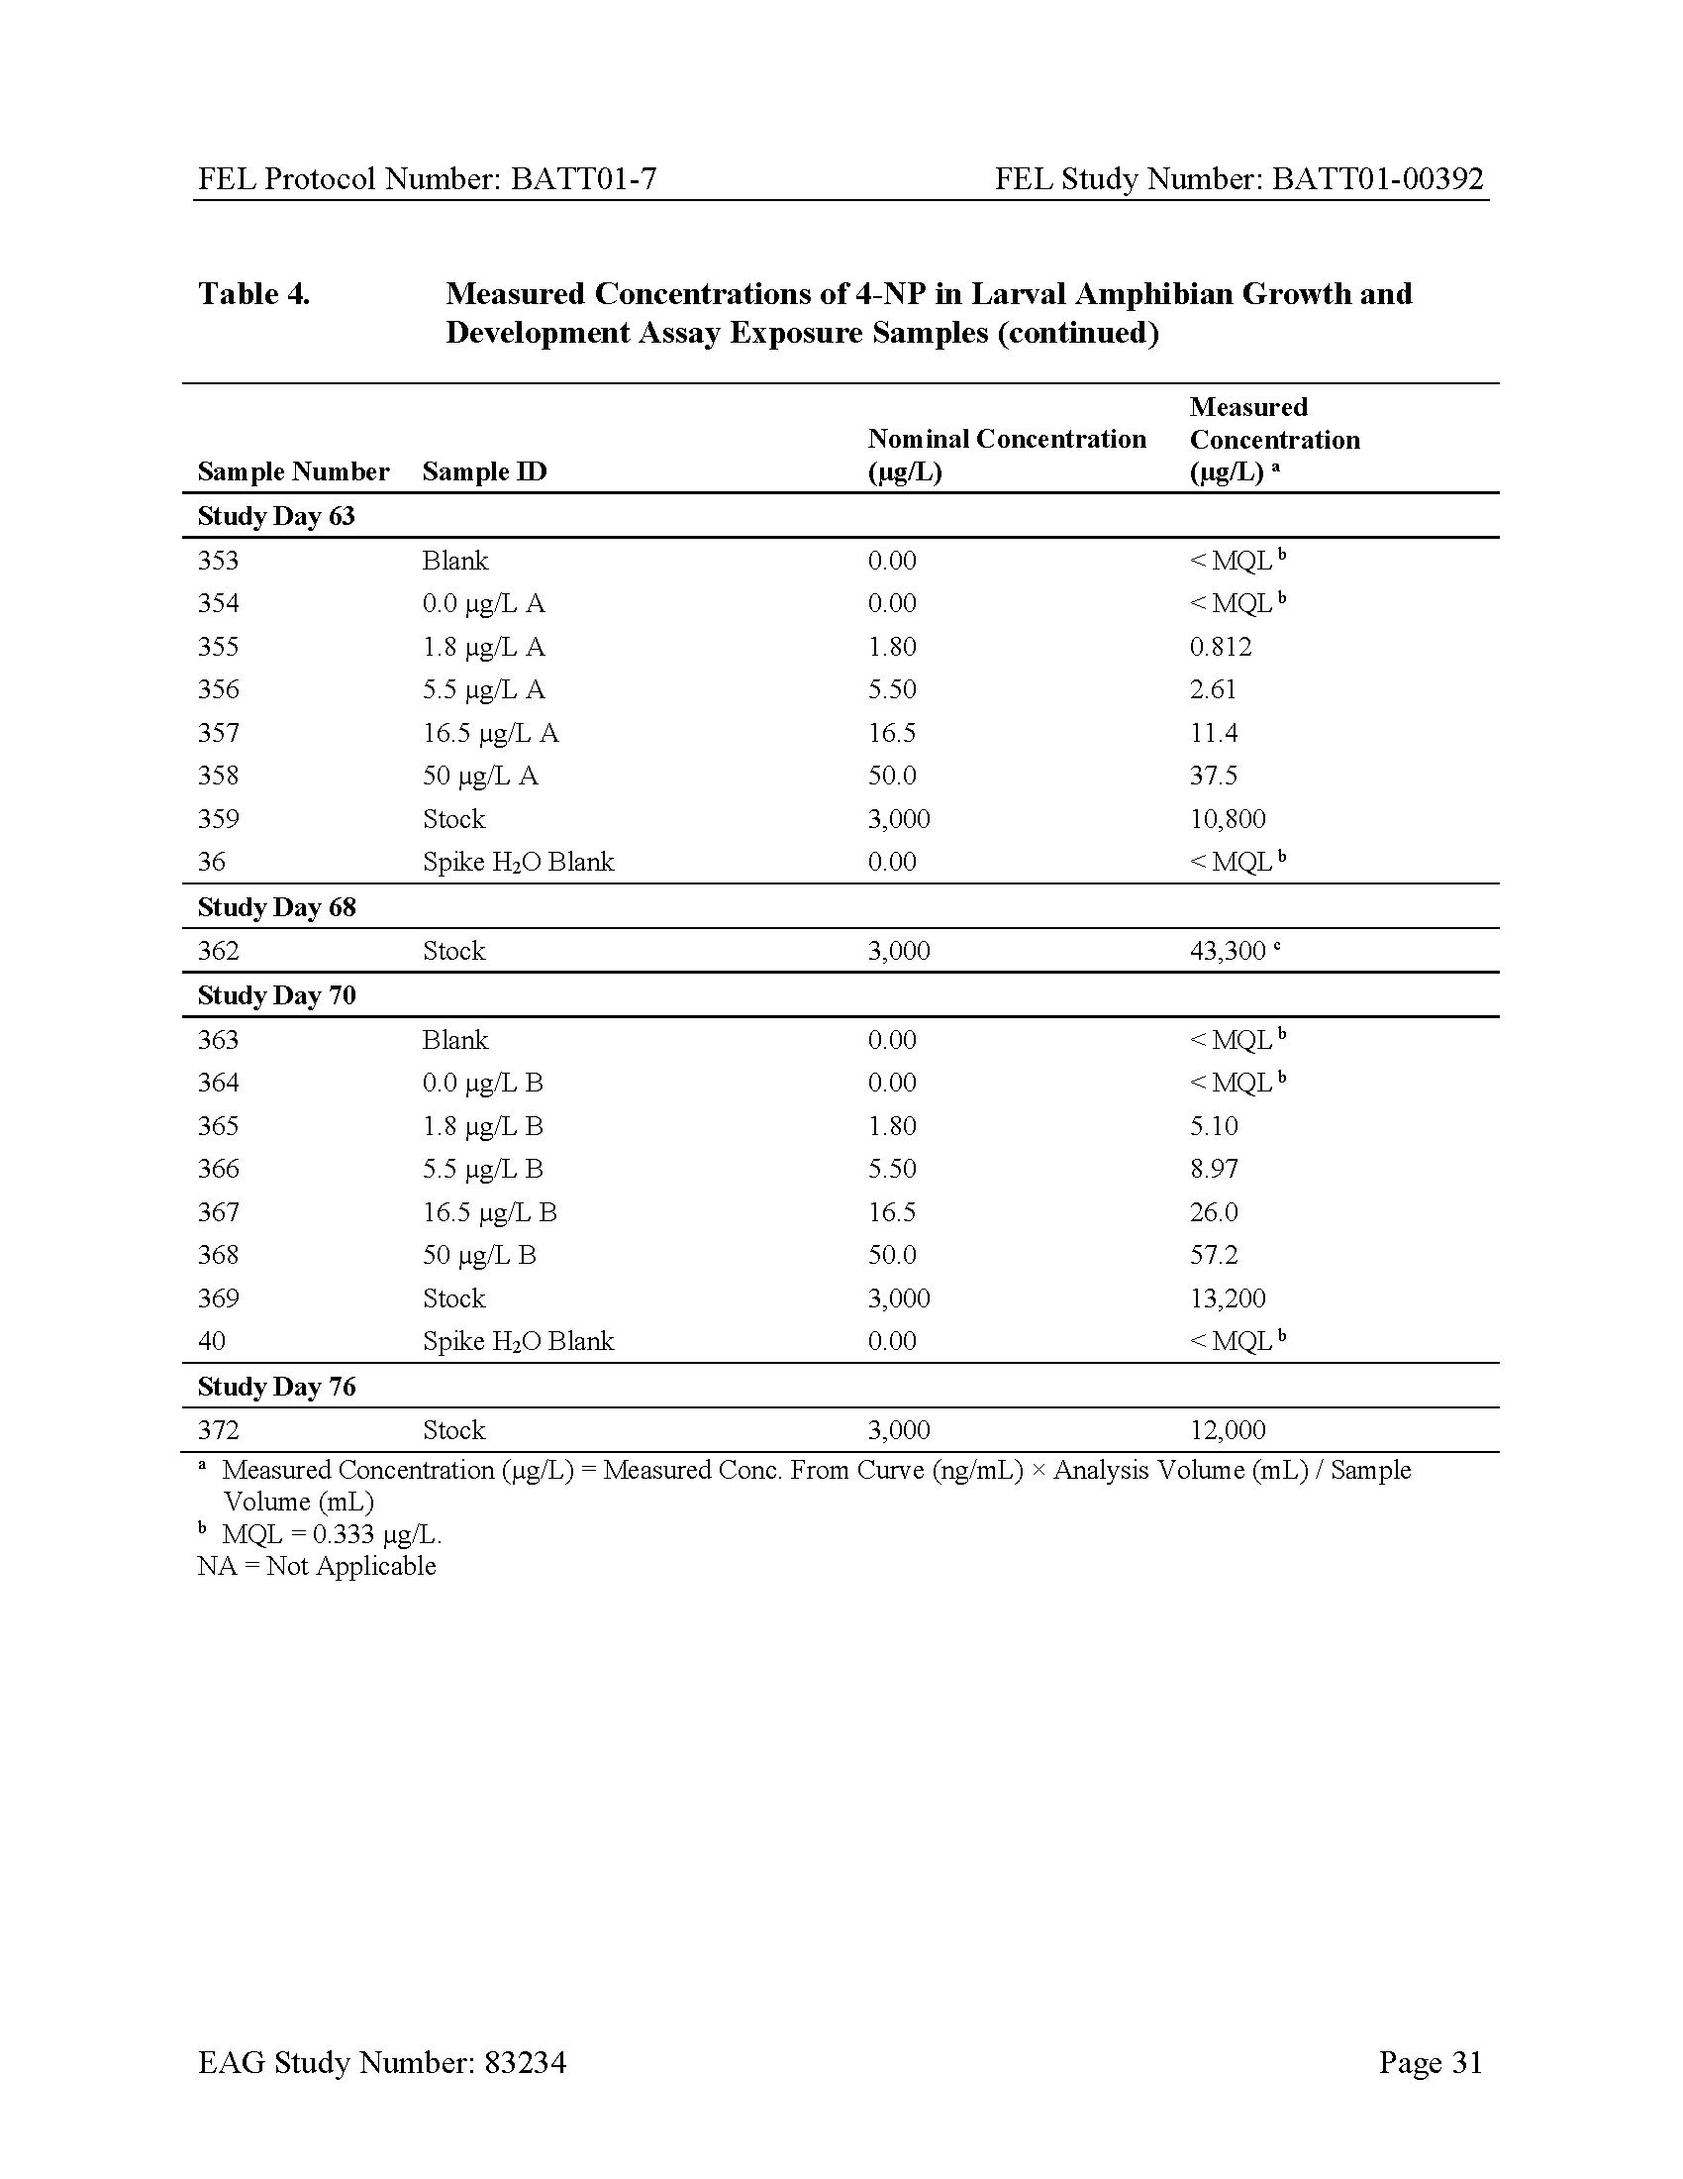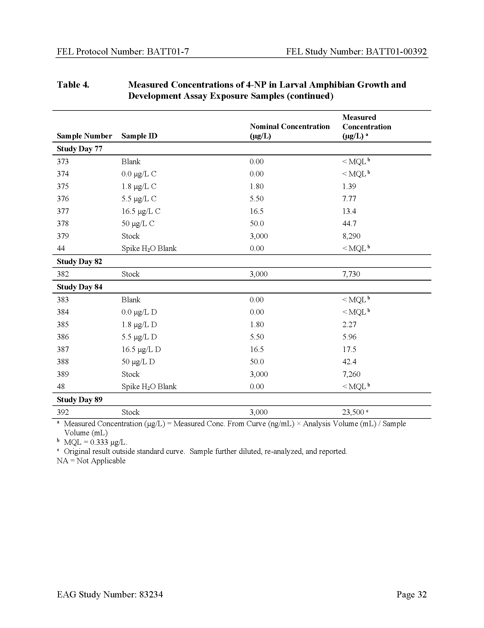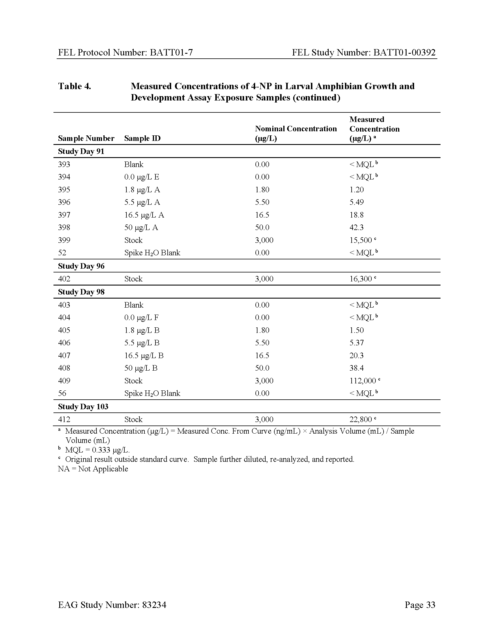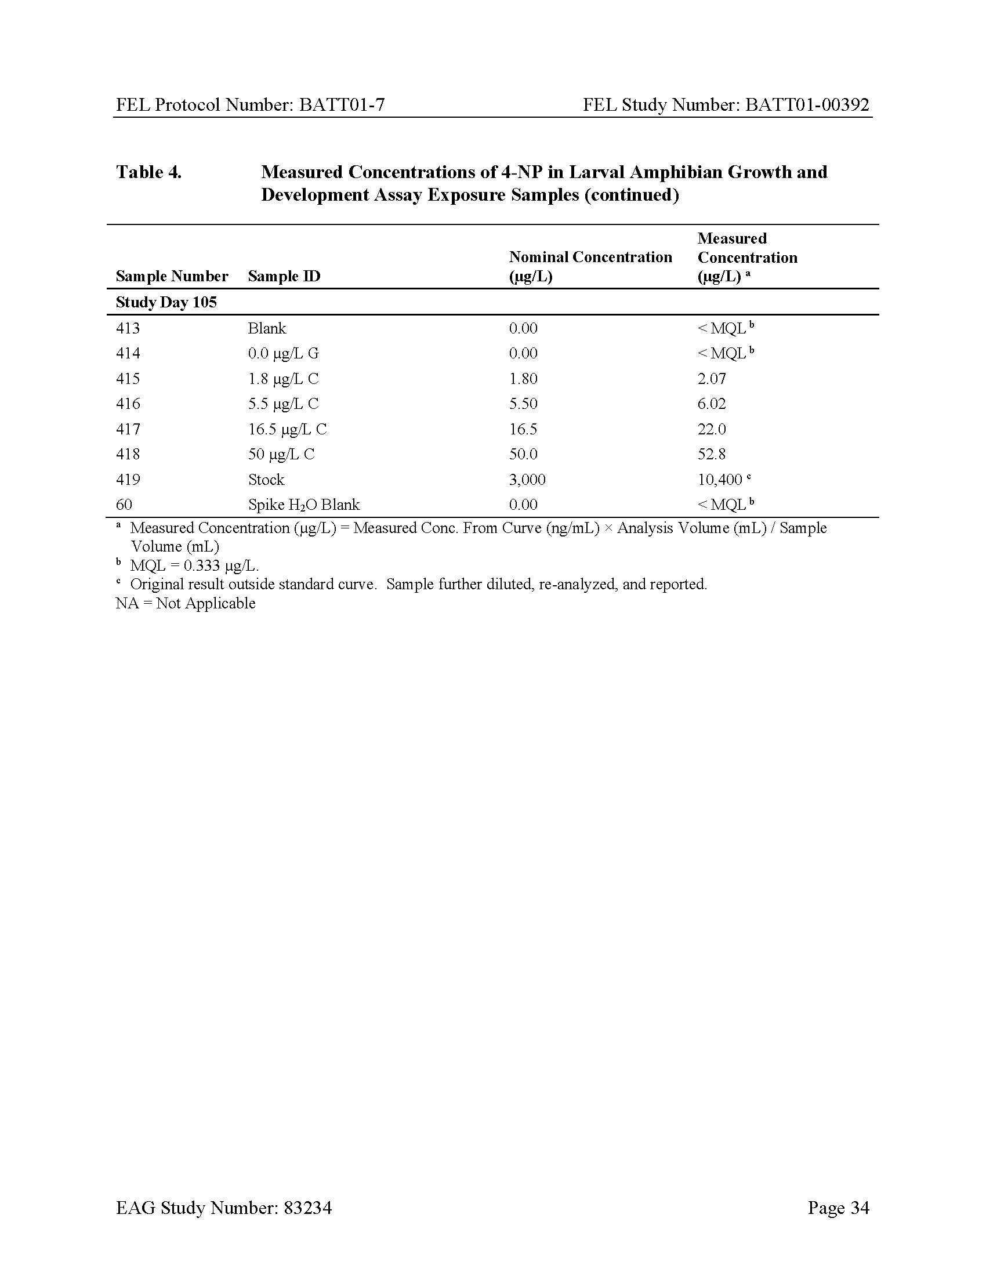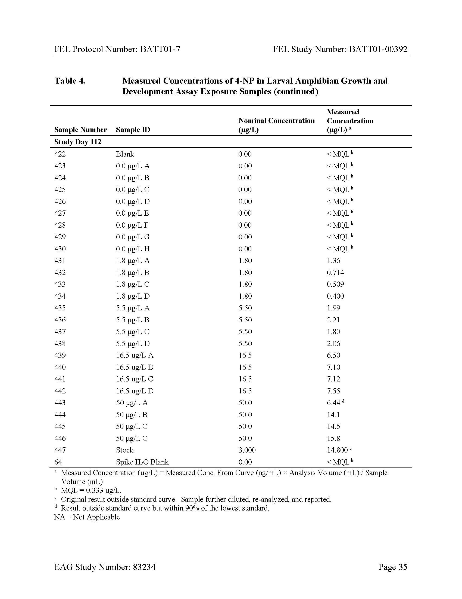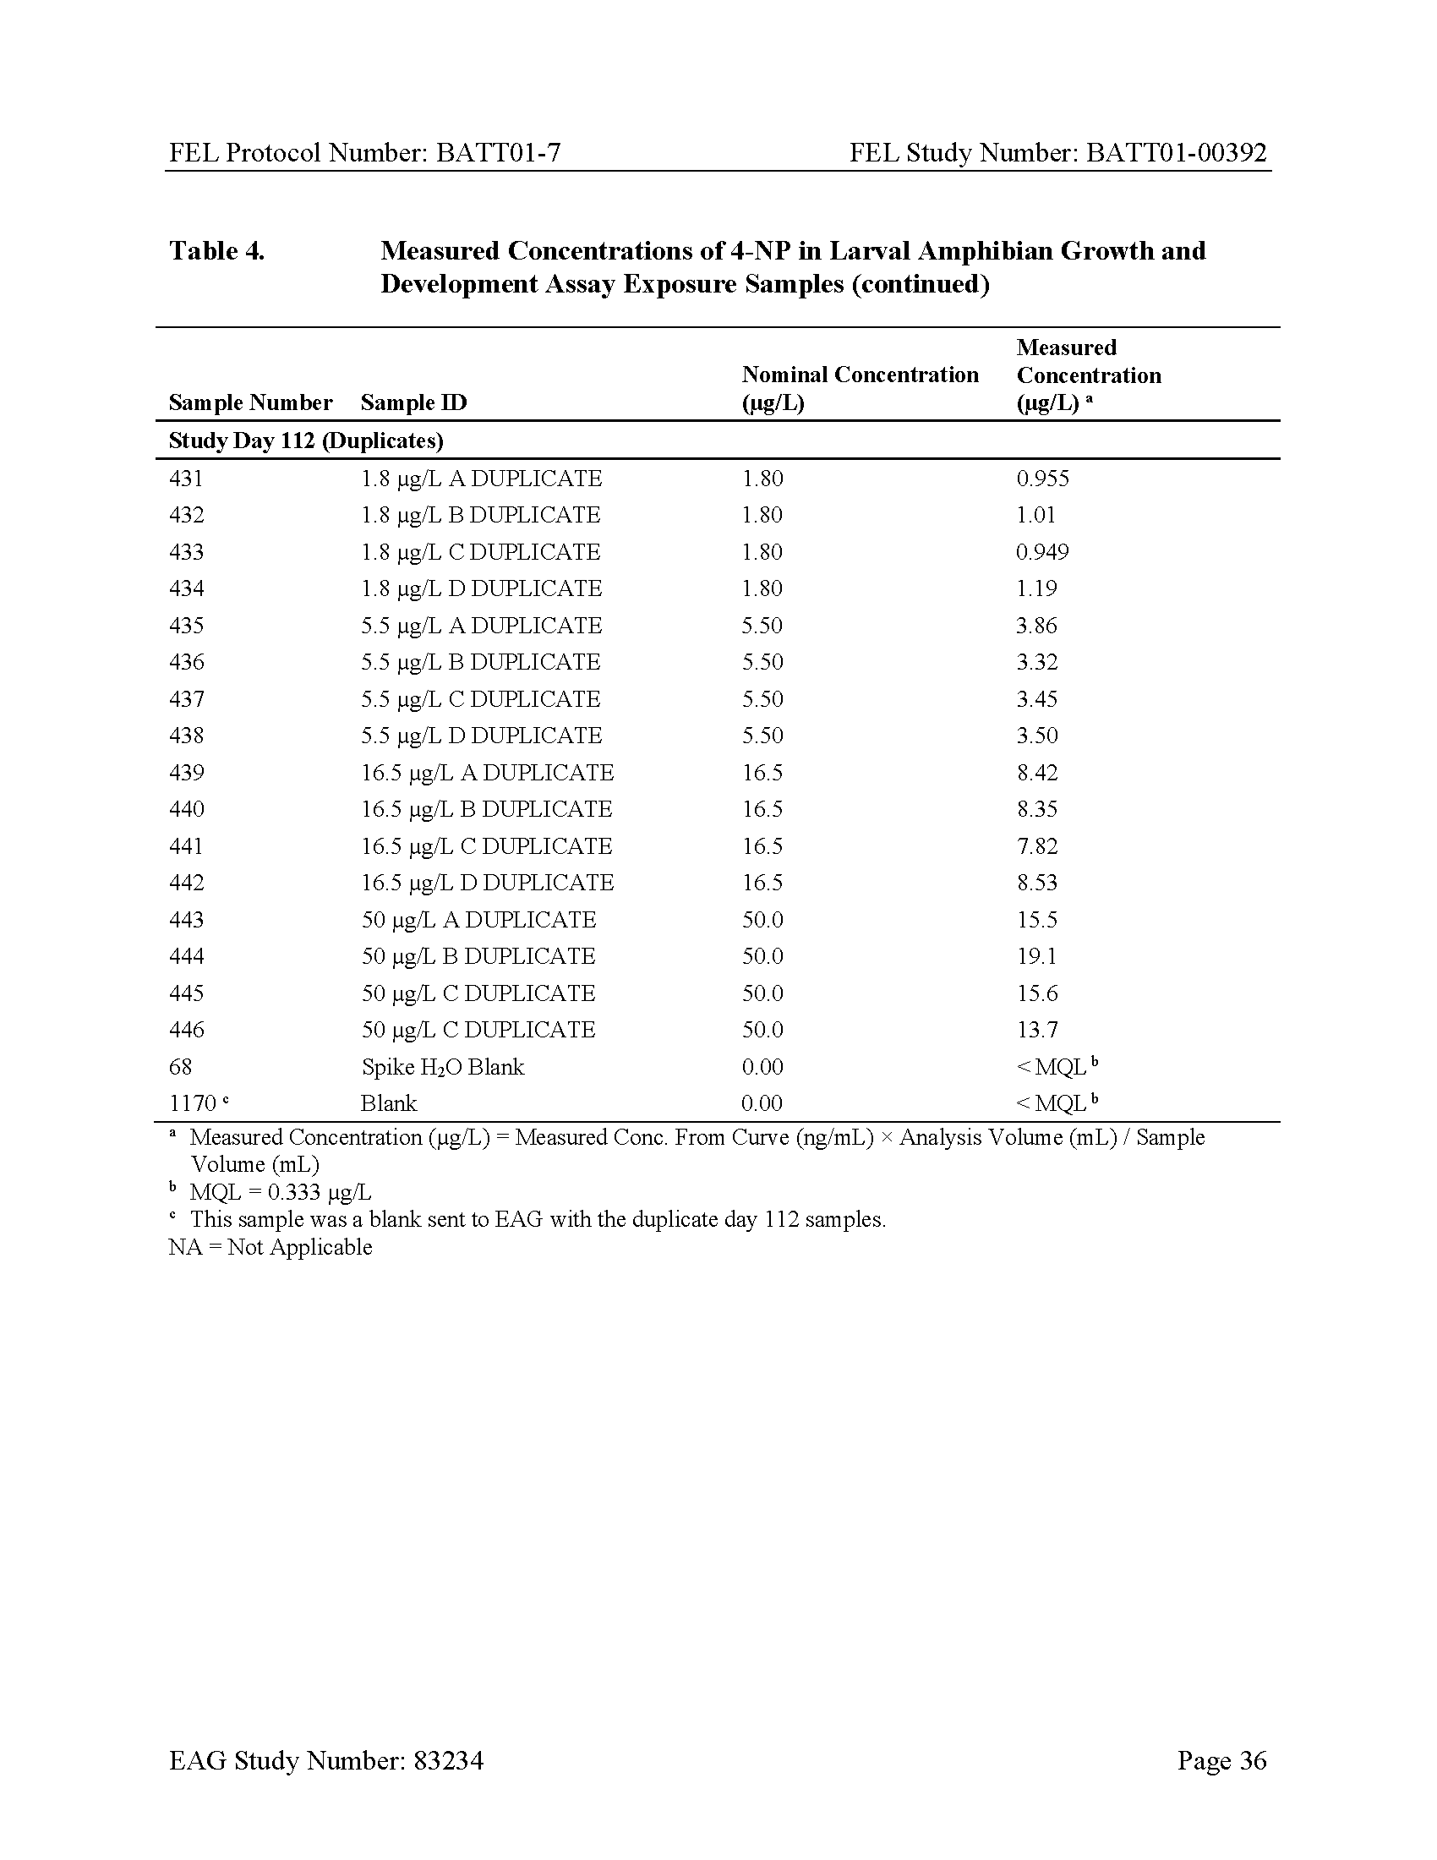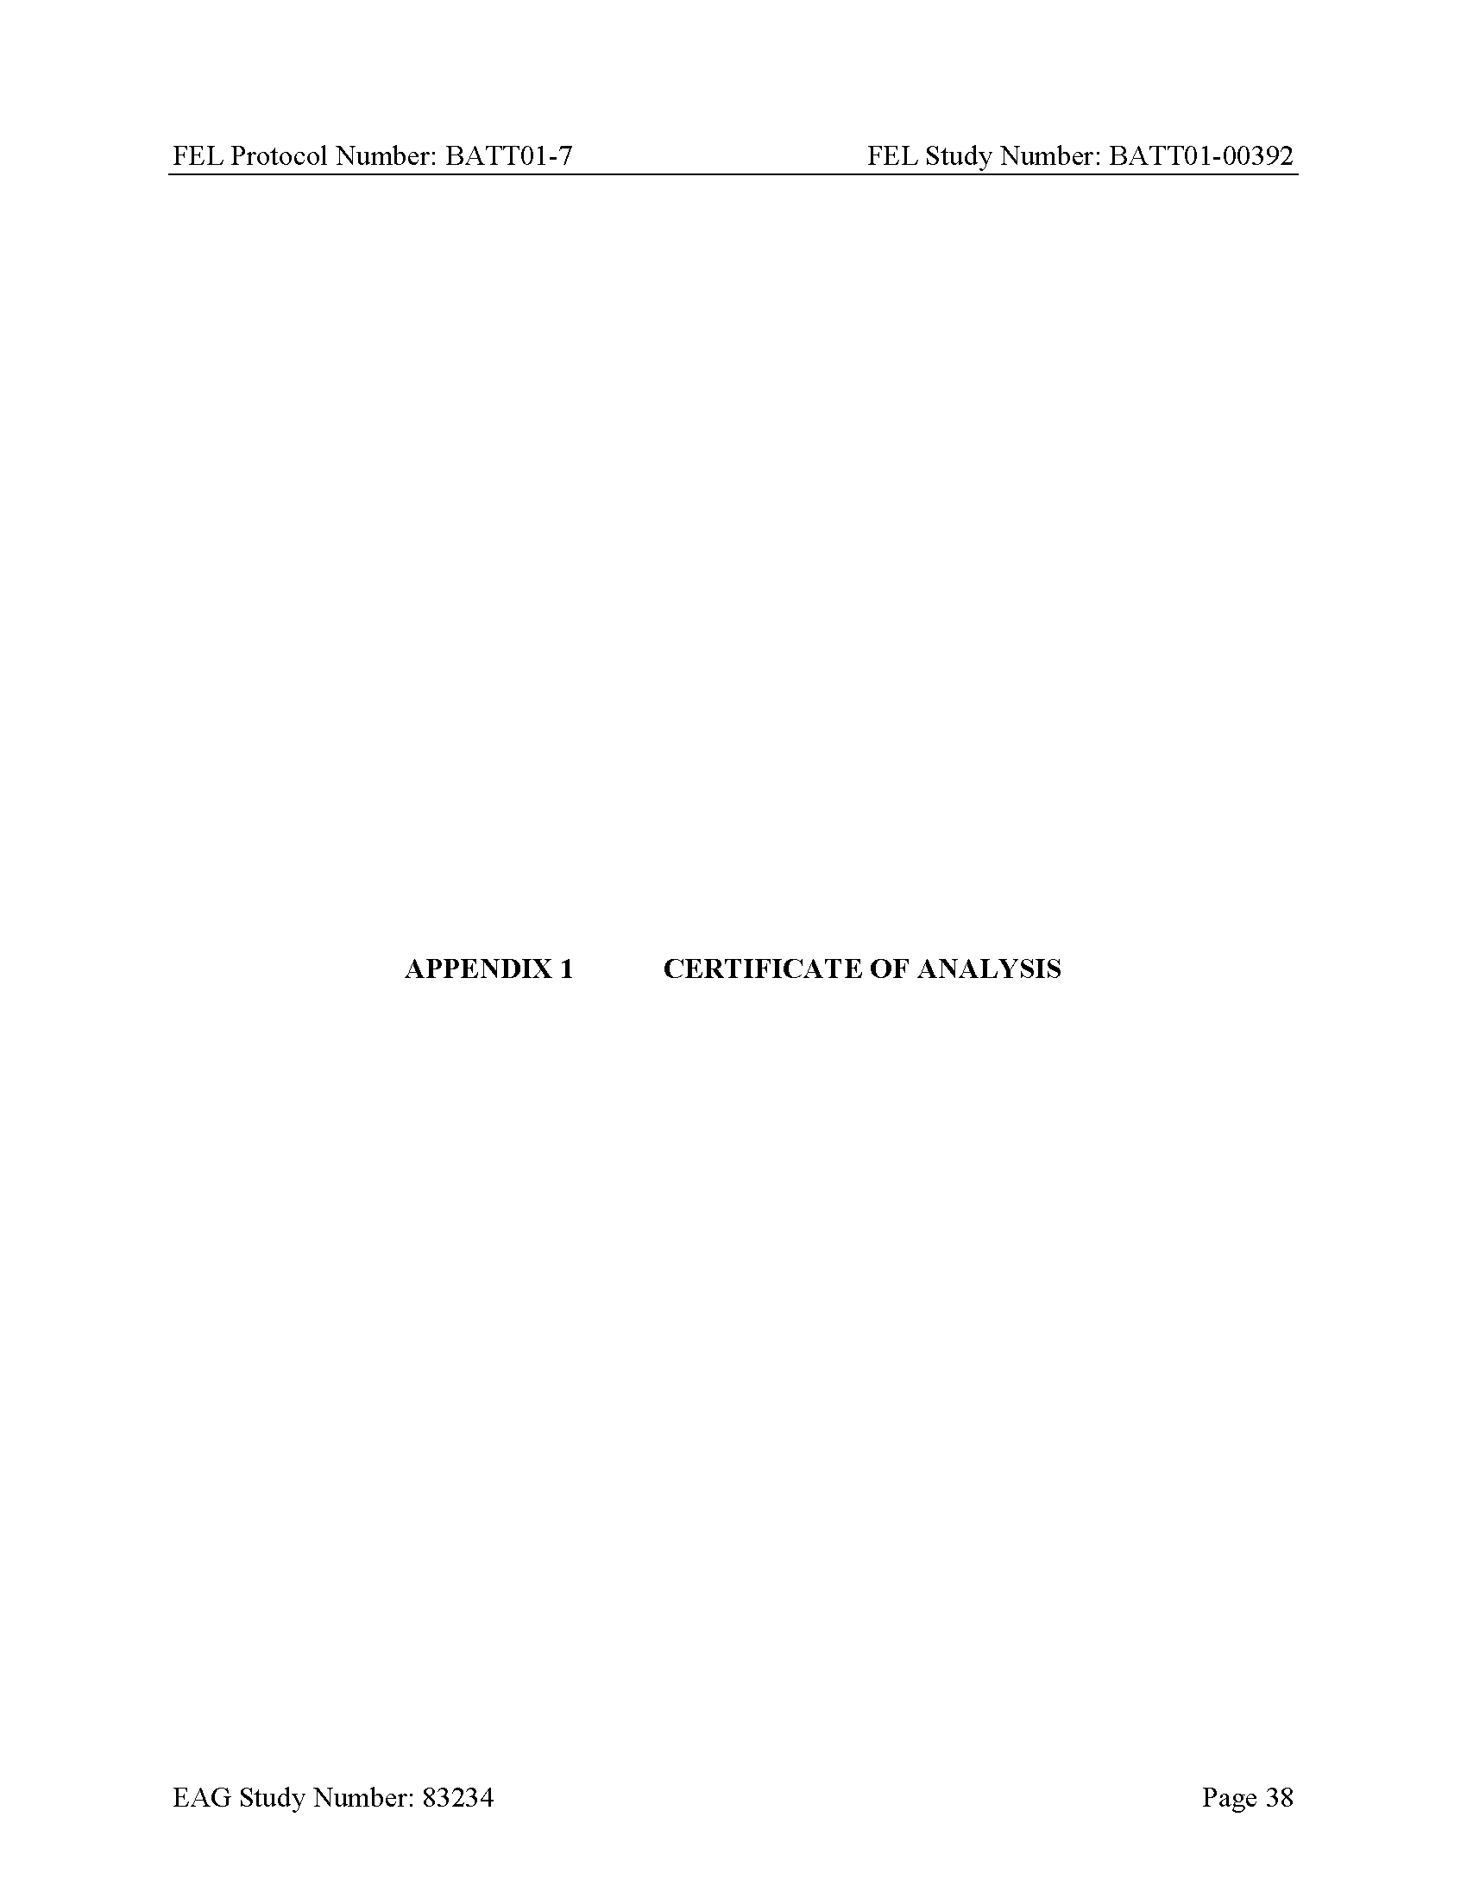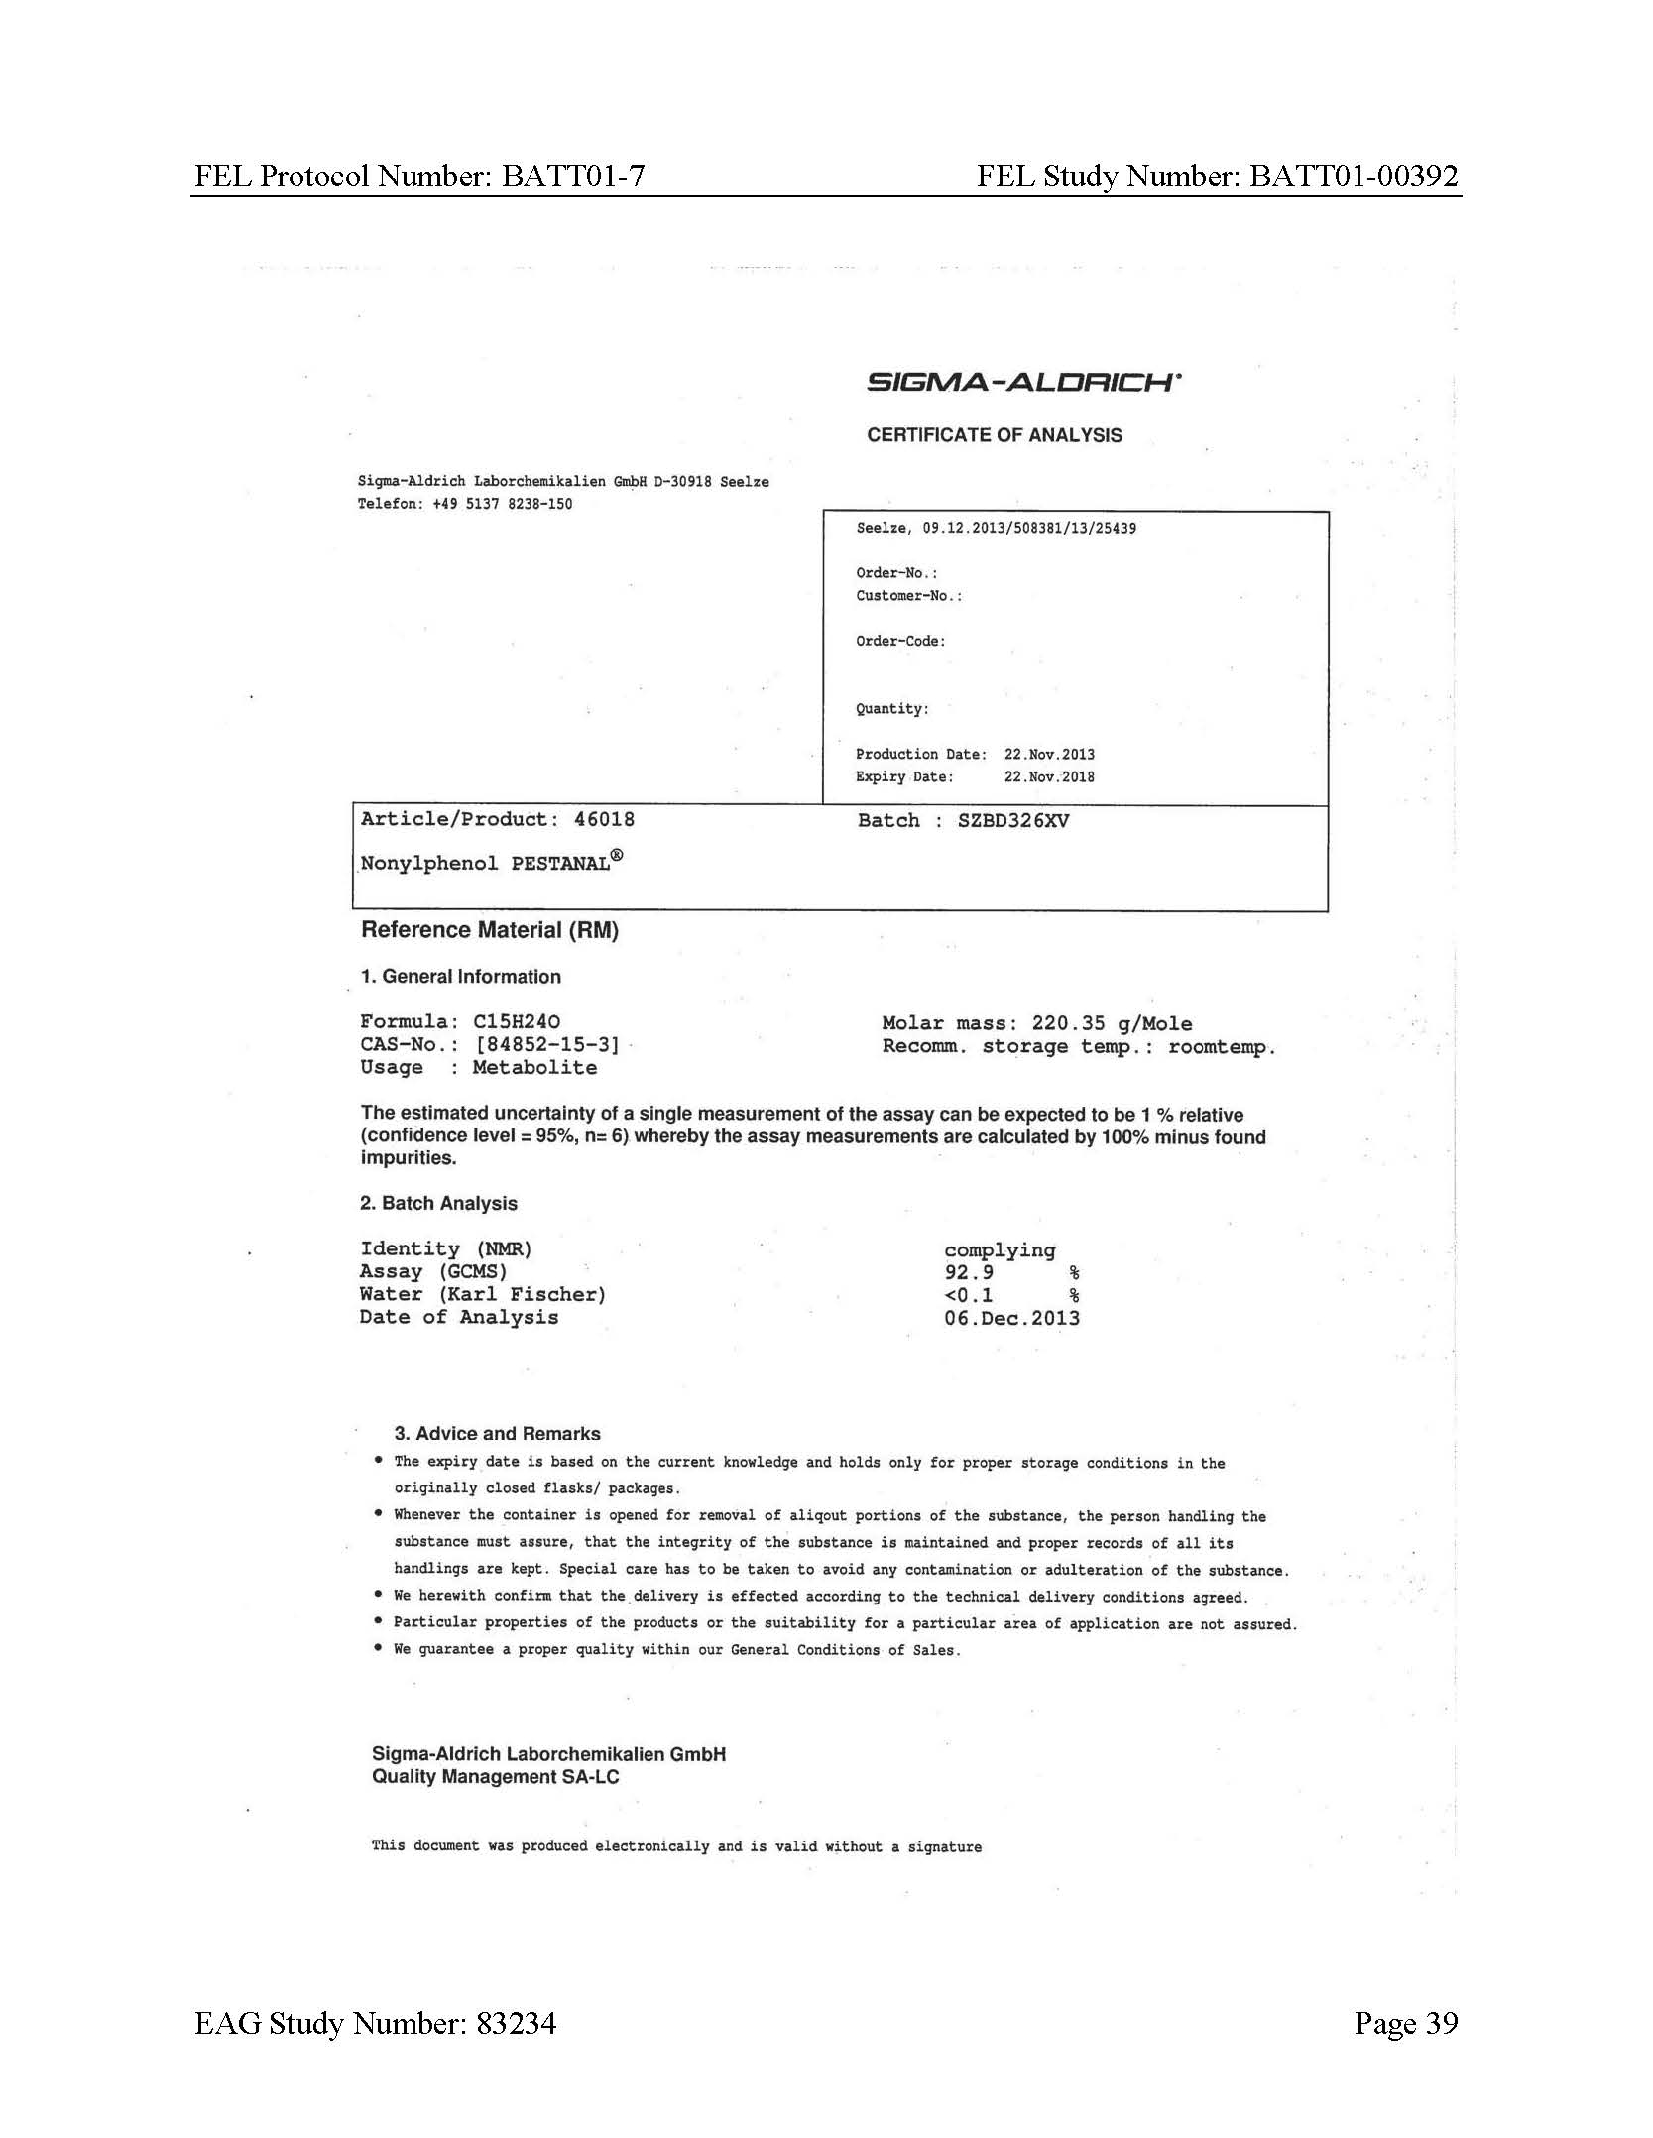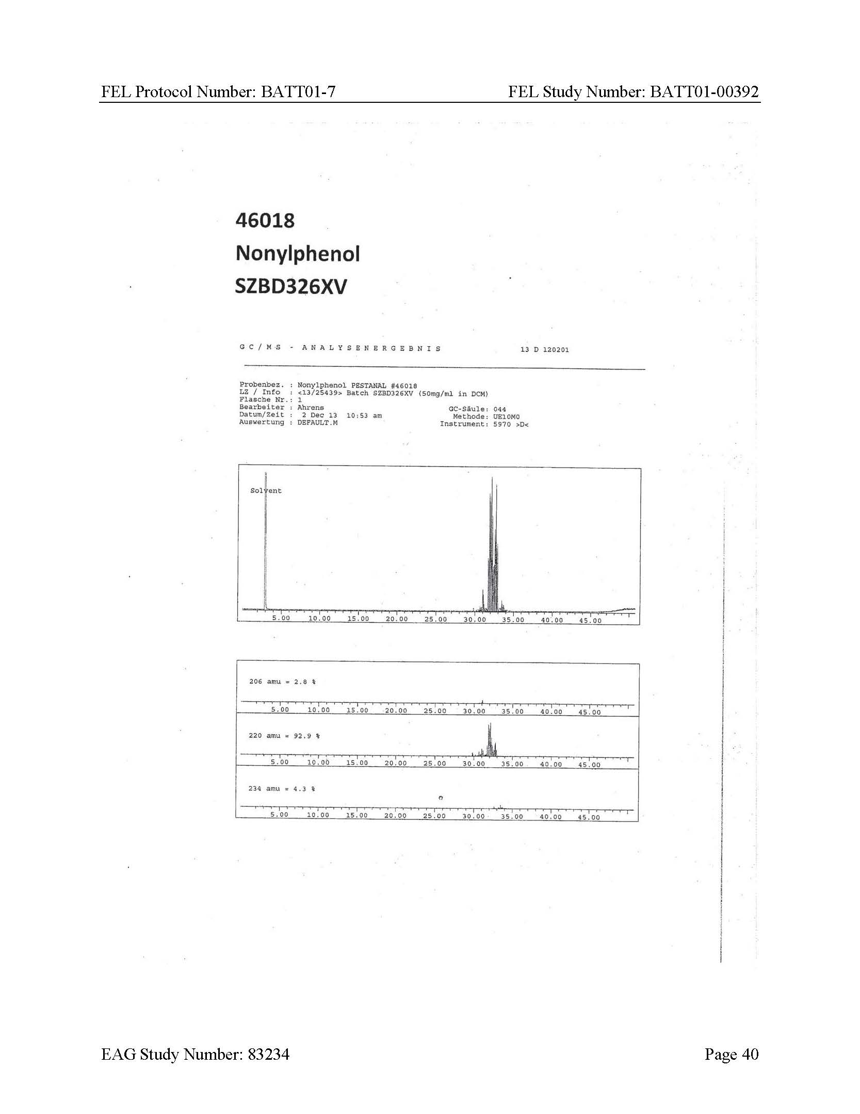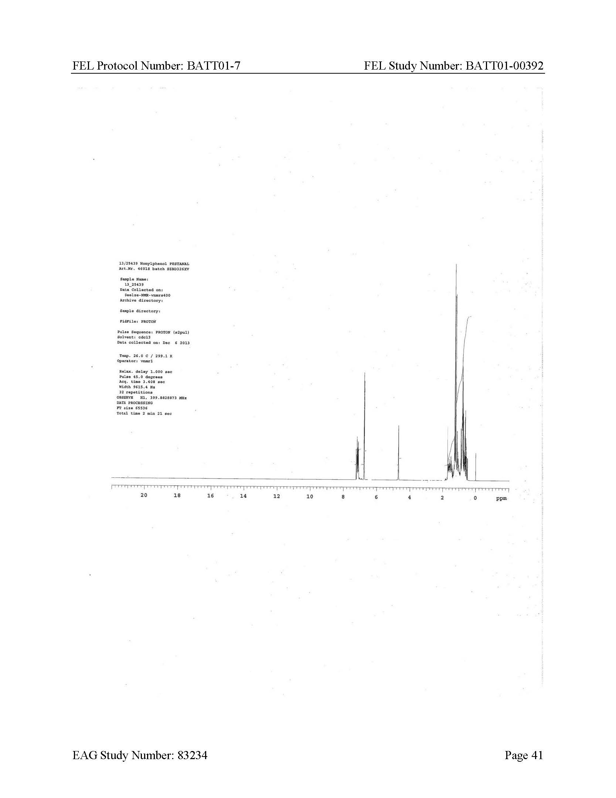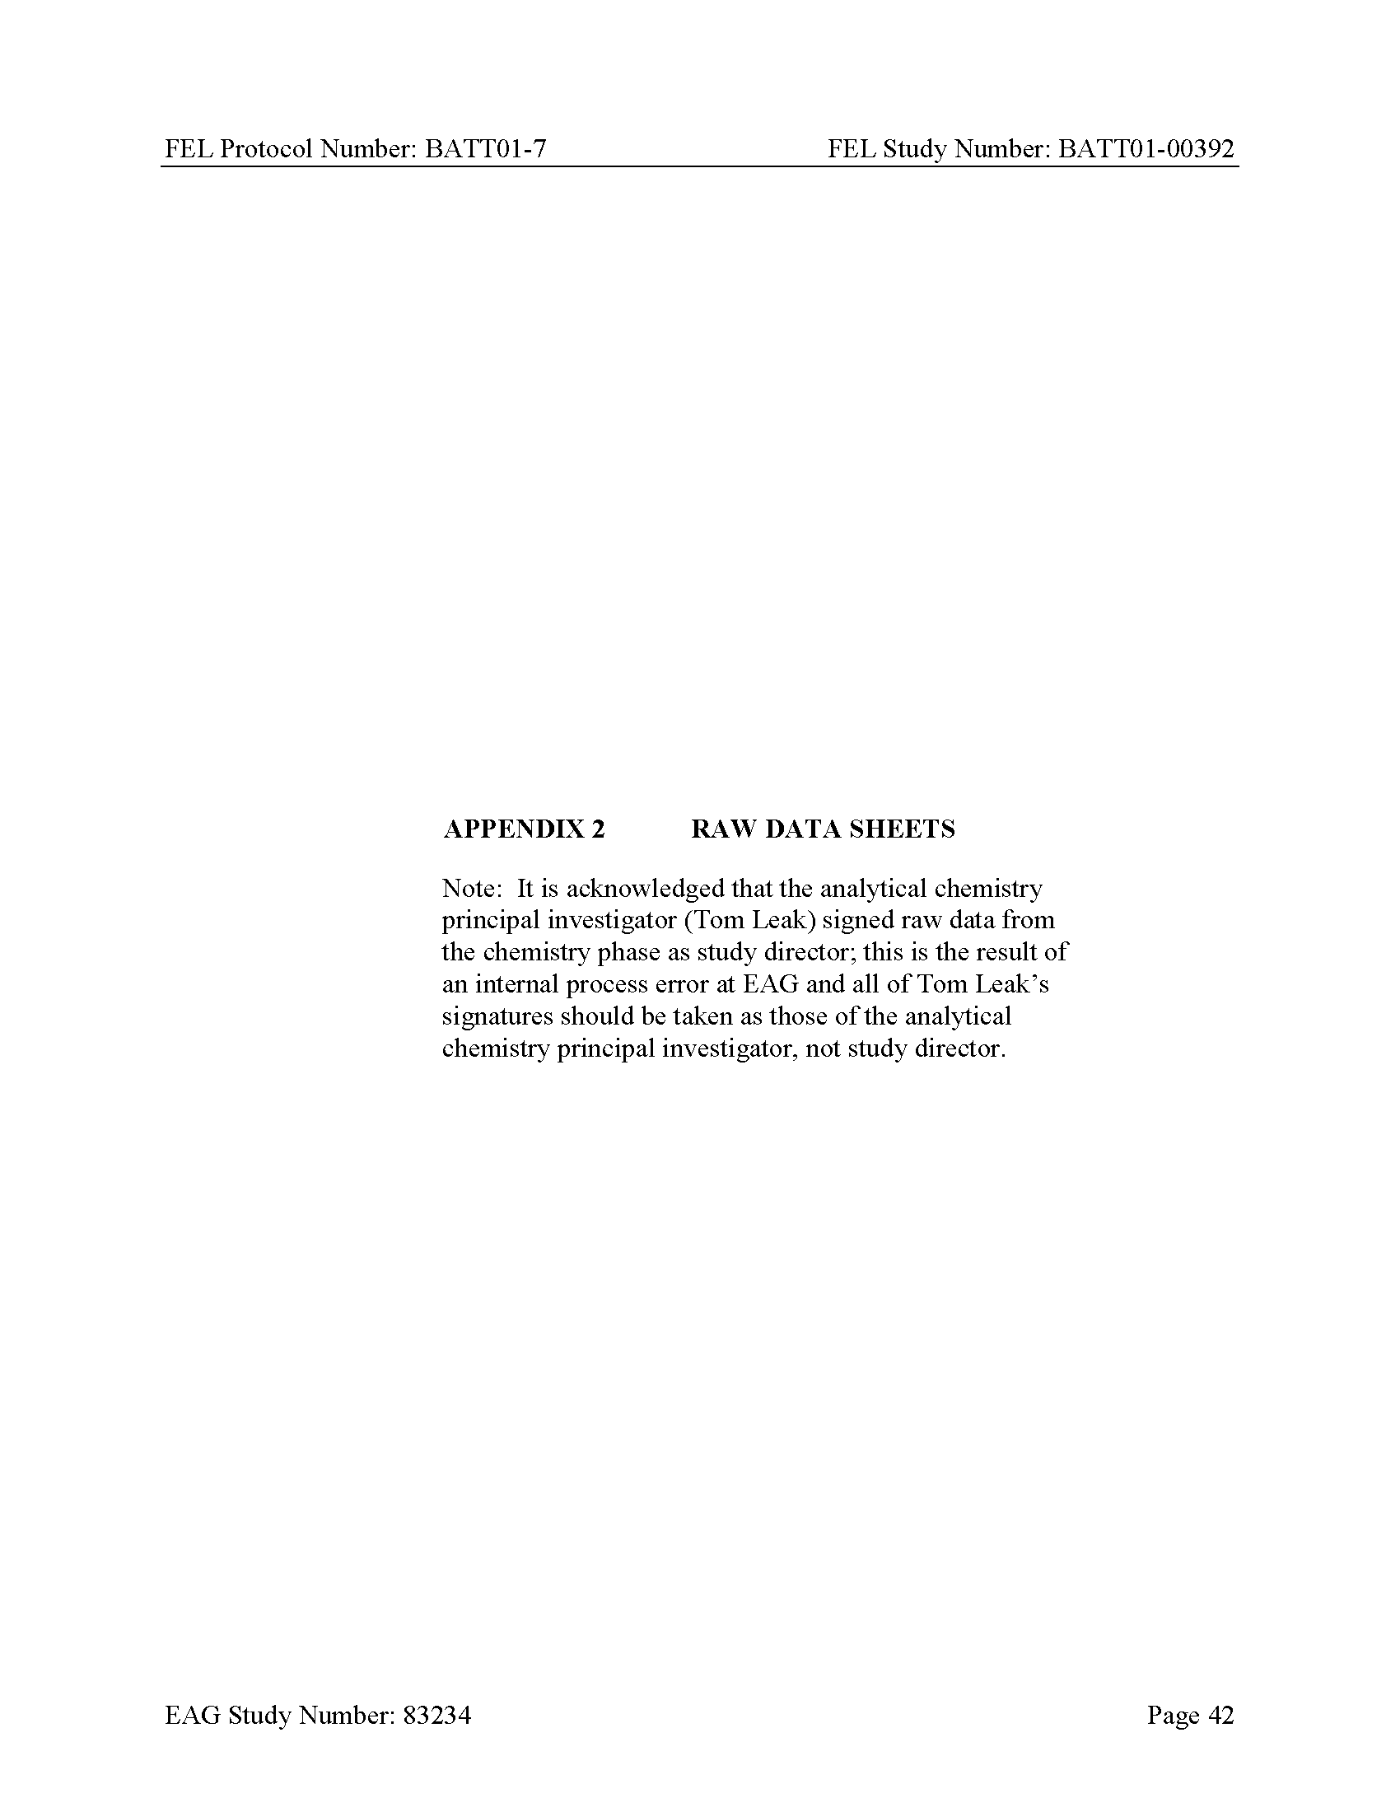

Histopathology Data Reports

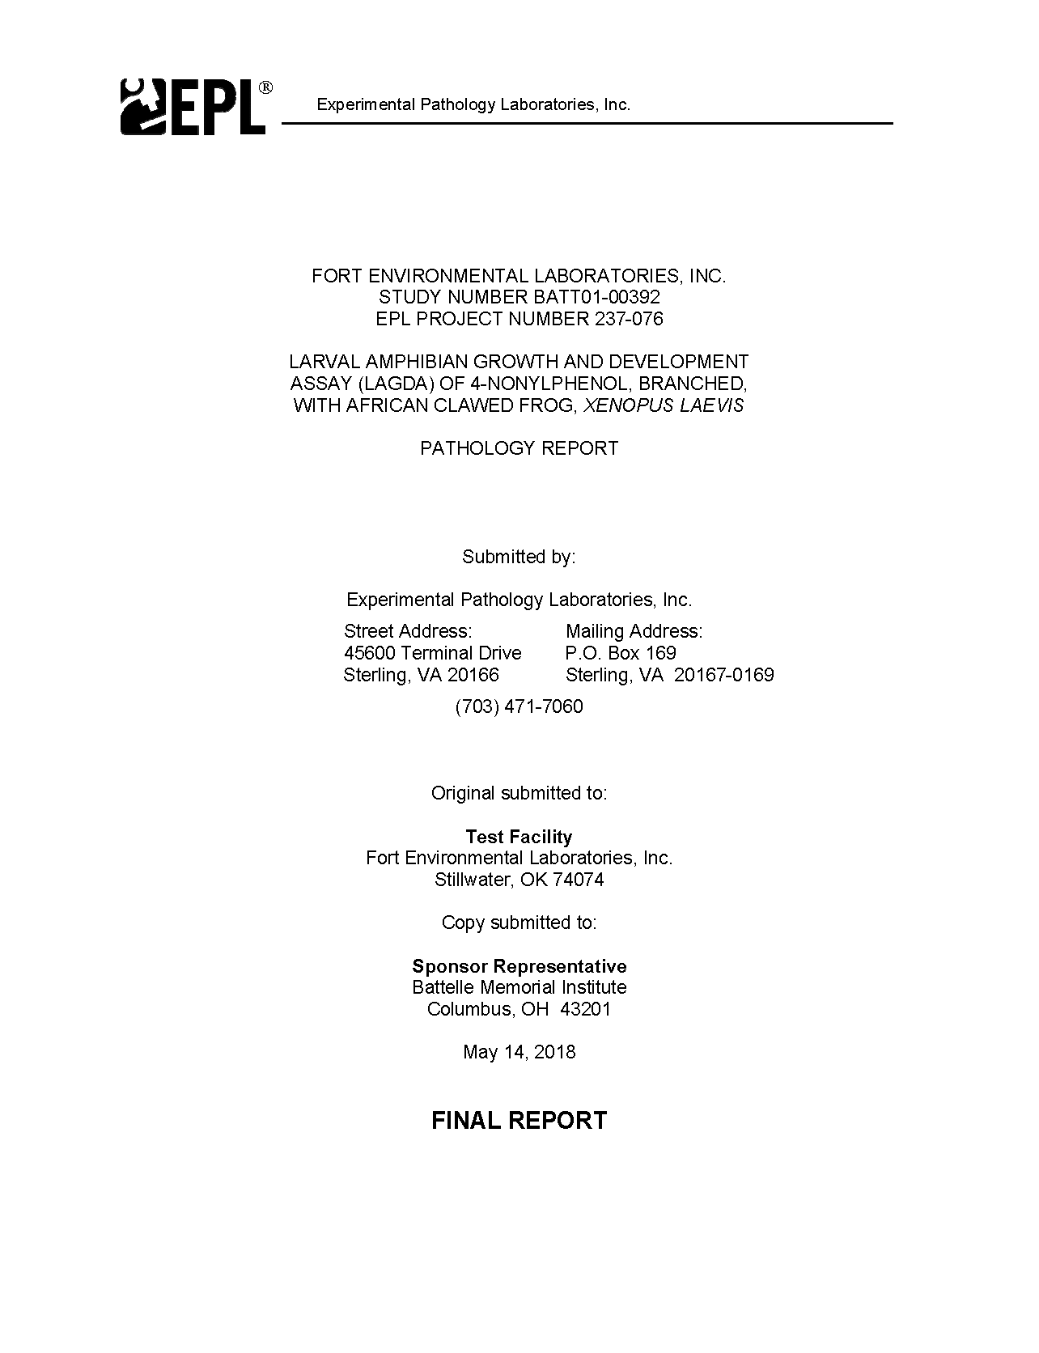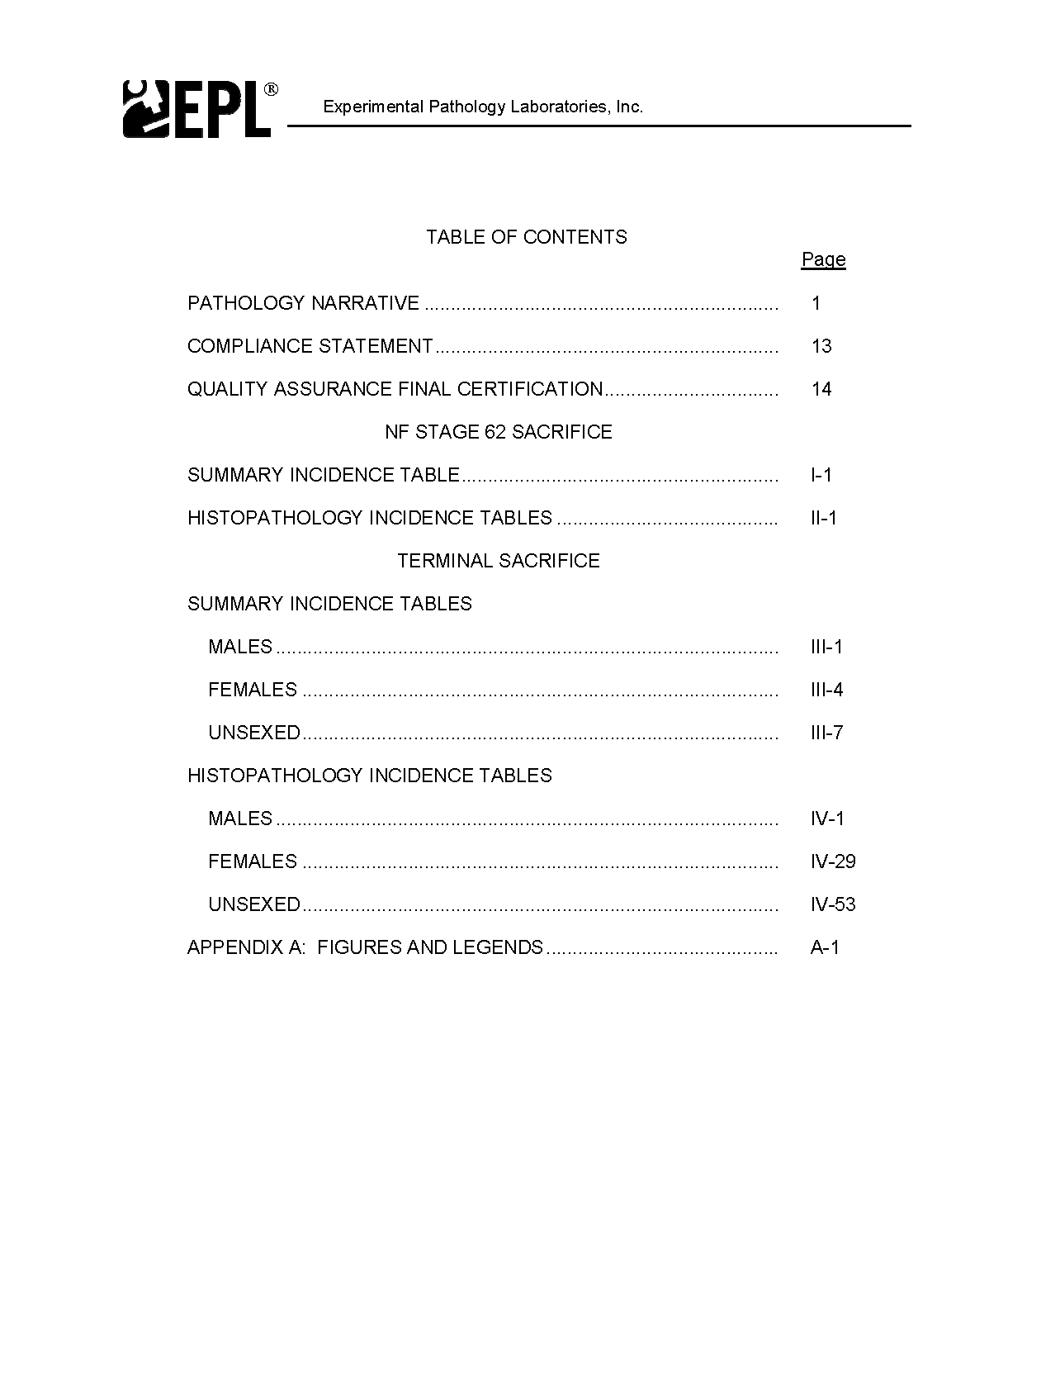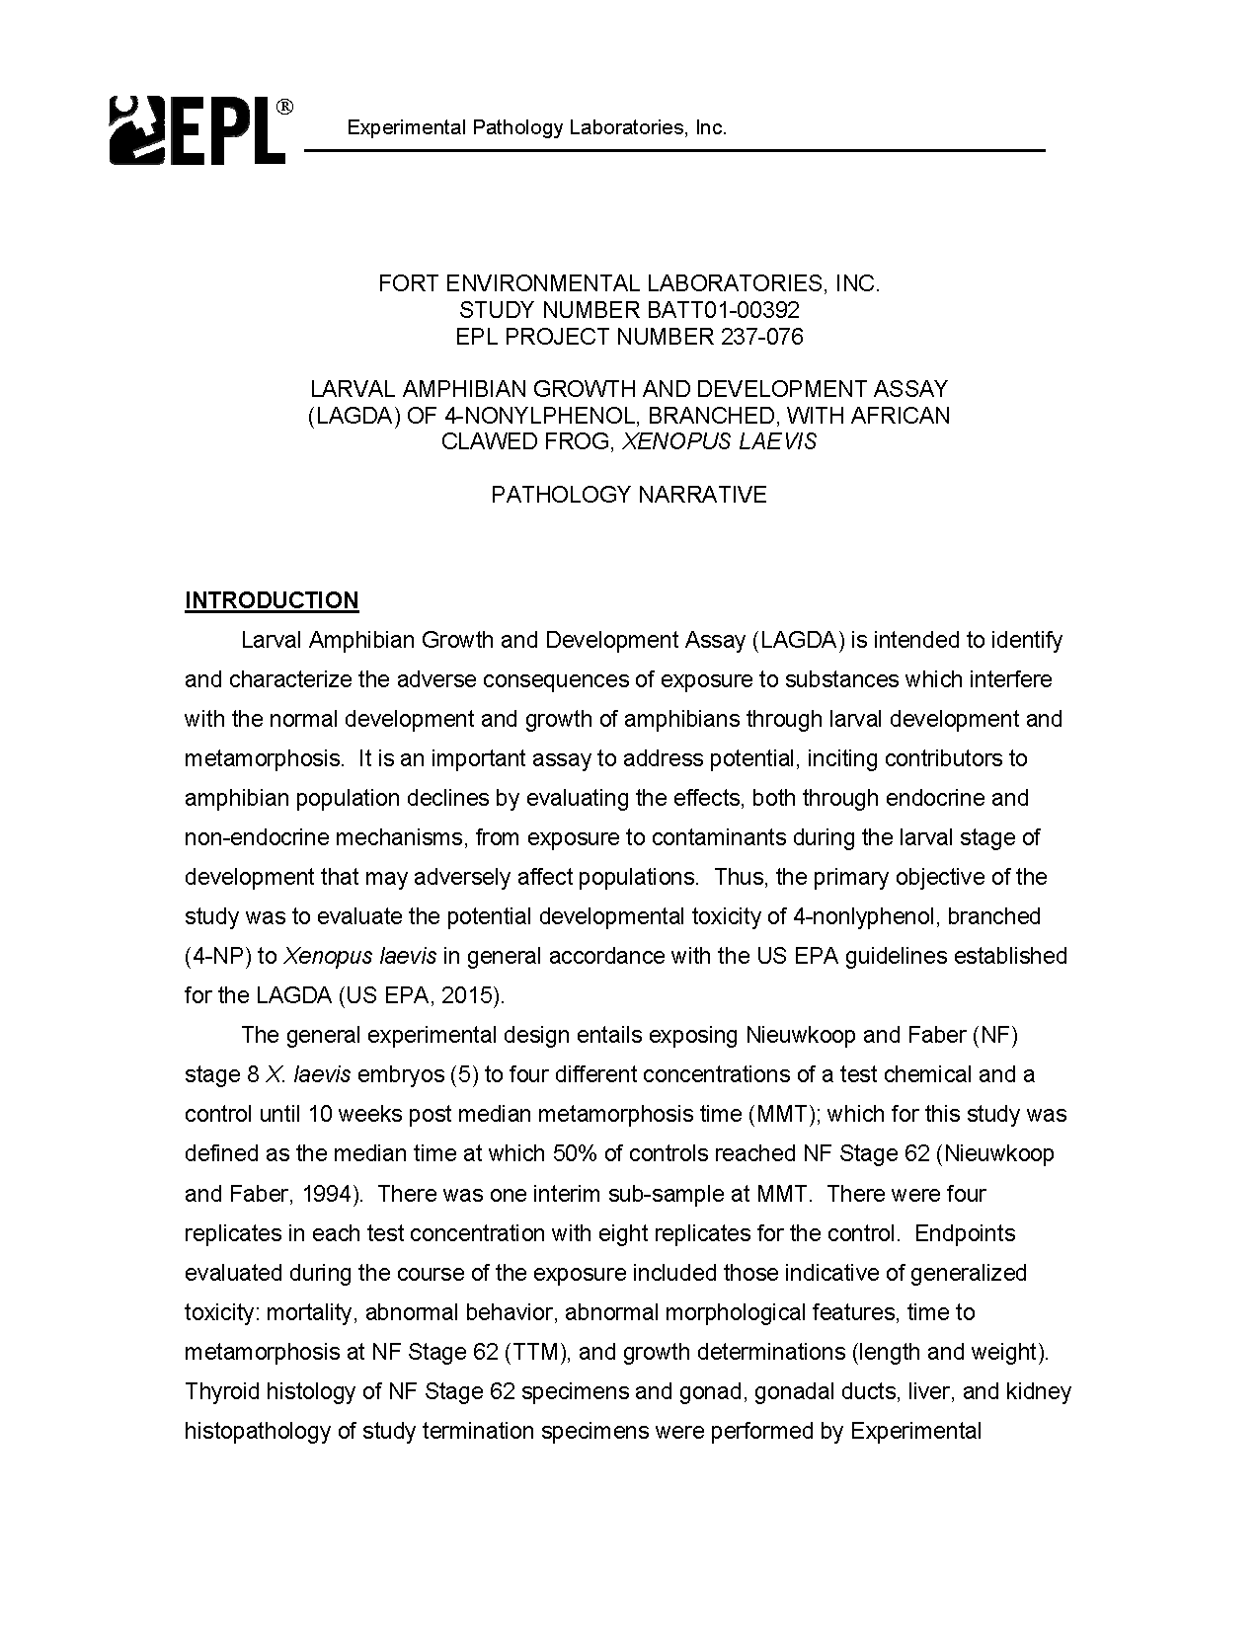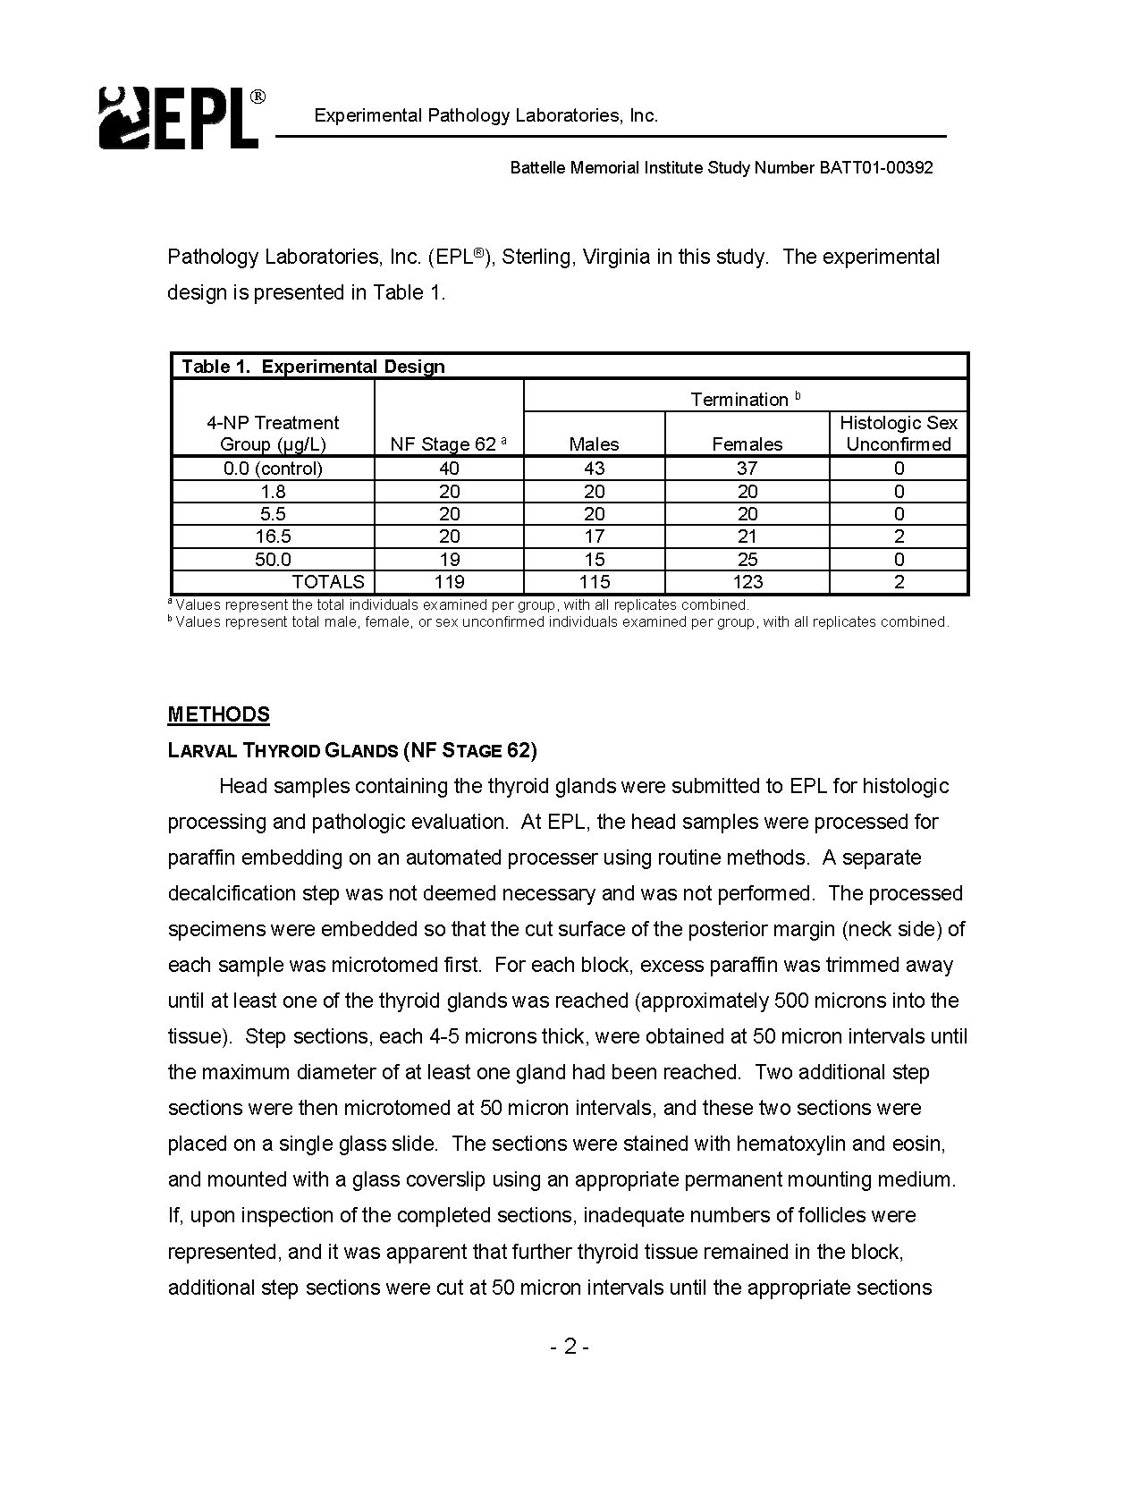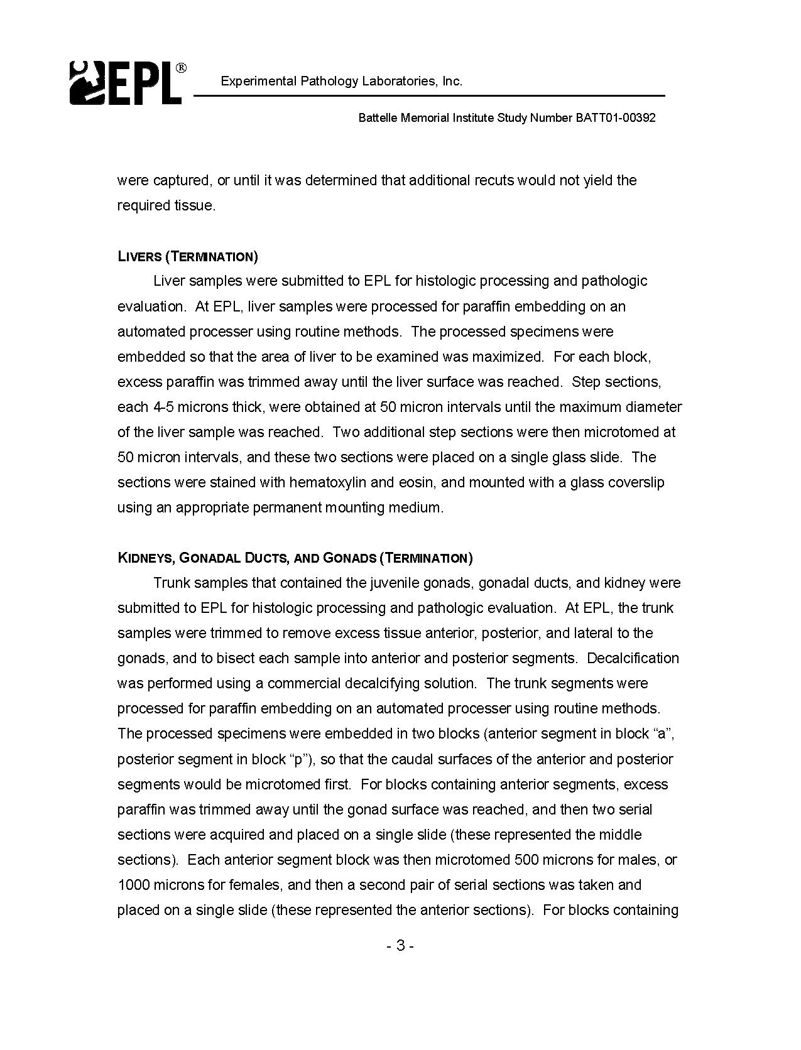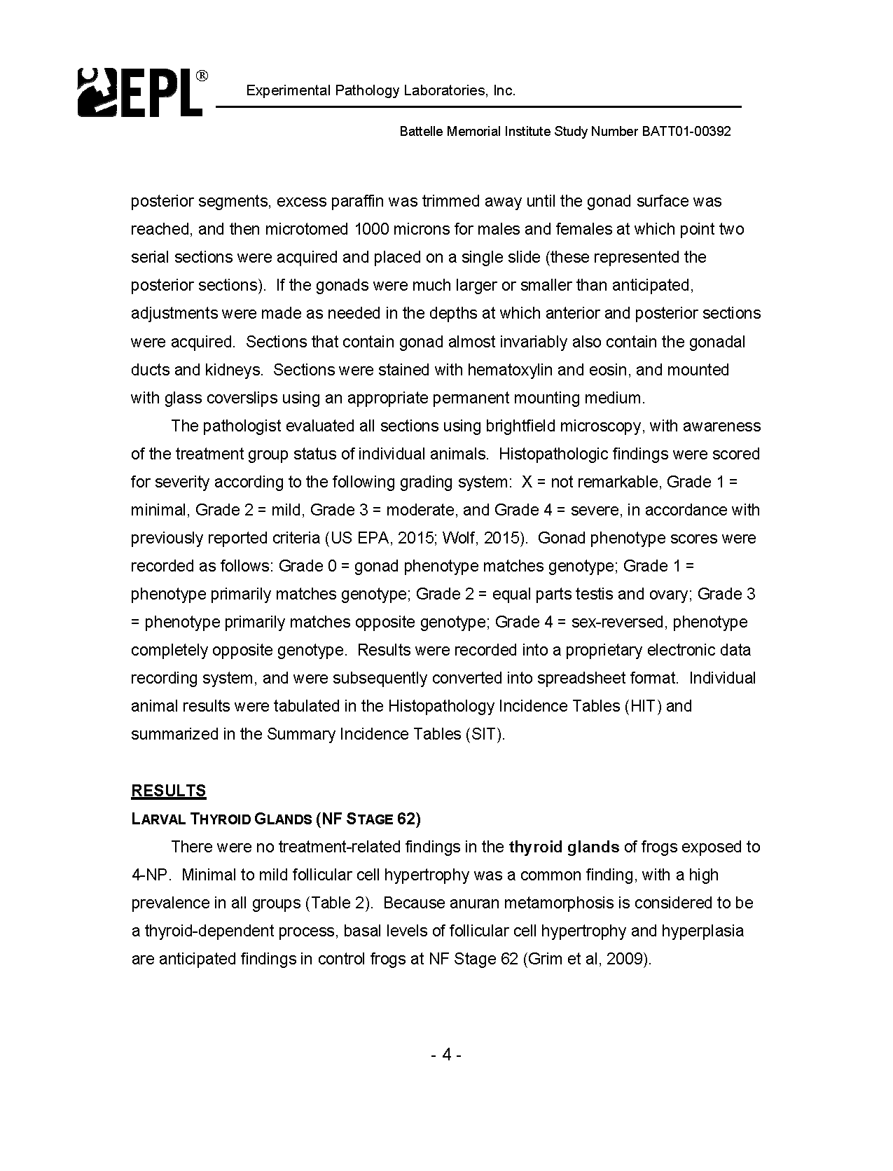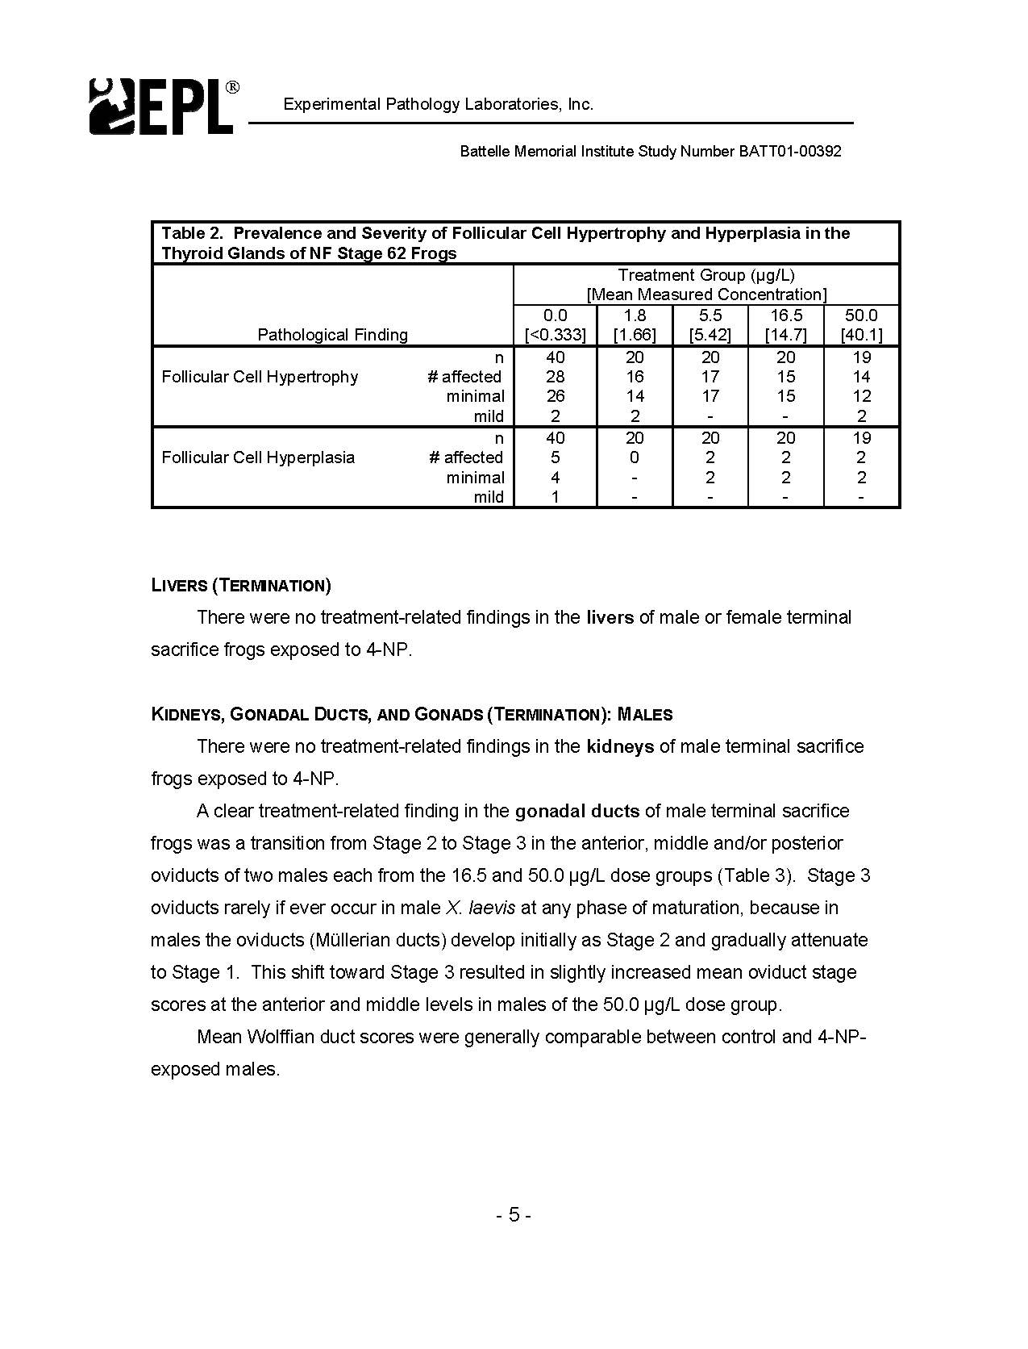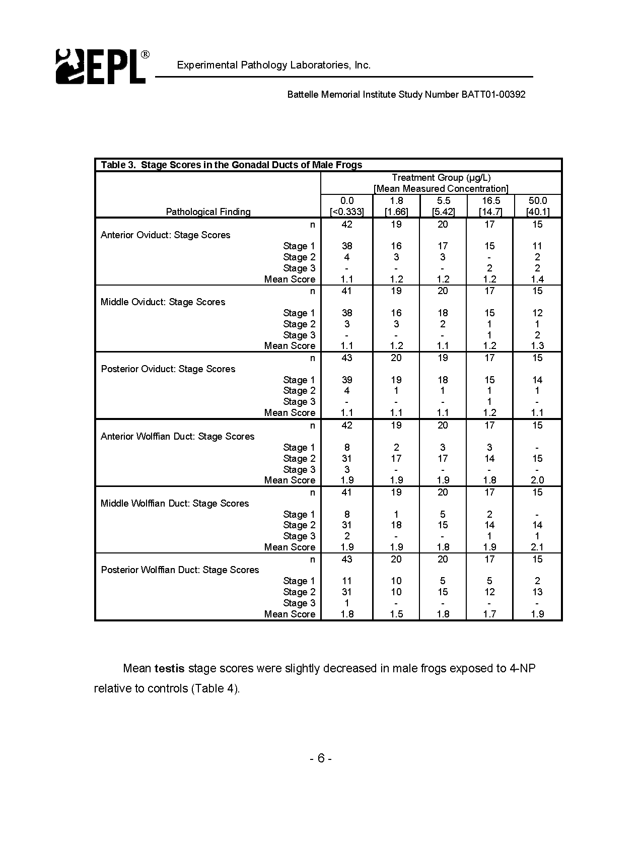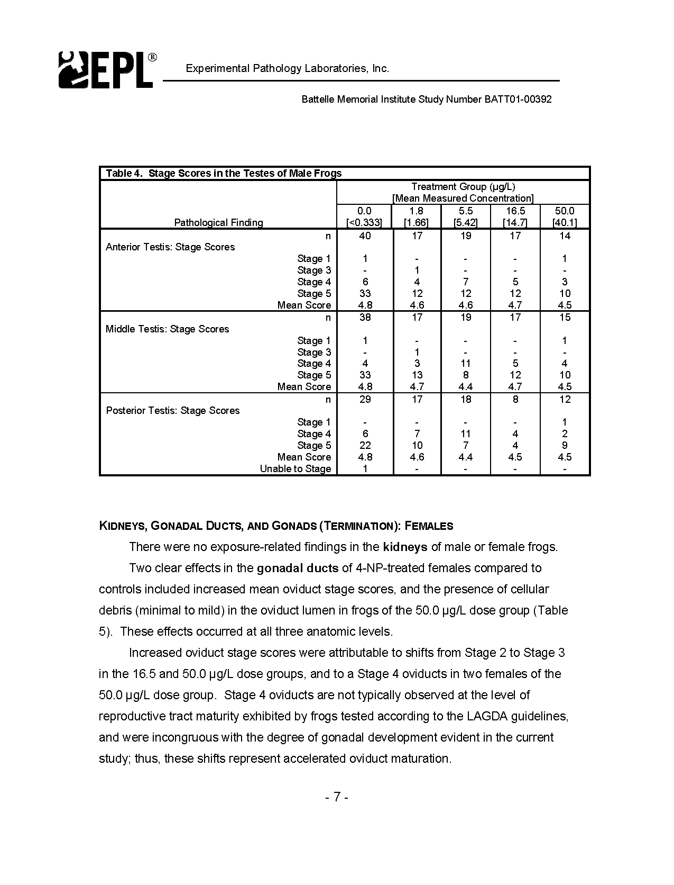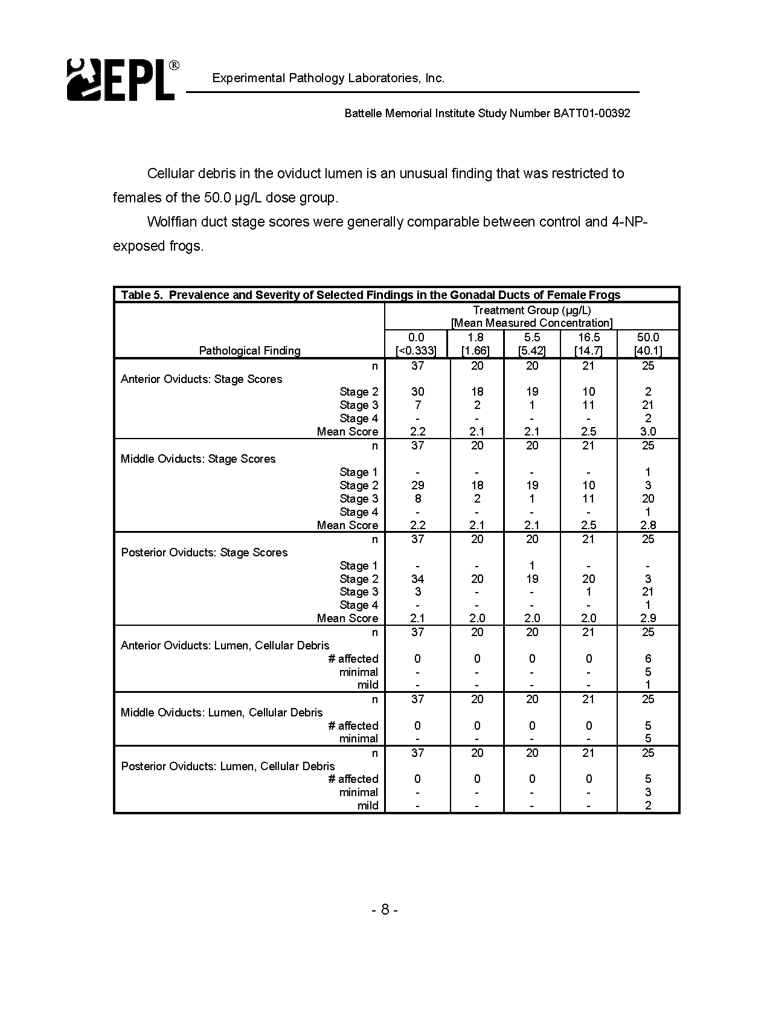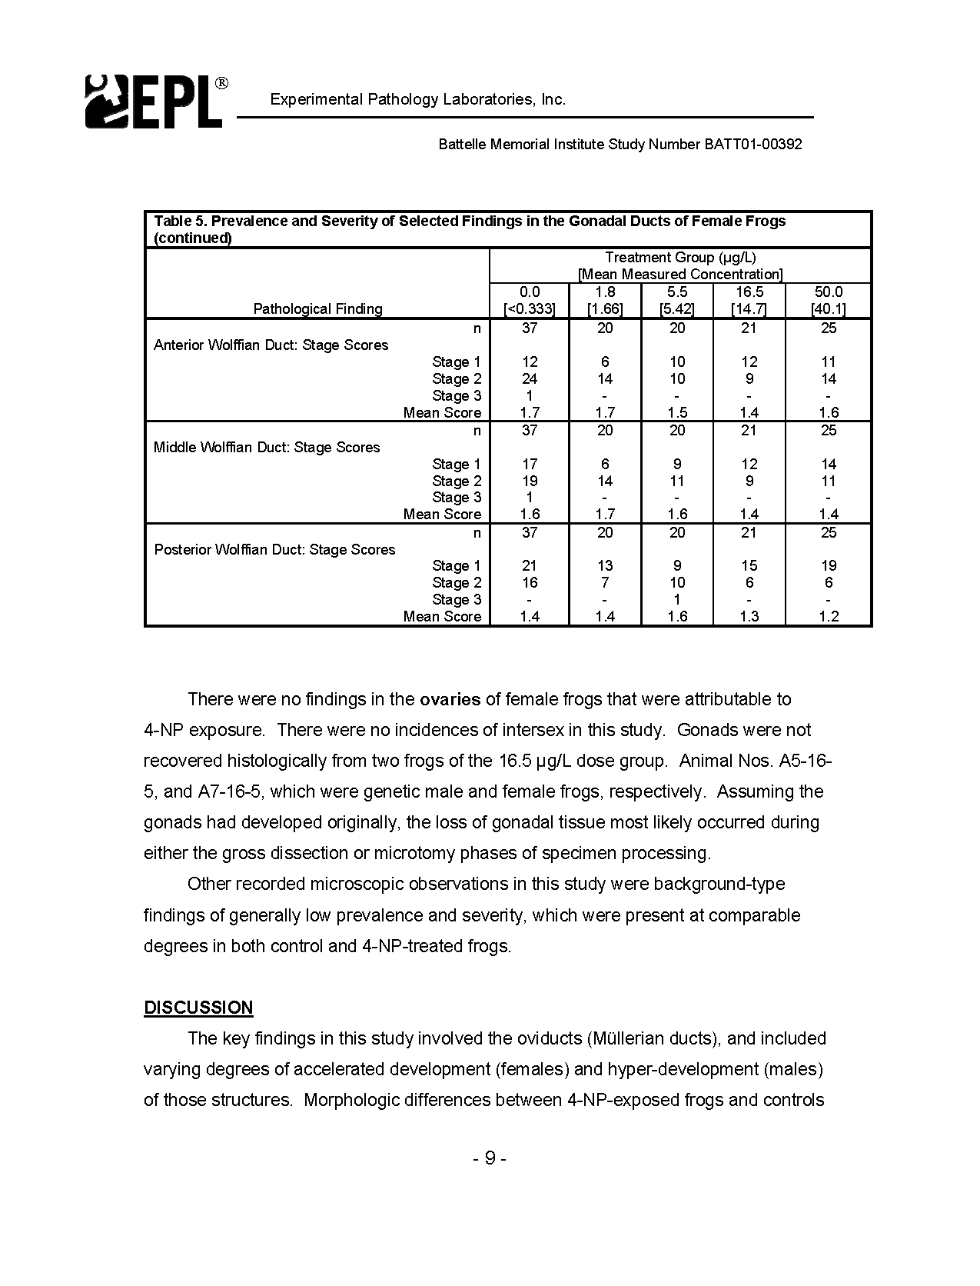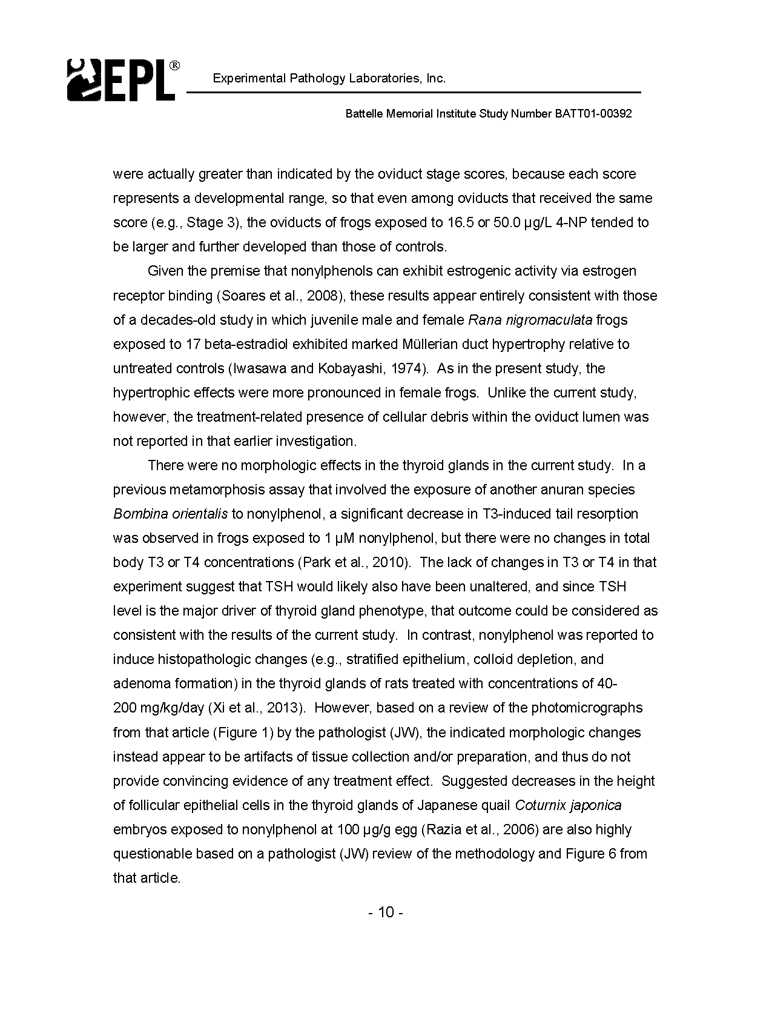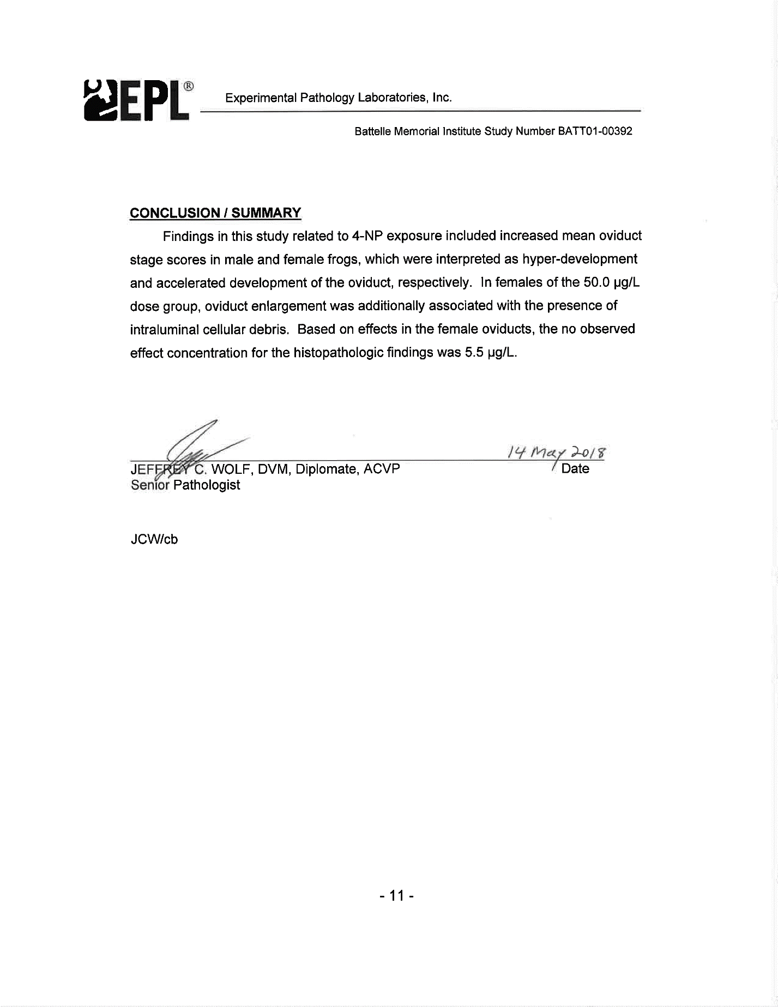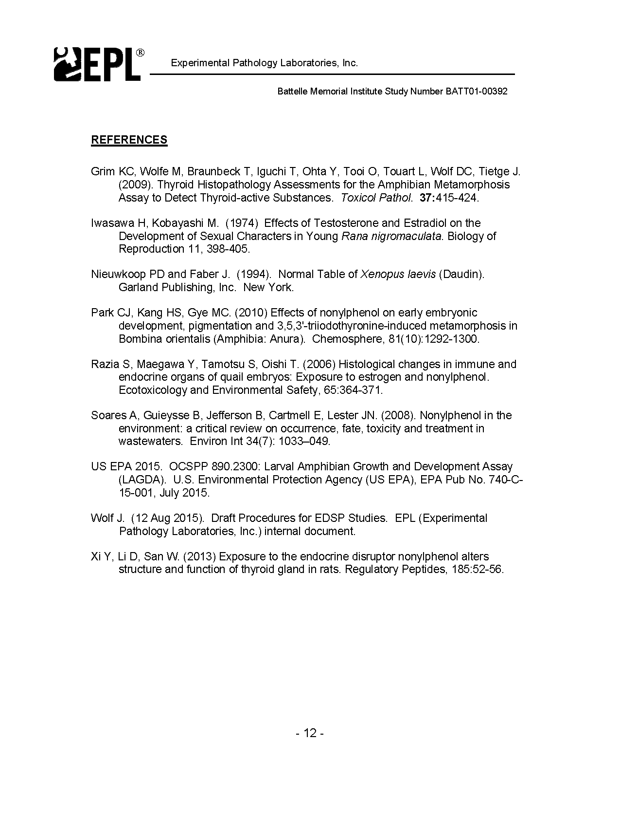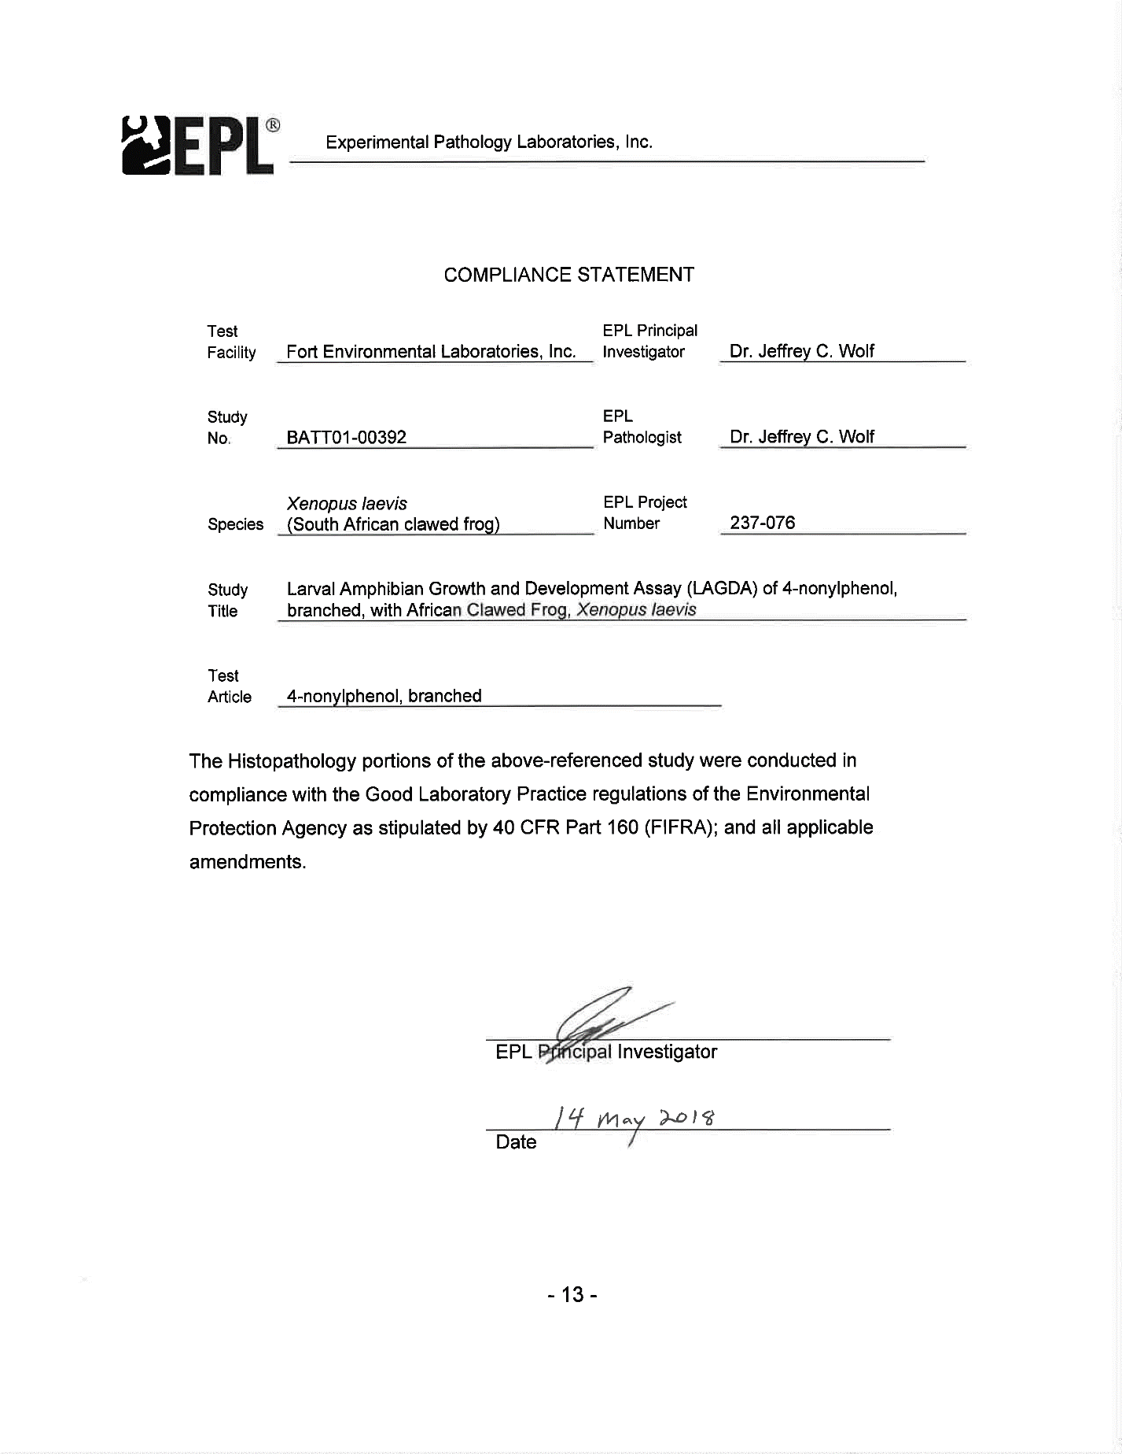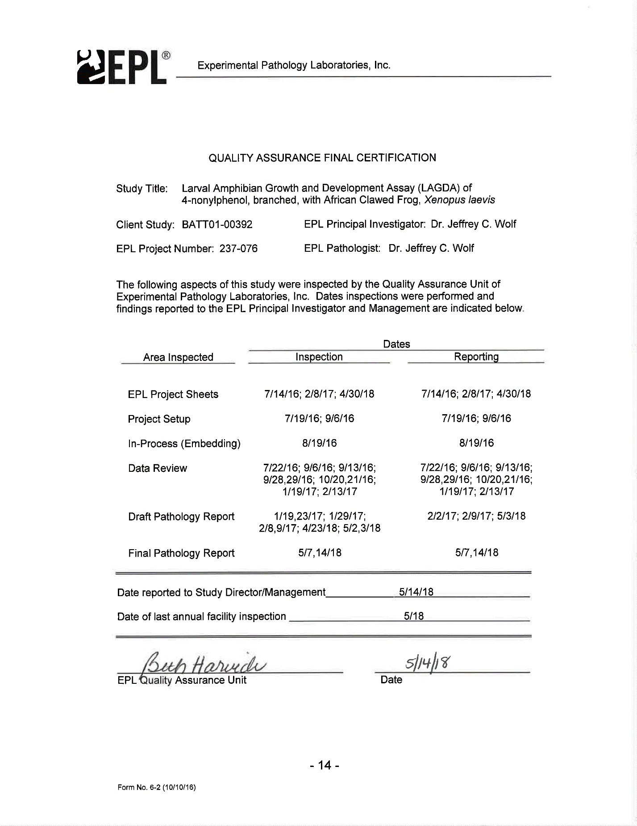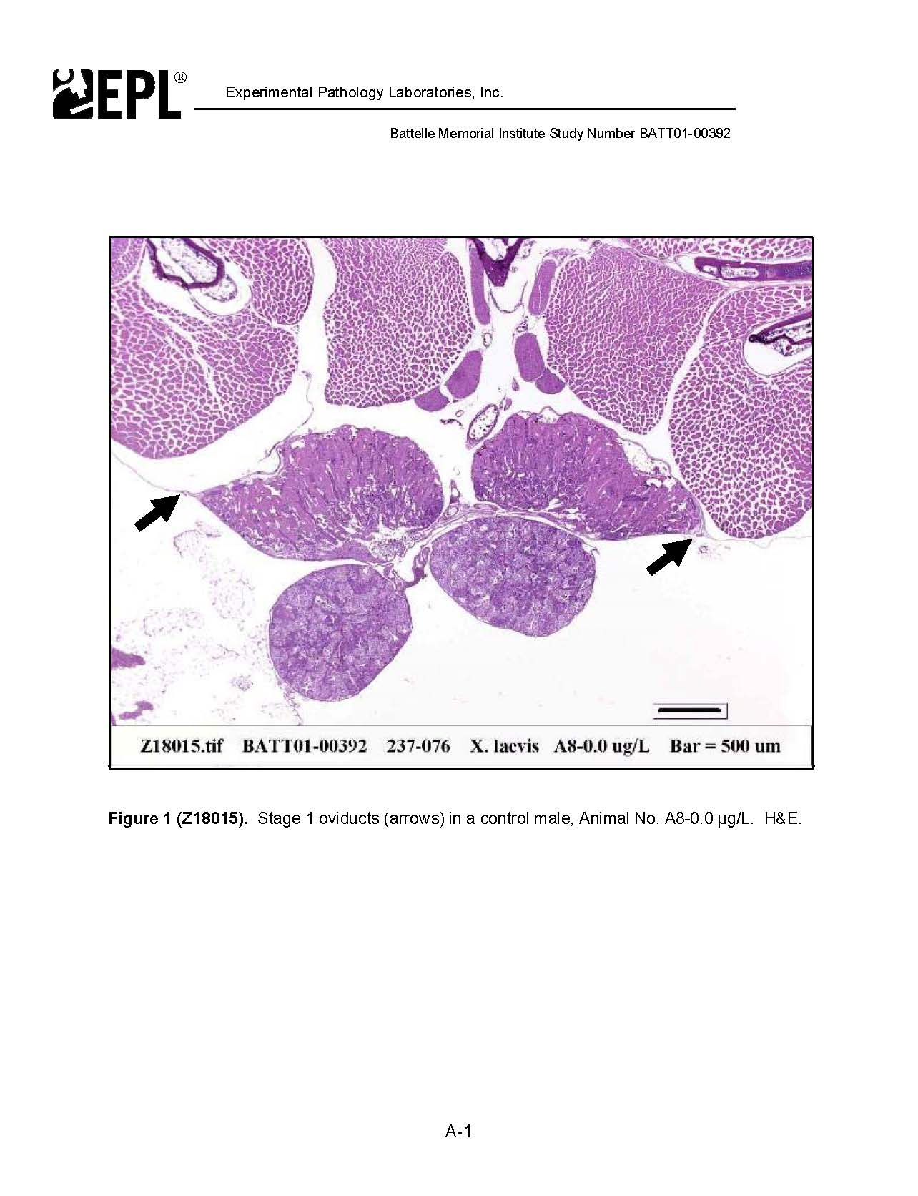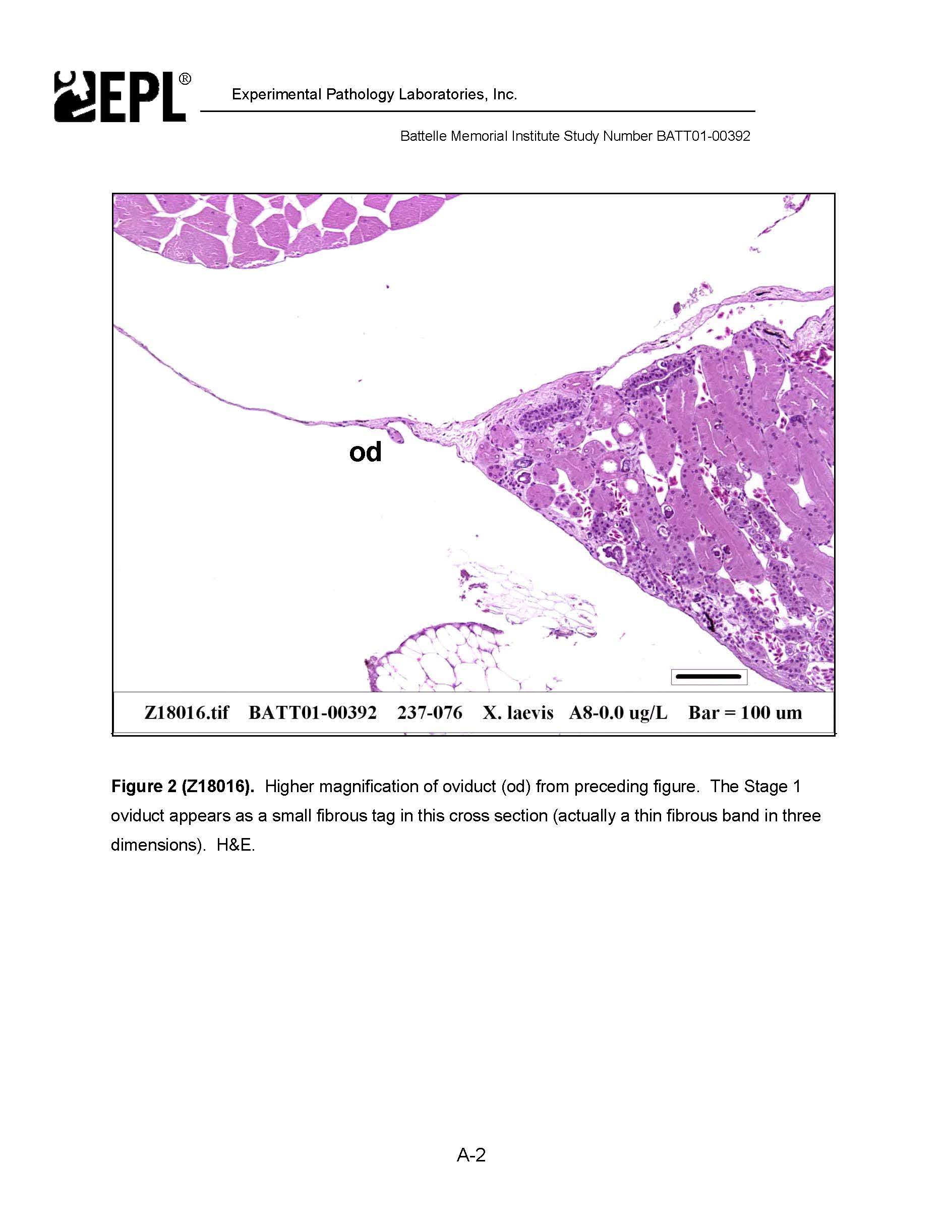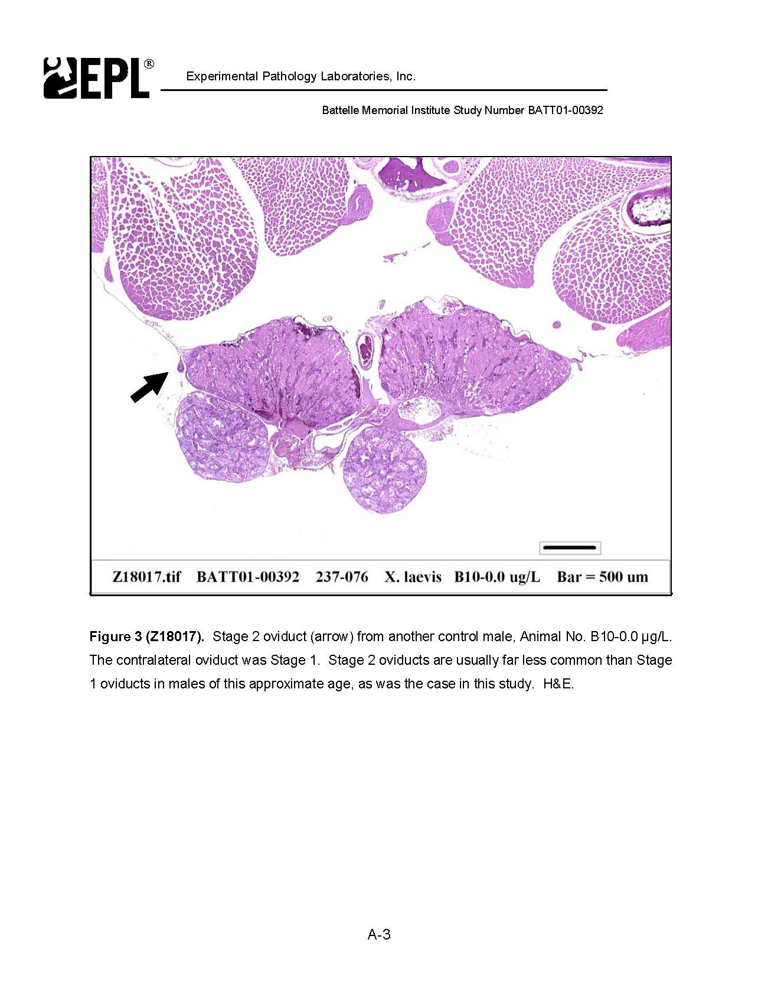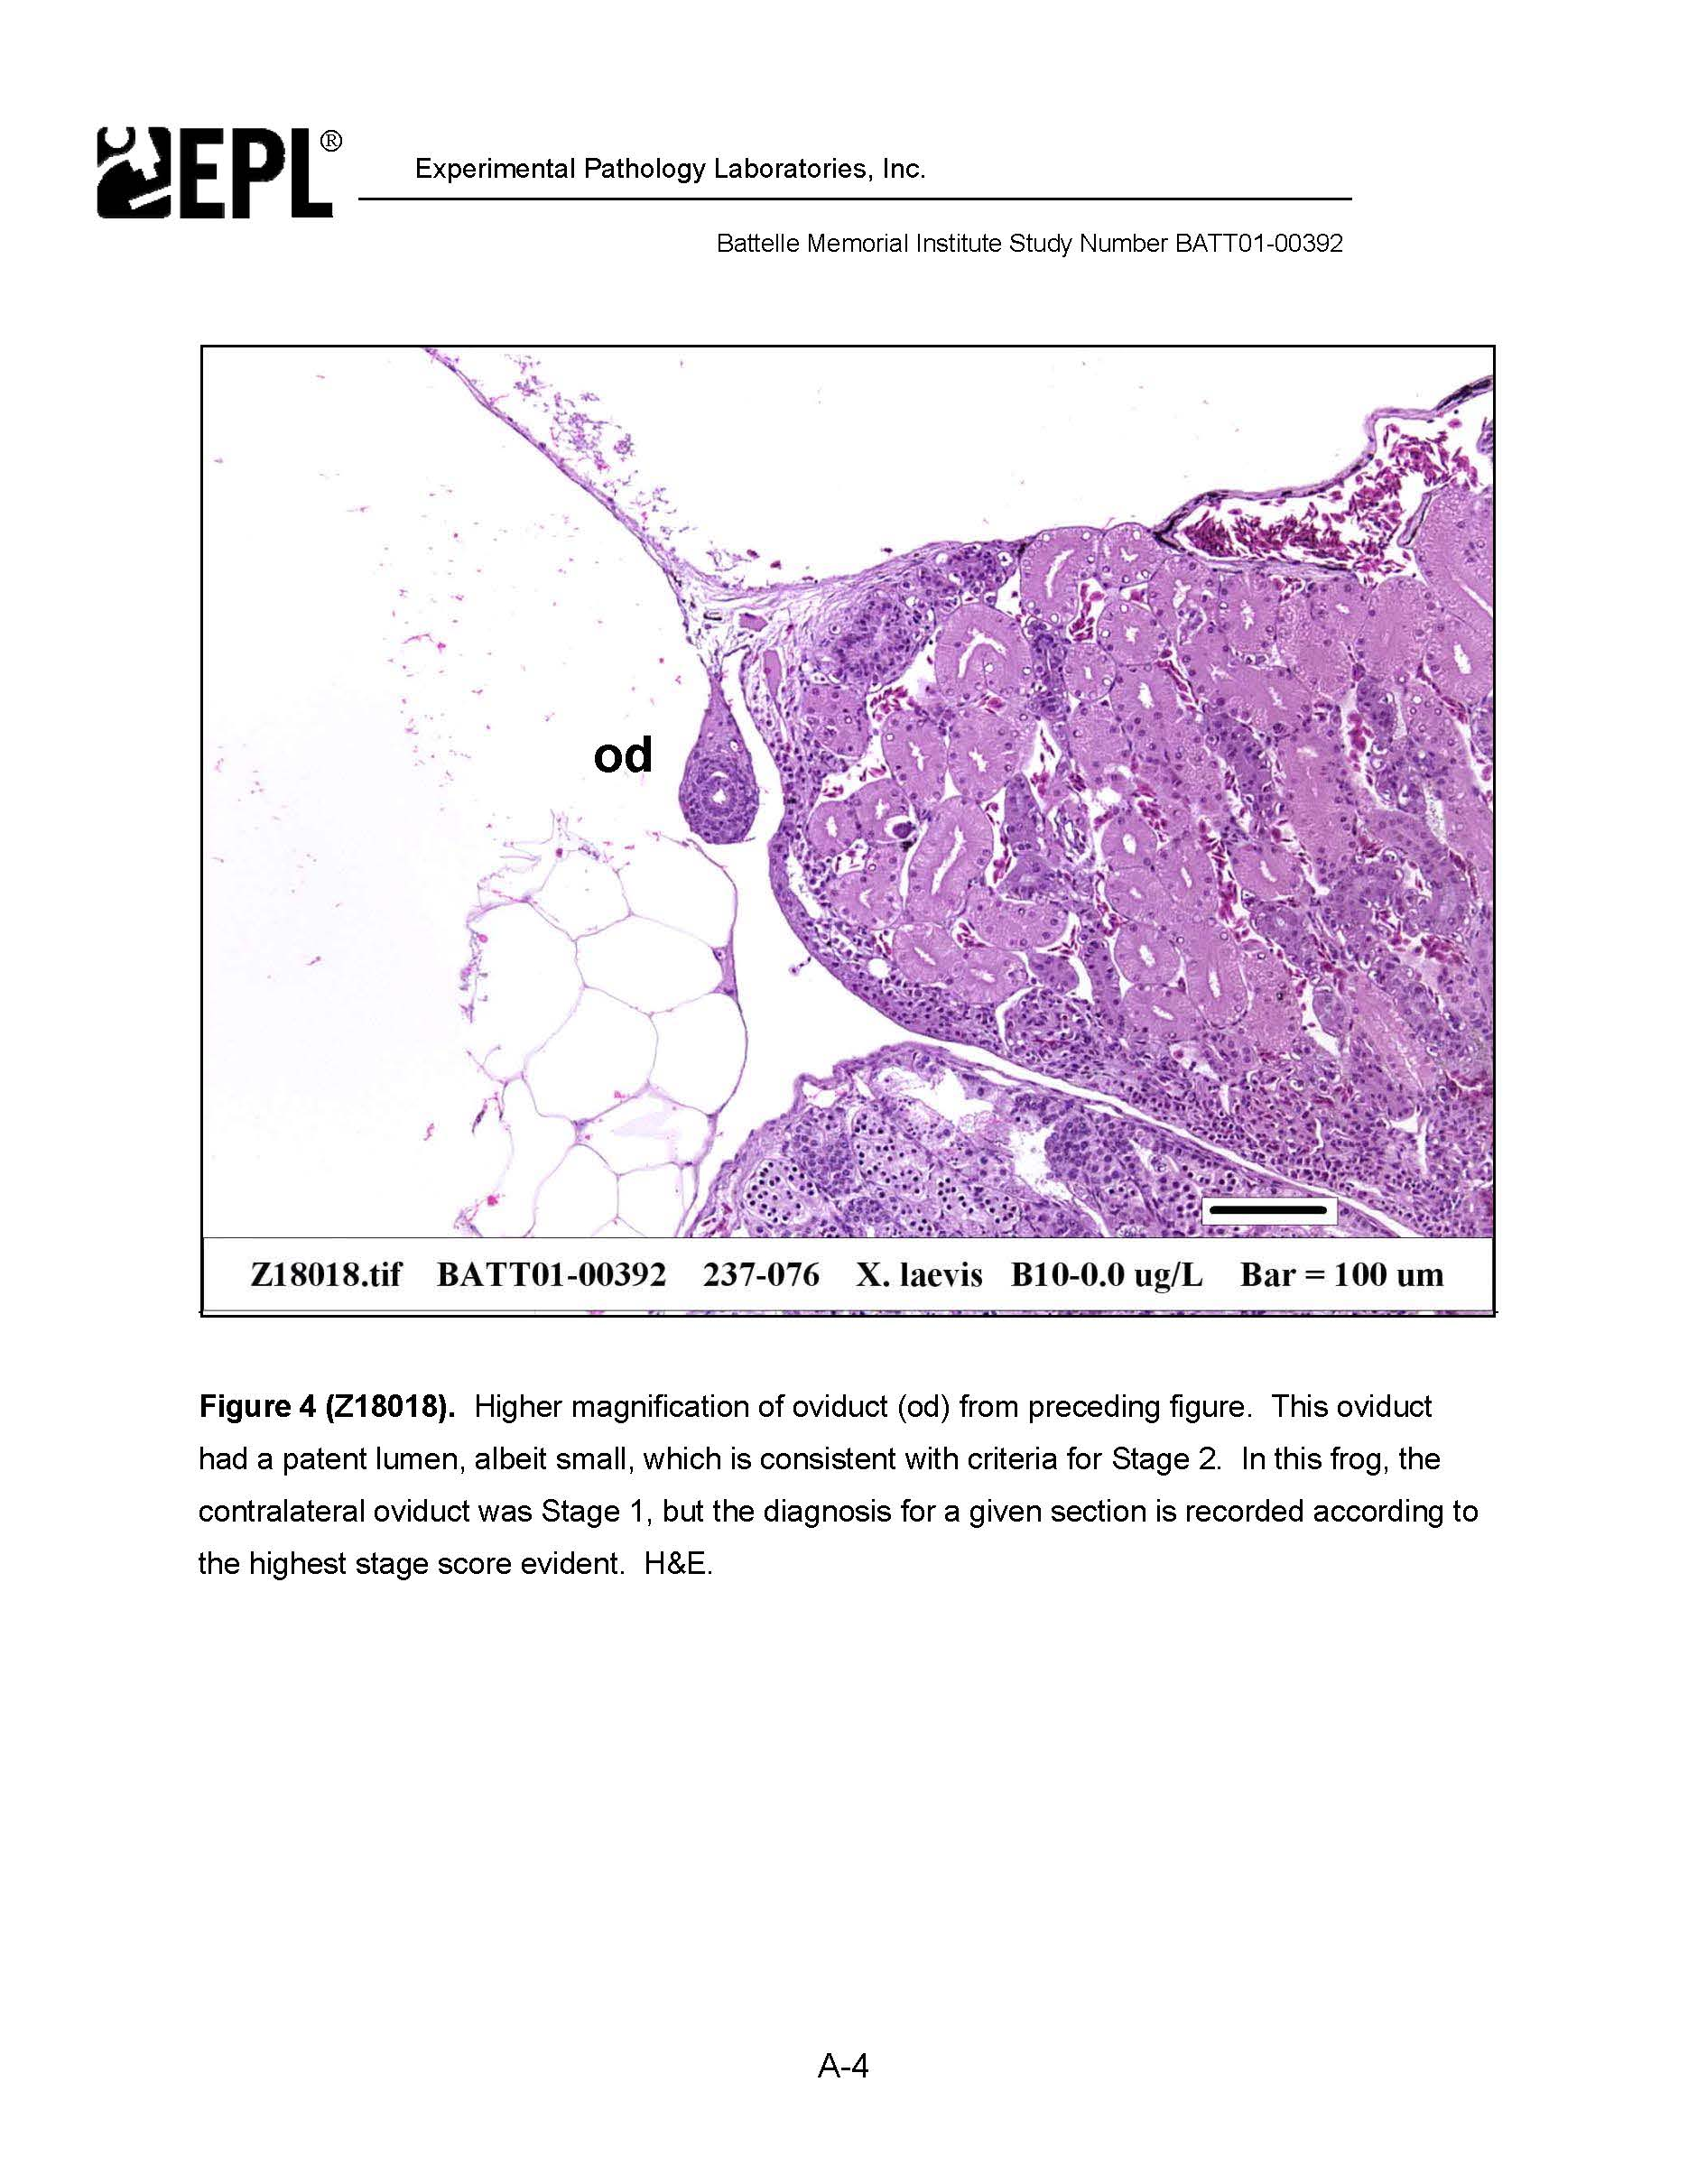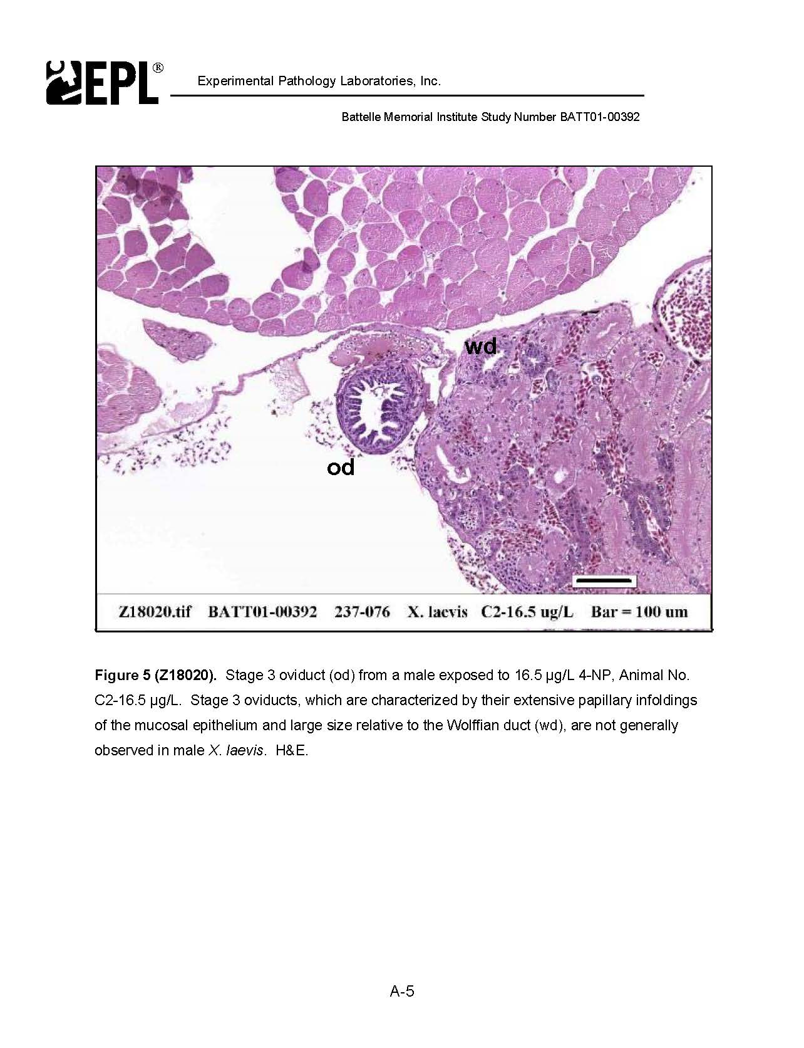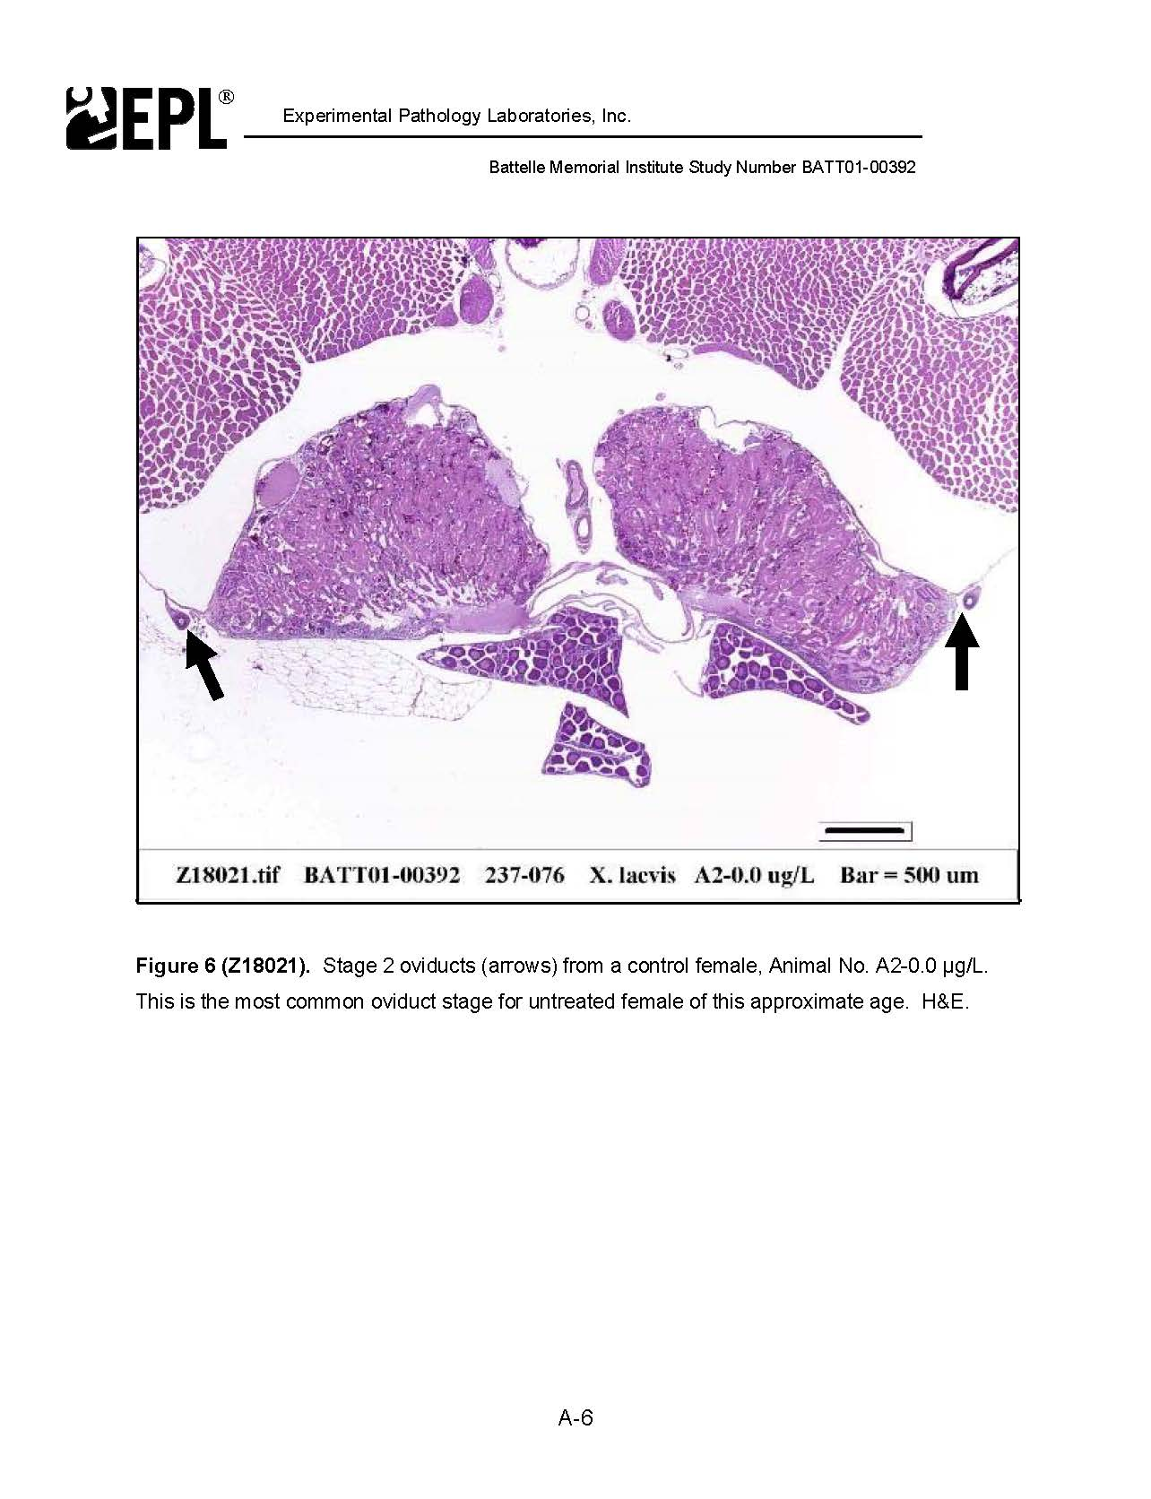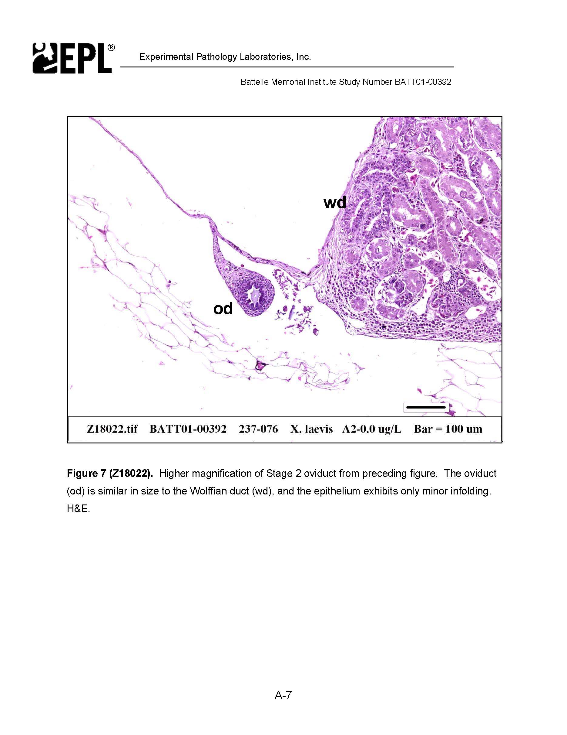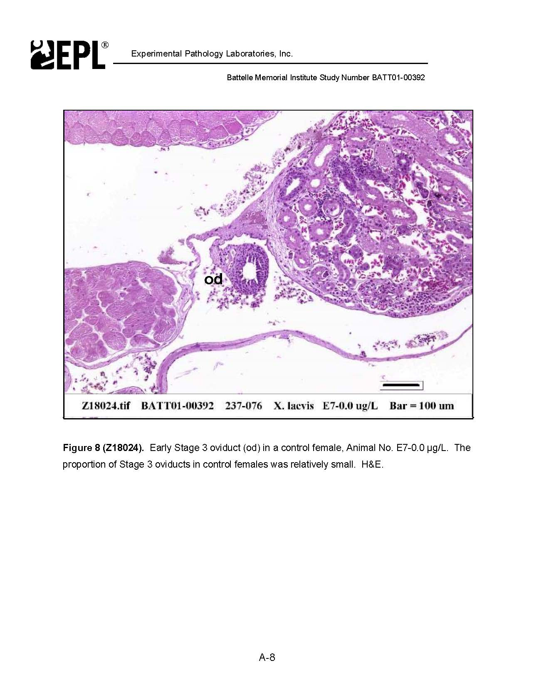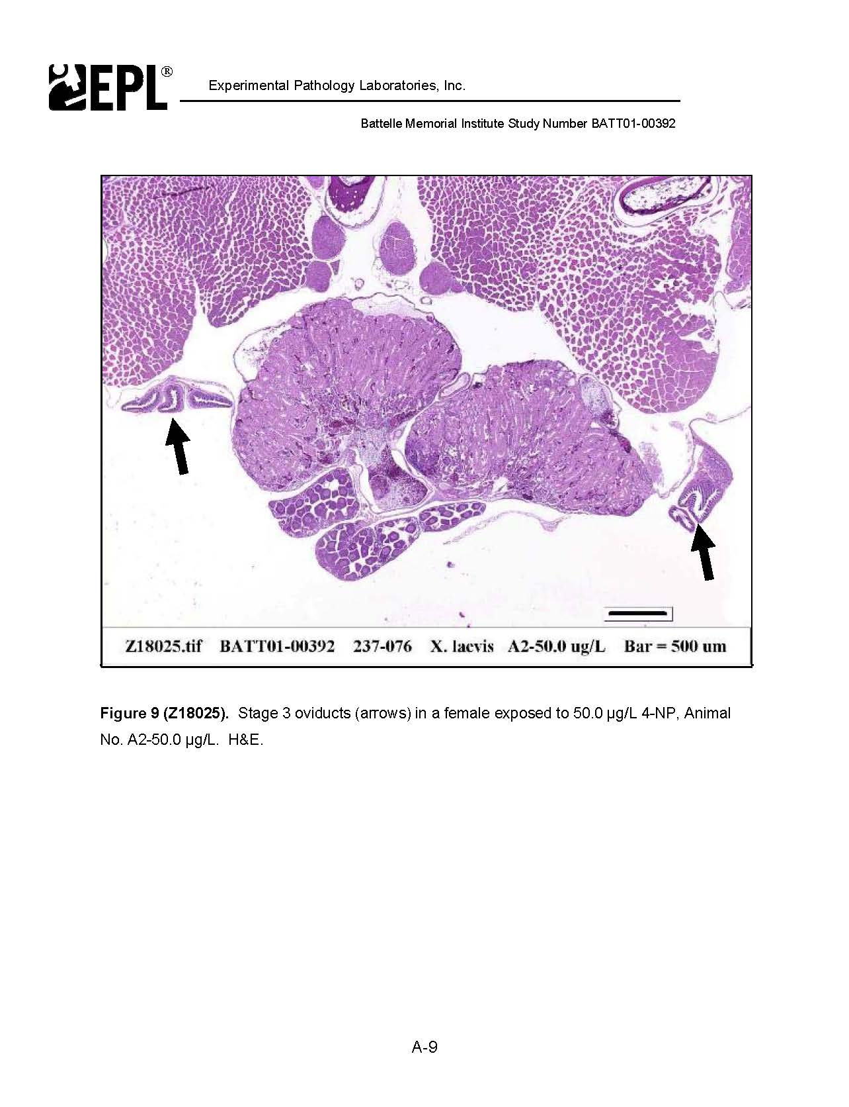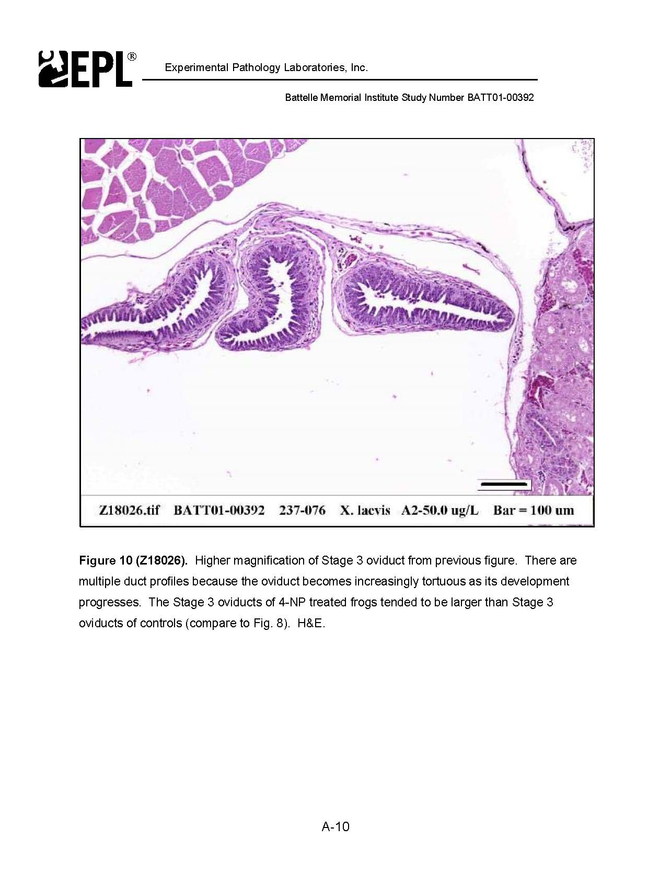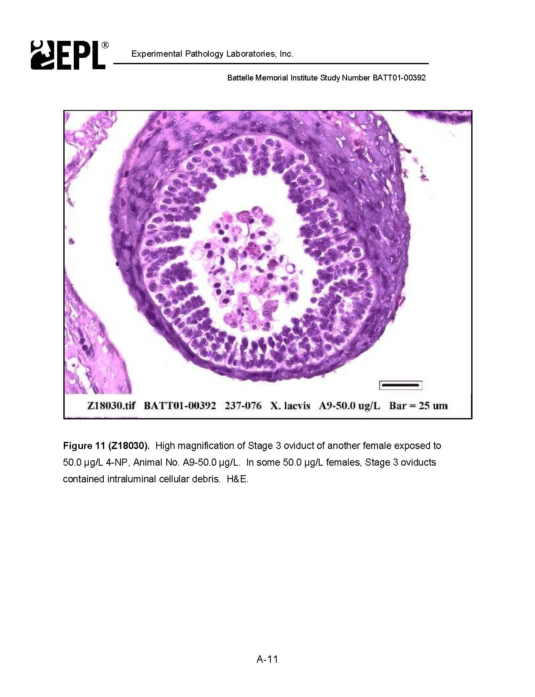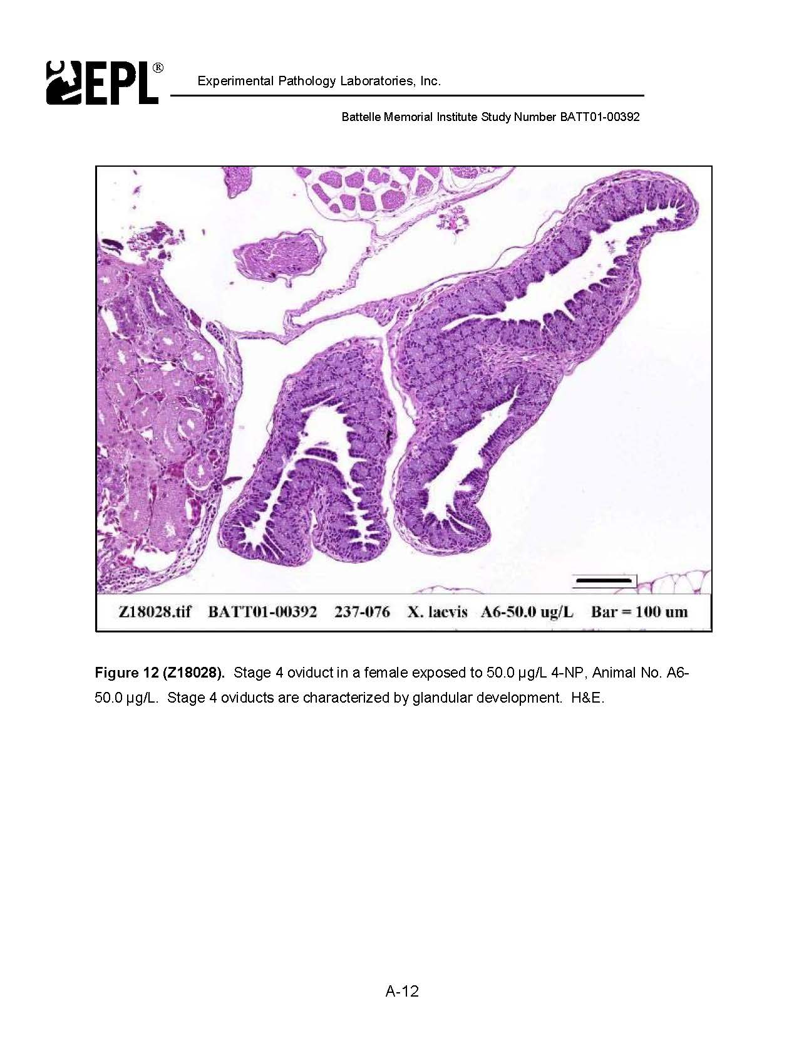

DEST

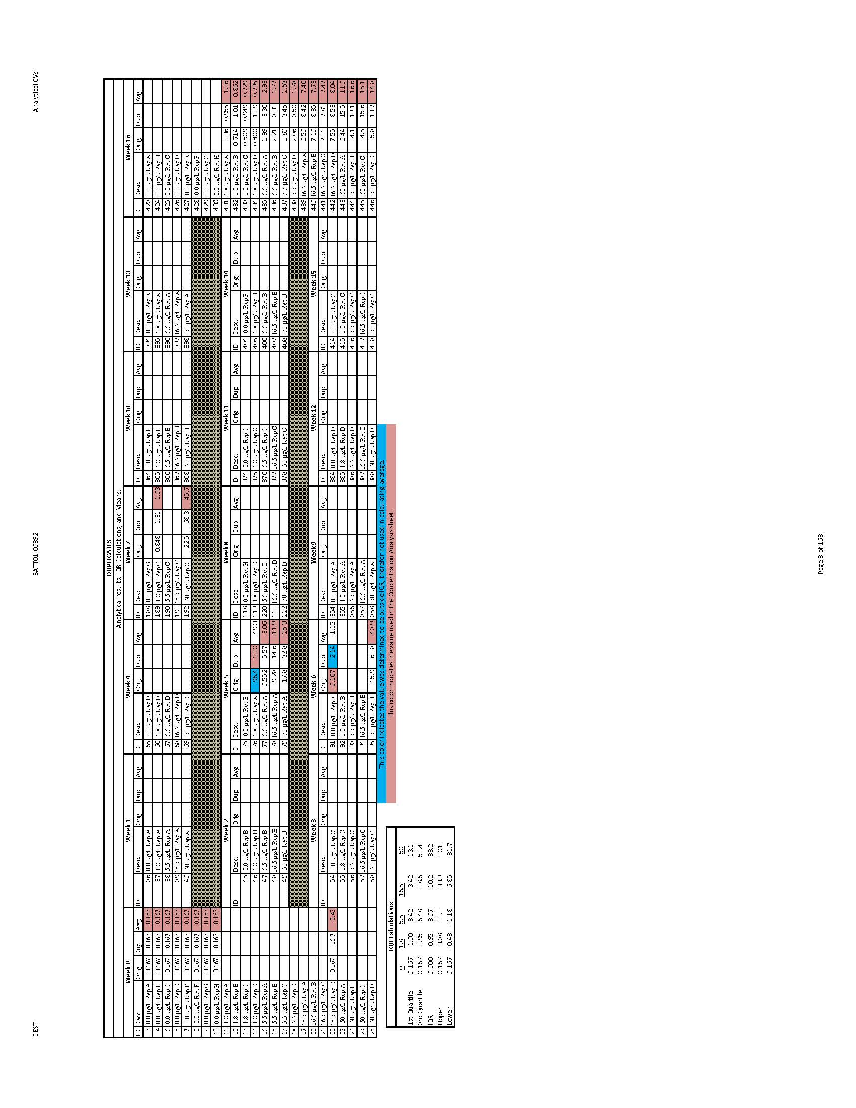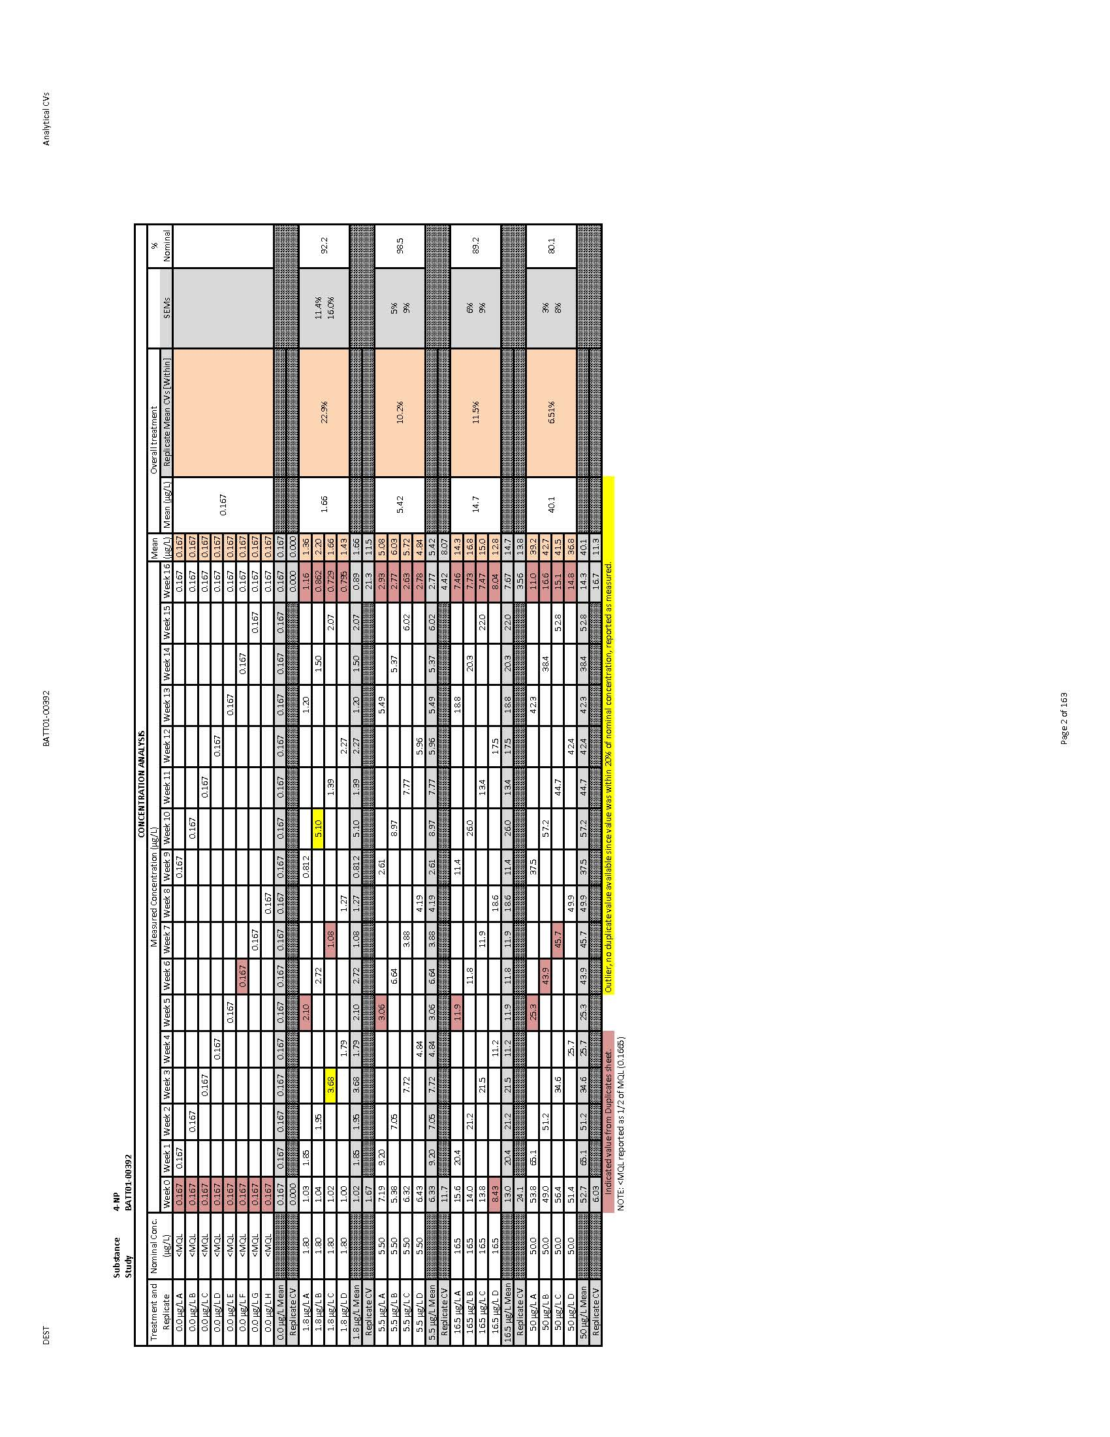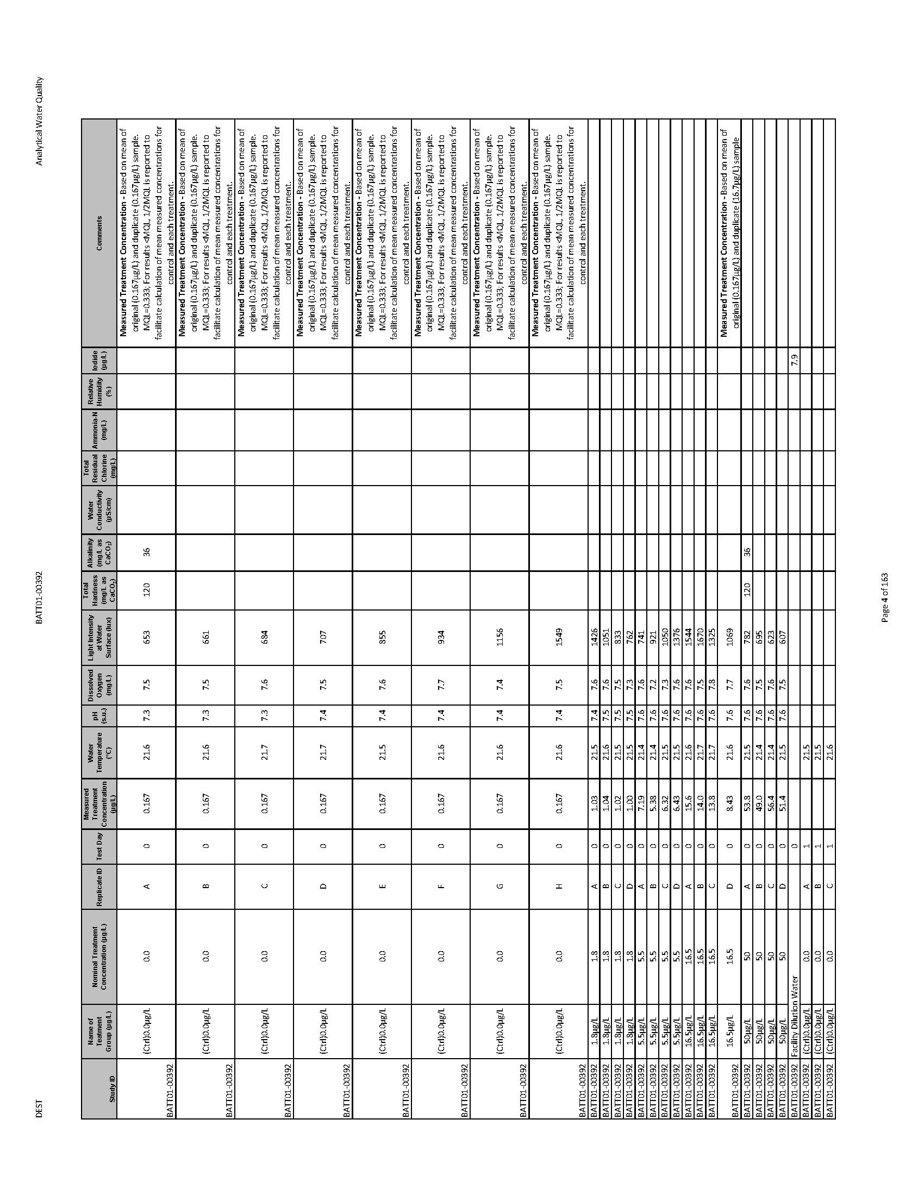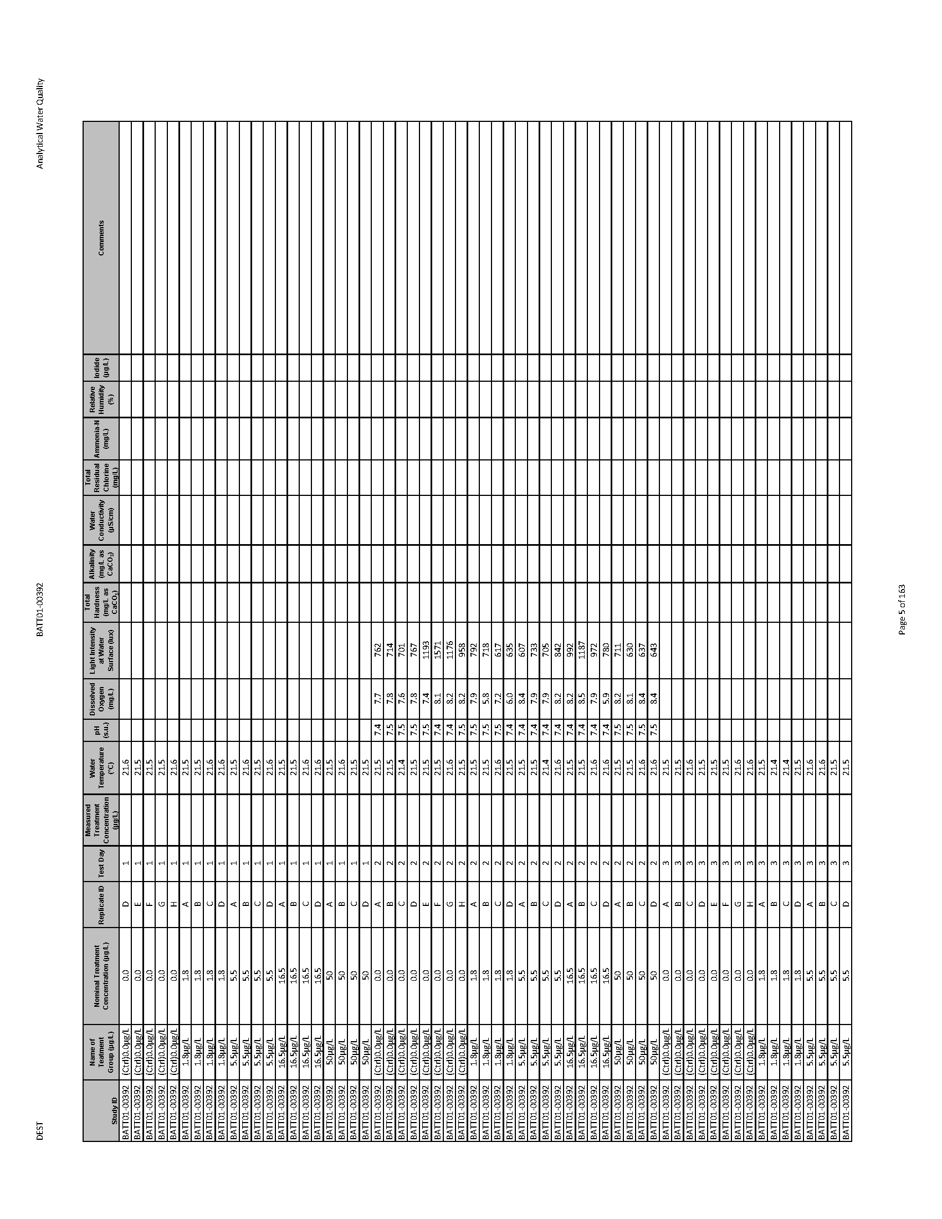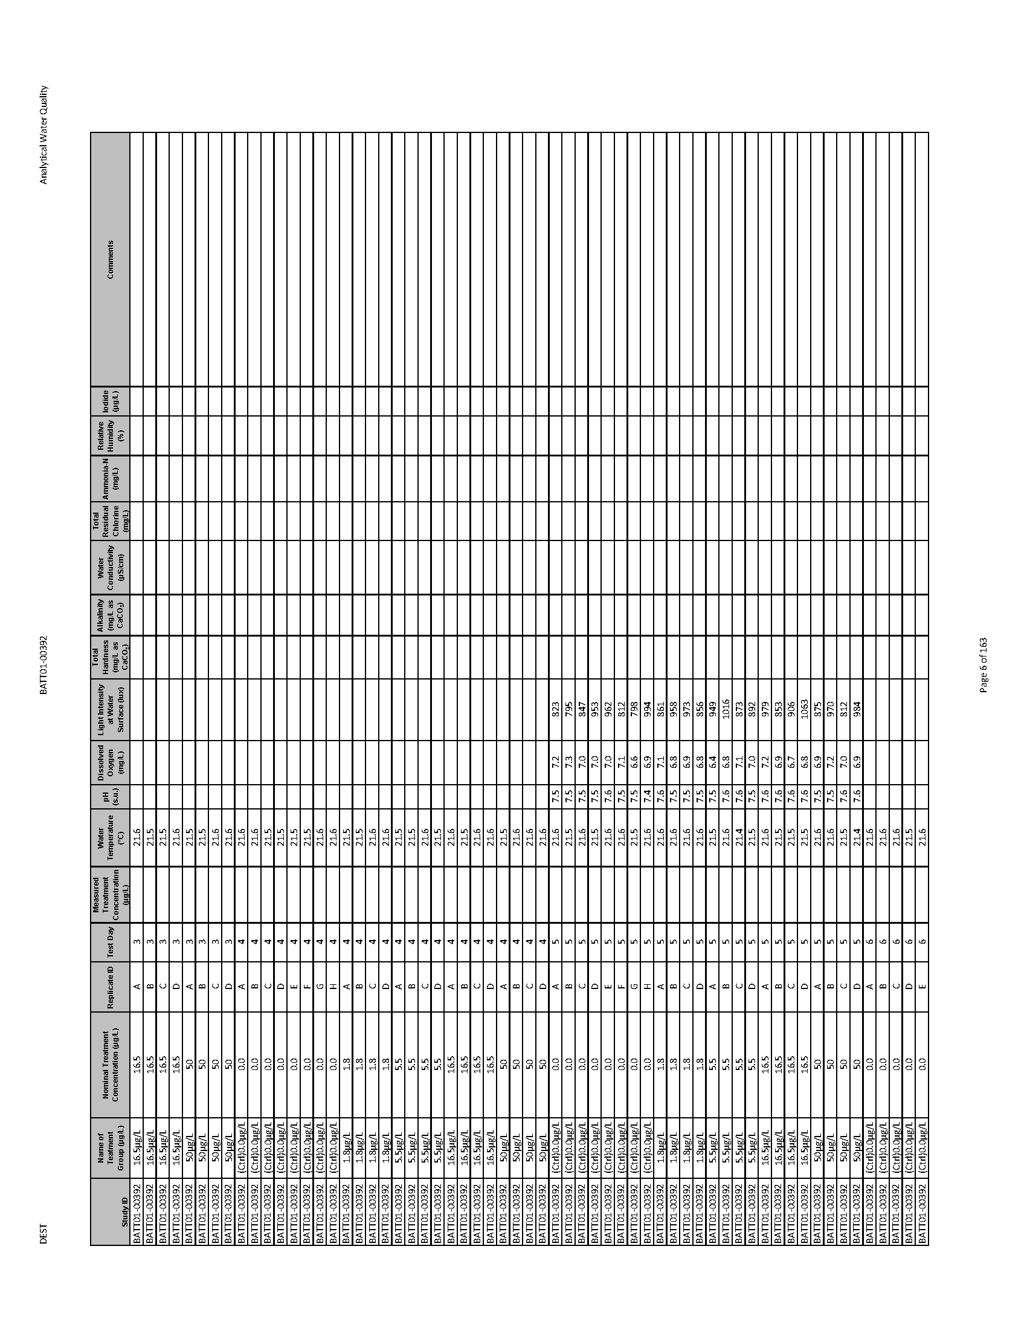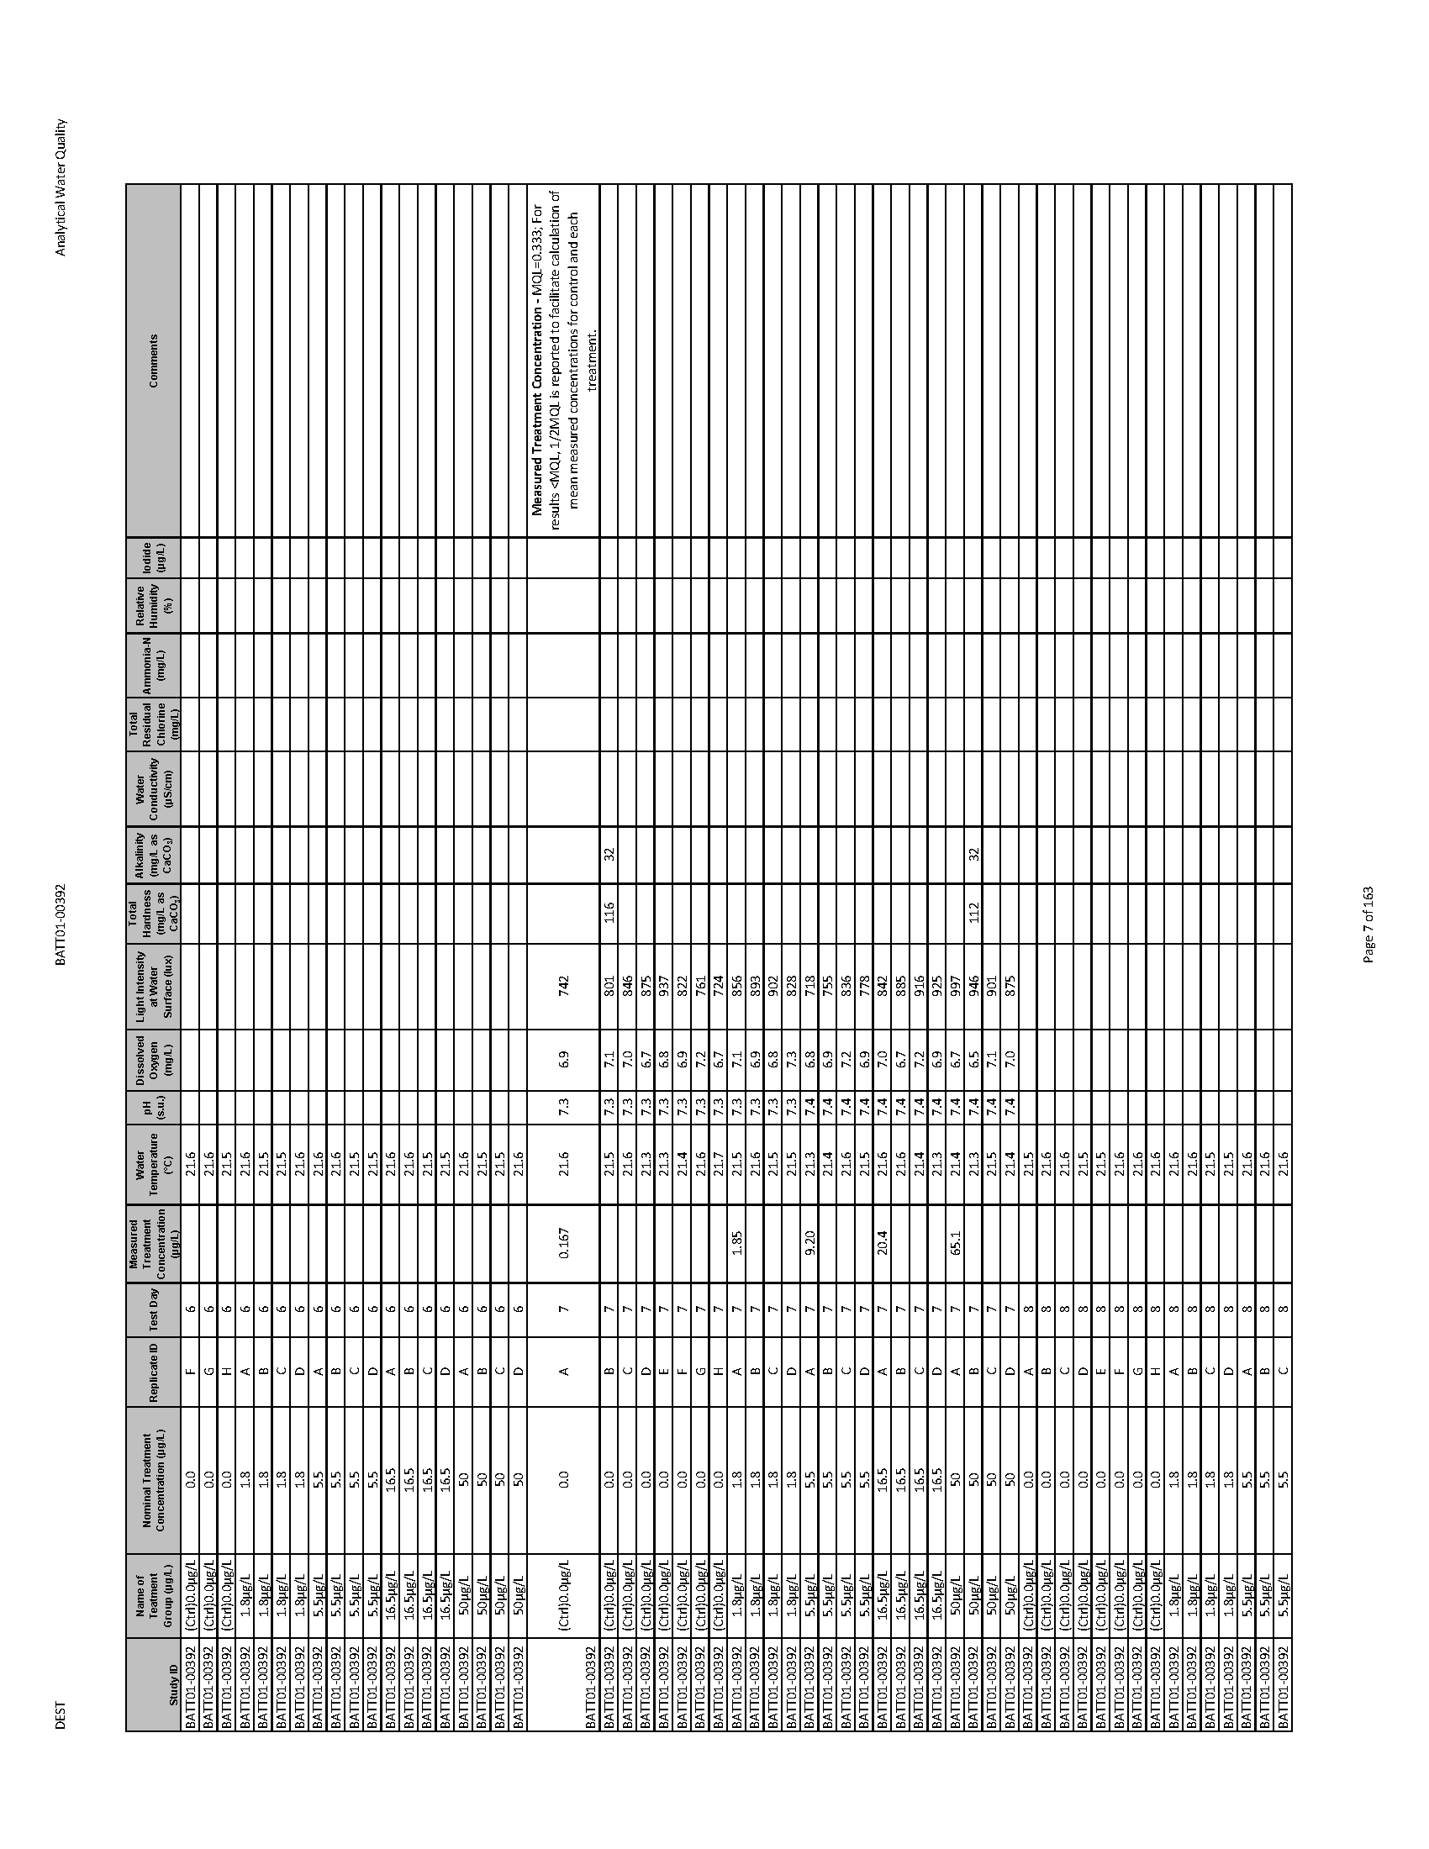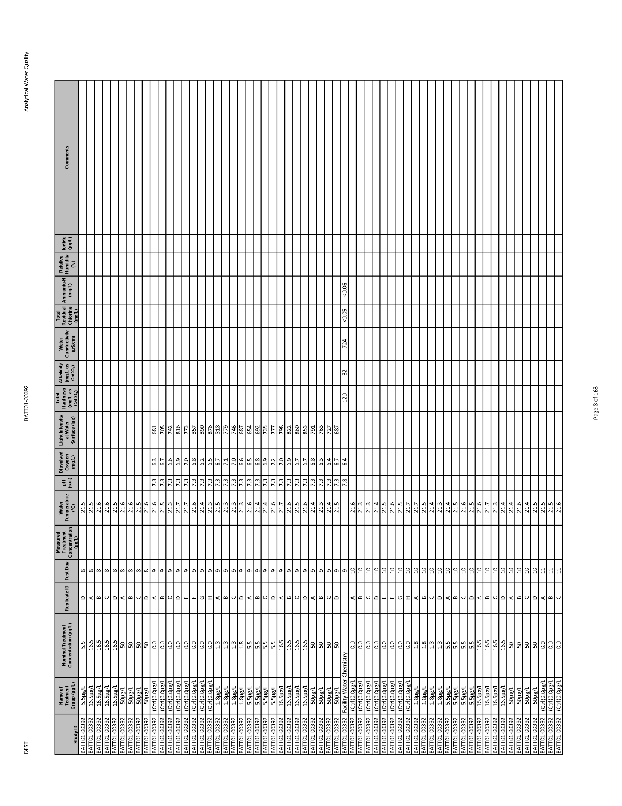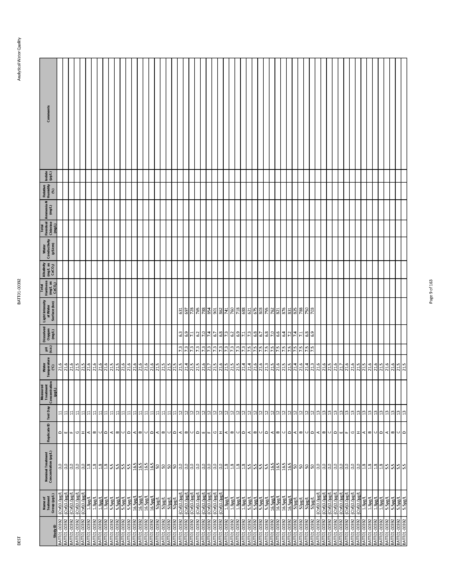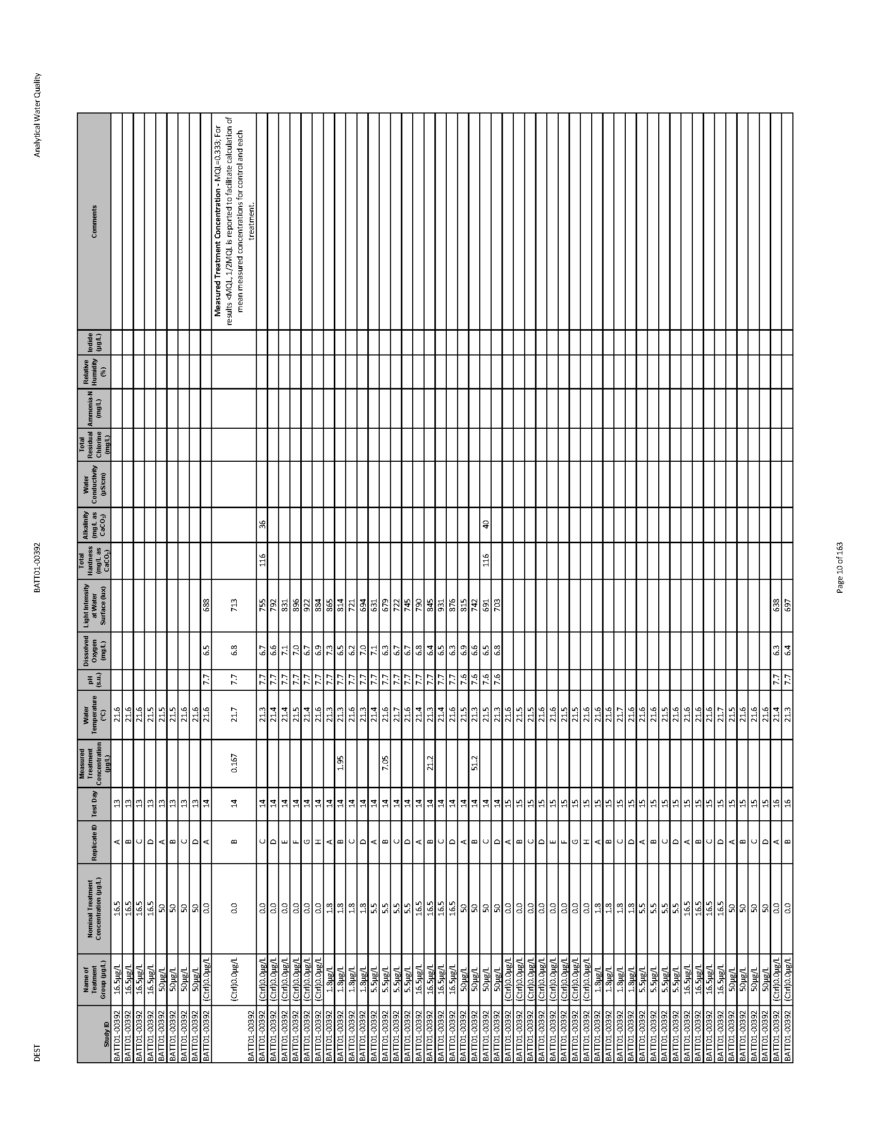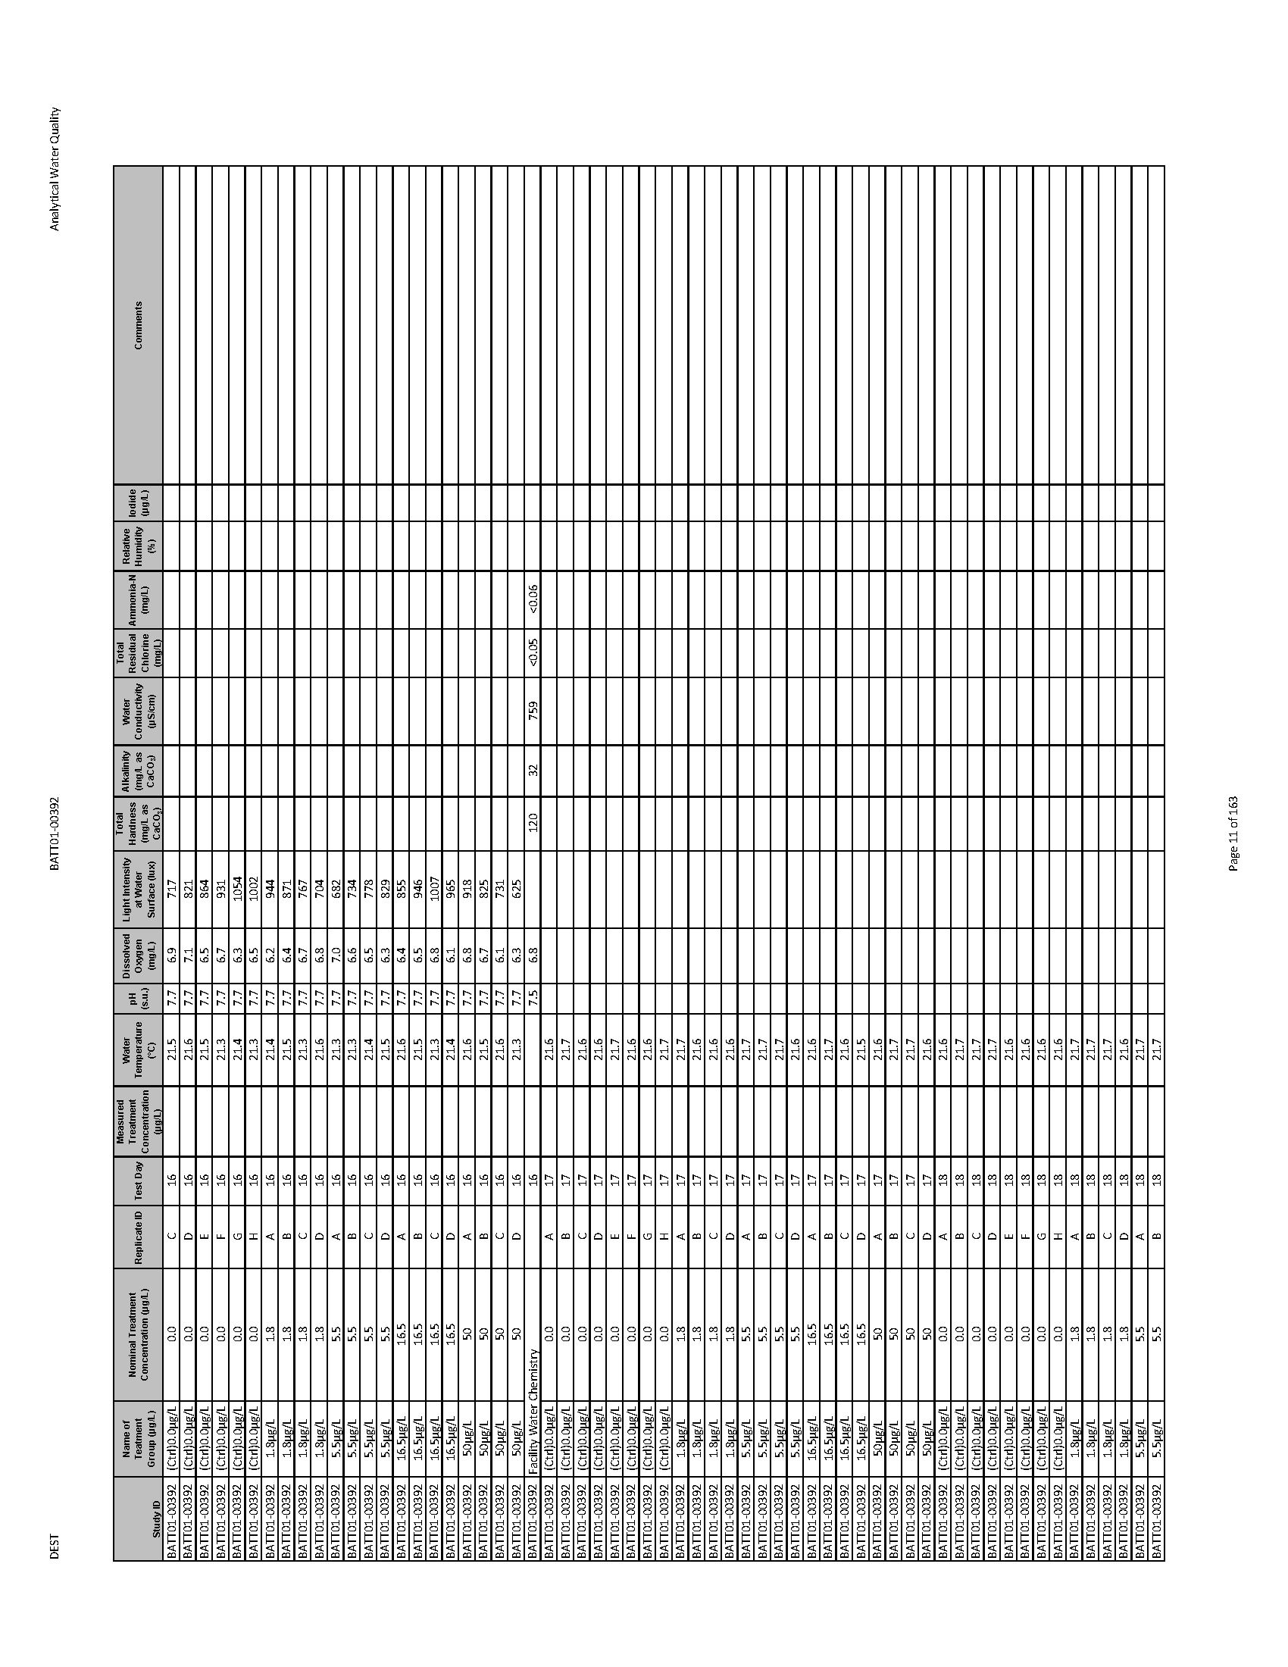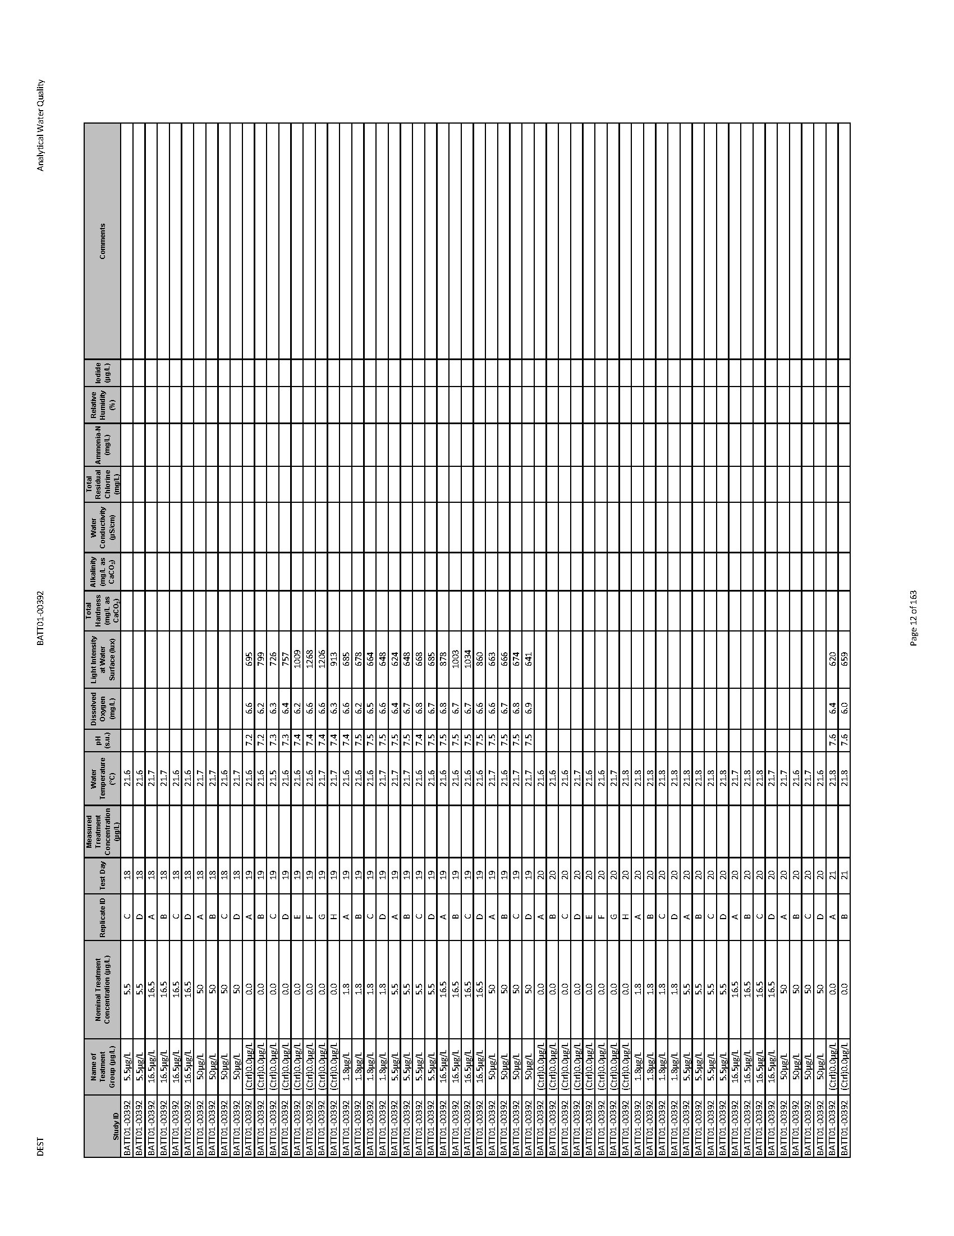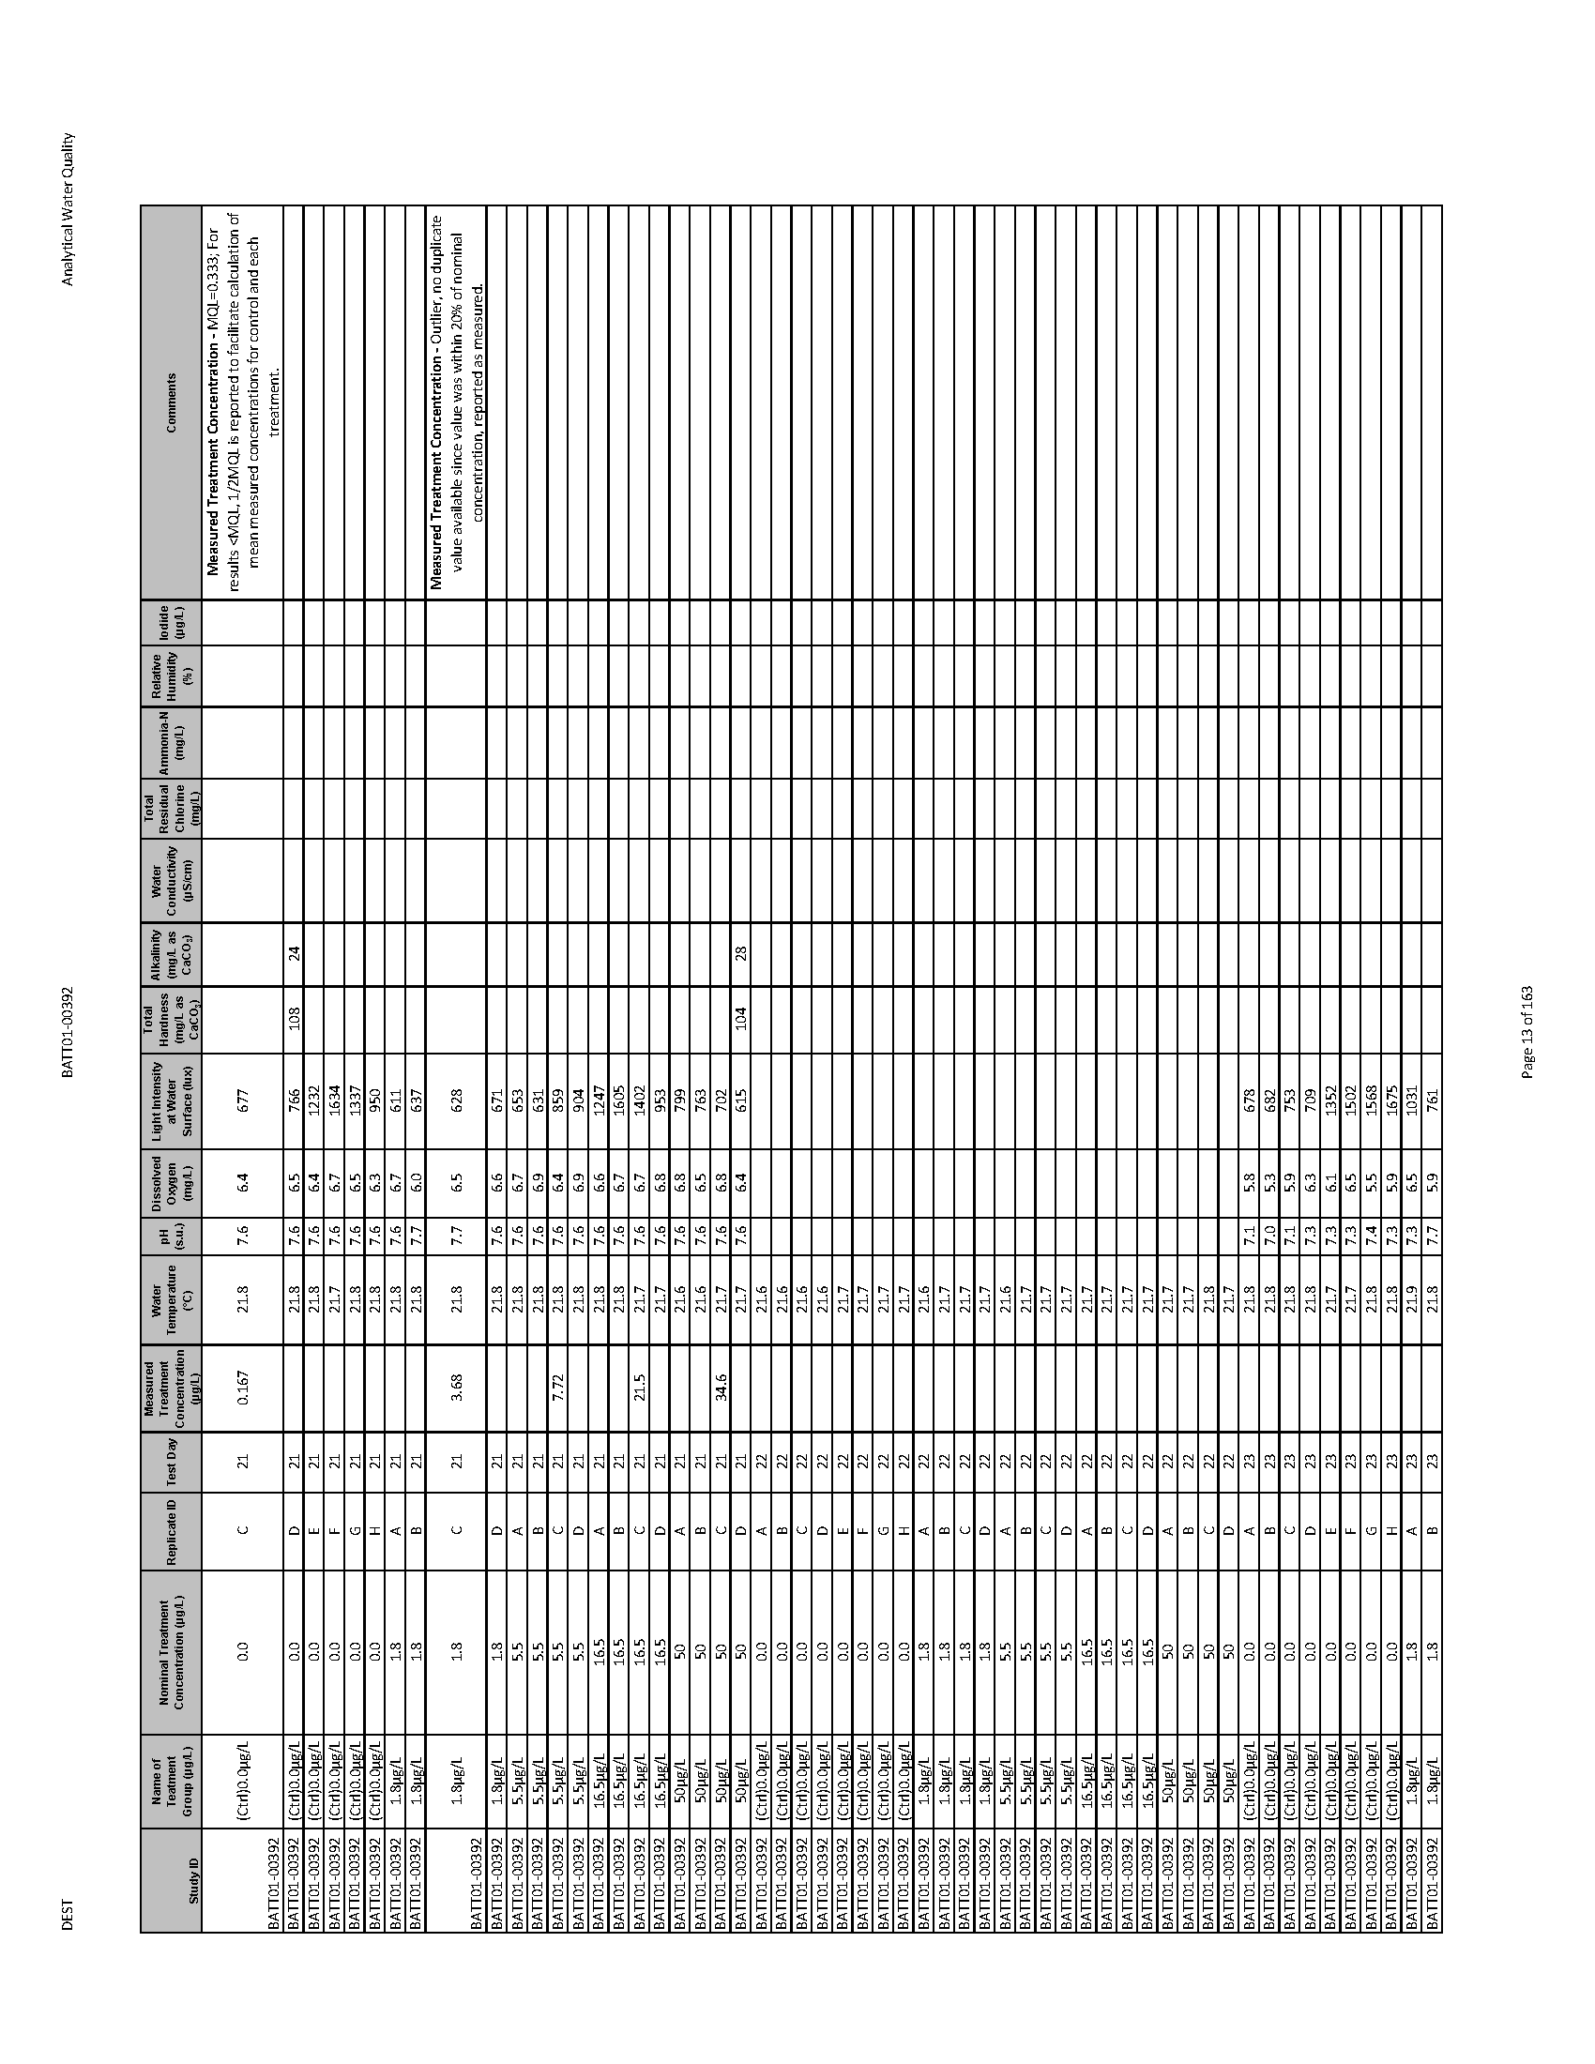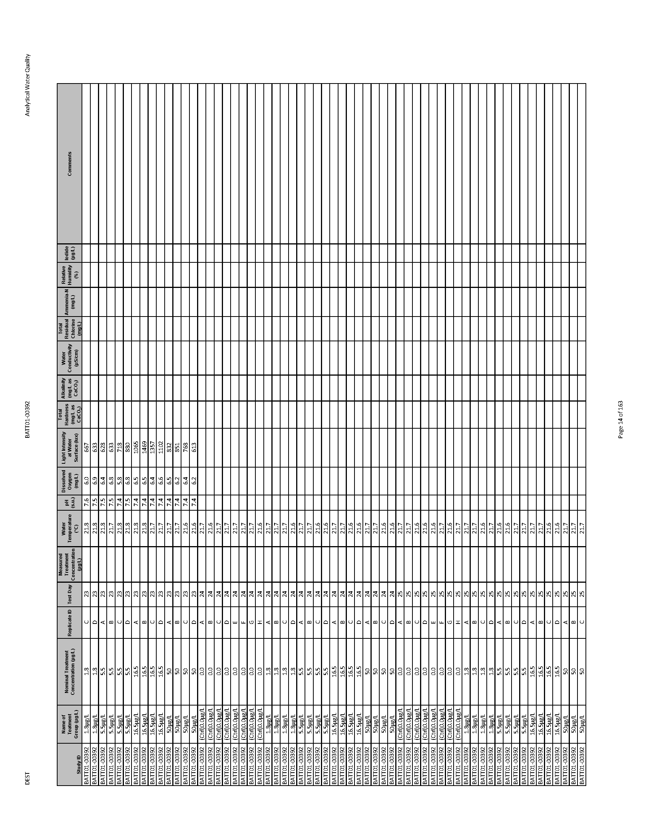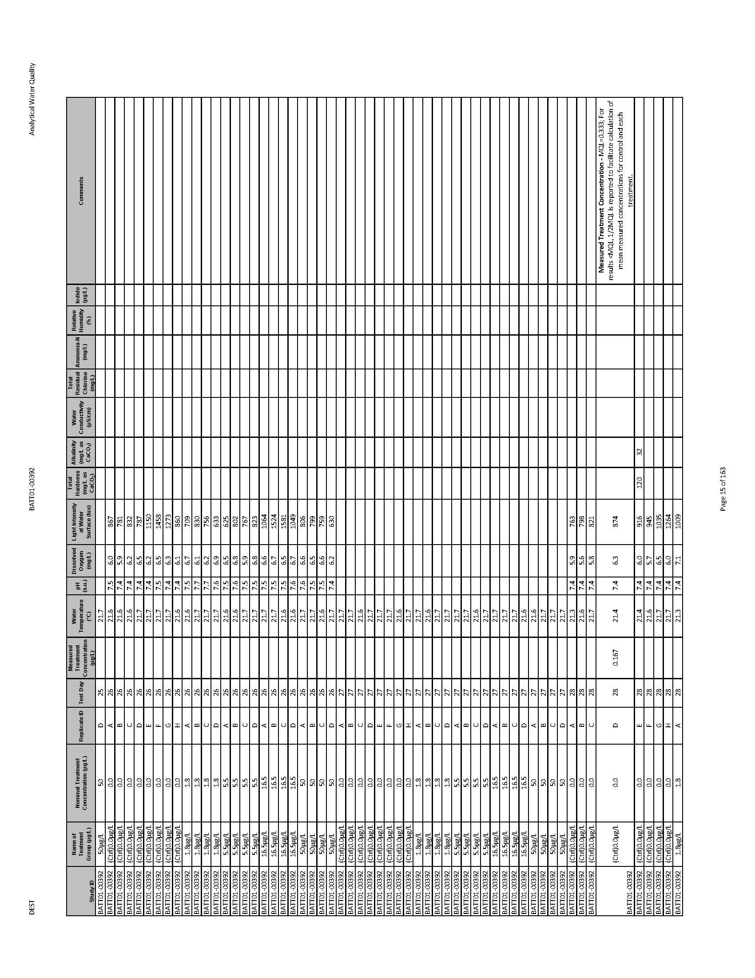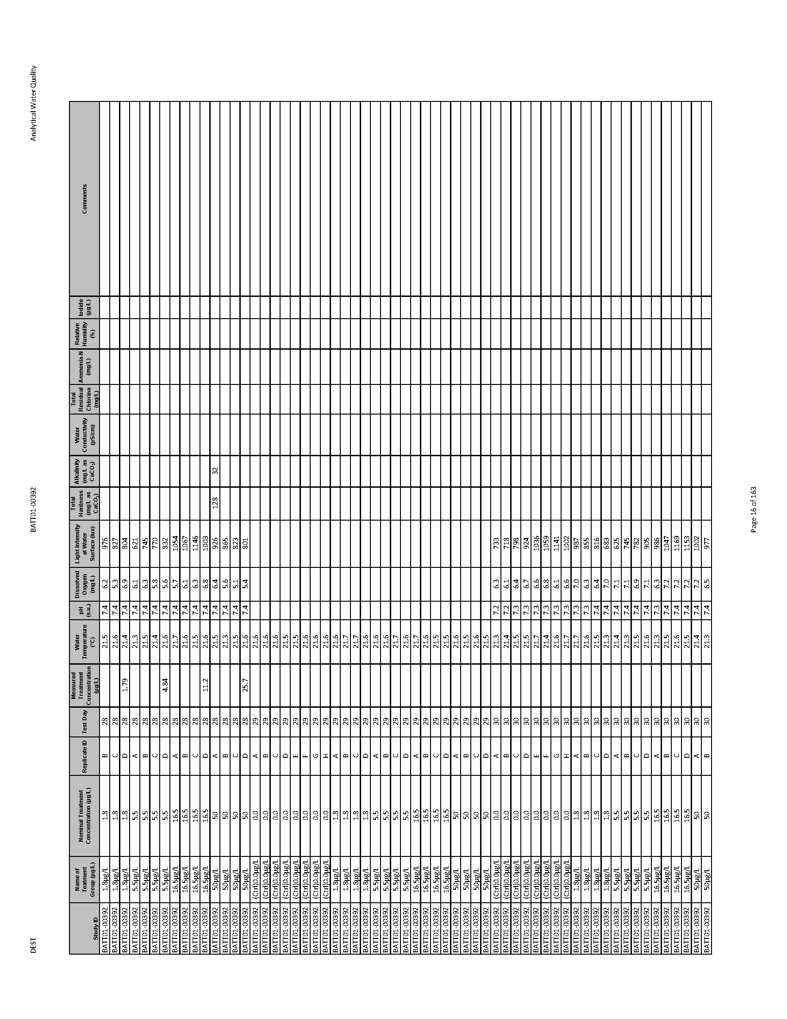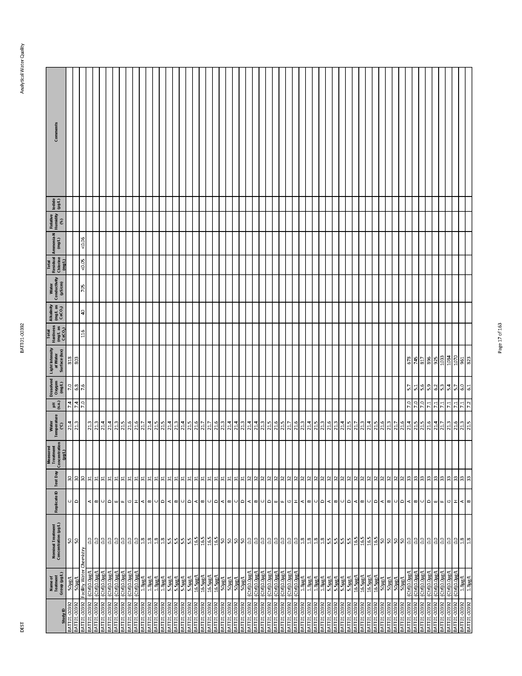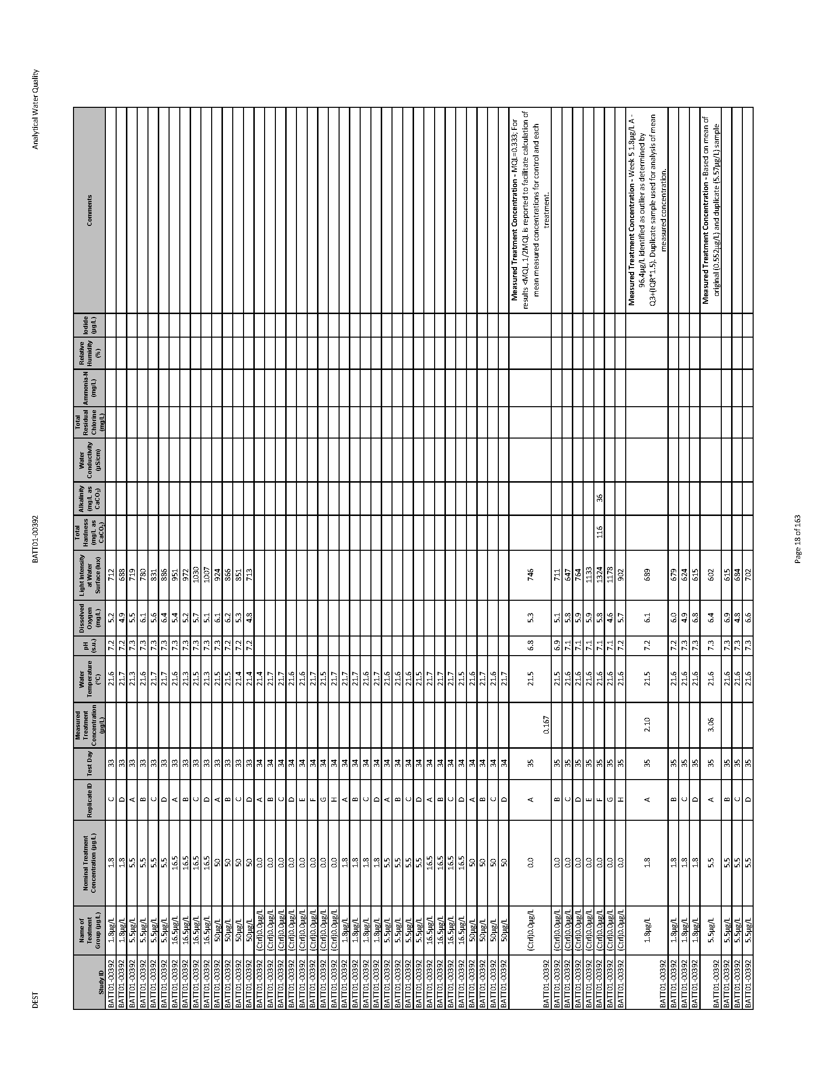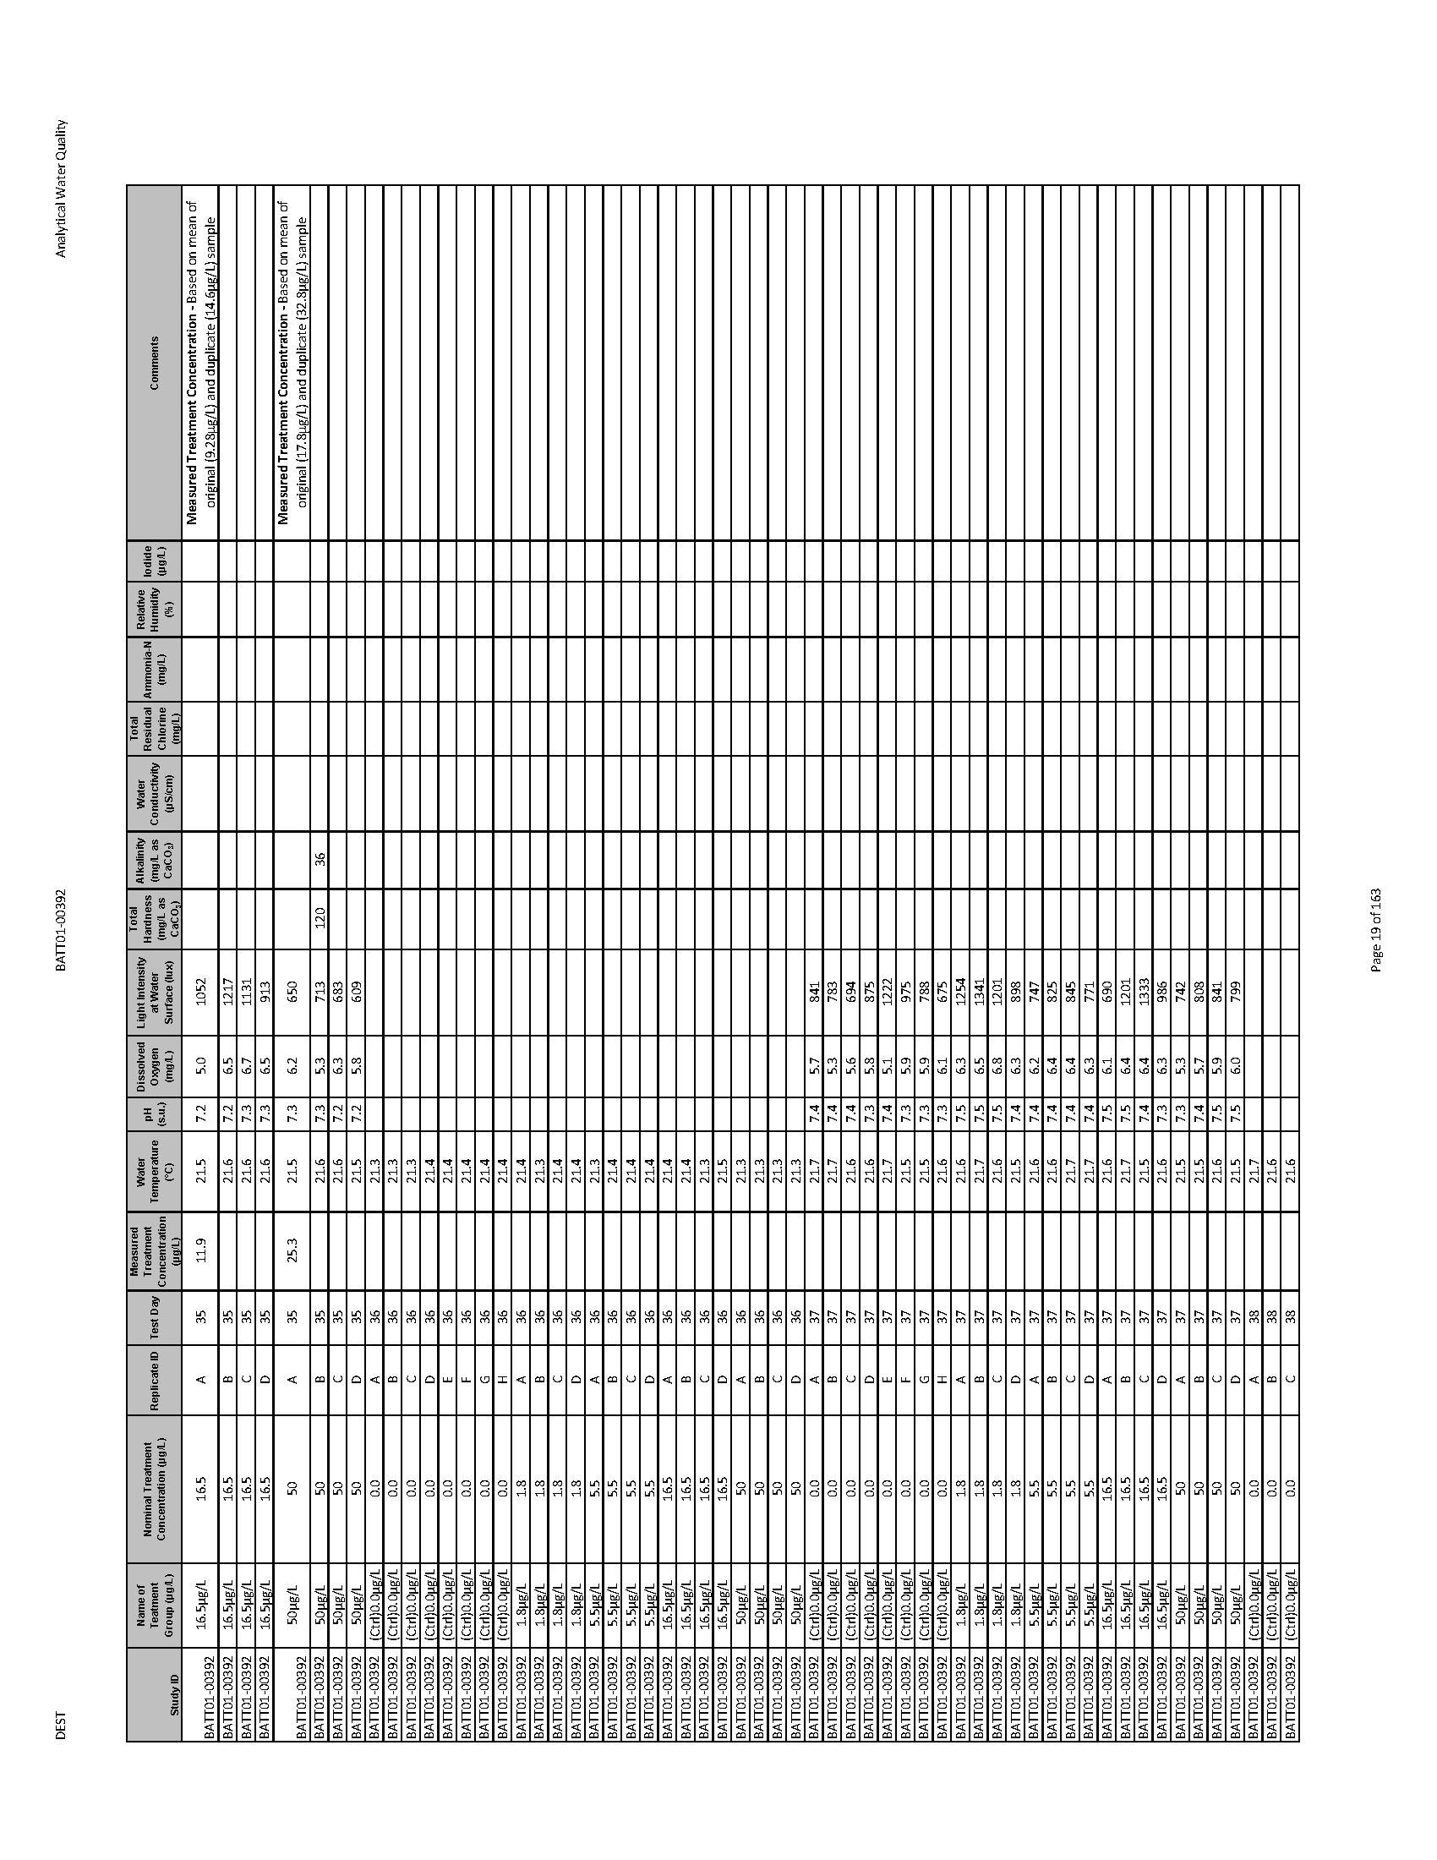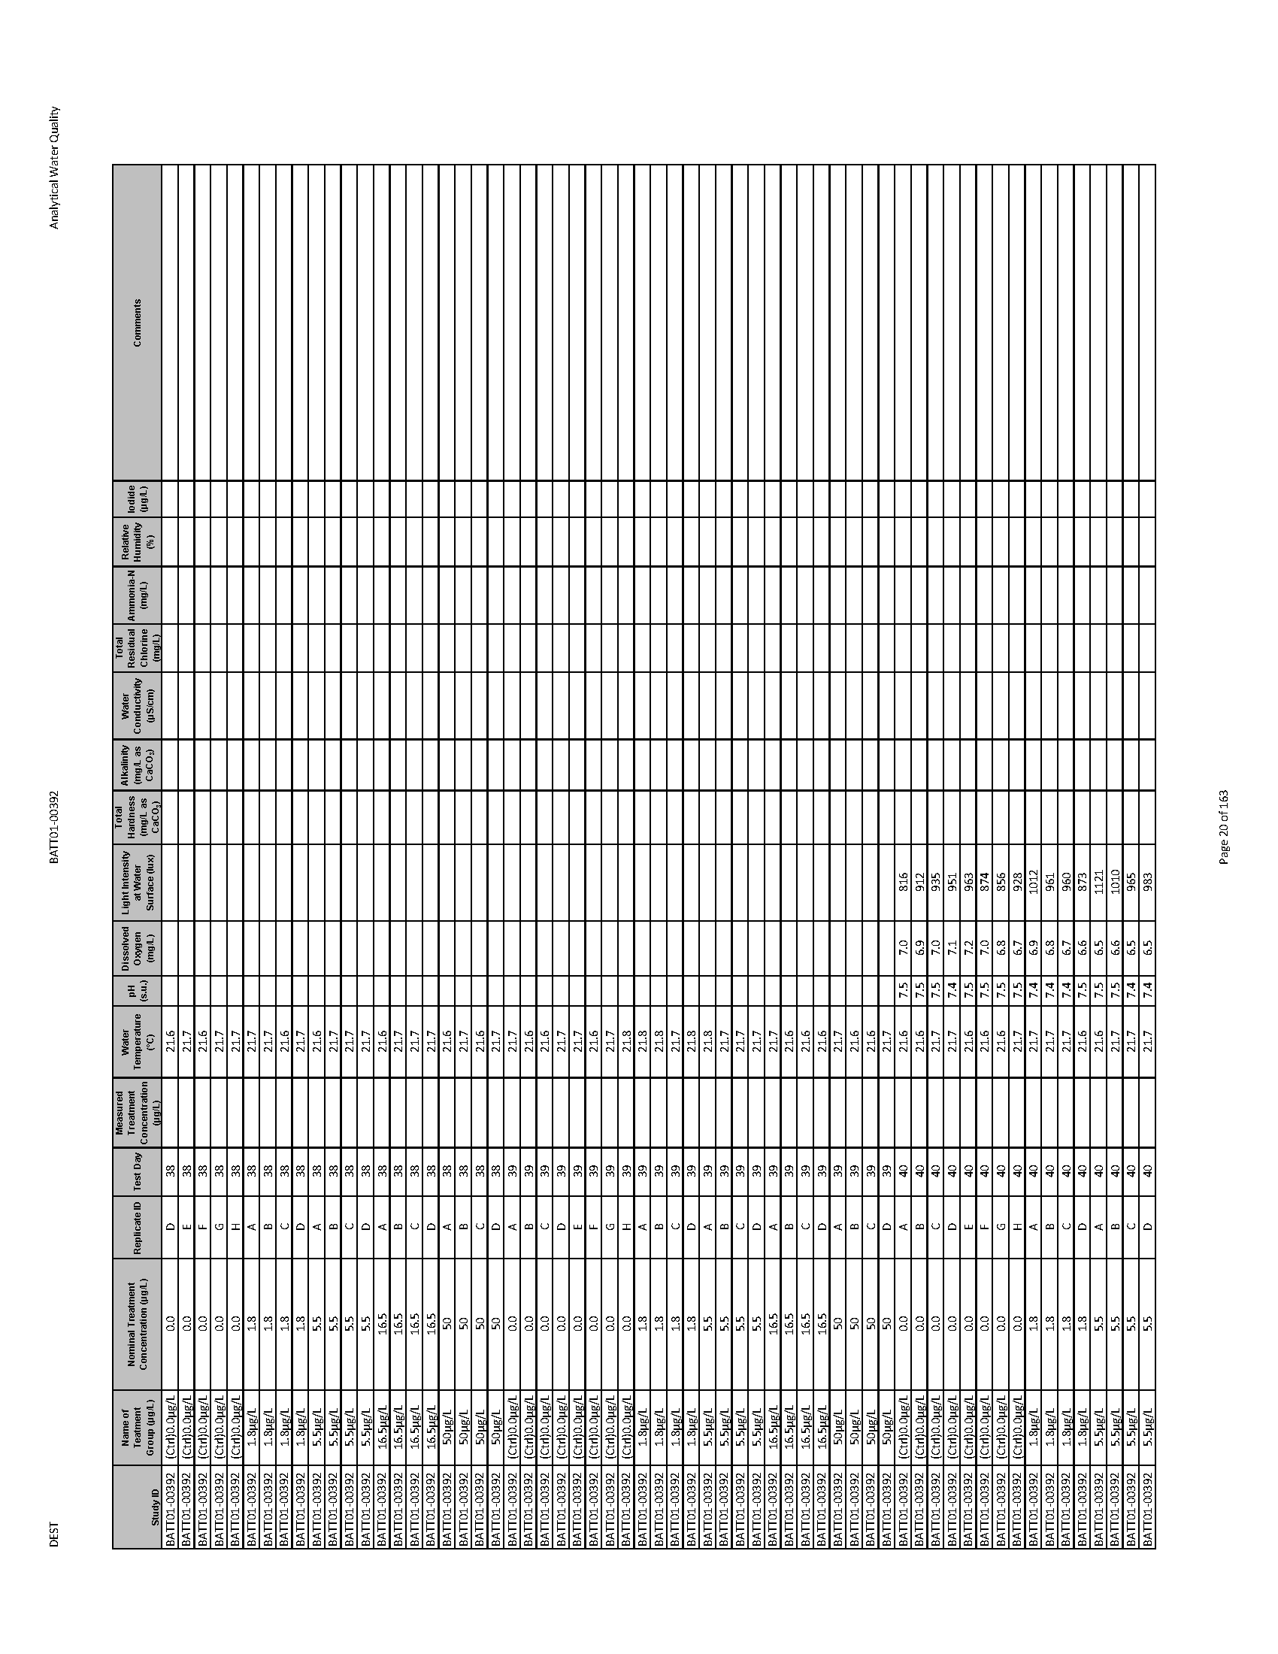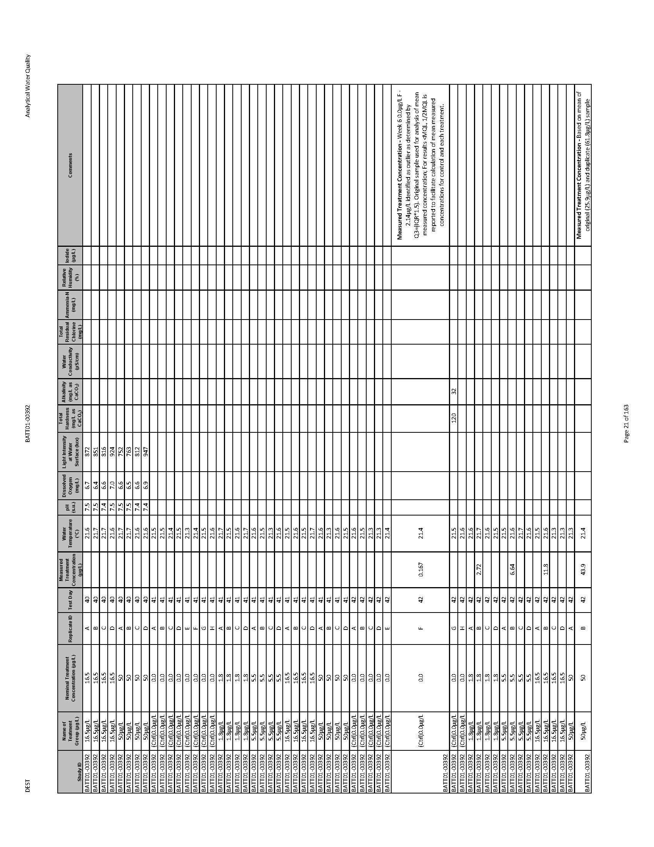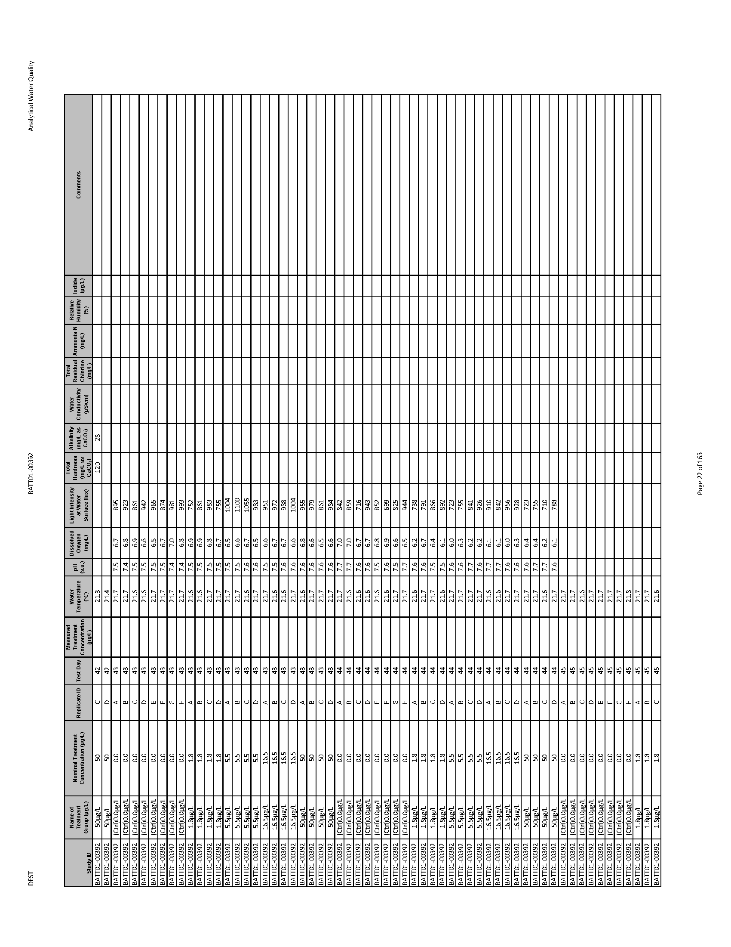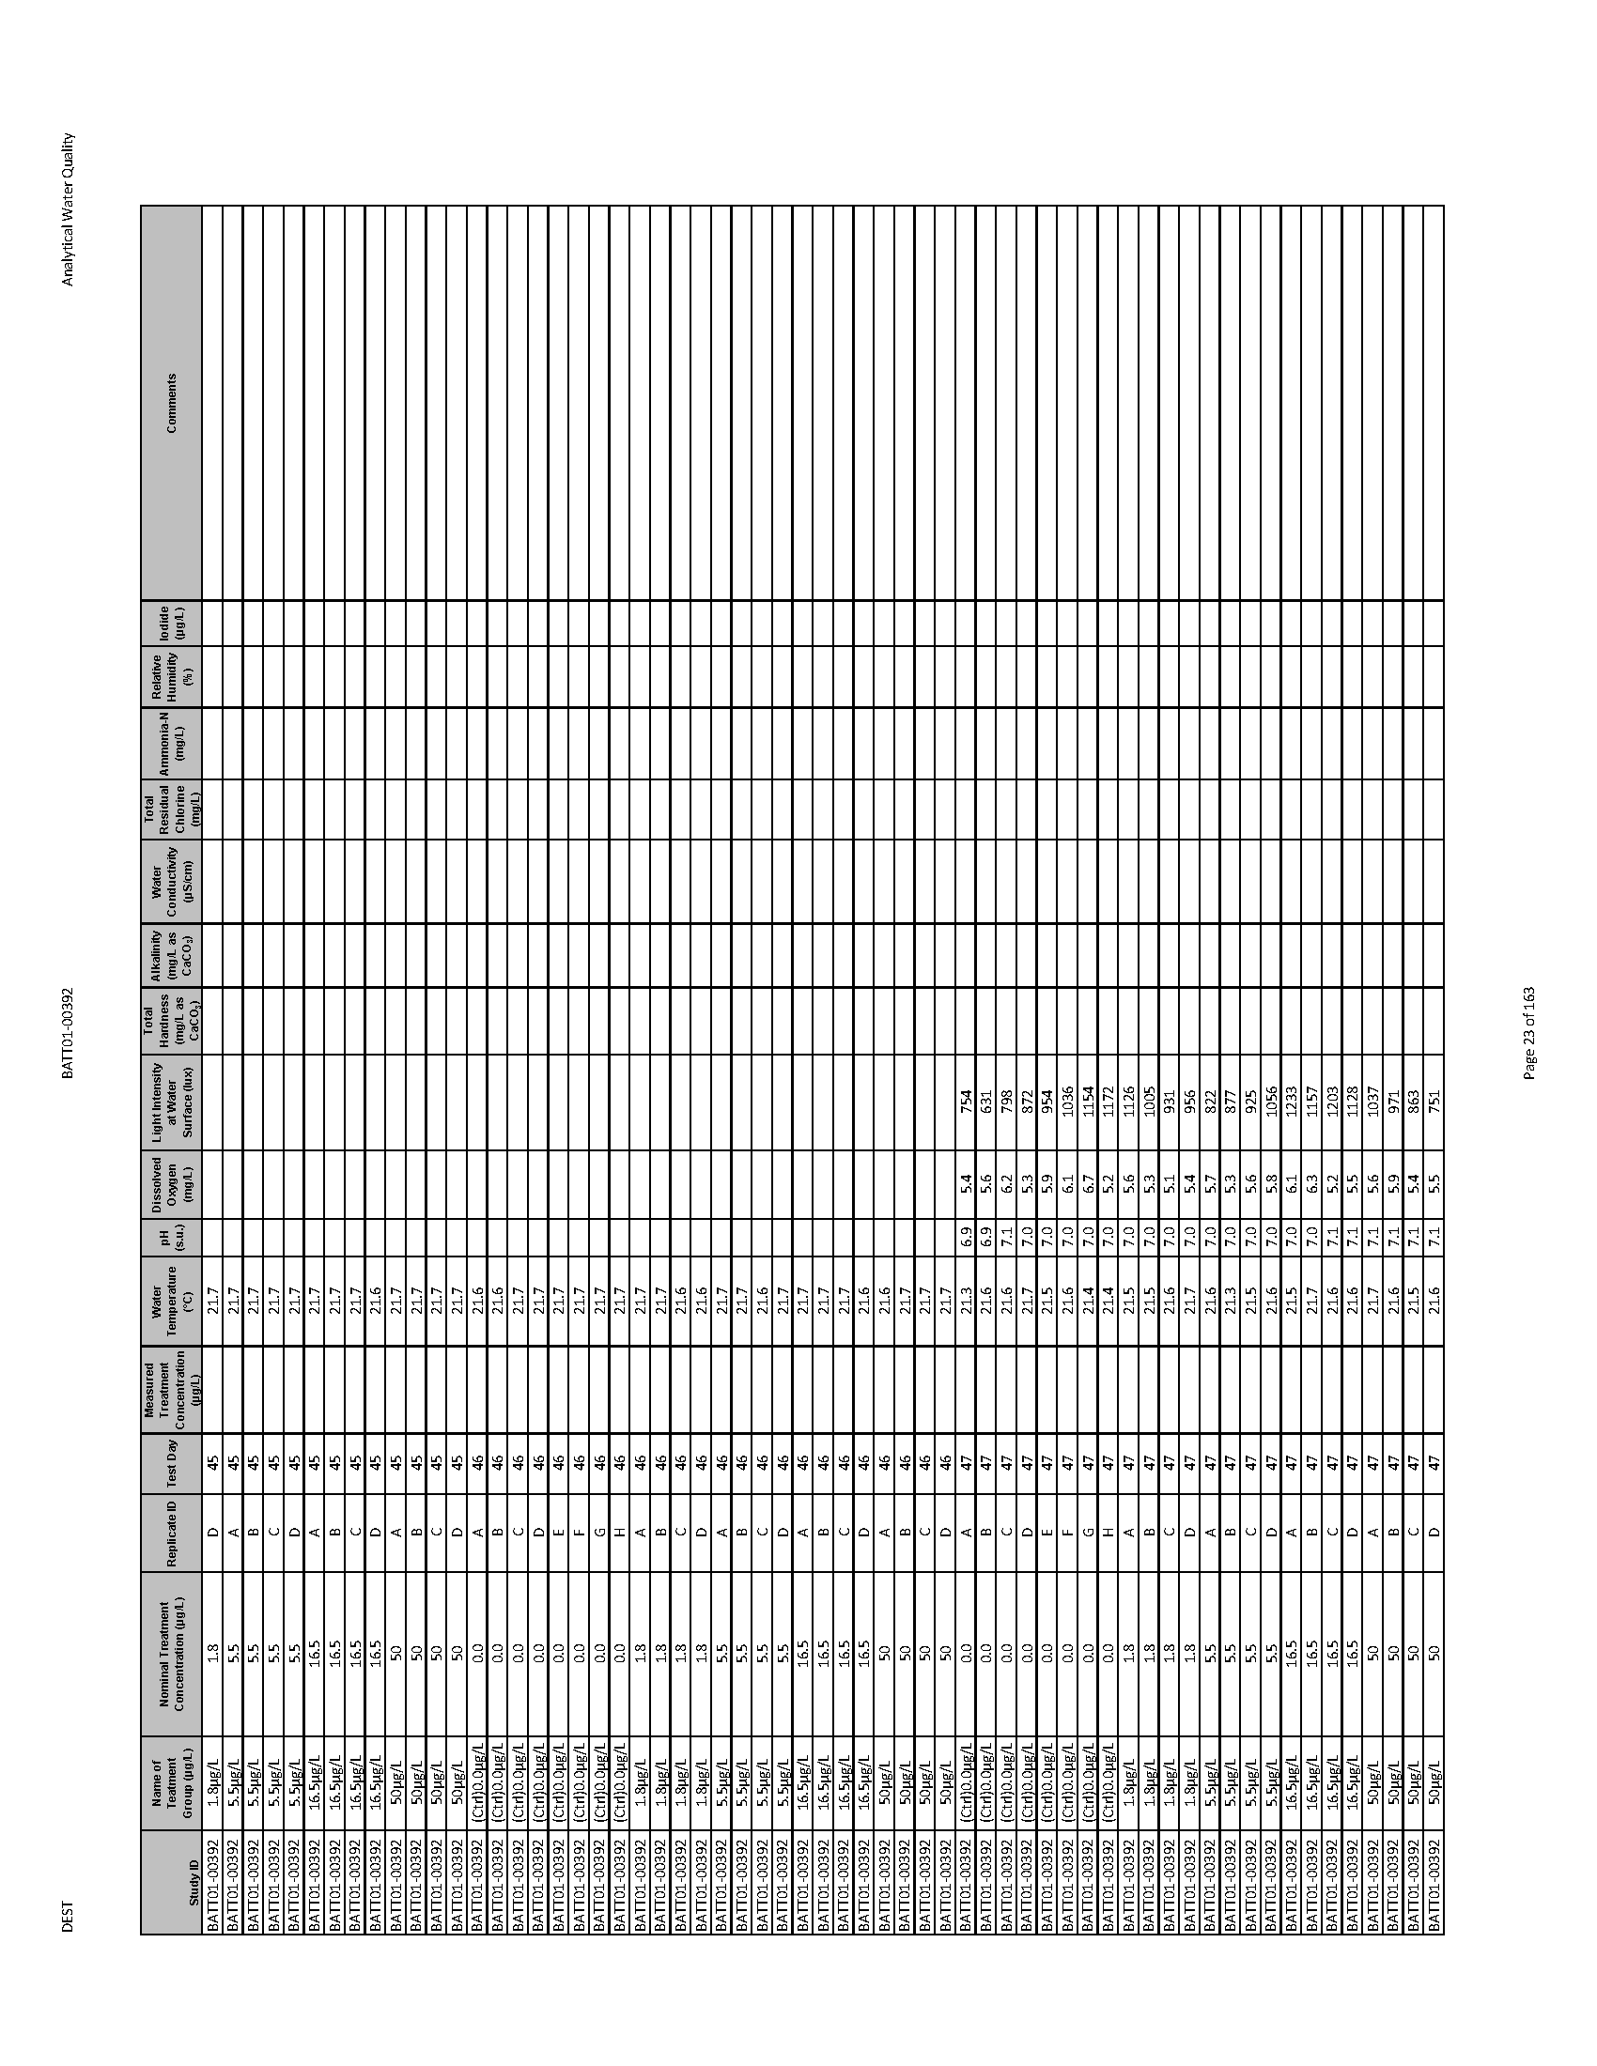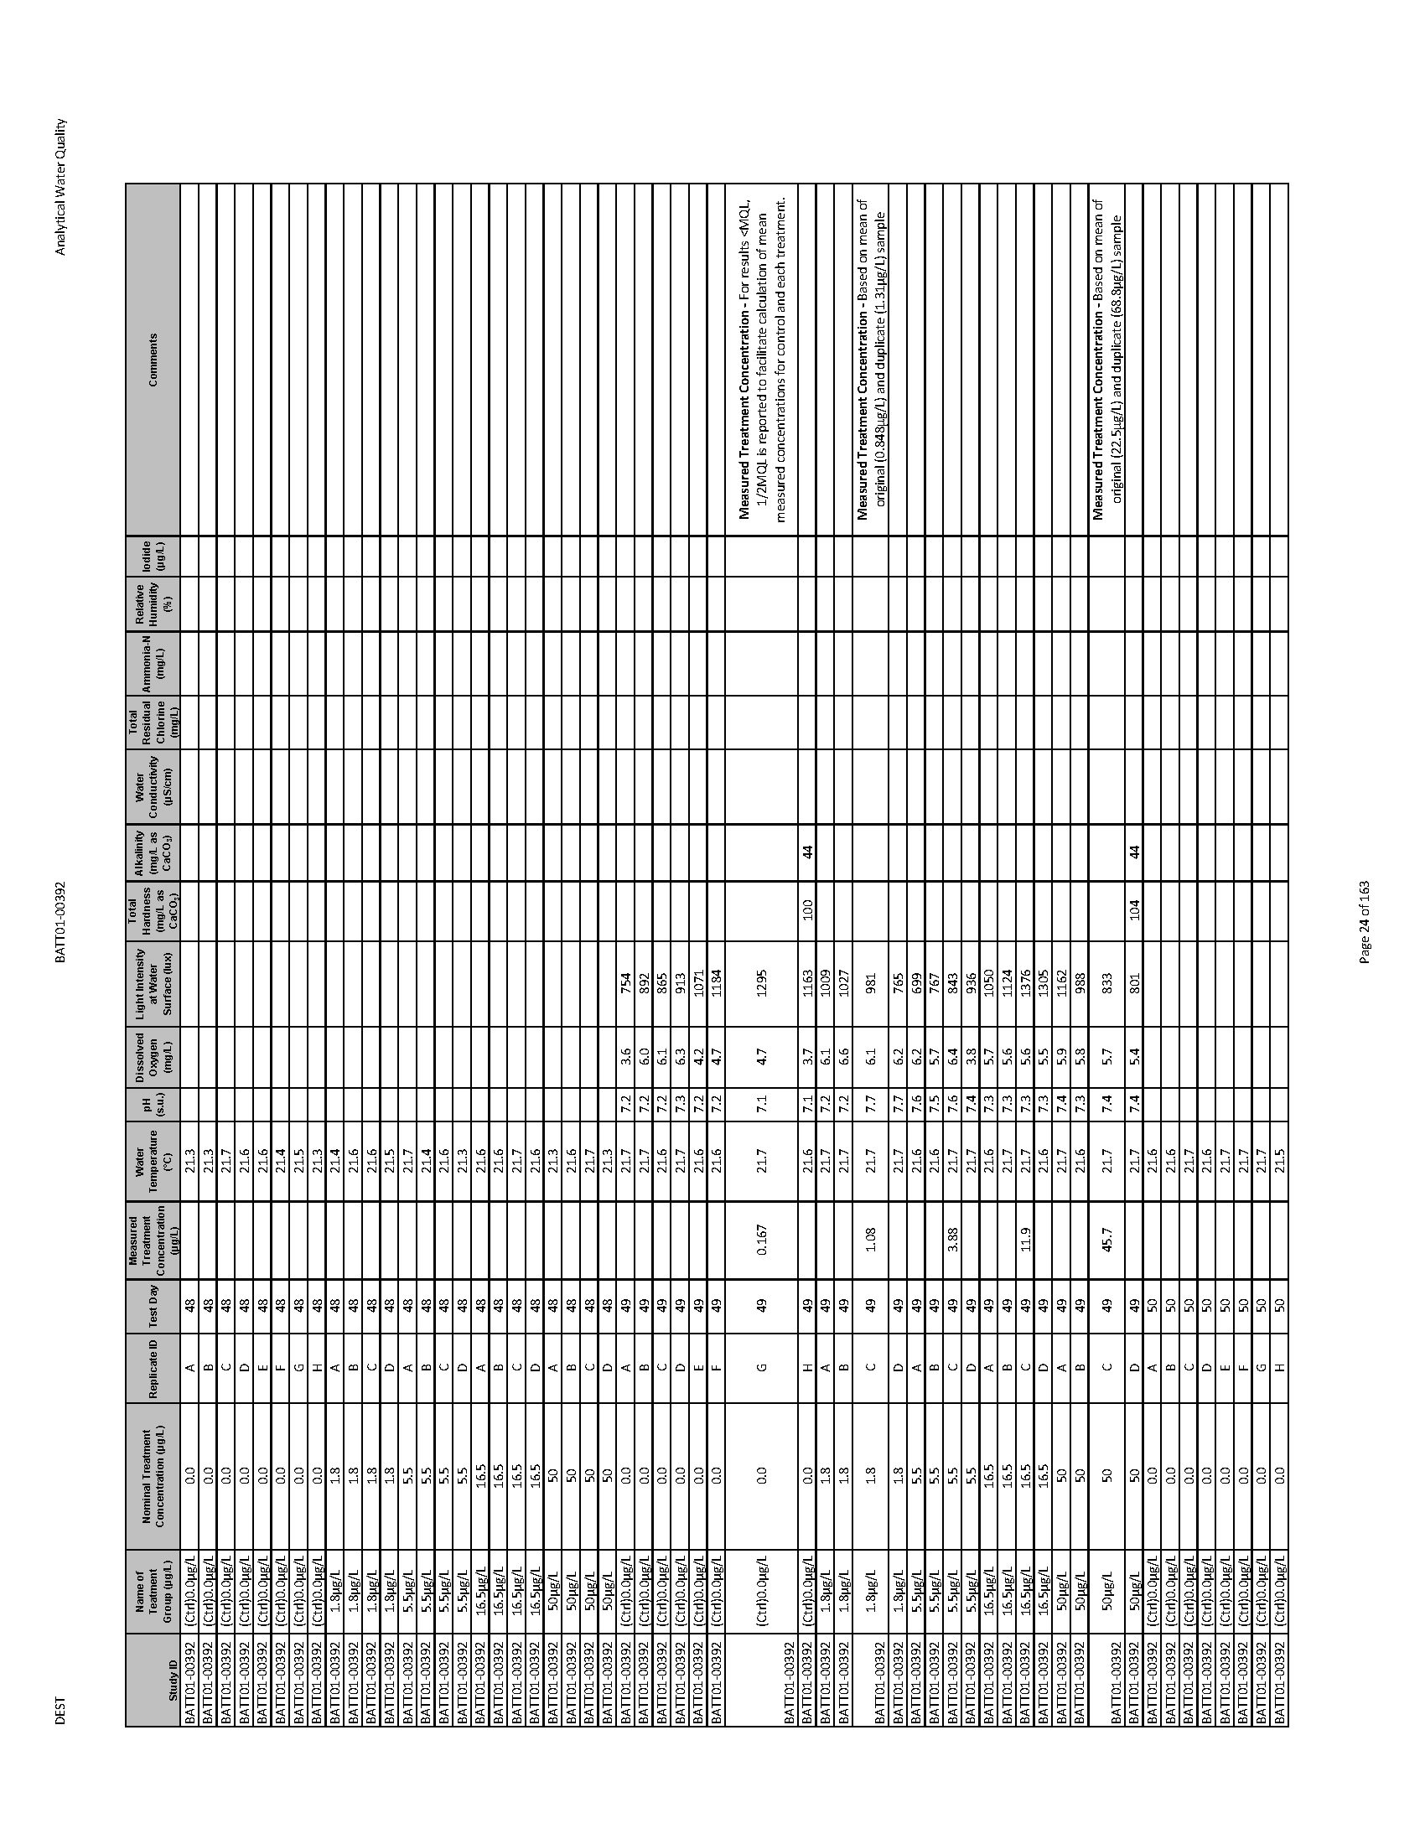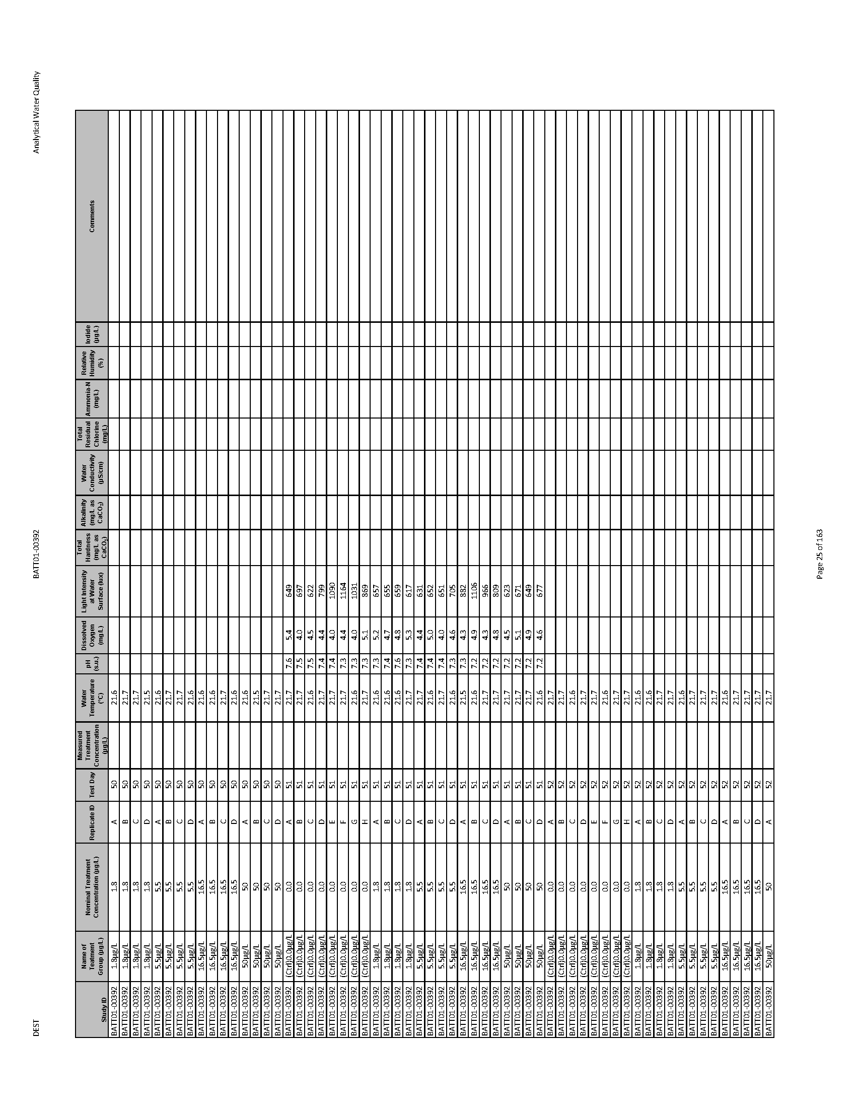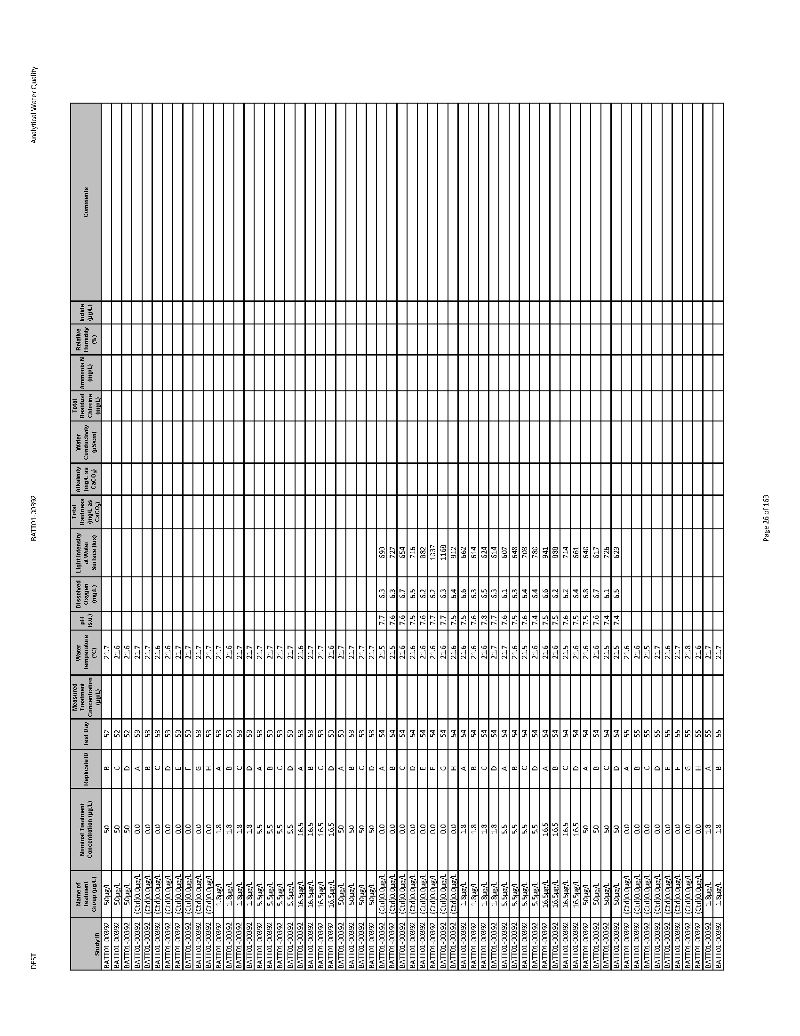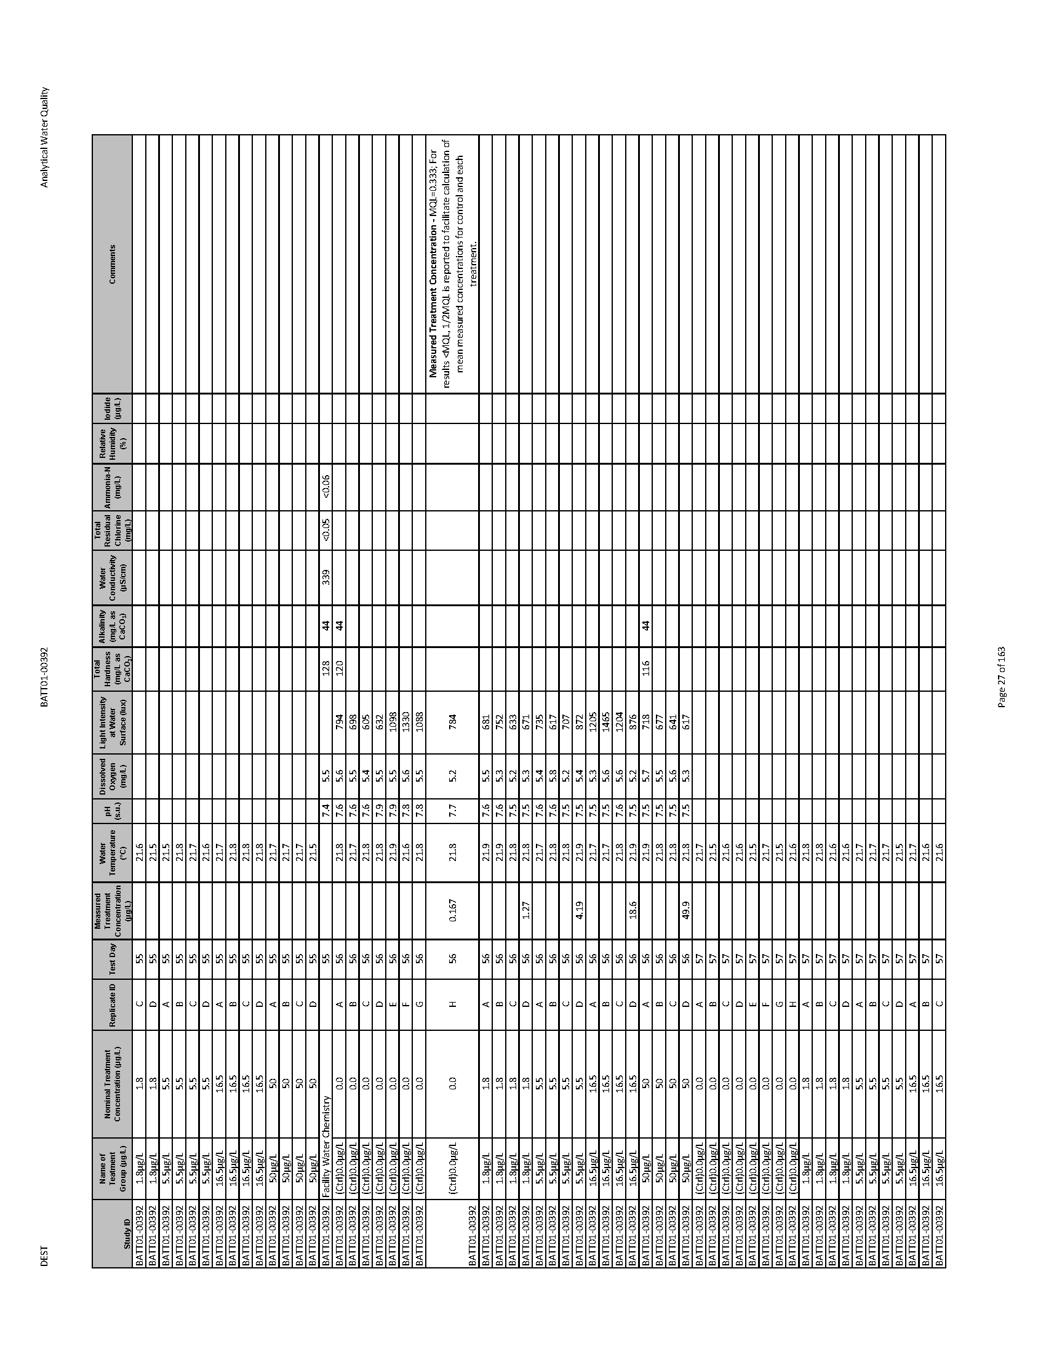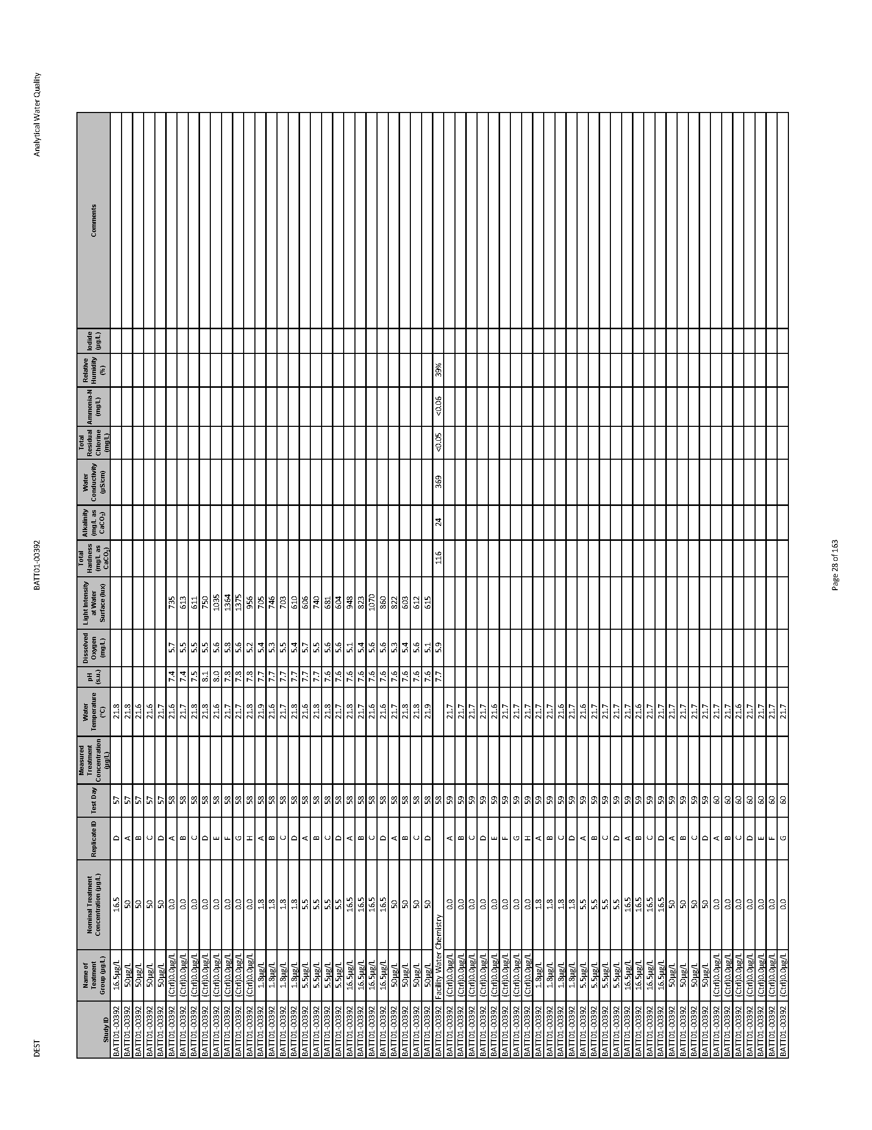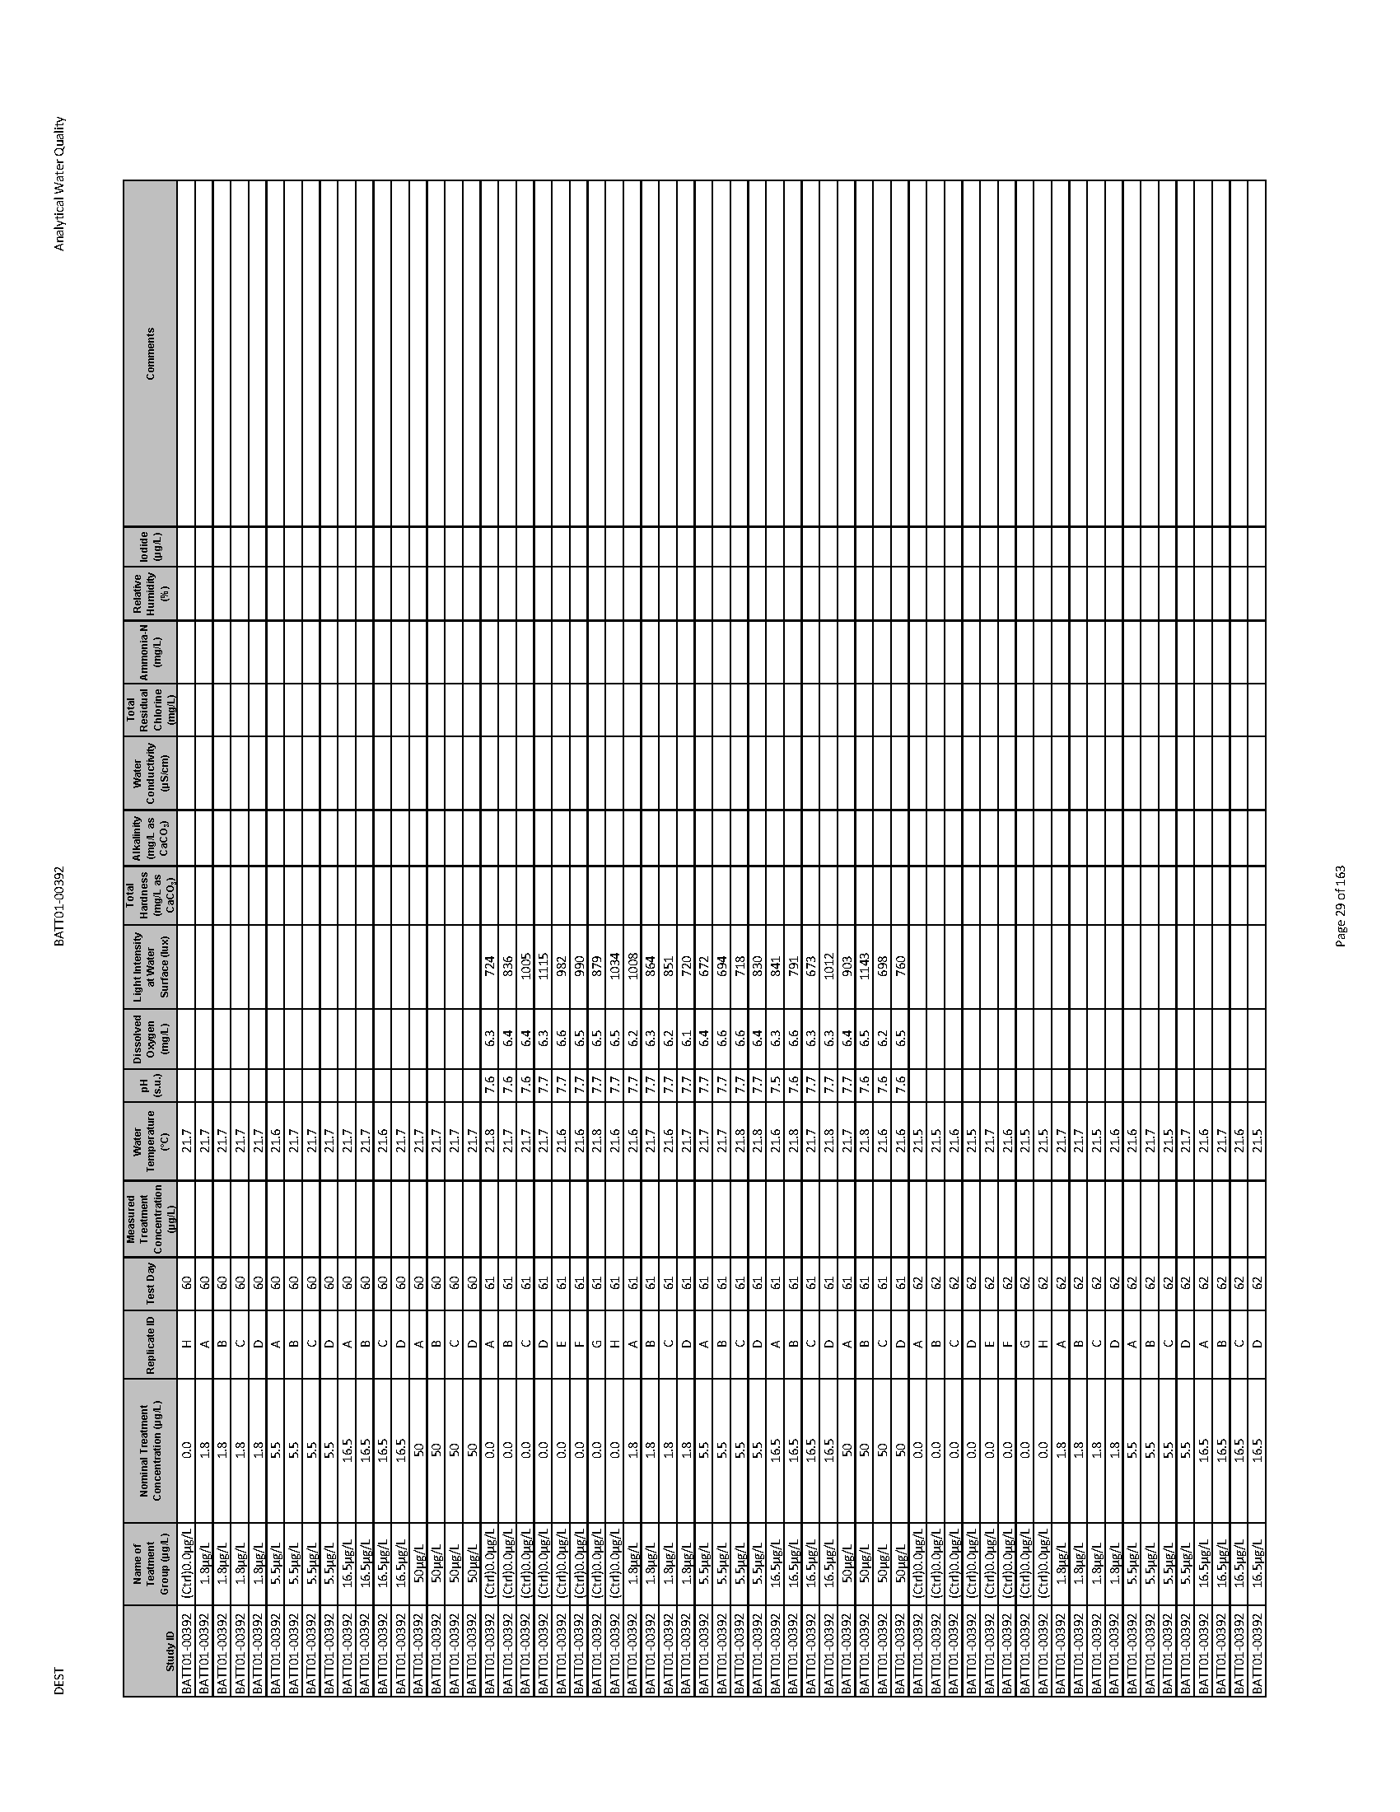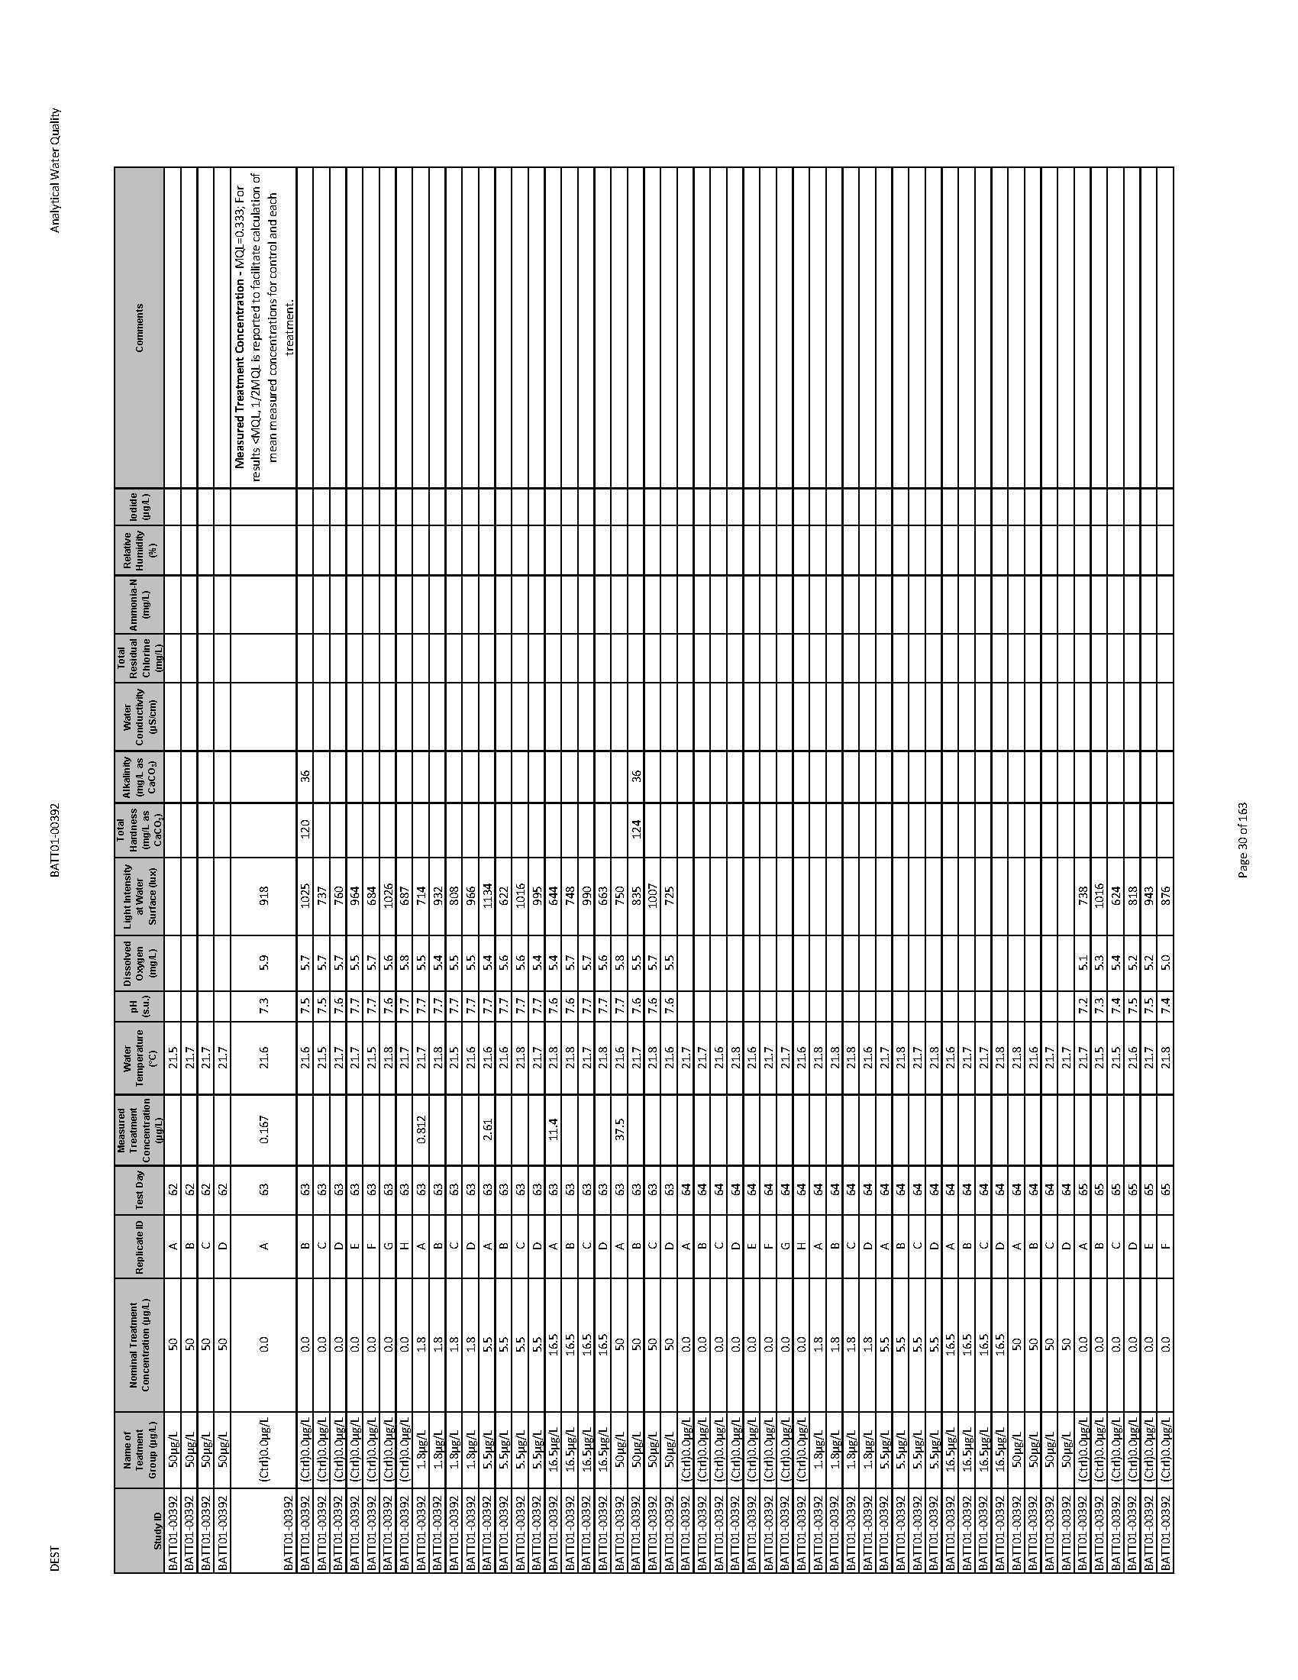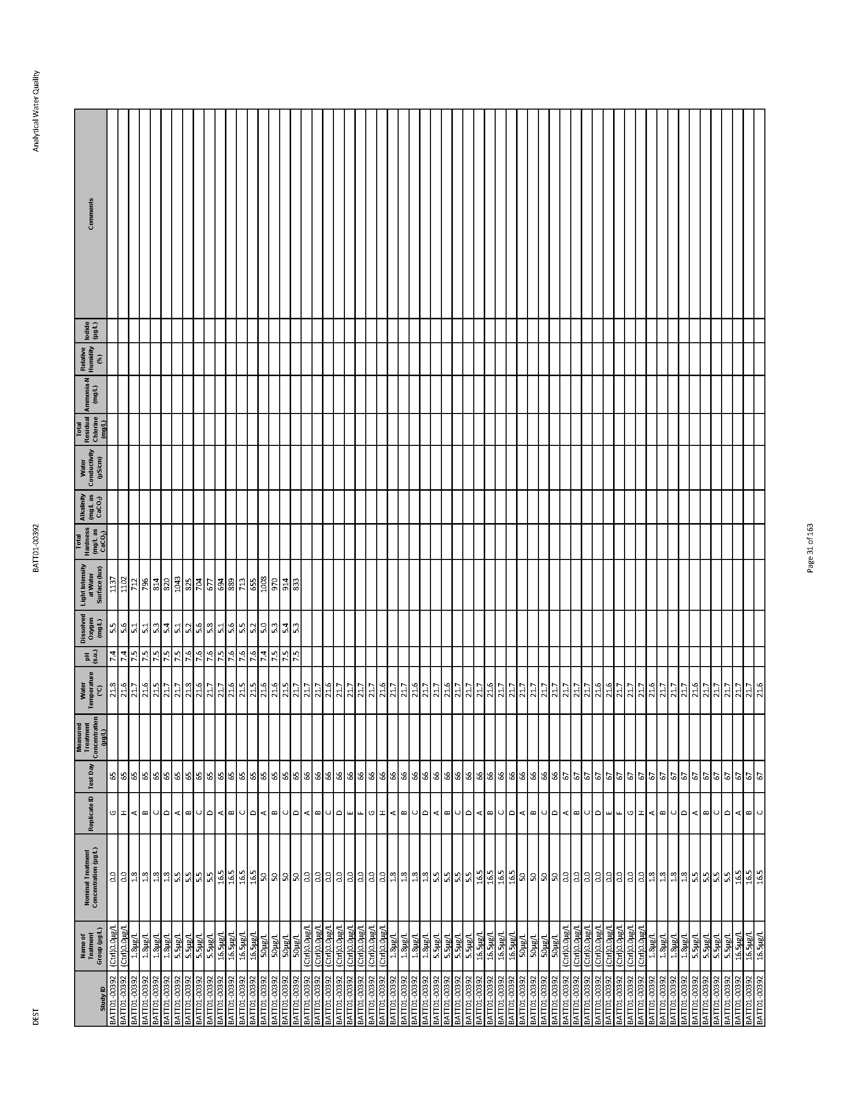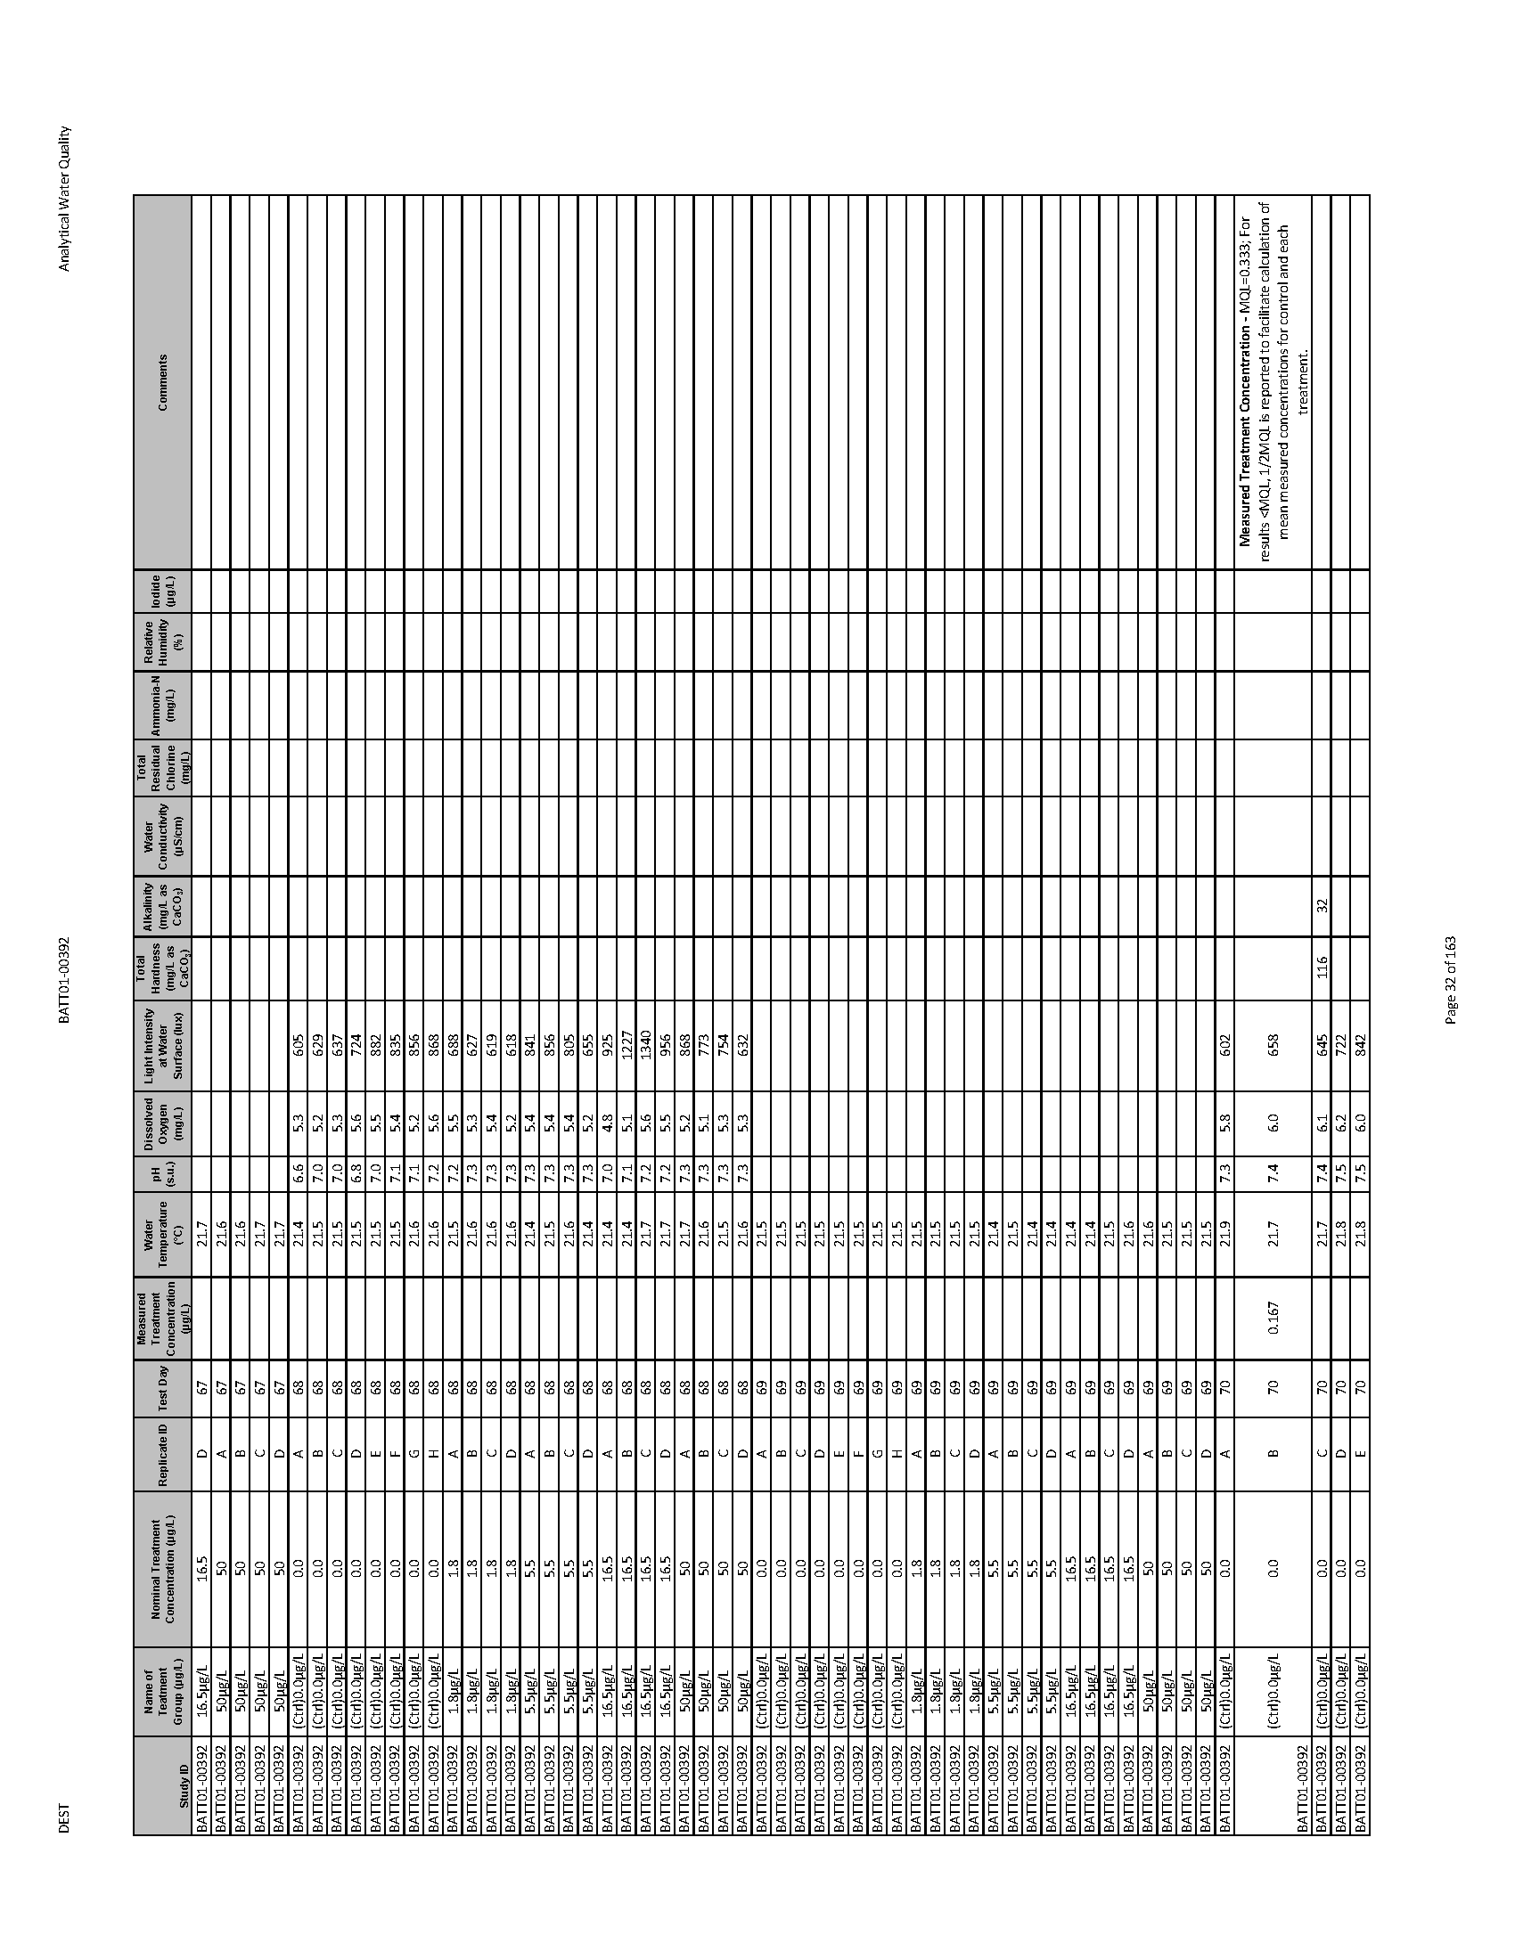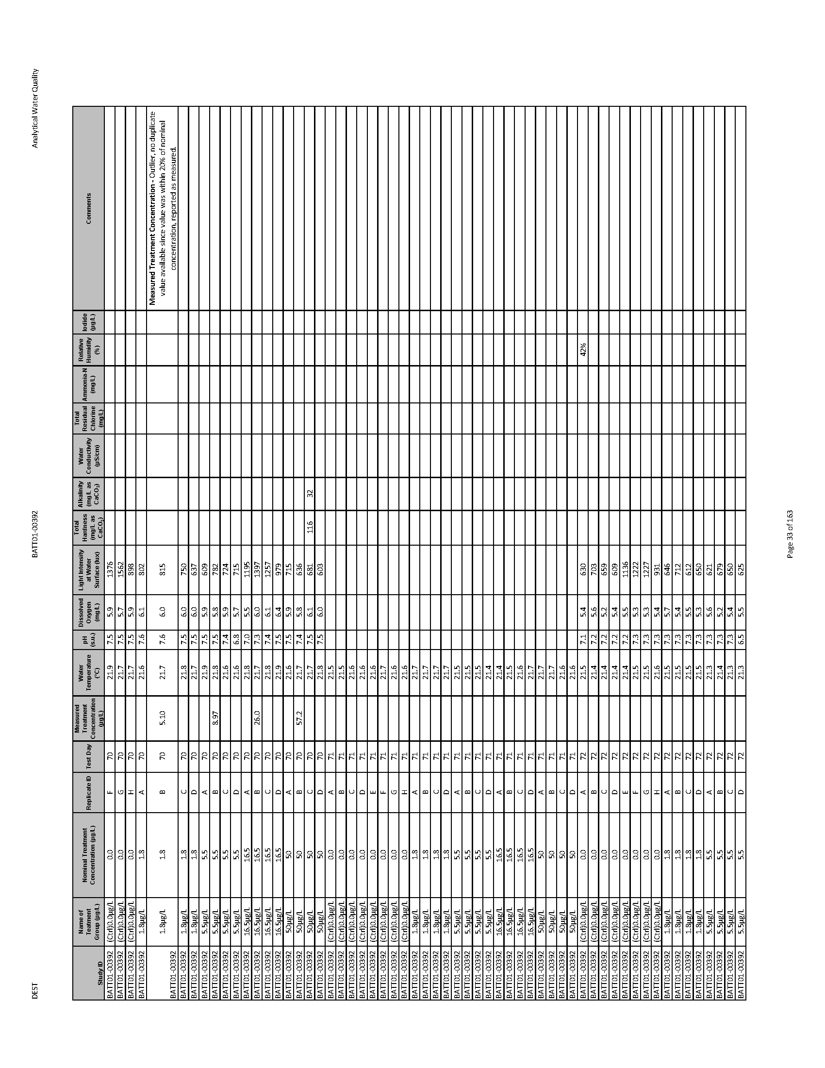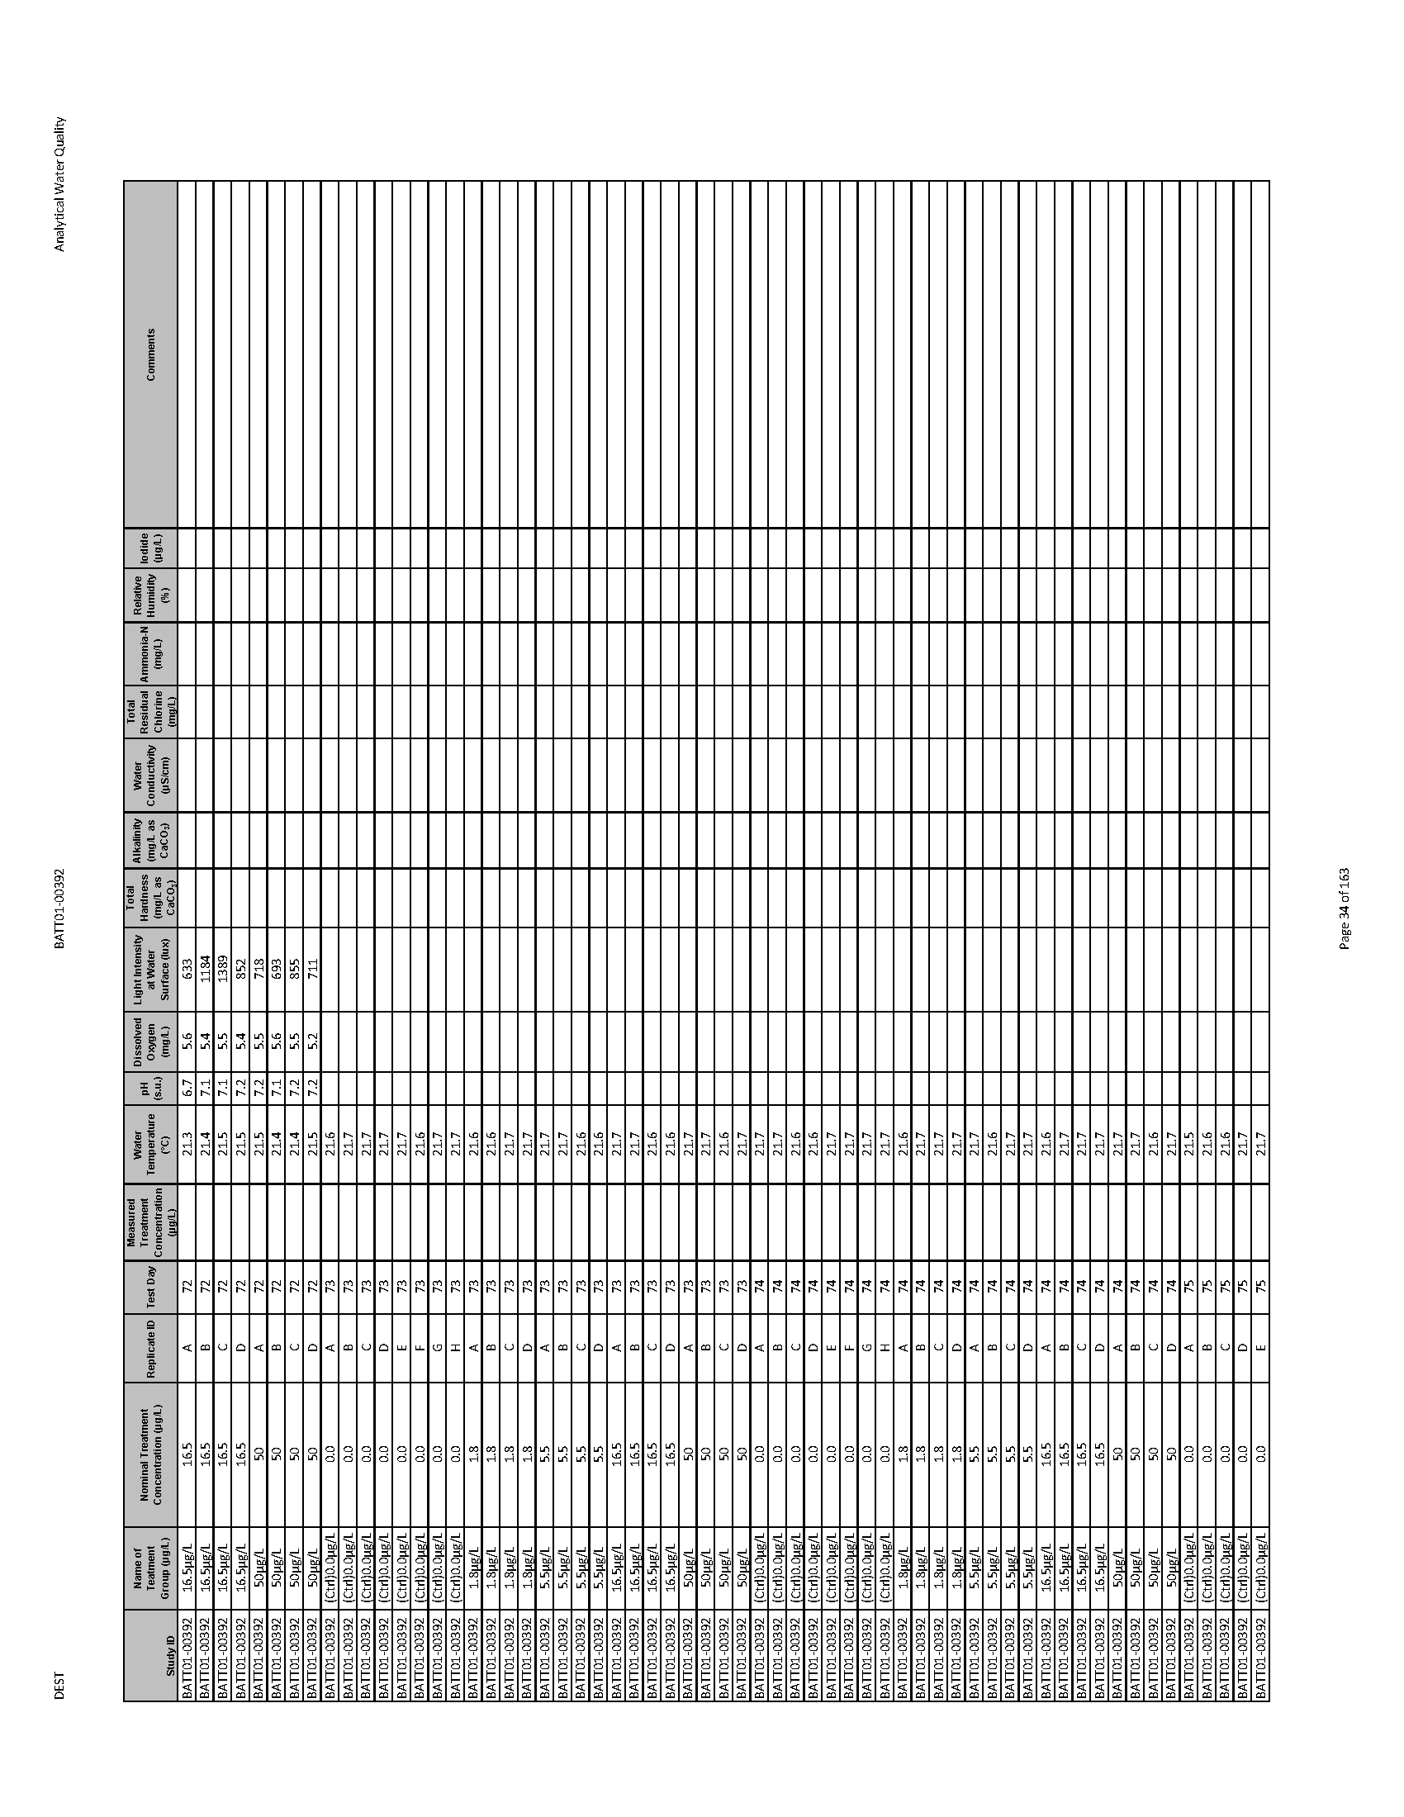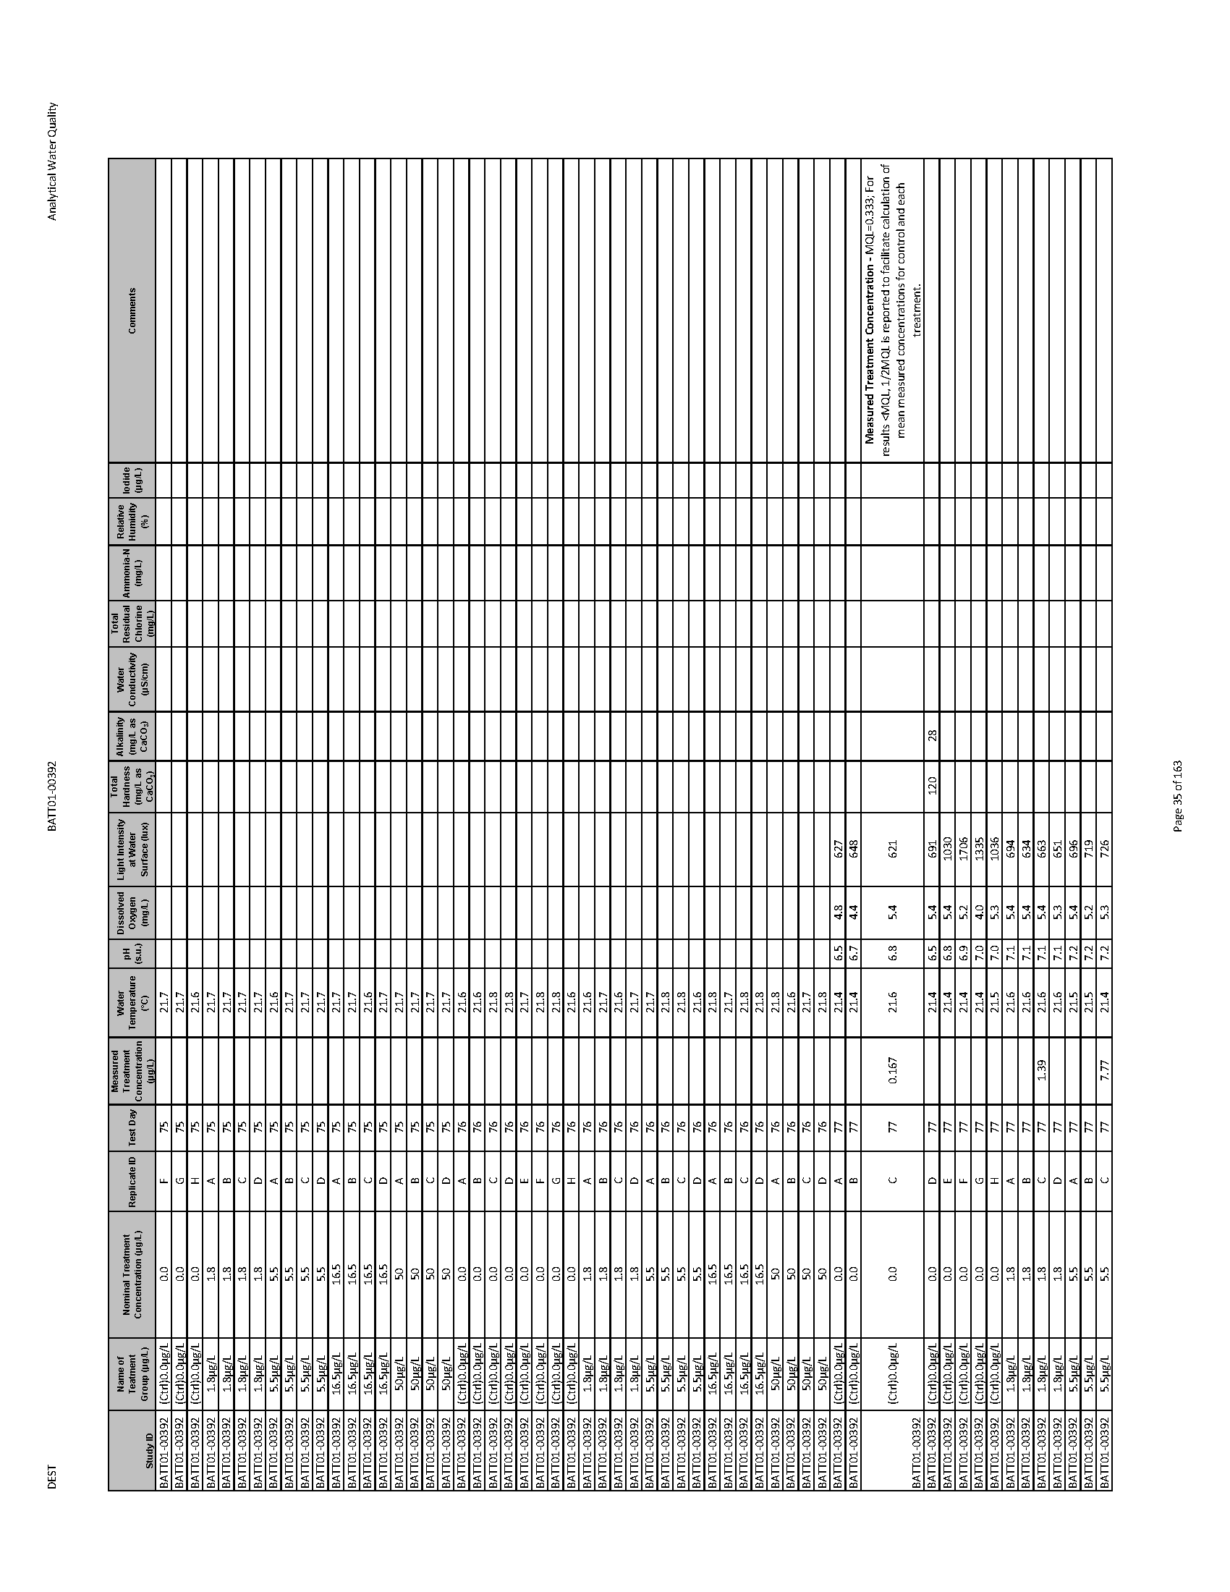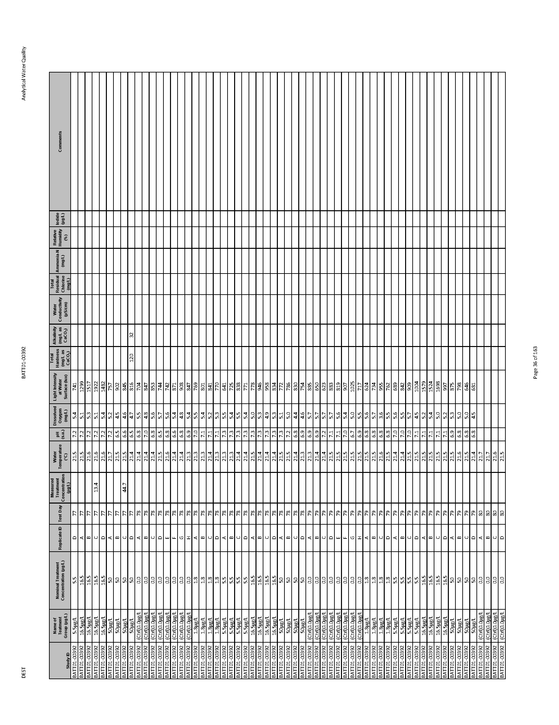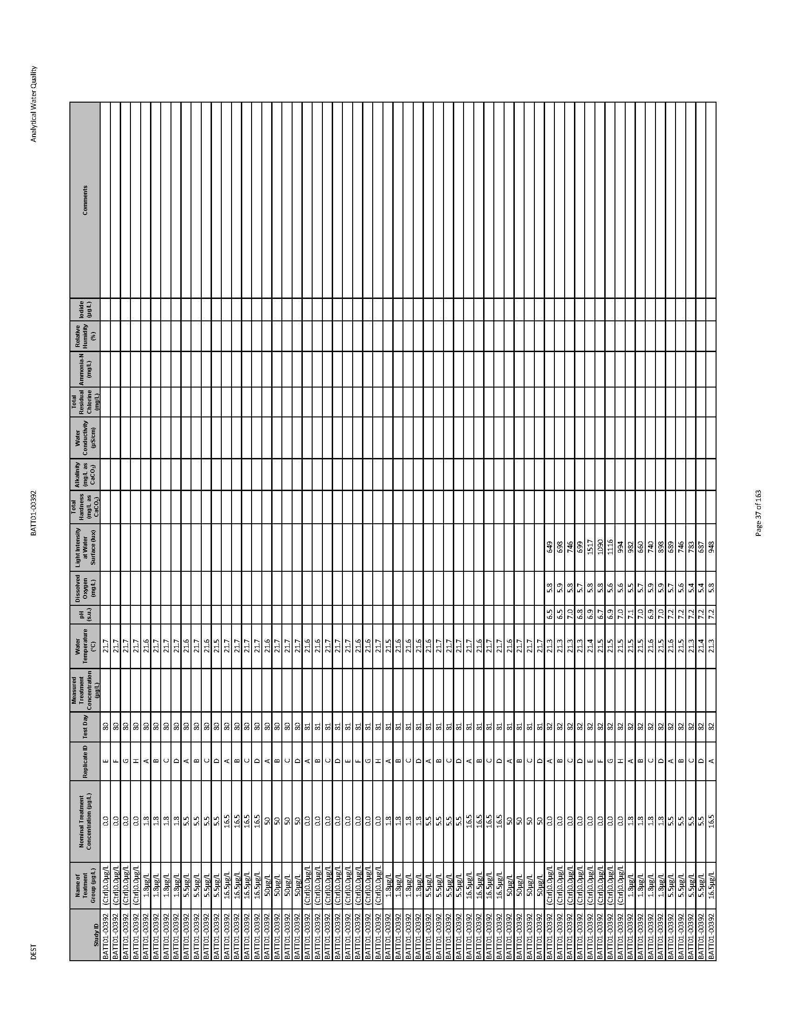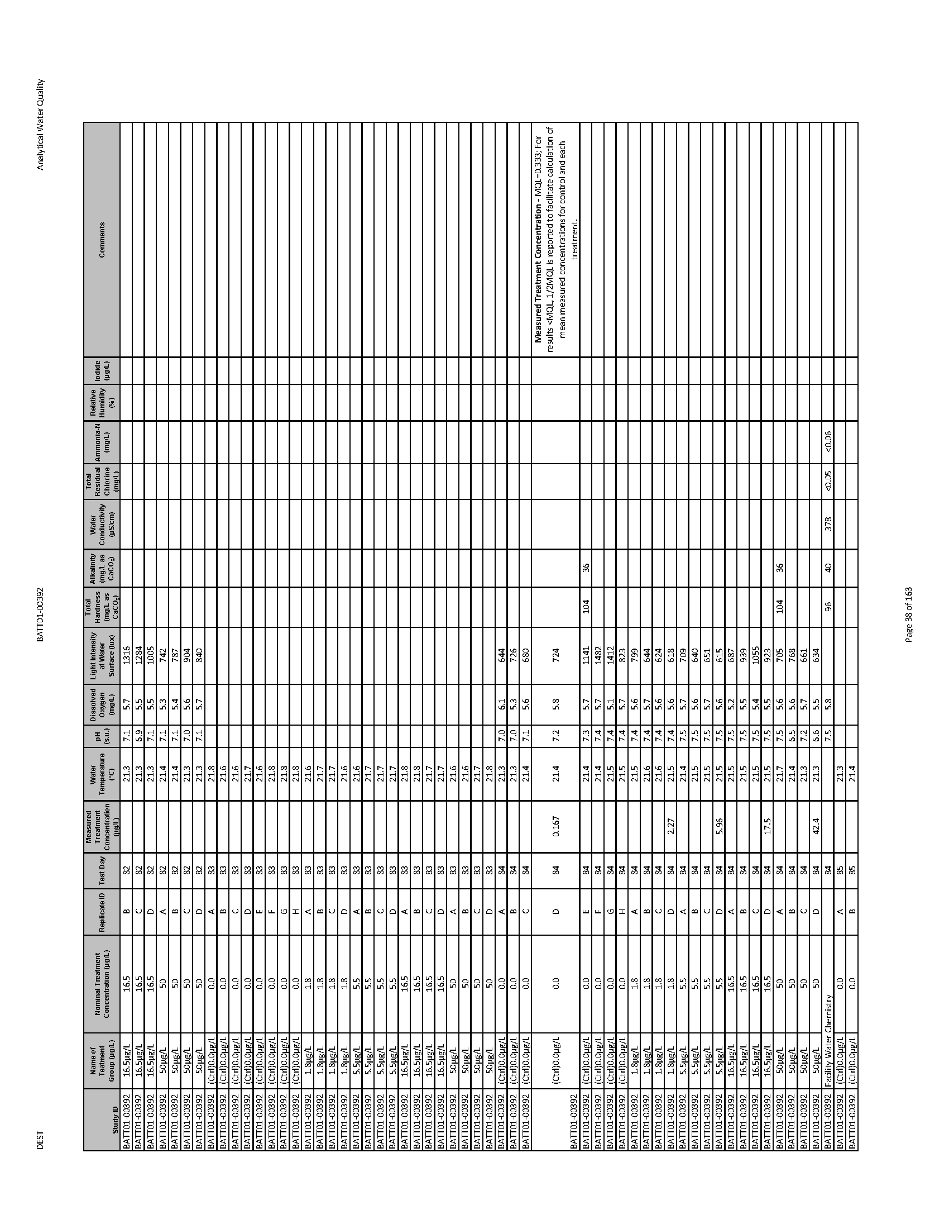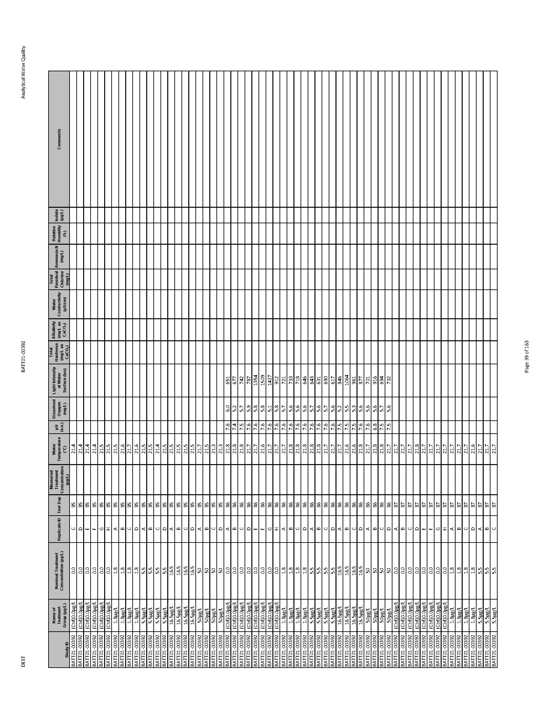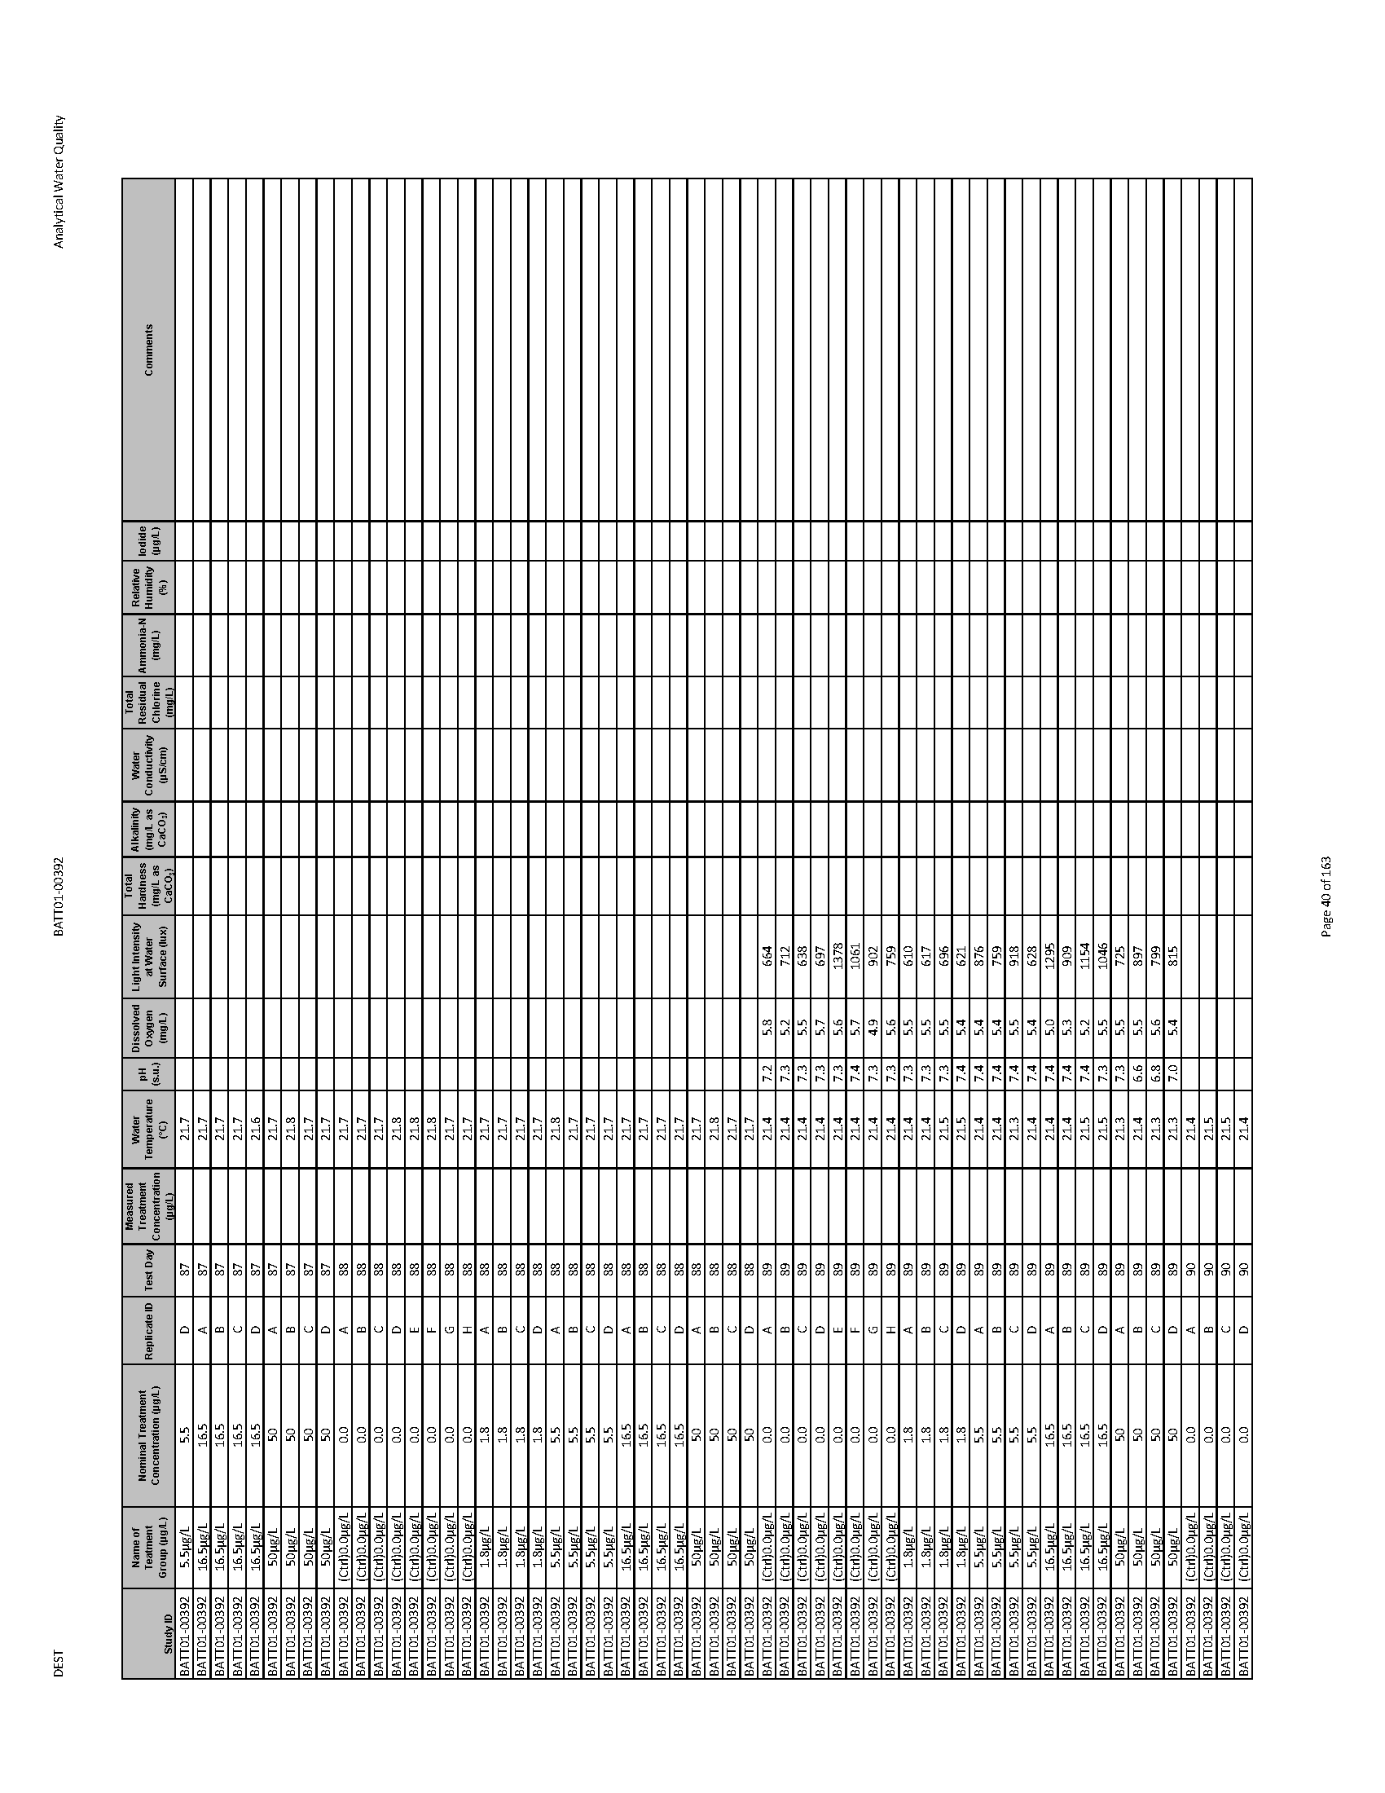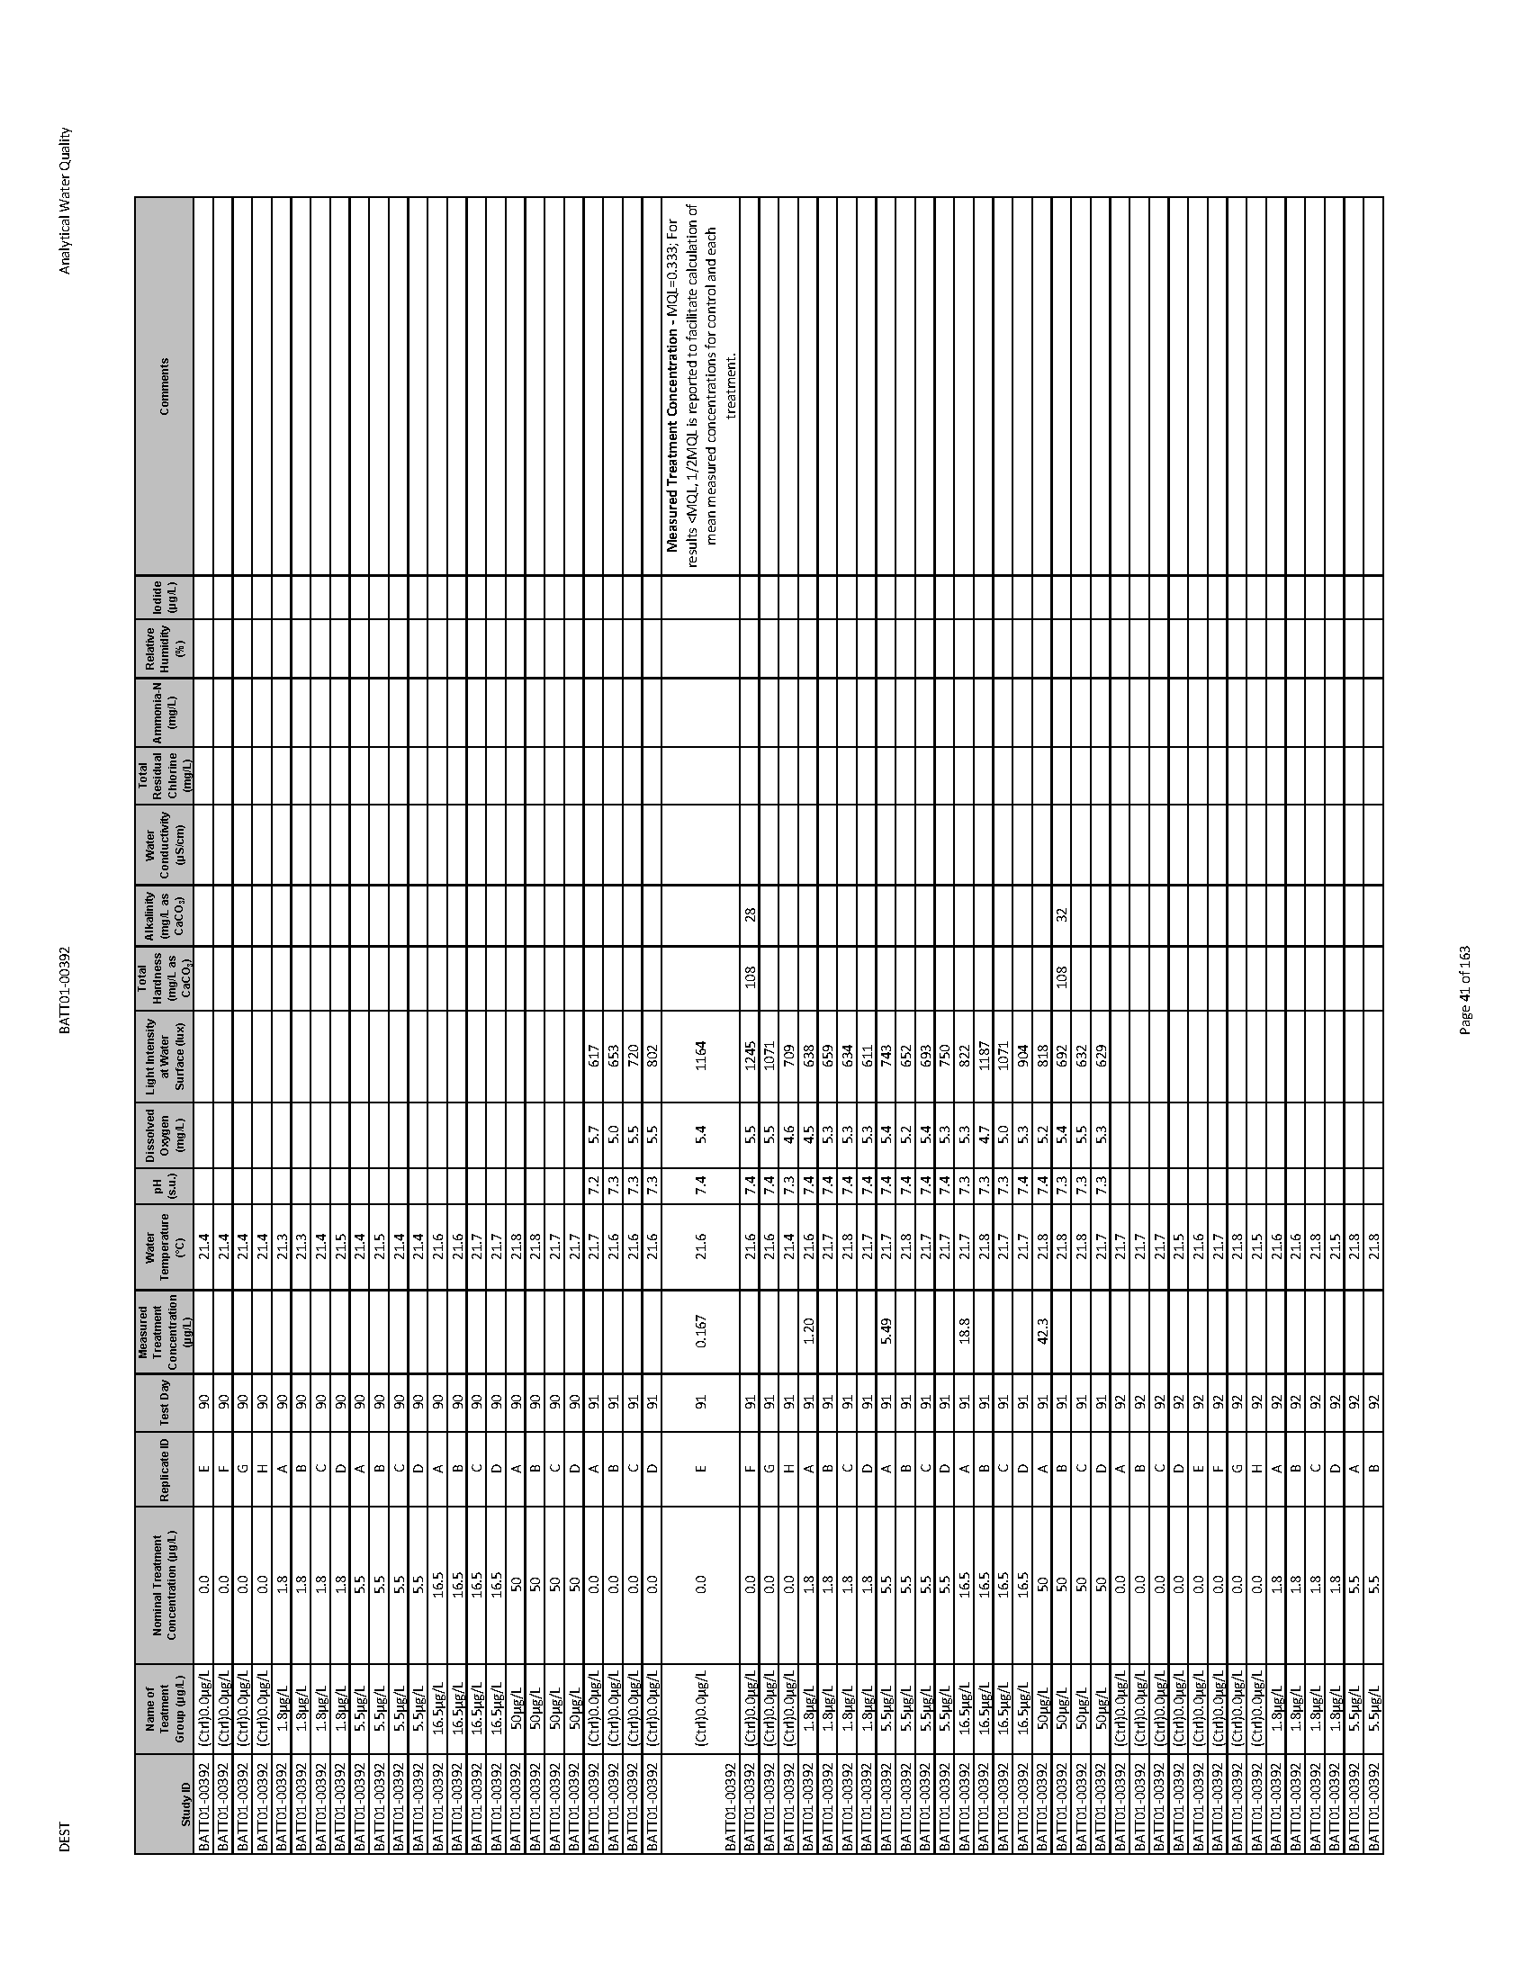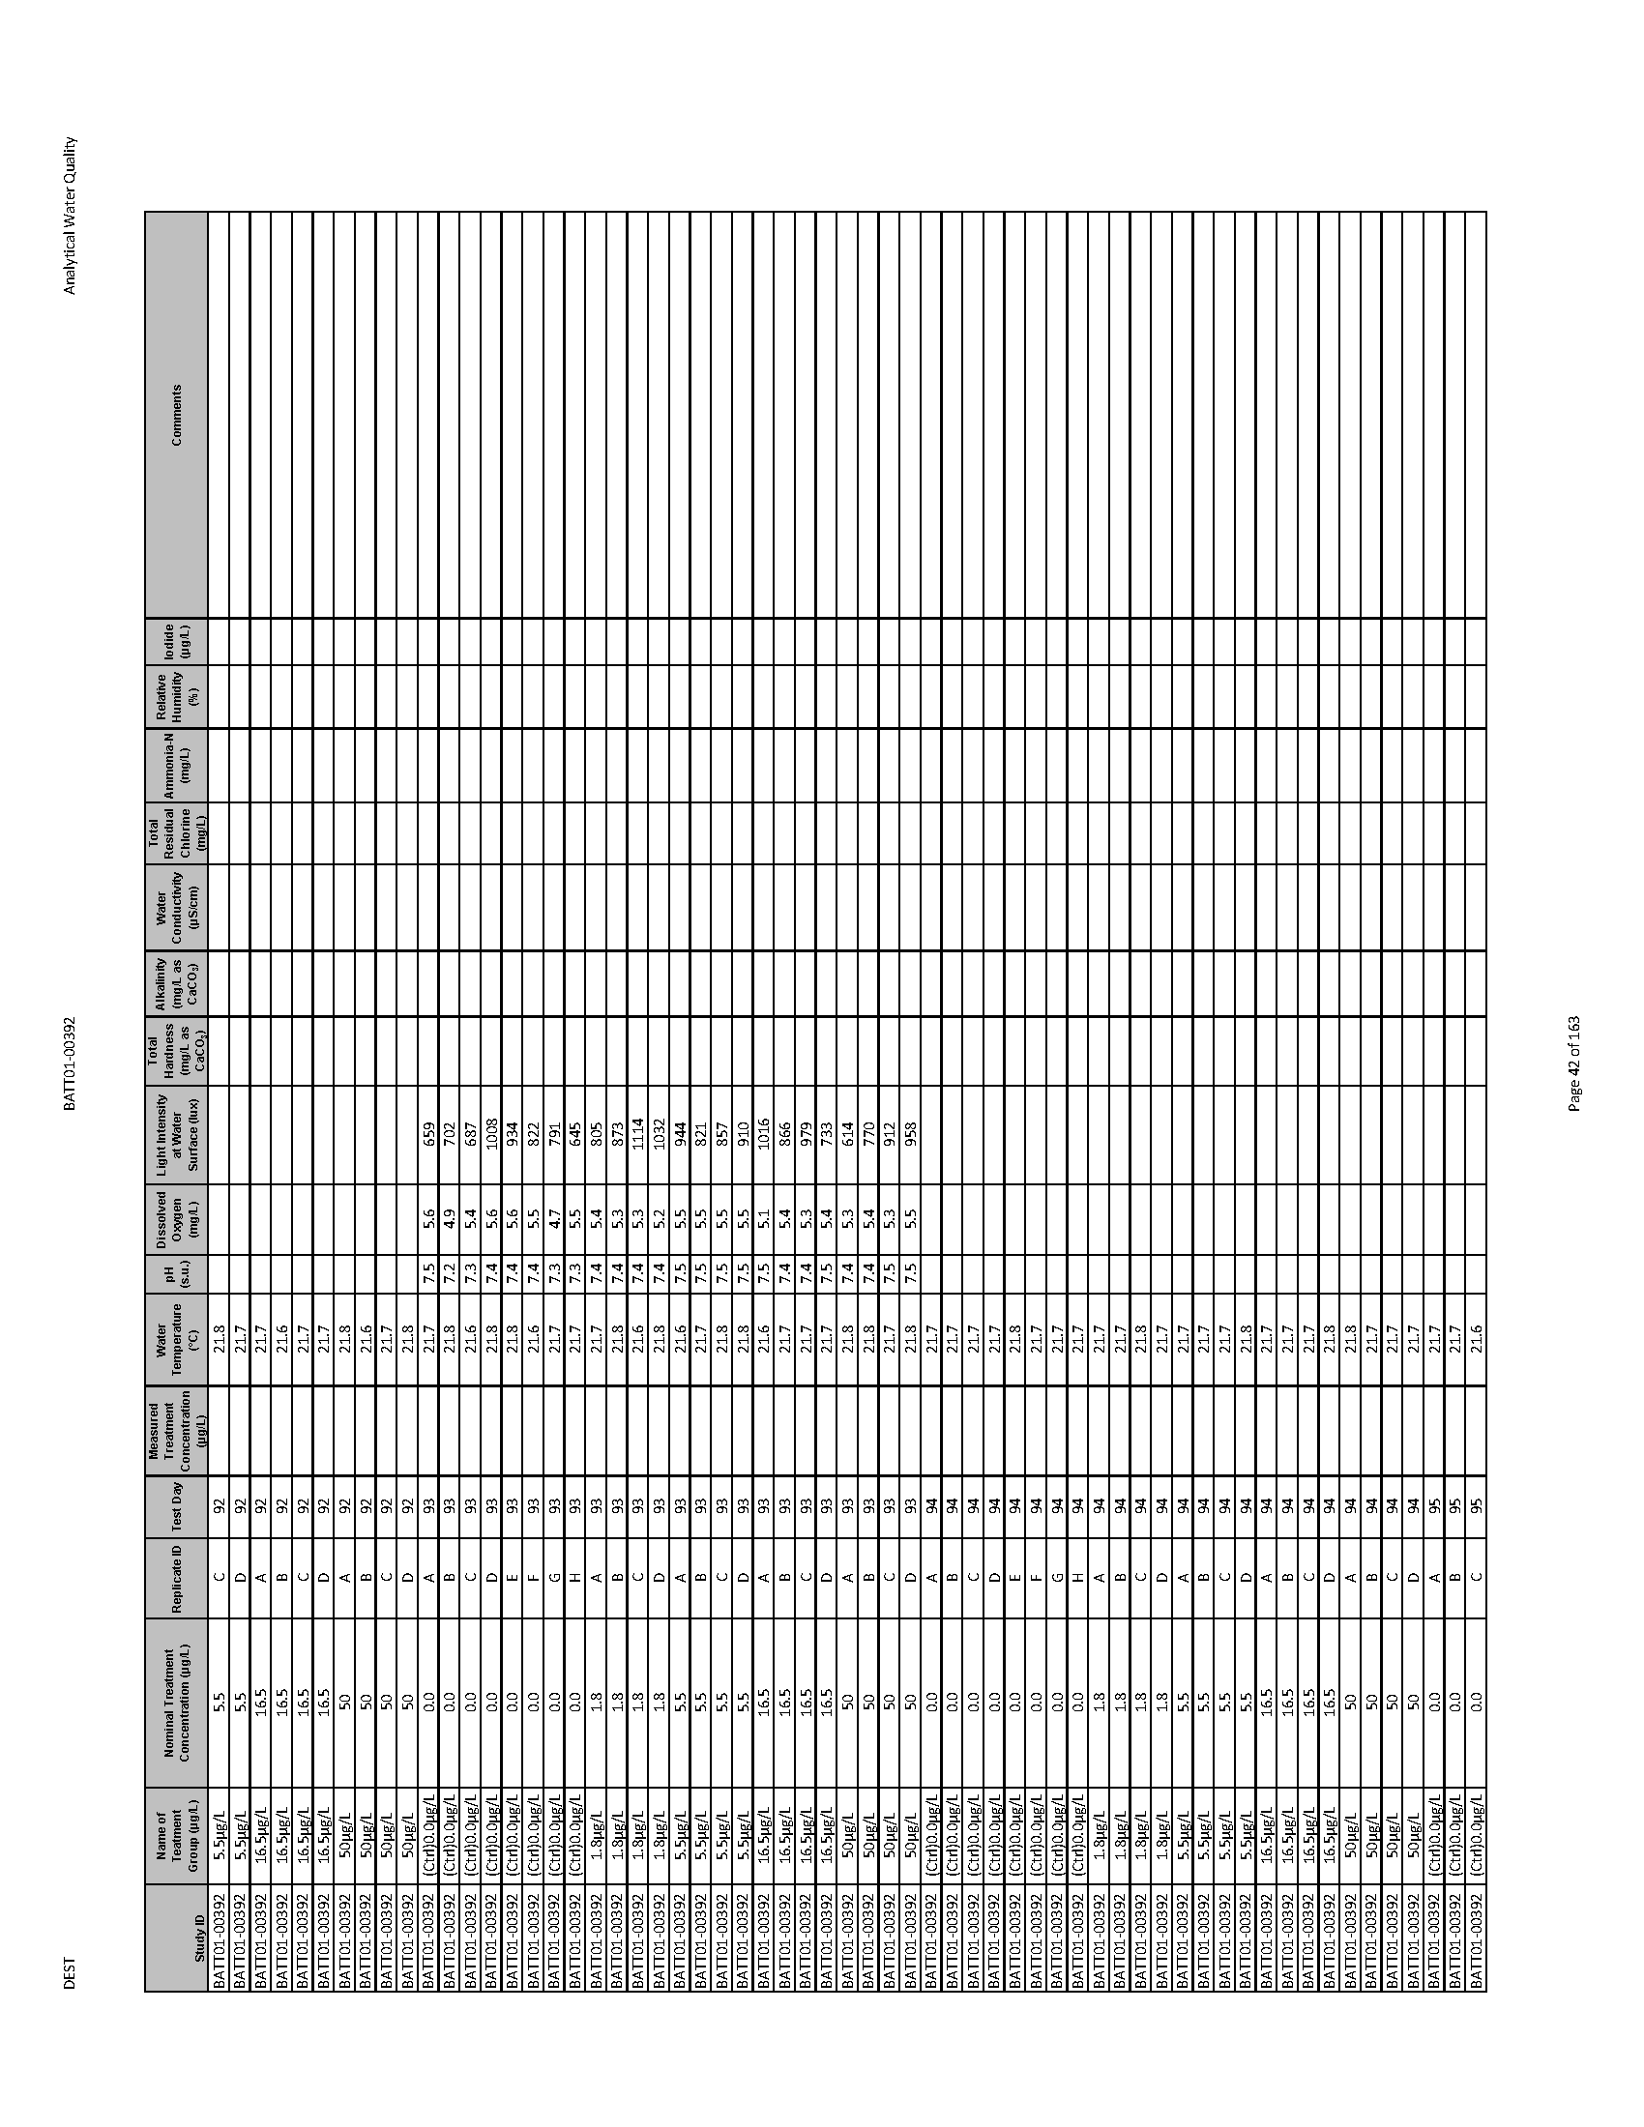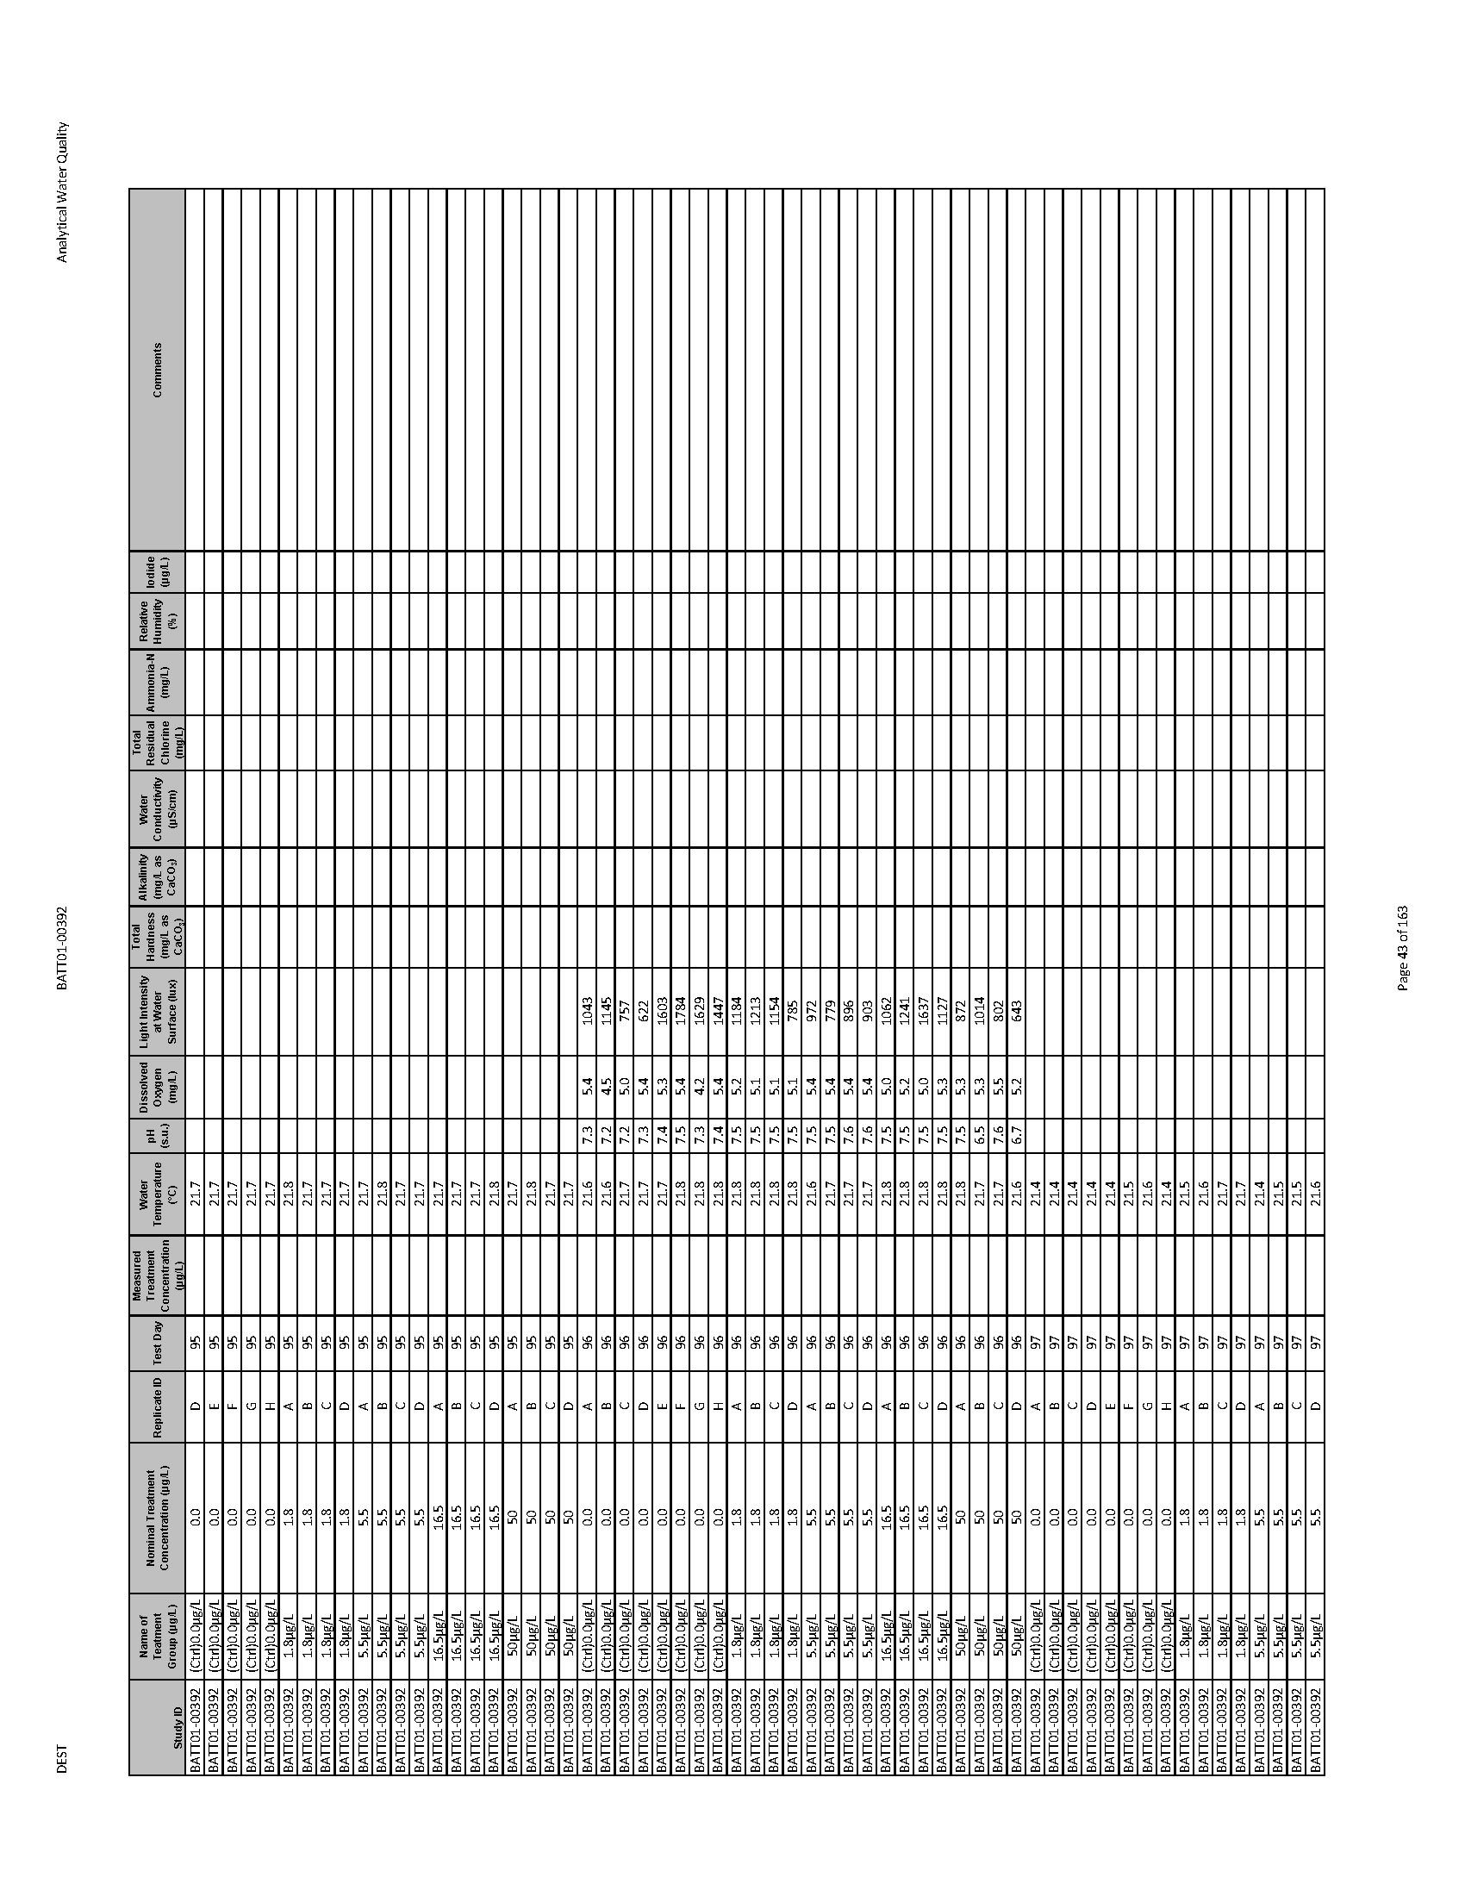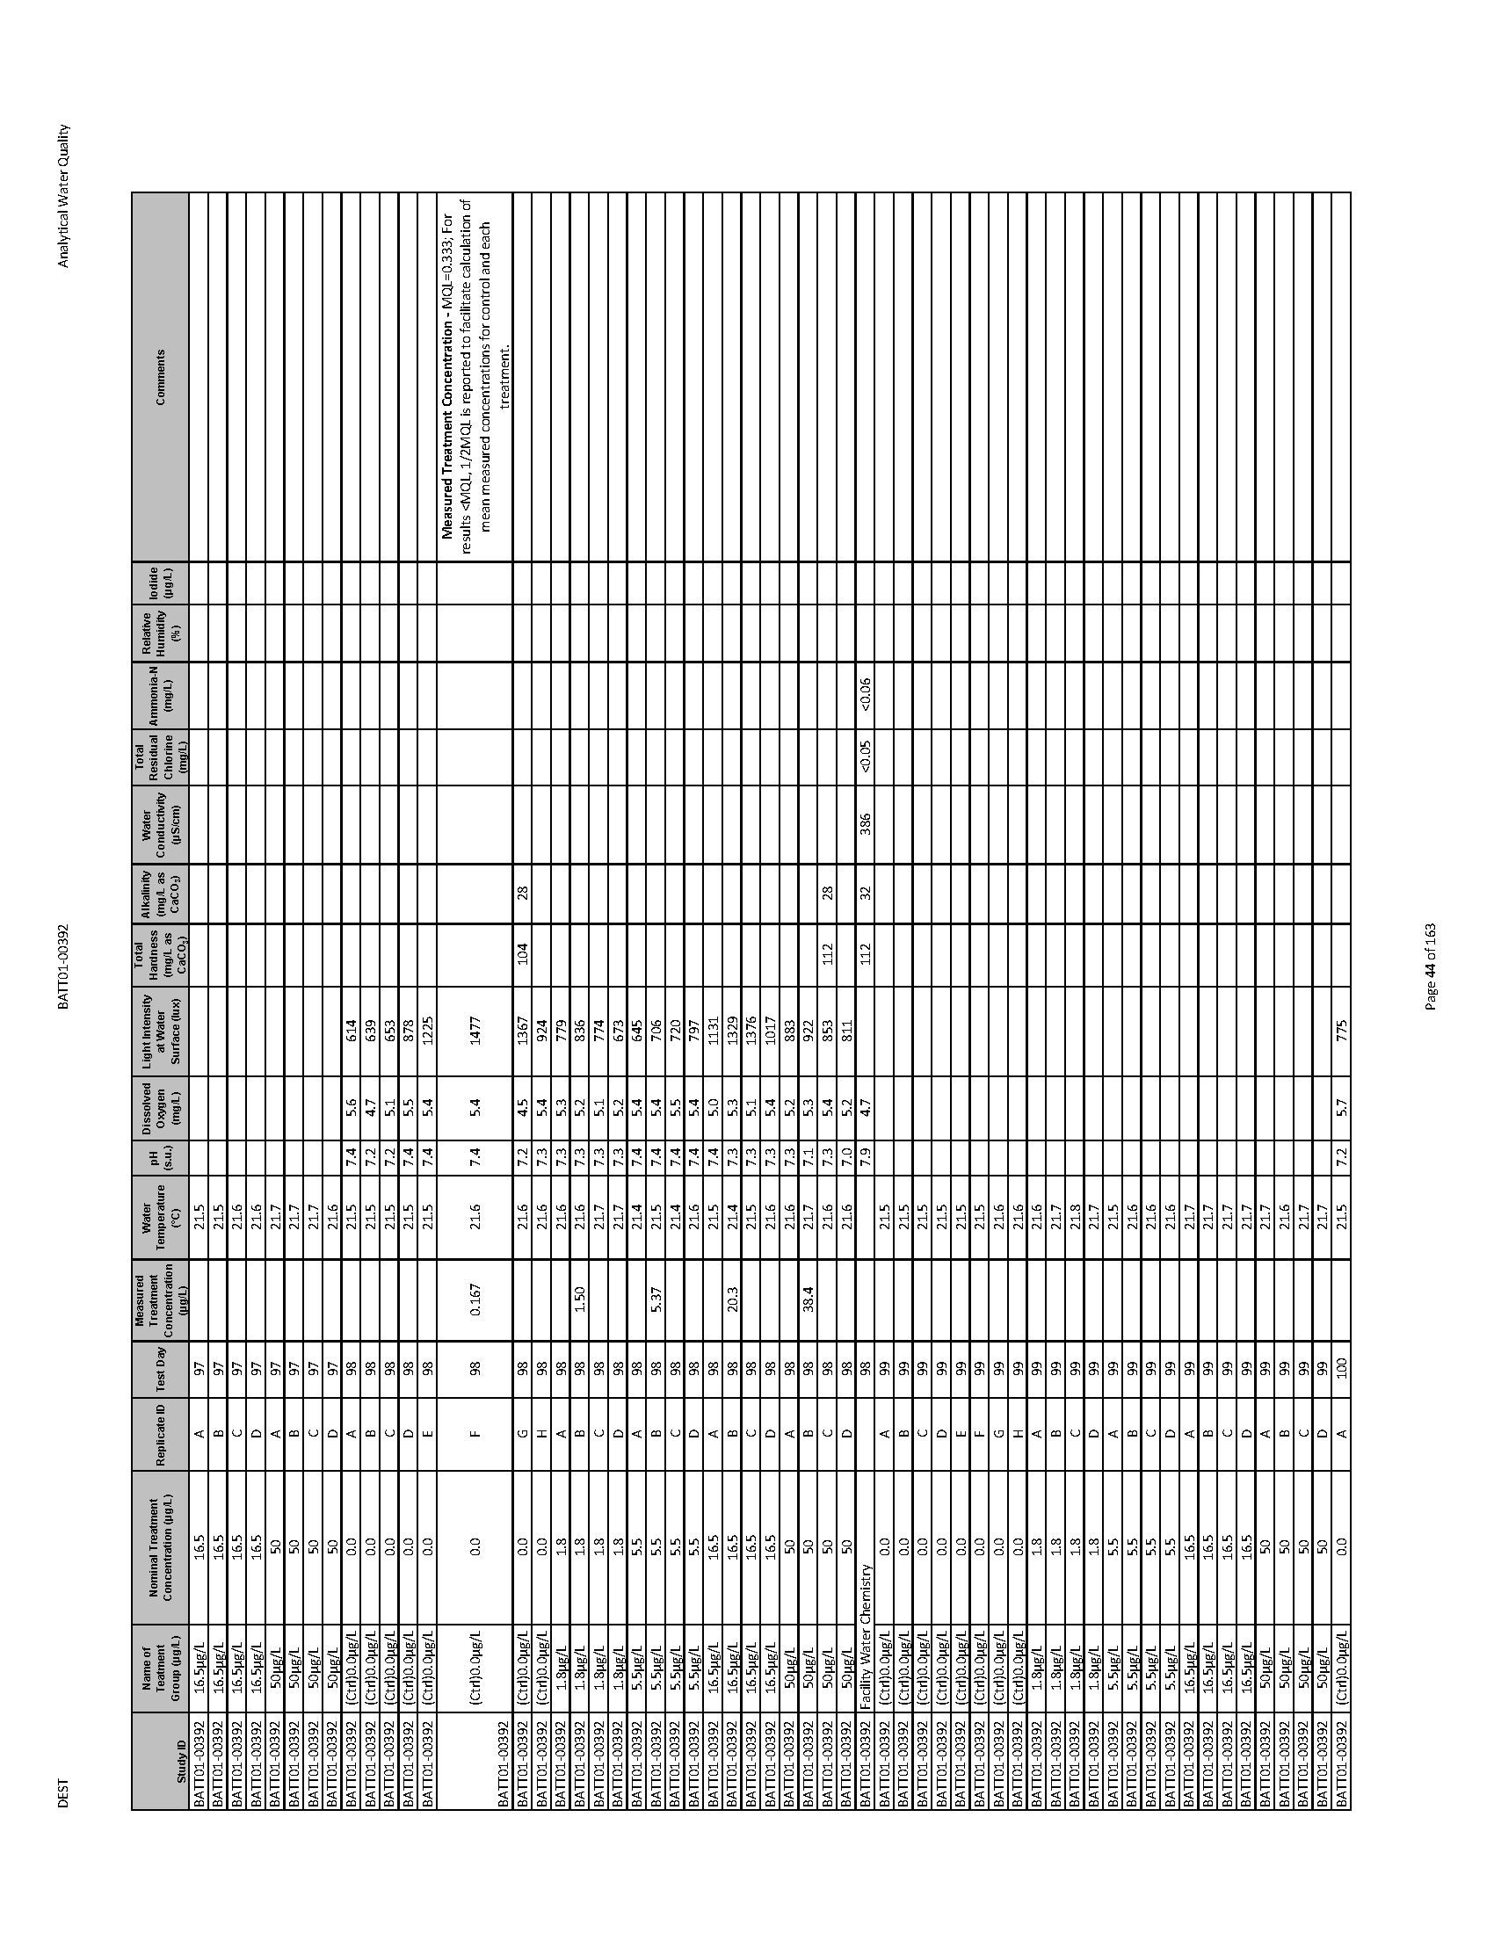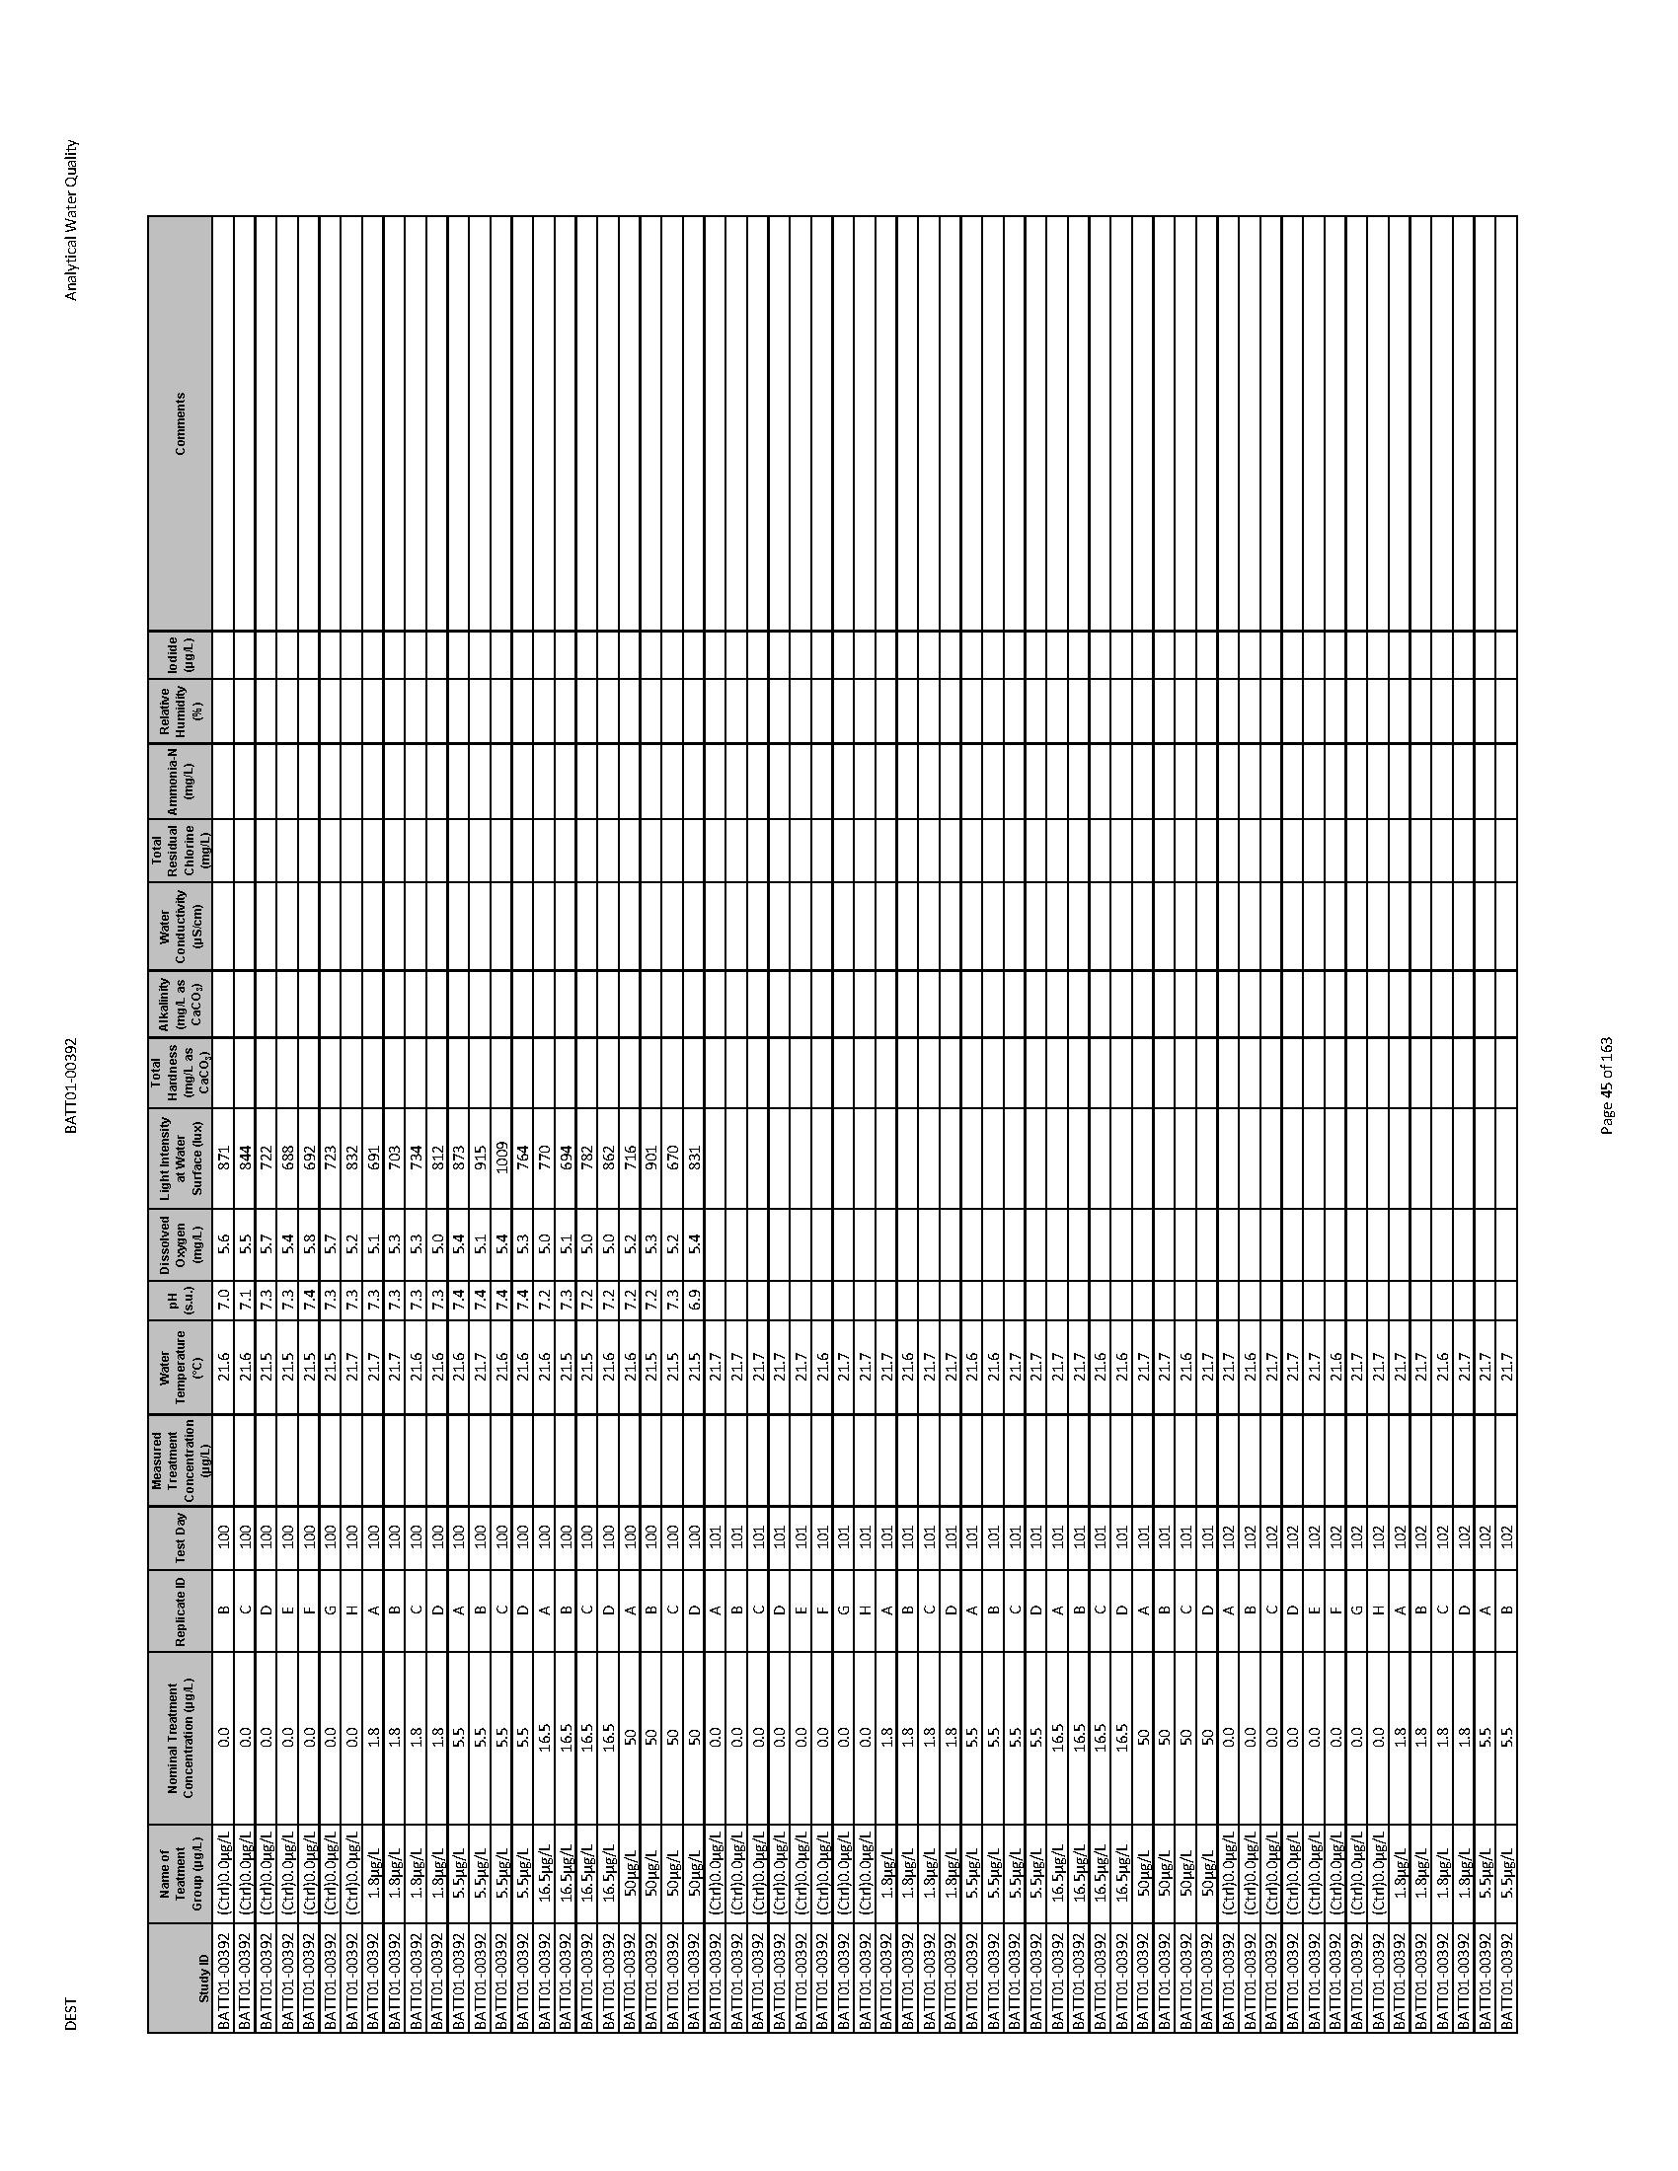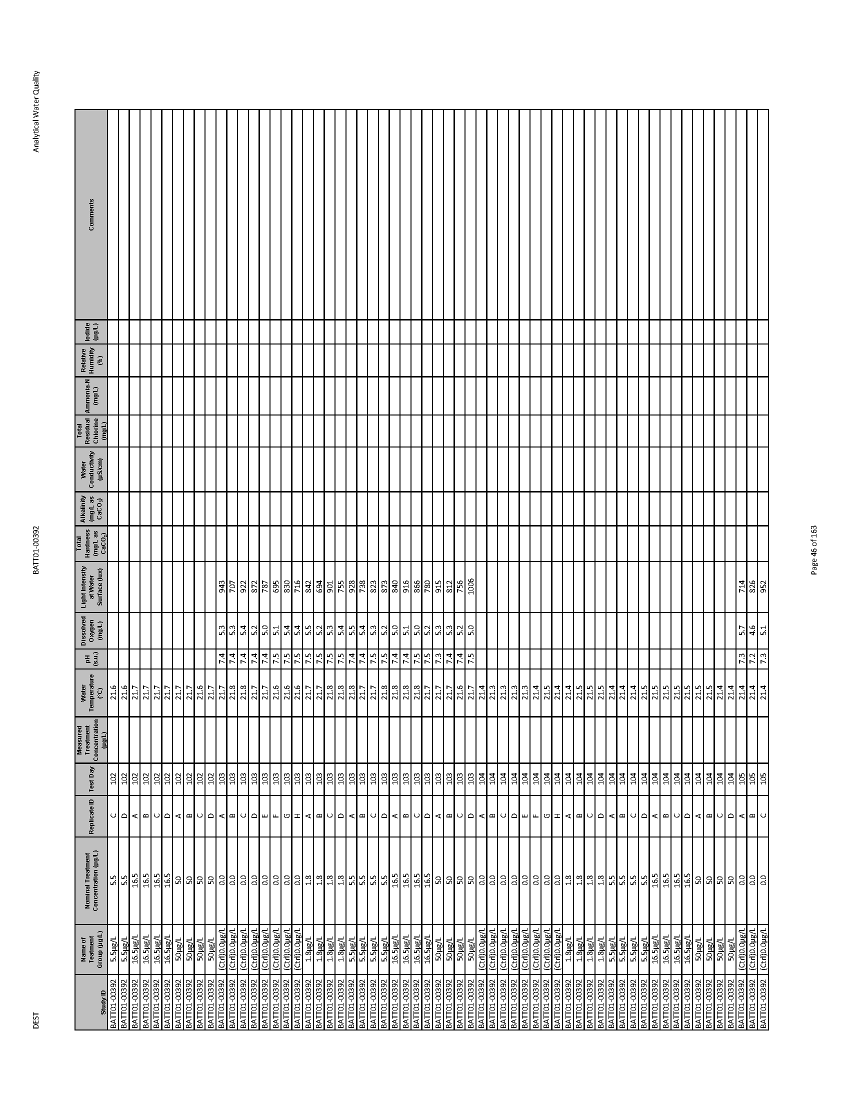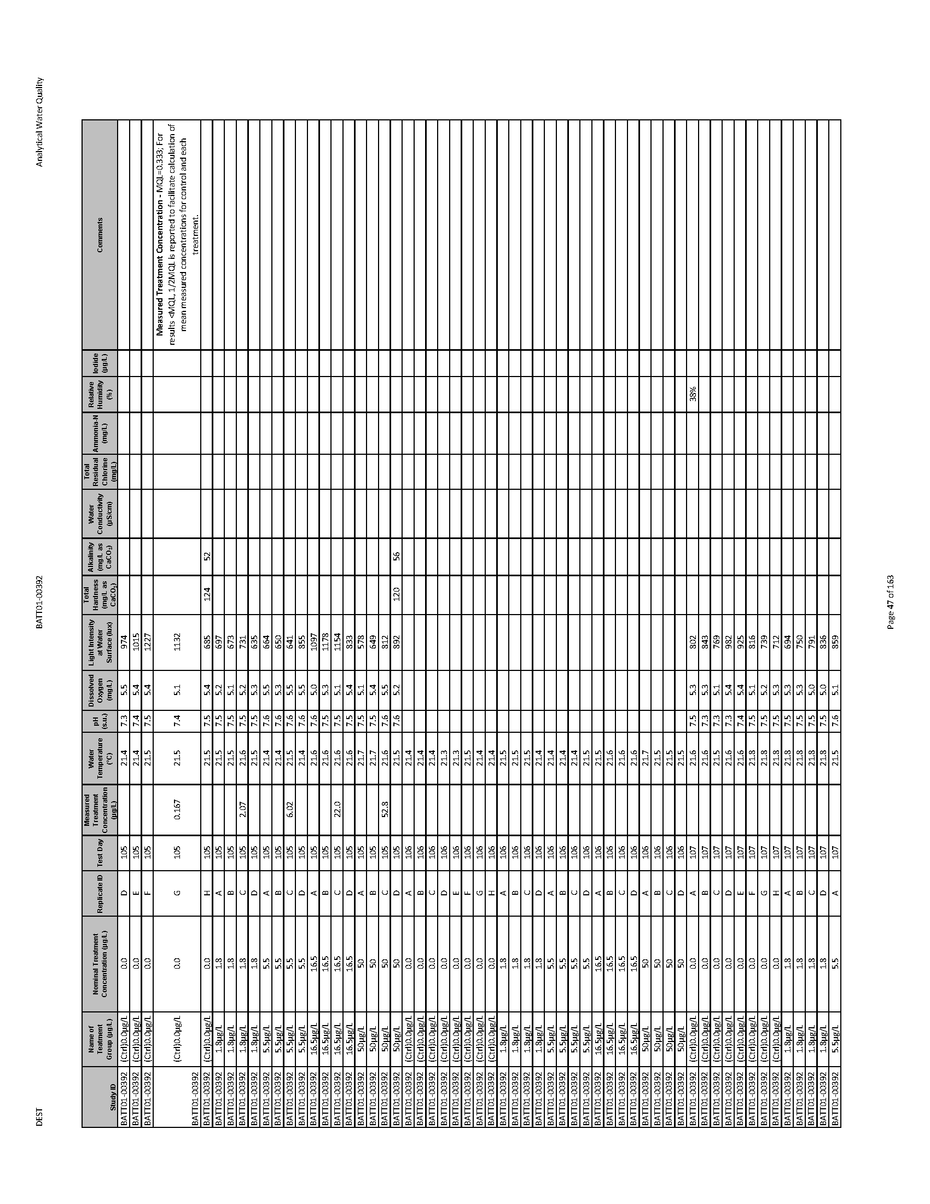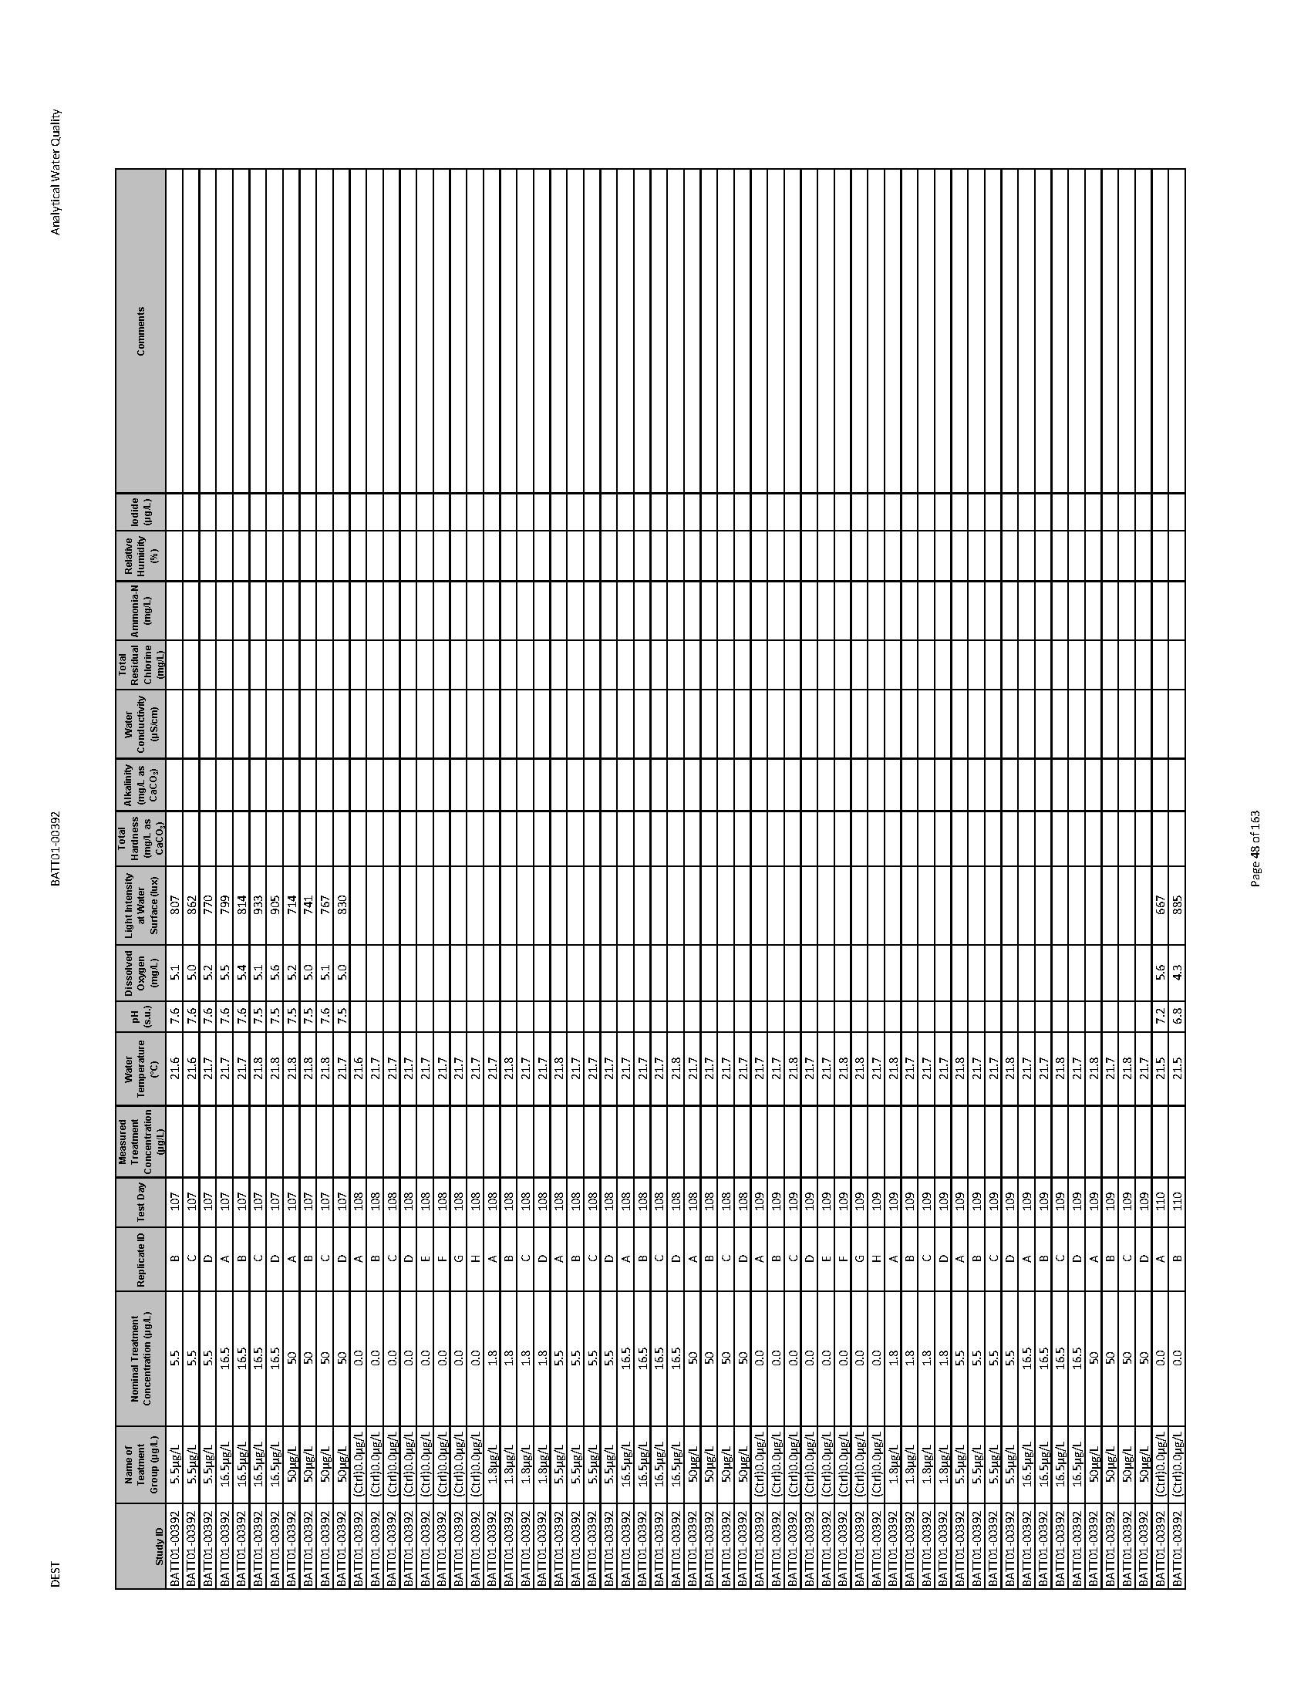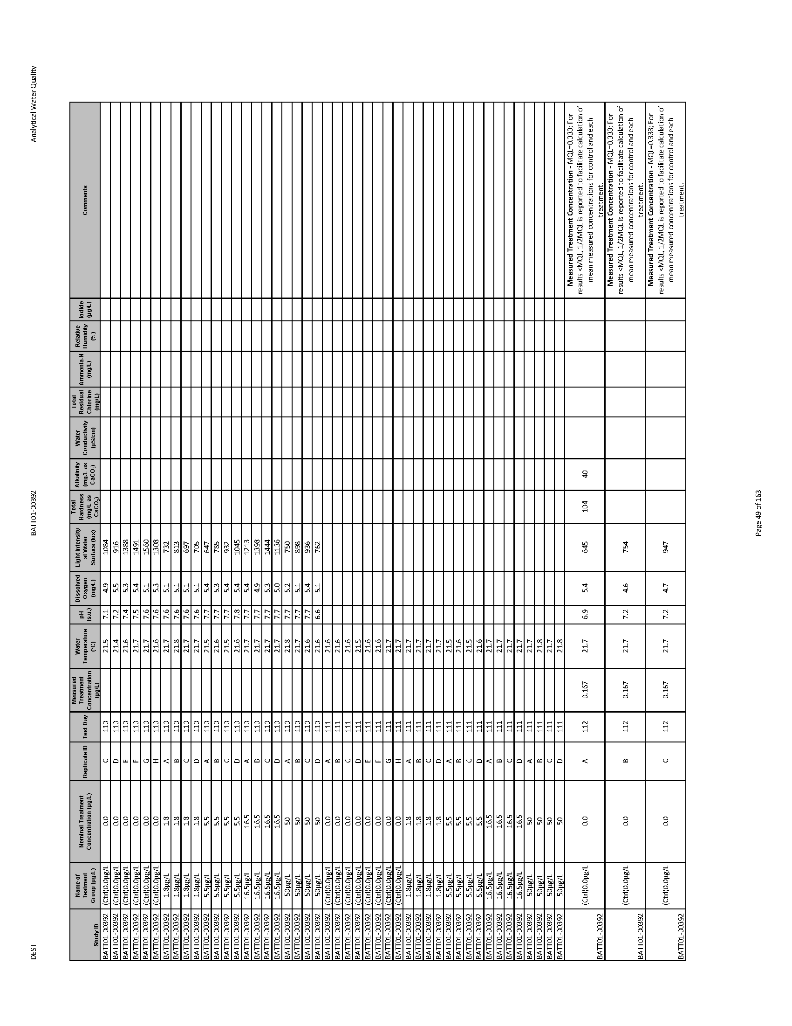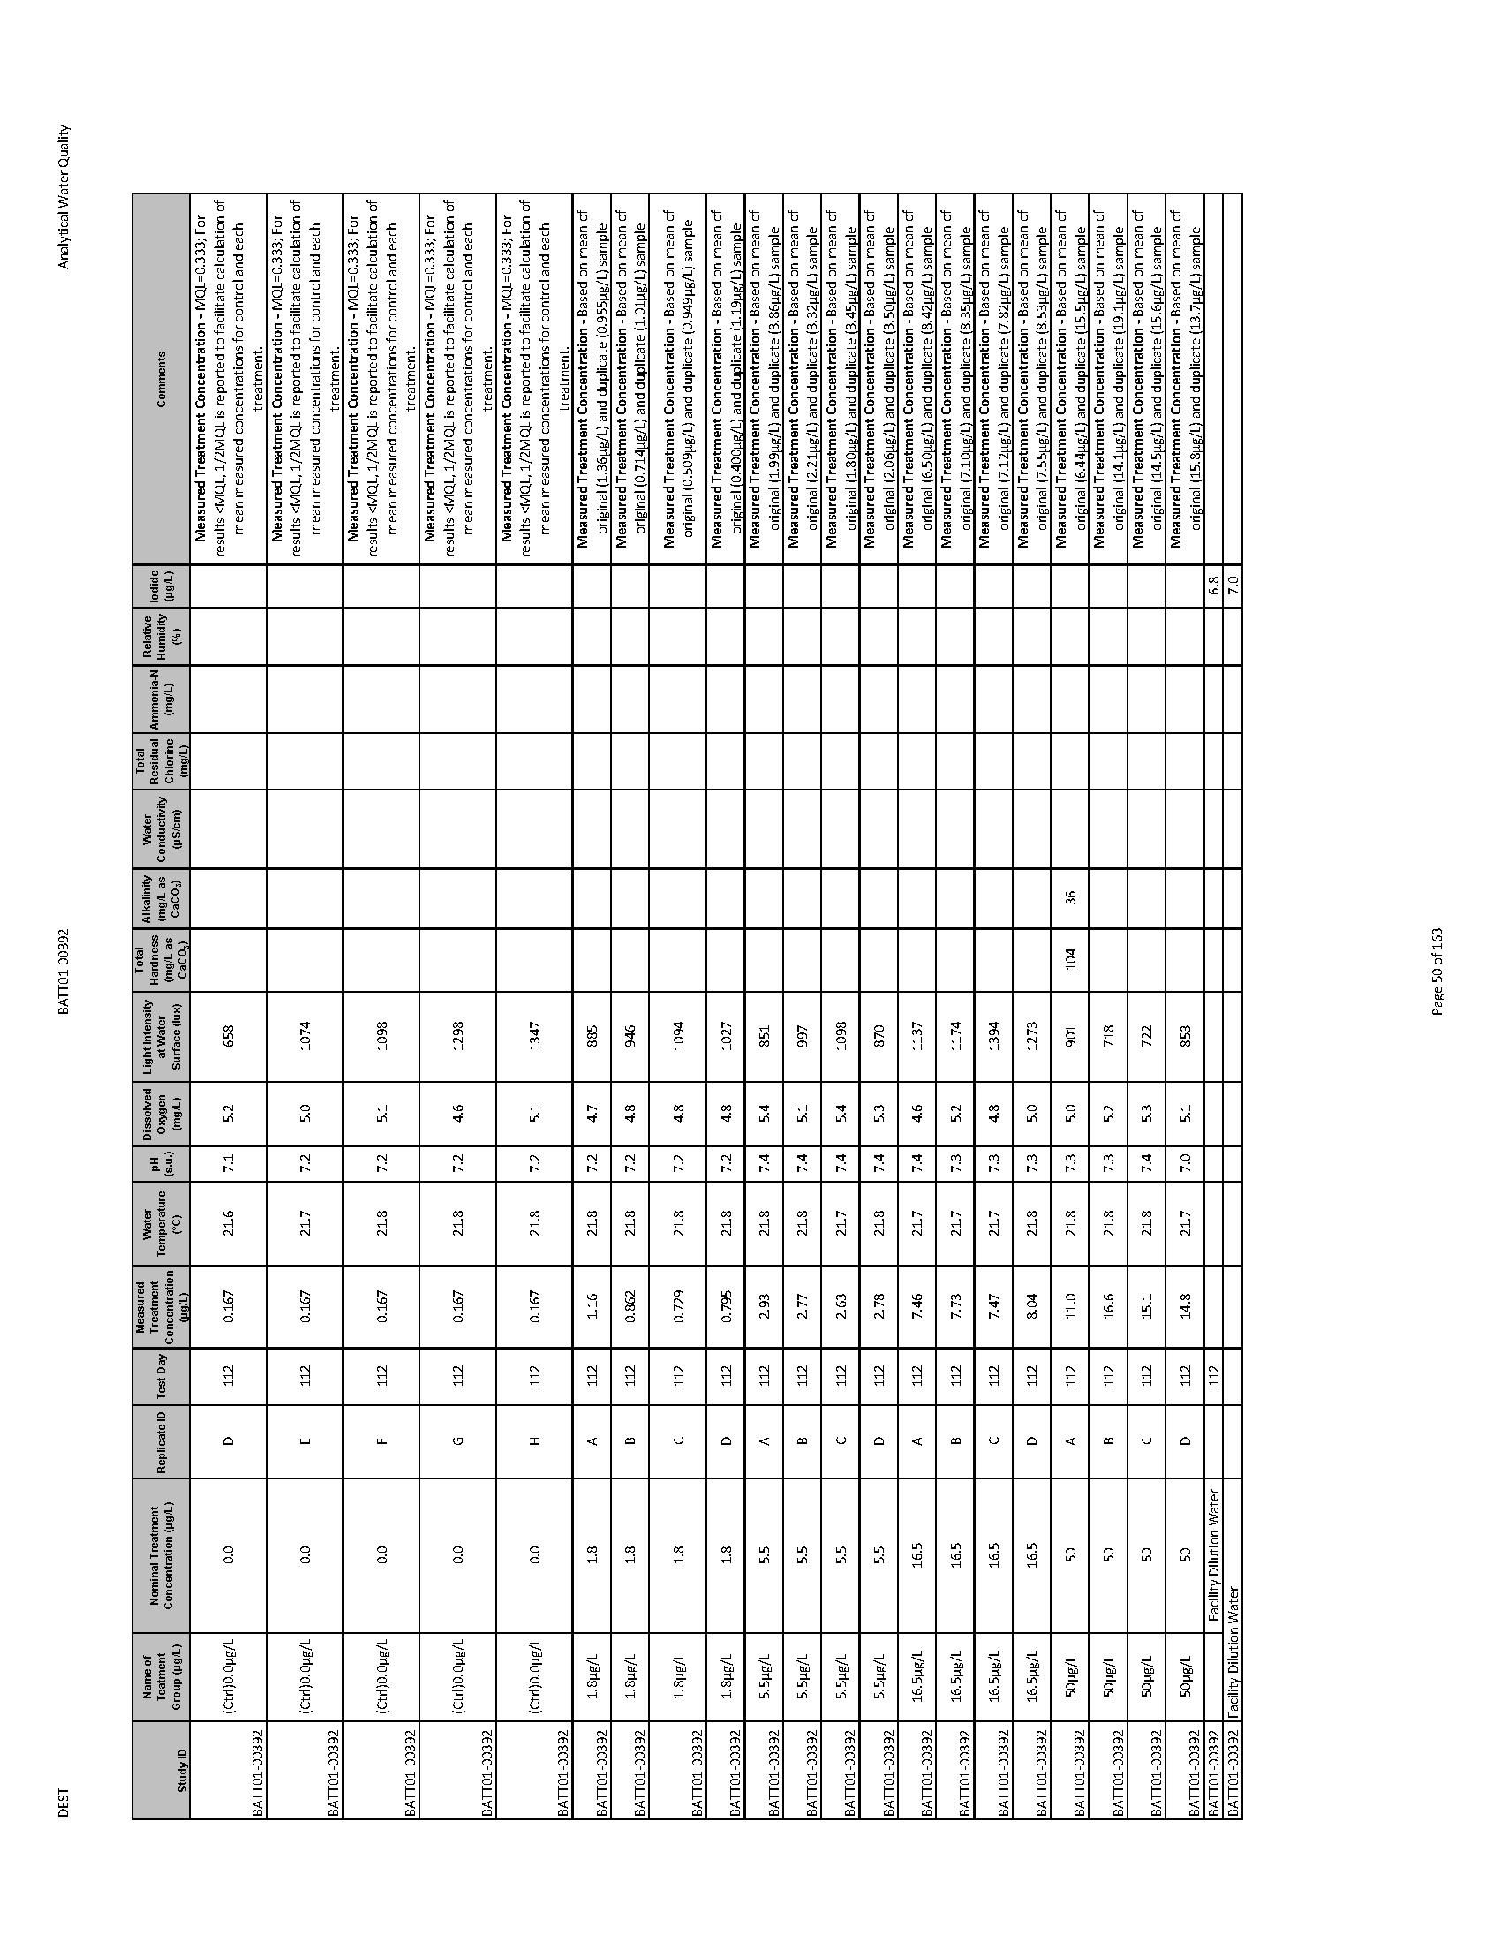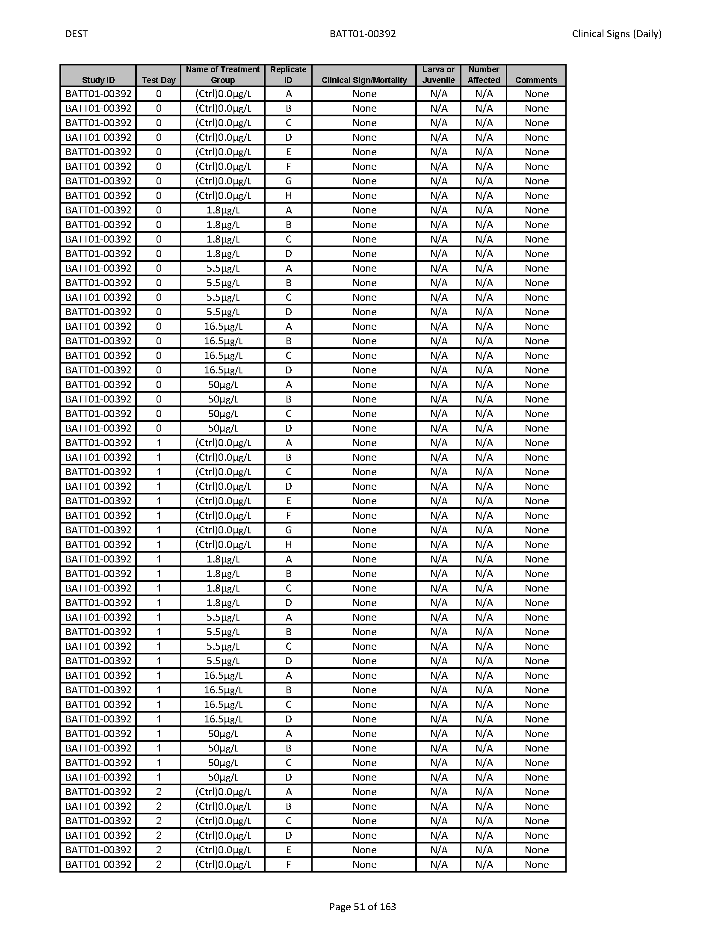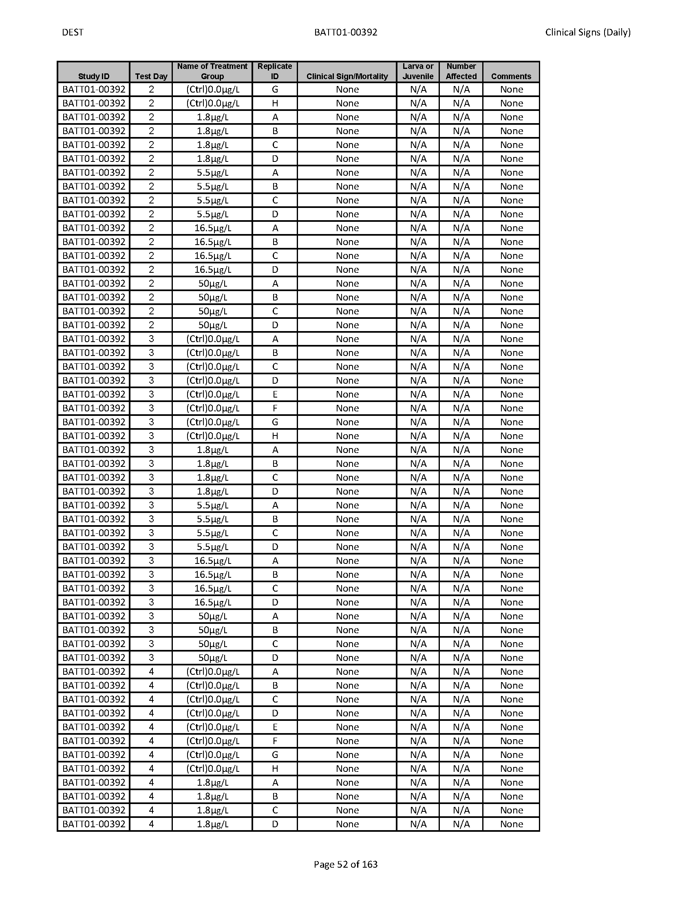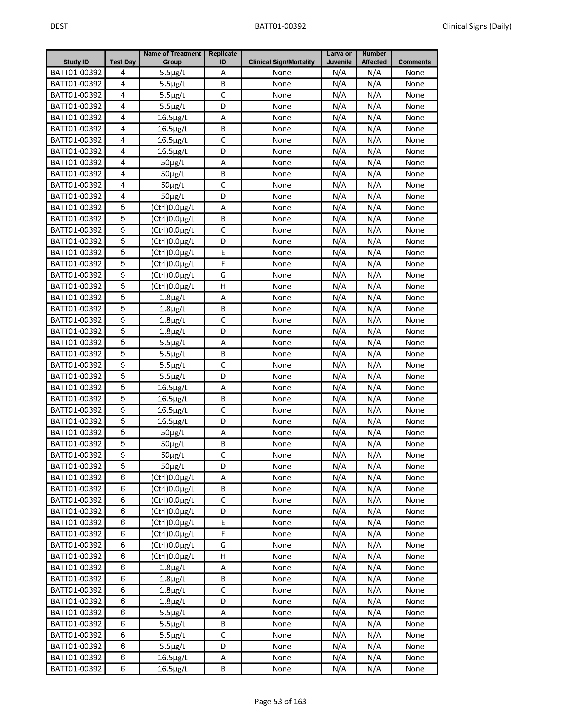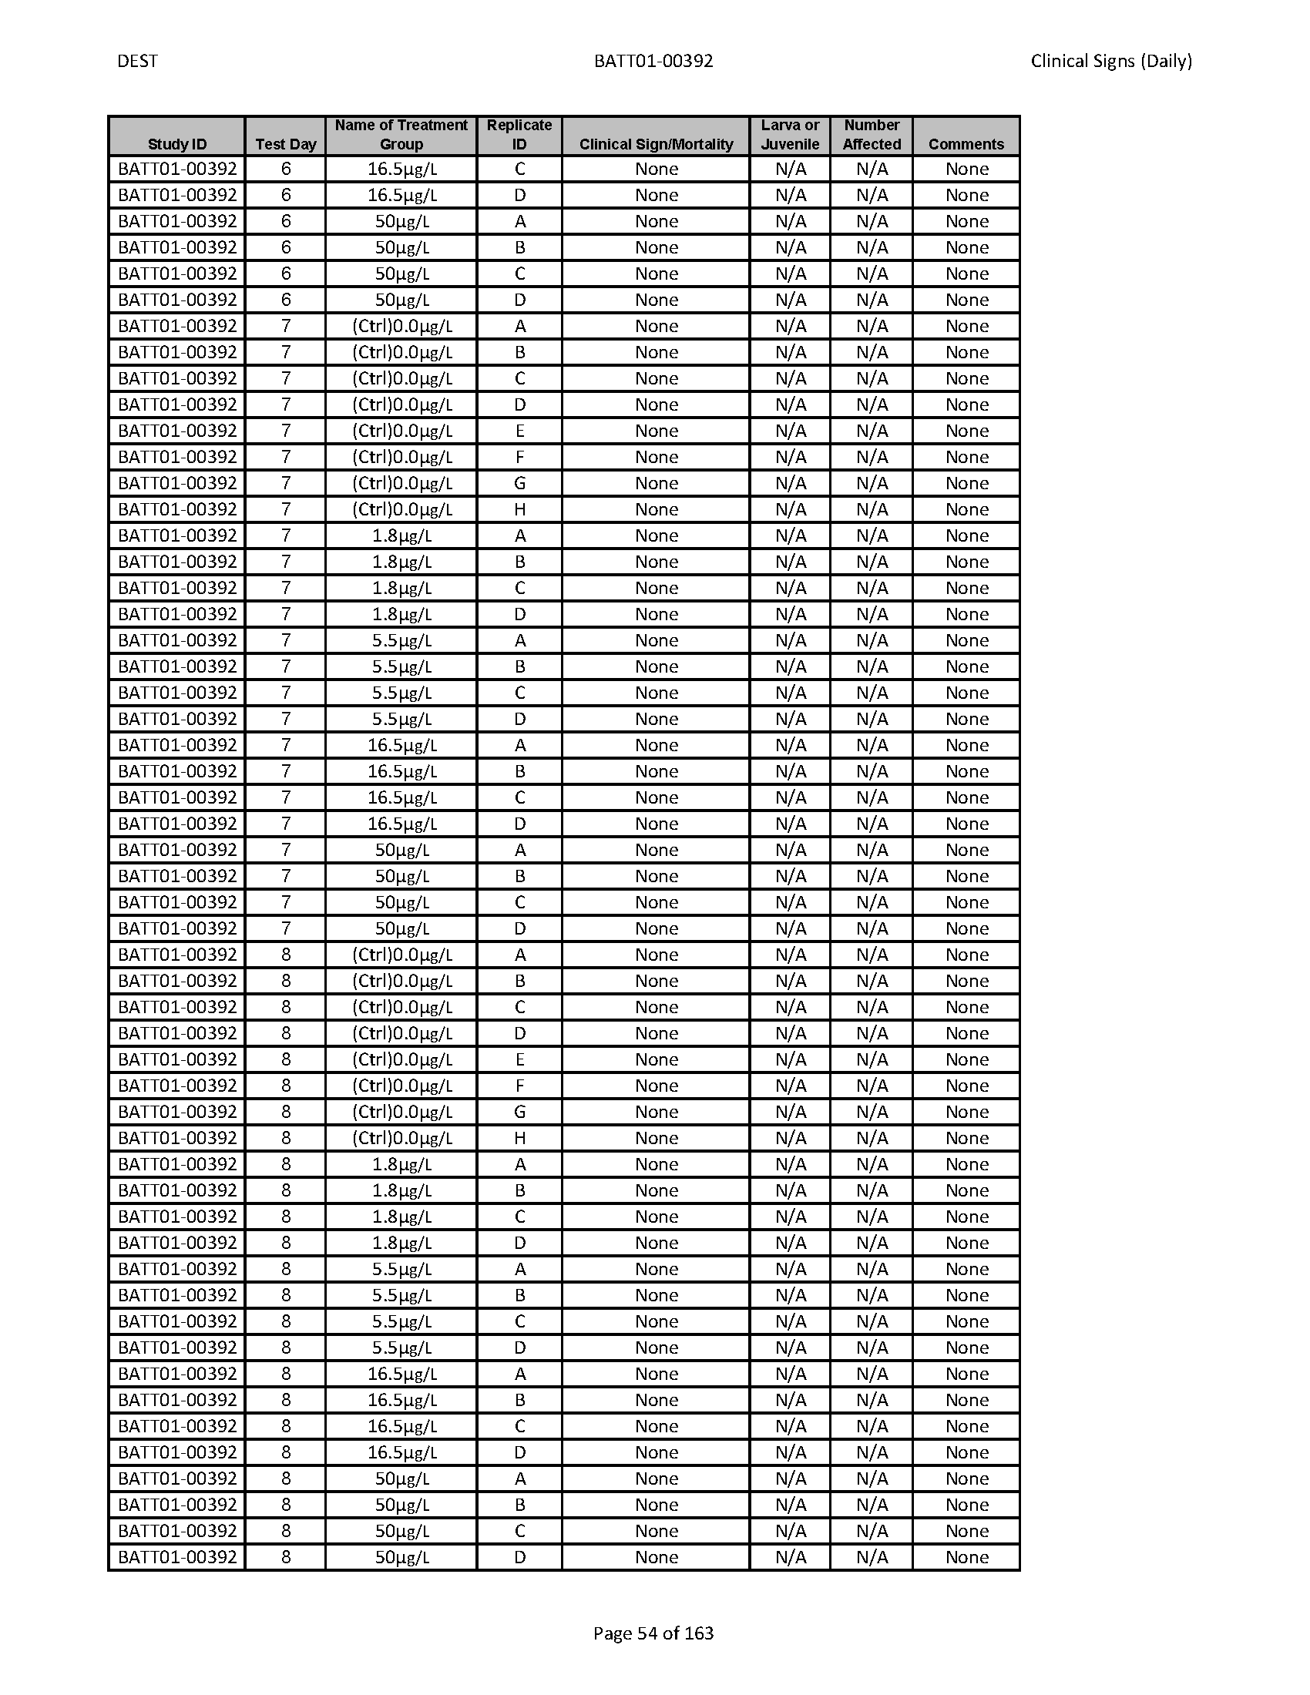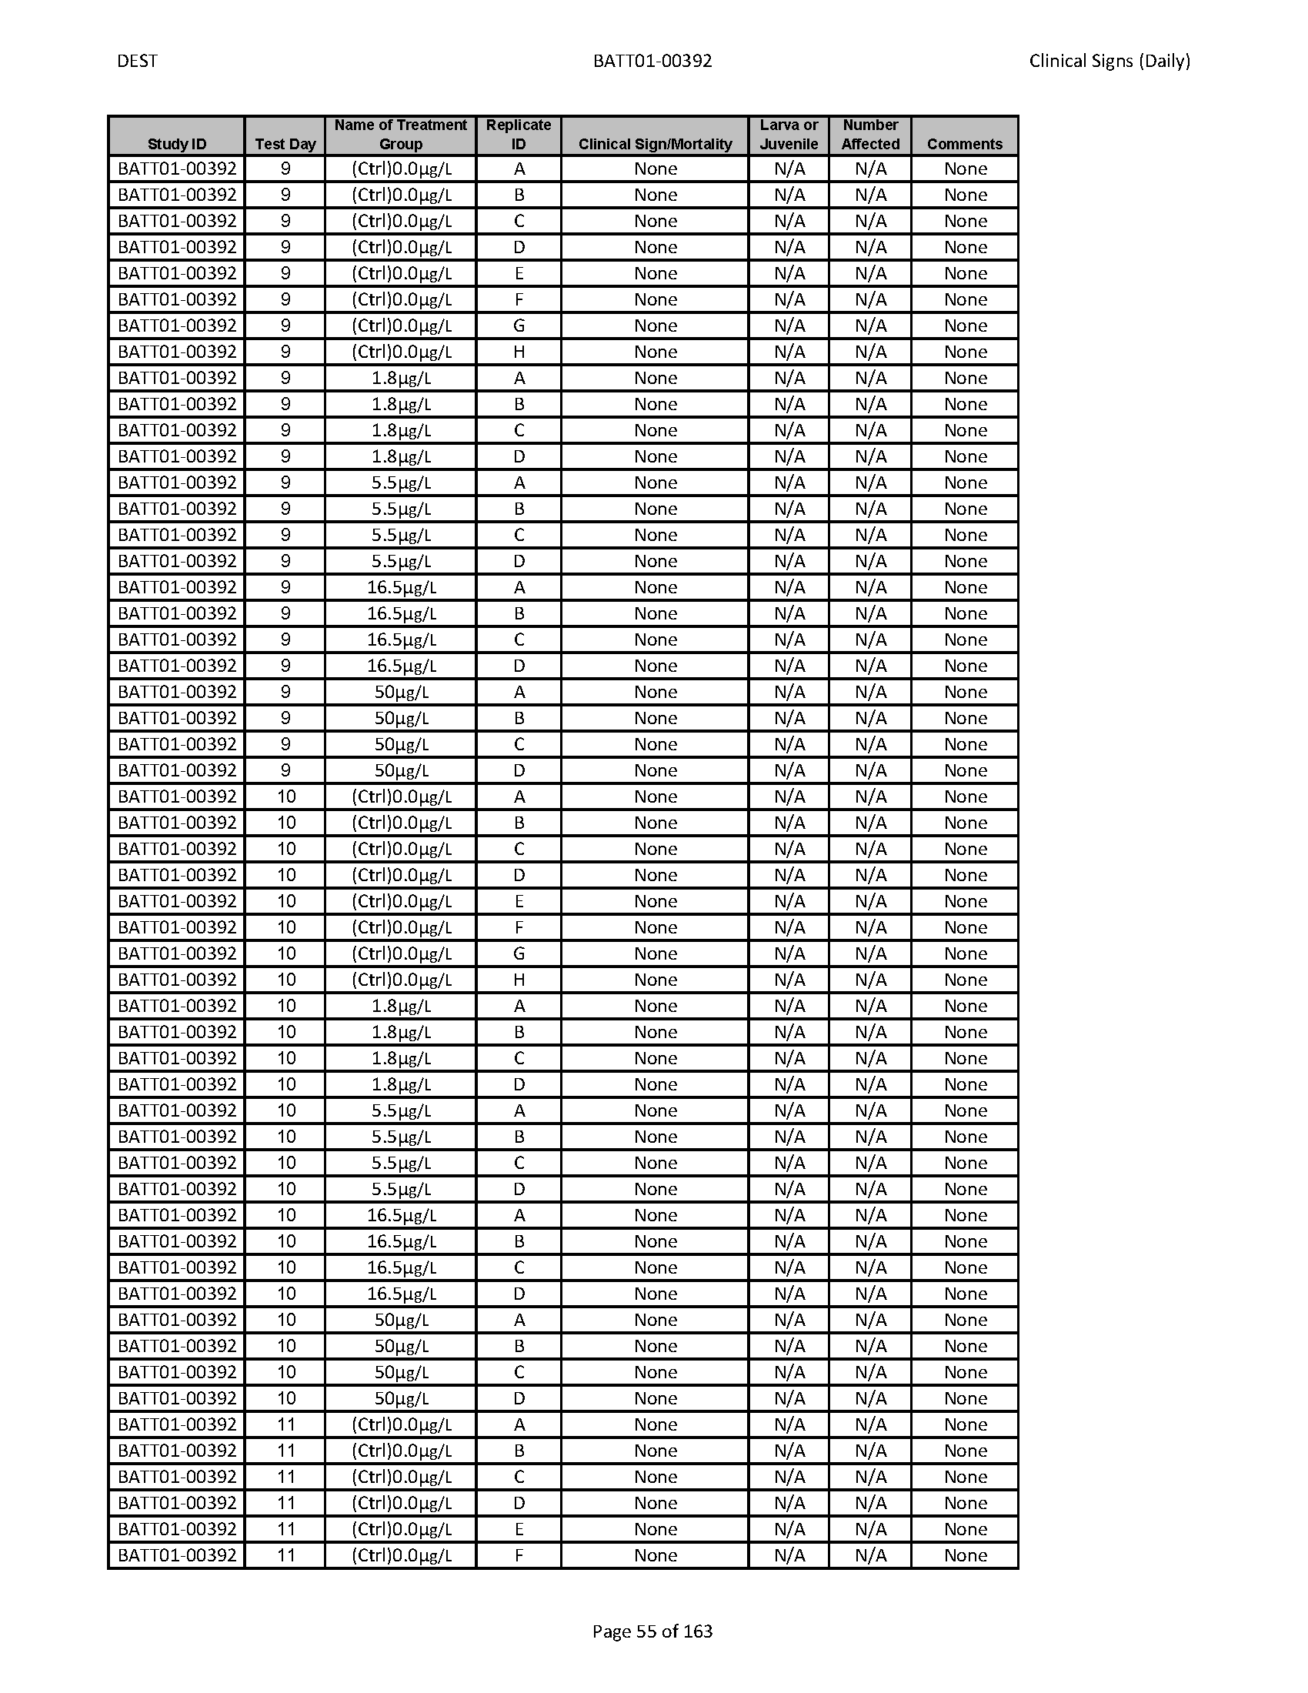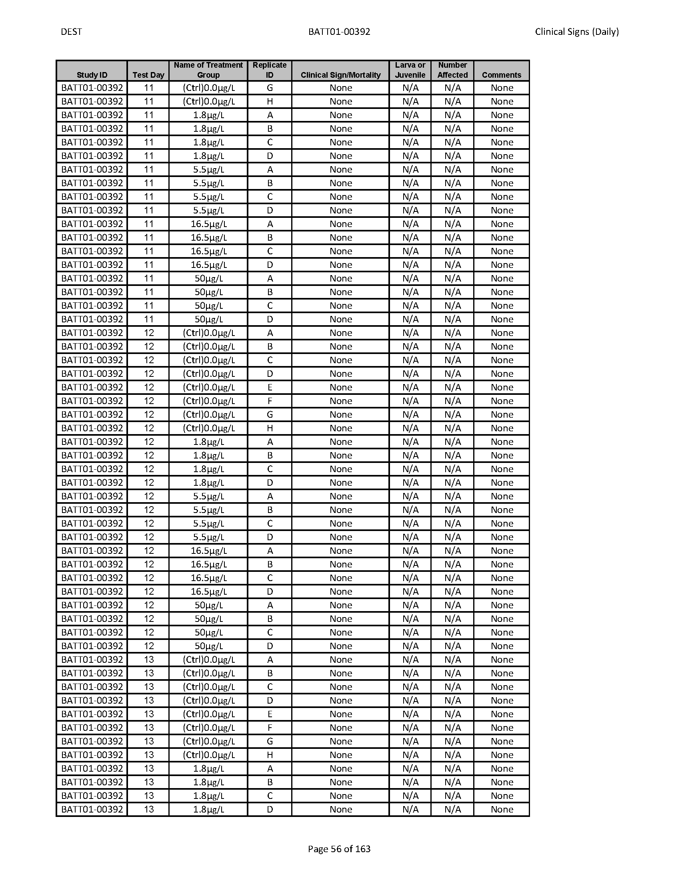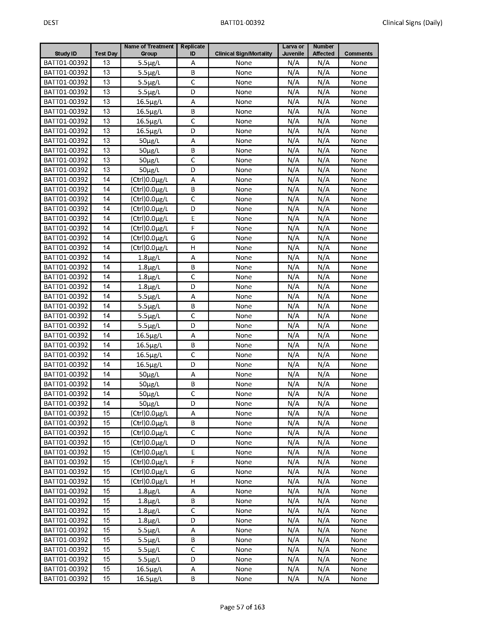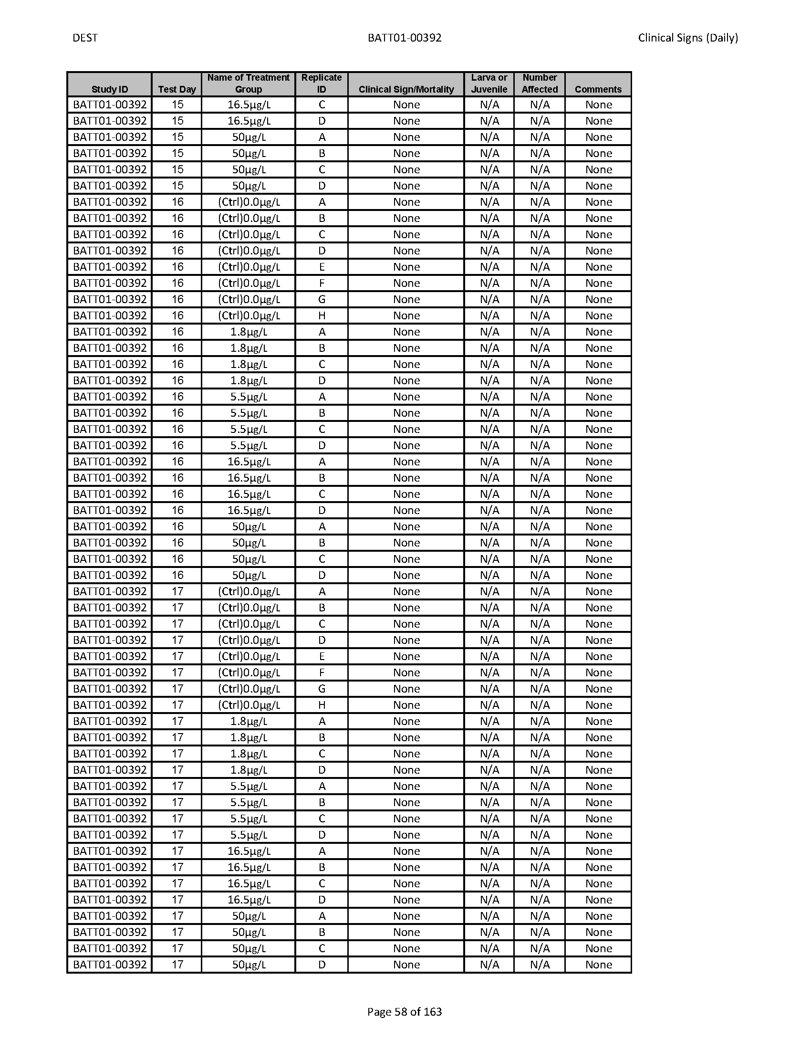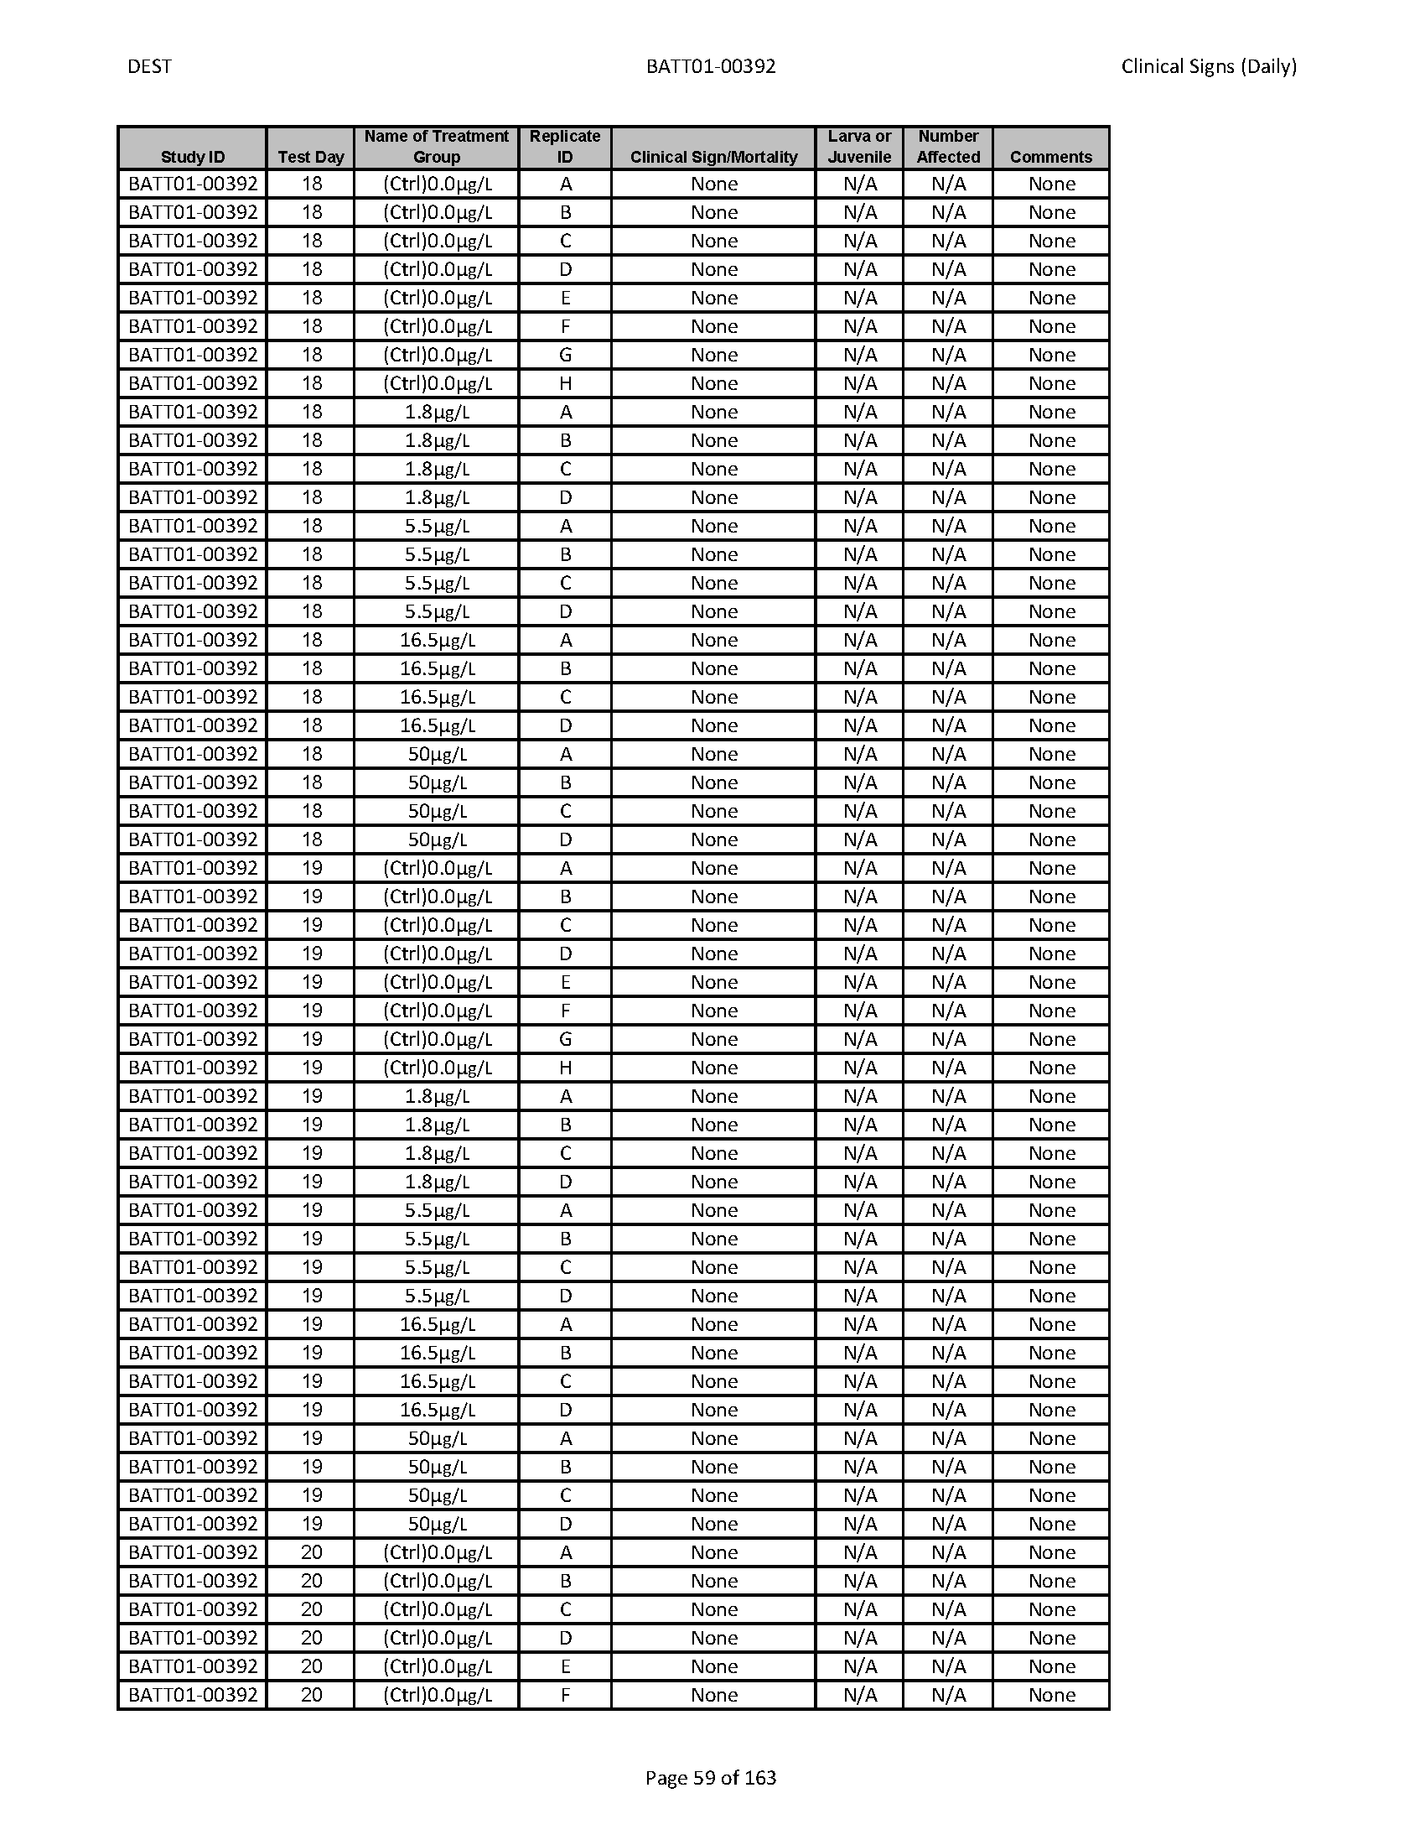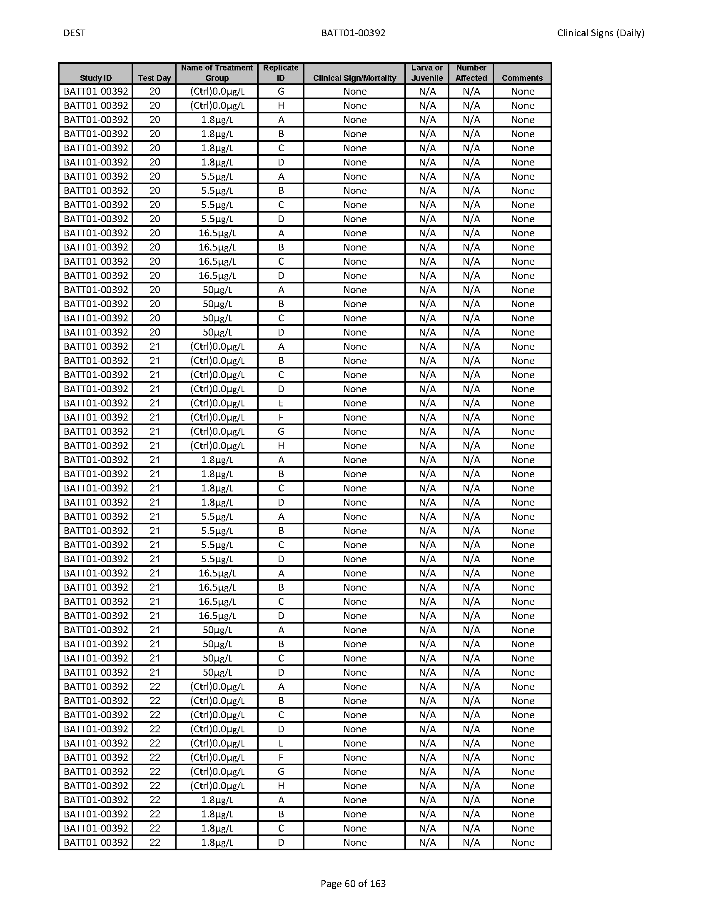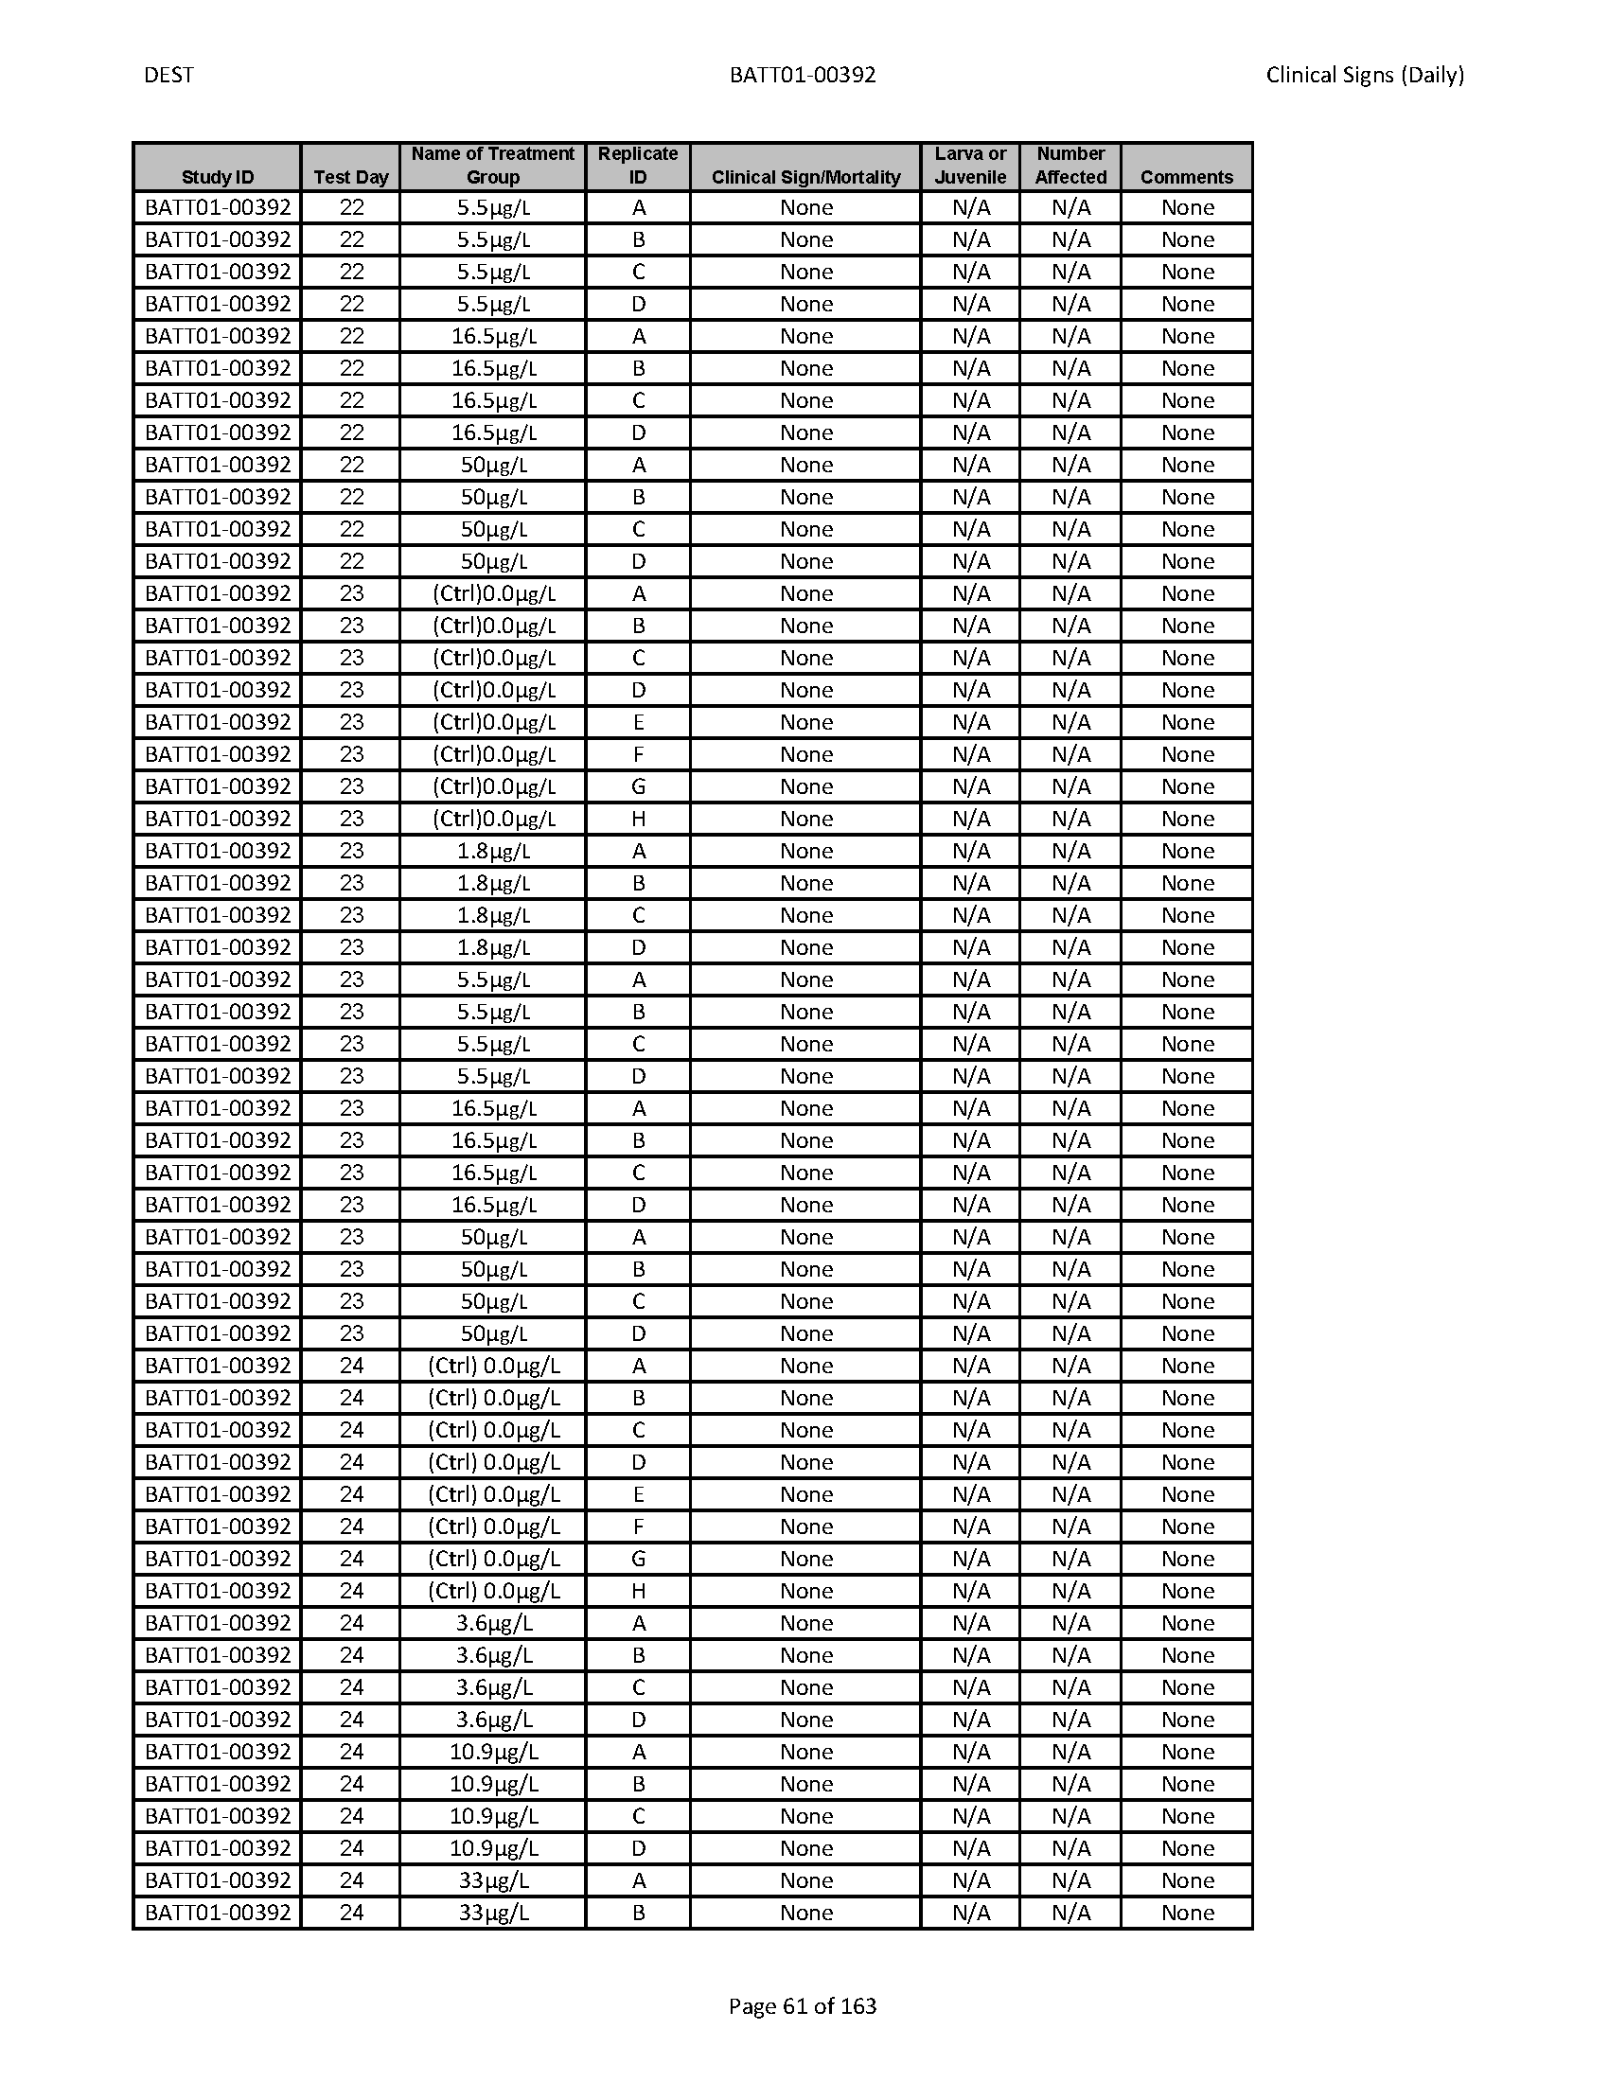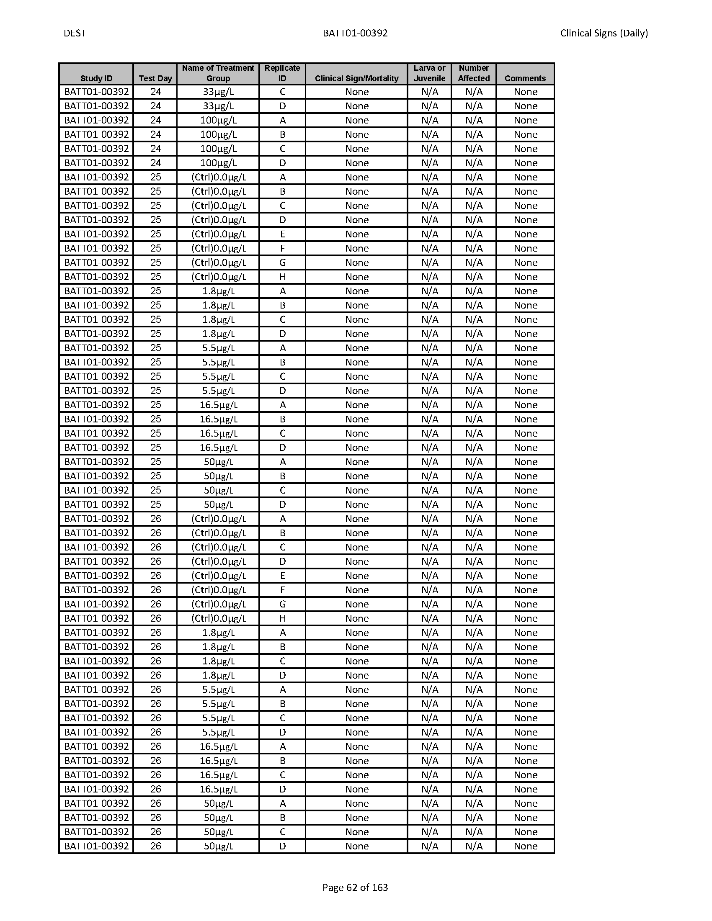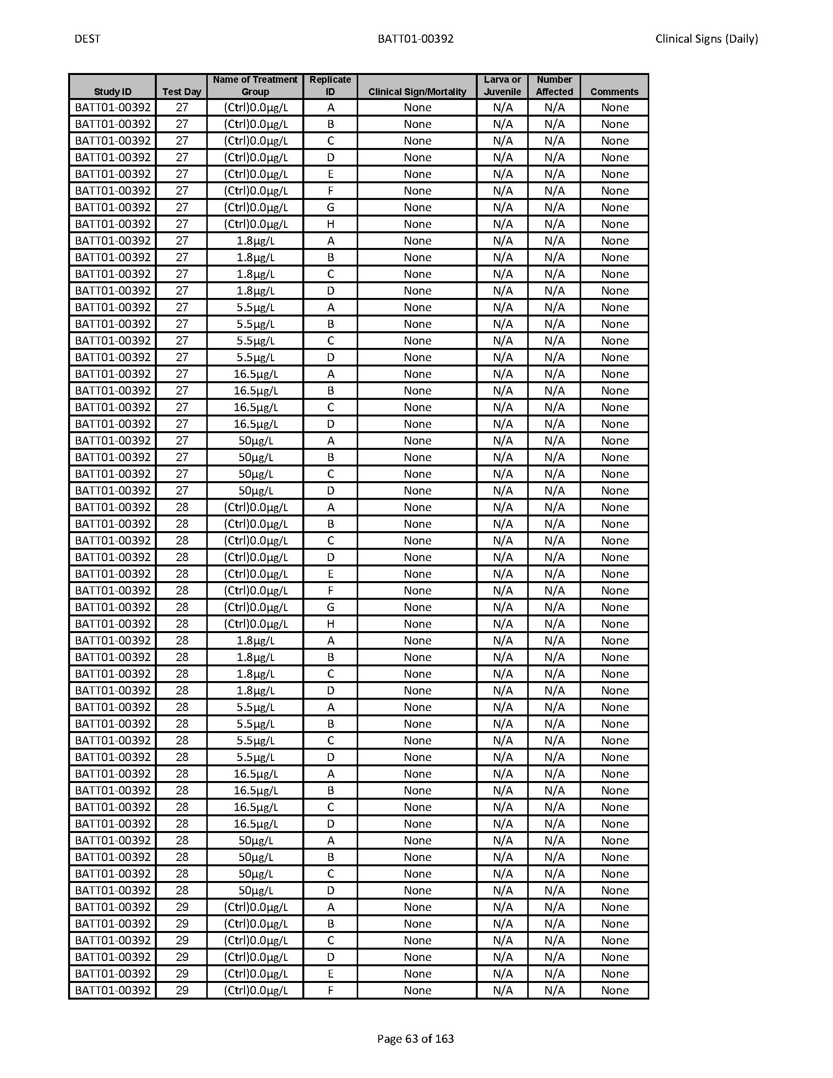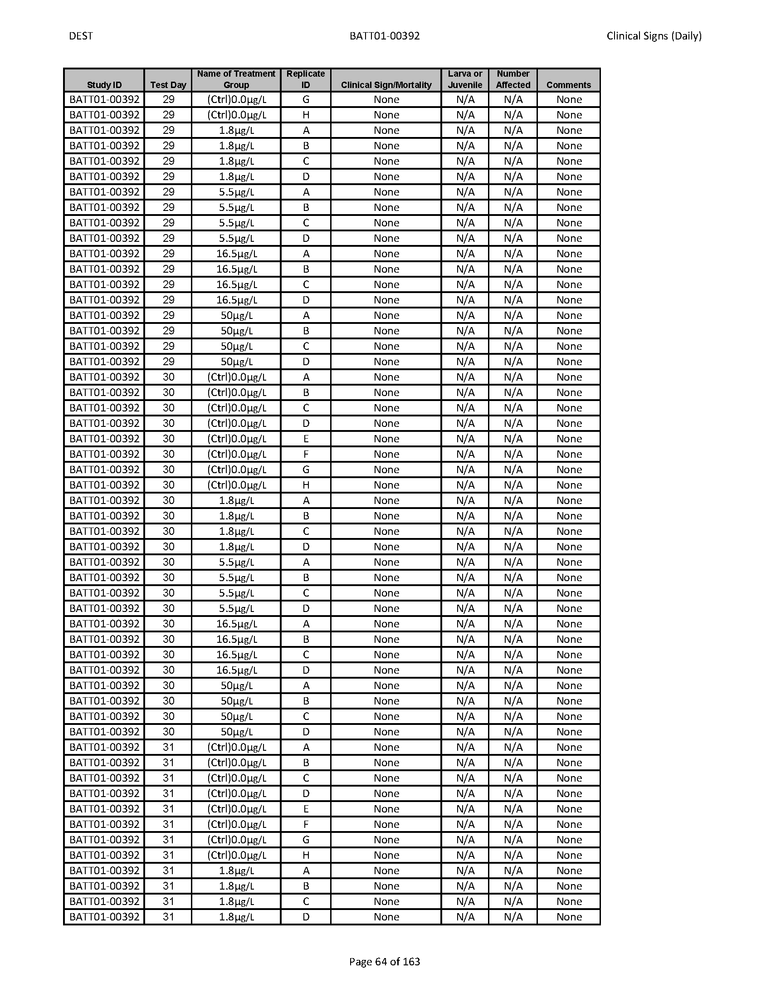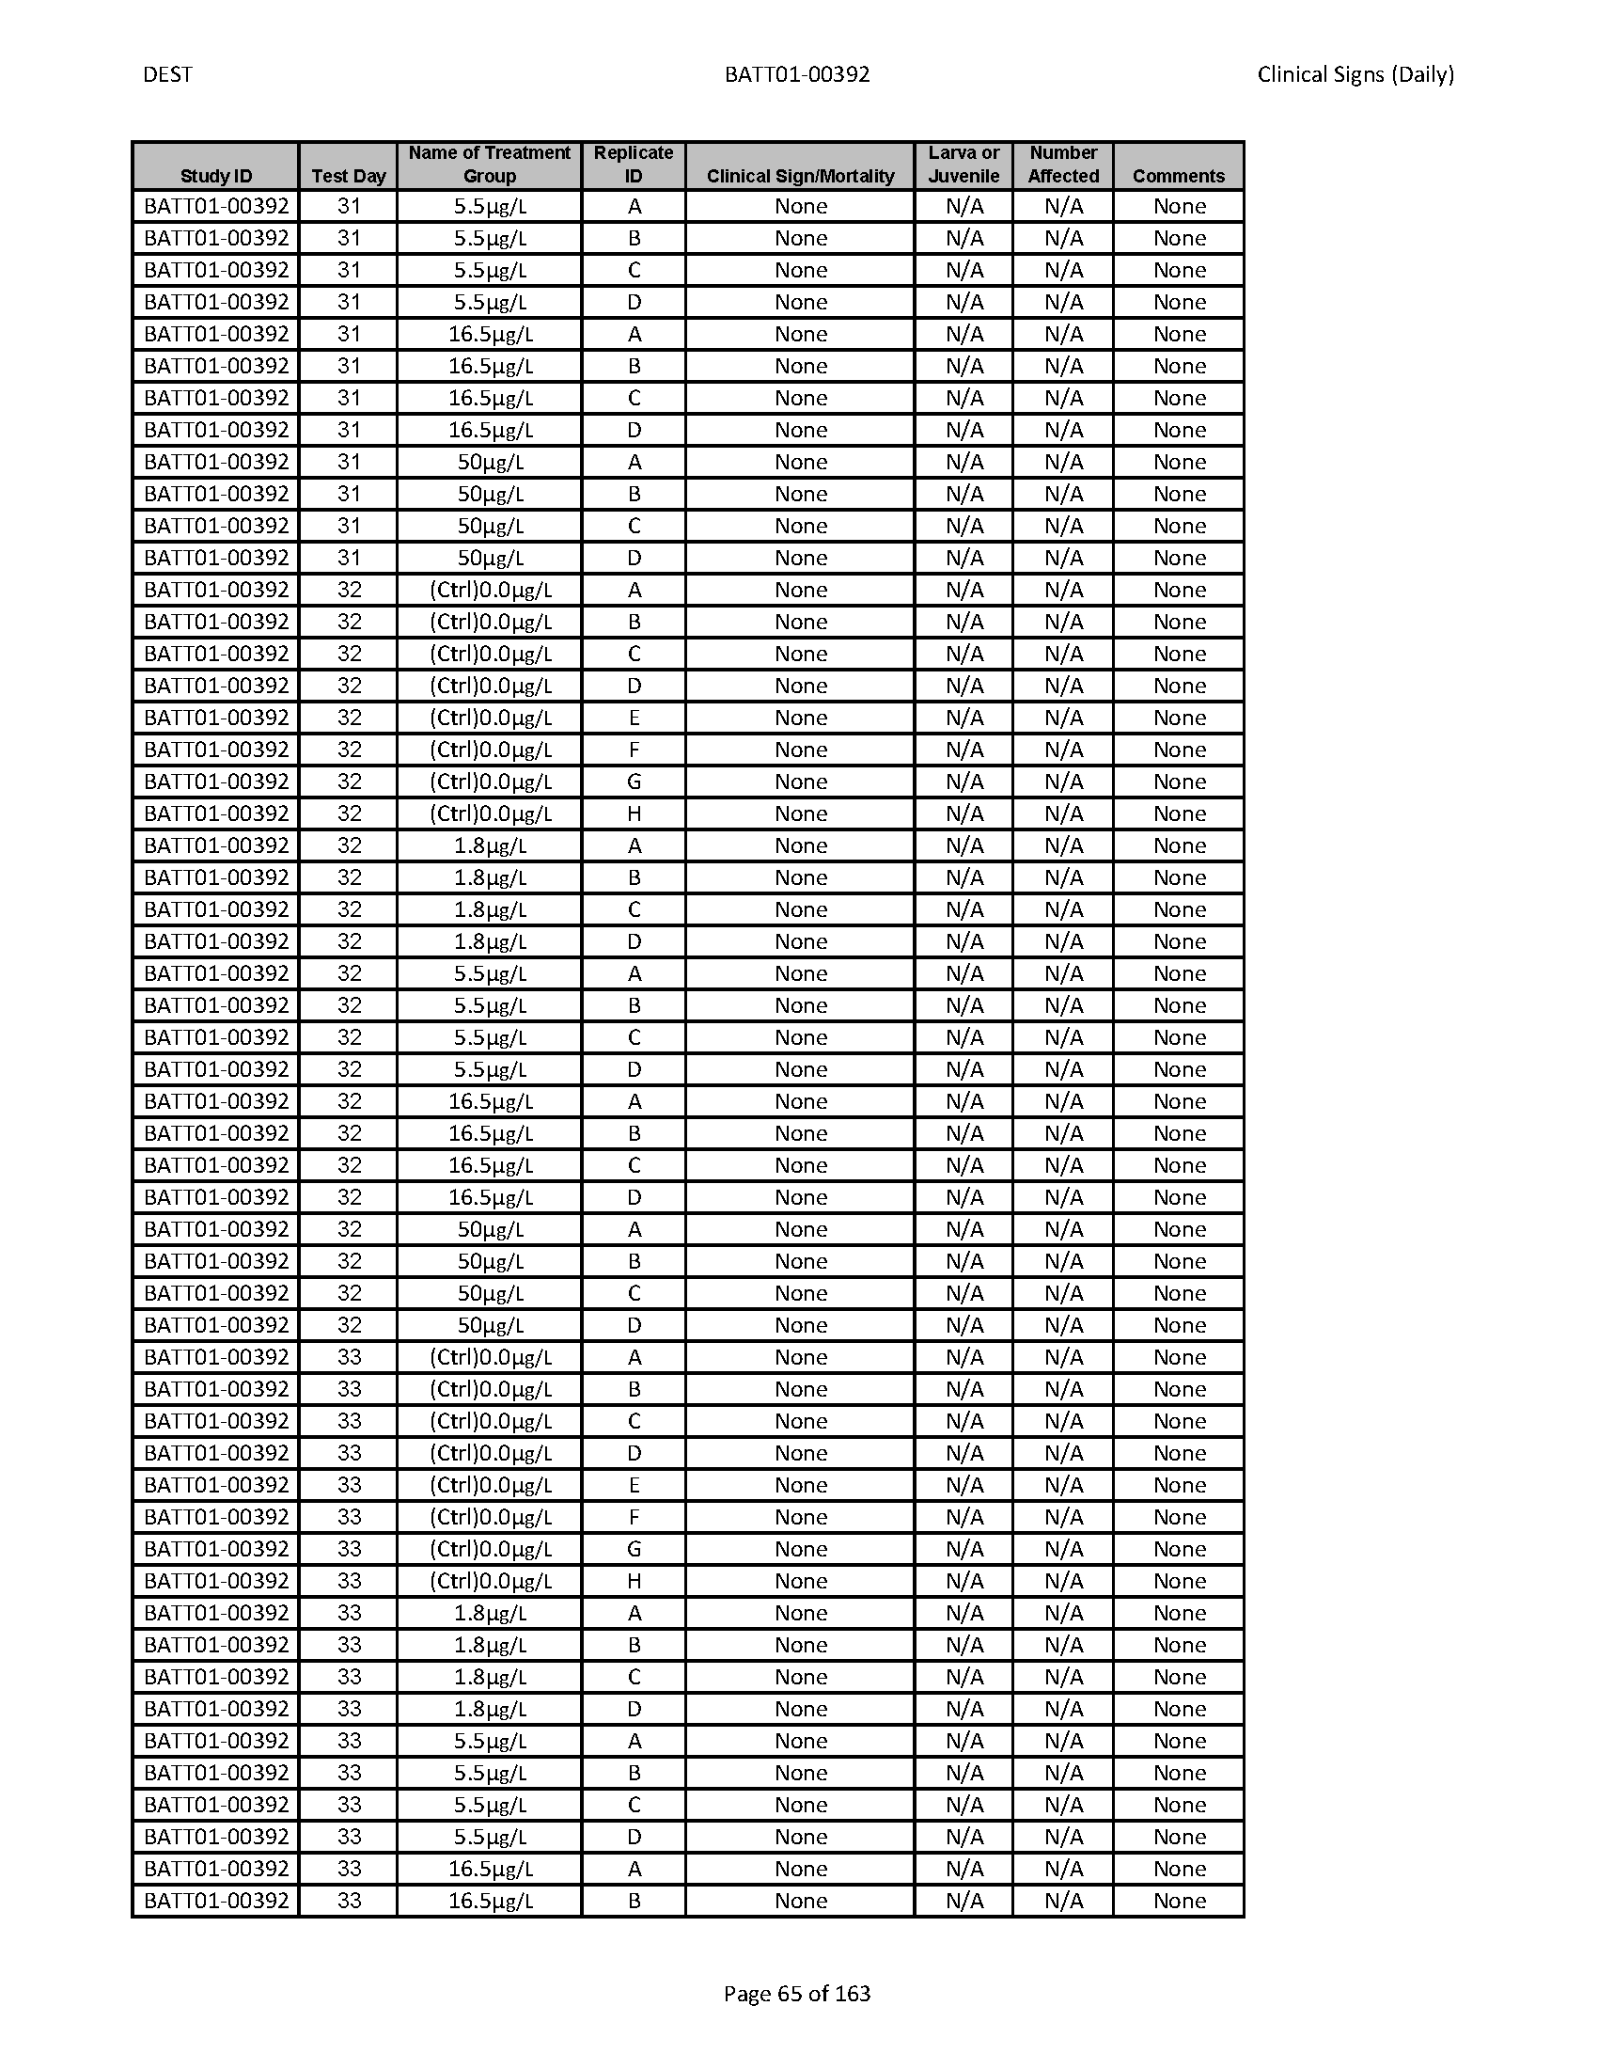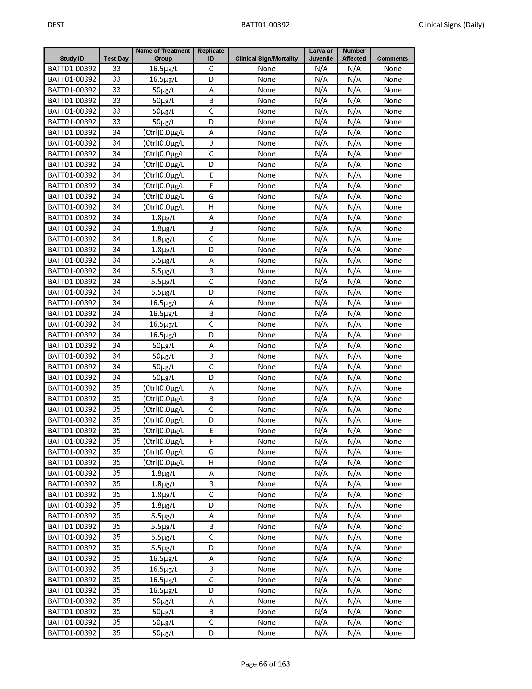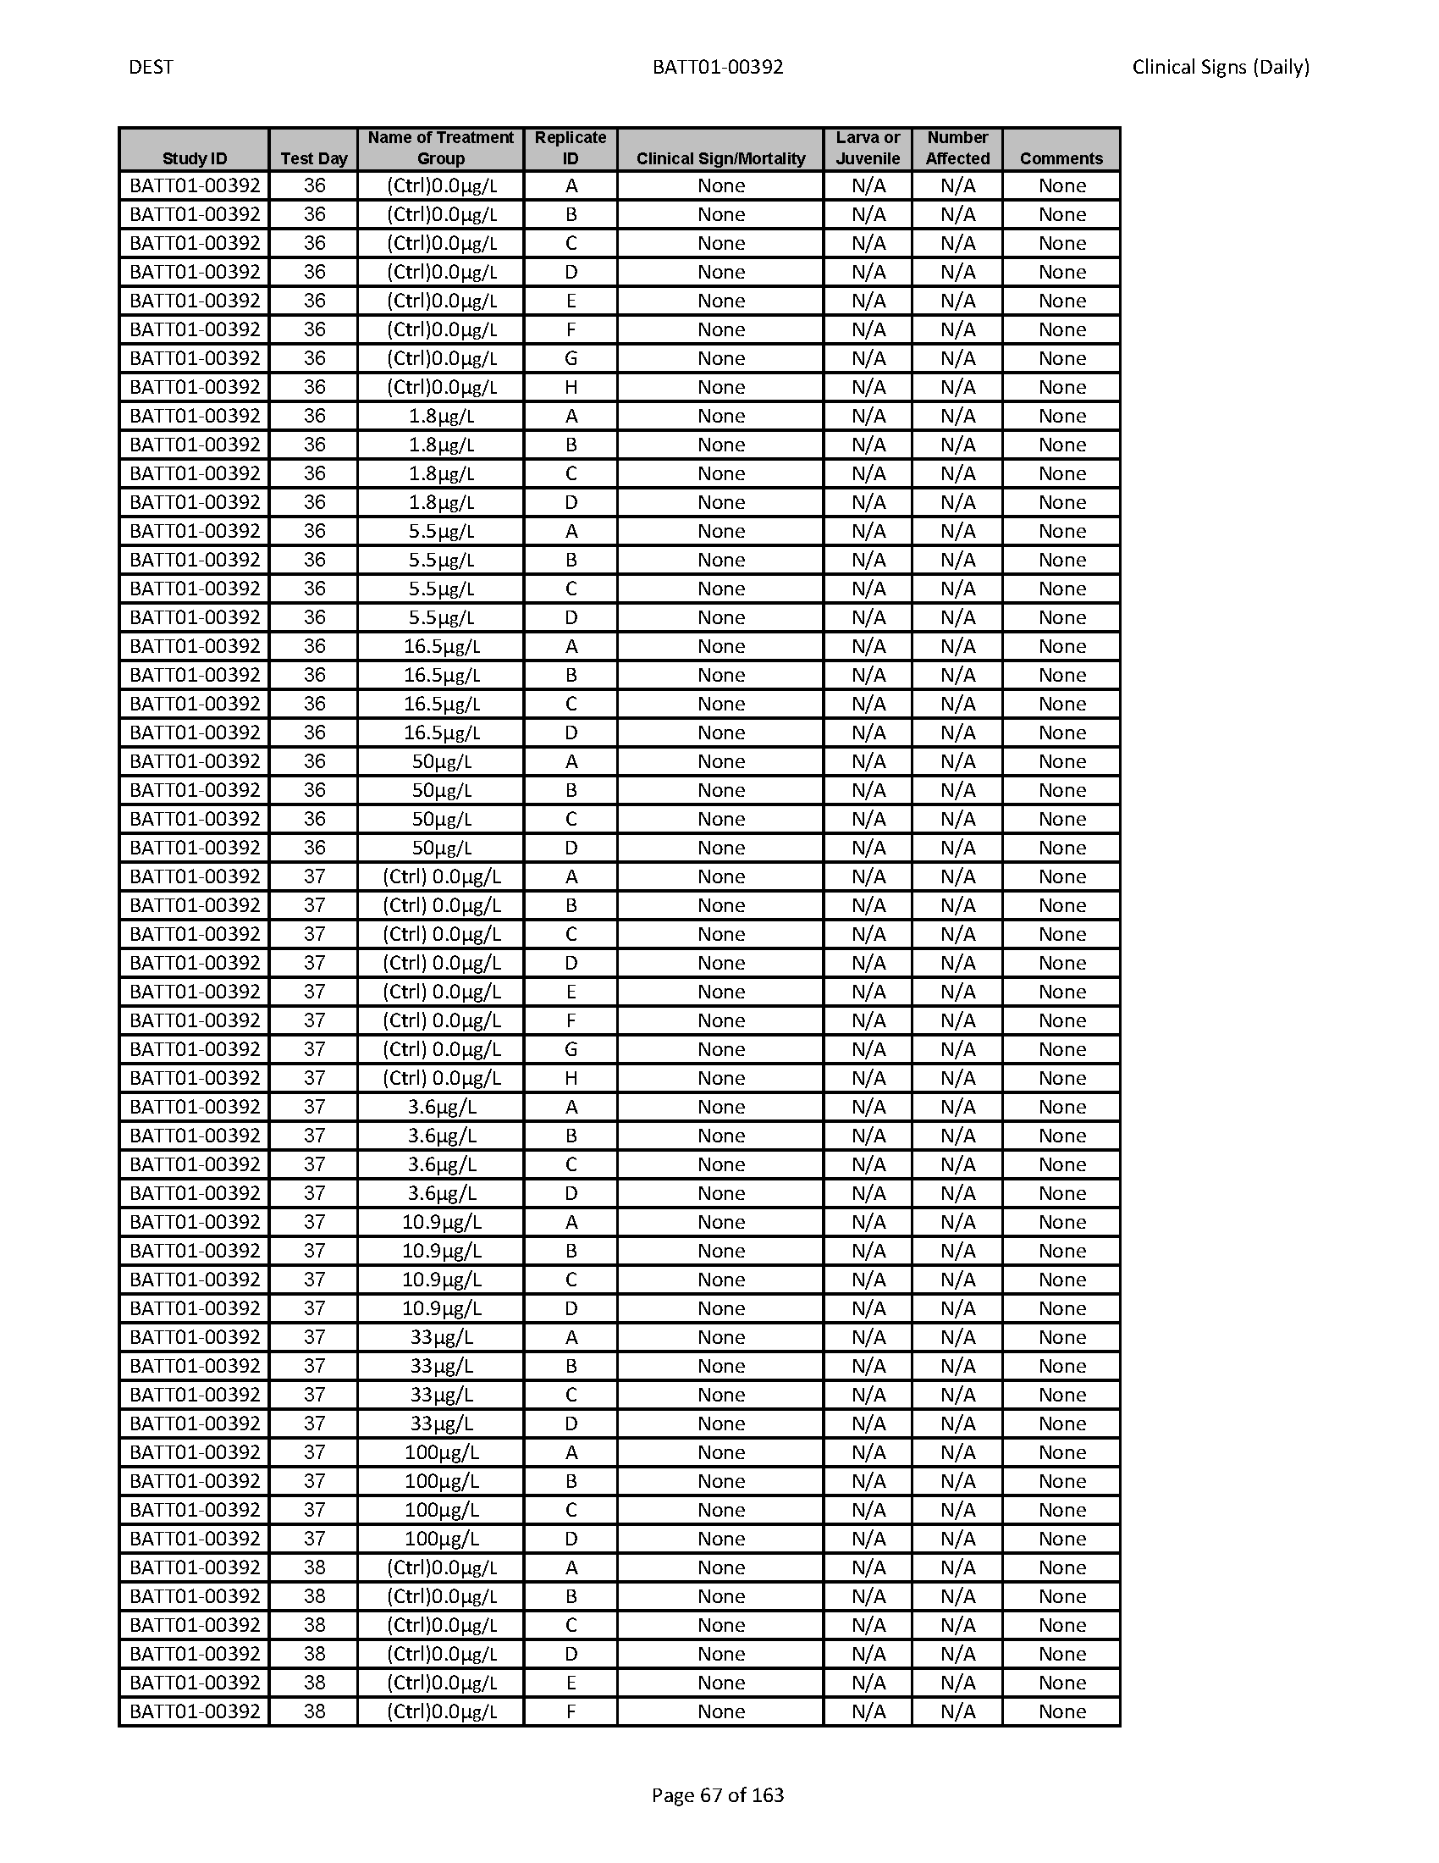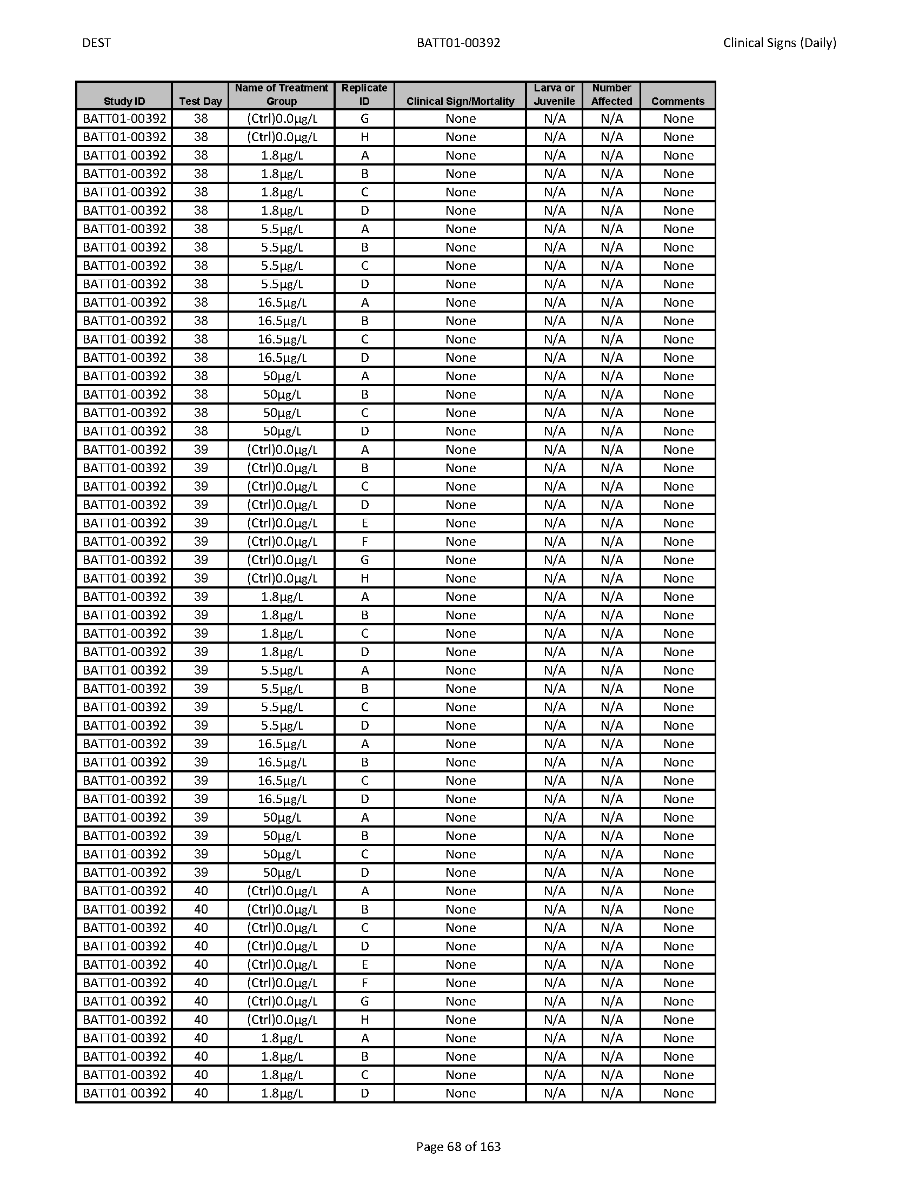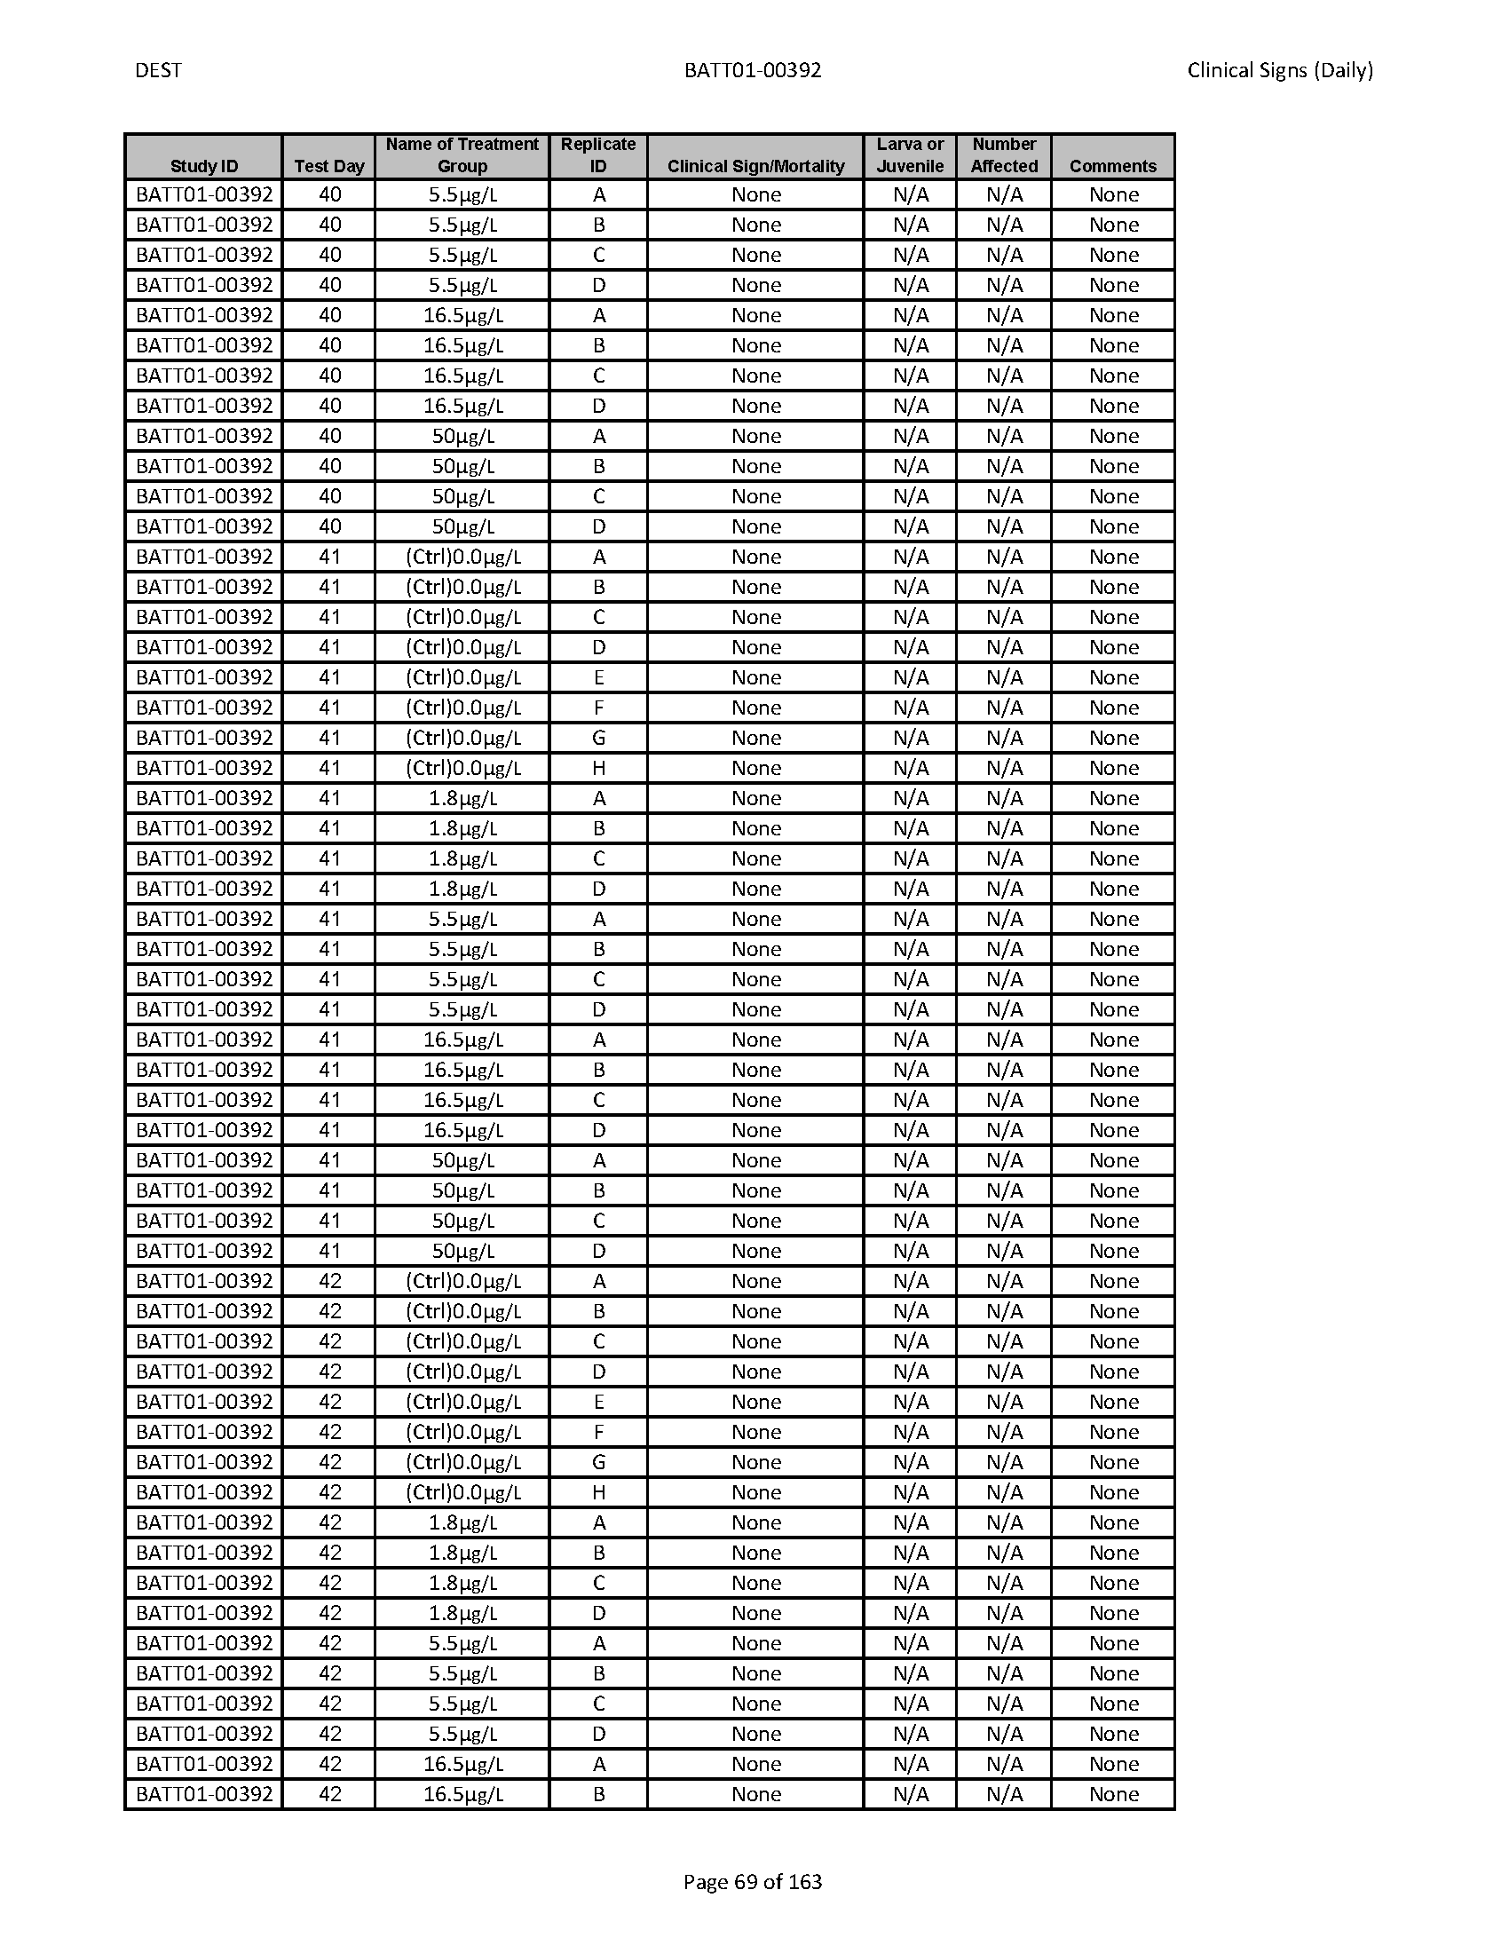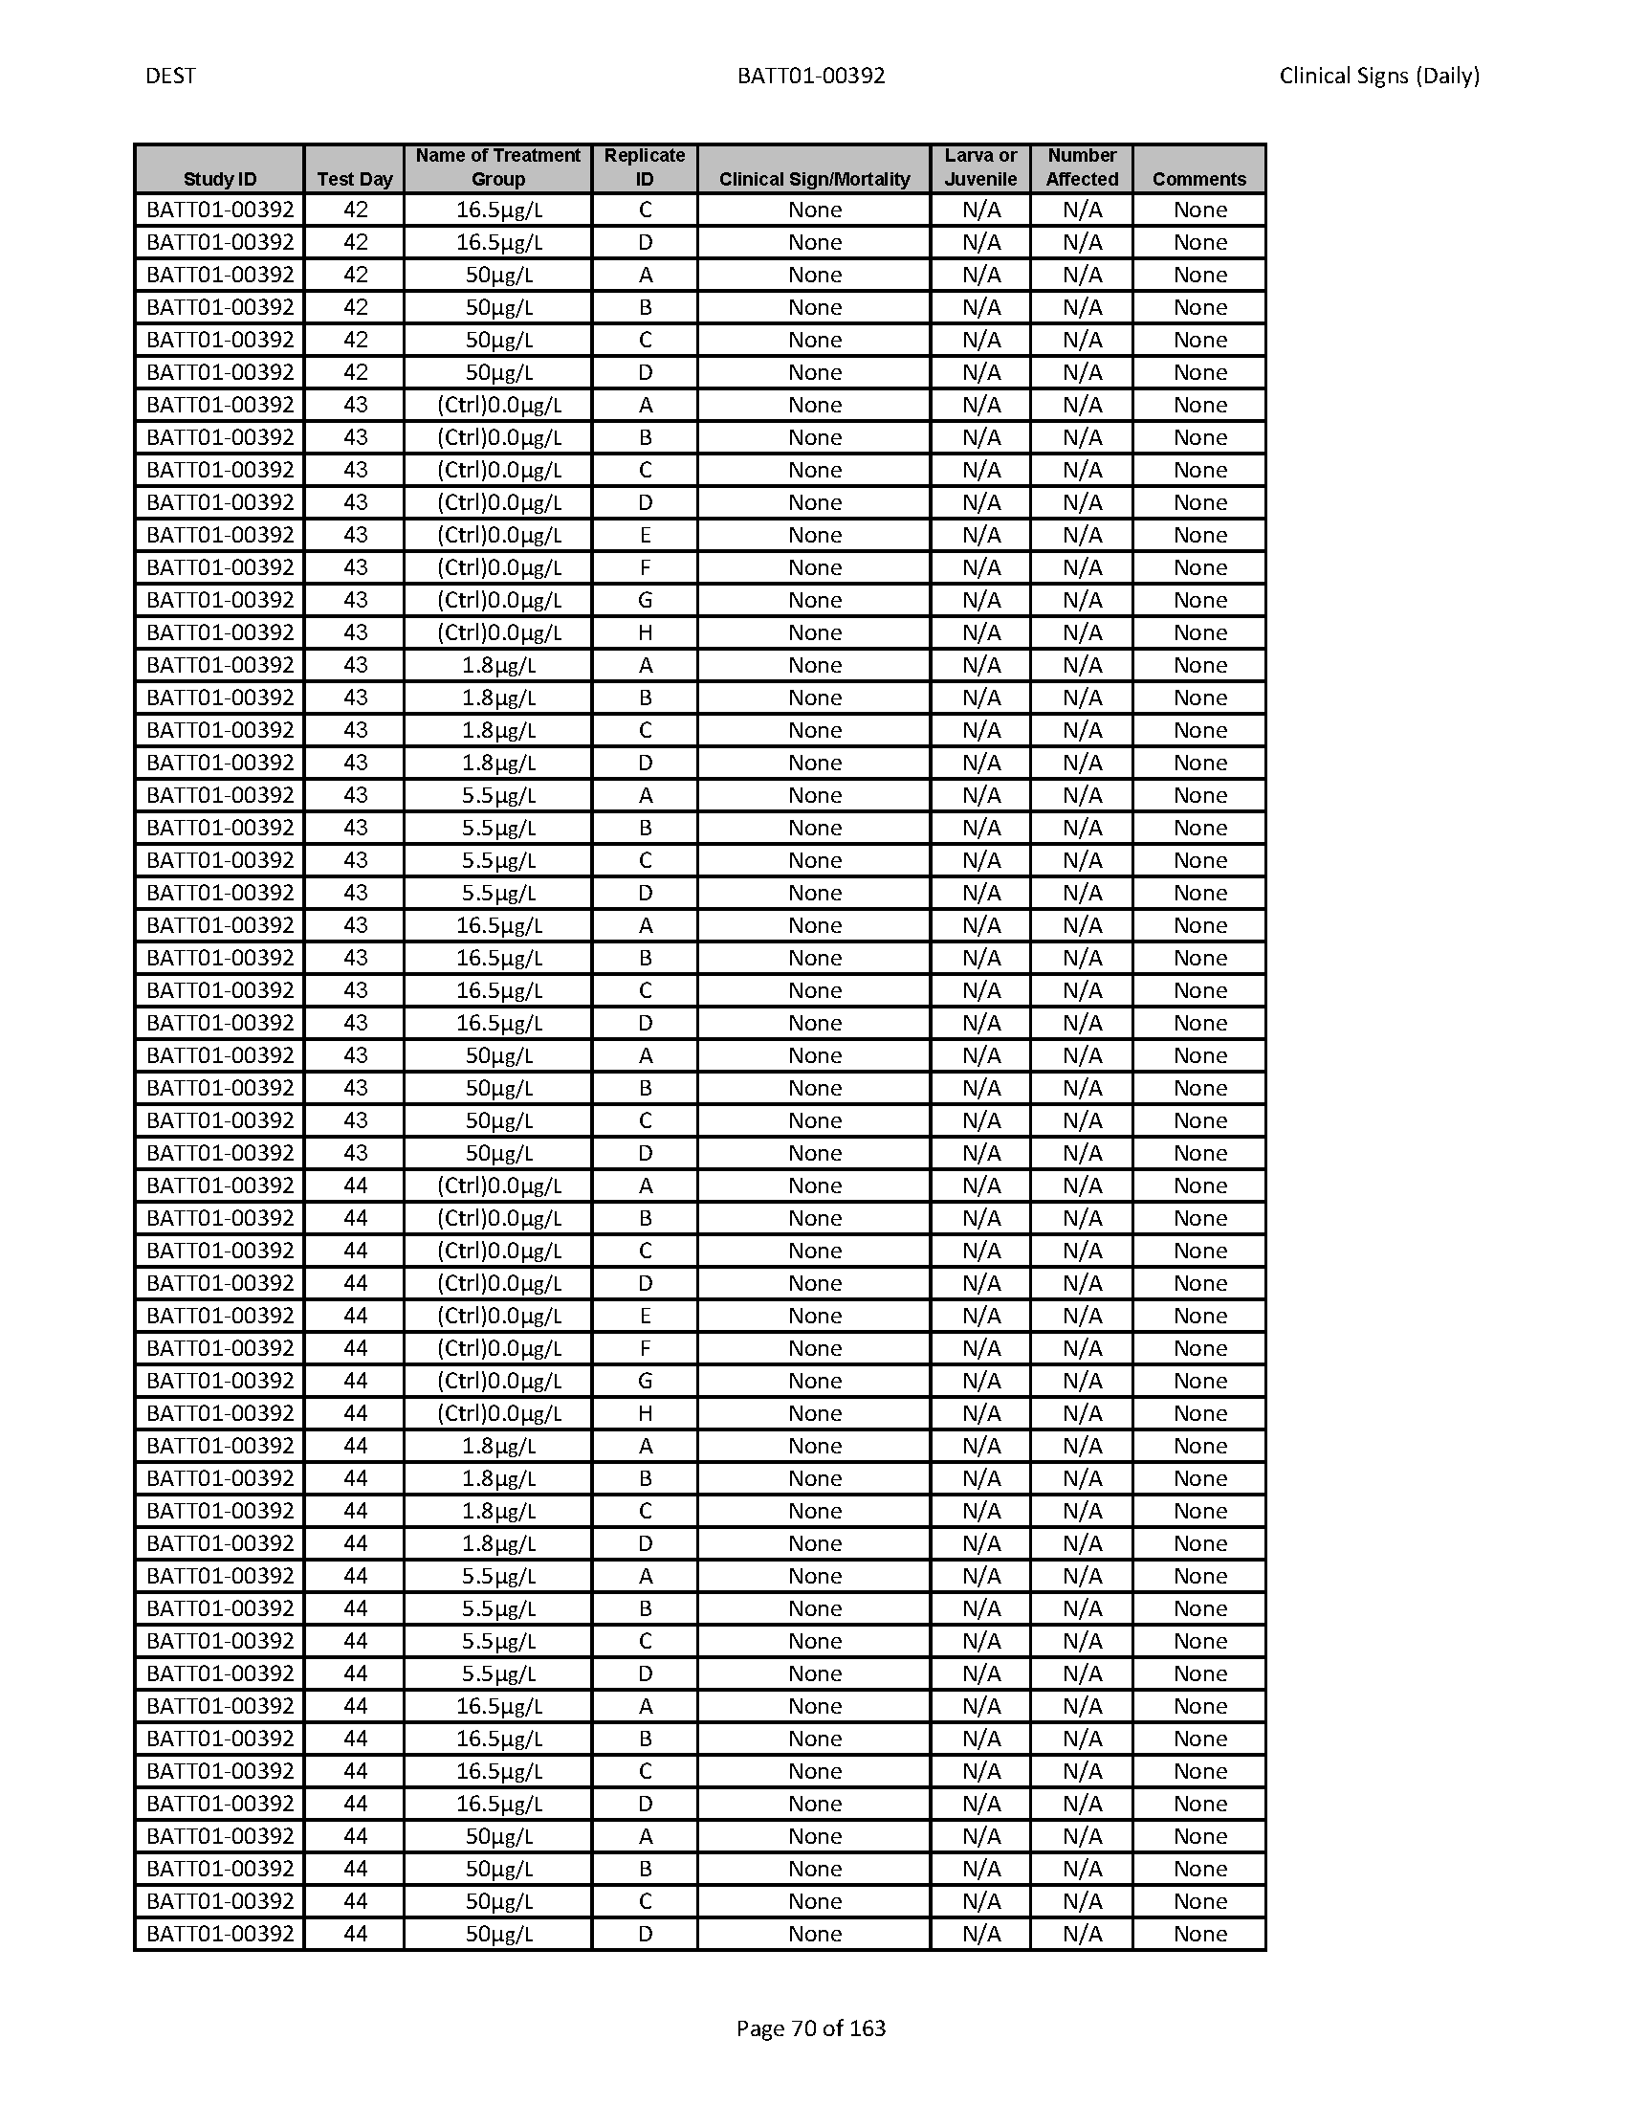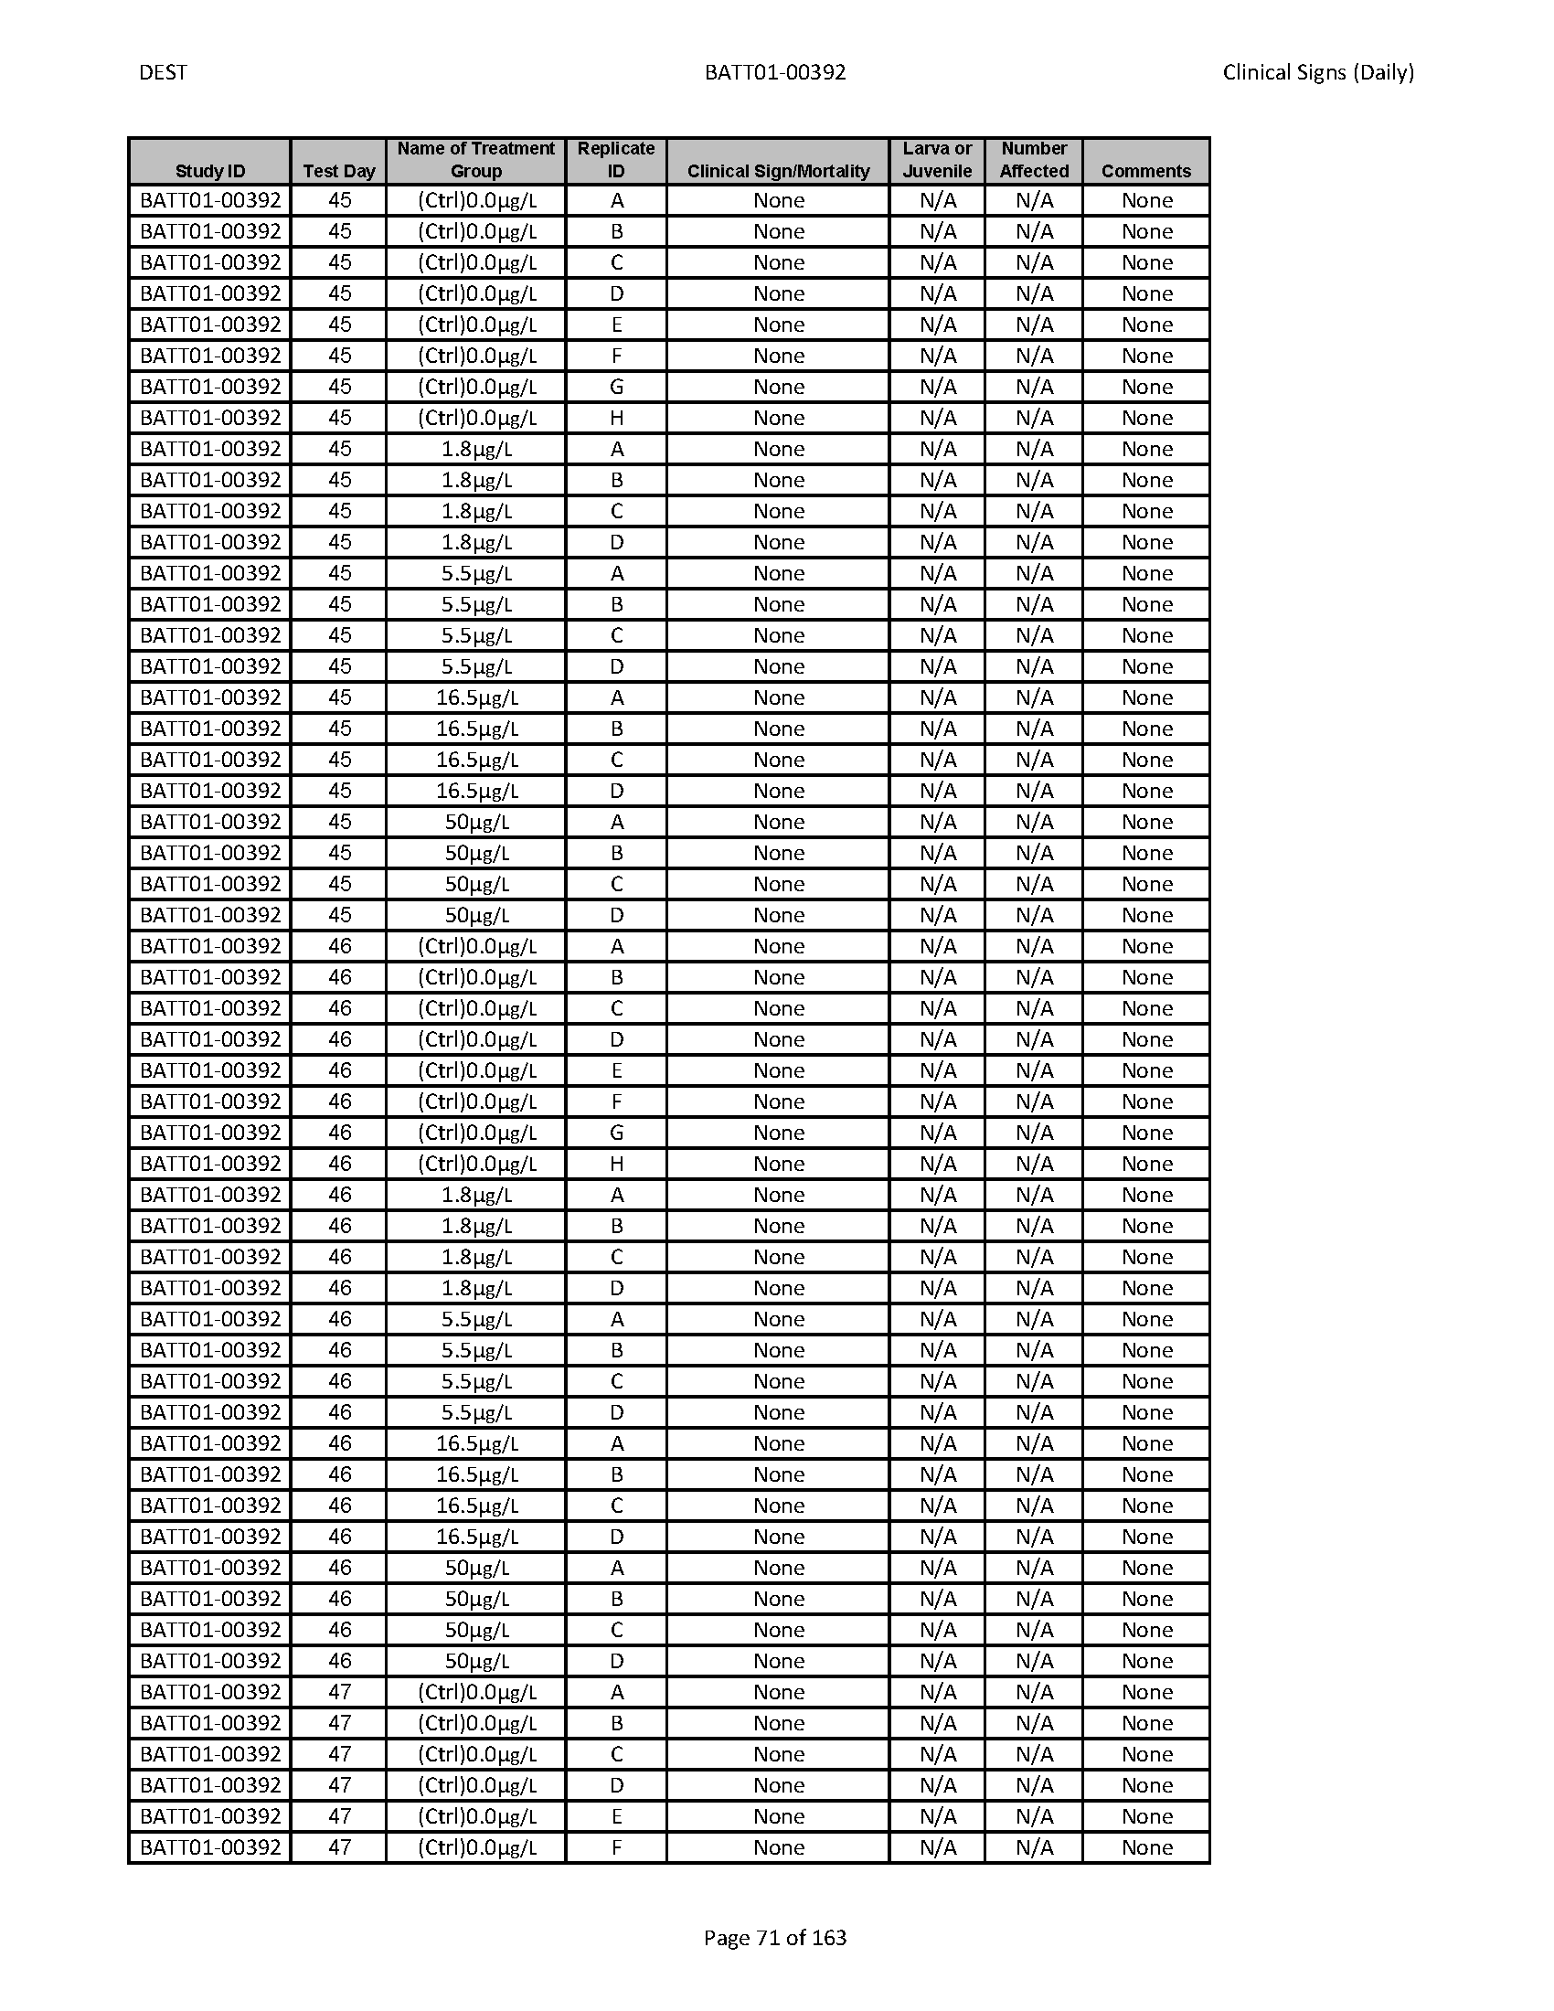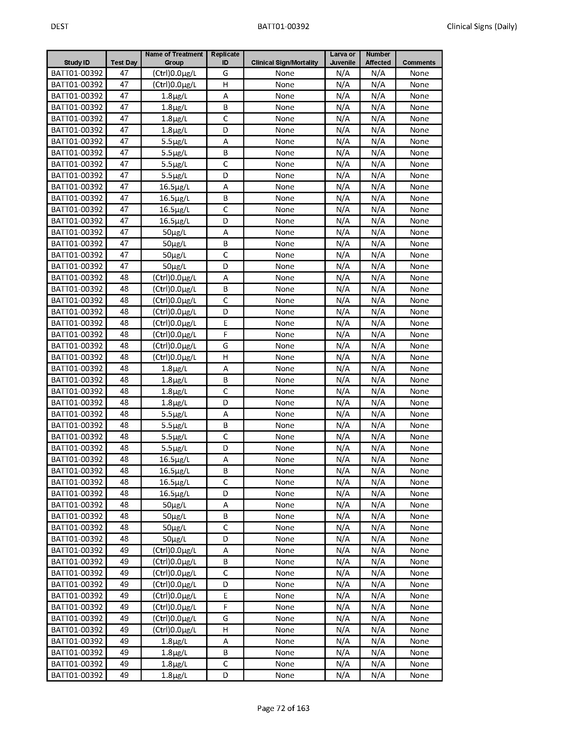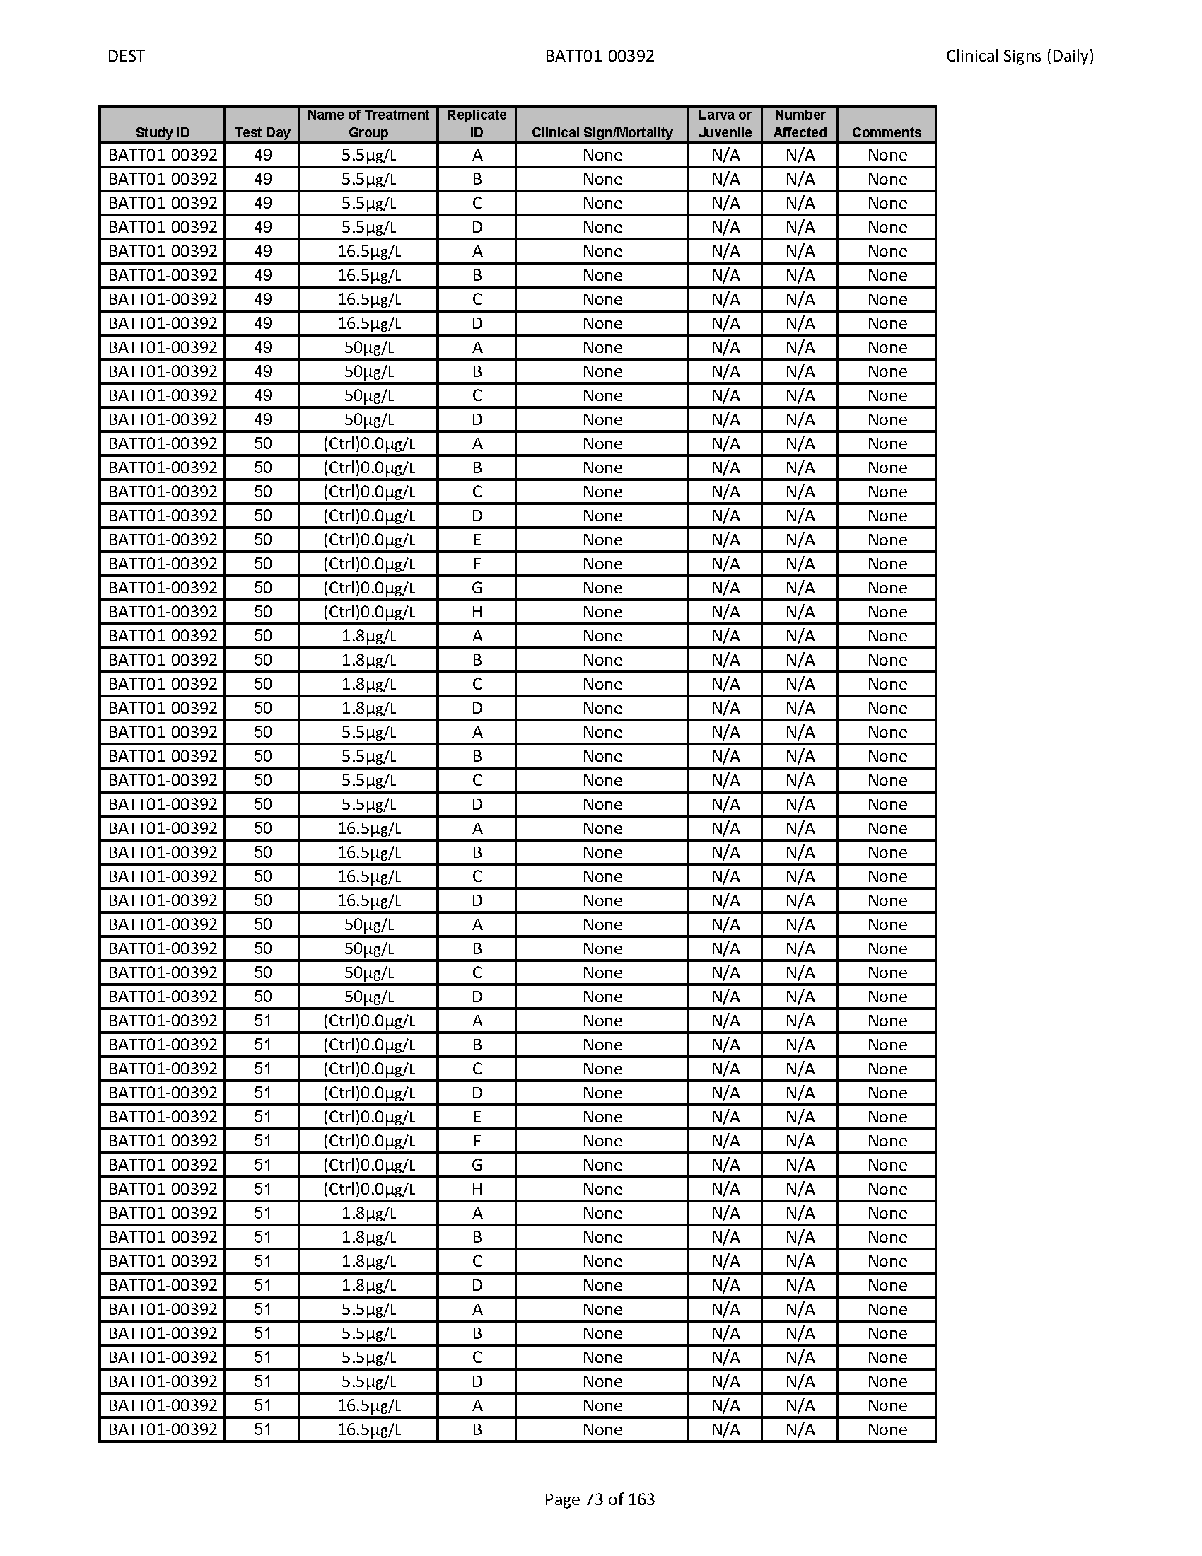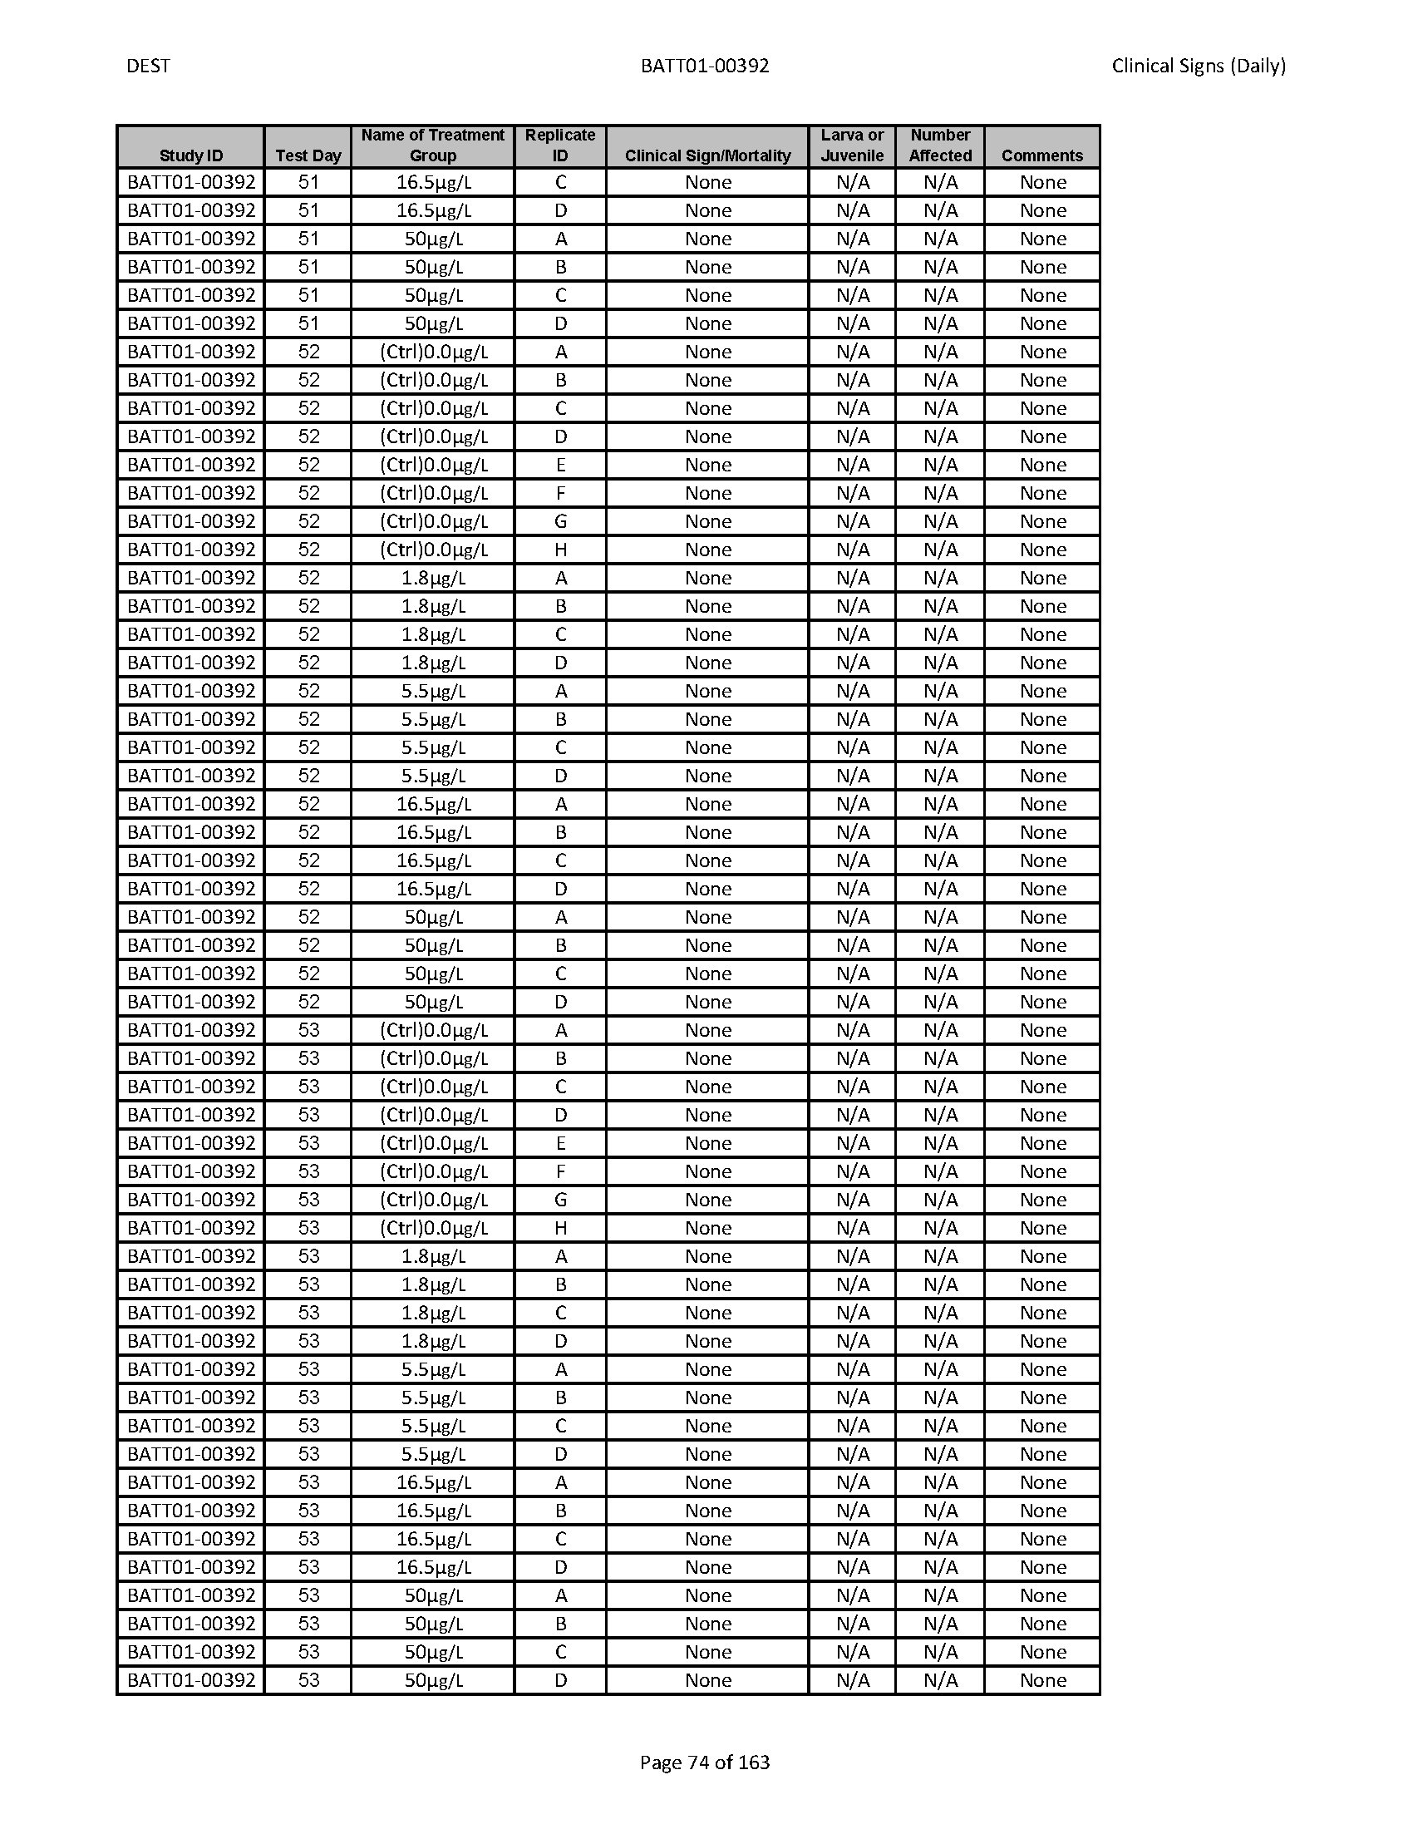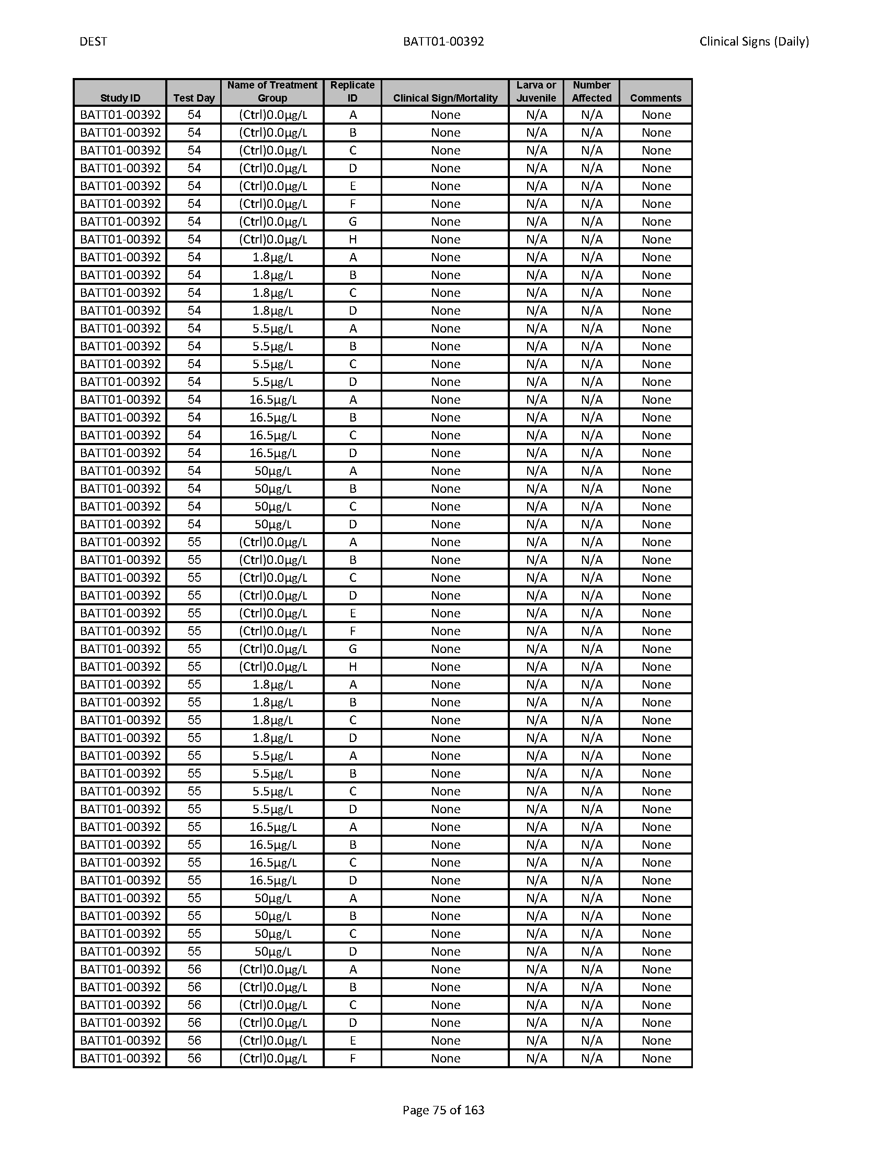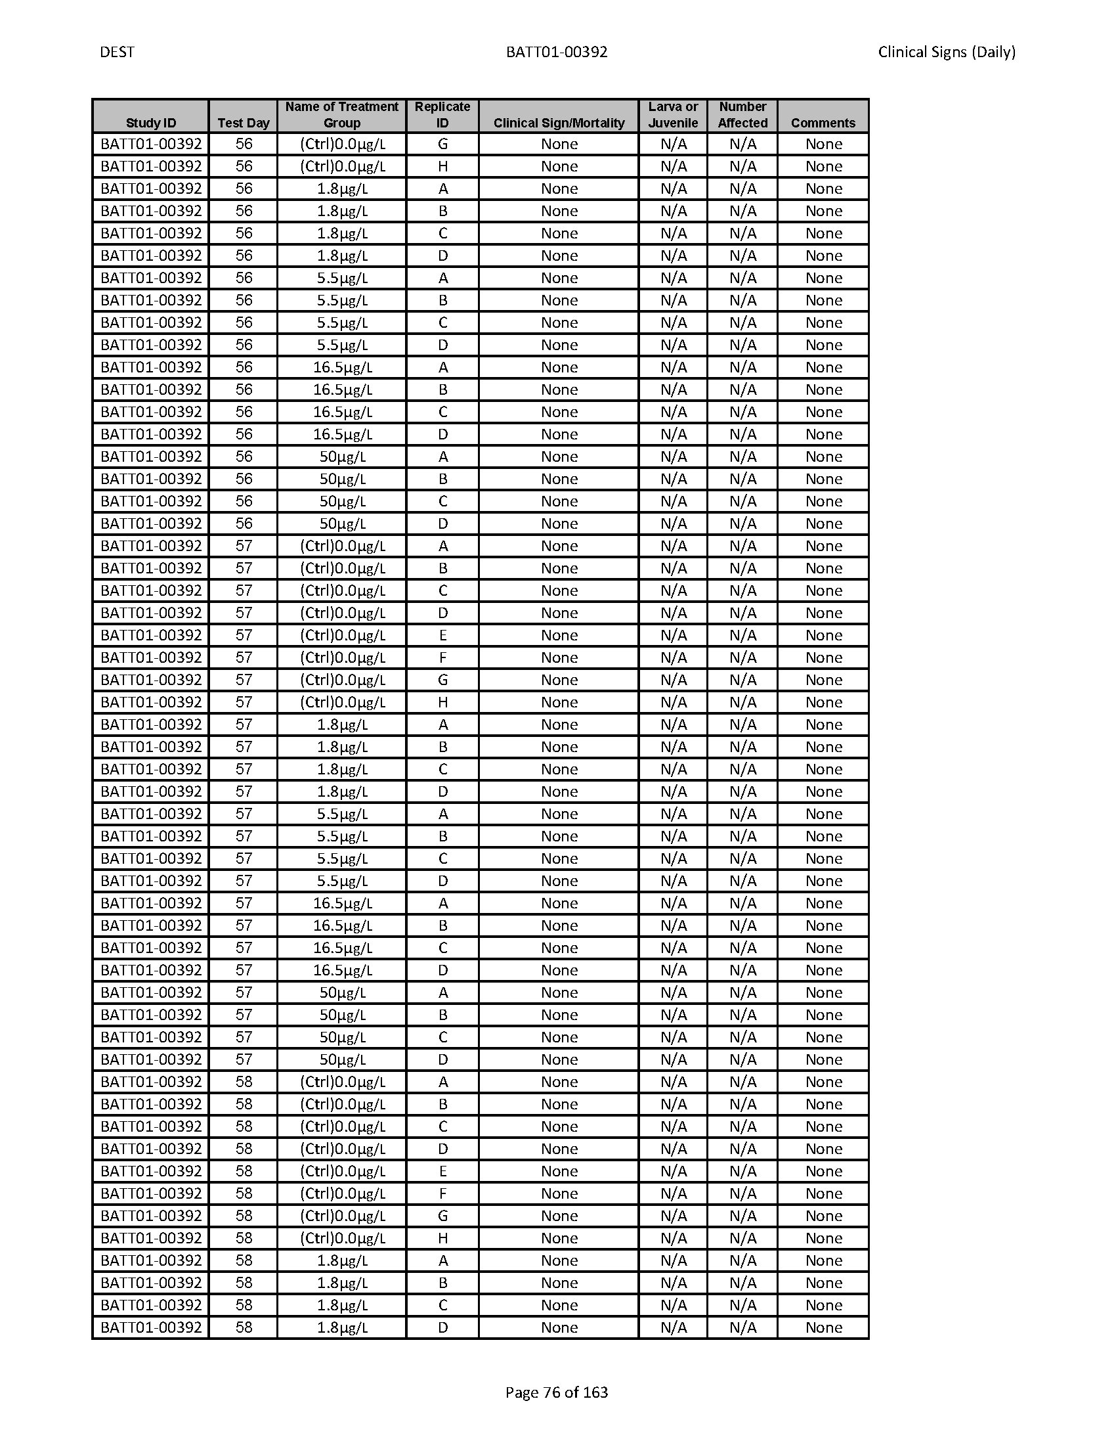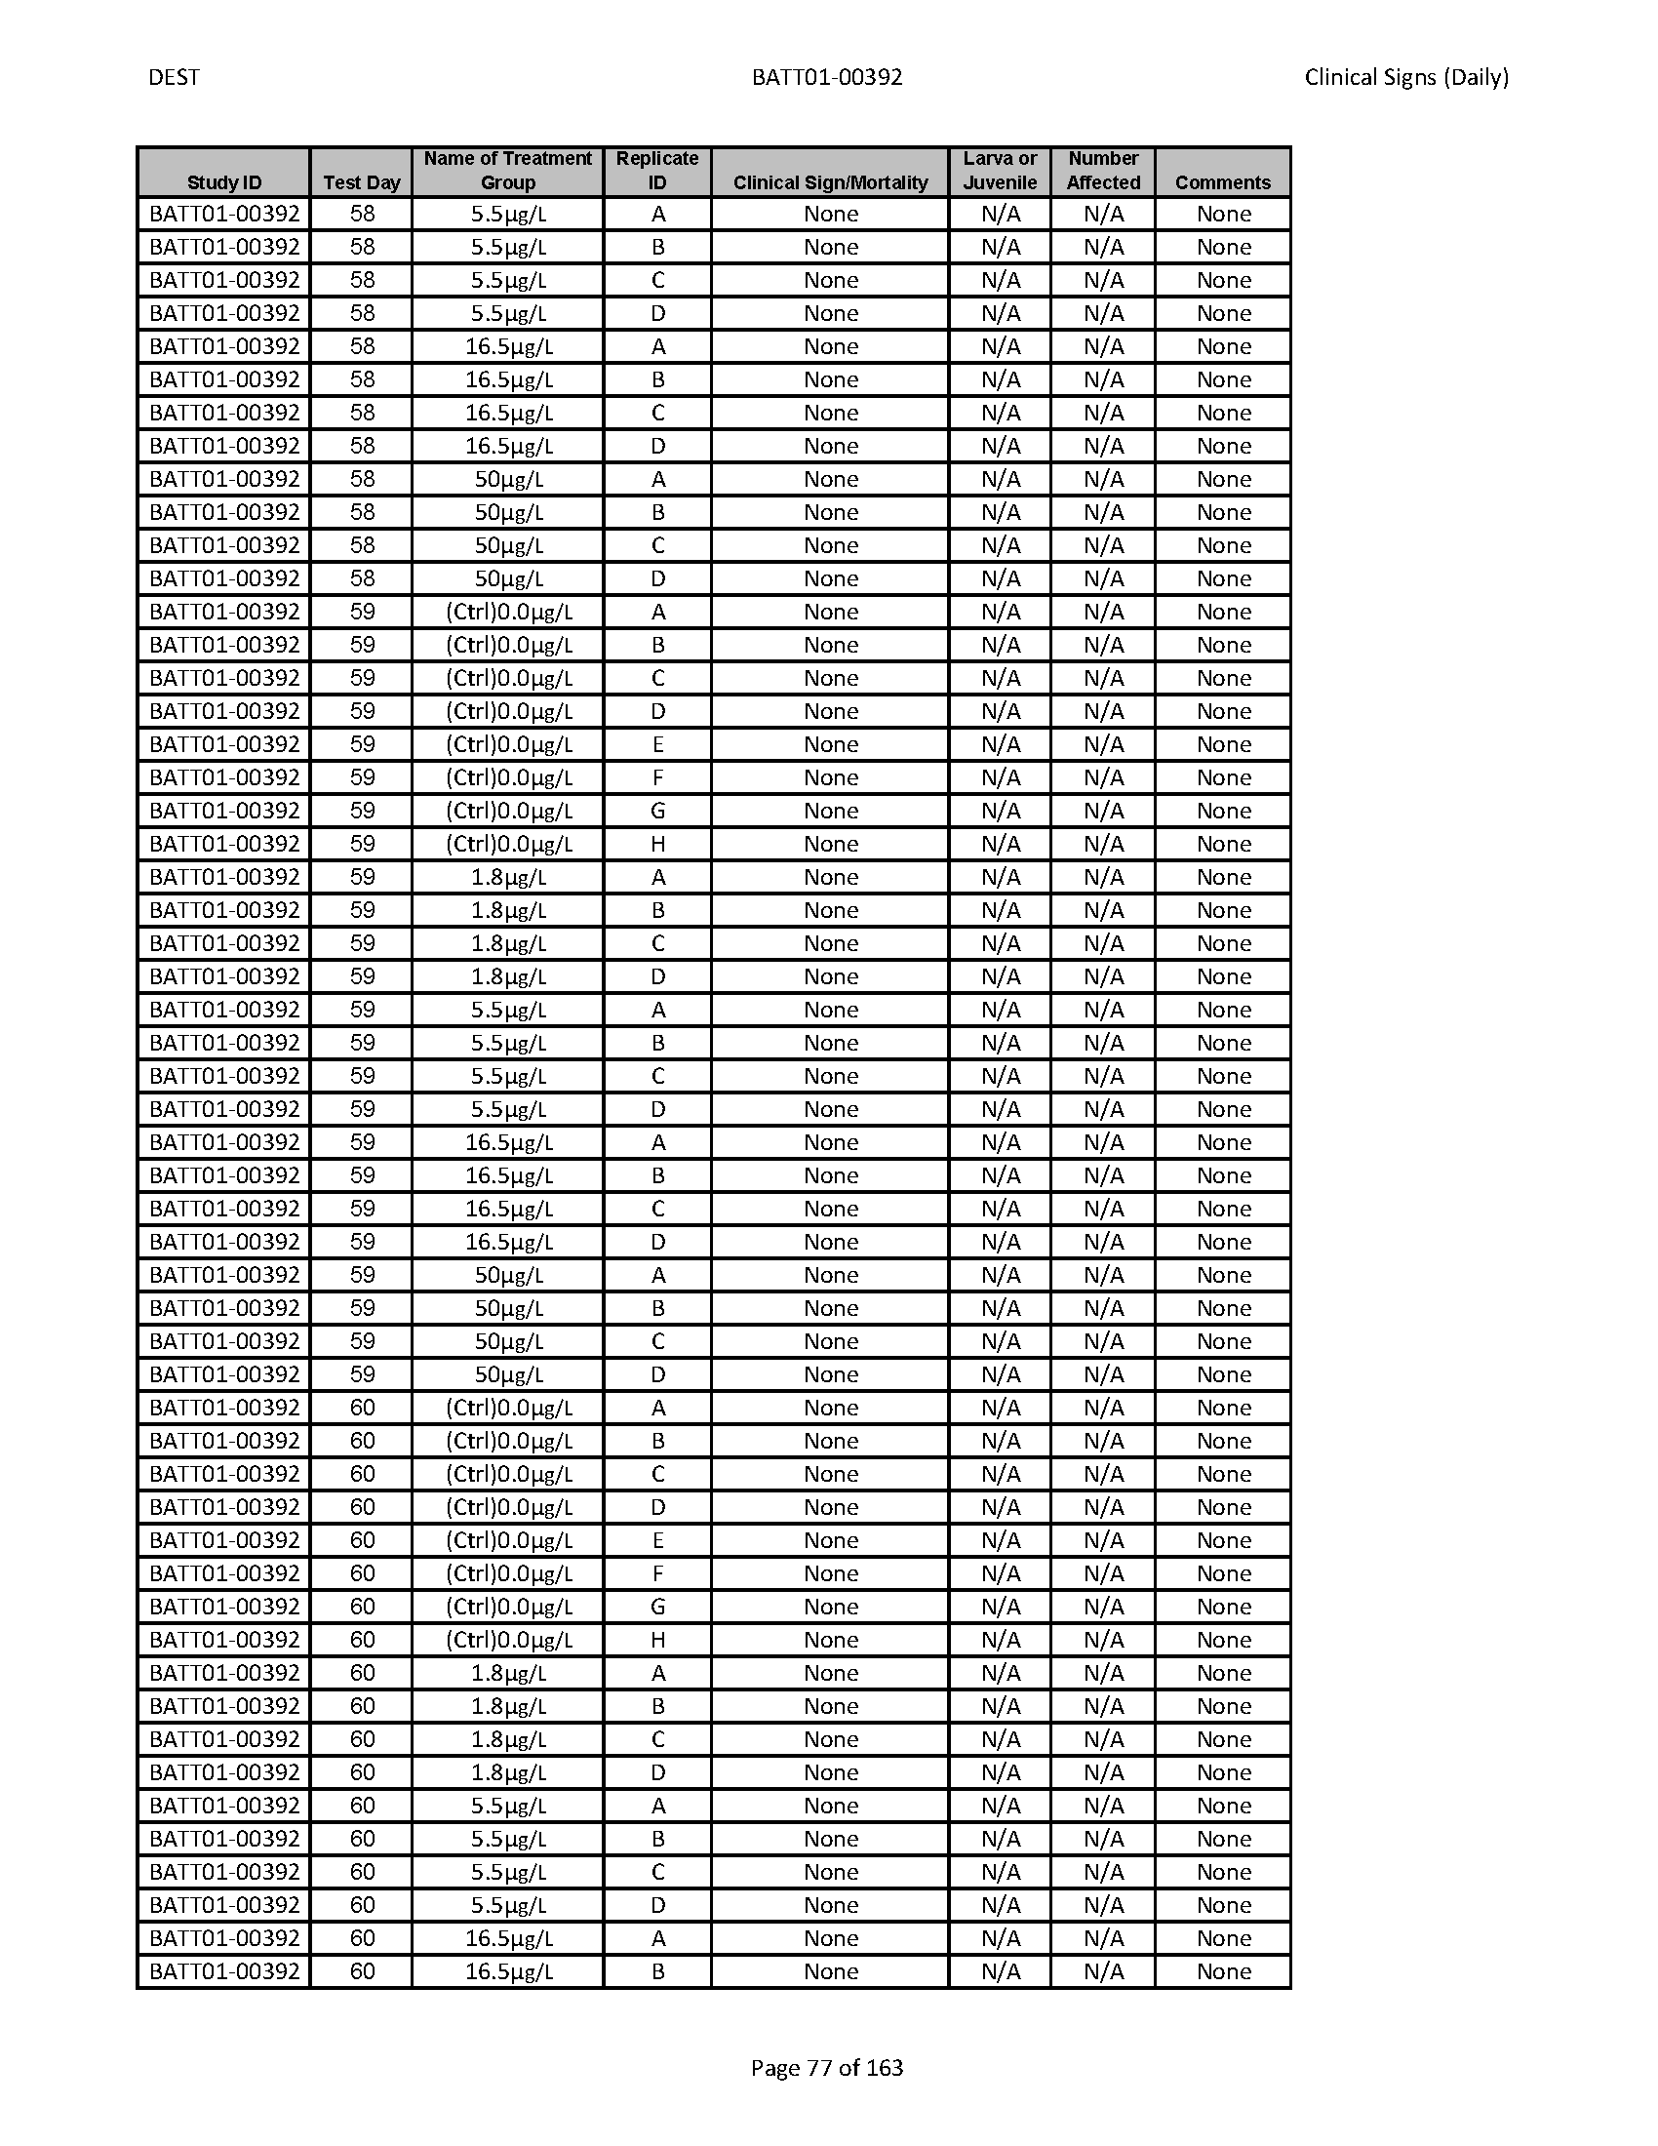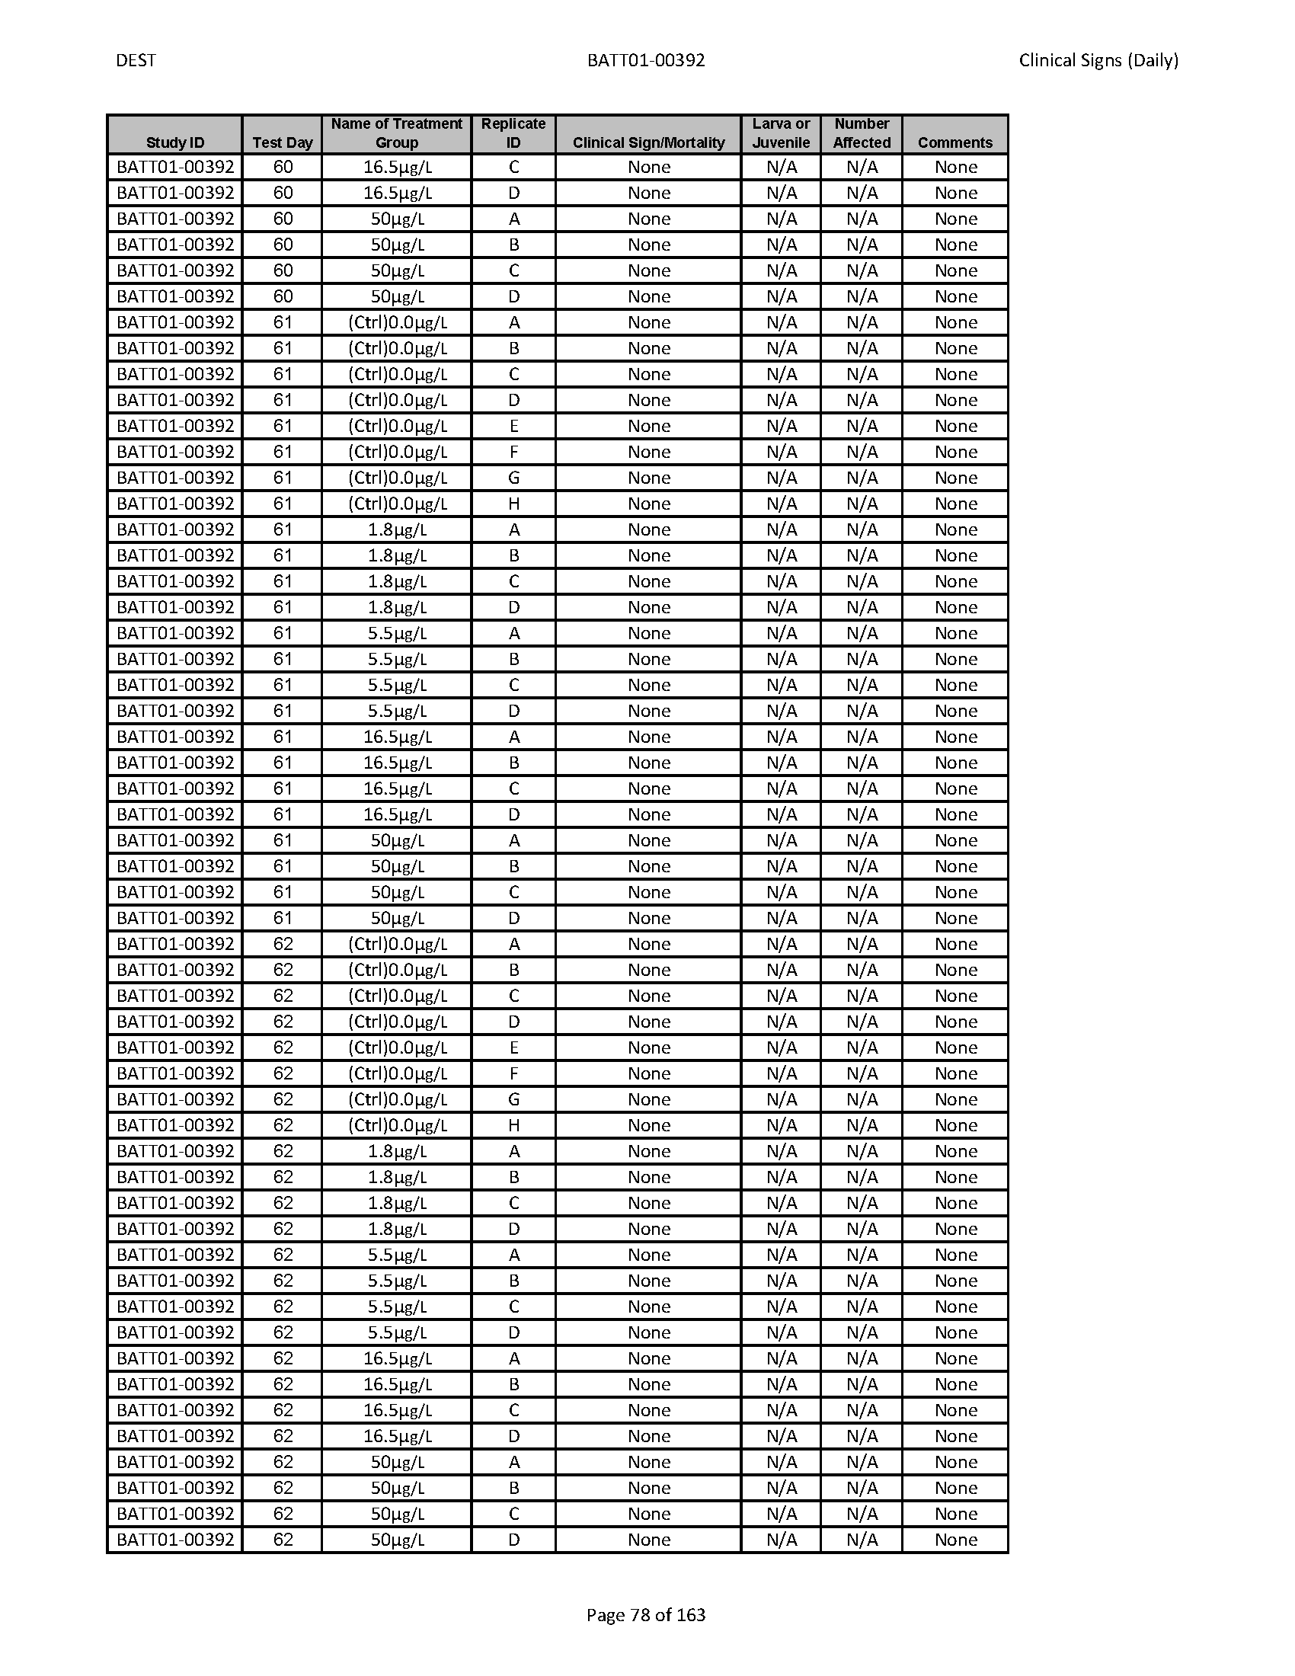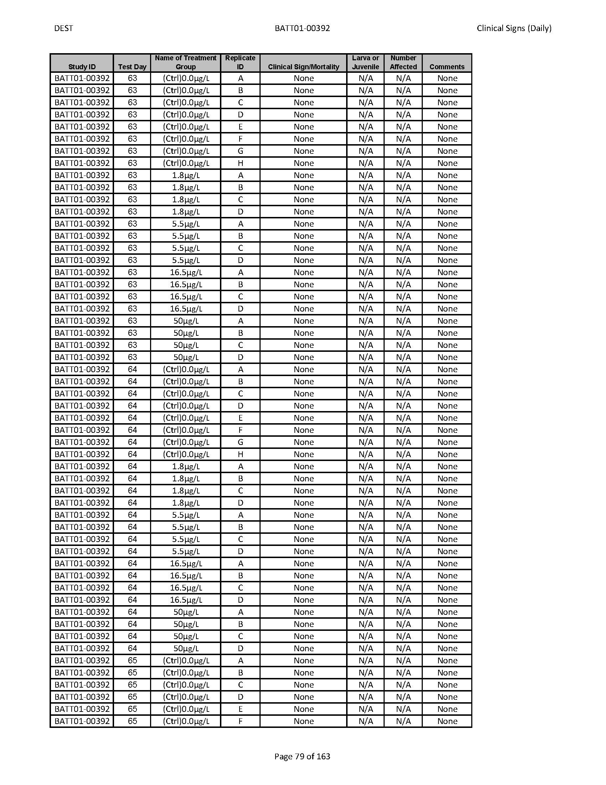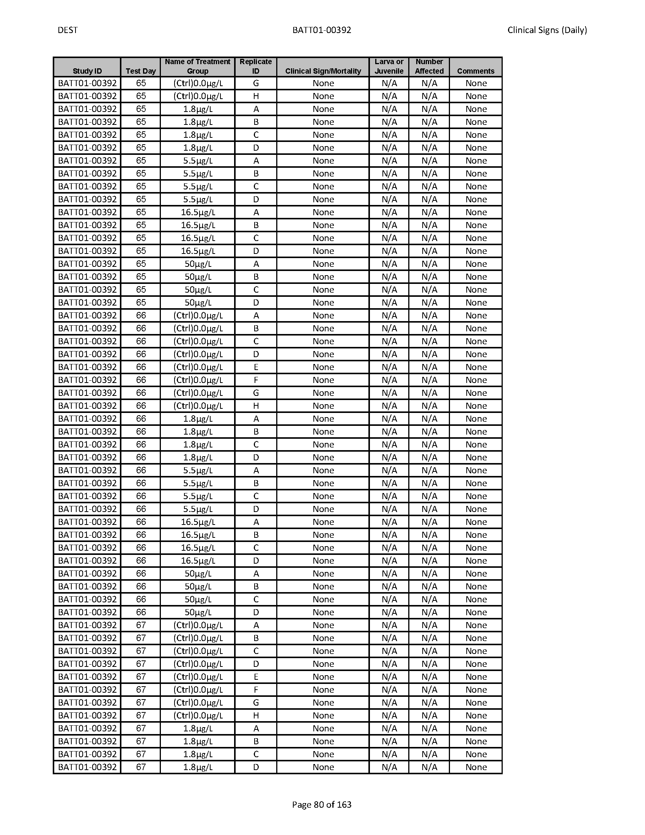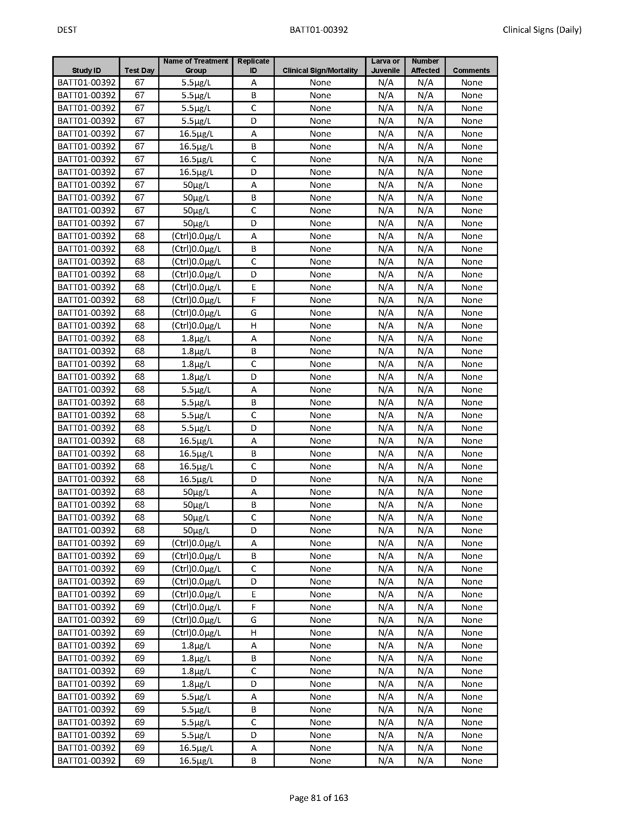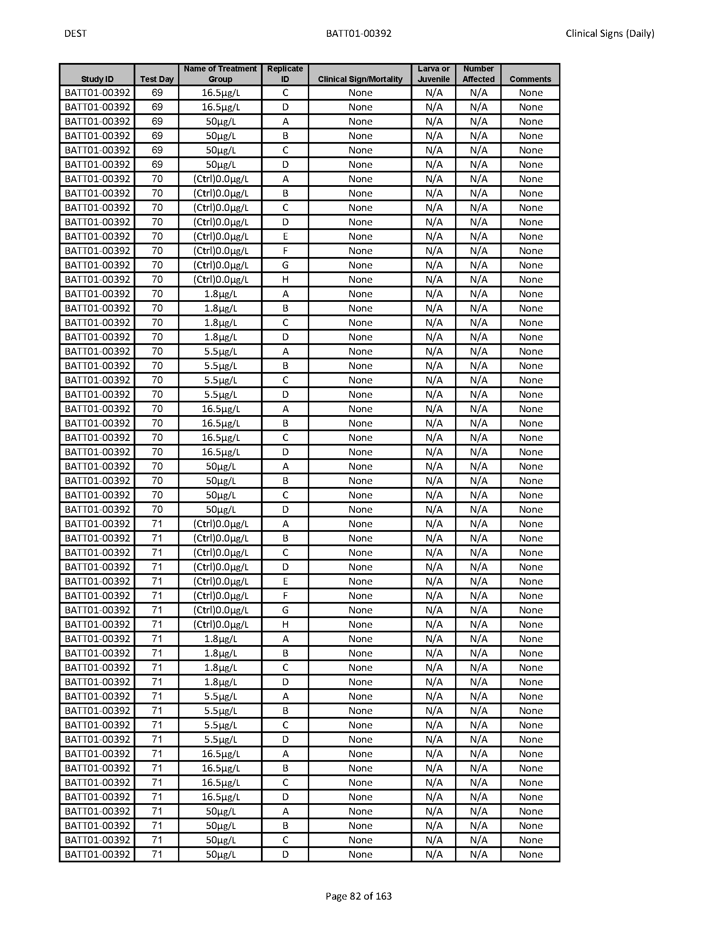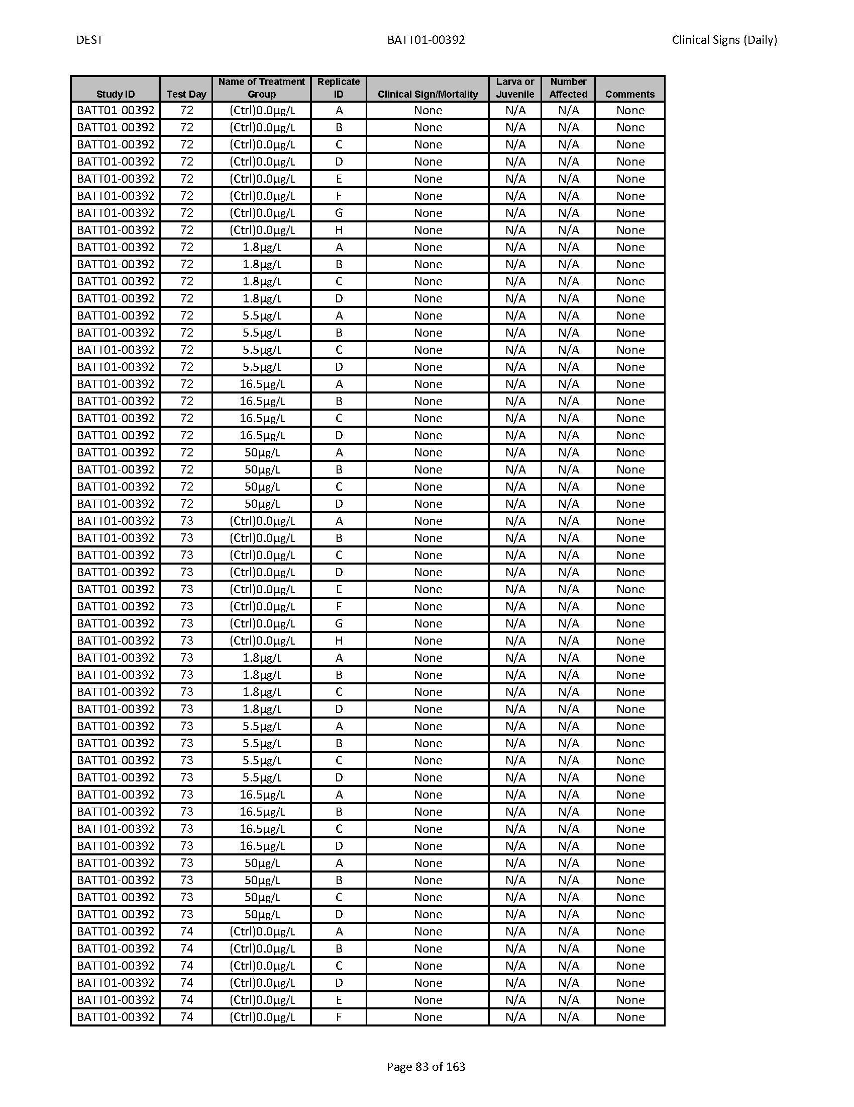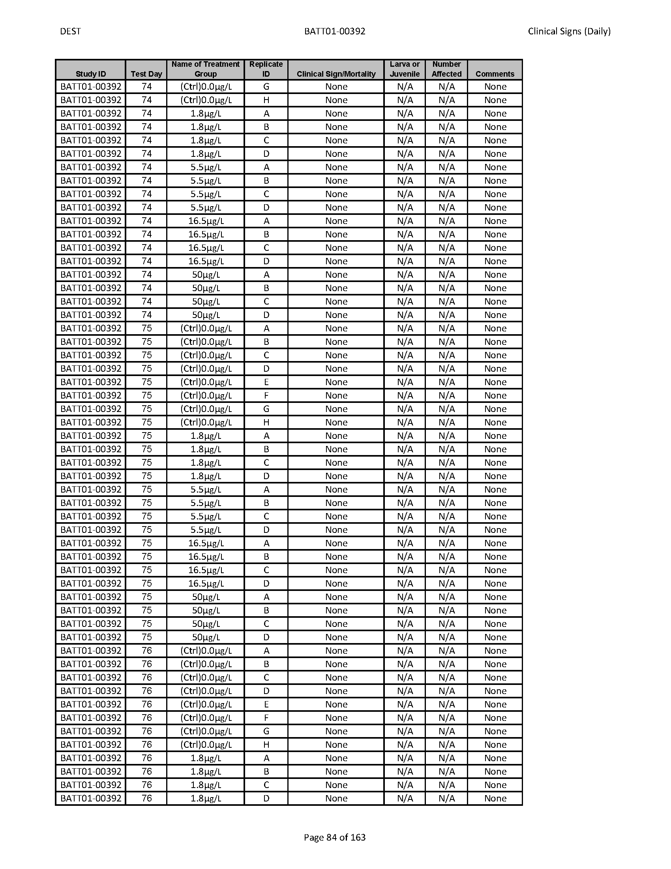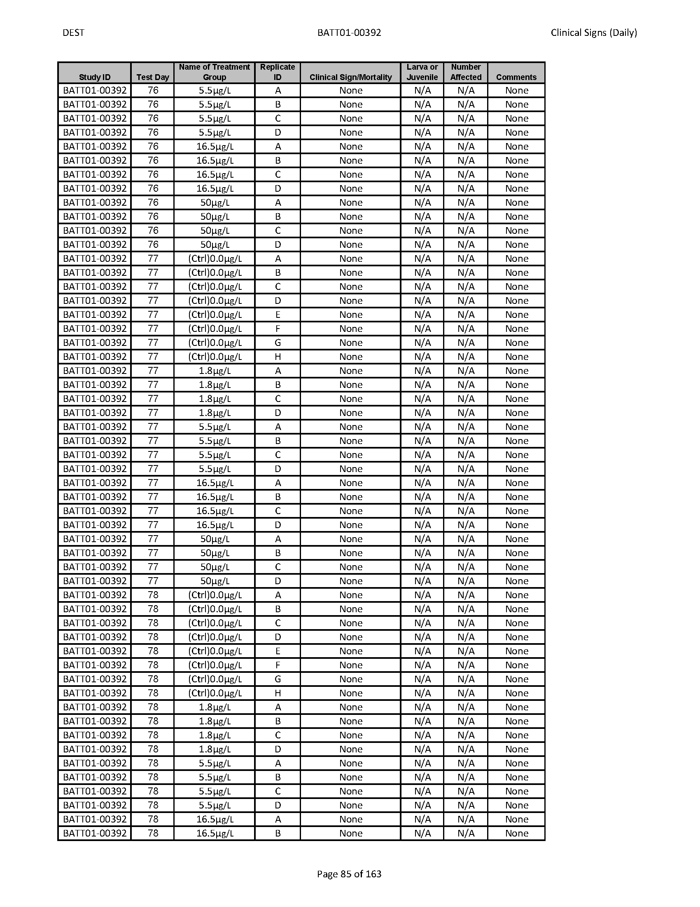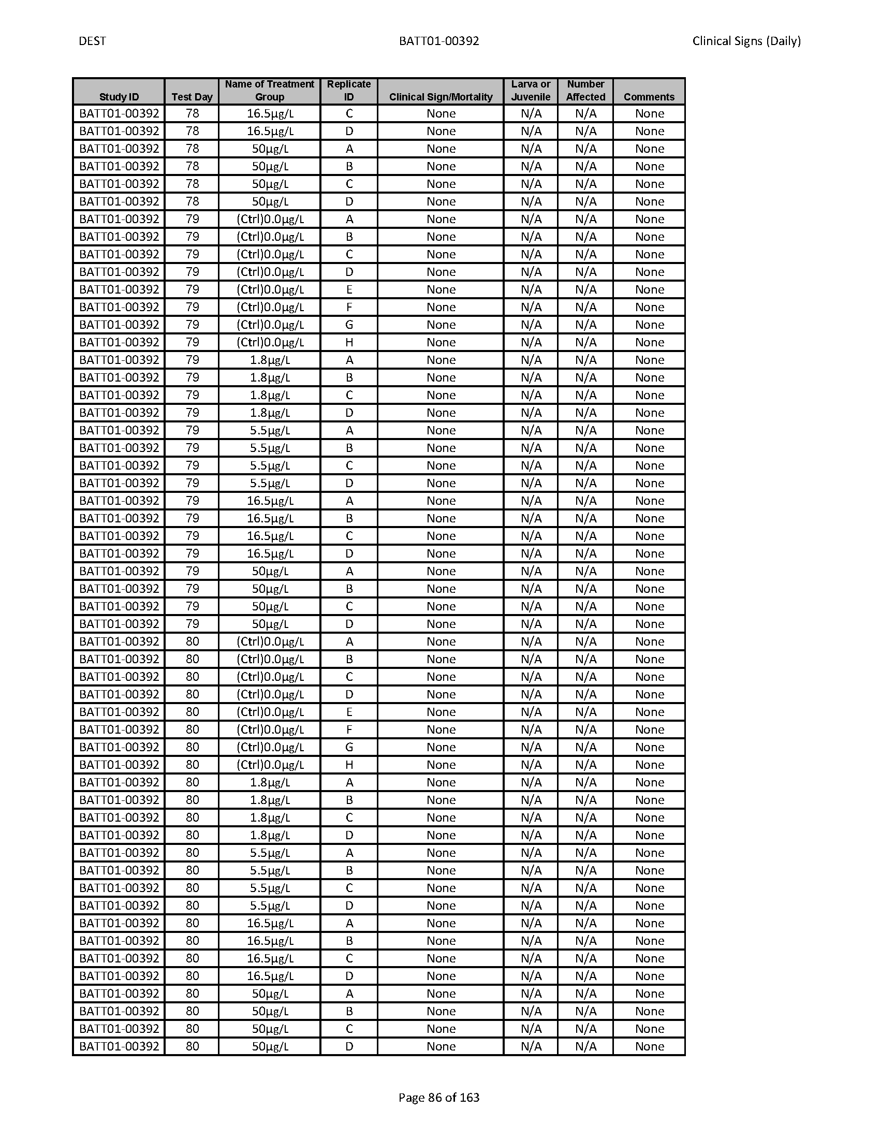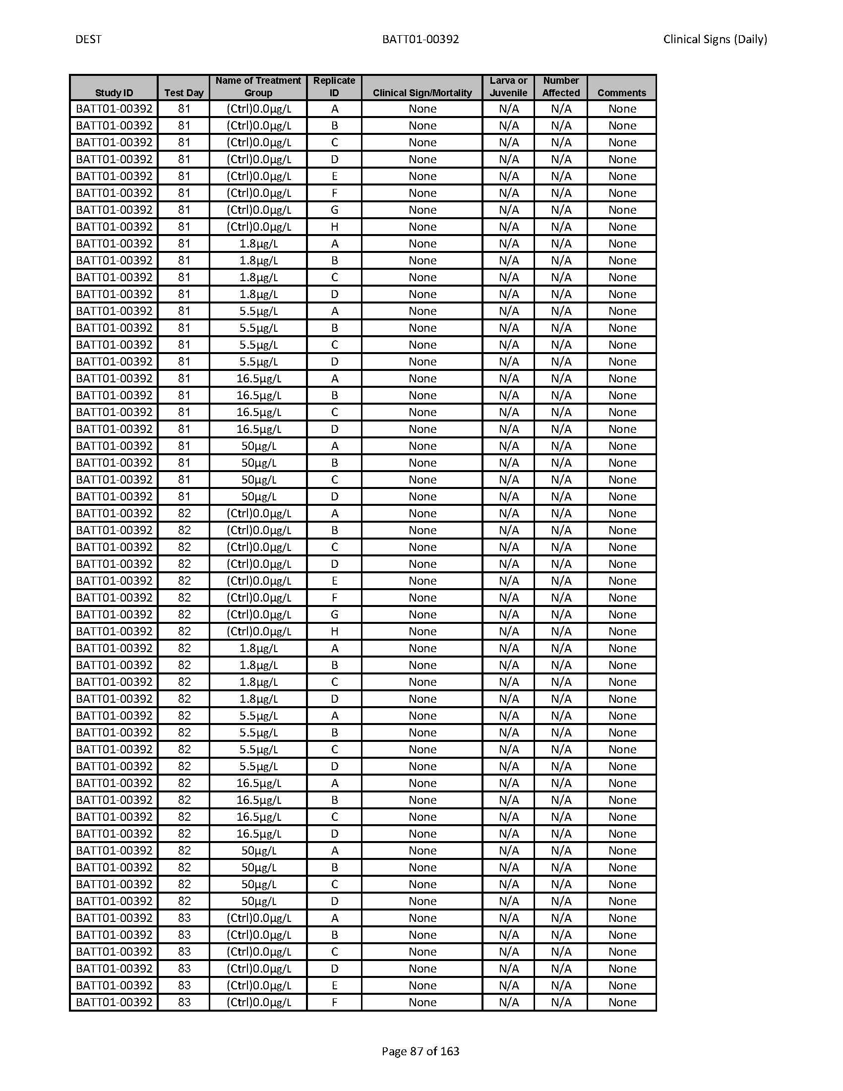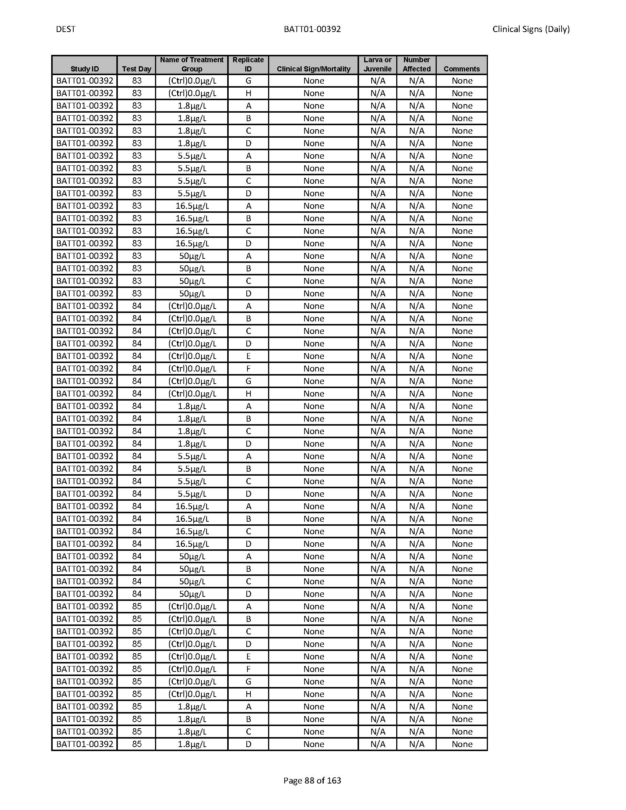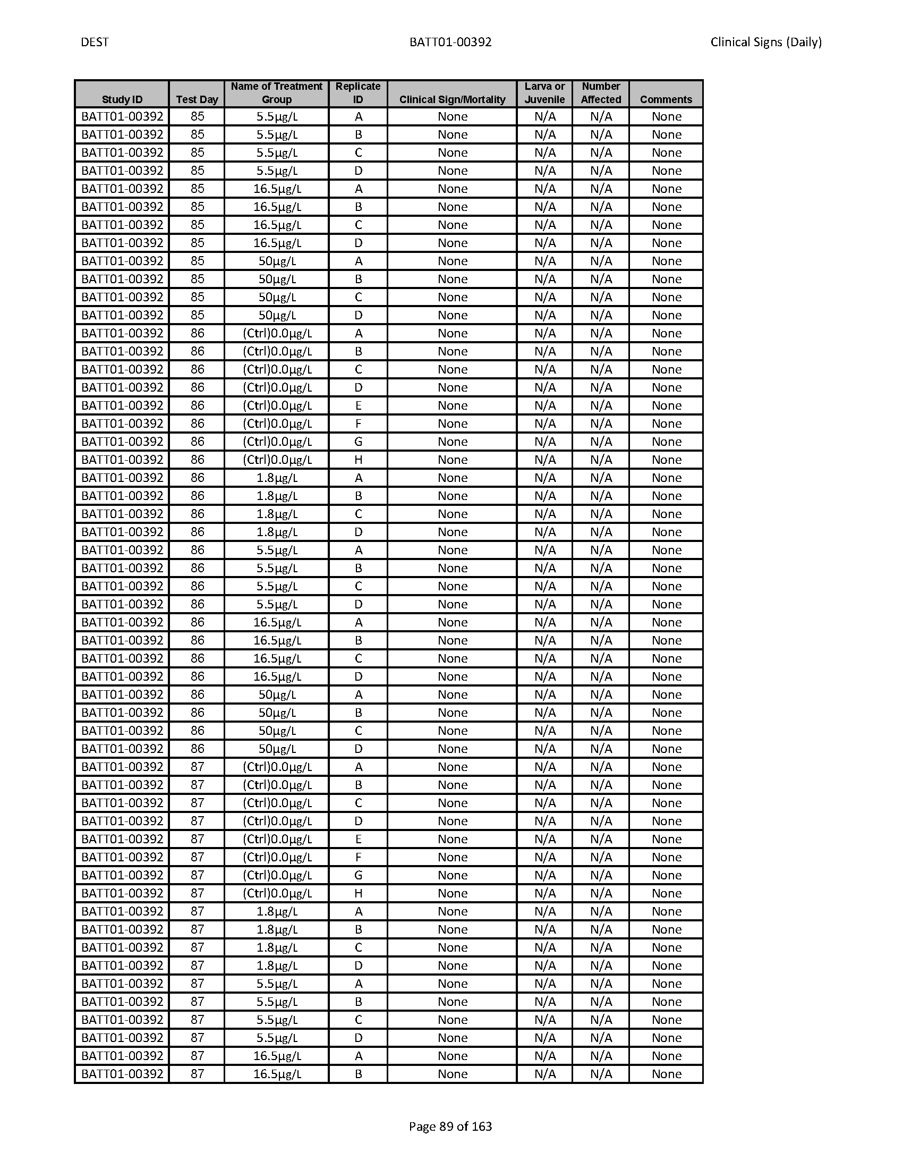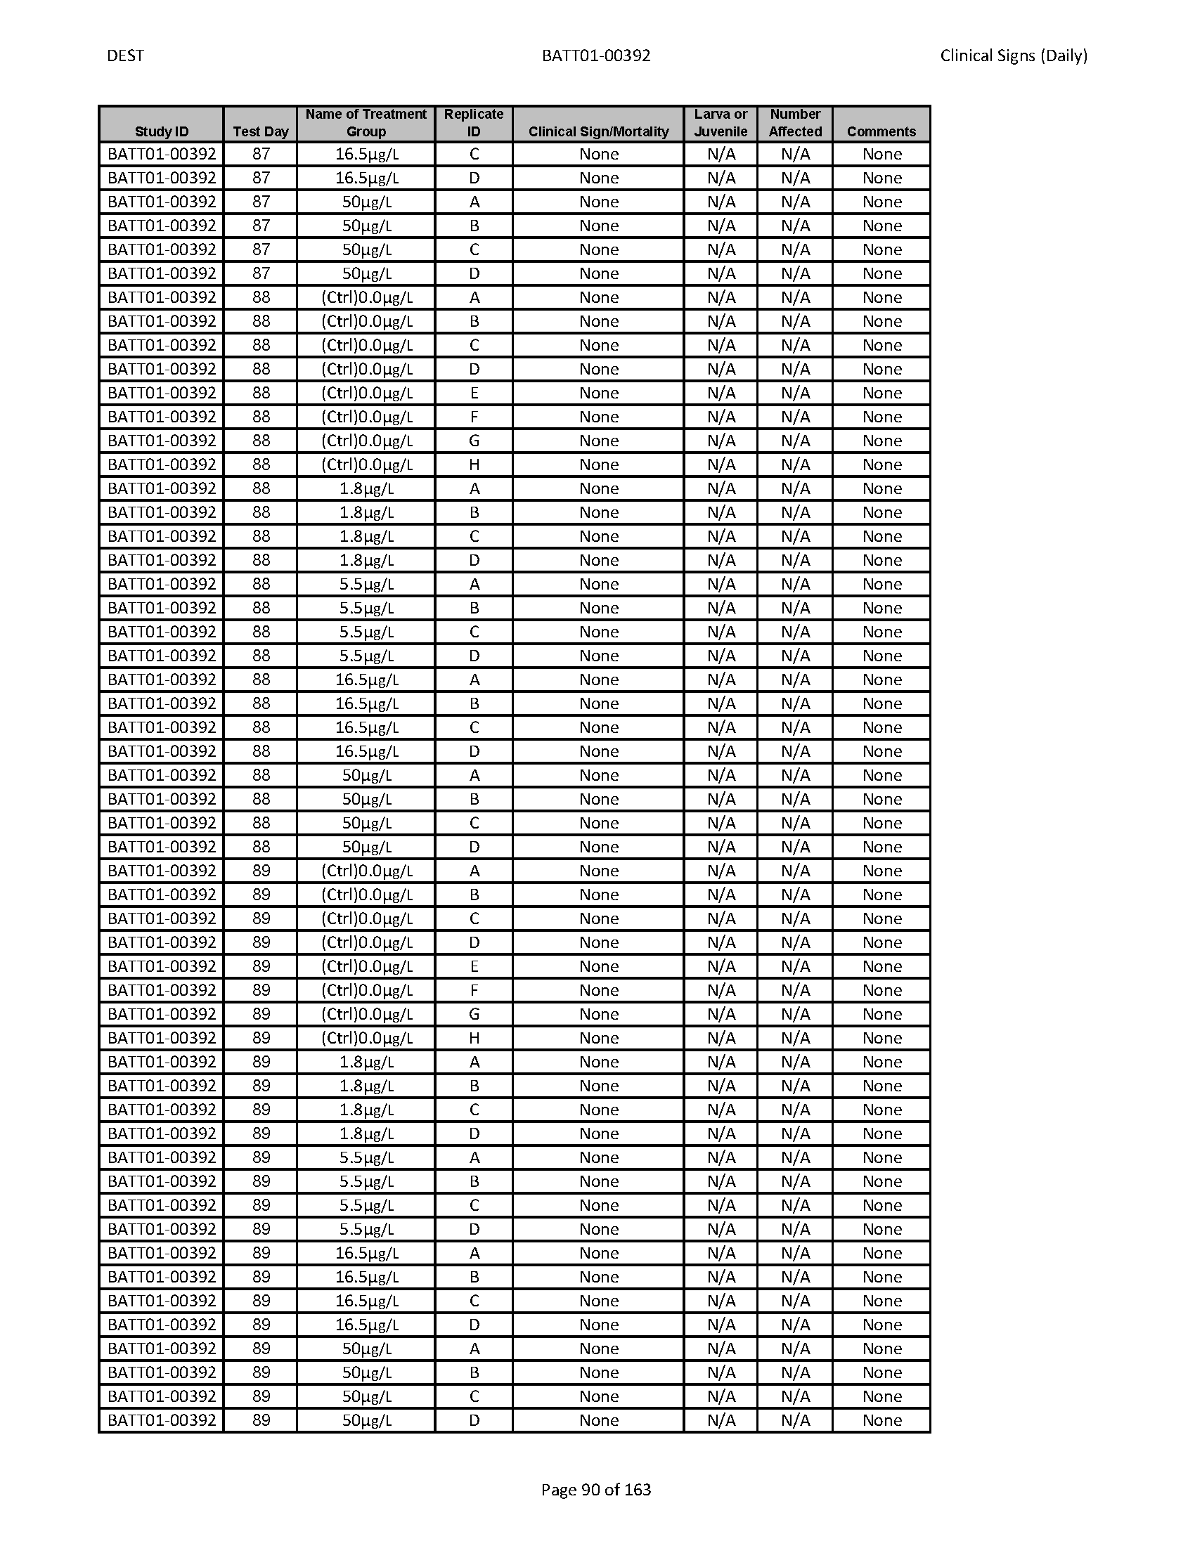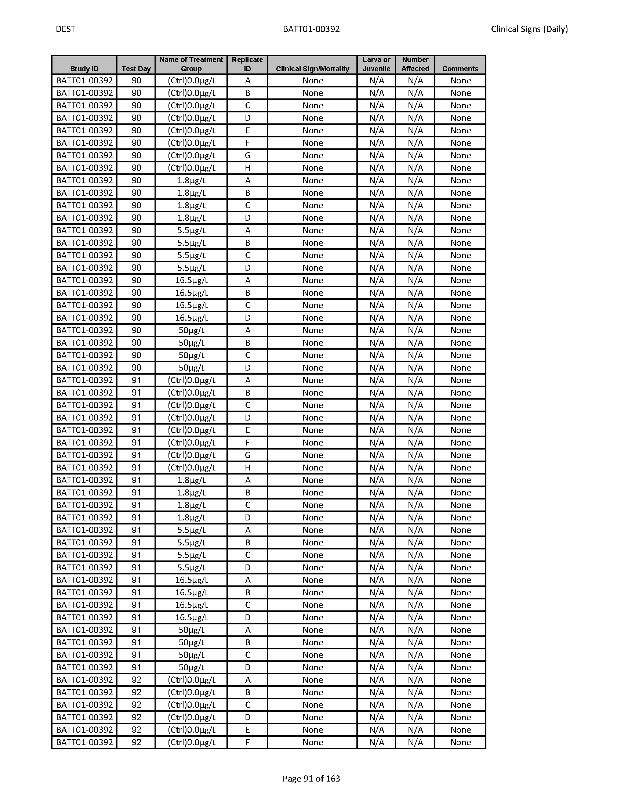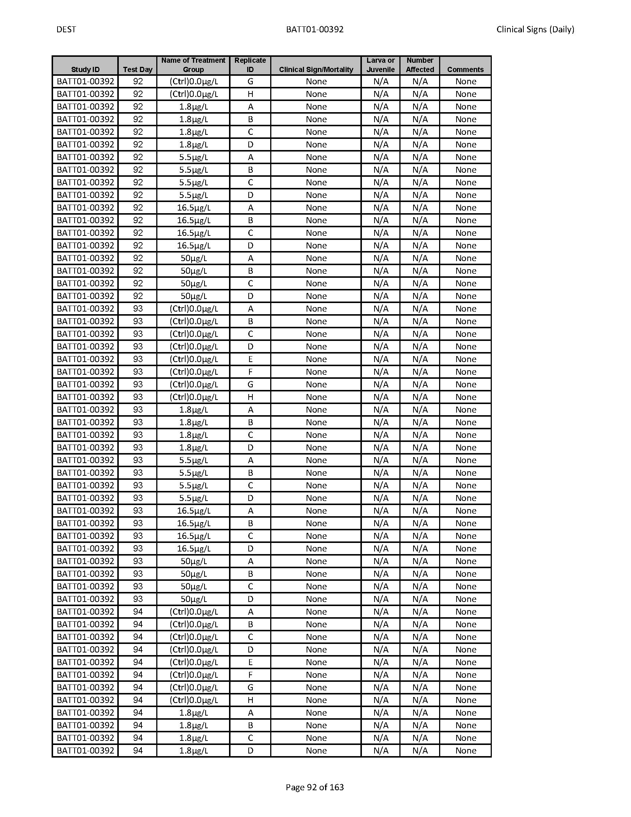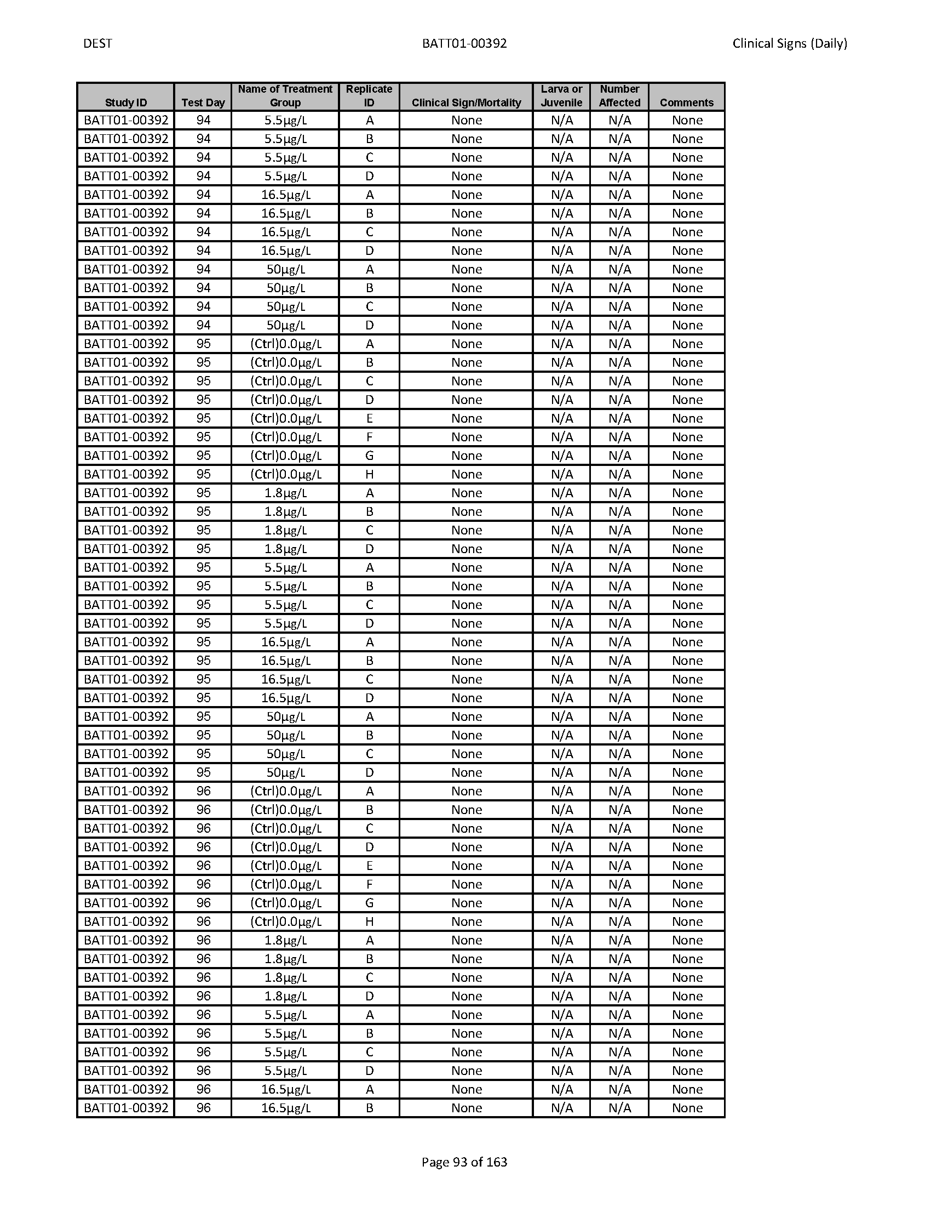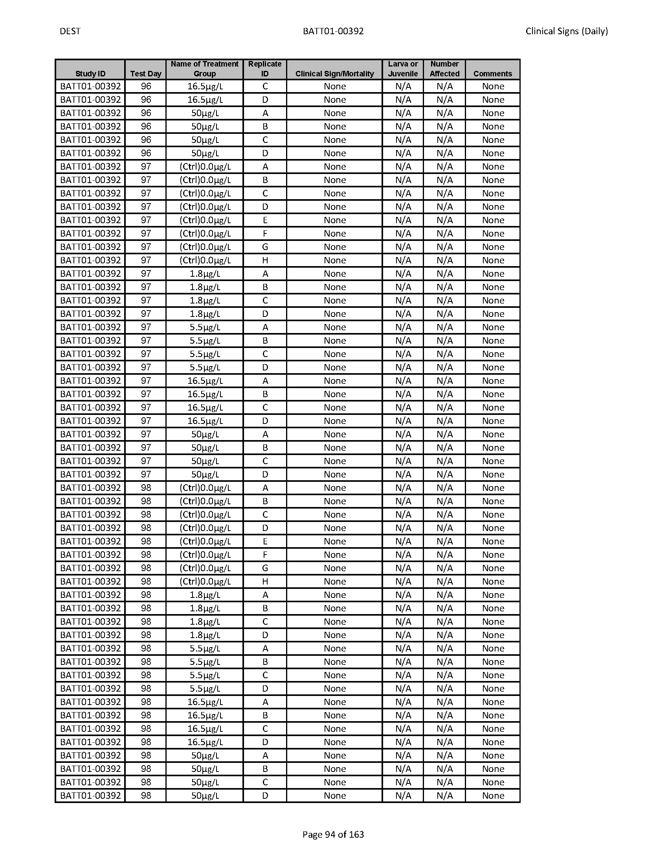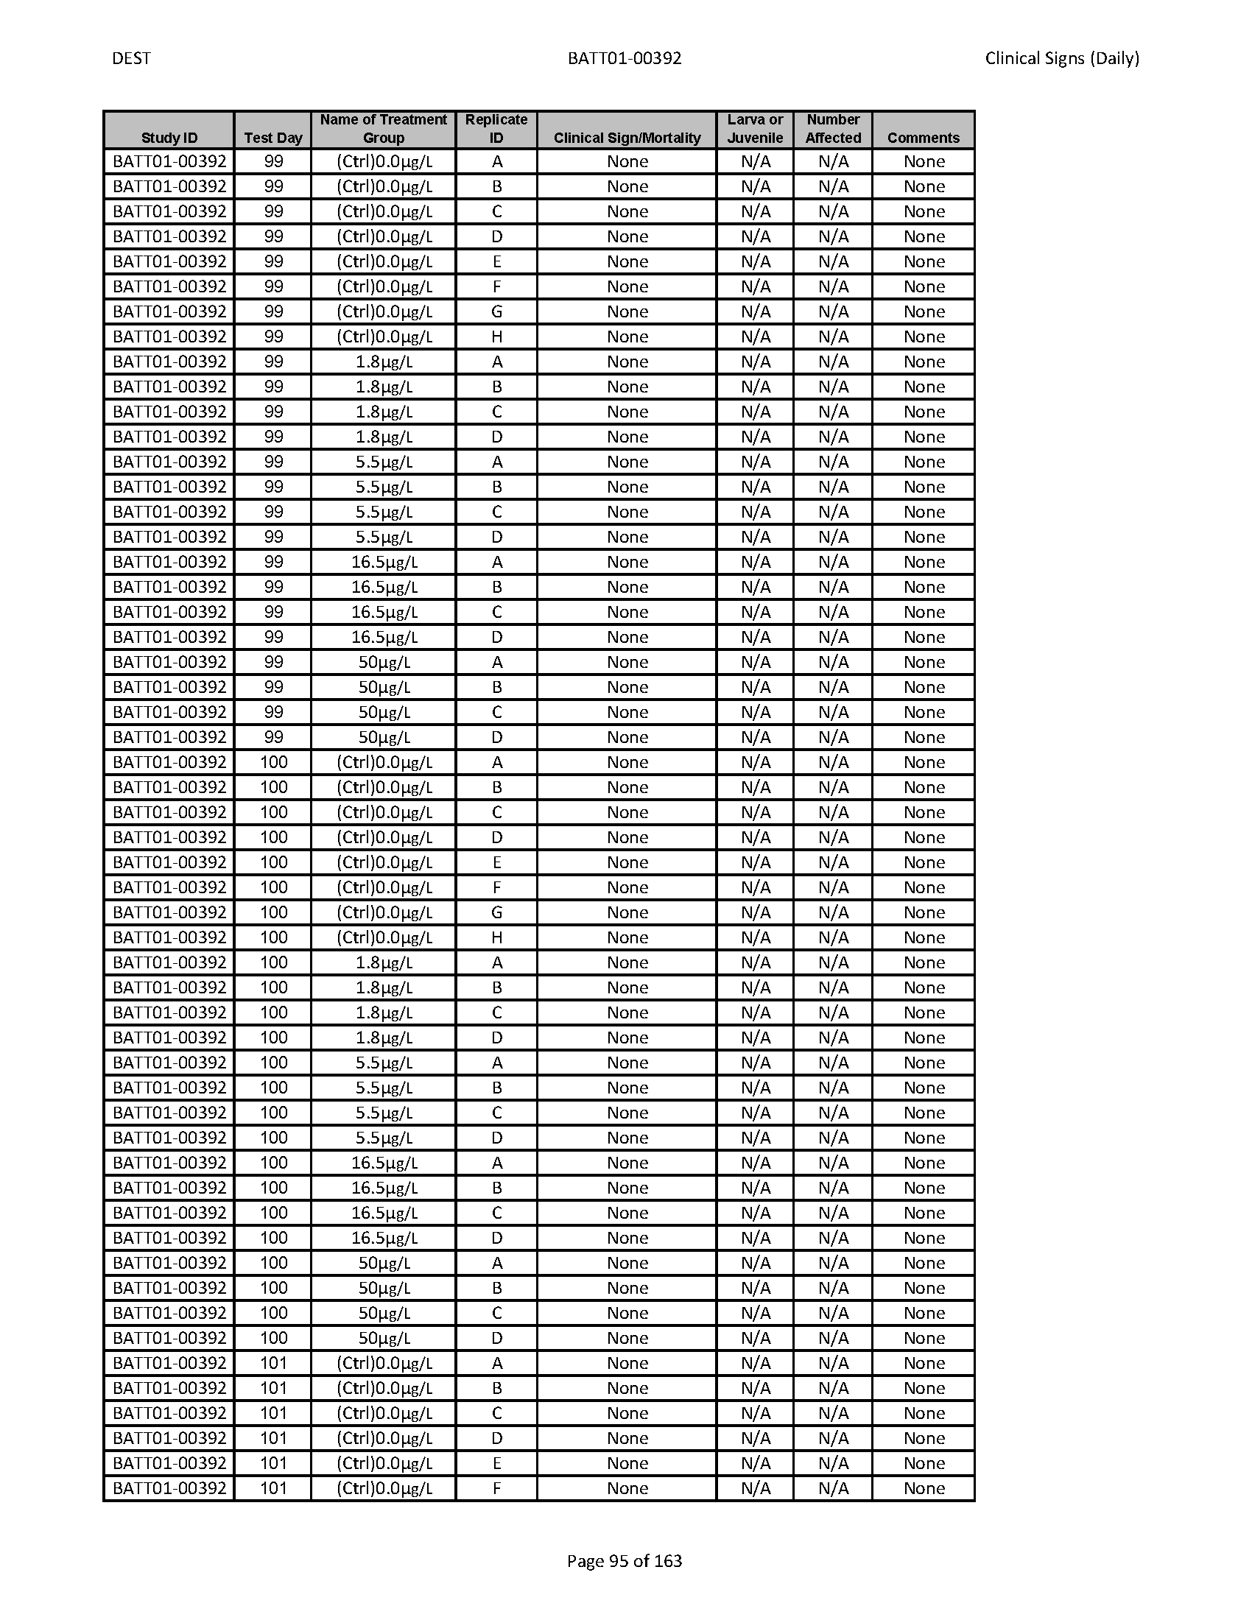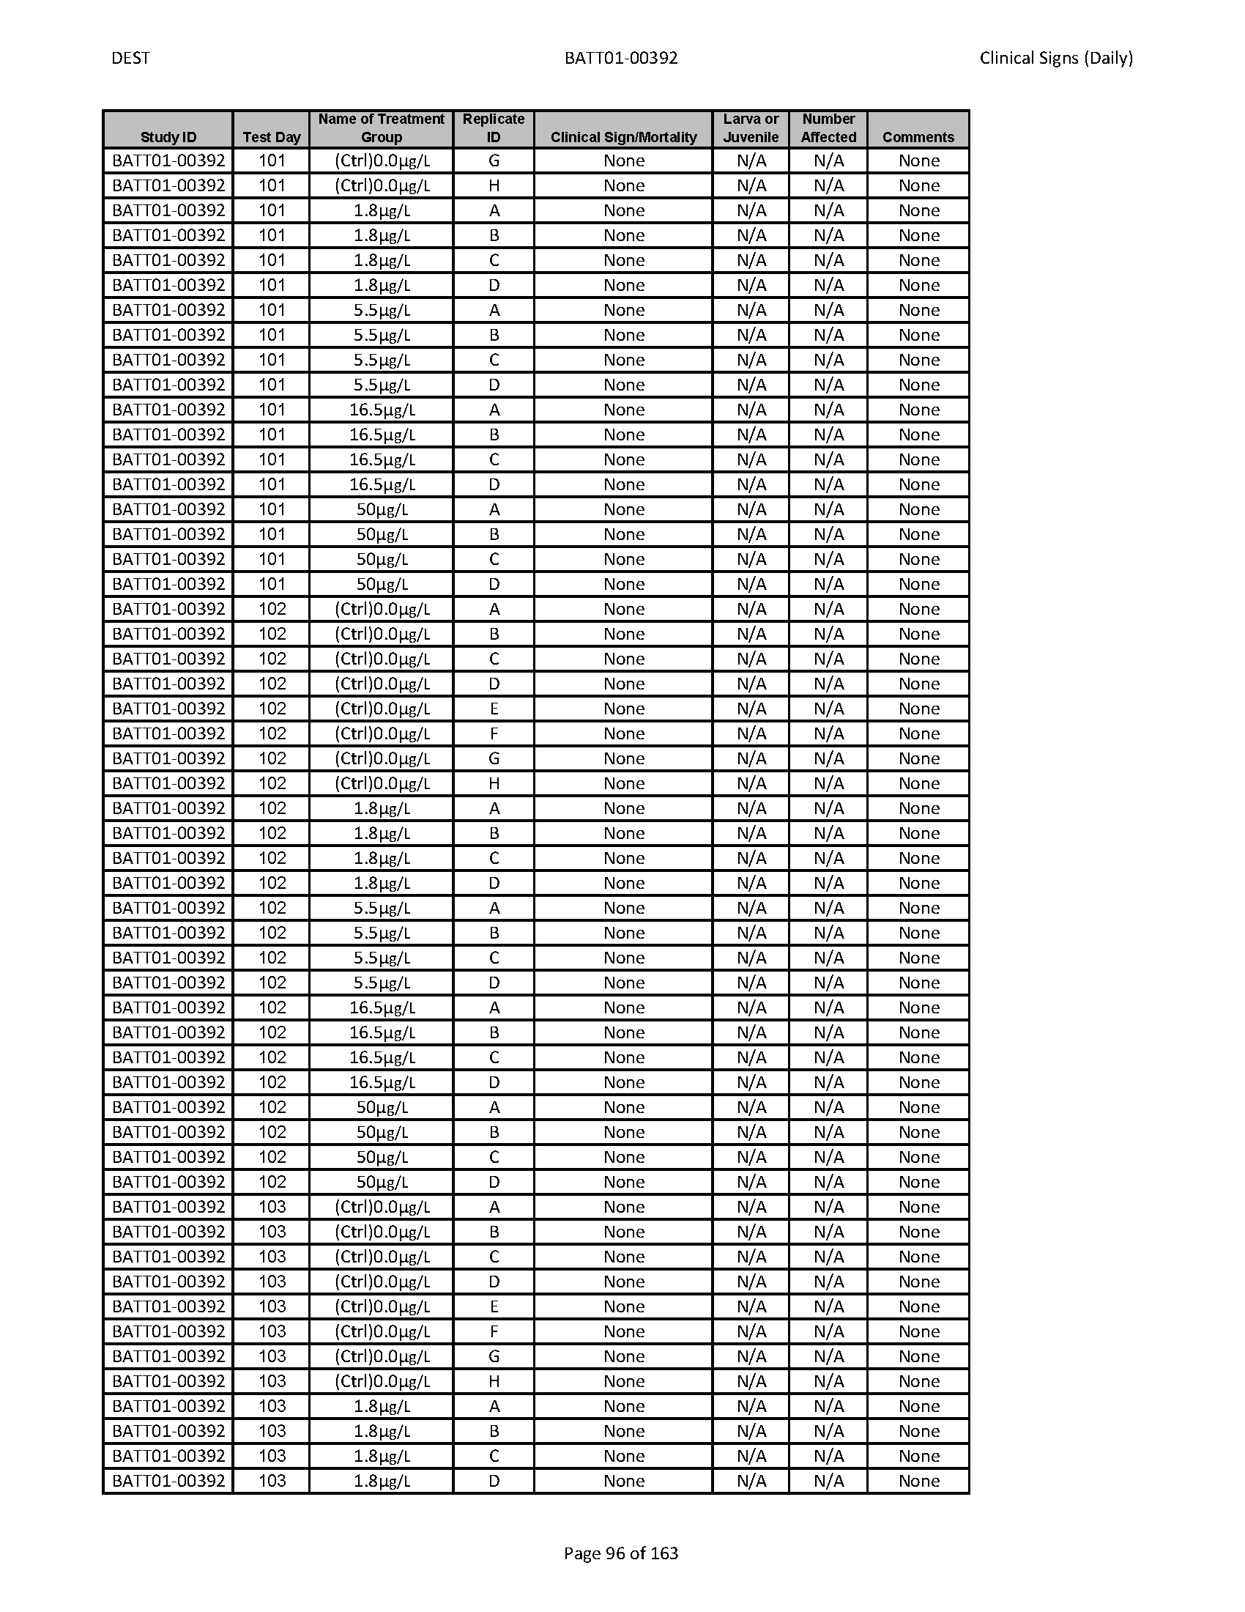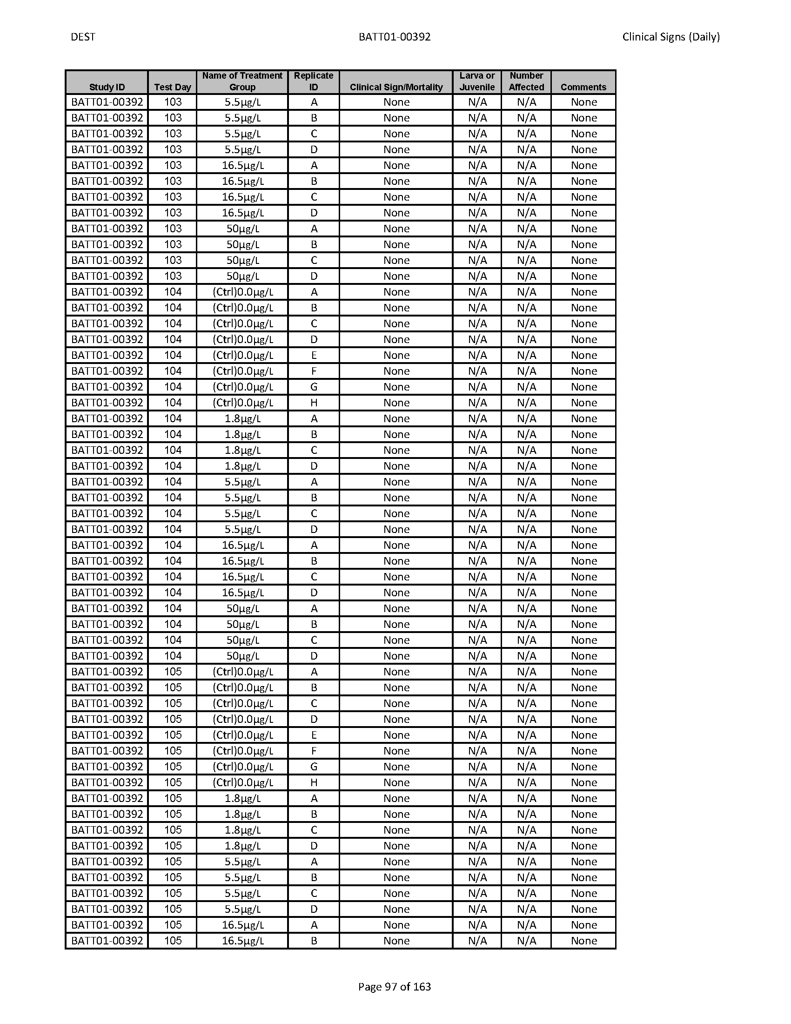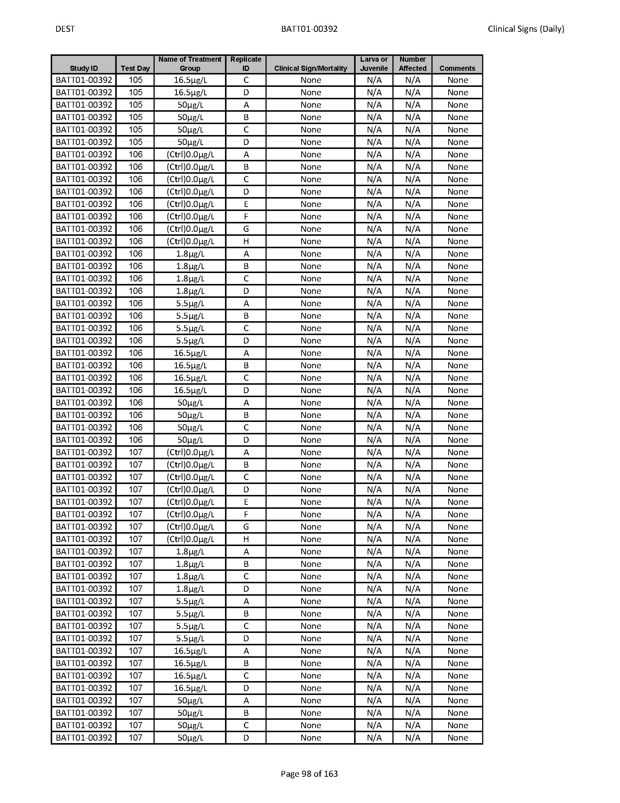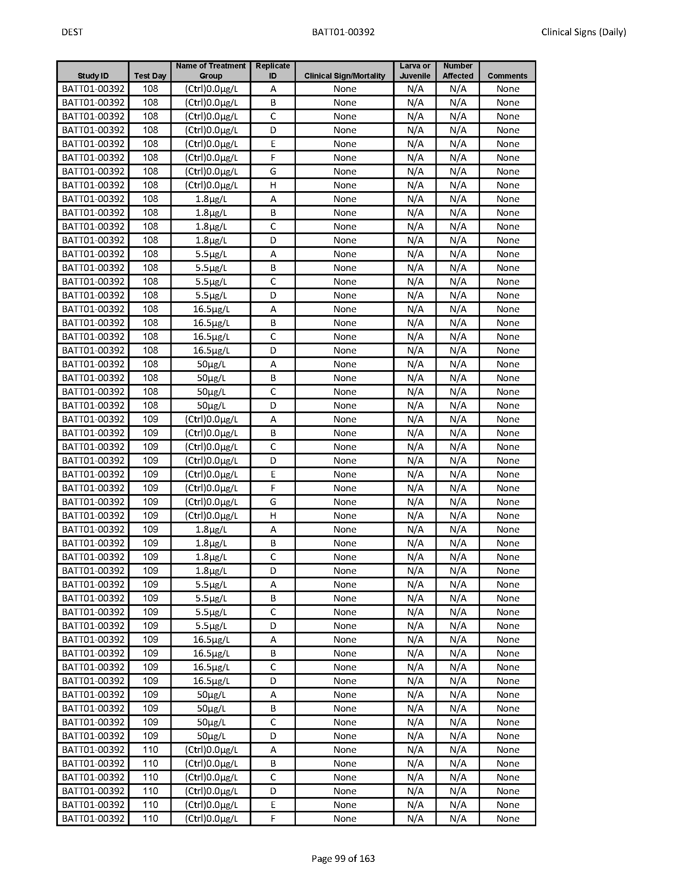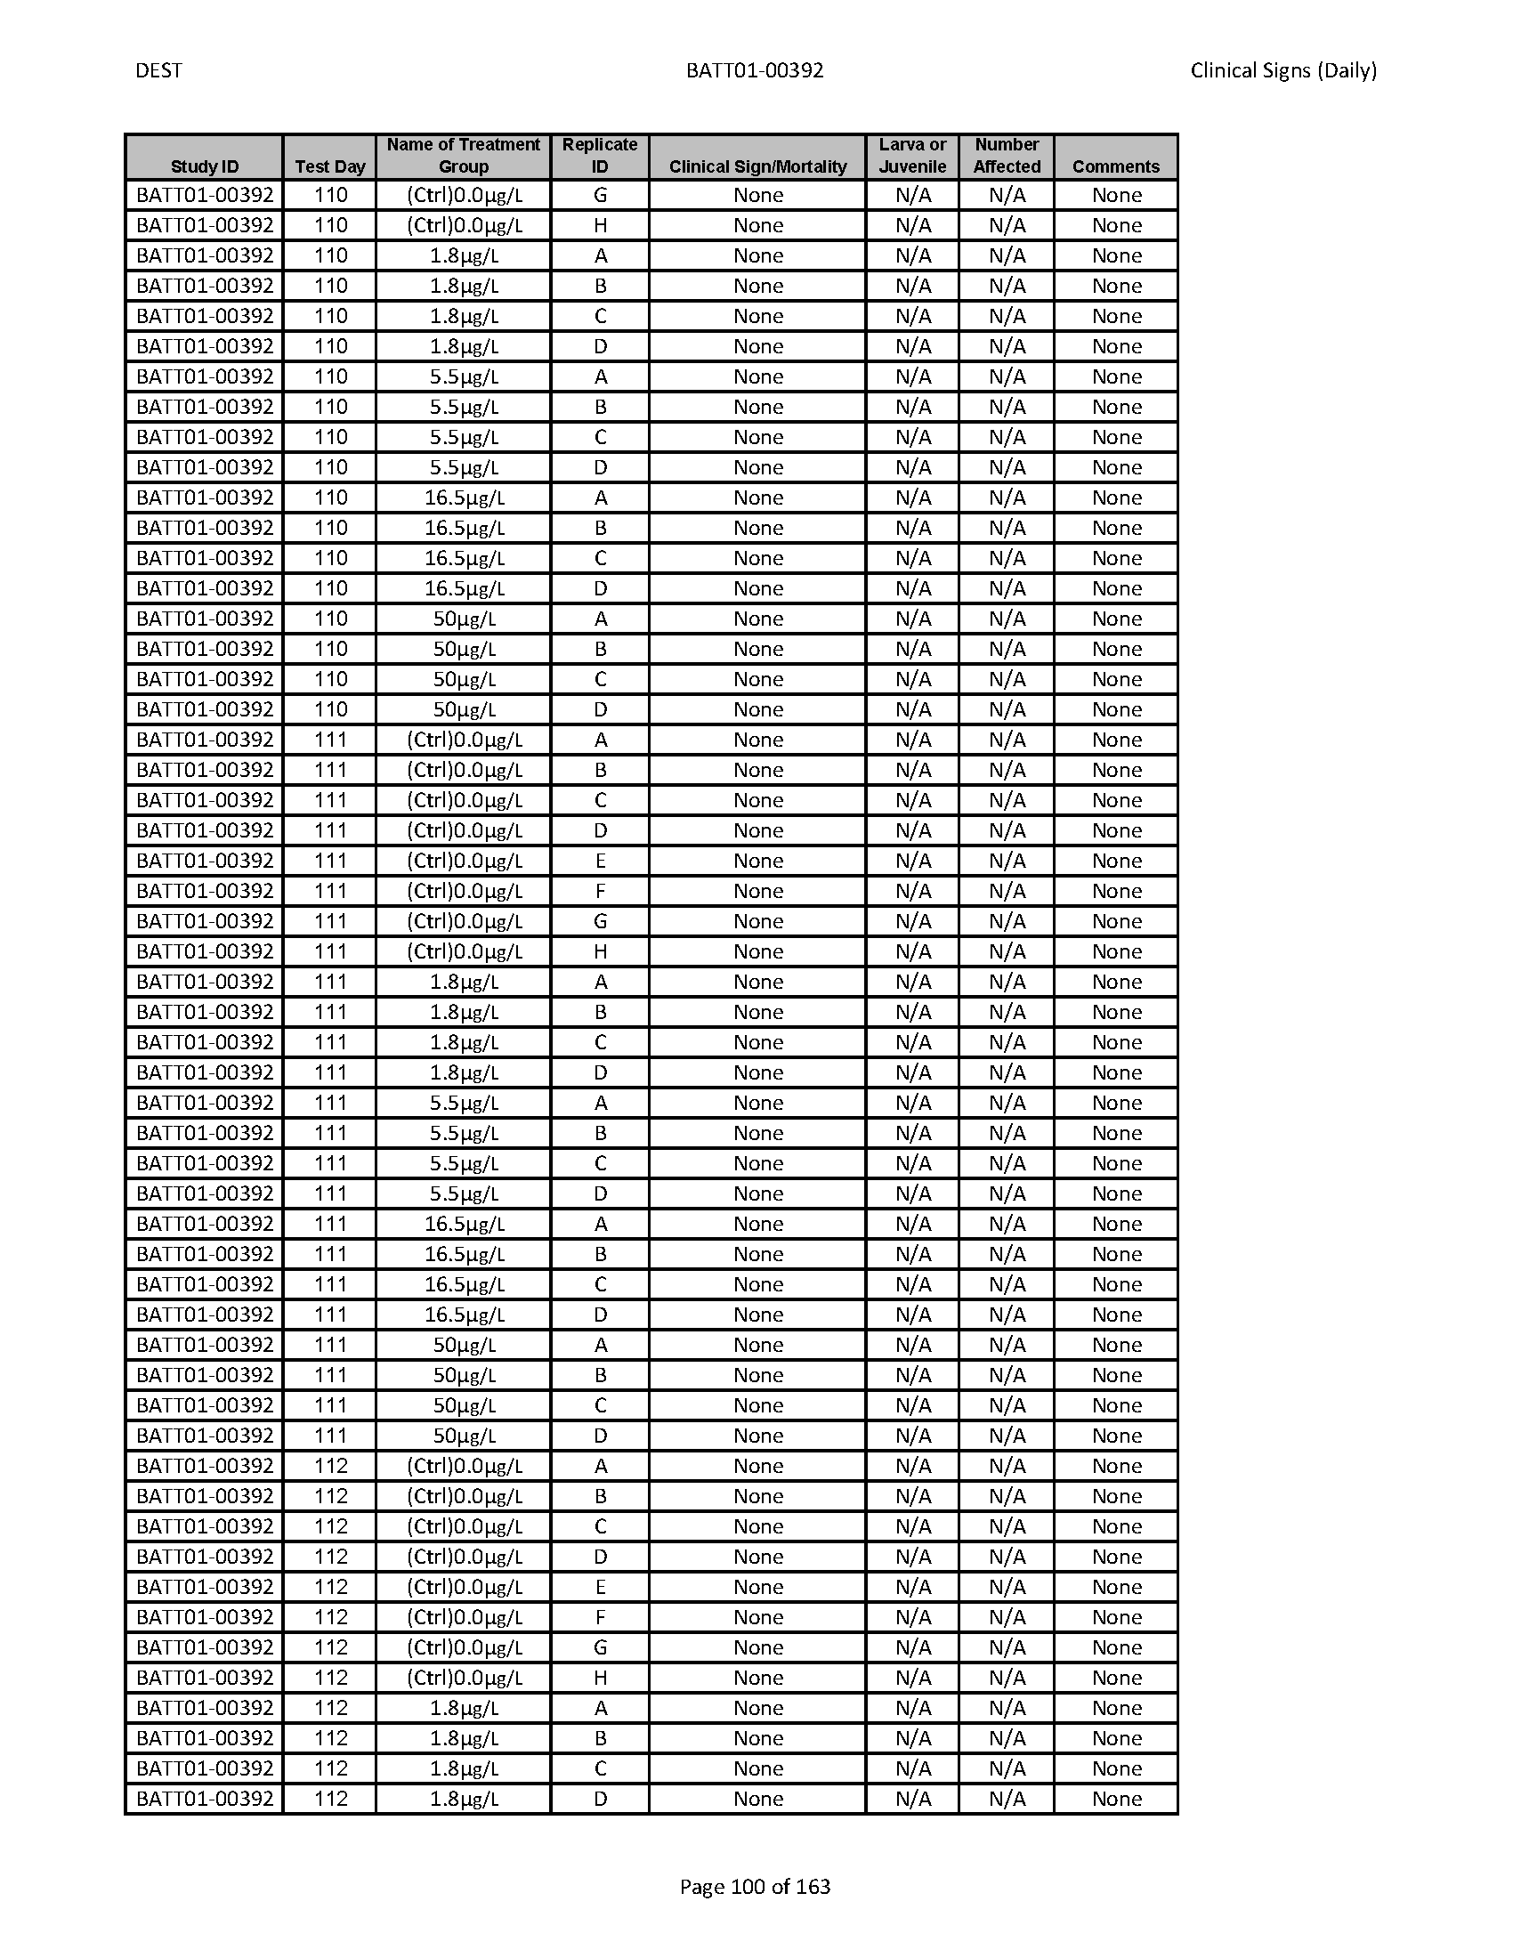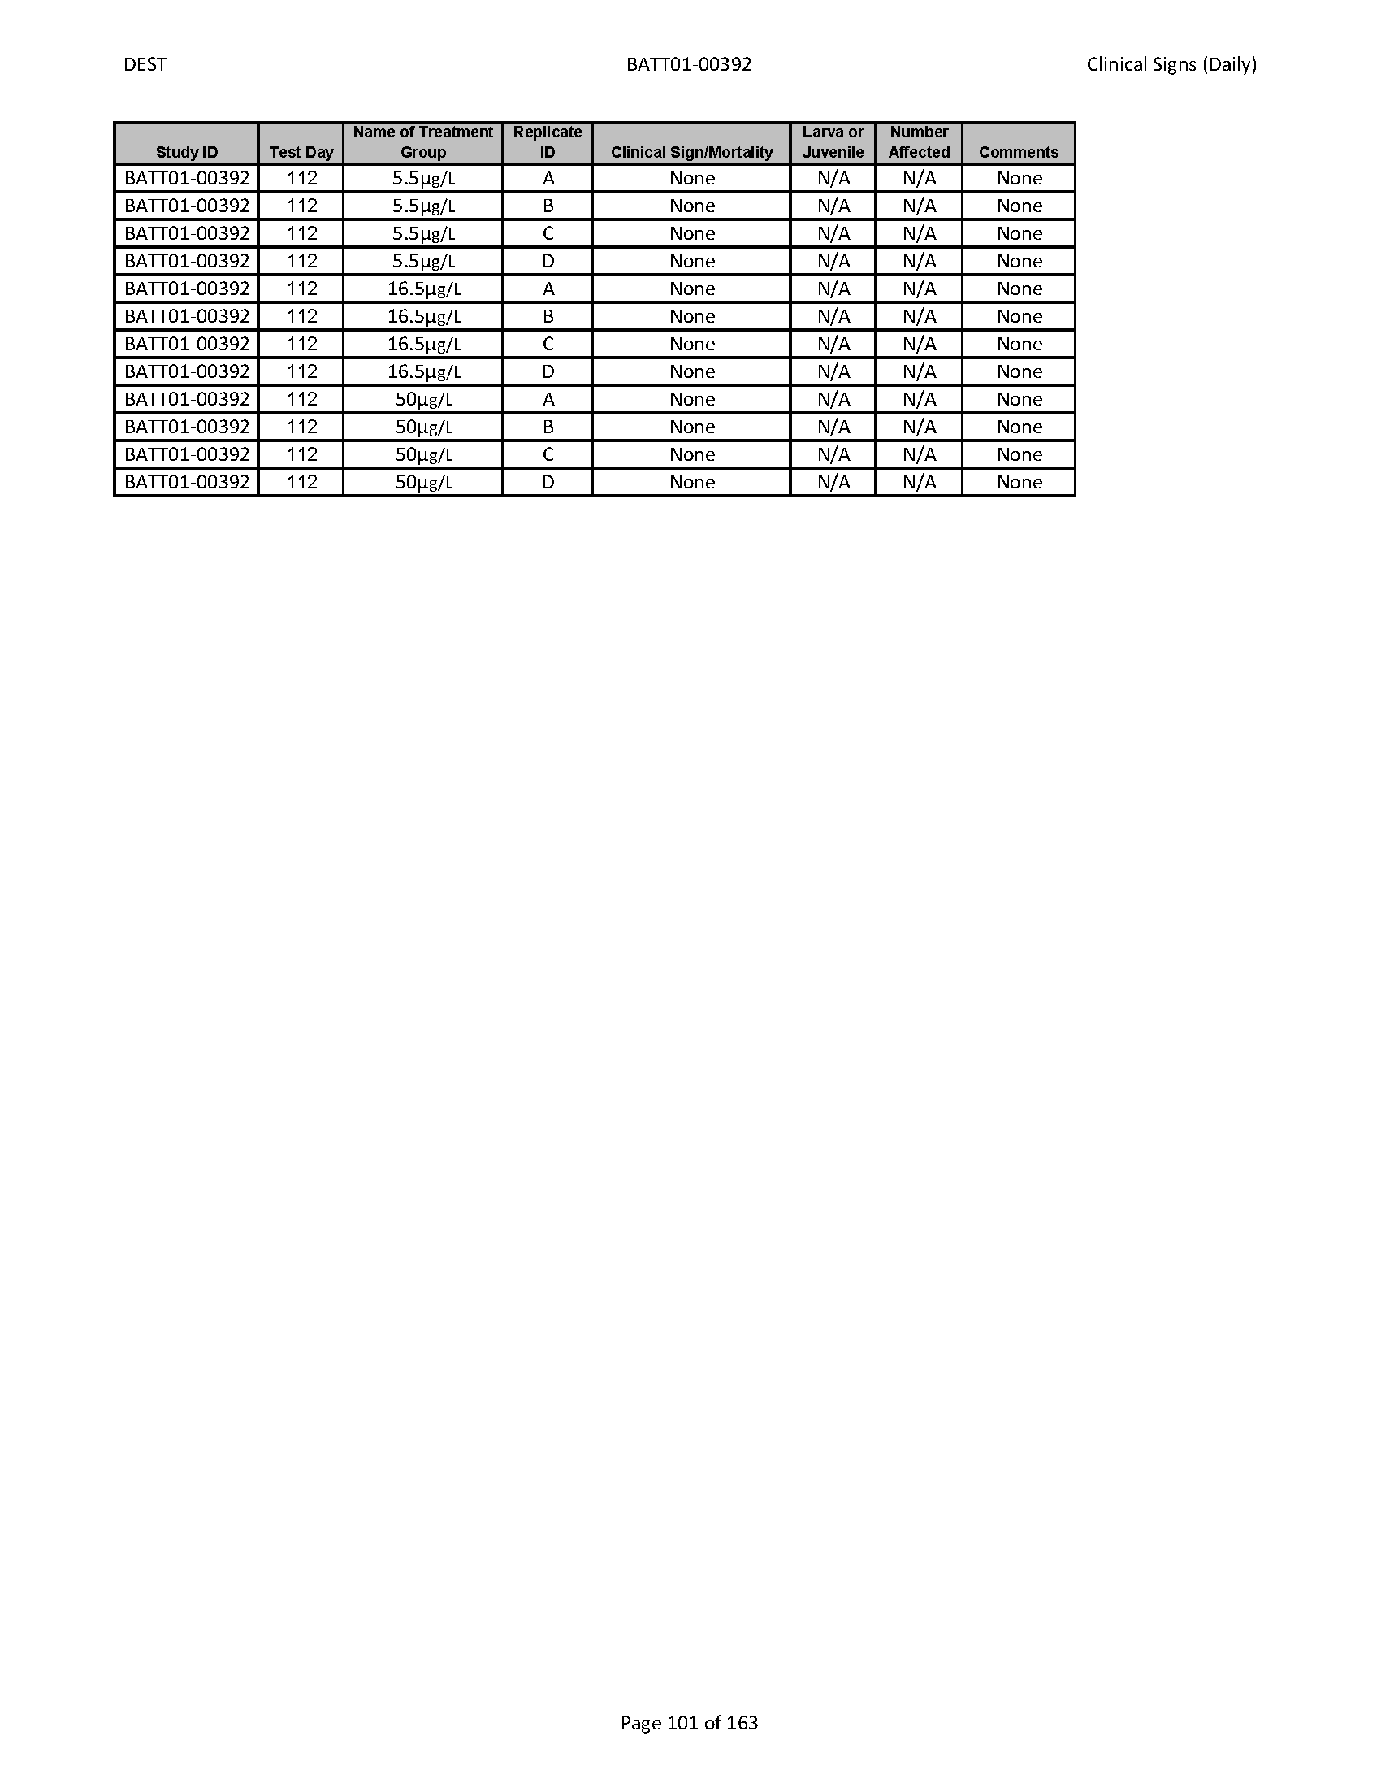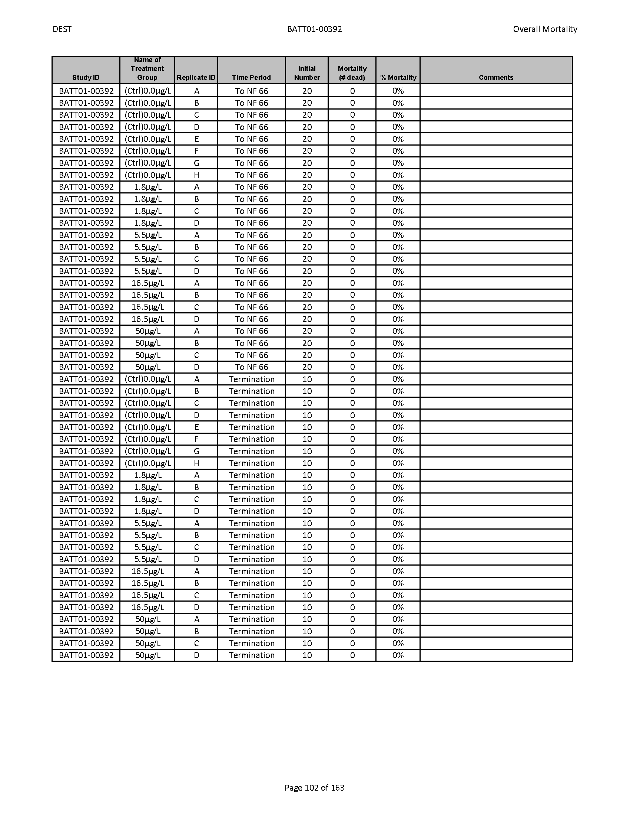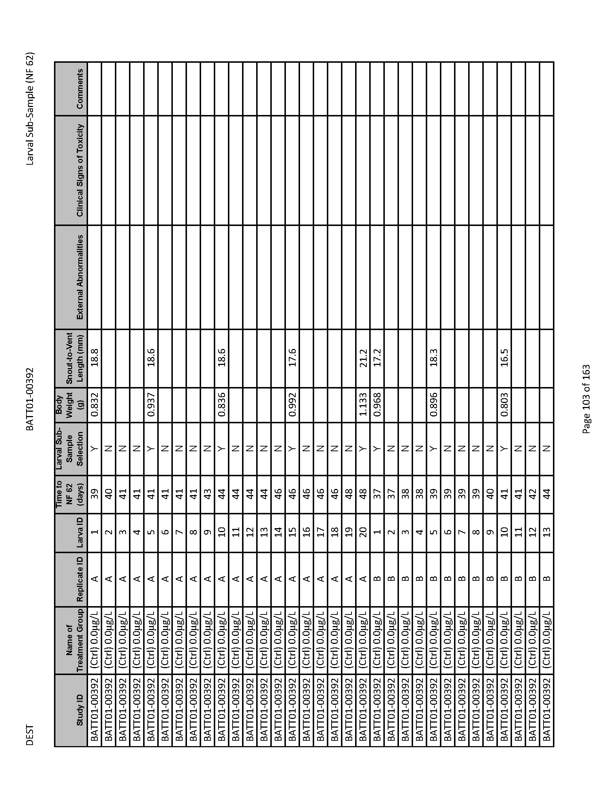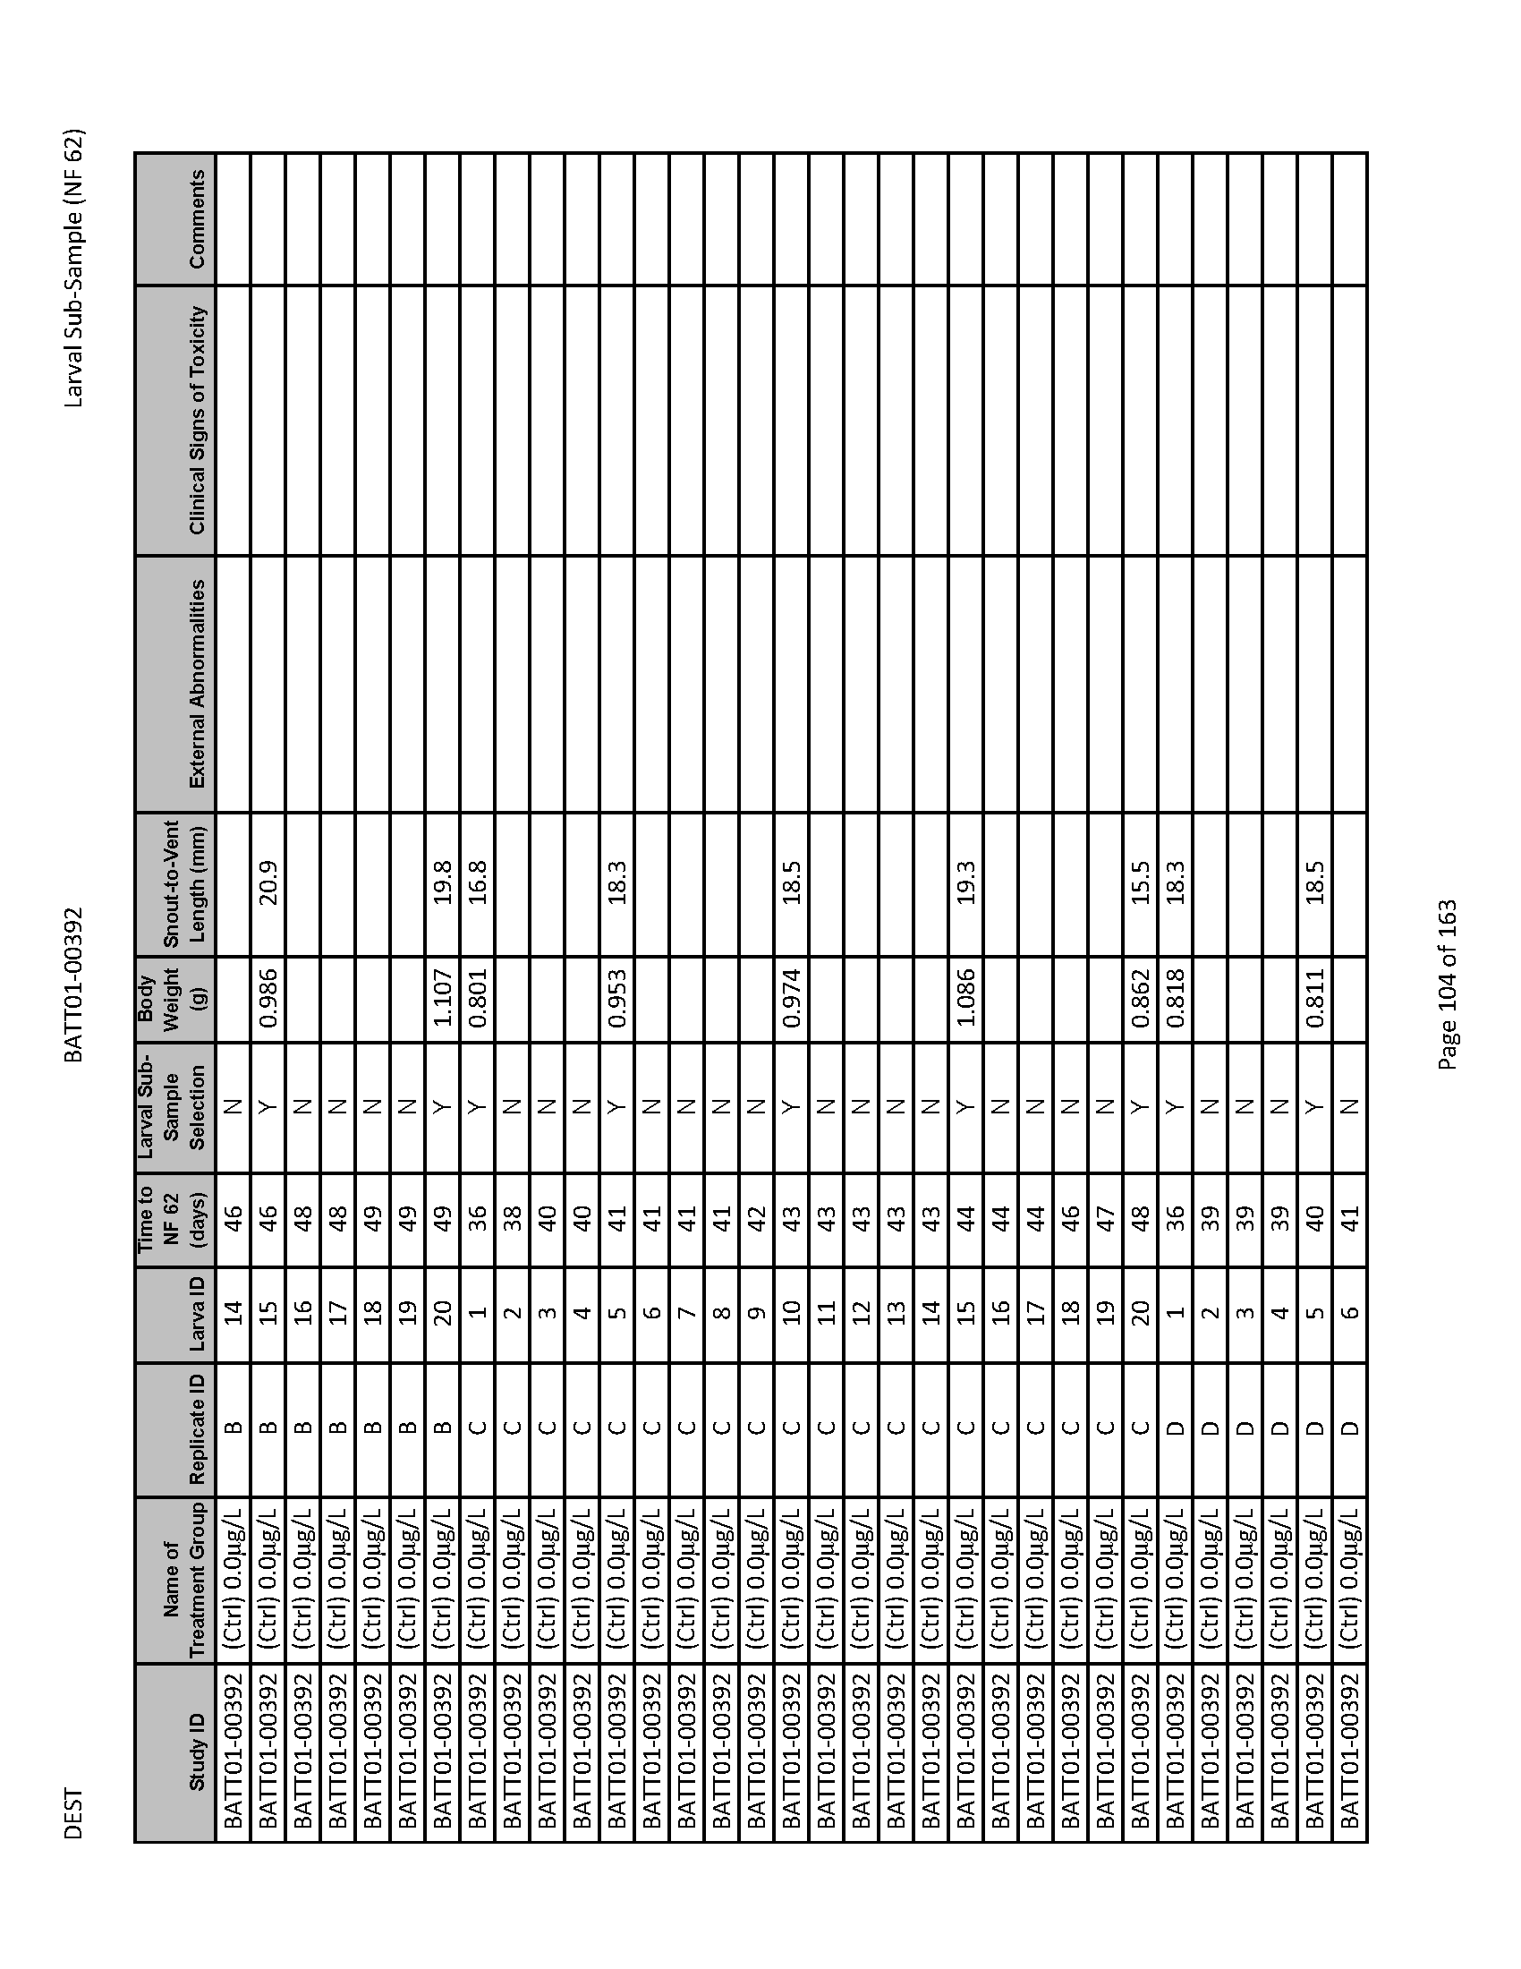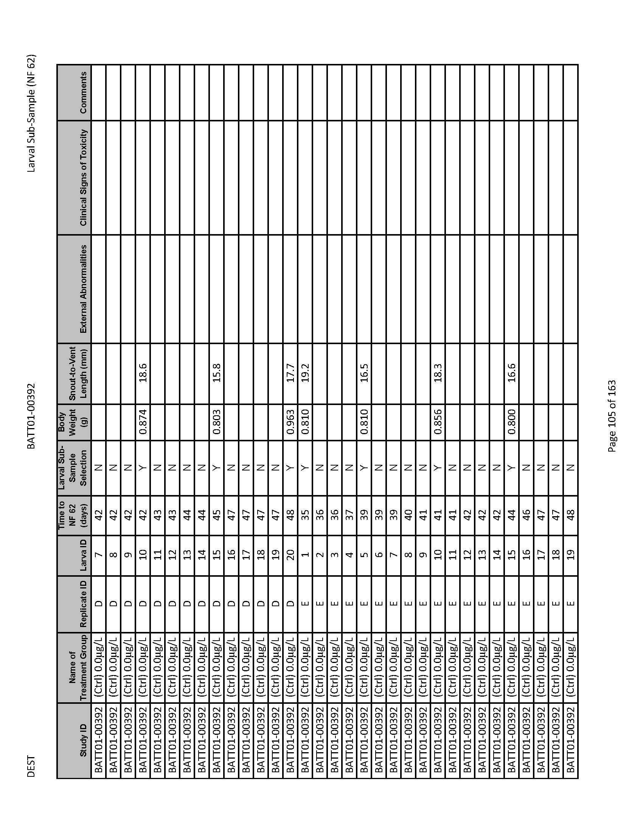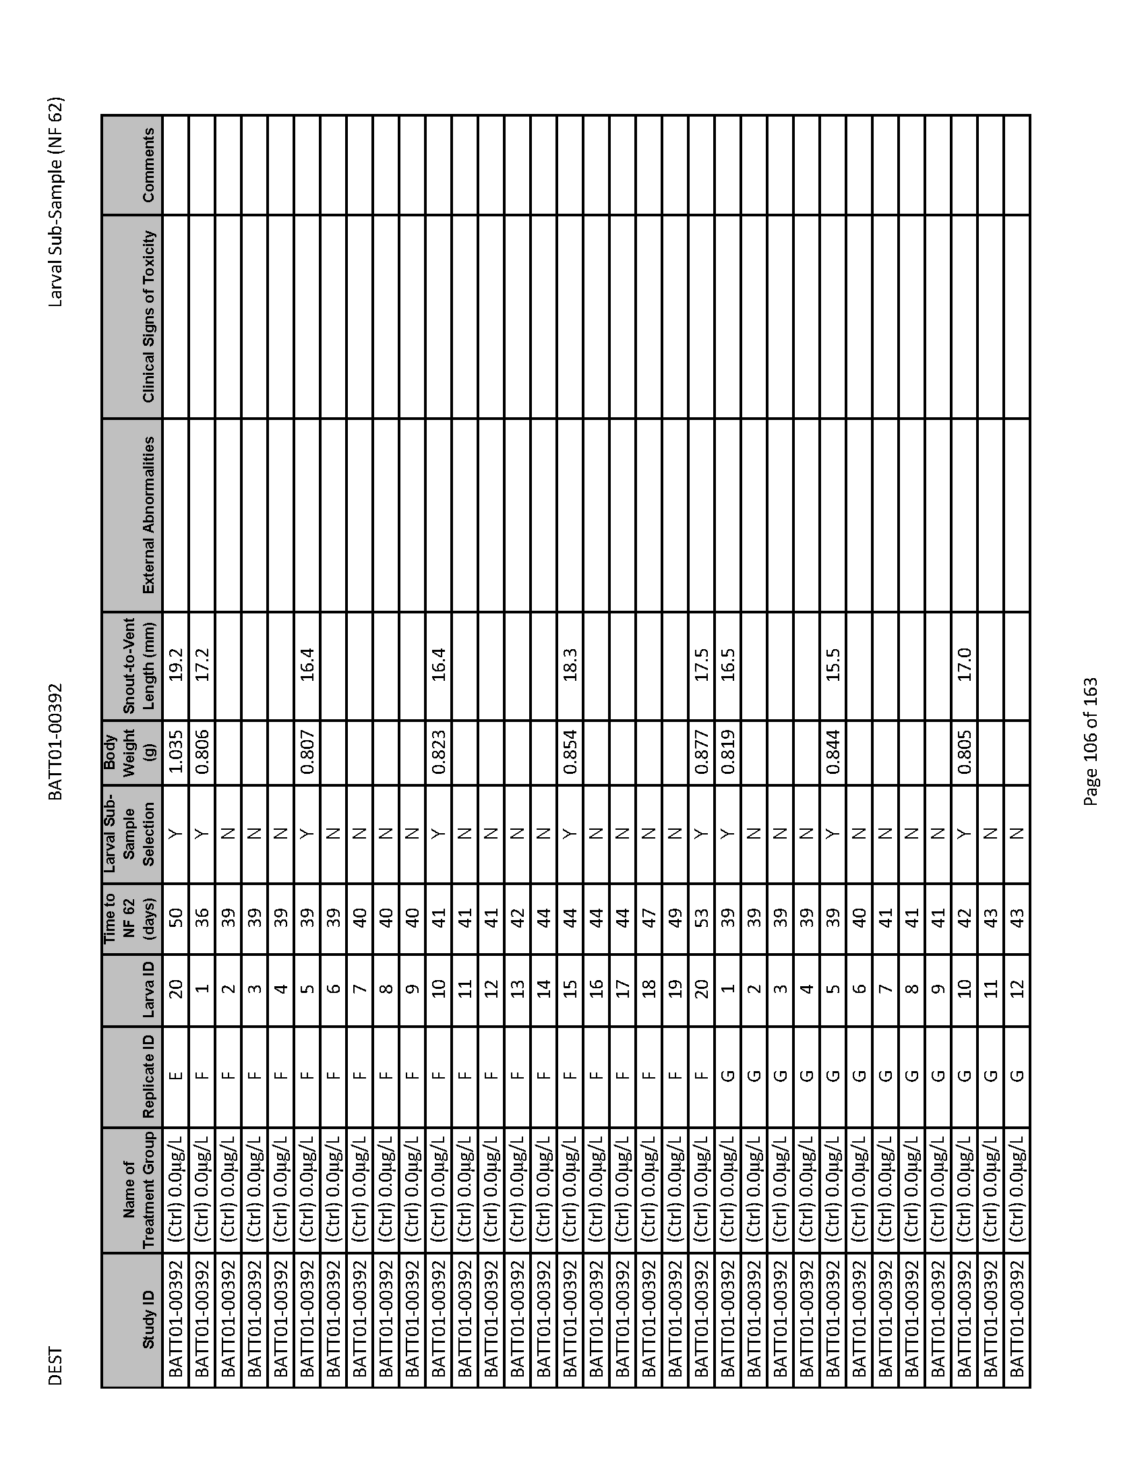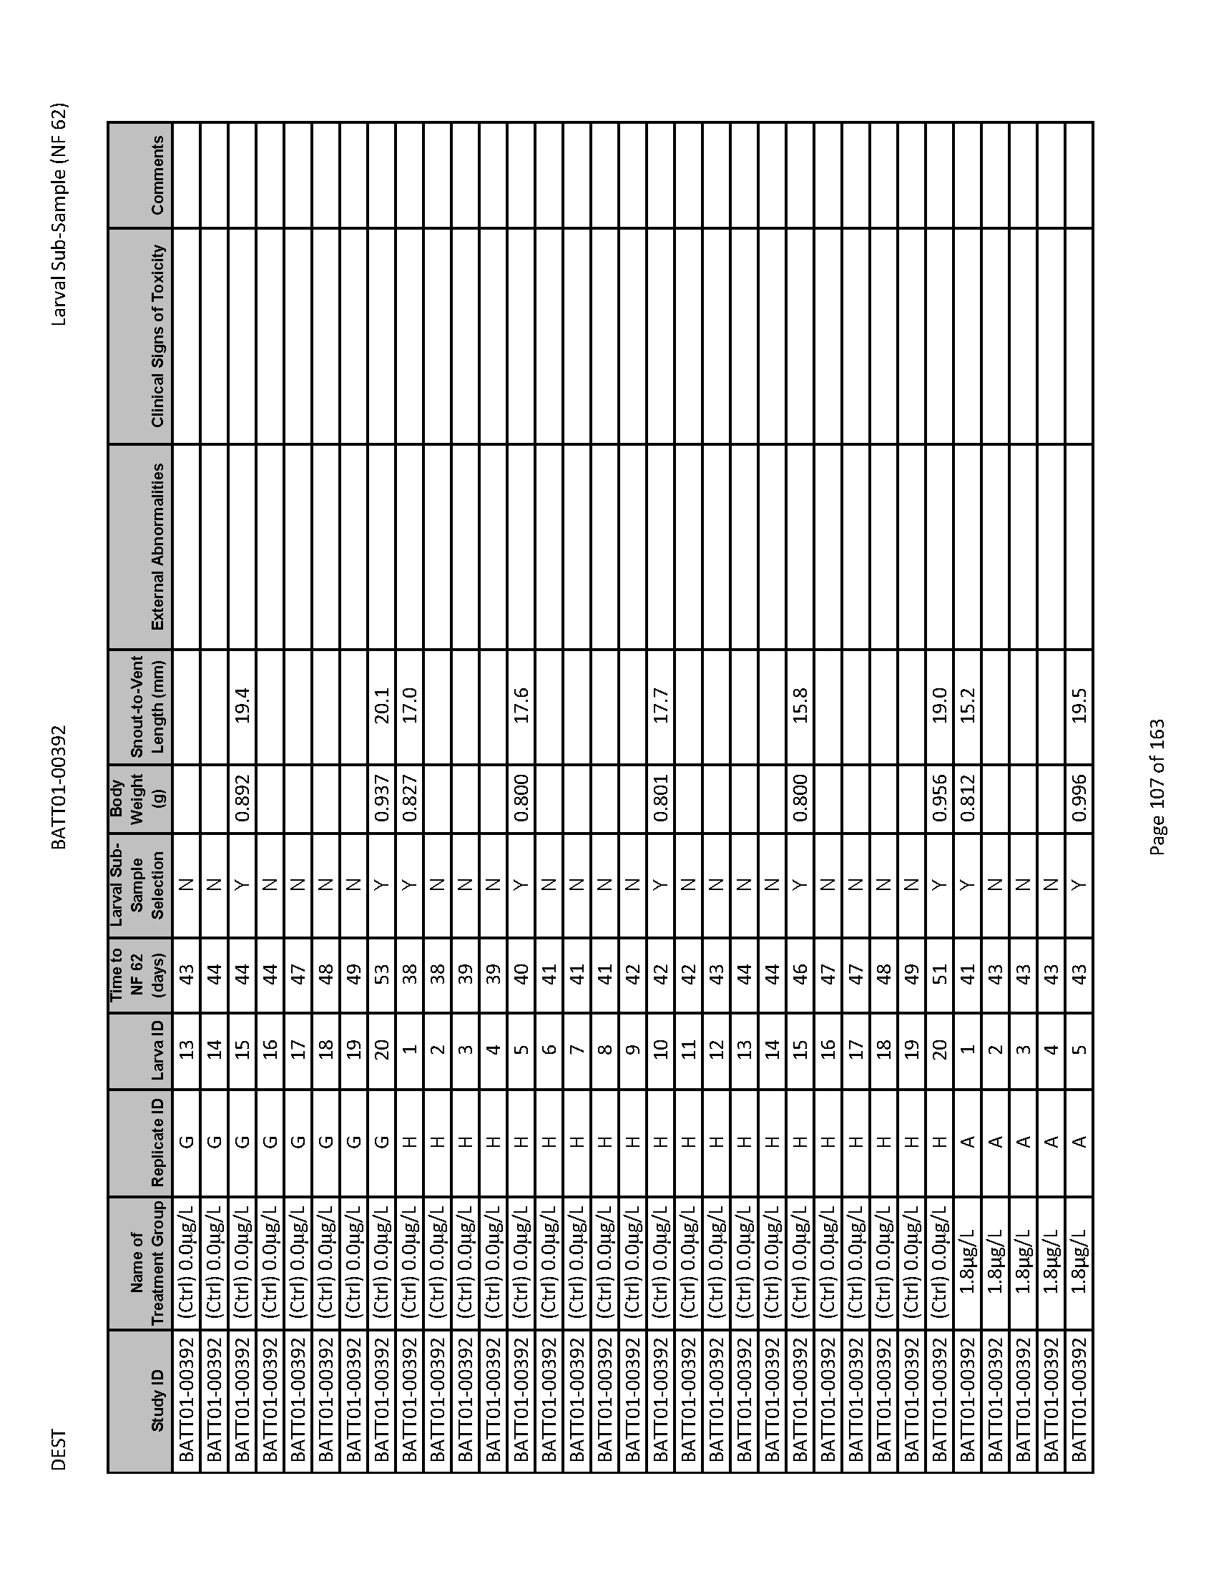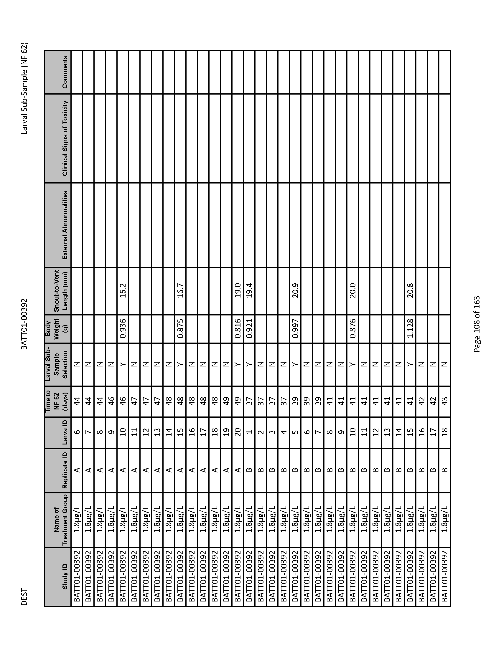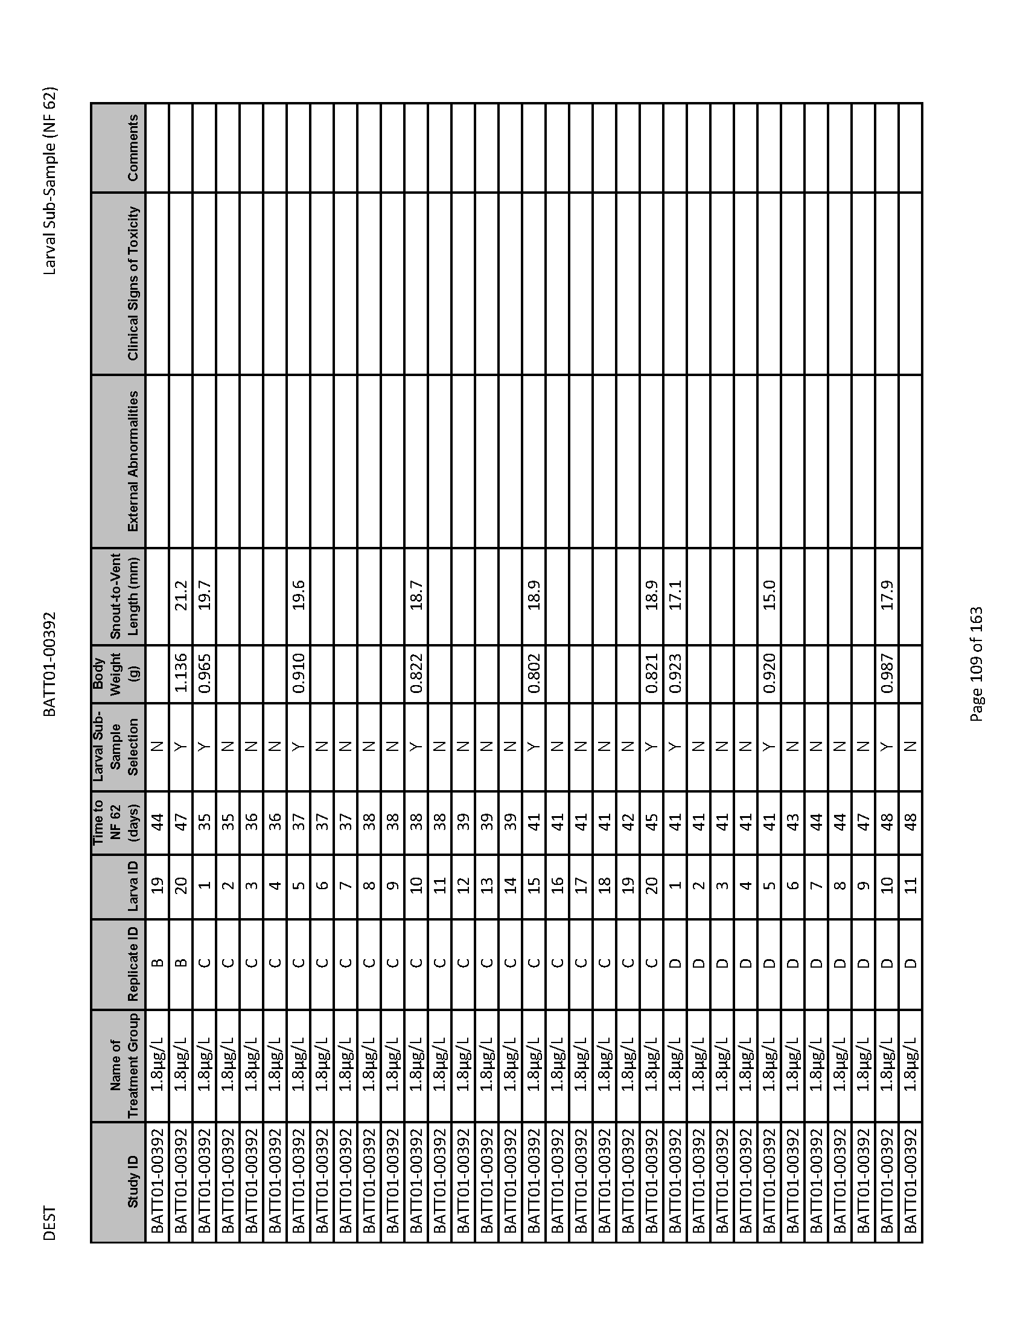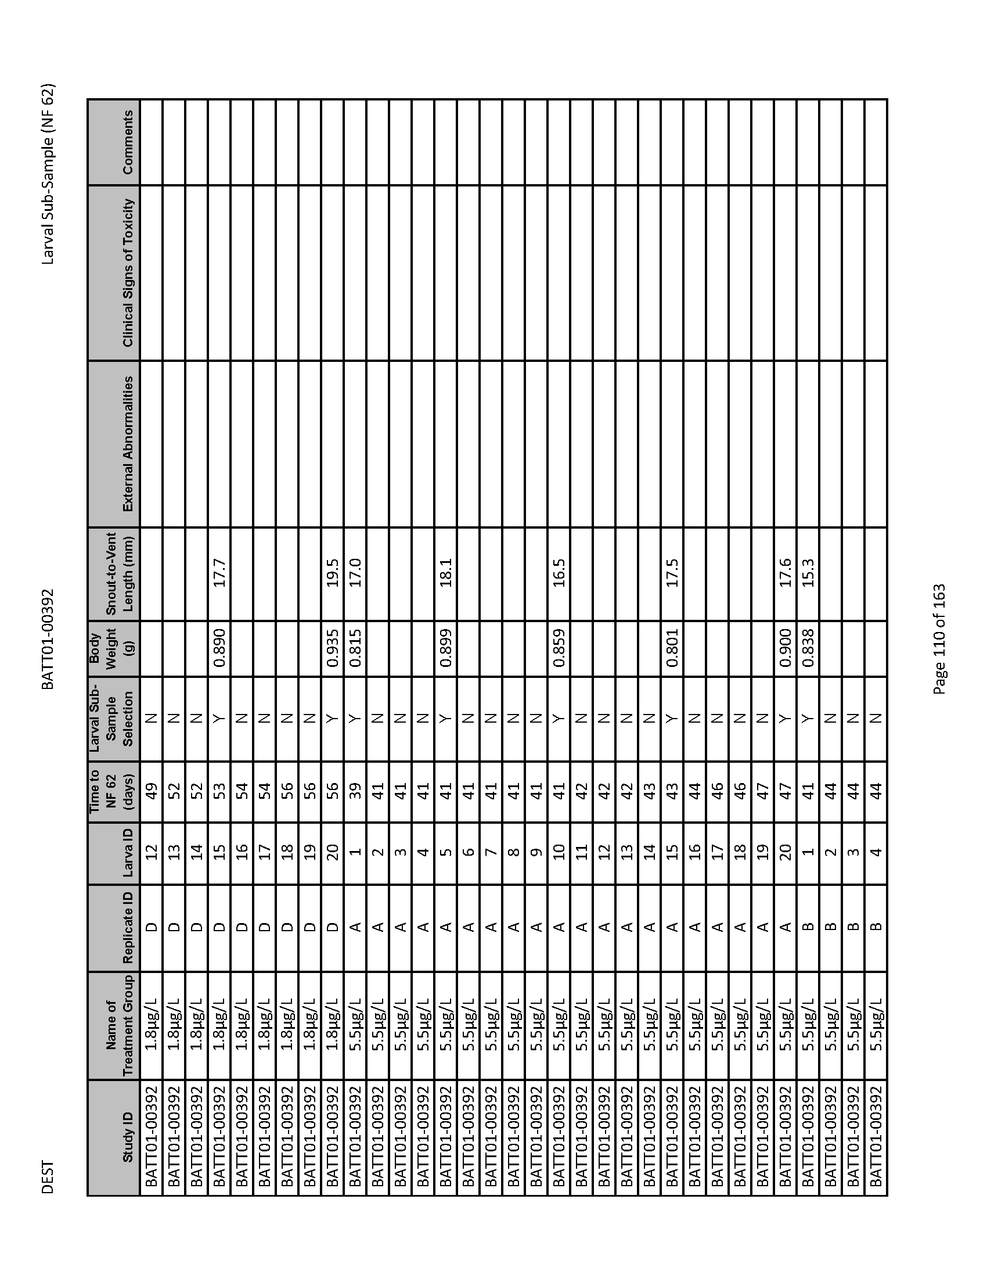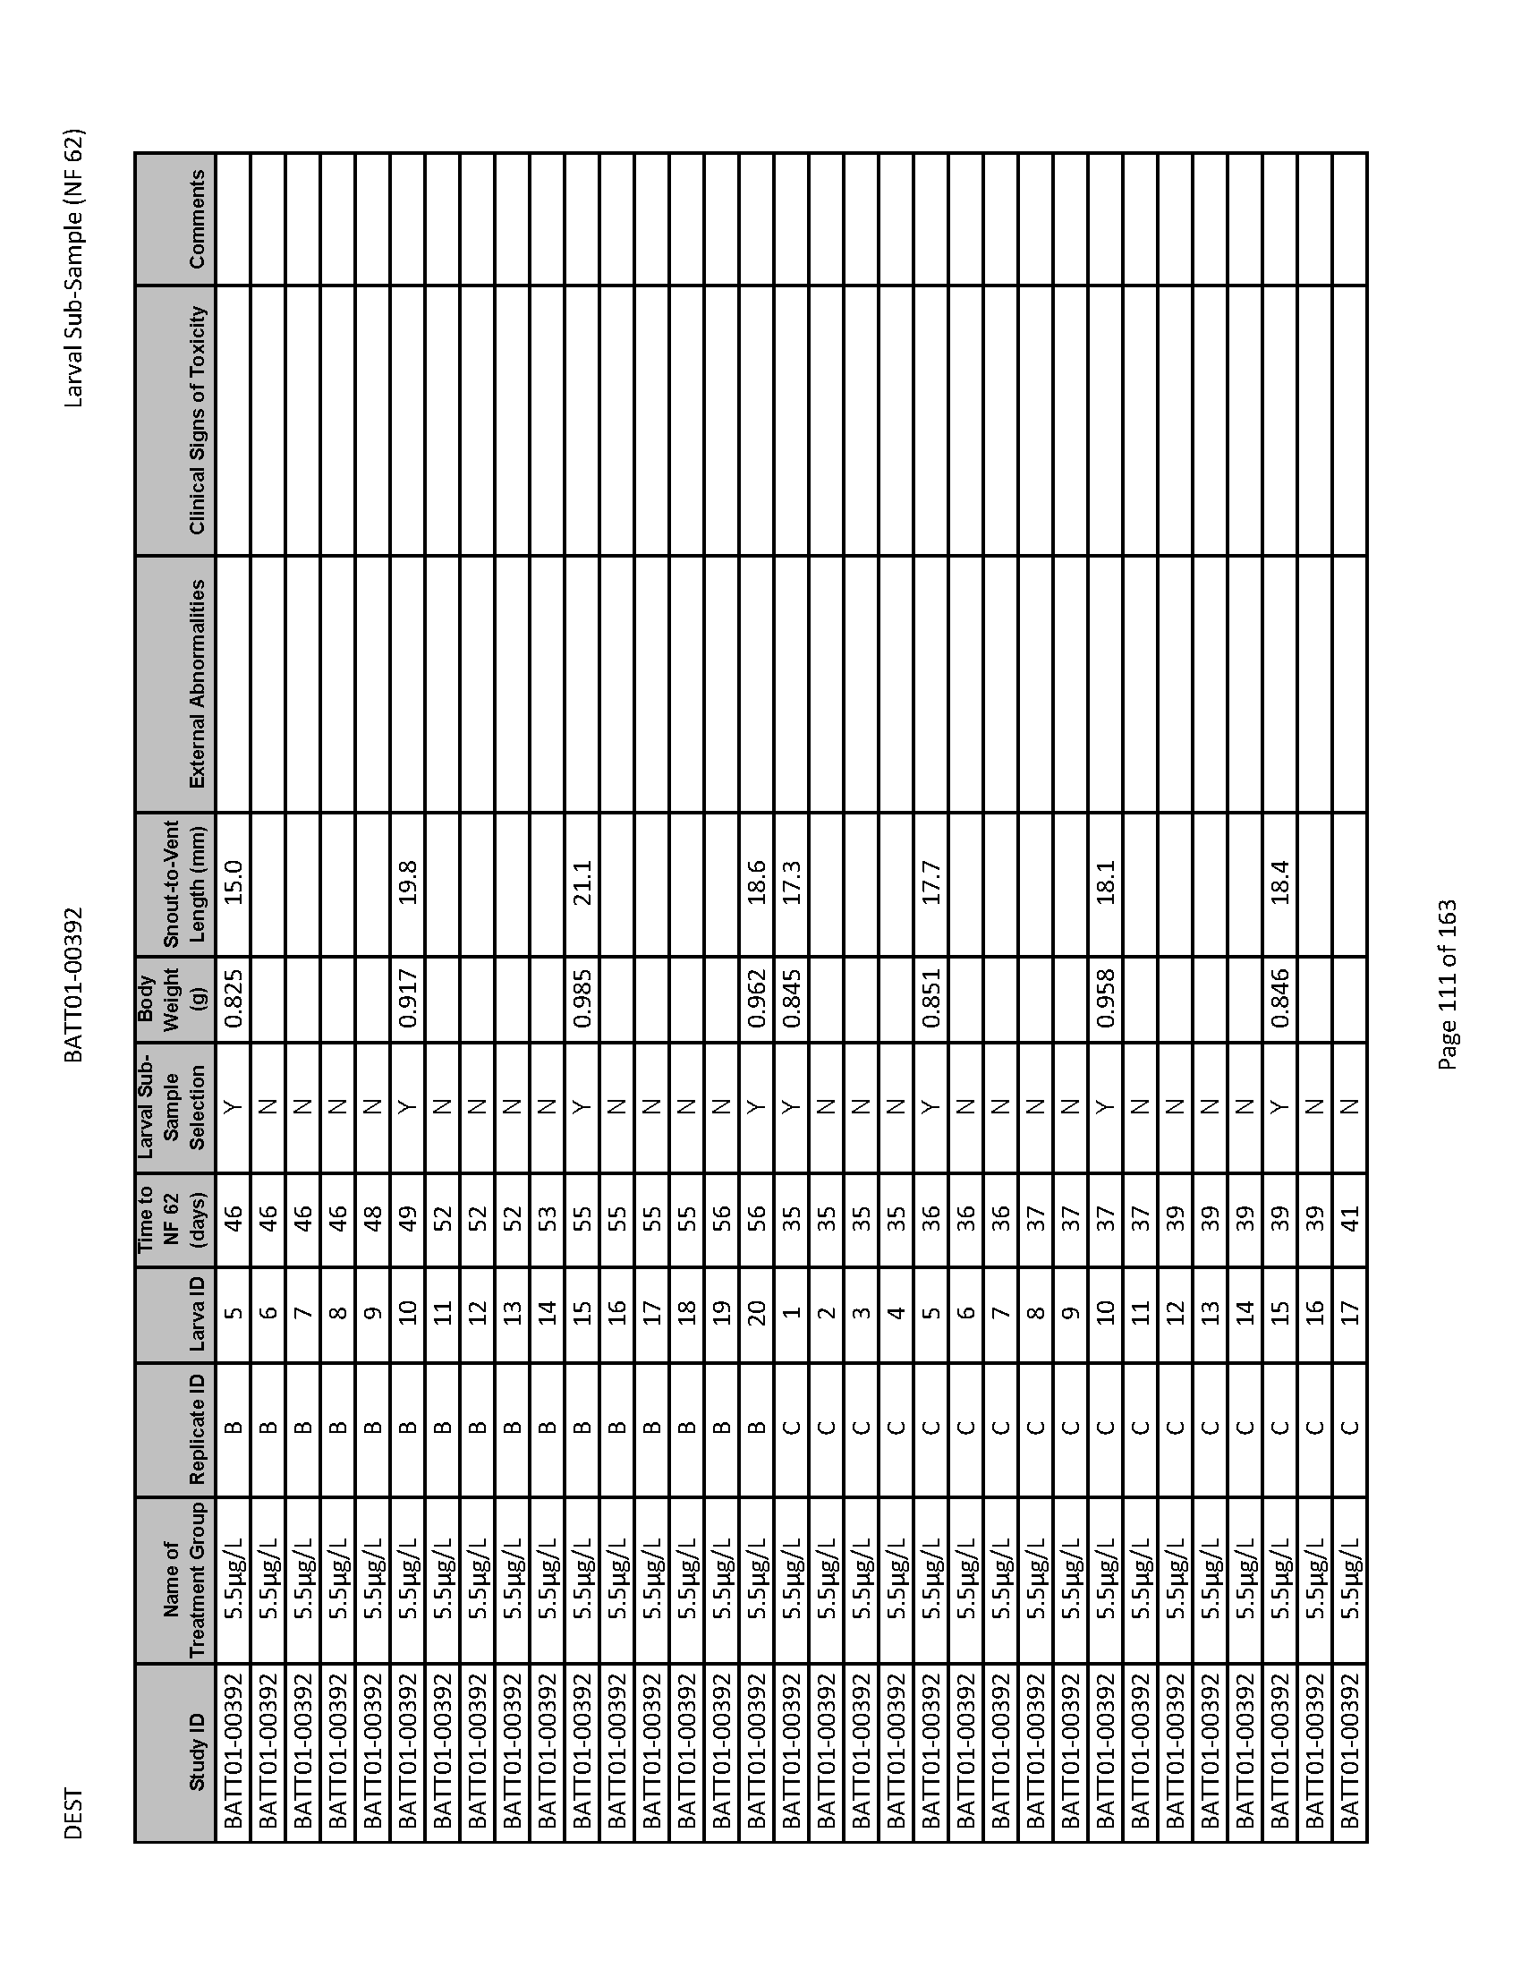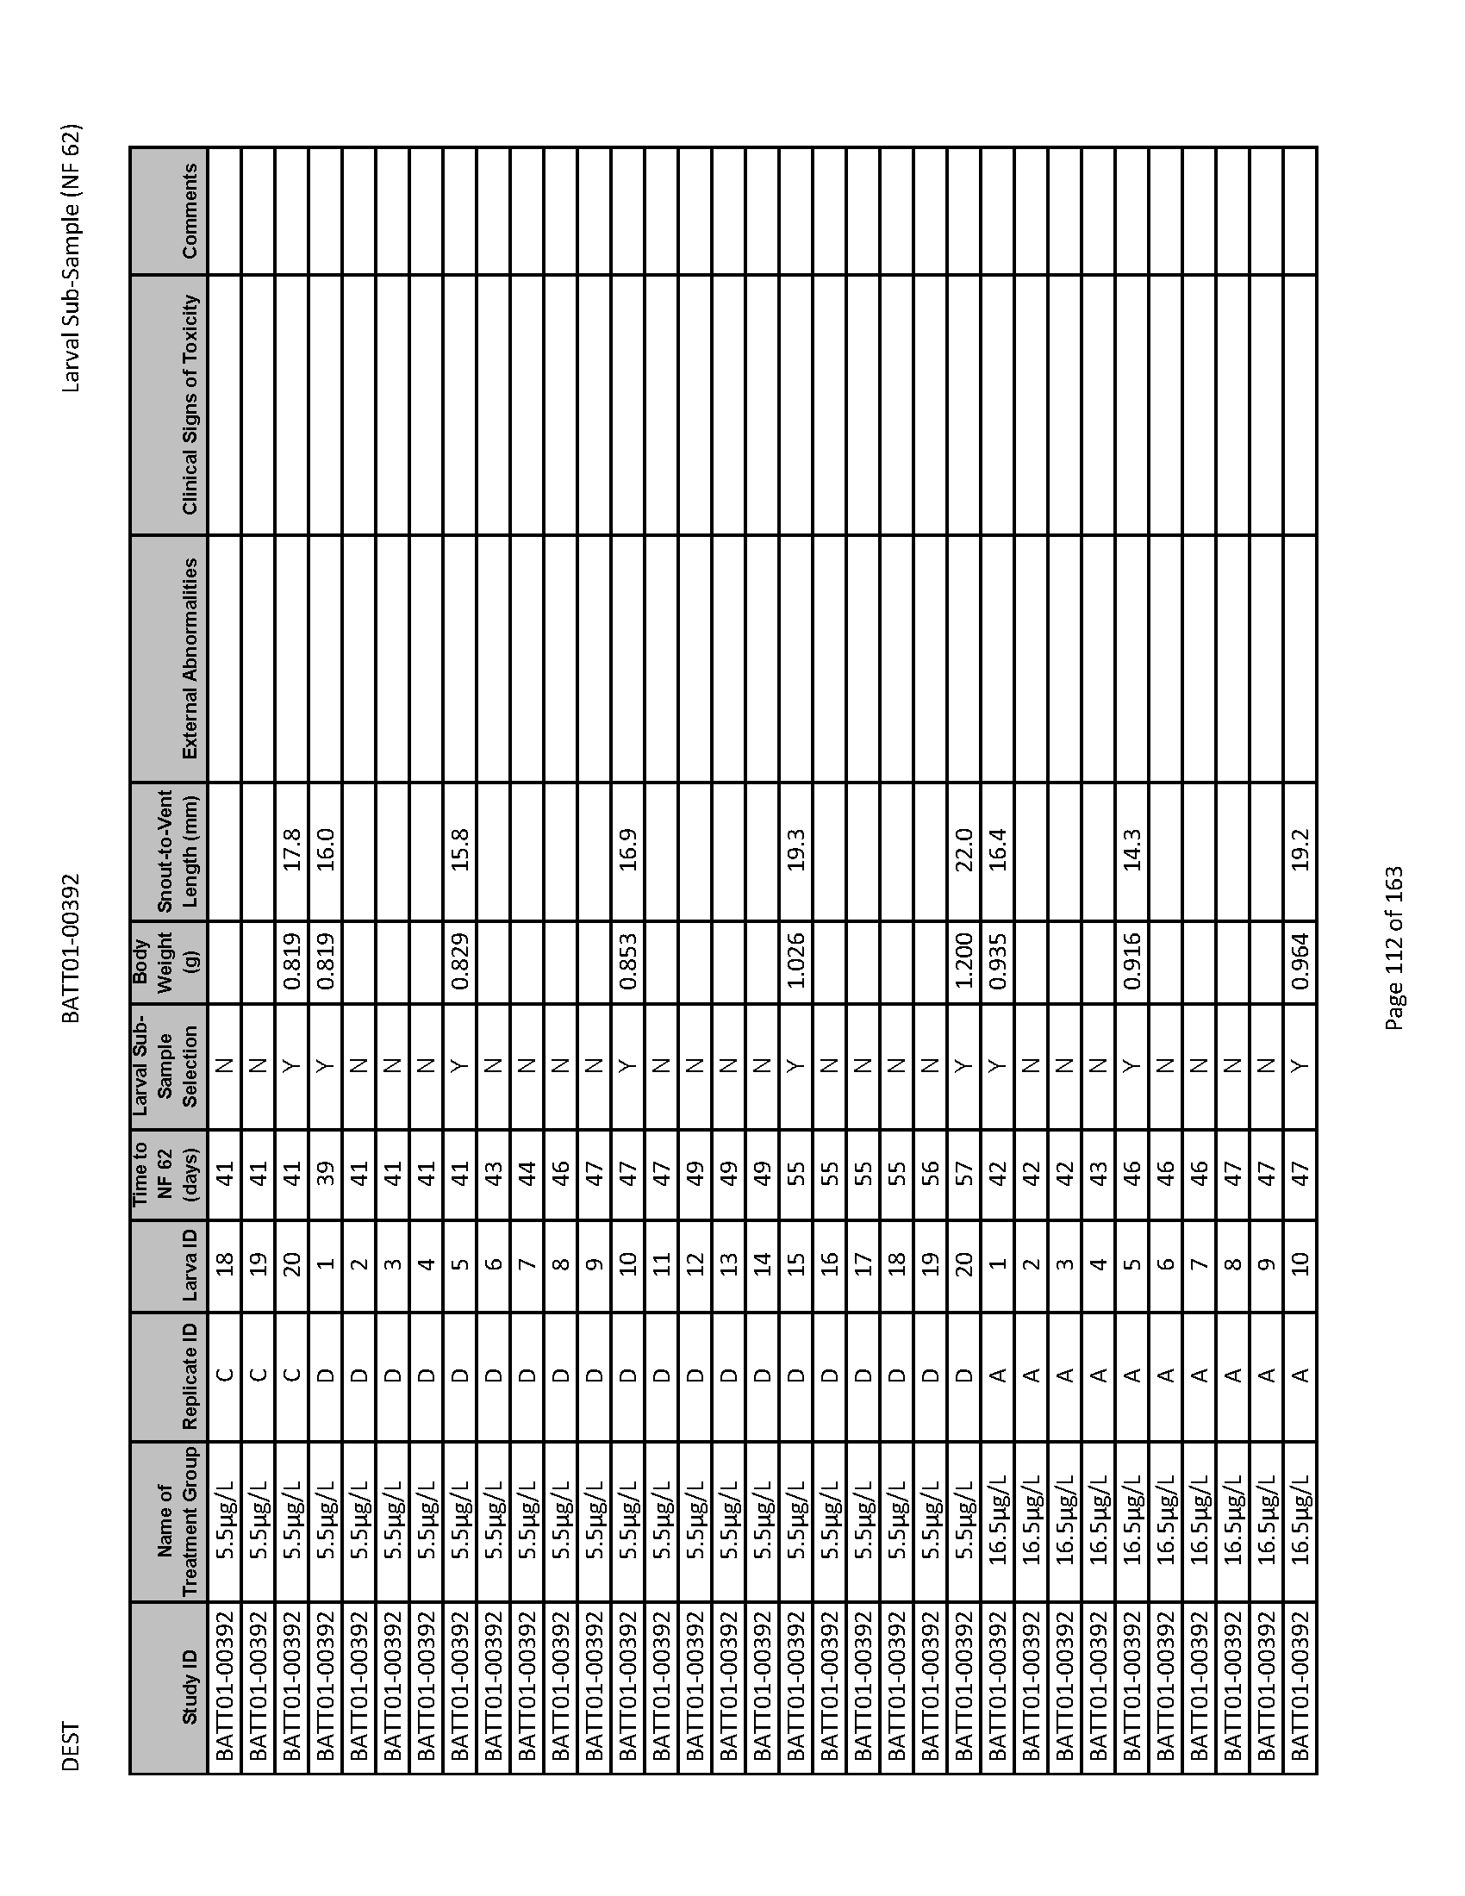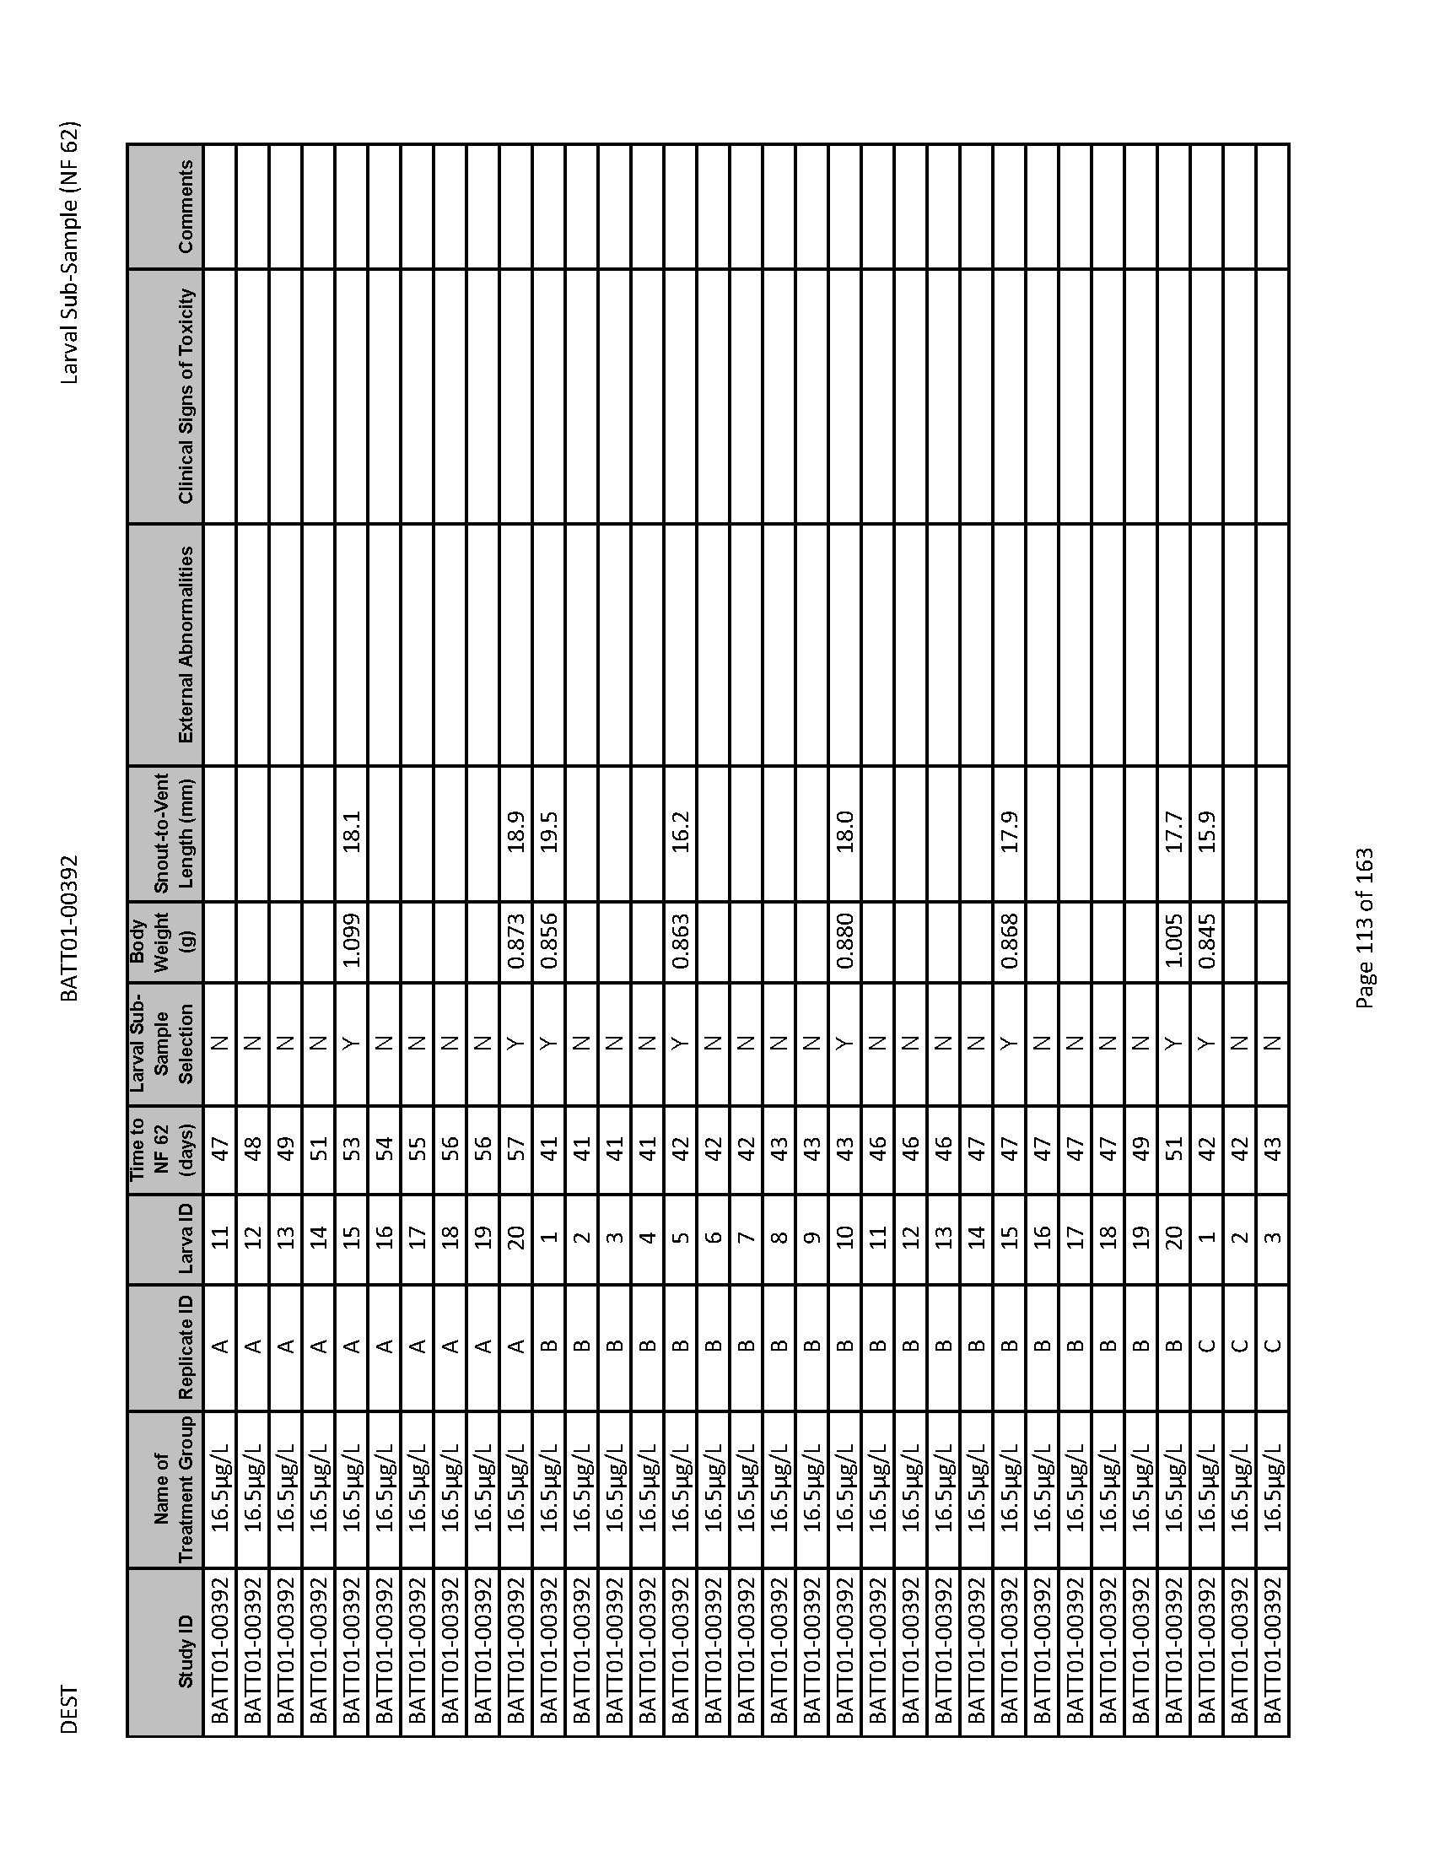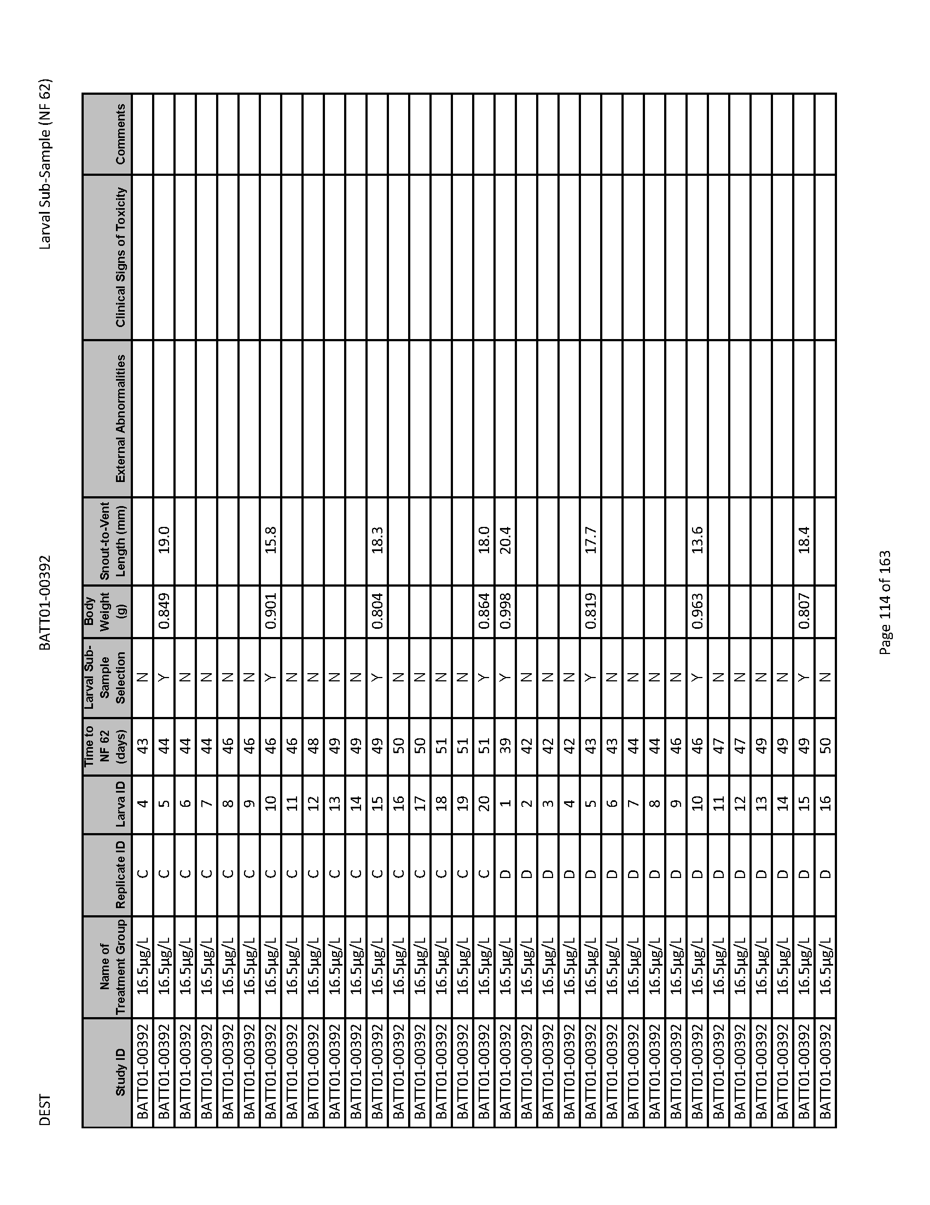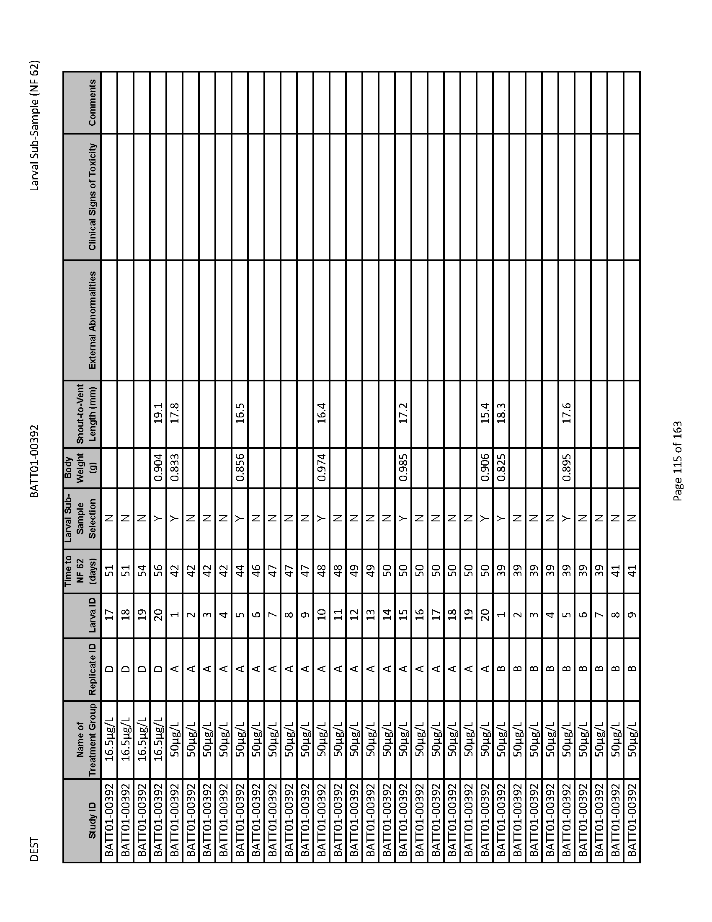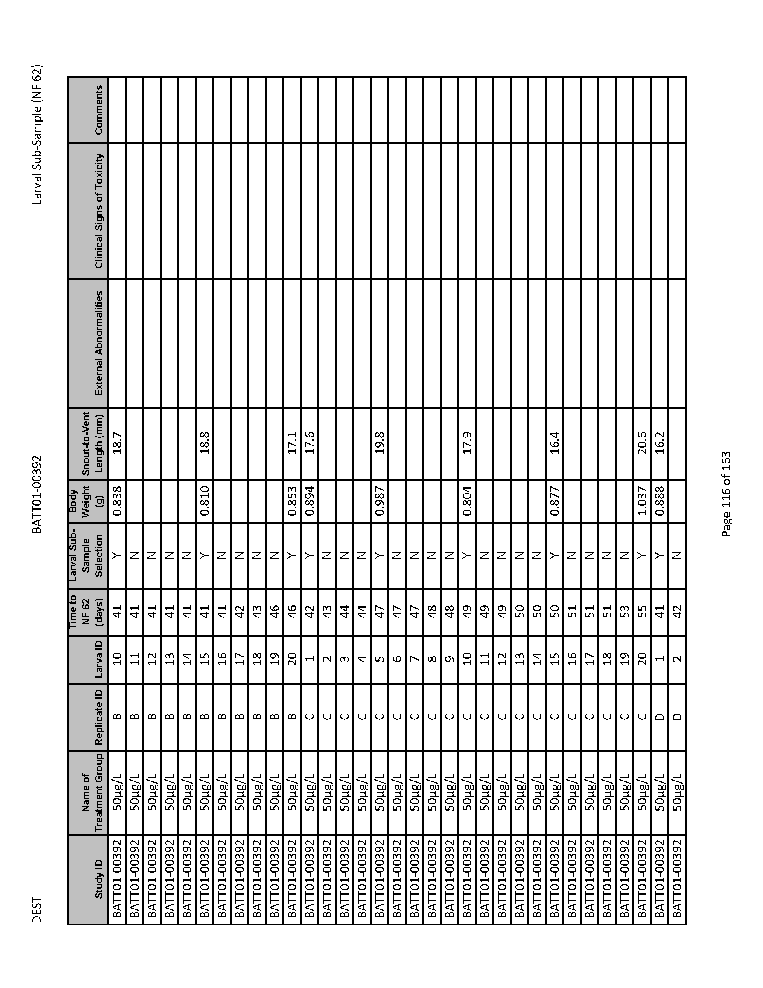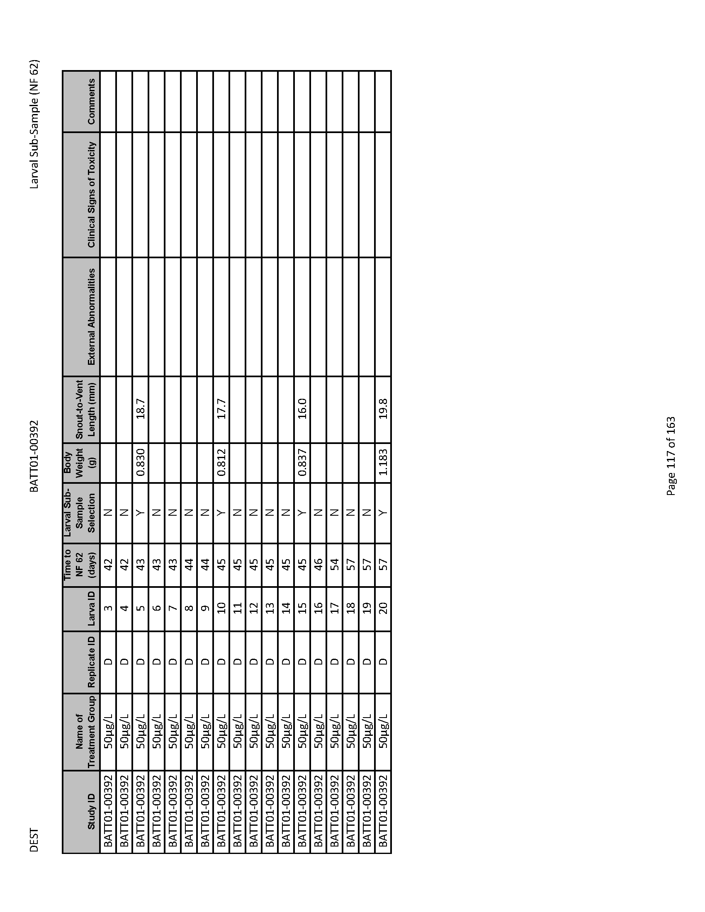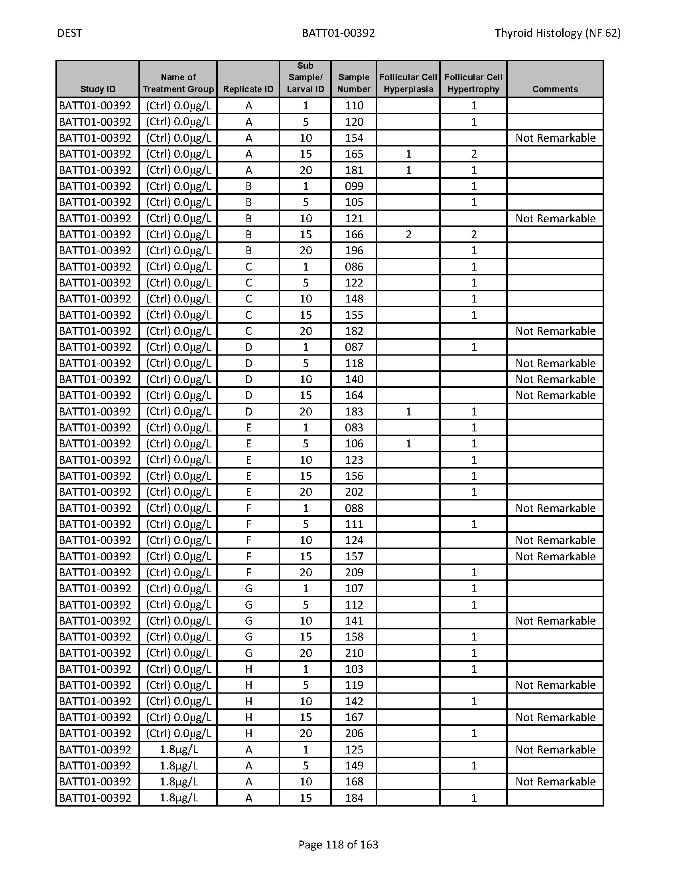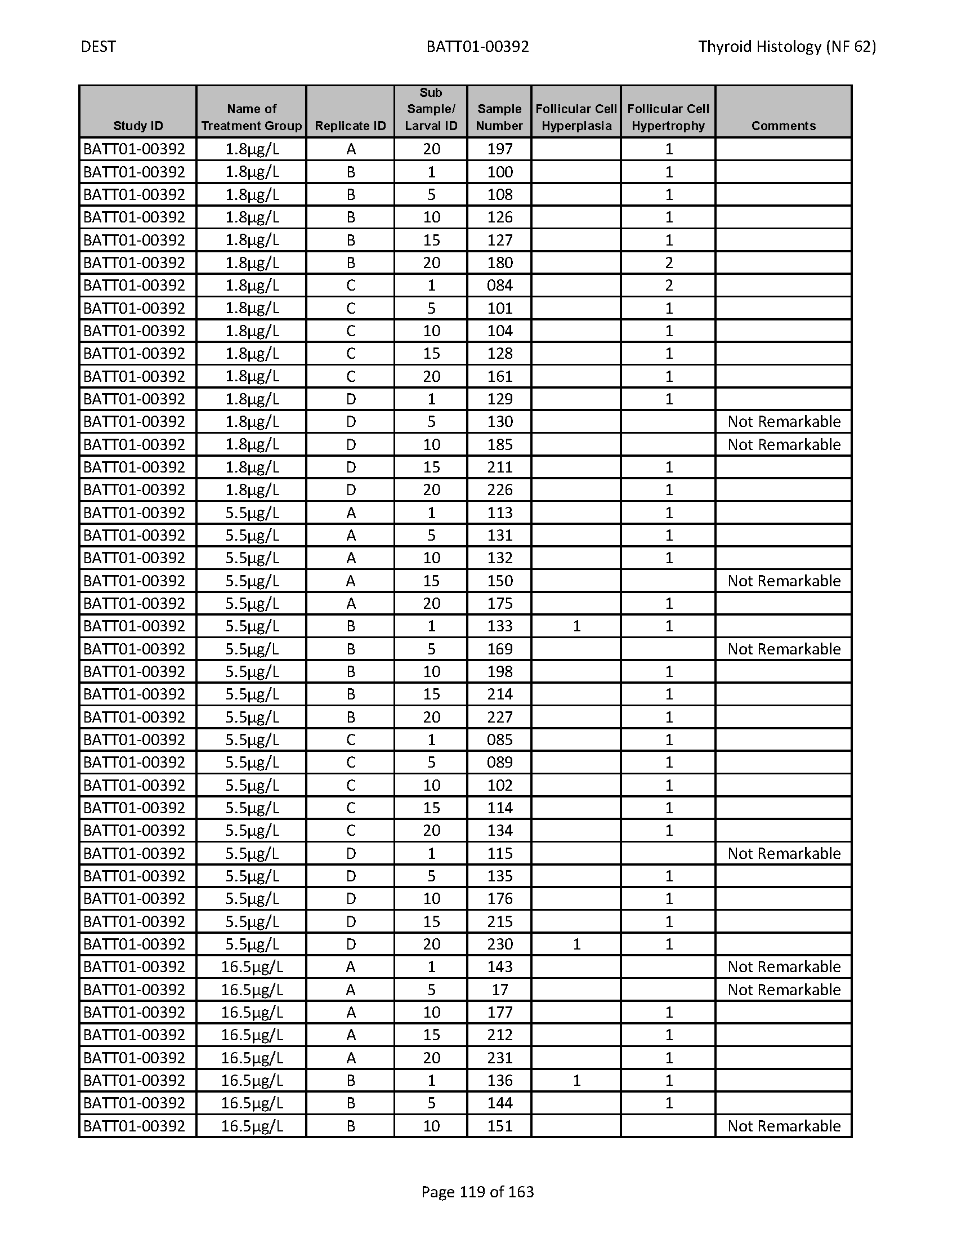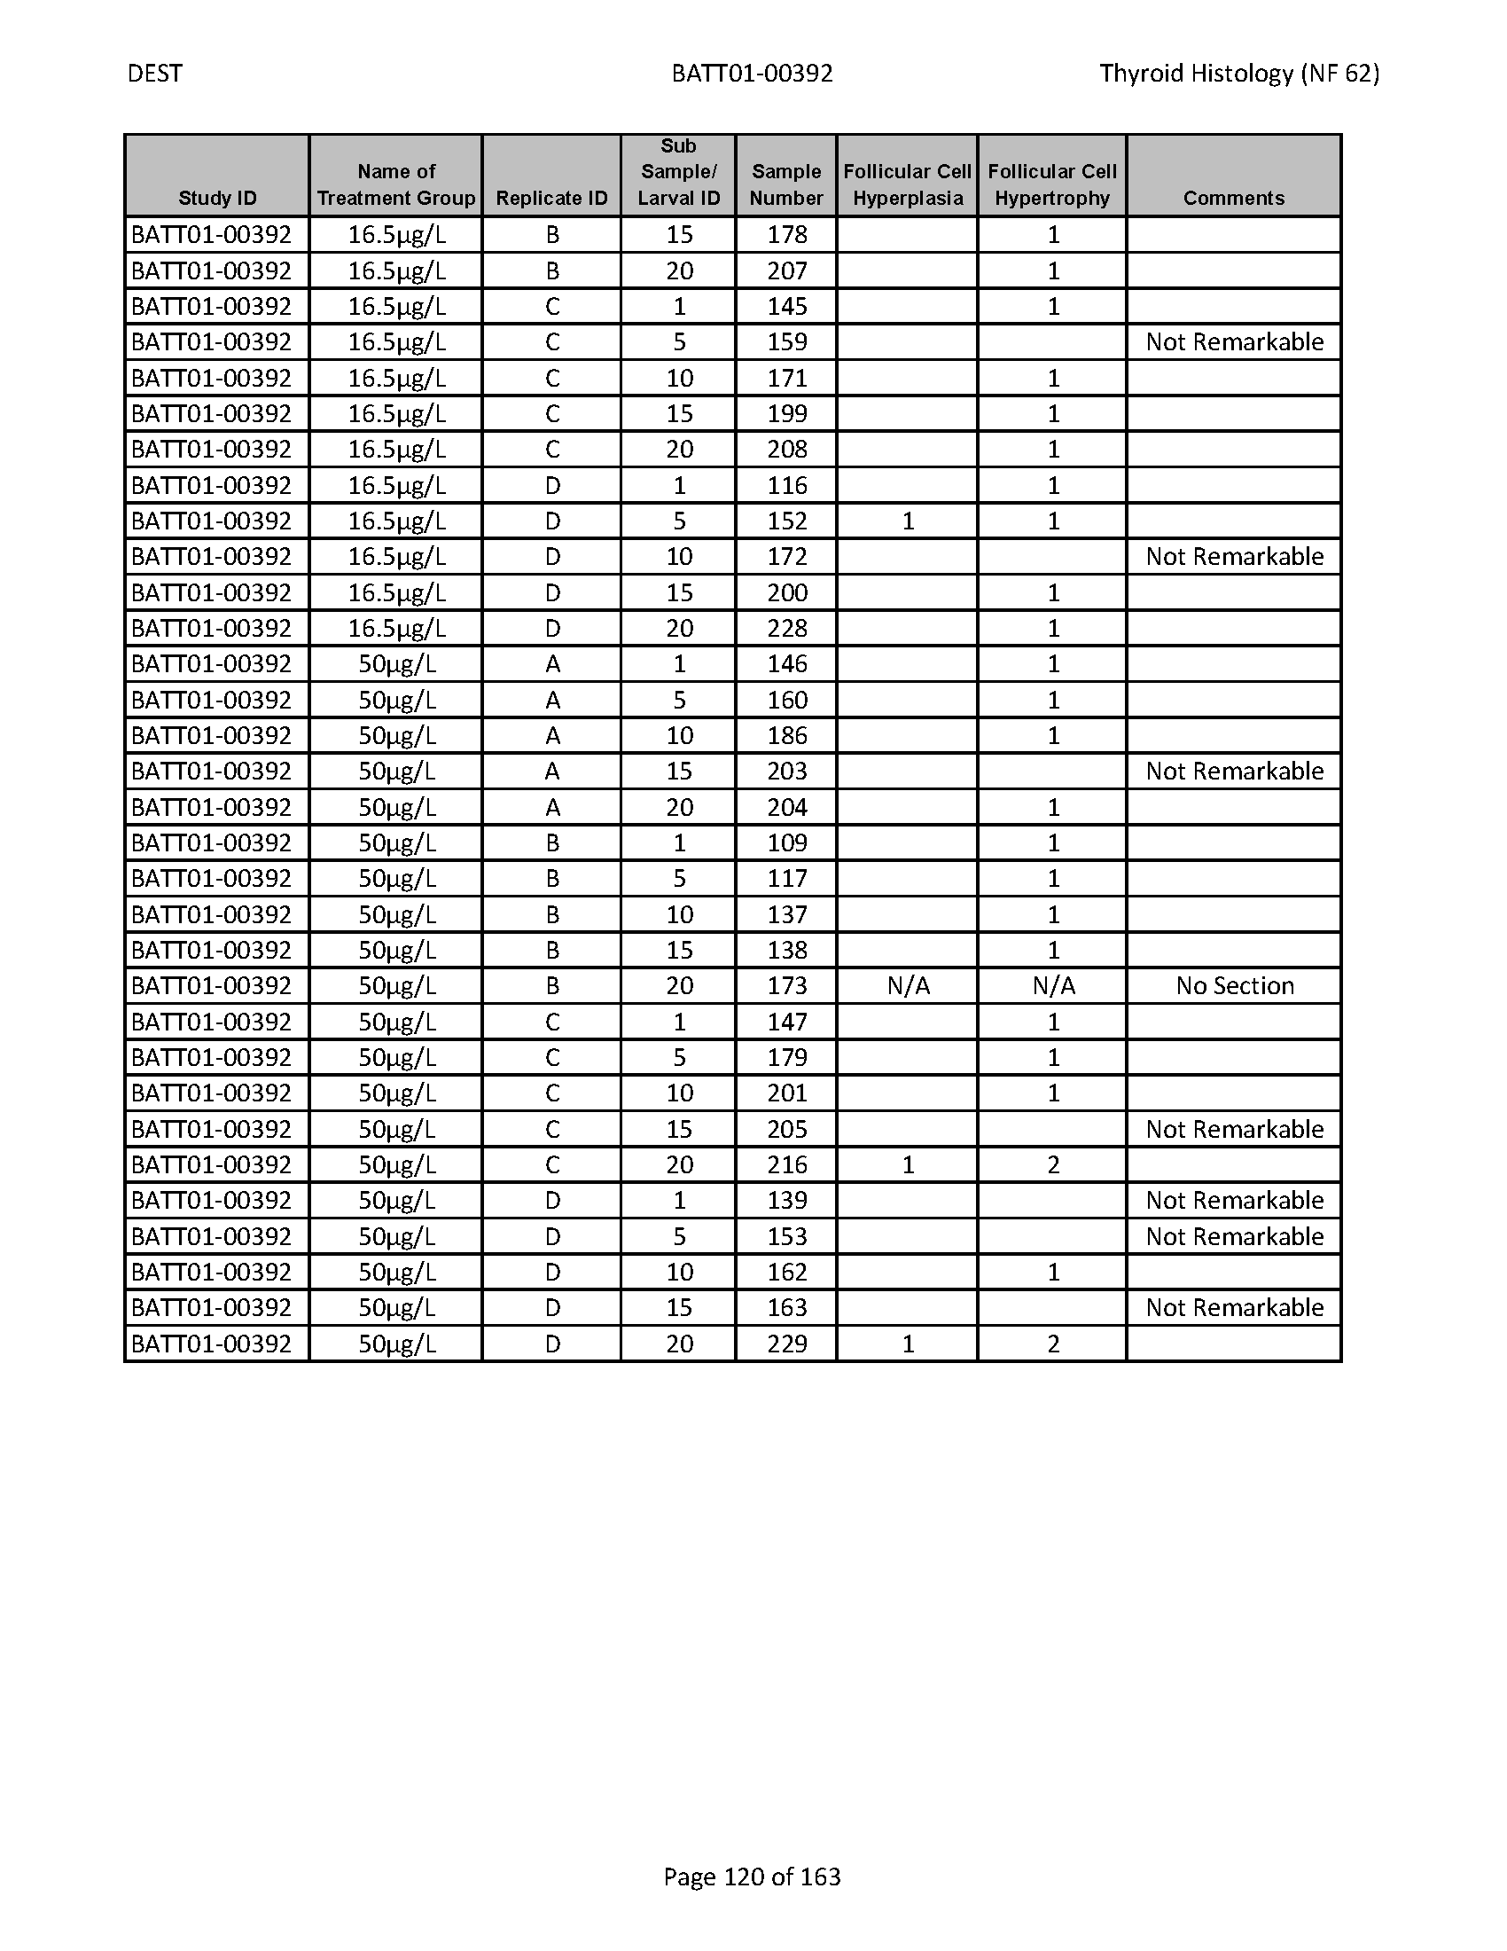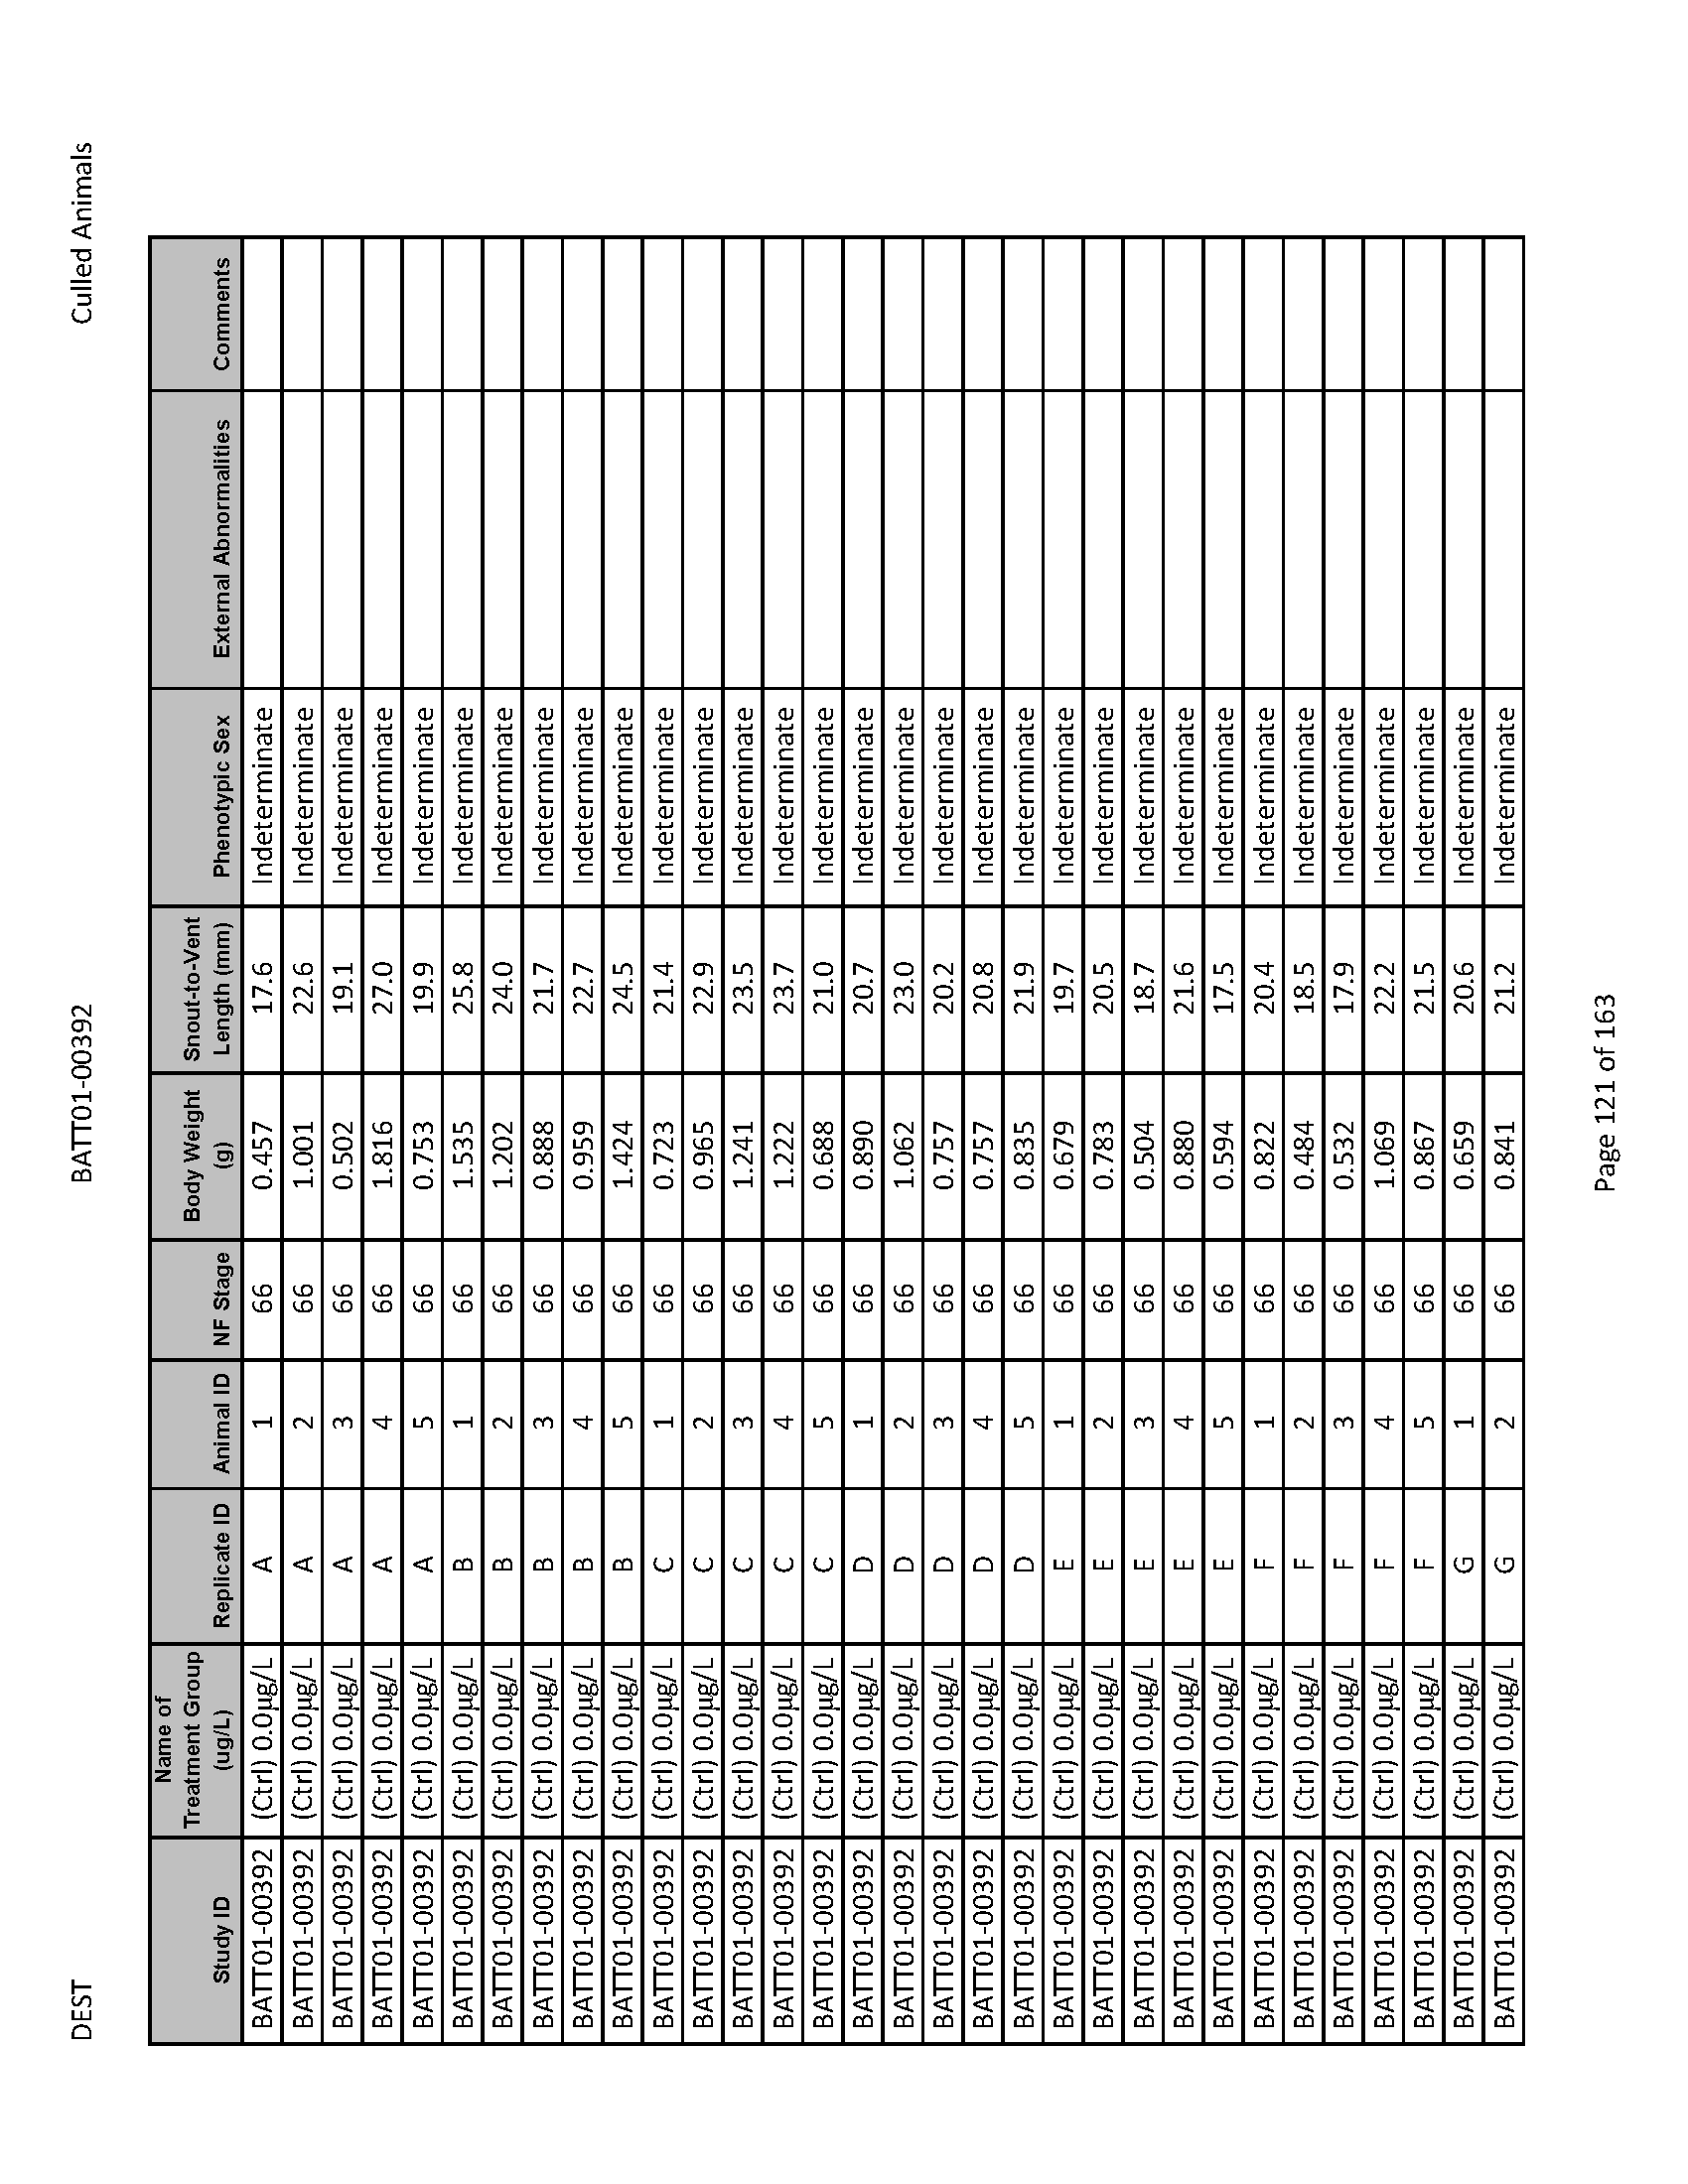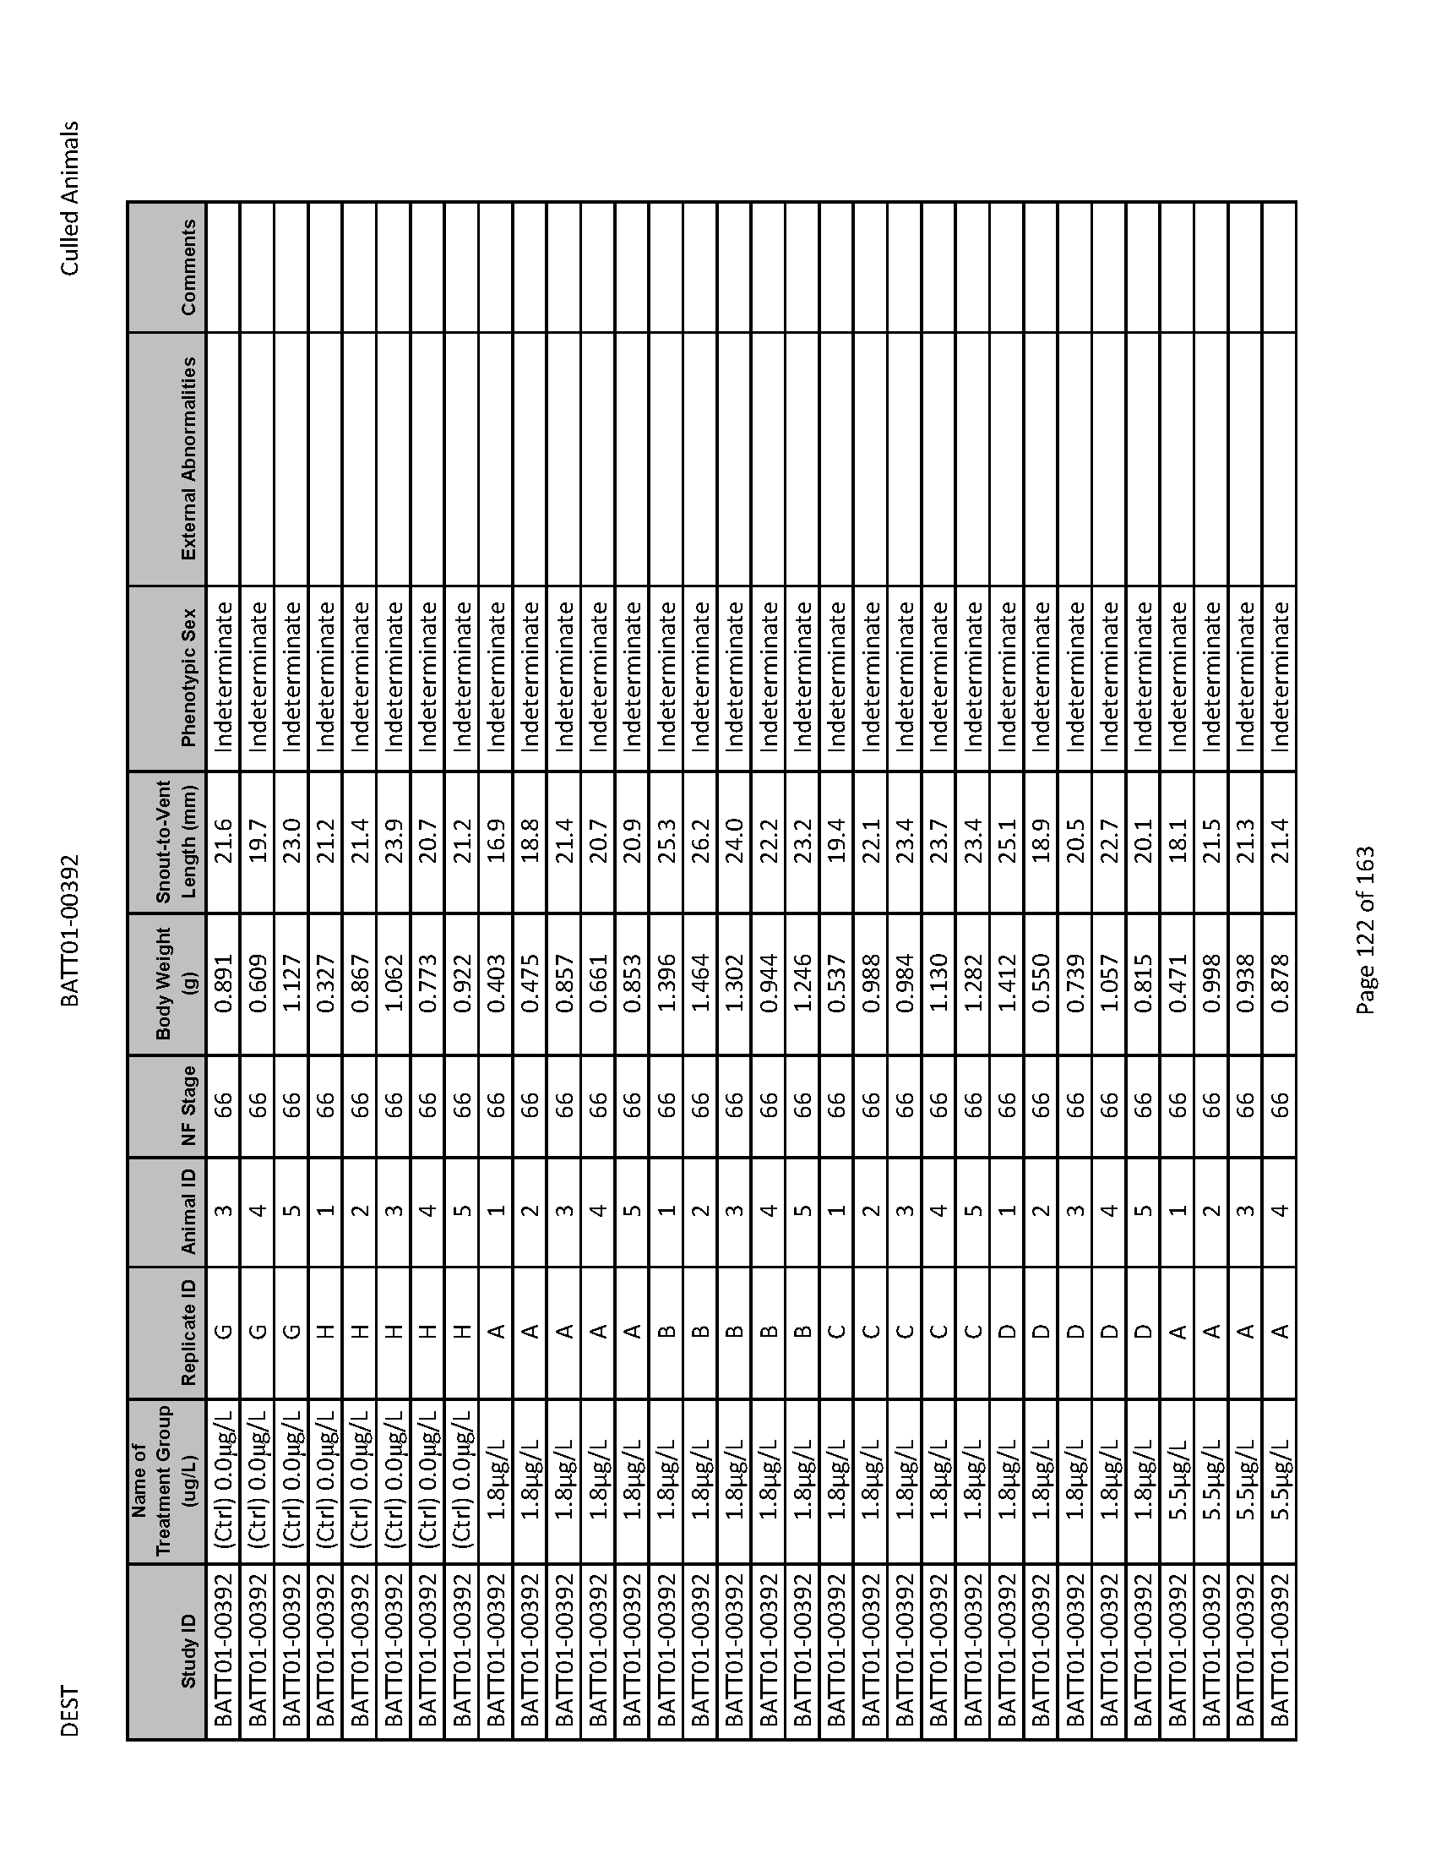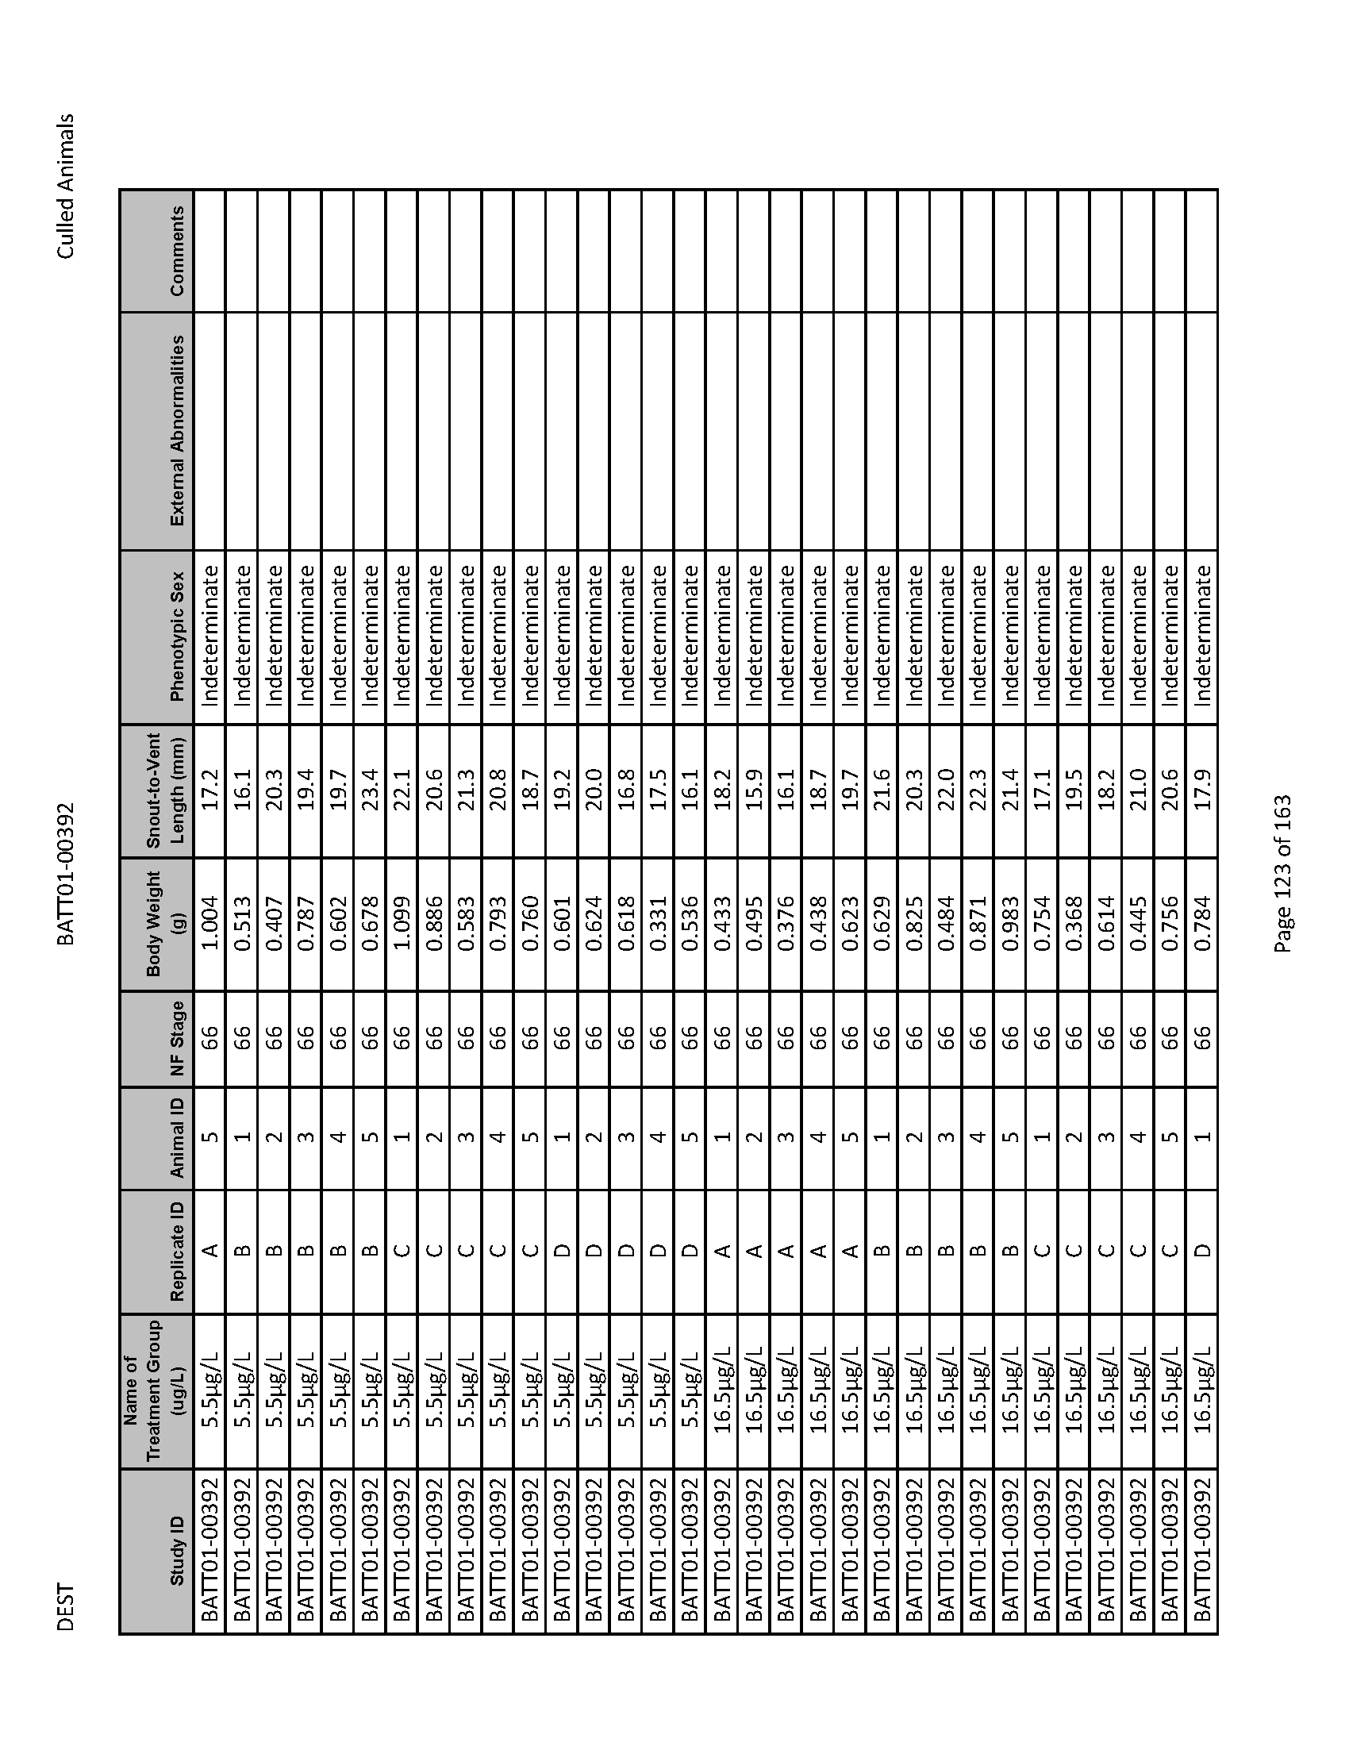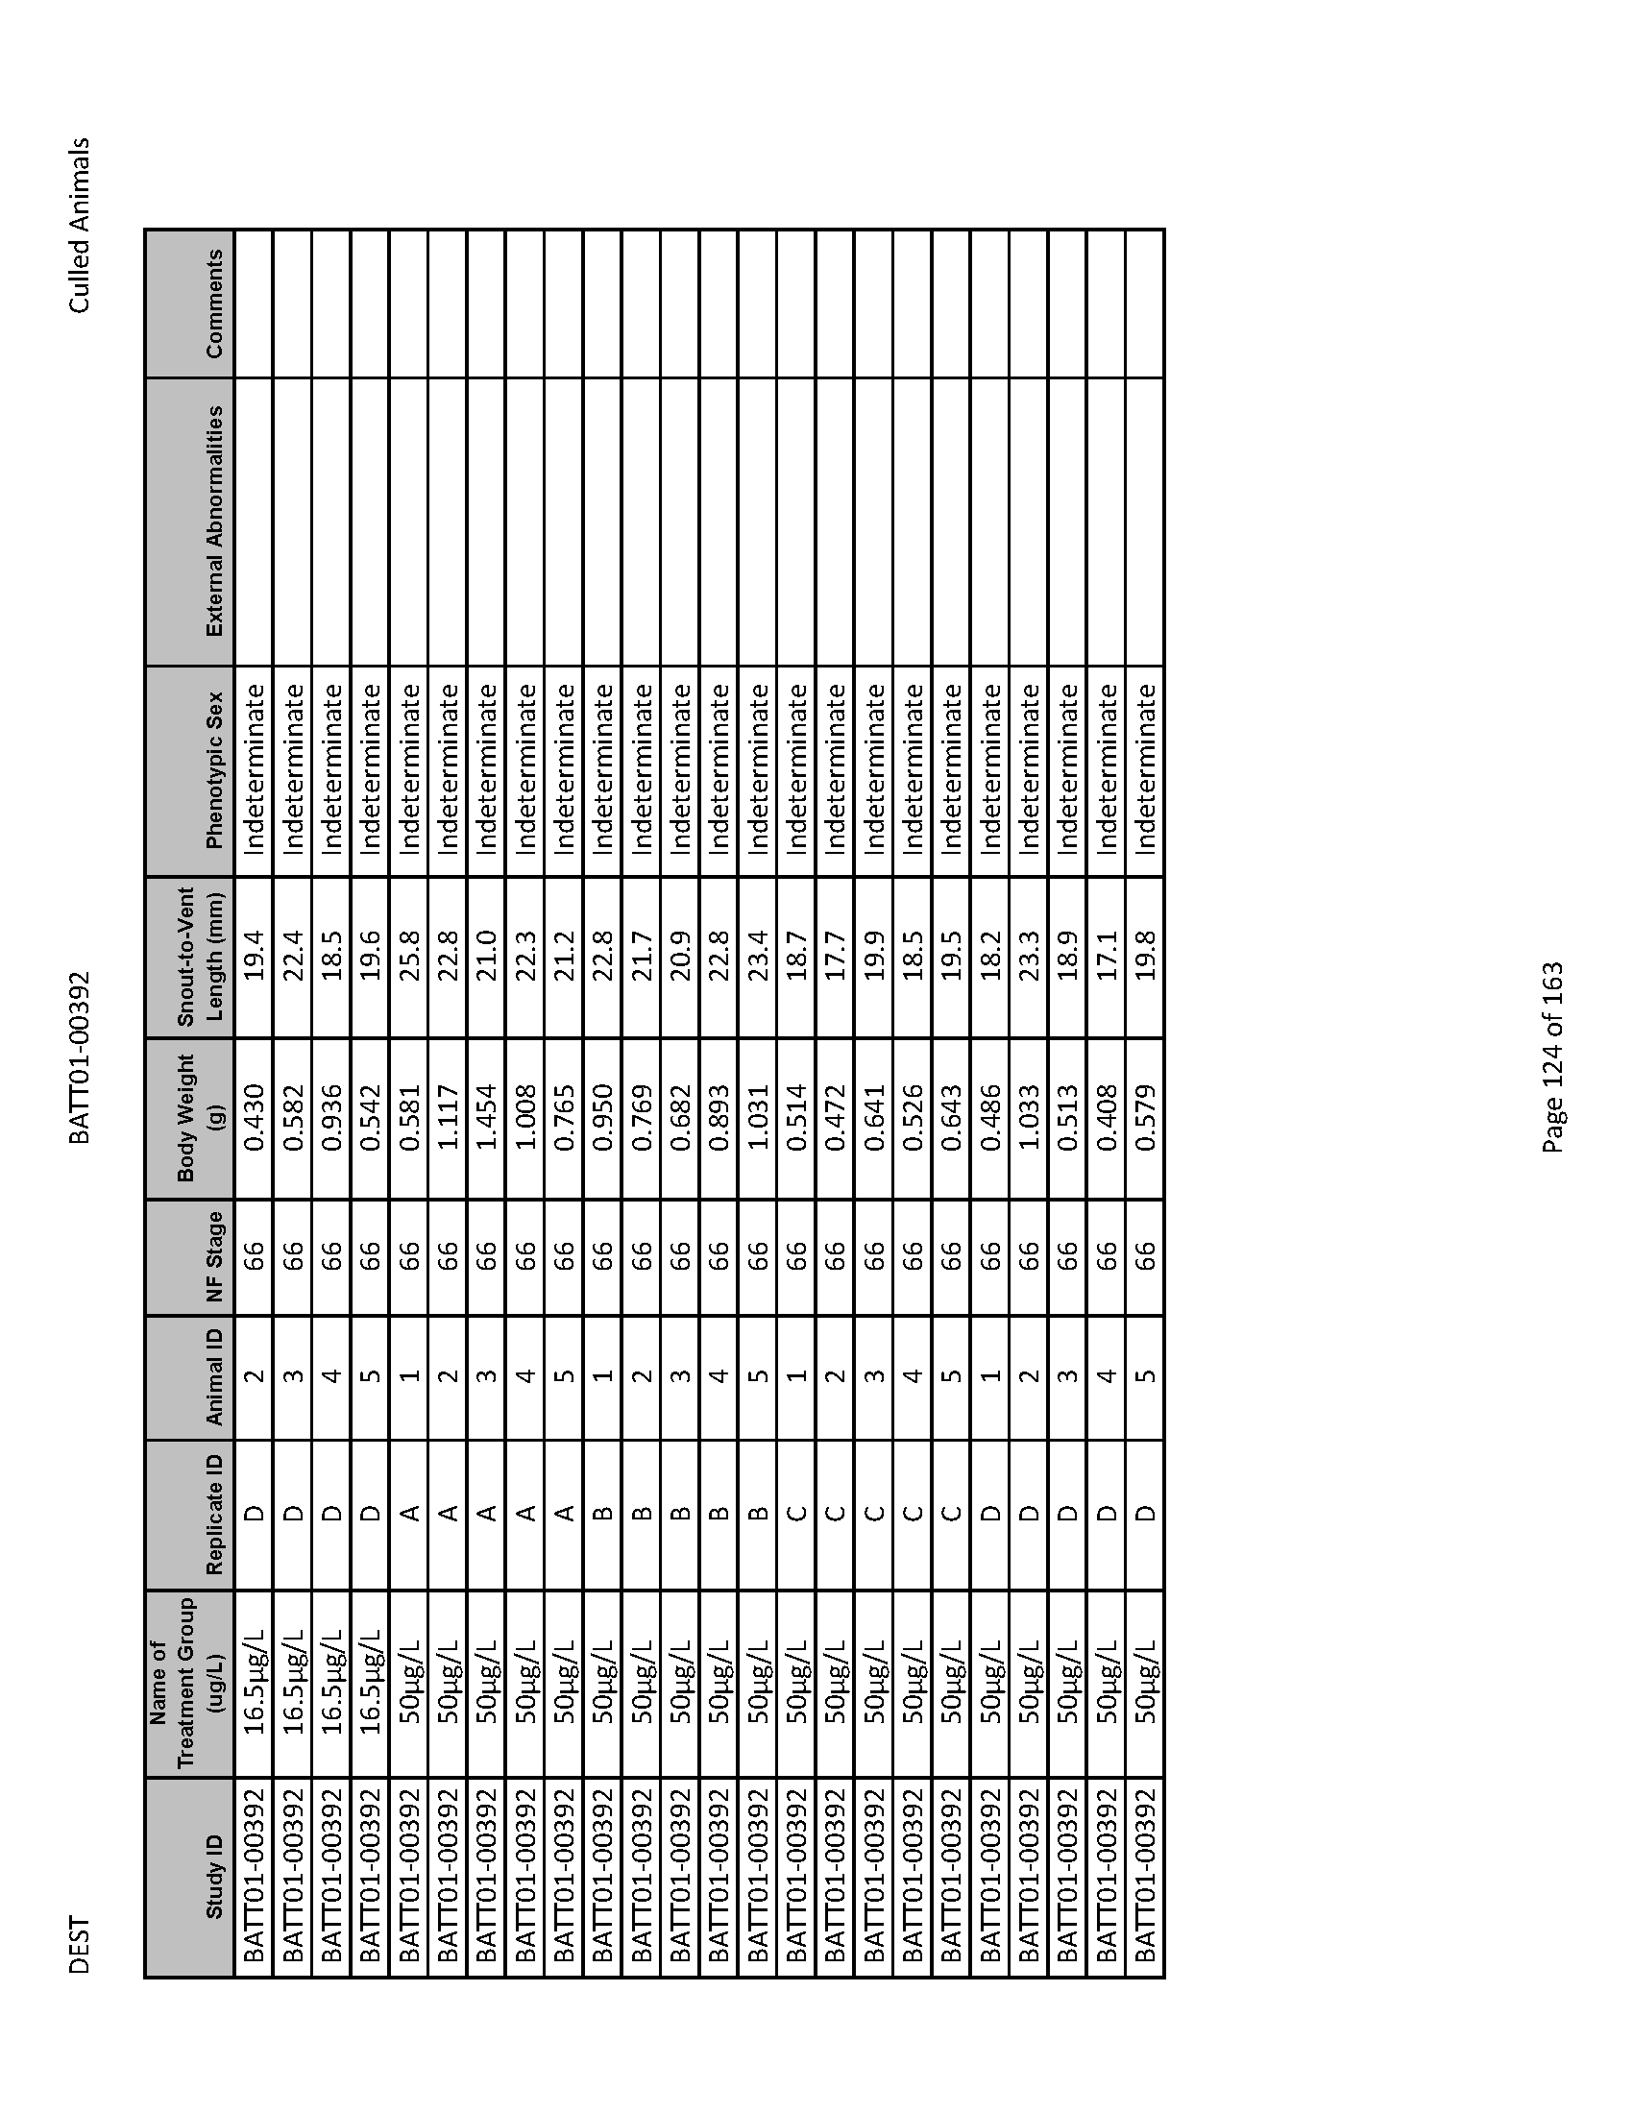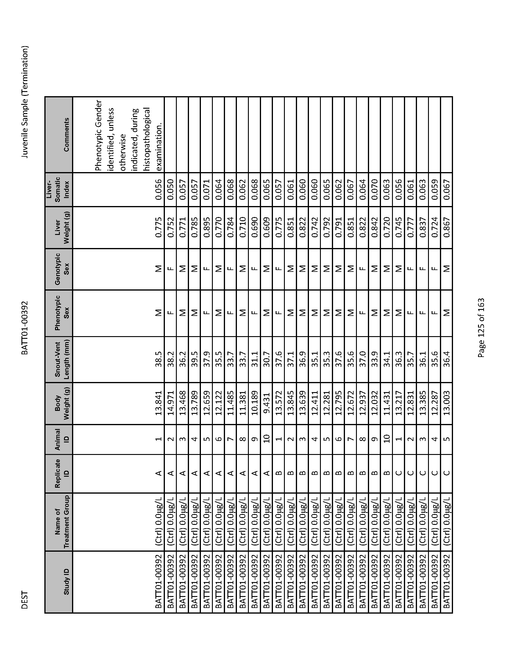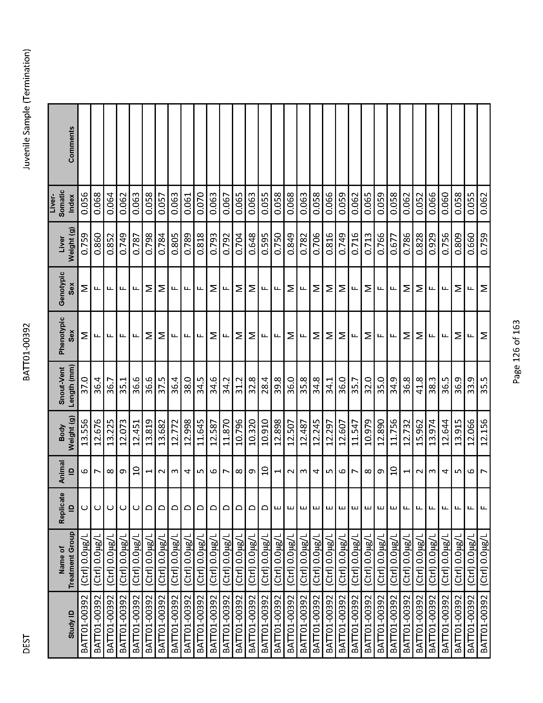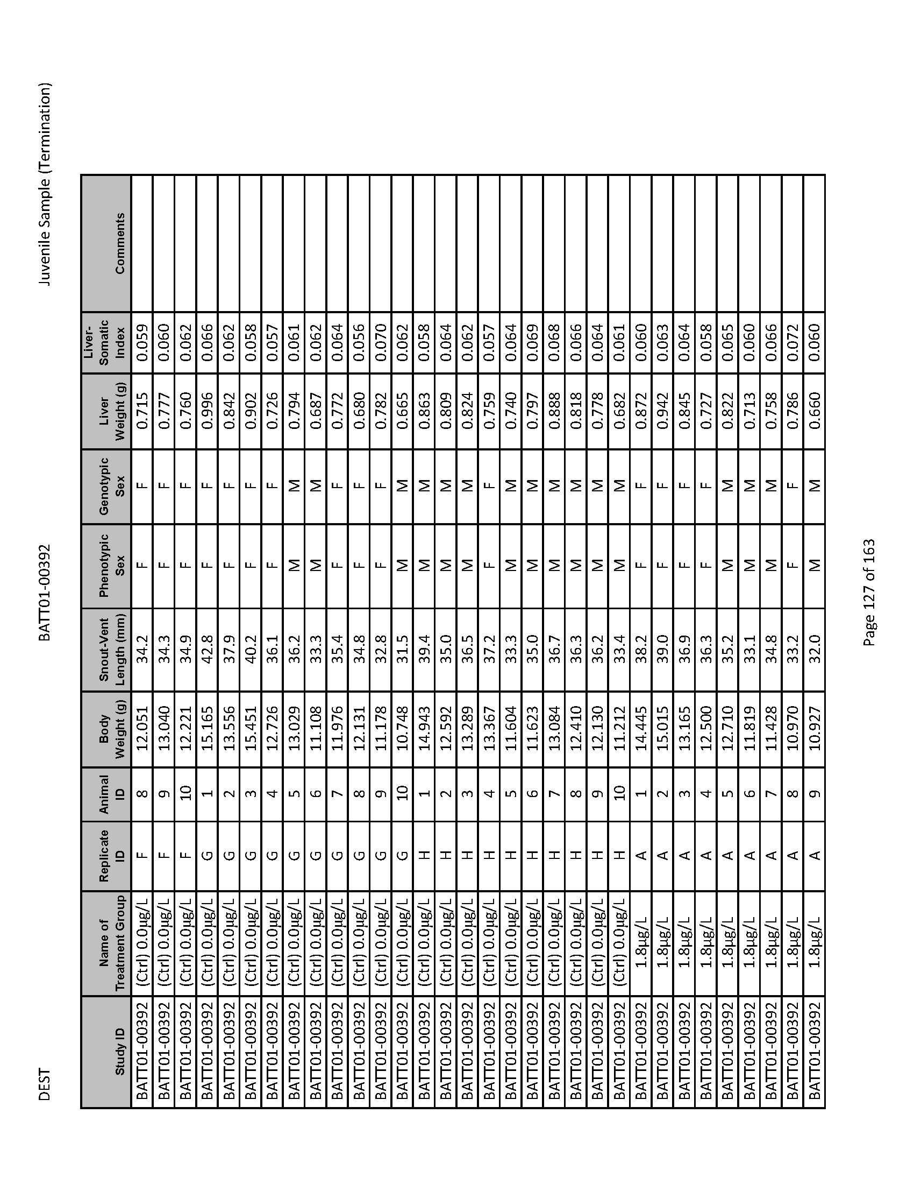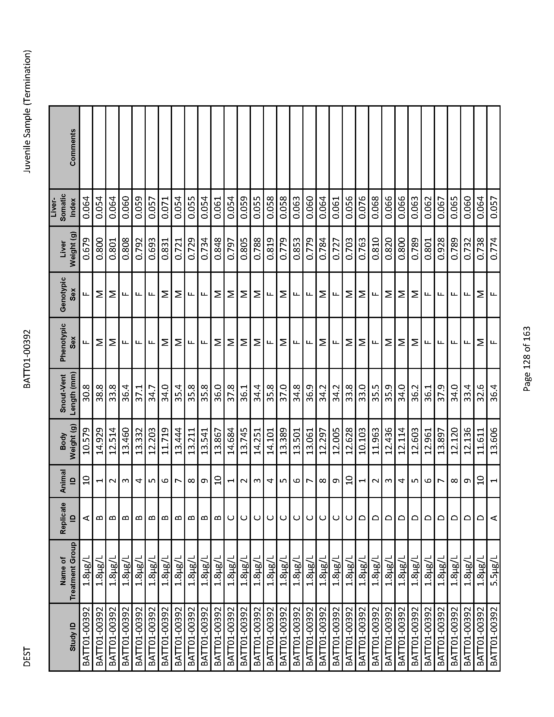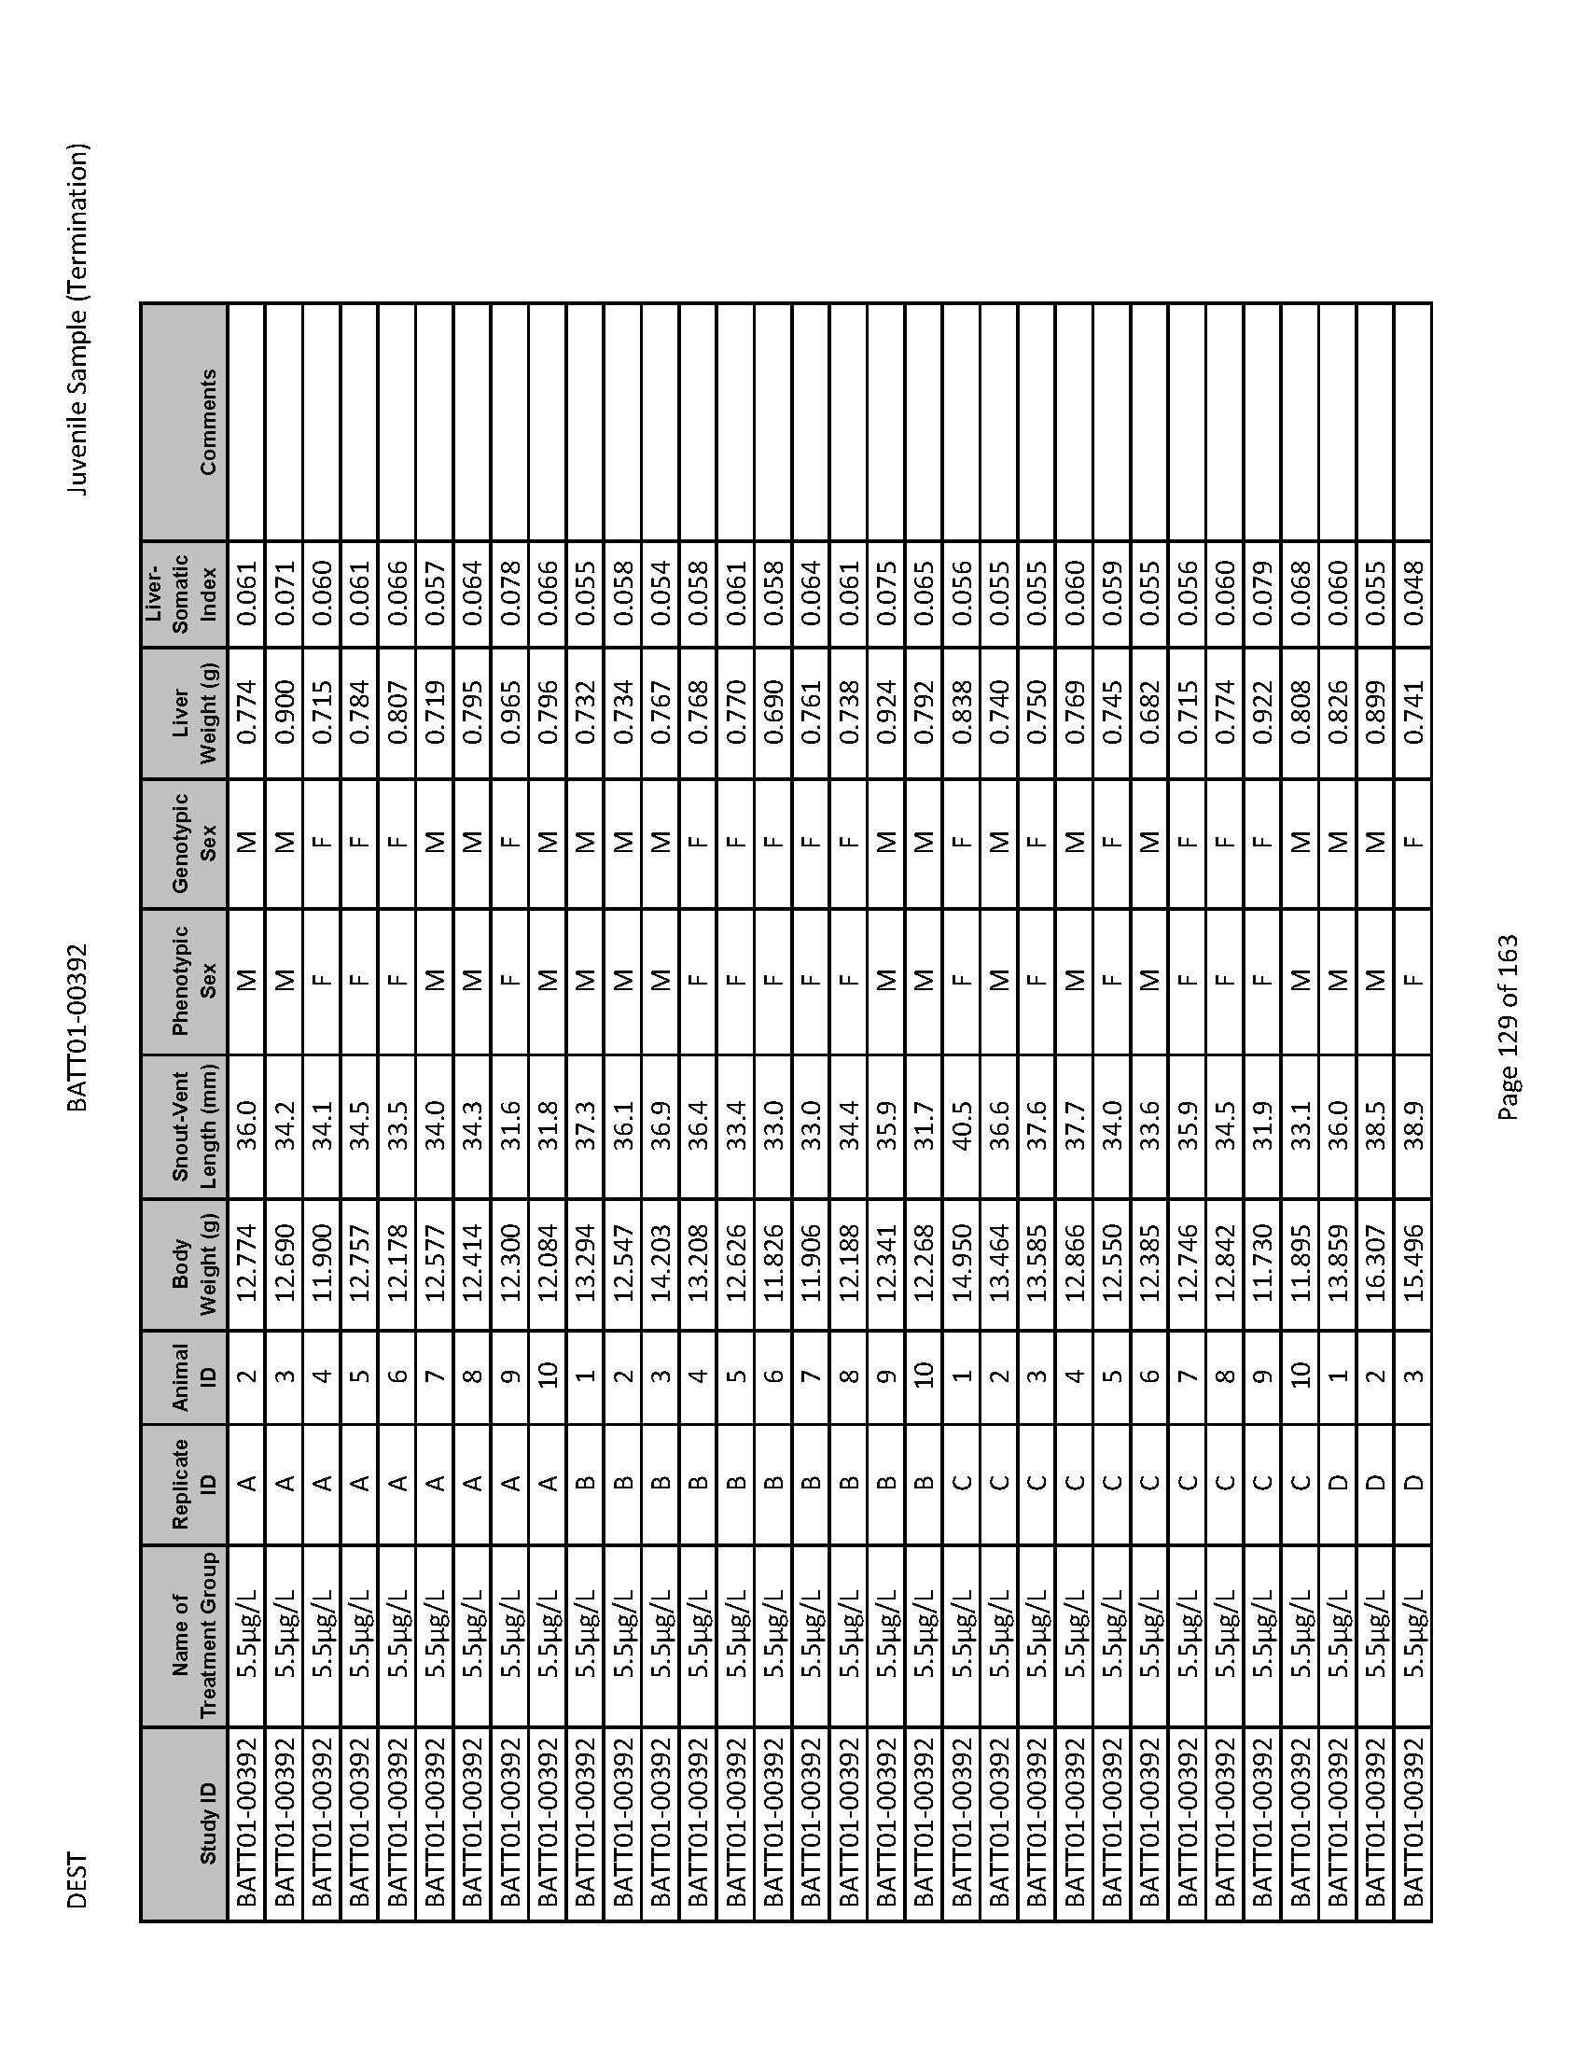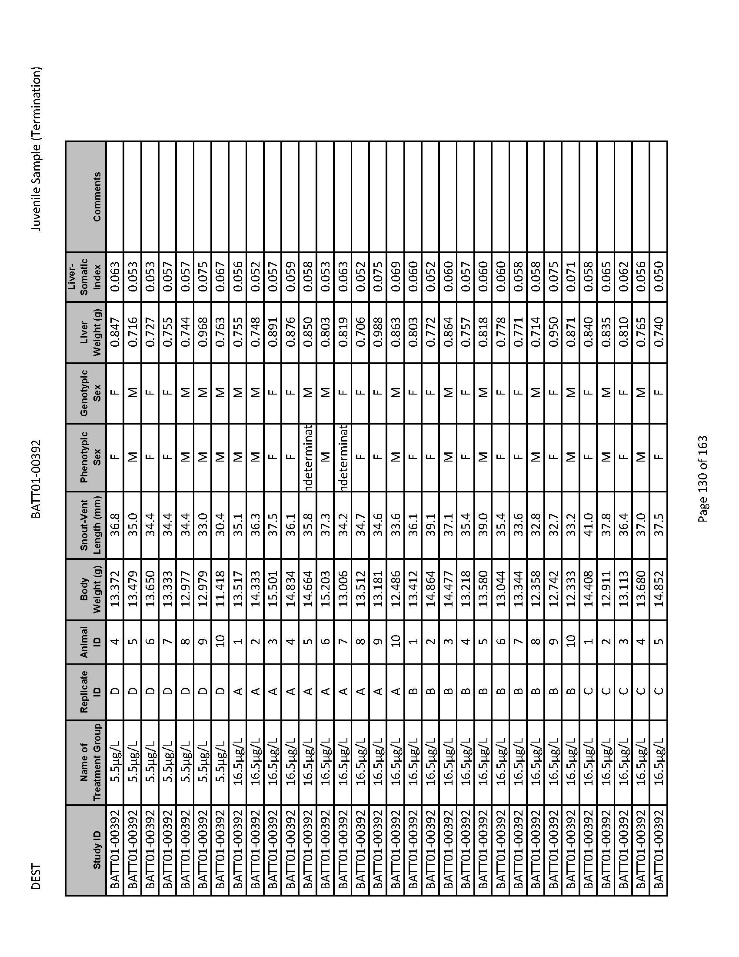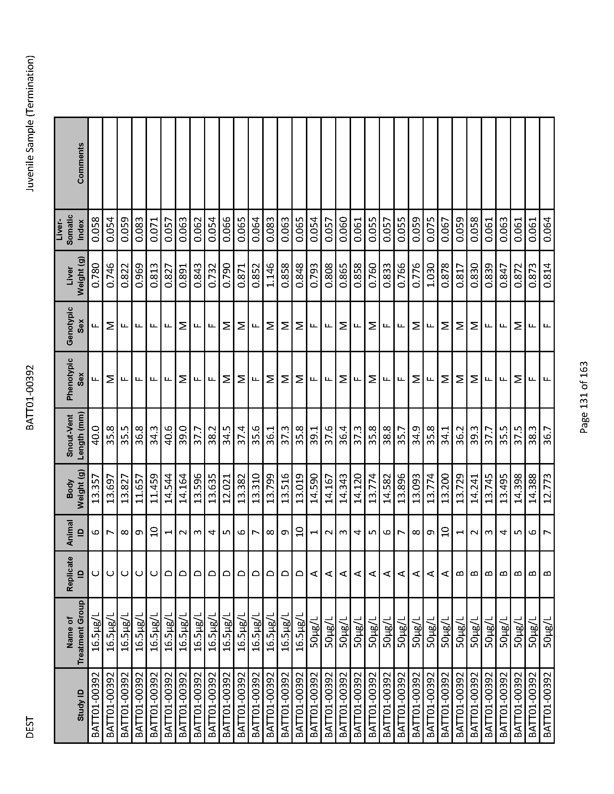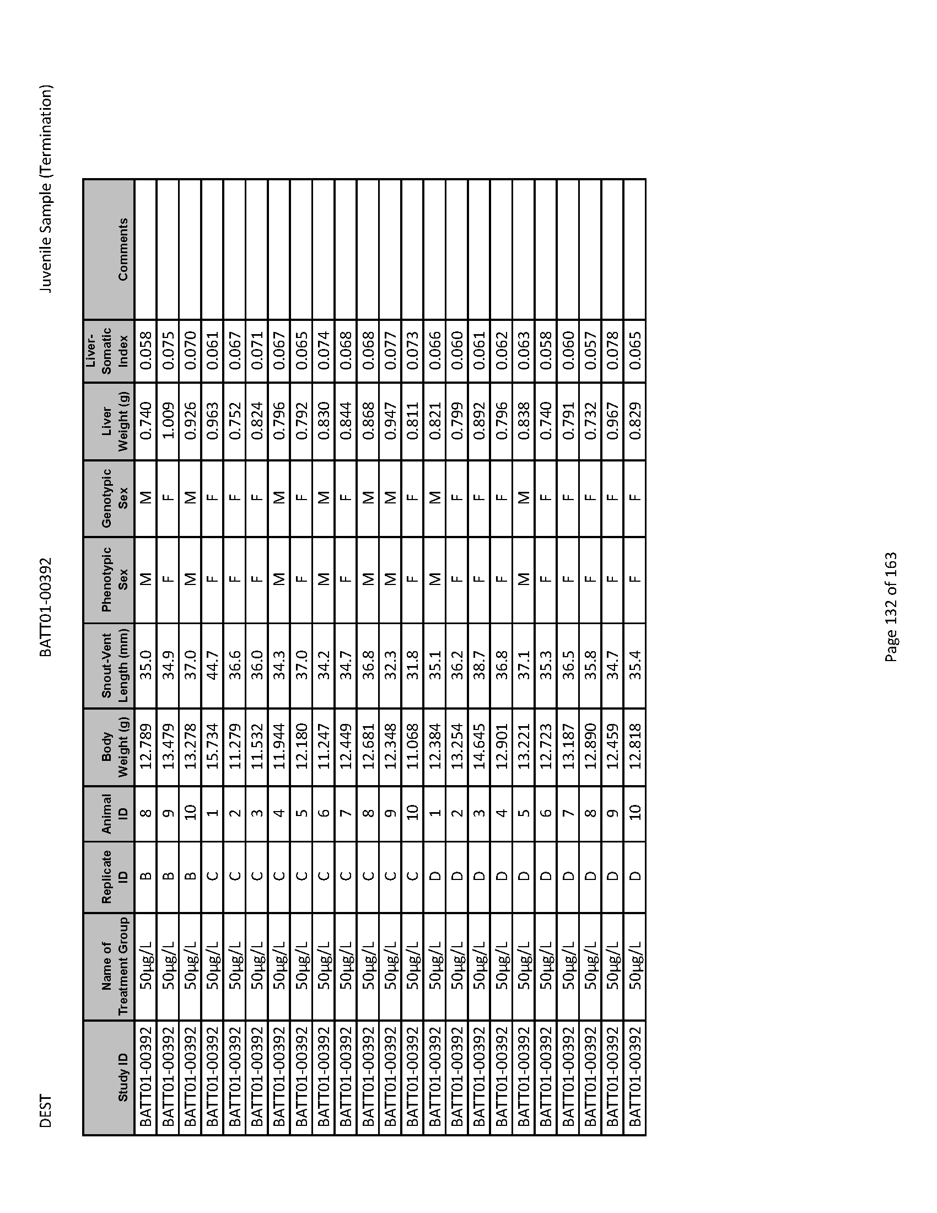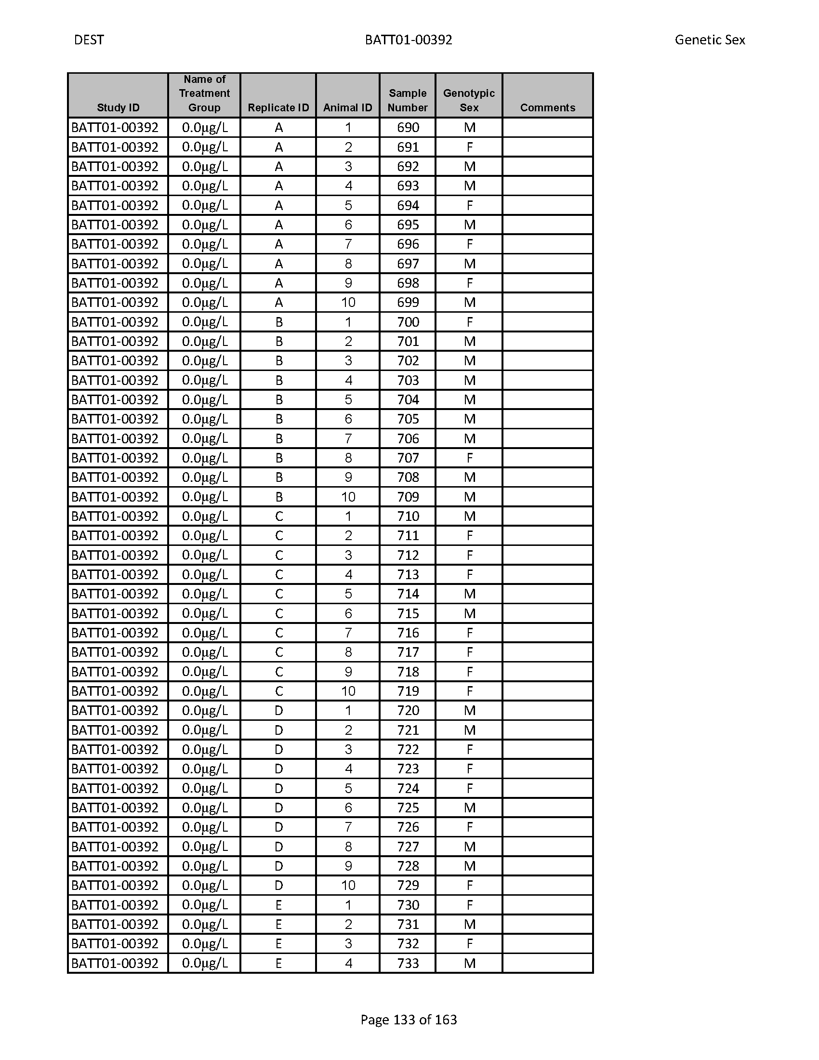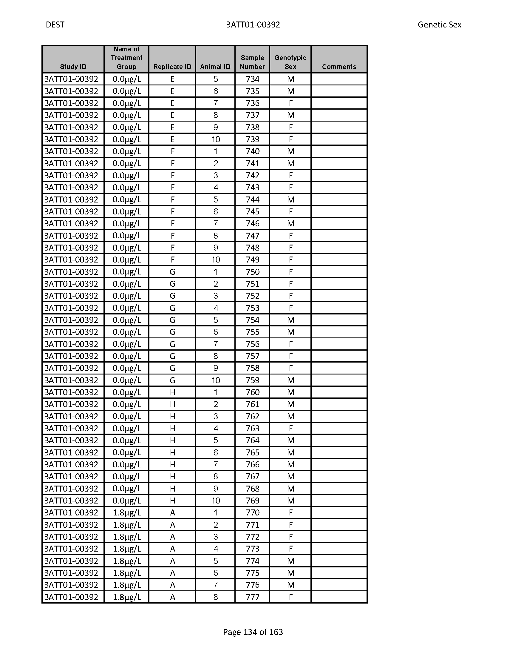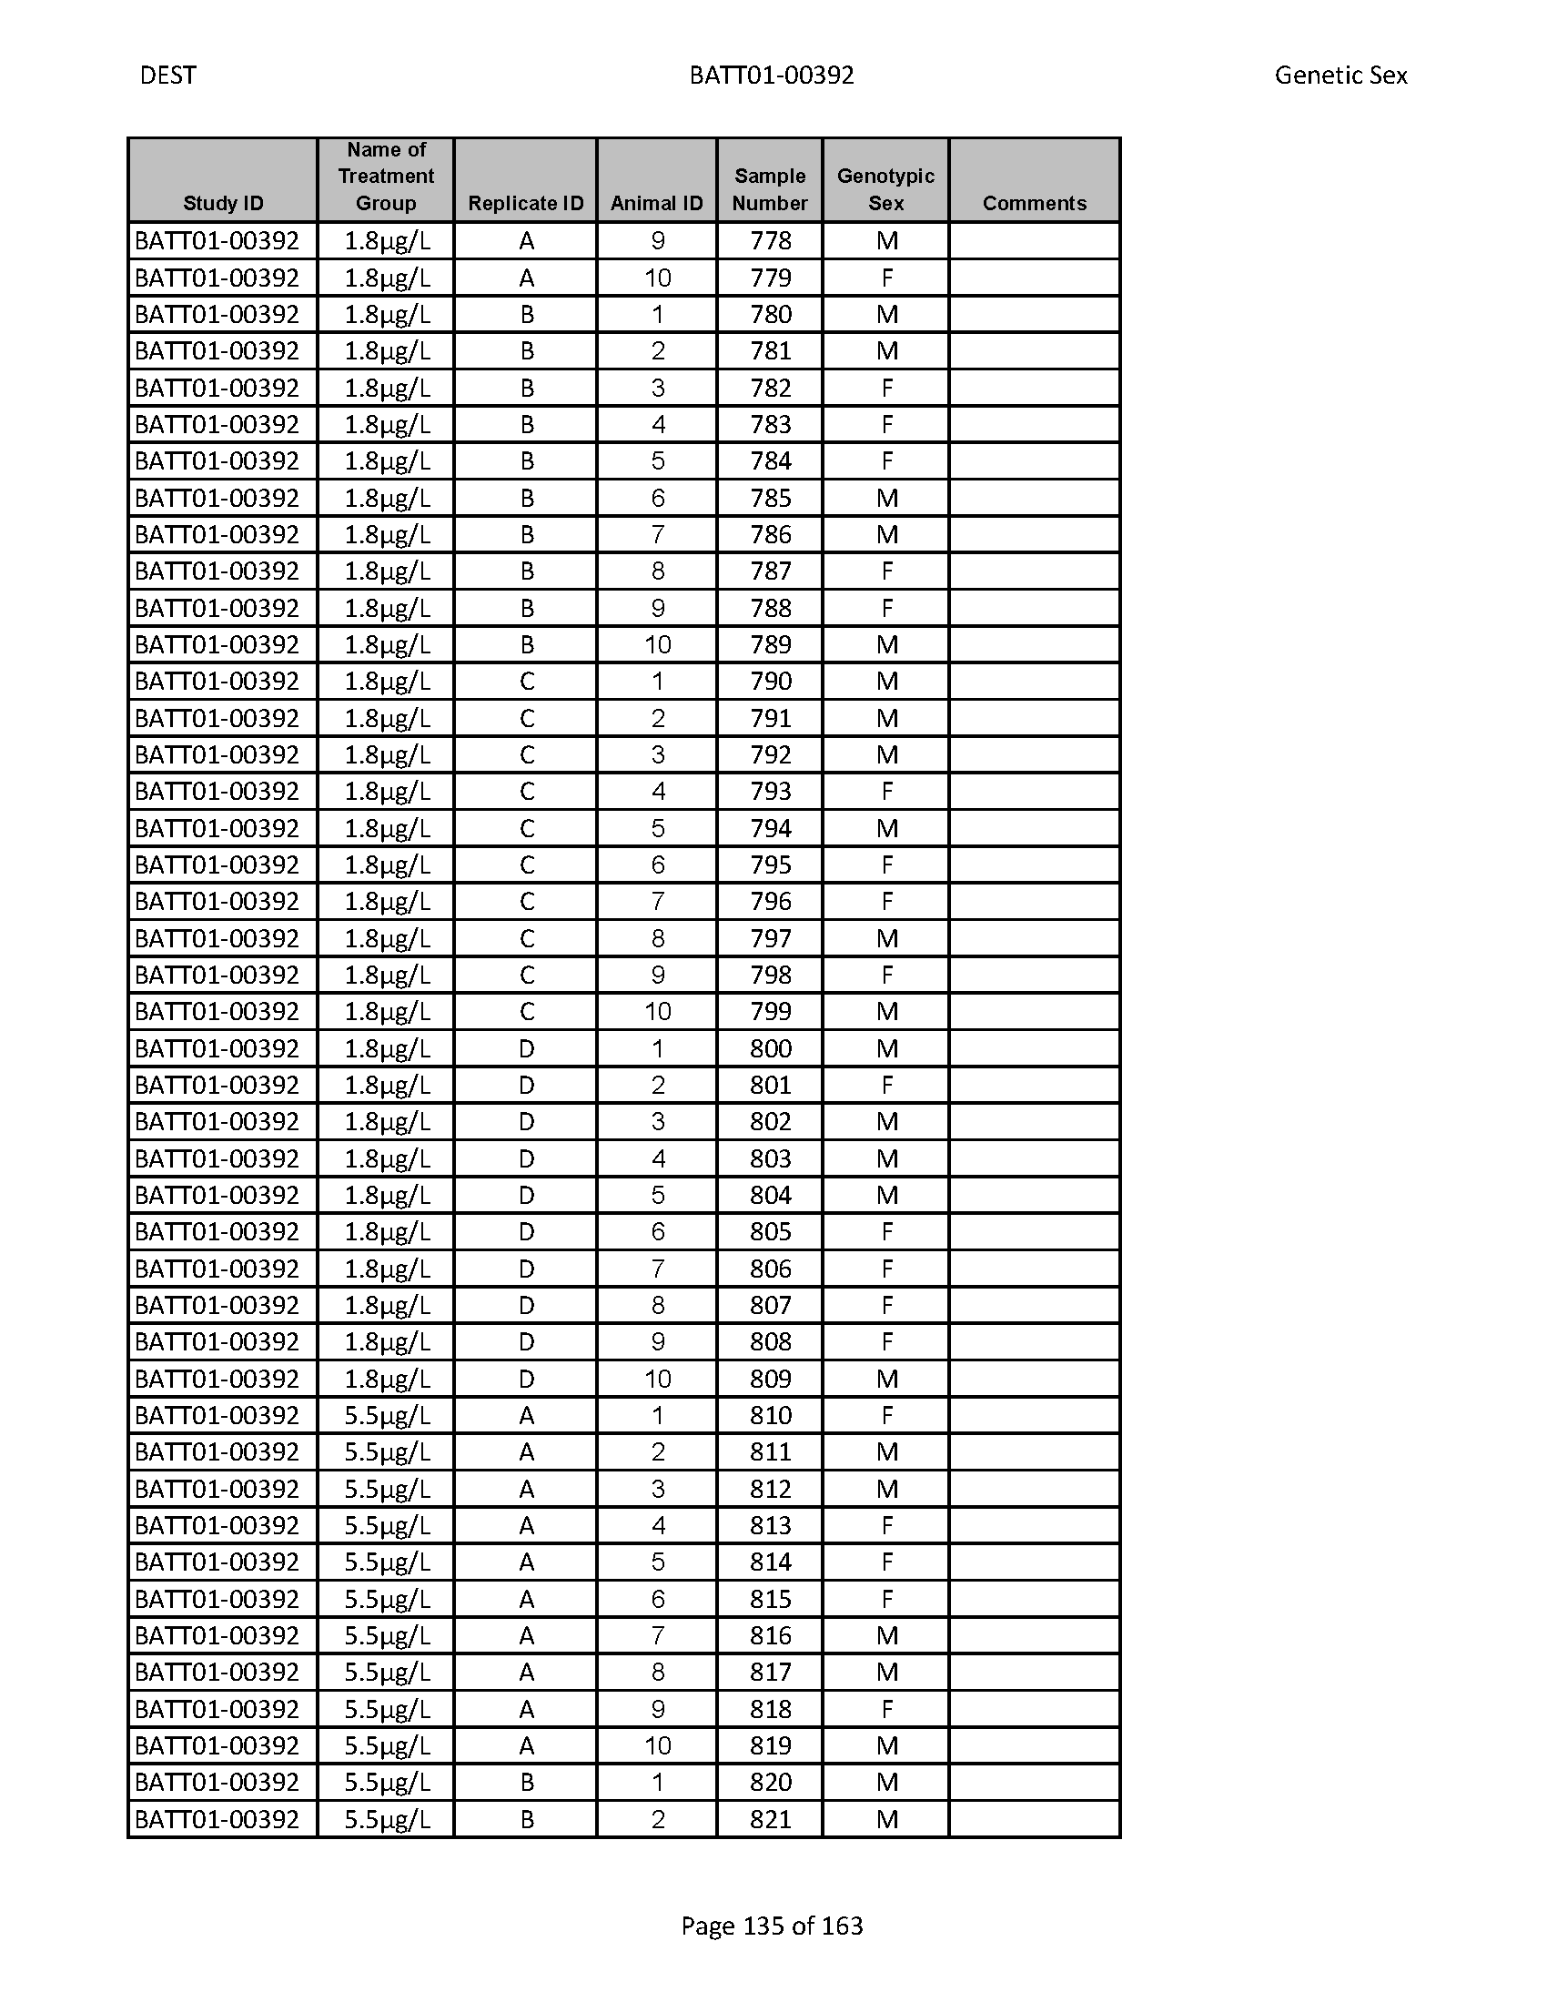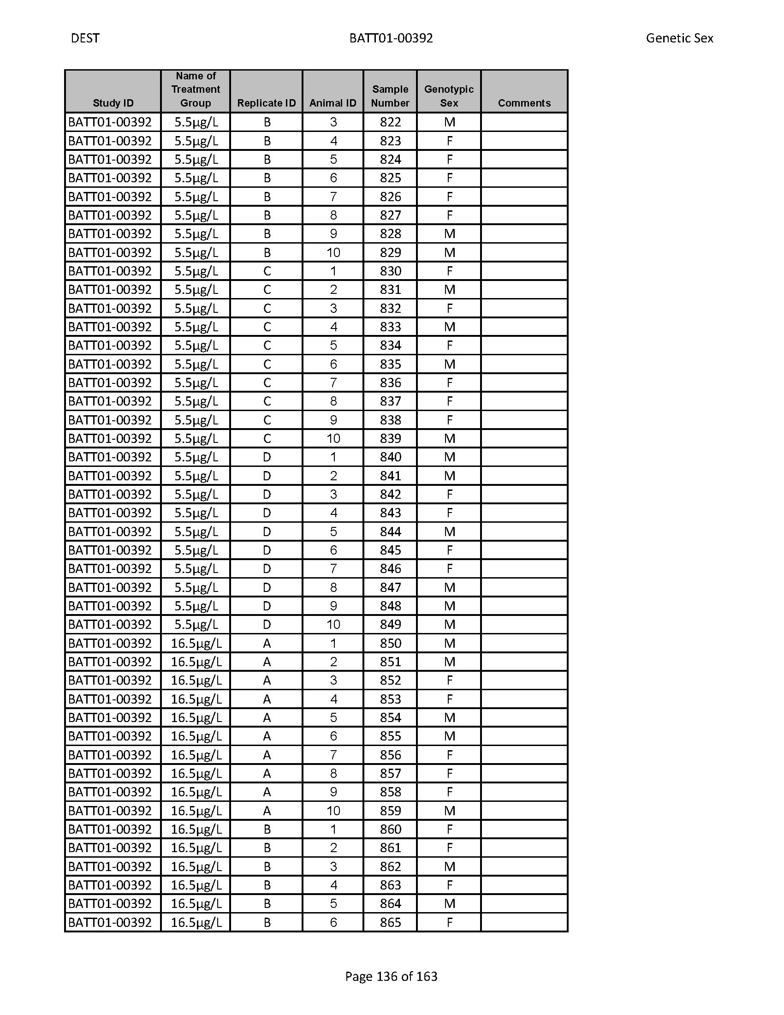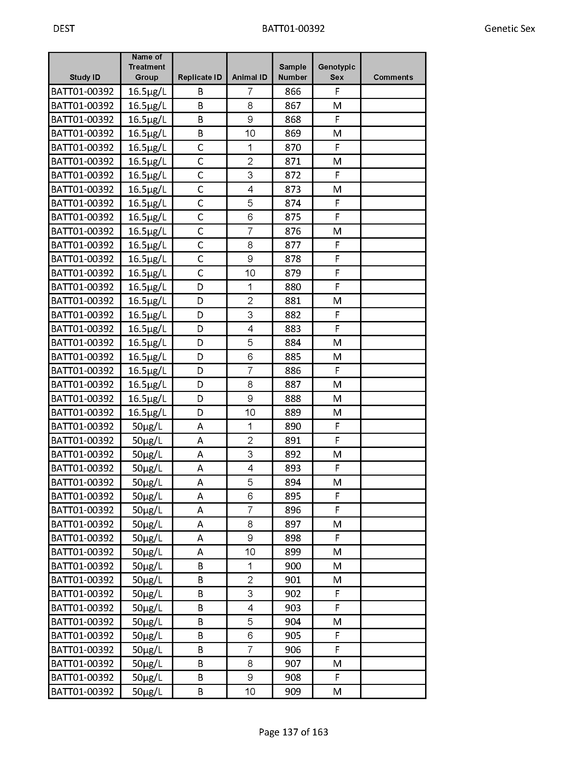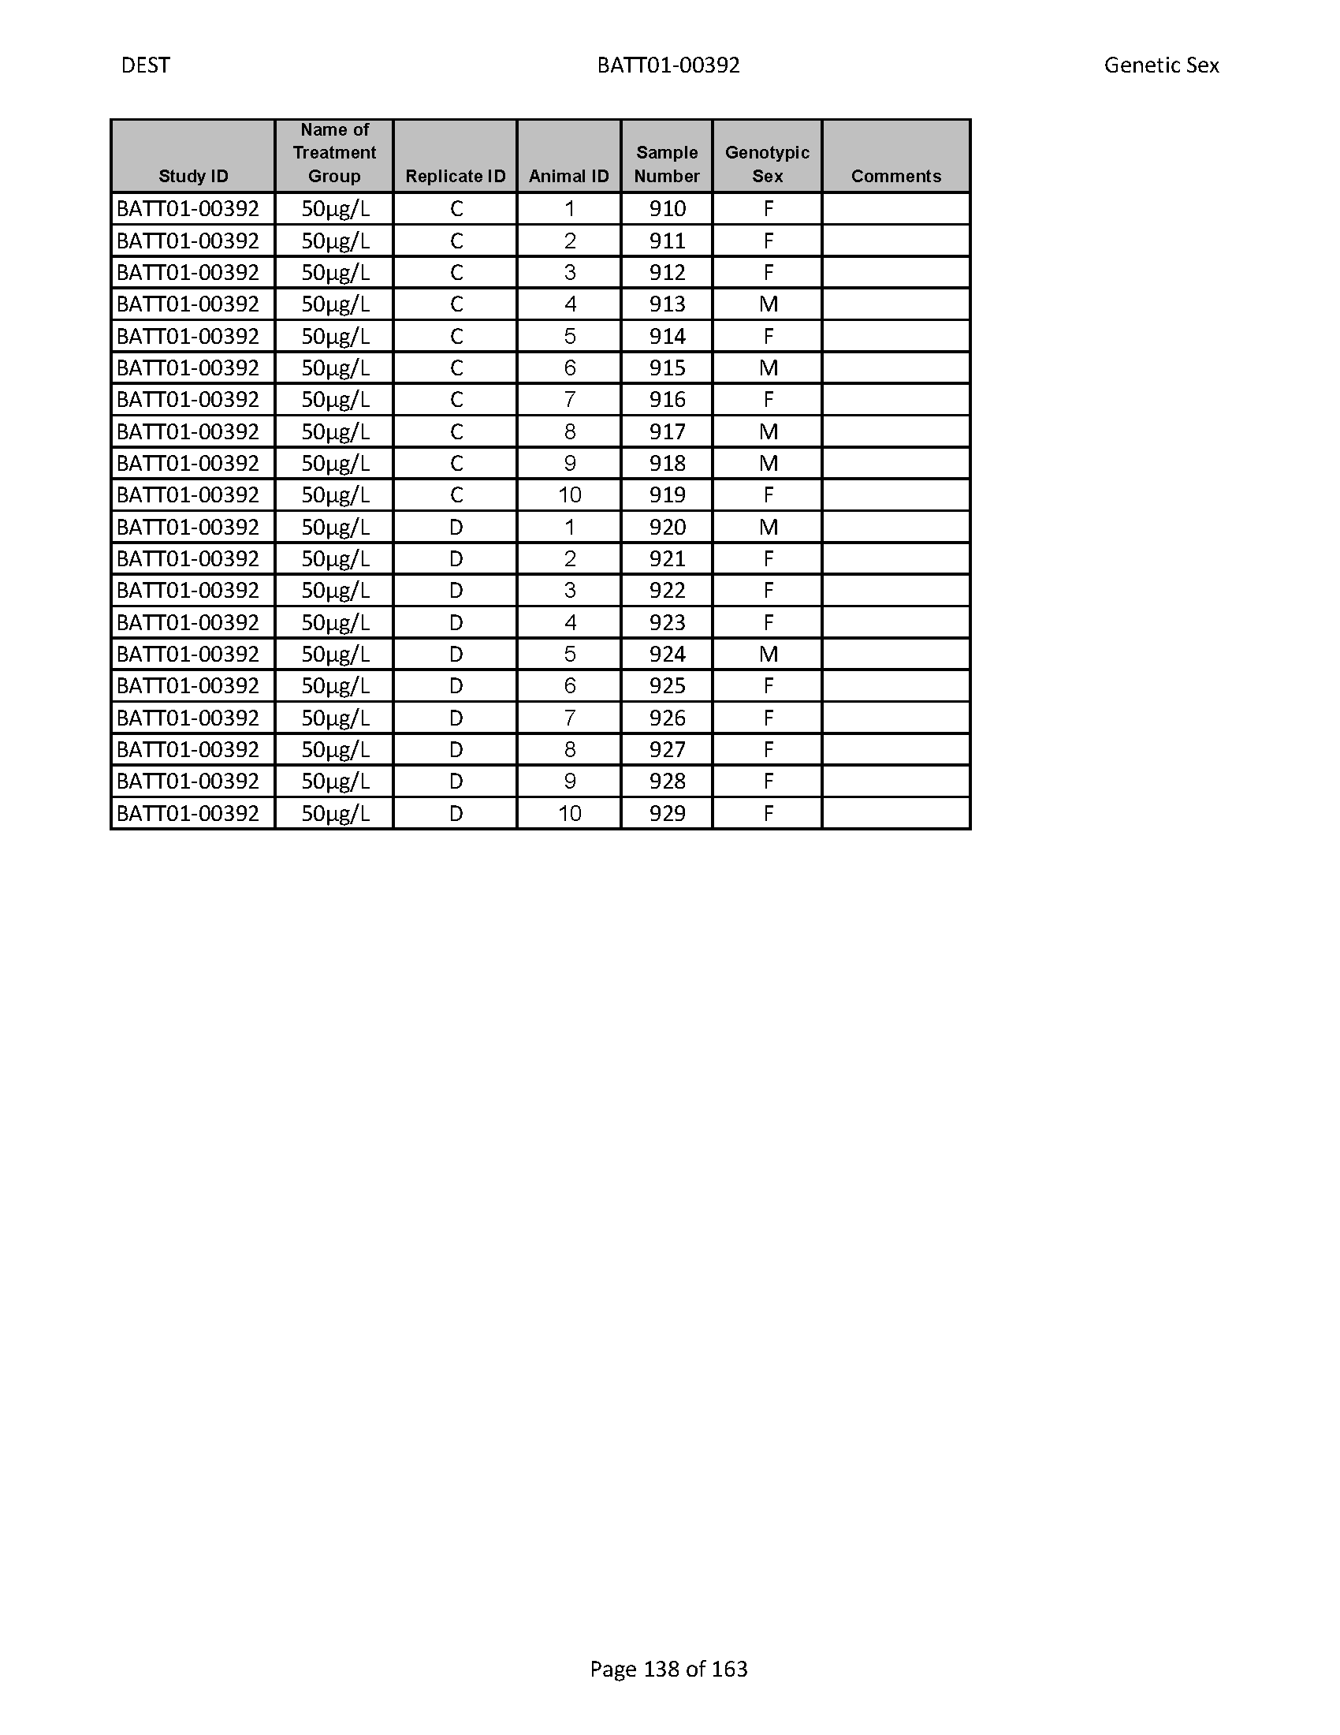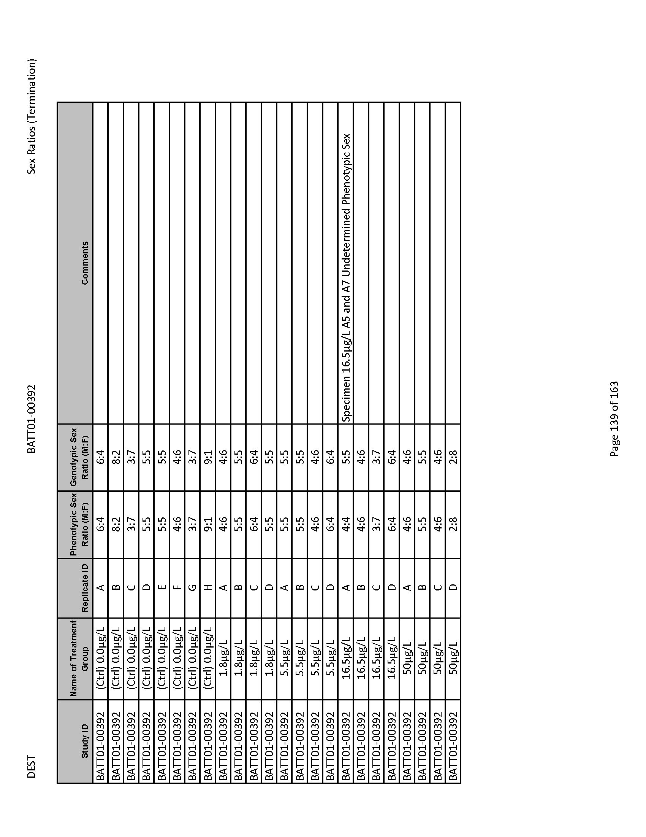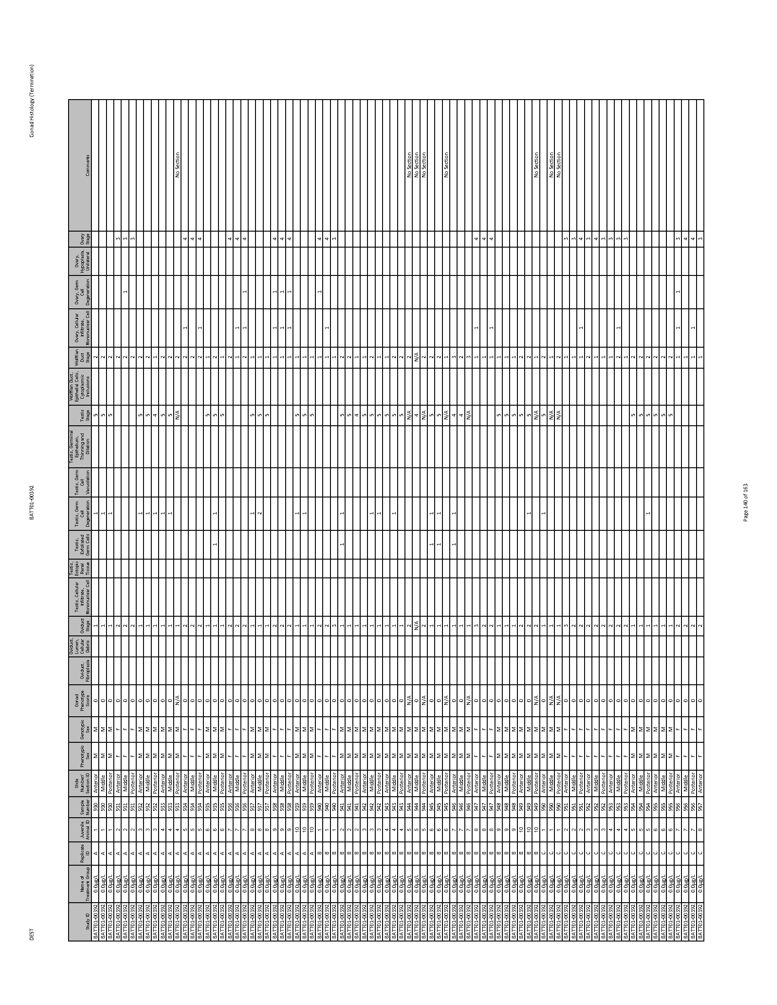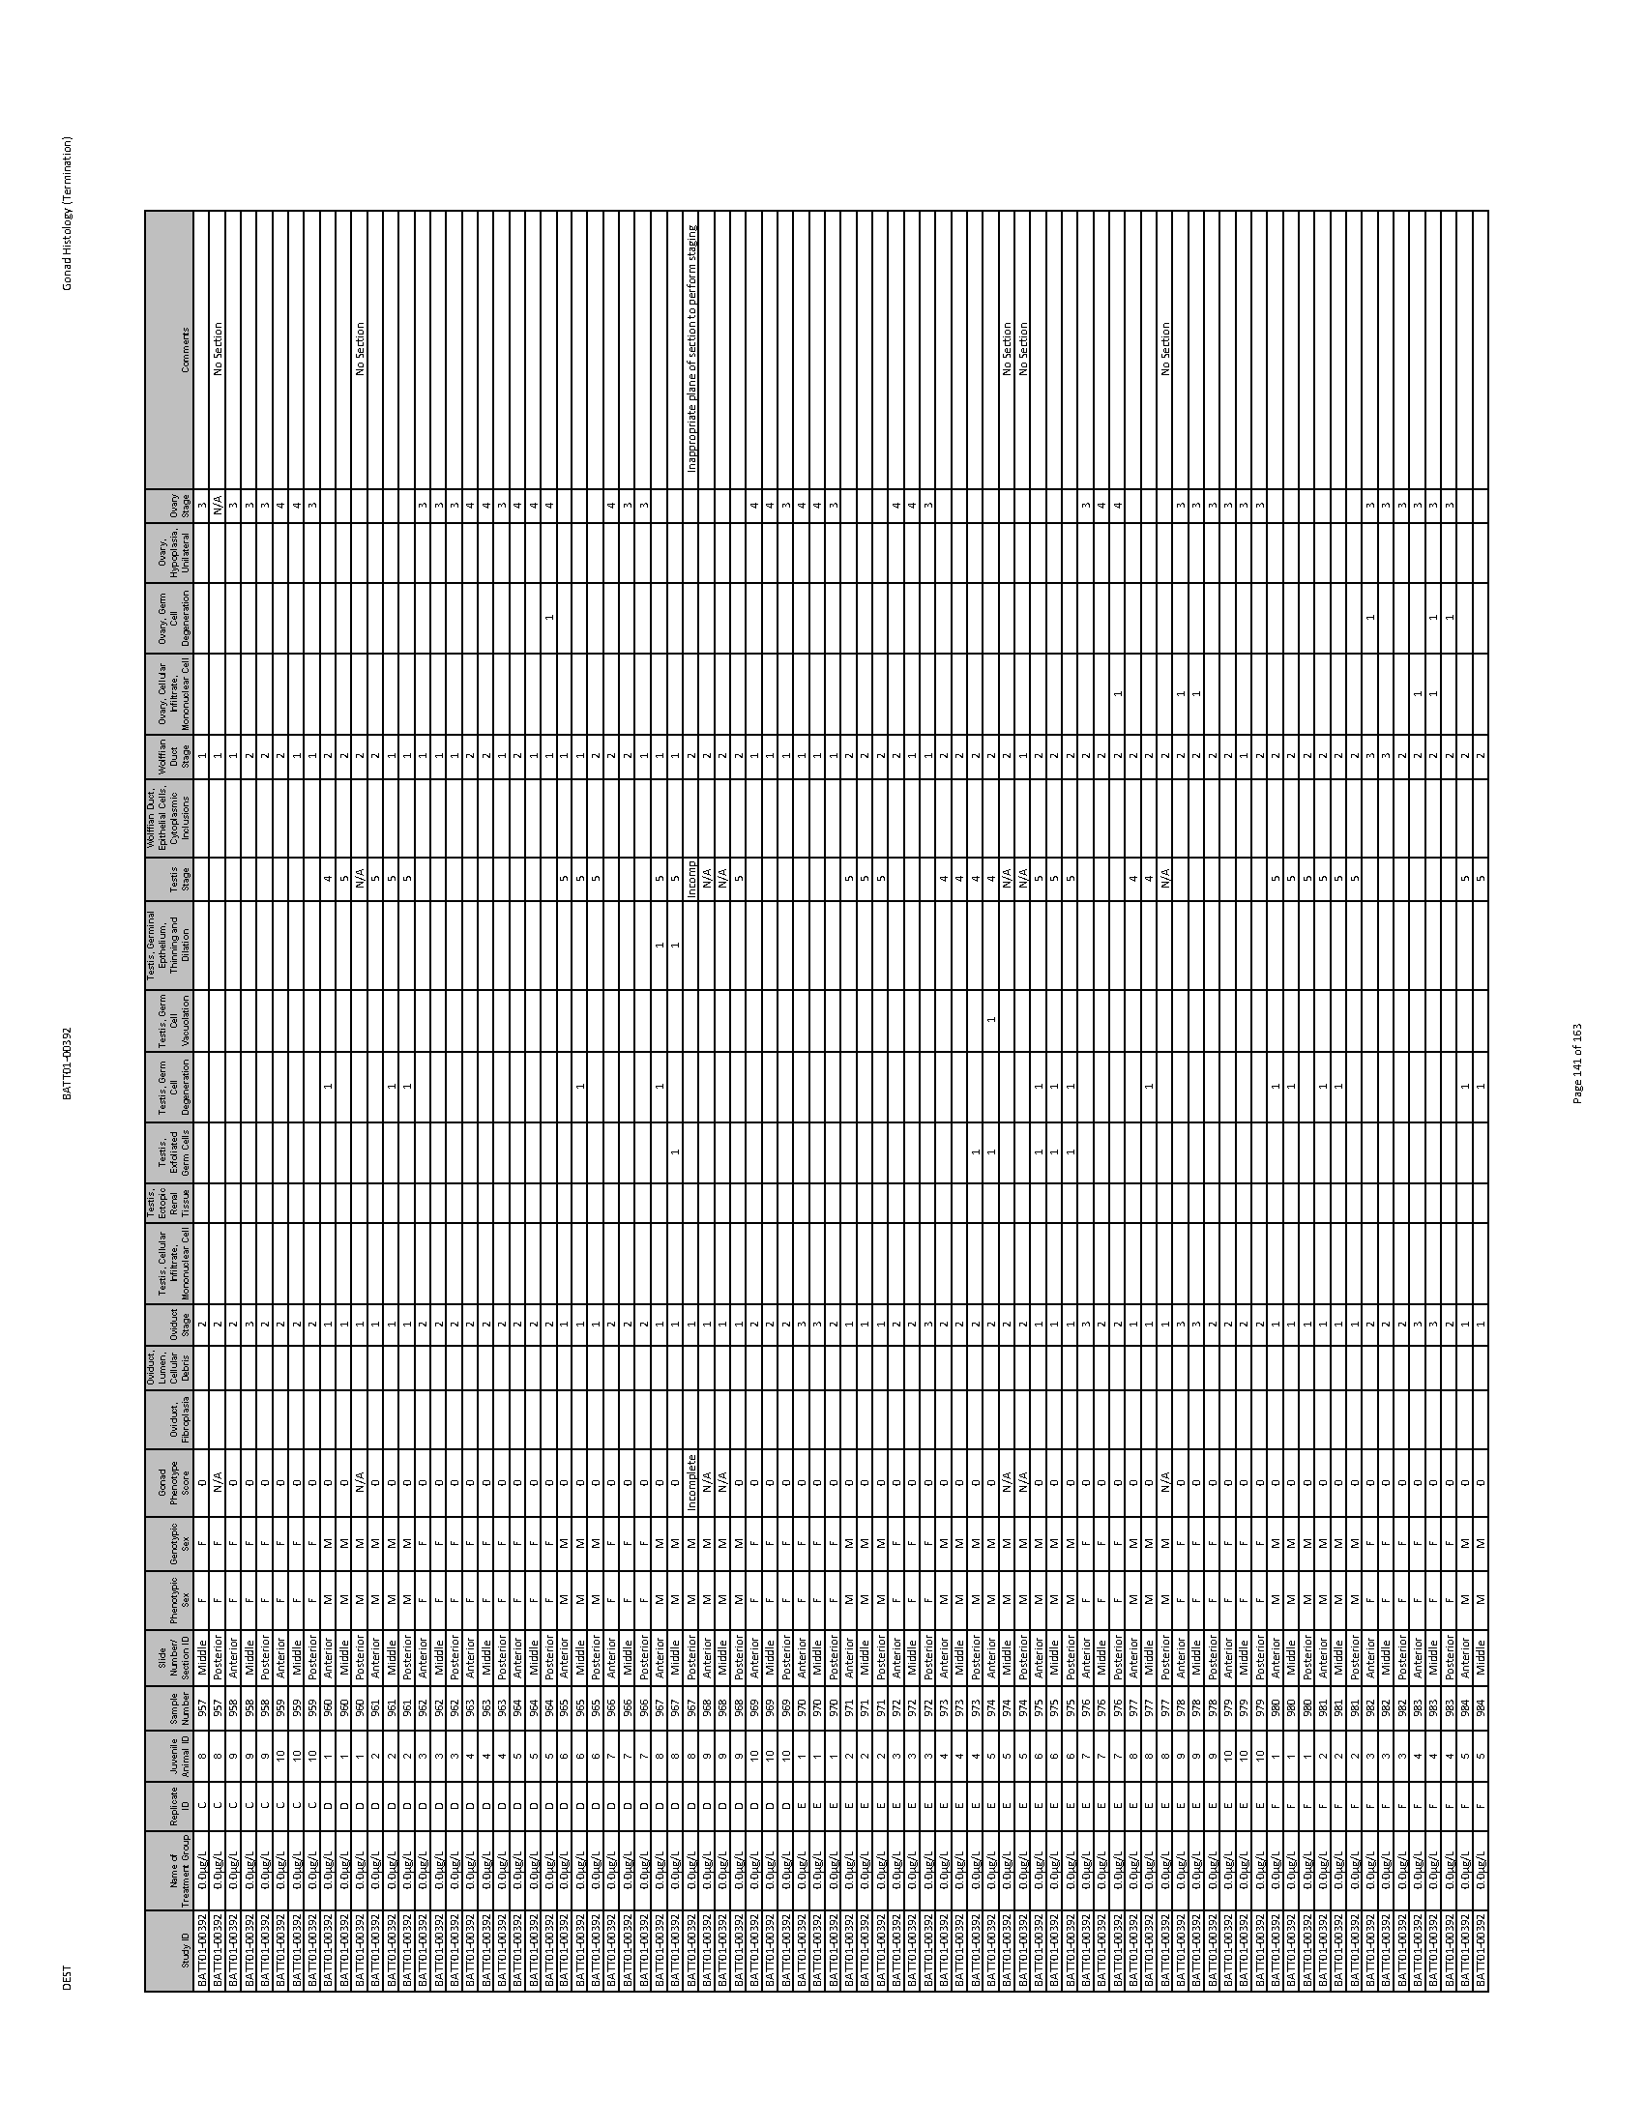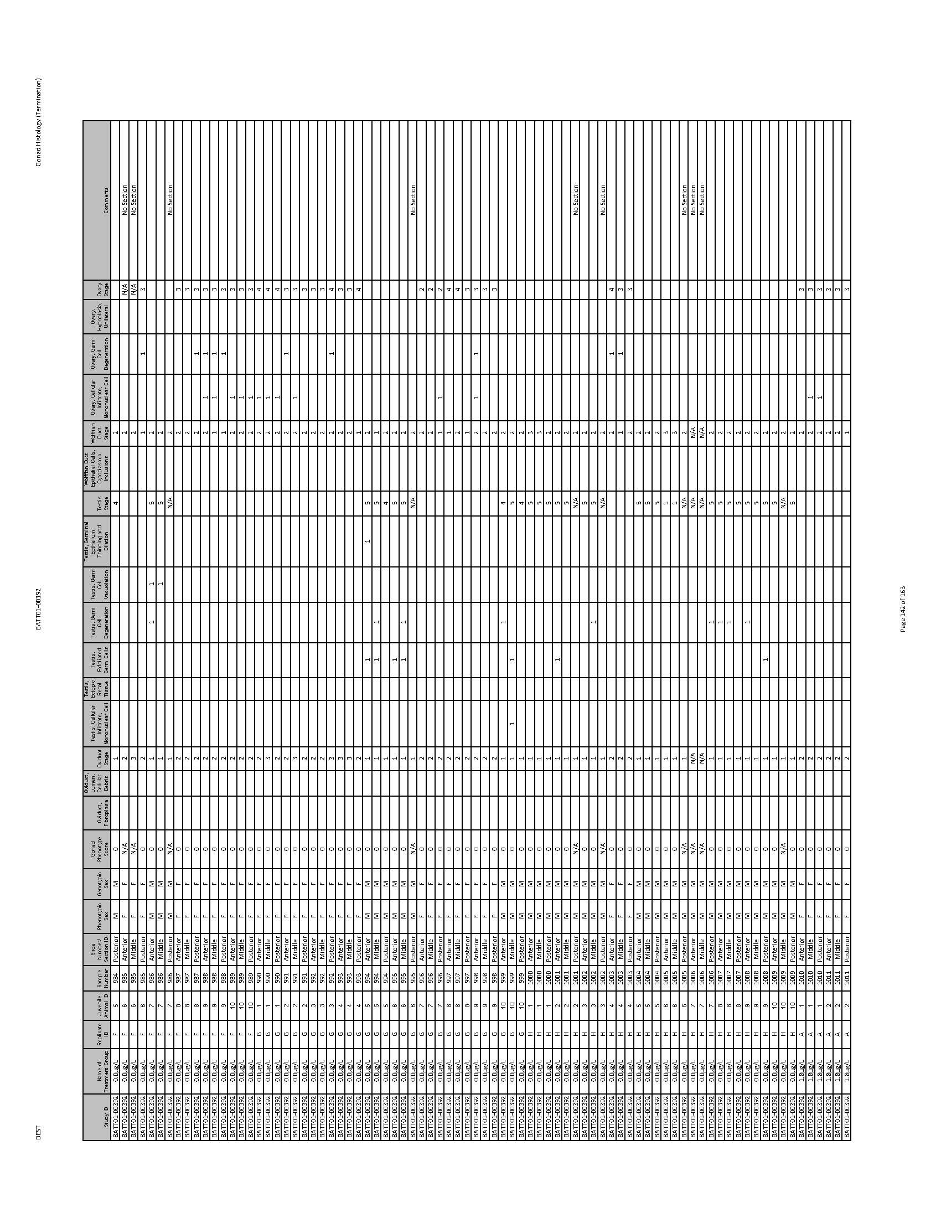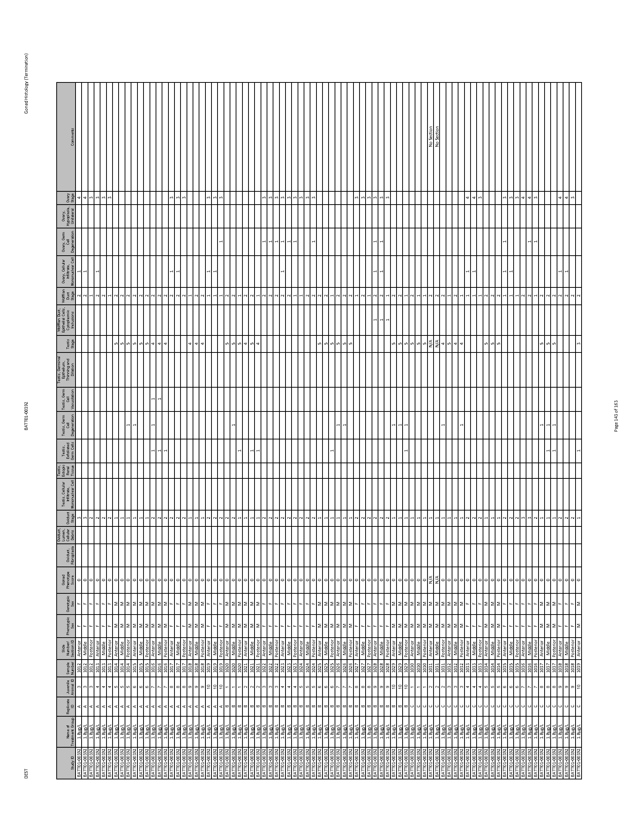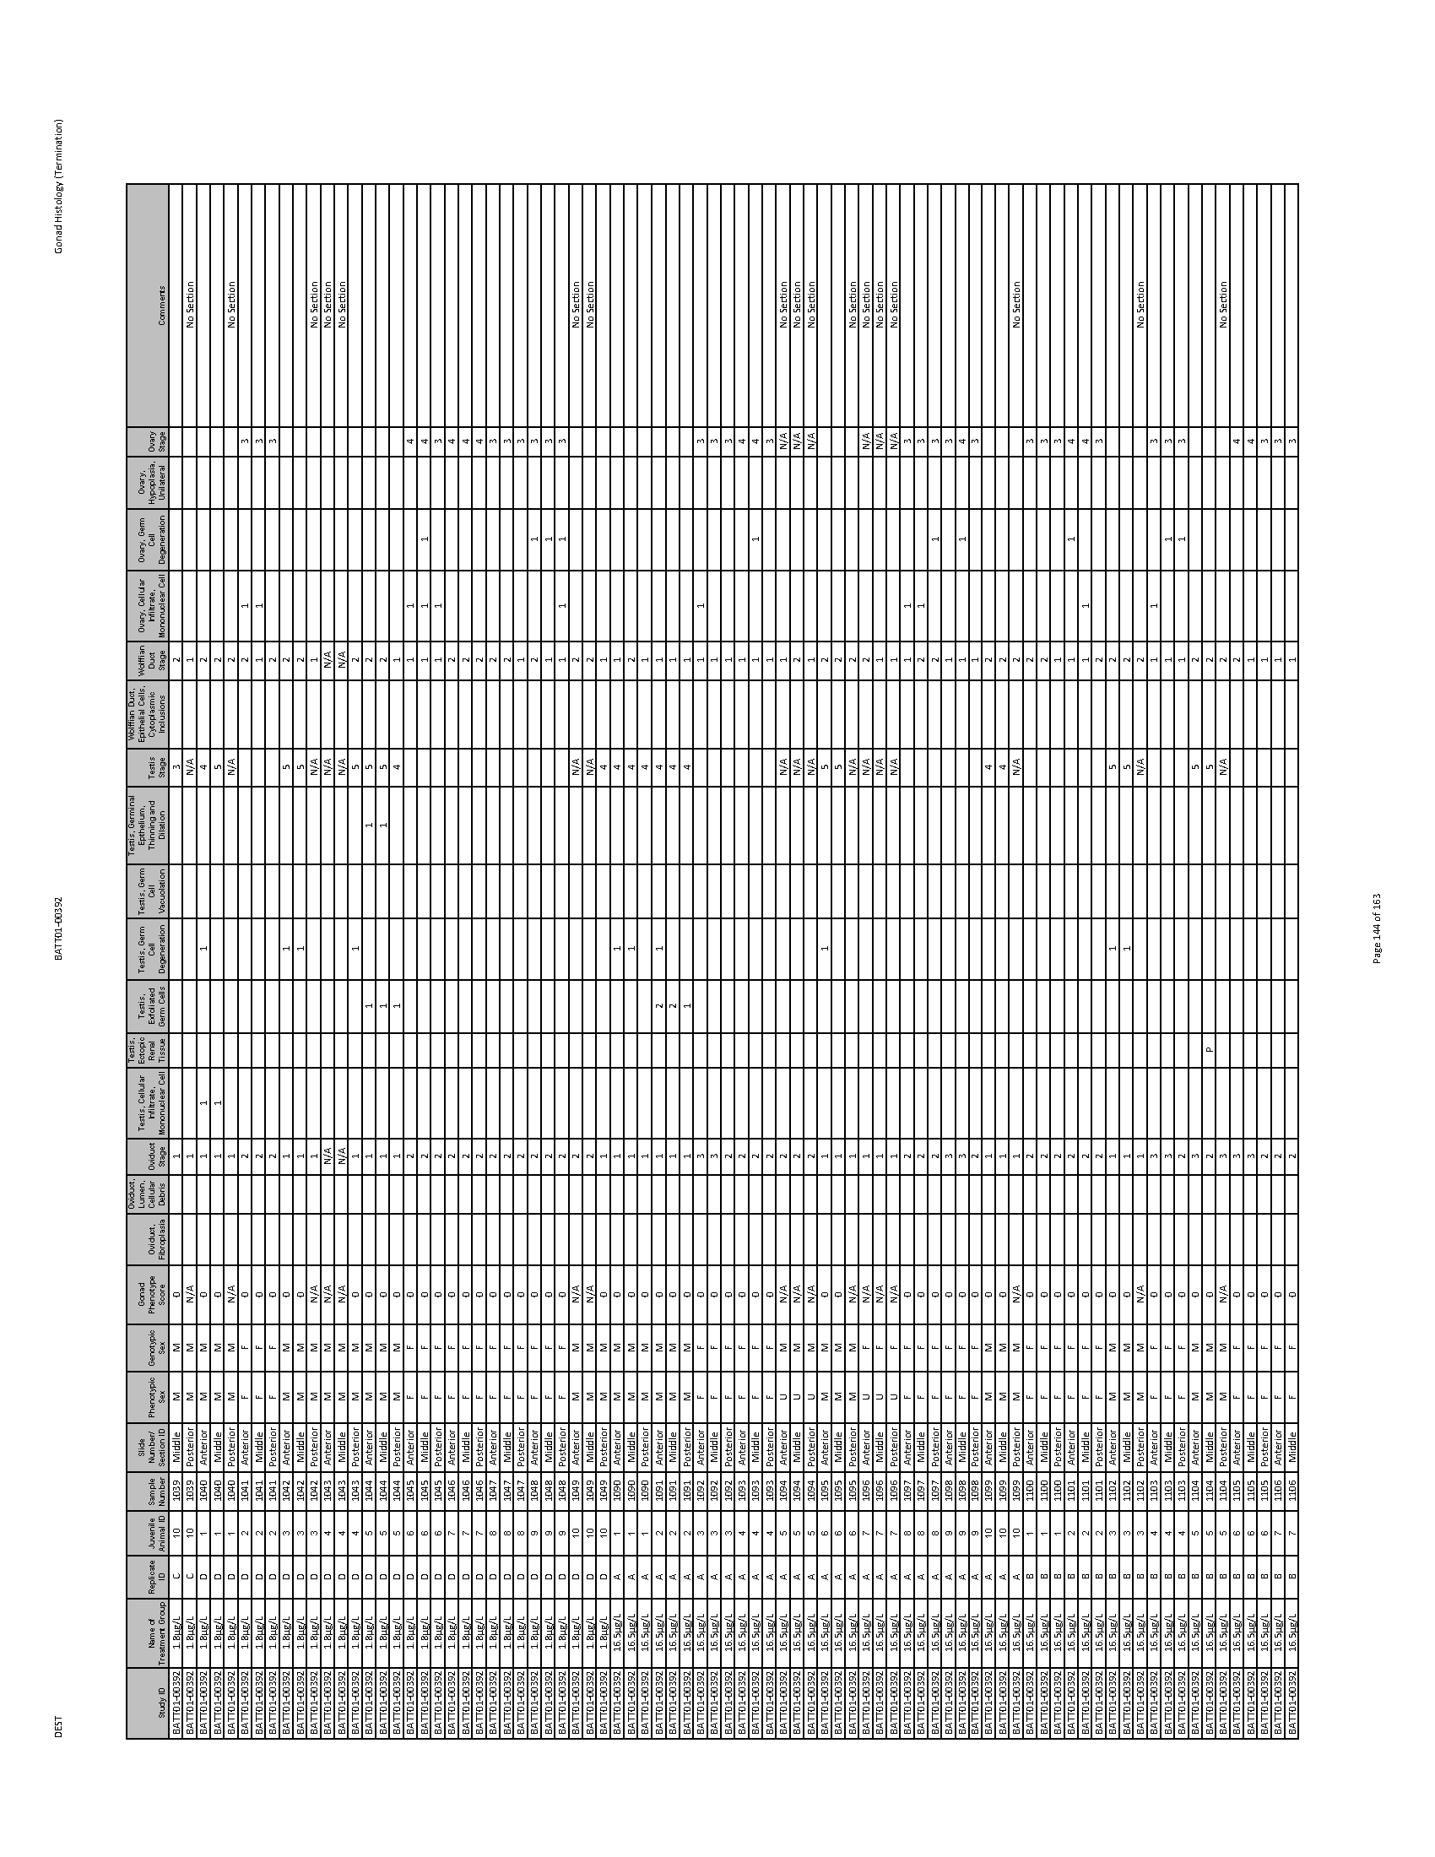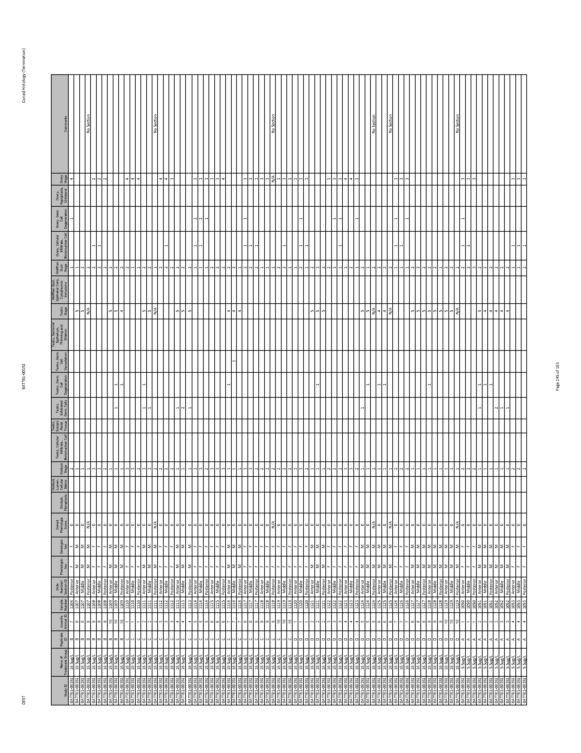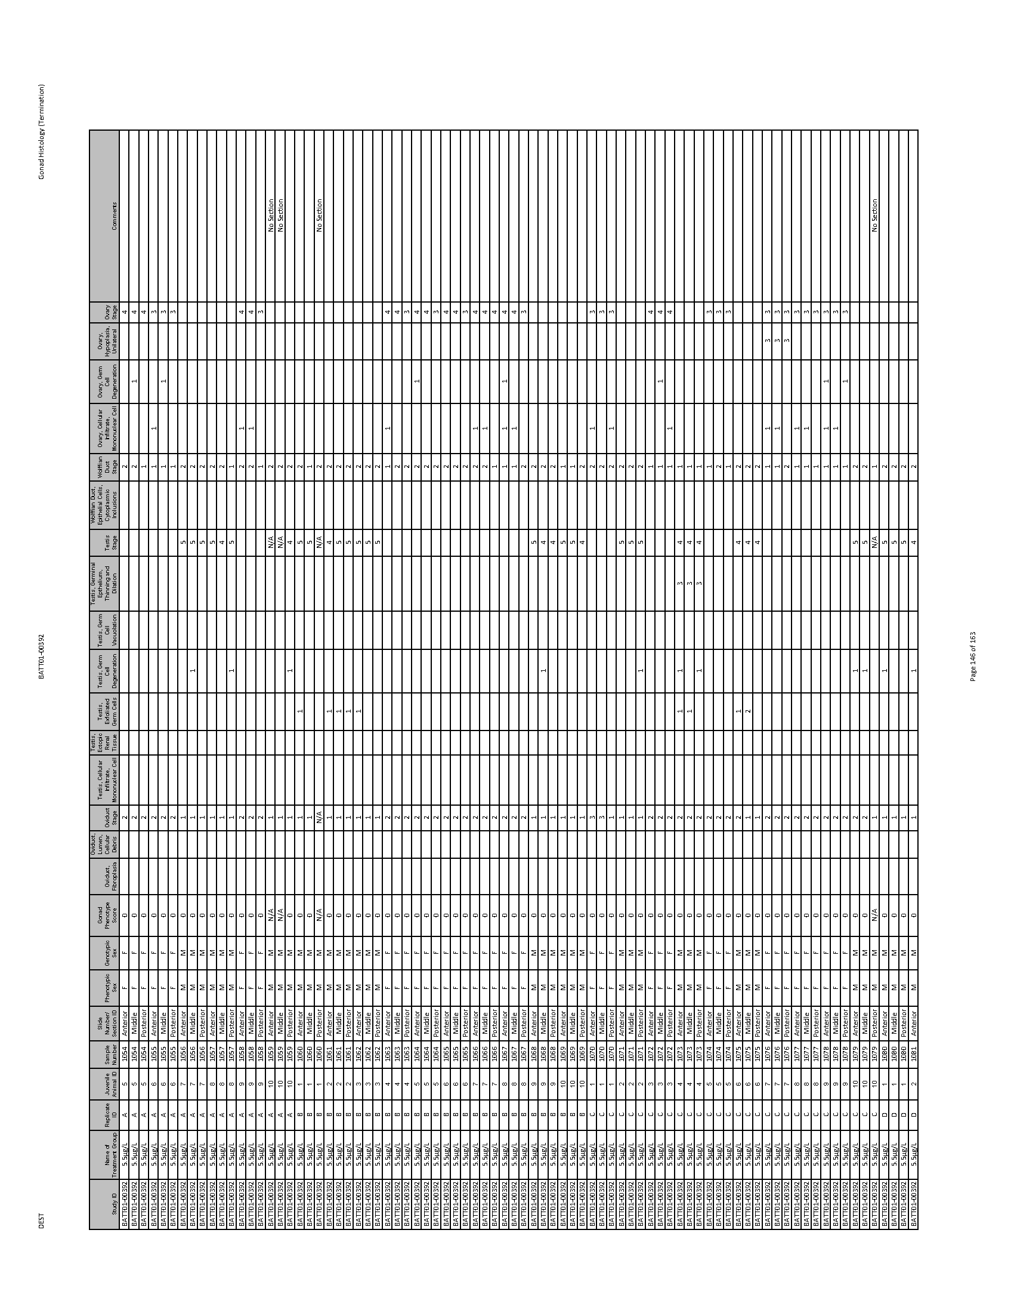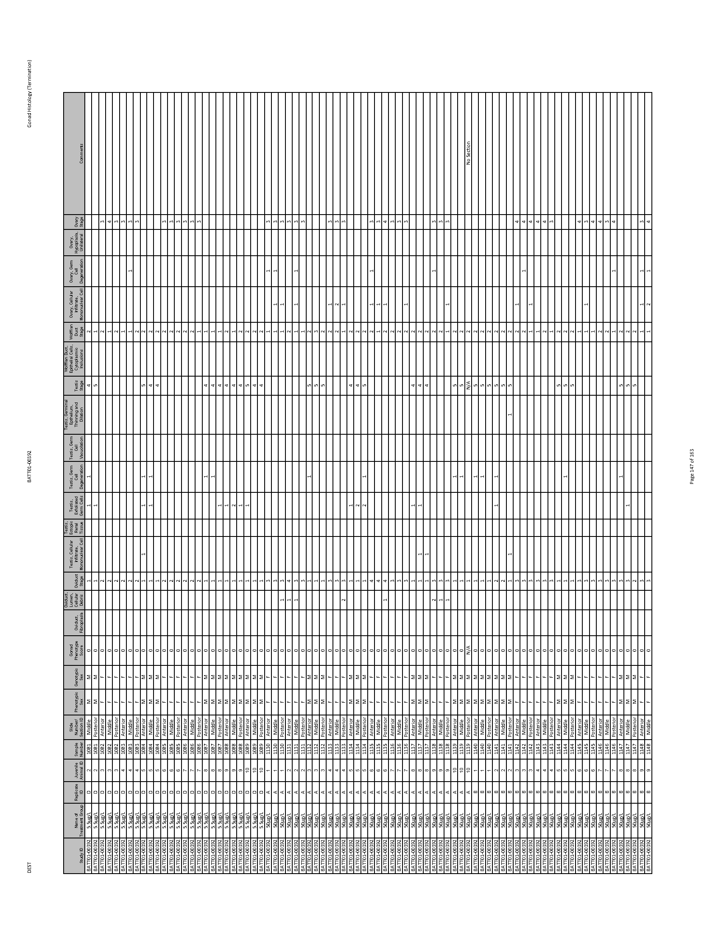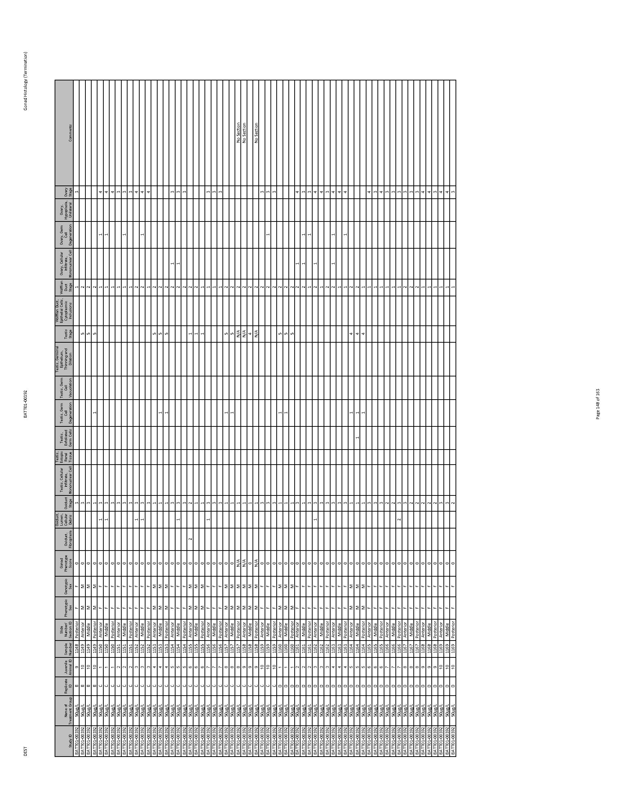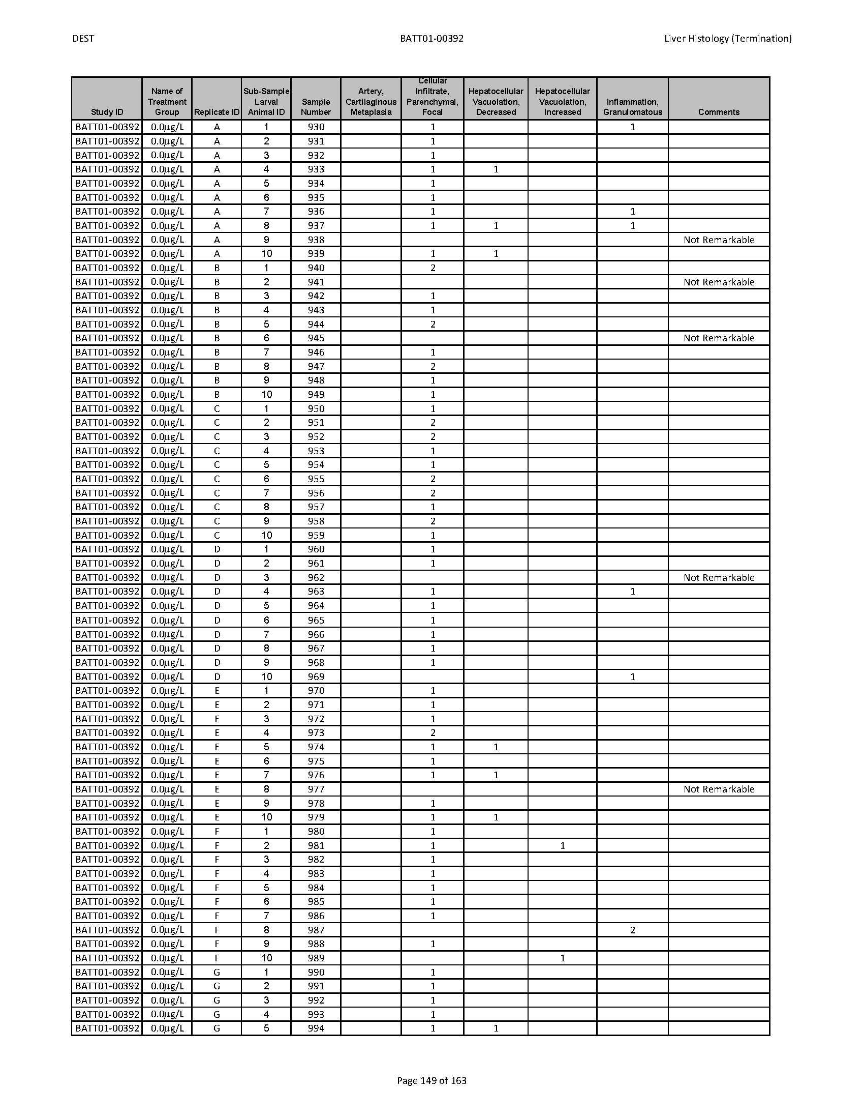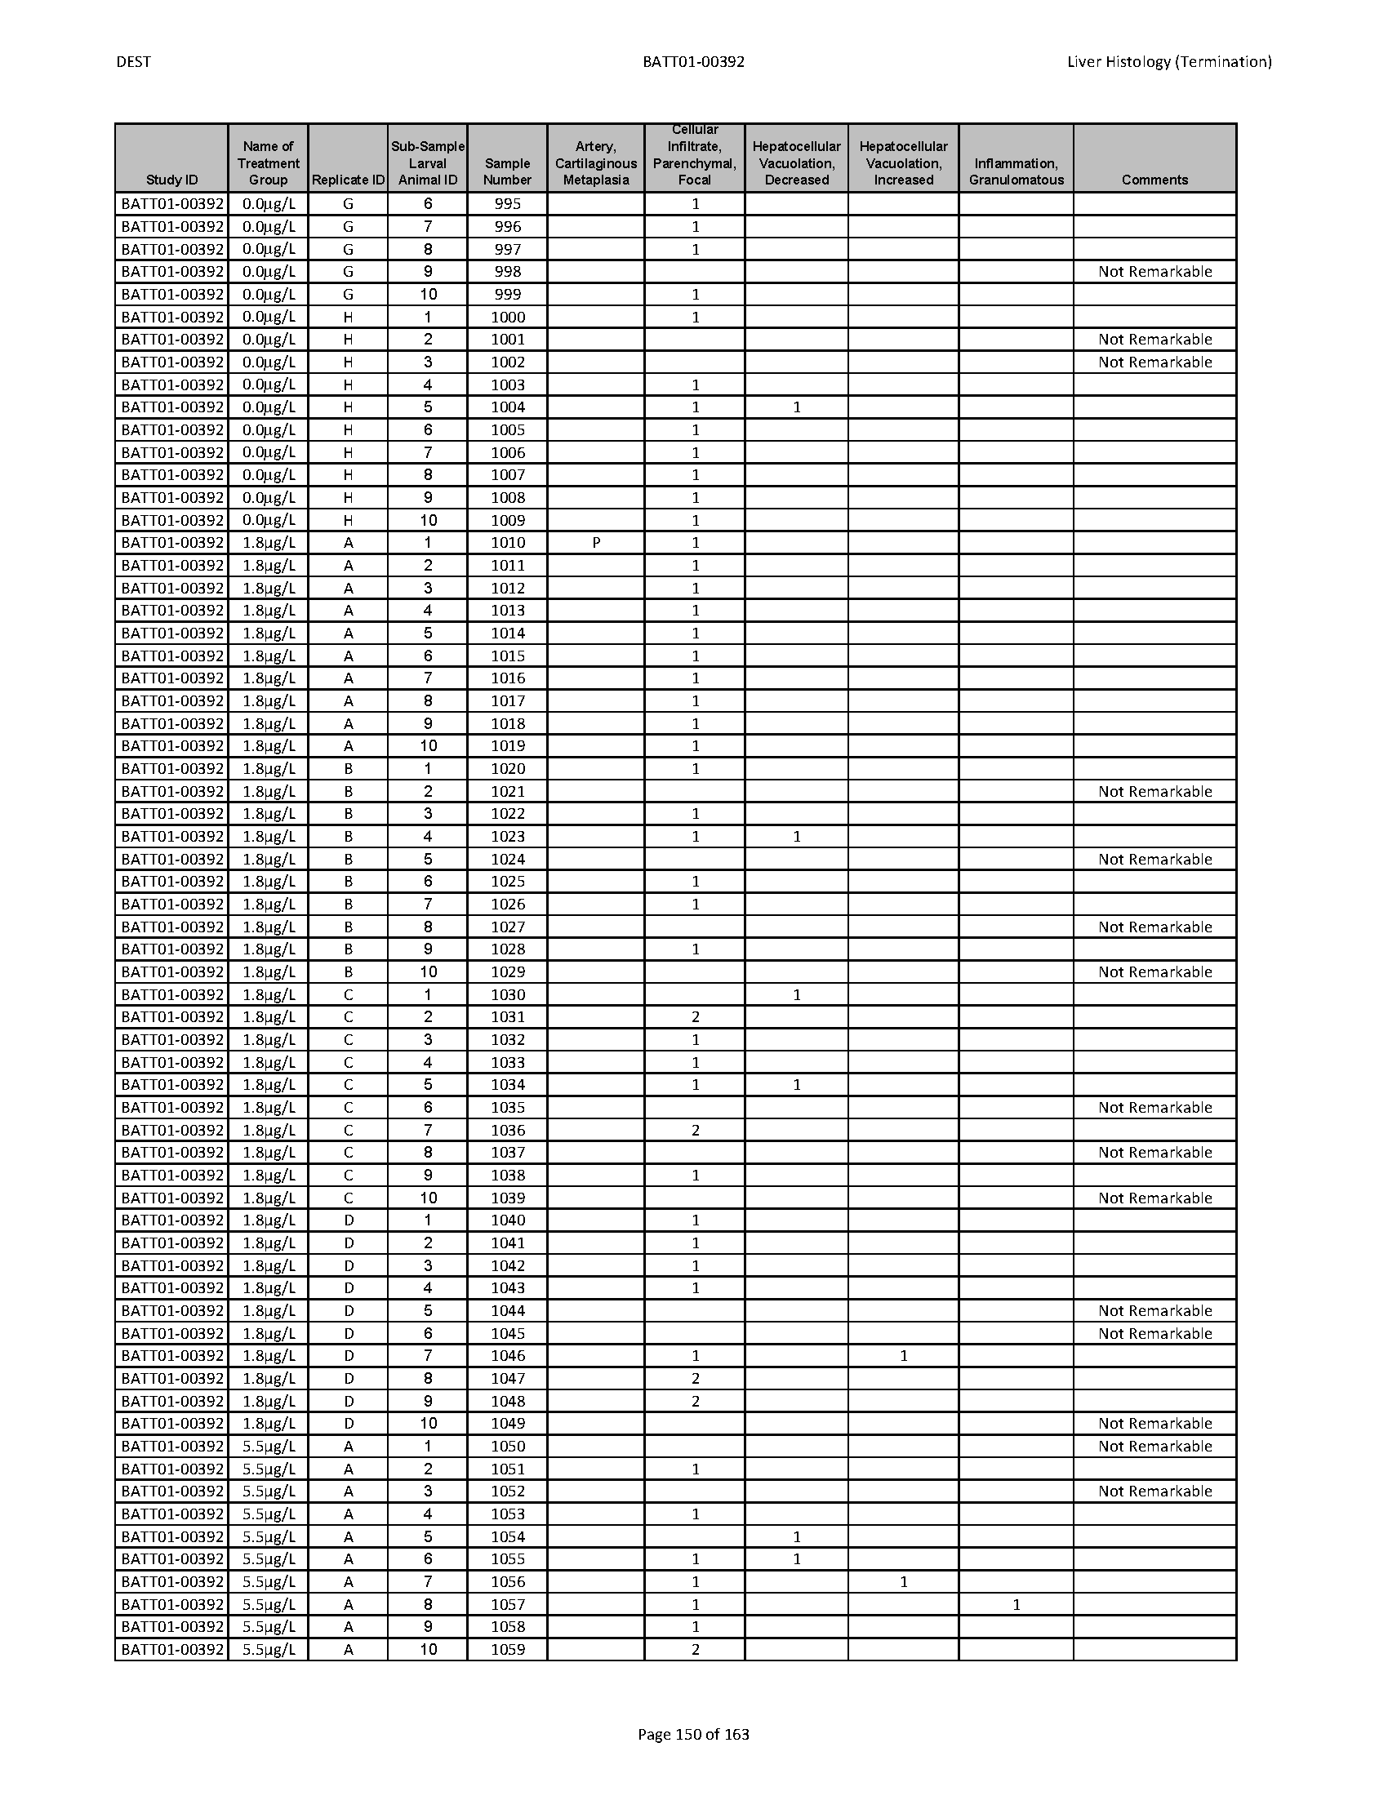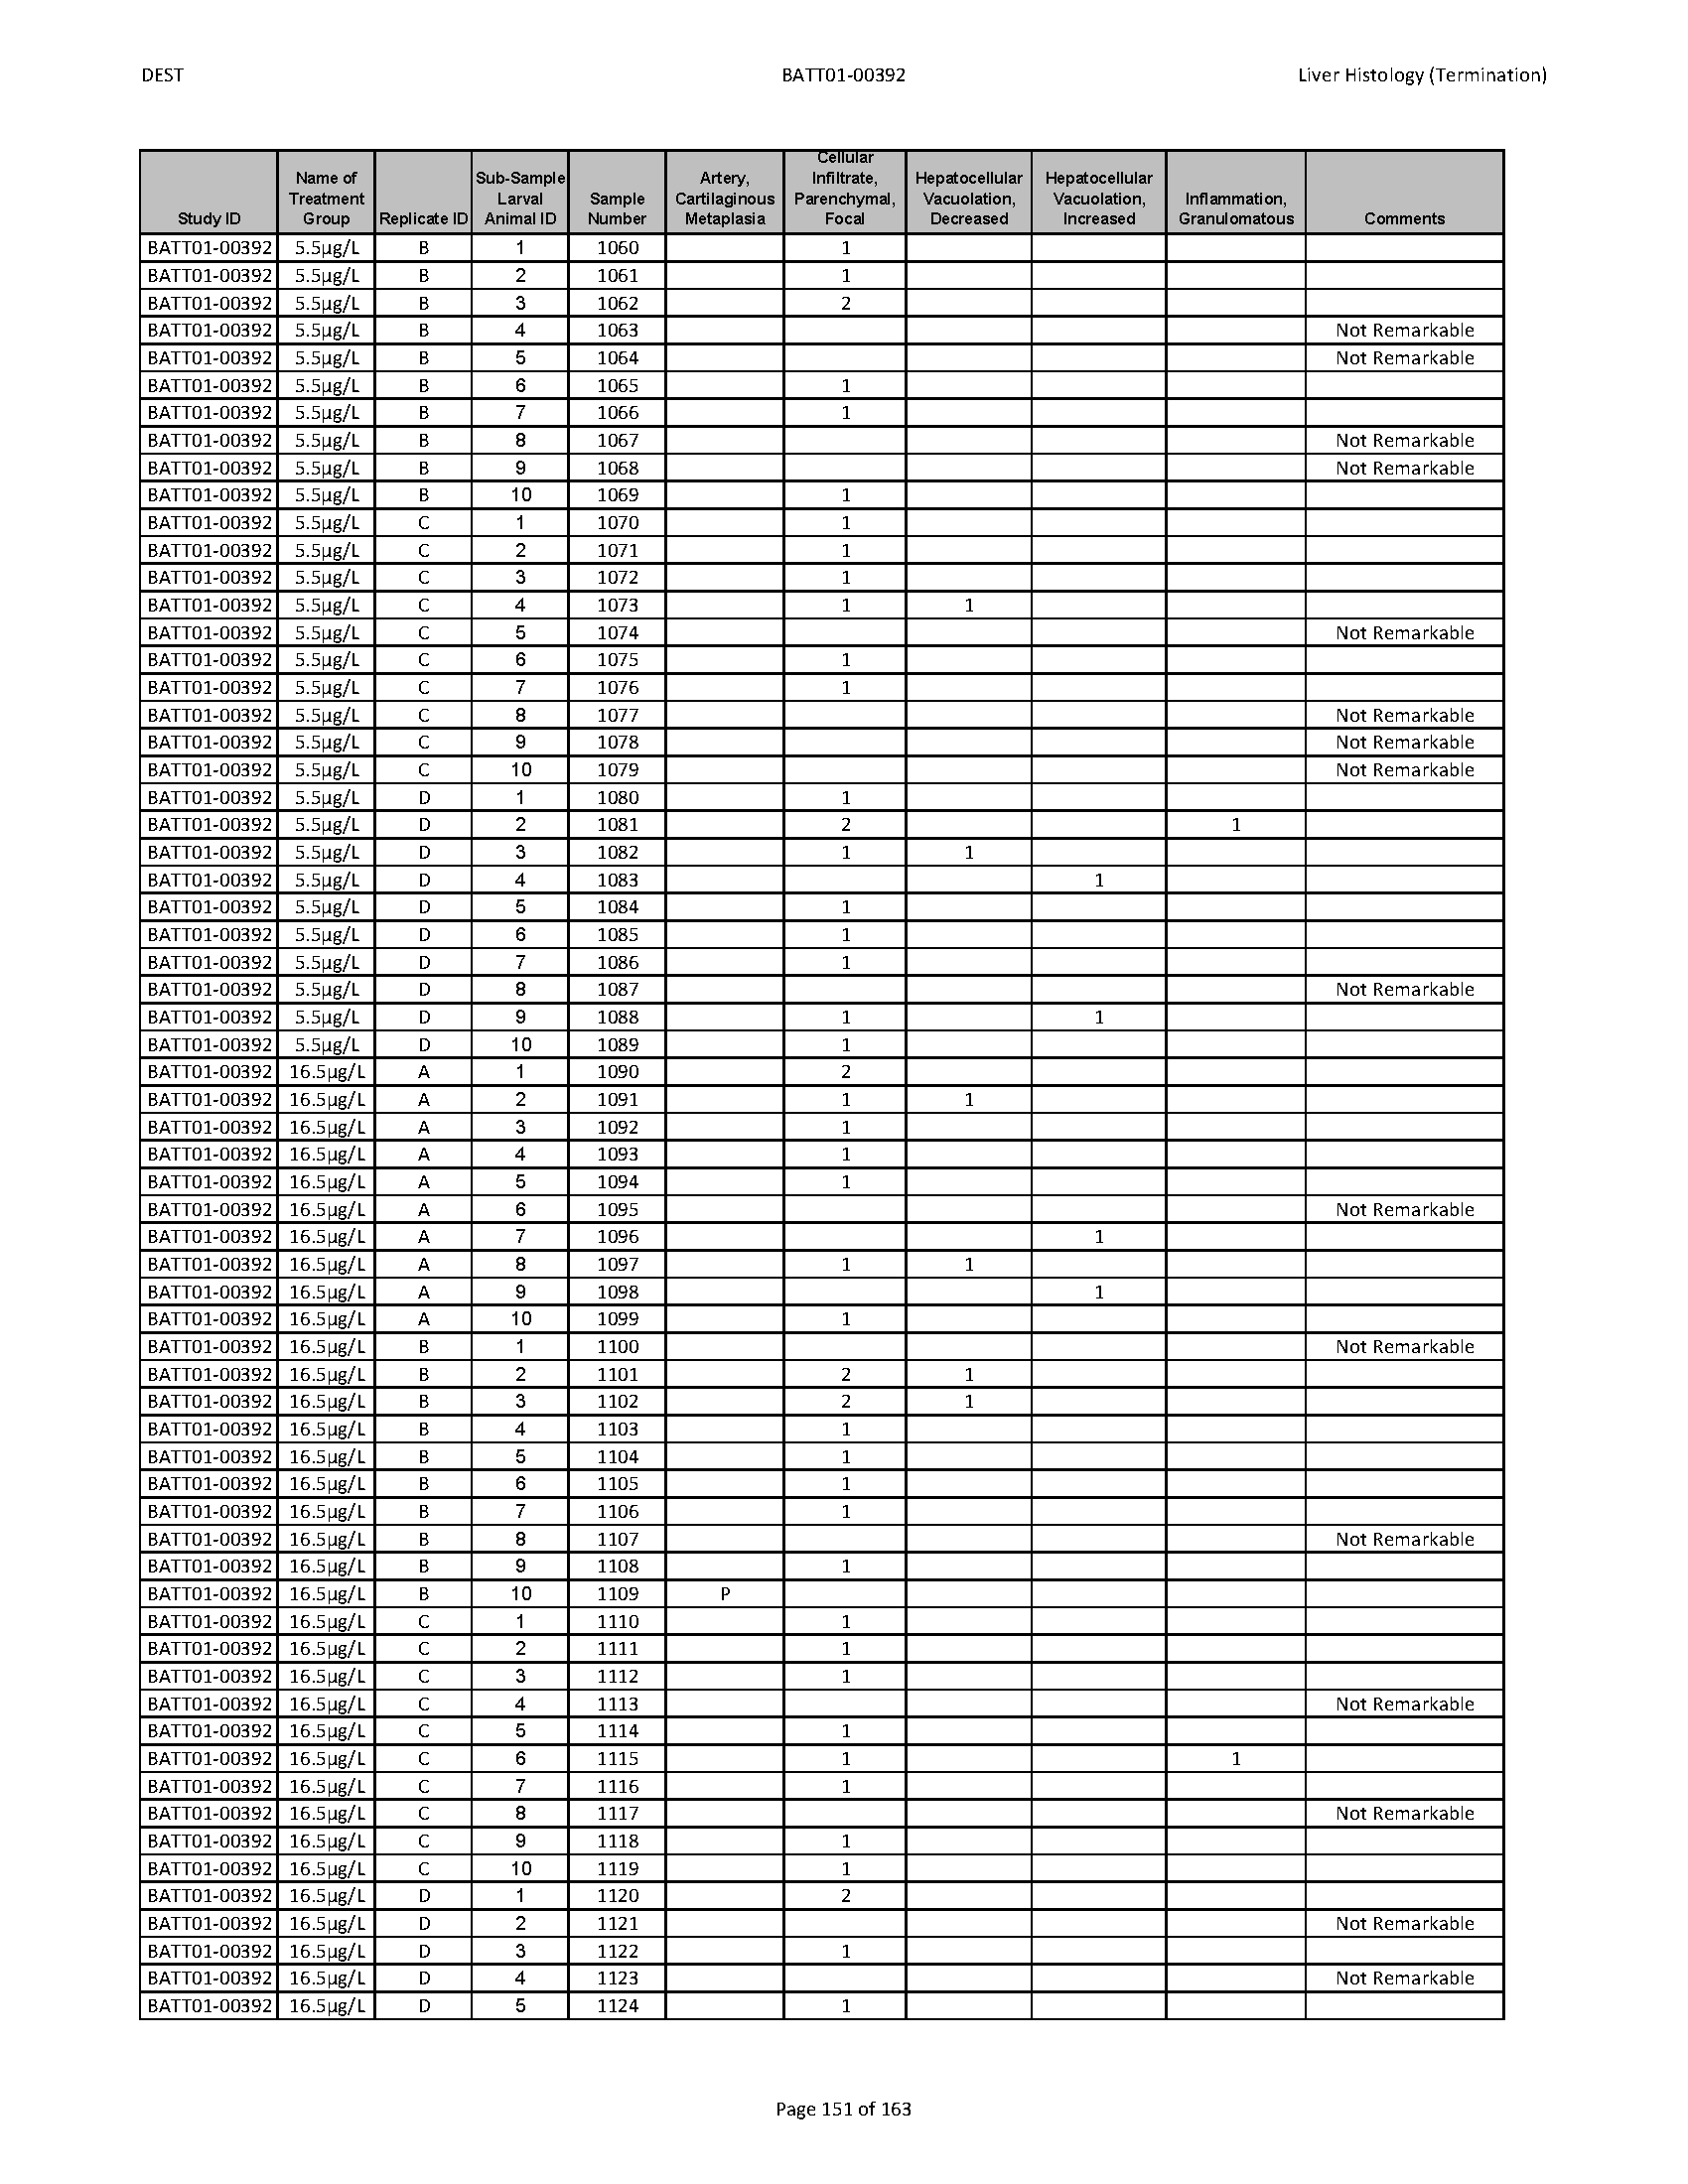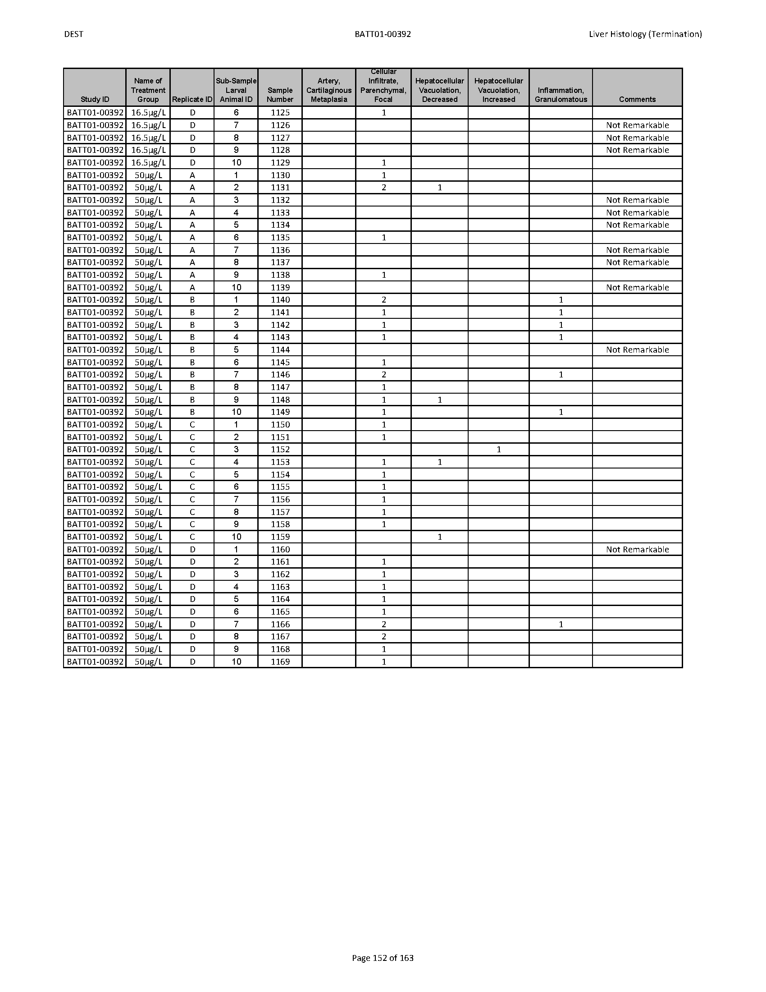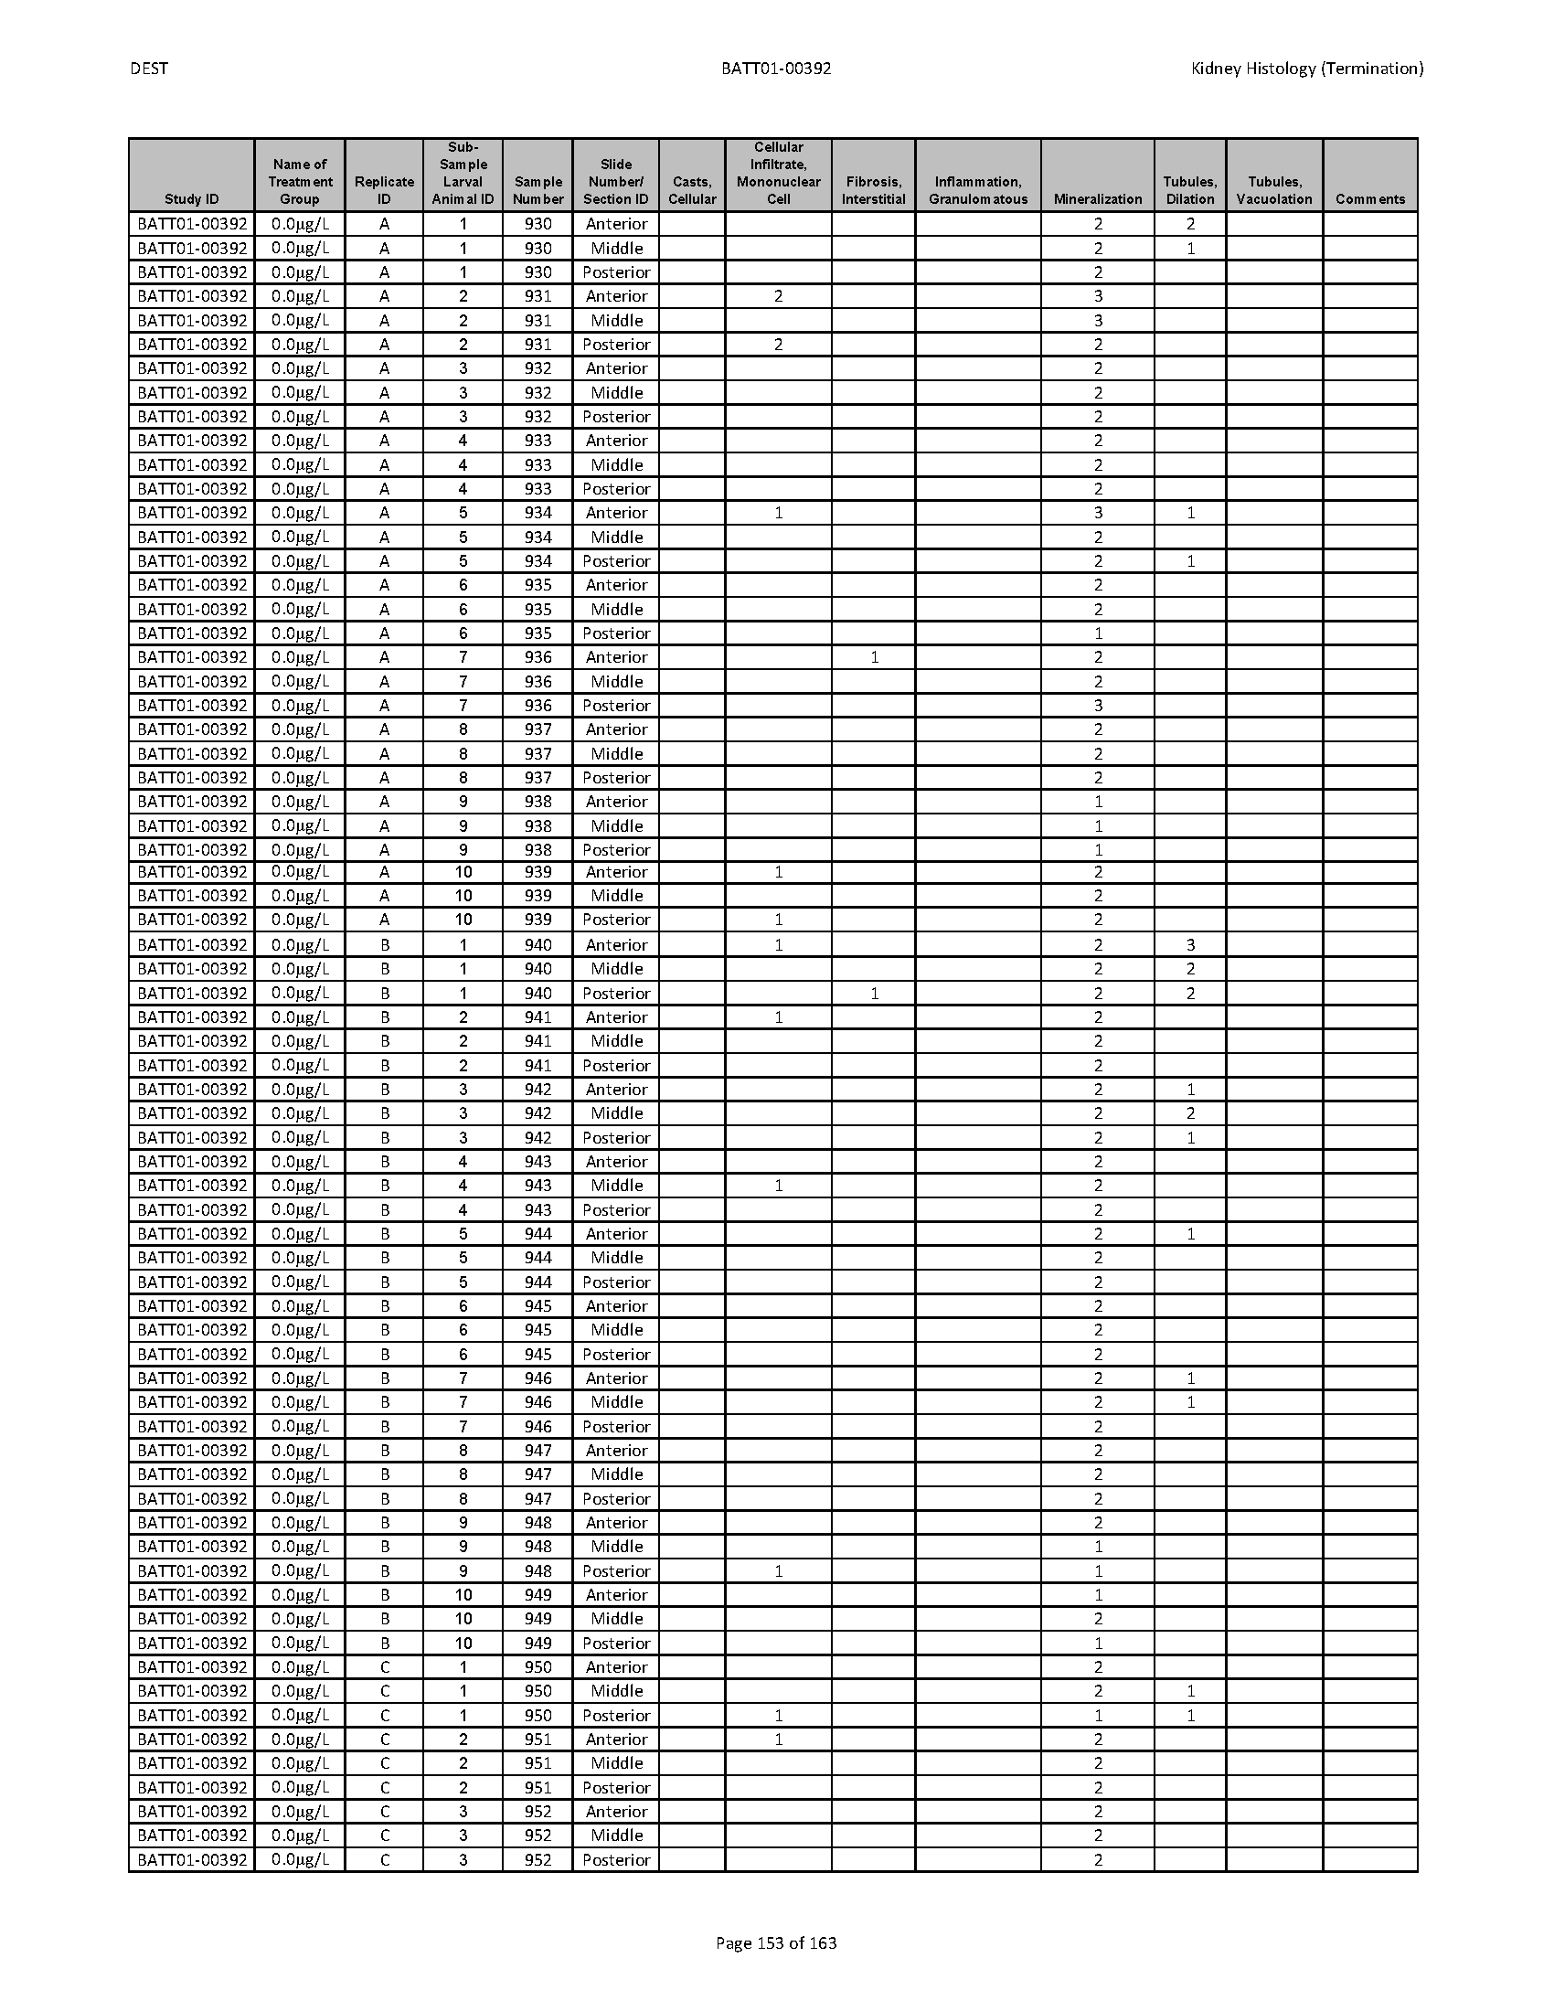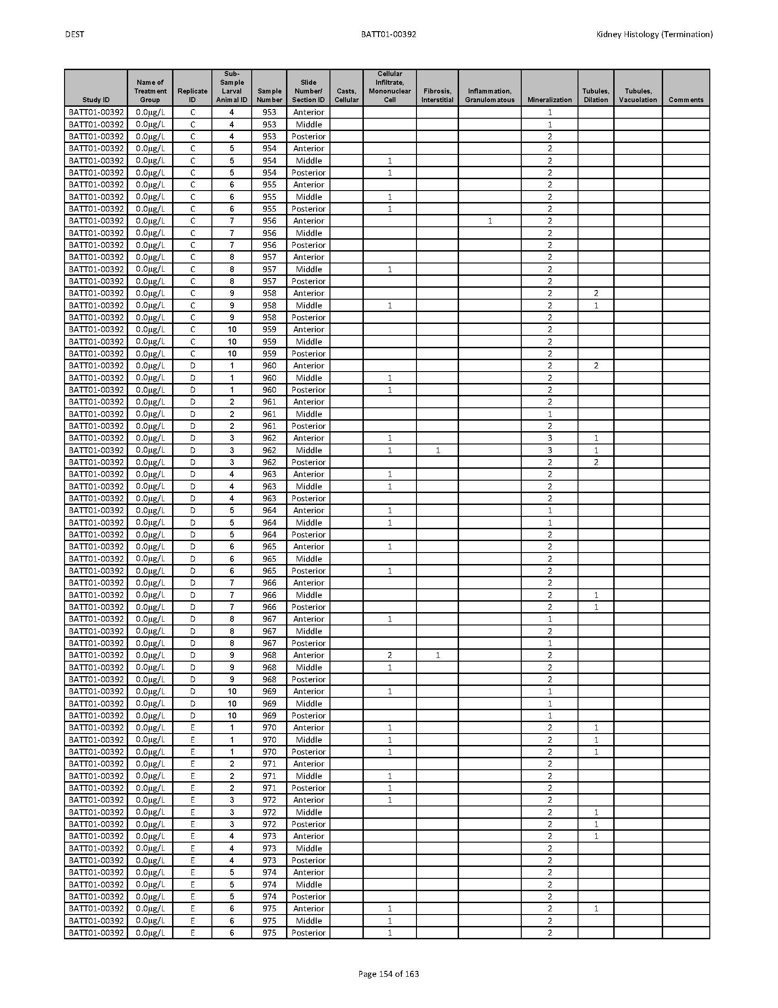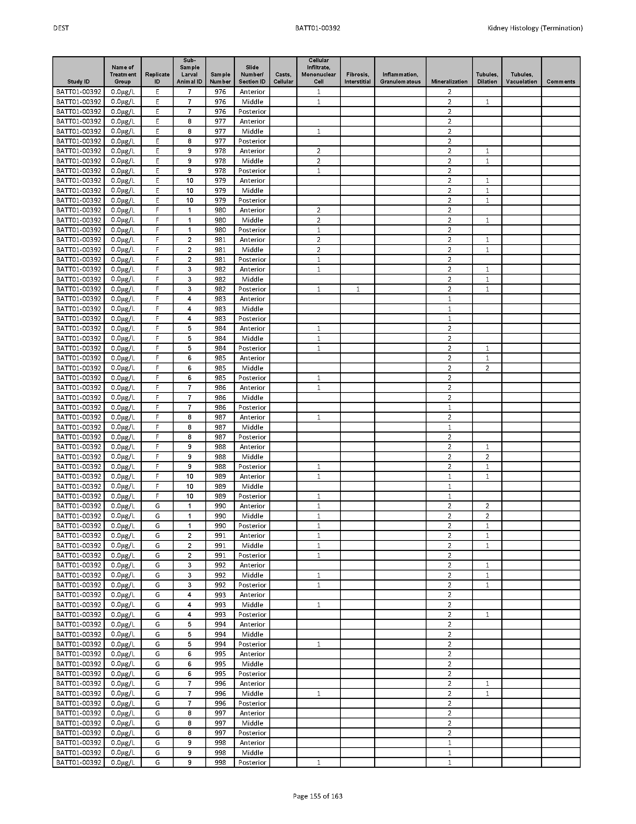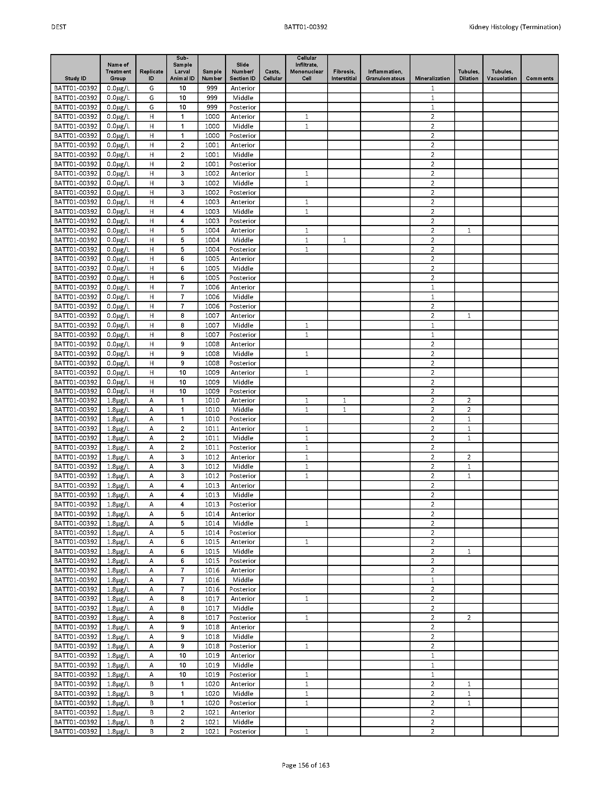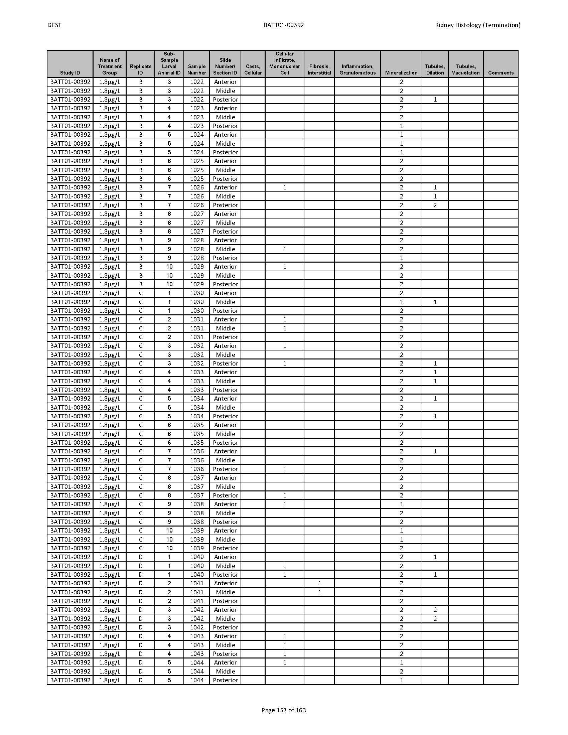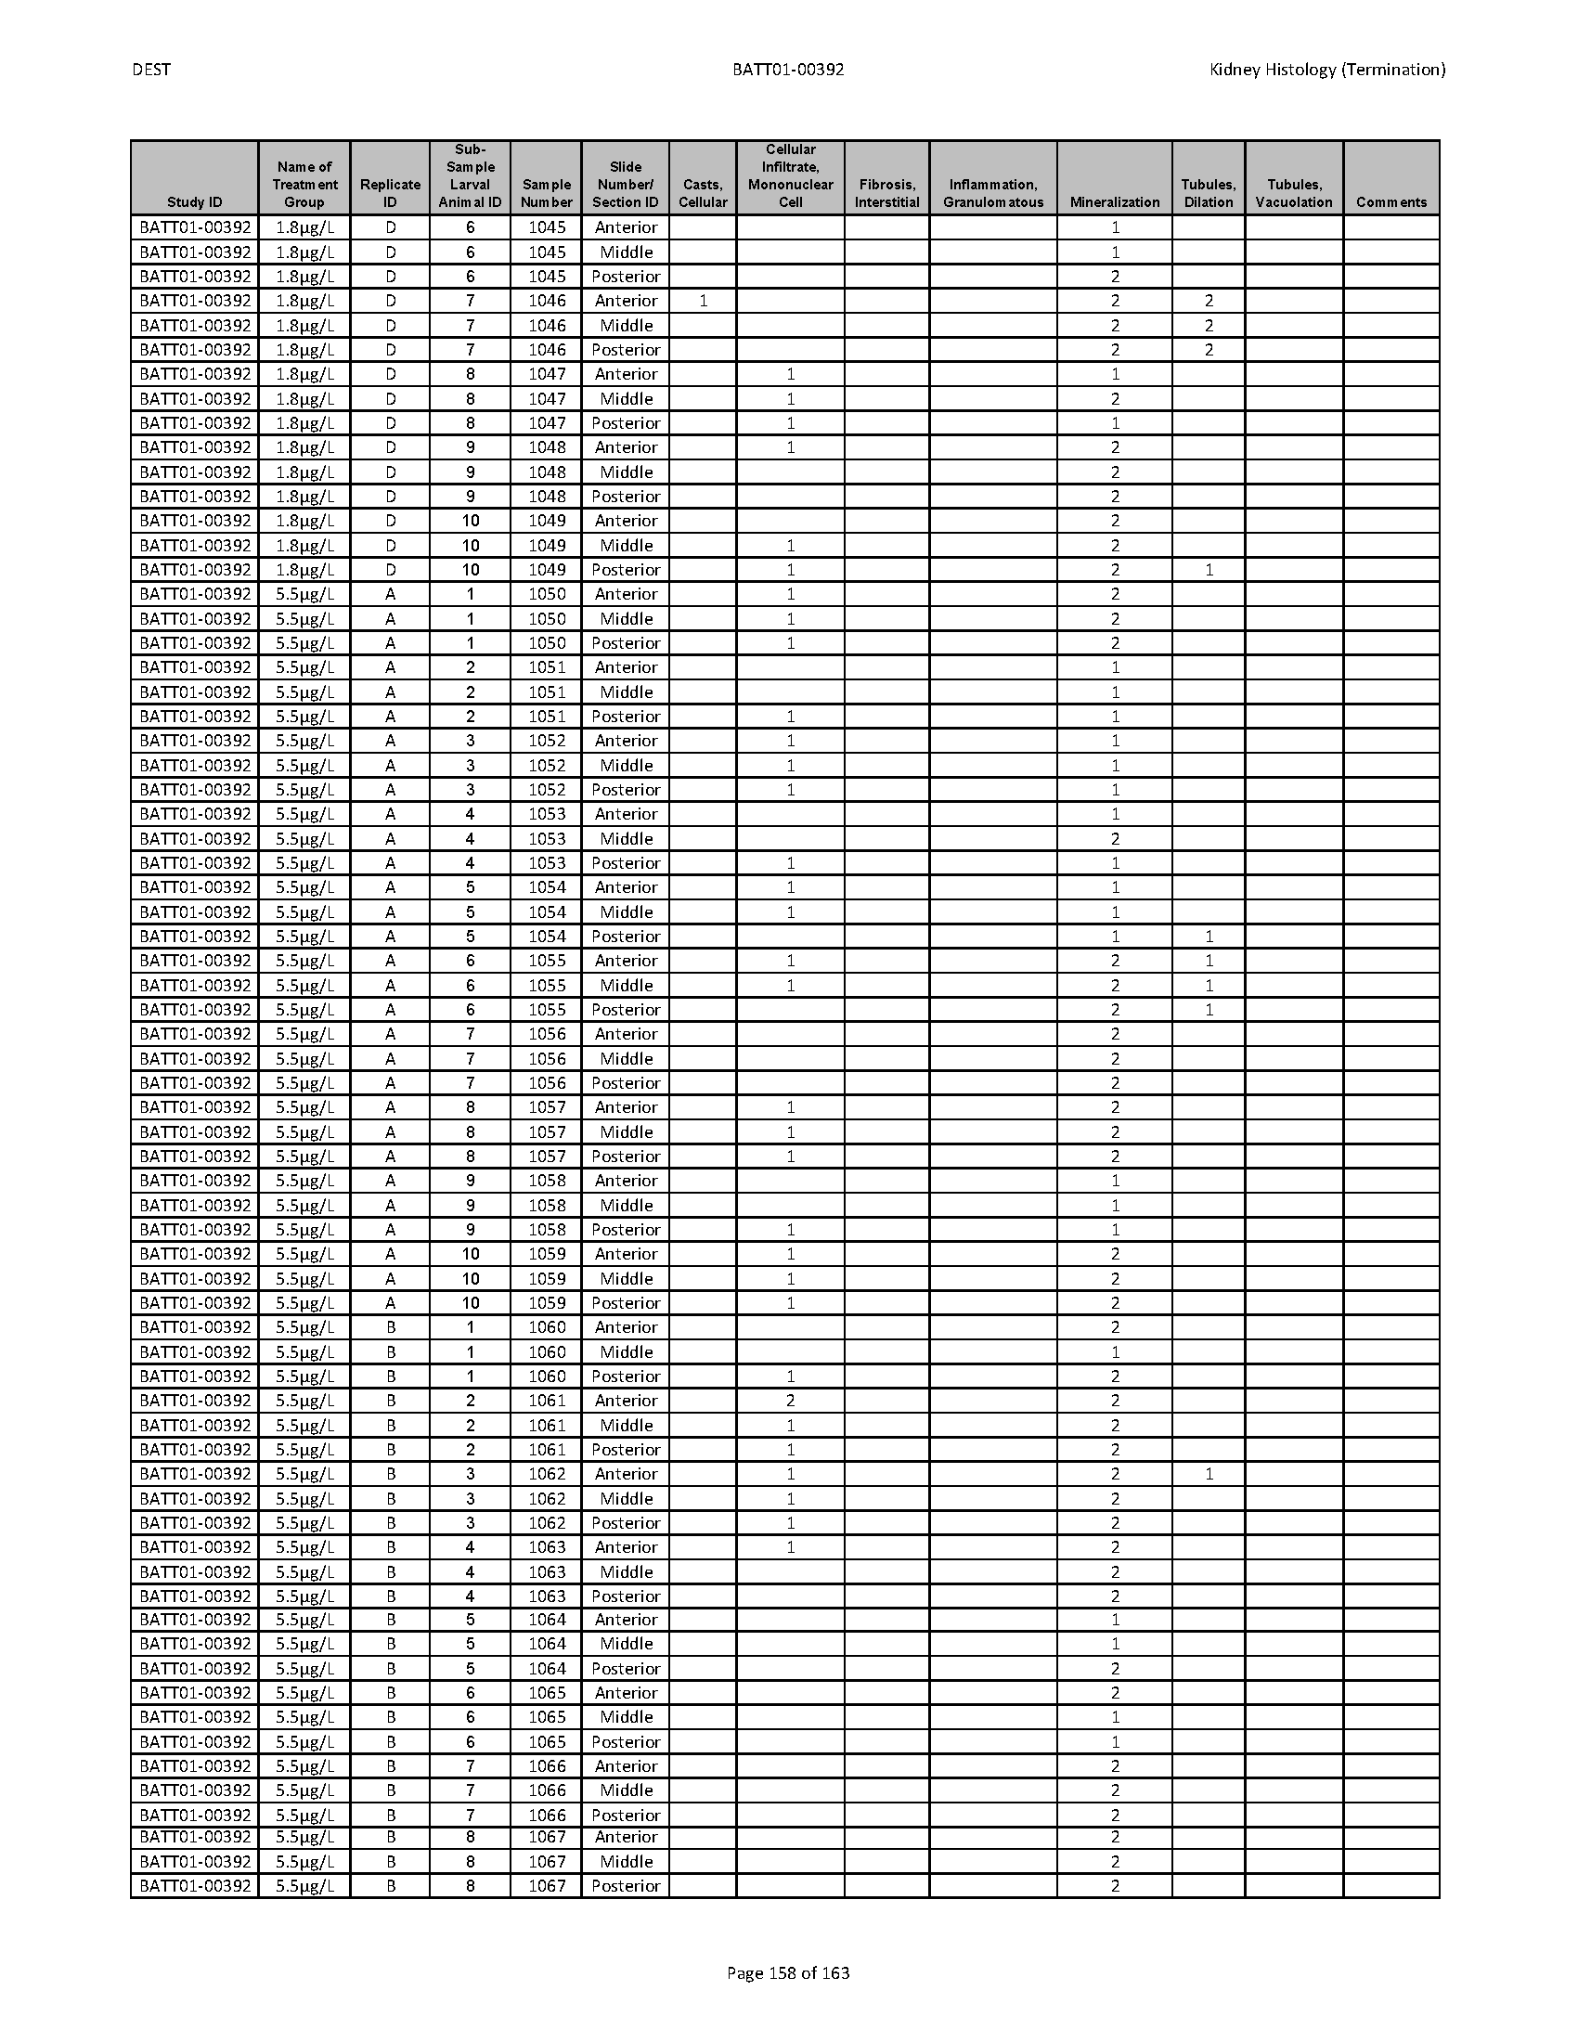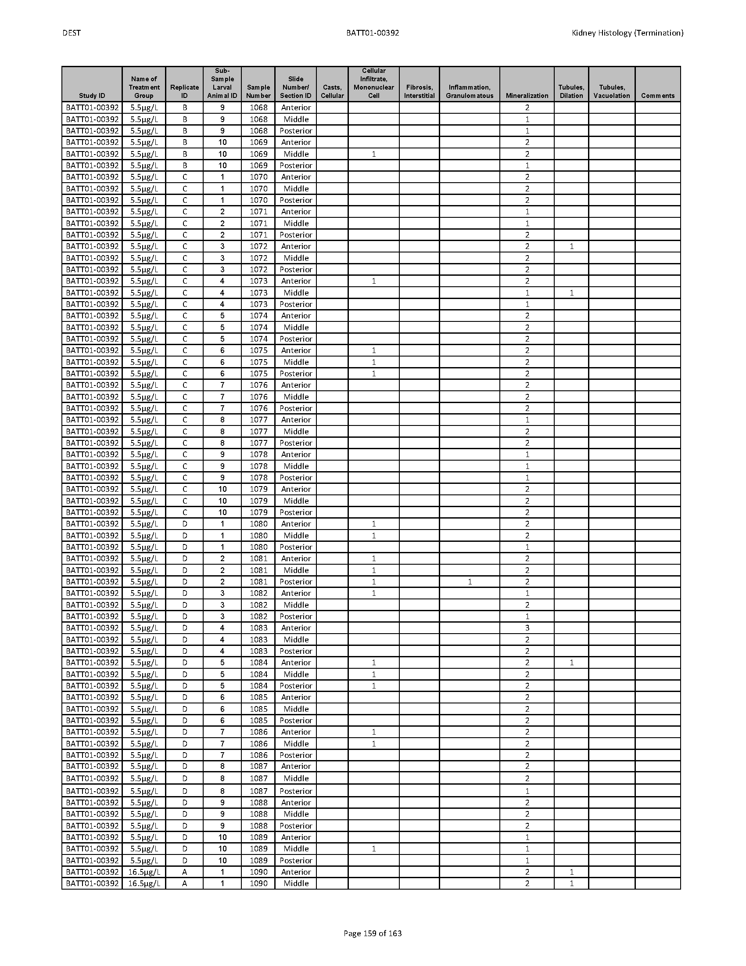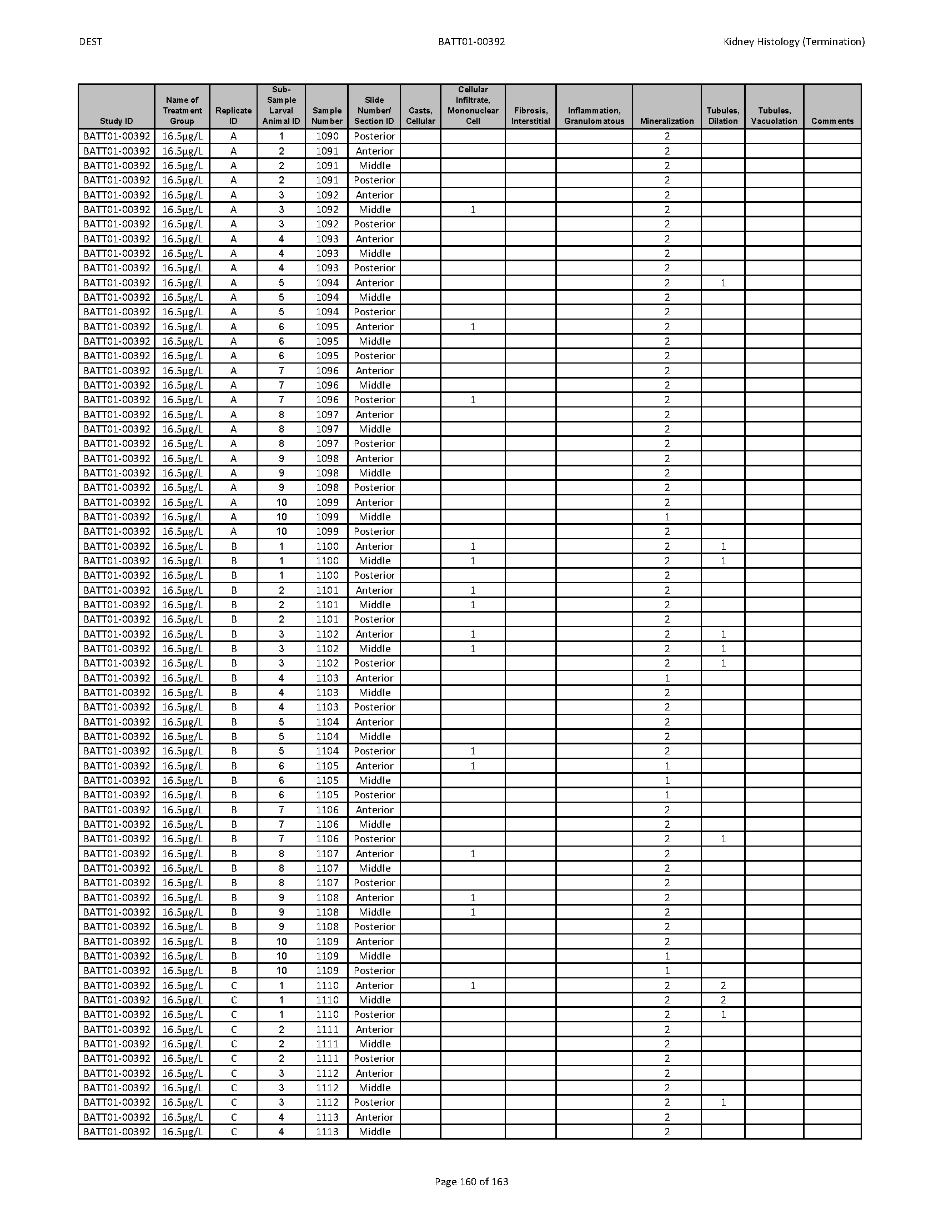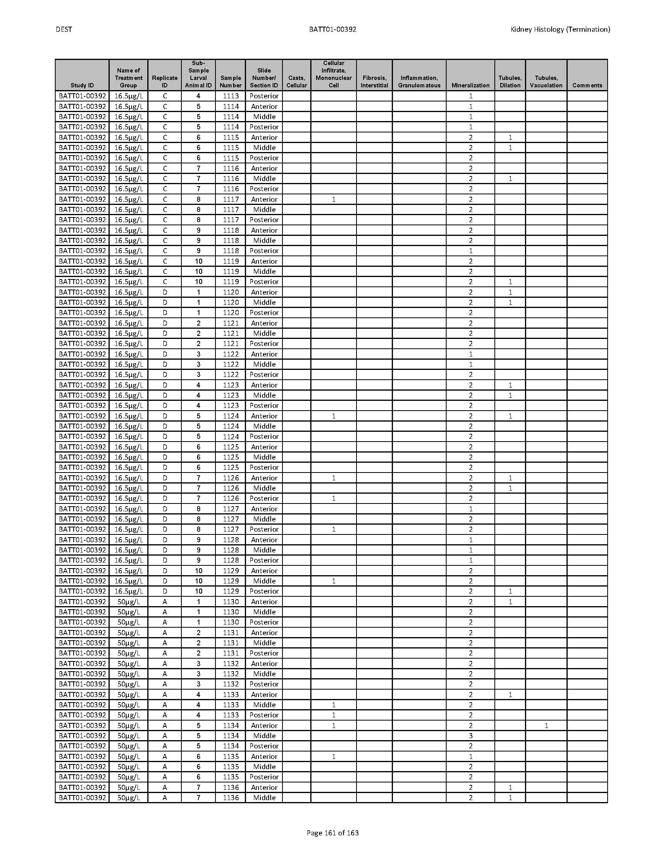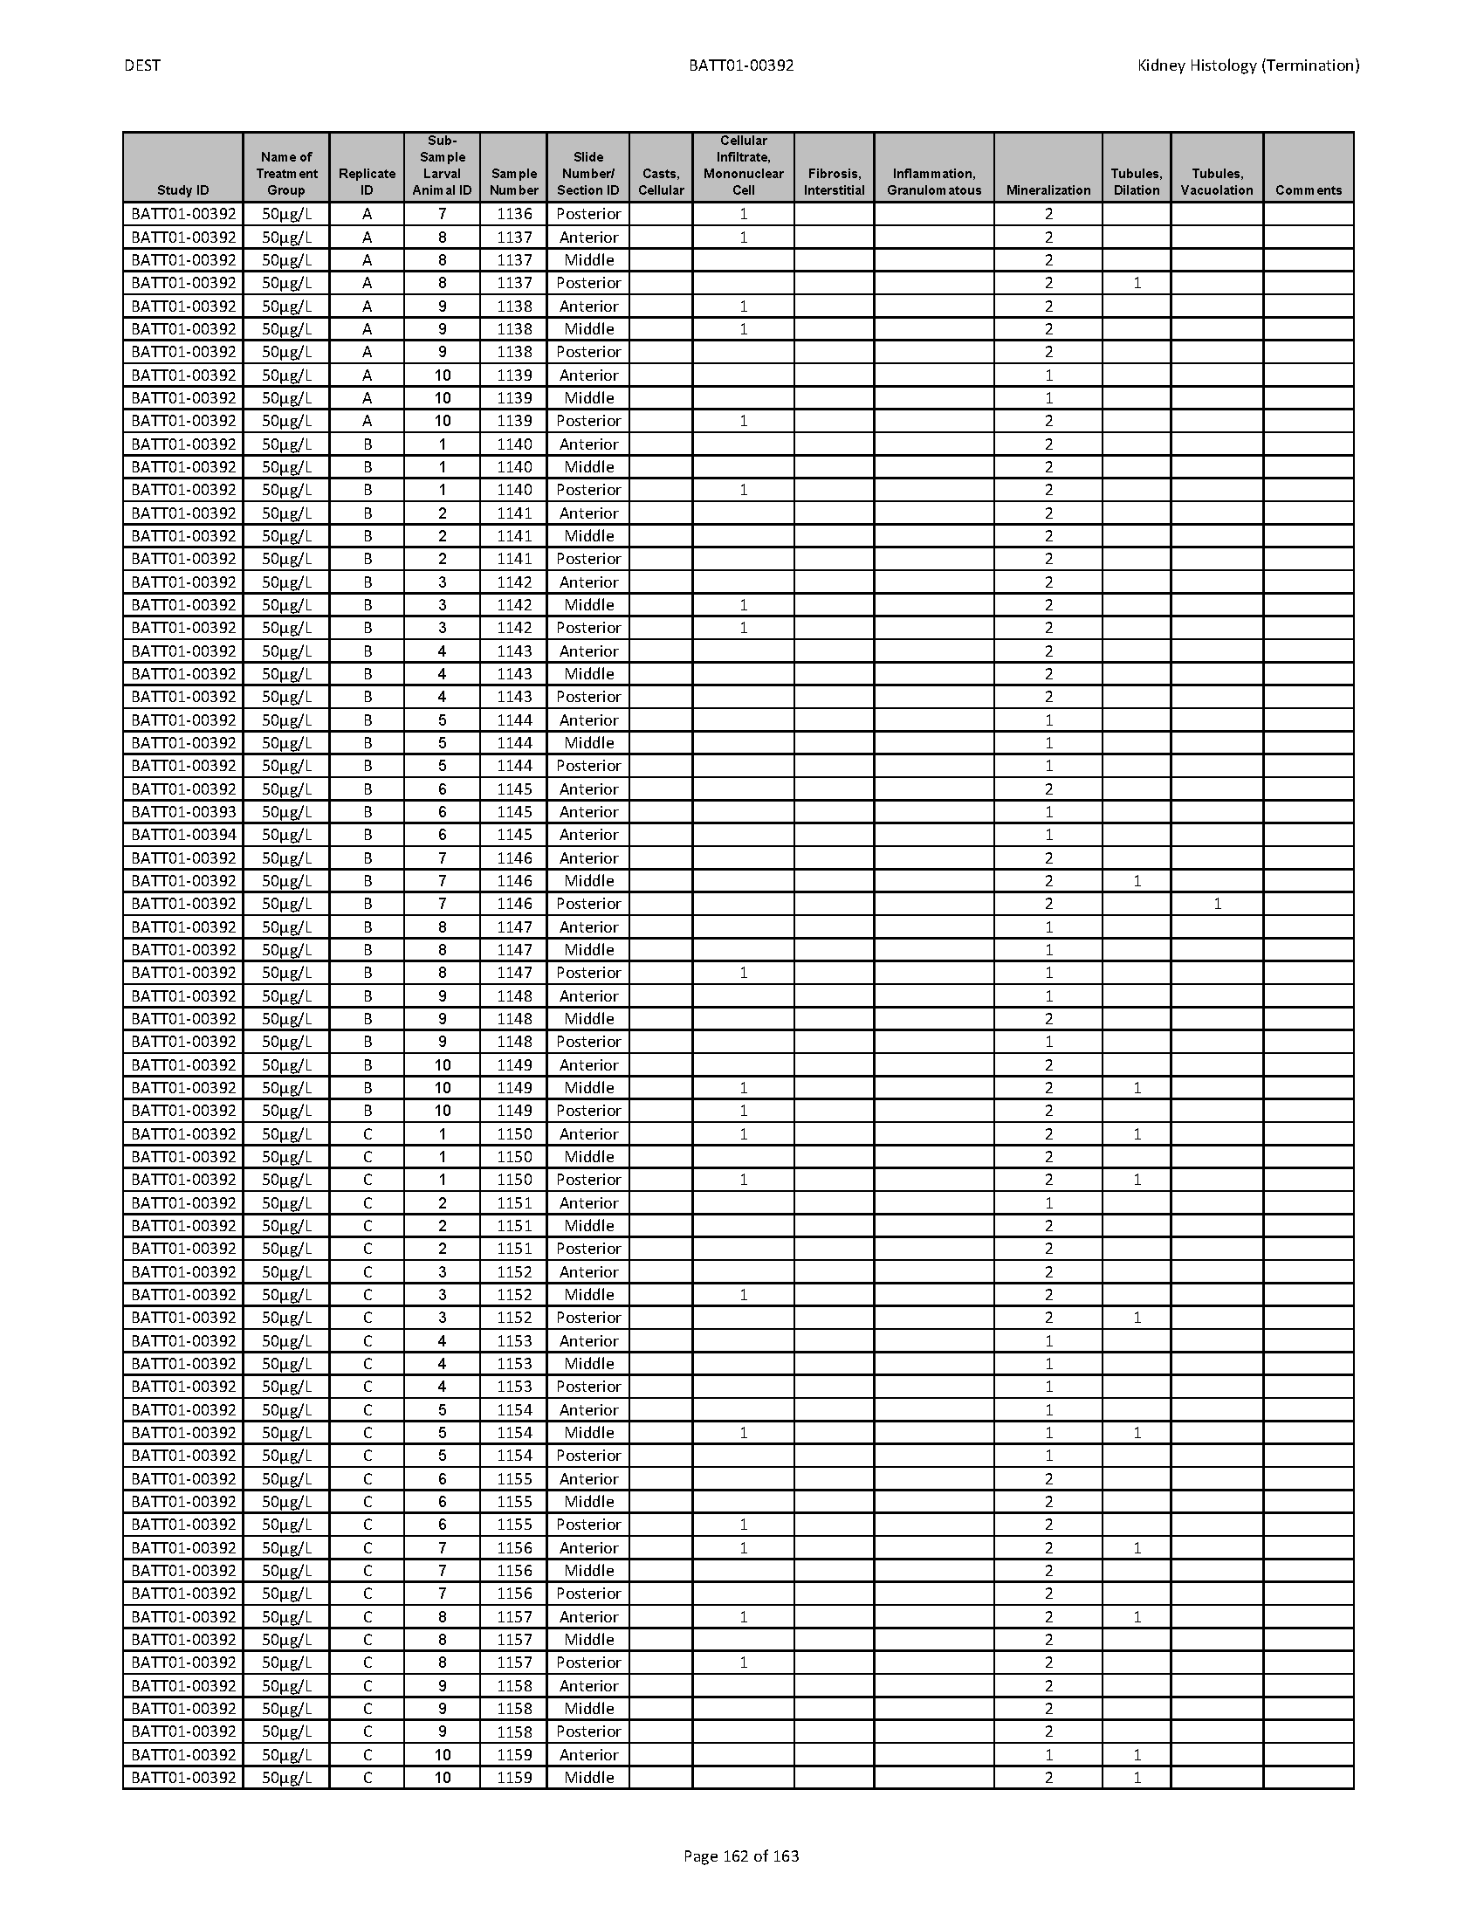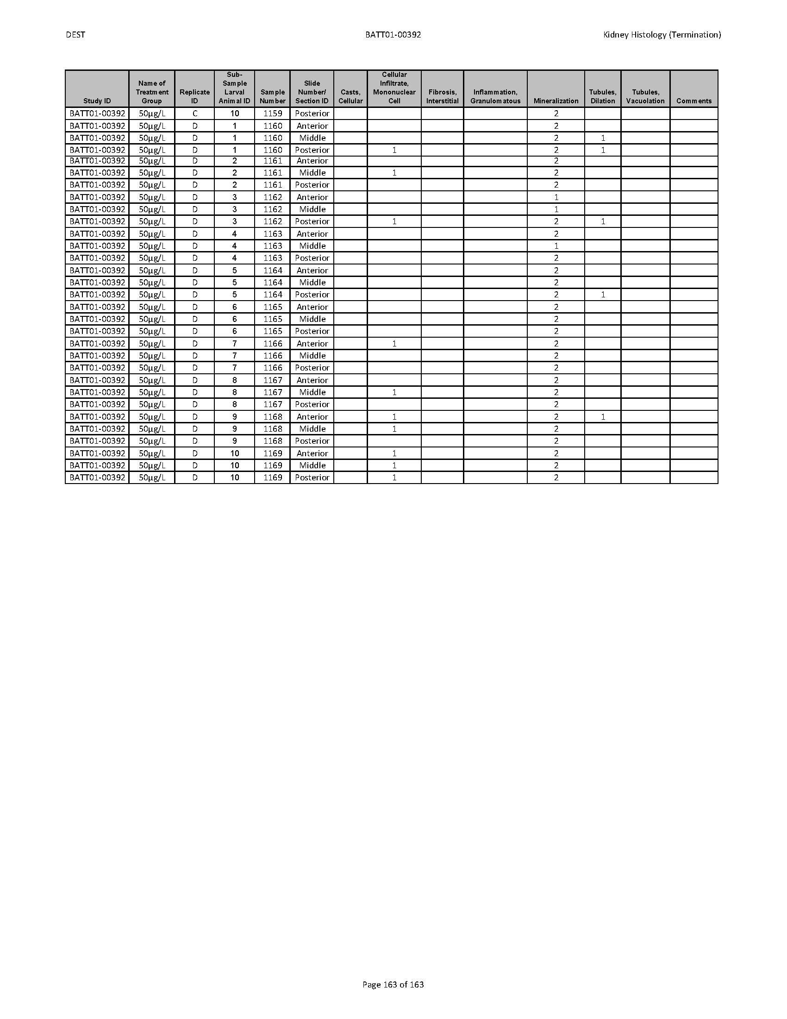

Statistical Analyses

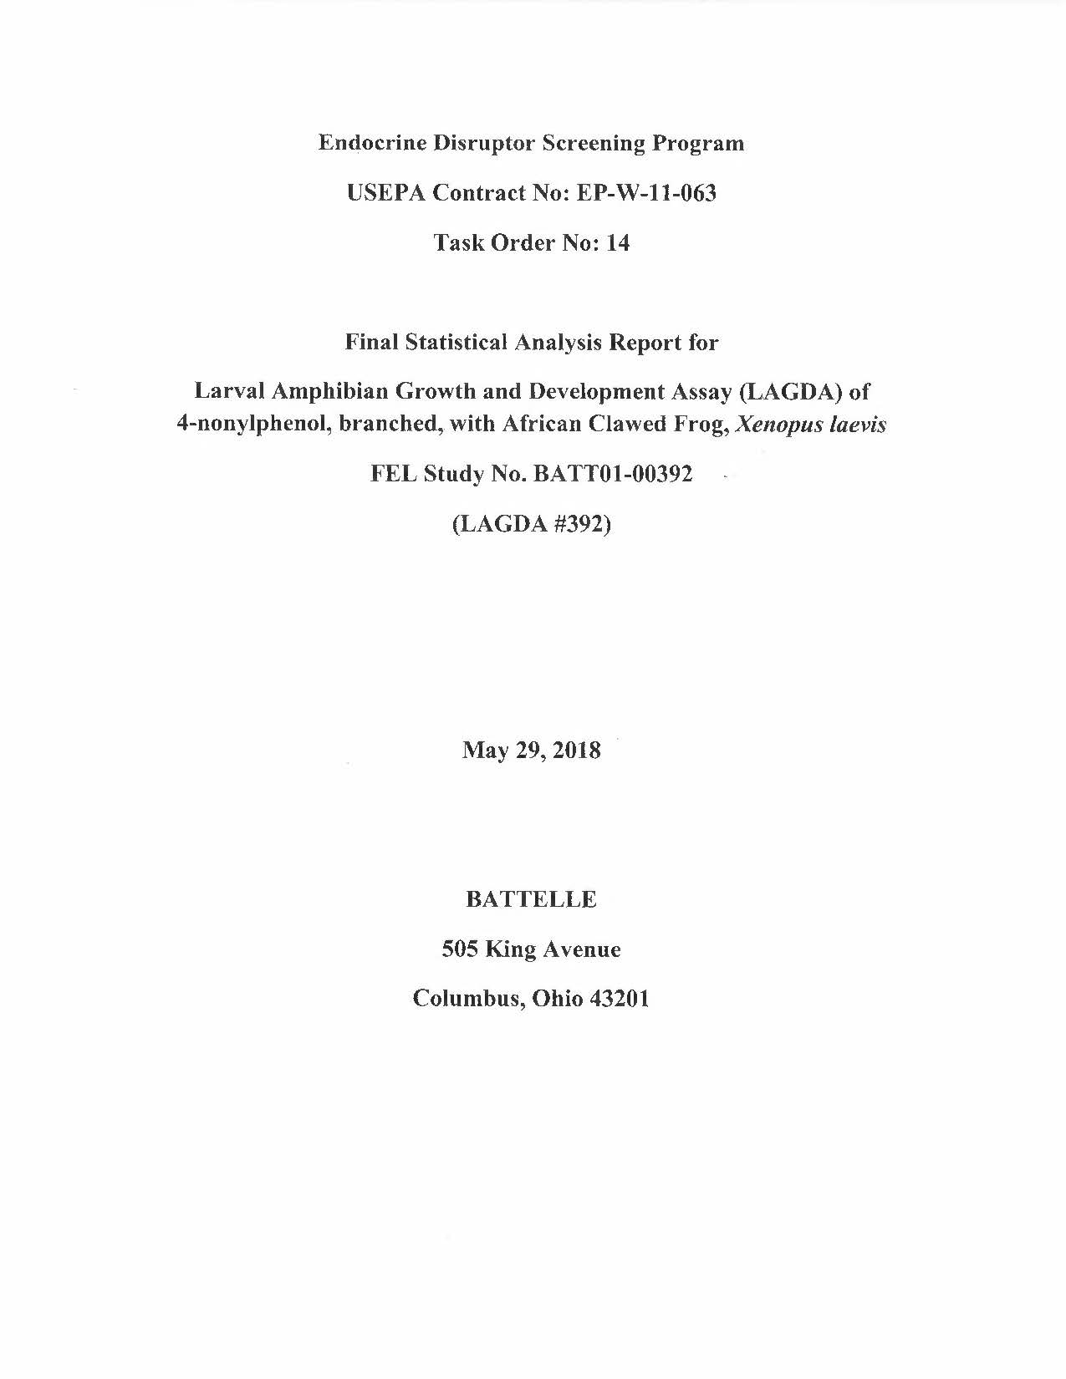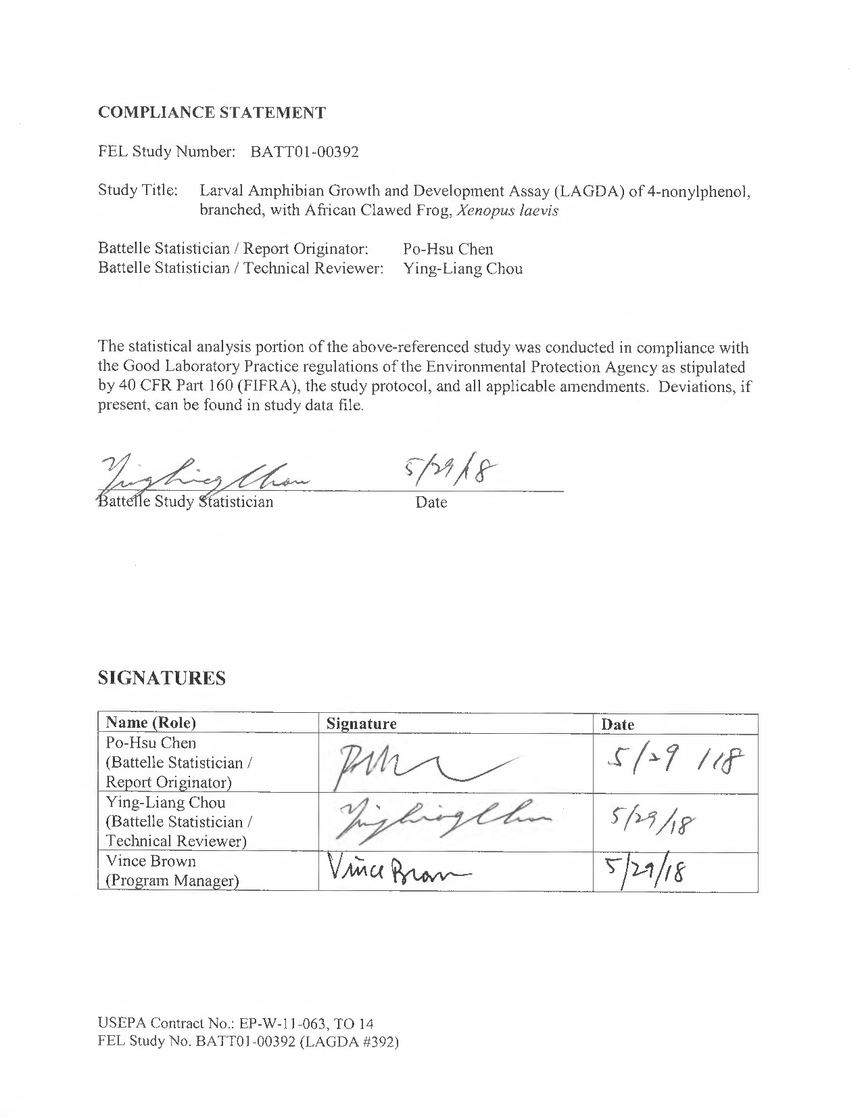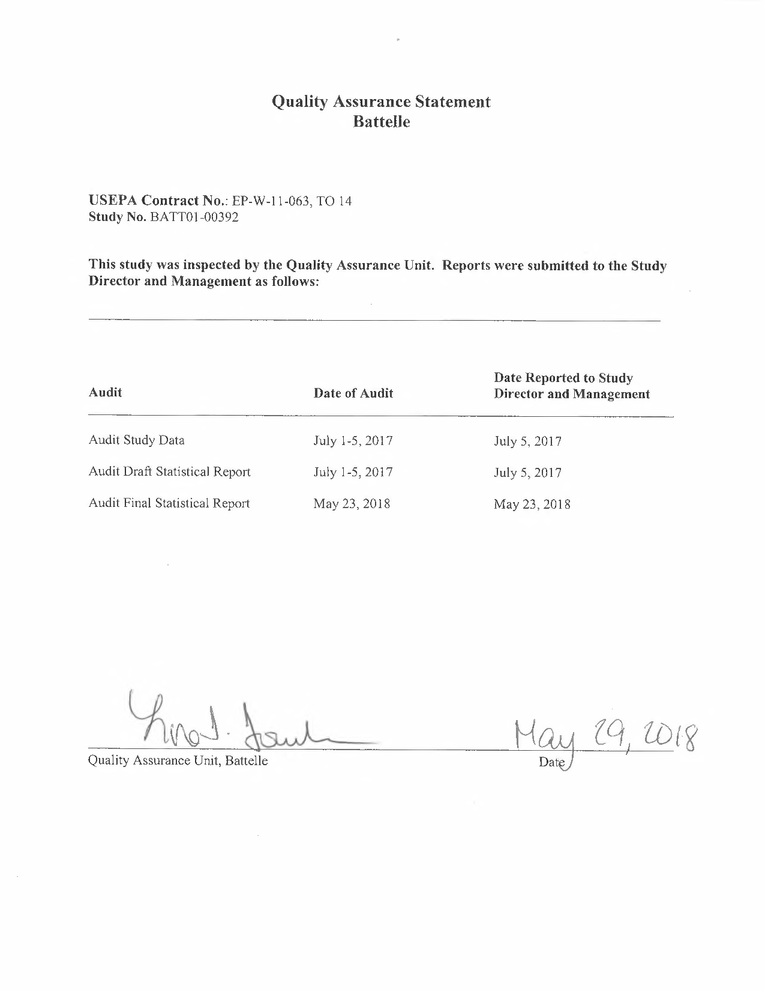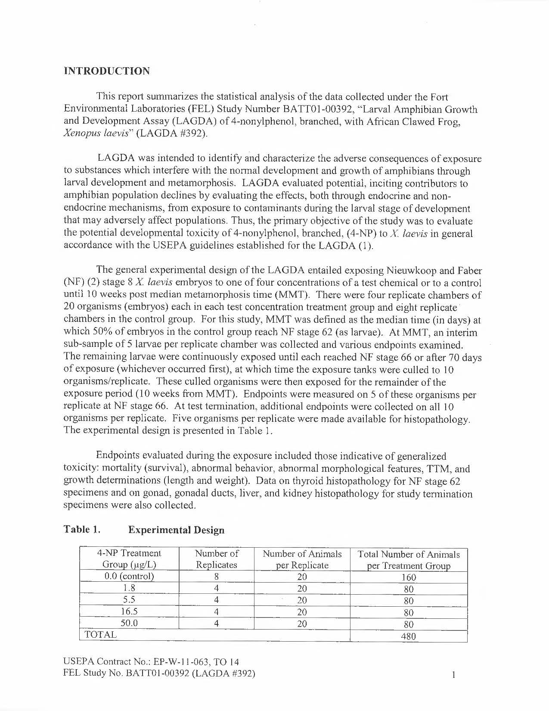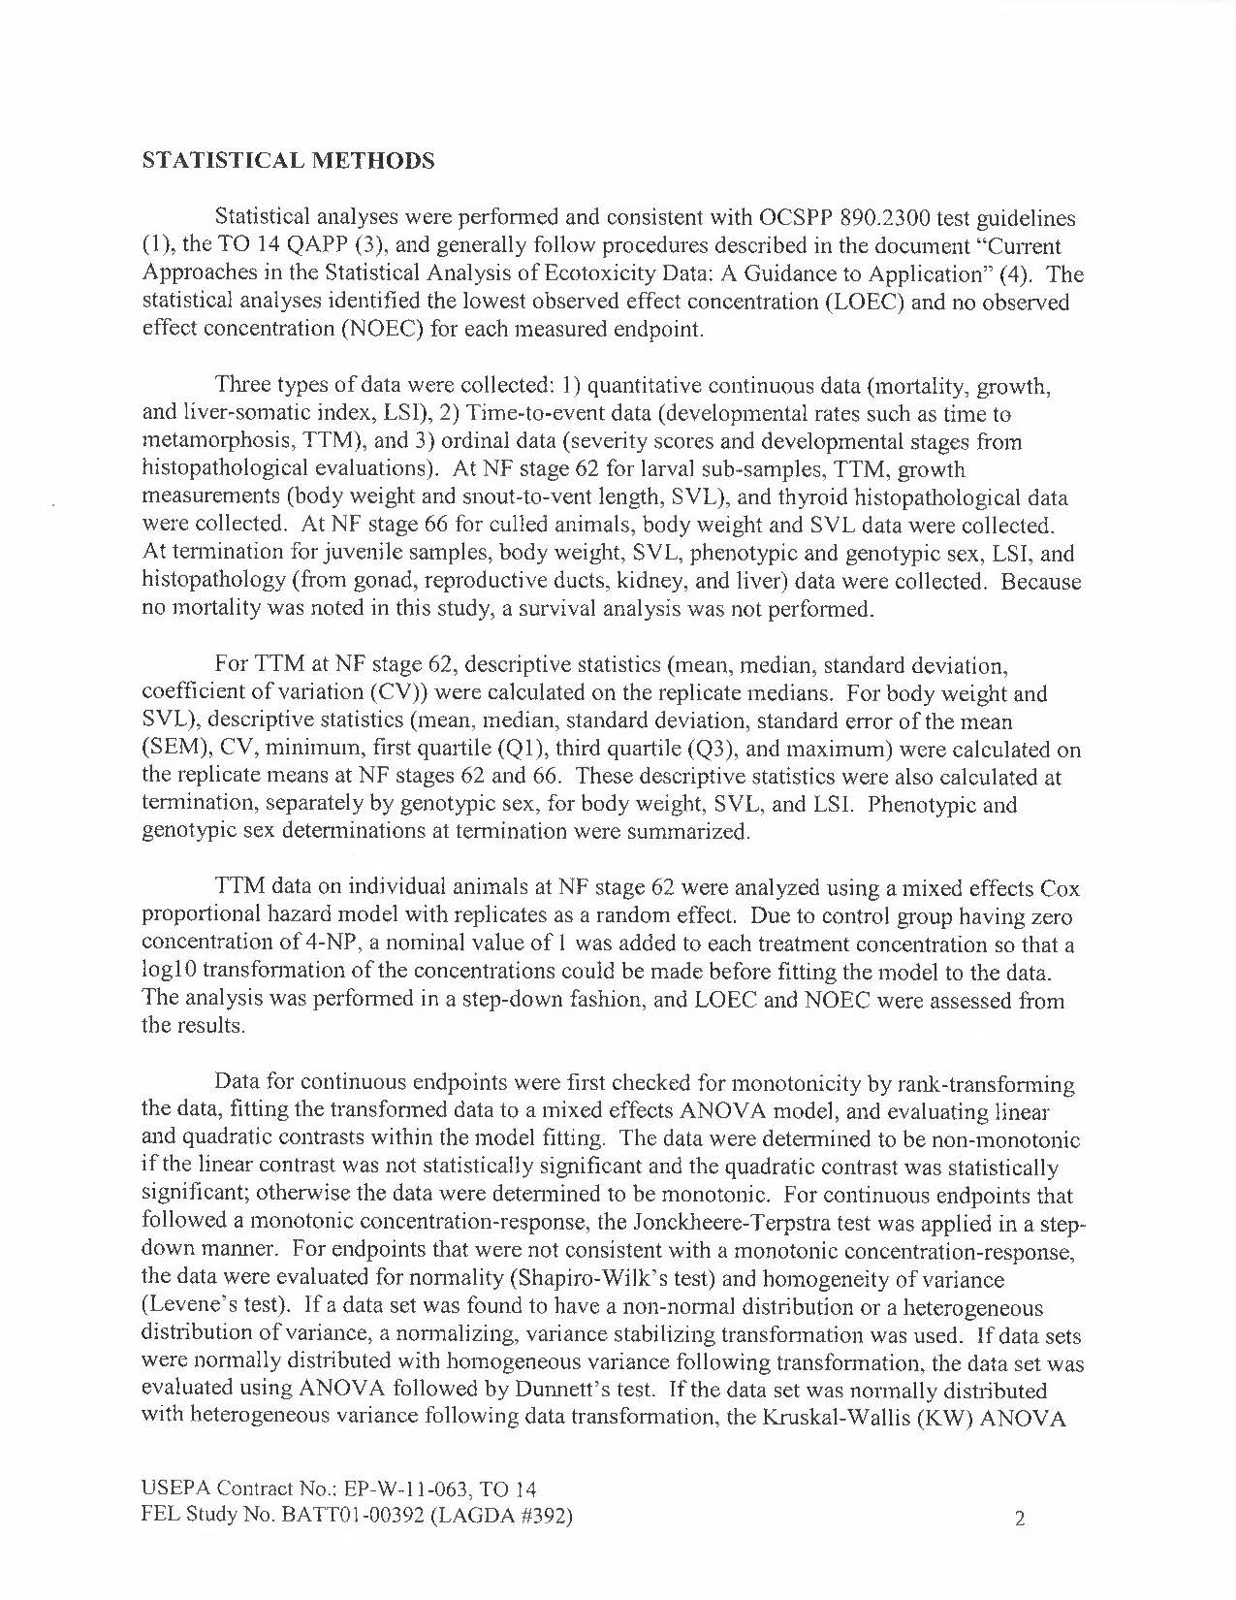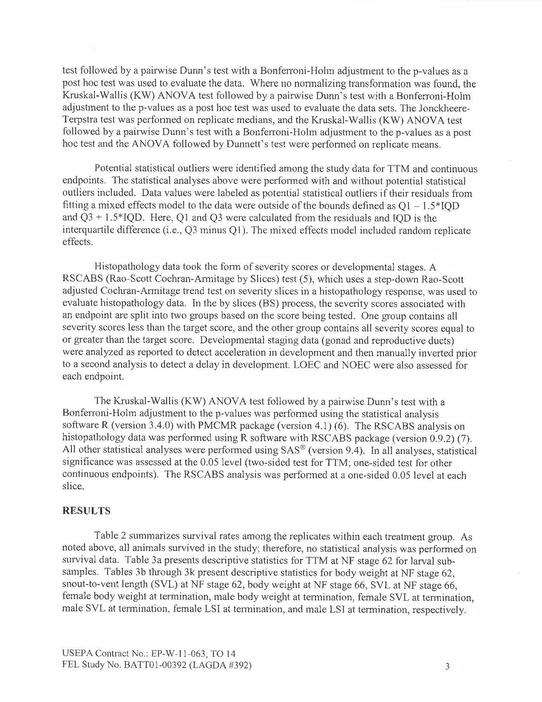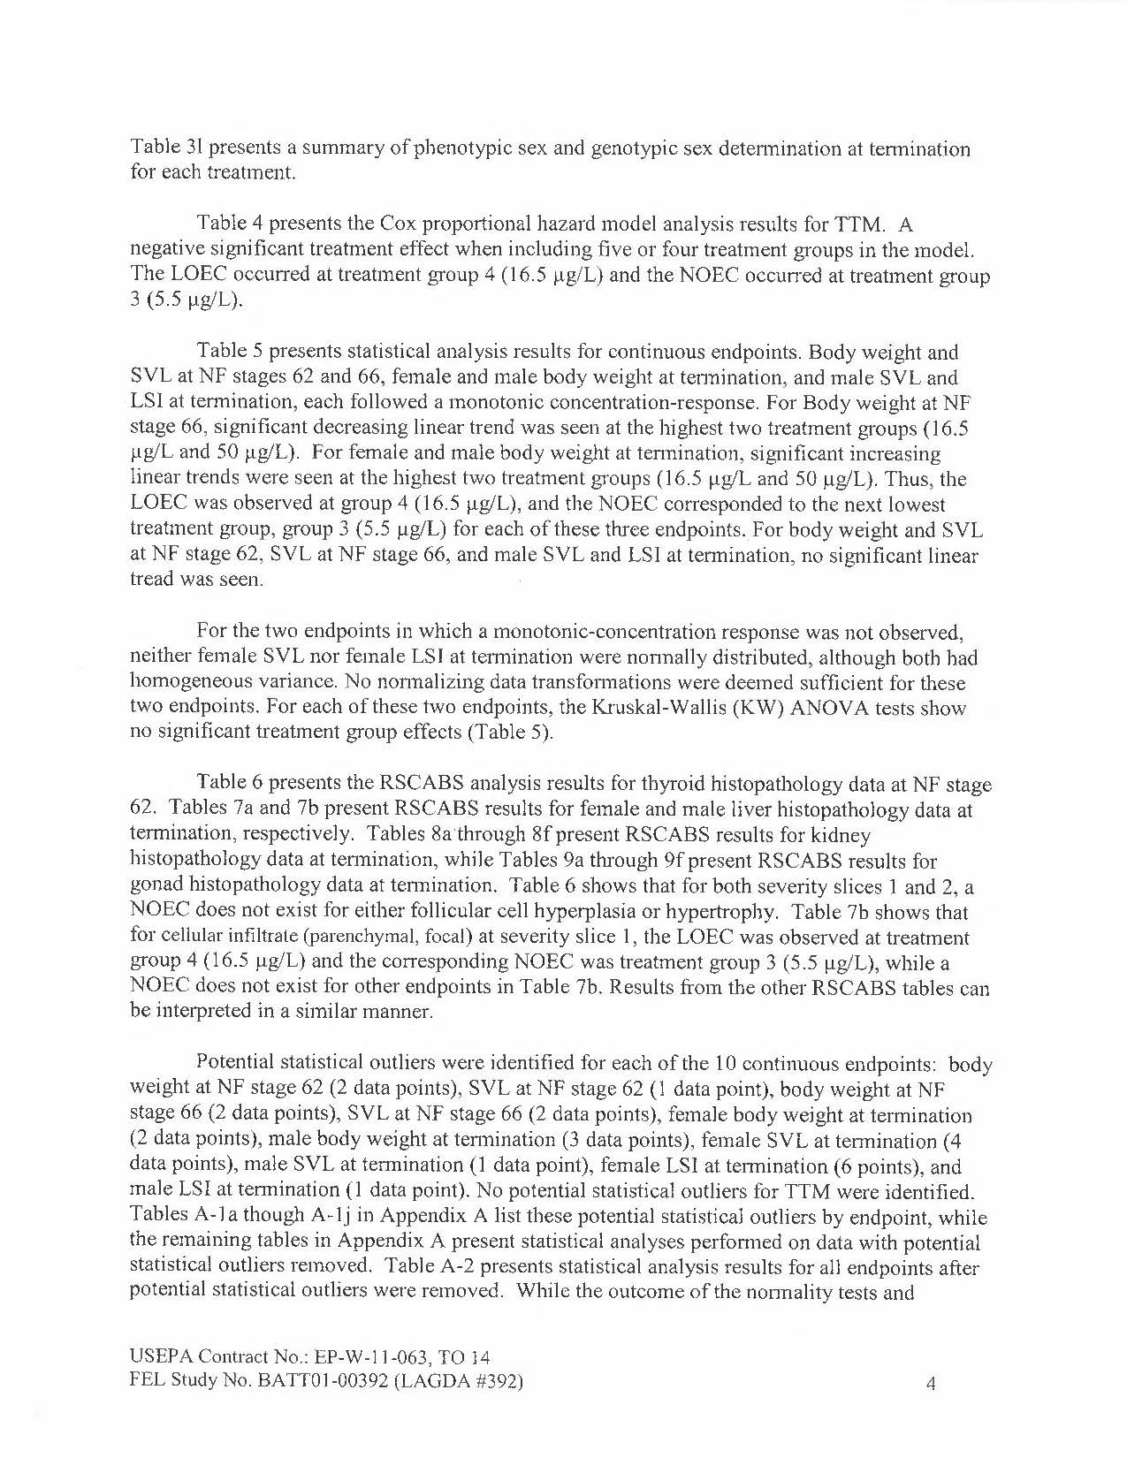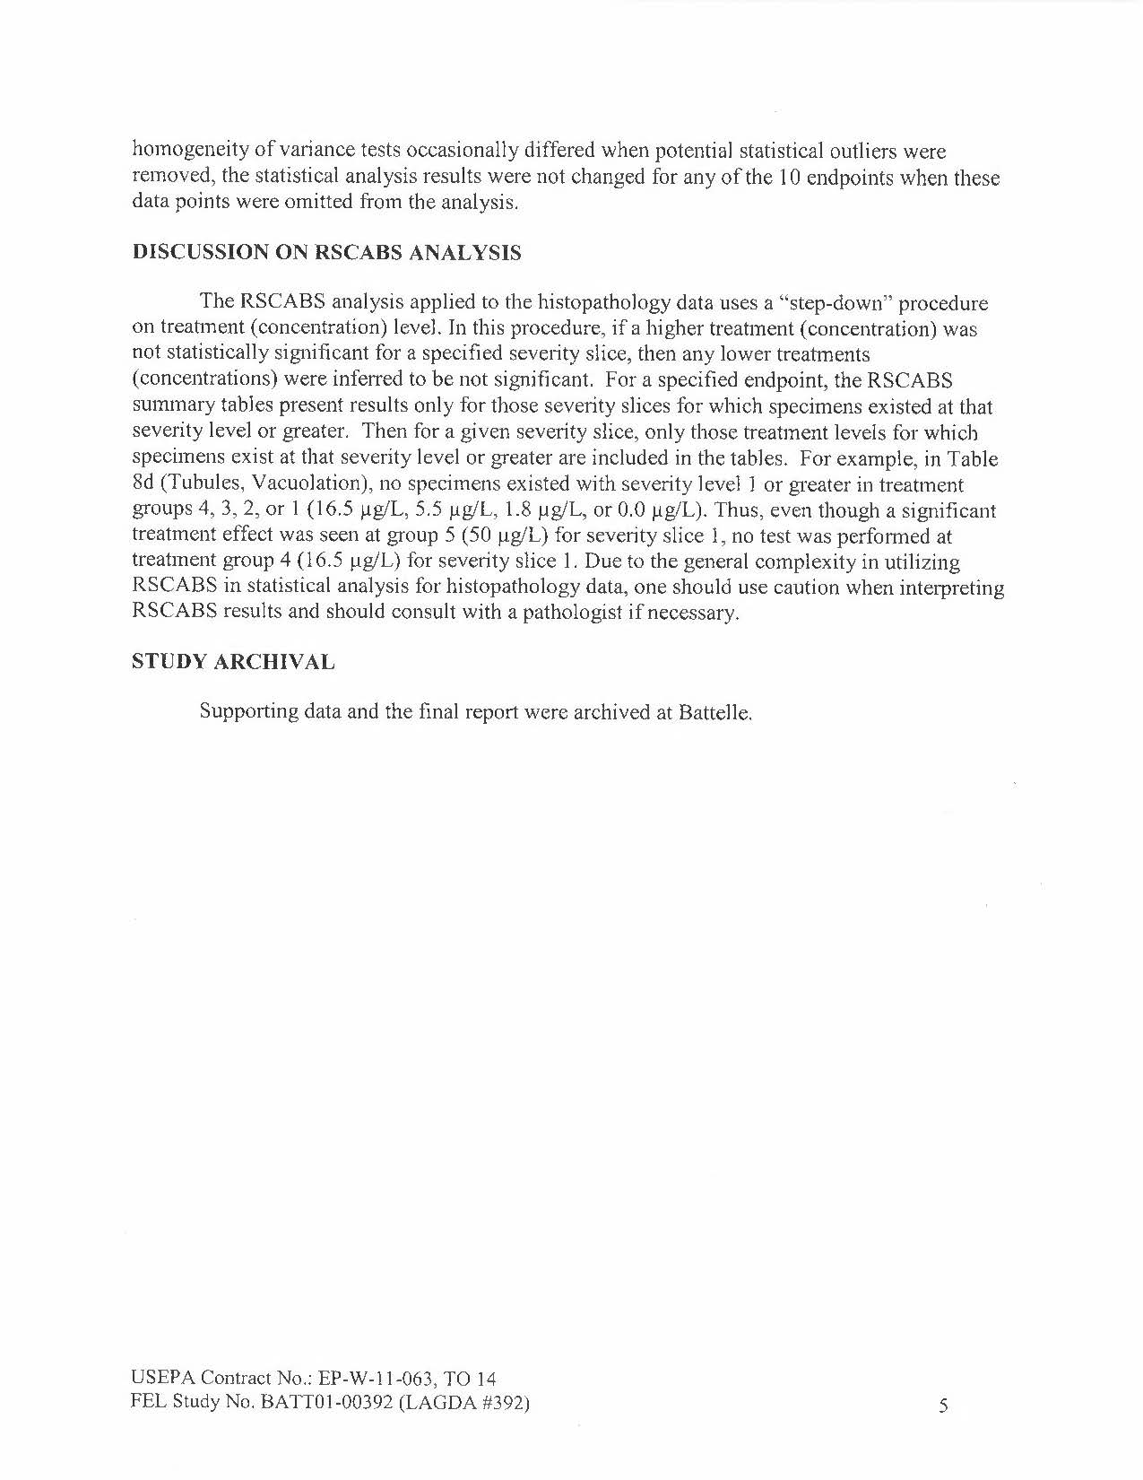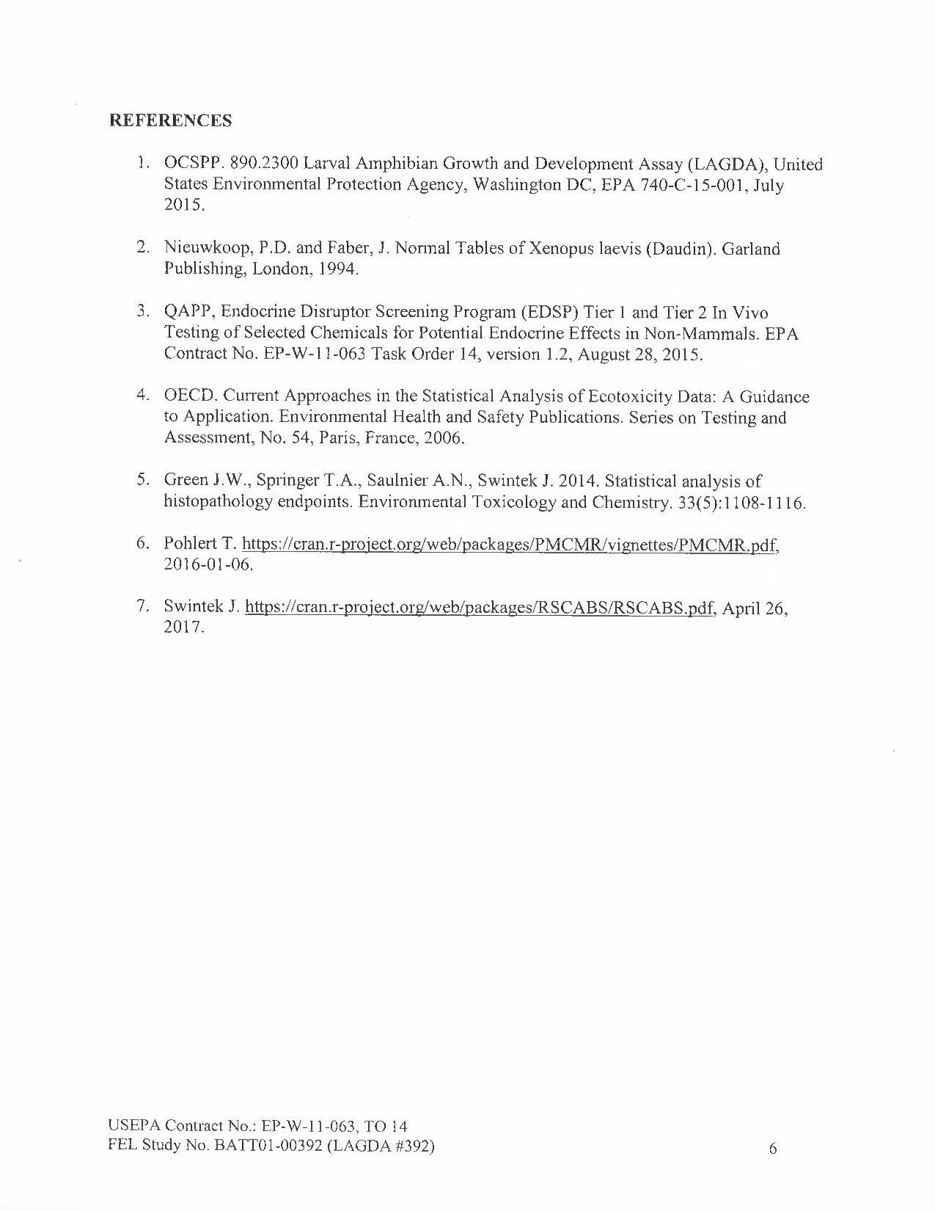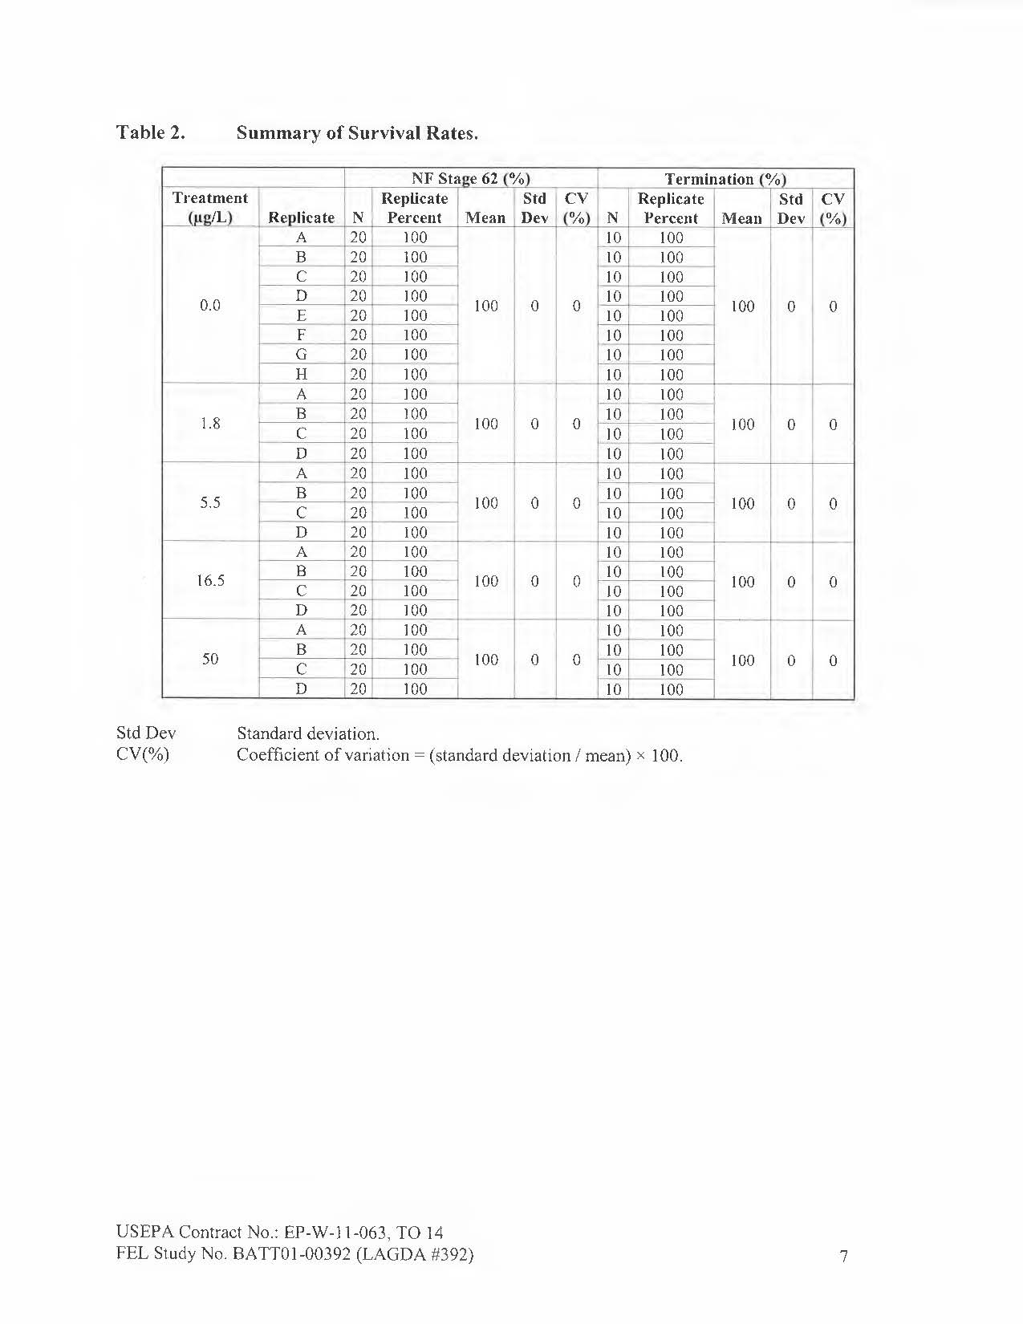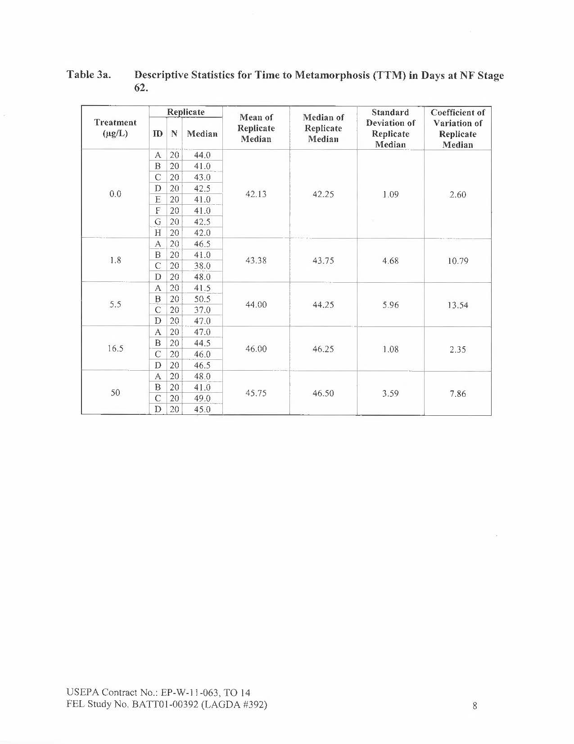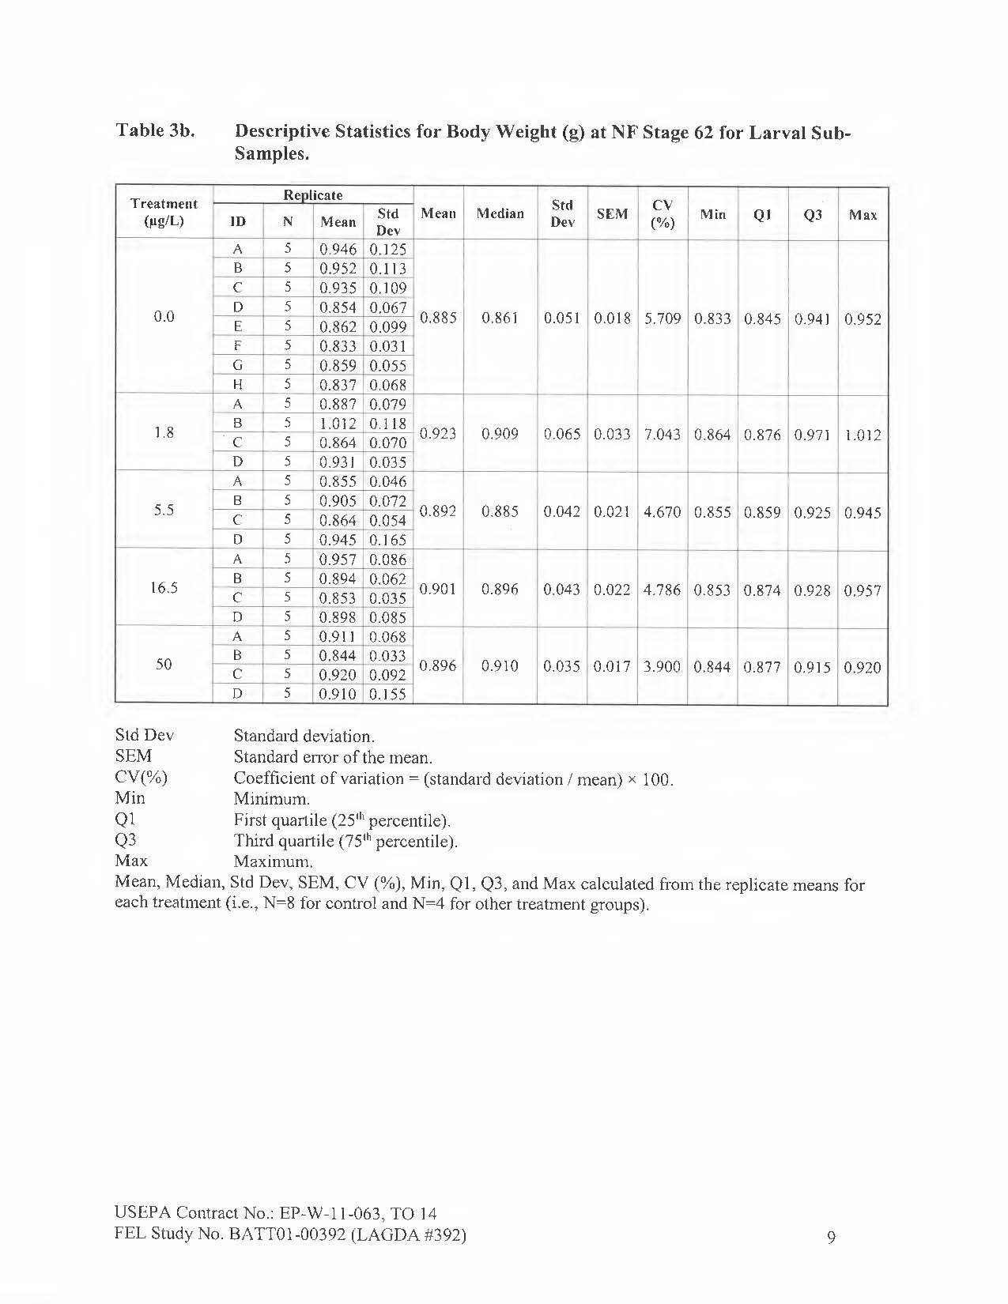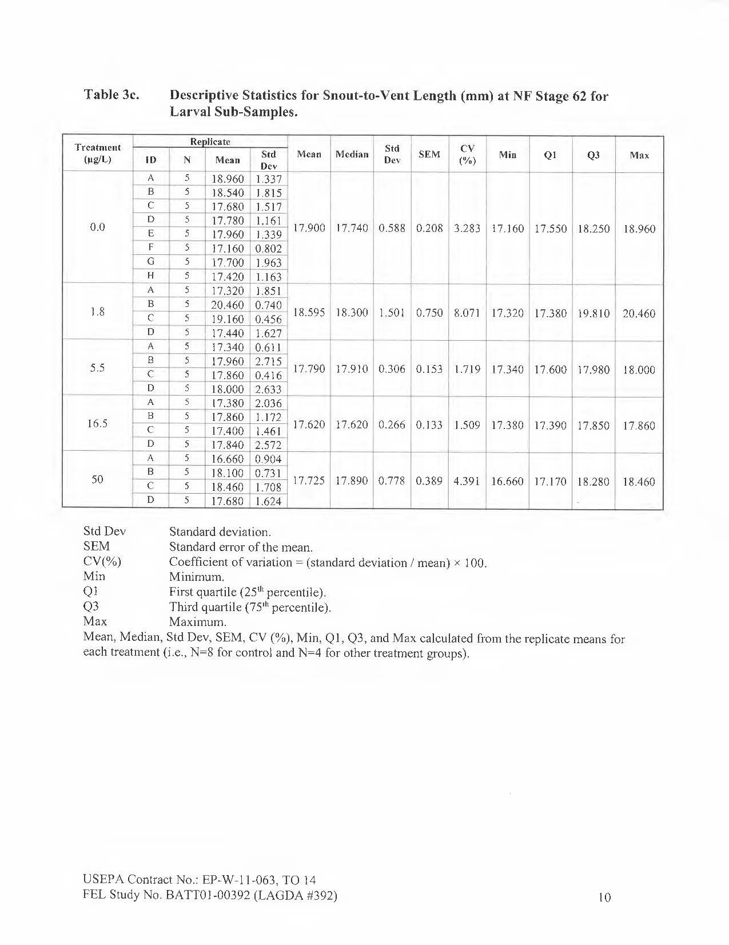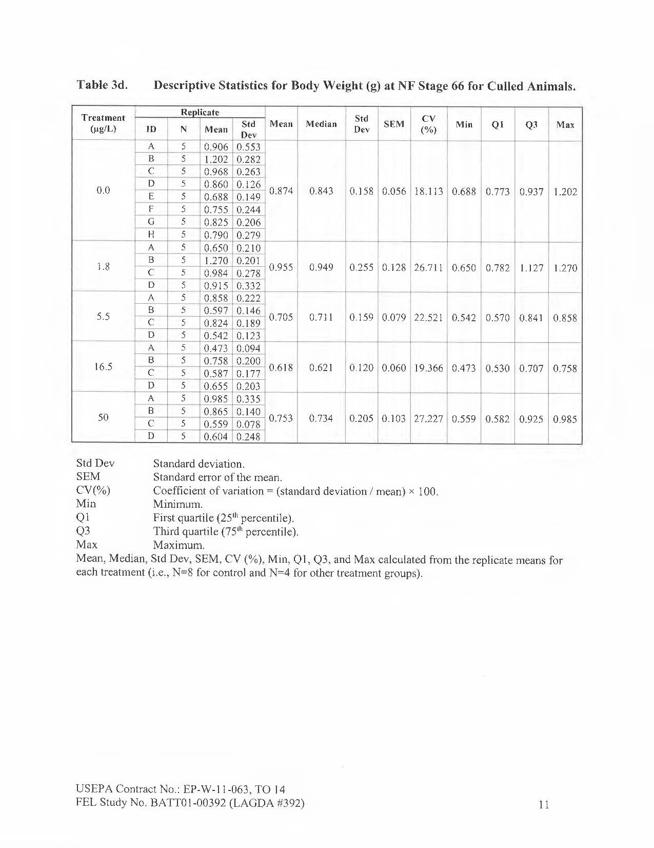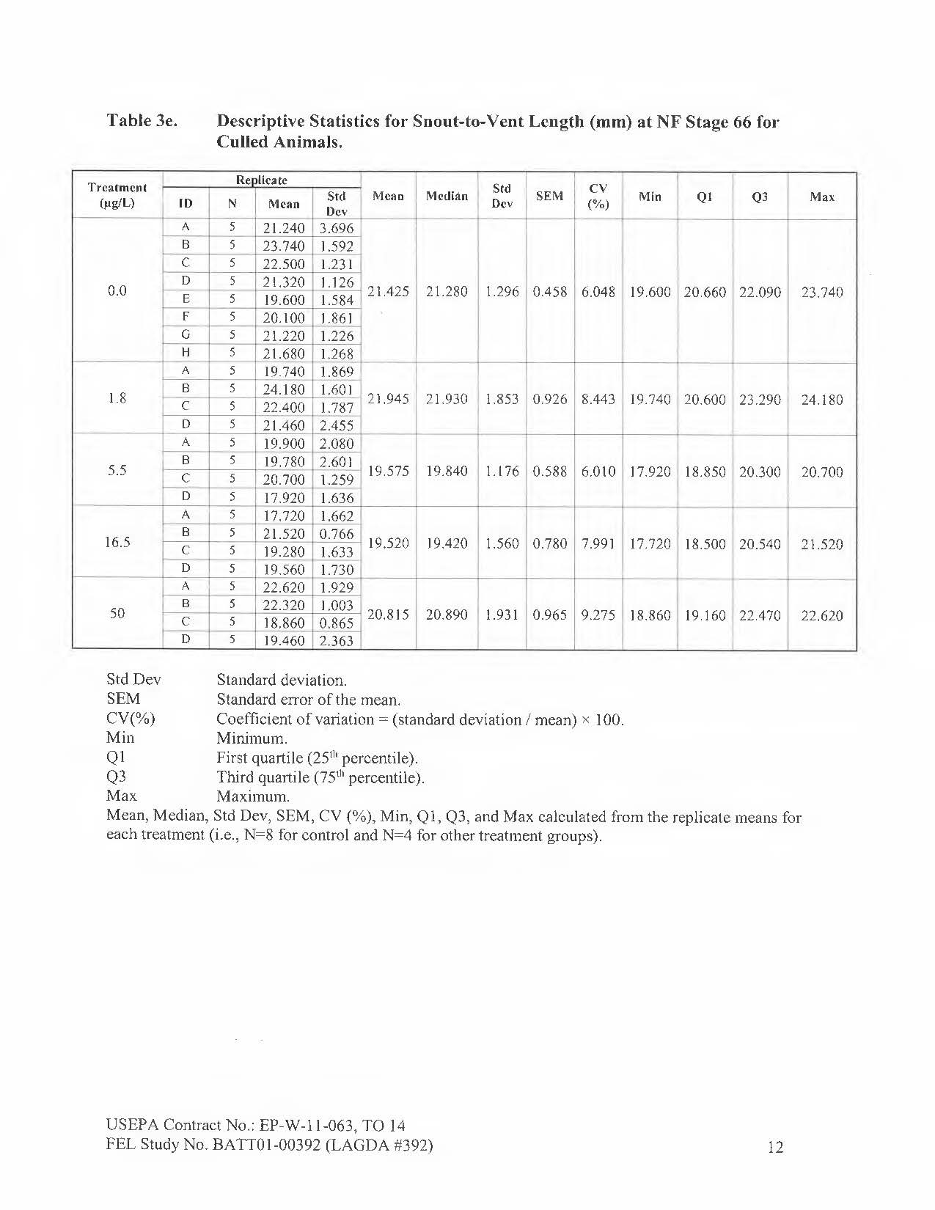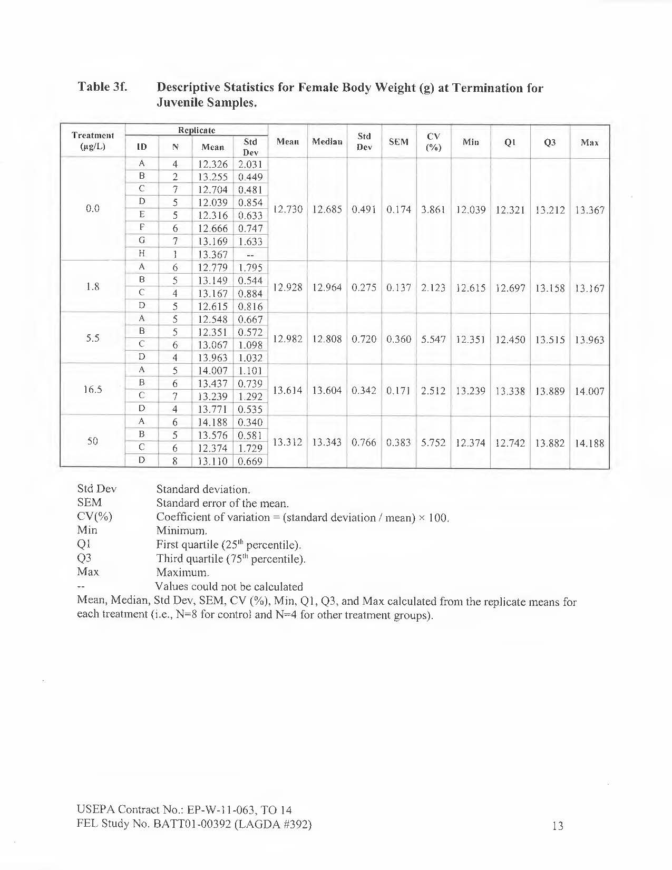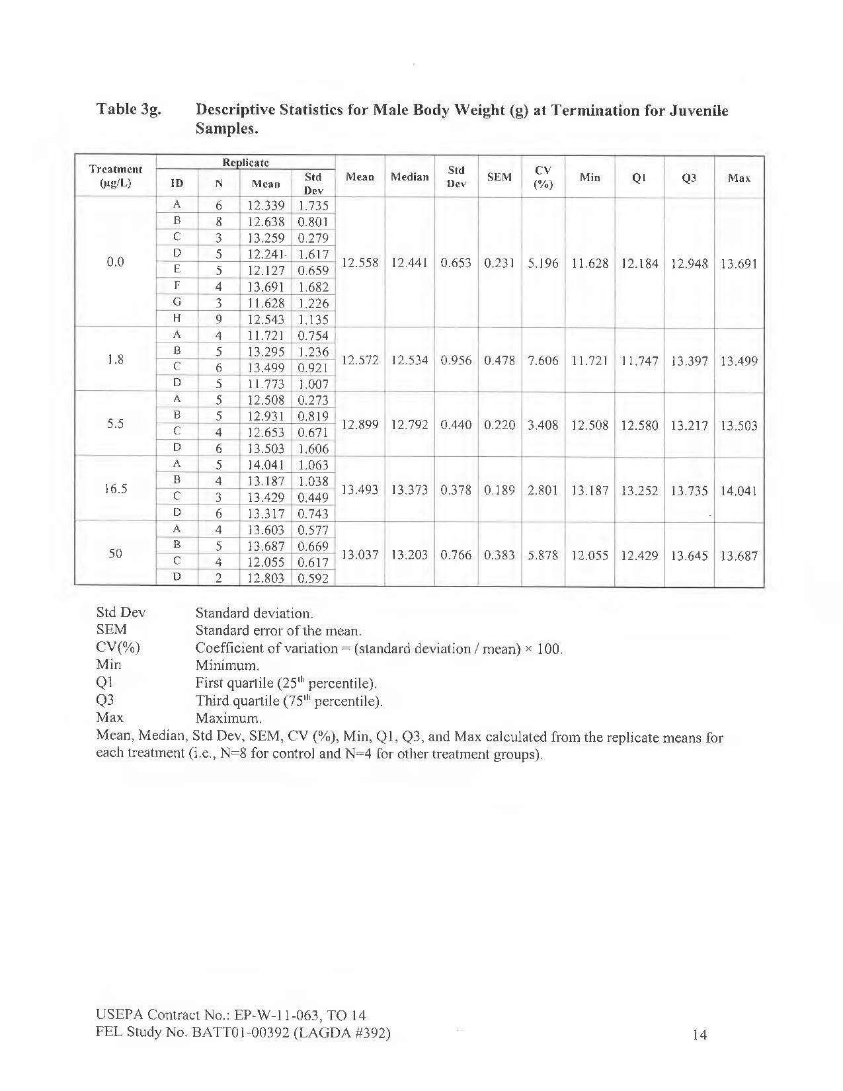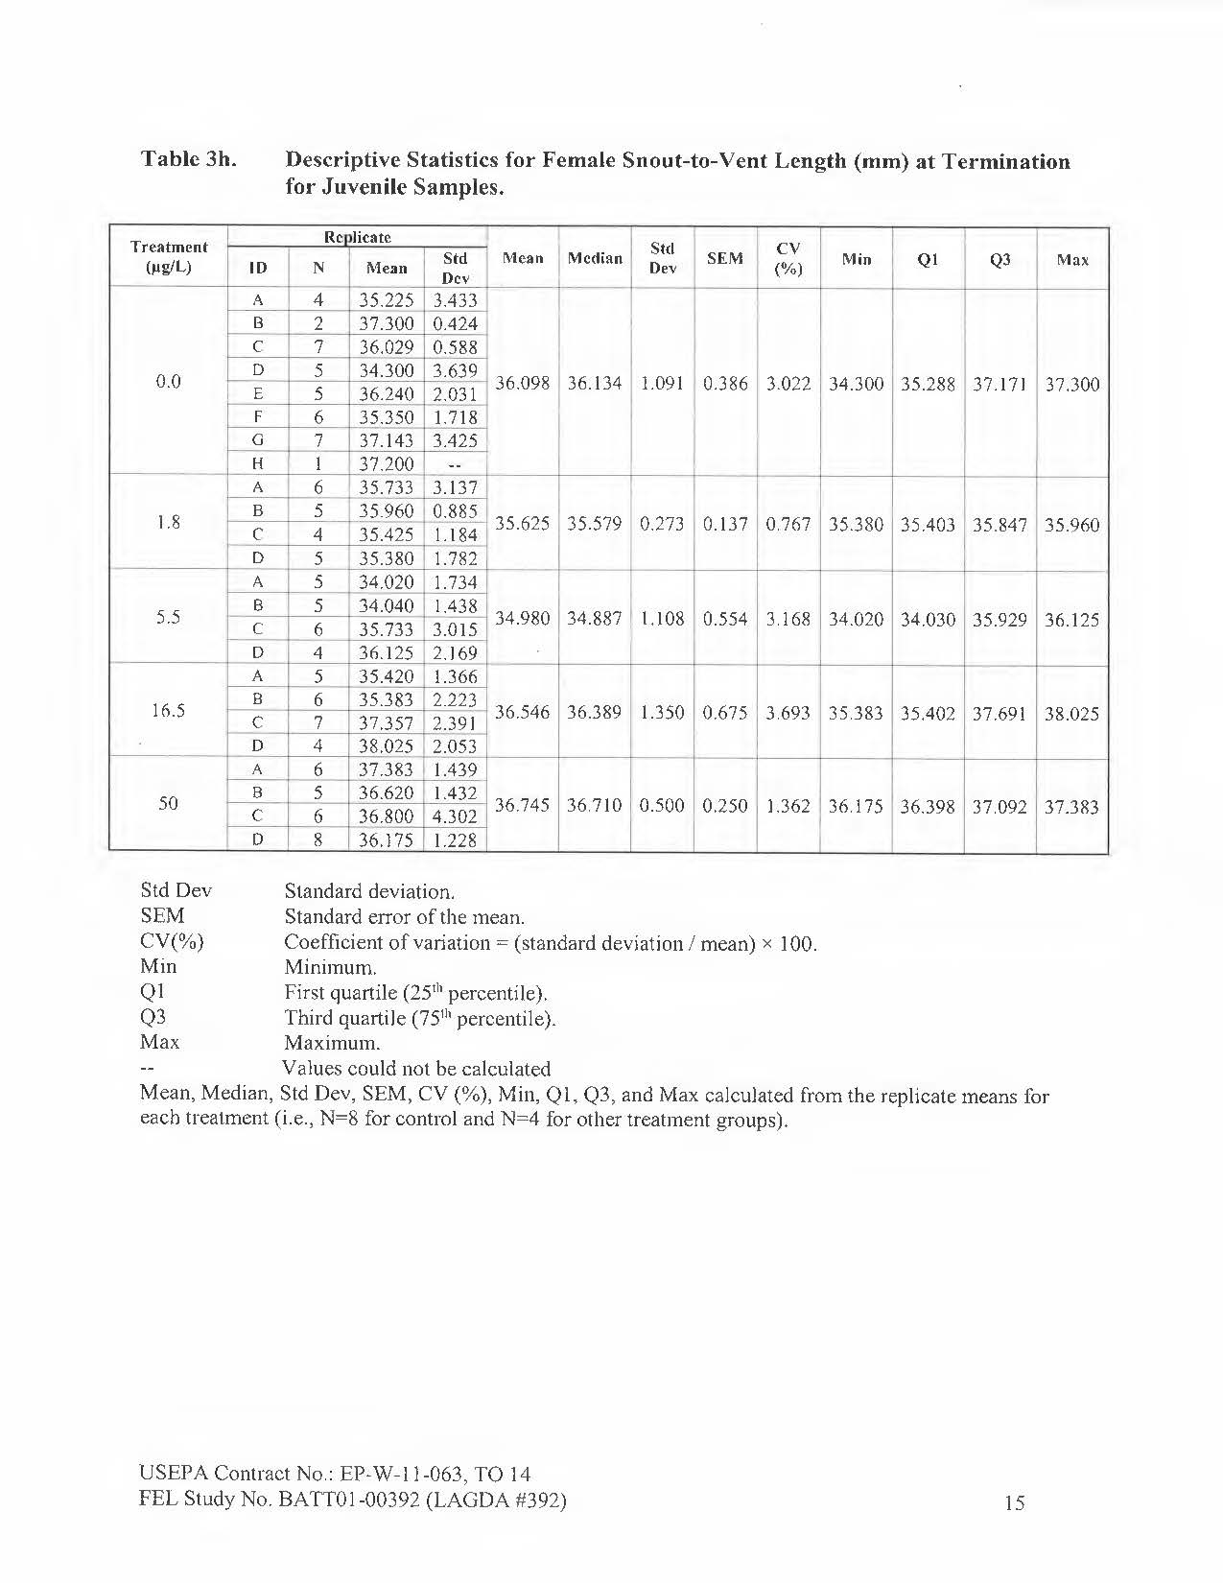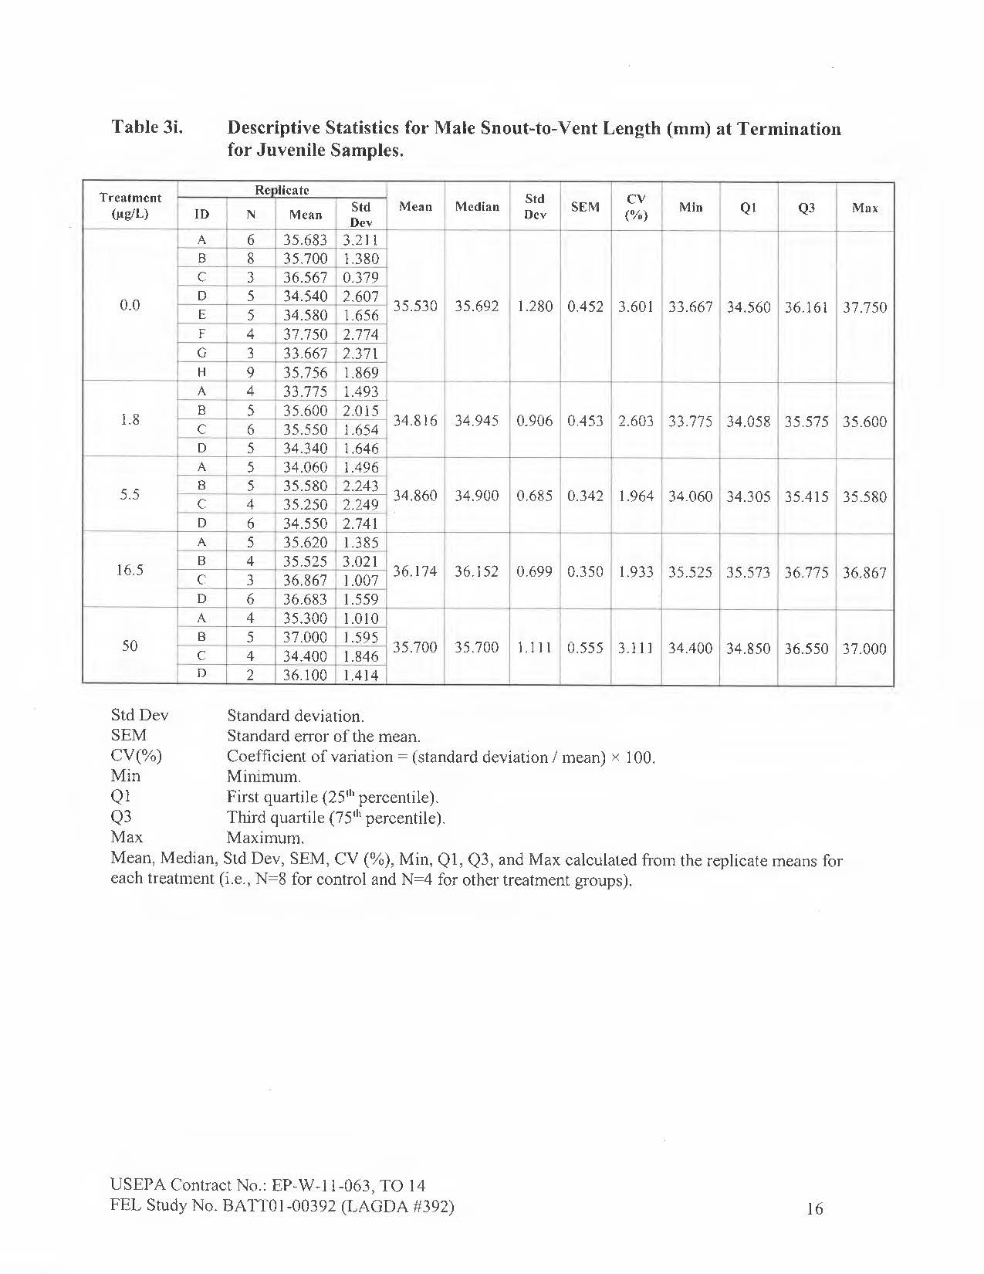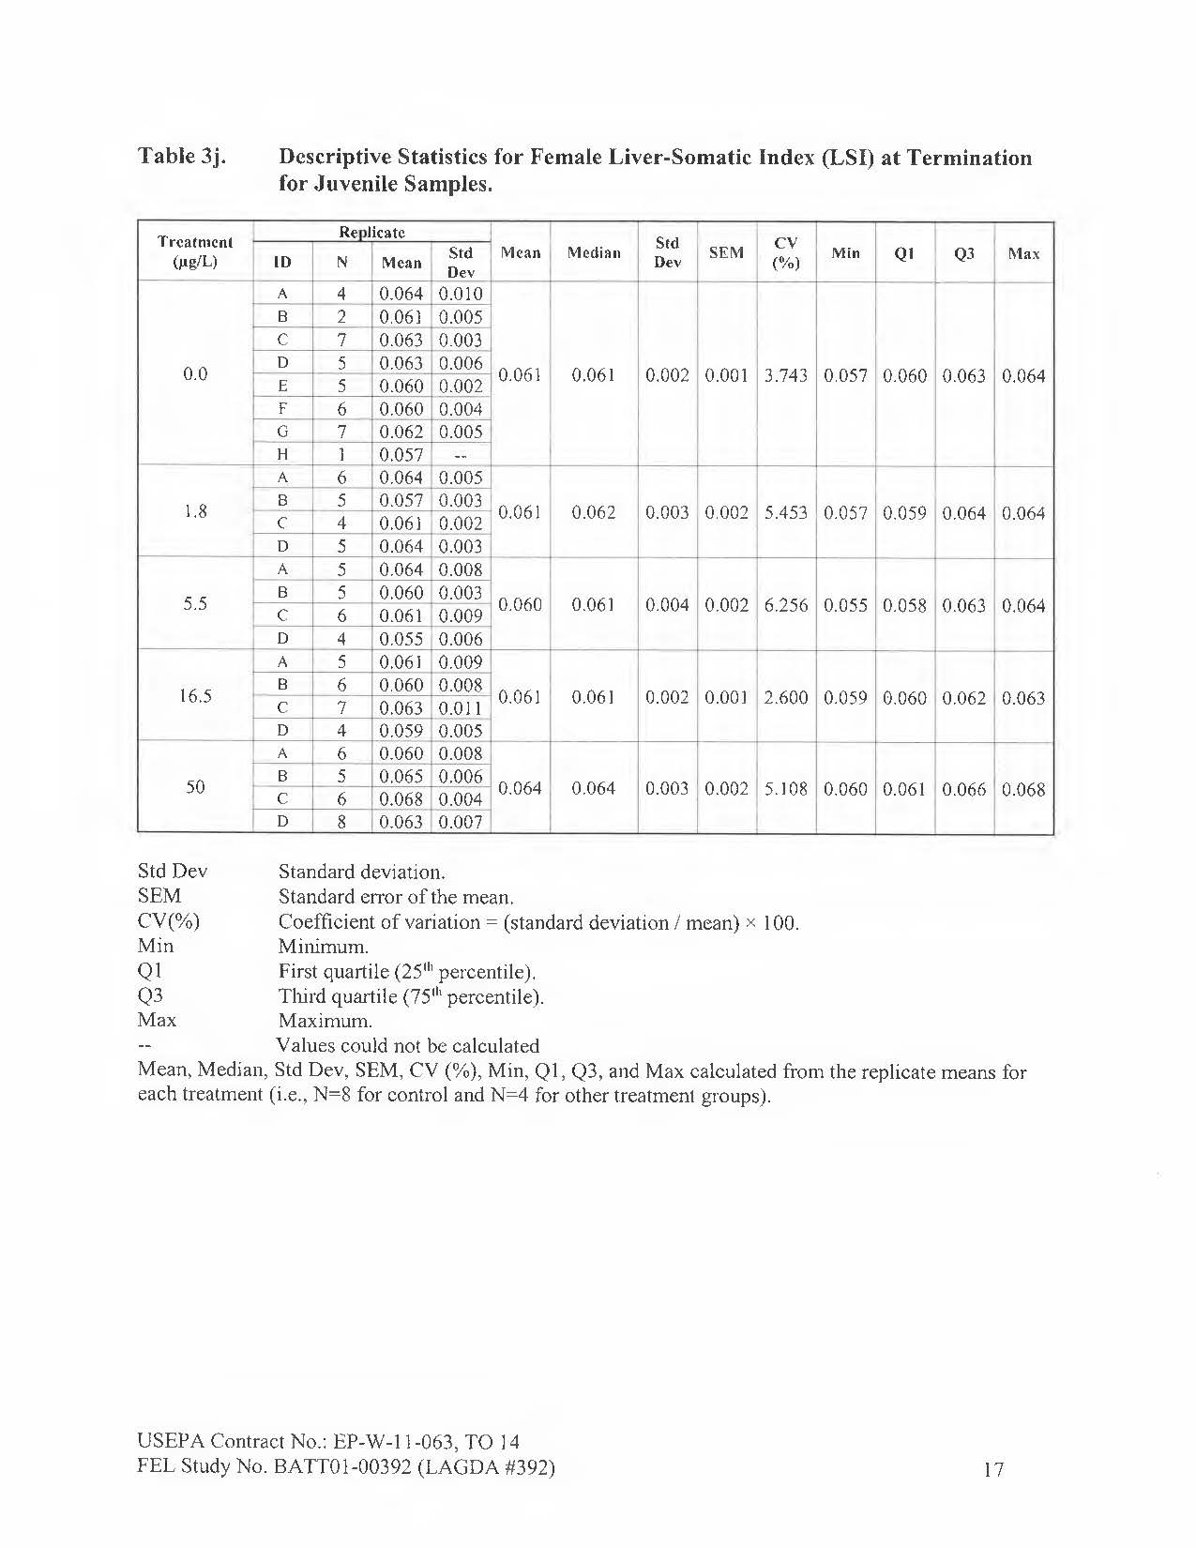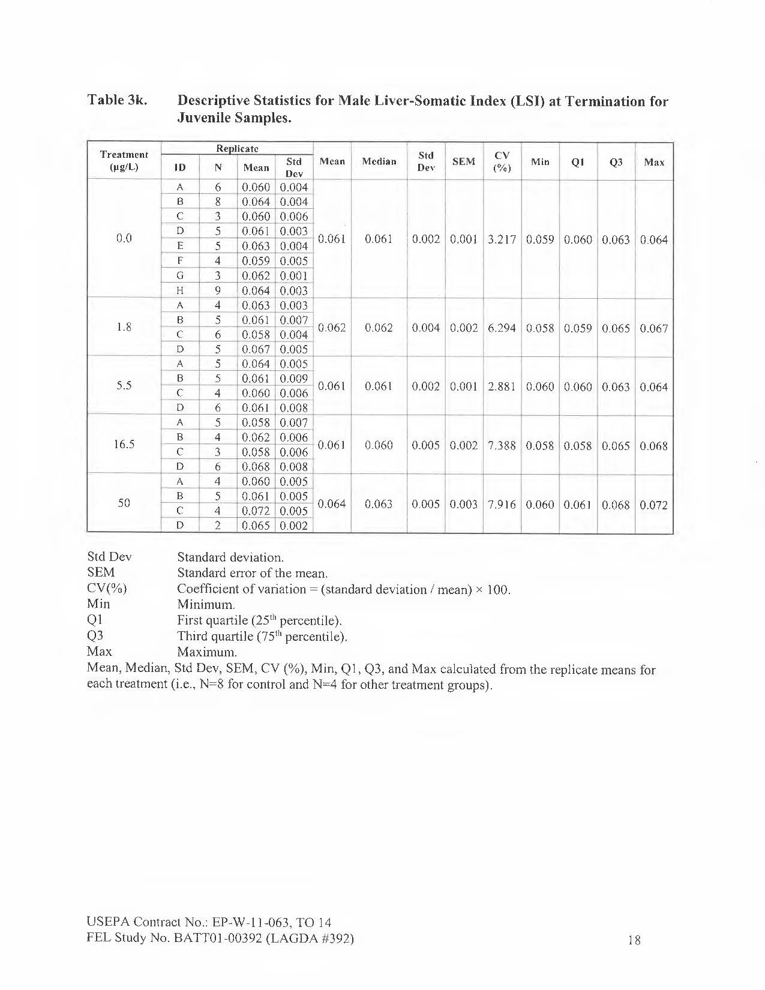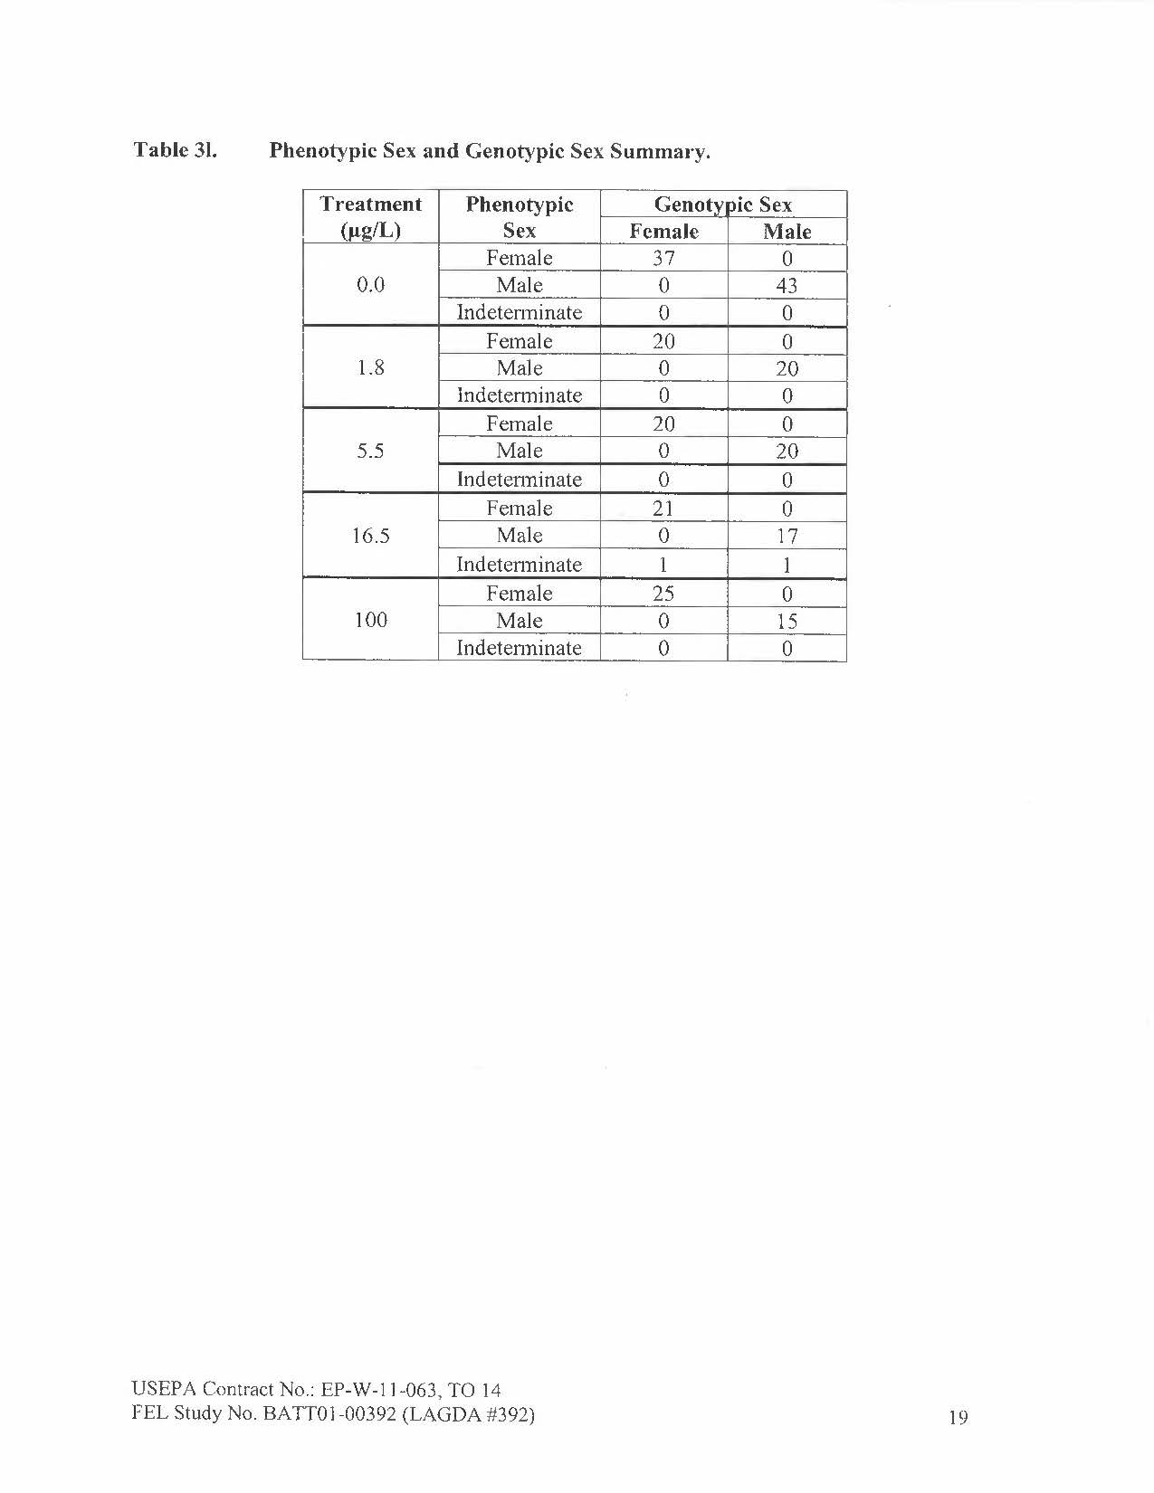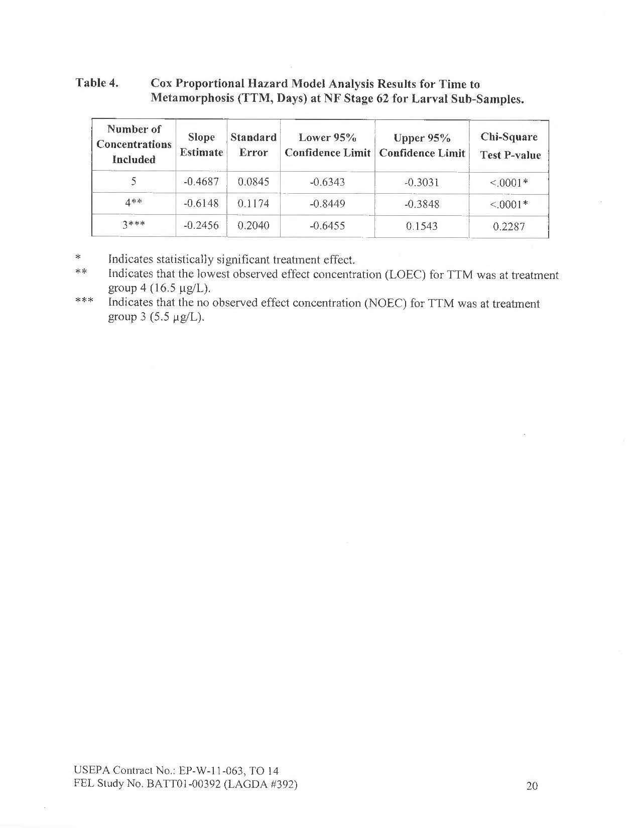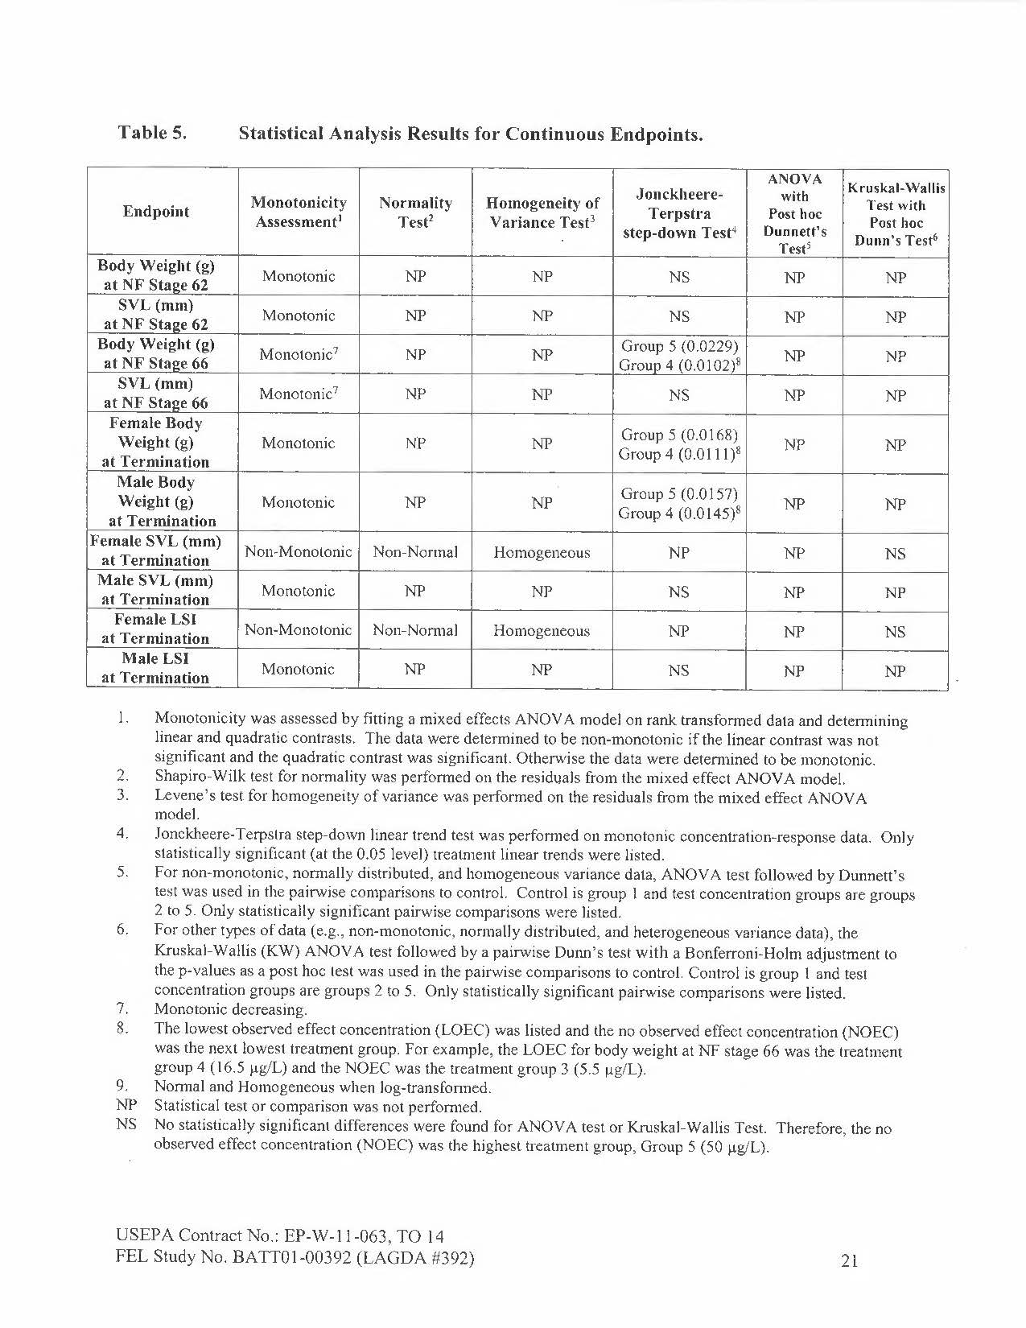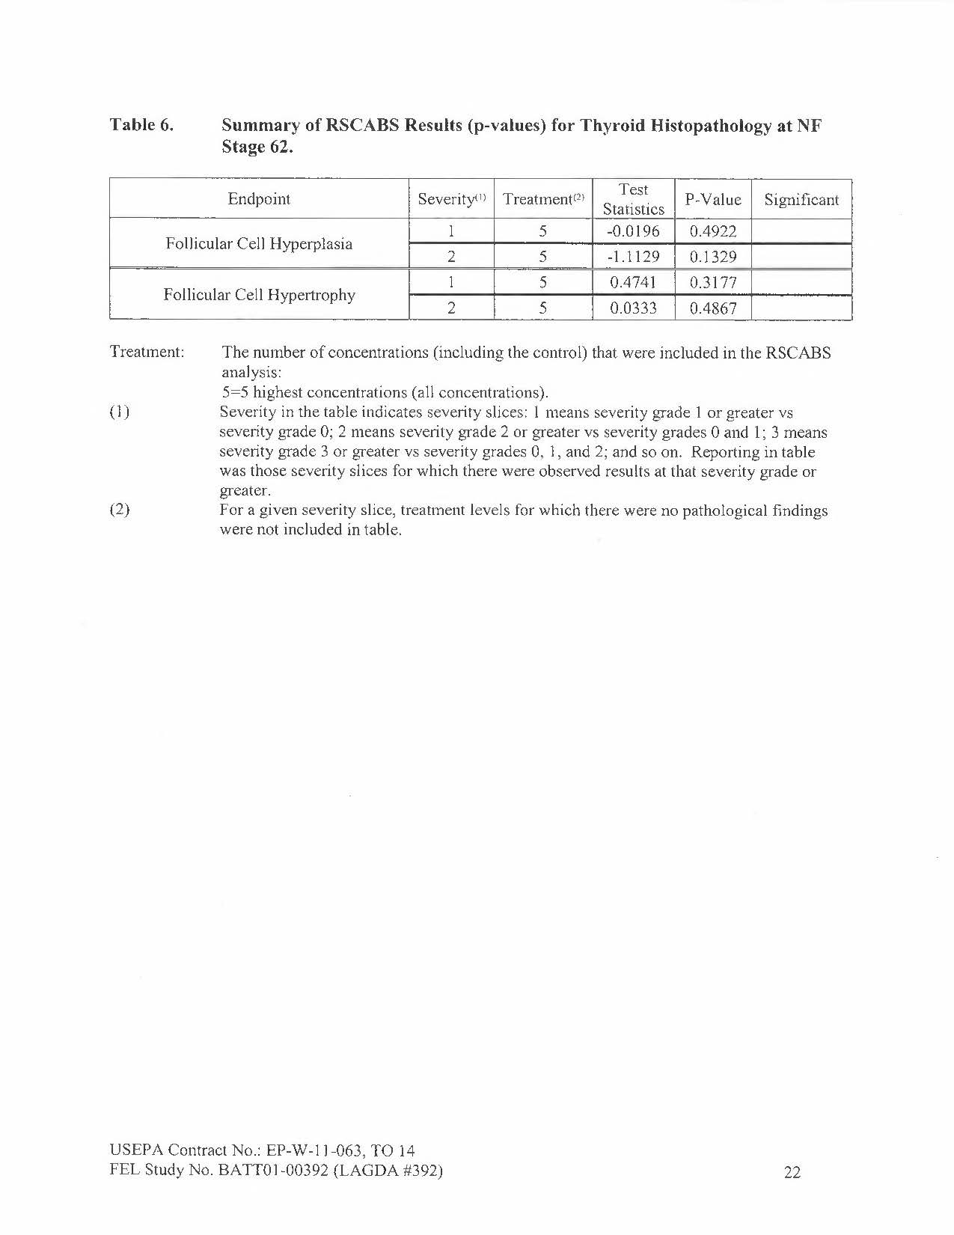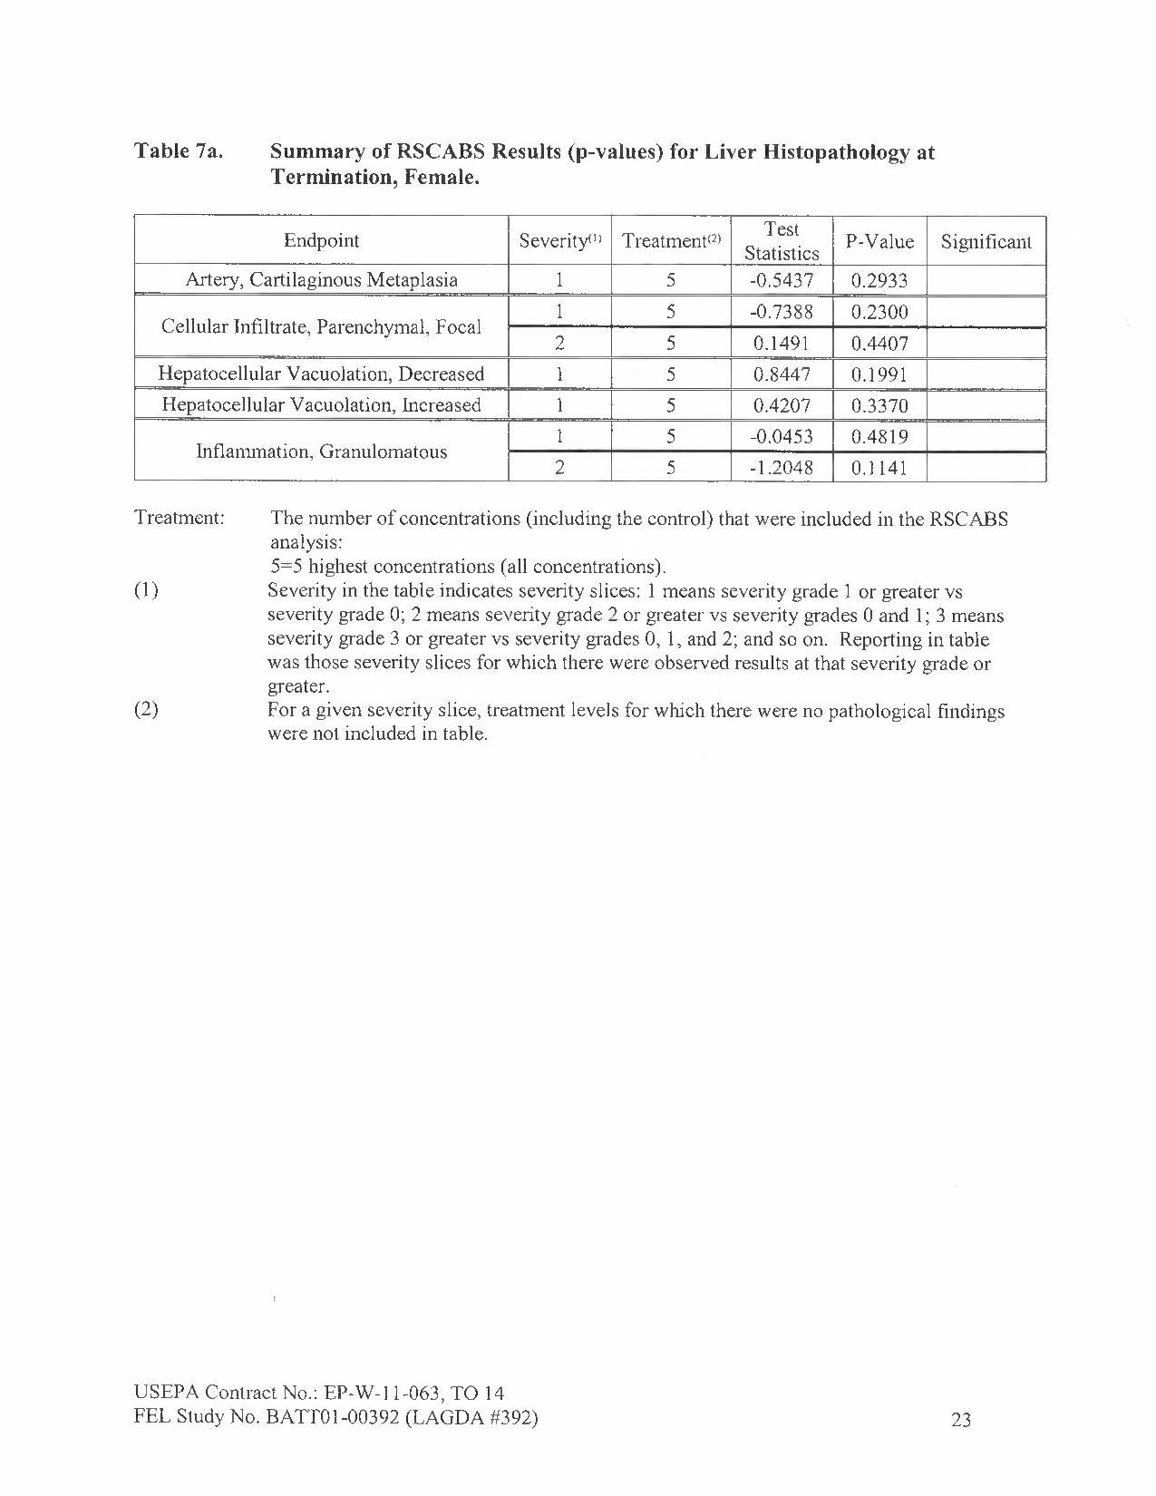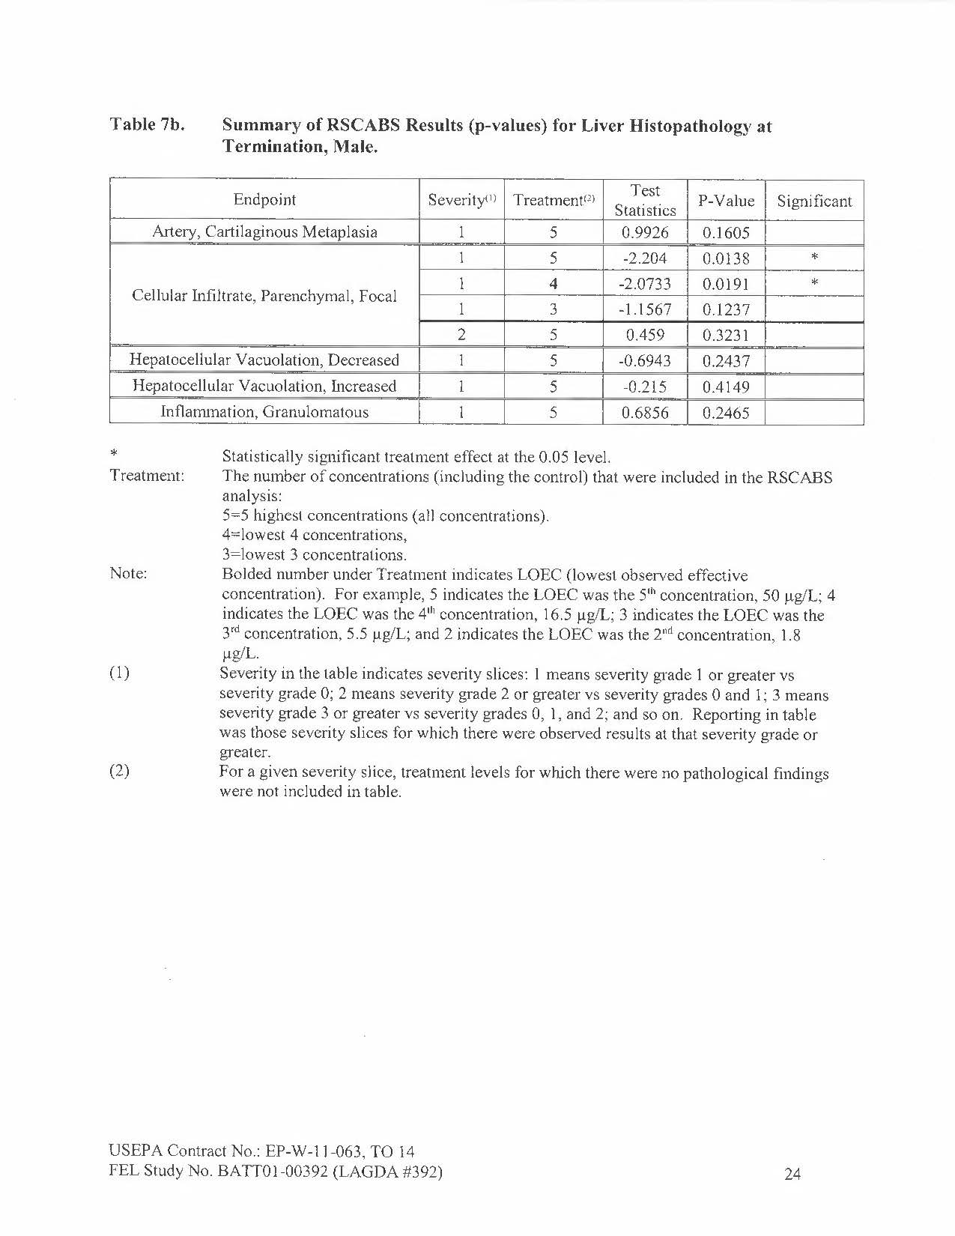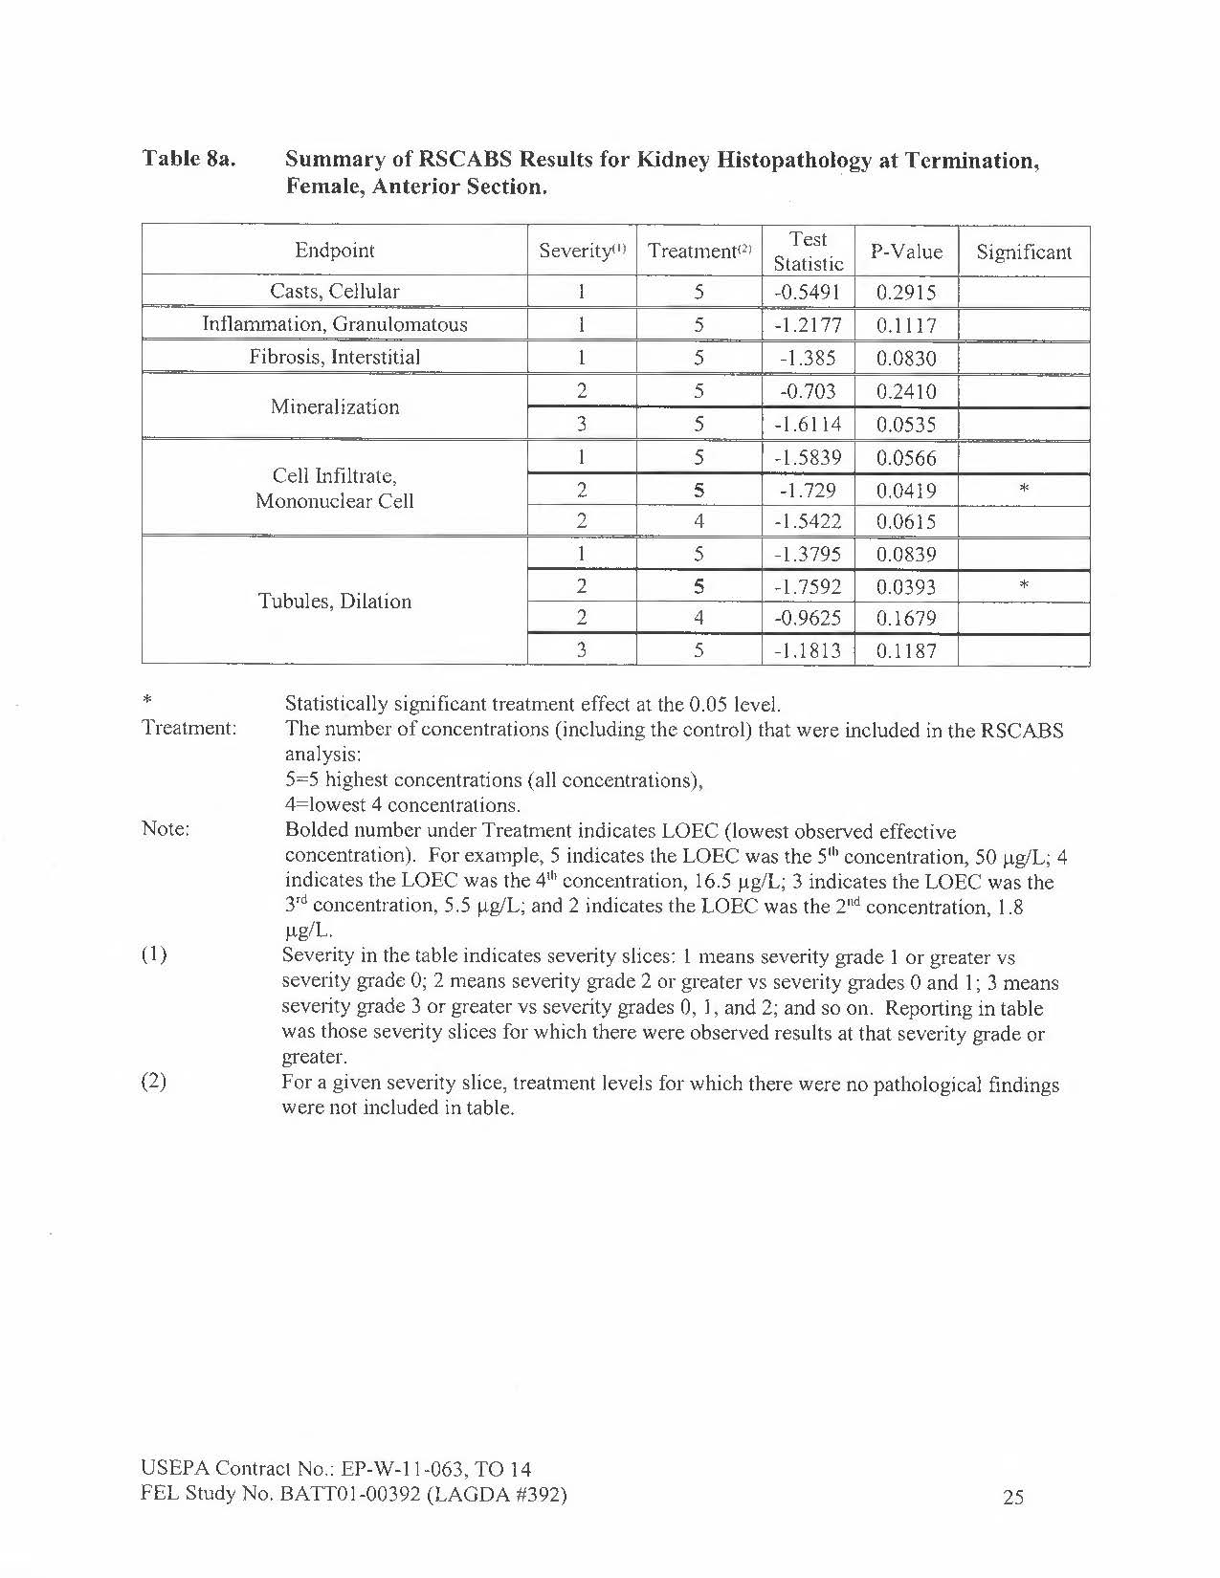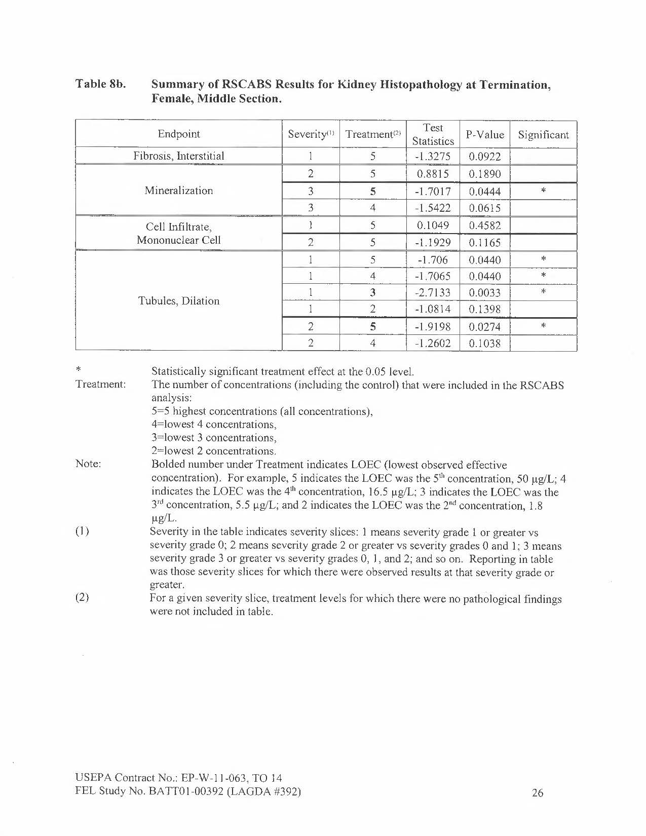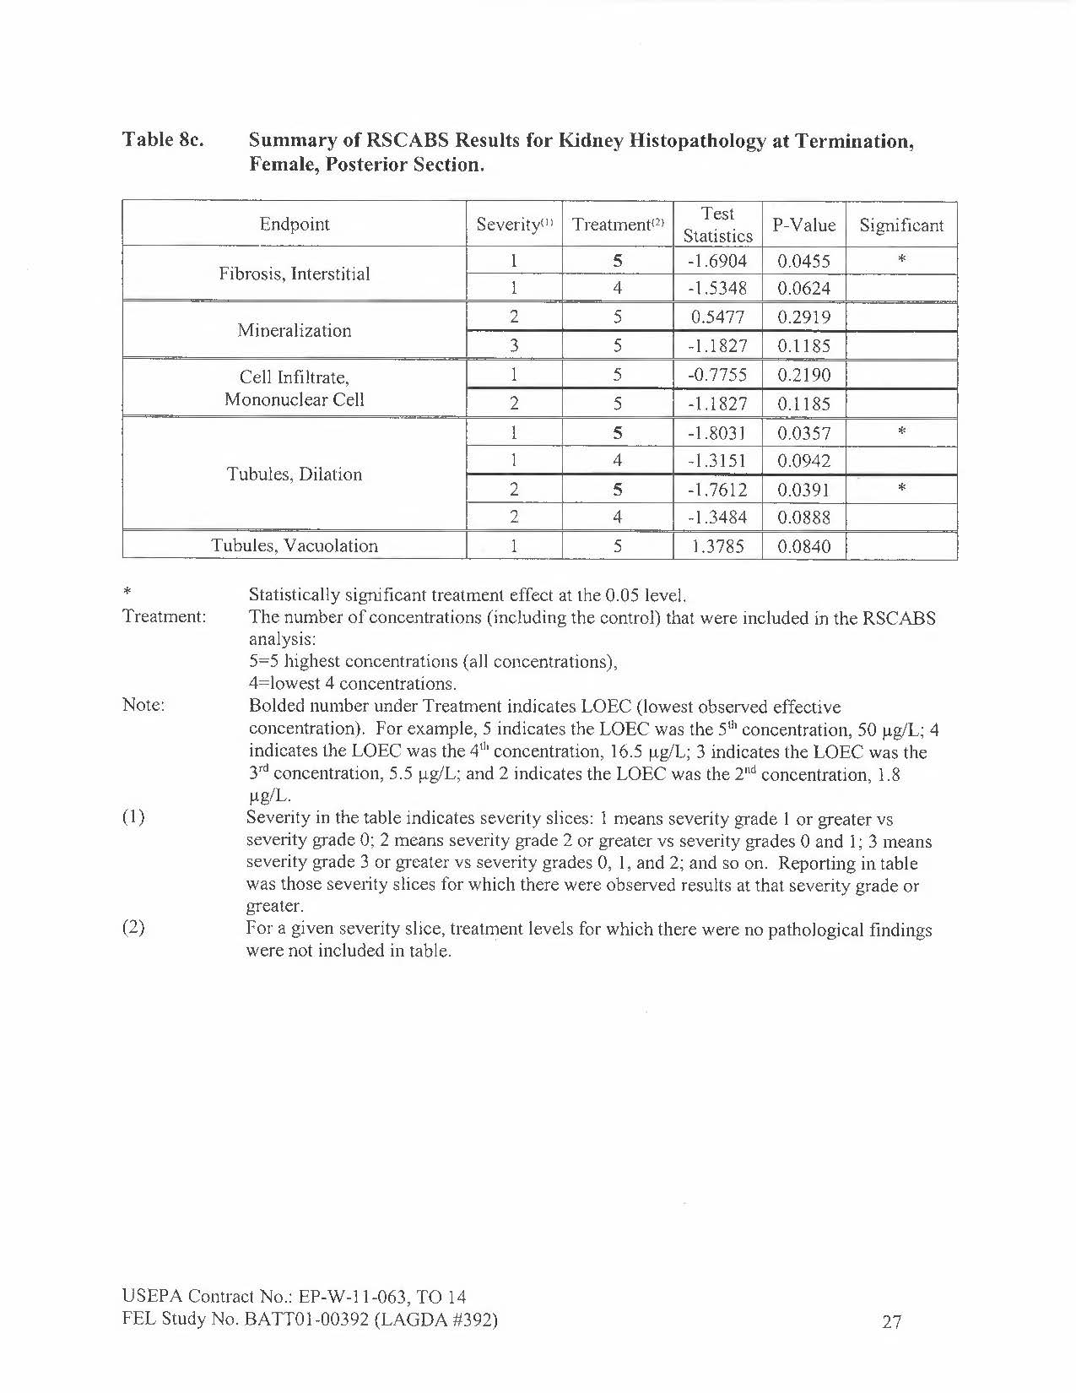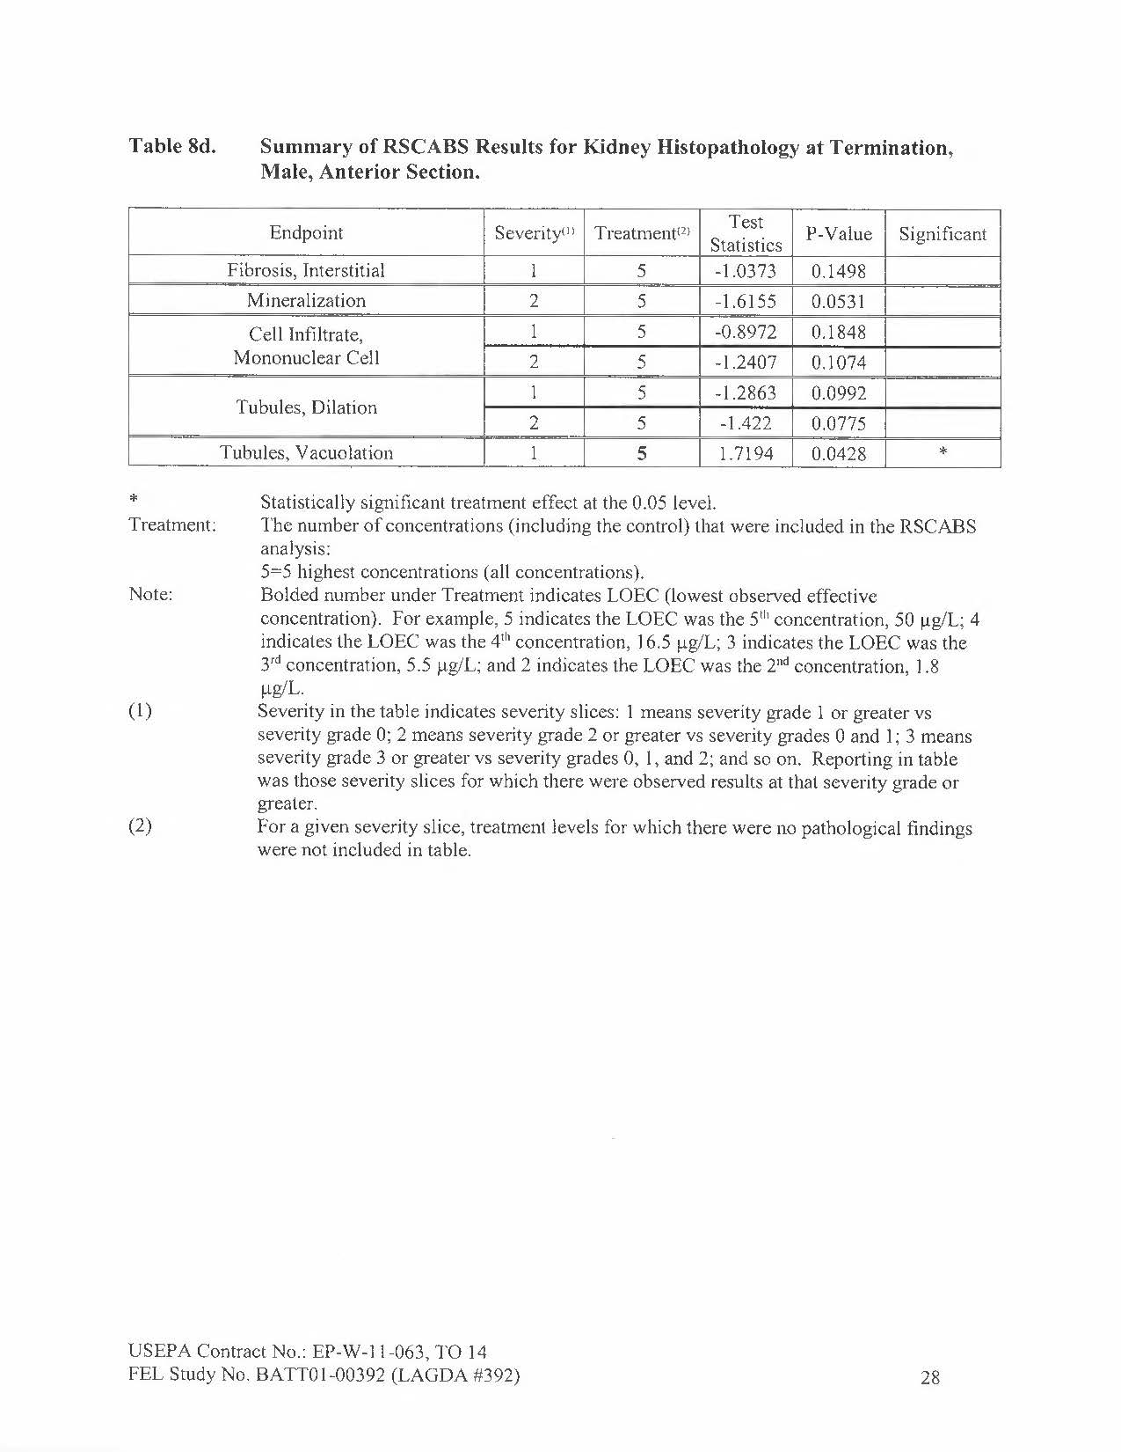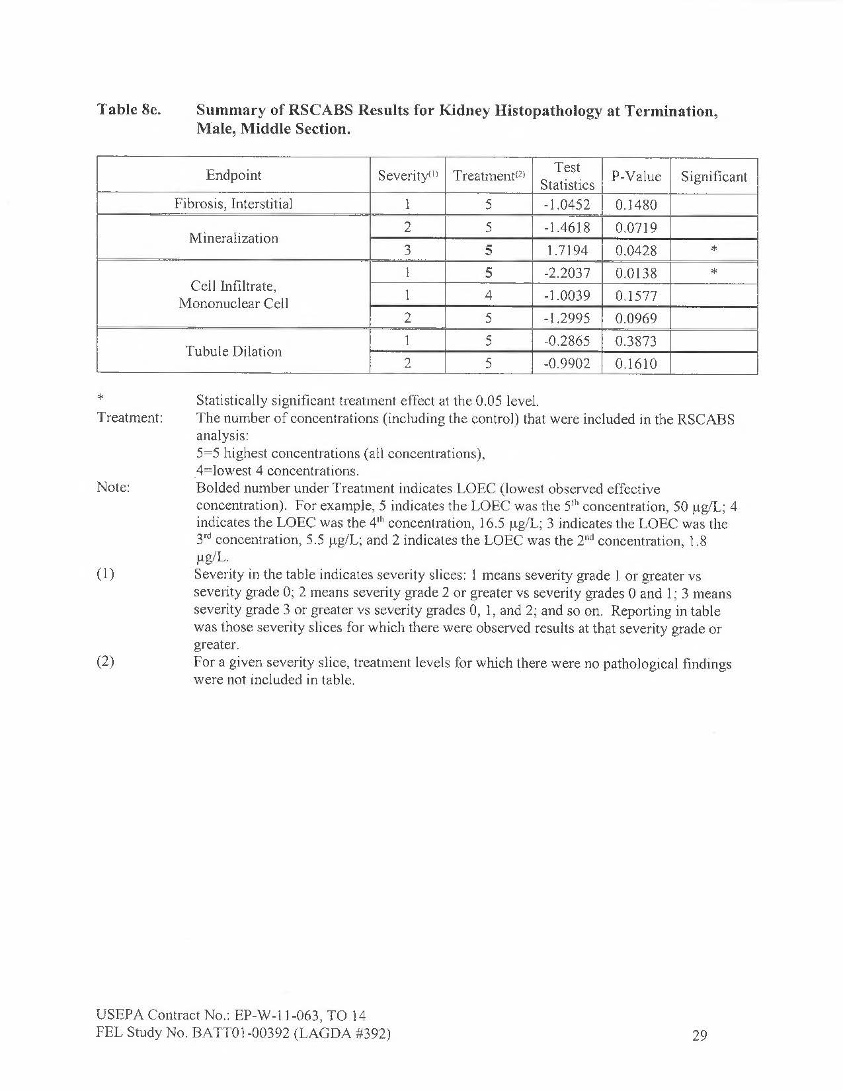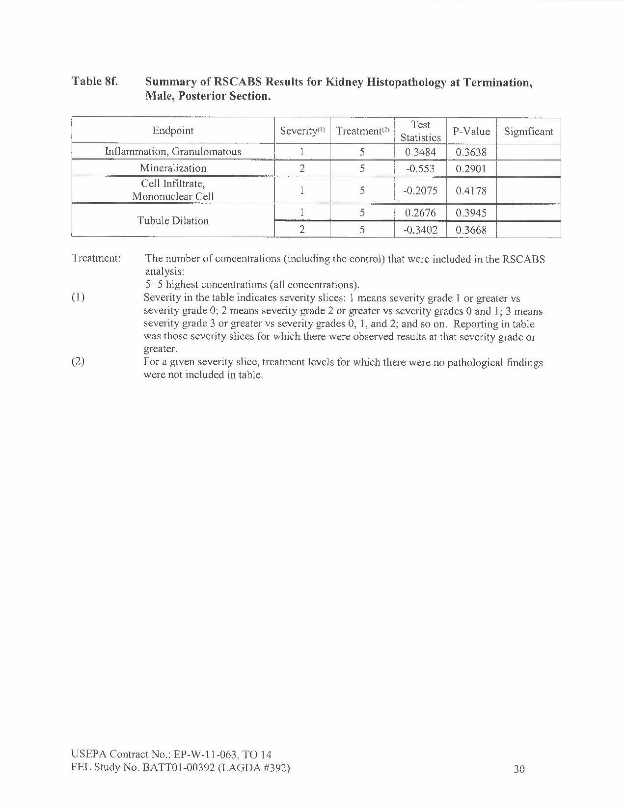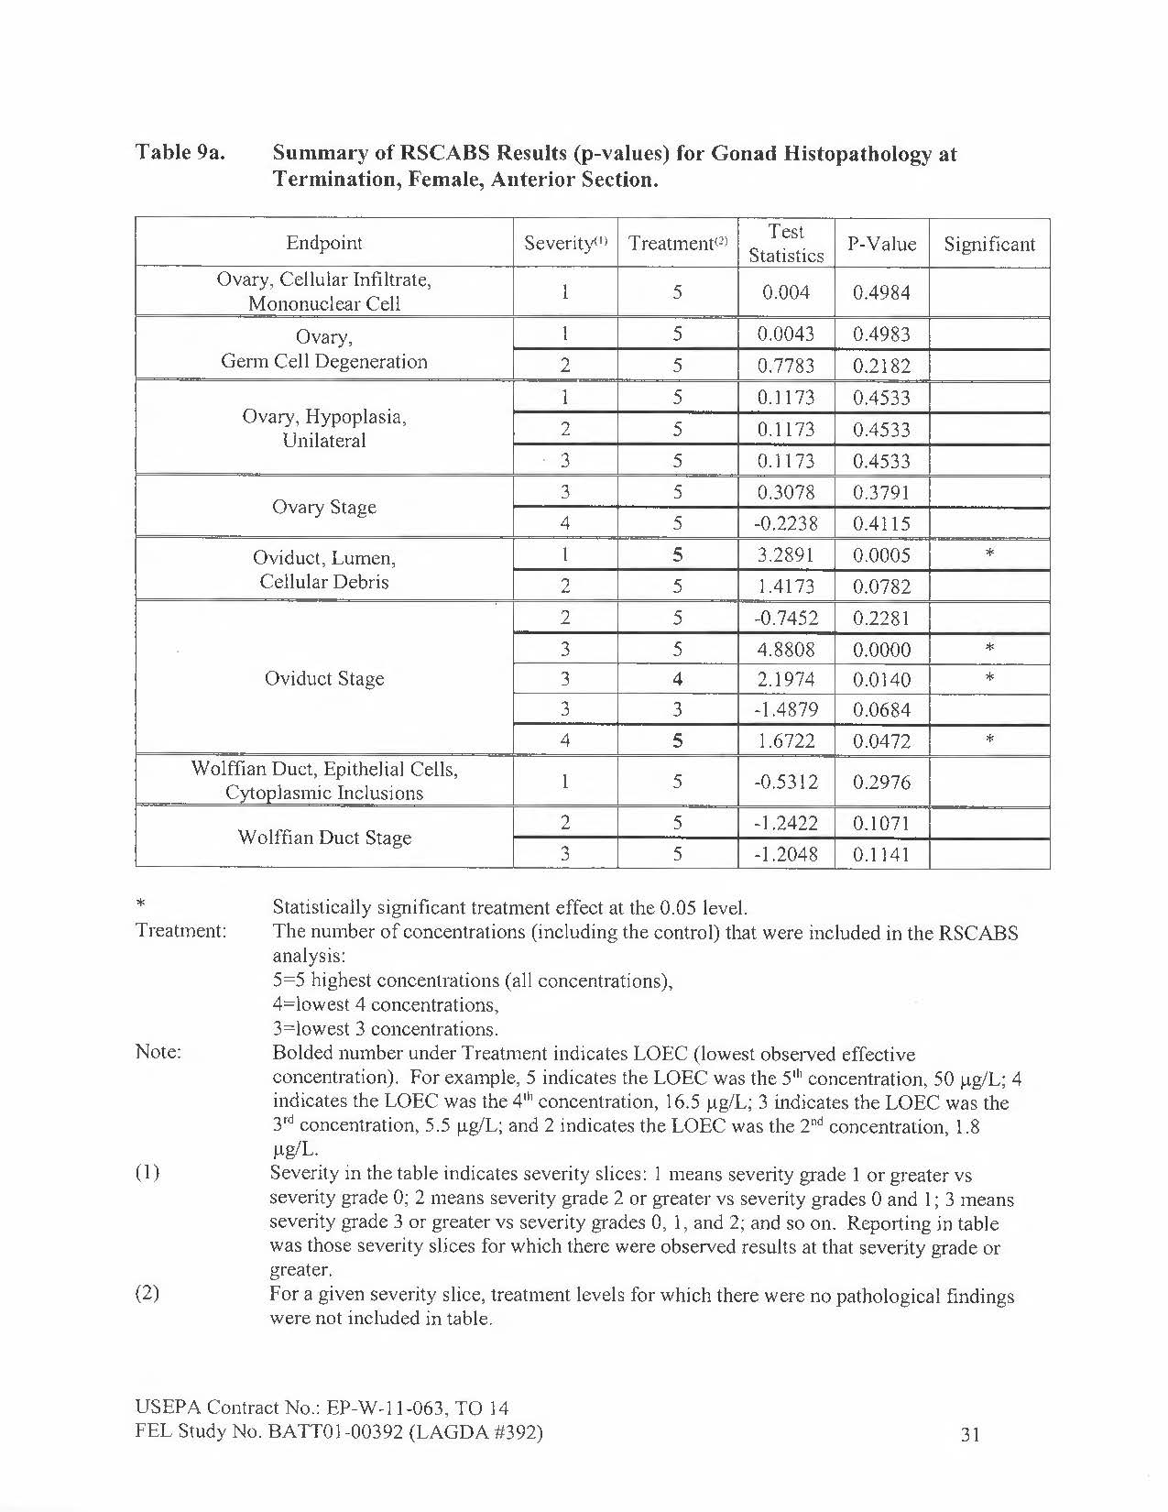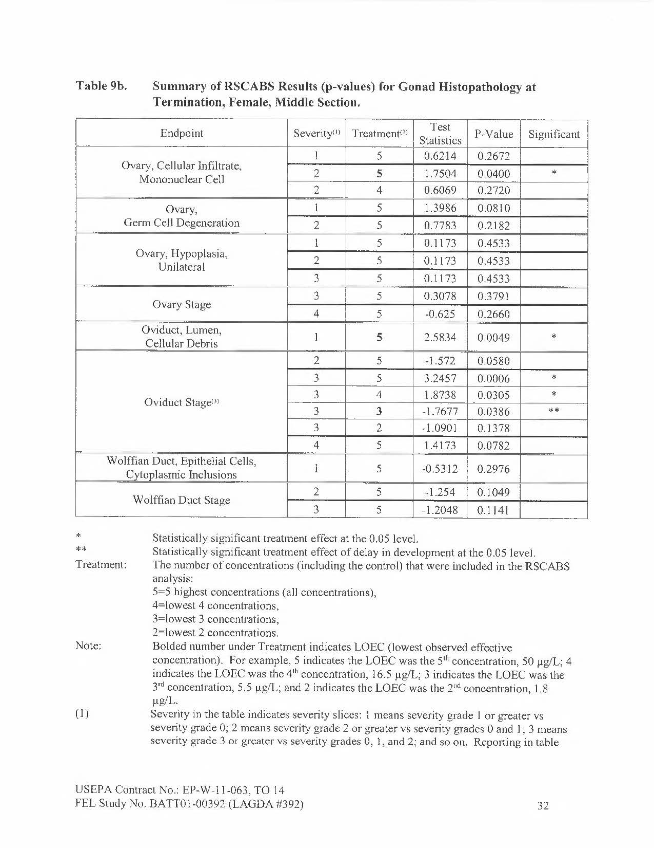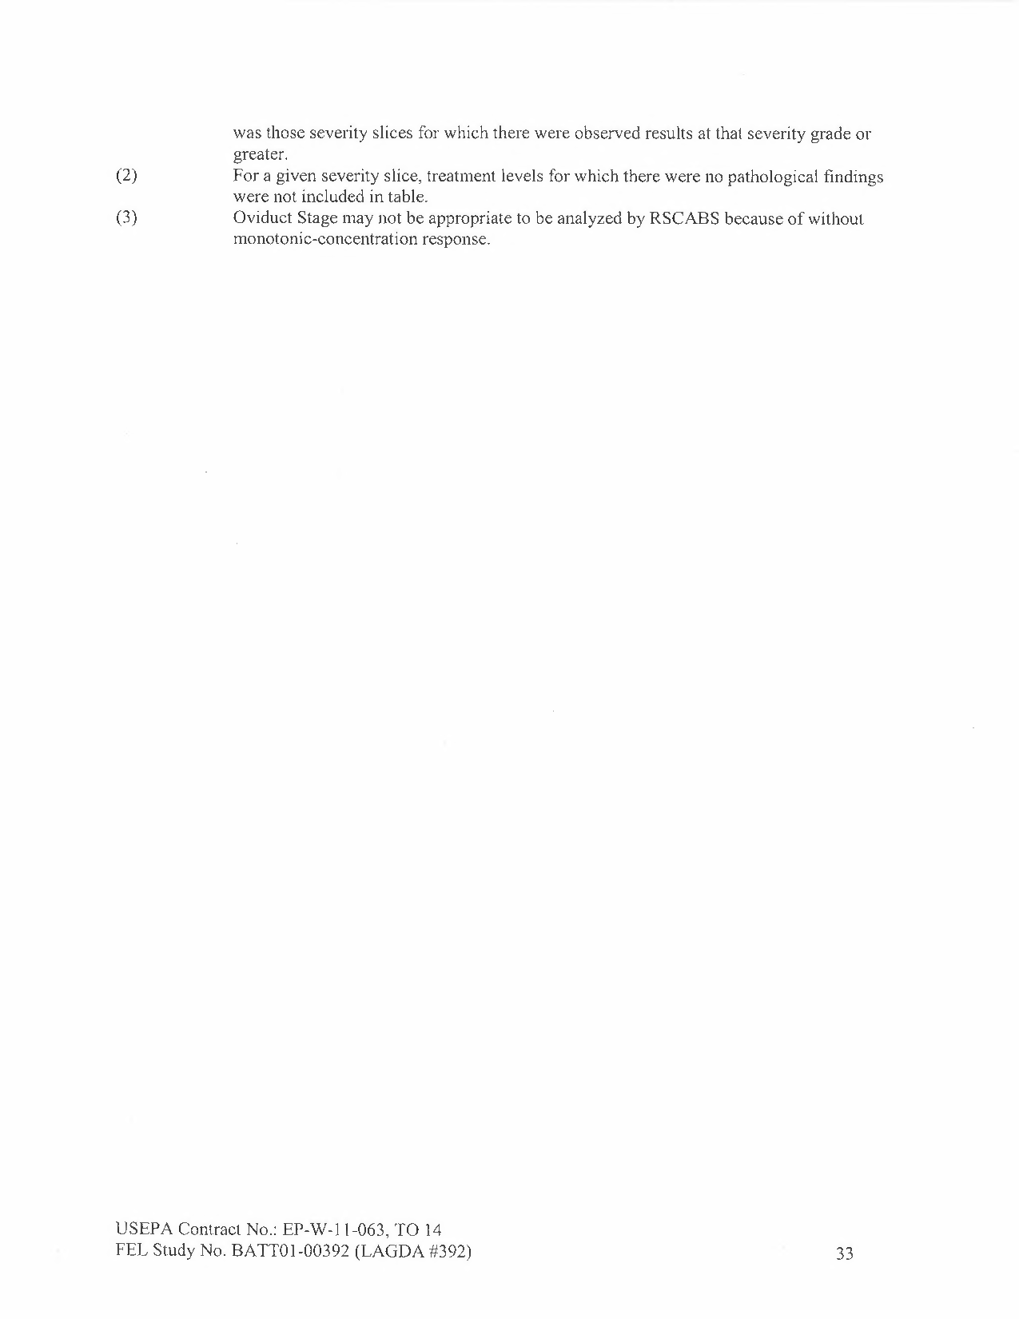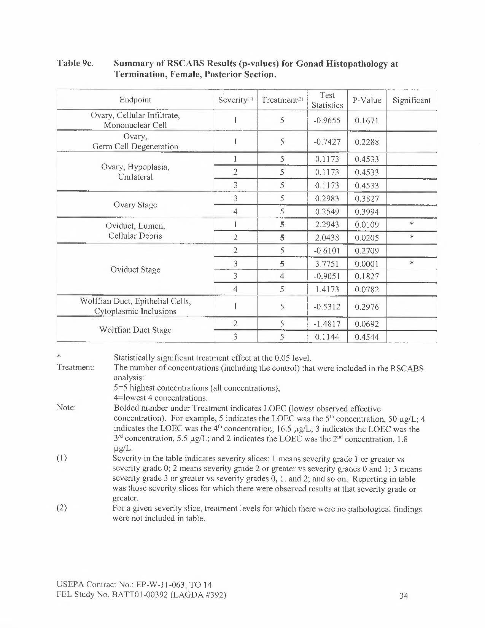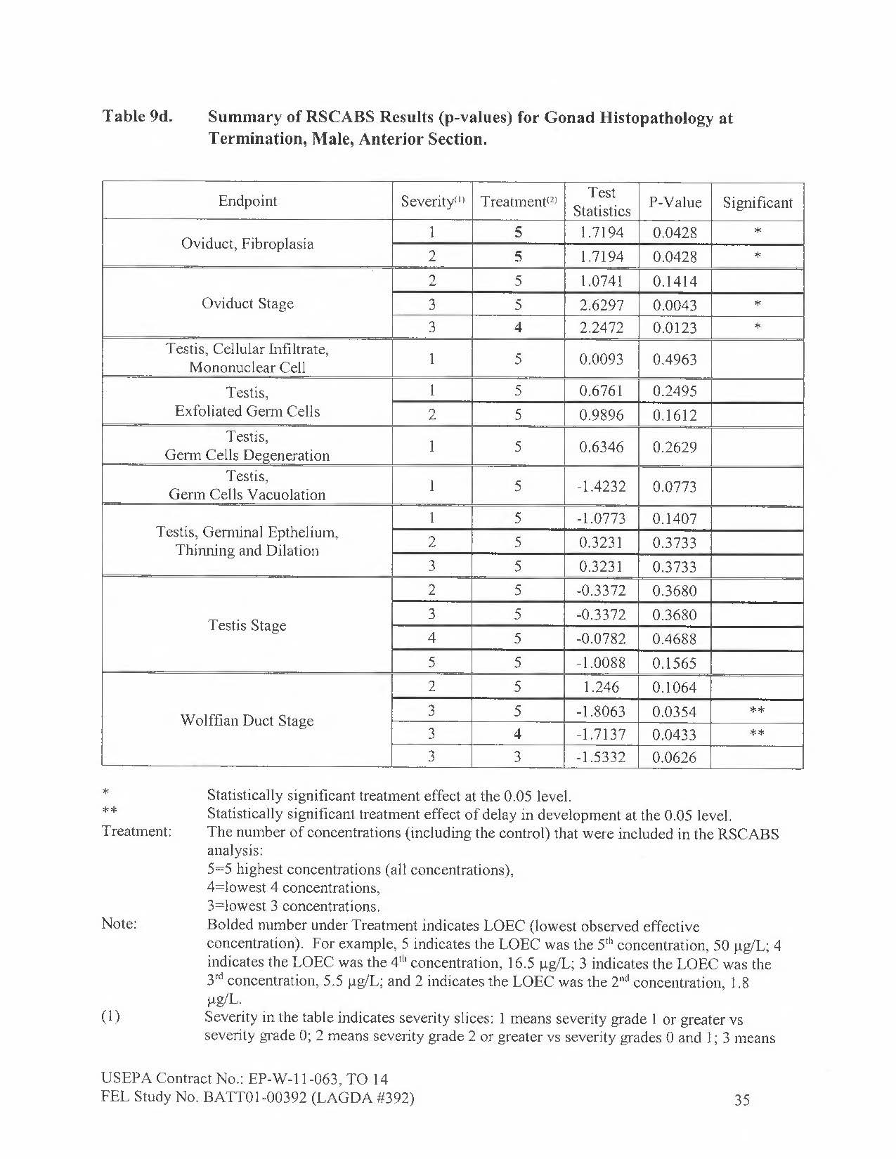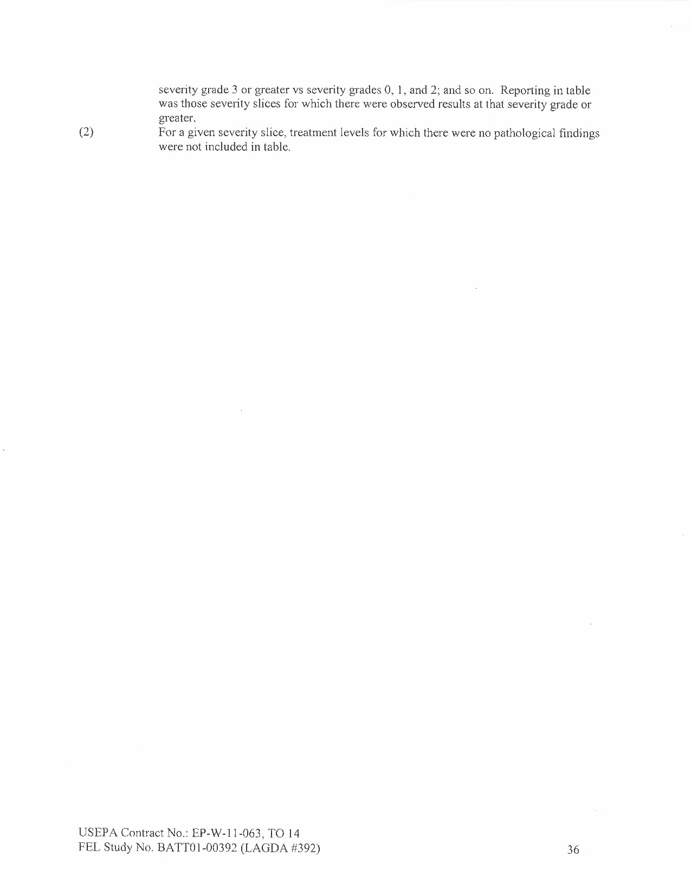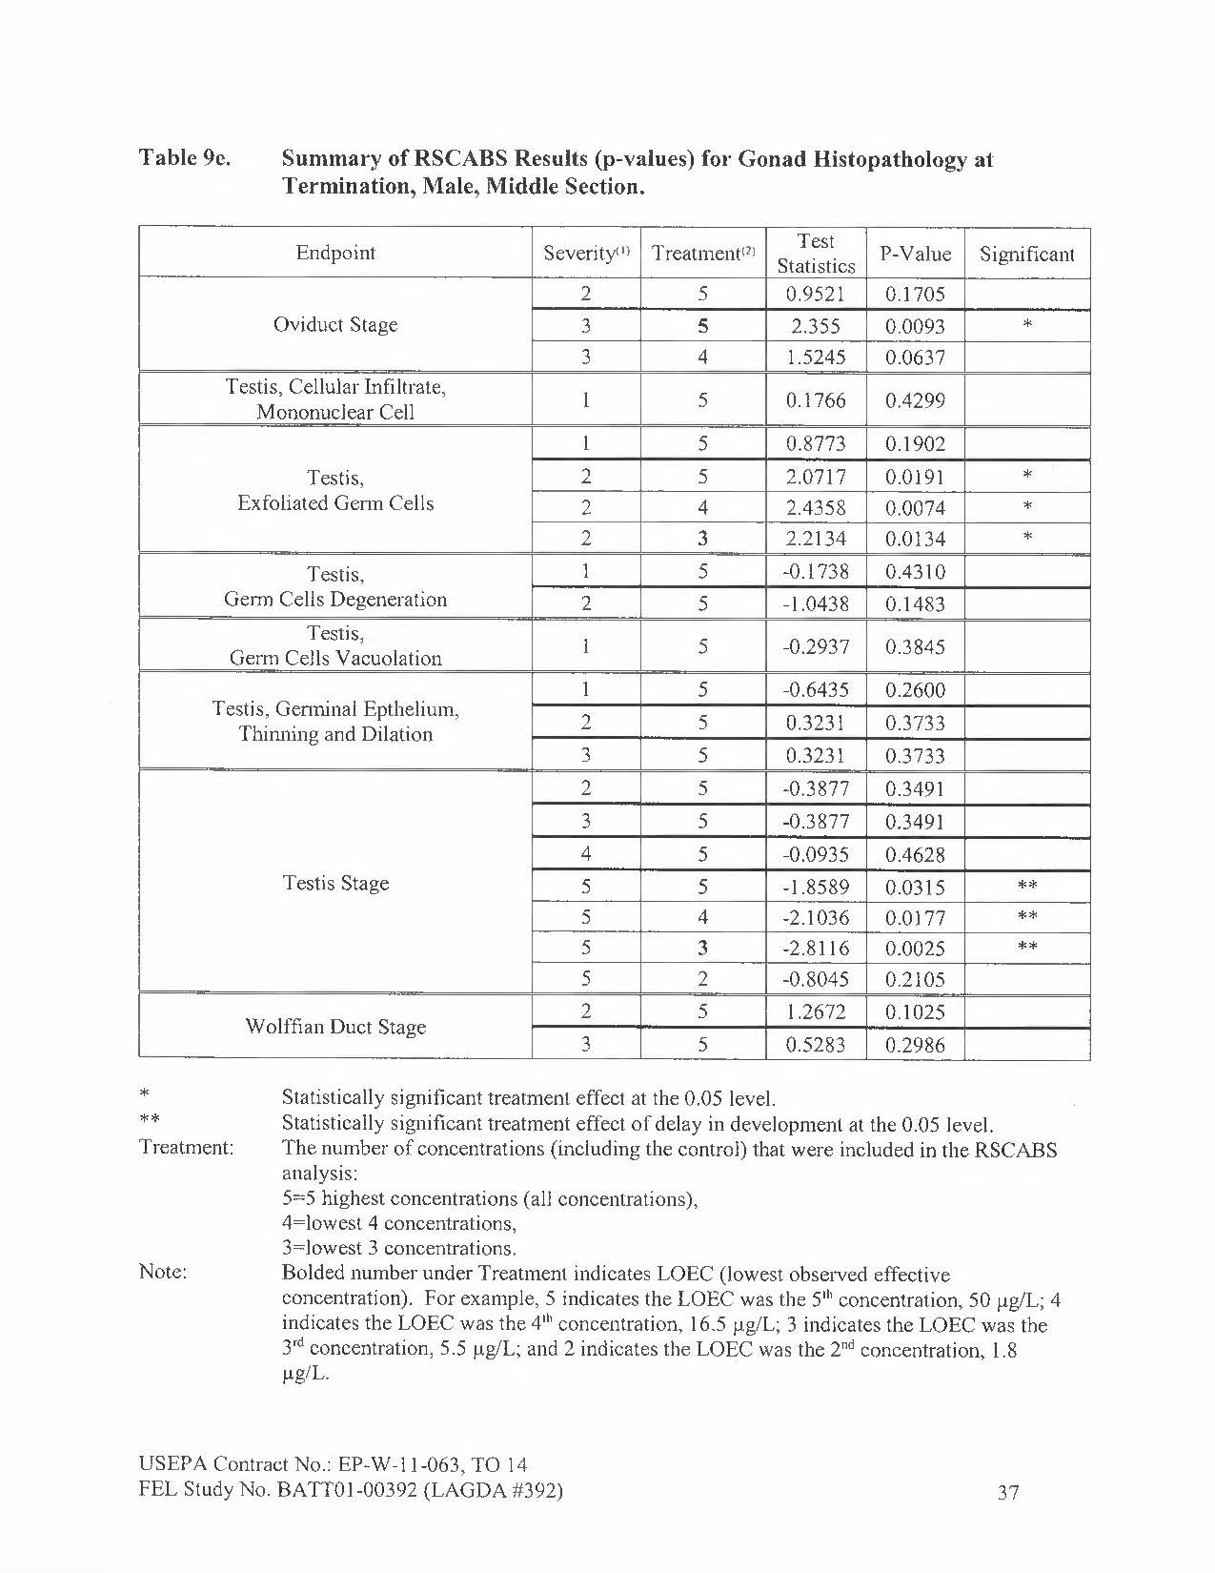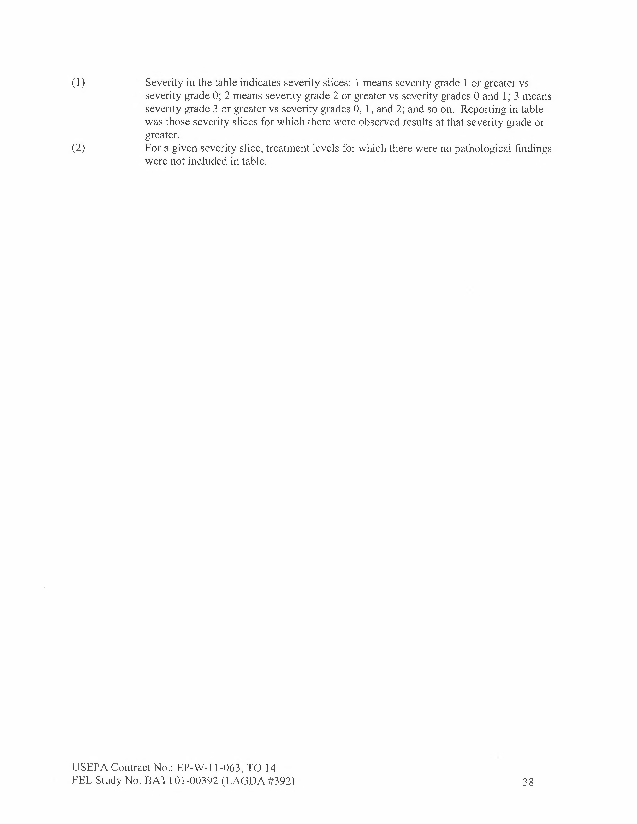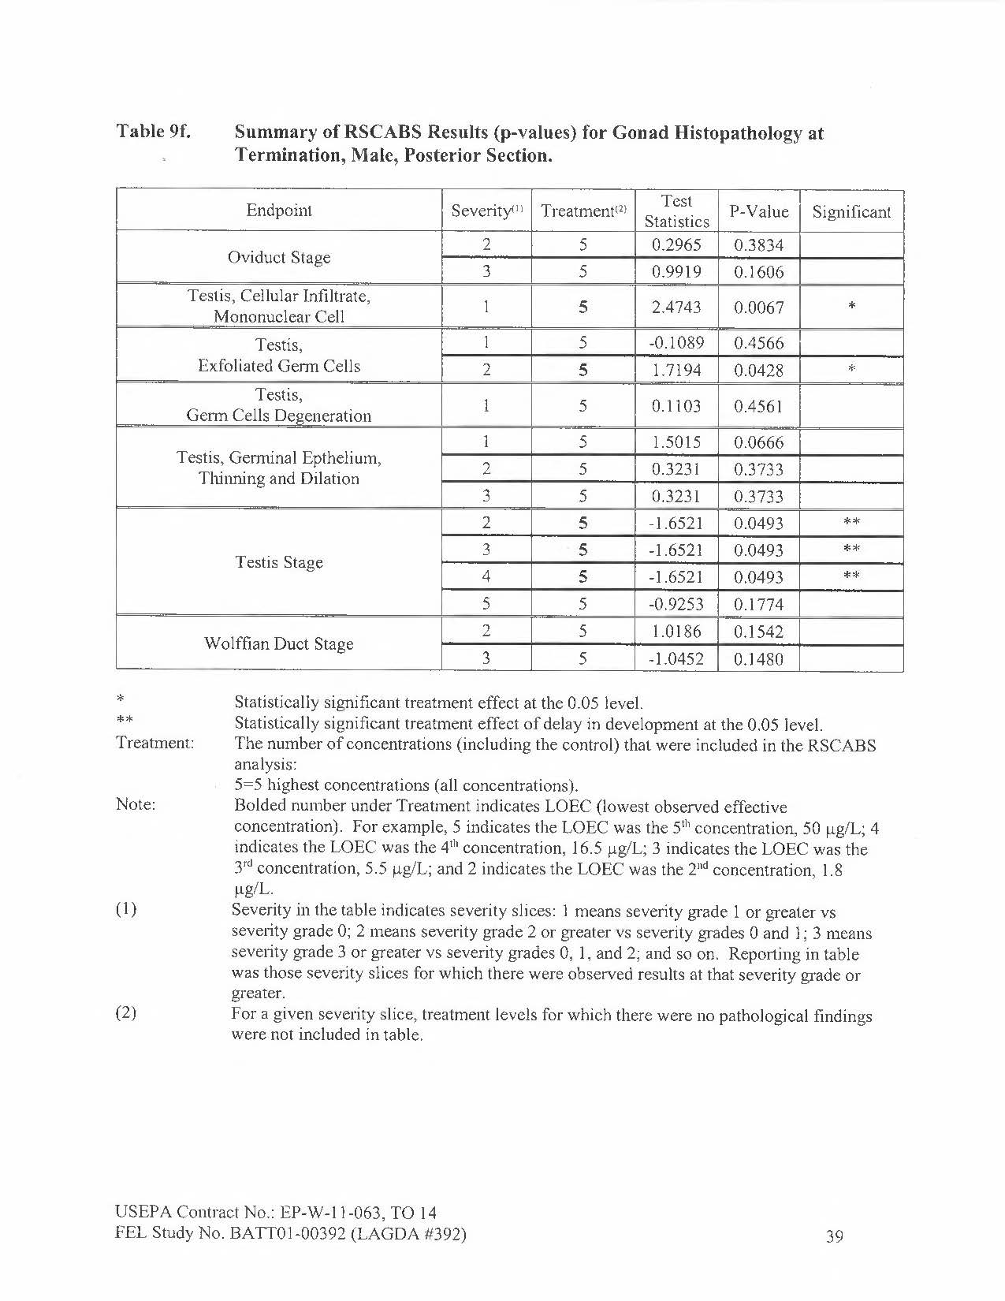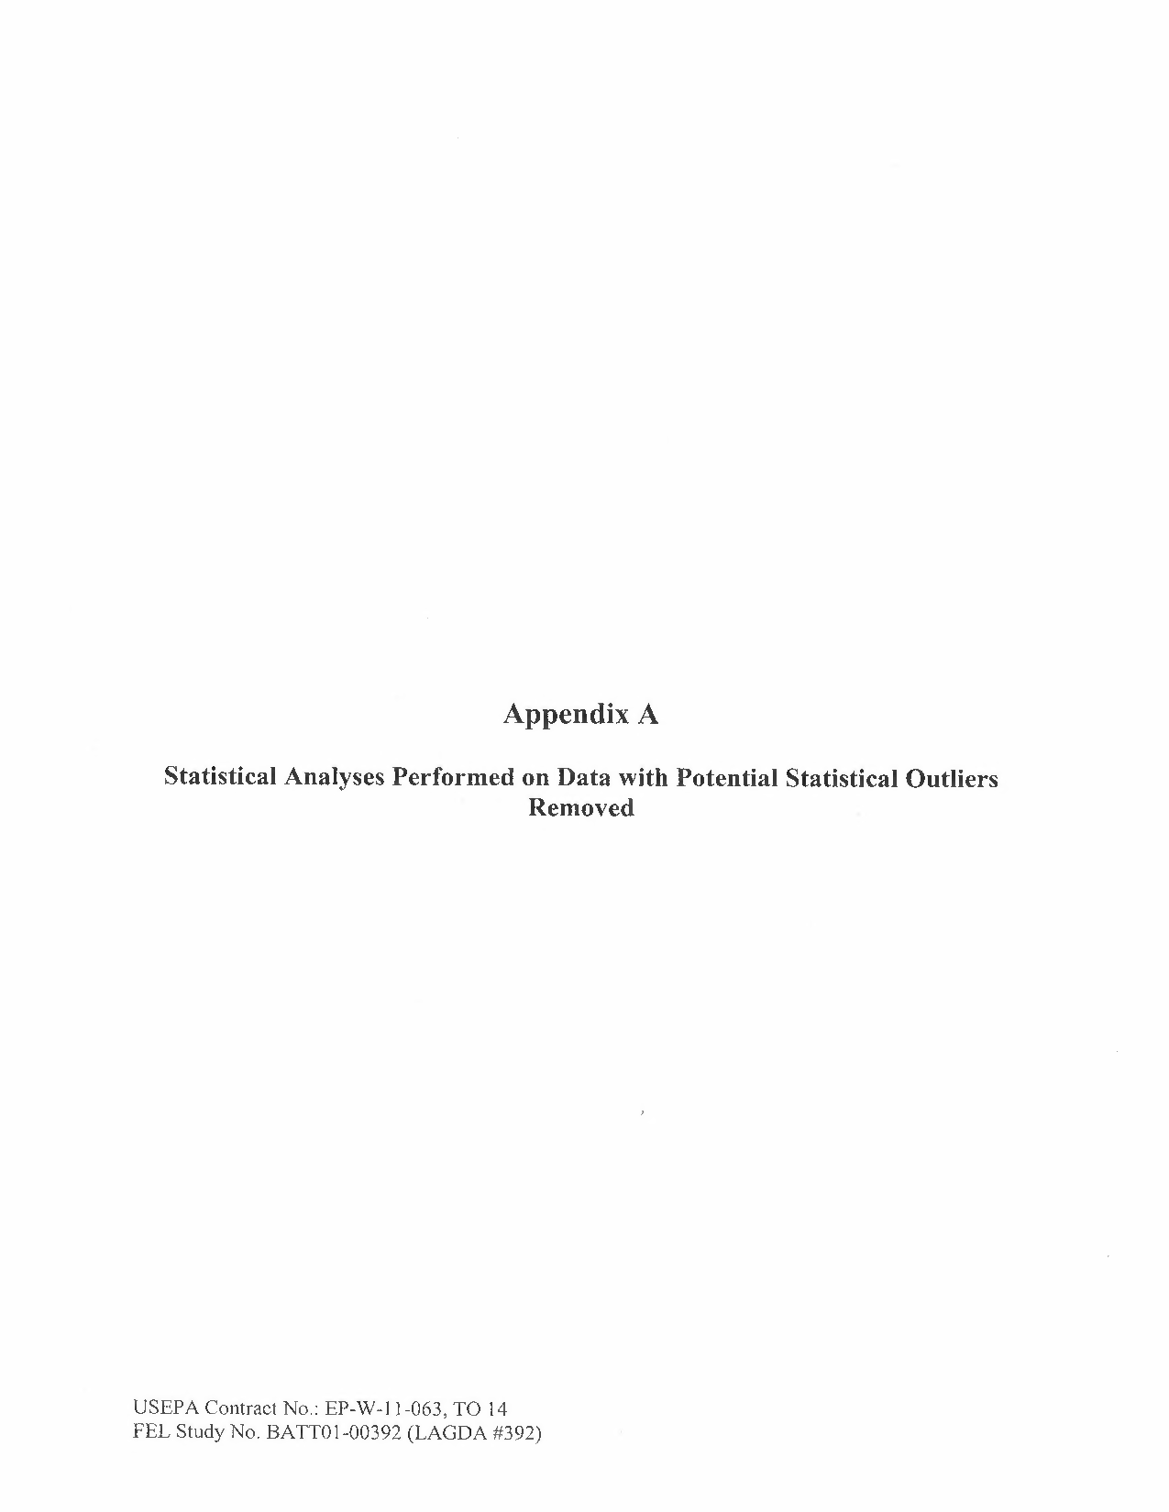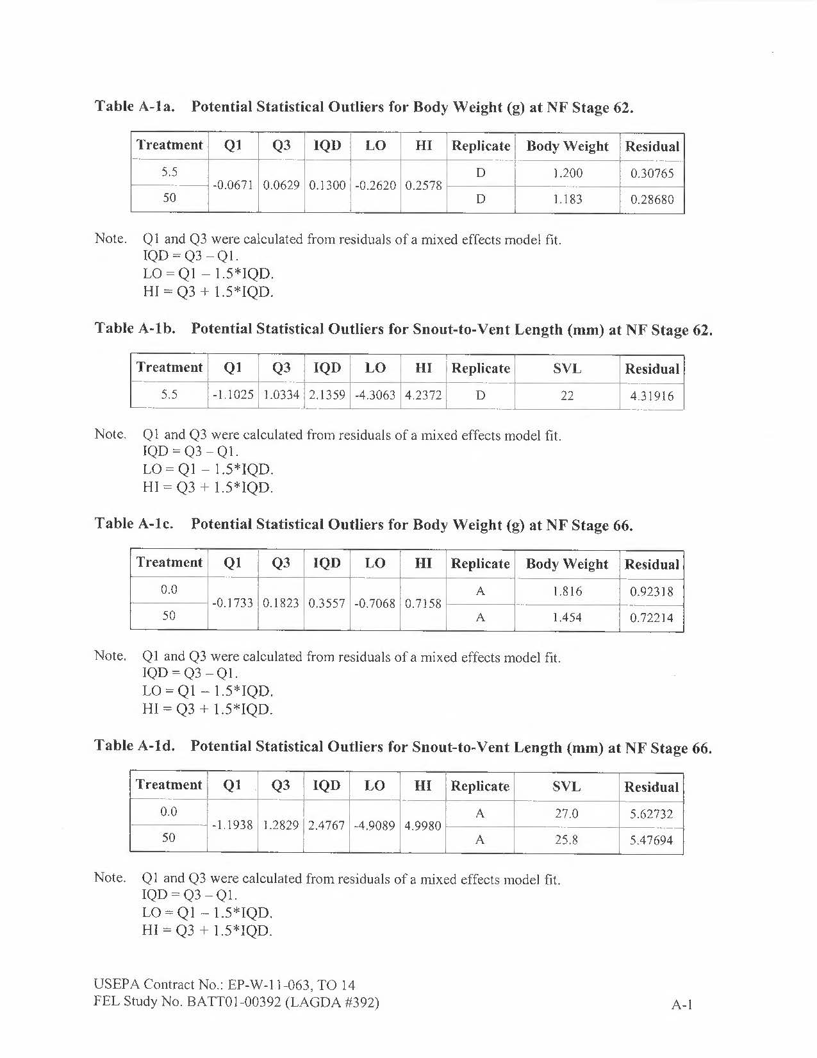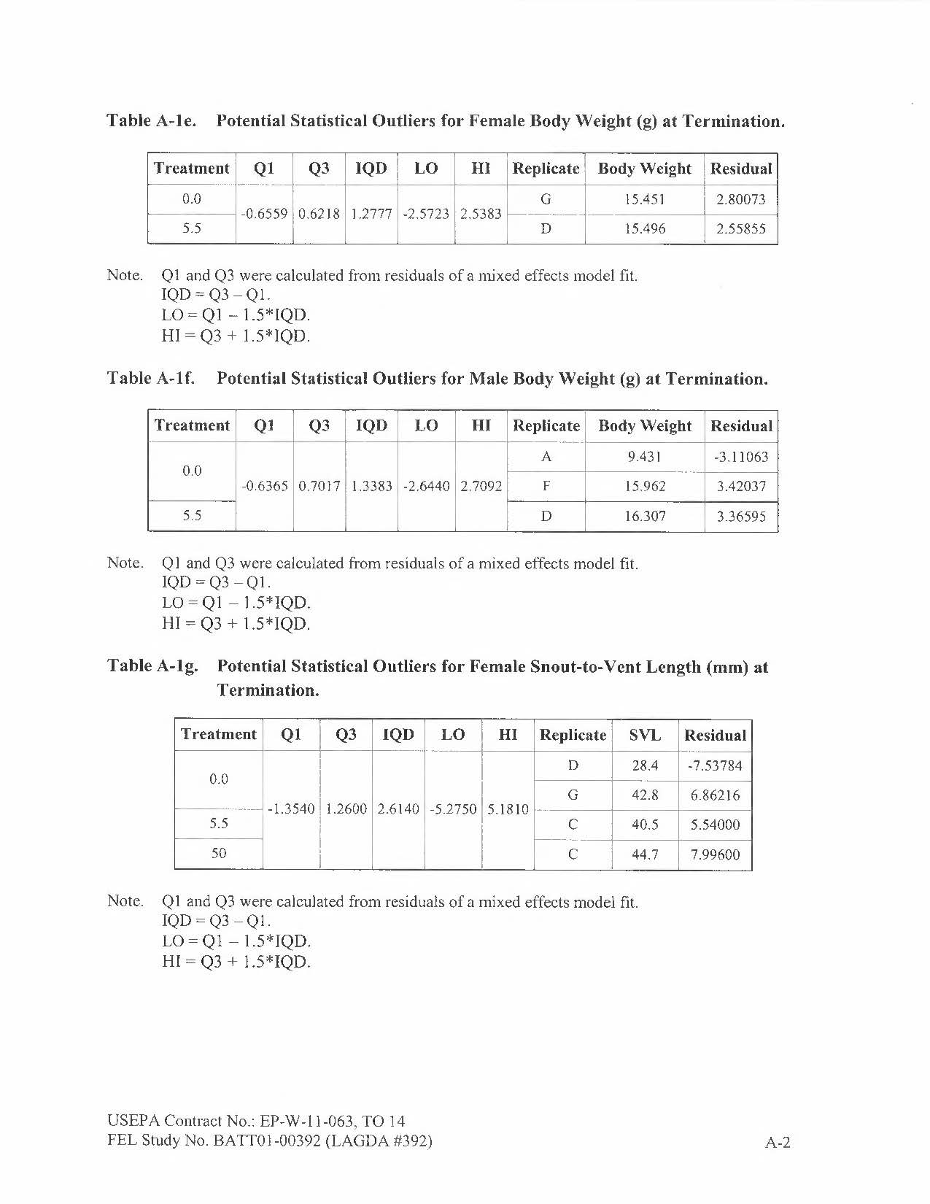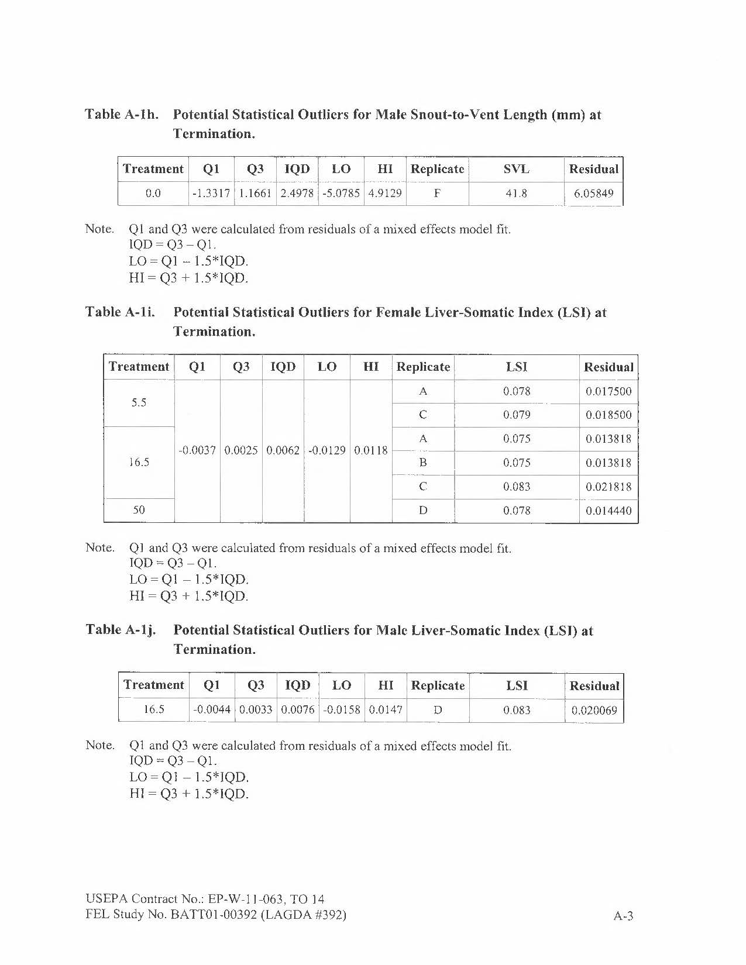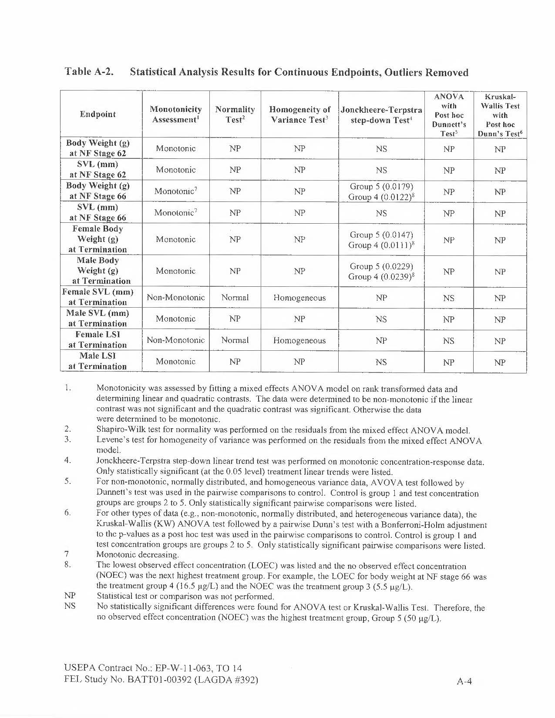

Range-Finding Data (range-finding studies were not performed in a GLP-compliant manner per exception noted in Section 1)
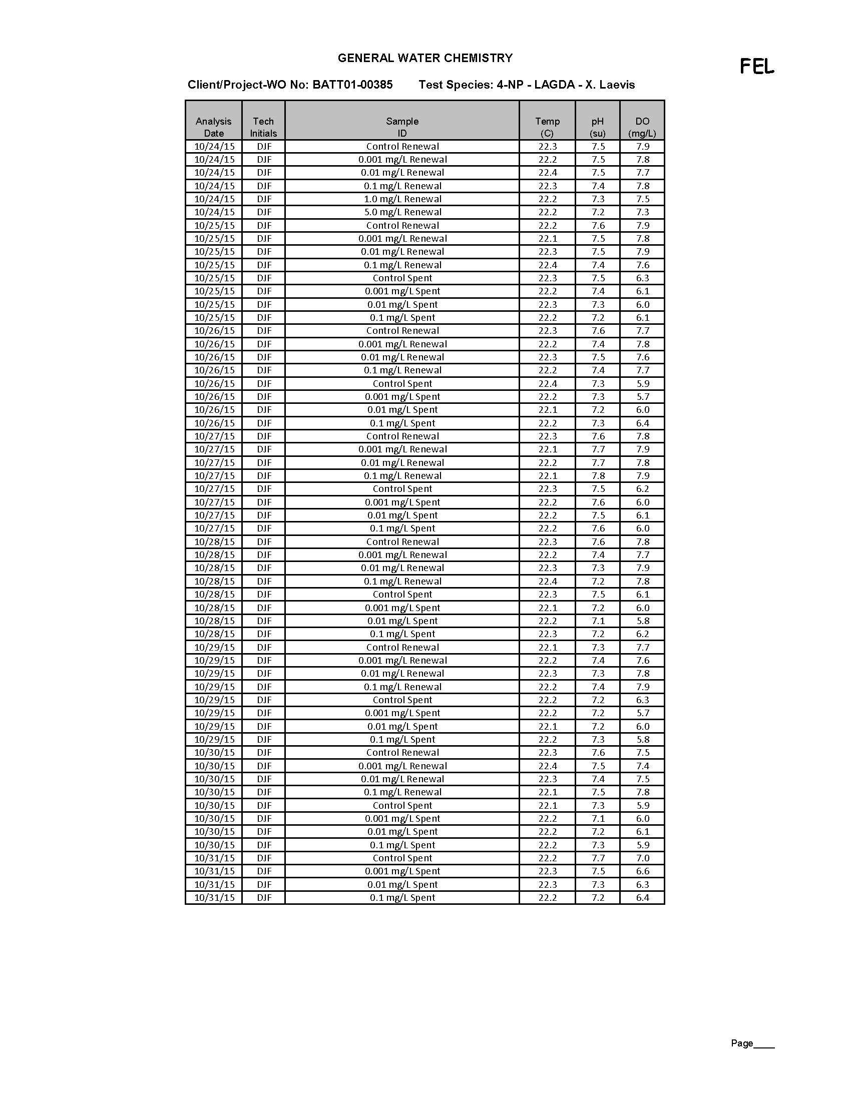

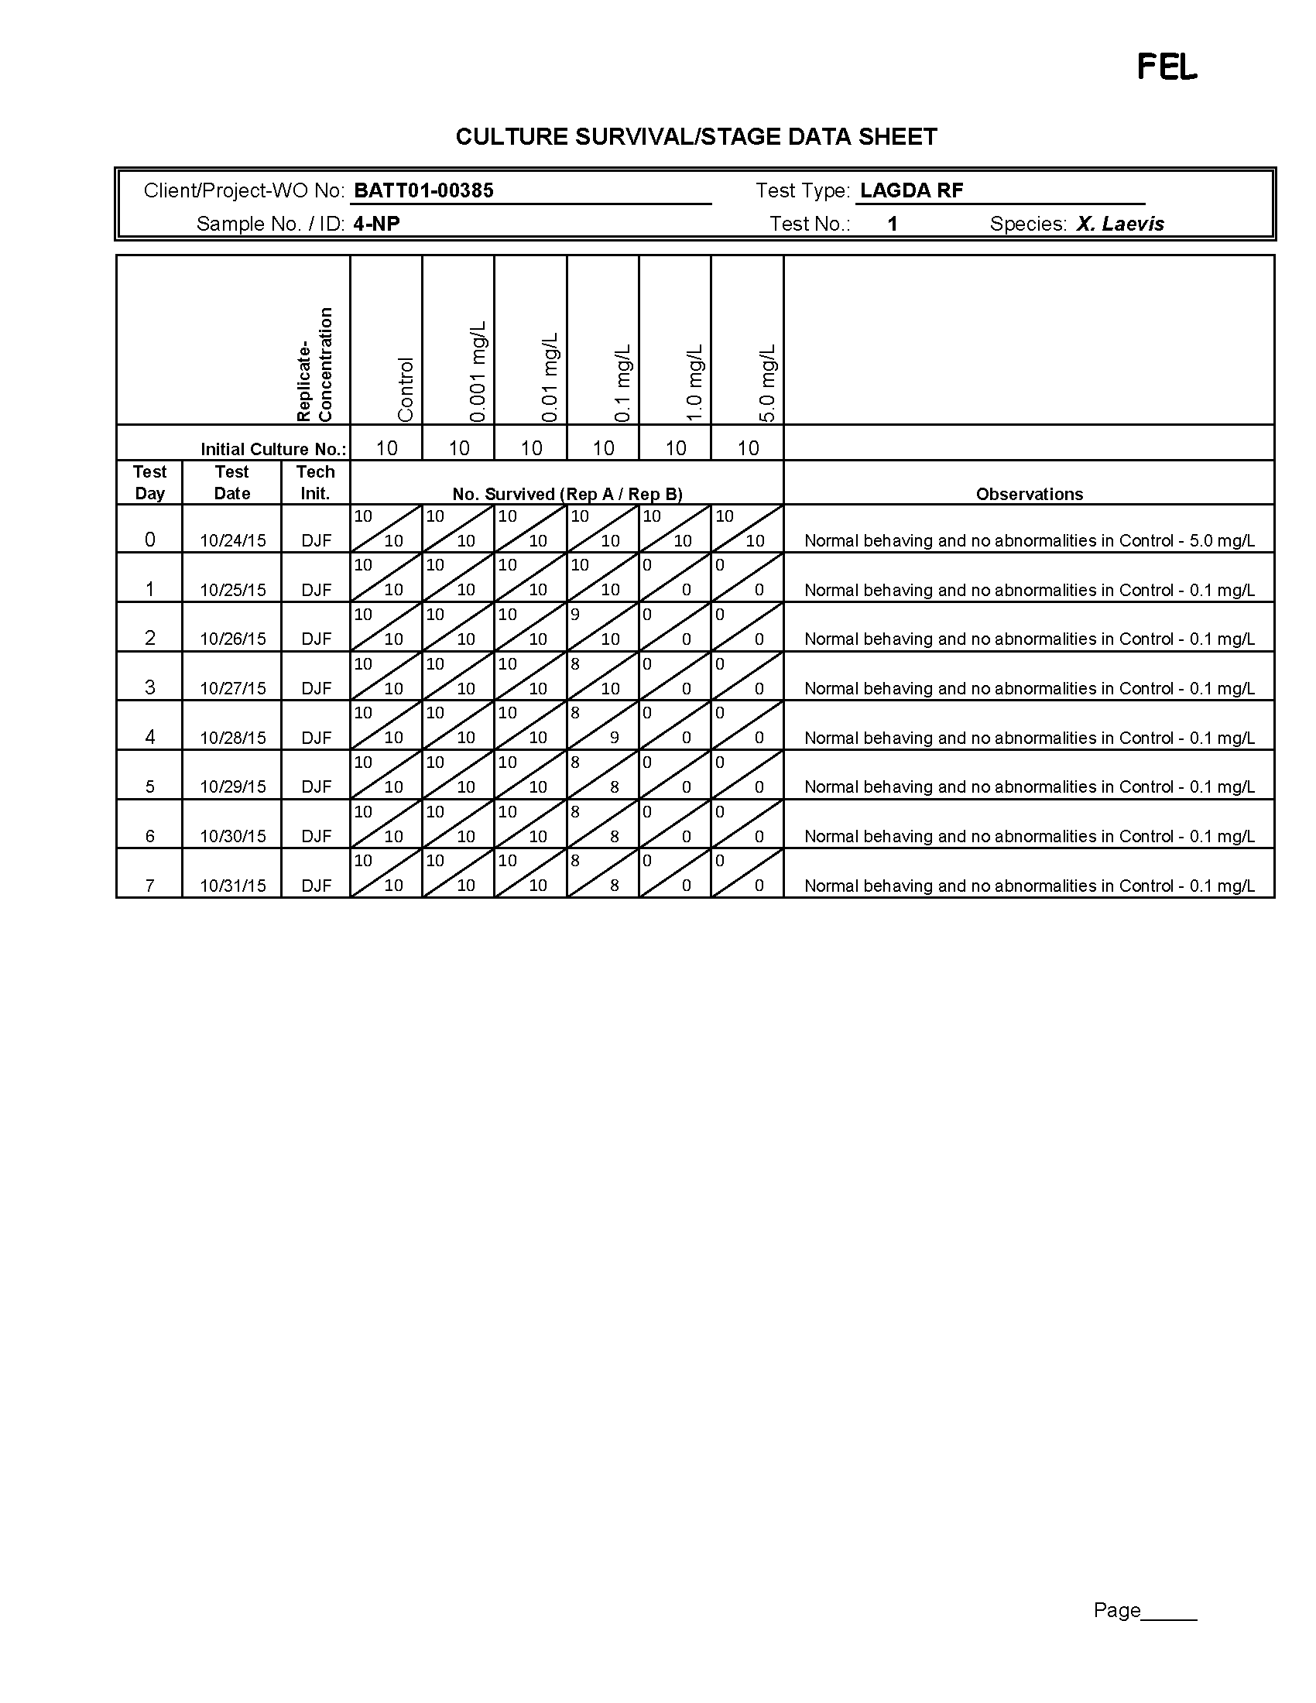

Feed the volume of food listed at a frequency of three times per weekday. Feed the volume of food listed once per day on weekends. Preparation based on OCSPP 890.2300 Larval Amphibian Growth and Development Assay (LAGDA) (3)
Feed volume twice per day and once during weekend.
SD 4-14 for blended food and SD 8-15 for brine shrimp.
Organisms that have not reached NF stage 62 should not be fed metamorphosed organism diet.
Statistical evaluation will be considered for each of the endpoints.
Median time-to metamorphosis (NF stage 62).
Minimum detection limit (MDL) is 0.06 mg/L; 0.5x detection limit used for calculation purposes.
Minimum detection limit (MDL) is 0.05 mg/L; 0.5x detection limit used for calculation purposes.
Measured on SD 0, 45, and 10 wpm (in-life termination).
Minimum Quantitation Level (MQL) = 0.333 μg/L.
Coefficient of variation = (Standard deviation / mean)100. Represents inter-replicate CV at each sampling point based on mean and standard deviation of each replicate (A-D) for each test concentration at each time points measured. Only determined on SD 0 and SD 112 (exposure termination) since only single replicates in rotation were analyzed on designated SD in between.
Average of original and duplicate sample.
Minimum Quantitation Level (MQL) = 0.333 μg/L.
Coefficient of variation = (Standard deviation / mean)100. Represents inter-replicate CV at each sampling point based on mean and standard deviation of each replicate (A-D) for each test concentration at each time points measured. Only determined on SD 0 and SD 112 (exposure termination) since only single replicates in rotation were analyzed on designated SD in between.
Average of original and duplicate sample.
Minimum Quantitation Level (MQL) = 0.333 μg/L.
Coefficient of variation = (Standard deviation / mean)100. Represents inter-replicate CV at each sampling point based on mean and standard deviation of each replicate (A-D) for each test concentration at each time points measured. Only determined on SD 0 and SD 112 (exposure termination) since only single replicates in rotation were analyzed on designated SD in between.
Minimum Quantitation Level (MQL) = 0.333 μg/L.
Coefficient of variation = (Standard deviation / mean)100. Represents inter-replicate CV at each sampling point based on mean and standard deviation of each replicate (A-D) for each test concentration at each time points measured. Only determined on SD 0 and SD 112 (exposure termination) since only single replicates in rotation were analyzed on designated SD in between.
Average of original and duplicate sample.
Since time interval between sample collection events was consistent throughout study, the mean measured concentration represents an accurate estimation of exposure concentration. The mean measured concentration represents the average of weekly data points. On SD 0 and in-life phase termination all replicate control replicates (n=8) and treatment replicates (n=4) were sampled and analyzed. On the weeks between these two points, a sample was collected from one replicate tank of the control and each test concentration. The replicate selected for weekly sampling rotated. Coefficient of variation = (Standard deviation / mean). CV based on the standard deviation of mean measured concentration of each replicate and mean measured treatment concentration per facility SOP.
Minimum Quantitation Level (MQL) = 0.333 μg/L.
Std Dev = Standard deviation. CV(%) = Coefficient of variation = (standard deviation / mean) × 100.
Survival at NF stage 66 prior to cull from N=15 to N=10 was 100% in each replicate of the control and each treatment. Since the survival at NF stage 66 was not analyzed statistically, it was not enumerated in table.
MMT defined as the median time required to reach NF stage 62. Coefficient of variation = (standard deviation / mean) × 100%. Median, Standard deviation, and coefficient of variation calculated from the replicate medians for each treatment (i.e., N=8 for control and N=4 for other treatment groups). d = days.
Significantly greater than control (Cox Proportional Hazard Model, Chi Square, p<0.0001).
Std Dev = standard deviation, SEM = standard error of the mean, and CV(%) = coefficient of variation (standard deviation / mean) × 100. Mean, Std Dev, SEM, CV (%) were calculated from the replicate means for each treatment (i.e., N=8 for control and N=4 for other treatment groups). Not significantly different from control (Jonckheere-Terpstra test, p>0.05).
Std Dev = standard deviation, SEM = standard error of the mean, and CV(%) = coefficient of variation (standard deviation / mean) × 100. Mean, Std Dev, SEM, CV (%) were calculated from the replicate means for each treatment (i.e., N=8 for control and N=4 for other treatment groups). Not significantly different from control (Jonckheere-Terpstra test, p>0.05).
Std Dev = standard deviation, SEM = standard error of the mean, and CV(%) = coefficient of variation (standard deviation / mean) × 100. Mean, Std Dev, SEM, CV (%) were calculated from the replicate means for each treatment (i.e., N=8 for control and N=4 for other treatment groups).
Significantly less than control (Jonckheere-Terpstra test, p=0.0102).
Significantly less than control (Jonckheere-Terpstra test, p=0.0229).
Std Dev = standard deviation, SEM = standard error of the mean, and CV(%) = coefficient of variation (standard deviation / mean) × 100. Mean, Std Dev, SEM, CV (%) were calculated from the replicate means for each treatment (i.e., N=8 for control and N=4 for other treatment groups).
Significantly greater than control (Jonckheere-Terpstra test, p=0.0111).
Significantly greater than control (Jonckheere-Terpstra test, p=0.0168).
Std Dev = standard deviation, SEM = standard error of the mean, and CV(%) = coefficient of variation (standard deviation / mean) × 100. Mean, Std Dev, SEM, CV (%) were calculated from the replicate means for each treatment (i.e., N=8 for control and N=4 for other treatment groups).
Significantly greater than control (Jonckheere-Terpstra test, p=0.0145).
Significantly greater than control (Jonckheere-Terpstra test, p=0.0157).
Std Dev = standard deviation, SEM = standard error of the mean, and CV(%) = coefficient of variation (standard deviation / mean) × 100. Mean, Std Dev, SEM, CV (%) were calculated from the replicate means for each treatment (i.e., N=8 for control and N=4 for other treatment groups). Not significantly different from control (Jonckheere-Terpstra test, p>0.05).
Std Dev = standard deviation, SEM = standard error of the mean, and CV(%) = coefficient of variation (standard deviation / mean) × 100. Mean, Std Dev, SEM, CV (%) were calculated from the replicate means for each treatment (i.e., N=8 for control and N=4 for other treatment groups). Not significantly different from control (Jonckheere-Terpstra test, p>0.05).
Std Dev = standard deviation, SEM = standard error of the mean, and CV(%) = coefficient of variation (standard deviation / mean) × 100. Mean, Std Dev, SEM, CV (%) were calculated from the replicate means for each treatment (i.e., N=8 for control and N=4 for other treatment groups). Not significantly different from control (Jonckheere-Terpstra test, p>0.05).
Std Dev = standard deviation, SEM = standard error of the mean, and CV(%) = coefficient of variation (standard deviation / mean) × 100. Mean, Std Dev, SEM, CV (%) were calculated from the replicate means for each treatment (i.e., N=8 for control and N=4 for other treatment groups). Not significantly different from control (Jonckheere-Terpstra test, p>0.05).
Std Dev = standard deviation, SEM = standard error of the mean, and CV(%) = coefficient of variation (standard deviation / mean) × 100. Mean, Std Dev, SEM, CV (%) were calculated from the replicate means for each treatment (i.e., N=8 for control and N=4 for other treatment groups). Not significantly different from control (Jonckheere-Terpstra test, p>0.05).
N= 80 for control and 40 for each treatment.
Female to male ratio. Does not include indeterminants in phenotype ratio.
Histopathologic findings were scored for severity according to the following grading system: X = not remarkable, Grade 1 = minimal, Grade 2 = mild, Grade 3 = moderate, and Grade 4 = severe, in accordance with previously reported criteria (3,8).
Moderate mononuclear cell infiltrate of the ovary noted in the 50.0 µg/L 4-NP treatment (RSCABS, p=0.0400).
Histopathologic findings were scored for severity according to the following grading system: X = not remarkable, Grade 1 = minimal, Grade 2 = mild, Grade 3 = moderate, and Grade 4 = severe, in accordance with previously reported criteria (3,8).
Significantly greater than control (RSCABS, p=0.0140).
Significantly greater than control (RSCABS, p=0.0000).
Significantly greater than control (RSCABS, p=0.0472).
Significantly less than control (RSCABS, p=0.0386). Represented significant developmental delay.
Significantly greater than control (RSCABS, p=0.0006).
Significantly greater than control (RSCABS, p=0.0305).
Significantly greater than control (RSCABS, p=0.0001).
Significantly greater than control (RSCABS, p=0.0005).
Significantly greater than control (RSCABS, p=0.0049).
Significantly greater than control (RSCABS, p=0.0109).
Significantly greater than control (RSCABS, p=0.0205).
Minimal fibroplasia of the anterior oviduct observed in the 50.0 µg/L 4-NP treatment. Significantly greater than control (RSCABS, p=0.0428).
Histopathologic findings were scored for severity according to the following grading system: X = not remarkable, Grade 1 = minimal, Grade 2 = mild, Grade 3 = moderate, and Grade 4 = severe, in accordance with previously reported criteria (3,8). Gonad phenotype scores were recorded as follows: Grade 0 = gonad phenotype matches genotype; Grade 1 = phenotype primarily matches genotype; Grade 2 = equal parts testis and ovary; Grade 3 = phenotype primarily matches opposite genotype; and Grade 4 = sex-reversed, phenotype completely opposite genotype.
Significantly greater than control (RSCABS, p=0.0043).
Significantly greater than control (RSCABS, p=0.0123).
Significantly greater than control (RSCABS, p=0.0093).
Significantly less than control (RSCABS, p=0.0354). Represented significant developmental delay.
Significantly less than control (RSCABS, p=0.0433). Represented significant developmental delay.
Histopathologic findings were scored for severity according to the following grading system: X = not remarkable, Grade 1 = minimal, Grade 2 = mild, Grade 3 = moderate, and Grade 4 = severe, in accordance with previously reported criteria (3,8). Gonad phenotype scores were recorded as follows: Grade 0 = gonad phenotype matches genotype; Grade 1 = phenotype primarily matches genotype; Grade 2 = equal parts testis and ovary; Grade 3 = phenotype primarily matches opposite genotype; and Grade 4 = sex-reversed, phenotype completely opposite genotype.
Mild Exfoliated germ cells noted in the 5.5, 16.5, and 50 0 µg/L 4-NP treatment (RSCABS, p=0.0134, 0.0074, and 0.0191, respectively).
Mononuclear cell infiltrate and exfoliated germ cells noted in the 50 0 µg/L 4-NP treatment. Significantly greater than control (RSCABS, p=0.0067 and 0.0428, respectively).
Significantly less than control (RSCABS, p=0.0494). Represented significant developmental delay.
Nominal concentrations.
Median metamorphosis time determined from the time to metamorphosis from each individual in a given replicate (replicate MMT). The treatment and control MMTs were basedon the median of the replicate MMT values.
Based on most-sensitive finding for the tissue represented.
The mean measured concentrations were consistent with protocol BATT01-5 for study BATT01-00392 with the exception of the 3.6 µg/L treatment in which the coefficient of variation was 23%. Coefficient of variation = (Standard deviation / mean). CV based on the standard deviation of mean measured concentration of each replicate and mean measured treatment concentration per FEL SOP 6.2. Overall, the mean measured concentrations were a reasonable estimation of exposure concentration and the CV exceeding the acceptable limit of 20% did not impact the interpretation of the results or conclusions drawn.

