SSWR 1.2.2.3 Sub-product title: Develop relationship between the index of catchment integrity and NCCA estuarine response in low gradient coastal catchments
Extended Abstract title: Relating coastal indices of catchment integrity to estuarine condition
Anne Kuhn¹, Michael Charpentier², Jane Copeland¹, and Jeff Hollister¹
¹U.S. Environmental Protection Agency, Office of Research and Development, National Health and Environmental Effects Research Laboratory, Atlantic Ecology Division, Narragansett, Rhode Island, USA
² General Dynamics Information Technology, 27 Tarzwell Dr. Narragansett RI, USA 02882
This research spatially relates and evaluates indices of catchment integrity (ICI) and watershed integrity (IWI) with estuarine condition response data using National Coastal Condition Assessment (NCCA) data in low gradient coastal areas of the Virginian Province, which includes the coastal region of the Northeast United States from Cape Cod south to the mouth of Chesapeake Bay. Indices of watershed integrity (IWI) and ICI were previously derived using landscape stressor data from StreamCat (https://www.epa.gov/national-aquatic-resource-surveys/streamcat-dataset) (Hill et al., 2016) and mapped for 2.6 million stream segments across the conterminous U.S. (Thornbrugh et al., 2018) The IWI characterizes the integrity of watersheds based on key watershed functions and the relative presence of landscape stressors that affect them (Flotemersch et al., 2016). The ICI uses landscape stressors in local drainages of individual stream segments to characterize the local influence and integrity of the catchment. Using GIS, the ICI and IWI were spatially related to the nearest NCCA sampling stations using rasters to obtain the best approximation of “across water” distance for each sample location (Figure 1). This research developing and analyzing spatially explicit stressor-response relationships with NCCA and ICI, IWI datasets extends the use of NARS data to support EPA regulatory program needs.
Using Pearson’s correlation coefficient (r), estuarine condition response variables, especially nutrient measures (nitrogen and phosphorus) in surface waters, were significantly correlated (p ≤0.001) with ICI and IWI values, especially when evaluated at the individual estuary level. We characterize the strength of these correlations using five classification categories: ‘very strong’ (0.80–1.0); ‘strong’ (0.60–0.79); ‘moderate’ (0.40–0.59); ‘weak’ (0.20–0.39); ‘very weak’ (0.0–0.19). When evaluating the correlation between the NCCA water quality response condition data and the spatially related ICI and IWI values across estuaries, the Delaware River, Long Island Sound and Chesapeake Bay estuaries consistently had the highest correlations with nutrients such as NO2+NO3-N with absolute correlations (|r|) of 0.68, 0.58 and 0.23, respectively for ICI values at the catchment scale. At the watershed scale Chesapeake Bay, Long Island Sound and the Delmarva Coast estuaries demonstrated significant correlations between NO2+NO3-N and IWI values, with a |r| of 0.58, 0.33 and .023, respectively. The Delaware River estuary demonstrated a very strong correlation between total nitrogen (TN) and ICI values, with a |r| of 0.99 at the catchment scale, while the Chesapeake Bay estuary demonstrated a moderate correlation between TN and IWI values, with a |r| of 0.42 at the watershed scale.
Of the 8 major estuary systems (RI/MA Coast, Long Island Sound, NY/NJ Harbor, NY Bight, Delaware River, Delaware Bay, Chesapeake Bay and Delmarva Coast), 7 demonstrated significantly strong correlations between various NCCA estuarine response variables (especially nitrogen and phosphorous) in surface waters and ICI and IWI values. The RI/MA Coast estuary system (which includes Block Island Sound, Narragansett Bay, Westport River, Connecticut River, Thames River, Vineyard Sound Buzzards Bay, Niantic River) did not indicate any strong correlations between estuarine response and ICI and IWI values, and only exhibited a significantly weak negative correlation with total phosphorus with an r value of -0.32 associated with the ICI value. All correlation analyses were performed in R Software Version 4.1.0., and are presented in Appendix A.
As part of this sub-product, a GIS data hub was developed with data dashboards displaying the relationship of ICI and IWI with estuarine condition using a subset of NCCA water quality (nutrients, chlorophyll a, dissolved oxygen) condition response data in individual low gradient coastal estuaries and sub-estuaries. The GIS data hub and data dashboards are available for viewing on the EPA GeoPlatform (https://storymaps.arcgis.com/collections/c9596f62e10743319fadf8a70c2584bb). These data dashboards display the geospatial relationship of ICI and IWI with a subset of estuarine water quality response condition using the NCCA estuarine response data in low gradient coastal areas. The dashboards provide a way to explore and visualize the geodatabase geographically at different scales and the ability to dynamically control distances to nearest catchments, water column sample layer and concentration levels of response measures (Figure 2). The results of the spatially joined NCCA full water quality dataset with the associated nearest catchment and watershed indices for each NCCA sampling station are also provided in an Excel file (SSWR1.2.2.3_NCCA_ICI_IWI.xlsx).
The results from this research provide a proof-of-concept approach for spatially relating two existing national scale databases to assess the impacts of land-based stressors on estuarine condition. This approach provides a framework for spatially associating and evaluating the relationship between coastal receiving waters condition and the land-based stressors impacting these receiving waters. This geospatial approach could be used to spatially relate and evaluate the relationship of catchment and watershed integrity indices with other NCCA estuarine condition response datasets such as sediment contaminants, sediment toxicity, benthic and eutrophication indices, and sediment and fish quality indices (Kiddon et al., 2020).
Utilizing national databases such as the ICI, IWI and NCCA allows for evaluating landscape stressor and estuarine condition response relationships across the coastal US and at regional scales ranging from small estuaries to large estuarine systems like the Chesapeake as well as inland coastal systems such as the Great Lakes (Kuhn et al., 2018). State environmental agencies, tribal and coastal managers can prioritize catchment and stream scale protection and restoration efforts by focusing efforts on coastal catchments within higher value watershed conditions based on the IWI (Aho et al., 2020). Coastal mangers can also use this approach to improve upstream ecosystems in the higher elevations of coastal watersheds that contribute flow to the low gradient coastal catchments. This approach of using the indices of catchment and watershed integrity to target protection and restoration at multiple scales strengthens the ability to mitigate land-based stressor impacts on coastal receiving waters. The resulting geodatabase from this research extends the use of National Aquatic Resource Surveys (NARS) data to support priority setting and management actions. This research will inform stressor response relationships for coastal managers to support effective management of land-based stressors to reduce their impacts on coastal estuarine waters and assist managers in meeting the goals of the Clean Water Act (CWA), and to effectively implement CWA 303(d), TMDL, nonpoint source, and stormwater programs supporting the National Estuary Program and Regional Program Offices.
This sub-product, SSWR 1.2.2.3, research is associated with the product, SSWR.1.2.2: Interpolation and stressor-response analyses that extend the use of NARS data to support regulatory program needs. This research is associated with the SSWR Watersheds Topic, and Research Area: Assessment, Monitoring, and Management of Aquatic Resources. Specifically, this research supports the SSWR Output 2: Extended Applications of NARS Data and Approaches to Support Priority Setting and Management Actions.
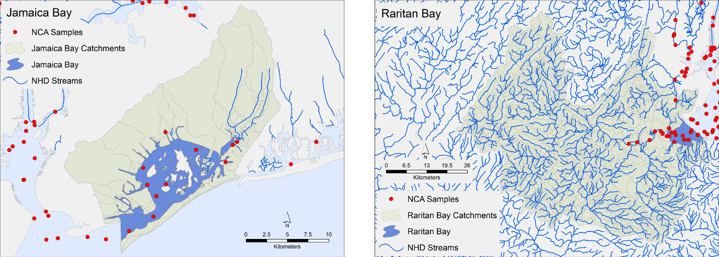Figure 1. Examples of NCCA sample sites spatially related to nearest National Hydrography Dataset (NHDPlusV2) catchment and index of catchment integrity (ICI).
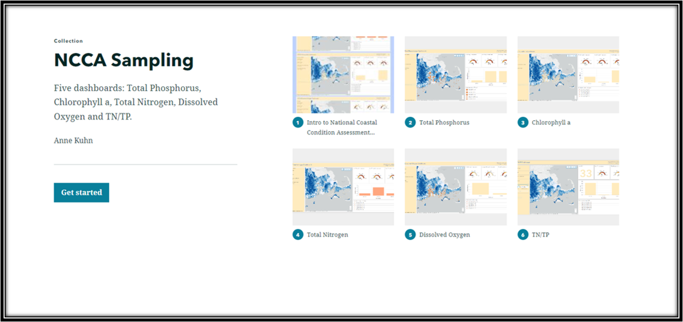
Figure 2. Screenshot of the GIS data dashboard hosted on the EPA GeoPlatform displaying the geospatial relationship of ICI and IWI with a subset of estuarine water quality condition using the NCCA estuarine response data in low gradient coastal areas. (https://storymaps.arcgis.com/collections/c9596f62e10743319fadf8a70c2584bb)

REFERENCES
Aho, K. B., J. E. Flotemersch, S. G. Leibowitz, M. A. LaCroix & M. H. Weber (2020). Applying the index of watershed integrity to the Matanuska–Susitna basin, Arctic, Antarctic, and Alpine Research, 52:1, 435-449, DOI: 10.1080/15230430.2020.1800219
Esri 2021. ArcGIS Pro: Release 2.8.0. Redlands, CA: Esri, Inc.
Flotemersch, J.E.; Leibowitz, S.G.; Hill, R.A.; Stoddard, J.L.; Thoms, M.C.; Tharme, R.E. A Watershed Integrity Definition and Assessment Approach to Support Strategic Management of Watersheds (2016). River Res. Appl., 32, 1654–1671.
Hill, R.A.; Weber, M.H.; Leibowitz, S.G.; Olsen, A.R.; Thornbrugh, D.J. The Stream-Catchment (Streamcat) Dataset: A Database of Watershed Metrics for the Conterminous United States (2016). J. Am. Water Resour. Assoc., 52, 120–128
Kiddon, J. A., Sullivan, H., Nelson, W. G., Pelletier, M. C., Harwell, L., Nord, M., & Paulsen, S. (2020). Lessons Learned from 30 Years of Assessing U.S. Coastal Water. In (Ed.), Water Quality - Science, Assessments and Policy. IntechOpen. https://doi.org/10.5772/intechopen.92326
Kuhn, A., S.G. Leibowitz, Z.C. Johnson, J. Lin, J. A. Massie, J.W. Hollister, J.L. Ebersole, J.L. Lake, J.R. Serbst, J. James, M.G. Bennett, R.J. Brooks, C.T. Nietch, N.J. Smucker, J.E. Flotemersch, L.C. Alexander, and J.E. Compton. (2018). Performance of National Maps of Watershed Integrity at Watershed Scales. Water 10, 604; https://doi.org/10.3390/w10050604
R Core Team (2021). R: A Language and Environment for Statistical Computing; R Foundation for Statistical Computing: Vienna, Austria. Available online: https://www.R-project.org (accessed on 17 June 2022).
Thornbrugh, D.J.; Leibowitz, S.G.; Hill, R.A.; Weber, M.H.; Johnson, Z.C.; Olsen, A.R.; Flotemersch, J.E.; Stoddard, J.L.; Peck, D.V. Mapping watershed integrity for the conterminous United States (2018). Ecol. Indic., 85, 1133–1148
U.S. Environmental Protection Agency. 2016. National Coastal Condition Assessment 2010. EPA 841-R-15-006. https://www.epa.gov/sites/default/files/2016-01/documents/ncca_2010_report.pdf
U.S. Environmental Protection Agency. 2020. Documented hypoxia and associated risk factors in estuaries, coastal waters, and the Great Lakes ecosystems. https://www.epa.gov/nutrient-policy-data/documented-hypoxia-andassociated-risk-factors-estuaries-coastal-waters-and U.S.
U.S. Environmental Protection Agency. 2021. National coastal condition assessment 2015 technical support document. EPA 841-R-21-002. https://www.epa.gov/national-aquatic-resource-surveys/national-coastal-condition-assessment2015-technical-support
U.S. Environmental Protection Agency. 2021 National Coastal Condition Assessment. A collaborative survey of the Nation’s Estuaries and Great Lakes Nearshore Waters. EPA 841-R-21-001. https://www.epa.gov/system/files/documents/2021-09/nccareport_final_2021-09-01.pdf
Wickham, H. Tidy data. (2014). The Journal of Statistical Software, vol. 59.

Appendix A
Relating coastal indices of catchment integrity to estuarine condition
Pearson correlations for National Coastal Condition Assessment (NCCA) water quality condition response variables with Indices of Watershed (IWI) and Catchment Integrity (ICI). Significance levels: ‘***’ p < 0.001; ‘**’ p < 0.01; ‘*’ p < 0.05. Blank signifies correlation not significant. All correlation analyses were performed in R Software Version 4.1.0.
Geographic Region | Index | chl a | DIN | DIN/DIP | DIP | DO | NH3 | NO2 | NO3 | NO2+NO3 | Secchi | TN | TP
RI MA Coast | ICI | -0.02 | 0.03 | 0.10* | -0.07 | 0.12* | -0.05 | 0.05 | 0.09 | 0.04 | 0.00 | -0.10 | -0.32**
RI MA Coast | IWI | 0.00 | 0.07 | 0.16* | -0.03 | 0.05 | -0.01 | 0.00 | -0.04 | 0.09 | -0.10 | 0.04 | -0.15*
Long Island Sound | ICI | 0.00 | -0.68*** | -0.74*** | -0.62*** | 0.43*** | -0.81*** | NA | NA | -0.58*** | 0.41** | NA | NA
Long Island Sound | IWI | -0.34*** | -0.40*** | -0.17* | -0.52*** | 0.28** | -0.57*** | NA | NA | -0.33** | 0.65*** | NA | NA
NY NJ Harbor | ICI | -0.07 | -0.11* | -0.24** | 0.02 | 0.08 | -0.14* | 0.23* | 0.09 | -0.05 | -0.32** | 0.11 | 0.14*
NY NJ Harbor | IWI | -0.02 | -0.07 | -0.18** | 0.01 | 0.09 | -0.18* | 0.23* | 0.09 | -0.01 | -0.28** | 0.07 | 0.11
NY Bight | ICI | -0.17* | 0.15* | -0.02 | 0.05 | -0.18* | 0.15* | 0.10 | 0.12* | 0.08 | -0.08 | -0.12* | 0.14*
NY Bight | IWI | -0.14* | 0.04 | -0.09 | 0.08 | -0.12* | 0.18* | 0.03 | -0.15* | -0.11 | 0.00 | -0.20* | 0.16*
Delaware River | ICI | 0.38*** | -0.71*** | 0.19** | -0.66*** | -0.26** | -0.75*** | -0.78*** | -0.89*** | -0.68*** | -0.36** | -0.99*** | -0.74***
Delaware River | IWI | -0.63*** | 0.11* | -0.32** | 0.41*** | 0.08 | 0.51*** | 0.63*** | 0.25* | 0.10 | 0.49*** | 0.27* | -0.52***
Delaware Bay | ICI | -0.11* | -0.21** | -0.28** | 0.08 | -0.06 | -0.03 | 0.21* | -0.17* | -0.20* | 0.07 | -0.07 | -0.05
Delaware Bay | IWI | -0.10* | -0.04 | -0.13* | -0.05 | 0.10 | -0.26** | -0.02 | 0.06 | 0.00 | -0.04 | -0.06 | 0.16*
Chesapeake Bay | ICI | -0.01 | -0.24** | -0.21* | -0.17* | 0.02 | -0.16* | -0.11 | -0.28* | -0.23* | -0.07 | -0.10 | -0.13*
Chesapeake Bay | IWI | 0.06 | -0.58*** | -0.47*** | -0.09 | 0.06 | -0.22** | -0.02 | -0.73*** | -0.58*** | 0.01 | -0.42** | -0.18*
Delmarva Coast | ICI | -0.13* | -0.18** | -0.31** | 0.02 | 0.11* | -0.07 | -0.14* | -0.36** | -0.27** | 0.20* | -0.44** | -0.24**
Delmarva Coast | IWI | -0.12* | -0.16** | -0.29** | 0.03 | 0.12* | -0.07 | -0.16* | -0.31** | -0.23* | 0.27** | -0.21* | -0.10

NOTE: This sub-product, SSWR 1.2.2.3, Develop relationship between the index of catchment integrity and NCCA estuarine response in low gradient coastal catchments, research is associated with the product, SSWR.1.2.2: Interpolation and stressor-response analyses that extend the use of NARS data to support regulatory program needs. This research is associated with the SSWR Watersheds Topic, and Research Area: Assessment, Monitoring, and Management of Aquatic Resources. Specifically, this research supports the SSWR Output 2: Extended Applications of NARS Data and Approaches to Support Priority Setting and Management Actions.

