Supplemental Material for Long-term exposure to criteria air pollutants and infant mortality: a systematic review and meta-analysis

Adrien A Wilkie*^{1,2}, Alison K Krajewski¹, Fanny Njie³, Kevin Park³, Sarah Zelasky³, Kristen M Rappazzo¹, Thomas J Luben¹

*Corresponding Author: Dr. Adrien A Wilkie, 109 T.W. Alexander Dr, RTP, NC 27711. wilkie.adrien@epa.gov. 919-541-1492

1: U.S. Environmental Protection Agency, Office of Research and Development, Center for Public Health and Environmental Assessment, RTP, North Carolina, USA
2: Oak Ridge Institute for Science and Education (ORISE) at the U.S. Environmental Protection Agency, RTP, North Carolina, USA
3: Oak Ridge Associated Universities (ORAU) at the U.S. Environmental Protection Agency, RTP, North Carolina, USA

Table of Contents:
- Table S1. Search strings used in Web of Science (WOS) and PubMed to identify relevant literature for the systematic review.
- Table S2. Study evaluation requirements.
- Table S3. Study Summaries.
- Table S4. Summary statistics from meta-analyses of long-term air pollution exposure and postneonatal infant mortality (all-cause, respiratory, and SIDS)
- Figure S1. Trim and fill funnel plot for studies included in meta-analysis of associations between long-term PM₁₀ exposure and odds of all-cause infant mortality. Actual studies are shown with black circles, while expected studies are white circles.
- Figure S2. Leave-one-out sensitivity analysis for studies included in the PM10 meta-analysis for all-cause infant mortality.
- Figure S3. Trim and fill funnel plot for studies included in meta-analysis of associations between long-term PM_{2.5} exposure and odds of all-cause infant mortality. Actual studies are shown with black circles, while expected studies are white circles.
- Figure S4. Leave-one-out sensitivity analysis for studies included in the PM_{2.5} meta-analysis for all-cause infant mortality.
- Figure S5. Trim and fill funnel plot for studies included in meta-analysis of associations between short term PM₁₀ exposure and odds of respiratory-related infant mortality. Actual studies are shown with black circles, while expected studies are white circles.
- Figure S6. Leave-one-out sensitivity analysis for studies included in the PM₁₀ meta-analysis for respiratory-related infant mortality.
- Figure S7. Trim and fill funnel plot for studies included in meta-analysis of associations between short term PM_{2.5} exposure and odds of respiratory-related infant mortality. Actual studies are shown with black circles, while expected studies are white circles.
- Figure S8. Leave-one-out sensitivity analysis for studies included in the PM_{2.5} meta-analysis for respiratory-related infant mortality.
- Figure S9. Trim and fill funnel plot for studies included in meta-analysis of associations between long-term PM₁₀ exposure and odds of SIDS-related infant mortality. Actual studies are shown with black circles, while expected studies are white circles.
- Figure S10. Leave-one-out sensitivity analysis for studies included in the PM₁₀ meta-analysis for SIDS-related infant mortality.
- Figure S11. Trim and fill funnel plot for studies included in meta-analysis of associations between long-term PM_{2.5} exposure and odds of SIDS-related infant mortality. Actual studies are shown with black circles, while expected studies are white circles.
- Figure S12. Leave-one-out sensitivity analysis for studies included in the PM_{2.5} meta-analysis for SIDS-related infant mortality.
Table S1. Search strings used in Web of Science (WOS) and PubMed to identify relevant literature for the systematic review
Search Strategy |  | Date and Results
WOS | ((TS="infant mortality" OR TS="neonatal mortality" OR TS="post neonatal mortality" OR TS="perinatal mortality" OR TS="SIDS") AND (TS="air pollution" OR TS="particulate matter" OR TS="ozone" OR TS="PM2.5" OR TS="O3" OR TS="NO2" OR TS="nitrogen dioxide" OR TS="nitrogen oxide" OR TS="sulfur dioxide" OR TS="SO2" OR TS="carbon monoxide")) | 4/15/2023  488 results
PubMed | (("infant mortality"[tw] OR "neonatal mortality"[tw] OR "post neonatal mortality"[tw] OR "perinatal mortality"[tw] OR SIDS*[tw]) AND ("air pollution"[tw] OR ozone[tw] OR "particulate matter"[tw] OR PM2.5[tw] OR O3[tw] OR NO2[tw] OR "nitrogen dioxide"[tw] OR "nitrogen oxide"[tw] OR "sulfur dioxide"[tw] OR SO2[tw] OR "carbon monoxide"[tw])) | 4/15/2023  287results

Table S2. Study evaluation requirements: Study evaluations are performed on an endpoint/outcome-specific basis. For each evaluation domain, core and prompting questions are provided to guide the reviewer in assessing different aspects of study design and conduct related to reporting, risk of bias and study sensitivity. For some domains (see below), additional outcome- or chemical-specific refinements to the criteria used to answer the questions should be developed a priori by reviewers. Each domain receives a judgment of Good, Adequate, Deficient, Not Reported or Critically Deficient accompanied by the rationale and primary study-specific information supporting the judgment. Once all domains are evaluated, a confidence rating of High, Medium, or Low confidence or Uninformative is assigned for each endpoint/outcome from the study. The overall confidence rating should, to the extent possible, reflect interpretations of the potential influence on the results (including the direction and/or magnitude of influence) across all domains. The rationale supporting the overall confidence rating should be documented clearly and consistently, including a brief description of any important strengths and/or limitations that were identified and their potential impact on the overall confidence.
Selection and Performance Domain | Evaluation of Participant Selection | Good/Definitely Low Risk of Bias  - Age of participants/study subjects should be of reproductive years  - If case-control, controls should be selected from full population at risk  - Minimal concern for selection bias based on description of recruitment process.  - Exclusion and inclusion criteria specified and would not induce bias.  - Minimal concern that selection of comparison population introduced selection bias.
Selection and Performance Domain | Evaluation of Participant Selection | Adequate  - Enough of a description of the recruitment process to be comfortable that there is no serious risk of bias.  - Inclusion and exclusion criteria specified and would not induce bias.  - Participation rate is incompletely reported but available information indicates participation is unlikely to be related to exposure.
Selection and Performance Domain | Evaluation of Participant Selection | Deficient  - Little information on recruitment process, selection strategy, sampling framework, and/or participation  or  - Aspects of the recruitment process, selection strategy, sampling framework, or participation raise the potential for bias (e.g., healthy worker effect, survivor bias)
Selection and Performance Domain | Evaluation of Participant Selection | Critically Deficient  - Population selected in such a way that selection bias is likely for example, if cases taken from one hospital, or from a high-exposure geographic area, while controls taken from a different hospital or specifically low-exposure geographic area.
Confounding/ Variable Control Domain | Confounding | Good/Definitely Low Risk of Bias  - Clear delineation of how and why confounders were chosen.  - Covariates include: Maternal age, Maternal education and/or income, Maternal race, ethnicity, or indigenous status (depending on country)  - Inclusion in model not based on solely on statistical significance criteria (e.g., p < 0.05 from stepwise regression)  - Does not include mediators in the model  - Descriptive information on population characteristics is presented  - Consideration of unmeasured/residual confounding and its potential effects in the discussion section.  - Consideration of co-pollutant confounding, could be either adjustment in models or presentation of correlations with other pollutants
Confounding/ Variable Control Domain | Confounding | Adequate  - Clear delineation of how and why confounders were chosen.  OR  - Considers multiple adjustment models in a clearly delineated fashion  - Covariates include: Maternal age, Maternal education and/or income, Maternal race, ethnicity, or indigenous status (depending on country)  - May include covariates that are potentially not confounders, but not on a causal pathway. AND Inclusion in model not based on solely on statistical significance criteria (e.g., p < 0.05 from stepwise regression)  - Does not include mediators in the model  - Descriptive information on population characteristics is presented  - Consideration of unmeasured/residual confounding and its potential effects in the discussion section
Confounding/ Variable Control Domain | Confounding | Deficient  - Strategy of evaluating confounding is unclear or is not recommended (e.g., based on statistical significance criteria only)  OR  - Descriptive information on population characteristics is not presented  OR  - There is likely unmeasured or uncontrolled confounding based on the included confounders and their measurement
Confounding/ Variable Control Domain | Confounding | Critically Deficient  - No adjustment for confounding  OR  - Mediators included in model
Exposure Methods Domain | Exposure Assessment | Good/Definitely Low Risk of Bias  - Monitor equivalent to FRM  - Within 50km  - Methods such as inverse distance weighting are acceptable  OR  - Validated modeling approach  - Monitor corrected CMAQ output  - Satellite hybrid models  - Land use regression with sufficient monitoring  AND  - Exposure based on residential history, not solely residence at birth  - Exposure measured/modeled concurrent with window of interest
Exposure Methods Domain | Exposure Assessment | Adequate  - Monitor equivalent to FRM  - Within 50km  - Methods such as inverse distance weighting  OR  - Validated modeling approach  - CMAQ output  - Satellite models  - Land use regression  AND  - Exposure based on residential history or residence at birth  - Exposure measured/modeled concurrent with window of interest
Exposure Methods Domain | Exposure Assessment | Deficient  - Monitor non-equivalent to FRM  - No distance requirement  OR  - Non-validated modeling approach  AND  - Exposure based on residential history or residence at birth  - Exposure measured/modeled before/after window of interest and extrapolated
Exposure Methods Domain | Exposure Assessment | Critically Deficient  - Exposure measurement/model timing does not match exposure window of interest (i.e., exposure for 1st 28 days assigned based on annual average)
Outcome Methods/ Results Presentation Domain | Outcome Assessment | Good/Definitely Low Risk of Bias  - Neonatal – deaths within first 28 days of life  - Death certificates + cause of death  - Post neonatal mortality - deaths between day 29 and 1 year of life  - Death certificates + cause of death  - Perinatal – mortality between GW 28 and 7 days after birth  - Death certificates + cause of death
Outcome Methods/ Results Presentation Domain | Outcome Assessment | Adequate  - Neonatal – deaths within first 28 days of life  - Death certificates  - Post neonatal mortality – deaths between day 29 and 1 year of life  - Death certificates  - Perinatal – mortality between GW 28 and 7 days after birth  - Death certificates  OR  - Infant mortality  - Death certificates
Outcome Methods/ Results Presentation Domain | Outcome Assessment | Deficient  - Neonatal – deaths within first 28 days of life  - Maternal report or DHS survey  - Post neonatal mortality – deaths between day 29 and 1 year of life  - Maternal report or DHS survey  - Perinatal – mortality between GW 28 and 7 days after birth  - Maternal report or DHS survey  OR  - Infant mortality  - Maternal report or DHS survey
Outcome Methods/ Results Presentation Domain | Outcome Assessment | Critically Deficient  - Method not reported
Analysis Domain | Analysis | Good/Definitely Low Risk of Bias  - Quantitative results presented (e.g., effect estimates and confidence limits, not “significant/non-significant”)  - Missing data noted and addressed in an appropriate fashion  - Descriptive information about the outcome and exposure presented  - Includes sensitivity and/or a priori effect measure modification analyses  - No deficiencies in analysis evident
Analysis Domain | Analysis | Adequate  - Quantitative results presented (e.g., effect estimates and confidence limits, not significant/not significant)  - Missing data noted and addressed in an appropriate fashion  - Descriptive information about the exposure is presented, but some information may not be provided  - Includes sensitivity and/or a priori effect measure modification analyses, but does not include all important sensitivity analyses
Analysis Domain | Analysis | Deficient  - Inappropriate control or population selection  - Descriptive information about the exposure is not presented  - Quantitative results presented without an estimate of random error or only as “significant/non-significant”
Analysis Domain | Analysis | Critically Deficient  - Analysis methods are not appropriate for design or data of the study
Selective Reporting Domain | Selective Reporting | Good/Definitely Low Risk of Bias  - All effects are presented either in the main article or supplemental materials
Selective Reporting Domain | Selective Reporting | Adequate  - All main effects are presented either in the main article or supplemental materials, but sensitivity analyses and EMM results may not be
Selective Reporting Domain | Selective Reporting | Deficient  - Not all main effects are presented
Selective Reporting Domain | Selective Reporting | Critically Deficient  - Only statistically significant effects are presented  OR  - No results presented for analyses discussed in methods
Sensitivity Domain | Sensitivity | Adequate  - Sufficient variability in air pollution exposure levels to be able to detect an effect should one exist
Sensitivity Domain | Sensitivity | Deficient  - Insufficient variability in air pollution exposure levels to be able to detect an effect should one exist
Overall Study Confidence Domain | Overall | High  - Generally good across domains, and adequate for sensitivity domain
Overall Study Confidence Domain | Overall | Medium  - Generally adequate across domains
Overall Study Confidence Domain | Overall | Low  - One or more deficiencies across domains
Overall Study Confidence Domain | Overall | Uninformative  - Critically deficient in any one of: participant selection, outcome ascertainment, exposure ascertainment, confounding, or analysis.  OR  - Multiple deficiencies across domains and critically deficient in selective reporting domain

Table S3: Study summaries for studies of long-term air pollution exposure and infant mortality
Study Reference &  Study Design | Data Source,  Study Location,  Study Dates | Pollutant | Outcomeª | Odds Ratios (95% CI)^{b}
Bachwenkizi et al. (2021)  Cross-sectional | Demographic and Health Surveys  15 African countries (Guinea, Cameroon, Mali, Nigeria, Chad, Benin, South Africa, Burundi, Uganda, Ethiopia, Tanzania, Zambia, Zimbabwe, Angola, and Malawi)  2005-2015 | PM2.5 | Infant mortality (All cause) | NA - "Uninformative" study quality evaluation
Bobak and Leon (1999)  Case-control | Death registry  Czech Republic  1989-1991 | SO2 | Postneonatal mortality (All cause) ^{c} | 1.02 (1.00, 1.04)
Bobak and Leon (1999)  Case-control | Death registry  Czech Republic  1989-1991 | SO2 | Postneonatal mortality (Respiratory) ^{c} | 1.06 (1.00, 1.12)
Bobak and Leon (1999)  Case-control | Death registry  Czech Republic  1989-1991 | SO2 | Postneonatal mortality (Nonrespiratory) ^{c} | 1.01 (0.99, 1.01)
Bobak and Leon (1999)  Case-control | Death registry  Czech Republic  1989-1991 | SO2 | Infant mortality (All cause) ^{c} | 1.00 (0.98, 1.01)
Bobak and Leon (1999)  Case-control | Death registry  Czech Republic  1989-1991 | SO2 | Infant mortality (Respiratory) ^{c} | 1.06 (1.01, 1.12)
Bobak and Leon (1999)  Case-control | Death registry  Czech Republic  1989-1991 | SO2 | Infant mortality (Nonrespiratory) ^{c} | 0.99 (0.98, 1.00)
Bobak and Leon (1999)  Case-control | Death registry  Czech Republic  1989-1991 | SO2 | Infant mortality (External causes) ^{c} | 0.98 (0.94, 1.03)
Bobak and Leon (1999)  Case-control | Death registry  Czech Republic  1989-1991 | SO2 | Neonatal mortality (All cause) ^{c} | 0.98 (0.96, 1.00)
Bobak and Leon (1999)  Case-control | Death registry  Czech Republic  1989-1991 | SO2 | Neonatal mortality (Respiratory) ^{c} | 1.12 (0.98, 1.28)
Bobak and Leon (1999)  Case-control | Death registry  Czech Republic  1989-1991 | SO2 | Neonatal mortality (Nonrespiratory) ^{c} | 0.98 (0.96, 0.99)
deSouza et al. (2022)  Cross-sectional | National Family Health Survey-4  India  2009-2018 | PM2.5 | Postneonatal mortality (All cause) | 0.99 (0.95, 1.02)
deSouza et al. (2022)  Cross-sectional | National Family Health Survey-4  India  2009-2018 | PM2.5 | Infant mortality (All cause) | 1.00 (0.98, 1.02)
deSouza et al. (2022)  Cross-sectional | National Family Health Survey-4  India  2009-2018 | PM2.5 | Neonatal mortality (All cause) | 1.01 (1.00, 1.01)
Ghosh et al. (2019)  Case-control | Office for National Statistics  Great Britian  2003-2010 | PM10 ^{d} | Postneonatal mortality (All cause) | NA - per doubling of exposure; categorical (quintiles) exposure
Ghosh et al. (2019)  Case-control | Office for National Statistics  Great Britian  2003-2010 | PM10 ^{d} | Neonatal mortality (All cause) | NA - per doubling of exposure; categorical (quintiles) exposure
Goyal and Canning (2022)  Cross-sectional | Demographic and Health Surveys  43 low- and middle- income countries  1998-2014 | PM2.5 | Postneonatal (All cause) | 0.56 (0.25, 1.28)
Goyal and Canning (2022)  Cross-sectional |  | PM2.5 | Infant mortality (All cause) | 0.95 (0.56, 1.76)
Goyal and Canning (2022)  Cross-sectional |  | PM2.5 | Neonatal mortality (All cause) | 1.47 (0.77, 2.82)
Heft-Neal et al. (2018)  Cross-sectional | Demographic and Health Surveys  30 sub-Saharan African countries  2001-2015 | PM2.5 | Infant mortality (All cause) | NA – qualitative only
Heft-Neal et al. (2020)  Cross-sectional | Demographic and Health Surveys  30 sub-Saharan African countries  2001-2015 | PM2.5 | Infant mortality (All cause) | NA – qualitative only
Jung et al. (2020)  Case-control | Vital records  South Korea  2010-2015 | PM2.5 | Infant mortality (All cause) | 0.95 (0.87, 1.05)
Karimi et al. (2020)  Cross-sectional | Demographic and Health Surveys  Burkina Faso  1993, 2003, 2010 | PM10 ^{e} | Neonatal mortality (All cause) | NA – qualitative only
Karimi et al. (2020)  Cross-sectional |  | PM2.5 ^{e} | Neonatal mortality (All cause) | NA- qualitative only
Khadka and Canning (2021)  Cohort | National Center for Health Statistics  United States  2011-2013 | PM2.5 | Infant mortality (All cause) | NA - categorical (polychotomous) exposure
Klonoff-Cohen et al. (2005)  Case-control | Health departments  Southern California, United States  1988-1992 | CO | Infant mortality (SIDS) | NA - categorical (dichotomous) exposure
Klonoff-Cohen et al. (2005)  Case-control |  | NO2 | Infant mortality (SIDS) | NA - categorical (dichotomous) exposure
Kotecha et al. (2020)  Cross-sectional | Office for National Statistics  England and Wales  2001-2012 | PM10 | Postneonatal mortality (All cause) | NA - categorical (quintile) exposure
Kotecha et al. (2020)  Cross-sectional | Office for National Statistics  England and Wales  2001-2012 | PM10 | Infant mortality (All cause) | NA - categorical (quintile) exposure
Kotecha et al. (2020)  Cross-sectional | Office for National Statistics  England and Wales  2001-2012 | PM10 | Infant mortality (Perinatal) | NA - categorical (quintile) exposure
Kotecha et al. (2020)  Cross-sectional | Office for National Statistics  England and Wales  2001-2012 | PM10 | Infant mortality (Congenital malformations) | NA - categorical (quintile) exposure
Kotecha et al. (2020)  Cross-sectional | Office for National Statistics  England and Wales  2001-2012 | PM10 | Infant mortality (Respiratory) | NA - categorical (quintile) exposure
Kotecha et al. (2020)  Cross-sectional | Office for National Statistics  England and Wales  2001-2012 | PM10 | Infant mortality (Endrocrine) | NA - categorical (quintile) exposure
Kotecha et al. (2020)  Cross-sectional | Office for National Statistics  England and Wales  2001-2012 | PM10 | Infant mortality (Neoplasm) | NA - categorical (quintile) exposure
Kotecha et al. (2020)  Cross-sectional | Office for National Statistics  England and Wales  2001-2012 | PM10 | Neonatal mortality (All cause) | NA - categorical (quintile) exposure
Kotecha et al. (2020)  Cross-sectional | Office for National Statistics  England and Wales  2001-2012 | NO2 | Postneonatal mortality (All cause) | NA - categorical (quintile) exposure
Kotecha et al. (2020)  Cross-sectional | Office for National Statistics  England and Wales  2001-2012 | NO2 | Infant mortality (All cause) | NA - categorical (quintile) exposure
Kotecha et al. (2020)  Cross-sectional | Office for National Statistics  England and Wales  2001-2012 | NO2 | Infant mortality (Perinatal) | NA - categorical (quintile) exposure
Kotecha et al. (2020)  Cross-sectional | Office for National Statistics  England and Wales  2001-2012 | NO2 | Infant mortality (Congenital malformations) | NA - categorical (quintile) exposure
Kotecha et al. (2020)  Cross-sectional | Office for National Statistics  England and Wales  2001-2012 | NO2 | Infant mortality (Respiratory) | NA - categorical (quintile) exposure
Kotecha et al. (2020)  Cross-sectional | Office for National Statistics  England and Wales  2001-2012 | NO2 | Infant mortality (Endrocrine) | NA - categorical (quintile) exposure
Kotecha et al. (2020)  Cross-sectional | Office for National Statistics  England and Wales  2001-2012 | NO2 | Infant mortality (Neoplasm) | NA - categorical (quintile) exposure
Kotecha et al. (2020)  Cross-sectional | Office for National Statistics  England and Wales  2001-2012 | NO2 | Neonatal mortality (All cause) | NA - categorical (quintile) exposure
Kotecha et al. (2020)  Cross-sectional | Office for National Statistics  England and Wales  2001-2012 | SO2 | Postneonatal mortality (All cause) | NA - categorical (quintile) exposure
Kotecha et al. (2020)  Cross-sectional | Office for National Statistics  England and Wales  2001-2012 | SO2 | Infant mortality (All cause) | NA - categorical (quintile) exposure
Kotecha et al. (2020)  Cross-sectional | Office for National Statistics  England and Wales  2001-2012 | SO2 | Infant mortality (Perinatal) | NA - categorical (quintile) exposure
Kotecha et al. (2020)  Cross-sectional | Office for National Statistics  England and Wales  2001-2012 | SO2 | Infant mortality (Congenital malformations) | NA - categorical (quintile) exposure
Kotecha et al. (2020)  Cross-sectional | Office for National Statistics  England and Wales  2001-2012 | SO2 | Infant mortality (Respiratory) | NA - categorical (quintile) exposure
Kotecha et al. (2020)  Cross-sectional | Office for National Statistics  England and Wales  2001-2012 | SO2 | Infant mortality (Endrocrine) | NA - categorical (quintile) exposure
Kotecha et al. (2020)  Cross-sectional | Office for National Statistics  England and Wales  2001-2012 | SO2 | Infant mortality (Neoplasm) | NA - categorical (quintile) exposure
Kotecha et al. (2020)  Cross-sectional | Office for National Statistics  England and Wales  2001-2012 | SO2 | Neonatal mortality (All cause) | NA - categorical (quintile) exposure
Lipfert et al. (2000)  Cross-sectional | National Center for Health Statistics  United States  1990 | PM10 | Postneonatal mortality (All cause) | NA - "Uninformative" study quality evaluation
Lipfert et al. (2000)  Cross-sectional | National Center for Health Statistics  United States  1990 | PM10 | Infant mortality (All cause) | NA - "Uninformative" study quality evaluation
Lipfert et al. (2000)  Cross-sectional | National Center for Health Statistics  United States  1990 | PM10 | Neonatal mortality (All cause) | NA - "Uninformative" study quality evaluation
Lipfert et al. (2000)  Cross-sectional | National Center for Health Statistics  United States  1990 | PM10 | Infant mortality (Respiratory) | NA - "Uninformative" study quality evaluation
Lipfert et al. (2000)  Cross-sectional | National Center for Health Statistics  United States  1990 | PM10 | Infant mortality (SIDS) | NA - "Uninformative" study quality evaluation
Lipfert et al. (2000)  Cross-sectional | National Center for Health Statistics  United States  1990 | CO | Postneonatal mortality (All cause) | NA - "Uninformative" study quality evaluation
Lipfert et al. (2000)  Cross-sectional | National Center for Health Statistics  United States  1990 | CO | Infant mortality (All cause) | NA - "Uninformative" study quality evaluation
Lipfert et al. (2000)  Cross-sectional | National Center for Health Statistics  United States  1990 | CO | Neonatal mortality (All cause) | NA - "Uninformative" study quality evaluation
Lipfert et al. (2000)  Cross-sectional | National Center for Health Statistics  United States  1990 | CO | Infant mortality (Respiratory) | NA - "Uninformative" study quality evaluation
Lipfert et al. (2000)  Cross-sectional | National Center for Health Statistics  United States  1990 | CO | Infant mortality (SIDS) | NA - "Uninformative" study quality evaluation
Mahapatra et al. (2020)  Cross-sectional | National Family Health Survey-4  India  2015-2016 | PM10 | Postneonatal mortality (All cause) | NA - "Uninformative" study quality evaluation
Mahapatra et al. (2020)  Cross-sectional | National Family Health Survey-4  India  2015-2016 | PM10 | Neonatal mortality (All cause) | NA - "Uninformative" study quality evaluation
Ritz et al. (2006)  Case-control | Vital records  Southern California, United States  1989-2000 | PM10 | Postneonatal mortality (All cause) | 1.04 (1.01, 1.06)
Ritz et al. (2006)  Case-control | Vital records  Southern California, United States  1989-2000 | PM10 | Postneonatal mortality (Respiratory) | 1.05 (1.01, 1.10)
Ritz et al. (2006)  Case-control | Vital records  Southern California, United States  1989-2000 | PM10 | Postneonatal mortality (SIDS) | 1.03 (0.99, 1.08)
Ritz et al. (2006)  Case-control | Vital records  Southern California, United States  1989-2000 | CO | Postneonatal mortality (All cause) | 1.11 (1.06, 1.16)
Ritz et al. (2006)  Case-control | Vital records  Southern California, United States  1989-2000 | CO | Postneonatal mortality (Respiratory) | 1.14 (1.03, 1.25)
Ritz et al. (2006)  Case-control | Vital records  Southern California, United States  1989-2000 | CO | Postneonatal mortality (SIDS) | 1.19 (1.10, 1.28)
Ritz et al. (2006)  Case-control | Vital records  Southern California, United States  1989-2000 | NO2 | Postneonatal mortality (All cause) | 1.08 (1.04, 1.11)
Ritz et al. (2006)  Case-control | Vital records  Southern California, United States  1989-2000 | NO2 | Postneonatal mortality (Respiratory) | 1.06 (0.98, 1.14)
Ritz et al. (2006)  Case-control | Vital records  Southern California, United States  1989-2000 | NO2 | Postneonatal mortality (SIDS) | 1.15 (1.08, 1.23)
Ritz et al. (2006)  Case-control | Vital records  Southern California, United States  1989-2000 | O3 | Postneonatal mortality (All cause) | 0.96 (0.94, 0.98)
Ritz et al. (2006)  Case-control | Vital records  Southern California, United States  1989-2000 | O3 | Postneonatal mortality (Respiratory) | 1.01 (0.96, 1.07)
Ritz et al. (2006)  Case-control | Vital records  Southern California, United States  1989-2000 | O3 | Postneonatal mortality (SIDS) | 0.94 (0.91, 0.98)
Shinkura et al. (2020)  Cross-sectional | Yamashita Health Center  Kagoshima City, Japan  1978-1988 | SO2 | Neonatal mortality | NA - categorical (quartile) exposure
Son et al. (2011) | National Statistical Office mortality records  Seoul, South Korea  2004-2007 | PM10 | Postneonatal mortality (All cause) ^{f} | 0.84 (0.67, 1.06)
Son et al. (2011) |  | PM10 | Postneonatal mortality (Respiratory) ^{f} | 0.29 (0.09, 0.97)
Son et al. (2011) |  | PM10 | Postneonatal mortality (SIDS) ^{f} | 0.40 (0.20, 0.84)
Son et al. (2011) |  | PM2.5 | Postneonatal mortality (All cause) ^{f} | 1.00 (0.75, 1.36)
Son et al. (2011) |  | PM2.5 | Postneonatal mortality (Respiratory) ^{f} | 0.16 (0.03, 0.81)
Son et al. (2011) |  | PM2.5 | Postneonatal mortality (SIDS) ^{f} | 0.60 (0.25, 1.41)
Son et al. (2017) ^{g}  Cohort | Death records  Massachusetts, United States  2001-2007 | PM2.5 | Postneonatal mortality (All cause)  [Lifetime exposure] ^{h} | 43.07 (17.67, 105.77)
Son et al. (2017) ^{g}  Cohort | Death records  Massachusetts, United States  2001-2007 | PM2.5 | Postneonatal mortality (All cause) [Gestational exposure] ^{h} | 0.82 (0.47, 1.49)
Son et al. (2017) ^{g}  Cohort | Death records  Massachusetts, United States  2001-2007 | PM2.5 | Postneonatal mortality (Respiratory) [Lifetime exposure] ^{h} | 81.52 (28.53, 233.90)
Son et al. (2017) ^{g}  Cohort | Death records  Massachusetts, United States  2001-2007 | PM2.5 | Postneonatal mortality (Respiratory) [Gestational exposure] ^{h} | 0.70 (0.35, 1.39)
Son et al. (2017) ^{g}  Cohort | Death records  Massachusetts, United States  2001-2007 | PM2.5 | Postneonatal mortality (SIDS)  [Lifetime exposure] ^{h} | 33.93 (5.53, 206.83)
Son et al. (2017) ^{g}  Cohort | Death records  Massachusetts, United States  2001-2007 | PM2.5 | Postneonatal mortality (SIDS)  [Gestational exposure] ^{h} | 1.21 (0.42, 3.36)
Suryadhi et al. (2020)  Cross-sectional | Indonesian Demographic Health Survey  Indonesia  2009-2011 | NO2 | Infant mortality (All cause) | NA - "Uninformative" study quality evaluation
Suryadhi et al. (2020)  Cross-sectional | Indonesian Demographic Health Survey  Indonesia  2009-2011 | NO2 | Neonatal mortality (All cause) | NA - "Uninformative" study quality evaluation
Suryadhi et al. (2020)  Cross-sectional | Indonesian Demographic Health Survey  Indonesia  2009-2011 | SO2 | Infant mortality (All cause) | NA - "Uninformative" study quality evaluation
Suryadhi et al. (2020)  Cross-sectional | Indonesian Demographic Health Survey  Indonesia  2009-2011 | SO2 | Neonatal mortality (All cause) | NA - "Uninformative" study quality evaluation
Woodruff et al. (1997)  Cohort | National Center for Health Statistics  United States  1989-1991 | PM10 | Postneonatal mortality (All cause) | 1.04 (1.02, 1.07)
Woodruff et al. (1997)  Cohort |  | PM10 | Postneonatal mortality (Respiratory) ^{f} | 1.20 (1.06, 1.36)
Woodruff et al. (1997)  Cohort |  | PM10 | Postneonatal mortality (SIDS) ^{f} | 1.12 (1.07, 1.17)
Woodruff et al. (1997)  Cohort |  | PM10 | Postneonatal mortality (All other causes) | 1.00 (0.99, 1.00)
Woodruff et al. (2006)  Case-control | Death records  California, United States  1999-2000 | PM2.5 | Postneonatal mortality (All cause) | 1.03 (0.96, 1.11)
Woodruff et al. (2006)  Case-control | Death records  California, United States  1999-2000 | PM2.5 | Postneonatal mortality (Respiratory) | 1.46 (1.06, 2.01)
Woodruff et al. (2006)  Case-control | Death records  California, United States  1999-2000 | PM2.5 | Postneonatal mortality (SIDS) | 0.91 (0.74, 1.11)
Woodruff et al. (2006)  Case-control | Death records  California, United States  1999-2000 | PM2.5 | Postneonatal mortality (External causes) | 0.91 (0.71, 1.18)
Woodruff et al. (2008)  Cohort | Death records  United States  1999-2002 | PM10 | Postneonatal mortality (All cause) | 1.04 (0.99, 1.09)
Woodruff et al. (2008)  Cohort | Death records  United States  1999-2002 | PM10 | Postneonatal mortality (Respiratory) | 1.16 (1.05, 1.28)
Woodruff et al. (2008)  Cohort | Death records  United States  1999-2002 | PM10 | Postneonatal mortality (SIDS) | 1.02 (0.90, 1.14)
Woodruff et al. (2008)  Cohort | Death records  United States  1999-2002 | PM10 | Postneonatal mortality (Other causes) | 1.02 (0.96, 1.06)
Woodruff et al. (2008)  Cohort | Death records  United States  1999-2002 | PM2.5 | Postneonatal mortality (All cause) | 1.03 (0.99, 1.08)
Woodruff et al. (2008)  Cohort | Death records  United States  1999-2002 | PM2.5 | Postneonatal mortality (Respiratory) | 1.08 (0.97, 1.20)
Woodruff et al. (2008)  Cohort | Death records  United States  1999-2002 | PM2.5 | Postneonatal mortality (SIDS) | 1.01 (0.90, 1.14)
Woodruff et al. (2008)  Cohort | Death records  United States  1999-2002 | PM2.5 | Postneonatal mortality (Other causes) | 1.02 (0.97, 1.08)
Woodruff et al. (2008)  Cohort | Death records  United States  1999-2002 | CO | Postneonatal mortality (All cause) | 1.03 (0.88, 1.19)
Woodruff et al. (2008)  Cohort | Death records  United States  1999-2002 | CO | Postneonatal mortality (Respiratory) | 1.40 (0.83, 2.37)
Woodruff et al. (2008)  Cohort | Death records  United States  1999-2002 | CO | Postneonatal mortality (SIDS) | 0.72 (0.49, 1.08)
Woodruff et al. (2008)  Cohort | Death records  United States  1999-2002 | CO | Postneonatal mortality (Other causes) | 1.05 (0.92, 1.19)
Woodruff et al. (2008)  Cohort | Death records  United States  1999-2002 | SO2 | Postneonatal mortality (All cause) | 0.93 (0.84, 1.04)
Woodruff et al. (2008)  Cohort | Death records  United States  1999-2002 | SO2 | Postneonatal mortality (Respiratory) | 1.09 (0.89, 1.36)
Woodruff et al. (2008)  Cohort | Death records  United States  1999-2002 | SO2 | Postneonatal mortality (SIDS) | 0.91 (0.76, 1.08)
Woodruff et al. (2008)  Cohort | Death records  United States  1999-2002 | SO2 | Postneonatal mortality (Other causes) | 0.96 (0.86, 1.08)
Woodruff et al. (2008)  Cohort | Death records  United States  1999-2002 | O3 | Postneonatal mortality (All cause) | 1.02 (0.99, 1.05)
Woodruff et al. (2008)  Cohort | Death records  United States  1999-2002 | O3 | Postneonatal mortality (Respiratory) | 0.97 (0.90, 1.04)
Woodruff et al. (2008)  Cohort | Death records  United States  1999-2002 | O3 | Postneonatal mortality (SIDS) | 1.10 (1.05, 1.16)
Woodruff et al. (2008)  Cohort | Death records  United States  1999-2002 | O3 | Postneonatal mortality (Other causes) | 1.00 (0.97, 1.03)
a. Bolded outcome row(s) indicates corresponding standardized effect estimate (95% CI) was used in meta-analyses
b. Effect estimates in bold included in meta-analyses. Effect estimates standardized to a 10-µg/m³ increase in PM₁₀, a 5-µg/m³ increase in PM_{2.5} concentration, a 5-ppb increase in O₃, NO₂, or SO₂ concentration, or a 1-ppm increase in CO concentration using the formula: standardized effect estimate = EXP(ln(reported effect estimate)*(standardized unit increase/reported increase in pollutant)). This formula is also used to standardize reported upper and lower confidence intervals. Standardized ORs may not match ORs reported in paper due to standardization.
c. Standardized effect estimates (95% CI) are derived from the fully adjusted models presented in Table 3 ("Adjusted for all covariates")
d. Modeled concentrations of PM₁₀ arising from municipal waste incinerator emissions
e. Modeled concentrations of PM₁₀ and PM_{2.5} arising from Saharan sand and dust storms
f. Standardized effect estimates (95% CI) from restricted to normal birth weight subpopulation
g. Excluded from main meta-analysis because unrealistic standardized effect estimates for lifetime exposure
h. Standardized effect estimates (95% CI) from restricted to term births (37-44 weeks of gestation) subpopulation
Abbreviations: PM₁₀: coarse particulate matter; PM_{2.5}: fine particulate matter; O₃: ozone, NO₂: nitrogen dioxide; SO₂: sulfur dioxide; CO: carbon monoxide; Resp: respiratory; SIDS: sudden infant death syndrome; NA: Not Available

Table S4. Summary statistics from meta-analyses of long-term air pollution exposure and postneonatal infant mortality (all-cause, respiratory, and SIDS)

 | # of Studies (k) | Fixed Effect Pooled Estimate  (95% CI) | I²  for FE | Random Effect Pooled Estimate  (95% CI) | I²  for RE | Q-Statistic  p-value | Prediction Interval
Postneonatal mortality (All-cause)
PM₁₀ | 4 | 1.04 (1.02, 1.06) | 13.1% | 1.04 (1.02, 1.06) | 0.4% | 0.33 | 1.02, 1.06
PM_{2.5} | 6 | 1.00 (0.98, 1.03) | 15.5% | 1.00 (0.97, 1.03) | 15.8% | 0.31 | 0.96, 1.05
Postneonatal mortality (Respiratory)
PM₁₀ | 4 | 1.08 (1.04, 1.12) | 73.4% | 1.11 (1.02, 1.21) | 57.6% | 0.01 | 0.96, 1.29
PM_{2.5} | 3 | 1.10 (1.00, 1.22) | 76.7% | 0.83 (0.30, 2.27) | 95.7% | 0.01 | 0.13, 5.35
Postneonatal mortality (SIDS)
PM₁₀ | 4 | 1.07 (1.04, 10.10) | 79.8% | 1.05 (0.98, 1.13) | 66.8% | 0.00 | 0.93, 1.19
PM_{2.5} | 3 | 0.97 (0.88, 1.08) | 1.8% | 0.97 (0.88, 1.08) | 0.0% | 0.36 | 0.88, 1.08

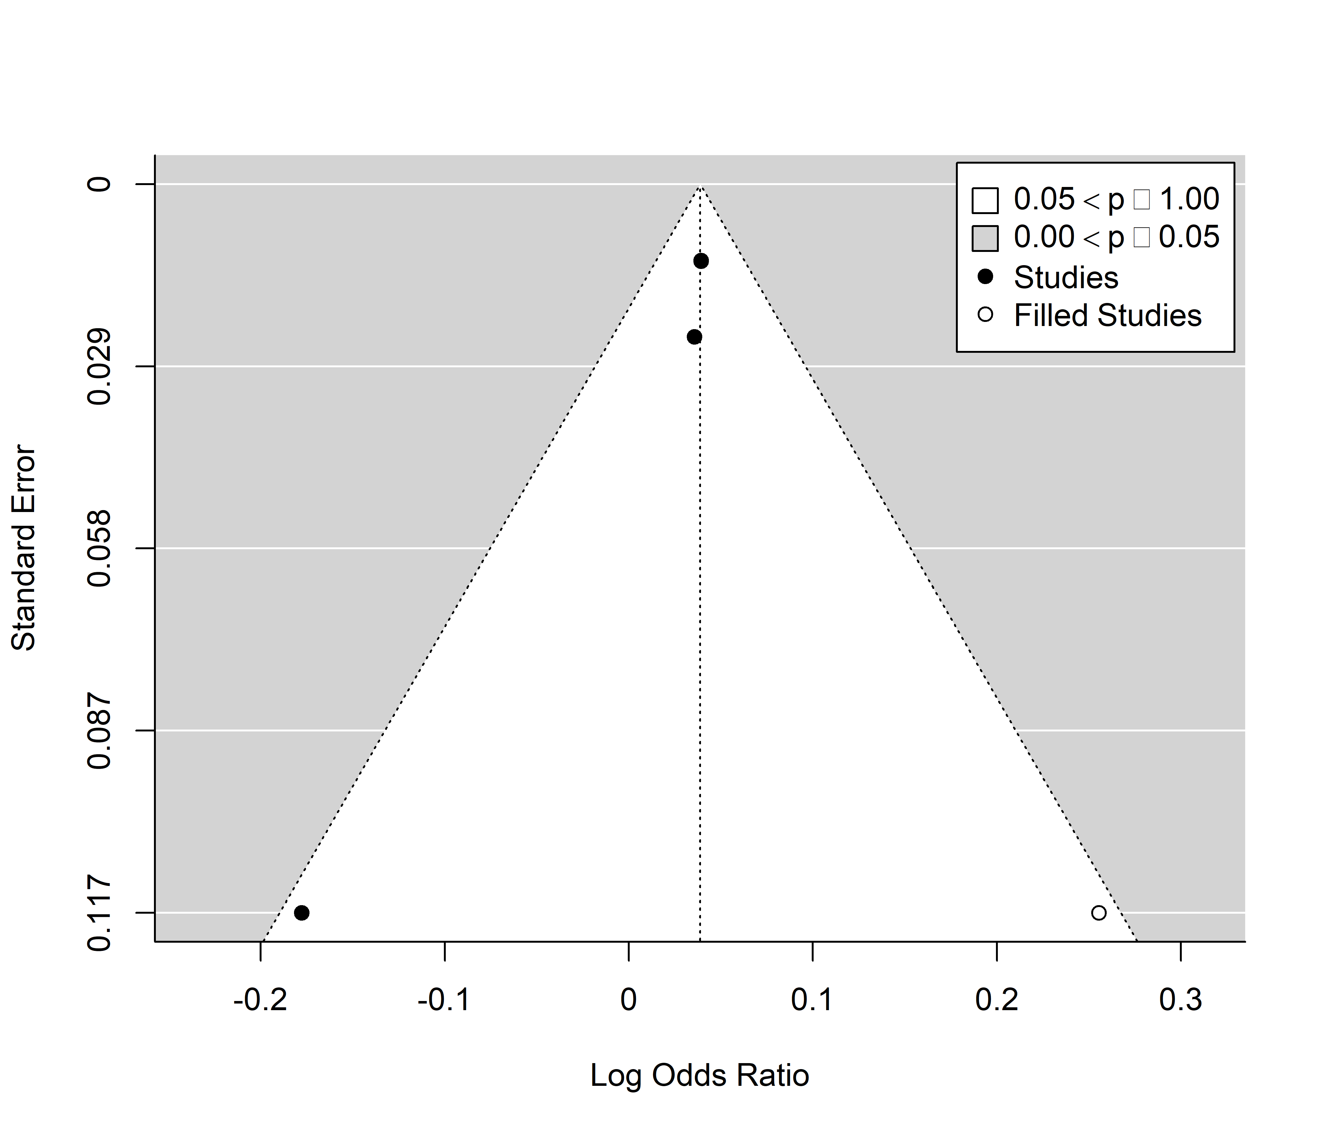
Figure S1. Trim and fill funnel plot for studies included in meta-analysis of associations between long-term PM₁₀ exposure and odds of all-cause infant mortality. Actual studies are shown with black circles, while expected studies are white circles.

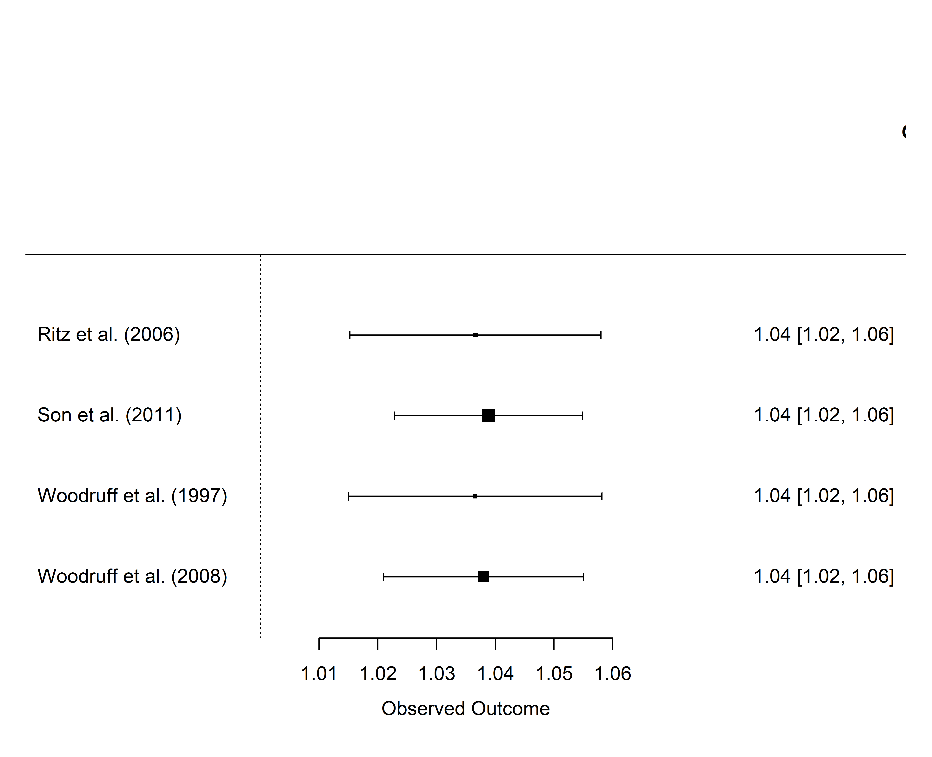
Figure S2. Leave-one-out sensitivity analysis for studies included in the PM10 meta-analysis for all-cause infant mortality.

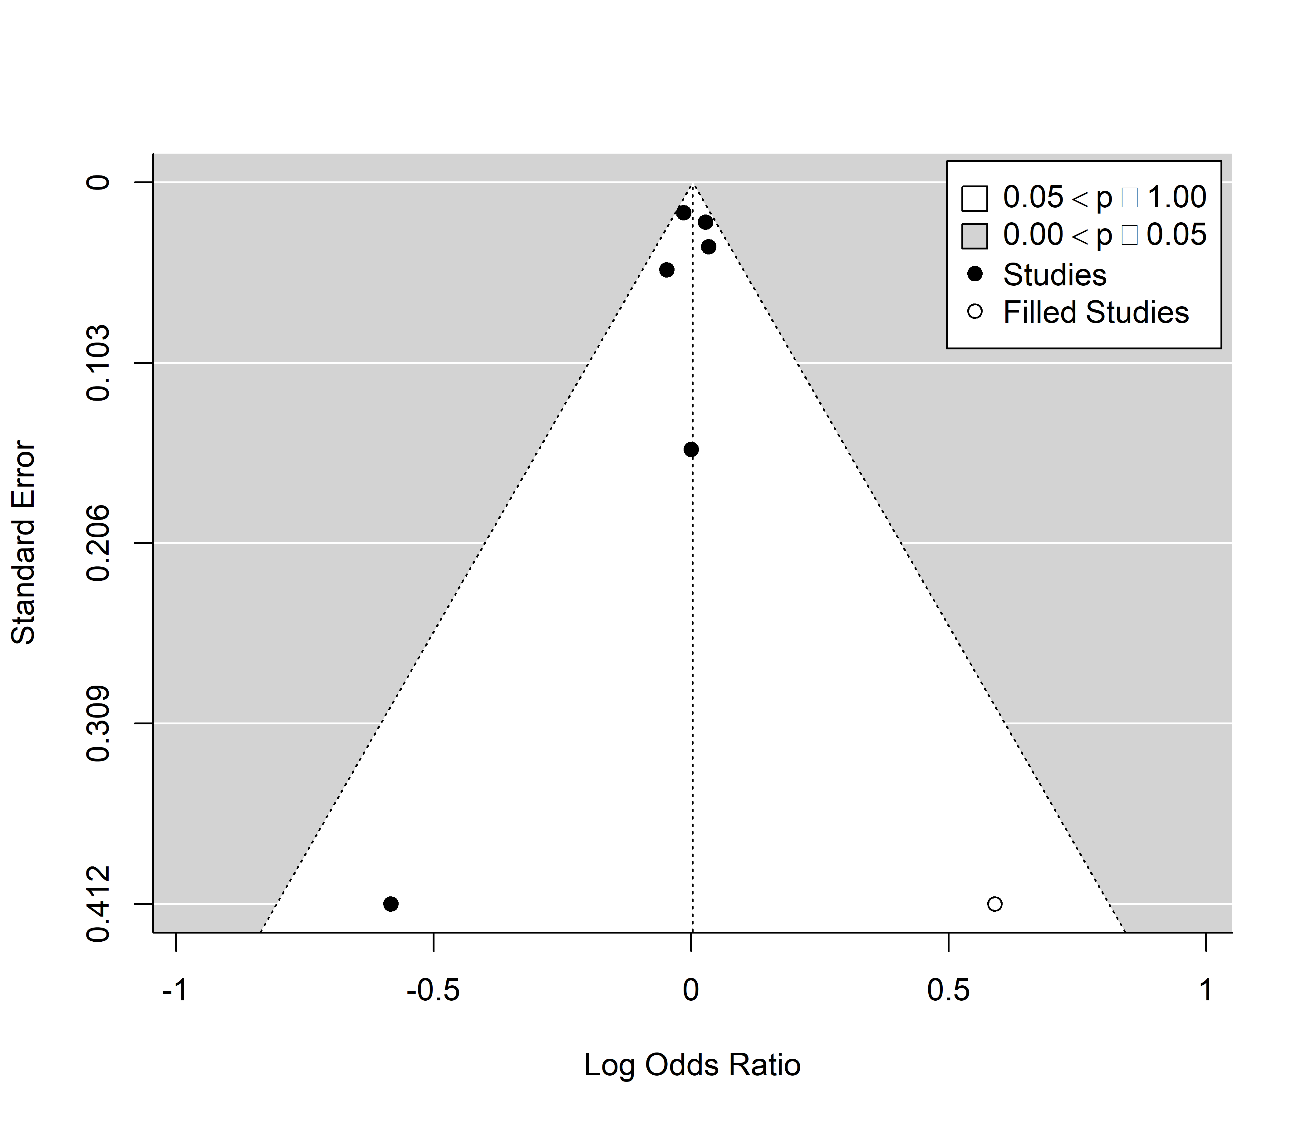
Figure S3. Trim and fill funnel plot for studies included in meta-analysis of associations between long-term PM_{2.5} exposure and odds of all-cause infant mortality. Actual studies are shown with black circles, while expected studies are white circles.

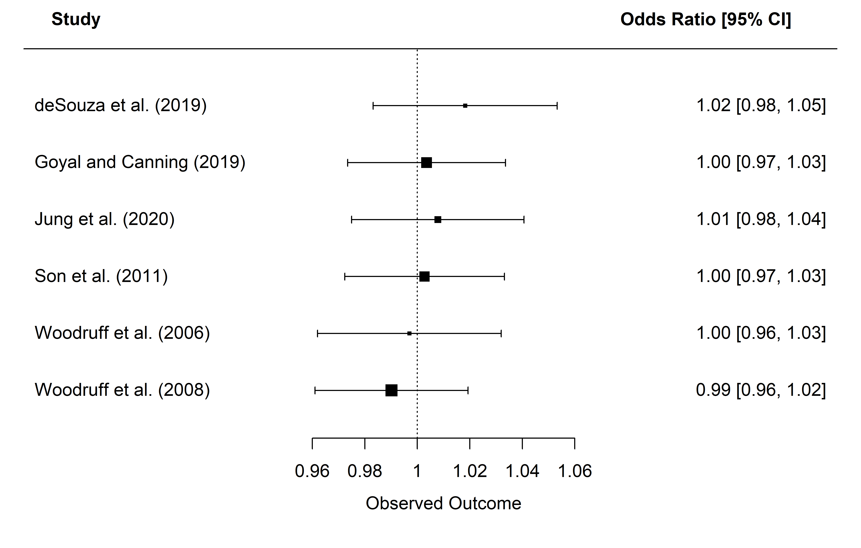
Figure S4. Leave-one-out sensitivity analysis for studies included in the PM_{2.5} meta-analysis for all-cause infant mortality.

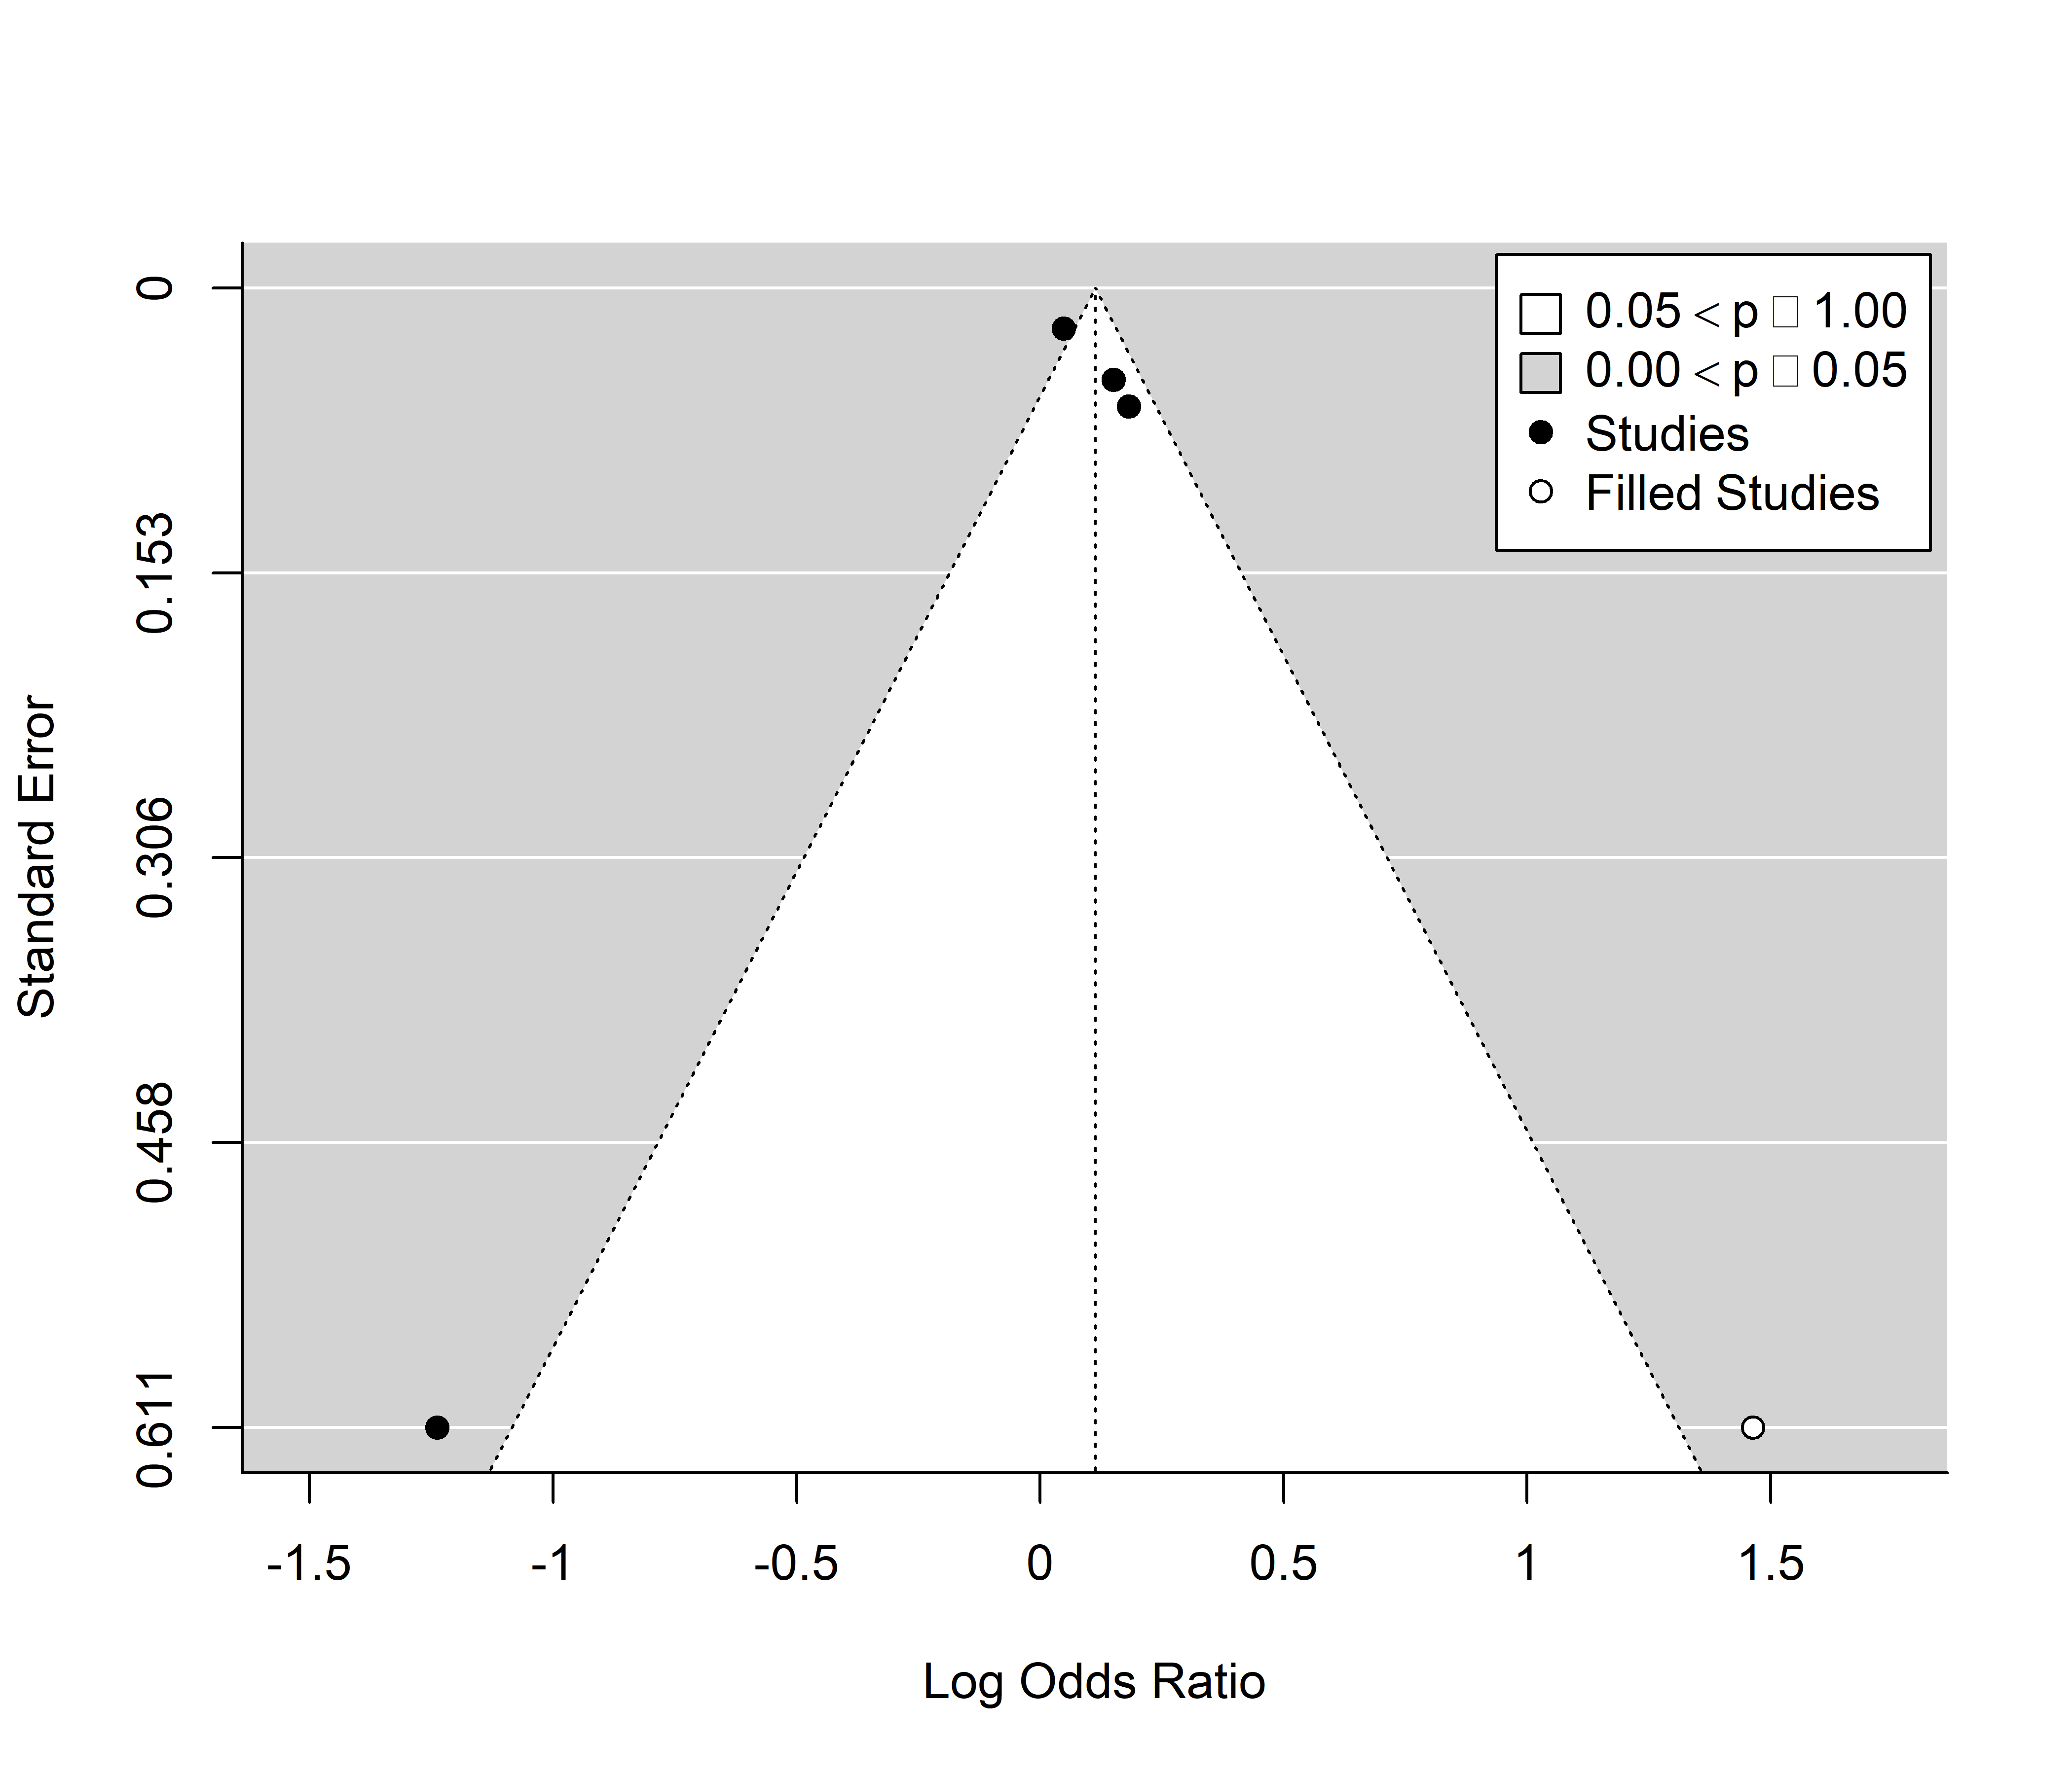
Figure S5. Trim and fill funnel plot for studies included in meta-analysis of associations between short term PM₁₀ exposure and odds of respiratory-related infant mortality. Actual studies are shown with black circles, while expected studies are white circles.

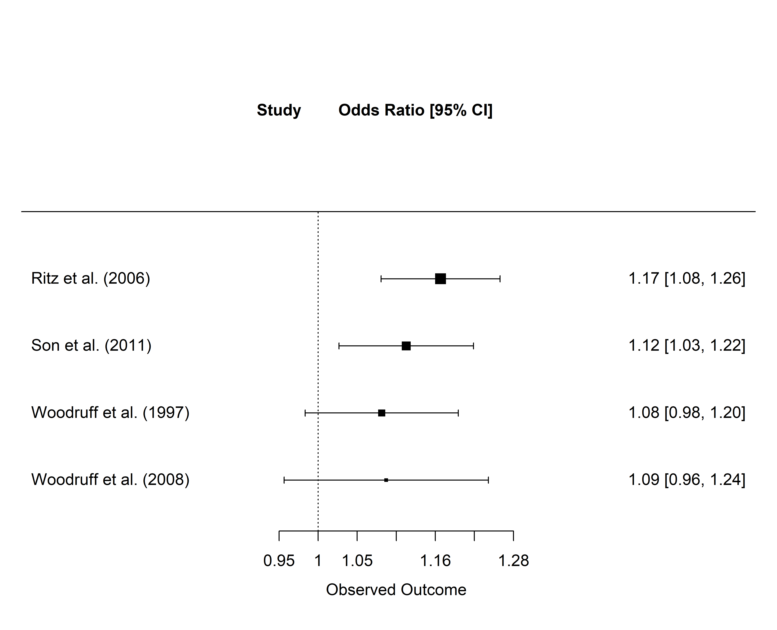
Figure S6. Leave-one-out sensitivity analysis for studies included in the PM₁₀ meta-analysis for respiratory-related infant mortality.

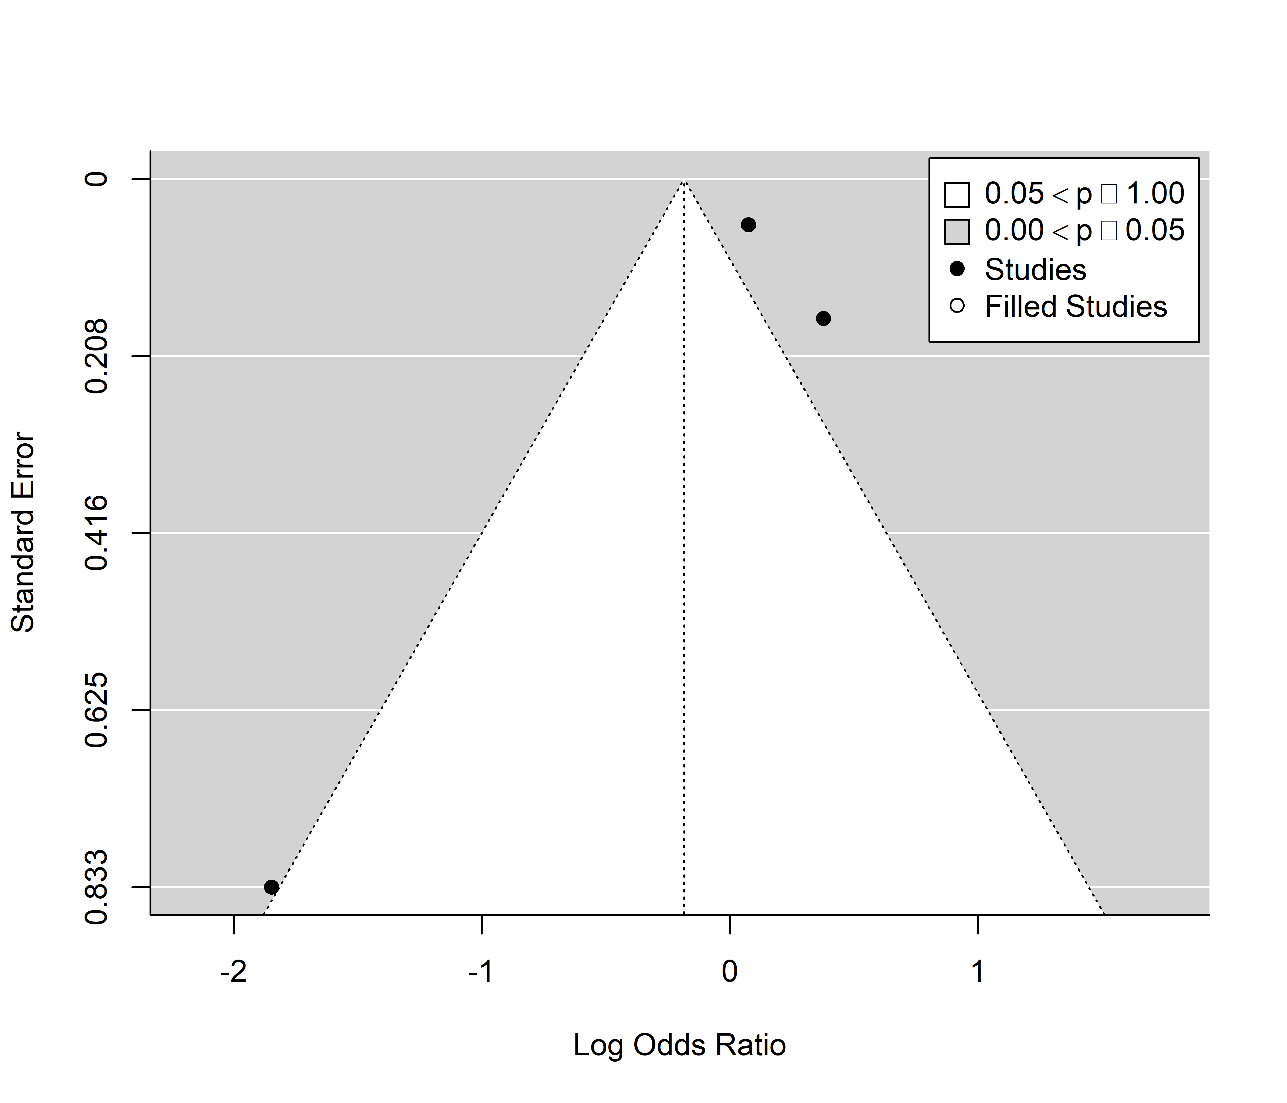
Figure S7. Trim and fill funnel plot for studies included in meta-analysis of associations between short term PM_{2.5} exposure and odds of respiratory-related infant mortality. Actual studies are shown with black circles, while expected studies are white circles.

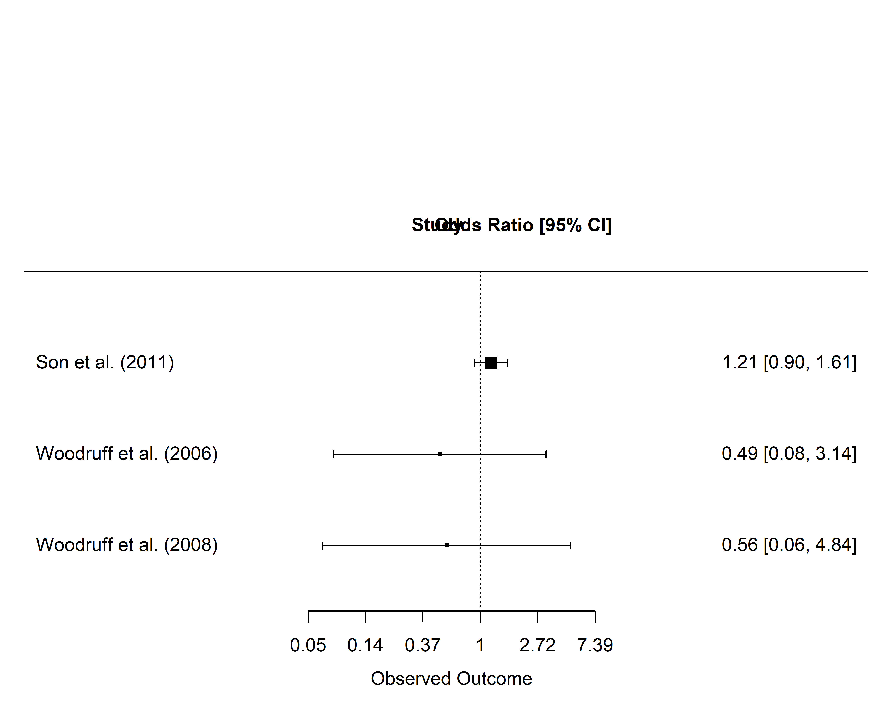
Figure S8. Leave-one-out sensitivity analysis for studies included in the PM_{2.5} meta-analysis for respiratory-related infant mortality.

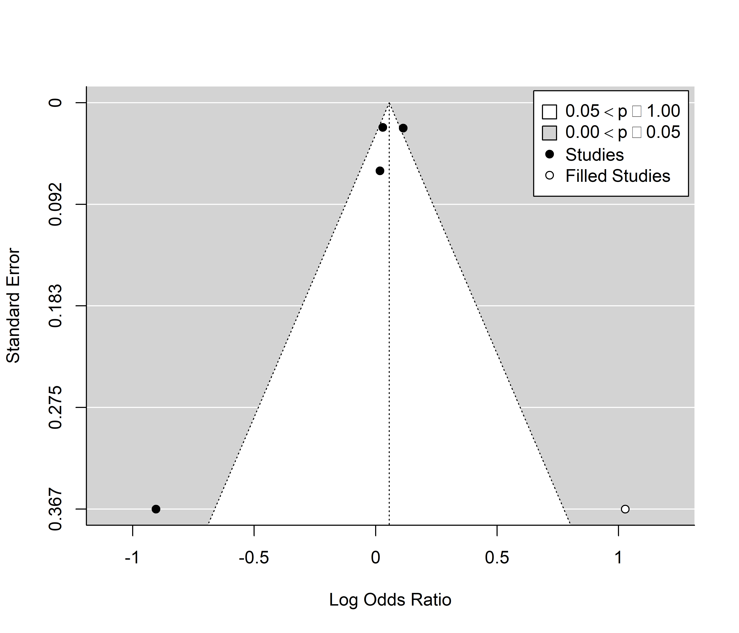
Figure S9. Trim and fill funnel plot for studies included in meta-analysis of associations between long-term PM₁₀ exposure and odds of SIDS-related infant mortality. Actual studies are shown with black circles, while expected studies are white circles.

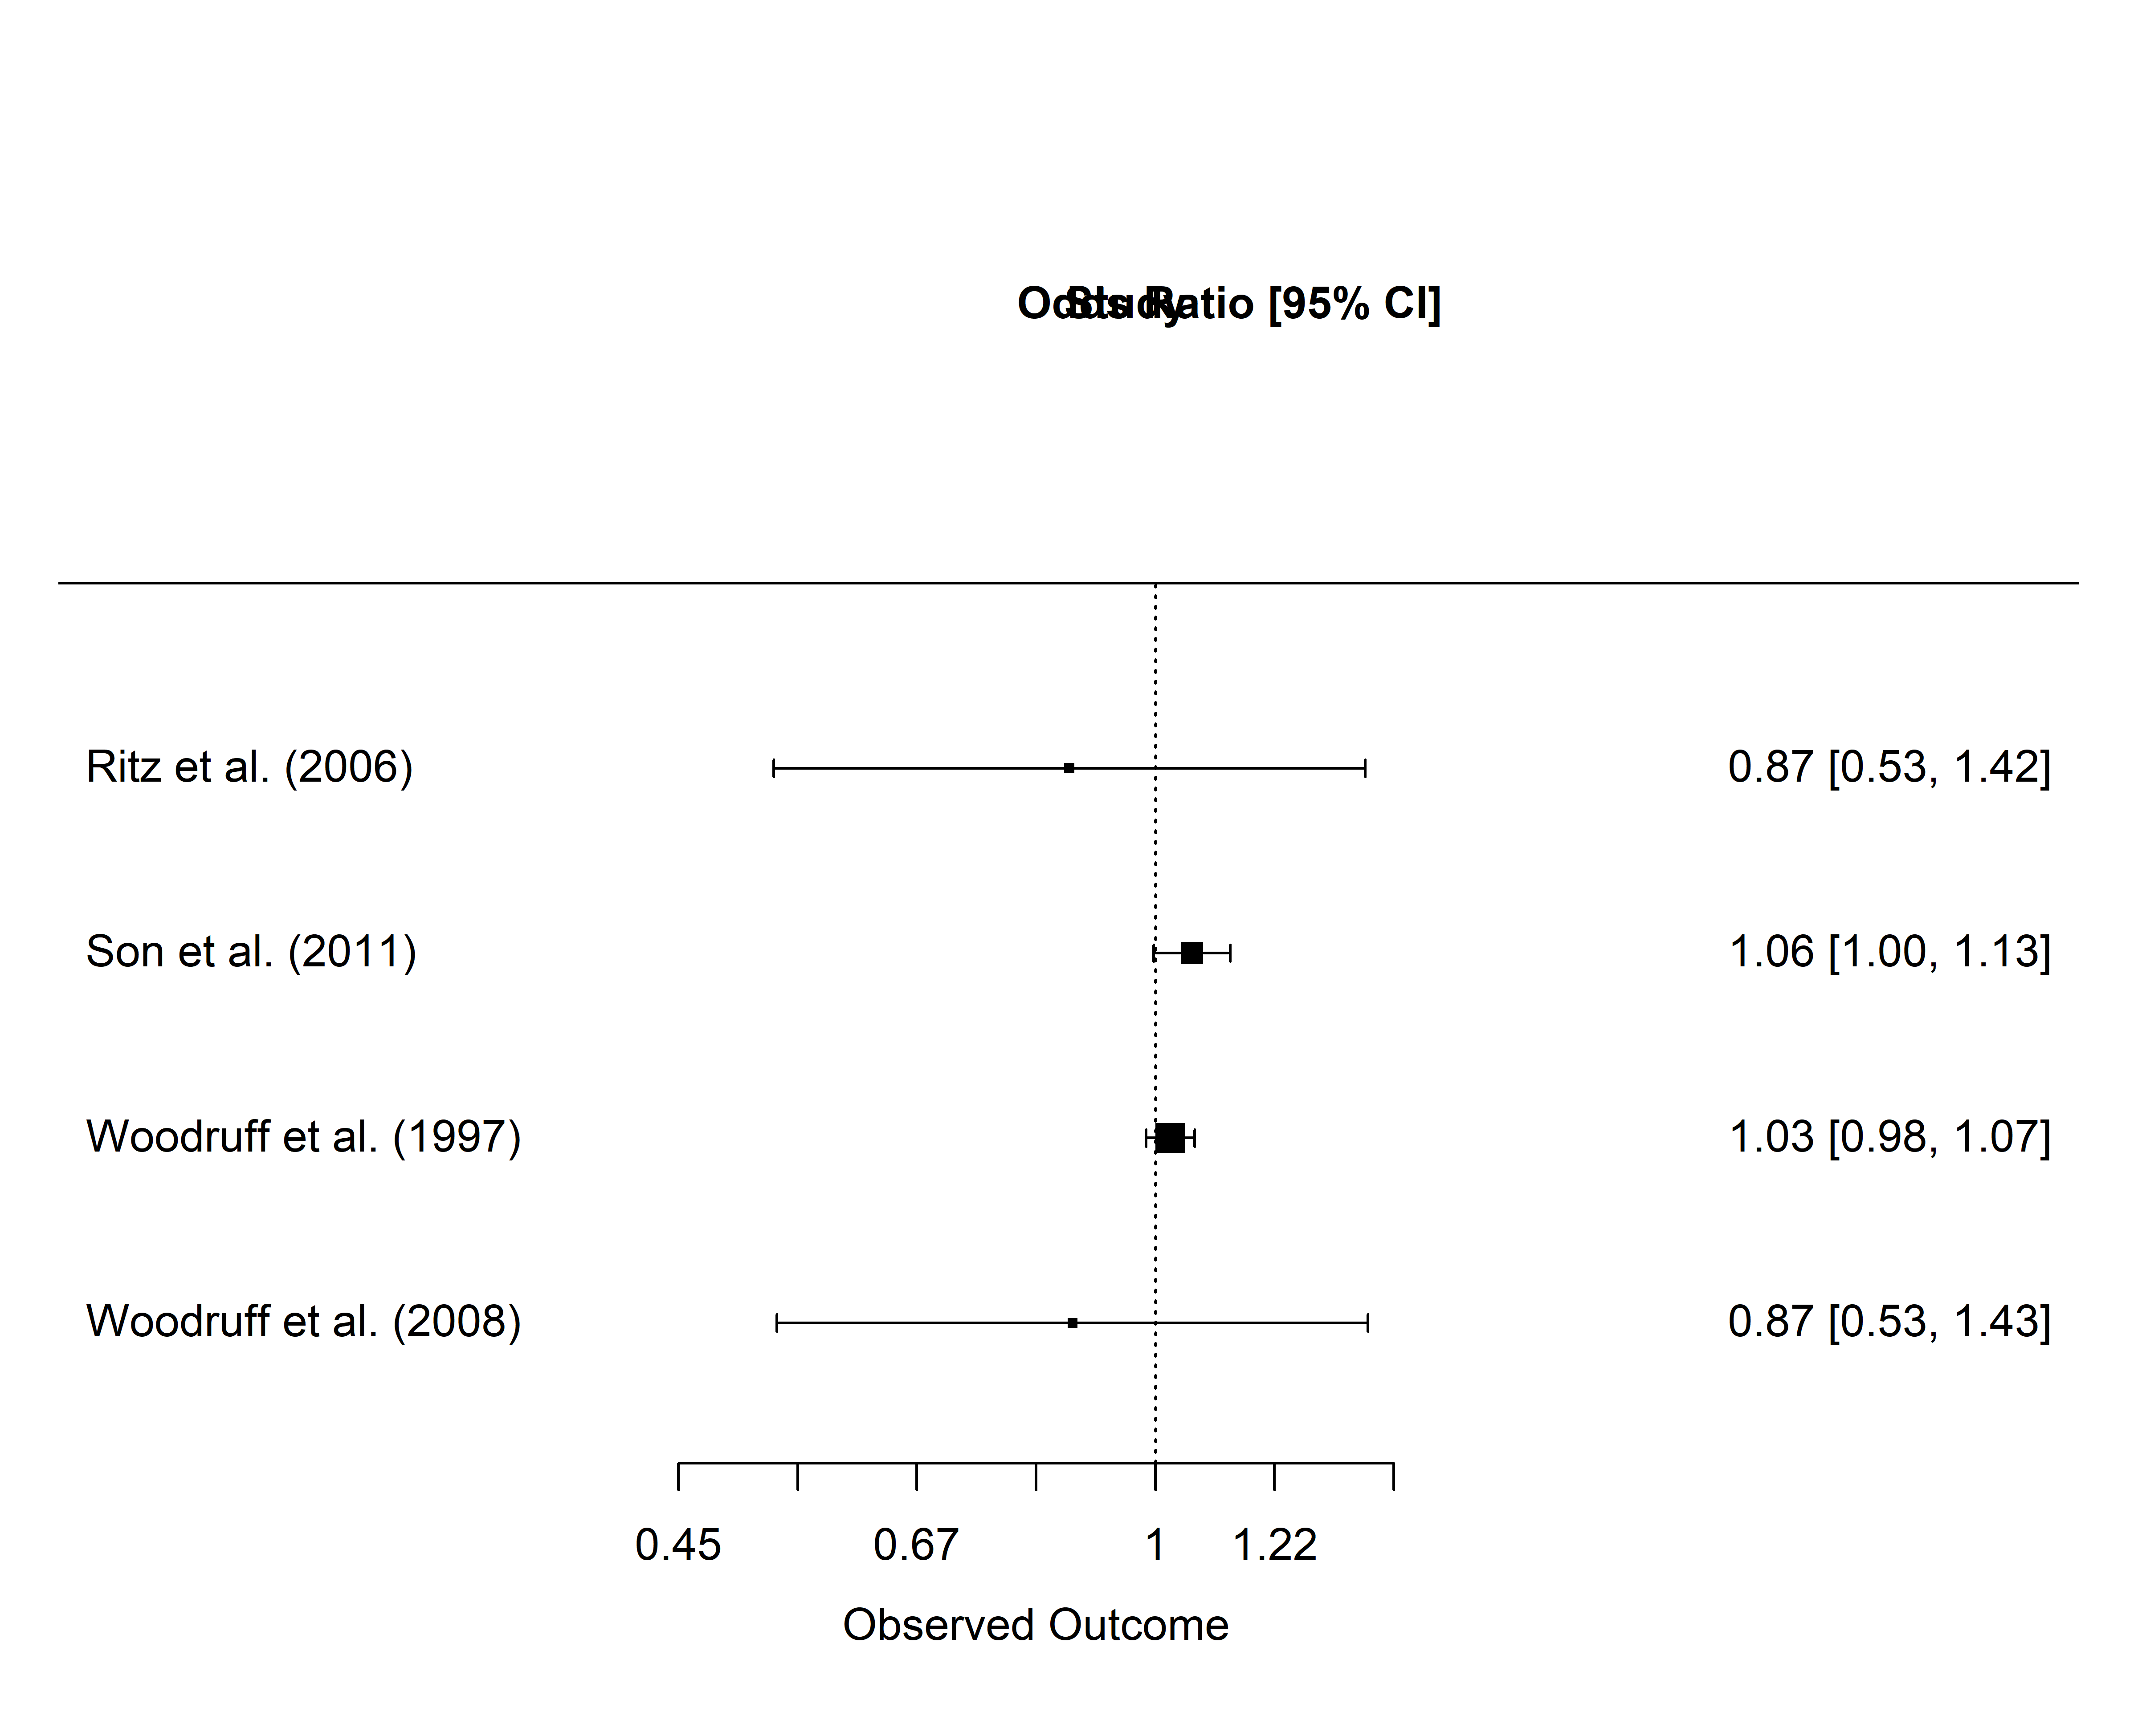
Figure S10. Leave-one-out sensitivity analysis for studies included in the PM₁₀ meta-analysis for SIDS-related infant mortality.

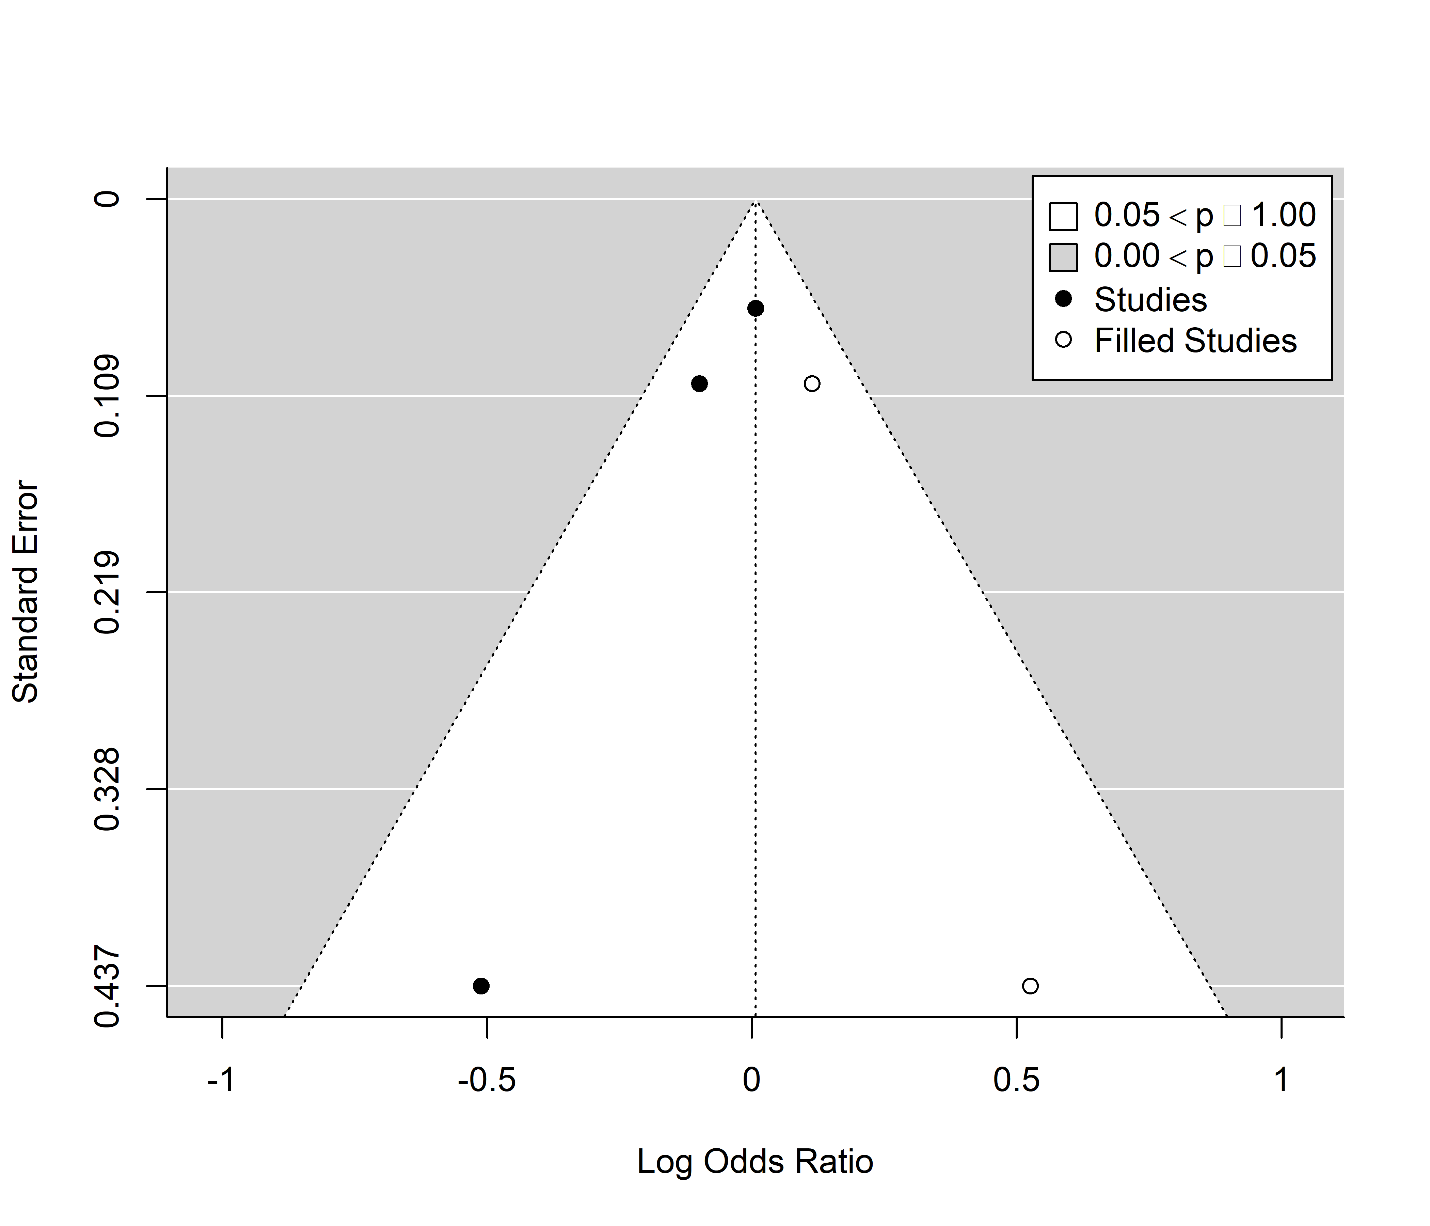
Figure S11. Trim and fill funnel plot for studies included in meta-analysis of associations between long-term PM_{2.5} exposure and odds of SIDS-related infant mortality. Actual studies are shown with black circles, while expected studies are white circles.

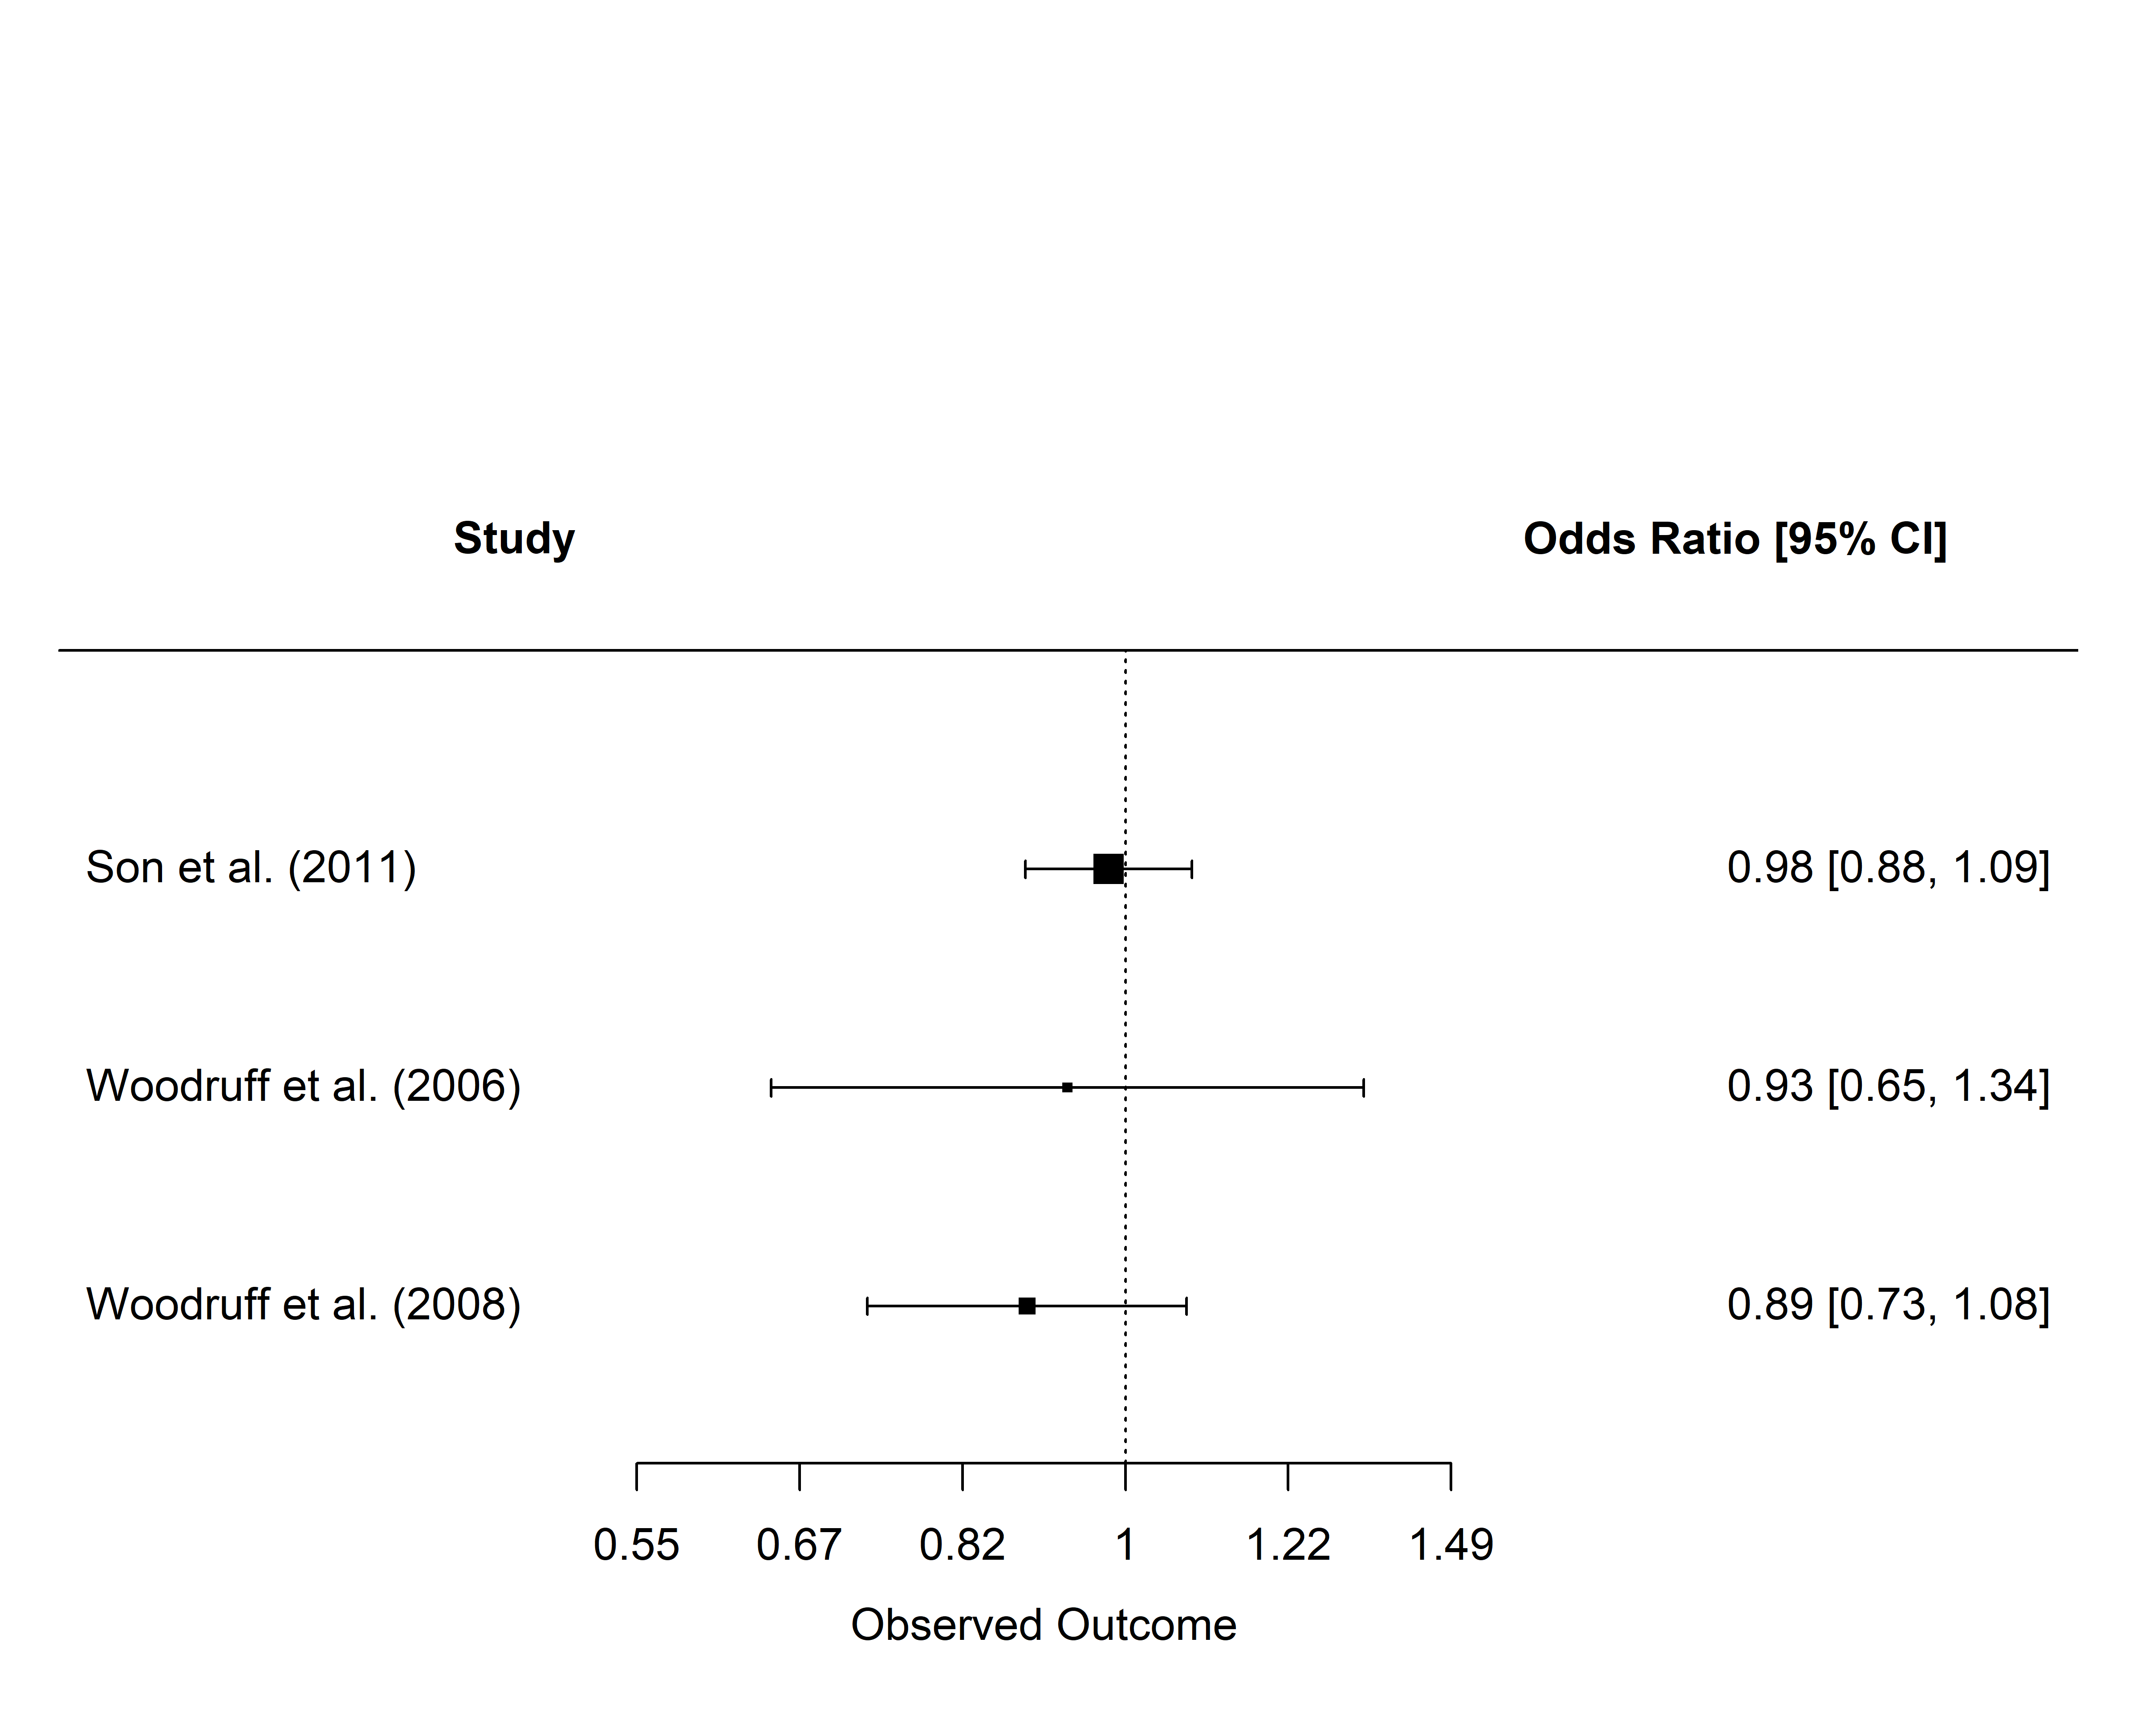
Figure S12. Leave-one-out sensitivity analysis for studies included in the PM_{2.5} meta-analysis for SIDS-related infant mortality.

