Data Dictionary for “Updated in-cloud secondary aerosol production in the Northern Hemisphere predicted by the Community Multiscale Air Quality modeling system”

Summary
Clouds are important physicochemical processors of atmospheric pollutants. Major contributors to secondary sulfate, clouds also provide media for the production and processing of secondary organic aerosol (SOA). Sulfate and organic compounds often dominate particulate mass, and the accurate representation of their important production and loss pathways in models is necessary to effectively address the adverse health, ecosystem, and climate effects associated with elevated particulate concentrations. In this study we investigate the impacts of an extended cloud-chemistry scheme on predictions of particulate sulfur and low molecular weight organic acids in an annual hemispheric application of the Community Multiscale Air Quality (CMAQ) modeling system, version 5.3. Building upon the previously developed Kinetic Mass Transfer (KMT) framework1, the AQCHEM-KMT version 2 (KMT2) cloud-chemistry scheme supplements CMAQ’s default (AQCHEM) seven-reaction cloud-chemistry parameterization with additional inorganic and organic aqueous-phase chemistry, including additional S(IV) reactions and replacement of the default in-cloud SOA parameterization with an explicit representation of the aqueous oxidation of small carbonyl compounds. Modeled impacts vary seasonally and spatially, and results indicate that, compared with the default seven-reaction cloud-chemistry scheme, the extended aqueous-phase chemistry mechanism contributes to predicted inorganic and organic aerosol fractions and can lead to increases in seasonally averaged PM_{2.5} predictions up to ~1 μg m⁻³, with greater episodic impacts. While model performance for particulate sulfur species is mixed and, in fact, slightly degraded over CONUS on average for these simulations, a comparison with seasonal oxalate observations indicates that the updated cloud chemistry code may lead to improved model performance for organic aerosol, particularly in areas and seasons where there is limited influence from primary organic acid and/or biomass emissions. The work here suggests there may be a potential benefit realized from re-evaluating and updating the simple cloud chemistry parameterizations that are common in chemical transport models. Future efforts should continue improving representation of the most important aqueous-phase chemical pathways in air quality models while minimizing computational cost.

The data used for this work include inputs/outputs/code for the Community Multiscale Air Quality (CMAQ) modeling platform over the N. Hemisphere (Figure 1) for 2016. It also includes data used to generate specific figures in the manuscript. The following sections describe the data that comprise this project and are used to develop figures in the manuscript as well as their location on the archival file system, /asm, for EPA’s atmos high-performance computing platform.

**PM_{2.5} refers to particulate matter 2.5 micrometers or less in diameter
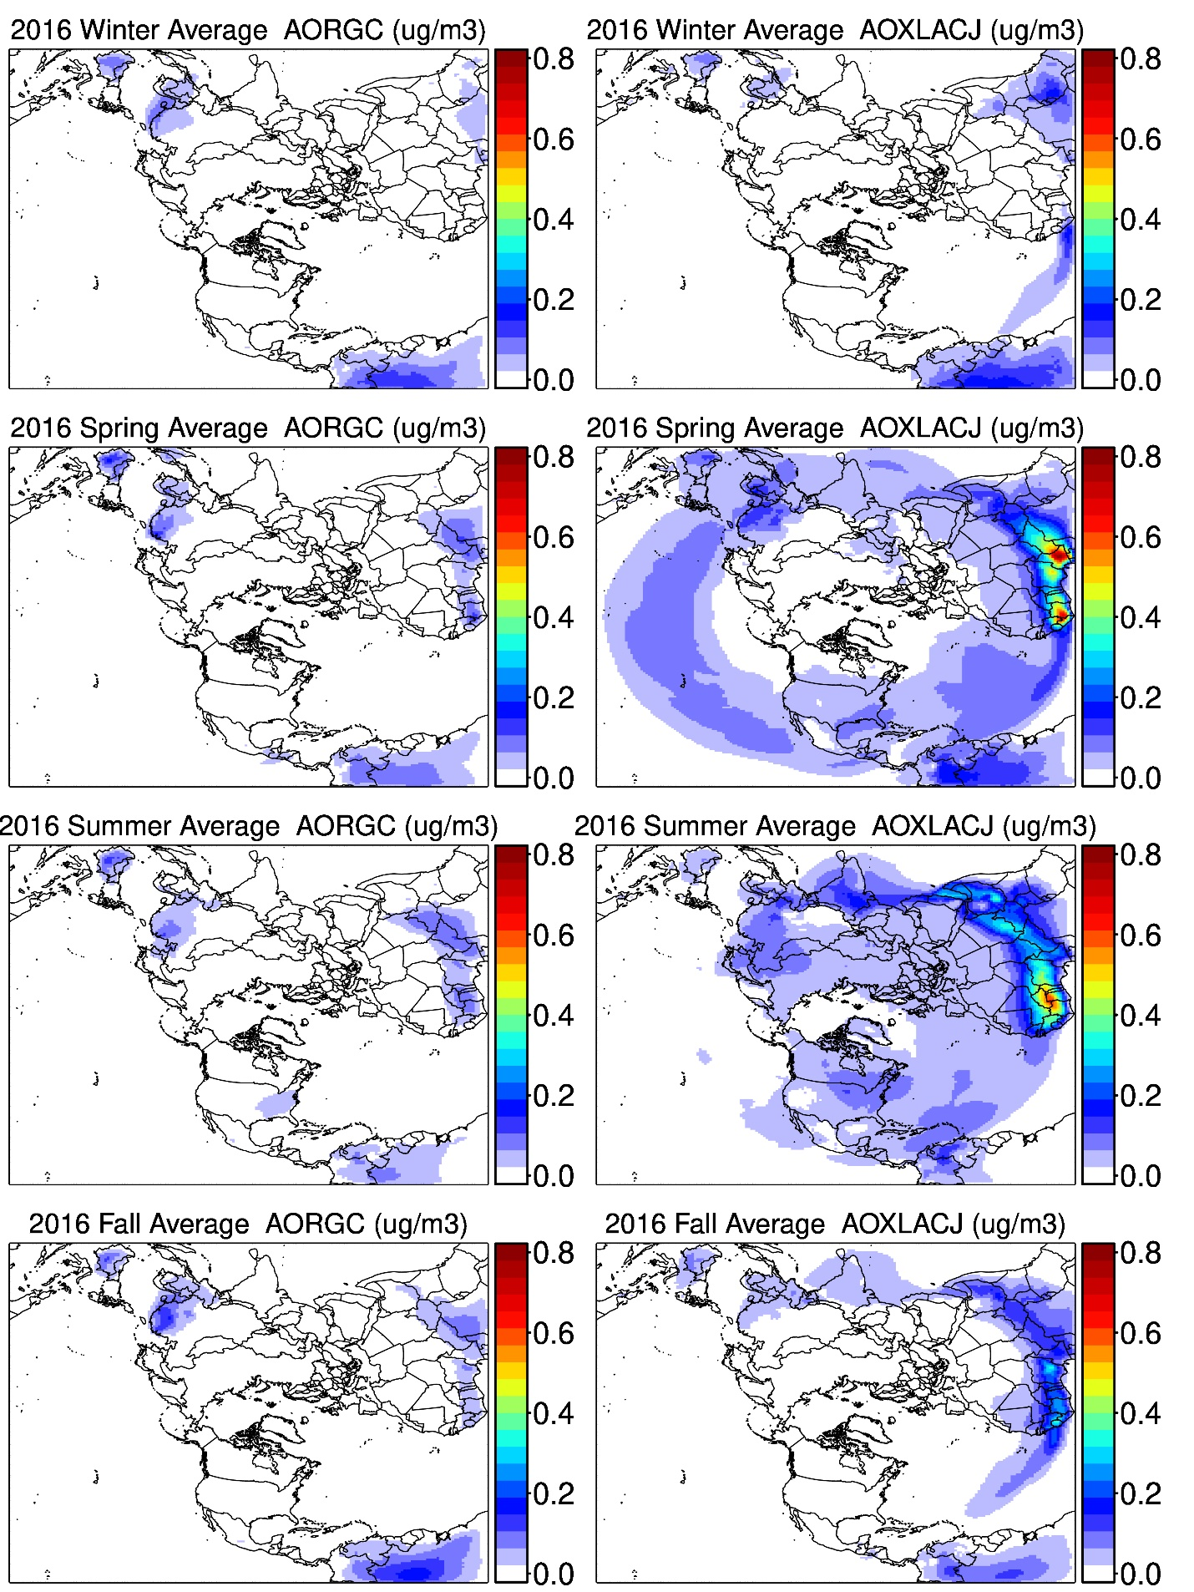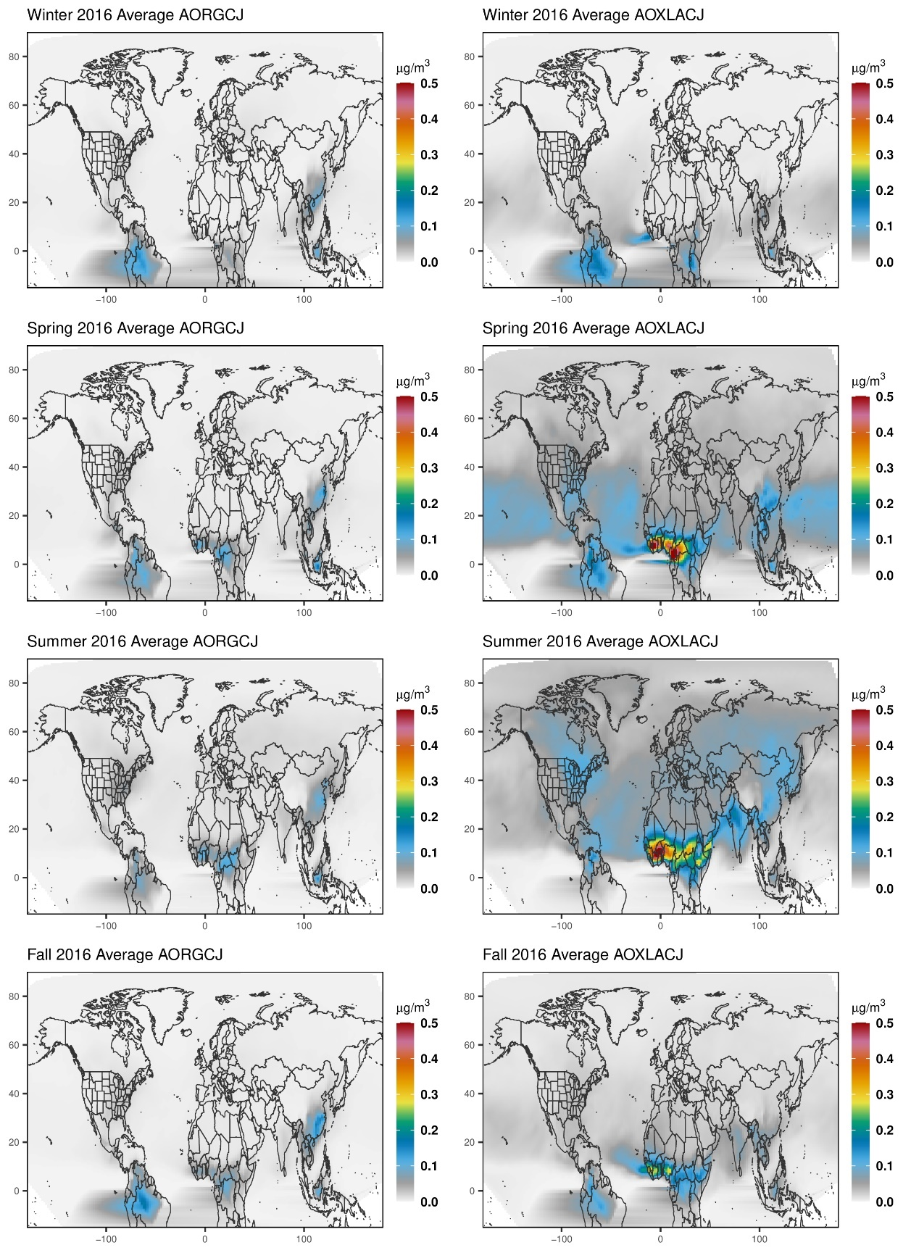
Figure 1: US EPA Hemispheric CMAQ (HCMAQ) domain with 108 km horizontal resolution and 44 vertical layers (left) with an example of a re-mapped spatial plot (right) as used in the manuscript.

Table 1. Description of model simulations performed in this work and the model species* representing in-cloud secondary organic aerosol
Model Simulation | Description | In-cloud SOA CMAQ species
AQCHEM | CMAQ default cloud chemistry module. Aqueous-phase ·OH is determined from the gas-phase ·OH concentration and Henry’s law coefficient at the start of cloud processing and held constant for the model sync step. | AORGCJ (lumped species representing a mix of organic acids and oligomers formed in cloud water; parameterized as a 4% molar yield from ·OH reaction with glyoxal and methylglyoxal)
KMT2 | KMT2 cloud chemistry module with fixed gas-phase ·OH during the model sync step (≤ 5 minutes) | AOXLACJ (oxalic acid/oxalate)  APYRACJ (pyruvic acid/pyruvate)  AGCOLACJ (glycolic acid/glycolate)  AGLYACJ (glyoxylic acid/glyoxylate)
KMT2-DYNOH | KMT2 cloud chemistry module with variable gas-phase ·OH during the model sync step (gas-phase ·OH only changes due to mass transfer between the gas and aqueous phases) | AOXLACJ (oxalic acid/oxalate)  APYRACJ (pyruvic acid/pyruvate)  AGCOLACJ (glycolic acid/glycolate)  AGLYACJ (glyoxylic acid/glyoxylate)
*When not comparing with observations in a particular size range (e.g., PM_{2.5} OXLAC), model values represent the total accumulation (J) mode aerosol concentration of the organic species (e.g., “AOXLACJ”).

Data/Code for Manuscript

Table 2: Data for Manuscript Figures
Figure | Data description | File type* | Relevant Variables | Definition (units) | Location
1, 4, 5, S-3, S-5 | Gridded seasonal average files for AQCHEM, KMT2, and KMT2-DYNOH simulations | netCDF | ASO4  AHMSJ  AOXLACJ  AGLYACJ  AGCOLACJ  APYRACJ  ASOAcld  AORGC | I+J mode sulfate  Hydroxymethanesulfonate (HMS)  Oxalate  Glyoxylate  Glycolate  Pyruvate  Sum (OXLAC + GLYAC + GCOLAC + PYRAC)  AORGC – AQCHEM in-cloud SOA  (all in μg m⁻³) | Attached  “FIGS_1_4_5.tar”
2, 3, S-8 | Observed, KMT2, KMT2-DYNOH, and AQCHEM organic acids for model-obs comparison | EXCEL file .xlsx | oxalate+pyruvate+glycolate for FASE flights  and seasonal mean (and standard deviation) oxalate at different sites for 2016 | OBS = observations  KMT2 = KMT2 predictions  KMT2-DYNOH = KMT2-DYNOH predictions  AQCHEM = AQCHEM predictions  (all in μg m⁻³) | Attached  ”KMT2_FIGURE_DATA.xlsx”
6 | CMAQ ACONC, APMDIAG, WETDEP, and DRYDEP files | netCDF | Hourly, gridded CMAQ outputs  Simulations = AQCHEM and KMT2 | Figures generated with the Atmospheric Model Evaluation Tool (AMET)  (all in μg m⁻³) | /asm/MOD3DEV/kfa/KMT2-paper-runs/NEW_RUNS_072420/{OUTDIR}  where {OUTDIR} = OUT_HEMI_STDAQ,  OUT_HEMI_KMT2_expl
S-1 | July average model concentrations for different sync steps | netCDF | AOXLACJ  ASOAcld | J-mode oxalate  Sum of J-mode (oxalate + pyruvate + glycolate + glyoxylate) | /asm/MOD3DEV/kfa/KMT2-paper-runs/NEW_RUNS_072420/{OUTDIR}/POST/AVG.ACONC*  where {OUTDIR} = OUT_HEMI_KMT2_dynoh_expl,  OUT_HEMI_KMT2_dynoh_expl-1minDT,  OUT_HEMI_KMT2_expl
S-2 | Gridded hourly July [OH]_{aq} concentrations for KMT2 and KMT2-DYNOH subgrid clouds, resolved clouds – layer 1, and resolved clouds – layer 20 | netCDF | OHRES1  OHRES20  OHavCONV | Resolved cloud hydroxyl – layer 1  Resolved cloud hydroxyl – layer 20  Subgrid cloud hydroxyl  Missing values = -9999  Units = M (mol/L) | /asm/MOD3DEV/kfa/KMT2-paper-runs/NEW_RUNS_072420/{OUTDIR}/POST/COMBINE_OH*  where {OUTDIR} = OUT_HEMI_KMT2_dynoh_expl-outputOH,  OUT_HEMI_KMT2_expl-outputOH
S-4 | Gridded summer LAI and CFRAC data | netCDF | LAI  CFRAC | Leaf area index (area/area)  Cloud fraction | /asm/MOD3DEV/kfa/KMT2-paper-runs/NEW_RUNS_072420/OUT_HEMI_KMT2_PARTITION-GASSPCS/POST/ COMBINE_MET_SUMMER
S-6 | Gridded summer average organic acid concentrations when gas-aerosol partitioning is considered | netCDF | AOXLACJ  GOXLACm | J-mode oxalate  Gas-phase oxalic acid  (both in μg m⁻³) | /asm/MOD3DEV/kfa/KMT2-paper-runs/NEW_RUNS_072420/OUT_HEMI_KMT2_PARTITION-GASSPCS/POST/AVG_SUMMER.nc
S-7 | Gridded seasonal average files for sensitivity KMT2-Moch et al. (2018) and no loss to OH | netCDF | AHMSJ | Hydroxymethanesulfonate (HMS)  (μg m⁻³) | /asm/MOD3DEV/kfa/KMT2-paper-runs/NEW_RUNS_072420/OUT_HEMI_KMT2_expl-Moch/POST/SEASONAL/{AVG or MAX}_{SEASON}.nc
CMAQ code | KMT2 and AQCHEM build directories | ASCII | N/A | Fortran code | Attached  “BLD_AQCHEM.tar.gz”  “BLD_KMT2.tar.gz”
*Note that netCDF files contain metadata describing the variables and their units in each file

CMAQ Model-Ready Inputs for October 2015 – December 2016

Table 3: Location of CMAQ input files
Data description | File type* | Location on asm
CMAQ-ready meteorology inputs | netCDF | /asm/MOD3DEV/kfa/KMT2-paper-runs/NEW_RUNS_072420/INPUTS/met
CMAQ-ready emissions inputs | netCDF | /asm/MOD3DEV/kfa/KMT2-paper-runs/NEW_RUNS_072420/INPUTS/emis
CMAQ initial conditions and boundary condition files | netCDF | /asm/MOD3DEV/kfa/KMT2-paper-runs/NEW_RUNS_072420/INPUTS/icbc
Surface input files | netCDF | /asm/MOD3DEV/kfa/KMT2-paper-runs/NEW_RUNS_072420/INPUTS/surface
*Note that netCDF files contain metadata describing the variables and their units in each file

CMAQ code (build directories)
Table 4: ASM location of CMAQ Build Directories for all simulations in this project
Simulation | Description | Use in paper figures and tables | Build directories (CMAQ code)  BLDDIRS = /asm/MOD3DEV/kfa/KMT2-paper-runs/NEW_RUNS_072420/BUILDS/
AQCHEM | Base configuration of CMAQ with the default AQCHEM cloud chemistry module | Figures 1, 2, 3, 5, 6, S-3, S-5, S-8, Table S-1 | $BLDDIRS/BLD_STDAQ_GCOL-HLAW
KMT2 | CMAQ with the KMT2 cloud chemistry module where gas-phase concentration of OH is held constant during cloud processing during a sync step | Figures 1, 2, 3, 4, 5, 6, S-1, S-2, S-3, S-4, S-5, S-6, S-7, S-8  Tables 1, S-1:S-4 | $BLDDIRS/BLD_KMT2_expl-hmsa-updateglyac-hms-hchohlaw
KMT2-dynoh | CMAQ with the KMT2 cloud chemistry module where gas-phase concentration of OH is dynamic during cloud processing during a sync step | Figures 2, 3, 4, S-1, S-2, S-8, Tables 1, S-1:S-4 | $BLDDIRS/BLD_KMT2_dynoh_expl-hmsa-updateglyac-hms-hchohlaw
Sensitivity-Moch et al. (2018) parameters | Sensitivity-simulation with KMT2 cloud chemistry using HMS rate coefficients from Moch et al. (2018) and removing HMS loss by OH | Figure S-7 | $BLDDIRS/BLD_KMT2_expl-Moch-coefs
Sensitivity-PARTITIONING | Sensitivity-simulation with KMT2 cloud chemistry and simple partitioning. Added non-reactive gas-phase OXLAC, PYRAC, GCOLAC, GLYAC (dry deposition like acetic acid; wet deposition in SCAVWDEP using Henry’s law coefficients from Sander (2015)) | Figure S-6 | $BLDDIRS/BLD_KMT2_expl-PARTITION-GASSPCS
Sensitivity- KMT2-DYNOH with 1.5*JH2O2 and 1.5 * 10 * JHNO3 | Sensitivity – Updated aqueous-phase photolysis rates for J_{H2O2,aq} and J_{NO3-,aq} in KMT2 (with dynamic gas-phase OH) to 1.5*J_{H2O2,g} and 1.5 * 10 * J_{HNO3,g} respectively | NA | $BLDDIRS/BLD_KMT2_dynoh_expl-hmsa-updateglyac-hms-hchohlaw-intel21-sens
Sensitivity- KMT2 with 1.5 * JH2O2 and 1.5 * 10 * JHNO3 | Sensitivity – Updated aqueous-phase photolysis rates for J_{H2O2,aq} and J_{NO3-,aq} in KMT2 (with constant gas-phase OH) to 1.5*J_{H2O2,g} and 1.5 * 10 * J_{HNO3,g} respectively | NA | $BLDDIRS/BLD_KMT2_expl-hmsa-updateglyac-hms-hchohlaw-1.6photolysis-intel21.4
Sensitivity – 1 minute sync step with DYNOH | Sensitivity – KMT2 cloud chemistry module where gas-phase concentration of OH is dynamic during cloud processing during a sync step with maximum sync step reduced to 60 seconds (from 300 seconds) | Figure S-1 | Same as KMT2-dynoh but with CTM_MAXSYNC in CMAQ run script changed from 300 to 60 seconds
OH outputs for KMT2 | KMT2 simulation updated to output aqueous [OH] concentrations in clouds | Figure S-2 | $BLDDIRS/BLD_KMT2_expl-outputOH
OH outputs for KMT2-DYNOH | KMT2-DYNOH simulation updated to output aqueous [OH] concentrations in clouds | Figure S-2 | $BLDDIRS/BLD_KMT2_dynoh_expl-outputOH

CMAQ Outputs for 2016 N. Hemisphere

Table 5: Location of CMAQ output files for all simulations
 | Data description | Simulation | File type* | Location on asm
 | CMAQ hourly average surface concentrations (“ACONC”) | AQCHEM | netCDF | /asm/MOD3DEV/kfa/KMT2-paper-runs/NEW_RUNS_072420/ OUT_HEMI_STDAQ
 | CMAQ hourly average PM diagnostic variables (“APMDIAG”) | AQCHEM | netCDF | /asm/MOD3DEV/kfa/KMT2-paper-runs/NEW_RUNS_072420/ OUT_HEMI_STDAQ
 | CMAQ hourly wet deposition (“WETDEP”) | AQCHEM | netCDF | /asm/MOD3DEV/kfa/KMT2-paper-runs/NEW_RUNS_072420/ OUT_HEMI_STDAQ
 | CMAQ hourly dry deposition (“DRYDEP”) | AQCHEM | netCDF | /asm/MOD3DEV/kfa/KMT2-paper-runs/NEW_RUNS_072420/ OUT_HEMI_STDAQ
 | CMAQ hourly average surface concentrations (“ACONC”) | KMT2 | netCDF | /asm/MOD3DEV/kfa/KMT2-paper-runs/NEW_RUNS_072420/ OUT_HEMI_KMT2_expl
 | CMAQ hourly average PM diagnostic variables (“APMDIAG”) | KMT2 | netCDF | /asm/MOD3DEV/kfa/KMT2-paper-runs/NEW_RUNS_072420/ OUT_HEMI_KMT2_expl
 | CMAQ hourly wet deposition (“WETDEP”) | KMT2 | netCDF | /asm/MOD3DEV/kfa/KMT2-paper-runs/NEW_RUNS_072420/ OUT_HEMI_KMT2_expl
 | CMAQ hourly dry deposition (“DRYDEP”) | KMT2 | netCDF | /asm/MOD3DEV/kfa/KMT2-paper-runs/NEW_RUNS_072420/ OUT_HEMI_KMT2_expl
 | CMAQ hourly average surface concentrations (“ACONC”) | KMT2-dynoh | netCDF | /asm/MOD3DEV/kfa/KMT2-paper-runs/NEW_RUNS_072420/ OUT_HEMI_KMT2_dynoh_expl
 | CMAQ hourly average PM diagnostic variables (“APMDIAG”) | KMT2-dynoh | netCDF | /asm/MOD3DEV/kfa/KMT2-paper-runs/NEW_RUNS_072420/ OUT_HEMI_KMT2_dynoh_expl
 | CMAQ hourly wet deposition (“WETDEP”) | KMT2-dynoh | netCDF | /asm/MOD3DEV/kfa/KMT2-paper-runs/NEW_RUNS_072420/ OUT_HEMI_KMT2_dynoh_expl
 | CMAQ hourly dry deposition (“DRYDEP”) | KMT2-dynoh | netCDF | /asm/MOD3DEV/kfa/KMT2-paper-runs/NEW_RUNS_072420/ OUT_HEMI_KMT2_dynoh_expl
 | CMAQ hourly average surface concentrations (“ACONC”) | Sensitivity-Moch parameters | netCDF | /asm/MOD3DEV/kfa/KMT2-paper-runs/NEW_RUNS_072420/ OUT_HEMI_KMT2_expl-Moch
 | CMAQ hourly average PM diagnostic variables (“APMDIAG”) | Sensitivity-Moch parameters | netCDF | /asm/MOD3DEV/kfa/KMT2-paper-runs/NEW_RUNS_072420/ OUT_HEMI_KMT2_expl-Moch
 | CMAQ hourly wet deposition (“WETDEP”) | Sensitivity-Moch parameters | netCDF | /asm/MOD3DEV/kfa/KMT2-paper-runs/NEW_RUNS_072420/ OUT_HEMI_KMT2_expl-Moch
 | CMAQ hourly dry deposition (“DRYDEP”) | Sensitivity-Moch parameters | netCDF | /asm/MOD3DEV/kfa/KMT2-paper-runs/NEW_RUNS_072420/ OUT_HEMI_KMT2_expl-Moch
 | CMAQ hourly average surface concentrations (“ACONC”) | Sensitivity – 1 minute sync step with DYNOH | netCDF | /asm/MOD3DEV/kfa/KMT2-paper-runs/NEW_RUNS_072420/ OUT_HEMI_KMT2_dynoh_expl-1minDT
 | CMAQ hourly average PM diagnostic variables (“APMDIAG”) | Sensitivity – 1 minute sync step with DYNOH | netCDF | /asm/MOD3DEV/kfa/KMT2-paper-runs/NEW_RUNS_072420/ OUT_HEMI_KMT2_dynoh_expl-1minDT
 | CMAQ hourly wet deposition (“WETDEP”) | Sensitivity – 1 minute sync step with DYNOH | netCDF | /asm/MOD3DEV/kfa/KMT2-paper-runs/NEW_RUNS_072420/ OUT_HEMI_KMT2_dynoh_expl-1minDT
 | CMAQ hourly dry deposition (“DRYDEP”) | Sensitivity – 1 minute sync step with DYNOH | netCDF | /asm/MOD3DEV/kfa/KMT2-paper-runs/NEW_RUNS_072420/ OUT_HEMI_KMT2_dynoh_expl-1minDT
CMAQ hourly average surface concentrations (“ACONC”) |  | Sensitivity – KMT2 with simple partitioning and gas phase organic acids | netCDF | /asm/MOD3DEV/kfa/KMT2-paper-runs/NEW_RUNS_072420/ OUT_HEMI_KMT2_PARTITION-GASSPCS
CMAQ hourly average PM diagnostic variables (“APMDIAG”) |  | Sensitivity – KMT2 with simple partitioning and gas phase organic acids | netCDF | /asm/MOD3DEV/kfa/KMT2-paper-runs/NEW_RUNS_072420/ OUT_HEMI_KMT2_PARTITION-GASSPCS
CMAQ hourly wet deposition (“WETDEP”) |  | Sensitivity – KMT2 with simple partitioning and gas phase organic acids | netCDF | /asm/MOD3DEV/kfa/KMT2-paper-runs/NEW_RUNS_072420/ OUT_HEMI_KMT2_PARTITION-GASSPCS
CMAQ hourly dry deposition (“DRYDEP”) |  | Sensitivity – KMT2 with simple partitioning and gas phase organic acids | netCDF | /asm/MOD3DEV/kfa/KMT2-paper-runs/NEW_RUNS_072420/ OUT_HEMI_KMT2_PARTITION-GASSPCS
 | CMAQ hourly average surface concentrations (“ACONC”) | OH outputs for KMT2 | netCDF | /asm/MOD3DEV/kfa/KMT2-paper-runs/NEW_RUNS_072420/ OUT_HEMI_KMT2_expl-outputOH
 | CMAQ hourly average surface concentrations (“ACONC”) | OH outputs for KMT2-DYNOH | netCDF | /asm/MOD3DEV/kfa/KMT2-paper-runs/NEW_RUNS_072420/ OUT_HEMI_KMT2_dynoh_expl-outputOH
 | Seasonal average and hourly maximum concentrations (“AVG_FALL”, “AVG_SPRING”, “AVG_SUMMER”, “AVG_WINTER”, “MAX_FALL”, “MAX_SPRING”, “MAX_SUMMER”, “MAX_WINTER”) | All simulations except 1 minute sync step run | netCDF | /asm/MOD3DEV/kfa/KMT2-paper-runs/NEW_RUNS_072420/{OUTPUT DIRECTORY FOR A GIVEN SIMULATION}/POST/SEASONAL
 | Monthly average and hourly maximum concentrations (“AVG.ACONC_{run}_2016_month”) | All simulations | netCDF | /asm/MOD3DEV/kfa/KMT2-paper-runs/NEW_RUNS_072420/{OUTPUT DIRECTORY FOR A GIVEN SIMULATION}/POST
*Note that netCDF files contain metadata describing the variables in each file and their units

Table 6. Sample CMAQ run script
Data description | File type | Location on asm
Example run script | ASCII (shell script) | /asm/MOD3DEV/kfa/KMT2-paper-runs/NEW_RUNS_072420/RUN_KMT2_expl/run_cctm_2015_HEMI-kmt2-RH8-intel21-temp_inp.csh

