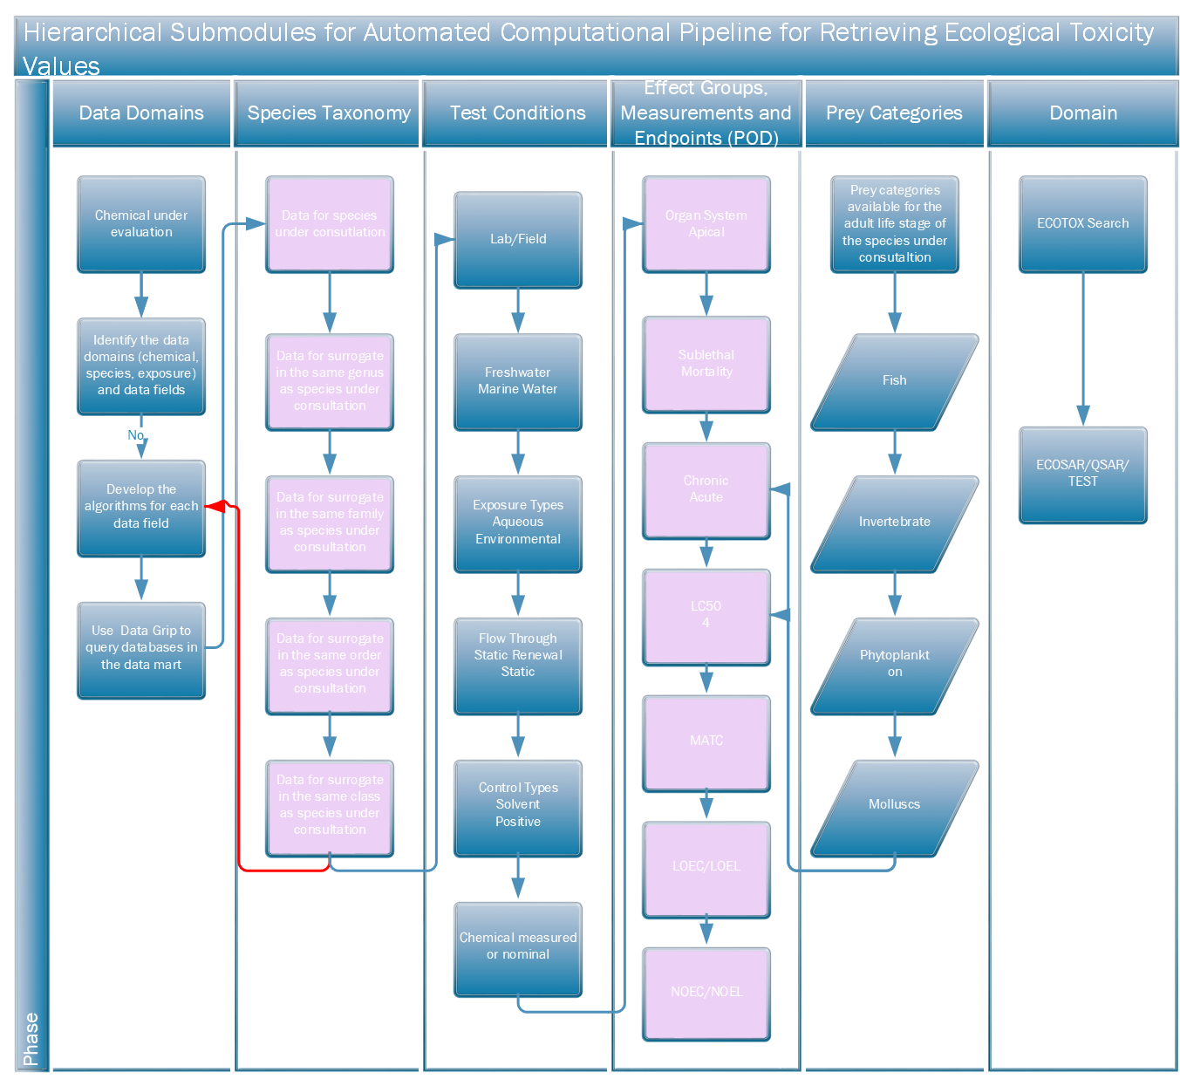
Figure S1. General framework for prioritizing and retrieving ECOTOX data for RASRTox.
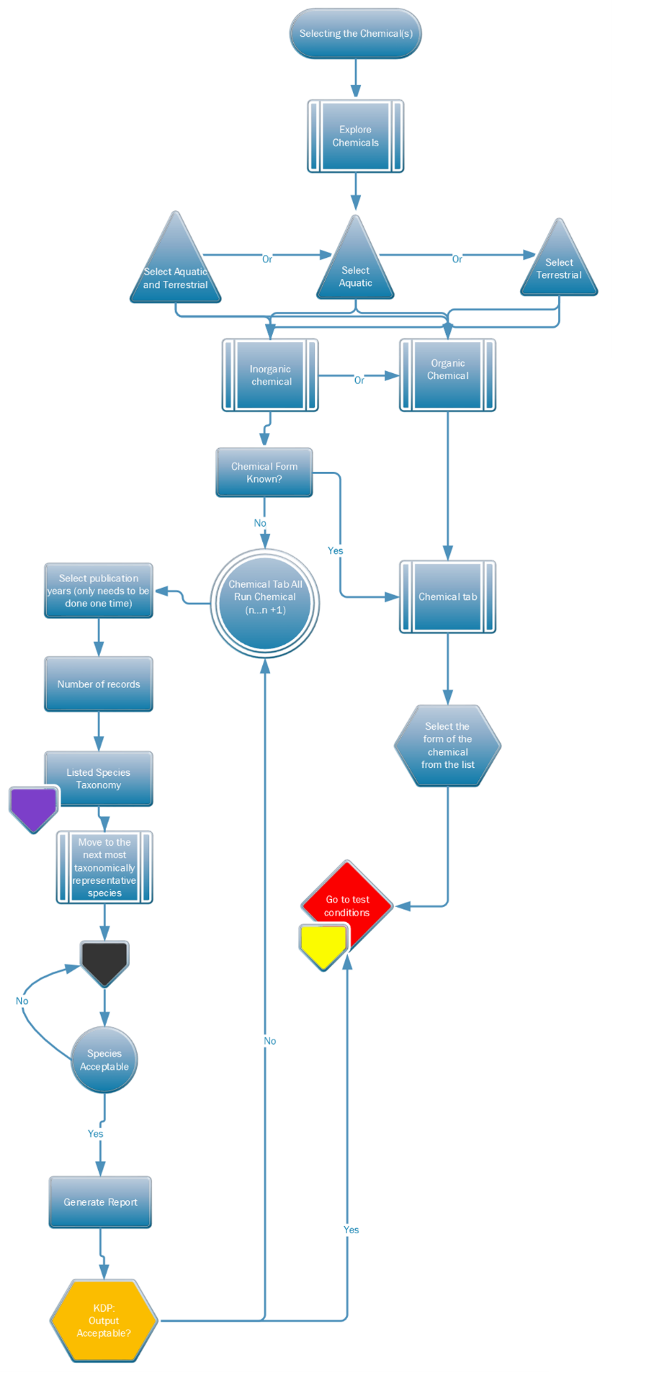
Figure S2. Flowchart for chemical selection from customized RASRTox data mart.
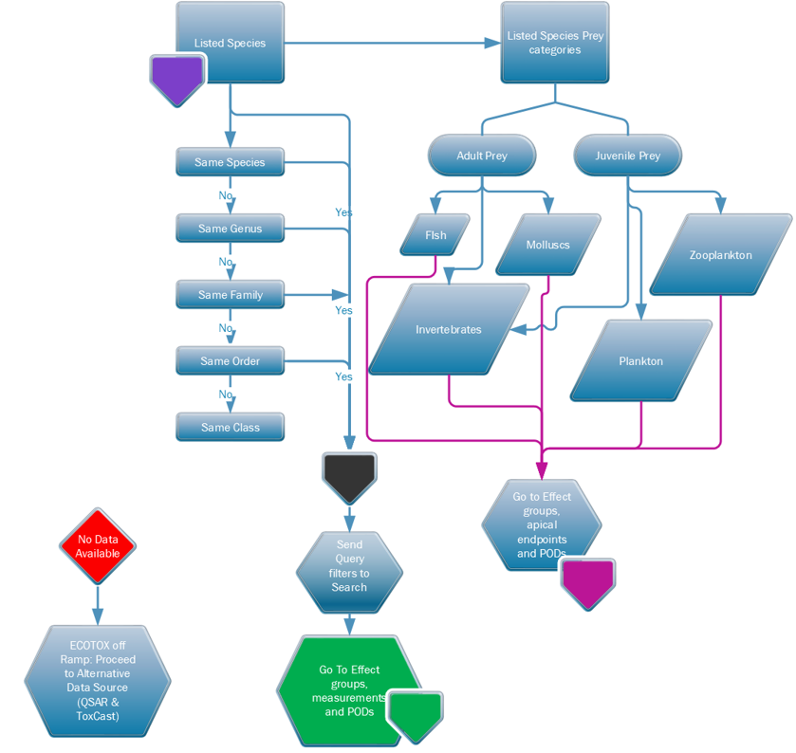
Figure S3. Flowchart describing selection process for species data based on taxonomic rank.

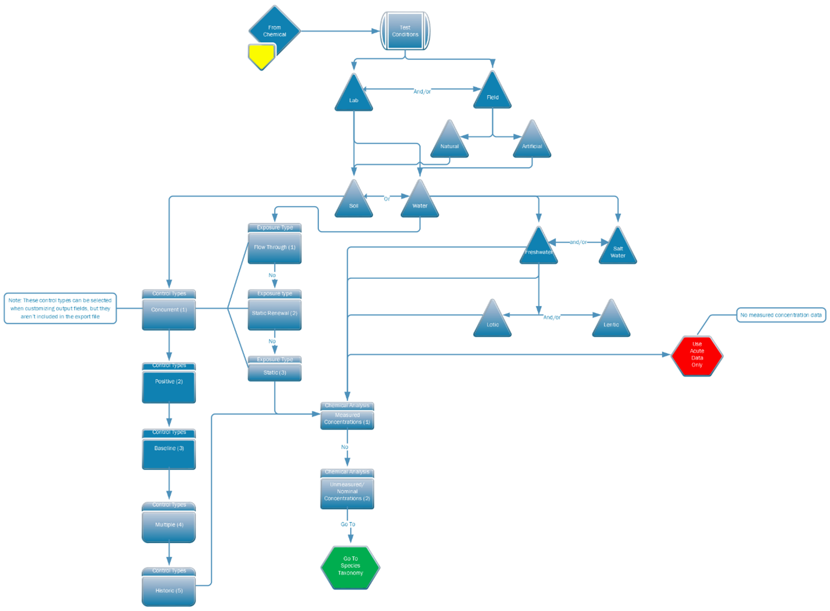
Figure S4. Flow diagram illustrating hierarchical selection rules for test conditions in RASRTox data mart.

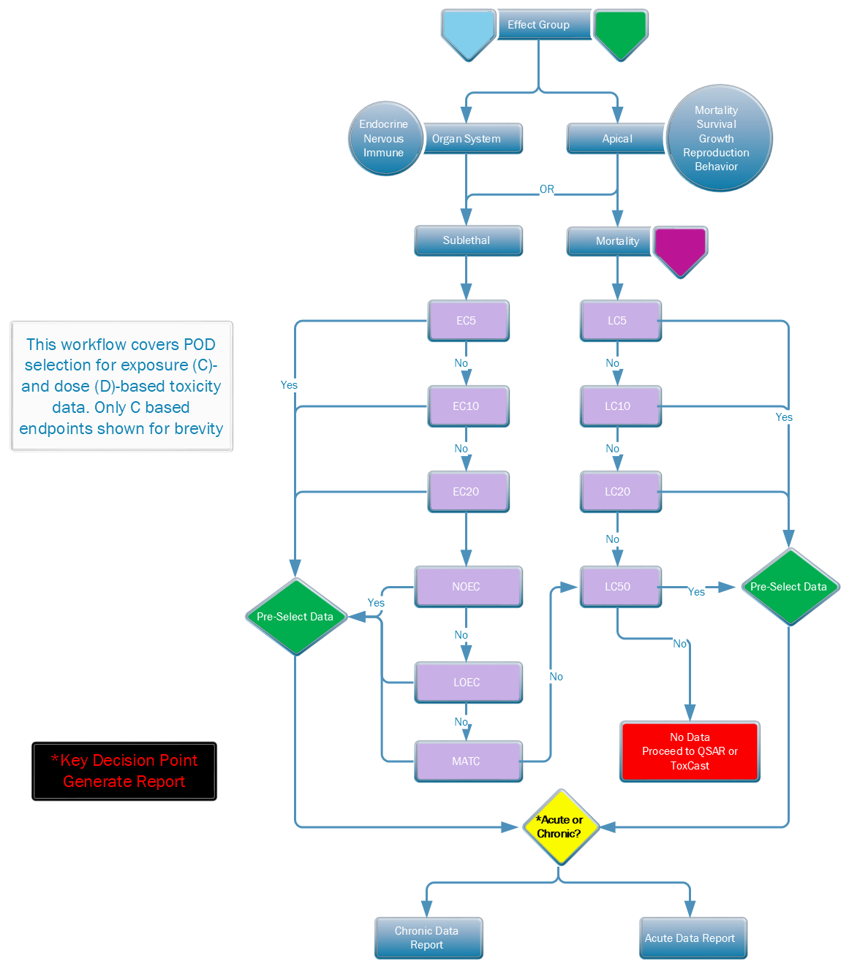
Figure S5. Process flowchart for effects groups/measurements data selection in RASRTox.
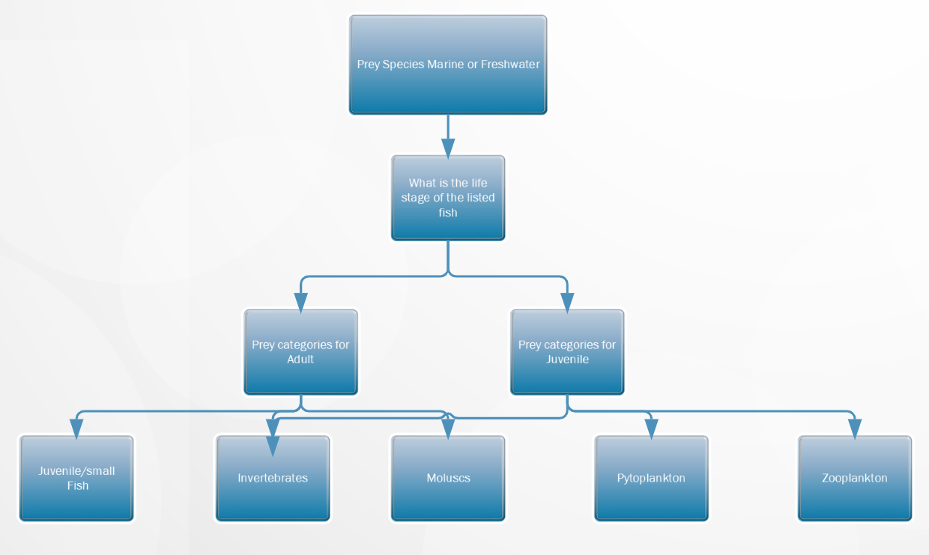
Figure S6. Prey species decision logic for ECOTOX data in RASRTox.

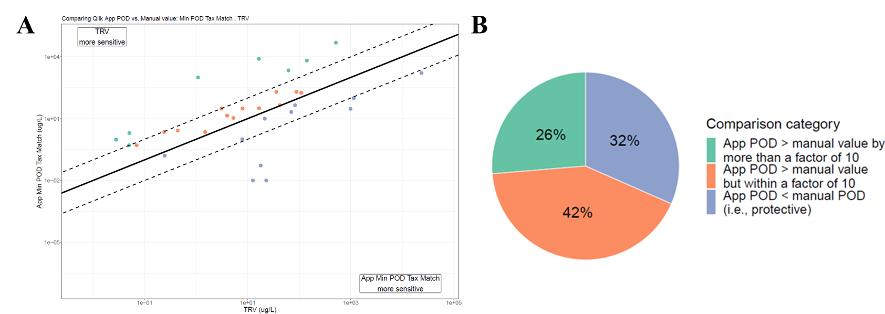
Figure S7. Scatterplot (A) and pie chart (B) depicting comparisons between RASRTox min POD by taxon match and freshwater TRVs. The solid black line in the scatterplot represents the line of singularity, while the hashed lines represent one order of magnitude above and below the 1:1 line (i.e. RASRTox POD and corresponding benchmark are within an order of magnitude). Text boxes above and below the lines indicate the direction of protectiveness. In the pie chart, percentages correspond to portion of chemicals which fall into the comparison categories denoted in legend on the right.

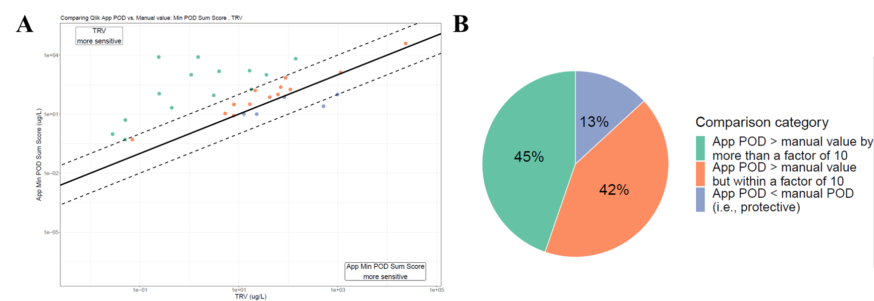
Figure S8. Scatterplot (A) and pie chart (B) depicting comparisons between RASRTox min POD by summed score and freshwater TRVs. The solid black line in the scatterplot represents the line of singularity, while the hashed lines represent one order of magnitude above and below the 1:1 line (i.e. RASRTox POD and corresponding benchmark are within an order of magnitude). Text boxes above and below the lines indicate the direction of protectiveness. In the pie chart, percentages correspond to portion of chemicals which fall into the comparison categories denoted in legend on the right.

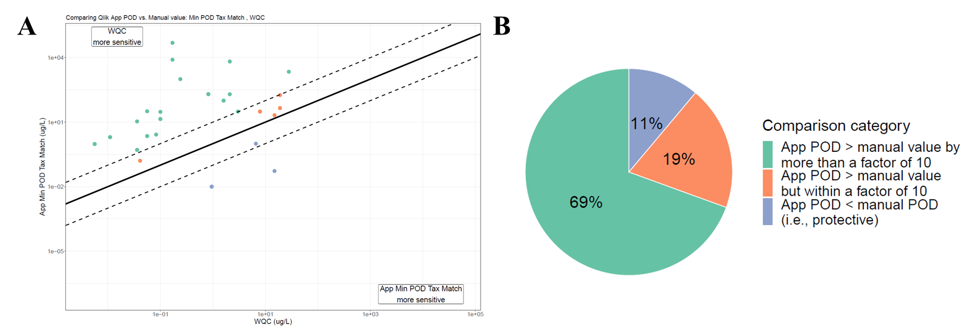
Figure S9. Scatterplot (A) and pie chart (B) depicting comparisons between RASRTox min POD by taxon match and corresponding freshwater WQC. The solid black line in the scatterplot represents the line of singularity, while the hashed lines represent one order of magnitude above and below the 1:1 line (i.e. RASRTox POD and corresponding benchmark are within an order of magnitude). Text boxes above and below the lines indicate the direction of protectiveness. In the pie chart, percentages correspond to portion of chemicals which fall into the comparison categories denoted in legend on the right.
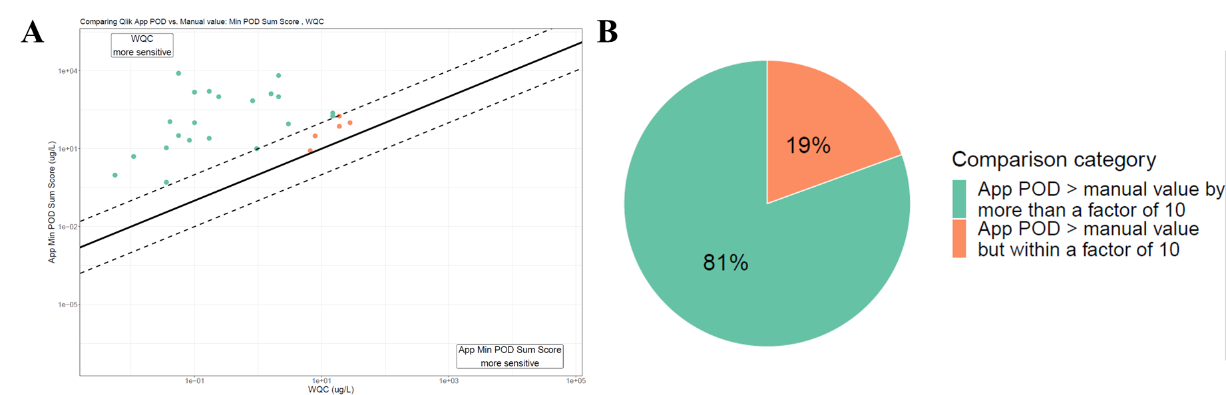
Figure S10. Scatterplot (A) and pie chart (B) depicting comparisons between RASRTox min POD by summed score and corresponding freshwater WQC. The solid black line in the scatterplot represents the line of singularity, while the hashed lines represent one order of magnitude above and below the 1:1 line (i.e. RASRTox POD and corresponding benchmark are within an order of magnitude). Text boxes above and below the lines indicate the direction of protectiveness. In the pie chart, percentages correspond to portion of chemicals which fall into the comparison categories denoted in legend on the right.
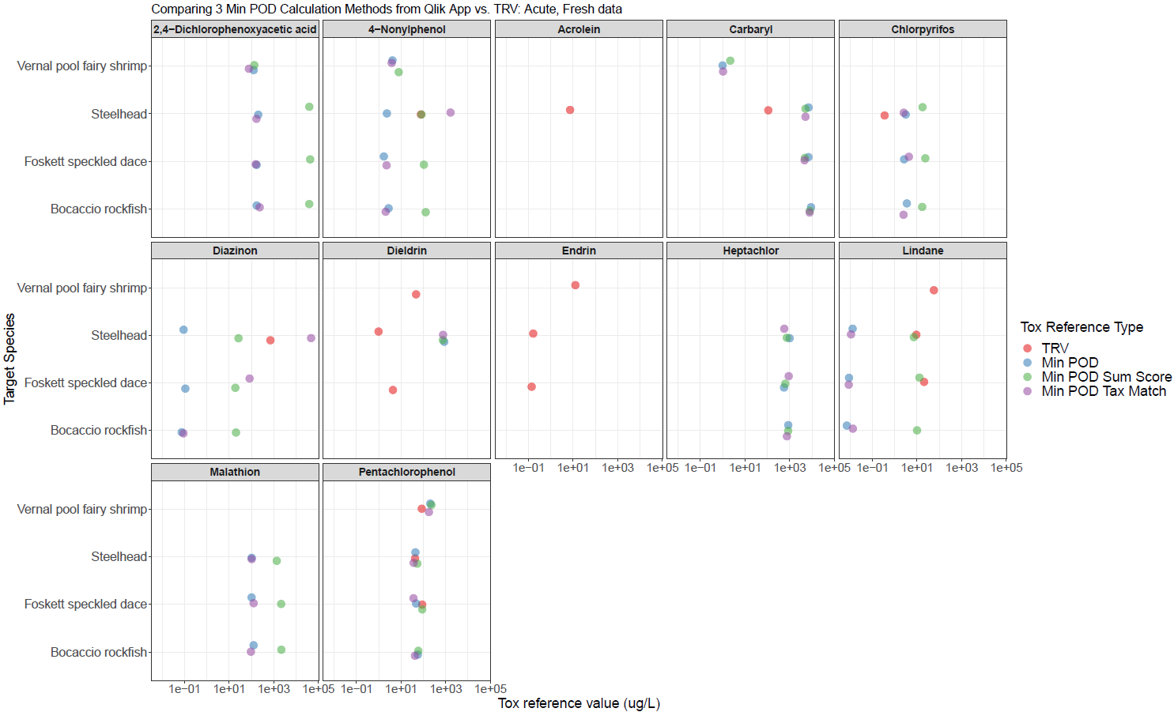Figure S11. Strip plots depicting comparisons between three RASRTox PODs and acute freshwater TRVs for thirteen chemicals and four target species. Note that for certain chemicals and species, TRVs are unavailable.

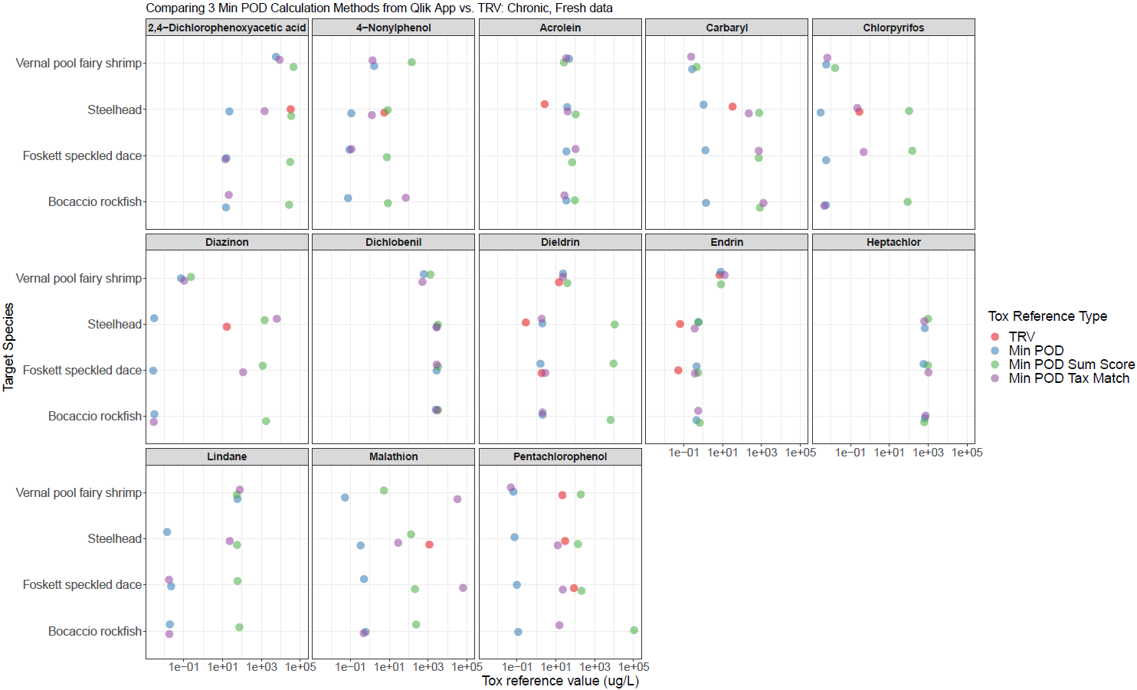
Figure S12. Strip plots depicting comparisons between three RASRTox PODs and chronic freshwater TRVs for thirteen chemicals and four target species. Note that for certain chemicals and species, TRVs are unavailable.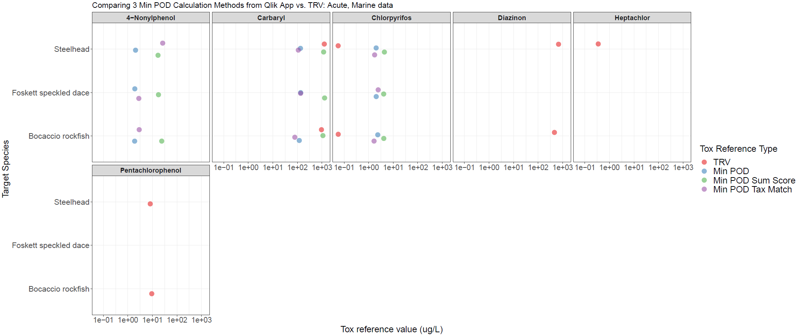 Figure S13. Strip plots depicting comparisons between three RASRTox PODs and acute marine TRVs for six chemicals and three target species. Acute marine TRVs were unavailable for 2,4-D, 4-nonylphenol, acrolein, dichlobenil, dieldrin, endrin, lindane, and malathion. Vernal pool fairy shrimp live and reproduce exclusively in freshwater, so derivation of a marine TRV would be inappropriate for this species.
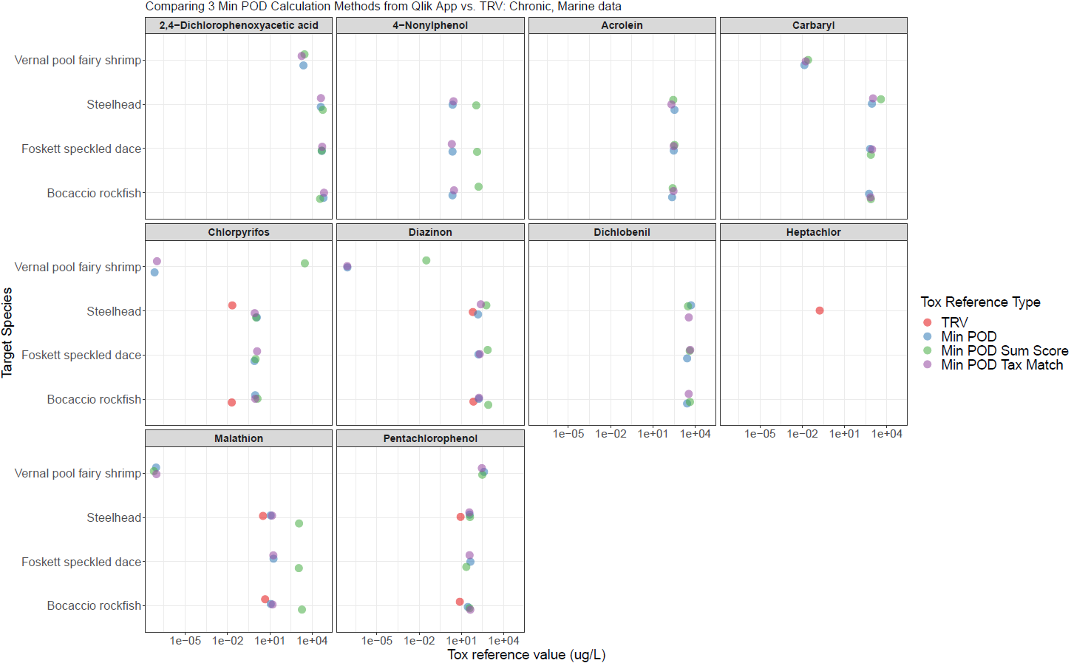 Figure S14. Strip plots depicting comparisons between three RASRTox PODs and chronic marine TRVs for ten chemicals and four target species. Chronic marine TRVs were unavailable for 2,4-D, 4-nonylphenol, acrolein, carbaryl, dichlobenil, dieldrin, endrin, and lindane. Vernal pool fairy shrimp live and reproduce exclusively in freshwater, so derivation of a marine TRV would be inappropriate for this species.
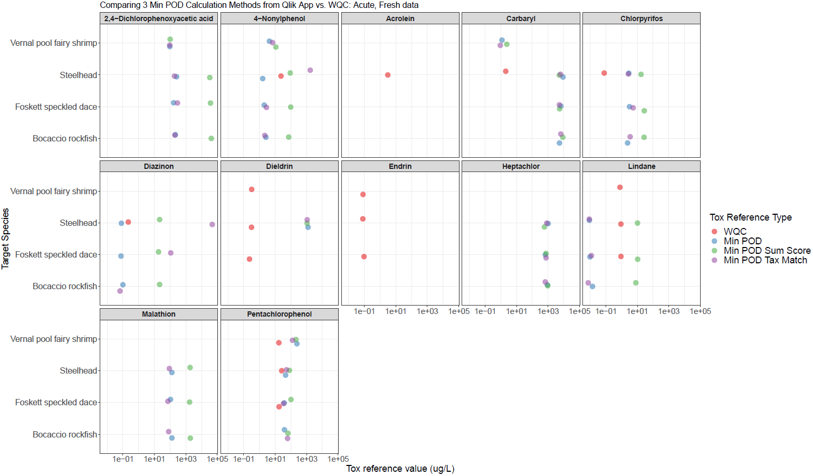 Figure S15. Strip plots depicting comparisons between three RASRTox PODs and acute freshwater WQC for twelve chemicals and four target species. Acute WQC are unavailable for 2,4-D, dichlobenil, and malathion.
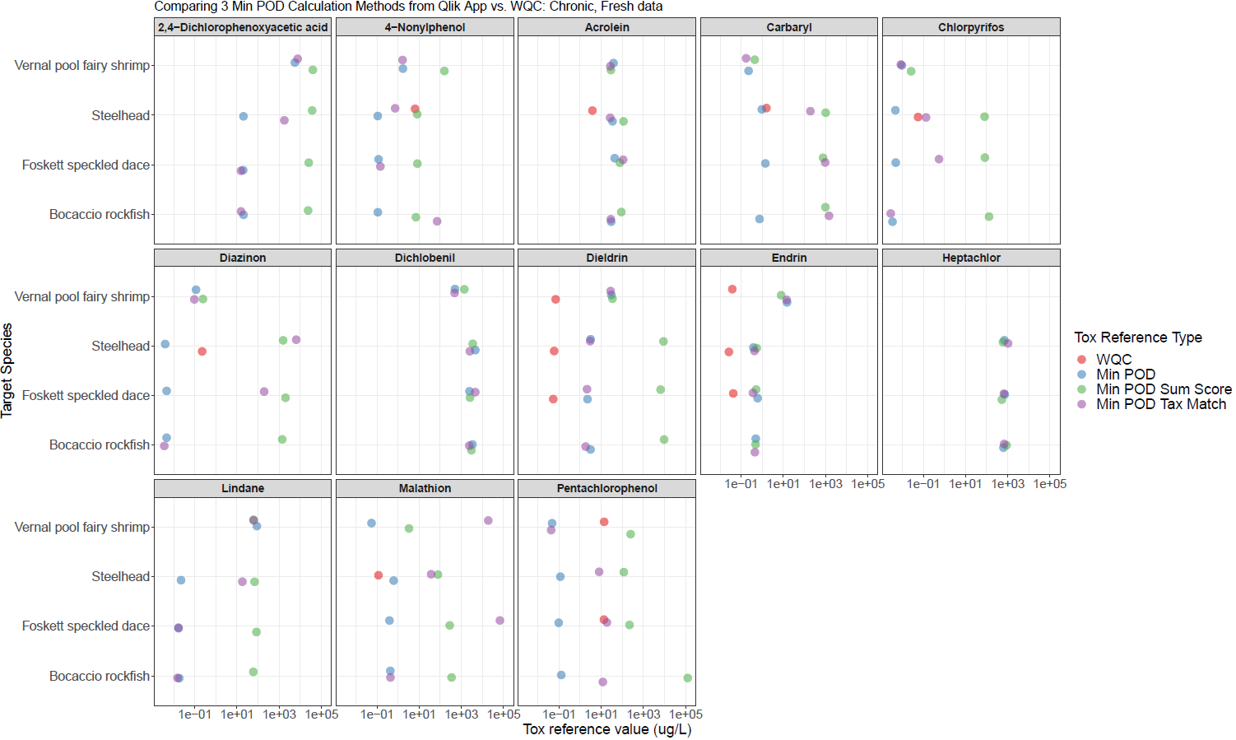 Figure S16. Strip plots depicting comparisons between three RASRTox PODs and chronic freshwater WQC for thirteen chemicals and four target species. Chronic WQC are unavailable for 2,4-D, dichlobenil, and lindane.
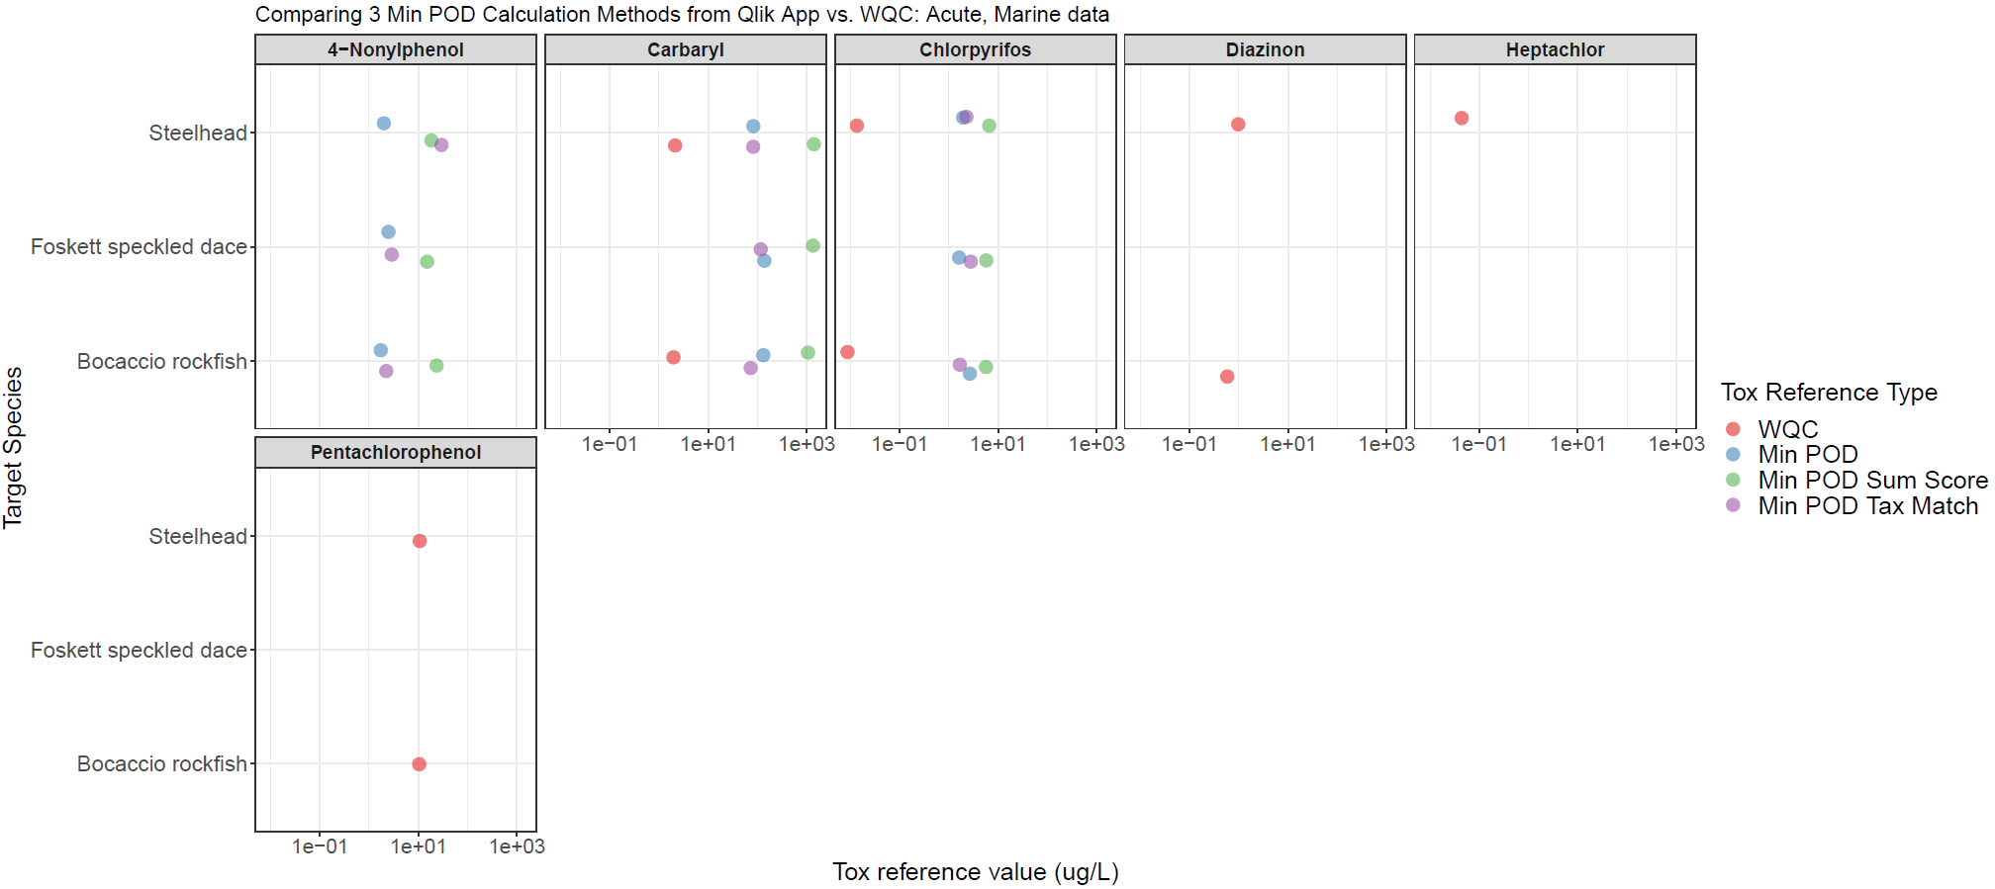 Figure S17. Strip plots depicting comparisons between three RASRTox PODs and acute marine WQC for seven chemicals and three target species. Chronic WQC are unavailable for 2,4-D, dichlobenil, and lindane. Vernal pool fairy shrimp live and reproduce exclusively in freshwater, so derivation of marine WQC would be inappropriate for this species.

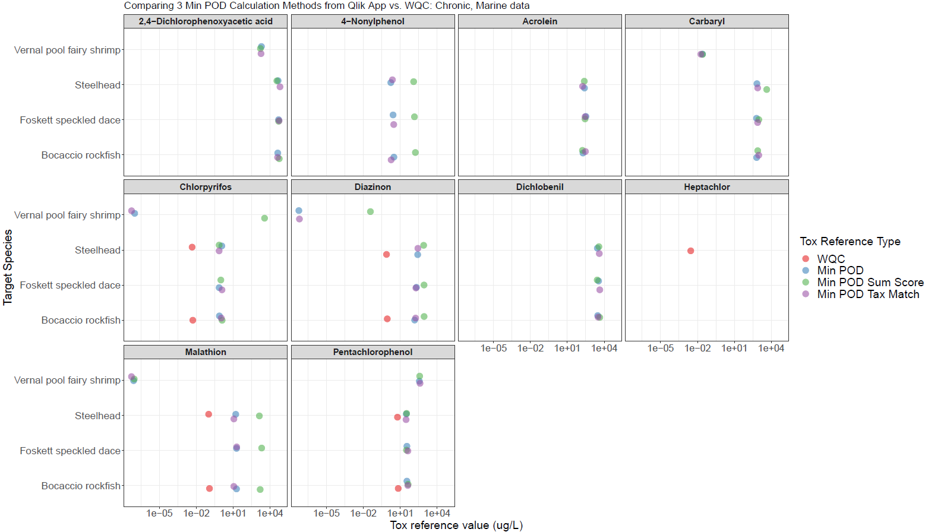 Figure S18. Strip plots depicting comparisons between three RASRTox PODs and chronic marine WQC for ten chemicals and four target species. Chronic WQC are unavailable for 2,4-D, acrolein, carbaryl, dichlobenil, and lindane. Vernal pool fairy shrimp live and reproduce exclusively in freshwater, so derivation of marine WQC would be inappropriate for this species.

