Supporting Tables and Figure for 2012-2022 National-Level Greenhouse Gas Emission Totals by Industry Dataset

Ben Young

Wesley Ingwersen

These tables are updates of those present in the documentation of the 2012-2020 Greenhouse Gas National- and State-Level Emission Totals by Industry (Young, Birney, and Ingwersen 2024b; Young, Birney, and Ingwersen 2024a) using the 2012-2022 National-Level Greenhouse Gas Emission Totals by Industry.

# 

Figure 1 shows each of the totals by aggregate sector by year.

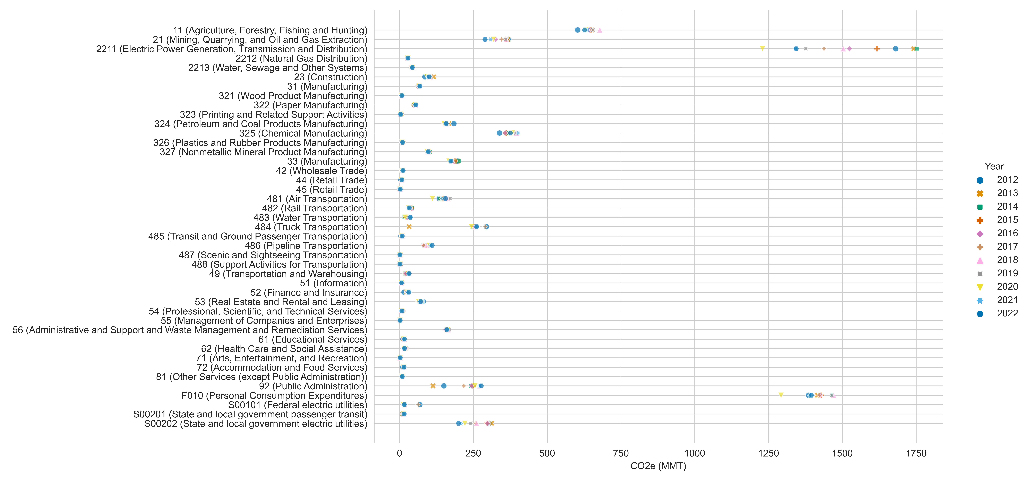

Figure 1: GHG totals by sector, 2012-2022, given in CO2e using AR5-100 GWPs.

# Allocation Sources

Table 1 shows the data years used for attribution sources when necessary for the new models.

Table 1: Data Years for Allocation Sources By Model and Year. Column headers are for the model years.

| **Allocation Source** | **2012** | **2013** | **2014** | **2015** | **2016** |
| --- | --- | --- | --- | --- | --- |
| Detail Make | 2012 | 2013 | 2014 | 2015 | 2016 |
| Detail Use | 2012 | 2013 | 2014 | 2015 | 2016 |
| MECS Tables 2-2, 3-2 | 2014 | 2014 | 2014 | 2014 | 2018 |
| CoA Cropland | 2012 | 2012 | 2012 | 2017 | 2017 |
| CoA Cropland NAICS | 2012 | 2012 | 2012 | 2017 | 2017 |
| MYB Lead | 2012 | 2013 | 2014 | 2015 | 2016 |

| **Allocation Source** | **2017** | **2018** | **2019** | **2020** | **2021** | **2022** |
| --- | --- | --- | --- | --- | --- | --- |
| Detail Make | 2017 | 2018 | 2019 | 2020 | 2021 | 2022 |
| Detail Use | 2017 | 2018 | 2019 | 2020 | 2021 | 2022 |
| MECS Tables 2-2, 3-2 | 2018 | 2018 | 2018 | 2018 | 2018 | 2018 |
| CoA Cropland | 2017 | 2017 | 2017 | 2017 | 2022 | 2022 |
| CoA Cropland NAICS | 2017 | 2017 | 2017 | 2017 | 2022 | 2022 |
| MYB Lead | 2017 | 2018 | 2019 | 2020 | 2020 | 2020 |

# Comparison to Reported Totals

Table 2 presents the results of the validation check against the GHGI totals by gas or groups of minor gas.

Table 2: Relative difference between sum of GHG or groups between the national detail model (m2) and GHGI

| **GHG** | **2012** | **2013** | **2014** | **2015** | **2016** | **2017** | **2018** | **2019** | **2020** | **2021** | **2022** |
| --- | --- | --- | --- | --- | --- | --- | --- | --- | --- | --- | --- |
| Carbon dioxide | 1.005 | 0.945 | 1.002 | 1.003 | 1.003 | 1.004 | 1.004 | 1.005 | 1.006 | 1.006 | 1.001 |
| HFCs | 0.964 | 0.965 | 0.959 | 0.958 | 0.951 | 0.947 | 0.949 | 0.950 | 0.950 | 0.950 | 0.949 |
| Methane | 0.998 | 0.997 | 0.997 | 0.997 | 0.997 | 0.996 | 0.997 | 0.997 | 0.997 | 0.997 | 0.997 |
| Nitrogen trifluoride | 0.951 | 1.027 | 1.082 | 0.927 | 1.013 | 0.967 | 0.868 | 0.967 | 1.019 | 0.999 | 0.999 |
| Nitrous oxide | 0.999 | 1.000 | 1.000 | 0.999 | 0.997 | 0.997 | 0.998 | 0.995 | 0.995 | 0.996 | 0.995 |
| PFCs | 0.858 | 0.795 | 0.875 | 0.838 | 0.879 | 0.899 | 0.883 | 0.865 | 0.891 | 0.919 | 0.986 |
| Sulfur hexafluoride | 1.014 | 1.008 | 0.997 | 1.003 | 1.000 | 0.987 | 1.013 | 1.000 | 1.000 | 1.000 | 0.987 |
| total CO2e | 1.003 | 0.954 | 1.001 | 1.001 | 1.000 | 1.001 | 1.001 | 1.002 | 1.002 | 1.003 | 0.999 |

# 

# Changes from the Previous Release

The previous dataset (Young, Birney, and Ingwersen 2024a) also includes GHG totals at the national level for aggregate and detailed industries for years 2012-2022. A series of csv files are provided as supplementary files that show the change in GHG totals by detailed industry. For each year there is one comparison file on GHG totals and another on GHG by sector totals. In each file a *national_new* field shows totals for the new dataset and the *national_old* field shows the old dataset totals. The *comp_nat* field is simply the *national_new* divided by the *national_old* value.

# References

Young, Ben, Catherine Birney, and Wesley Ingwersen. 2024a. “2012-2020 Greenhouse Gas National- and State-Level Emission Totals by Industry.” USEPA Office of Research; Development. <https://doi.org/10.23719/1529805>.

Young, Ben, Catherine Birney, and Wesley W. Ingwersen. 2024b. “Dataset of 2012-2020 U.S. National- and State-Level Greenhouse Gas Emissions by Sector.” *Data in Brief* 53: 110173. <https://doi.org/10.1016/j.dib.2024.110173>.