Supplementary Information: A systematic analysis of read-across within REACH registration dossiers

G Patlewicz¹, P Karamertzanis², K Paul Friedman¹, M Sannicola², I Shah¹

¹Center for Computational Toxicology & Exposure (CCTE), U.S. Environmental Protection Agency, Research Triangle Park, Durham, NC, 27709, USA
²Computational Assessment and Alternative Methods, European Chemicals Agency (ECHA), Telakkakatu 6, Helsinski, Finland

Supplementary information

Supplemental data
An assumption was made that the target-source analogue pairs identified were valid and appropriate. A handful of cases were explored for those target substances where the pairwise similarity was particularly low to see whether further explanation/justification was forthcoming in the ECHA decision letters and whether a determination of the read-across validity was forthcoming.
One example was that of 3-Methylbutyl acetate [DTXSID9025453] and its source analogue Isopentyl alcohol [DTXSID3025469]. The pairwise structural similarity on the basis of Morgan fingerprints was low at 0.307. The associated decision letter is available at https://echa.europa.eu/documents/10162/c622e289-e050-8193-9128-e6e4ecacf7cd Two main issues were at play – the scope of the study being used in terms of coverage of key parameters being addressed and the evidence to substantiate the analogue proposed. The rationale focused on the source analogue being a metabolite of the target substance – this at least accounted for the pairwise structural similarity being so low in that the basis for identification of the source analogue was due to a metabolism hypothesis. The justification was determined not to have sufficiently demonstrated the fast metabolism expected such that systemic exposure to the parent could not be ruled out. Accordingly the read-across was rejected. Although the read-across was ultimately rejected, the manner in which the analogue was identified at least clarifies the low structural similarity calculated in this study.

Another example was that of Exo-1,7,7-trimethylbicyclo[2.2.1]hept-2-yl methacrylate [Isobornyl methacrylate, DTXSID9027653] and its analogue methyl methacrylate with a pairwise similarity of 0.2619. The decision letter noted that no justification or documentation had been provided to substantiate this or a second analogue butyl methacrylate. This case could be argued as an invalid example for the purposes of this study. The full decision letter is available here https://echa.europa.eu/documents/10162/a2606686-418b-6d6b-b1c8-ca03d628db9e.

Another example was that of Ethylene [DTXSID1026378] and its associated source analogue 1-Propene [DTXSID5021205]. The pairwise structural similarity in this case was only 0.142. No mention of the read-across was made in the decision letter – only the fact that the dossier referenced an OECD HPV document for a summary of the studies. It is questionable whether this is a valid case, possibly the read-across could be appropriate but the underlying data to satisfy the information requirement was insufficient. See https://echa.europa.eu/documents/10162/0101e570-e56d-121b-f0ef-81a7031835ed for the decision letter.

A more recent case such as this one for 1,4-Dimethylpiperazine made for interesting reading since the ECHA Read-Across Assessment Framework had since been published and the dossier made reference to the scenarios in building the justification. The pairwise similarity between 1,4-Dimethylpiperazine [DTXSID8051544] and source 1-Methylpiperazine [DTXSID4021898] was 0.38. The read-across appears to be valid but was not sufficiently justified with supporting data to confirm that both substances would cause the same type of effects (https://echa.europa.eu/documents/10162/6e444049-8b2d-af5d-7937-84114ca6d717).

Supplementary Figures
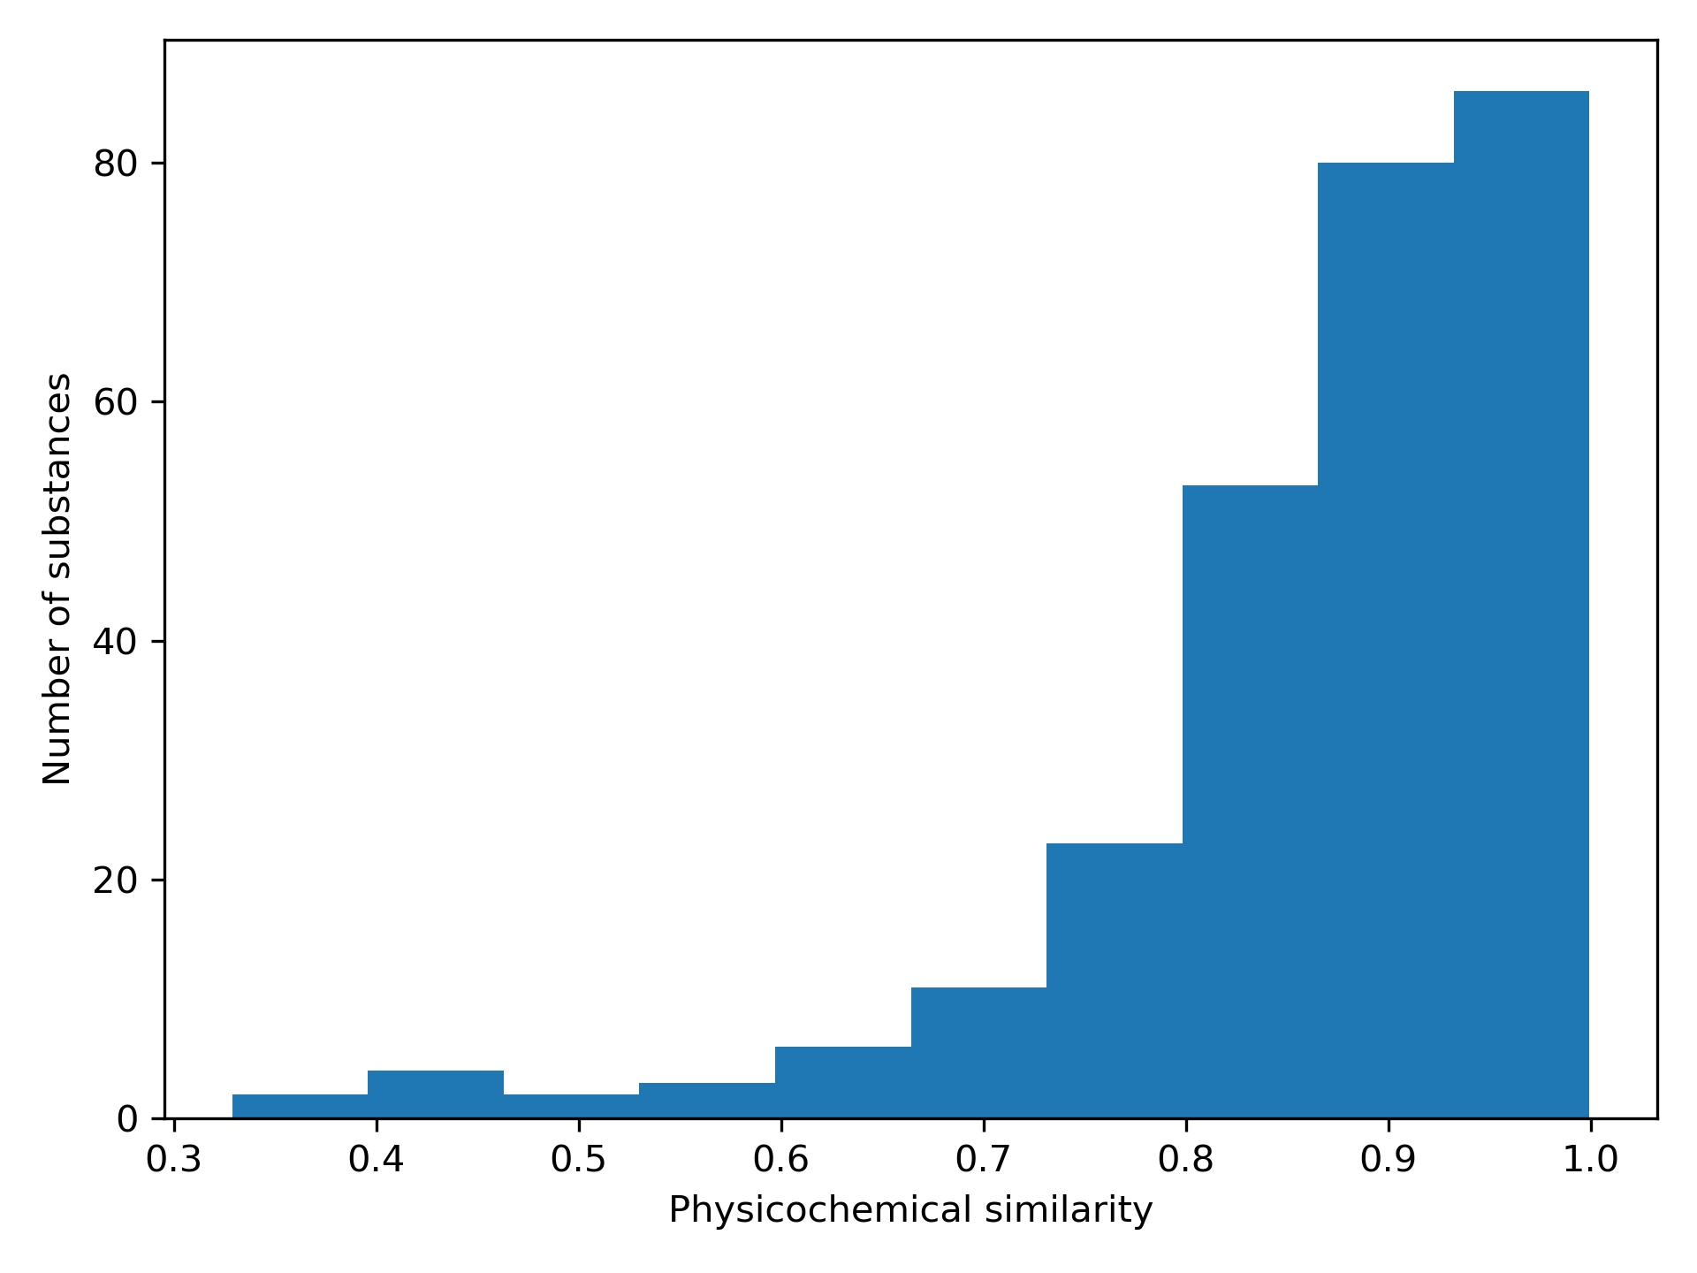
Figure A1: Distribution of pairwise physicochemical similarities for target-source associations

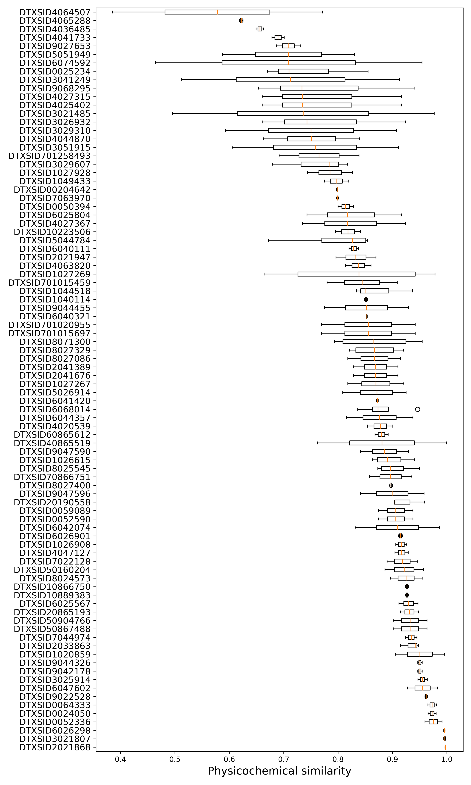
Figure A2: Distribution of pairwise physicochemical similarities for target-source associations with more than 1 source analogue per target. The y-axis gives the DSSTox substance identity of the target. The targets are sorted so that the median physicochemical similarity of the target with the source analogues increases going from top to bottom.

