The Sustainability Assessment of Additive Manufacturing End-of-Life Material Management
John D. Chea¹, Gerardo J. Ruiz-Mercado^{2,3}, Raymond L. Smith², and David Meyer²
¹ Oak Ridge Institute for Science and Education, hosted by Office of Research & Development, US Environmental Protection Agency, Cincinnati, OH 45268, USA
² Office of Research & Development, US Environmental Protection Agency, Cincinnati, OH, 45268, USA
³ Chemical Engineering Graduate Program, Universidad del Atlántico, Puerto Colombia 080007, Colombia

Corresponding Author: Gerardo J. Ruiz-Mercado
Email: Ruiz-Mercado.Gerardo@epa.gov

Supporting Information
Table S1. Parameters and assumptions made for the material flow analysis in the end-of-life stage following additive manufacturing (Adapted from [1])
Parameters | Value | Unit | Reference
Total 3D Printers | 870000 | units | [2]
Typical Material Consumption | 12 | kg/operator/yr | [3]
Waste Rate (1-40%) | 10 | % | [3]
Liquid Resin Process Use Rate | 35 | % | [4]
Solid Resin Process Use Rate | 65 | % | [4]
Failed Parts Waste Rate (Solid/Liquid) | 5 | % | [5]
Failed Parts Liquid Resin Contamination | 5 | % | [5]
Inorganic Filler in Liquid Resins (0 - 15%) | 5 | % | [6]
Wash Solvent Consumption Rate | 3 | kg/2 weeks/operator) | [7]
Wash Solvent Consumed Ratio to Materials Used | 6.5 | Unitless | Calculated
Resin and Filler waste in Liquid/Solid Resin Process | 5 | % | Assumption
UV Treatment VOC post-cure Releases (1 - 360 μg/day) | 360 | μg/day | [8]
Wastewater Treatment Plants Inorganic Removal Efficiency | 90 | % | [9]
Litter Rate of Materials Discarded to MSW | 2 | % | [10], [11]
MSW Recycled (Of total MSW) | 23.6 | % | [12]
MSW Incinerated (Of total MSW) | 11.8 | % | [12]
MSW Landfilled (Of total MSW) | 50 | % | [12]
MSW Recycled Normalized % | 27.6 | % | Calculated
MSW Incinerated Normalized % | 13.8 | % | Calculated
MSW Landfilled Normalized % | 58.5 | % | Calculated
MSW Recycling/Transportation Spill Rate | 0.01 | % | [13]
Ash Generated (15 - 25% wt of MSW) | 20 | % | [14]
Fly Ash Generated (10 - 20% wt of ash) | 15 | % | [14]
Pollution Control - Fly Ash Removed (95 - 99.5% efficiency) | 95 | % | [15], [16]
Bottom Ash Generated (80 - 90% wt of ash) | 85 | % | [14]
MSW Landfilling Mass Release | 10 | % | [13]
MSW Leachate Release (0.1 - 2%) | 2 | % | [17]
MSW Landfill Gas Release (8 - 11%) | 11 | % | [17]

Assumptions:
- The mass flow looks strictly at the end-of-life stage, and we assume that there is no true accumulation; thus, eventually, all products made get discarded.
- Products produced from additive manufacturing are non-hazardous and do not contribute toward releases once fully cured.
- Solid resin/Filaments are recycled by a special recycling center rather than through MSW, and a filament extruder handles these materials. Byrley et al. (2020) estimated that 1.7E9 - 3.5E11 particles are released/min of extrusion use (ABS and PLA)
- While recycling filaments and failed parts through a filament extruder is possible, there is no established infrastructure to handle EoL recycling of these materials. Additionally, material management programs vary from region to region. It is possible to throw scraps into filament machines to recycle. However, solo AM users do not justify purchasing a filament extruder solely for this purpose. Therefore, recycling is assumed negligible.
- Solvents used during the post-processing of liquid-based AM processes are recyclable (up to 99%), but it is often not recycled in-house due to the processing costs.
- Solvent washes post-processing for liquid-based AM processes are done twice to ensure sufficient uncured resin removal.
- Washing agent consumption may last up to 2 weeks per gallon (Frequency of replacement changes based on needs). This assumption leads to a “wash solvent consumed ratio to materials used” of 6.5 kg solvent/kg input
- Packaging EoL materials are excluded from the analysis.
- AM products and scraps are recycled, incinerated, and landfilled; liquid resins and solvents are not recycled in the final processing.
- Incineration of plastic EoL material results in ash content equal to 1% of the original volume
- Incinerator ash generated ranges between 15 - 25% wt. (20% avg) for MSW, with 15% of the total ash being fly ash and 85% being bottom ash
- All UV Curable Resins are fully cured post-UV Treatment
- 10% of materials sent to landfill ends up in the environment/ocean either through mismanagement or littering.
- Hazardous EoL material treatment may have overlapped with MSW management. Stream 12 release is related to mass loss from transportation rather than hazardous EoL material treatment.

Table S2. Material flow analysis results tracing the mass distribution of the additive manufacturing industry (Adapted from [1])
Stream | 1 | 2 | 3 | 4 | 5 | 6
 | kg/yr | kg/yr | kg/yr | kg/yr | kg/yr | kg/yr
UV Curable Resins (liquid) | 3,471,300 | 3,471,300 | 0 | 0 | 173,565 | 0
Inorganic Fillers | 182,700 | 182,700 | 0 | 0 | 9,135 | 8,222
Solvents | 0 | 0 | 21,435,278 | 0 | 21,435,278 | 0
Solid Feedstocks | 6,786,000 | 0 | 0 | 6,786,000 | 0 | 0
Printed Products | 0 | 0 | 0 | 0 | 3,297,735 | 3,297,735
Scraps/Failed Prototypes/Supports | 0 | 0 | 0 | 0 | 173,565 | 0
Fly Ash | 0 | 0 | 0 | 0 | 0 | 0
Bottom Ash | 0 | 0 | 0 | 0 | 0 | 0
Leachate | 0 | 0 | 0 | 0 | 0 | 0
Landfill Gas | 0 | 0 | 0 | 0 | 0 | 0
Total (kg/yr) | 10,440,000 | 3,654,000 | 21,435,278 | 6,786,000 | 25,089,278 | 3,305,957

Stream | 7 | 8 | 9 | 10 | 11 | 12
 | kg/yr | kg/yr | kg/yr | kg/yr | kg/yr | kg/yr
UV Curable Resins (liquid) | 173,565 | 8,678 | 1.140 | 8,677 | 164,887 | 1,649
Inorganic Fillers | 914 | 46 | 0.000 | 46 | 868 | 9
Solvents | 21,435,278 | 0 | 0.000 | 0 | 21,435,278 | 214,353
Solid Feedstocks | 0 | 0 | 0.000 | 0 | 0 | 0
Printed Products | 0 | 0 | 0.000 | 0 | 0 | 0
Scraps/Failed Prototypes/Supports | 173,565 | 173,565 | 0.000 | 173,565 | 0 | 0
Fly Ash | 0 | 0 | 0.000 | 0 | 0 | 0
Bottom Ash | 0 | 0 | 0.000 | 0 | 0 | 0
Leachate | 0 | 0 | 0 | 0 | 0 | 0
Landfill Gas | 0 | 0 | 0 | 0 | 0 | 0
Total (kg/yr) | 21,783,321 | 182,289 | 1.14 | 182,288 | 21,601,032 | 216,010

Stream | 13 | 14 | 15 | 16 | 17 | 18
 | kg/yr | kg/yr | kg/yr | kg/yr | kg/yr | kg/yr
UV Curable Resins (liquid) | 163,238 | 0 | 0 | 163,238 | 0 | 0
Inorganic Fillers | 859 | 773 | 0 | 86 | 0 | 0
Solvents | 21,220,925 | 0 | 0 | 21,220,925 | 0 | 0
Solid Feedstocks | 0 | 0 | 0 | 0 | 339,300 | 0
Printed Products | 0 | 0 | 0 | 0 | 6,107,400 | 6,107,400
Scraps/Failed Prototypes/Supports | 0 | 0 | 0 | 0 | 339,300 | 0
Fly Ash | 0 | 0 | 0 | 0 | 0 | 0
Bottom Ash | 0 | 0 | 0 | 0 | 0 | 0
Leachate | 0 | 0 | 0 | 0 | 0 | 0
Landfill Gas | 0 | 0 | 0 | 0 | 0 | 0
Total (kg/yr) | 21,385,022 | 773 | 0 | 21,384,249 | 6,786,000 | 6,107,400

Table S2. Material flow analysis results tracing the mass distribution of the additive manufacturing industry (Continued)
Stream | 19 | 20 | 21 | 22 | 23 | 24
 | kg/yr | kg/yr | kg/yr | kg/yr | kg/yr | kg/yr
UV Curable Resins (liquid) | 0 | 0 | 0 | 0 | 0 | 8,677
Inorganic Fillers | 0 | 0 | 0 | 0 | 0 | 46
Solvents | 0 | 0 | 0 | 0 | 0 | 0
Solid Feedstocks | 0 | 0 | 339,300 | 0 | 339,300 | 339,300
Printed Products | 9,405,135 | 9,405,135 | 0 | 0 | 0 | 9,405,135
Scraps/Failed Prototypes/Supports | 0 | 0 | 339,300 | 0 | 339,300 | 512,865
Fly Ash | 0 | 0 | 0 | 0 | 0 | 0
Bottom Ash | 0 | 0 | 0 | 0 | 0 | 0
Leachate | 0 | 0 | 0 | 0 | 0 | 0
Landfill Gas | 0 | 0 | 0 | 0 | 0 | 0
Total (kg/yr) | 9,405,135 | 9,405,135 | 678,600 | 0 | 678,600 | 10,266,023

Stream | 25 | 26 | 27 | 28 | 29 | 30
 | kg/yr | kg/yr | kg/yr | kg/yr | kg/yr | kg/yr
UV Curable Resins (liquid) | 0 | 8,677 | 171,915 | 0 | 0 | 171,915
Inorganic Fillers | 0 | 46 | 132 | 0 | 0 | 132
Solvents | 0 | 0 | 21,220,925 | 0 | 0 | 21,220,925
Solid Feedstocks | 0 | 339,300 | 339,300 | 93,764 | 938 | 46,882
Printed Products | 188,103 | 9,217,032 | 9,217,032 | 2,547,096 | 25,471 | 1,273,548
Scraps/Failed Prototypes/Supports | 10,257 | 502,608 | 502,608 | 138,894 | 1,389 | 69,447
Fly Ash | 0 | 0 | 0 | 0 | 0 | 0
Bottom Ash | 0 | 0 | 0 | 0 | 0 | 0
Leachate | 0 | 0 | 0 | 0 | 0 | 0
Landfill Gas | 0 | 0 | 0 | 0 | 0 | 0
Total (kg/yr) | 198,360 | 10,067,663 | 31,451,911 | 2,779,754 | 27,798 | 22,782,848

Stream | 31 | 32 | 33 | 34 | 35
 | kg/yr | kg/yr | kg/yr | kg/yr | kg/yr
UV Curable Resins (liquid) | 1,719 | 0 | 0 | 0 | 0
Inorganic Fillers | 1 | 130 | 0 | 773 | 90
Solvents | 212,209 | 0 | 0 | 0 | 0
Solid Feedstocks | 469 | 0 | 198,653 | 198,653 | 19,865
Printed Products | 12,735 | 0 | 5,396,389 | 5,396,389 | 539,639
Scraps/Failed Prototypes/Supports | 694 | 0 | 294,267 | 294,267 | 29,427
Fly Ash | 34,174 | 649,307 | 0 | 0 | 64,931
Bottom Ash | 0 | 3,873,062 | 0 | 0 | 387,306
Leachate | 0 | 0 | 0 | 0 | 208,252
Landfill Gas | 0 | 0 | 0 | 0 | 1,145,384
Total (kg/yr) | 262,003 | 4,522,500 | 5,889,309 | 5,890,082 | 2,394,894

Additional References
[1] J. D. Chea, G. Ruiz-Mercado, R. L. Smith, D. E. Meyer, M. Gonzalez, and W. M. Barrett, “Material Flow Analysis and Occupational Exposure Assessment in Additive Manufacturing End-of-Life Material Management,” 2024.
[2] J. Green, “America’s Garage Hobbyists Fight the Pandemic With 3D Printers,” Bloomberg. [Online]. Available: https://www.bloomberg.com/news/articles/2020-04-22/america-s-garage-hobbyists-fight-the-pandemic-with-3d-printers
[3] R. Toor, “The 3D Printing Waste Problem,” Filamentive. [Online]. Available: https://www.filamentive.com/the-3d-printing-waste-problem/
[4] AMFG, “The Additive Manufacturing Landscape 2019.” AMFG Automatic Manufacturing, 2019.
[5] M. Dwamena, “3D Print Failures – Why Do They Fail & How Often?,” 3D Printerly. [Online]. Available: https://3dprinterly.com/3d-print-failures-why-do-they-fail-how-often/
[6] Q. Chen, “DIVERSE APPLICATIONS OF INORGANIC FILLERS IN ADDITIVE MANUFACTURING OF FUNCTIONAL MATERIALS,” 2020.
[7] Formlabs, “Best practices for washing prints,” Formlabs. [Online]. Available: https://support.formlabs.com/s/article/Washing-Prints?language=en_US
[8] J. E. Krechmer et al., “Chemical Emissions from Cured and Uncured 3D-Printed Ventilator Patient Circuit Medical Parts,” ACS Omega, vol. 6, no. 45, pp. 30726–30733, Nov. 2021, doi: 10.1021/acsomega.1c04695.
[9] A. Cristaldi et al., “Efficiency of Wastewater Treatment Plants (WWTPs) for Microplastic Removal: A Systematic Review,” IJERPH, vol. 17, no. 21, p. 8014, Oct. 2020, doi: 10.3390/ijerph17218014.
[10] J. R. Jambeck et al., “Plastic waste inputs from land into the ocean,” Science, vol. 347, no. 6223, pp. 768–771, Feb. 2015, doi: 10.1126/science.1260352.
[11] K. L. Law, N. Starr, T. R. Siegler, J. R. Jambeck, N. J. Mallos, and G. H. Leonard, “The United States’ contribution of plastic waste to land and ocean,” Sci. Adv., vol. 6, no. 44, Oct. 2020, doi: 10.1126/sciadv.abd0288.
[12] US EPA, “Advancing Sustainable Materials Management: 2018 Tables and Figures - Assessing Trends in Materials Generation and Management in the United States,” United States Environmental Protection Agency, 2020.
[13] J. D. Chea, K. M. Yenkie, J. F. Stanzione, III, and G. J. Ruiz-Mercado, “A Generic Scenario Analysis of End-of-Life Plastic Management: Chemical Additives,” Journal of Hazardous Materials, p. 129902, Sep. 2022, doi: 10.1016/j.jhazmat.2022.129902.
[14] US EPA, “Energy Recovery from the Combustion of Municipal Solid Waste (MSW),” U.S. Environmental Protection Agency. [Online]. Available: https://www.epa.gov/smm/energy-recovery-combustion-municipal-solid-waste-msw#:~:text=The%20amount%20of%20ash%20generated,fly%20ash%20and%20bottom%20ash.
[15] S. Kurella and B. C. Meikap, “Removal of fly-ash and dust particulate matters from syngas produced by gasification of coal by using a multi-stage dual-flow sieve plate wet scrubber,” Journal of Environmental Science and Health, Part A, vol. 51, no. 10, pp. 870–876, Aug. 2016, doi: 10.1080/10934529.2016.1181465.
[16] B. Meikap, “Fly-ash removal efficiency in a modified multi-stage bubble column scrubber,” Separation and Purification Technology, vol. 36, no. 3, pp. 177–190, May 2004, doi: 10.1016/S1383-5866(03)00213-2.
[17] H. J. Kim, T. Matsuto, and Y. Tojo, “An investigation of carbon release rate via leachate from an industrial solid waste landfill,” Waste Manag Res, vol. 29, no. 6, pp. 612–621, Jun. 2011, doi: 10.1177/0734242X10382440.
[18] G. J. Ruiz-Mercado, R. L. Smith, and M. A. Gonzalez, “GREENSCOPE.xlsm User’s Guide.” US Environmental Protection Agency, 2014.

Table S3. GREENSCOPE analysis score comparison of conventional AM EoL management (Base Case) and the effects of implementing solvent recovery for post-processing (Alternate Scenario)
Indicators | Symbol | Base Case Value | Alternate Scenario Value | Unit | Base Case Score | Alternate Scenario Score
Efficiency
Total Material Consumption | m_{mat,tot} | 3,984 | 1439 | kg/hr | 72.9 | 91.1
Mass Intensity | MI | 11.6 | 4 | kg input/kg product | 72.9 | 91.1
Mass Productivity | MP | 0.086 | 0 | kg product/kg material input | 8.6 | 22.3
Environmental Factor | E | 10.6 | 3.48 | kg waste/kg product | 72.9 | 91.1
Mass Loss Index | MLI | 10.6 | 3 | kg unconverted/kg valuable products | 89.4 | 96.5
Renewability-material index | RI_{M} | 0.00053 | 0.0013274 | kg renewable/kg material input | 0.1 | 0.1
Breeding-material factor | BF_{M} | 1.00053 | 1 | kg input/kg nonrenewable material | 10.0 | 10.0
Recycled material fraction | w_{recycl,mat} | 0.21 | 0.62 | kg recyclable material/kg material input | 21.3 | 61.9
Mass fraction of products designed for recycling | w_{recov,prod} | 1 | 1 | kg recyclable material/kg product | 100.0 | 100.0
Environment
Mass of hazardous materials input | m_{haz,mat} | 3,113 | 568 | kg/hr | 21.9 | 60.5
Specific hazardous raw materials input | m_{haz,mat,spec} | 9.05 | 2 | kg hazardous material/kg product | 21.9 | 60.5
Safety hazard, acute toxicity | SH_{acute tox} | 592 | 359 | m3 polluted air/kg product | 94.1 | 96.4
Environmental Quotient | EQ | 221 | 54.9 | m3/kg | 34.9 | 66.7
Environmental hazard, air hazard | EH_{air} | 417,890 | 253859 | m3 polluted air/kg product | 95.8 | 97.5
Environmental hazard, water hazard | EH_{water} | 12,163 | 9105 | m3 polluted water/kg product | 87.8 | 90.9
Environmental hazard, solid waste (inorganic pollutants) | EH_{solid} | 0.00030 | 0.000086 | kg inorganic solid/kg product | 100.0 | 100.0
Environmental hazard, bioaccumulation (in food chain/soil) | EH_{bioacc} | 31 | 12.4 | kg/kg product | 68.8 | 87.6
Total solid waste mass | m_{s,tot} | 1,257 | 1175 | kg solid waste/hr | 1.9 | 1.9
Specific solid waste mass | m_{s,spec} | 3.7 | 4 | kg solid waste/kg product | 1.9 | 1.9
Solid waste mass for recovery | m_{s,recov} | 347.5 | 325 | kg solid recoverable waste/hr | 27.6 | 27.6
Solid waste mass for disposal | m_{s,disp} | 910 | 850 | kg nonrecoverable solid/hr | 27.6 | 27.6
Recycling mass fraction | w_{s,recycl} | 0.28 | 0.28 | kg solid recovered/kg solid waste | 27.6 | 27.6
Disposal mass fraction | w_{s,non-recycl} | 0.72 | 0.72 | kg nonrecoverable solid/kg solid waste | 27.6 | 27.6
Hazardous solid waste mass fraction | w_{s,haz} | 0 | 0 | kg nonrecoverable hazardous solid/kg nonrecoverable solid waste | 100.0 | 100.0
Total hazardous solid waste disposal | m_{s,haz} | 0 | 0 | kg nonrecoverable hazardous waste/hr | 100.0 | 100.0
Specific hazardous solid waste | m_{s,haz,spec} | 0 | 0 | kg nonrecoverable hazardous waste/kg product | 100.0 | 100.0
Total non-hazardous solid waste disposal | m_{s,n-haz} | 913 | 853 | kg non-hazardous waste/hr | 100.0 | 100.0
Table S3. GREENSCOPE analysis score comparison of conventional AM EoL management and the effects of implementing solvent recovery for post-processing (Continued)
Indicators | Symbol | Base Case Value | Alternate Scenario Value | Unit | Base Case Score | Alternate Scenario Score
Energy
Total energy consumption | E_{total} | 63254 | 101911 | MJ/h | 95.4 | 84.7
Specific energy intensity | R_{SEI} | 0.0230 | 0.0396 | MJ/kg | 95.4 | 85.8
Energy intensity | R_{EI} | 0.0000427 | 0.0000737 | MJ/$ | 95.4 | 85.8
Waste treatment energy | WTE | -0.0185 | 0.006174 | MJ/kg | 100.0 | 0.0
Solvent recovery energy | SRE | 0 | 13 | MJ/kg | 100.0 | 0.0
Resource-energy efficiency | η_{E} | 0.057 | -0.0074 | MJ product/MJ feedstock | 5.7 | 0.0
Renewability-energy index | RI_{E} | 0.00250 | 0.0025 | MJ renewable/MJ total supplied | 0.2 | 0.2
Breeding-energy factor | BF_{E} | 0.057 | -0.0074 | MJ total output/MJ nonrenewable input | 0.6 | 0.0
Energy for recycling | E_{recycl} | 0.02 | 0.021 | MJ/kg | 0.0 | 0.0
Economic
Total process cost (end-of-life) | TPC | 25,793,470 | 8,802,658.02 | $/yr | 74.8 | 65.2
Annual operation of EoL Processes (COM) | COM | 20,634,776 | 7,042,126.42 | $/yr | 68.2 | 68.2
Specific raw material cost | C_{SRM} | 2.16 | 0.72 | $/kg | 85.6 | 89.6
Total material cost | C_{mat. tot.} | 5,945,864 | 1,856,867.10 | $/yr | 85.6 | 89.6
Total energy cost | CE_{, tot.} | 1,774,922 | 4,853,389.72 | $/yr | 86.7 | 67.4
Average cost of energy source | CE_{, source} | 0.000004 | 0.00 | $/kJ | 86.7 | 17.1
Specific energy cost | CE_{, spec.} | 0.07 | 0.55 | $ energy cost/$ total | 84.2 | 0.0
Total solid waste cost | C_{s tot.} | 1,635,394 | 1,529,818.85 | $/yr | 92.0 | 92.0
Solid waste cost fraction | C_{s, spec}. | 0.06 | 0.17 | $ solid waste cost/$ total | 92.0 | 92.0
Total liquid waste cost | C_{l tot}. | 3,391,849 | 169,592.43 | $/yr | 92.0 | 92.0
Liquid waste cost fraction | C_{l, spec.} | 0.13 | 0.02 | $ liquid waste cost/$ total | 92.0 | 92.0
Revenues from eco-products | REV | 762,741 | 712,635.17 | $/yr | 100.0 | 100.0
Revenues fraction of eco-products | REV_{eco-prod} | 1 | 1.07 | $/$ | 100.0 | 100.0

Table S4. GREENSCOPE Efficiency Indicator Equations Adapted from [18]
Efficiency Indicator |  | Acronym | Definition | Equation | unit
1 | Total material consumption | m_{mat tot} | It is the total material input of goods and services to the process or process unit. | $$m_{mat.,tot}=\sum_{i=1}^{N}{{\dot{m}}_{i}^{in}}$$ | kg/h
2 | Mass intensity | MI | MI is defined as the ratio between the total mass fed to the unit over the mass of the desired product. | $$MI=\frac{\sum_{i=1}^{N}{{\dot{m}}_{i}^{in}}}{{\dot{m}}_{product}}$$ | kg/kg
3 | Mass Productivity | MP | MP is defined as the ratio between the mass of the desired product over the total mass fed to the unit. | $$MP=\frac{{\dot{m}}_{product}}{\sum_{i=1}^{N}{{\dot{m}}_{i}^{in}}}$$ | kg/kg
4 | Environmental Factor | E | E factor is the ratio of the mass of waste per unit of mass of the desired product. | $$E=\frac{\sum{{\dot{m}}_{waste ≠H2O}}}{{\dot{m}}_{product}}$$ | kg/kg
5 | Mass Loss Index | MLI | MLI is defined as the ratio between the total mass fed to the unit over the mass of the desired product. | $$MLI=\frac{(\sum_{i=1}^{N}{{\dot{m}}_{i}^{in}}-{\dot{m}}_{product})}{{\dot{m}}_{product}}$$ | kg/kg
6 | Renewability-Material Index | RI_{M} | RIM is the ratio of the consumption of renewable resources to total consumption. It lies between 0 and 1. | $$RI_{M}=\frac{\sum_{i=1}^{N}{{\left({\dot{m}}_{i}^{in}\right)}_{renewable}}}{\sum_{i=1}^{N}{{\dot{m}}_{i}^{in}}}$$ | kg/kg

Table S4. GREENSCOPE Efficiency Indicator Equations Adapted from [18] (Continued)
Efficiency Indicator |  | Acronym | Definition | Equation | unit
7 | Breeding-material factor | BF_{M} | BFM is the total mass output of the process divided by the non-renewable mass input. | 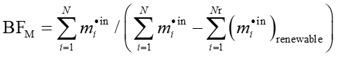  $BF_{M}=\frac{\sum_{i=1}^{N}{{\dot{m}}_{i}^{in}}}{(\sum_{i=1}^{N}{{\dot{m}}_{i}^{in}}-\sum_{i=1}^{N}{{\left({\dot{m}}_{i}^{in}\right)}_{renewable}})}$ | kg/h
8 | Recycled material fraction | w_{recycl. mat.} | This is the amount of material input from recyclable source. | $$w_{recycl. mat.}=\frac{\sum_{i=1}^{N}{{\left({\dot{m}}_{i}^{in}\right)}_{recyclable}}}{\sum_{i=1}^{N}{{\dot{m}}_{i}^{in}}}$$ | kg/kg
10 | Mass fraction of products designed for disassembly, reuse or recycling | w_{recov. prod.} | This is the mass fraction of product that can be recovered for reuse or recycling per mass of product. | $$w_{recov.prod.}=\frac{\sum_{i=1}^{M'}{{\left({\dot{m}}_{product,i}\right)}_{recyclable}}}{\sum_{i=1}^{M}{{\dot{m}}_{product,i}}}$$ | kg/kg

Table S5. GREENSCOPE Environmental Indicator Equations Adapted from [18]
Environmental Indicator |  | Acronym | Definition | Equation | unit
1 | Mass of hazardous materials input | m_{haz. mat.} | Total mass of hazardous substances fed to the process | $$m_{haz. mat.}=\sum_{i=1}^{I}{{\dot{m}}_{haz. mat., i}^{in}}$$ | kg/h
2 | Specific hazardous raw materials input | m_{haz. mat. spec.} | Total mass of hazardous substances fed to the process per unit of valuable product | $$m_{haz. mat. spec.}=\frac{\sum_{i=1}^{I}{{\dot{m}}_{haz. mat., i}^{in}}}{{\dot{m}}_{product}}$$ | kg hazardous input/kg product
3 | Safety hazard, acute toxicity | SH_{acute tox.} | Acute toxicity to humans and animals. | $${SH}_{acute tox}=\frac{{\dot{V}}_{t,air polluted}}{{\dot{m}}_{product}}$$  $${\dot{V}}_{t,air polluted}=\sum_{i=1}^{N}{{PhysVal}_{i}×{\dot{m}}_{i}}$$  $${PhysVal}_{i}=\left\{\begin{aligned}{10}^{4×{IndVal}_{i}+1} for {IndVal}_{i}>0 \\ {1×10}^{-4} for {IndVal}_{i}=0\end{aligned}\right.$$  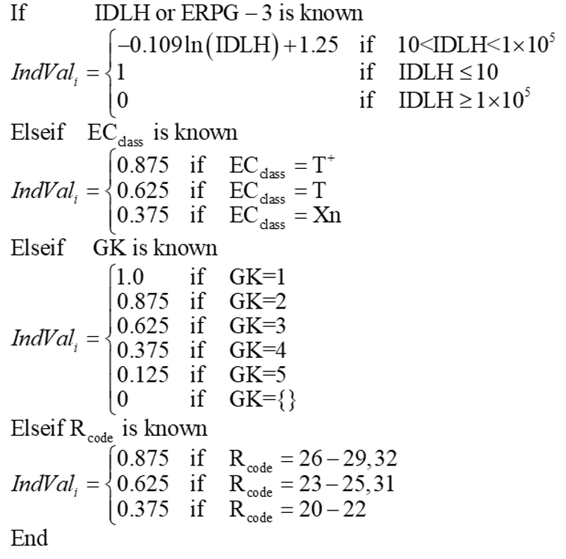 | m³/kg

Table S5. GREENSCOPE Environmental Indicator Equations Adapted from [18] (Continued)
Environmental Indicator |  | Acronym | Definition | Equation | unit
4 | Environmental quotient | EQ | EQ is a characterization of the environmental unfriendliness of the produced waste. This is computed multiplying the E factor by the quotient Q. Q is an arbitrarily assigned coefficient that can be 1 if the waste is innocuous, while for toxic material such as heavy metals, Q could be a scalar between 100-1000. In case of heterogeneous multicomponent emissions is not possible to characterize it with just one Q factor. | $$EQ=E ×Q$$  $$E=\frac{\sum{{\dot{m}}_{waste ≠H2O}}}{{\dot{m}}_{product}}$$ | m³/kg
5 | Environmental hazard, air hazard | EH_{air} | Carcinogenicity, mutagenicity, reproductive toxicity, sensitization to humans and environment. | $${EH}_{air}=\frac{V_{t,air polluted}}{{\dot{m}}_{product}}$$  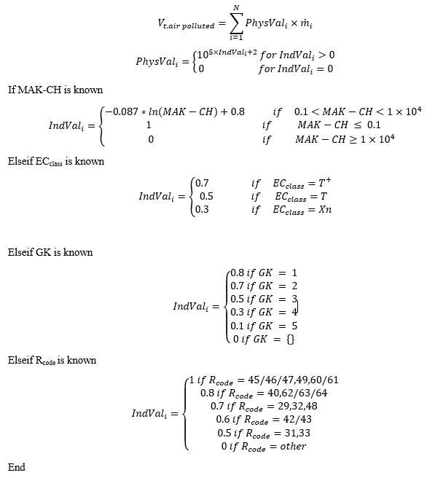 | kg hazardous input/kg product

Table S5. GREENSCOPE Environmental Indicator Equations Adapted from [18] (Continued)
Environmental Indicator |  | Acronym | Definition | Equation | unit
6 | Environmental hazard, water hazard | EH_{water} | Toxicity to aquatic environment. This is the volume of limit concentration water release equivalents per unit mass of desired product | $${EH}_{water}=\frac{V_{t,water polluted}}{{\dot{m}}_{product}}$$  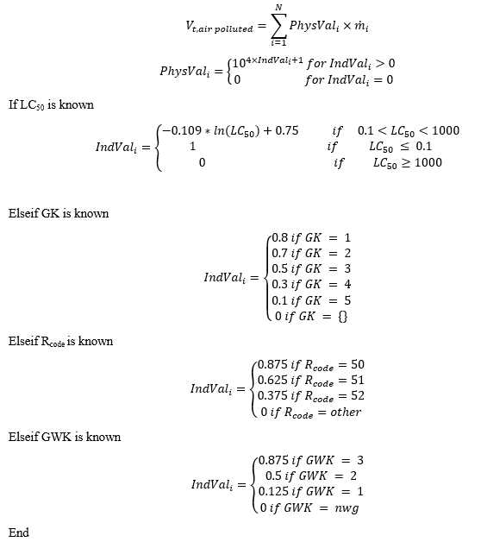 | m³/kg

Table S5. GREENSCOPE Environmental Indicator Equations Adapted from [18] (Continued)
Environmental Indicator |  | Acronym | Definition | Equation | unit
7 | Environmental hazard, solid waste (inorganic pollutants) | EH_{solid} | Solid waste for disposal via landfill or wastewater. It is the total mass of inorganic dry solid waste. | $${EH}_{solid}=\frac{\sum_{i=1}^{N}{{\dot{m}}_{inorganic solid.,i}^{out}}}{{\dot{m}}_{product}}$$ | kg/kg prod
8 | Environmental hazard, bioaccumulation (the food chain or in soil) | EH_{bioacc.} | Accumulation in food chain, in soil, and organic matter. | $${EH}_{bioacc}=\frac{{\dot{m}}_{t,acc.food.ch}}{{\dot{m}}_{product}}$$  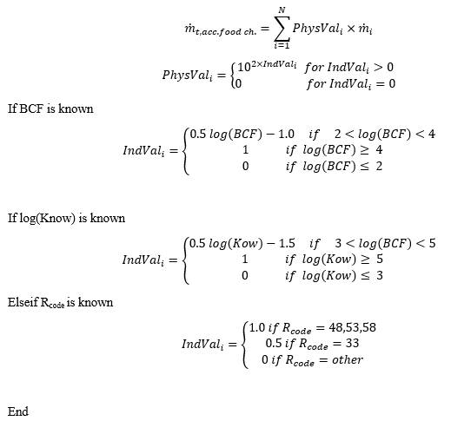 | kg/kg prod

Table S5. GREENSCOPE Environmental Indicator Equations Adapted from [18] (Continued)
Environmental Indicator |  | Acronym | Definition | Equation | unit
9 | Total solid waste mass | m_{s, tot.} | This is the total mass of releases as solid state. | $$m_{s,tot}=\sum_{i=1}^{N}{{\dot{m}}_{solid.,i}^{out}}$$ | kg
10 | Specific solid waste mass | m_{s, spec.} | This is the total mass of releases as solid state per unit mass of desired or valuable products | $$m_{s,spec}=\frac{\sum_{i=1}^{N}{{\dot{m}}_{solid.,i}^{out}}}{{\dot{m}}_{product}}$$ | kg/kg prod
11 | Solid waste mass for recovery | m_{s, recov.} | This is the total mass of releases as solid state that can be recovered from waste streams and recycled to the process. | $$m_{s,recov}=\sum_{i=1}^{N}{{\left({\dot{m}}_{solid.,i}^{out}\right)}_{recoverable}}$$ | kg
12 | Solid waste mass for disposal | m_{s, disp.} | The amount of solid waste that cannot be recovered. | $$m_{s,disp}=\sum_{i=1}^{N}{{\left({\dot{m}}_{solid.,i}^{out}\right)}_{non-recoverable}}$$ | kg
13 | Recycling mass fraction | w_{s, recycl.} | This is the fraction of the total solid waste mass that is recovered for reuse in the process | $$w_{s,recycl}=\frac{\sum_{i=1}^{N}{{\left({\dot{m}}_{solid.,i}^{out}\right)}_{recoverable}}}{\sum_{i=1}^{N}{{\dot{m}}_{solid.,i}^{out}}}$$ | kg/kg solid releases
14 | Disposal mass fraction | w_{s, non-recycl.} | This is the fraction of the total solid waste mass that can not be recovered for reuse | $$w_{s,non-recycl}=\frac{\sum_{i=1}^{N}{{\left({\dot{m}}_{solid.,i}^{out}\right)}_{non-recoverable}}}{\sum_{i=1}^{N}{{\dot{m}}_{solid.,i}^{out}}}$$ | kg/kg solid releases
Table S5. GREENSCOPE Environmental Indicator Equations Adapted from [18] (Continued)
Environmental Indicator |  | Acronym | Definition | Equation | unit
15 | Hazardous solid waste mass fraction | w_{s, haz.} | This is the fraction of the total solid waste mass that can not be recovered for reuse and is considered a hazardous waste | $$w_{s,non-recycl}=\frac{\sum_{i=1}^{N}{{\left({\dot{m}}_{solid.,i}^{out}\right)}_{non-recoverable}^{hazardous}}}{\sum_{i=1}^{N}{{\left({\dot{m}}_{solid.,i}^{out}\right)}_{non-recoverable}}}$$ | kg hazard solid/kg solid releases
16 | Total hazardous solid waste disposal | m_{s, haz.} | This is the amount of the total solid waste mass that can not be recovered for reuse and is considered a hazardous waste | $$m_{s,haz}=\sum_{i=1}^{N}{{\left({\dot{m}}_{solid.,i}^{out}\right)}_{non-recoverable}^{hazardous}}$$ | kg hazardous solid releases
17 | Specific hazardous solid waste | m_{s, haz. spec.} | This is the amount produced hazardous waste per unit mass of valuable product. | $$m_{s,haz,spec}=\frac{\sum_{i=1}^{N}{{\left({\dot{m}}_{solid.,i}^{out}\right)}_{non-recoverable}^{hazardous}}}{{\dot{m}}_{product}}$$ | kg non-hazard solid/kg prod
18 | Total non-hazardous solid waste disposal | m_{s,n-haz.} | This is the amount of the total solid waste mass that can not be recovered for reuse and is considered a non-hazardous waste | $$m_{s,non-haz}=\sum_{i=1}^{N}{{\left({\dot{m}}_{solid.,i}^{out}\right)}_{non-recoverable}} - \sum_{i=1}^{N}{{\left({\dot{m}}_{solid.,i}^{out}\right)}_{non-recoverable}^{hazardous}}$$ | kg non-hazardous solid

Table S6. GREENSCOPE Energy Indicator Equations Adapted from [18]
Energy Indicator |  | Acronym | Definition | Equation | unit
1 | Total energy consumption | E_{total} | All utilities provided to the system are expressed as flow rates of mass (e.g., steam) and energy and are aggregated by converting into primary fuel equivalent or caloric units. When the user needs to calculate the enthalpy value for any of these flow streams, this requires CP, T, P, normal phase change temperatures, and composition (xi). External data requirements consisting of the conversion factor into fuel energy for each utility stream (e.g., steam, cooling water, electricity) is needed in order to obtain the energy consumption in primary fuel equivalents. | $$E_{total}={\left(C_{factor}\dot{E}\right)}_{natural gas}+{\left(C_{factor}\dot{E}\right)}_{fuel oil}+{\left(C_{factor}\dot{E}\right)}_{steam}+…+{\left(C_{factor}\dot{E}\right)}_{electricity}$$  $${\dot{E}}_{k}=\left\{\begin{aligned}{\dot{Q}}_{k} (heat requirements) \\ {\dot{W}}_{k} (power requirements)\end{aligned}\right.$$  $$\sum_{j=1}^{J'}{{\dot{m}}_{j}^{out}×∆H_{j}+\sum_{k=1}^{K}{{\dot{Q}}_{k}}+}\sum_{k=1}^{K}{{\dot{W}}_{k}}-\sum_{j=1}^{J}{{\dot{m}}_{j}^{in}×∆H_{j}=0}$$ | MJ/h
2 | Specific energy intensity | R_{SEI} | This indicator describes quantitatively the total energy consumed by the process or process operating unit in primary fuel equivalents needed to produce a product per unit mass of valuable product(s). Total product energy (caloric) value per mass of product is the best case scenario and ten times the total product energy value per mass of product is the worst case scenario value for this indicator. | $$R_{SEI}=\frac{{\left(C_{factor}\dot{E}\right)}_{natural gas}+{\left(C_{factor}\dot{E}\right)}_{fuel oil}+{\left(C_{factor}\dot{E}\right)}_{steam}+…+{\left(C_{factor}\dot{E}\right)}_{electricity}}{{\dot{m}}_{product}}$$ | MJ/kg
3 | Energy intensity | R_{EI} | This is a measure of the net fuel-energy consumed to provide the heat and the power required to the process or process unit(s) per unit of sales revenue or value added. The total product energy (caloric) value per sales revenue is the best case scenario and ten times the total product energy value per sales revenue is the worst case scenario value for this indicator. | $$R_{EI}=\frac{{\left(C_{factor}\dot{E}\right)}_{natural gas}+{\left(C_{factor}\dot{E}\right)}_{fuel oil}+{\left(C_{factor}\dot{E}\right)}_{steam}+…+{\left(C_{factor}\dot{E}\right)}_{electricity}}{S_{m}}$$ | MJ/$

Table S6. GREENSCOPE Energy Indicator Equations Adapted from [18] (Continued)
Energy Indicator |  | Acronym | Definition | Equation | unit
4 | Waste treatment energy | WTE | This indicator describes the net amount of energy required by the process unit(s), which are related to the processing the output waste streams per unit mass of valuable product(s). A zero energy (caloric) value per mass of product is the best case scenario and a ten percent (10%) of the total energy consumed per mass of product is the worst case scenario value for this indicator. | $$WTE=\frac{{\left[{\left(C_{factor}\dot{E}\right)}_{natural gas}+{\left(C_{factor}\dot{E}\right)}_{fuel oil}+{\left(C_{factor}\dot{E}\right)}_{steam}+…+{\left(C_{factor}\dot{E}\right)}_{electricity}\right]}_{\begin{aligned}waste \\ units\end{aligned}}}{{\dot{m}}_{product}}$$ | MJ/kg
5 | Solvent recovery energy | SRE | Solvent recovery energy, SRE. This indicator describes the net amount of energy required by the process units, which are related to the processing of solvent recovery for reuse per unit mass of valuable product(s). A zero energy (caloric) value per mass of product is the best case 69 scenario and a ten percent (10%) of the total energy consumption per mass of product is the worst case scenario value for this indicator. | $$SRE=\frac{{\left[{\left(C_{factor}\dot{E}\right)}_{natural gas}+{\left(C_{factor}\dot{E}\right)}_{fuel oil}+{\left(C_{factor}\dot{E}\right)}_{steam}+…+{\left(C_{factor}\dot{E}\right)}_{electricity}\right]}_{\begin{aligned}solvent \\ recov. \\ units\end{aligned}}}{{\dot{m}}_{product}}$$ | MJ/kg

Table S6. GREENSCOPE Energy Indicator Equations Adapted from [18] (Continued)
Energy Indicator |  | Acronym | Definition | Equation | unit
6 | Resource-energy efficiency | η_{E} | This is a ratio between the energy content of the products to the total energy content of the feedstocks represented in the same energetic unit. This defines the quantity of the raw material energy that is remaining in the desired product. A value of 1 is the best case scenario and zero is the worst case scenario value for this indicator. | $$η_{E}=\frac{{\dot{m}}_{product}×∆H_{product}}{\sum_{j=1}^{J}{{\dot{m}}_{j}^{in}×∆H_{j}}}$$ | MJ product/MJ feedstock
7 | Renewability-energy index | RI_{E} | Renewability-energy index, RIE. This is the ratio of the consumption of renewable energy to the total quantity of energy supplied to the process. A value of 1 is considered the best case scenario and a zero value is the worst case reference value. | 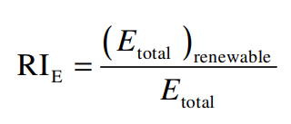 | MJ renewable/MJ total supplied
8 | Breeding-energy factor | BF_{E} | This is the ratio between the total energy process outputs over the nonrenewable energy content from process inputs. A value of 10 is considered the best case scenario and a zero value is the worst case reference value. | $${BF}_{E}=\frac{{\dot{m}}_{product}×∆H_{product}}{\sum_{j=1}^{J}{{\dot{m}}_{non-renewable,j}^{in}×∆H_{j}}}$$ | MJ total output/MJ nonrenewable input
9 | Energy for recycling | E_{recycl} | This indicator describes the net amount of energy required by the process units, which are related to the recycling of unreacted reagents or unprocessed feedstocks per unit mass of valuable product(s). A zero energy (caloric) value per mass of 70 product is the best case scenario and ten percent (10%) of the total energy consumption per mass of product is the worst case scenario value for this indicator. | $$SRE=\frac{{\left[\begin{aligned}{\left(C_{factor}\dot{E}\right)}_{natural gas}+{\left(C_{factor}\dot{E}\right)}_{fuel oil}+{\left(C_{factor}\dot{E}\right)}_{steam} \\ +…+{\left(C_{factor}\dot{E}\right)}_{electricity}\end{aligned}\right]}_{\begin{aligned}Recycling \\ units\end{aligned}}}{{\dot{m}}_{product}}$$ | MJ/kg

Table S7. GREENSCOPE Economic Indicator Equations Adapted from [18]
Economic Indicator |  | Acronym | Definition | Equation | unit
1 | Total process cost (end-of-life) | TPC | TPC combines the operating costs of the plant, distribution and selling the products, administrative costs, and research and development costs. | $$TPC=COM+GE$$ | $/yr
2 | Daily operation of EoL Processes (COM) | COM | These are the costs related with the day-to-day operation of the end-of-life (EoL) process. | $$C_{E,source}=\frac{\sum_{u=1}^{U^{'}}{C_{UT,u }×{\dot{utility}}_{energy,u} }}{E_{total}}$$ | $/yr
3 | Specific raw material cost | C_{SRM} | C_{SRM} could be used as economic indicator at the basic process design stage, assuming 100% reaction yield, thus the minimum raw material cost is computed. Some process design routes can be discarded when C_{SRM} exceeds the targeted product value. | $$C_{SRM,m}=\frac{\sum_{u=1}^{I^{'}}{({\dot{m}}_{m,i}^{in}×C_{m,i}) }}{\sum_{i=1}^{I}{{\dot{m}}_{m, product i}}}$$ | $/kg
4 | Total material cost | C_{mat. tot.} | This is the absolute cost of total material used in the process or process unit | $$C_{RM,m}=\sum_{u=1}^{I}{({\dot{m}}_{m,i}^{in}×C_{m,i}) }$$ | $/yr
5 | Total energy cost | C_{E, tot.} | These are the costs related with the utility energy demand costs during the day-to-day operation of a manufacturing plant: fuels, electricity, steam, etc. | $$C_{E,tot.}=\sum_{u=1}^{U^{'}}{C_{UT,u }×{\dot{utility}}_{energy,u} }$$ | $/yr

Table S7. GREENSCOPE Economic Indicator Equations Adapted from [18] (Continued)
Economic Indicator |  | Acronym | Definition | Equation | unit
6 | Average cost of energy source | C_{E, source} | This is the average cost related to the utility energy demand costs during the day-to-day operation of a manufacturing plant per unit of consumed energy as equivalent primary energy source. | $$C_{E,source}=\frac{\sum_{u=1}^{U^{'}}{C_{UT,u }×{\dot{utility}}_{energy,u} }}{E_{total}}$$ | $/kJ
7 | Specific energy cost | C_{E, spec.} | These are the costs related with the utility energy demand costs during the day-to-day operation of a manufacturing plant per value unit of total production cost. | $$C_{E,spec.}=\frac{\sum_{u=1}^{U^{'}}{C_{UT,u }×{\dot{utility}}_{energy,u} }}{TPC}$$ | $ energy cost/$ total
8 | Total solid waste cost | C_{s tot.} | These are the costs related to the handle and disposal of solid waste produced during the day-to-day operation of a manufacturing plant: external waste removal fees, internal storage, personnel, waste treatment, and transportation costs. | $$C_{s tot.}=\sum_{j=1}^{s}{C_{solid treat., j }×{\dot{m}}_{solid w., j}^{out}}$$ | $/yr
9 | Solid waste cost fraction | C_{s, spec.} | These are the costs related with the handle of solid waste produced during the day-to-day operation of a manufacturing plant per value unit of total production cost. | $$C_{s spec.}=\frac{\sum_{j=1}^{s}{C_{solid treat., j }×{\dot{m}}_{solid w., j}^{out}}}{TPC}$$ | $ solid waste cost/$ total
10 | Total liquid waste cost | C_{l tot.} | These are the costs related to the handle of liquid waste produced during the day-to-day operation of a manufacturing plant: external waste removal fees, internal storage, personnel, waste treatment, and transportation costs. | $$C_{l tot.}=\sum_{j=1}^{l}{C_{liquid treat., j }×{\dot{m}}_{liquid w., j}^{out}}$$ | $/yr

Table S7. GREENSCOPE Economic Indicator Equations Adapted from [18] (Continued)
Economic Indicator |  | Acronym | Definition | Equation | unit
11 | Liquid waste cost fraction | C_{l, spec.} | These are the costs related to the handle of liquid waste produced during the day-to-day operation of a manufacturing plant per value unit of total production cost. | $$C_{l spec.}=\frac{\sum_{j=1}^{l}{C_{liquid treat., j }×{\dot{m}}_{liquid w., j}^{out}}}{TPC}$$ | $ liquid waste cost/$ total
12 | Revenues from eco-products | REV | The net revenues from the sale of products categorized as eco-products | $$REV_{m}= \sum_{i=1}^{I}{{\dot{m}}_{m, eco-product i}}×C_{m,eco-product i}$$ | $/yr
13 | Revenue fraction of eco-products | REV_{eco-prod} | The net revenues from the sale of products categorized as eco-products over the total sales revenue or value added | $$REV_{eco-prod.}= \frac{\sum_{i=1}^{I}{{\dot{m}}_{m, eco-product i}}×C_{m,eco-product i}}{S_{m}}$$ | $/$

General Parameter Definition:
$BCF$= Bioconcentration factor
$C$= Cost
Subscript
Liquid treat., j = liquid treatment of component j
m, eco-product i = component i classified as eco-product
Solid treat., j = solid treatment of component j
UT, u = utility type u
$C_{factor}$= Cost factor
$\dot{E}$= Energy flow
$EC_{class}$= European community classification of dangerous substance code {T = toxic, C = corrosive substances or preparations, X_{i} = irritants}
$ERPG-3$= Emergency Response Planning Guidelines
GK = Swiss poison class
GWK = Swiss poison class
$∆H_{j}$ = Change in enthalpy of component j
IDLH = Immediately dangerous to life or health air concentration values
$Indval_{i}$= Indicator value of component i
$K_{ow}$= Logarithmic Octanol/Water Partitioning Coefficient
${LC}_{50}$= The lethal dose or amount of substance aqueous concentration that causes 50% mortality of fathead minnow after 96 hrs (mg/L)
$\dot{m }$= Mass flow rate
Superscript
in = input flow
out = output flow

Subscript
haz, mat. = hazardous materials
i, j, k = component i, j, and k
m, eco-product i = component i classified as eco-product
product = product
t, acc. food. ch = total accumulated in the food chain
waste ≠ H2O = waste excluding water
$Physval_{i}$= Physical value of component i
$R_{code}$ = risk phrase of European community codes
${\dot{utility}}_{energy}$= utility energy flow
${\dot{V}}_{t}$ = Total volumetric flow rate
Subscript
air polluted = Air polluted
water polluted = Water polluted

Reference:
[17] G. J. Ruiz-Mercado, R. L. Smith, and M. A. Gonzalez, “GREENSCOPE.xlsm User’s Guide.” US Environmental Protection Agency, 2014.

