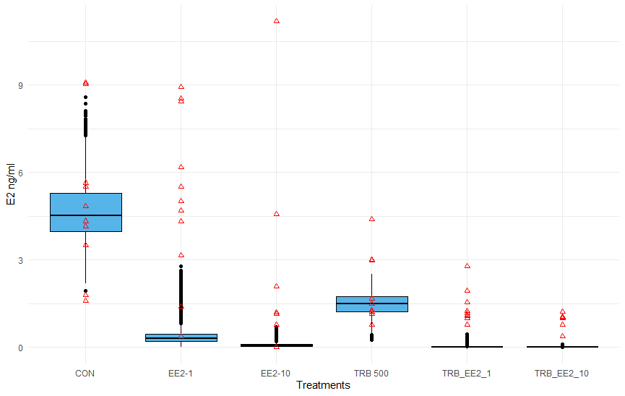
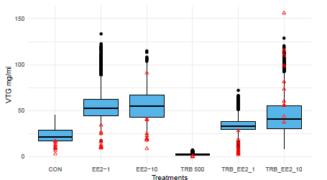

Supplementary Figure S.1. Comparison of model-based simulations (n=1000; summarized in box and whisker plot and black points) of Experiment 1 using a computational model of the fathead minnow hypothalamic-pituitary-gonadal axis developed by Li et al. (2011) with empirical results (red triangles).

