EFFECTIVENESS OF Nutrient Management for Reducing Phosphorus Losses from Agricultural Areas

Supplemental Materials

Literature search
The search was conducted using three databases: PubMed, Web of Science Core Collection, and ScienceDirect. Nearly 3000 articles were obtained from the literature search on September 22, 2022. Bibliographic information was imported into EndNote. Duplicate citations were removed using the Find Duplicates function in Endnote. The search terms/keywords were split into three of the four PICO systematic review framework components: Population, Intervention, and Outcome. These components were combined using Boolean operators. Intervention terms centered on “agricultural”, “watershed”, and “runoff”. Population terms centered on “nutrient management” and “4R”. Outcome terms centered on “phosphorus” and phosphorus species (e.g., SRP, DRP, TP). Where applicable, search terms were truncated, and an asterisk was placed at the end to obtain alternative forms of the words (e.g., agricultur* = to include “agriculture” and “agricultural”). The final search string was a modification of the following template: (“Agricultur*” OR “watershed” OR “runoff” OR “tile” OR “drainage”) AND (“nutrient management” OR "4R" OR “conservation practice” OR “management”) AND (“nutrient” OR “phosphorus” OR “SRP” OR “DRP” OR "TP" OR “water quality”).

Supplementary searches
In addition to the structured term search, forward and backward citation tracing was conducted on selected literature using the search strategy, to find further relevant articles. Additional databases, like the MANAGE database, were used to obtain additional relevant publications, but cannot be searched like publication databases.

Overview of Studies
Table S1. Details for the 15 studies from which data was collected and used.
ID | Source | Location | Study scale | Plot size | Unit | Materials | Soil P | Rainfall type | Application to runoff
76 | (Tabbara, 2003) | Iowa | plot | 0.0014 | ha | Field plots | reported - single value | simulated | 1 day
77 | (Kovar, Moorman, Singer, Cambardella, & Tomer, 2011) | Iowa | plot | 0.011 | ha | Field plots | reported - single value | simulated | 8 days, 3 months
2 | (Adeli et al., 2013) | Mississippi | plot | 0.00077 | ha | Field plots | reported - single value | simulated | 1 day, 1 month
78 | (Grande, Karthikeyan, Miller, & Powell, 2005) | Wisconsin | plot | 0.0003 | ha | Field plots | reported - individual values | simulated | 1 month, 3 months, 1 year
79 | (Johnson, Kleinman, Beegle, Elliott, & Saporito, 2011) | Pennsylvania | plot | 0.013 | ha | Field plots | reported - single value | simulated | 3 days
57 | (D. R. Smith, Owens, Leytem, & Warnemuende, 2007) | Indiana | plot | 0.00015 | ha | Field plots | reported - individual values | simulated | 1, 4,8, 15, and 29 days
85 | (Yuan, Fernandez, Pittelkow, Greer, & Schaefer, 2018) | Illinois | plot | 0.0003 | ha | Field plots | reported - individual values | simulated | 1 month, 3 months
86 | (P. J. Kleinman, Sharpley, Moyer, & Elwinger, 2002) | Pennsylvania | plot | 0.00002 | ha | Runoff boxes | reported - two average values | simulated | 3 days
87 | (P. J. Kleinman & Sharpley, 2003) | Pennsylvania | plot | 0.00002 | ha | Runoff boxes | reported - single value | simulated | 3 days
88 | (Gilley, Eghball, & Marx, 2007) | Nebraska | plot | 0.00015 | ha | Field plots | reported - single value | simulated | 4 days
91 | (Daverede et al., 2004) | Illinois | plot | 0.00015 | ha | Field plots | NA | simulated | 1 month, 6 months
92 | (D. R. Smith et al., 2017) | Indiana | plot | 0.0002 | ha | Field plots | reported - single value | simulated | 1 day
5 | (Carver et al., 2022) | Kansas | field | 0.5 | ha | Fields | reported - single value | natural | NA
40 | (Madison et al., 2014) | Wisconsin | field | 6.2 to 16.2 | ha | Fields | reported - individual values | natural | NA
74 | (Algoazany, Kalita, Czapar, & Mitchell, 2007) | Illinois | field | 3 to 7.6 | ha | Fields | NA | natural | NA

Table S1 (continued).
ID | Rate details | Fertilizer type | Application | Sampling duration | P species | P data | single value or mean | N | Summary findings
76 | low (60-70 kg - P/ha); high (120-150 kg-P/ha) | Inorganic: ammonium polyphosphate; Organic: liquid swine manure | Surface: broadcast; Subsurface: Incorporation | 90 min | DRP | C, L | TRT mean | 8 | Incorporation reduced DRP losses no matter which fertilizer source and application rate was used
77 | 0, 53, and 88 kg-P/ha | Organic: liquid swine manure | Subsurface: Injected | 30 min | DRP | C, L | TRT mean | 3 | Knife injection produced significantly lower DRP surface losses in both the fall and spring. But especially in the fall.
2 | 0, 68, 80 kg-P/ha | Organic: poultry litter | Surface: broadcast; Subsurface: banded | < 24 hrs | WSP | C, L | TRT mean | 6 | Subsurface banding significantly reduced the concentration and load of both SRP and TP in surface runoff
78 | 0, 58 kg-P/ha | Organic: liquid dairy manure | Surface: broadcast | 60 min | DRP | C, L | TRT mean | 2 | DRP concentrations were greater in the spring when the interval between application and runoff was shortest. However, this phenomenon was the opposite for TP. Spring-applied manure was also found to increase the DRP fraction of total P losses.
79 | 0, 27 kg-P/ha | Organic: liquid dairy manure | Surface: broadcast; Subsurface: injected, banded or incorporated | 60 min | DRP | C, L | TRT mean | 6 | Surface broadcasting of manure slurry led to significantly greater DRP and TP concentrations in runoff
57 | 0, 35 kg-P/ha | Inorganic: triple superphosphate; Organic: liquid swine manure, Poultry litter | Surface: broadcast | 30 min | SP | C | TRT mean | 4 | Swine manure was most susceptible to initial losses, with the greatest DRP concentrations if runoff occurred within 5 days after application
85 | 0, 22, 39 kg-P/ha | Inorganic: triple superphosphate | Surface: broadcast; Subsurface: banded or incorporated | 30 min | DRP | C | TRT mean | 9 | incorporation/injection had a greater effect on reducing P losses than the tillage practices.
86 | 0, 100 kg-P/ha | Inorganic: DAP; Organic: poultry, dairy, or swine manure | Surface: broadcast; Subsurface: Incorporation | 30 min | DRP | C, L | TRT mean | 18 | runoff DRP concentrations were highly correlated with water-soluble P concentration of surface-applied manure.
87 | 0, 10, 50, 75, 100, 150 kg-P/ha | Organic: dairy, poultry, or swine | Surface: broadcast | 30 min | DRP | C | TRT mean | 32 | Application rate increased, so did the contribution of DRP to runoff TP
88 | 37, 203 kg-P/ha | Organic: beef or swine manure | Surface: broadcast; Subsurface: Incorporation | 30 min | DRP | C | TRT mean | 8 | Overall, incorporation resulted in lower P concentrations in runoff for storms in the first 50 days after application
91 | 0, 35, 54, 70 kg-P/ha | Inorganic: triple superphosphate; Organic: liquid swine manure | Surface: broadcast; Subsurface: incorporated or injected | 30 min | DRP | C, L | TRT mean | 9 | Surface application produced significantly greater DRP and TP losses in the rainfall event 1 month after application.
92 | 0, 9.6, or 24.4 kg-P/ha | Inoganic: DAP, MAP, or Poly | Surface: broadcast; Subsurface: incorporated or injected | 30 min | SP | C, L | TRT mean | 8
5 | 0, 27 kg-P/ha | Inorganic: DAP or MAP | Surface: broadcast; Subsurface: incorporation | annual | DRP | C, L | Annual mean | 12
40 | 0 to 81 kg-P/ha | Organic: liquid dairy manure | Surface: broadcast; Subsurface: injected | annual | DRP | C, L | Annual mean | 28 | 14 for surface/14 for tile
74 | 0 to 222 kg-P/ha | Inorganic: DAP or MAP | Surface: broadcast | annual | SP | C, L | Annual mean | 56 | 28 for surface/28 for tile

Regional P fertilizer rate recommendations

Table S2. P fertilizer rate recommendations for midwestern states in the USA. All values are in kg-P2O5 ha-1. Recommended rates were based on corn grain at an expected yield of 200 bu/acre. Maximum-recommended values were those recommended for fields with the lowest soil P value. Moderate recommended values were those recommend for fields with soil P values of approximately 20 mg kg-1 (mehlich-3).

State | Max  recommended | Moderate
Illinois | 96
Iowa | 134 | 95
Tri-State  (Ohio, Indiana, Michigan) | 134 | 80
Pennsylvania | 157 | 94
Wisconsin | 130 | 84
Minnesota | 146 | 101
Average | 133 | 90.8

Cost-Benefit Analysis Assumptions
To perform the cost-benefit analysis, following assumptions were made. First, we assumed a soil test P (STP) (Bray method) greater than 20 mg P kg⁻¹ (equivalent to ~30 mg P kg ⁻¹ when using the Mehlich-3 method) because there were little data on the influence of P fertilizer on crop yield at lower STP values (< 20 mg P kg⁻¹). Studies showed that crop yield doesn’t respond to the P application rate when STP is above 20 mg P kg⁻¹ (Dodd & Mallarino, 2005; Fulford & Culman, 2018). Thus, we assumed that fertilizer rate did not impact crop yield. Furthermore, most of the studies summarized in this review had STP greater than 20 mg P kg⁻¹ using the Bray method or 30 mg P kg⁻¹ using the Mehlich-3 method. Without an influence on crop yield, decreasing the P application rate did not negatively impact profit from crop yield. In addition, we assumed that monoammonium phosphate (MAP) or diammonium phosphate (DAP) inorganic fertilizers were used. Finally, the fertilizer rates for low, moderate, and high fertilizer rate groups were set to 35, 105, and 163 kg-P2O5 ha⁻¹ (or 15, 45, and 70 kg-P ha⁻¹), respectively.

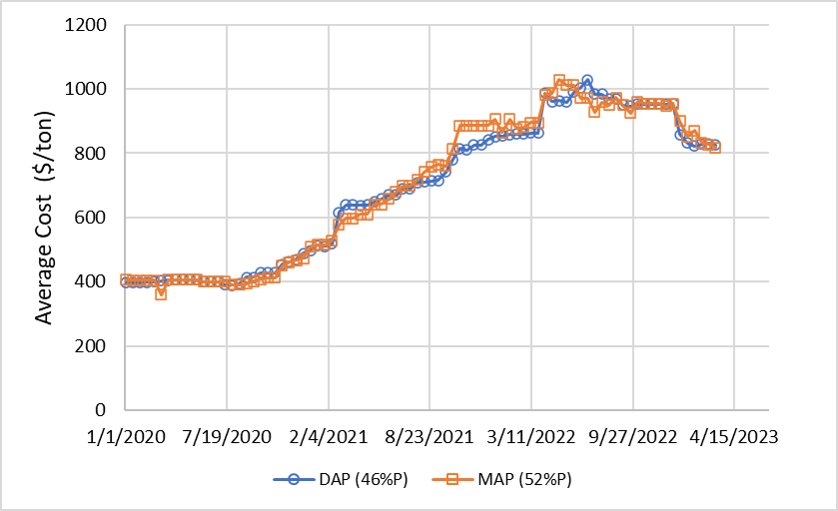
Figure S1. Average biweekly fertilizer costs for both MAP and DAP by dollar per ton. Values obtained from biweekly Illinois Production Cost Reports provided by the USDA.

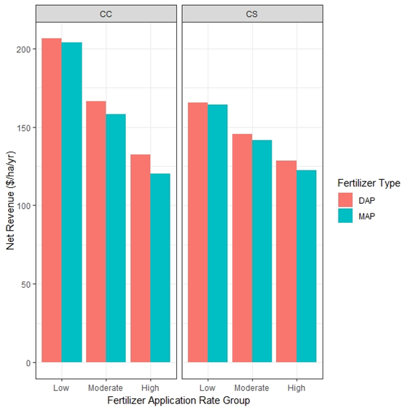
Figure S2. Average annual revenue for each fertilizer and fertilizer rate. Values are in $ ha⁻¹ yr⁻¹.

Results from statistical analysis

Table S3. Summary of the Kruskal-Wallis tests performed for application rate, application method, and fertilizer type. Kruskal-Wallis tests were significant where p-value < 0.05. Significance in the Kruskal-Wallis tests indicates that there is a significant difference in the medians of at least two of the independent variable groups (i.e., pollutants).

4R nutrient management | Dataset | χ² | df | p-value
Fertilizer Rate | Concentration | 38.8 | 3 | <0.001
Fertilizer application method | Concentration | 70.8 | 2 | <0.001
Fertilizer Source | Concentration | 32.2 | 2 | <0.001

Table S4. Summary of Dunn’s test results. The adjusted p-value was used to determine significant differences. Significant comparisons are emphasized using italics and asterisks.

4R nutrient management | Dataset | Groups | Z-statistic | Adjusted p-value
Fertilizer Rate | Concentration | High – Low | 2.49 | 0.07
 |  | High - Moderate | 2.13 | 0.20
 |  | Low - Moderate | -0.45 | 1.00
 |  | High – Unfertilized* | 6.16 | <0.001
 |  | Low – Unfertilized* | 3.52 | 0.003
 |  | Moderate – Unfertilized* | 4.06 | <0.001
Fertilizer Source | Concentration | Inorganic – Organic | -1.27 | 0.61
 |  | Inorganic – Unfertilized* | 4.02 | <0.001
 |  | Organic – Unfertilized* | 5.67 | <0.001
Application Method | Concentration | Subsurface – Surface* | -6.34 | <0.001
 |  | Subsurface - Unfertilized | 1.88 | 0.18
 |  | Surface – Unfertilized* | 6.90 | <0.001

Table S5. The number of liquid and solid fertilizers within each fertilizer source. In addition to the number of observations in each phase, the median concentrations were also included.

Fertilizer Type | Fertilizer Source | DRP Concentration (mg L⁻¹)
 |  | N | Median
Liquid | Inorganic | 5 | 1.52
 | Organic | 53 | 1.90
Solid | Inorganic | 19 | 1.20
 | Organic | 18 | 10.8

References Cited
Dodd, J. R., & Mallarino, A. P. (2005). Soil-Test Phosphorus and Crop Grain Yield Responses to Long-Term Phosphorus Fertilization for Corn-Soybean Rotations. Soil Science Society of America Journal, 69(4), 1118-1128. doi:https://doi.org/10.2136/sssaj2004.0279
Fulford, M. A., & Culman, W. S. (2018). Over-Fertilization Does Not Build Soil Test Phosphorus and Potassium in Ohio. Agronomy, Soils & Enviornmental Quality, 110(1), 56-65.

