Supplementary Information for

Guarding drinking water safety against harmful algal blooms: Could UV/Cl₂ treatment be the answer?
Minghao Kong ª, Toby Sanan ^{b}, AfzAAl Nadeem Mohammed ^{c}, Alexandria L. B. Forster ^{d}, Armah de la Cruz ^{b}, Susan D. Richardson ^{d}, Judy A. Westrick ^{e}, Kevin O’Shea ^{f}, Evangelia Anna Passa ª, Bangxing Ren ª, Mallikarjuna N. Nadagouda ^{b}, Jagjit S. Yadav ^{c}, Xiaodi Duan ^{g,}*, and Dionysios D. Dionysiou ^{a,}*

Texts: 8
Figures: 8
Tables: 5

Captions
Text S1. Reagents and field water samples
Text S2. UV/chlorine and chlorination experiments
Text S3. Quencher selection and MC quantification
Text S4. Kinetic model simulations, details
Text S5. Analytical methods
Text S6. In vitro Cytotoxicity
Text S7. Chlorine speciation with added chloride ions.
Text S8. Microcystin transformation products without cleavage of Adda chain
Text S9. Additional MC-RR transformation products
Figure S1. Structures of microcystins
Figure S2. Degradation of MC-RR, remaining concentration vs. time and UV dose
Figure S3. Degradation of MC-RR, ln(C/C₀) vs. time, and synergistic effect in k_{obs}
Figure S4. pH dependency of amino acids - chlorination
Figure S5. The fraction of conjugate acids in tested system
Figure S6. Role of nitrobenzene concentrations on MC-RR degradation kinetics
Figure S7. Degradation of mixed MCs in NOM and GCWW sample
Figure S8. Cytotoxicity of treated waters
Table S1. Microcystin concentrations in field samples
Table S2. Integration of MC-RR degradation by UV/chlorine and the role of Cl₂(aq)
Table S3. Conditions to achieve 1.0-log reduction of MC-RR
Table S4. Water quality of tested water samples.
Table S5: DBPs form from the treatment of Microcystin-LR
Table S6. TOX speciation formed from the treatment of microcystin-LR

Text S1. Reagents and field water samples
The pH of reaction was controlled by using 0.1 M buffer solutions, including acetate buffer (pH 4-5), Phosphate buffer (pH 6-8), and borate buffer (pH 8-10). Precolumn OPA (o-phthalaldehyde) reagents with 10 g/L OPA and 3-mercaptopropionic acid (3-MPA) in 0.4 M borate buffer (Agilent 5061-3335) was utilized for the analysis of amino acids (AAs). N,N-diethyl-p-phenylenediamine (DPD) free chlorine reagents were used to performed the free available chlorine (FAC) and total chlorine analysis. Two types of chemical actinometry, including ferrioxalate and iodine-iodate actinometer, were performed to verify the UV irradiance of the collimated beam LP-UV along with the UV radiometer (ILT1700, UV₂₅₄ sensor) biweekly. HepaRG cells (Gibco™, HPRGC10), suggested reagents from the user guide, and Cell Proliferation Kit II (Roche, XTT) were acquired and used in the cytotoxicity test. All stock and working solutions were stored in 4ºC and warmed up to 25±1ºC before use.
Suwannee River Natural Organic Matter (SRNOM-RO isolate, 2R101N) standard was purchased from the International Humic Substances Society (MN, US). The NOM and AOM stock solution was filtered through an Acrodisc® 0.45 µm filter with Supor® membrane (Pall Corporation, NY, USA). HAB-impacted water samples from Grand Lake St. Marys (temperature = 28.8°C, pH = 8.79, DO = 12.0 mg/L, TOC = 7.6 mg/L as C) were collected at the location (40.544089 N, - 84.507766 W) and acidified to pH 2.5 with HCl and then filtered with a 0.45 µm filter. Algal organic matter (GLSM-AOM) was extracted with Solid Phase Extraction Bond Elut PPL cartridges (Agilent). First, PPL conditioning was processed by eluting each cartridge with 100 mL of methanol. The filtered water was loaded onto the PPL cartridge by gravity and then eluted using methanol. The extracts were then placed into a glass Rotovap flask. The Rotovap water bath was heated to 50 - 60°C. The extract was kept in the Rotovap until all methanol was evaporated. The dried DOM was removed from the flask using MilliQ water. The DOM-MilliQ mixture was then put into plastic containers and placed in a freezer until all material was frozen. The containers were then put into the lyophilizer. The DOM was kept at room temperature in a dark condition before use.
Solid GLSM-AOM was collected, extracted, and provided by Dr. Carissa Hipsher and Dr. Allison MacKay (Department of Civil, Environmental & Geodetic Engineering, The Ohio State University, Columbus, OH, 43210, USA). All other reagents were of ACS analytical grade.

Text S2. UV/chlorine and chlorination experiments
The concentration of Cl– in FAC solution was tested by subtracting chloride mass in the form of FAC from the total chloride mass by transfer of HOCl and OCl– to Cl– by quenching FAC with excess ascorbic acid ([Cl–] = [Cl–] _{Total} – [Cl–] _{FAC}, eq. 1). The results showed that in 2.0 mg/L Cl₂ FAC solution, 2.5 mg/L Cl– was present in the reactor (28 µM FAC with 72 µM Cl–) as shown in Figure T2-1. The chloride content is from commercial NaOCl solution impurities and FAC decomposition, which is affected by storage time and temperature^{1, 2}.
C₅H₅O₅CH₂OH + HOCl → C₅H₃O₅CH₂OH + H⁺ + Cl– + H₂O Eq. 1.
In this study, the term “added Cl–” was used to describe the additional dosage of NaCl in chloride-related experiments. The Cl– contributed by FAC was considered in model simulations.
Figure T2-1. Chloride ions in the free chlorine solution.

In chloride-related experiments, the phosphate buffer doses were adjusted from 6 to 12 mM to maintain the ionic strength as 30 ± 1 mM and pH as 7.4 ± 0.1 based on Visual Minteq. 3.1 simulations, as described in Table T2-1. pH 8.4 solution was buffered with similar dosages of sodium borate buffer (6 to 12 mM, pH 8.4; ionic strength was not considered for borate buffer because of the complexity of the calculations³).

Table T2-1. Phosphate buffer concentration required to maintain the same ionic strength with different dosage of chloride ions.
Phosphate buffer (PB)  stock solution | monobasic dihydrogen phosphate |  | dibasic monohydrogen phosphate
0.10 M | 0.08 M |  | 0.02 M
Working solution
Concentration of PB | Cl⁻ concentration | pH in the solution |  | Ionic strength
12 mM | 0 | 7.6 |  | 29.1 mM
10 mM | 5 mM | 7.6 |  | 29.1 mM
8 mM | 10 mM | 7.6 |  | 29.1 mM
6 mM | 15 mM | 7.6 |  | 29.2 mM
Simulation results were obtained by using Visual Minteq 3.1 simulations, with the ionic strength fixed at 29.2±0.1mM.

Chlorine residuals during the sampling period were analyzed by removing 10 mL aliquots for DPD-based colorimetry. For chlorination of amino acids and field water samples, chlorine decay was fitted with a two-reactant (2R) model: rapid decay of chlorine with fast reducing agents, i.e., organic amines and ammonia (R-NH₂ and NH₃), and the subsequent slow depletion of chlorine by reacting with less reactive reducing agents, i.e., MCs, amino acid residues^{4, 5}. The crossover stage between 2R occurred around 60 s. Thus, [FAC]_{60s} was tested and used as an initial chlorine dosage for slow reactions with the goal to explore the reactivity of MCs and amino residues⁶. For the field samples spiked with mixed MCs (DOC, 0.5 - 2.0 mg/L C with 0.1 µM MCs), [FAC]_{60s} was adjusted to 21 ± 0.5 µM by dosing suitable [FAC]_{0s} before spiking the MCs at 60 s. Thus, the MC degradation in various field samples would be comparable with the same initial chlorine dosage ([FAC]_{60s}) with the assumption that the contribution of R-NHCl on degradation is negligible (k_{app} between chloramine and phenolic compounds is around 10⁻⁴ – 10⁻¹ M⁻¹ s⁻¹)⁷. In the chlorination of amino acids (28 µM FAC, 4 µM amino acid), more than 10% chlorine loss was also observed.

Text S3. Quencher selection and MC quantification.
Free amino acids and peptides undergo a two-stage chlorination process, where unstable N-chloramines (RNHCl/RNH₂⁺Cl) rapidly form via the chlorination of free amino groups (-NH₂) present on both residues (i.e., Arg side chains) and at the N-terminal. Chlorine depletion occurs rapidly during this stage in tested systems with fast formation of N-chloramines. This is followed by degradation of other less reactive functional groups, typically the side-chains of reactive amino acids (such as the Tyr sidechain)⁸. During the stage of fast chlorination, N-chloramines (i.e., N-chloro-amino acids and N-chloro-MCs) are rapidly formed, while the other susceptible sidechains including toxicity-attributing groups (i.e., the Adda moiety of MCs) remain intact.
The formation of N-chloramines does not seem to affect the toxicity of MCs. According to Zhang et al. (2016)⁹, the cytotoxicity of chlorinated MC-LR remained stable with chlorine: MC-LR exposed to chlorine at ratios of 2:1 and 1:1 significantly decreased the MC-LR signal (by LC-MS), suggesting transformation by chlorine without loss of toxicity. This MC-LR chlorination experiment was reproduced in this study with ascorbic acid (5-fold excess vs chlorine) for sample quenching. After quenching, N-chloro-MCs reverted back to the parent MCs, as evidenced by greater response of chlorinated MC-LR was observed after mixing with ascorbic acid (Figure T3-1), and as previously reported.¹⁰ The MC-LR measurement by UPLC-DAD showed consistent trends with the reported cytotoxicity in Zhang et al.’s study. In conclusion, formation of N-chloro-MC-LR did not affect cytotoxicity of MC-LR, and ascorbic acid can revert N-chloro-MC-LR to MC-LR (Figure T3-2). To emphasize the decomposition and detoxification of MCs in various chlorine-related processes with a focus on the modification of sidechains, these unstable intermediates (RNHCl/RNH₂⁺Cl) reverted to -NH₂ by transferring the chlorine to ascorbic acid after sampling.
Signal at 5 min
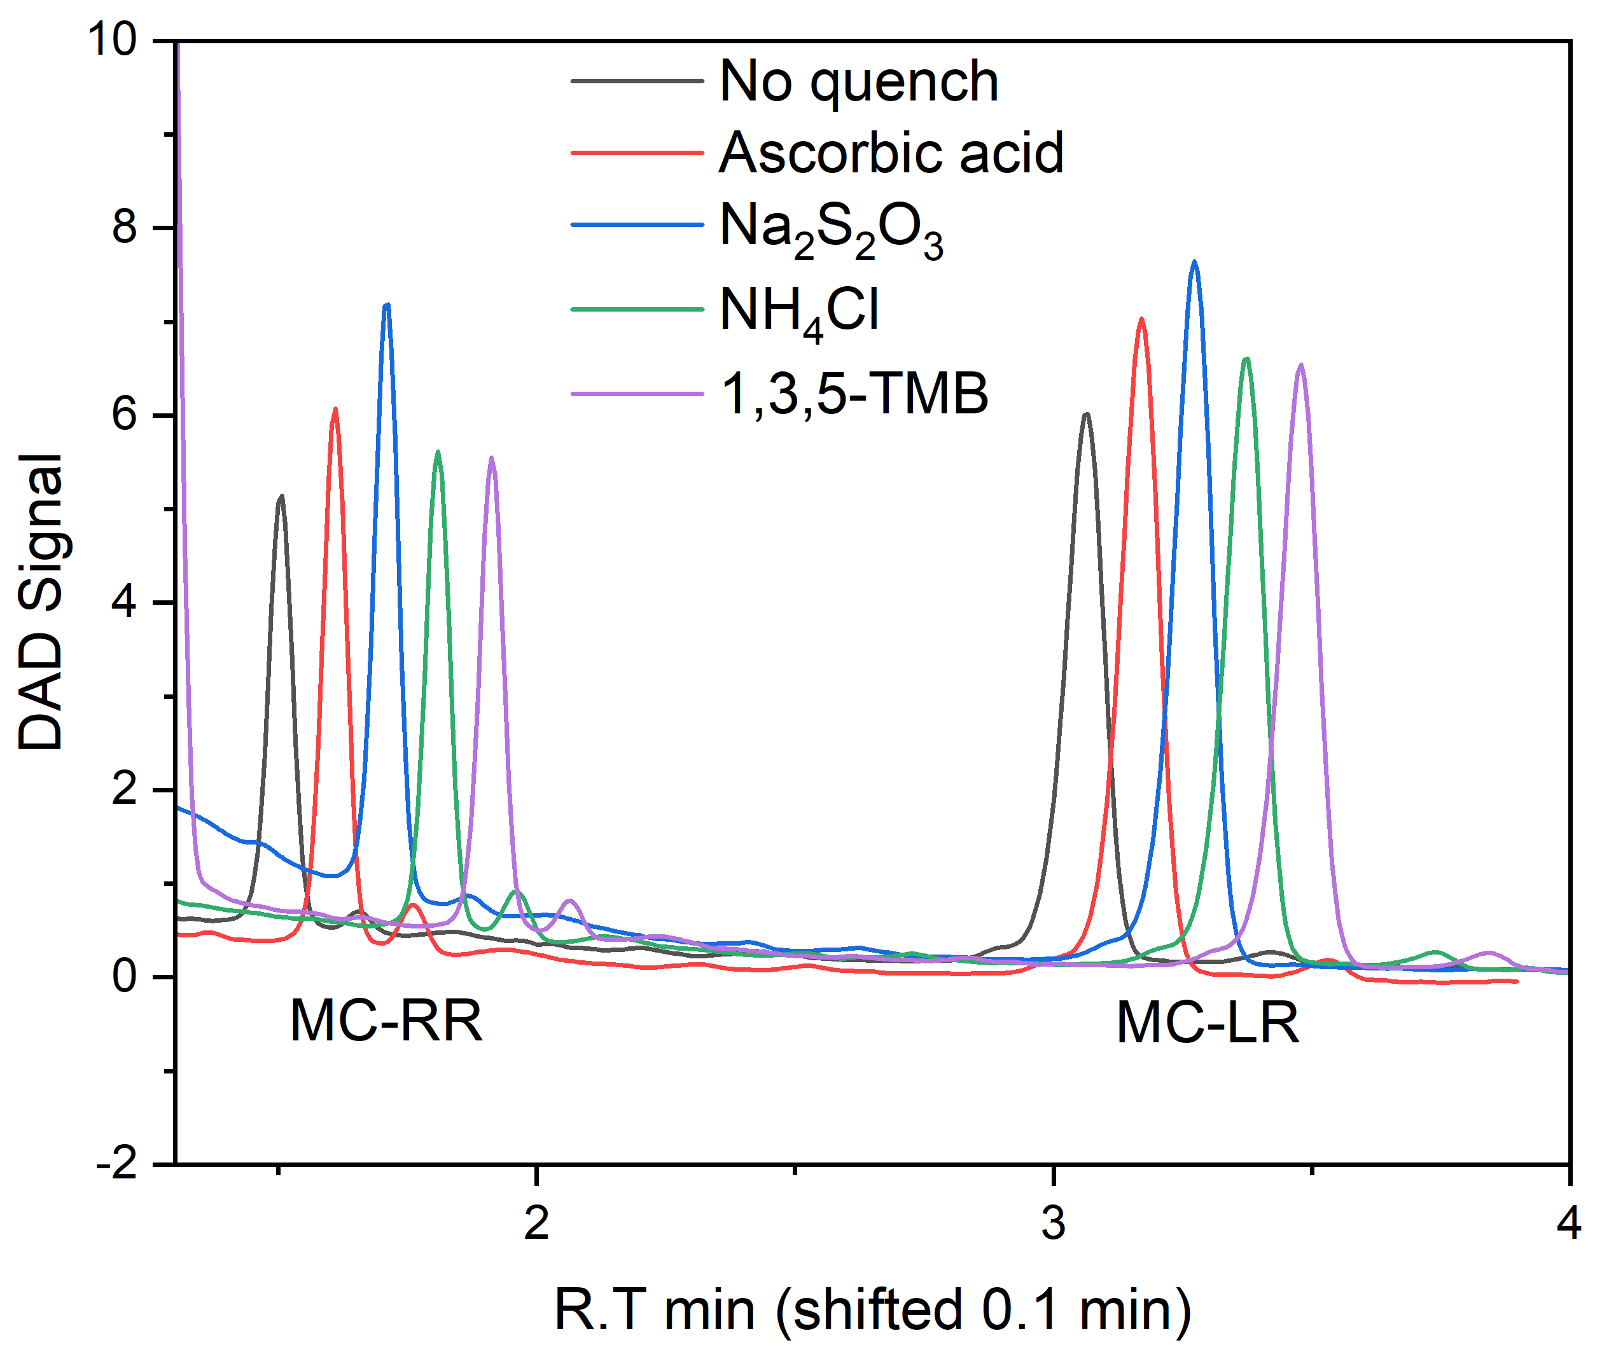
Signal at 10 min
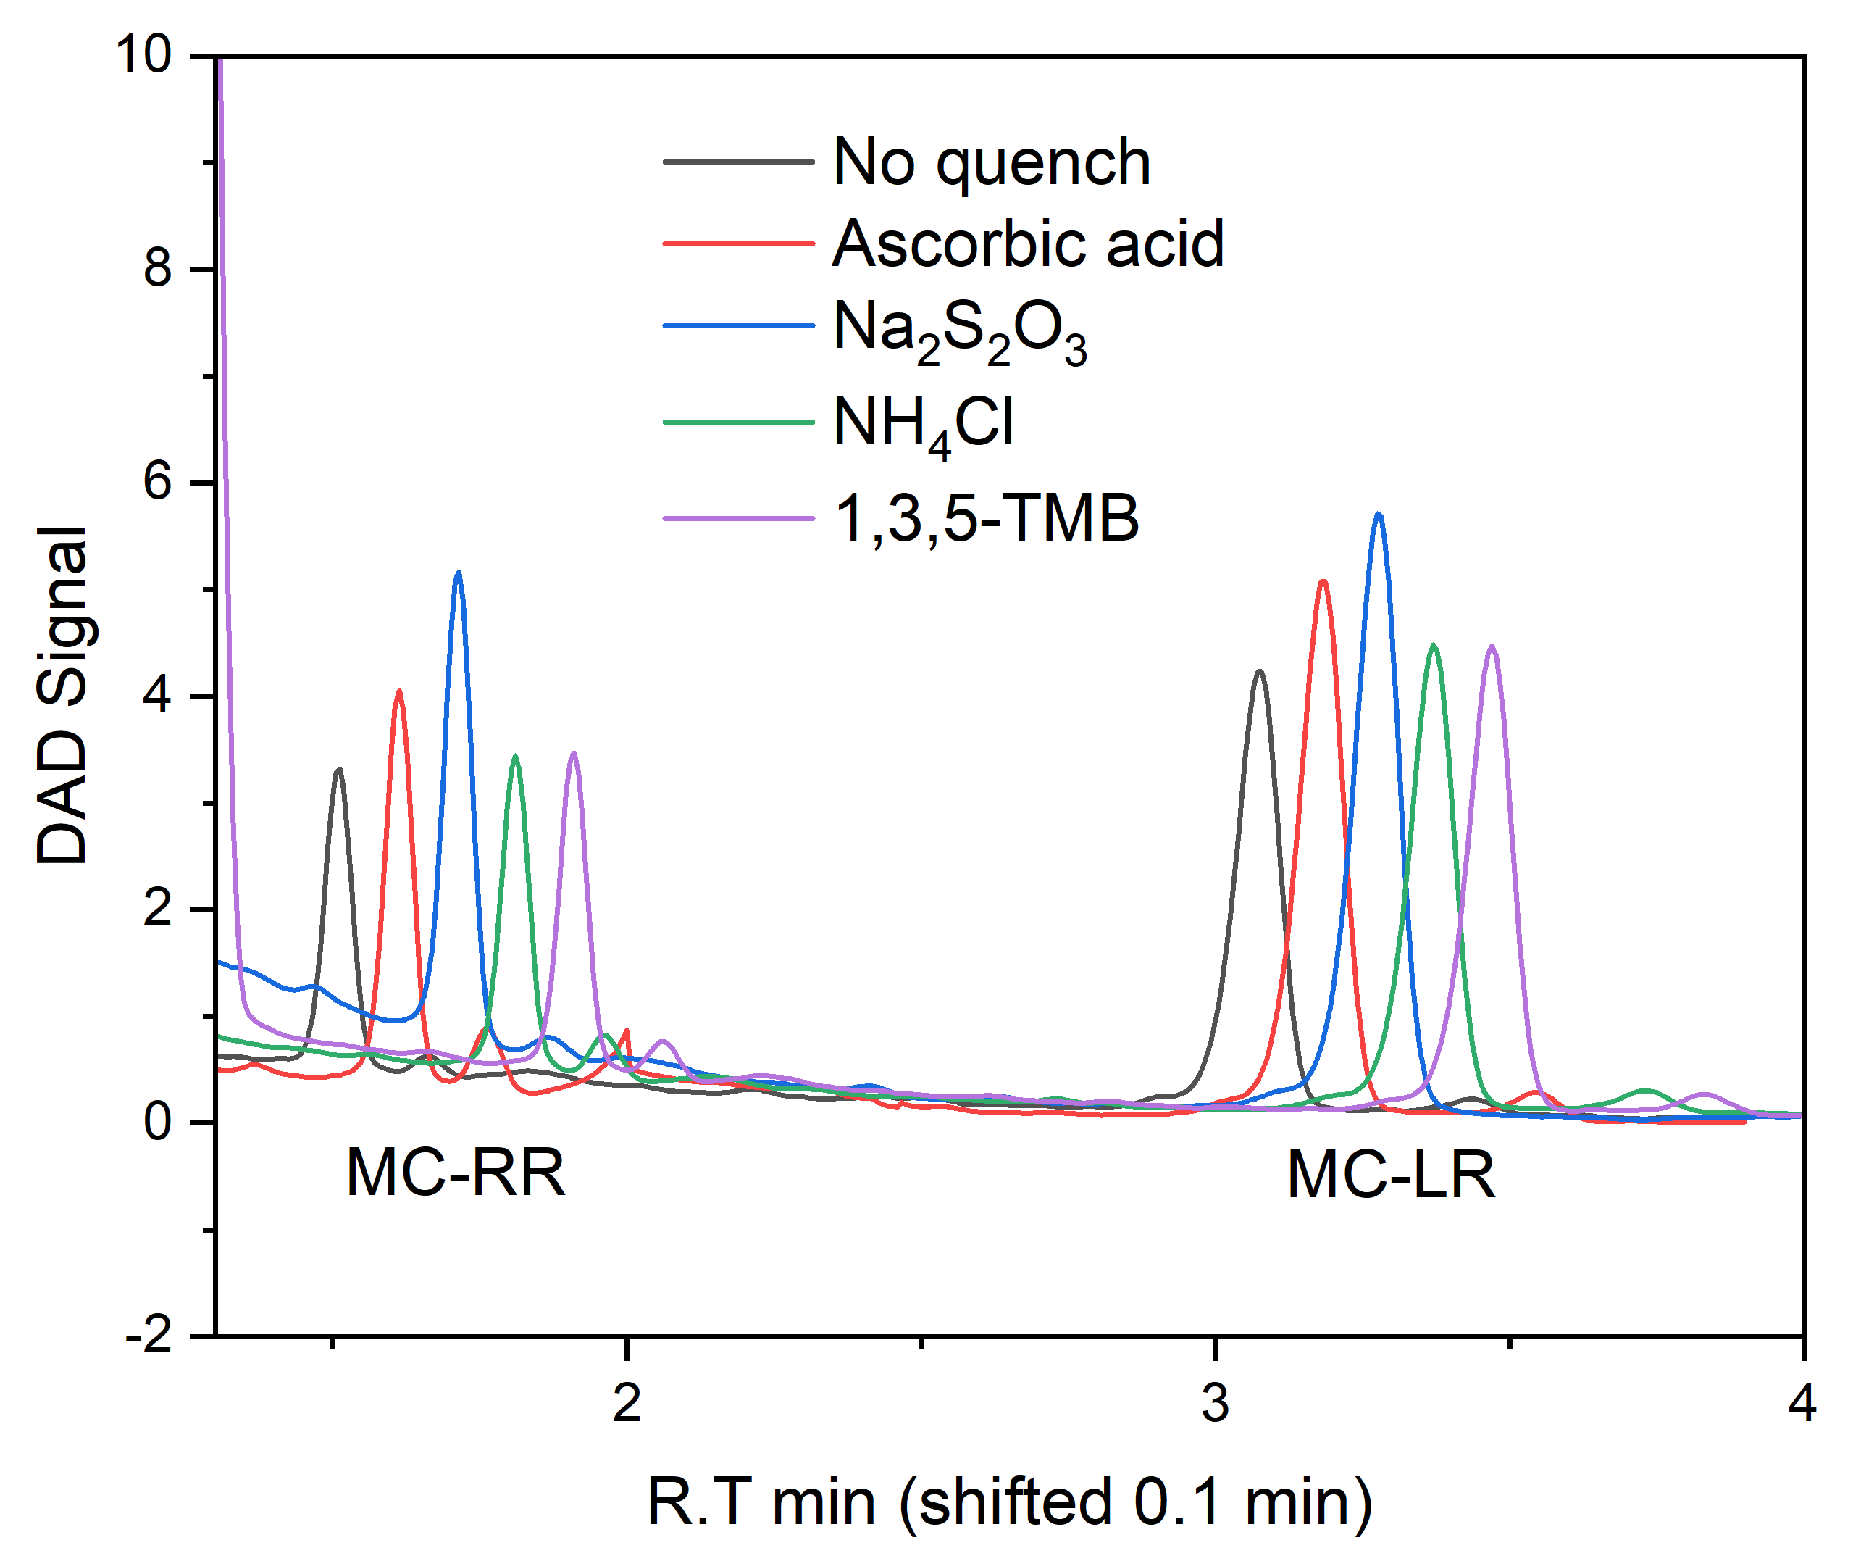
Figure T3-1. The impact of quenchers on the chlorinated MCs
1 µM MC-RR and 1 µM MC-LR were chlorinated by 28 µM chlorine, at pH 7.4 (5 mM). The DAD signal was shown as follows: the sample without quenching, and quenching by 140 µM ascorbic acid, 140 µM Na₂S₂O₃, 140 µM NH₄Cl, and 140 µM 1,3,5-trimethoxybenzene, respectively.
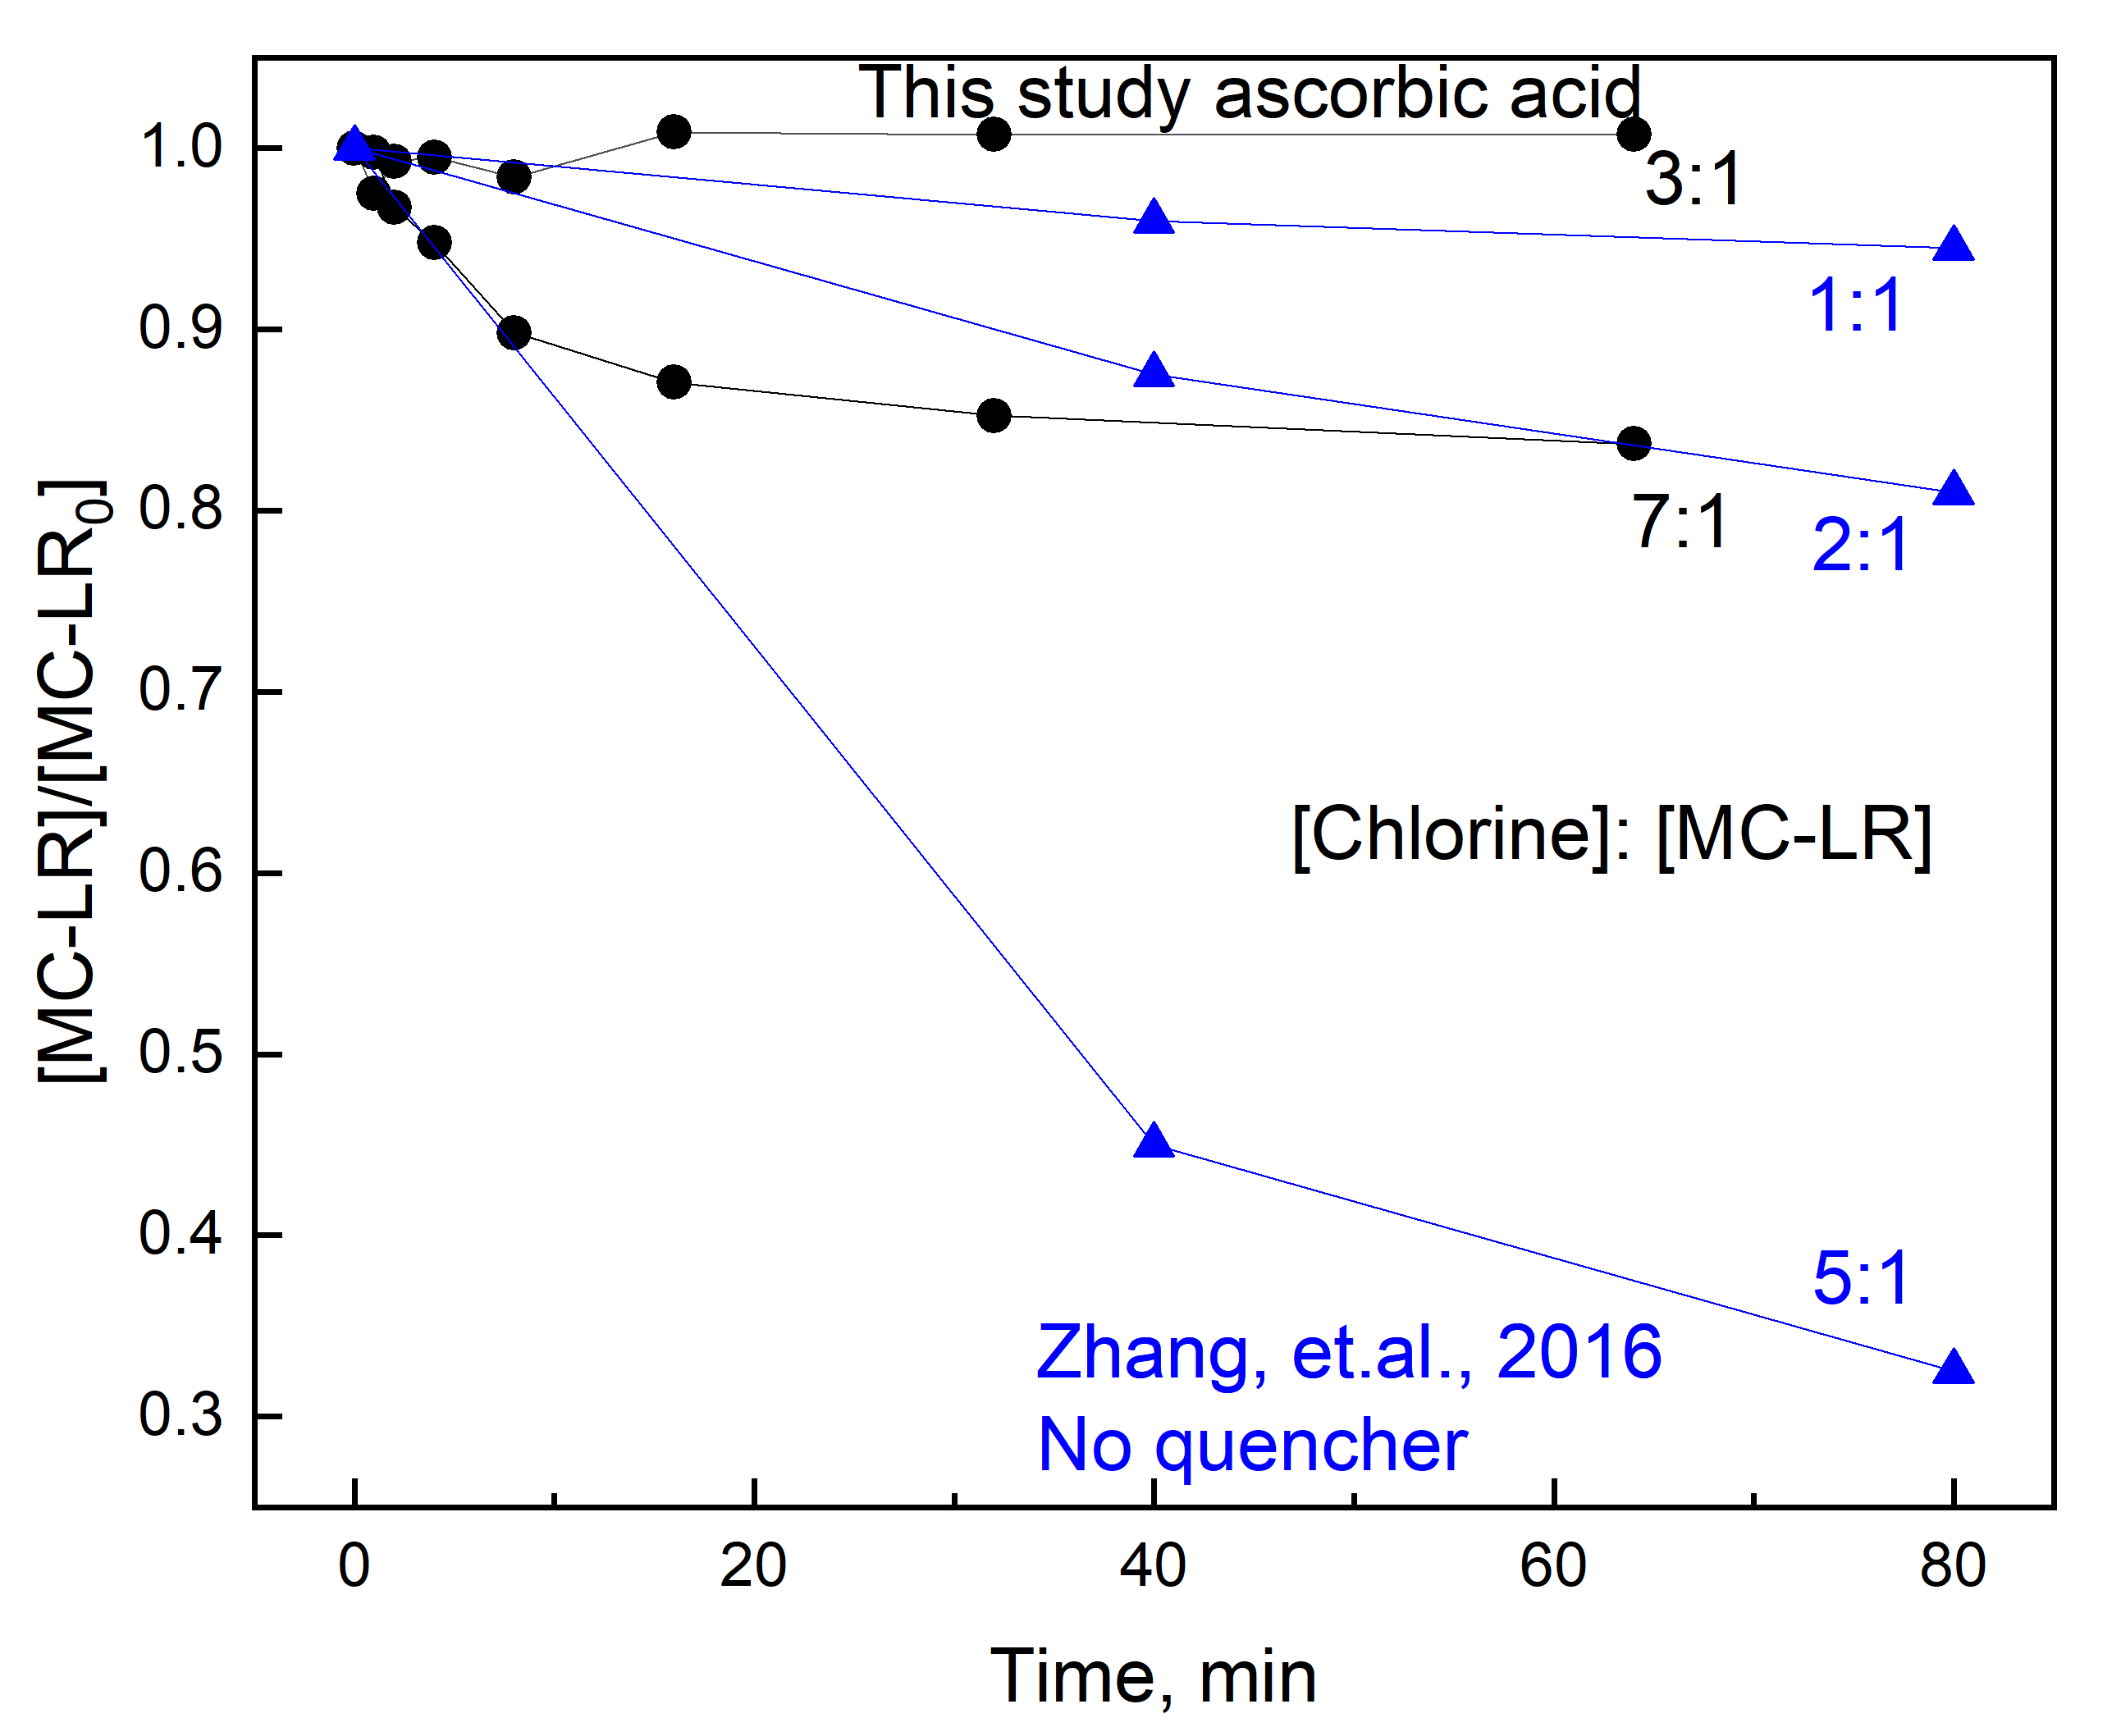
Figure T3-2. The comparison between two MC-LR detoxification experiments.

In Zhang et al.’s study, the chlorination with chlorine to MC-LR ratios as 1:1, 2:1, and 5:1 resulted in a slight decrease in cytotoxicity. The cell viabilities (compared with control) for MC-LR chlorinated by 1, 2, and 5 fold of chlorine were not significantly different (Within the range of 55% to 60 %). On the other hand, around 70% MC-LR degraded (based on the LC-MS results) at a chlorine-to-MC-LR ratio of 5:1. In this study, no apparent degradation of MC-LR was observed within 3 fold of chlorine. Thus, the ascorbic acid-quenched samples were more consistent with the cytotoxicity evolution.

Text S4. Kinetic model simulations, details
The empirical equation for chlorine decay in the tested systems is based on the following two equations,
$\frac{d{\left[FAC\right]}_{t}}{dt}=-{k_{app,C}×{\left[C\right]}_{t}×\left[FAC\right]}_{t}$ Eq. 6
$\frac{d{\left[FAC\right]}_{t}}{dt}=-{{\sum_{i}^{n}{k_{app,C_{i}}}}_{}×{\left[C_{i}\right]}_{t}×\left[FAC\right]}_{t}$ Eq. 7
Where in Eq. 6, more than one type of reducing agent contributed to the chlorine decay; in Eq. 7, only primary reducing agent contributed to the chlorine consumption. The empirical equation was based on these two assumptions: (1) only one reducing agent exists or all the existing reducing agents have the same second order kinetic constant; (2) the chlorine decay can be precisely fitted by the pseudo-first-order reaction.

The empirical equation was validated by comparing the tested and predicted chlorine residues in the tested systems as shown in Figure T4-1.
Figure T4-1. Depletion of chlorine in tested water matrices.

This was done by taking the [FAC] depletion into consideration. FAC exposure was calculated by simulation of the time course nonlinear FAC depletion Simulating FAC exposure was conducted by calculating the area under the curve of [FAC]_{t} verses t, Eq. 8.
$FAC exposure =\int_{60}^{t}{{\left[FAC\right]}_{t}dt}$ Eq. 8.
The chlorine decay in tested reactions ([FAC]_{t}) was predicted by the empirical equation, Eq. 9.
${\left[FAC\right]}_{t}={\left[FAC\right]}_{i}×e^{\frac{t-T_{i}}{T_{r}-T_{i}}×ln\frac{{\left[FAC\right]}_{r}}{{\left[FAC\right]}_{60s}}}$ Eq. 9.
Where the [FAC]_{i} and [FAC]_{r} present initial and residual [FAC]; T_{i}, and T_{r} are the times of the first sample and residual analysis, respectively. Similarly, the chlorine exposure was further obtained based on the empirical equations by integration method shown in Figure T4-2. No significant difference between calculated FAC exposure based on Eq. 6 and calculated CT value at different time intervals was observed.
Figure T4-2. Chlorine exposure simulation.

In addition, when measured using DPD/KI, N-chloramines contributed to the total chlorine signal (mostly as combined chlorine) and can further decompose to produce NH₃ and aldehydes (RCHO) or reverse back to the free amines (-NH₂) ^{11, 12}. In this study, by replacing the quenching agent ascorbic acid with excess 1,3,5-trimethoxybenzene (TMB, TMB:FAC=5:1) which quenches FAC via substitution reactions, the degradation of the tested amino acids continued even with the FAC reading below detection limit (0.02 mg/L Cl₂).
For the chlorination of MC-LR, Huang and Mackay (2020)¹³ noticed the differences between k_{app(MCLR, FAC)} obtained from reactions quenching with thiosulfate and TMB. By considering the formed N-chloro-MC-LR as a part of degraded MC-LR in their study, the TMB was selected as quencher, which led to greater k_{app (MCLR, FAC)}.

Text S5. Analytical Methods
Anions including Cl⁻ in sodium hypochlorite stock, buffer solutions, and real water samples were quantified using a Dionex™ Integrion™ high pressure ion chromatography (HPIC™, Thermo Fisher) system. Free and total chlorine dosages were determined using the USEPA DPD method (HACH 8021). Post-reaction pH values and chlorine residues ([FAC]_{r}) were measured immediately.
Amino acids were analyzed by UPLC coupled with a fluorescence detector (FLD) with precolumn OPA derivatization. Quenched amino acids form fluorescent compounds following OPA derivatization as described in the figure below.
The OPA derivatization of amino acids for UPLC-FLD analysis
Though quenching with ascorbic acid and OPA derivatization, covalent changes on both amine and sidechains of amino acids are reflected in the results (Figure T5-1).

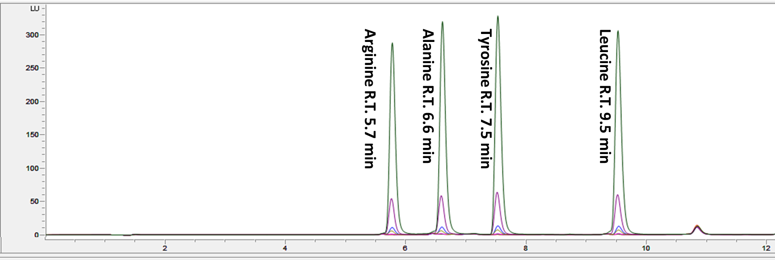
Figure T5-1. Analysis of amino acids (Arginine, Alanine, Tyrosine, and Leucine) by UPLC-FLD from 0.02 -10 µM.

Lower levels of MCs (1 – 100 µg/L) were analyzed were qualified and quantified by using Ultra‐high performance liquid chromatography (UltiMate™ 3000 rapid separation dual system with a RS pump for chromatographic separation and a SD pump for the loading and conditioning phase of online solid phase extraction) coupled to triple quadrupole mass spectrometer (TSQ Quantis™, Figure T5-3 and Table T5-1). Thermo Scientific SII software was used to control these pumps, in conjunction with Tracefinder 5.1 software (Thermo Fisher Scientific, Waltham, MA). For analyte concentration, a Hypersil Gold aQ (20 x 2mm, 12 um particle size) column was used as the sorbent for online solid phase extraction. For analyte separation, a Hypersil Gold C-18 column was employed (50 x 2.1 mm, 1.9 µm particle size).
High levels of MCs (50 – 1000 µg/L) were quantified with an Agilent 1260 liquid chromatograph equipped with a reversed phase C18 column (Poroshell 120, EC-C18, 4.6 × 100 mm, 2.7 µm). MCs were isolated using an isocratic flow of 0.1 % (v/v) trifluoroacetic acid in purified water and acetonitrile at an eluent ratio of 59:41, with a flow rate of 1.0 mL min⁻¹, detection wavelength of 238 nm, injection volume of 20 µL, and column temperature of 40 ºC. As shown in Figure T2-2, MCs elute with the order of MC-RR (1.5 min), MC-YR (2.4 min), MC-LR (2.7 min), and MC-LA (7.3 min).

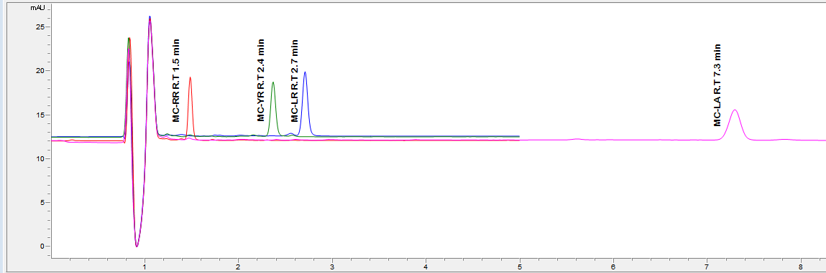
Figure T5-2. High level range (50 – 1000 µg/L) Microcysins detection with UHPLC-DAD.

Table T5-1. Microcystin molecular formulas, theoretical and observed m/z*
MCs | Formula | Theorticalm/z | C | H | N | O | Observed m/z
 |  |  |  |  |  |  | (M+2H)⁺² | (M+H)⁺
MC-LR | C₄₉H₇₄N₁₀O₁₂ | 994.5488 | 49 | 74 | 10 | 12 |  | 995.5541
MC-RR | C₄₉H₇₅N₁₃O₁₂ | 1037.566 | 49 | 75 | 13 | 12 | 519.7897
MC-LA | C₄₆H₆₇N₇O₁₂ | 909.4848 | 46 | 67 | 7 | 12 |  | 910.4926
MC-YR | C₅₂H₇₂N₁₀O₁₃ | 1044.528 | 52 | 72 | 10 | 13 |  | 1045.533
* Measurements made by LC-MS

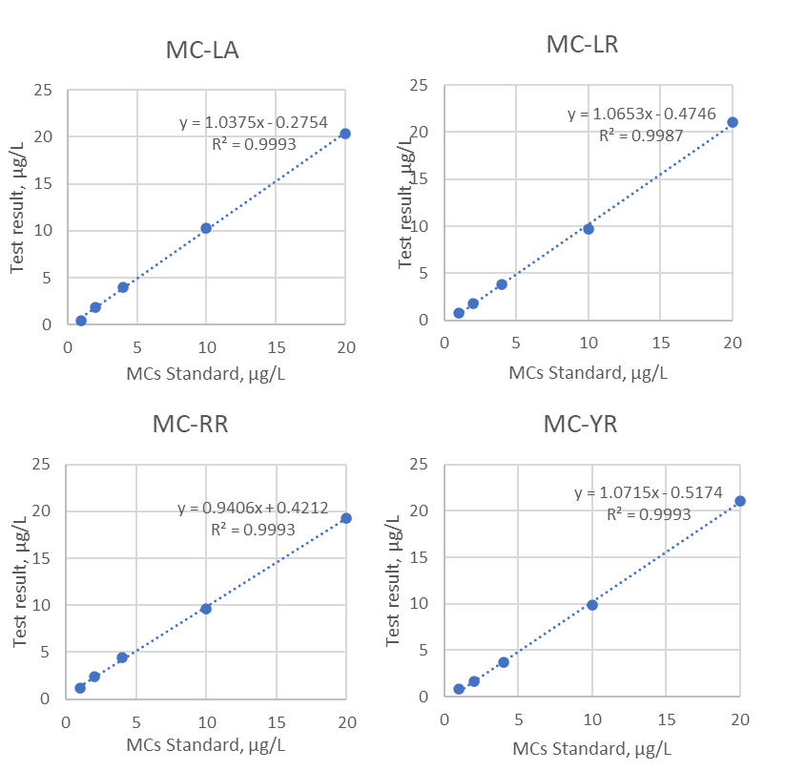
Figure T5-3. Online solid phase extraction-LC-MS analysis degraded MCs (mixture). Low level range (1 – 20 µg/L) mixed microcystins.

Dissolved organic carbon (DOC) was measured as non-purgeable organic carbon (NPOC) using a total organic carbon analyzer (Shimazu TOC-V) with potassium hydrogen phthalate as standard. The UV/vis absorption of tested water samples was measured using a Agilent 8453 spectrophotometer.
Disinfection by-product (DBPs) measured included 66 regulated and unregulated priority DBPs, with 10 trihalomethanes (THMs), 13 haloacetic acids (HAAs), 10 haloacetonitriles (HANs), 9 haloketones (HKs), 7 halonitromethanes (HNMs), 13 haloacetamides (HAMs), and 4 haloaldehydes (HALs) (Table SX). Water samples (100 mL) were adjusted to a pH < 1 using concentrated sulfuric acid, spiked with 30 g of sodium sulfate, and extracted using 5 mL of methyl tert-butyl ether (MTBE). Samples were shaken for 15 min on a mechanical shaker, after which the aqueous layer was allowed to separate from the organic layer for 10 min before removing the organic layer into a conical test tube. This was repeated 3 times for a total of 15 mL of organic layer. The removed organic layer was then passed through dried sodium sulfate and concentrated to 200 µL under nitrogen gas, and split into two 100 µL aliquots. The first aliquot was spiked with an internal standard (1,2-dibromopropane) before analysis of THMs, HALs, HANs, HKs, HNMs, and I-THMs by GC-MS. The second aliquot was derivatized using diazomethane for the analysis of HAAs. Quantification of DBPs was done using an Agilent 7890 GC coupled to an Agilent 5977A mass spectrometer with electron ionization (Agilent Technologies, Santa Clara, CA) in selected ion monitoring (SIM) mode. Further details including instrumental parameters can be found elsewhere. ^{x}

Table SX. Molecular Mass, quantifier and qualifier ions, and limits of quantification (LOQs) for DBPs quantified.
DBP Class | Name |  | Abbrev. | Molecular mass (Da) | Quantifier ion (m/z) | Qualifier ion (m/z) | LOQ*  (µg/L)
THMs | Trichloromethane | TCM |  | 119.38 | 83.0 | 85.0 | 0.1
THMs | Tribromomethane | TBM |  | 252.73 | 173.0 | 252.0 | 0.1
THMs | Dibromochloromethane | DBCM |  | 208.28 | 129.0 | 127.0 | 0.1
THMs | Bromodichloromethane | BDCM |  | 163.83 | 83.0 | 129.0 | 0.1
THMs | Dichloroiodomethane | DCIM |  | 210.83 | 83.0 | 126.9 | 0.1
THMs | Bromochloroiodomethane | BCIM |  | 255.28 | 128.9 | 126.9 | 0.1
THMs | Dibromoiodomethane | DBIM |  | 299.73 | 172.8 | 299.7 | 0.1
THMs | Chlorodiiodomethane | CDIM |  | 302.28 | 174.9 | 126.9 | 0.1
THMs | Bromodiiodomethane | BDIM |  | 346.73 | 218.8 | 220.8 | 0.1
THMs | Triiodomethane | TIM |  | 393.73 | 393.7 | 266.8 | 0.1
HAAs | Chloroacetic acid | CAA |  | 94.5 | 108.0 | 77.0 | 0.1
HAAs | Dichloroacetic acid | DCAA |  | 128.94 | 83.0 | 85.0 | 0.03
HAAs | Trichloroacetic acid | TCAA |  | 163.39 | 119.0 | 117.0 | 0.03
HAAs | Bromoacetic acid | BAA |  | 138.95 | 152 | 154 | 0.03
HAAs | Dibromoacetic acid | DBAA |  | 217.84 | 173.0 | 175.0 | 0.03
HAAs | Tribromoacetic acid | TBAA |  | 296.74 | 251.0 | 253.0 | 0.25
HAAs | Bromochloroacetic acid | BCAA |  | 173.39 | 129.0 | 127.0 | 0.03
HAAs | Dibromochloroacetic acid | DBCAA |  | 252.29 | 207.0 | 209.0 | 0.05
HAAs | Bromodichloroacetic acid | BDCAA |  | 207.84 | 163.0 | 161.0 | 0.1
HAAs | Iodoacetic acid | IAA |  | 185.95 | 200.0 | 73.0 | 0.025
HAAs | Chloroiodoacetic acid | CIAA |  | 220.39 | 234.0 | 175.0 | 0.125
HAAs | Bromoiodoacetic acid | BIAA |  | 264.84 | 151.0 | 278.0 | 0.03
HAAs | Diiodoacetic acid | DIAA |  | 311.85 | 326.0 | 199.0 | 0.05
HALs | Trichloroacetaldehyde | TCAL |  | 147.39 | 82.0 | 110.9 | 0.1
HALs | Bromodichloroacetaldehyde | BDCAL |  | 191.84 | 83.0 | 111/163.8 | 0.1
HALs | Dibromochloroacetaldehyde | DBCAL |  | 236.29 | 128.9 | 127.9 | 0.1
HALs | Tribromoacetaldehyde | TBAL |  | 280.74 | 172.8 | 171.8 | 0.1
HKs | 1,1-Dichloropropanone | 11DCP |  | 126.97 | 63.0 | 83.0 | 0.25
HKs | Chloropropanone | CP |  | 92.52 | 92.0 | 94.0 | 0.1
HKs | 1,1,1-Trichloropropanone | 111TCP |  | 161.41 | 125.0 | 127.0 | 0.1
HKs | 1,1-Dibromopropanone | 11DBP |  | 215.87 | 216.0 | 218.0 | 0.1
HKs | 1-Bromo-1,1-dichloropropanone | 1B11DCP |  | 205.87 | 125.0 | 127.0 | 0.1
HKs | 1,3-Dichloropropanone | 13DCP |  | 126.97 | 77.0 | 49.0 | 0.1
HKs | 1,1,3-Trichloropropanone | 113TCP |  | 161.41 | 77.0 | 83.0 | 0.1
HKs | 1,1,3,3-Tetrachloropropanone ^{b} | 1133TeCP |  | 195.86 | 83.0 | 85.0 | 0.1
HKs | 1,1,3,3-Tetrabromopropanone | 1133TeBP |  | 373.66 | 200.8 | 119.9 | 0.1
HAMs | Chloroacetamide | CAM |  | 93.51 | 93.0 | 44.0 | 0.1
HAMs | Bromoacetamide | BAM |  | 137.96 | 137.0 | 44.0 | 0.1
HAMs | Dichloroacetamide | DCAM |  | 127.96 | 44.0 | 127.0 | 0.1
HAMs | Bromochloroacetamide | BCAM |  | 172.41 | 44.0 | 173.0 | 0.1
HAMs | Iodoacetamide | IAM |  | 184.96 | 158.0 | 85.0 | 0.1
HAMs | Trichloroacetamide | TCAM |  | 162.4 | 44.0 | 82.0 | 0.1
HAMs | Dibromoacetamide | DBAM |  | 216.86 | 44.0 | 217.0 | 0.1
HAMs | Bromodichloroacetamide | BDCAM |  | 206.85 | 44.0 | 128.0 | 0.1
HAMs | Chloroiodoacetamide | CIAM |  | 206.85 | 92.0 | 219.0 | 0.1
HAMs | Bromoiodoacetamide | BIAM |  | 263.86 | 136.0 | 138.0 | 0.1
HAMs | Dibromochloroacetamide | DBCAM |  | 251.3 | 44.0 | 128.0 | 0.1
HAMs | Tribromoacetamide | TBAM |  | 295.76 | 44.0 | 295.0 | 0.1
HAMs | Diiodoacetamide | DIAM |  | 310.86 | 184.0 | 311.0 | 0.1
HNMs | Trichloronitromethane | TCNM |  | 164.38 | 116.9 | 119.0 | 0.1
HNMs | Dichloronitromethane | DCNM |  | 129.93 | 83.0 | 85.0 | 0.1
HNMs | Bromochloronitromethane | BCNM |  | 174.38 | 129.0 | 127.0 | 0.1
HNMs | Dibromonitromethane | DBNM |  | 218.83 | 172.8 | 171.0 | 0.1
HANs | Trichloroacetonitrile | TCAN |  | 144.39 | 108.0 | 110.0 | 0.1
HANs | Dichloroacetonitrile | DCAN |  | 109.94 | 74.0 | 82.0 | 0.75
HANs | Chloroacetonitrile | CAN |  | 75.50 | 75.0 | 77.0 | 0.1
HANs | Bromochloroacetonitrile | BCAN |  | 154.39 | 153.0 | 155.0 | 0.1
HANs | Bromoacetonitrile | BAN |  | 119.95 | 118.90 | 120.9 | 0.1
HANs | Dibromoacetonitrile | DBAN |  | 198.84 | 117.9 | 199.0 | 0.1
HANs | Iodoacetonitrile | IAN |  | 166.95 | 167.0 | 126.9 | 0.1

Total organic chlorine (TOCl), bromine (TOBr), and iodine (TOI) measurements were made using a Mitsubishi total organic halogen system (Mitsubishi Chemical Analytech, Chigasaki, Japan) and a Dionex Integrion ion chromatograph (IC) (Dionex, Sunnyvale, CA). Aqueous samples were adjusted to pH 2 with concentrated nitric acid, passed through two pre-packed activated carbon (AC) columns in series using an adsorption module (TXA-04), and rinsed with 10 mL of 5000 mg/L of KNO₃ adjusted to pH 2. The two ACs were then loaded into a ceramic boat and loaded into a quick furnace (AQF-2100H) using an automatic solid sampler (ASC-240S). The ACs containing the sample were then combusted inside the furnace at 1000°C. The gas effluent from the furnace was then bubbled into a centrifuge tube containing 5 mL of absorption solution (0.003% H₂O₂, 0.01 mM phosphate) using a gas absorption unit (AU-250) and subsequently analyzed for chloride, bromide, and iodide using ion chromatography. The IC system included a 500 µL sample loop, an IonPac AS20 analytical column, an IonPac AS20 guard column, and a Dionex EGC 500 KOH generator. Run times were 30 min using gradient elution with NaOH: 5 mM from 0-5 min, 30 mM from 5-15 min, and 50 mM from 15-30 min. External calibration curves were constructed using two stock solution mixes (10 and 100 mg/L) of sodium chloride, sodium bromide, and sodium iodide (1, 5, 10, 20, 30, 50, 75, 100, 200, 300, 500, and 750 µg/L) in nanopure water. Calibration curves were prepared fresh before sample analysis and checked with two calibration check-points (25 and 75 µg/L).
Non-target LC-MS analysis was conducted using an Agilent 1290 Infinity II ultrahigh performance liquid chromatograph (UHPLC) coupled to an Agilent 6545 quadrupole time-of-flight (QTOF) mass spectrometer with negative ion-electrospray ionization (ESI), using UHPLC and MS parameters similar to the U.S Environmental Protection Agency (EPA) Method 544 for measuring microcystins and nodularin in drinking water.¹⁴ Parameters were set as following: 30,000 resolution, capillary voltage 5500 V, gas temperature 125 °C, drying gas 12 L min⁻¹, nebulizer pressure 40 psi, m/z 50–1700 scan range, and gradient LC program (Table SX).

Table SX. UHPLC conditions for quantitative analyses
Mobile Phase | - 20 mM ammonium formate in ultrapure water  B) methanol
Gradient | Time (min)  0  2.0  16  16.1  22  22.1  26.0 | %B  10  10  80  90  90  10  10
Flow Rate | 0.4 mL/min
Column | Agilent C18 (3.0 x 150 mm, 2.7 µm)
Temperature | 50º C
Injection Volume | 10 µL

Text S6. In vitro Cytotoxicity
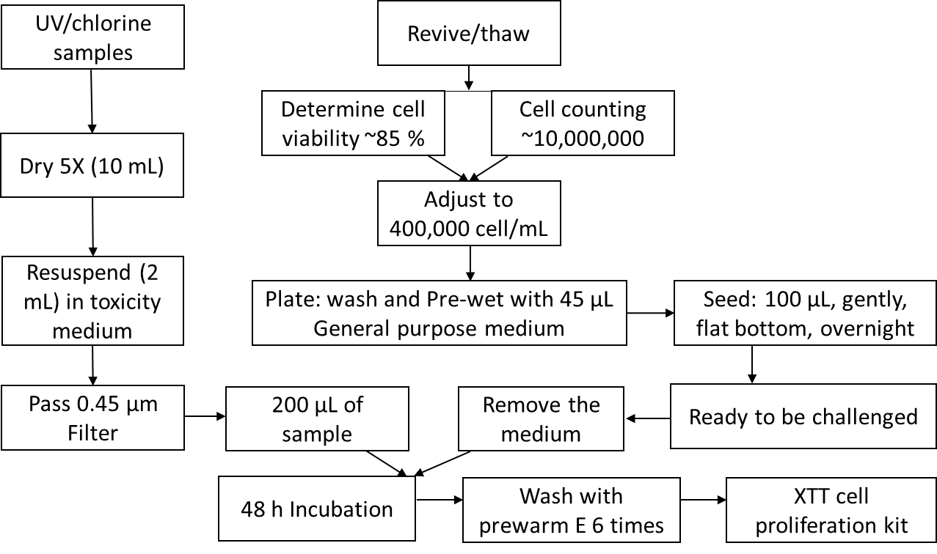
Figure T6-1. In vitro cytotoxicity assay protocol.

The toxicity of treated samples was assessed using HepaRG hepatocytes in vitro (Figure T3-1). Water samples were dried in a SpeedVac System (Thermo Electron Corporation, FL, USA), resuspended in Toxicity Medium (TM, Williams’ Medium E supplemented with glutamine and HepaRG™ toxicity medium supplement; Life Technologies, CA, USA) and filter sterilized (sterile 0.45 µm PTFE syringe filter, Thomas Scientific, NJ, USA). Terminally differentiated cryopreserved HepaRG cells were obtained from Life Technologies. HepaRG cells were thawed, seeded, maintained, and tested for toxicity according to the manufacturer’s procedure (Life Technologies HepaRG™ Cell User Guide). Cells were seeded onto a pre-wet sterile flat-bottom collagen-coated 96-well plate (4-5 × 10⁵ cells per well) in HepaRG™ Thaw, Plate, and General Purpose Working Medium (WM), allowed to settle for 10 min at room temperature and then transferred to a humidified 5% CO₂ incubator at 37 ºC. The next day and on the 4th day, cells were fed with TM. On the 7th day, confluent cells were exposed to treated water samples in TM and returned to a humidified 5% CO₂ incubator at 37 ºC. After 6 hours, cells were evaluated for cytopathic effects using a microscope.
The cytotoxicity was evaluated by comparing cell viabilities of treatment and control group in triplicate on the same plate by using XTT Cell Proliferation assay.
Specific Absorbance = A_{475nm}(Test) – A_{475nm}(Blank) – A_{660nm}(Test)
The cell viability was calculated by normalizing the specific absorbance of control sample (Toxicity medium).

Text S7. Chlorine speciation with added chloride ions.
Eq. 2
$$HOCl↔{OCl}^{-}{+ H}^{+}$$
logK_{eq,1} = -7.58 (20ºC, 0 M) (Morris, 1966)¹⁵
$$K_{a}=\frac{[{OCl}^{-}]{[H}^{+}] }{[HOCl]}={10}^{-7.537}(25ºC, 0 M)$$
K_{a} is the dissociation (acid ionization) constant.
Eq. 3
$$HOCl+{Cl}^{-}{+ H}^{+} ↔{Cl}_{2}{+ H}^{+}$$
logK_{eq,2} = 3.43 (20ºC, 0 M) (Sivey and Roberts, 2012)¹⁶
$$K_{d}=\frac{\left[HOCl\right][{Cl}^{-}]{[H}^{+}] }{{[Cl}_{2}]}={10}^{-3.4}{ mol}^{2}/L^{2}(25ºC, 0 M)$$
Eq. 3 occurs reversibly with the equilibrium as K_{d}. K_{d} is the disproportionation constant.
2HOCl ⇌ Cl₂O + H₂O logK_{eq,3} = -2.06 (20ºC, 0 M) (Sivey and Roberts, 2012)¹⁶ Eq. 4
H2OCl⁺ ⇌ HOCl + H⁺ logK_{eq,4} = 3- 4 (20ºC, 0 M) (Arotsky and Symons, 1962)¹⁷ Eq. 5

Simulation of chlorine speciation with added chloride ion was obtained according to the mass balance of Equations 2-5 from pH 6.4-9.4. The initial concentration of FAC was 28 µM with 0.1 mM chloride ion. By increasing chloride ion from 0.2 mM to 500 mM, each of the chlorine species was calculated and figured in Fig. 2. Based on the modified Davies equation, the equilibrium constants were calculated considering the ionic strength contributed by the presence of chloride ion (ionic strength < 0.5 M)^{18, 19}. The modified Davies equation is commonly used in drinking water or wastewater treatment processes, as Equations following:
$${-logγ}_{i}=AZ_{i}^{2}[\frac{\sqrt{i}}{1+\sqrt{i}}-0.3I]$$
$$A=1.82×{10}_{}^{6}{(DT)}^{-1.5}$$
$$D=\frac{60,954}{T+116}-68.937$$
Where, T stands for absolute temperature; the equation is valid for I < 0.5 M. (White’s Handbook of Chlorination and Alternative Disinfectants, Blank & Veatch, P78)¹⁸
In this modified Davies equation, the activity coefficients were assumed to be the same among monovalent ions, $γ_{m}$, and uncharged molecules were assumed to have negligible interaction with ions ($γ=1$). Two of these assumptions work with the constraint of I < 0.5 M. With the consideration of the impact of ionic strength, the equilibrium constant was calculated by means of activity rather than the molar concentration. Thus, the ‘corrected’ equilibrium constant was calculated by the following equations. ^{c}K_{a}, ^{c}K_{d} are corrected equilibrium constants for HOCl dissociation and disproportionation of Cl₂ based on the molar concentrations, respectively. For Eq. 3 and Eq. 4, the activity coefficient was irrelevant to the constants for the calculation. In model simulations ($25ºC,$ I < 0.5 M), k_{w} was assumed to be constant as 10⁻¹⁴ mol²/L² since the reported difference between pK_{w} ($25ºC,$ I = 0.1 M) and pK_{w} ($25ºC,$ I = 0.5 M) was minor (< 0.05%)²⁰.
$$K_{a}=\frac{\{{OCl}^{-}\}{\{H}^{+}\} }{\{HOCl\}}=\frac{γ_{m}\left[O{Cl}^{-}\right]γ_{m}{[H}^{+}] }{\left[HOCl\right]}=γ_{m}^{2}{×{}_{}^{c}K}_{a}^{}$$
$$K_{d}=\frac{\left\{HOCl\right\}\left\{{Cl}^{-}\right\}\{H^{+}\} }{\{{Cl}_{2}\}}=\frac{\left[HOCl\right]γ_{m}[{Cl}^{-}]{γ_{m}[H}^{+}] }{{[Cl}_{2}]}=γ_{m}^{2}{×{}_{}^{c}K}_{d}^{}$$

Text S8. MC-RR transformation products
The TPs of MC-RR generated by various treatment processes were analyzed by LC-Q-TOF-MS to investigate the degradation pathway and to obtain the TP concentration change during the reaction, separating from the low-level MC-TPs identification in mixture. The total or composite mass spectra in Figure T8-1 show the degradation of 1 µM MC-RR at two distinct removal time rates (C/C0, 50% and 99%, collected at 6 and 16 min, respectively).
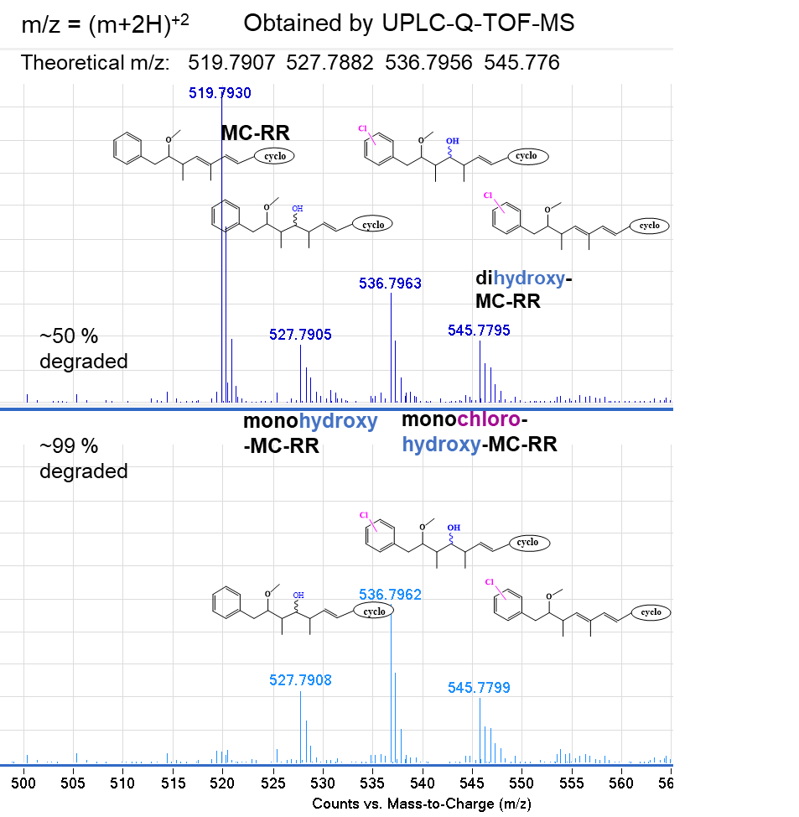
Figure T8-1. The MC-RR transformation by-products in UV/chlorine treatment

RCS generated by UV/chlorine could produce chlorinated intermediates²¹. Addition reaction by-products of MC-RR were observed in both 50% and 99% MC-RR degradation conditions. MC-RR, Monohydroxy-MC-RR, Monochloro-MC-RR, monochloro-hydroxy-MC-RR, and dihydroxy-MC-RR were identified and semi-quantified by UPLC-Q-TOF-MS analysis, as shown in the Figure T8-1. Even 99% MC-RR has been degraded, the TPs are still present in comparable abondance those at 50% degradation.
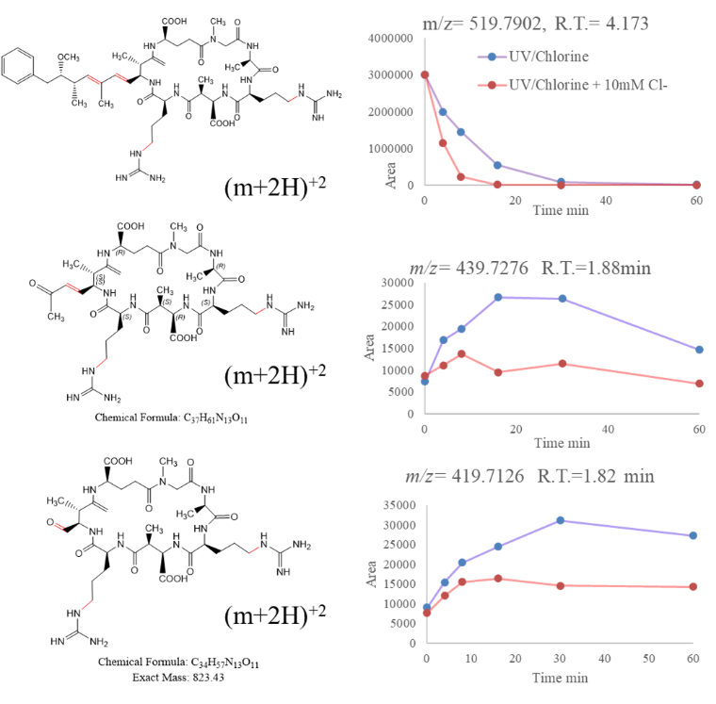
Figure T8-2. The MC-RR transformation by-products in UV/chlorine treatment
The toxicity of MCs is related to the Adda moiety, which leads to protein phosphatase (PP1 & PP2A) inhibitions²². Thus, the modifications on Adda sidechain are more relevant to the detoxification of MCs. The conjugated diene bond on Adda is potential oxidizable site by oxidants, i.e., free chlorine, or hydroxyl radicals^{23, 24}.
In addition, with the excitement of UV_{254nm}, the photo-isomerization of MCs may occur at unsaturated diene double bonds on the 4-5 and 6-7 positions, which are the main chromophores on MCs structure²⁵. The π bond at either 4-5 or 6-7 position can uncouple and leave only σ bond when the electron is promoted to a π* orbital. Then the cis-trans photo-isomerization in alkene may occur because of the rotation caused by the repelling between the electron in carbon 2p orbitals. By this mechanism, the π bond is weakened and more vulnerable to reactive species. Two types of TPs reflecting Adda changes were detected in MC-RR degradation by UV/chlorine and UV/chlorine + Cl– (Figure T9-2). TP (m/z 439.7276, z=2) matched with MC-RR by-product (C₃₇H₆₁N₁₃O₁₂) which is formed after bond cleavage at C₆ – C₇ on the Adda side chain of MC-RR as shown in Fig. T8-2. Also, TP (m/z 419.7126, z=2) matched with MC-RR by-product (C₃₇H₆₁N₁₃O₁₂) which is formed after bond cleavage at C₃ – C₄ on the Adda side chain of MC-RR. With the presence of 10 mM Cl–, the parent MC-RR degraded faster, and meanwhile, the lower levels of formed TPs were detected, which indicated the Cl– enhanced the reactivities for both MCs and TPs of MCs, especially through the bond cleavage on the Adda side chain.
Overall, the Adda side chain on MC structures is reactive towards reactive species in UV/chlorine with photo-isomerization effects. The detected MC-RR TPs can be grouped into two categories, non-bond-cleavage TPs (i.e., addition reactions, substitution reactions, and hydroxylation) and bond cleavage TPs. Due to the complexity of the MC structure, the other TPs related to the bond cleavage on the amino acid moieties were not identified by the UPLC-Q-TOF-MS analysis.

Text S9. Microcystin transformation products (TPs) without cleavage of Adda chain.
High-resolution mass spectrometry data were acquired using an Orbitrap Fusion Lumos mass spectrometer (Orbitrap MS, Thermo Scientific) using both positive and negative electrospray ionization (ESI) and were analyzed with Thermo Xcalibur 4.3 software.
The following mass spectra showed the comparison results for exact mass of predicted elemental composition and detected mass by matching both by-products and their fragments (Xcalibur-Freestyle-elemental composition with FTObritrap centroid algorism and 5 ppm mass tolerance).
The potential transformation location and by-products can be charactered by the exact concordance between observed mass and theoretical mass and confined by the limited possibilities of reactive sites.

TPs of MC-LR
C₄₉H₇₄N₁₀O₁₂ MC-LR m/z 994.5488
C₄₉H₇₅N₁₀O₁₂ [MC-LR+H]⁺¹ m/z 995.5566
TPs of MC-LR
Positive ion mode ESI-MS data

MC-LR TP1: Monochloro-hydroxy-MC-LR
C₄₉H₇₆N₁₀O₁₃Cl [MC-LR +HO+Cl +H]⁺¹ theo. m/z:1047.5276
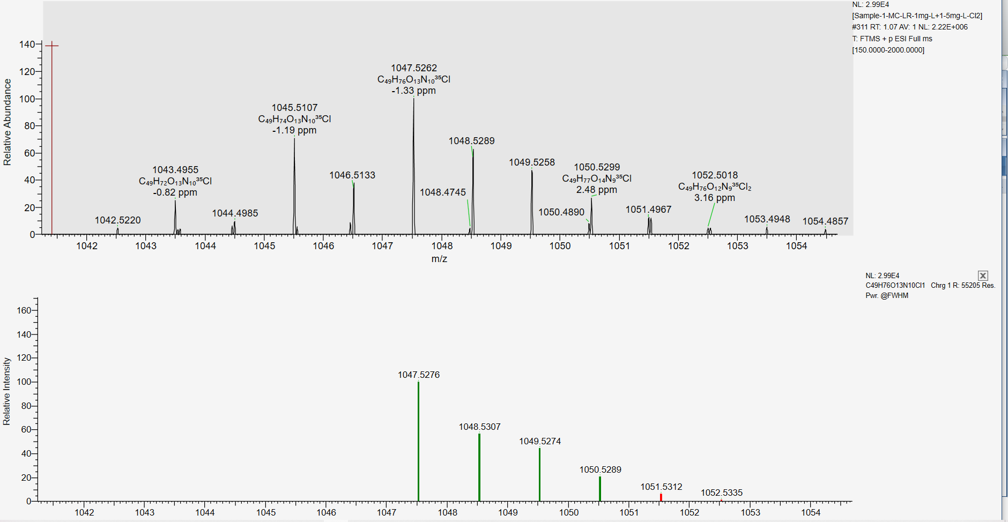
C₄₉H₇₆N₁₀O₁₃Cl
delta mass -1.33 ppm

MC-LR TP2: dihydroxy-MC-LR
C₄₉H₇₇N₁₀O₁₄ [MC-LR +2OH+H]⁺¹ theo. m/z 1029.5615
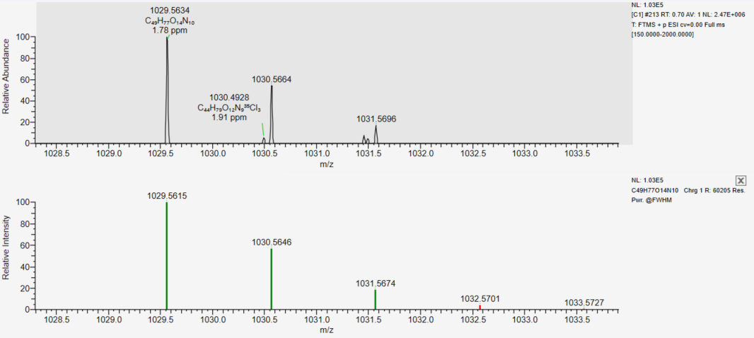
C₄₉H₇₇N₁₀O₁₄
delta mass 1.78 ppm
MC-LR TP3: monochloro-MC-LR
C₄₉H₇₄N₁₀O₁₂Cl [MC-LR +Cl–H+H]⁺¹ theo. m/z 1029.5171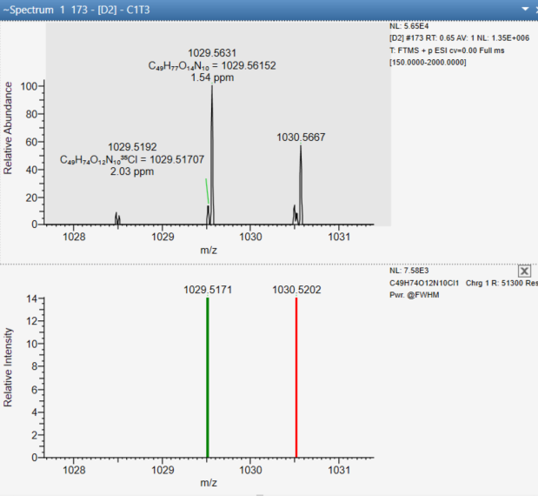
C₄₉H₇₄N₁₀O₁₂Cl
delta mass 1.54 ppm

MC-LR TP4: monohydroxy-MC-LR
C₄₉H₇₃N₁₀O₁₃ [MC-LR +OH–H–H]^{–1} theo. m/z 1009.5353
C₄₉H₇₃N₁₀O₁₃
delta mass 1.54 ppm
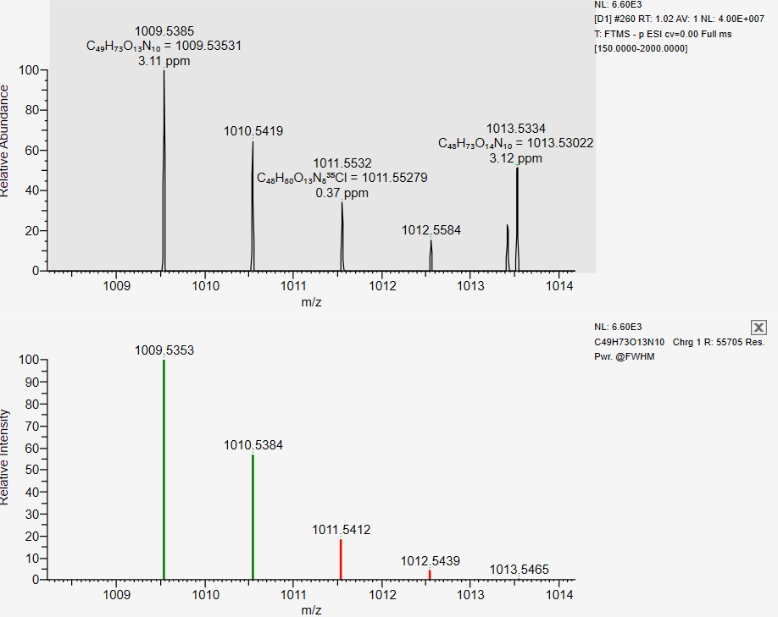
MC-LR TP5: trichloro-MC-LR
C₄₉H₇₅N₁₀O₁₂Cl₃ [MC-LR+3Cl-3H+2H]⁺² theo. m/z 550.2389 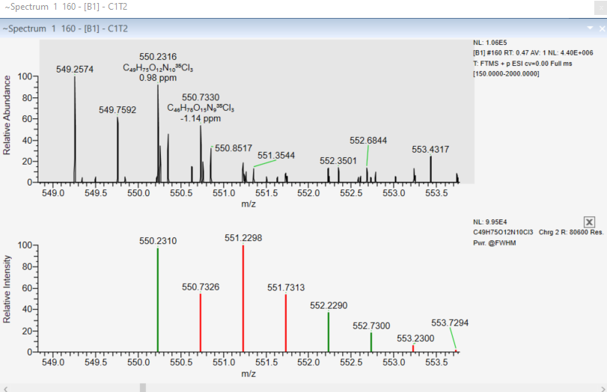
C₄₉H₇₅N₁₀O₁₂Cl₃
delta mass 0.98 ppm

MC-LR TP6: unknown TP structure- MC-LR
C₄₄H₇₇N₆O₆Cl theo m/z 821.5671

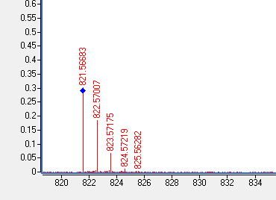
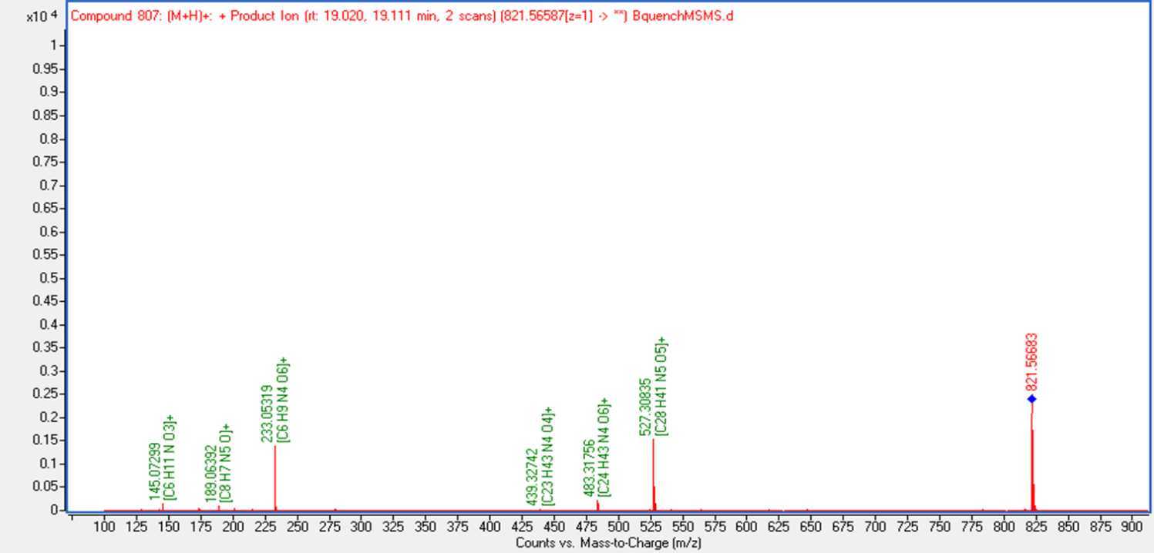
C₄₄H₇₇N₆O₆Cl
delta mass 1.20 ppm

TPs of MC-RR
C₄₉H₇₅N₁₃O₁₂ MC-RR m/z 1037.5658
C₄₉H₇₇N₁₃O₁₂ [MC-RR+2H]⁺² m/z 519.7901
TPs of MC-RR
Positive ion mode ESI-MS data
MC-RR TP1: monochloro-hydroxy -MC-RR
C₄₉H₇₈N₁₃O₁₃Cl [MC-RR+OH+Cl +2H]⁺² theo. m/z 545.7760
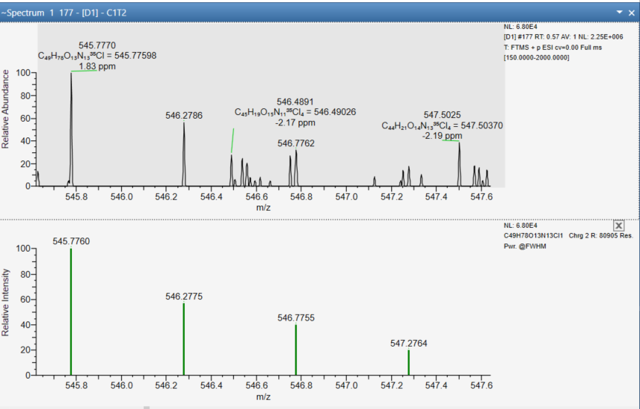
C₄₉H₇₈N₁₃O₁₃Cl
delta mass 1.83 ppm
MC-RR TP2: dihydroxy -MC-RR
C₄₉H₇₉N₁₃O₁₄ [MC-RR +2OH+2H]⁺² theo. m/z 536.7929
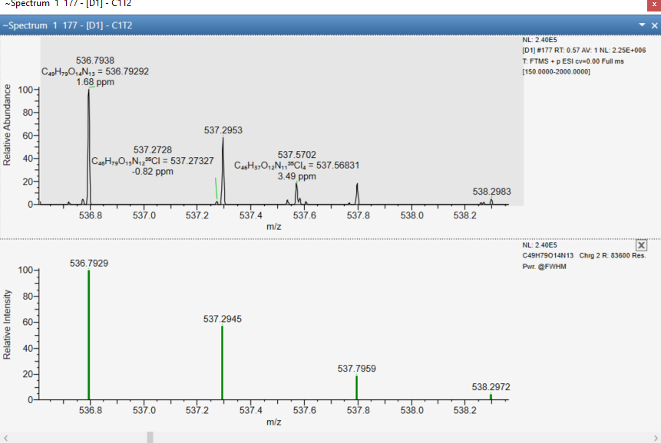
C₄₉H₇₉N₁₃O₁₄
delta mass 1.68 ppm
MC-RR TP3: Monochloro -MC-RR
C₄₉H₇₆N₁₃O₁₂Cl [MC-RR +Cl–H+2H]⁺² theo. m/z 536.7707
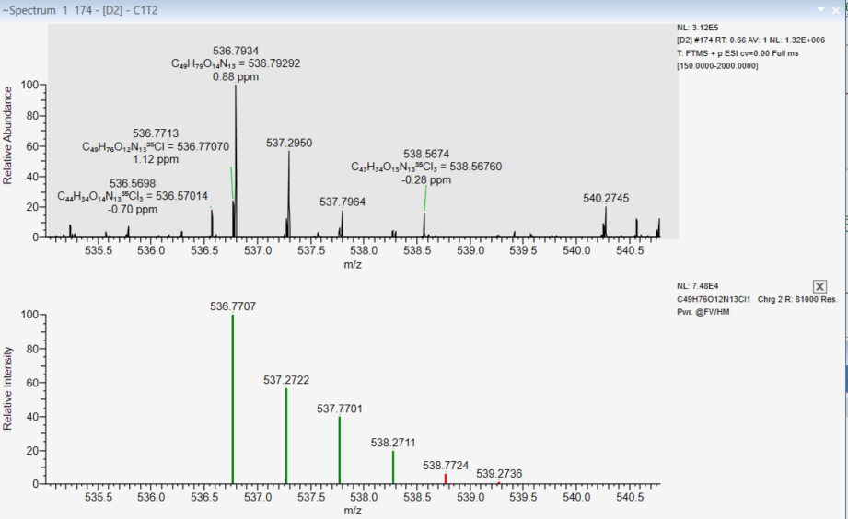
C₄₉H₇₆N₁₃O₁₂Cl
delta mass 0.88 ppm
MC-RR TP4: Monochloro - dihydroxy -MC-RR
C₄₉H₇₈N₁₃O₁₄Cl [MC-RR +2OH+Cl –H+2H]⁺² theo. m/z 553.7734
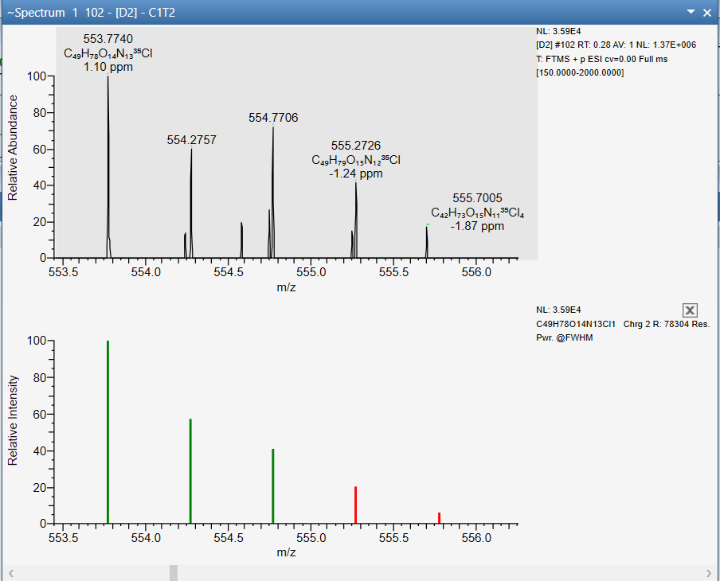
C₄₉H₇₈N₁₃O₁₄Cl
delta mass 1.10 ppm
MC-RR TP5: dichloro - hydroxy -MC-RR
C₄₉H₇₇N₁₃O₁₃Cl₂ [MC-RR +OH +Cl+Cl–H +2H]⁺² theo. m/z 562.7565
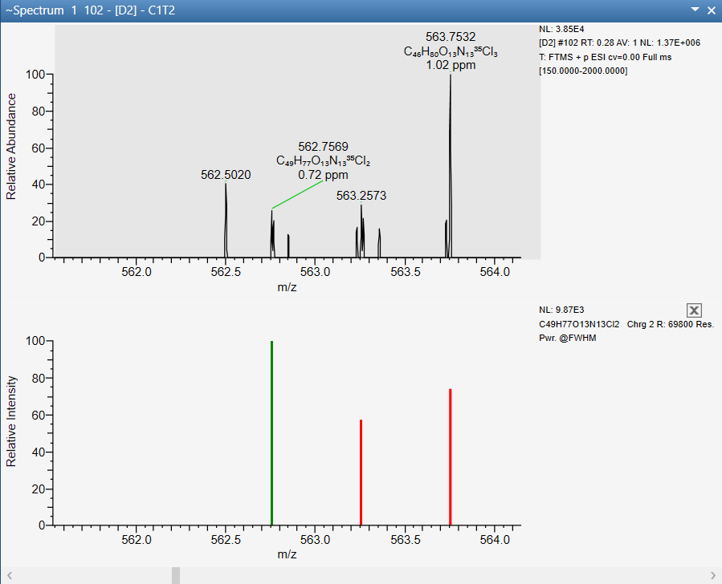
C₄₉H₇₇N₁₃O₁₃Cl₂
delta mass 0.72 ppm
MC-RR TP6: monohydroxy -MC-RR
C₄₉H₇₇N₁₃O₁₃ [MC-RR +OH–H +2H]⁺² theo. m/z 527.7876
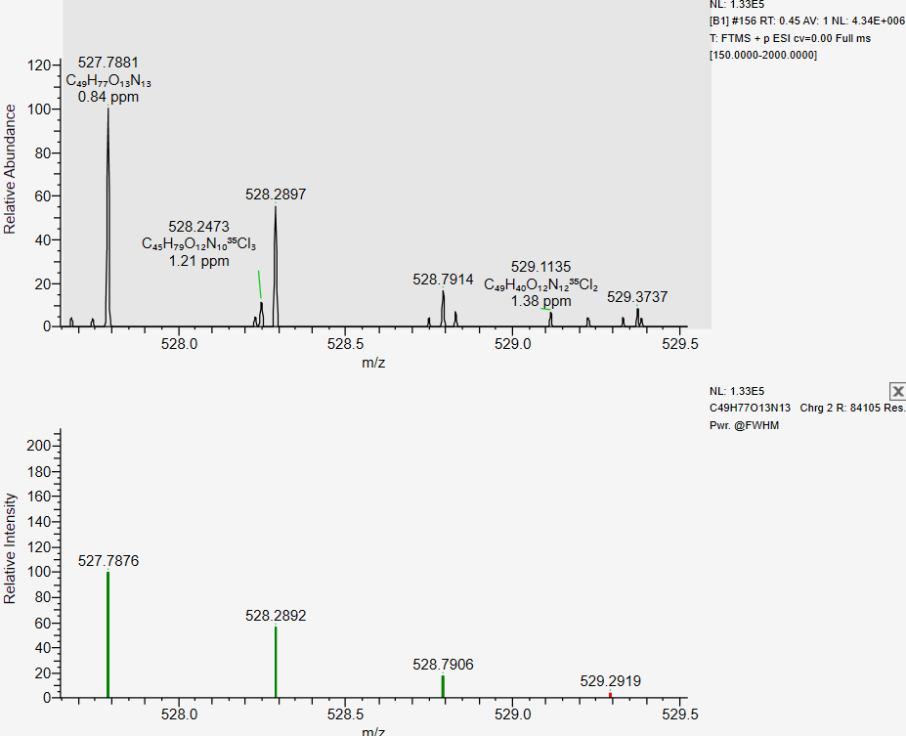
C₄₉H₇₇N₁₃O₁₃
delta mass 0.84 ppm

TPs of MC-LA
C₄₆H₆₇N₇O₁₂ MC-LA m/z 909.4842
C₄₆H₆₈N₇O₁₂ [MC-LA +H]⁺¹ m/z 910.4920
Positive ion mode ESI-MS data
MC-LA TP1: dihydroxy- MC-LA
C₄₆H₆₈N₇O₁₄ [MC-LA +2OH–2H+H]⁺¹ theo. m/z 942.4829
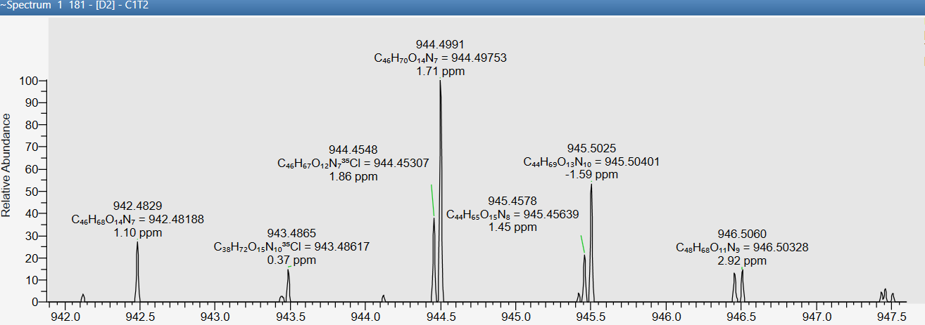
C₄₆H₆₈N₇O₁₄
delta mass 1.10 ppm
MC-LA TP2: monochloro- MC-LA
C₄₆H₆₇N₇O₁₂Cl [MC-LA +Cl–H+H]⁺¹ theo. m/z 944.4531
C₄₆H₆₇N₇O₁₂Cl
delta mass 1.86 ppm
MC-LA TP3: dihydroxy- MC-LA
C₄₆H₇₀N₇O₁₄ [MC-LA +2OH+H]⁺¹ theo. m/z 944.4975
C₄₆H₇₀N₇O₁₄
delta mass 1.71 ppm
MC-LA TP4: monochloro-hydroxy- MC-LA
C₄₆H₆₉N₇O₁₃Cl [MC-LA +Cl +OH+H]⁺¹ theo. m/z 962.4636
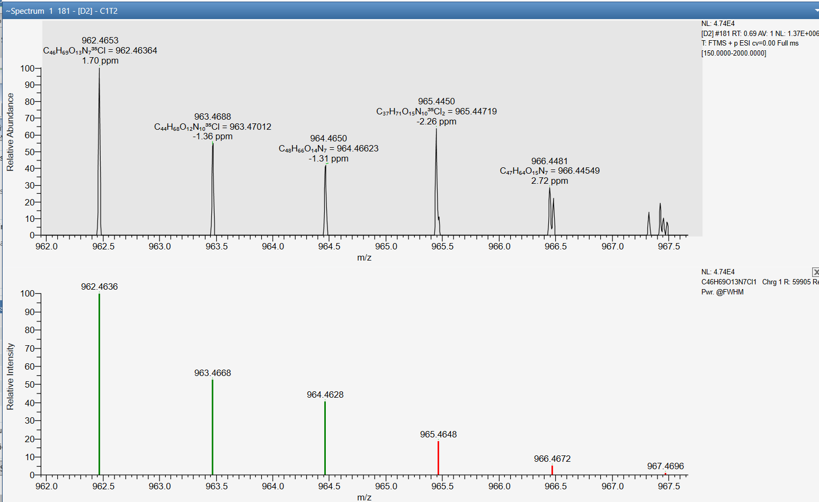
C₄₆H₆₉N₇O₁₃Cl
delta mass 1.70 ppm

MC-LA TP5: monohydroxy- MC-LA
C₄₆H₆₉N₇O₁₃Cl [MC-LA +Cl +OH+H]⁺¹ theo. m/z 926.4870
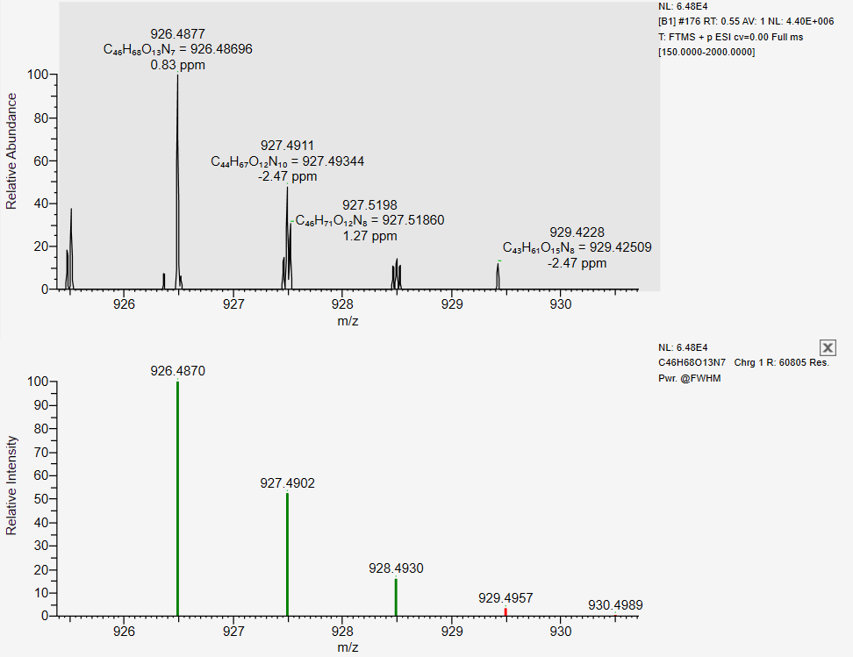

TPs of MC-YR
C₅₂H₇₂N₁₀O₁₃ MC-YR m/z 1044.5281
C₅₂H₇₃N₁₀O₁₃ [MC-YR +H]⁺¹ m/z 1045.533
TPs of MC-YR
Negative ion mode ESI-MS data
MC-YR TP1: dihydroxy- MC-YR
C₅₂H₇₃N₁₀O₁₅ [MC-YR +2OH–H]^{–1} theo. m/z 1077.5251
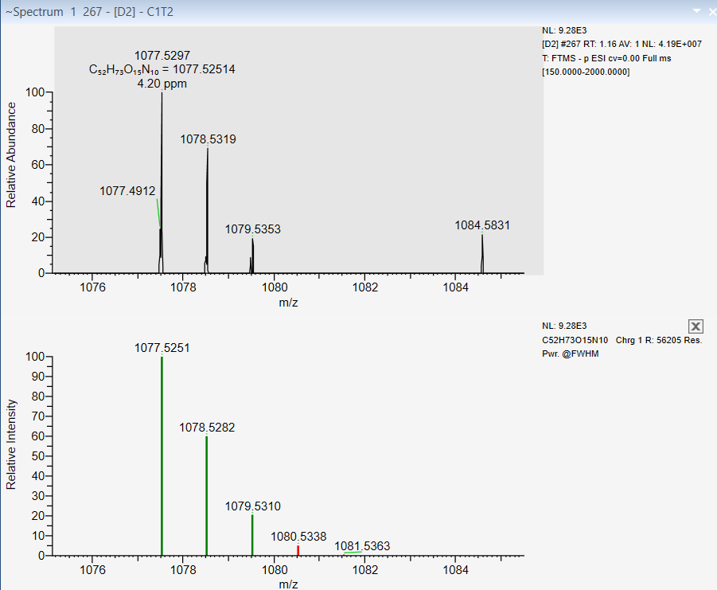
C₅₂H₇₃N₁₀O₁₅
delta mass 4.20 ppm

MC-YR TP2: monochloro- hydroxy- MC-YR
C₅₂H₇₂N₁₀O₁₄Cl [MC-YR +OH +Cl–H]^{–1} theo. m/z 1095.4913
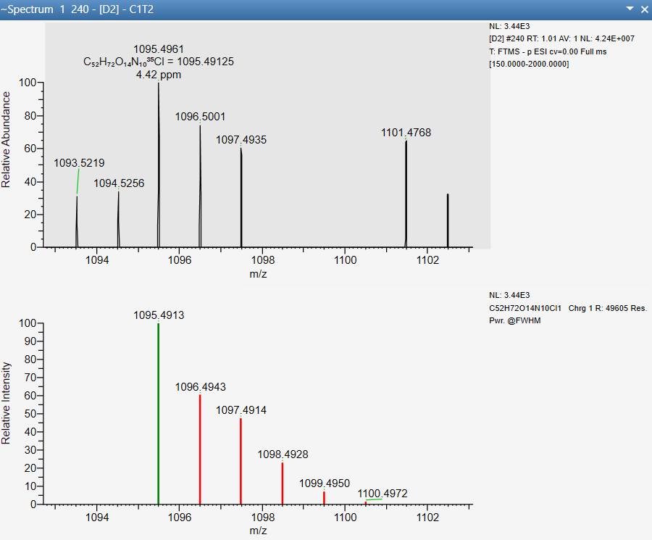
C₅₂H₇₂N₁₀O₁₄Cl
delta mass 4.42 ppm

MC-YR TP3: monochloro- dihydroxy- MC-YR
C₅₂H₇₂N₁₀O₁₅Cl [MC-YR +OH+OH + Cl–H–H]^{–1} theo. m/z 1111.4862
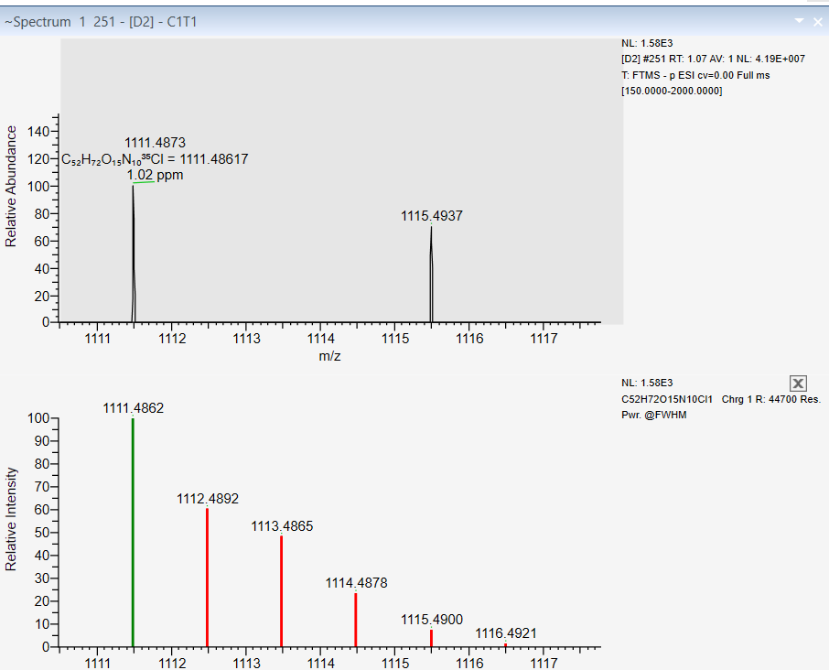
C₅₂H₇₂N₁₀O₁₅Cl
delta mass 1.02 ppm
MC-YR TP4: monochloro-hydroxy- MC-YR
C₅₂H₇₁N₁₀O₁₄Cl [MC-YR +OH +Cl–2H]^{–2} theo. m/z 547.2414
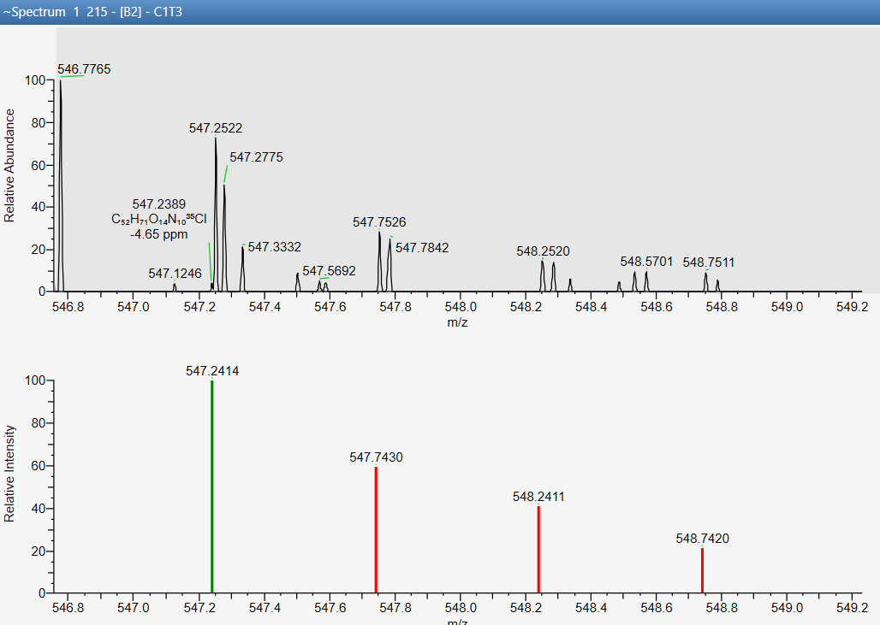
C₅₂H₇₁N₁₀O₁₄Cl
delta mass 4.65 ppm
Positive ion mode ESI-MS data
MC-YR TP5: dihydroxy- MC-YR
C₅₂H₇₅N₁₀O₁₅ [MC-YR +2OH+H]⁺¹ theo. m/z 1079.5408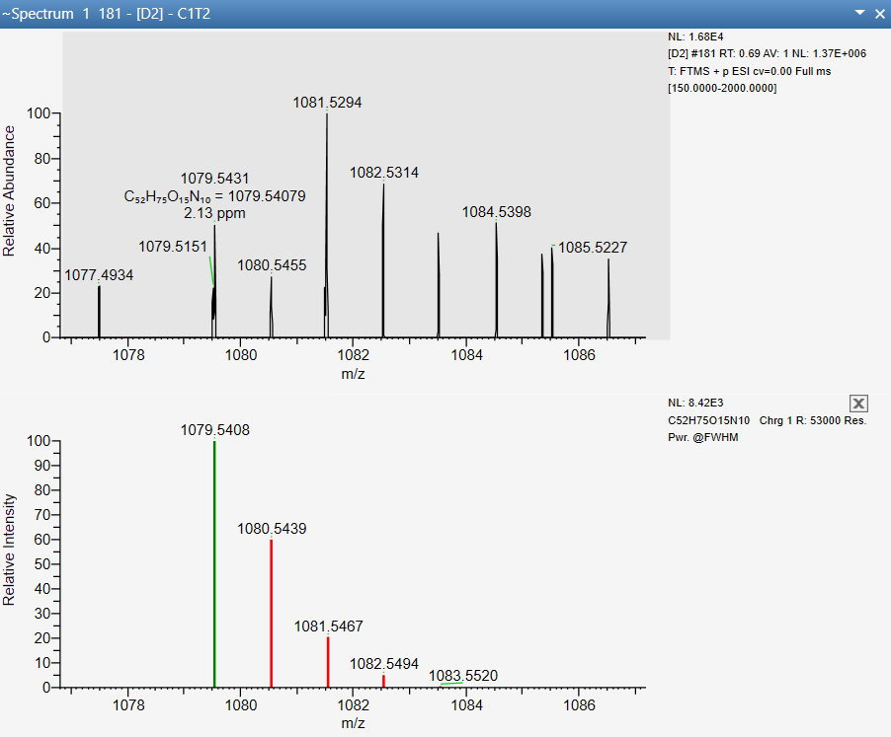
C₅₂H₇₅N₁₀O₁₅
delta mass 2.13 ppm

MC-YR TP6: monochloro- MC-YR
C₅₂H₇₂N₁₀O₁₃Cl [MC-YR +Cl–H+H]⁺¹ theo. m/z 1079.4963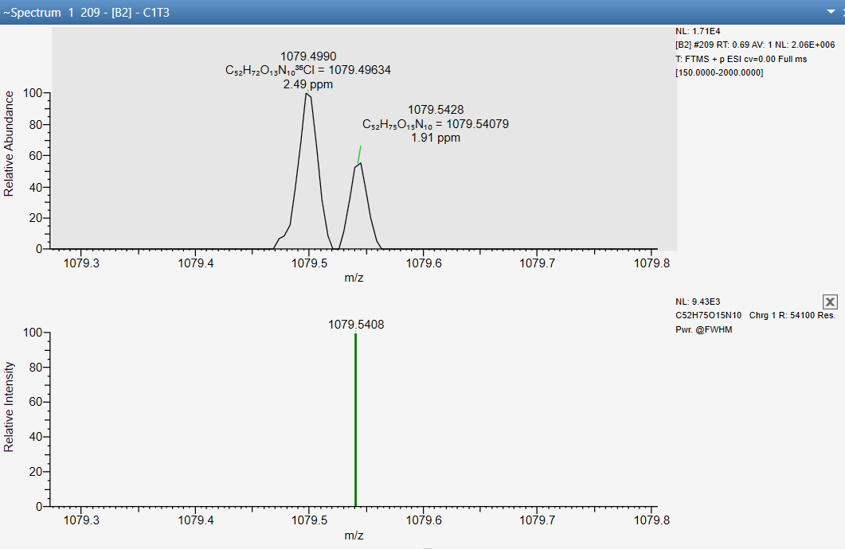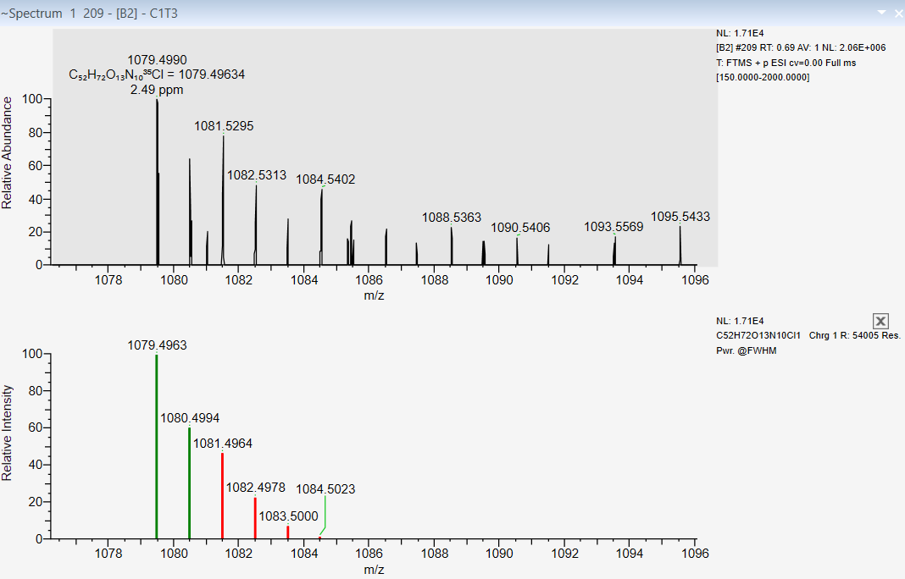
C₅₂H₇₂N₁₀O₁₃Cl
delta mass 2.49 ppm
MC-YR TP7: monochloro- hydroxy- MC-YR
C₅₂H₇₄N₁₀O₁₄Cl [MC-YR +OH +Cl+H]⁺¹ theo. m/z 1097.5069
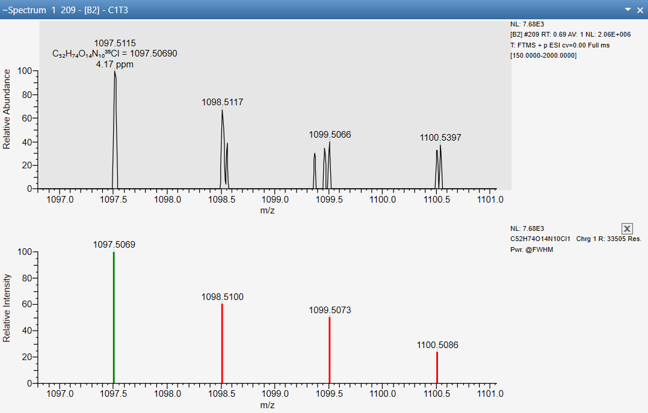
C₅₂H₇₄N₁₀O₁₄Cl
delta mass 4.17 ppm

MC-YR TP8: dichloro- MC-YR
C₅₂H₇₁N₁₀O₁₃Cl₂ [MC-YR +2Cl–2H+H]⁺¹ theo. m/z 1113.4574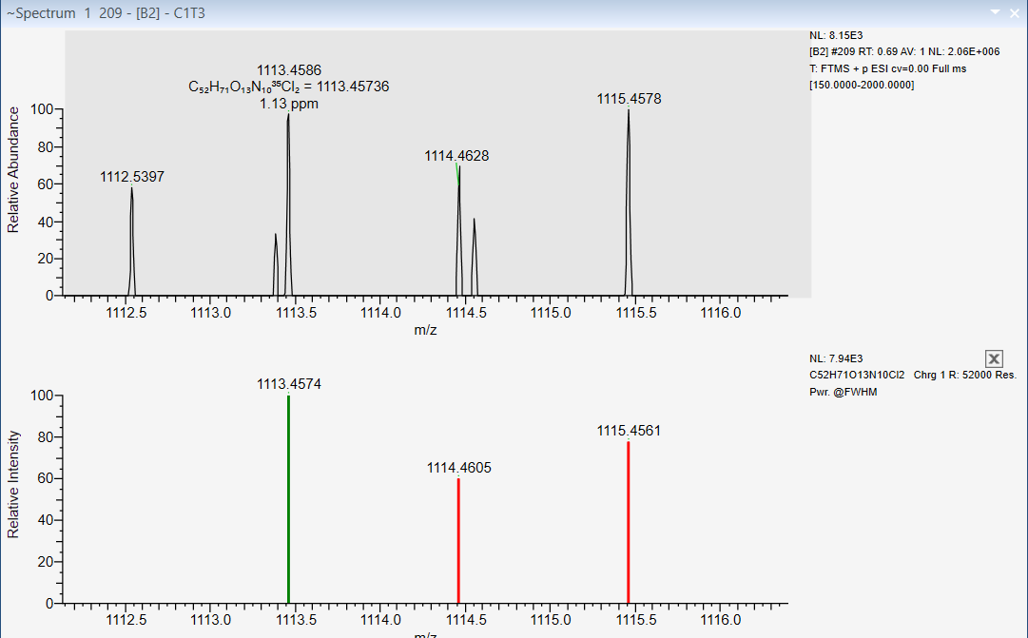
C₅₂H₇₂N₁₀O₁₃Cl₂
delta mass 1.13 ppm
MC-YR TP9: dichloro-hydroxy- MC-YR
C₅₂H₇₃N₁₀O₁₄Cl₂ [MC-YR +Cl–H+Cl+OH+H]⁺¹ theo. m/z 1131.4679
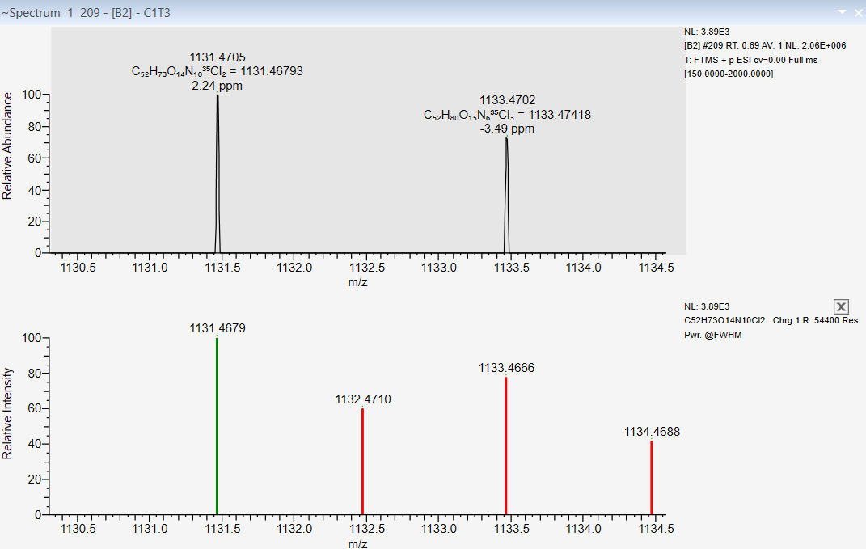
C₅₂H₇₃N₁₀O₁₄Cl₂
delta mass 2.24 ppm
MC-YR TP10: dichloro-dihydroxy- MC-YR
C₅₂H₇₃N₁₀O₁₅Cl₂ [MC-YR +Cl–H+OH–H+Cl+OH+H]⁺¹ theo. m/z 1147.4628
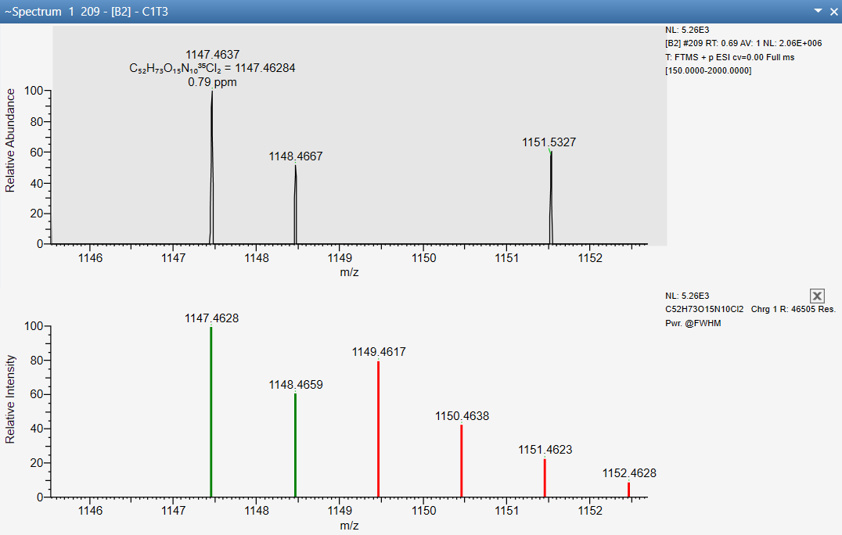
C₅₂H₇₃N₁₀O₁₅Cl₂
delta mass 0.79 ppm

MC-YR TP11: monohydroxy- MC-YR
C₅₂H₇₄N₁₀O₁₄ [MC-YR +OH –H+2H]⁺² theo. m/z 531.2687
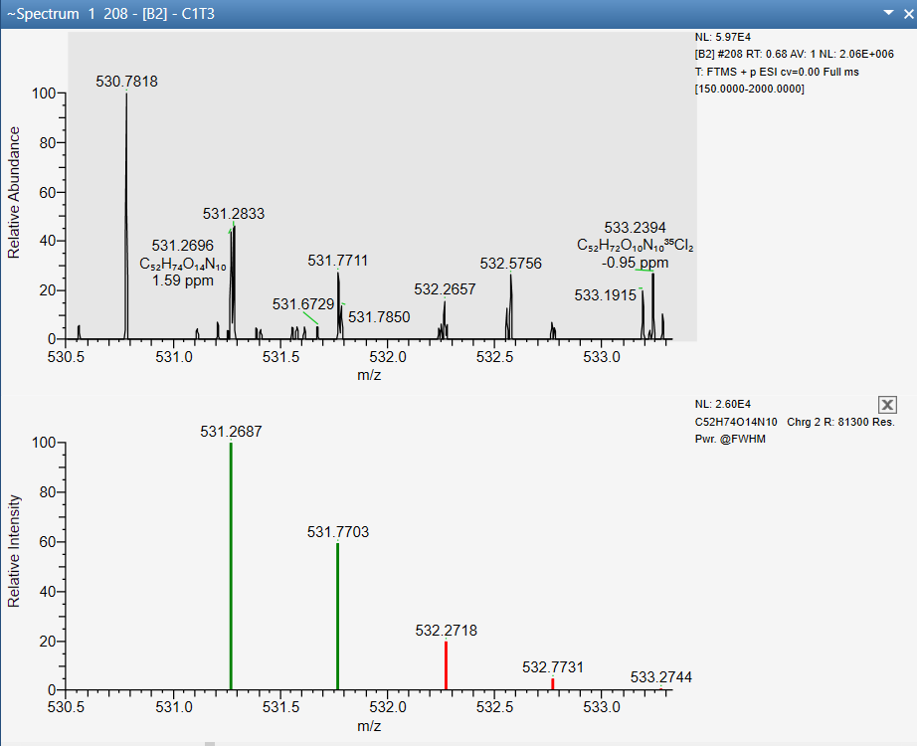
C₅₂H₇₄N₁₀O₁₄
delta mass 1.59 ppm
MC-YR TP12: monochloro-hydroxy- MC-YR
C₅₂H₇₅N₁₀O₁₄Cl [MC-YR +OH +Cl+2H]⁺² theo. m/z 549.2571
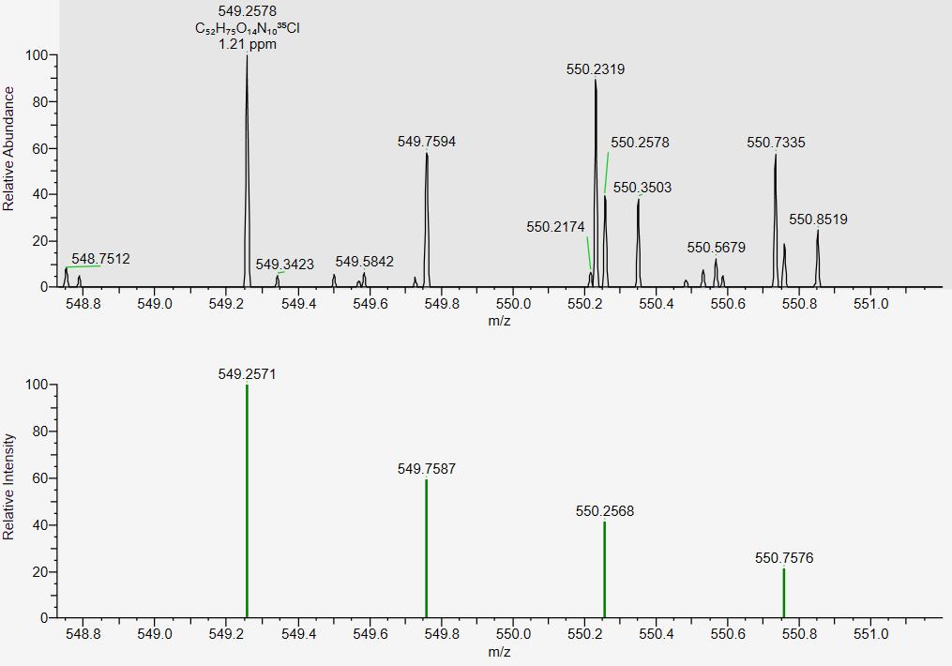
C₅₂H₇₅N₁₀O₁₄Cl
delta mass 1.21 ppm
MC-YR TP13: monochloro- MC-YR
C₅₂H₇₃N₁₀O₁₃Cl [MC-YR +Cl+H]⁺² theo. m/z 540.2518 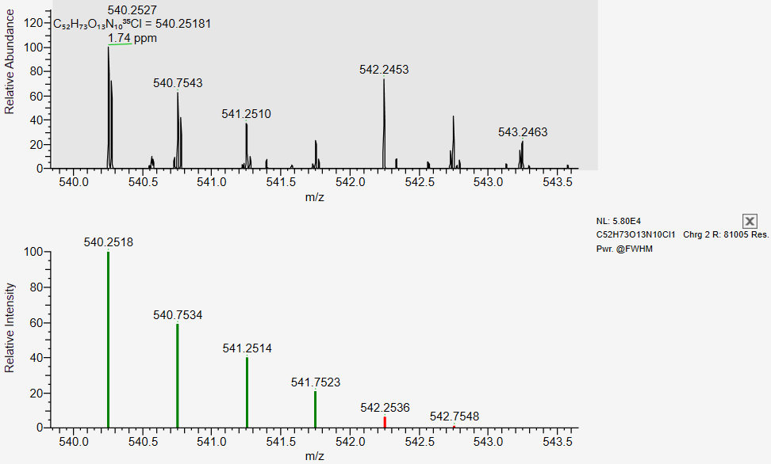
C₅₂H₇₃N₁₀O₁₃Cl
delta mass 1.74 ppm
MC-YR TP14: dihydroxy- MC-YR
C₅₂H₇₆N₁₀O₁₅ [MC-YR +2OH+2H]⁺² theo. m/z 540.2740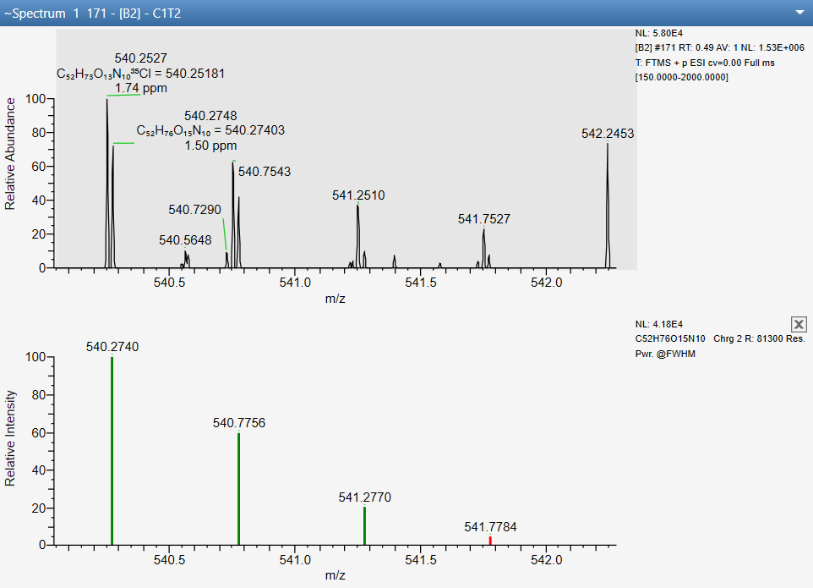
C₅₂H₇₆N₁₀O₁₅
delta mass 1.50 ppm
MC-YR TP15: dichloro- MC-YR
C₅₂H₇₂N₁₀O₁₃Cl₂ [MC-YR +2Cl–2H+2H]⁺² theo. m/z 557.2323
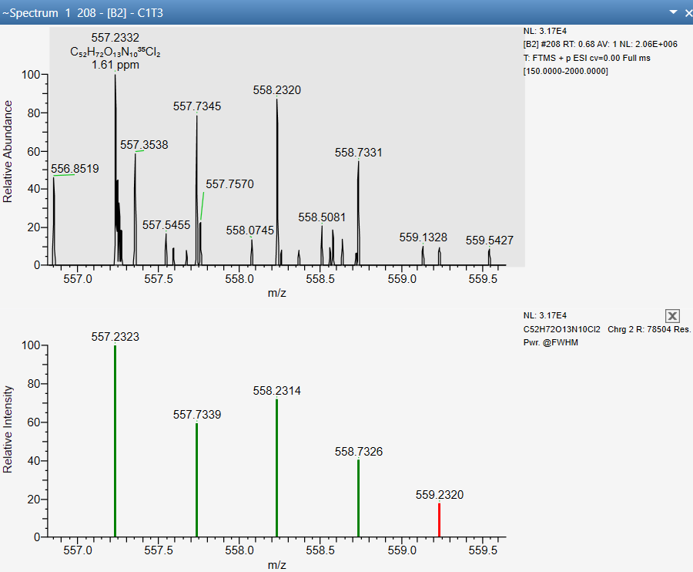
C₅₂H₇₂N₁₀O₁₃Cl₂
delta mass 1.61 ppm
MC-YR TP16: dichloro-hydroxy- MC-YR
C₅₂H₇₄N₁₀O₁₄Cl₂ [MC-YR +Cl+OH+Cl–H+2H]⁺² theo. m/z 566.2376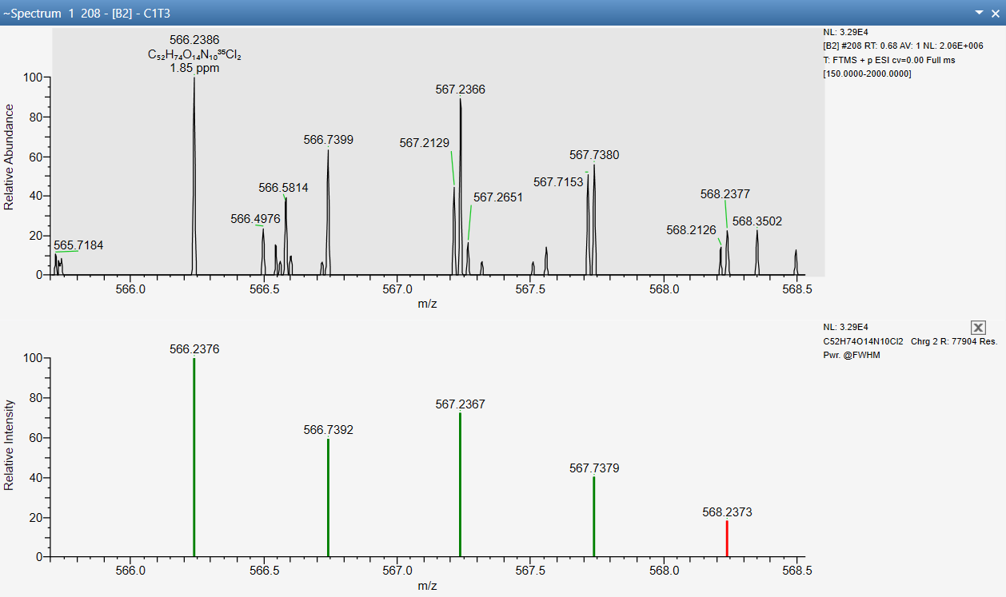
C₅₂H₇₄N₁₀O₁₄Cl₂
delta mass 1.85 ppm
MC-YR TP17: dichloro-dihydroxy- MC-YR
C₅₂H₇₄N₁₀O₁₅Cl₂ [MC-YR +Cl+OH+Cl–H +OH–H+2H]⁺² theo. m/z 574.2351
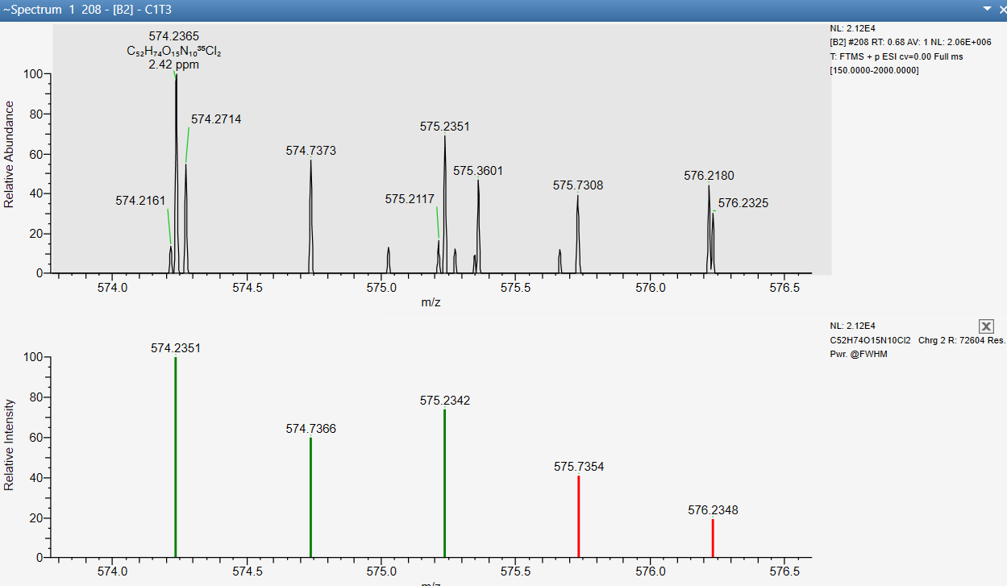 MC-YR TP18: trichloro-hydroxy- MC-YR
C₅₂H₇₄N₁₀O₁₅Cl₂
delta mass 2.42 ppm
C₅₂H₇₃N₁₀O₁₄Cl₃ [MC-YR +2Cl–2H+Cl+OH+2H]⁺² theo. m/z 583.2181
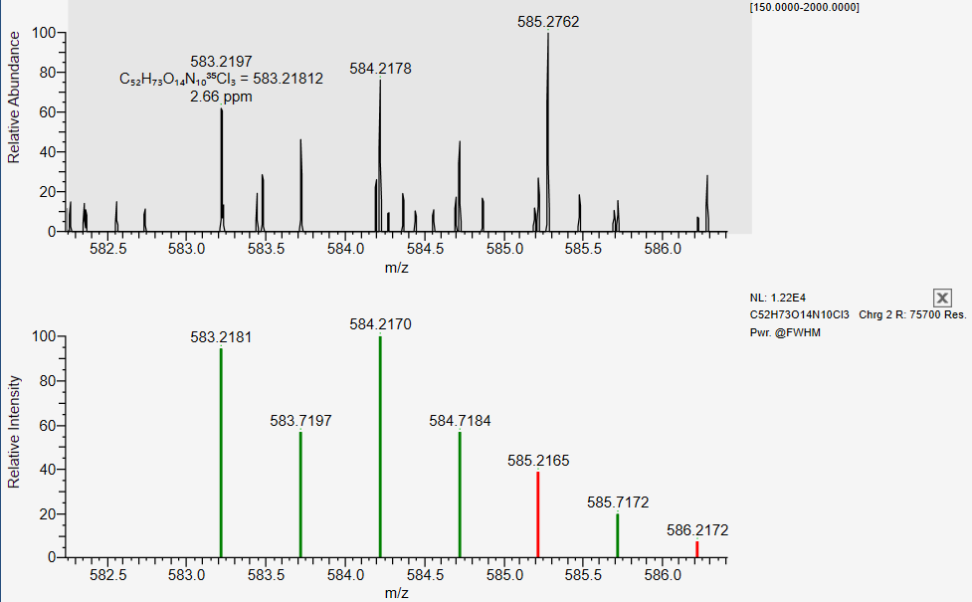
C₅₂H₇₃N₁₀O₁₄Cl₃
delta mass 2.66 ppm

MC-YR TP19: trichloro-dihydroxy- MC-YR
C₅₂H₇₃N₁₀O₁₅Cl₃ [MC-YR +Cl–H +2Cl +2OH–2H+2H]⁺² theo. m/z 591.2156
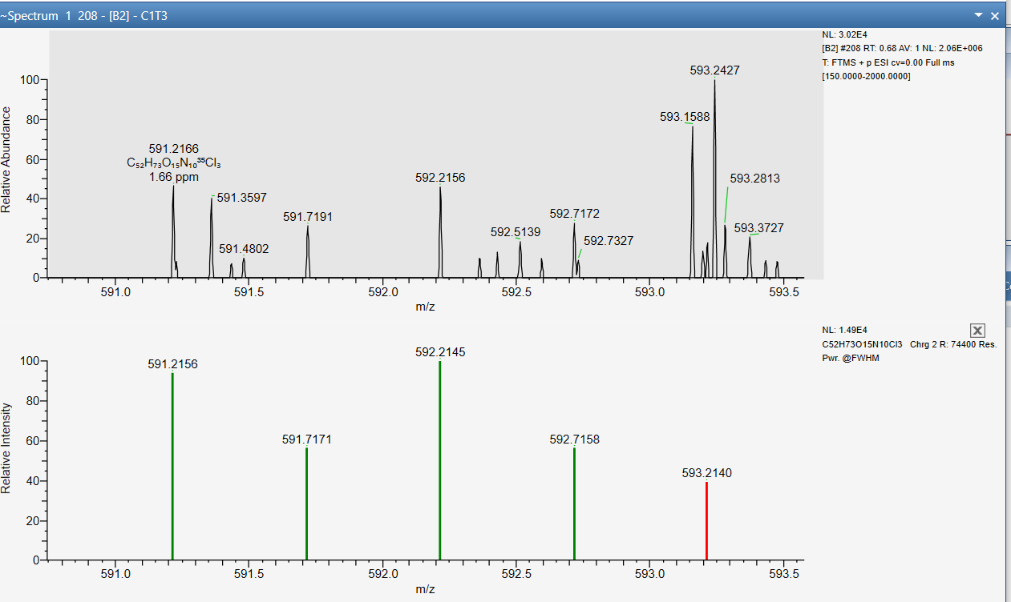
C₅₂H₇₃N₁₀O₁₅Cl₃
delta mass 2.42 ppm

To compare the relative abundance of the mentioned MC-TPs from all four processes, 100 ppb of MC-LR, MC-LA, MC-RR, and MC-YR each were spiked in ultrapure water and degraded by chlorine, chlorine+chloride, UV/chlorine, and UV/chlorine+chloride for 6 min, respectively. And the remaining solvents were quenched by ascorbic acid(5 folds of chlorine), extracted, and concentrated by HLB solid phase extraction after sufficient mixing. The following table lists the NL (normalization number) for every peak, which is proportional to the sample concentration (and peak height). The extraction and analysis were performed in duplicate for each collection. For the duplicate runs, there were some slight variations in peak intensities. In the table, the NL values were the average values of the duplicate with 9 of the 272 values excluded as outlier due to their extent of variations determined statistically.

Table T8-1. The normalization number (NL) of identified MC-TPs with no Adda cleavage

Figure S1. Structures of microcystins
Figure 1. The general structure of microcystins with variable amino acid moieties of AA₂ and AA₄.
Cyclic heptapeptides:
AA₁ D-Alanine (D-Ala),
AA₃ Methyl aspartic acid (MeAsp),
AA₅ 3-amino-9-methoxy-2,6,8-trimethyl-10-phenyldeca-4,6-dienoic acid (Adda residue),
AA₆ D-Glutamic acid (D-Glu),
and AA₇ N-methyl dehydro alanine (Mdha).

Figure S2. Degradation of MC-RR, remaining concentration vs. time and UV dose
Figure S2. Degradation of MC-RR, remaining concentration vs. time and UV dose.

Figure S3 Degradation of MC-RR, ln(C/C0) vs. time
Figure S3. Degradation of MC-RR, ln(C/C₀) vs. time, and synergistic effects in pseudo-first-order rate constants.

Figure S4. pH dependency of amino acids - chlorination
Figure S4. pH dependency of amino acid chlorination reactions.

Figure S5. The fraction of conjugate acids in the tested system

Figure S5. The fraction of conjugate acids in the tested system

Figure S6. Role of nitrobenzene concentrations on MC-RR degradation kinetics

Figure S6. Role of nitrobenzene concentrations on the MC-RR degradation kinetics

Figure S7. Degradation of mixed MCs in NOM and GCWW sample

Figure S7. Degradation of mixed MCs in H₂O, NOM and GCWW sample.

Figure S8. Cytotoxicity of treated waters
Figure S8. Cytotoxicity with same treatment level by four treatment processes.

Table S1. Microcystin concentrations in field samples
Table S1. Microcystin concentrations in field samples from Grand Lake St Marys and WTP processes. Sample and analysis results were provided by Dr. Judy A. Westrick, Lumigen Instrument Center, Wayne State University.

Table S2. Integration of MC-RR degradation by UV/chlorine and the role of Cl₂(aq)
Figure 3. The role of chloride ions on MC-RR degradation kinetics in chlorination and UV/chlorine.
$k_{obs,MC}, s^{-1}={k^{'}}_{UV}+k_{app, FAC}\left[FAC\right]+k_{app, OH∙}\left[OH∙\right]+k_{app, {Cl}_{2}}[{Cl}_{2}] {+ k^{'}}_{RCS,app}$ the simulation details is included in Table S3.

To explore the role of Cl– in the degradation of MC-RR by UV/chlorine treatment, especially the potential impact of HO•, 1 µM nitrobenzene (NB) was added as a HO• probe with 1 µM MC-LR and 21 µM chlorine. The addition of 1 µM NB had minor impact on MC-RR degradation kinetics (within 10%, as shown in Fig. S6). Considering the depletion of chlorine (18 - 30 %) during the 16 min reaction, the abundance of reactive radicals generated from chlorine activation and the removal of MC-RR and NB were expected to change simultaneously. Based on time-course analysis of the chlorine residual, NB, and MC-RR concentrations, combined with known apparent kinetic constants and modeling, the contributors for MC-RR degradation were simulated (Fig. 3B and Table S2). Without Cl– addition, UV, chlorine, HO•, and RCS contributed to 9%, 30%, 19%, and 39% of MC-RR degradation, respectively. With the addition of Cl–, the enhancement of UV/chlorine degradation of MC-RR can be attributed to the contribution of Cl_{2(aq)}. With 10 mM Cl–, the generated Cl_{2(aq)} contributed to 26% of total MC-RR degradation. Meanwhile, the contribution from HO• was similar to the experiment without additional Cl–, which indicates the generation of Cl_{2(aq)} with Cl– addition (within 10 mM) has minor impact on HO• generation in UV/chlorine treatment (Eq. 1). The concentrations of HOCl and OCl– remain relatively stable in both chlorination and UV/chlorine with the addition of Cl–. This finding is in line with the result of chlorine speciation simulations (with total 21 µM FAC, increasing [Cl–] from 0.1 to 10 mM, the HOCl decreases from 11.8 to 11.1 µM, and ClO– increases from 9.2 to 9.9 µM), which also further clarifies the role of Cl_{2(aq)} as an additonal chlorinating agent. Thus, in spite of the lower concentrations relative to other reactive species in the experiment, greater reactivity is expected in UV/chlorine treatment following fortification with Cl– because of increased formation of reactive Cl_{2(aq)}. In addition, the UHPLC-QTOF-MS results suggest that the presence of the Cl– facilitates the cleavage of Adda chain and the degradation of the formed TPs, as described in Text S8.

Table. S2. Integration of MC-RR degradation by UV/chlorine and the role of Cl₂ (aq)
Time (s) | 0 | 960 | 960 | 960
Chloride (mM) | 0, 5, or 10 | 0 | 5 | 10
MC-RR (µM) | 1.0 | 0.01 | 0.01 | 0.00
Nitrobenzene(NB) (µM) | 1.0 | 0.90 | 0.89 | 0.88
Chlorine (µM) | 21.0 | 17.4 | 14.6 | 14.8
Integration | Contributed by: | Degraded MC-RR (µM)
$$\int_{0}^{960}{k_{chlorine}\left[chlorine\right]\left[MC-RR\right]dt}$$ | Chlorine | 0.30 | 0.28 | 0.25
$$\int_{0}^{960}{k_{HO∙}\left[HO\right]\left[MC-RR\right]dt}$$ | HO• | 0.19 | 0.20 | 0.18
$$\int_{0}^{960}{{k'}_{UV}\left[MC-RR\right]dt}$$ | UV photolysis | 0.09 | 0.09 | 0.08
$$\int_{0}^{960}{k_{Cl2(aq)}\left[{Cl}_{2(aq)}\right]\left[MC-RR\right]dt}$$ | Cl_{2(aq)} | 0.01 | 0.15 | 0.26
$$\int_{0}^{960}{k_{RCS}\left[RCS\right]\left[MC-RR\right]dt}$$ | RCS | 0.39 | 0.27 | 0.23

Table S3. Conditions to achieve 1.0-log reduction of MC-RR

Table S3. Conditions to achieve 1.0-log reduction of MC-RR
1.0-log reduction of MC-RR | FAC 1.5 mg/L CT value  mg/L·min | UV_{254nm} dose, mJ/cm²  (0.1 mW/cm²)
UV_{254nm} | 0 | 840
Chlorine | 39 | 0
Chlorine + 7 mM Cl⁻ | 22.5 | 0
UV_{254nm}/chlorine | 18 | 72
UV_{254nm}/chlorine+ 7 mM Cl⁻ | 13.5 | 54
Reaction: 5 mM phosphate buffer with pH 7.4, 25 °C, quencher: ascorbic acid (5 fold of FAC).

Table S4. Water quality of tested water samples.
Table S4. Water quality of tested water samples.
Sample | Sample ID | Sample date | pH | DOC  (mg L⁻¹ as C) | Alkalinity  (mg L⁻¹ as CaCO₃) | SUVA₂₅₄  (L mg⁻¹ m⁻¹) | Nitrate  (mg L⁻¹) | Chloride  (mg L⁻¹)
GLSM — Post GAC | GLSM | Mar 25, 2021 | 8.6 | 0.9 | 101 | 1.7 | 0.61 | 35
GCWW — Post GAC | GCWW | Feb 14, 2021 | 7.9 | 0.9 | 81 | 1.2 | 0.67 | 16.1
GLSM-AOM (PPL extracted) | AOM | Aug 12, 2016 | Adj. to 7.4 | Adj. to 2.0 ± 0.1 | N.A. | 2.1 | N.D. | N.A.
SR-NOM (RO isolate) | NOM | N.A. | Adj. to 7.4 | Adj. to 2.0 ± 0.1 | N.A. | 2.9 | N.D. | N.A.
PPL SPE: Agilent Bond Elut PPL SPE cartridge (Part# 12105503).

Table S5. Disinfection by-products (DBPs) formed from the treatment of microcystin-LR

DBP | Chlorine | Chlorine + Chloride | UV/Chlorine | UV/Chlorine + Chloride | No Treatment
TCM | 1.7 | 1.4 | ND | 0.8 | ND
TCAL | ND | 0.9 | 0.9 | 0.9 | ND
DCAN | < 0.75 | < 0.75 | 1.3 | < 0.75 | ND
CAN | 3.2 | 3.6 | 3.3 | 3.5 | ND
11DCP | 1.0 | < 0.25 | 1.0 | 0.9 | ND
CP | 2.2 | 4.6 | 2.2 | 2.1 | ND
TCNM | 0.9 | 0.9 | 0.9 | 0.9 | ND
DCAM | 2.6 | 0.9 | 1.2 | 0.9 | ND
TCAM | 3.2 | 3.7 | 3.3 | 3.2 | ND
CAA | 0.1 | 0.1 | 0.1 | 0.1 | ND
DCAA | 0.5 | 0.4 | 0.1 | 0.3 | ND
TCAA | < 0.1 | < 0.1 | < 0.1 | < 0.1 | ND
TOTAL | 15.5 | 16.4 | 14.3 | 13.6

* ND: not detected. DBPs that were not present in any of the sample sets are not listed. Results are the mean of 3 replicates. [Chlorine] = 1.5 mg/L, [chloride] = 5 mM, UV₂₅₄ dose 70 ± 5 mJ/cm².

Table S6. Total organic halogen (TOX) formation from the treatment of microcystin-LR.*

TOX | Chlorine | Chlorine + Chloride | UV/Chlorine | UV/Chlorine + Chloride | No Treatment
TOCl | 47.2 ± 2.1 | 51.2 ± 0.9 | 33.4 ± 0.8 | 39.7 ± 1,8 | ND
TOBr | ND | ND | ND | ND | ND
TOI | ND | ND | ND | ND | ND
*Results are the mean of 3 replicates. [Chlorine] = 1.5 mg/L, [chloride] = 5 mM, UV₂₅₄ dose 70 ± 5 mJ/cm². ND: no detection.
To explore the differences between degradation of MC-LR by using various oxidative processes, a series of experiments was designed and conducted. MC-LR was dissolved in Milli-Q water with the pH controlled at 7.4 by 5 mM phosphate buffer. Four treatment processes, including, (A) chlorination (1.5 mg/L Cl₂), (B) chlorination (1.5 mg/L Cl₂) with chloride ion (5 mM), (C) UV/chlorine (1.5 mg/L Cl₂), (D) UV/chlorine (1.5 mg/L Cl₂) with chloride ion (5 mM) were performed at 25 °C with continuous stirring.
To achieve 0.5-log removal of 1 mg/L MC-LR (0.3 mg/L remaining), 31 min of chlorination, 19 min of chlorination with Cl⁻, 3.5 min of UV/chlorine, 3.3 min of UV/chlorine with Cl⁻ were required. Thus, by controlling the reaction time, 1.0 mg/L MC-LR were degraded to 0.3 mg/L in each of the six processes. With the same removal level, samples were collected for total organic halogen (TOX) analysis. TOX can be compared by collecting samples with ascorbic acid (1.3 fold of FAC) as quencher.

References:

1. Wojtowicz, J., Chlorine oxygen acids and salts: chlorine monoxide, hypochlorous acid and hypochlorites. Kirk-Othmer encyclopedia of chemical technology 1979, 5, 580-611.
2. OxyChem, OxyChem Sodium Hypochlorite Handbook. Occidental Chemical Corporation 2014.
3. Manov, G.; DeLollis, N.; Acree, S., Ionization constant of boric acid and the pH of certain borax-chloride buffer solutions from 0 to 60 C. J Res Natl Bur Stand (US) 1944, 33, 287-306.
4. Fisher, I.; Kastl, G.; Sathasivan, A., A suitable model of combined effects of temperature and initial condition on chlorine bulk decay in water distribution systems. Water Research 2012, 46, (10), 3293-3303.
5. Hua, P.; Vasyukova, E.; Uhl, W., A variable reaction rate model for chlorine decay in drinking water due to the reaction with dissolved organic matter. Water Research 2015, 75, 109-122.
6. Westerhoff, P.; Chao, P.; Mash, H., Reactivity of natural organic matter with aqueous chlorine and bromine. Water Research 2004, 38, (6), 1502-1513.
7. Heeb, M. B.; Kristiana, I.; Trogolo, D.; Arey, J. S.; von Gunten, U., Formation and reactivity of inorganic and organic chloramines and bromamines during oxidative water treatment. Water Research 2017, 110, 91-101.
8. Hawkins, C.; Davies, M., Reaction of HOCl with amino acids and peptides: EPR evidence for rapid rearrangement and fragmentation reactions of nitrogen-centred radicals. Journal of the Chemical Society, Perkin Transactions 2 1998, (9), 1937-1946.
9. Zhang, X.; Li, J.; Yang, J.-Y.; Wood, K. V.; Rothwell, A. P.; Li, W.; Blatchley Iii, E. R., Chlorine/UV Process for Decomposition and Detoxification of Microcystin-LR. Environmental Science & Technology 2016, 50, (14), 7671-7678.
10. Jiang, P.; Huang, G.; Jmaiff Blackstock, L. K.; Zhang, J.; Li, X.-F., Ascorbic acid assisted high performance liquid chromatography mass spectrometry differentiation of isomeric C-chloro-and N-chloro-tyrosyl peptides in water. Analytical chemistry 2017, 89, (24), 13642-13650.
11. Weng, S.; Blatchley, E. R., Ultraviolet-Induced Effects on Chloramine and Cyanogen Chloride Formation from Chlorination of Amino Acids. Environmental Science & Technology 2013, 47, (9), 4269-4276.
12. How, Z. T.; Linge, K. L.; Busetti, F.; Joll, C. A., Chlorination of Amino Acids: Reaction Pathways and Reaction Rates. Environmental Science & Technology 2017, 51, (9), 4870-4876.
13. Huang, K.; MacKay, A. A., Microcystin-LR degradation kinetics during chlorination: Role of water quality conditions. Water Research 2020, 185, 116305.
14. Shoemaker, J.; Tettenhorst, D.; Delacruz, A., Determination of Microcystins and Nodularin in Drinking Water by Solid Phase Extraction and Liquid Chromatography. Tandem Mass Spectrometry (LC/MS/MS) 2015, 1-40.
15. Morris, J. C., The Acid Ionization Constants ot HUL1 trom 5 to 35 C. lour. Phvs. Chem 1966, 70, (12), 3798.
16. Sivey, J. D.; McCullough, C. E.; Roberts, A. L., Chlorine monoxide (Cl2O) and molecular chlorine (Cl2) as active chlorinating agents in reaction of dimethenamid with aqueous free chlorine. Environmental science & technology 2010, 44, (9), 3357-3362.
17. Arotsky, J.; Symons, M., Halogen cations. Quarterly Reviews, Chemical Society 1962, 16, (3), 282-297.
18. White, G. C., White's handbook of chlorination and alternative disinfectants. Wiley: 2010.
19. Lahoutifard, N.; Lagrange, P.; Lagrange, J., Kinetics and mechanism of nitrite oxidation by hypochlorous acid in the aqueous phase. Chemosphere 2003, 50, (10), 1349-1357.
20. Hawkes, S. J., pKw is almost never 14.0: Contribution from the task force on the General Chemistry Curriculum. Journal of Chemical Education 1995, 72, (9), 799.
21. Kimura, S. Y.; Ortega-Hernandez, A., Formation mechanisms of disinfection byproducts: Recent developments. Current Opinion in Environmental Science & Health 2018.
22. Kull, T. P. J.; Backlund, P. H.; Karlsson, K. M.; Meriluoto, J. A. O., Oxidation of the Cyanobacterial Hepatotoxin Microcystin-LR by Chlorine Dioxide: Reaction Kinetics, Characterization, and Toxicity of Reaction Products. Environmental Science & Technology 2004, 38, (22), 6025-6031.
23. He, X.; Armah, A.; Hiskia, A.; Kaloudis, T.; O'Shea, K.; Dionysiou, D. D., Destruction of microcystins (cyanotoxins) by UV-254 nm-based direct photolysis and advanced oxidation processes (AOPs): Influence of variable amino acids on the degradation kinetics and reaction mechanisms. water research 2015, 74, 227-238.
24. Antoniou, M. G.; Shoemaker, J. A.; Cruz, A. A. d. l.; Dionysiou, D. D., Unveiling New Degradation Intermediates/Pathways from the Photocatalytic Degradation of Microcystin-LR. Environmental Science & Technology 2008, 42, (23), 8877-8883.
25. A. Lawton, L.; K. J. Robertson, P., Physico-chemical treatment methods for the removal of microcystins (cyanobacterial hepatotoxins) from potable waters. Chemical Society Reviews 1999, 28, (4), 217-224.

