Figure S1. Relationship between two measures of imidacloprid in water samples collected from 16 Great Lakes tributaries from October 2015 to September 2016, including a solid-phase extraction method (y axis) and a direct injection method (x axis). The black line represents the 1:1 line, and the blue line represents a linear regression that was used to calculate the offset applied to all samples that were analyzed using the direct injection (general pesticide schedule) method (slope (standard error) = 0.48 (0.015), intercept (standard error) = -0.92 (1.18), R2 = 0.97, pValue = <0.001)

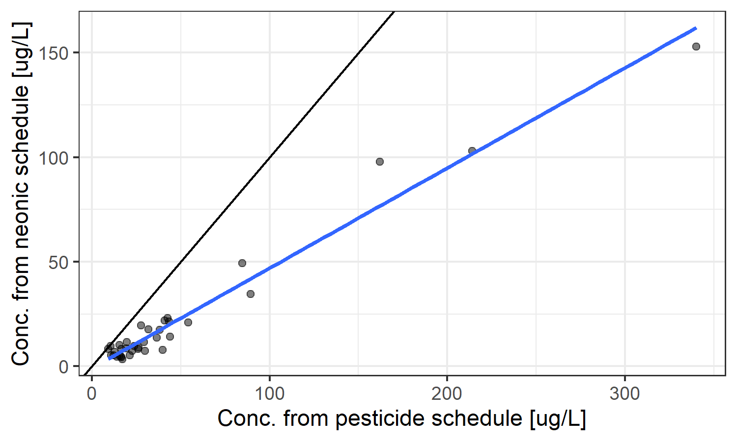

Figure S2. Relationship between the EPA’s Aquatic Life Benchmarks (ALBs) and ToxCast Activity Cutoff Concentration (ACC) values (US EPA 2019, 2020). The minimum ACC and minimum ALB values for each chemical were used for comparison. Points are colored by chemical class, while filled and open circles represent parent and transformation products, respectively. The black line indicates the 1:1 line.

# 

Figure S3. The mean exposure activity ratio (EARchem) or toxicity quotient (TQchem) values for compounds at the mean reported detection limit. The size of the dots represents the proportion of samples with detections. Values above the thresholds (EARchem > 0.001 or TQchem > 0.1, dotted vertical line) indicate that we may be underestimating toxicity of those compounds when they are below detection limits. Chemicals with EARchem < 0.000001 and TQchem < 0.001 at the mean detect level concentration are not included in this figure.

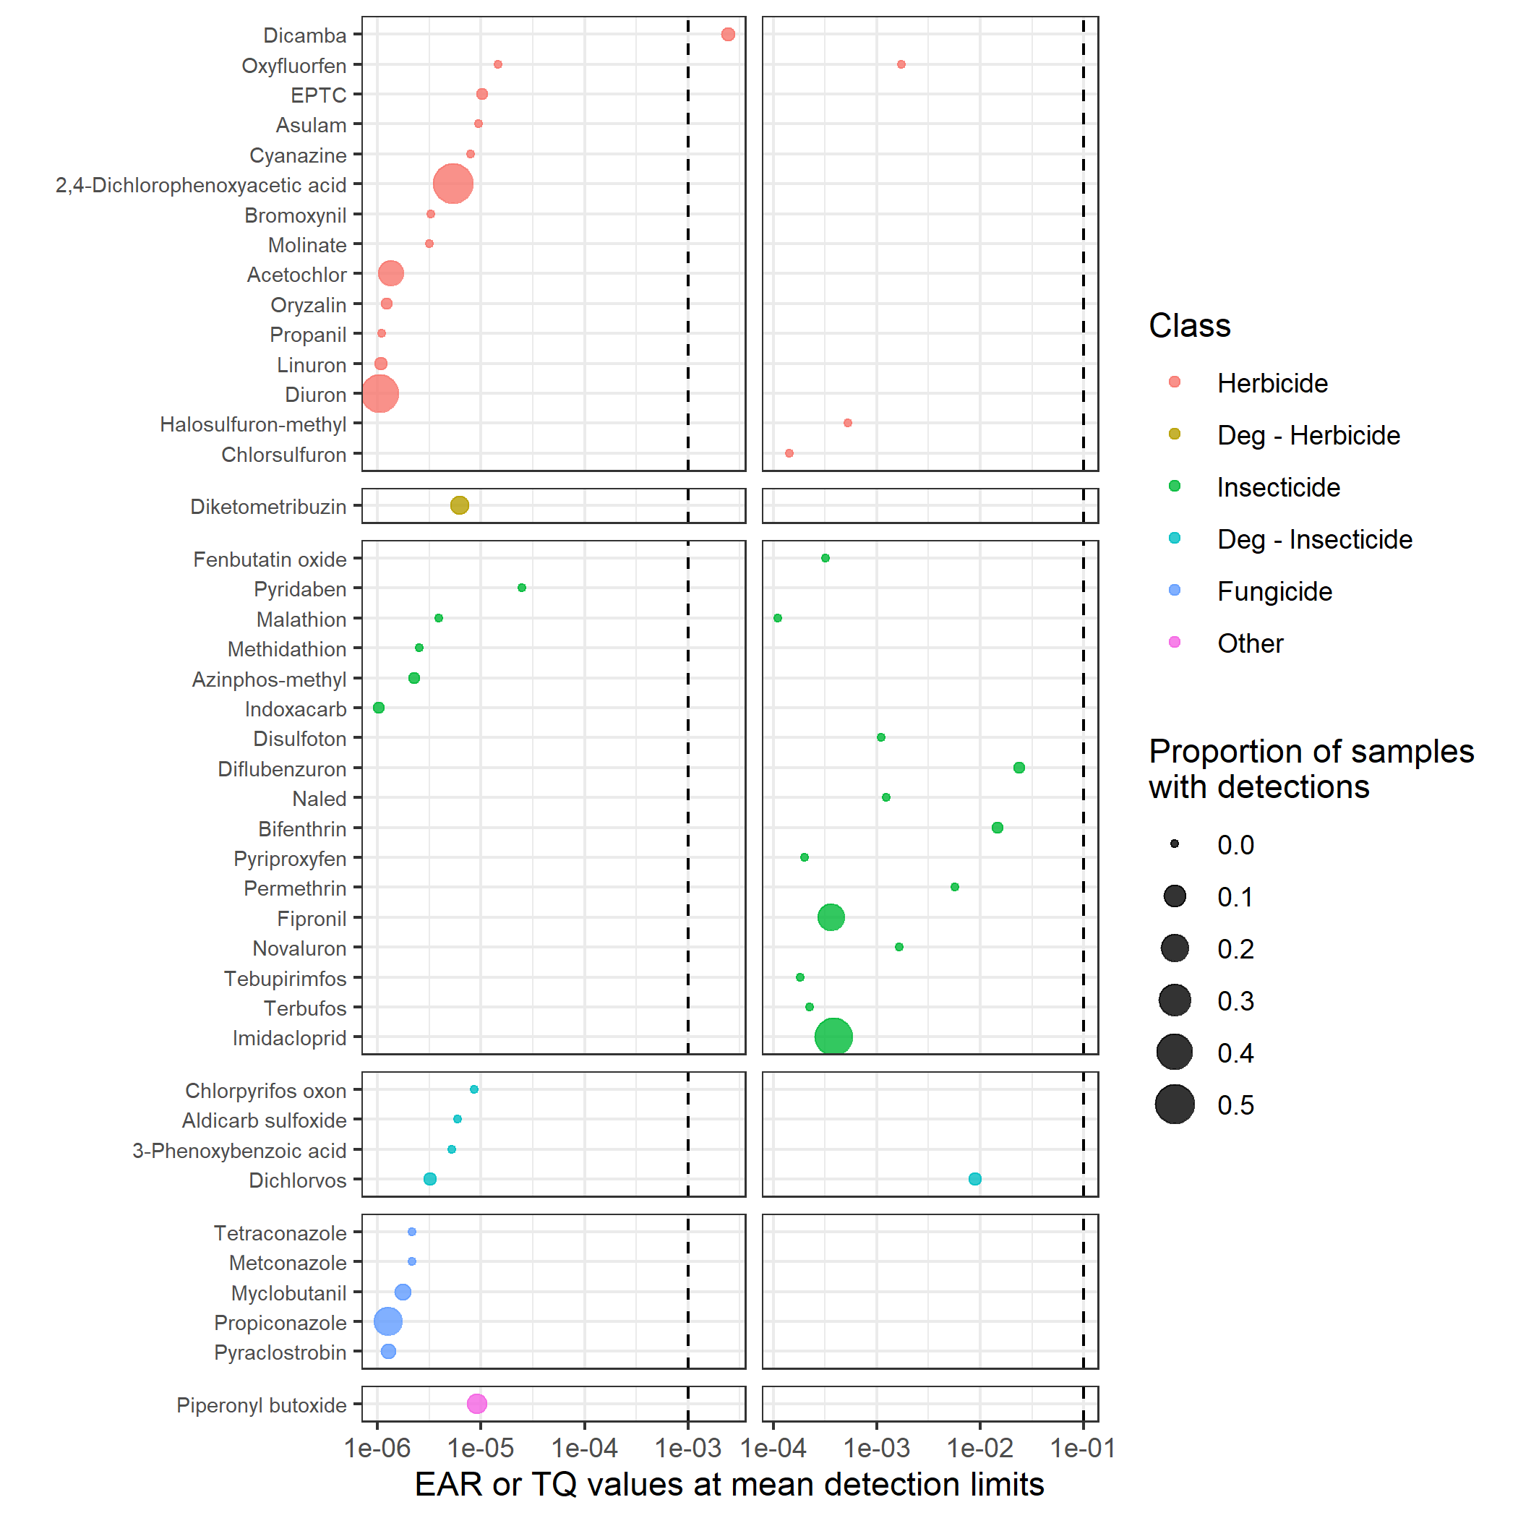

# 

Figure S4. Comparison of flow conditions on the day of sample collection (black dots), across all of water year 2016 (gray violin plot), and since water year 1986 (yellow violin plot). Dots and violin plots represent daily mean flow in cubic feet per second. Horizontal lines represent the median daily mean flow on sample dates (black), in water year 2016 (light gray), and over the last 30 years (yellow). Note some sites did not date back to 1986; shorter flow records occurred at Indiana HC (flow record began in 1992), Milwaukee (1994), Vermillion (2001), and Grand MI (2011). All data are from the National Water Information System (U.S. Geological Survey, 2016).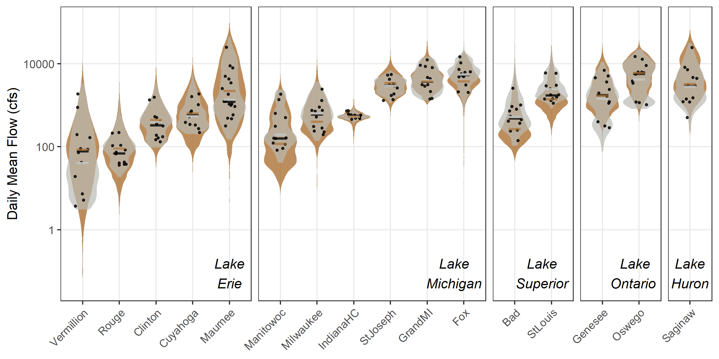

Figure S5. Monthly pesticides concentrations and number of chemicals detected in water samples collected from 16 Great Lakes tributaries, October 2015-September 2016. Concentrations are the sum of all detected pesticides. Each boxplot is a summary across 16 sites (one sample per site per month).

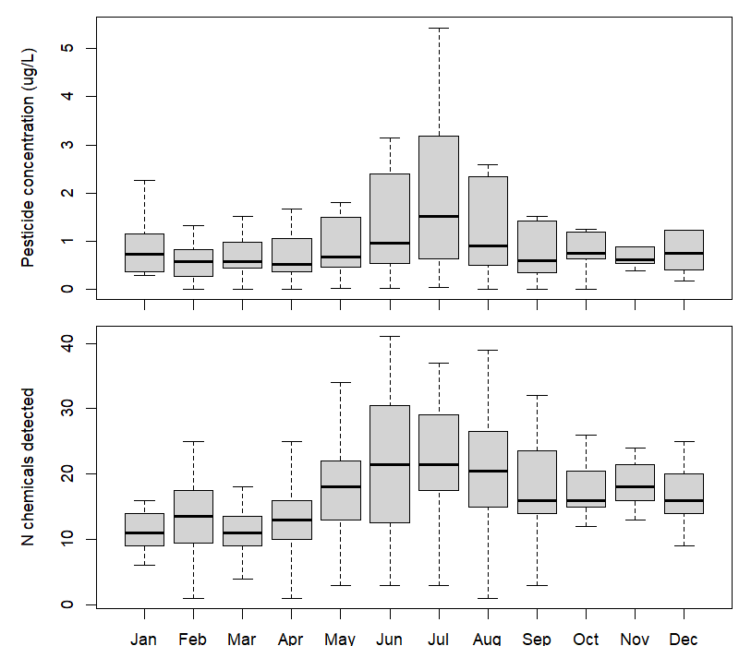

Figure S6. Monthly pesticide concentrations across compound class (top) and dominant land use (bottom) for water samples collected from 16 Great Lakes tributaries, October 2015-September 2016. Detected pesticide concentrations were first summed for each site-date-class (top) or site-date (bottom). The y-axis values are median concentrations across all sites (top) or all sites in each land use category (bottom). For land cover categories, points represent median values across 5 urban sites, 5 cropland sites, 4 mixed agriculture sites, and a single forested site and wetland site. Because the y-axis is log scaled, points that fall on the x-axis are zero.

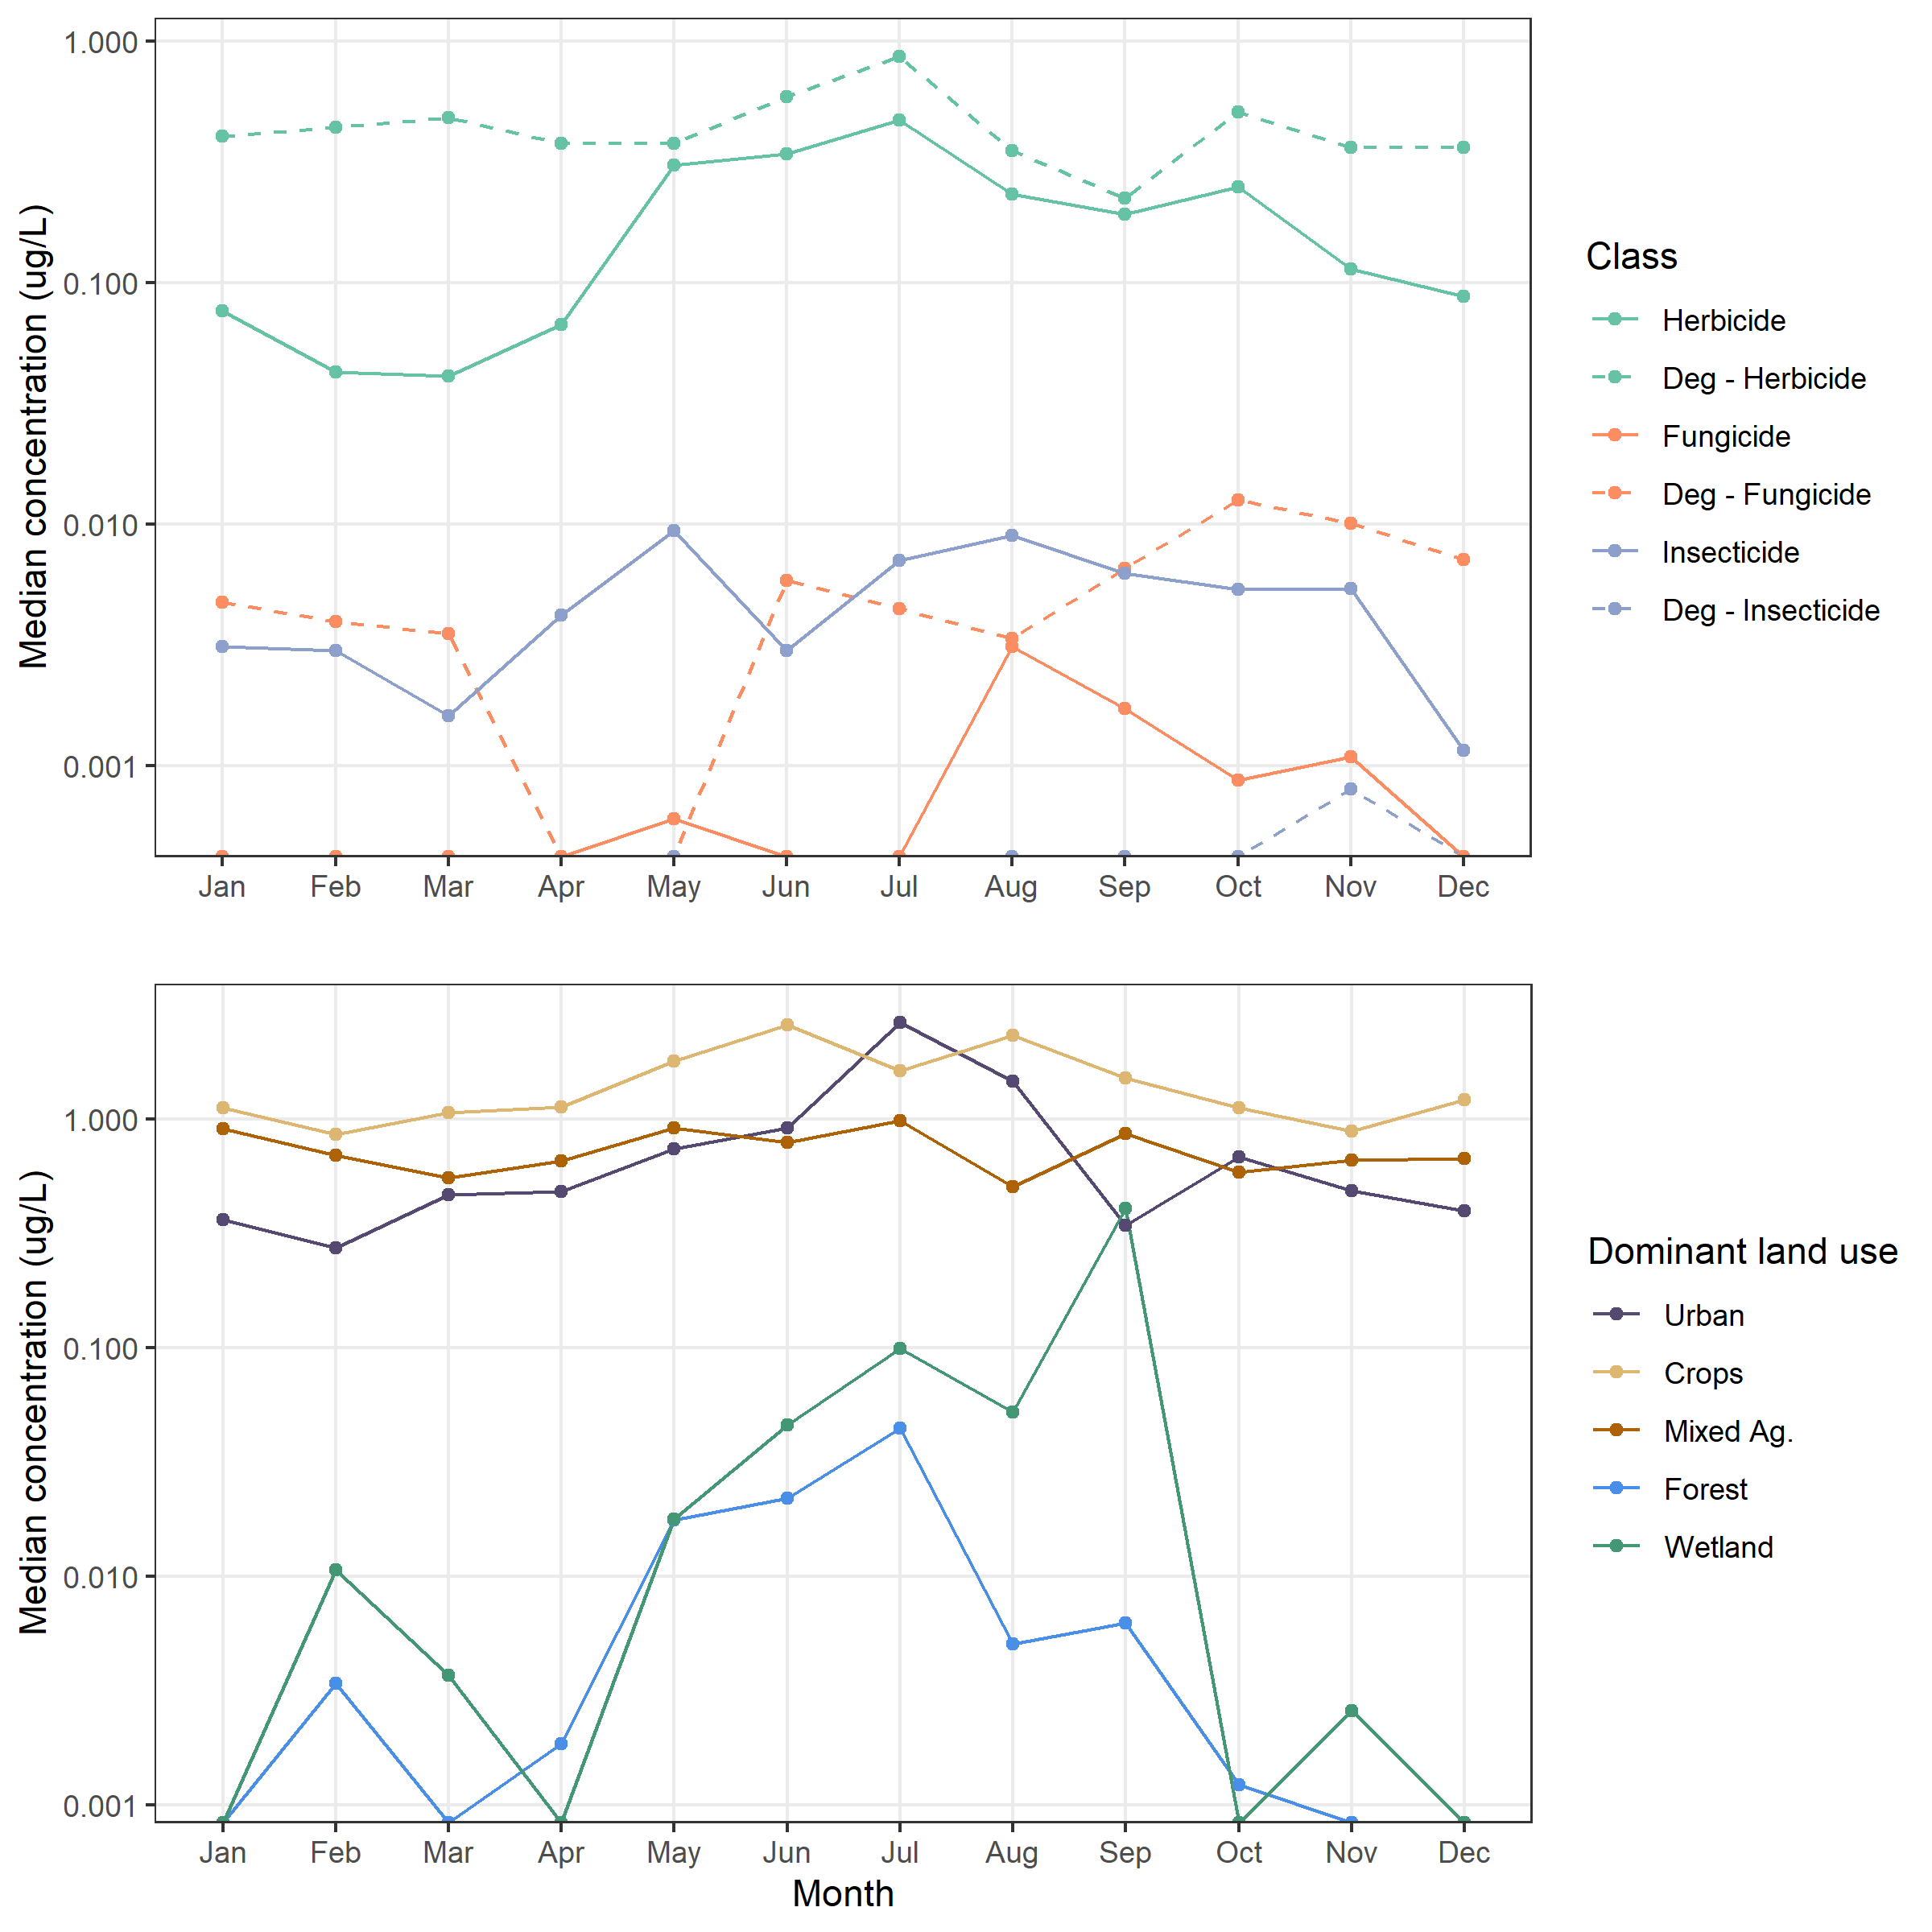

Figure S7. The number of sites (top) and chemicals (bottom) with EARchem > 0.001 or TQchem > 0.1 in each month for water samples collected from 16 Great Lakes tributaries, October 2015-September 2016. Line types show the same calculation for different groups of pesticides; for sites (top row), the solid line represents the number of sites with exceedances from all pesticides with estimated or known bioactivity/toxicity, whereas the dotted line represents the number of sites with exceedances only using compounds with known bioactivity or toxicity and not those where we used the parent compound to estimate bioactivity or toxicity. For chemicals (bottom row), the lines show the number of chemicals with exceedances for all compounds with known or estimated bioactivity/toxicity (solid), parent pesticides (dashed), transformation products (TPs) with estimated bioacitivity/toxicity (dotted), and TPs with known bioactivity/toxicity (alternating dot dash).

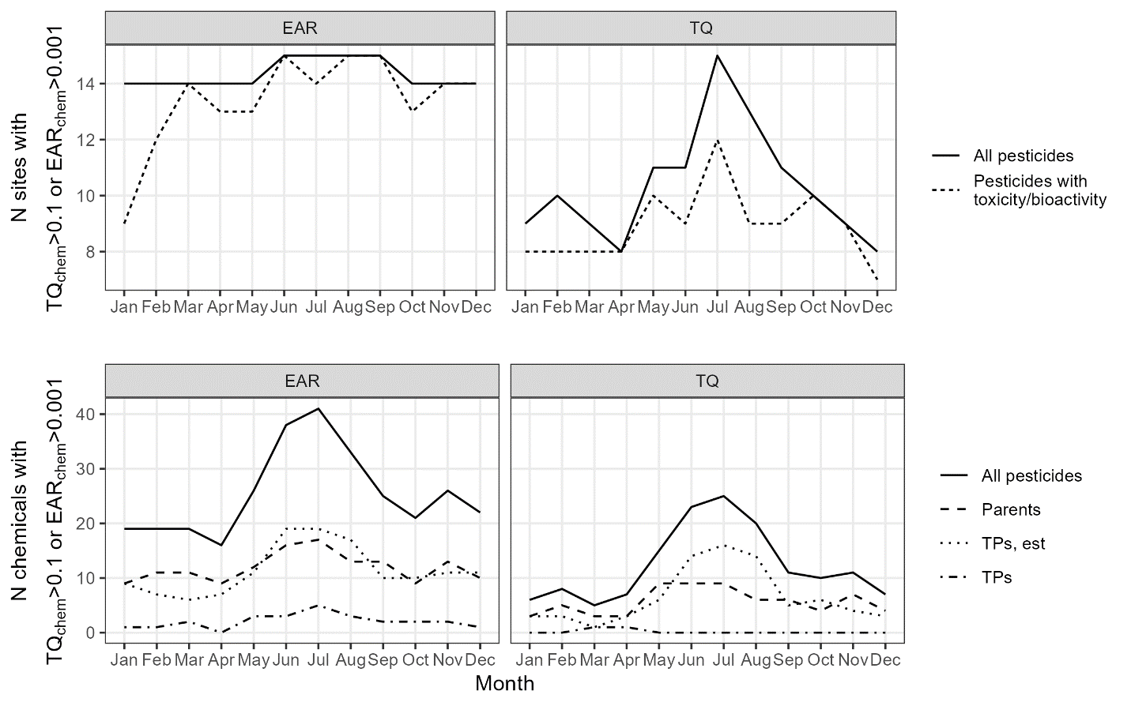

Figure S8. Temporal dynamics of pesticides and pesticide transformation products in water samples collected from 16 Great Lakes tributaries, October 2015-September 2016. Chemicals are grouped by major class (columns), and site data are grouped by dominant land use type (rows). Each dot is an individual sample and represents the maximum TQparent value for that site-date-class of compounds (distance from center) and number of chemicals with TQparent > 0.1 (dot size). Parent and transformation product TQ values were summed to calculate TQparent. All sites are represented once per month, and a site-date without any TQparent > 0.001 would not appear in this figure. The wetland and forested site were removed from this figure because of limited threshold exceedances.

