Supporting information for:

Prioritizing pesticides of potential concern and identifying potential mixture effects in Great Lakes tributaries using passive samplers

Luke C. Loken^{*1}, Steven R. Corsi¹, David A. Alvarez², Gerald T. Ankley³, Austin K. Baldwin⁴, Brett R. Blackwell³, Laura A. De Cicco¹, Michele A. Nott¹, Samantha K. Oliver¹, Daniel L. Villeneuve³

¹ U.S. Geological Survey, Upper Midwest Water Science Center, Madison, WI, USA
² U.S. Geological Survey, Columbia Environmental Research Center, Colombia, MO, USA
³ U.S. Environmental Protection Agency, Center for Computational Toxicology and Exposure, Great Lakes Toxicology and Ecology Division, Duluth, MN, USA.
⁴ U.S. Geological Survey, Idaho Water Science Center, Boise, ID, USA

* Correspondence: lloken@usgs.gov

Supplementary Information Figures
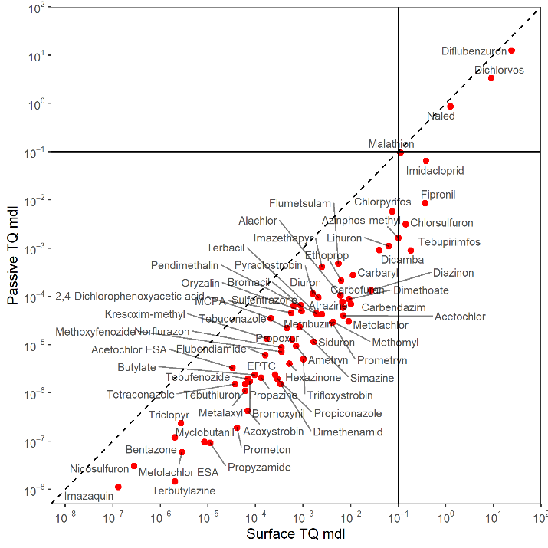
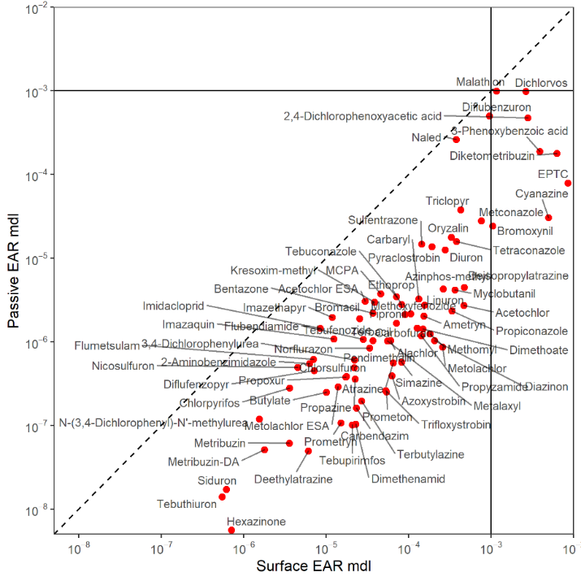
Figure SI-1. Calculated Exposure Activity Ratios (EARs; left) and Toxicity Quotients (TQs; right) based on the minimum detection limits (MDL) for surface discrete (x-axis) and passive (y-axis) samples for pesticides and pesticide transformation products in samples collected from 15 Great Lakes tributaries, June-July 2016. Chemicals below the 1:1 line (dashed) had lower passive sampler MDLs. The solid lines are EAR values of 10⁻³ and TQ values of 0.1. Chemicals to the right or above the solid lines represent chemicals with MDLs above the EAR or TQ threshold concentrations for discrete and passive samples, respectively.

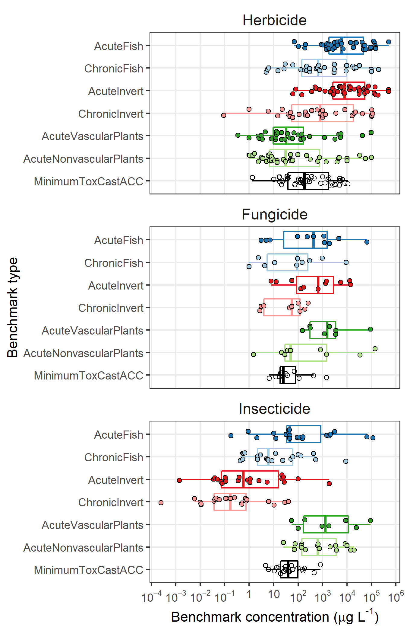
Figure SI-2. Aquatic Life Benchmark (ALB) and Activity Concentrations at Cutoffs (ACC) concentrations by chemical class for pesticides and pesticide transformation products in samples collected from Great Lakes tributaries, June-July 2016. Only chemicals that were detected in at least one passive sample that had either an ALB or ACC are included. Benchmark types (e.g., acute fish) are consistently colored among panels. The upper and lower edges are the 25th and 75th percentiles, and whiskers are drawn up to 1.5 times the interquartile range.

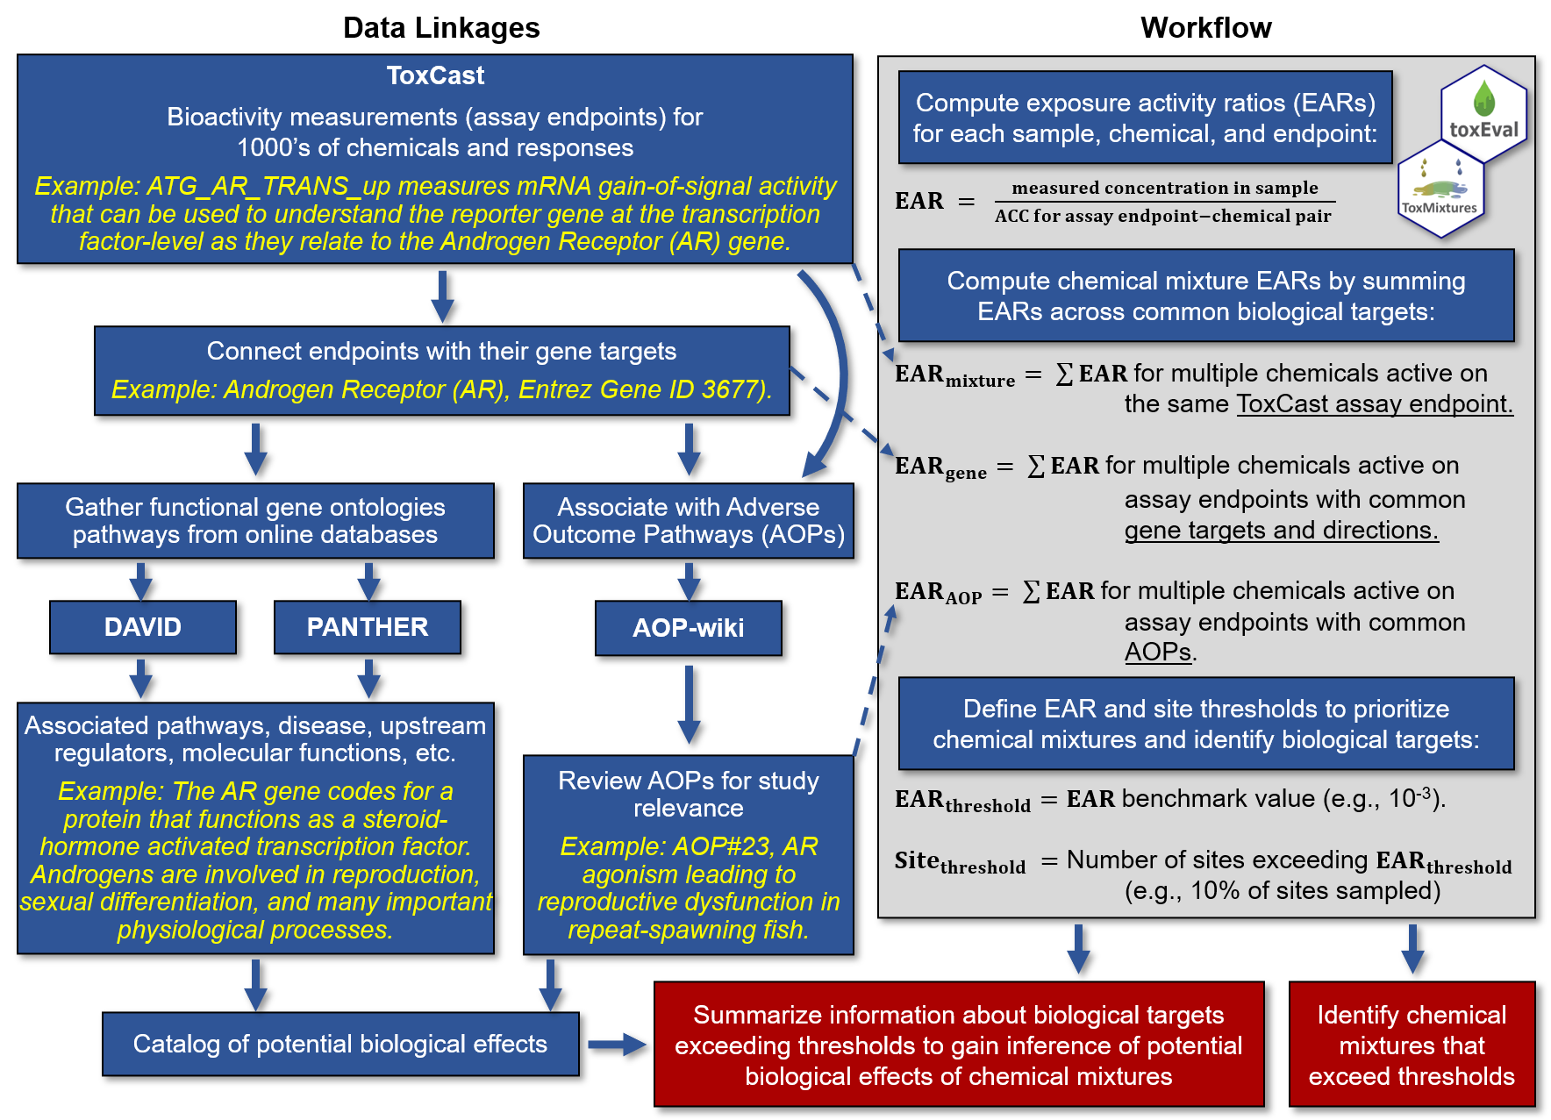
Figure SI-3. Conceptual framework of ToxMixtures (https://code.usgs.gov/water/toxmixtures). Data on chemical potency and environmental relevance from multiple online data sources (left) are combined with environmental chemistry datasets (right) to identify potential biological effects associated with chemical mixtures.

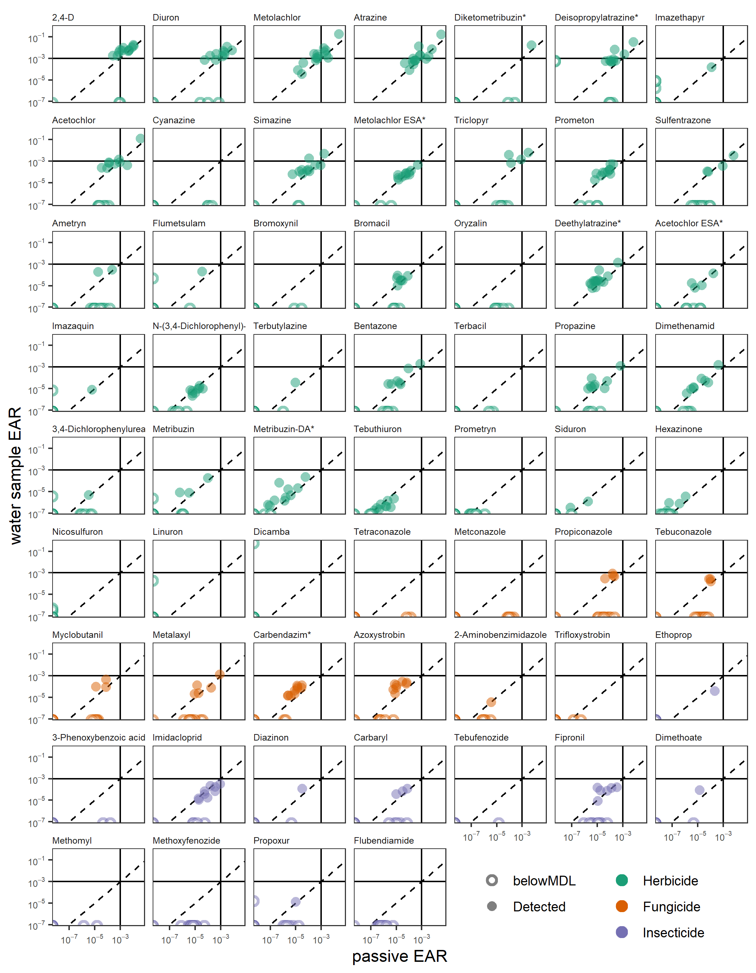
Figure SI-4. Exposure Activity Ratio (EAR) comparison among passive (x-axis) and traditional discrete water (y-axis) samples for pesticides and pesticide transformation products in samples collected from Great Lakes tributaries, June-July 2016. Dashed diagonal line is the 1:1. Solid lines represent the EAR threshold of 10⁻³. Hollow symbols indicate that either sample was below the minimum detection limit (MDL), and points are positioned on the respective axis (i.e., samples on the x-axis had pesticide concentrations below the MDL for the water sample method).
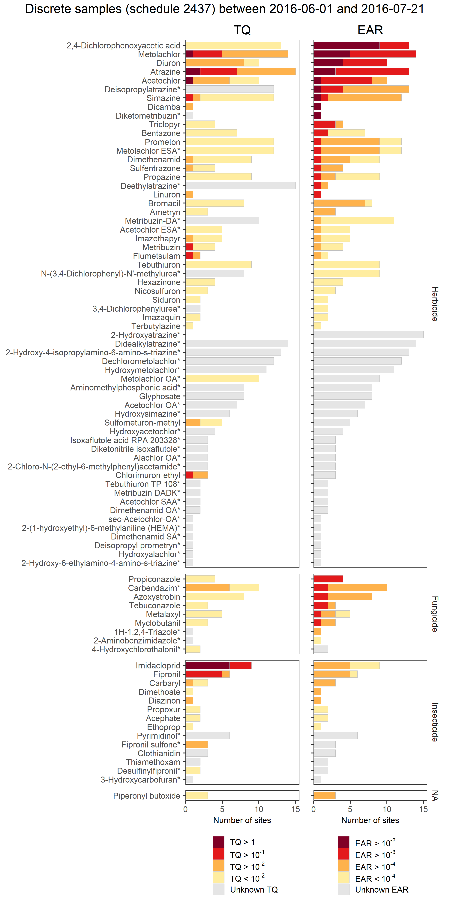
Figure SI-5. Chemical detections (yellow) and potential activity (red/orange) based on Toxicity Quotients (TQ; left) and Exposure Activity Ratios (EAR; right) from discrete samples collected from 15 Great Lakes tributaries, June-July 2016 (2-6 samples per site). The combined height of each bar represents the number of rivers where a chemical was detected above the minimum detection limit. Red, orange, and yellow colors show the number of sites where a chemical exceeded TQ or EAR values. Chemicals are grouped by intended use and ordered by frequency of elevated EAR values. Data represent a subset of data published in Oliver et al. (in review). Data only includes analytes included in National Water Quality Lab schedule 2437 (Sandstrom et al. 2015).[*, transformation product.]
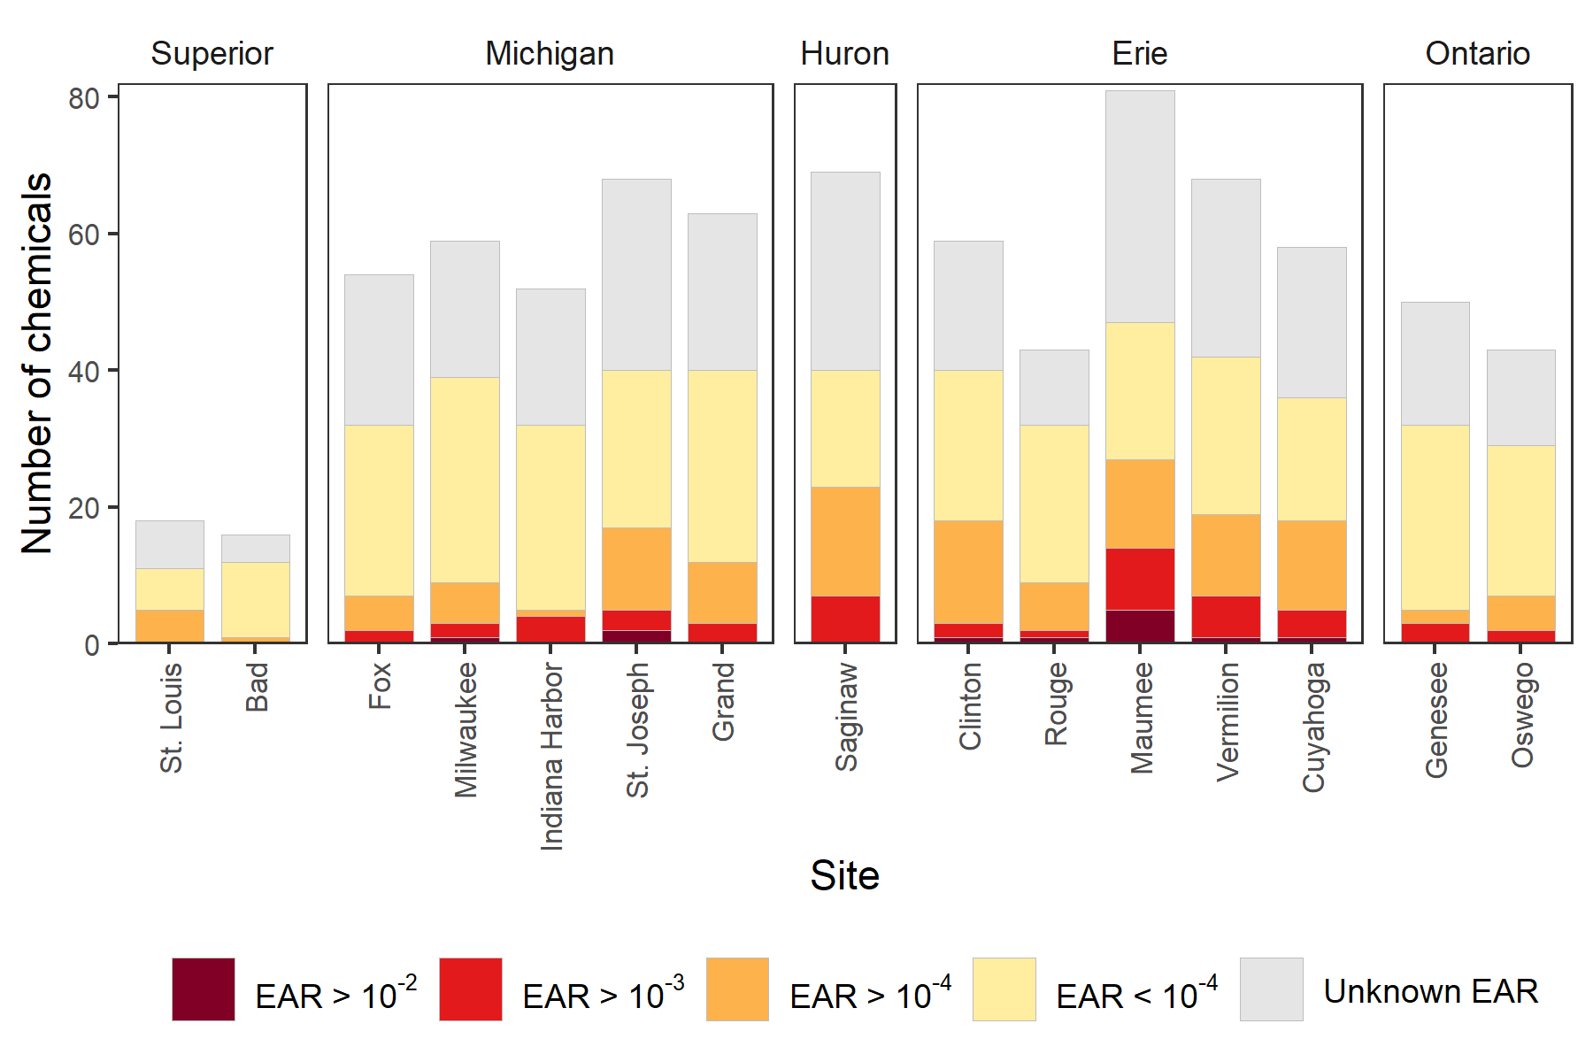
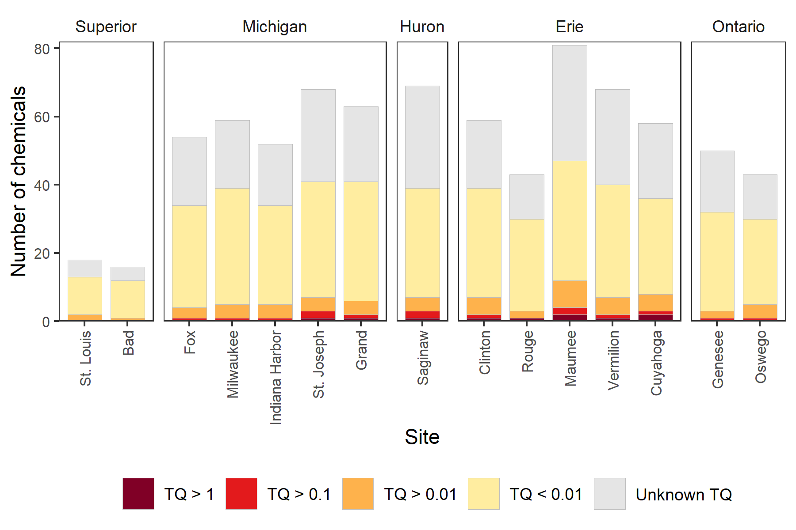
Figure SI-6. Number of pesticides and pesticide transformation products detected, Toxicity Quotient (TQ) threshold exceedances (top panel), and Exposure Activity Ratio (EAR) threshold exceedances (bottom panel) in passive sampler monitoring results from 15 Great Lakes tributaries, June-July 2016. The combined height of each bar notes the total number of chemicals detected above the minimum detection limit. Red, orange, and yellow colors show the frequency of chemicals above TQ and EAR threshold levels. Sites are arranged from west to east (counter-clockwise around the Great Lakes) and grouped by Great Lake watershed.

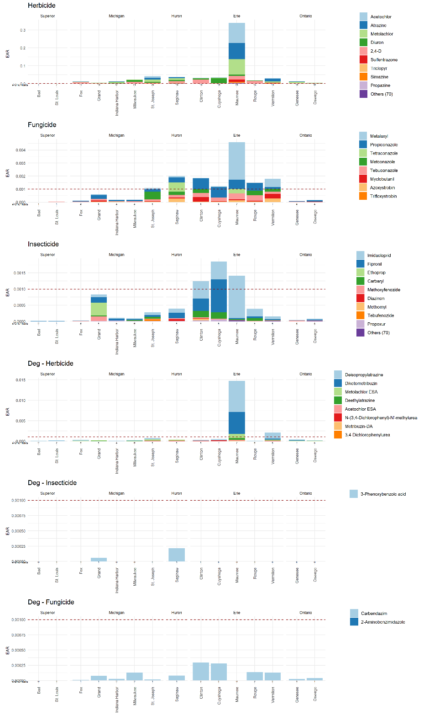
Figure SI-7. Sum of Exposure Activity Ratios (EAR) per site organized by chemical (color) and chemical class (panel) for pesticides and pesticide transformation products (Deg) in passive samples collected from Great Lakes tributaries, June-July 2016. The number of chemicals detected per class that have ToxCast representation are listed below each bar. Note each panel has a different scale and legend. Within each panel, chemicals are ordered (top to bottom) by mean EAR and only the top 9 chemicals are plotted with a unique color. For example, the chemicals with the highest mean EAR by class are light blue and are on the top of each bar. The horizontal red line notes an EAR threshold of 10⁻³.
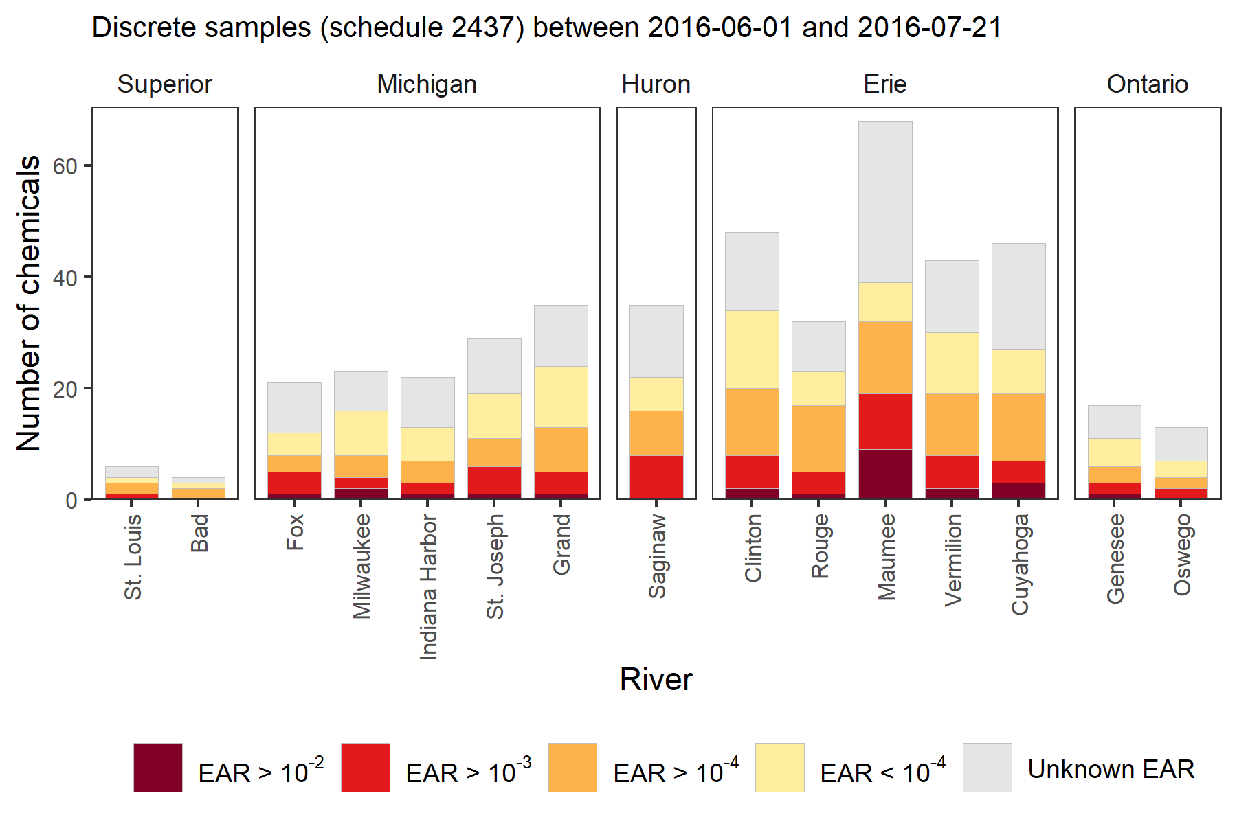
Figure SI-8. Number of pesticides and pesticide transformation products detected in each river from discrete samples collected from each of the 15 Great Lakes tributaries, June-July 2016 concurrent with POCIS deployments (2-6 samples per site). The combined height of each bar notes the number of chemicals detected. Red and orange colors show the number of chemicals detected at concentrations exceeding Exposure Activity Ratio (EAR) thresholds. Grey bars note chemicals detected without ToxCast information. Chemicals are grouped by the Great Lake watershed and ordered from west to east (counterclockwise around the lakes). Data represent a subset of data published in Oliver et al. (in review). Data only include analytes included in National Water Quality Lab schedule 2437 (Sandstrom et al. 2015).

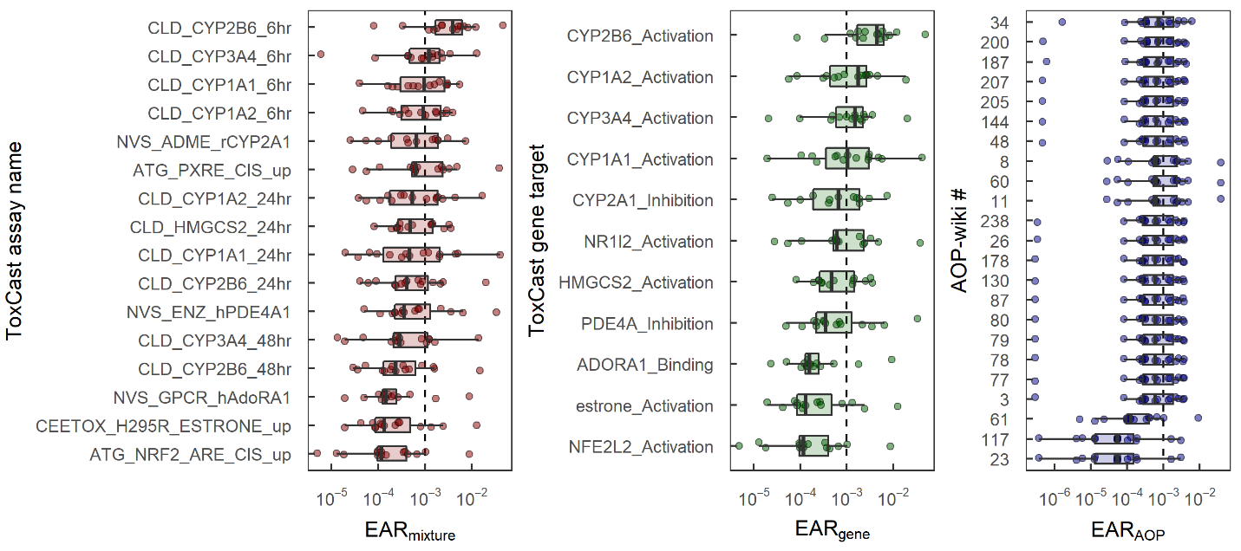
Figure SI-9. Priority endpoints (left), genes (center), and Adverse Outcome Pathways (AOP; right) associated with Exposure Activity Ratio (EAR) threshold exceedances from passive samples for pesticides and pesticide transformation products collected in Great Lakes tributaries, June-July 2016. Each panel only includes targets (i.e., endpoints, genes (and assay direction), or AOPs) that exceeded EAR of 10⁻³ at two or more sites. Each dot is a site, and each panel is ordered by median EAR among sites. For one endpoint without a specific gene target, the gene name was replaced with the hormone induced by the ToxCast assay (i.e., estrone). The upper and lower edges are the 25th and 75th percentiles, and whiskers are drawn up to 1.5 times the interquartile range.

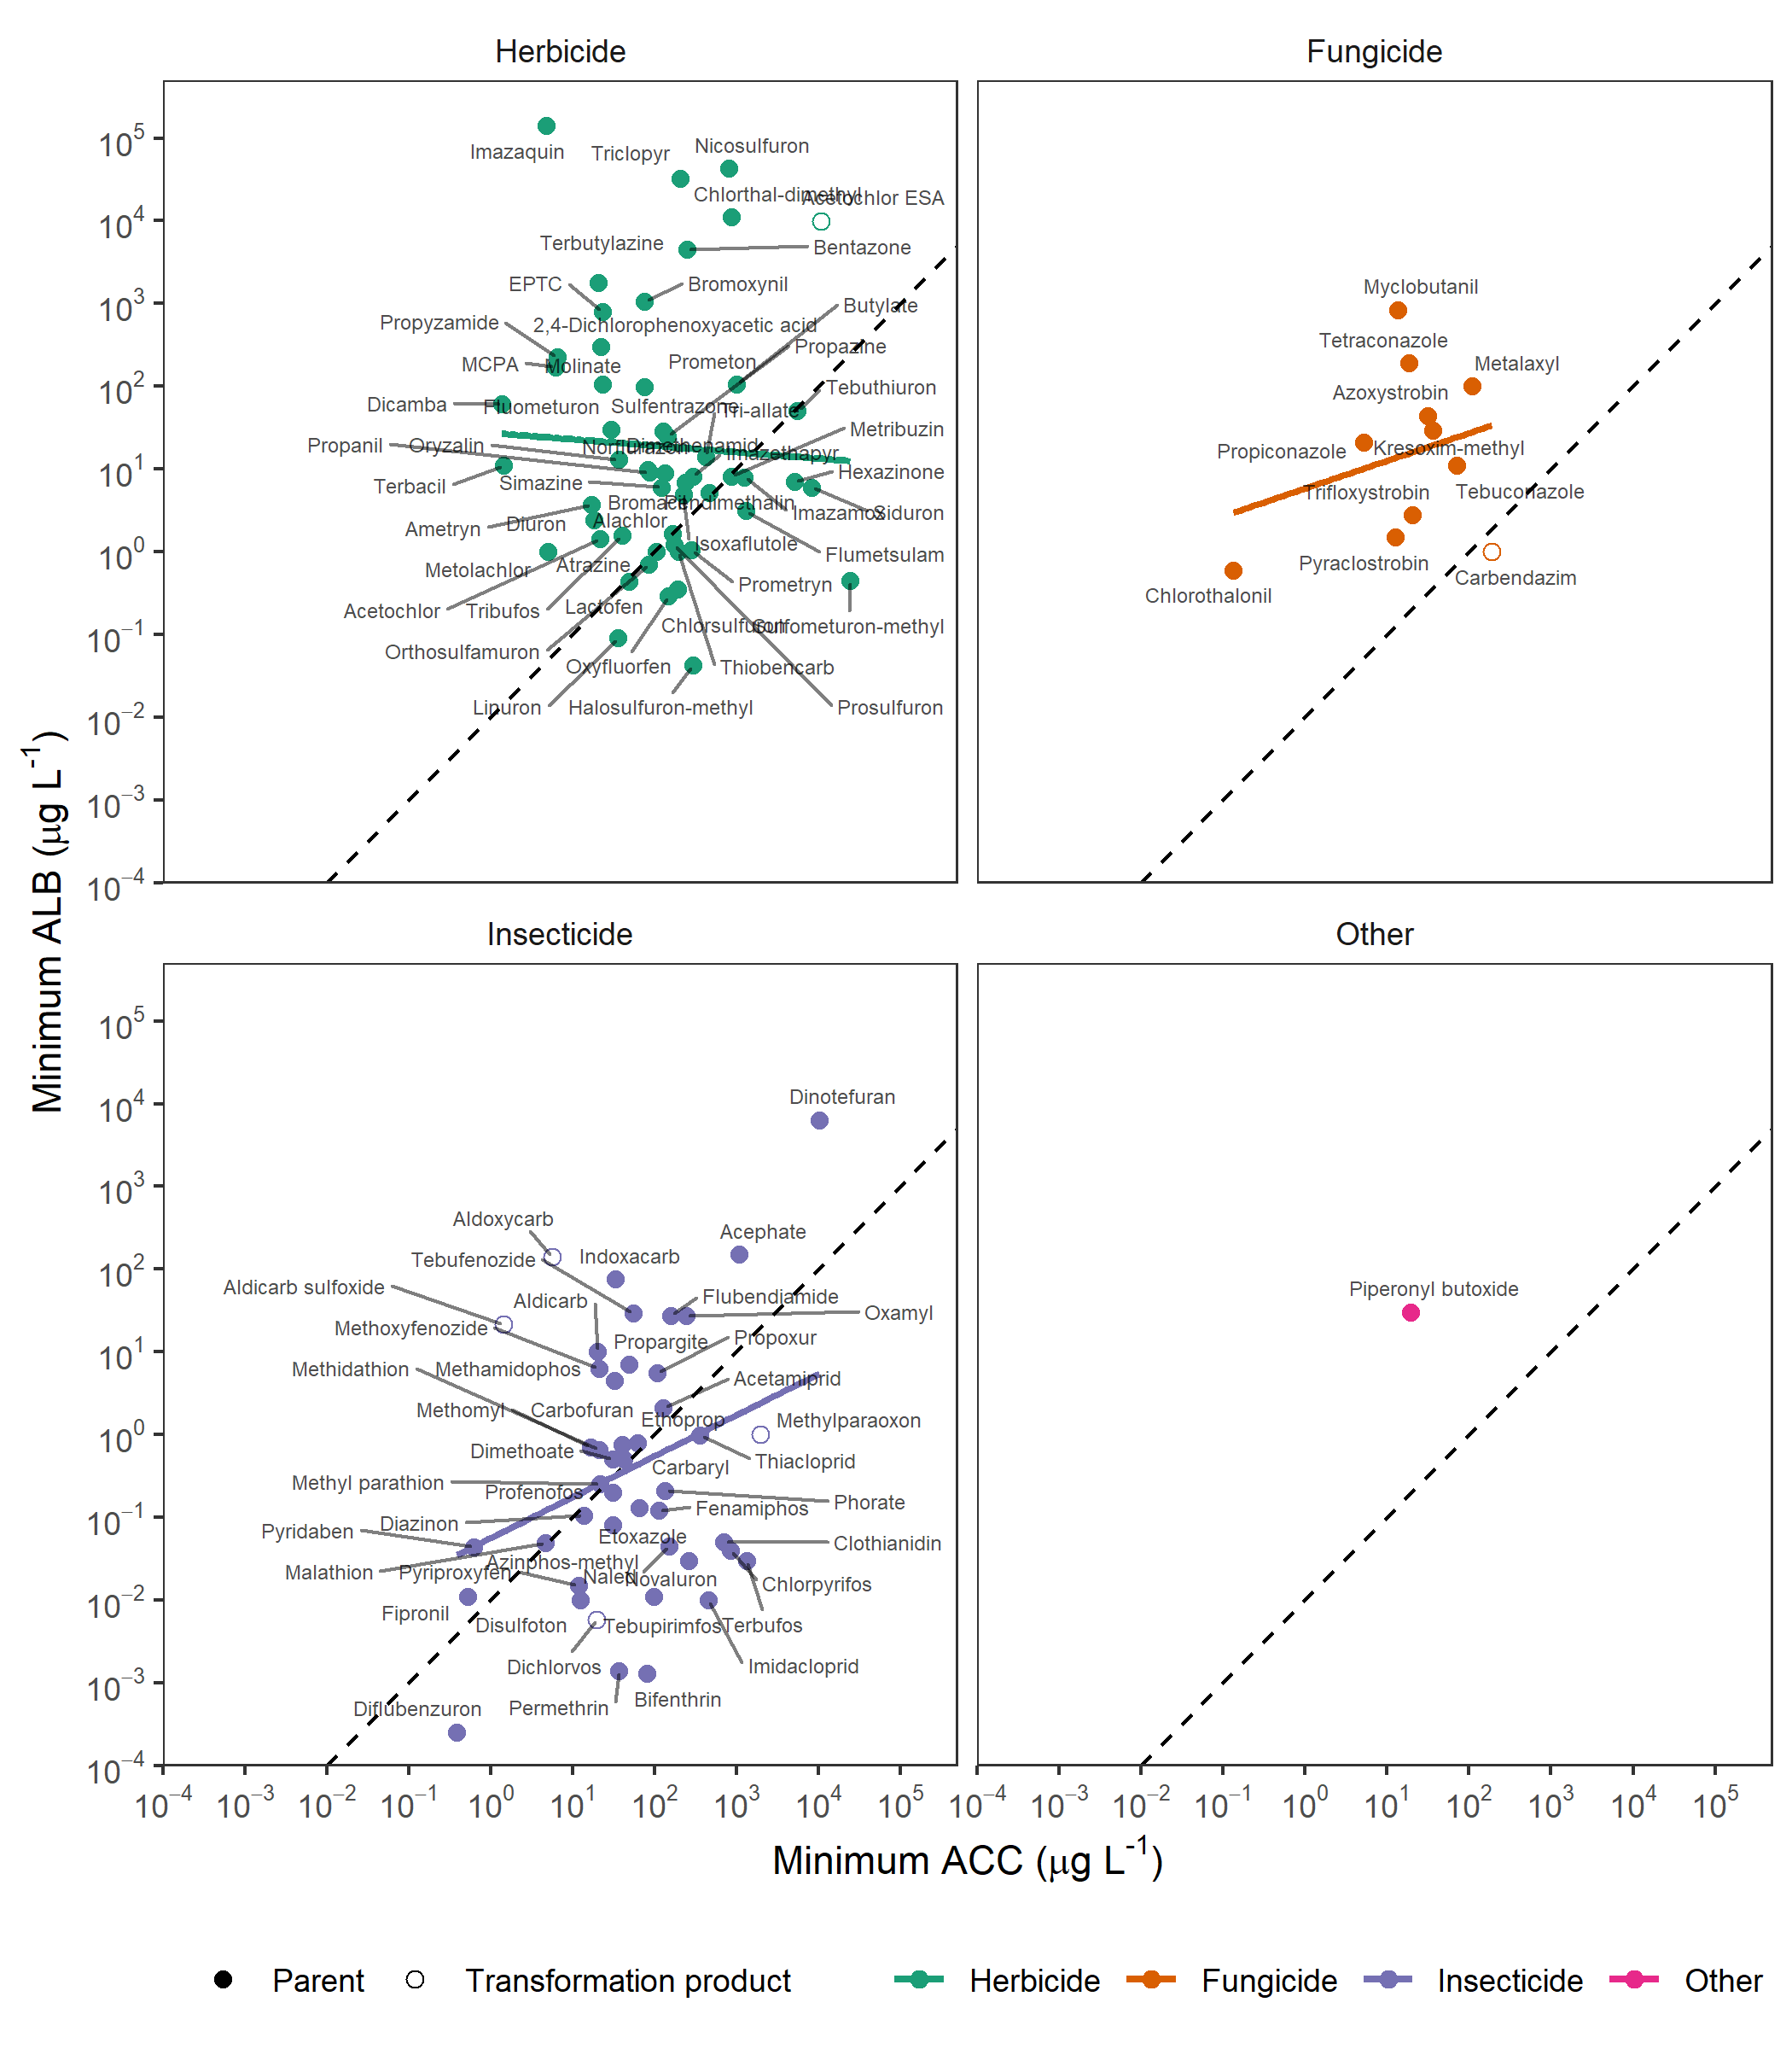
Figure SI-10. Minimum Aquatic Life Benchmarks (ALB) versus minimum Activity Concentration at Cutoff (ACC) for pesticide (filled symbols) and pesticide transformation products (hollow symbols). ALBs and ACCs were used to compute Toxicity Quotients (TQs) and Exposure Activity Ratios (EAR). The diagonal dashed line represents ALBs and ACCs that would result in a TQ of 0.1 and EAR of 0.001 (i.e., the thresholds used in this study to prioritize contaminants) at the same chemical concentration. Compounds above the diagonal line would be prioritized first using ACC-based EARs, and chemicals below the diagonal line would be prioritized first using ALB-based TQs. The solid lines are the simple least squares regression model for all compounds in that chemical class.
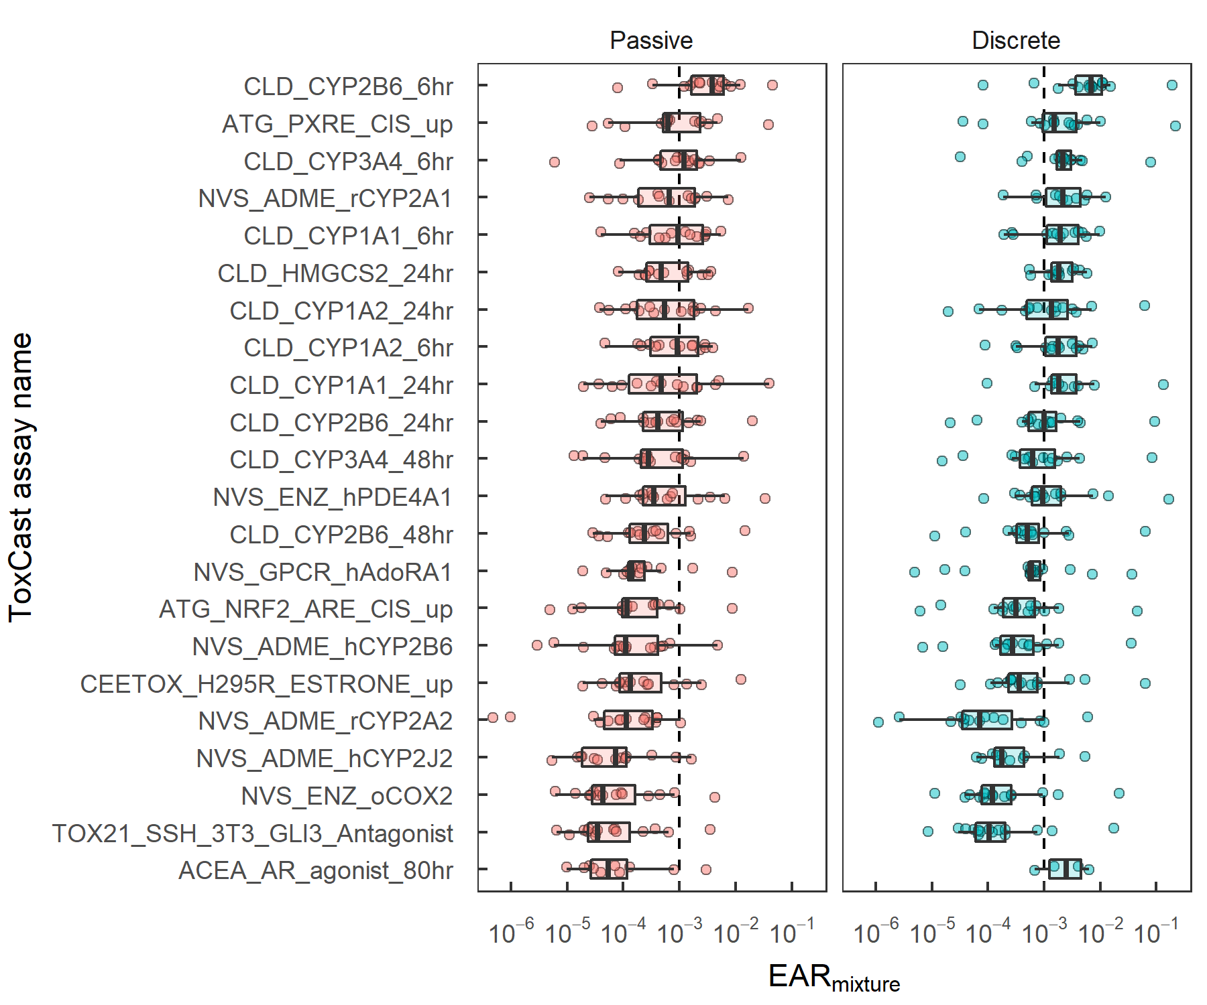
Figure SI-11. Exposure Activity Ratios from mixtures (EAR_{Mixture}) of pesticides and pesticide transformation products by site and across ToxCast assays for passive (left) and discrete water (right) samples collected in 15 Great Lakes tributaries, June-July 2016. Assays included had EAR_{Mixture} > 10⁻³ in at least two sites for either method. ToxCast assays are ordered by median EAR_{Mixture} among all sites, endpoints, and methods. The upper and lower edges are the 25th and 75th percentiles, and whiskers are drawn up to 1.5 times the interquartile range.

