**Supplemental Information**

**Fragmentation and release of pristine and functionized carbon nanotubes from epoxy-nanocomposite during accelerated weathering**

E. Sahle-Demessie1*, Changseok Han2,3*, Eunice Varughese1, Brad Acrey5, Richard Zepp4

1U.S. Environmental Protection Agency, Office of Research and Development, Center for Environmental Solution and Emergency Response

2Department of Environmental Engineering, INHA University, Incheon 22212, Korea

3Program in Environmental & Polymer Engineering, Graduate School of INHA University, Incheon 22212, Korea

4U.S. Environmental Protection Agency, Office of Research and Development, Center for Environmental Measurement and Modeling

5U.S. Environmental Protection Agency, Region 4, Laboratory Services and Applied Science Division (LSASD), Athens, GA USA

***# of pages* 9**

***# of Figures 11 and # Tables* 1**

**Making of Epoxy-MWCNT composite**

Epoxies are made of a polymer formed by reaction of a hardening agent (EpiCure) and a prepolymer (EPON 862). The composite was made of Epon 862 (bisphenol F epoxy) and the curing agent EpiCure W that were provided by Miller-Stephenson Chemical Company, Figure S1 shows the molecular structures of these chemicals. Pyrrole (C4H5N, ≥98%), ammonium persulfate (APS, (NH4)2S2O8, 98%) and *p*-toluene sulfonic acid (PTSA, C7H8O3S, ≥98.5%) were purchased from Sigma-Aldrich.

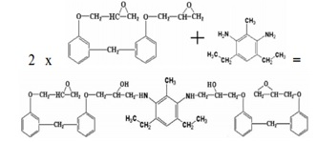

**Figure S1.** Epoxy is the reaction product of two molecules of EPON 862 and one molecule of the curing agent, and the MWCNT were added in the mix before the thermoset reaction.

Table S1 Polymers and nanocomposites used for the study

|  |  |
| --- | --- |
| **Polymer** | **Additive** |
| Epoxy | None |
| Epoxy | Pure CNT, 1 wt% |
| Epoxy | COOH-CNT, 1 wt% |
| Epoxy | NH2-CNT, 1 wt% |

**Figure S2**. Preparation of Epoxy-MWCNT composites

**Figure S3**. Modified Experimental Setup, Sample positions were rotated daily to ensure even spraying

**Figure S4**. Gradual discoloration of pure epoxy as the aging progresses. Sample panels degraded and started breaking and crumbled as the materials ages.

A close up of a map

Description generated with high confidence

**Figure S5**. FTIR analysis of surface of aged epoxy-CNT composite plates

Epoxy Raw

Epoxy-CNT

composite

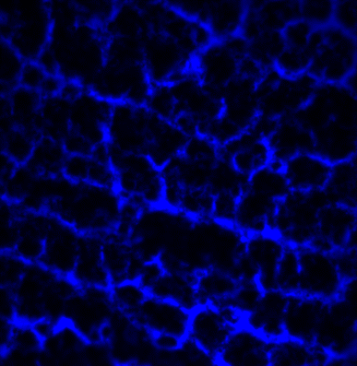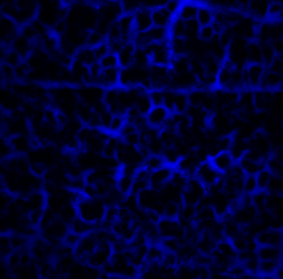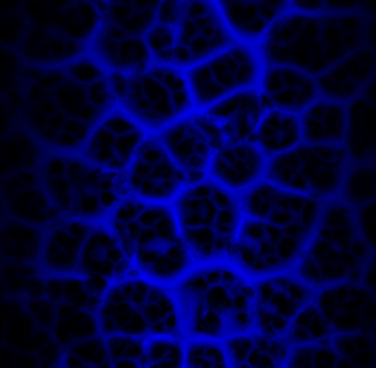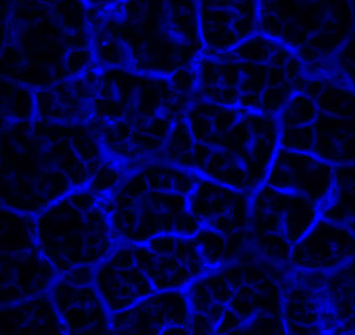

**10 mm**

**10 mm**

**10 mm**

**10 mm**

3 month

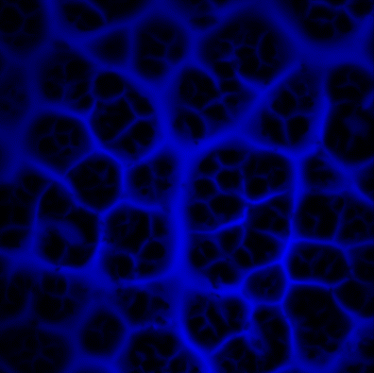

**10 mm**

12 month

6 month

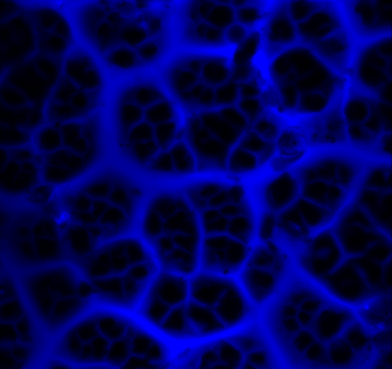

**10 mm**

cracks

Equivalent Sun Exposure Length

**Figure S6.** Imaging using Zyglo fluorescent penetrant dye, **l**peak = 365 nm, Laser Confocal microscopy, 40X, Cracks widened with extended weathering

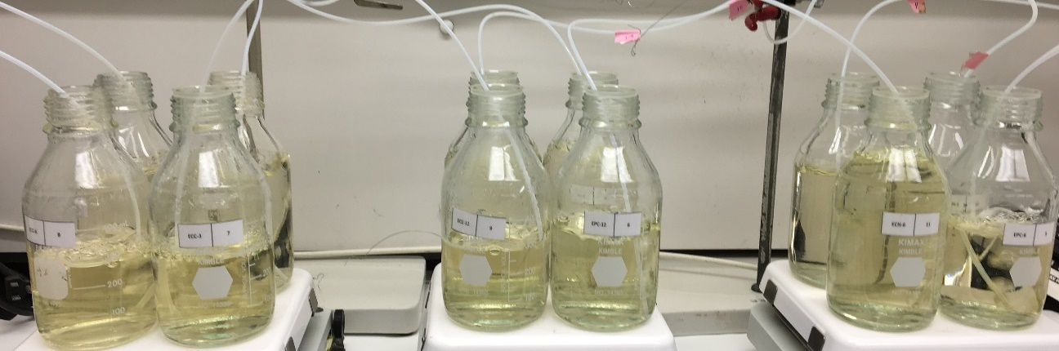

Figure S7. **Washwater evaporation and leachate concentration Setup**

Water from each flask sample in the SunTest chamber were *collected every day* (avg 200 ml), and *transferred* to bottles, and gradually evaporated by bubbling nitrogen. Water temperature in the bottles was 60-65 oC. Wash water collected for 12 test days (1500 ml) is reduced to 150 ml, were store in air-tight jars (4 oC )

**Figure S8.** Release of pollutants from aged epoxy composites

**Table S2**. Raman band shift at the peak bands for the functionalized CNT 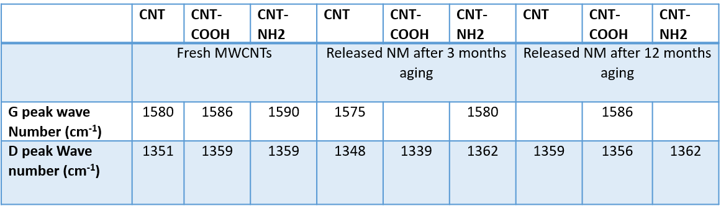

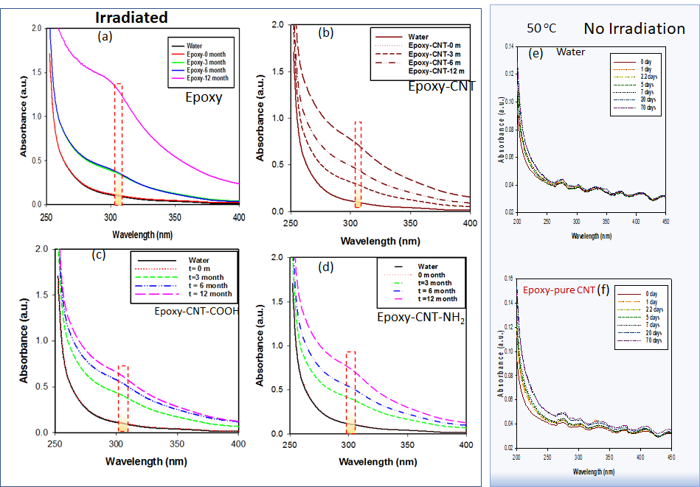

**Figure S9.** UV-vis spectroscopy leachate and released particles. Samples (a) to (d) are for irradiated sample wash water, and samples (e) and (f) are for non-irradiated sample water.

Dashed box represent UV-vis absorbance of MWCNT [1]

**Figure S10.** Polydispersed size distribution determined using dynamic light scattering (DLS) of wash water samples containing released fragments from (a) neat epoxy and epoxy composite of (b) CNT, (c) CNT-COOH, (d) CNT-NH2 collected after 6 months of aging. The right column shows DLS analysis after filtering with 0.7 mm filter.

**Figure S11.** In vitro assessment of Toxicity of wash water from aged epoxy-MWCNT composite Measuring the ability of nanoparticles to cause cell death or damage to basic cellular functions, where (a) Cell Viability & Activity (MTS Assay) and Cell based assays measurements of cell proliferation in response to toxicity of released materials direct cytotoxicity, (b) Oxidative stress measurement via detection of reactive oxygen speciesOxidative Stress Measurement via detection of reactive Oxygen Species (DCF Assay) which has in vivo and in vitro toxic effects

References

1. Abdulhameed, A., et al., *Optimization of surfactant concentration in carbon nanotube solutions for dielectrophoretic ceiling assembly and alignment: Implications for transparent electronics.* ACS omega, 2022. **7**(4): p. 3680-3688.