Supplementary Material

Comparison of in silico, in vitro, and in vivo toxicity benchmarks suggests a role for ToxCast data in ecological hazard assessment.

Christopher M. Schaupp*^{,1}, Erin M. Maloney², Kali Mattingly³, Jennifer H. Olker⁴, Daniel L. Villeneuve⁴

¹Oak Ridge Institute for Science and Education, US EPA, Great Lakes Toxicology and Ecology Division, Duluth, MN, USA.
²University of Minnesota-Duluth, Integrated Biological Sciences Program, Duluth, MN, USA.
³Spec-Pro Professional Services, 6201 Congdon Blvd, Duluth, MN, 55804, USA.
⁴US Environmental Protection Agency, Center for Computational Toxicology and Exposure, Great Lakes Toxicology and Ecology Division, Duluth, MN, USA.
*Corresponding author. Oak Ridge Institute for Science and Education, US EPA, Great Lakes Toxicology and Ecology Division, 6201 Congdon Blvd, Duluth, MN, 55804, USA. Email address: Schaupp.Christopher@epa.gov.

This file includes:
SI Figures: Figures S1-S25 (Pages 4-28)
SI Text (Pages 2-3)

Supplementary Text
ECOTOX point-of-departure derivation methods
ECOTOX data were filtered and entries meeting the following criteria were excluded: approximate effect concentrations; formulated and not reported chemical (test) grades; chemical purity < 85 %; test species outside of Animalia, Chromista, Plantae, or ‘Community’ Kingdoms; exposure type = “not reported”; results from multi-stressor toxicity tests (e.g., UV, chemical mixtures); results from tests with no clear dose response or no statistical significance at any tested concentration; bioaccumulation, time-to-effects, and asymptomatic threshold concentration results; results from tests with insufficient, unsatisfactory, or historical controls; NOECs/NOELs at the highest tested concentration; study lengths flagged as “approximate.”
Reported mean effect concentrations were preferentially used. When unavailable, mean concentrations were estimated by averaging reported min and max effect concentrations. Study length and mean effect concentration units were standardized (days and mg/L, respectively). ECOTOX benchmarks were derived by taking the minimum effect concentration for each chemical within the filtered dataset.

Subsequently, toxicity data were categorized according to the following annotations in ECOTOX:
1) Endpoint Type:
-No Effect: NOEC, NOEL, NR-ZERO, LC/EC/ICXX where XX < 10
-Low Effect: LOEC, LOEL, MATC, LC/EC/ICXX where 10 ≤ XX ≤ 50
-High Effect: NR-LETH, LETC, LC/EC/ICXX where XX ≥ 50
2) Effect Type:
-Tier 1: Mortality, Population, Growth, Reproduction, Development, Injury, Physiology, Intoxication, Morphology, Behaviour, Avoidance
-Tier 2: Biochemistry, Histology, Genetics, Enzyme(s), Hormone(s), Cell(s), Immunological, Multiple, Ecosystem Process
3) Species Group:
-Vertebrates: Fish, amphibians
-Invertebrates: Insects/spiders, crustaceans, molluscs, worms, other invertebrates
-Aquatic plants: Algae, moss, hornworts, fungi, flowers, trees, shrubs, ferns (aquatic)
4) Study Length:
-Acute: Test Type Description = Acute or Subacute
-Chronic: Test Type Description = Chronic, full life cycle, subchronic, generational, partial life cycle

Final PODs represented a diverse suite of benchmarks accounting for differing endpoints and effects:
-Overall ECOTOX PODs – included all available data
-Effect-Type PODs – Tier 1 vs. Tier 2 data
-Exposure Length PODs – Acute vs. Chronic
-Taxonomy-based PODs – aquatic vertebrates, invertebrates, or aquatic plants
-Endpoint-Type PODs – LC₅₀ or XC₅₀ data only

Terms Appendix
EC: Effect concentration
IC: Inhibitory concentration
LC: Lethal concentration
LC₅₀: Lethal concentration to 50% of test organisms
LETC: Lethal threshold concentration
LOEC: Lowest observable effect concentration
LOEL: Lowest observable effect level
MATC: Maximum acceptable toxicant concentration
NOEC: No observable effect concentration
NOEL: No observable effect level
NR-LETH: 100% mortality or 0% survival of organisms
NR-ZERO: 0% mortality or 100% survival of organisms
XC₅₀: 50% effect/inhibition/lethal concentrations; X stands for effect, inhibition, or lethal
Supplementary Figures
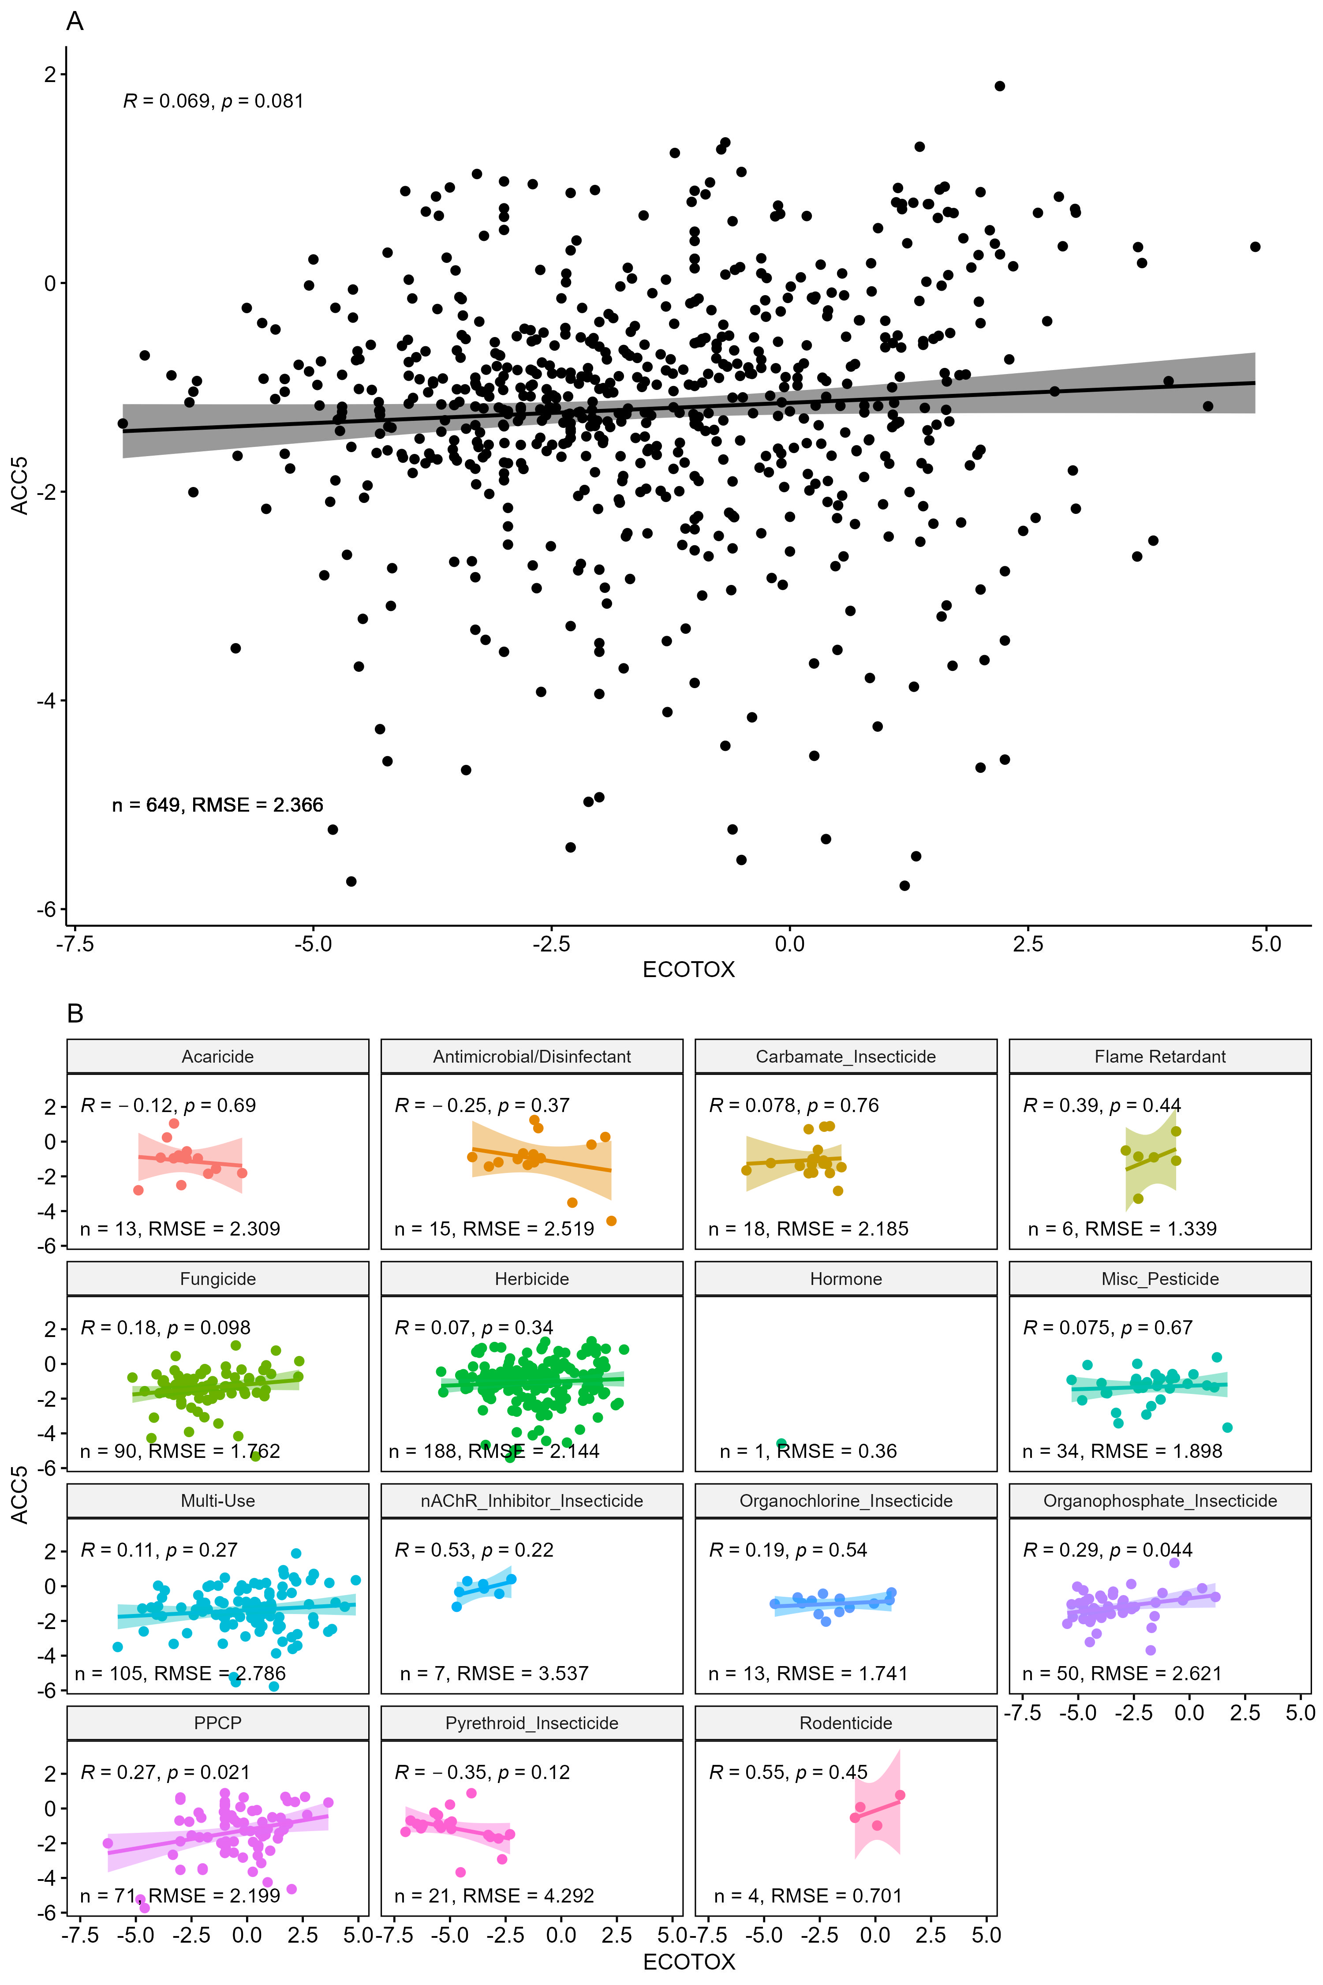
Figure S1. Correlation plots comparing ACC₅ and ECOTOX PODs overall (A) and by chemical use class (B). Data were log₁₀(common, or base 10, logarithm)-transformed for comparisons, with log₁₀ of ACC₅ plotted on the y-axis and log₁₀ of the minimum ECOTOX POD plotted on the x-axis. Statistical p-values and coefficients (ρ) are based on Pearson correlation analysis (α < 0.05).

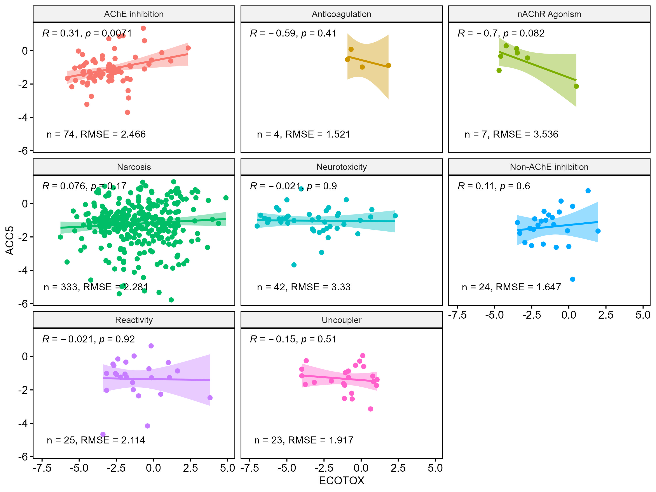

Figure S2. Correlation plots comparing ACC₅ and ECOTOX PODs by mode of action (MOA) grouping. Data were log₁₀(common, or base 10, logarithm)-transformed for comparisons, with log₁₀ of ACC₅ plotted on the y-axis and log₁₀ of the minimum ECOTOX POD plotted on the x-axis. Statistical p-values and coefficients (ρ) are based on Pearson correlation analysis (α < 0.05).

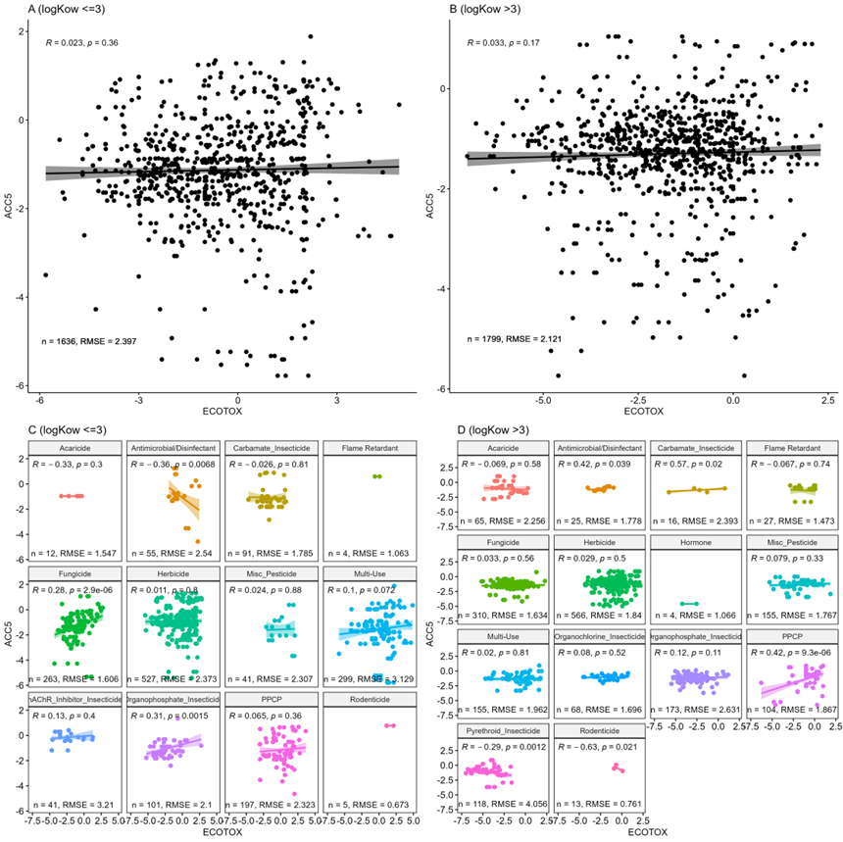
Figure S3. Correlation plots comparing ACC₅ and ECOTOX PODs, separated by logK_{ow}. Plots in panels A and C contain only chemicals with logK_{ow} ≤ 3, whereas B and D includes chemicals with logK_{ow} > 3. Common logarithm of the minimum ECOTOX POD is plotted on the y-axis and log₁₀ of ACC₅ plotted on the x-axis. Statistical p-values and coefficients (ρ) are based on Pearson correlation analysis (α < 0.05).
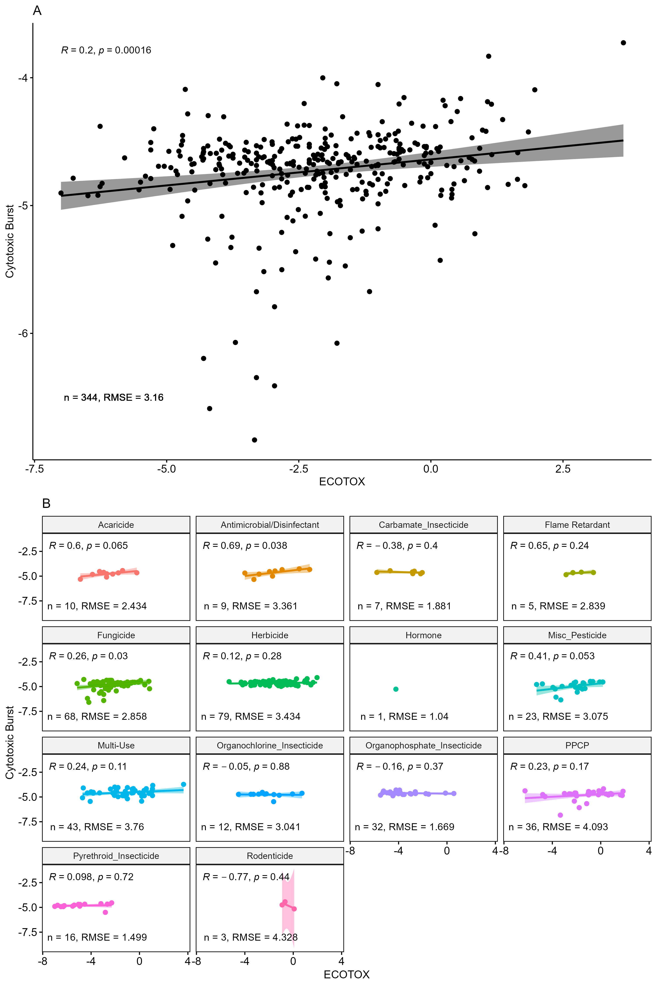
Figure S4. Correlation plot comparing ToxCast lower-bound cytotoxic burst and ECOTOX PODs overall (A) and by chemical class (B). Data were log₁₀-transformed for comparisons, with log₁₀ of cytotoxic burst plotted on the y-axis and log₁₀ of the minimum ECOTOX POD plotted on the x-axis. Statistical p-values and coefficients (ρ) are based on Pearson correlation analysis (α < 0.05).

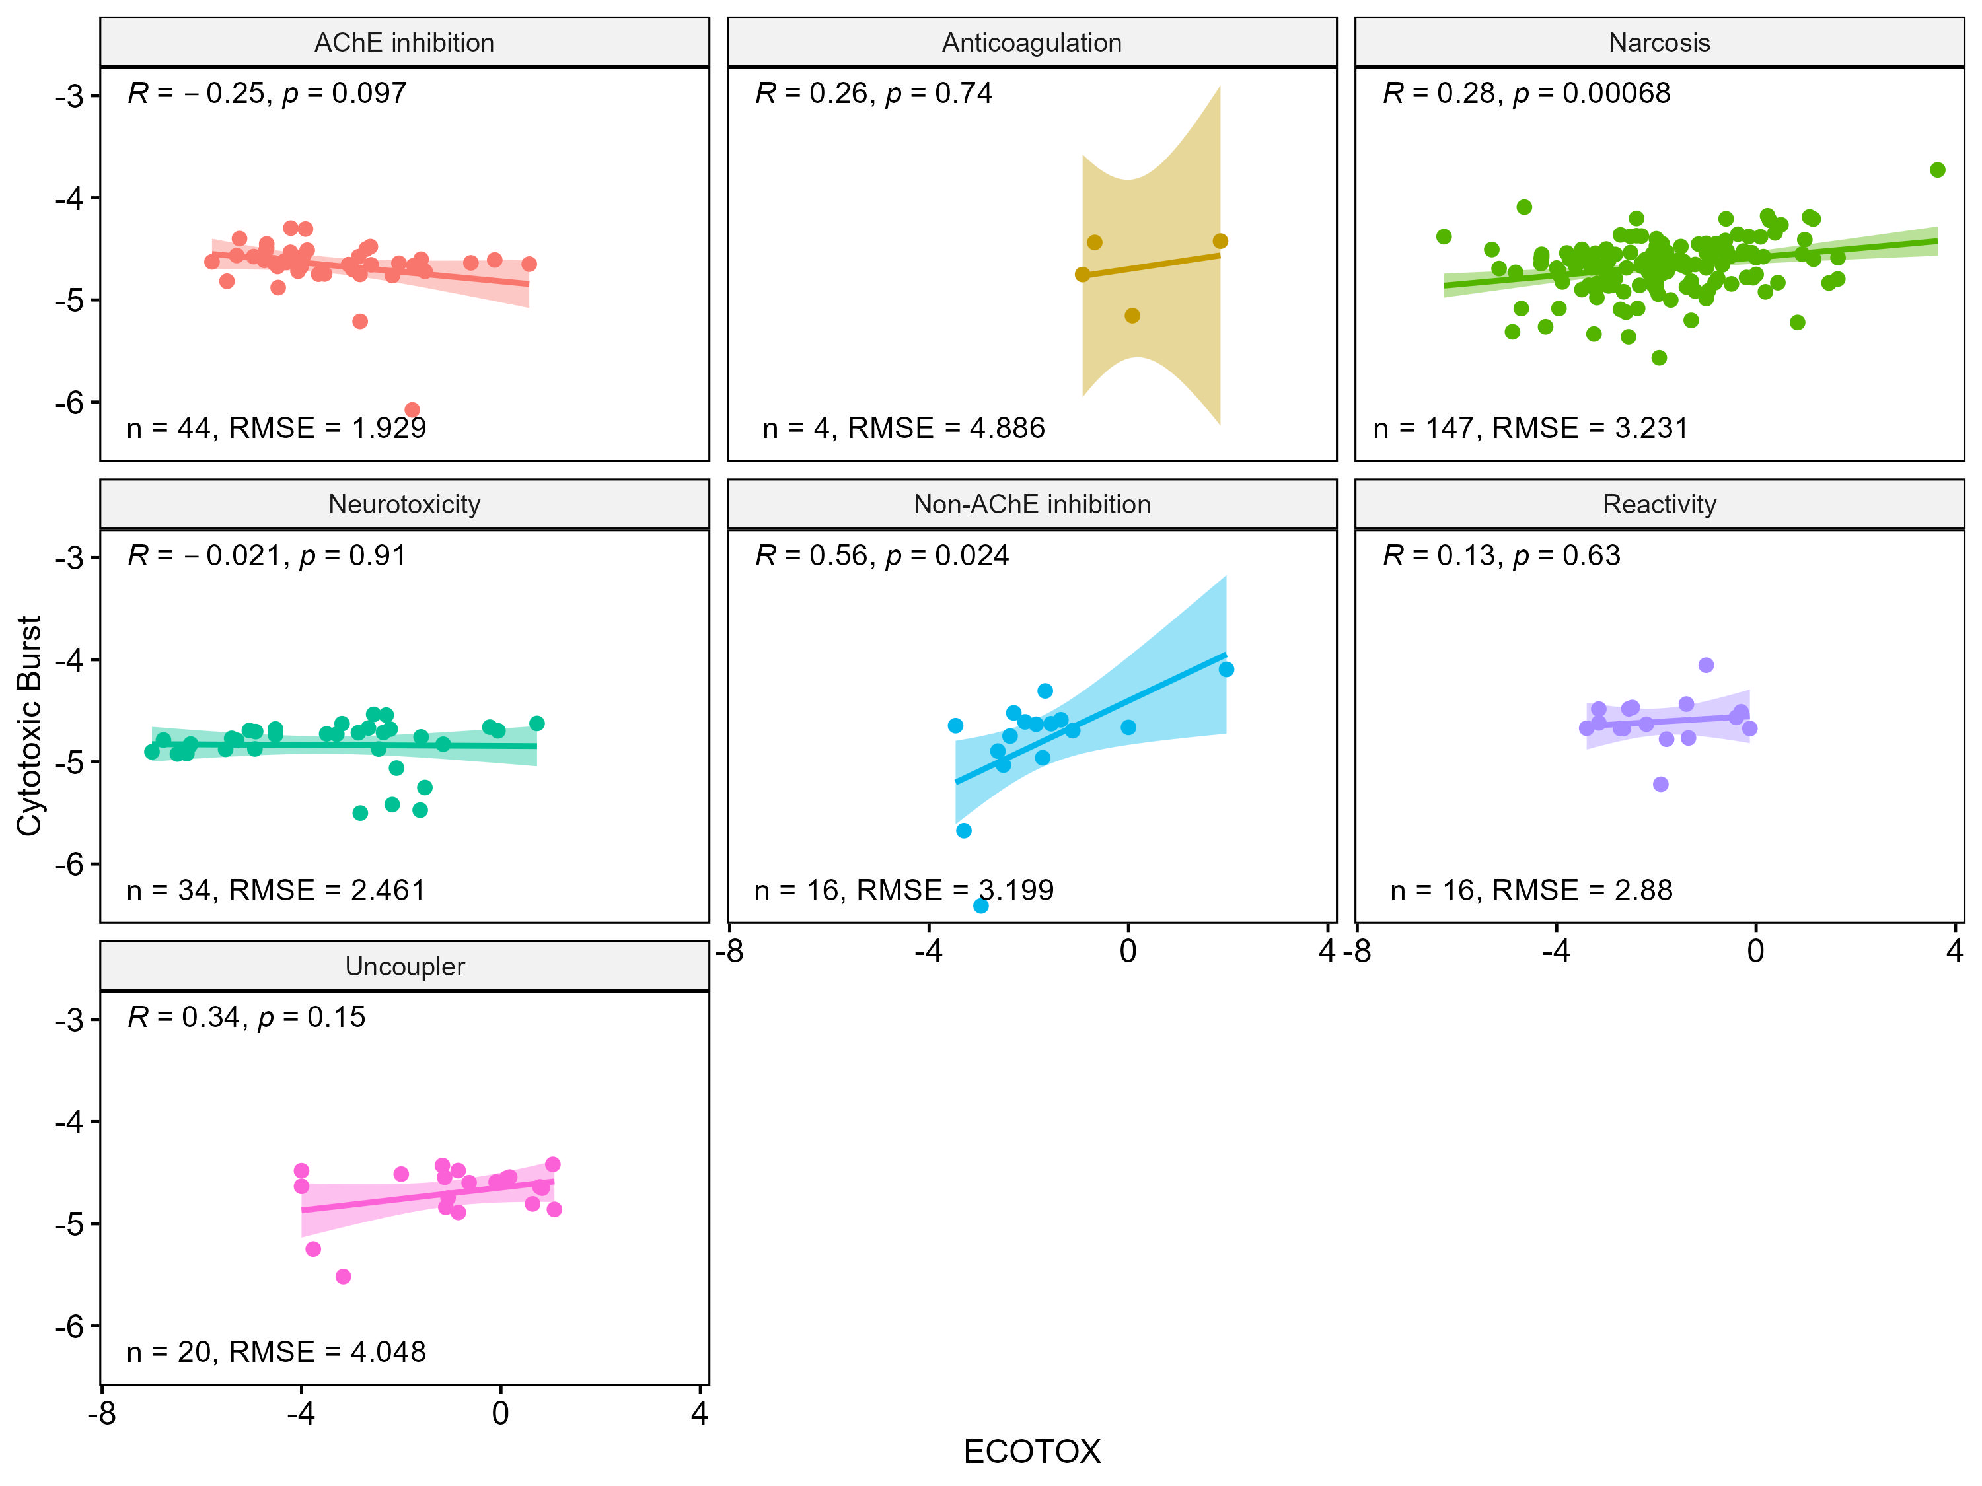
Figure S5. Correlation plots comparing ToxCast lower-bound cytotoxic burst and ECOTOX PODs by mode of action (MOA) grouping. Data were log₁₀(common, or base 10, logarithm)-transformed for comparisons, with log₁₀ of ACC₅ plotted on the y-axis and log₁₀ of the minimum ECOTOX POD plotted on the x-axis. Statistical p-values and coefficients (ρ) are based on Pearson correlation analysis (α < 0.05).

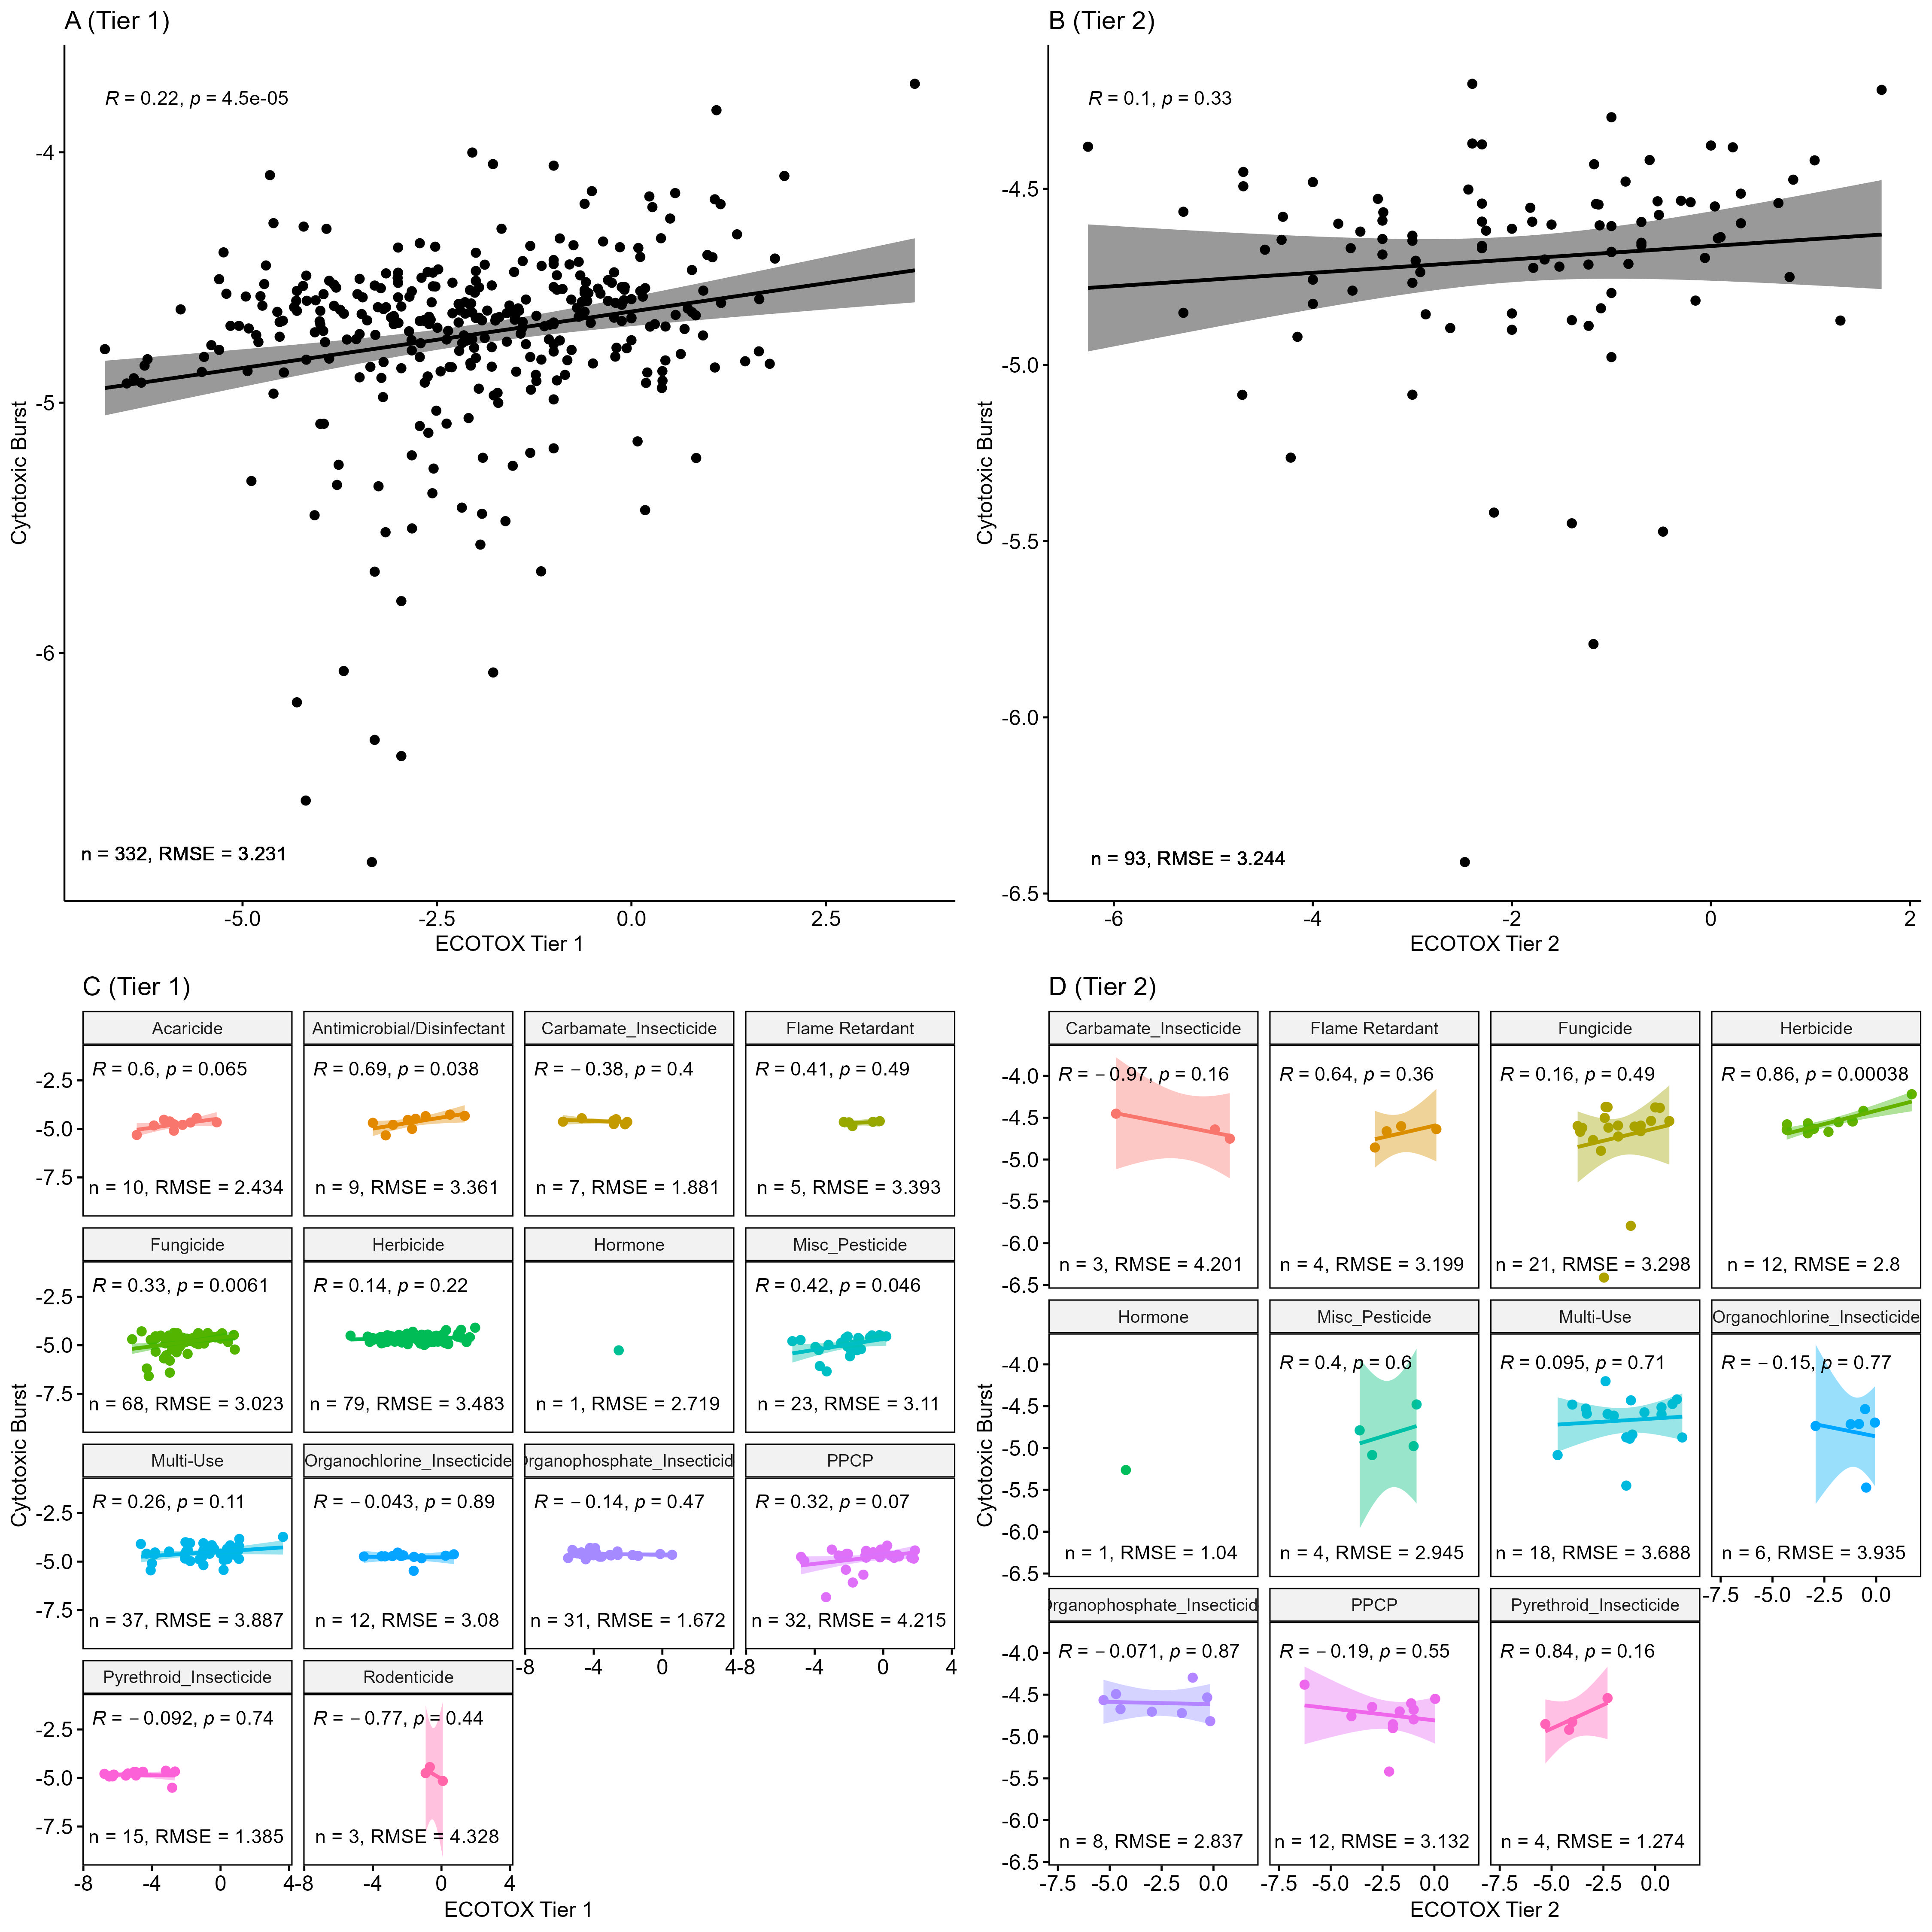
Figure S6. Correlation plots comparing ToxCast lower-bound cytotoxic burst and ECOTOX PODs overall (A, B) and by chemical class (C, D). Plots in panels A and C use only Tier 1 ECOTOX data for POD derivation, whereas B and D includes only Tier 2 ECOTOX data. Data were log₁₀-transformed for comparisons, with log₁₀ of cytotoxic burst plotted on the y-axis and log₁₀ of the minimum ECOTOX POD plotted on the x-axis. Statistical p-values and coefficients (ρ) are based on Pearson correlation analysis (α < 0.05).
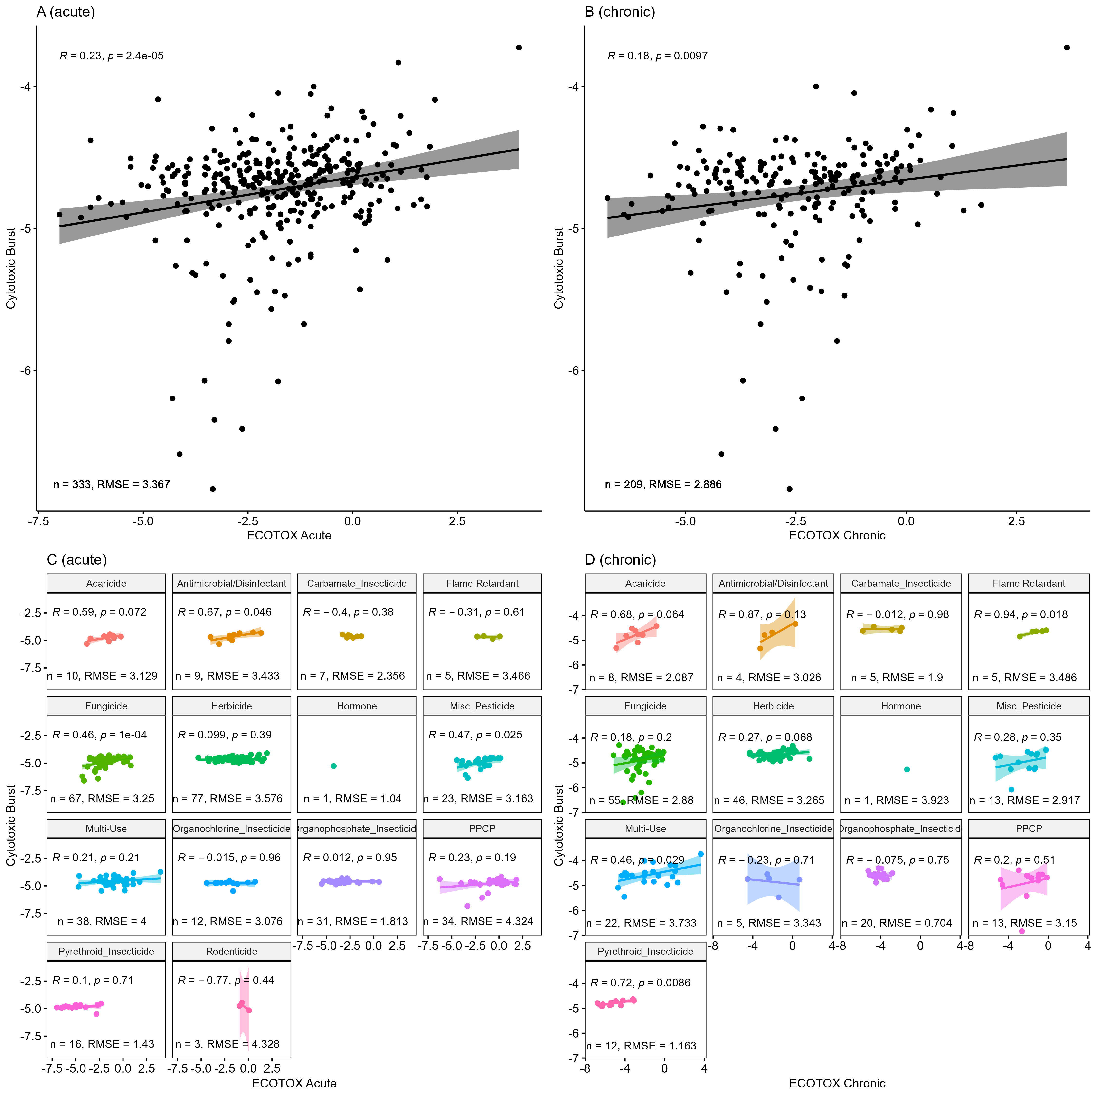
Figure S7. Correlation plots comparing ToxCast lower-bound cytotoxic burst and ECOTOX PODs overall (A, B) and by chemical class (C, D). Plots in panels A and C use only acute ECOTOX data for POD derivation, whereas B and D includes only chronic ECOTOX data. Data were log₁₀-transformed for comparisons, with log₁₀ of cytotoxic burst plotted on the y-axis and log₁₀ of the minimum ECOTOX POD plotted on the x-axis. Statistical p-values and coefficients (ρ) are based on Pearson correlation analysis (α < 0.05).

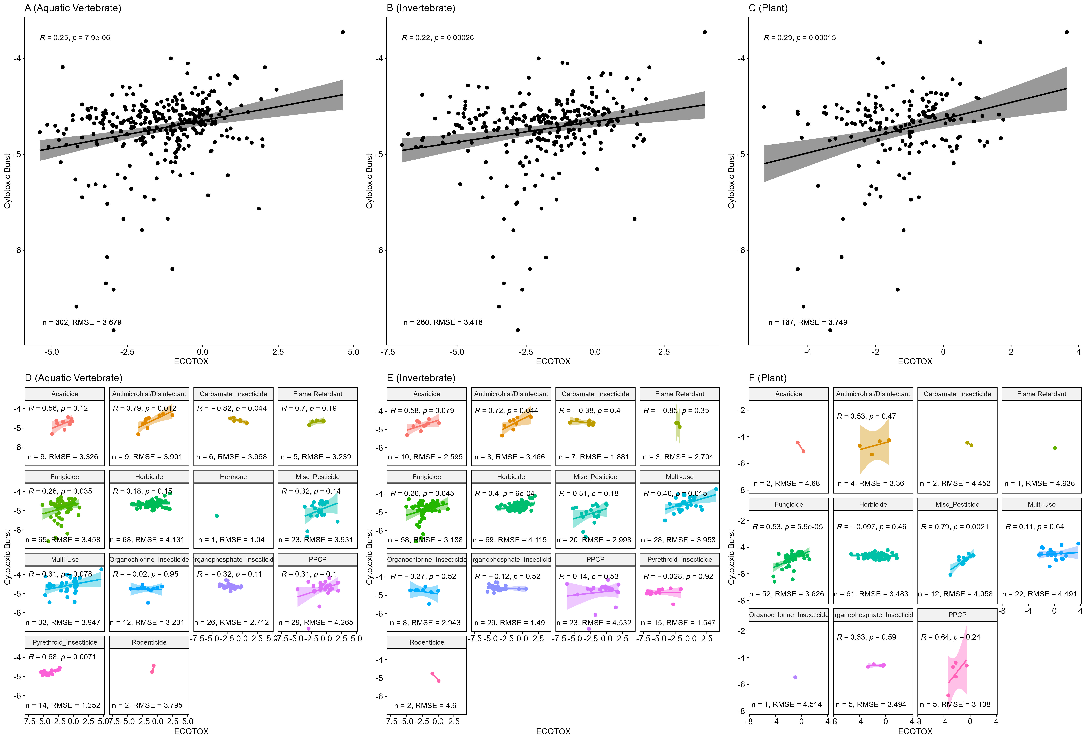
Figure S8. Correlation plots comparing ToxCast lower-bound cytotoxic burst and ECOTOX PODs based on taxonomic classifications; overall (A,B,C) and by chemical class (D,E,F). Plots in panels A and D use ECOTOX data only from fish, B and E includes only invertebrate ECOTOX data, and C and F display plant data from ECOTOX. Data were log₁₀-transformed for comparisons, with log₁₀ of cytotoxic burst plotted on the y-axis and log₁₀ of the minimum ECOTOX POD plotted on the x-axis. Statistical p-values and coefficients (ρ) are based on Pearson correlation analysis (α < 0.05).

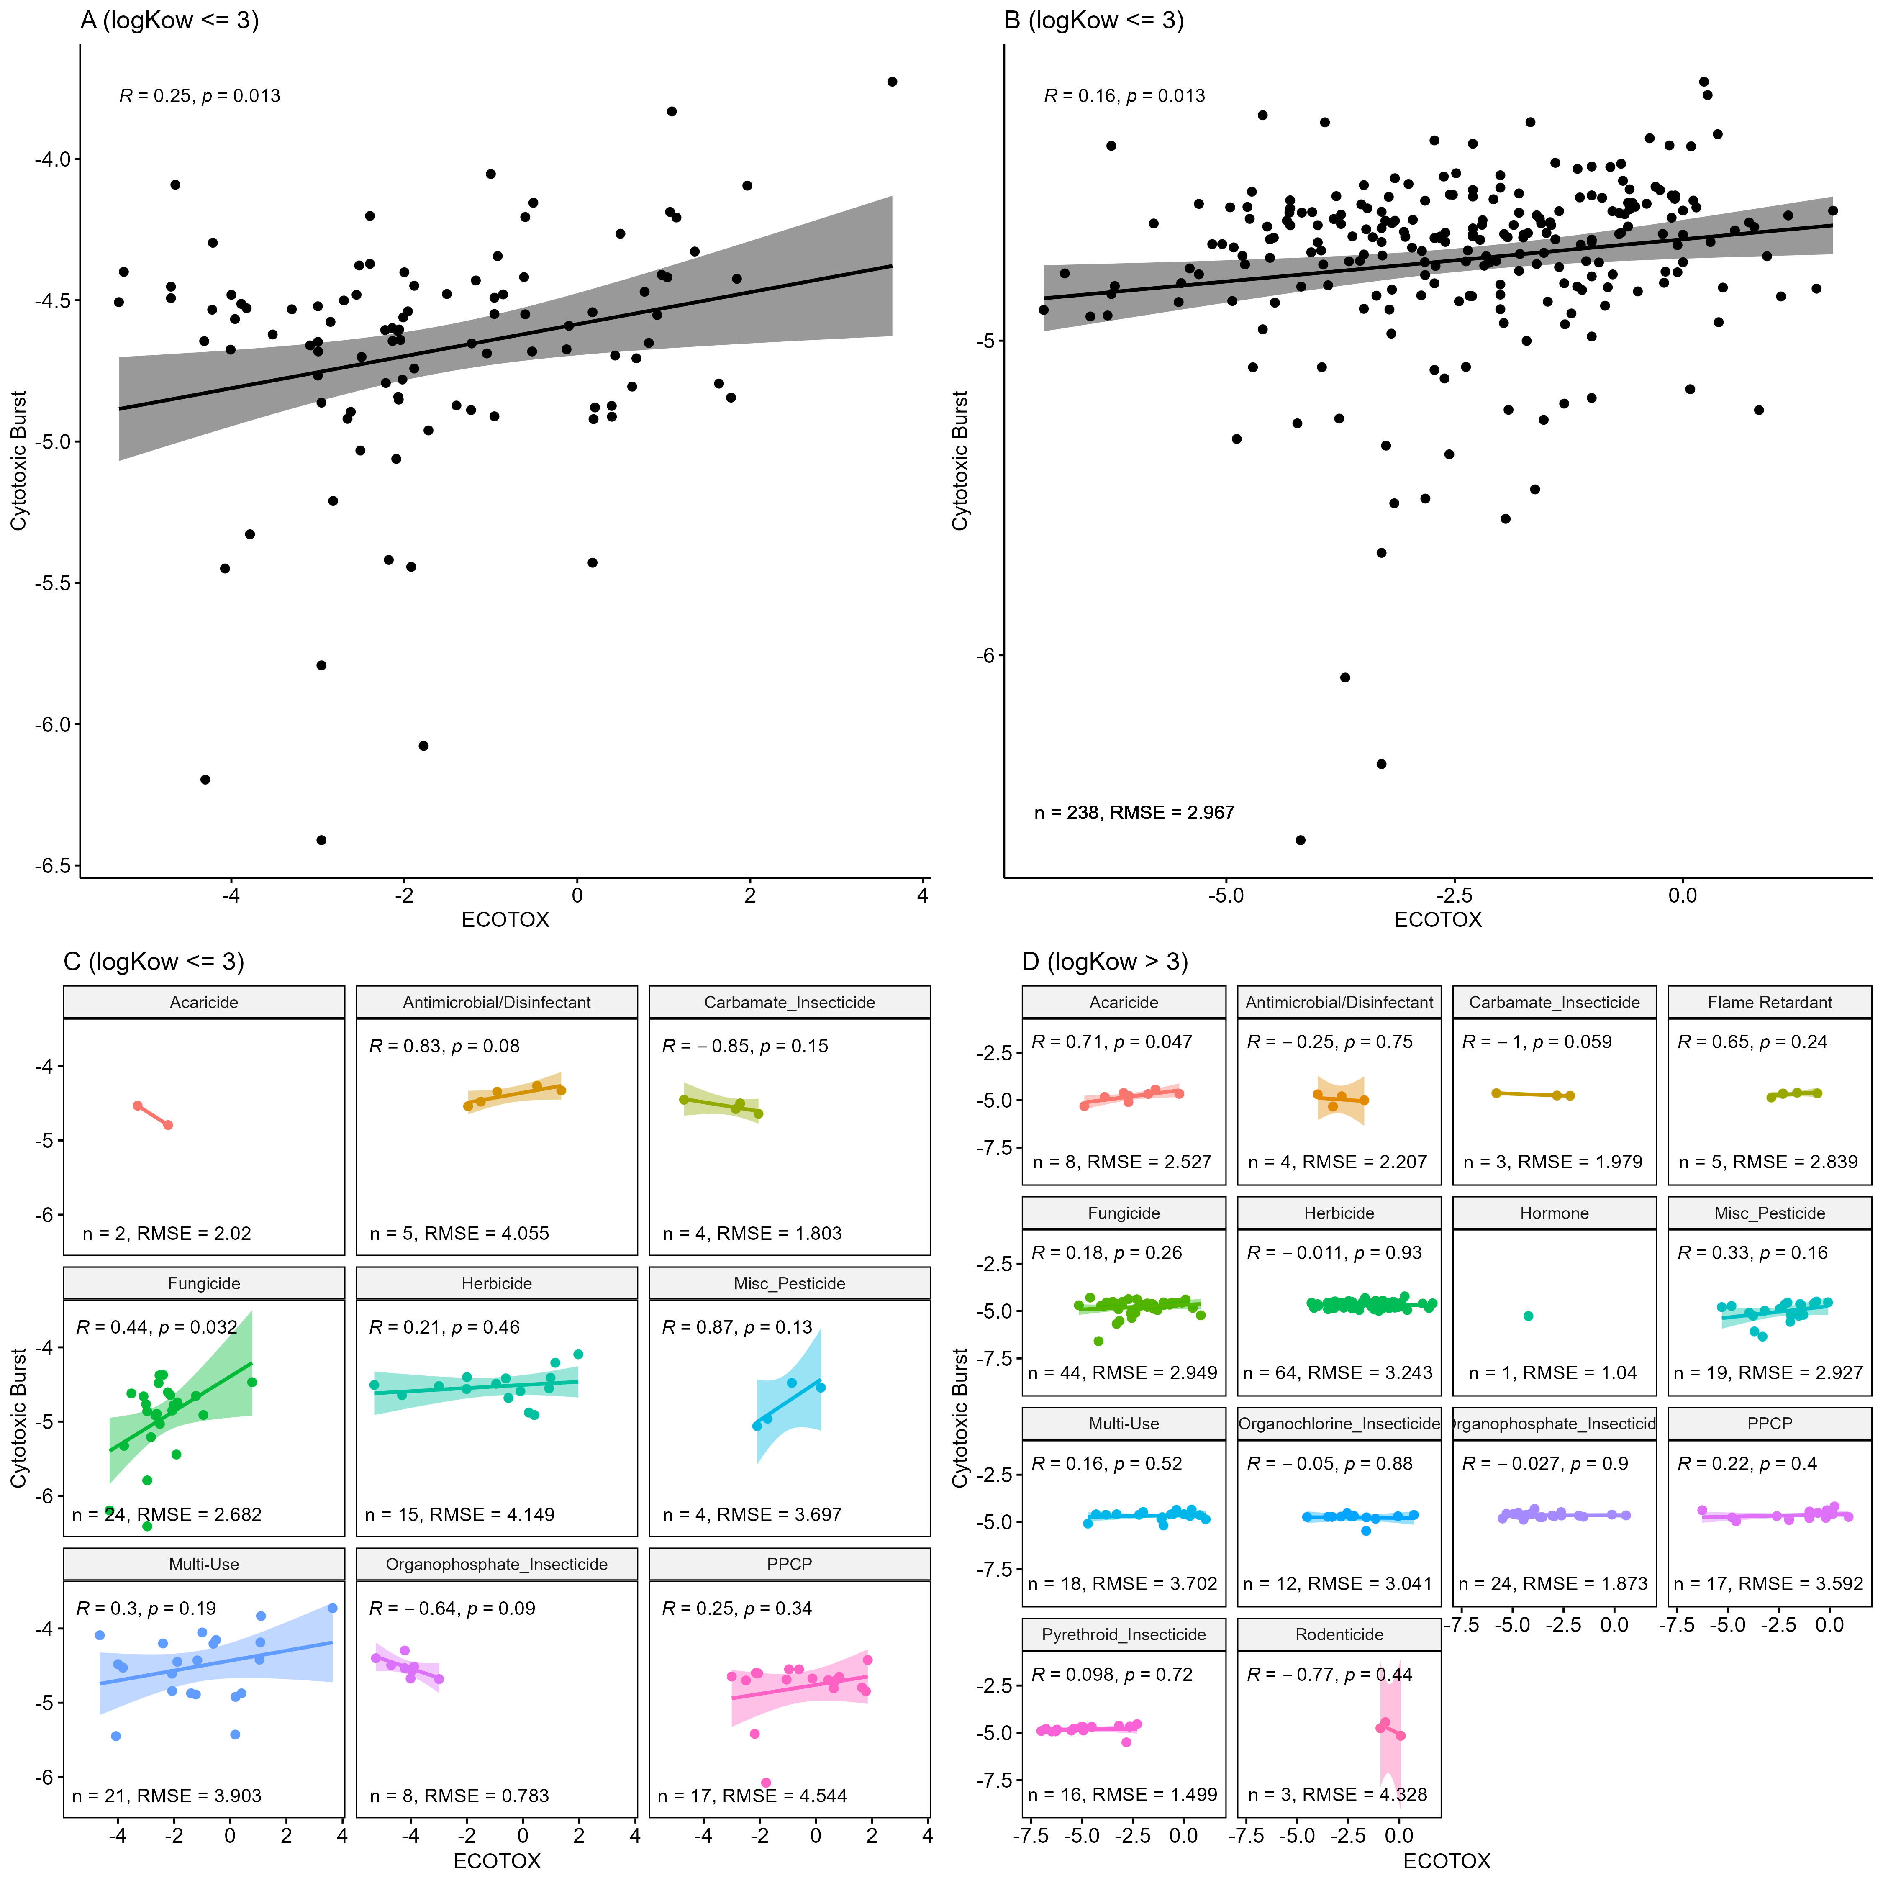
Figure S9. Correlation plots comparing ToxCast lower-bound cytotoxic burst and ECOTOX PODs, separated by logK_{ow}. Plots in panels A and C contain only chemicals with logK_{ow} ≤ 3, whereas B and D includes chemicals with logK_{ow} > 3. Data were log₁₀-transformed for comparisons, with log₁₀ of cytotoxic burst plotted on the y-axis and log₁₀ of the minimum ECOTOX POD plotted on the x-axis. Statistical p-values and coefficients (ρ) are based on Pearson correlation analysis (α < 0.05).
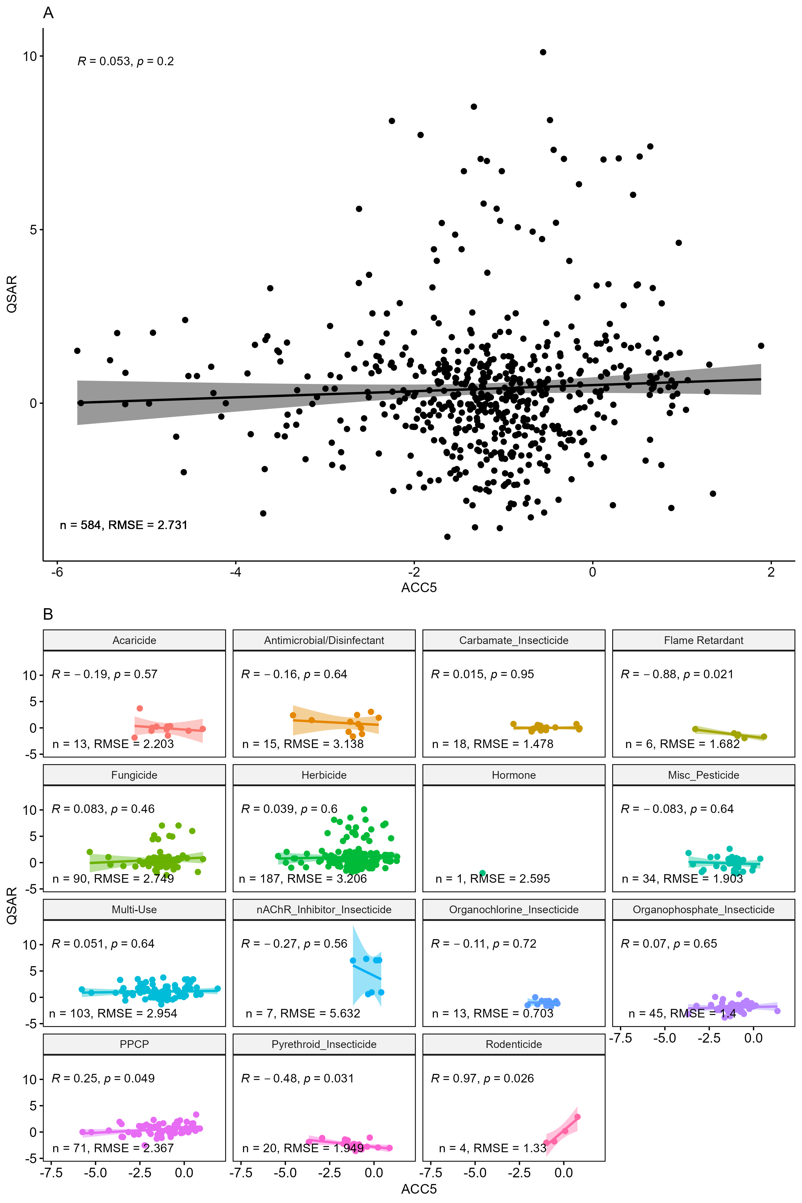
Figure S10. Correlation plots comparing ACC₅ and QSAR estimates overall (A) and by chemical use class (B). Data were log₁₀-transformed for comparisons, with log₁₀ of minimum QSAR estimates plotted on the y-axis and log₁₀ of ACC₅ plotted on the x-axis. Statistical p-values and coefficients (ρ) are based on Pearson correlation analysis (α < 0.05).

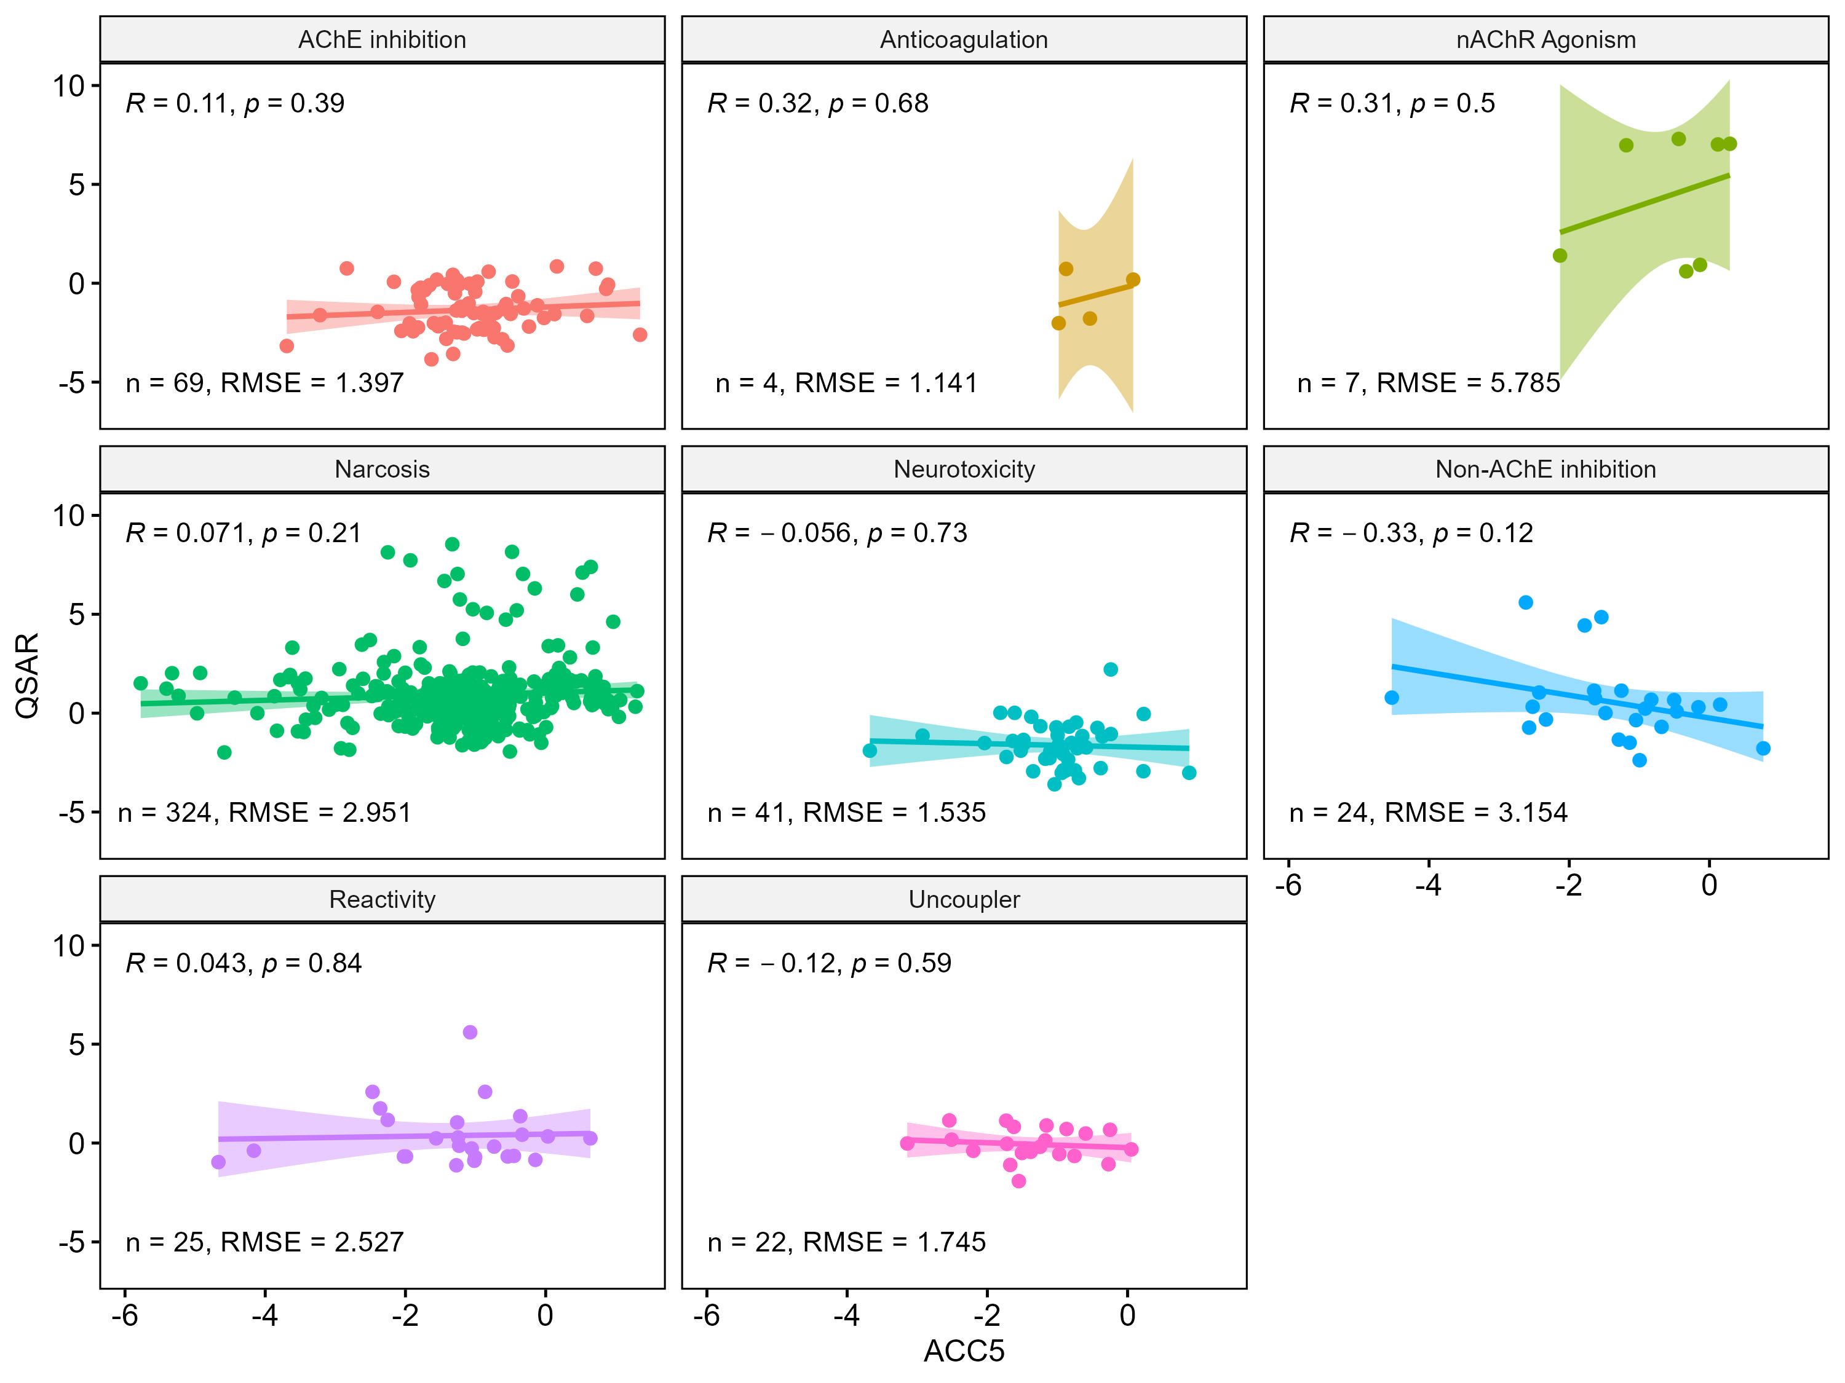
Figure S11. Correlation plots comparing ACC₅ and QSAR estimates by mode of action (MOA) grouping. Data were log₁₀(common, or base 10, logarithm)-transformed for comparisons, with log₁₀ of ACC₅ plotted on the y-axis and log₁₀ of the minimum ECOTOX POD plotted on the x-axis. Statistical p-values and coefficients (ρ) are based on Pearson correlation analysis (α < 0.05).

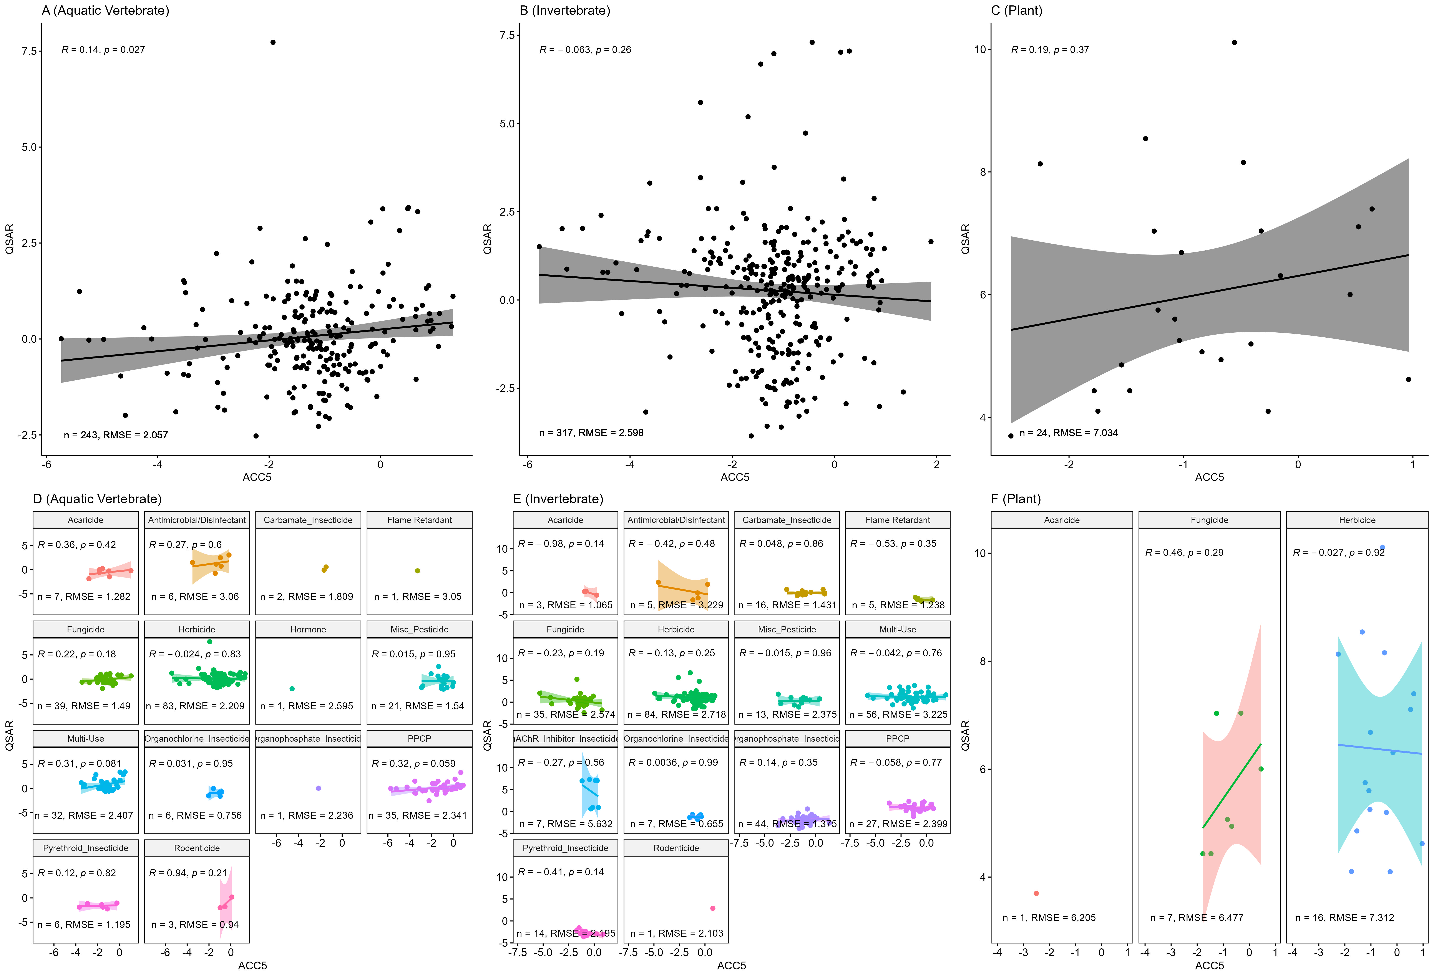
Figure S12. Correlation plots comparing ACC₅ and QSAR estimates based on taxonomic classifications; overall (A,B,C) and by chemical class (D,E,F). Plots in panels A and D include QSAR estimates from fish, B and E show only invertebrate QSARs, and C and F display plant-based QSAR estimates. Data were log10-transformed for comparisons, with log₁₀ of minimum QSAR estimates plotted on the y-axis and log₁₀ of ACC₅ plotted on the x-axis. Statistical p-values and coefficients (ρ) are based on Pearson correlation analysis (α < 0.05).
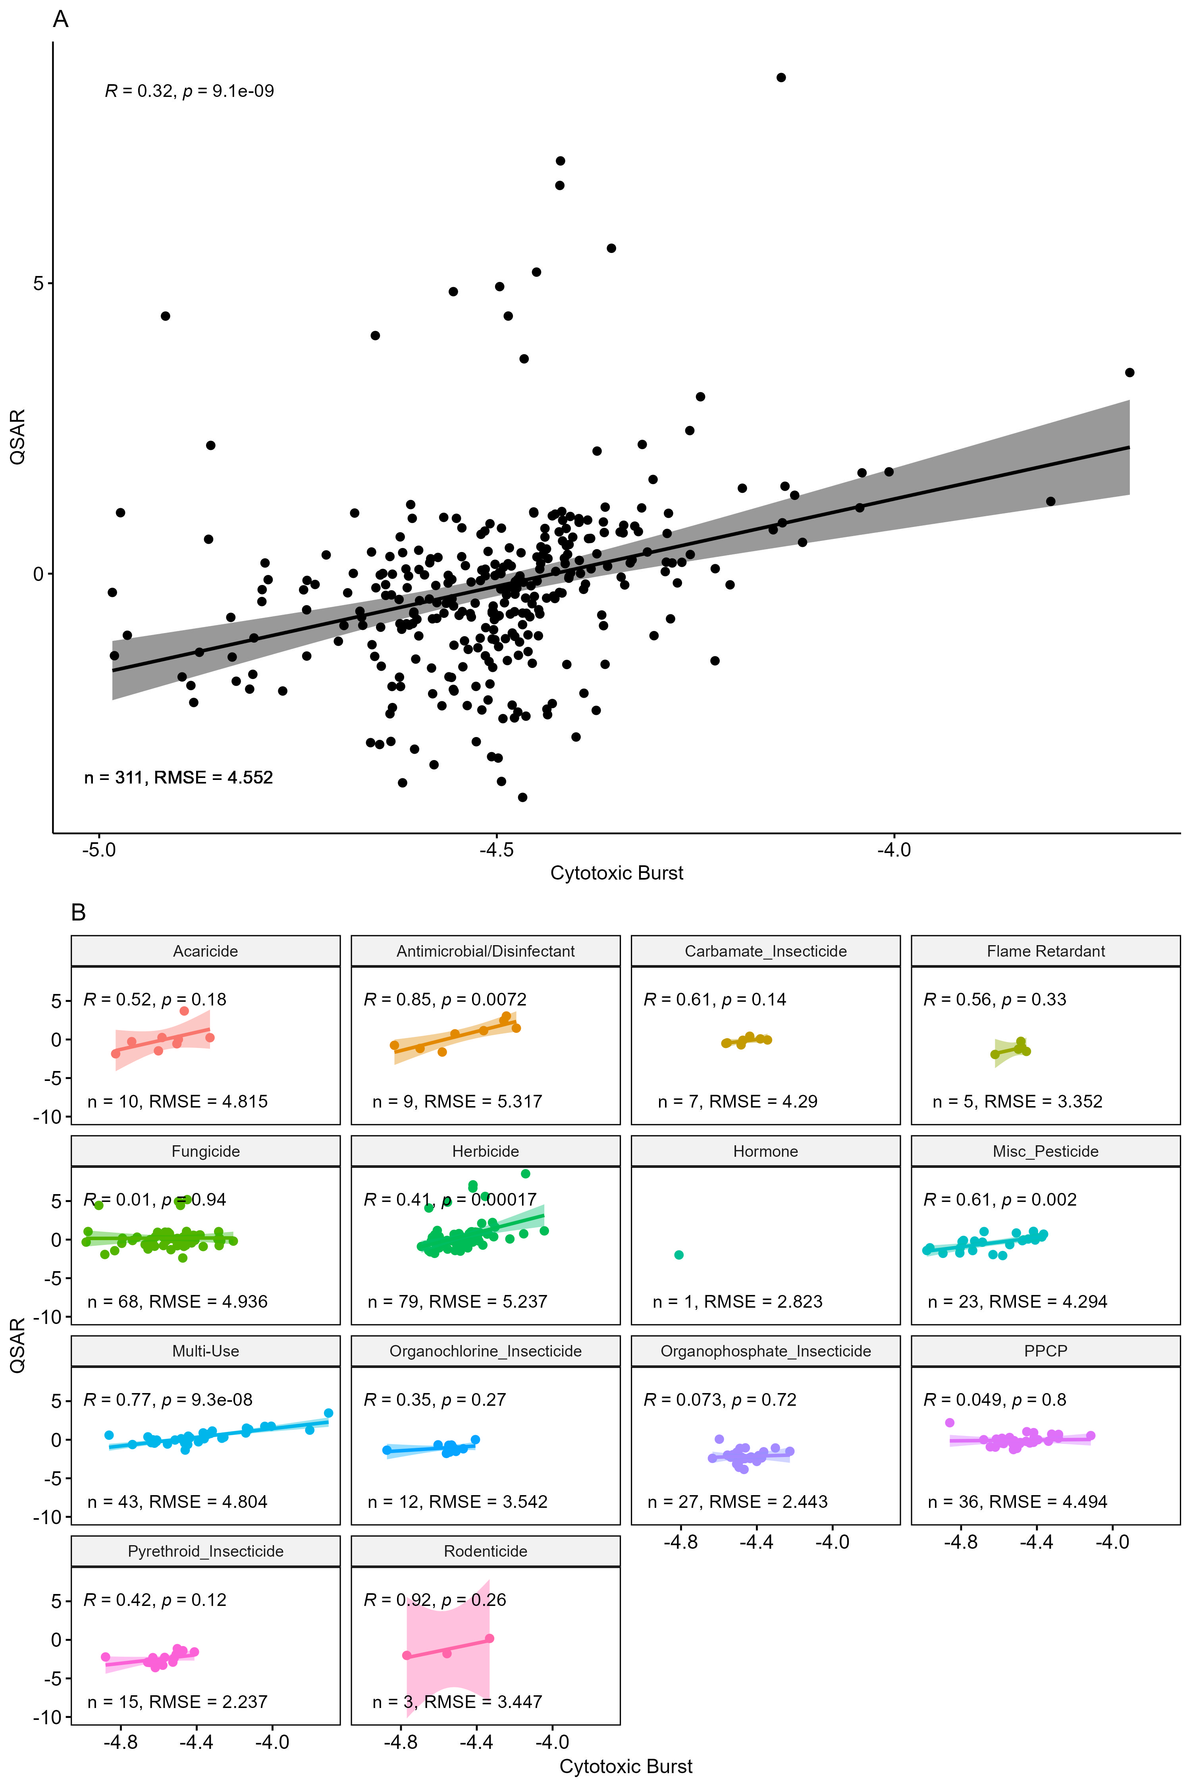
Figure S13. Correlation plots comparing ToxCast lower-bound cytotoxic burst and QSAR estimates, overall (A) and by chemical class (B). Data were log₁₀-transformed for comparisons, with log₁₀ of minimum QSAR estimates plotted on the y-axis and log₁₀ of cytotoxic burst plotted on the x-axis. Statistical p-values and coefficients (ρ) are based on Pearson correlation analysis (α < 0.05).

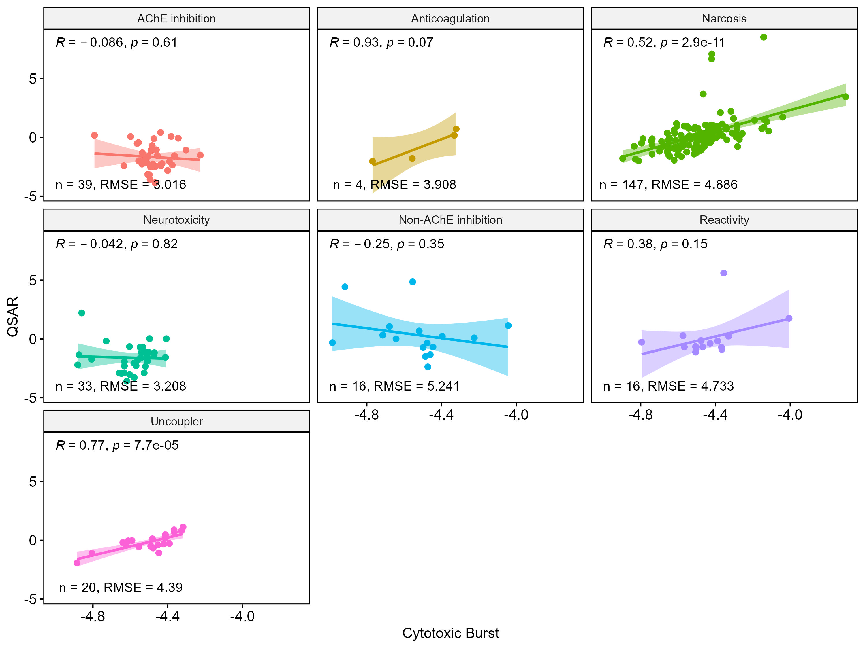
Figure S14. Correlation plots comparing ToxCast lower-bound cytotoxic burst and QSAR estimates by mode of action (MOA) grouping. Data were log₁₀(common, or base 10, logarithm)-transformed for comparisons, with log₁₀ of ACC₅ plotted on the y-axis and log₁₀ of the minimum ECOTOX POD plotted on the x-axis. Statistical p-values and coefficients (ρ) are based on Pearson correlation analysis (α < 0.05).

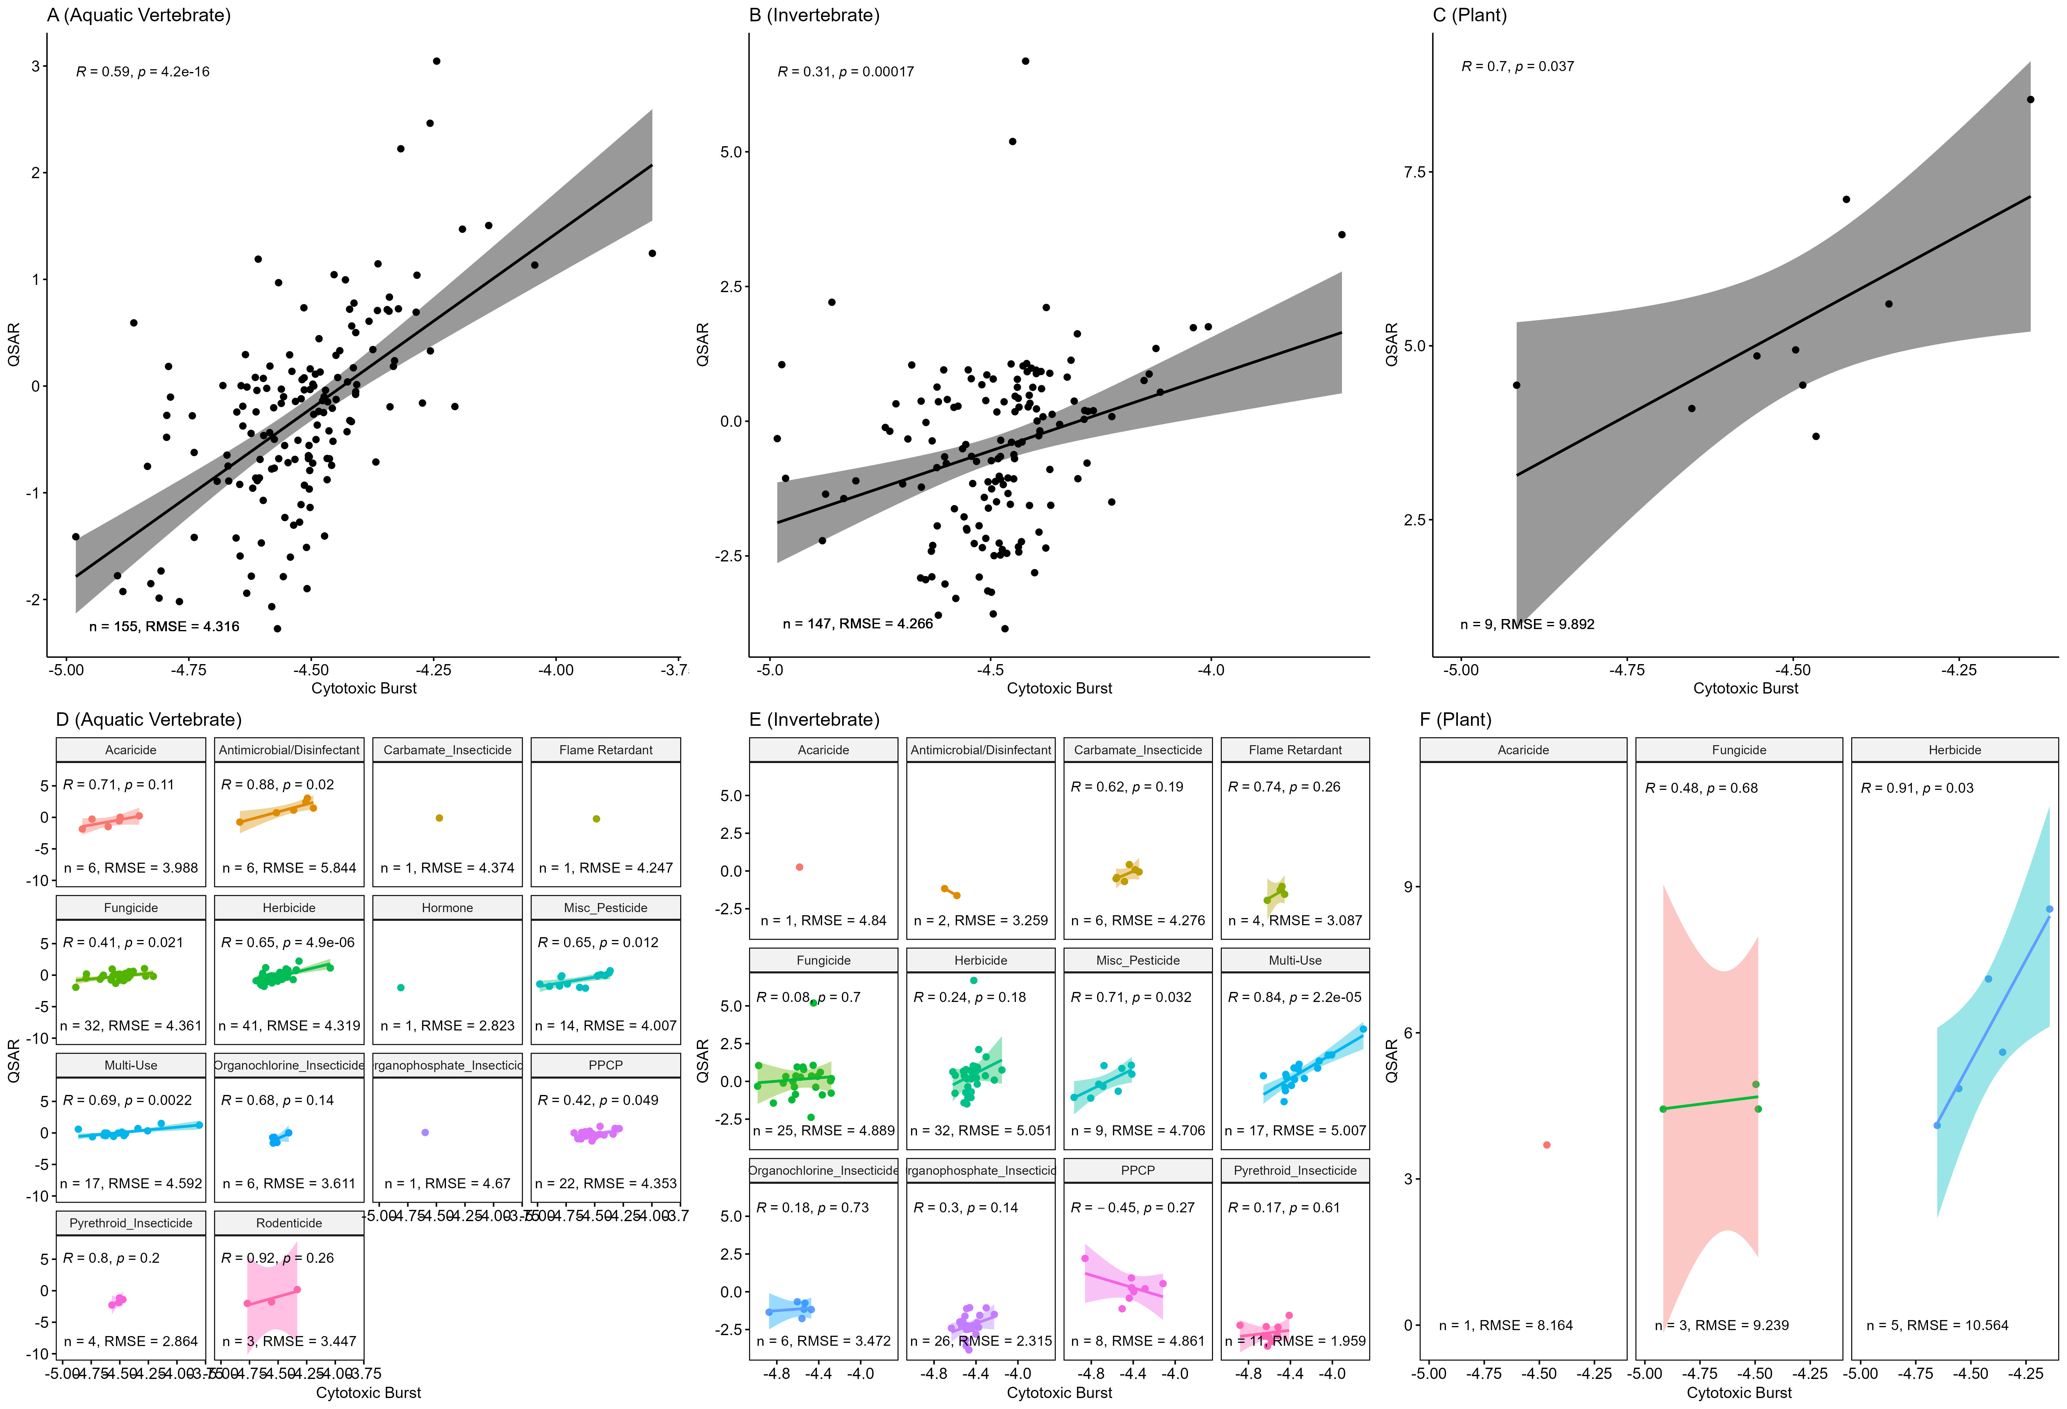
Figure S15. Correlation plots comparing ToxCast lower-bound cytotoxic burst and QSAR estimates based on taxonomic classification; overall (A,B,C) and by chemical class (D,E,F). Plots in panels A and D use QSAR estimates only from fish, B and E includes only invertebrate QSARs, and C and F display QSARs from aquatic plants. Data were log₁₀-transformed for comparisons, with log₁₀ of minimum QSAR estimates plotted on the y-axis and log₁₀ of the cytotoxic burst plotted on the x-axis. Statistical p-values and coefficients (ρ) are based on Pearson correlation analysis (α < 0.05).

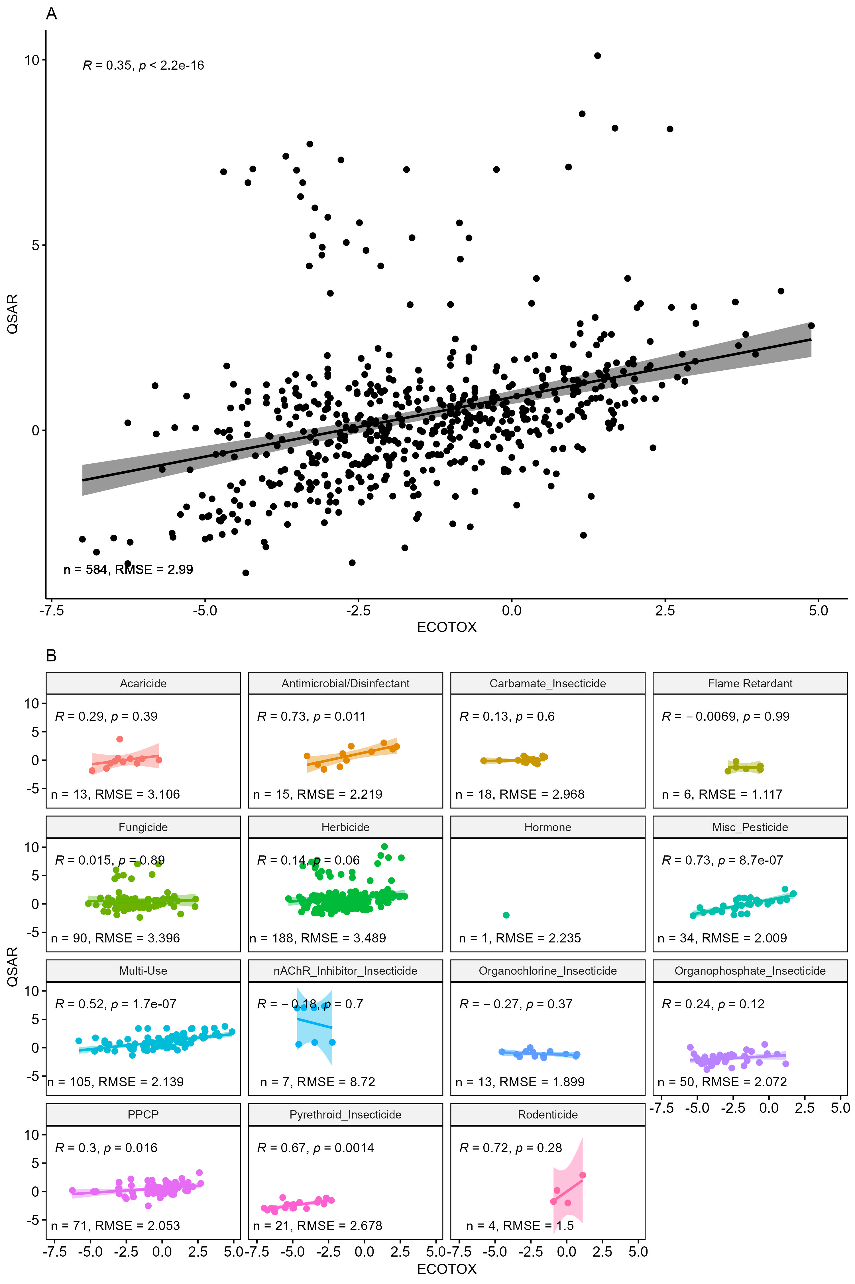
Figure S16. Correlation plots comparing ECOTOX PODs and QSAR estimates, overall (A) and by chemical class (B). Data were log₁₀-transformed for comparisons, with log₁₀ of minimum QSAR estimates plotted on the y-axis and log₁₀ of minimum ECOTOX POD plotted on the x-axis. Statistical p-values and coefficients (ρ) are based on Pearson correlation analysis (α < 0.05).

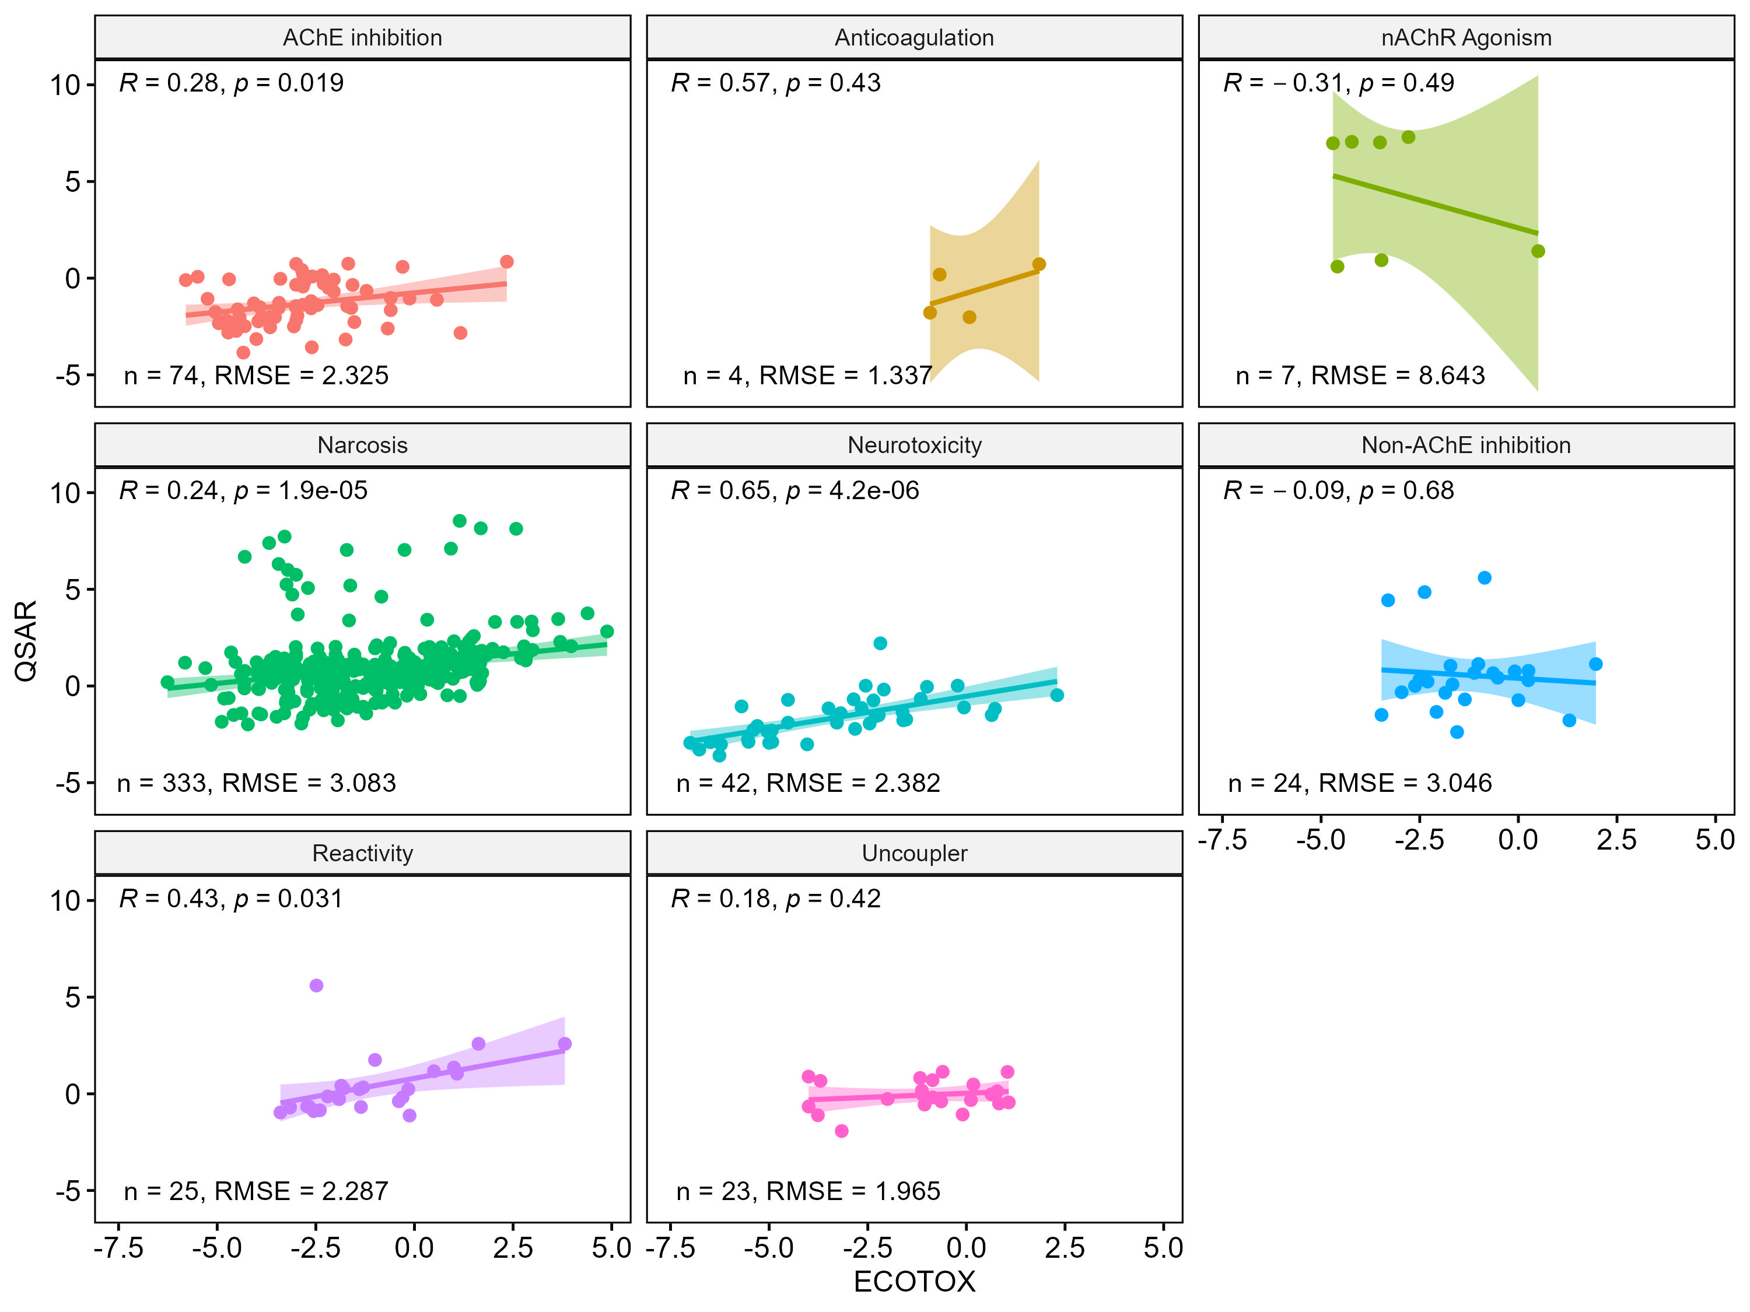
Figure S17. Correlation plots comparing ECOTOX PODs and QSAR estimates by mode of action (MOA) grouping. Data were log₁₀(common, or base 10, logarithm)-transformed for comparisons, with log₁₀ of ACC₅ plotted on the y-axis and log₁₀ of the minimum ECOTOX POD plotted on the x-axis. Statistical p-values and coefficients (ρ) are based on Pearson correlation analysis (α < 0.05).

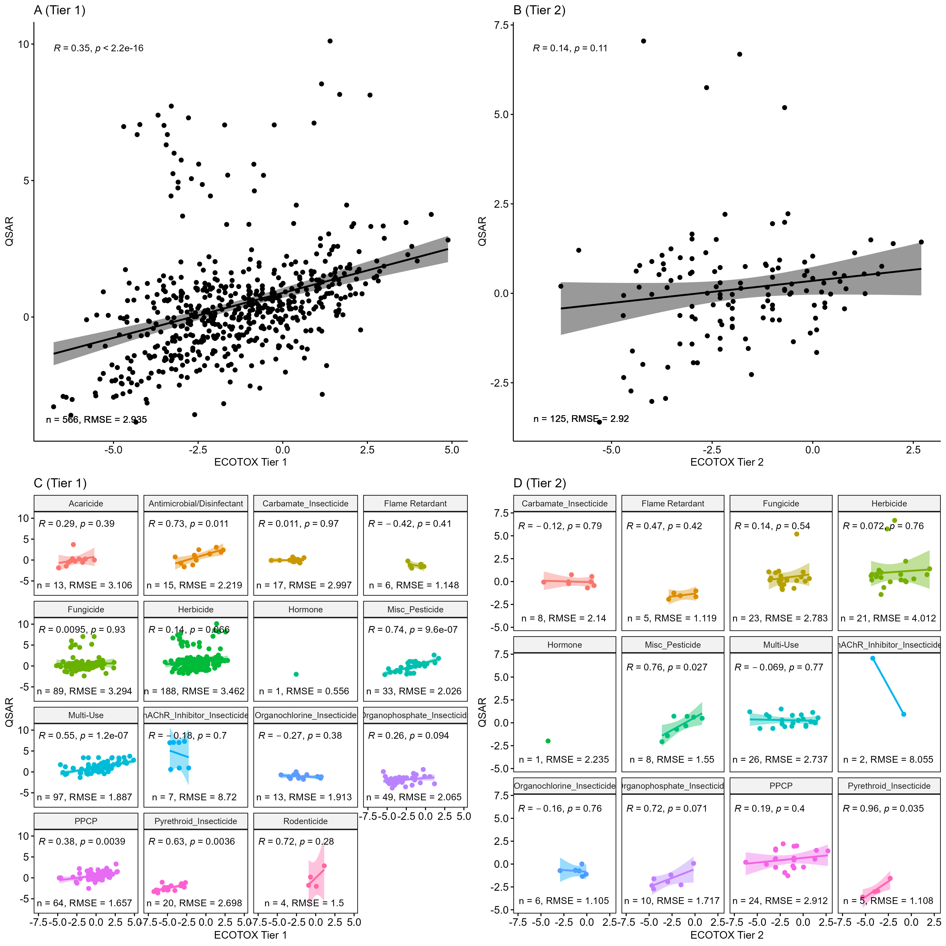
Figure S18. Correlation plots comparing ECOTOX PODs and QSAR estimates, overall (A, B) and by chemical class (C, D). Plots in panels A and C use only Tier 1 ECOTOX data for POD derivation, whereas B and D includes only Tier 2 ECOTOX data. Data were log₁₀-transformed for comparisons, with log₁₀ of minimum QSAR estimates plotted on the y-axis and log₁₀ of minimum ECOTOX POD plotted on the x-axis. Statistical p-values and coefficients (ρ) are based on Pearson correlation analysis (α < 0.05).
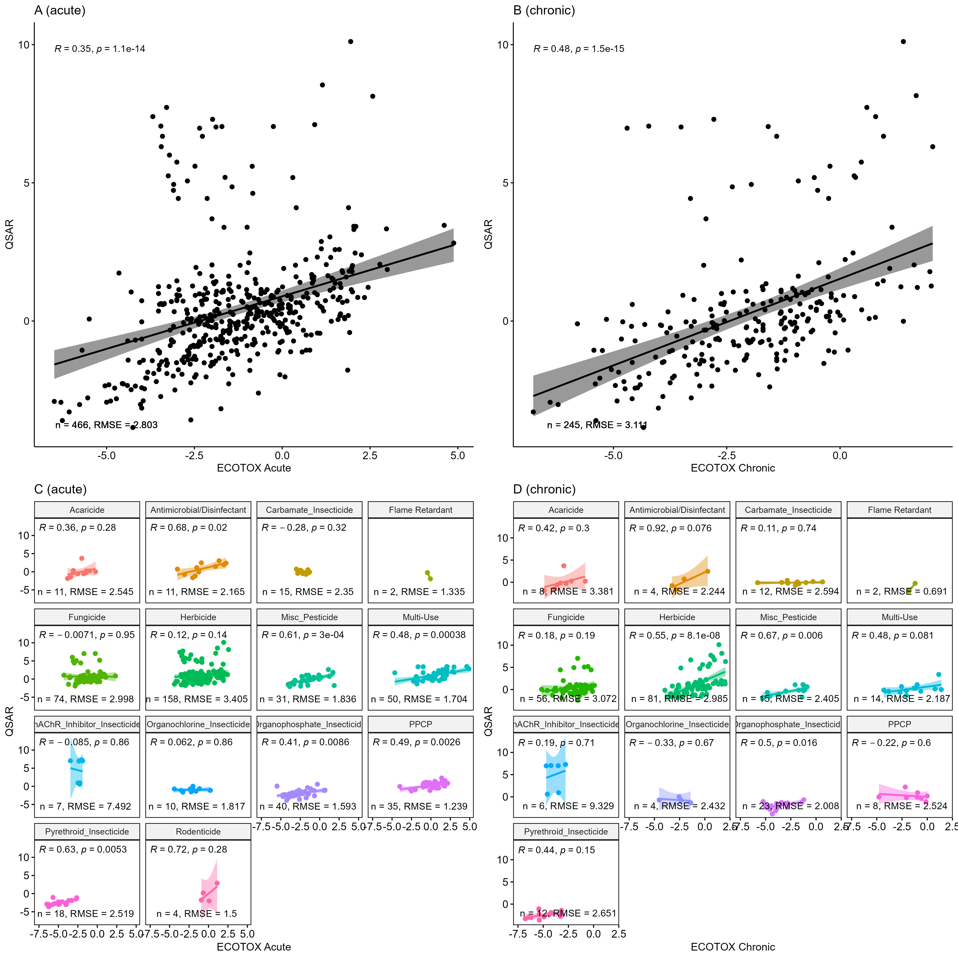
Figure S19. Correlation plots comparing ECOTOX PODs and corresponding QSAR estimates, overall (A, B) and by chemical class (C, D). Plots in panels A and C use only acute ECOTOX data for POD derivation, whereas B and D includes only chronic ECOTOX data. Data were log₁₀-transformed for comparisons, with log₁₀ of minimum QSAR estimates plotted on the y-axis and log₁₀ of minimum ECOTOX POD plotted on the x-axis. Statistical p-values and coefficients (ρ) are based on Pearson correlation analysis (α < 0.05).

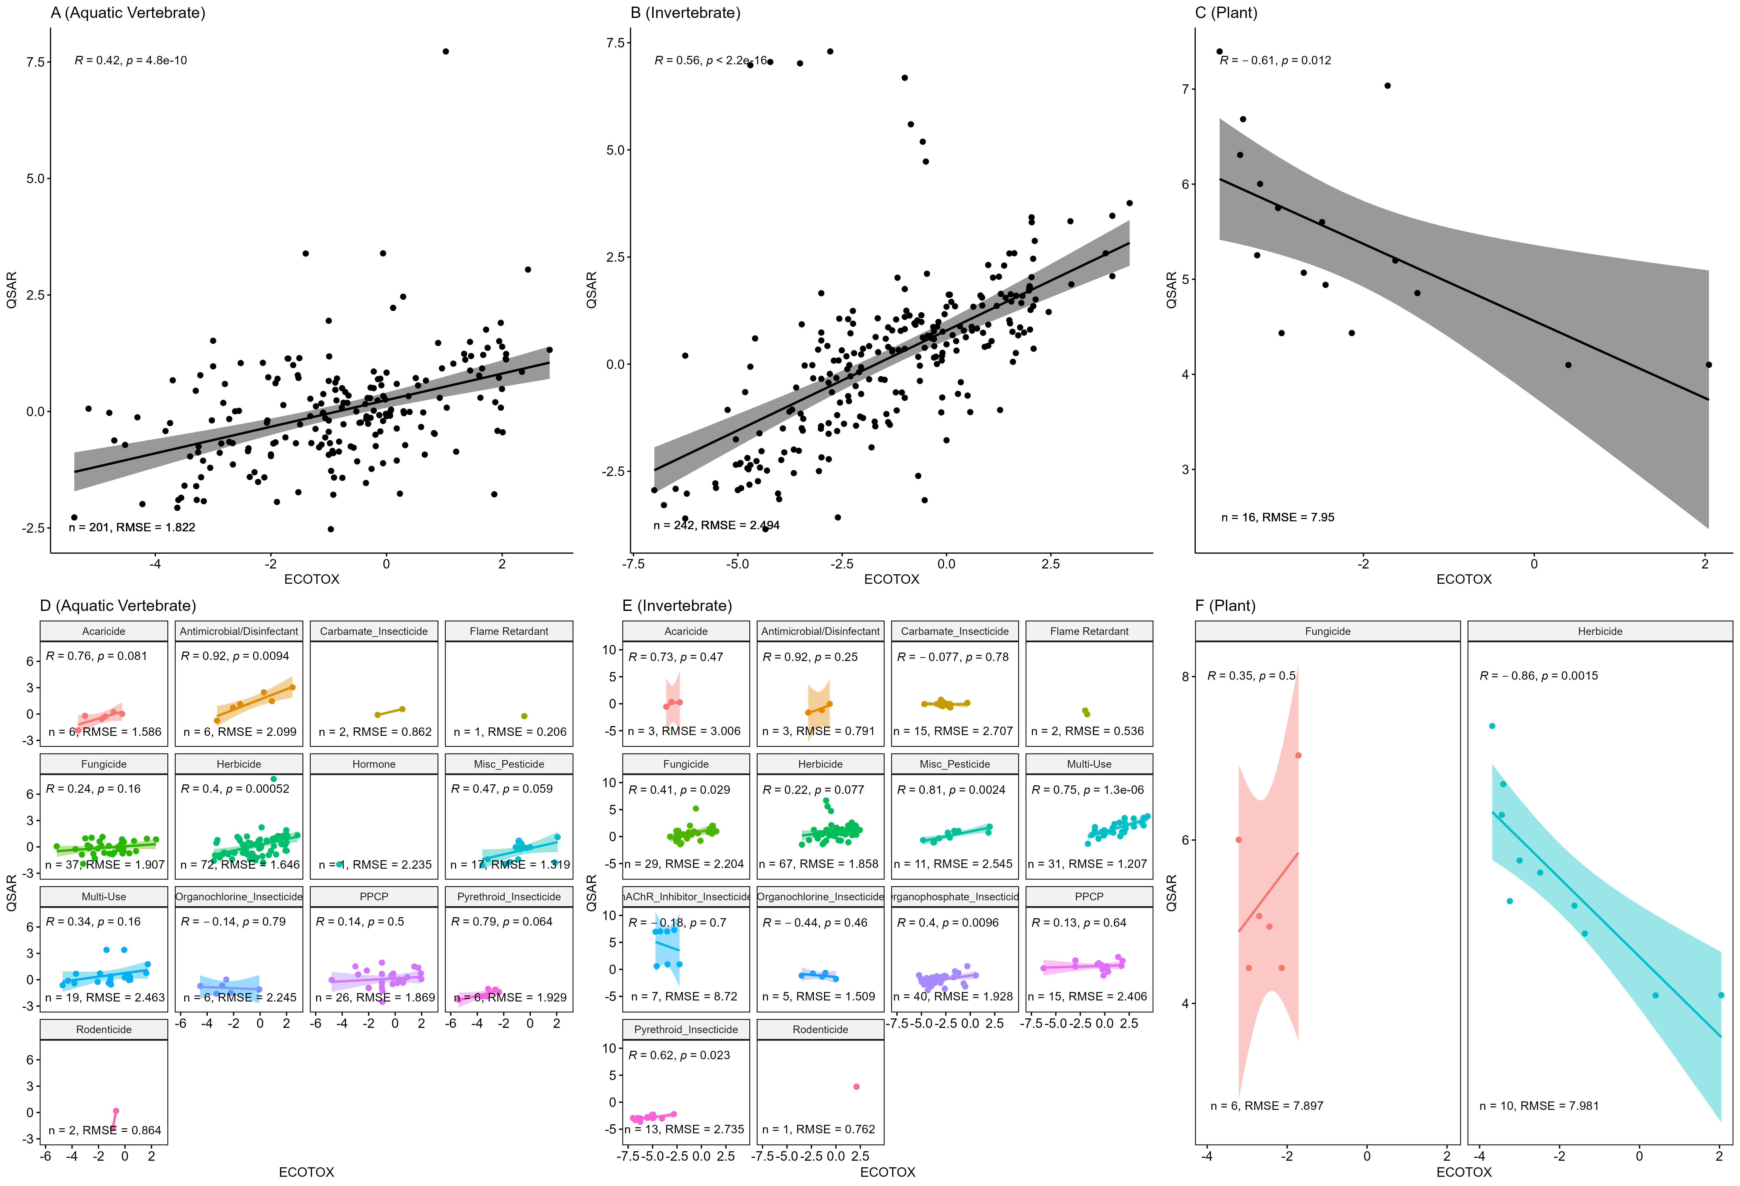
Figure S20. Correlation plots comparing ECOTOX PODs and QSAR estimates based on taxonomic classification; overall (A,B,C) and by chemical class (D,E,F). Plots in panels A and D use estimates only for fish, B and E include only invertebrate data, and C and F display data from aquatic plants. Data were log₁₀-transformed for comparisons, with log₁₀ of minimum QSAR estimates plotted on the y-axis and log₁₀ of minimum ECOTOX POD plotted on the x-axis. Statistical p-values and coefficients (ρ) are based on Pearson correlation analysis (α < 0.05).
Figure S21. Stacked bar chart showing the chemical composition of each ECOTOX data grouping by chemical use subclass. The number of observations (chemicals) is shown on the Y-axis.
Figure S22. Stacked bar chart showing the chemical composition of each ECOTOX data grouping by mode-of-action classification. The number of observations (chemicals) is shown on the Y-axis.
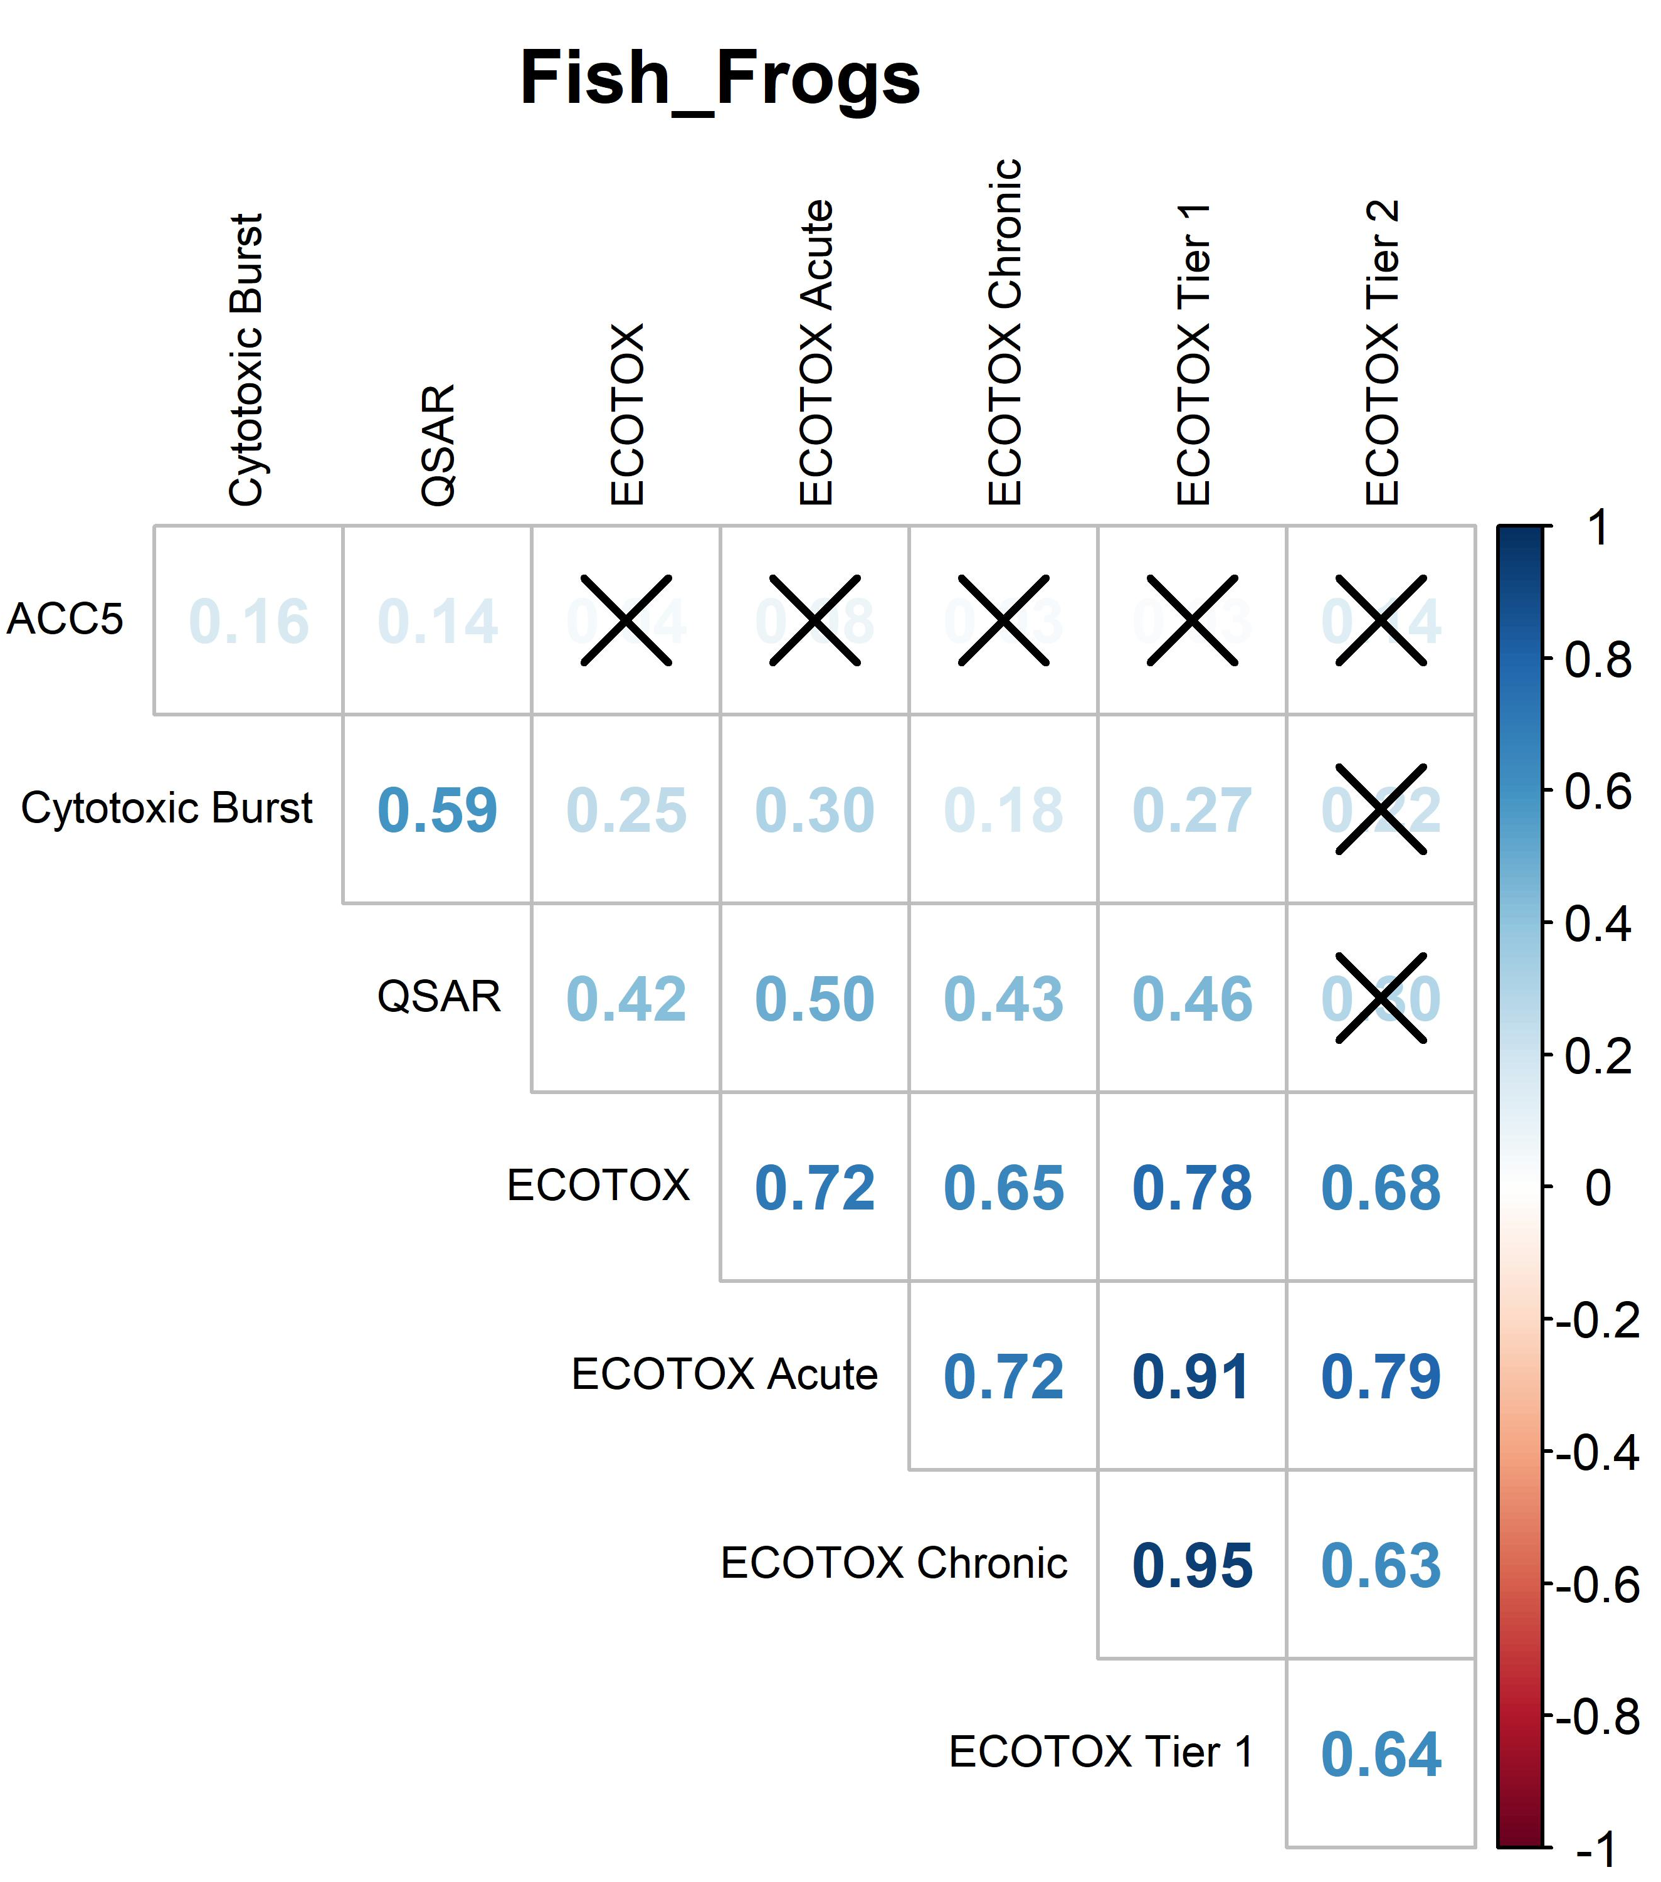
Figure S23. Correlogram displaying associations between different POD datasets for aquatic vertebrate (fish and frogs) data only. Square color reflects the Pearson correlation coefficient, while an “X” designates non-significance (p > 0.05).
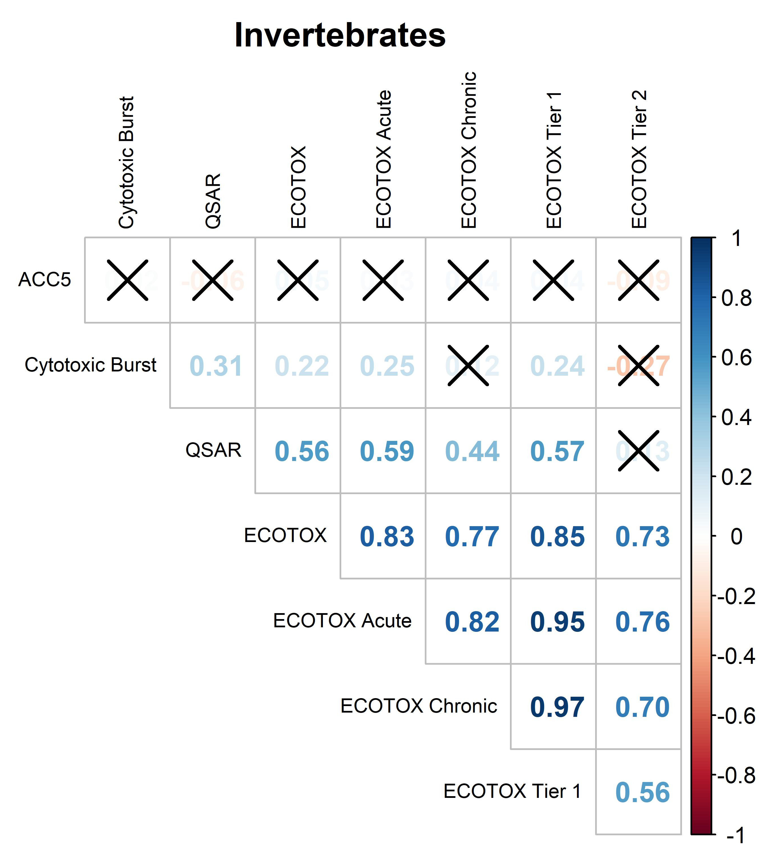
Figure S24. Correlogram displaying associations between different POD datasets for invertebrate data only. Square color reflects the Pearson correlation coefficient, while an “X” designates non-significance (p > 0.05).
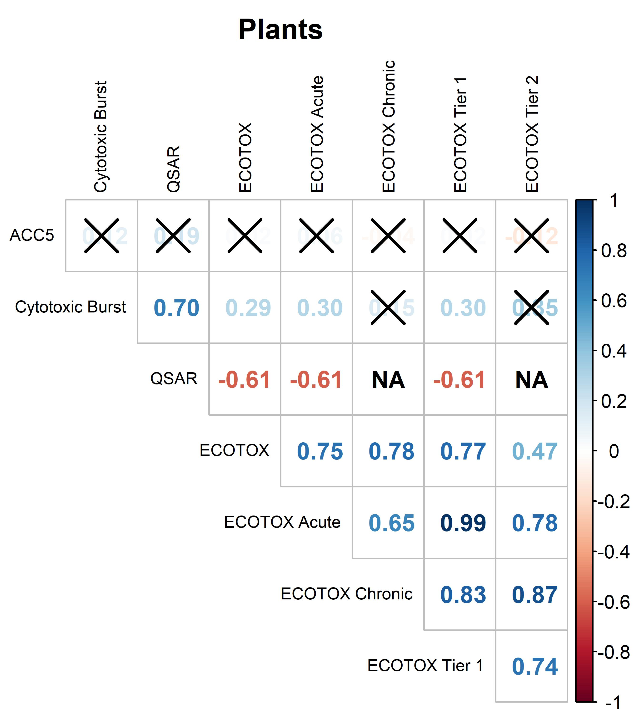
Figure S25. Correlogram displaying associations between different POD datasets for plant data only. Square color reflects the Pearson correlation coefficient, while an “X” designates non-significance (p > 0.05).

