Winter
Consumers | Sources | Plankton | POM | Macroalgae | MPB | SOM | Detritus
S1
Zooplankton | E-26(6-44) |  | 29(13-46) | 41(18-74)
Scrobicularia plana
Cyathura carinata | M-16(0-42)* |  | 49(29-80)* | 35(2-55)*
Hediste diversicolor | E- 42(27-62) |  | 25(5-42) | 33(4-57)
S2
Zooplankton |  |  | 39(20-60) |  | 25(16-35) | 36(20-51)
Cyathura carinata | M-16(2-32)* |  | 21(1-38)* | 31(9-52)* |  | 32(14-51)*
Hediste diversicolor | E-42(25-62)* |  | 25(5-42) | 33(4-57)
S3
Zooplankton
Corbicula fluminea | E- 19(4-38) | 70(59-79) | 10(3-18)
Corophium sp. | E- 20(3-37) |  |  | 53(32-74) | 28(3-48)
Cyathura carinata | M-45(23-71)* |  |  | 38(9-61)* | 17(0-34)*
Hediste diversicolor | E- 41(11-75)* | 36(1-63)* |  | 22(0-44)*
TFW
Zooplankton | F- 47(16-72) | 10(0-45) |  |  |  | 39(1-61)
Corbicula fluminea |  | 31(16-46) |  | 29(16-42) | 30(22-38) | 10(4-16)
Corophium sp. |  | 36(9-61) |  |  |  | 27(2-48), 38(26-51)
Diptera larvae
Oligochaeta |  |  |  |  | 40(25-55) | 42(32-53), 18(1-34)
Gastropoda
Atyaephyra desmarestii |  |  |  | 32(17-46) |  | 35(26-44),33(26-41)

Table A.1 Proportion of each food source to the benthic macroinvertebrates' biomass in stations (S) 1, 2, 3, and tidal freshwater (TFW) during the winter, spring, and summer of 2011, based on the stable isotope mixing model results. The food sources included in the model were the phytoplankton (M- marine; E- estuarine; F- freshwater), particulate organic matter (POM), macroalgae, microphytobenthos (MPB), sediment OM (SOM), and plant detritus. Data presented include the most likely solution (mode) and the 95% Bayesian credibility intervals. Two mode (and 95% CI) values in the column “Detritus” correspond to the contribution of EAV and SAV. *indicate the results from the mixing models after correcting for two trophic levels.
Spring
Consumers | Sources | Plankton | POM | Macroalgae | MPB | SOM | Detritus
S1
Zooplankton | M-30(1-52) |  | 45(29-61) |  | 26(9-44)
Scrobicularia plana | M-37(0-64) | 23(0-57) |  | 40(2-72)
Cyathura carinata
Hediste diversicolor | M-34(2-62) | 37(13-60) | 29(10-48)
S2
Zooplankton | M-34(3-57) |  |  |  | 21(5-42) | 44(26-62)
Cyathura carinata | M-23(1-45)* |  | 36(6-60)* |  |  | 41(19-63)*
Hediste diversicolor | M-37(1-60)* | 48(21-77)* | 15(0-40)*
S3
Zooplankton |  | 42(20-71) | 22(7-37) | 37(2-59)
Corbicula fluminea | E- 26(6-45) | 27(0-45) |  | 13(0-35) |  | 34(20-46)
Corophium sp. |  |  | 27(15-41) | 46(26-69) | 25(3-46)
Cyathura carinata | M-38(5-67)* |  | 25(3-46)* | 37(13-60)*
Hediste diversicolor
TFW
Zooplankton | F- 20(0-43) |  |  | 43(17-71) |  | 38(1-63)
Corbicula fluminea |  | 48(29-69) |  | 17(1-38) |  | 35(6-55)
Corophium sp.
Diptera larvae |  |  |  | 14(0-45) |  | 56(28-75), 29(5-44
Oligochaeta |  |  |  |  | 37(16-54) | 47(32-61), 15(0-37)
Gastropoda |  | 36(17-47) |  | 10(0-36) |  | 54(35-67)
Atyaephyra desmarestii |  |  |  | 13(0-32) |  | 44(31-54), 43(28-54)

Table A.1 continuation

Summer
Consumers | Sources | Plankton | POM | Macroalgae | MPB | SOM | Detritus
S1
Zooplankton | M-22(3-38) |  | 38(21-55) | 41(17-64)
Scrobicularia plana | M-12(0-27) |  | 55(46-66) | 33(12-49)
Cyathura carinata | M-12(0-42)* |  | 44(23-73)* | 40(8-63)*
Hediste diversicolor | M-46(28-64) |  | 16(3-31) | 38(12-61)
S2
Zooplankton | M-19(1-36) |  |  |  | 6(0-19) | 73(58-86)
Cyathura carinata |  |  |  | 20(0-40)* | 1(0-14)* | 75(52-94)*
Hediste diversicolor | M-35(6-59)* |  | 39(21-63)* |  | 27(4-43)*
S3
Zooplankton | E-20(0-42) |  | 42(29-53) |  | 37(19-55)
Corbicula fluminea | F-73(63-78) |  | 25(19-31) |  | 1(0-13)
Corophium sp. | M-38(1-62) | 18(0-47) |  | 44(11-75)
Cyathura carinata | M-37(7-60)* |  |  | 45(26-65)* | 20(4-36)*
Hediste diversicolor | M-35(2-59)* |  |  | 43(20-68)* | 24(2-42)*
TFW
Zooplankton | F- 37(22-54) |  |  | 36(7-62) |  | 27(11-42)
Corbicula fluminea | F- 37(14-60) | 39(8-66) |  |  |  | 25(15-36)
Corophium sp. |  | 30(11-49) |  |  | 29(15-44) | 40(31-50)
Diptera larvae
Oligochaeta |  |  |  | 20(0-50) |  | 48(23-71), 32(6-49)
Gastropoda |  | 40(1-60) |  | 34(0-60) |  | 26(2-75)
Atyaephyra desmarestii |  |  |  | 26(5-42) |  | 37(26-51),37(28-47)

Table A.1 continuation

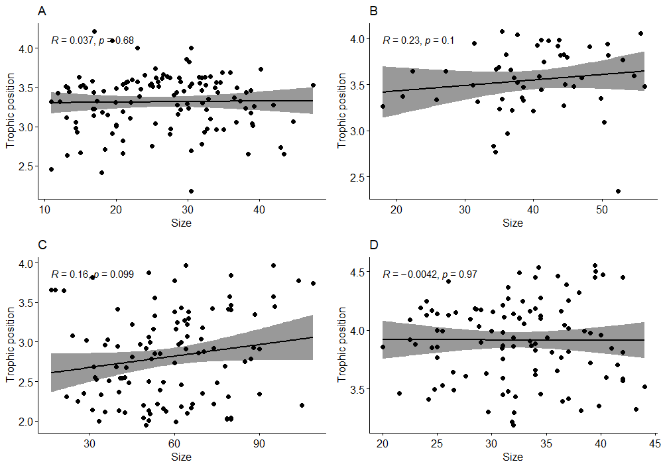
Fig. A.1 Spearman correlation between size and trophic position for Crangon crangon (A), Carcinus maenas (B), Platichthys flesus (C), and Pomatoschistus microps (D). Note that axis vary between plots.

