**Speciation of Inorganic Arsenic with Mixed Mode HPLC-** **Electrospray Ionization-Mass Spectrometry and Arsenite Oxidation**

Tao Li,

*Center for Environmental Solutions and Emergency Response, Office of Research and Development, U.S. Environmental Protection Agency, Cincinnati, Ohio, 45268, USA*

Supplementary material

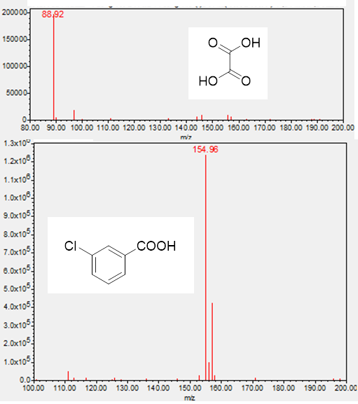

**Figure 1.** MS spectra (QDa negative mode, Cone voltage 14 V) of oxalic acid and m-chlorobenzoic acid eluted between 9-14 min

**Table 1** Impacts of mobile phase and flow on retention time

|  |  |  |  |  |  |  |  |
| --- | --- | --- | --- | --- | --- | --- | --- |
| **Source/Term** | Effect test | | | | Parameter estimates (Model R2 = 0.9942) | | |
| **DF** | **Sum of Squares** | **F Ratio** | **Prob > F** | **Estimate** | **Std Error** | **t Ratio** |
| Intercept |  |  |  |  | 10.603 | 0.2410 | 43.99 |
| HCOOH | 1 | 6.691 | 251.17 | <.0001 | -3.272 | 0.2065 | -15.85 |
| Flow | 1 | 21.668 | 813.36 | <.0001 | -14.720 | 0.5161 | -28.52 |
| Reagent Alcohol | 1 | 0.562 | 21.08 | 0.0013 | -0.012 | 0.0026 | -4.59 |
| (HCOOH-0.65)*(HCOOH-0.65) | 1 | 0.370 | 13.89 | 0.0047 | 5.684 | 1.5248 | 3.73 |
| (HCOOH-0.65)*(Flow-0.3) | 1 | 0.656 | 24.61 | 0.0008 | 11.450 | 2.3082 | 4.96 |
| (Flow-0.3)*(Flow-0.3) | 1 | 0.779 | 29.23 | 0.0004 | 51.523 | 9.5299 | 5.41 |

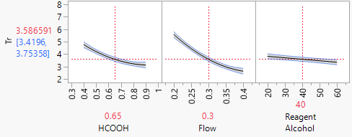

**Table 2**. Impacts of mobile phase and flow on peak area

|  |  |  |  |  |  |  |  |
| --- | --- | --- | --- | --- | --- | --- | --- |
| Source/Term | Effect test | | | | Parameter estimates (Model R2 = 0.9300) | | |
| DF | Sum of Squares | F Ratio | Prob > F | Estimate | Std Error | t Ratio |
| Intercept |  |  |  |  | 26971 | 11602.33 | 2.32 |
| HCOOH | 1 | 1342701563 | 20.3329 | 0.0009 | 46350 | 10278.97 | 4.51 |
| Flow | 1 | 1263600810 | 19.1351 | 0.0011 | -112410 | 25697.43 | -4.37 |
| Reagent Alcohol | 1 | 6269214746 | 94.9366 | <.0001 | 1252 | 128.49 | 9.74 |
| (HCOOH-0.65)*(Reagent Alcohol-40) | 1 | 690674361 | 10.4591 | 0.008 | 1858 | 574.61 | 3.23 |

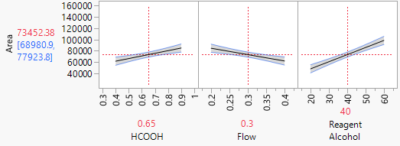

**Table 3**. Impacts of mobile phase and flow on theoretical plate number

|  |  |  |  |  |  |  |  |
| --- | --- | --- | --- | --- | --- | --- | --- |
| Source/Term |  | Effect test | | | Parameter (Model R2 = 0.9938) | | |
| DF | Sum of Squares | F Ratio | Prob > F | Estimate | Std Error | t Ratio |
| Intercept |  |  |  |  | 5108.187 | 117.0342 | 43.65 |
| HCOOH | 1 | 44489 | 6.96 | 0.0248 | -266.8 | 101.1336 | -2.64 |
| Flow | 1 | 151044 | 23.63 | 0.0007 | -1229 | 252.834 | -4.86 |
| Reagent Alcohol | 1 | 9549198 | 1493.81 | <.0001 | -48.86 | 1.26417 | -38.65 |
| (HCOOH-0.65)*(Reagent Alcohol-40) | 1 | 351961 | 55.06 | <.0001 | 41.95 | 5.65354 | 7.42 |
| (Reagent Alcohol-40)*(Reagent Alcohol-40) | 1 | 107781 | 16.86 | 0.0021 | 0.423833 | 0.103219 | 4.11 |

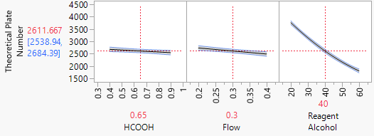

**Table 4**. Recovery of As(V) and total iAs for samples in 5 mM oxalic acid over 15 days

|  |  |  |  |  |  |  |  |  |
| --- | --- | --- | --- | --- | --- | --- | --- | --- |
| Sample | As(V)  (mM) | As(III)  (mM) | Day 1 | Day 2 | Day 3 | Day 4 | Day 8 | Day 15 |
| Recovery of As (V)  (%) | | | | | |
| 1 | 0.2 | 0.8 | 100 | 90 | 110 | 94.5 | 94.5 | 95 |
| 2 | 0.5 | 0.5 | 92 | 98 | 106 | 92.2 | 93.2 | 98.8 |
| 3 | 0.8 | 0.2 | 97.5 | 102.5 | 98.8 | 100.5 | 96.3 | 100.8 |
| Sample | As(V)  (mM) | As(III)  (mM) | Recovery of iAs  (%) | | | | | |
| 1 | 0.2 | 0.8 | 102 | 97 | 105 | 95.8 | 99.4 | 102.7 |
| 2 | 0.5 | 0.5 | 100 | 92 | 103 | 104.9 | 94.1 | 103.5 |
| 3 | 0.8 | 0.2 | 95 | 88 | 101 | 105.9 | 97.3 | 106.1 |