Dermal and oral exposure risks to heavy metals from 3D Printing metal-fill thermoplastics
Anna M. Wade ^{1, 2}, Derek Peloquin ^{1,2}, Joanna Matheson³, and Todd P. Luxton ²*

¹ Oak Ridge Institute for Science and Education, Oak Ridge, TN, 37830, USA
² U.S. Environmental Protection Agency, Office of Research and Development, Center for Environmental Research and Emergency Response, Cincinnati, OH, USA
³ U.S. Consumer Product and Safety Commission, Health Sciences Directorate, Rockville, MD 20850

Key words: Plastics, Hazardous additives, Metals, Additive manufacturing, Dermal exposure, Metal speciation, Fused Filament Fabrication

Abstract
Manufacturing advancements in polymer printing now allow for the addition of metal additives to thermoplastic feedstock up to 80-90% by weight and subsequent printing on low-cost desktop 3D printers. Particles associated with metal additives are not chemically bound to the plastic polymer, meaning these particles can potentially migrate and become bioavailable. This study investigates the degree to which two human exposure pathways, oral (ingestion) and dermal (skin contact), are important exposure pathways for metals (Cu, Cr, and Sn) from metal-fill thermoplastics used in consumer fused filament fabrication (FFF). We found that dermal exposure to copper and bronze filaments presented the highest exposure risk due to Cl⁻ in synthetic sweat driving Cu²⁺ release and dissolution. Cr and Sn were released as micron sized particles < 24 µm in diameter with low bioaccessibility during oral and dermal exposure but with the potential to undergo dissolution in the gastrointestinal tract. The rate of metal particle release increased by one to two orders of magnitude when thermoplastics were degraded under 1 year of simulated UV weathering. This calls into question the long-term suitability of biodegradable polymers such as PLA for use in metal-fill thermoplastics if they are designed not to be sintered. The greatest exposure risk appears to be from the raw filaments rather than the printed forms, with the former having higher metal release rates for all but one of the filament types. For brittle feedstock that require greater handling, as metal-fill thermoplastics can be, practices common in metal powder 3D printing such as wearing gloves and washing hands may adequately reduce metal exposure risks.

Graphical Abstract
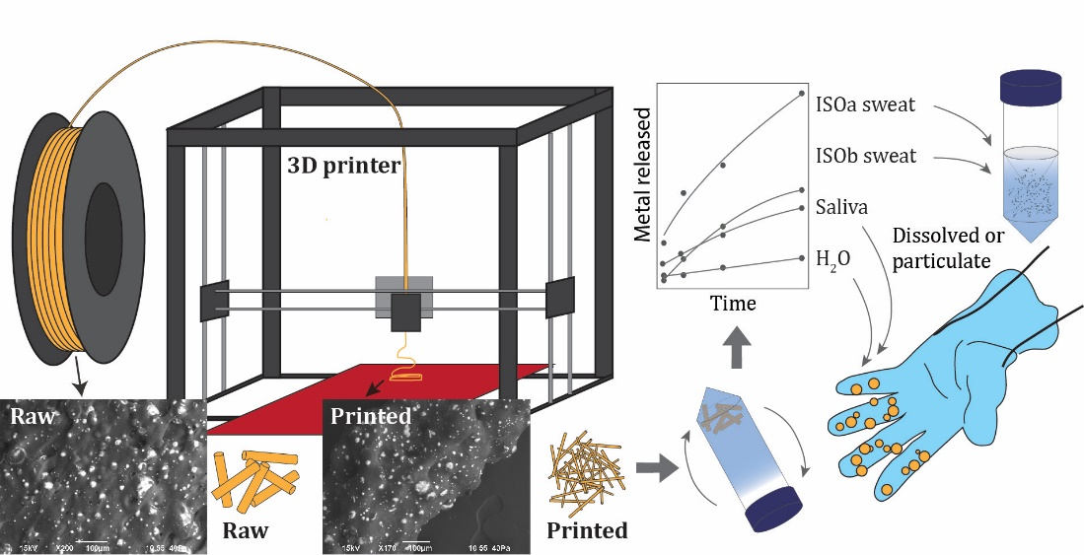
1. Introduction

Fused filament fabrication (FFF), also known as fused deposition modeling, is a material extrusion process and the most popular type of additive manufacturing (AM)/3D printing. Low-cost 3D printers used in FFF can print with a variety of thermoplastic materials (most commonly polylactic acid, PLA, and acrylonitrile butadiene styrene, ABS) with constraints only consisting of nozzle diameter and maximum printing temperature (typically < 250° C), making them ideal for small-scale production and home use (Ćwikła et al., 2017; Tagliaferri et al., 2019). With the global AM market forecasted to expand at a compound growth rate of 20% through 2030 (GVR, 2022) and countries such as the U.S. listing AM as an emerging technology critical for national security (U.S. NSTC, 2022), market demand for AM and for FFF will continue to grow.
With this increased demand comes a need to assess the potential health effects from thermoplastic materials and printing processes. Literature on possible exposure risks from FFF has not kept up with the expanding market of novel materials and processes (Roth et al., 2019; Stefaniak et al., 2018). To date, research on adverse exposure effects from FFF printing have focused on the large number of ultrafine particles (UFP, less than 100 nm) and hazardous volatile organic compounds (VOC) emitted during thermoplastic extrusion and printing processes (Azimi et al., 2016; Farcas et al., 2022; Farcas et al., 2020; Stephens et al., 2013). UFPs have been linked to acute respiratory infections, cardiovascular diseases, and lung cancer (Oberdörster et al., 2005). Adverse health effects from VOCs are still unknown but believed to cause a range of illness from mild irritation to respiratory diseases and cancer (Rumchev et al., 2007). Thermoplastics such as ABS and PLA are known to release polymer breakdown products during extrusion that can become toxins upon release (Floyd et al., 2017; Kim et al., 2015). The number of emitted UFPs and VOCs, of particular concern for desktop 3-D printers with inadequate ventilation, have led researchers to conclude that inhalation is the main path of exposure for extrusion-based AM processes such as FFF (Bours et al., 2017; Floyd et al., 2017). However, few studies exist on health hazards outside of emissions from thermoplastic extrusion, leaving knowledge gaps for common exposure conditions (Roth et al., 2019).
Metal additives are one understudied component of the health risks associated with consumer FFF printing (Alberts et al., 2021). Thermoplastics, like all plastic products, contain chemical substances (known as “additives”) that improve polymer properties such as ductility and conductivity and are meant to prolong product life (Hahladakis et al., 2018). Metal additives, typically as fine atomized metal powders with average diameters on the order of microns to hundreds of nanometers, are mixed with polymer pellets, and the resulting metal/polymer mixture is melted into feedstock (Turner & Filella, 2021). These metal powder particles are not chemically bound to the plastic polymer and can potentially migrate and become bioavailable (Hahladakis et al., 2018; Meng et al., 2021). Because the surface area of these micro-sized particles is large, significant oxidative reactions may occur in a short time if these metal powders are exposed to aqueous solutions or body fluids (Flint, 1998). Metal additives can be incorporated into thermoplastic feedstock either in trace concentrations (for color, UV-resistance or other properties) or anywhere from 10–80% by weight, known as “metal fill” filaments (Tedla et al., 2022). Metal FFF printing has two post-printing steps, debinding and sintering, which are meant to dissolve and subsequently burn away the plastic polymer binding material and solidify the metal powder. However, because use of sintering ovens outside of manufacturing facilities is limited by high costs and low accessibility, manufacturers are now coming out with metal-fill thermoplastics designed to be polished.
Like ABS and PLA filaments, metal-fill thermoplastics present an inhalation exposure threat. Copper and bronze-fill thermoplastics emit particles and VOCs during the extrusion process at rates higher than their respective neat (i.e. only trace metal amounts) thermoplastics (Alberts et al., 2021; Floyd et al., 2017). Tedla et al. (2022) suggested that these higher particle emissions could stem from increased thermal conductivity in the copper feedstock that triggers higher temperatures and subsequently greater emission rates around the nozzle during extrusion. Oral ingestion and dermal exposure are other important exposure pathways in AM (Roth et al., 2019) but have received less attention within the literature. The first known AM exposure assessment was a case of allergic contact dermatitis caused by cumulative exposure from the vat photopolymerization process, another AM method (T. Y. Chang et al., 2004). More recently, another study confirmed workplace exposure to metal particles, ranging in size from 15 to 45 µm, when handling feedstock for powder bed fusion (Graff et al., 2017). For FFF specifically, dermal exposure is a likely exposure pathway for metal additives that are too large to be aerosolized. Alberts et al. (2021) failed to find copper or tungsten metal additives in SEM particle collection filters and suggested that copper and tungsten additives remained within the extruded feedstock. Vance et al. (2017) did not identify a discernible copper peak in the Raman spectra of aerosols emitted from copper-infused PLA (21% copper by weight), concluding that copper additives affect aerosol emissions but do not partition into the aerosol fraction. The lack of research on dermal exposure from FFF methods is perhaps attributable to the fact that only recently has the use of FFF with metal-fill filaments gained popularity (Tosto et al., 2021).
This study investigates the degree to which two main human exposure pathways, oral (ingestion) and dermal (skin contact), are important exposure pathways for metal-fill filaments (hereafter referred to as metal filaments). Raw and printed PLA and PLA/PHA feedstock filaments infused with copper, bronze and stainless-steel fine metal powder were subjected to 2-hour release scenarios that simulated contact with water, synthetic sweat and synthetic saliva, and a 1-hour exposure to synthetic stomach fluids. Concentration, particle size, and speciation of metal additives in these leachates were determined using total metals analysis, sequential filtration, electron microscopy, and X-Ray Absorption Near Edge Spectroscopy (XANES). The specific objectives were to: (1) determine the bulk physicochemical properties of two different manufacturers of metal filaments; (2) compare leaching rates from different solutions including synthetic biological fluids before and post-production; and (3) determine the bioavailability of non-aerosolized metal additives. Copper (Cu), chromium (Cr), and tin (Sn) were focused on as they were the best diagnostic indicators of the different alloys.
2. Materials and Methods
2.1 Printer and Feedstock
Six different metal/polymer filaments from two manufacturers were selected for analysis, labeled Manufacturer A (Man. A) and B (Man. B). Three of the metal filaments were composites of PLA/Polyhydroxyalkanoate [PHA] from one manufacturer (Man. A) with copper (1.75 mm, 3.9 g/cm³), bronze (1.75 mm, 3.9 g/cm³), and 410L stainless-steel additives (1.75 mm, 3.13 g/cm³) with the % metal not specified. These filaments were designed to be sanded and polished after printing, with the base polymer matrix remaining. The other three metal/polymer filaments were pure PLA composites from a different manufacturer (Man. B) with copper (1.75 mm, 4.5 g/cm³, 87.0-90.7% metal according to manufacturer), bronze (1.75 mm, 4.5 g/cm³, 88.0-90.0% metal), and 316L stainless-steel additives (1.75 mm, 3.5 g/cm³, 80.0-85.0% metal). These filaments can be sintered post printing, removing up to 98% of the thermoplastic binder, which comprises anywhere between 8-20% of the feedstock by weight. A natural, colorless PLA filament, with no measurable metal additives, was also chosen to be a baseline comparison (Manufacturer C, 2.85 mm, 1.24 g/cm³). The main differences in grade specifications for 316L and 410L stainless steel are a higher Cr content for 316L (16 – 18% weight) than for 410L (11 – 13.5% Cr) as well as higher nickel (Ni) content for 316L (10 – 14%) than 410L (max 0.60%). Full grade specifications are in supporting information (SI Table S1). To distinguish between copper filament (raw and printed, solid) and the chemical element copper (released from filament), only the latter will be abbreviated as Cu.
Filaments were extruded from a LulzBot TAZ 6 FFF printer (Aleph Objects Inc., Loveland, CA) using a 0.5 mm steel nozzle toolhead with a print speed between 35 to 45 mm/s. Extrusion temperatures were set at recommended temperatures by manufacturers: 200° C for the metal PLA/PHA composites, 210° C for metal PLA composites and neat PLA, and 230° C for ABS filaments.
2.2 Characterization methods
Total elemental abundance of metals present in the filaments was determined by microwave assisted acid digestion with three replicates. Digestions were performed using TFM iPrep digestion vessels (CEM Corporation) with 9 mL of HNO₃ and 3 mL of HCl that were heated to 200 ± 5 °C with a 20-minute ramp time and 20-minute hold time. iPrep vessels have a maximum pressure of 1500 psi (103 bar) versus 500 psi (35 bar) for the MARSXpress vessels and withstood all digestions without any venting of contents. After digestion, all supernatants were collected and diluted to 50 mL with ultrapure water from a Super-Q water purification system (MilliporeSigma, Burlington, MA) and stored at 4 ± 2 °C in 50 mL polypropylene centrifuge tubes (Fisher Scientific).
Total metal concentrations of the acid digests, filtered, and unfiltered samples were measured using an Agilent 7900 ICP-MS (Agilent Technologies, Santa Clara, CA) with either no gas or helium collision mode depending on the element in accordance with EPA Method 6020B (USEPA, 2014). Analysis of matrix spikes (spike recovery 100 ± 20%), analysis of certified second source standards (100 ± 20% of certified value), and method blanks were used for quality assurance/quality control. Extractions were performed with three replicates and where coefficient of variation (CV) > 100% for metal concentrations of interest (Cr, Cu, and Sn) on the ICP-MS, repeated for a second analysis.
Particle size and shape were analyzed by field emission scanning electron microscopy (SEM) (JEOL JSM-7600F, Tokyo, Japan) in Secondary Electron Imaging (SEI) and Backscatter Electron Imaging (BEC). Elemental analysis was conducted by Energy Dispersive X-ray analysis. All experimental samples mounted on carbon tabs on aluminum SEM stubs, and imaged at 50x – 5,000x magnification. The SEM operated at 15 kV with a 2 nm resolution. The diameter of extruded filaments was measured within the SEM software. Images were then processed in ImageJ (Schindelin et al., 2012) by converting grayscale images to a binary image with a lower threshold cutoff ≈ 100 and upper cutoff of ≈ 255 with the dark background option. Sizes of the particles were determined using ImageJ’s particle analysis package with circularity from 0.3 to 1. Diameter was estimated based on calculated area for each particle, assuming a spherical approximation. The number of particles released per mL was obtained by dividing the concentration of metal in solution by the average mass of a metal particle based on alloy density (copper ~ 8.15 g cm³, bronze ~ 8.15 g cm³, and steel ~ 8.95 g cm³), diameter (from SEM analysis), and metal percentage. Bronze was approximated as being 88% Cu and 12% Sn. For stainless steel, the 410L filament (Man. A) was estimated to have metal particles with 12.5% Cr and the 316L filament (Man. B) 16% Cr based on grade specifications (SI Table S1). Leaching rates were normalized to surface area on a mg cm⁻² basis given that, from a chemical and material viewpoint, metal release is a surface reaction. Approximate diameter for the raw filament was 1.75 mm and for the printed filament 0.5 mm.
2.3 Simulated Leaching and Weathering Experiments
Leaching Experiments: Estimates of metal exposure were determined by leaching materials with DI water, artificial saliva (oral exposure), and two types of artificial sweat (dermal exposure). For each experiment, 2 ± 0.005 g of unprinted raw filament (hereby referred to as “filament”) or extruded/printed filament (referred to as “printed”) were cut into 1 cm long pieces and extracted in 40 mL of solution in 50 mL trace metal grade centrifuge tubes. Samples were rotated at 30 rpm, and 1 mL samples taken at 15, 30, 60 and 120 minutes and preserved with 5% HNO3 (HNO₃ 69%, reagent grade, Sigma-Aldrich). Triplicates, matrix spikes, and method blanks were used to assess accuracy and precision. The 2-hour limit is the standard time limit for the European standard EN 71 which measures the migration of hazardous elements in toys (Weidenhamer et al., 2011).
Artificial saliva was prepared according to Standard EUR 19899 EN (2001) by the General Directorate Joint Research Center of the European Commission. Two artificial sweat solutions were prepared using Standard 105-E04:2013 by the International Organization for Standardization (ISO) at pH 5.5 ± 0.2 (Sweat ISOa) for the acidic formulation and pH 8.0 ± 0.2 (Sweat ISOb) for the basic formulation (SI Table S2). Artificial solutions were stored in HDPE bottles at room temperature (19 – 22 C°) and prepared fresh daily. A subset of samples was passed through a 0.45 µm membrane filter and a subsequent 10 kDa centrifugal filter (Millipore Amicon Ultra-15) with a ≈ 3 nm cutoff to divide metals into dissolved forms (<1 kDa), colloids (1 kDa-0.45 µm) and particles (> 0.45 µm). Two different batches of extracted solution were run through the 10 kDa filters, and samples were taken from the second filtrate.
IVBA: An in vitro bioaccessibility (IVBA) assay was used to mimic the solubility of Cu, Cr and Sn when exposed to a simple extraction medium (0.4 M glycine buffer at pH 1.5 +/- 0.5) that mimics gastrointestinal tract (GIT) fluids (USEPA, 2017). Developed for use in the assessment of lead relative bioavailability (RBA), the IVBA assay has been used to estimate potential exposure through the GIT following incidental ingestion of metals including Cu (Santiago-Rodríguez et al., 2015) and Cr (Wang et al., 2020). Briefly, the modified approach used in this study was to extract 0.5 g of raw filament in 50 mL of the extraction solution, adjust the pH to 1.5 and rotate at 30 rpm for 1 hour at a constant temperature of 37°C. Extracts were then run through 0.45 um and 10 kDa filters. Only raw filaments, not printed, were analyzed because metal particle solubility upon exposure to gastrointestinal conditions was expected to be similar between the two forms.
Weathering Experiment: Metal filaments and extruded material were irradiated using a UV lamp (BHK Mercury Grid lamp, BHK Engineering, Product No. 977208) for simulation of UV-C sunlight at 254 nm, verified with a 254 +/-8nm solar meter. Samples were placed in 40 mm diameter glass petri dishes 120 mm beneath the grid lamp and irradiance averaged 1950 µW cm². 2 ± 0.005 grams raw and printed filaments (n = 3) were irradiated for approximately 220 hours, during which samples were rotated and gently mixed in the petri dishes. The yearly-average insolation in Cincinnati, OH from 1998 to 2016 was 1,551 kW h m⁻² (NREL, 2018; https://www.aurora-energy.com/power-production/). 220 h insolation with irradiance 1950 µW cm² corresponded to 9.2 days of exposure, calculated by the following: 1950 µW cm² x (1 mW/1000 µW) x (1 kW/1000000 mW) x (1000 cm⁻²/m⁻²) x 3600 sec = 7.02 kW h m⁻²; 1,551 kW h m⁻²/7.02 kW h m⁻² ≈ 220 h or 9.2 days. Leaching with DI water was started within 30 minutes after irradiation ended.
2.4 XANES analysis
Raw filaments were sanded with 80 grit sanding discs and then homogenized by hand with a mortar and pestle. This powder was combined with polyvinylpyrrolidone (PVP), pressed into 1.3 mm pellets using a manual pellet press, and sealed in Kapton^{(R)} polymide tape. The 10 kDa filters, which captured the suspended particles greater than ~ 10 nm in size, were cut and then layered and sealed between Kapton polymide tape. For the aqueous samples, clean Kimwipes were cut and loaded dry into sample racks, saturated with solution and sealed with Kapton polymide tape. Pellets were measured for Cr, Cu, and Sn K-edge at the Materials Research Collaborative Access Team (MRCAT) 10-BM line at the Advanced Photon Source (APS) operated by the U.S. Department of Energy (DOE) at Argonne National Lab (Lemont, IL). Energy of the incident X-rays was scanned using a Si(111) monochromator consisting of a water-cooled first crystal and a 50-mm long second crystal. Incident beam energies were calibrated to the first derivative inflection points of the absorption edges (5989 eV for Cr, 8979 eV for Cu, and 29200 eV for Sn) for the metal reference foil standards. XANES spectra, 3-5 scans per sample, were collected from –200 eV below the respective adsorption edge to 550 eV above the respective edge. Spectra were merged, calibrated, and normalized using the software, Athena (Ravel & Newville, 2005). Normalization was done by fitting a first order polynomial from -150 to 30 eV below the edge and either a second or third order polynomial to spectra from 75 to 150 to 225-300 eV above the edge. Linear least-squares combination fitting (LCF) of the XANES region was performed in Athena on select spectra along with a library of reference compounds. The energy range for the fit was -20 to 30 eV above the edge. Quality of the fits was indicated by chi-square and the R factor. The average sensitivity of XANES LCF is 5%, meaning any species with a chemical composition less than 5% is speculative (Kelly et al., 2008).
2.5 Statistical Analysis
All calculations and statistical analyses were performed in R (Team, 2022). All data were tested for normality (Shapiro-Wilk test). Statistical differences between datasets were measured using one-way ANOVA with Tukey’s HSD test a posteriori, or Student’s t-test, with p values < 0.05 significant. An unpaired t-test was used to determine if the average value of an element or metal present in the filament were statistically different (m1 ≠ m2; a = 0.05). Zero-order rate constants were calculated using simple linear regression models with ‘dplyr,’ ‘broom,’ and ‘tidyr’ packages.

3. Results and Discussion
3.1 Physicochemical Characterization of Metal-Fill Filaments
Metal filaments are comparable to metal powders used in powder bed fusion, another FFF method, in terms of metal concentration and particle size. The nominal composition of the metal filaments (Table 1) was 68 to 87% metal infill, including additives, and 13 to 32% thermoplastic binder. In addition to the expected elements for bronze, copper and stainless steel, other trace metals were present including As, Pb, Sb, and Zn. The stainless-steel filaments had significant differences in major elements reflective of their different alloys: Man. B 316L stainless-steel filament had significantly more Cr (p = 0.007), Mo (p < 0.0001), and Ni (p < 0.0001) whereas Man. A 410L stainless-steel filaments had significantly more Mn (p < 0.0001). Because of its higher Cr content, reflective of the austenitic 316L alloy, Man. B stainless steel filament likely has greater oxidation resistance than the Man. A stainless-steel filament, a martensitic 410L alloy. The 316L stainless steel filament (Man. B) also contains 8.5% Ni, which is an alloying element unique to 400 series stainless steel and improves resistance to corrosion and oxidation. Man. B bronze, copper and stainless-steel filaments, which were designed to be sintered, all contained more total metal than Man. A filaments, designed to be polished, but the differences between manufacturers were not significant at p = 0.05.
Table 1. Average concentration (± SD) of select elements from digestions of metal-fill filaments (n =3) presented either as mg g⁻¹ or µg g⁻¹ based on total abundance. Total metal content in the filaments (bottom row) was determined by summing the total mass of the elements present. The asterisk (*) indicates that there was significantly more of an element of metal present in the either the Man. A or Man. B filament. Blanks indicate that an average was not detected, and italics indicate that it was not quantified. Elements not presented but included in the total metal calculation include Si, P, and K (see SI Table S3).
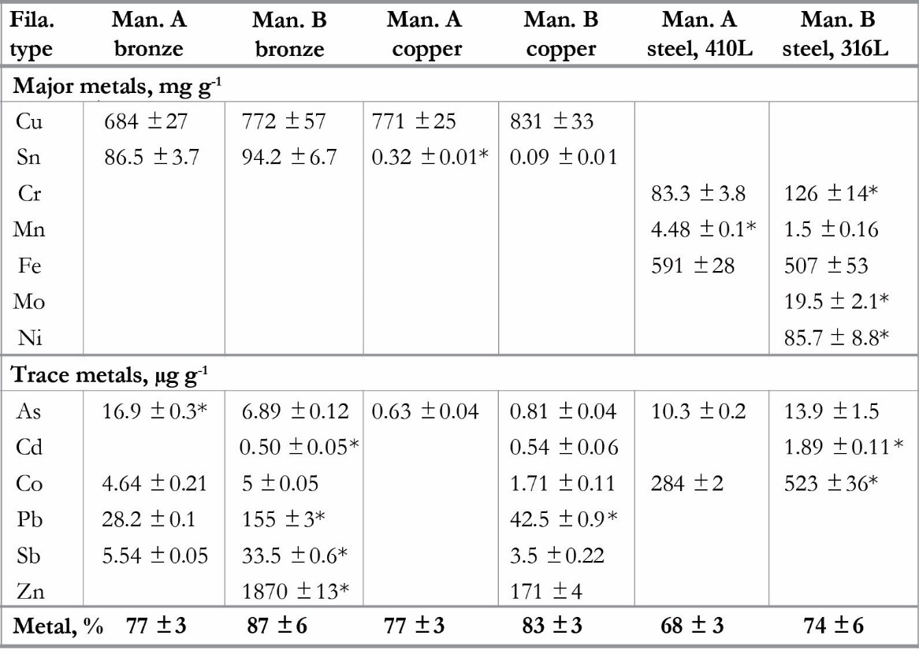

The metal infill for the filaments was present as micro-sized metallic spheres dispersed as metallic powder through the polymer matrix. Particles were roughly spherical in shape, sometimes having irregularities such as elongated or joined particles and indentations or smaller particles known as “satellites” agglomerating on the surface of larger particles (Barreto et al., 2022). These non-spherical particles were attributed to oxidation during atomization process, which is when molten metals are rapidly broken into smaller metal droplets by high-velocity gas, water or plasma jets and solidified into powder (Ansell et al., 2021). Both manufacturers used metal powders produced by gas atomization in their feedstock, the most common technique used for producing powders in AM, which produces metal powders at an optimal cost but inevitably yields a fraction of non-spherical particles with irregular morphologies in the final product (Kassym & Perveen, 2020).

Table 2. Metallic particle diameter and specific surface area (SSA) in metal-fill filaments, including density distributions of data. CV = coefficient of variation.
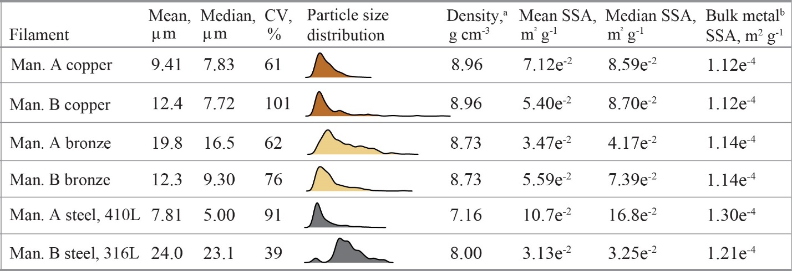
ª Density of metal alloys
^{b} Based on 1g of a bulk metal sphere

Particle size analysis based on SEM images showed mean diameter to range from 7.8 µm to 24.0 µm for the micron sized fraction, with distributions skewed to the smaller sizes. This micro-size distribution of the metal powders imbedded in the polymer means these materials have surface areas two to three orders of magnitude higher than their bulk metal counterparts (Table 2). VF filaments had larger copper and stainless-steel particles (12.4 µm and 24.0 µm) than CF filaments (9.4 µm and 7.8 µm). In contrast, bronze particles were larger in the CF filaments (19.8 µm) than in the VF filaments (12.3 µm). These differences are important for oxidation rates, as smaller particles are more impacted by surface oxidation and other surface chemical reactions than larger particles due to having a higher oxide fraction by mass. Chromium and manganese oxides have been found on the surface of gas atomized 316L stainless steel powders used in AM (Riabov et al., 2020). Oxide thickness on pure Cu powder used in laser powder bed fusion (99.7-99.95% Cu wt%) starts out anywhere from 2 to 15 nm in thickness and increases following each printing cycle (Bojestig et al., 2020). Based on SEM images, this metal infill is non-uniformly distributed (Fig. 2). This is a common problem for thermoplastic fillers such as metal powders, especially when there are varieties in particle size (Masood & Song, 2004; Valino et al., 2019). This poor filler distribution likely explains some of the high variability in leached metal concentrations from all filament types (Table 3).
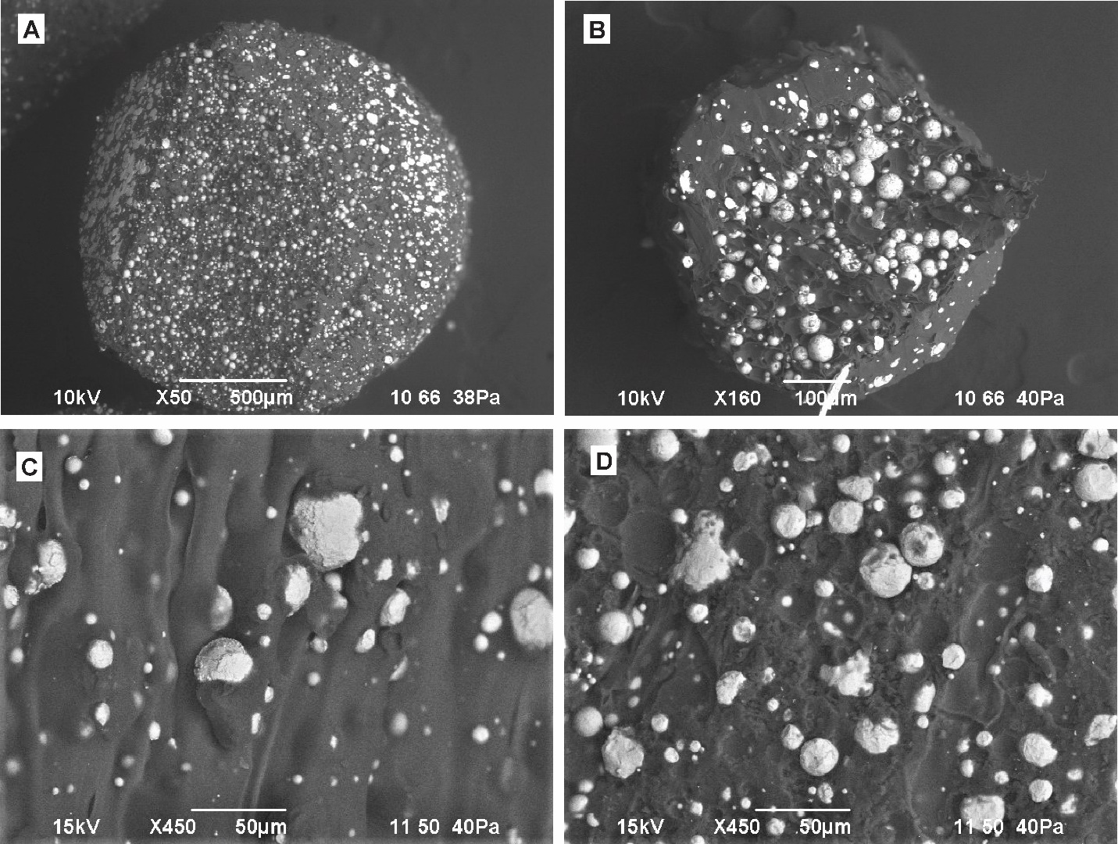
Figure 2. SEM images showing cross diagrams of (A) Man. A copper raw filament and (B) Man. A copper printed filament, and microscopic surface morphologies of (C) Man. A copper, raw filament unweathered and (D) Man. A copper, raw filament UV weathered 10 days. Copper metallic particles are lighter and more reflective, embedded within the PLA/PHA thermoplastic matrix.

As expected, Cr, Cu and Sn species in the raw filament were primarily metallic based on analysis of the XANES region (SI Fig S1). The Cu K-edge for copper and bronze filaments were nearly identical to the metallic copper foil reference, suggesting minimal oxidation had occurred during atomization and filament fabrication. The energy position of the Cr absorption K-edge for both 316L and 410L stainless steel types showed no shift in comparison to the metallic Cr foil. However, the subsequent XANES region (within 100 eV of the edge) was starkly different between the two alloys, likely due to different crystal structures. The martensitic 410L alloy (Man. A) has its chromium atoms in a body-centered cubic structure whereas the austenitic 316L alloy (Man. B) has chromium atoms in a face-centered cubic crystal structure due to the inclusion of Ni. Finally, the Sn K-edge for the CF and VF bronze filaments resembled a mixture of tin(IV) oxide and metallic Sn, the former likely from cassiterite (SnO2), which is the principal source for Sn metal (79.6% Sn) and commonly used in bronze metallurgy (Haldar, 2020). Both bronze filaments exhibited a clear increase in white line intensities, characteristic of oxide species, from the Sn foil reference but with reduced intensities compared to the SnO₂ standard as well as a slight energy shift toward lower energies, reflecting the inclusion of metallic Sn. XANES is a bulk measurement of the metal powder speciation, so the nanometer thick oxide layer that forms on the particle surface during the atomization process is not visible on micro-sized particles (Fleischmann et al., 2022; Hryha et al., 2018). Subsequent solid-state processing, such as sintering, is meant to reduce and decompose these metal oxides before the particles are fused together but the process is not entirely 100% efficient (Chasoglou et al., 2013).
Table 3. Average metal release (coefficient of variation, CV % in parathesis) after 2-hour extraction in different fluids (n = 3). (*) indicates significant differences between filament and printed metal type (p < 0.05) of same manufacturer. Italics indicates values were not normally distributed based on Shapiro-Wilk test at p = 0.05 significance. For filament type: F = filament, P = printed, Steel = Stainless Steel.
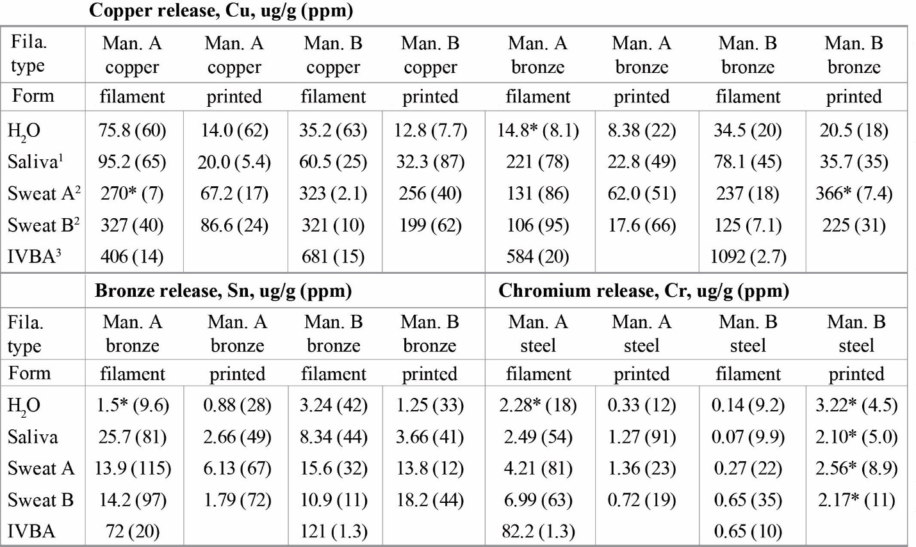
¹ Synthetic saliva, Standard EUR 19899 EN (2001)
² Synthetic sweat, Standard 105-E04:2013

3.2 Total Metal Release
Total Cu, Sn and Cr concentrations, including both the soluble and particulate fractions, released during 2-hour exposure scenarios into synthetic fluids are presented in Table 3. Total Cu and Cr concentrations exceed EPA drinking water limits of 1.3 mg L⁻¹ Cu and 0.1 mg L⁻¹ Cr by one to two orders of magnitude; recommending to not use metal-fill thermoplastic as a food-grade material. During this 2-hour period, Man. A filaments released higher concentrations of Cr, Cu, and Sn than printed Man. A material, despite the latter having a surface area 3x higher. Additionally, released Cu concentrations were highest in synthetic sweat (maximum 327 ug g⁻¹) in comparison to H₂O and synthetic saliva (maximum 76 and 95 ug g⁻¹, respectively). Maximum amounts of Sn and Cr released were low (25.7 ug g⁻¹ and 6.99 ug g⁻¹) and showed less release in synthetic sweat. Figure 3 demonstrates the increase in Cu and Cr concentrations for copper and stainless-steel filaments over this 2-hour period. Copper and Sn release from bronze filaments followed similar trends to the copper filament, the data for which is in the SI (Fig. S2). Copper release patterns did not appear to differ based on manufacturer. Despite a lower Cr content, the 410L raw filament (Man A., ~8% Cr by weight) released significantly more Cr than the 316L raw filament (Man. B, ~13% Cr by weight). When normalized to surface area, all but one of the filament types released more total metal in its raw form than in the printed form (SI Table S4).

In addition to concentration, the physicochemical form of released metals plays a critical role in exposure potential. Because metal additives were released as particles rather than dissolved species (see Section 3.3), Figures 3 and 4 also provides estimates of the total number of metal particles released in water, saliva and sweat. Generally, dissociated or dissolved metal species will be more bioaccessible than particulate forms (Reeder et al., 2006). However, the micron-scale diameter of these metal particles gives them high potential for dermal adherence. As demonstrated with soils, most particles that adhere to the hand are less than 50 μm in size (Madrid et al., 2008; Sheppard & Evenden, 1994; Yamamoto et al., 2006). This incidental exposure by way of dermal adherence and subsequent hand-to-mouth activity can lead to soil ingestion rates of 1 to > 100 mg/day (Deubner et al., 2001).

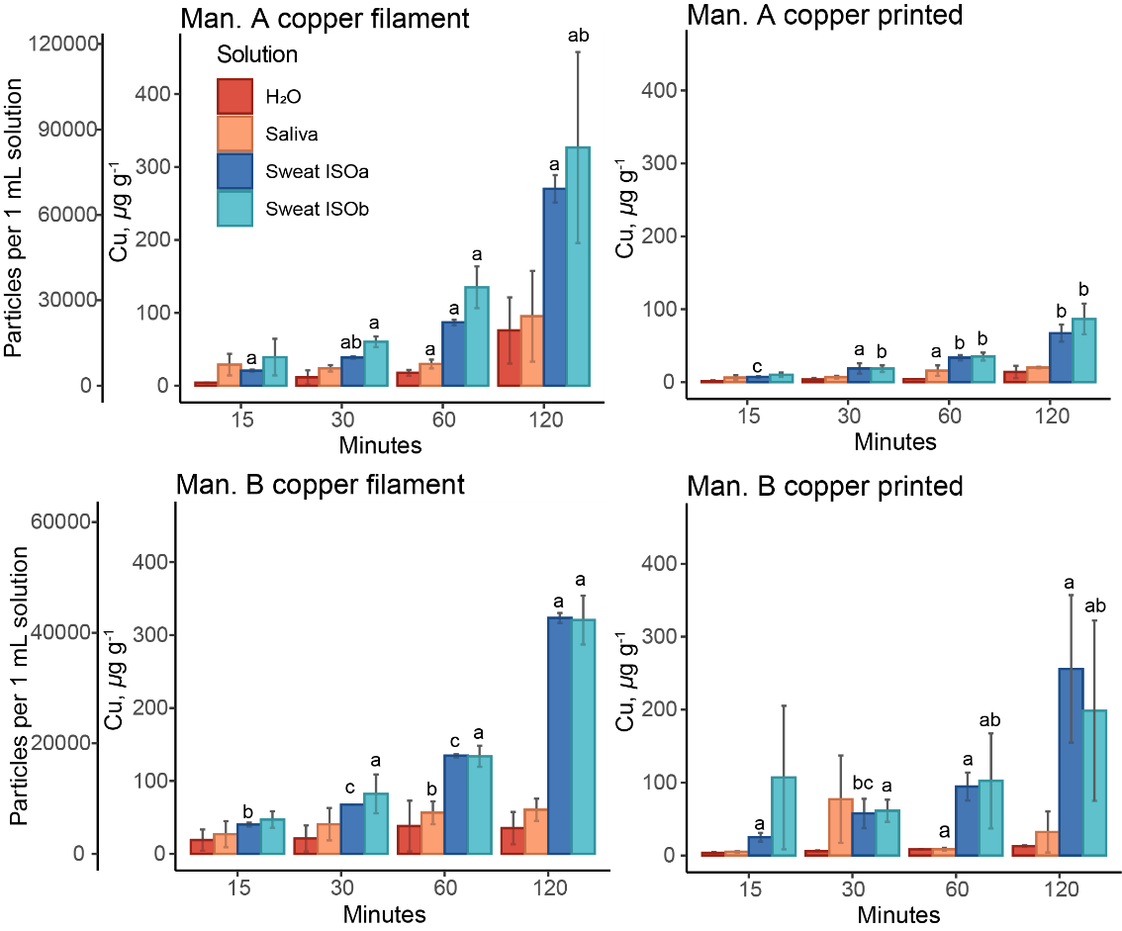
Figure 3. Cu release in H₂O, synthetic saliva and synthetic sweats over two-hour period (n = 3). For each solution (H2O, saliva, sweat ISOa, sweat ISOb), different lowercase letters indicate significant differences in Cu released from the 4 filament types (ANOVA and post-hoc Tukey’s HSD test at p < 0.05) at each time point. For example, Man. B copper filament released significantly more Cu at 120 minutes than Man. A copper printed, but not significantly more than Man. A copper filament or Man. B copper printed.

Solution chemistries had a significant impact on Cu release. Synthetic sweat (ISOa and ISOb) increased the amount of total released Cu, particulate and dissolved, by an order of magnitude in comparison to H₂O and synthetic saliva. Differences in Cu were not immediately apparent after the initial 15 minutes, suggesting chemical dissolution rather than an immediate physical loss (Fig. 3). Artificial sweat contained chloride (~1850 mg L⁻¹), a strong Cu corrosion catalyst, as well as l-histidine, an amino acid that chelates Cu, both of which would hasten Cu release (Boulay & Edwards, 2001; Deschamps et al., 2005). Chloride (Cl) is an aggressive anion that is known to break down the passivating oxide layer on metals and alloys (Hoar & Jacob, 1967). Cu release from copper filaments after 2 hours and Cl concentration (0, 365 and 1850 mg L⁻¹ for H₂O, synthetic saliva and synthetic sweat, respectively) had a significant positive relationship (p < 0.05, R² > 0.95, SI Fig. S3). This suggests Cl is driving the Cu release from copper filaments, although the relationship was not significant for bronze filaments. Less chloride (~365 mg L⁻¹) may explain why artificial saliva did not have as marked of an impact on Cu release from copper and bronze filaments.

The response of Sn to different solutions was highly correlated to Cu loss. For bronze filaments, Sn release increased linearly with Cu release (R² = 0.67, F_{1,176} = 366.5, p < 2e-16). Proportionally less Sn was lost as compared to Cu based on the ratio of Sn:Cu in the raw filament, and this solution ratio decreased over the 2-hour time period, likely due to incongruent dissolution (SI Fig. S4). Sn is added to bronze alloy as a corrosion inhibitor (T. Chang et al., 2020; Liang et al., 2020). However, when normalized to the percentage of total Cu (Table 1), the percentage of Cu lost over the 2-hour time period did not significantly differ between bronze and copper filaments, suggesting the addition of Sn does not impact Cu release.
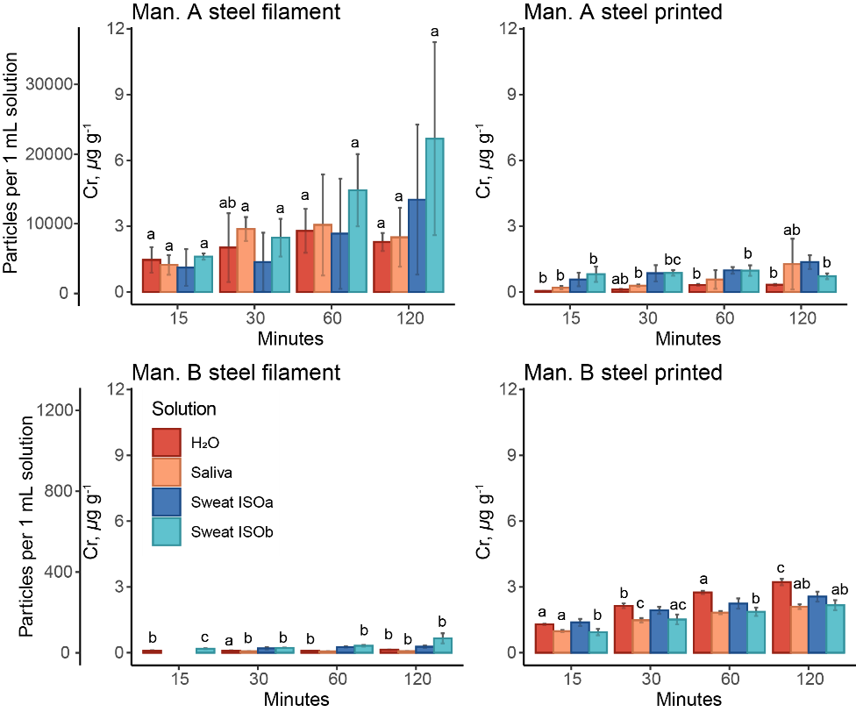
Figure 4. Cr release in H₂O, synthetic saliva and synthetic sweats over two-hour period (n = 3). For each solution (H2O, saliva, sweat ISOa, sweat ISOb), different lowercase letters indicate significant differences in Cr released from the 4 filament types (ANOVA and post-hoc Tukey’s HSD test at p < 0.05) at each time point.

Stainless-steel particles were more stable in the polymer matrix and were not as responsive to changes in solution type, as indicated by low amounts of Cr release across solutions (Fig. 4). Overall, 2-hr average concentrations across all solutions and filament types compromised 0.04% (CV = 107%) of the total bulk content (Tables 1 and 3). Previous research reported very small fractions of Cr released from particles of stainless steel in artificial sweat, attributing the lack to a chromium(III)-rich surface oxide creating an insoluble barrier (Hedberg et al., 2010b). In another study, localized corrosion of stainless steel occurred by chloride ions only at temperatures above 60°C (Sim et al., 2017). Within the medical field, no effective chelating agent for metallic chromium has been identified (Smith, 2013). Different alloy grades may explain the greater total Cr release from Man. A steel filament, an austenitic steel with less corrosive resistance than the martensitic Man. B steel filament. Differences between the printed filaments may be due to particle size, as the larger Man. B steel particles may be more susceptible to physical release as the surface area of the matrix polymer increases upon printing.

3.3 Evidence for Metal Corrosion and Speciation Changes
Size fractionation data corroborated the notion of chemical dissolution for Cu while showing little evidence of any significant Cr and Sn dissolution in dermal and oral exposure scenarios. For Cu, the fraction of dissolved versus particulate Cu released into solution varied widely across solution types (SI Table S5). Following 2-hour extractions, anywhere from 25% to 100% of the Cu released from copper and bronze filaments in H₂O was dissolved (passing through a 10 kDa membrane). This is likely due to the leaching of cupric ions (Cu²⁺), which will chelate with Cl- forming stable solution complexes (Cuppett et al., 2006). Copper released in synthetic saliva was entirely particulate, with 10 kDa filtrates below the method detection limit (MDL) (~ 2 ppb), suggesting dissolution kinetics are either longer than 2 hours or potentially hindered by phosphate (753 mg L⁻¹ K₂HPO₄) in the artificial saliva. Phosphates are frequently used for potable water treatment to reduce soluble copper and to inhibit corrosion (Edwards et al., 2002). In contrast, 100% of the Cu released in synthetic sweat (ISOa) was dissolved. Size fractionation data for Cr and Sn showed little evidence of any substantial dissolution in H₂O, synthetic saliva and synthetic sweat, with 10 kDa filtrates at or below MDLs for both metals. Thermodynamically, Sn(0) and Sn(IV) oxide (SnO₂(s)) are very stable in near-neutral environments characteristic of artificial sweat and saliva (pH 5.5 – 8) (Séby et al., 2001). Metallic Cr and chromium(III) oxide are both highly insoluble, which explains why neither has been found to cause skin sensitization or irritation (Hedberg et al., 2010b).

Metallic particles underwent greater dissolution in the IVBA assay, suggesting potential for chemical changes upon ingestion and translocation to the gastrointestinal tract (pH 1.5). Sn underwent complete dissolution for both filament types (SI Table S6). This is likely due to the dissolution of metallic Sn, known to dissolve to stable water-soluble Sn²⁺ in highly acidic solutions (Gerhátová et al., 2022). Cr also underwent complete dissolution from the martensitic steel (410L, Man. A) filament in the IVBA assay, as well as from the austenitic steel (316L, Man. B) albeit at far lower rates due to higher corrosion resistance (see release rates in Section 3.4). These results show that highly acidic, aggressive environments such as the gastric tract can potentially negate any corrosion resistance of these metal particles, even if bioaccessibility is minimal during oral and dermal exposure (Santiago-Rodríguez et al., 2015).

In terms of speciation, metallic Cu released from copper and bronze filaments in biological fluids and trapped on filters showed significant oxidation (Fig. 5). In synthetic sweat, metallic Cu released from copper and bronze filaments oxidized to species that closely resemble Cu(II)-organo acid complexes, Cu(II) hydroxide and Cu(II) oxide. Linear combination fitting (LCF) of the normalized XANES showed that 96% of the Cu present was present as Cu(II) hydroxide, CuO, and Cu-Organic complexes such as Cu-histidine with trace amounts (<5%) of raw filament present (SI Table S7). Of the Cu(II) reference spectra considered, Cu-hydroxide, Cu-histidine and CuO were the predominant Cu species found after exposure to synthetic sweat. Copper oxidation proceeded rapidly – a sample of CF Copper filament exposed to synthetic sweat for one hour showed complete oxidation of metallic Cu to Cu(II) species similar to Cu(OH)₂, Cu(II)-organic complexes and CuO (SI Fig. S5). Copper oxidation occurred in a modified IVBA assay, carried out at room temperature, with about 50% of the Cu oxidizing to Cu(I) or Cu(II) species after one hour. Copper bound to lactic acid, Cu(I) oxide and Cu(II) oxide were the most common species identified. Lactic acid is a known degradation product of PLA upon hydrolysis and contact with biological media (Da Silva et al., 2018).

Speciation of Cr and Sn did not show any marked changes in oxidation state after exposure to synthetic sweat or saliva, although the spectra were of poor quality due to low element concentration. For Sn, this is likely due to the stability of Sn(IV) oxide over a wide pH and conductivity range (Hutchison & Scully, 2018). For Cr, it is likely due to the passivating layer of chromium oxide, Cr₂O₃. In the IVBA assay, dissolved Cr (< 10 kDa) was too low to be analyzed for XANES in solution. This dissolved fraction was likely chromium oxide, based on previous studies which have found Cr to be released as Cr(III) from 316L-stainless steel (Hedberg et al., 2010).
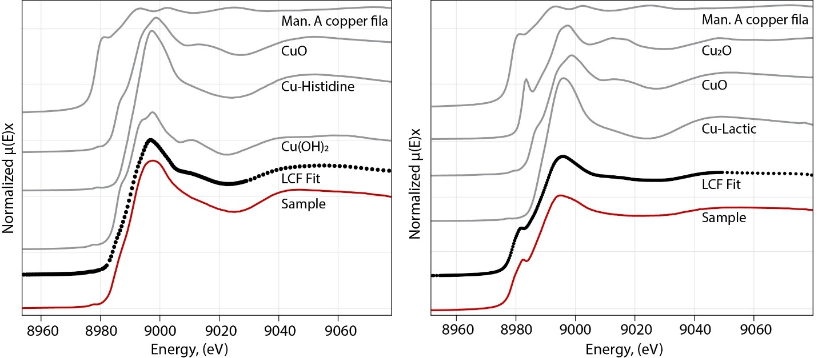
Figure 5. Normalized Cu Ka XANES spectrum of Cu present on A) 10 kDa filter from Man. A copper filament in synthetic sweat ISOb after 24 hours and B) 0.45 um filter from Man. A copper filament in IVBA extraction solution after 1 hour along with reference compounds used for the LCF fit (fit range -20 to 30 eV above E₀). LCF fits presented as black circles.

3.4 Connecting release rates to potential exposure scenarios
To evaluate exposure risks, a simple rate was calculated by fitting a linear regression between metal release and exposure time, with rates in mg cm⁻² min⁻¹. Model fits were significant (p < 0.05) for Cu release from copper and bronze filaments in H₂O and synthetic sweat but not in synthetic saliva (SI Table S8). Model fits were poorer for Sn and Cr release from bronze and stainless-steel filaments. Those rates with significant to marginally significant fits (p ≤ 0.10) were subsequently converted to mg hr⁻¹ and scaled up to a 5 cm cube with a 150 cm² surface area to mimic a 3-D printed object. This conversion was done for both raw and printed filaments to compare the rates on a larger hypothetical scale.

Raw copper filaments had significantly higher release rates of Cu than printed filaments, particularly in synthetic sweat (Fig. 6). Upon exposure to H₂O, a 5 cm cube of raw Man. A copper filament release about 1 mg of Cu in 1 hour, in comparison to 0.05 mg from a printed Man. A copper filament. Upon exposure to synthetic sweat (ISOa), these rates increase to 3.30 mg hr⁻¹ from raw filament and 0.26 mg Cu hr⁻¹ from printed; among the printed types, the highest estimated release rate of Cu was from Man. B bronze, with 1.41 mg Cu hr⁻¹ from a 5-cm cube. The EPA has not developed a formal oral reference dose (RfD) for copper exposure but developed an optimal intake value of 0.04 mg Cu kg day⁻¹ based on the drinking water action level and assuming 2 L day⁻¹ of water consumption and a 70-kg body weight (Taylor et al., 2020). The release rate of Cu from Man. A copper filament yields 0.47 mg Cu kg hr⁻¹ (3.30 mg hr⁻¹ divided by 70 kg), meaning 1 hour of handling time would suffice to exceed the RfD. In contrast, over 10 hours of handling time of the printed Man. A copper form would be needed to exceed the RfD (0.0037 mg Cu kg hr⁻¹). Among the stainless-steel filaments, Man. A steel filament had the highest release rate of Cr in synthetic sweat, with 0.06 mg Cr per hour from a 5-cm cube (See Table S8).

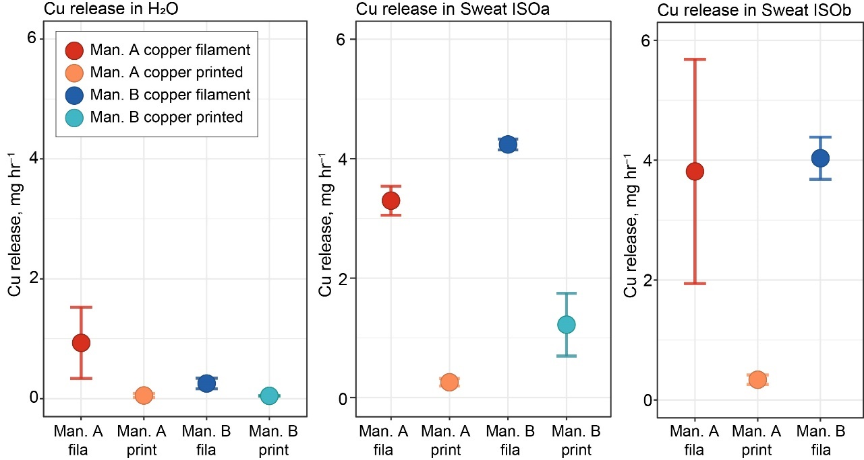
Figure 6. Cu release rates, in mg hr⁻¹, from a 5 cm³ cube in (1) H₂O, (2) synthetic sweat ISOa, and (3) synthetic sweat ISOb from copper filaments. Only model fits with p < 0.05 shown (n = 3 replicates). Full model fits are in SI Table S8.

For brittle feedstock, as metal-fill thermoplastics are prone to be (Woods, 2022), greater handling of the material is required during the printing process leading to possible higher dermal exposure than with neat thermoplastic (low metal). SEM images of the raw filament surfaces showed 5 to 20 µm diameter holes not observed on the printed filament, suggesting metal particles had broken off the surface of the thermoplastic prior to printing (SI Fig S6). Using the reference dose of 0.04 mg Cu kg⁻¹ day⁻¹ again, a threshold printing rate can be made above which someone might be at risk due to high usage. A standard 1 kg spool of Man. A copper raw filament with a density of 4.0 g/cm³ would yield 12.25 mg Cu via dermal exposure in synthetic sweat (ISOb). This is based on 0.049 mg Cu released per cm⁻² surface area (SI Table S4). Normalized to an average body weight of 70 kg, this yields 0.175 mg Cu/kg. To not exceed the RfD of 0.04 mg/kg/day, the duration of use for a 1 kg spool would need to exceed 4.4 days. Given the high solubility of the Cu, extended exposure should be limited to prevent any gastrointestinal effects. Of course, this risk may be mitigated by use of personal protective equipment (PPE). NIOSH, in a publication for 3D printing with metal powders, such as metal powder fusion, recommended nitrile gloves and other PPE equipment for workplaces (Glassford et al., 2020). Practices such as wearing gloves and washing hands may adequately reduce exposure during the printing and post-printing steps.

3.5 Impact of weathering on metal release
Release of metal additives is predicted to increase upon plastic UV aging due to increases in porosity and surface area of the matrix (Turner & Filella, 2021; Zhang et al., 2018). Prolonged exposure to UV light causes oxidative chain scission (degradation of the main polymer chain), increasing the brittleness and the hydrolysis of PLA (Agustin-Salazar et al., 2014; Copinet et al., 2004). In this study, weathering of the thermoplastic disrupted the polymer’s surface structure, accelerating the loss of metal particles by increasing porosity and surface area of the matrix. The coarse brittle surface of the aged, UV-weathered plastics is clear, exposing metal particles (Fig 2).

This UV degradation process increased leachable concentrations of Cr, Cu and Sn metal additives from both raw and printed filaments by one to two orders of magnitude (SI, Table S9). When exposed to H₂O, Cu concentrations leached from weathered copper filament over 2 hours were approximately 2,096 ppm (CV = 43%) for Man. A filament and 3,850 (CV = 40%) for Man. B filament, about two orders of magnitude greater than unweathered filament (75 ppm (61%) and 35 ppm (63%), respectively). For stainless steel filaments, UV degradation had a greater impact on Man. A filament, both raw and printed, than on Man. B filament. Two-hour Cr concentrations in H₂O from Man. A filament were two orders of magnitude higher than the Man. B filament, reaching 46.8 ppm Cr (CV = 48%) as opposed to 0.81 ppm (CV = 9%) for raw filament. This greater susceptibility of the former may be attributed to structural differences between a PLA thermoplastic (Man. B filament) and a PLA/PHA thermoplastic (Man. A filament) that impact how polymer chains degrade, or due to differences in metal particle size. Filtration data showed metal loss to be entirely in particulate form. Less than 5% of total Cu from weathered filaments passed through a 10 kDa filter, while Sn and Cr were at or below detection levels (SI Table S7). This shows metal-fill thermoplastics have high potential for photooxidative degradation that increases the surface release of metal additives embedded in the matrix. Continued UV exposure of metal-fill 3D printed thermoplastics, coupled with moisture and heat fluctuations, may have significant deleterious effects upon thermoplastic physical properties. This calls into question the long-term tenability of using FFF to print metal-fill thermoplastic objects, especially ones using biodegradable polymers such as PLA, that are designed to be polished rather than sintered.

4. Conclusion
Metal additives are an understudied component of the health risks associated with consumer fused filament fabrication (FFF), the most popular type of additive manufacturing (AM). Here, we showed that metal-fill thermoplastics contain metal particles < 25 µm in diameter that have surface areas two to three orders of magnitude greater than their bulk metal counterparts, with high potential for dermal adherence upon release. Following 2-hour exposure scenarios into synthetic fluids, total Cu and Cr concentrations exceeded EPA drinking water limits of 1.3 mg L⁻¹ and 0.1 mg L⁻¹, respectively; recommending to not use metal-fill thermoplastics a as food-grade material (USEPA, 2009). The highest exposure risk was dermal exposure to Cu²⁺ from copper and bronze filaments, believed to be caused by leaching induced by Cl⁻ in artificial sweat, a strong corrosion catalyst and chelating agent. To relate release rates to exposure scenarios, we calculated the theoretical handling time and printed rate needed to exceed the oral drinking water reference dose of 0.04 mg Cu kg⁻¹ day⁻¹. Cr and Sn were more stable in the polymer matrix and were released as micron-sized particles with low bioaccessibility during oral and dermal exposure. Metal-fill thermoplastics showed significant degradation upon 1 year of simulated UV weathering, which increased the release of metal additives from both raw and printed material by one to two orders of magnitude. Prolonged UV exposure alongside moisture and heat fluctuations in household environments may degrade the mechanical properties and microstructure of metal-fill 3D printed thermoplastics in such a way that challenges the suitability of these materials for long-term use. Overall, the greatest exposure risk appears to be dermal exposure from raw filaments. Practices such as wearing gloves and frequent washing of hands, as well as safety measures used in metal powder bed fusion, may mitigate metal exposure risks during pre-printing steps.

Acknowledgements
This work was part of an interagency agreement between the U.S. EPA and the U.S. CPSC. This work has been subjected to EPA administrative review and approved for publication. The findings and conclusions in this paper are those of the authors and do not necessarily represent the views of the CPSC or EPA. Mention of trade names or commercial products does not constitute endorsement or recommendation for use. Thank you to the Advanced Photon Source (APS, Argonne, Illinois, USA) for the allocation of beam time. MRCAT operations are supported by the Department of Energy (DOE) and the MRCAT member institutions. Additionally, this project was supported in part by A.M. Wade’s appointment to the Research Participation Program at the Office of Research and Development, U.S. Environmental Protection Agency, administered by the Oak Ridge Institute for Science and Education through an interagency agreement between the U.S. Department of Energy and U.S. EPA. We would like to thank Mahendra Arambewela, Logan Rand, Matt Noerpel, Aaron Betts, and Geoffrey Millard for technical support and assistance as well as Tyler Sowers and Phillip Potter for serving as internal reviewers.

References
Agustin-Salazar, S., Gamez-Meza, N., Medina-Juàrez, L. À., Soto-Valdez, H., & Cerruti, P. (2014). From nutraceutics to materials: effect of resveratrol on the stability of polylactide. J ACS Sustainable Chemistry and Engineering, 2(6), 1534-1542.
Alberts, E., Ballentine, M., Barnes, E., & Kennedy, A. (2021). Impact of metal additives on particle emission profiles from a fused filament fabrication 3D printer. Atmospheric Environment, 244, 117956.
Ansell, T. Y., Hanneman, T., Gonzalez-Perez, A., Park, C., & Nieto, A. (2021). Effect of high energy ball milling on spherical metallic powder particulates for additive manufacturing. Particulate Science and Technology, 39(8), 981-989. doi:10.1080/02726351.2021.1876192
Azimi, P., Zhao, D., Pouzet, C., Crain, N. E., & Stephens, B. (2016). Emissions of Ultrafine Particles and Volatile Organic Compounds from Commercially Available Desktop Three-Dimensional Printers with Multiple Filaments. Environmental Science & Technology, 50(3), 1260-1268. doi:10.1021/acs.est.5b04983
Barreto, E. S., Frey, M., Wegner, J., Jose, A., Neuber, N., Busch, R., . . . Uhlenwinkel, V. (2022). Properties of gas-atomized Cu-Ti-based metallic glass powders for additive manufacturing. Materials and Design, 215, 110519.
Bojestig, E., Cao, Y., & Nyborg, L. (2020). Surface chemical analysis of copper powder used in additive manufacturing. Surface and Interface Analysis, 52(12), 1104-1110.
Boulay, N., & Edwards, M. (2001). Role of temperature, chlorine, and organic matter in copper corrosion by-product release in soft water. Water Research, 35(3), 683-690.
Bours, J., Adzima, B., Gladwin, S., Cabral, J., & Mau, S. (2017). Addressing hazardous implications of additive manufacturing: complementing life cycle assessment with a framework for evaluating direct human health and environmental impacts. Journal of Industrial Ecology, 21(S1), S25-S36.
Chang, T., Maltseva, A., Volovitch, P., Wallinder, I. O., & Leygraf, C. (2020). A mechanistic study of stratified patina evolution on Sn-bronze in chloride-rich atmospheres. Corrosion Science, 166, 108477.
Chang, T. Y., Lee, L. J., Wang, J. D., Shie, R. H., & Chan, C. C. (2004). Occupational risk assessment on allergic contact dermatitis in a resin model making process. J Occup Health, 46(2), 148-152. doi:10.1539/joh.46.148
Chasoglou, D., Hryha, E., & Nyborg, L. (2013). Effect of process parameters on surface oxides on chromium-alloyed steel powder during sintering. Materials Chemistry and Physics, 138(1), 405-415.
Copinet, A., Bertrand, C., Govindin, S., Coma, V., & Couturier, Y. (2004). Effects of ultraviolet light (315 nm), temperature and relative humidity on the degradation of polylactic acid plastic films. Chemosphere, 55(5), 763-773.
Cuppett, J. D., Duncan, S. E., & Dietrich, A. M. (2006). Evaluation of copper speciation and water quality factors that affect aqueous copper tasting response. Chemical Senses, 31(7), 689-697.
Ćwikła, G., Grabowik, C., Kalinowski, K., Paprocka, I., & Ociepka, P. (2017). The influence of printing parameters on selected mechanical properties of FDM/FFF 3D-printed parts. Paper presented at the IOP conference series: materials science and engineering.
Da Silva, D., Kaduri, M., Poley, M., Adir, O., Krinsky, N., Shainsky-Roitman, J., & Schroeder, A. (2018). Biocompatibility, biodegradation and excretion of polylactic acid (PLA) in medical implants and theranostic systems. Chemical Engineering Journal, 340, 9-14.
Deschamps, P., Kulkarni, P., Gautam-Basak, M., & Sarkar, B. (2005). The saga of copper (II)–l-histidine. Coordination Chemistry Reviews, 249(9-10), 895-909.
Deubner, D. C., Lowney, Y. W., Paustenbach, D. J., & Warmerdam, J. (2001). Contribution of incidental exposure pathways to total beryllium exposures. Applied Occupational and Environmental Hygiene, 16(5), 568-578.
Edwards, M., Hidmi, L., & Gladwell, D. (2002). Phosphate inhibition of soluble copper corrosion by-product release. Corrosion Science, 44(5), 1057-1071.
Farcas, M. T., McKinney, W., Coyle, J., Orandle, M., Mandler, W. K., Stefaniak, A. B., . . . Hammer, M. A. (2022). Evaluation of Pulmonary Effects of 3-D Printer Emissions From Acrylonitrile Butadiene Styrene Using an Air-Liquid Interface Model of Primary Normal Human-Derived Bronchial Epithelial Cells. International Journal of Toxicology, 41(4), 312-328.
Farcas, M. T., McKinney, W., Qi, C., Mandler, K. W., Battelli, L., Friend, S. A., . . . Winn, A. (2020). Pulmonary and systemic toxicity in rats following inhalation exposure of 3-D printer emissions from acrylonitrile butadiene styrene (ABS) filament. Inhalation Toxicology, 32(11-12), 403-418.
Fleischmann, B., Chateau-Cornu, J.-P., Dembinski, L., Gyss, O., Bigot, R., Danlos, Y., & Ghanbaja, J. (2022). Influence of particle size on surface oxide of 316L stainless steel powders for hot isostatic pressing. Materialia, 22, 101405. doi:https://doi.org/10.1016/j.mtla.2022.101405
Flint, G. (1998). A metallurgical approach to metal contact dermatitis. Contact dermatitis, 39(5), 213-221.
Floyd, E. L., Wang, J., & Regens, J. L. (2017). Fume emissions from a low-cost 3-D printer with various filaments. Journal of Occupational and Environmental Hygiene, 14(7), 523-533. doi:10.1080/15459624.2017.1302587
Gerhátová, Ž., Babincová, P., Drienovský, M., Pašák, M., Černičková, I., Ďuriška, L., . . . Palcut, M. (2022). Microstructure and Corrosion Behavior of Sn–Zn Alloys. Materials, 15(20), 7210.
Glassford, E., Dunn, K., Dunn, K., Hammond, D., & Tyrawski, J. (2020). 3D printing with metal powders: Health and safety questions to ask. (DHHS (NIOSH) Publication No. 2020-114). Cincinnati, OH: NIOSH
Graff, P., Ståhlbom, B., Nordenberg, E., Graichen, A., Johansson, P., & Karlsson, H. (2017). Evaluating measuring techniques for occupational exposure during additive manufacturing of metals: a pilot study. Journal of Industrial Ecology, 21(S1), S120-S129.
Hahladakis, J. N., Velis, C. A., Weber, R., Iacovidou, E., & Purnell, P. (2018). An overview of chemical additives present in plastics: Migration, release, fate and environmental impact during their use, disposal and recycling. Journal of hazardous materials, 344, 179-199.
Haldar, S. K. (2020). Introduction to mineralogy and petrology: Elsevier.
Hedberg, Y., Gustafsson, J., Karlsson, H. L., Möller, L., & Wallinder, I. O. (2010). Bioaccessibility, bioavailability and toxicity of commercially relevant iron-and chromium-based particles: in vitro studies with an inhalation perspective. Particle and fibre toxicology, 7, 1-14.
Hedberg, Y., Midander, K., & Odnevall Wallinder, I. (2010b). Particles, sweat, and tears: a comparative study on bioaccessibility of ferrochromium alloy and stainless steel particles, the pure metals and their metal oxides, in simulated skin and eye contact. Integrated Environmental Assessment and Management, 6(3), 456-468.
Hoar, T., & Jacob, W. (1967). Breakdown of passivity of stainless steel by halide ions. Nature, 216(5122), 1299-1301.
Hryha, E., Shvab, R., Gruber, H., Leicht, A., & Nyborg, L. (2018). Surface oxide state on metal powder and its changes during additive manufacturing: An overview. Metall. Ital, 3, 34-39.
Hutchison, M., & Scully, J. (2018). Patina enrichment with SnO2 and its effect on soluble Cu cation release and passivity of high-purity Cu-Sn bronze in artificial perspiration. Electrochimica Acta, 283, 806-817.
Kassym, K., & Perveen, A. (2020). Atomization processes of metal powders for 3D printing. Materials Today: Proceedings, 26, 1727-1733. doi:https://doi.org/10.1016/j.matpr.2020.02.364
Kelly, S., Hesterberg, D., & Ravel, B. (2008). Analysis of soils and minerals using X‐ray absorption spectroscopy. Methods of soil analysis part 5—mineralogical methods, 5, 387-463.
Kim, Y., Yoon, C., Ham, S., Park, J., Kim, S., Kwon, O., & Tsai, P.-J. (2015). Emissions of Nanoparticles and Gaseous Material from 3D Printer Operation. Environmental Science & Technology, 49(20), 12044-12053. doi:10.1021/acs.est.5b02805
Liang, Z., Jiang, K., Zhang, T., & Dou, Z. (2020). Corrosion behavior of Cu–Sn bronze alloys in simulated archeological soil media. Materials and Corrosion, 71(4), 617-627.
Madrid, F., Biasioli, M., & Ajmone-Marsan, F. (2008). Availability and bioaccessibility of metals in fine particles of some urban soils. Archives of environmental contamination toxicology, 55, 21-32.
Masood, S. H., & Song, W. Q. (2004). Development of new metal/polymer materials for rapid tooling using Fused deposition modelling. Materials & Design, 25(7), 587-594. doi:https://doi.org/10.1016/j.matdes.2004.02.009
Meng, J., Xu, B., Liu, F., Li, W., Sy, N., Zhou, X., & Yan, B. (2021). Effects of chemical and natural ageing on the release of potentially toxic metal additives in commercial PVC microplastics. Chemosphere, 283, 131274.
Oberdörster, G., Oberdörster, E., & Oberdörster, J. (2005). Nanotoxicology: an emerging discipline evolving from studies of ultrafine particles. Environmental Health Perspectives, 113(7), 823-839.
Ravel, B., & Newville, M. A. (2005). ATHENA, ARTEMIS, HEPHAESTUS: data analysis for X-ray absorption spectroscopy using IFEFFIT. Journal of Synchrotron Radiation, 12(4), 537-541.
Reeder, R. J., Schoonen, M. A., & Lanzirotti, A. (2006). Metal speciation and its role in bioaccessibility and bioavailability. Reviews in Mineralogy and Geochemistry, 64(1), 59-113.
Riabov, D., Hryha, E., Rashidi, M., Bengtsson, S., & Nyborg, L. (2020). Effect of atomization on surface oxide composition in 316L stainless steel powders for additive manufacturing. Surface and Interface Analysis, 52(11), 694-706.
Roth, G. A., Geraci, C. L., Stefaniak, A., Murashov, V., & Howard, J. (2019). Potential occupational hazards of additive manufacturing. Journal of Occupational and Environmental Hygiene, 16(5), 321-328. doi:10.1080/15459624.2019.1591627
Rumchev, K., Brown, H., & Spickett, J. (2007). Volatile organic compounds: do they present a risk to our health? Reviews on Environmental Health, 22(1), 39-56.
Santiago-Rodríguez, L., Griggs, J. L., Bradham, K. D., Nelson, C., Luxton, T., Platten, W. E., & Rogers, K. R. (2015). Assessment of the bioaccessibility of micronized copper wood in synthetic stomach fluid. Environmental Nanotechnology, Monitoring & Management, 4, 85-92. doi:https://doi.org/10.1016/j.enmm.2015.07.003
Schindelin, J., Arganda-Carreras, I., Frise, E., Kaynig, V., Longair, M., Pietzsch, T., . . . Cardona, A. (2012). Fiji: an open-source platform for biological-image analysis. Nature Methods, 9(7), 676-682. doi:10.1038/nmeth.2019
Séby, F., Potin-Gautier, M., Giffaut, E., & Donard, O. F. X. (2001). A critical review of thermodynamic data for inorganic tin species. Geochimica et Cosmochimica Acta, 65(18), 3041-3053.
Sheppard, S., & Evenden, W. (1994). Contaminant enrichment and properties of soil adhering to skin. J. Environmental Quality, 23, 604-613.
Sim, J.-H., Kim, Y.-S., & Cho, I.-J. (2017). Corrosion behavior induced by LiCl-KCl in type 304 and 316 stainless steel and copper at low temperature. Nuclear Engineering and Technology, 49(4), 769-775.
Smith, S. W. (2013). The role of chelation in the treatment of other metal poisonings. Journal of Medical Toxicology, 9, 355-369.
Stefaniak, A., Johnson, A. R., Du Preez, S., Hammond, D. R., Wells, J., Ham, J. E., . . . Plessis, J. L. (2018). Evaluation of emissions and exposures at workplaces using desktop 3-dimensional printer. Journal of Chemical Health and Safety, 26. doi:10.1016/j.jchas.2018.11.001
Stephens, B., Azimi, P., El Orch, Z., & Ramos, T. (2013). Ultrafine particle emissions from desktop 3D printers. Atmospheric Environment, 79, 334-339.
Tagliaferri, V., Trovalusci, F., Guarino, S., & Venettacci, S. (2019). Environmental and economic analysis of FDM, SLS and MJF additive manufacturing technologies. Materials, 12(24), 4161.
Taylor, A. A., Tsuji, J. S., Garry, M. R., McArdle, M. E., Goodfellow, W. L., Adams, W. J., & Menzie, C. A. (2020). Critical review of exposure and effects: implications for setting regulatory health criteria for ingested copper. Environmental management, 65(1), 131-159.
Team, R. (2022). RStudio: Integrated Development Environment for R. Boston, MA: RStudio, PBC. Retrieved from http://www.rstudio.com/
Tedla, G., Jarabek, A. M., Byrley, P., Boyes, W., & Rogers, K. (2022). Human exposure to metals in consumer-focused fused filament fabrication (FFF)/ 3D printing processes. Science of The Total Environment, 814, 152622. doi:https://doi.org/10.1016/j.scitotenv.2021.152622
Tosto, C., Tirillò, J., Sarasini, F., & Cicala, G. (2021). Hybrid Metal/Polymer Filaments for Fused Filament Fabrication (FFF) to Print Metal Parts. Applied Sciences, 11(4), 1444.
Turner, A., & Filella, M. (2021). Hazardous metal additives in plastics and their environmental impacts. Environment International, 156, 106622.
USEPA. (2009). National Primary Drinking Water Regulations. (EPA 816-F-09-004). United States Environmental Protection Agency Retrieved from https://www.epa.gov/ground-water-and-drinking-water/national-primary-drinking-water-regulation-table
USEPA. (2014). Method 6020B (SW-846): Inductively coupled plasma-mass
spectrometry. Revision 2. Washington, DC: US Environmental Protection Agency
USEPA. (2017). Method 1340: In vitro bioaccessibility assay for lead in soil. Washington, DC: United States Environmental Protection Agency
Valino, A. D., Dizon, J. R. C., Espera, A. H., Chen, Q., Messman, J., & Advincula, R. C. (2019). Advances in 3D printing of thermoplastic polymer composites and nanocomposites. Progress in Polymer Science, 98, 101162. doi:https://doi.org/10.1016/j.progpolymsci.2019.101162
Vance, M. E., Pegues, V., Van Montfrans, S., Leng, W., & Marr, L. C. (2017). Aerosol Emissions from Fuse-Deposition Modeling 3D Printers in a Chamber and in Real Indoor Environments. Environmental Science & Technology, 51(17), 9516-9523. doi:10.1021/acs.est.7b01546
Wang, Y.-L., Tsou, M.-C., Liao, H.-T., Hseu, Z.-Y., Dang, W., Hsi, H.-C., & Chien, L.-C. (2020). Influence of soil properties on the bioaccessibility of Cr and Ni in geologic serpentine and anthropogenically contaminated non-serpentine soils in Taiwan. Science of The Total Environment, 714, 136761. doi:https://doi.org/10.1016/j.scitotenv.2020.136761
Weidenhamer, J. D., Miller, J., Guinn, D., & Pearson, J. (2011). Bioavailability of cadmium in inexpensive jewelry. Environmental Health Perspectives, 119(7), 1029-1033.
Woods, B. (2022). Beginner’s FFF Metal 3D Printing Guide. Retrieved from https://thevirtualfoundry.com/2022/06/20/fff-metal-3d-printing-guide/
Yamamoto, N., Takahashi, Y., Yoshinaga, J., Tanaka, A., & Shibata, Y. (2006). Size distributions of soil particles adhered to children’s hands. Arch. Environ. Contam. Toxicol., 51(2), 157-163.
Zhang, H., Wang, J., Zhou, B., Zhou, Y., Dai, Z., Zhou, Q., . . . Luo, Y. (2018). Enhanced adsorption of oxytetracycline to weathered microplastic polystyrene: Kinetics, isotherms and influencing factors. Environmental Pollution, 243, 1550-1557. doi:https://doi.org/10.1016/j.envpol.2018.09.122

Supporting Information
Dermal and oral exposure risks to heavy metals from 3D Printing metal-fill thermoplastics
Anna M. Wade ^{1, 2}
Derek Peloquin ^{1, 2}
Todd Luxton² *
¹ Oak Ridge Institute for Science and Education, 1299 Bethel Valley Rd, Oak Ridge, TN, 37830, USA
² U.S. Environmental Protection Agency, Office of Research and Development, Center for Environmental Research and Emergency Response, Cincinnati, OH, USA

13 pages containing 6 Figures and 9 Tables

List of the Supporting Information

- Table S1: Specifications for 316L and 410L Stainless Steel.
- Table S2: Chemical composition (g L⁻¹) of artificial biological fluids.
- Table S3: Complete elemental composition of the metal-fill filament data.
- Figure S1: XANES Spectra for raw filaments.
- Figure S2: Cu and Sn release during 2-hour exposure study from bronze filaments.
- Figure S3: Relationship between Cl⁻ concentration and Cu release from copper filament types.
- Figure S4: Relationship between total Cu and Sn release from bronze filaments.
- Table S4. Average metal release in mg cm⁻² after 2-hour extraction in different synthetic fluids.
- Table S5: Size fractionation data for Cu in H₂O, synthetic saliva, and synthetic sweat.
- Table S6: Size fractionation data for Cu, Sn, and Cr in IVBA assay.
- Figure S5: XANES Spectra for Cu (aq) after 1-hr exposure to artificial sweat
- Table S7: Summary of LCF fits of normalized XANES
- Table S8: Zero-order release rates, K0, in different solutions for p ≤ 0.10
- Figure S6: SEM images of raw and printed copper filament
- Table S9: Metal release over 2 hrs in H₂O following UV degradation

Table S1. Specifications for 316L and 410L Stainless Steel. All values are % weight.¹
Product | C ≤ | N ≤ | Si ≤ | P ≤ | S ≤
316L | 0.030 | 0.1 | 0.75 | 0.045 | 0.030
410L | 0.030 |  | 1.0 | 0.04 | 0.030
Product | Cr | Mn ≤ | Fe | Ni | Mo
316L | 16 – 18 | 2.0 | 62 – 72 | 10 – 14 | 2.0 – 3.0
410L | 11.5 – 13.5 | 1.0 |  | 0.60
¹ Maximum “≤” unless range (Min-Max) or minimum (≥) is indicated.

Table S2. Chemical composition (g L⁻¹) of artificial biological fluids
Chemicals | Name | Artificial saliva¹ | Sweat ISOa² | Sweat ISOb²
K₂HPO₄•3H₂O | Potassium hydrogen phosphate, trihydrate | 0.7531
K₂CO₃ | Potassium carbonate | 0.5252
NaCl | Sodium chloride | 0.3273 | 5.00 | 5.00
KCl | Potassium chloride | 0.7455
MgCl₂ · 6H₂O | Magnesium chloride, hexahydrate | 0.1667
CaCl₂H₄O₂ | Calcium chloride, dihydrate | 0.147
NaH₂PO₄ · 2H₂O | Sodium phosphate, monobasic, dihydrate |  | 2.20 | 2.50
C₆H₉N₃O₂ · HCl · H₂O | l-histidine monohydrochloride monohydrate |  | 0.50 | 0.50
pH |  | 6.8 ± 0.2 | 5.5 ± 0.2 | 8.0 ± 0.2
¹ Standard EUR 19899 EN (2001)
² Standard ISO 105-E04:2013

Table S3. Complete elemental composition of the metal-fill filament data presented in Table 1 (n = 3). Average concentration (± SD) presented either as µg g⁻¹ or mg g⁻¹ based on total abundance of the element. The metal row indicates the percent total metal that was present in the filament based on the total recovered metals. The asterisk (*) indicates that there was significantly more of an element of metal present in the either Man. A or Man. B filament. Blanks indicate that an average was not detected, and italics indicate that it was not quantified.
Fila. | Bronze |  | Copper |  | Stainless Steel
Manu. | Man. A | Man. B | Man. A | Man. B | Man. A | Man. B
Major elements, mg g⁻¹
Cu | 684 ± 27 | 772 ± 57 | 771 ± 25 | 831 ± 33
Sn | 86.5 ± 3.7 | 94.2 ± 6.7 | 0.32 ± 0.01* | 0.09 ± 0.01
Cr |  |  |  |  | 83.3 ± 3.8 | 126 ± 14*
Mn |  |  |  |  | 4.48 ± 0.1* | 1.50 ± 0.16
Fe |  |  |  |  | 591 ± 28 | 507 ± 53
Mo |  |  |  |  |  | 19.5 ± 2.1*
Ni |  |  |  |  |  | 85.7 ± 8.8*
Trace elements, µg g⁻¹
As | 16.9 ± 0.3* | 6.89 ± 0.12 | 0.63 ± 0.04 | 0.81 ± 0.04 | 10.3 ± 0.2 | 13.9 ± 1.5
Cd |  | 0.50 ± 0.05 |  | 0.54 ± 0.05 |  | 1.89 ± 0.11*
Co | 4.64 ± 0.21 | 5 ± 0.05 |  | 1.71 ± 0.11 | 284 ± 2 | 523 ± 36*
Pb | 28.2 ± 0.1 | 155 ± 3* |  | 42.5 ± 0.9*
Sb | 5.54 ± 0.05 | 33.5 ± 0.6* |  | 3.5 ± 0.22
Zn |  | 1870 ± 10* |  | 171 ± 4
K |  |  | 26.9 ± 5 | 44.7 ± 23.3
P | 1880 ± 10 | 1170 ± 20 | 1530 ± 20 | 383 ± 15
Si | 175 ± 27 |  | 171 ± 31 |  | 3140 ± 120 | 2720 ± 370
Metal, % | 77 ± 3 | 87 ± 6 | 77 ± 3 | 83 ± 3 | 68 ± 3 | 74 ± 8

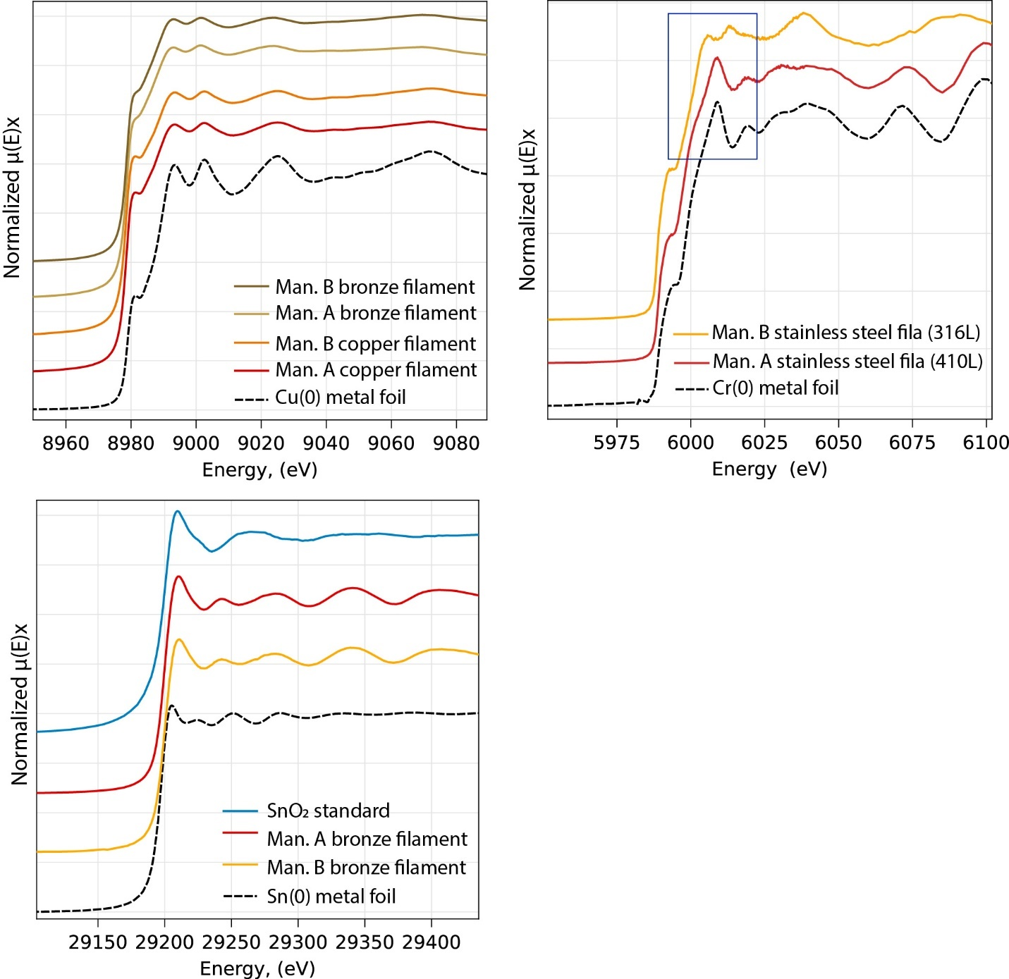
Figure S1. XANES Spectra for A) Cu in raw copper and bronze filament along with metallic Cu foil, B) Cr in raw stainless steel filament and metallic Cr foil, with blue box highlighting spectral differences between the two alloys in the XANES region and C) Sn in raw bronze filament with metallic Sn foil and SnO₂ reference.

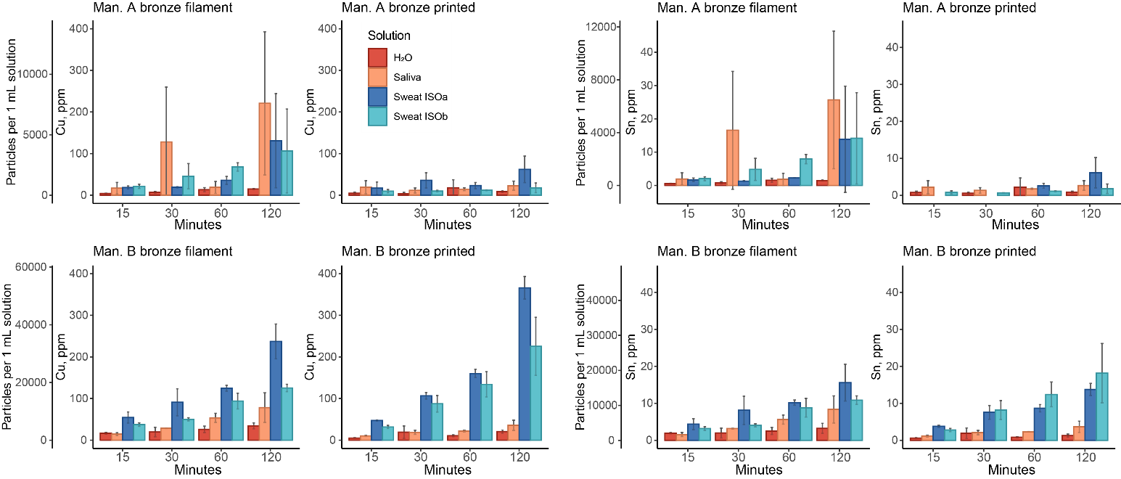
Fig S2. Cu and Sn concentration and particle release during 2-hour exposure study in H₂O, synthetic saliva, and synthetic sweat (Sweat ISOa, Sweat ISOb). Secondary y-axes show estimated number of particles released based on average particle size and assuming 88% Cu and 12% Sn in bronze.

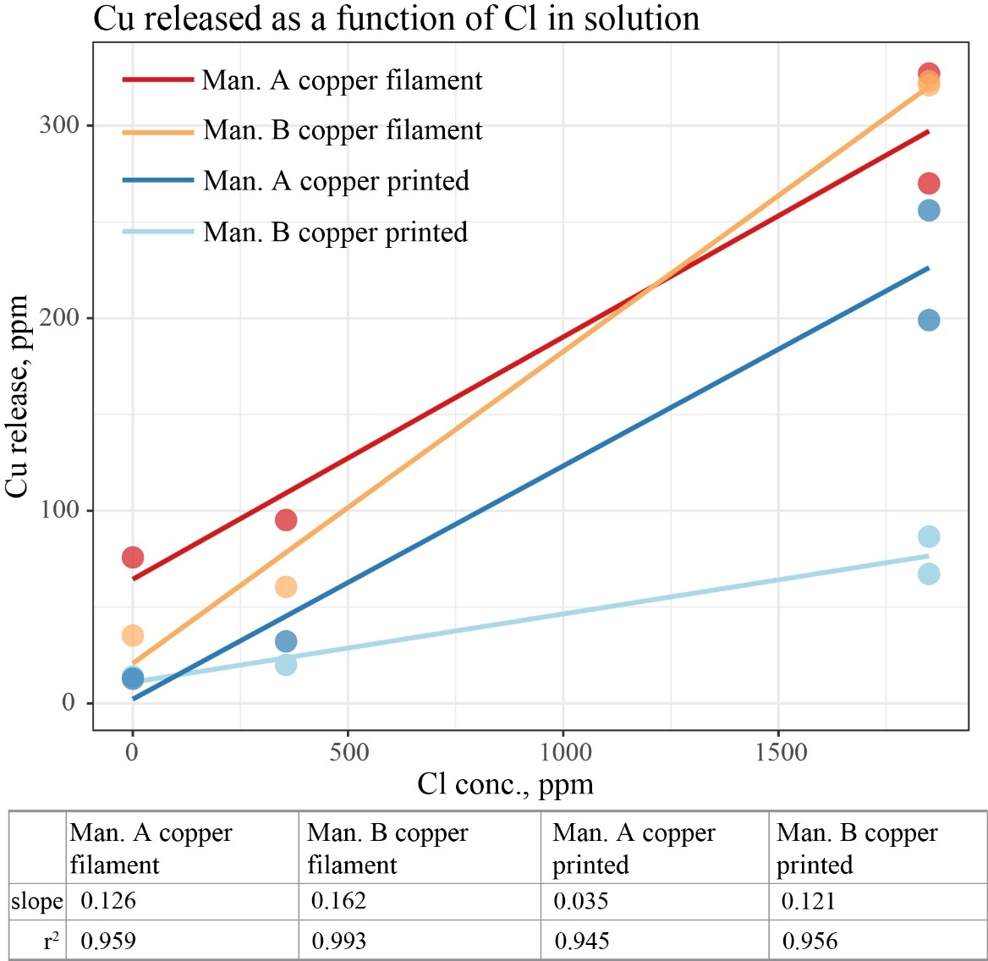
Figure S3. Relationship between chloride concentration in H₂O, synthetic sweat and synthetic saliva, and Cu release from copper filament types. Table includes fit results from linear regressions shown above.

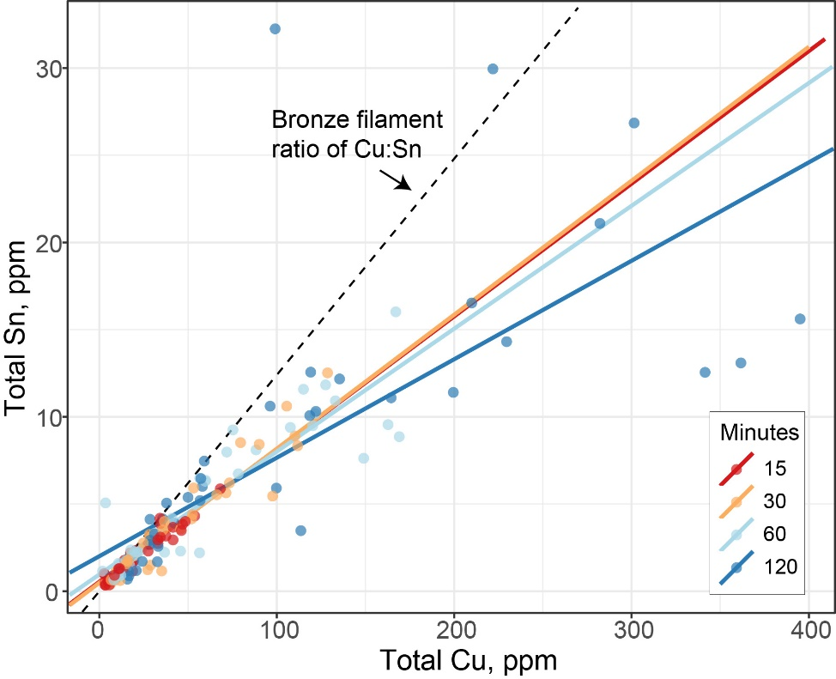
Figure S4. Relationship between total Cu and Sn release from all bronze filament types for 4 solutions (H₂O, synthetic saliva, and synthetic sweats). Dashed black line shows ratio of Cu:Sn in bronze filament (100:12.4), the expected slope where there was 1:1 release from filament.

Table S4. Average metal release in mg cm⁻² after 2-hour extraction in different synthetic fluids (n = 3). (*) indicates significant differences between filament and printed metal type (p < 0.05) of same manufacturer. Italics indicates values were not normally distributed based on Shapiro-Wilk test at p = 0.05 significance.

Fila. | Copper |  | Bronze |  |  |  |  | Steel
Manu. | A | B | A |  | B | A | B | A | B
Metal | Cu |  | Cu |  |  | Sn |  | Cr
Solution | Filament, mg cm⁻²
H₂O | 0.011 | 6.06e-3 | 2.28e-3* | 6.24e-3* |  | 2.25e-4* | 5.85e-4 | 2.93e-4* |  | 2.03e-5
Saliva | 0.014 | 0.010* | 0.034 | 0.014 |  | 3.95e-3 | 1.51e-3 | 3.20e-4 |  | 1.07e-5
Sweat a | 0.041* | 0.056* | 0.020 | 0.043* |  | 2.13e-3 | 2.82e-3 | 5.42e-4 |  | 4.06e-5
Sweat b | 0.049 | 0.055 | 0.016 | 0.023* |  | 2.18e-3 | 1.96e-3* | 8.98e-4 |  | 9.8e-5
Solution | Printed, mg cm⁻²
H₂O | 7.11e-4 | 7.95e-4 | 4.50e-4 | 1.09e-3 |  | 4.71e-5 | 6.65e-5 | 1.80e-5 |  | 1.42e-4*
Saliva | 1.02e-3 | 2.0e-3 | 1.22e-3 | 1.89e-3 |  | 1.43e-4 | 1.94e-4 | 6.99e-5 |  | 9.25e-5*
Sweat a | 3.4e-3 | 0.016 | 3.33e-3 | 0.019 |  | 3.29e-4 | 7.28e-4 | 7.50e-5 |  | 1.13e-4*
Sweat b | 4.41e-3 | 0.012 | 9.47e-4 | 0.012 |  | 9.63e-5 | 9.61e-4 | 3.95e-5 |  | 9.56e-5
Table S5. Size fractionation data for Cu for 2-hr extraction in water, artificial saliva, and artificial sweat (ISOa). Values show average (CV) for n = 3. Total is unfiltered fraction, 10 kDa is the fraction filtered through a 10 kDa filter.
Type | Fraction | H₂O | Artificial Saliva | Artificial Sweat, ISOa
Man. A copper | Total | 11.4 (33.2) | 64.6 (71) | 347.5 (4.2)
Filament | 10 kDa | 5.87 (2.5) | < MDL | 416.3 (1.4)
 | Dissolv. % | 51 | 0 | 100
Man. A copper | Total | 11.96 (115) | 19.8
Print | 10 kDa | 3.66 (36) | < MDL
 | Dissolv. % | 31 | 0
Man. B copper | Total | 58.6 (59) | 77.8 | 441 (1.0)
Filament | 10 kDa | 14.0 (30) | < MDL | 508 (4.5)
 | Dissolv. % | 24 | 0 | 100
Man. B copper | Total | 15.6 (25) | 41.5 (78)
Print | 10 kDa | 12.6 (9.4) | < MDL
 | Dissolv. % | 81 | 0
Man. A bronze | Total | 8.09 (15) | 157 (119) | 103.9 (9.6)
Filament | 10 kDa | 8.73 (22) | < MDL | 120.7 (0.2)
 | Dissolv. % | 100 | 0 | 100
Man. A bronze | Total | 5.80 (76) | 16.4 (8.3)
Print | 10 kDa | 2.00 (18) | < MDL
 | Dissolv. % | 34 | 0
Man. B bronze | Total | 12.8 (25) | 119 | 304.3 (36)
Filament | 10 kDa | 7.01 (6.4) | < MDL | 283 (2.0)
 | Dissolv. % | 55 | 0 | 93
Man. B bronze | Total | 12.9 (13) | 28.5
Print | 10 kDa | 8.68 (13) | < MDL
 | Dissolv. % | 67 | 0

Table S6. Size fractionation data for Cu, Sn and Cr from 1-hr IVBA assay. Values show average (CV) for n = 3. Total is unfiltered fraction, 10 kDa is the fraction filtered through a 10 kDa filter. Manufacturer C (Man. C) is a standard PLA filament without any metal powder.
Type | Fraction | Cu | Sn |  | Type | Fraction | Cr
Man. A copper | Total | 406 (14) | 1.32 (1.2) |  | Man. A steel | Total | 82.2 (3.2)
Filament | 10 kDa | 509 (0.9) | 1.44 (2.0) |  | Filament | 10 kDa | 126 (9.0)
 | Dissolv. % | 100 | 100 |  |  | Dissolv. % | 100
Man. B copper | Total | 681 (15) | 1.05 |  | Man. B steel | Total | 0.65 (10)
Filament | 10 kDa | 871 (6.0) | 1.47 (50) |  | Filament | 10 kDa | 0.90 (19)
 | Dissolv. % | 100 |  |  |  | Dissolv. % | 100
Man. A bronze | Total | 584 (20) | 72.2 (20) |  | Man. C Filament | Total | 0.18 (8.5)
Filament | 10 kDa | 728 (3.5) | 86.3 (4.0)
 | Dissolv. % | 100 | 100
Man. B bronze | Total | 1092 (2.7) | 121 (1.3)
Filament | 10 kDa | 1454 (2.6) | 146 (3.1)
 | Dissolv. % | 100 | 100
Man. C Filament | Total | 0.72 (47) | < MDL

Figure S5. Normalized Cu Ka XANES spectrum (aqueous sample) from Man. A copper filament after 1-hour exposure to artificial sweat (ISOb) along with reference compounds.
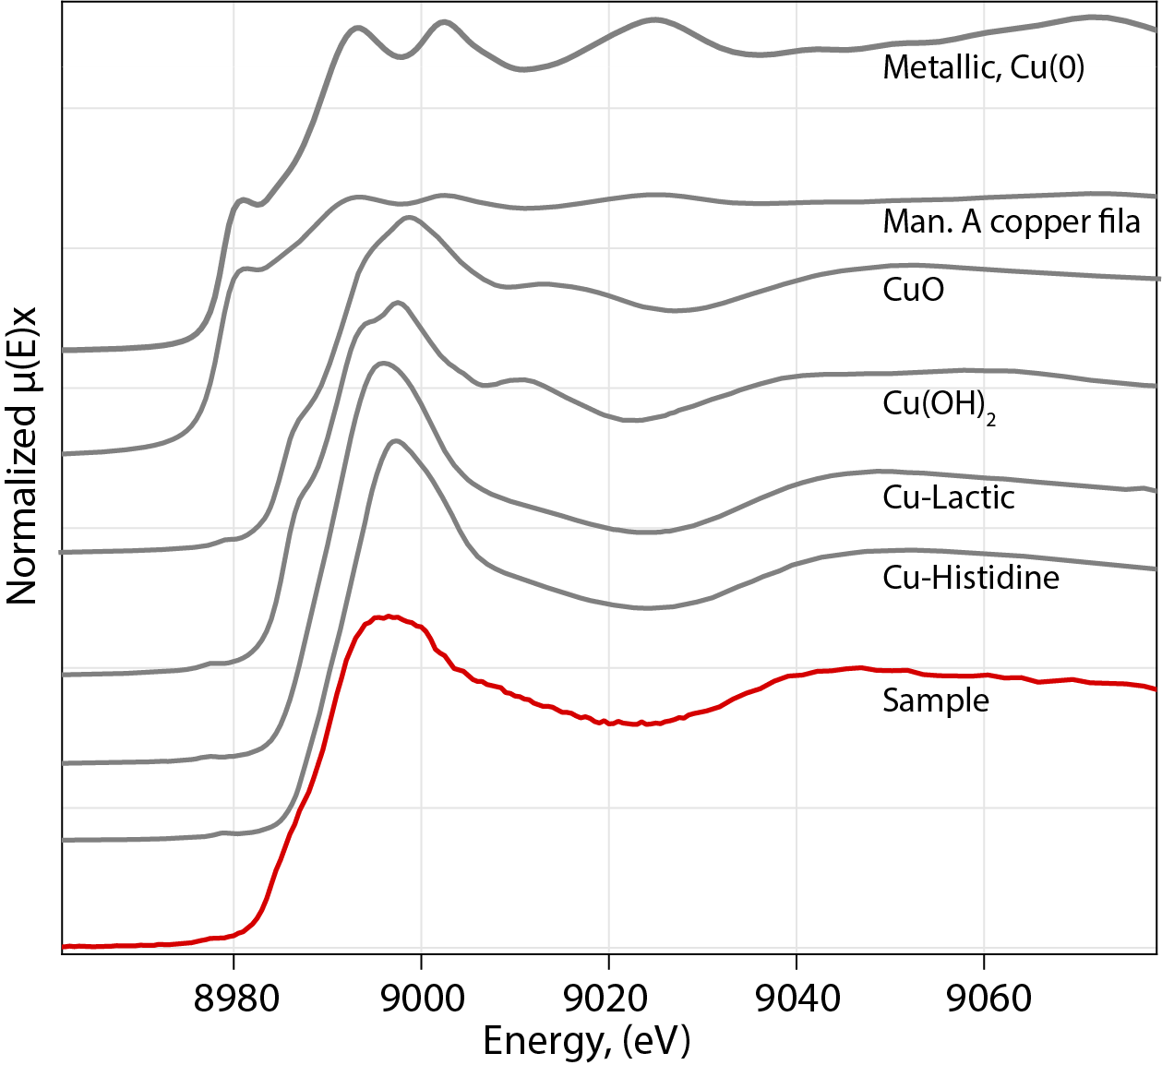

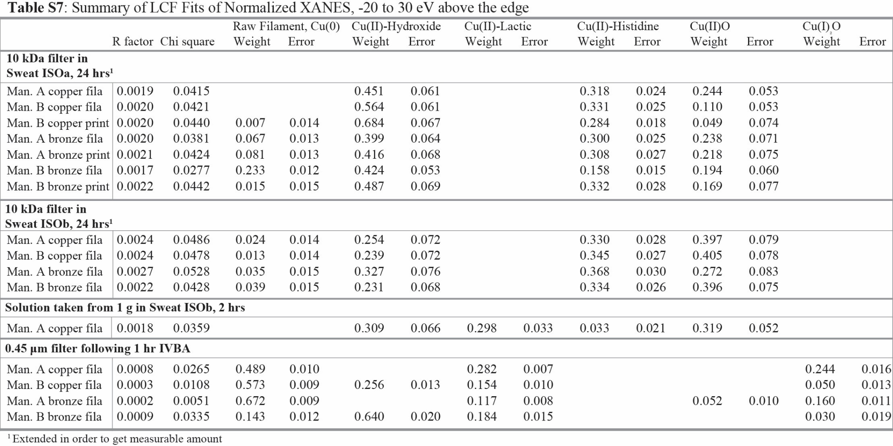

Table S8. Zero-order release rates, K₀, in different solutions for p ≤ 0.10. K₀, mg h⁻¹, 5cm cube represents the rate of release for a 5 cm cube with 150 cm² surface area over 1 hour.

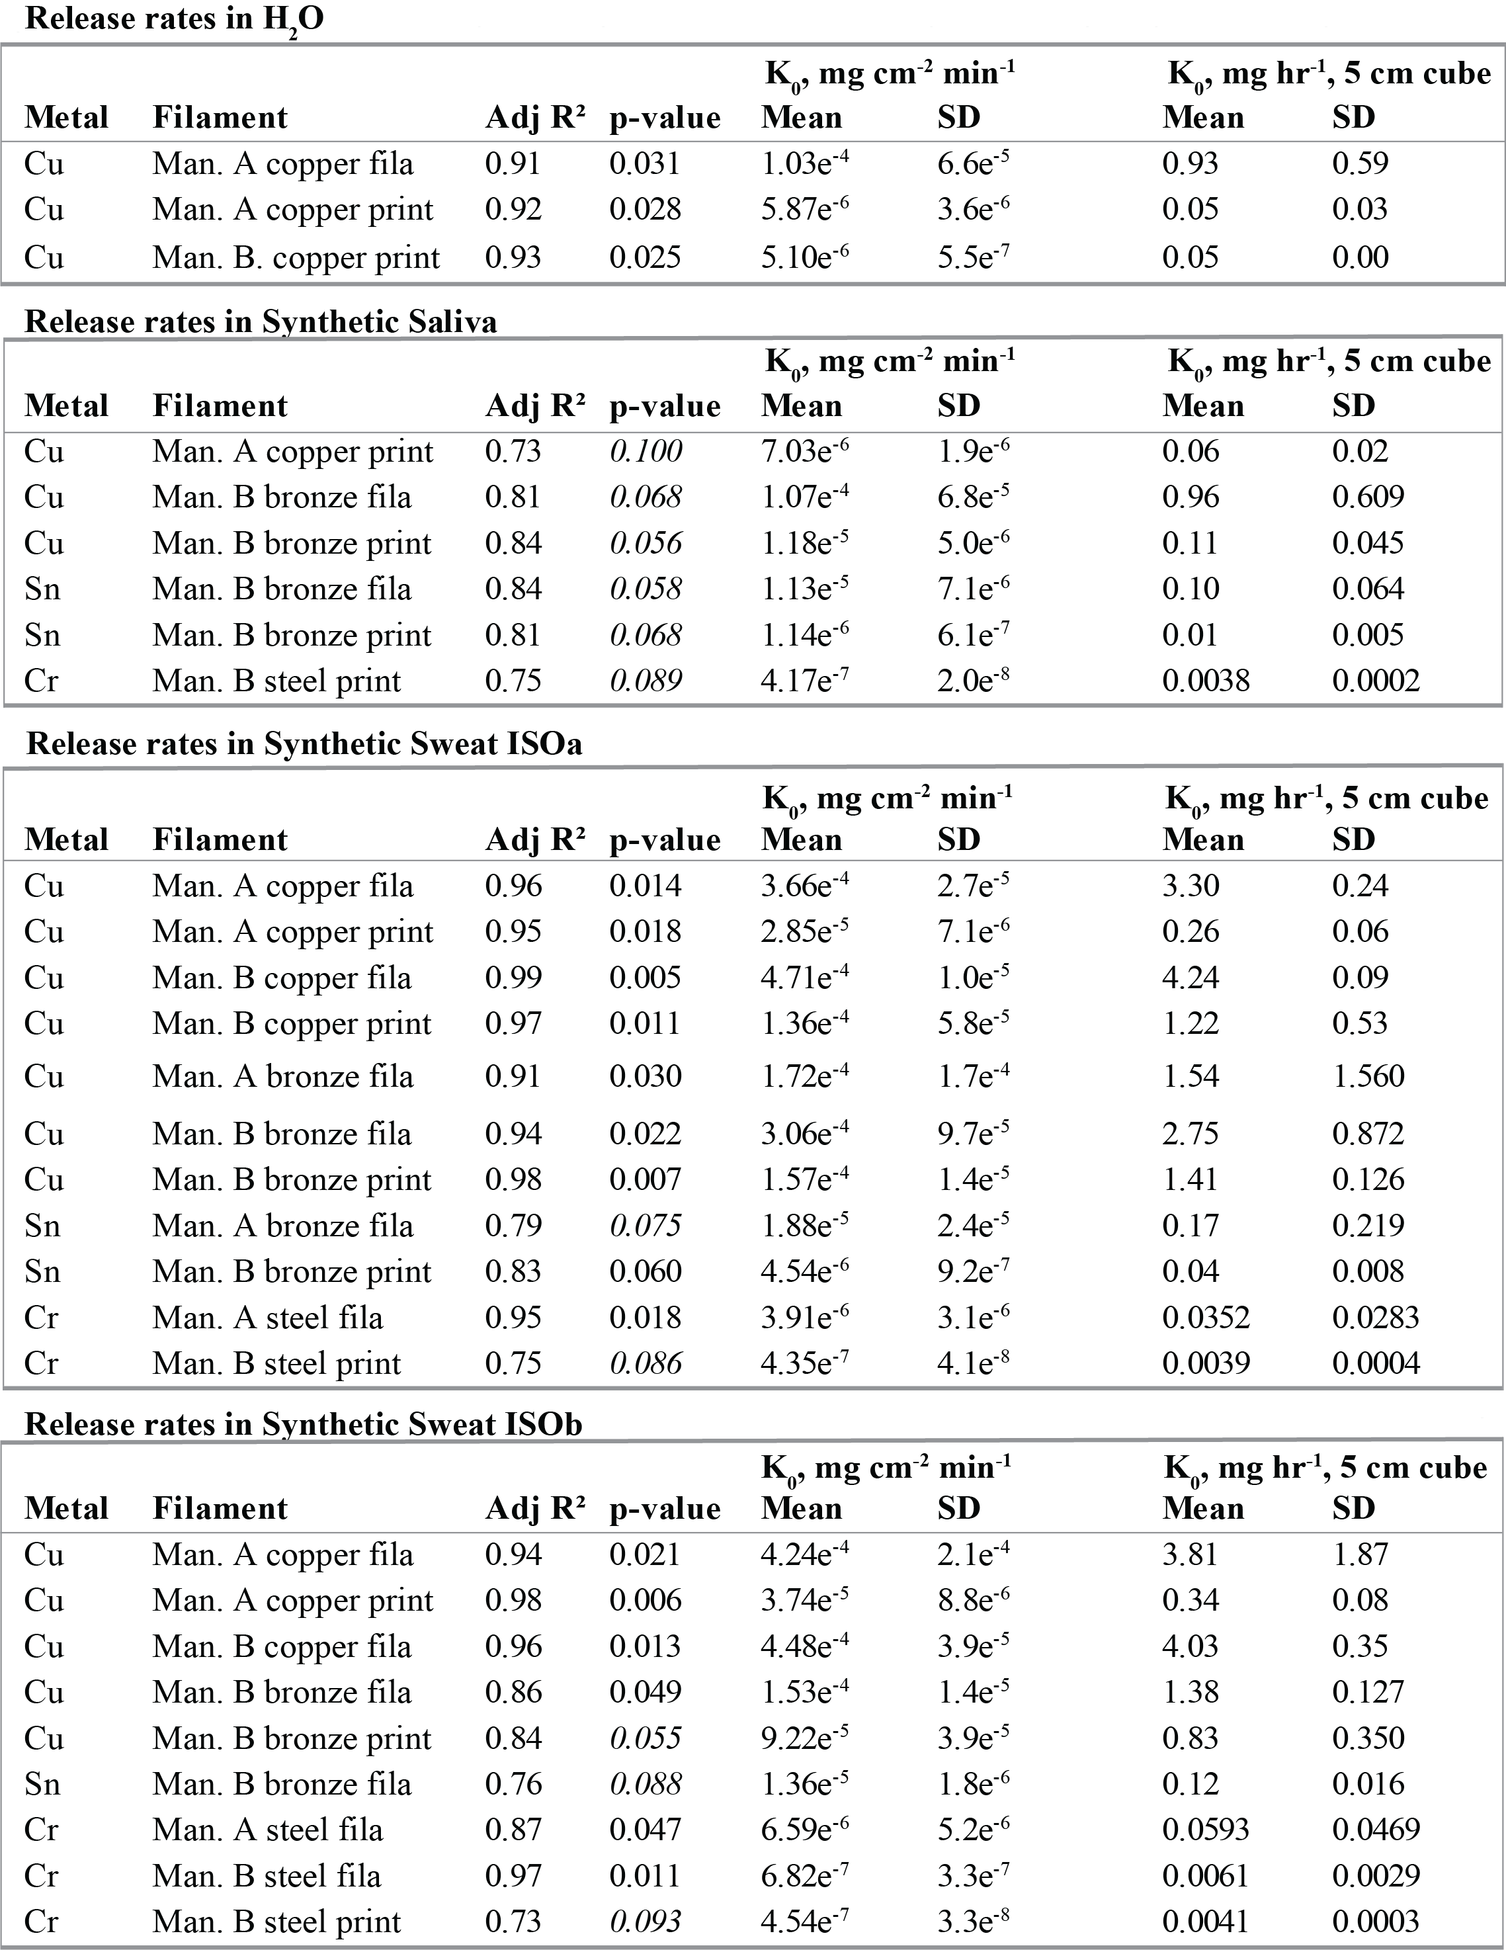

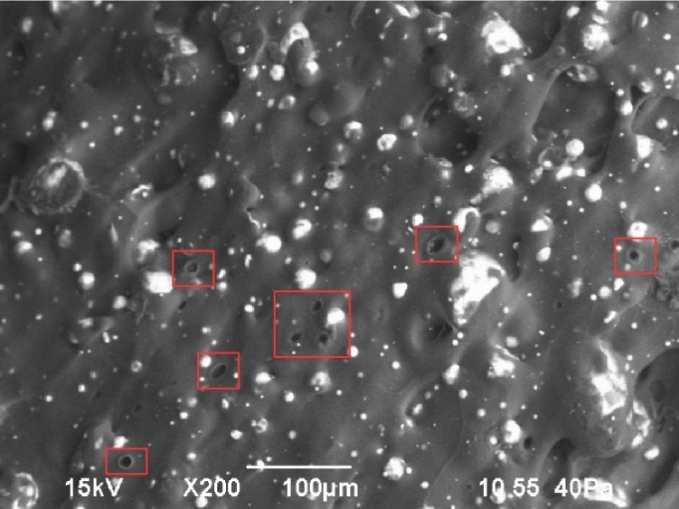
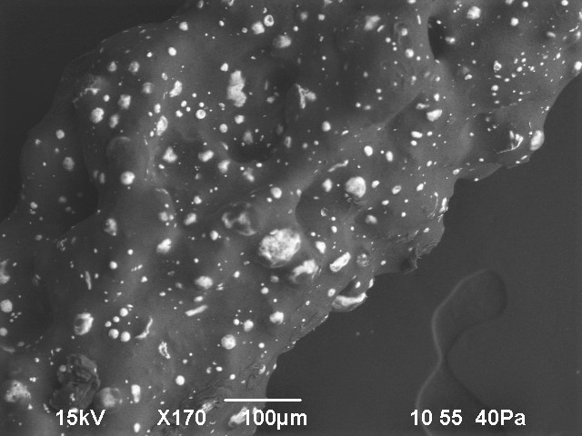
A.
B.

Figure S6. SEM images of Man. B copper filament both A) raw and B) printed. Red boxes show holes in raw filament surface where metal particles likely were.

Table S9. Average metal release over 2-hour extraction period in H₂O following UV degradation (n = 3). Concentrations in ppm, with CV in parathesis (%). Long dash, – , signifies a measurement was not taken. < MRL signifies below method reporting limit. * 0.45 um and 10 kDa samples were taken at 120 minutes.
Fila. | Copper |  | Bronze |  |  |  | Stainless Steel
Manu. | Man. A | Man. B | Man. A | Man. B | Man. A | Man. B | Man. A | Man. B
Metal | Cu |  | Cu |  | Sn |  | Cr
Minutes | Filament, ppm
15 | 283 (5.0) | 189 (57) | 707 (46) | 109 (9.6) | 83.2 (47) | 13.3 (9.4) | 13.3 (25) |  | 0.46 (30)
30 | 1475 (40) | 534 (29) | 1526 (3.7) | 213 (39) | 177 (2.8) | 26.3 (40) | 44.5 (34) |  | 0.49 (75)
60 | 1674 (45) | 1121 (56) | 4959 (65) | 1230 (84) | 535 (62) | 145 (81) | 40.9 (0.4) |  | 0.46 (20)
120 | 2096 (43) | 3850 (40) | 9066 (66) | 4311 (42) | 972 (69) | 495 (39) | 46.8 (48) |  | 0.81 (8.8)
0.45 um* | — | — | — | — | — | — | < MRL |  | 0.2 (2.2)
10kDa* | 74.3 (2.3) | 31.9 (8.0) | — | 23.7 (8.8) | — | < MRL | < MRL |  | 0.2 (4.0)
Minutes | Printed, ppm
15 | 186 (39) | 187 (20) | 117 (40) | 4.1 (2.5) | 11.9 (45) | 0.33 (0.8) | 9.4 (14) |  | 0.23 (53)
30 | 263 (16) | 660 (48) | 518 (51) | 46 (6.7) | 57.5 (55) | 3.53 (8.9) | 15 (6.9) |  | 0.41 (64)
60 | 2030 (46) | 376 (46) | 457 (22) | 233 (30) | 51.6 (25) | 25.2 (28) | 18.1 (5.2) |  | 0.85 (40)
120 | 1449 (73) | 280 (6.9) | 712 (52) | 159.4 (44.6) | 79.5 (56) | 15.0 (46) | 25.0 (20) |  | 1.77 (24)
0.45 um* | 95.7 (6.8) | 49.7 (2.2) | 46.7 (3.0) | 31.5 (4.8) | 0.35 (13) | < MRL | < MRL |  | 1.42 (17)
10kDa* | 88.5 (7.7) | 44.2 (8.0) | 39.3 (5.9) | 31.3 (6.4) | < MRL | 0.31 (34) | < MRL |  | 1.55 (18)

