Proteome profiling of rat brain cortical changes during early postnatal brain development

Witold M. Winnik^{a*}, William Padgettª, Emily M. Pitzerª, David W. Herrª

ªCenter for Public Health and Environmental Assessment, U.S. Environmental Protection Agency, Research Triangle Park, NC 27711; Winnik.witold@epa.gov, Padgett.william@epa.gov, Pitzer.emily@epa.gov, Herr.david@epa.gov

*Corresponding Author: Witold M. Winnik
Mail Code D305-02
CPHEA/PHITD/NETB
US EPA
109 TW Alexander Drive
Durham, NC 27711

Key Words: Label-free quantitation; early postnatal brain cortex development, nanoflow-LC/MS, high-resolution MS
Disclaimer: The research described in this article has been reviewed by the Center for Public Health and Environmental Assessment, U.S. Environmental Protection Agency, and approved for publication. Approval does not signify that the contents necessarily reflect the views and policies of the Agency, nor does mention of trade names or commercial products constitute endorsement or recommendation for use.

Abstract
Label free quantitation (LFQ) was applied to proteome profiling of rat brain cortical development during the early postnatal period. Male and female rat brain extracts were prepared using a convenient, detergent-free sample preparation technique at postnatal days (PND) 2, 8, 15, 22. The PND protein ratios were calculated using Proteome Discoverer, and the PND protein change profiles were constructed separately for male and female animals for key presynaptic, postsynaptic and adhesion brain proteins. The profiles were compared to the analogous profiles assembled from the published mouse and rat cortex proteomic data, including the fractionated-synaptosome data. The PND protein-change trendlines, Pearson Correlation Coefficient (PCC) and linear regression analysis of the statistically significant PND protein changes were used in the comparative analysis of the datasets. The analysis identified similarities and differences between the datasets. Importantly, there were significant similarities in the comparison of the rat cortex PND (current work) vs. mouse (previously published) PND profiles. The male and the female rat cortex PND profiles were expectedly almost identical, which also substantiated this LFQ nanoflow liquid chromatography – high resolution mass spectrometry approach to the PND protein profiling.

Introduction. During the perinatal period, environmental stressors pose a potential threat to brain development because the brain undergoes extensive, rapid developmental and organizational changes [1, 4-7]. Biological and environmental stresses and insults sustained during this period might negatively impact brain development [3]. Therefore, to be able to better assess the impact of a chemical exposure on developing brain, it is important to gather information about the biological transformations occurring during postnatal development of the animals used in toxicoproteomic studies. Working towards this goal, we applied proteomics to investigate the protein changes occurring during the early postnatal rat cortical development. To allow comparisons with existing literature data, we used the developmental profile of proteomic changes in the control animals in this report. This study demonstrates effectiveness of the modified TFA-based sample preparation method [2] and high mass resolution MS label-free quantitation in postnatal day (PND) protein profiling using unfractionated brain cortex samples. It sets the stage for the pending treated vs control experiments investigating toxico-proteomic environmental exposure endpoints in young rats, and for further hypothesis-based focused follow up studies. Importantly, the PND protein ratios were substantiated by good linear correlation of the synaptosomal and microsomal data subgroups of this dataset with the corresponding protein ratio data obtained from the high-quality MS dataset produced from fractionated rat cortex proteome utilizing ¹⁵N Stable Isotope Labeling in Mammals (SILAM) methodology [7]. In addition, the current study focused on the protein changes in the male and the female rostral cortex at the PND 2, 8, 15 and 22, and on the resulting protein profile comparison with the PND protein profiles available from the mouse cortex synaptosome study [1]. The rat vs mouse comparison was facilitated by the availability of the appropriate mouse proteomic dataset published in a Microsoft Excel format, S.Table 1 in [1] which was transformed to provide close-in-time PND reference points. For the reason of clarity and convenience of the between-study PND profile comparison, the current work adopted the exact cortex protein grouping as it was presented in [1], although the protein assignment as pre- or postsynaptic is arguably not always accurate. Firstly, because this work does not involve fractionation, and secondly, because different fractionation-based studies classify proteins as both pre- and postsynaptic and often there is little consensus in the matter of such assignment [8]. Overall, the current data and the data comparisons demonstrate a noteworthy PND trendline similarities and correlations between the rat and the mouse PND synaptic protein ratio change trends, and between the total vs the fractionated rat cortex [7], despite the differences in the proteomic LC-MS techniques, in the protein extraction, labeling and fractionation approach, data processing softwares, the PND timepoints, and in the animal species and animal numbers used per PND group.
This work provides LFQ proteomic data reference for future toxicoproteomics studies, highlights the possible similarities and differences between the early PND development of the synaptic proteome in rat vs mouse cerebral cortex, and describes selected trends in the male and the female rat PND proteomic profiles. It contributes to the general understanding of the protein changes occurring during the early postnatal development days and demonstrates feasibility of comparing different proteomic datasets obtained from different laboratories for studying proteomic ratio change trends. The study also demonstrates the utility of logarithmic PND trendlines anchored to a proximal PND timepoint to visualizing and comparing PND data from different studies, and it provides additional quantitative PND protein ratio data which have not yet been captured in the previous studies.
Experimental
Sample Preparation. For proteomic experiments, Long Evans pup cortical brain tissues were collected throughout the postnatal period (PND 2, 8, 15, 22); animals were perfused with Dulbecco’s Phosphate-Buffered saline (2.7 mM KCl, 1.5 mM KH₂PO₄, 147 mM NaCl, 142 mM Na₂HPO₄) containing 10 μM sodium nitroprusside, the tissue was dissected, frozen on dry ice, and stored at -80°C. During the tissue dissection, the brain was sliced in half at the optic chiasm and all cortex rostral to that slice were collected. The rostral cortex samples were processed as six individual samples for each PND using a SPEED method (with some adjustments to accommodate brain tissue), which was initially demonstrated in the LC-MS analyses of bacteria, HeLa, and lung tissue proteins [2]. The samples were randomized to avoid sample processing bias. Briefly, whole frozen rat brain cortex tissues, weight ranging from 30 mg to 398 mg, were placed in a five-fold excess of trifluoroacetic acid (TFA 5 μl /mg of tissue) and dissolved by agitation for 10 min at 37°C. Ten microliter aliquots of the TFA cortex solution were pH-set to ca 8.5 (pH range between 8 and 9) by adding 100 μl of 2M Tris base solution (pH unadjusted) [2], and then were reduced and alkylated for 10 min at 90°C (in the dark) using an added mixture of 11 μl of a 100 mM TCEP and 400 mM 2-chloroacetic acid solution. After cooling to room temperature, the mixtures were diluted with a five-fold amount of water to 605 μl of the total volume. The mixture was briefly probe-sonicated to ensure uniform suspension without aggregation, and a McFarland Turbidity protein assay was performed to estimate the protein concentration in the extracted samples [2]. The protein samples were placed in a thermomixer and digested with trypsin (50:1 protein to trypsin ratio) at 37 °C for 18 h with agitation [2]. The digestion was quenched by acidification with TFA (2% final concentration) and desalted on reversed-phase solid phase extraction C18 SPE 1 mL bed volume cartridges using 3 mL of the elution solvent consisting of 30% water, 70% methanol, and 0.2% TFA, optimized to facilitate elution of all peptides including the long ones. The peptide eluates were evaporated in two steps: the bulk volume of methanol was reduced under nitrogen in a TurboVap (Biotage) in 15 mL glass tubes, and then the samples were evaporated to dryness in Centrivap Concentrator (Labconco) in 1.5 mL polypropylene centrifuge tubes. The dried peptides were stored at -80 °C until the sample batch was ready for the nLC-MS analysis. Subsequently, the dried peptides were solubilized by agitation (vortex) in 200 μl of an aqueous 2% acetonitrile, 0.2% TFA solution. Using 0.2% TFA was superior to 0.1% formic acid to ensure reproducible peptide solubilization (unpublished data), and the peptide concentration was determined using a Pierce Quantitative Colorimetric Peptide Assay, PI23275. The peptide concentration was adjusted to 200 ug/μL and used for the nLC-MS label-free quantitative proteomic analysis.
Nanoflow LC-MS (MS/MS) analysis. One microliter of a 200 ng/ul peptide solution was injected onto an Acclaim PepMap 100Å, 2um, 75 μm x 2 cm nanoViper C18 loading column (Thermo Fisher) maintained at 45°C in an Ultimate 3000 UHPLC RSLCnano system (Thermo Fisher-Dionex) operating at the loading LC flowrate of 3 uL/min of 0.1 % formic acid in 98% water, 2% acetonitrile (HPLC water and acetonitrile from Thermo Fisher). The peptides were separated on an EASYSpray™ 50 cm PepMap™ RSLC C18 column (75 μm i.d, 100 Å, 2 μm; Thermo Fisher Scientific, Bremen, Germany) using a linear gradient at the flowrate of 600 nl/min, from 0 to 2.4% B in 6 min, to 20% B in 103 min, to 32% B in 123 min. (total time), to 95% B in 125 min, followed by an isocratic flow period (10 min.), returning back to 2% B in 2 min. The column temperature was maintained at 45°C by the EASYSpray column housing heater. The Orbitrap Exploris 480 mass spectrometer (Thermo Fisher Scientific, Bremen, Germany) operated in a data-dependent scanning mode with the precursor m/z range of 380 – 1,500 m/z, at a full scan resolution of 120,000 FWHM, and the normalized AGC target value of 300%. The maximum injection time was set to “Auto”; the total data dependent scanning cycle time was 3s. The most intense ions were chosen for high-energy dissociation (HCD) at a normalized collision energy of 28 %. MSMS centroid spectra were collected using a precursor ion isolation width of 1.6 Da, at a resolution of 60,000 FWHM measured at 200 m/z, with a maximum injection time set to “Auto”, the first mass set to 120 m/z, the intensity threshold of 5,000, and the normalized AGC target set to 75%. Precursor ion dynamic exclusion count was set to 1, the exclusion duration to 20 s, and the mass tolerance to 10 ppm. The peptides were ionized using electrospray within an EASYSpray column built-in sprayer at a voltage of 1.8 kV and were transferred into the mass spectrometer through a heated ion transfer tube at 300 °C.
Data Analysis
Data Processing. Proteome Discoverer v.2.5 (PDv.2.5) (Thermo Scientific) was used for protein identification and LFQ quantitation. Ninety six LC-MS .raw data files, each one representing an animal rostral cortex, were grouped in 16 LFQ groups containing 6 biological sample repeats per group. The 16 groups were constructed by combining the following sample descriptions: PND 2, 8, 15, 22 with the male and the female sample subgroups, and the treated and the control, non-treated subgroups. The sample files were used by the software in the two distinct processes: protein identification (in the processing step) and LFQ quantification (in the consensus step). The rat chemical treatment research LFQ findings are outside the scope of this paper, and although the whole set of the 96 sample files benefited the cortex protein identification part, the subset comprised of the 48 non-treated animal LFQ dataset was further quantitatively analyzed and discussed in this paper, S-Data-Table 1. The eight groups of the LFQ dataset (six biological repeats per groups) were: P2M, P8M, P15M, P22M, P2F, P8F, P15F, P22F, and hence there were six calculated protein ratios: P2M / P22M, P8M / P22M, P15M / P22M, P2F / P22F, P8F / P22F, P15F / P22F, anchoring the data to the last available PND day 22. All PDv.2.5 software settings for the processing and the consensus steps can be found in the supplementary files: S-Table-Processing and S-Table-Consensus. Briefly, protein identification (sample processing) was carried out in 21 processing nodes in PDv.2.5 starting with a spectrum file recalibration node, and a Minora Feature Detector and a Precursor Detector node, which were important for the interpretation of chimeric MSMS spectra. The subsequent processing steps were carried out in a sequence and the bulk of protein identification was performed in the two MSPepSearch library search nodes: the first accommodating a complete trypsin cleavage, and the second performing a semi-tryptic one. In the absence of the rat library in the PDv.2.5 NIST peptide library menu, the MSPepSearch library nodes utilized human peptide libraries for matching the homologous MSMS rat data to the tryptic and semi-tryptic protein digest MSMS libraries, in conjunction with the rattus norvegicus protein fasta database assigning the peptide sequences to rat proteins. Subsequently, four sequential SEQUESTTM nodes performed protein identification for the remaining unassigned .raw MSMS data, including the peptides possessing several common amino acid modifications that were absent from the peptides libraries. This task was divided into four SEQUESTTM nodes to minimize the search space size (S-Table-Processing). Protein LFQ consensus step consisted of 16 PDv.2.5 nodes, starting with the MSF Files node (utilizing the .msf files obtained from the preceding processing), involving the data quality threshold settings for the LFQ, a Feature Mapper node for the LC retention time chromatographic alignment of the quantifiable features in the dataset, and a Precursor Ion Quantifier node for setting the LFQ quantitation parameters including the hypothesis testing rules. Importantly, the Precursor Ion Quantifier node included the following parameters: protein abundance calculation by summed peptide MS feature intensity abundances, protein ratio calculation by using median protein abundance of the six biological repeats, and the hypothesis test was selected as the individual protein intensity-based ANOVA (S-Table-Consensus) to give the p-values and the adjusted p-values assigned to protein ratios. The Peptide and Protein Filter node allowed only the high-quality peptide and protein identification results, and the protein identifications characterized by at least two peptide sequences (the protein FDR confidence was set to “high”).
Data comparison. The protein identification and the LFQ data table was exported from PDv.2.5 to Microsoft Excel (S-Table-1). The following abbreviated code was used in the results table to identify the PND days: P2 = A, P8 = B, P15 = C, P22 = D. The logarithmic ratios: Abundance Ratio (log₂) (Female, P_{X}) / (Female, P₂₂), Abundance Ratio (log₂) (Male, P_{X}) / (Male, P₂₂), x=2, 8, 15, 22 and the corresponding adjusted p-values generated by PDv.2.5 were used for the data comparison with the datasets available from [1], [6], and [7]. Consequently, the mouse cortex synaptosome-fraction data from the supplementary sTable 1: Protein summary of the high confident proteins in each experiment and in average with statistical analysis in [1] were re-normalized from P280 to P21 by subtracting the Excel columns H from F and H from G: log₂ (Pn/P280) - log₂ (P21/P280) = log₂(Pn/P21), where n = 9, 15. This calculation shifted the mouse PND trendline curves presented in [1] by the - log₂ (P21/P280) vector, thus forcing them through the zero point at P21. This curve shift did not change the curves shape, but it facilitated trendline comparison for the PND: P2, P8, P15, P22 (rat) vs. P9, P15, and P21 (mouse) by bringing the reference zero points closer. Similarly, the log₂ P1/P20 and log₂P10/P20 synaptosome and the mitochondrial protein ratios were calculated for the matching protein gene symbols between the compared datasets, using the p1, p10, and P20 average abundance data from S. Table 5 in [7]: Statistically significant changes in synaptosomal cortical proteome during development, and from S. Table 8 in [7]: Statistically significant changes in mitochondrial cortical proteome during development. These ratios were the base for construction of the PND trendlines P1, P10, P20 [7] for the comparison with the corresponding protein P2, P8, P15, P22 trends (current data), thus taking advantage of the proximity of the P20 and P22 reference points. All the matching protein ratio data were collected in S-Data-Table 2.
Results and Discussion. 2,577 male and female rat proteins were identified with high confidence (protein high FDR confidence in PDv.2.5), and 2,573 proteins were assigned at least one quantifiable PND ratio (male or female) using a proteomics label-free (LFQ) methodology (counting the proteins passing the criteria set in PDv.2.5, S-Table-Consensus). Specifically, 1,917 male rat proteins and 1,894 female proteins produced quantifiable and statistically significant non-zero LFQ log₂ Pn/P22 ratios (n=2, 8, 15) over the rat PND timeframe. A protein ratio was deemed statistically significant in an ANOVA LFQ protocol of the PDv.2.5 processing workflow, when it possessed an adjusted p-value of 0.05 or less. A lack of systematic technical-procedural errors in the dataset was evidenced by the PCA data grouping in PDv.2.5, which showed that the only noticeable rat protein data grouping was that according to the PND (S.Fig. 6). The PDv.2.5 protein data reports were exported to Microsoft Excel for further analysis and for comparison with the published mouse cortical synaptosome proteomic data [1]. First, the mouse data (Supplementary Table 1 in [1]) were re-normalized from P280 to P21 according to the above description. The mouse data which were retrieved from the supplementary Table 1 [1] showed 1,978 identified proteins, including 696 statistically significant mouse protein PND trends over time [1]. The mouse vs rat data comparison was performed according to the synaptic protein mouse data layout in [1] by constructing the corresponding protein ratio change trendlines. The rat PND data and the closest corresponding mouse PND data points were chosen for the trendline comparison. The mouse and the rat gene symbols in the combined data table were used in Microsoft Excel to match the rat and the mouse PND log2 (ratio) data. The rat protein ratios: log₂ P2/P22, log₂ P8/P22, log₂ P15/P22 and the resulting protein trendlines were compared with the similar mouse protein ratios of log₂ P9/P21, log₂ P15/P21, presented as the reconstructed trendlines, following the layout of Figures 6-8 and Table 1 in reference [1]. In the current work, out of the total of 2,573 quantifiable rat proteins possessing a log₂ Pn/P22 PND ratio, 1,235 proteins were also reported in the mouse study [1]. As a subgroup of that total, 508 quantifiable rat proteins were matched by gene symbol to the 696 statistically-significantly changing mouse proteins over time across the PNDs experiments (Bayesian Estimation of Temporal
Regulation, BETR <= 0.001) in [1]. Among the 508 proteins, 453 male rat proteins and 456 female rat proteins possessed at least one adjusted p-value of 0.05 or lower among the three studied PND ratios, S-Data-Table-2. To compare the rat dataset to the published mouse data [1] and to highlight the biologically-relevant information, the rat data were split into the same functional groups: the presynaptic proteins, Fig. 1a-g, the postsynaptic proteins, S.Fig. 1a-g, and the adhesion proteins, S.Fig. 2a-c. In addition, the proteins demonstrating the most prominent changes in the mouse brain development, which were originally shown in Table 1 in [1] as referenced to P280, were displayed as the shorter PND trendlines referenced to P21 and compared in S.Fig. 3a-c with the rat counterparts. The upper right quadrants of these figures show the trendlines constructed for the quantifiable synaptic cortex rat proteins calculated from Supplementary Table 5 Statistically significant changes in synaptosomal cortical proteome during development in [7], which were also shown in the mouse [1] and in the current rat data presented in Figures Fig. 1a-g and S.Fig. 1a-3c. Finally, the mouse proteins data from [1] for which both the LC/MS and the immunoassay quantitative data were available in S.Fig.1 in [1], were compared with the current LFQ rat quantitative data. Both the rat male and the female PND trendlines were constructed independently using the corresponding data. Adopting such classification of the synaptosome proteins as the presynaptic and postsynaptic categories based on [1] was useful for the rat vs mouse protein profile comparison purpose, but it was somewhat arbitrary considering that, according to a recent literature review, many synaptosomal proteins were categorized as both pre- and postsynaptic in numerous publications [8]. The reliability of such protein classification increases with the number of the reference papers confirming the assignment. Hence, in this work, we also cross-referenced each protein with the number of publications listed in [8] identifying each protein as presynaptic, postsynaptic or none (S-Data-Table-2). Out of the total of the 2,577 rat cortex proteins which were identified in the current work, 618 were classified in [8] as neither presynaptic nor postsynaptic, whereas 1,648 proteins were described in [8] as postsynaptic and 821 proteins as presynaptic by more than one publication source. Using the same criteria, 848 and 21 proteins were categorized as exclusively postsynaptic or presynaptic, respectively, while 800 proteins were categorized as both. After applying a stricter “greater than four publications” qualifying criteria, 882 and 11 proteins were categorized as exclusively postsynaptic or presynaptic, respectively, while 233 proteins were categorized as both, and 882 were classified as neither.
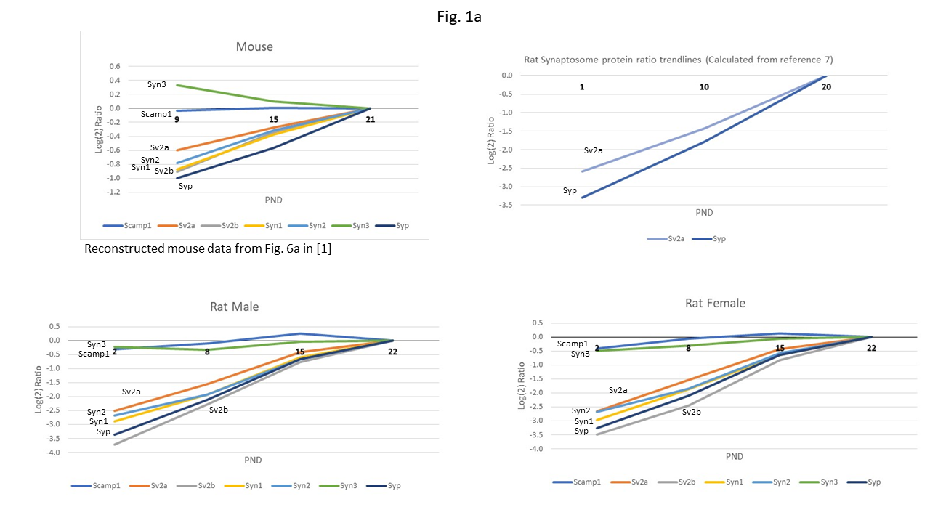
Fig. 1a-g: The top left quadrants in Figures 1a-g show the mouse protein PND trendlines constructed from the S.Table 1 data in [1] for the proteins in figures 6a-g in [1] which match the rat protein gene symbols in the current work. The bottom graphs show the male and the female rat trendlines matching the PND trendlines above (current work). The reference point for the mouse P9/P21, P15/P21 logarithmic protein abundance ratios is P21, and for the rat (current work) P2/P22, P8/P22, P15/P22 logarithmic protein abundance ratios the reference point is P22. The upper right quadrants of these figures show, whenever available, the reconstructed trendlines which match rat protein gene symbols in the current work for the quantifiable synaptic cortex rat proteins calculated from Supplementary Table 5: Statistically significant changes in synaptosomal cortical proteome during development in [7], for which the PND protein ratio reference point is P20.
Presynaptic proteins. Out of the eleven quantifiable synaptic vesicle mice proteins [1] involved in neurotransmitter release cycle, there were seven corresponding quantifiable rat male and female proteins, Fig. 1a. In agreement with the mouse study data, five proteins: Sc2a, Sv2b, Syn1, Syn2 and Syp synaptic vesicle proteins showed increasing levels with similar slight differences in the order of the extent of protein regulation. Scamp1 was, as it was observed in the mouse data [1], also minimally increasing. The exception was Syn3 which showed a small decreasing trend in mouse and flat - to - minimally increasing trends both in the male and the female rats. Both Syp and Sv2a demonstrated analogous trendlines in the male and the female rat cortex, and in the cortex rat synaptosomes, where the trendlines consisted of three protein ratios: log₂ P1/P20, log₂ P10/P20 and log₂ P20/P20; abbreviated symbol (P10/P20) and constructed from the [7] rat synaptosome data. Residing on the membrane of small synaptic vesicles was Synapsin, Syn1, which was shown to bind spectrin Sptbn2, was deemed essential for synaptic transmission [9]. In the current work, both Sptbn2 and Sptbn1 were quantified. Sptbn2 and Sptbn1 exhibited similarly rising PND ratio profiles; Sptbn2: -1.65 (P2/P22), -1.27 (P8/P22), -0.53 (P15/P22) in male rat, and -1.65 (P2/P22), -1.25 (P8/P22), -0.54 (P15/P22) in female rat (current work); and -1.89 (P1/P20), -0.92 (P10/P20) in rat cortex synaptosomes [7]. Sptbn1: -1.32 (P2/P22), -0.73 (P8/P22), -0.26 (P15/P22) in male rat, and -1.32 (P2/P22), -0.75 (P8/P22), -0.27 (P15/P22) in female rat (current work); and -1.22 (P1/P20), -0.37 (P10/P20) in rat cortex synaptosomes [7]. In contrast, in the mouse synaptosomes only Sptb1 was quantified, and it produced a minimally rising PND profile from P9 though P15 to P21. Camsap1—calmodulin-regulated, spectrin-associated protein 1 [10] was quantified in the current work, S-Data-Table-2, and it produced a mildly decreasing trend between P2 and P22, while showing a flat profile in mouse synaptosomal fraction [1], but it was not quantified in the rat synaptosomal fraction [7]. It is noteworthy that synaptophysin (syp) was also quantified on the Western Blot [7], demonstrating a visible syp band only in the synaptosome isolate blots and not in the unfractionated brain protein extracts of P1, P10, P20 and P45 (Supplementary Figure 5 in [7]). However, in the current rat cortex study, syp was identified based on six unique peptides and it was quantified without difficulty by LFQ using the unfractionated cortex extract, thus demonstrating good sensitivity for that protein in the current LFQ study. Interestingly, in parallel to the rostral cortex rat protein PND profiles, Syn1, Syn2, Syp, Snap25 showed also increasing levels from P1 through P45 in rat cerebellum [5].
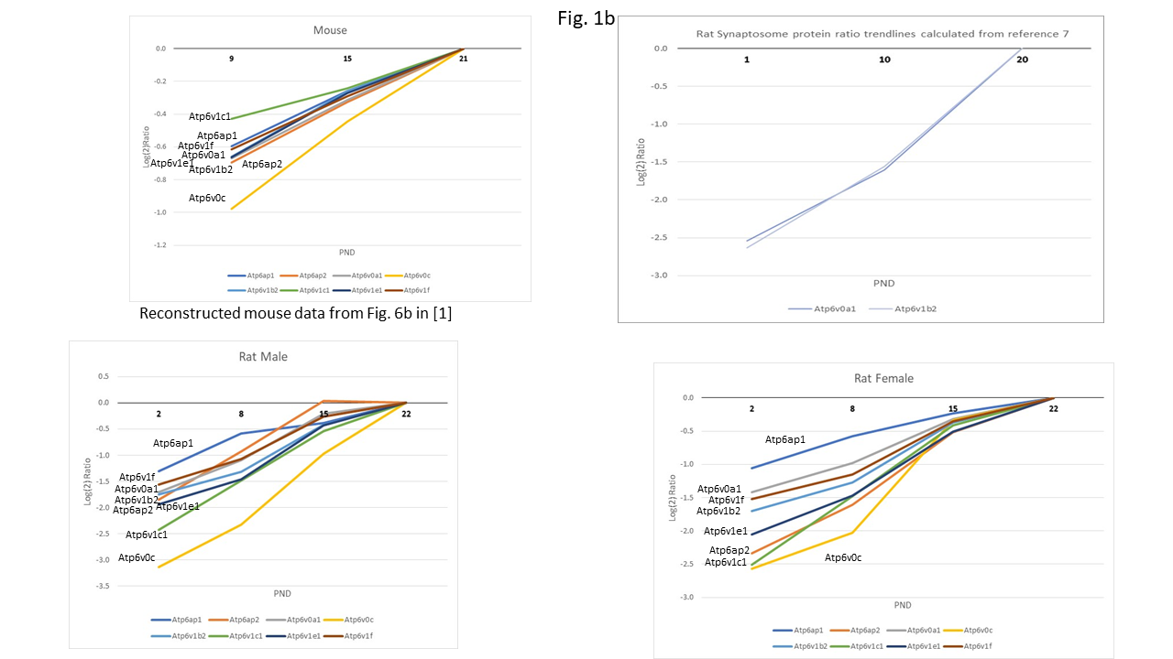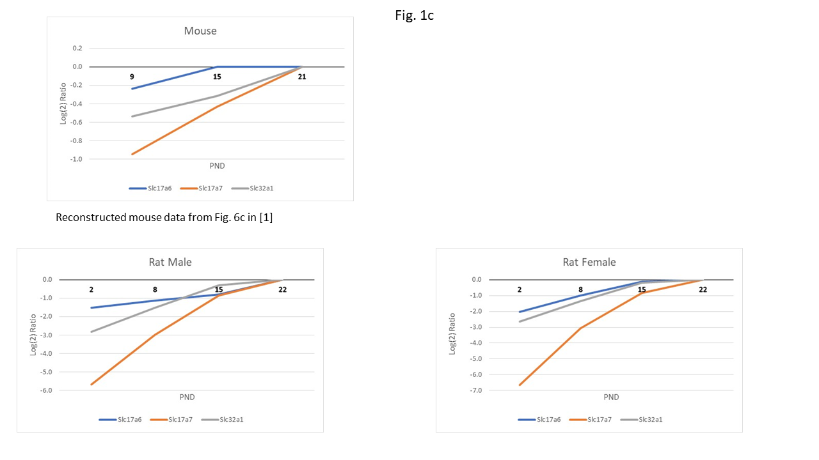
All functionally-similar proton-pump ATPase subunits of a vesicle type demonstrated protein level increases, both in mouse [1] and in male and female rats throughout the PNDs 2-22 (Fig. 1b). However, Atp6v1c1 appeared out of sequence as it displayed a much flatter curve in mouse in comparison with the male – female rat study. The log₂ (ratio) values showed the larger magnitude changes in rat vs the changes observed in mouse. Interestingly, this general ratio magnitude difference was true for most of the rat vs mouse proteins compared in this study. However, the protein ratio trendlines which were reconstructed based on the supplemental rat synaptosome data in [7] showed the analogous sharply increasing protein ratios from P1 to P20 for the two proteins Atp6v0a1 and Atp6v1b2, matching both the current rat study and the mouse [1] datasets. Plasma membrane calcium-transporting ATPases 1 – 4 and Atp2a2 also showed increasing trends in rat rostral cortex (current work), in agreement with the rat cerebellum synaptosome P1-P45 data [5], while in the mouse cortex synaptosome only Atp2b2 was identified and showed an increasing ratio trend between P9 and P21.
Three glutamate and GABA vesicular transporters (Fig. 1c), which were assigned to the presynaptic section based on [1], showed increasing PND protein expression trends comparing the rat and the mice data, although the magnitude of the protein ratio increases in mice was, again, noticeably smaller. The related by a synaptic vesicle complex, proteins Bassoon (Bsn), piccolo (Pclo) and Erc2 showed similarly increasing trends across the studied PND timeline [1 and the reference therein]. Lin7A and Unc13a also increased. The overall PND trendline picture was similar between the mice and the rat studies and was characterized by Bsn showing the steepest increase, while Cask showing the flattest and barely changing expression pattern from P8 to P22 (rat) and P9 to P21 (mouse). The independently obtained male and female rat trendlines were almost identical, (Fig. 1d) and S-Data-Table 2.
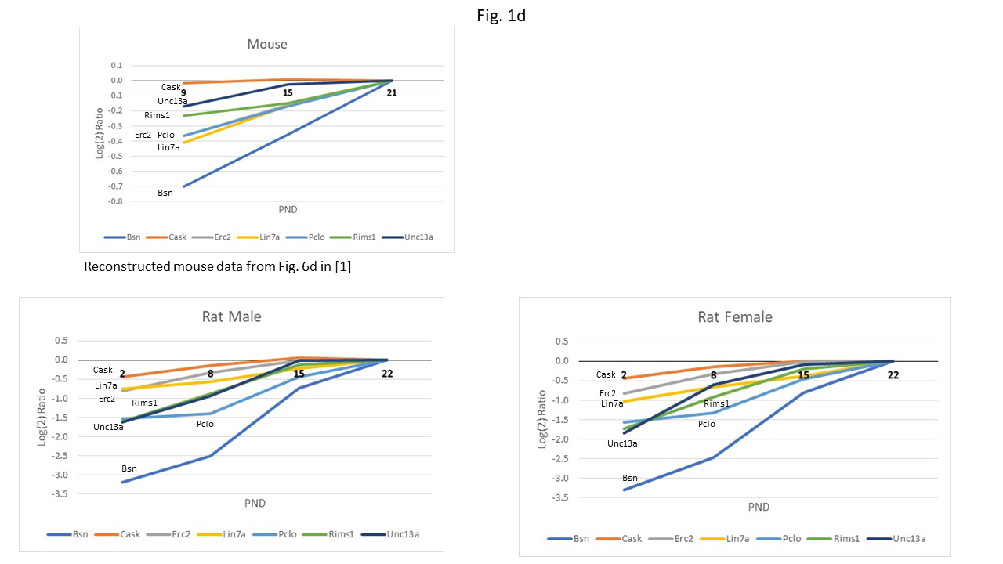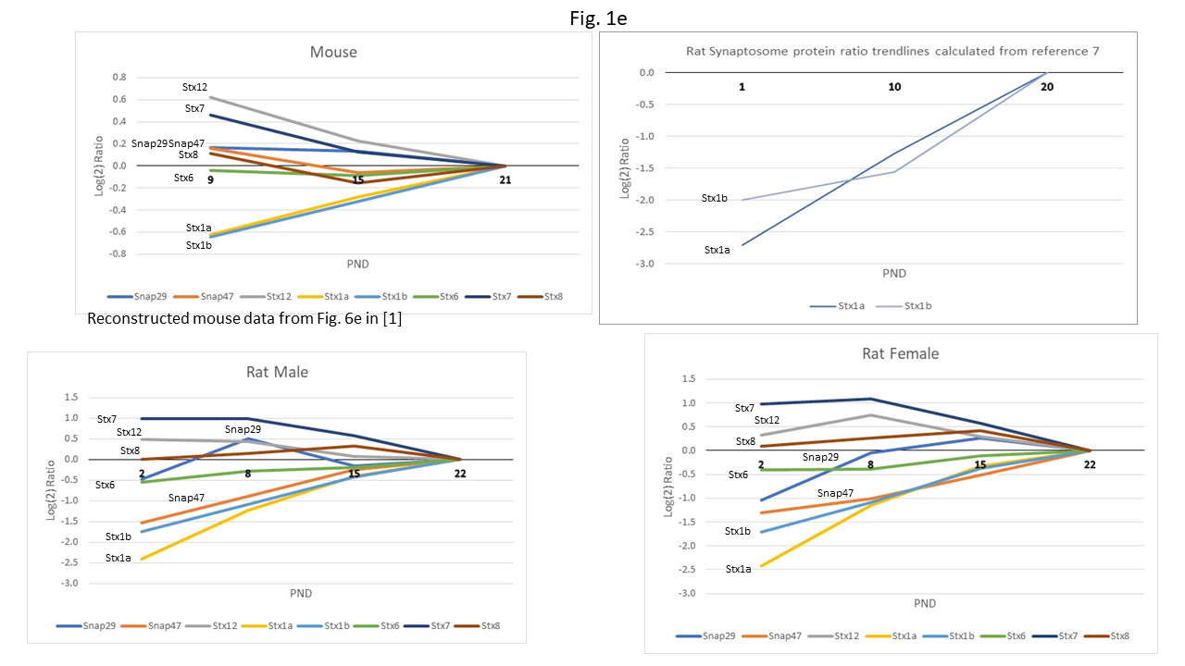
Despite the varying profile line directions showed in Fig. 1e, again there was an agreement between the rat and the mouse protein change patterns for P9-21 (mouse) [1] and P8-P22 (rat). The synaxins Stx7, Stx12 and Snap29 were decreasing, Stx6 and Stx8 were close to being flat, whereas the syntaxins Stx1a and Stx1b were increasing sharply. One difference was found between the mouse and the rat Snap47 lines P8 (P9) and P15: it was somewhat decreasing in mouse while it was sharply increasing in the male and the female rat experiments. The syntaxin Stx1a, Stx1b trendlines demonstrated almost identical shape and magnitude of the PND changes for the proteins quantified in the current rat study and in the rat synaptosome study, ([7] and Supplementary Table 5 therein). Syntaxin, synaptotagmin (Syt1), complexin I/II, and syntaxin-binding proteins are functionally-related, as they participate via membrane-fusion in the presynaptic vesicle Ca2+-controlled neurotransmitter release ([11] and references therein). Accordingly, Syt1 exhibited rising PND ratio profiles analogous to the syntaxin Stx1a, Stx1b: -0.91 (P9/P21), -0.39 (P15/P21) in mouse synaptosomes [1]; -3.16 (P2/P22), -1.93 (P8/P22), -0.59 (P15/P22) in male rat, -3.25 (P2/P22), -1.97 (P8/P22), -0.62 (P15/P22) in female rat (current work), and -2.22 (P1/P20), -1.08 (P10/P20) in rat cortex synaptosomes [7]. In addition, the synaptotagmins Syt2, Syt5, Syt7, Syt11, Syt12 and Syt17 were quantified in the current work, all demonstrating steeply rising trendlines between P2 and P22, except for Syt6 which showed a flat trendline. In contrast, in the mouse synaptosome fraction, only Syt2 and Syt7 were quantified besides Syt1, and they presented a close to a flat trend from P9, P15 to P21 with a significant change later past the P21 zero reference point. The rat synaptosome fraction proteomic study did not list these synaptotagmins as quantified in Supplementary Table 5 in [7]. In the current work, the functionally-related complexins Cplx1 and Cplx2 demonstrated almost identical, steeply rising PND profiles from P2 to P22; Cplx1: -2.58 (P2/P22), -1.32 (P8/P22), -0.32 (P15/P22) in male rat, and -2.48 (P2/P22), -1.32 (P8/P22), -0.33 (P15/P22) in female rat. And for cplx2: -2.36 (P2/P22), -1.17 (P8/P22), -0.22 (P15/P22) in male rat, and -2.33 (P2/P22), -1.06 (P8/P22), -0.14 (P15/P22) in female rat (S-Data-Table 2). The mouse synaptosome study showed a similar Cplx1 rising trend: -1.04 (P9/P21), -0.45 (P15/P21). In contrast, Cplx1 and Cplx2 were not reported among the quantified cortex synaptosome proteins in [7]. The functionally related to Stx1a and Stx1b, syntaxin-binding proteins Stxbp1 and Stxbp5 were reported and quantified in all three studies, demonstrating steeply rising PND trendlines in this rat study and in the synaptosome fraction rat work [7]. The mouse study reported these proteins as moderately increasing in abundance. Stxbp1: -1.89 (P2/P22), -1.15 (P8/P22), -0.36 (P15/P22) in male rat, and -1.89 (P2/P22), -1.07 (P8/P22), -0.34 (P15/P22) in female rat; In the mouse synaptosomes [1] it showed: -0.56 (P9/P21), -0.24 (P15/P21); and -1.92 (P1/P20), -1.00 (P10/P20) in rat cortex synaptosomes (calculated from the data in [7]). Stxbp5: -2.11 (P2/P22), -0.86 (P8/P22), -0.14 (P15/P22) in male rat, and -2.21 (P2/P22), -0.83 (P8/P22), -0.07 (P15/P22) in female rat; in the mouse synaptosomes [1] it was: -0.55 (P9/P21), -0.28 (P15/P21); and it was -2.93 (P1/P20), -1.44 (P10/P20) in rat cortex synaptosomes [7]. In addition to the aforementioned key regulatory components of the membrane fusion SNARE complex, the Vesicle-Fusing ATPase (nsf), Alpha-synuclein (snca), and Vesicle-associated membrane proteins (vamp1, 2, 3, 4, 7, 8) were also part of the complex ([12] and the references therein), Vamp2 being the most prominent. Accordingly, these proteins demonstrated similar rising PND expression profiles. The nsf PND profile was: -2.79 (P2/P22), -1.72 (P8/P22), -0.49 (P15/P22) in male rat, and -2.89 (P2/P22), -1.78 (P8/P22), -0.54 (P15/P22) in female rat; in the mouse synaptosomes [1] it was: -0.61 (P9/P21), -0.22 (P15/P21); and it was -2.40 (P1/P20), -1.33 (P10/P20) in rat cortex synaptosomes [7]. The PND profile for Snca was: -2.24 (P2/P22), -1.17 (P8/P22), -0.20 (P15/P22) in male rat, and -2.65 (P2/P22), -1.21 (P8/P22), -0.37 (P15/P22) in female rat; in the mouse synaptosomes [1] it was: -0.82 (P9/P21), -0.25 (P15/P21), but it was not quantified in the rat cortex synaptosomes [7]. The PND profile of vamp2 was: -2.06 (P2/P22), -1.17 (P8/P22), -0.28 (P15/P22) in male rat, and -2.15 (P2/P22), -1.14 (P8/P22), -0.37 (P15/P22) in female rat; in the mouse synaptosomes [1] it was: -0.47 (P9/P21), -0.21 (P15/P21); and it was -2.68 (P1/P20), -1.14 (P10/P20) in rat cortex synaptosomes [7]. Vamp1, vamp3, and vamp7 were also quantified showing analogous steep-rising P2-P22 PND profiles in the current work, however they were not quantified in [1] and [7], and (S-Data-Table 2).
As shown in Fig. 1f there were similarly increasing trendlines for mouse and rat voltage-dependent presynaptic and postsynaptic calcium channel subunits Cacna2d1, Cacna2d3, Cacnb3 and Cacnb4, Cacna1e (with some slope difference), while Cacna2d2 was almost flat. However, Cacnb1 exhibited different change direction in the mouse and in the rat experiments. Cacna2d1 exhibited the same shape and magnitude of the PND protein changes in the current rat data and in the synaptosome rat protein data reported in Supplementary Table 5 in [7]. Cacng8 was uniquely quantified in the current work presenting a steeply rising PND line from P2 to P22.
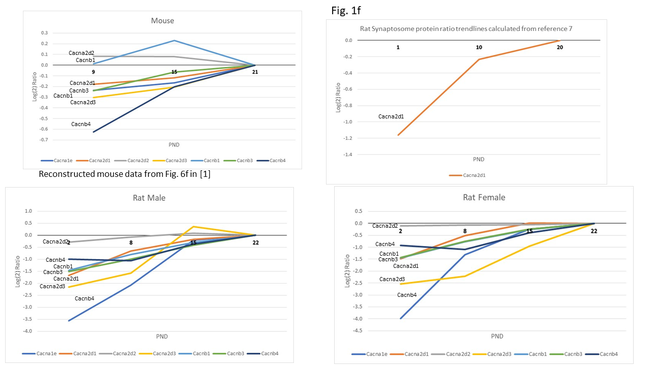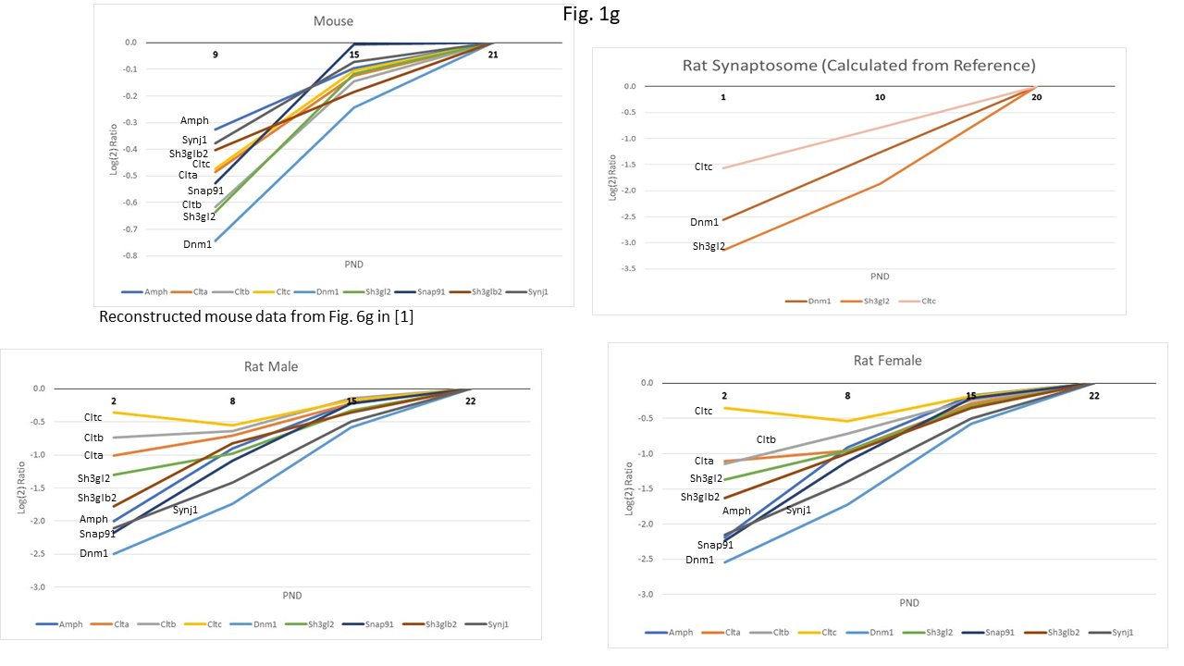
A functional subgroup of calcium-managing proteins are the plasma membrane calcium ATPases (PMCAs) which extrude calcium ions from cytosol to the extracellular space. These key regulators of calcium signaling are formed from four PMCA subunits 1-4, neuroplastin and basigin [13]. The four PMCA subunits Atp2b1 – Atp2b4, neuroplastin (Nptn) and basigin (Bsg) were quantified in the current work, and their PND profiles were compared with the ones constructed based on the data presented in [1] and [7]. All four subunit PND profiles were almost identical (current work), and the two subunits 1 and 3 were quantified in [7], all showing similarly rising protein PND profiles. Only subunit 2 was quantified in mouse synaptosomes [1] displaying a moderately rising trend. Nptn was quantified in rat (current work) with a sharply rising PND P2-P22 trend, whereas mouse synaptosome data [1] indicated a moderate increase between P9 and P21. Concurrently, Basigin displayed a steep PND protein increase both in the rat (current work) and in the rat synaptosome data [7], whereas it could not be quantified with statistical significance in the mouse synaptosome data [1], (S-Data-Table-2).
Proteins linked to clathrin-mediated endocytosis [1 and the references therein] all showed increasing trends for the mouse and the rat PND time points P9, (P8), P15, (P15), relative to P21 (P22) (Fig. 1g). The three clathrins: Clta, Cltb and Cltc exhibited close expression patterns in both species. Among the nine compared trendlines, Dnm1 showed a steep increase both in the male and the female rat and in the mouse experiments. A characteristic pattern for all trendlines was a large increase toward the P15 point and then a small increase towards P21 (P22) reference points. Overall, these presynaptic proteins demonstrated remarkable similarities in the early postnatal development between the mouse and the rat species, whereas the observed changes between the male and the female rats were mostly identical. Three proteins Dnm1, Cltc and Sh3gl2 which were quantified in rat synaptosome, [7], were also quantified in the present rat cortex male / female study and in the mouse cortex synaptosome study [1]. In the two rat studies, Dnm1 trendlines were almost identical, while Cltc and Sh3gl2 were similar in the direction of the PND protein changes, although the magnitude of the protein ratios at the first PND data point was larger in [7], (Fig. 1g). The dynamins Dnm1l, Dnm2 and Dnm3 were uniquely quantified in the current work and their PND profiles were similarly raising from P2 to P22 (S-Data-Table-2).
Postsynaptic proteins. The Grin1 and Grin2b, the NMDA receptor proteins, presented a similar early-PND trendline in rat and mice [1]: both Grin1 and Grin2b increased since the early age, and the Grin1 line was steeper than that of Grin2b (S.Fig. 1a). At the development time points 8 – 22 glutamate receptor proteins Grik3, Grm2, Grm3, Grm5 and Grm7 moved around the log₂ (Ratio) zero axis line, although in rat there was a distinct increase between P2 and P8 for all proteins except for Grik3. At P8, the relative positions of the mouse and the rat log₂ (ratio) values were similar, with Grm5 and Grm7 positioned above the zero line, Grm3 positioned close to the zero line, and Grm2, Grik3 below (S.Fig. 1c). Three AMPA receptor proteins Gria1, Gria2 and Gria3 showed similar increasing trends in rat and in mouse. The P8 to P15 protein abundance increases in rat were larger than the corresponding protein increases in mouse (S.Fig. 1b). The NMDAR, KA and AMPA receptors are part of a multiprotein complex at the glutamatergic synapse [14]. Other proteins from the glutamatergic synapse pathway which were quantified in the current study were the ERK mitogen-activated protein kinases Mapk1 and Mapk3, which produced statistically-significant PND ratios, but were not quantifiable in mouse synaptosomes [1]. In contrast, Mapk1 was quantified in the rat synaptosome study [7], and the PND profiles of Mapk1 were: -1.34 (P2/P22), -0.92 (P8/P22), -0.28 (P15/P22) in male rat, and -1.27 (P2/P22), -0.89 (P8/P22), -0.13 (P15/P22) in female rat; and -1.42 (P1/P20), -1.06 (P10/P20) in rat cortex synaptosomes [7]. The protein kinase C protein group Prkca, Prkcb and Prkcg from the glutamatergic synapse pathway displayed similar rising trends from P2 to P22, ranging between the P2/P22 ratio of -2.75 and the P15/P22 ratio of -0.2 (current work). In the mouse synaptosome study only Prkcg showed a shallow rising trend from the P9/P22 of -0.33, to -0.11 for P15/P22, (S-Data-Table-2). The inositol 1,4,5-trisphosphate endoplasmic reticulum receptor protein Itpr1 displayed a rising PND protein ratio trend: -2.73 (P2/P22), -2.06 (P8/P22), -0.78 (P15/P22) in male rat, and -2.53 (P2/P22), -1.91 (P8/P22), -0.85 (P15/P22) in female rat, in contrast to the almost flat P9-P22 profile in mouse synaptosomes [1]. Among the glutamatergic synapse pathway proteins, glutamine synthetase (Glul) exhibited the largest P2/P22 protein ratio increase of -4.02 (male rat) and -3.95 (female rat), which corresponded to the analogous increase of -4.14 for P1/P20 in rat synaptosomes [7]; the P2/P22 protein ratio was -1.98 (male rat), -1.87 (female rat) and -1.34 (P1/P20, rat synaptosomes, [7]), and -0.83 (P9/P21, mouse synaptosomes, [1]). The excitatory amino acid transporter proteins Slc1a2, and Slc1a3 also exhibited large PND ratio protein ratio increases in the current work and in the synaptosome fraction studies [1], [7]. Five guanine nucleotide binding proteins Gnai1-3, Gnao1, and Gnaq [14] showed a moderately increasing PND pattern (current work), which was paralleled by a similar trend described in the rat synaptosomes for Gnai1 and Gnao1 [7]. Gnao1 showed only a small increase between P9 and P21 in the mouse synaptosomes [1], but no change was observed for the other four Gnai and Gnaq proteins, (S-Data-Table-2). Additional five guanine nucleotide binding proteins Gnb1,2,4,5, and Gnb7 of the glutamatergic synapse pathway showed modestly rising P2-P22 protein abundance profile, except for Gng7 which displayed a larger protein ratio increase from -2.6 for P2/P22. In contrast, the corresponding mouse synaptosome profiles [1] ranged from small to flat. The rat synaptosome data [7] showed only one quantitative profile for this group of proteins for the Gnb1 protein, for which the P1/P20 and P10/P20 ratios exhibited a modest increase. Three proteins of the phosphatase PP2B group: Ppp3ca, Ppp3cb, Ppp3r1 [14] were quantified in the current work, and all the three proteins exhibited rising PND profiles. The mouse synaptosome data [1] also showed proportional increases in the PND protein ratios for Ppp3ca and Ppp3r1, while Ppp3cb trend was flat. The rat synaptosome data [7] showed one quantitative P1 to P20 trend for Ppp3cb, which was comparable to the one observed in the current work data. Neuronal pentraxins Nptx1 and Nptx2 are the proteins involved in the AMPA-mediated excitatory synapse assembly [15]. Nptx1-2 and the receptor Nptxr were quantified in the rat cortex (current work, S-Data-Table-2), showing steep rising P2-P22 PND profiles, whereas in mouse synaptosomes [1] Nptx1 displayed only a moderate increase from P9 to P21, and these proteins were not quantified in rat synaptosomes [7]. Neurogranin (Nrgn) is a small postsynaptic protein which binds to calmodulin [16]. Both in the current work and in the rat synaptosomal data [7], Nrgn exhibited a sharp increase in the PND profile, and it was not reported in mouse [1].
In the current rat study, the following calcium sensor calmodulin proteins and their associates were identified: Calm3, Calml3, Camk1, Camk2a, Camk2b, Camk2d, Camk2g, Camk2n1, Camk4, Camkk2, Camkv, Camsap1, Camsap2, Pde1b, Grk2, (S-Data-Table-2). The calmodulin Calm3 and Calml3 displayed moderately increasing PND profiles, whereas the five type II kinases and Camk4 demonstrated steeper PND profiles (ca -2.0 for P2/P22). Camk2a showed a similarly steep PND rise in mouse, [1], and rat synaptosomes [7], (S.Fig. 3a). Camk2d exhibited an analogous steep PND rise in the rat synaptosomes [7]: -3.44 P1/P20 and -2.00 P10/P20, but only a small increase was noticeable in the mouse data [1]. Camsap1 was unique in this group of proteins in that it displayed a modestly declining PND profile in the current rat study. The following neuronal calcium sensor (NCS) proteins [17] were identified in the current rat study: Vsnl1, Ncs1, Hpcal1, Hpcal4, Hpca, Ncald, Kcnip4. Vsnl1 showed an analogous PND profile in the current rat study and in the rat synaptosome work: -2.14 (P2/P22), -1.05 (P8/P22), -0.1 (P15/P22) in male rat, and -2.56 (P2/P22), -1.1 (P8/P22), -0.07 (P15/P22) in female rat (current work); and -2.78 (P1/P20), -1.38 (P10/P20) in rat cortex synaptosomes [7]. Ncs1 trend was close to flat across the studied PND points. The three hippocalcins showed strongly increasing PND trendlines (current work), while demonstrating only a moderate increase in the mouse data [1]. Ncald and Kcnip4 showed strongly increasing PND trends in the current work, but they were not quantified in mouse [1] and in rat [7] (S-Data-Table-2).
Postsynaptic scaffolding proteins Dlg1, Dlg2, Dlg3, Dlg4, Dlgap1, Dlgap2, Dlgap3, and Dlgap4 presented almost identical profiles for the male and the female rat early PNDs, in which the proteins were sharply increasing except for Dlgap4 presenting a mildly decreasing and then a flat trendline (S.Fig. 1d). In the corresponding mouse profiles, the least changing proteins were Dlg3 and Dlgap4, and this finding matched the rat cortex profiles. The trend and the magnitude of the Dlg3 and Dlg4 protein expression changes were analogous both in the current rat study and the preceding synaptosome rat study (calculated from the supplementary Table 5 data in [7]). SH3 domain and ankyrin repeat proteins (Shanks) showed increasing trends both in rat and in mouse (S.Fig. 1e); the exception, however was Homer1 displaying a flatter trendline in rat with respect to the Shank1-3 protein PND trendlines.
A variable expression was observed in the mouse vs. rat PND profiles for the inhibitory metabotropic GABA_{B} receptors and ionotropic GABA_{A} receptors (S.Fig. 1f-g). In the male and the female rats all trends were either increasing or flat. In mouse most of the trends were also increasing or flat, except for Gabra3 which displayed a more sharply decreasing trend from P9 to P21, indicating that a subunit composition become an adult isoform [1 and references therein]. Gabrb1 PND expression differed between the rat and the mouse: it was steeply increasing in rat, while being flat in the mouse from P9 to P21. Gabbr1 and Gabbr2 showed similarly-shaped trendlines for the rat and the mouse.
Adhesion molecules. Adhesion molecules are involved in synaptogenesis of the presynaptic and postsynaptic elements [1]. In this category there were found: ephrin-receptors (S.Fig. 2a), cadherins (S.Fig. 2b), and neuroligins and neurexins (S.Fig. 2c). Different isoforms from the ephrin receptor family of proteins were quantified in the mouse and the rat studies (S.Fig. 2a), of which both species exhibited modest expression changes near the log₂ (Ratio) zero axis. Ncam1 expression peaked at P8 (rat) and P9 (mouse), and then its abundance decreased towards the corresponding P22 and P21 reference points. In the rat synaptosome study [7] Ncam1 expression also initially increased from P1 to P10, and then it leveled off between P10 and P20 (S.Fig. 2a). Both male and the female rat proteomic experiments showed a great degree of similarity within the Cadm1-4 and Cntnap1 group of adhesion proteins. Cadm2 showed also significant changes from P1 through P10 to P20 in the rat synaptosome study (calculated from the supplementary Table 5 data in [7]), replicating the trends evident in the current rat and the mouse synaptosome [1] studies (S.Fig. 2b). S.Fig. 2c presents neuroligins, Nlgn 1-3, and neurexins, Nrxn 1-3, showing similar abundance increase toward P15 and then stable-to-flat trends. In the adhesion protein category, the overall early PND trendlines in mouse and in rat cortex were complex, displaying both rising and falling protein abundance ratios. Cntn1 exhibited identical trendline shapes in the male and the female cortex P2 - P8 - P15 - P22 profiles and in the rat synaptosome reconstructed P1 – P10 – P20 trendlines [7], however the trends were found opposite for Cdh2 in this comparison. Neuronal cell adhesion protein Nrcam displayed a flat abundance ratio between P9 and P21 in mouse cortex synaptosome, whereas it displayed an increase in abundance between P2 and P15 followed by a flat abundance ratio from P15 to P22 (S-Data-Table-2).
Adhesion ADGRL and ADGRB receptors in the nervous systems induce synaptogenesis and axonal growth [18]. In the current work, Adgrl1, Adgrl3 and Adgrb1 proteins were identified based on 25, 13 and 8 unique peptides, respectively, and displayed a moderate (Adgrl3, Adgb1) and low (Adgrl1) P2-P22 rising PND profiles. In contrast, Adgrl2 exhibited a moderately decreasing profile, while Adgrg1 was unchanging. These proteins were not listed as quantifiable neither in the mouse nor in the rat synaptosomes [1], [7]. Leucine-rich repeat-containing protein 7, Lrrc7, was a postsynaptic protein which was confidently identified based on 25 unique peptides, and displayed a strongly upward PND profile line both in the current work and in the rat synaptosome [7]: -3.35 (P2/P22), -1.98 (P8/P22), -0.46 (P15/P22) in male rat, and -3.74 (P2/P22), -2.08 (P8/P22), -0.50 (P15/P22) in female rat, and it was -4.04 (P1/P20), -1.32 (P10/P20) in rat cortex synaptosomes [7]. This protein was associated with genomic neuron projection fetal development and neuron differentiation networks [19].

Highly expressed mouse vs. rat proteins. The mouse proteomic study [1] presented a table of proteins possessing high expression differences at P9 and P15 with respect to the adult mouse proteome (Table 1 in [1]). S.Fig 3a-c present rat vs mouse trendlines for these mouse proteins listed in Table 1 in [1]. In our study, the rat male and female trendlines were almost identical. The rat vs mouse early-PND trendlines were similar, although in general, the magnitude of the rat protein ratio abundance changes appeared higher, both in the current study and in the synaptosome rat cortex [7]. This general difference in the magnitude of the rat vs mouse PND protein ratios could be in part attributed to the analytical technique used in [1], as evidenced by the disparity between the immunochemistry mouse PND data trendlines and the corresponding LC-MS based trendlines presented in the supplementary Figure 1 in [1]. The mouse immunoblotting-derived PND protein changes were largely higher than the mouse LCMS-derived expression data, thus being closer to the LC/MS rat proteome data. The rat vs mouse protein expression differences might be partly attributed to biological differences during the rat vs mouse PND development, and also to the differences in the sample preparation techniques used in these two studies: the mouse brain cortex study used a cortex synaptosome, while the present rat study used the whole unfractionated rat cortex tissue. The non-synaptosome proteins were, in general, either absent, or underrepresented in the mouse study relative to the rat study. Such underrepresentation is evidenced by the difference in the total number of proteins identified and quantified in the rat and the mouse studies, with this current rat study showing significantly more quantified proteins.

A global comparison of the presynaptic, postsynaptic, adhesion and the highly-expressed protein groups between the three studies: rat rostral cortex vs. mouse cortex synaptosome [1], and rat rostral cortex vs. rat cortex synaptosome [7].
The developmental protein relationships which were visualized above as the PND protein ratio trendlines were also tested using Pearson correlation coefficient (PCC) and the linear correlation plots. Consequently, the logarithmic rat protein ratios described in the current study, possessing an adjusted p-value of 0.05 or less, were compared as a group with the corresponding synaptosomal fraction mouse protein ratios [1] spanning the rat-mouse-shared presynaptic, postsynaptic, adhesion and the highly expressed proteins quantified both in the mouse [1] and in the rat studies (Fig. 1a-g and S.Fig. 1a-3c). The Pearson correlation coefficient (PCC) for such rat log₂ (P8/P22) vs. mouse log₂ (P9/P21) comparison was 0.84 (male rat), and 0.85 (female rat). The corresponding linear regression plot parameters were as follows: y = 0.395x + 0.185, R² = 0.711 for the male rat rostral cortex vs. mouse cortex synaptosome data correlation, and y = 0.400x + 0.175, R² = 0.722 for the female rat rostral cortex vs. mouse cortex synaptosomes (Fig. 2a).
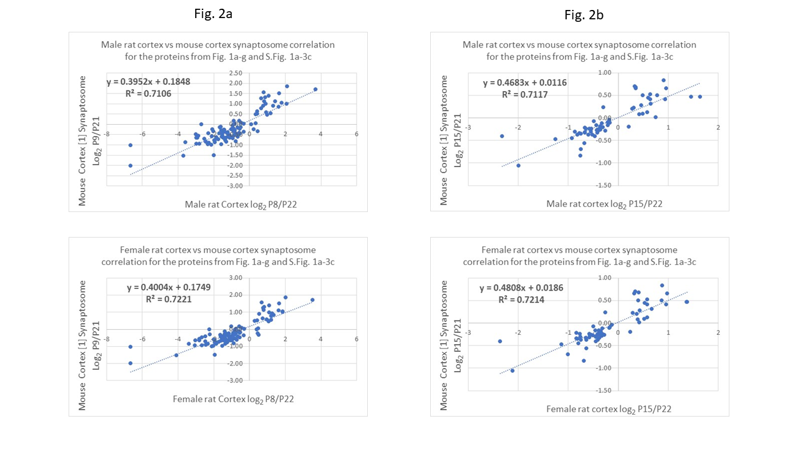
Figures 2a-b: Linear correlation plots comparing the male (top quadrant) and the female (bottom quadrant) rat rostral cortex logarithmic protein abundance PND ratios P8/P22 (Fig. 2a) and P15/P22 (Fig. 2b), adjusted p-Value 0.05 threshold, vs. the corresponding mouse cortex synaptosome P9/21 and P15/P21 data [1], respectively. The data include the discussed above presynaptic, postsynaptic, adhesion and the highly expressed proteins quantified both in the mouse [1] and in the rat study (current work).
The rat log₂ (P15/P22) vs. mouse log₂ (P15/P21) comparison yielded the PCC values of 0.84 (male rat vs. mouse) and 0.85 (female rat vs. mouse) for this group of proteins. The corresponding linear plot parameters were: (a) y = 0.468x + 0.012, R² = 0.712 (male rat vs. the mouse) and (b) y = 0.481x + 0.019, R² = 0.721, female rat vs. the mouse (Fig. 2b). The slopes of the linear regression lines were within the 0.4-0.5 range confirming that in these two studies, on average, the synaptic mouse proteins demonstrated smaller PND changes with respect to the corresponding rat proteins. One of the possible explanations for this difference could be a ratio compression effect which generally gives rise to protein ratio flattening in isobaric mass tagging experiments [20], depending on the degree to which it was corrected by the software in [1].
A similar comparative analysis was performed for the rat log₂ (P2/P22) current work data presented in Fig. 1a-g and S.Fig. 1a-3c, and the synaptosomal fraction rat log₂ (P1/P20) data calculated from the P1 average and P20 average columns in the Supplementary Table 5 in [7]. There were 85 proteins in common between such P1/P20 data from [7] and the current work P2/P22 data. The PCC was 0.82 for this comparison of the male rat cortex vs. the synaptosomal rat cortex data [7], and the linear plot parameters were: y = 0.757x - 0.523, R² = 0.670. In the corresponding comparison of the female rat cortex data from (Fig. 1a-g and S.Fig. 1a-3c) vs. the synaptosomal fraction of the rat cortex data from [7], the PCC was 0.82, and the linear parameters were: y = 0.735x - 0.562, R² = 0.678, (Fig. 3a). This 85 protein dataset was reduced to 21 by restricting the p-values to 0.05 or lower in both the current data and the rat data from [7]. This restriction resulted in an improvement of the PCC values for the P2/P22 vs the P1/P20 [7] comparison to: 0.90 (male) and 0.90 (female), which corresponded to the following linear equation parameters: y = 0.896x - 0.692, R² = 0.809 (male) and y = 0.858x - 0.764, R² = 0.796 (female) (Fig. 3b). A similar data analysis was performed for an analogous 22 protein data subset of the 85 proteins, meeting the requirements set above, whereby the log₂ [P8/P22] dataset was correlated with the log₂ [P10/P20] data from [7]. This comparison showed the PCC of: 0.90 for the rat male data and 0.89 for the rat female data, and the corresponding linear parameters of: y = 0.797x - 0.365, R² = 0.819 (male rat data), and y = 0.766x - 0.401, R² = 0.799 (rat female data).
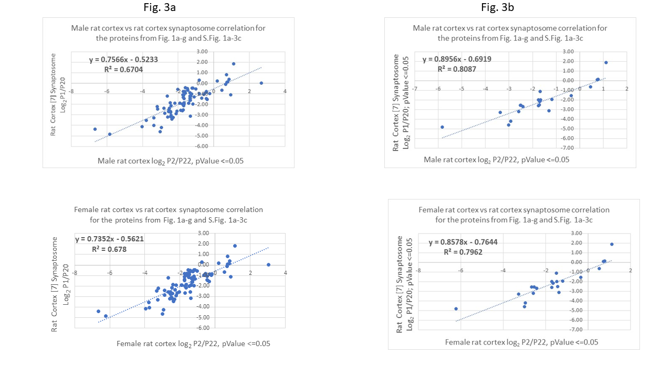
Figures 3a-b: Linear correlation plots comparing the male (top quadrant) and the female (bottom quadrant) rat rostral cortex logarithmic protein abundance PND ratios P2/P22, adjusted p-Value 0.05 threshold, vs. the corresponding rat cortex synaptosome data [7]. The data include the discussed above presynaptic, postsynaptic, adhesion and the highly expressed proteins quantified both in the rat [7] and in the current rat study. Fig. 3a: current rat data possessing the adjusted p-Value of 0.05 or lower; Fig. 3b: current rat data possessing the adjusted p-Value of 0.05 or lower and the P1/P20 rat synaptosome logarithmic ratios were calculated only when both the P1 and P20 abundances possessed the p-Value of 0.05 or less (as described in [7]).

Biological processes and the PND protein changes in rat cortex. Biological processes are frequently associated with networks of multiple proteins, and therefore it is anticipated that such proteins are co-regulated. We analyzed a group of eighty three 28S, 39S, 40S and 60S ribosomal proteins which were quantified in this rat cortex study, out of which 49 proteins were in common with the mouse dataset [1]. These ribosomal proteins were isolated using a “*ribosomal protein*” keyword filter in the protein description (protein name) column of the PDv.2.5 data report. The majority of the 49 ribosomal proteins exhibited decreasing ratio trends across the respective PND time points: P2-P22 and P9-P21 (S.Fig. 4a). However, the P8/P22 rat ribosomal proteins possessing the protein ratio adj. p-value of 0.05 or less [1] did not correlate well with the P9/P21 mouse ribosomal proteins possessing the parameter BETR below 0.001, as it was evidenced by the poor PCC values of 0.39 (male rat) and -0.04 (female rat). Notably, none of these ribosomal protein PND changes were statistically significant in the cortex synaptosomal and mitochondrial fractions described in the previous rat cortex study [7]. In general, the magnitudes of the statistically significant mouse ribosomal protein PND changes were low [1], which could be explained by a merely residual presence of ribosomal proteins in the synaptosomal isolates. Therefore, this particular mouse synaptosome vs rat cortex data discrepancy could be attributed to the effects of the sucrose gradient fractionation in [1] and [7] and the use of whole tissue in the present study.

Twenty seven proteasome proteins were quantified in rat rostral cortex presenting a very similar PND protein change profile between the male and the female rat groups (S.Fig. 4b). The proteasome proteins were grouped using a keyword filter (“*Proteasome*”) in the description column of the report. The average PND protein ratio trend was somewhat decreasing. Seventeen corresponding proteasome proteins were also found in mouse [1] and were characterized by flat P9 – P21 protein ratio profiles which were not deemed statistically-significant in [1], indicating that the proteasome proteins were not well represented in the mouse synaptosome fractions. In concordance with the sporadic, apparently residual, appearance and the low-level abundance of the proteasome proteins within the mouse synaptosome isolate [1], there were no proteasome proteins reported as quantifiable in the rat synaptosome cortex study [7].

Two protein groups representing opposite trends in the early rat PND development were mRNA splicing proteins and mitochondrial proteins. The mRNA proteins showed a mostly decreasing trend while the mitochondrial proteins showed an increasing trend (S.Fig. 4c). A similar decreasing trend was observed for a group of 28 functionally related rat translation initiation factors. The group of the mRNA splicing proteins was filtered in Reactome Pathways protein data column of the Protein Discoverer, (PDv.2.5) protein report using the filter “*mRNA Splicing*”, whereas the “*Translation factors*” filter in the WikiPathways column of the report yielded the translation factors proteins. This trend is understandable because such housekeeping protein production in cells initiates early in the postnatal development, and the decreasing abundance of ribosomal and mRNA regulatory protein during progressing development corroborate it. The mouse synaptosome study [1] did not produce any statistically significant mRNA splicing protein changes, identifying only eight proteins in this category which were in common with this current rat dataset. This stands in contrast to the 56 rat proteins quantified in the current study, thus indicating that this protein group was likely underrepresented and residual in the mouse synaptosome fraction. There were no mRNA splicing proteins and only one translation factor, elongation factor 2, quantified and was in common between the current rat data and the previous rat synaptosome cortex dataset in supplementary Table 5 data reported in [7]. This finding demonstrated again a presence of specific differences in the datasets, originating likely from the different sample preparation methodologies.

There were 200 mitochondrial proteins identified in the current male and female rat rostral cortex work, which were matched by gene symbols and assembled with their quantitative abundance ratio values. The mitochondrial proteins were collected using the keyword “*mitochondrial*” in the description names. Out of these proteins, 161 proteins possessed statistically significant protein abundance PND ratios, whereby at least one PND ratio per protein was characterized by the adjusted p-value of 0.05 or less. The rat cortex study [7] provided a list of 128 mitochondrial proteins and their statistically significant quantitative abundance values in Supplementary Table 8 in [7]: Statistically significant changes in mitochondrial cortical proteome during development. Those were the mitochondrial proteins isolated using sucrose gradient fractionation, in which at least one PND comparison had a statistically significant abundance ratio p-value of 0.05 or lower. Seventy-nine of these proteins, [7], had gene symbols assigned to them, out of which 47 quantifiable proteins were in common between both rat cortex studies. The matching proteins were identified by the gene symbol (S-Data-Table-2). For these 47 proteins, log₂ (Px average/P20 average) values were calculated from the P1 average, P10 average and P20 average values provided in the Supplementary Table 8 in [7]; where x is 1, 10. These calculated relative abundance ratios were compared using PCC with the corresponding log₂ (Pn/P22) protein ratios in the current rat cortex work (n-sizes 2, 8, 15). The Pearson function value of 0.87 (male rat) and 0.89 (female rat) showed strong correlation and linearity for the P2/P22 vs P1/P20 [7] data (Fig. 4).
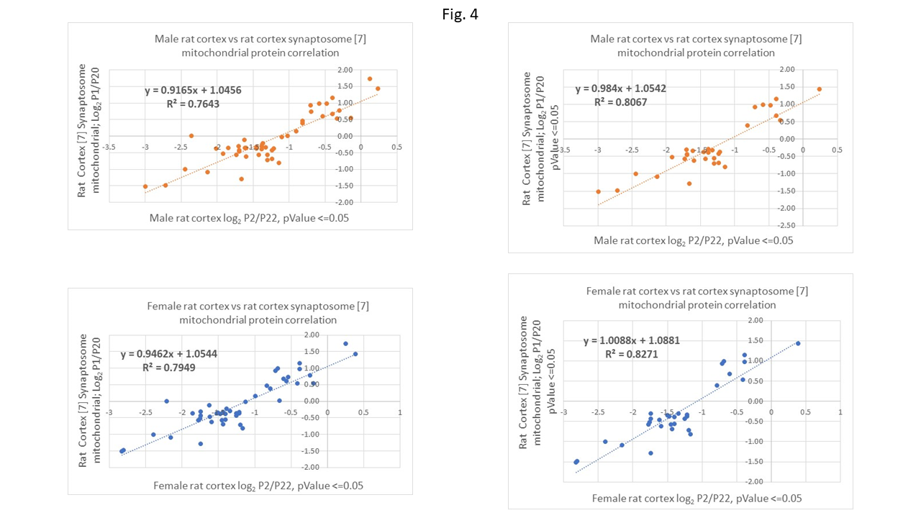

Figure 4: Linear correlation plots comparing the male (top quadrant) and the female (bottom quadrant) rat rostral cortex logarithmic mitochondrial protein abundance PND ratios P2/P22, adjusted p-Value 0.05 threshold, vs. the corresponding rat cortex synaptosome data [7]. The data include the mitochondrial proteins both identified by a keyword name search (unfractionated; current work) and in the mitochondrial rat fraction study [7]. Left panel: current rat data possessing the adjusted p-Value of 0.05 or lower; right panel: current rat data possessing the adjusted p-Value of 0.05 or lower vs. the corresponding P1/P20 rat mitochondrial protein abundance logarithmic ratios, calculated only when both the P1 and P20 abundances possessed the p-Value of 0.05 or less (as described in [7]).

The PCC values showed weaker correlations for the comparisons of P8/P22 vs P10/P20 [7] (0.74 male and 0.66 female) and for P15/P22 vs P10/P20 [7] (0.76 male and 0.64 female). The weaker correlation coefficients might be explained by two factors: a prevalence of the closer to parity protein abundance ratios of smaller magnitude for the shorter PND spans, and a larger discrepancy between the PND days used in the rat vs rat-synaptosome data comparison. To further explore the best correlation in the P2/P22 vs P1/P20 data subset, [7], the group of 47 proteins was reduced to the 31 proteins which possessed the adjusted p-values of 0.05 or lower both for the P2/P22 ratio (in the current study), and for the P1 and P20 abundances in Supplementary Table 8 in [7]. The application of this stricter p-value criterion for the P1 and P20 abundances [7] resulted in a slight improvement of the PCC values for the P2/P22 vs the P1/P20 [7] comparison to give: 0.90 (male) and 0.91 (female). This modest correlation improvement corresponded to the better linear equation parameters: y = 0.984x + 1.0542, R² = 0.8067 (male) and y = 1.0088x + 1.0881, R² = 0.8271 (female), improved from y = 0.9165x + 1.0456, R² = 0.7643 (male) and y = 0.9462x + 1.0544, R² = 0.7949 (female), respectfully (Fig. 4). It is noteworthy, that these correlation lines exhibited the slope of approximately 1.0 and the intercept of 1.0. The line upward shift by the intercept of 1.0 relative to the hypothetical ideal data match, might possibly be explained by the difference in the sample preparation: the current rat cortex mitochondrial proteome came from the unfractionated tissue, while the reference rat cortex data [7] originated from the sucrose-gradient fractionated one. In comparison, the same subset of 31 mitochondrial proteins showed the PCC of 0.99 and the linear equation: y = 0.9789x - 0.029, R² = 0.9822 for the comparison of the male rat cortex vs female rat cortex (current study). The line exhibited the slope of 1.0 and the 0.0 intercept, which was consistent with the fact that both male and the female samples were prepared in the same laboratory using the same sample preparation protocol, and that the male and the female proteomes demonstrated negligible differences in their cortex PND protein changes (S-Data-Table-2).
The comparison of the 27 mouse mitochondrial proteins characterized by the PND BETR trendline parameter equal or lower than 0.001, [1], and shared with the current rat mitochondrial data, demonstrated the PCC of 0.82 (mouse vs. male rat) and 0.77 (mouse vs. female rat) for the mouse P9/P21 [1] and the rat P8/P22 logarithmic ratios, respectively. The corresponding linear correlation equations demonstrated the following linearity parameters: 0.6111x + 0.4634, R² = 0.6687 (male) and y = 0.5883x + 0.4217, R² = 0.5973 (female), which were inferior comparing to the ones shown above for the mitochondrial rat vs rat mitochondrial sucrose gradient fraction data correlation [7]. The discrepancy between these two data comparisons might have occurred because the mouse mitochondrial proteins were apparently a narrow subset of the synaptosomal sucrose gradient protein fraction [1], whereas specifically a mitochondrial cortical fraction was used in the rat study [7].
DNA or RNA-related, and apoptosis- related proteins were grouped using an appropriate keyword filter in the data report columns (*DNA*, *RNA*; *apopto*). Ninety-two rat DNA or RNA – associated proteins mostly decreased between P2 and P22 (S.Fig. 4d), which is consistent with the clearly decreasing trend of the previously discussed mRNA and ribosomal proteins belonging to a cell protein infrastructure category. Twenty six apoptosis-related rat proteins were grouped and graphed (S.Fig. 4d), however they were not characterized by a clear up or down trend, which could be attributed to a complex role of different proteins in the apoptotic neuronal network – brain cortex shaping processes occurring in the early rat PND period [3]; this finding was in agreement with the finding that the apoptotic cell death in rat cortex reached the highest level at PND 1 [3]. Notably, there were no statistically significant PND changes reported for these proteins in the synaptosome (mouse) [1] and the synaptosome and the mitochondrial (rat) [7] fractions.

Male to female rat protein ratios across the PND timeline. Overall, in this rat proteomic study 42% of the changing cortex male and female proteins were increasing, and 41% displayed a consistently decreasing trend from P2, through P8, and P15 to the P22 reference point, S.Fig. 5. The average protein ratio increasing trends appeared to be slightly steeper than the average decreasing trends, S.Fig. 5. In general, the largest protein ratio changes were observed for the earliest PND day studied, eg the P2/P22 vs the P8/P22 and P15/P22, which was in agreement with the finding that the biggest rat brain protein changes occur early in the PND timeline [7]. There were no clear, consistent rat male vs female ratio changes identified within the four investigated PND time points P2, P8, P15, P22, which would demonstrate any development trend differences in cortex between the male and the female rats.

Comparison of the 2D-PAGE rat cortex PND data with the current rat study data. Cerebral cortex samples obtained from the rat PND points P7, P90 and P637 were analyzed by two dimensional
polyacrylamide gel electrophoresis (2DE) and matrix-assisted laser desorption/ionization time-of-flight
mass spectrometry (MALDI-TOF-MS) [6]. Seventy-three proteins which were described in the 2D-PAGE study in Table 1 in [6], as either up or down - regulated between P7 and P90, were also identified in the current rat work. Despite the significant difference in time between the reference points P22 and P90 [6], 85% of the reported proteins agreed in the + or – expression direction sign represented by the log₂ (P8/P22) ratio (current work) and the P7/P90 up or down - regulation direction. The proteins which differed in the reported regulation direction were: Acat2, Prdx2, Gda, Cfl1, Gdi2, Tmod2, Calr, Hspa8, Trap1, Actb, Tuba1c. Coincidentally among these proteins, in the current work, Prdx2, Cfl1, Gdi2, Tmod2, Calr, Hspa8, Trap1, Actb2, Tuba1c exhibited relatively small P8/P22 protein changes and the flat-shaped protein ratio change trends from P2 to P22. This factor could explain the expression-direction discrepancy, especially taking into consideration the significant time difference between the closest comparable P22 and the P90 reference points.
Conclusions. This work demonstrated a cross-study PND proteomic data comparison between the current rat cortex work (P2, P8, P15, P22) and the three other past studies: the mouse cortex synaptosomal fraction (P9, P15, P21) [1], the rat cortex synaptosomal and mitochondrial fractions (P1, P10, P20) [7], and also the rat cortex proteomic study involving 2D-PAGE gel analysis (P7, P90) [6]. The synaptic and the mitochondrial protein PND ratios obtained from the current rat cortex work correlated well with the similar PND ratios obtained from the rat cortex synaptosomal and mitochondrial cellular fractions [7]. An excellent correlation was found in this work between the male and the female rat cortex proteomes during the early PND, P2 – P22. In addition, 85% of the quantified proteins which were found in common between this study and the 2D-PAGE gel analysis, [6], agreed in direction of the protein up or down regulation at the PND time points. The current dataset represented an unfractionated rat rostral cortex proteome and therefore it provided complementary data to the data obtained using cellular fractionation in combination with other analytical techniques. Linear regression – correlation and PCC tools were particularly useful in identifying, on a global scale, differences between the PND proteomic profiles within the protein groups. This study showed that the early PND rat cortex and the mouse synaptic protein profiles were similar, regardless of comparing the unfractionated rat rostral cortex proteome to the mouse cortex fractionated synaptosome. However, other than synaptosome protein groups, which were reported as differentially quantified in both studies, displayed generally flatter rat cortex vs mouse PND protein ratio profiles and worse correlation coefficients which possibly might be explained by the lower abundance of such proteins in the mouse synaptosomal fraction [1]. The early PND profiles demonstrated that the rat profiles P2-P22 (current work) were similar to those constructed from the rat synaptosome data presented in [7]. Overall, the current study demonstrated that high-resolution LC-MS LFQ method in conjunction with the facile, TFA-based and detergent-free brain protein extraction technique can be confidently used for PND brain protein profiling.

Declaration of Competing Interest: The authors declare that they have no known competing financial interests or personal relationships that could have appeared to influence the work reported in this paper.

Acknowledgements: The authors would like to thank Dr. Yue Ge and Colette Miller for performing an EPA internal review for this manuscript. We also wish to acknowledge the excellent services provided by Tracey Beasley. Garyn Jung, Kathy McDaniels, and the animal care staff.
References
1. M.A. Gonzalez-Lozano, P. Klemmer, T. Gebuis, C. Hassan, P. van Nierop, R.E. van Kesteren, A.B. Smit, K. Wan Li. Dynamics of the mouse brain cortical synaptic proteome during postnatal brain development. Sci. Rep. 2016, 6, 35456.
2. J. Doellinger, A. Schneider, M. Hoeller, P. Lasch. Sample Preparation by Easy Extraction and Digestion (SPEED) - A Universal, Rapid, and Detergent-free Protocol for Proteomics Based on Acid Extraction. Mol. Cell Proteomics, 2020, 19, 209-222.
3. Z. Drastichova, V. Rudajev, G. Pallag and J. Novotny. Proteome profiling of different rat brain regions reveals the modulatory effect of prolonged maternal separation on proteins involved in cell death‑related processes. Biol. Res. 2021, 54:4.
4. M.S. Breen, S. Ozcan, J.M. Ramsey, Z. Wang, A. Ma’ayan, N. Rustogi, M.G. Gottschalk, M.J. Webster, C.S. Weickert, J.D. Buxbaum and S. Bahn. Temporal proteomic profiling of postnatal human cortical development. Translational Psychiatry, 2018, 8:267.
5. D.B. McClatchy, L. Liao, S.K Park, J.D. Venable, and J.R. Yates. Quantification of the synaptosomal proteome of the rat cerebellum during post-natal development. Genome Res. 2007, 17, 1378–1388.
6. M. Wille, A. Schümann, M. Kreutzer, M.O. Glocker, A. Wree, G. Mutzbauer, and O. Schmitt. Differential Proteomics of the Cerebral Cortex of Juvenile, Adult and Aged Rats: An Ontogenetic Study
J. Proteomics Bioinform. 2017, 10:2.
7. D.B. McClatchy, L.L, J. H. Lee, S.K. Park, and J. R. Yates III. Dynamics of Subcellular Proteomes During Brain Development. J Proteome Res. 2012, 11(4), 2467–2479.
8. O. Sorokina, C. Mclean, M.D. R. Croning, K.F. Heil, E. Wysocka, Xin He, D. Sterratt, S.G.N. Grant, T. I. Simpson and J.D Armstrong. A unified resource and configurable model of the synapse proteome and its role in disease. Sci Rep. 2021; 11: 9967.
9. W.E. Zimmer, Y. Zhaoa, A.F. Sikorski, S.D. Critz, J. Sangerman , L.A. Elferink , X. Susan Xu , S.R. Goodman. The domain of brain β-spectrin responsible for synaptic vesicle association is essential for synaptic transmission. Brain Research 2000, 881, 18–27.
10. A.J. Baines, P.A. Bignone, M.D.A. King, A.M. Maggs, P.M. Bennett, J.C. Pinder, and G.W. Phillips. The CKK Domain (DUF1781) Binds Microtubules and Defines the CAMSAP/ssp4 Family of Animal Proteins. Mol. Biol. Evol. 2009, 26, 2005–2014.
11. N.A. Courtney, H. Bao, J.S. Briguglio, and E.R. Chapman. Synaptotagmin 1 clamps synaptic vesicle fusion in mammalian neurons independent of complexin. Nat Commun. 2019, 10, 4076.
12. C. Yan, J. Jiang, Y. Yang, X. Geng, and W. Dong. The function of VAMP2 in mediating membrane fusion: An overview. Front. Mol. Neurosci. 2022, 15:948160, 1-15.
13. N.Schmidt, A. Kollewe, C.E. Constantin, S. Henrich, A. Ritzau-Jost, W. Bildl, A. Saalbach, S. Hallermann, A. Kulik, B. Fakler, and U. Schulte. Neuroplastin and Basigin Are Essential Auxiliary Subunits of Plasma Membrane Ca²⁺-ATPases and Key Regulators of Ca²⁺ Clearance. Neuron, 2017, 96, 827–838.
14. Online Kegg Glutamatergic synapse - Rattus norvegicus (rat).
15. G. Chapman, U. Shanmugalingam and P.D. Smith. The Role of Neuronal Pentraxin 2 (NP2) in Regulating Glutamatergic Signaling and Neuropathology. Front. Cell. Neurosci. 13, 575.
16. H. Hwang, et al. Neurogranin, encoded by the schizophrenia risk gene NRGN, bidirectionally modulates synaptic plasticity via calmodulin-dependent regulation of the neuronal phosphoproteome. Biol Psychiatry. 2021, 89, 256.
17. R.D. Burgoyne. Neuronal Calcium Sensor Proteins: Generating Diversity in Neuronal Ca2+ Signalling. Nat Rev Neurosci. 2007, 8, 182.
18. A. Vizurraga, R. Adhikari, J. Yeung, M. Yu , and G.G. Tall. Mechanisms of adhesion G protein–coupled receptor activation. J. Biol. Chem. 2020, 295, 14065.
19. B.J. Chena, S. Huanga, M. Janitz. Changes in circular RNA expression patterns during human foetal brain development. Genomics 2019, 111, 753.
20. M.M. Savitski, T. Mathieson, N. Zinn, G. Sweetman, C. Doce, I. Becher, F. Pachl, B. Kuster, and M. Bantscheff. Measuring and Managing Ratio Compression for Accurate iTRAQ/TMT Quantification. J. Proteome Res. 2013, 12, 3586.

