METADATA Description for SDMP.FY22.176
Tables and Figures
Table 1. Studies included in the primary group with the number of soils, non-control treatments and total number of samples in each study.
Reference | soils | treatments | samples
Basta et al. (2001)* | 1 | 1 | 6
Hettiarachchi et al. (2001)* | 5 | 5 | 84
Yang et al. (2001) | 1 | 3 | 12
Geebelen et al. (2003) | 10 | 1 | 60
Tang et al. (2004) | 1 | 8 | 27
Brown et al. (2005)* | 2 | 3 | 15
Codling (2007) | 2 | 1 | 12
Yoon et al. (2007) | 2 | 5 | 36
Cao et al. (2008) | 2 | 3 | 24
Kilgour et al. (2008) | 1 | 3 | 8
Zupančič et al. (2012) | 1 | 6 | 21
Beyer et al. (2016) | 1 | 1 | 18
Obrycki et al. (2016) | 2 | 2 | 84
Sanderson et al. (2016)* | 4 | 2 | 36
Obrycki et al. (2017)* | 1 | 1 | 6
Gu et al. (2020) | 2 | 6 | 56
Alasmary (2020) | 2 | 19 | 63
*Corresponding authors provided additional information

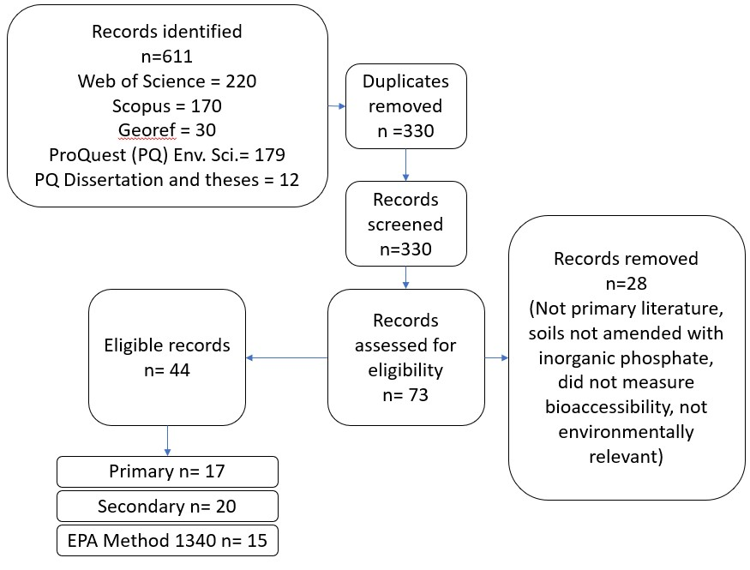
Figure 1. Flowchart of literature search and eligible records in this meta-analysis

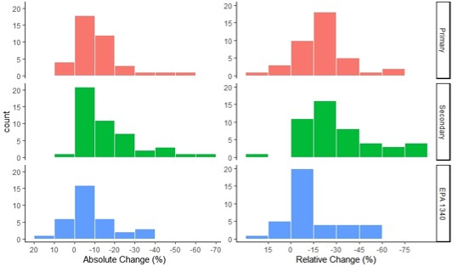
A
B
Figure 2. Distribution of A) absolute change in IVBA Pb (%) and B) relative change in IVBA Pb (%) for soils in each analysis group.

Table 2. Summary of pooled treatment effect via random effects model for each analysis group. I² is percentage of difference due real differences, and τ is the between study standard deviation. The value of τ is in the same units as the treatment effects.
Group | n | Absolute change |  |  |  |  |  | Relative change
 |  | I² | τ | p-value | Average | 95% confidence interval |  | I² | τ | p-value | Average | 95% confidence interval
Primary | 40 | 98.6% | 12.2% | <0.05 | -11.4% | [-15.4% ,-7.4%] |  | 95.7% | 15.4% | <0.05 | -21.4% | [-26.7% , -16.1%]
Secondary | 36 | 96.7% | 16.4% | <0.05 | -15.6% | [-21.4% ,-9.7%] |  | 94.3% | 22.4% | <0.05 | -32.3% | [-40.5%, -24.2%]
Secondary (no field studies) | 28 | 96.9% | 15.6% | <0.05 | -12.4% | [-18.7% , -6.1%] |  | 94.7% | 20.2% | <0.05 | -27.2% | [-35.4%, -18.9%]
Secondary (only field studies) | 8 | 88.4% | 15.0% | <0.05 | -28.5% | [-41.8%, -15.2%] |  | 87.4% | 22.9% | <0.05 | -53.6% | [-74.4%,-32.9%]
EPA Method 1340 | 23 | 98.6% | 11.4% | <0.05 | -5.6% | [-10.7% ,-0.6%] |  | 98.0% | 17.2% | <0.05 | -8.3% | [-16.4%, -0.8%]

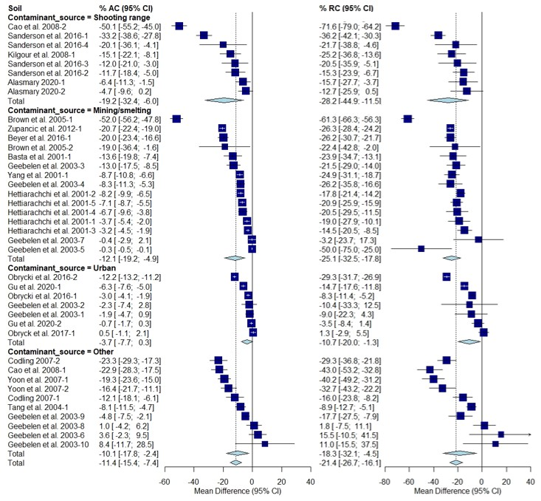
Figure 3. Fully random effects forest plot for AC and RC grouped by contaminant source. Squares represent the mean difference for a soil and error bars are 95% CI. Diamonds represent the 95% CI of the mean difference between the control and treated soil for each subgroup and the overall treatment effect.
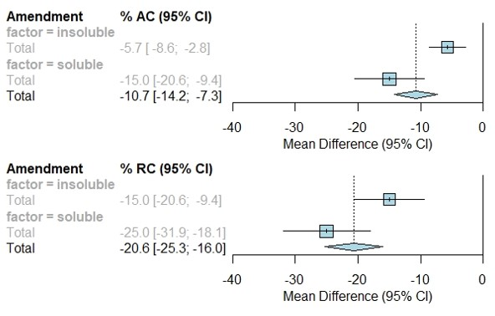
Figure 4. Fully random effects forest plot for AC and RC by amendment type. Squares represent average treatment effect for each subgroup with error bars denoting the 95% CI. Diamonds represent the 95% CI of the overall treatment effects.
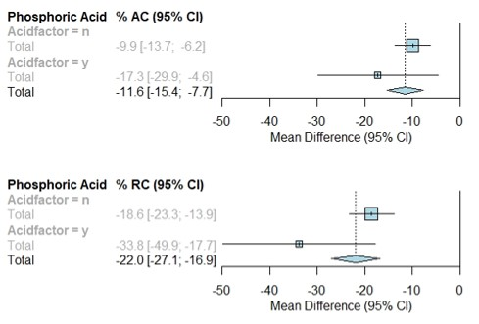
Figure 5. Fully random effects forest plot for AC and RC by acid factor. Squares represent average treatment effect for each subgroup with error bars denoting the 95% CI. Diamonds represent the 95% CI of the overall treatment effects.
R² =31%
R² =26%
E

R²= 10%
B

R² =41%

D

R² = 27%
A

R² =12%
Weight (%) -AC 1.25 2.5 RC 1.2 2 2.6
F
C

Figure 6. Single linear meta-regression for AC by A) incubated pH, B) control IVBA Pb, and C) total Pb and RC by D) incubated pH, E) control IVBA Pb, and F) total Pb
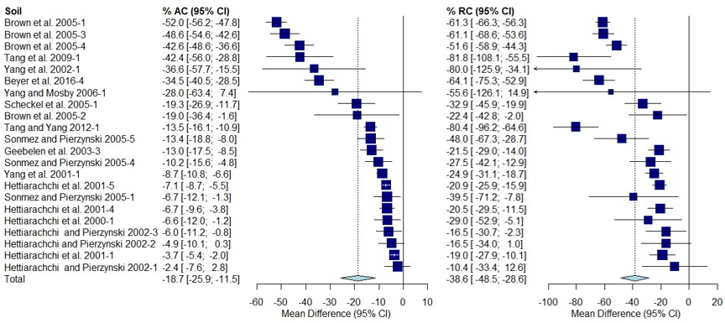
Figure 7. Random effects forest plot of AC and RC for soils from Jasper County, MO. Squares represent the mean difference for a soil and error bars are 95% CI. Diamonds represent the 95% CI for summary treatment effects.
Column fittings for figures and tables -Table 1.- 1.5, Table 2.- 1., Figure 1.- 1, Figure 2.- 2, Figure 3.- 2, Figure 4.- 1, Figure 5.- 1, Figure 6.- 2, Figure 7.- 2
Table S1. Summary of references included in each analysis group
Reference | Analysis group
Alasmary 2020 | Primary
Barth et al. 2005 | EPA Method 1340
Basta et al. 2001 | Primary
Beyer et al. 2016 | Primary
Beyer et al. 2016 | Secondary
Beyer et al. 2016 | EPA Method 1340
Bosso et al. 2008 | Excluded
Brown et al. 2005 | Primary
Brown et al. 2005 | Secondary
Brown et al. 2007 | Secondary
Cai et al. 2017 | Secondary
Cao et al. 2009 | Primary
Codling 2007 | Primary
Cui et al. 2010 | Secondary
Cui et al. 2017 | Secondary
Geebelen et al. 2003 | Primary
Gu et al. 2020 | Primary
He et al. 2013 | Secondary
Hettiarachchi and Pierzynski 2002 | Secondary
Hettiarachchi et al. 2000 | Secondary
Hettiarachchi et al. 2001 | Primary
Hettiarachchi et al. 2001 | Secondary
Juhasz et al. 2016 | Secondary
Juhasz et al. 2016 | EPA Method 1340
Kastury et al. 2019a | EPA Method 1340
Kastury et al. 2019b | EPA Method 1340
Kilgour et al. 2008 | Primary
Li et al. 2017 | Secondary
Li et al. 2017 | EPA Method 1340
Madrid et al. 2008 | EPA Method 1340
Mele et al. 2015 | EPA Method 1340
Moseley et al. 2008 | Secondary
Moseley et al. 2008 | EPA Method 1340
Obrycki et al. 2016 | Primary
Obrycki et al. 2016 | EPA Method 1340
Obrycki et al. 2017 | Primary
Park et al. 2011 | EPA Method 1340
Rizwan, et al. 2016 | EPA Method 1340
Sanderson et al. 2016 | Primary
Scheckel et al. 2005 | Secondary
Scheckel et al. 2005 | EPA Method 1340
Schwab et al. 2006 | EPA Method 1340
Seshadri et al. 2017 | EPA Method 1340
Sharma, et al. 2011 | Secondary
Sonmez and Pierzynski 2005 | Secondary
Tang and Yang 2012 | Secondary
Tang et al. 2009 | Secondary
Tang et al. 2004 | Primary
Yang and Mosby 2006 | Secondary
Yang et al. 2001 | Primary
Yang et al. 2002 | Secondary
Yoon et al. 2007 | Primary
Zupančič et al. 2012 | Primary

