Characterization   
of Chloride and Conductivity Levels   
in the Bitter Creek Watershed, Wyoming

**Prepared for:**

U.S. Environmental Protection Agency’s

Region 8 and the Office of Science and Technology, Office of Water

**Prepared by:**

Susan M. Cormier, CEMM, U.S. Environmental Protection Agency

Yu-Chen Wang, Tetra Tech, Inc.

Christopher Wharton, Tetra Tech, Inc.

August 2022

[[Type a quote from the document or the summary of an interesting point. You can position the text box anywhere in the document. Use the Text Box Tools tab to change the formatting of the pull quote text box.]]



**The views expressed in this report are those of the authors and do not necessarily represent the views or policies of the U.S. Environmental Protection Agency.**

CONTENTS

1.0 INTRODUCTION 1

1.1 Geographic Area 1

1.2 Historical Anecdotal Information 6

2.0 DATASETS 7

2.1 Ecoregional Dataset 7

2.2 Watershed Datasets 7

2.3 Watershed Predicted Natural Background Dataset 10

3.0 CHARACTERIZATION OF IONIC MIXTURES 11

3.1 Background on Ionic Mixture Compositions 11

3.2 Bitter Creek Watershed Ionic Composition 12

3.2.1 Dominant Ions in the Bitter Creek Watershed and Wyoming Basin Ecoregion 12

3.3 Categories for Analysis of Ion Mixtures in Bitter Creek Watershed 14

3.3.1 Dominance of Ionic Mixtures in Bitter Creek Watershed Datasets 15

3.4 Correlation Matrix Comparing Relative Ion Concentrations 16

3.5 Estimation of Chloride from Specific Conductivity 16

3.6 Spatial Distribution of Ion Mixtures 17

3.7 Summary for Ionic Composition: Na+ and SO42− are Dominant, Cl− Indicates Alteration 18

5.0 PREDICTED BACKGROUND SPECIFIC CONDUCTIVITY AND CHLORIDE 20

5.1 National Random Forest Regression Model 20

5.2 Least Disturbed SC Predicted Background at the Watershed Scale 20

5.2.1 Stream Segments with Observed SC Less than Predicted Least Disturbed Background SC 21

5.2.1.1 Spatial distribution of observed SC less than predicted least disturbed background 21

5.2.1.2. Absolute difference of observed SC versus predicted least disturbed background 21

5.2.1.3. Sample size 23

5.2.1.4. Evidence suggesting need for separate surface flow and ground water flow background 24

5.2.2 Considerations for Comparison of Observed and Predicted SC 25

5.2.3 Summary of Predicted Background SC 26

6.0 WATERSHED SCALE OBSERVED BACKGROUND SPECIFIC CONDUCTIVITY AND CHLORIDE 27

6.1 Considerations Used for Assessing Observed Background Specific Conductivity and Chloride 27

6.1.1 Data Quality and Suitability 27

6.1.1.1 Ecoregional observations 27

6.1.1.2 Watershed observations 28

6.1.2 Summary of Watershed Observational Data 29

6.2 Selection of Statistic to Represent Background from Acceptable Observed Data 29

6.3 Magnitude of Observed Water Chemistry Background Estimates 30

6.3.1 Ecoregional Observations 30

6.3.2 Watershed Observations 30

6.3.3 Temporal Characteristics of Observed SC and Flow 31

6.4 Summary of Weight of Evidence of Background Estimates 35

7.0 PRAGMATIC ESTIMATION OF BACKGROUND SC ESTIMATES 38

7.1 Provisional Model of Background SC When Ground Water Is Dominant 41

7.2 Recommended approach for estimating background surface water- and ground water-dominant flows 45

8.0 BIOLOGICAL INFORMATION 45

9.0 CALCULATION AND ASSESSMENT OF EXTIRPATION ESTIMATES 46

9.1 Introduction for Calculation and Assessment of Modeled Extirpation Estimates 46

9.1.1 Estimated Effect Level 47

10.0 CONCLUSION AND DISCUSSION 48

10.1 Ionic Proportions in Bitter Creek Watershed 48

10.2 Background Cl ̶ Concentrations 48

10.3 Comparison of Predicted and Observed Background SC and Cl- Concentrations 49

10.4 5% Extirpation SC and Cl- Values 50

10.5 Recommended Process for Estimating Background from Predicted and Observed Data 50

11.0 DATASET AVAILABILITY 51

12.0 ACKNOWLEDGEMENTS 52

12.0 REFERENCES 52

Figures

Figure 1. Bitter Creek watershed in southwest Wyoming is part of the Green River and Colorado River drainage (*Source*: HAL 2007). 2

Figure 2. Satellite imagery of the Rock Springs Uplift within the Bitter Creek watershed. 3

Figure 3. Sections of Bitter Creek and Killpecker Creek listed as impaired for aquatic life by salinity, TDS, chlorides, and sulfates. 5

Figure 4. Observed Bitter Creek log10 chloride profile (mg/l). 6

Figure 5. Spatial distributions of median observed specific conductivity (SC) and chloride. 9

Figure 6. Piper plot of relative ionic composition (in microequivalents) in surface water samples from the Bitter Creek watershed. 13

Figure 7. Scatter plots of [Cl−] concentrations versus [HCO3− + SO42−] concentrations from each dataset with multiple measurements. 14

Figure 8. Scatter plot from the Combined dataset using all samples depicting relative concentration of [HCO3−] + [SO42−] and [Cl¯] with multiple measurements. 14

Figure 9. Correlation matrix comparing SC to the relative ion concentrations. 15

Figure 10. Least square regression of log10 SC and log10 chloride concentration used to estimate chloride from SC without outliers. 17

Figure 11. Spatial distribution of different ion mixtures depicted network of annual mean predicted background SC for stream segments between 2000 and 2015. 18

Figure 12. USGS stations with observed data within the predicted SC background range. 19

Figure 13.Log-log scatter plots of data from USGS stations with a geomean within the range of predicted natural background (< 1004 µS/cm, *N* = 48). 22

Figure 14. Scatter plots sample size versus difference between observed geomean and predicted background. 23

Figure 15. Example of pattern of observed SC and stream flow and predicted SC range. 25

Figure 16. Paired SC (µS/cm) and flow (cfs) at three USGS gaging stations and identified by month. 32

Figure 17. All samples in the watershed from the USGS dataset used to assess low- and high-conductivity seasons. 34

Figure 18. Box and whisker plot of stream flow (cfs) based on six historical USGS stream gages. 35

Figure 19. Least square regression model for predicting ground water background specific conductivity (SC) from empirically modeled surface flow background. 43

Figure 20. Observed Bitter Creek SC profile (circles). 43

Figure 21. Observed Killpecker Creek SC profile (circles). 44

Figure 22. Observed Salt Wells Creek SC profile (*circles*). 44

Figure 23. Example 5% extirpation using a background-to-criterion model (Source: Cormier et al. 2018a). 47

Tables

Table 1. Number of samples and number of stations of measured specific conductivity and chloride used in the analysis 8

Table 2. Model Performance for National Rivers and Stream Assessment (NRSA) Xeric Ecoregion (*Modified from* Olson and Cormier 2019, Table A.8) 10

Table 3. Summary of ionic concentrations for the Level III ecoregion in Wyoming Basin (*upper table*) and Bitter Creek watershed (*lower table*) 12

Table 4. Number of samples for different ionic mixture categories in different datasets 16

Table 5. Mean predicted natural background SC estimated from random forest model 21

Table 6. Descriptive statistics of measured SC (µS/cm) in the Bitter Creek watershed 31

Table 7. Descriptive statistics for measured chloride (mg/l) in the Bitter Creek watershed 31

Table 8. Weight-of-evidence table for selection of method, dataset, and statistic for surface flow background SC and Cl− in Bitter Creek watershed 36

Table 9. Methods for estimating background (Source: Cormier et al. 2018c) 38

**EXECUTIVE SUMMARY**

In response to a request for scientific support to assess whether chloride in Bitter and Killpecker Creeks in Wyoming may be naturally high, warranting site-specific criteria, the USEPA Office of Research and Development characterized background SC and ionic concentrations in the Bitter Creek watershed; estimated SC and chloride levels expected to result in the extirpation of 5 percent of genera from streams in the watershed; and developed a proposed process for estimating background SC and chloride for surface water- and ground water -dominant conditions. For this report background is the range of conditions that would occur naturally without human alteration. Deviation from background is associated with anthropogenic alteration. Loading of salts can results from run-off, direct inputs to surface or ground water, changes to groundwater levels and flowpaths.

*Ionic Composition*: On average in the Bitter Creek watershed, sodium cation (Na+) concentrations are greater than calcium cation (Ca2+) concentrations, which are greater than magnesium ion (Mg2+) concentrations. For the dominant anions, sulfate ion (SO42−) concentrations are greater than bicarbonate ion (HCO3−) concentrations, which are greater than chloride ion (Cl−) concentrations. These patterns are not universal, however, and other mixtures occur in the watershed naturally and are likely associated with anthropogenic influences.

Samples with Cl¯ concentrations equal to or greater than the concentration of [HCO3¯ + SO42¯] on a mass basis (milligrams per liter [mg/l]) were identified as chloride-dominant mixtures and are likely associated with anthropogenic alteration. Samples were identified as “mixed” on a mass basis (mg/l) when these samples had more than one and up to five times as much [HCO3¯ + SO42¯] as [Cl¯] and may be ground water-dominant flows. When mixtures had more than five times as much [HCO3¯ + SO42¯] as [Cl¯], they were identified as “[HCO3¯ + SO42¯]-dominant mixtures” and may be surface water-dominated flow. To confirm and refine the ionic signatures associated with different sources, the ionic signature could be compared to high- and low-flow relative conditions or types of effluent.

*Chloride*: In the U.S. Geological Survey (USGS) dataset, chloride is dominant only at conductivity levels greater than 1130 microSiemens per centimeter (µS/cm). Only one station exceeded the water quality criteria chloride level of more than 230 mg/l with SC less than 2000 µS/cm. Of the USGS stations (*N* = 127), no stations with less than 5000 µS/cm exceeded the water quality criteria of 860 mg/l chloride. In the Combined dataset formed from four watershed datasets supplied by the Wyoming Department of Environmental Quality plus the USGS dataset, 100 percent of stations with more than 6000 µS/cm exceeded 230 mg/l chloride. In longitudinal stream profiles, chloride levels were greater near the confluence with Bitter Creek and for the lower 50-plus river miles of Bitter Creek.

Higher levels of chloride are more likely from anthropogenic inputs or from altered ground water based on (1) predicted SC levels compared to observed values; (2) observed SC and chloride levels; (3) known sources of chloride; (4) likely ionic signatures of surface water, ground water, and anthropogenic alteration; and (5) different chloride levels with the same geologic strata in difference parts of the watershed. Additional sampling is needed to attribute local sources and may require isotope analysis to distinguish the relative contributions of natural from anthropogenic sources.

*Specific Conductivity (SC)*: In general, SC was higher during low flows in the winter months and SC was lower during higher flows in the spring and following summer storms. Owing to arid conditions, most streams are intermittent unless flow is maintained by effluent. Observed SC levels dip into the predicted background range during naturally higher surface flow, but then SC increases during base flow, which may be dominated by effluent or ground water. Causes of higher-than-expected SC during base flow were not assessed but are more likely the result of anthropogenically altered ground water salt concentrations or anthropogenic discharges when normally the stream would be dry.

A random forest model was used to predict least disturbed SC for stream segments in the watershed based on spatial and temporal patterns of geology, land cover, precipitation, temperature, and other parameters. Predicted mean least disturbed background SC for stream segments ranged between 384 and 1004 µS/cm. The rather broad range of 620 µS/cm of mean SC background levels cautions against a single background value for the entire watershed. The evidence also suggests that the predicted values are appropriate for surface flow-dominant conditions, but the same estimate may not be appropriate for ground water-dominant conditions. A provisional regression model suggests that background SC dominated by ground water flow is more than twice the predicted surface flow background SC.

None of the developers of the datasets identified least disturbed or reference stations. However, the fact that there were 48 stations with median SC in the predicted background range suggests that some stations in the dataset may in fact be relatively free of anthropogenic alteration. In the absence of confirmed least disturbed conditions, a pragmatic approach to estimating SC background in the watershed is described for surface water- and ground water-dominated flow. To accurately estimate least disturbed background, site-specific source assessments are needed prior to using a higher background than suggested below.

1. If the stream segment is classified as least disturbed based on a set of *a priori* criteria, then the observed background is the most relevant and reliable estimate. SC data can be parsed to high-flow conditions and the background ranges estimated.
2. If the stream segment condition is disturbed or unknown, then consider the three options below.
   1. If available, identify and use background from nearby least disturbed sites as an approximated observed background for the new location. Data can be parsed to surface flow conditions to estimate background ranges.
   2. If some observed SC observations are less than 1004 µS/cm (the maximum predicted background), use the predicted SC.
   3. If there are no observations less than 1004 µS/cm, then use the predicted estimate plus the mean absolute error (MAE) (210 µS/cm) (i.e., 1214 µS/cm).

For ground water-dominant or base flow conditions, the uncertainty is much greater.

1. If the stream segment is classified as least disturbed based on a set of *a priori* criteria, then the observed background is the most relevant and reliable estimate. SC data can be parsed to low-flow conditions and background ranges can be estimated.
2. If the stream segment condition is disturbed or unknown, then consider the two options below.
3. If available, identify and use background from nearby least disturbed sites as an approximated observed background for the new location. Then, data can be parsed to low-flow conditions and background ranges can be estimated.
4. If no observed least disturbed observations are available, predict the least disturbed 90th centile SC using the surface flow estimated background from #2 above and the provisional regression equation of predicted background and observed 90th centile SC of least disturbed stations in the watershed. Using this formula, the predicted ground water dominant flow is not expected to exceed 3113 µS/cm nor the surface flow background to be greater than 1214 µS/cm. Note that estimates obtained using the predicted ground water model have a high-level of uncertainty because the R2 of the model is low. When extrapolating beyond the original observation range of a predicted model for surface flow background SC of 626 μS/cm, there is greater uncertainty.

To improve confidence and precision, daily flow and SC could be monitored at more stations identified as least disturbed in the watershed for perennial and intermittent flow conditions. These data can be used to develop more precise calibrations of the predicted SC surface water and ground water background models. These data could also be used to provide a better characterization of surface water and ground water ionic composition to enable discrimination among them and from anthropogenic influences.

A linear log10-log10 least square regression model (Cormier et al. 2018a) was used with an example background SC to estimate the SC level likely to cause 5 percent extirpation of the aquatic macroinvertebrates. A linear regression model of SC and chloride was used to convert the example SC 5% extirpation to chloride. Owing to the broad range of potential background SC across the watershed, station specific background SC is recommended to estimate 5 percent extirpation.

Predicted background SC for surface and ground water-dominated flow was compared with observed SC as longitudinal profiles for Bitter Creek, Killpecker Creek, and Salt Wells Creek. In general, the upper stream segment SC observations fell between the two predicted background levels. Near the confluence with Bitter Creek, however, some observations exceeded predicted background. Chloride levels also were high and were sometimes the dominant ion at these stations. Owing to the known anthropogenic influences, spatial and temporal patterns, and predicted background levels during surface and ground water-dominant flow, the sources of higher SC are likely anthropogenic.

Formal detailed causal and source assessments are warranted for the Bitter Creek watershed. Source assessments would help inform and identify both on-the-ground solutions to improve water quality and any regulatory options to address the impairments. Nevertheless, where chloride is the dominant anion or even strongly elevated ([HCO3−] + [SO42−])/[Cl−] less than 5, this is likely not a natural condition. Some of the chloride loadings may be reduced and mitigated with better management practices. The geological alteration of Bitter Creek from legacy mining near Rock Springs, however, may have irrevocably altered the stream’s hydrology. This puts additional focus on reducing additional ion inputs and protecting those locations that still provide dilution.

ABBREVIATIONS AND ACRONYMS

| **Abbreviation or Acronym** | **Definition** |
| --- | --- |
| µS/cm | microSiemens per centimeter |
| AML | Abandoned Mine Land Division |
| B-C model | background-to-criterion model |
| Ca2+ | calcium ion |
| cfs | cubic feet per second |
| Cl− | chloride ion |
| CO2 | carbon dioxide |
| HCO3− | bicarbonate ion |
| HUC | hydrologic unit code |
| K+ | potassium ion |
| km | Kilometer |
| LQD | Land Quality Division |
| MAE | mean absolute error |
| mg/l | milligrams per liter |
| Mg2+ | magnesium ion |
| *N* | number of samples |
| Na+ | sodium ion |
| NRSA | National Rivers and Streams Assessment |
| ORD | Office of Research and Development |
| R2 | coefficient of determination |
| RM | river miles |
| SC | specific conductivity |
| SO42− | sulfate ion |
| SU | standard unit |
| SWCCD | Sweetwater County Conservation District |
| TDS | total dissolved solids |
| TMDL | total maximum daily load |
| TSS | total suspended solids |
| U.S. EPA | U.S. Environmental Protection Agency |
| USGS | U.S. Geological Survey |
| WDEQ | Wyoming Department of Environmental Quality |
| WQD | Water Quality Division |
| XCD05 | extirpation of 5% of benthic invertebrates |

# 1.0 INTRODUCTION

The U.S. Environmental Protection Agency (U.S. EPA) Region 8 and the U.S. EPA Office of Water requested assistance from scientists at the U.S. EPA Office of Research and Development (ORD) to analyze data from the Bitter Creek watershed. The U.S. EPA Region 8, the Office of Water, and the Wyoming Department of Environmental Quality (WDEQ) have an interest in the natural background levels of specific conductivity (SC) and chloride ion (Cl−) in the Bitter Creek watershed and how those levels affect community composition and tolerance to salinization.

Portions of the Bitter Creek watershed are Clean Water Act Section 303(d)-listed as impaired for chloride. Water bodies that are listed as impaired undergo an assessment process to estimate total maximum daily loads (TMDLs) that, if achieved, are expected to improve water quality and thus meet designated uses. The chronic Wyoming chloride criterion is 230 milligrams per liter (mg/l) and the acute criterion is 860 mg/l (WDEQ 2018a). These values are the same as those recommended by the U.S. EPA based on toxicity tests performed on laboratory test organisms using sodium chloride (NaCl) and are not adjusted for ion mixtures or natural background levels (U.S. EPA 1988). If natural background concentrations of chlorides exceed these standards, then site-specific criteria may be warranted. Also, if the laboratory test animals used to develop these standards are more tolerant than species at the station(s) in question, site-specific criteria may be necessary to protect the applicable designated uses. WDEQ was interested in understanding whether chloride in Bitter and Killpecker creeks may be naturally high, warranting site-specific criteria. In response to WDEQ’s interest, U.S. EPA investigated whether chloride levels are naturally high in these streams and how chloride concentrations expected to protect 95 percent of aquatic genera in these streams compare to Wyoming’s chloride criteria applicable to the Bitter Creek watershed.

The objectives of ORD’s analyses are:

1. to characterize background SC and ionic concentrations in the Bitter Creek watershed;
2. to estimate SC and chloride levels expected to result in the extirpation of 5 percent of genera from streams in the watershed; and
3. to assess whether Wyoming’s chloride standards might be overprotective of aquatic life in the watershed.

## 1.1 Geographic Area

The Bitter Creek watershed is located within Sweetwater County in southwest Wyoming (Figure 1 and Figure 2) and is a part of the Green River drainage basin. The watershed is situated west of the Continental Divide in the Wyoming Basin Ecoregion (Ecoregion 18) within the National Rivers and Streams Assessment (NRSA) Xeric Ecoregion. The watershed is dominated by arid grasslands and shrublands and prone to flooding. Long-term precipitation records indicate greater precipitation during May and October (ACE 2018; Mason and Miller 2005; Clark and Davidson 2009), which might affect the ionic composition and relative contribution of stream flow from surface and ground water. Most smaller streams are intermittent or ephemeral, and some of the perennial streams are likely to be effluent-dominated and would otherwise be dry at least part of the time. Mineral extraction industries are common in the Bitter Creek watershed (Figure A.1) (Root et al. 1973; ACE 2018).

Bc

Bc

Baxter shale

Figure 1. Bitter Creek watershed in southwest Wyoming is part of the Green River and Colorado River drainage (*Source*: HAL 2007).

The Bitter Creek watershed is located in the Wyoming Basin Ecoregion and includes parts of three Level IV ecoregions: 18a Rolling Sage Brush, 18d Foothills Shrublands and Low Mountains, and 18e Salt Desert Shrub Basins (U.S. EPA 2013). Its 8-digit U.S. Geological Survey (USGS) hydrological unit code (HUC) is 14040105. Black circles are the station locations from the USGS dataset used in this assessment. Bitter Creek flows within the alluvium and colluvium deposits (sea green branching network) through the Rock Springs Uplift, an eroded anticline with exposed concentric rings of primarily different types of sedimentary rock with Baxter Shale (yellow) at the center of the of the uplift. South of Baxter shale are two areas with Bishop conglomerate (Bc). For a more detailed map with oil fields and streams see Lucke, S. W., et al. 2007. (Source: <https://ngmdb.usgs.gov/Prodesc/proddesc_16366.htm>).

Abandoned subsurface coal mines

Surface coal mines

Bc

Baxter shale

Figure 2. Satellite imagery of the Rock Springs Uplift within the Bitter Creek watershed.

Lighter rock between Rock Springs and Point of Rocks is the Baxter Basin. Dark area south of Baxter Basin are areas with Bishop conglomerate (Bc). In the north are the Killpecker Sand Dunes. Scale similar to Figure 1. Satellite imagery, Landsat Copernicus (<https://earth.google.com/web/@41.39942313,-109.02949314,2258.23834908a,288825.9552256d,35y,0h,0t,0r>).

The geology of the watershed is primarily sedimentary in nature. Sediment was deposited as both marine and fresh water repeatedly covered and receded over the landscape before and after formation of the Rock Springs Uplift. During geologic periods, the anticline eroded into a broad plain with buttes and outcrops (Figure 1 and Figure 2) (U.S. BLM 2012). Bitter Creek flows westward cutting through this geologically diverse stratigraphy.

Along the north-south axis of the crest of the Rock Springs Uplift lies Baxter Basin, a plain about 25 kilometers (km) wide and 65 km long dissected by badlands carved into the soft Baxter Shale (Figure 1). Baxter Basin lies mostly north of Aspen Mountain and is enclosed by a series of concentric ridges formed by tilted, relatively erosion-resistant sandstone beds. The ridges are separated by valleys that are eroded into softer beds of shale and coal. The ridges include erosion-resistant sandstone and the associated beds of the Mesaverde formation; hard, erosion-resistant limestone and sandstone and associated beds of the nearly horizontal Green River and Wasatch formations; and soft beds of the Wasatch formation and Lewis shale overlying the Mesaverde formations (Mason and Miller 2005). The Lewis shale is more saline than other formations owing to marine origins. On the far northern end of the Rock Springs Uplift are the Killpecker Sand Dunes. To the northeast are the Leucite Hills, where there are buttes capped with high-potassium lava flows, a remnant of a volcanic neck, and volcanic outcrops (U.S. BLM 2012). To the south are Aspen and Miller Mountain and areas of Bishop conglomerate (Schultz 1920; Aslan et al. 2018).

The mineral and organic content of sedimentary rocks in the Bitter Creek watershed are dependent on their makeup and include marine, shoreline, lake, riverine, and mudflat origins (Morrill et al. 2001). The Bishop conglomerate is reported to produce the freshest water in the watershed and is located in the southeast portion of the watershed (Schultz 1920). In contrast, much of the rest of the watershed is more alkaline. The best ground water quality from Quaternary aquifers is associated with the Killpecker Sand Dunes and from landslide deposits on the west side of Pine Mountain in the south (Mason and Miller 2005). These broad differences are reflected in the predicted background and observed SC of streams in the watershed.

Sections of Bitter Creek and Killpecker Creek are listed as impaired for aquatic life by salinity, total dissolved solids (TDS), chlorides, and sulfates (Figure 3, Figure A.1) (WDEQ 2018b). In 2018, TMDLs were completed for *Escherichia coli* (*E. coli*) to address fecal coliform impairments in sections of Bitter Creek and Killpecker Creek. Although increased chloride is known to be a co-contaminant with fecal coliforms, no fecal coliform data were analyzed in this study.

Potential sources of dissolved minerals in the Bitter Creek watershed include dissolution of natural surface and subsurface minerals, dissolution of minerals associated with mine tailings and unpaved roads, seeps from underground coal mines, fracking waste and flowback water from gas and oil extraction, wastewater treatment and septic systems, phosphogypsum stacks, agricultural practices such as irrigation for hay, and winter road deicing (Figure A.1, Figure A.2, and Table A.1) (ACE 2018).

Below RM 55 WDEQ chronic and acute chloride criteria are exceeded at 230 mg/l and 860 mg/l, respectively (Figure 4). High levels of chloride near the confluence of Bitter Creek with Killpecker Creek are indicative of anomalous inputs. The dilution effect of lower chloride levels from Salt Wells Creek and Little Bitter Creek are also evident. The potential specific sources were not investigated in this study; however, chloride and SC stream profiles of SC and chloride were generated for Bitter Creek, Killpecker Creek, and Salt Wells Creek (Figures A.3 through A.8.). In general, SC and chloride have similar linear stream profiles with low levels in the upper parts of the creeks and higher levels downstream. Note that many of these data are decades old and may not represent current conditions. SC level do not consistently change with similar rock formations which suggests anthropogenic sources as a cause rather than natural variation.

Figure 3. Sections of Bitter Creek and Killpecker Creek listed as impaired for aquatic life by salinity, TDS, chlorides, and sulfates.

In 2018, TMDLs were completed for E. coli to address the fecal coliform impairment in sections of Bitter and Killpecker creeks (*Source of imagery*: U.S. EPA Freshwater Explorer, Cormier et al. 2021; U.S. EPA 2021 ATTAINS database). [File: Bitter Creek Attains 20210805]

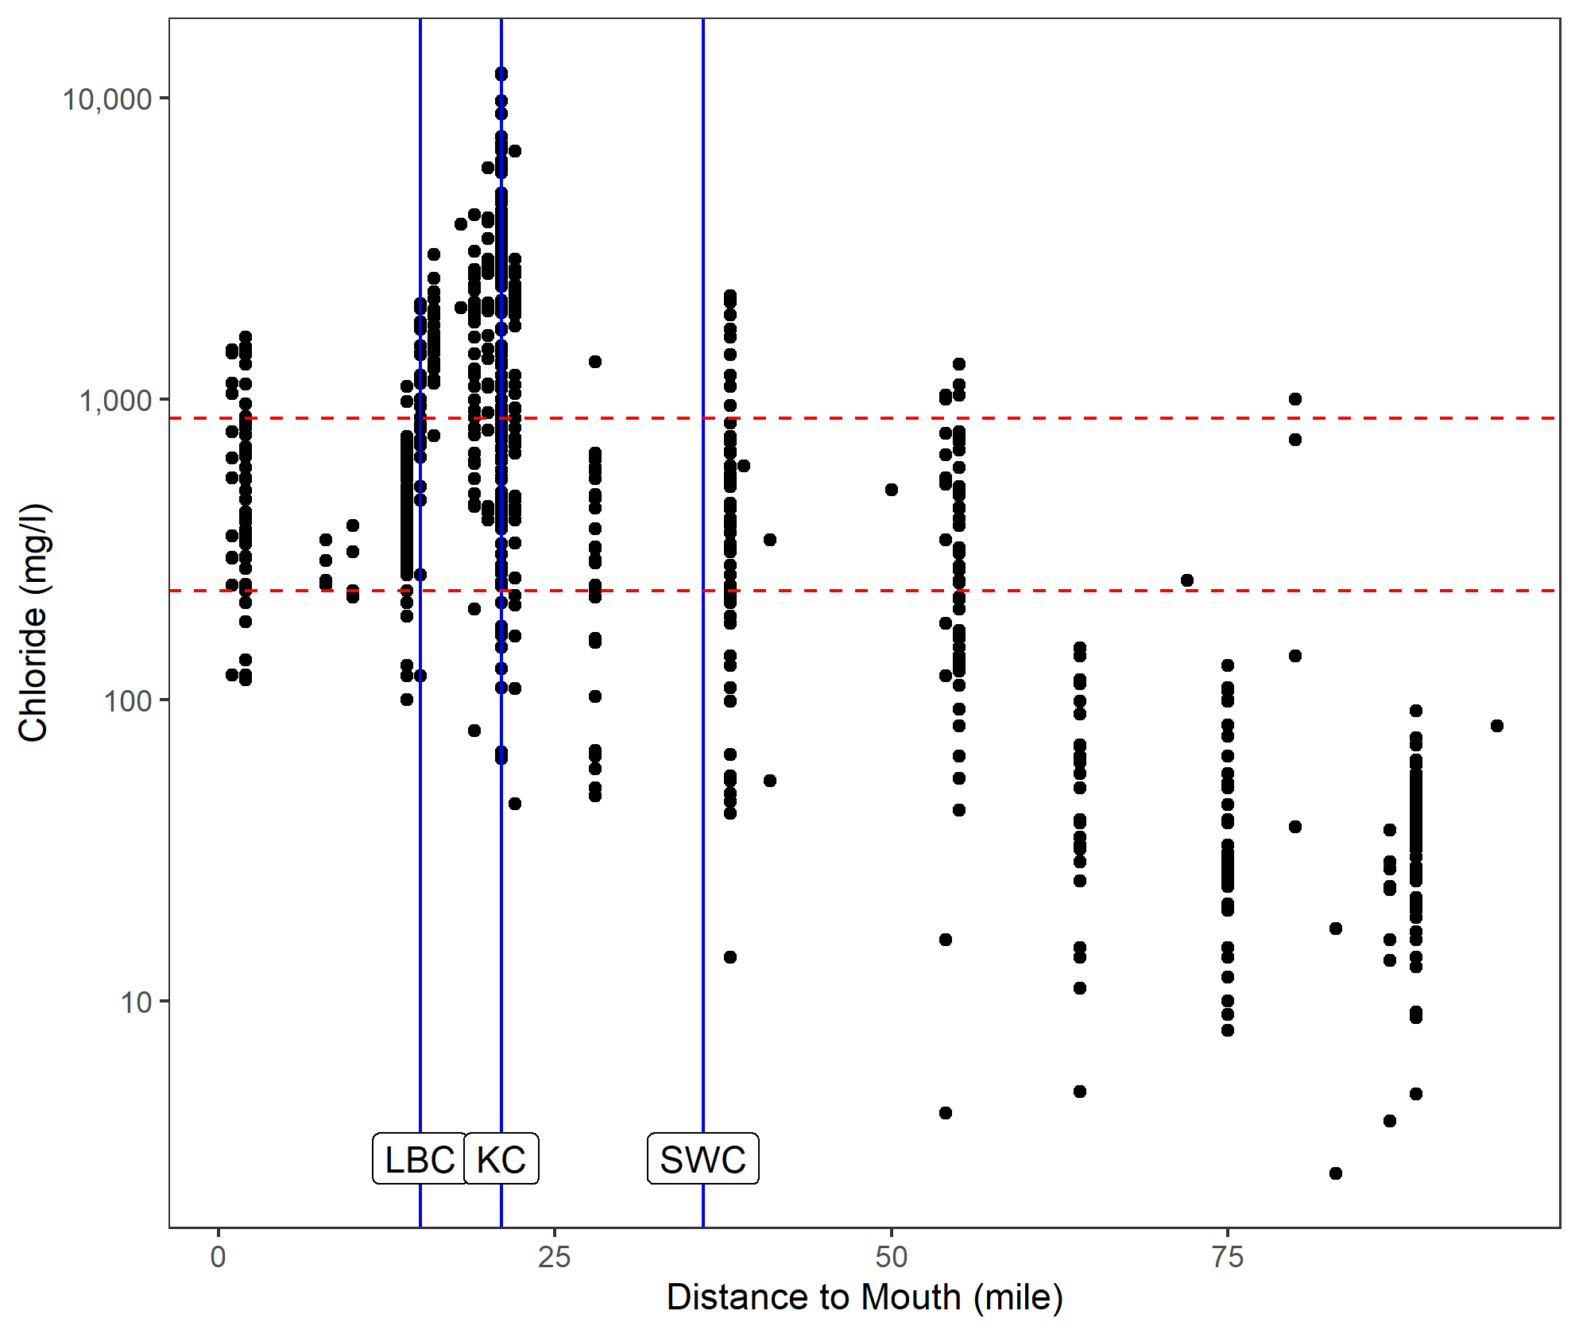

Surface coal mines

Surface coal mines

Figure . Observed Bitter Creek log10 chloride profile (mg/l).

WDEQ chronic and acute chloride criteria shown as horizontal red dashed lines at 230 mg/l and 860 mg/l, respectively. High levels of chloride near the confluence of Bitter Creek with Killpecker Creek (KC) is indicative of potential point sources. Lower chloride levels below the confluence of Salt Wells Creek (SWC) and Little Bitter Creek (LBC) suggest dilution of Bitter Creek by these two creeks. Chloride and SC stream profiles for Bitter Creek, Killpecker Creek, and Salt Wells Creek are available in Figure A3 to Figure A8.

## 1.2 Historical Anecdotal Information

The water quality in Bitter Creek has a long history of mineralization and is unlikely to have ever been as fresh as some other streams in the Wyoming Basin. Early journal entries and recent first-person oral accounts highlight the long history of salt and mineralized water issues (Table A.3B), but they are neither quantifiable nor useful for characterizing background conditions other than that the stream was highly mineralized at times. It is unclear from the anecdotal information whether the noted salinity or mineralization had been a natural chronic condition or remarked upon in these journals as unusual occurrences. There are conflicting accounts regarding the ionic mixture from earlier reports of high saline content (mid 1800s) and more recent reports of high sulfate content (1900s).

Determination of background levels from first-person accounts is ambiguous. Information is based on visual and taste anecdotes and not on chemical analyses. With the available data, it is impossible to distinguish natural sources from alterations following European and Asian settlement in the mid-1800s and more recent anthropogenic modification.

For example, depots for the Overland Stage Company (c. 1862) were sited to take advantage of the springs in the watershed (e.g., near Point of Rocks and Rock Springs), suggesting that spring water was potable at that time. Personal journal entries from two independent authors in 1857 and 1863, however, noted that Bitter Creek’s “water is not fit for use, being at least 1/8 salt,” “sides of banks are crusted,” and “when washing, acts like seawater.” These 1800s journal accounts describing the mainstem of Bitter Creek also noted that water quality decreased from headwaters to the mouth (Lost Iguana Consulting 2003). The first documented mention of coal in the Rock Springs area comes from an 1850 U.S. Army survey party. Small-scale coal mining provided coal for heating and blacksmithing. The first commercial coal mine in Rock Springs opened and the Union Pacific Railroad arrived in 1868.

In a 2003 interview, an 87-year-old lifelong resident described how mineral deposits containing sulfur were collected from the riverbanks. He also noted that water seeps from old mines under the town of Rock Springs were caused by a shallow water table of about 1 meter. In other parts of the watershed, he noted fresher water quality for livestock during his lifetime. Thus, observed background in localized areas near Rock Springs may not be natural and may be irrevocably altered, but other areas may be more resilient.

Anecdotal early diaries describe water quality in Bitter Creek in 1857 and 1863 during construction of the railroad and eventually extensive subsurface coal mining. Journal accounts indicate that water tasted like seawater, which would suggest NaCl rather than calcium sulfate and bicarbonate salts. Some journal entries indicate “alkali,” but this usage might be a vernacular usage perhaps indicating high pH rather than a distinction between monovalent and divalent anions. It is not clear whether descriptions relate to regular or occasional occurrences.

# 2.0 DATASETS

Several datasets are available that contain conductivity and chloride data for portions of the Bitter Creek watershed. These datasets were evaluated to determine whether they could be used for characterizing natural background of SC and chloride for water bodies in the watershed. Short descriptions of the datasets are provided below.

## 2.1 Ecoregional Dataset

An ecoregional survey dataset was obtained for the Wyoming Basin from M. Griffith, U.S. EPA. The dataset contains samples collected during a spring (April) to summer (September) index period for the 2008–2009 NRSA and the 2000–2004 National Wadeable Streams Assessment (Griffith 2014). A probability sampling design guided site selection.

## 2.2 Watershed Datasets

Five watershed datasets were supplied by WDEQ and originated from several sources, including the Abandoned Mine Land (AML) Division, Land Quality Division (LQD), and Water Quality Division (WQD) of WDEQ; from the Sweetwater County Conservation District (SWCCD); and from the USGS. A “Combined” dataset was formed from all five sources. Subsets of the Combined dataset were also analyzed for the mainstems of Bitter Creek and Killpecker Creek (Table 1). Depending on the analysis, U.S. EPA either used the datasets with multiple measurements at a station or a dataset composed of station medians. Station median datasets were composed of a median measurement for each station that may have been sampled once or multiple times. Medians were generated for this second dataset to minimize bias because of variable number of samples among stations. For example, of the 143 unique stations in the USGS dataset, only nine stations had more than 50 samples, whereas 131 stations had fewer than 10 samples per station.

Table . Number of samples and number of stations of measured specific conductivity and chloride used in the analysis

| Higher flow  (Mar–Aug)  lower flow  (Oct–Jan) | Individual datasets | | | | | Combined data set | | |
| --- | --- | --- | --- | --- | --- | --- | --- | --- |
| AML | LQD | SWCCD | USGS | WQD | Killpecker Creek | Bitter Creek | Bitter Creek Watershed |
| Number of Observations for Specific Conductivity (µS/cm) | | | | | | | | |
| Total samples | 172 | 72 | 675 | 1,088 | 264 | 324 | 1,258 | 2,271 |
| Total stations | 13 | 10 | 59 | 143 | 13 | 30 | 87 | 238 |
| Oct–Jan samples | 60 | 13 | 50 | 244 | 76 | 64 | 261 | 443 |
| Oct–Jan stations | 13 | 4 | 16 | 56 | 13 | 13 | 42 | 102 |
| Mar–Aug samples | 92 | 49 | 458 | 707 | 157 | 205 | 762 | 1,463 |
| Mar–Aug stations | 13 | 9 | 56 | 95 | 13 | 28 | 71 | 186 |
| Number of Observations for Chloride (mg/l) | | | | | | | | |
| Total samples | 178 | 240 | 249 | 718 | 272 | 281 | 827 | 1,657 |
| Total stations | 13 | 15 | 52 | 132 | 13 | 30 | 78 | 225 |
| Oct–Jan samples | 59 | 34 | 16 | 184 | 76 | 67 | 198 | 369 |
| Oct–Jan stations | 13 | 12 | 14 | 66 | 13 | 15 | 45 | 118 |
| Mar–Aug samples | 94 | 149 | 170 | 438 | 163 | 169 | 494 | 1,014 |
| Mar–Aug stations | 13 | 14 | 52 | 93 | 13 | 28 | 75 | 185 |

*Notes*: µS/cm = microSiemens per centimeter; *N* = number of samples.

Some areas were more heavily sampled while others were not represented at all owing to the objectives of the collecting entity or because no sample could be obtained due to the intermittent or ephemeral nature of streams in the watershed (ACE 2018). For example, in Black Butte Creek, there are no samples in any dataset, probably due to intermittent or ephemeral surface flow (Figure 5).

b

Killpecker Creek

Bitter Creek

Little Bitter Creek

Salt Wells Creek

Black Butte Creek

(µS/cm)

Conductivity (µS/cm)

a

Figure . Spatial distributions of median observed specific conductivity (SC) and chloride.

Lines represent the mean predicted SC stream network while symbols for different monitoring agency represent median observed SC (*5a*) and observed chloride data (*5b*) at stations in the Bitter Creek watershed. Yellow, orange, and red indicate greater SC or chloride values. Greater chloride values coincide with greater SC values. Drainages with no in-stream observations are typically due to intermittent surface flow. Note that data from the station on Sage Creek (*lower left, outside of watershed boundary*) resides within the same USGS HUC as Bitter Creek and was included in the USGS and Combined datasets in U.S. EPA’s analyses.

Except for the ecoregional NRSA Wyoming Basin dataset, sampling locations were not randomly selected and were often associated with targeted monitoring where natural hydrology and vegetative cover were altered. For these reasons, the observed dataset distributions as well as other information were evaluated by weight of evidence to determine their suitability for estimating background SC and chloride concentrations (U.S. EPA 2017; Cormier et al. 2018c). Suitability of datasets for analysis for the estimation of background SC and chloride was assessed based on dataset quality and representativeness. The list of considerations and qualifications for each dataset are listed in Table A.2.

Descriptive statistics and background SC and chloride estimates were generated from sampling station medians to minimize bias from some stations with many samples. Although higher flows on average occur March through June, summer thunderstorms may result in a long-term bimodal precipitation pattern between May and October (Figure A.11) (ACE 2018; Mason and Miller 2005; Clark and Davidson 2009). The SC data analyzed in the present study is unimodal. In the few hydrographs with concurrent SC in the Bitter Creek watershed, higher flow and lower SC occurred between March and August. Lower flow and higher SC occurred in any month but were consistently lower in winter because precipitation usually occurs in the form of snow and low temperature precludes surface runoff (Mason and Miller, 2005).

## 2.3 Watershed Predicted Natural Background Dataset

A dataset of annual mean predicted natural background SC for stream segments in the Bitter Creek watershed was extracted from a larger, previously published dataset (Olson and Cormier 2019). The stream segment file was obtained from StreamCat and the stream paths were defined by the National Hydrography Dataset Plus Version 2 (NHD+) (McKay et al. 2012). Predicted SC was estimated using a random forest regression model developed from 11,796 observations at 1,785 least disturbed stream segments and validated with observations from an additional 92 segments from across the contiguous United States.

Nineteen predictors of least disturbed SC were included in the final model, representing influences of geology, climate, soils, and vegetation (Olson and Cormier, 2019) (Method A.1). Geology had the greatest effect on variation in SC, with SC being specifically influenced by variation in calcium and sulfur rock content as well as rock strength, which reflects resistance to physical weathering. Other variables included atmospheric deposition of calcium, temperature, evapotranspiration, and precipitation. Several vegetation types (grasses, shrubs, and mixed forests) and soil properties (water table depth, erodibility, and percent clay) were positively related to SC. The final dataset was analyzed alone and as a subset when paired with observational data from USGS or the Combined dataset. Whenever a value or estimate is referred to as “predicted” or “predicted background SC,” it is referring to a value predicted using this random forest regression model.

The national random forest model was validated for the contiguous United States and for individual NRSA regions. The random forest model performance in the NRSA Xeric Ecoregion, which includes the Wyoming Basin and Bitter Creek watershed, is very good (Table 2) (Olson and Cormier 2019). The coefficient of determination (R2) for the NRSA Xeric Ecoregion is 0.92 and the Nash-Sutcliffe efficiency estimate is also 0.92. Both statistics are close to one and indicate that the national model provides reasonable estimates in the NRSA Xeric Ecoregion. The mean absolute error (MAE) is 62 microSiemens per centimeter (µS/cm). The predicted bias is +1.4, indicating a slight tendency to overestimate least disturbed background SC in the NRSA Xeric Ecoregion (Olson and Cormier 2019).

Stream segments in the Bitter Creek watershed were identified as a separate dataset, which included a total of 1,157 stream segments and associated predicted natural background SC generated by the national random forest regression model (Olson and Cormier 2019). Absolute difference of observed versus predicted background SC is described in section 5.2.1.2.

Table 2. Model Performance for National Rivers and Stream Assessment (NRSA) Xeric Ecoregion (*Modified from* Olson and Cormier 2019, Table A.8)

| Statistic | Description | Relevance | Value |
| --- | --- | --- | --- |
| Mean absolute error (MAE) | The MAE is the difference between the actual values and the predicted values (residuals) independent of direction. MAE is a measure of how concentrated the data is around the line of best fit. Unlike the root-mean-square error, the residuals are not squared, the statistic is less sensitive to outliers and has the same units as the model, µS/cm. | The smaller the MAE value, the greater the confidence in model predictions. It is an estimate of how far the sample mean (average) of the data is likely to be from the true population mean, a measure of precision. | 62 µS/cm |
| Nash-Sutcliffe efficiency | The Nash-Sutcliffe efficiency estimates the correspondence between predicted and observed data. | An efficiency of 1 indicates equality between the predicted and observed data. | 0.92 |
| Coefficient of determination (R2) | R2 describes the proportion of the variation in the observations explained by the model. | R2 ranges from 0 to 1, with higher values indicating greater explanatory power and less error. | 0.92 |
| Percent bias | Percent bias is low when over and under predictions occur randomly around the regression model. | Values near zero have less bias. A positive bias indicates that overprediction is more common. | +1.4 |

# 3.0 CHARACTERIZATION OF IONIC MIXTURES

## 3.1 Background on Ionic Mixture Compositions

Most fresh waters in the United States, including the Bitter Creek watershed, exhibit ion concentrations characteristic of natural weathering of minerals in the catchment (Gibbs 1970; Stallard and Edmond 1987; Anning and Flynn 2014; Mason and Miller 2005). Given the very arid conditions, however, evaporation and evapotranspiration may also affect the type and concentration of ions in the Bitter Creek watershed (Bern et al. 2015). SC tends to be higher in grass and shrubland in more arid ecoregions (Griffith 2014; Anning and Flynn 2014; Olson and Cormier 2019). Nationally, the dominant cation combination is calcium (Ca2+) plus magnesium (Mg2+) and the dominant anion combination is bicarbonate (HCO3− ) plus sulfate (SO42−) (Griffith 2014). However, the Bitter Creek watershed ionic composition may differ from both the nation and the ecoregion of which it is a part.

Weathering of soils and geologic formations is a natural source of ions (Olson and Hawkins 2012; Hem 1985; Pond 2004; Mason and Miller 2005; Clark and Davidson 2009; Clark 2012; Bern et al. 2015). Factors such as rock texture and porosity, regional structural geology, the degree of fissuring (or fracturing), exposure time with rock and soil, and other factors may influence the composition of water flowing over and percolating through rocks and in ground water (Hem 1985; Mason and Miller 2005). As found in the Bitter Creek watershed, carbonaceous sedimentary rocks, such as shale, sandstone, limestone, and dolomite, are sources of Ca2+, HCO3−, and Mg2+, while other sedimentary rocks, such as those containing gypsum (CaSO4·2H2O) and anhydrite (CaSO4), may be natural sources of SO42− (Hem 1985). Shale beds in Bitter Creek have both freshwater and marine origins and can affect the relative amounts of sodium ions (Na+) and Cl− ions in surface and ground water. Sedimentary rocks and salt deposits associated with evaporation, such as ancient sea-beds and terminal lakes, may contain high levels of Na+ and Cl−. The ionic concentration of surface waters may increase naturally through evapotranspiration, evaporation, or recharge from ground water with higher ionic concentrations (Mason and Miller 2005; Bern et al. 2015). Many of these recognized conditions are apparent in the erodible sedimentary geomorphology of Bitter Creek. The geology was not characterized in the present study, and readers may wish to consult other sources for mineral and soil composition and ground water characteristics (Root et al. 1973; ACE 2018; Wyoming State Geological Survey and USGS reports [e.g., Clark 2009; Mason and Miller 2005]).

Different anthropogenic activities can increase ionic concentrations with different ionic compositions. Table A.1 lists references for ion mixtures associated with different sources (U.S. EPA 2016; Bern et al. 2015). Coal, oil, and gas extraction occurs extensively in the watershed (Figure A.1). There are several National Pollutant Discharge Elimination System-permitted facilities in the watershed that discharge dissolved salts to streams (Figure A.2).

## 3.2 Bitter Creek Watershed Ionic Composition

### 3.2.1 Dominant Ions in the Bitter Creek Watershed and Wyoming Basin Ecoregion

*Ecoregional Dataset* – Below the 75th centile SC (< 935.5 µS/cm) in a probability sample in the Wyoming Basin, the relative dominance of cations by mass (mg/l) is Ca2+ > Mg2+ > Na+; but at the maximum SC, the relative dominance is Na+ > Ca2+ > Mg2+. At different centiles, the relative dominance of anions varies, but is never dominated by Cl−. At the maximum SC, Na+ and SO42− are the dominant ions (Table 2) (Griffith 2014).

*Watershed Dataset* –The dominant ions in the Bitter Creek watershed differ from those reported for the Wyoming Basin ecoregion (Griffith, 2014). On average in the Bitter Creek watershed, the dominant cation (mg/l) is Na+ rather than Ca2+ and the dominant anions are SO42− > HCO3− > Cl−, as shown in Table 3, Figure 6, Figure 7, and Figure 8. The relative mixture of ions contributing to salinization and mineralization of water varies in the Bitter Creek watershed, as shown in Table 3, Figure 6, Figure 7, Figure 8, and Figure 9. At low SC, HCO3− dominates, while SO42− dominates at higher SC. Table A.6 and Table A.7 list descriptive statistics for station median ions and SC for different datasets. However, based on microequivalents which takes into consideration charge and number of ions rather than mass, SWCCD samples tend to have more Na+ and SO42− dominated mixtures than USGS samples (Figure 6).

Table 3. Summary of ionic concentrations for the Level III ecoregion in Wyoming Basin (*upper table*) and Bitter Creek watershed (*lower table*)

Although Bitter Creek is located in the Wyoming Basin, its cationic composition is dominated by Na+ rather than Ca2+. Dominant ions are highlighted in gray. Note that centiles are not the same stations because the number of stations including ion measurement varies. The Bitter Creek watershed dataset used here is the Combined dataset of station medians. K+ = potassium ion.

| *N* and centiles | Total ions (µS/cm) | SU | Cations (mg/l) | | | | Anions (mg/l) | | |
| --- | --- | --- | --- | --- | --- | --- | --- | --- | --- |
| SC | pH | Ca2+ | Mg2+ | Na+ | K+ | HCO3− | SO42− | Cl− |
| Wyoming Basina | |  |  |  |  |  |  |  |  |
| *N* | 39 | 39 | 39 | 39 | 39 | 39 | 27 | 39 | 39 |
| Maximum | 4614.0 | 8.88 | 368.2 | 135.5 | 767.1 | 56.6 | 352.6 | 1717.2 | 448.5 |
| 75th | 935.5 | 8.45 | 89.95 | 46.5 | 48.4 | 2.7 | 263.9 | 546.6 | 10.3 |
| Mean | 845.7 | 8.23 | 86.1 | 32.7 | 62.9 | 4.7 | 217.2 | 256.6 | 23.2 |
| Median | 571.2 | 8.36 | 64.6 | 24.4 | 18.5 | 1.8 | 210.5 | 95.0 | 3.9 |
| 25th | 341.4 | 8.18 | 38.3 | 8.99 | 5.6 | 1.3 | 156.17 | 18.7 | 1.4 |
| Minimum | 59.9 | 7.63 | 6.6 | 1.6 | 1.4 | 0.64 | 27.6 | 2.64 | 0.29 |
| Bitter Creek Watershedb | |  |  |  |  |  |  |  |  |
| *n* | 143 | 133 | 132 | 132 | 125 | 125 | 96 | 132 | 132 |
| Maximum | 30800.00 | 10.25 | 520.00 | 1180.00 | 18000.00 | 190.00 | 1172.13 | 9140.00 | 7800.00 |
| 75th | 3240.00 | 8.60 | 107.68 | 75.38 | 610.00 | 11.00 | 334.43 | 710.00 | 270.00 |
| GeoMean | 1746.71 | 8.14 | 34.24 | 24.13 | 175.89 | 5.63 | 238.04 | 209.82 | 56.31 |
| Median | 1700.00 | 8.20 | 55.70 | 31.00 | 160.00 | 5.80 | 258.61 | 280.00 | 35.00 |
| 25th | 715.00 | 7.50 | 17.50 | 11.75 | 30.00 | 2.50 | 206.66 | 67.38 | 8.58 |
| 10th | 411.20 | 7.20 | 1.75 | 2.71 | 10.72 | 1.57 | 88.52 | 17.05 | 3.94 |
| Minimum | 95.00 | 6.10 | 0.10 | 0.10 | 1.20 | 0.10 | 26.23 | 2.80 | 1.00 |

aExtracted from Griffith, 2014, and converted to mg/l.

bStation medians from the USGS dataset (mg/l).

A Piper plot of relative median ionic composition in surface water samples from the Bitter Creek watershed shown in Figure 6 was prepared with USGS and SWCCD data from the Combined dataset (summary statistics in Table A.6) (Piper 1944; Rice 2019). Differences between the SWCCD and USGS data are illustrated by the different patterns of these two datasets in the Piper plot. The SWCCD samples are more often dominated by SO42− and Cl− than by HCO3−; whereas the USGS samples exhibit a greater variety of relative amounts of ions. The Piper plot analysis was performed using microequivalents rather than mg/l, as shown in Table 3. Microequivalents, which are equal to mass divided by molecular weight times charge, show that SO42− is nearly proportionally equivalent to Cl− in the upper quartile of SC levels. For Piper plots of ground water associated with specific rock strata, see Mason and Miller (2005). SWCCD samples were more often chloride dominant than USGS samples, as evident by more red dots to the right of the Piper plot (Figure 6).

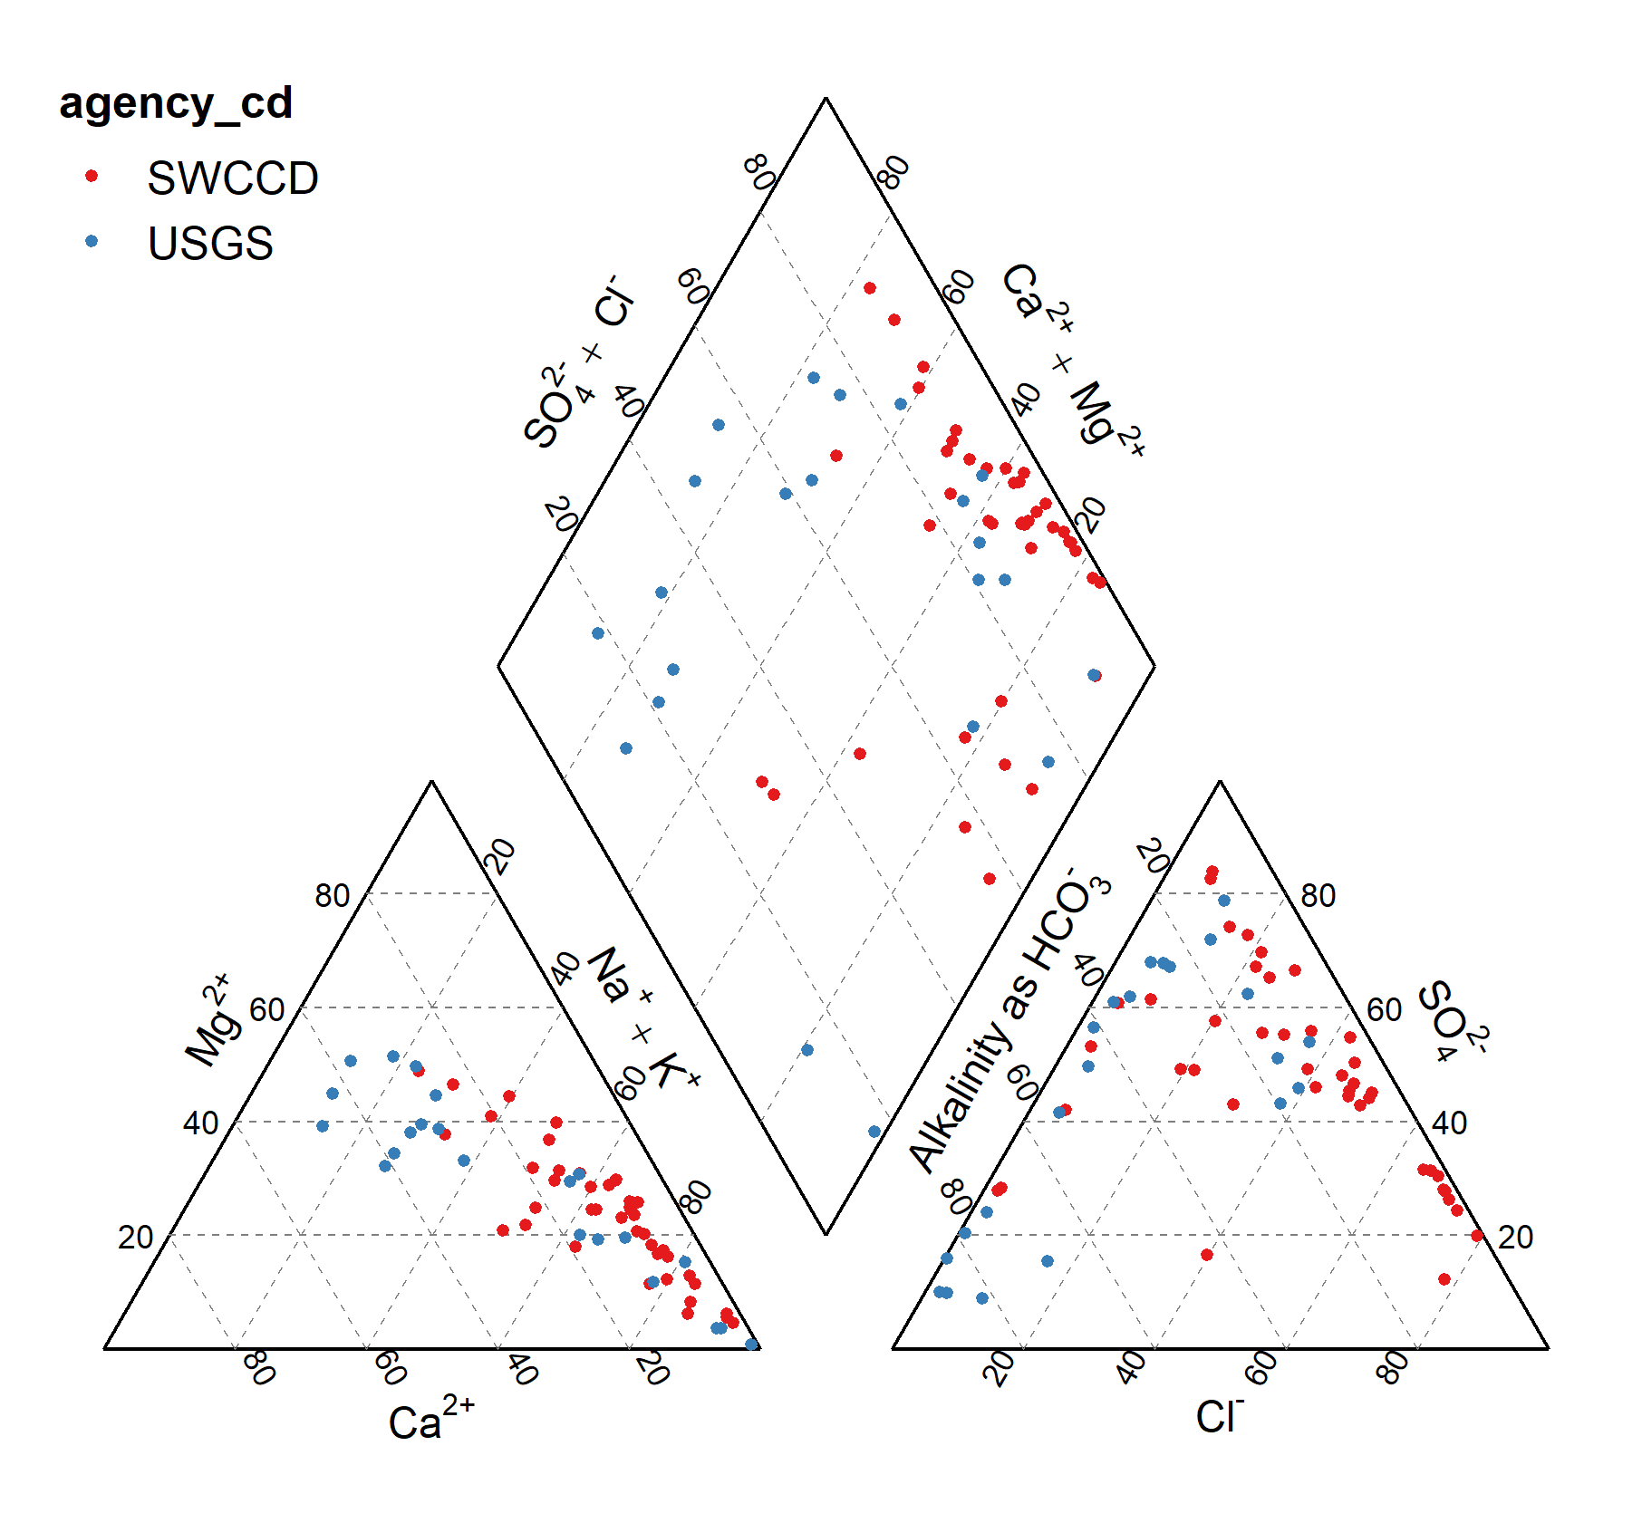

Figure . Piper plot of relative ionic composition (in microequivalents) in surface water samples from the Bitter Creek watershed.

Multiple samples from the same location are expressed as medians. Distributions of SWCCD (*red dots*) and USGS (*blue dots*) illustrate the difference between the USGS and SWCCD samples.

Figure . Scatter plots of [Cl−] concentrations versus [HCO3− + SO42−] concentrations from each dataset with multiple measurements.

Multiplesamples collected by SWCCD and WQD were more likely to include chloride-dominant mixtures. The ratio of the ionic mixture below the solid red line is ≥ 1 and below the dashed red line is > 5 ([HCO3−] + [SO42−])/[Cl−]. Chloride-dominant (*purple circles*), mixed (*blue circles*), strongly [HCO3¯ + SO42¯]-dominant (*gray circles*).

Figure . Scatter plot from the Combined dataset using all samples depicting relative concentration of [HCO3−] + [SO42−] and [Cl¯] with multiple measurements.

The ratio of the ionic mixture below the solid red line is ≥ 1 and below the dashed red line is >5 ([HCO3−] + [SO42−])/[Cl−]. Chloride-dominant (*purple circles*), mixed (*blue circles*), strongly [HCO3¯ + SO42¯]-dominant (*gray circles)*.

## 3.3 Categories for Analysis of Ion Mixtures in Bitter Creek Watershed

We sorted sites into three categories based on anion dominance (Table 4). Three datasets, SWCCD, WQD, and USGS, contained concentrations of the three anions used for categorization (Figure 7), and the data were also combined into a single dataset (Figure 8 and Table A.6).

The three categories of anion dominance are chloride-dominant, mixed, and [HCO3-+ SO42-]-dominant. Samples with Cl¯ concentrations equal to or greater than the concentration of [HCO3¯ + SO42¯] on a mass basis (mg/l) were identified as chloride-dominant mixtures. Samples were identified as “mixed” on a mass basis (mg/l) when these samples had more than one and up to five times as much [HCO3¯ + SO42¯] as [Cl¯]. When mixtures had more than five times as much [HCO3¯ + SO42¯] as [Cl¯], they were identified as “[HCO3¯ + SO42¯]-dominant mixtures.”

### 3.3.1 Dominance of Ionic Mixtures in Bitter Creek Watershed Datasets

All three mixture categories contained some of each anion, even though each may not be dominant. Mixed or strongly [HCO3¯ + SO42¯]-dominant mixtures occurred across the SC range observed in the watershed (Figure 9 and Figure 11).

Figure . Correlation matrix comparing SC to the relative ion concentrations.

Correlations were performed using the Combined datasets with multiple measurements. Regressions and *R2* were calculated after outliers (*red dots*) were removed. The fewer chloride-dominated samples may affect the overall strength of those models.

In the USGS dataset, chloride is dominant only at conductivity levels greater than 1130 µS/cm and greater than 410 mg/l chloride (Figure 8 and Figure 9). Of the USGS stations (*N* = 127) less than 2000 µS/cm, only one station exceeded the chronic water quality criteria (WCQ) chloride level > 230 mg/l. No stations less than 5000 µS/cm exceeded the acute WQC of 860 mg/l chloride. In the Combined dataset, 100 percent of stations greater than 6000 µS/cm exceeded 230 mg/l chloride. In longitudinal stream profiles, chloride levels were greater near the confluence with Bitter Creek and for the lower 50-plus RM of Bitter Creek.

Table 4. Number of samples for different ionic mixture categories in different datasets

Note that most of the Cl−-dominant samples were obtained from the SWCCD and WQD datasets, whereas only one Cl−-dominant station was identified in the USGS dataset. This is consistent with the more recent SWCCD and WQD interest in anthropogenic influences in the Bitter Creek mainstem compared to the generally older data from USGS’s broader mission. Ion data for AML and LQD were not complete so are not shown. Datasets with multiple measurements were used for this analysis.

| Dominant anion | ([HCO3−] + [SO42−])/[Cl−] | Number of samples (repeat visits) | | | |
| --- | --- | --- | --- | --- | --- |
|  |  | Combined | SWCCD | USGS | WQD |
| Cl− | ≤ 1 | 93 | 43 | 1 | 49 |
| Mixed | > 1 and ≤ 5 | 439 | 114 | 157 | 168 |
| [HCO3¯ + SO42¯] | > 5 | 410 | 91 | 264 | 55 |

Although preliminary, samples with Cl¯ concentrations equal to or greater than the concentration of [HCO3¯ + SO42¯] on a mass basis (mg/l) were identified as chloride-dominant mixtures and are likely associated with anthropogenic alteration. Samples were identified as “mixed” on a mass basis (mg/l) when these samples had more than one and up to five times as much [HCO3¯ + SO42¯] as [Cl¯] and may be ground water-dominant flows or anthropogenically impacted. When mixtures had more than five times as much [HCO3¯ + SO42¯] as [Cl¯], they were identified as “[HCO3¯ + SO42¯]-dominant mixtures” and may be surface water-dominated flow (Figure 7 and Figure 8). To confirm and refine the ionic signatures associated with different sources, the ionic signature could be compared to high- and low-flow relative conditions or types of effluent.

## 3.4 Correlation Matrix Comparing Relative Ion Concentrations

To examine the relationship between the relative ion concentrations and SC within the Bitter Creek watershed, associations between SC and ion concentrations were evaluated. There is a strong association between [Cl−] ions with SC at locations where [HCO3− + SO42−] is the dominant anion mixture, but, interestingly, the association with SC is only moderate within the Cl¯-dominant group (Figure 9, *top row*), perhaps indicative of the stronger influence of other ions on SC or some of the high SC points being unreliable. Regression slopes of ion concentrations versus SC are steep for all regression mixtures except with HCO3− ions (Figure 9, *3rd row*), which may be indicative of the saturation and equilibration of carbon dioxide (CO2)and HCO3−. With increasing SC at greater mineral concentrations, CO2 increases and is released to the atmosphere.

## 3.5 Estimation of Chloride from Specific Conductivity

To be able to estimate [Cl¯] from conductivity, log-log linear regression models of SC and chloride mixtures were developed. Figure 10 shows the regression models for the Combined dataset and subsets: [HCO3¯ + SO42¯]-dominant, mixed, and Cl−-dominant datasets.

Overall, the Combined dataset regression model for estimating Cl- from SC is judged to be the most relevant for estimating chloride concentrations in samples in the freshwater range of 0–1500 µS/cm because the relationship is strong (*r* = 0.94) and the dataset includes the full range of SC values (Figure 10). Outliers (red dots) were removed before calculating the regression. In contrast, no samples of less than 1130 µS/cm occurred in the chloride-dominant samples and only a few samples are more than 1130 µS/cm in the mixed samples. The [HCO3¯ + SO42¯]-dominant samples have a lower proportion of chloride than the mixed or Cl−-dominant samples.

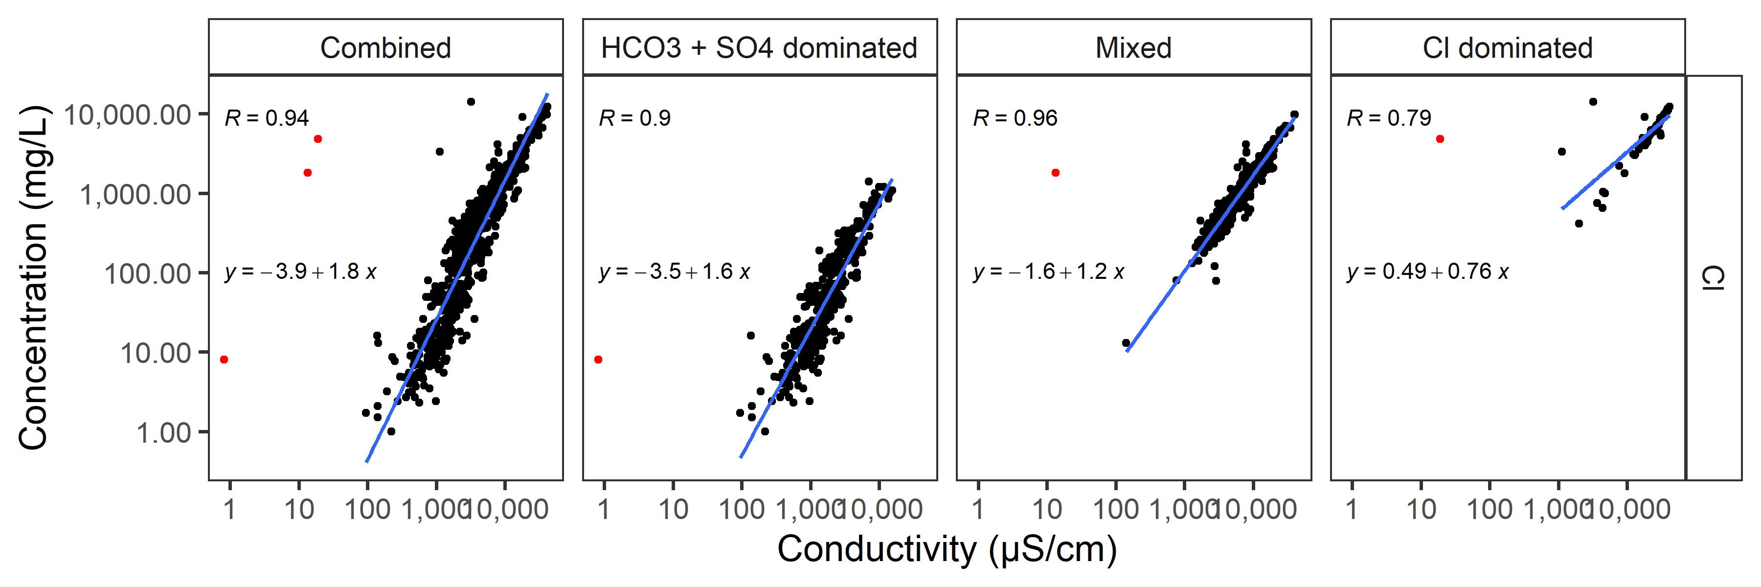

*r* = 0.94

*r* = 0.79

r = 0.96

*r* = 0.90

Figure . Least square regression of log10 SC and log10 chloride concentration used to estimate chloride from SC without outliers.

Combined dataset (*N* = 890); [HCO3¯ + SO42¯]-dataset (*N* = 406); mixed dataset (*N* = 420); and chloride-dominant dataset (*N* = 64). Combined dataset with multiple measurements was used for these models. Note that both *x* and *y* are log10 variables.

## 3.6 Spatial Distribution of Ion Mixtures

The spatial patterns of the different ionic mixtures (Figure 5 and Figure 11) are similar to the distribution of sample locations with higher levels of chloride (Figure 5b). In particular, the area near the confluence of Killpecker Creek and Bitter Creek has higher chloride concentrations, and some are chloride-dominant mixtures.

It is uncertain how much targeted sampling, anthropogenic alteration, geologic anomalies, or chloride sources may have influenced the overall spatial pattern. The area near Rock Springs has many abandoned underground coal mines and the area is characterized by variable strata of the Rock Springs Uplift (Root et al. 1973; ACE 2018). The Rock Springs Uplift is an anticline formed from the Late Cretaceous to the Eocene that was once covered by Lake Gosiute, resulting in the deposit of lacustrine mudflat sediments south of the Bitter Creek mainstem and salty deposits from the drying lake in the southernmost part of the watershed (Morril et al., 2001). However, in the area of Lake Gosiute, surface flow SC is among the lowest in the watershed (Figure 5 and Figure 12), and it is not chloride dominant (Figure 11). The geological composition of the stream bed or ground water may be affected by the series of exposed strata, and the tilt of the strata can alter ground water behavior and may contribute to the different ionic compositions (Mason and Miller 2005); however, samples from streams crossing similar rock strata have different relative ionic compositions and SC levels (Figure 1 and Figure 5). Also, some stations near Rock Springs are not chloride dominant. Mason and Miller (2005) noted that there are large TDS concentrations, small suspended-sediment concentrations, and low stream flows indicative of ground water inflows as well as point discharges from municipal and commercial sources in and near Rock Springs.

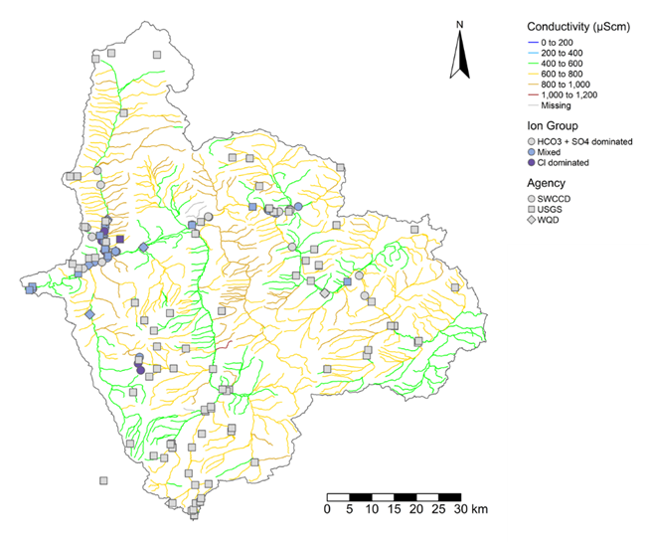

Figure . Spatial distribution of different ion mixtures depicted network of annual mean predicted background SC for stream segments between 2000 and 2015.

Yellow and gold colors indicate higher predicted background SC. Circles, squares, and diamonds indicate medians of measured SC from different agencies and their colors indicate ion mixture types. USGS sampling stations are more uniformly distributed whereas SWCCD and WQD stations are clumped. Purple and blue shapes have a greater proportion of chloride ions than gray shapes (Complete ion data are not available for AML and LQD). Bitter Creek flows east to west. Note that the station on Sage Creek (*lower left, outside of watershed boundary*) resides within the same USGS HUC as Bitter Creek and was included in the USGS and Combined datasets in U.S. EPA’s analyses.

## 3.7 Summary for Ionic Composition: Na+ and SO42− are Dominant, Cl− Indicates Alteration

On average for most of the watershed, the observed ionic matrix is predominately dominated by Na+ and SO42−, with Ca2+, Mg2+, HCO3−, and Cl− also present in lesser proportions. Cl− is only dominant at high SC in a few locations, which indicates that chloride dominance is unlikely to represent background conditions and is presumably the result of anthropogenic alteration. Mixtures throughout the watershed include chloride and sodium owing to the marine and lacustrine origins of some sedimentary deposits, but many may be related to anthropogenic influences. In the area of Rock Springs and the confluence of Killpecker Creek, uplift of strata may bring more chloride-rich deposits closer to the surface. The measured chloride levels are higher near Rock Springs, but there are also anthropogenic sources, such as mine seepage and oil and gas extraction waste. As SC increases, the relative concentration of chloride increases and may be indicative of ground water flow.

Although these conclusions are preliminary, samples with Cl¯ concentrations equal to or greater than the concentration of [HCO3¯ + SO42¯] on a mass basis (mg/l) were identified as chloride-dominant mixtures and are likely associated with anthropogenic alteration. Samples were identified as “mixed” on a mass basis (mg/l) when these samples had less than one and up to five times as much [HCO3¯ + SO42¯] as [Cl¯] and may be mixed ground water-dominant flows, effluent, and surface water flow. When mixtures had more than five times as much [HCO3¯ + SO42¯] as [Cl¯], they were identified as “[HCO3¯ + SO42¯]-dominant mixtures” and may be surface water-dominated flow.

Bitter Creek

Salt Wells Creek

Killpecker Creek

Bitter Creek

Figure 12. USGS stations with observed data within the predicted SC background range.

Forty-eight unique stations throughout the Bitter Creek watershed had observed SC data within the range of the predicted SC background. Proportionally, there are more stations from the Salt Wells Creek drainage and none from upper Bitter Creek mainstem in the eastern portion of the watershed. The observed geomeans are more often less than the predicted values (median of predictions between years 2000 and 2015). Stations where the observed value is less than the predicted value are indicated by *green circles*, and stations where the observed value is greater than the predicted value are indicated by *red circles*.

Higher levels of chloride are more likely from anthropogenic inputs or from altered ground water based on (1) predicted SC levels compared to observed values; (2) observed SC and chloride levels; (3) known sources of chloride; (4) likely ionic signatures of surface water, ground water, and anthropogenic alteration; and (5) different chloride levels with the same geologic strata in difference parts of the watershed (Compare Figure A.3 and Figure A.7 with the geologic map in Figure 1). Additional sampling is needed to attribute local sources and may require isotope analysis to distinguish the relative contributions of natural from anthropogenic sources.

# 5.0 PREDICTED BACKGROUND SPECIFIC CONDUCTIVITY AND CHLORIDE

Background SC from an empirical model was considered as a potential means for estimating least disturbed background in the watershed where SC and chloride were not measured or where SC or chloride was higher than expected (Cormier et al., 2018c; Olson and Cormier, 2019). SC greater than predicted least disturbed background is one piece of evidence that background is altered by anthropogenic sources. In addition to comparing predicted and observed SC and chloride, analyses were used to assess the reliability of reach and watershed scale least disturbed background estimates in the Bitter Creek watershed. The model estimates were also compared to observed SC during periods likely to be dominated by surface flow or ground water flow to evaluate whether the least disturbed background estimates represented surface flow, ground water flow, or the annual average upon which the empirical model was originally developed.

## 5.1 National Random Forest Regression Model

Geology, climate, and other factors were used in a national random forest regression model to predict background SC for each of 1,157 stream segments in the Bitter Creek watershed, as described in section 2.3 (Olson and Cormier 2019; Method A.1). The stream segment file was obtained from StreamCat and the NHD+ stream dataset as defined by the National Hydrography Dataset Plus Version 2 (NHD+) (McKay et al. 2012). Descriptive statistics of the range of least disturbed predicted SC background for stream segments in the watershed are provided in Table 5. Least disturbed predicted background Cl– is calculated from a regression model of observed chloride and SC measurements from the Combined dataset with multiple measurements (Figure 10 and Table 5). Predicted background chloride levels are estimated from the regression model because no random forest model is available for estimating background chloride.

Least disturbed predicted SC values are useful for evaluating whether an ecoregion’s natural background SC may have been altered by anthropogenic activity. Large deviations from observed ambient water quality from predicted values may indicate that the high SC is the result of anthropogenic influences or of ground water dominating the flow during periods dominated by base flow conditions (Cormier et al. 2018c; Olson and Cormier 2019).

## 5.2 Least Disturbed SC Predicted Background at the Watershed Scale

In the United States, the overall variability of natural predicted background for an area can be fairly uniform or quite large (Olson and Cormier 2019). In the Bitter Creek watershed, variability is large because the geological formations exposed to surface and ground water have variable levels of associated salts and precipitation. For example, lower SC is predicted and observed in the southwestern part of the watershed associated with Bishop conglomerate versus the other parts of the watershed (Figure 1 and Figure 5) (Schultz 1920; Aslan et al. 2018); whereas in the dryer eastern parts of the watershed, SC is predicted and observed to be higher. The predicted natural mean background SC in the Bitter Creek watershed ranges from 384 µS/cm to 1004 µS/cm (Table 5). Thus, a single annual background SC estimate does not reflect the relatively broad range of background SC levels that can be expected to occur in the watershed based on geology, soils, and climate. Because the single watershed-wide predicted background estimate is large — as much as 620 µS/cm — the stream segment least disturbed background is a better estimate than the single watershed estimate.

Table . Mean predicted natural background SC estimated from random forest model

Predicted background chloride was estimated from predicted SC and the Combined regression model.

|  | Specific conductivity (µS/cm) | | | Chloride (mg/l)a | | |
| --- | --- | --- | --- | --- | --- | --- |
|  | Killpecker Creek | Bitter Creek | Bitter Creek Watershed | Killpecker Creek | Bitter Creek | Bitter Creek Watershed |
| *N* | 51 | 80 | 1,157 | 51 | 80 | 1,157 |
| Minimum | 414 | 554 | 384 | 5.43 | 9.08 | 4.76 |
| 10thcentile | 445 | 554 | 502 | 6.16 | 9.08 | 7.63 |
| 25th centile | 447 | 567 | 554 | 6.23 | 9.47 | 9.08 |
| Median | 498 | 598 | 645 | 7.53 | 10.38 | 11.86 |
| 75th centile | 528 | 608 | 731 | 8.33 | 10.69 | 14.77 |
| Maximum | 532 | 684 | 1004 | 8.46 | 13.15 | 25.84 |

*Note*: aPredicted chloride estimated from regression model of SC and chloride using Combined dataset regression model conversion to Cl- (Log10(Chloride, mg/l) = -3.87 + 1.76 * Log10(SC µS/cm)) from Figure 10.

### 5.2.1 Stream Segments with Observed SC Less than Predicted Least Disturbed Background SC



Although the Bitter Creek watershed is extensively modified by humans, we wanted to assess whether there are stations that are likely to represent undisturbed background SC. We also wanted to determine whether the random forest model tended to overpredict background in the Bitter Creek watershed as it did in the larger NRSA Xeric Ecoregion (Olson and Cormier, 2019). Because the developers of the available datasets did not designate high quality or least disturbed stations in the Bitter Creek watershed dataset, we made an assumption that stations with geomeans within the predicted background range of SC < 1004 µS/cm are most likely to include a stream segment with undisturbed background. This assumption produced a subset of 48 stations (Figure 12). The more randomly the spatial distribution of stations with observed SC < 1004 µS/cm, the greater the confidence we would have in using the model throughout the watershed. Similarly, the smaller the absolute difference between the observed and predicted SC, the more confidence we would have in the model’s predictions.

#### 5.2.1.1 Spatial distribution of observed SC less than predicted least disturbed background

Stations in the USGS dataset with a geomean < 1004 µS/cm, the predicted maximum background SC, occur throughout the Bitter Creek watershed. However, there are more such stations in the Little Bitter Creek and Salt Wells Creek drainages and fewer in upper Bitter Creek in the eastern portion of the watershed (Figure 12). This may be partly the result of fewer USGS stations in the northern and eastern part of the watershed (Figure 5). However, streams in the southwestern areas are predicted to have lower SC, and there is less resource extraction than in other areas of the watershed. Additional analysis of land use alteration and sources are needed to confirm that anthropogenic alteration accounts for the non-random distribution of stations < 1004 µS/cm. Based on this limited data, however, the use of the empirical model based on spatial distribution of potential least disturbed background SC is supported throughout the watershed.



#### 5.2.1.2. Absolute difference of observed SC versus predicted least disturbed background

Among the 48 USGS stations with observed SC less than the predicted background SC maximum, the MAE is 210.5 µS/cm, and the standard deviation of the absolute difference is 150 µS/cm (Figure 13). This difference is greater than the MAE estimated for the NRSA Xeric Ecoregion, which is 62 µS/cm (Olson and Cormier 2019). Possible reasons for these differences include true differences of least disturbed background in the Bitter Creek watershed, perhaps owing to larger relative contributions of surface or ground water. The dataset of least disturbed stations used to develop the model included mostly perennial streams with multiple samples, whereas the Bitter Creek samples include more intermittent streams and many with one or two samples. Other possible reasons are the inclusion of stations in the dataset that are not least disturbed and have anthropogenic inputs, non-representative sampling, sampling bias, and other issues associated with using available data not specifically designed for estimating least disturbed background.

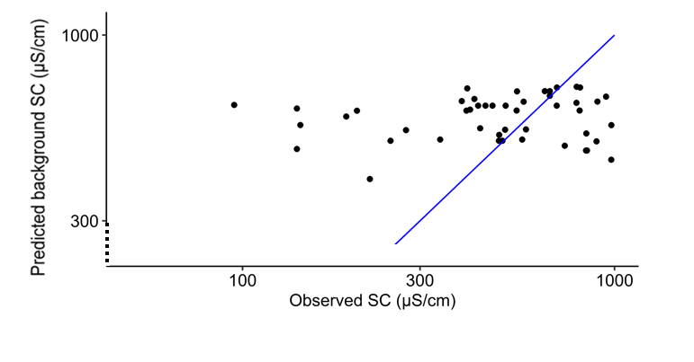



Figure 13.Log-log scatter plots of data from USGS stations with a geomean within the range of predicted natural background (< 1004 µS/cm, *N* = 48).



Seventy-seven percent of the one-time observed values were less than the predicted value, indicating a bias for overpredicting mean background for samples within the range of predicted natural background. Stations with SC less than 430 µS/cm have fewer than four samples and may not reflect the annual average for these stations. *Horizontally aligned circles* are stations on the same stream segment. The *solid blue line* is 1:1 line.

Among USGS stations with a geomean annual background SC < 1004 µS/cm (*N* = 48), 76 percent of the observed values are less than the predicted values (Figure 13). Of those with an annual geomean SC < 700 µS/cm (*N* = 35), most were overpredicted (32 of 35), and all stations with SC ≥ 700 µS/cm (*N* = 13) were underpredicted (Figure 12 and Figure 13). The results of the subset of 13 stations with a geomean ≥ 700 µS/cm suggests that (1) these stations may be anthropogenically altered, (2) observed estimates may be influenced by ground water inputs, or (3) the model may underpredict background SC except in the area influenced by Bishop conglomerate and a few other areas, especially in the southwestern part of the watershed, in which the water has relatively low mineral content compared to the rest of the watershed (Figure 1 compared with Figure 5 and Figure 12).

Bias is low when over- and underpredictions occur randomly (i.e., evenly distributed above and below the one-to-one line). For five of nine stations with more than four samples, the geomean annual SC values are greater than predicted, about an even split. This is not surprising because the summarized predictive SC model output estimated mean least disturbed SC, not daily or monthly values. In contrast, the predicted background for 77 percent of the stations with fewer than three samples are overpredicted. This suggests that the USGS may have selected sampling times to ensure the ability to obtain a sample (i.e., when surface flow was likely to be greater but also when SC tends to be lower). In fact, 45 percent of stations were sampled only between March and June (a four-month span), indicating a bias toward measurement when flow is expected to be higher and/or because they could not be sampled outside this time window because there was no water.

Although, the occurrence of some stations with an observed geomean SC less than predicted background suggests that there are potential examples of undisturbed background SC, 62.5 percent of these stations were represented by a single grab sample (Figure 14). Because we do not have multiple measurements from most of the stations with observed SC within the predicted background range, we know only that some streams occasionally flow at or below the predicted background SC.

Figure 14. Scatter plots sample size versus difference between observed geomean and predicted background.

Scatter plot of sample size and absolute difference between observed SC and predicted background SC. *Points* are individual geomean SC of samples at a station (often with *N* < 3) and *squares* are the geomeans within a sample size category. The variance of the absolute difference between observed and predicted SC decreases from 1 to 5 samples per station. Three stations with five or more samples may include samples with greater ground water influence. Data from USGS stations with a geomean less than the maximum predicted natural background (< 1004 µS/cm, *N* = 48).

#### 5.2.1.3. Sample size

Many of the samples are one-time measurements that may not adequately characterize the annual background. Using the 48 stations with an annual observed SC within the predicted background SC (< 1004 µS/cm) (Figure 12), we generated a scatter plot of sample sizes and absolute differences between observed SC and predicted background SC. Of the 48 stations, 30 were single-grab samples (Figure 14). The variance of the absolute difference between observed and predicted SC decreases from 1 to 5 samples per station. Larger sample sizes reduced the scatter but did not appreciatively reduce the difference between observed and predicted SC. More samples were taken during drier months at the two stations with 19 and 60 samples and, therefore, flow may be maintained by anthropogenic inputs (e.g., Figure 15). Alternatively, if these three stations are truly representative of least disturbed conditions (i.e., minimal anthropogenic inputs), the samples with high SC are likely associated with evaporation and undisturbed ground water dominant flow.

#### 5.2.1.4. Evidence suggesting need for separate surface flow and ground water flow background

To get a sense of least disturbed background SC variability and the possible need for a range or separate background estimates for surface water- and ground water-dominant flows rather than a single background estimate, we compared seasonal SC patterns for streams with at least six observations from the USGS dataset to predict SC during the time that modeling was possible (2000 and 2015). Unfortunately, none of the 48 stations averaging less than the predicted background maximum had long term records that coincided with the later collection period (2000-2025) when satellite imagery and other parameters are available to run the random forest model. For available USGS records between 2000 and 2015, there was no consistency in seasonal patterns (Figure A.12 and Figure A.13). For example, inspection of long-term records from the 1970s and 1980s, indicated that although SC was below modeled background at times, generally between March and August, observed SC had greater variability than might be expected based on the model and resulted in an overall median or annual geomeans greater than the predicted background SC (Figure 15 and Figure A.13). The predicted background empirical model was derived primarily from larger perennial stream data which better represents surface flow than ground water flow (Olson and Cormier 2019). It is evident that SC is low during high flows that are likely to be surface water flow, and SC is higher when flow is low and the stream is more likely fed by ground water or has inputs of anthropogenic flow.

An evaluation of a range of modeled background or distinct backgrounds for surface water- and ground water-dominated flow may be more relevant for evaluating anthropogenic influences than a mean background estimate. For example, Figure 15 shows predicted and observed SC in a stream segment (USGS station 09216565 at Salt Wells Creek, Figure A.8), and while some samples are close to the predicted annual mean background SC (622.2 µS/cm), the observed geomean is 1046 µS/cm. Also, the SC range may be an order of magnitude greater than the MAE predicted by the model even if precipitation and temperatures were greater than during the observed period. The variability of observed SC in this stream is relatively large and high SC occurs for more months out of the year than low SC. As such, a single grab sample is unlikely to be particularly informative with respect to the annual character (i.e., variability) of the stream segment, nor is the single value likely to match the annual mean value.

For the few stations with multiple measurements in the watershed with a geomean < 1050 µS/cm, the SC minima often fall below the predicted background, but the annual observed geomean is often higher (Figure A.13). One interpretation is that for part of the year, the SC is at the predicted SC, but the annual average will be higher and more strongly influenced by the longer dry periods when ground water may dominate flow. Although a simple national-level calibration of the model has been applied to streams (Olson and Cormier 2019), this does not seem appropriate for the Bitter Creek watershed in the Xeric Ecoregion because most streams in the national model were larger, perennial streams. As such the model was calibrated to fit SC with interactions between precipitation and upper geologic strata, and not baseflow conditions dominated by groundwater flows and interactions with deeper strata leading to considerably higher SC. It is noteworthy that in contrast to the low-flow periods, the model does a reasonable job capturing the lower average SC during periods where there is at least moderate flow despite using precipitation data from a different decade. The model’s apparent inability to model the low flow periods would negatively impact the ability to model either annual means or seasonal variability. Therefore, a separate predicted background estimate for ground water flow appears to be needed that would bound the upper background SC range for streams in the Bitter Creek watershed.

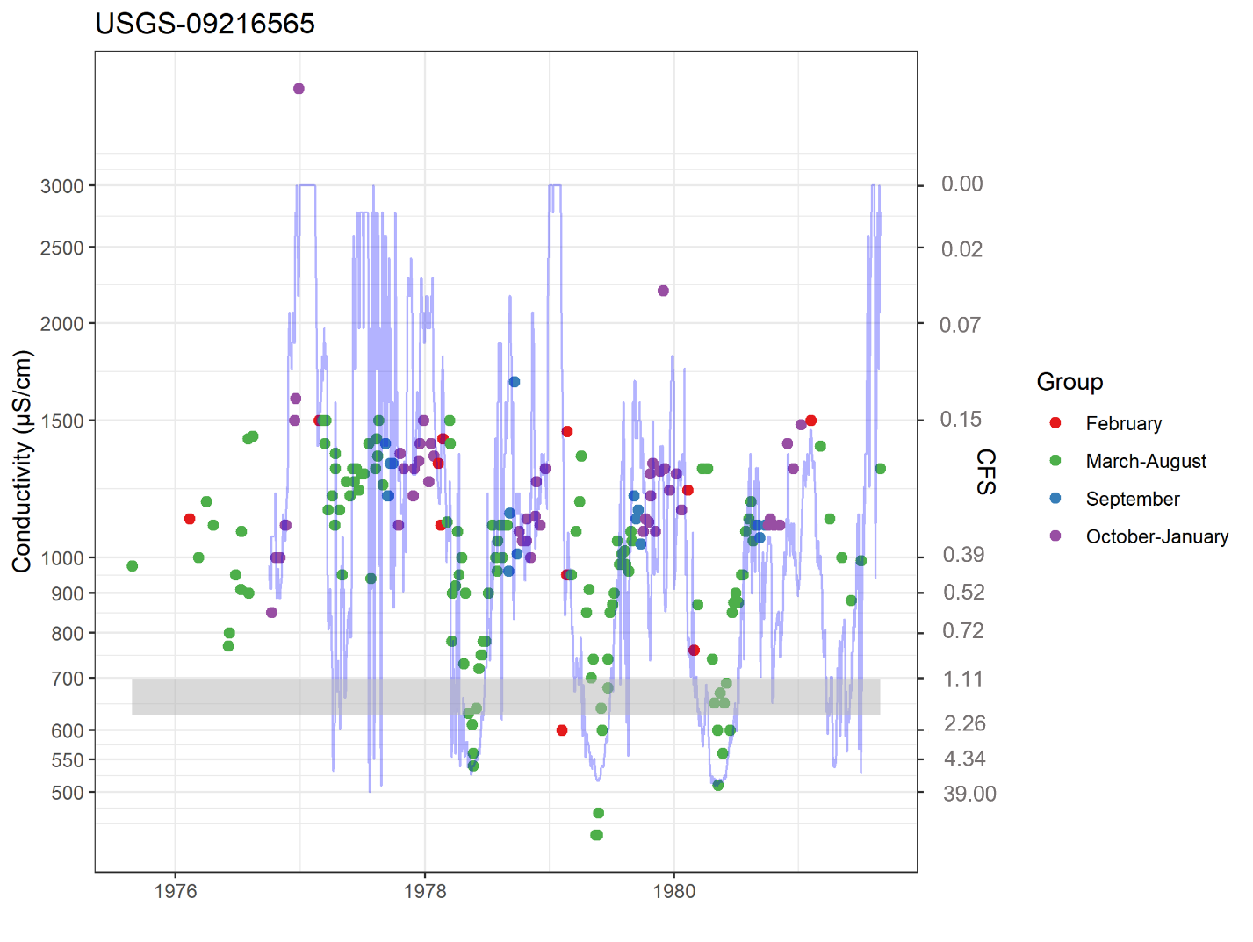

Figure 15. Example of pattern of observed SC and stream flow and predicted SC range.

Data for USGS station 09216565 at Salt Wells Creek: Observed SC (*circles*) and observed hydrologic flow (*solid blue line*) shown for comparing flow pattern with SC. Minimum and maximum predicted SC (gray bar) shown as for comparison with observed SC, predicted range if between 2000-2015 because satellite data were not available to run models for 1975–1983. Least disturbed background is predicted to vary < 62 µS/cm during the year based on the MAE of reference stations in the NRSA Xeric Ecoregion and 210 µS/cm based on the 48 stations less than 1004 µS/cm. Note that observed SC values (*circles*) are sometimes less than or equal to the predicted background SC gray bar, but the average annual SC exceeds the predicted background SC. The predicted annual mean and median for this site were 622.2 µS/cm and 660.9 µS/cm, respectively. The observed geomean was 1046 µS/cm, resulting in a difference between the predicted median and observed geomean of 385 µS/cm. Note right *y*-axis is inverted. CFS = cubic feet per second.

### 5.2.2 Considerations for Comparison of Observed and Predicted SC

Observed least disturbed values represent actual measured conditions and are potentially more locally relevant than models. If the observed SC at a station is lower than the model prediction plus the Bitter Creek MAE (210 µS/cm), this lower observed SC is a true background *for that stream on that day for those environmental conditions*. It may not represent the annual background SC regime for the stream, but then again, it might. Without more information, the conservative position is to assume that the observed SC is the valid background for surface water flow rather than a higher predicted background until data can be collected to show otherwise. Furthermore, where the observed value is equal to or lower than the predicted natural background from regional least disturbed stations, the station could be in a nearly natural state and additional sampling may be worthwhile to ensure its characterization and protection.

Conversely, when observed SC during surface water flow conditions is greater than the predicted natural background plus the MAE, then that is evidence of an anthropogenically altered SC region because the model tends to over predict not underpredict SC (Table 2). However, it is only one piece of evidence and not sufficient evidence alone. In the absence of other types of evidence such as time order of SC changes, co-occurrence with sources, known mechanisms, etc. (Cormier et al. 2010), the predicted least disturbed background at such a location is a more realistic estimate of natural surface flow background than the greater observed value. This is because mean predicted background is independent of anthropogenic determinants and, therefore, more likely to characterize surface water flow background for the location rather than a higher observed SC.

In summary, anthropogenic influences are suggested where the observed value is more than 210 µS/cm greater than the modeled value and the following conditions apply:

Observations are known to have been taken during surface flow conditions

Observed values are greater than values predicted by the model

There are no observations prior to potential disturbance to establish that SC has not changed

There are possible sources of dissolved mineral from anthropogenic inputs or flow alteration

There are no known natural sources such as salt springs nor consistent cooccurrence with similar rock strata

Based on what we know about least disturbed streams in the NRSA Xeric Ecoregion, we can make some assumptions about streams that have measured SC lower than model predictions or higher than model predictions. In watersheds with no human influence, the background water quality for any parameter, including SC, is what is measured in the stream and is related to the environmental conditions on that day. For example, during the year, evapotranspiration, evaporation, precipitation, and ground water influences vary, causing natural background mineral content to fluctuate. In some ecoregions in the United States, long-term daily measurements for streams with natural background show that SC remains relatively constant and seasonal variation is greater where there are anthropogenic influences (U.S. EPA 2016). Also, where climate is becoming more arid, soil and stream SC is increasing (Hassani et al. 2021; Olson 2019). In the NRSA Xeric Ecoregion, which includes the Wyoming Basin, the MAE was 62 µS/cm (Olson and Cormier 2019) and the MAE for the Bitter Creek watershed is 210 µS/cm. Therefore, when observed surface flow conditions occur and SC is greater than the predicted background SC plus the MAE for the Bitter Creek watershed (210 µS/cm), then anthropogenic influences are likely altering the SC regime.

### 5.2.3 Summary of Predicted Background SC

Because of the high levels of anthropogenic alteration within this watershed, observed datasets could not be assumed to encompass natural background levels. The development of the random forest model used least disturbed stations across the United States, thereby reducing the effects of anthropogenic influence when predicting background levels. However, as with any model, validation and ground-truthing is an important step. Because of its size, distribution, and spatial characteristics, the USGS dataset was chosen to site-specifically validate the model predictions. The model results are comparable to values in the lower end of observations in the USGS dataset distribution. However, the observed background (10th centile) from the USGS dataset was slightly lower than the comparable metric from the model of the predicted median of least disturbed stations, suggesting that the model is generally accurate within the Bitter Creek watershed but predicting slightly higher for what appears to be surface water flow conditions. Gaging station SC and flow records suggest that the predicted background estimates may represent surface flow-dominant conditions rather than base flow conditions dominated by ground water.

# 6.0 WATERSHED SCALE OBSERVED BACKGROUND SPECIFIC CONDUCTIVITY AND CHLORIDE

Analyses in the previous section indicate that least disturbed background differs with surface and ground water flow dominance. We used a weight-of-evidence approach to estimate surface flow dominant background SC. However, without verified least disturbed sampling stations nor a predictive regional model for ground water dominant flow, we are unable to precisely estimate the SC dominated by ground water flow. Therefore, we developed a provisional model to estimate SC background for ground water dominant flow (described in Section 7.1).

## 6.1 Considerations Used for Assessing Observed Background Specific Conductivity and Chloride

Available measured stream data were not specifically designed to estimate background SC; therefore, many factors were considered before choosing a dataset that might be suitable for estimating background SC and choosing an appropriate statistical endpoint (e.g., a centile). These considerations are listed in Table A.2 and Table A.3 and results are summarized at the end of this section in Table 8.

A weight-of-evidence approach was adapted from Cormier et al. (2018c) and U.S. EPA (2017) to assess surface flow background water quality SC and chloride for the watershed. Weighing all available and relevant evidence provides greater confidence than a single line of evidence, because it is more likely that the body of evidence will be adequate, and the resulting inference will have built-in checks and validations. A list of considerations was developed that relate to the following questions:

A. Data quality and suitability—Do the available sampling methods, design, and number of samples in the watershed meet data quality needs for performing an assessment of the background SC and chloride?

E. Observed water chemistry—What is the most suitable observational dataset and statistic to provide the most relevant and reliable estimate of background SC and chloride used in stream measurements?

### 6.1.1 Data Quality and Suitability

#### *6.1.1.1 Ecoregional observations*

The Wyoming Basin data were assembled by Griffith (2014) from several U.S. EPA probability-designed surveys (*N* = 39). No transcriptional errors were noted; however, two stations in the Griffith (2014) dataset were outside the ecoregion and estimates were revised by Cormier et al. (2018b). In the Wyoming Basin Ecoregional dataset, the ecoregional samples were most likely sampled during a spring (April) to summer (September) index period. The ionic matrix reported for the Wyoming Basin Ecoregion is dominated by Ca2+ salts, whereas the ionic composition in the Bitter Creek watershed is often dominated by Na+ salts, even at locations with low conductivity. Overall, the ecoregional estimate of background is considered to be representative of the watershed but less relevant because the Wyoming Basin covers a large geographic area, may not represent surface flow conditions or an annual average, has a different ionic composition, and is less reliable because of a small sample size. The Wyoming Basin dataset was used in this study for comparative purposes only.

#### 6.1.1.2 Watershed observations

Probabilistic sampling designs were not used by the collecting entities because their objectives were not intended to establish background or condition estimates for the watershed. Some datasets were small and focused on mined areas or point sources (e.g., AML, LQD, and WQD datasets). One dataset was related to local interests (SWCCD). Therefore, several dataset characteristics were used to assess the suitability of observational datasets available in the Bitter Creek watershed. Some influential considerations are described below and summarized in Table 8, Table A.2, and Table A.3. Based on size, sampling bias, and/or data entry error rates, the SWCCD, AML, LQD, WQD, and Combined datasets were considered less reliable for estimating surface flow background SC (Table A.2). The USGS dataset was a more representative and reliable set of observational data. The quality and suitability of different datasets were variable. Data quality and suitability characteristics are summarized in Table 8 and Table A.2.

**Dataset quality:** Extreme low values in the SWCCD dataset,( e.g., 0.71 µS/cm and 0.82 µS/cm) and 18.98 µS/cm in the WQD dataset are likely data entry errors (Table A.4 and Table A.5). When data are moved between some programs, the Greek letter mu (µ) is sometimes converted to the letter “m” resulting in an under-reporting error of 1000x. It is likely that 0.71 µS/cm suffered this type of degradation at some unknown stage prior to receipt by U.S. EPA and was originally 710 µS/cm. Another common data management error occurs when a column shift moves data under an incorrect parameter header. It is not possible for us to determine if these data or other data in the mid-range of values had similar errors with units. SWCCD has 23.95 percent repeated values, which may be indicative of data management issues, and 2.38 percent of values are less than 10 µS/cm, which are likely incorrectly recorded units and may indicate that there are other undetected errors greater than 10 µS/cm. For this reason, the SWCCD and the Combined datasets were judged to be less reliable and used for comparison purposes only.

**Dataset range:** Histograms of the distribution of SC values levels were prepared to determine if the datasets represented the entire SC range in the watershed and whether data were skewed and, therefore, less representative of background conditions in the watershed (Figure A.9 and Figure A.10). Most of the datasets covered the range likely to include background except the AML dataset with a minimum (2430 µS/cm) that clearly exceeded the upper threshold for a natural sample that was not anthropogenically impacted. The SWCCD dataset was strongly kurtotic (10.58). A kurtosis of less than 3 corresponds to longer tails and more outliers. Only the USGS dataset was not skewed toward SC values likely to represent anthropogenic influences and contained many values in the freshwater range

**Dataset sample size:** The two largest datasets (SWCCD, *N* = 59 stations and USGS, *N* = 143 stations) had multiple samples at stations, but they exhibited different spatial patterns and different SC and chloride levels (Figure 5).

**Spatial distribution of dataset:** The USGS dataset and the Combined dataset (likely by inclusion of the USGS dataset in the Combined dataset) are spread across the watershed. The other datasets had few stations or were mostly concentrated near Rock Springs (i.e., SWCCD). Stations with low SC and chloride levels are distributed throughout the watershed, but there is some spatial clustering (Figure 5). In particular, the southwest portion of the watershed has more low SC measurements than the rest of the watershed (Figure 5). These differences may be the result of less anthropogenic sources that were not fully explored in this study, but there is also more precipitation in the southwestern drainage. The areas along the Bitter Creek mainstem with higher chloride values and extreme SC variance warrant closer examination to ascertain the cause; however, performing a local causal assessment is outside the scope of this effort (Norton et al. 2014).

**Ionic matrix:** The ionic matrix in the USGS dataset appears to be more similar to the expected natural background mixture. For example, the USGS dataset had only one sample station with chloride-dominant samples, whereas the SWCCD dataset had more than one (Table 4 and Figure 7). Cl−-dominant mixtures occur only at high SC and not in the range of the potential observed or predicted background estimates (Table 6 and Table 7). The greater number of stations with high observed Cl− and very high SC in the SWCCD dataset is indicative of more human disturbance than is represented in the USGS dataset. Therefore, the USGS dataset was judged to be more representative of background for the watershed than the SWCCD dataset.

6.1.2 Summary of Watershed Observational Data

Of the observed datasets, the USGS dataset was judged to be more reliable and suitable for estimating natural background. The USGS dataset was quality assured, large, spatially distributed across the watershed, had a more normal distribution than the other datasets, and had no apparent data entry errors. However, the dataset is older, sampling intensity is variable, and it had many single grab samples and a few heavily sampled locations. To reduce bias from multiple measurement from a station, most analyses used the dataset comprised of station medians. Weighing these several factors, the USGS dataset was judged to best represent the distribution of SC and chloride concentrations from the available observational datasets.

## 6.2 Selection of Statistic to Represent Background from Acceptable Observed Data

Conventionally, the 75th centile of observed data from least disturbed reference sites is often used to estimate background. No reference or high-quality sites were identified in the available datasets, so the 75th centile was not selected.

The 25th centile from a probabilistic sampling design (e.g., NRSA and Environmental Monitoring Assessment Program [EMAP]) from regions without extensive anthropogenic disturbance has been shown to be similar to the 75th centile of reference stations, but others have contradicted this assumption (U.S. EPA 2000; Herlihy and Sifneos 2008; Stoddard et al. 2006). Following convention, the 25th centile was selected for the Wyoming Basin Ecoregional background estimate.

The selection of a statistic to characterize background from the Bitter Creek watershed is less clear because the datasets do not use a probability design and contain samples from anthropogenically altered landscapes. The 10th centile has been used by others as the default statistic to estimate a least altered background condition (Cormier et al. 2018c; Stoddard et al. 2006). Although there were some stations that conceivably could represent background, there has been no ground truthing and there is extensive anthropogenic alteration in this watershed, especially near the eastern headwaters, along the Bitter Creek and Killpecker Creek mainstems, and near Rock Springs. Furthermore, there is a large SC step increase from the 10th centile to the 25th centile, suggesting that the 25th centile is not the watershed background. Therefore, for the USGS watershed dataset, the 10th centile rather than the 25th centile was selected to estimate surface flow background SC.

For the reasons stated above and because the watershed has extensive anthropogenic alterations, the more conservative statistic of the 10th centile was selected for estimating surface flow background SC from observed data from the USGS dataset.

## 6.3 Magnitude of Observed ***Water Chemistry*** Background Estimates

### *6.3.1 Ecoregional Observations*

The Wyoming Basin dataset is based on a probability sample design, so the 25th centile of the dataset was used to characterize background. The 25th centile of a small probability sample (*N* = 39) reported by Griffith (2014) for the Wyoming Basin Ecoregion was 341.4 µS/cm (Table 3) and 38.9 mg/l for chloride.

Overall, the ecoregional estimates of background SC and chloride are considered to be representative of the watershed, but less relevant than other estimates because the Wyoming Basin covers a large geographic area, the data may not represent an annual average, and the ionic composition of waters in the basin are different than in the watershed. The ecoregion background estimate is less reliable because it is estimated from a very small sample size given the size of the Wyoming Basin geographic area.

### 6.3.2 Watershed Observations

Within the watershed, there were no datasets from sites identified as reference, high-quality, or less disturbed stream catchments. A probabilistic sampling design was not used by the collecting entities because their objectives were not intended to establish background estimates. In the absence of these types of datasets, using a centile less than or equal to the 10th centile to estimate background SC is a common default. Using the 10th centile is also supported because there are extensive anthropogenic influences in the watershed (see the Background statistic and selection of background endpoint sections of Table 8).

Both predicted and measured SC levels in the Bitter Creek mainstem were greater than in the southwestern drainage of Salt Wells Creek (Figure 5 and Figure 11). Killpecker Creek was predicted to have lower background SC levels in its headwaters, with SC levels becoming progressively higher toward the mouth. This pattern was also observed in the measured data (Figure A.4 to Figure A.8). Between the upper Bitter Creek and Salt Wells Creek runs Black Butte Creek, which is predicted to have a higher background SC than the rest of the watershed; however, there are no stream measurements, perhaps owing to its ephemeral hydrologic regime. These results are consistent with precipitation and hydrologic patterns for the area (ACE 2018).

In the Bitter Creek watershed, the median SC is 1700 µS/cm (Table 6 [USGS dataset]) and the median chloride level is 35 mg/l (Table 7 [USGS dataset]), showing that even at relatively high SC, chloride is typically quite low and well below the WDEQ chronic standard.

Within the Bitter Creek watershed, the 10th and 25thcentile SC values (411 µS/cm and 715 µS/cm, respectively) of the USGS (Table 6) occur within the range of the annual mean predicted natural background SC (384 µS/cm to 1004 µS/cm) estimated from the random forest model using data between 2000 and 2015 (Olson and Cormier, 2019). However, the 10th centile was selected as the best estimate of surface water background SC because of the level of anthropogenic alteration in the watershed.

Table . Descriptive statistics of measured SC (µS/cm) in the Bitter Creek watershed

USGS-measured data are most abundant and more widely distributed in the watershed and are, therefore, more likely to include stations with least disturbed background. These data are comprised of station medians to reduce bias from repeat sampling.

|  | Bitter Creek watershed | | | | | | Killpecker Creek | | Bitter Creek | |
| --- | --- | --- | --- | --- | --- | --- | --- | --- | --- | --- |
|  | LQD | SWCCD | WQD | AML | USGS | Combined | USGS | Combined | USGS | Combined |
| Number of stations | 10 | 59 | 13 | 13 | 143 | 238 | 6 | 30 | 39 | 238 |
| Minimum | 73 | 1 | 1497 | 2430 | 95 | 1 | 508 | 508 | 409 | 1 |
| 10th centile | 367 | 756 | 3018 | 4086 | 411 | 481 | 543 | 958 | 1776 | 481 |
| 25th centile | 537 | 1699 | 6627 | 4575 | 715 | 993 | 679 | 2251 | 2575 | 993 |
| Median | 1750 | 4840 | 13533 | 5940 | 1700 | 2340 | 1165 | 9330 | 3775 | 2340 |
| Maximum | 6620 | 39200 | 30637 | 12630 | 30800 | 39200 | 8000 | 39200 | 30700 | 39200 |

*Note*:Zero entries were removed from the dataset because they may be dry or data management errors.

Table . Descriptive statistics for measured chloride (mg/l) in the Bitter Creek watershed

USGS-measured data are most abundant and more widely distributed in the watershed and are, therefore, more likely to represent background conditions. Data are comprised of station medians to reduce bias from repeat sampling.

|  |  |  |  |  |  |  |  |  |  |  |
| --- | --- | --- | --- | --- | --- | --- | --- | --- | --- | --- |
|  | Watershed | | | | | Killpecker Creek | | | Bitter Creek | |
|  | LQD | SWCCD | WQD | AML | USGS | Combined | USGS | Combined | USGS | Combined |
| Number of stations | 15 | 52 | 13 | 13 | 132 | 225 | 6 | 30 | 38 | 78 |
| Minimum | 3 | 7 | 25 | 73 | 1 | 1 | 2 | 2 | 4 | 4 |
| 10th centile | 4 | 26 | 298 | 207 | 4 | 5 | 9 | 23 | 62 | 34 |
| 25th centile | 14 | 191 | 644 | 551 | 9 | 15 | 16 | 139 | 168 | 168 |
| Median | 38 | 938 | 1904 | 1260 | 35 | 110 | 21 | 2634 | 475 | 518 |
| Maximum | 343 | 16100 | 8340 | 7210 | 7800 | 16100 | 1200 | 15500 | 7800 | 7800 |

### 6.3.3 Temporal Characteristics of Observed SC and Flow

Because measured SC and chloride estimates are not static and may vary throughout the year, seasonal background estimates were characterized. In reference streams in other watersheds, the seasonal pattern varies less than when there are anthropogenic influences. For example, the least disturbed Sisquoc River in California, also in the NRSA Xeric Ecoregion, varies about 150 µS/cm annually (Olson and Cormier, 2019). The analyses described below were performed to determine if background estimates for surface and ground water flow could be estimated from SC and/or flow regime. Unfortunately, although the overall pattern of high flow and lesser SC is evident and low flow and greater SC is the norm (Figure 15, Figure 16, Figure 17, Figure 18, Figure A.11, and Figure A.12), their interactions and anthropogenic influences interfered with making separate quantitative background estimates for surface water- and ground water-dominant background ranges using observed SC. The analyses and results are described below and followed by a pragmatic approach for estimating background in Section 7.0.



We also looked at flow and conductivity levels of all available USGS stations with at least six measurements (Figure A.11 and Figure A.12). Three examples of paired flow and conductivity measured in different months are shown in Figure 16. In each example stream, the lesser SC observations generally coincided with the highest flow. Note that these gaging stations are not located at sites where natural background conditions are thought to exists, but are nonetheless useful to visualize how flow affects SC.



In Bitter Creek near Bitter Creek, WY, in the upper mainstem (USGS station 09216545), the lowest paired SC coincided with the highest flows, which occurred in April with less than 120 cfs (Figure 16a). In Bitter Creek near the confluence with Salt Wells Creek (USGS station 09216562), the highest flow and lowest SC occurred in March (Figure 16b) with flow less than 100 cfs; however, at greater than 200 cfs, SC was higher in July and August. In Salt Wells Creek near South Baxter, WY (USGS station 09216565), at stream lower flows, the lowest SC coincided with the highest flows, which occurred in May (Figure 16c). Based on these few stream gages, higher seasonal flow and conductivity values can occur during different months, but SC appears to be lower during higher flow. However, the variation in SC at each of these sample stations was larger than would be expected and may be attributed to anthropogenic influences in USGS station 09216545 and USGS station 09216562.



**c**

**b**

**a**

Figure . Paired SC (µS/cm) and flow (cfs) at three USGS gaging stations and identified by month.

*Graph a*, USGS station 0921545, Bitter Creek south of town of Bitter Creek; data from 7/17/1975–10/1/1981. *Graph b*, USGS station 0921562, Bitter Creek near mouth of Salt Wells Creek; data from 11/17/1975–9/2/1981. *Graph c*, USGS station 0921565, upper section of Salt Wells Creek near South Baxter, WY; data from 8/27/1975–8/28/1981. Note that these are likely anthropogenically influenced stream segments and may not represent background conditions.

To characterize the magnitude of flow and SC variability throughout the year, SC and hydrographs of flow were examined for six USGS gaging stations operational in the 1970s and 1980s. Highest flow, assumed to be surface water dominated, occurred in March through May based on median flow (Figure 18 and Figure A.11). The lowest flow, assumed to be ground water flow, was in January. Although an analysis using restricted time periods may isolate influences of low and high flow, the sample sizes would be small. We then considered seasonal patterns of SC; in general, the SC pattern exhibits an inverse pattern with flow (Compare Figure 17d and Figure 18). January has the highest SC and, depending on stream gage, March through May have the lowest SC. Surface water flow and ground water flow cannot be discriminated from one another because of the intra- and interstation variability.

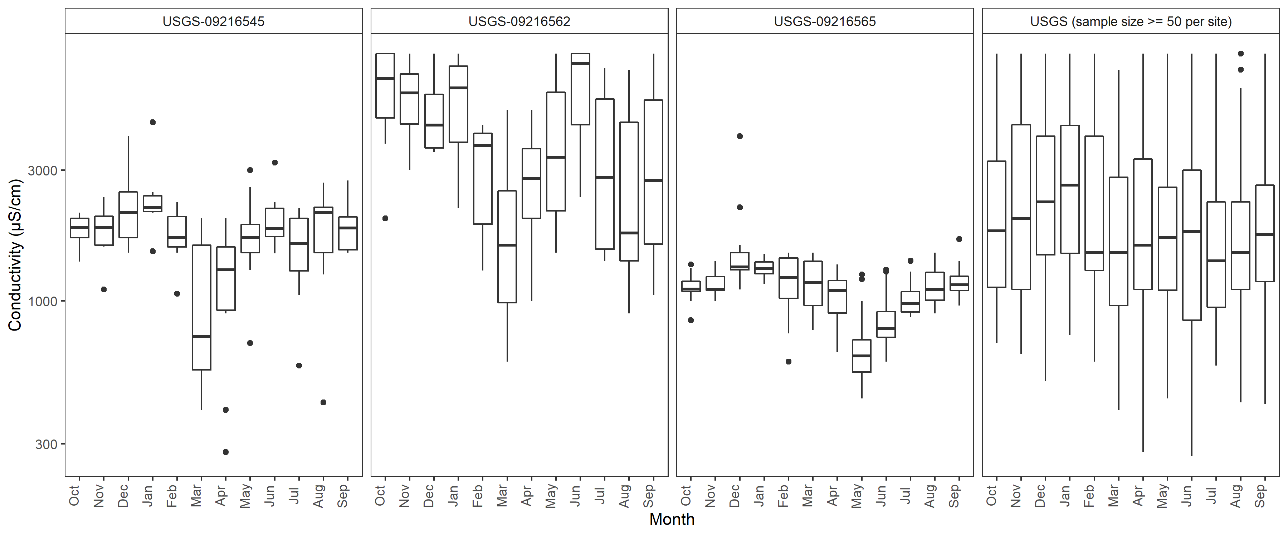

a

c

b

d

Figure . All samples in the watershed from the USGS dataset used to assess low- and high-conductivity seasons.

Box plots by month at three-sample USGS long-term monitoring stations. Lower median SC occurs in March through September. Note that these include anthropogenically influenced stream segments and may not represent background conditions. *Box plot a*, USGS station 0921545, 7/17/1975–10/1/1981, Bitter Creek south of town of Bitter Creek, maximum stream flow 333 cfs. *Box plot b*, USGS station 0921562, 11/17/1975–9/2/1981, Bitter Creek near mouth of Salt Wells Creek, maximum stream flow 411 cfs. *Box plot c*, USGS station 0921565, 8/27/1975–8/28/1981, upper section of Salt Wells Creek near South Baxter, WY, maximum stream flow ~39 cfs. *Box plot d*, by month for all USGS stations with more than 50 samples per station (*N* = 7).

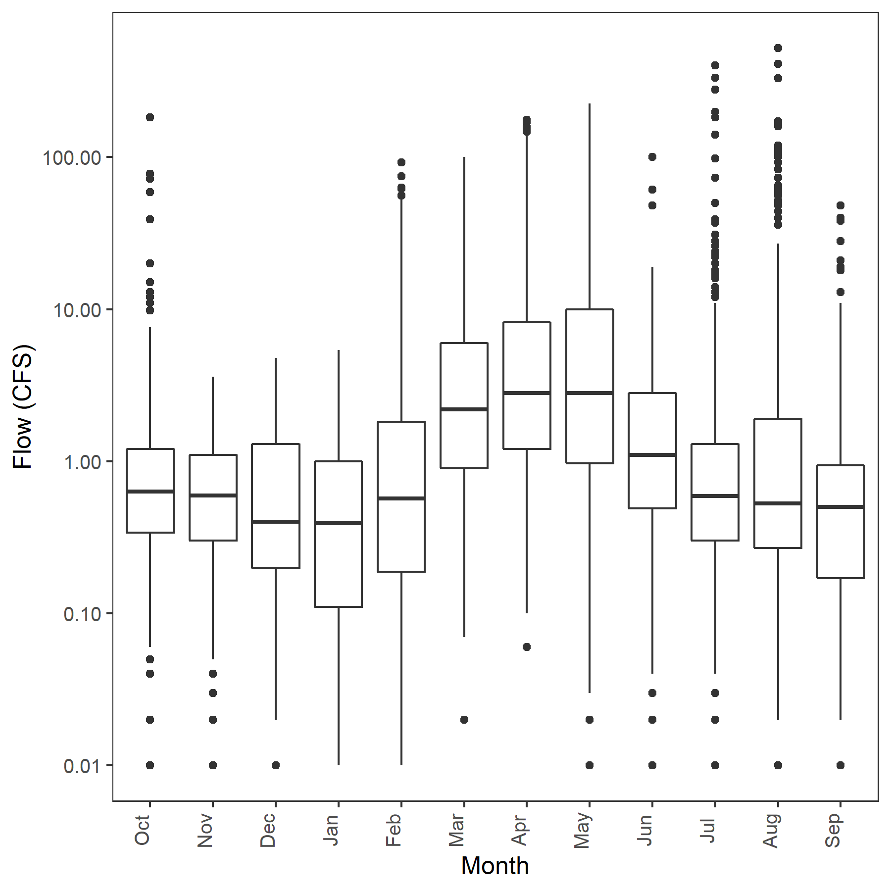

Figure . Box and whisker plot of stream flow (cfs) based on six historical USGS stream gages.

Flow is greater from March to May and less November to January. High flows indicated by whiskers also occur in February through October. Flows among gaging stations are not normalized; zeros were removed before analysis.

## 6.4 Summary of Weight of Evidence of Background Estimates

A weight-of-evidence approach was used to evaluate dataset quality, suitability, scale, and statistics to best represent background SC and chloride levels from observational data (Table 9 and Table A.2). The weight of evidence revealed that the available observational data were not as useful as estimates from the predicted background model because it was not possible to confidently identify least disturbed SC or chloride records. Also, the large natural SC range makes the estimate of a single watershed value imprecise for local conditions. However, the analysis is useful for illustrating these issues and asserting that both surface water and ground water background are needed for identifying anthropogenic influences.

Among the five agency datasets and a combined dataset, the USGS dataset was identified as more representative and suitable for characterizing surface flow SC and Cl─ from observational data (Table 8 and Table A.2). The SC measurements are more normally distributed in the USGS dataset for both the dataset with multiple measurements and the dataset composed of station medians (Figure A.9 and Figure A.10). The USGS dataset was also more widely spread across the watershed than the other datasets (Figure 5). No potential data reporting errors were identified in the USGS dataset, as they were in the other datasets, and the dataset was large with 1,088 samples from 143 stations. The 10th centile statistic was selected to estimate background SC and Cl¯ concentrations for this dataset because the dataset is not a probabilistic sample and because the watershed is anthropogenically altered, but surface water flow and ground water flow could not be fully isolated for distinct analyses.

The background and SC chloride levels of surface flow, estimated at the 10th centile of the USGS station median dataset, are 411.2 µS/cm and 3.94 mg/l, respectively.

In summary, although a single surface flow background SC value was estimated for this large watershed using observational data, the estimate is imprecise for local conditions. Also, least disturbed background for ground water flow was not estimated from observational data because of the lack of verified least disturbed stations and because anthropogenic influences at higher SC levels could not be discriminated from natural ground water influences using the limited data sets with samples with multiple measurements during drier months. However, in section 7.1, we describe a provisional model for estimating ground water dominant background at the stream segment scale.

Table . Weight-of-evidence table for selection of method, dataset, and statistic for surface flow background SC and Cl− in Bitter Creek watershed

A plus sign or signs indicate support (+) or strong support (++) of the consideration based on relevance or confidence. A minus sign (─) weakens the consideration based on relevance or confidence. Zero (0) indicates ambiguous weighting that neither strengthens nor weakens.

|  | Relevance |  | Confidence and justification |  |
| --- | --- | --- | --- | --- |
| Scale | | | | |
| Ecoregion | Regional statistics are only somewhat relevant to a watershed due to variance in geology, ionic composition, and physiography. | + | The Level III Wyoming Basin Ecoregion 25th centile (341 µS/cm) is consistent with the Bitter Creek watershed background from observed values (411 µS/cm) and with the lowest predicted background (384 µS/cm). However, this is a small dataset with different dominant ions compared to the Bitter Creek watershed. | + |
| Watershed | A watershed is most relevant to itself but may be altered from background. | + | Xeric conditions and the ephemeral and intermittent flows of streams increase the variability likely to occur throughout the watershed and site-specific background may be more accurate. | + |
| Stream segment | Stream segment is most relevant to itself, but the stream may be altered or there may be no observed data. | ++ | Observed background in a stream segment is dependent on ground truthing stations but are not available for this study. | 0 |
| Predicted background is not dependent on ground truthing but useful for validation. | + |
| Summary | The smaller the scale, the more relevant the estimate; however, dataset characteristics affect selection. Ecoregional estimate offers no advantage over watershed or stream segment scale. | | | |
| Source of estimate | | | | |
| Predicted (random forest model) | The model is based on natural factors that affect background and thus more relevant because it is minimally influenced by human alterations. However, because it is a national model, it may not be optimized for the watershed and require calibration. | + | Model performance was good for the NRSA Xeric Ecoregion and for the few Bitter Creek watershed stations with multiple samples with a geomean within the range of predicted natural background. Observed 10th centile estimates from the USGS and Combined datasets fell within the range of predicted background values (384 µS/cm and 1004 µS/cm, respectively). | ++ |
| Observed ecoregional | Randomly sampled stations reduce bias. | + | Wyoming Basin covers a large geographic area, may not represent an annual average, has a different ionic composition, and is less reliable because of a small sample size. | ─ |
| Observed USGS | Measurements are inherently relevant to local conditions, but purpose of site selection is unknown and included altered waters. | ++ | The USGS dataset was representative of background because it had no apparent errors, was large, was spatially distributed across the watershed, and had a more normal distribution than the other datasets. However, the dataset is older. | ++ |
| Observed Combined | Measurements are inherently relevant to local conditions, but site selection was often targeted toward altered waters. | ─ | Combined observations have less consistent quality assurance. Some are unlikely to have many high-quality stations because they are targeted to areas of concern. Data distribution is more skewed toward greater SC and Cl─ values. Ionic composition differs at more of the sampling stations. | ─ |
| Summary | Of the observed datasets, the USGS dataset is suitable, but as noted above, the watershed scale is coarse. Other datasets are not suitable. At the stream segment scale, the predicted estimates are recommended because they are more accurate, scaled to the stream segment, and based on least disturbed stations and thus represent minimal influence by anthropogenic alteration. | | | |
| Background statistic | | | | |
| Annual mean | Central tendency appropriate for a stream segment for predicted natural background surface water flow. | + + | Central tendency is statistically more robust than a low centile. Among stations within the predicted background range, the absolute difference between observed geomean and mean predicted values (MAE) was 210.5 µS/cm ± 150.4 µS/cm. The national model MAE for the Xeric Ecoregion is 62 µS/cm. The difference is attributed to the relative contribution of surface and ground water flow in the Bitter Creek watershed compared to more perennial streams in the Xeric Ecoregion that are likely dominated by surface water flow. | + |
| A mean would characterize neither surface flow nor ground water flow background SC from observed data. | ─ | Annual mean using observed data would be biased toward ground water flow. | ─ |
| 10th centile | Anthropogenic alterations support the selection of 10th centile of observed data. | ++ | Low centile stations are more likely to represent background but may be conservative for segments with naturally saline sources. | + |
| 25th centile | Historical anecdotal reports of salinity support the selection of a higher centile of observed data for background but may be a localized situation. | 0 | The large SC step increase from 10th centile to 25th centile suggests that 25th is not the watershed background. Degree of anthropogenic influence also does not support selecting the 25th centile. | ─ |
| 75th centile | Appropriate with minimally affected samples, but none were identified by dataset metadata. | ─ | Minimally affected samples were not identified. | ─ |
| Summary | Suitable statistics are (1) mean or median predicted background and (2) 10th centile from USGS observed SC. | | | |
| **Selection of background endpoint** | Predicted background appears to be the most reliable estimate of background and may be particularly useful where there are no reference stations or where there are anthropogenic alterations. Of the observed datasets, the 10th centile of the USGS dataset with repeat measurements is also a reasonable choice, but accuracy is affected by the large, predicted range of possible background SC in the watershed. Confidence could be improved with more evidence, including comparison with verified minimally disturbed reference stations, evidence from biological data, and identification of local anthropogenic and natural sources.  Because there are no confirmed reference stations in Bitter Creek, we offer a pragmatic process for setting background described for unknown or non-reference stations using the predicted background SC of the stations (see Section 7.0). | | | |

# 7.0 PRAGMATIC ESTIMATION OF BACKGROUND SC ESTIMATES

In this study, “background SC” refers to the range of SC naturally occurring in waters that have not been substantially influenced by human activity. The process of defining that range can be attempted using a variety of approaches, a form of causal assessment (Cormier et al., 2018c). For example, one may ask the question, “Is the observed SC altered by anthropogenic inputs?” If so, it is not used to characterize the background range. If not, the observed SC value is within background range and can be used to characterize the background range. Alternatively, a descriptive approach may define background based on some proportion of samples or a break point. For example, one may ask, “At what concentration does the slope statistically differ in a distribution of SC measurements?” There are numerous approaches for quantifying background and determining whether an observed condition exhibits an altered SC (see Table 9). Some of these methods were used in the weight of evidence to guide the pragmatic process for selecting background described in this section. Although some of these methods could be used on their own and are recommended where conditions and data allow, among the various options, the modeled predicted background is the most pragmatic approach at this time (Method 7 in Table 9).

Table . Methods for estimating background (Source: Cormier et al. 2018c)

Cells in gray are methods applied in this study.

|  | Method | Example | Used in Bitter Creek Assessment |
| --- | --- | --- | --- |
| 1. | Anything that is not an anomaly (e.g., not an ore body, salt spring, or stream reach receiving an effluent) may be background. | This results in background limits, such as the mean plus two standard deviations (Reimann and Garrett 2005). | Not done but could be attempted in small sections of streams. |
| 2. | When concentrations at background and contaminated sites have distinct distributions, background has been defined by inflections, break points, or deviations from normality (Molinari et al. 2014). | For example, the contaminant lead was distinguished from the natural concentration distribution in soil by deviation from linearity in a probability plot (Zhao et al. 2006). | Not used to identify background, but inflection in SC distribution was used to select background statistic. The method could be attempted in small sections of streams with additional sampling. |
| 3. | Background may be distinguished by differences in isotopic composition of natural and unnatural materials or differences in the “fingerprints” of chemical mixtures (the relative concentrations of constituents) from different sources. | For example, polyaromatic hydrocarbon mixtures may differ among natural oil seeps, bunker fuels, and oil spills (Page et al. 1996). Similarly, stable isotope ratios have been used to determine natural and anthropogenic sources of lead (Sucharova et al. 2014; Luo et al. 2015). | Not done, but it may be possible to distinguish ground water background from effluent or altered ground water (Bern et al. 2015). |
| 4. | Background may be what is found in uncontaminated or undisturbed sites or materials, such as reference streams, deep sediments, ice cores, predevelopment analyses, or museum specimens. | For example, Hinsby et al. (2008) used the 90th or 97.5th centile of uncontaminated ground water concentrations as background, depending on the amount and quality of data. The U.S. EPA commonly uses the 75th centile of reference site surface water concentrations as the limit of background, because some surface water reference sites are the best available (U.S. EPA 2000). | Yes. Sampling agencies did not identify least disturbed stations in their datasets, so stations with SC less than the maximum predicted annual background were used for some analyses. Analysis could be improved with additional sampling and ground truthing. |
| 5. | Low levels for a chemical may represent background. | U.S. EPA commonly has used the 10th or 25th centile of regional levels as the background level (U.S. EPA 2000; Cormier et al. 2018c; Stoddard et al. 2006). | Yes. Observed SC at the 25th centile of the Wyoming Basin and the 10th centile of the Bitter Creek watershed dataset were estimated as a watershed-wide surface flow background. |
| 6. | Background may be the concentration in the source materials. | For example, background for Rhine River sediments was assumed to be the concentration of elements in upper watershed soils (Van deMeent et al. 1990). | Yes. Surface water-dominated SC background is assumed to occur during greater flows. Ground water-dominated flow was assumed to be associated with increased SC and increased chloride levels at lower flow. |
| 7. | Background may be estimated by hydro-bio-geo-chemical models (Runnells et al. 1992; Mast et al. 2007). | For example, background nutrient levels are empirically modeled from runoff and other watershed characteristics (Smith et al. 2003). | Yes. Predicted background model estimates are used (Olson and Cormier 2019). |
| 8. | If background may be defined by the absence of input from identified sources, it may be determined from the distribution of concentrations relative to the sources. | For example, background elemental concentrations for soils receiving coal fly ash were defined by the asymptotic concentrations on sampling gradients away from a power plant (Gough and Crock 1997). Alternatively, source strength, dilution, and losses may be modeled to determine what proportion of downstream concentration is not background (Helgen and Moore 1995). | Yes. In some hydrographs, SC at greater flows (presumably surface flow dominated) is distinct from what is apparently ground water flow. However, the degree to which ground water and natural ground water ionic concentrations are anthropogenically enriched is uncertain. |
| 9. | Weight of evidence or background may be the level that best displays the characteristics of background given the body of evidence. | After reviewing and dismissing individual methods to define background, Reimann et al. (2005) recommended graphical inspection of various maps and plots (particularly box plots) and application of integrative judgment. The USGS similarly applies multiple analyses to background derivation (Mast et al. 2007). Those approaches are limited to analyses of concentration data. Evidence of similar SC background was weighed in a formal assessment process comparing two areas in an ecoregion (Cormier et al. 2018c). | Yes. Weight of evidence in this study considers:   * Data quality and suitability; * Anecdotal information; * Regional and geophysical characteristics; * Measured water chemistry; and * Empirical modeled background. |

Because background SC varies naturally, primarily due to different soils and geology, the range of background SC will be broader with more varied geology and a wider geographic scale. Because surface water and ground water have different backgrounds owing to the different lengths of time they are in contact with different geologies, the relative proportions of these natural sources affect the background as they shift with weather, season, and climate (Bolotin et al. 2022). In the Bitter Creek watershed, all of these factors are important and made more complicated because the geologic stratigraphy and structure is comprised of at least 25 surficial geologies and more strata interacting with ground water below the surface. One can anticipate that a relevant estimate of background will not be applicable at the watershed scale.

Background SC is affected by flow. There are currently no active USGS gages in the Bitter Creek watershed. However, based on older gage records and information from the wider geographic area, some information is available (ACE 2018; Mason and Miller 2005). Flow characteristics of streams are influenced by the diverse physiography and climate of Bitter Creek as well as anthropogenic factors. Moderate-to-large flows in major perennial streams are a result of runoff from snowmelt in mountainous areas mostly to the south and from the Killpecker Sand Dunes. Diversions associated with irrigation (mostly for hay) and with mineral and energy extraction alter flow characteristics of the perennial streams. Because precipitation in the watershed is scanty, low flows in most streams are the result of ground water discharges, irrigation return flows, effluent discharges, and reservoir releases. In some perennial reaches, snowmelt runoff, ground water inflows, and/or springs maintain stream flows. Most streams are intermittent or ephemeral with flow dependent on the gain from precipitation, ground water discharges, and anthropogenic inputs minus the losses to seepage, evaporation, evapotranspiration, and/or diversions (ACE 2018; Mason and Miller 2005).

## 7.1 Provisional Model of Background SC When Ground Water Is Dominant

Characterizing background SC in this watershed is challenging because there are no identified or verified least disturbed stations and because SC background is expected to vary substantially across the watershed. Unlike surface water flow where the lowest SC may be assumed to be background, the greatest SC level may be natural ground water or anthropogenically influenced flows. The available empirical model (Olson and Cormier 2019) predicted surface flow but did not accurately predict ground water flow. Furthermore, loadings of high SC waste from oil, gas, and coal extraction and other sources leave fewer streams and ground water with background conditions that can be used to calibrate any model. However, some insights could still be gleaned from comparison of the predicted SC and observed SC and general knowledge about high desert stream hydrology.

First, we considered the SC range of surface flow. Most of the least disturbed streams used to develop the predicted background model are perennial streams that have a small predicted and observed site-specific SC variance (Olson and Cormier 2019) compared to streams with anthropogenic influences or deep ground water influence from rock strata of marine origins. Therefore, the mean predicted SC would be expected to be nearer surface-dominant flow than to ground water-dominated base flow as seen in a hydrograph of the Sisquoc River in California, where the model tracks the variance of surface flow but SC levels increased as ground water became dominant (Olson and Cormier 2019). The mean predicted range for streams in the Bitter Creek watershed is 384–1004 µS/cm. The mean absolute squared error (MAE) for the model in the Xeric Ecoregion is 62 µS/cm and in the Bitter Creek watershed, it is 210 µS/cm. So, on average, the surface-dominated flow is not expected to exceed 1214 µS/cm (1004 µS/cm + 210 µS/cm).

Of the 1,088 samples from 143 stations in the USGS dataset, 23.2 percent of the mean SC observations are less than 1004 µS/cm. Of the 143 stations in the USGS dataset, 48 stations (33.6 percent) had a geomean less than the maximum predicted natural background. At two discontinued USGS gages (09216545 and 09216565) with maxima SC of 4500 µS/cm and 4000 µS/cm, respectively, SC decreased with increasing flow and many samples were less than 1004 µS/cm (Figure 16). Therefore, during higher flows that are likely surface flow dominant, predicted background SC levels appear to occur at some locations and support the use of the background SC model estimates for surface flow.

Next, we considered the SC range of ground water-dominant stream flow. Although there can be exceptions, ground water is expected to have higher SC levels because longer resident times and interactions with unweathered minerals increases dissolution of ions and increases SC. In this high desert watershed, ground water is dominant during base flow and is expected to occur during dry periods and when water is frozen. Ground water SC levels are expected to be greater than mean predicted SC. The most likely candidates to represent least disturbed base flow SC are the 48 streams in the USGS dataset with a geomean less than the maximum predicted natural background. Only three stations had at least six samples and, therefore, are likely to include periods with dominant ground water flow. The 90th centiles of SC measurements are 1600 µS/cm, 1420 µS/cm, and 1030 µS/cm for stations 09216576, 09216574, and 411038109042101, respectively. At a fourth station, 09216565, the 90th centile SC is 1400 µS/cm with a predicted background of 1046 µS/cm, which is less than the predicted background plus the MAE (1214 µS/cm). The absolute differences between the 90th centile and the predicted SC of these four stations are 1127 µS/cm, 807 µS/cm, 528 µS/cm, and 739 µS/cm, respectively. The large variation suggests that a single calibration factor would contribute uncertainty to a base flow background estimate using the predicted background SC. However, the variation is informative.

For modeling background for ground water-dominant flow, the sample size was increased by including all streams from the Combined dataset that had 10 or more samples with 10 percent of samples less than the predicted watershed median (645 µS/cm) or with a geomean plus the MAE less than the maximum predicted natural background (1214 µS/cm). Of this slightly larger set of stations (*N* = 6), the station geomeans and standard deviation ranged between 806 µS/cm (SD = 422 µS/cm) and 1369 µS/cm (SD = 570 µS/cm).

A regression model of predicted background and the observed 90th centile at these six stations was developed to estimate background SC during base flow (Figure 19). Some of these streams could have altered ground water SC and may be effluent dominated during low flow and the *R2* is weak (0.27). So, this model for estimating ground water-dominated background estimates is very exploratory and is included to offer an approach that might be attempted with more data rather than a definitive model. However, it is the best available estimate at this time for background dominated by ground water flow.

The predicted background SC for surface and ground water flow was plotted with observed SC profiles by river mile for Bitter Creek, Killpecker Creek, and Salt Wells Creek (Figure 20, Figure 21, and Figure 22). At stations in the headwaters, where there are fewer cumulative anthropogenic impacts, the predicted surface water and ground water flow background estimates reasonably span the upper and lower bounds of observed SC.

However, in the lower 50 RM of Bitter Creek and near the confluences with Bitter Creek, observations often exceed predicted background. Chloride levels are also high and are sometimes the dominant ion at these stations. Owing to the known anthropogenic influences, spatial and temporal patterns, and predicted background levels during surface- and ground water-dominant flow, the sources of higher SC are likely anthropogenic when SC is always greater than predicted surface water flow background and frequently greater than predicted ground water flow background.

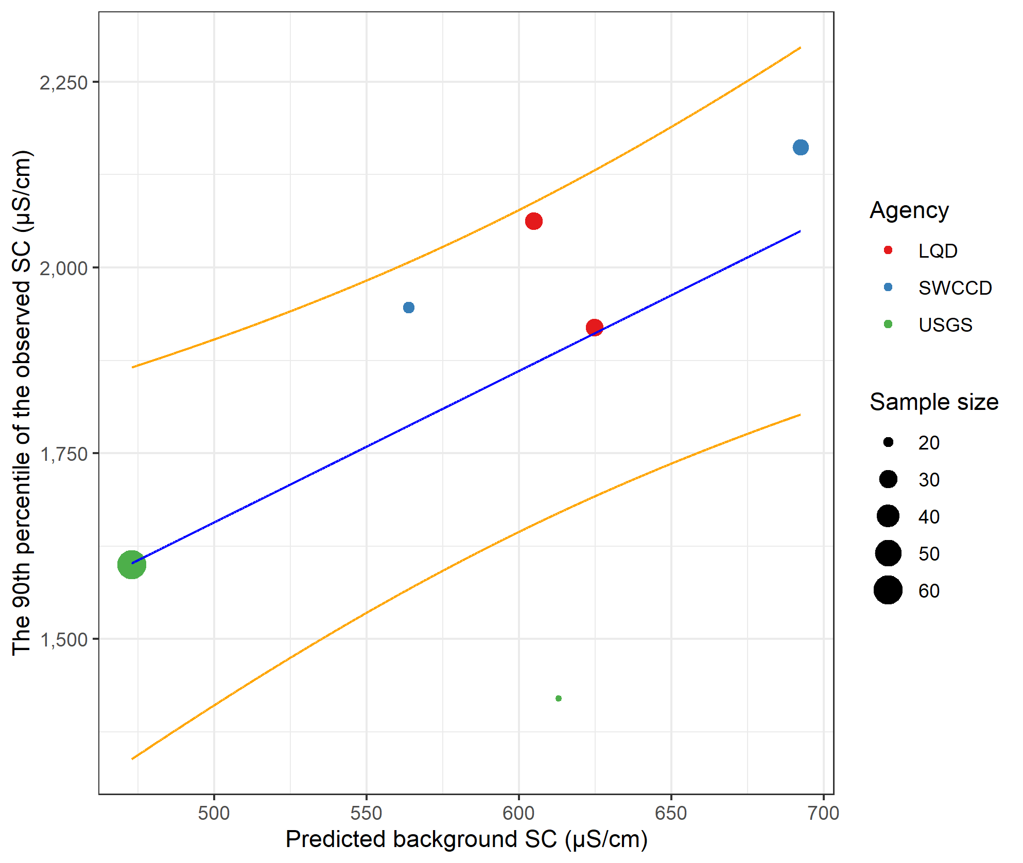

Figure . Least square regression model for predicting ground water background specific conductivity (SC) from empirically modeled surface flow background.

Colored *circles* are paired 90th centile of observations with predicted background SC, least squares regression (*blue line*), and 50% prediction interval in *orange lines;* *y* = 638.373 + 2.038 * *x*., where *x* is predicted background, *R2* = 0.27.

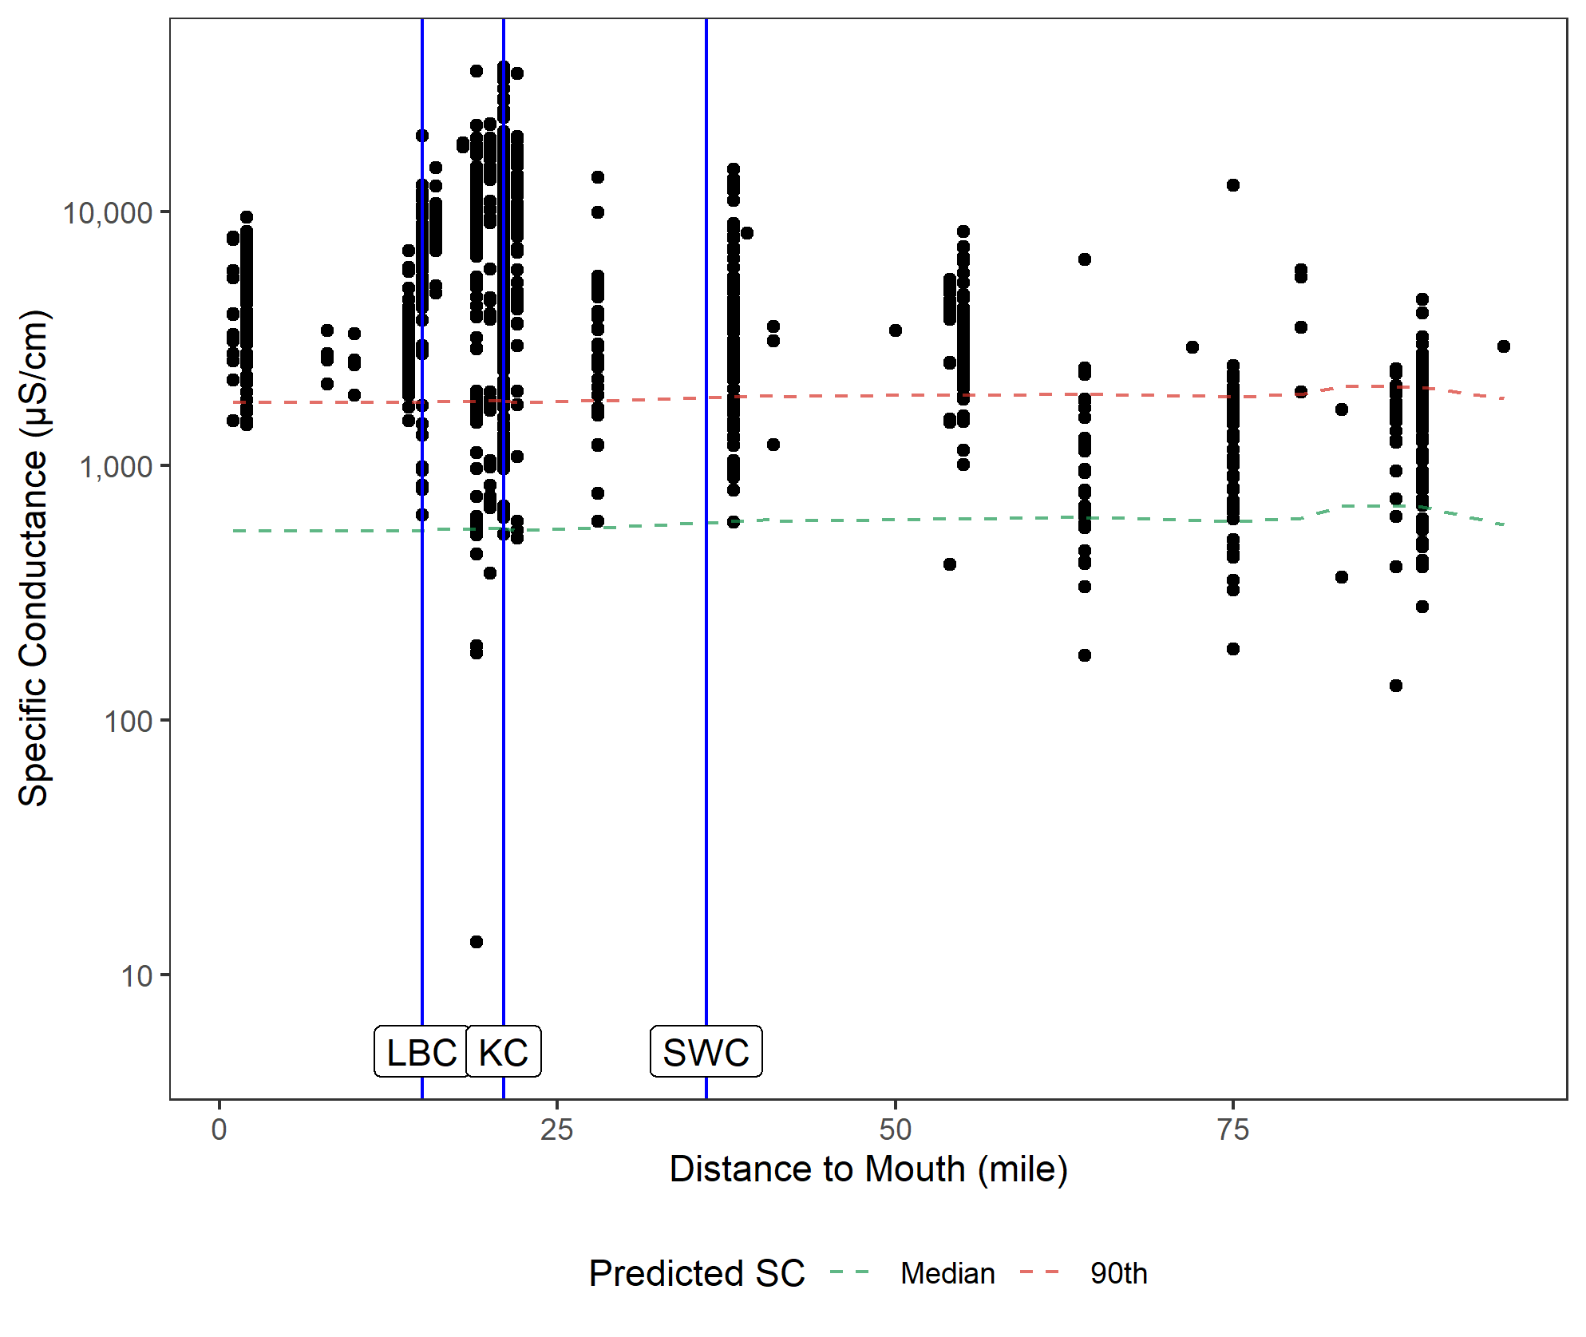

Figure . Observed Bitter Creek SC profile (circles).

High levels of SC below river mile 56 is indicative of anomalous point sources. The dilution effect of lower SC levels from Little Bitter Creek (LBC) is also evident. Higher SC levels near the confluence also suggests a change in background compared to upstream. Predicted surface water background (*dotted green line*) and predicted ground water background (*dotted red line*) are shown. Sources of loadings were not investigated in this study.

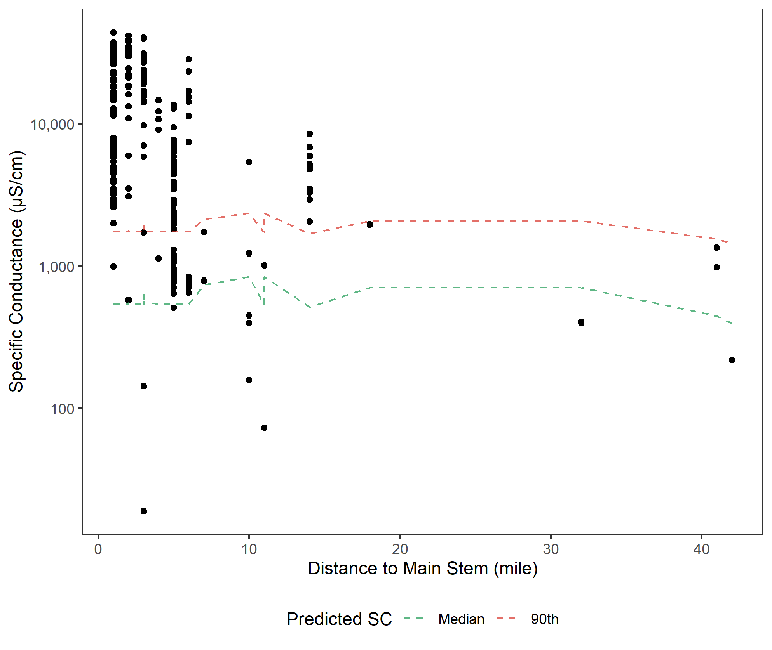

Figure . Observed Killpecker Creek SC profile (circles).

High levels of SC below RM 10 indicates that KC is a source of increasing SC in Bitter Creek. Higher SC levels near the confluence also suggests a change in background compared to upstream. Predicted surface water background (*dotted green line*) and predicted ground water background (*dotted red line*). Sources of loadings were not investigated in this study.

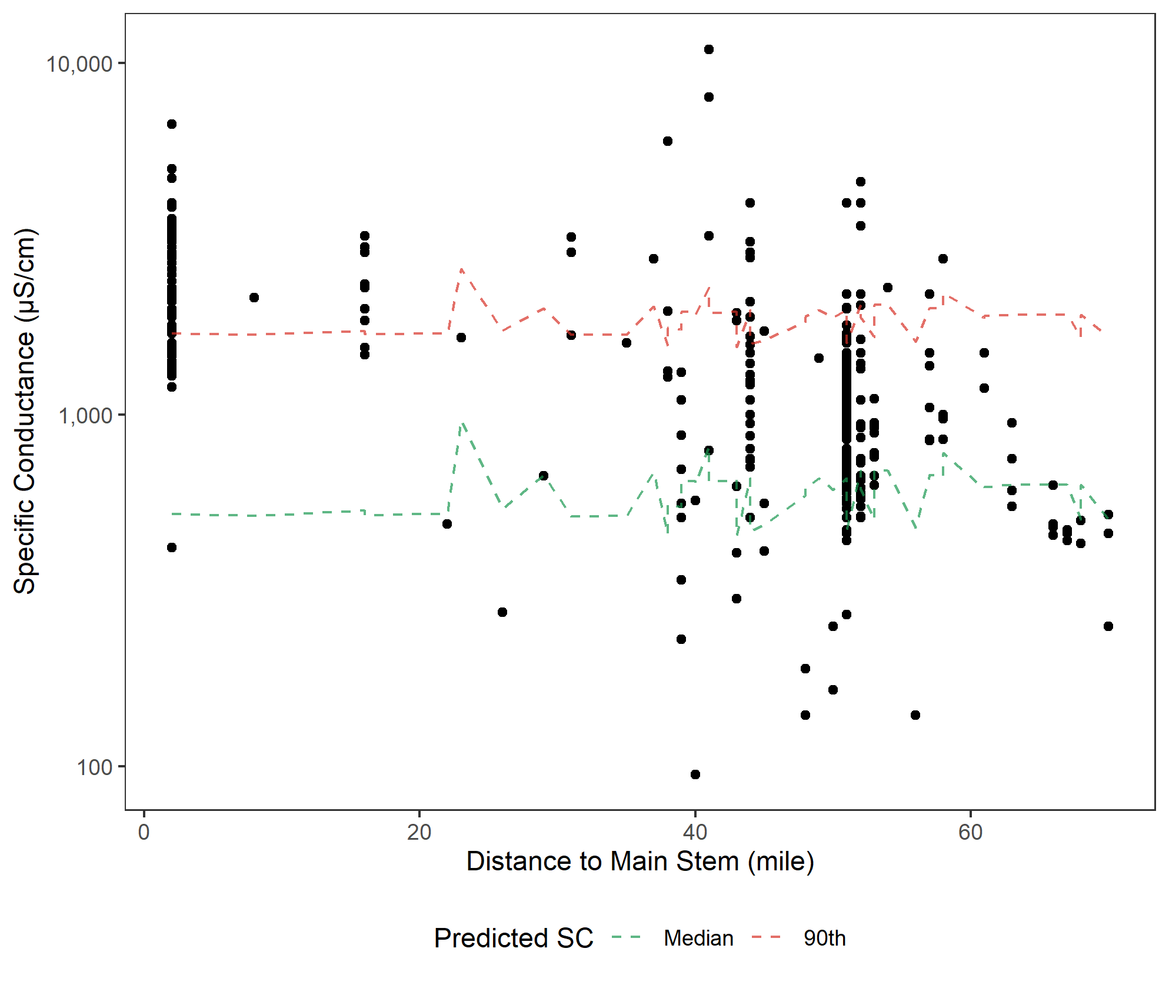

Figure . Observed Salt Wells Creek SC profile (*circles*).

Predicted surface water background (*dotted green line*) and predicted ground water background (*dotted red line*). Note that, although Salt Wells Creek transects the same geology does Bitter Creek near Rock Springs, SC does not increase by a similar magnitude. The sources of loadings were not investigated in this study.

## 7.2 Recommended approach for estimating background surface water- and ground water-dominant flows

A pragmatic approach for estimating SC background in the watershed is described here for surface water- and ground water-dominated flows. To be protective, site-specific source assessments are needed before choosing to use a higher background than suggested below.

1. If the stream segment is classified as least disturbed based on a set of a priori criteria, then the observed background is the most relevant and reliable estimate. SC data can be parsed to high-flow conditions and background ranges estimated.
2. If the stream segment condition is disturbed or unknown, then consider the three options below.
   1. Find nearby least disturbed sites as an approximated observed background for the new location. Data can be parsed to surface flow conditions to estimate background ranges.
   2. If some observed SC observations are less than 1004 µS/cm (the maximum predicted background), use the predicted SC.
   3. If there are no observations less than 1004 µS/cm, then use the predicted estimate plus the MAE (210 µS/cm) (i.e., 1214 µS/cm).

For ground water-dominant or base flow conditions, the uncertainty is much greater.

1. If the stream segment is classified as least disturbed based on a set of a priori criteria, then the observed background is the most relevant and reliable estimate. SC data can be parsed to low-flow conditions and background ranges can be estimated.
2. If the stream segment condition is disturbed or unknown, then consider the two options below.
3. Find nearby least disturbed sites as an approximated observed background for the new location. Then, data can be parsed to low-flow conditions and background ranges can be estimated.
4. If no observed least disturbed observations are available, predict the least disturbed 90th centile SC using the surface flow estimated background from #2 above and the provisional regression equation of predicted background and observed 90th centile SC of least disturbed stations in the watershed. Using this formula, the predicted ground water dominant flow is not expected to exceed 3113 µS/cm nor the surface flow background to be greater than 1214 µS/cm. Note that estimates obtained using the predicted ground water model have a high-level of uncertainty because the R2 of the model is low. When extrapolating beyond the original observation range of a predicted model for surface flow background SC of 626 μS/cm, there is greater uncertainty.

To improve confidence and precision, daily flow and SC could be monitored at more stations identified as least disturbed in the watershed for perennial and intermittent flow conditions. These data can be used to develop more precise calibrations of the predicted SC surface water and ground water background models. These data could also be used to provide a better characterization of surface water and ground water ionic composition to enable discrimination among them and from anthropogenic influences.

# 8.0 BIOLOGICAL INFORMATION

No assessment was made based on observed biological evidence from the Bitter Creek watershed because sample sizes were insufficient for analysis. A few *Ephemeroptera* were among the genera at the nine stations sampled by WDEQ for benthic invertebrates. *Ephemeroptera* as a group are generally intolerant of salt (Cormier et al. 2020; Timpano et al. 2018). No data were available for plants and algae in the Bitter Creek watershed. SC tolerance values for algae are available in the literature for comparison if data become available (Potapova 2005, 2014; Potapova and Charles 2003). Some species of fish are reported to occur in the watershed, but insufficient data were available for the present study. No evidence was noted in the weight-of-evidence Table A.3.

# 9.0 CALCULATION AND ASSESSMENT OF EXTIRPATION ESTIMATES

## 9.1 Introduction for Calculation and Assessment of Modeled Extirpation Estimates

Conventional U.S. EPA water quality criterion recommendations are derived from laboratory-based toxicity tests with single chemicals (Stephen et al. 1985; U.S. EPA 1988). This laboratory-based approach controls exposure conditions, which means that the cause of observed effects can be known and well characterized. However, because laboratory tests are simple simulations of nature, the conditions are not natural and do not replicate nature’s diversity of sensitive species’ responses, species interactions, autecology, and routes and dynamics of exposure. As a result, other sources of information may be needed to inform our understanding of toxic effects, and, in some cases, field observational data may be more relevant than laboratory test information.

The primary advantages of using observational field data are that the exposures occur in nature and data can potentially be collected regarding any aspect of the life history of any species that lives in the wild or any community or ecological process (Gerritsen et al. 2014). Disadvantages with using field data to develop effect levels are that exposures and deleterious effects must already have done their damage and that the detection of those effects may be confounded by other coincidentally occurring toxicants, stressors, or natural conditions (Farrar et al. 2014). Furthermore, datasets may be too small to detect an effect threshold or not representative of the site (Cormier et al. 2020). Nevertheless, with appropriate caution, field observational data have been successfully used for developing tolerance values associated with salts (Cormier et al., 2020, Humphrey and Chandler 2018).

In 2011, U.S. EPA released a method for deriving benchmarks for SC based on the extirpation of benthic invertebrates in large regional datasets with paired biology and chemistry data. These types of data are not always available, so U.S. EPA’S ORD developed an alternate method that compares local SC observations with a SC-benthic invertebrate regression model (Cormier et al. 2018a).

Natural conditions limit where species can thrive. Where a niche is absent due to natural factors affecting background, species specialized for that absent niche are also absent. Species specialized for the absent niche are not observed in those situations because they are unable to compete and survive under conditions that are outside of their normal survival ranges. As a result, biological communities naturally differ from place to place. SC is one natural parameter that can determine a niche for a species. The lowest SC tolerance limit of species in a natural community is relative to the lowest SC niche. Specialized species may differ from place to place, but the lowest SC or chloride niches are still occupied by organisms. This translates into a positive mathematical relationship between increasing natural background, increasing SC niche minima, and increasing tolerance values of species inhabiting the available SC niches.

U.S. EPA recognized that this basic ecological relationship could be mathematically modeled using species sensitivity distributions from many datasets with different background SC regimes and, therefore, different ionic-niche structures. A model was constructed using 24 datasets of benthic aquatic macroinvertebrate occurrences of genera paired with background SC. The model assumed that background is the 25th centile of each dataset. The resulting model is a linear log10-log10 least square regression model that can be used to estimate the SC likely to cause 5 percent extirpation of the aquatic genera present at a station with just the input of background SC (Figure 23) (Cormier et al. 2018a).

### 9.1.1 Estimated Effect Level

To illustrate this method, the 10th centile of the USGS station medians (411 µS/cm) is used as the example estimated annual background (Table 6). The SC level expected to extirpate 5 percent of benthic invertebrates (XCD05) (*y*) is estimated using the annual surface water background SC for the Bitter Creek watershed (example: 411 µS/cm) as the independent variable (*x*) in the 5 percent extirpation model in Equation (Eq.) 1.

Log10*y* = 0.658* log*x* + 1.071 Eq. 1

log10y = 0.658* log10(411 µS/cm) + 1.071

*y* = XCD05=618 µS/cm

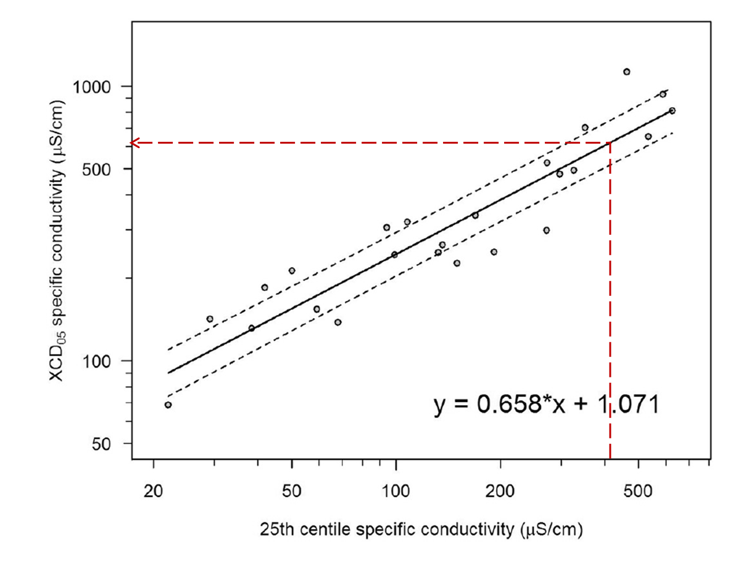

Figure . Example 5% extirpation using a background-to-criterion model (Source: Cormier et al. 2018a).

The solid oblique lines are the least squares regression model with 90% confidence limits. An estimated background value was inserted into the model as the independent *x* variable to yield the SC value likely to cause extirpation of 5% of benthic invertebrates (XCD05). Red vertical dashed line at 411 µS/cm intercepts the mean regression line at 618 µS/cm.

The chloride level associated with the example XCD05 can be estimated from the SC-chloride regression generated from the Combined dataset with multiple measurements (Figure 10). We chose the Combined dataset regression model to maximize the number of observations and the entire range of concentrations. The chloride-dominant model was not selected because chloride-dominant stations were rare and were associated with very high SC and chloride levels. If the ion mixture is known, then either the [HCO3¯ + SO42¯]-dominated or the mixed ion model can be selected to convert SC to chloride concentration. The SC XCD05 from Eq. 1 was used as the independent variable (*x*) to predict a chloride XCD05 (*y*). An example is shown in Eq. 2.

Log10 (chloride XCD05 mg/l) =1.76* log10(618 µS/cm) – 3.87 Eq. 2

Chloride XCD05 = 11 mg/l

# 10.0 CONCLUSION AND DISCUSSION

Because deviations from background help to define concentrations that may be considered contamination, defining background levels can inform applicability of criteria, potential benchmarks, or remedial activity. There are no generally accepted methods for defining or estimating background, but there are numerous options, which are associated with different concepts of background or different types of data (Table 9) (Reimann and Garrett 2005; Reimann et al. 2005; Galuszka 2007; Mast et al. 2007). Several methods were used to estimate background, and then a pragmatic approach for estimating background was developed for conditions dominated by surface flow and ground water flow.

## 10.1 Ionic Proportions in Bitter Creek Watershed

On average, the relative proportions of cations based on mg/l in the Bitter Creek watershed are Na+ > Ca2+ > Mg2+. Dominant anions are SO42− > HCO3− > Cl− (Table 3, details in Table A.6). These ions occur in a variety of mixtures throughout the watershed (Figure 6 and Figure 11). In the USGS dataset, chloride is rarely dominant and only at SC > 1130 µS/cm and > 410 mg/l chloride. There are only four samples < 2000 µS/cm where chloride ions are not dominant and where chloride is > 230 mg/l (Figure 10). These observations suggest that, where chloride is the dominant anion, the natural ionic regime has been altered or there are anthropogenic sources of chloride. Furthermore, although conditions dominated by chloride of >230 mg/l can result in SC less than 400, this situation was rarely observed in the watershed except in datasets with less reliable SC measurements.

## 10.2 Background Cl ̶ Concentrations

Given the available data, the 10th centile of the USGS dataset is probably the most appropriate statistic to estimate background chloride concentrations in this watershed from observational data. However, even higher centiles are illustrative. For example, the 50th centile of the USGS median stations (*N* = 132 stations) is 35 mg/l (Table A.6). The maximum annual predicted background chloride is 25.8 mg/l (Table 5). Therefore, both observed and predictive estimates indicate that the background chloride level is likely to be < 35 mg/l in the watershed when surface water is the dominant source of flow. This value is much lower than the WDEQ chronic chloride standard of 230 mg/l. Of the USGS stations (*N* = 127) less than 2000 µS/cm, only one station exceeded the WCQ chloride level > 230 mg/l. No USGS stations less than 5000 µS/cm exceeded the WQC of 860 mg/l chloride. These facts indicated that, even when ground water is likely the dominant source of flow, chloride often rarely exceeds the WQC for chloride when anthropogenic inputs are less likely as in the USGS dataset.

In longitudinal stream profiles, chloride levels were greater for the lower 50-plus RM of Bitter Creek and the lower portion of Killpecker Creek (Figure A.3, Figure A.5, and Figure A.7). Higher levels of chloride are more likely from anthropogenic inputs or from altered ground water based on (1) predicted SC levels compared to observed values; (2) observed SC and chloride levels; (3) known sources of chloride; (4) likely ionic signatures of surface water, ground water, and anthropogenic alteration; and (5) different chloride levels with the same geologic strata in difference parts of the watershed. Compare Figure A.3 and Figure A.7 with the geologic map in Figure 1. Additional sampling is needed to attribute local sources and may require isotope analysis to distinguish the relative contributions of natural from anthropogenic sources.

Although preliminary, samples with Cl¯ concentrations equal to or greater than the concentration of [HCO3¯ + SO42¯] on a mass basis (mg/l) that were identified as chloride-dominant mixtures are likely associated with anthropogenic alteration. Samples were identified as “mixed” on a mass basis (mg/l) when these samples had more than one and up to five times as much [HCO3¯ + SO42¯] as [Cl¯] and may be ground water-dominant flows. When mixtures had more than five times as much [HCO3¯ + SO42¯] as [Cl¯], they were identified as “[HCO3¯ + SO42¯]-dominant mixtures” and may be surface water-dominated flow (Figure 7 and Figure 8). To confirm these inferences and refine the ionic signatures associated with different sources, the ionic composition could be characterized for high- and low-flow relative conditions or types of effluent.

## 10.3 Comparison of Predicted and Observed Background SC and Cl- Concentrations

Multiple lines of evidence indicate that the lowest annual surface flow background SC during the year is expected to be near 300–400 µS/cm. The lowest predicted mean background SC for the Bitter Creek watershed is 384 µS/cm, and the maximum is 1004 µS/cm. The 25th centile of the Wyoming Basin Ecoregion probability sample is 341 µS/cm, and the 10th centile of the Bitter Creek watershed USGS station median is 411.2 µS/cm. Collectively, the analyses support the conclusion that surface water background SC for this watershed is expected to average about 400 µS/cm.

The lowest annual mean predicted background Cl− for the Bitter Creek watershed is 4.76 mg/l. The 25th centile of the Wyoming Basin Ecoregion probability sample is 1.4 mg/l. The 10th centile of the Bitter Creek watershed targeted USGS station medians is 3.94 mg/l. These comparisons indicate that the average mean background Cl− level during surface flow is expected to be about 4 mg/l.

Although these values are useful, the complexity of the geology and resulting ionic stream characteristics strongly indicate that the watershed-wide estimate of background has limited practical use. The predicted backgrounds for individual stream segments have a broad range across the watershed (between 384 µS/cm and 1004 µS/cm). Using the observed watershed background estimate of 411 µS/cm and assuming that the random forest model reliably predicts background, a stream segment at the maximum predicted background SC of 1004 µS/cm would be underestimated by 593 µS/cm. Likewise, the predicted background Cl− values in the watershed ranged between 4.76 mg/l Cl−and 25.84 mg/l Cl−, and the observed background is 9 mg/l Cl−. In general, it would be useful to consider using the predicted natural background for site-specific estimates of surface flow background SC and chloride, especially where no measurements are available or background has been altered by human activity. Furthermore, a range of separate surface flow and ground water flow estimates of background would be more relevant and reliable.

A comparison of predicted and observed background SC suggests that the model reasonably predicts surface water flow but may not faithfully predict background during dry periods dominated by ground water flow (Figure 12, Figure 13 and Figure 15). Therefore, background SC estimates during ground water-dominated conditions were provisionally estimated from the predicted and observed 90th centile at approximately twice the predicted value (Figure 23). Admittedly, this model is weak partly owing to small sample size, and the model could be improved with more data. Linear SC stream profiles suggest that using a surface flow- and ground water flow-predicted background estimate is useful (Figure 20, Figure 21, and Figure 22) in bounding the range of SC of surface water- and ground water-dominated flows.

## 10.4 5% Extirpation SC and Cl- Values

The application of the background-to-criterion (B-C) model was illustrated in Section 9.0 using the observed 10th centile watershed background SC of 411 μS/cm (Cormier et al. 2018a). Although the lower 50 percent confidence limit is recommended when using data of a similar quality of data available for the Bitter Creek watershed, we calculated the less conservative mean 5 percent extirpation SC and chloride levels are calculated (Cormier et al. 2018b). On average, where the surface flow background is predicted to be 411 μS/cm, freshwater animals are expected to be protected if the geometric mean SC concentration does not exceed 618 µS/cm and 1476 µS/cm when surface water and ground water flow are the dominant sources of flow, respectively.

The equivalent example effect level for chloride during surface water flow and ground water flow are 11 mg/l and 36 mg/l, respectively. The values are estimated by converting the 5 percent extirpation SC values (618 µS/cm and 1476 µS/cm) to chloride using a regression model of chloride and SC (Figure 10).

These examples would apply to all flowing fresh waters (intermittent and perennial streams) in the Bitter Creek watershed with similar SC background because the same niches would be present in both stream types (Datry 2012; De Jong and Canton 2013; Feminella 1996; Grubbs 2010; Stout and Wallace 2003).

## 10.5 Recommended Process for Estimating Background from Predicted and Observed Data

Based on the weight of evidence, a process was developed for selecting site-specific background values depending on the available data. Being unable to calibrate the predicted SC owing to the varied geologies and precipitation patterns and the lack of verified least disturbed stations, we recommend a pragmatic approach for provisional estimates for surface water- and ground water-dominated background SC. To be protective, site-specific source assessments are needed prior to using higher values than suggested below.

1. If the stream segment is classified as least disturbed based on a set of a priori criteria, then the observed background is the most relevant and reliable estimate. SC data can be parsed to high-flow conditions and background ranges estimated.
2. If the stream segment condition is disturbed or unknown, then consider the three options below.
   1. Find nearby least disturbed sites as an approximated observed background for the new location. Data can be parsed to surface flow conditions to estimate background ranges.
   2. If some observed SC observations are less than 1004 µS/cm (the maximum predicted background), use the predicted SC.
   3. If there are no observations less than 1004 µS/cm, then use the predicted estimate plus the MAE (210 µS/cm) (i.e., 1214 µS/cm).

For ground water-dominant or base flow conditions, the uncertainty is much greater. If the flow is perennial, one must assume that there are anthropogenic inputs resulting from the land use near perennial streams in the watershed.

1. If the stream segment is classified as least disturbed based on a set of a priori criteria, then the observed background is the most relevant and reliable estimate. SC data can be parsed to low-flow conditions and background ranges can be estimated.
2. If the stream segment condition is disturbed or unknown, then consider the two options below.
3. Find nearby least disturbed sites as an approximated observed background for the new location. Then, data can be parsed to low-flow conditions and background ranges can be estimated.
4. If no observed least disturbed observations are available, predict the least disturbed 90th centile SC using the surface flow estimated background from #2 above and the provisional regression equation of predicted background and observed 90th centile SC of least disturbed stations in the watershed. Using this formula, the predicted ground water dominant flow is not expected to exceed 3113 µS/cm nor the surface flow background to be greater than 1214 µS/cm. Note that estimates obtained using the predicted ground water model have a high-level of uncertainty because the R2 of the model is low. When extrapolating beyond the original observation range of a predicted model for surface flow background SC of 626 μS/cm, there is greater uncertainty.

The confidence in the estimated background could be improved by identifying least disturbed stations and obtaining observations over a year-long period. Locations identified in Figure 12 as having a median SC less than 1000 µS/cm might be good candidates for reconnaissance. Observations from identified least disturbed stations would be useful in themselves and would allow the predicted model to be more confidently assessed for the Bitter Creek watershed. In particular, it would be useful to characterize the SC during periods dominated by surface water flow and periods dominated by ground water flow. The available data suggest that the predictive model faithfully characterizes surface flow SC. However, ground water is likely to result in higher SC because of longer contact with and dissolution of minerals. Additional data could be immediately acquired by quality assuring those datasets that have been identified with data entry errors (Table A.2).

If WDEQ develops a TMDL or a site-specific criterion for the Bitter Creek mainstem or Killpecker Creek, a formal causal and source assessment is warranted (Norton et al. 2014). Nevertheless, where chloride is dominant or even strongly elevated, conditions are not natural. It is likely that at least part of the chloride load can be reduced and mitigated. However, the geological alteration of Bitter Creek from legacy mining near Rock Springs may have irrevocably altered the stream’s hydrology. This emphasizes the need to focus on reducing additional chloride inputs and to protect those locations that still provide dilution.

# 11.0 DATASET AVAILABILITY

***Wyoming Basin Ecoregional***

Data extracted from Griffith (2014) is available at Cormier, S.M., 2017. Data for: Estimation of field-based benchmarks from background specific conductivity. <https://doi.org/10.23719/1371706>. Datasets are available at https://pasteur.epa.gov/uploads/10.23719/1371706/Griffith%20ion_MG20150729.zip (Cormier 2017).

***Combined***

Five Bitter Creek watershed datasets were supplied by WDEQ and originated from several sources, including the Abandoned Mine Land (AML) Division, Land Quality Division (LQD), and Water Quality Division (WQD) of WDEQ; from the Sweetwater County Conservation District (SWCCD); and from the USGS. These can be obtained from [cormier.susan@epa.gov](mailto:cormier.susan@epa.gov).

***Watershed Predicted Natural Background***

Wharton, C., J. Olson, and S. Cormier. 2021. Data set: Background Conductivity Data View. <https://www.arcgis.com/home/item.html?id=85c2000098e446cb979af577fd95e821#overview>.

Metadata for the empirical model that predicts natural background conductivity are available on the U.S. EPA Environmental Dataset Gateway for the published manuscripts:

* Olson, J.R., and S.M. Cormier. 2019. Modeling spatial and temporal variation in natural background specific conductivity. *Environmental Science & Technology*. DOI: 10.1021/acs.est.8b06777.
* Cormier, S.M. 2018. Dataset for modeling spatial and temporal variation in natural background specific conductivity. <https://edg.epa.gov/metadata/catalog/search/resource/details.page?uuid=%7BDEE76C66-2670-47CA-9A96-693EA85D4C7B%7D>.

The original geophysical, land use, and climatological data are available from StreamCat at <https://www.epa.gov/national-aquatic-resource-surveys/streamcat>.

***Background-to-Criterion Model Datasets***

Data, metadata, and individual extirpation concentration distribution (XCD) results used to develop the B-C model are available at the U.S. EPA Environmental Dataset Gateway (https://doi.org/10.23719/1371707) (Cormier 2017). Data are contained in three zip files. The folder “Biological.zip” contains occurrences of benthic invertebrate genera in 24 state datasets. The folder “Environmental. zip” contains environmental data sorted into 24 datasets. The folder “model.zip” contains the calculated XC95 values, probability of observation plots as generalized additive models, and cumulative frequency distribution for benthic invertebrate genera from the 24 datasets used to develop the B-C model.

**Pedigree of Data Files and R-code**

Available from [cormier.susan@epa.gov](mailto:cormier.susan@epa.gov), [yuchen.wang@tetratech.com](mailto:yuchen.wang@tetratech.com), and [chris.wharton@tetratech.com](mailto:chris.whrton@tetratech.com).

# 12.0 ACKNOWLEDGEMENTS

The maps in this document were prepared by Christopher Wharton, TetraTech, Inc. The figures and tables were prepared by Yu-Chen Wang, U. of Michigan. The document was reviewed by USEPA scientists Drs. Mark Bagley, Michael Elovitz, Michael Griffith, and Sylvia Lee and independently reviewed two non-EPA experts by an EPA-led letter review.

# 12.0 REFERENCES

ACE (Anderson Consulting Engineers, Inc.). 2018. *Bitter Creek/ East Flaming Gorge Watershed Level I Study*. Final report. Prepared for Wyoming Water Development Commission by ACE, Fort Collins, CO. <http://library.wrds.uwyo.edu/wwdcrept/Bitter_Creek/Bitter_Creek_East_Flaming_Gorge-Watershed_Study_Level_I-Final_Report-2018.html>.

Anning, D.W., and M.E. Flynn. 2014. Dissolved-solids sources, loads, yields, and concentrations in streams of the conterminous United States. U. S. Geological Survey Scientific Investigations Report 2014-5012. <http://dx.doi.org/10.3133/sir20145012>.

Aslan, A., M. Boraas-Connors, D.A. Sprinkel, T.P. Becker, R. Lynds, K.E. Karlstrom, and M. Heizler. 2018. Cenozoic collapse of the eastern Uinta Mountains and drainage evolution of the Uinta Mountains region. *Geosphere* 14(1):115–140.

Bern, C.R., M.L. Clark, T.S. Schmidt, J.M. Holloway, and R.R. McDougal. 2015. Soil disturbance as a driver of increased stream salinity in a semiarid watershed undergoing energy development. [in English]. *Journal of Hydrology* 524 (May 2015):123–36. <https://doi.org/10.1016/j.jhydrol.2015.02.020>.

Bolotin, L.A., B.M. Summers, P. Savoy, and J.R. Blaszczak. 2022. Classifying freshwater salinity regimes in central and western US streams and rivers. *Limnology and Oceanography Letters*. Wiley Online Library. https://doi.org/10.1002/lol2.10251.

Clark, M. 2012. Water-quality characteristics and trend analysis for the Tongue, Powder, Cheyenne, and Bell Fourche River drainage basins, Wyoming and Montana, for selected periods, water years 1991 through 2010. U.S. Geological Survey Scientific Investigations Report 2012-5117.

Clark, M.L., and S.L. Davidson. 2009. Specific conductance and dissolved solids characteristics for the Green River and Muddy Creek, Wyoming, water years 1999–2008. U.S. Geological Survey Scientific Investigations Report 2009-5168.

Cormier, S.M. 2017. Data for: Estimation of field-based benchmarks from background specific conductivity. <https://doi.org/10.23719/1371706>.

Cormier, S.M., G.W. Suter, M.B. Fernandez, and L. Zheng. 2020. Adequacy of number of samples for estimating a value from field observational data. *Ecotoxicology and Environmental Safety* 203:110992. <https://www.sciencedirect.com/science/article/pii/S0147651320308319>.

Cormier S., C. Wharton, J. Olson. 2021. U.S. EPA Freshwater Explorer. V: 0.1. United States Environmental Protection Agency. July 2021. https://www.epa.gov/water-research/freshwater-explorer

Cormier, S.M., L. Zheng, and C.M. Flaherty. 2018a. A field-based model of the relationship between extirpation of salt-intolerant benthic invertebrates and background conductivity. *Science of the Total Environment* 633:1629–1636.

Cormier, S.M., L. Zheng, R.A. Hill, R.M. Novak, and C.M. Flaherty. 2018b. A flow-chart for developing water quality criteria from two field-based methods. *Science of The Total Environment* 633:1647–1656.

Cormier, S.M., L. Zheng, G.W. Suter II, and C.M. Flaherty. 2018c. Assessing background levels of specific conductivity using weight of evidence. *Science of The Total Environment* 628:1637–1649.

Datry, T. 2012. Benthic and hyporheic invertebrate assemblages along a flow intermittence gradient: Effects of duration of dry events. *Freshwater Biology* 57:563−574.

De Jong, G.D., and S.P. Canton. 2013. Presence of long-lived taxa and hydrologic permanence. *Journal of Freshwater Ecology* 28(2):277−282.

Farrar, D., L.C. Alexander, L.L. Yuan and J. Gerritsen. 2014. Regional observational studies addressing confounding. In: Ecological Causal Assessment, S.B. Norton, S.M. Cormier, G.W. Suter II (Eds.). CRC Press, Taylor and Francis Group, Boca Raton, FL. pp. 203-212.

Feminella, J.W. 1996. Comparison of benthic macroinvertebrate assemblages in small streams along a gradient of flow permanence. *Journal of the North American Benthic Society* 15:651−669.

Galuszka, A. 2007. A review of geochemical background concepts and an example using data from Poland. *Environmental Geology* 52:861–870.

Gerritsen, J., L.L. Yuan, P. Shaw-Allen, and S.M. Cormier. 2014. Regional observational studies, deriving evidence. In: *Ecological Causal Assessment*, ed. S.B. Norton, S.M. Cormier, and G.W. Suter II. CRC Press, Taylor and Francis Group, Boca Raton, FL. pp 203-212.

Gibbs, R.J. 1970. Mechanisms controlling world water chemistry. *Science* 170:1088−1090.

Gough, L., and J. Crock. 1997. *Distinguishing Between Natural Geologic and Anthropogenic Trace Element Sources. 1105. Denali National Park and Preserve*. U.S. Geological Survey Circular., pp. 57–71.

Griffith, M.B. 2014. Natural variation and recent reference for specific SC and major ions in wadeable streams of the coterminous U.S. *Freshwater Science* 33(1):1−17.

Grubbs, S.A. 2010. Influence of flow permanence on headwater macroinvertebrate communities in a Cumberland Plateau watershed, USA. *Aquatic Ecology* 45:185−195.

HAL (Hansen, Allen and Luce, Inc.). 2007. *Bitter Creek Reconstruction Plan & Design: Master Plan for the Reclamation and Development of the Bitter Creek Drainage through Downtown Rock Springs, Wyoming*. Prepared for the City of Rock Springs, WY, by Hansen, Allen and Luce, Inc. December 14, 2007. <http://library.wyo.gov/downloads/services/planning/docs/Bitter%20Creek%20Reconstuction%20Plan%20and%20Design.pdf>.

Hassani, A., A. Azapagic, and N. Shokri. 2021. Global predictions of primary soil salinization under changing climate in the 21st century. *Nature Communications* 12(1):1–17. <https://www.nature.com/articles/s41467-021-26907-3>.

Helgen, S., and J. Moore. 1995. Natural background determination and impact quantification in trace metal-contaminated river sediments. *Environmental Science & Technology* 30:129–135.

Hem, J.D. 1985. *Study and Interpretation of the Chemical Characteristics of Natural Water*. U.S. Geological Survey Water-Supply Paper 2254. U.S. Geological Survey, Richmond, VA. <http://pubs.usgs.gov/wsp/wsp2254/html/pdf.html>.

Herlihy, A.T., and J.C. Sifneos. 2008. Developing nutrient criteria and classification schemes for wadeable streams in the conterminous US. *Journal of the North American Benthological Society* 27(4):932–948.

Hill, R.A., M.H. Weber, S.G. Leibowitz, A.R. Olsen, and D.J. Thornbrugh. 2016. The Stream-Catchment (StreamCat) Dataset: A database of watershed metrics for the conterminous United States. *Journal of the American Water Resources Association* 52(1):120−128.

Hinsby, K., M. de Melo, and M. Dahl. 2008. European case studies supporting the derivation of natural background levels and groundwater threshold values for the protection of dependent ecosystems and human health. *Science of the Total Environment* 401:1–20.

Hopkins, R., B. Altier, D. Haselman, A. Merry, J. White. 2013. Exploring the legacy effects of surface coal mining on stream chemistry. Hydrobiologia 713, 87–95.

Humphrey, C.L., and L. Chandler. 2018. Use of field-effects information to derive a surface water guideline value for magnesium in Magela Creek, NT Australia. Supervising Scientist Report 212. *Supervising Scientist*, Darwin NT.

Joanes, D.N., and C.A. Gill. 1998. Comparing measures of sample skewness and kurtosis. *The Statistician* 47:183–189.

Lost Iguana Consulting, Inc. 2003. *Historical Water Quality Report for the Bitter Creek Watershed*. Prepared for the Sweetwater County Conservation District and the Bitter/Killpecker Watershed Advisory Group. <http://www.swccd.us/docs/SWCCDfile03212011154652823.pdf>.

Lucke, S. W., McLaughlin, J. F. Jones, R. W. 2007. Geologic map and oil and gas fields of the Rock Springs Uplift in Sweetwater County, Southwestern Wyoming. https://www.wsgs.wyo.gov/products/wsgs-2007-ofr-04.pdf.

Luo, X.-S., Y. Xue, Y.-L. Wang, L. Cang, L., B. Xu, J. Ding. 2015. Source identification and apportionment of heavy metals in urban soil profiles. Chemosphere 127, 152–157.

Mason, J.P., and K.A. Miller. 2005. Water Resources of Sweetwater County, Wyoming. U.S. Geological Survey Scientific Investigations Report 2004–5214, 188 p., 2 pl. <https://pubs.usgs.gov/sir/2004/5214/>.

Mast, M.A., P.L. Verplanck, W.G. Wright, and D.J. Bove. 2007. Characterization of Background Water Quality. Professional Paper 1651. Chapter E7 in: *Integrated Investigations of Environmental Effects of Historical Mining in the Animas River Wathershed, San Juan County, Colorado*, ed. S.E. Church, P. von Guerard, and S.E. Finger. U.S. Geological Survey, Washington, DC. <https://pubs.usgs.gov/pp/1651/downloads/Vol1_combinedChapters/vol1_chapE7.pdf>.

McKay, L., T. Bondelid, T. Dewald, J. Johnston, R. Moore, and A. Rea. 2012. NHDPlus Version 2: User Guide; National Operational Hydrologic Remote Sensing Center, Washington, DC. <ftp://ftp.horizon-systems.com/NHDplus/NHDPlusV21/Documentation/NHDPlusV2_User_Guide.pdf>. (32)

Molinari, A., F. Chidichimo, S. Straface, and A. Guadagmini. 2014. Assessment of natural background levels in potentially contaminated coastal aquifers. *Science of the Total Environment* 476:38–48.

Morrill, C., E.E. Small, and L.C. Sloan. 2001. Modeling orbital forcing of lake level change: Lake Gosiute (Eocene), North America. *Global and Planetary Change* 29(1-2):57–76.

NASA, 2019. Moderate Resolution Imaging Spectroradiometer (MODIS) satellite data. Available at: https://modis.gsfc.nasa.gov/data/

Norton, S.B., S.M. Cormier, and G.W. Suter. 2014. *Ecological Causal Assessment*. CRC Press, Boca Raton, FL. ISBN 9781138073937. <https://doi.org/10.1201/b17603>.

Olson, J.R. 2019. Predicting combined effects of land use and climate change on river and stream salinity. *Philosophical Transactions of the Royal Society B* 374(1764):20180005. <https://royalsocietypublishing.org/doi/full/10.1098/rstb.2018.0005>.

Olson, J.R., and S.M. Cormier. 2019. Modeling spatial and temporal variation in natural background specific conductivity. *Environmental Science & Technology* 53(8):4316–4325.

Olson, J.R., and C.P. Hawkins. 2012. Predicting natural base-flow stream water chemistry in the western United States. *Water Resources Research* 48:W02504.

Page, D.S., P.D. Boehm, G.S. Douglas, A.E. Bence, W.A. Burns, and P.J. Mankiewicz. 1996. The natural petroleum hydrocarbon background in subtidal sediments of Prince William Sound, Alaska, USA. *Environmental Toxicology and Chemistry* 15:1266–1281.

Piper, A.M. 1944. A graphic procedure in the geochemical interpretation of water-analyses. *Eos, Transactions, American Geophysical Union* 25(6):914–928.

Pond, G.J. 2004. *Effects of Surface Mining and Residential Land Use on Headwater Stream Biotic Integrity in the Eastern Kentucky Coalfield Region*. Kentucky Department of Environmental Protection, Division of Water, Frankfort, KY.

Potapova, M. 2005. Relationships of soft-bodied algae to water-quality and habitat characteristics in the U.S. rivers: Analysis of the National Water-Quality Assessment (NAWQA) Program data set. The Academy of Natural Sciences, Philadelphia, PA. <http://diatom.acnatsci.org/autecology/uploads/Report_October20.pdf>.

Potapova, M. 2014. *Autecology of Freshwater Algae Datafiles and Links to Internet Resources*. The Academy of Natural Sciences of Drexel University, Philadelphia, PA. <http://diatom.acnatsci.org/autecology/>.

Potapova, M., and D.F. Charles. 2003. Distribution of benthic diatoms in U.S. rivers in relation to SC and ionic composition. *Freshwater Biology* 48:1311−1328.

Reimann, C., and R. Garrett. 2005. Geochemical background—concept and *reality. Science of the Total Environment* 350:12–27.

Reimann, C., P. Filzmoser, and R.G. Garrett. 2005. Background and threshold: critical comparison of methods and determination. *Science of the Total Environment* 346:1–16.

Rice, B. 2019. Piper Diagram. Bill Rice’s website. Posted on July 23, 2019. <https://wcrice.github.io/2019-07023-Piper-Diagram/>.

Root, F.K., G.B. Glass, and D.W. Lane. 1973. Sweetwater County, Wyoming—Geologic map atlas and summary of economic mineral resources: Geological Survey of Wyoming [Wyoming State Geological Survey] County Resource Series 1, 9 pls. <https://www.wsgs.wyo.gov/products/wsgs-1973-crs-02.pdf>.

Runnells, D., T. Shepherd, and E. Angino. 1992. Metals in water, determining natural background concentrations in mineralized areas. *Environmental Science & Technology* 26(12):2316–2323.

Schultz, A.R. 1920. Oil possibilities in and around Baxter Basin, in the Rock Springs Uplift, Sweetwater County, Wyoming: U.S. Geological Survey Bulletin 702, 107 p.

Smith, R., R. Alexander, and G. Schwarz. 2003. Natural background concentrations of nutrients in streams and rivers of the conterminous United States. *Environmental Science & Technology* 37:3039–3047.

Stallard, R.F., and J.M. Edmond. 1987. Geochemistry of the Amazon. 3. Weathering chemistry and limits to dissolving inputs. *Journal of Geophysical Research* 92:8293−8302.

Stoddard, J.L., D.P. Larsen, C.P. Hawkins, R.K. Johnson, and R.H. Norris. 2006. Setting expectations for the ecological condition of streams: The concept of reference condition. *Ecological Applications* 16(4):1267–1276.

Stout, B, and J.B. Wallace. 2003. A survey of eight major aquatic insect orders associated with small headwater streams subject to valley fills from mountaintop mining. Appendix in *Mountaintop Mining/Valley Fills in Appalachia. Final Programmatic Environmental Impact Statement*. U.S. Environmental Protection Agency, Philadelphia, PA.

Sucharova, J., I. Suchara, M. Hola, and C. Reimann. 2014. Contemporary lead concentration and stable isotope ratio distribution in forest moss across the Czech Republic. *Applied Geochemistry* 40:51–60.

Timpano, A.J., S.H. Schoenholtz, D.J. Soucek, and C.E. Zipper. 2018. Benthic macroinvertebrate community response to salinization in headwater streams in Appalachia USA over multiple years. *Ecological Indicators* 91:645–656.

U.S. BLM (Bureau of Land Management). 2012. Solid Mineral Occurrence and Development Potential Report for the Rock Springs Field Office Resource Management Plan and Associated Environmental Impact Statement United States Department of the Interior Bureau of Land Management Wyoming High Desert District Rock Springs Field Office. August 2012. BLM/WY/PL-12/033+1330, Pp 133. <https://www.transmissionhub.com/wp-content/uploads/2018/12/BLM-Feb-13-Minerals-Report.pdf>.

U.S. EPA (U.S. Environmental Protection Agency). 2000. *Nutrient Criteria Technical Guidance Manual: Rivers and Streams*. EPA/822/B 00/002. Office of Water, Washington, DC. <http://www2.epa.gov/sites/production/files/documents/guidance_rivers.pdf>.

U.S. EPA (U.S. Environmental Protection Agency). 2013. *Level III and IV Ecoregions of the Continental United States: Corvallis, Oregon*. U.S. EPA, National Health and Environmental Effects Research Laboratory, map scale 1:3,000,000. <http://www.epa.gov/wed/pages/ecoregions/level_iii_iv.htm>.

U.S. EPA (U.S. Environmental Protection Agency). 1988. *Aquatic Life Ambient Water Quality Criteria for Chloride*. EPA 440/5-88-00146. <https://www.epa.gov/wqc/aquatic-life-ambient-water-quality-criteria-chloride>.

U.S. EPA (U.S. Environmental Protection Agency). 2011. *A Field-Based Aquatic Life Benchmark for Conductivity In Central Appalachian Streams* (Final Report). EPA/600/R-10/023F. U.S. Environmental Protection Agency, Washington, DC. <https://cfpub.epa.gov/ncea/risk/recordisplay.cfm?deid=233809>.

U.S. EPA (U.S. Environmental Protection Agency). 2016. *Field-Based Methods for Developing Aquatic Life Criteria for Specific Conductivity*. Public Review Draft. EPA-822-R-07-010. Office of Water, Office of Science and Technology, Washington, DC. <https://archive.epa.gov/epa/wqc/draft-field-based-methods-developing-aquatic-life-criteria-specific-conductivity-2016.html>.

U.S. EPA (U.S. Environmental Protection Agency). 2016b. STORET. Available at: <https://www.epa.gov/storet/>

U.S. EPA (U.S. Environmental Protection Agency). 2017. *Weight of Evidence in Ecological Assessment*. EPA/100/ R16/001. U.S. Environmental Protection Agency, Washington, DC. <https://nepis.epa.gov/Exe/ZyPURL.cgi?Dockey=P100SFXR.TXT>

U.S. EPA (U.S. Environmental Protection Agency). 2021. Assessment, Total Maximum Daily Load (TMDL) Tracking and Implementation System (ATTAINS). <https://www.epa.gov/waterdata/attains>.

Van deMeent, D., T. Aldenberg, J. Canton, C. van Gestel, and W. Sloof. 1990. *Desire for Levels, Background Study for the Policy Document Setting Environmental Quality Standards for Water and Soil*. Report Number 670101 002. RIVM, Bilthoven, the Netherlands.

Wharton, C., J. Olson, and S. Cormier. 2021. Data set: Background Conductivity Data View. <https://www.arcgis.com/home/item.html?id=85c2000098e446cb979af577fd95e821#overview>.

WDEQ (Wyoming Department of Environmental Quality). 2018a. Water Quality Rules and Regulations. Chapter 1 in *Wyoming Surface Water Quality Standards*. Effective July 26, 2018. <https://www.epa.gov/sites/production/files/2014-12/documents/wy-chapter1.pdf>.

WDEQ (Wyoming Department of Environmental Quality). 2018b. Wyoming's Draft 2016/2018 Integrated 305(b) and 303(d) Report. Rep. No. 18-0111. U.S. Environmental Protection Agency. <http://deq.wyoming.gov/media/attachments/Water%20Quality/Water%20Quality%20Assessment/Reports/2016-2018_Integrated-305b-and-303d-Report_EPA-Submit_2018-0815.pdf>.

Zhao, F., S. McGrath, and G. Merrington. 2006. Estimates of ambient background concentrations of trace metals in soils for risk assessment. *Environmental Pollution* 148:221–229.

**Other References Not Cited**

EDE Consultants LLC for Sweetwater County Conservation District (SWCCD). 2019. *Bitter Creek and Killpecker Creek Watershed Management Plan and Implementation Project 2019 Report*. May 2020. EDE Project Number SWC1901. <http://www.swccd.us/bitter-creek-watershed.php>.

EDE Consultants LLC for Sweetwater County Conservation District (SWCCD). 2021. *Bitter Creek Watershed-Based Plan*. January 2021. EDE Project Number SWC1901.

Love, J.D., and A.C. Christiansen. 1985. Geologic Map of Wyoming: U.S. Geological Survey, scale 1:500,000. <https://pubs.er.usgs.gov/publication/70046739>.

Winkler, G.R. 1970. Sedimentology and Geomorphic Significance of the Bishop Conglomerate and the Browns Park Formation: Eastern Uinta Mountains, Utah, Colorado and Wyoming. PhD diss., University of Utah, Department of Geological and Geophysical Sciences.

Wright, M.R. 2007. *An Introduction to Aqueous Electrolyte Solutions*. Wiley. ISBN 978-0-470-84293-5.

<http://sales.wsgs.wyo.gov/sweetwater-county-wyoming-geologic-map-atlas-and-summary-of-economic-mineral-resources-1973/>.

<https://gis.deq.wyo.gov/Html5Viewer/index.html?viewer=LQD_Viewer.LQD_Viewer>.

<https://www.usclimatedata.com/climate/rock-springs/wyoming/united-states/uswy0146>.