Data/Metadata
Manuscript: “Evaluation of Two Methods for Detection of Viable Bacillus anthracis Simulant Spores in Maritime Environmental Samples”

HS19-01.02-5877 (Original Project)

PI: Sanjiv Shah, ORD-CESER-HSMMD-DCB

Glossary/Dictionary for Terms, Variables, and Acronyms Used to Present the DATA/Metadata

B. thuringiensis kurstaki T1B2 = Bacillus thuringiensis subspecies kurstaki with T1B2 genetic
barcode
Btk = Bacillus thuringiensis subspecies kurstaki with T1B2 genetic barcode
SS = Sponge stick wipe
VFC = Vacuum filter cassette
SBMGAL = Small Boat Marine Grade Aluminum
TCHSCRN = Touchscreen
NSKID = Nonskid
CONPIER = Concrete pier
SBWASH = Boat washdown water
TC = Traditional Culture
CFU = Colony Forming Unit
mL = milliliter
PCR = Polymerase chain reaction
RV-PCR = Rapid viability-PCR
N/A = Not Applicable
Pos = Positive
Neg = Negative
True Pos = True-positive, sample spiked with Btk T1B2 spores that had a PCR positive
analytical method result
True Neg = True-negative, zero-spike sample that had a PCR negative analytical method result
False Pos = False-positive, zero-spike sample that had a PCR positive analytical method result
False Neg = False-negative, sample spiked with Btk T1B2 spores that had a PCR negative
analytical method result

Data/MetaData
Table 2. Percent Positive Results for Surface Samples Using TC and RV-PCR Analytical Methods
Maritime Surface/  Material Sampled | Sample ID | Sampling Method | Nominal Spore Load (CFU) | TC |  |  | RV-PCR
 |  |  |  | Samples Positive | Total Samples | % Samples Positive | Samples Positive | Total Samples | % Samples Positive
RBS Marine Grade Aluminum | SBMGAL | SS | 0 | 2 | 6 | 33 | 0 | 6 | 0
 |  |  | 300 | 5 | 6 | 83 | 6 | 6 | 100
 |  |  | 3,000 | 6 | 6 | 100 | 6 | 6 | 100
Nonskid Tread | NSKID |  | 0 | 3 | 7 | 43 | 0 | 7 | 0
 |  |  | 300 | 5 | 7 | 71 | 6 | 7 | 86
 |  |  | 3,000 | 7 | 7 | 100 | 7 | 7 | 100
Touch Screen | TCHSCRN |  | 0 | 1 | 6 | 17 | 0 | 6 | 0
 |  |  | 300 | 6 | 6 | 100 | 6 | 6 | 100
 |  |  | 3,000 | 6 | 6 | 100 | 6 | 6 | 100
All Surfaces Sampled | All Surfaces Sampled |  | 0 | 6 | 19 | 32 | 0 | 19 | 0
 |  |  | 300 | 16 | 19 | 84 | 18 | 19 | 95
 |  |  | 3,000 | 19 | 19 | 100 | 19 | 19 | 100
N/A | Lab/Field Controls |  | 0 | 0 | 11 | 0 | 1 | 11 | 9
 |  |  | 300 | 4 | 4 | 100 | 4 | 4 | 100
 |  |  | 3,000 | 4 | 4 | 100 | 4 | 4 | 100
Nonskid Tread | NSKID | VFC | 0 | 1 | 8 | 13 | 0 | 8 | 0
 |  |  | 300 | 5 | 8 | 63 | 5 | 8 | 63
 |  |  | 3,000 | 8 | 8 | 100 | 7 | 8 | 88
Concrete Pier | CONPIER |  | 0 | 3 | 8 | 38 | 0 | 8 | 0
 |  |  | 300 | 7 | 8 | 88 | 6 | 8 | 75
 |  |  | 3,000 | 8 | 8 | 100 | 7 | 8 | 88
All Surfaces Sampled | All Surfaces Sampled |  | 0 | 4 | 16 | 25 | 0 | 16 | 0
 |  |  | 300 | 12 | 16 | 75 | 11 | 16 | 69
 |  |  | 3,000 | 16 | 16 | 100 | 14 | 16 | 88
N/A | Lab/Field Controls |  | 0 | 1 | 11 | 9 | 0 | 11 | 0
 |  |  | 300 | 6 | 6 | 100 | 6 | 6 | 100
 |  |  | 3,000 | 6 | 6 | 100 | 6 | 6 | 100

Table 3. Percent Positive Results for Grab Samples Using TC and RV-PCR Analytical Methods
Maritime Surface/  Material Sampled | Sample ID | Nominal Spore Load (CFU) | TC |  |  | RV-PCR
 |  |  | Samples Positive | Total Samples | % Samples Positive | Samples Positive | Total Samples | % Samples Positive
RBS Washdown Water | SBWASH | 0 | 0 | 3 | 0 | 0 | 3 | 0
 |  | 300 | 0 | 3 | 0 | 0 | 3 | 0
 |  | 3,000 | 3 | 3 | 100 | 0 | 3 | 0
 |  | 30,000 | 3 | 3 | 100 | 3 | 3 | 100
Gravel Parking Lot | GRAVEL | 0 | 0 | 3 | 0 | 0 | 3 | 0
 |  | 300 | 1 | 3 | 33 | 1 | 3 | 33
 |  | 3,000 | 2 | 3 | 67 | 1 | 3 | 33
Loam Soil | SOIL | 0 | 0 | 3 | 0 | 0 | 3 | 0
 |  | 3,000 | 2 | 3 | 67 | 1 | 3 | 33
 |  | 30,000 | 3 | 3 | 100 | 3 | 3 | 100
 |  | 300,000 | 3 | 3 | 100 | 3 | 3 | 100
Grass Vegetation | VEGE | 0 | 0 | 3 | 0 | 0 | 3 | 0
 |  | 300 | 0 | 3 | 0 | 0 | 3 | 0
 |  | 3,000 | 1 | 3 | 33 | 0 | 3 | 0
 |  | 30,000 | 3 | 3 | 100 | 3 | 3 | 100

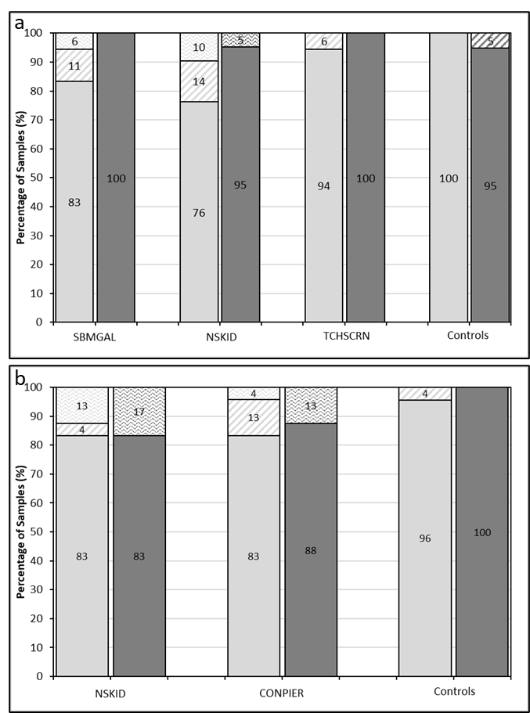
Fig 1 Analytical Assay Comparison of Surface Samples. Traditional culture method results (light gray bars) and RV-PCR method results (dark gray bars) for each surface sampled for SS (a) and VFC (b). True positive or negative results represented by solid fill, false-positive results represented by diagonal stripe pattern, and false-negative results represented by zig zag pattern. RV-PCR data for CONPIER results in a total percentage of 101 due to rounding. SBMGAL: small boat marine grade aluminum; NSKID: nonskid tread; TCHSCRN: touch screen; CONPIER: concrete pier. Controls are reagent or field blank samplers processed with samples.

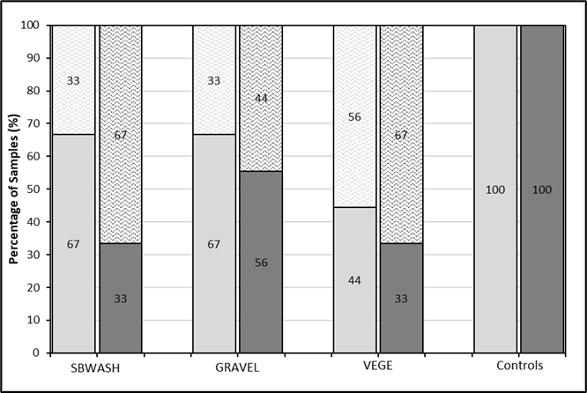
Fig 2 Analytical Assay Comparison of Grab Samples. Traditional culture method results (light gray bars) and RV-PCR method results (dark gray bars). True positive or negative results represented by solid fill, false-positive results represented by diagonal stripe pattern, and false-negative results represented by zig zag pattern. SBWASH: small boat washdown water; GRAVEL: gravel parking lot; VEGE: grass vegetation. Controls are reagent or field blanks processed with samples.

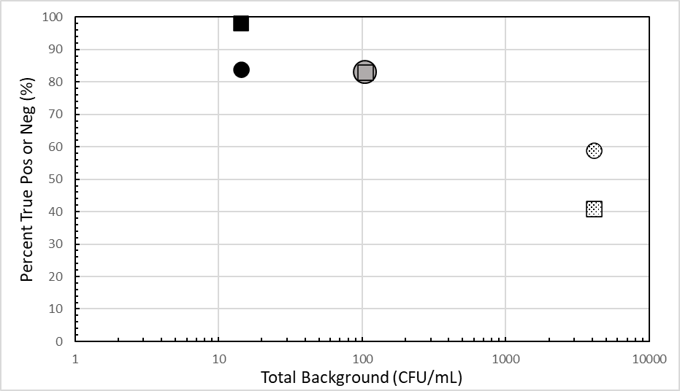
Fig 3 Percent True Results per Sample Type and Analytical Method. Total background is the average number of CFU/mL recovered from zero-spike samples on TSA plates. Traditional culture results are represented by circles, SS (black circle), VFC (gray circle, overlaps with gray square), and grab (patterned circle). RV-PCR results are represented by squares, SS (black square), VFC (gray square), and grab (patterned square). Pos: Positive; Neg: Negative

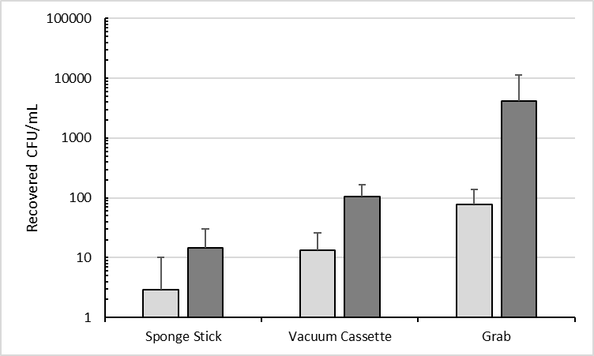
Fig 4 Presumptive and Total Background Microbial Load Recovered from 0 CFU Btk Spore Load Samples. Recovered CFU recovered from zero-spiked samples with presumptive Btk morphology (light gray bars) and total background microorganisms, all morphologies (dark gray bars) for each sample type.

Supplementary Data

Manuscript: “Evaluation of Two Methods for Detection of Viable Bacillus anthracis Simulant Spores in Maritime Environmental Samples”

Supplemental Results Tables
Supplemental Table S1. Actual Btk T1B2 Spore Load and Recovery Values
Maritime Surface/  Material Sampled | Sample ID | Sampling Method | Actual Btk T1B2 Spore Load  (CFU/mL) | Presumptive Btk Recovered (CFU/mL) (X ± σ) | Average Recovery  % | Sample Replicates Presumptive Positive | Total Samples | Sample Replicates Presumptive Positive  %
RBS Marine Grade Aluminum | SBMGAL | SS | 0 ± 0 | 1.2 ± 0.7 | N/A | 6 | 6 | 100
 |  |  | 7.0 ± 2.4 | 2.9 ± 1.1 | 41 | 6 | 6 | 100
 |  |  | 71.7 ± 27.0 | 34.9 ± 8.0 | 49 | 6 | 6 | 100
Nonskid Tread | NSKID |  | 0.0 ± 0.0 | 6.8 ± 11.3 | N/A | 6 | 7 | 86
 |  |  | 9.2 ± 4.1 | 8.0 ± 6.1 | 87 | 7 | 7 | 100
 |  |  | 93.1 ± 37.5 | 35.1 ± 11.0 | 38 | 7 | 7 | 100
Touch Screen | TCHSCRN |  | 0.0 ± 0.0 | 0.2 ± 0.3 | N/A | 2 | 6 | 33
 |  |  | 11.6 ± 7.3 | 12.8 ± 18.2 | 110 | 6 | 6 | 100
 |  |  | 112.2 ± 69.4 | 39.1 ± 49.6 | 35 | 6 | 6 | 100
All Surfaces  Sampled | All Surfaces  Sampled |  | 0.0 ± 0.0 | 2.7 ± 4.1 | N/A | 14 | 19 | 74
 |  |  | 9.3 ± 4.6 | 7.9 ± 8.5 | 85 | 19 | 19 | 100
 |  |  | 92.3 ± 44.6 | 36.4 ± 22.9 | 39 | 19 | 19 | 100
N/A | Controls |  | 0.0 ± 0.0 | 0.0 ± 0.0 | N/A | 0 | 11 | 0
 |  |  | 8.9 ± 4.1 | 2.8 ± 1.7 | 32 | 4 | 4 | 100
 |  |  | 88.7 ± 38.7 | 52.1 ± 36.9 | 59 | 4 | 4 | 100
Nonskid Tread | NSKID | VFC | 0.0 ± 0.0 | 14.1 ± 17.2 | N/A | 6 | 8 | 75
 |  |  | 19.9 ± 12.1 | 20.2 ± 15.1 | 102 | 8 | 8 | 100
 |  |  | 199.3 ± 121.1 | 43.4 ± 29.7 | 22 | 8 | 8 | 100
Concrete Pier | CONPIER |  | 0.0 ± 0.0 | 12.3 ± 8.9 | N/A | 8 | 8 | 100
 |  |  | 19.9 ± 12.1 | 14.9 ± 14.2 | 75 | 8 | 8 | 100
 |  |  | 199.3 ± 121.1 | 30.6 ± 19.9 | 15 | 8 | 8 | 100
All Surfaces  Sampled | All Surfaces  Sampled |  | 0.0 ± 0.0 | 13.2 ± 13.1 | N/A | 14 | 16 | 88
 |  |  | 19.9 ± 12.1 | 17.6 ± 14.7 | 88 | 16 | 16 | 100
 |  |  | 199.3 ± 121.1 | 37.0 ± 24.8 | 19 | 16 | 16 | 100
N/A | Lab/Field  Controls |  | 0.0 ± 0.0 | 0.0 ± 0.0 | N/A | 0 | 11 | 0
 |  |  | 24.5 ± 12.2 | 13.7 ± 30.5 | 56 | 6 | 6 | 100
 |  |  | 245.0 ± 122.3 | 143.0 ± 309.0 | 58 | 6 | 6 | 100
N/A | Total  (w/Controls) |  | 0.0 ± 0.0 | 8.8 ± 8.7 | N/A | 14 | 27 | 52
 |  |  | 21.5 ± 12.2 | 16.3 ± 20.0 | 76 | 22 | 22 | 100
 |  |  | 214.5 ± 122.3 | 72.3 ± 119.5 | 34 | 22 | 22 | 100
RBS Washdown Water | SBWASH | Grab | 0.0 ± 0.0 | 85.0 ± 49.2 | N/A | 3 | 3 | 100
 |  |  | 9.0 ± 0.0 | 123.3 ± 33.3 | 1,370 | 3 | 3 | 100
 |  |  | 90 ± 0.0 | 133.3 ± 66.9 | 148 | 3 | 3 | 100
 |  |  | 3,000 ± 0.0 | 471.1 ± 76.8 | 16 | 3 | 3 | 100
Gravel Parking Lot | GRAVEL |  | 0.0 ± 0.0 | 70.3 ± 95.3 | N/A | 3 | 3 | 100
 |  |  | 9.0 ± 0.0 | 18.3 ± 13.7 | 203 | 3 | 3 | 100
 |  |  | 90.0 ± 0.0 | 79.3 ± 45.5 | 88 | 3 | 3 | 100
Loam Soil | SOIL |  | 0.0 ± 0.0 | 37.8 ± 17.1 | N/A | 3 | 3 | 100
 |  |  | 110 ± 0.0 | 42.2 ± 5.1 | 38 | 3 | 3 | 100
 |  |  | 1,100 ± 0.0 | 90.0 ± 17.6 | 8 | 3 | 3 | 100
 |  |  | 11,000 ± 0.0 | 561.1 ± 351.1 | 5 | 3 | 3 | 100
Grass Vegetation | VEGE |  | 0.0 ± 0.0 | 136. 3 ± 43.5 | N/A | 3 | 3 | 100
 |  |  | 1.4 ± 0.3 | 242.0 ± 6.1 | 17,323 | 3 | 3 | 100
 |  |  | 14.6 ± 3.7 | 311.0 ± 81.5 | 2,137 | 3 | 3 | 100
 |  |  | 750.0 ± 167.0 | 294.4 ± 32.4 | 39 | 3 | 3 | 100

Supplemental Table S2. PCR Results for TC Method
Surface/  Material Sampled | Sample ID | Sampling Method | Nominal Spore Load  (CFU) | Colonies from Initial Culture Plates PCR-Screened  (# PCR +) ^{(a)} | Colony PCR Ct  (X ± σ) ^{(b)} | Colonies from BHIB Streak Plates PCR-Screened  (# PCR +) ^{(c)} | BHIB PCR-Screened  (# PCR +) ^{(d)} | BHIB PCR Ct  (X ± σ) ^{(e)} | Culture Replicates PCR Positive
RBS Marine Grade Aluminum | SBMGAL | SS | 0 | 13 (1) | 37.2 ± 7.4 | 0 | 4 (1) | 37.2 ± 0.6 | 2 of 6
 |  |  | 300 | 19 (5) | 22.5 ± 1.3 | 1 (0) | 1 (0) | N/A | 5 of 6
 |  |  | 3,000 | 24 (6) | 22.7 ± 0.8 | 0 | 0 | N/A | 6 of 6
Nonskid Tread | NSKID |  | 0 | 28 (3) | 34.7 ± 2.5 | 0 | 3 (0) | N/A | 3 of 7
 |  |  | 300 | 34 (5) | 24.6 ± 3.6 | 1 (0) | 2 (0) | N/A | 5 of 7
 |  |  | 3,000 | 43 (7) | 22.9 ± 1.3 | 1 (0) | 0 | N/A | 7 of 7
Touch Screen | TCHSCRN |  | 0 | 15 (1) | 38.1 ± 0.0 | 0 | 1 (1) | 39.1 ± 0.8 | 1 of 6
 |  |  | 300 | 49 (6) | 22.2 ± 3.2 | 0 | 0 | N/A | 6 of 6
 |  |  | 3,000 | 51 (6) | 20.7 ± 0.7 | 0 | 0 | N/A | 6 of 6
N/A | Lab/Field Control |  | 0 | 0 | N/A | 0 | 0 | N/A | 0 of 11
 |  |  | 300 | 22 (4) | 21.2 ± 0.9 | 0 | 0 | N/A | 4 of 4
 |  |  | 3,000 | 22 (4) | 21.2 ± 0.2 | 0 | 0 | N/A | 4 of 4
Nonskid Tread | NSKID | VFC | 0 | 42 (0) | N/A | 1 (0) | 4 (1) | 40.0 ± 4.7 | 1 of 8
 |  |  | 300 | 57 (2) | 24.3 ± 1.2 | 1 (0) | 5 (3) | 35.7 ± 0.4 | 5 of 8
 |  |  | 3,000 | 62 (7) | 23.5 ± 2.5 | 0 | 1 (1) | 31.1 ± 0.8 | 8 of 8
Concrete Pier | CONPIER |  | 0 | 62 (3) | 34.9 ± 2.4 | 0 | 4 (0) | N/A | 3 of 8
 |  |  | 300 | 56 (5) | 24.6 ± 1.1 | 0 | 2 (2) | 33.0 ± 0.8 | 7 of 8
 |  |  | 3,000 | 62 (7) | 23.7 ± 2.1 | 1 (1) | 1 (1) | 23.3 ± 1.5 | 8 of 8
N/A | Lab/Field Control |  | 0 | 0 (0) | N/A | 0 | 1 (1) | 38.3 ± 6.3 | 1 of 11
 |  |  | 300 | 18 (4) | 21.9 ± 1.1 | 0 | 0 | N/A | 6 of 6
 |  |  | 3,000 | 51 (6) | 21.0 ± 1.3 | 0 | 0 | N/A | 6 of 6
RBS Washdown Water | SBWASH | Grab | 0 | 23 (0) | N/A | 30 (0) | 3 (0) | N/A | 0 of 3
 |  |  | 300 | 34 (0) | N/A | 20 (0) | 3 (0) | N/A | 0 of 3
 |  |  | 3,000 | 30 (3) | 23.3 ± 3.0 | 10 (0) | 3 (2) | 38.6 ± 1.0 | 3 of 3
 |  |  | 30,000 | 30 (3) | 18.2 ± 0.7 | 0 | 0 | N/A | 3 of 3
Gravel Parking Lot | GRAVEL |  | 0 | 30 (0) | N/A | 30 (0) | 0 | N/A | 0 of 3
 |  |  | 300 | 28 (1) | 22.4 ± 0.1 | 20 (0) | 0 | N/A | 1 of 3
 |  |  | 3,000 | 30 (2) | 23.1 ± 0.6 | 0 | 0 | N/A | 2 of 3
Loam Soil | SOIL |  | 0 | 27 (0) | N/A | 0 | 0 | N/A | 0 of 3
 |  |  | 3,000 | 30 (1) | 22.1 ± 0.1 | 4 (0) | 3 (2) | 38.6 ± 1.0 | 2 of 3
 |  |  | 30,000 | 30 (3) | 20.4 ± 0.5 | 0 | 3 (3) | 37.0 ± 0.5 | 3 of 3
 |  |  | 300,000 | 30 (3) | 19.8 ± 0.6 | 0 | 3 (3) | 33.7 ± 0.2 | 3 of 3
Grass Vegetation | VEGE |  | 0 | 30 (0) | N/A | 0 | 3 (0) | N/A | 0 of 3
 |  |  | 300 | 30 (0) | N/A | 16 (0) | 3 (0) | N/A | 0 of 3
 |  |  | 3,000 | 30 (1) | 29.0 ± 0.1 | 16 (0) | 3 (0) | N/A | 1 of 3
 |  |  | 30,000 | 30 (3) | 19.7 ± 0.8 | 0 | 0 | N/A | 3 of 3
^{(a)} Number of colonies PCR-screened from initial plating, with number of PCR positive replicates in parentheses.
^{(b)} Colony PCR Ct values for positive samples (Ct value of ≤ 40).
^{(c)} Number of colonies PCR-screened from BHIB streak plates, with number of PCR positive replicates in parentheses.
^{(d)} Number of samples with PCR screening of BHIB enrichment culture, with number of PCR positive replicates in parentheses.
^{(e)} BHIB enrichment culture PCR Ct values for positive samples (Ct value of ≤ 40).

Supplemental Table S3. RV-PCR ΔCt Values and Total Microbial Load
Maritime Surface/Material Sampled | Sample ID | Sampling Method | Nominal Spore Load  (CFU) | RV-PCR ΔCt (X ± σ) | RV-PCR Replicates Positive | Average Total Microbial Load CFU/mL (X ± σ)
RBS Marine Grade Aluminum | SBMGAL | SS | 0 | 0.2 ± 1.6 | 0 of 6 | 9.5 ± 4.7
 |  |  | 300 | 16.3 ± 3.9 | 6 of 6 | 13.4 ± 3.8
 |  |  | 3,000 | 21.7 ± 3.3 | 6 of 6 | 42.8 ± 8.8
Nonskid Tread | NSKID |  | 0 | 0.9 ± 2.0 | 0 of 0 | 27.6 ± 19.7
 |  |  | 300 | 13.0 ± 5.4 | 6 of 7 | 32.6 ± 21.0
 |  |  | 3,000 | 16.2 ± 3.3 | 7 of 7 | 53.9 ± 13.9
Touch Screen | TCHSCRN |  | 0 | 2.3 ± 3.6 | 0 of 6 | 4.0 ± 2.7
 |  |  | 300 | 20.6 ± 3.1 | 6 of 6 | 25.2 ± 22.2
 |  |  | 3,000 | 23.1 ± 2.0 | 6 of 6 | 42.3 ± 52.5
N/A | Lab/Field Control |  | 0 | 1.7 ± 3.4 | 1 of 11 | 0.1 ± 0.2
 |  |  | 300 | 25.0 ± 0.4 | 4 of 4 | 2.8 ± 1.7
 |  |  | 3,000 | 24.8 ± 0.2 | 4 of 4 | 52.1 ± 36.9
Nonskid Tread | NSKID | VFC | 0 | 0.5 ± 0.9 | 0 of 8 | 94.7 ± 76.1
 |  |  | 300 | 8.4 ± 5.2 | 5 of 8 | 108.3 ± 111.0
 |  |  | 3,000 | 13.6 ± 4.4 | 7 of 8 | 126.3 ± 86.5
Concrete Pier | CONPIER |  | 0 | 0.0 ± 0.0 | 0 of 8 | 115.4 ± 44.9
 |  |  | 300 | 12.2 ± 6.9 | 6 of 8 | 114.0 ± 86.8
 |  |  | 3,000 | 16.2 ± 4.5 | 7 of 8 | 98.5 ± 79.5
N/A | Lab/Field Control |  | 0 | 2.2 ± 3.4 | 0 of 8 | 0.1 ± 0.1
 |  |  | 300 | 23.0 ± 4.6 | 6 of 6 | 13.7 ± 30.5
 |  |  | 3,000 | 23.9 ± 2.4 | 6 of 6 | 143.0 ± 309.0
RBS Washdown Water | SBWASH | Grab | 0 | 0.0 ± 0.0 | 0 of 3 | 1,311.7 ± 210.1
 |  |  | 300 | 0.0 ± 0.0 | 0 of 3 | 1,633.3 ± 181.5
 |  |  | 3,000 | 7.0 ± 0.8 | 0 of 3 | 1,713.3 ± 248.3
 |  |  | 30,000 | 12.2 ± 0.6 | 3 of 3 | 2,210.0 ± 229.1
Gravel Parking Lot | GRAVEL |  | 0 | 0.7 ± 1.3 | 0 of 3 | 154.8 ± 101.1
 |  |  | 300 | 7.5 ± 2.6 | 1 of 3 | 71.7 ± 11.0
 |  |  | 3,000 | 6.9 ± 3.1 | 1 of 3 | 189.0 ± 106.2
Loam Soil | SOIL |  | 0 | 0.6 ± 1.0 | 0 of 3 | 13,373.3 ± 8,486.9
 |  |  | 3,000 | 8.7 ± 1.5 | 1 of 3 | 6,926.7 ± 2,189.5
 |  |  | 30,000 | 13.2 ± 1.2 | 3 of 3 | 6,493.3 ± 1,467.3
 |  |  | 300,000 | 16.6 ± 0.6 | 3 of 3 | 5,360.0 ± 937.4
Grass Vegetation | VEGE |  | 0 | 0.0 ± 0.0 | 0 of 3 | 378.0 ± 62.2
 |  |  | 300 | 0.0 ± 0.0 | 0 of 3 | 484.0 ± 12.2
 |  |  | 3,000 | 1.6 ± 1.5 | 0 of 3 | 556.7 ± 85.0
 |  |  | 30,000 | 12.6 ± 1.3 | 3 of 3 | 994.4 ± 423.1

