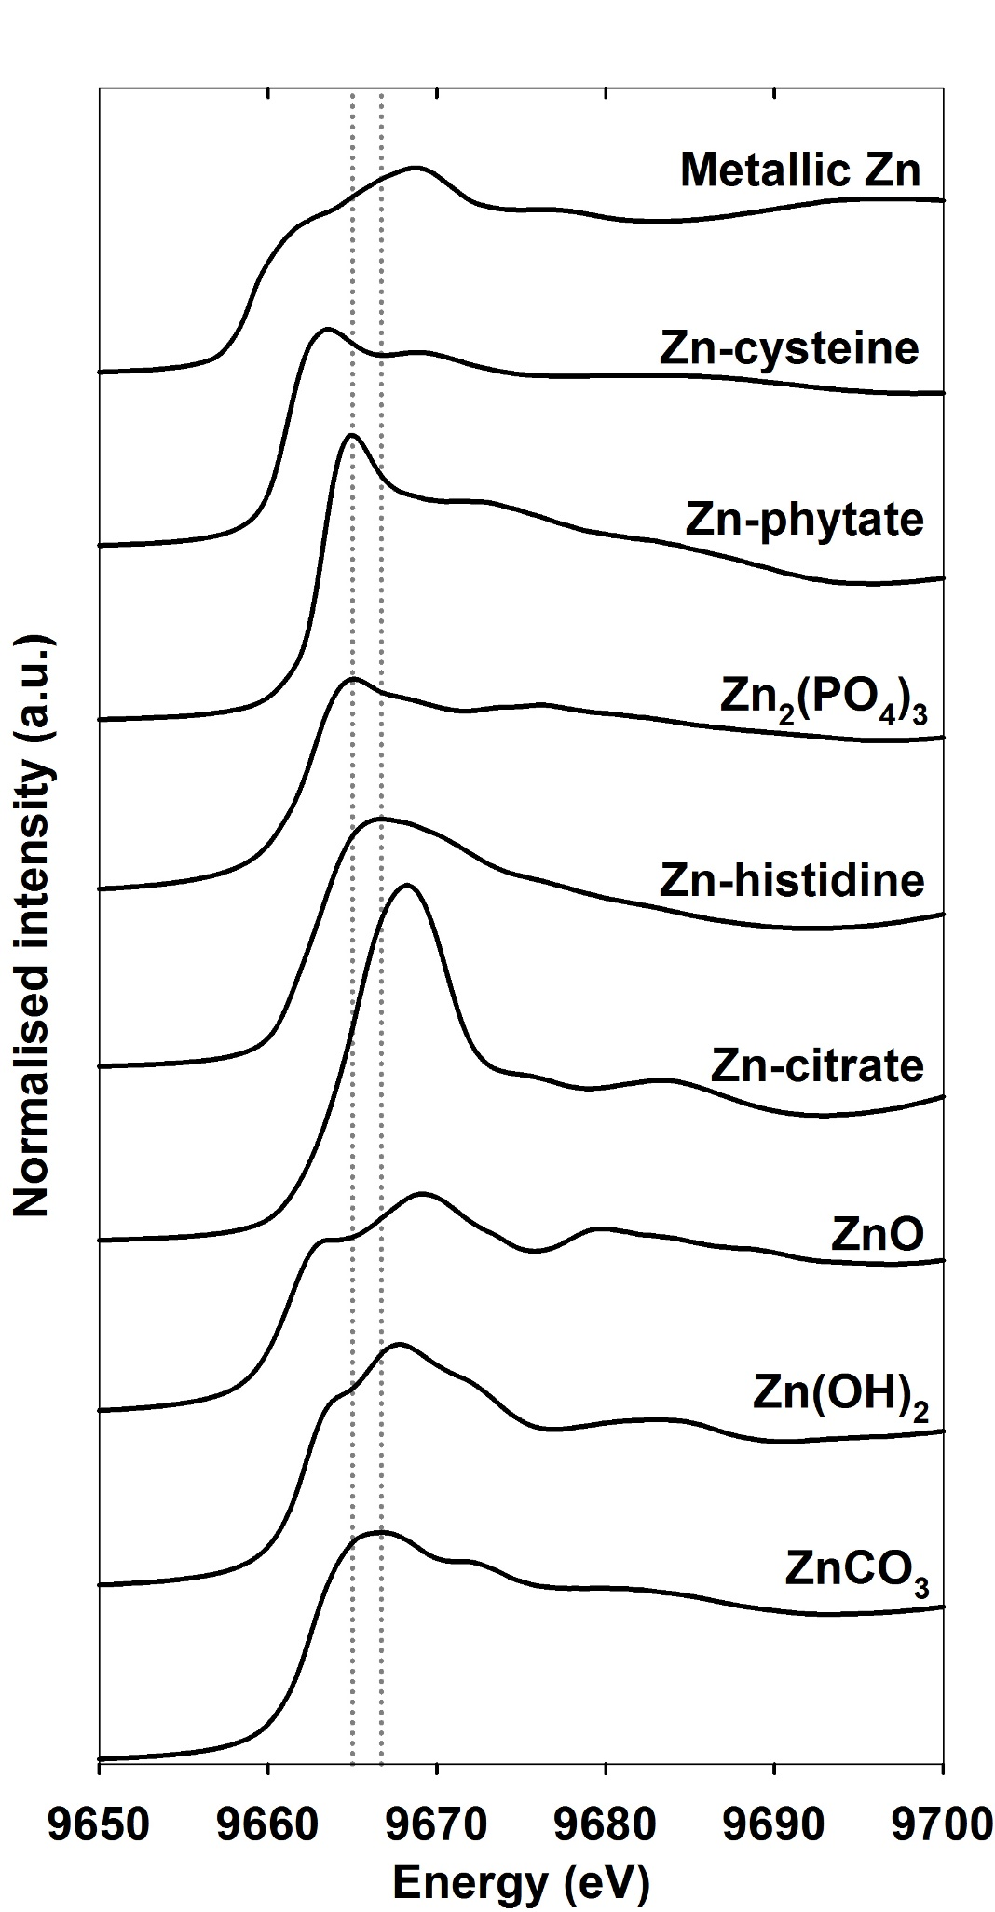
Fig 1. Average of the normalised Zn K-edge XANES spectra for the nine standard compounds analysed at pH 7. The vertical lines are at 9664.8 eV and 9666.8 eV, which correspond to the white line peaks of Zn-phytate and Zn-histidine, respectively.

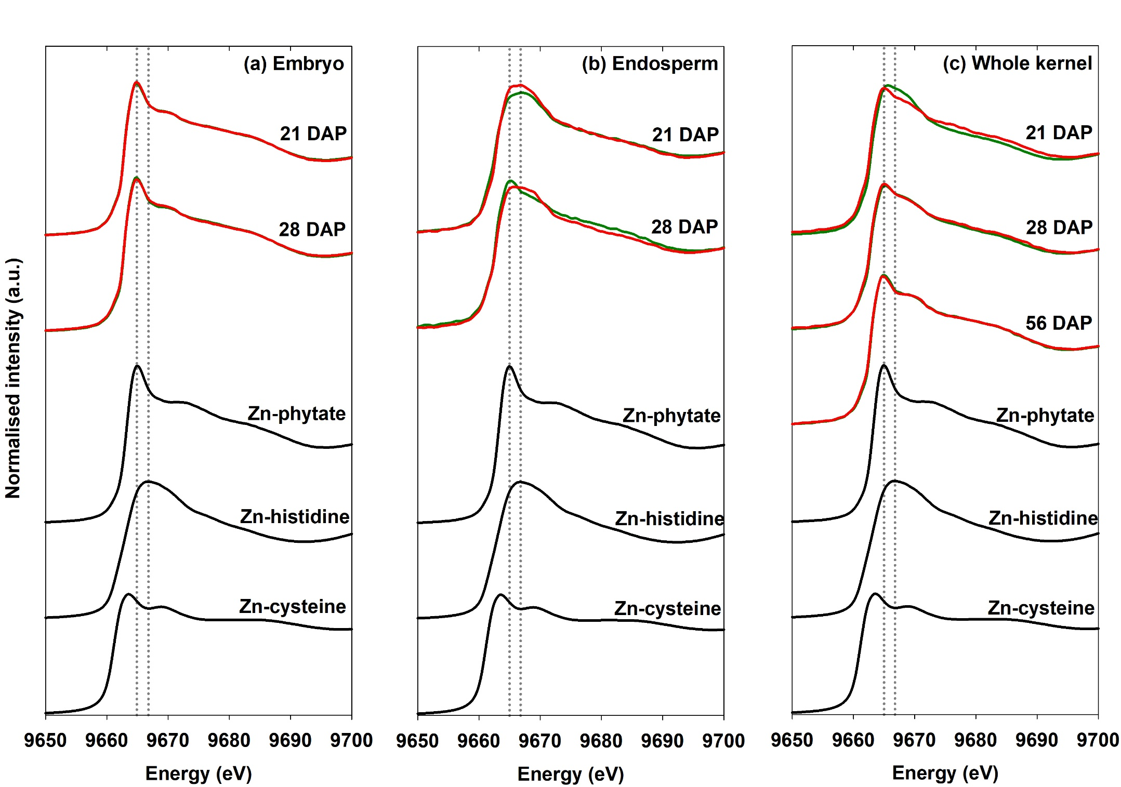
Fig 2. Average normalised Zn K-edge XANES spectra for ‘Hybrix 5’ sweetcorn and ‘Thai Floury 2’ maize (Zea mays) embryo, endosperm and whole kernel at 21, 28 and 56 d after pollination. Spectra of sweetcorn and maize are in red and green respectively. Data are also presented for relevant standard compounds. The vertical lines are at 9664.8 eV and 9666.8 eV, which correspond to the white line peaks of Zn-phytate and Zn-histidine, respectively.
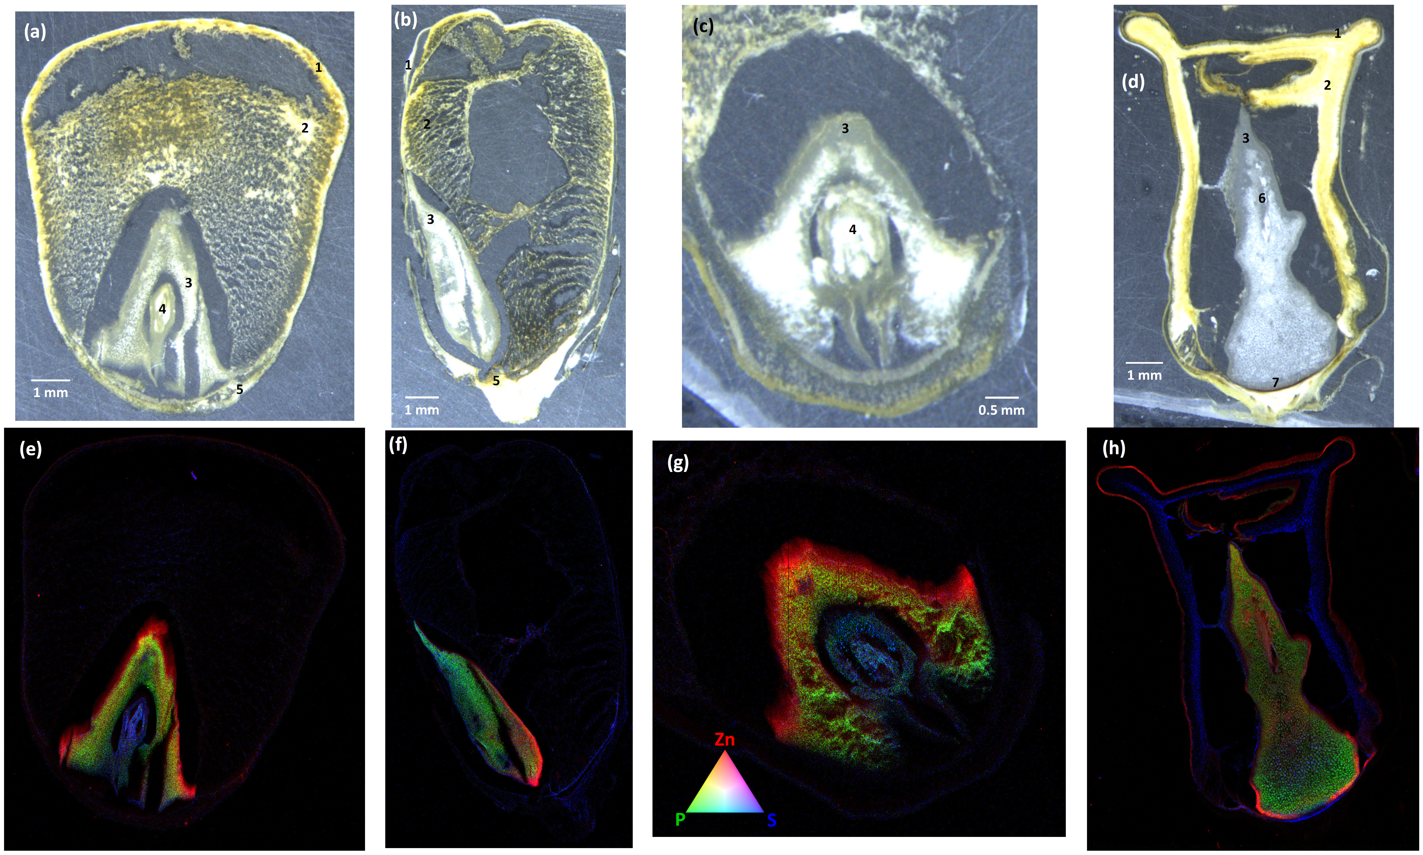
Fig 3. Light micrographs and RGB co-localisation maps of Zn (red), P (green) and S (blue) in ‘Hybrix 5’ sweetcorn (Zea mays) whole kernels from the front view (a,e), side view (b,f) and embryo (c,g) at 21 DAP, and whole kernel front view at 56 DAP (d,h). 1, aleurone layer; 2, endosperm; 3, scutellum; 4, embryo axis; 5, basal plate; 6, shoot apical meristem; 7, black abscission zone. Micrographs were taken using a Leica MZ6 dissection microscope, objective achromat ×1.0, working distance = 90 mm.
Table 1. Means and standard errors of tissue Zn concentration and the mass of Zn in embryos, endosperms and whole kernels from 15 sweetcorn and maize (Zea mays) varieties sampled 21 d after pollination. The proportion of the total kernel Zn (and dry matter in parentheses) found in the embryo and endosperm is also shown. Concentration data are reported on a dry weight (DW) basis.
Variety | Zn concentration (mg kg⁻¹ DW) |  |  | Zn content (µg kernel⁻¹) |  |  | Proportion of total kernel Zn  (and DW) (%)
 | Whole kernel | Embryo | Endosperm | Whole kernel | Embryo | Endosperm | Embryo | Endosperm
Sweetcorn
6-1 × 15-2 | 28 ± 1.1 | 121 ± 6.4 | 22 ± 0.9 | 3.5 ± 0.4 | 0.9 ± 0.2 | 2.6 ± 0.2 | 27 (6) | 73 (94)
Hybrix 5 | 28 ± 2.9 | 113 ± 4.9 | 23 ± 1.4 | 3.5 ± 0.2 | 0.8 ± 0.2 | 2.7 ± 0.1 | 23 (5) | 77 (95)
23-1 | 33 ± 2.6 | 128 ± 18.8 | 26 ± 2.3 | 3.4 ± 0.4 | 0.9 ± 0.1 | 2.5 ± 0.3 | 28 (8) | 72 (92)
HiZeax 103146 | 30 ± 0.6 | 132 ± 5.1 | 21 ± 0.4 | 3.4 ± 0.1 | 1.1 ± 0.1 | 2.2 ± 0.1 | 34 (8) | 66 (92)
56.3-1 | 41 ± 3.3 | 167 ± 17.5 | 28 ± 2.6 | 3.3 ± 0.4 | 1.3 ± 0.1 | 2.1 ± 0.3 | 38 (10) | 62 (90)
14-6 | 44 ± 6.4 | 168 ± 23.7 | 39 ± 6.7 | 2.9 ± 0.5 | 0.5 ± 0.2 | 2.4 ± 0.4 | 17 (5) | 83 (95)
13-2 | 33 ± 2.0 | 182 ± 12.8 | 24 ± 2.0 | 2.9 ± 0.2 | 1.0 ± 0.1 | 1.9 ± 0.1 | 33 (6) | 67 (94)
O2su | 30 ± 2.9 | 156 ± 34.5 | 26 ± 1.4 | 2.7 ± 0.3 | 0.5 ± 0.1 | 2.2 ± 0.2 | 19 (4) | 81 (96)
23-7 | 30 ± 0.4 | 132 ± 9.4 | 22 ± 0.5 | 2.5 ± 0.2 | 0.8 ± 0.1 | 1.7 ± 0.1 | 33 (8) | 67 (92)
23-6 | 29 ± 1.6 | 104 ± 5.7 | 22 ± 1.7 | 2.3 ± 0.2 | 0.7 ± 0.1 | 1.6 ± 0.1 | 31 (8) | 69 (92)
Garrison | 20 ± 1.0 | 55 ± 2.3 | 17 ± 1.0 | 2.3 ± 0.2 | 0.5 ± 0.0 | 1.7 ± 0.1 | 23 (8) | 77 (92)
fl2sh2 | 25 ± 1.7 | 99 ± 22.1 | 23 ± 1.9 | 1.4 ± 0.3 | 0.2 ± 0.1 | 1.2 ± 0.2 | 17 (4) | 83 (96)
Mean | 31 ± 2.2 | 130 ± 13.6 | 24 ± 1.9 | 2.8 ± 0.3 | 0.8 ± 0.1 | 2.1 ± 0.2 | 27 (7) | 73 (93)
Maize
Dull purple | 20 ± 0.6 | 86 ± 7.7 | 15 ± 0.7 | 2.9 ± 0.2 | 0.8 ± 0.1 | 2.1 ± 0.1 | 27 (6) | 73 (94)
Thai Floury 2 | 28 ± 2.4 | 130 ± 7.7 | 20 ± 0.8 | 2.9 ± 0.2 | 0.9 ± 0.0 | 2.0 ± 0.1 | 31 (7) | 69 (93)
EM 540 | 26 ± 1.1 | 136 ± 12.5 | 20 ± 1.0 | 2.7 ± 0.1 | 0.8 ± 0.1 | 1.9 ± 0.1 | 30 (6) | 70 (94)
Mean | 25 ± 1.4 | 117 ± 9.3 | 18 ± 0.8 | 2.8 ± 0.2 | 0.8 ± 0.1 | 2.0 ± 0.1 | 29 (6) | 71 (94)

Table 2. Means and standard errors of tissue Zn concentration and the mass of Zn in embryos, endosperms and whole kernels of ‘Hybrix 5’ sweetcorn and ‘Thai Floury 2’ maize (Zea mays) at 18, 21, 24, 28 and 56 d after pollination (DAP). Concentration data are reported on a dry weight (DW) basis. Means that do not share the same letter indicate significant differences within tissue types at various stages of maturity.
Tissue |  | Zn concentration (mg kg⁻¹ DW) |  |  |  |  |  |  |  |  | Zn content (µg kernel⁻¹)
 | 18 DAP |  | 21 DAP |  | 24 DAP |  | 28 DAP |  | 56 DAP |  | 18 DAP | 21 DAP | 24 DAP | 28 DAP | 56 DAP
‘Hybrix 5’ sweetcorn
Embryo | 138 ± 2.6 | a | 113 ± 4.9 | b | 112 ± 3.5 | b | 104 ± 7.4 | b | - |  | 0.5 ± 0.1 | 0.8 ± 0.2 | 1.5 ± 0.1 | 1.9 ± 0.1 | -
Endosperm | 32 ± 1.6 | a | 23 ± 1.4 | c | 26 ± 0.9 | b | 23 ± 1.5 | c | - |  | 2.1 ± 0.1 | 2.7 ± 0.1 | 3.7 ± 0.3 | 3.9 ± 0.3 | -
Whole kernel | 37 ± 1.2 | a | 28 ± 2.9 | c | 33 ± 0.7 | b | 31 ± 2.0 | bc | 32 ± 1.8 | b | 2.6 ± 0.2 | 3.5 ± 0.2 | 5.2 ± 0.3 | 5.8 ± 0.4 | 8.8 ± 0.7
Embryo (%) |  |  |  |  |  |  |  |  |  |  | 18 | 23 | 28 | 33
Endosperm (%) |  |  |  |  |  |  |  |  |  |  | 82 | 77 | 72 | 67
‘Thai Floury 2’ maize
Embryo | 112 ± 8.0 | c | 130 ± 7.7 | b | 145 ± 8.0 | a | 92 ± 9.1 | d | - |  | 0.5 ± 0.1 | 0.9 ± 0.0 | 2.3 ± 0.4 | 3.3 ± 0.2 | -
Endosperm | 18 ± 1.9 | a | 20 ± 0.8 | a | 21 ± 1.8 | a | 14 ± 0.6 | b | - |  | 1.3 ± 0.1 | 2.0 ± 0.1 | 2.9 ± 0.2 | 3.4 ± 0.0 | -
Whole kernel | 24 ± 1.2 | c | 28 ± 2.4 | b | 34 ± 1.8 | a | 25 ± 2.3 | bc | 23 ± 1.1 | c | 1.8 ± 0.2 | 2.9 ± 0.2 | 5.2 ± 0.2 | 6.7 ± 0.3 | 10.5 ± 0.6
Embryo (%) |  |  |  |  |  |  |  |  |  |  | 28 | 31 | 44 | 49
Endosperm (%) |  |  |  |  |  |  |  |  |  |  | 72 | 69 | 56 | 51

Table 3. Linear combination fitting predictions of Zn speciation composition in embryos, endosperms and whole kernels of ‘Hybrix 5’ sweetcorn and ‘Thai Floury 2’ maize (Zea mays) at 21, 28 and 56 d after pollination (DAP). There are no R-factor values for whole kernel samples, as the speciation estimates are calculated values from individual tissue analysis instead of LCF predictions.
Variety |  |  | ‘Hybrix 5’ sweetcorn |  |  |  |  |  |  |  |  |  | ‘Thai Floury 2’ maize
Tissue |  |  | Embryo |  |  | Endosperm |  |  | Whole kernel |  |  |  | Embryo |  |  | Endosperm |  |  | Whole kernel
DAP |  |  | 21 | 28 |  | 21 | 28 |  | 21 | 28 |  |  | 21 | 28 |  | 21 | 28 |  | 21 | 28
Speciation (%)
Zn-phytate |  |  | 88 | 88 |  | 13 | 18 |  | 30 | 41 |  |  | 88 | 92 |  | - | 83 |  | 27 | 87
Zn-cysteine |  |  | 12 | 12 |  | - | - |  | 3 | 4 |  |  | 12 | 8 |  | 8 | 15 |  | 9 | 12
Zn-histidine |  |  | - | - |  | 87 | 82 |  | 67 | 55 |  |  | - | - |  | 92 | 2 |  | 63 | 1
R-factor |  |  | 0.00056 | 0.00064 |  | 0.0014 | 0.00099 |  | - | - |  |  | 0.00062 | 0.00065 |  | 0.00086 | 0.0061 |  | - | -

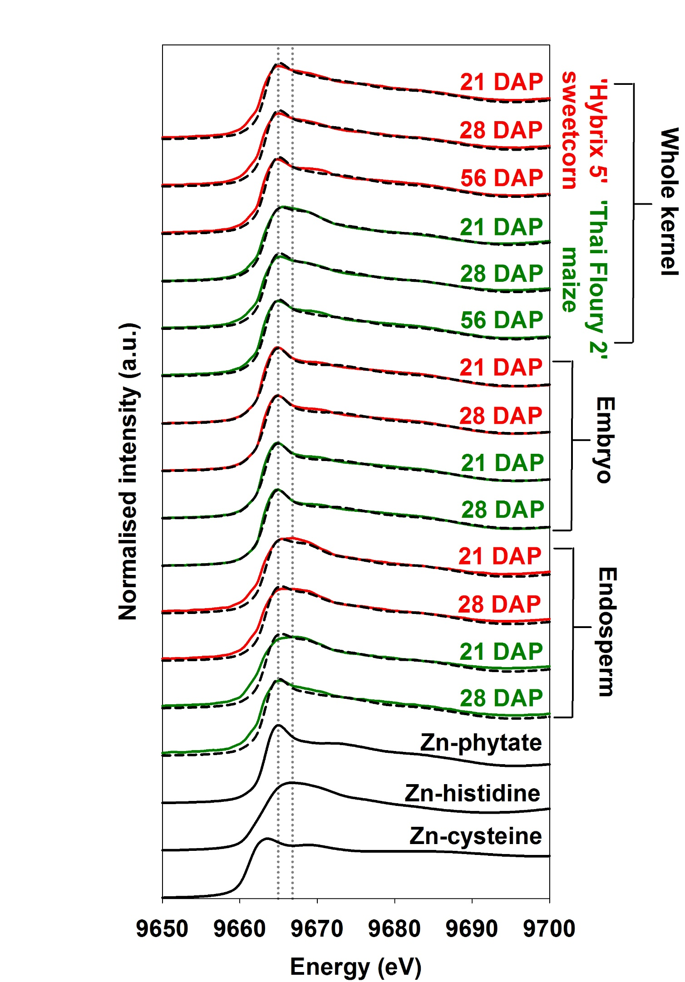
Fig S1. Average normalised Zn K-edge XANES spectra for whole kernel, embryo and endosperm of ‘Hybrix 5’ sweetcorn and ‘Thai Floury 2’ maize (Zea mays) at 21, 28 and 56 d after pollination. Data are also presented for relevant standard compounds at pH 7. The vertical line corresponds to the white line peak of the Zn-phytate (9664.8 eV) and Zn-histidine (9666.8 eV) standards. Dashed lines show the spectral profile generated by the best three-component linear combination fit of vertical standards for the samples.

