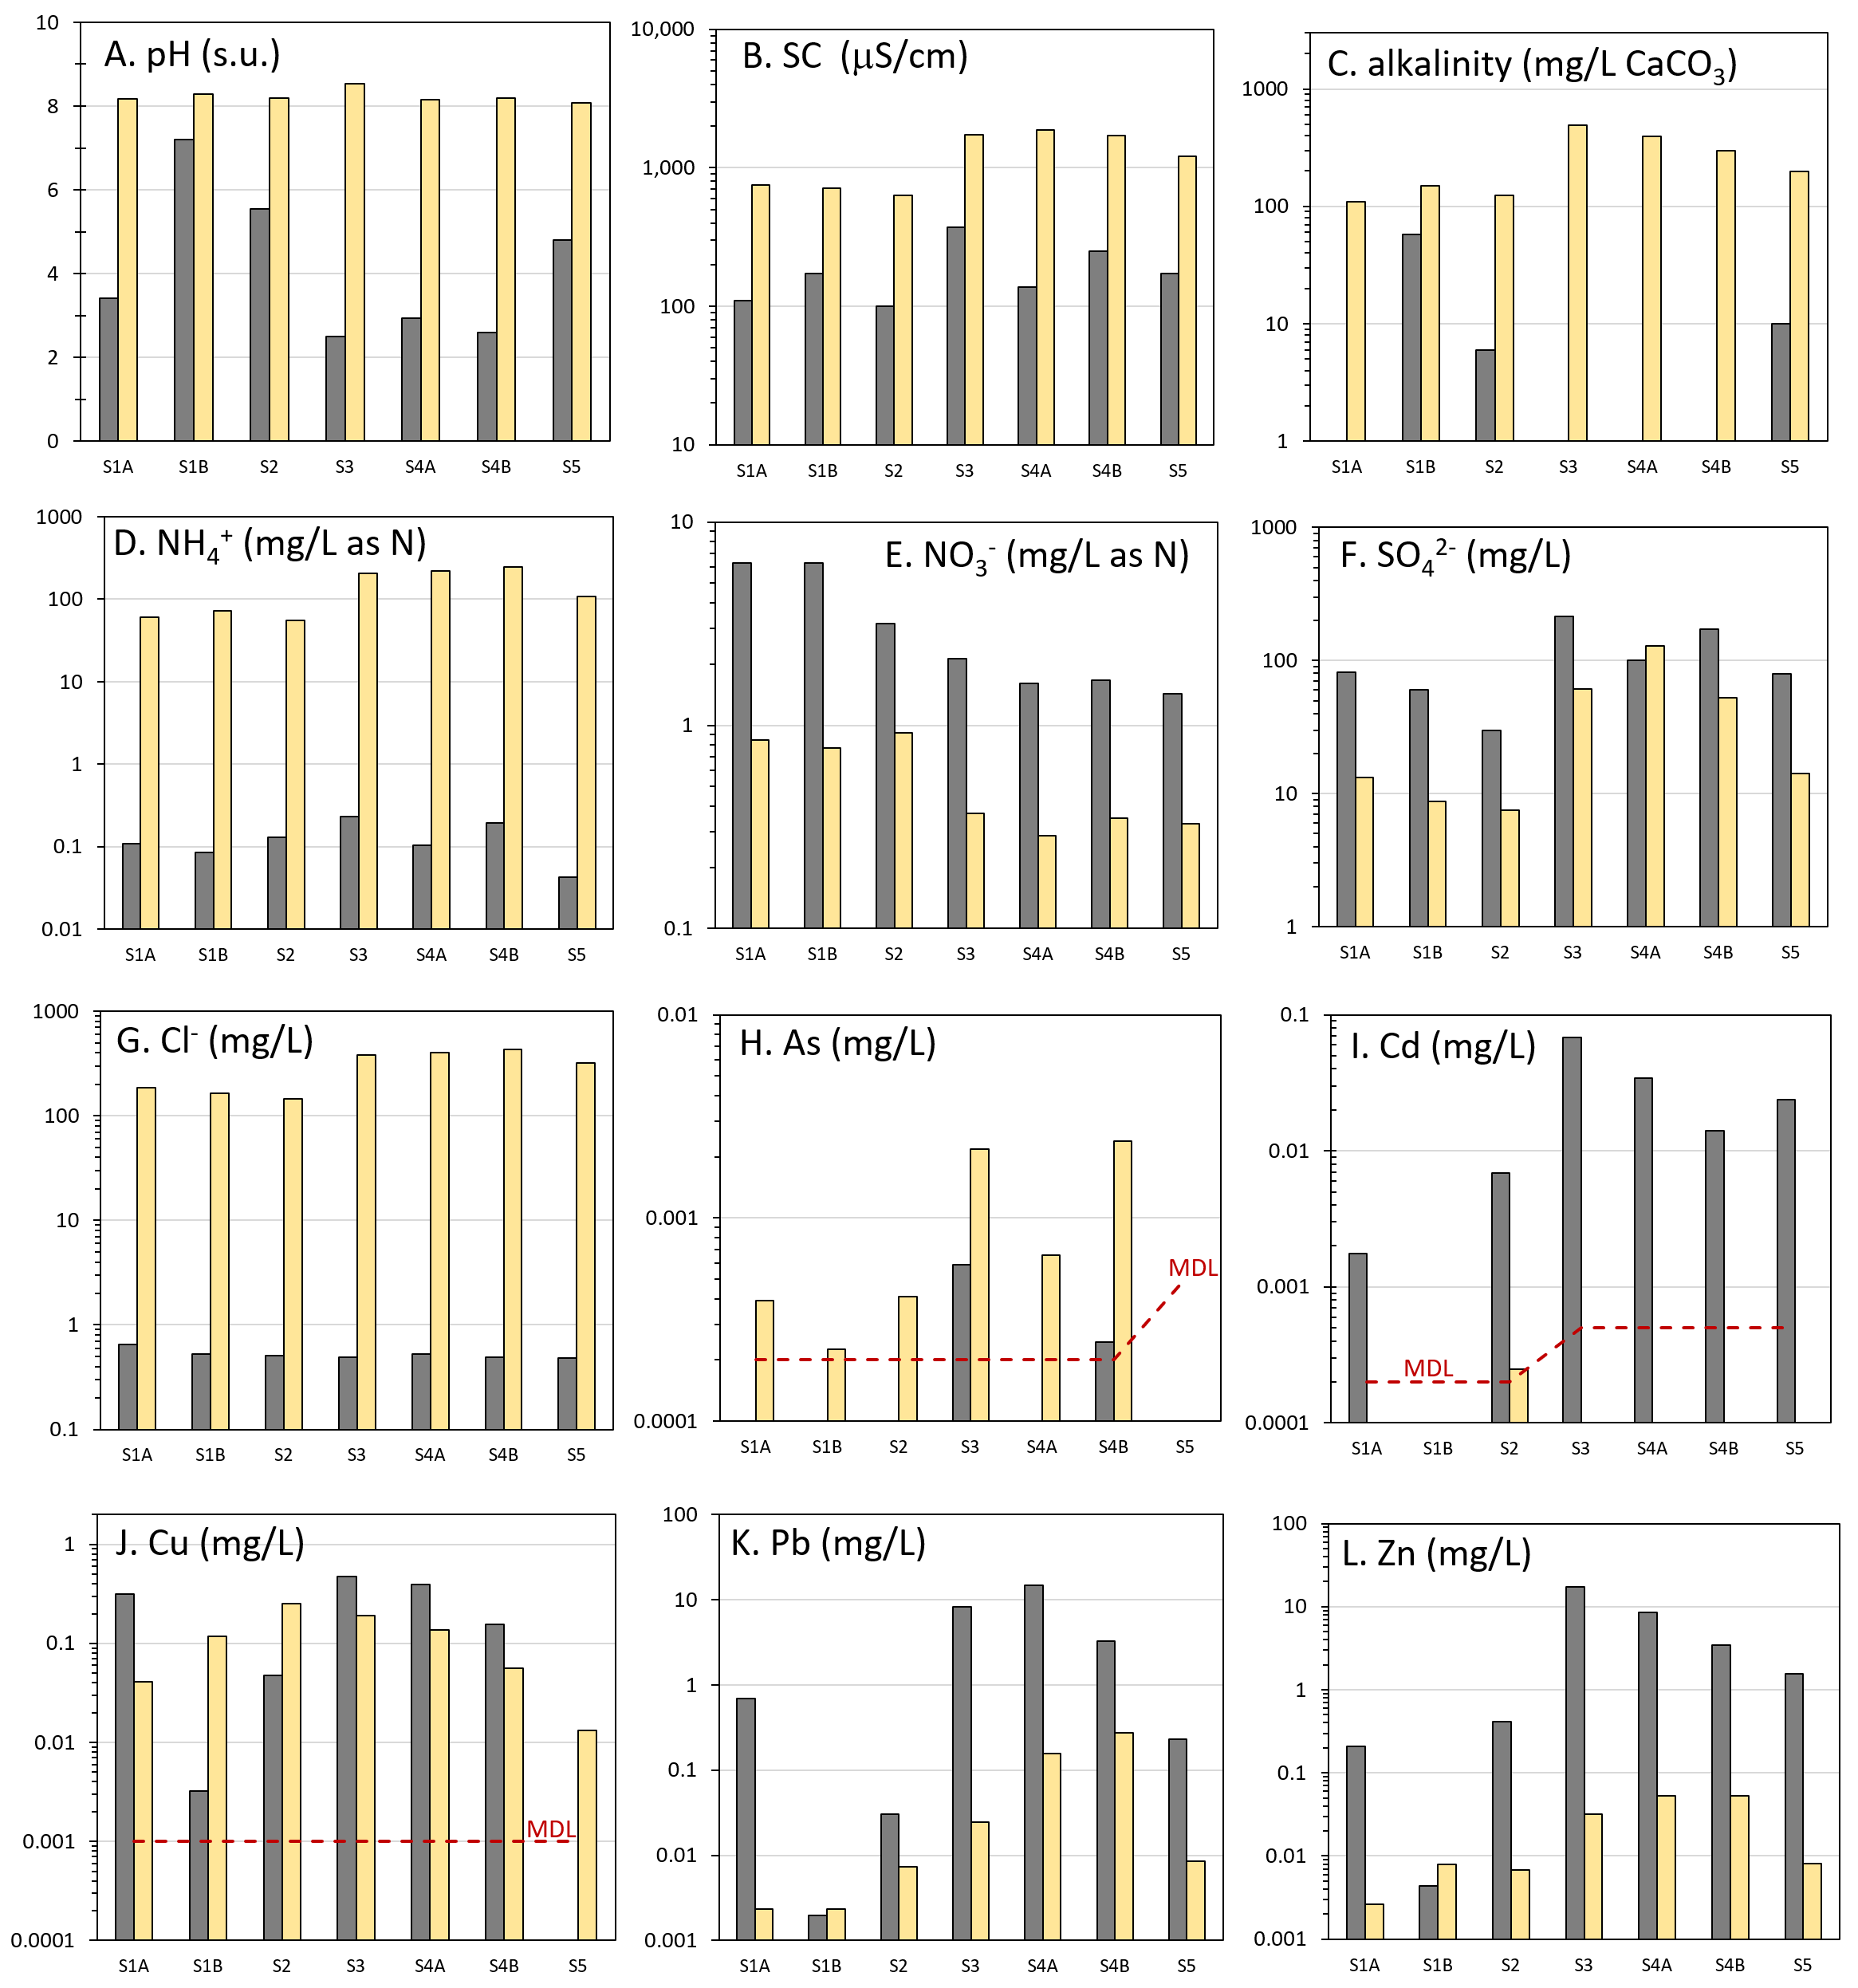
Leaching results pre vs. post treatment

