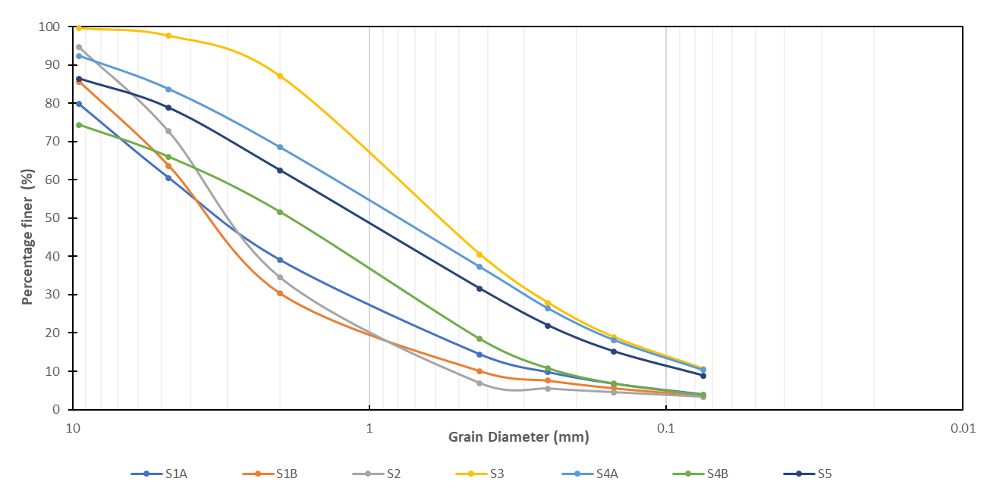
Grain Size Distribution of Tailings

