1. **Summary of results**

Table 1: Sampling information



Table 2: Analysis data from University of Cincinnati

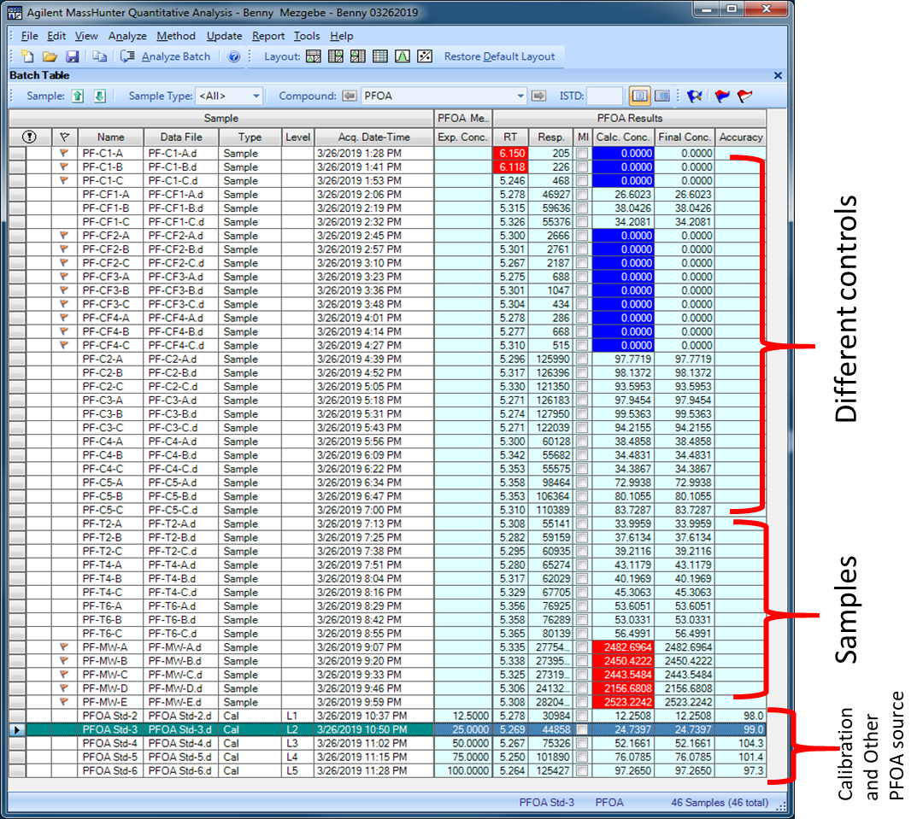

**Compound Information**

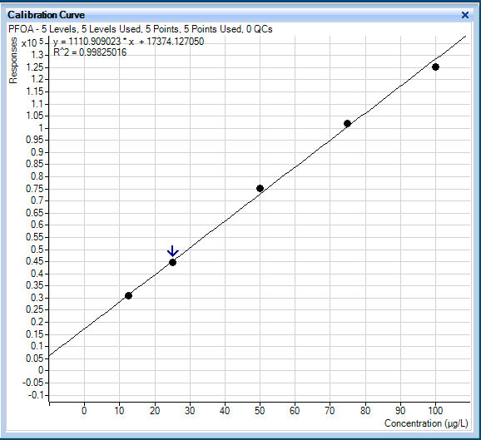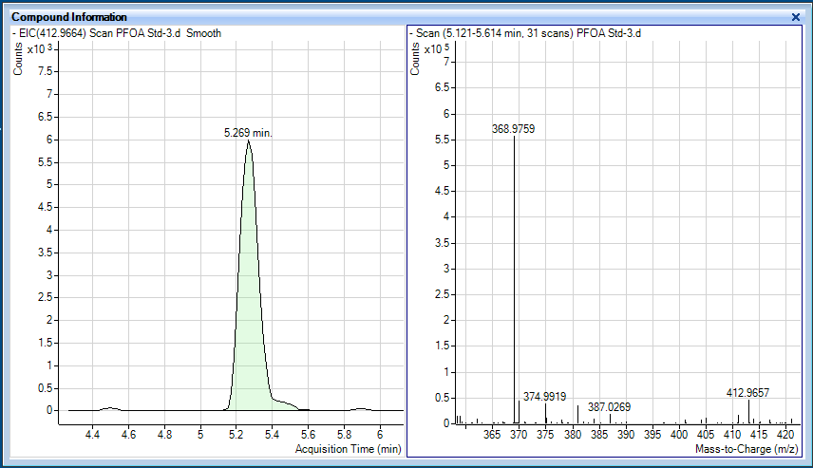

**Calibration Plots**

**Results: PFOA** **(100 µg/L) and Filter effect**







**Table 3:** Summary of analysis results

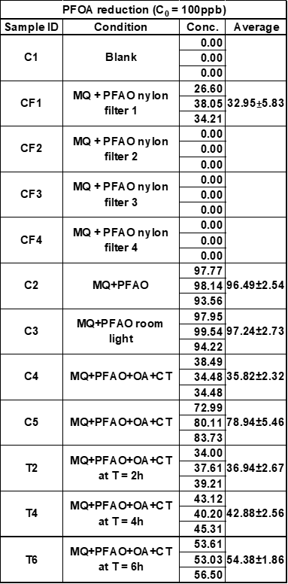

1. **Data qualifiers**

Answer: We did not face any problem with the data, storage, handling, and analysis.

Samples were stored at 4 oC before analysis.

1. **Method informations**

**Answer:** Simultaneous Qualitative and Quantitative Analysis of Perfluoroalkyl Substances (PFASs) in Water Samples by Direct Injection Using Agilent 6540 UHD Accurate-Mass Q-TOF LC/MS from University of Cincinnati



**Q-TOF Quick auto Tune report**



1. **Raw data**

Please see section a.

1. **Sample information**

Table 4: Chain of Custody

