Response of chlorophyll a to total nitrogen and total phosphorus concentrations in lotic ecosystems: a systematic review [Bennett et al.]
ADDITIONAL FILE 12: Forest plots for effect sizes reported in experimental studies and variance distribution over meta-analysis models

FOREST PLOTS FOR EXPERIMENTAL STUDIES

Forest plots for (a) total phosphorus-benthic chlorophyll a and (b) total nitrogen-benthic chlorophyll a effect sizes reported in experimental studies.

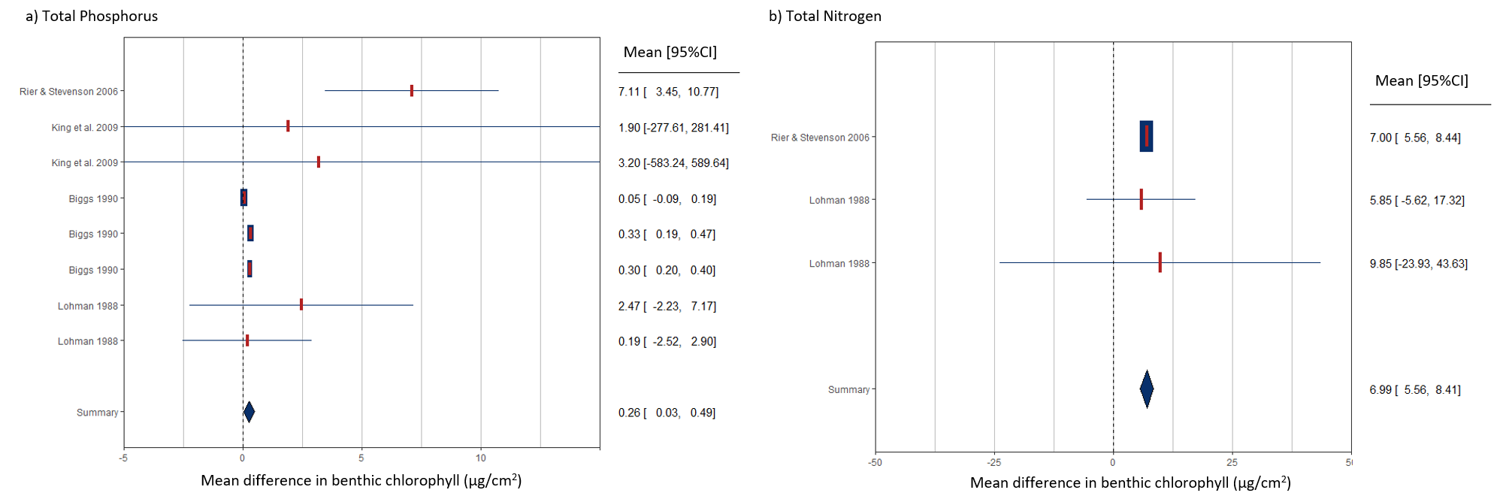

VARIANCE DISTRIBUTION

Table of variance (%) distribution over the three levels of the meta-analysis models. The three-level random-effects model (Assink, 2016 #72) accounts for sampling variance (level 1), the variance between effect sizes extracted from the same study (level 2), and the variance between studies (level 3).

Level | TN-benthic | TP-benthic | TN-sestonic | TP-sestonic
1 | 17.7 | 14.7 | 6.5 | 6.6
2 | 1.4 | 41.8 | 14.9 | 18.2
3 | 80.9 | 43.5 | 78.6 | 75.2

