Supplementary Data

Effect of colloid-size copper-based pesticides and wood preservatives against microbial activities of Gram positive Bacillus species using five-day biochemical oxygen demand test

Ayenachew Tegenawª, Thabet M. Tolaymat^{b}, George A. Sorial^{a,}*, Endalkachew Sahle-Demessie^{c}

ª Environmental Engineering Program, Department of Chemical and Environmental Engineering, College of Engineering and Applied Science, University of Cincinnati, 701 Engineering Research Center, 2901 Woodside Drive P.O. Box 210012, Cincinnati, OH 45221-0012, United States
^{b} U.S. Environmental Protection Agency, National Risk Management Research Laboratory, 5995 Center Hill Ave, Cincinnati, OH, 45224, USA
^{c} U.S. Environmental Protection Agency, Office of Research and Development, Center for Environmental Solution and Emergency Response, 26 W. Martin Luther Drive, Cincinnati, OH 45268, United States

* Corresponding author.
E-mail address: george.sorial@uc.edu, Tel: +1 (513) 556-2987

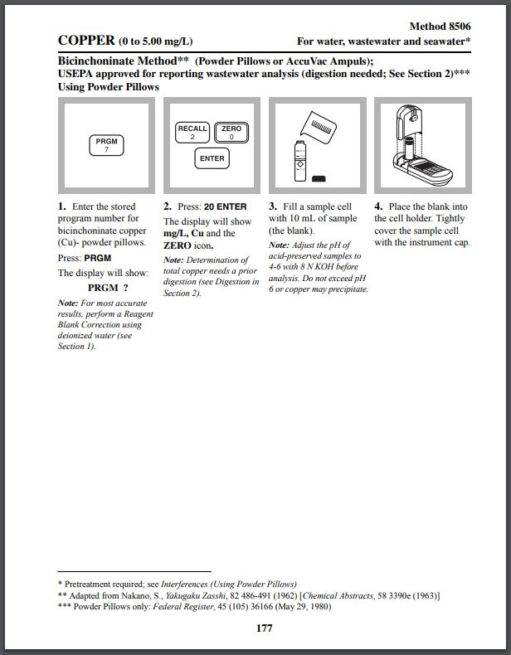
Figure S1a. Bicinchoninate method for ionic Cu determination using AQ4000 colorimeter
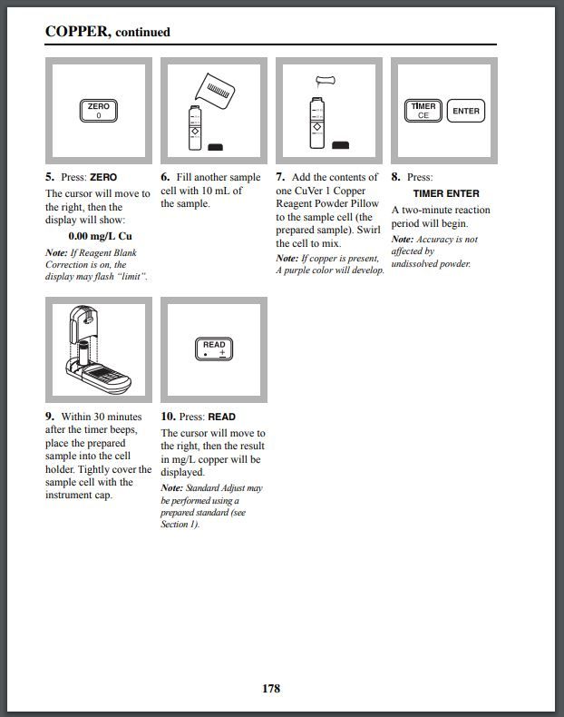
Figure S1b. Bicinchoninate method for ionic Cu determination using AQ4000 colorimeter
Table S1. Hydrodynamic diameter and ζ-potential values of CuPRO 2005 and Kocide 3000 pesticides and CuCO₃ solution after particle size and ζ-potential analyzer analysis
 | Samples suspended in Milli-Q water
Suspension characterization | CuPRO 2005 | Kocide 3000 | CuCO₃
Hydrodynamic diameter (nm) | 620 ± 30 | 600 ± 30 | 286 ± 6
ζ-potential (mV) | -42 ± 3 | -44 ± 2 | -30 ± 2

