Supplementary Material
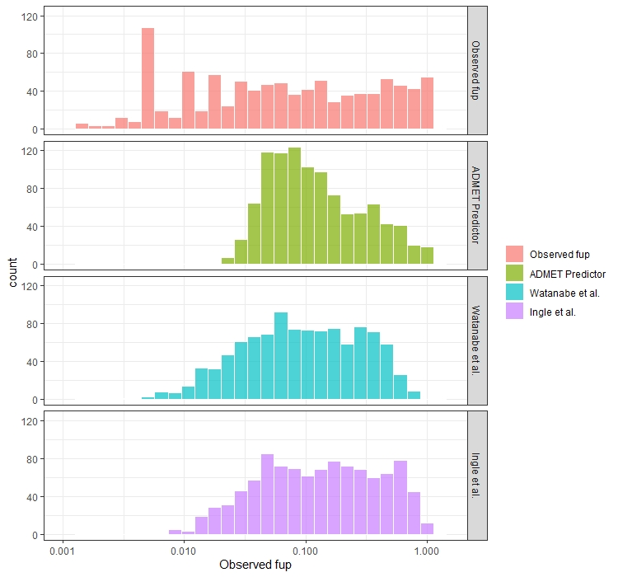
Figure S1. The distributions of the observed fup values and the predicted values according to each QSPR model.

