Supporting Information

Advanced Phosphorus Recovery from Municipal Wastewater using Anoxic/Aerobic Membrane Bioreactors and Magnesium-based Pellets

Soryong Chae ^{1,*}, Brindha Murugesan ¹, Dilip Kumar Duvvuru ^{1,2}, Hyunsik Kim ¹, Tae K. Lee ², and Mallikarjuna N. Nadagouda ^{2,*}

¹ Department of Chemical and Environmental Engineering, University of Cincinnati, Cincinnati, 2901 Woodside Drive, Cincinnati, Ohio 45221, United States
² U.S. Environmental Protection Agency, ORD, CESER, WID, CMTB, 26 W. Martin Luther King Drive, Cincinnati, Ohio 45268, United States

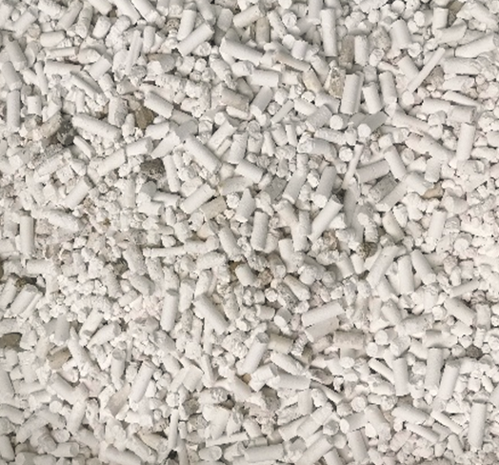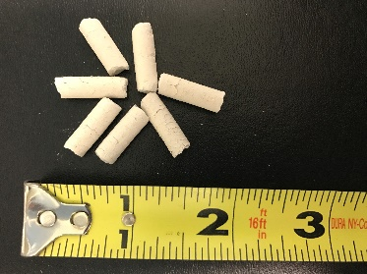
Figure S1. Magnesium carbonate pellets.
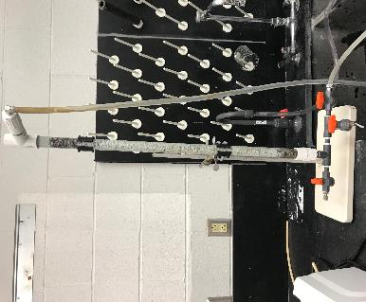
Figure S2. A bench-scale continuous flow column packed with MgCO₃ pellets for P recovery from the MBR effluent.
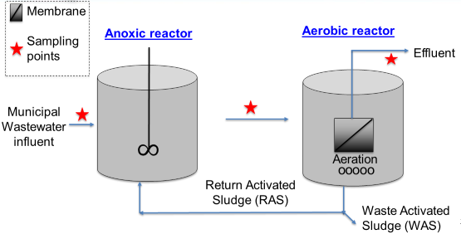
Figure S3. Anoxic/aerobic membrane bioreactor (MBR) system (Run 5).
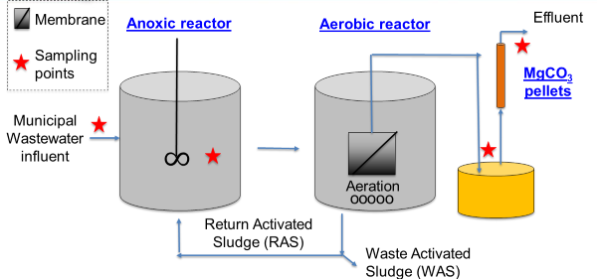
Figure S4. Schematic diagram of the MBR system with magnesium carbonate pellets for enhanced P recovery (Run 6).

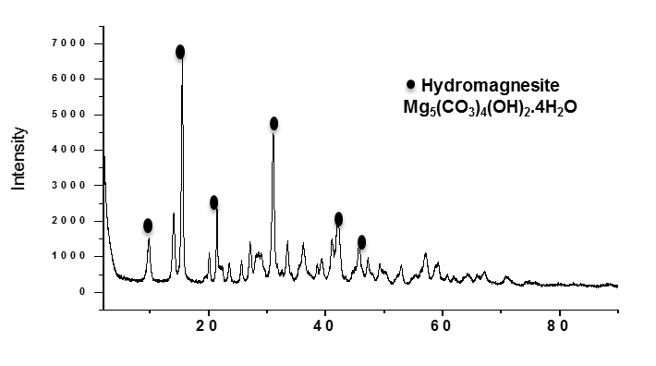
Figure S5. A typical XRD pattern of pristine MgCO₃ pellets.
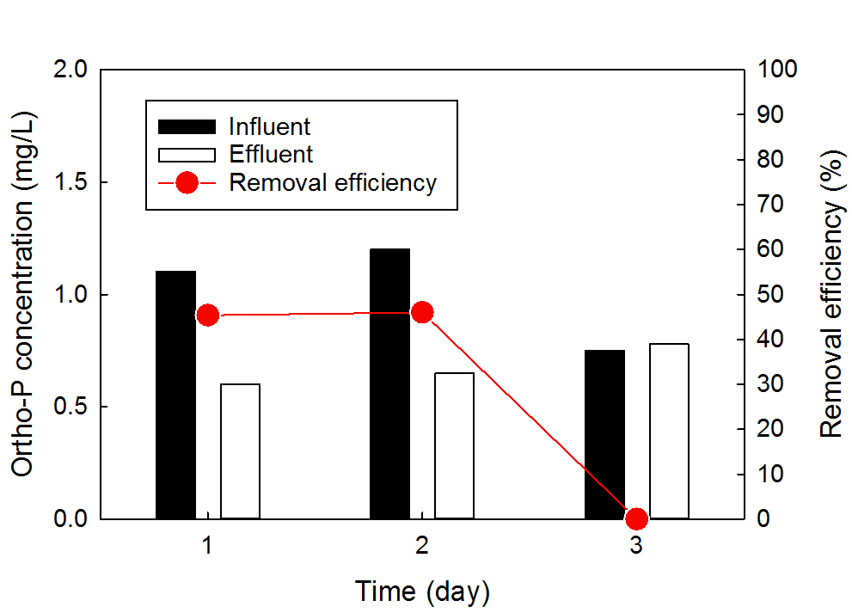Figure S6. P recovery from raw wastewater using the MgCO₃ pellets (Run 1).
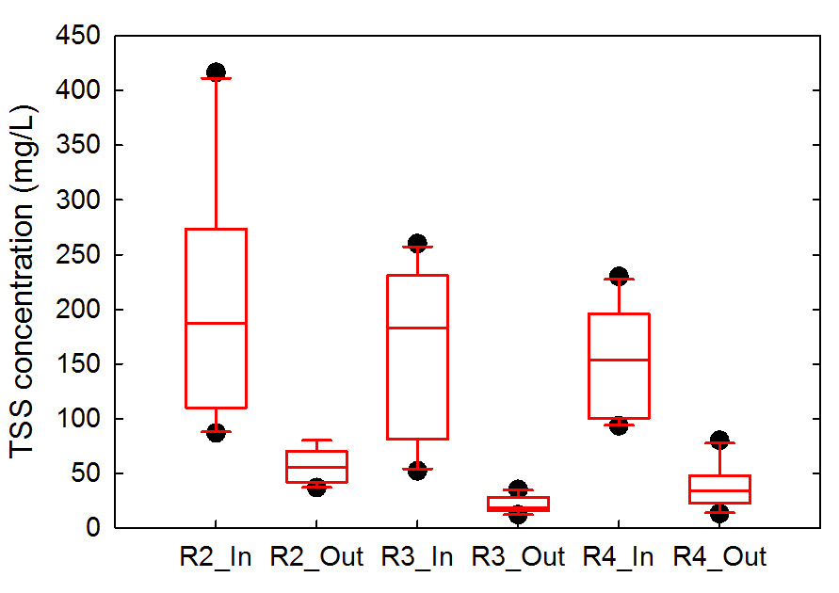
Figure S7. Distribution of TSS concentrations in primary effluent and the MgCO₃ column effluent (Runs 2 - 4).
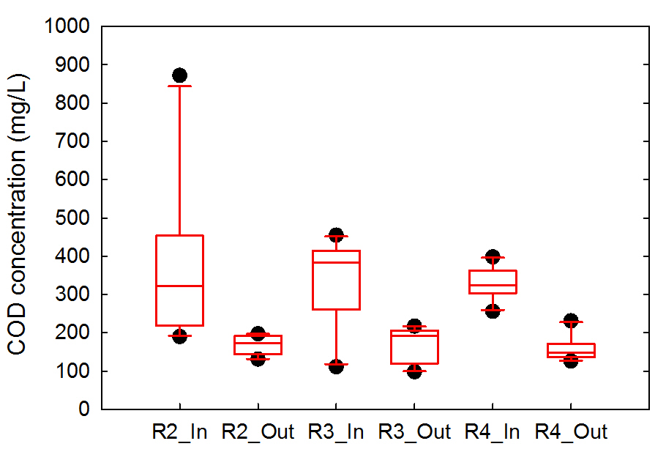
Figure S8. Distribution of COD concentrations in primary effluent and the MgCO₃ column effluent (Runs 2 - 4).
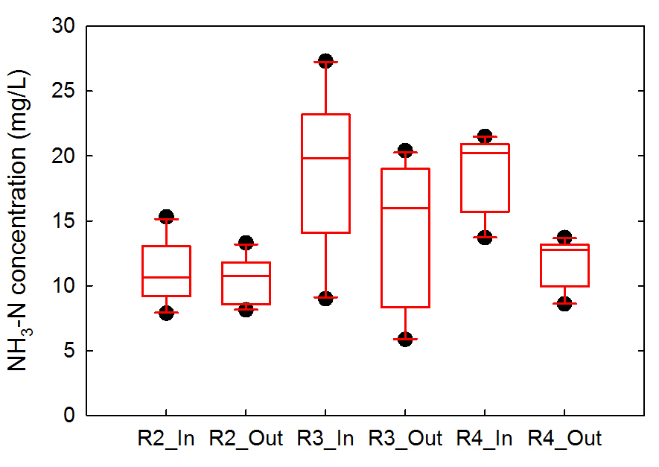
Figure S9. Distribution of NH₃-N concentrations in primary effluent and the MgCO₃ column effluent (Runs 2 - 4).

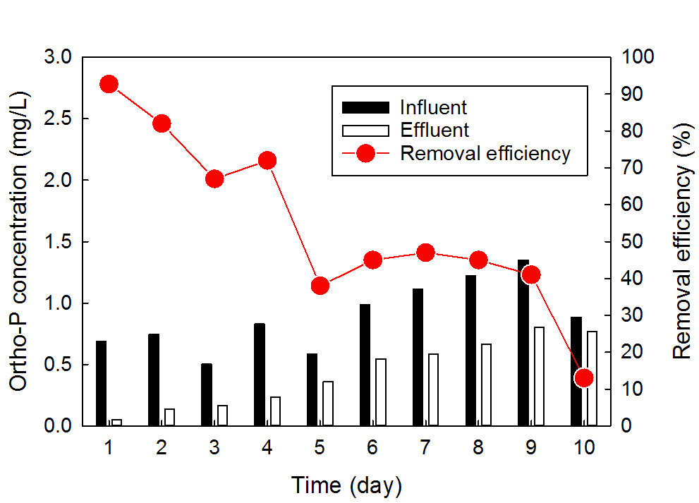
Figure S10. P recovery from primary effluent using the MgCO₃ pellets at 10 L/day (Run 2).
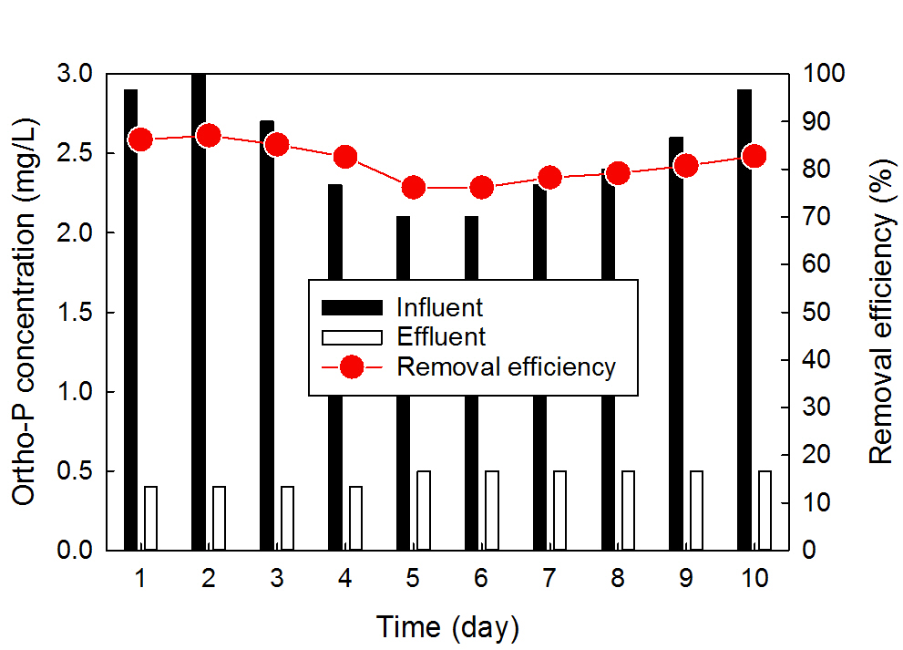
Figure S11. P recovery from the MBR effluent using the MgCO₃ pellets at 5.0 L/day (Run 3).

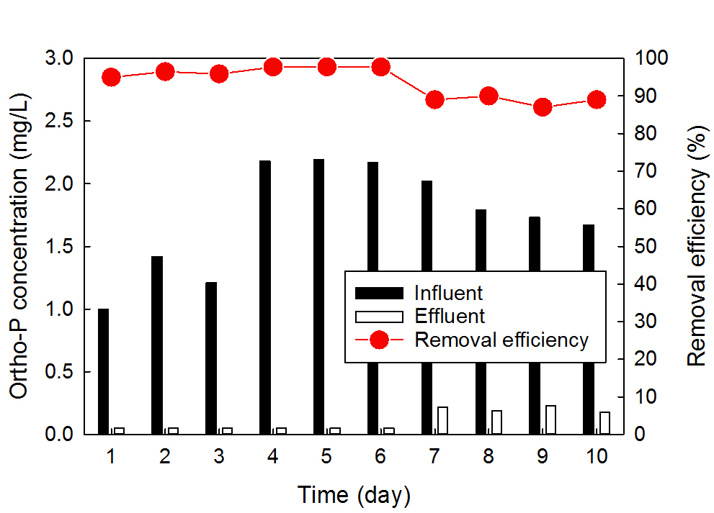
Figure S12. P recovery from primary effluent using the MgCO₃ pellets at 2.5 L/day (Run 4).
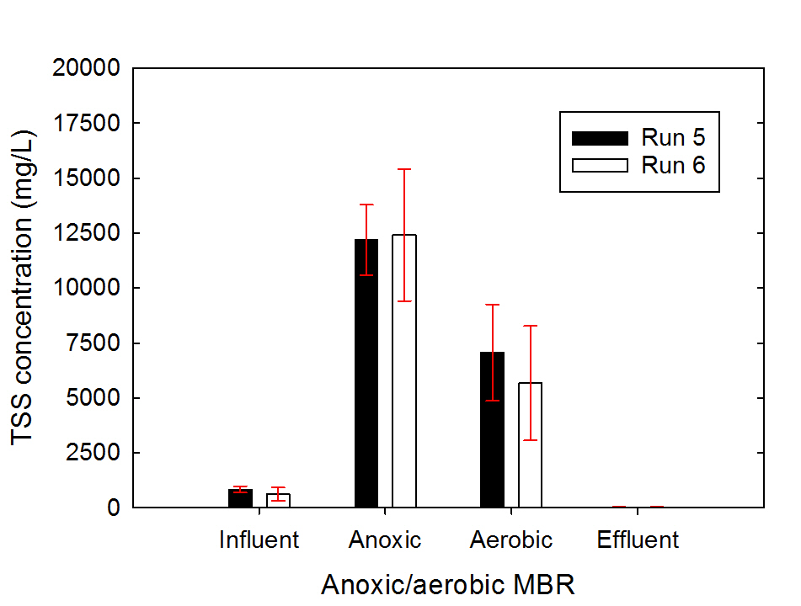
Figure S13. Changes in TSS concentration through the anoxic/aerobic MBR system (Runs 5 - 6).
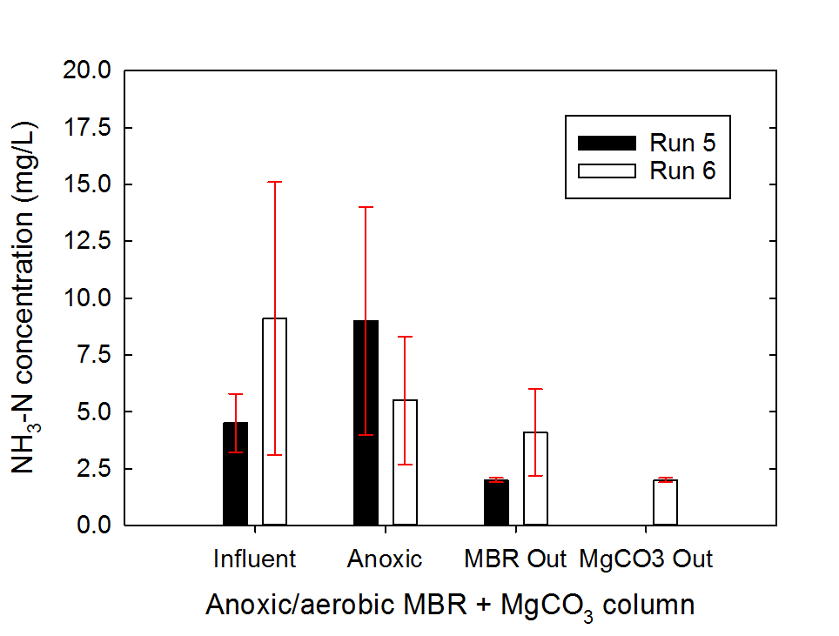
Figure S14. Changes in NH₃-N concentration through the anoxic/aerobic MBR system and the MgCO₃ column (Runs 5 - 6).

