Supplemental Data, S1
ER alpha Summary results from SeqAPASS
Level 1 and Level 2 results previously summarized in Ankley et al., 2016
Ankley, G; LaLone, C; Gray, L; Villeneuve, D; Hornung, M. (2016). Evaluation of the scientific underpinnings for identifying estrogenic chemicals in nonmammalian taxa using mammalian test systems. Environ. Toxicol. Chem. 35 (11), 2806-2816.
Level 3 (for full results see Supplemental Tables, Estrogen Receptor)
Taxonomic Group | Class Name | # of Spp. | Shared Susceptibility
Mammals | Mammalia | 130 | Yes
Birds | Aves | 72 | Yes
Lizards, Snakes | Lepidosauria | 14 | Yes
Turtles | Testudines | 9 | Yes
Crocodiles, Alligators | Crocodylia | 7 | Yes
Amphibians | Amphibia | 14 | Yes
Coelacanths | Coelacanthiformes | 1 | Yes
Lungfish | Ceratodontimorpha | 2 | Yes
Boney Fish | Actinopteri | 104 | Yes
Sharks, Rays | Chondrichthyes | 2 | Yes
Lamprey | Petromyzontiformes | 1 | Yes
Hagfish | Myxiniformes | 1 | Yes

ER beta Summary results from SeqAPASS
Level 1 Human Estrogen Receptor beta primary amino acid comparison
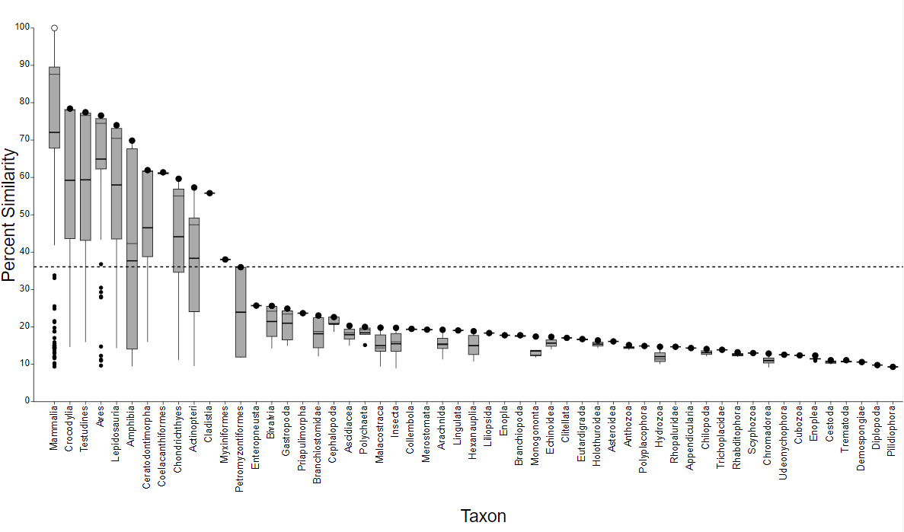
Level 2 Human Estrogen Receptor beta ligand binding domain comparison (cd06934)
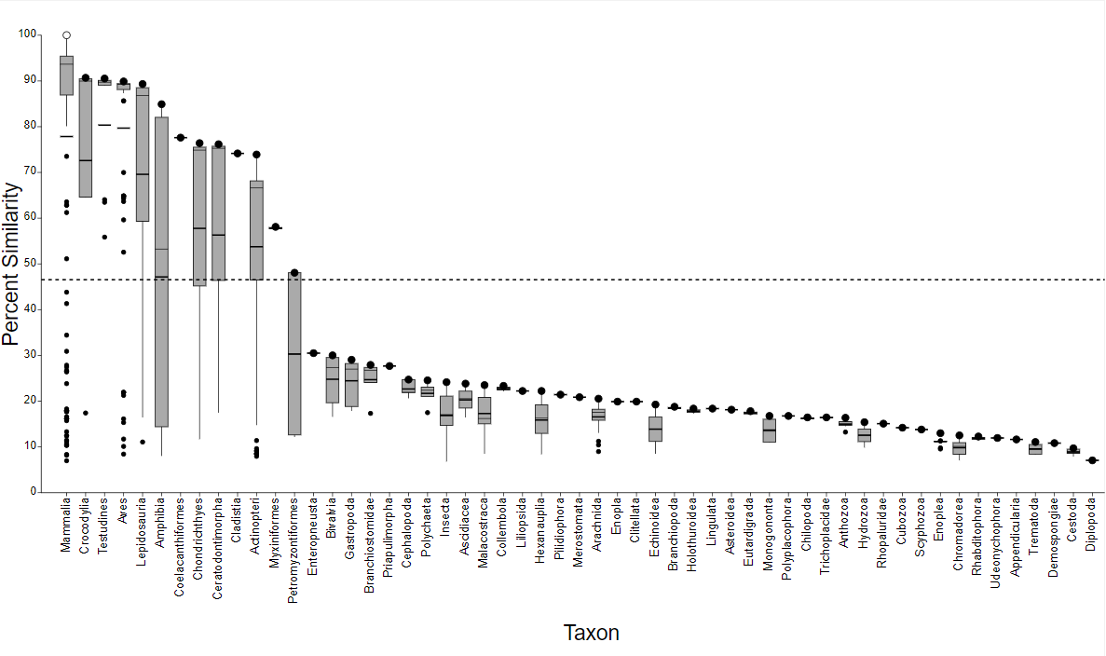
Level 3 (for full results see Supplemental Tables, Estrogen Receptor beta)
Taxonomic Group | Class Name | # of Spp. | Shared Susceptibility
Mammals | Mammalia | 88/14 | Yes/No
Crocodiles/Alligators | Crocodylia | 4 | Yes
Testudines | Testudines | 6 | Yes
Birds | Aves | 67 | Yes
Bony Fish | Actinopteri | 32/71 | Yes/No
Lizards/Snakes | Lepidosauria | 10/3 | Yes/No
Frogs/Salamanders | Amphibia | 8/2 | Yes/No
Lung fish | Ceratodontimorpha | 2 | Yes
Coelacanth | Coelacanthiformes | 2 | Yes
Sharks/Rays | Chondrichthyes | 5 | Yes
Bichir | Cladistia | 1 | Yes
Hagfish | Myxiniformes | 1 | Yes
Lamprey | Petromyzontiformes | 1 | Yes

AR Summary results from SeqAPASS
Level 1 and Level 2 results previously summarized in LaLone et al., 2018
LaLone, C.A., Villeneuve, D., Doering, J.A., Blackwell, B.R., Transue, T.R., Simmons, C.W., Swintek, J.A., Degitz, S.J., Williams, A.J., and Ankley, G.T. (2018). Defining the Taxonomic Domain of Applicability for Mammalian-Based High-Throughput Screening Assays. Environmental Science and Technology. Environmental Science and Technology 52(23), 13960-13971.
Level 3 (for full results see Supplemental Tables, Androgen Receptor)
Taxonomic Group | Class Name | # of Spp. | Shared Susceptibility
Mammals | Mammalia | 118/1 | Yes/No
Lizards, Snakes | Lepidosauria | 11 | Yes
Turtles | Testudines | 3 | Yes
Birds | Aves | 58 | Yes
Crocodiles, Alligators | Crocodylia | 4 | Yes
Amphibians | Amphibia | 13 | Yes
Coelacanths | Coelacanthiformes | 2 | Yes
Eel-shaped | Cladistia | 1 | Yes
Bony Fish | Actinopteri | 87/1 | Yes/No
Sharks, Rays | Chondrichthyes | 4 | Yes
Lungfish | Ceratodontimorpha | 2 | Yes

THa Summary results from SeqAPASS
Level 1 and Level 2 results previously summarized in LaLone et al., 2018
LaLone, C.A., Villeneuve, D., Doering, J.A., Blackwell, B.R., Transue, T.R., Simmons, C.W., Swintek, J.A., Degitz, S.J., Williams, A.J., and Ankley, G.T. (2018). Defining the Taxonomic Domain of Applicability for Mammalian-Based High-Throughput Screening Assays. Environmental Science and Technology. Environmental Science and Technology 52(23), 13960-13971.
Level 3 (for full results see Supplemental Tables, Thyroid Hormone Receptor a)
Taxonomic Group | Class Name | # of Spp. | Shared Susceptibility
Mammals | Mammalia | 113/8 | Yes/No
Birds | Aves | 21 | Yes
Lizards, Snakes | Lepidosauria | 9 | Yes
Turtles | Testudines | 3 | Yes
Crocodiles, Alligators | Crocodylia | 4 | Yes
Amphibians | Amphibia | 10 | Yes
Coelacanths | Coelacanthiformes | 1 | Yes
Bony Fish | Actinopteri | 65/13 | Yes/No
Sharks, Rays | Chondrichthyes | 1 | Yes
Lamprey | Petromyzontiformes | 1 | No

THb Summary results from SeqAPASS
Level 1 and Level 2 results previously summarized in LaLone et al., 2018
LaLone, C.A., Villeneuve, D., Doering, J.A., Blackwell, B.R., Transue, T.R., Simmons, C.W., Swintek, J.A., Degitz, S.J., Williams, A.J., and Ankley, G.T. (2018). Defining the Taxonomic Domain of Applicability for Mammalian-Based High-Throughput Screening Assays. Environmental Science and Technology. Environmental Science and Technology 52(23), 13960-13971.
Level 3 (for full results see Supplemental Tables, Thyroid Hormone Receptor b)
Taxonomic Group | Class Name | # of Spp. | Shared Susceptibility
Mammals | Mammalia | 120 | Yes
Birds | Aves | 72 | Yes
Lizards, Snakes | Lepidosauria | 9 | Yes
Turtles | Testudines | 4 | Yes
Crocodiles, Alligators | Crocodylia | 4 | Yes
Amphibians | Amphibia | 12 | Yes
Bony Fish | Actinopteri | 70/1 | Yes/No
Sharks, Rays | Chondrichthyes | 1 | Yes
Lamprey | Petromyzontiformes | 1 | Yes

PXR Summary results from SeqAPASS
Level 1 Human Pregnane X Receptor primary amino acid comparison
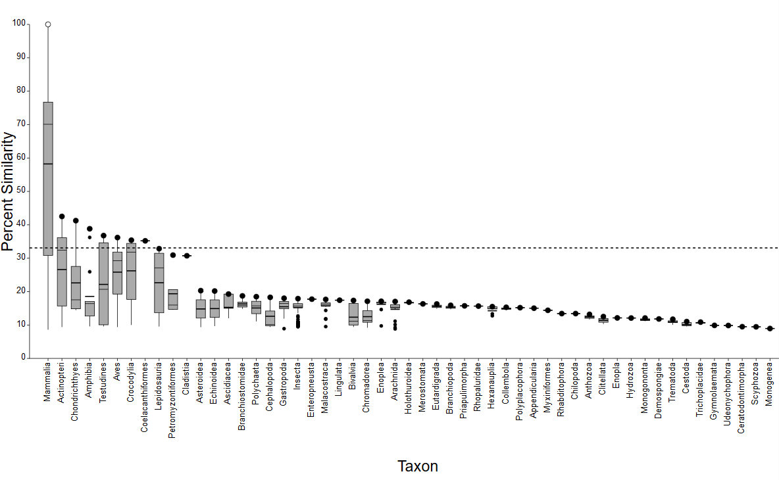
Level 2 Human Pregnane X Receptor ligand binding domain comparison (cd06934)
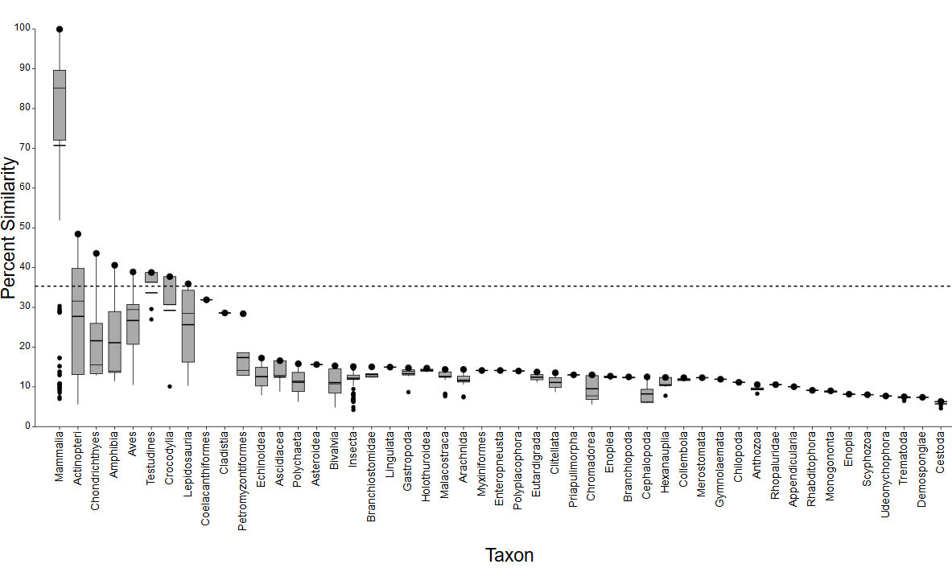
Level 3 (for full results see Supplemental Tables, Pregnane X Receptor )
Taxonomic Group | Class Name | # of Spp. | Shared Susceptibility
Mammals | Mammalia | 88/14 | Yes/No
Birds | Aves | 1 | Yes
Amphibians | Amphibia | 1/1 | Yes/No
Boney Fish | Actinopteri | 51/1 | Yes/No
Sharks, Rays | Chondrichthyes | 1 | Yes

PPARg Summary results from SeqAPASS
Level 1 Human PPARgamma primary amino acid comparison
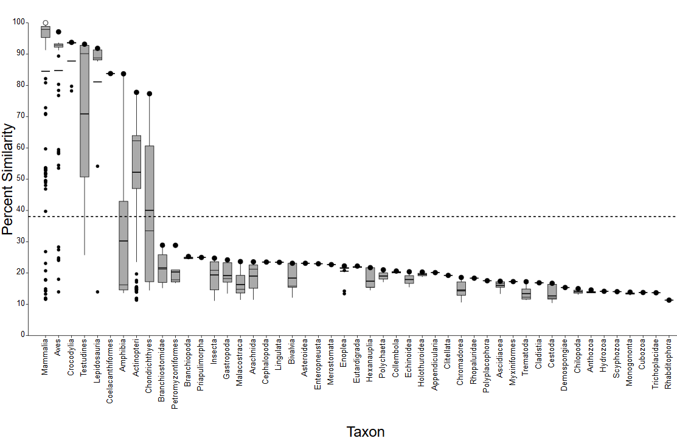

Level 2 Human PPARgamma functional domain comparison (cd06932)
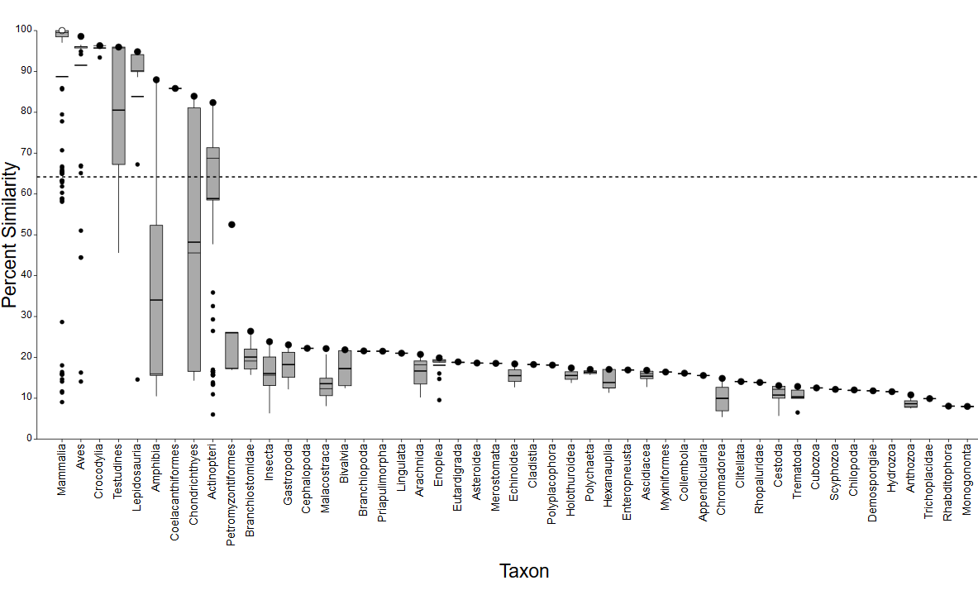
Level 3 (for full results see Supplemental Tables, PPARgamma)
Taxonomic Group | Class Name | # of Spp. | Shared Susceptibility
Mammals | Mammalia | 126 | Yes
Birds | Aves | 1/80 | Yes/No
Lizards, Snakes | Lepidosauria | 11 | No
Turtles | Testudines | 7 | No
Crocodiles, Alligators | Crocodylia | 5 | No
Amphibians | Amphibia | 2 | No
Coelacanths | Coelacanthiformes | 1 | No
Bony Fish | Actinopteri | 90 | No
Sharks, Rays | Chondrichthyes | 3 | No
Lamprey | Petromyzontiformes | 1 | No

