Examining NTA performance and potential using fortified and reference house dust as part of EPA’s Non-Targeted Analysis Collaborative Trial (ENTACT)
Supplemental Information Figures
Seth Newton^{1,*}, Jon R. Sobus¹, Elin M. Ulrich¹, Randolph R. Singh^{2,3}, Alex Chao⁴, James McCord⁵, Sarah Laughlin-Toth^{2,6}, Mark Strynar⁵
1) Center for Computational Toxicology and Exposure, Office of Research & Development, U.S. Environmental Protection Agency, Research Triangle Park, NC, USA
2) Oak Ridge Institute for Science and Education, Post-Doctoral Participant, National Exposure Research Laboratory, Office of Research & Development, U.S. Environmental Protection Agency, Research Triangle Park, NC, USA
3) Current affiliation: Luxembourg Centre for Systems Biomedicine (LCSB), University of Luxembourg, Luxembourg
4) Oak Ridge Associated Universities, Student Services Contractor, National Exposure Research Laboratory, Office of Research & Development, U.S. Environmental Protection Agency, Research Triangle Park, NC, USA
5) Center for Environmental Measurement and Modeling, Office of Research & Development, U.S. Environmental Protection Agency, Research Triangle Park, NC, USA
6) Current affiliation: Aflac Cancer and Blood Disorders Center, Department of Pediatrics, Emory University School of Medicine, Atlanta, GA, USA

*Corresponding author email: Newton.Seth@epa.gov

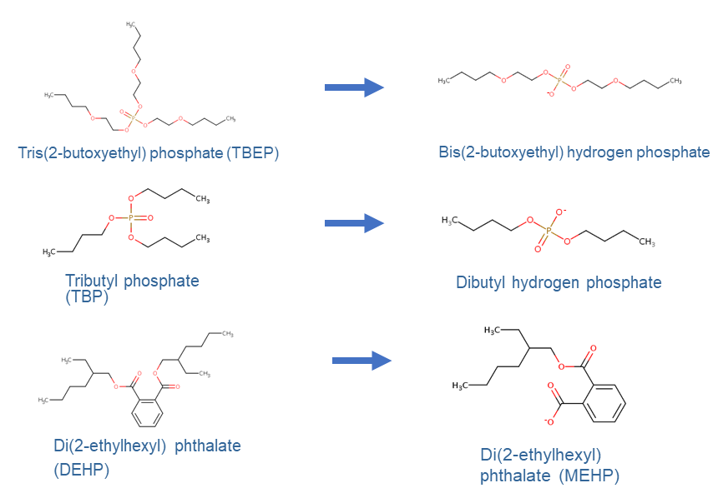
Figure S1 - In-source fragments observed in this study.

Figure S2 - Box and whisker plots of the reported range of concentrations of LC-ESI amenable compounds observed and unobserved in this study.

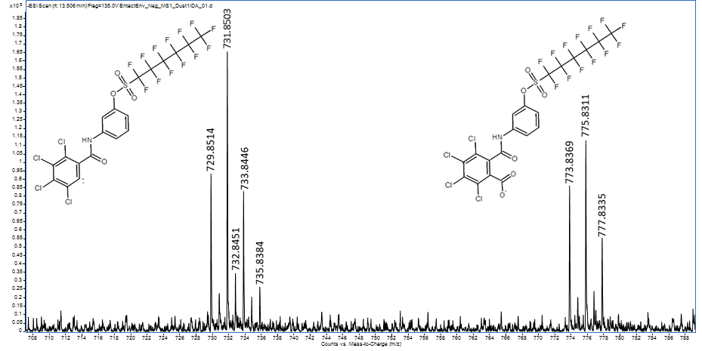Figure S3 - MS1 spectrum of TCBA-BA-PFHxS and its decarboxylated form.

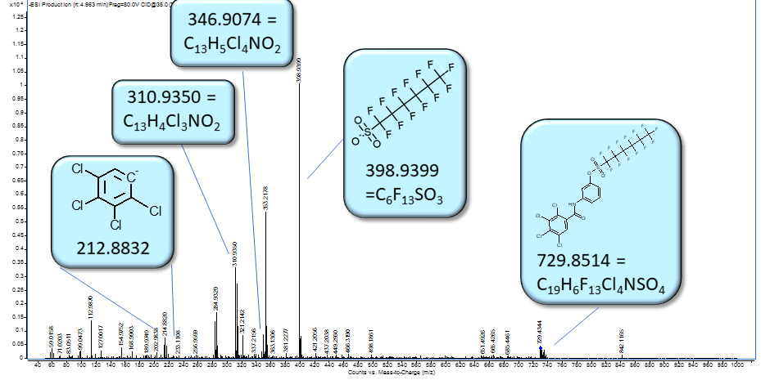
Figure S4 – Annotated MS/MS spectrum of decarboxylated TCBA-BA-PFHxS.

Figure S5 - Range of Log K_{ow} values for compounds recovered from the extraction and clean-up procedure vs those not recovered.

