Supporting Information (SI) Materials

Table S1. Differences in data sources for crop VPF compared to VNF.

 | States that did not have P application rates | States that did not have % P in edible crop | States that did not have % P in whole plant
Tomatoes | New York | Georgia
Onions | Colorado, New York | Oregon, Colorado | Washington, Idaho
Lettuce |  | Arizona
Potatoes | Arizona, Maine, New York, Virginia
Soybeans | Delaware, Florida, Illinois, Missouri, Pennslyvania, South Carolina, Texas
Apples
Grapes
Oranges*
Watermelons | Indiana
Corn | Alabama, Arizona, California, Montana, Delaware, New Jersey, Pennsylvania, South Carolina, South Dakota, Virginia, West Virginia
Wheat | Alabama, Arizona, Illinois, Kansas, Louisianna, Nebraska, Pennsylvania, South Carolina, Virginia
Rice | California, Missouri, Texas
Barley | Maine, Pennsylvania, Virginia, Washington
Sorghum | Missouri, Texas, Arizona, Illinois
Oats | Alabama, Iowa, South Carolina, Washington
Alfalfa | Arizona, Arkansas, Illinois, Indiana, Kentucky, Maine, Maryland, Massachusetts, Nevada, New Hampshire, New Jersey, North Carolina, Rhode Island, Vermont, Virginia, Washington, West Virginia, Wyoming
Hay | Ohio, Pennsylvania, North Carolina, Delaware, California, Arizona, Indiana, West Virginia
*Many states recommended 0 fertilization for trees. In Florida we used a different data source for P application (Singerman 2018), but used the same assumptions about life span, tree density and yields as was done for N.
Singerman, A. (2018) University of Florida Institute of Food and Agricultural Science. Citrus Research and Education Center. https://crec.ifas.ufl.edu/economics/

Table S2. VNF and VPF values – kg nutrient released per kg of nutrient consumed. This is used in Figure S1.
Food | VNF | VPF
Animal products
Pork | 5.69 | 15.26
Poultry | 5.08 | 15.00
Beef | 13.44 | 54.93
Milk | 3.90 | 2.52
Cheese | 3.90 | 2.52
Eggs | 4.06 | 10.98
Fruits - Avg | 5.88 | 4.32
Apples | 3.15 | 4.99
Oranges | 6.53 | 3.04
Grapes | 5.81 | 1.35
Watermelon | 4.95 | 12.33
Vegetables - Avg | 5.07 | 8.20
Lettuce | 5.15 | 6.36
Tomato | 5.60 | 9.65
Onion | 3.44 | 6.49
Potatoes | 2.62 | 2.76
Grains - Avg | 1.70 | 1.66
Corn | 1.13 | 1.08
Wheat | 1.82 | 1.82
Rice | 1.15 | 0.89
Beans | 0.49 | 0.57

Figure S3. P released to the environment for Specific food items that comprise the vegetal product food groups presented. The values are used in figure 4.
Food | P release per kg of food
Animal products
Pork | 34.03
Poultry | 27.90
Beef | 112.05
Milk | 2.54
Cheese | 12.18
Eggs | 21.73
Fruits - Avg | 0.61
Apples | 0.55
Oranges | 0.43
Grapes | 0.27
Watermelon | 1.36
Vegetables -Avg | 2.18
Lettuce | 1.68
Tomato | 2.47
Onion | 1.82
Potatoes | 1.81
Grains - Avg | 5.18
Corn | 2.96
Wheat | 6.75
Rice | 2.59
Beans | 3.03

Figure S1. Relationships between N and P footprint metrics as (A) Virtual factors, (B) Losses per weight of food, and (C) Losses per kilocalorie of food. The trends are obviously positive. Linear regressions in all three cases have high R2 values (A. 0.71, B. 0.98, C. 0.96) with p values below 0.001, but as the data are aggregated (in the case of B. and C.) and heteroscedastic, any such statistic should be treated as just an illustration.
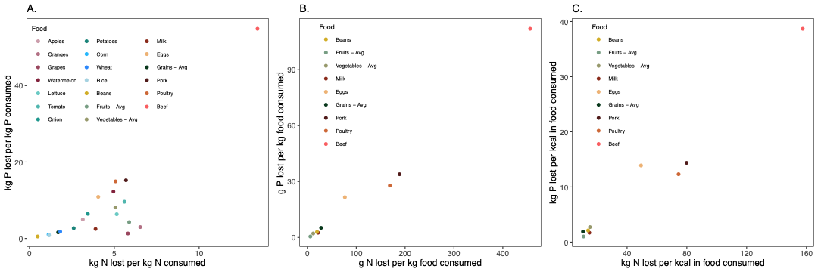

Figure S2. Comparison of grams of N and P released to the environment per gram of food consumed for (A) Animal products and major food groups and (B) Non-animal product food items that make up the categories presented in panel A. Panel A is the same data as presented in figure 4 and is presented here for scale (as per the dotted line) in relation to the values presented in panel B.
